Table of Contents

B1.3 · Unit 10 · Never Have I Been So
English Animated · Making the Case · a university campus, Melbourne Student's Book pages 204–225 · 22 pp · ~11 hours

Part 0 · The Big Picture ◆ A · THE WORLD
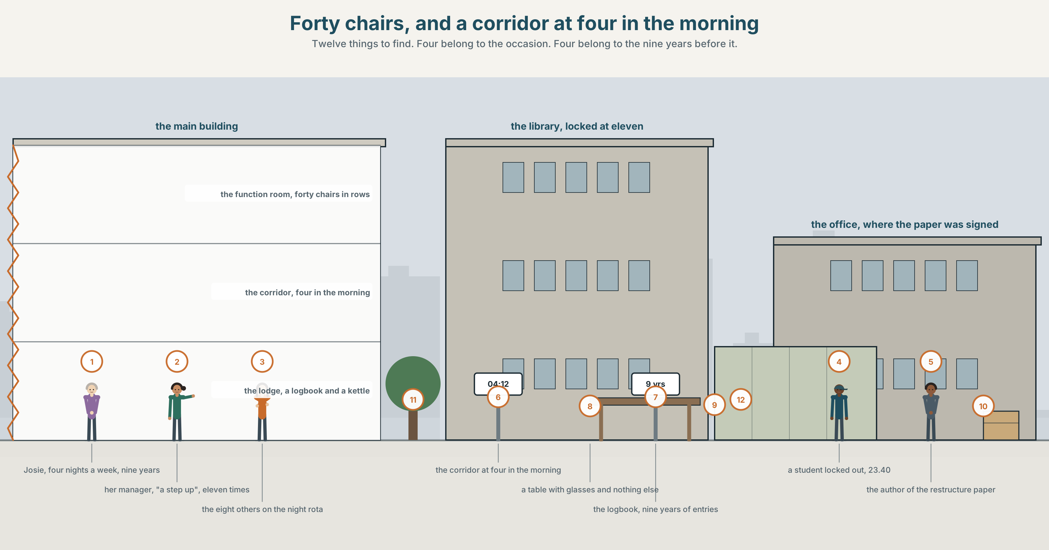{width=6.6in}
Forty chairs, and a corridor at four in the morning — Twelve things to find. Four belong to the occasion. Four belong to the nine years before it.

Never have I been so…
By the end of this unit you can deliver a three-minute formal address.
◆ A · THE WORLD | A promotion that nobody asked whether anybody wanted
◆ B · THE SYSTEM | inversion after negative adverbials · 24 words for rhetoric and occasion · 21 fronting forms · emphatic stress
◆ C · THE PERFORMANCE | Three minutes, standing up, in front of people who know you

0A · Find it
Find twelve things in this picture. Four of them belong to the occasion. Four belong to the nine years before it.
a room set out with forty chairs · a small podium with a microphone taped to it · a printed programme with one name on it · a table with glasses and nothing else · a card signed by thirty people · a corridor at four in the morning · a set of keys on a ring, worn smooth · a logbook with nine years of entries · a staff photograph from 2016 with one person at the edge · a window showing a sky that is not dark · a lanyard being handed over · a chair at the back, nearest the door

0B · Guess it
Two of the twelve are nine years apart and show the same thing. Which, and what has changed?

0C · Say it ⏺
Record forty-five seconds. Describe a time you were given something you had not asked for. Say what it was supposed to mean and what it actually meant. You will record it again at the end of this unit.

Part 1 · Vocabulary Lab 1 ◆ B · THE SYSTEM
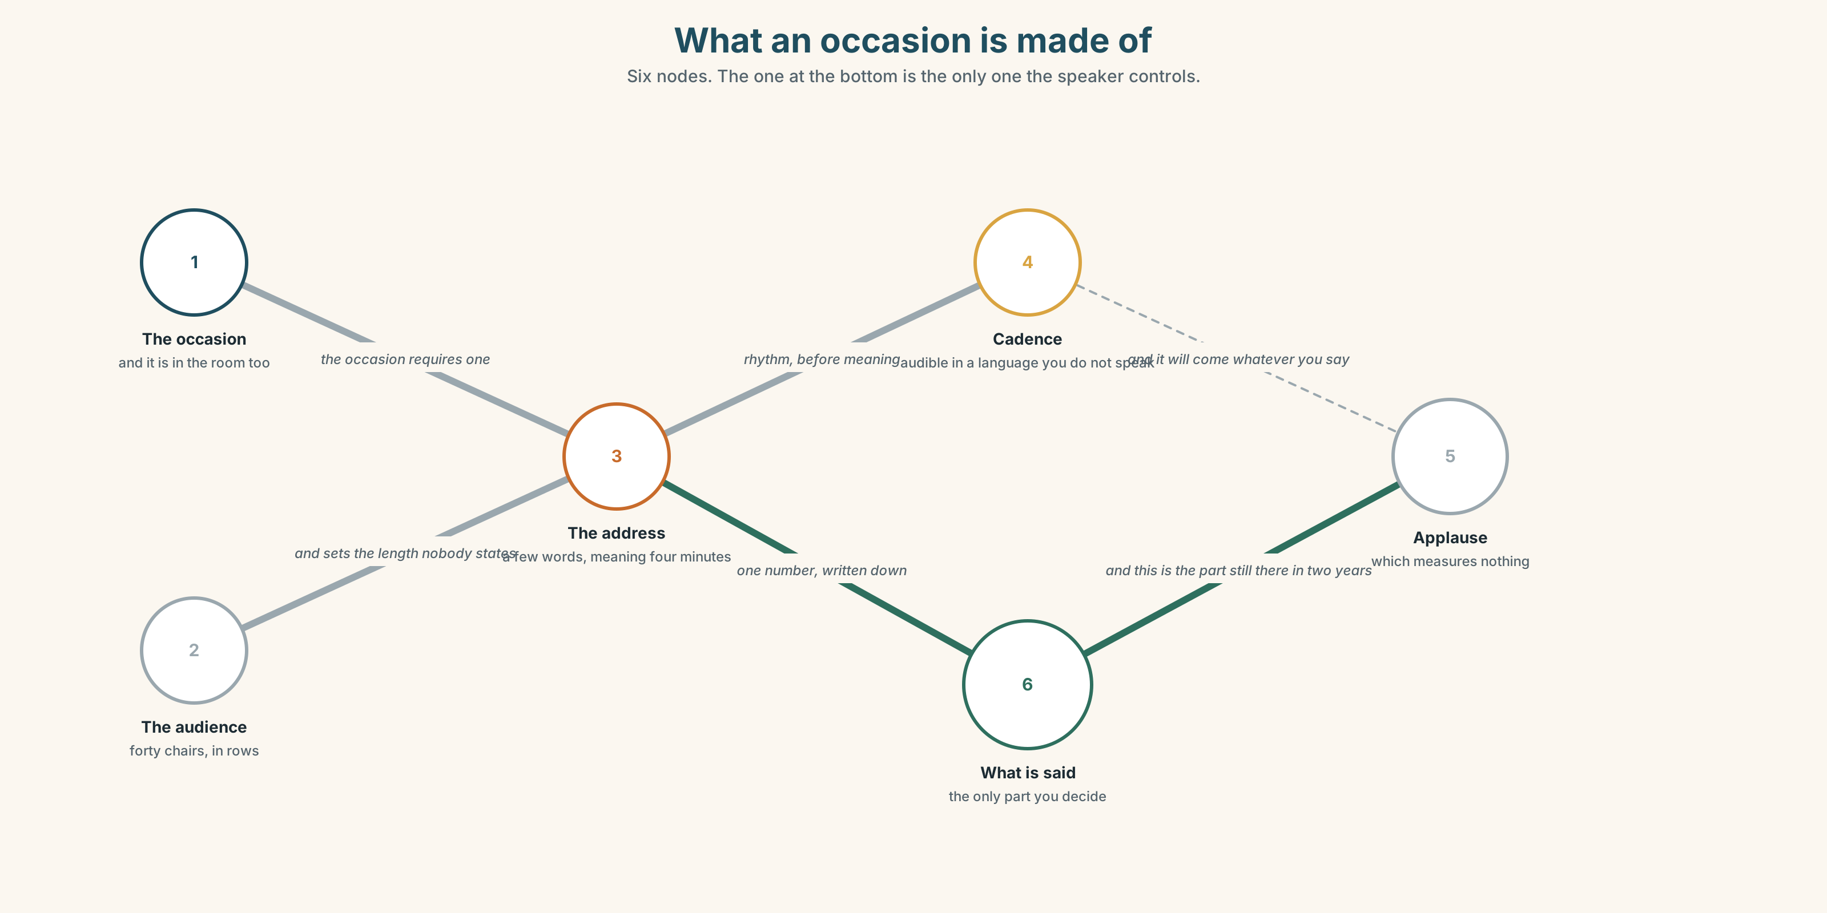{width=6.6in}
What an occasion is made of — Six nodes. The one at the bottom is the only one the speaker controls.

1A · Meet — the words of an occasion
address · audience · rhetoric · cadence · pause · podium · applause · gravity
- Which two of these belong to the room rather than the speaker?
- What is cadence, and why can you hear it in a speech you cannot understand?
- Rhetoric has a neutral meaning and an insulting one. Give both.
- What exactly does gravity mean here, and can a short speech have it?
An address is not a speech. It is a speech given because an occasion requires one, which means the occasion is also in the room, and some of what is said is said to it rather than to the people.

1B · Sort — before, during, or after?
occasion · tribute · acknowledgement · promotion · take the floor · a few words · on this occasion · in all my years · a step up
Three columns. Two of them belong in more than one. Say which and why.

1C · Meet — the phrase that does most of the work
c a few words
Never a few. It is a request for a short formal speech, and the person asking knows exactly how long they mean and will not say.
- How long is a few words, in your experience?
- What is the difference between being asked for them in advance and being asked in the room?

1D · Collocation Lab
take the floor | ~ for a moment · she took ~
on this occasion | ~ , I would like to · not ~
in all my years | ~ I have never · ~ here
a step up | ~ in pay · ~ , on paper
Which two of these can be said without any warmth at all?

1E · The fixed expressions
f Never have I been so. — the shape of a hundred toasts, and it only works if what follows is unexpected. f I did not ask for this. — eight syllables that can be gratitude, refusal or grief, and only the delivery decides.
Say the second one three ways. How many did the room hear differently?

1F · Own it
The four phrasal verbs of taking a job or not.
stand down · take on · turn down · rise to
- Which two are about leaving, and which two about accepting?
- What is the difference between taking on a role and being given one?
- Rise to what — the occasion, the challenge, or the bait?
- Write one sentence in which somebody turns down something and is not believed.

Part 2 · Listening ◆ A · THE WORLD
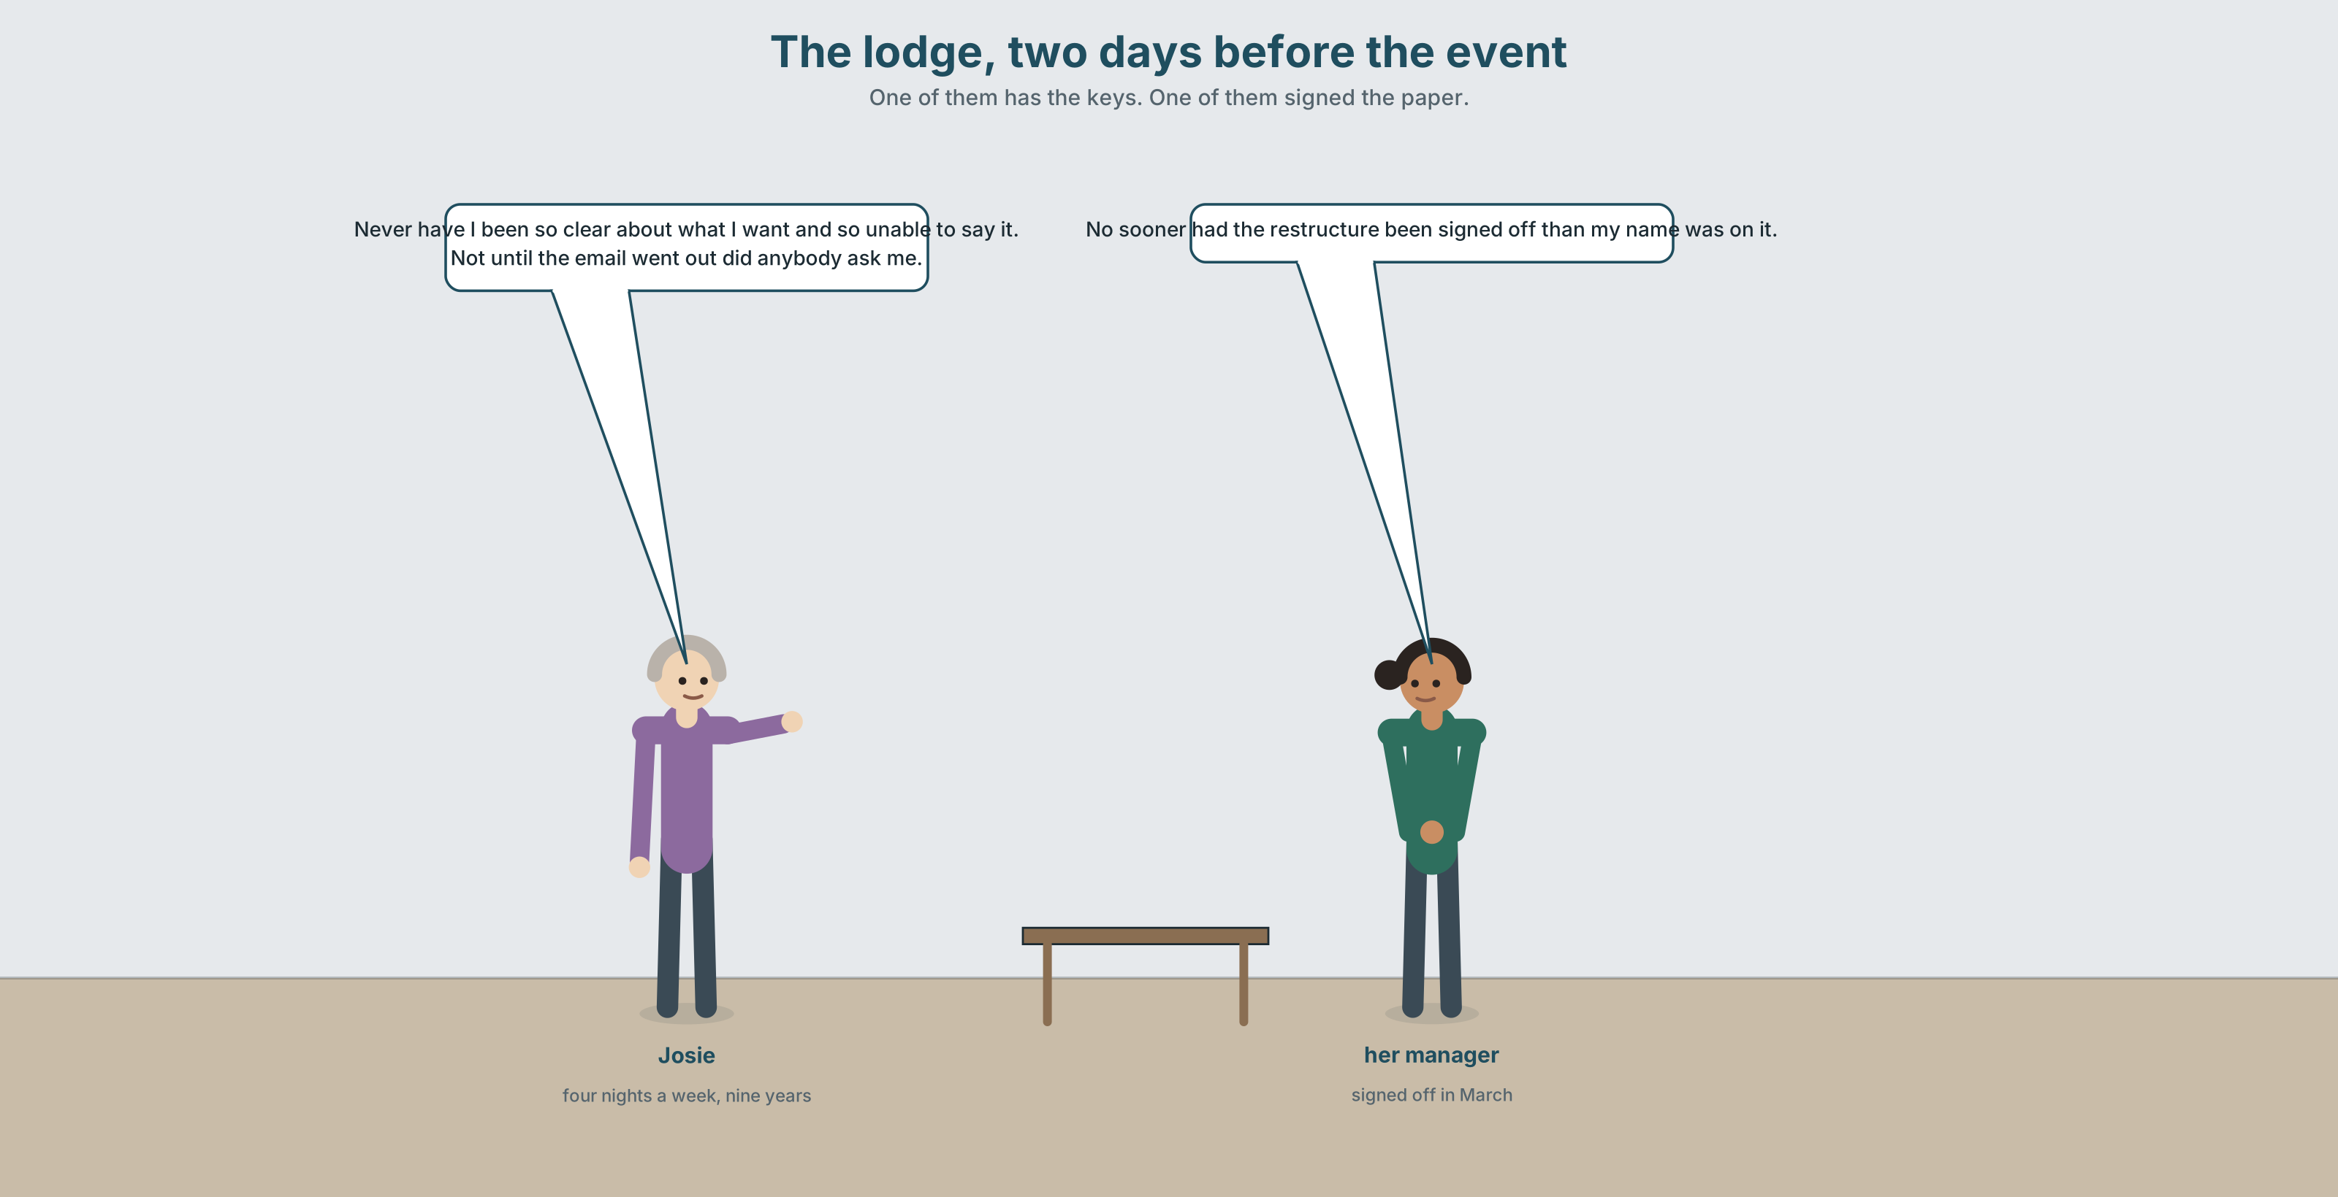{width=6.6in}
The lodge, two days before the event — One of them has the keys. One of them signed the paper.

2A · A step up 🔊 Track 10.1
Before you listen. Josie has worked nights for nine years. She is being moved to days, with more money and a title. Guess: has anybody asked her?
Listen once. One question. Who decided, and when was Josie told?
Listen again. Complete the table.
 | The night job | The day job
hours
pay
people she works with
what she decides herself
Listen again. Choose the best answer.
- The move is a promotion / a restructure / both.
- Josie was told before / after / at the same time as the announcement.
- Her manager thinks she is pleased / reluctant / difficult.
- The leaving event has already been booked / not been booked / been cancelled.
Noticing. Four sentences from the recording.
- Never have I been so clear about what I want and so unable to say it.
- Not until the email went out did anybody ask me.
- No sooner had the restructure been signed off than my name was on it.
- At no point was there a conversation.
All four begin with a negative and invert the verb. Which one would be unremarkable if you put it back in order?

2B · Decoding clinic 🔊 Track 10.2
Thirty seconds of Josie. Four jobs.
- How many inverted sentences can you count?
- In never have I been so, which word is loudest?
- Catch the two numbers.
- She says one thing in ordinary order and then again inverted. Which, and what changes?
Transcripts, page 159.

Part 3 · Grammar Lab 1 ◆ B · THE SYSTEM

Putting the negative first, and paying for it

3A · Notice
Look at the four sentences in Part 2.
- In sentence 1, where would I have be in ordinary order?
- In sentence 2, what is the auxiliary, and where did it come from?
- Rewrite sentence 3 in ordinary order. How many words change position?
- Sentence 4 inverts a be verb. Is that the same operation?
- Try "Never I have been so clear." What is missing?

3B · See
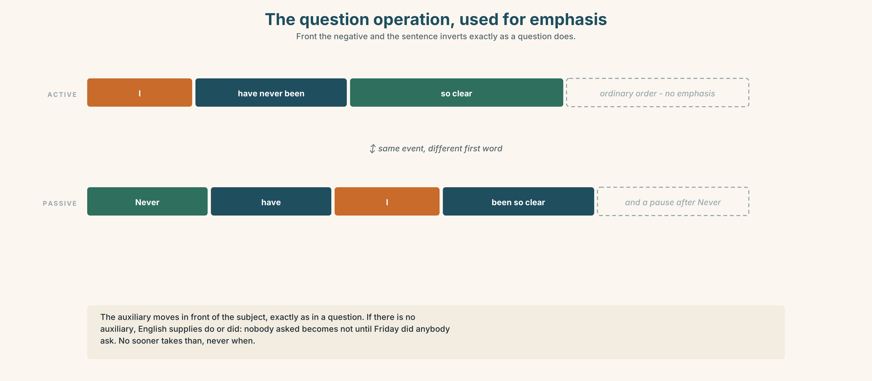{width=6.6in}
The question operation, used for emphasis — Front the negative and the sentence inverts exactly as a question does.

3C · Know
Fronted element | Example | What moves
never · rarely · seldom | Never have I been so sure. | auxiliary before subject
hardly · scarcely · no sooner | No sooner had it been signed than… | and than, not when
not until · at no point | Not until Friday did anybody ask. | do / did appears if there is no auxiliary
little | Little did we know. | fixed, and almost always ironic
only then · only when | Only then did she answer. | the inversion comes after the whole clause
nor · neither | Nor was there any warning. | joins to a previous negative
The operation is the question operation. I have never been → Have I been? → Never have I been. If there is no auxiliary, English supplies do, exactly as in a question: Nobody asked → Not until Friday did anybody ask.
no sooner takes than, not when. No sooner had it been signed than my name was on it. This is the single most common error with this structure.
Inversion is formal and it is emphatic, and it costs something. Used twice in a speech it is powerful. Used six times it is a parody of a speech, and the audience will hear the structure instead of the content.
Why it matters. This is the grammar of occasions: toasts, tributes, resignations, verdicts. You will not need it often and when you need it nothing else will do.

3D · Use — controlled
(1) __________ have I been so clear about what I want and so unable to say it. (2) __________ until the email went out __________ anybody ask me. (3) __________ sooner had the restructure been signed off (4) __________ my name was on it, in a list, between two people I have never met. (5) __________ no point was there a conversation. (6) __________ did I imagine, nine years ago, that the thing I would have to defend would be the shift nobody else wants. And (7) __________ then, standing in a room with forty chairs in it, did I understand that the promotion was not for me.

3E · Use — guided
Invert each one. Two of them need do or did.
- I have never been so sure.
- Nobody asked until Friday.
- It had no sooner been signed than my name was on it.
- She answered only then.
- We little knew what it would mean.

3F · Use — open
In pairs. Give a sixty-second tribute to something ordinary — a bus route, a kettle, a shift pattern — using exactly two inversions. Your partner's job is to say whether a third would have helped.

3G · Error autopsy
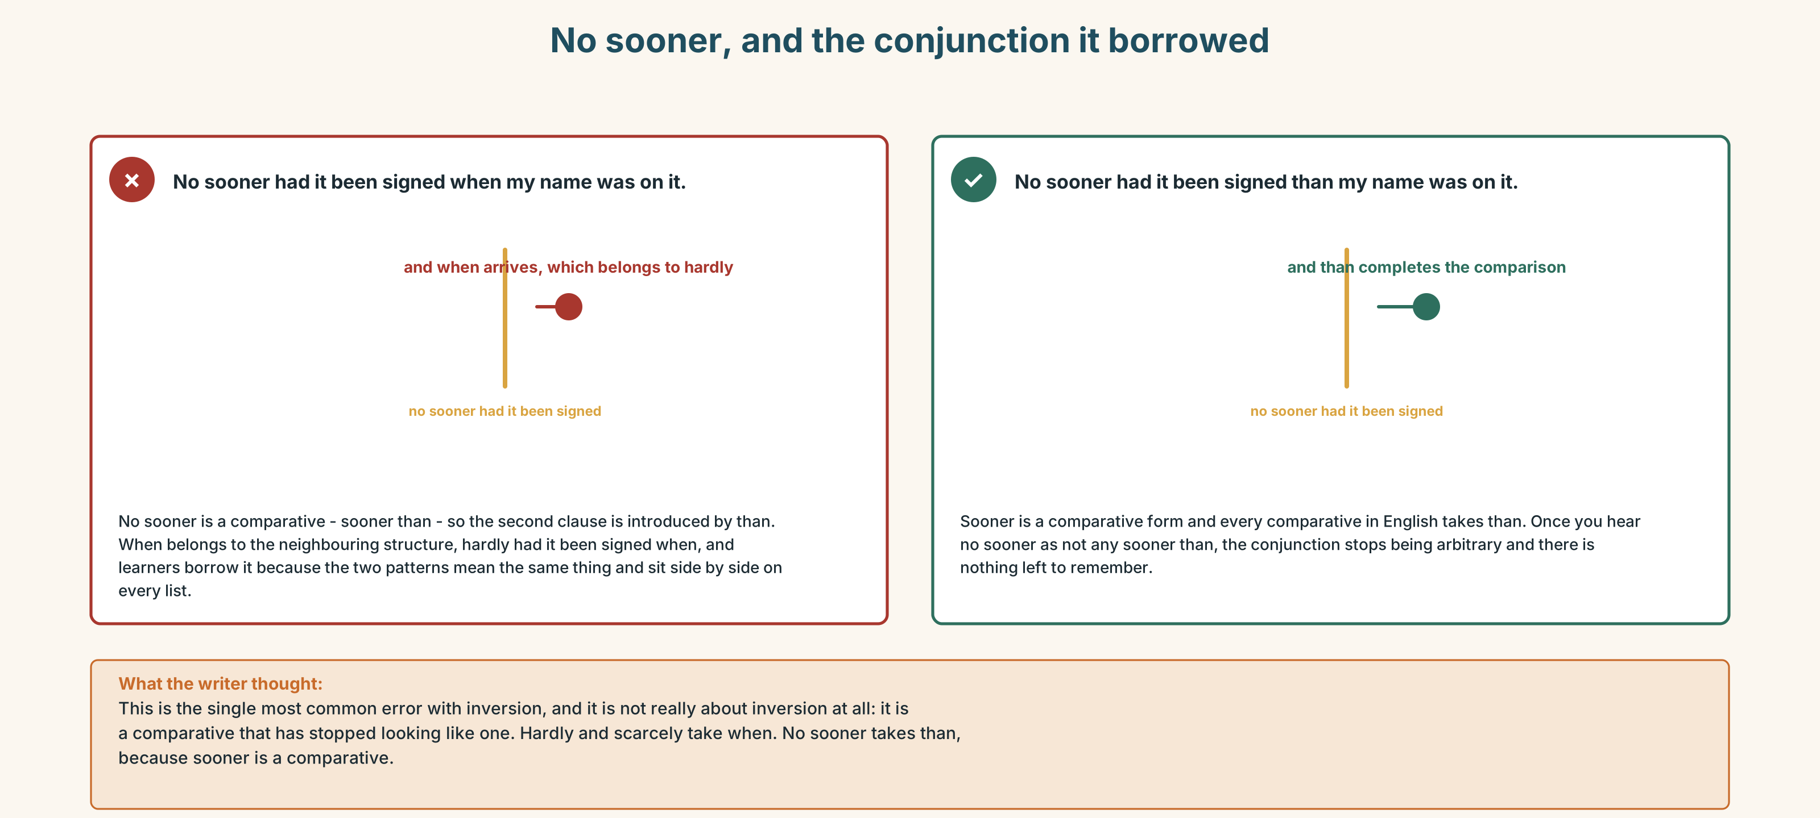{width=6.6in}
No sooner, and the conjunction it borrowed — No sooner, and the conjunction it borrowed
Read both versions. Then say which word the first one borrowed from a different structure.

3H · Check — eight items
- ______ have I been so sure. (negative adverb)
- ______ until Friday ______ anybody ask. (no auxiliary present)
- No sooner had it been signed ______ my name was on it. (correct conjunction)
- ______ then did she answer. (after a clause)
- ______ did we know. (fixed, ironic)
- ✗ Never I have been so clear. → correct it.
- ______ was there any warning. (joining a previous negative)
- ______ no circumstances will I be moved. (prepositional phrase)
0–4 → Workbook pp. 42–45. 5–6 → Part 6. 7–8 → page 217.

Part 4 · Speaking ◆ C · THE PERFORMANCE

4A · Fluency starter — front it
One learner gives an ordinary sentence with a negative in it. The next fronts the negative and inverts. The chain breaks on a missing auxiliary.

4B · The functional core — a formal address
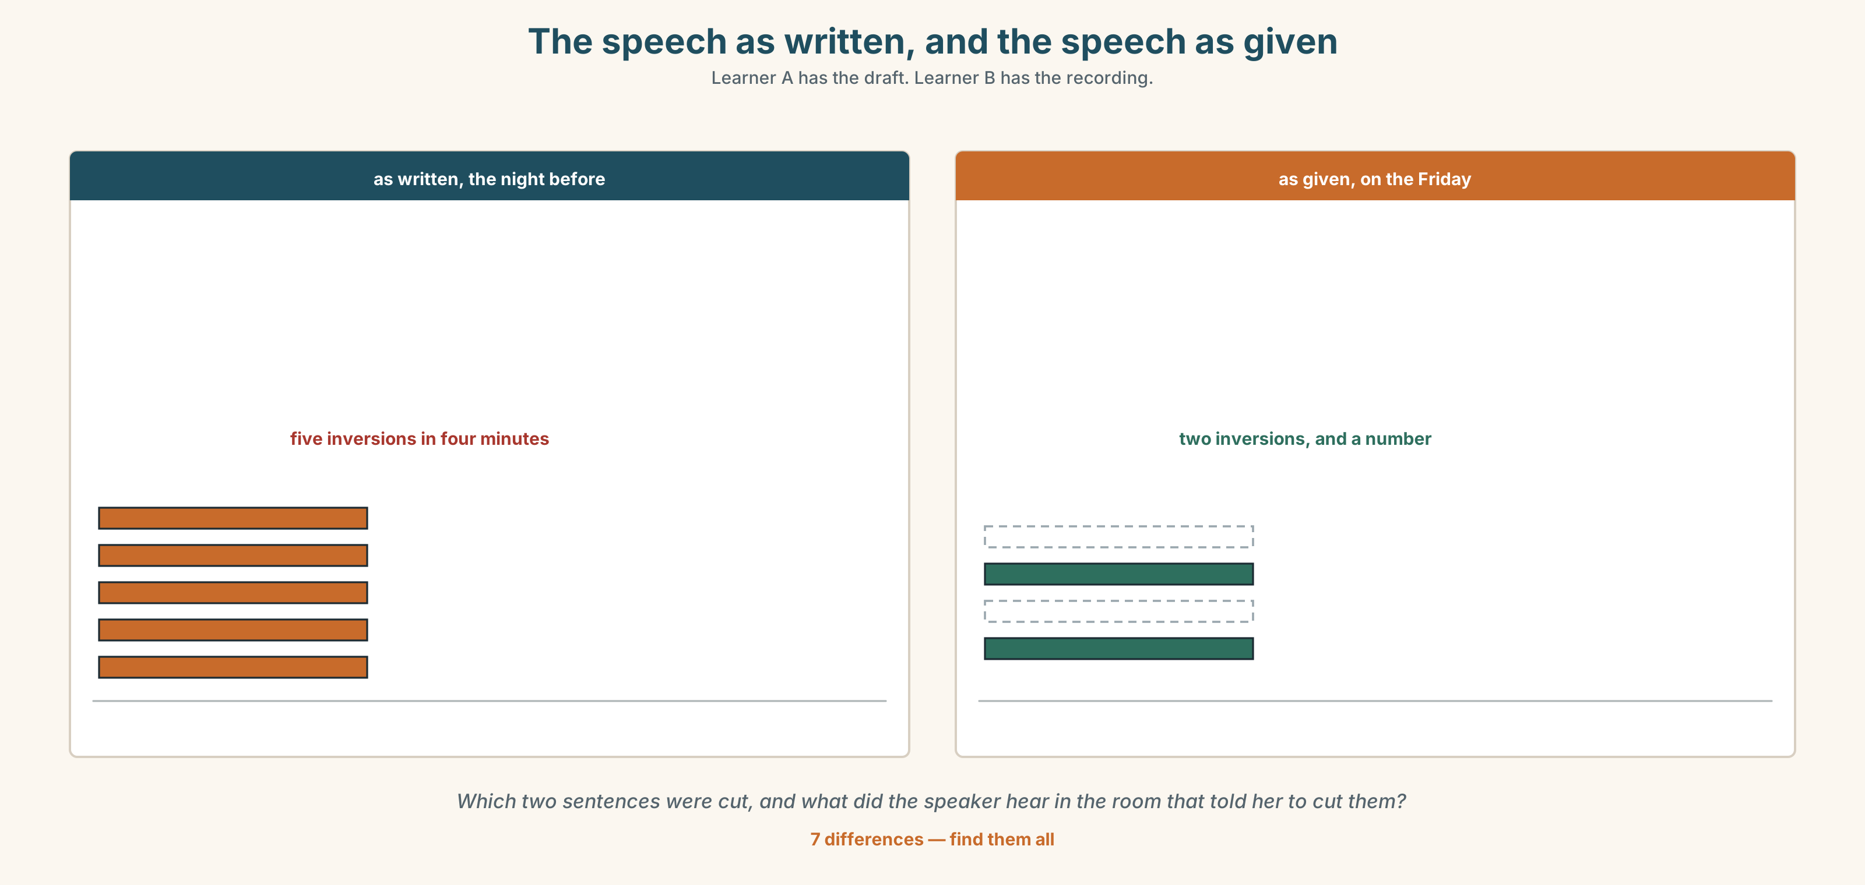{width=6.6in}
The speech as written, and the speech as given — Learner A has the draft. Learner B has the recording.
Language Bank
the opening | On this occasion… · I have been asked to say a few words.
the acknowledgement | In all my years here… · Not once has anybody…
the turn | Never have I… · No sooner had… than… · Only then did I…
the landing | one short sentence, in ordinary word order, and stop
Information gap. Learner A has the speech as written. Learner B has what was actually said. Find the two sentences that were cut in the room, and say why.

4C · The performance — three minutes ⏺
Deliver a formal address. Three minutes, standing. You must include:
an opening that names the occasion · an acknowledgement of somebody specific · exactly two inversions · a landing of one short sentence in ordinary order
Record it.

4D · Observer
One person listens for one thing: did the structure start to be more audible than the content?

4E · Three criteria
☐ Did I use exactly two inversions, and were they in the right places? ☐ Is the acknowledgement about a specific person doing a specific thing? ☐ Is the last sentence short and in ordinary order?

Part 5 · Reading ◆ A · THE WORLD

5A · Predict
An interview transcript, titled "Nine years of nights." What do you expect her to say she will miss? Two sentences.

5B · Read — two minutes and a quarter

NINE YEARS OF NIGHTS interview transcript, lightly edited
Q: You have been offered a day role with a promotion. You have not accepted it.
I have not turned it down either. I want to be careful about that, because the version going round is that I am being difficult, and I am not being difficult. I have asked two questions and neither has been answered.
Q: What are the two questions?
What happens to the building between eleven at night and six in the morning, and who does it. That is one question really. The other is why nobody asked me before my name went on a list.
Q: Tell me about the nights.
There are nine of us across the week and I have done four of them for nine years. In that time I have let three hundred and sixty people into buildings they were locked out of, most of them at a point in the evening where they had decided the whole degree was a mistake. You do not read about that in a restructure document. It is not a duty. It is what happens when the person who has the keys is also the only person awake.
Q: What will the day role involve?
Supervision. A team of four. More money, which I am not going to pretend does not matter, and a title. It is a step up. Everybody has said a step up to me eleven times in a fortnight and nobody has said what is at the top of the step.
Q: Would you have said yes if they had asked first?
Probably. That is the part people find hard to believe. If somebody had come to me in March and said we need you on days, here is why, here is what happens to the nights — I would almost certainly have said yes, and I would have helped them work out the handover.
Not until the email went out did anybody ask me. By then I was in a list, and once you are in a list you are either grateful or you are difficult. There is no third thing you are allowed to be.
Q: Is there anything you want to say to the people organising the event?
Move the chairs. Forty chairs in rows is a thing you do to an audience. We are nine people and a kettle. Nobody who works nights wants to be looked at.

5C · Comprehension — eight questions
- What has she not done, and what is she careful to distinguish it from?
- What are her two questions, and why does she say they are "really one"?
- How many night staff are there, and how many nights does she work?
- What is the three hundred and sixty, and why does she say it is "not a duty"?
- What does the day role involve? Give four things.
- What has been said eleven times in a fortnight, and what has not been said?
- Would she have said yes, and under what condition?
- What does she ask the organisers to do, and what is her reason?

5D · Vocabulary in context
Guess from the text. Then check.
the version going round · a restructure document · at the top of the step · once you are in a list · a thing you do to an audience

5E · The counter-text
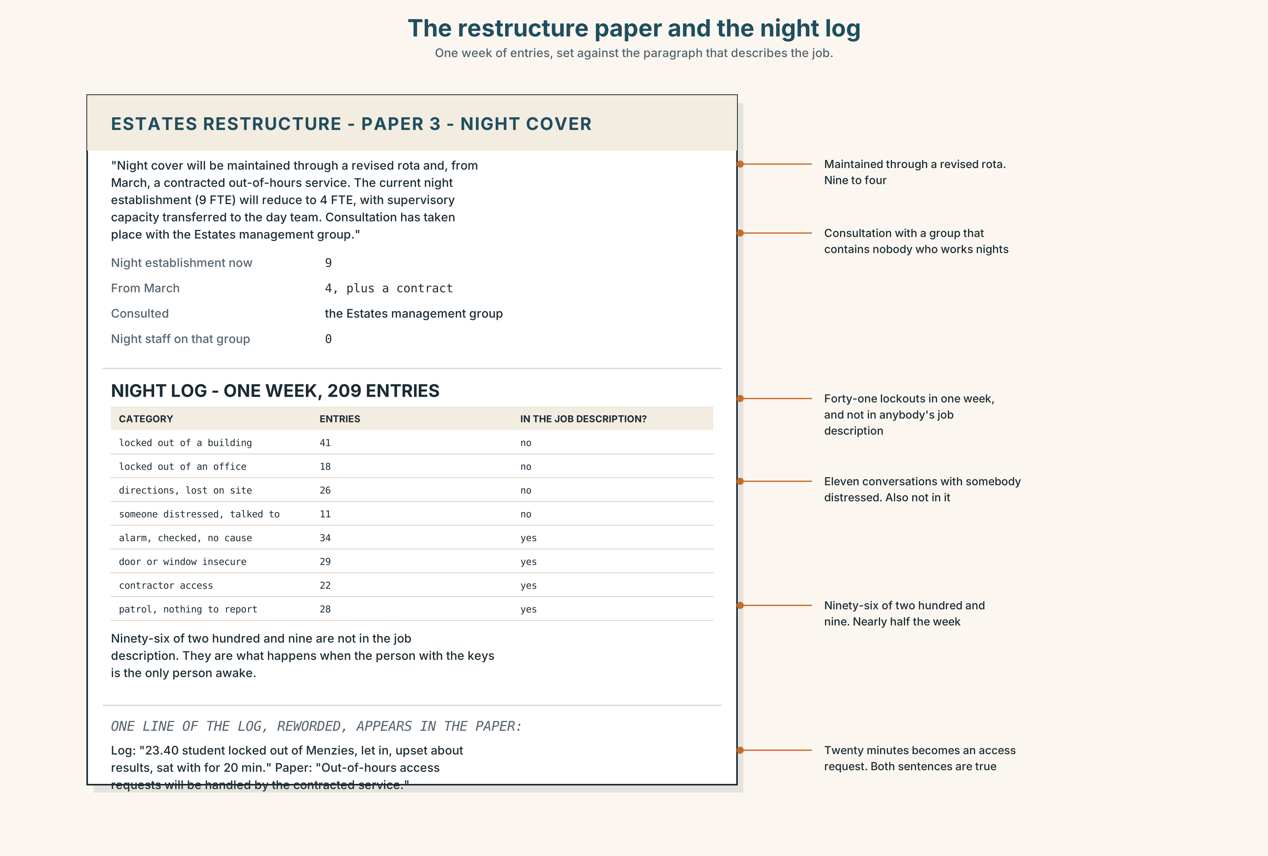{width=6.6in}
The restructure paper and the night log — One week of entries, set against the paragraph that describes the job.
Read the restructure paper and the night log, and answer.
- What does the restructure paper say about night cover?
- How many entries are in the night log for one week, and what are they?
- What is the proposed night establishment after the change?
- What does the paper say about consultation, and with whom?
- One line of the log appears in the restructure paper, reworded. Which?

5F · Two texts
The paper says night cover will be maintained through a revised rota. The log shows two hundred and nine entries in one week, of which most are not security.
Does the paper describe the job? Three sentences.

Part 6 · Vocabulary Lab 2 ◆ B · THE SYSTEM

What can go first, and what has to follow it

6A · Sort — which take do / did?
Three columns: needs do / did · uses an existing auxiliary · uses be.
never · rarely · seldom · little · hardly · scarcely · nowhere · nor · neither · only · no sooner

6B · Chunk completion
- not ______ the email went out
- at ______ point was there a conversation
- under no ______ will I be moved
- only ______ did I understand it
- no sooner ______ it been signed
- little did we ______

6C · Two that are not negative at all
only · not until
Neither contains a negative word, and both invert. Only then did she answer. Not until Friday did anybody ask. What they share is that they restrict, and restriction is what triggers the inversion, not negation.
Write two sentences about the interview in Part 5, one with each.

6D · Three phrasal verbs for a career
p set out · p look back · p rise to
When I set out, nine years ago… · Looking back, the nights were the job. · She rose to it, and nobody noticed that she had.
Write one sentence with each, in a tribute to somebody you know.

6E · The fixed expressions
f Not for one moment. — a whole-sentence denial, and it inverts whatever follows it. c not once — Not once has anybody asked.
Use both in the same short paragraph.

6F · Contrast Clinic
Eight items. Four are wrong. Correct them and say what the rule is.
- Never I have been so sure.
- Never have I been so sure.
- No sooner had it been signed when my name was on it.
- No sooner had it been signed than my name was on it.
- Not until Friday anybody asked.
- Not until Friday did anybody ask.
- Only then she answered.
- Nor was there any warning.

Part 7 · Pronunciation & Fluency Lab ◆ B · THE SYSTEM

Emphatic stress, and the pause before it
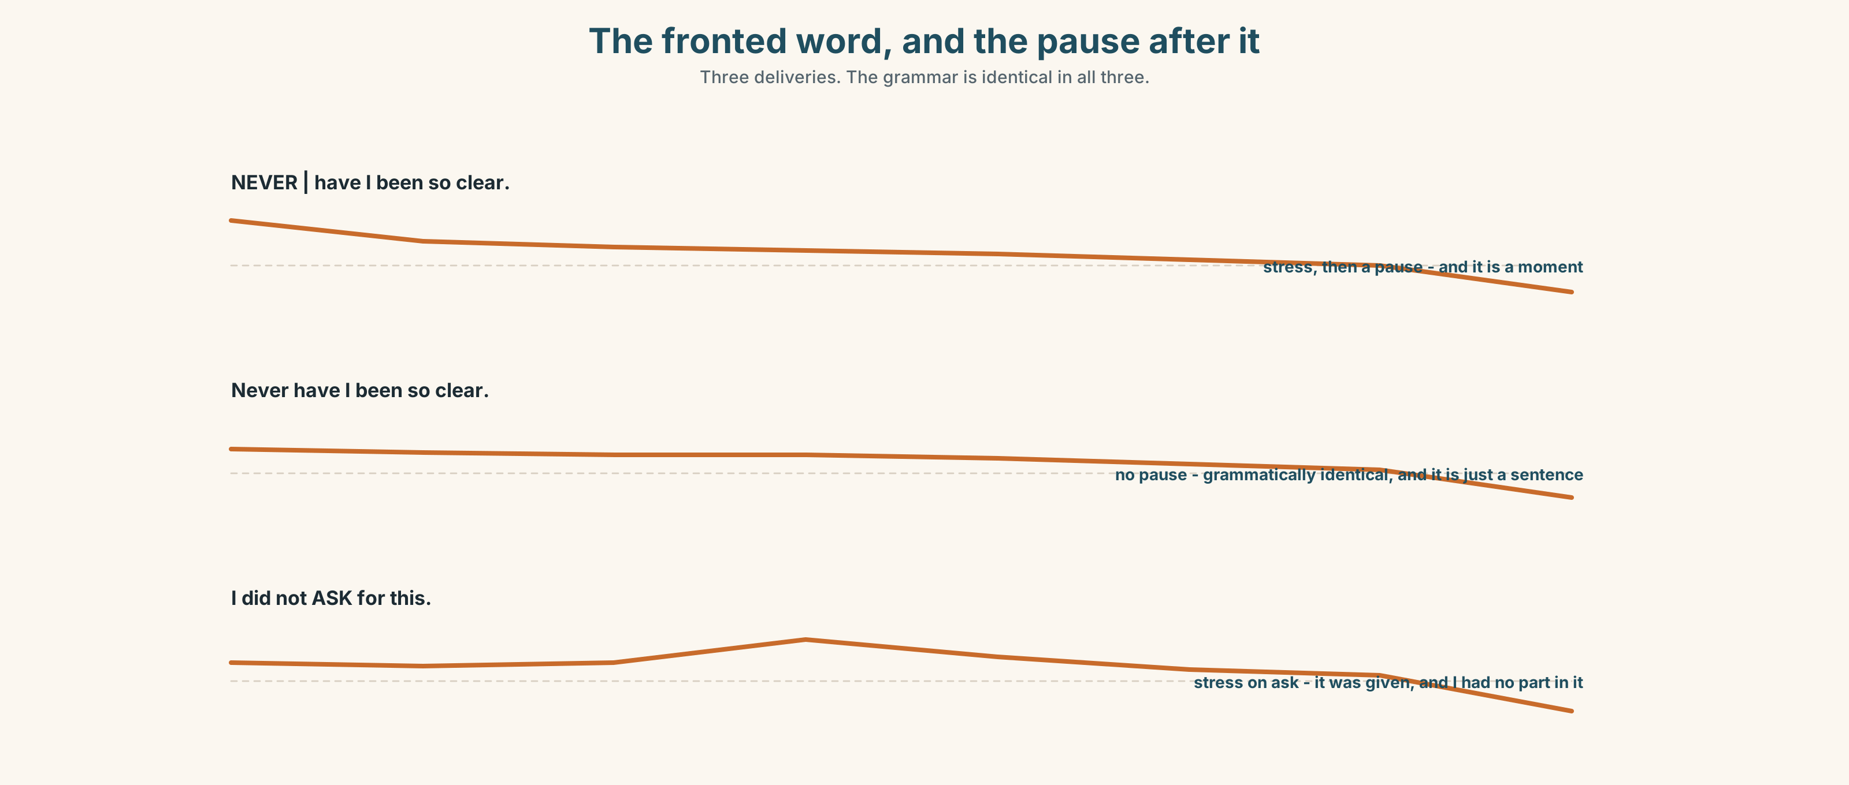{width=6.6in}
The fronted word, and the pause after it — Three deliveries. The grammar is identical in all three.

7A · Hear 🔊 Track 10.3
NEVER | have I been so clear. The fronted word takes the stress, and then there is a pause, and the pause is the whole effect.
Now without the pause:
Never have I been so clear. Grammatically identical. It has become a sentence rather than a moment.

7B · Say
Say both. Then say this one three times, with the pause in a different place each time:
No sooner had the restructure been signed off than my name was on it.

7C · Make it mean something
Say these two:
I did not ask for THIS . (I asked for something else) I did not ASK for this. (it was given to me, and I had no part in it)
One sentence, two complaints. Which is which?

7D · Fluency 30 ⏺
Thirty seconds: two inversions, each with a pause after the fronted element, and nothing else inverted. Three times. Count how many you want to add, and do not.

Part 8 · Writing ◆ C · THE PERFORMANCE

An address · 200 words
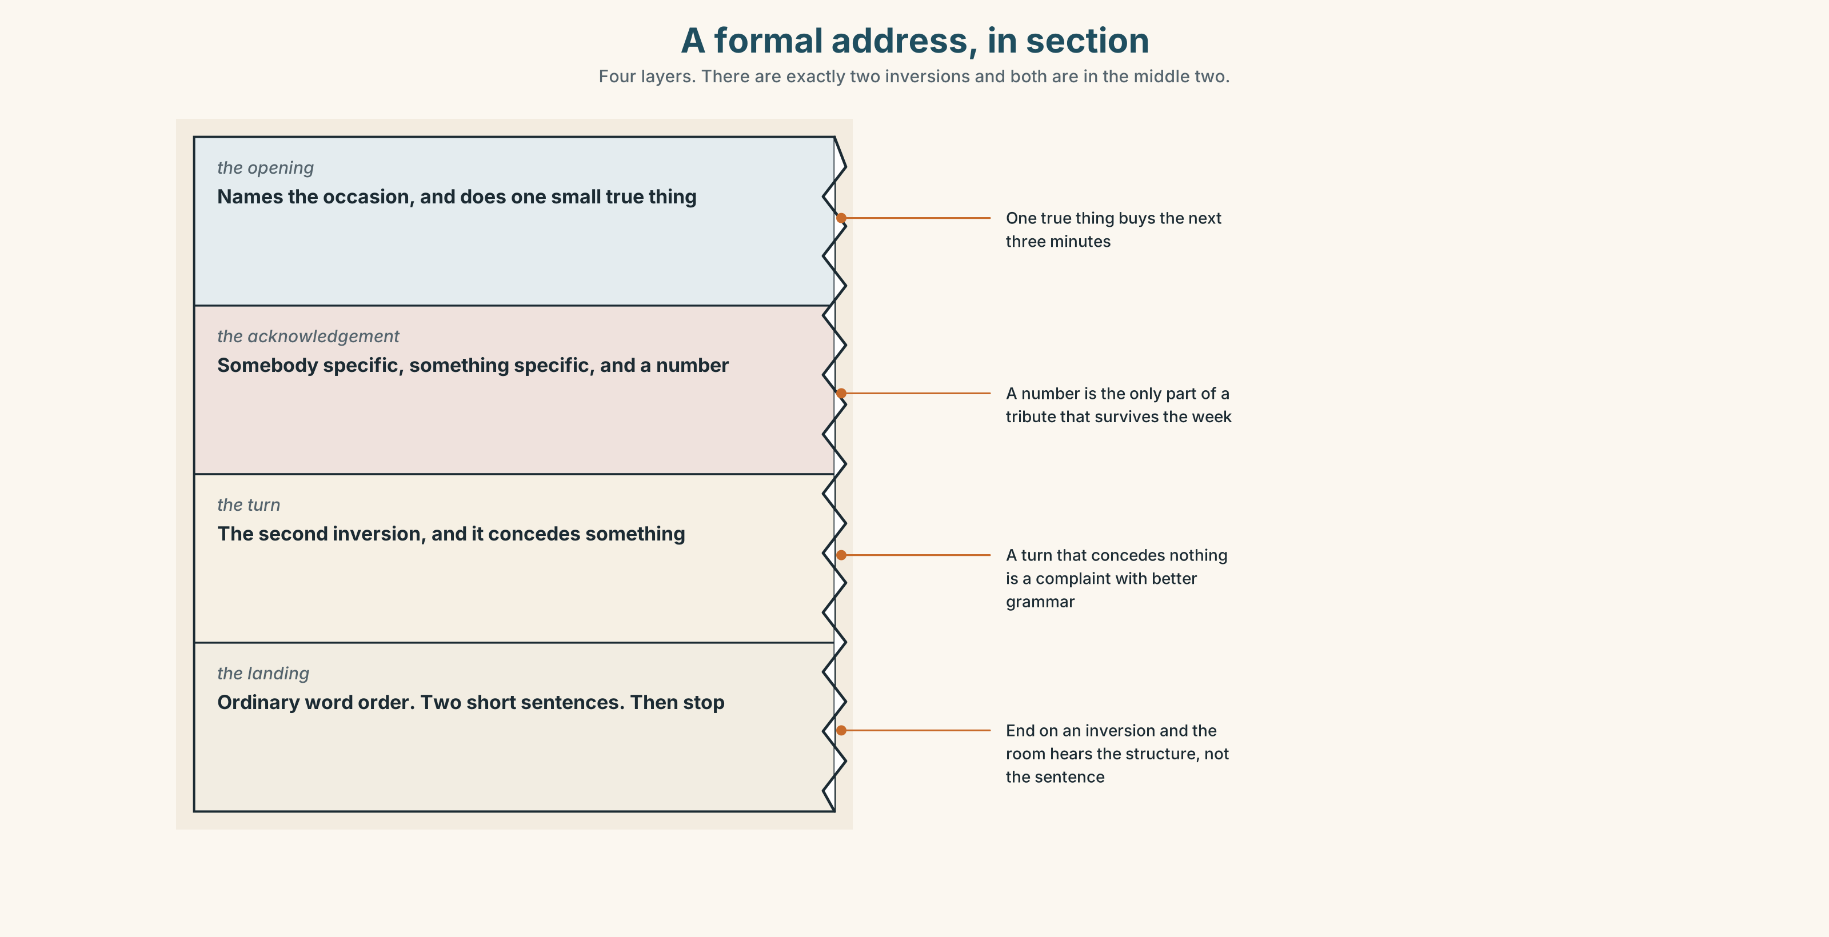{width=6.6in}
A formal address, in section — Four layers. There are exactly two inversions and both are in the middle two.

8A · Read the model
I have been asked to say a few words, and I have been told that a few words means four minutes, which is the first honest thing anybody has said to me about this event. [the opening — it names the occasion and does one small true thing]
In all my years here, the part of this job I would defend is not on any document. Between eleven and six, three hundred and sixty people have been let back into buildings they were locked out of. Not once has that appeared in a restructure paper. [the acknowledgement, with a number — and the first inversion]
No sooner had the paper been signed than my name was on a list, and I want to say clearly that I would probably have said yes. [the turn, the second inversion, and it concedes]
Move the chairs. We are nine people and a kettle. [the landing — ordinary word order, two short sentences, and it is an instruction]
Questions about the writer's choices:
- The opening does "one small true thing". Why does an address need one?
- There are exactly two inversions. Where would a third have gone, and what would it cost?
- The last two sentences are ordinary. Why not end on an inversion?

8B · The anti-model
Never before have I been so honoured, and seldom have I felt such gratitude. Not only has this institution given me a career, but rarely does one find such colleagues. Little did I imagine, when I started, that never would I wish to be anywhere else.
Grammatically perfect. Count the inversions, and say at which one you stopped listening to the content.

8C · Plan
the opening, naming the occasion and doing one true thing → the acknowledgement, with a number → the turn, with the second inversion → the landing, ordinary and short

8D · Write — 200 words

8E · Peer review — three criteria
☐ Exactly two inversions? ☐ Is there a number in the acknowledgement? ☐ Is the last sentence in ordinary word order?

8F · Write it again · 8G · Publish
Stand up and deliver it. That is the only version of this task that counts.

Part 9 · The File ◆ A · THE WORLD + C · THE PERFORMANCE

WORK FILE · The Meeting
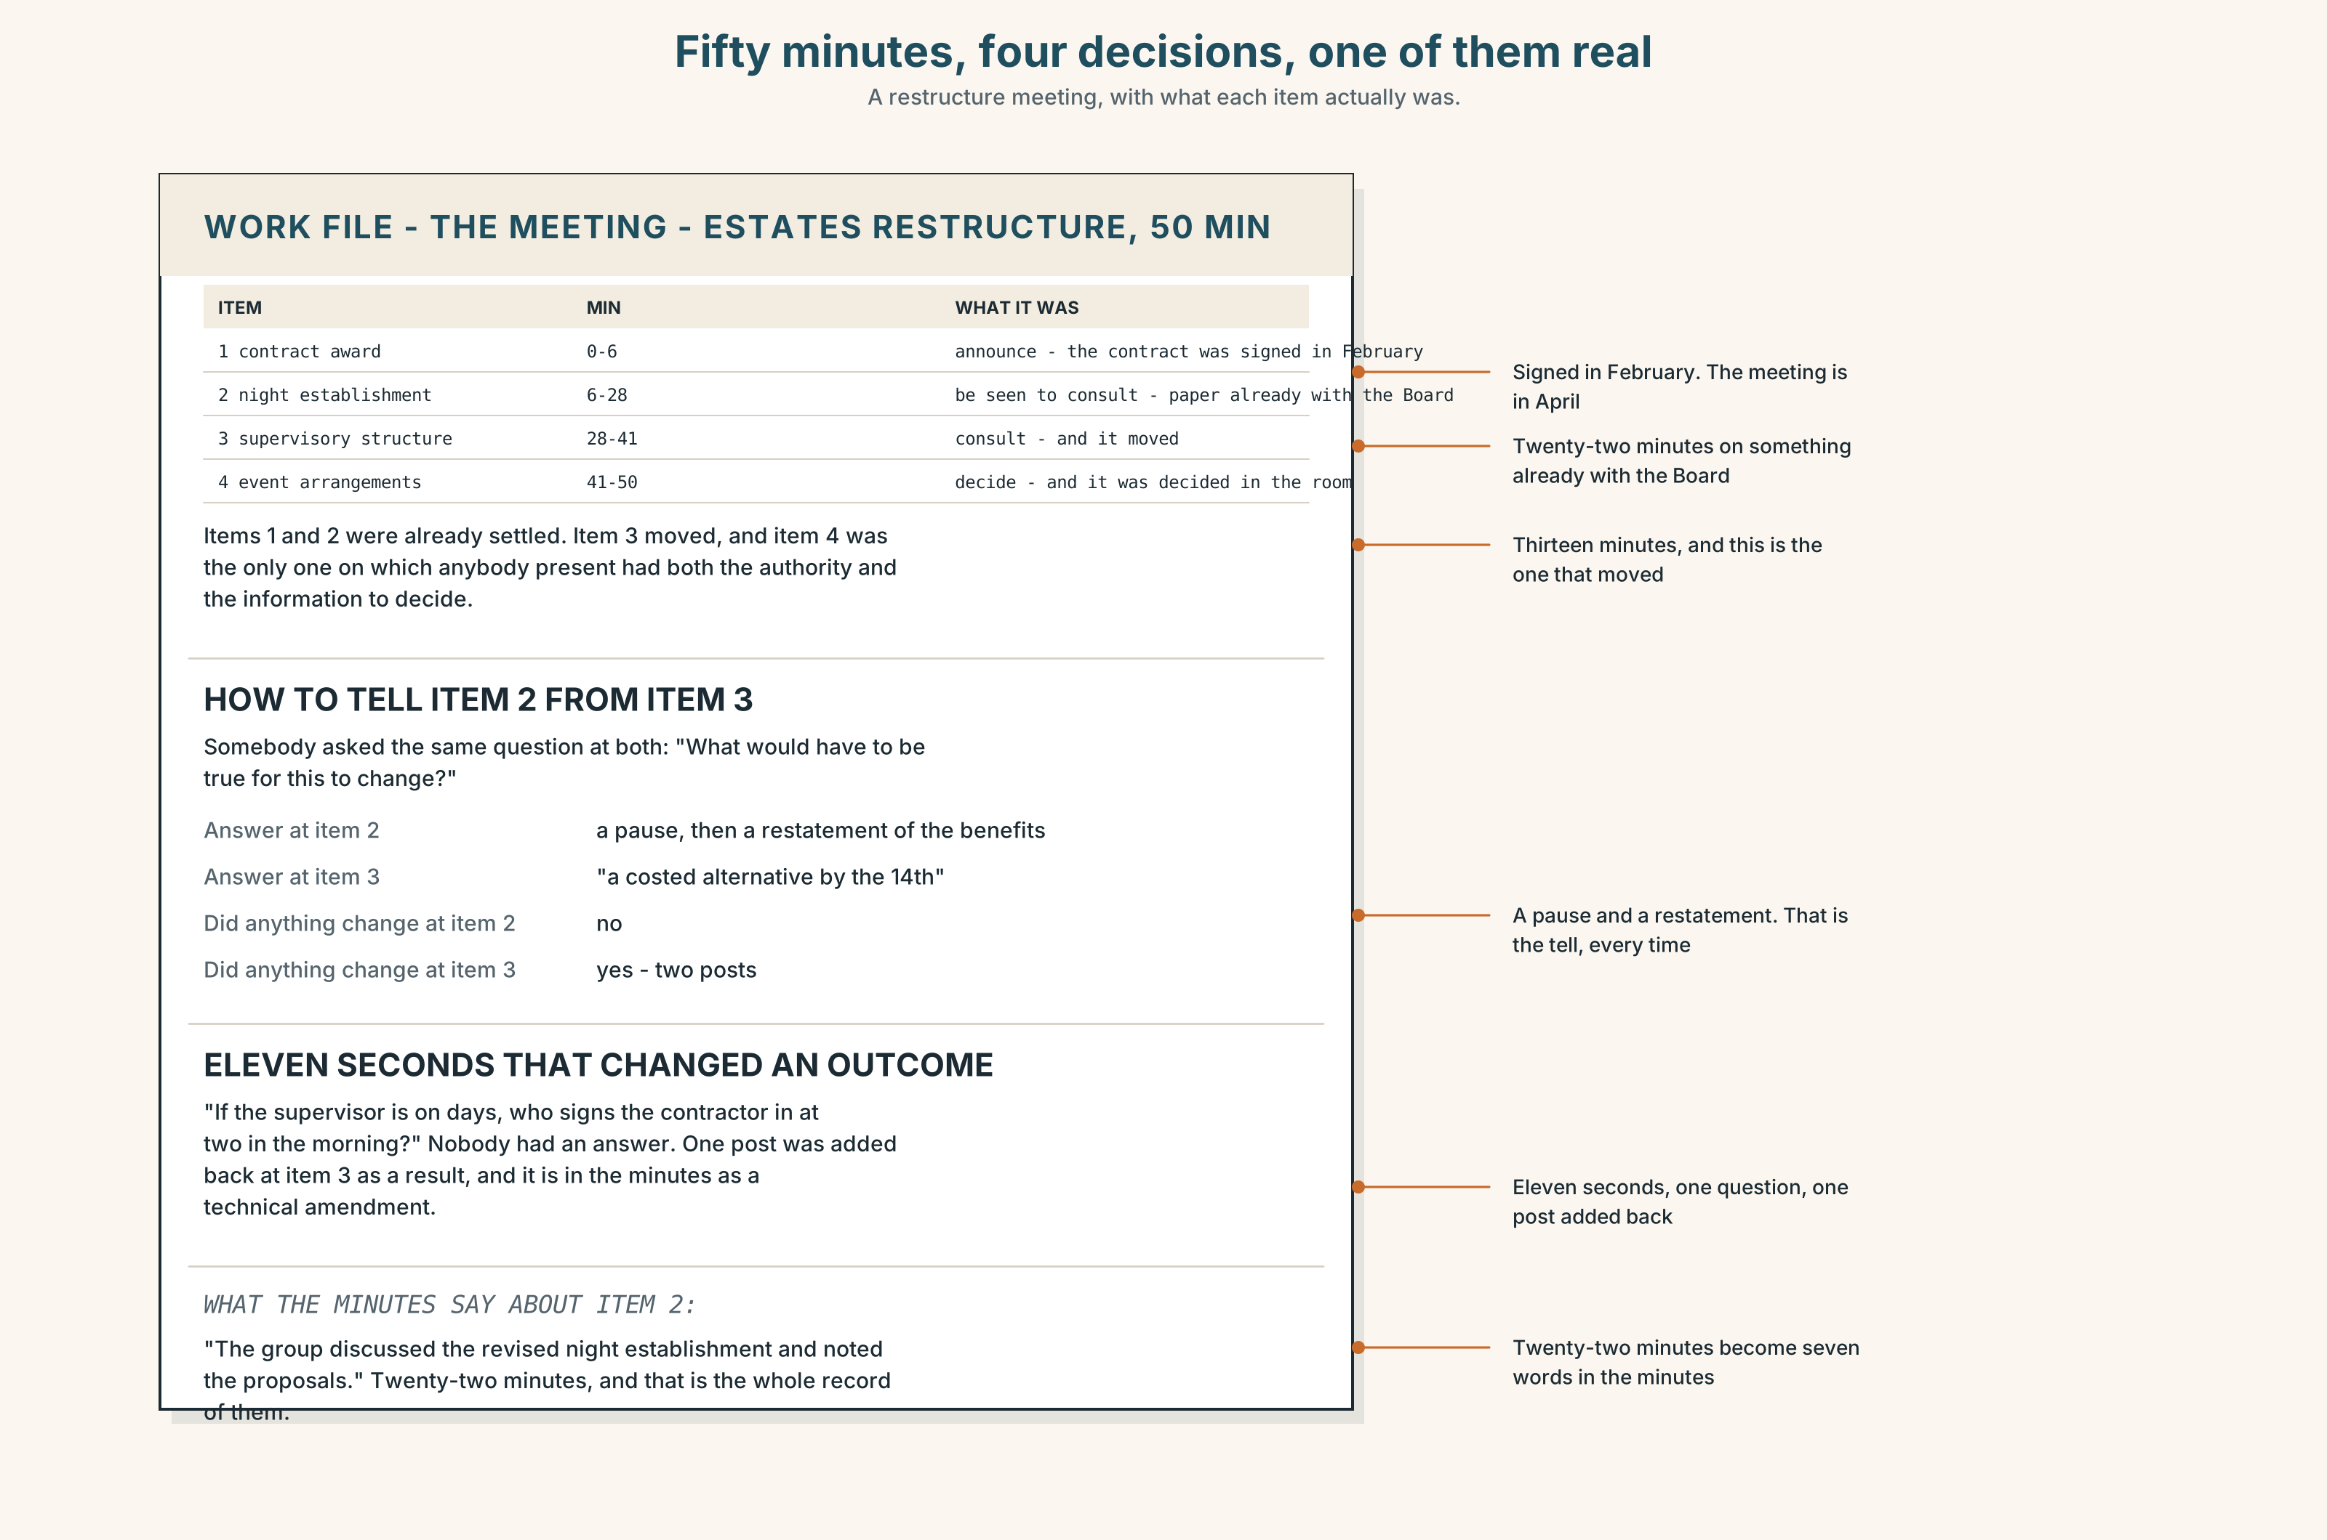{width=6.6in}
Fifty minutes, four decisions, one of them real — A restructure meeting, with what each item actually was.

9A · Fifty minutes, four decisions 🔊 Track 10.4
A restructure meeting. Listen.
- How many of the four decisions were made in the room?
- Which one was already made, and how can you tell?
- One person speaks for eleven seconds and changes an outcome. What do they say?

9B · What a meeting is for
to decide — and the decision is not made before it to announce — and the decision was to consult — and the decision can still move to be seen to consult — and it cannot
Which of the four is hardest to tell apart from which, and who can tell?

9C · The question that reveals it
"What would have to be true for this to change?"
If there is an answer, it is a consultation. If the answer is a pause and then a restatement of the benefits, it is not.
Where would you have asked it in the meeting in 9A?

9D · Your turn
In fours. Twelve minutes. One person chairs a meeting about something real on your campus. Everybody else must work out, without asking directly, which of the four kinds it is.

9E · Transfer
In the next meeting you attend, write down at the start which of the four you think it is. Check at the end. Were you right?

Part 10 · Mediation & Interaction ◆ C · THE PERFORMANCE
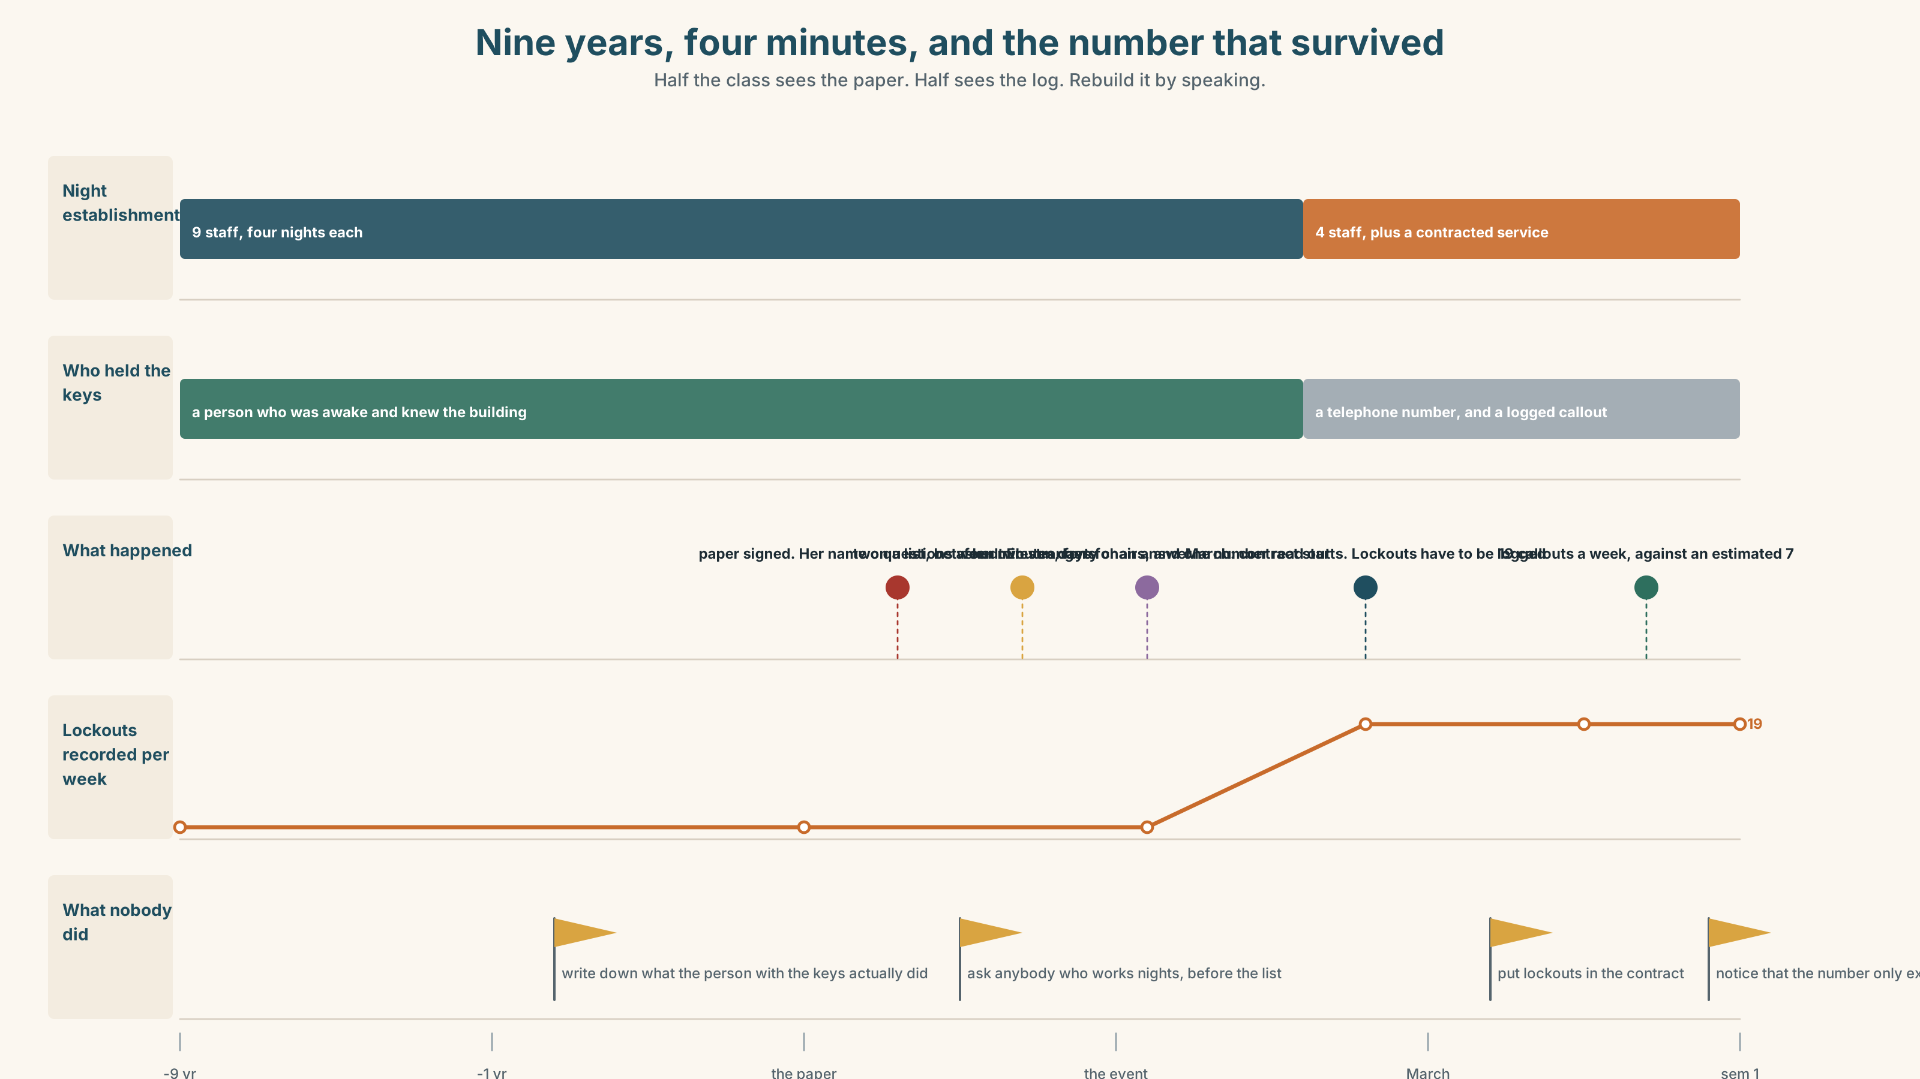{width=6.6in}
Nine years, four minutes, and the number that survived — Half the class sees the paper. Half sees the log. Rebuild it by speaking.

10A · Relay
Half the class sees the restructure paper. Half sees the night log. Rebuild the nine years by speaking. Twelve minutes.

10B · Simplify
Explain the restructure to a first-year who has been locked out of a building at midnight. Five sentences only.
Plan: what the night job is → what the paper says → what changes → what it means at midnight → who to tell

10C · Compress
The interview in Part 5B into forty words, keeping the last answer.

10D · Online
Write one message to the organisers of the event. You are not refusing to attend. You are asking for one specific change to the room, and giving the reason in one sentence.

10E · Your language
Does your language invert for emphasis? Say never have I been so sure in both languages. Which moves the verb, and which uses a particle or a different word order entirely?

Part 11 · The Decision ◆ C · THE PERFORMANCE

A promotion nobody asked about
Josie has worked four nights a week for nine years. She has been named in a restructure paper as moving to a day supervisory role, with more money and a title. The paper is signed. The event is booked for Friday. She has asked two questions and neither has been answered.
- Take it. More money, a team, and the night rota will be covered by somebody. Nine years is a long time on nights and nobody stays for ever.
- Turn it down. Stay on nights, decline the title, and accept that she will be the person who said no to a promotion, which is a sentence that follows people.
- Answer the two questions first. Refuse to decide until somebody puts in writing what happens to the building between eleven and six, and who does it.

11A · The evidence
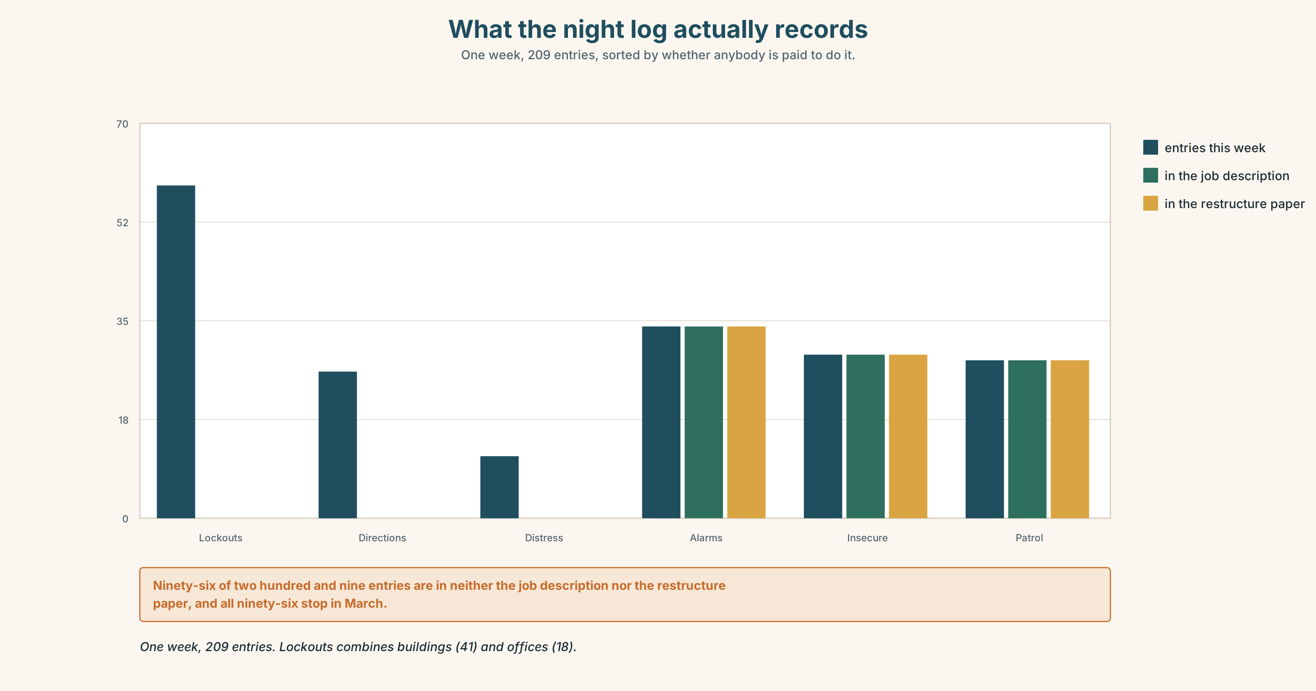{width=6.6in}
What the night log actually records — One week, 209 entries, sorted by whether anybody is paid to do it.
- The restructure paper and the night log from Part 5E — and the line that appears in both.
- The chart — what the night log actually records, by category, across one week.
- The voice. Josie, thirty seconds: "Three hundred and sixty people. I am not saying that to be thanked for it. I am saying it because it is going to stop happening in March and nobody has written it down anywhere, and in two years somebody will ask why the complaints went up and there will be no document to find."

11B · Talk about it
In fours. Everybody speaks twice. Use the frame.
Never ______ . Not until ______ did ______ . Only then ______ .
Words you can use: address · audience · occasion · tribute · acknowledgement · promotion · gravity · a step up · take the floor · in all my years

11C · Decide
Write three sentences. Choose, say why, and name what it costs.
I think Josie should ______________________ , because ______________________ . What this costs is ______________________ .

11D · Model decision
Answer the two questions first, in writing, and then take it. The questions are not a negotiating position and they are not reluctance; they are the only part of nine years that cannot be handed over in a conversation, and once she has moved to days nobody will ever ask them again. The cost is a fortnight of being called difficult by people who have not read the log, and a fortnight is cheap for a document that will still exist in two years.

11E · The Reveal
What happened. She asked for the two answers in writing. It took eleven days. The written answer said night cover would be provided by a contracted service from March, which was true, and did not mention lockouts, because lockouts are not in the contract.
She took the job. In her four minutes on the Friday she read out the number — three hundred and sixty — and said that from March there would be a telephone number instead, and that the telephone number was fine, and that somebody should write down what it did not do. The room was quiet and then clapped for slightly too long.
Lockout callouts went from an average of seven a week to nineteen in the first semester under the contract, because a contracted callout has to be logged and a person with keys does not. The nineteen is the first number anybody has ever had. It is in a report now, and the report exists because of four minutes in a room with forty chairs in it.
She was right that it would stop happening and wrong about why it mattered. The thing that survived was not the service. It was the number.
Was it the right decision? Say why — and say what should be in the contract.

Part 12 · Landing ◆ all three lines

12A · Recycle — twelve items
- ______ have I been so sure.
- ______ until Friday ______ anybody ask.
- No sooner had it been signed ______ my name was on it.
- ______ then did she answer.
- ______ did we know.
- ______ was there any warning.
- Under no ______ will I be moved.
- At no ______ was there a conversation.
- ______ once has anybody asked.
- When I ______ out, nine years ago…
- ______ back, the nights were the job.
- She ______ to it, and nobody noticed.

12B · Consolidate
Three columns, from memory: fronted elements needing do / did · those using an existing auxiliary · those using be.

12C · Can-do, with evidence
☐ I can deliver a three-minute formal address. Evidence: 4C, 8D ☐ I can invert correctly after negative and restrictive adverbials. Evidence: 3H, 6F ☐ I can place emphatic stress and the pause that goes with it. Evidence: 7D ☐ I can stop at two inversions. Evidence: 8D, 4D

12D · Replay ⏺
Record 0C again. Listen to both. What have you got that you did not have in week one? And listen to 0C from Unit 1 of this book. That one is ten units ago.

12E · Glossary — forty-five items, as a map
THE OCCASION · address · audience · occasion · podium · applause · gravity · tribute · acknowledgement THE SPEAKING · rhetoric · cadence · pause · take the floor · a few words · on this occasion · in all my years THE JOB · promotion · a step up · the night shift · stand down · take on · turn down · rise to · set out · look back WHAT PEOPLE SAY · never have I been so · I did not ask for this · not for one moment FRONTING · never · rarely · seldom · little · hardly · scarcely · nowhere · nor · neither · only · no sooner THE PHRASES · not until · at no point · under no circumstances · only then · no sooner had · little did we know · not once

12F · Next
You have finished Making the Case, and with it level B1. Next: B2.1 · The Long Argument.

