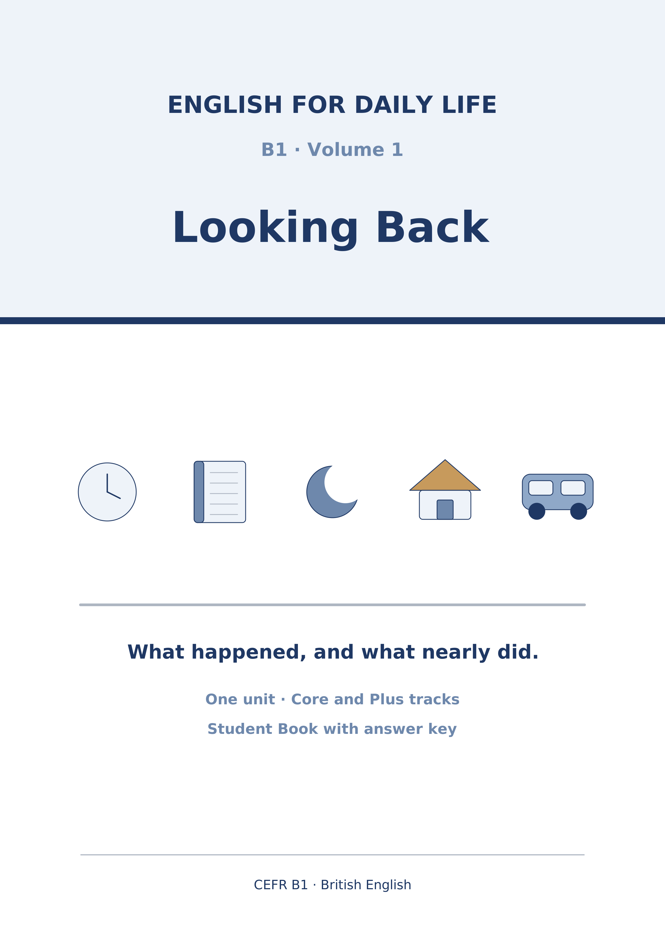
English for Daily Life
A2 · Volume 1 · Looking Back
How to use this book
Every unit has the same ten parts in the same order, so after Unit 1 you always know where you are.
[CORE] is the Warm Up and Parts 1–6. Everybody does these.
[PLUS] is Parts 7–9. They are there when you are ready for them, and optional when you are not. Part 10 is for everybody.
Almost every exercise opens with item 0, already answered. It is the worked example: read it before you start.
Symbols
🔊 | an audio track; the script is printed on the page
☐ | something to tick when you have checked it
✗ → ✓ | a common mistake, then the correction
Stretch | a harder version of the task, for the Plus track
→ Harvest | the grammar you will meet again later in the unit
Map of the Book
Unit | Topic | Grammar | Glossary
1 | The Skip Outside Number 14 | past continuous vs past simple - while/when | skip, delivery, queue, pavement…
Audio tracks
Track | Where | What
Unit 1: The Skip Outside Number 14
In this unit you…
- talk about two past actions: I was working when it happened
- use while and when to join a long action and a short one
- talk about deliveries, queues and things that go wrong
- make a phone call about a problem and agree what happens next
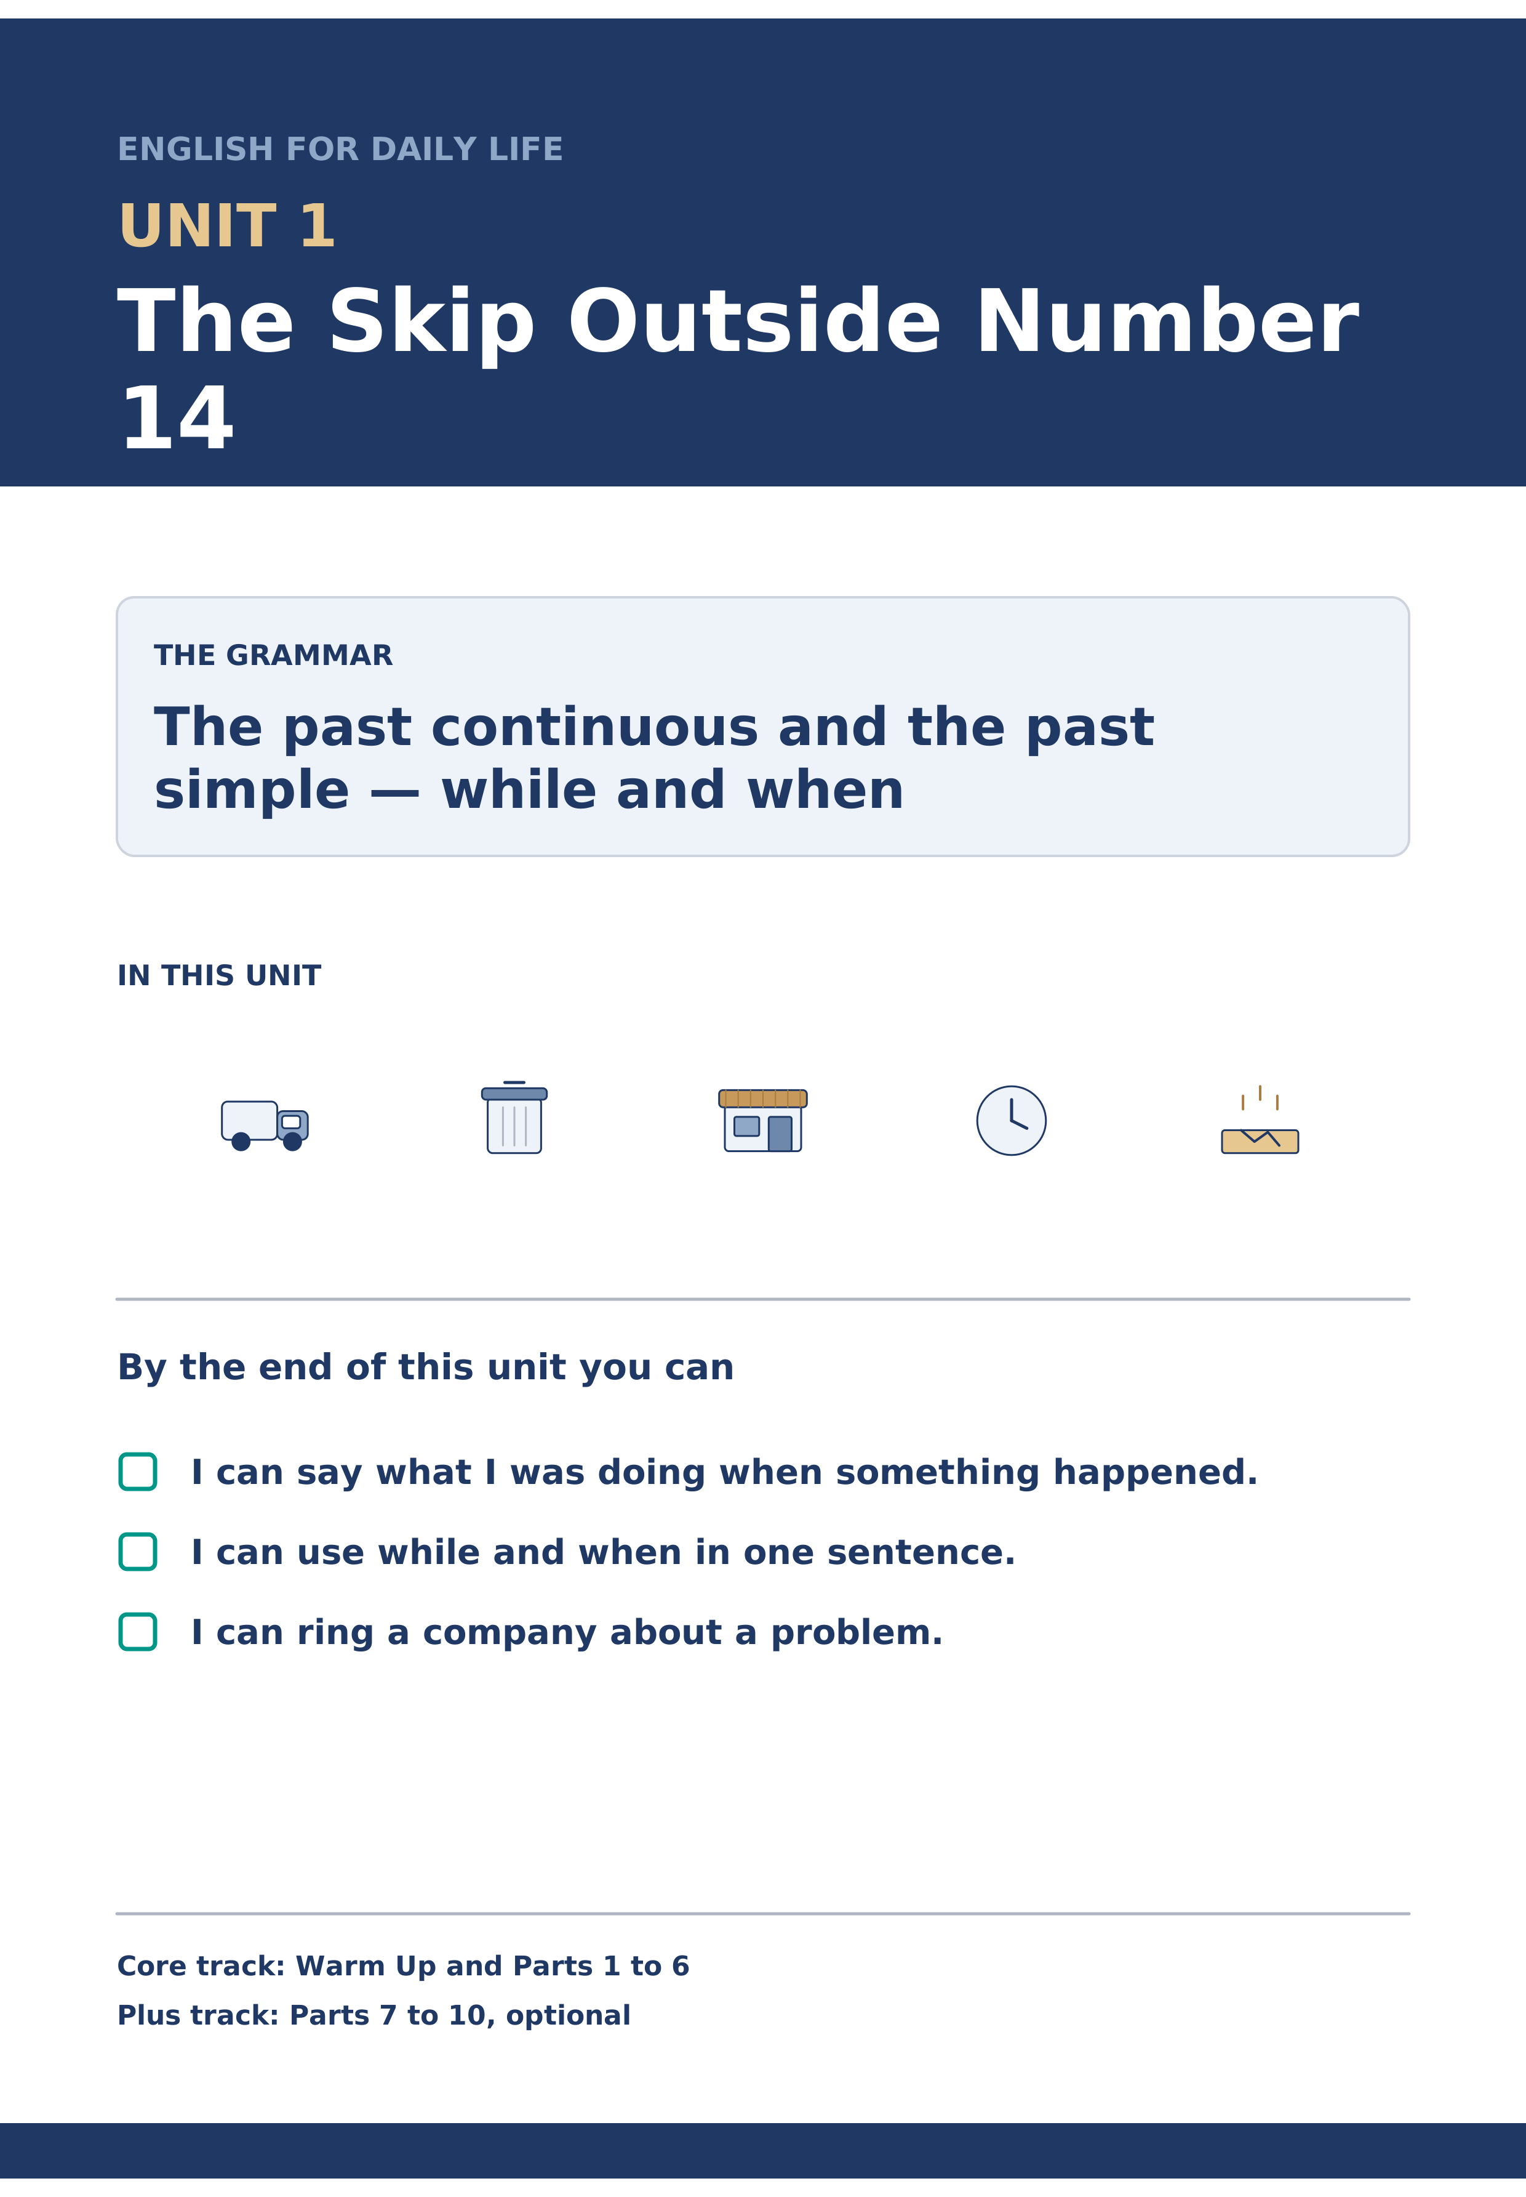
Figure 1.1 · Unit 1 at a glance.
Warm Up
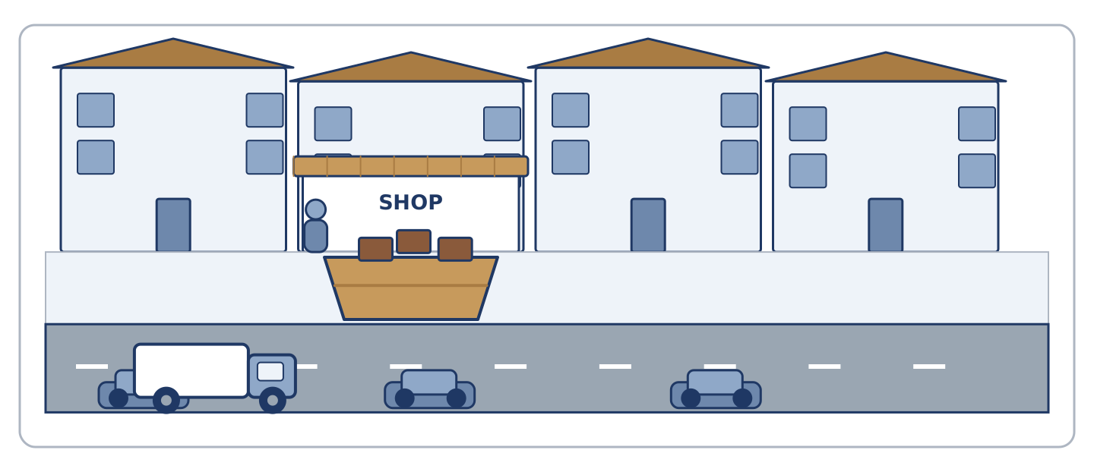
Figure 1.2 · A skip on the pavement.
W1 Match the problem (1–4) to the Plan B (a–e).
- The delivery can't get through. → Send it back to the depot. (example)
Match | to
1. A skip is on the pavement. | a. Use the car park at the back.
2. The card machine stops working. | b. Ring the hire company.
3. Your phone battery dies. | c. Take cash.
4. Nobody can park. | d. Borrow a charger.
 | e. Buy a new phone.
One option is not needed.
W2 Complete about Saturday afternoon.
Words: queue · pavement · skip · delivery
- The shop had a big ___ on Saturday. (delivery) (example)
- A lorry left a ______________ outside number 14.
- It stood on the ______________ , so the van could not pass.
- Eleven people were in the ______________ at the bookshop.
- Amina lost the ______________ she was waiting for.
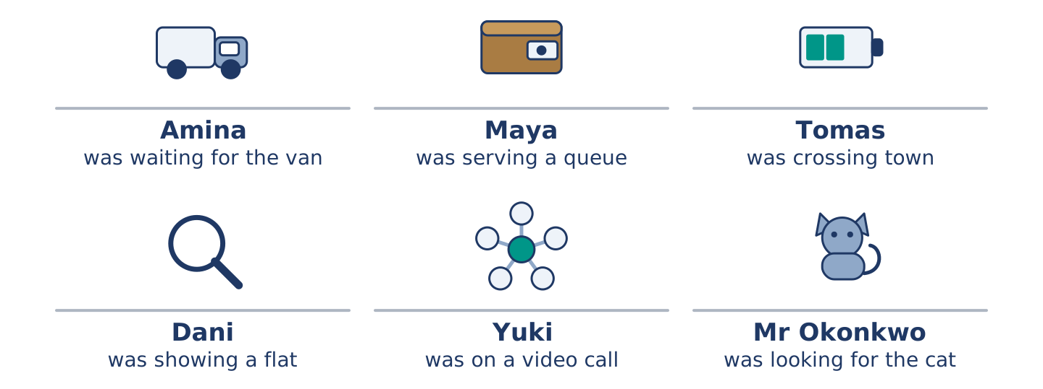
Figure 1.3 · Six people, one Saturday afternoon.
W3 Read. Choose the correct answer.
Before you read: Look at the picture. Why can't the van get past?
Glossary: skip — a large metal container for rubbish, left in the street
On Saturday afternoon a lorry left a skip outside 14 Alder Street. Number 40 ordered it, not number 14. The skip stood on the pavement. Amina's delivery van could not get past it. The driver waited six minutes and took the load back to the depot. Amina lost a day's trade.
- The skip was outside number … (a) 14 (example)
- Who ordered the skip? (a) number 14 (b) number 40 (c) the shop
- What did the driver do? (a) waited an hour (b) took the load back (c) moved the skip Part 1 · Vocabulary & Pronunciation
Deliveries, queues and problems in the street.
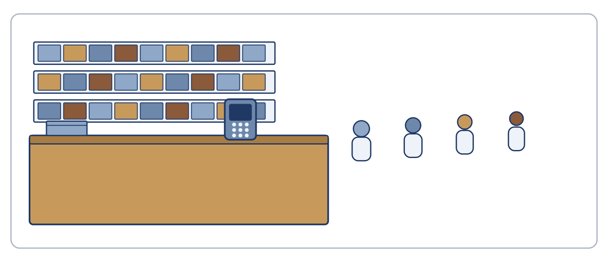
Figure 1.4 · Words for a street that is not working.
Word | Meaning
skip | a large metal container for rubbish
delivery / depot | goods brought to you / the building the vans come from
pavement / kerb | the path at the side of the road / its edge
queue | a line of people waiting
card reader / till | the machine that takes a card / where you pay
landing / stairwell | the flat space at the top of stairs / the space the stairs run up
car park | open ground where cars are left
battery / flat | it holds the power / with no power left
agent | a person who lets a flat for its owner
shift | the hours somebody works
crack | a thin line where something has broken
block / pass | stop the way / go past
1A Look at the pictures. Match the picture (2–7) to the word (a–g).
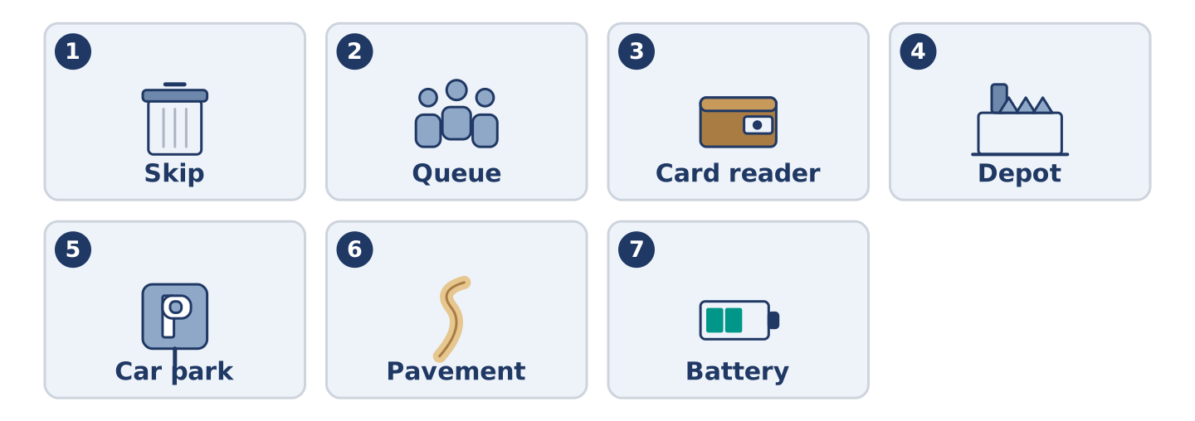
Figure 1.5 · What are they?.
- Picture 1 → skip (example)
Match | to
1. Picture 2 | a. battery
2. Picture 3 | b. queue
3. Picture 4 | c. card reader
4. Picture 5 | d. depot
5. Picture 6 | e. car park
6. Picture 7 | f. pavement
 | g. landing
One option is not needed.
1B Street, shop or journey? Put the words in the table.
Words: kerb · till · platform · queue · pavement · shift
- skip → street (example)
STREET: ______________ SHOP: ______________ JOURNEY: ______________
1C Complete with a word from the box.
Words: depot · pavement · queue · card reader · battery
- A lorry left a ___ outside the shop. (skip) (example)
- The ______________ stood on the ______________ all weekend.
- Eleven people waited in the ______________ .
- The ______________ stopped working at ten past two.
- My phone ______________ was flat by three o'clock.
- The van went back to the ______________ .
1D Pronunciation (Track 1.1). Listen. Do you hear was or were?
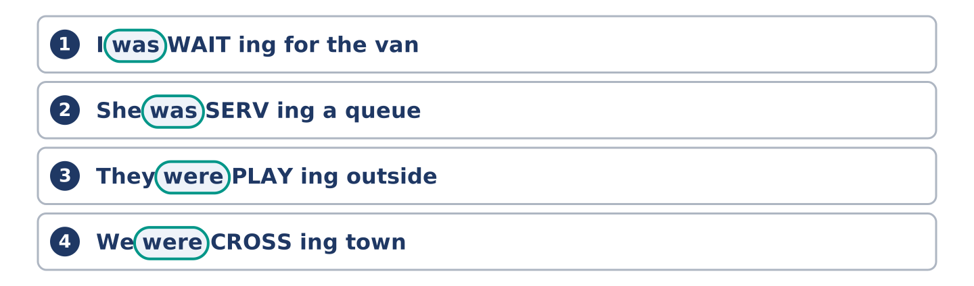
Figure 1.6 · Listen for the -ing, not for was.
- (I was waiting. / I were waiting.) → I was waiting (example)
- (she was serving / she were serving)
- (they was waiting / they were waiting)
- (we was crossing / we were crossing)
- (he was ringing / he were ringing)
- (you was looking / you were looking)
- (I was carrying / I were carrying)
1E Choose the correct word.
- (take / make) a delivery → take (example)
- (miss / lose) a delivery
- (catch / take) a bus
- (do / make) a phone call
- (close / block) the road
- (pay / buy) by card
- (check / look) the time
1F Choose the correct answer.
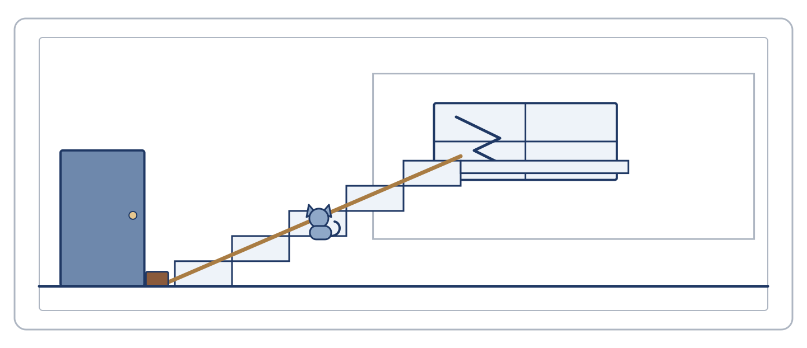
Figure 1.7 · Where does each one happen?.
- A line of people: (a) queue (example)
- Where the vans come from: (a) landing (b) depot (c) kerb
- The machine that takes a card: (a) card reader (b) battery (c) agent
- The hours somebody works: (a) crack (b) queue (c) shift
1G Complete with a word from the box.
Words: agent · crack · shift · stairwell · landing
- There is a ___ in the window. (crack) (example)
- The ______________ let the flat that morning.
- Tomas was crossing town to cover a ______________ .
- The window is on the half ______________ .
- Sound carries in a ______________ .
- Nobody saw the ______________ until the evening.
1H About you. Write about a day when something went wrong. What happened? What did you do?
Model: Last month my bus was cancelled. I was waiting at the stop for twenty minutes. Then I walked to the station and took a train. I was late, but I arrived. Part 2 · Grammar
The past continuous; the past simple; while and when.
Notice Read the Warm-Up again. Find the sentence with could not. What was the van doing?
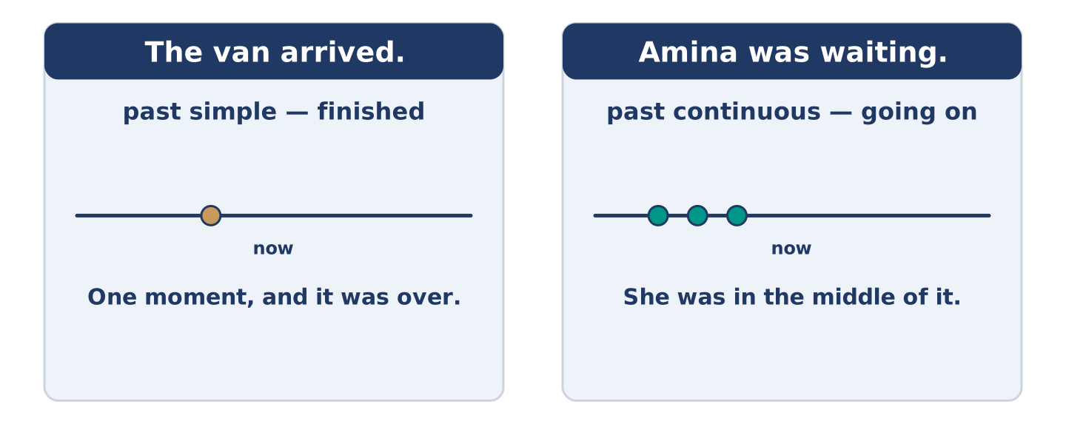
Figure 1.8 · The past continuous.
The past continuous
Form | was / were + verb + -ing
Use | a longer action, in the middle of happening
Example | Amina was waiting for a delivery.
Not | I was knowing the answer. Use I knew.
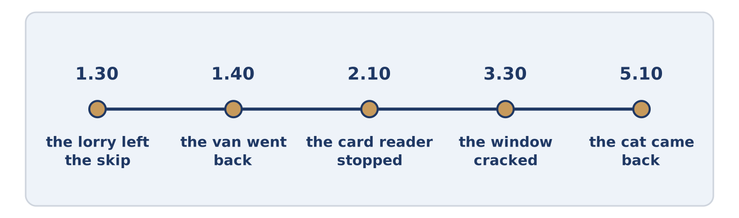
Figure 1.9 · One long action, one short one.
Past continuous + past simple
Form | was / were + -ing … when + past simple
Use | a short action cuts into a longer one
Example | She was serving a queue when the machine stopped.
Also | While she was serving, the machine stopped.
Glossary: past continuous — was / were + -ing, for an action in the middle of happening
2A Choose the correct form.
- I (was walking / walked) home when it started to rain. → was walking (example)
- Amina (was waiting / waited) when the lorry arrived.
- The machine (was stopping / stopped) at ten past two.
- While we (were standing / stood) outside, the van left.
- He (was carrying / carried) the box when he dropped it.
- The cat (was going / went) out at two o'clock.
- They (were playing / played) in the car park all afternoon.
2B Complete with the correct form.
- She ___ (serve) a customer when it happened. (was serving) (example)
- Tomas ______________ (cross) town when his phone died.
- While Dani ______________ (show) the flat, the agent sent an email.
- The window ______________ (crack) at about half past three.
- Yuki ______________ (speak) when the call stopped.
- We ______________ (wait) outside for six minutes.
2C Long action or short action? Put the sentences in the table.
Words: the lorry arrived · she was waiting · the machine stopped · they were playing · he was crossing · the van left
- she was waiting → long action (example)
LONG ACTION: ______________ SHORT ACTION: ______________
2D Choose while or when.
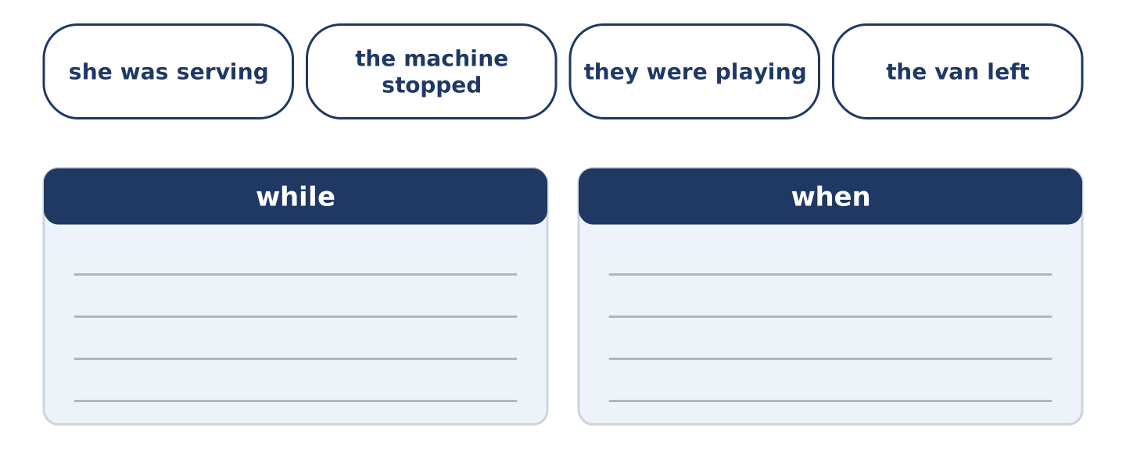
Figure 1.10 · while or when?.
- ___ I was reading, the phone rang. (While) (example)
- ______________ she was serving, the machine stopped.
- He was crossing town ______________ his phone died.
- ______________ we were waiting, the driver rang the depot.
- The cat went out ______________ nobody was looking.
- ______________ Dani was showing the flat, the email arrived.
2E Put the conversation in order.
- Hello, is that Hadwin Hire? — 1 (example)
____ Tuesday morning. It's full, so I need the lorry. ____ Yes. Do you have an order number? ____ No. The skip is outside the wrong house. ____ When can you collect it?
2F Complete the sentences with your own ideas.
- I was reading when ___ . (the lights went out) (example)
- I was walking home when ______________ .
- While I was cooking, ______________ .
- My friend rang while ______________ .
2G Find the mistake. Write the correct sentence.
- I was knowing the answer. → I knew the answer. (example)
- While Yuki was speaking, the call were stopping.
- He was carrying the box when he was dropping it.
- While we waiting outside, nobody said anything.
- The lorry was arriving at half past one and left the skip.
2H Choose the correct answer.
- She ___ a queue when it stopped. (a) was serving (example)
- While I ___ , the phone rang. (a) cooked (b) was cooking (c) cook
- He was crossing town ___ his phone died. (a) while (b) when (c) so
→ Harvest: you will hear these two forms again in Part 3 and read them in Part 5. Part 3 · Listening
A phone call, a queue and a cracked window.
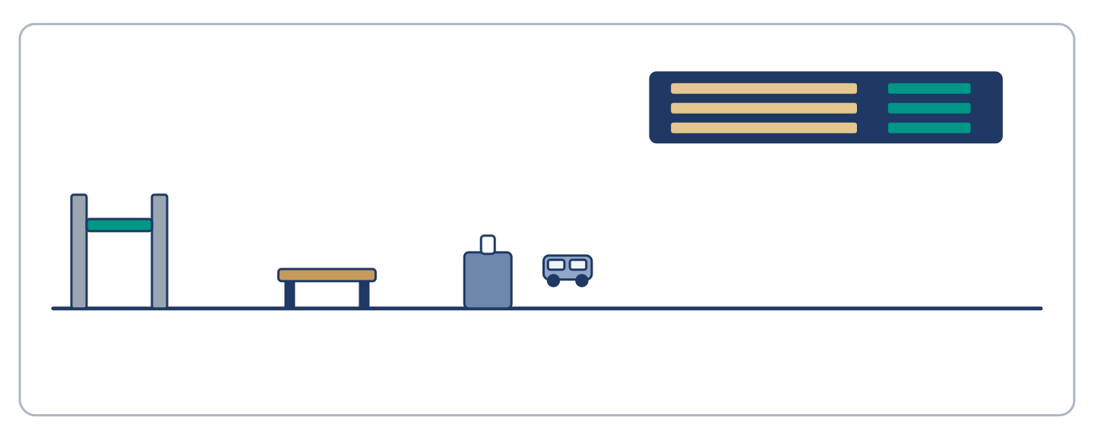
Figure 1.11 · Three people, one afternoon.
3A Listen (Track 1.2). True or false? Write T or F.
Before you listen: Look at the picture. Where is Tomas?
TOMAS: I was on the number 42 bus, about twenty minutes from the hospital. I was reading my notes on my phone when the screen went black. The battery was at nine per cent all morning. I thought it would last. A woman lent me her phone. Then I found the problem: I don't know any numbers. They are all in my phone, and my phone was flat. So I rang my mother in another country. She rang the hospital for me.
- Tomas was on a bus. — T (example)
- Tomas was reading a book.
- His battery was at nine per cent in the morning.
- A woman lent him her phone.
- Tomas knew the hospital number.
3B Listen again (Track 1.2). Put the lines in order.
- I was reading my notes. — 1 (example)
____ A woman lent me her phone. ____ My mother rang the hospital. ____ The screen went black. ____ I don't know any numbers.
3C Listen (Track 1.3). Complete the notes.
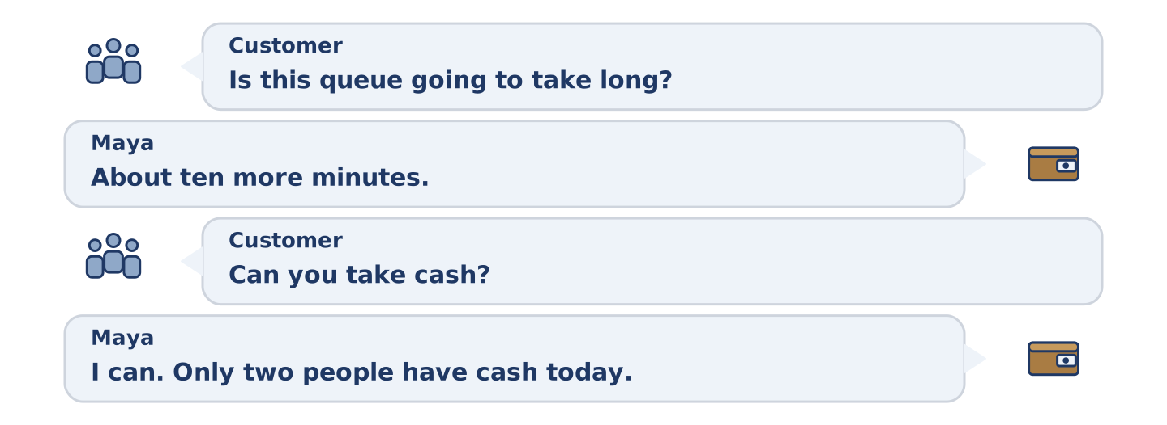
Figure 1.12 · The queue at the bookshop.
CUSTOMER: Is this queue going to take long?
MAYA: About ten more minutes. The card reader stopped at ten past two.
CUSTOMER: Can you take cash?
MAYA: I can. Only two people here have cash today.
CUSTOMER: There's a paper slip, isn't there?
MAYA: There is. It asks for the long number on the card. Look at yours.
CUSTOMER: There's no number on mine.
MAYA: That's the problem. I'm writing down names instead. I'll ring four people tomorrow.
Words: two · ten past two · names · four
- Shop: Hadley Books (example)
- (1) Card reader stopped at: ______________
- (2) People with cash: ______________
- (3) Maya is writing down: ______________
- (4) She will ring: ______________ people
3D Listen (Track 1.4). Who says it? Write D (Dani), O (Mr Okonkwo) or N (a neighbour).
DANI: I walked through the car park twice. I didn't look up at the building.
MR OKONKWO: I was out there for three hours, looking for my cat. I was looking down.
NEIGHBOUR: I was loading my car. The boot was open, so I couldn't see the building.
- I didn't look up at the building. — D (example)
- I was looking for my cat.
- The boot was open.
- I was out there for three hours.
- I walked through twice.
3E Useful phrases. Match the sentence (1–4) to the answer (a–e).
- Is this going to take long? → About ten minutes. (example)
Match | to
1. Can you take cash? | a. No, I didn't see anything.
2. What were you doing at three? | b. Yes, I can.
3. Did you see the window? | c. I was loading my car.
4. When did it stop? | d. At ten past two.
 | e. In the car park.
One option is not needed. Part 4 · Speaking
Saying what you were doing; asking what other people saw.
4A Read the conversation. Then talk about last Saturday: what were you doing at three o'clock?
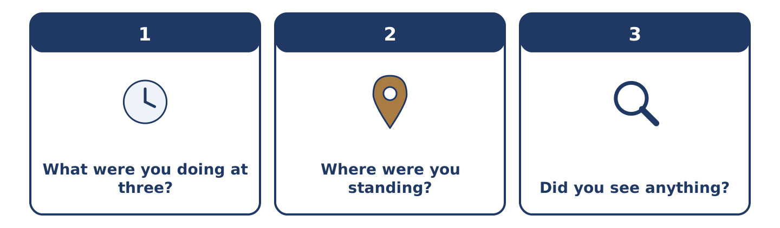
Figure 1.13 · What were you doing?.
Useful language:
- I was … when …
- While I was … , …
- What were you doing at … ?
A | What were you doing at three on Saturday?
B | I was cooking. Why?
A | Somebody cracked a window in the car park.
B | I didn't hear anything. I was cooking with the radio on.
A | Did you see the children out there?
B | I saw two boys at about two. Then I went inside.
A | So you were inside when it happened.
B | Yes. Sorry, I'm no help at all.
4B Look at the picture. Your delivery cannot get through. What will you say to the driver?
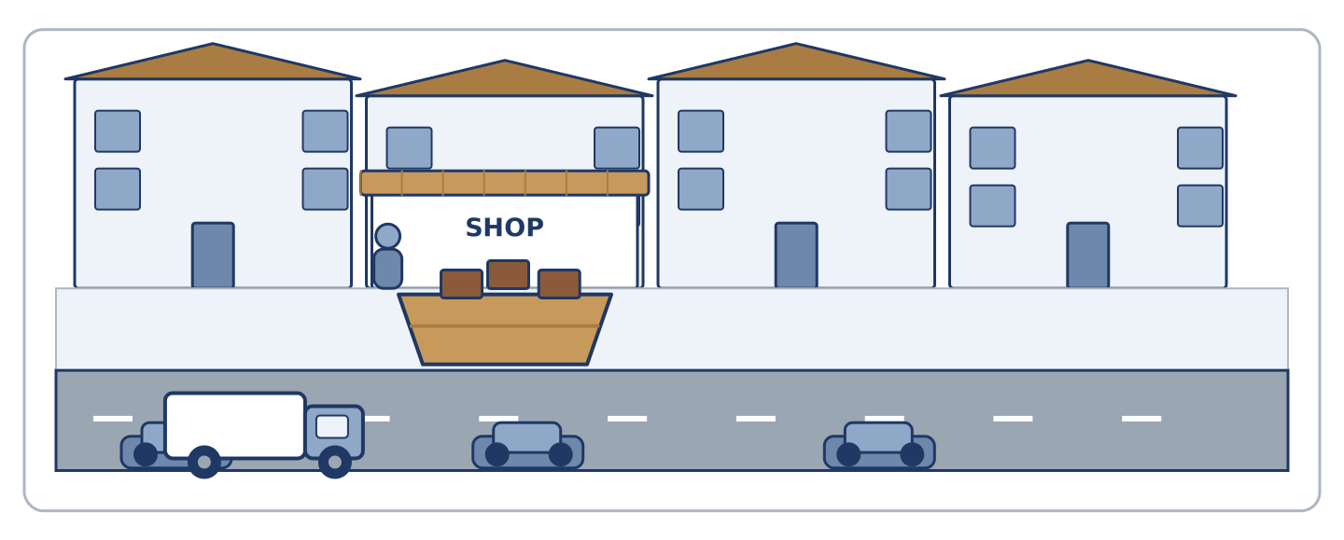
Figure 1.14 · The van and the skip.
Card A You are the driver. Say why you cannot pass. Card B You are the shopkeeper. Ask three questions.
4C In pairs, ask about Saturday afternoon. Use the table.
- Amina → waiting for a delivery (example)
Person | At three o'clock
Maya | serving a queue
Tomas | crossing town
Dani | showing a flat
Yuki | on a video call
Mr Okonkwo | looking for his cat
4D How sure are you? Talk about these: who cracked the window, where the cat went, why the agent emailed.
Useful language: I think … · I'm not sure, but … · Nobody saw it, so …
4E In groups, agree one thing. The window costs £140. The fund has £210. Do you pay, or do you wait? Part 5 · Reading
Why Saturday afternoon is the busy hour.
5A Read the page. Choose the correct answer.
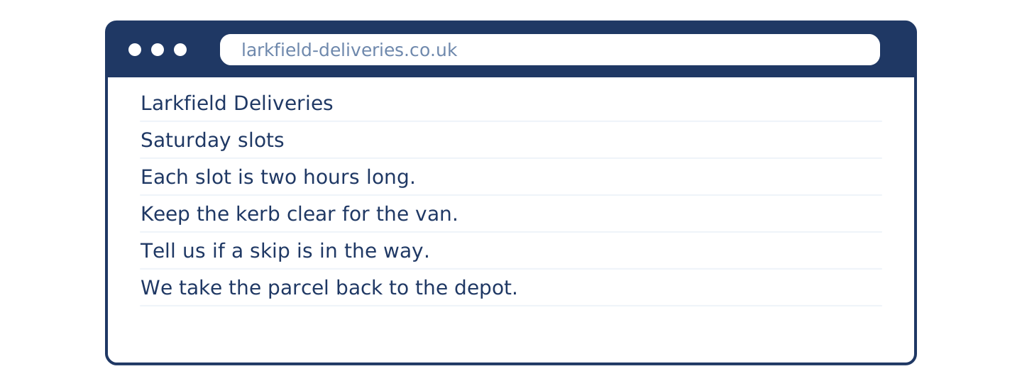
Figure 1.15 · A delivery company's web page.
Before you read: Look at the picture. What time does the van come?
Larkfield Deliveries — Saturday slots. Saturday is our busiest day. Most people are at home on a Saturday, so we sell more slots than on any other day. Each slot is two hours long. One street can take nine deliveries between one and five. Two vans often want the same six metres of kerb. Please keep the kerb clear, and tell us if a skip or a lorry is in the way. If we cannot stop, we take your parcel back to the depot.
- Saturday is their ___ day. (a) busiest (example)
- How long is one slot? (a) one hour (b) two hours (c) four hours
- What should you tell them? (a) your phone number (b) if something blocks the kerb (c) your door colour
- What happens if the van cannot stop? (a) it waits (b) it parks on the pavement (c) it takes the parcel back
5B True or false? Write T or F.
- Most people are at home on a Saturday. — T (example)
- Each slot is one hour long.
- One street can take nine deliveries.
- The van waits until the kerb is clear.
5C Read the notice. Choose the correct answer.
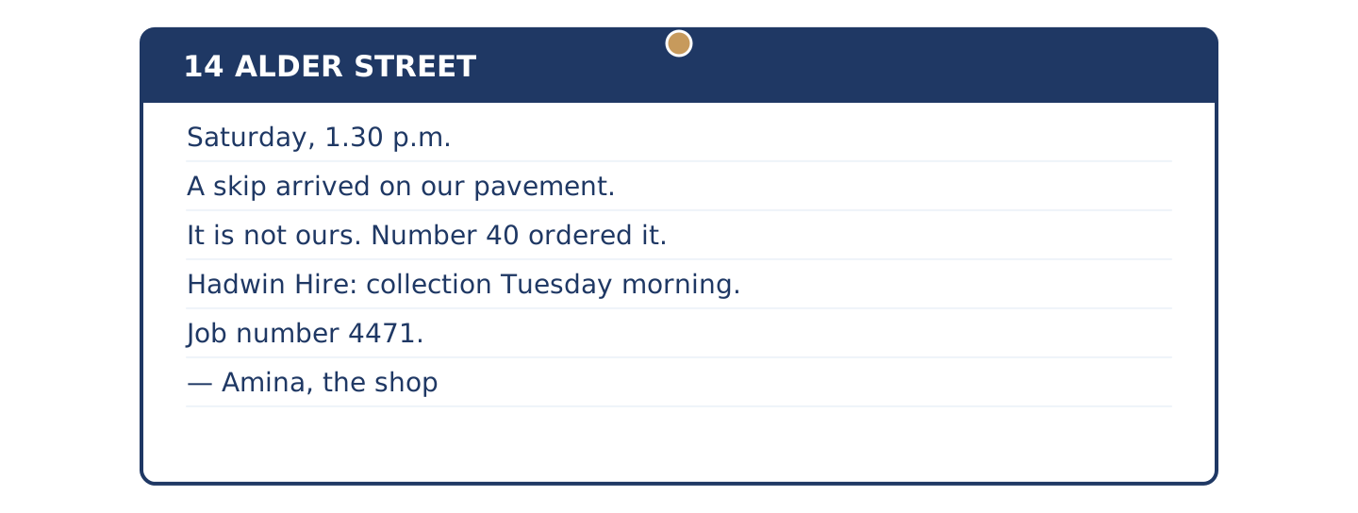
Figure 1.16 · A notice on the stair door.
Notice — 14 Alder Street. Saturday, 1.30 p.m. A skip arrived on our pavement. It is not ours. Number 40 ordered it. The driver had our number on his sheet. I rang Hadwin Hire at four. They cannot collect it before Tuesday morning, because it is full. A full skip needs the lorry. I do not know who filled it. My job number is 4471. If it is still here on Tuesday afternoon, I will ring again. — Amina, the shop
- The skip arrived at ___ . (a) 1.30 p.m. (example)
- Who ordered the skip? (a) Amina (b) number 40 (c) Hadwin Hire
- Why can't they collect it before Tuesday? (a) it is full (b) it is too small (c) nobody paid
5D Remove the wrong options first. Which two are wrong?
- 5C question 1: (a) Amina → wrong, the notice says number 40 (example)
- 5C question 2, option (b)
- 5C question 2, option (c)
5E Complete the sentences about the web page and the notice.
Words: Tuesday · kerb · depot · 4471 · two hours
- One slot is ___ long. (two hours) (example)
- Keep the ______________ clear for the van.
- The parcel goes back to the ______________ .
- The skip goes on ______________ morning.
- Amina's job number is ______________ .
5F Match the problem (1–4) to the advice (a–e).
- A skip is in the way. → Ring the hire company. (example)
Match | to
1. The card reader stops. | a. Charge it before you go out.
2. Your battery is low. | b. Take cash, or take names.
3. The van cannot stop. | c. Ask the neighbours first.
4. A window is cracked. | d. Tell the depot the street is blocked.
 | e. Buy a new window.
One option is not needed.
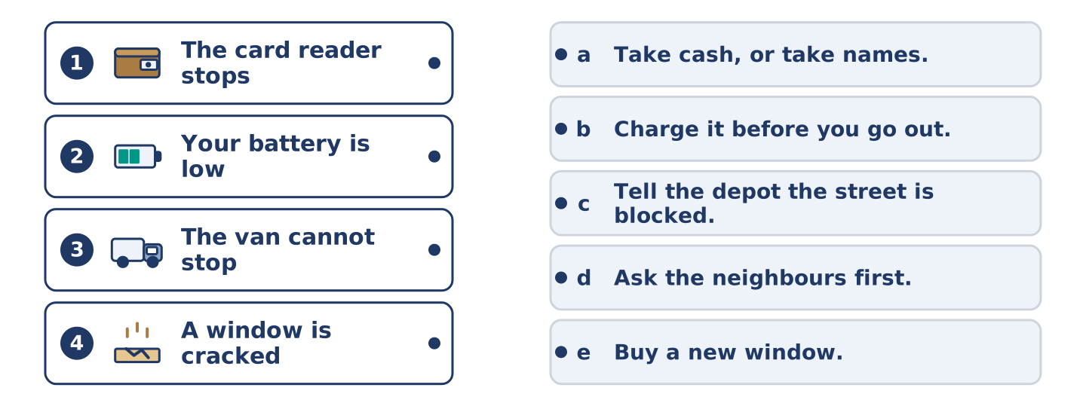
Figure 1.17 · Four problems, four answers.
5G Write two pieces of advice for your street, with when or while. Part 6 · Writing
A message to your neighbours, and a note for a noticeboard.
6A Write a message to your neighbours about something that went wrong (40–50 words).
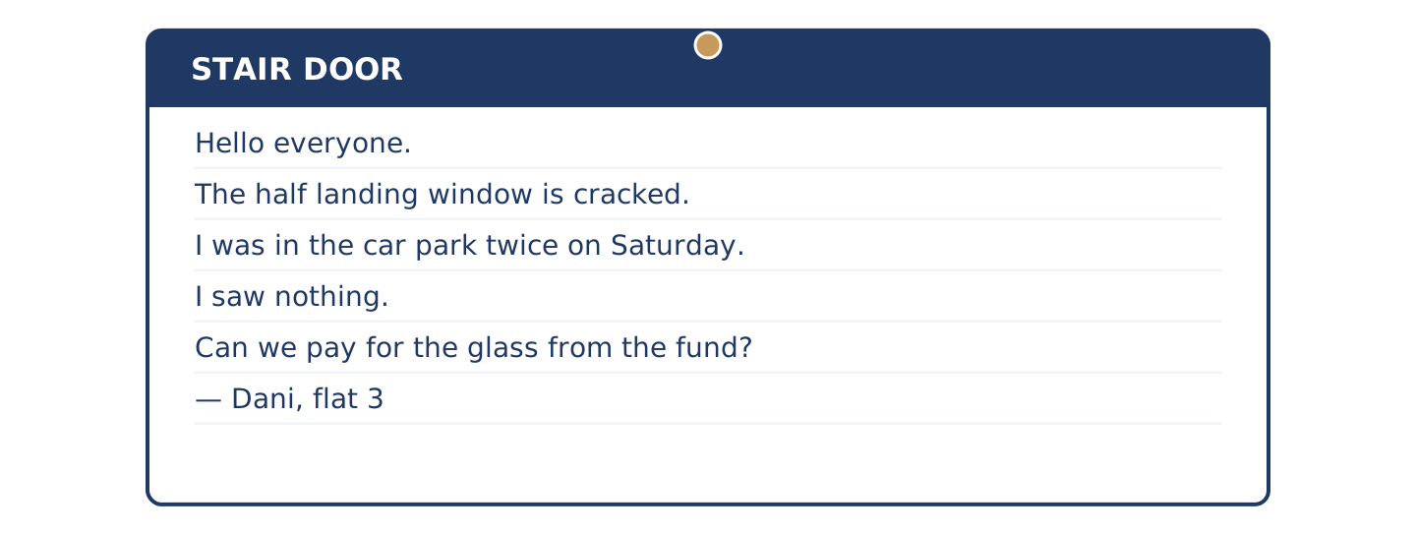
Figure 1.18 · A message on the stair door.
Model: Hello everyone. The window on the half landing is cracked. I was in the car park twice on Saturday and I saw nothing. I am not asking who did it. Can we pay for the glass from the fund? Dani, flat 3.
Sentence starters:
- Hello everyone. …
- I was … on Saturday …
- I am not asking …
- Can we … ?
6B Read the prices. Write three sentences about the conditions.
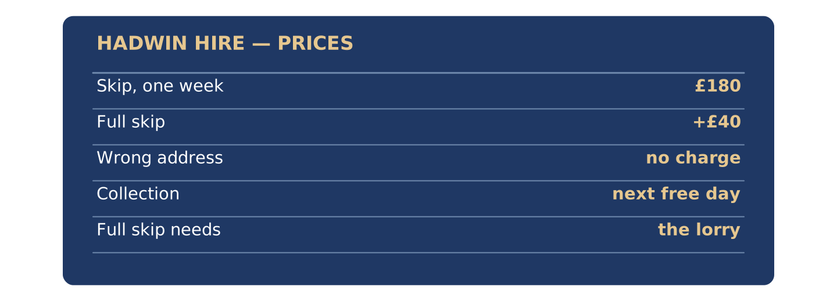
Figure 1.19 · Hadwin Hire: prices and conditions.
Item | Price | Condition
Skip, one week | £180 | collection on the next free day
Full skip | +£40 | needs the lorry, not the small truck
Wrong address | no charge | if you ring the same day
- If you ring the same day, ___ . (there is no charge) (example)
6C Choose the correct sentence.
- (I was waiting when it came. / I waited when it was coming.) → I was waiting when it came. (example)
- (While I cooked, the phone rang. / While I was cooking, the phone rang.)
- (She was serving when it stopped. / She served when it was stopping.)
- (They were playing all afternoon. / They played all afternoon when.)
6D Write a short note for your noticeboard about a problem (35–45 words).
Check before you finish ☐ What happened, and when ☐ One past continuous ☐ What you will do next ☐ 35–45 words Part 7 · Exam Skills
Reading: choose from three options. Listening: complete the notes.
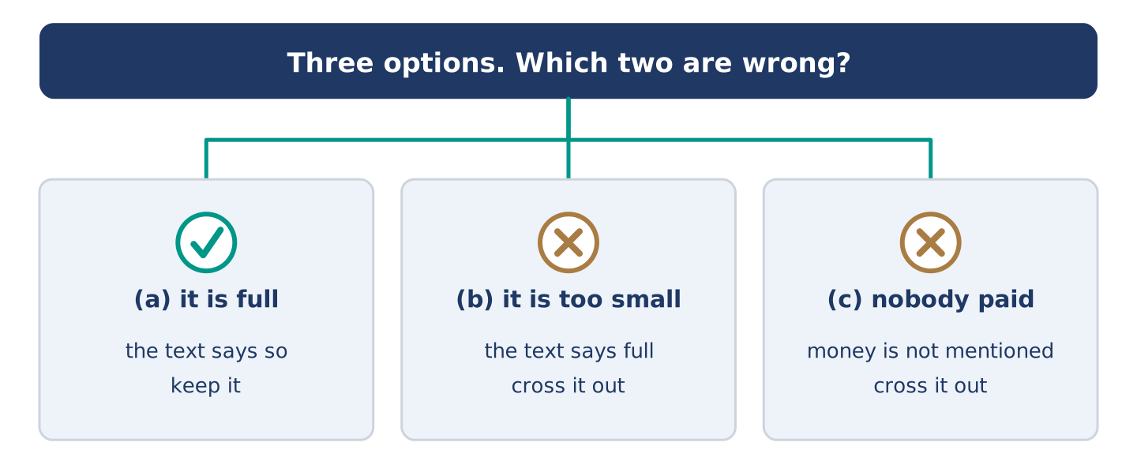
Figure 1.20 · Remove the wrong options first.
Exam skill — Reading Part 3 and Listening Part 2. Reading Part 3: one short text and three questions (a, b or c). Find the part of the text for each question. Cross out the two wrong options, then choose. Listening Part 2: complete the notes with a word or a number. Read the notes first and ask: is it a time, a number or a name?
7A Look at 5A again. For each question, say why the two wrong options are wrong.
7B Exam strategy. True or false? Write T or F.
- Read the notes before you listen. — T (example)
- Write a long answer in the notes.
- Cross out the wrong options first.
- Find the part of the text for each question.
- Guess before you read the text.
7C Put the steps of Listening Part 2 in order.
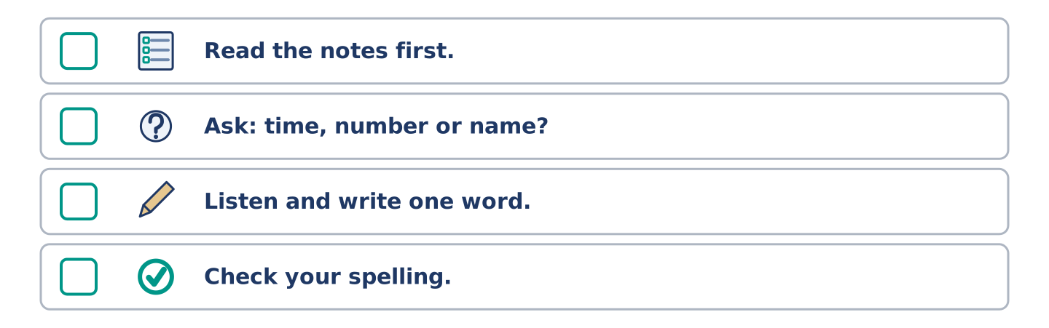
Figure 1.21 · Four steps.
- Read the notes. — 1 (example)
____ Check your spelling. ____ Ask: a time, a number or a name? ____ Listen and write one word or number.
7D Write two tips for Reading Part 3. Part 8 · At Work
Amina's shop, and the day she lost.
8A Read the email. Choose the correct answer.
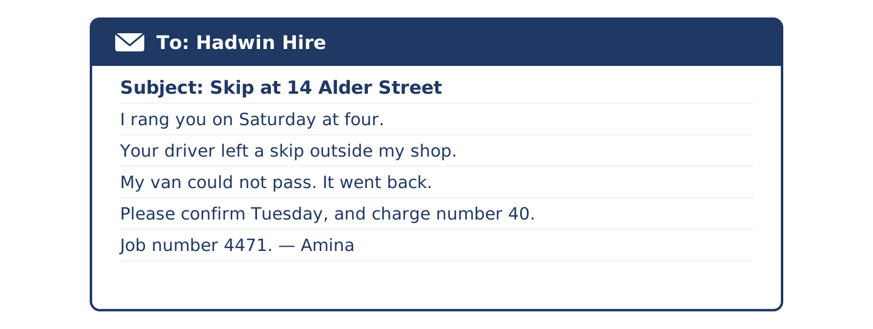
Figure 1.22 · An email to the hire company.
To: Hadwin Hire From: Amina Chaudhry Subject: Skip at 14 Alder Street
Dear Hadwin Hire, I rang you on Saturday at four. Your driver left a skip outside my shop. Number 40 ordered it, not me. My number was on his sheet by mistake. My delivery van could not pass, so it went back to the depot. I lost a day's trade. You said Tuesday morning for collection. Please confirm the time, and please send the charge to number 40. My job number is 4471. Thank you, Amina
- Amina rang on ___ . (a) Saturday (example)
- Why could the van not pass? (a) the road was closed (b) the skip was in the way (c) the driver was late
- What does Amina want? (a) a new skip (b) the time, and the charge sent to number 40 (c) her money back
8B Words in the email. Match the word (1–4) to the meaning (a–e).
- depot → where the vans come from (example)
Match | to
1. confirm | a. money you must pay
2. charge | b. say again that it is right
3. trade | c. the goods a shop sells in a day
4. sheet | d. the paper the driver carries
 | e. a short journey
One option is not needed.
8C Listen (Track 1.5). Complete Amina's notes.
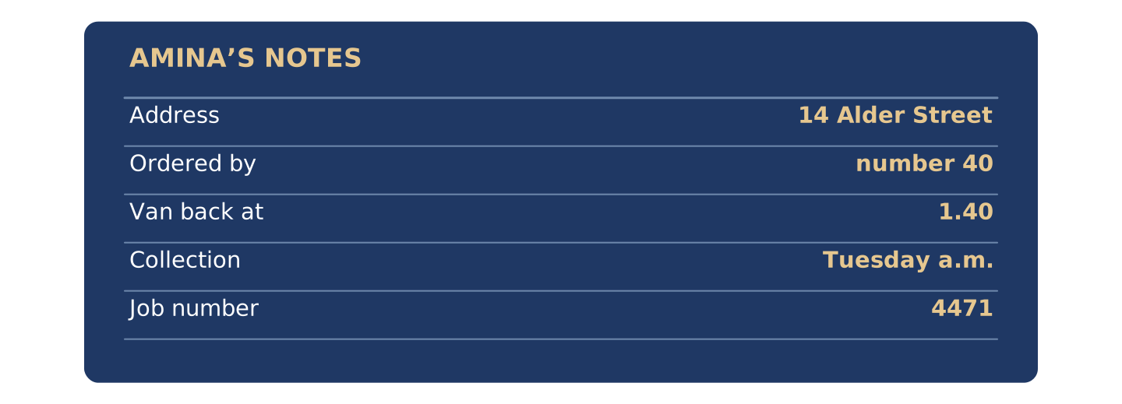
Figure 1.23 · The call to the hire company.
OPERATOR: Hadwin Hire, good afternoon. Do you have an order number?
AMINA: No, I don't. The skip is outside the wrong house. I'm at 14 Alder Street. Number 40 ordered it.
OPERATOR: Thank you. Let me find the booking.
AMINA: It is blocking my shop. My van went back to the depot at twenty to two.
OPERATOR: I can see it. The driver wrote 14 on his sheet. I'm sorry about that.
AMINA: When can you collect it?
OPERATOR: Tuesday morning. It's full already, so I need the lorry.
AMINA: Tuesday is two more days.
OPERATOR: It is. I'll put you first on Tuesday. Your job number is 4471.
Words: 4471 · Tuesday · 40 · 1.40
- Address: 14 Alder Street (example)
- (1) Ordered by number: ______________
- (2) Van went back at: ______________
- (3) Collection day: ______________
- (4) Job number: ______________
8D Problem or answer? Put the parts in the table.
Words: the skip is full · ring the same day · the van cannot pass · use the car park · my number was on the sheet · put you first on Tuesday
- the skip is full → problem (example)
PROBLEM: ______________ ANSWER: ______________
8E Discuss. What else could go wrong in your street? Say two things. Part 9 · Real-World File
Telephoning about a delivery that went wrong.
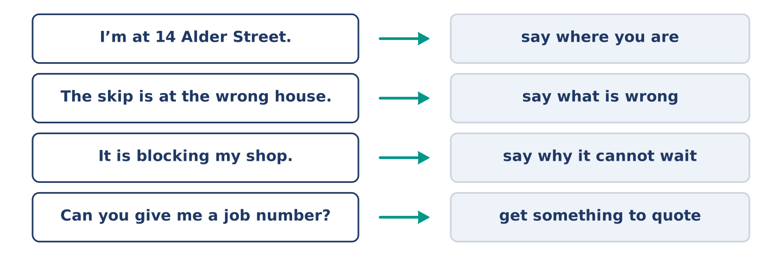
Figure 1.24 · How to make the call.
9A Read the steps. Then put Amina's call in order.
Steps: 1 Say where you are. 2 Say what is wrong. 3 Say why it cannot wait. 4 Ask for a date. 5 Ask for a job number.
- I'm at 14 Alder Street. — 1 (example)
____ Can you give me a job number? ____ The skip is outside the wrong house. ____ When can you collect it? ____ It is blocking my shop.
9B Role-play: ring about a delivery problem.
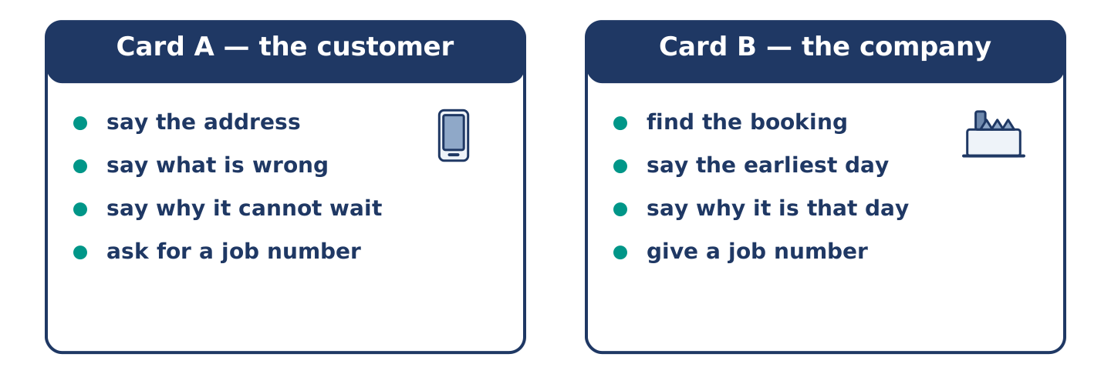
Figure 1.25 · Two people, one telephone.
Card A You are the customer. Say the address, the problem and why it cannot wait. Ask for a date and a job number.
Card B You work for the company. Find the booking. Say the earliest date. Give a job number.
Model:
A | Hello. There's a skip outside my shop. It isn't mine.
B | What's the address?
A | 14 Alder Street. Number 40 ordered it.
B | I can see it. We can collect it on Tuesday.
A | Tuesday is two more days. It's blocking my van.
B | I'll put you first on Tuesday. Your job number is 4471.
9C Write an email to confirm (40–50 words).
Model: Dear Hadwin Hire, thank you for your help today. To confirm: collection on Tuesday morning, job number 4471, and the charge to number 40. Please ring me before the lorry comes. Best wishes, Amina
Sentence starters: Dear … , thank you for … · To confirm: … · Please … · Best wishes, …
9D A good call? Choose the better sentence.
- (Hello, is that Hadwin Hire? / Who are you?) → Hello, is that Hadwin Hire? (example)
- (Your driver is useless. / Your driver had the wrong number.)
- (Can you give me a job number? / Just sort it out.)
- (It's blocking my shop. / It's a bit annoying.)
- (I'll send you an email today. / Maybe I'll write.)
- (Thanks for your help. / Bye.) Part 10 · Review & Can-Do
Check what you know.
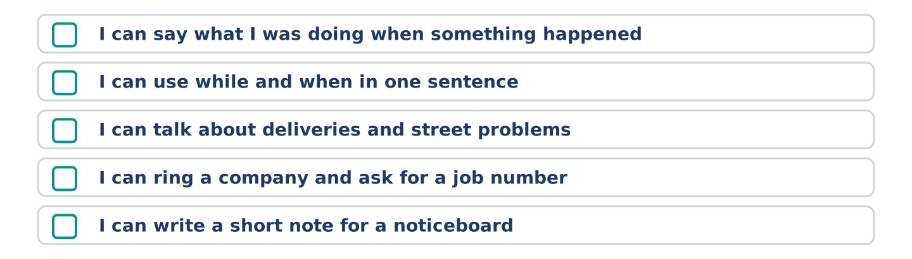
Figure 1.26 · What you learned in Unit 1.
10A Vocabulary. Complete with a word from the box.
Words: depot · queue · pavement · battery · shift · skip
- Check the ___ before you go out. (time) (example)
- A lorry left a ______________ on our street.
- It stood on the ______________ .
- Eleven people were in the ______________ .
- The van went back to the ______________ .
- My phone ______________ was flat.
- Tomas was crossing town to cover a ______________ .
10B Grammar. Choose the correct word.
- I was reading (when / while) the phone rang. → when (example)
- (While / When) I was cooking, the bell rang.
- She (was serving / served) a queue when it stopped.
- He was crossing town (when / while) his phone died.
- I (was knowing / knew) the answer.
- They (was / were) playing in the car park.
10C Grammar review. Choose the correct answer.
- She ___ a queue when it stopped. (a) was serving (example)
- While I ___ , the van arrived. (a) was waiting (b) waited (c) wait
- He dropped the box ___ he was carrying it. (a) while (b) so (c) because
- The cat went out ___ nobody was looking. (a) when (b) so (c) and
10D Odd one out. Which word is different?
- skip · depot · pavement · kettle → kettle (example)
- queue · till · card reader · landing
- battery · phone · charger · kerb
- while · when · as · depot
- crack · window · glass · shift
10E Match the sentence (1–4) to the answer (a–e).
- Is this going to take long? → About ten minutes. (example)
Match | to
1. What were you doing at three? | a. Tuesday morning.
2. When can you collect it? | b. I was cooking.
3. Can I have a job number? | c. No, nobody saw it.
4. Did anyone see the window? | d. Yes, it's 4471.
 | e. On the pavement.
One option is not needed.
10F Write three sentences about last Saturday: one with while, one with when, and one about something you did not see.
Model: While I was cooking, somebody rang the bell. I was reading when the lights went out. I did not see the van, because I was upstairs.
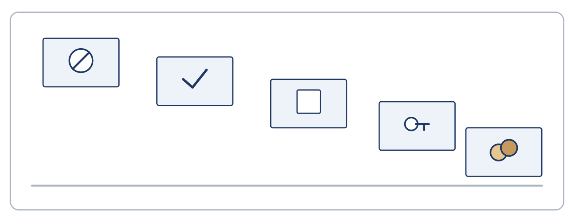
Figure 1.27 · Can-Do — Unit 1.
Can-Do — tick what you can do now
☐ I can say what I was doing when something happened. ☐ I can use while and when in one sentence. ☐ I can talk about deliveries, queues and street problems. ☐ I can ring a company about a problem and ask for a job number. ☐ I can write a short note for a noticeboard.
Glossary — 12 key words
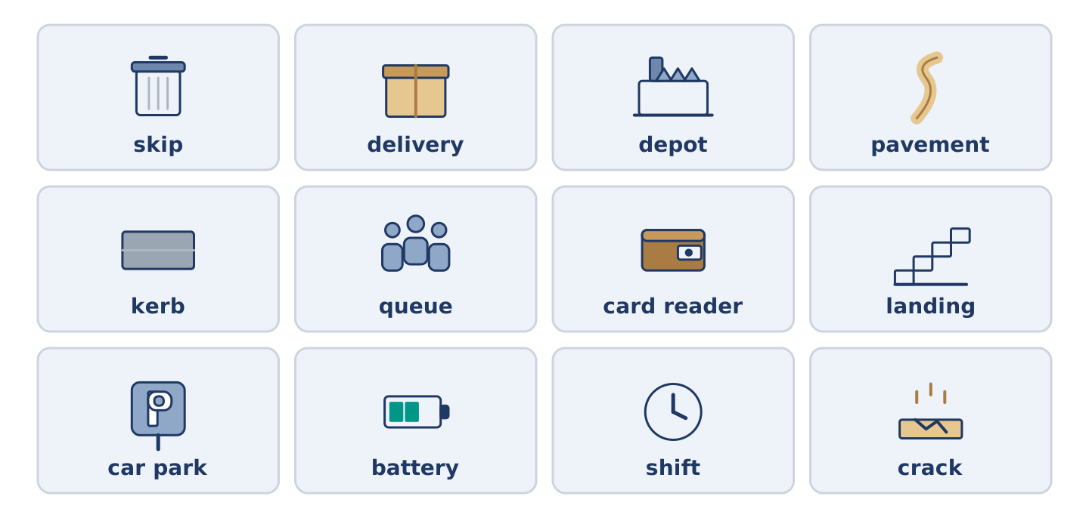
Figure 1.28 · Revise the words.
Word | Meaning
skip | a large metal container for rubbish
delivery | goods brought to you
depot | the building the vans come from
pavement | the path at the side of the road
kerb | the edge of the pavement
queue | a line of people waiting
card reader | the machine that takes a card
landing | the flat space at the top of stairs
car park | open ground where cars are left
battery | it holds the power in a phone
shift | the hours somebody works
crack | a thin line where something has broken
Answer Key
The source this course is modelled on has no answer key at all. This one covers every closed item, and gives marking points and a sample answer for every open task.
Unit 1: The Skip Outside Number 14 — Answer Key
Teacher's section. Open tasks carry a sample answer, not the only correct one.

Warm Up
W1 1. b · 2. c · 3. d · 4. a — not needed: e (Buy a new phone.)
W2 1. skip · 2. pavement · 3. queue · 4. delivery
W3 1. (b) number 40 · 2. (b) took the load back
Item 1 is the one to check. Learners who answer (a) have read outside 14 as ordered by 14. The text says both in two short sentences.

Part 1 · Vocabulary & Pronunciation
1A 1. f · 2. b · 3. c · 4. d · 5. e · 6. a — not needed: g (landing)
1B STREET: kerb, pavement · SHOP: till, queue · JOURNEY: platform, shift
1C 1. skip / pavement · 2. queue · 3. card reader · 4. battery · 5. depot
1D (Track 1.1) 1. she was serving · 2. they were waiting · 3. we were crossing · 4. he was ringing · 5. you were looking · 6. I was carrying
The point is that was and were are almost never stressed. Play line 1 twice and ask how many beats they heard. Most will say three, and was is not one of them.
1E 1. miss · 2. catch · 3. make · 4. block · 5. pay · 6. check
1F 1. (b) depot · 2. (a) card reader · 3. (c) shift
1G 1. agent · 2. shift · 3. landing · 4. stairwell · 5. crack
1H Open. Marking: one past continuous, one past simple, 25–40 words.
Sample: I was waiting for a parcel last Friday. The driver came at six, but I was out. He left a card. I collected it on Saturday morning.

Part 2 · Grammar
Notice The van was arriving. It was in the middle of coming down the street.
2A 1. was waiting · 2. stopped · 3. were standing · 4. was carrying · 5. went · 6. were playing
2B 1. was crossing · 2. was showing · 3. cracked · 4. was speaking · 5. were waiting
2C LONG: she was waiting, they were playing, he was crossing · SHORT: the lorry arrived, the machine stopped, the van left
2D 1. While · 2. when · 3. While · 4. when · 5. While
Rule of thumb for the board: while takes the long action, when takes the short one.
2E 2. Yes. Do you have an order number? · 3. No. The skip is outside the wrong house. · 4. When can you collect it? · 5. Tuesday morning. It's full, so I need the lorry.
2F Open. Marking: a past simple clause after when, a past continuous clause after while.
2G 1. …the call stopped. · 2. …when he dropped it. · 3. While we were waiting outside… · 4. The lorry arrived at half past one and left the skip.
2H 1. (b) was cooking · 2. (b) when

Part 3 · Listening
3A (Track 1.2) 1. F — he was reading his notes on his phone. · 2. T · 3. T · 4. F — the numbers were all in the flat phone.
3B 2. The screen went black. · 3. A woman lent me her phone. · 4. I don't know any numbers. · (then) My mother rang the hospital.
3C (Track 1.3) 1. ten past two · 2. two · 3. names · 4. four
Item 2 catches people. Maya says only two people here have cash, not two people paid.
3D (Track 1.4) 1. O · 2. N · 3. O · 4. D
3E 1. b · 2. c · 3. a · 4. d — not needed: e (In the car park.)

Part 4 · Speaking
4A Open pairwork. Listen for one sentence carrying both tenses.
Expect: I was cooking when the bell rang. · While I was out, the parcel came.
4B Open. Marking: the driver gives a reason; the shopkeeper asks three questions.
4C Open. Marking: was/were + -ing for all six people.
4D Open. Marking: a reason for each opinion, not just a guess.
4E Open group task. Marking: one decision, and a reason that is not only the price.

Part 5 · Reading
5A 1. (b) two hours · 2. (b) if something blocks the kerb · 3. (c) it takes the parcel back
5B 1. F — two hours. · 2. T · 3. F — it takes the parcel back to the depot.
5C 1. (b) number 40 · 2. (a) it is full
5D 1. (b) is wrong — the notice says nothing about size. · 2. (c) is wrong — the notice says nothing about paying.
This is the exam move: find the sentence, then cross out what the text does not say. Both wrong options here are things the text is silent on, not things it denies.
5E 1. kerb · 2. depot · 3. Tuesday · 4. 4471
5F 1. b · 2. a · 3. d · 4. c — not needed: e (Buy a new window.)
5G Open. Marking: two sentences, each with if, when or while.
Sample: When the bins are full, put the bag inside the gate. If a van is on the kerb, use the back lane.

Part 6 · Writing
6A Open (40–50 words). Marking: what is wrong · where you were · one clear request.
Sample (44 words): Hello everyone. The light in the stairwell is not working. I was coming up at eight last night and I could not see the steps. Can we ask the landlord this week? I am happy to make the call. — Flat 4
6B Open. Marking: three sentences with if.
Sample: If you ring the same day, there is no charge. If the skip is full, they send the lorry. If you book a week, it costs £180.
6C 1. While I was cooking, the phone rang. · 2. She was serving when it stopped. · 3. They were playing all afternoon.
6D Open (35–45 words). Use the checklist on the page.

Part 7 · Exam Skills
7A Question 1: (a) landing and (c) kerb are places, not buildings — the text says depot. Question 2: (b) and (c) name things the text never mentions.
7B 1. F — write one word or a number. · 2. T · 3. T · 4. F — read the text first, then choose.
7C 2. Ask: a time, a number or a name? · 3. Listen and write one word or number. · 4. Check your spelling.
7D Open. Marking: two tips, each one instruction.
Sample: Find the sentence before you choose. Cross out the two options the text does not mention.

Part 8 · At Work
8A 1. (b) the skip was in the way · 2. (b) the time, and the charge sent to number 40
8B 1. b · 2. a · 3. c · 4. d — not needed: e (a short journey)
8C (Track 1.5) 1. 40 · 2. 1.40 · 3. Tuesday · 4. 4471
8D PROBLEM: the skip is full, the van cannot pass, my number was on the sheet · ANSWER: ring the same day, use the car park, put you first on Tuesday
8E Open. Marking: two problems, each with one thing you would do.

Part 9 · Real-World File
9A 2. The skip is outside the wrong house. · 3. It is blocking my shop. · 4. When can you collect it? · 5. Can you give me a job number?
9B Open role-play. Marking: the address, the problem, the urgency, a date, a number.
9C Open (40–50 words). Marking: the day, the job number, who pays, one request.
9D 1. Your driver had the wrong number. · 2. Can you give me a job number? · 3. It's blocking my shop. · 4. I'll send you an email today. · 5. Thanks for your help.
The pattern across all five: say the fact, ask for the thing, keep the person on your side. Rudeness costs you the Tuesday slot.

Part 10 · Review & Can-Do
10A 1. skip · 2. pavement · 3. queue · 4. depot · 5. battery · 6. shift
10B 1. While · 2. was serving · 3. when · 4. knew · 5. were
10C 1. (a) was waiting · 2. (a) while · 3. (a) when
10D 1. landing · 2. kerb · 3. depot · 4. shift
10E 1. b · 2. a · 3. d · 4. c — not needed: e (On the pavement.)
10F Open. Marking: one while, one when, one negative.
Sample: While I was working, the post came. I was asleep when the alarm went off. I did not see the van, because I was in the garden.
Glossary Twelve words, with the table on the page. Every one appears at least three times before Part 10.
