PERVASIVE ENGLISH · BOOK 2 · UNIT 8
If and When

In this unit you…
• talk about facts with if / when + present
• talk about possible results: If …, I’ll …
• give reasons and results: because, so, to
• talk about travel problems, interrupt politely and agree conditions
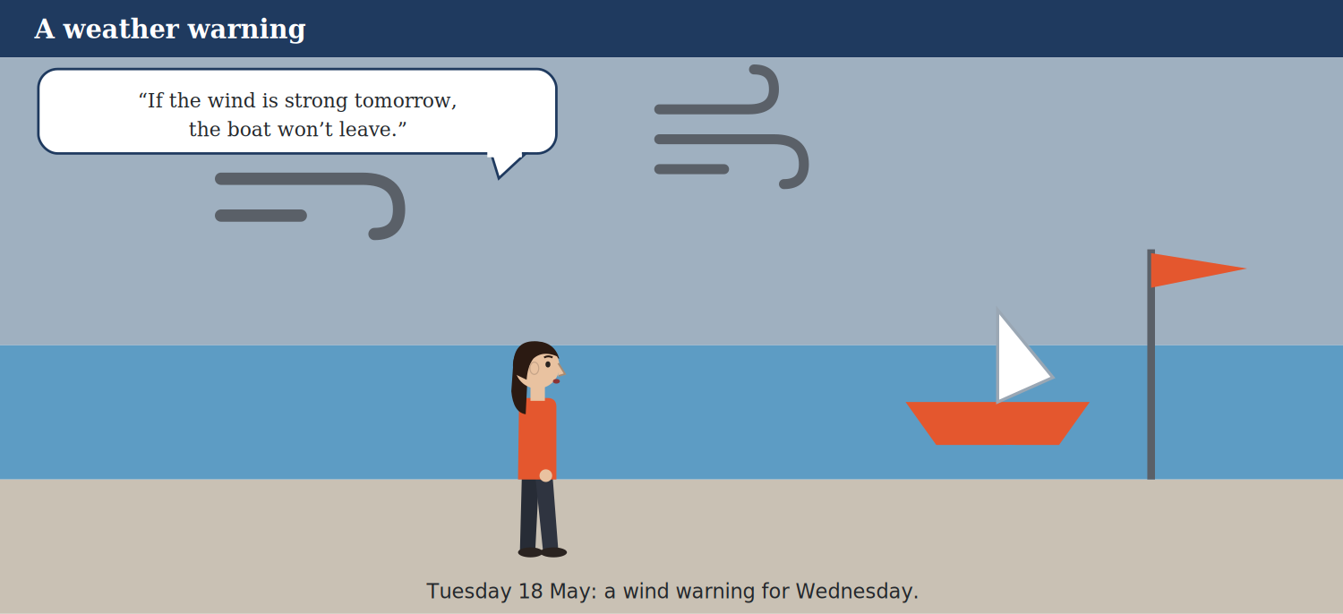
A weather warning.

Warm-Up
W1 Match the problem (1–4) to the Plan B (a–e).
0. The bus is late. → Take an e-scooter. (example)
Match | to
1. The train is cancelled. | a. Eat in a tent.
2. It’s raining at lunch. | b. Take the next train.
3. The boat trip can’t go. | c. Buy a new car.
4. The power goes out. | d. Visit the museum.
 | e. Use torches.
One option is not needed.
W2 Complete about travel problems.
Words: cancelled · B · boats · plans
0. Sofia is planning a big ___ in June. (conference) (example)
1. Weather can change your ____________________.
2. If the wind is strong, ____________________ stop.
3. If a train is ____________________, you need a new plan.
4. Sofia wants a good Plan ____________________.
W3 Read. Choose the correct answer.
Before you read / listen: Look at the picture. Why will the boat stay in the harbour?
Glossary
Plan B a second plan if the first plan doesn’t work
Weather and travel problems can change your plans. If the wind is strong, boats stop. If a train is cancelled, you need a new plan. At Brightway, Sofia is planning a big conference in June, and she wants a good Plan B.
0. Sofia wants a good Plan … (a) B (example)
1. If the wind is strong, …
(a) boats stop (b) trains are free (c) the café closes
2. The conference is in …
(a) May (b) June (c) July
PART 1 Vocabulary & Pronunciation

Travel problems, how likely, and interrupting.
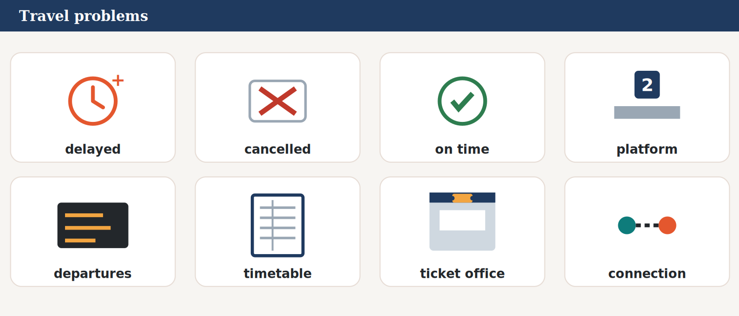
Travel problems.

Word | Meaning
delayed / cancelled / on time | late / it won’t go / not late
platform / departures / arrivals | where you get on the train / trains leaving / trains arriving
timetable / ticket office | times of trains and buses / where you buy tickets
connection | a second train or bus on the same journey
warning / alert | information about a danger
strong / wind | very powerful / moving air
boat / trip | … / a short journey to visit a place
tent / chairs / tables | …
supplier | a company: it sells things to your company
condition / conditions | what must happen first
book / cancel / delivery | reserve / stop a booking / bringing things to you
conference / guests / speaker / talk | a big meeting / visitors / he or she gives a talk / a short lesson to a group
likely / unlikely | probably will / probably won’t happen
possible / impossible / certainly | it can happen / it can’t happen / 100%
interrupt | speak when someone is talking
Plan B / memo | a second plan / a short note at work
heat / boil / melt | make hot / water at 100°C / ice to water
option / options | one of the choices
if / when | maybe / we’re sure it will happen
because / so | for a reason / for a result
discount | a lower price
twenty-fourth | 24th
1A Look at the pictures. Match the picture (2–8) to the word (a–h).
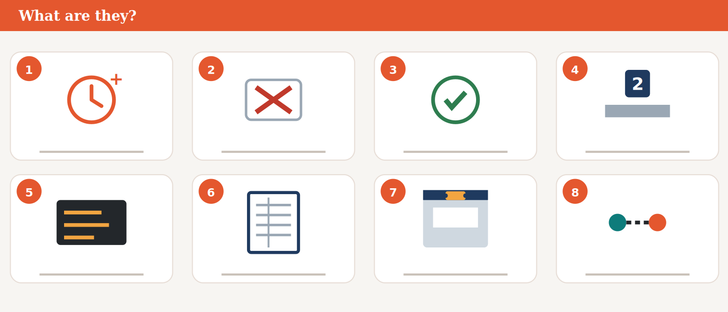
What are they?

0. Picture 1 → delayed (example)
Match | to
1. Picture 2 | a. on time
2. Picture 3 | b. ticket office
3. Picture 4 | c. departures
4. Picture 5 | d. seat belt
5. Picture 6 | e. connection
6. Picture 7 | f. platform
7. Picture 8 | g. cancelled
 | h. timetable
One option is not needed.
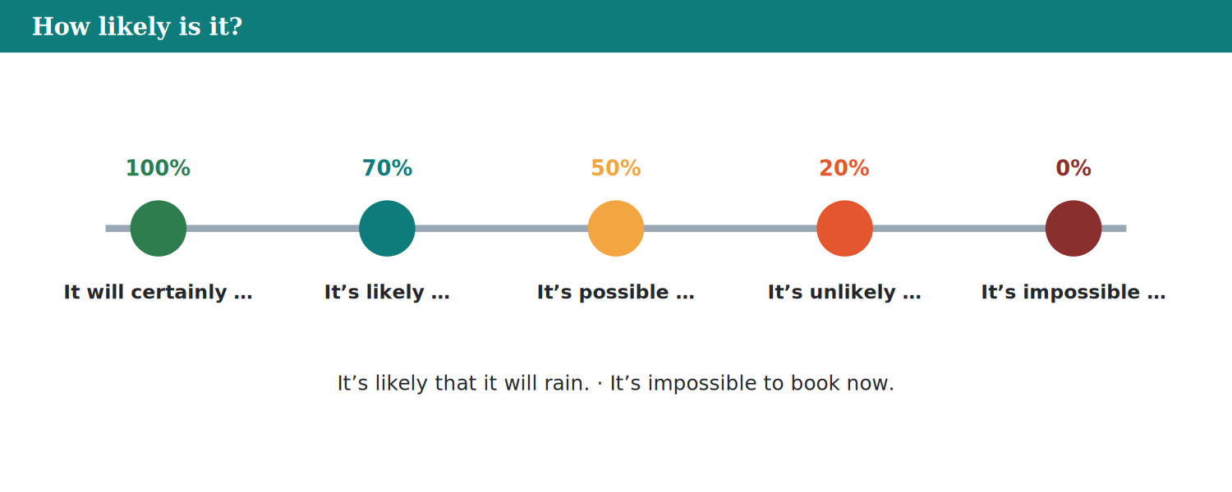
How likely is it?

1B Travel, weather or conference? Put the words in the table.
0. departures → travel (example)
Words: guests · talk · storm · warning · timetable · speaker · connection · strong wind · platform
TRAVEL: ____________________ WEATHER: ____________________ CONFERENCE: ____________________
1C Complete with a word from the box.
Words: platform · office · delayed · connection · timetable
0. The 10:30 train is ___. It won’t go today. (cancelled) (example)
1. The 10:15 train is ____________________. It’s 20 minutes late.
2. The train to London leaves from ____________________ 1.
3. Check the bus ____________________ before you go.
4. Buy your ticket at the ticket ____________________.
5. I missed my ____________________ in London.
1D Pronunciation (Track 8.1). Listen. Do you hear ’ll?
0. (If it rains, we’ll stay. / we stay.) → we’ll stay (example)
1. (we’ll stay / we stay)
2. (it stops / it’ll stop)
3. (I take / I’ll take)
4. (you get / you’ll get)
5. (they leave / they’ll leave)
6. (she’ll call / she calls)
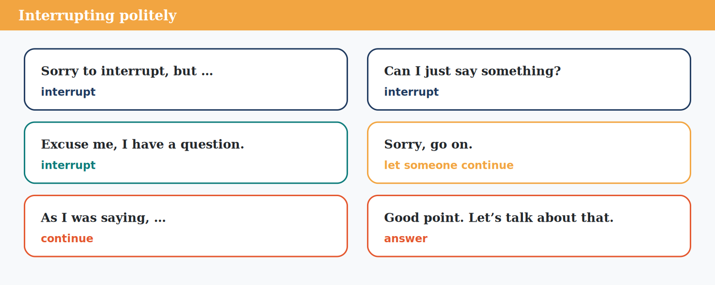
Interrupting politely.

1E Choose the correct word.
0. (get / make) a discount → get (example)
1. (miss / lose) a train
2. (catch / take) a connection
3. (do / book) a place
4. (close / cancel) a booking
5. (give / make) a talk
6. (look / check) the timetable
1F Choose the correct answer.
0. Not late: (a) on time (example)
1. Trains leaving:
(a) arrivals (b) delays (c) departures
2. It can’t happen:
(a) impossible (b) possible (c) likely
3. Speak when someone is talking:
(a) book (b) interrupt (c) deliver
1G Complete with a word from the box.
Words: delivery · likely · twenty-fourth · supplier · guests
0. There’s a weather ___ for tomorrow. (warning) (example)
1. It’s ____________________ that it will rain.
2. The ____________________ arrive at nine.
3. Our ____________________ brings the chairs.
4. Free ____________________ at 8 a.m.
5. The conference is on the ____________________ of June.
1H About you. Write about a travel problem you had: what happened, and what did you do?
Model
Last year, my bus was cancelled because of snow. I called my friend, and she drove me to work.
PART 2 Grammar

The zero conditional; the first conditional; if or when; because, so, to.
Notice Read the Warm-Up again. Find two sentences with if. Do they talk about facts or the future?
The zero conditional — Form, Use, Example
• Form: if / when + present simple, present simple.
• Use: facts and things that are always true: If the wind is strong, boats don’t leave.
• When a train is cancelled, you can use the same ticket.
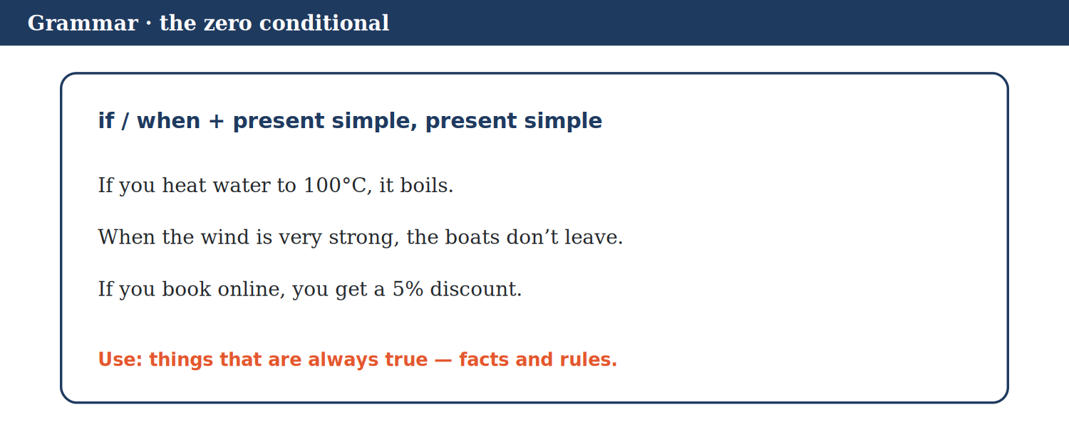
The zero conditional.

Glossary
zero conditional if + present, present: for facts
2A Choose the correct form (facts).
0. If you don’t water plants, they (die / will dies). → die (example)
1. If you heat ice, it (melts / will melts).
2. When the wind is strong, the boats (won’t to / don’t) leave.
3. If you book online, you (got / get) a discount.
4. When it (rains / will rain), Bus 12 is often late.
5. If you press this button, the light (came / comes) on.
6. Water (boils / boil) if you heat it to 100°C.
The first conditional
• Form: if + present simple, will / won’t + verb.
• Use: a possible future situation and its result: If it rains, we’ll have lunch in the tent.
• NOT: If it will rain … The if part uses the present.
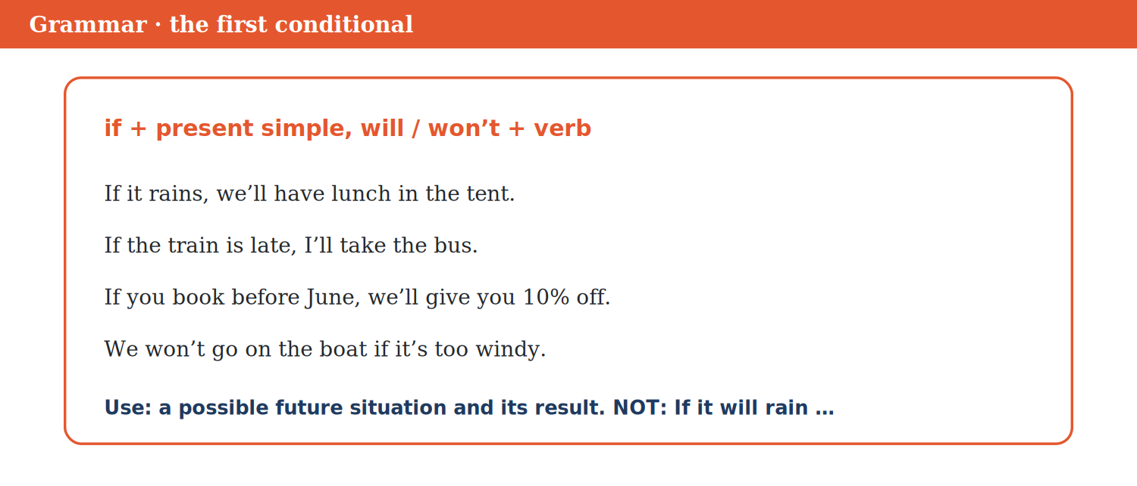
The first conditional.

Glossary
first conditional if + present, will: for possible results
Watch out!
NOT: If it will rain, we stay inside. → If it rains, we’ll stay inside.
NOT: If I will see him, I tell him. → If I see him, I’ll tell him.
2B Complete with the correct form.
Words: book · rains · ’ll take · won’t go
0. If I see Tom, I ___ him. (tell) (’ll tell) (example)
1. If it ____________________, we’ll use the tent. (rain)
2. If the train is late, I ____________________ the bus. (take)
3. We ____________________ on the boat if it’s windy. (not go)
4. If you ____________________ before June, you’ll get 10% off. (book)
2C Fact or possible future? Put the sentences in the table.
0. If you book before June, we’ll give you 10% off. → possible future (example)
Words: When the wind is strong, boats don’t leave. · If I finish early, I’ll call you. · If it rains tomorrow, we’ll stay in. · If you mix blue and yellow, you get green. · If you heat ice, it melts. · If the train is late, I’ll miss my meeting.
FACT: ____________________ POSSIBLE FUTURE: ____________________
if or when?
• if = maybe: If it rains, we’ll use the tent. (perhaps it won’t rain)
• when = we’re sure it will happen: When the guests arrive, we’ll give them coffee.
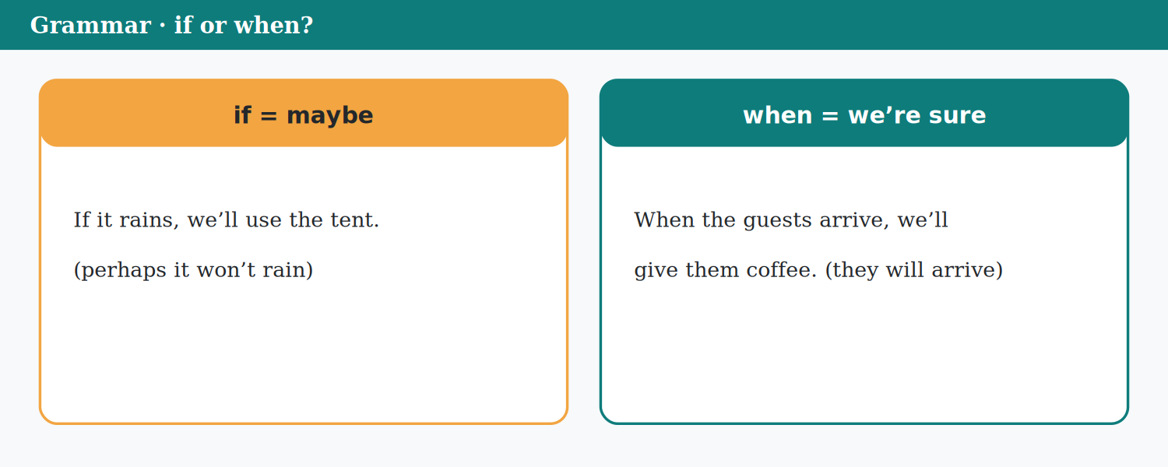
if or when?

2D Choose if or when.
0. (When / If) the shop opens, I’ll buy bread. (it will open) → When (example)
1. (If / When) the guests arrive, we’ll say hello. (they will arrive)
2. (When / If) it rains, lunch will be in the tent. (maybe)
3. I’ll call you (when / if) I get home. (I will get home)
4. (When / If) the train is cancelled, I’ll take the bus. (maybe)
5. (When / If) the conference ends, we’ll clean up. (sure)
6. We’ll go to the beach (if / when) it’s sunny. (maybe)
2E Put the conversation in order.
Number the lines. Line 1 is done for you.
a. ( ) If it rains, I’ll stay at home.
b. ( ) And if it rains?
c. ( ) If the weather’s good, I’ll go to the beach.
d. ( 1 ) What will you do this weekend?
Glossary
purpose why you do something
result what happens because of something
2F Choose because, so or to.
0. I went to the station (to / so) buy a ticket. → to (example)
1. The boat stopped (so / because) the wind was strong.
2. It was windy, (so / because) we went to the museum.
3. Sofia called Joe (to / so) book the tent.
4. I took an umbrella (to / because) it was raining.
5. The train was late, (to / so) I missed my meeting.
6. Priya called Ms Lane (to / because) change the time.
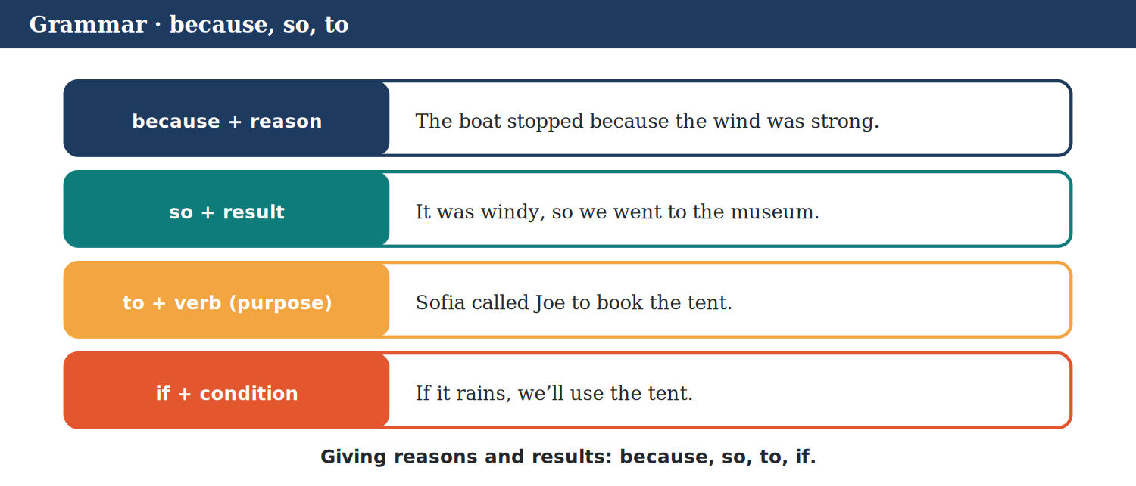
because, so, to.

2G Complete the sentences with your own ideas.
Words: so · to · watch · usually
0. If it’s sunny tomorrow, I’ll ___ (go out) (example)
1. If I have time this evening, I’ll ____________________ a film. (e.g.)
2. When I get home, I ____________________ cook dinner. (e.g.)
3. I’m learning English ____________________ get a better job. (e.g.)
4. It was cold, ____________________ I wore a coat. (e.g.)
2H Find the mistake. Write the correct sentence.
0. If it will rain, we stay inside. → If it rains, we’ll stay inside. (example)
1. If you will book today, you get 10% off. ____________________
2. When I will arrive, I’ll call you. ____________________
3. If you heat ice, it will melts. ____________________
4. I called him for ask a question. ____________________
2I Review. Choose the correct answer.
0. If the train is late, I … the bus. (a) ’ll take (example)
1. If it …, we’ll use the tent.
(a) will rain (b) rained (c) rains
2. If you heat water to 100°C, it …
(a) will boils (b) boils (c) boiled
3. I’ll call you … I arrive. (sure)
(a) when (b) if (c) so
4. She went to the shop … buy milk.
(a) for (b) so (c) to
2J Write four sentences: two zero conditionals (facts) and two first conditionals (your plans).
Model
If I drink coffee at night, I don’t sleep. When it’s hot, I go to the sea. If I pass the exam, I’ll have a party. If it rains on Friday, I’ll stay at home.
PART 3 Listening

A cancelled train, Plan B for the visitors, and conference notes.
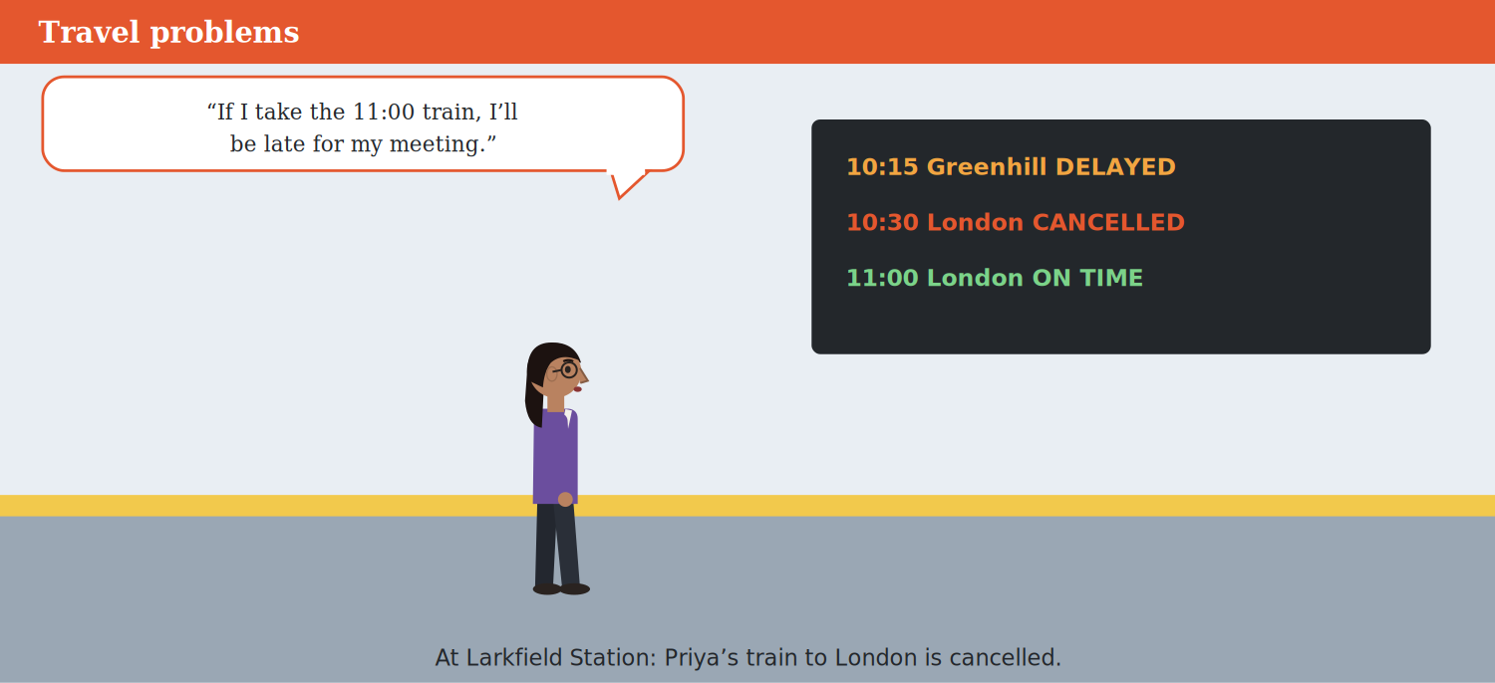
Travel problems.

3A Listen (Track 8.2). True or false? Write T or F.
Before you read / listen: Look at the picture. What will Priya do?
0. Priya calls Ms Lane. → T (example)
1. Priya needs to buy a new ticket. ________
2. They’re going to start the meeting at one. ________
3. Priya’s train to London is cancelled. ________
4. The next train is at ten. ________
5. The meeting was at half past twelve. ________
6. Ms Lane is angry with Priya. ________
3B Listen again (Track 8.2). Put the lines in order.
Number the lines. Line 1 is done for you.
a. ( ) What are you going to do?
b. ( 1 ) My train to London is cancelled.
c. ( ) Shall we start at one o’clock?
d. ( ) There’s another train at eleven.
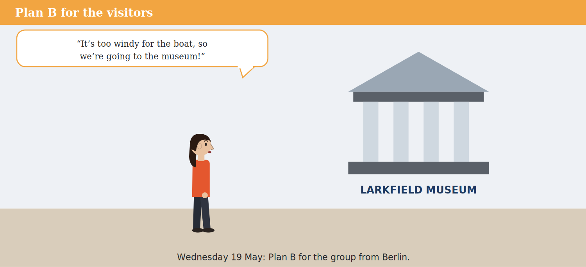
Plan B for the visitors.

3C Listen (Track 8.3). Complete the notes.
Before you read / listen: Look at the picture. Where is the group going?
Words: two · wind · Museum · Café
0. Bring your ___ (coats) (example)
1. The problem: very strong ____________________
2. Afternoon: the Larkfield ____________________
3. After that: coffee and cake at the Harbour ____________________
4. Boat trip: Thursday at ____________________
3D Exam practice (Listening Part 2, Track 8.4). Listen and complete the notes.
Before you read / listen: Read the notes first. What kind of word or number is missing in each gap?
Words: 120 · tent · website · harbour · 9:30
0. Day: Thursday 24 ___ (June) (example)
1. (1) First talk starts at: ____________________
2. (2) Number of guests: ____________________
3. (3) Lunch: by the ____________________
4. (4) If it rains, lunch is in a ____________________
5. (5) Book a place on the ____________________
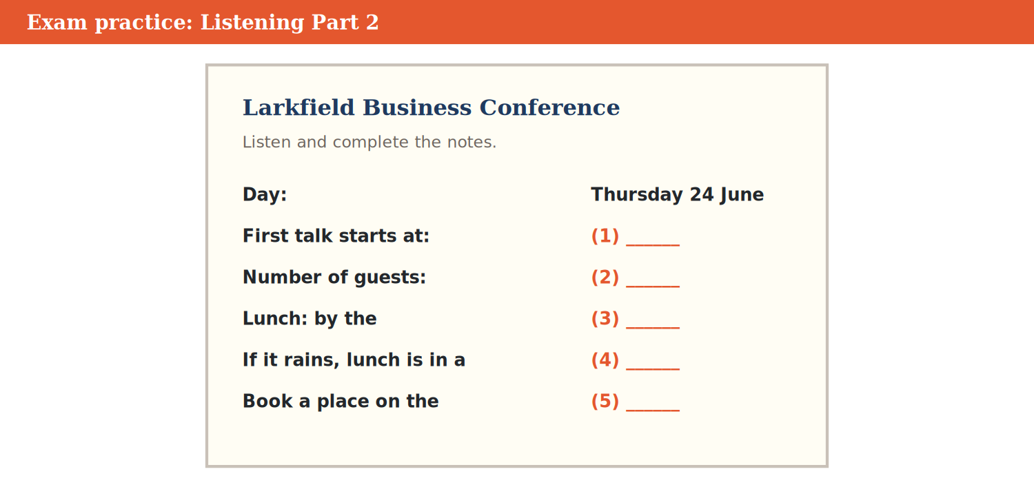
Listening Part 2: the conference.

3E Useful phrases. Match the sentence (1–4) to the answer (a–e).
0. If it rains? → We’ll use the tent. (example)
Match | to
1. What will you do if the train is late? | a. That’s perfect.
2. Shall we start at one? | b. Yes, go on.
3. Do you need a new ticket? | c. I’ll take the bus.
4. Sorry to interrupt, but … | d. No, I can use the same one.
 | e. In the summer.
One option is not needed.
PART 4 Speaking

Plans and conditions; travel problems; interrupting.
4A Read the conversation. Then talk about your plans for the weekend: what will you do if …?
Useful language
• If the weather’s good, I’ll …
• If it rains, I’ll …
• When I …, I’ll …
Model
Two friends talk about the weekend.
A | What will you do this weekend?
B | If the weather’s good, I’ll go to the beach.
A | And if it rains?
B | If it rains, I’ll stay at home and watch a film.
A | I’m going to the market on Saturday. Do you want to come?
B | Maybe. If I finish my work, I’ll come with you.
A | Great. When you’re ready, send me a message.
B | OK. If I can’t come, I’ll call you.
A | Perfect. Let’s hope for sunshine!
Card A Say three plans with if.
Card B Ask: And if …?
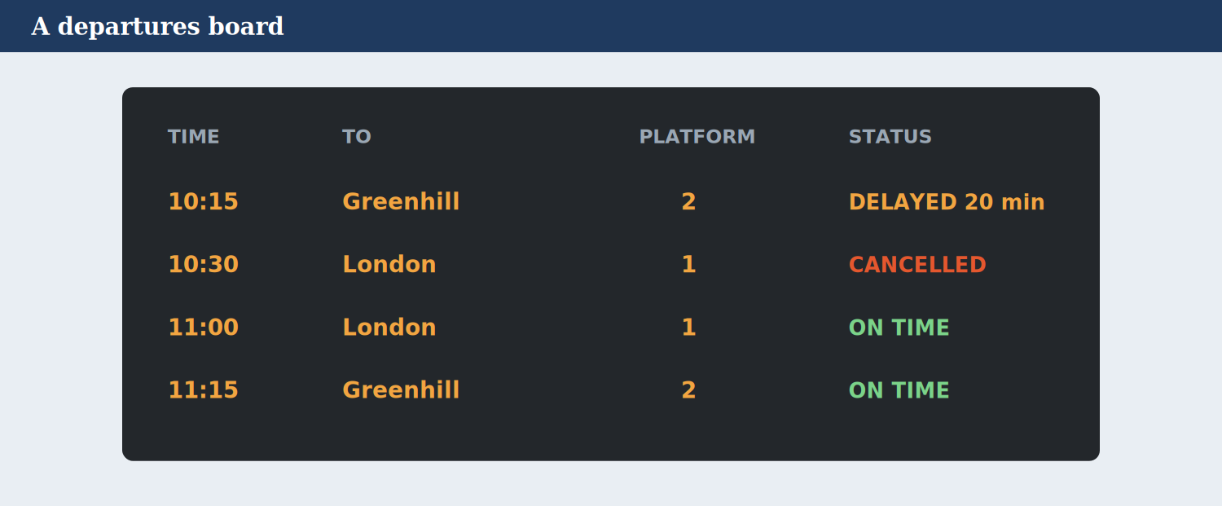
A departures board.

4B Look at the departures board. Your train is delayed or cancelled. What will you do?
Useful language
• If the 10:30 is cancelled, I’ll take …
• If the train is late, I’ll miss …
• I’ll call … to …
Model
The 10:30 to London is cancelled. If I take the 11:00, I’ll be late, so I’ll call my client to change the meeting.
Card A Choose a train and a problem.
Card B Say your Plan B with if and so.
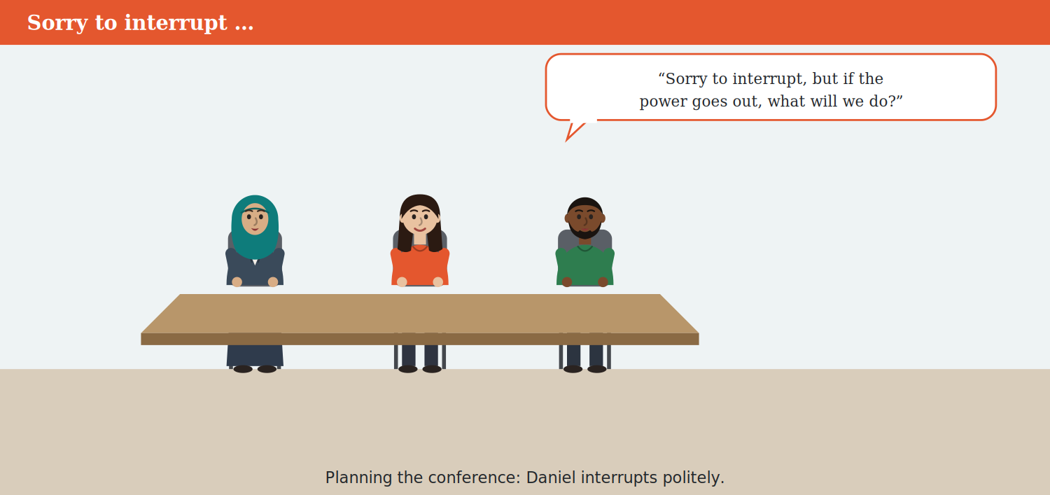
Sorry to interrupt …

4C Interrupting: in groups, plan a class party. Interrupt politely to add an idea.
Useful language
• Sorry to interrupt, but …
• Can I just say something?
• Sorry, go on.
• Good point.
Model
A: We’ll have the party on Friday … B: Sorry to interrupt, but if it’s on Friday, Ali can’t come. A: Good point. What about Saturday?
Card A Plan the party: day, place, food.
Card B Interrupt politely two times.
4D How likely? Talk about these things: it will rain tomorrow, you’ll travel abroad this year, you’ll meet a famous person.
Useful language
• It’s likely that …
• It’s possible, but …
• It’s unlikely that …
• It’s impossible!
Model
It’s likely that it will rain tomorrow. It’s unlikely that I’ll meet a famous person!
Card A Talk about three things.
Card B Agree or disagree with your partner.
4E Exam practice: the examiner asks about travel.
Useful language
• When I travel, I usually …
• If the weather is bad, I …
• I like … because …
Model
Examiner: How do you travel to work? You: I usually take the bus. If the bus is late, I walk, because it’s only twenty minutes.
Card A You are the examiner. Ask: What do you do when a bus or train is late? Where will you go on holiday this year?
Card B Answer in full sentences. Give a reason.
PART 5 Reading

A travel-advice web page and a weather alert.
5A Exam practice (Reading Part 3). Read the travel advice. Choose the correct answer.
Before you read / listen: Read the questions first. Then find the part of the text for each question.
Glossary
charge put electricity into a phone or battery
in a hurry you need to go fast
LarkMove — Travel advice: travelling in bad weather.
Bad weather can make travel difficult. Here’s our advice for Larkfield.
Before you go: check the weather and the LarkMove app. If there’s a warning, leave earlier, or travel on a different day. When it’s very windy, boat trips on the harbour don’t leave, so check before you go to the harbour.
Trains: if your train is late, you’ll see it on the departures board and in the app. If a train is cancelled, you can take the next train with the same ticket. You don’t need to buy a new one.
Buses: when the wind is strong, Bus 12 is often late, because it goes along the harbour. If you’re in a hurry, you could take an e-scooter — but not in a storm!
What to take: take a coat and an umbrella. If your phone battery is low, you can’t use the app, so charge your phone before you leave.
And remember: if you have a Plan B, a travel problem won’t be a big problem!
0. The advice is from … (a) LarkMove (example)
1. When it’s very windy, …
(a) trains are free (b) Bus 12 is early (c) boat trips don’t leave
2. If your train is cancelled, you …
(a) must buy a new ticket (b) can use the same ticket (c) can’t travel that day
3. Bus 12 is often late in the wind because it …
(a) goes along the harbour (b) is very old (c) stops at the station
4. If your phone battery is low, …
(a) you can’t use the app (b) the app is free (c) you’ll get an alert
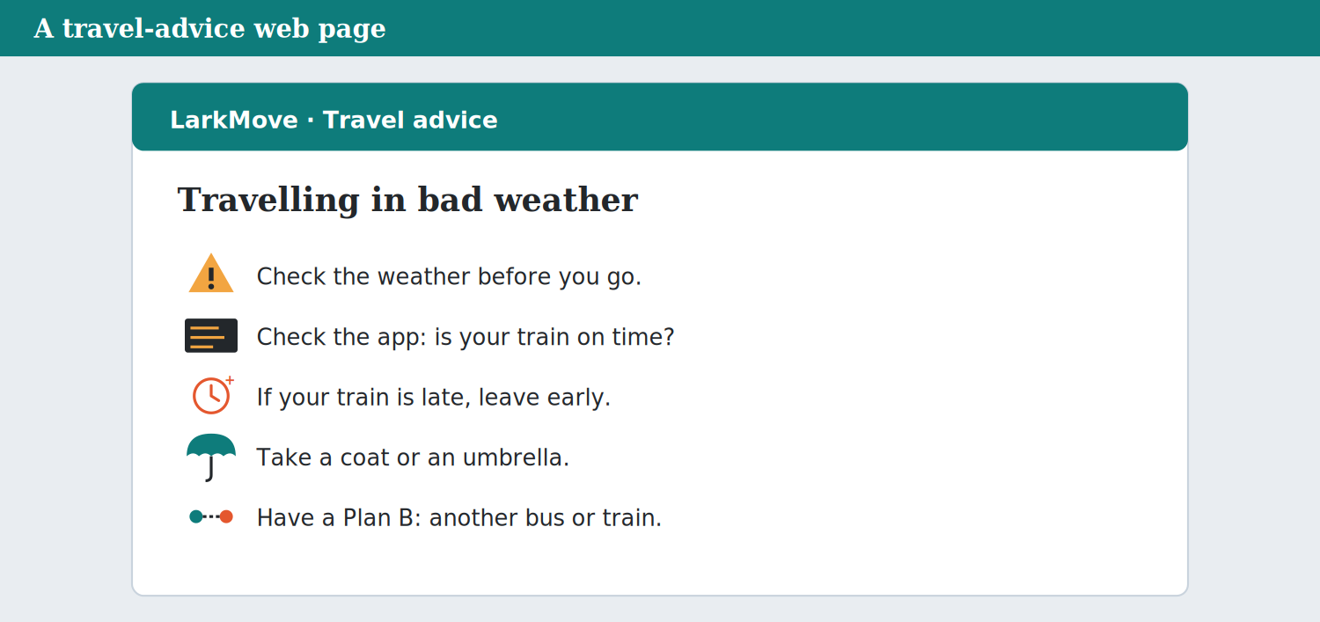
A travel-advice web page.

5B True or false? Write T or F.
0. The page gives advice. → T (example)
1. You need a new ticket for the next train. ________
2. The page says: take a coat and an umbrella. ________
3. If there’s a warning, you should leave earlier. ________
4. You should take an e-scooter in a storm. ________
5. A Plan B can help you. ________
6. You can see delays on the departures board. ________
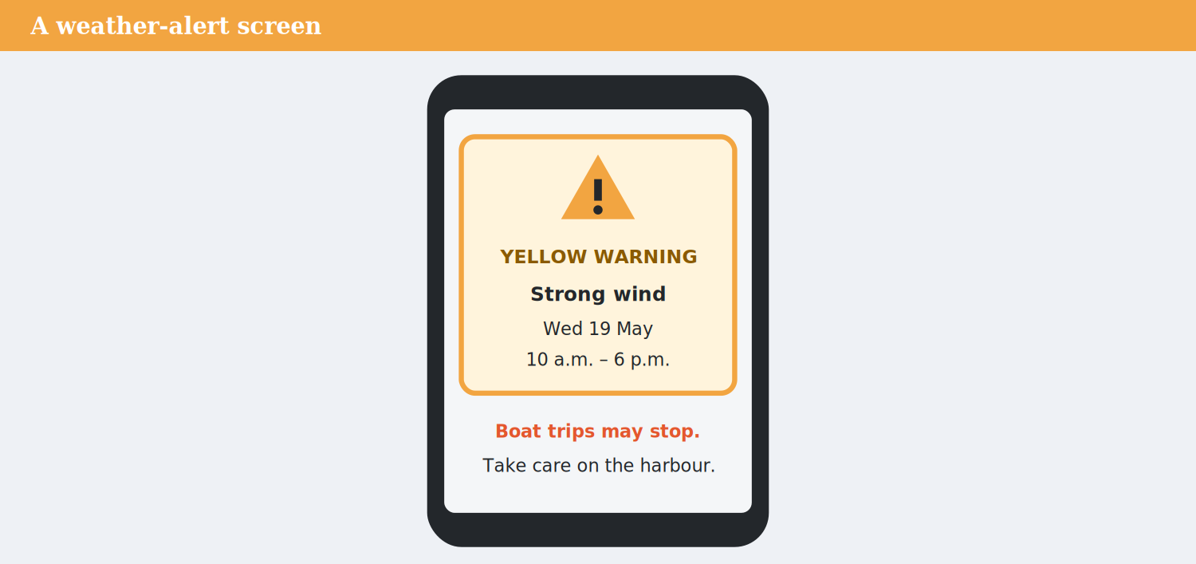
A weather-alert screen.

5C Read the weather alert. Choose the correct answer.
Before you read / listen: Look at the screen. What kind of warning is it?
Glossary
especially more than usually
midday 12 o’clock in the day
park leave your car
Weather alert — Larkfield. Yellow warning: strong wind. When: Wednesday 19 May, 10 a.m. to 6 p.m.
What will happen? The wind will be very strong, especially near the harbour. It’s likely that boat trips will stop, and some trains may be late. It’s unlikely that there will be rain.
What should you do? If you’re near the harbour, walk carefully. Don’t park under trees. If you have a boat trip, call the company before you go. If you’re travelling by train, check the app for delays.
Bus 12: it will probably run, but it may be ten or fifteen minutes late.
The weather will be better on Thursday morning, and the wind will stop by midday. We’ll send you another alert if anything changes.
0. The wind will stop by … on Thursday. (a) midday (example)
1. The warning is for …
(a) heavy snow (b) strong wind (c) rain
2. It’s likely that …
(a) trains will be free (b) it will rain (c) boat trips will stop
3. Bus 12 may be …
(a) cancelled (b) early (c) ten or fifteen minutes late
5D Remove the wrong options first. Which two options are wrong? Then choose the answer.
Before you read / listen: Read each question. Which two options does the alert say are wrong?
0. The warning is … (a) yellow (example)
1. The alert is for …
(a) Wednesday (b) Monday (c) Sunday
2. Near the harbour, you should …
(a) take a boat (b) walk carefully (c) park under trees
3. You’ll get another alert …
(a) if anything changes (b) every hour (c) on Friday
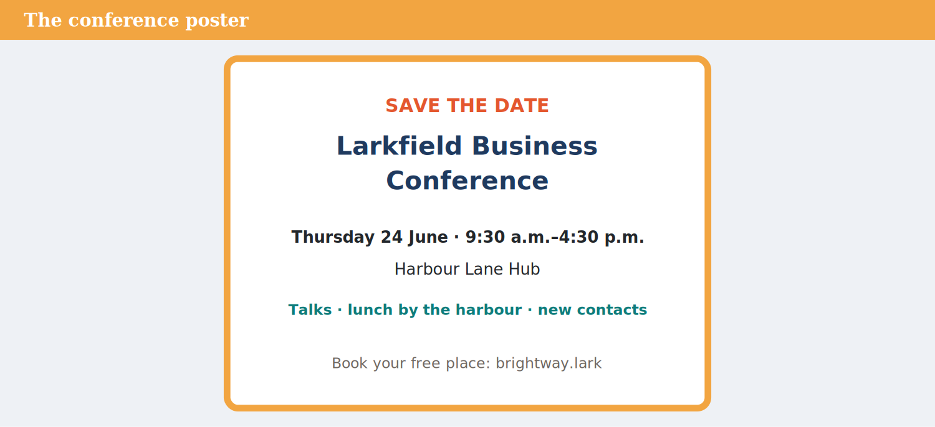
The conference poster.

Glossary
save the date remember this date for an event
5E Complete the sentences about the alert and the poster.
Words: trees · Hub · p.m. · 9:30
0. Book your free place on the ___ (website) (example)
1. The wind warning is from 10 a.m. to 6 ____________________
2. Don’t park under ____________________.
3. The conference starts at ____________________ a.m.
4. The conference is at the Harbour Lane ____________________
5F Match the problem (1–4) to the advice (a–e).
0. rain → take an umbrella (example)
Match | to
1. a wind warning | a. take the next train
2. a cancelled train | b. leave earlier
3. a low battery | c. take an e-scooter
4. a late bus | d. buy a new car
 | e. charge your phone
One option is not needed.
5G Write two pieces of travel advice for your town, with if or when.
Model
If you visit in summer, bring water — it’s very hot. When the roads are busy, take the train.
PART 6 Writing

Plans, conditions and a Plan B.
Glossary
per cent 10 per cent = 10%
hire pay to use something for a short time
6A Exam practice (Writing Part 6). Write to a friend about a day out on Saturday: the plan, and your Plan B if it rains (25 words or more).
Model
Hi Ana! Let’s go to the beach on Saturday. If it’s sunny, we’ll have a picnic. If it rains, we’ll go to the cinema instead. I’ll call you on Friday. Mia
Plan
1. The plan.
2. If it’s sunny, …
3. If it rains, …
4. When will you call?
Useful words: If it’s sunny · If it rains · instead · I’ll call
Check before you finish
☐ Two first conditionals
☐ 25 words or more
☐ Friendly ending
When the weather changes your plans.

6B Read the supplier’s prices. Write three sentences about the conditions with if.
Model
If we book before 1 June, we’ll get 10% off. If we cancel the tent 48 hours before, we won’t pay for it. If we book everything, it’ll cost £711.
Plan
1. The discount.
2. The tent.
3. The total price.
Useful words: If we book · we’ll get · we won’t pay · it’ll cost
Check before you finish
☐ Correct numbers
☐ if + present, will
☐ Three sentences
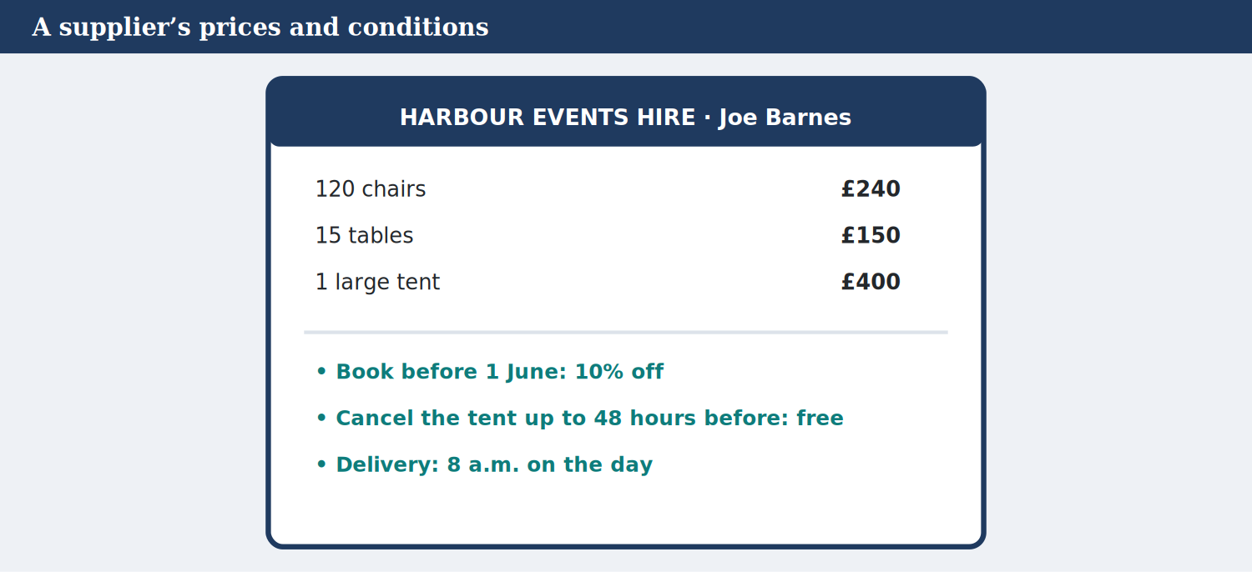
A supplier’s prices and conditions.

6C Choose the correct sentence.
0. (If I finish early, I’ll come. / If I’ll finish early, I come.) → If I finish early, I’ll come. (example)
1. (If it rains, we’ll stay inside. / If it will rain, we stay inside.)
2. (When I get home, I’ll call you. / When I will get home, I call you.)
3. (If you heat ice, it will melts. / If you heat ice, it melts.)
4. (She came for help us. / She came to help us.)
5. (It was late, so we took a taxi. / It was late, because we took a taxi.)
6. (If I’ll see her, I tell her. / If I see her, I’ll tell her.)
6D Write a short Plan B for an event at your school or work (35–45 words).
Model
Plan B for our sports day: If it rains, we’ll use the school hall. If the bus is late, we’ll start at eleven. If a teacher is ill, Mr Haddad will help. When it ends, we’ll clean up together.
Plan
1. The event.
2. Three problems with if.
3. When it ends …
Useful words: If it rains · If … is late · When it ends
Check before you finish
☐ Three first conditionals
☐ One when
☐ 35 words or more
PART 7 Study Skills

Exam strategy: remove the wrong options first; the exam: Reading Part 3 and Listening Part 2.
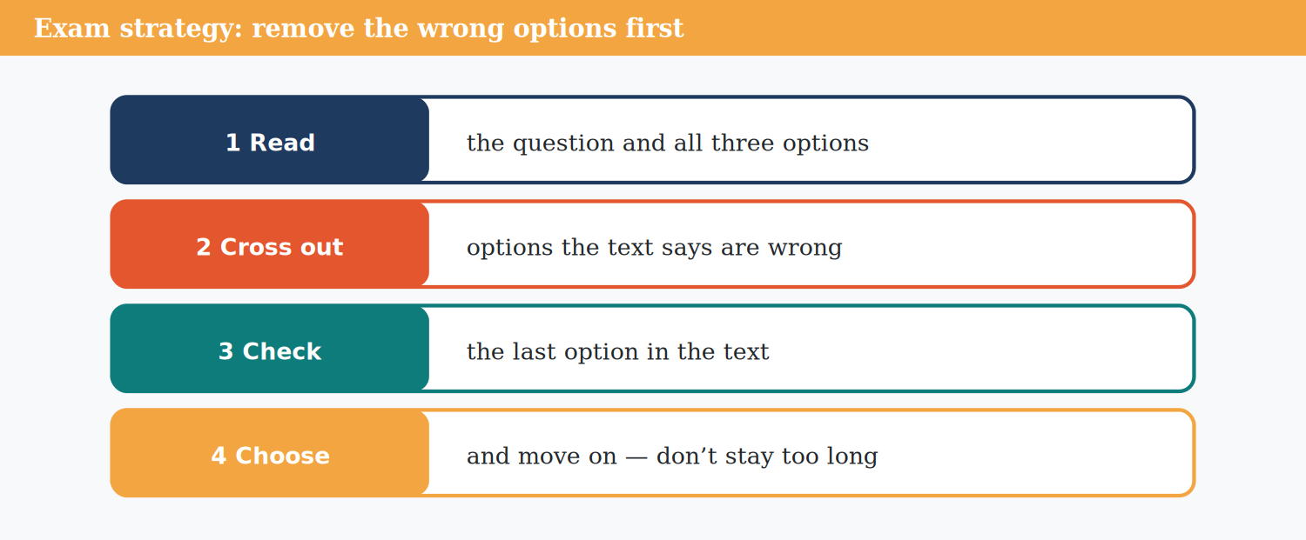
Exam strategy: remove the wrong options first.

Glossary
remove take away
7A Look at 5D again. For each question, say why the two wrong options are wrong.
Model
Question 1: Monday and Sunday are wrong — the alert says Wednesday 19 May.
7B Exam strategy. True or false? Write T or F.
0. Removing wrong options helps you choose. → T (example)
1. Choose the option with the same words as the text. ________
2. If an option is wrong, cross it out. ________
3. The first option is always right. ________
4. Spend ten minutes on one question. ________
5. Read all three options before you choose. ________
6. Check the last option in the text. ________
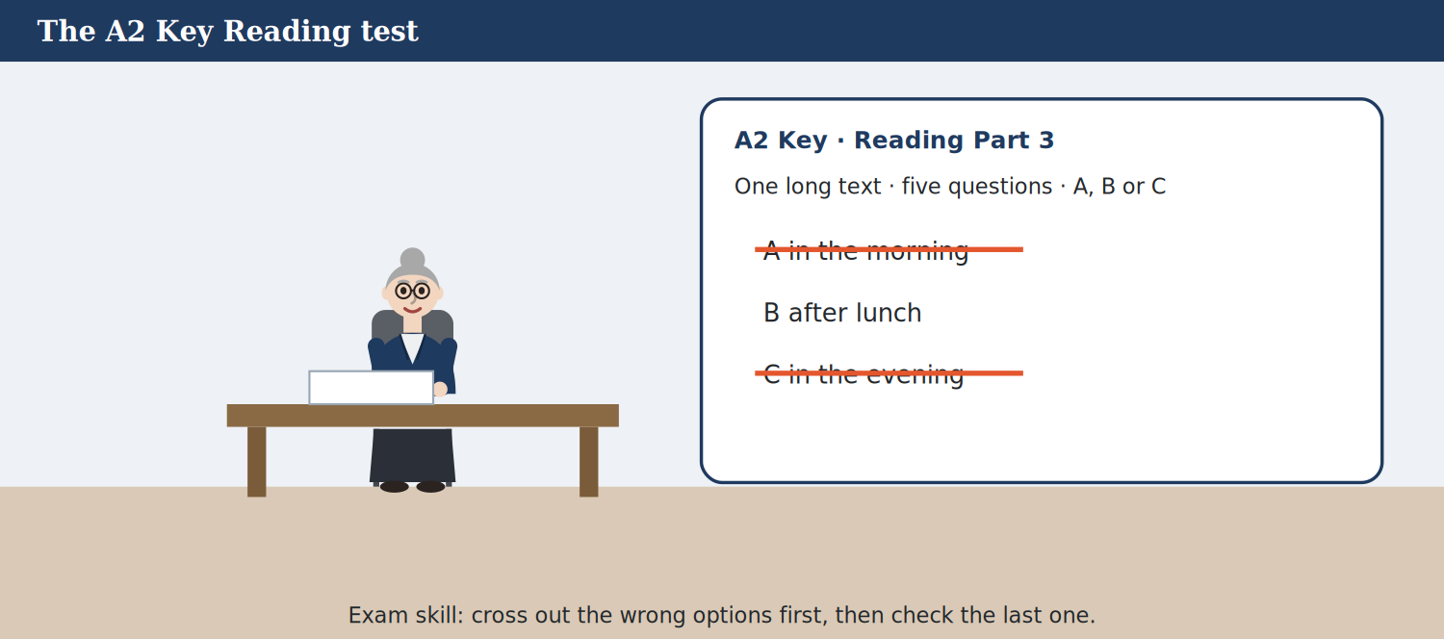
The A2 Key Reading test: Part 3.

Exam skill — A2 Key Reading Part 3 and Listening Part 2
Reading Part 3: one longer text and five questions (A, B or C). Find the part of the text for each question, cross out the wrong options, then choose. Listening Part 2: complete notes with a word or a number. Read the notes first and think: is it a time, a number or a place?
7C Put the steps of Listening Part 2 in order.
Number the lines. Line 1 is done for you.
a. ( ) Listen and write one word or a number.
b. ( ) Check your spelling.
c. ( ) Think: a time, a number or a place?
d. ( 1 ) Read the notes before you listen.
7D Write two tips for Listening Part 2.
Model
Tip 1: listen for numbers carefully — they may change! Tip 2: write the answer, not a word you hear first.
PART 8 Business Skills — Case Study

Plan B for the conference.
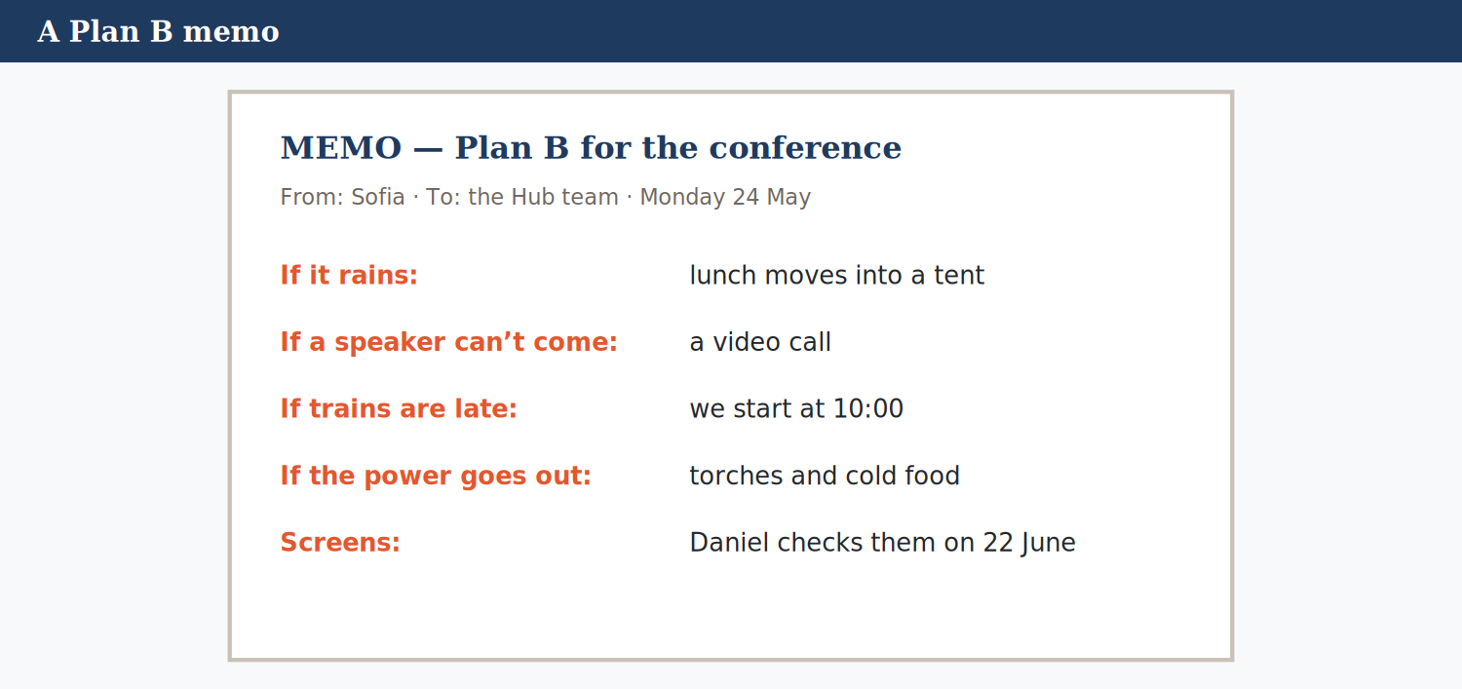
The Plan B memo.

8A Read Sofia’s memo. Choose the correct answer.
Before you read / listen: Look at the memo. What problems can happen at a big conference?
Glossary
memo a short note at work
away in the future: a month away = in one month
MEMO. To: the Hub team. From: Sofia. Date: Monday 24 May. Subject: Plan B for the conference on 24 June.
Hi everyone, the conference is a month away, so here’s our Plan B. Please read it and tell me if you have any questions.
If it rains: lunch is outside on the harbour side, but if the weather is bad, it will move into a tent. Harbour Events Hire will bring the tent at 8 a.m. If we don’t need it, we can cancel it up to 48 hours before, and we won’t pay.
If a speaker can’t come: they’ll give their talk by video call. Yusuf will help with this.
If trains are late: the first talk will start at 10:00, not 9:30. We’ll send a message to all the guests.
If the power goes out: we’ll use torches, and we’ll have cold drinks and sandwiches. We learned this at the open day!
Screens: Daniel will check all the screens on Tuesday 22 June. Thanks, Sofia
0. Daniel will check the screens on … (a) 22 June (example)
1. If the weather is bad, lunch will …
(a) be in the café (b) be cancelled (c) move into a tent
2. If a speaker can’t come, …
(a) Sofia will give the talk (b) they’ll talk by video call (c) the conference will stop
3. If trains are late, the first talk will start at …
(a) 9:30 (b) 11:00 (c) 10:00
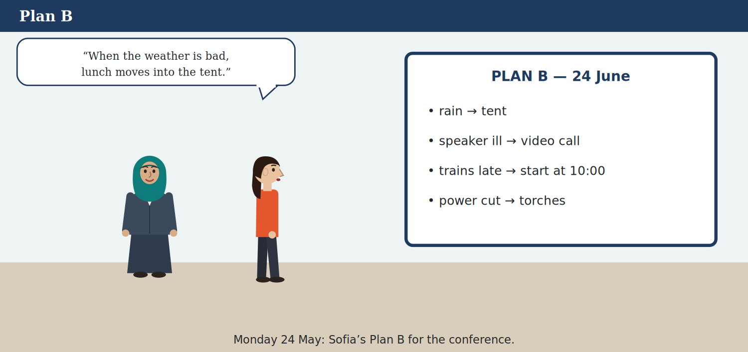
Plan B.

8B Words in the memo. Match the word (1–4) to the meaning (a–e).
0. torches → small lights (example)
Match | to
1. subject | a. people at the conference
2. guests | b. not in a building
3. learned | c. very small
4. outside | d. found out from experience
 | e. what the memo is about
One option is not needed.
8C Listen (Track 8.5). Complete Sofia’s notes.
Before you read / listen: Sofia calls Joe Barnes. What will she ask about?
Words: 790 · 10 · morning · 15
0. Cancel the tent ___ hours before: free (48) (example)
1. Chairs: 120. Tables: ____________________
2. Total price: £____________________
3. Discount: ____________________% if we book before 1 June
4. Delivery: 8 a.m. on the ____________________ of the conference
8D Condition or result? Put the parts in the table.
0. if trains are late → condition (example)
Words: lunch will be in a tent · we won’t pay for it · if we book before 1 June · we’ll get 10% off · if we cancel the tent 48 hours before · if it rains
CONDITION: ____________________ RESULT: ____________________
8E Discuss. What else could go wrong at the conference? What’s your Plan B? Say two things.
Model
If there aren’t enough chairs, people can stand at the back. If the coffee runs out, Tom’s café can help.
PART 9 Business Skills — In Action

Agree simple conditions with a supplier.
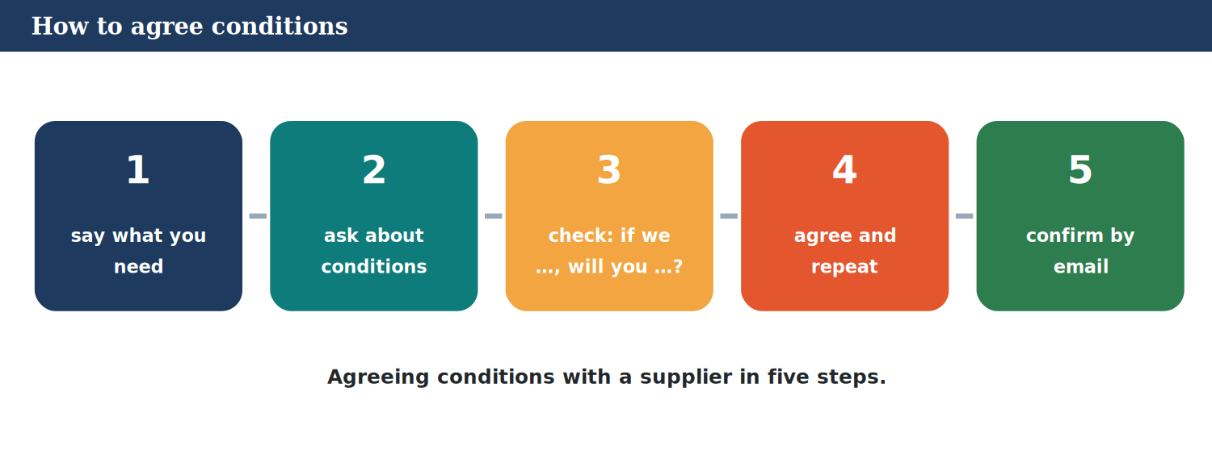
How to agree conditions.

9A Read the steps. Then put Sofia’s call in order.
Number the lines. Line 1 is done for you.
a. ( ) If you book before the first of June, we’ll give you ten per cent off.
b. ( ) So, a hundred and twenty chairs, with ten per cent off.
c. ( 1 ) We need chairs, tables and a tent.
d. ( ) Is there a discount if we book today?
9B Role-play: agree conditions with a supplier. Student A needs things for an event; Student B is the supplier.
Model
A: We need fifty chairs for Saturday. Is there a discount? B: If you book today, we’ll give you 5% off. A: And if it rains, can we cancel? B: If you cancel 24 hours before, you won’t pay.
Sentence starters
… We need … for …
… Is there a discount if …?
… What if …?
… So, … I’ll send you an email.
Check before you finish
☐ Ask about two conditions
☐ Repeat the agreement
☐ Polite
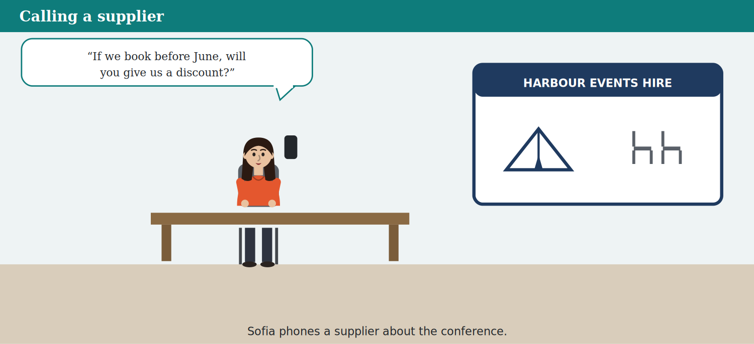
Calling a supplier.

9C Write an email to confirm the conditions (50–60 words).
Model
Dear Mr Barnes, thank you for your help today. To confirm: 120 chairs, 15 tables and one large tent for 24 June, with 10% off. If we don’t need the tent, we’ll cancel it 48 hours before. Please deliver everything at 8 a.m. Best wishes, Sofia
Sentence starters
… Dear …, thank you for …
… To confirm: …
… If …, we’ll …
… Please … Best wishes, …
Check before you finish
☐ All the numbers
☐ One first conditional
☐ 50 words or more
9D A good call with a supplier? Choose the better sentence.
0. (Hello, is that Joe Barnes? / Who are you?) → Hello, is that Joe Barnes? (example)
1. (Is there a discount if we book today? / Give me a discount.)
2. (What if it rains? / Rain is your problem.)
3. (OK, whatever. / So, to confirm: 120 chairs.)
4. (I’ll send you an email today. / Maybe I’ll write.)
5. (Stop talking. / Sorry to interrupt, but can I ask something?)
6. (Bye. / Thanks for your help.)
PART 10 Review & Can-Do

Check what you know — and remember Units 1–7.
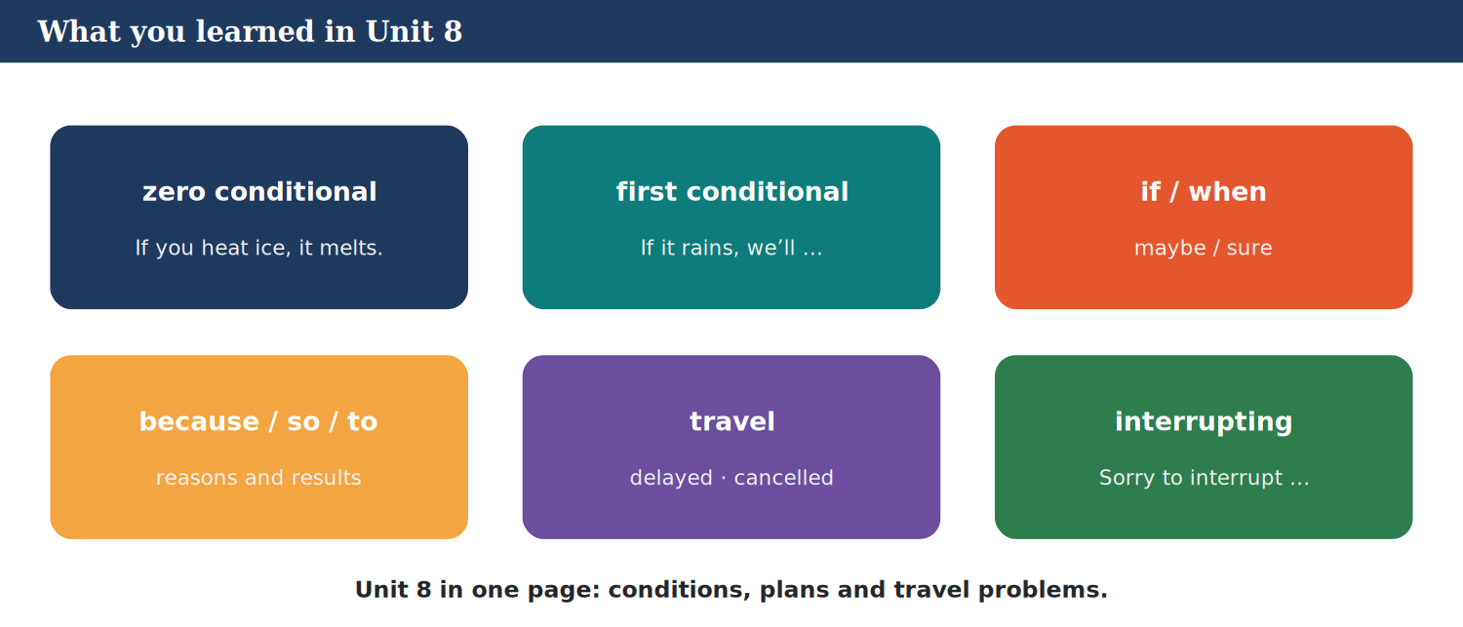
What you learned in Unit 8.

10A Vocabulary. Complete with a word from the box.
Words: warning · likely · cancelled · interrupt · supplier · delayed
0. Check the train ___ online. (timetable) (example)
1. The train is ____________________. It’s late.
2. My bus was ____________________.
3. There’s a weather ____________________.
4. Our ____________________ brings the tent.
5. It’s ____________________ to rain.
6. Sorry to ____________________, but …
10B Grammar. Choose the correct word.
0. She went out (to / for) buy bread. → to (example)
1. If it (will rain / rains), we’ll stay in.
2. If you heat ice, it (melts / will melts).
3. I’ll call you (if / when) I arrive. (sure)
4. Unit 7: I’m sure you (are / ’ll) love it.
5. Unit 6: I was cooking (when / while) you called.
6. Unit 5: You (should / may) rest. (advice)
Remember: the first conditional.

10C Grammar review (and Units 1–7). Choose the correct answer.
0. If the bus is late, I … walk. (a) ’ll (example)
1. If I … time, I’ll help you.
(a) will have (b) have (c) had
2. Unit 7: … I open the window?
(a) Shall (b) Will (c) Do
3. Unit 6: What … you doing at two?
(a) did (b) were (c) was
10D Odd one out. Which word is different?
0. wind · storm · warning · chairs → chairs (example)
1. cancelled · delayed · on time · umbrella
2. timetable · departures · platform · tent
3. if · when · because · kettle
4. possible · impossible · likely · receipt
10E Match the sentence (1–4) to the answer (a–e).
0. The train’s cancelled! → I’ll take the next one. (example)
Match | to
1. What will you do if it rains? | a. Yes, if you book today.
2. Is there a discount? | b. No, it’s very unlikely.
3. Sorry to interrupt, but … | c. I’ll stay at home.
4. Is it likely to snow? | d. At 8 a.m.
 | e. Sure, go on.
One option is not needed.
10F Write three sentences: a fact with if, a plan with if, and a reason with because.
Model
If I don’t sleep, I feel tired. If I pass my exam, I’ll have a party. I’m learning English because I want to travel.
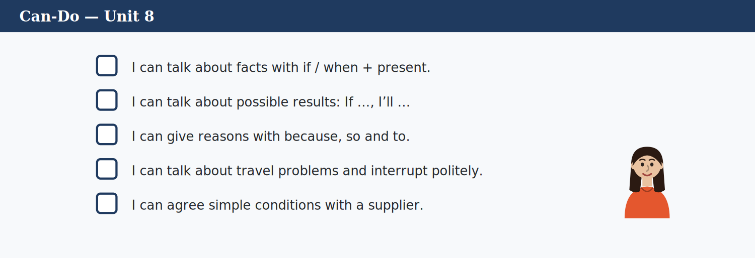
Can-Do — Unit 8.

Can-Do — tick what you can do now
☐ I can talk about facts with if / when + present.
☐ I can talk about possible results: If …, I’ll …
☐ I can give reasons with because, so and to.
☐ I can talk about travel problems and interrupt politely.
☐ I can agree simple conditions with a supplier.
Glossary — 12 key words
Travel problems — revise the words.

Word | Meaning
delayed | late
cancelled | it won’t go
platform | where you get on the train
timetable | times of trains and buses
warning | information about a danger
supplier | a company: it sells things to you
condition | what must happen first
likely | probably will happen
impossible | it can’t happen
interrupt | speak when someone is talking
if | maybe
when | we’re sure

