

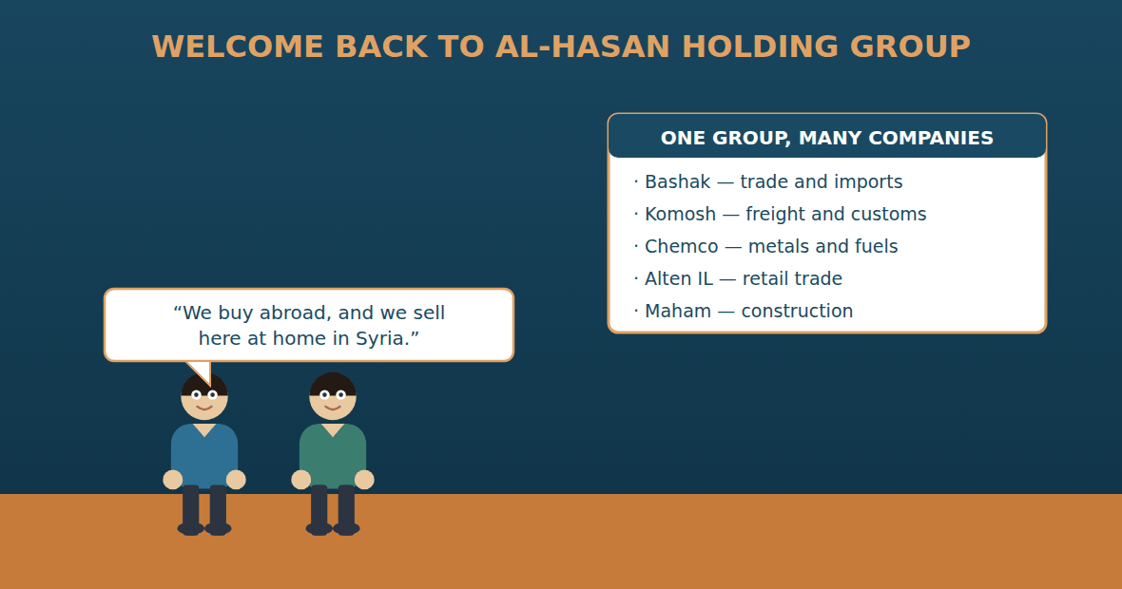
Unit 1: The Group and Its Companies
Al-Hasan International — English for Trade, Industry & Global Partnerships
CEFR B1 · Grammar: present perfect (for / since · already / yet / just · ever / never) vs past simple · Function: Trade + Admin
Can-Do (by the end of this unit)
- I can say what my company has done this year
- I can say what we buy and what we sell
- I can explain which company in the Group does what
- I can write a short year-in-review email
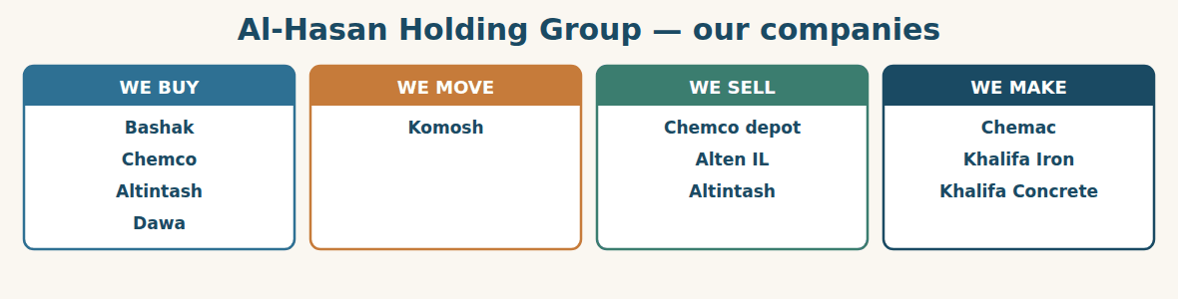
Figure · The companies inside the Group, and what each one does.
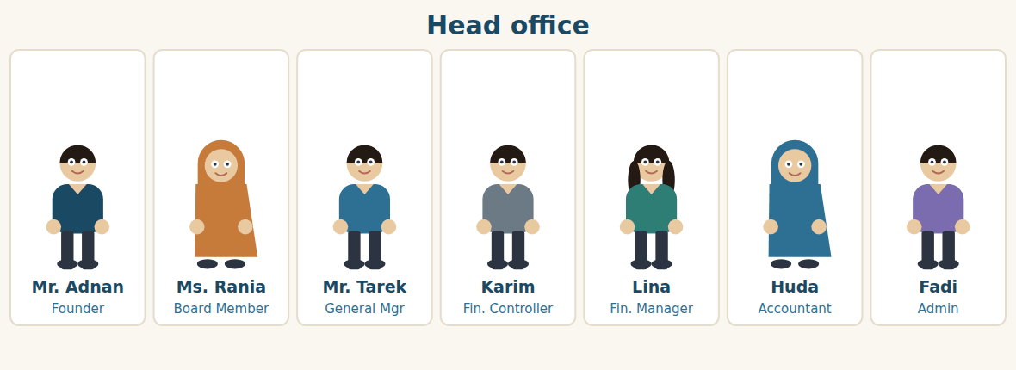
Figure · The seven people at head office in Damascus.
Warm Up TRADE
Look at the pictures. Answer these questions before you read.
1. What does your company buy? What does it sell?
2. Does your company buy from other countries? Which ones?
3. How long have you worked there?
Read
It is one year since Ms. Chen first came to Damascus. On that day, NorthBridge Industrial Trading bought cement from Al-Hasan. Today the two companies still work together, but something has changed.
Al-Hasan Holding Group has grown. The Group still makes things: Chemac makes cement in Aleppo, and the two Khalifa factories make iron and concrete. But today the Group buys much more than it makes. It buys from suppliers abroad, and it sells inside Syria. This is the big change of the year.
Twelve companies work inside the Group. Bashak buys. It is the import company, and Rami is the Import Manager. Komosh moves the goods: it arranges the ship, and it clears the goods at customs. Chemco sells metals and fuels to builders and factories. Alten IL sells in shops to ordinary people. Altintash sells fodder to farmers. Maham builds, and it buys from the Group too.
Today is the annual review. Mr. Adnan, the Founder, wants to know one thing: what has the Group done this year? Rami speaks first. “We have imported steel, fuel and machines,” he says. “We have opened two new supplier accounts since March, and we have already placed eleven orders this year.” Mr. Tarek asks, “Have we had any late shipments?” “Two,” says Rami. “Both arrived in the end.”
Then Lina speaks about the Syrian side. “We have sold more than last year,” she says. “The depot has sold 9,000 tonnes of steel. Alten IL has opened a third shop. Altintash has not reached its target yet, but it is close.”
At the end, Karim reads an email. It is from Ms. Chen. NorthBridge wants to sell machines to Al-Hasan — not only buy cement from it. “So now they are our customer and our supplier,” says Mr. Adnan. He smiles. “Good. That is how a group grows.”
A. Comprehension. Answer in your own words. (0 is done for you.)
0. How long is it since Ms. Chen first came to Damascus? (one year)
1. What is the big change of the year?
2. Which company buys for the Group, and who manages it?
3. What does Komosh do? Give two things.
4. Name two companies that sell inside Syria, and say who they sell to.
5. What has Rami done since March?
6. Why does Mr. Adnan smile at the end?
B. True or False? Write T or F. (0 is done for you.)
0. Al-Hasan makes everything it sells. (F)
1. The Group buys more than it makes. ____
2. Bashak is the import company. ____
3. Komosh sells fodder to farmers. ____
4. Alten IL has opened a third shop. ____
5. Altintash has reached its target. ____
6. NorthBridge now wants to sell to Al-Hasan. ____
C. Find the words. Find a word or phrase in the text that means: (0 is done for you.)
0. a company inside a bigger group → (a subsidiary / a company inside the Group)
1. to bring goods into a country → to i____________
2. the place where we keep our stock → the d____________
3. in another country → a____________
4. the number we want to reach → the t____________
D. Over to you. Answer about yourself.
1. What has your company done this year? Say one thing.
2. Does your company buy from abroad, sell at home, or both?
3. How long have you worked in your job?
Part 1 · Vocabulary and Terminology TRADE
Buying and selling
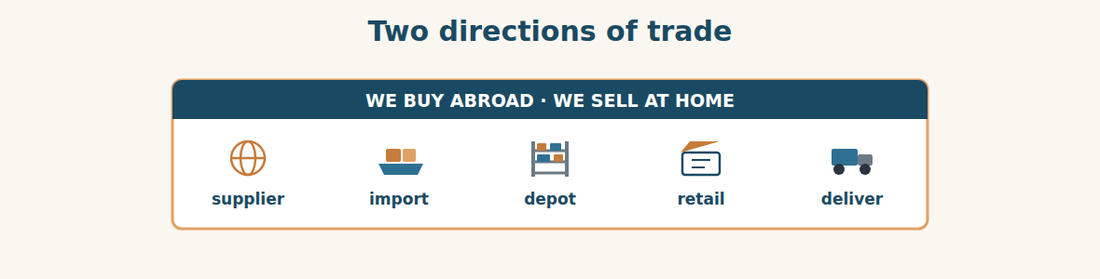
Figure · Goods come in from abroad, and go out to Syrian customers.
A. Match each word (1–7) with its meaning (a–h). There is one you do not need. (0 is done for you.)
0. import (c)
1. export ____ a. a company that sells to us
2. supplier ____ b. a person or company that buys from us
3. customer ____ c. to bring goods into a country
4. wholesale ____ d. selling in small amounts, in a shop
5. retail ____ e. a building where we keep goods
6. depot ____ f. to send goods out of a country
7. subsidiary ____ g. selling in large amounts, to other businesses
8. h. a company inside a bigger group
B. Complete the sentences with the words in the word bank.
Word bank: import | supplier | customer | depot | retail | subsidiary
1. Bashak is the ____________ that buys for the whole Group.
2. We ____________ steel and fuel from three countries.
3. Westgate Metals is a new ____________ of ours.
4. Maham is a ____________ of Al-Hasan, and it is also our ____________.
5. We keep 4,000 tonnes of steel in the ____________ outside Damascus.
6. Alten IL is a ____________ business: it sells to ordinary people.
Who does what in the Group
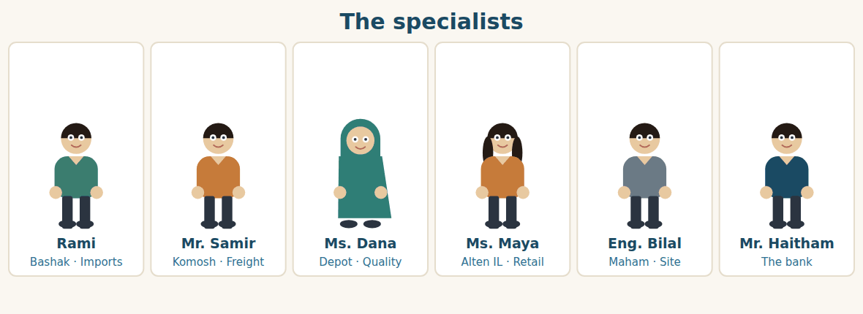
Figure · Six people, six companies — and two very different jobs.
C. Match the person (1–6) with what they do (a–f).
1. Rami ____ a. clears the goods at customs and books the trucks
2. Mr. Samir ____ b. serves customers in the shop
3. Ms. Dana ____ c. buys from suppliers abroad
4. Ms. Maya ____ d. buys steel for a building site
5. Eng. Bilal ____ e. handles the money at the bank
6. Mr. Haitham ____ f. checks the goods when they arrive at the depot
Saying how long
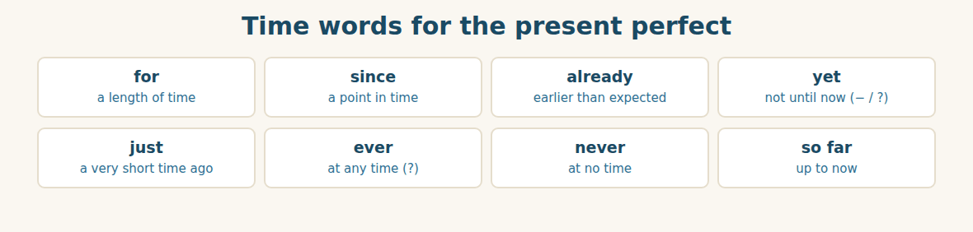
Figure · The words that go with the present perfect.
D. Odd one out. Which word is different? Circle it.
1. supplier · customer · depot · partner
2. import · buy · order · sell
3. depot · warehouse · shop · Tuesday
4. for · since · already · Damascus
5. Bashak · Komosh · Chemco · Lattakia
E. Choose the best answer.
1. A company that sells to us is a… (a) supplier (b) customer
2. Selling in large amounts to other businesses is… (a) retail (b) wholesale
3. A company inside a bigger group is a… (a) subsidiary (b) branch
4. Money we make above the cost is the… (a) margin (b) market
F. Classify. Write each company in the correct column.
Companies: Bashak | Komosh | Alten IL | Chemac | Chemco depot | Khalifa Iron
We buy | We move | We sell or make
__________ | __________ | __________
__________ | __________ | __________
__________ | __________ | __________
G. Match the two halves (1–6 with a–f).
1. a new ____ a. office
2. the head ____ b. clearance
3. customs ____ c. supplier
4. product ____ d. group
5. a holding ____ e. line
6. the annual ____ f. review
H. Complete the paragraph with the words in the box.
Box: abroad | depot | Group | imports | sells | subsidiaries
Al-Hasan is a holding (1)____________ with twelve (2)____________. Bashak (3)____________ steel and fuel from (4)____________. Komosh brings the goods to the (5)____________ outside Damascus. Then Chemco (6)____________ the steel to builders inside Syria.
Part 2 · Grammar — present perfect vs past simple TRADE
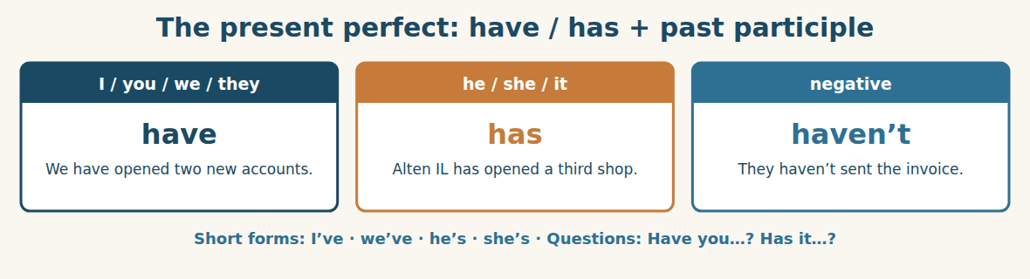
Figure · The present perfect — we use it for the past inside the present.
We use the PRESENT PERFECT for a past action when we do not say exactly when it happened, or when the action is still true now. We make it with have / has and the past participle: We have imported steel. She has sold the stock.
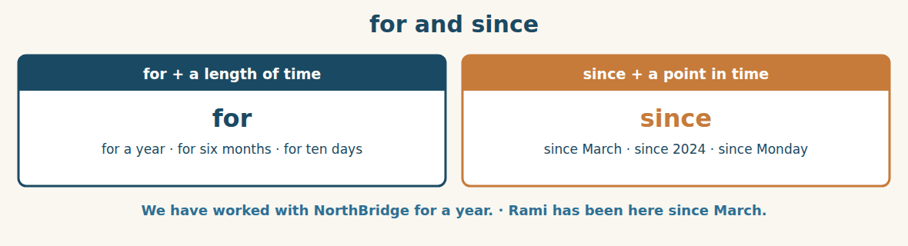
Figure · for a length of time, since a point in time.
We use FOR with a length of time, and SINCE with a point in time. We have known NorthBridge for one year. We have known them since last April. Both sentences mean the same thing, but the time word is different.
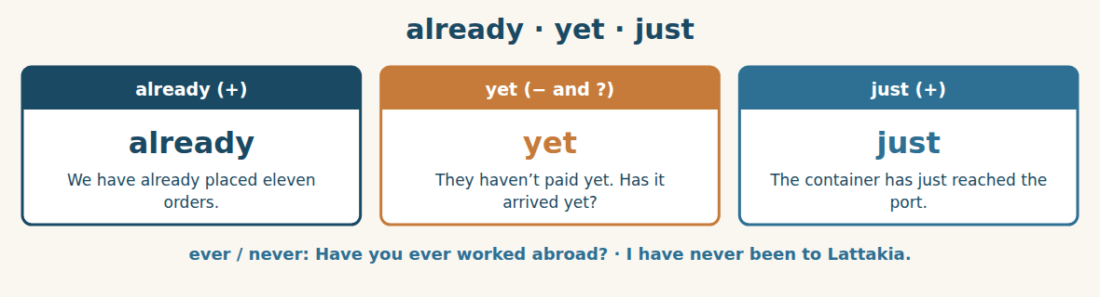
Figure · The small words that live with the present perfect.
ALREADY means earlier than we expected, and it goes before the main verb. YET means not until now; it goes at the end, and we use it in negatives and questions. JUST means a very short time ago. We also use EVER in questions and NEVER in negatives.
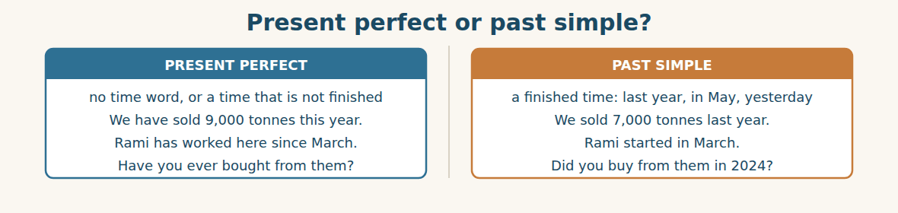
Figure · The same facts, told two ways — the time word decides.
Use the PAST SIMPLE when the time is finished: last year, in May, two days ago, when she visited. Use the PRESENT PERFECT when the time is not finished, or when you give no time at all: this year, this month, today, so far.
Watch out! Never use the present perfect with a finished time. Not: We have sold it last year. Say: We sold it last year. And after a question with When…?, always use the past simple: When did the ship arrive? (not When has the ship arrived?)
Form
present perfect: have / has + past participle · past simple: verb + -ed, or the irregular form · for + length · since + point
A. Complete with HAVE or HAS. (0 is done for you.)
0. We have opened two new accounts.
1. Rami ____________ placed eleven orders this year.
2. The factories ____________ worked all month.
3. Alten IL ____________ opened a third shop.
4. I ____________ never visited that supplier.
5. Our customers ____________ paid on time.
B. Write the past participle.
1. buy → ____________
2. send → ____________
3. pay → ____________
4. sell → ____________
5. make → ____________
6. take → ____________
C. Complete with FOR or SINCE.
1. We have worked with NorthBridge ____________ one year.
2. Rami has managed the import desk ____________ March.
3. The depot has been full ____________ three weeks.
4. We haven’t bought fuel from them ____________ 2024.
D. Complete with ALREADY, YET or JUST.
1. Good news — the ship has ____________ reached Lattakia. (one minute ago)
2. We have ____________ paid the deposit, so we can order now.
3. They haven’t sent the packing list ____________.
4. Has the container cleared customs ____________?
E. Present perfect or past simple? Choose the correct form. (0 is done for you.)
0. We (sell / have sold) 7,000 tonnes last year. (sold)
1. We ____________ (sell) 9,000 tonnes so far this year.
2. Ms. Chen ____________ (visit) Damascus in April 2024.
3. Rami ____________ (work) here since March.
4. The ship ____________ (arrive) two days ago.
5. I ____________ (not / see) the new price list yet.
F. Make questions with HAVE / HAS.
1. (?) you / ever / buy / from Westgate → ____________
2. (?) the goods / arrive / yet → ____________
3. (?) how long / she / work / in the depot → ____________
4. (?) we / pay / the invoice → ____________
G. Find and correct the mistake in each sentence. (0 is done for you.)
0. We have sold it last year. → (We sold it last year.)
1. He has been here since three months. → ____________
2. Have you saw the report? → ____________
3. They have already not paid. → ____________
4. When have you ordered it? → ____________
H. About you. Write two sentences: one with “I have…” and one with “I worked…”.
1. ______________________________________________
2. ______________________________________________
I. Complete with the present perfect.
1. The Group ____________ (grow) a lot this year.
2. We ____________ (not / reach) our target yet.
3. Komosh ____________ (clear) every container so far.
4. Our suppliers ____________ (send) all the documents.
5. She ____________ (never / work) in logistics.
J. Rewrite in the past simple, using the time in brackets.
1. We have opened two new accounts. (in March) → ____________
2. Alten IL has opened a third shop. (last month) → ____________
3. Rami has placed eleven orders. (in 2025) → ____________
4. The ship has arrived. (on Tuesday) → ____________
Part 3 · Listening and Dialogue TRADE
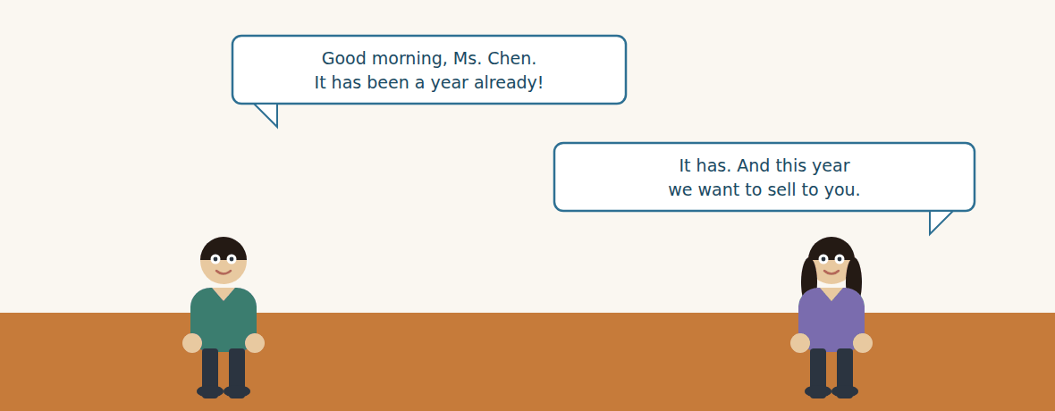
Figure · Strand A · Rami takes a call from a supplier abroad.
Dialogue 1 — A year of business (the import desk)
Listen and read. (Your teacher will read the dialogue, or play the audio.)
Rami: Good morning, Ms. Chen. Rami here, from Bashak. It has been a year already!
Ms. Chen: Good morning, Rami. Yes — a whole year since my first visit to Damascus.
Rami: A good year. We have placed eleven orders with your group since January.
Ms. Chen: Eleven? I have only counted nine. Let me check my file.
Rami: Nine are shipped. Two are still open — we haven’t received them yet.
Ms. Chen: Ah, I see them now. Rami, I have some news. NorthBridge has opened a machines division.
Rami: Machines? So you would like to sell to us, not only buy from us.
Ms. Chen: Exactly. Have you ever imported packing machines?
Rami: Never. But Chemac has asked for two, so your timing is good.
Ms. Chen: Then I will send the catalogue today. Thank you, Rami.
A. Comprehension. Answer in your own words. (0 is done for you.)
0. Who is calling, and from which company? (Rami, from Bashak)
1. How long is it since Ms. Chen’s first visit?
2. How many orders have been shipped, and how many are still open?
3. What is NorthBridge’s news?
4. Has Bashak ever imported packing machines?
5. Why is Ms. Chen’s timing good?
B. True or False? Write T or F.
1. Rami and Ms. Chen disagree about the number of orders. ____
2. Two orders have not arrived yet. ____
3. NorthBridge only buys; it never sells. ____
4. Chemac has asked for two packing machines. ____
5. Ms. Chen will send a price list today. ____
C. Language focus. Find in the dialogue: (0 is done for you.)
0. a sentence with “since” → (a whole year since my first visit)
1. a sentence with “yet” → ____________
2. a question with “ever” → ____________
3. an answer with “never” → ____________
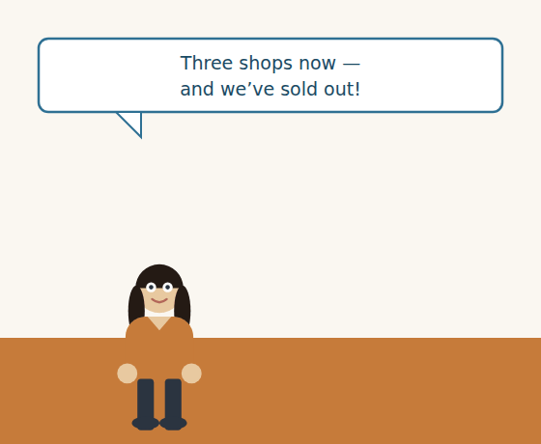
Figure · Strand B · Ms. Maya reports from the shop floor.
Dialogue 2 — The shops (the Syrian market)
Karim: Maya, I need your numbers for the annual review. How has the third shop done?
Ms. Maya: Very well. We opened it in May, and it has already paid for itself.
Karim: That is fast. And the cement bags?
Ms. Maya: We have sold out twice this month. Twice, Karim! People queue outside.
Karim: Then the depot must send you more. Have you written to Ms. Dana?
Ms. Maya: I have written three times. She hasn’t answered yet.
Karim: Leave it with me. I’ll speak to her this afternoon.
Ms. Maya: Thank you. One more thing — customers keep asking for fodder.
A. Comprehension. Answer in your own words.
1. What does Karim need from Ms. Maya, and why?
2. When did the third shop open, and how has it done?
3. What has happened twice this month?
4. Who has Ms. Maya written to, and what has happened?
B. Listen again and choose the best answer (A–D).
1. The third shop opened in… A) March B) May C) July D) last year
2. The shop has sold out of cement… A) once B) twice C) never D) every day
3. Ms. Dana works at the… A) bank B) port C) depot D) factory
4. Customers keep asking for… A) steel B) fuel C) fodder D) machines
Part 4 · Speaking and Your Role TRADE
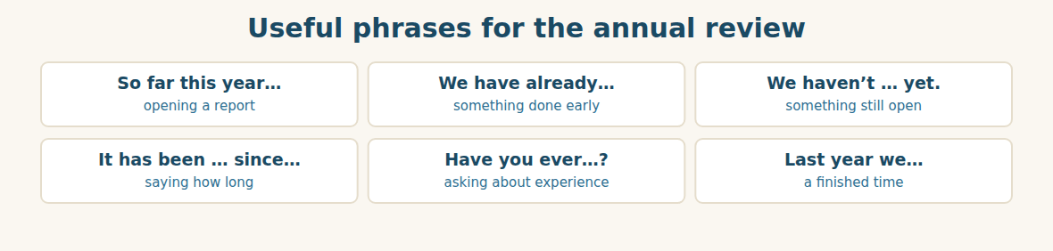
Figure · Phrases for saying what has happened, and when.
A. Role-play: the annual review. Student A is Mr. Adnan and asks the questions. Student B reports on the year. Then change roles.
1. A: Ask what the company has done this year.
2. B: Give two things, using “We have…”.
3. A: Ask how long B has worked there.
4. B: Answer with “for” or “since”.
5. A: Ask about something that is not finished.
6. B: Answer with “… haven’t … yet”.
B. Your Role. Report on your year from YOUR job. Use the phrases below. (Choose your real role.)
1. [Trade] Import Manager: “We have opened two new supplier accounts since March.”
2. [Trade] Sales: “We have sold 9,000 tonnes so far this year.”
3. [Finance] Financial Controller: “We have collected 92% of our invoices.”
4. [Finance] Accountant: “I have checked every invoice this month.”
5. [Logistics] Freight: “We have cleared forty containers, and lost none.”
6. [Admin] Assistant: “I have filed all the documents, but two are missing.”
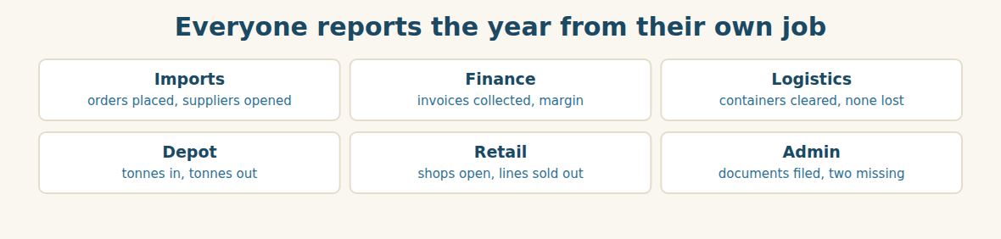
Figure · The same year, six different reports.
C. Ask your partner. Walk around and ask three people.
1. How long have you worked here?
2. What have you done this week?
3. Have you ever worked with a company from another country?
D. Discuss. Ask and answer.
1. Is it better for a group to buy or to make? Why?
2. What has changed in your work in the last year?
Part 5 · Extended Reading TRADE
Why a trading group owns its own trucks
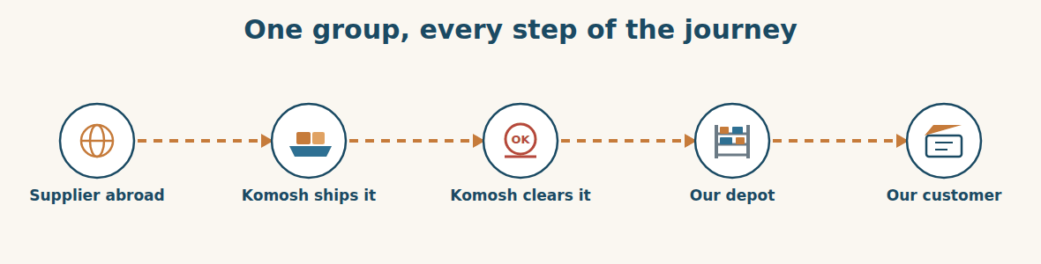
Figure · Each step belongs to a company inside the Group.
Many trading companies do one thing: they buy goods and they sell them. They pay other companies to move the goods, to store them, and to deliver them. This is simple, but it is not always safe. If the transport company is slow, the trader can do nothing. If the warehouse is full, the goods wait outside.
Al-Hasan has chosen a different road. The Group owns every step of the journey. Bashak finds the supplier and places the order. Komosh books the ship, and Komosh clears the goods at customs. Komosh also owns the trucks that carry the goods to the depot. Then Chemco sells the goods to builders, and Alten IL sells them in shops.
Why does this matter? Three reasons. First, speed. When a container lands at Lattakia, nobody has to telephone a stranger. Komosh is already there, and the driver already has the paper. Second, information. Rami can tell a customer exactly where the goods are, because the trucks belong to his own group. Third, money. The Group pays itself for the transport, so the money stays inside the family of companies.
There is also a cost. Trucks are expensive. A warehouse is expensive. A company that owns everything must pay for everything, even in a quiet month. A trader who rents pays only when it needs to. So the Group has made a choice: it pays more in the quiet months, and it wins in the busy ones.
Mr. Adnan explains it in one sentence. “A ship is late for everybody,” he says. “But if the truck is mine, the truck is never late.” This year, that choice has worked. Komosh has cleared more than forty containers, and the Group has not lost a single one. For a business that buys abroad and sells at home, that is the whole game.
A. Comprehension. Answer in your own words. (0 is done for you.)
0. What do many trading companies pay other companies to do? (move, store and deliver the goods)
1. Which company in the Group books the ship and clears customs?
2. What are the three reasons for owning every step? Name two.
3. Why can Rami tell a customer where the goods are?
4. What is the cost of owning everything?
5. What does Mr. Adnan mean by “if the truck is mine, the truck is never late”?
B. Choose the best answer (A–D).
1. A trader who rents transport pays… A) always B) never C) only when needed D) once a year
2. Komosh owns the… A) shops B) trucks C) factories D) bank
3. The Group has cleared more than … containers. A) four B) fourteen C) forty D) four hundred
4. The Group has lost … A) many containers B) two C) one D) none
5. The writer thinks the choice has… A) failed B) worked C) cost too much D) ended
C. Find a word or phrase in the text that means:
1. to keep goods in a building → to s____________
2. to take goods through the customs office → to c____________ them
3. a month with little business → a q____________ month
4. not one → not a s____________ one
D. Complete the summary with ONE word in each gap.
Al-Hasan (1)____________ every step of the journey. Bashak (2)____________ the order, Komosh moves and (3)____________ the goods, and Chemco and Alten IL (4)____________ them. This is faster, and the money stays inside the (5)____________. But trucks and warehouses are (6)____________, even in a quiet month.
E. Discuss. Talk in pairs.
1. Does your company own its transport, or rent it? Which is better for you?
2. What else could a group own, to be safer?
F. True or False? (about the reading). Write T, F or NOT GIVEN.
1. Renting transport is always cheaper than owning it. ____
2. Komosh works at Lattakia. ____
3. Komosh has fifty trucks. ____
4. The Group has lost no containers this year. ____
Part 6 · Writing (a real email) ADMIN
Model — A year-in-review email to a supplier
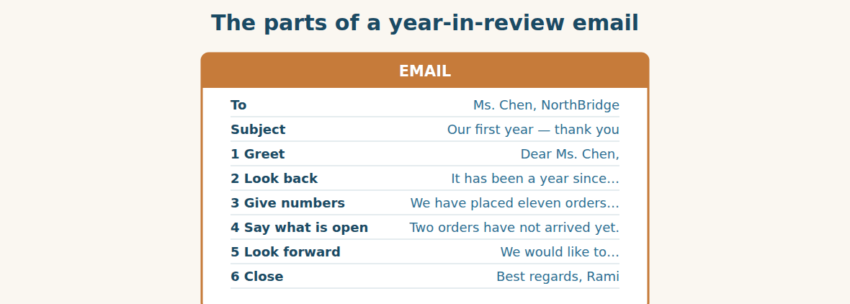
Figure · Six short moves, in this order.
Subject: Our first year — thank you. Dear Ms. Chen, It has been a year since your first visit to Damascus, and I would like to thank you. We have placed eleven orders with your group since January, and nine have arrived in good condition. Two orders have not reached us yet, and I will send you the numbers separately. We have also read your news about the machines division with great interest. Chemac has asked us for two packing machines, so your catalogue has come at the right time. Thank you again for a good first year. Best regards, Rami Import Manager, Bashak Co.
A. Answer about the email. (0 is done for you.)
0. Who is the email to? (Ms. Chen, at NorthBridge)
1. How many orders have been placed, and how many have arrived?
2. What has not happened yet?
3. Why has the catalogue come at the right time?
B. Put the email in order (1–6).
1. ( ) Best regards, Rami
2. ( ) Dear Ms. Chen,
3. ( ) It has been a year since your first visit.
4. ( ) Two orders have not reached us yet.
5. ( ) We have placed eleven orders since January.
6. ( ) Chemac has asked us for two packing machines.
Guided writing
C. Now you write. Write a year-in-review email (70–100 words) to a supplier or a customer. Use the present perfect at least three times, and the past simple once.
Plan: 1) “Dear …,” 2) “It has been … since …” 3) “We have …” (a number) 4) “We haven’t … yet.” 5) “Next year we would like to …” 6) “Best regards, …”
Sentence starters: “It has been a year since…” · “So far we have…” · “We have already…” · “We haven’t … yet.” · “Last year we…”
______________________________________________
______________________________________________
______________________________________________
______________________________________________
______________________________________________
D. Checklist. Tick each one when you have checked your email.
- I used the present perfect at least three times.
- I gave at least one number.
- I said one thing that is not finished, using “yet”.
- I used “for” or “since” correctly.
- I wrote “Best regards, …” and my job title at the end.
Part 7 · Trade-Skills Track ADMIN
Reading a group structure: who buys, who moves, who sells
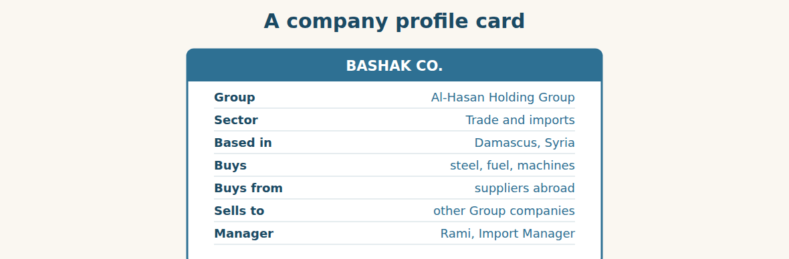
Figure · One card for each company: what it does, and who it deals with.
A holding group can be confusing. Twelve companies, twelve managers, twelve telephone numbers. New staff waste days asking the wrong person. The cure is simple: learn the direction of each company. Does it buy, does it move, does it sell, or does it make?
At Al-Hasan, four companies buy. Bashak imports steel, fuel and machines. Chemco buys metals and fuels. Altintash buys poultry, livestock and fodder. Dawa buys medical equipment. One company moves: Komosh books the ships, clears customs, and drives the trucks. Three companies sell inside Syria: the Chemco depot sells wholesale to builders, Alten IL sells retail in shops, and Altintash sells to farmers. And three factories make: Chemac makes cement, and the two Khalifa factories make iron and concrete.
Once you know the direction, you know who to ask. A question about a ship goes to Komosh. A question about a shop goes to Alten IL. A question about a price abroad goes to Bashak. A good employee does not know everything — a good employee knows which door to knock on.
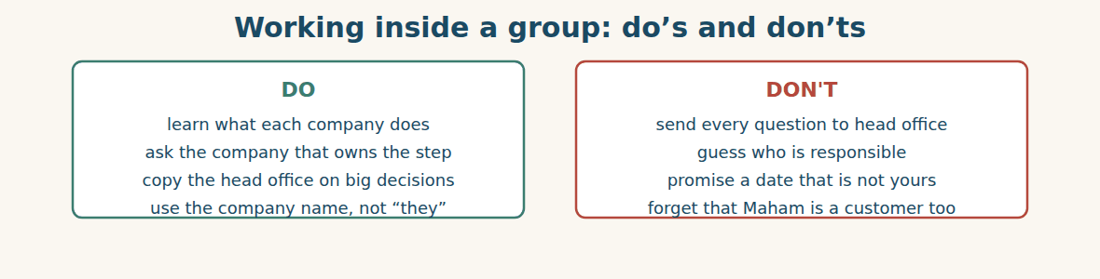
Figure · Knowing who does what saves days.
A. Comprehension. Answer in your own words.
1. What are the four directions a company in the Group can have?
2. Which company moves the goods, and what three things does it do?
3. Which two companies sell to people rather than to businesses?
4. Who do you ask about a ship? Who do you ask about a shop?
5. What does “a good employee knows which door to knock on” mean?
B. Listen and complete. A manager explains the Group. Write the missing word.
1. Manager: Bashak imports steel, fuel and ____________.
2. Manager: Komosh books the ships and clears ____________.
3. Manager: Alten IL sells ____________ in shops.
4. Manager: Chemac makes ____________ in Aleppo.
C. Practice. Draw a profile card for YOUR company or team. Use the headings on the card above. Then tell your partner what your company buys and what it sells.
D. Who do you ask? Answer with a company name.
1. A container is sitting at customs. → ____________
2. A shop has run out of cement. → ____________
3. A supplier abroad has raised its price. → ____________
4. A building site needs 200 tonnes of steel. → ____________
Part 8 · Consolidation TRADE
Two reports, one group
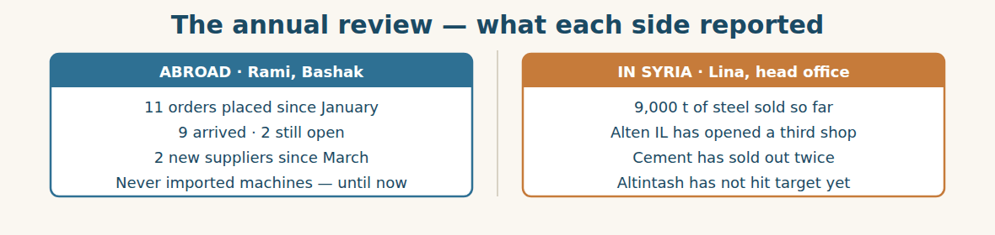
Figure · The two strands of one year, side by side.
The review ends at four o’clock. Mr. Adnan looks at the two lists on the wall. On the left is what the Group has bought. On the right is what it has sold. For a moment nobody speaks.
“They do not match,” says Mr. Tarek at last. “We have brought in more steel than we have sold. The depot is full.” “And the shops are empty,” says Karim. “Maya has sold out of cement twice this month, and she has written to the depot three times. Nobody has answered her.”
Mr. Adnan nods slowly. This is the real lesson of the year. The Group has done two things well and one thing badly. It has bought well: eleven orders, two new suppliers, no lost containers. It has sold well: more tonnes than last year, and a new shop. But the two sides have not talked to each other. Steel has waited in a depot while cement has run out in a shop forty kilometres away.
“Next year,” says Mr. Adnan, “Rami and Maya meet every month. Not me. Them.” He stands up. “We have been a good buyer and a good seller. We have not yet been one company. That is the work for next year.”
A. Comprehension. Answer in your own words. (0 is done.)
0. What are the two lists on the wall? (what the Group has bought, and what it has sold)
1. What is the problem with the depot and the shops?
2. How many times has Maya written to the depot, and what has happened?
3. What two things has the Group done well?
4. What has the Group not done well?
5. What will change next year?
B. Complete each sentence with ONE word from the text. (0 is done for you.)
0. The review ends at four o’clock.
1. The Group has brought in more steel than it has ____________.
2. The ____________ is full, but the shops are empty.
3. Nobody has ____________ Maya’s messages.
4. Next year, Rami and Maya will ____________ every month.
5. The Group has not yet been one ____________.
C. Discuss. Talk in pairs.
1. Why do the buying side and the selling side need to talk?
2. Has this ever happened in your company? What did you do?
D. Find a word from the text that means: (0 is done for you.)
0. to be the same as each other → (to match)
1. to have none left → to run o____________
2. to move the head up and down → to n____________
3. the thing we learn → the l____________
Part 9 · Case Studies and Decisions ADMIN
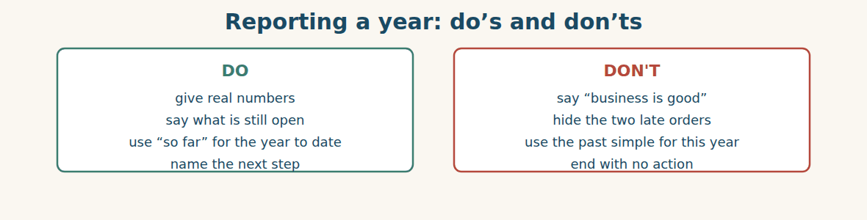
Figure · A report people can act on.
Case 1 — The number nobody checked (strand A · the import desk)
Rami tells the review that the Group has placed eleven orders. Ms. Chen’s file says nine. Rami counts two orders that are still open, and he has counted them as placed. The two of you now have different numbers in two different files.
Choose the best action and say why.
1. ( ) Use your own number and say nothing.
2. ( ) Agree one definition with the supplier: “placed” or “shipped”, and write it down.
3. ( ) Ask head office to decide.
4. ( ) Change your file to match the supplier’s file.
Write one sentence to the supplier to agree the definition.
______________________________________________
______________________________________________
Case 2 — Three emails, no answer (strand B · the shop)
Ms. Maya has written to the depot three times, and nobody has answered. Her shop has sold out of cement twice this month. Customers are going to another shop.
Answer the questions.
1. What should Ms. Maya do now, after three unanswered emails?
2. Who else should she tell, and why?
3. Write one short, polite message that is hard to ignore.
Case 3 — A full depot and an empty shop (where the two strands meet)
The depot holds more steel than the Group can sell this quarter. At the same time, the shops have run out of cement. Money is sitting still in one place and running out in another. Mr. Adnan asks you for one recommendation.
Answer the questions.
1. Why is a full depot a problem, and not a sign of success?
2. What one meeting, or one report, would have prevented this?
3. Write one sentence recommending a change for next year.
Part 10 · Review and Can-Do TRADE
A. Vocabulary. Complete the sentence.
1. A company inside a bigger group is a ____________.
2. A company that sells to us is a ____________.
3. To bring goods into a country is to ____________.
4. The building where we keep our stock is the ____________.
5. Selling in small amounts in a shop is ____________.
B. Grammar. Complete with the present perfect or the past simple.
1. We ____________ (place) eleven orders so far this year.
2. Ms. Chen ____________ (visit) Damascus in April 2024.
3. Rami ____________ (work) here since March.
4. The shop ____________ (sell) out twice this month.
5. They ____________ (not / send) the catalogue yet.
6. We ____________ (sell) 7,000 tonnes last year.
C. Reading. Read the short text and answer.
Al-Hasan Holding Group has twelve companies. Bashak buys abroad; Komosh moves the goods and clears customs; Chemco and Alten IL sell inside Syria. This year the Group has placed eleven import orders and has sold 9,000 tonnes of steel. Alten IL has opened a third shop. Altintash has not reached its target yet.
1. Which company clears customs?
2. How much steel has the Group sold this year?
3. Which company has not reached its target?
D. Listening. Listen and answer. (Teacher reads.)
[Teacher reads] “Good afternoon. So far this year we have placed eleven orders and we have opened two new supplier accounts since March. Nine orders have arrived. Two haven’t reached us yet. Last year we placed only seven.”
1. How many orders have been placed so far this year?
2. How many new supplier accounts, and since when?
3. How many orders were placed last year?
E. Speaking. Work in pairs. Report your year: two things you have done, and one thing you have not done yet.
F. Writing. Write two sentences: one with “We have… since…” and one with “Last year we…”.
1. ______________________________________________
2. ______________________________________________
G. Error correction. Find and correct one mistake in each sentence.
1. We have opened the shop last May. → ____________
2. He has worked here since three years. → ____________
3. Have you ever went to Lattakia? → ____________
4. They haven’t already paid. → ____________
5. When have the ship arrived? → ____________
H. Match the company (1–5) to what it does (a–e).
1. Bashak ____ a. clears customs and drives the trucks
2. Komosh ____ b. sells retail in shops
3. Chemco ____ c. imports for the whole Group
4. Alten IL ____ d. makes cement in Aleppo
5. Chemac ____ e. sells metals and fuels wholesale
I. Match the person (1–4) to their company (a–d).
1. Rami ____ a. Alten IL
2. Mr. Samir ____ b. Bashak
3. Ms. Maya ____ c. the Chemco depot
4. Ms. Dana ____ d. Komosh
Can-Do check. Tick what you can do.
- I can say what my company has done this year.
- I can say what we buy and what we sell.
- I can explain which company in the Group does what.
- I can write a short year-in-review email.
Part 11 · Foundations for Further Study TRADE
Concept Spotlight: One group, two directions
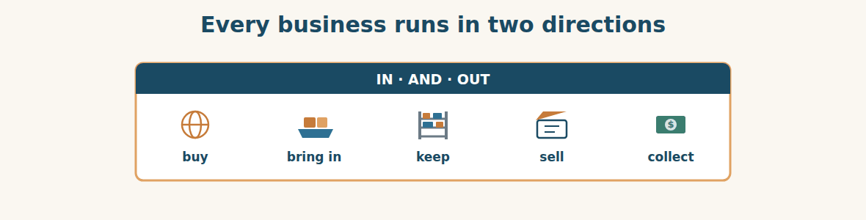
Figure · Money goes out to buy; money comes back from selling.
In this unit you met a big idea, and it is bigger than one company in Damascus. Every business runs in two directions at the same time. Money goes out to buy things. Goods come in. Then goods go out to customers, and money comes back. The business lives in the gap between the two.
Most people only see one direction. The person at the shop counter sees customers all day, so the business looks like selling. The person at the import desk sees suppliers all day, so the business looks like buying. Both are right, and both are half right. The Group only works when the two directions match: when the steel that comes in is the steel that someone wants to buy.
Someone will say: this is obvious. Why spend a unit on it? Because it is obvious and companies still get it wrong. Al-Hasan got it wrong this year. A full depot looked like success — the Group had plenty of steel. An empty shop looked like success too — everything had sold. Only when the two reports stood side by side did anyone see the problem. Each half looked healthy. Together they showed a company talking to itself in two rooms.
This is why the English in this book has two strands. In every unit you will work on the import side, facing a supplier abroad, and on the market side, facing a customer in Syria. The words are different. The tone is different: a letter to a supplier you have never met is not a two-minute conversation at a shop counter. You need both, because one person who can speak in both directions is worth more than two who can only speak in one.
So as you learn, keep asking the question Mr. Adnan asked: does what we buy match what we sell? It is a question about steel and cement. It is also a question about you. What you learn should match what you need to do.
A. Understanding check. Answer in your own words.
1. What are the two directions every business runs in?
2. Why is the person at the shop counter only “half right”?
3. Why did a full depot and an empty shop both look like success?
4. Why does this book give every unit two strands?
B. Apply it. Do this task with a partner.
Draw your own company in two directions. On the left, what comes in and who it comes from. On the right, what goes out and who it goes to. Then find one place where the two sides do not match, and explain it in simple English.
C. Micro-writing (optional).
Write a few sentences (50–70 words) about your company this year. Use the present perfect three times. Example: “This year we have … . We have already … . We haven’t … yet.”
Study terms: holding group · subsidiary · head office · branch · depot · warehouse | import (v) · export (v) · supplier · customer · wholesale · retail | distributor · product line · stock · turnover · growth · market | annual review · target · founder · board member · general manager · import manager | customs clearance · freight · container · fodder · for · since | already · yet · just · ever · never · so far
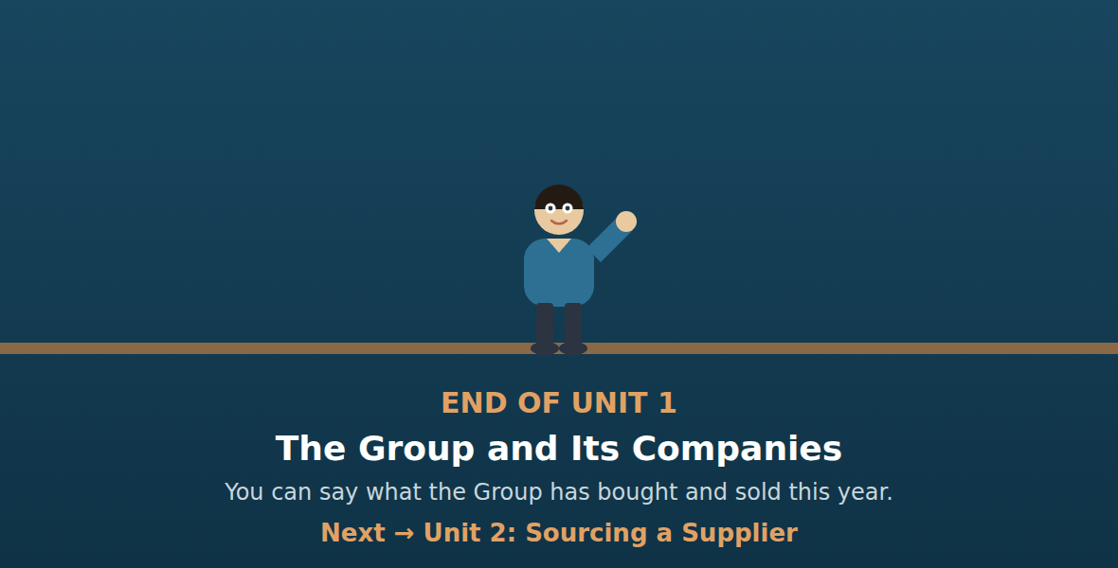
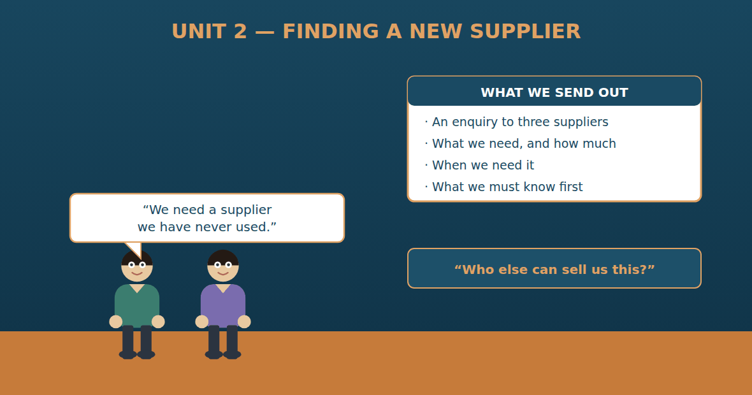

Unit 2: Sourcing a Supplier
Al-Hasan International — English for Trade, Industry & Global Partnerships
CEFR B1 · Grammar: must · have to · mustn’t · don’t have to · can for permission · Function: Trade + Admin
Can-Do (by the end of this unit)
- I can write a clear enquiry to a new supplier
- I can say what a supplier must and must not do
- I can explain our own rules for buying
- I can compare two suppliers simply
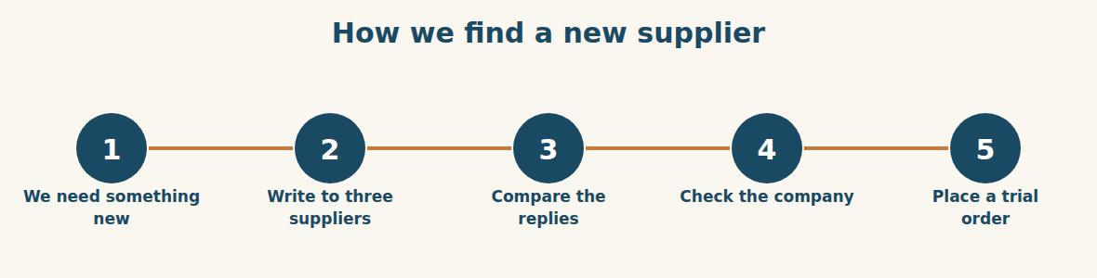
Figure · Five steps, and we never skip one.
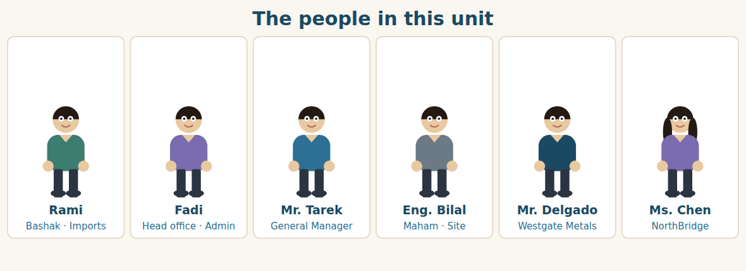
Figure · Two sides: the suppliers abroad, and our own rules at home.
Warm Up TRADE
Look at the pictures. Answer these questions before you read.
1. When your company needs something new, who finds it?
2. What must you know about a company before you buy from it?
3. How many prices do you ask for before you decide?
Read
Chemac, the cement factory in Aleppo, has a problem. Its packing machine is twenty years old. It breaks every month. The factory has to stop, and the bags wait. Chemac needs two new machines, and it needs them before the winter.
The request comes to head office on a Monday morning. Fadi reads it and takes it to Rami at Bashak. There is one difficulty. Bashak has bought steel for years, and fuel for years. It has never bought a machine.
“We have no supplier for this,” Rami says. “I have to find one.” Mr. Tarek nods. “Then follow the rule. Three enquiries, three replies, and nothing signed until we have checked the company.”
The rule is clear, and everybody at Al-Hasan knows it. For anything new, you must write to at least three suppliers. You must put the enquiry in writing, never on the telephone only. You don’t have to choose the cheapest, but you have to explain your choice. And you mustn’t sign anything over fifty thousand dollars without the board.
So Rami writes. He writes to NorthBridge, because Ms. Chen has just opened a machines division. He writes to Westgate Metals, a company he has never used. And he writes to a third company in the same market. Each enquiry says the same four things: who we are, what we need, how many, and when.
Two days later the first reply arrives. It is from Mr. Delgado at Westgate. “We can supply two machines,” he writes, “but you must order before the end of the month. Our lead time is ninety days.” Rami reads it twice. Ninety days takes them past the winter. He picks up the phone.
A. Comprehension. Answer in your own words. (0 is done for you.)
0. What is wrong with Chemac’s packing machine? (it is twenty years old and breaks every month)
1. Why has Bashak never bought a machine before?
2. What are the four rules for buying something new? Name two.
3. Why does Rami write to NorthBridge?
4. What four things does every enquiry say?
5. What is the problem with Westgate’s reply?
B. True or False? Write T or F. (0 is done for you.)
0. Chemac needs one new machine. (F)
1. Bashak has bought machines before. ____
2. You must write to at least three suppliers. ____
3. You have to choose the cheapest offer. ____
4. You mustn’t sign over $50,000 without the board. ____
5. Westgate’s lead time is ninety days. ____
C. Find the words. Find a word or phrase in the text that means: (0 is done for you.)
0. a letter asking a supplier for information → (an enquiry)
1. the time between the order and the delivery → the l____________ t____________
2. on paper, not spoken → in w____________
3. to find a supplier for something → to s____________ it
D. Over to you. Answer about yourself.
1. What rules does your company have for buying something new?
2. Do you have to ask permission? Who from?
3. What must a new supplier show you before you buy?
Part 1 · Vocabulary and Terminology TRADE
Asking a supplier
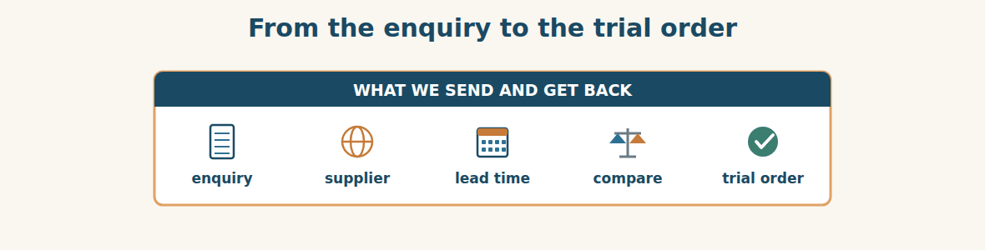
Figure · The words of sourcing, in the order you meet them.
A. Match each word (1–7) with its meaning (a–h). There is one you do not need. (0 is done for you.)
0. enquiry (d)
1. quotation ____ a. the smallest amount a supplier will sell
2. lead time ____ b. a small first order, to test a supplier
3. minimum order ____ c. a paper that proves something is true
4. trial order ____ d. a letter asking a supplier for information
5. certificate ____ e. the time between the order and the delivery
6. shortlist ____ f. a written price from a supplier
7. catalogue ____ g. the two or three best, chosen from many
8. h. a book of all the products a company sells
B. Complete the sentences with the words in the word bank.
Word bank: enquiry | lead time | minimum order | catalogue | trial order | shortlist
1. I have sent the same ____________ to three suppliers.
2. Their ____________ is ninety days, which is too long for us.
3. The ____________ is 500 tonnes, so we cannot buy 100.
4. Please send us your ____________ and your price list.
5. We never start big. We always place a ____________ first.
6. Three companies replied, and we put two on the ____________.
What a new supplier must show us
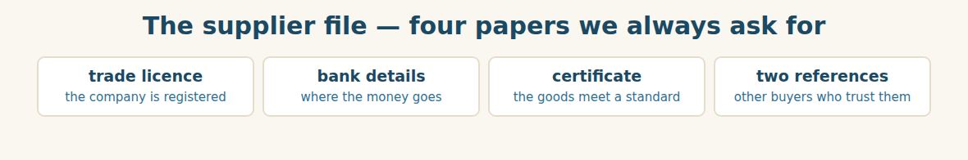
Figure · No file, no order — the rule is the same for everyone.
C. Match the paper (1–4) with the question it answers (a–d).
1. trade licence ____ a. Who else has bought from them?
2. bank details ____ b. Is this a real, registered company?
3. certificate ____ c. Where do we send the money?
4. references ____ d. Are the goods good enough?
The three suppliers
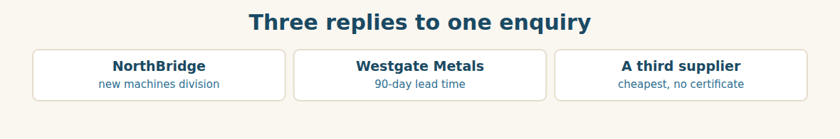
Figure · Three suppliers, three different problems.
D. Odd one out. Which word is different? Circle it.
1. enquiry · quotation · catalogue · warehouse
2. must · have to · mustn’t · machine
3. licence · certificate · reference · deadline
4. supplier · customer · vendor · seller
5. compare · choose · decide · deliver
E. Choose the best answer.
1. A written price from a supplier is a… (a) quotation (b) catalogue
2. The time between order and delivery is the… (a) deadline (b) lead time
3. A small first order is a… (a) minimum order (b) trial order
4. A paper that proves a standard is a… (a) certificate (b) reference
F. Classify. Write each item in the correct column.
Items: enquiry | trade licence | quotation | certificate | price list | two references
We send it | They send it | We ask them for it
__________ | __________ | __________
__________ | __________ | __________
__________ | __________ | __________
G. Match the two halves (1–6 with a–f).
1. place a ____ a. licence
2. send an ____ b. order
3. a trade ____ c. enquiry
4. the lead ____ d. references
5. two ____ e. time
6. in ____ f. writing
H. Complete the paragraph with the words in the box.
Box: approve | enquiry | lead time | references | rule | trial
Our (1)____________ is simple. For anything new, send the same (2)____________ to three suppliers. Ask every one for two (3)____________. Check the (4)____________ before you compare the prices. The General Manager must (5)____________ the choice, and we always start with a (6)____________ order.
Part 2 · Grammar — must · have to · mustn’t · don’t have to ADMIN
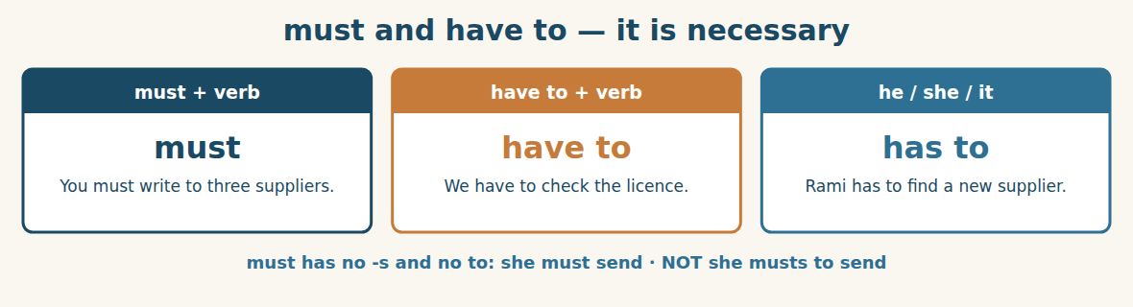
Figure · Two ways to say that something is necessary.
We use MUST and HAVE TO for something that is necessary. They are very close in meaning. We often use must for a rule we make ourselves, and have to for a rule that comes from outside: I must answer this email today. We have to send the certificate, because the customs office asks for it.
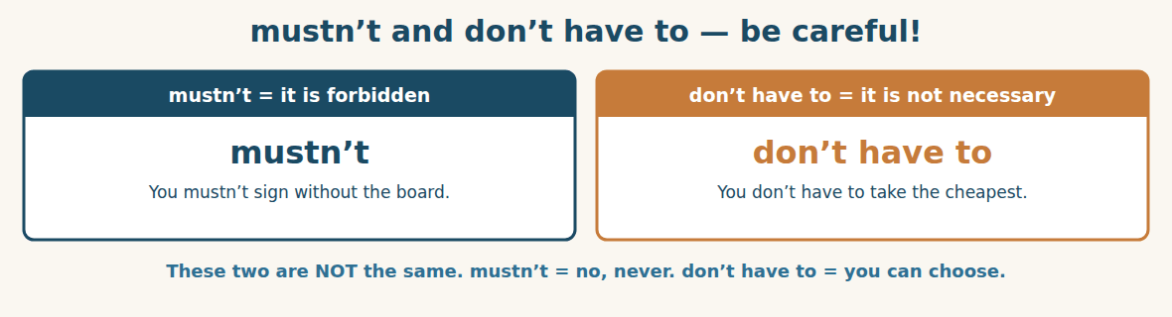
Figure · The most useful difference in this unit.
MUSTN’T means it is forbidden. DON’T HAVE TO means it is not necessary, but you can if you want. You mustn’t pay before the goods arrive means never do it. You don’t have to pay today means it is fine to pay later.
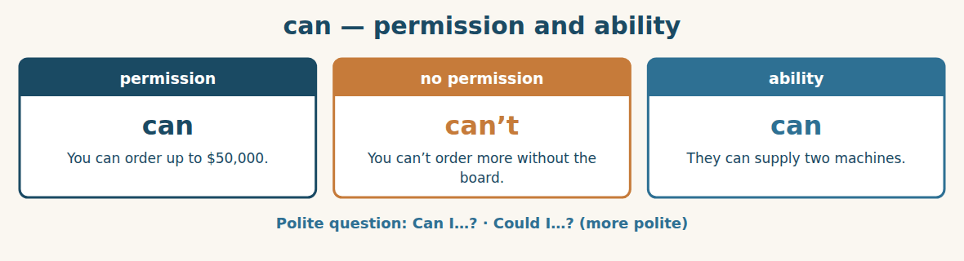
Figure · can for what is allowed, and for what is possible.
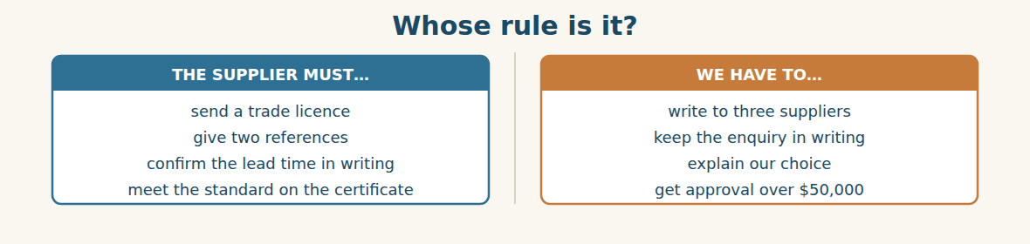
Figure · The same grammar, pointed in two directions.
Watch out! mustn’t and don’t have to are not the same. You mustn’t send it = do not send it. You don’t have to send it = send it or don’t, as you like. And remember: must has no third-person -s, and never takes to.
Form
must / mustn’t + verb · have to / has to + verb · don’t have to / doesn’t have to + verb · can / can’t + verb
A. Complete with MUST or MUSTN’T. (0 is done for you.)
0. You must write to three suppliers.
1. You ____________ sign a contract over $50,000 without the board.
2. Every new supplier ____________ send a trade licence.
3. We ____________ forget to ask for references.
4. The enquiry ____________ be in writing.
5. You ____________ promise a date before you have the lead time.
B. Complete with HAVE TO or HAS TO.
1. Rami ____________ find a supplier for machines.
2. We ____________ compare three replies.
3. Chemac ____________ stop the line when the machine breaks.
4. Our suppliers ____________ confirm everything in writing.
C. MUSTN’T or DON’T HAVE TO? Choose the right one. (0 is done for you.)
0. You (mustn’t / don’t have to) pay before the goods arrive. It is forbidden. (mustn’t)
1. You ____________ take the cheapest offer. You can choose.
2. You ____________ tell a supplier what another supplier charges.
3. We ____________ answer today. The deadline is Friday.
4. You ____________ use a supplier with no trade licence.
D. Complete with CAN or CAN’T.
1. Westgate ____________ supply two machines.
2. You ____________ order over $50,000 alone — ask the board.
3. ____________ I see the catalogue, please?
4. We ____________ wait ninety days. The winter is coming.
E. Make the sentence negative.
1. We have to pay a deposit. → ____________
2. He must sign it today. → ____________
3. They can deliver in May. → ____________
4. She has to answer the enquiry. → ____________
F. Rewrite with the word in brackets, keeping the meaning.
1. It is necessary to send the licence. (must) → ____________
2. It is not necessary to decide today. (have to) → ____________
3. It is forbidden to pay in advance. (mustn’t) → ____________
4. It is permitted to order up to $50,000. (can) → ____________
G. Find and correct the mistake in each sentence. (0 is done for you.)
0. She musts to send it. → (She must send it.)
1. We must to write three enquiries. → ____________
2. He have to check the licence. → ____________
3. You don’t must pay today. → ____________
4. Must you to ask the board? → ____________
H. About you. Write two sentences about your job: one with “I have to…” and one with “I don’t have to…”.
1. ______________________________________________
2. ______________________________________________
I. Complete with must, mustn’t, have to or don’t have to.
1. Every supplier ____________ give us two references. It is our rule.
2. You ____________ take the cheapest — but you ____________ explain your choice.
3. We ____________ sign anything the board has not seen.
4. Chemac ____________ wait ninety days; we can find a faster supplier.
5. The certificate ____________ be in English or Arabic.
J. Write the rule. Use must, mustn’t or don’t have to.
1. Three enquiries, always. → You ____________
2. Cheapest offer — your choice. → You ____________
3. Never tell one supplier another supplier’s price. → You ____________
4. Board approval over $50,000. → You ____________
Part 3 · Listening and Dialogue TRADE
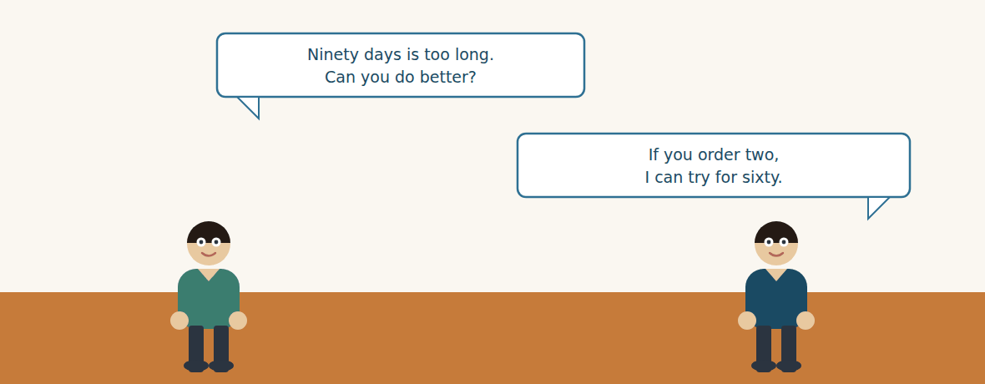
Figure · Strand A · Rami calls a supplier he has never used.
Dialogue 1 — A first call to a new supplier (the import desk)
Listen and read. (Your teacher will read the dialogue, or play the audio.)
Rami: Good afternoon. My name is Rami, from Bashak, part of Al-Hasan Holding Group in Damascus. May I speak to Mr. Delgado?
Mr. Delgado: Speaking. You sent us the enquiry about the packing machines.
Rami: That’s right. Thank you for your reply. I have one difficulty: your lead time.
Mr. Delgado: Ninety days. That is standard for us.
Rami: I understand. But our factory has to have them before the winter. Ninety days is too long. Can you do better?
Mr. Delgado: Hm. If you order two machines, not one, I can try for sixty days.
Rami: Two is exactly what we need. Now — before we go further, I have to ask you for four papers.
Mr. Delgado: Four?
Rami: Your trade licence, your bank details, the machine certificate, and two references. It is our rule for every new supplier. We can’t place an order without them.
Mr. Delgado: That is fair. You’ll have them tomorrow. And the order?
Rami: A trial order first — the two machines. If they work well, we talk again.
A. Comprehension. Answer in your own words. (0 is done for you.)
0. Who is Rami, and which company does he work for? (the Import Manager, at Bashak)
1. What is Rami’s difficulty with the reply?
2. What does Mr. Delgado offer, and on what condition?
3. Which four papers does Rami ask for?
4. What happens if Bashak does not get the papers?
5. What kind of order will Rami place first?
B. True or False? Write T or F.
1. Rami has worked with Mr. Delgado before. ____
2. Ninety days is Westgate’s normal lead time. ____
3. Mr. Delgado offers sixty days for an order of two. ____
4. Rami will place a large first order. ____
5. The four papers are a rule for every new supplier. ____
C. Language focus. Find in the dialogue: (0 is done for you.)
0. a polite way to ask for a person on the phone → (May I speak to…?)
1. a sentence with “has to” → ____________
2. a sentence with “can’t” → ____________
3. a polite way to ask for something better → ____________
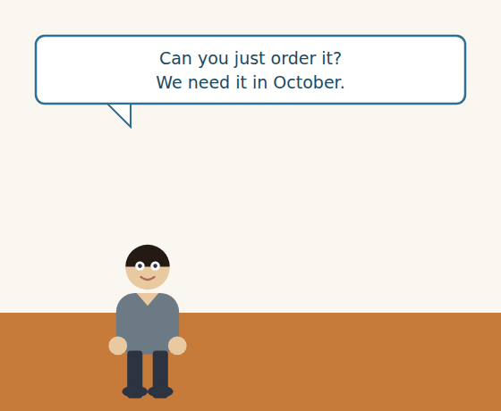
Figure · Strand B · a colleague asks head office to buy something.
Dialogue 2 — The internal request (inside the Group)
Eng. Bilal: Fadi, I need forty rolls of waterproof sheet for the Homs site. Can you just order it?
Fadi: I can’t just order it, Bilal. Do we have a supplier for waterproof sheet?
Eng. Bilal: I don’t know. I only know I need it in October.
Fadi: Then it is new, and new means three enquiries. That takes two weeks.
Eng. Bilal: Two weeks! Can’t you make an exception? It’s a small order.
Fadi: Small orders have the same rule. But you don’t have to wait for all three — if two replies come back fast, Mr. Tarek can approve on two.
Eng. Bilal: All right. What do you need from me?
Fadi: The exact specification, the quantity, and your date. In writing, today.
A. Comprehension. Answer in your own words.
1. What does Eng. Bilal need, how many, and when?
2. Why can’t Fadi “just order it”?
3. How long does the three-enquiry rule normally take?
4. What is the one way to move faster, and who must agree?
B. Listen again and choose the best answer (A–D).
1. Eng. Bilal needs … rolls. A) fourteen B) forty C) four D) four hundred
2. The site is at… A) Aleppo B) Damascus C) Homs D) Lattakia
3. Small orders follow… A) no rule B) a faster rule C) the same rule D) the board’s rule
4. Fadi asks Bilal for the specification, the quantity and the… A) price B) date C) supplier D) licence
Part 4 · Speaking and Your Role TRADE
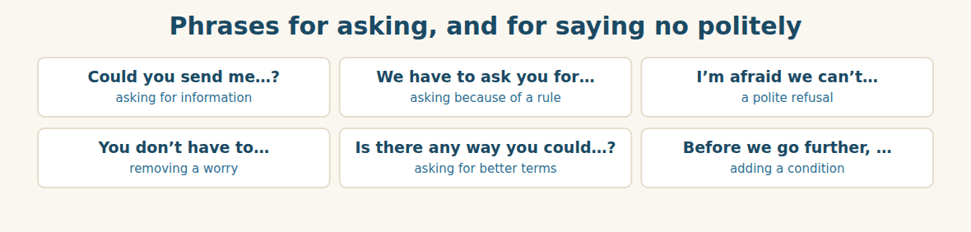
Figure · Saying what is necessary without sounding rude.
A. Role-play: a first call to a new supplier. Student A is the buyer and asks for the four papers. Student B is the supplier and asks why. Then change roles.
1. A: Introduce yourself and your company.
2. B: Say you remember the enquiry.
3. A: Say what you have to ask for, and why it is a rule.
4. B: Ask one question about the rule.
5. A: Explain, and say what you can’t do without the papers.
6. B: Agree, and ask about the order.
B. Your Role. Say one rule you have to follow at work. Use the phrases below. (Choose your real role.)
1. [Trade] Import Manager: “We must write to three suppliers before we buy.”
2. [Trade] Sales: “I can give 5% myself. Over that, I have to ask my manager.”
3. [Finance] Financial Controller: “Nothing over $50,000 goes out without the board.”
4. [Finance] Accountant: “Every invoice must match an order. No order, no payment.”
5. [Logistics] Freight: “The packing list must travel with the goods. Always.”
6. [Admin] Assistant: “Requests have to come in writing, not by telephone.”
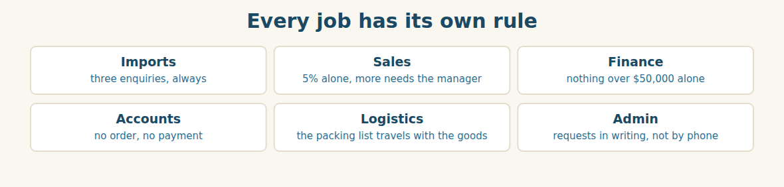
Figure · Six roles, six rules — the same grammar.
C. Ask your partner. Walk around and ask three people.
1. What is one thing you must do every day at work?
2. What is one thing you mustn’t do?
3. What is one thing you don’t have to do, but you do anyway?
D. Discuss. Ask and answer.
1. Is the three-enquiry rule a good rule? When is it a problem?
2. Should a small order follow the same rules as a big one? Why?
Part 5 · Extended Reading TRADE
Why we ask three companies, not one
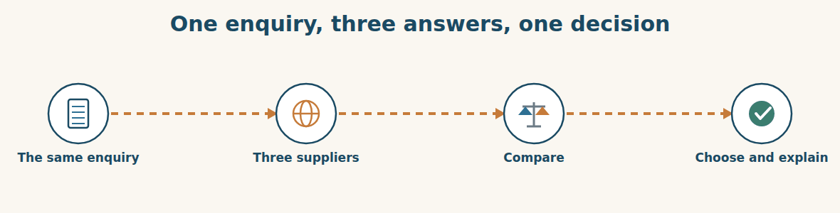
Figure · The same question, asked three times.
A buyer who asks one company has no choice. The supplier names a price, and the buyer can only say yes or no. A buyer who asks three companies has information, and information is power. This is why almost every serious company in the world has the same rule: for anything new, ask at least three.
But the rule only works if the three enquiries are the same. If you ask one supplier for 500 tonnes and another for 600, you cannot compare the prices. If you tell one supplier your date and forget to tell another, their lead times mean nothing. So a good buyer writes the enquiry once, and sends the same words to everybody.
When the replies come back, the cheapest is not always the best. A low price with a ninety-day lead time can cost more than a high price with a thirty-day one, because the factory has to stop while it waits. A low price from a company with no certificate can cost everything, because the goods may be stopped at customs. The buyer has to look at four things together: the price, the lead time, the quality, and the company itself.
There is one more reason, and it is not about money. Three enquiries protect the buyer. When Rami explains to the board why he chose Westgate, he does not have to say “I liked them”. He can show three replies and one clear reason. Nobody can say he made a private arrangement. In a group where one person spends other people’s money, that protection matters.
The rule has a cost: it is slow. Two weeks for three replies is a long time when a factory is stopping every month. Good companies therefore keep a list of approved suppliers, checked in advance, so that the next time the same thing is needed, the work is already done. The three enquiries are for the first time. After that, you have a supplier.
A. Comprehension. Answer in your own words. (0 is done for you.)
0. What choice does a buyer who asks only one company have? (only yes or no)
1. Why must the three enquiries use the same words?
2. Why can a cheap offer with a long lead time cost more?
3. What four things must a buyer look at together?
4. How do three enquiries protect the buyer?
5. What is the cost of the rule, and how do good companies reduce it?
B. Choose the best answer (A–D).
1. Information gives the buyer… A) time B) power C) money D) friends
2. You cannot compare prices if the quantities are… A) large B) small C) different D) equal
3. Goods with no certificate may be stopped at… A) the depot B) customs C) the bank D) the factory
4. Three enquiries protect the buyer from the accusation of a… A) high price B) late delivery C) private arrangement D) small order
5. An approved supplier list makes the next purchase… A) cheaper B) faster C) bigger D) safer
C. Find a word or phrase in the text that means:
1. to keep someone safe → to p____________ them
2. a secret deal between two people → a p____________ arrangement
3. checked before you need it → a____________ in advance
4. to look at two things to see which is better → to c____________ them
D. Complete the summary with ONE word in each gap.
A good buyer asks at least (1)____________ suppliers, and sends them all the (2)____________ enquiry. The (3)____________ offer is not always the best, because a long (4)____________ time can stop the factory. Three replies also (5)____________ the buyer, who can show a clear reason. The rule is (6)____________, so companies keep a list of approved suppliers.
E. Discuss. Talk in pairs.
1. Does your company compare suppliers? How many do you ask?
2. When is it right to break the rule and ask only one?
F. True or False? (about the reading). Write T, F or NOT GIVEN.
1. The cheapest offer is always the best. ____
2. The same enquiry must go to every supplier. ____
3. Most companies ask five suppliers. ____
4. An approved supplier list saves time later. ____
Part 6 · Writing (a real email) ADMIN
Model — An enquiry to a new supplier
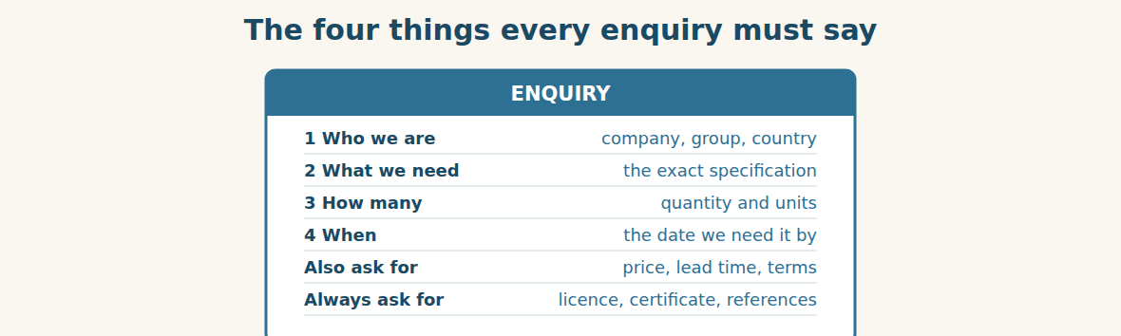
Figure · Miss one of the four, and the reply is useless.
Subject: Enquiry — two bag-packing machines. Dear Mr. Delgado, My name is Rami and I am the Import Manager at Bashak Co., part of Al-Hasan Holding Group in Damascus, Syria. We would like a quotation for two automatic bag-packing machines for 50 kg cement bags. We need them delivered before 1 November. Could you please send us your unit price, your lead time, your minimum order and your payment terms? We also have to ask every new supplier for a trade licence, a product certificate and two trade references. We cannot place an order without them. Thank you. I look forward to your reply. Best regards, Rami Import Manager, Bashak Co.
A. Answer about the email. (0 is done for you.)
0. Who is writing, and from which company? (Rami, Import Manager at Bashak Co.)
1. What exactly does he want, and how many?
2. By what date does he need them?
3. Which three papers does he ask for, and why?
B. Put the email in order (1–6).
1. ( ) Could you please send us your unit price and lead time?
2. ( ) Dear Mr. Delgado,
3. ( ) Best regards, Rami
4. ( ) My name is Rami and I am the Import Manager at Bashak Co.
5. ( ) We also have to ask every new supplier for three papers.
6. ( ) We would like a quotation for two bag-packing machines.
Guided writing
C. Now you write. Write an enquiry (70–100 words) to a supplier you have never used. Use “must” or “have to” at least twice, and ask at least three questions.
Plan: 1) “Dear …,” 2) “My name is … and I am the … at ….” 3) “We would like a quotation for ….” 4) “We need them by ….” 5) “Could you please send us …?” 6) “We have to ask every new supplier for ….” 7) “Best regards, …”
Sentence starters: “We would like a quotation for…” · “Could you please send us…?” · “We have to ask every new supplier for…” · “We cannot place an order without…”
______________________________________________
______________________________________________
______________________________________________
______________________________________________
______________________________________________
D. Checklist. Tick each one when you have checked your enquiry.
- I said who I am and which company I work for.
- I said exactly what I need, with a quantity.
- I gave the date I need it by.
- I asked for the price AND the lead time.
- I used “must” or “have to” for our rules.
Part 7 · Trade-Skills Track ADMIN
The supplier check-list: approving a company before you buy
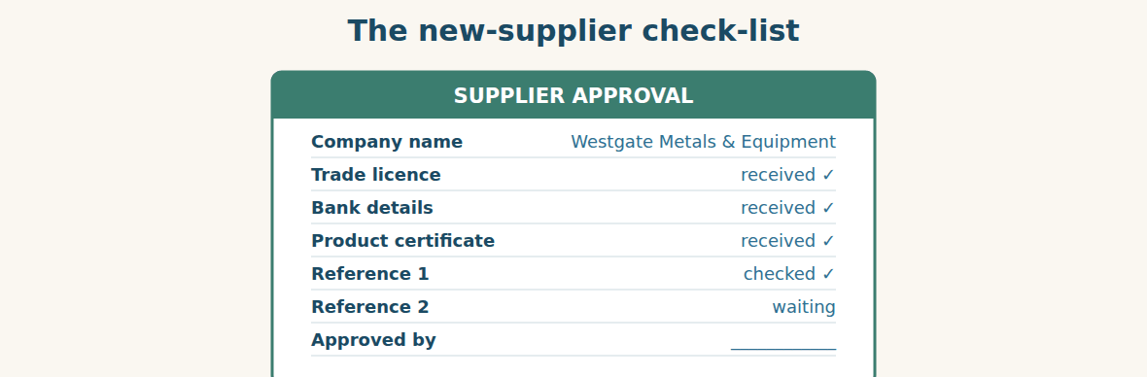
Figure · Nothing moves until every line has a tick.
A check-list looks like a small thing. It is not. It is the difference between a company that knows who it is paying and a company that hopes. Every line on the list answers one question, and the order matters.
The trade licence answers: is this a real company? A licence has a number and a date, and you can check both. The bank details answer: where does the money go? This is the line that criminals attack, so a change of bank details must always be confirmed by telephone, never by email alone. The certificate answers: are the goods good enough? And the two references answer the question no paper can answer: does this company keep its promises?
References are the line people skip, because telephoning a stranger is uncomfortable. It is also the most useful line on the list. You do not have to ask a long question. Three are enough: Did they deliver on time? Was the quality what they promised? Would you buy from them again? A buyer who asks those three questions learns more in five minutes than from a hundred pages of catalogue.
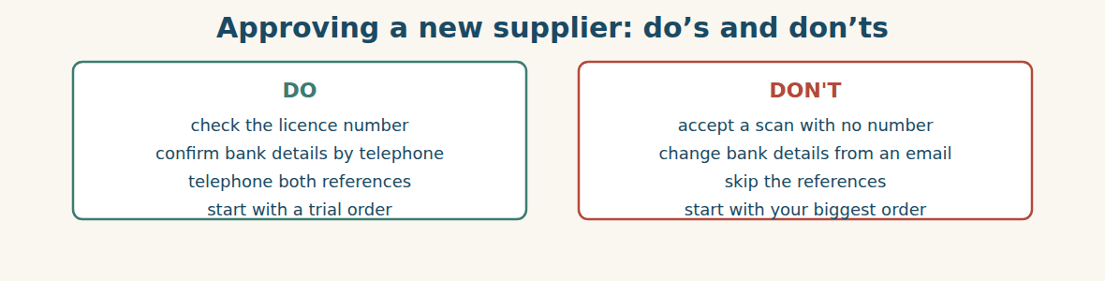
Figure · Four habits that prevent most sourcing accidents.
A. Comprehension. Answer in your own words.
1. What question does the trade licence answer?
2. Why must a change of bank details be confirmed by telephone?
3. What question can no paper answer?
4. Why do people skip the references?
5. What are the three questions to ask a reference?
B. Listen and complete. A manager explains the check-list. Write the missing word.
1. Manager: The trade ____________ tells us the company is real.
2. Manager: Never change ____________ details from an email alone.
3. Manager: Always telephone both ____________.
4. Manager: And always start with a ____________ order.
C. Practice. Make a check-list for YOUR company. Write five lines that a new supplier must complete before you buy. Then compare with your partner.
D. Must, mustn’t or don’t have to? Complete the rule.
1. You ____________ check the licence number.
2. You ____________ accept new bank details from an email.
3. You ____________ telephone both references, not only one.
4. You ____________ use the supplier again after the trial — it is your choice.
Part 8 · Consolidation TRADE
Two weeks, two problems
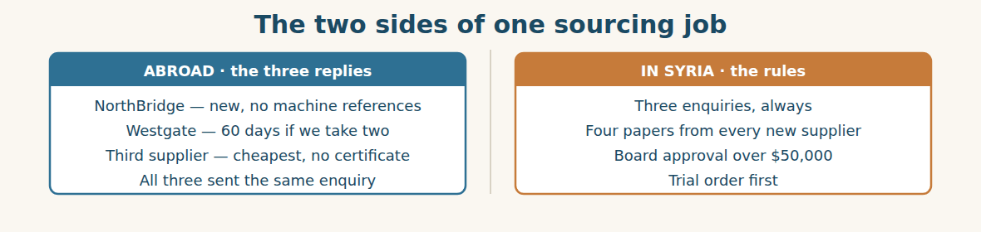
Figure · The supplier decides the price; the rule decides the process.
Two weeks later, Rami has three replies on his desk. The third supplier is the cheapest by eleven per cent. It has no certificate. Rami puts it to one side. “Eleven per cent is nothing,” he says, “if customs stops the machine at the port.”
That leaves NorthBridge and Westgate. NorthBridge is a company the Group knows well, and Ms. Chen has been a good partner for a year. But her machines division is new, and she cannot give a single machine reference. Westgate is a company nobody knows, but it has two references, a certificate, and sixty days.
Mr. Tarek asks the hard question. “You trust Ms. Chen. Does that count?” Rami thinks about it. “It counts,” he says, “but not for machines. She has never sold us one.” So Westgate wins the trial order, and Rami writes to Ms. Chen the same afternoon. He tells her why, honestly, and he asks her to send a reference when she has one.
The order goes to the board, because two machines cost fifty-eight thousand dollars. Mr. Adnan reads the three replies and the check-list, and he signs in less than a minute. “This is what the rule is for,” he says. “Not to slow you down. To let me sign quickly.”
A. Comprehension. Answer in your own words. (0 is done.)
0. How many replies does Rami have, and after how long? (three, after two weeks)
1. Why does Rami reject the cheapest supplier?
2. What is the problem with NorthBridge?
3. What does Westgate have that NorthBridge does not?
4. Why does the order have to go to the board?
5. What does Mr. Adnan say the rule is for?
B. Complete each sentence with ONE word from the text. (0 is done for you.)
0. The third supplier is the cheapest by eleven per cent.
1. It has no ____________, so Rami puts it to one side.
2. Ms. Chen cannot give a single machine ____________.
3. Westgate wins the ____________ order.
4. The two machines cost fifty-eight thousand ____________.
5. Mr. Adnan says the rule lets him ____________ quickly.
C. Discuss. Talk in pairs.
1. Was Rami right to choose a company nobody knows over a partner he trusts?
2. How would you write the email to Ms. Chen?
D. Find a word from the text that means: (0 is done for you.)
0. to say no to an offer → (to reject it)
1. telling the truth → h____________
2. in less than sixty seconds → in less than a m____________
3. to make something slower → to s____________ it d____________
Part 9 · Case Studies and Decisions ADMIN
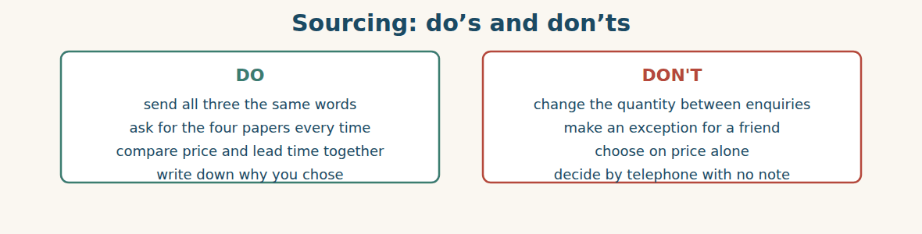
Figure · Most sourcing mistakes are made before any money moves.
Case 1 — The supplier who will not send references (strand A · abroad)
A supplier abroad sends you a licence, bank details and a certificate. For the two references, they write: “Our customers are confidential. We cannot give names.” Their price is the best you have seen, and your factory is waiting.
Choose the best action and say why.
1. ( ) Accept it. Three papers out of four is enough.
2. ( ) Offer a very small trial order, paid after delivery, and keep the rule for the big order.
3. ( ) Reject them at once and use a slower supplier.
4. ( ) Ask your manager to sign an exception, and say nothing to the board.
Write one sentence to the supplier explaining what you can do without references.
______________________________________________
______________________________________________
Case 2 — “Just this once” (strand B · inside the Group)
A colleague from another Group company asks you to order from one supplier only. “I know them, they are good, and we have no time.” If you follow the rule, the goods arrive two weeks late. If you break it, nobody will know.
Answer the questions.
1. What could go wrong if you break the rule and the supplier fails?
2. What can you offer your colleague instead of breaking the rule?
3. Write one polite sentence that says no, and offers the alternative.
Case 3 — The trusted partner and the better stranger (where the strands meet)
A partner you have worked with for a year wants the order. A company nobody knows has better references for this product, a certificate, and a shorter lead time. The partner will be disappointed, and you have to work with them next month on something else.
Answer the questions.
1. Should past experience with a partner count for a product they have never supplied? Why?
2. How do you protect the relationship while you give the order to someone else?
3. Write one sentence to the partner, explaining your decision honestly.
Part 10 · Review and Can-Do TRADE
A. Vocabulary. Complete the sentence.
1. A letter asking a supplier for information is an ____________.
2. The time between the order and the delivery is the ____________ ____________.
3. A small first order, to test a supplier, is a ____________ order.
4. A paper that proves the goods meet a standard is a ____________.
5. The smallest amount a supplier will sell is the ____________ order.
B. Grammar. Complete with must, mustn’t, have to, has to or don’t have to.
1. Every new supplier ____________ send a trade licence.
2. You ____________ sign over $50,000 without the board. It is forbidden.
3. Rami ____________ find a supplier for machines.
4. You ____________ take the cheapest offer — you can choose.
5. The enquiry ____________ be in writing.
6. We ____________ compare three replies before we decide.
C. Reading. Read the short text and answer.
At Al-Hasan, anything new needs three enquiries. Every new supplier must send a trade licence, bank details, a certificate and two references. You don’t have to take the cheapest offer, but you have to explain your choice. Nothing over $50,000 is signed without the board. The first order with a new supplier is always a trial order.
1. How many enquiries are needed for something new?
2. Which four papers must a new supplier send?
3. What must you do if you don’t take the cheapest?
D. Listening. Listen and answer. (Teacher reads.)
[Teacher reads] “Our lead time is ninety days. But if you order two machines, I can try for sixty. Before that, you have to send us your order in writing. And we can’t start until we receive your deposit.”
1. What is the normal lead time, and what can it become?
2. What must the buyer send in writing?
3. What can’t the supplier do until the deposit arrives?
E. Speaking. Work in pairs. Telephone a new supplier: introduce yourself, say what you need, and ask for the four papers.
F. Writing. Write two sentences about your own work: one with “I have to…” and one with “I mustn’t…”.
1. ______________________________________________
2. ______________________________________________
G. Error correction. Find and correct one mistake in each sentence.
1. She must to send the licence. → ____________
2. He have to check the references. → ____________
3. You don’t must pay in advance. → ____________
4. Must you to ask the board? → ____________
5. We musts write three enquiries. → ____________
H. Match the paper (1–5) to the question it answers (a–e).
1. trade licence ____ a. Where does the money go?
2. bank details ____ b. Do they keep their promises?
3. certificate ____ c. Is this a real company?
4. references ____ d. How long until delivery?
5. lead time ____ e. Are the goods good enough?
I. Match the rule (1–4) to the right modal (a–d).
1. Three enquiries, always. ____ a. You don’t have to…
2. Board approval over $50,000. ____ b. You mustn’t…
3. Cheapest offer is your choice. ____ c. You must…
4. Never share another supplier’s price. ____ d. You can’t … without…
Can-Do check. Tick what you can do.
- I can write a clear enquiry to a new supplier.
- I can say what a supplier must and must not do.
- I can explain our own rules for buying.
- I can compare two suppliers simply.
Part 11 · Foundations for Further Study TRADE
Concept Spotlight: A rule is a promise you make before you are tempted
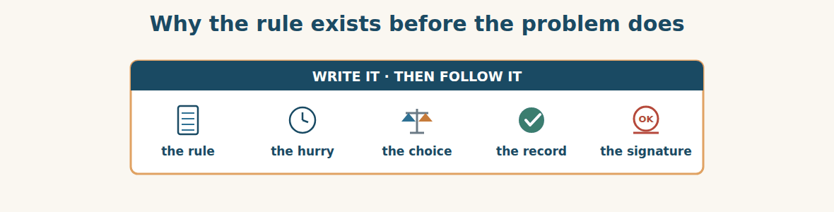
Figure · The rule is written on a calm day, for a difficult one.
In this unit you met four words that look small and carry a lot: must, mustn’t, have to, don’t have to. They are the grammar of rules. And rules are strange things. Nobody argues with them on a quiet Tuesday. Everybody argues with them on the day the factory stops.
That is exactly why they exist. A rule is a promise a company makes to itself before it is tempted. On a calm day, everyone agrees that three enquiries are sensible. On the day the machine breaks, three enquiries feel like a wall. The rule is there to hold the company to the decision it made when it was thinking clearly.
Someone will object: surely a good manager should use judgement, not follow rules blindly? That is fair, and it is why the difference between mustn’t and don’t have to matters so much. Good rules are careful about which is which. You mustn’t pay before you check the bank details — that is absolute, because the loss cannot be repaired. You don’t have to take the cheapest offer — that is judgement, because a human being has to weigh four things at once. A company that makes everything a mustn’t makes its people stupid. A company that makes nothing a mustn’t loses money it cannot get back.
Notice too what Mr. Adnan said. He did not say the rule protects the company from the supplier. He said it lets him sign quickly. A rule that is followed turns a hard decision into an easy one, because the work has already been done. The three replies, the check-list and the reason are on the table. The signature takes a minute.
So when you learn must, mustn’t and don’t have to in English, you are learning more than grammar. You are learning to say which things are absolute, which are necessary, and which are free. People who can say that clearly, in any language, are trusted with other people’s money.
A. Understanding check. Answer in your own words.
1. Why does the writer say rules are “strange things”?
2. What is a rule, in the writer’s definition?
3. What is the difference between a “mustn’t” rule and a “don’t have to” rule?
4. Why does a followed rule make a signature fast?
B. Apply it. Do this task with a partner.
Write three rules for your own team: one with must, one with mustn’t, and one with don’t have to. Then swap with your partner and ask: is each one in the right group? Could any “mustn’t” really be a “don’t have to”?
C. Micro-writing (optional).
Write a few sentences (50–70 words) about one rule at your work. Say what it is, why it exists, and one day when it was difficult to follow. Use must, mustn’t and have to at least once each.
Study terms: enquiry · quotation · catalogue · price list · source (v) · lead time | minimum order · trial order · shortlist · specification · sample · certificate | trade licence · reference · bank details · approve · approval · authorise | requirement · criteria · compare · reliable · registered · confidential | exception · policy · deadline · in writing · confirm · reject | must · mustn’t · have to · don’t have to · can / can’t · be allowed to
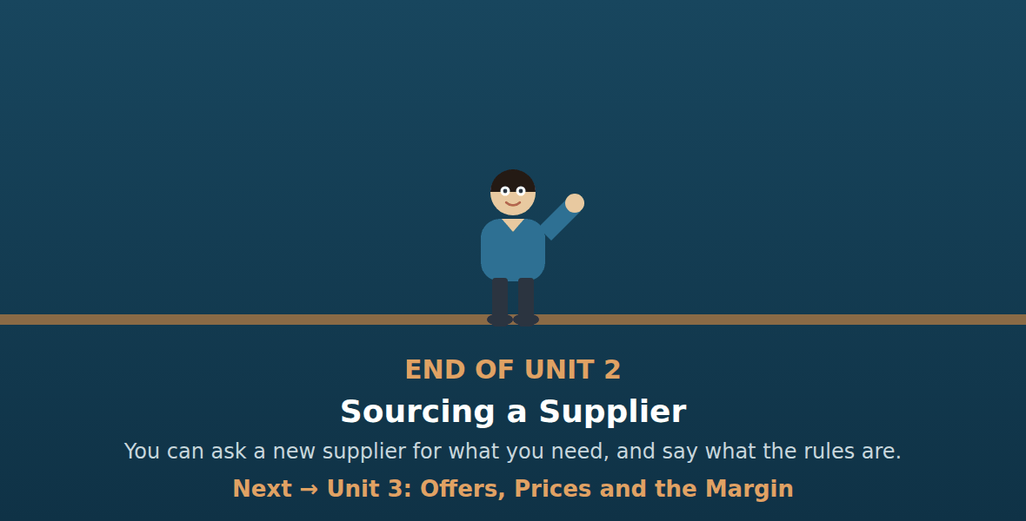
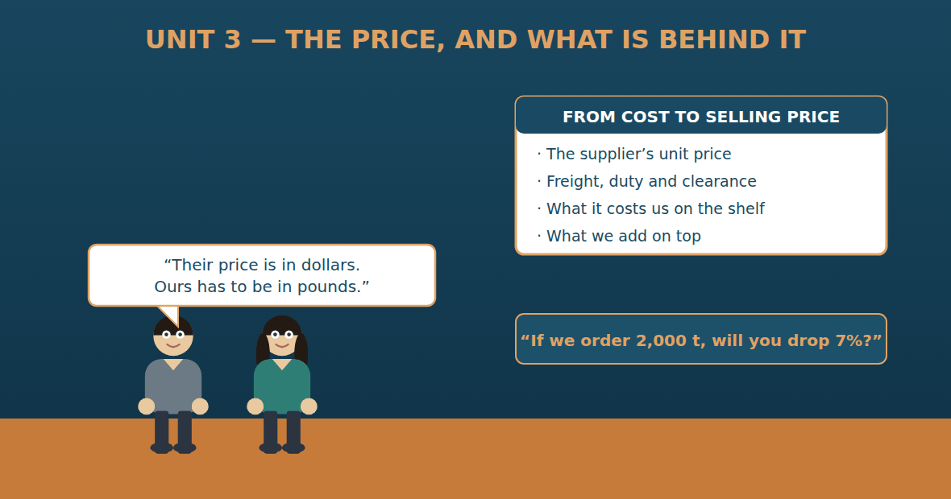

Unit 3: Offers, Prices and the Margin
Al-Hasan International — English for Trade, Industry & Global Partnerships
CEFR B1 · Grammar: first conditional · unless · time clauses (when / as soon as / until) · Function: Finance + Trade
Can-Do (by the end of this unit)
- I can read and check a supplier’s offer
- I can make a conditional offer
- I can explain how we get from cost to selling price
- I can write a counter-offer
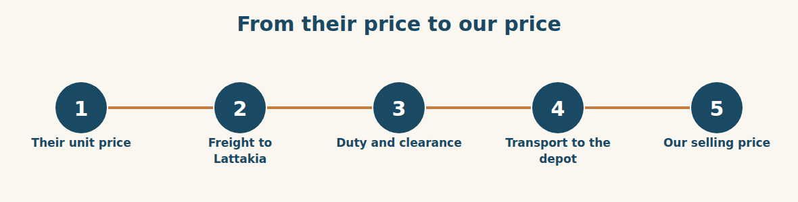
Figure · Five steps between a price abroad and a price in a Syrian shop.
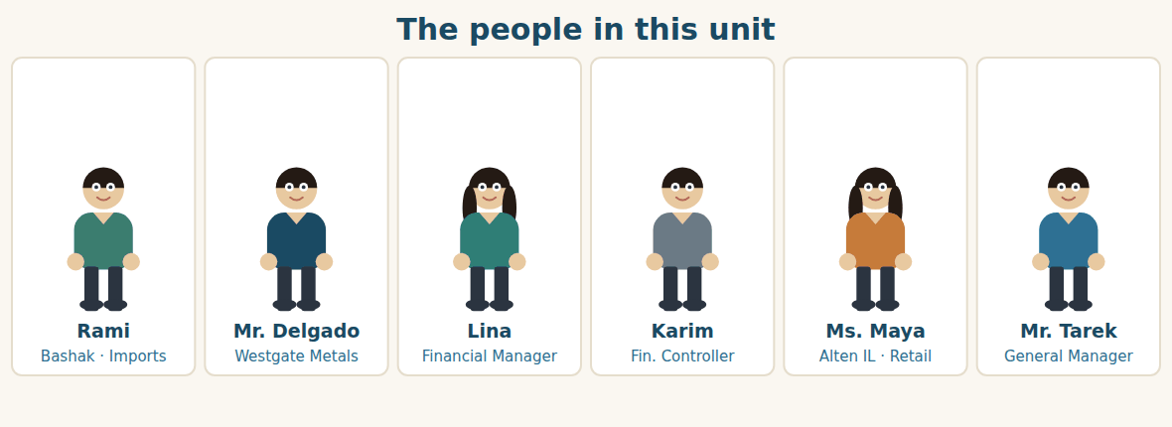
Figure · One side argues about dollars; the other side works in pounds.
Warm Up FINANCE
Look at the pictures. Answer these questions before you read.
1. When a supplier gives you a price, what else do you need to know?
2. What costs are there between the supplier’s door and your warehouse?
3. How does your company decide its selling price?
Read
The packing machines worked. Westgate delivered them in sixty days, Chemac installed them, and the bags stopped waiting. So now Rami asks Mr. Delgado a bigger question: what about steel?
The offer arrives on Tuesday. Five hundred tonnes of steel coil at 640 dollars a tonne, CFR Lattakia. That means the price includes the ship to the Syrian port. There is one line at the bottom that interests Rami: “If you take 2,000 tonnes, we will reduce the price by seven per cent.”
Seven per cent of 640 dollars is about 45 dollars a tonne. On 2,000 tonnes that is ninety thousand dollars. Rami takes the offer to Lina.
Lina is the Financial Manager, and she does not look at the 640. She looks at what the steel will cost when it is standing in the depot outside Damascus. “The price at the port is not the price,” she says. “Add the customs duty. Add the clearance fee. Add Komosh’s trucks from Lattakia. Then tell me what a tonne really costs us.”
She builds it up on one sheet of paper. Unit price, 640. Duty, a percentage of the value. Clearance, a fixed fee per container. Inland transport, so much per tonne. When she has finished, the real cost is 712 dollars a tonne, not 640. “And now,” she says, “we add our margin, and we convert to Syrian pounds. That is the number Maya puts on the shelf.”
Then Karim asks the question nobody wants to hear. “If we take 2,000 tonnes, where will we put it? The depot is still half full from last year.” Nobody answers. Unless they can sell it, a discount is not a saving. It is money sleeping in a warehouse.
A. Comprehension. Answer in your own words. (0 is done for you.)
0. How long did Westgate take to deliver the machines? (sixty days)
1. What exactly does Westgate offer, and at what price?
2. What does CFR Lattakia include?
3. What is the condition for the seven per cent?
4. Name three costs Lina adds to the 640 dollars.
5. Why is Karim worried about the 2,000 tonnes?
B. True or False? Write T or F. (0 is done for you.)
0. The machines arrived late. (F)
1. CFR Lattakia includes the ship to the Syrian port. ____
2. The discount is seven per cent on any quantity. ____
3. Lina says the price at the port is the real cost. ____
4. The real cost in the depot is 712 dollars a tonne. ____
5. The depot is empty. ____
C. Find the words. Find a word or phrase in the text that means: (0 is done for you.)
0. the price of one tonne → (the unit price)
1. money paid to the government on imported goods → the c____________ d____________
2. what the goods really cost us in our own depot → the l____________ cost
3. the money we add on top of our cost → our m____________
D. Over to you. Answer about yourself.
1. Which costs does your company add to a supplier’s price?
2. Does your company get discounts for large orders? How large?
3. Who decides the final selling price where you work?
Part 1 · Vocabulary and Terminology FINANCE
Reading an offer
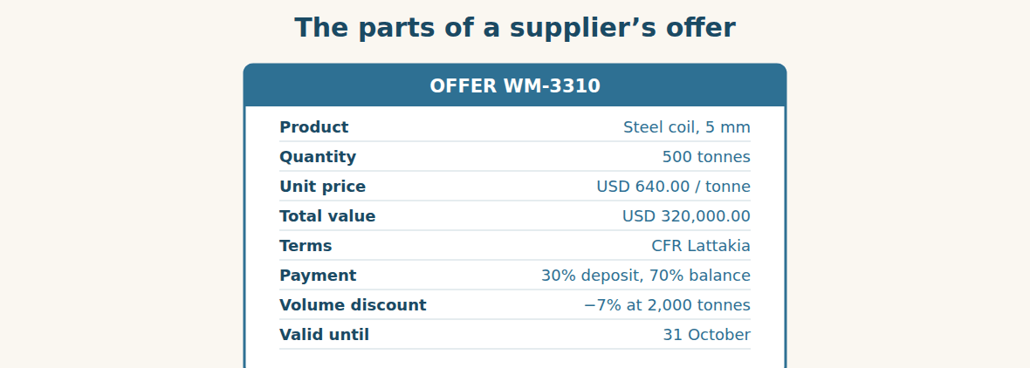
Figure · Eight lines. Every one of them changes the real cost.
A. Match each word (1–7) with its meaning (a–h). There is one you do not need. (0 is done for you.)
0. unit price (e)
1. total value ____ a. money off for a large order
2. volume discount ____ b. the last day the price is good
3. deposit ____ c. the rest of the money, paid later
4. balance ____ d. unit price × quantity
5. valid until ____ e. the price of one tonne or one item
6. margin ____ f. the first part of the money, paid early
7. landed cost ____ g. what the goods cost us in our own depot
8. h. what we add on top of our cost
B. Complete the sentences with the words in the word bank.
Word bank: unit price | total value | deposit | balance | valid until | volume discount
1. The ____________ is 640 dollars a tonne.
2. The ____________ of the order is 320,000 dollars.
3. We pay a 30% ____________ before they start.
4. The ____________ is due when the goods are shipped.
5. The offer is ____________ 31 October.
6. At 2,000 tonnes we get a ____________ of seven per cent.
Money words
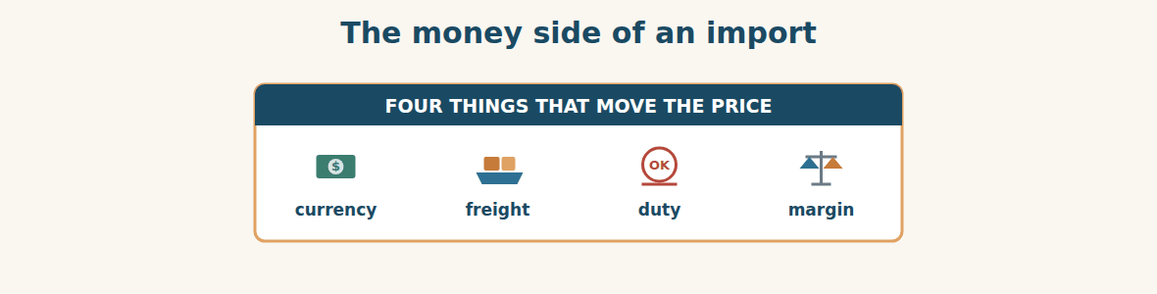
Figure · A price in dollars is not yet a price in Syria.
C. Match the cost (1–5) with what it pays for (a–e).
1. freight ____ a. the government, on imported goods
2. customs duty ____ b. the agent who handles the papers at the port
3. clearance fee ____ c. the ship from the supplier’s port to Lattakia
4. inland transport ____ d. our own profit on the sale
5. margin ____ e. the trucks from Lattakia to the depot
Building the landed cost
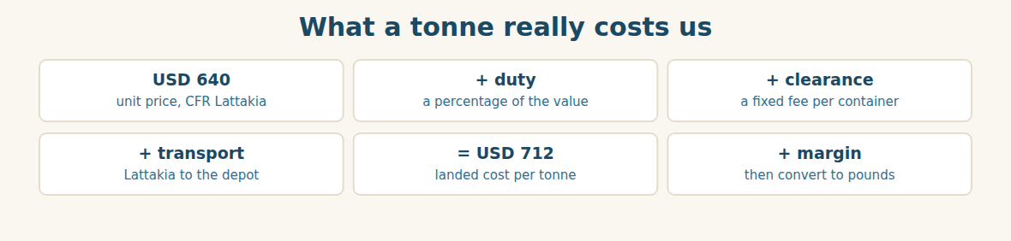
Figure · The ladder from their price to ours.
D. Odd one out. Which word is different? Circle it.
1. duty · freight · clearance · margin
2. deposit · balance · payment · tonne
3. discount · reduction · increase · cut
4. dollar · pound · euro · litre
5. offer · quotation · price · depot
E. Choose the best answer.
1. Money off for a large order is a… (a) deposit (b) volume discount
2. What the goods cost in our own depot is the… (a) unit price (b) landed cost
3. What we add on top of our cost is the… (a) margin (b) duty
4. The first part of the money, paid early, is the… (a) balance (b) deposit
F. Classify. Write each item in the correct column.
Items: unit price | customs duty | margin | freight | clearance fee | selling price
The supplier charges it | Syria charges it | We add it
__________ | __________ | __________
__________ | __________ | __________
__________ | __________ | __________
G. Match the two halves (1–6 with a–f).
1. a volume ____ a. cost
2. the landed ____ b. price
3. the unit ____ c. discount
4. customs ____ d. rate
5. the exchange ____ e. duty
6. payment ____ f. terms
H. Complete the paragraph with the words in the box.
Box: discount | duty | landed | margin | pounds | unit
Their (1)____________ price is 640 dollars. We add the customs (2)____________, the clearance fee and the transport, and we reach a (3)____________ cost of 712 dollars. Then we add our (4)____________ and convert to Syrian (5)____________. If we order 2,000 tonnes, we also get a (6)____________ of seven per cent.
Part 2 · Grammar — first conditional · unless · time clauses FINANCE
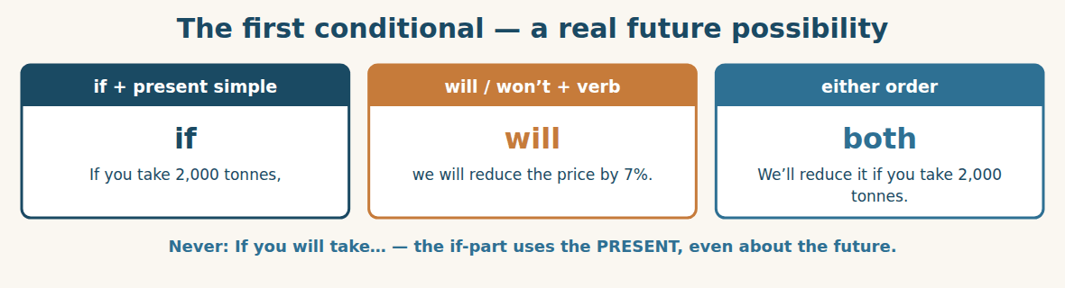
Figure · The grammar of every offer and every counter-offer.
We use the FIRST CONDITIONAL for something that may really happen in the future. The if-part uses the present simple, and the other part uses will or won’t. If we order early, they will give us a discount. They won’t ship it if we don’t pay the deposit.
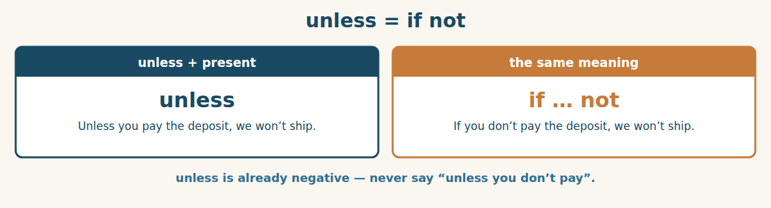
Figure · One word that replaces “if … not”.
UNLESS means if not. Unless the price falls, we will buy less = If the price does not fall, we will buy less. Because unless already means if not, we never put another negative after it.
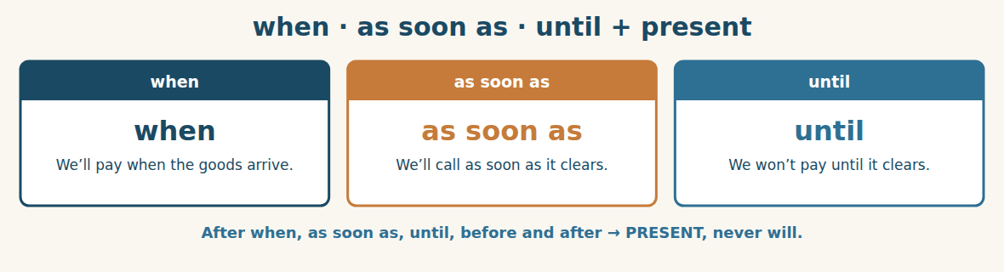
Figure · Time words follow the same rule as if.
After WHEN, AS SOON AS, UNTIL, BEFORE and AFTER we use the present simple for the future, exactly as we do after if. We will unload it as soon as it arrives. We won’t release the goods until the balance is paid.
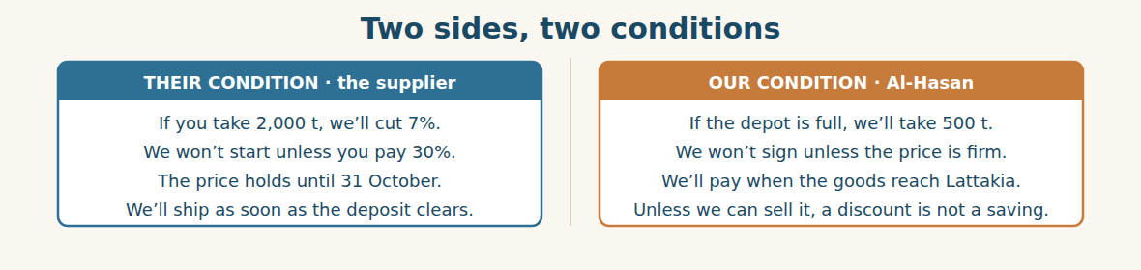
Figure · A negotiation is two sets of conditions meeting.
Watch out! Never use will in the if-part or after when, as soon as or until. Say: If you order 2,000 tonnes, we will give you 7%. Not: If you will order… And remember that unless already means “if not”, so you never add another not after it.
Form
if + present simple , will / won’t + verb · unless + present simple (= if not) · when / as soon as / until / before / after + present simple
A. Complete with the correct form. (0 is done for you.)
0. If we order (order) 2,000 tonnes, they will give us 7%.
1. If the price ____________ (fall), we ____________ (buy) more.
2. They ____________ (not / ship) if we ____________ (not / pay) the deposit.
3. If the depot ____________ (be) full, we ____________ (take) only 500 tonnes.
4. We ____________ (lose) the discount if we ____________ (wait) until November.
B. Rewrite with UNLESS.
1. If we don’t pay the deposit, they won’t ship. → ____________
2. If the price doesn’t fall, we will buy less. → ____________
3. If you don’t confirm today, the offer will expire. → ____________
4. If they don’t send the certificate, customs will stop it. → ____________
C. Complete with WHEN, AS SOON AS or UNTIL.
1. We will pay the balance ____________ the goods reach Lattakia.
2. I will call you ____________ I have the figures — within the hour.
3. We won’t release the steel ____________ the invoice is paid.
4. ____________ the rate changes, our cost changes too.
D. Put the verb in the right form.
1. We will ship it as soon as the deposit ____________ (clear).
2. If the duty ____________ (go) up, our landed cost ____________ (rise).
3. They won’t hold the price until we ____________ (sign).
4. When the trucks ____________ (arrive), we ____________ (unload) the same day.
E. Make a conditional offer from the notes.
1. order 1,000 t / discount 4% → If you ____________
2. pay in 15 days / extra 2% off → If you ____________
3. no deposit / no production → Unless you ____________
4. confirm today / price held → If you ____________
F. Match the condition (1–5) with its result (a–e).
1. If we take 2,000 tonnes, ____ a. our landed cost will rise.
2. If the duty goes up, ____ b. we will get seven per cent off.
3. Unless we pay the deposit, ____ c. we will lose the discount.
4. If we wait until November, ____ d. they won’t start production.
5. As soon as it clears customs, ____ e. Komosh will collect it.
G. Find and correct the mistake in each sentence. (0 is done for you.)
0. If you will order 2,000 t, we give 7%. → (If you order 2,000 t, we will give 7%.)
1. We will pay when the goods will arrive. → ____________
2. Unless you don’t pay, we won’t ship. → ____________
3. If the price falls, we buying more. → ____________
4. We won’t ship until you will confirm. → ____________
H. About you. Write two sentences about your work: one with “If…, I will…” and one with “I won’t … until …”.
1. ______________________________________________
2. ______________________________________________
I. Complete with if, unless, when, as soon as or until.
1. ____________ you confirm today, the price is good for a month.
2. We won’t sign ____________ the price is firm in writing.
3. I will send the order ____________ Mr. Tarek approves it.
4. The offer expires ____________ you reply before 31 October.
5. We will convert to pounds ____________ we know the duty.
J. Write the counter-offer. Use the first conditional.
1. They want 2,000 t. We can take 1,200 t. We want 5%. → “If we ____________”
2. We want 90 days to pay. They want 30. → “If you ____________”
3. We will confirm today, but we want the price held for 60 days. → “If we ____________”
4. We want free delivery to the depot on orders over 1,000 t. → “If we ____________”
Part 3 · Listening and Dialogue FINANCE
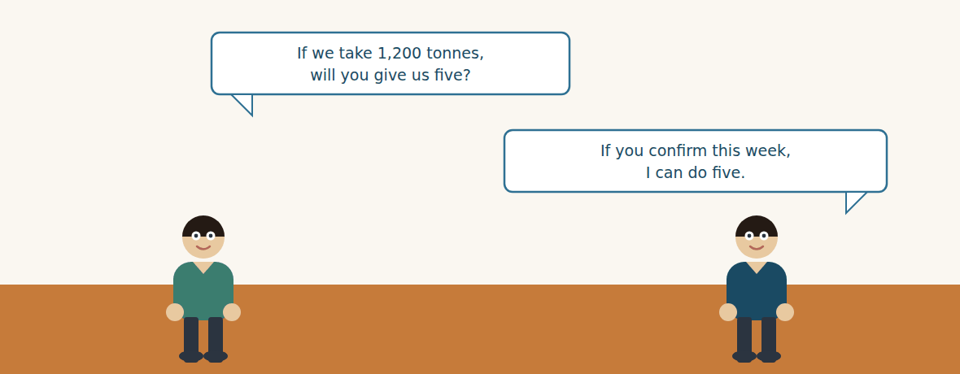
Figure · Strand A · the discount is argued in dollars.
Dialogue 1 — Arguing about the discount (the import desk)
Listen and read. (Your teacher will read the dialogue, or play the audio.)
Rami: Mr. Delgado, thank you for the offer. The price is reasonable. The quantity is my problem.
Mr. Delgado: Two thousand tonnes is where the discount starts. That is our policy.
Rami: I understand. But our depot is half full. If we take 2,000, the steel will sit there until spring.
Mr. Delgado: Then take 500 at the full price.
Rami: Let me put something to you. If we take 1,200 tonnes, will you give us five per cent?
Mr. Delgado: Twelve hundred is not two thousand, Rami.
Rami: No. But 1,200 is more than double the 500 you offered, and we will confirm this week.
Mr. Delgado: Hm. If you confirm before Friday, I can do five per cent on 1,200. After Friday, the offer goes back to 640.
Rami: And will the price hold for sixty days?
Mr. Delgado: It will hold until the end of November, unless the steel market moves more than three per cent.
Rami: That is fair. I will send you our confirmation as soon as Mr. Tarek signs.
A. Comprehension. Answer in your own words. (0 is done for you.)
0. What does Rami say is not a problem? (the price — the quantity is the problem)
1. Why can’t Bashak take 2,000 tonnes?
2. What does Rami offer instead, and what does he ask for?
3. What two conditions does Mr. Delgado attach to the five per cent?
4. Until when will the price hold, and what could change it?
5. When will Rami send the confirmation?
B. True or False? Write T or F.
1. Rami thinks the price is too high. ____
2. The discount normally starts at 2,000 tonnes. ____
3. Mr. Delgado agrees to five per cent on 1,200 tonnes. ____
4. The condition is that Bashak confirms before Friday. ____
5. The price will hold even if the market moves ten per cent. ____
C. Language focus. Find in the dialogue: (0 is done for you.)
0. a conditional question asking for a discount → (If we take 1,200 tonnes, will you give us five per cent?)
1. a condition with a deadline → ____________
2. a sentence with “unless” → ____________
3. a sentence with “as soon as” → ____________
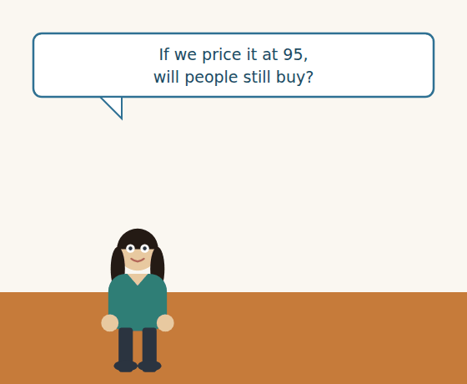
Figure · Strand B · the same steel, priced for a Syrian shelf.
Dialogue 2 — Setting the shelf price (the Syrian market)
Lina: Maya, the landed cost will be about 712 dollars a tonne. What can the market take?
Ms. Maya: Builders are careful this year. If we go above the Homs yard, they will walk.
Lina: What is the Homs yard charging?
Ms. Maya: A little under ours, but their steel is thinner. Mine is five millimetre.
Lina: So we can hold a higher price if we explain the difference.
Ms. Maya: Only if the salesman explains it. If he just says a number, we lose.
Lina: Then I will put the specification on the price card. Will that help?
Ms. Maya: It will. And Lina — don’t change the price again until the winter.
A. Comprehension. Answer in your own words.
1. What is the landed cost, and what does Lina want to know?
2. What will builders do if the price goes above the Homs yard?
3. Why can Al-Hasan hold a higher price than the Homs yard?
4. What does Ms. Maya ask Lina not to do?
B. Listen again and choose the best answer (A–D).
1. The landed cost is about … a tonne. A) $640 B) $712 C) $760 D) $800
2. The Homs yard’s steel is… A) thicker B) thinner C) the same D) cheaper to ship
3. Lina will put the … on the price card. A) discount B) specification C) margin D) duty
4. Ms. Maya asks Lina not to change the price until… A) Friday B) November C) the winter D) next year
Part 4 · Speaking and Your Role FINANCE
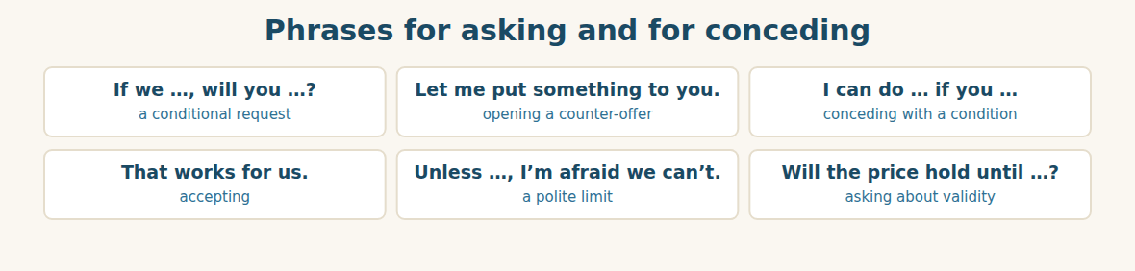
Figure · Never give something away without attaching a condition.
A. Role-play: the discount. Student A is the buyer and wants a better price for a smaller quantity. Student B is the supplier. Then change roles.
1. A: Say the price is acceptable but the quantity is not.
2. B: Say where your discount normally starts.
3. A: Make a conditional offer: a middle quantity for a smaller discount.
4. B: Accept, but attach a deadline.
5. A: Ask how long the price will hold.
6. B: Answer with “until…” and one condition with “unless”.
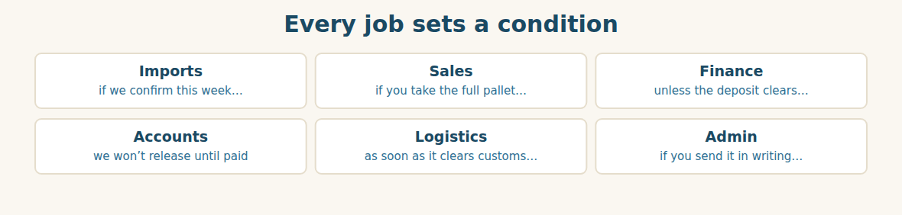
Figure · Six roles, the same grammar of conditions.
B. Your Role. Make one conditional offer from YOUR job. Use the phrases below. (Choose your real role.)
1. [Trade] Import Manager: “If we confirm this week, will you hold the price?”
2. [Trade] Sales: “If you take the whole pallet, I will give you five per cent.”
3. [Finance] Financial Manager: “Unless the deposit clears, we won’t place the order.”
4. [Finance] Accountant: “We won’t release the goods until the invoice is paid.”
5. [Logistics] Freight: “As soon as it clears customs, I will send the truck.”
6. [Admin] Assistant: “If you send it in writing, I will book it today.”
C. Ask your partner. Walk around and ask three people.
1. What will you do if your main supplier raises its price?
2. What won’t you agree to, unless you get something back?
3. What happens in your company as soon as an order is confirmed?
D. Discuss. Ask and answer.
1. Is a big discount always good? When is it a trap?
2. Who should set the selling price — the buyer or the seller? Why?
Part 5 · Extended Reading FINANCE
Why the price at the port is never the price
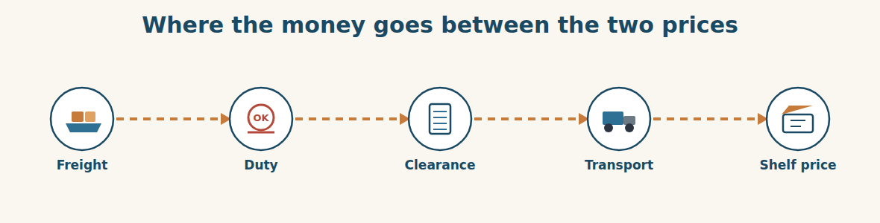
Figure · Four costs stand between their price and ours.
Every buyer learns this lesson once, and usually the hard way. A supplier sends an offer. The number looks good. The buyer compares it with last year’s number, says yes, and only later discovers that the goods cost eleven per cent more than the offer said. Nothing was dishonest. The buyer simply looked at the wrong number.
The price in an offer is a price at one place, on one day, under one set of rules. CFR Lattakia means the supplier pays for the ship to Lattakia. It does not mean the supplier pays the Syrian customs duty. It does not mean the supplier pays the clearance agent, or the trucks to Damascus, or the men who unload them. Each of those is somebody’s bill, and each of them lands on the buyer.
So a careful buyer never compares offers. A careful buyer compares landed costs. The landed cost is what one tonne costs when it is standing in your own warehouse, with every bill paid. It is the only number that can be compared fairly, because it is the only number that includes everything.
This matters most when two offers come from different places. Imagine a supplier whose price is thirty dollars higher but whose port is four days closer. The higher offer may land cheaper. Or imagine two identical prices, where one supplier’s goods carry a certificate and the other’s do not. If the goods without a certificate wait three weeks at customs, the cheaper offer is the expensive one.
And then there is the currency. The offer is in dollars; the shelf price is in Syrian pounds. Between the day the price is agreed and the day the money is paid, the exchange rate can move. A buyer who agrees a price in a foreign currency has quietly agreed to a risk as well. That is why a good offer says “valid until” — and why a good buyer asks how long the price will hold.
The lesson is short. The offer tells you what the supplier will charge. The landed cost tells you what you will pay. Only one of those two numbers belongs in your decision.
A. Comprehension. Answer in your own words. (0 is done for you.)
0. What mistake does almost every buyer make once? (comparing the offer price instead of the landed cost)
1. What does CFR Lattakia pay for, and what does it not pay for?
2. What is the landed cost?
3. Why may a higher offer from a closer port land cheaper?
4. How can a missing certificate make a cheap offer expensive?
5. What risk does a buyer accept by agreeing a price in a foreign currency?
B. Choose the best answer (A–D).
1. The buyer in the first paragraph was… A) cheated B) careless about which number to use C) too slow D) unlucky
2. The Syrian customs duty is paid by the… A) supplier B) ship C) buyer D) agent
3. The only number that can be compared fairly is the… A) unit price B) total value C) landed cost D) margin
4. Goods with no certificate may wait at… A) the depot B) customs C) the bank D) the shop
5. A good offer always states… A) the margin B) the duty C) “valid until” D) the shelf price
C. Find a word or phrase in the text that means:
1. not telling the truth → d____________
2. the cost of one tonne in your own warehouse → the l____________ cost
3. the price of one currency in another → the e____________ r____________
4. the chance that something bad will happen → a r____________
D. Complete the summary with ONE word in each gap.
An offer is a price at one (1)____________, under one set of rules. CFR pays for the (2)____________, but not the duty, the clearance or the (3)____________. A careful buyer compares (4)____________ costs, not offers. A missing (5)____________ can make a cheap offer expensive, and a moving exchange (6)____________ is a risk the buyer accepts.
E. Discuss. Talk in pairs.
1. Does your company calculate landed cost? Who does it?
2. How does your company protect itself against a moving exchange rate?
F. True or False? (about the reading). Write T, F or NOT GIVEN.
1. CFR Lattakia includes the Syrian customs duty. ____
2. The landed cost includes every bill. ____
3. Syrian customs duty on steel is fifteen per cent. ____
4. A price in a foreign currency carries a risk. ____
Part 6 · Writing (a real email) ADMIN
Model — A counter-offer
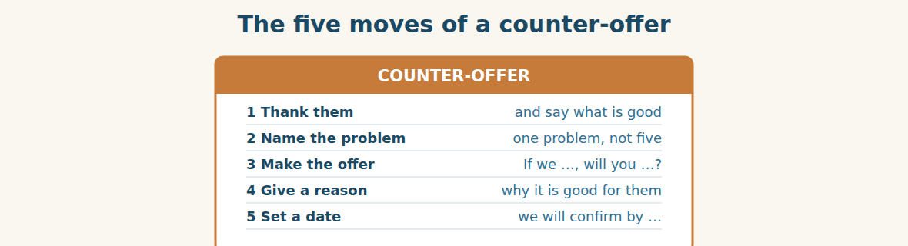
Figure · Say no and yes in the same email.
Subject: Offer WM-3310 — our counter-proposal. Dear Mr. Delgado, Thank you for your offer of 640 dollars a tonne, CFR Lattakia. The price is competitive and the terms are clear. Our difficulty is the quantity. Our depot is half full, so 2,000 tonnes will sit until the spring. If we increase our order to 1,200 tonnes, will you give us five per cent? Twelve hundred is more than double the quantity in your first offer, and we will confirm this week rather than next month. If you can agree five per cent, I will send our confirmation as soon as our General Manager signs, and in any case before Friday. Best regards, Rami Import Manager, Bashak Co.
A. Answer about the email. (0 is done for you.)
0. What does Rami say is good about the offer? (the price is competitive and the terms are clear)
1. What is the one problem, and why?
2. What exactly does Rami offer, and what does he ask for?
3. What two reasons does he give to make it attractive?
B. Put the email in order (1–6).
1. ( ) Our difficulty is the quantity.
2. ( ) Dear Mr. Delgado,
3. ( ) If we increase our order to 1,200 tonnes, will you give us five per cent?
4. ( ) Thank you for your offer of 640 dollars a tonne.
5. ( ) Best regards, Rami
6. ( ) I will send our confirmation before Friday.
Guided writing
C. Now you write. Write a counter-offer (70–100 words). Use the first conditional at least twice, and give one clear reason why your offer is good for the other side.
Plan: 1) “Dear …,” 2) “Thank you for … . The … is ….” 3) “Our difficulty is ….” 4) “If we …, will you …?” 5) “… because ….” 6) “I will … before ….” 7) “Best regards, …”
Sentence starters: “Thank you for your offer of…” · “Our difficulty is…” · “If we …, will you …?” · “We will confirm as soon as…” · “Unless …, I am afraid…”
______________________________________________
______________________________________________
______________________________________________
______________________________________________
______________________________________________
D. Checklist. Tick each one when you have checked your counter-offer.
- I said one thing that is good about their offer.
- I named one problem, not five.
- I used “If we …, will you …?” at least once.
- I gave a reason why my offer helps them too.
- I said when I will confirm.
Part 7 · Trade-Skills Track FINANCE
Building a price: from landed cost to shelf price
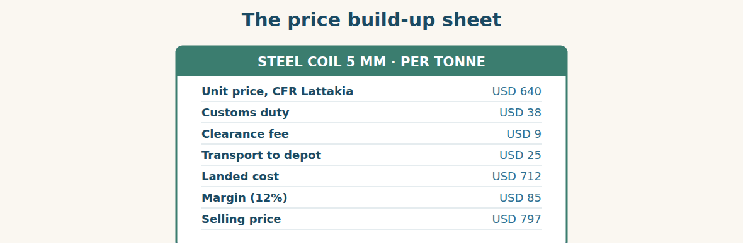
Figure · One sheet, seven lines, and nobody argues afterwards.
A price build-up is the most useful single sheet of paper in a trading company. It takes the supplier’s number at the top and walks down to the number the customer sees. Every line is a cost, and every line has an owner who can explain it.
Work from the top down. Start with the unit price and say which terms it includes — CFR, FOB, or something else. Add the customs duty, which is usually a percentage of the value, so it moves when the price moves. Add the clearance fee, which is usually a fixed amount per container, so it falls per tonne when the container is full. Add the inland transport. The total is the landed cost.
Only then do you add the margin, and only then do you convert into the selling currency. The order matters. A company that adds the margin before the duty is pricing on the wrong base, and will be surprised at the end of the year. And always keep the sheet. When a customer asks why the price rose, the sheet shows which line moved — and “the duty went up four points” is an answer a customer can accept, while “our prices have increased” is not.
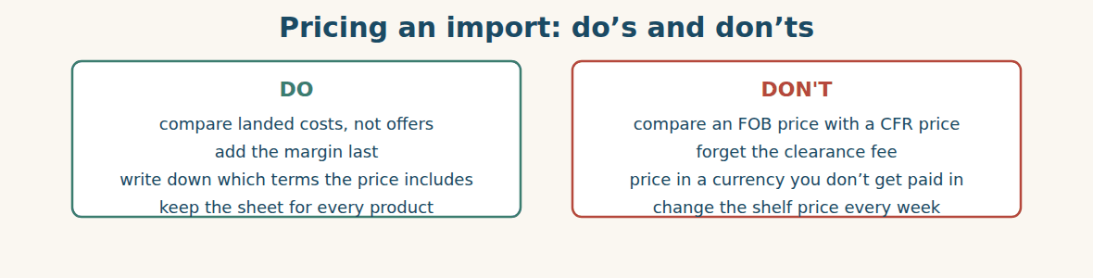
Figure · Four habits that keep a margin where you put it.
A. Comprehension. Answer in your own words.
1. What does a price build-up sheet do?
2. Why does the customs duty move when the price moves?
3. Why does the clearance fee fall per tonne when the container is full?
4. Why must the margin be added last?
5. Why is “the duty went up four points” a better answer than “our prices have increased”?
B. Listen and complete. Lina explains the sheet. Write the missing word.
1. Lina: Start with the unit price and say which ____________ it includes.
2. Lina: The customs duty is a ____________ of the value.
3. Lina: The clearance fee is a fixed amount per ____________.
4. Lina: Add the ____________ last, and convert after that.
C. Practice. Build a price for one product you sell. Write the seven lines from the sheet above, with your own numbers. Then explain to your partner which line would hurt you most if it doubled.
D. Calculate. Use the sheet above.
1. What is the landed cost per tonne? → ____________
2. If the duty rises to USD 58, what is the new landed cost? → ____________
3. With a 12% margin on USD 712, what is the selling price? → ____________
4. If Westgate gives 5% off the unit price, what is the new unit price? → ____________
Part 8 · Consolidation FINANCE
The discount that was not a saving
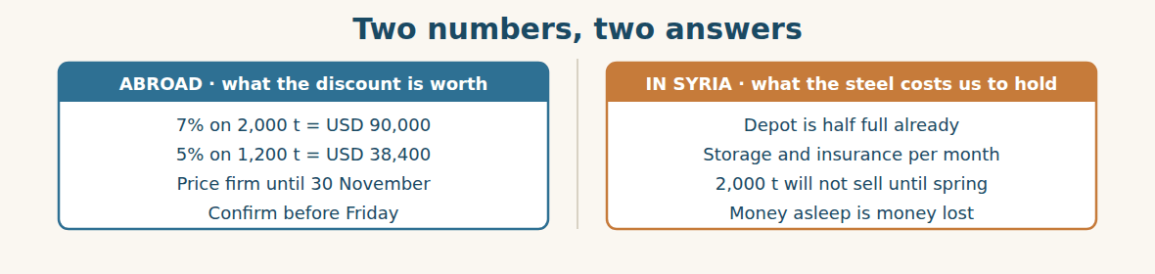
Figure · A saving on the left; a cost on the right.
On Thursday the two sheets meet on Mr. Tarek’s desk. Rami’s sheet says the seven per cent is worth ninety thousand dollars. Lina’s sheet says that two thousand tonnes will not move until spring, and that holding them costs storage, insurance, and money that cannot be used for anything else.
Mr. Tarek reads both. “So the discount is ninety thousand,” he says, “and the cost of taking it is?” Lina has the number ready. “Over six months, about seventy-four thousand. And that is if nothing goes wrong.”
Rami does not argue. He has learned something this week, and he says it out loud. “Then 1,200 at five per cent is the better deal, even though the percentage is smaller. We take what we can sell.”
Mr. Tarek signs the 1,200. Then he adds one line to the order by hand: the price is firm until 30 November, unless the market moves more than three per cent. “If the market moves,” he says, “I want to read it in the contract, not hear it on the telephone in December.”
Rami sends the confirmation at four o’clock. Downstairs, Lina is already converting 712 dollars into Syrian pounds for Maya’s price card. The deal abroad and the price at home are, for once, the same conversation.
A. Comprehension. Answer in your own words. (0 is done.)
0. What do the two sheets say? (the discount is worth $90,000; the steel will not sell until spring)
1. What is the cost of holding 2,000 tonnes for six months?
2. What has Rami learned?
3. What line does Mr. Tarek add by hand, and why?
4. What is Lina doing downstairs?
5. Why does the writer say the two conversations are “for once, the same”?
B. Complete each sentence with ONE word from the text. (0 is done for you.)
0. The two sheets meet on Mr. Tarek’s desk.
1. The seven per cent is worth ninety thousand ____________.
2. Holding the steel costs storage, insurance and ____________ that cannot be used.
3. Rami says they should take what they can ____________.
4. The price is ____________ until 30 November.
5. Lina is converting dollars into Syrian ____________.
C. Discuss. Talk in pairs.
1. Was Mr. Tarek right to refuse the bigger discount?
2. How would you explain “money asleep is money lost” to a new colleague?
D. Find a word from the text that means: (0 is done for you.)
0. not changing → (firm)
1. keeping goods in a warehouse → s____________
2. protection you pay for → i____________
3. to change one currency into another → to c____________
Part 9 · Case Studies and Decisions FINANCE
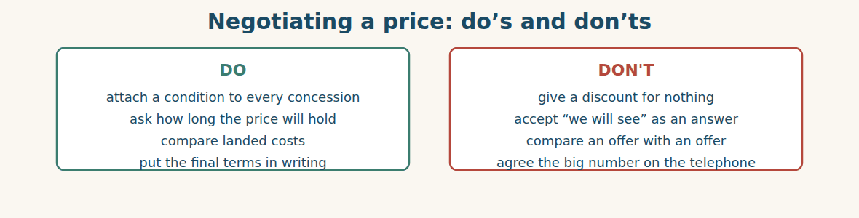
Figure · Everything you give away should buy something back.
Case 1 — The discount with a deadline (strand A · abroad)
A supplier offers you eight per cent, but only if you confirm by Friday. It is Wednesday. Your General Manager is travelling and cannot sign until Monday. The supplier will not move the deadline.
Choose the best action and say why.
1. ( ) Sign it yourself and tell the General Manager on Monday.
2. ( ) Ask the supplier in writing to hold the eight per cent until Monday, and offer something small in return.
3. ( ) Let the offer expire and start again next month.
4. ( ) Accept the offer at the full price now, to be safe.
Write one sentence asking the supplier to extend the deadline.
______________________________________________
______________________________________________
Case 2 — The customer who only sees the number (strand B · in Syria)
A builder says your steel is more expensive than the Homs yard. Your steel is five millimetre; theirs is four. He has not noticed. He is about to walk out of the shop.
Answer the questions.
1. What is the one fact he needs before he decides?
2. How can you show the difference without saying he is wrong?
3. Write one sentence that compares the two products fairly.
Case 3 — A bigger discount you cannot use (where the strands meet)
A supplier offers twelve per cent, but only on four thousand tonnes. Your depot can hold two thousand. Renting outside space would cost about half the discount, and the steel would take a year to sell.
Answer the questions.
1. Why is a discount you cannot store not really a discount?
2. What two numbers must you compare before you answer?
3. Write one sentence refusing the quantity but keeping the relationship.
Part 10 · Review and Can-Do FINANCE
A. Vocabulary. Complete the sentence.
1. The price of one tonne is the ____________ ____________.
2. Money off for a large order is a ____________ ____________.
3. What the goods cost in our own depot is the ____________ ____________.
4. What we add on top of our cost is the ____________.
5. The first part of the money, paid early, is the ____________.
B. Grammar. Complete with the correct form.
1. If we ____________ (confirm) today, they ____________ (hold) the price.
2. They won’t ship unless we ____________ (pay) the deposit.
3. We will unload it as soon as it ____________ (arrive).
4. We ____________ (not / release) the steel until the invoice is paid.
5. If the duty ____________ (rise), our landed cost ____________ (go) up.
6. When the rate ____________ (change), our cost ____________ (change) too.
C. Reading. Read the short text and answer.
Westgate offered 640 dollars a tonne, CFR Lattakia, with seven per cent off at 2,000 tonnes. The depot was half full, so Al-Hasan asked for five per cent on 1,200 tonnes instead. Westgate agreed, on condition that Al-Hasan confirmed before Friday. The landed cost is 712 dollars a tonne, and the price is firm until 30 November.
1. What discount did Al-Hasan finally get, and on what quantity?
2. What was Westgate’s condition?
3. What is the landed cost per tonne?
D. Listening. Listen and answer. (Teacher reads.)
[Teacher reads] “If you confirm before Friday, I can do five per cent on 1,200 tonnes. The price will hold until the end of November, unless the steel market moves more than three per cent. We will start production as soon as your deposit clears.”
1. What is the condition for the five per cent?
2. Until when will the price hold, and what could change that?
3. When will production start?
E. Speaking. Work in pairs. One is a buyer asking for a discount on a smaller quantity; one is a supplier conceding with a deadline.
F. Writing. Write two sentences: one with “If we …, will you …?” and one with “We won’t … until …”.
1. ______________________________________________
2. ______________________________________________
G. Error correction. Find and correct one mistake in each sentence.
1. If you will order 2,000 t, we will give 7%. → ____________
2. We will pay when the goods will arrive. → ____________
3. Unless you don’t confirm, the offer expires. → ____________
4. We won’t ship until you will pay. → ____________
5. If the duty rises, our cost rising too. → ____________
H. Match the cost (1–5) to what it pays for (a–e).
1. freight ____ a. the government, on imported goods
2. customs duty ____ b. our own profit
3. clearance fee ____ c. the ship to Lattakia
4. inland transport ____ d. the agent at the port
5. margin ____ e. the trucks to the depot
I. Put the price build-up in order (1–6).
1. ( ) add the clearance fee
2. ( ) start with the unit price
3. ( ) add the margin
4. ( ) add the customs duty
5. ( ) convert into the selling currency
6. ( ) add the inland transport
Can-Do check. Tick what you can do.
- I can read and check a supplier’s offer.
- I can make a conditional offer.
- I can explain how we get from cost to selling price.
- I can write a counter-offer.
Part 11 · Foundations for Further Study FINANCE
Concept Spotlight: Every price is a sentence with an “if” in it
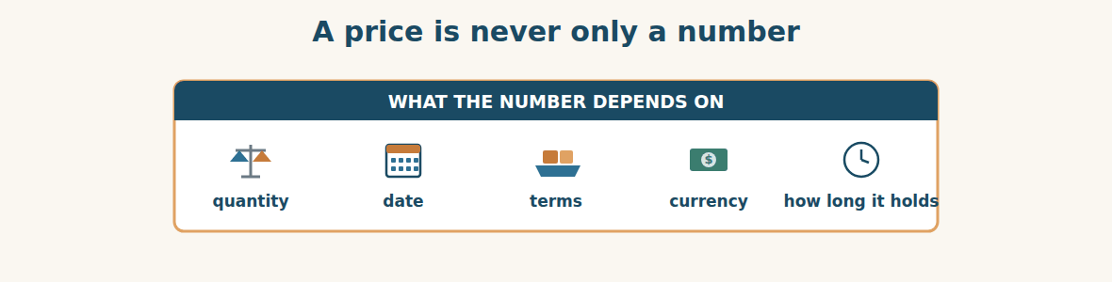
Figure · Change any one of these, and the number changes.
In this unit the grammar and the business were the same thing. The first conditional is not a tense you learn for an exam. It is how commerce actually speaks. If you take two thousand tonnes, we will reduce the price. Unless you pay the deposit, we will not start. We will ship as soon as the money clears. Every one of those sentences is a price with a condition attached, and in business a price without a condition barely exists.
This is worth sitting with, because people new to trade often hear a number and think they have heard the answer. They have not. They have heard one branch of a sentence. Six hundred and forty dollars a tonne is true if the quantity is five hundred, if the terms are CFR, if you confirm this month, if you pay thirty per cent in advance, and if the market does not move. Take away any of those, and the number quietly stops being true.
Once you see this, a negotiation stops being a fight about one number. It becomes an exchange of conditions. Rami could not win on quantity, so he bought the discount with speed: confirm this week instead of next month. That is the whole craft. You rarely get something for nothing, but you can very often get something for something else — and the something else need not be money. It can be time, certainty, a longer relationship, or a smaller risk for the other side.
Someone will object that this is just haggling, and that an honest company should name one fair price and keep it. There is something in that, and a company that changes its price every week will not be trusted. But naming a price without naming its conditions is not honesty; it is incompleteness. The most honest offer in this unit is Mr. Delgado’s last one, because it says exactly what would make it untrue: unless the steel market moves more than three per cent.
So when you write a price in English, write the whole sentence. How much, for how many, on what terms, in what currency, and until when. A number alone invites an argument later. A number with its conditions is a promise both sides can keep.
A. Understanding check. Answer in your own words.
1. Why does the writer say the first conditional is “how commerce actually speaks”?
2. What mistake do people new to trade make when they hear a number?
3. What did Rami use to buy the discount, since he could not win on quantity?
4. Why is Mr. Delgado’s last offer called the most honest one?
B. Apply it. Do this task with a partner.
Take one price from your own work. Write it as a full sentence: how much, for how many, on what terms, in what currency, and until when. Then ask your partner to find the condition you forgot.
C. Micro-writing (optional).
Write a few sentences (50–70 words) offering a customer a conditional discount. Use the first conditional twice and “unless” once. Example: “If you order …, we will … . Unless …, we cannot … .”
Study terms: offer · quotation · counter-offer · negotiate · unit price · total value | quantity · discount · volume discount · deposit · balance · payment terms | valid until · firm price · incoterm · CFR · FOB · freight | customs duty · clearance fee · inland transport · landed cost · cost price · selling price | margin · mark-up · profit · currency · exchange rate · convert | per tonne · storage · insurance · risk · concession · expire
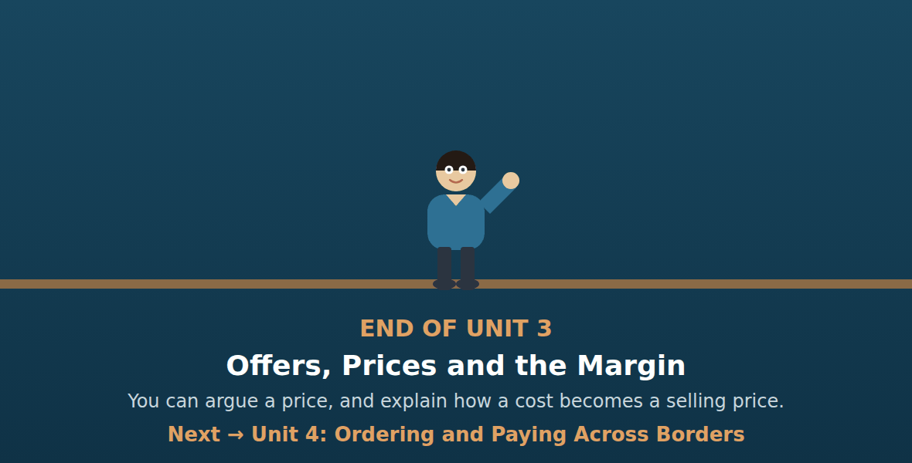
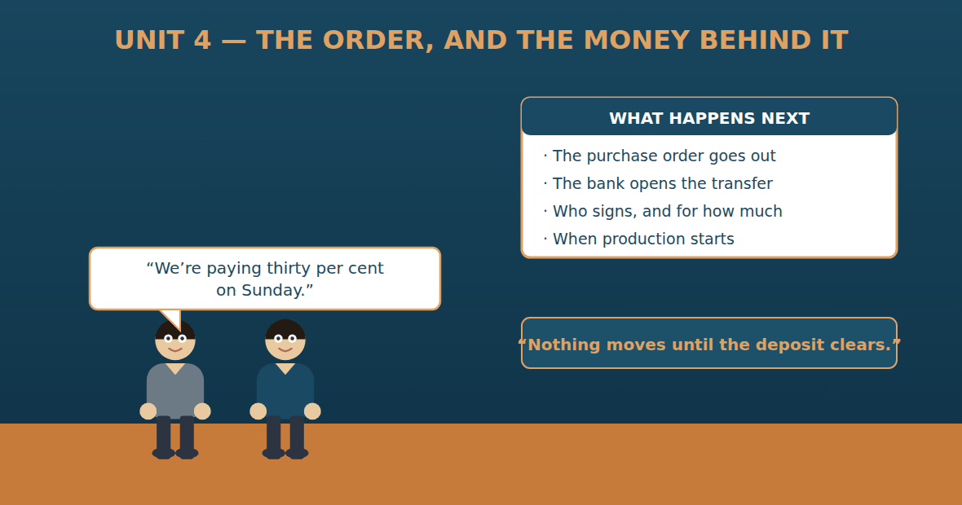

Unit 4: Ordering and Paying Across Borders
Al-Hasan International — English for Trade, Industry & Global Partnerships
CEFR B1 · Grammar: will · going to · present continuous for arrangements · Function: Finance + Admin
Can-Do (by the end of this unit)
- I can place an import order
- I can talk about plans and arrangements
- I can explain how and when we will pay
- I can write an instruction to the bank
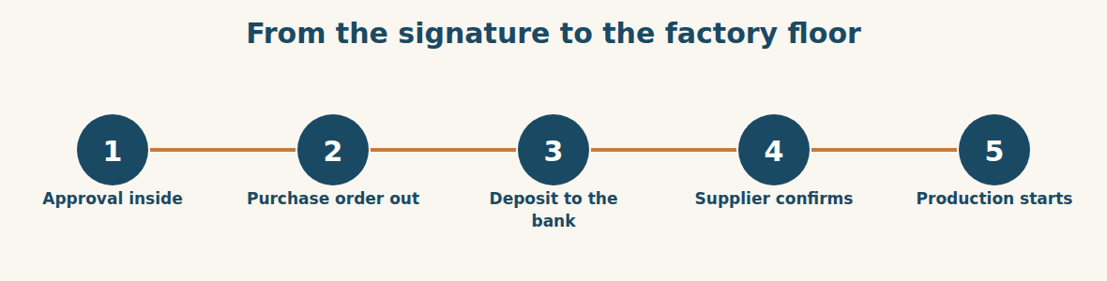
Figure · Nothing in this chain can jump the queue.
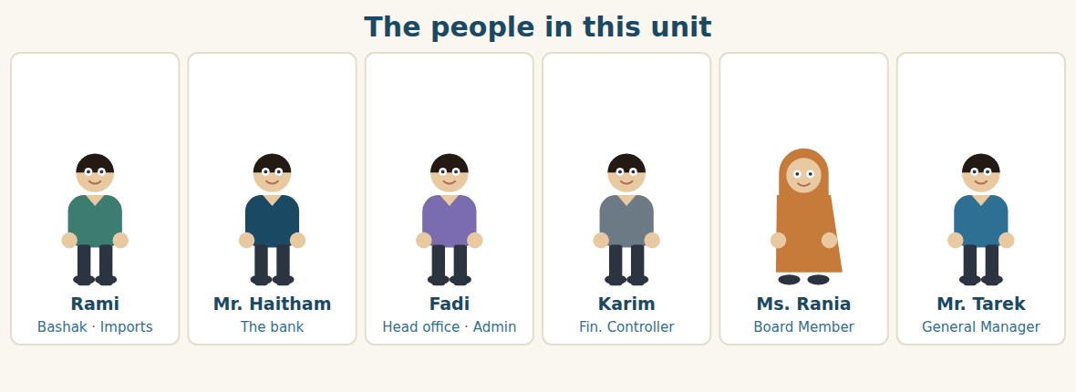
Figure · One side talks to a bank; the other side collects signatures.
Warm Up FINANCE
Look at the pictures. Answer these questions before you read.
1. Who has to sign before your company spends a large amount?
2. How does money travel from your bank to a supplier abroad?
3. What are you doing at work next week? Name one fixed arrangement.
Read
The price is agreed: 1,200 tonnes of steel coil, five per cent off, firm until the end of November. Now Rami has to turn a conversation into an order, and an order into money.
He starts with the purchase order. It is one page, and every line on it has to match the offer exactly: the product, the quantity, the unit price, the total, the terms, and the payment schedule. Thirty per cent on order, seventy per cent before shipment. Thirty per cent of 729,600 dollars is about 219,000 dollars.
That number changes who can sign. Up to fifty thousand dollars, Mr. Tarek signs alone. Above it, the board has to approve. So the order goes to Fadi, who prepares the file: the three enquiries, the check-list, the price build-up and the counter-offer. Then it goes to Karim, who checks the budget, and finally to Ms. Rania.
“I am going to sign it,” she says, “but not today. I am seeing the auditors this afternoon, and I want to ask them one question about the currency.” Rami’s stomach turns over. The price is firm only until 30 November.
She signs on Thursday morning. By Thursday afternoon Rami is at the bank with Mr. Haitham. “We are sending two hundred and nineteen thousand dollars to Westgate Metals,” he says. “When will it arrive?”
“It will leave here on Sunday,” says Mr. Haitham. “It usually arrives two working days later, so Tuesday. But I am going to tell you something people forget. Write the purchase order number in the payment reference. If you don’t, their accounts department will not know what the money is for, and nobody will start the production.”
A. Comprehension. Answer in your own words. (0 is done for you.)
0. What has been agreed before this unit starts? (1,200 tonnes at five per cent off, firm until 30 November)
1. What must every line of the purchase order match?
2. What is the payment schedule, and how much is the deposit?
3. Who can sign up to fifty thousand dollars, and who signs above it?
4. Why does Ms. Rania not sign on the first day?
5. What does Mr. Haitham say people forget, and why does it matter?
B. True or False? Write T or F. (0 is done for you.)
0. The purchase order is five pages long. (F)
1. The deposit is thirty per cent of the total. ____
2. Mr. Tarek can sign any amount alone. ____
3. Ms. Rania signs on Thursday morning. ____
4. The transfer will leave the bank on Sunday. ____
5. The payment reference does not matter. ____
C. Find the words. Find a word or phrase in the text that means: (0 is done for you.)
0. the paper that places an order with a supplier → (the purchase order)
1. when and how much we will pay → the payment s____________
2. the number the supplier uses to find our payment → the p____________ r____________
3. the money we send before the goods are made → the d____________
D. Over to you. Answer about yourself.
1. What is the approval limit in your company? Who signs above it?
2. How long does an international payment take from your bank?
3. What are you doing at work tomorrow? Give one fixed arrangement.
Part 1 · Vocabulary and Terminology ADMIN
The purchase order
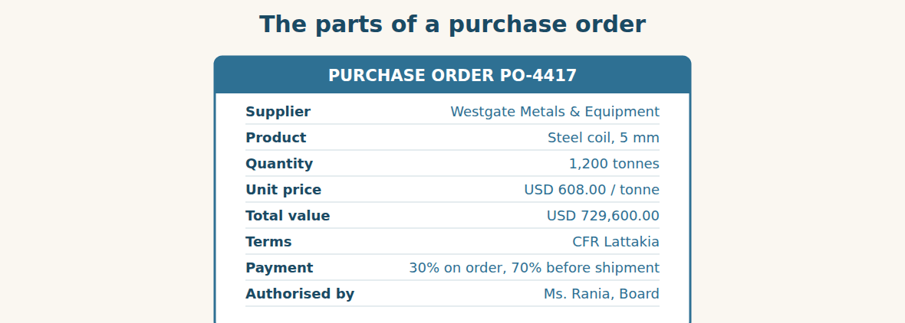
Figure · Eight lines, and every one must match the offer.
A. Match each word (1–7) with its meaning (a–h). There is one you do not need. (0 is done for you.)
0. purchase order (c)
1. order confirmation ____ a. the person who is allowed to sign
2. proforma invoice ____ b. the money that arrives in the account
3. payment schedule ____ c. the paper that places an order
4. bank transfer ____ d. the supplier’s paper saying “we accept”
5. beneficiary ____ e. when and how much we will pay
6. authorised signatory ____ f. a price document used to arrange payment
7. approval limit ____ g. the person or company receiving the money
8. h. the largest amount one person may approve
B. Complete the sentences with the words in the word bank.
Word bank: purchase order | order confirmation | payment schedule | beneficiary | approval limit | bank transfer
1. We sent the ____________ on Thursday afternoon.
2. Westgate replied the next day with an ____________.
3. Our ____________ is thirty per cent on order and seventy before shipment.
4. The ____________ on the transfer is Westgate Metals & Equipment.
5. Mr. Tarek’s ____________ is fifty thousand dollars.
6. The money will leave by ____________ on Sunday.
Paying across a border
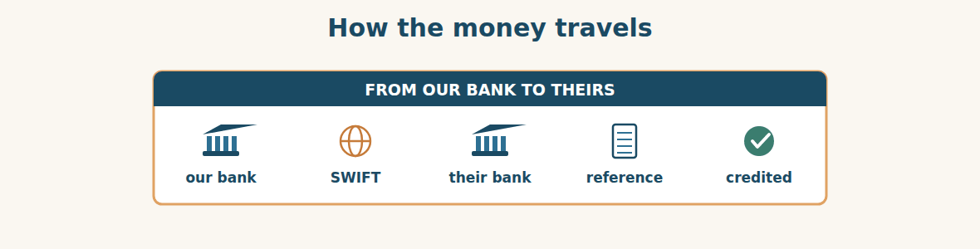
Figure · Four days, three banks, one reference number.
C. Match the word (1–5) with its meaning (a–e).
1. remitter ____ a. the day the money is available
2. beneficiary ____ b. the company sending the money
3. value date ____ c. what the banks charge for the transfer
4. bank charges ____ d. the company receiving the money
5. reference ____ e. the text that says what the payment is for
Who may sign what
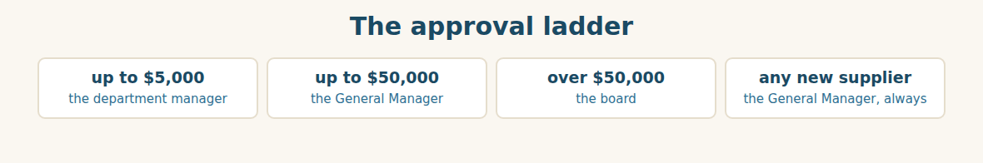
Figure · The amount decides the signature, not the hurry.
D. Odd one out. Which word is different? Circle it.
1. deposit · balance · instalment · depot
2. remitter · beneficiary · bank · tonne
3. approve · authorise · sign off · deliver
4. transfer · payment · remittance · catalogue
5. will · going to · present continuous · past simple
E. Choose the best answer.
1. The company receiving the money is the… (a) remitter (b) beneficiary
2. The largest amount one person may approve is the… (a) approval limit (b) budget
3. The supplier’s paper saying “we accept” is the… (a) proforma invoice (b) order confirmation
4. The text saying what a payment is for is the… (a) value date (b) reference
F. Classify. Write each item in the correct column.
Items: purchase order | order confirmation | bank transfer | proforma invoice | approval file | order acknowledgement
We send it | They send it | Stays inside our company
__________ | __________ | __________
__________ | __________ | __________
__________ | __________ | __________
G. Match the two halves (1–6 with a–f).
1. a purchase ____ a. limit
2. an approval ____ b. order
3. a bank ____ c. date
4. a payment ____ d. transfer
5. the value ____ e. schedule
6. an authorised ____ f. signatory
H. Complete the paragraph with the words in the box.
Box: approval | beneficiary | confirmation | deposit | reference | transfer
Above fifty thousand dollars we need board (1)____________. Then we send the purchase order and wait for the (2)____________. The (3)____________ is thirty per cent, sent by bank (4)____________. The (5)____________ is the supplier, and we always write the order number in the (6)____________.
Part 2 · Grammar — will · going to · present continuous FINANCE
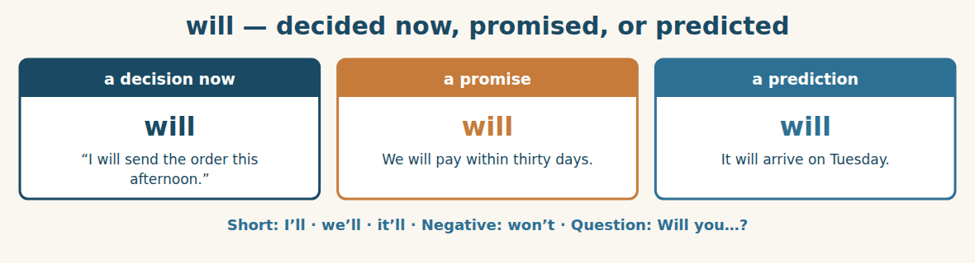
Figure · will — for what we decide, promise or expect.
We use WILL for a decision we make at the moment of speaking, for a promise, and for a prediction about the future. The transfer will leave on Sunday. I’ll call you when it clears. We won’t release the balance until we see the shipping documents.
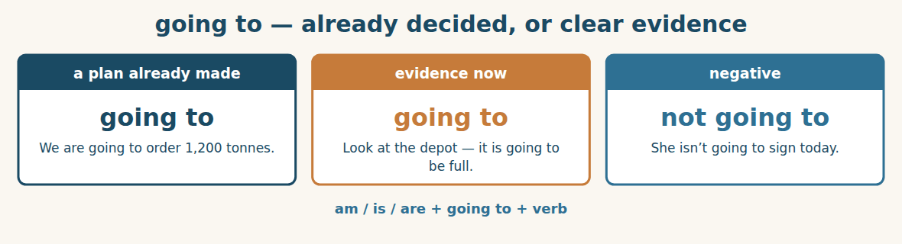
Figure · going to — for a plan made before you spoke.
We use GOING TO for a plan we decided earlier, and for something we can see coming. I am going to sign it, but not today = she decided before the meeting. Compare: I will sign it = she decides as she speaks.
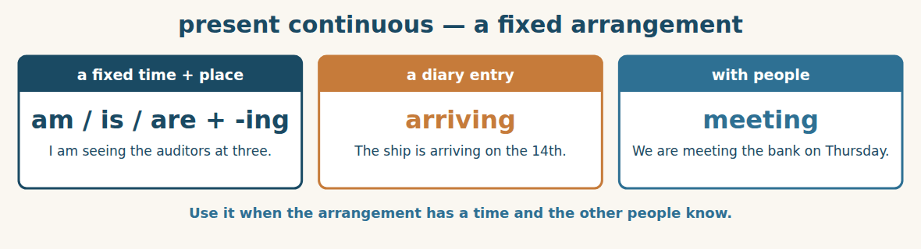
Figure · The diary tense — fixed, agreed, with a time.
We use the PRESENT CONTINUOUS for an arrangement that is already fixed: a time is agreed and other people are involved. I am seeing the auditors this afternoon. We are shipping on the 14th. It is the tense of a diary.
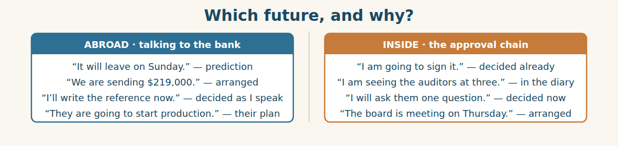
Figure · Three futures, used in the same two conversations.
Watch out! Don’t use will for an arrangement that is already in the diary. Say I am seeing the auditors at three, not I will see the auditors at three. And after I think, I hope, probably and maybe, use will, not going to: I think it will arrive on Tuesday.
Form
will / won’t + verb · am / is / are + going to + verb · am / is / are + verb-ing (+ a time)
A. Complete with WILL or WON’T. (0 is done for you.)
0. The transfer will leave the bank on Sunday.
1. We ____________ release the balance until we see the documents.
2. I think it ____________ arrive on Tuesday.
3. Don’t worry — I ____________ write the reference now.
4. They ____________ start production without the deposit.
B. Complete with GOING TO and the verb in brackets.
1. We ____________ (order) 1,200 tonnes, not 2,000.
2. She ____________ (sign) it, but not today.
3. Look at the depot — it ____________ (be) full by March.
4. They ____________ (not / wait) for the balance.
C. Complete with the present continuous (a fixed arrangement).
1. I ____________ (see) the auditors at three o’clock.
2. We ____________ (meet) Mr. Haitham on Thursday morning.
3. The ship ____________ (arrive) on the 14th.
4. Rami ____________ (fly) to the port next week.
D. Choose the best future form. (0 is done for you.)
0. I ___ call you as soon as it clears. (will)
1. We ___ (meet) the board on Thursday — it is in the diary.
2. Look at those clouds. It ___ (rain).
3. I’ve decided. I ___ (take) the 1,200 tonnes.
4. That is heavy. I ___ (help) you.
E. Match the sentence (1–5) with the reason (a–e).
1. I’ll send it now. ____ a. an arrangement in the diary
2. We are going to open a third depot. ____ b. a decision made as I speak
3. I am meeting the bank at ten. ____ c. a prediction
4. It will probably arrive Tuesday. ____ d. a plan decided earlier
5. Look — the container is going to fall. ____ e. evidence we can see now
F. Make questions about the plan.
1. (?) when / the transfer / leave → ____________
2. (?) who / going to / sign → ____________
3. (?) you / meet / the bank / on Thursday → ____________
4. (?) what time / the ship / arrive → ____________
G. Find and correct the mistake in each sentence. (0 is done for you.)
0. I will see the auditors at three. (it is in my diary) → (I am seeing the auditors at three.)
1. We will going to order 1,200 tonnes. → ____________
2. She is going sign it tomorrow. → ____________
3. I think it is going to arrive on Tuesday. (just an opinion) → ____________
4. What time you are meeting the bank? → ____________
H. About you. Write two sentences: one with “I am going to…” and one with “I am …-ing” for a fixed arrangement.
1. ______________________________________________
2. ______________________________________________
I. Complete with will, going to, or the present continuous.
1. We ____________ (send) the deposit on Sunday — the bank has the instruction.
2. I ____________ (ask) Karim about the budget. I have just thought of it.
3. The board ____________ (meet) at nine on Thursday.
4. I think the rate ____________ (move) before December.
5. We ____________ (not / place) the order until Ms. Rania signs.
J. Write the plan. Use the form in brackets.
1. deposit leaves Sunday (present continuous) → ____________
2. production starts when the money clears (will) → ____________
3. we have decided to use Komosh for the freight (going to) → ____________
4. board meeting, Thursday 09:00 (present continuous) → ____________
Part 3 · Listening and Dialogue FINANCE
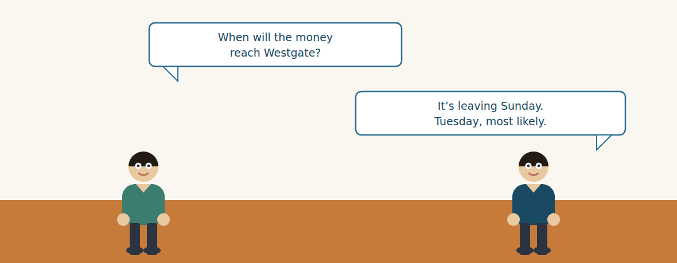
Figure · Strand A · at the bank, arranging the transfer.
Dialogue 1 — At the bank (the import desk)
Listen and read. (Your teacher will read the dialogue, or play the audio.)
Rami: Mr. Haitham, we are sending two hundred and nineteen thousand dollars to Westgate Metals. Here is the instruction.
Mr. Haitham: Thank you. Let me check the beneficiary details against the invoice. Account name, account number… yes, they match.
Rami: When will it reach them?
Mr. Haitham: It is leaving here on Sunday. It usually arrives two working days later, so Tuesday. I will send you the confirmation the same day.
Rami: Good, because production doesn’t start until the money clears.
Mr. Haitham: Then I am going to tell you the thing people forget. The reference. Put the purchase order number in it.
Rami: PO-4417.
Mr. Haitham: Exactly. Without it, their accounts department sees an amount and no name they recognise, and it sits for a week.
Rami: One more question. Who pays the bank charges?
Mr. Haitham: That depends on your instruction. If you choose “shared”, they will receive a little less than you send. If they need the full amount, you pay all the charges.
Rami: Then we will pay all the charges. I don’t want an argument over forty dollars in December.
A. Comprehension. Answer in your own words. (0 is done for you.)
0. How much is Bashak sending, and to whom? (USD 219,000, to Westgate Metals)
1. What does Mr. Haitham check first, and against what?
2. When will the money leave, and when will it probably arrive?
3. Why does the purchase order number matter so much?
4. What are the two choices about bank charges?
5. Which does Rami choose, and why?
B. True or False? Write T or F.
1. The beneficiary details did not match the invoice. ____
2. The money is leaving on Sunday. ____
3. Production starts before the money clears. ____
4. Without a reference, a payment can sit for a week. ____
5. Rami chooses “shared” charges. ____
C. Language focus. Find in the dialogue: (0 is done for you.)
0. a present continuous for a fixed arrangement → (It is leaving here on Sunday.)
1. a “going to” for something decided earlier → ____________
2. a “will” for a promise → ____________
3. a first conditional about the charges → ____________
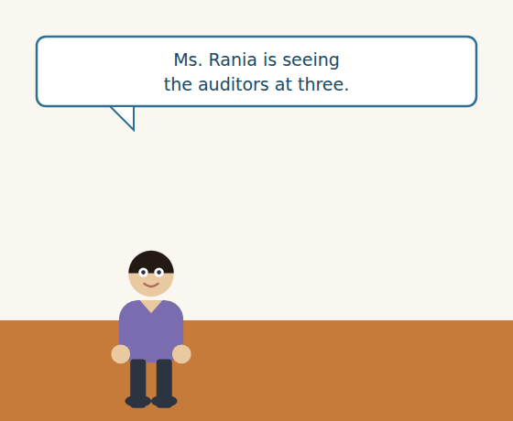
Figure · Strand B · the signature that holds everything up.
Dialogue 2 — Waiting for a signature (inside the Group)
Rami: Fadi, where is the file? The price is only firm until 30 November.
Fadi: It is on Ms. Rania’s desk. She is seeing the auditors at three, and she wants to ask them about the currency first.
Rami: Today is the 21st. If she signs tomorrow we are still fine, but only just.
Fadi: She is going to sign it — she told Karim this morning. She is not going to sign it before she has asked her question.
Rami: All right. Will you call me the moment it is signed?
Fadi: I will. And Rami — the bank needs the file too, not only the signature. I am sending them a copy this afternoon.
Rami: Thank you. That saves me a day.
A. Comprehension. Answer in your own words.
1. Where is the file, and why has it not been signed?
2. What is Ms. Rania doing at three o’clock?
3. How does Fadi know she is going to sign?
4. What is Fadi doing this afternoon, and why does it help Rami?
B. Listen again and choose the best answer (A–D).
1. The price is firm until… A) 21 November B) 30 November C) 30 December D) Thursday
2. Ms. Rania wants to ask the auditors about the… A) price B) supplier C) currency D) budget
3. Fadi says she is going to sign because… A) Rami asked B) she told Karim C) the bank asked D) the board voted
4. Fadi is sending a copy of the file to the… A) supplier B) auditors C) bank D) port
Part 4 · Speaking and Your Role ADMIN
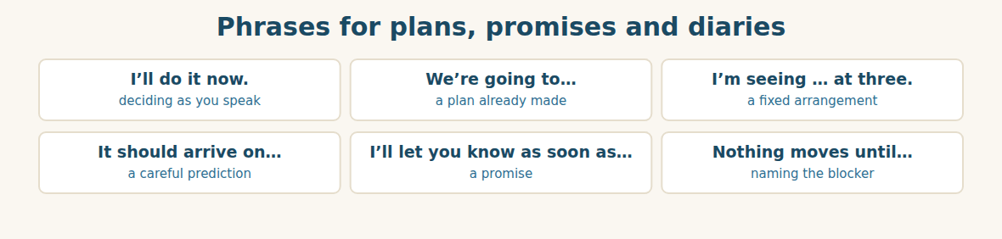
Figure · Say which kind of future you mean, and people can plan around you.
A. Role-play: at the bank. Student A takes a payment instruction to the bank. Student B is the bank manager. Then change roles.
1. A: Say how much you are sending, and to whom.
2. B: Check the beneficiary details and ask for the reference.
3. A: Give the purchase order number.
4. B: Say when the money is leaving and when it will arrive.
5. A: Ask who pays the bank charges.
6. B: Explain the two choices, and ask A to decide.
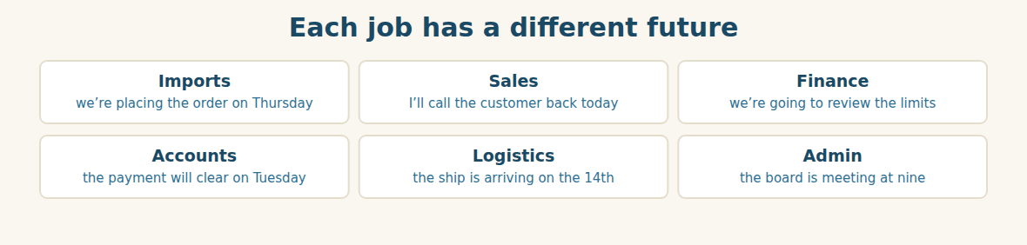
Figure · Six roles, three futures.
B. Your Role. Say one plan and one arrangement from YOUR job. Use the phrases below. (Choose your real role.)
1. [Trade] Import Manager: “We are placing the order on Thursday.”
2. [Trade] Sales: “I will call the customer back before five.”
3. [Finance] Financial Manager: “We are going to review the approval limits.”
4. [Finance] Accountant: “The payment will clear on Tuesday.”
5. [Logistics] Freight: “The ship is arriving on the 14th.”
6. [Admin] Assistant: “The board is meeting at nine on Thursday.”
C. Ask your partner. Walk around and ask three people.
1. What are you doing tomorrow morning?
2. What is your company going to do next year?
3. What do you think will happen to prices this year?
D. Discuss. Ask and answer.
1. Should one person be allowed to approve a very large payment? Why or why not?
2. What is the longest you have waited for a signature? What did it cost?
Part 5 · Extended Reading FINANCE
Why a payment needs a name
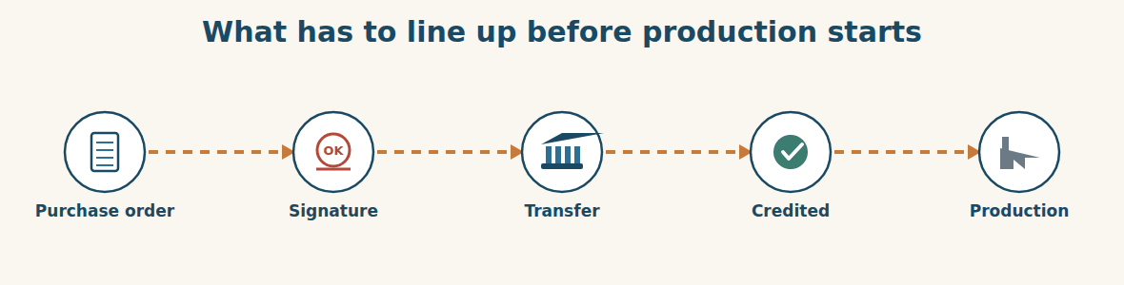
Figure · Five steps, and the fourth one is where orders go to sleep.
Money sent across a border is not like money handed over a counter. It passes through at least three banks, it takes two or three working days, and when it arrives it is only a number in a list. Somebody in the supplier’s accounts department has to look at that number and decide what it belongs to.
This is why the reference matters more than almost anything else on the instruction. A payment with a purchase order number is matched to an order in thirty seconds. A payment with no reference becomes a problem on a desk. It is not lost — the money is perfectly safe — but it is not doing its job, because the order it was supposed to start is still waiting.
The second thing people forget is the charges. When a bank sends money abroad, somebody has to pay the banks in the chain. If the instruction says “shared”, the beneficiary receives a little less than the sender sent. For a small payment nobody notices. For a deposit against a large order, the supplier’s accounts department sees an amount that is not exactly thirty per cent, and a careful clerk will not release the order until somebody explains the difference. Forty dollars can hold up seven hundred thousand.
The third thing is timing, and this is where the three futures of this unit become practical. A payment that is leaving on Sunday is an arrangement — the bank has the instruction and a date. A payment that will probably arrive on Tuesday is a prediction, and predictions can be wrong, because a bank holiday in a third country can add a day. So a careful buyer never says “the money has been sent” to a supplier. A careful buyer says “the transfer left our bank on Sunday with reference PO-4417, and we expect it with you on Tuesday.” That sentence can be checked.
None of this is complicated. It is simply the difference between a company whose orders start on time and a company that spends every December asking where its money went. The money is almost never the problem. The information attached to the money is.
A. Comprehension. Answer in your own words. (0 is done for you.)
0. How is money sent abroad different from money handed over a counter? (it passes through several banks, takes days, and arrives as a number in a list)
1. What happens to a payment with a purchase order number?
2. What happens to a payment with no reference?
3. Why can forty dollars of bank charges hold up a large order?
4. What is the difference between “leaving on Sunday” and “arriving on Tuesday”?
5. What does the writer say is almost never the problem?
B. Choose the best answer (A–D).
1. Money sent abroad passes through at least … banks. A) one B) two C) three D) ten
2. A payment with a reference is matched in… A) thirty seconds B) a day C) a week D) a month
3. With “shared” charges, the beneficiary receives… A) more B) a little less C) exactly the same D) nothing
4. A bank holiday in a third country can add… A) a day B) a week C) nothing D) a charge
5. The writer says the real problem is the… A) money B) bank C) information D) supplier
C. Find a word or phrase in the text that means:
1. to connect a payment to an order → to m____________ it
2. the person who receives the money → the b____________
3. to stop something from going forward → to h____________ it u____________
4. a day when the banks are closed → a bank h____________
D. Complete the summary with ONE word in each gap.
A payment abroad passes through three (1)____________ and arrives as a number. The (2)____________ tells the supplier what it is for. If the charges are (3)____________, the supplier receives a little less, and a careful clerk will not (4)____________ the order. A payment leaving on Sunday is an (5)____________; arriving on Tuesday is only a (6)____________.
E. Discuss. Talk in pairs.
1. Has a payment ever gone missing in your company? What happened?
2. What information does your company put in a payment reference?
F. True or False? (about the reading). Write T, F or NOT GIVEN.
1. A payment with no reference is lost. ____
2. Shared charges mean the beneficiary gets less than the sender sent. ____
3. Most suppliers accept payments with no reference. ____
4. A bank holiday abroad can delay a transfer. ____
Part 6 · Writing (a real email) ADMIN
Model — A payment instruction to the bank
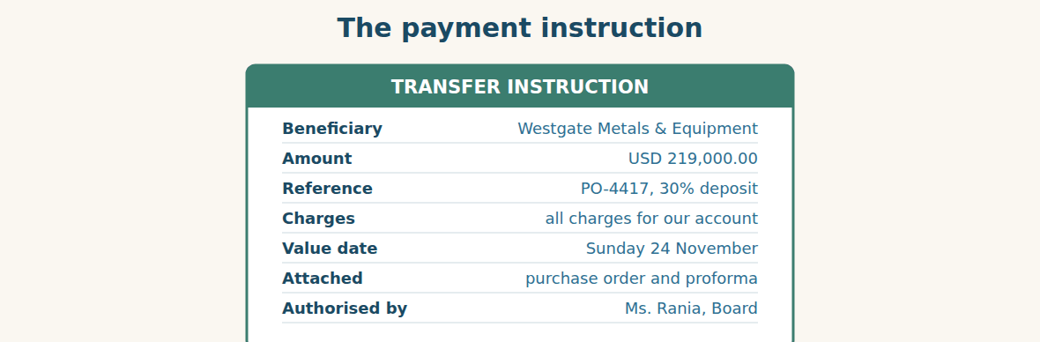
Figure · Seven lines. Leave one out and the money sleeps.
Subject: Transfer instruction — PO-4417, 30% deposit. Dear Mr. Haitham, Please arrange a transfer of USD 219,000.00 to Westgate Metals & Equipment. The beneficiary details are on the attached proforma invoice, and the signed purchase order is attached as well. Please put “PO-4417, 30% deposit” in the payment reference. All bank charges are for our account, so the beneficiary must receive the full amount. We would like the value date to be Sunday 24 November. Could you please send me the confirmation on the day it leaves? Our supplier is not going to start production until the money clears, so the date matters to us. Best regards, Rami Import Manager, Bashak Co.
A. Answer about the email. (0 is done for you.)
0. How much is being transferred, and to whom? (USD 219,000.00, to Westgate Metals & Equipment)
1. What exactly must go in the payment reference?
2. Who pays the bank charges, and why does Rami say so?
3. Why does the date matter to Bashak?
B. Put the email in order (1–6).
1. ( ) All bank charges are for our account.
2. ( ) Dear Mr. Haitham,
3. ( ) Please arrange a transfer of USD 219,000.00 to Westgate Metals.
4. ( ) Best regards, Rami
5. ( ) Please put “PO-4417, 30% deposit” in the reference.
6. ( ) Our supplier is not going to start production until the money clears.
Guided writing
C. Now you write. Write a payment instruction (70–100 words) to your bank. Use a present continuous or “going to” at least once, and a “will” promise or request at least once.
Plan: 1) “Dear …,” 2) “Please arrange a transfer of … to ….” 3) “Please put … in the reference.” 4) “All charges are for ….” 5) “We would like the value date to be ….” 6) “Could you please …?” 7) “Best regards, …”
Sentence starters: “Please arrange a transfer of…” · “Please put … in the payment reference.” · “All bank charges are for…” · “We would like the value date to be…” · “Our supplier is not going to … until …”
______________________________________________
______________________________________________
______________________________________________
______________________________________________
______________________________________________
D. Checklist. Tick each one when you have checked your instruction.
- I gave the exact amount and the currency.
- I named the beneficiary exactly as the invoice spells it.
- I gave a reference with the order number in it.
- I said who pays the bank charges.
- I said when I need the money to leave.
Part 7 · Trade-Skills Track ADMIN
The approval file: what a signature is really signing
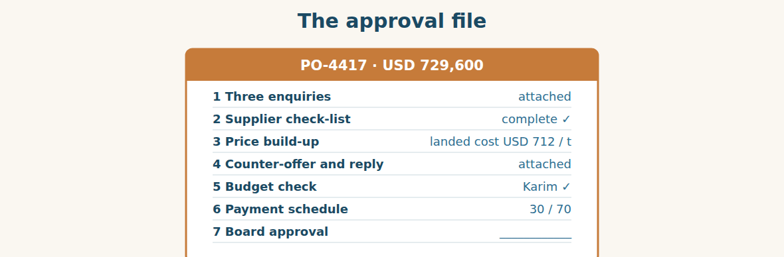
Figure · Six pages of work, so that the seventh line takes a minute.
When a board member signs a purchase order, she is not agreeing with a number. She is agreeing that a process happened. That is why the file matters more than the signature: the file is the evidence, and the signature is only the last line of it.
A good approval file answers six questions in order. Did we look at more than one supplier? Is this supplier real and checked? What will the goods actually cost us, landed? Did we try to improve the terms? Is the money in the budget? And when exactly does it leave? If all six have an answer, the seventh line — the signature — is easy. If any of them is missing, the signature is a guess.
This is also why you should never send a signature request alone. “Please approve, urgent” is the sentence that slows a company down, because the person receiving it now has to find everything themselves. Send the file, name the deadline, and say what happens if it is missed. Ms. Rania did not delay the order because she was slow. She delayed it because she had one unanswered question, and the file did not answer it. A file that anticipates the question is signed the same day.
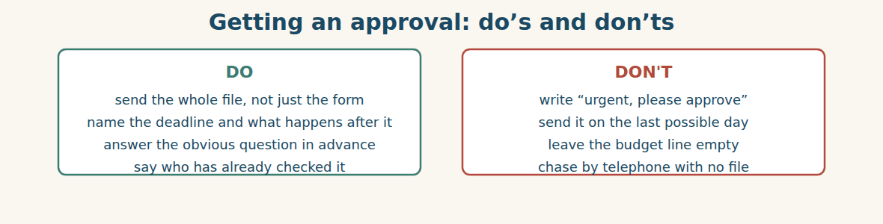
Figure · A signature is fast when the thinking is already done.
A. Comprehension. Answer in your own words.
1. What is a board member really agreeing to when she signs?
2. What are the six questions a good approval file answers? Name three.
3. Why is “please approve, urgent” a bad sentence?
4. Why did Ms. Rania delay the order?
5. What kind of file is signed the same day?
B. Listen and complete. Karim explains the file. Write the missing word.
1. Karim: The file is the evidence; the signature is the last ____________.
2. Karim: Always show what the goods cost us ____________.
3. Karim: Name the ____________ and say what happens if we miss it.
4. Karim: Never send a request marked only “____________”.
C. Practice. Build an approval file for something your company buys. Write the six lines, with one sentence under each. Then ask your partner: which line would stop you signing?
D. Who signs? Use the approval ladder from Part 1.
1. A repair costing $3,000. → ____________
2. A first order from a brand-new supplier, $8,000. → ____________
3. Steel worth $729,600. → ____________
4. Office furniture, $40,000, existing supplier. → ____________
Part 8 · Consolidation ADMIN
Eight days, two clocks
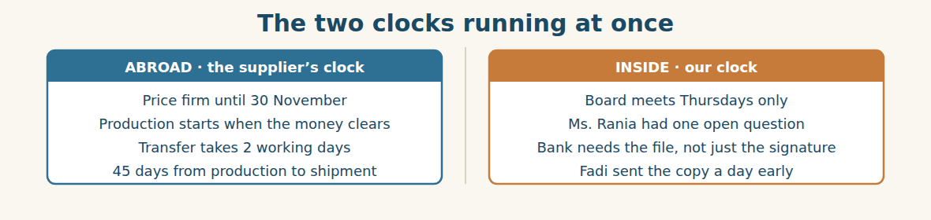
Figure · The deadline is abroad; the delay is always at home.
Ms. Rania signs on Thursday at nine. By ten, Fadi has scanned the file to the bank. By two, Rami has the instruction stamped. The transfer leaves on Sunday with “PO-4417, 30% deposit” in the reference, and all charges for Bashak’s account.
On Tuesday afternoon Mr. Delgado writes four words: “Deposit received. Production starts.” Rami prints the email and puts it in the file, because in December somebody will ask when production started, and a printed line is worth an hour of remembering.
Then he counts. Eight days have passed since the price was agreed. Three of them were the board waiting for Thursday. One was Ms. Rania’s question. Two were the bank. Two were his own. The price was firm until the 30th, so eight days was safe — but only just.
At the review, Mr. Tarek asks the useful question. “Which of those eight days can we remove?” Not the bank: two days is what banks take. Not Thursday: the board meets when it meets. But Ms. Rania’s question could have been answered in the file, because it was the obvious question. And Fadi’s copy to the bank, sent a day early, had already saved one.
“So next time,” says Mr. Tarek, “the file answers the currency question before she asks it.” He writes it on the board. It is not a rule about money. It is a rule about guessing what the other person will need.
A. Comprehension. Answer in your own words. (0 is done.)
0. What happens between nine and two on Thursday? (Ms. Rania signs, Fadi scans the file to the bank, Rami gets the instruction stamped)
1. What four words does Mr. Delgado write, and when?
2. Why does Rami print the email?
3. How are the eight days divided?
4. Which days could not be removed, and why?
5. What is the new rule, and what is it really about?
B. Complete each sentence with ONE word from the text. (0 is done for you.)
0. Ms. Rania signs on Thursday at nine.
1. The transfer leaves on ____________.
2. Mr. Delgado writes: “Deposit received. Production ____________.”
3. Three of the eight days were the ____________ waiting for Thursday.
4. Fadi’s copy to the bank saved ____________ day.
5. Next time, the file answers the ____________ question before she asks it.
C. Discuss. Talk in pairs.
1. Where do the delays happen in your company — inside or outside?
2. What question does your manager always ask? Could it be answered in advance?
D. Find a word from the text that means: (0 is done for you.)
0. to make a copy with a machine and send it → (to scan it)
1. marked with an official mark → s____________
2. to take away → to r____________
3. to think what will happen before it does → to g____________
Part 9 · Case Studies and Decisions FINANCE
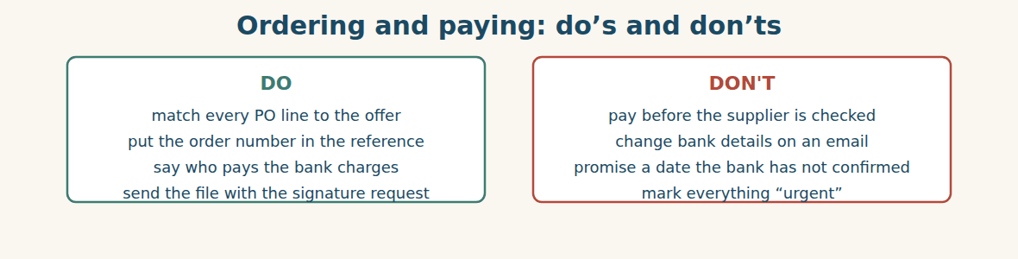
Figure · Four habits that keep money and orders together.
Case 1 — New bank details, one day before payment (strand A · abroad)
The day before the transfer, an email arrives from your supplier’s address. “Please note our bank has changed. Use the account below for the deposit.” The signature and the logo look right. The amount is two hundred and nineteen thousand dollars.
Choose the best action and say why.
1. ( ) Use the new details. The email came from their address.
2. ( ) Telephone your known contact on the number you already have, and confirm before anything moves.
3. ( ) Reply to the email and ask them to confirm.
4. ( ) Send a small test amount to the new account.
Write one sentence to your bank telling them to hold the payment.
______________________________________________
______________________________________________
Case 2 — The signature that will not come (strand B · inside)
Your price is firm for three more days. The only person who can sign is travelling and does not answer email. Your General Manager’s limit is below the amount. Waiting costs you five per cent.
Answer the questions.
1. What can you ask the supplier for, instead of breaking the approval rule?
2. What could the company change so that this does not happen again?
3. Write one sentence to the supplier asking to extend the price.
Case 3 — The deposit that arrived short (where the strands meet)
Your supplier writes: “We have received 218,955 dollars, not 219,000. This is not thirty per cent, so we cannot release the order to production.” The difference is forty-five dollars of bank charges.
Answer the questions.
1. Why is the supplier’s accounts clerk right to stop, even over forty-five dollars?
2. What should have been written on the instruction to prevent this?
3. Write one sentence that solves it today, and one that prevents it next time.
Part 10 · Review and Can-Do ADMIN
A. Vocabulary. Complete the sentence.
1. The paper that places an order with a supplier is the ____________ ____________.
2. The company receiving the money is the ____________.
3. The largest amount one person may approve is the ____________ ____________.
4. The text saying what a payment is for is the ____________.
5. The supplier’s paper saying “we accept” is the ____________ ____________.
B. Grammar. Complete with will, going to or the present continuous.
1. The transfer ____________ (leave) on Sunday — the bank has the instruction.
2. I ____________ (ask) Karim about the budget. I have just thought of it.
3. We ____________ (order) 1,200 tonnes. We decided yesterday.
4. The board ____________ (meet) at nine on Thursday.
5. I think the rate ____________ (move) before December.
6. They ____________ (not / start) production until the money clears.
C. Reading. Read the short text and answer.
Bashak placed purchase order PO-4417 for 1,200 tonnes at 608 dollars a tonne, total 729,600 dollars. The payment schedule is thirty per cent on order and seventy per cent before shipment. Because the deposit is above fifty thousand dollars, the board had to approve it. The transfer left on Sunday with the order number in the reference, and all bank charges were paid by Bashak.
1. What is the total value of the order?
2. Why did the board have to approve it?
3. What two things did Bashak do to make sure the payment was not delayed?
D. Listening. Listen and answer. (Teacher reads.)
[Teacher reads] “It is leaving here on Sunday, and it usually arrives two working days later. I will send you the confirmation the same day. But put the purchase order number in the reference — without it, their accounts department will not know what the money is for.”
1. When is the money leaving, and when will it arrive?
2. What will the bank manager send, and when?
3. What must go in the reference, and why?
E. Speaking. Work in pairs. One gives a payment instruction at the bank; one checks the details and asks about charges and the reference.
F. Writing. Write two sentences: one with “We are going to…” and one with “I am …-ing” for a fixed arrangement.
1. ______________________________________________
2. ______________________________________________
G. Error correction. Find and correct one mistake in each sentence.
1. We will going to order 1,200 tonnes. → ____________
2. She is going sign it tomorrow. → ____________
3. I will see the auditors at three. (it is in the diary) → ____________
4. What time you are meeting the bank? → ____________
5. They are going to not start production. → ____________
H. Match the word (1–5) to its meaning (a–e).
1. remitter ____ a. the day the money is available
2. beneficiary ____ b. what the banks charge
3. value date ____ c. the company sending the money
4. bank charges ____ d. the text saying what the payment is for
5. reference ____ e. the company receiving the money
I. Put the steps in order (1–6).
1. ( ) the supplier confirms the deposit
2. ( ) the board approves the file
3. ( ) the bank sends the transfer
4. ( ) we send the purchase order
5. ( ) production starts
6. ( ) we give the bank the payment instruction
Can-Do check. Tick what you can do.
- I can place an import order.
- I can talk about plans and arrangements.
- I can explain how and when we will pay.
- I can write an instruction to the bank.
Part 11 · Foundations for Further Study ADMIN
Concept Spotlight: Work moves at the speed of the slowest signature
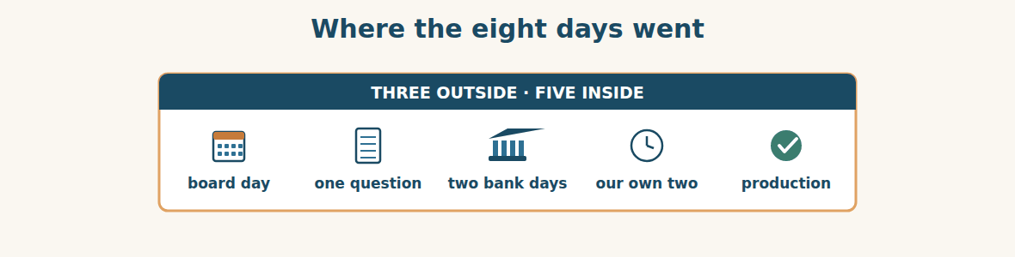
Figure · Most of the wait was ours, not theirs.
In this unit you learned three ways to talk about the future, and that is not an accident. A company is, in a sense, nothing but a set of claims about the future. We will pay. We are going to order. The ship is arriving on the 14th. Everything a business does is a promise about something that has not happened yet, and the whole machine works only if the people in it can say clearly which kind of promise they are making.
That is why the three forms are worth the trouble. “I’ll ask Karim” tells your colleague you have just decided, so do not plan around it yet. “We are going to open a third depot” tells them this is settled, and they can start thinking about it. “The board is meeting at nine on Thursday” tells them there is a time, a place and other people, so it will not move. Three sentences, three completely different amounts of certainty. A person who uses them carelessly is not making a grammar mistake. They are making a planning mistake.
Now notice where the eight days went. Two days belonged to the banks, which nobody can change. Three belonged to the calendar, because the board meets on Thursdays. The rest belonged to Al-Hasan: one day for a question the file should have answered, and two for ordinary internal handling. Most companies, looking at a delay, blame the outside. Mr. Tarek did the harder and more useful thing, and asked which of our own days we could remove.
Someone might answer that the real fix is to raise the approval limit, so that fewer things need a board. Sometimes that is right. But notice what the limit is protecting. It exists exactly so that a large amount gets a second pair of eyes, and the cost of that protection is measured in days. The question is never “rules or speed”. It is “which risks are worth days, and which are not” — and that is a decision a company should make calmly, in advance, not in a hurry on the 21st of November.
So the real lesson of this unit is small and practical. Say which future you mean. Send the file, not the request. Answer the obvious question before it is asked. Those three habits are worth more than any clever negotiation, because they are the difference between a price you agreed and a price you still have.
A. Understanding check. Answer in your own words.
1. Why does the writer say a company is “a set of claims about the future”?
2. What does each of the three future forms tell a colleague?
3. Where did most of the eight days actually go?
4. What is the approval limit protecting, and what does it cost?
B. Apply it. Do this task with a partner.
Think of the last thing that was late at your work. Write down where each day went, and mark each one “ours” or “theirs”. Then find one day that was yours and could be removed next time. Explain it to your partner in simple English.
C. Micro-writing (optional).
Write a few sentences (50–70 words) about next week at your work. Use all three futures: one “will”, one “going to”, and one present continuous for a fixed arrangement.
Study terms: purchase order · PO number · order confirmation · proforma invoice · payment schedule · deposit | balance · instalment · in advance · bank transfer · remitter · beneficiary | account number · value date · bank charges · reference · clear (v) · credited | debited · letter of credit · approval · approval limit · authorised signatory · sign off | board approval · budget · commitment · deadline · will · going to | arrangement · schedule (v) · hold up (v) · anticipate · working day · bank holiday
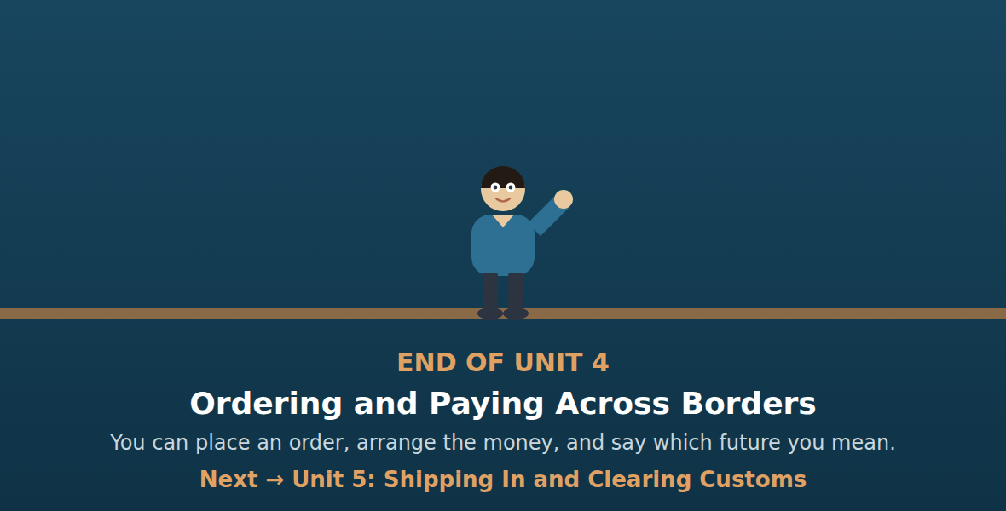
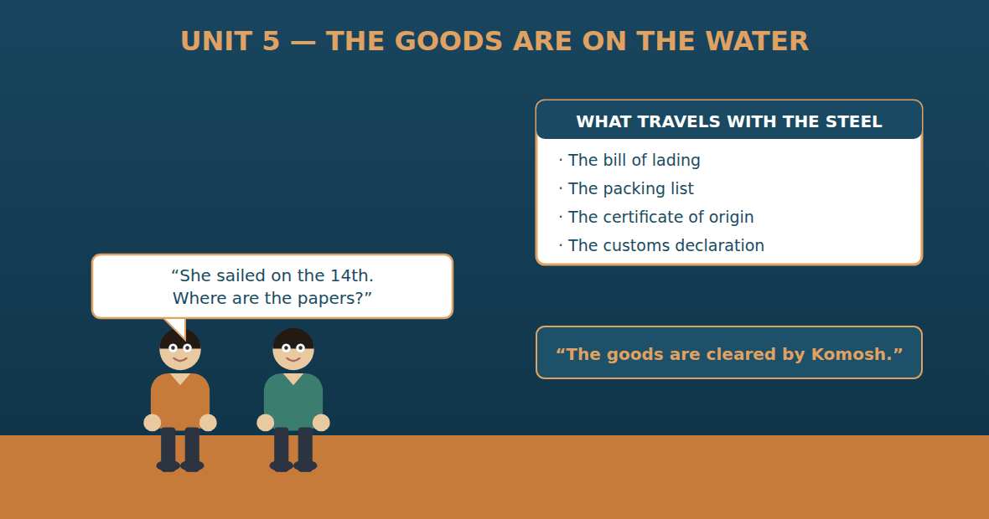

Unit 5: Shipping In and Clearing Customs
Al-Hasan International — English for Trade, Industry & Global Partnerships
CEFR B1 · Grammar: the passive — present simple and past simple · by + agent · Function: Logistics
Can-Do (by the end of this unit)
- I can describe how goods are shipped and cleared
- I can use the passive to describe a process
- I can read shipping and customs documents
- I can write a clearance update
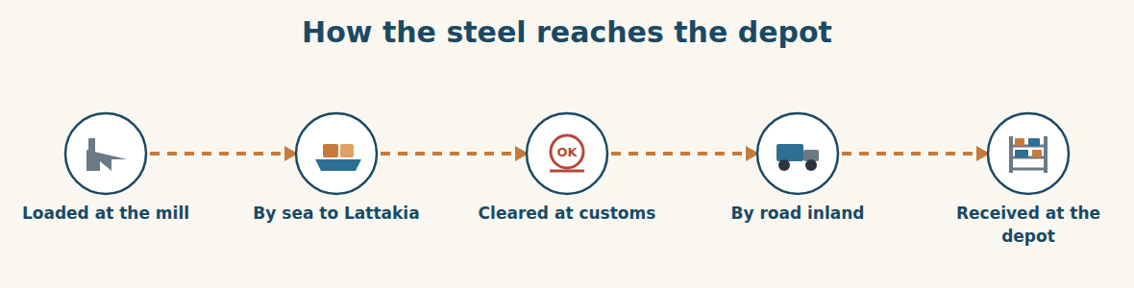
Figure · Five stages. The goods are handed over four times.
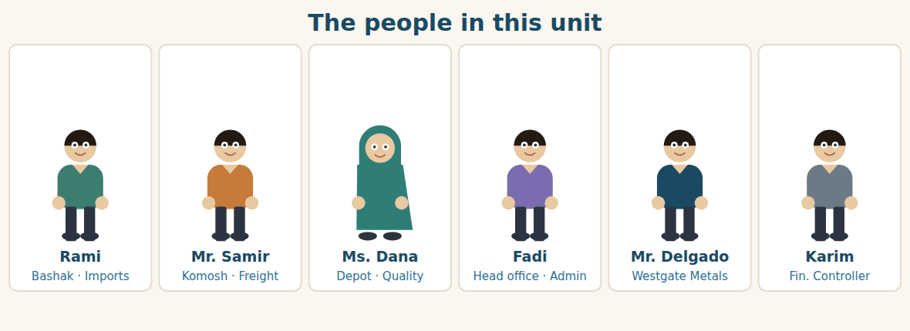
Figure · One side watches a ship; the other side waits at a gate.
Warm Up LOGISTICS
Look at the pictures. Answer these questions before you read.
1. How do goods arrive in your country — by sea, by road, or by air?
2. What papers travel with a shipment?
3. What can stop goods at a border?
Read
The steel is loaded at the mill on the 10th and the vessel sails on the 14th. Forty-eight containers, 1,200 tonnes. The voyage takes eleven days.
While the ship is at sea, the papers travel separately. Four documents are needed: the bill of lading, which proves the goods were put on board; the packing list, which says what is in each container; the commercial invoice, which says what the goods are worth; and the certificate of origin, which says where they were made. Without all four, nothing is released.
Mr. Samir of Komosh reads them on the 19th, before the ship arrives. He reads them the way a customs officer will read them, line by line. On the fourth document he stops.
“The certificate of origin is made out to Bashak Co.,” he says. “The bill of lading is made out to Al-Hasan Holding Group. They are not the same name.”
Rami does not see the problem at first. “It is the same group.” “It is the same group to you and me,” says Mr. Samir. “It is two companies to a customs officer. If the names do not match, the consignment is held, and after five days we are charged storage.”
So the correction is requested the same afternoon. Westgate is asked for a new certificate, and a courier is booked. The ship arrives at Lattakia on the 25th. The corrected certificate arrives on the 24th, by one day.
The containers are discharged on the 26th. The declaration is submitted the same morning, four containers are opened and inspected, and the consignment is released on the 27th. Komosh’s trucks begin the run to Damascus that evening. Nothing was late. But it was close, and it was close because of a name.
A. Comprehension. Answer in your own words. (0 is done for you.)
0. When was the steel loaded, and when did the vessel sail? (loaded on the 10th, sailed on the 14th)
1. What four documents are needed, and what does each one prove?
2. What does Mr. Samir find on the fourth document?
3. Why is it a problem, if it is the same group?
4. What happens if a consignment is held for more than five days?
5. By how much did the corrected certificate arrive in time?
B. True or False? Write T or F. (0 is done for you.)
0. The voyage takes twenty-one days. (F)
1. The papers travel with the ship. ____
2. The bill of lading proves the goods were put on board. ____
3. The certificate of origin says what the goods are worth. ____
4. Four containers were opened and inspected. ____
5. The consignment was released on the 27th. ____
C. Find the words. Find a word or phrase in the text that means: (0 is done for you.)
0. the ship that carries the goods → (the vessel)
1. the journey of a ship from one port to another → the v____________
2. the goods sent in one shipment → the c____________
3. money charged when goods stay too long at the port → s____________
D. Over to you. Answer about yourself.
1. Who clears goods through customs for your company?
2. Has a shipment of yours ever been held? Why?
3. How long does customs clearance usually take where you are?
Part 1 · Vocabulary and Terminology LOGISTICS
The bill of lading
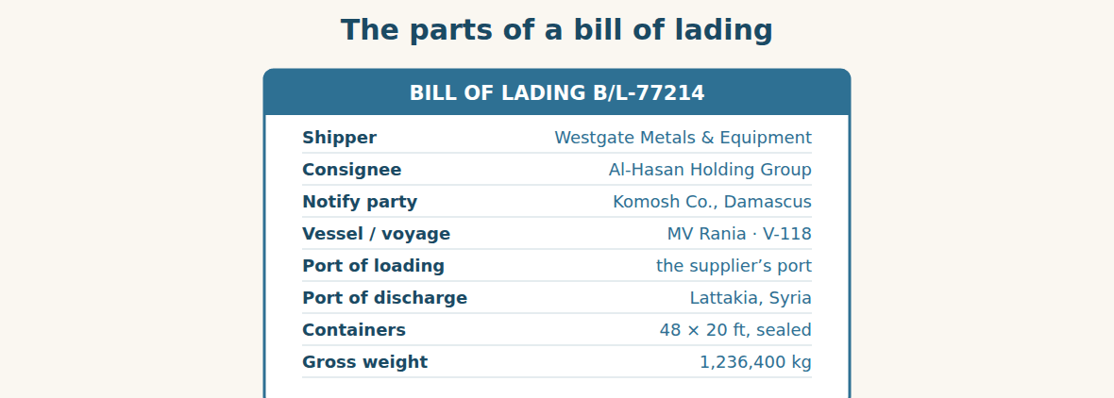
Figure · The document that proves the goods were put on board.
A. Match each word (1–7) with its meaning (a–h). There is one you do not need. (0 is done for you.)
0. shipper (f)
1. consignee ____ a. the port where the goods are unloaded
2. notify party ____ b. the company the goods are sent to
3. port of discharge ____ c. the expected day of arrival
4. ETA ____ d. the company told when the ship arrives
5. packing list ____ e. a paper saying where the goods were made
6. certificate of origin ____ f. the company sending the goods
7. demurrage ____ g. a paper saying what is in each container
8. h. money charged when containers stay too long
B. Complete the sentences with the words in the word bank.
Word bank: bill of lading | consignee | ETA | packing list | certificate of origin | demurrage
1. The ____________ proves that the goods were put on board.
2. The ____________ on this shipment is Al-Hasan Holding Group.
3. The ____________ is the 25th, but ships are often a day late.
4. Open the ____________ to see what is in container number twelve.
5. Customs asked for the ____________, because the duty depends on it.
6. After five days at the port, we start paying ____________.
The documents that travel
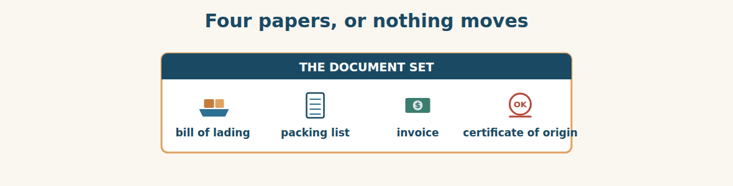
Figure · All four must agree with each other, exactly.
C. Match the document (1–4) with the question it answers (a–d).
1. bill of lading ____ a. What is in each container?
2. packing list ____ b. Where were the goods made?
3. commercial invoice ____ c. Were the goods put on board?
4. certificate of origin ____ d. What are the goods worth?
At the port
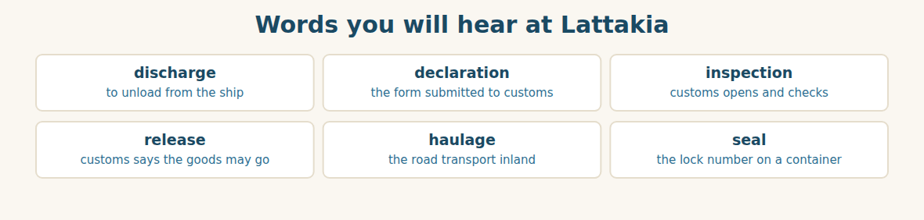
Figure · Six words that decide whether today is a good day.
D. Odd one out. Which word is different? Circle it.
1. vessel · voyage · container · margin
2. shipper · consignee · notify party · demurrage
3. discharge · unload · release · invoice
4. inspect · check · examine · deliver
5. seal · container · pallet · duty
E. Choose the best answer.
1. The company the goods are sent to is the… (a) shipper (b) consignee
2. To take goods off a ship is to… (a) discharge (b) declare
3. Money charged for staying too long at the port is… (a) duty (b) demurrage
4. The paper saying where goods were made is the… (a) packing list (b) certificate of origin
F. Classify. Write each word in the correct column.
Words: vessel | declaration | haulage | container | inspection | release order
At sea | At customs | On the road
__________ | __________ | __________
__________ | __________ | __________
__________ | __________ | __________
G. Match the two halves (1–6 with a–f).
1. bill of ____ a. of origin
2. port of ____ b. list
3. certificate ____ c. lading
4. packing ____ d. party
5. notify ____ e. discharge
6. customs ____ f. declaration
H. Complete the paragraph with the words in the box.
Box: cleared | consignee | discharged | inspected | released | submitted
The containers are (1)____________ on the 26th. The declaration is (2)____________ the same morning, and four containers are (3)____________. The (4)____________ on the bill of lading must match the certificate of origin. The goods are (5)____________ by Komosh and (6)____________ on the 27th.
Part 2 · Grammar — the passive (present and past simple) LOGISTICS
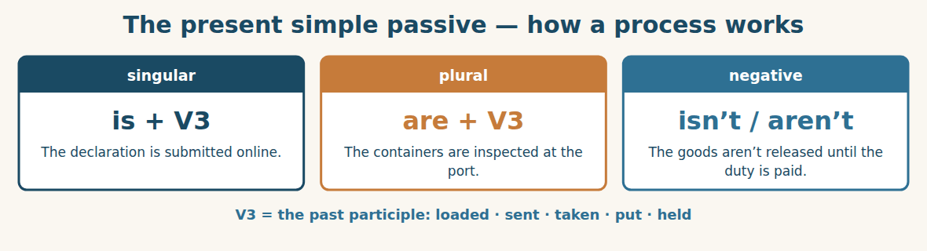
Figure · We use it when the action matters more than the person.
We use the PASSIVE when the action matters more than the person who does it, or when everybody already knows who does it. The containers are inspected at the port. Nobody needs to say “customs officers inspect the containers” — it is obvious. The passive is the normal voice of a process.
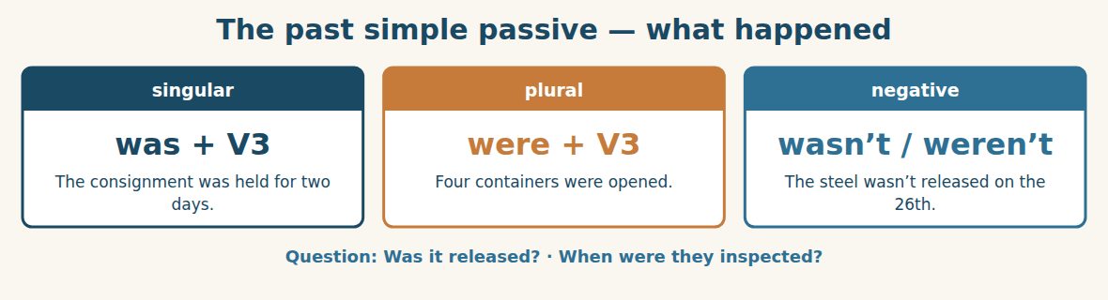
Figure · The same idea, in the past.
For a finished action we use WAS or WERE with the past participle. The vessel was loaded on the 10th. The containers were discharged on the 26th. Four were opened and inspected.
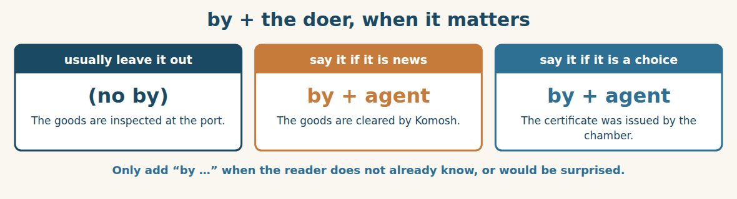
Figure · Most passive sentences have no “by” at all.
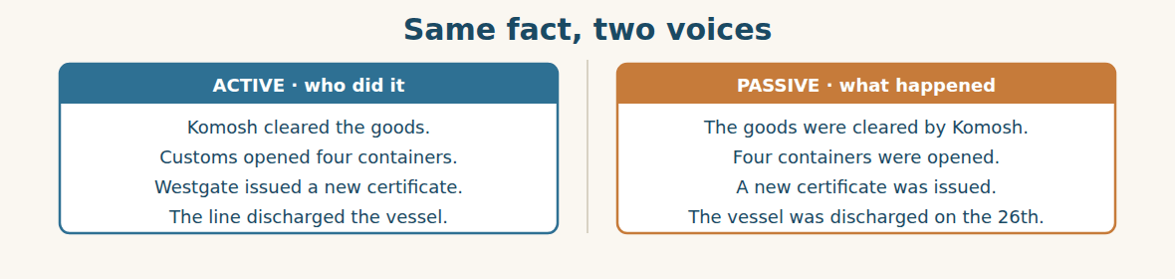
Figure · Use the active for people; use the passive for procedure.
Watch out! Build the passive from the past participle, not the past simple: it was sent, not it was send. And do not use the passive with verbs that take no object: the ship arrived (never the ship was arrived).
Form
present passive: am / is / are + past participle · past passive: was / were + past participle · the doer, if needed: by + person or company
A. Complete with IS or ARE. (0 is done for you.)
0. The declaration is submitted on the morning of arrival.
1. The containers ____________ inspected at the port.
2. The duty ____________ calculated from the invoice value.
3. The goods ____________ released when the duty is paid.
4. Four papers ____________ needed for every consignment.
B. Complete with WAS or WERE.
1. The vessel ____________ loaded on the 10th.
2. Four containers ____________ opened at the port.
3. The consignment ____________ held for two days.
4. The corrected certificates ____________ sent by courier.
C. Write the past participle.
1. send → ____________
2. load → ____________
3. hold → ____________
4. take → ____________
5. pay → ____________
6. give → ____________
D. Make the sentence passive. Leave out the doer if it is obvious. (0 is done for you.)
0. Customs inspect the containers. → (The containers are inspected.)
1. Komosh cleared the goods. → ____________
2. They submit the declaration online. → ____________
3. Someone opened four containers. → ____________
4. The chamber issued the certificate. → ____________
E. Make the sentence active.
1. The goods are cleared by Komosh. → ____________
2. The steel was loaded by the mill on the 10th. → ____________
3. A new certificate was issued by Westgate. → ____________
4. The trucks are booked by Mr. Samir. → ____________
F. Make questions in the passive.
1. (?) when / the vessel / load → ____________
2. (?) how many containers / inspect → ____________
3. (?) the goods / release / yet → ____________
4. (?) who / the certificate / issue / by → ____________
G. Find and correct the mistake in each sentence. (0 is done for you.)
0. The papers was send by courier. → (The papers were sent by courier.)
1. The ship was arrived on the 25th. → ____________
2. Four containers was opened. → ____________
3. The duty is calculate from the invoice. → ____________
4. The goods are cleared from Komosh. → ____________
H. About you. Write two sentences about your workplace in the passive: one present, one past.
1. ______________________________________________
2. ______________________________________________
I. Complete with the present or past passive.
1. The containers ____________ (discharge) yesterday morning.
2. Every declaration ____________ (check) before it is submitted.
3. The consignment ____________ (hold) for two days last week.
4. Our goods ____________ (always / clear) by Komosh.
5. The seal numbers ____________ (record) when the container is opened.
J. Describe the process in the passive.
1. they load the steel at the mill → ____________
2. the line discharges the containers at Lattakia → ____________
3. customs inspects four containers → ____________
4. Komosh hauls the steel to Damascus → ____________
Part 3 · Listening and Dialogue LOGISTICS
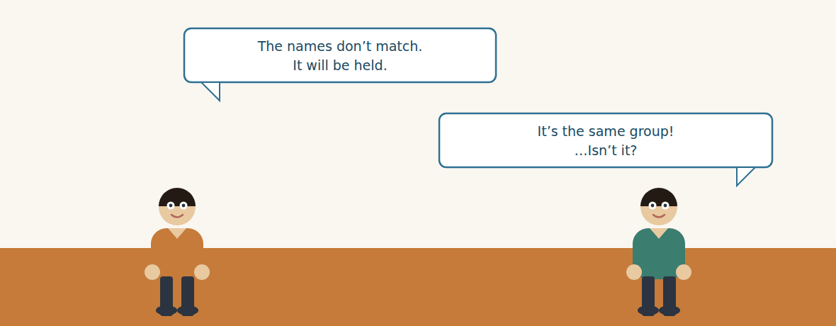
Figure · Strand A · the document check, six days before arrival.
Dialogue 1 — Checking the documents (the freight desk)
Listen and read. (Your teacher will read the dialogue, or play the audio.)
Mr. Samir: Rami, I have read the set. Three documents are fine. The fourth is not.
Rami: Which one?
Mr. Samir: The certificate of origin. It is made out to Bashak Co. The bill of lading is made out to Al-Hasan Holding Group.
Rami: It is the same group.
Mr. Samir: It is the same group to you and me. To a customs officer it is two companies. If the names do not match, the consignment is held.
Rami: And if it is held?
Mr. Samir: Five free days. After that we are charged storage, and the containers are charged demurrage by the line. Both clocks run at the same time.
Rami: Then I will ask Westgate for a corrected certificate today.
Mr. Samir: Ask for it by courier, not by email. A scan is not accepted. And tell them exactly how the name must be spelled — copy it from the bill of lading, letter by letter.
Rami: The ship arrives on the 25th. Is six days enough?
Mr. Samir: It is enough if it is sent tomorrow. It is not enough if it is sent on Thursday.
A. Comprehension. Answer in your own words. (0 is done for you.)
0. How many documents are fine, and how many are not? (three are fine, one is not)
1. What exactly is wrong with the certificate of origin?
2. Why is “the same group” not an answer for a customs officer?
3. What two charges start after the five free days?
4. Why must the certificate come by courier?
5. When must it be sent, and why?
B. True or False? Write T or F.
1. All four documents had the same name on them. ____
2. There are five free days before charges start. ____
3. A scanned certificate is accepted. ____
4. Mr. Samir tells Rami to copy the name letter by letter. ____
5. Six days is enough if the certificate is sent on Thursday. ____
C. Language focus. Find in the dialogue: (0 is done for you.)
0. a present passive about what happens to a consignment → (the consignment is held)
1. a present passive about charges → ____________
2. a passive in the negative → ____________
3. a first conditional about the names → ____________
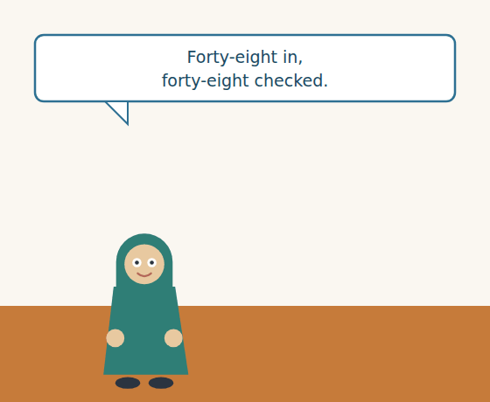
Figure · Strand B · the gate at the depot, eleven days later.
Dialogue 2 — At the depot gate (inside Syria)
Ms. Dana: Samir, the first eighteen are in. Were the seals checked at the port?
Mr. Samir: They were. Four containers were opened by customs, so those four carry new seal numbers.
Ms. Dana: Which four? My sheet has the old numbers.
Mr. Samir: They are listed on the release order. I am sending you a photograph now.
Ms. Dana: Good. Anything damaged?
Mr. Samir: One container has a bent door. It was not opened by customs — that happened at sea.
Ms. Dana: Then I will photograph it before it is unloaded, not after. If we unload first, nobody can prove anything.
Mr. Samir: Agreed. Photograph the seal, the door and the number, all in one picture.
A. Comprehension. Answer in your own words.
1. How many containers have arrived at the depot so far?
2. Why do four containers carry new seal numbers?
3. Where are the new seal numbers listed?
4. Why will Ms. Dana photograph the damaged container before unloading?
B. Listen again and choose the best answer (A–D).
1. The first … containers are in. A) four B) eight C) eighteen D) forty-eight
2. The containers opened by customs were… A) two B) four C) eighteen D) none
3. The bent door happened… A) at customs B) at sea C) at the depot D) at the mill
4. Mr. Samir says to photograph the seal, the door and the… A) driver B) number C) invoice D) date
Part 4 · Speaking and Your Role LOGISTICS
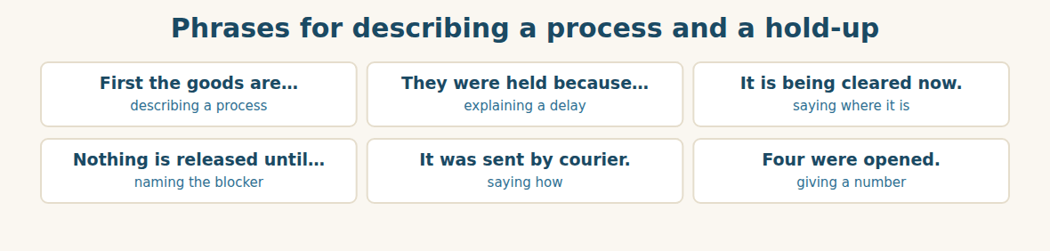
Figure · The passive is how a shipping update is written.
A. Role-play: the document check. Student A is the freight manager and finds a problem. Student B is the import manager. Then change roles.
1. A: Say that three documents are fine and one is not.
2. B: Ask which one.
3. A: Explain the problem, using the passive.
4. B: Say it is the same group.
5. A: Explain what will happen if the names do not match.
6. B: Say what you will do, and ask if there is time.
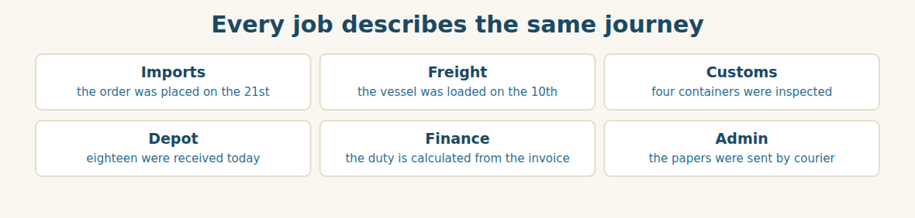
Figure · Six roles, one shipment, all in the passive.
B. Your Role. Describe one step of a process from YOUR job, in the passive. (Choose your real role.)
1. [Trade] Import Manager: “The order was placed on the 21st.”
2. [Logistics] Freight: “The vessel was loaded on the 10th and sailed on the 14th.”
3. [Logistics] Customs clerk: “Four containers were opened and inspected.”
4. [Trade] Depot: “Eighteen containers were received this morning.”
5. [Finance] Accountant: “The duty is calculated from the invoice value.”
6. [Admin] Assistant: “The documents were sent by courier on Tuesday.”
C. Ask your partner. Walk around and ask three people.
1. How are goods delivered to your company?
2. When was the last shipment you received, and was anything checked?
3. What is never released until something else is done?
D. Discuss. Ask and answer.
1. Why do customs officers check names so carefully?
2. Is it better to use your own freight company, or to pay another one?
Part 5 · Extended Reading LOGISTICS
Why a border stops paper, not goods
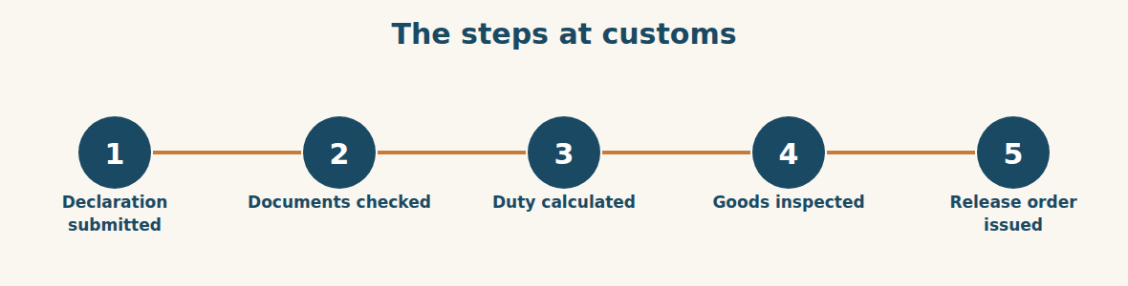
Figure · Five steps, and only one of them touches the steel.
People imagine that customs is about goods. It is mostly about paper. An officer at a port has thousands of containers and a few hours. He cannot open them all, and he is not trying to. What he is doing is reading documents and looking for sentences that disagree with each other.
The logic is simple once you see it. The invoice says what the goods are worth. The duty is calculated from that value, so if the invoice is wrong, the country is paid the wrong amount. The certificate of origin says where the goods were made, and different countries pay different rates, so origin changes the money too. The packing list says what is inside, and the bill of lading says who owns it. Four papers, four facts, and every one of them has a price attached.
So the officer compares. If the bill of lading says Al-Hasan Holding Group and the certificate says Bashak Co., he is not being difficult. He is looking at two documents that name two different owners for the same steel, and he cannot release goods to a company that is not on the bill of lading. The containers are not the problem. The sentence is.
This is why experienced freight people read the whole set before the ship arrives, and why they read it as the officer will. The name is copied letter by letter. The weights on the packing list are added up and compared with the bill of lading. The invoice value is checked against the purchase order. Anything that disagrees is corrected while the goods are still at sea, because a correction takes three days by courier and a hold costs money every day after the fifth.
And the cost is not only storage. When a container sits at a port, the shipping line charges demurrage for its own box, the depot plans for steel that does not come, and the customer who was promised a date is told a new one. One mismatched name on one page can move a date for five hundred people. That is why the work is done in advance, quietly, by somebody reading very slowly.
A. Comprehension. Answer in your own words. (0 is done for you.)
0. What is customs mostly about? (paper, not goods)
1. Why can’t the officer open every container?
2. How is the duty calculated, and why does the invoice matter?
3. Why does the certificate of origin change the money?
4. Why is the officer not “being difficult” about the names?
5. Name two costs of a held container, apart from storage.
B. Choose the best answer (A–D).
1. The officer is looking for… A) damaged goods B) sentences that disagree C) heavy containers D) new suppliers
2. The duty is calculated from the… A) weight B) seal C) invoice value D) packing list
3. The certificate of origin changes the… A) weight B) rate of duty C) vessel D) consignee
4. Experienced freight people read the set… A) after arrival B) before the ship arrives C) at the depot D) never
5. A correction by courier takes about… A) one day B) three days C) ten days D) a month
C. Find a word or phrase in the text that means:
1. to not agree with each other → to d____________
2. to say the goods may leave the port → to r____________ them
3. the money charged by the line for its own container → d____________
4. a mistake where two papers say different things → a m____________
D. Complete the summary with ONE word in each gap.
Customs is mostly about (1)____________. The officer compares four documents and looks for facts that (2)____________. The duty is calculated from the invoice (3)____________, and the rate depends on the (4)____________. If the names do not match, the goods cannot be (5)____________. A correction takes three days, so the set is checked while the goods are still at (6)____________.
E. Discuss. Talk in pairs.
1. Who checks shipping documents in your company, and when?
2. What is the worst delay you have seen at a border? What caused it?
F. True or False? (about the reading). Write T, F or NOT GIVEN.
1. Customs officers open every container. ____
2. The rate of duty can depend on where the goods were made. ____
3. Demurrage is charged by the shipping line. ____
4. Most delays at Lattakia are caused by paperwork. ____
Part 6 · Writing (a real email) ADMIN
Model — A shipping and clearance update
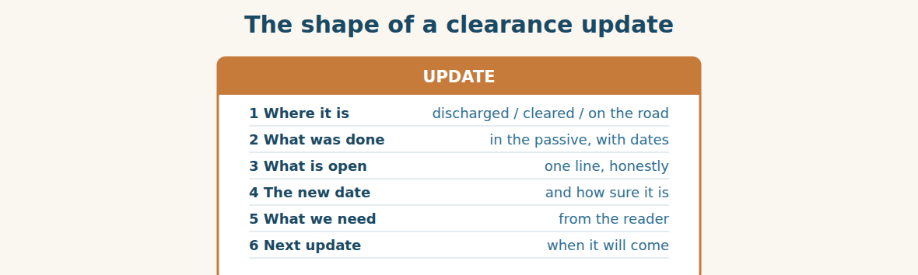
Figure · Six lines. People read updates standing up.
Subject: PO-4417 — cleared, on the road. Dear Mr. Tarek, The vessel was discharged at Lattakia on the 26th. The declaration was submitted the same morning and four containers were opened and inspected. The consignment was released yesterday afternoon and the first eighteen containers were received at the depot this morning. The remaining thirty are being hauled today and tomorrow. One container has a bent door, which happened at sea and not at customs; it was photographed before it was unloaded, and a claim is being prepared. We expect the full consignment to be in the depot by Thursday evening. I will send the final confirmation on Thursday. Best regards, Rami Import Manager, Bashak Co.
A. Answer about the email. (0 is done for you.)
0. Where was the vessel discharged, and when? (at Lattakia, on the 26th)
1. What happened to four of the containers?
2. How many containers are in the depot, and how many are still on the road?
3. What is the problem with one container, and what has been done about it?
B. Put the email in order (1–6).
1. ( ) The consignment was released yesterday afternoon.
2. ( ) Dear Mr. Tarek,
3. ( ) The vessel was discharged at Lattakia on the 26th.
4. ( ) I will send the final confirmation on Thursday.
5. ( ) One container has a bent door, which happened at sea.
6. ( ) Best regards, Rami
Guided writing
C. Now you write. Write a clearance update (70–100 words) about a shipment. Use the past passive at least three times, and give one date.
Plan: 1) “Dear …,” 2) “The vessel was … on the ….” 3) “The declaration was … and … were ….” 4) “One … is still ….” 5) “We expect … by ….” 6) “I will send … on ….” 7) “Best regards, …”
Sentence starters: “The vessel was discharged on…” · “The declaration was submitted…” · “Four containers were…” · “The consignment was released…” · “We expect … by …”
______________________________________________
______________________________________________
______________________________________________
______________________________________________
______________________________________________
D. Checklist. Tick each one when you have checked your update.
- I said where the goods are now.
- I used the past passive with dates.
- I said honestly what is still open.
- I gave a new date and said how sure it is.
- I said when the next update will come.
Part 7 · Trade-Skills Track LOGISTICS
Reading a packing list against a bill of lading
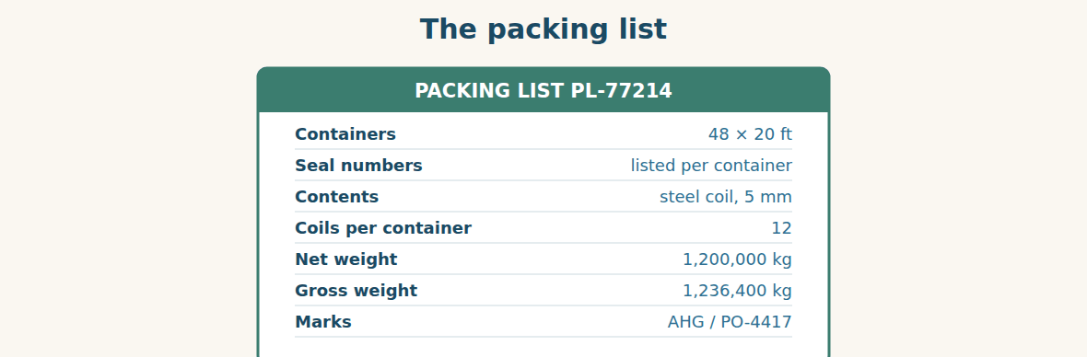
Figure · The list that must agree with everything else.
A packing list looks like a boring table. It is the document that decides whether a claim can be made. If a container arrives short, the packing list is the only paper that says how many coils should have been inside it. If the weight is wrong, the packing list is the only paper that says what it should have been.
So it is checked against the bill of lading, line by line, before arrival. The container count must be identical. The marks must be identical. The gross weight on the packing list must equal the gross weight on the bill of lading — and the difference between gross and net is the weight of the packing itself, which should be reasonable. A gross weight thirty per cent above net means something is wrong, and it is better to find that out at a desk than at a gate.
Then there are the seals. Every container is closed with a numbered seal, and the number is written on the list. When a container is opened by customs, the old seal is destroyed and a new one is fitted with a new number, which appears on the release order. The depot must be given both lists, or the gate will report forty-eight containers with four “wrong” seals, and an afternoon will be lost to a problem that does not exist.
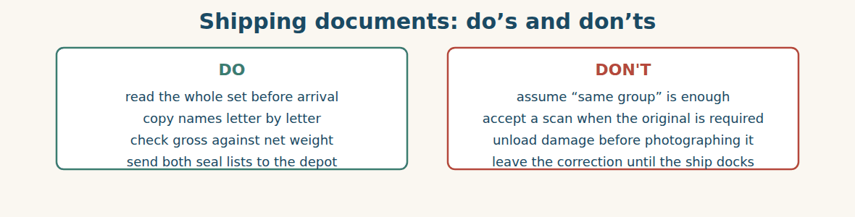
Figure · Every item here costs money the day it is ignored.
A. Comprehension. Answer in your own words.
1. Why is the packing list the document that decides whether a claim can be made?
2. Which three things must match between the packing list and the bill of lading?
3. What does the difference between gross and net weight represent?
4. What happens to the seal when customs opens a container?
5. Why must the depot be given both seal lists?
B. Listen and complete. Mr. Samir explains the check. Write the missing word.
1. Mr. Samir: The container count must be ____________.
2. Mr. Samir: Gross minus net is the weight of the ____________.
3. Mr. Samir: When customs opens a container, a new ____________ is fitted.
4. Mr. Samir: The new numbers appear on the ____________ order.
C. Practice. Take any delivery note or packing list from your work. Check three things on it against another document. Tell your partner what you checked and whether it agreed.
D. What is checked against what? Match (1–4) with (a–d).
1. the consignee name ____ a. the purchase order
2. the invoice value ____ b. the bill of lading
3. the gross weight ____ c. the release order
4. the new seal numbers ____ d. the packing list
Part 8 · Consolidation LOGISTICS
One name, eleven days
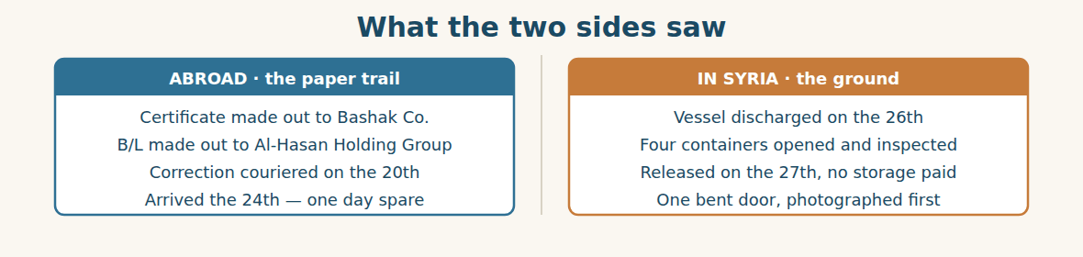
Figure · A document problem and a physical problem, running together.
On Thursday evening the last truck turns into the depot yard. Forty-eight containers in, forty-eight checked, one with a bent door and a photograph to go with it. Nothing was lost, and no storage was paid.
At the review, Mr. Tarek asks what the near miss cost. Rami has the figures. The courier was ninety dollars. Mr. Samir’s afternoon was free, because he works for the Group. And if the certificate had been sent two days later, the consignment would have been held: five free days, then storage and demurrage on forty-eight containers, at a rate Rami does not want to say out loud.
“So ninety dollars bought us the whole shipment,” says Mr. Tarek.
“No,” says Mr. Samir. “Reading bought us the shipment. The courier was just delivery.” Everyone laughs, but he is not joking, and he says the thing he has been waiting to say all month. “The documents are not checked when the ship arrives. They are checked when they are issued. By then the ship is still being loaded, and a mistake costs an email.”
Mr. Tarek writes it down. From now on, the full document set is read within forty-eight hours of issue, by Komosh, every time — not when the vessel is announced, and not when it docks. The rule fits on one line, and it was bought with ninety dollars and one bad afternoon.
A. Comprehension. Answer in your own words. (0 is done.)
0. How many containers arrived, and in what condition? (forty-eight, one with a bent door)
1. What did the courier cost?
2. What would have happened if the certificate had been two days later?
3. What does Mr. Samir say really saved the shipment?
4. When should documents be checked, according to Mr. Samir?
5. What is the new rule?
B. Complete each sentence with ONE word from the text. (0 is done for you.)
0. The last truck turns into the depot yard on Thursday evening.
1. No ____________ was paid.
2. The courier cost ninety ____________.
3. Mr. Samir says ____________ bought them the shipment.
4. Documents are checked when they are ____________.
5. The full set is now read within ____________ hours of issue.
C. Discuss. Talk in pairs.
1. Why is a rule that costs nothing often the hardest one to start?
2. What in your work should be checked earlier than it is?
D. Find a word from the text that means: (0 is done for you.)
0. an accident that almost happened → (a near miss)
1. to be officially given out → to be i____________
2. the open space at a depot → the y____________
3. said at a volume everyone can hear → out l____________
Part 9 · Case Studies and Decisions LOGISTICS
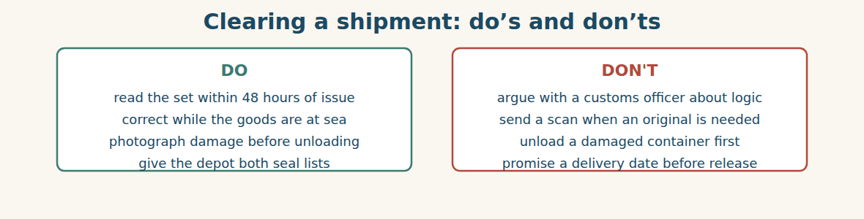
Figure · Clearance is won at a desk, days before the ship docks.
Case 1 — The weight that does not add up (strand A · the paper)
Three days before arrival you add up the packing list: 1,200,000 kg net. The bill of lading says 1,260,000 kg gross. The difference is five per cent, which is far more than the packing could weigh. The supplier is in a different time zone and has closed for the day.
Choose the best action and say why.
1. ( ) Say nothing. Customs rarely weighs containers.
2. ( ) Email the supplier tonight with both figures and ask which is correct, and copy the freight company.
3. ( ) Change the packing list yourself to match.
4. ( ) Wait until the ship arrives and see what happens.
Write one sentence to the supplier asking about the difference.
______________________________________________
______________________________________________
Case 2 — The gate reports four wrong seals (strand B · the ground)
Your depot gate telephones: four containers have seal numbers that are not on the packing list. The drivers are waiting, the yard is blocked, and the gate supervisor wants to refuse them.
Answer the questions.
1. What is the most likely innocent explanation?
2. Which document will prove it, and who has it?
3. Write one short message to the gate that unblocks the yard.
Case 3 — A date you were asked to promise (where the strands meet)
A customer asks when the steel will be in the depot. The vessel has arrived but the consignment has not been released, and release usually takes one day — usually. Your sales colleague wants to tell the customer Thursday.
Answer the questions.
1. Why is it dangerous to promise a date before release?
2. What can you tell the customer that is true, useful and still helpful?
3. Write one sentence giving the customer a date you can keep.
Part 10 · Review and Can-Do LOGISTICS
A. Vocabulary. Complete the sentence.
1. The company the goods are sent to is the ____________.
2. The paper that proves the goods were put on board is the ____________ ____________ ____________.
3. To take goods off a ship is to ____________ them.
4. Money charged when containers stay too long at the port is ____________.
5. The paper saying where the goods were made is the ____________ ____________ ____________.
B. Grammar. Complete with the present or past passive.
1. The containers ____________ (inspect) at the port every time.
2. The vessel ____________ (load) on the 10th.
3. Four containers ____________ (open) yesterday.
4. The goods ____________ (not / release) until the duty is paid.
5. The documents ____________ (send) by courier last week.
6. The duty ____________ (calculate) from the invoice value.
C. Reading. Read the short text and answer.
The vessel was loaded on the 10th and sailed on the 14th. The certificate of origin was made out to Bashak Co., but the bill of lading named Al-Hasan Holding Group, so a corrected certificate was couriered and arrived on the 24th. The containers were discharged on the 26th, four were inspected, and the consignment was released on the 27th. No storage was paid.
1. Why was a corrected certificate needed?
2. When were the containers discharged?
3. How many containers were inspected?
D. Listening. Listen and answer. (Teacher reads.)
[Teacher reads] “The consignment was released yesterday afternoon. Eighteen containers were received at the depot this morning, and the remaining thirty are being hauled today and tomorrow. One container has a bent door; it was photographed before it was unloaded.”
1. When was the consignment released?
2. How many containers are still on the road?
3. What was done before the damaged container was unloaded?
E. Speaking. Work in pairs. One describes how goods are cleared in five steps, using the passive; the other asks one question about each step.
F. Writing. Write two sentences about a process at your work: one in the present passive and one in the past passive.
1. ______________________________________________
2. ______________________________________________
G. Error correction. Find and correct one mistake in each sentence.
1. The papers was send by courier. → ____________
2. The ship was arrived on the 25th. → ____________
3. Four containers was opened. → ____________
4. The duty is calculate from the invoice. → ____________
5. The goods are cleared from Komosh. → ____________
H. Match the document (1–5) to what it proves (a–e).
1. bill of lading ____ a. what each container holds
2. packing list ____ b. where the goods were made
3. commercial invoice ____ c. the goods were put on board
4. certificate of origin ____ d. customs says the goods may go
5. release order ____ e. what the goods are worth
I. Put the clearance steps in order (1–5).
1. ( ) the goods are inspected
2. ( ) the declaration is submitted
3. ( ) the release order is issued
4. ( ) the documents are checked
5. ( ) the duty is calculated
Can-Do check. Tick what you can do.
- I can describe how goods are shipped and cleared.
- I can use the passive to describe a process.
- I can read shipping and customs documents.
- I can write a clearance update.
Part 11 · Foundations for Further Study LOGISTICS
Concept Spotlight: The passive is the voice of a system
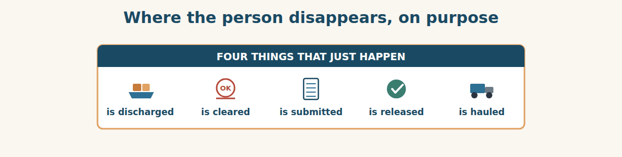
Figure · Nobody is named, and nobody needs to be.
Learners often meet the passive and decide it is a worse way of saying things — longer, colder, and somehow evasive. In ordinary conversation that is often true. In the work you have just read, it is exactly backwards. The passive is not hiding anybody. It is describing a system in which the person genuinely does not matter.
Think about who inspects a container. It is a customs officer; you will never learn his name, and it makes no difference to anything. What matters is that four containers were opened, that this is normal, and that a new seal was fitted. “Four containers were inspected” is not a vaguer sentence than “a customs officer inspected four containers”. It is a more accurate one, because it puts the weight of the sentence where the meaning actually is.
This is why almost every procedure in the world is written in the passive, and why learning it changes what you can read. A shipping update, a laboratory method, a safety instruction, a bank’s terms: all of them describe things that are done, repeatedly, by whoever is on duty. The grammar matches the reality.
But there is a real objection, and you should hold on to it. The passive can hide people, and sometimes that is the point. “Mistakes were made” is the famous example: something went wrong and nobody did it. So the test is simple and you can apply it in any language. Ask whether naming the doer would add information. If it would — the goods are cleared by Komosh, the certificate was issued by the chamber — then name them. If it would not, leave them out. And if you find yourself leaving them out precisely because naming them would be uncomfortable, you have stopped describing a system and started hiding inside one.
That is the whole craft of this unit. Use the passive for the procedure, the active for the people, and never use the grammar to avoid a sentence you ought to write.
A. Understanding check. Answer in your own words.
1. What do learners often wrongly think about the passive?
2. Why is “four containers were inspected” more accurate than naming the officer?
3. Why are most procedures written in the passive?
4. What is the test for whether to name the doer?
B. Apply it. Do this task with a partner.
Describe one process at your work in five passive sentences, with no names. Then go back and find the one step where naming the person really would add information. Rewrite that one, and explain to your partner why it is different.
C. Micro-writing (optional).
Write a few sentences (50–70 words) describing how something is checked, made or delivered at your work. Use the present passive three times, and “by + somebody” only once.
Study terms: shipment · consignment · vessel · voyage · bill of lading · shipper | consignee · notify party · port of loading · port of discharge · ETA · ETD | packing list · commercial invoice · certificate of origin · customs declaration · clearance · clearing agent | inspection · release order · demurrage · storage charge · container · seal | gross weight · net weight · discharge (v) · haulage · in transit · on board | hold (v) · release (v) · submit · issue (v) · mismatch · near miss
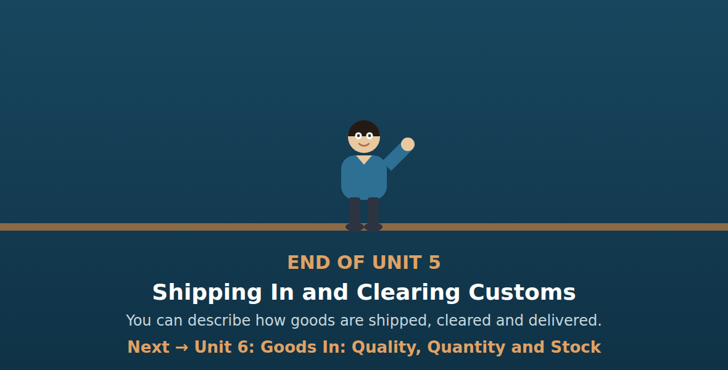
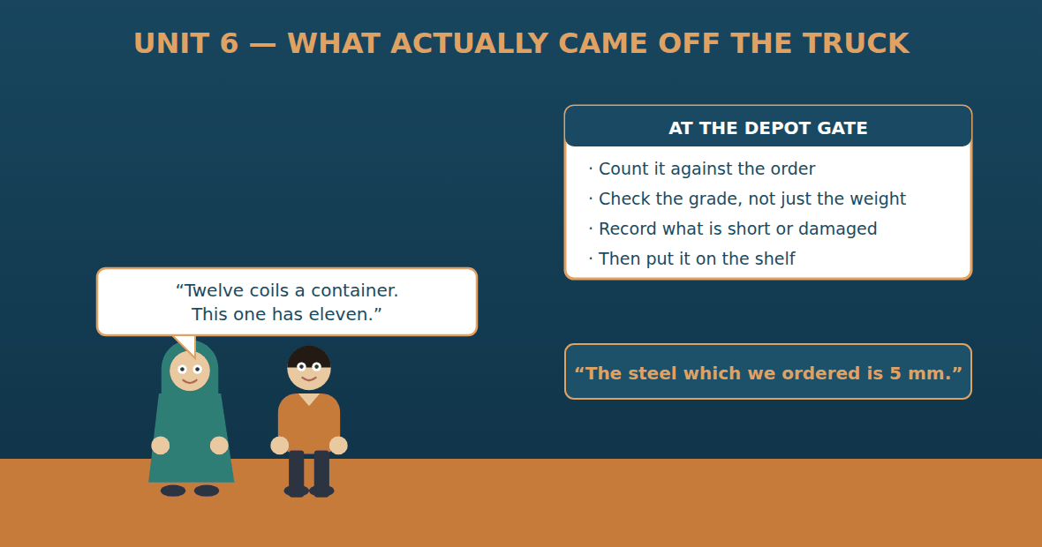

Unit 6: Goods In: Quality, Quantity and Stock
Al-Hasan International — English for Trade, Industry & Global Partnerships
CEFR B1 · Grammar: defining relative clauses — who · which · that · where · Function: Trade + Logistics
Can-Do (by the end of this unit)
- I can check goods against the order
- I can describe a product with which, who or where
- I can report what is short, damaged or missing
- I can write a goods-received note and a claim
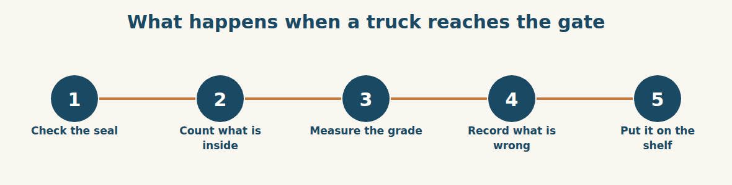
Figure · Five minutes at the gate save five weeks of argument.
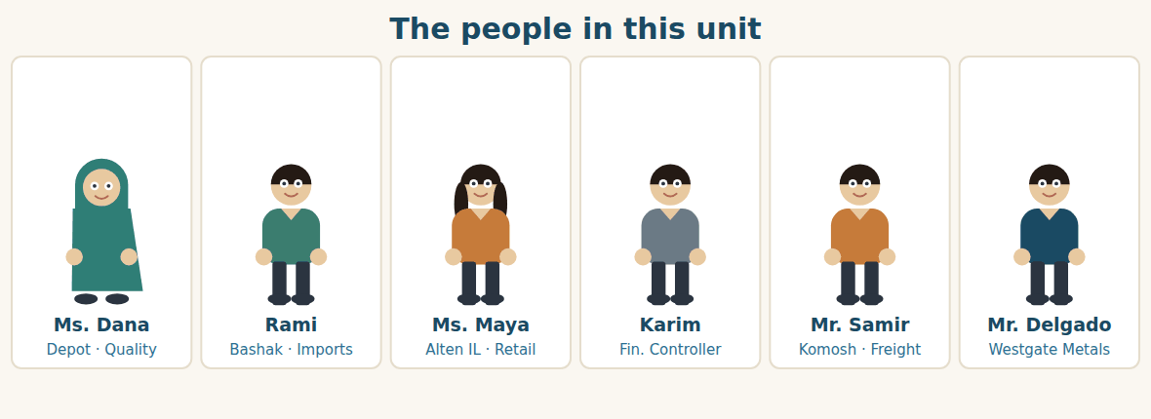
Figure · One side measures steel; the other side counts shelves.
Warm Up LOGISTICS
Look at the pictures. Answer these questions before you read.
1. Who checks goods when they arrive at your company?
2. What do you do if a delivery is short?
3. How do you know when it is time to order more?
Read
Ms. Dana runs the depot which Chemco keeps outside Damascus. She has a rule that everybody there knows: nothing goes on a shelf until it has been counted and measured.
Forty-eight containers arrive over three days. The packing list says twelve coils in each one. Forty-seven containers hold twelve. One holds eleven.
Then there is the second problem, which is quieter and worse. Ms. Dana measures one coil from every fourth container, because that is the rule. Most measure 5 mm. But the coils which came out of containers 31 to 34 measure 4.8. The order says five millimetre, and the customer who is waiting for this steel is a builder who needs five.
“It is only two tenths,” says the driver, who wants to go home. “It is a different product,” says Ms. Dana. She photographs the gauge, the coil and the container number in one picture, writes the batch numbers on the goods-received note, and puts those forty tonnes in the corner of the yard where rejected stock goes.
Rami raises a claim with Westgate the same day: one coil short, and forty tonnes below specification. He asks for a credit note for the missing coil and a replacement for the under-size steel.
Meanwhile Karim is reading the stock count, and he finds something nobody ordered. The depot now holds 6,400 tonnes of steel, which is four months of sales. It holds eleven tonnes of cement, which is nine days. The shops which sell cement are emptying while the yard which holds steel is full. It is the same problem as last year, in a new month.
A. Comprehension. Answer in your own words. (0 is done for you.)
0. What is Ms. Dana’s rule? (nothing goes on a shelf until it has been counted and measured)
1. What is the first problem with the delivery?
2. What is the second problem, and why is it worse?
3. What does Ms. Dana do with the forty tonnes?
4. What two things does Rami ask Westgate for?
5. What does Karim find in the stock count?
B. True or False? Write T or F. (0 is done for you.)
0. Every container held twelve coils. (F)
1. Ms. Dana measures one coil from every fourth container. ____
2. The coils from containers 31 to 34 measure 5 mm. ____
3. The driver thinks the difference matters. ____
4. Rami asks for a credit note and a replacement. ____
5. The depot holds nine days of steel. ____
C. Find the words. Find a word or phrase in the text that means: (0 is done for you.)
0. goods that do not meet the specification → (rejected stock)
1. a delivery with less than the agreed quantity → a s____________ delivery
2. a paper that gives money back for goods not received → a c____________ n____________
3. the exact details the goods must meet → the s____________
D. Over to you. Answer about yourself.
1. What does your company check when goods arrive?
2. Where do you put goods which are not accepted?
3. How many weeks of stock does your company normally hold?
Part 1 · Vocabulary and Terminology LOGISTICS
The goods-received note
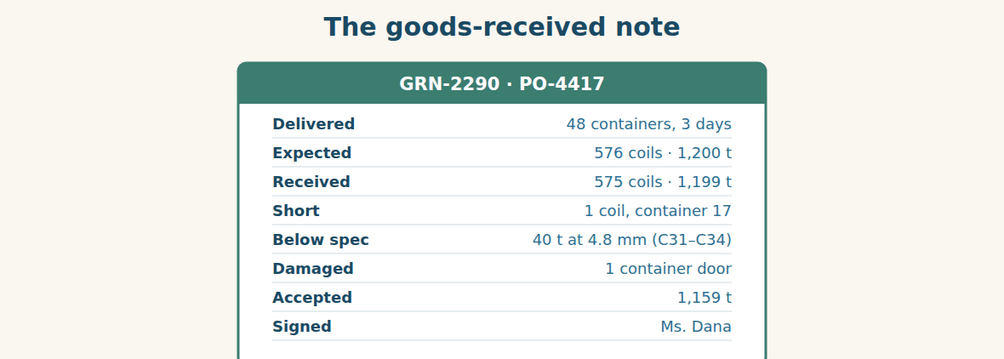
Figure · What was expected, what came, and the difference — in writing.
A. Match each word (1–7) with its meaning (a–h). There is one you do not need. (0 is done for you.)
0. shortage (b)
1. defect ____ a. a paper giving money back
2. specification ____ b. less than the agreed quantity
3. tolerance ____ c. goods sent to replace bad ones
4. credit note ____ d. the exact details goods must meet
5. replacement ____ e. something wrong with the goods
6. batch ____ f. how much difference is allowed
7. reorder level ____ g. a group of goods made at one time
8. h. the stock level at which we order more
B. Complete the sentences with the words in the word bank.
Word bank: shortage | specification | tolerance | credit note | replacement | reorder level
1. There is a ____________ of one coil in container seventeen.
2. The ____________ says five millimetre, and this steel is 4.8.
3. A ____________ of 0.1 mm is normal; 0.2 is not.
4. We asked Westgate for a ____________ for the missing coil.
5. We also asked for a ____________ for the forty tonnes.
6. When stock falls to the ____________, we place a new order.
Checking what arrived
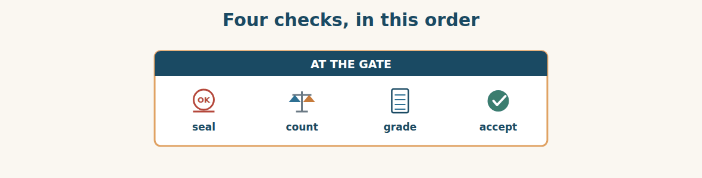
Figure · Each check can stop the one after it.
C. Match the check (1–5) with what it finds (a–e).
1. the seal number ____ a. whether the quantity is right
2. the count ____ b. whether anyone opened it on the way
3. the gauge ____ c. whether the goods are damaged
4. a visual check ____ d. whether the grade is right
5. the batch number ____ e. which production run it came from
Stock in the depot
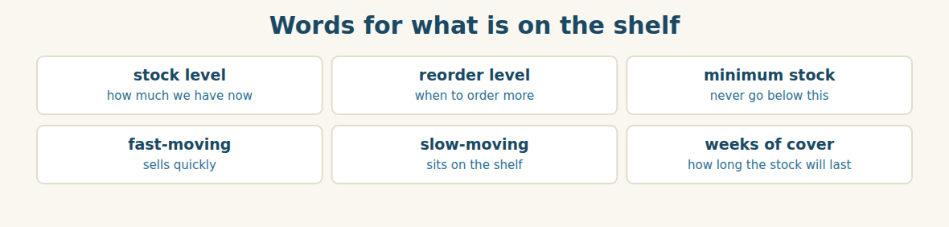
Figure · Six words that tell you whether the depot is healthy.
D. Odd one out. Which word is different? Circle it.
1. shortage · surplus · defect · invoice
2. accept · reject · approve · deliver
3. batch · lot · grade · pallet
4. who · which · where · when
5. fast-moving · slow-moving · minimum stock · demurrage
E. Choose the best answer.
1. How much difference is allowed is the… (a) tolerance (b) specification
2. Goods sent to replace bad ones are a… (a) credit note (b) replacement
3. The level at which we order more is the… (a) minimum stock (b) reorder level
4. Steel that sits on the shelf for months is… (a) fast-moving (b) slow-moving
F. Classify. Write each word in the correct column.
Words: shortage | reorder level | defect | weeks of cover | wrong grade | minimum stock
A problem with the delivery | A stock measure | Either
__________ | __________ | __________
__________ | __________ | __________
__________ | __________ | __________
G. Match the two halves (1–6 with a–f).
1. a goods-received ____ a. note
2. a credit ____ b. level
3. a reorder ____ c. note
4. below ____ d. number
5. a batch ____ e. specification
6. weeks of ____ f. cover
H. Complete the paragraph with the words in the box.
Box: claim | cover | rejected | short | specification | which
One container was (1)____________ by one coil. Forty tonnes were below (2)____________, so they were (3)____________ and kept in the corner of the yard. Rami raised a (4)____________ the same day. The steel (5)____________ was accepted is now four months of (6)____________.
Part 2 · Grammar — relative clauses: who · which · that · where TRADE
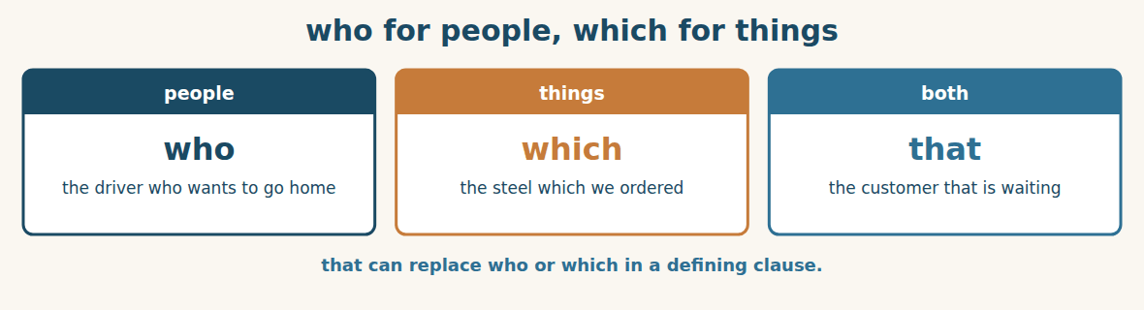
Figure · One sentence instead of two.
A relative clause gives more information about a noun, and it joins two short sentences into one. We use WHO for people, WHICH for things, and THAT for either. The builder who ordered the steel needs 5 mm. The coils which came from container 31 measure 4.8.
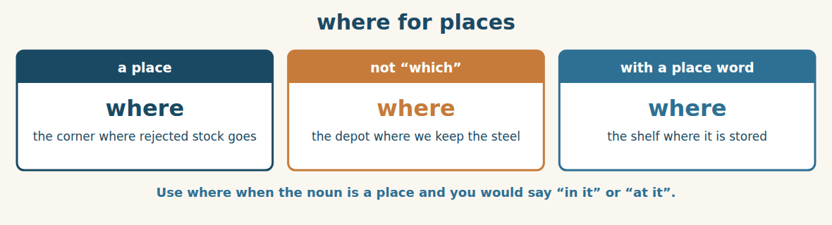
Figure · The one that learners forget.
We use WHERE after a place. The yard where we keep rejected stock. The shop where the cement sold out. Be careful: use which when the place is the subject or object — the depot which Chemco keeps — and where when you would otherwise say in it or at it.
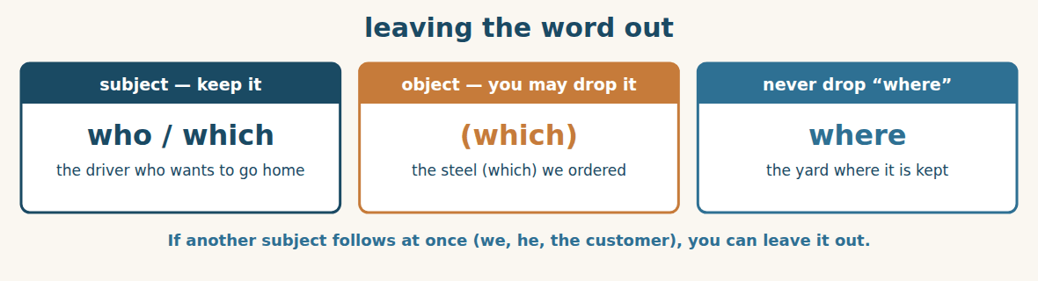
Figure · A small rule that makes English sound natural.
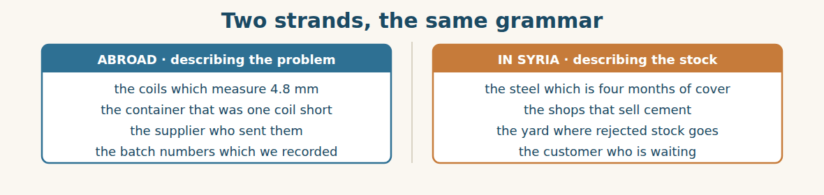
Figure · The same four words, in two different conversations.
Watch out! Do not use two subjects: say the steel which we ordered, not the steel which we ordered it. And after a place, use where — the depot where we keep it — not the depot which we keep it.
Form
noun + who / which / that + verb · place + where + subject + verb · object clause: the thing (which) we ordered
A. Complete with WHO, WHICH or WHERE. (0 is done for you.)
0. The driver who delivered it wanted to go home.
1. The coils ____________ came from container 31 measure 4.8 mm.
2. This is the yard ____________ we keep rejected stock.
3. The builder ____________ ordered this steel needs 5 mm.
4. The depot ____________ Chemco keeps is outside Damascus.
5. That is the shelf ____________ the cement is stored.
B. Join the two sentences with a relative pronoun.
1. This is the container. It was one coil short. → ____________
2. She is the supervisor. She signed the note. → ____________
3. That is the corner. We put rejected stock there. → ____________
4. These are the batch numbers. We recorded them. → ____________
C. Where can you leave the pronoun out? Write YES or NO.
1. the steel which we ordered ____
2. the driver who wants to go home ____
3. the claim which Rami raised ____
4. the yard where we keep it ____
D. Choose the correct word.
1. The customer (who / which) is waiting needs 5 mm.
2. The coils (who / which) measure 4.8 were rejected.
3. The depot (where / which) we keep the steel is full.
4. The shops (that / where) sell cement are empty.
E. Complete the definition with a relative clause.
1. A reorder level is the point ____________ we order more.
2. A credit note is a paper ____________ gives money back.
3. A quality supervisor is the person ____________ checks the goods.
4. A batch number is a number ____________ shows the production run.
F. Make one sentence. Use who, which, that or where.
1. forty tonnes / below specification / were rejected → ____________
2. the yard / rejected stock / is kept → ____________
3. the supplier / sent the short container → ____________
4. the photograph / Ms. Dana took → ____________
G. Find and correct the mistake in each sentence. (0 is done for you.)
0. The steel which we ordered it is 5 mm. → (The steel which we ordered is 5 mm.)
1. The driver which delivered it went home. → ____________
2. This is the depot which we keep the steel. → ____________
3. The coils who measure 4.8 were rejected. → ____________
4. The person which signed the note is Ms. Dana. → ____________
H. About you. Write two sentences about your work: one with “who” and one with “where”.
1. ______________________________________________
2. ______________________________________________
I. Complete with who, which, that or where.
1. The coils ____________ came out of containers 31 to 34 are 4.8 mm.
2. The corner ____________ we put rejected stock is at the back.
3. The builder ____________ is waiting will not accept 4.8.
4. The note ____________ Ms. Dana signed lists every shortage.
5. The shop ____________ sold out twice is in Rural Damascus.
J. Define these words. Use a relative clause.
1. a consignee → “a company ____________”
2. a depot → “a building ____________”
3. a claim → “a letter ____________”
4. a quality supervisor → “a person ____________”
Part 3 · Listening and Dialogue LOGISTICS
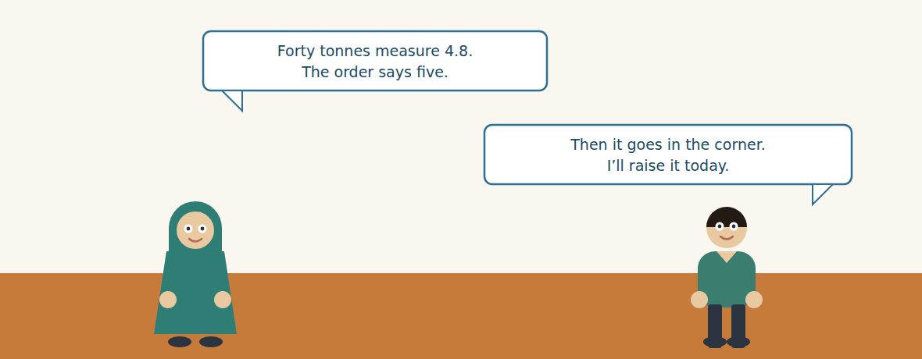
Figure · Strand A · the measurement that starts a claim.
Dialogue 1 — Below specification (the depot, calling the import desk)
Listen and read. (Your teacher will read the dialogue, or play the audio.)
Ms. Dana: Rami, two things. Container seventeen is one coil short — eleven, not twelve. And I have a worse one.
Rami: Go on.
Ms. Dana: The coils which came out of containers 31 to 34 measure 4.8 millimetre. The order says five.
Rami: Four containers. That is about forty tonnes.
Ms. Dana: Forty exactly. The driver who brought them told me it was only two tenths.
Rami: It is two tenths to him. To the builder who is waiting, it is a different product.
Ms. Dana: That is what I said. I have photographed the gauge, the coil and the container number in one picture, and I have written the batch numbers on the goods-received note.
Rami: Good. Have you put it with the accepted stock?
Ms. Dana: No. It is in the corner where rejected stock goes. If it touches the good steel, somebody will sell it by Friday.
Rami: Then I will raise the claim today: a credit note for the coil, and a replacement for the forty tonnes.
Ms. Dana: Ask for the replacement first. Money does not build anything.
A. Comprehension. Answer in your own words. (0 is done for you.)
0. What are the two problems Ms. Dana reports? (one coil short, and forty tonnes below specification)
1. Which containers hold the under-size coils, and how much steel is that?
2. What did the driver say, and how does Rami answer it?
3. What three things did Ms. Dana photograph, and in how many pictures?
4. Why does she keep the steel in the corner?
5. Why does she want the replacement before the money?
B. True or False? Write T or F.
1. Container seventeen held twelve coils. ____
2. Forty tonnes measure 4.8 millimetre. ____
3. The driver thought the difference was serious. ____
4. The rejected steel is stored with the accepted steel. ____
5. Ms. Dana would rather have a replacement than a credit note. ____
C. Language focus. Find in the dialogue: (0 is done for you.)
0. a relative clause with “which” → (the coils which came out of containers 31 to 34)
1. a relative clause with “who” → ____________
2. a relative clause with “where” → ____________
3. a first conditional about the rejected steel → ____________
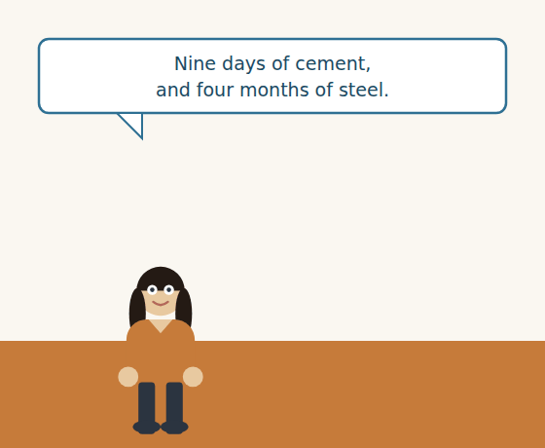
Figure · Strand B · the shelf tells a different story.
Dialogue 2 — The stock count (inside Syria)
Karim: Dana, I have your count. Six thousand four hundred tonnes of steel.
Ms. Dana: That is what is on the shelves, yes.
Karim: At the rate which we sold last quarter, that is four months.
Ms. Dana: And the cement is eleven tonnes, which is nine days.
Karim: Nine days. Maya’s shops will be empty again before the new order lands.
Ms. Dana: Then give me a reorder level for cement and I will watch it. At the moment nobody owns that number.
Karim: What would you set?
Ms. Dana: Six weeks of cover. When we fall to six weeks, somebody orders — not when the shop telephones.
A. Comprehension. Answer in your own words.
1. How much steel is in the depot, and how many months is that?
2. How much cement is there, and how long will it last?
3. What does Ms. Dana ask Karim for, and why?
4. What reorder level does she suggest, and what should trigger an order?
B. Listen again and choose the best answer (A–D).
1. The depot holds … tonnes of steel. A) 640 B) 1,200 C) 6,400 D) 11,000
2. The steel is about … of sales. A) four weeks B) four months C) nine days D) a year
3. The cement will last about… A) nine days B) nine weeks C) four months D) six weeks
4. Ms. Dana suggests a reorder level of … of cover. A) nine days B) three weeks C) six weeks D) four months
Part 4 · Speaking and Your Role TRADE
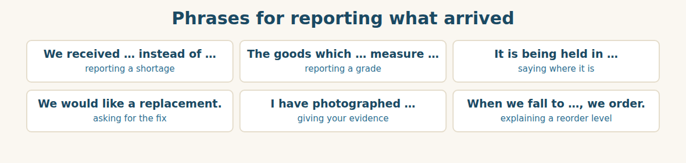
Figure · A clear report is a short one with a number in it.
A. Role-play: reporting a delivery. Student A is at the depot and reports a shortage and a grade problem. Student B is the import desk. Then change roles.
1. A: Report the shortage, with the container number.
2. B: Ask how many tonnes the second problem is.
3. A: Describe the goods with a relative clause (“the coils which…”).
4. B: Ask what evidence has been taken.
5. A: Say where the goods are being kept, and why.
6. B: Say what you will claim, and when.
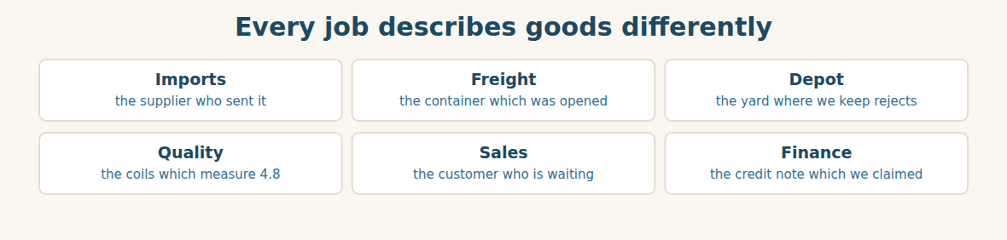
Figure · Six roles, one grammar.
B. Your Role. Describe one thing at work using a relative clause. (Choose your real role.)
1. [Trade] Import Manager: “The supplier who sent the short container has replied.”
2. [Logistics] Freight: “The container which customs opened has a new seal.”
3. [Trade] Depot: “The yard where we keep rejected stock is at the back.”
4. [Trade] Quality: “The coils which measure 4.8 were not accepted.”
5. [Trade] Sales: “The customer who is waiting needs five millimetre.”
6. [Finance] Accountant: “The credit note which we claimed has not arrived.”
C. Ask your partner. Walk around and ask three people.
1. Who is the person who checks goods in your company?
2. What is the thing which goes wrong most often with your deliveries?
3. Where is the place where you keep goods you cannot use?
D. Discuss. Ask and answer.
1. Is 4.8 instead of 5.0 a real problem, or is the depot being difficult?
2. Who should own the reorder level — the depot, sales, or finance?
Part 5 · Extended Reading TRADE
The shelf that tells the truth
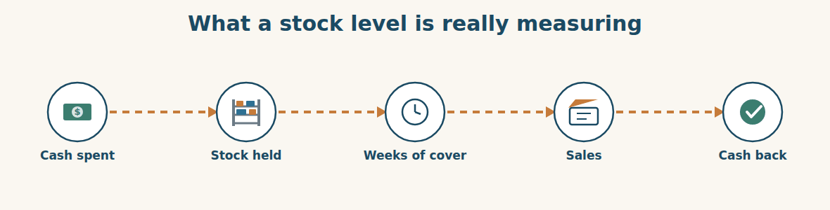
Figure · Stock is money, stopped halfway through a circle.
A warehouse full of goods looks like success. It is not. Every tonne on a shelf is money the company has already spent and has not yet earned back. A full depot is a bank account turned into steel, and steel cannot pay a salary.
This is why experienced companies do not measure stock in tonnes. They measure it in time. Six thousand four hundred tonnes means nothing by itself. Six thousand four hundred tonnes at last quarter’s rate of sale means four months, and four months is a sentence anybody can argue with. Eleven tonnes of cement is also meaningless, until you say nine days — and then everyone in the room sits up.
Measuring in time also shows you which goods are quietly killing you. Fast-moving stock is not a problem even when there is a lot of it, because it will be money again soon. Slow-moving stock is dangerous even in small amounts, because it sits, and while it sits it costs storage, insurance, and the interest on the money that bought it. The worst stock of all is the stock nobody has looked at, because it is usually the stock that cannot be sold.
The second idea is the reorder level, and it is beautifully simple. Instead of ordering when somebody complains, you decide in advance how low you will let the stock fall, and you order then. The level is not a guess. It is the rate of sale multiplied by the lead time, plus a little for safety. If a shop sells two tonnes of cement a week, and a new order takes six weeks to arrive, then the reorder level is twelve tonnes plus some safety — and the day the shelf shows thirteen, somebody orders.
What makes this hard is not the arithmetic. It is ownership. In most companies the reorder level belongs to nobody. Sales assume the depot is watching. The depot assumes purchasing is watching. Purchasing waits for a request. And so the shelf empties, the shop telephones, an urgent order goes out at a bad price, and everybody agrees it was unlucky. It was not unlucky. It was unowned.
A. Comprehension. Answer in your own words. (0 is done for you.)
0. Why is a full warehouse not success? (every tonne is money already spent and not yet earned back)
1. How do experienced companies measure stock, and why?
2. Why is slow-moving stock dangerous even in small amounts?
3. What is the worst stock of all, and why?
4. How do you calculate a reorder level?
5. What does the writer say is the real difficulty — and why is it not “unlucky”?
B. Choose the best answer (A–D).
1. Stock on a shelf is… A) profit B) money already spent C) a sale D) free
2. Experienced companies measure stock in… A) tonnes B) money C) time D) containers
3. Slow-moving stock costs storage, insurance and… A) duty B) interest C) freight D) tax
4. A reorder level is the rate of sale multiplied by the… A) margin B) lead time C) tolerance D) quantity
5. The real problem with reorder levels is… A) arithmetic B) software C) ownership D) cost
C. Find a word or phrase in the text that means:
1. how long the stock will last → weeks of c____________
2. goods that sell quickly → f____________-moving
3. the cost of borrowing money → i____________
4. belonging to nobody → u____________
D. Complete the summary with ONE word in each gap.
Stock is money the company has already (1)____________. Good companies measure it in (2)____________, not in tonnes. (3)____________-moving stock is dangerous even in small amounts. A reorder level is the rate of sale multiplied by the (4)____________ time, plus a little for (5)____________. The real difficulty is not the arithmetic but the (6)____________.
E. Discuss. Talk in pairs.
1. How many weeks of cover does your company hold? Is that too much or too little?
2. Who owns the reorder level where you work?
F. True or False? (about the reading). Write T, F or NOT GIVEN.
1. A full warehouse means the company is doing well. ____
2. Fast-moving stock is less dangerous than slow-moving stock. ____
3. Most companies use software to set reorder levels. ____
4. A reorder level depends on the lead time. ____
Part 6 · Writing (a real email) ADMIN
Model — A claim for a shortage and a grade problem
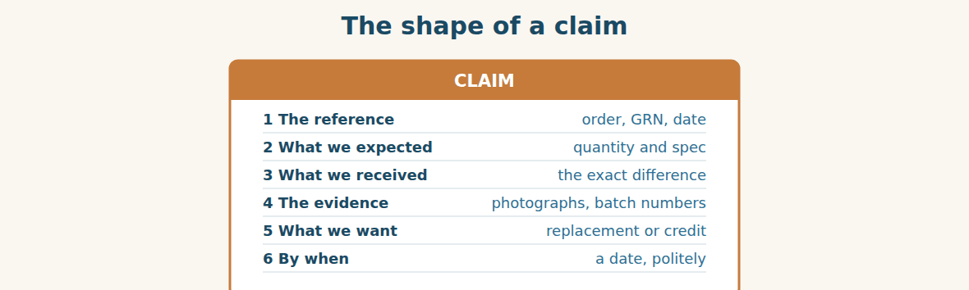
Figure · A claim is a fact, a number and a request — not an argument.
Subject: PO-4417 — shortage and material below specification. Dear Mr. Delgado, The consignment against PO-4417 was received at our depot between the 27th and the 29th and checked against goods-received note GRN-2290. Two problems were found. First, container 17 held eleven coils instead of twelve, a shortage of one coil. Second, the coils which came out of containers 31 to 34 measure 4.8 mm, while the order specifies 5 mm. That is approximately forty tonnes. The batch numbers are listed on the attached note and photographs are attached as well. We would like a replacement for the forty tonnes and a credit note for the missing coil. The material is being held separately and has not been sold. Could you let us know by Thursday how you would like to proceed? Best regards, Rami Import Manager, Bashak Co.
A. Answer about the email. (0 is done for you.)
0. When was the consignment received? (between the 27th and the 29th)
1. What are the two problems, with their numbers?
2. What evidence is attached?
3. What exactly does Rami ask for, and by when?
B. Put the email in order (1–6).
1. ( ) We would like a replacement and a credit note.
2. ( ) Dear Mr. Delgado,
3. ( ) The consignment was received between the 27th and the 29th.
4. ( ) Container 17 held eleven coils instead of twelve.
5. ( ) Could you let us know by Thursday how you would like to proceed?
6. ( ) Best regards, Rami
Guided writing
C. Now you write. Write a claim (70–100 words) about a delivery that was short or wrong. Use at least two relative clauses, and give two numbers.
Plan: 1) “Dear …,” 2) “The consignment against … was received on ….” 3) “We expected … and received ….” 4) “The goods which … measure / weigh ….” 5) “The photographs are attached.” 6) “We would like ….” 7) “Could you let us know by …?” 8) “Best regards, …”
Sentence starters: “Two problems were found.” · “The goods which came out of…” · “That is approximately…” · “We would like a replacement for…” · “The material is being held separately.”
______________________________________________
______________________________________________
______________________________________________
______________________________________________
______________________________________________
D. Checklist. Tick each one when you have checked your claim.
- I gave the order number and the date.
- I said what we expected and what we received.
- I used a relative clause to say exactly which goods.
- I said what evidence I have.
- I asked for one clear thing, by a date.
Part 7 · Trade-Skills Track TRADE
The stock card: reorder levels that somebody owns
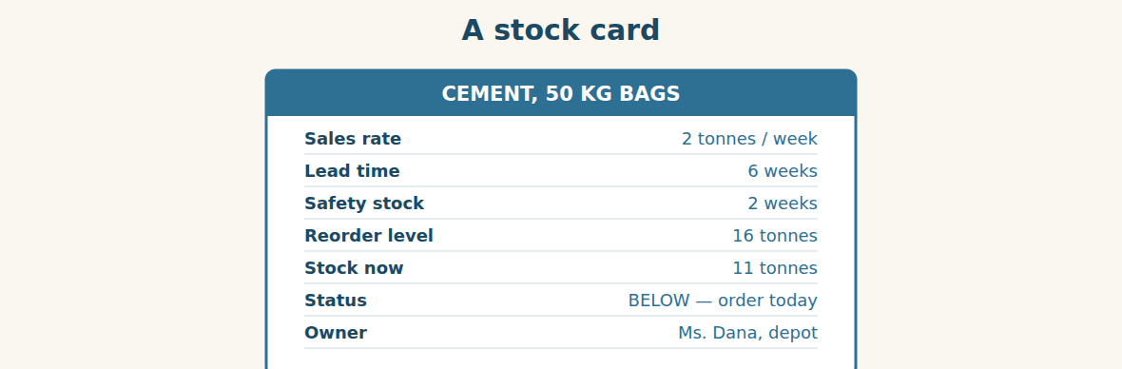
Figure · Seven lines, and the last one is the one that works.
A stock card is not a record of the past. It is an instruction for the future. The first four lines calculate a number, and the last three say what to do about it and who does it.
The arithmetic takes a minute. Multiply the rate of sale by the lead time: two tonnes a week for six weeks is twelve tonnes. That is what you will sell while the new order is travelling. Then add safety stock for the weeks when sales are higher or the ship is late — two weeks here, so four tonnes. The reorder level is sixteen tonnes. When the shelf shows sixteen, somebody orders, and nobody has to be asked.
The last line is the one companies leave empty, and it is the only one that makes the card work. A reorder level with no owner is a number on a wall. A reorder level with a name beside it is a job. Notice that the owner does not have to be senior; she has to be the person who sees the shelf. In this depot that is Ms. Dana, and the day the card said eleven against a level of sixteen, she did not need a meeting.
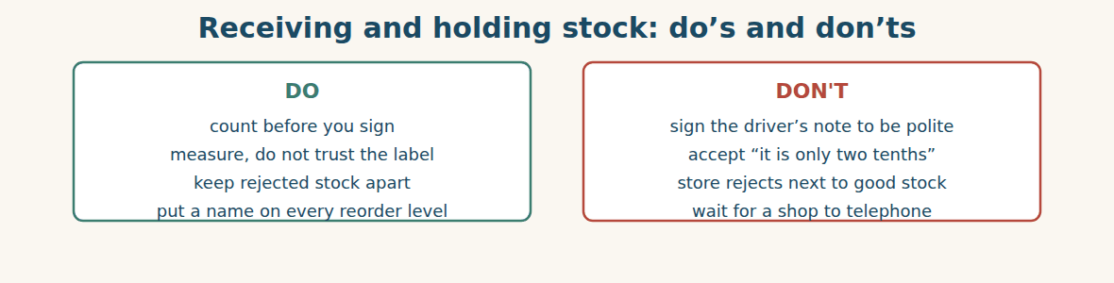
Figure · Four habits, and the first one costs five minutes.
A. Comprehension. Answer in your own words.
1. What is a stock card really for?
2. How do you calculate the twelve tonnes?
3. What is safety stock for?
4. Which line do companies leave empty, and why does it matter?
5. Why does the owner not have to be senior?
B. Listen and complete. Ms. Dana explains the card. Write the missing word.
1. Ms. Dana: Multiply the rate of sale by the ____________ time.
2. Ms. Dana: Then add ____________ stock for the bad weeks.
3. Ms. Dana: When the shelf shows sixteen, somebody ____________.
4. Ms. Dana: A reorder level with no ____________ is a number on a wall.
C. Practice. Make a stock card for one product at your work. Fill in all seven lines, and put a real name on the last one. Then tell your partner what would happen today if you used it.
D. Calculate the reorder level.
1. Sells 5 t/week, lead time 4 weeks, safety 1 week. → ____________
2. Sells 2 t/week, lead time 6 weeks, safety 2 weeks. → ____________
3. Sells 10 t/week, lead time 2 weeks, no safety stock. → ____________
4. Stock now 11 t, reorder level 16 t. What do you do? → ____________
Part 8 · Consolidation TRADE
Two kinds of wrong
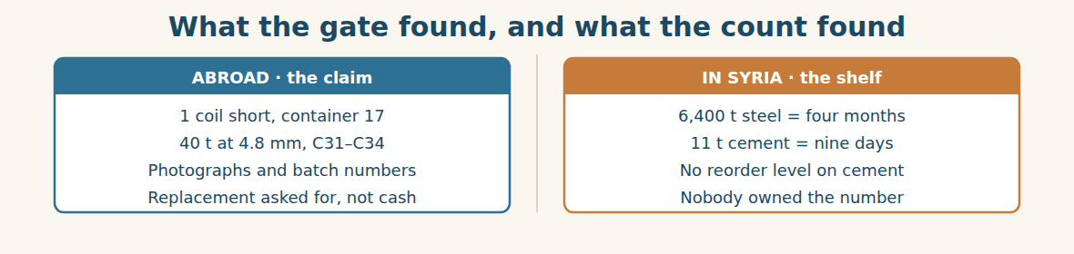
Figure · One problem came from the supplier. The other we made ourselves.
On Friday morning Mr. Tarek has two reports in front of him, and they are not the same kind of problem at all.
The first is Westgate’s. One coil short, forty tonnes under gauge. It is annoying, it is expensive, and it is somebody else’s fault. Rami has the photographs, the batch numbers and the goods-received note which Ms. Dana signed, so the claim is strong and it will probably be paid.
The second report is the one which should worry him, because nobody sent it from abroad. The depot holds four months of steel and nine days of cement. No supplier did that. The Group did it, over several months, with nobody watching a number that belonged to nobody.
“The claim will take six weeks,” says Mr. Tarek, “and we will win it. The cement will be gone on Tuesday.” He turns to Ms. Dana. “The card you asked for — write it today. Every line we sell, a rate, a lead time and a level, and your name at the bottom of each one.”
Ms. Dana asks the only question that matters. “And if the level says order, and purchasing says wait?” Mr. Tarek does not hesitate. “Then purchasing writes down why, and signs it. A rule that anybody can ignore quietly is not a rule. It is a decoration.”
A. Comprehension. Answer in your own words. (0 is done.)
0. What are the two reports? (Westgate’s shortage and grade problem, and the depot’s stock count)
1. Why is the claim strong?
2. Why is the second report more worrying?
3. Who caused the stock problem?
4. What does Mr. Tarek ask Ms. Dana to write?
5. What must purchasing do if it disagrees with a reorder level?
B. Complete each sentence with ONE word from the text. (0 is done for you.)
0. On Friday morning Mr. Tarek has two reports in front of him.
1. The claim is strong because of the photographs, the batch numbers and the ____________-received note.
2. The depot holds four months of steel and nine days of ____________.
3. Nobody was watching a number that belonged to ____________.
4. Every line needs a rate, a lead time, a level and a ____________.
5. A rule that anybody can ignore quietly is a ____________.
C. Discuss. Talk in pairs.
1. Which problem would you fix first, and why?
2. Is “write down why, and sign it” a fair rule? Would it work where you are?
D. Find a word from the text that means: (0 is done for you.)
0. making you slightly angry → (annoying)
1. below the measurement it should be → under g____________
2. to wait before speaking, because you are unsure → to h____________
3. something put there only to look nice → a d____________
Part 9 · Case Studies and Decisions LOGISTICS
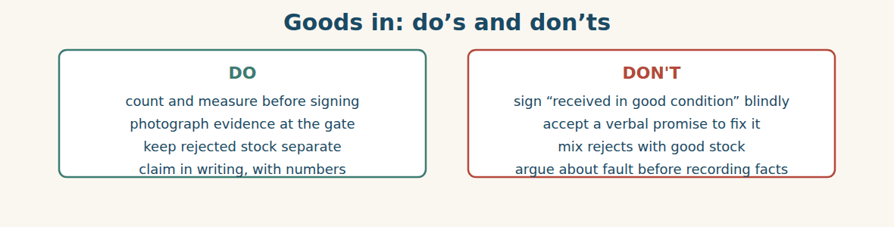
Figure · Evidence is only free if you collect it on the day.
Case 1 — The driver who will not wait (strand A · at the gate)
A driver arrives at six in the evening with the last four containers. He says he has been driving since five this morning and asks you to sign now and count tomorrow. He is tired, he is polite, and he is right that it is late.
Choose the best action and say why.
1. ( ) Sign the note. He has had a long day and the seals look fine.
2. ( ) Sign the note marked “received unchecked, subject to count”, and record the seal numbers and the time.
3. ( ) Refuse the delivery and send him away.
4. ( ) Count all four containers and make him wait, whatever the time.
Write one sentence to put on the note before you sign it.
______________________________________________
______________________________________________
Case 2 — Nine days of cement (strand B · the shelf)
Your stock card says sixteen tonnes is the reorder level. The shelf shows eleven. Purchasing says the price is high this month and suggests waiting three weeks for a better one. The lead time is six weeks.
Answer the questions.
1. What will happen in week four if you wait?
2. What is purchasing really comparing, and what are they leaving out?
3. Write one sentence asking purchasing to order now, or to write down why not.
Case 3 — Forty tonnes nobody will admit to (where the strands meet)
The supplier replies that 4.8 mm is “within normal tolerance” and offers a five per cent credit instead of a replacement. Your builder customer will not take 4.8. The forty tonnes are sitting in your yard, and somebody in sales has started asking whether they could be sold cheaply.
Answer the questions.
1. Why is selling the under-size steel cheaply a dangerous idea?
2. What would you need from the supplier before you could accept a credit instead of a replacement?
3. Write one sentence refusing the credit and repeating the request.
Part 10 · Review and Can-Do TRADE
A. Vocabulary. Complete the sentence.
1. Less than the agreed quantity is a ____________.
2. How much difference is allowed is the ____________.
3. A paper that gives money back is a ____________ ____________.
4. The stock level at which we order more is the ____________ ____________.
5. Goods that sit on the shelf for months are ____________-moving.
B. Grammar. Complete with who, which, that or where.
1. The coils ____________ came out of container 31 measure 4.8 mm.
2. The builder ____________ ordered this steel needs 5 mm.
3. This is the yard ____________ we keep rejected stock.
4. The note ____________ Ms. Dana signed lists every shortage.
5. The driver ____________ delivered it wanted to go home.
6. The shop ____________ sold out twice is in Rural Damascus.
C. Reading. Read the short text and answer.
Forty-eight containers were received. Container 17 held eleven coils instead of twelve. The coils which came out of containers 31 to 34 measured 4.8 mm, and the order specified 5 mm — about forty tonnes. Those tonnes were kept in the corner where rejected stock goes. The depot now holds 6,400 tonnes of steel, which is four months of cover, and eleven tonnes of cement, which is nine days.
1. How many coils were missing, and from which container?
2. How much steel was below specification?
3. How many days of cement cover does the depot hold?
D. Listening. Listen and answer. (Teacher reads.)
[Teacher reads] “Multiply the rate of sale by the lead time, then add safety stock. Two tonnes a week for six weeks is twelve. Add two weeks of safety, and the reorder level is sixteen tonnes. The shelf shows eleven, so we order today.”
1. How do you calculate the twelve tonnes?
2. What is the reorder level?
3. What does the speaker decide to do, and why?
E. Speaking. Work in pairs. One reports a short or wrong delivery; the other asks what evidence was taken and where the goods are now.
F. Writing. Write two sentences about your work: one with “which” and one with “where”.
1. ______________________________________________
2. ______________________________________________
G. Error correction. Find and correct one mistake in each sentence.
1. The steel which we ordered it is 5 mm. → ____________
2. The driver which delivered it went home. → ____________
3. This is the depot which we keep the steel. → ____________
4. The coils who measure 4.8 were rejected. → ____________
5. The person which signed the note is Ms. Dana. → ____________
H. Match the term (1–5) to its meaning (a–e).
1. tolerance ____ a. how long the stock will last
2. batch ____ b. how much difference is allowed
3. weeks of cover ____ c. goods sent to replace bad ones
4. replacement ____ d. a group of goods made at one time
5. reorder level ____ e. the point at which we order more
I. Put the goods-in steps in order (1–5).
1. ( ) measure the grade
2. ( ) check the seal number
3. ( ) put it on the shelf
4. ( ) count what is inside
5. ( ) record what is short or wrong
Can-Do check. Tick what you can do.
- I can check goods against the order.
- I can describe a product with which, who or where.
- I can report what is short, damaged or missing.
- I can write a goods-received note and a claim.
Part 11 · Foundations for Further Study TRADE
Concept Spotlight: Exactly which one?
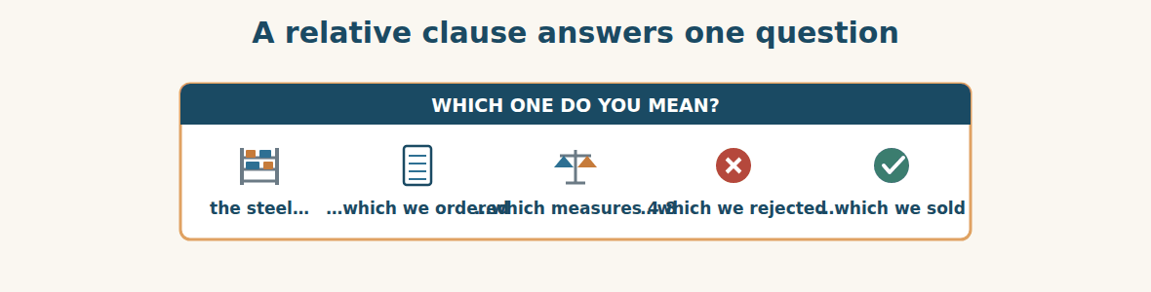
Figure · Four different piles of steel, one noun.
This unit’s grammar looks like a small decoration, and it is not. A relative clause answers one question, and it is the question that runs through every warehouse in the world: exactly which one do you mean?
Say “the steel” in a depot holding six thousand four hundred tonnes and you have said almost nothing. The steel which we ordered. The steel which arrived. The steel which measures 4.8. The steel which we rejected. The steel which the builder is waiting for. Those are five different quantities with five different values, and in this unit two of them were in the same yard at the same time. The only thing standing between them was a clause and a painted line on the floor.
You can see why this is the grammar of claims and specifications. A claim that says “some of the steel was the wrong size” cannot be paid. A claim that says “the coils which came out of containers 31 to 34 measure 4.8 mm” can be checked by a stranger six weeks later in another country. The clause is not making the sentence longer for the sake of it. It is making it provable.
There is a wider habit here, and it goes beyond English. Vague nouns hide problems, and precise ones expose them. “Stock is high” is a comment. “The cement which Alten IL sells is at nine days of cover” is a fact somebody has to do something about. In this unit, nobody discovered the cement problem by having a new idea. They discovered it by saying which cement, in which shops, measured against what.
So when you write in English at work, treat every important noun as a question waiting to be answered. Which steel? Whose order? Which shop? The clause that answers it costs you four words, and it is the difference between a sentence people discuss and a sentence people act on.
A. Understanding check. Answer in your own words.
1. What single question does a relative clause answer?
2. Why does saying “the steel” in a large depot say almost nothing?
3. Why can a claim with a relative clause be paid, when a vague one cannot?
4. What is the difference between “stock is high” and the precise version?
B. Apply it. Do this task with a partner.
Write down three vague sentences you have heard at work — “sales are down”, “the customer complained”, “there is a problem with the stock”. Rewrite each one with a relative clause so that it says exactly which one, and compare with your partner.
C. Micro-writing (optional).
Write a few sentences (50–70 words) describing a problem with a delivery at your work. Use three relative clauses, and make sure a stranger could identify exactly which goods you mean.
Study terms: goods-received note · inspection · count (v) · short delivery · shortage · surplus | damage · defect · grade · gauge · specification · tolerance | below specification · sample · reject (v) · accept (v) · claim · credit note | replacement · batch · batch number · quality control · segregate · stock level | stock count · reorder level · safety stock · weeks of cover · fast-moving · slow-moving | pallet · shelf life · who · which · that · where
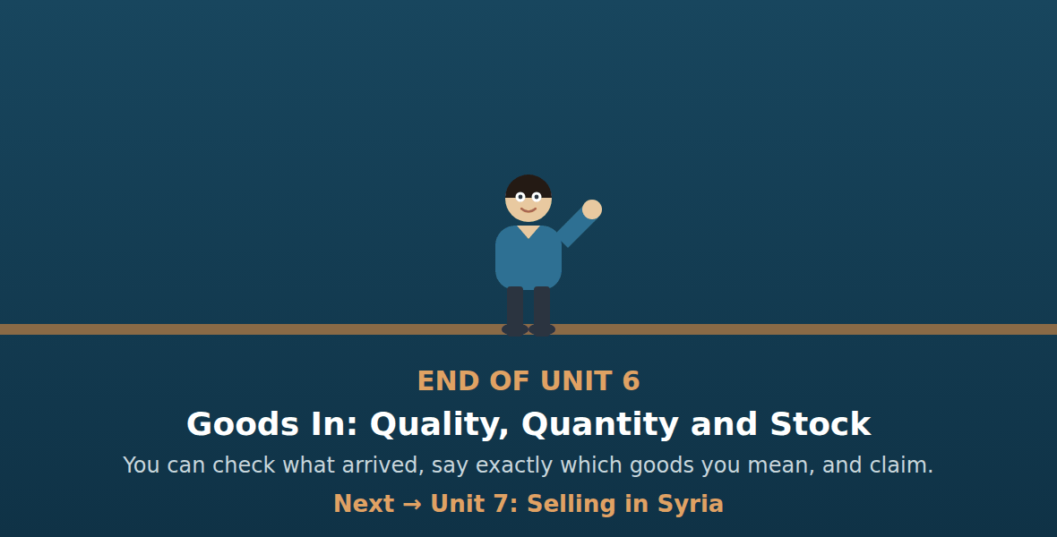
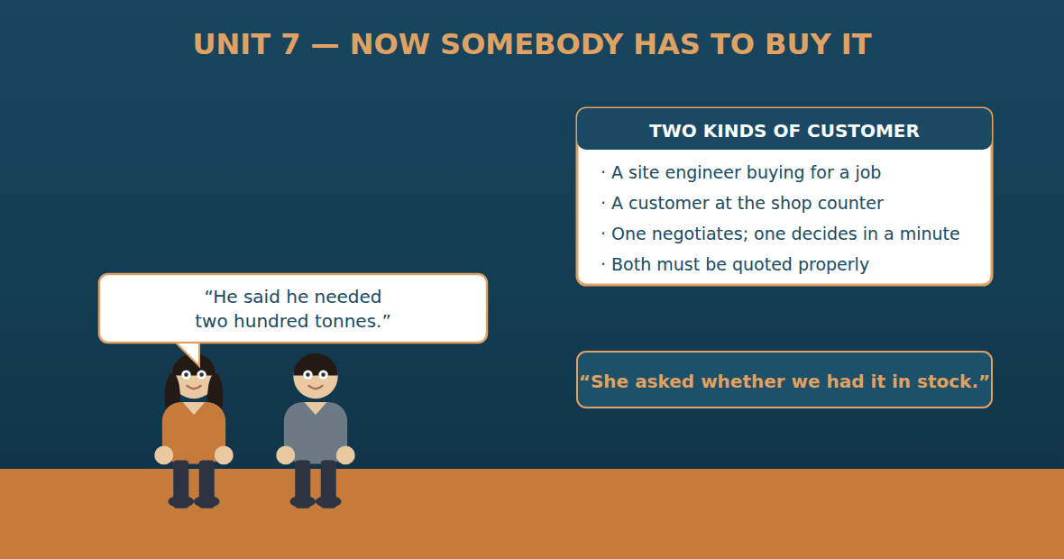

Unit 7: Selling in Syria
Al-Hasan International — English for Trade, Industry & Global Partnerships
CEFR B1 · Grammar: reported speech — say · tell · ask (statements and questions) · Function: Trade
Can-Do (by the end of this unit)
- I can sell to a trade customer and to a retail customer
- I can report what a customer said or asked
- I can quote a price and say what is included
- I can write a quotation
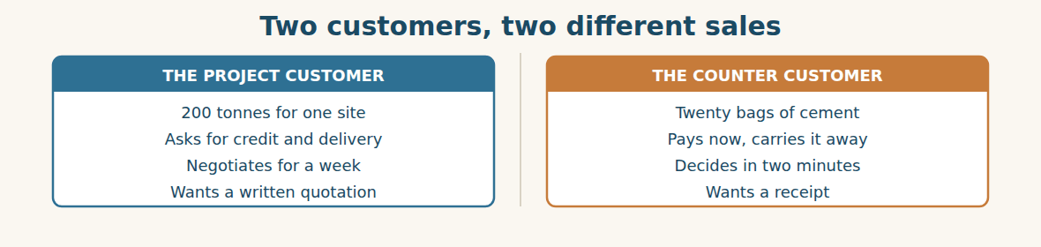
Figure · The same steel, sold two completely different ways.
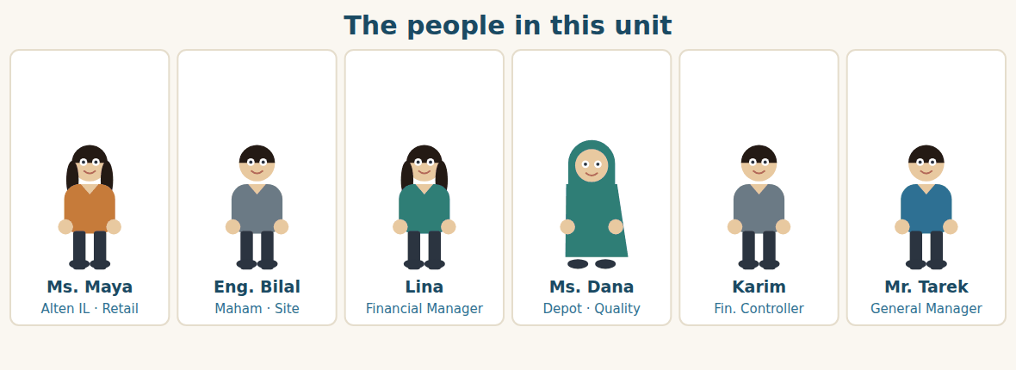
Figure · One sale takes a week. The other takes two minutes.
Warm Up TRADE
Look at the pictures. Answer these questions before you read.
1. Who buys from your company — businesses, or ordinary people, or both?
2. What is the difference between selling to a business and selling to a person?
3. When a colleague takes a message for you, what do you need them to write down?
Read
Six thousand four hundred tonnes of steel are in the depot, and steel on a shelf is not money. Somebody has to sell it, and at Al-Hasan that happens in two completely different rooms.
The first room is a site office in Homs. Eng. Bilal of Maham is building a warehouse, and he needs two hundred tonnes. He telephones on Sunday and says he wants a quotation. Then he asks three questions that every project customer asks: is the price delivered to site or collected from the depot, can he pay in sixty days instead of thirty, and what happens if he needs another fifty tonnes in March.
Lina writes the quotation. She knows the landed cost, so she knows what she can give away and what she cannot. She tells him that the price includes delivery to Homs, that sixty days is possible on his first order, and that March steel will be quoted in March because nobody knows the exchange rate.
The second room is a shop in Rural Damascus. A man comes in and asks whether Alten IL has cement. Ms. Maya says they have, and he buys twenty bags. The whole sale takes two minutes, he pays cash, and he carries the bags to his van himself. He will never negotiate, never ask for credit, and never read a quotation.
In the evening Ms. Maya telephones Lina with the thing that actually matters. “Eleven people asked for five-millimetre steel bar this week,” she says. “I told them we didn’t stock it. Three of them said they would go to Homs for it.”
Lina writes it down. Six thousand four hundred tonnes of coil in the depot, and eleven people walking out of a shop asking for bar. The steel the Group bought and the steel the market wants are not the same steel.
A. Comprehension. Answer in your own words. (0 is done for you.)
0. Why must the steel be sold? (steel on a shelf is not money)
1. What does Eng. Bilal need, and what three questions does he ask?
2. Why can Lina decide what to give away?
3. What three answers does she give him?
4. How long does the sale at the shop take, and how does the customer pay?
5. What does Ms. Maya report in the evening, and why does it matter?
B. True or False? Write T or F. (0 is done for you.)
0. Steel in the depot is already money. (F)
1. Eng. Bilal needs two hundred tonnes. ____
2. Lina refuses sixty-day payment. ____
3. The shop customer pays cash and carries the bags himself. ____
4. Eleven people asked for steel bar. ____
5. The depot stocks what those eleven people wanted. ____
C. Find the words. Find a word or phrase in the text that means: (0 is done for you.)
0. a customer who buys for a building project → (a project customer)
1. to pay later instead of now → to buy on c____________
2. brought to the customer’s place → d____________ to site
3. to take the goods from the depot yourself → to c____________ them
D. Over to you. Answer about yourself.
1. Does your company give credit? To whom, and for how long?
2. What do your customers ask for that you do not have?
3. Who takes messages in your office, and how do they pass them on?
Part 1 · Vocabulary and Terminology TRADE
The quotation
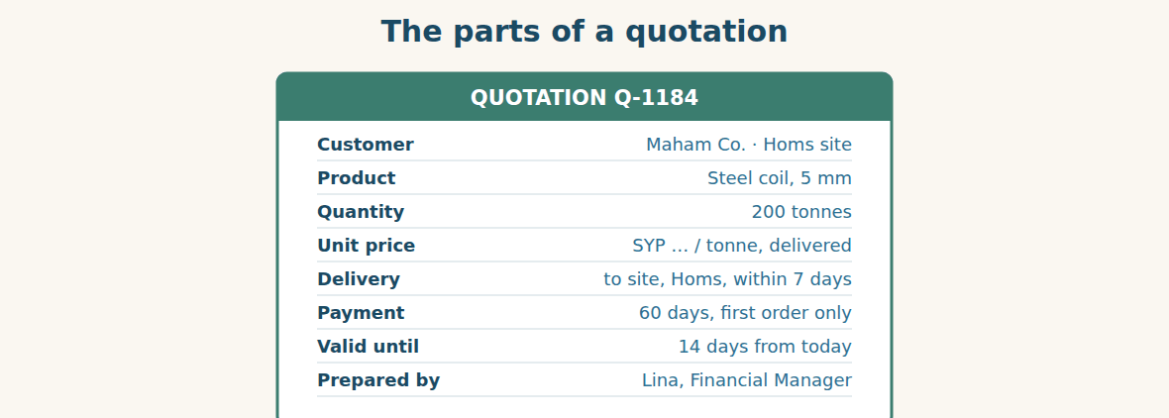
Figure · Eight lines. Leave one out and the customer will ask.
A. Match each word (1–7) with its meaning (a–h). There is one you do not need. (0 is done for you.)
0. quotation (d)
1. trade customer ____ a. a customer who walks into the shop
2. retail customer ____ b. paying later, not now
3. walk-in ____ c. a business that buys to use or sell on
4. credit terms ____ d. a written price for a customer
5. delivered price ____ e. a person buying for themselves
6. collection ____ f. the customer takes the goods away
7. lead ____ g. a price that includes transport to the customer
8. h. a possible customer who has shown interest
B. Complete the sentences with the words in the word bank.
Word bank: quotation | credit terms | delivered | collection | in stock | valid
1. I will send you a written ____________ this afternoon.
2. Our ____________ are thirty days for account customers.
3. The price is ____________ to your site in Homs.
4. If you prefer ____________, the price is lower.
5. Yes, we have it ____________ — two hundred tonnes in the depot.
6. The offer is ____________ for fourteen days.
Two kinds of sale
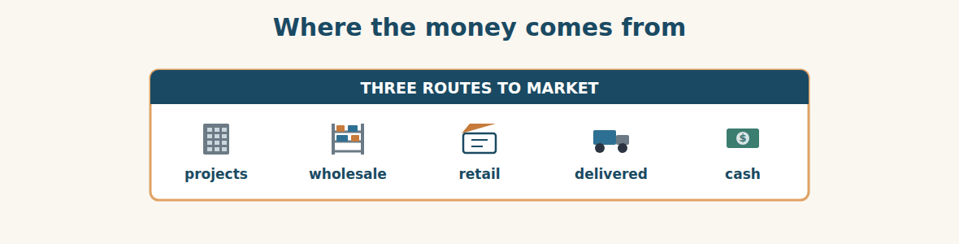
Figure · The same tonne of steel, three different customers.
C. Match the customer (1–5) with what they want (a–e).
1. a site engineer ____ a. twenty bags, now, paid in cash
2. a wholesale buyer ____ b. a written quotation and sixty days
3. a walk-in customer ____ c. a price per tonne for a full truck
4. an account customer ____ d. a monthly invoice, not a receipt
5. a new customer ____ e. to see the product before buying
Passing on what the customer said
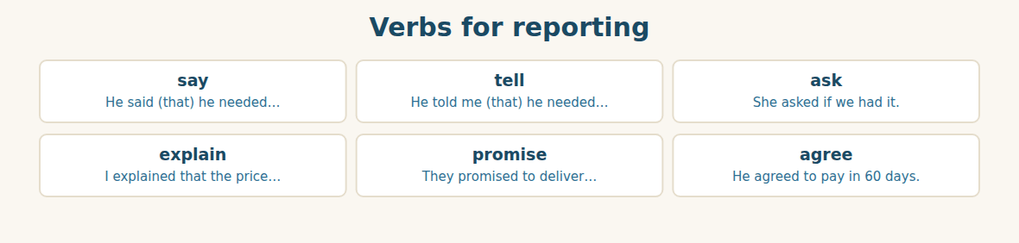
Figure · Six verbs that carry a message from one person to another.
D. Odd one out. Which word is different? Circle it.
1. quotation · offer · price list · depot
2. say · tell · ask · deliver
3. cash · credit · invoice · gauge
4. walk-in · retail · counter · wholesale
5. in stock · out of stock · available · delivered
E. Choose the best answer.
1. A price that includes transport is a… (a) delivered price (b) collection price
2. A business that buys to sell on is a… (a) retail customer (b) trade customer
3. A possible customer who has shown interest is a… (a) lead (b) walk-in
4. Paying later, not now, is buying on… (a) credit (b) cash
F. Classify. Write each item in the correct column.
Items: a written quotation | a receipt | sixty days credit | cash at the counter | delivery to site | twenty bags
The project customer | The counter customer | Either
__________ | __________ | __________
__________ | __________ | __________
__________ | __________ | __________
G. Match the two halves (1–6 with a–f).
1. credit ____ a. price
2. a delivered ____ b. customer
3. a trade ____ c. terms
4. out of ____ d. stock
5. valid ____ e. for 14 days
6. to close ____ f. the sale
H. Complete the paragraph with the words in the box.
Box: asked | credit | delivered | quotation | stock | told
Eng. Bilal (1)____________ for two hundred tonnes. Lina sent him a written (2)____________ with a (3)____________ price to Homs. She (4)____________ him that sixty days of (5)____________ was possible on a first order. The steel was in (6)____________, so delivery was within seven days.
Part 2 · Grammar — reported speech: say · tell · ask TRADE
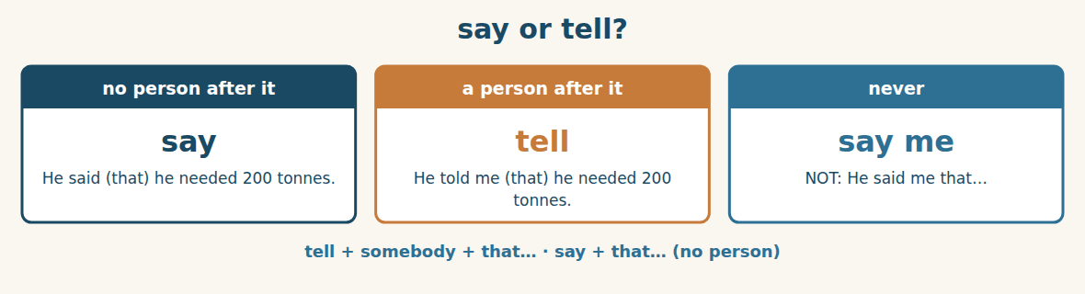
Figure · The difference that every learner gets wrong once.
Use SAY when you do not name the listener: She said that the price included delivery. Use TELL when you do: She told him that the price included delivery. We never say “she said me”, and we never say “she told that”.
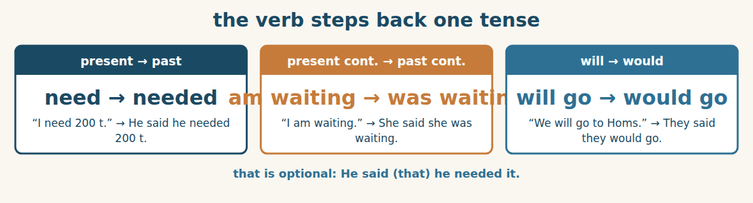
Figure · What was present becomes past.
When we report what somebody said, the verb usually steps back one tense. “We have it in stock” becomes She said they had it in stock. “I will pay in sixty days” becomes He said he would pay in sixty days. We also change the pronouns: I becomes he or she, and we becomes they.
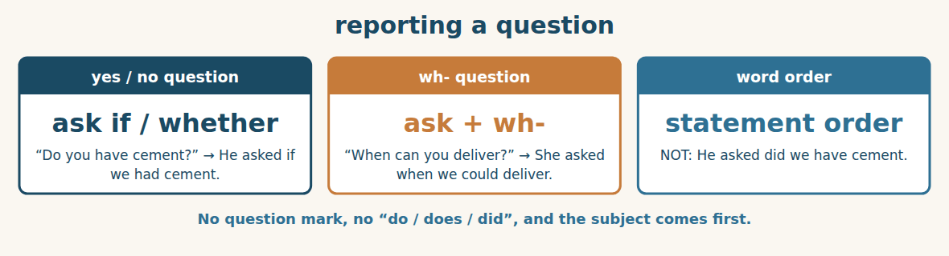
Figure · A reported question is not a question any more.
When we report a question, we use ASK, and the words go back into statement order. For a yes/no question we add IF or WHETHER. “Is it in stock?” becomes He asked if it was in stock. For a wh- question we keep the question word: “Where is the site?” becomes She asked where the site was.
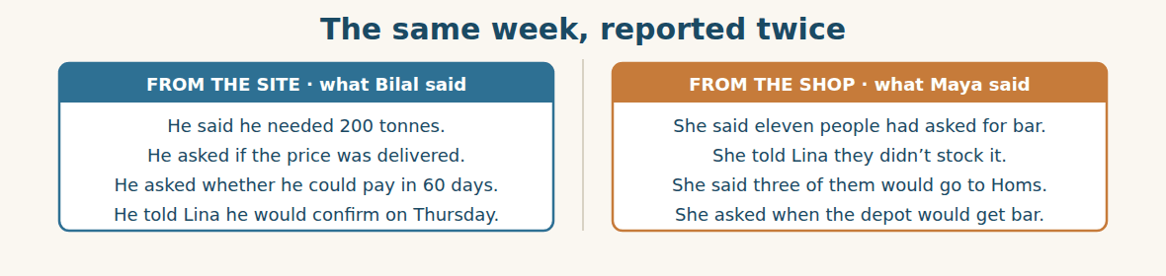
Figure · Two conversations, carried to one desk.
Watch out! Never use “say” with a person: say that…, but tell somebody that…. And in a reported question, do not keep the question word order or the auxiliary: He asked if we had it, not He asked did we have it.
Form
say (that) + clause · tell + somebody + (that) + clause · ask + (somebody) + if / whether + statement · ask + (somebody) + wh-word + statement
A. SAY or TELL? Complete the sentence. (0 is done for you.)
0. He said that he needed 200 tonnes.
1. She ____________ me the price included delivery.
2. They ____________ they would confirm on Thursday.
3. I ____________ him that we had it in stock.
4. Maya ____________ that eleven people had asked for bar.
B. Report the statement. (0 is done for you.)
0. “I need 200 tonnes.” → (He said he needed 200 tonnes.)
1. “We have it in stock.” → She said ____________
2. “I will pay in sixty days.” → He said ____________
3. “We are waiting for the truck.” → They said ____________
4. “The price includes delivery.” → Lina told him ____________
C. Report the question with IF or WHETHER.
1. “Do you have cement?” → He asked ____________
2. “Is the price delivered?” → She asked ____________
3. “Can I pay in sixty days?” → He asked ____________
4. “Have you got five-millimetre bar?” → They asked ____________
D. Report the wh- question.
1. “When can you deliver?” → She asked ____________
2. “Where is the site?” → He asked ____________
3. “How much is a tonne?” → The customer asked ____________
4. “Why is it out of stock?” → They asked ____________
E. Change the pronouns and times.
1. “I will send it to you today.” → He said he ____________
2. “We delivered it yesterday.” → They said they ____________
3. “Our price is firm this month.” → She said their price ____________
4. “I can come tomorrow.” → He said he ____________
F. Match the direct words (1–5) with the report (a–e).
1. “Do you deliver?” ____ a. He said he would confirm on Thursday.
2. “I’ll confirm Thursday.” ____ b. She asked if we delivered.
3. “We don’t stock bar.” ____ c. He asked how much a tonne was.
4. “How much is a tonne?” ____ d. She told him they didn’t stock bar.
5. “Where is the depot?” ____ e. He asked where the depot was.
G. Find and correct the mistake in each sentence. (0 is done for you.)
0. He said me he needed 200 tonnes. → (He told me he needed 200 tonnes.)
1. She told that the price was delivered. → ____________
2. He asked did we have cement. → ____________
3. She asked me where is the site. → ____________
4. They said they will pay in sixty days. → ____________
H. About you. Report two things a colleague or a customer said to you this week.
1. ______________________________________________
2. ______________________________________________
I. Complete with said, told, or asked.
1. Eng. Bilal ____________ Lina that he needed two hundred tonnes.
2. He ____________ whether he could pay in sixty days.
3. Lina ____________ that March steel would be quoted in March.
4. Maya ____________ me that eleven people had asked for bar.
5. The customer ____________ if the shop had cement.
J. Report the whole conversation.
1. Bilal: “I need 200 tonnes.” → ____________
2. Bilal: “Is the price delivered?” → ____________
3. Lina: “Yes, delivery to Homs is included.” → ____________
4. Lina: “We will quote March steel in March.” → ____________
Part 3 · Listening and Dialogue TRADE
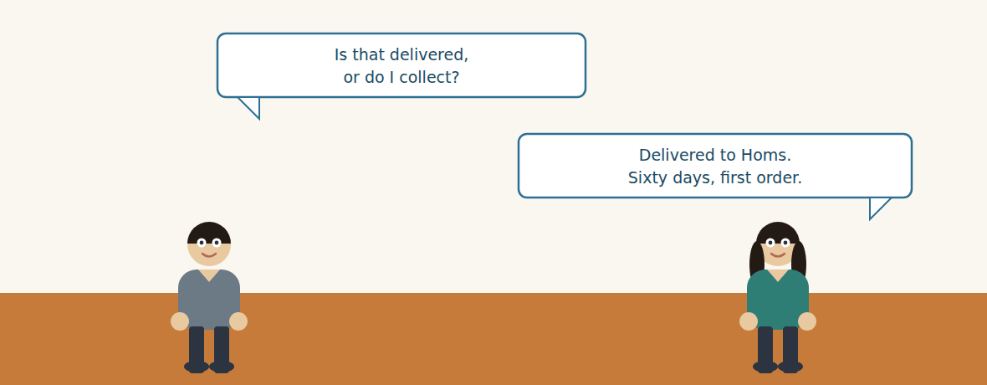
Figure · Strand A · a sale that takes a week.
Dialogue 1 — Quoting a project customer (the site call)
Listen and read. (Your teacher will read the dialogue, or play the audio.)
Eng. Bilal: Lina, I need two hundred tonnes of five-millimetre coil for the Homs warehouse. Can you quote me?
Lina: I can. Give me your dates and I will send it this afternoon.
Eng. Bilal: I need it on site by the end of the month. Three questions. Is the price delivered, or do I collect from the depot?
Lina: Delivered to Homs. Collection is cheaper, but you would need your own trucks.
Eng. Bilal: Delivered. Second: can I pay in sixty days instead of thirty?
Lina: On a first order, yes. After that we will look at it again together.
Eng. Bilal: And third — I will probably need another fifty tonnes in March. Can you hold this price?
Lina: No. I am not going to promise a March price in November, because I do not know the exchange rate. What I can promise is that you will get our best price on the day, and that we will keep fifty tonnes for you.
Eng. Bilal: That is honest. Put the fifty tonnes in writing and we have an agreement.
Lina: It will be in the quotation. Valid fourteen days.
A. Comprehension. Answer in your own words. (0 is done for you.)
0. What does Eng. Bilal need, and for which site? (200 tonnes of 5 mm coil, for the Homs warehouse)
1. What are his three questions?
2. What is the difference between delivered and collection?
3. What does Lina agree about payment, and with what limit?
4. Why does she refuse to hold the March price?
5. What two things does she promise instead?
B. True or False? Write T or F.
1. The price Lina quotes includes delivery to Homs. ____
2. Collection would be more expensive. ____
3. Sixty days is offered on every order. ____
4. Lina agrees to fix the March price now. ____
5. The quotation will be valid for fourteen days. ____
C. Language focus. Report these lines from the dialogue. (0 is done for you.)
0. Bilal: “I need two hundred tonnes.” → (He said he needed two hundred tonnes.)
1. Bilal: “Is the price delivered?” → He asked ____________
2. Lina: “I will send it this afternoon.” → She said ____________
3. Lina: “I am not going to promise a March price.” → She told him ____________
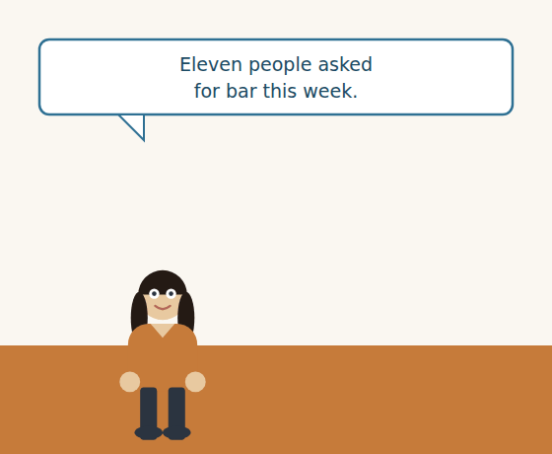
Figure · Strand B · a sale that takes two minutes — and a message that matters more.
Dialogue 2 — At the counter, and afterwards (the shop)
Customer: Have you got cement?
Ms. Maya: We have. Fifty-kilo bags. How many do you need?
Customer: Twenty. And five-millimetre bar — have you got that?
Ms. Maya: I am sorry, we don’t stock bar. Only coil, and only at the depot.
Customer: Then I will get the bar in Homs and take the cement there too.
Ms. Maya: Twenty bags, then. Here is your receipt.
Ms. Maya: [later, on the telephone] Lina, eleven people have asked me for five-millimetre bar this week. I told every one of them that we didn’t stock it. Three said they would go to Homs.
Lina: Eleven in one week? Did they ask for coil?
Ms. Maya: Nobody asks a shop for coil, Lina. They ask for bar.
A. Comprehension. Answer in your own words.
1. What does the customer buy, and what does he not get?
2. What will the customer do instead, and what does the shop lose?
3. How many people asked for bar, and over what period?
4. What does Ms. Maya mean by “nobody asks a shop for coil”?
B. Listen again and choose the best answer (A–D).
1. The customer buys … bags. A) five B) eleven C) twenty D) fifty
2. The shop does not stock… A) cement B) bar C) coil D) nails
3. The number of people who asked for bar was… A) three B) five C) eleven D) twenty
4. Three of them said they would go to… A) Damascus B) Aleppo C) Homs D) Lattakia
Part 4 · Speaking and Your Role TRADE
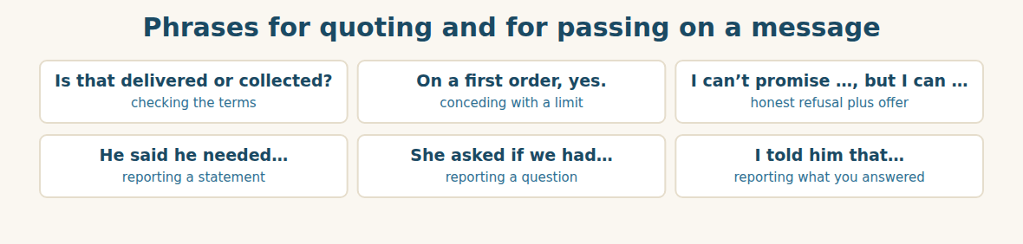
Figure · Selling is half quoting and half carrying messages accurately.
A. Role-play: the project quotation. Student A is the site engineer with three questions. Student B quotes. Then change roles.
1. A: Say what you need, how much, and by when.
2. B: Offer to quote and ask for the dates.
3. A: Ask whether the price is delivered or collected.
4. B: Answer, and give the difference.
5. A: Ask for longer credit.
6. B: Agree with a limit, and refuse one thing honestly.
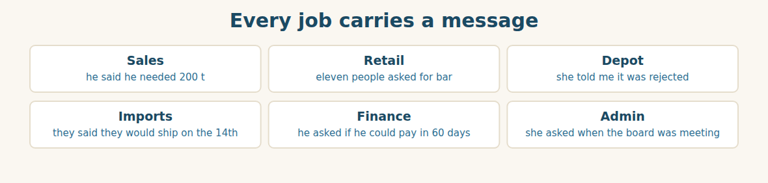
Figure · Six roles, one grammar — and one chance to get it wrong.
B. Your Role. Report one thing a customer or colleague said to you. (Choose your real role.)
1. [Trade] Sales: “He said he needed two hundred tonnes by the end of the month.”
2. [Trade] Retail: “Eleven people asked me for bar this week.”
3. [Trade] Depot: “She told me the forty tonnes were rejected.”
4. [Trade] Import Manager: “They said they would ship on the 14th.”
5. [Finance] Accountant: “He asked if he could pay in sixty days.”
6. [Admin] Assistant: “She asked when the board was meeting.”
C. Ask your partner. Walk around and ask three people.
1. What did a customer ask you last week?
2. What did you have to tell a customer you could not do?
3. What do customers ask for that your company does not sell?
D. Discuss. Ask and answer.
1. Should the same salesperson handle projects and the counter? Why or why not?
2. Who in your company hears what customers ask for but cannot buy?
Part 5 · Extended Reading TRADE
The customers who leave without buying
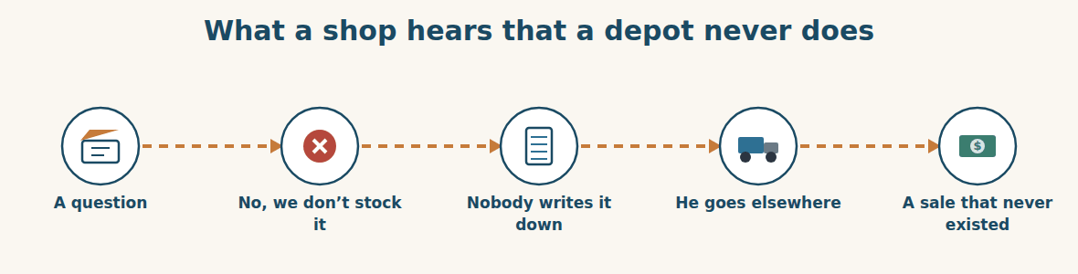
Figure · The most valuable information in a company walks out of the door.
Every company counts what it sells. Almost no company counts what it was asked for and could not supply. This is strange, because the second number is often more useful than the first.
What you sold tells you about your past. It is already in the invoices, it is already money, and it describes a decision you made months ago when you bought the stock. What you were asked for tells you about your future. It is the market speaking directly, at no cost, in your own shop — and in most companies nobody is writing it down.
The reason is simple and human. A “no” feels like a failure, and nobody wants to record their failures eleven times in a week. The shop assistant who says “sorry, we don’t stock bar” is having a small bad moment, not collecting data. And the person who buys the stock is forty kilometres away, looking at a report which contains only the things that sold.
So the information dies at the counter. Eleven people ask for the same product. Each one is told no by a different assistant on a different day. No single person ever knows it was eleven. Then at the end of the year somebody looks at the sales figures and concludes, quite logically and quite wrongly, that there is no demand for bar.
The fix is not expensive. It is a sheet of paper by the till with two columns: what they asked for, and whether we had it. One line a day, written by the person who heard the question. At the end of the month somebody reads it, and for the first time the company hears the sentence that was said eleven times.
Ms. Maya did not need a system. She kept the number in her head because she was paying attention. But a company cannot depend on one person paying attention. It needs the question written down by whoever is standing there — because the market only says things once to each person, and then it walks to Homs.
A. Comprehension. Answer in your own words. (0 is done for you.)
0. What do almost no companies count? (what they were asked for and could not supply)
1. What does “what you sold” tell you, and what does “what you were asked for” tell you?
2. Why does nobody write down the “no”?
3. Why does no single person know it was eleven?
4. What wrong conclusion is reached at the end of the year?
5. What is the fix, and who writes it?
B. Choose the best answer (A–D).
1. The second number is often … than the first. A) smaller B) more useful C) harder to get D) less honest
2. What you sold describes… A) the future B) the market C) a past decision D) demand
3. A “no” feels like… A) data B) a failure C) a sale D) a question
4. The eleven requests were heard by… A) one person B) nobody C) different assistants D) the depot
5. The fix is… A) new software B) a sheet of paper by the till C) more staff D) a bigger depot
C. Find a word or phrase in the text that means:
1. how much people want to buy → d____________
2. to decide something after thinking → to c____________
3. the machine where customers pay in a shop → the t____________
4. watching and noticing carefully → paying a____________
D. Complete the summary with ONE word in each gap.
Companies count what they (1)____________, but not what they were (2)____________ for. The first describes the (3)____________; the second describes the future. Nobody records a “no” because it feels like a (4)____________. The fix is a sheet of (5)____________ by the till, written by the person who heard the (6)____________.
E. Discuss. Talk in pairs.
1. Does your company record what customers ask for and do not get?
2. What would you find if you recorded it for one month?
F. True or False? (about the reading). Write T, F or NOT GIVEN.
1. Sales figures show what customers wanted but could not buy. ____
2. Recording lost requests needs expensive software. ____
3. Ms. Maya used a written system. ____
4. The writer thinks a company should not depend on one attentive person. ____
Part 6 · Writing (a real email) ADMIN
Model — A quotation to a customer
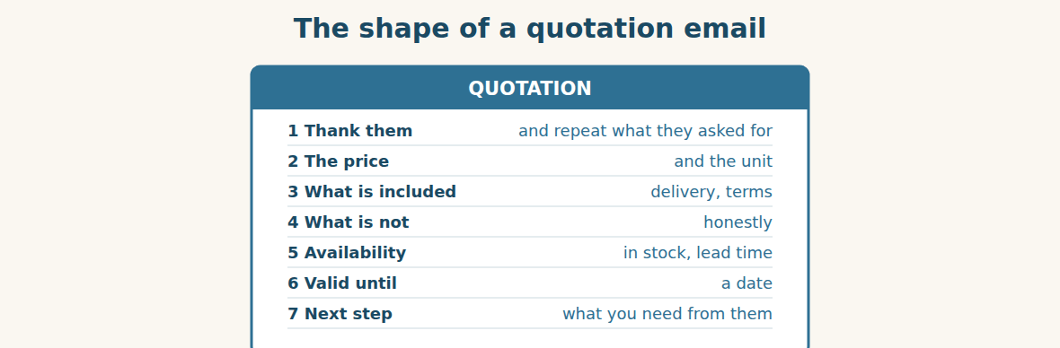
Figure · Answer the questions they asked, in the order they asked them.
Subject: Quotation Q-1184 — 200 t steel coil, Homs site. Dear Eng. Bilal, Thank you for your enquiry this morning. You asked for two hundred tonnes of five-millimetre coil for the Homs warehouse, on site by the end of the month. Our price is as shown in the attached quotation, per tonne, delivered to your site in Homs. Delivery is within seven days of your written order, because the material is in stock at our Damascus depot. You asked whether you could pay in sixty days. We are able to offer sixty days on this first order, and we will review the terms together afterwards. You also asked us to hold the price for a further fifty tonnes in March. I am afraid we cannot fix a March price now, but we will reserve fifty tonnes for you and quote our best price on the day. This quotation is valid for fourteen days. Please confirm in writing and we will book the delivery. Best regards, Lina Financial Manager, Al-Hasan Holding Group.
A. Answer about the email. (0 is done for you.)
0. What did Eng. Bilal ask for? (200 tonnes of 5 mm coil, on site by the end of the month)
1. What is included in the price, and how fast is delivery?
2. What does Lina agree to about payment, and with what limit?
3. What does she refuse, and what does she offer instead?
B. Put the email in order (1–6).
1. ( ) This quotation is valid for fourteen days.
2. ( ) Dear Eng. Bilal,
3. ( ) Thank you for your enquiry this morning.
4. ( ) We are able to offer sixty days on this first order.
5. ( ) I am afraid we cannot fix a March price now.
6. ( ) Best regards, Lina
Guided writing
C. Now you write. Write a quotation email (80–110 words) answering a customer who asked three questions. Report at least one of their questions, and refuse one thing honestly.
Plan: 1) “Dear …,” 2) “Thank you for your enquiry. You asked for ….” 3) “Our price is … , delivered ….” 4) “You asked whether … . We are able to ….” 5) “I am afraid we cannot … , but we can ….” 6) “This quotation is valid for ….” 7) “Best regards, …”
Sentence starters: “You asked for…” · “You asked whether…” · “We are able to offer…” · “I am afraid we cannot…, but we will…” · “This quotation is valid for…”
______________________________________________
______________________________________________
______________________________________________
______________________________________________
______________________________________________
D. Checklist. Tick each one when you have checked your quotation.
- I repeated what the customer asked for.
- I said what the price includes.
- I reported at least one of their questions.
- I refused one thing honestly and offered something instead.
- I gave a valid-until date and a next step.
Part 7 · Trade-Skills Track TRADE
The lost-sales sheet: counting the noes
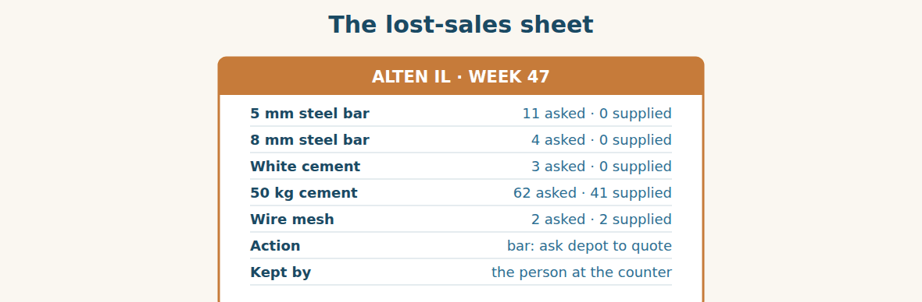
Figure · Two columns and a name. That is the whole system.
The lost-sales sheet is the cheapest useful document in retail, and almost nobody keeps one. It has two columns — what they asked for, and whether we had it — and it is written by whoever is standing at the counter when the question is asked.
Read the sheet above and you learn three things that no sales report contains. First, there is real demand for steel bar: eleven requests in one week, and four more for a different size. Second, cement is not only selling, it is running out: sixty-two people asked and forty-one were served, so twenty-one walked away from a product the Group actually imports. Third, wire mesh is fine, so nobody needs to spend a minute on it.
Notice how different that is from a sales report. A sales report would show cement selling well and no bar sales at all. The honest conclusion from the sales report is “customers do not want bar”. The honest conclusion from the lost-sales sheet is “customers want bar and we send them to Homs every week”. Same shop, same week, opposite decisions.
The discipline is small but it must be real. Write it at the moment, not at the end of the day, because by six o’clock you remember the difficult customers and not the quiet ones. Write what they asked for in their words, not yours. And make sure somebody reads it every month and writes an action, because a sheet nobody reads teaches the counter staff that it does not matter.
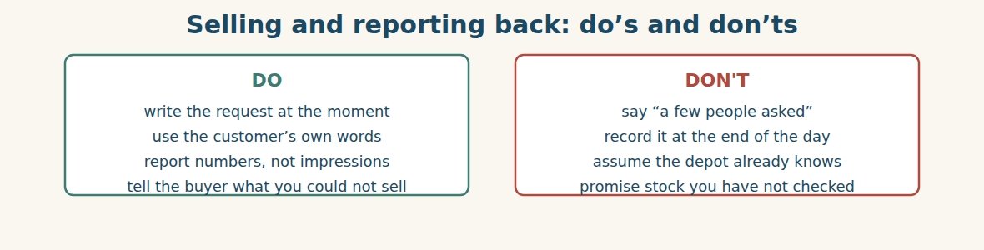
Figure · An impression starts an argument. A number starts an order.
A. Comprehension. Answer in your own words.
1. What are the two columns on a lost-sales sheet, and who writes it?
2. What three things does the sheet above tell you?
3. What would a sales report show instead, and what would you wrongly conclude?
4. Why must the sheet be written at the moment, not at the end of the day?
5. Why must somebody read it every month?
B. Listen and complete. Ms. Maya explains the sheet. Write the missing word.
1. Ms. Maya: Two columns — what they asked for, and whether we ____________ it.
2. Ms. Maya: Write it at the ____________, not at the end of the day.
3. Ms. Maya: Use the customer’s own ____________.
4. Ms. Maya: Somebody must read it every month and write an ____________.
C. Practice. Make a lost-sales sheet for your own workplace. Write five lines for last week, as well as you can remember. Then tell your partner which line would surprise your manager most.
D. Read the sheet above and answer.
1. How many requests for steel bar in total, both sizes? → ____________
2. How many cement customers walked away? → ____________
3. Which line needs no action at all? → ____________
4. What one product would you ask the depot to quote first, and why? → ____________
Part 8 · Consolidation TRADE
Two hundred tonnes and eleven questions
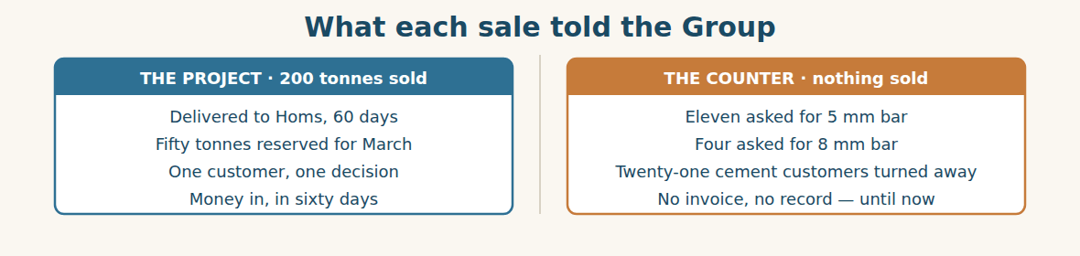
Figure · One sale earned money. The other told them what to buy next.
Eng. Bilal confirms on Thursday. Two hundred tonnes leave the depot on Monday, delivered to Homs, sixty days to pay. It is the largest single sale of the quarter, and everyone is pleased.
Lina is pleased too, but she keeps thinking about Maya’s telephone call. She goes back through the quarter and finds no record of a single request for bar — not because nobody asked, but because nobody wrote it down. Eleven in a week, in one shop, for one size.
At the Monday meeting she puts both numbers on the table. “We sold two hundred tonnes of coil to one customer,” she says, “and we turned away at least fifteen people who wanted bar, in one shop, in one week. We do not know how many in the other two shops, because nobody is counting.”
Mr. Tarek asks whether the Group could import bar. Rami says it would be a new product line, a new specification and probably a new supplier, which is Unit Two all over again. “Then we start with the question, not the order,” says Mr. Tarek. “Maya keeps the sheet for a month, in all three shops. If the number is real, Rami writes three enquiries.”
Lina writes one more line in her notes, and it is the line that will matter next year: the biggest sale of the quarter came from a customer who telephoned us, and the biggest decision of the year came from a customer who walked out.
A. Comprehension. Answer in your own words. (0 is done.)
0. What is the largest single sale of the quarter? (200 tonnes of coil to Eng. Bilal, delivered to Homs)
1. What does Lina find when she goes back through the quarter?
2. What two numbers does she put on the table?
3. Why does Rami say importing bar is “Unit Two all over again”?
4. What does Mr. Tarek decide to do first?
5. What is the line Lina writes in her notes?
B. Complete each sentence with ONE word from the text. (0 is done for you.)
0. Eng. Bilal confirms on Thursday.
1. Two hundred tonnes leave the depot on ____________.
2. Lina finds no record of a single ____________ for bar.
3. At least fifteen people were turned ____________ in one shop in one week.
4. Mr. Tarek says they start with the ____________, not the order.
5. Maya keeps the sheet for a month, in all three ____________.
C. Discuss. Talk in pairs.
1. Which is the more important number — the two hundred tonnes or the eleven questions?
2. What would you need to see before you imported a new product?
D. Find a word from the text that means: (0 is done for you.)
0. three months of the year → (a quarter)
1. one kind of product a company sells → a product l____________
2. sent away without buying → turned a____________
3. to say yes to an order formally → to c____________
Part 9 · Case Studies and Decisions TRADE
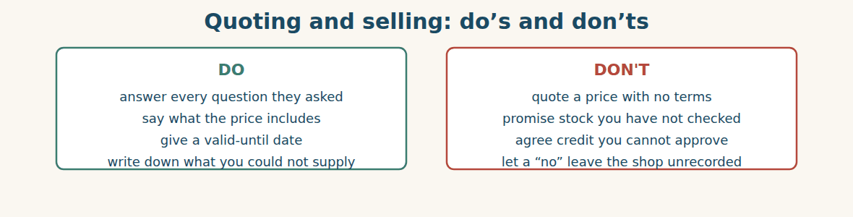
Figure · A quotation is a promise; make only the ones you can keep.
Case 1 — Credit you are not allowed to give (strand A · the project sale)
A good customer asks for ninety days instead of sixty. The order is large and he has always paid. Your limit is sixty days, and your Financial Controller is away for a week. The customer says he will order today if you agree.
Choose the best action and say why.
1. ( ) Agree ninety days. He has always paid, and the order is worth it.
2. ( ) Offer sixty days now, say you will put ninety to the Financial Controller, and give a date for the answer.
3. ( ) Refuse and say nothing more.
4. ( ) Agree verbally but write sixty days on the quotation.
Write one sentence offering what you can, and promising an answer.
______________________________________________
______________________________________________
Case 2 — The eleventh customer (strand B · the counter)
You are the only person at the counter. A customer asks for a product you do not stock. It is the eleventh time this week, and you are tired of saying no. There are three people waiting behind him.
Answer the questions.
1. What should you say to the customer, in one sentence, that is honest and quick?
2. What should you do in the five seconds after he leaves, and why then?
3. Write the one line you would put on the lost-sales sheet.
Case 3 — Two hundred tonnes or a new product line? (where the strands meet)
Your depot holds four months of coil. Your shops are turning away customers who want bar. You can discount the coil to move it faster, or you can start the work of importing bar — which will take three months and tie up money you have not got back from the coil.
Answer the questions.
1. What would you need to know before you spent money on bar?
2. Can you do both at once? What is the risk if you do?
3. Write one sentence recommending what to do first, with a reason.
Part 10 · Review and Can-Do TRADE
A. Vocabulary. Complete the sentence.
1. A written price for a customer is a ____________.
2. A price that includes transport is a ____________ price.
3. Paying later, not now, is buying on ____________.
4. A customer who walks into the shop is a ____________.
5. A possible customer who has shown interest is a ____________.
B. Grammar. Report these words.
1. “I need two hundred tonnes.” → He said ____________
2. “We have it in stock.” → She told me ____________
3. “Do you deliver to Homs?” → He asked ____________
4. “When can you deliver?” → She asked ____________
5. “I will confirm on Thursday.” → He said ____________
6. “We don’t stock bar.” → She told him ____________
C. Reading. Read the short text and answer.
Eng. Bilal asked for two hundred tonnes of five-millimetre coil, delivered to his site in Homs by the end of the month. He asked whether he could pay in sixty days, and Lina told him that sixty days was possible on a first order. He also asked her to hold the price for fifty tonnes in March. She said she could not fix a March price, but she would reserve the fifty tonnes.
1. What did Eng. Bilal ask for, and by when?
2. What did Lina agree about payment?
3. What did she refuse, and what did she offer instead?
D. Listening. Listen and answer. (Teacher reads.)
[Teacher reads] “Eleven people asked me for five-millimetre bar this week. I told every one of them that we didn’t stock it. Three said they would go to Homs. Nobody asks a shop for coil — they ask for bar.”
1. How many people asked for bar, and over what period?
2. What did the speaker tell them?
3. What did three of them say they would do?
E. Speaking. Work in pairs. One is a customer with three questions about price, delivery and credit; one quotes and refuses one thing honestly.
F. Writing. Write two sentences: one reporting a statement with “told”, and one reporting a question with “asked if”.
1. ______________________________________________
2. ______________________________________________
G. Error correction. Find and correct one mistake in each sentence.
1. He said me he needed 200 tonnes. → ____________
2. She told that the price was delivered. → ____________
3. He asked did we have cement. → ____________
4. She asked me where is the site. → ____________
5. They said they will pay in sixty days. → ____________
H. Match the customer (1–5) to what they want (a–e).
1. a site engineer ____ a. twenty bags, cash, now
2. a walk-in customer ____ b. a monthly invoice
3. an account customer ____ c. a written quotation and credit
4. a wholesale buyer ____ d. to see the product first
5. a new customer ____ e. a price per tonne for a full truck
I. Put the quotation steps in order (1–6).
1. ( ) say what the price includes
2. ( ) thank them and repeat what they asked for
3. ( ) give the valid-until date
4. ( ) give the price and the unit
5. ( ) say what you cannot do
6. ( ) say what you need from them next
Can-Do check. Tick what you can do.
- I can sell to a trade customer and to a retail customer.
- I can report what a customer said or asked.
- I can quote a price and say what is included.
- I can write a quotation.
Part 11 · Foundations for Further Study TRADE
Concept Spotlight: A message is a thing that can be dropped
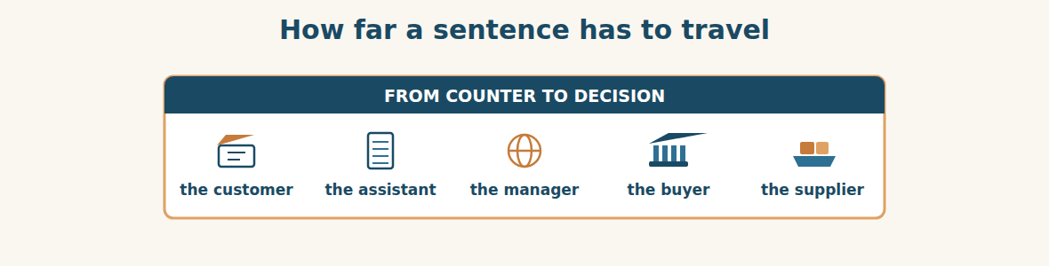
Figure · Five people, and the words change shape at every step.
Reported speech looks like a grammar exercise about moving tenses backwards. It is really about something much more important: information inside a company has to travel, and it travels by being repeated.
Follow one sentence through this unit. A man in a shop says “Have you got five-millimetre bar?” Ms. Maya reports it: eleven people asked for five-millimetre bar. Lina reports that to a meeting. Mr. Tarek turns it into a decision: keep a sheet for a month. If the number is real, Rami writes to three suppliers, and six months later a ship leaves a port. One question at a counter, carried four times, becomes a container.
Now notice what can go wrong, because every one of those steps is a place where the message can be dropped or changed. It can simply not be passed on, which is what happened for a whole quarter. It can lose its number — “a few people have been asking” is almost useless, and “eleven in one week” is an instruction. It can lose its exactness: bar is not coil, and somebody reporting carelessly would have said “people want steel”, which the depot already has six thousand tonnes of. And it can gain an opinion that nobody said, which is the most dangerous one of all.
That is why the grammar matters so much more than it looks. “He said he needed two hundred tonnes” is a report. “He wants a lot” is a rumour. When you learn to say exactly who said what, and whether it was a statement or a question, you are learning to carry information without damaging it — and in a group of twelve companies, that is most of what a manager actually does.
Someone might say that this is why you should keep everything in writing, and skip the repeating. But writing is only a slower kind of repeating, and the first step is always a person hearing something and deciding it matters. The sheet by the till does not replace the reporting. It just makes sure the first repetition happens at all.
A. Understanding check. Answer in your own words.
1. What is reported speech “really about”, according to the writer?
2. Trace the one sentence through the unit: who reports it to whom, and what does it become?
3. Name three ways a message can be damaged as it travels.
4. What is the difference between a report and a rumour?
B. Apply it. Do this task with a partner.
Think of something a customer or colleague told you that never reached the person who could act on it. Report it properly now, in two sentences, with a number in it. Then decide together who it should have gone to, and why it stopped.
C. Micro-writing (optional).
Write a few sentences (50–70 words) reporting a conversation you had at work this month. Use “said”, “told” and “asked if” at least once each, and include one number.
Study terms: quotation · quote (v) · enquiry · lead · trade customer · retail customer | walk-in · account customer · project customer · credit terms · on credit · cash | delivered price · collection · ex-works · in stock · out of stock · availability | valid until · receipt · till · counter · objection · close a sale | follow up · lost sale · demand · turn away · reserve (v) · product line | say · tell · ask · explain · promise · agree
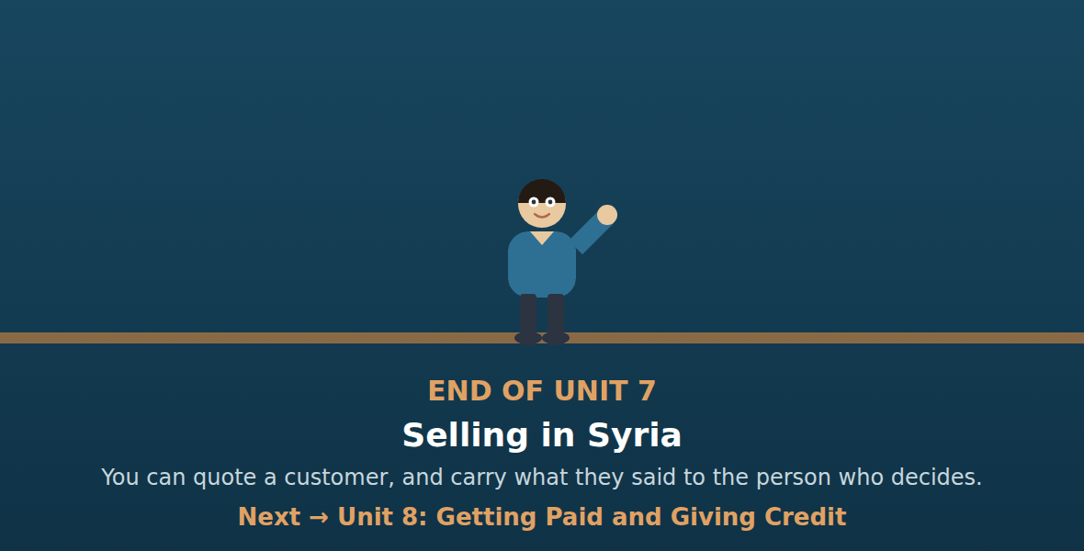
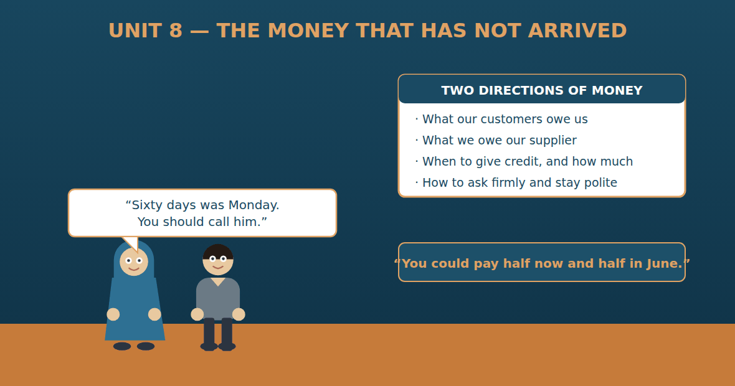

Unit 8: Getting Paid and Giving Credit
Al-Hasan International — English for Trade, Industry & Global Partnerships
CEFR B1 · Grammar: should · shouldn’t · could · may · might · Function: Finance + Admin
Can-Do (by the end of this unit)
- I can ask for payment politely and firmly
- I can give advice with should and could
- I can explain credit terms
- I can write a payment reminder
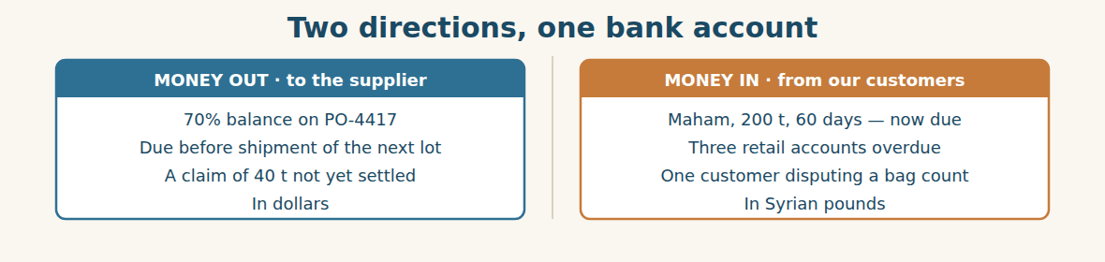
Figure · The same week: one payment to make, several to collect.
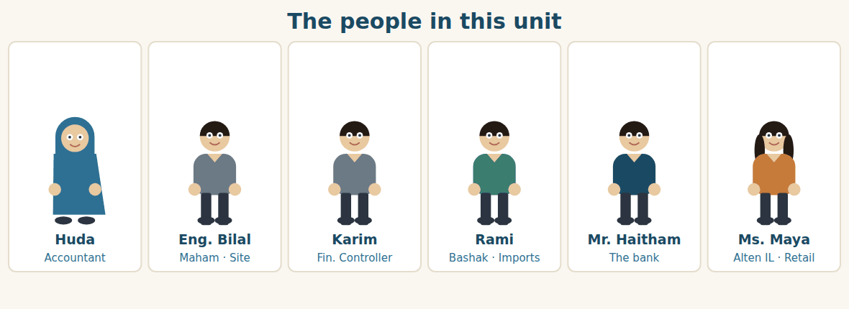
Figure · One side asks for money politely; the other side has to pay it.
Warm Up FINANCE
Look at the pictures. Answer these questions before you read.
1. How long do your customers have to pay?
2. Who asks a customer for money when it is late?
3. Has your company ever not been paid? What happened?
Read
Huda prints the aged debt list every Monday. It is one page, and it tells her who owes money and for how long. This Monday there is a line she has been expecting. Maham Co., two hundred tonnes, sixty days — and the sixty days ended last Thursday.
Maham is a company inside the Group, which makes it easier and harder at the same time. Easier, because nobody is going to disappear. Harder, because it is uncomfortable to telephone a colleague about money.
She telephones anyway. Eng. Bilal is honest with her. The warehouse he built has been finished and handed over, but his own customer has not paid him, and he cannot pay out money he has not received. “You should talk to Karim,” he says. “I am not refusing. I am waiting.”
Karim looks at it for ten minutes and makes a decision that is not obvious. “He could pay half now and half in June,” he says. “That is better than sixty more days of nothing, and it keeps the number honest. But Huda, write it down. A part payment that nobody writes down becomes an argument in August.”
Meanwhile the other direction is also moving. The seventy per cent balance for PO-4417 is due to Westgate, and the claim for the forty tonnes has still not been settled. Rami suggests the obvious thing: pay the balance less the value of the claim.
Karim shakes his head. “You shouldn’t hold back money for a claim they have not agreed. They might see it as a late payment, and then we are the ones in the wrong. Pay the balance in full, on the day. Then chase the claim as a claim.” He writes one line on the file: never mix two arguments in one payment.
A. Comprehension. Answer in your own words. (0 is done for you.)
0. What does the aged debt list tell Huda? (who owes money, and for how long)
1. Why is it both easier and harder that Maham is inside the Group?
2. Why has Eng. Bilal not paid?
3. What does Karim suggest, and what condition does he attach?
4. What does Rami suggest about the balance to Westgate?
5. Why does Karim refuse, and what rule does he write down?
B. True or False? Write T or F. (0 is done for you.)
0. The aged debt list is printed once a year. (F)
1. Maham’s sixty days ended last Thursday. ____
2. Eng. Bilal refuses to pay. ____
3. Karim suggests half now and half in June. ____
4. Karim agrees to hold back money for the claim. ____
5. Karim says the balance should be paid in full, on the day. ____
C. Find the words. Find a word or phrase in the text that means: (0 is done for you.)
0. a list showing who owes money and for how long → (an aged debt list)
1. money that should have been paid already → an o____________ amount
2. paying only a part of what is owed → a p____________ p____________
3. to take one amount away from another → to o____________ it
D. Over to you. Answer about yourself.
1. What should a company do when a good customer pays late?
2. Who in your company decides how much credit a customer gets?
3. What could you offer a customer who cannot pay the whole amount?
Part 1 · Vocabulary and Terminology FINANCE
The aged debt list
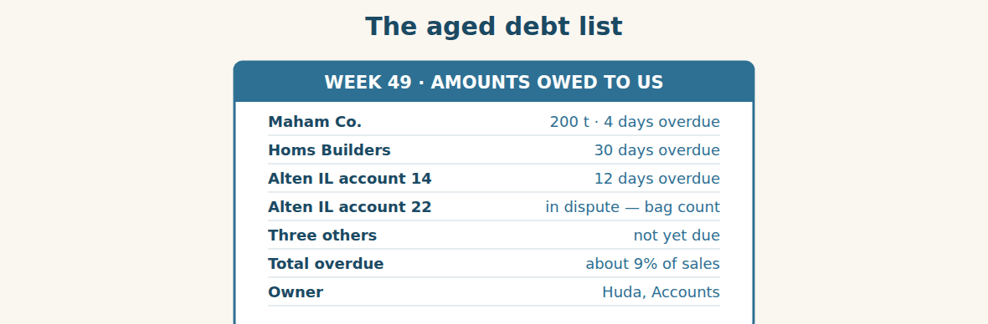
Figure · One page a week, and nobody can pretend they did not know.
A. Match each word (1–7) with its meaning (a–h). There is one you do not need. (0 is done for you.)
0. overdue (e)
1. debtor ____ a. the most credit a customer may have
2. creditor ____ b. money we will never be paid
3. credit limit ____ c. a company that owes us money
4. outstanding ____ d. a company we owe money to
5. bad debt ____ e. money that should have been paid already
6. settle ____ f. still not paid
7. remittance advice ____ g. to pay in full and close the account
8. h. a note saying what a payment is for
B. Complete the sentences with the words in the word bank.
Word bank: overdue | credit limit | outstanding | settle | reminder | instalment
1. The invoice is now four days ____________.
2. His ____________ is fifty million pounds, and he is close to it.
3. Two invoices are still ____________ from October.
4. He has promised to ____________ the whole amount by June.
5. We sent a polite ____________ on Monday morning.
6. He will pay the first ____________ this week and the rest in June.
Money in and money out
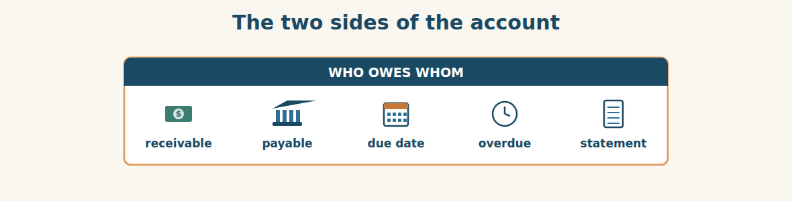
Figure · Money we are owed, and money we owe.
C. Match the term (1–5) with its meaning (a–e).
1. receivable ____ a. the day the money must be paid
2. payable ____ b. money our customers owe us
3. due date ____ c. a list of everything owed on an account
4. statement ____ d. money we owe our suppliers
5. cash flow ____ e. money actually moving in and out
Chasing a payment
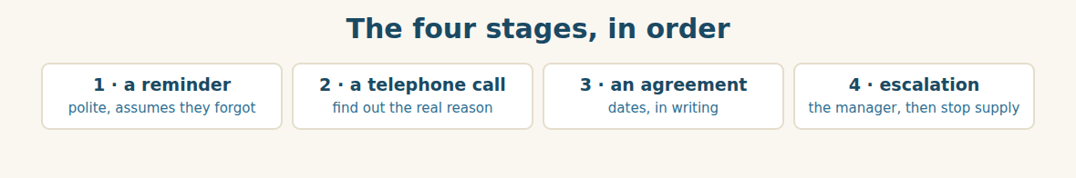
Figure · Never start at stage four, and never stay at stage one.
D. Odd one out. Which word is different? Circle it.
1. overdue · outstanding · unpaid · delivered
2. debtor · creditor · customer · container
3. reminder · statement · invoice · tolerance
4. should · could · might · did
5. settle · pay · clear · reject
E. Choose the best answer.
1. Money our customers owe us is a… (a) receivable (b) payable
2. The most credit a customer may have is the… (a) credit limit (b) credit terms
3. Money we will never be paid is a… (a) bad debt (b) discount
4. A note saying what a payment is for is a… (a) statement (b) remittance advice
F. Classify. Write each item in the correct column.
Items: an overdue customer | the supplier balance | a credit limit | a bad debt | a reminder letter | our bank charges
Money in | Money out | A control
__________ | __________ | __________
__________ | __________ | __________
__________ | __________ | __________
G. Match the two halves (1–6 with a–f).
1. a credit ____ a. debt
2. a bad ____ b. limit
3. a part ____ c. date
4. a due ____ d. payment
5. an aged ____ e. advice
6. a remittance ____ f. debt list
H. Complete the paragraph with the words in the box.
Box: instalments | might | overdue | reminder | should | writing
The invoice is four days (1)____________. We sent a polite (2)____________ on Monday. The customer says he (3)____________ be able to pay half this week. Karim says we (4)____________ accept two (5)____________ rather than wait sixty more days — but everything must be put in (6)____________.
Part 2 · Grammar — should · shouldn’t · could · may · might FINANCE
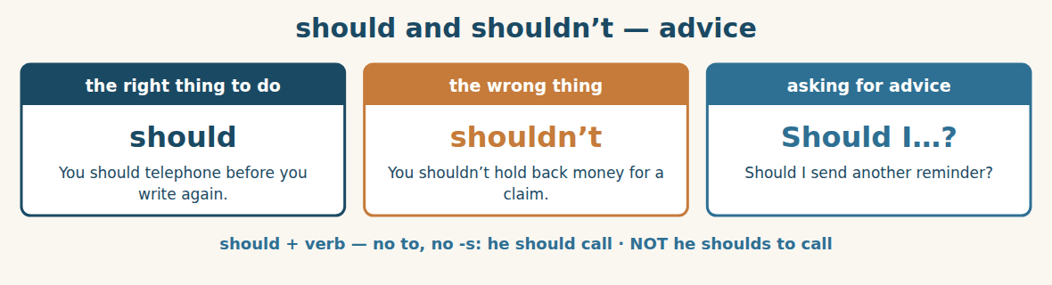
Figure · Advice, not an order.
We use SHOULD to say what is a good idea, and SHOULDN’T to say what is not. It is advice, so it is softer than must. Compare: you must pay by Thursday (a rule) and you should pay before Thursday (good advice).
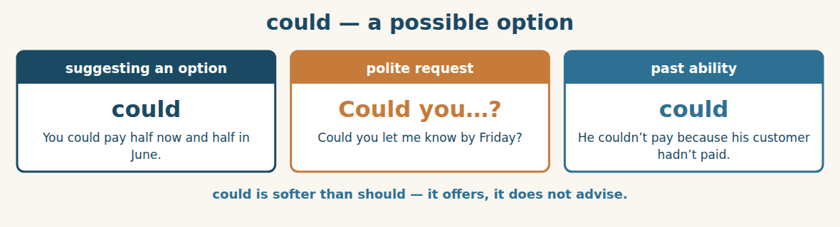
Figure · The word that opens a door without pushing.
We use COULD to suggest one possible option among several. You could pay half now. We could extend the terms this once. It does not say the option is best — it says it is available. That is why it is so useful when you are negotiating.
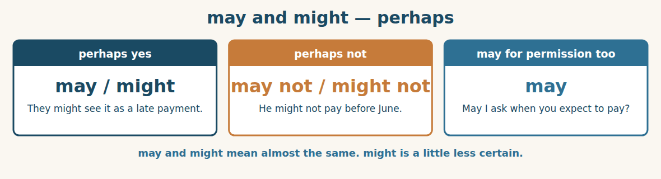
Figure · For things that are possible but not certain.
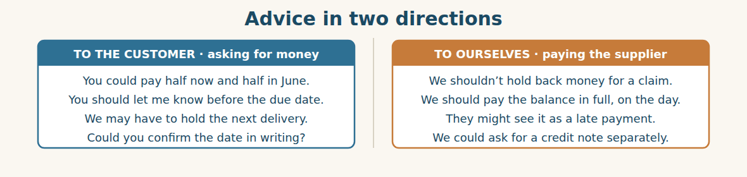
Figure · The same four words, used to advise and to offer.
Watch out! should, could, may and might take no to and no -s: he should pay, she might come. And remember the difference between advice and an order: you should pay is a suggestion; you must pay is a rule.
Form
should / shouldn’t + verb · could + verb · may / might + verb · Could you…? / May I…?
A. Complete with SHOULD or SHOULDN’T. (0 is done for you.)
0. You should telephone before you write again.
1. We ____________ hold back money for a claim they have not agreed.
2. You ____________ put every part payment in writing.
3. We ____________ wait sixty more days for nothing.
4. You ____________ send a reminder on the day the invoice falls due.
B. Rewrite the advice with the word in brackets.
1. It is a good idea to telephone first. (should) → ____________
2. One option is to pay in two instalments. (could) → ____________
3. Perhaps they will treat it as late. (might) → ____________
4. It is a bad idea to mix two arguments. (shouldn’t) → ____________
C. Complete with COULD, MAY or MIGHT.
1. You ____________ pay half now and half in June — it is one option.
2. They ____________ see it as a late payment. We cannot be sure.
3. ____________ I ask when you expect to pay?
4. He ____________ not have the money before his own customer pays.
D. Advice or offer? Write ADVICE or OFFER. (0 is done for you.)
0. You should pay before the due date. (advice)
1. You could pay in two instalments. ____
2. We shouldn’t mix a claim with a payment. ____
3. We could extend your terms this once. ____
4. You should put it in writing. ____
E. Make polite requests with COULD or MAY.
1. (?) you / confirm the date in writing → ____________
2. (?) I / ask when you expect to pay → ____________
3. (?) you / send the remittance advice → ____________
4. (?) I / speak to your accounts department → ____________
F. Match the situation (1–5) with the sentence (a–e).
1. He cannot pay the whole amount. ____ a. You should put it in writing.
2. You are not sure what they will think. ____ b. He could pay in two instalments.
3. A colleague forgot to record an agreement. ____ c. They might see it as a late payment.
4. You want a date, politely. ____ d. We shouldn’t hold back the balance.
5. Your colleague wants to offset a claim. ____ e. Could you confirm by Friday?
G. Find and correct the mistake in each sentence. (0 is done for you.)
0. He shoulds to pay today. → (He should pay today.)
1. You should to telephone him first. → ____________
2. They might to see it as late. → ____________
3. We could extending the terms. → ____________
4. She shouldn’t holds back the money. → ____________
H. About you. Write two sentences: one giving advice with “should”, and one offering an option with “could”.
1. ______________________________________________
2. ______________________________________________
I. Complete with should, shouldn’t, could, may or might.
1. We ____________ pay the balance in full, on the day.
2. You ____________ mix a claim and a payment — it makes us look wrong.
3. He ____________ pay half now; that is one possibility.
4. ____________ I ask what the delay is?
5. They ____________ refuse, but I think they will agree.
J. Give advice for each problem.
1. A good customer is four days late. → “You ____________”
2. A customer offers half now, half in June. → “We ____________”
3. A colleague wants to deduct a claim from a payment. → “We ____________”
4. You are not sure whether the supplier will accept. → “They ____________”
Part 3 · Listening and Dialogue FINANCE
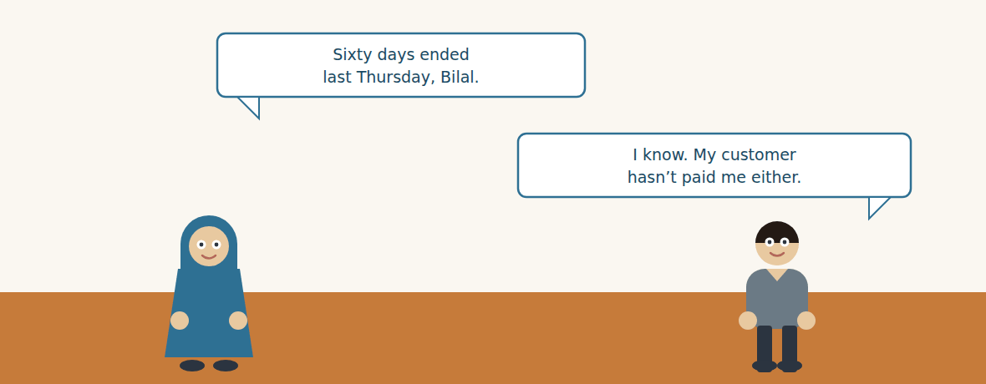
Figure · Strand B · asking a colleague for money.
Dialogue 1 — Chasing a late payment (accounts calling the site)
Listen and read. (Your teacher will read the dialogue, or play the audio.)
Huda: Bilal, it is Huda from accounts. The two hundred tonnes — sixty days ended last Thursday.
Eng. Bilal: I know. I have the invoice in front of me.
Huda: Is there a problem with it? A wrong quantity, a wrong price?
Eng. Bilal: No, the invoice is correct. The warehouse is finished and handed over. But my customer has not paid me, and I cannot pay out money I have not received.
Huda: Thank you for being straight with me. When do you expect them to pay you?
Eng. Bilal: They might pay at the end of this month. They might not.
Huda: Then could I suggest something? You could pay half now, from your own account, and half in June when they settle.
Eng. Bilal: I could do half. Yes.
Huda: Good. I will put both dates in an email this afternoon, and you should reply just confirming them. Not for me — for August, when neither of us remembers this conversation.
Eng. Bilal: That is fair. And Huda — you should ask Karim about Homs Builders. They are thirty days late with me as well.
A. Comprehension. Answer in your own words. (0 is done for you.)
0. What is Huda calling about? (the invoice for 200 tonnes, which is overdue)
1. What is the first thing she asks, and why is that a good question?
2. Why has Eng. Bilal not paid?
3. What does Huda suggest, and in what words?
4. Why does she want an email reply?
5. What does Eng. Bilal tell her at the end?
B. True or False? Write T or F.
1. There is a mistake on the invoice. ____
2. Eng. Bilal’s customer has paid him. ____
3. Huda suggests two instalments. ____
4. She wants the agreement in writing. ____
5. Homs Builders have paid Eng. Bilal. ____
C. Language focus. Find in the dialogue: (0 is done for you.)
0. a polite way to make a suggestion → (Then could I suggest something?)
1. a sentence with “could” offering an option → ____________
2. a sentence with “might” twice → ____________
3. a sentence giving advice with “should” → ____________
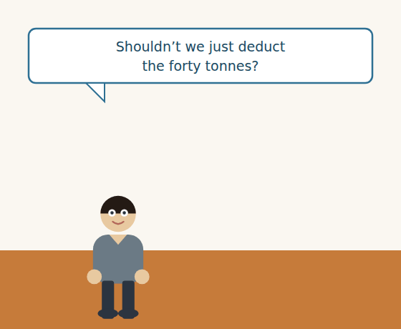
Figure · Strand A · the same week, the other direction.
Dialogue 2 — Paying the supplier (inside finance)
Rami: Karim, the seventy per cent is due to Westgate on Thursday. The claim for the forty tonnes is still open. Shouldn’t we just deduct it?
Karim: No. You shouldn’t hold back money for a claim they have not agreed.
Rami: But they owe it to us.
Karim: They may owe it. They have not said so yet. If we pay short, they might treat it as a late payment, and then the conversation changes — suddenly we are the ones in the wrong, and the claim is forgotten.
Rami: So we pay in full and chase a company that owes us money.
Karim: We pay in full, on the day, and we chase the claim as a claim. Two conversations, two files. You could put it in the same email if you like, but never in the same payment.
Rami: And if they refuse the claim?
Karim: Then we have a clean record and a strong position. Never mix two arguments in one payment.
A. Comprehension. Answer in your own words.
1. What does Rami suggest doing about the balance?
2. Why does Karim refuse?
3. What does Karim say might happen if they pay short?
4. What does Karim allow, and what does he forbid?
B. Listen again and choose the best answer (A–D).
1. The balance due is… A) 30% B) 40% C) 60% D) 70%
2. The claim is for … tonnes. A) four B) forty C) two hundred D) twelve
3. If they pay short, the supplier might treat it as a… A) discount B) claim C) late payment D) credit note
4. Karim’s rule is: never mix two … in one payment. A) invoices B) arguments C) currencies D) orders
Part 4 · Speaking and Your Role FINANCE
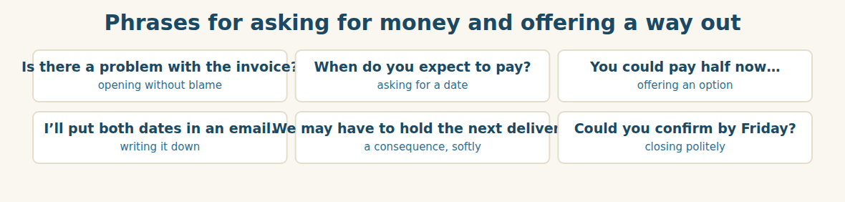
Figure · Firm about the money, easy about the person.
A. Role-play: the overdue invoice. Student A is from accounts; Student B is a customer who cannot pay in full. Then change roles.
1. A: Say which invoice and how many days overdue.
2. B: Say the invoice is correct, but give your reason.
3. A: Ask when they expect to pay.
4. B: Say you are not sure, using “might”.
5. A: Offer an option with “could”.
6. B: Accept a part of it, and agree to confirm in writing.
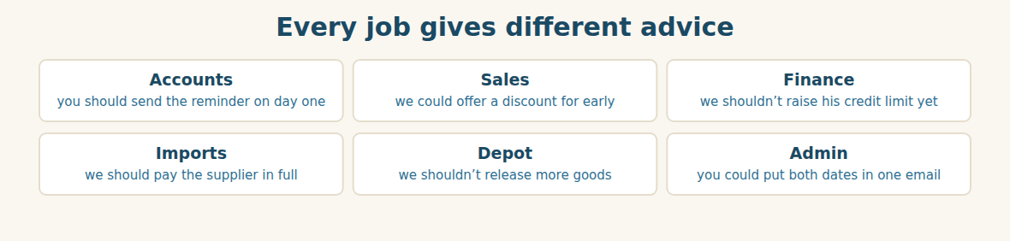
Figure · Six roles, one set of modal verbs.
B. Your Role. Give one piece of advice from YOUR job, using should or could. (Choose your real role.)
1. [Finance] Accountant: “You should send the reminder on the day it falls due.”
2. [Trade] Sales: “We could offer two per cent for payment in ten days.”
3. [Finance] Financial Controller: “We shouldn’t raise his limit until he settles.”
4. [Trade] Import Manager: “We should pay the supplier in full and claim separately.”
5. [Logistics] Depot: “We shouldn’t release more goods to an overdue account.”
6. [Admin] Assistant: “You could put both dates in one email and ask him to reply.”
C. Ask your partner. Walk around and ask three people.
1. What should a company do on the first day an invoice is late?
2. What could you offer a customer who cannot pay in full?
3. What shouldn’t you ever do when you are chasing money?
D. Discuss. Ask and answer.
1. Is it harder to ask a colleague for money than a stranger? Why?
2. Should a company stop supplying a customer who is late? When?
Part 5 · Extended Reading FINANCE
A sale is not a sale until the money arrives
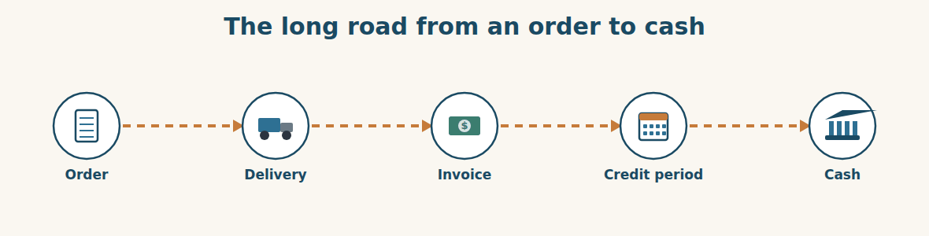
Figure · Four of the five steps feel like success. Only the last one is.
Every business celebrates the order. Almost none celebrates the payment, and that is the wrong way round. An order is a promise. A delivery is a cost. An invoice is a piece of paper. Only the money in the bank is a sale, and between the order and the money there are sixty days in which anything can happen.
This is why giving credit is a decision and not a courtesy. When you let a customer pay in sixty days, you are lending them money. You are paying your supplier, your staff and your transport now, and getting paid two months later, and the difference has to come from somewhere. A company that grows fast while giving long credit can run out of cash while its order book is full, and that is one of the commonest ways a profitable business dies.
So credit has to be controlled in three ways. First, a limit: the most any one customer may owe at one time. Second, a term: how long they have. Third, somebody whose job it is to watch. The third is the one companies forget, exactly as they forget the reorder level, and for the same reason — it belongs to nobody until it is given a name.
Chasing, when it is needed, should be fast and kind. Fast, because the first week is worth more than the next month: a reminder on the day an invoice falls due is read as efficiency, while a reminder after three weeks is read as desperation. Kind, because most late payers are not thieves. They are companies with their own late customers, which is exactly what Eng. Bilal was. The right first question is never “why haven’t you paid?” but “is there a problem with the invoice?” — because about a quarter of the time, there is one, and the customer was quietly waiting for somebody to ask.
And when a customer genuinely cannot pay in full, an agreement beats a demand. Half now and half in June is money. Sixty more days of silence is not. But the agreement must be written down on the day it is made, because the two people who understand it perfectly today will both have forgotten the details by August — and only one of them will be asked to remember.
A. Comprehension. Answer in your own words. (0 is done for you.)
0. Why is celebrating the order “the wrong way round”? (an order is only a promise; only the money in the bank is a sale)
1. What are you really doing when you give a customer sixty days?
2. How can a profitable business with a full order book die?
3. What are the three ways credit must be controlled?
4. Why should chasing be fast, and why should it be kind?
5. Why is the first question “is there a problem with the invoice?”
B. Choose the best answer (A–D).
1. Only … is a sale. A) the order B) the delivery C) the invoice D) the money in the bank
2. Giving sixty days credit is a form of… A) discount B) lending C) marketing D) insurance
3. The control companies most often forget is… A) the limit B) the term C) the owner D) the invoice
4. A reminder after three weeks is read as… A) efficiency B) desperation C) politeness D) a mistake
5. About a quarter of late payments are caused by… A) dishonesty B) a problem with the invoice C) bank delays D) holidays
C. Find a word or phrase in the text that means:
1. to have no money left → to r____________ o____________ of cash
2. the orders a company has not yet delivered → the order b____________
3. a feeling of having no hope → d____________
4. a polite thing you do for someone → a c____________
D. Complete the summary with ONE word in each gap.
Only the (1)____________ in the bank is a sale. Giving sixty days of credit means (2)____________ the customer money. Credit needs a (3)____________, a term, and somebody whose job it is to (4)____________. Chasing should be fast and (5)____________, and any agreement must be put in (6)____________ on the day.
E. Discuss. Talk in pairs.
1. How long does your company wait before sending a first reminder?
2. Has your company ever lost money because a customer did not pay?
F. True or False? (about the reading). Write T, F or NOT GIVEN.
1. An invoice is the same thing as a sale. ____
2. A profitable company can run out of cash. ____
3. Most late payers are dishonest. ____
4. Half now and half later is better than sixty more days of silence. ____
Part 6 · Writing (a real email) ADMIN
Model — A payment reminder that keeps the customer
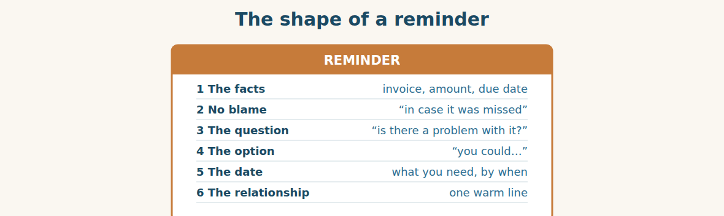
Figure · Firm about the money. Easy about the person.
Subject: Invoice INV-2219 — now due. Dear Eng. Bilal, I am writing about invoice INV-2219 for the two hundred tonnes delivered to the Homs site. The sixty-day term ended on Thursday, so the amount is now four days overdue. I am sending this in case the invoice was simply missed. If there is a problem with it — a quantity, a price, or a document you need from us — please tell me and I will correct it today. If the difficulty is timing, you could settle half this week and the balance in June, and I will confirm both dates in writing. Could you let me know by Friday which you prefer? It has been a good project and we would like the paperwork to be as straight as the warehouse. Best regards, Huda Accountant, Al-Hasan Holding Group.
A. Answer about the email. (0 is done for you.)
0. Which invoice is it about, and how late is it? (INV-2219, four days overdue)
1. What reason does Huda give for writing?
2. What two possibilities does she offer?
3. What does she ask for, and by when?
B. Put the email in order (1–6).
1. ( ) Could you let me know by Friday which you prefer?
2. ( ) Dear Eng. Bilal,
3. ( ) The sixty-day term ended on Thursday.
4. ( ) If there is a problem with it, please tell me.
5. ( ) You could settle half this week and the balance in June.
6. ( ) Best regards, Huda
Guided writing
C. Now you write. Write a payment reminder (80–110 words). Use “could” to offer an option and “should” or “may” once, and ask one question that is not “why haven’t you paid?”.
Plan: 1) “Dear …,” 2) “I am writing about invoice … for ….” 3) “The … term ended on … , so it is now … overdue.” 4) “If there is a problem with it, ….” 5) “You could ….” 6) “Could you let me know by …?” 7) “Best regards, …”
Sentence starters: “I am writing about invoice…” · “I am sending this in case…” · “If there is a problem with it…” · “You could … and …” · “Could you let me know by…?”
______________________________________________
______________________________________________
______________________________________________
______________________________________________
______________________________________________
D. Checklist. Tick each one when you have checked your reminder.
- I gave the invoice number, the amount and the due date.
- I did not blame the customer.
- I asked whether there is a problem with the invoice.
- I offered one option with “could”.
- I asked for an answer by a date.
Part 7 · Trade-Skills Track FINANCE
Setting a credit limit, and knowing when to stop
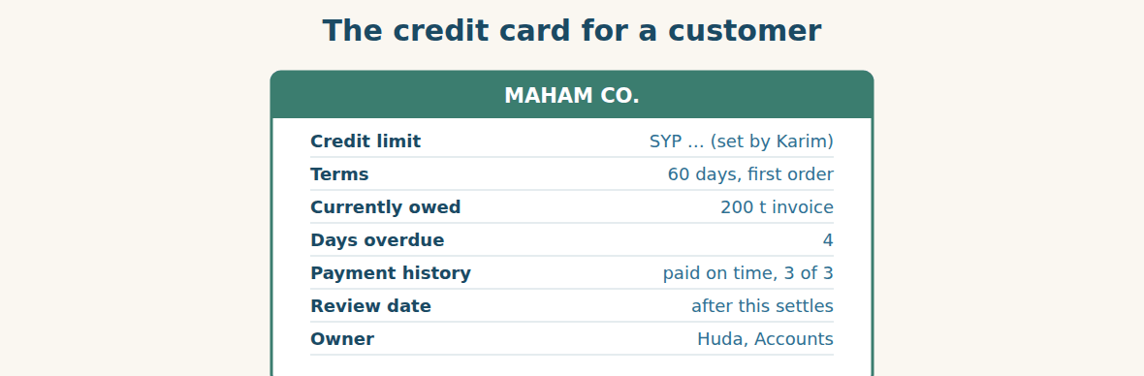
Figure · A limit, a term, a history and a name.
A credit limit is not a judgement about a customer’s honesty. It is a decision about how much of your own money you are willing to have outside the building at one time. A completely honest customer can still fail, and when they do, your limit is the size of the hole.
Three things set the number. The first is how much you can afford to lose without being damaged — not how much you expect to lose, but how much you could survive. The second is the customer’s payment history, which is the only honest evidence you have: three invoices paid on time are worth more than any reference. The third is the size of their business, because a customer who owes you more than they can turn over in a month is a customer you have lent too much to.
Then comes the part that takes nerve: stopping. The rule should be written before you need it, and it should be mechanical. At thirty days overdue, no new orders are released until the account is settled or an agreement is in writing. Mechanical, because the moment it becomes a judgement, it becomes a conversation, and the customer who argues best gets the most credit — which is exactly backwards.
And note what the rule does not say. It does not say stop talking to them. A suspended account with a weekly telephone call usually pays. A suspended account with a silence usually does not, because silence tells the customer that you have written them off, and a customer who believes that will pay somebody else first.
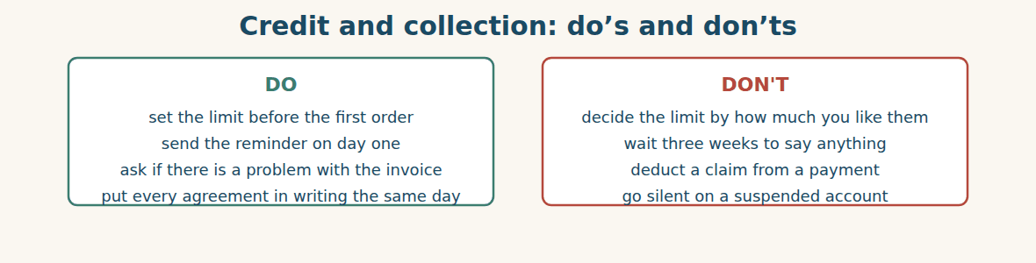
Figure · The rules are easy. Applying them to a friend is not.
A. Comprehension. Answer in your own words.
1. What is a credit limit really a decision about?
2. What three things set the number?
3. Why is payment history the best evidence?
4. Why should the stopping rule be mechanical rather than a judgement?
5. Why is silence on a suspended account dangerous?
B. Listen and complete. Karim explains the policy. Write the missing word.
1. Karim: A limit is how much of our own money is outside the ____________.
2. Karim: Three invoices paid on time are worth more than any ____________.
3. Karim: At thirty days overdue, no new orders are ____________.
4. Karim: A suspended account with a weekly telephone call usually ____________.
C. Practice. Write a credit card for one of your customers, using the seven lines above. Then tell your partner at what point you would stop supplying them, and why that point and not another.
D. What should you do? Answer with should, shouldn’t or could.
1. An invoice falls due today and is unpaid. → ____________
2. A customer is thirty days overdue and wants more goods. → ____________
3. A customer offers half now, half in June. → ____________
4. A supplier has not agreed your claim, and their balance is due. → ____________
Part 8 · Consolidation FINANCE
Paid in full, chased in full
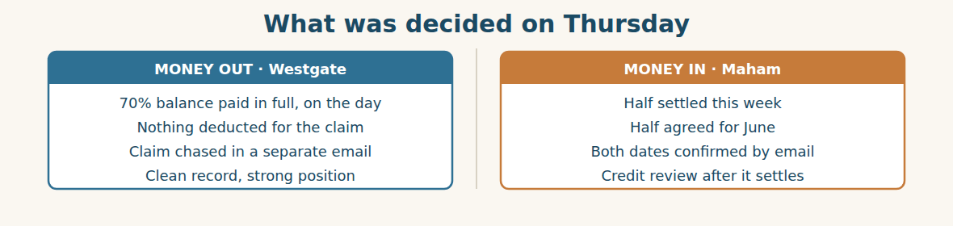
Figure · Two problems, four days, and not one argument.
On Thursday the balance goes to Westgate in full, on the day it is due. Rami sends a separate email about the forty tonnes with the photographs attached again, and the words “this is a claim, not a deduction” in the first line.
Westgate replies on Monday. They accept the shortage of one coil without argument. On the forty tonnes they do not agree, but they do not refuse either: they ask for the gauge readings and the batch numbers, which Ms. Dana recorded at the gate six weeks ago. Rami sends them the same afternoon.
Eng. Bilal pays half on Wednesday. Huda emails both dates and he replies with four words — “confirmed, June the 15th” — which is all anybody will need in August.
At the review Karim puts up one number that nobody expected. Overdue money has fallen from nine per cent of sales to five, and not one customer was lost. “We did not get tougher,” he says. “We got faster. Everything on this list was chased in the first week instead of the fourth.”
Mr. Tarek asks Huda what the hardest part was. She does not say the money. “The hardest part,” she says, “is telephoning somebody you will see at a family wedding.” Everybody laughs, and then Karim writes it on the board as a rule, because it is one: the person who chases should never be the person who sold.
A. Comprehension. Answer in your own words. (0 is done.)
0. What happens to the balance on Thursday? (it is paid to Westgate in full, on the day)
1. What words does Rami put in the first line of his email, and why?
2. What does Westgate accept, and what do they ask for?
3. How does Eng. Bilal reply, and why are four words enough?
4. What has happened to the overdue money, and what does Karim say caused it?
5. What rule does Karim write on the board?
B. Complete each sentence with ONE word from the text. (0 is done for you.)
0. On Thursday the balance goes to Westgate in full.
1. Rami writes “this is a claim, not a ____________”.
2. Westgate accept the shortage of one ____________ without argument.
3. They ask for the gauge readings and the ____________ numbers.
4. Overdue money has fallen from nine per cent to ____________.
5. The person who chases should never be the person who ____________.
C. Discuss. Talk in pairs.
1. Why is “we got faster” better than “we got tougher”?
2. Do you agree that the seller should not chase the payment? Why?
D. Find a word from the text that means: (0 is done for you.)
0. an amount taken off a payment → (a deduction)
1. to say yes to something without arguing → to a____________ it
2. the measurement of thickness → the g____________ reading
3. stronger and less willing to give way → t____________
Part 9 · Case Studies and Decisions FINANCE
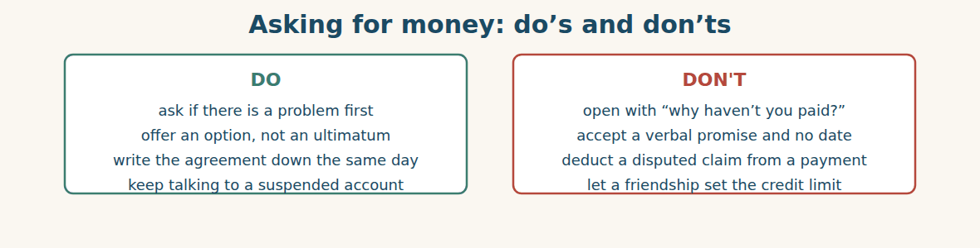
Figure · Firm about the money, easy about the person.
Case 1 — The claim they will not answer (strand A · the supplier)
Six weeks after your claim, the supplier has gone quiet. Their next balance is due in three days. A colleague suggests simply paying less and letting them ask why.
Choose the best action and say why.
1. ( ) Deduct the claim. They have had six weeks.
2. ( ) Pay in full on the day, and send a separate email escalating the claim to their manager with a date for an answer.
3. ( ) Stop paying anything until they reply.
4. ( ) Forget the claim; the relationship is worth more.
Write one sentence escalating the claim without threatening the payment.
______________________________________________
______________________________________________
Case 2 — The customer who pays everyone but you (strand B · the customer)
A retail account is twelve days overdue. You know from a driver that they have paid two other suppliers this week. They are polite on the telephone and always say the money is coming tomorrow.
Answer the questions.
1. What does paying other suppliers first tell you about how they see you?
2. What should change in your approach — and what should not?
3. Write one sentence that is still polite but is harder to answer with “tomorrow”.
Case 3 — A friend at thirty days (where the strands meet)
A customer you have known for years hits thirty days overdue. Your written rule says no new orders until it is settled. He telephones you personally and asks for one more delivery “as a friend”, and says he will be embarrassed if you refuse.
Answer the questions.
1. What happens to the rule if you make one exception for a friend?
2. How can you refuse the delivery without refusing the friendship?
3. Write one sentence saying no, and one offering what you can do instead.
Part 10 · Review and Can-Do FINANCE
A. Vocabulary. Complete the sentence.
1. Money that should have been paid already is ____________.
2. The most credit a customer may have is the credit ____________.
3. Money we will never be paid is a ____________ ____________.
4. A list showing who owes money and for how long is an ____________ ____________ list.
5. Money our customers owe us is a ____________.
B. Grammar. Complete with should, shouldn’t, could, may or might.
1. We ____________ pay the balance in full, on the day.
2. You ____________ hold back money for a claim they have not agreed.
3. He ____________ pay half now and half in June — it is one option.
4. They ____________ treat it as a late payment. We cannot be sure.
5. ____________ I ask when you expect to pay?
6. You ____________ put every agreement in writing.
C. Reading. Read the short text and answer.
The two-hundred-tonne invoice was four days overdue. The customer said the invoice was correct but his own customer had not paid him. Accounts suggested he could pay half immediately and the balance in June, and both dates were confirmed by email. At the same time the seventy per cent balance to the supplier was paid in full, and the claim for forty tonnes was chased separately.
1. How late was the invoice, and why had it not been paid?
2. What was agreed, and how was it recorded?
3. Why was nothing deducted from the supplier’s balance?
D. Listening. Listen and answer. (Teacher reads.)
[Teacher reads] “You shouldn’t hold back money for a claim they have not agreed. If we pay short, they might treat it as a late payment, and then we are the ones in the wrong. Pay in full on the day, and chase the claim as a claim.”
1. What does the speaker advise against?
2. What might the supplier do if the payment is short?
3. What two things does the speaker tell you to do?
E. Speaking. Work in pairs. One chases an overdue invoice; one explains why they cannot pay in full and accepts an option.
F. Writing. Write two sentences: one giving advice with “should”, and one offering an option with “could”.
1. ______________________________________________
2. ______________________________________________
G. Error correction. Find and correct one mistake in each sentence.
1. He shoulds to pay today. → ____________
2. You should to telephone him first. → ____________
3. They might to see it as late. → ____________
4. We could extending the terms. → ____________
5. She shouldn’t holds back the money. → ____________
H. Match the term (1–5) to its meaning (a–e).
1. debtor ____ a. money we owe our suppliers
2. creditor ____ b. to pay in full and close the account
3. payable ____ c. a company that owes us money
4. settle ____ d. a company we owe money to
5. bad debt ____ e. money we will never be paid
I. Put the chasing stages in order (1–4), and match them (a–d).
1. ( ) escalation ____ a. find out the real reason
2. ( ) a telephone call ____ b. dates, in writing
3. ( ) an agreement ____ c. polite, assumes they forgot
4. ( ) a reminder ____ d. the manager, then stop supply
Can-Do check. Tick what you can do.
- I can ask for payment politely and firmly.
- I can give advice with should and could.
- I can explain credit terms.
- I can write a payment reminder.
Part 11 · Foundations for Further Study FINANCE
Concept Spotlight: Separate the argument from the money
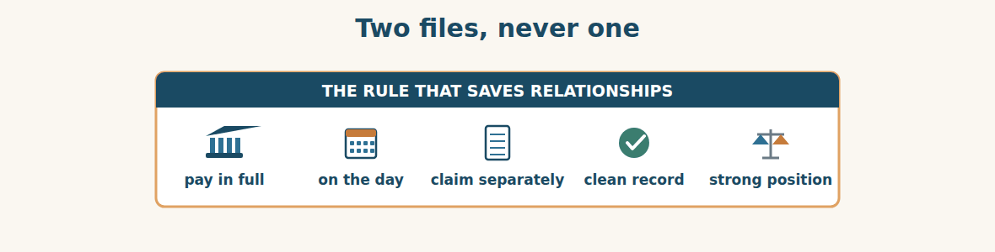
Figure · One payment, one meaning.
The most useful sentence in this unit is not a grammar point. It is Karim’s rule: never mix two arguments in one payment. It is worth understanding properly, because it applies far beyond money.
When you pay a supplier short because they owe you something, you have combined two separate questions into one act. The first question is whether you owe them the balance. You do; that is not in dispute. The second is whether they owe you for the forty tonnes. That is in dispute. By deducting, you have not resolved the second question — you have simply put your own clear obligation into the same box as their unclear one, and made both of them arguable. Worse, you have changed what you are. A minute ago you were a customer with a valid claim. Now you are a customer who has paid late, and every conversation starts from there.
There is a reasonable objection. If you pay in full, you lose your only piece of leverage. Why would they ever settle the claim once they have the money? It is a real risk, and the answer is that leverage bought by breaking your own promises is expensive. You get this claim settled and you lose the thing that makes you worth supplying — the certainty that when Al-Hasan says it will pay on Thursday, it pays on Thursday. In a trade where everyone is somebody’s debtor, that reputation is worth more than forty tonnes.
Notice that the same logic runs through the other strand of this unit. Huda does not open with “why haven’t you paid?”, which mixes the question of the money with an accusation about the person. She asks whether there is a problem with the invoice, which separates them, and the separation is what allows Eng. Bilal to tell her the truth. Then she writes the agreement down — separating today’s understanding from August’s memory.
This is what the modal verbs of this unit are really for. Should, could, may and might let you be firm about one thing while staying soft about another. “You should pay by Thursday” and “you could pay in two instalments” can live in the same email, and the customer hears both a limit and a door. That is the whole skill: keep the obligation clear, keep the person comfortable, and never let the two get mixed up in a single sentence.
A. Understanding check. Answer in your own words.
1. What two separate questions get mixed when you pay a supplier short?
2. What does deducting change about what you are?
3. What is the reasonable objection, and how does the writer answer it?
4. How does Huda’s first question separate the money from the person?
B. Apply it. Do this task with a partner.
Think of a disagreement at your work where two separate issues got mixed together. Write the two issues as two sentences. Then write how you would have handled each one separately, and compare with your partner.
C. Micro-writing (optional).
Write a few sentences (50–70 words) to a customer who is late. Use “should” once and “could” once, ask one question that is not an accusation, and give a date.
Study terms: invoice · due date · overdue · outstanding · aged debt list · debtor | creditor · receivable · payable · credit terms · credit limit · credit check | payment history · reminder · statement · remittance advice · settle · part payment | instalment · balance · bad debt · write off · offset · deduction | dispute · escalate · suspend · cash flow · order book · run out of cash | should · shouldn’t · could · may · might · chase (v)
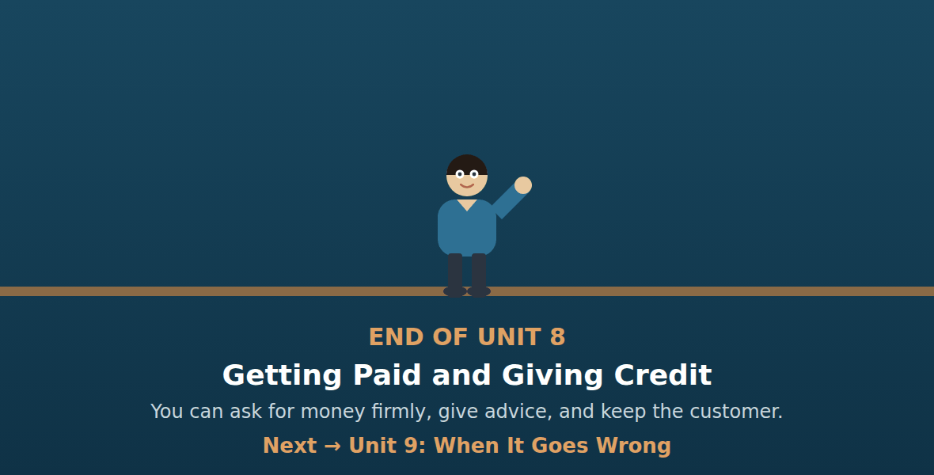
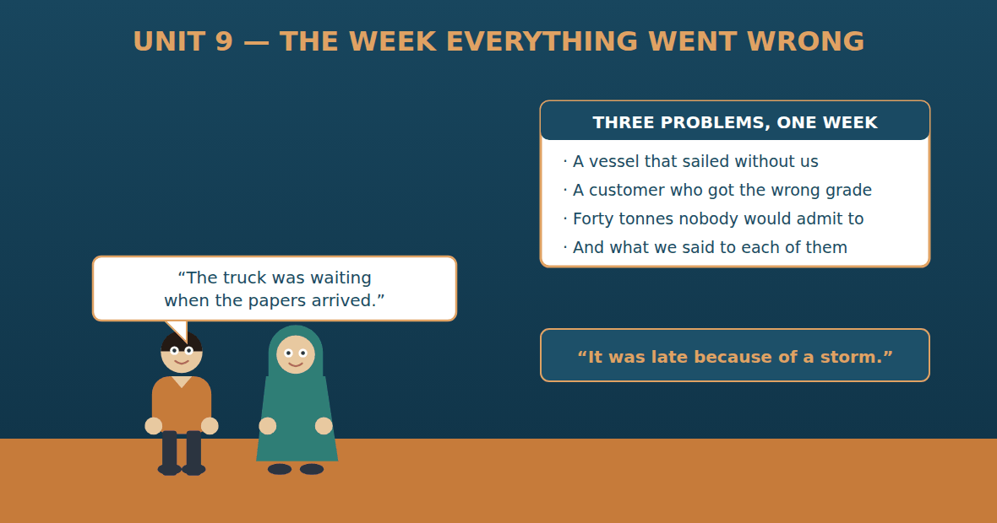

Unit 9: When It Goes Wrong
Al-Hasan International — English for Trade, Industry & Global Partnerships
CEFR B1 · Grammar: past continuous vs past simple · because of · so · although · Function: Logistics · Finance · Admin
Can-Do (by the end of this unit)
- I can say what was happening when the problem started
- I can give a reason with because of, so and although
- I can apologise and offer a solution
- I can write an apology with an action plan
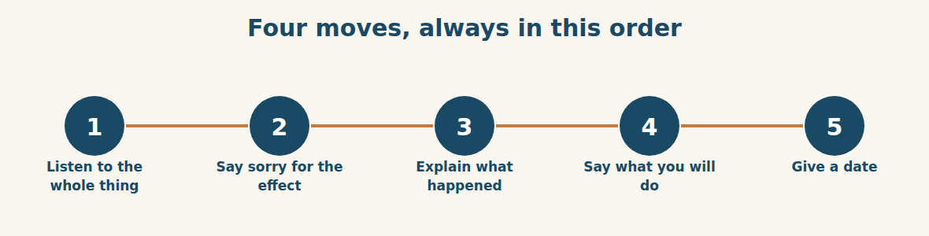
Figure · Most apologies fail because somebody starts at step three.
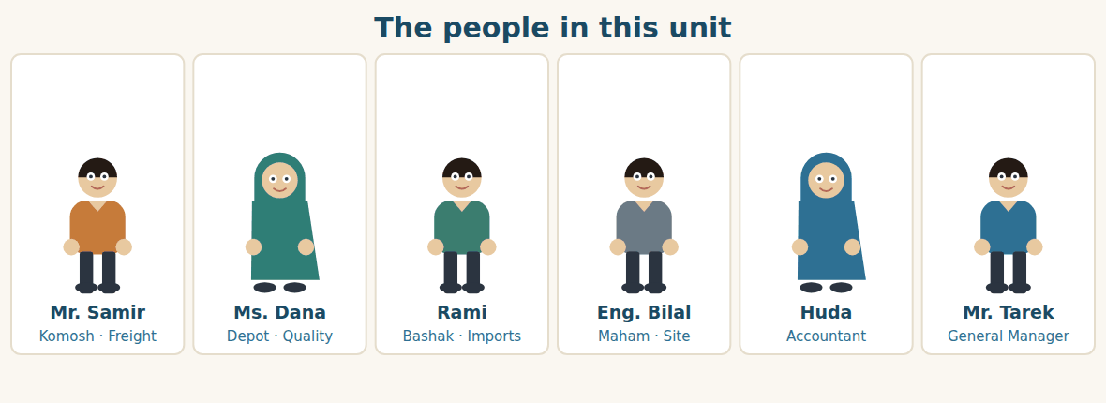
Figure · One problem came from the weather. The other came from us.
Warm Up LOGISTICS
Look at the pictures. Answer these questions before you read.
1. What usually goes wrong with deliveries at your company?
2. When something is late, who tells the customer?
3. Is it better to explain the reason, or just to fix it? Why?
Read
It was a bad week, and it was bad in two completely different ways.
The first problem arrived from the sea. The second shipment was waiting at the supplier’s port when a storm closed it for three days. While the port was closed, the vessel sailed without the containers. The next ship on that route was eleven days later. Nobody at Al-Hasan did anything wrong, and nothing anybody did could change it.
The second problem arrived from inside. Ms. Dana was on leave for a week. While she was away, a loader was clearing space in the yard, and he moved the forty rejected tonnes because they were in his way. Nobody had told him what they were. Two days later twelve of those tonnes were sold and delivered to a builder in Homs.
The builder telephoned on Thursday. He was not angry; he was something worse. He was disappointed. He had ordered five millimetre, he had been given 4.8, and he had already cut forty of the bars before anyone noticed.
Mr. Tarek took that call himself. He did not explain, and he did not mention the loader. He said he was sorry, he said the fault was entirely theirs, and he asked one question: what do you need, and when? New steel was on a truck by Friday morning. The explanation came afterwards, in writing, because the builder asked for it.
At the review, Mr. Tarek put the two problems side by side. “The storm cost us eleven days and nothing else,” he said. “The yard cost us twelve tonnes, a customer’s week, and something I cannot put a number on. One of these was weather. The other was a painted line on a floor that nobody painted.”
A. Comprehension. Answer in your own words. (0 is done for you.)
0. What closed the supplier’s port, and for how long? (a storm, for three days)
1. What happened while the port was closed?
2. Why did the loader move the rejected steel?
3. How did the builder feel, and what had he already done?
4. What did Mr. Tarek do first, and what did he not do?
5. What is the difference between the two problems?
B. True or False? Write T or F. (0 is done for you.)
0. Al-Hasan caused the storm delay. (F)
1. The next ship was eleven days later. ____
2. The loader knew the steel was rejected. ____
3. Twelve tonnes were sold by mistake. ____
4. Mr. Tarek explained about the loader on the telephone. ____
5. New steel was on a truck by Friday morning. ____
C. Find the words. Find a word or phrase in the text that means: (0 is done for you.)
0. time away from work → (leave)
1. the person who moves goods in a yard → a l____________
2. sad because something was not as good as expected → d____________
3. the mistake was completely ours → the f____________ was entirely ours
D. Over to you. Answer about yourself.
1. What was the last thing that went wrong at your work? What were you doing when you found out?
2. Was it caused by someone outside, or by your own company?
3. What did you say to the customer first?
Part 1 · Vocabulary and Terminology LOGISTICS
Words for things going wrong
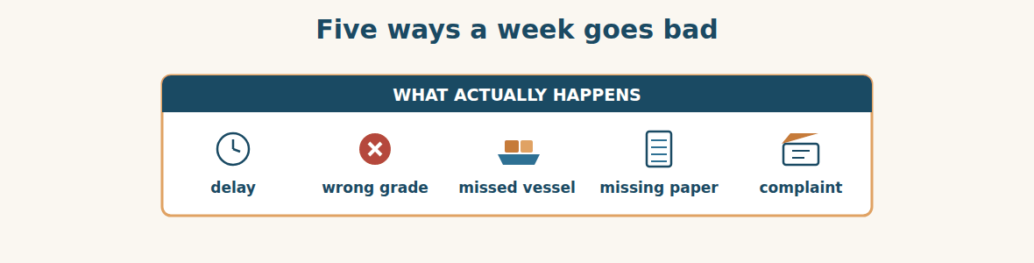
Figure · Different causes, and two very different kinds of fault.
A. Match each word (1–7) with its meaning (a–h). There is one you do not need. (0 is done for you.)
0. delay (c)
1. complaint ____ a. the real reason, not the first one you see
2. fault ____ b. money or goods given to make up for a loss
3. root cause ____ c. when something happens later than planned
4. compensation ____ d. a customer telling you something is wrong
5. goodwill ____ e. responsibility for a mistake
6. action plan ____ f. the same problem happening again
7. recurrence ____ g. a list of what we will do, and by when
8. h. something given to keep a good relationship
B. Complete the sentences with the words in the word bank.
Word bank: delay | complaint | fault | root cause | action plan | recurrence
1. The storm caused a ____________ of eleven days.
2. We received a ____________ from a builder in Homs on Thursday.
3. Mr. Tarek said the ____________ was entirely ours.
4. The ____________ was not the loader. It was that nobody had told him.
5. We sent the customer a written ____________ the same week.
6. A painted line and a label will prevent a ____________.
How sorry, and for what
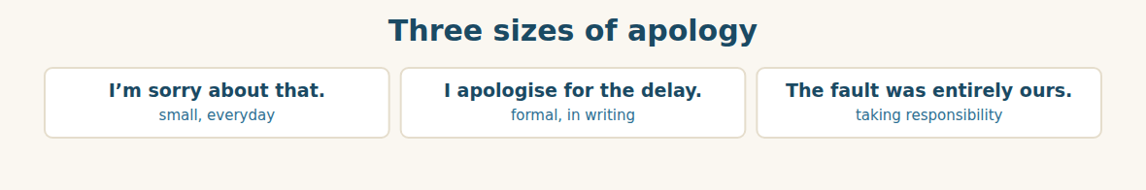
Figure · Say sorry for the effect on them, not for your own feelings.
C. Match the situation (1–5) with the right sentence (a–e).
1. a two-hour delay ____ a. “The fault was entirely ours.”
2. a formal written delay ____ b. “I’m sorry about that.”
3. your own clear mistake ____ c. “I apologise for the delay to your order.”
4. something outside your control ____ d. “We will replace it on Friday.”
5. what you will do about it ____ e. “The port was closed because of a storm.”
Saying what you will do
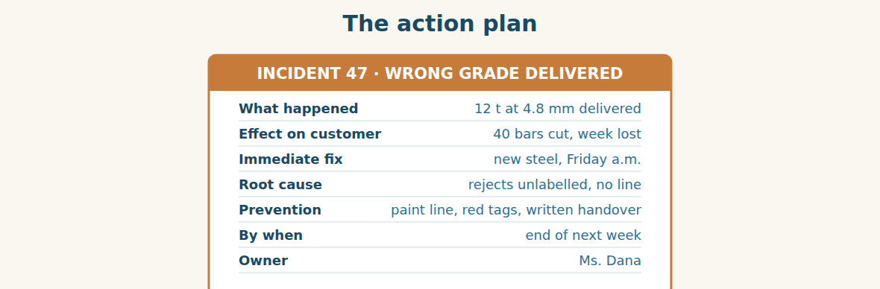
Figure · Seven lines. The last two are the ones the customer remembers.
D. Odd one out. Which word is different? Circle it.
1. delay · hold-up · breakdown · discount
2. apologise · explain · admit · deliver
3. fault · cause · reason · invoice
4. because of · due to · although · owing to
5. storm · strike · leave · breakdown
E. Choose the best answer.
1. The real reason, not the first one you see, is the… (a) root cause (b) complaint
2. The same problem happening again is a… (a) recurrence (b) delay
3. Something given to keep a good relationship is a… (a) goodwill gesture (b) refund
4. A list of what we will do and by when is an… (a) action plan (b) apology
F. Classify. Write each cause in the correct column.
Causes: a storm | an unlabelled pallet | a port strike | no written handover | a late certificate | a missed vessel
Outside our control | Our own fault | Could be either
__________ | __________ | __________
__________ | __________ | __________
__________ | __________ | __________
G. Match the two halves (1–6 with a–f).
1. a root ____ a. plan
2. an action ____ b. gesture
3. a goodwill ____ c. cause
4. to take ____ d. responsibility
5. to prevent ____ e. a recurrence
6. to put ____ f. it right
H. Complete the paragraph with the words in the box.
Box: although | because of | cause | fault | prevent | so
The vessel sailed without us (1)____________ a storm, (2)____________ the shipment was eleven days late. (3)____________ nobody at Al-Hasan was to blame for that, the second problem was our (4)____________. The root (5)____________ was that the rejects were not labelled. A painted line will (6)____________ it happening again.
Part 2 · Grammar — past continuous · because of · so · although LOGISTICS
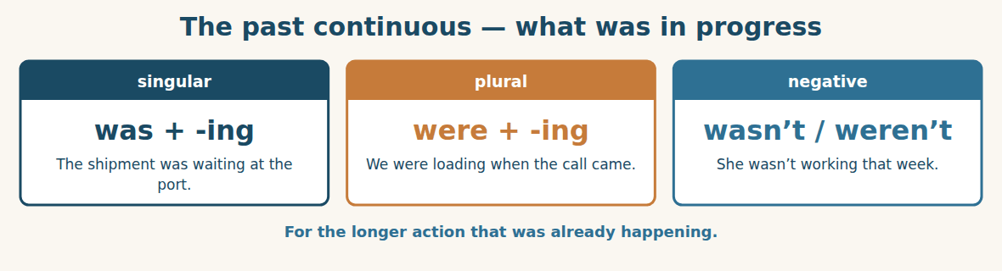
Figure · The background, not the event.
We use the PAST CONTINUOUS for an action that was already in progress at a moment in the past. The shipment was waiting at the port. Ms. Dana was taking a week’s leave. It sets the scene; it does not tell you what happened next.
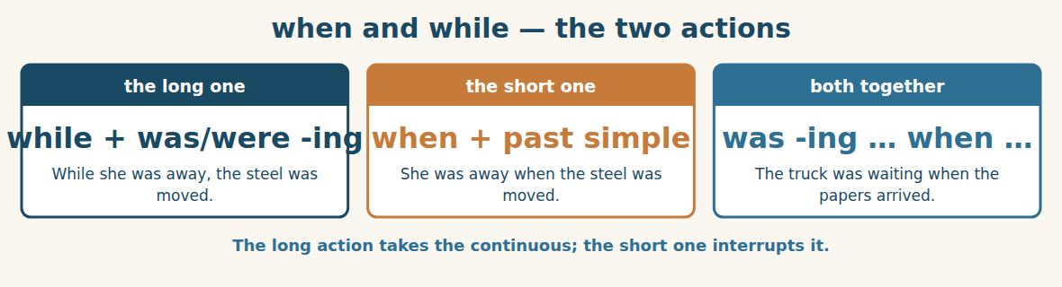
Figure · A longer action, interrupted by a shorter one.
Use WHILE with the long action and WHEN with the short one. While the port was closed, the vessel sailed. The truck was waiting when the papers finally arrived. The continuous is the background; the past simple is the thing that happened.
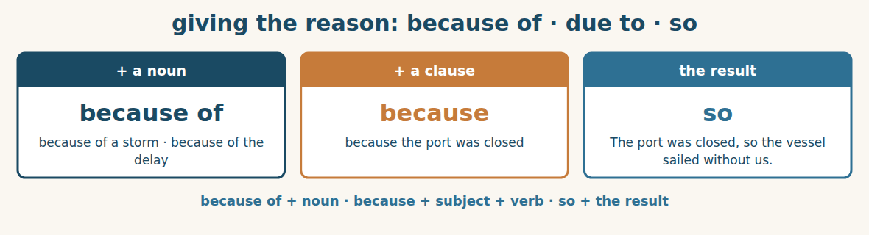
Figure · Cause on one side, result on the other.
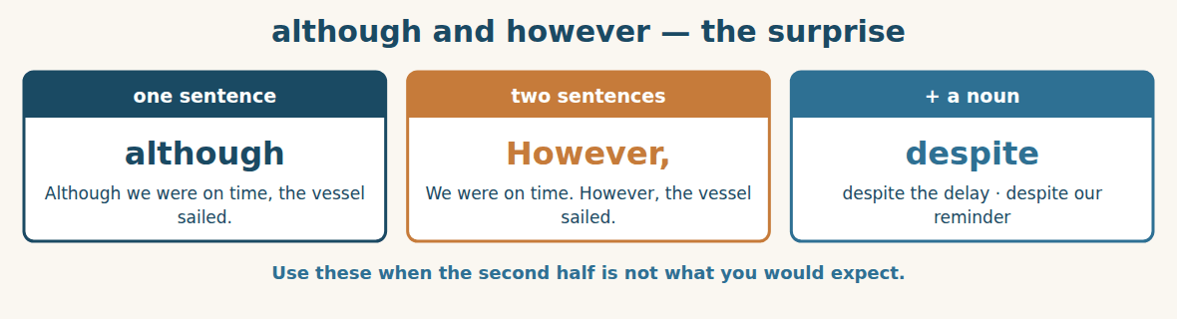
Figure · For the part the reader will not expect.
Watch out! because of takes a noun (because of the storm); because takes a subject and a verb (because the port was closed). And do not use although and but together: say Although it was late, we accepted it — not Although it was late, but we accepted it.
Form
was / were + verb-ing · while + past continuous, past simple · because of + noun · because + clause · so + result · although + clause · despite + noun
A. Complete with the past continuous. (0 is done for you.)
0. The shipment was waiting (wait) at the port.
1. While Ms. Dana ____________ (take) leave, the steel was moved.
2. The truck ____________ (stand) at the gate for two hours.
3. We ____________ (not / expect) a storm that week.
4. The loader ____________ (clear) space when he moved the pallets.
B. Past simple or past continuous? Choose the correct form.
1. While the port (was closing / was closed), the vessel (sailed / was sailing).
2. The truck (waited / was waiting) when the papers (arrived / were arriving).
3. She (worked / was working) in the depot when the builder (telephoned / was telephoning).
4. They (loaded / were loading) the containers when the storm (started / was starting).
C. Join with WHILE or WHEN.
1. Ms. Dana was away. The steel was moved. → ____________
2. The truck was waiting. The papers arrived. → ____________
3. We were loading. The storm started. → ____________
4. He was clearing the yard. He moved the pallets. → ____________
D. Complete with BECAUSE or BECAUSE OF.
1. The vessel sailed without us ____________ a storm.
2. The vessel sailed without us ____________ the port was closed.
3. We lost eleven days ____________ the delay.
4. The customer complained ____________ he received the wrong grade.
E. Join the two sentences with SO or ALTHOUGH.
1. The port was closed. The vessel sailed without us. → ____________
2. We checked the papers early. The vessel still sailed. → ____________
3. The steel was rejected. Nobody had labelled it. → ____________
4. The customer was disappointed. He stayed with us. → ____________
F. Rewrite with DESPITE or HOWEVER.
1. Although the papers were ready, the vessel sailed. (despite) → ____________
2. We apologised. The customer was still unhappy. (However) → ____________
3. Although it was our fault, he ordered again. (Despite) → ____________
4. The storm closed the port. We still delivered on time. (However) → ____________
G. Find and correct the mistake in each sentence. (0 is done for you.)
0. It was late because of the port was closed. → (It was late because the port was closed.)
1. While we were load, the storm started. → ____________
2. Although it was late, but we accepted it. → ____________
3. The truck was waiting when the papers were arriving. → ____________
4. We lost a week because of the vessel sailed. → ____________
H. About you. Write two sentences about a problem at work: one with “while … was …-ing” and one with “because of”.
1. ______________________________________________
2. ______________________________________________
I. Complete with because, because of, so, although or while.
1. ____________ the port was closed, the vessel sailed without us.
2. We lost eleven days ____________ a storm.
3. The steel was unlabelled, ____________ the loader moved it.
4. ____________ we apologised at once, the builder had already cut the bars.
5. ____________ Ms. Dana was on leave, nobody was watching the rejects.
J. Explain each problem in one sentence. Use the word in brackets.
1. storm → port closed → vessel sailed (because of) → ____________
2. no label → loader moved it → wrong steel sold (so) → ____________
3. we were on time → the ship still left (although) → ____________
4. Dana on leave → nobody checked the yard (while) → ____________
Part 3 · Listening and Dialogue LOGISTICS
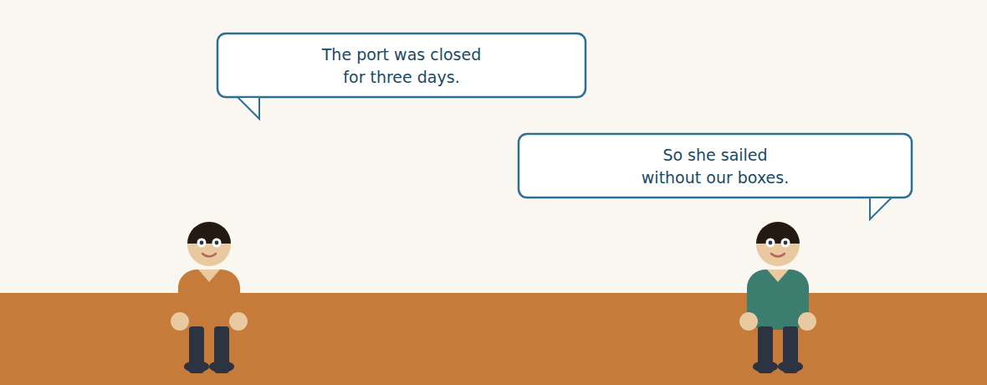
Figure · Strand A · a delay nobody could have prevented.
Dialogue 1 — The vessel that sailed without us (the freight desk)
Listen and read. (Your teacher will read the dialogue, or play the audio.)
Mr. Samir: Rami, bad news about the second shipment. It did not sail.
Rami: What happened? The papers were ready a week ago.
Mr. Samir: The papers were fine. The containers were waiting at the port when a storm closed it. Three days.
Rami: And while the port was closed, the vessel sailed.
Mr. Samir: She sailed empty of our boxes, yes. The line will not hold a ship for forty-eight containers.
Rami: When is the next one?
Mr. Samir: Eleven days. There is nothing faster on that route, although I checked three lines this morning.
Rami: So we tell Chemac they will get their clinker eleven days late, because of the weather.
Mr. Samir: Tell them the date, not the weather. The weather is our explanation; the date is their problem.
Rami: You are right. The 14th, then — and I will confirm when she is actually loaded, not when she is booked.
A. Comprehension. Answer in your own words. (0 is done for you.)
0. What is the bad news? (the second shipment did not sail)
1. Were the papers the problem? What was?
2. What happened while the port was closed?
3. Why will the line not wait?
4. How long is the delay, and what has Mr. Samir already tried?
5. What does Mr. Samir say Rami should tell Chemac, and why?
B. True or False? Write T or F.
1. The documents caused the delay. ____
2. A storm closed the port for three days. ____
3. The shipping line waited for the containers. ____
4. Mr. Samir checked three shipping lines. ____
5. Rami will confirm the date when the ship is booked. ____
C. Language focus. Find in the dialogue: (0 is done for you.)
0. a past continuous interrupted by a past simple → (The containers were waiting at the port when a storm closed it.)
1. a sentence with “while” → ____________
2. a sentence with “although” → ____________
3. a sentence with “because of” → ____________
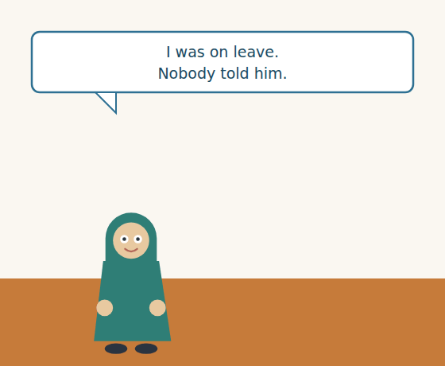
Figure · Strand B · a problem that came from inside the yard.
Dialogue 2 — Twelve tonnes that should not have moved (inside the depot)
Mr. Tarek: Dana, I need to understand the yard. Twelve tonnes of rejected steel reached a customer in Homs.
Ms. Dana: I know. I was on leave that week.
Mr. Tarek: I am not asking who. I am asking how.
Ms. Dana: The loader was clearing space for the cement when he moved the pallets. They were in his way. Nobody had told him what they were.
Mr. Tarek: Was there a label?
Ms. Dana: There was a note on my desk. There was nothing on the steel.
Mr. Tarek: So the root cause is not the loader.
Ms. Dana: No. The root cause is that rejected stock lives in a corner that is only a corner because I say it is. Although everyone knows, nothing says it.
Mr. Tarek: Then paint the line, tag every reject in red, and write the handover down before anybody takes leave. How long?
Ms. Dana: End of next week.
A. Comprehension. Answer in your own words.
1. What does Mr. Tarek say he is not asking, and what is he asking?
2. What was the loader doing when he moved the pallets?
3. What was on the desk, and what was on the steel?
4. What three things does Mr. Tarek ask for?
B. Listen again and choose the best answer (A–D).
1. The steel that reached Homs was … tonnes. A) four B) twelve C) forty D) two hundred
2. Ms. Dana was … that week. A) ill B) in Homs C) on leave D) at the port
3. The loader was clearing space for… A) steel B) cement C) trucks D) containers
4. The fix is due by the end of… A) today B) this week C) next week D) the month
Part 4 · Speaking and Your Role ADMIN
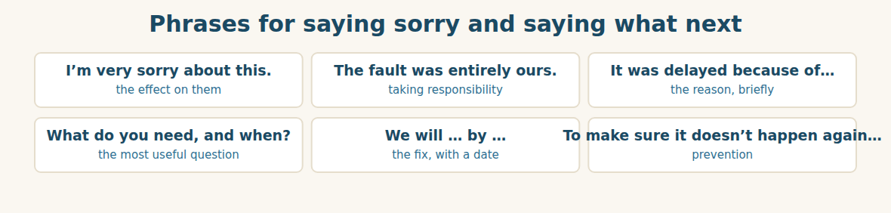
Figure · Sorry, reason, fix, date — and never reason first.
A. Role-play: the complaint. Student A is a customer who received the wrong goods. Student B takes the call. Then change roles.
1. A: Say what you ordered, what you received, and what it cost you.
2. B: Listen, then apologise for the effect — not for yourself.
3. A: Ask how it happened.
4. B: Give the reason in one sentence, with “because of” or “because”.
5. B: Ask what they need and when.
6. A: Say what you need. B: Give a date and say what will prevent it.
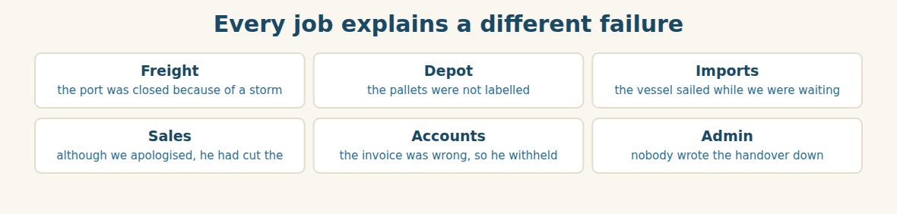
Figure · Six roles, one week, six explanations.
B. Your Role. Explain one real problem from YOUR job in one sentence, using because of, so or although. (Choose your real role.)
1. [Logistics] Freight: “The port was closed because of a storm, so the vessel sailed without us.”
2. [Trade] Depot: “The pallets were not labelled, so the loader moved them.”
3. [Trade] Import Manager: “Although the papers were ready, the ship did not wait.”
4. [Trade] Sales: “Although we apologised at once, he had already cut the bars.”
5. [Finance] Accountant: “The invoice was wrong, so he withheld payment.”
6. [Admin] Assistant: “Nobody wrote the handover down, so nobody knew.”
C. Ask your partner. Walk around and ask three people.
1. What were you doing when the last problem happened?
2. What was the root cause — the first reason, or something behind it?
3. What would prevent it happening again?
D. Discuss. Ask and answer.
1. Should you tell a customer the reason, or only the new date?
2. Is a problem you caused worse than one you could not control? Why?
Part 5 · Extended Reading ADMIN
The difference between a reason and an excuse
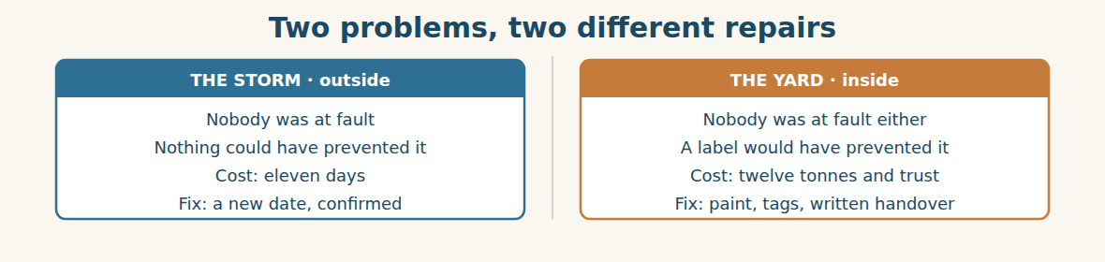
Figure · The second one is the expensive one, and it is the cheap one to fix.
Every company has two kinds of problem, and it is worth being very clear about which one you are holding. The first kind comes from outside: a storm, a closed port, a bank holiday in a third country. The second kind comes from inside: a pallet with no label, a handover nobody wrote down.
Customers can forgive the first kind easily, and companies therefore love explaining it. A storm is a wonderful reason. It is true, it is verifiable, and it is nobody’s fault. The danger is that a company which has a good external reason tends to stop thinking, because the sentence is already finished. Eleven days were lost; it was the weather; there is nothing more to say.
But there usually is. The storm was not preventable. Losing the vessel might have been. If the containers had reached the port four days earlier, they would have sailed before the weather closed it. Nobody can control a storm, but almost everybody can control how much time they leave between being ready and being needed. The honest version of the sentence is not “a storm delayed us”. It is “a storm delayed us, and we had no days in hand”.
The second kind of problem is uncomfortable, which is exactly why it is valuable. When twelve tonnes of rejected steel reach a customer, nobody outside the company did anything. The loader was doing his job; the supervisor was on leave, as people are. The failure was not a person. It was that a rule existed only inside one person’s head. Everyone knew that the corner was for rejects, and nothing said so.
This is why the right question after a failure is never “who?” but “how?”. Who produces a name, a quiet apology and no change. How produces a painted line, a red tag, and a written handover — three things that cost almost nothing and that will still be working in five years, when everybody involved has moved on to other jobs.
And the test of which kind of problem you are holding is simple. If the same thing happened next month, would anything stop it? If the answer is no, you do not have a reason. You have an excuse, and you have not finished.
A. Comprehension. Answer in your own words. (0 is done for you.)
0. What are the two kinds of problem? (those from outside, and those from inside)
1. Why do companies “love explaining” the first kind?
2. What is the danger of having a good external reason?
3. What was preventable about the lost vessel, even though the storm was not?
4. Why was the failure in the yard “not a person”?
5. What is the test of whether you have a reason or an excuse?
B. Choose the best answer (A–D).
1. A storm is “a wonderful reason” because it is… A) rare B) nobody’s fault C) cheap D) short
2. The honest version adds: “and we had no … in hand.” A) money B) containers C) days D) staff
3. The failure in the yard was that a rule existed only… A) in writing B) at the gate C) in one person’s head D) on the invoice
4. The right question after a failure is… A) who? B) when? C) how much? D) how?
5. If nothing would stop it happening again, you have… A) a reason B) an excuse C) a plan D) bad luck
C. Find a word or phrase in the text that means:
1. able to be checked and proved → v____________
2. able to be stopped before it happens → p____________
3. spare time you have kept for safety → days in h____________
4. a reason given to avoid blame → an e____________
D. Complete the summary with ONE word in each gap.
Problems come from (1)____________ or from inside. An external reason is easy to explain, (2)____________ it can stop a company thinking. The storm was not preventable, but having no days in (3)____________ was. The yard failure was not a (4)____________ but a rule that existed only in one head. The right question is not who but (5)____________. If nothing would stop it happening again, you have an (6)____________.
E. Discuss. Talk in pairs.
1. Think of a recent problem at your work. Was it outside or inside? Be honest.
2. What rule in your company exists only in somebody’s head?
F. True or False? (about the reading). Write T, F or NOT GIVEN.
1. The writer thinks external reasons are dishonest. ____
2. Leaving time in hand could have saved the vessel. ____
3. The loader was blamed for moving the pallets. ____
4. The writer prefers “how?” to “who?”. ____
Part 6 · Writing (a real email) ADMIN
Model — An apology with an action plan
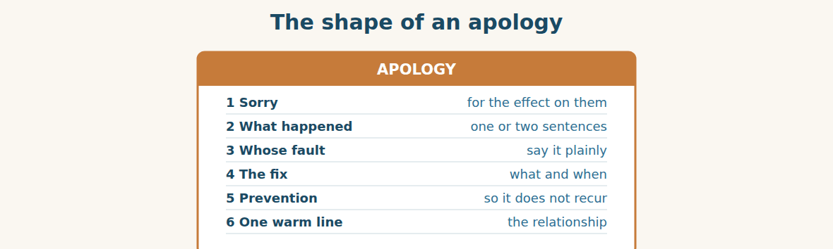
Figure · Sorry first, reason second. Never the other way round.
Subject: Your order — our mistake, and what we are doing. Dear Mr. Haddad, I am very sorry about the steel you received on Tuesday. You ordered five-millimetre bar and we delivered material at 4.8 millimetre, and I understand you had already cut forty bars before anyone noticed. That has cost you a week on site, and I am sorry for that. The fault was entirely ours. The material had been rejected at our depot but it was not labelled, so it was moved and then sold while our supervisor was on leave. Nothing about this was your mistake. Replacement five-millimetre bar left our depot on Friday morning and we will collect the 4.8 material at the same time, at our cost. To prevent this happening again we are painting a separate area for rejected stock, tagging every rejected pallet in red, and writing a handover note before anybody takes leave. All three will be done by the end of next week. Thank you for telling us so directly. Best regards, Tarek General Manager, Al-Hasan Holding Group.
A. Answer about the email. (0 is done for you.)
0. What did the customer order, and what did he receive? (5 mm bar; he received 4.8 mm)
1. What has it cost him?
2. How did the mistake happen? Give the two reasons.
3. What three things will prevent it happening again, and by when?
B. Put the email in order (1–6).
1. ( ) The fault was entirely ours.
2. ( ) Dear Mr. Haddad,
3. ( ) I am very sorry about the steel you received on Tuesday.
4. ( ) Replacement bar left our depot on Friday morning.
5. ( ) To prevent this happening again we are painting a separate area.
6. ( ) Best regards, Tarek
Guided writing
C. Now you write. Write an apology (80–110 words) for a problem your company caused. Use the past continuous once, “because of” or “because” once, and give a date for the fix.
Plan: 1) “Dear …,” 2) “I am very sorry about ….” 3) “You ordered … and we ….” 4) “The fault was ….” 5) “It happened because ….” 6) “We will … by ….” 7) “To prevent this happening again, ….” 8) “Best regards, …”
Sentence starters: “I am very sorry about…” · “The fault was entirely ours.” · “It happened because…” · “While … was …, …” · “To prevent this happening again, we are…”
______________________________________________
______________________________________________
______________________________________________
______________________________________________
______________________________________________
D. Checklist. Tick each one when you have checked your apology.
- I said sorry for the effect on them, before any explanation.
- I said plainly whose fault it was.
- I explained what happened in one or two sentences.
- I said what we will do, and by when.
- I said what will stop it happening again.
Part 7 · Trade-Skills Track ADMIN
Finding the root cause: asking “how” five times
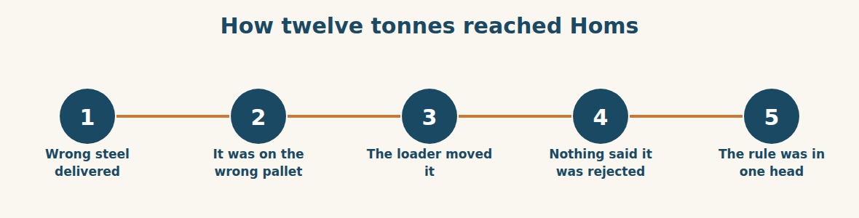
Figure · Five steps back from the complaint to the thing you can fix.
When something goes wrong, the first explanation you find is almost never the one worth fixing. It is simply the last link in a chain. The method for getting past it is to ask “how did that happen?” several times in a row, and to keep going until the answer is something you could put a tin of paint on.
Look at the chain in this unit. A customer got the wrong steel — how? Because it was picked from the wrong pallet. How? Because the rejected pallets had been moved into the general stock. How? Because a loader needed the space and nothing told him not to. How? Because rejected stock was identified by a note on a desk and a habit in one supervisor’s head. That is the end of the chain, and it is the first answer you can actually repair.
Notice how much changes along the way. At step one the fix is “tell the picker to be careful”, which will work for about three weeks. At step five the fix is paint, red tags and a written handover, which works whether or not anybody is careful, and works when everybody involved has left the company.
The reason people stop early is that the early answers have a person in them and the late answers do not. “The loader moved it” feels like a complete explanation because it names somebody. But naming somebody is not the same as explaining something, and a company that stops at a name learns nothing and quietly teaches its staff to hide mistakes. Keep asking how until the answer is a thing, not a person. Then buy the paint.
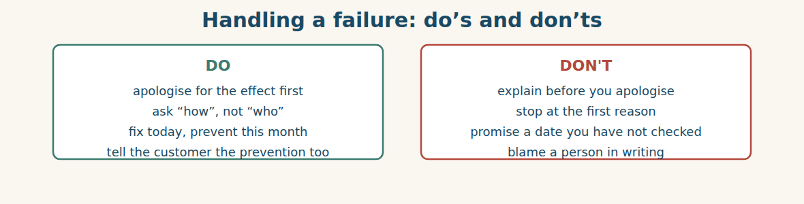
Figure · The goal is a system that works when nobody is careful.
A. Comprehension. Answer in your own words.
1. Why is the first explanation “almost never the one worth fixing”?
2. Trace the five steps from the complaint to the root cause.
3. What is the fix at step one, and how long will it work?
4. What is the fix at step five, and why is it better?
5. Why do people stop early, and what does a company that stops at a name teach its staff?
B. Listen and complete. Mr. Tarek explains the method. Write the missing word.
1. Mr. Tarek: Ask “how did that happen?” several times in a ____________.
2. Mr. Tarek: Keep going until the answer is something you could put ____________ on.
3. Mr. Tarek: The early answers have a ____________ in them.
4. Mr. Tarek: A company that stops at a name teaches its staff to ____________ mistakes.
C. Practice. Take one real problem from your work. Write the complaint, then ask “how?” four times and write each answer. Tell your partner what you would buy or write to fix the last one.
D. Which fix is the root-cause fix? Choose A or B.
1. A) Tell the driver to check. B) Print the address on the pallet. → ____________
2. A) Paint a line round the reject area. B) Remind the loader each morning. → ____________
3. A) Write the handover before leave. B) Ask people to be careful in August. → ____________
4. A) Add four days before the sailing date. B) Hope for good weather. → ____________
Part 8 · Consolidation ADMIN
Paint, tags, and four days in hand
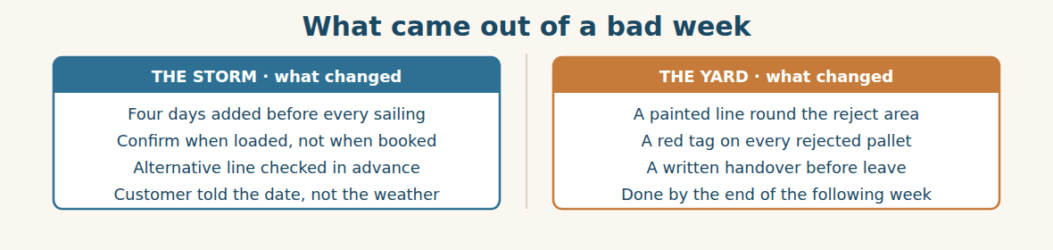
Figure · Eight changes, and seven of them cost almost nothing.
The builder in Homs ordered again in March. Mr. Tarek had not expected that, and he said so. The builder’s answer is the sentence Huda later wrote on the office wall: “Everybody delivers the wrong thing once. You are the only one who told me what you were going to do about it.”
By the end of the following week the yard had a painted line, every rejected pallet had a red tag, and there was a handover sheet in a plastic folder by the gate. The whole thing cost less than the twelve tonnes.
The storm was harder, because nothing could be fixed — only prepared for. Mr. Samir made one change: four days in hand before every sailing, and a second line checked before it is needed, not after. “I cannot stop a storm,” he said. “I can stop a storm costing eleven days.”
At the review Mr. Tarek asked what the week had cost. Rami read it out: eleven days on the clinker, twelve tonnes replaced, one truck both ways, and about four hours of everyone’s time. Then Karim added the line that mattered. “And one customer who ordered again, which is the only number on that list that is positive.”
Mr. Tarek wrote two words on the board and left them there for a month: paint and days. One for the problems we make, and one for the problems we meet.
A. Comprehension. Answer in your own words. (0 is done.)
0. What did the builder do in March? (he ordered again)
1. What did the builder say, and why did Huda write it on the wall?
2. What three things were in place by the end of the following week?
3. What change did Mr. Samir make, and why can he not do more?
4. What did the week cost, according to Rami?
5. What two words did Mr. Tarek write, and what does each one mean?
B. Complete each sentence with ONE word from the text. (0 is done for you.)
0. The builder in Homs ordered again in March.
1. Every rejected pallet now has a red ____________.
2. There is a handover sheet in a plastic folder by the ____________.
3. Mr. Samir added four days in ____________ before every sailing.
4. The only positive number on the list was one ____________ who ordered again.
5. Mr. Tarek wrote two words on the board: ____________ and days.
C. Discuss. Talk in pairs.
1. Why did telling the builder the prevention matter more than the apology?
2. What would “four days in hand” look like in your own work?
D. Find a word from the text that means: (0 is done for you.)
0. a small piece of card or plastic with information on it → (a tag)
1. the paper that tells the next person what is happening → a h____________ sheet
2. spare time kept for safety → days in h____________
3. good, not negative → p____________
Part 9 · Case Studies and Decisions ADMIN
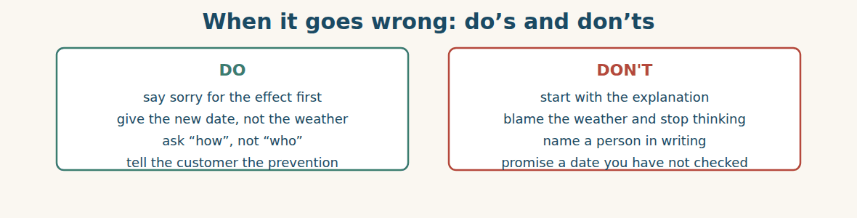
Figure · Customers forgive mistakes. They do not forgive silence.
Case 1 — Eleven days you cannot shorten (strand A · abroad)
A storm has cost you eleven days and there is no faster route. Your customer is a factory that will have to slow its line. You have to telephone them today, and you have nothing to offer except the truth.
Choose the best action and say why.
1. ( ) Wait two days until you have better news.
2. ( ) Telephone today with the new date, say what you have already checked, and offer to update them when the vessel is loaded.
3. ( ) Email the explanation and the weather report.
4. ( ) Tell them it is “about two weeks” to keep some room.
Write one sentence giving the new date without hiding behind the weather.
______________________________________________
______________________________________________
Case 2 — The complaint you caused (strand B · at home)
A customer received goods that were rejected in your own depot. He has already used some of them. On the telephone he is calm, which is worse than angry, and he asks you directly: “How did this happen?”
Answer the questions.
1. What should you say before you answer his question?
2. How much of the internal story should he hear, and what should you leave out?
3. Write one sentence that answers “how did this happen?” without naming a person.
Case 3 — The reason that is really an excuse (where the strands meet)
At the review, somebody writes “delay caused by storm” and closes the file. You believe the real reason is that the containers reached the port only one day before the sailing, as they have for two years. Saying so means contradicting a colleague in front of the General Manager.
Answer the questions.
1. Why is “delay caused by storm” an incomplete explanation here?
2. How can you add the missing part without blaming your colleague?
3. Write one sentence that reopens the question usefully.
Part 10 · Review and Can-Do LOGISTICS
A. Vocabulary. Complete the sentence.
1. The real reason, not the first one you see, is the ____________ ____________.
2. The same problem happening again is a ____________.
3. A list of what we will do and by when is an ____________ ____________.
4. Something given to keep a good relationship is a ____________ gesture.
5. A customer telling you something is wrong is a ____________.
B. Grammar. Complete with the past simple, past continuous, because, because of, so or although.
1. The containers ____________ (wait) at the port when the storm closed it.
2. The vessel sailed ____________ a storm.
3. The vessel sailed ____________ the port was closed.
4. The pallets were not labelled, ____________ the loader moved them.
5. ____________ we apologised at once, he had already cut the bars.
6. While Ms. Dana ____________ (take) leave, the steel was moved.
C. Reading. Read the short text and answer.
The containers were waiting at the supplier’s port when a storm closed it for three days. While the port was closed, the vessel sailed, and the next ship was eleven days later. At the same time, twelve tonnes of rejected steel were delivered to a builder because the pallets were not labelled. Although the company apologised at once, the builder had already cut forty bars.
1. What were the containers doing when the storm closed the port?
2. How long was the delay?
3. Why were the rejected tonnes delivered?
D. Listening. Listen and answer. (Teacher reads.)
[Teacher reads] “The papers were fine. The containers were waiting at the port when a storm closed it — three days. While the port was closed, the vessel sailed. The next one is eleven days later, although I checked three lines this morning.”
1. What was not the problem?
2. What were the containers doing when the storm came?
3. What has the speaker already tried?
E. Speaking. Work in pairs. One makes a complaint about wrong goods; one apologises, explains in one sentence, and gives a fix with a date.
F. Writing. Write two sentences about a problem: one with “while … was …-ing”, and one with “although”.
1. ______________________________________________
2. ______________________________________________
G. Error correction. Find and correct one mistake in each sentence.
1. It was late because of the port was closed. → ____________
2. While we were load, the storm started. → ____________
3. Although it was late, but we accepted it. → ____________
4. The truck was waiting when the papers were arriving. → ____________
5. We lost a week because of the vessel sailed. → ____________
H. Match the term (1–5) to its meaning (a–e).
1. root cause ____ a. the same problem happening again
2. recurrence ____ b. responsibility for a mistake
3. fault ____ c. the real reason behind the first one
4. compensation ____ d. a list of what we will do, and when
5. action plan ____ e. money or goods given to make up for a loss
I. Put the apology in order (1–5).
1. ( ) say what will prevent it
2. ( ) say sorry for the effect
3. ( ) give the fix and the date
4. ( ) say whose fault it was
5. ( ) explain what happened
Can-Do check. Tick what you can do.
- I can say what was happening when the problem started.
- I can give a reason with because of, so and although.
- I can apologise and offer a solution.
- I can write an apology with an action plan.
Part 11 · Foundations for Further Study ADMIN
Concept Spotlight: What you were doing, and what happened
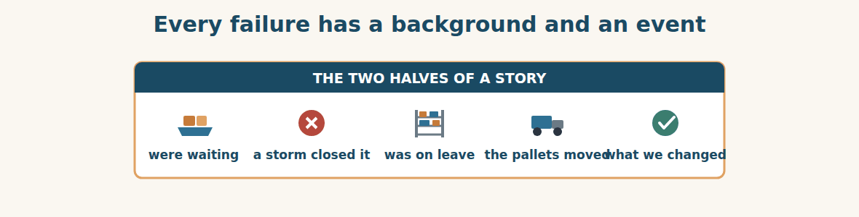
Figure · The continuous holds the scene; the simple holds the blow.
The grammar of this unit is the grammar of explanation, and the two tenses do two completely different jobs. The past continuous tells you what the world was like. The past simple tells you what hit it. “The containers were waiting at the port” is the situation. “A storm closed it” is the event. Put them the other way round and the story stops making sense.
This is worth more than it looks, because most failures at work are exactly this shape. Something was true for a long time, quietly, and then something short happened. Rejected steel was sitting in a corner identified by nothing but habit — for months, harmlessly. Then one loader needed the space, once. The habit was the background; the loader was the event. And this is why blaming the event is so useless. The loader was the shortest and smallest part of the sentence.
Once you see it this way, you also see where prevention has to go. You cannot stop the events. There will always be a storm, a loader, a person on leave, a customer who telephones on the wrong day. What you can change is the background — the long, quiet, continuous thing that was true before anything happened. Paint the line. Write the handover. Keep four days in hand. None of those stop the event. All of them change what the event costs.
There is an objection worth taking seriously: this can become a way of letting people off. If the background is always at fault, nobody is ever responsible, and a company can comfort itself with systems while the same person makes the same mistake. That is real, and the answer is that responsibility and cause are different questions. Somebody is responsible for fixing the background — in this unit, Ms. Dana, by the end of the following week, with her name on it. What you must not do is confuse the person who was present with the thing that was wrong.
So when you explain a failure in English, build the sentence honestly. The continuous for what was already true, the simple for what happened, because or because of for the link, and although for the part that will surprise them. Then add the only sentence a customer actually waits for: and this is what we have changed.
A. Understanding check. Answer in your own words.
1. What different jobs do the past continuous and the past simple do?
2. What shape do most failures at work have?
3. Why is blaming the event useless?
4. What is the objection to this way of thinking, and how does the writer answer it?
B. Apply it. Do this task with a partner.
Describe a failure at your work in two sentences: one past continuous for the background, one past simple for the event. Then write a third sentence saying what you would change about the background, with a name and a date.
C. Micro-writing (optional).
Write a few sentences (50–70 words) explaining something that went wrong. Use the past continuous once, “because of” once, and “although” once — and finish with what has been changed.
Study terms: delay · hold-up · backlog · breakdown · complaint · apology | apologise · fault · cause · root cause · excuse · explanation | responsibility · admit · deny · put right · replacement · refund | compensation · goodwill gesture · action plan · prevent · recurrence · escalate | follow-up · handover · days in hand · preventable · verifiable · leave | because of · because · so · although · despite · while
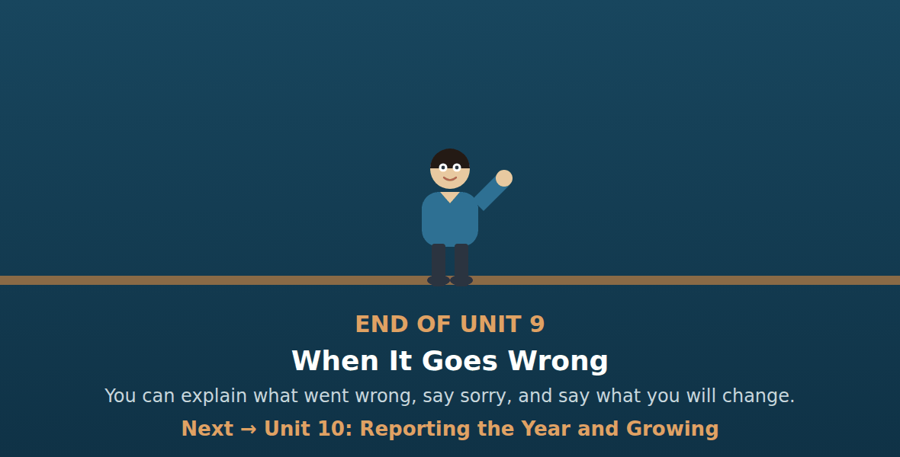
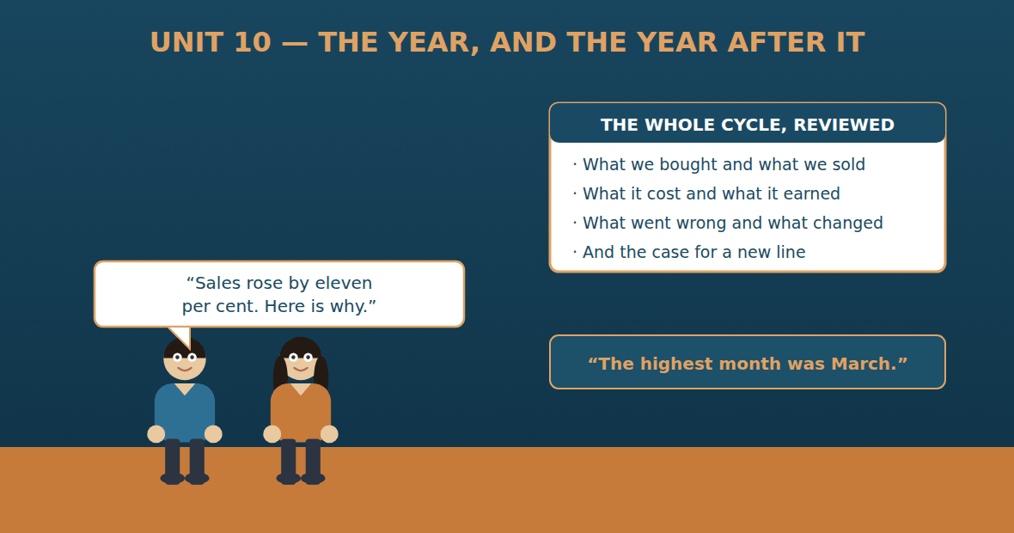

Unit 10: Reporting the Year and Growing
Al-Hasan International — English for Trade, Industry & Global Partnerships
CEFR B1 · Grammar: review of Units 1–9 (no new forms) · the language of figures and trends · Function: Trade · Finance · Logistics · Admin
Can-Do (by the end of this unit)
- I can describe figures going up and down
- I can present a short report
- I can argue for a new supplier, line or branch
- I can write a one-page proposal
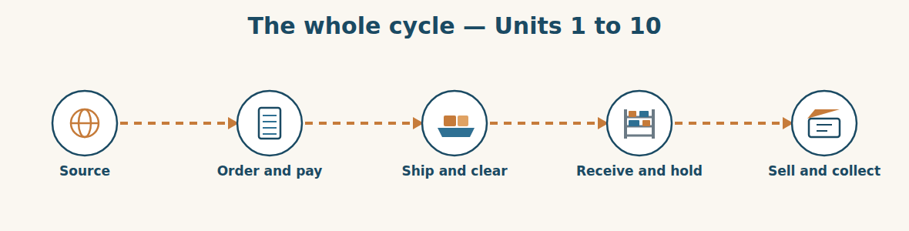
Figure · One year, five stages, and back to the beginning.
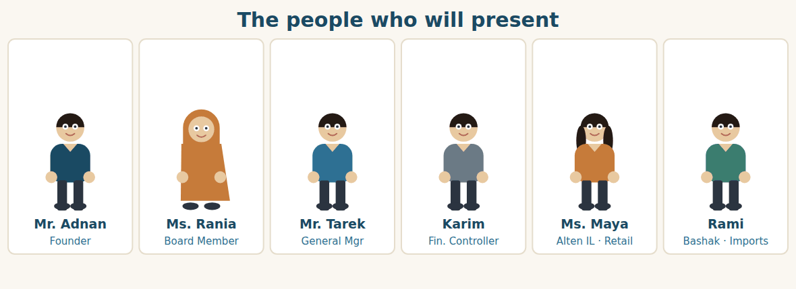
Figure · Six people, six parts of one report.
Warm Up TRADE
Look at the pictures. Answer these questions before you read.
1. What numbers does your company look at at the end of a year?
2. Which went up this year, and which went down?
3. If you could change one thing next year, what would it be?
Read
It is the annual review again, one year after Unit 1. The same room, the same seven people, and a very different set of numbers.
Karim presents first, and he has learned something about presenting. He does not read the whole sheet. He gives five figures and one sentence for each. Imports rose from eleven orders to nineteen. Sales grew by twenty-two per cent, with the highest month in March. Overdue money fell from nine per cent of sales to five. Stock cover on steel dropped from four months to seven weeks, although cement is still tight. And the margin held steady, which, after a year of moving exchange rates, is the number he is proudest of.
Then he says the thing that makes it a report rather than a list. “Three of those five changed because we changed something. Overdue money fell because we chased in the first week instead of the fourth. Stock fell because every line now has a reorder level with a name on it. And the margin held because we price from landed cost, not from the offer.”
Ms. Maya presents second, and she has no history at all — only a future. For three months the three shops have kept the lost-sales sheet. Four hundred and six people asked for five-millimetre steel bar and were told no. Sixty-one asked for eight millimetre. “That is not a feeling,” she says. “That is four hundred and six people.”
Rami has already done the work from Unit 2. Three enquiries, three replies, two suppliers checked, a landed cost built, a price tested against the Homs yard. The proposal is on one page: import bar as a trial, two hundred tonnes, sell it through the existing three shops, and decide about a fourth shop after six months.
Mr. Adnan listens to all of it without writing anything. Then he asks one question, and it is not about the money. “Who owns it?”
A. Comprehension. Answer in your own words. (0 is done for you.)
0. How long is it since Unit 1? (one year)
1. What are Karim’s five figures?
2. What makes his presentation “a report rather than a list”?
3. What did the lost-sales sheet show after three months?
4. What exactly is Rami proposing?
5. What is Mr. Adnan’s only question, and why is it surprising?
B. True or False? Write T or F. (0 is done for you.)
0. Karim reads the whole sheet aloud. (F)
1. Imports rose from eleven orders to nineteen. ____
2. Overdue money rose this year. ____
3. Stock cover on steel fell to seven weeks. ____
4. Four hundred and six people asked for five-millimetre bar. ____
5. Rami proposes opening a fourth shop immediately. ____
C. Find the words. Find a word or phrase in the text that means: (0 is done for you.)
0. went up → (rose)
1. went down → f____________ / d____________
2. did not change → held s____________
3. a small first order to test an idea → a t____________
D. Over to you. Answer about yourself.
1. Give one figure from your work that rose this year, and say why.
2. Give one that fell. Was that good or bad?
3. What would you propose for next year, and who would own it?
Part 1 · Vocabulary and Terminology (review) FINANCE
Describing figures
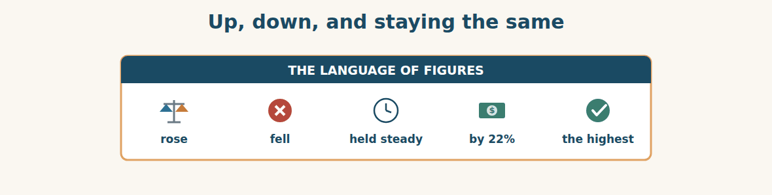
Figure · Five words that turn a table into a sentence.
A. Match each word (1–7) with its meaning (a–h). There is one you do not need. (0 is done for you.)
0. rise (f)
1. fall ____ a. the highest point reached
2. peak ____ b. not changing much
3. steady ____ c. a large, fast change
4. sharp ____ d. a small change
5. slight ____ e. twice as much
6. double ____ f. to go up
7. forecast ____ g. to go down
8. h. what we expect to happen
B. Complete the sentences with the words in the word bank.
Word bank: rose | fell | by | to | peak | steady
1. Sales ____________ twenty-two per cent this year.
2. Overdue money ____________ from nine per cent ____________ five.
3. Imports ____________ from eleven orders to nineteen.
4. The ____________ month was March.
5. The margin held ____________ all year.
The words of the whole course
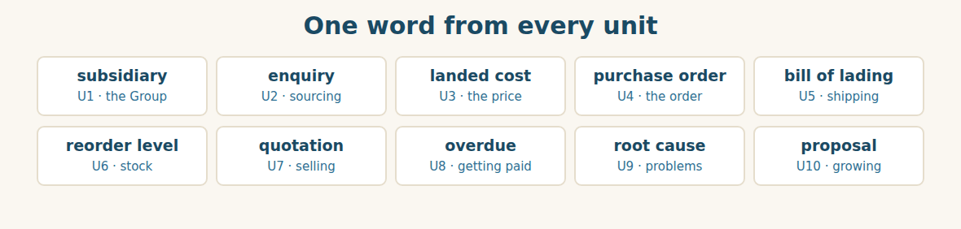
Figure · Ten units, ten words, one business.
C. Match the word (1–5) with the unit it came from (a–e).
1. landed cost ____ a. shipping and customs
2. bill of lading ____ b. getting paid
3. reorder level ____ c. offers and prices
4. overdue ____ d. goods in and stock
5. root cause ____ e. when it goes wrong
The year in numbers
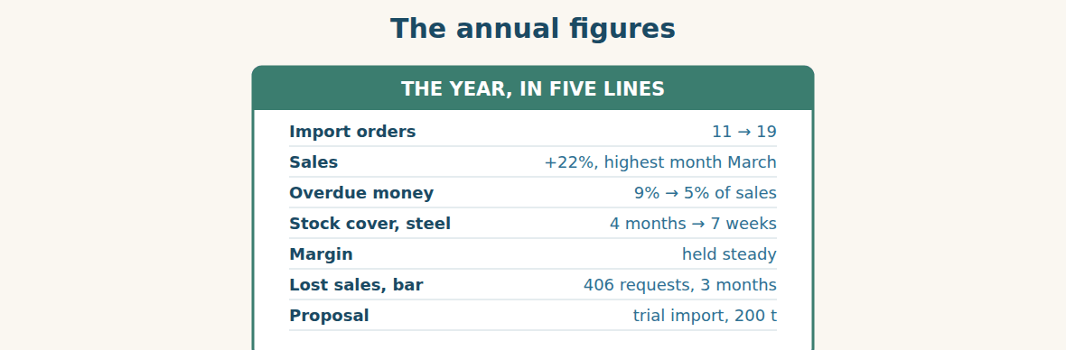
Figure · Five numbers that changed, and one that did not.
D. Odd one out. Which word is different? Circle it.
1. rose · grew · increased · fell
2. sharp · slight · gradual · overdue
3. peak · highest · lowest · maximum
4. forecast · target · actual · freight
5. proposal · recommendation · business case · invoice
E. Choose the best answer.
1. A large, fast change is a… (a) sharp (b) slight change
2. The highest point reached is the… (a) peak (b) average
3. What we expect to happen is the… (a) forecast (b) actual
4. A small first order to test an idea is a… (a) trial (b) target
F. Classify. Write each word in the correct column.
Words: rose | fell | held steady | grew | dropped | remained flat
Went up | Went down | Did not change
__________ | __________ | __________
__________ | __________ | __________
__________ | __________ | __________
G. Match the two halves (1–6 with a–f).
1. rose ____ a. steady
2. fell from nine ____ b. by 22%
3. held ____ c. to five
4. the highest ____ d. case
5. a business ____ e. month
6. a trial ____ f. order
H. Complete the paragraph with the words in the box.
Box: by | fell | from | highest | rose | steady
Imports (1)____________ from eleven orders to nineteen. Sales grew (2)____________ twenty-two per cent, and the (3)____________ month was March. Overdue money (4)____________ (5)____________ nine per cent of sales to five. The margin held (6)____________ all year.
Part 2 · Grammar Review (all units) TRADE
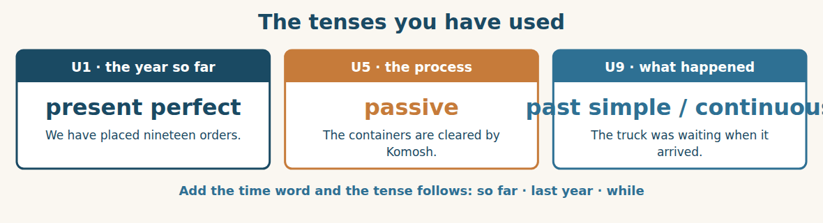
Figure · Three tenses, three jobs.
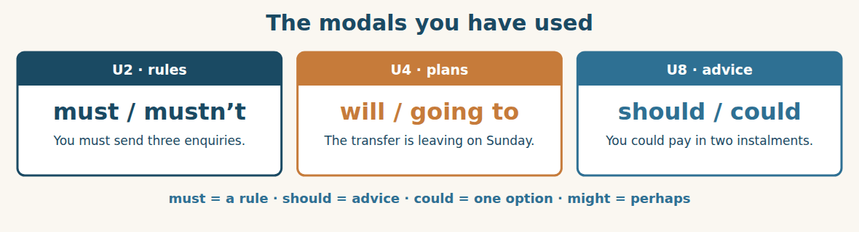
Figure · From the strongest to the softest.
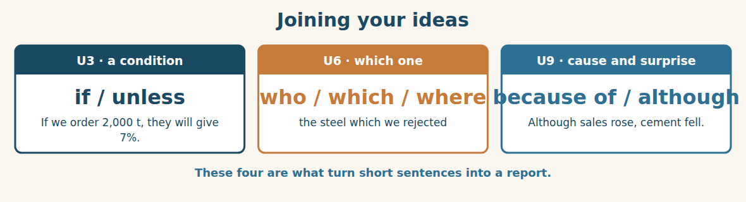
Figure · The words that carry an argument.
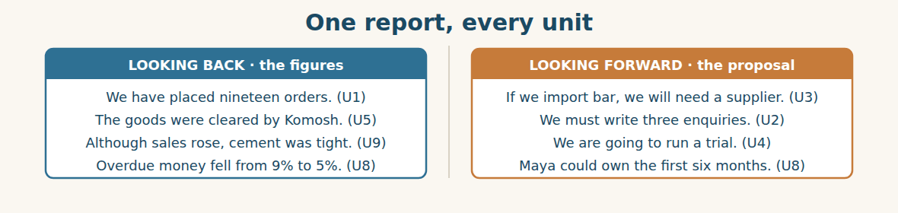
Figure · Nine units, two columns, one meeting.
Watch out! In a report, keep the tenses apart. Use the present perfect for the year so far (we have placed nineteen orders), the past simple for a finished time (we placed eleven last year), and will or going to for what comes next. Mixing them is the commonest fault in a written summary.
Form
present perfect: have / has + V3 · passive: be + V3 · past continuous: was / were + -ing · must · should · could · might · if / unless · who / which / where · because of · although
A. Choose the right tense. (0 is done for you.)
0. We ___ (place) nineteen orders so far this year. (have placed)
1. We ____________ (place) eleven orders last year.
2. The containers ____________ (clear) by Komosh every time.
3. The truck ____________ (wait) when the papers arrived.
4. Next year we ____________ (run) a trial import of bar.
B. Complete with must, mustn’t, should, could or might.
1. You ____________ send three enquiries. It is the rule.
2. You ____________ deduct a claim from a payment.
3. We ____________ import bar as a trial first — it is one option.
4. Sales ____________ fall in the summer, but we are not sure.
5. You ____________ put every agreement in writing.
C. Join the sentences with if, unless, although or because of.
1. We order 200 tonnes. They give us a better price. → ____________
2. We do not check the certificate. Customs will hold it. → ____________
3. Sales rose. Cement was still tight. → ____________
4. The port was closed. We lost eleven days. → ____________
D. Complete with who, which or where.
1. The supplier ____________ sent the short container has replied.
2. The steel ____________ we rejected is still in the yard.
3. The shop ____________ sold out twice is in Rural Damascus.
4. The person ____________ owns the reorder level is Ms. Dana.
E. Make the sentence passive.
1. Komosh clears the goods. → ____________
2. Customs inspected four containers. → ____________
3. The chamber issued the certificate. → ____________
4. Ms. Dana signs every goods-received note. → ____________
F. Report the words.
1. “Four hundred and six people asked for bar.” → She said ____________
2. “Can we run a trial?” → He asked ____________
3. “I will own the first six months.” → She said ____________
4. “We don’t stock it.” → She told them ____________
G. Find and correct the mistake in each sentence. (0 is done for you.)
0. We have placed eleven orders last year. → (We placed eleven orders last year.)
1. The goods was cleared by Komosh. → ____________
2. If we will order 2,000 t, they give 7%. → ____________
3. Although sales rose, but cement was tight. → ____________
4. He said me he needed 200 tonnes. → ____________
H. About you. Write two sentences about your year: one with the present perfect, and one with “going to”.
1. ______________________________________________
2. ______________________________________________
I. Complete the report with the right form.
1. Imports ____________ (rise) from eleven orders to nineteen.
2. Overdue money ____________ (fall) because we ____________ (chase) earlier.
3. Every line now ____________ (have) a reorder level with a name on it.
4. Next year we ____________ (import) bar as a trial.
5. If the trial ____________ (work), we ____________ (open) a fourth shop.
J. Write one sentence for each unit, using its grammar.
1. U1 present perfect — what the Group has done this year → ____________
2. U3 first conditional — a discount you want → ____________
3. U5 passive — how goods are cleared → ____________
4. U8 should — advice about a late payment → ____________
Part 3 · Listening and Dialogue FINANCE
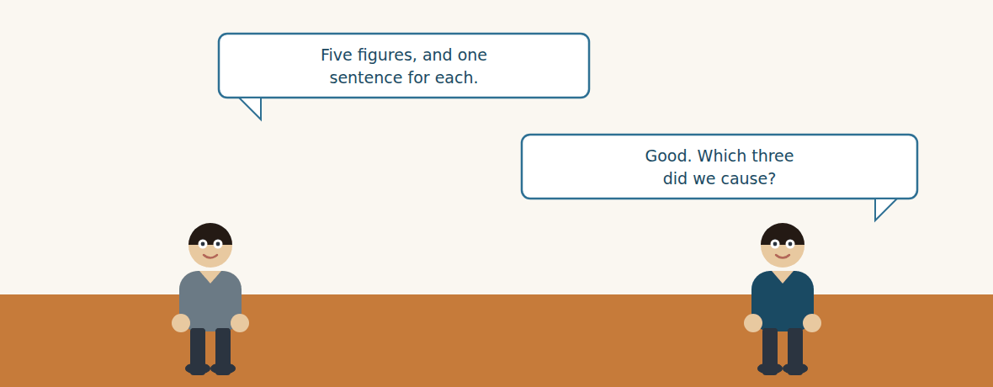
Figure · Strand A · presenting the year that has gone.
Dialogue 1 — Presenting the figures (the review)
Listen and read. (Your teacher will read the dialogue, or play the audio.)
Karim: Five figures. Imports rose from eleven orders to nineteen. Sales grew by twenty-two per cent, with the highest month in March.
Mr. Adnan: And the money?
Karim: Overdue money fell from nine per cent of sales to five. Stock cover on steel dropped from four months to seven weeks, although cement is still tight.
Mr. Adnan: And the margin?
Karim: It held steady. After a year of moving rates, that is the one I am proudest of.
Mr. Adnan: Good. Which three did we cause?
Karim: Overdue money, because we chased in the first week instead of the fourth. Stock, because every line now has a reorder level with a name on it. And the margin, because we price from landed cost and not from the offer.
Mr. Adnan: And the other two?
Karim: Sales and imports. Those grew because the market grew. If the market turns, they will fall again, and the three we caused will not.
Mr. Adnan: That is the first honest sentence I have heard at a review in ten years.
A. Comprehension. Answer in your own words. (0 is done for you.)
0. How many figures does Karim present? (five)
1. What happened to imports and to sales?
2. What happened to overdue money and to stock cover?
3. Which figure is Karim proudest of, and why?
4. Which three changes did the company cause, and how?
5. Why does Karim say sales and imports are different?
B. True or False? Write T or F.
1. Imports fell this year. ____
2. The highest sales month was March. ____
3. Overdue money is now five per cent of sales. ____
4. Cement stock is comfortable. ____
5. Karim says sales grew because of something the company did. ____
C. Language focus. Find in the dialogue: (0 is done for you.)
0. a figure that went up, with “from … to …” → (Imports rose from eleven orders to nineteen.)
1. a figure that went up, with “by” → ____________
2. a sentence with “although” → ____________
3. a first conditional about the future → ____________
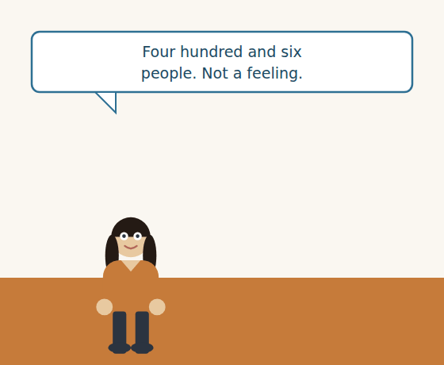
Figure · Strand B · arguing for something that does not exist yet.
Dialogue 2 — Making the case (the proposal)
Ms. Maya: Three shops, three months, one sheet of paper. Four hundred and six people asked us for five-millimetre bar. Sixty-one asked for eight.
Ms. Rania: And we told all of them no.
Ms. Maya: We told all of them no. That is not a feeling. That is four hundred and six people.
Rami: I have done the Unit Two work. Three enquiries, three replies, two suppliers checked, landed cost built, and I have tested the price against the Homs yard.
Ms. Rania: What would you need?
Rami: Two hundred tonnes as a trial. Sell it through the three shops we already have. Decide about a fourth shop after six months, not before.
Ms. Rania: And if it does not sell?
Rami: Then we have two hundred tonnes of a product four hundred people asked for, and we will have learned something that costs less than one container of a mistake.
Mr. Adnan: Who owns it?
Ms. Maya: I do. The sheet was mine. The first six months should be mine too.
A. Comprehension. Answer in your own words.
1. What evidence does Ms. Maya give, and over what period?
2. What work has Rami already done?
3. What exactly is the proposal, and what is deliberately left until later?
4. What is Rami’s answer to “and if it does not sell?”
B. Listen again and choose the best answer (A–D).
1. The sheet was kept for … months. A) one B) two C) three D) six
2. The number who asked for 5 mm bar was… A) 61 B) 200 C) 406 D) 467
3. The trial would be … tonnes. A) 40 B) 200 C) 406 D) 1,200
4. The fourth shop would be decided after … months. A) three B) six C) nine D) twelve
Part 4 · Speaking and Your Role (the simulation) TRADE
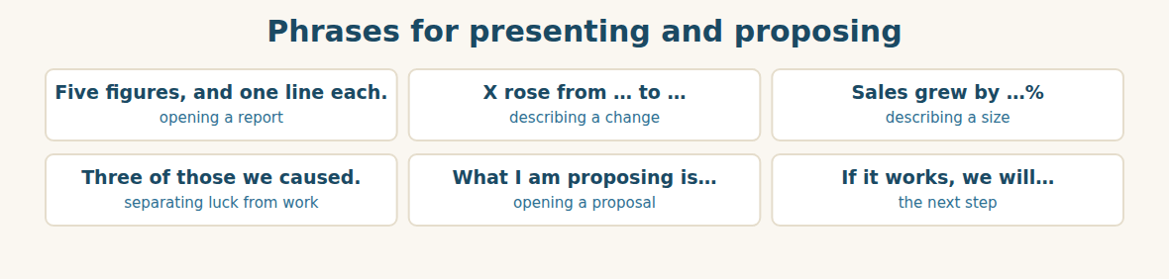
Figure · A report is figures plus the reason for each one.
A. Role-play: the annual review. Work in groups of four. One presents the figures, one makes a proposal, one asks the hard questions, one decides.
1. Presenter: give five figures, one sentence each.
2. Decider: ask which of them the company caused.
3. Proposer: give your evidence as a number, not a feeling.
4. Questioner: ask “and if it does not work?”
5. Proposer: answer honestly, and say what the trial would cost.
6. Decider: ask “who owns it?” and get a name.
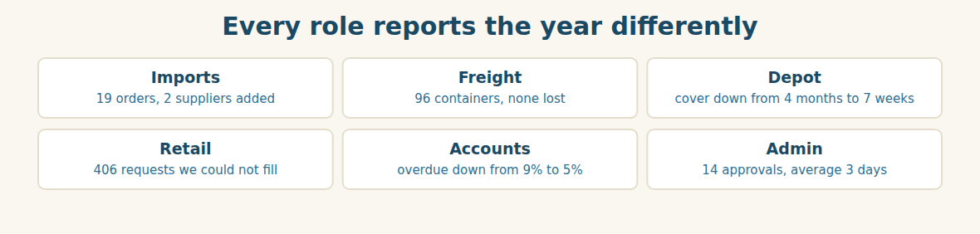
Figure · Six roles, six figures, one year.
B. Your Role. Report YOUR year in one figure and one reason. (Choose your real role.)
1. [Trade] Import Manager: “We have placed nineteen orders, up from eleven.”
2. [Logistics] Freight: “We cleared ninety-six containers and lost none.”
3. [Trade] Depot: “Cover fell from four months to seven weeks, because every line has an owner.”
4. [Trade] Retail: “Four hundred and six people asked for a product we do not stock.”
5. [Finance] Accountant: “Overdue money fell from nine per cent to five.”
6. [Admin] Assistant: “Fourteen approvals, three days on average, down from eight.”
C. Ask your partner. Walk around and ask three people.
1. Which of your figures went up this year, and did you cause it?
2. What would you propose, and what evidence do you have?
3. Who would own it?
D. Discuss. Ask and answer.
1. Why does Mr. Adnan ask “who owns it?” instead of asking about the money?
2. Is it better to grow by selling more of what you have, or by adding something new?
Part 5 · Extended Reading TRADE
The two questions a good report answers
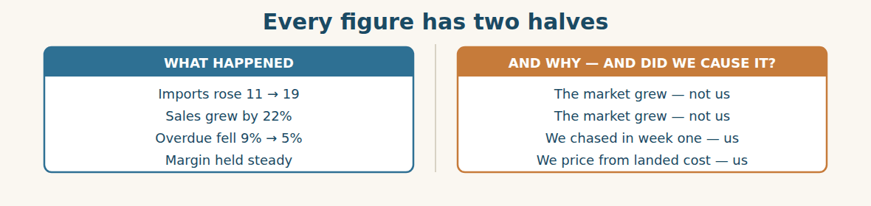
Figure · Half the figures are weather. Half are work.
Almost every company produces a report at the end of the year, and most of them are useless in the same way: they say what happened and stop. Sales were up eleven per cent. Costs were down three. Everyone nods, and nobody learns anything, because a number on its own cannot tell you what to do next.
A good report answers two questions about every figure. The first is what happened, which is arithmetic. The second is why, which is judgement — and the most important part of the second question is whether the company caused it or merely received it.
This distinction is not academic. Suppose sales rise twenty-two per cent in a year when the whole market rises twenty-five. The figure is good and the performance is bad: the company lost ground while its numbers improved. Now suppose overdue money falls from nine per cent to five because collection was changed from week four to week one. That is smaller, less impressive, and far more valuable, because it will still be true next year when the market is worse.
The habit of asking “did we cause it?” also protects a company from its own good luck. A business that grows in a rising market usually believes it is growing because it is clever. It hires, it buys stock, it opens branches — and when the market turns, all of those decisions turn out to have been built on weather. The company that knows which three of its five figures were its own work is the one that can tell the difference between a good year and a good company.
The second half of a report is the proposal, and it follows the same rule. A proposal built on an opinion — “I think customers want bar” — is a feeling with a budget attached. A proposal built on four hundred and six recorded requests is an argument. The difference is not confidence; it is evidence, and evidence is almost always boring to collect. Somebody wrote a line on a sheet by a till, four hundred and six times, over three months, and that is what a hundred-thousand-dollar decision is made of.
And then the last question, which costs nothing and decides everything: who owns it? A proposal with no name is a wish. A proposal with a name, a date and a number is a plan — and the person whose name is on it will keep thinking about it on a Sunday, which no committee has ever done.
A. Comprehension. Answer in your own words. (0 is done for you.)
0. Why are most annual reports useless? (they say what happened and stop)
1. What are the two questions a good report answers?
2. Why can a twenty-two per cent rise be a bad performance?
3. Why is the fall in overdue money “far more valuable”?
4. How does a rising market mislead a company?
5. What is the difference between a proposal that is a feeling and one that is an argument?
B. Choose the best answer (A–D).
1. A number on its own cannot tell you… A) what happened B) what to do next C) the total D) the date
2. If the market rose 25% and sales rose 22%, the company… A) did well B) lost ground C) grew fastest D) broke even
3. The fall in overdue money is valuable because it will still be true… A) in March B) next year C) abroad D) in the shops
4. A proposal with no evidence is… A) an argument B) a feeling with a budget C) a forecast D) a report
5. A proposal with no name is… A) a plan B) a wish C) a trial D) a target
C. Find a word or phrase in the text that means:
1. to become worse, about a market → to t____________
2. facts that support an argument → e____________
3. to lose position compared with others → to lose g____________
4. not based on fact, only on what you believe → an o____________
D. Complete the summary with ONE word in each gap.
Most reports say what (1)____________ and stop. A good one also asks (2)____________, and whether the company (3)____________ it. A rise in a rising market can be a bad (4)____________. A proposal built on an opinion is a feeling; one built on (5)____________ is an argument. And a proposal with no (6)____________ is a wish.
E. Discuss. Talk in pairs.
1. Which of your company’s results last year did it actually cause?
2. What evidence would you need before proposing something new?
F. True or False? (about the reading). Write T, F or NOT GIVEN.
1. A number on its own tells you what to do next. ____
2. Growing in a rising market proves a company is clever. ____
3. Most companies record lost sales. ____
4. The writer thinks a named owner matters more than a committee. ____
Part 6 · Writing (a real email) ADMIN
Model — A one-page proposal
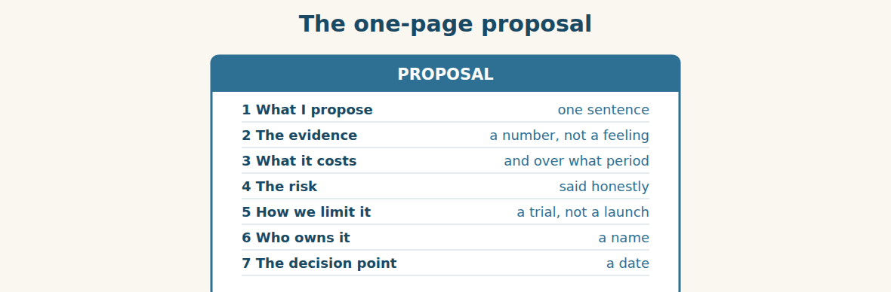
Figure · Seven lines. If it needs two pages, it is not ready.
Subject: Proposal — trial import of 5 mm steel bar. Dear Mr. Adnan, I propose that we import two hundred tonnes of five-millimetre steel bar as a trial, and sell it through our three existing shops. The evidence is not an opinion. Over three months our shops recorded four hundred and six customers who asked for five-millimetre bar and were told we did not stock it, and a further sixty-one who asked for eight millimetre. Rami has completed the sourcing work: three enquiries, three replies, two suppliers checked, and a landed cost built and tested against the Homs yard. The main risk is that bar sells more slowly than coil, and we would be holding stock we have not held before. We limit that risk by starting with two hundred tonnes rather than a full container load, and by using shops we already pay for. Ms. Maya would own the trial. I suggest we review it after six months and decide then whether to continue, and only after that whether a fourth shop is justified. Best regards, Rami Import Manager, Bashak Co.
A. Answer about the email. (0 is done for you.)
0. What exactly is proposed? (a trial import of 200 tonnes of 5 mm steel bar, sold through the three existing shops)
1. What is the evidence, and over what period?
2. What is the main risk, and how is it limited?
3. Who owns it, and when is the decision point?
B. Put the proposal in order (1–6).
1. ( ) The main risk is that bar sells more slowly than coil.
2. ( ) Dear Mr. Adnan,
3. ( ) I propose that we import two hundred tonnes as a trial.
4. ( ) Over three months our shops recorded four hundred and six customers.
5. ( ) Ms. Maya would own the trial.
6. ( ) Best regards, Rami
Guided writing
C. Now you write. Write a one-page proposal (90–120 words) for something at your work. Give one number as evidence, say the risk honestly, name an owner, and give a decision date.
Plan: 1) “Dear …,” 2) “I propose that we ….” 3) “The evidence is ….” 4) “The main risk is ….” 5) “We limit that by ….” 6) “… would own it.” 7) “I suggest we review it in ….” 8) “Best regards, …”
Sentence starters: “I propose that we…” · “The evidence is not an opinion.” · “The main risk is…” · “We limit that risk by…” · “I suggest we review it after…”
______________________________________________
______________________________________________
______________________________________________
______________________________________________
______________________________________________
D. Checklist. Tick each one when you have checked your proposal.
- I said what I propose in one sentence.
- I gave a number as evidence, not a feeling.
- I said the main risk honestly.
- I said how the risk is limited.
- I named an owner and gave a decision date.
Part 7 · Trade-Skills Track (the project) TRADE
The course project: run one cycle, end to end
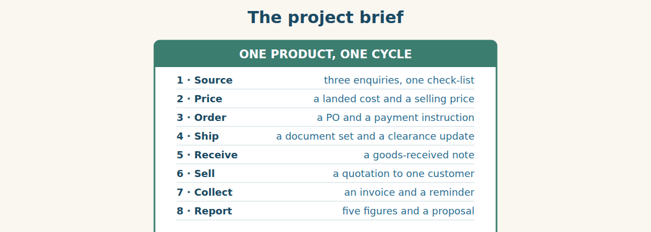
Figure · Eight documents, one product, the whole of Book 2.
This is the project the whole course has been building towards. Working in groups of four, take one real product — something your own company buys or sells — and run it through the entire cycle, producing one document at each stage. Nothing has to be long. A quotation is five lines. A clearance update is six.
Share the roles so that everybody writes at least two documents. One person is the import desk and writes the enquiry and the purchase order. One is finance and builds the landed cost and the payment instruction. One is logistics and writes the document set and the clearance update. One is sales and writes the quotation and the reminder. Then everybody contributes to the final report.
Two rules make the project worth doing. First, use real numbers. Invent a price if you must, but then carry it all the way through: the landed cost must come from the unit price you wrote earlier, and the selling price must come from the landed cost. A project where the numbers do not join up teaches nothing. Second, when you reach stage eight, include one thing that went wrong, and write the apology for it. Every real cycle has one.
At the end, present it in ten minutes: five figures and one proposal, exactly as Karim and Rami did. Your classmates ask the two questions Mr. Adnan asked — which of these did you cause, and who owns it? If you can answer both in English, you have finished this book.
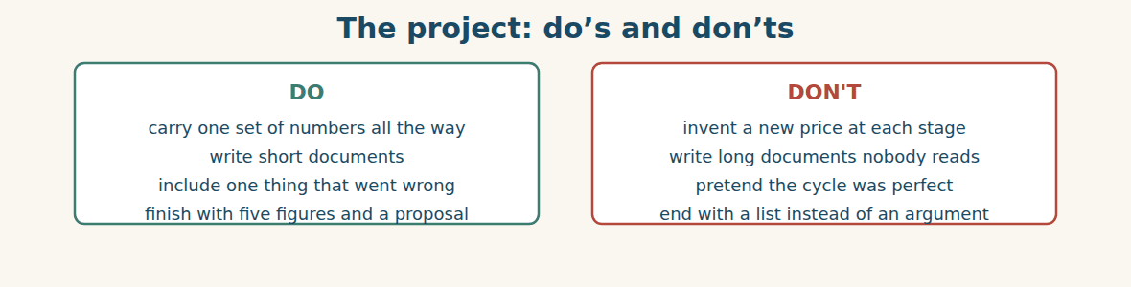
Figure · A project that joins up is worth ten that do not.
A. Comprehension. Answer in your own words.
1. What does the project ask each group to do?
2. How are the roles shared, and how many documents does each person write?
3. What is the first rule about numbers, and why does it matter?
4. What must you include at stage eight?
5. What two questions will your classmates ask at the end?
B. Listen and complete. Mr. Tarek explains the project. Write the missing word.
1. Mr. Tarek: Take one real ____________ and run it through the whole cycle.
2. Mr. Tarek: The landed cost must come from the ____________ price you wrote earlier.
3. Mr. Tarek: Include one thing that went ____________.
4. Mr. Tarek: Finish with five figures and one ____________.
C. Practice. In your group, choose your product now and write the first document — the enquiry — in ten minutes. Then swap with another group and mark it against the Unit 2 checklist.
D. Which unit does each document come from?
1. a landed cost build-up → Unit ____________
2. a bill of lading check → Unit ____________
3. a goods-received note → Unit ____________
4. a payment reminder → Unit ____________
Part 8 · Consolidation TRADE
Who owns it?
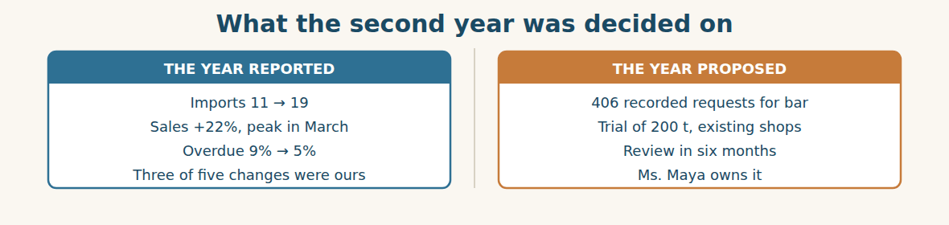
Figure · A page of figures and a page of evidence, and one name.
Mr. Adnan approves the trial in about forty seconds, which surprises nobody who has watched him for a year. The file answered every question before he asked it — which was the lesson of Unit Four, learned in November and used in October.
Then he does the thing that makes it real. He does not say “go ahead”. He says “Maya, two hundred tonnes, review on the fifteenth of June, and you report it — not Rami, not Lina, you.” Ms. Maya, who has worked at Alten IL for six years and has never spoken at a board review, writes the date on the back of her hand.
Afterwards Karim and Rami walk down to the yard, past the painted line and the red tags, past the handover folder hanging by the gate. Rami says the thing he has been thinking all morning. “A year ago we didn’t know what the depot held. Today we know what four hundred and six people wanted and couldn’t have.”
“That is the whole year,” says Karim. “We did not get cleverer. We started writing things down.”
In the shop on the Rural Damascus road, somebody will ask for five-millimetre bar on Monday morning, and for the first time in two years the answer will not be no. It will be “not yet — but in March.” Which is, as everybody in this book has learned by now, a completely different sentence.
A. Comprehension. Answer in your own words. (0 is done.)
0. How long does Mr. Adnan take to approve the trial, and why so fast? (about forty seconds — the file answered every question before he asked it)
1. What does he say instead of “go ahead”?
2. Why is it significant that Ms. Maya will report it?
3. What three things do Karim and Rami walk past in the yard?
4. What does Rami say has changed in a year?
5. What will the answer in the shop be on Monday, and why does it matter?
B. Complete each sentence with ONE word from the text. (0 is done for you.)
0. Mr. Adnan approves the trial in about forty seconds.
1. The ____________ answered every question before he asked it.
2. The review is on the fifteenth of ____________.
3. Ms. Maya writes the date on the back of her ____________.
4. Karim says they did not get cleverer — they started ____________ things down.
5. The answer on Monday will be “not yet — but in ____________”.
C. Discuss. Talk in pairs.
1. Why does Mr. Adnan insist that Ms. Maya reports it herself?
2. Do you agree that “we started writing things down” is the whole year?
D. Find a word from the text that means: (0 is done for you.)
0. to say officially that something can happen → (to approve it)
1. a small first order to test an idea → a t____________
2. the paper that tells the next person what is happening → a h____________ folder
3. the person responsible for something → the o____________
Part 9 · Case Studies and Decisions TRADE
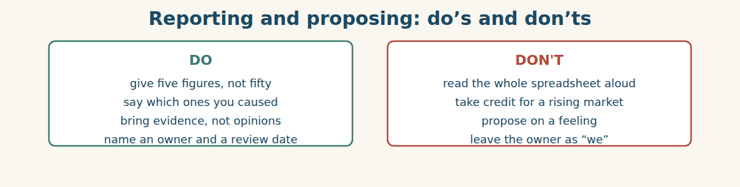
Figure · The shortest report in the room is usually the best one.
Case 1 — The figure that flatters you (strand A · the report)
Your sales rose eleven per cent. You then learn that the whole market rose eighteen. Your manager has already congratulated you in front of the board, and the figure is in the pack.
Choose the best action and say why.
1. ( ) Say nothing. The figure is true.
2. ( ) Add one line to the pack showing the market figure beside yours, and say it yourself before somebody else does.
3. ( ) Tell your manager privately after the meeting.
4. ( ) Leave it and work harder next year.
Write one sentence that reports both figures honestly.
______________________________________________
______________________________________________
Case 2 — A proposal with no number (strand B · the proposal)
A colleague proposes opening a shop in a new town. His argument is that “everybody knows there is demand there” and that a competitor opened one last year. He has no figures at all, and he is well liked.
Answer the questions.
1. What is wrong with “everybody knows”, and with the competitor argument?
2. What is the smallest piece of evidence that would make it a real proposal?
3. Write one sentence asking for evidence without attacking the idea.
Case 3 — Two good proposals, one budget (where the strands meet)
You can fund the bar trial or a fourth shop, not both. The bar trial has four hundred and six recorded requests and an owner. The fourth shop has a better long-term return but no evidence yet, and the person proposing it is more senior than you.
Answer the questions.
1. Which would you fund first, and what is your single strongest reason?
2. How could you keep the second idea alive without funding it this year?
3. Write one sentence recommending one and protecting the other.
Part 10 · Review and Can-Do (course review) TRADE
A. Vocabulary. Complete the sentence with a word from the course.
1. A letter asking a supplier for information is an ____________.
2. What the goods cost in our own depot is the ____________ ____________.
3. The paper proving goods were put on board is the ____________ ____________ ____________.
4. The level at which we order more is the ____________ ____________.
5. The real reason behind the first one is the ____________ ____________.
B. Grammar. Complete with the correct form.
1. We ____________ (place) nineteen orders so far this year.
2. The containers ____________ (clear) by Komosh every time.
3. The truck ____________ (wait) when the papers arrived.
4. If we ____________ (order) 2,000 tonnes, they ____________ (give) us seven per cent.
5. You ____________ (not) deduct a claim from a payment.
6. Although sales ____________ (rise), cement ____________ (be) still tight.
C. Reading. Read the short text and answer.
Imports rose from eleven orders to nineteen and sales grew by twenty-two per cent, with the highest month in March. Overdue money fell from nine per cent of sales to five, and stock cover on steel dropped from four months to seven weeks. The margin held steady. Three of the five changes were caused by the company itself; the other two followed the market.
1. What happened to imports, in figures?
2. Which month was the highest for sales?
3. How many of the five changes did the company cause?
D. Listening. Listen and answer. (Teacher reads.)
[Teacher reads] “Four hundred and six people asked us for five-millimetre bar over three months, and sixty-one asked for eight millimetre. We told all of them no. That is not a feeling — that is four hundred and six people. I propose a trial of two hundred tonnes through our existing shops.”
1. How many people asked for five-millimetre bar, and over what period?
2. What were they all told?
3. What exactly is proposed?
E. Speaking. In groups of four, run the review: one presents five figures, one proposes, one questions, one decides and asks “who owns it?”
F. Writing. Write two sentences about your own year: one with the present perfect and “so far”, and one with “going to”.
1. ______________________________________________
2. ______________________________________________
G. Error correction. Find and correct one mistake in each sentence.
1. We have placed eleven orders last year. → ____________
2. The goods was cleared by Komosh. → ____________
3. If we will order 2,000 t, they give 7%. → ____________
4. Although sales rose, but cement was tight. → ____________
5. He said me he needed 200 tonnes. → ____________
H. Match the unit (1–5) to its grammar (a–e).
1. Unit 1 ____ a. the passive
2. Unit 3 ____ b. reported speech
3. Unit 5 ____ c. present perfect vs past simple
4. Unit 7 ____ d. should, could, may, might
5. Unit 8 ____ e. first conditional and unless
I. Put the trade cycle in order (1–6).
1. ( ) clear it at customs
2. ( ) find and check a supplier
3. ( ) collect the money
4. ( ) agree the price
5. ( ) sell it to a customer
6. ( ) place the order and pay the deposit
Can-Do check. Tick what you can do.
- I can describe figures going up and down.
- I can present a short report.
- I can argue for a new supplier, line or branch.
- I can write a one-page proposal.
Part 11 · Foundations for Further Study TRADE
Concept Spotlight: Writing it down is the whole trick
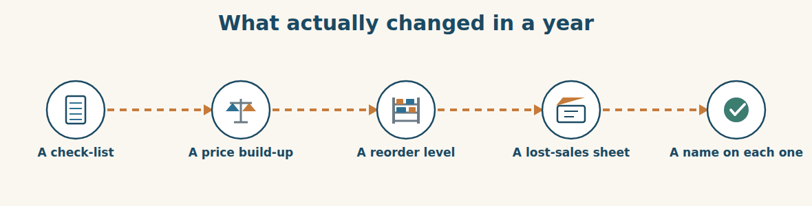
Figure · Five sheets of paper, and not one clever idea among them.
Look back at the year in this book and try to find the clever part. There isn’t one. Nobody invented a product, outsmarted a competitor or had an idea at three in the morning. What happened was duller and far more powerful: things that lived in people’s heads were written down, and each one was given a name.
The supplier rules were in Mr. Tarek’s head, so Unit Two wrote them as a check-list. The real cost of a tonne was in Lina’s head, so Unit Three wrote it as a build-up. The reject corner was in Ms. Dana’s head — until she took a week’s leave, and twelve tonnes went to Homs. And the demand for steel bar was in four hundred and six separate customers’ heads, where it was completely useless to anybody, until somebody put a sheet of paper next to a till.
This is why learning English for your work is not really about English. It is about the same thing. A fact inside your head helps only you, and only while you are in the room. The moment you can write it in a language your supplier, your bank and your customer all read, it becomes something the whole business can use — and it keeps working when you are on leave, when you change jobs, and when the people who remember the story have all gone.
There is a fair objection to all this. Writing things down can become its own disease: forms that nobody reads, reports that take a week to produce, procedures thicker than the thing they describe. That is real, and the test is the same one this book has used throughout. Does anybody act on it? The lost-sales sheet was two columns, and it moved a hundred thousand dollars. A fifty-page quarterly review that changes nothing is not thoroughness; it is decoration, as Mr. Tarek would say.
So as you close this book, keep three habits rather than three hundred words. Write down the thing only you know. Put a number on it instead of an adjective. And put a name beside it, preferably your own. Everything else in these ten units — the enquiries, the conditionals, the passives, the reported speech — is just the machinery for doing those three things in a language the rest of the world can read.
A. Understanding check. Answer in your own words.
1. What does the writer say was NOT the reason for the year’s improvements?
2. Give two examples of knowledge that moved from a head onto paper.
3. Why is learning English for work “not really about English”?
4. What is the fair objection, and what is the test the writer gives?
B. Apply it. Do this task with a partner.
Name one thing that exists only in your head at work. Write it down now, in English, in no more than four lines, with one number and one name. Then give it to your partner and ask: could you act on this if I were not here?
C. Micro-writing (optional).
Write a few sentences (60–80 words) about your own year at work. Use the present perfect, one figure with “rose” or “fell”, and one sentence beginning “Next year we are going to…”.
Study terms: rise / rose · fall / fell · grow / grew · drop · increase · decrease | by · from … to … · peak · the highest · the lowest · steady | sharp · slight · gradual · double · per cent · figure | total · average · forecast · target · actual · quarter | year on year · summary · proposal · recommendation · business case · evidence | trial · pilot · risk · return · owner · review date
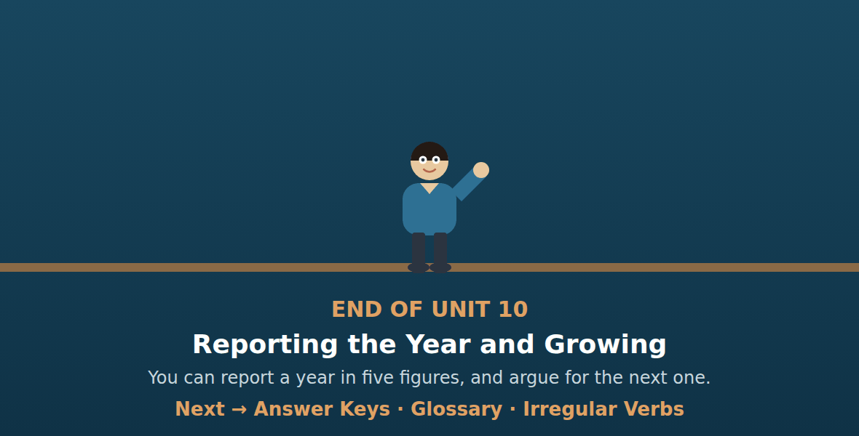

Irregular Verbs
Al-Hasan International — English for Trade, Industry & Global Partnerships
The sixty irregular verbs used in this book · base form · past simple · past participle
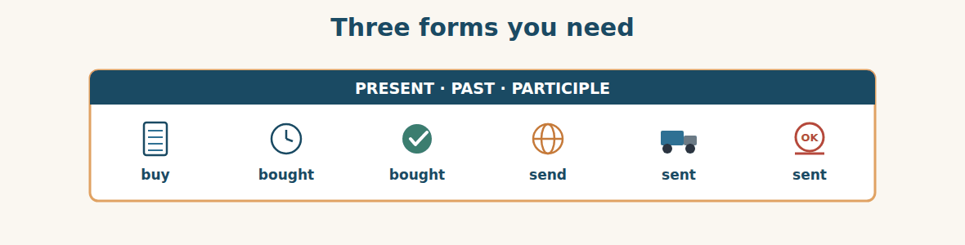
Figure · The three forms, for the present perfect and the passive.
Use the past simple (column 2) for a finished action with a time: We bought it last week. Use the past participle (column 3) after have / has (We have bought it) and in the passive (It was bought in May).
be — was / were — been become — became — become begin — began — begun
break — broke — broken bring — brought — brought build — built — built
buy — bought — bought catch — caught — caught choose — chose — chosen
come — came — come cost — cost — cost cut — cut — cut
deal — dealt — dealt do — did — done draw — drew — drawn
drive — drove — driven fall — fell — fallen feel — felt — felt
find — found — found forget — forgot — forgotten get — got — got
give — gave — given go — went — gone grow — grew — grown
have — had — had hear — heard — heard hold — held — held
keep — kept — kept know — knew — known lead — led — led
leave — left — left lend — lent — lent let — let — let
lose — lost — lost make — made — made mean — meant — meant
meet — met — met pay — paid — paid put — put — put
read — read — read rise — rose — risen run — ran — run
say — said — said see — saw — seen sell — sold — sold
send — sent — sent set — set — set show — showed — shown
sign — signed — signed speak — spoke — spoken spend — spent — spent
stand — stood — stood take — took — taken teach — taught — taught
tell — told — told think — thought — thought understand — understood — understood
win — won — won write — wrote — written rebuild — rebuilt — rebuilt

Glossary
Al-Hasan International — English for Trade, Industry & Global Partnerships
Every target term in Book 2, in alphabetical order, with the unit that teaches it
accept (v) (U6) to agree that goods are right
account customer (U7) a customer we invoice monthly
account number (U4) the number of a bank account
action plan (U9) a list of what we will do, and by when
actual (U10) what really happened
admit (U9) to agree that something is true
aged debt list (U8) who owes money, and for how long
agree (U7) to say yes to something proposed
already (U1) earlier than expected
although (U9) the next part will surprise you
annual review (U1) the yearly meeting about results
anticipate (U4) to think what will happen before it does
apologise (U9) to say you are sorry
apology (U9) saying you are sorry
approval (U2) official permission
approval limit (U4) the largest amount one person may approve
approve (U2) to say officially that something can happen
arrangement (U4) something fixed with a time and other people
ask (U7) to report a question
authorise (U2) to give someone the right to act
authorised signatory (U4) the person who is allowed to sign
availability (U7) what we can supply and when
average (U10) the usual amount
backlog (U9) work that has built up and is waiting
bad debt (U8) money we will never be paid
balance (U3) the rest of the money, paid later
bank charges (U4) what the banks charge for a transfer
bank details (U2) the account the money is sent to
bank holiday (U4) a day when the banks are closed
bank transfer (U4) money moved from one bank to another
batch (U6) a group of goods made at one time
batch number (U6) the number showing the production run
be allowed to (U2) to have permission
because (U9) the reason, with a subject and verb
because of (U9) the reason, with a noun
below specification (U6) not meeting the agreed details
beneficiary (U4) the company receiving the money
bill of lading (U5) the paper proving goods were put on board
board approval (U4) permission from the board
board member (U1) a person who helps decide the big things
branch (U1) one shop or office of a company
breakdown (U9) when a machine stops working
budget (U4) the money set aside for something
business case (U10) the argument for spending money
by (U10) the size of a change (rose by 22%)
can / can’t (U2) it is allowed / not allowed
cash (U7) money paid at once
cash flow (U8) money actually moving in and out
catalogue (U2) a book of all the products a company sells
cause (U9) the thing that made it happen
certificate (U2) a paper proving the goods meet a standard
certificate of origin (U5) a paper saying where goods were made
CFR (U3) the seller pays the ship to our port
chase (v) (U8) to ask again for money that is late
claim (U6) a letter asking for money or goods back
clear (v) (U4) to arrive and be available in an account
clearance (U5) getting goods through the customs office
clearance fee (U3) what the agent charges at the port
clearing agent (U5) the company that handles clearance for you
close a sale (U7) to get the customer to agree
collection (U7) the customer takes the goods away
commercial invoice (U5) the paper saying what the goods are worth
commitment (U4) money the company has promised to spend
compare (U2) to look at two things to see which is better
compensation (U9) money or goods to make up for a loss
complaint (U9) a customer saying something is wrong
concession (U3) something you give away in a negotiation
confidential (U2) secret; not to be shared
confirm (U2) to say again that something is true
consignee (U5) the company the goods are sent to
consignment (U5) the goods sent in one shipment
container (U1) a big steel box for carrying goods
convert (U3) to change one currency into another
cost price (U3) what we pay, before our margin
could (U8) one possible option
count (v) (U6) to find out how many there are
counter (U7) the table where customers are served
counter-offer (U3) a different offer, in reply
credit check (U8) finding out if a customer pays
credit limit (U8) the most a customer may owe at once
credit note (U6) a paper that gives money back
credit terms (U7) how long the customer has to pay
credited (U4) put into an account
creditor (U8) a company we owe money to
criteria (U2) the things you judge a choice by
currency (U3) the money of a country
customer (U1) a person or company that buys from us
customs clearance (U1) getting goods through the customs office
customs declaration (U5) the form submitted to customs
customs duty (U3) money paid to the government on imports
damage (U6) harm done to the goods
days in hand (U9) spare time kept for safety
deadline (U2) the last possible date
debited (U4) taken out of an account
debtor (U8) a company that owes us money
decrease (U10) to go down, or the amount of the fall
deduction (U8) an amount taken off a payment
defect (U6) something wrong with the goods
delay (U9) when something happens later than planned
delivered price (U7) a price including transport to the customer
demand (U7) how much people want to buy
demurrage (U5) money charged for keeping a container too long
deny (U9) to say something is not true
deposit (U3) the first part of the money, paid early
depot (U1) a building where goods are kept
despite (U9) although, with a noun
discharge (v) (U5) to unload from a ship
discount (U3) money off a price
dispute (U8) a disagreement about an amount
distributor (U1) a company that sells goods for someone else
don’t have to (U2) it is not necessary; you can choose
double (U10) twice as much
drop (U10) to go down, often quickly
due date (U8) the day the money must be paid
enquiry (U2) a letter asking a supplier for information
escalate (U8) to take a problem to a manager
ETA (U5) the expected day of arrival
ETD (U5) the expected day of departure
ever (U1) at any time, in questions
evidence (U10) facts that support an argument
ex-works (U7) the price before any transport
exception (U2) a case where the rule is not followed
exchange rate (U3) the price of one currency in another
excuse (U9) a reason given to avoid blame
expire (U3) to come to an end, like an offer
explain (U7) to make something clear
explanation (U9) saying how something happened
export (v) (U1) to send goods out of a country
fall / fell (U10) to go down
fast-moving (U6) selling quickly
fault (U9) responsibility for a mistake
figure (U10) a number in a report
firm price (U3) a price that will not change
FOB (U3) the seller pays only to their own port
fodder (U1) food for farm animals
follow up (U7) to contact a customer again
follow-up (U9) contacting again to check
for (U1) with a length of time
forecast (U10) what we expect to happen
founder (U1) the person who started the company
freight (U1) goods carried by ship, truck or plane
from … to … (U10) the start and end of a change
gauge (U6) the thickness of a material
general manager (U1) the person who runs the whole company
going to (U4) a plan already decided
goods-received note (U6) the paper signed when goods arrive
goodwill gesture (U9) something given to keep a relationship
grade (U6) the quality or size of a material
gradual (U10) slow and even
gross weight (U5) the weight with the packing
grow / grew (U10) to get bigger
growth (U1) getting bigger
handover (U9) telling the next person what is happening
haulage (U5) road transport inland
have to (U2) it is necessary, often from outside
head office (U1) the main office of a group
hold (v) (U5) to stop goods from moving
hold up (v) (U4) to stop something going forward
hold-up (U9) something that stops progress for a time
holding group (U1) one big company that owns smaller ones
import (v) (U1) to bring goods into a country
import manager (U1) the person who buys from abroad
in advance (U4) before the goods are sent
in stock (U7) available now
in transit (U5) on the way, not yet arrived
in writing (U2) on paper or in an email, not spoken
incoterm (U3) a rule saying who pays for what
increase (U10) to go up, or the amount of the rise
inland transport (U3) the trucks from the port to the depot
inspection (U5) customs opening and checking the goods
instalment (U4) one part of a payment made in stages
insurance (U3) protection you pay for
invoice (U8) the paper asking a customer for payment
issue (v) (U5) to give out officially
just (U1) a very short time ago
landed cost (U3) what the goods cost in our own depot
lead (U7) a possible customer who has shown interest
lead time (U2) the time between the order and the delivery
leave (U9) time away from work
letter of credit (U4) a bank promise to pay on documents
lost sale (U7) a customer who asked and was not supplied
margin (U3) what we add on top of our cost
mark-up (U3) the margin as a percentage of cost
market (U1) the people and companies who buy
may (U8) perhaps; also, permission
might (U8) perhaps, a little less certain
minimum order (U2) the smallest amount a supplier will sell
mismatch (U5) two papers saying different things
must (U2) it is necessary
mustn’t (U2) it is forbidden
near miss (U5) an accident that almost happened
negotiate (U3) to talk until both sides agree
net weight (U5) the weight of the goods alone
never (U1) at no time
notify party (U5) the company told when the ship arrives
objection (U7) a reason the customer gives for not buying
offer (U3) a price a supplier proposes
offset (U8) to take one amount away from another
on board (U5) loaded onto the ship
on credit (U7) paying later, not now
order book (U8) orders a company has not yet delivered
order confirmation (U4) the supplier’s paper saying “we accept”
out of stock (U7) not available now
outstanding (U8) still not paid
overdue (U8) money that should have been paid already
owner (U10) the person responsible for something
packing list (U5) a paper saying what is in each container
pallet (U6) a wooden base for stacking goods
part payment (U8) paying only a part of what is owed
payable (U8) money we owe our suppliers
payment history (U8) how a customer has paid before
payment schedule (U4) when and how much we will pay
payment terms (U3) when and how the money is paid
peak (U10) the highest point reached
per cent (U10) out of a hundred
per tonne (U3) for each tonne
pilot (U10) a small first version, to learn from
PO number (U4) the number that identifies an order
policy (U2) the rules a company has written down
port of discharge (U5) where the goods come off the ship
port of loading (U5) where the goods go on the ship
prevent (U9) to stop something happening
preventable (U9) able to be stopped before it happens
price list (U2) a list of prices by product
product line (U1) one kind of product a company sells
profit (U3) what is left after all the costs
proforma invoice (U4) a price document used to arrange payment
project customer (U7) a customer buying for a building job
promise (U7) to say you will certainly do something
proposal (U10) a written suggestion to do something
purchase order (U4) the paper that places an order with a supplier
put right (U9) to correct a mistake
quality control (U6) the work of checking goods
quantity (U3) how many or how much
quarter (U10) three months of the year
quotation (U2) a written price from a supplier
quote (v) (U7) to give a price
receipt (U7) the paper a shop gives when you pay
receivable (U8) money our customers owe us
recommendation (U10) what you advise doing
recurrence (U9) the same problem happening again
reference (U2) another buyer who can speak for a supplier
refund (U9) money given back
registered (U2) officially listed with the authorities
reject (U2) to say no to an offer
reject (v) (U6) to refuse goods that are not right
release (v) (U5) to allow goods to go
release order (U5) customs saying the goods may go
reliable (U2) always doing what was promised
reminder (U8) a polite letter asking for payment
remittance advice (U8) a note saying what a payment is for
remitter (U4) the company sending the money
reorder level (U6) the level at which we order more
replacement (U6) goods sent to replace bad ones
requirement (U2) something that is necessary
reserve (v) (U7) to keep goods for one customer
responsibility (U9) the duty to deal with something
retail (U1) selling in small amounts in a shop
retail customer (U7) a person buying for themselves
return (U10) what you get back for what you spend
review date (U10) the day we decide whether to continue
rise / rose (U10) to go up
risk (U3) the chance that something bad will happen
root cause (U9) the real reason behind the first one
run out of cash (U8) to have no money left
safety stock (U6) extra stock for bad weeks
sample (U2) a small piece, to show the quality
say (U7) to report words, with no listener named
schedule (v) (U4) to fix a time for something
seal (U5) the numbered lock on a container
segregate (U6) to keep separate from other goods
selling price (U3) what the customer pays
settle (U8) to pay in full and close the account
sharp (U10) a large, fast change
shelf life (U6) how long goods stay good
shipment (U5) goods sent together at one time
shipper (U5) the company sending the goods
short delivery (U6) a delivery with less than agreed
shortage (U6) less than the agreed quantity
shortlist (U2) the best two or three, chosen from many
should (U8) advice: the right thing to do
shouldn’t (U8) advice: the wrong thing to do
sign off (U4) to approve formally
since (U1) with a point in time
slight (U10) a small change
slow-moving (U6) sitting on the shelf
so (U9) and the result was
so far (U1) up to now
source (v) (U2) to find a supplier for something
specification (U2) the exact details of what we need
statement (U8) a list of everything owed on an account
steady (U10) not changing much
stock (U1) the goods a company has now
stock count (U6) counting everything on the shelves
stock level (U6) how much we have now
storage (U3) keeping goods in a warehouse
storage charge (U5) money charged for goods left at the port
submit (U5) to send a form officially
subsidiary (U1) a company inside a bigger group
summary (U10) a short account of the main points
supplier (U1) a company that sells to us
surplus (U6) more than we need
suspend (U8) to stop supplying for now
target (U1) the number we want to reach
tell (U7) to report words to a named listener
that (U6) for people or things
the highest (U10) the biggest in a set
the lowest (U10) the smallest in a set
till (U7) where customers pay in a shop
tolerance (U6) how much difference is allowed
total (U10) everything added together
total value (U3) unit price multiplied by quantity
trade customer (U7) a business that buys to use or sell on
trade licence (U2) a paper proving the company is registered
trial (U10) a small first order to test an idea
trial order (U2) a small first order, to test a supplier
turn away (U7) to send a customer off without a sale
turnover (U1) the total money a business takes in
unit price (U3) the price of one tonne or one item
valid until (U3) the last day the price is good
value date (U4) the day the money is available
verifiable (U9) able to be checked and proved
vessel (U5) the ship that carries the goods
volume discount (U3) money off for a large order
voyage (U5) a ship’s journey from port to port
walk-in (U7) a customer who comes into the shop
warehouse (U1) a large building for storing goods
weeks of cover (U6) how long the stock will last
where (U6) for places
which (U6) for things
while (U9) during the time that
who (U6) for people
wholesale (U1) selling in large amounts to businesses
will (U4) a decision now, a promise, or a prediction
working day (U4) a day when the banks are open
write off (U8) to accept that money will not be paid
year on year (U10) compared with the same time last year
yet (U1) not until now

Answer Keys
Al-Hasan International — English for Trade, Industry & Global Partnerships
Complete Course · Units 1–10

Answer Key — Unit 1
Warm-Up A 1 The Group buys much more than it makes. 2 Bashak; Rami is the Import Manager. 3 It arranges the ship and clears the goods at customs (and owns the trucks). 4 (any two) Chemco — to builders and factories; Alten IL — to ordinary people in shops; Altintash — to farmers. 5 He has opened two new supplier accounts. 6 Because NorthBridge is now both a customer and a supplier — that is how a group grows.
Warm-Up B 1 T · 2 T · 3 F · 4 T · 5 F · 6 T
Warm-Up C 1 import · 2 depot · 3 abroad · 4 target
Warm-Up D Answers vary.
P1 A 0 c · 1 f · 2 a · 3 b · 4 g · 5 d · 6 e · 7 h (d and h both used; “b” spare)
P1 B 1 subsidiary · 2 import · 3 supplier · 4 subsidiary / customer · 5 depot · 6 retail
P1 C 1 c · 2 a · 3 f · 4 b · 5 d · 6 e
P1 D 1 depot · 2 sell · 3 Tuesday · 4 Damascus · 5 Lattakia
P1 E 1 a · 2 b · 3 a · 4 a
P1 F We buy: Bashak · We move: Komosh · We sell or make: Alten IL, Chemac, Chemco depot, Khalifa Iron
P1 G 1 c · 2 a · 3 b · 4 e · 5 d · 6 f
P1 H 1 Group · 2 subsidiaries · 3 imports · 4 abroad · 5 depot · 6 sells
P2 A 1 has · 2 have · 3 has · 4 have · 5 have
P2 B 1 bought · 2 sent · 3 paid · 4 sold · 5 made · 6 taken
P2 C 1 for · 2 since · 3 for · 4 since
P2 D 1 just · 2 already · 3 yet · 4 yet
P2 E 1 have sold · 2 visited · 3 has worked · 4 arrived · 5 haven’t seen
P2 F 1 Have you ever bought from Westgate? 2 Have the goods arrived yet? 3 How long has she worked in the depot? 4 Have we paid the invoice?
P2 G 1 He has been here for three months. 2 Have you seen the report? 3 They haven’t paid yet. 4 When did you order it?
P2 H Answers vary — one present perfect, one past simple.
P2 I 1 has grown · 2 haven’t reached · 3 has cleared · 4 have sent · 5 has never worked
P2 J 1 We opened two new accounts in March. 2 Alten IL opened a third shop last month. 3 Rami placed eleven orders in 2025. 4 The ship arrived on Tuesday.
P3 D1 A 1 Rami, from Bashak. 2 One year. 3 Nine shipped, two still open. 4 NorthBridge has opened a machines division and wants to sell to Al-Hasan. 5 No — never. 6 Because Chemac has asked for two packing machines.
P3 D1 B 1 T · 2 T · 3 F · 4 T · 5 F (a catalogue)
P3 D1 C 1 we haven’t received them yet · 2 Have you ever imported packing machines? 3 Never.
P3 D2 A 1 Her numbers for the annual review. 2 It opened in May and has already paid for itself. 3 The shop has sold out of cement twice. 4 Ms. Dana, three times — she hasn’t answered.
P3 D2 B 1 B · 2 B · 3 C · 4 C
P4 B Answers vary — report your own year from your own role (see the phrases).
P5 A 1 Move, store and deliver the goods. 2 Komosh. 3 (any two) speed; information; money stays inside the Group. 4 Because the trucks belong to his own group. 5 You must pay for trucks and a warehouse even in a quiet month. 6 If you own the transport, you control it, so delays are your own to fix.
P5 B 1 C · 2 B · 3 C · 4 D · 5 B
P5 C 1 store · 2 clear · 3 quiet · 4 single
P5 D 1 owns · 2 places · 3 clears · 4 sell · 5 Group · 6 expensive
P5 F 1 NOT GIVEN · 2 T · 3 NOT GIVEN · 4 T
P6 A 1 Eleven placed, nine arrived. 2 Two orders have not reached them yet. 3 Because Chemac has asked for two packing machines.
P6 B Order: 2 (Dear Ms. Chen,) · 3 (It has been a year…) · 5 (We have placed eleven orders…) · 4 (Two orders have not reached us yet.) · 6 (Chemac has asked…) · 1 (Best regards, Rami) — i.e. 1 = Best regards, last.
P7 A 1 Buy, move, sell, make. 2 Komosh — books the ships, clears customs, drives the trucks. 3 Alten IL (shops) and Altintash (farmers). 4 Komosh; Alten IL. 5 You do not need to know everything — you need to know who is responsible.
P7 B 1 machines · 2 customs · 3 retail · 4 cement
P7 D 1 Komosh · 2 the Chemco depot · 3 Bashak · 4 Chemco (the depot)
P8 A 1 What the Group has bought, and what it has sold. 2 The depot is full of steel while the shops have run out of cement. 3 Three times; nobody has answered. 4 It has bought well and sold well. 5 The two sides have not talked to each other. 6 Rami and Maya will meet every month.
P8 B 1 sold · 2 depot · 3 answered · 4 meet · 5 company
P8 D 1 out · 2 nod · 3 lesson
P10 A 1 subsidiary · 2 supplier · 3 import · 4 depot · 5 retail
P10 B 1 have placed · 2 visited · 3 has worked · 4 has sold · 5 haven’t sent · 6 sold
P10 C 1 Komosh. 2 9,000 tonnes. 3 Altintash.
P10 D 1 Eleven. 2 Two, since March. 3 Seven.
P10 G 1 We opened the shop last May. 2 He has worked here for three years. 3 Have you ever been to Lattakia? 4 They haven’t paid yet. 5 When did the ship arrive?
P10 H 1 c · 2 a · 3 e · 4 b · 5 d
P10 I 1 b · 2 d · 3 a · 4 c
P11 A 1 Money and goods go out to buy; goods and money come back from selling. 2 Because selling is only one of the two directions. 3 Each half looked healthy on its own — plenty of stock, and everything sold. 4 Because the words and the tone of the import side and the market side are different, and you need both.

Answer Key — Unit 2
Warm-Up A 1 Because Bashak has only ever bought steel and fuel. 2 (any two) write to at least three suppliers; put the enquiry in writing; you don’t have to take the cheapest but you must explain your choice; nothing over $50,000 without the board. 3 Because Ms. Chen has just opened a machines division. 4 Who we are, what we need, how many, and when. 5 The lead time is ninety days, which takes them past the winter.
Warm-Up B 1 F · 2 T · 3 F · 4 T · 5 T
Warm-Up C 1 lead time · 2 writing · 3 source
Warm-Up D Answers vary.
P1 A 0 d · 1 f · 2 e · 3 a · 4 b · 5 c · 6 g · 7 h
P1 B 1 enquiry · 2 lead time · 3 minimum order · 4 catalogue · 5 trial order · 6 shortlist
P1 C 1 b · 2 c · 3 d · 4 a
P1 D 1 warehouse · 2 machine · 3 deadline · 4 customer · 5 deliver
P1 E 1 a · 2 b · 3 b · 4 a
P1 F We send it: enquiry · They send it: quotation, price list · We ask them for it: trade licence, certificate, two references
P1 G 1 b · 2 c · 3 a · 4 e · 5 d · 6 f
P1 H 1 rule · 2 enquiry · 3 references · 4 lead time · 5 approve · 6 trial
P2 A 1 mustn’t · 2 must · 3 mustn’t · 4 must · 5 mustn’t
P2 B 1 has to · 2 have to · 3 has to · 4 have to
P2 C 1 don’t have to · 2 mustn’t · 3 don’t have to · 4 mustn’t
P2 D 1 can · 2 can’t · 3 Can · 4 can’t
P2 E 1 We don’t have to pay a deposit. 2 He mustn’t sign it today. 3 They can’t deliver in May. 4 She doesn’t have to answer the enquiry.
P2 F 1 You must send the licence. 2 You don’t have to decide today. 3 You mustn’t pay in advance. 4 You can order up to $50,000.
P2 G 1 We must write three enquiries. 2 He has to check the licence. 3 You don’t have to pay today. 4 Must you ask the board?
P2 H Answers vary — one “I have to…”, one “I don’t have to…”.
P2 I 1 must / has to · 2 don’t have to … have to · 3 mustn’t · 4 doesn’t have to · 5 must / has to
P2 J 1 You must send three enquiries. 2 You don’t have to take the cheapest offer. 3 You mustn’t tell one supplier another supplier’s price. 4 You must get board approval over $50,000.
P3 D1 A 1 The Import Manager at Bashak, part of Al-Hasan Holding Group. 2 The lead time of ninety days is too long. 3 Sixty days, if Bashak orders two machines. 4 Trade licence, bank details, machine certificate, two references. 5 They can’t place an order. 6 A trial order — the two machines.
P3 D1 B 1 F · 2 T · 3 T · 4 F · 5 T
P3 D1 C 1 our factory has to have them before the winter · 2 We can’t place an order without them · 3 Can you do better?
P3 D2 A 1 Forty rolls of waterproof sheet, in October. 2 Because there is no supplier for it yet, so the three-enquiry rule applies. 3 About two weeks. 4 Approve on two replies instead of three; Mr. Tarek must agree.
P3 D2 B 1 B · 2 C · 3 C · 4 B
P4 B Answers vary — one rule from your own role (see the phrases).
P5 A 1 Only yes or no. 2 So that the replies can be compared; different quantities or dates make the prices and lead times meaningless. 3 Because the factory has to stop while it waits. 4 The price, the lead time, the quality, and the company itself. 5 The buyer can show three replies and one clear reason, so nobody can say there was a private arrangement. 6 It is slow; companies keep a list of approved suppliers checked in advance.
P5 B 1 B · 2 C · 3 B · 4 C · 5 B
P5 C 1 protect · 2 private · 3 approved · 4 compare
P5 D 1 three · 2 same · 3 cheapest · 4 lead · 5 protect · 6 slow
P5 F 1 F · 2 T · 3 NOT GIVEN · 4 T
P6 A 1 Rami, Import Manager at Bashak Co. 2 Two automatic bag-packing machines for 50 kg cement bags. 3 Before 1 November. 4 A trade licence, a product certificate and two trade references — because they cannot place an order without them.
P6 B Order: 2 (Dear Mr. Delgado,) · 4 (My name is Rami…) · 6 (We would like a quotation…) · 1 (Could you please send us…) · 5 (We also have to ask…) · 3 (Best regards, Rami)
P7 A 1 Is this a real company? 2 Because that is the line criminals attack. 3 Does this company keep its promises? 4 Because telephoning a stranger is uncomfortable. 5 Did they deliver on time? Was the quality what they promised? Would you buy from them again?
P7 B 1 licence · 2 bank · 3 references · 4 trial
P7 D 1 must · 2 mustn’t · 3 must · 4 don’t have to
P8 A 1 Three replies, after two weeks. 2 It has no certificate, so customs could stop the machine. 3 Its machines division is new and it has no machine reference. 4 Two references, a certificate, and a sixty-day lead time. 5 Because the two machines cost $58,000, which is over $50,000. 6 To let him sign quickly, not to slow people down.
P8 B 1 certificate · 2 reference · 3 trial · 4 dollars · 5 sign
P8 D 1 honest · 2 minute · 3 slow … down
P10 A 1 enquiry · 2 lead time · 3 trial · 4 certificate · 5 minimum
P10 B 1 must / has to · 2 mustn’t · 3 has to · 4 don’t have to · 5 must · 6 have to
P10 C 1 Three. 2 A trade licence, bank details, a certificate and two references. 3 Explain your choice.
P10 D 1 Ninety days; sixty if two machines are ordered. 2 The order. 3 Start (work) until the deposit arrives.
P10 G 1 She must send the licence. 2 He has to check the references. 3 You don’t have to pay in advance. 4 Must you ask the board? 5 We must write three enquiries.
P10 H 1 c · 2 a · 3 e · 4 b · 5 d
P10 I 1 c · 2 d · 3 a · 4 b
P11 A 1 Because nobody argues with them on a quiet day, and everybody argues with them on a difficult one. 2 A promise a company makes to itself before it is tempted. 3 A “mustn’t” is absolute, because the loss cannot be repaired; a “don’t have to” is judgement, weighing several things at once. 4 Because the work is already done — the replies, the check-list and the reason are on the table.

Answer Key — Unit 3
Warm-Up A 1 Five hundred tonnes of steel coil at 640 dollars a tonne. 2 The ship from the supplier’s port to Lattakia. 3 Taking 2,000 tonnes. 4 (any three) customs duty, clearance fee, Komosh’s trucks / inland transport. 5 Because the depot is still half full, so the steel would not sell.
Warm-Up B 1 T · 2 F · 3 F · 4 T · 5 F
Warm-Up C 1 customs duty · 2 landed · 3 margin
Warm-Up D Answers vary.
P1 A 0 e · 1 d · 2 a · 3 f · 4 c · 5 b · 6 h · 7 g
P1 B 1 unit price · 2 total value · 3 deposit · 4 balance · 5 valid until · 6 volume discount
P1 C 1 c · 2 a · 3 b · 4 e · 5 d
P1 D 1 margin · 2 tonne · 3 increase · 4 litre · 5 depot
P1 E 1 b · 2 b · 3 a · 4 b
P1 F The supplier charges it: unit price, freight · Syria charges it: customs duty, clearance fee · We add it: margin, selling price
P1 G 1 c · 2 a · 3 b · 4 e · 5 d · 6 f
P1 H 1 unit · 2 duty · 3 landed · 4 margin · 5 pounds · 6 discount
P2 A 1 falls … will buy · 2 won’t ship … don’t pay · 3 is … will take · 4 will lose … wait
P2 B 1 Unless we pay the deposit, they won’t ship. 2 Unless the price falls, we will buy less. 3 Unless you confirm today, the offer will expire. 4 Unless they send the certificate, customs will stop it.
P2 C 1 when · 2 as soon as · 3 until · 4 When
P2 D 1 clears · 2 goes … will rise · 3 sign · 4 arrive … will unload
P2 E 1 If you order 1,000 tonnes, we will give you four per cent. 2 If you pay in fifteen days, we will give you an extra two per cent. 3 Unless you pay a deposit, we won’t start production. 4 If you confirm today, we will hold the price.
P2 F 1 b · 2 a · 3 d · 4 c · 5 e
P2 G 1 We will pay when the goods arrive. 2 Unless you pay, we won’t ship. 3 If the price falls, we will buy more. 4 We won’t ship until you confirm.
P2 H Answers vary — one first conditional, one “won’t … until …”.
P2 I 1 If · 2 unless · 3 as soon as / when · 4 unless · 5 when / as soon as
P2 J 1 If we take 1,200 tonnes, will you give us five per cent? 2 If you give us ninety days to pay, we will confirm today. 3 If we confirm today, will you hold the price for sixty days? 4 If we order over 1,000 tonnes, will you deliver free to the depot?
P3 D1 A 1 Because the depot is half full and the steel would sit until spring. 2 1,200 tonnes, and he asks for five per cent. 3 Confirmation before Friday, and the quantity of 1,200. 4 Until the end of November, unless the steel market moves more than three per cent. 5 As soon as Mr. Tarek signs.
P3 D1 B 1 F · 2 T · 3 T · 4 T · 5 F
P3 D1 C 1 If you confirm before Friday, I can do five per cent · 2 unless the steel market moves more than three per cent · 3 I will send you our confirmation as soon as Mr. Tarek signs
P3 D2 A 1 About 712 dollars a tonne; she wants to know what the market can take. 2 They will walk (go to the Homs yard). 3 Because its steel is five millimetre and the Homs yard’s is thinner. 4 Change the price again before the winter.
P3 D2 B 1 B · 2 B · 3 B · 4 C
P4 B Answers vary — one conditional offer from your own role (see the phrases).
P5 A 1 CFR Lattakia pays for the ship to Lattakia; it does not pay the customs duty, the clearance agent, the trucks or the unloading. 2 What one tonne costs standing in your own warehouse, with every bill paid. 3 Because the freight is lower, so the landed cost can be lower even with a higher unit price. 4 The goods may wait three weeks at customs, which costs more than the saving. 5 The exchange rate can move between the day the price is agreed and the day the money is paid.
P5 B 1 B · 2 C · 3 C · 4 B · 5 C
P5 C 1 dishonest · 2 landed · 3 exchange rate · 4 risk
P5 D 1 place · 2 ship / freight · 3 transport · 4 landed · 5 certificate · 6 rate
P5 F 1 F · 2 T · 3 NOT GIVEN · 4 T
P6 A 1 The quantity — the depot is half full, so 2,000 tonnes would sit until spring. 2 1,200 tonnes, in exchange for five per cent. 3 It is more than double the first quantity, and Bashak will confirm this week instead of next month.
P6 B Order: 2 (Dear Mr. Delgado,) · 4 (Thank you for your offer…) · 1 (Our difficulty is the quantity.) · 3 (If we increase our order…) · 6 (I will send our confirmation before Friday.) · 5 (Best regards, Rami)
P7 A 1 It takes the supplier’s number at the top and walks down to the price the customer sees. 2 Because it is a percentage of the value. 3 Because it is a fixed amount per container, shared over more tonnes. 4 Because adding it earlier prices on the wrong base. 5 Because it names the line that moved, which a customer can check and accept.
P7 B 1 terms · 2 percentage · 3 container · 4 margin
P7 D 1 USD 712 · 2 USD 732 · 3 about USD 797 · 4 USD 608
P8 A 1 About seventy-four thousand dollars over six months. 2 That the bigger percentage is not the better deal — you take what you can sell. 3 That the price is firm until 30 November unless the market moves more than three per cent; he wants it in the contract, not on the telephone. 4 Converting 712 dollars into Syrian pounds for Maya’s price card. 5 Because the deal abroad and the price at home were decided together.
P8 B 1 dollars · 2 money · 3 sell · 4 firm · 5 pounds
P8 D 1 storage · 2 insurance · 3 convert
P10 A 1 unit price · 2 volume discount · 3 landed cost · 4 margin · 5 deposit
P10 B 1 confirm … will hold · 2 pay · 3 arrives · 4 won’t release · 5 rises … will go · 6 changes … will change
P10 C 1 Five per cent on 1,200 tonnes. 2 That Al-Hasan confirmed before Friday. 3 712 dollars.
P10 D 1 Confirming before Friday. 2 Until the end of November, unless the steel market moves more than three per cent. 3 As soon as the deposit clears.
P10 G 1 If you order 2,000 t, we will give 7%. 2 We will pay when the goods arrive. 3 Unless you confirm, the offer expires. 4 We won’t ship until you pay. 5 If the duty rises, our cost will rise too.
P10 H 1 c · 2 a · 3 d · 4 e · 5 b
P10 I 2 start with the unit price · 4 add the customs duty · 1 add the clearance fee · 6 add the inland transport · 3 add the margin · 5 convert into the selling currency — i.e. the order is: unit price, duty, clearance, transport, margin, convert.
P11 A 1 Because almost every real price is spoken as a condition: if you take X, we will do Y. 2 They think a number is the answer, when it is only one branch of a sentence. 3 Speed — confirming this week instead of next month. 4 Because it states exactly what would make it untrue.

Answer Key — Unit 4
Warm-Up A 1 The product, the quantity, the unit price, the total, the terms and the payment schedule — all must match the offer. 2 Thirty per cent on order and seventy per cent before shipment; the deposit is about USD 219,000. 3 Mr. Tarek up to $50,000; above that, the board. 4 She is seeing the auditors and wants to ask them about the currency. 5 The purchase order number in the payment reference — without it the supplier’s accounts department will not know what the money is for.
Warm-Up B 1 T · 2 F · 3 T · 4 T · 5 F
Warm-Up C 1 schedule · 2 payment reference · 3 deposit
Warm-Up D Answers vary.
P1 A 0 c · 1 d · 2 f · 3 e · 4 h · 5 g · 6 a · 7 b (b is the spare)
P1 B 1 purchase order · 2 order confirmation · 3 payment schedule · 4 beneficiary · 5 approval limit · 6 bank transfer
P1 C 1 b · 2 d · 3 a · 4 c · 5 e
P1 D 1 depot · 2 tonne · 3 deliver · 4 catalogue · 5 past simple
P1 E 1 b · 2 a · 3 b · 4 b
P1 F We send it: purchase order, bank transfer · They send it: order confirmation, proforma invoice, order acknowledgement · Stays inside our company: approval file
P1 G 1 b · 2 a · 3 d · 4 e · 5 c · 6 f
P1 H 1 approval · 2 confirmation · 3 deposit · 4 transfer · 5 beneficiary · 6 reference
P2 A 1 won’t · 2 will · 3 will · 4 won’t
P2 B 1 are going to order · 2 is going to sign · 3 is going to be · 4 are not going to wait
P2 C 1 am seeing · 2 are meeting · 3 is arriving · 4 is flying
P2 D 1 are meeting · 2 is going to rain · 3 am going to take · 4 will help
P2 E 1 b · 2 d · 3 a · 4 c · 5 e
P2 F 1 When is the transfer leaving? / When will the transfer leave? 2 Who is going to sign? 3 Are you meeting the bank on Thursday? 4 What time is the ship arriving?
P2 G 1 We are going to order 1,200 tonnes. 2 She is going to sign it tomorrow. 3 I think it will arrive on Tuesday. 4 What time are you meeting the bank?
P2 H Answers vary — one “going to”, one present continuous.
P2 I 1 are sending · 2 will ask · 3 is meeting · 4 will move · 5 are not going to place / won’t place
P2 J 1 The deposit is leaving on Sunday. 2 Production will start when the money clears. 3 We are going to use Komosh for the freight. 4 The board is meeting at nine on Thursday.
P3 D1 A 1 The beneficiary details, against the invoice. 2 It is leaving on Sunday and will probably arrive on Tuesday. 3 Without it the supplier’s accounts department sees an amount and no name, and it sits for a week. 4 Shared charges, or all charges paid by the sender. 5 All charges, because he does not want an argument over forty dollars in December.
P3 D1 B 1 F · 2 T · 3 F · 4 T · 5 F
P3 D1 C 1 I am going to tell you the thing people forget · 2 I will send you the confirmation the same day · 3 If you choose “shared”, they will receive a little less than you send
P3 D2 A 1 On Ms. Rania’s desk; she wants to ask the auditors about the currency first. 2 She is seeing the auditors. 3 She told Karim that morning. 4 He is sending the bank a copy of the file, which saves Rami a day.
P3 D2 B 1 B · 2 C · 3 B · 4 C
P4 B Answers vary — one plan and one arrangement from your own role.
P5 A 1 It is matched to an order in thirty seconds. 2 It becomes a problem on a desk — safe, but not doing its job. 3 Because the supplier receives an amount that is not exactly thirty per cent, and a careful clerk will not release the order. 4 “Leaving on Sunday” is an arrangement the bank has fixed; “arriving on Tuesday” is only a prediction. 5 The money; the information attached to it is.
P5 B 1 C · 2 A · 3 B · 4 A · 5 C
P5 C 1 match · 2 beneficiary · 3 hold up · 4 holiday
P5 D 1 banks · 2 reference · 3 shared · 4 release · 5 arrangement · 6 prediction
P5 F 1 F · 2 T · 3 NOT GIVEN · 4 T
P6 A 1 “PO-4417, 30% deposit”. 2 Bashak pays all charges, so that the beneficiary receives the full amount. 3 Because the supplier is not going to start production until the money clears.
P6 B Order: 2 (Dear Mr. Haitham,) · 3 (Please arrange a transfer…) · 5 (Please put “PO-4417…” in the reference.) · 1 (All bank charges are for our account.) · 6 (Our supplier is not going to start…) · 4 (Best regards, Rami)
P7 A 1 That a process happened, not that a number is right. 2 (any three) Did we look at more than one supplier? Is the supplier checked? What is the landed cost? Did we try to improve the terms? Is it in the budget? When does the money leave? 3 Because the person receiving it has to find everything themselves. 4 She had one unanswered question about the currency, and the file did not answer it. 5 A file that anticipates the question.
P7 B 1 line · 2 landed · 3 deadline · 4 urgent
P7 D 1 The department manager. 2 The General Manager (any new supplier). 3 The board. 4 The General Manager.
P8 A 1 “Deposit received. Production starts.” — on Tuesday afternoon. 2 Because in December somebody will ask when production started. 3 Three were the board waiting for Thursday, one was Ms. Rania’s question, two were the bank, two were Rami’s own. 4 The bank’s two days and the board’s Thursday — banks take two days and the board meets when it meets. 5 The file answers the currency question before she asks it; it is a rule about anticipating what the other person needs.
P8 B 1 Sunday · 2 starts · 3 board · 4 one · 5 currency
P8 D 1 stamped · 2 remove · 3 guess
P10 A 1 purchase order · 2 beneficiary · 3 approval limit · 4 reference · 5 order confirmation
P10 B 1 is leaving · 2 will ask · 3 are going to order · 4 is meeting · 5 will move · 6 are not going to start
P10 C 1 USD 729,600. 2 Because the deposit was above fifty thousand dollars. 3 Put the order number in the reference, and pay all the bank charges.
P10 D 1 Sunday; two working days later. 2 The confirmation, on the day it leaves. 3 The purchase order number — without it the accounts department will not know what the money is for.
P10 G 1 We are going to order 1,200 tonnes. 2 She is going to sign it tomorrow. 3 I am seeing the auditors at three. 4 What time are you meeting the bank? 5 They are not going to start production.
P10 H 1 c · 2 e · 3 a · 4 b · 5 d
P10 I 2 the board approves the file · 4 we send the purchase order · 6 we give the bank the payment instruction · 3 the bank sends the transfer · 1 the supplier confirms the deposit · 5 production starts
P11 A 1 Because everything a business does is a promise about something that has not happened yet. 2 “I’ll…” = just decided, don’t plan around it; “going to” = settled; present continuous = fixed with a time and other people. 3 Five of the eight days were Al-Hasan’s own. 4 It makes sure a large amount gets a second pair of eyes, and it costs days.

Answer Key — Unit 5
Warm-Up A 1 Bill of lading — the goods were put on board; packing list — what is in each container; commercial invoice — what the goods are worth; certificate of origin — where they were made. 2 The certificate of origin is made out to Bashak Co., but the bill of lading names Al-Hasan Holding Group. 3 Because to a customs officer they are two different companies. 4 It is held, and after five days storage is charged. 5 By one day (it arrived on the 24th; the ship arrived on the 25th).
Warm-Up B 1 F · 2 T · 3 F · 4 T · 5 T
Warm-Up C 1 voyage · 2 consignment · 3 storage
Warm-Up D Answers vary.
P1 A 0 f · 1 b · 2 d · 3 a · 4 c · 5 g · 6 e · 7 h
P1 B 1 bill of lading · 2 consignee · 3 ETA · 4 packing list · 5 certificate of origin · 6 demurrage
P1 C 1 c · 2 a · 3 d · 4 b
P1 D 1 margin · 2 demurrage · 3 invoice · 4 deliver · 5 duty
P1 E 1 b · 2 a · 3 b · 4 b
P1 F At sea: vessel, container · At customs: declaration, inspection, release order · On the road: haulage
P1 G 1 c · 2 e · 3 a · 4 b · 5 d · 6 f
P1 H 1 discharged · 2 submitted · 3 inspected · 4 consignee · 5 cleared · 6 released
P2 A 1 are · 2 is · 3 are · 4 are
P2 B 1 was · 2 were · 3 was · 4 were
P2 C 1 sent · 2 loaded · 3 held · 4 taken · 5 paid · 6 given
P2 D 1 The goods were cleared by Komosh. 2 The declaration is submitted online. 3 Four containers were opened. 4 The certificate was issued by the chamber.
P2 E 1 Komosh clears the goods. 2 The mill loaded the steel on the 10th. 3 Westgate issued a new certificate. 4 Mr. Samir books the trucks.
P2 F 1 When was the vessel loaded? 2 How many containers were inspected? 3 Have the goods been released yet? / Were the goods released? 4 Who was the certificate issued by?
P2 G 1 The ship arrived on the 25th. 2 Four containers were opened. 3 The duty is calculated from the invoice. 4 The goods are cleared by Komosh.
P2 H Answers vary — one present passive, one past passive.
P2 I 1 were discharged · 2 is checked · 3 was held · 4 are always cleared · 5 are recorded
P2 J 1 The steel is loaded at the mill. 2 The containers are discharged at Lattakia. 3 Four containers are inspected. 4 The steel is hauled to Damascus.
P3 D1 A 1 It is made out to Bashak Co. instead of Al-Hasan Holding Group. 2 Because to a customs officer they are two separate companies. 3 Storage at the port and demurrage from the line. 4 Because a scan is not accepted. 5 Tomorrow — it is not enough if it is sent on Thursday.
P3 D1 B 1 F · 2 T · 3 F · 4 T · 5 F
P3 D1 C 1 we are charged storage / the containers are charged demurrage · 2 A scan is not accepted · 3 If the names do not match, the consignment is held
P3 D2 A 1 Eighteen. 2 Because they were opened by customs, so new seals were fitted. 3 On the release order. 4 Because if they unload first, nobody can prove anything.
P3 D2 B 1 C · 2 B · 3 B · 4 B
P4 B Answers vary — one passive sentence from your own role.
P5 A 1 He has thousands of containers and only a few hours. 2 From the invoice value, so a wrong invoice means the country is paid the wrong amount. 3 Because different countries pay different rates of duty. 4 Because two documents name two different owners for the same steel, and he cannot release goods to a company that is not on the bill of lading. 5 (any two) demurrage charged by the line; the depot planning for steel that does not come; a customer being given a new date.
P5 B 1 B · 2 C · 3 B · 4 B · 5 B
P5 C 1 disagree · 2 release · 3 demurrage · 4 mismatch
P5 D 1 paper · 2 disagree · 3 value · 4 origin · 5 released · 6 sea
P5 F 1 F · 2 T · 3 T · 4 NOT GIVEN
P6 A 1 They were opened and inspected. 2 Eighteen are in the depot; thirty are still being hauled. 3 It has a bent door, which happened at sea; it was photographed before it was unloaded and a claim is being prepared.
P6 B Order: 2 (Dear Mr. Tarek,) · 3 (The vessel was discharged…) · 1 (The consignment was released…) · 5 (One container has a bent door…) · 4 (I will send the final confirmation…) · 6 (Best regards, Rami)
P7 A 1 Because it is the only paper that says how many coils should have been inside, and what the weight should have been. 2 The container count, the marks, and the gross weight. 3 The weight of the packing itself. 4 The old seal is destroyed and a new one with a new number is fitted. 5 Otherwise the gate reports four “wrong” seals and an afternoon is lost to a problem that does not exist.
P7 B 1 identical · 2 packing · 3 seal · 4 release
P7 D 1 b · 2 a · 3 d · 4 c
P8 A 1 Ninety dollars. 2 The consignment would have been held, and after five free days storage and demurrage would have been charged on forty-eight containers. 3 Reading — the courier was just delivery. 4 When they are issued, not when the ship arrives. 5 The full document set is read within forty-eight hours of issue, by Komosh, every time.
P8 B 1 storage · 2 dollars · 3 reading · 4 issued · 5 forty-eight
P8 D 1 issued · 2 yard · 3 loud
P10 A 1 consignee · 2 bill of lading · 3 discharge · 4 demurrage · 5 certificate of origin
P10 B 1 are inspected · 2 was loaded · 3 were opened · 4 are not released · 5 were sent · 6 is calculated
P10 C 1 Because the certificate named Bashak Co. but the bill of lading named Al-Hasan Holding Group. 2 On the 26th. 3 Four.
P10 D 1 Yesterday afternoon. 2 Thirty. 3 It was photographed.
P10 G 1 The papers were sent by courier. 2 The ship arrived on the 25th. 3 Four containers were opened. 4 The duty is calculated from the invoice. 5 The goods are cleared by Komosh.
P10 H 1 c · 2 a · 3 e · 4 b · 5 d
P10 I 2 the declaration is submitted · 4 the documents are checked · 5 the duty is calculated · 1 the goods are inspected · 3 the release order is issued
P11 A 1 That it is longer, colder and evasive. 2 Because the officer’s name makes no difference; what matters is that four were opened, that it is normal, and that new seals were fitted. 3 Because they describe things done repeatedly by whoever is on duty. 4 Ask whether naming the doer would add information — if it would, name them.

Answer Key — Unit 6
Warm-Up A 1 One container held eleven coils instead of twelve. 2 Forty tonnes measure 4.8 mm instead of 5 mm; it is worse because it is a different product, and the customer needs five. 3 She photographs the evidence, writes the batch numbers on the goods-received note, and puts the steel in the corner where rejected stock goes. 4 A credit note for the missing coil and a replacement for the under-size steel. 5 The depot holds four months of steel and only nine days of cement.
Warm-Up B 1 T · 2 F · 3 F · 4 T · 5 F
Warm-Up C 1 short · 2 credit note · 3 specification
Warm-Up D Answers vary.
P1 A 0 b · 1 e · 2 d · 3 f · 4 a · 5 c · 6 g · 7 h
P1 B 1 shortage · 2 specification · 3 tolerance · 4 credit note · 5 replacement · 6 reorder level
P1 C 1 b · 2 a · 3 d · 4 c · 5 e
P1 D 1 invoice · 2 deliver · 3 grade · 4 when · 5 demurrage
P1 E 1 a · 2 b · 3 b · 4 b
P1 F A problem with the delivery: shortage, defect, wrong grade · A stock measure: reorder level, weeks of cover, minimum stock
P1 G 1 a · 2 c · 3 b · 4 e · 5 d · 6 f
P1 H 1 short · 2 specification · 3 rejected · 4 claim · 5 which · 6 cover
P2 A 1 which / that · 2 where · 3 who / that · 4 which / that · 5 where
P2 B 1 This is the container which was one coil short. 2 She is the supervisor who signed the note. 3 That is the corner where we put rejected stock. 4 These are the batch numbers which we recorded.
P2 C 1 YES · 2 NO · 3 YES · 4 NO
P2 D 1 who · 2 which · 3 where · 4 that
P2 E 1 where / at which · 2 which / that · 3 who / that · 4 which / that
P2 F 1 Forty tonnes which were below specification were rejected. 2 The yard where rejected stock is kept. 3 The supplier who sent the short container. 4 The photograph which Ms. Dana took.
P2 G 1 The driver who delivered it went home. 2 This is the depot where we keep the steel. 3 The coils which measure 4.8 were rejected. 4 The person who signed the note is Ms. Dana.
P2 H Answers vary — one “who”, one “where”.
P2 I 1 which / that · 2 where · 3 who / that · 4 which / that (or nothing) · 5 which / that
P2 J 1 a company which receives the goods · 2 a building where goods are kept · 3 a letter which asks for money or goods back · 4 a person who checks the goods
P3 D1 A 1 Containers 31 to 34; about forty tonnes. 2 He said it was only two tenths; Rami says that to the builder who is waiting it is a different product. 3 The gauge, the coil and the container number — in one picture. 4 Because if it touches the good steel, somebody will sell it by Friday. 5 Because money does not build anything.
P3 D1 B 1 F · 2 T · 3 F · 4 F · 5 T
P3 D1 C 1 the driver who brought them / the builder who is waiting · 2 the corner where rejected stock goes · 3 If it touches the good steel, somebody will sell it by Friday
P3 D2 A 1 6,400 tonnes, which is about four months. 2 Eleven tonnes, about nine days. 3 A reorder level for cement, because at the moment nobody owns that number. 4 Six weeks of cover; falling to six weeks should trigger the order, not a telephone call from the shop.
P3 D2 B 1 C · 2 B · 3 A · 4 C
P4 B Answers vary — one relative clause from your own role.
P5 A 1 In time (weeks or months of cover), because a number of tonnes means nothing by itself. 2 Because it sits, and while it sits it costs storage, insurance and interest. 3 The stock nobody has looked at, because it is usually the stock that cannot be sold. 4 Rate of sale × lead time, plus a little for safety. 5 Ownership — the level belongs to nobody, so everyone assumes someone else is watching.
P5 B 1 B · 2 C · 3 B · 4 B · 5 C
P5 C 1 cover · 2 fast · 3 interest · 4 unowned
P5 D 1 spent · 2 time · 3 Slow · 4 lead · 5 safety · 6 ownership
P5 F 1 F · 2 T · 3 NOT GIVEN · 4 T
P6 A 1 Container 17 held eleven coils instead of twelve (one short); the coils from containers 31–34 measure 4.8 mm instead of 5 mm, about forty tonnes. 2 The goods-received note with the batch numbers, and photographs. 3 A replacement for the forty tonnes and a credit note for the missing coil, with an answer by Thursday.
P6 B Order: 2 (Dear Mr. Delgado,) · 3 (The consignment was received…) · 4 (Container 17 held eleven coils…) · 1 (We would like a replacement and a credit note.) · 5 (Could you let us know by Thursday…) · 6 (Best regards, Rami)
P7 A 1 It is an instruction for the future, not a record of the past. 2 Rate of sale (2 t/week) × lead time (6 weeks). 3 For the weeks when sales are higher or the ship is late. 4 The owner — without a name the card is just a number on a wall. 5 Because the owner has to be the person who sees the shelf.
P7 B 1 lead · 2 safety · 3 orders · 4 owner
P7 D 1 25 tonnes (5 × 4 + 5) · 2 16 tonnes (2 × 6 + 4) · 3 20 tonnes · 4 Order today — the stock is below the reorder level.
P8 A 1 Because there are photographs, batch numbers and a signed goods-received note. 2 Because nobody sent it from abroad — the Group caused it itself. 3 The Group, over several months, with nobody watching the number. 4 A stock card for every line: a rate, a lead time, a level and her name. 5 Write down why, and sign it.
P8 B 1 goods · 2 cement · 3 nobody · 4 name · 5 decoration
P8 D 1 gauge · 2 hesitate · 3 decoration
P10 A 1 shortage · 2 tolerance · 3 credit note · 4 reorder level · 5 slow
P10 B 1 which / that · 2 who / that · 3 where · 4 which / that · 5 who / that · 6 which / that
P10 C 1 One coil, from container 17. 2 About forty tonnes. 3 Nine days.
P10 D 1 Two tonnes a week multiplied by a six-week lead time. 2 Sixteen tonnes. 3 Order today, because the shelf shows eleven, below the level.
P10 G 1 The steel which we ordered is 5 mm. 2 The driver who delivered it went home. 3 This is the depot where we keep the steel. 4 The coils which measure 4.8 were rejected. 5 The person who signed the note is Ms. Dana.
P10 H 1 b · 2 d · 3 a · 4 c · 5 e
P10 I 2 check the seal number · 4 count what is inside · 1 measure the grade · 5 record what is short or wrong · 3 put it on the shelf
P11 A 1 Exactly which one do you mean? 2 Because the depot holds several different quantities of steel with different values. 3 Because it can be checked by a stranger six weeks later — it is provable. 4 One is a comment; the other is a fact somebody has to act on.

Answer Key — Unit 7
Warm-Up A 1 200 tonnes; he asks whether the price is delivered or collected, whether he can pay in sixty days instead of thirty, and what happens if he needs fifty more tonnes in March. 2 Because she knows the landed cost. 3 Delivery to Homs is included; sixty days is possible on a first order; March steel will be quoted in March. 4 Two minutes; he pays cash and carries the bags himself. 5 That eleven people asked for five-millimetre bar and three said they would go to Homs — the steel the Group bought is not the steel the market wants.
Warm-Up B 1 T · 2 F · 3 T · 4 T · 5 F
Warm-Up C 1 credit · 2 delivered · 3 collect
Warm-Up D Answers vary.
P1 A 0 d · 1 c · 2 e · 3 a · 4 b · 5 g · 6 f · 7 h
P1 B 1 quotation · 2 credit terms · 3 delivered · 4 collection · 5 in stock · 6 valid
P1 C 1 b · 2 c · 3 a · 4 d · 5 e
P1 D 1 depot · 2 deliver · 3 gauge · 4 wholesale · 5 delivered
P1 E 1 a · 2 b · 3 a · 4 a
P1 F The project customer: a written quotation, sixty days credit, delivery to site · The counter customer: a receipt, cash at the counter, twenty bags
P1 G 1 c · 2 a · 3 b · 4 d · 5 e · 6 f
P1 H 1 asked · 2 quotation · 3 delivered · 4 told · 5 credit · 6 stock
P2 A 1 told · 2 said · 3 told · 4 said
P2 B 1 She said they had it in stock. 2 He said he would pay in sixty days. 3 They said they were waiting for the truck. 4 Lina told him that the price included delivery.
P2 C 1 He asked if we had cement. 2 She asked if / whether the price was delivered. 3 He asked if / whether he could pay in sixty days. 4 They asked if / whether we had got five-millimetre bar.
P2 D 1 She asked when we could deliver. 2 He asked where the site was. 3 The customer asked how much a tonne was. 4 They asked why it was out of stock.
P2 E 1 would send it to me that day · 2 had delivered it the day before · 3 was firm that month · 4 could come the next day
P2 F 1 b · 2 a · 3 d · 4 c · 5 e
P2 G 1 She said that the price was delivered. / She told me that… 2 He asked if we had cement. 3 She asked me where the site was. 4 They said they would pay in sixty days.
P2 H Answers vary — two reported sentences.
P2 I 1 told · 2 asked · 3 said · 4 told · 5 asked
P2 J 1 He said he needed two hundred tonnes. 2 He asked if the price was delivered. 3 She said that delivery to Homs was included. 4 She said they would quote March steel in March.
P3 D1 A 1 Whether the price is delivered or collected; whether he can pay in sixty days; whether the price can be held for fifty more tonnes in March. 2 Collection is cheaper, but he would need his own trucks. 3 Sixty days, but only on the first order. 4 Because she does not know the exchange rate. 5 Their best price on the day, and fifty tonnes reserved for him.
P3 D1 B 1 T · 2 F · 3 F · 4 F · 5 T
P3 D1 C 1 He asked if the price was delivered. 2 She said she would send it that afternoon. 3 She told him she was not going to promise a March price.
P3 D2 A 1 He buys twenty bags of cement; he does not get five-millimetre bar. 2 He will buy the bar in Homs and take the cement there too, so the shop loses the cement sale as well. 3 Eleven people, in one week. 4 Retail customers ask for the product they use, which is bar, not the raw form the depot holds.
P3 D2 B 1 C · 2 B · 3 C · 4 C
P4 B Answers vary — one reported sentence from your own role.
P5 A 1 What you sold describes a past decision; what you were asked for describes the future. 2 Because a “no” feels like a failure, and nobody wants to record it. 3 Because each request is heard by a different assistant on a different day. 4 That there is no demand for bar. 5 A sheet of paper by the till with two columns, written by the person who heard the question.
P5 B 1 B · 2 C · 3 B · 4 C · 5 B
P5 C 1 demand · 2 conclude · 3 till · 4 attention
P5 D 1 sell / sold · 2 asked · 3 past · 4 failure · 5 paper · 6 question
P5 F 1 F · 2 F · 3 F · 4 T
P6 A 1 The price per tonne, delivered to the site in Homs; delivery within seven days of a written order. 2 Sixty days, on this first order only, to be reviewed afterwards. 3 She refuses to fix a March price, but offers to reserve fifty tonnes and quote the best price on the day.
P6 B Order: 2 (Dear Eng. Bilal,) · 3 (Thank you for your enquiry…) · 4 (We are able to offer sixty days…) · 5 (I am afraid we cannot fix a March price…) · 1 (This quotation is valid for fourteen days.) · 6 (Best regards, Lina)
P7 A 1 What they asked for, and whether we had it; written by whoever is at the counter. 2 There is real demand for bar; cement is running out as well as selling; wire mesh needs no attention. 3 Cement selling well and no bar sales — you would wrongly conclude that customers do not want bar. 4 Because by six o’clock you remember the difficult customers, not the quiet ones. 5 Because a sheet nobody reads teaches the counter staff that it does not matter.
P7 B 1 had · 2 moment · 3 words · 4 action
P7 D 1 Fifteen (11 + 4). 2 Twenty-one (62 asked, 41 supplied). 3 Wire mesh. 4 Five-millimetre bar — eleven requests in one week is the largest unmet demand.
P8 A 1 No record of a single request for bar in the whole quarter, because nobody wrote it down. 2 Two hundred tonnes sold to one customer, and at least fifteen people turned away in one shop in one week. 3 Because it would need a new product line, a new specification and probably a new supplier. 4 Keep the lost-sales sheet for a month in all three shops. 5 The biggest sale of the quarter came from a customer who telephoned; the biggest decision of the year came from a customer who walked out.
P8 B 1 Monday · 2 request · 3 away · 4 question · 5 shops
P8 D 1 line · 2 away · 3 confirm
P10 A 1 quotation · 2 delivered · 3 credit · 4 walk-in · 5 lead
P10 B 1 he needed two hundred tonnes · 2 that they had it in stock · 3 if / whether we delivered to Homs · 4 when we could deliver · 5 he would confirm on Thursday · 6 that they didn’t stock bar
P10 C 1 200 tonnes of 5 mm coil, delivered to Homs by the end of the month. 2 Sixty days, on a first order. 3 She refused to fix a March price, but offered to reserve fifty tonnes.
P10 D 1 Eleven, in one week. 2 That they didn’t stock it. 3 Go to Homs.
P10 G 1 He told me he needed 200 tonnes. 2 She said that the price was delivered. 3 He asked if we had cement. 4 She asked me where the site was. 5 They said they would pay in sixty days.
P10 H 1 c · 2 a · 3 b · 4 e · 5 d
P10 I 2 thank them and repeat what they asked for · 4 give the price and the unit · 1 say what the price includes · 5 say what you cannot do · 3 give the valid-until date · 6 say what you need from them next
P11 A 1 That information inside a company has to travel, and it travels by being repeated. 2 A customer asks Maya; Maya reports it to Lina; Lina reports it to the meeting; Mr. Tarek turns it into a decision, and it may become an import order. 3 It can not be passed on; it can lose its number; it can lose its exactness; it can gain an opinion nobody said. 4 A report says exactly who said what; a rumour is vague and has no number.

Answer Key — Unit 8
Warm-Up A 1 Easier because a company inside the Group will not disappear; harder because it is uncomfortable to telephone a colleague about money. 2 Because his own customer has not paid him. 3 Half now and half in June; the condition is that it is written down. 4 Pay the balance less the value of the claim. 5 Because Westgate have not agreed the claim, so they might treat it as a late payment; his rule is never mix two arguments in one payment.
Warm-Up B 1 T · 2 F · 3 T · 4 F · 5 T
Warm-Up C 1 overdue · 2 part payment · 3 offset
Warm-Up D Answers vary.
P1 A 0 e · 1 c · 2 d · 3 a · 4 f · 5 b · 6 g · 7 h
P1 B 1 overdue · 2 credit limit · 3 outstanding · 4 settle · 5 reminder · 6 instalment
P1 C 1 b · 2 d · 3 a · 4 c · 5 e
P1 D 1 delivered · 2 container · 3 tolerance · 4 did · 5 reject
P1 E 1 a · 2 a · 3 a · 4 b
P1 F Money in: an overdue customer, a bad debt · Money out: the supplier balance, our bank charges · A control: a credit limit, a reminder letter
P1 G 1 b · 2 a · 3 d · 4 c · 5 f · 6 e
P1 H 1 overdue · 2 reminder · 3 might · 4 should · 5 instalments · 6 writing
P2 A 1 shouldn’t · 2 should · 3 shouldn’t · 4 should
P2 B 1 You should telephone first. 2 You could pay in two instalments. 3 They might treat it as late. 4 We shouldn’t mix two arguments.
P2 C 1 could · 2 may / might · 3 May / Could · 4 may / might
P2 D 1 offer · 2 advice · 3 offer · 4 advice
P2 E 1 Could you confirm the date in writing? 2 May I ask when you expect to pay? 3 Could you send the remittance advice? 4 May I speak to your accounts department?
P2 F 1 b · 2 c · 3 a · 4 e · 5 d
P2 G 1 You should telephone him first. 2 They might see it as late. 3 We could extend the terms. 4 She shouldn’t hold back the money.
P2 H Answers vary — one “should”, one “could”.
P2 I 1 should · 2 shouldn’t · 3 could · 4 May / Could · 5 may / might
P2 J 1 You should telephone before you write again. 2 We could accept two instalments if the dates are in writing. 3 We shouldn’t deduct a claim from a payment. 4 They might refuse, so we should ask first.
P3 D1 A 1 Whether there is a problem with the invoice — because about a quarter of the time there is one. 2 His own customer has not paid him. 3 That he could pay half now and half in June. 4 So that both of them have the dates in August, when neither remembers the conversation. 5 That Homs Builders are also thirty days late with him.
P3 D1 B 1 F · 2 F · 3 T · 4 T · 5 F
P3 D1 C 1 You could pay half now, from your own account, and half in June · 2 They might pay at the end of this month. They might not. · 3 you should reply just confirming them
P3 D2 A 1 Deducting the claim from the balance. 2 Because the supplier has not agreed the claim. 3 Treat it as a late payment, which puts Al-Hasan in the wrong and the claim is forgotten. 4 He allows both points in the same email; he forbids them in the same payment.
P3 D2 B 1 D · 2 B · 3 C · 4 B
P4 B Answers vary — one piece of advice from your own role.
P5 A 1 You are lending them money — paying your own costs now and being paid two months later. 2 By running out of cash while the order book is full. 3 A limit, a term, and somebody whose job it is to watch. 4 Fast, because a reminder on the due date reads as efficiency and one after three weeks reads as desperation; kind, because most late payers are companies with their own late customers. 5 Because about a quarter of the time there really is a problem, and the customer was waiting for somebody to ask.
P5 B 1 D · 2 B · 3 C · 4 B · 5 B
P5 C 1 run out · 2 book · 3 desperation · 4 courtesy
P5 D 1 money · 2 lending · 3 limit · 4 watch · 5 kind · 6 writing
P5 F 1 F · 2 T · 3 F · 4 T
P6 A 1 In case the invoice was simply missed. 2 That there may be a problem with the invoice, which she will correct; or that he could settle half this week and the balance in June. 3 An answer by Friday saying which he prefers.
P6 B Order: 2 (Dear Eng. Bilal,) · 3 (The sixty-day term ended on Thursday.) · 4 (If there is a problem with it, please tell me.) · 5 (You could settle half this week…) · 1 (Could you let me know by Friday…) · 6 (Best regards, Huda)
P7 A 1 How much of your own money you are willing to have outside the building at one time. 2 How much you could survive losing; the customer’s payment history; the size of their business. 3 Because it is the only honest evidence — three invoices paid on time are worth more than any reference. 4 Because once it is a judgement it becomes a conversation, and the customer who argues best gets the most credit. 5 Because silence tells the customer you have written them off, and they will pay somebody else first.
P7 B 1 building · 2 reference · 3 released · 4 pays
P7 D 1 You should send a reminder the same day. 2 You shouldn’t release more goods until it is settled or agreed in writing. 3 We could accept it, in writing, with both dates. 4 We should pay in full and chase the claim separately.
P8 A 1 “This is a claim, not a deduction” — so that the payment and the claim are clearly separate. 2 They accept the one-coil shortage; they ask for the gauge readings and the batch numbers. 3 “Confirmed, June the 15th” — because the dates are what anybody will need in August. 4 It has fallen from nine per cent of sales to five; Karim says they got faster, not tougher. 5 The person who chases should never be the person who sold.
P8 B 1 deduction · 2 coil · 3 batch · 4 five · 5 sold
P8 D 1 accept · 2 gauge · 3 tougher
P10 A 1 overdue · 2 limit · 3 bad debt · 4 aged debt · 5 receivable
P10 B 1 should · 2 shouldn’t · 3 could · 4 may / might · 5 May / Could · 6 should
P10 C 1 Four days; his own customer had not paid him. 2 Half immediately and the balance in June, confirmed by email. 3 Because the claim had not been agreed, so a short payment could be treated as a late payment.
P10 D 1 Holding back money for a claim the supplier has not agreed. 2 Treat it as a late payment. 3 Pay in full on the day, and chase the claim as a claim.
P10 G 1 He should pay today. 2 You should telephone him first. 3 They might see it as late. 4 We could extend the terms. 5 She shouldn’t hold back the money.
P10 H 1 c · 2 d · 3 a · 4 b · 5 e
P10 I Order: 4 escalation · 2 a telephone call · 3 an agreement · 1 a reminder. Matches: escalation d · telephone call a · agreement b · reminder c
P11 A 1 Whether you owe them the balance (not in dispute) and whether they owe you for the claim (in dispute). 2 You stop being a customer with a valid claim and become a customer who has paid late. 3 That you lose your only leverage; the answer is that leverage bought by breaking your own promises costs you your reputation for paying on the day. 4 She asks whether there is a problem with the invoice instead of “why haven’t you paid?”, which separates the money from an accusation about the person.

Answer Key — Unit 9
Warm-Up A 1 The vessel sailed without the containers. 2 Because they were in his way and nobody had told him what they were. 3 He was disappointed, and he had already cut forty bars. 4 He apologised, said the fault was entirely theirs and asked what the customer needed and when; he did not explain or mention the loader. 5 One was the weather and could not be prevented; the other was caused inside and could have been prevented by a painted line.
Warm-Up B 1 T · 2 F · 3 T · 4 F · 5 T
Warm-Up C 1 loader · 2 disappointed · 3 fault
Warm-Up D Answers vary.
P1 A 0 c · 1 d · 2 e · 3 a · 4 b · 5 h · 6 g · 7 f
P1 B 1 delay · 2 complaint · 3 fault · 4 root cause · 5 action plan · 6 recurrence
P1 C 1 b · 2 c · 3 a · 4 e · 5 d
P1 D 1 discount · 2 deliver · 3 invoice · 4 although · 5 leave
P1 E 1 a · 2 a · 3 a · 4 a
P1 F Outside our control: a storm, a port strike · Our own fault: an unlabelled pallet, no written handover · Could be either: a late certificate, a missed vessel
P1 G 1 c · 2 a · 3 b · 4 d · 5 e · 6 f
P1 H 1 because of · 2 so · 3 Although · 4 fault · 5 cause · 6 prevent
P2 A 1 was taking · 2 was standing · 3 were not expecting · 4 was clearing
P2 B 1 was closed … sailed · 2 was waiting … arrived · 3 was working … telephoned · 4 were loading … started
P2 C 1 While Ms. Dana was away, the steel was moved. 2 The truck was waiting when the papers arrived. 3 While we were loading, the storm started. 4 He was clearing the yard when he moved the pallets.
P2 D 1 because of · 2 because · 3 because of · 4 because
P2 E 1 The port was closed, so the vessel sailed without us. 2 Although we checked the papers early, the vessel still sailed. 3 Although the steel was rejected, nobody had labelled it. 4 Although the customer was disappointed, he stayed with us.
P2 F 1 Despite the papers being ready, the vessel sailed. 2 We apologised. However, the customer was still unhappy. 3 Despite its being our fault, he ordered again. 4 The storm closed the port. However, we still delivered on time.
P2 G 1 While we were loading, the storm started. 2 Although it was late, we accepted it. 3 The truck was waiting when the papers arrived. 4 We lost a week because the vessel sailed. / because of the sailing.
P2 H Answers vary — one “while … was …-ing”, one “because of”.
P2 I 1 Because / While · 2 because of · 3 so · 4 Although · 5 While
P2 J 1 The vessel sailed because of a storm which closed the port. 2 The steel was not labelled, so the loader moved it and the wrong steel was sold. 3 Although we were on time, the ship still left. 4 While Ms. Dana was on leave, nobody checked the yard.
P3 D1 A 1 No — the papers were fine; a storm closed the port. 2 The vessel sailed without the containers. 3 Because a line will not hold a ship for forty-eight containers. 4 Eleven days; he checked three lines that morning. 5 The date, not the weather — the weather is our explanation, the date is their problem.
P3 D1 B 1 F · 2 T · 3 F · 4 T · 5 F
P3 D1 C 1 And while the port was closed, the vessel sailed. 2 There is nothing faster on that route, although I checked three lines this morning. 3 they will get their clinker eleven days late, because of the weather
P3 D2 A 1 He is not asking who; he is asking how. 2 He was clearing space for the cement. 3 A note was on her desk; there was nothing on the steel. 4 Paint the line, tag every reject in red, and write the handover down before anybody takes leave.
P3 D2 B 1 B · 2 C · 3 B · 4 C
P4 B Answers vary — one explanation from your own role.
P5 A 1 Because it is true, verifiable and nobody’s fault. 2 The company stops thinking, because the sentence is already finished. 3 Losing the vessel — if the containers had reached the port four days earlier they would have sailed. 4 Because the loader was doing his job and the supervisor was on leave; the rule existed only inside one person’s head. 5 If the same thing happened next month, would anything stop it? If not, it is an excuse.
P5 B 1 B · 2 C · 3 C · 4 D · 5 B
P5 C 1 verifiable · 2 preventable · 3 hand · 4 excuse
P5 D 1 outside · 2 but · 3 hand · 4 person · 5 how · 6 excuse
P5 F 1 F · 2 T · 3 F · 4 T
P6 A 1 A week on site, because he had already cut forty bars. 2 The material had been rejected but was not labelled, so it was moved and then sold while the supervisor was on leave. 3 A painted area for rejected stock, red tags on every rejected pallet, and a written handover before anybody takes leave — all by the end of next week.
P6 B Order: 2 (Dear Mr. Haddad,) · 3 (I am very sorry about the steel…) · 1 (The fault was entirely ours.) · 4 (Replacement bar left our depot on Friday.) · 5 (To prevent this happening again…) · 6 (Best regards, Tarek)
P7 A 1 Because it is only the last link in a chain. 2 Wrong steel delivered → picked from the wrong pallet → rejected pallets moved into general stock → the loader needed space and nothing told him → rejected stock was identified only by a note on a desk and a habit. 3 “Tell the picker to be careful” — it works for about three weeks. 4 Paint, red tags and a written handover; they work whether or not anybody is careful, and after everyone has left. 5 Because the early answers contain a person; a company that stops at a name teaches its staff to hide mistakes.
P7 B 1 row · 2 paint · 3 person · 4 hide
P7 D 1 B · 2 A · 3 A · 4 A
P8 A 1 “Everybody delivers the wrong thing once. You are the only one who told me what you were going to do about it.” 2 A painted line, a red tag on every rejected pallet, and a handover sheet by the gate. 3 Four days in hand before every sailing and a second line checked in advance; he cannot stop a storm, only stop it costing eleven days. 4 Eleven days on the clinker, twelve tonnes replaced, one truck both ways, and about four hours of everyone’s time. 5 “Paint and days” — paint for the problems we make, days for the problems we meet.
P8 B 1 tag · 2 gate · 3 hand · 4 customer · 5 paint
P8 D 1 handover · 2 hand · 3 positive
P10 A 1 root cause · 2 recurrence · 3 action plan · 4 goodwill · 5 complaint
P10 B 1 were waiting · 2 because of · 3 because · 4 so · 5 Although · 6 was taking
P10 C 1 They were waiting at the supplier’s port. 2 Eleven days. 3 Because the pallets were not labelled.
P10 D 1 The papers. 2 They were waiting at the port. 3 He checked three shipping lines.
P10 G 1 It was late because the port was closed. 2 While we were loading, the storm started. 3 Although it was late, we accepted it. 4 The truck was waiting when the papers arrived. 5 We lost a week because the vessel sailed.
P10 H 1 c · 2 a · 3 b · 4 e · 5 d
P10 I 5 say what will prevent it · 1 say sorry for the effect · 4 give the fix and the date · 2 say whose fault it was · 3 explain what happened
P11 A 1 The past continuous says what the world was like; the past simple says what hit it. 2 Something was quietly true for a long time, and then something short happened. 3 Because the event is the shortest and smallest part of the sentence. 4 That it lets people off; the answer is that responsibility and cause are different questions — somebody is responsible for fixing the background.

Answer Key — Unit 10
Warm-Up A 1 Imports rose from 11 orders to 19; sales grew by 22% with the highest month in March; overdue money fell from 9% to 5%; stock cover on steel fell from four months to seven weeks; the margin held steady. 2 He says which three of the five the company caused, and how. 3 406 people asked for 5 mm bar and 61 for 8 mm, and all were told no. 4 A trial import of 200 tonnes of bar, sold through the three existing shops, with a decision on a fourth shop after six months. 5 “Who owns it?” — it is surprising because it is not about the money.
Warm-Up B 1 T · 2 F · 3 T · 4 T · 5 F
Warm-Up C 1 fell / dropped · 2 steady · 3 trial
Warm-Up D Answers vary.
P1 A 0 f · 1 g · 2 a · 3 b · 4 c · 5 d · 6 e · 7 h
P1 B 1 rose by · 2 fell … to · 3 rose · 4 peak · 5 steady
P1 C 1 c · 2 a · 3 d · 4 b · 5 e
P1 D 1 fell · 2 overdue · 3 lowest · 4 freight · 5 invoice
P1 E 1 a · 2 a · 3 a · 4 a
P1 F Went up: rose, grew · Went down: fell, dropped · Did not change: held steady, remained flat
P1 G 1 b · 2 c · 3 a · 4 e · 5 d · 6 f
P1 H 1 rose · 2 by · 3 highest · 4 fell · 5 from · 6 steady
P2 A 1 placed · 2 are cleared · 3 was waiting · 4 are going to run / will run
P2 B 1 must · 2 mustn’t · 3 could · 4 might / may · 5 should
P2 C 1 If we order 200 tonnes, they will give us a better price. 2 Unless we check the certificate, customs will hold it. 3 Although sales rose, cement was still tight. 4 We lost eleven days because of the closed port.
P2 D 1 who / that · 2 which / that (or nothing) · 3 which / that · 4 who / that
P2 E 1 The goods are cleared by Komosh. 2 Four containers were inspected. 3 The certificate was issued by the chamber. 4 Every goods-received note is signed by Ms. Dana.
P2 F 1 She said four hundred and six people had asked for bar. 2 He asked if / whether they could run a trial. 3 She said she would own the first six months. 4 She told them they didn’t stock it.
P2 G 1 The goods were cleared by Komosh. 2 If we order 2,000 t, they will give 7%. 3 Although sales rose, cement was tight. 4 He told me he needed 200 tonnes.
P2 H Answers vary — one present perfect, one “going to”.
P2 I 1 rose · 2 fell … chased · 3 has · 4 are going to import / will import · 5 works … will open
P2 J Answers vary — one sentence per unit, using that unit’s grammar.
P3 D1 A 1 Imports rose from eleven orders to nineteen; sales grew by twenty-two per cent, highest month March. 2 Overdue money fell from nine per cent to five; stock cover on steel fell from four months to seven weeks. 3 The margin, because it held steady after a year of moving rates. 4 Overdue money (chasing in week one), stock (reorder levels with names), and the margin (pricing from landed cost). 5 Because they grew with the market, so they will fall again if the market turns.
P3 D1 B 1 F · 2 T · 3 T · 4 F · 5 F
P3 D1 C 1 Sales grew by twenty-two per cent. 2 Stock cover dropped from four months to seven weeks, although cement is still tight. 3 If the market turns, they will fall again.
P3 D2 A 1 Four hundred and six requests for 5 mm bar and sixty-one for 8 mm, recorded in three shops over three months. 2 Three enquiries, three replies, two suppliers checked, a landed cost built and the price tested against the Homs yard. 3 A 200-tonne trial sold through the existing three shops; the fourth shop is deliberately left until after six months. 4 They would hold 200 tonnes of a product four hundred people asked for, and would have learned something cheaper than a container of a mistake.
P3 D2 B 1 C · 2 C · 3 B · 4 B
P4 B Answers vary — one figure and one reason from your own role.
P5 A 1 What happened, and why — including whether the company caused it. 2 Because the market rose twenty-five per cent, so the company lost ground while its numbers improved. 3 Because it was caused by the company and will still be true next year, when the market is worse. 4 The company believes it is growing because it is clever, and builds decisions on weather. 5 A feeling has a budget attached; an argument has evidence.
P5 B 1 B · 2 B · 3 B · 4 B · 5 B
P5 C 1 turn · 2 evidence · 3 ground · 4 opinion
P5 D 1 happened · 2 why · 3 caused · 4 performance · 5 evidence · 6 name
P5 F 1 F · 2 F · 3 NOT GIVEN · 4 T
P6 A 1 406 customers asked for 5 mm bar and 61 for 8 mm, recorded over three months. 2 That bar sells more slowly than coil and they would hold stock they have not held before; limited by starting with 200 tonnes and using shops they already pay for. 3 Ms. Maya; the review is after six months.
P6 B Order: 2 (Dear Mr. Adnan,) · 3 (I propose that we import two hundred tonnes…) · 4 (Over three months our shops recorded…) · 1 (The main risk is…) · 5 (Ms. Maya would own the trial.) · 6 (Best regards, Rami)
P7 A 1 Take one real product and run it through the whole cycle, producing one document at each stage. 2 Four roles — import desk, finance, logistics, sales — and everybody writes at least two documents. 3 Use real numbers and carry them all the way through; a project where the numbers do not join up teaches nothing. 4 One thing that went wrong, and the apology for it. 5 Which of these did you cause, and who owns it?
P7 B 1 product · 2 unit · 3 wrong · 4 proposal
P7 D 1 Unit 3 · 2 Unit 5 · 3 Unit 6 · 4 Unit 8
P8 A 1 He says “Maya, two hundred tonnes, review on the fifteenth of June, and you report it.” 2 Because she has worked there six years and has never spoken at a board review — the owner reports it herself. 3 The painted line, the red tags, and the handover folder by the gate. 4 A year ago they did not know what the depot held; now they know what 406 people wanted and could not have. 5 “Not yet — but in March”, which is a completely different sentence from “no”.
P8 B 1 file · 2 June · 3 hand · 4 writing · 5 March
P8 D 1 trial · 2 handover · 3 owner
P10 A 1 enquiry · 2 landed cost · 3 bill of lading · 4 reorder level · 5 root cause
P10 B 1 have placed · 2 are cleared · 3 was waiting · 4 order … will give · 5 mustn’t · 6 rose … was
P10 C 1 They rose from eleven orders to nineteen. 2 March. 3 Three of the five.
P10 D 1 406, over three months. 2 No — that the shops did not stock it. 3 A trial of 200 tonnes through the existing shops.
P10 G 1 We placed eleven orders last year. 2 The goods were cleared by Komosh. 3 If we order 2,000 t, they will give 7%. 4 Although sales rose, cement was tight. 5 He told me he needed 200 tonnes.
P10 H 1 c · 2 e · 3 a · 4 b · 5 d
P10 I 3 clear it at customs · 1 find and check a supplier · 6 collect the money · 2 agree the price · 5 sell it to a customer · 4 place the order and pay the deposit
P11 A 1 That anybody was clever, invented a product or had a brilliant idea. 2 (any two) the supplier rules became a check-list; the real cost of a tonne became a price build-up; the reject corner became a painted line and red tags; the demand for bar became a lost-sales sheet. 3 Because a fact inside your head helps only you, and only while you are in the room; written in a shared language it becomes something the whole business can use. 4 That writing things down can become forms nobody reads; the test is whether anybody acts on it.

