Table of Contents

B1.1 · Unit 6 · The Rule Nobody Follows
English Animated · Taking a Position · Jengo House, Nairobi Student's Book pages 108–127 · 20 pp · ~11.5 hours

Part 0 · The Big Picture ◆ A · THE WORLD
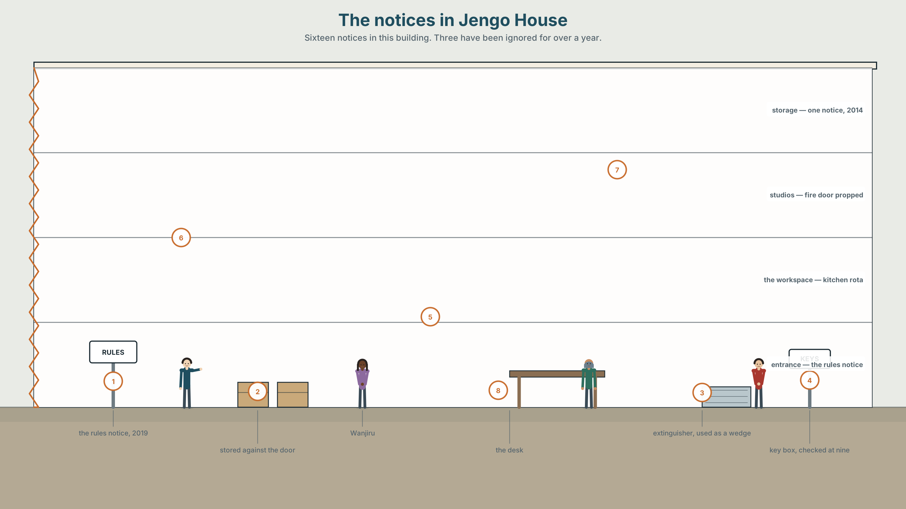{width=6.6in}
The notices in Jengo House — Sixteen notices in this building. Three have been ignored for over a year.

Who wrote this rule?
By the end of this unit you will write a one-page procedure a stranger could follow — and find out whether anybody does.
◆ A · THE WORLD | Where rules come from, how they survive, and what happens when they stop being followed
◆ B · THE SYSTEM | The passive across all simple tenses · by against with · the passive, returning · 24 words for procedure and authority · 21 ways to say something happened without saying who did it · consonant clusters at the end of -ed
◆ C · THE PERFORMANCE | A written procedure, tested on somebody who has never done the task

0A · Find it
Twelve notices in the building. Four of these sixteen are not there.
fire notice · lift inspection certificate · keyholder list · opening hours · no-smoking sign · recycling instructions · visitor policy · insurance certificate · kitchen rota · wifi notice · bin-day reminder · "please keep this door closed" · parking permit · noise curfew · first-aid notice · evacuation assembly point

0B · Guess it
Three of these notices have been ignored for over a year. Which, and what is the evidence in the picture?

0C · Say it ⏺
Record thirty seconds. Who wrote this rule? Pick any rule you live under. Unprepared.

Part 1 · Vocabulary Lab 1 ◆ B · THE SYSTEM
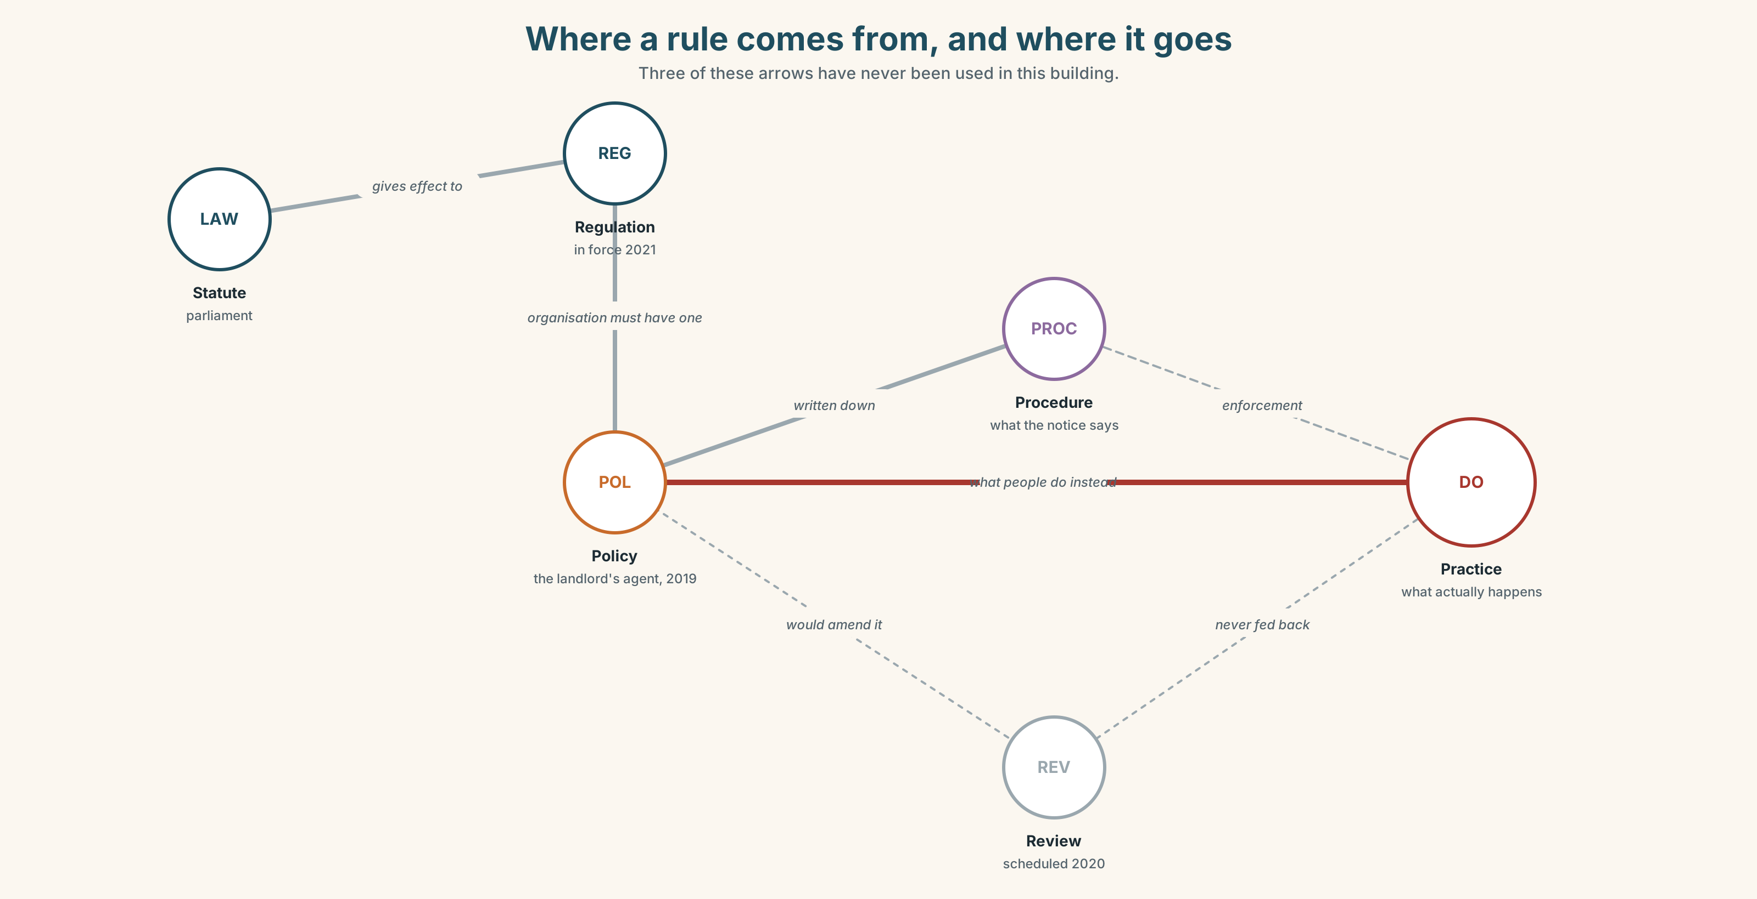{width=6.6in}
Where a rule comes from, and where it goes — Three of these arrows have never been used in this building.

1A · Meet — where a rule comes from
Use the network. Name the word at each stage.
statute · regulator · policy · procedure · protocol · clause · precedent · jurisdiction · enforce · waive · amend · appeal

1B · Sort — cline of authority
Order these from hardest to change to easiest.
a statute · a regulation · a lease clause · a published policy · a written procedure · standard practice · a notice on a door
Where does it stop being a rule and start being a habit? Mark it, and defend the mark.

1C · Sort — odd one out, and why
- enforce · waive · amend · appeal
- policy · procedure · protocol · precedent
- statute · regulator · jurisdiction · clause
- draw up · carry out · phase out · bring in

1D · Stretch — the phrases
- The works were done in ______ with the approved drawings.
- The lease is ______ to approval by the freeholder.
- Late entry is allowed at the ______ of the manager.
- Propping the door is not written down anywhere, but it is standard ______.
- The notice covers it. The lift does not. That is a ______ area.
- Nobody reads the ______ print, which is where the fee is.
- The regulation came into ______ in March 2021.

1E · Stretch — four phrasal verbs, one rule-book
draw up · carry out · phase out · bring in
Two are about creating a rule, two about what happens to it afterwards. Which?

1F · The two sayings
by the book · that's the policy
One is a compliment and an accusation at the same time. Which, and how do you tell?
Corpus Note Policy collocates with review, change and under. It almost never collocates with obey. English does not obey policies; it has them, reviews them, and works around them.

1G · Own it
Name one written rule where you are, and one unwritten rule that is stronger. Which would somebody new break first?

Part 2 · Listening ◆ A · THE WORLD
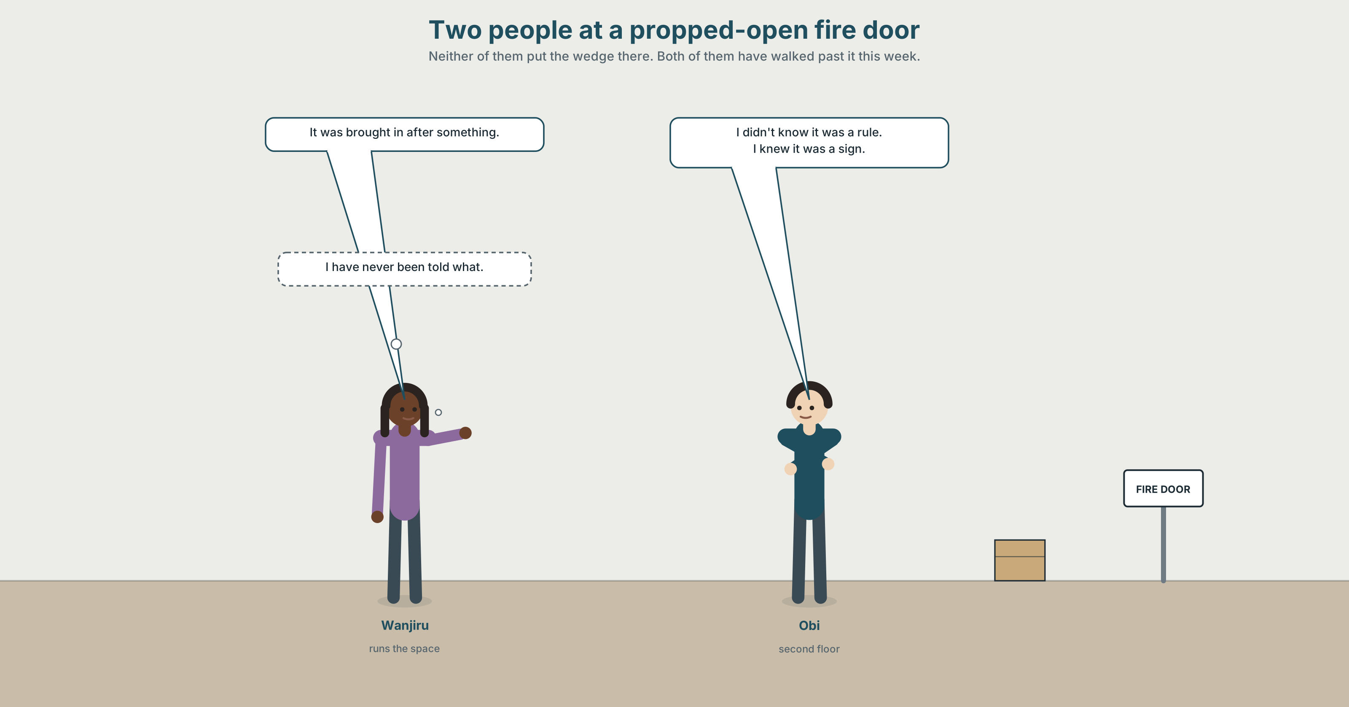{width=6.6in}
Two people at a propped-open fire door — Neither of them put the wedge there. Both of them have walked past it this week.

2A · It's on the door 🔊 Track 6.1
Before you listen. Two people are standing by a propped-open fire door. Which of them put the wedge there?
Gist — one listen, one question. Is the rule going to be enforced?
Detail — complete the frame.
 | When was it written? | Who by? | When was it last applied?
the fire-door rule
the key-return rule
the no-cooking rule
Inference. Wanjiru says "it was brought in after something." She does not say what. Why is that the most important sentence in the recording?
Attitude. Obi says "I didn't know." Did he? Which sound tells you.
Noticing. Six sentences. Sort them by what the speaker is doing with the agent.
- The rule was brought in in 2019.
- Somebody brought the rule in in 2019.
- The door was wedged open with a fire extinguisher.
- The door was wedged open by one of the tenants.
- It is enforced twice a year.
- Nobody has enforced it since 2022.
A. the doer is named · B. the doer is hidden · C. the instrument is named, not the doer

2B · Decoding clinic 🔊 Track 6.2
Forty seconds. Four jobs.
- Count the passives.
- was brought — what happens between the two words?
- Catch the three years.
- -ed at the end of propped, wedged, enforced — which one adds a syllable?
Transcripts, page 176.

Part 3 · Grammar Lab 1 ◆ B · THE SYSTEM

Who did it, and whether you say so

3A · Notice
Return to the six sentences.
- Which sentences tell you who did it?
- In sentence 3, with a fire extinguisher — is the extinguisher the doer?
- What is the difference between by and with here?
- Sentence 1 and sentence 2 describe the same event. Which one would a notice use, and why?
- Sentence 6 is active. Why does it feel like an accusation when sentence 1 does not?

3B · See
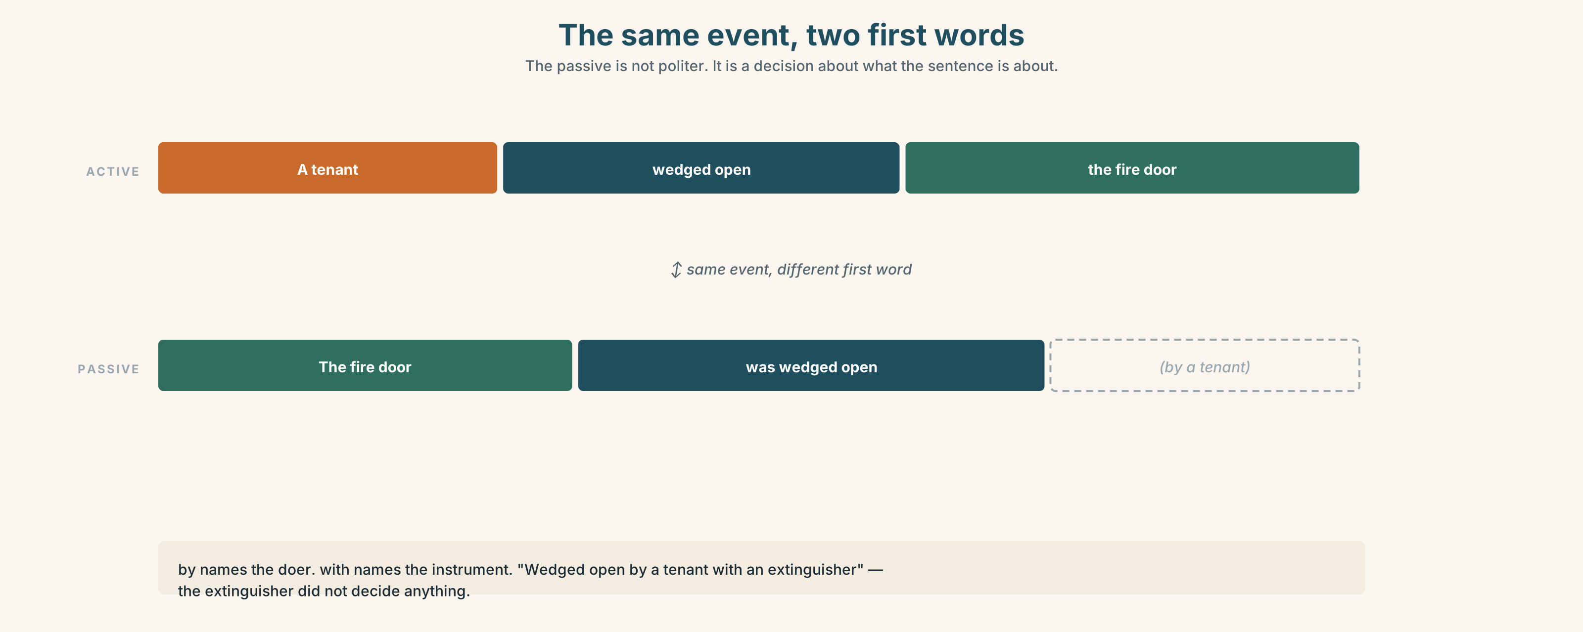{width=6.6in}
The same event, two first words — The passive is not politer. It is a decision about what the sentence is about.

3C · Know
Tense | Active | Passive
present | They enforce it. | It is enforced.
past | They enforced it. | It was enforced.
present perfect | They have enforced it. | It has been enforced.
past perfect | They had enforced it. | It had been enforced.
future | They will enforce it. | It will be enforced.
modal | They must enforce it. | It must be enforced.
by names the doer. with names the instrument.
The door was wedged open by a tenant with a fire extinguisher.
Watch out. The passive is not more polite and not more formal. It is a decision about what goes first in the sentence — and therefore about what the reader thinks the sentence is about.
Why it matters. Mistakes were made is grammatically unremarkable and does a specific job: it puts the mistakes first and leaves no room for a name.

3D · Use — controlled
Put each into the passive. Decide for each whether to keep the agent.
- Somebody propped the fire door open again.
- The managing agent brought the rule in after a fire in 2019.
- Nobody has reviewed the policy since 2022.
- Somebody will remove the wedge before the inspection.
- You must return keys to the box by six.
- A tenant wedged the door with an extinguisher.

3E · Use — guided
Each sentence names a doer. Remove the doer and say what the sentence gains and loses.
- Wanjiru decided not to enforce it.
- The landlord's agent wrote the policy.
- Two tenants have ignored the rule for a year.

3F · Use — open
Describe a procedure where you are, three times: once naming everybody, once naming nobody, and once naming only the person who benefits. Your partner says which version a notice would use.

3G · Check — six items
- The lift ______ (inspect) every six months.
- The rule ______ (bring) in after a fire.
- Nothing ______ (do) about it since 2022.
- Keys ______ (must / return) to the box.
- The door was wedged ______ a tenant ______ an extinguisher.
- By the time anyone noticed, the policy ______ (already / amend).
0–3 → Workbook pp. 46–48. 4–5 → Part 6. 6 → p. 119.
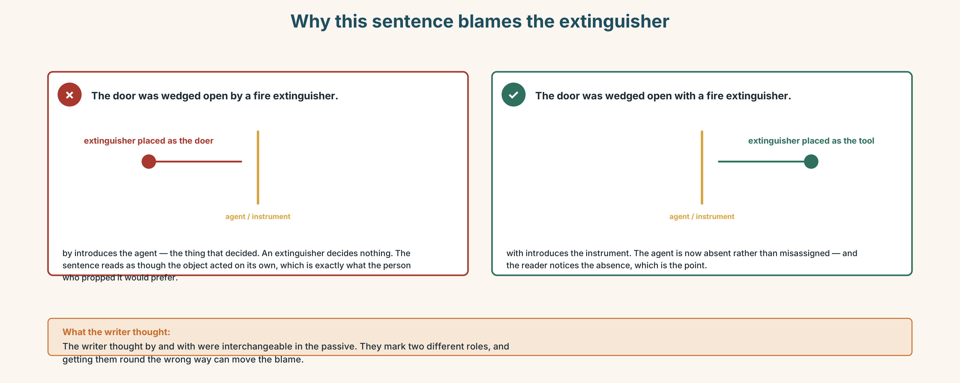{width=6.6in}
Why this sentence blames the extinguisher — Why this sentence blames the extinguisher

Part 4 · Speaking ◆ C · THE PERFORMANCE

4A · Fluency sprint — 4 / 3 / 2
A rule you have broken and would break again. Four minutes, three, two.

4B · The functional core — explaining a procedure
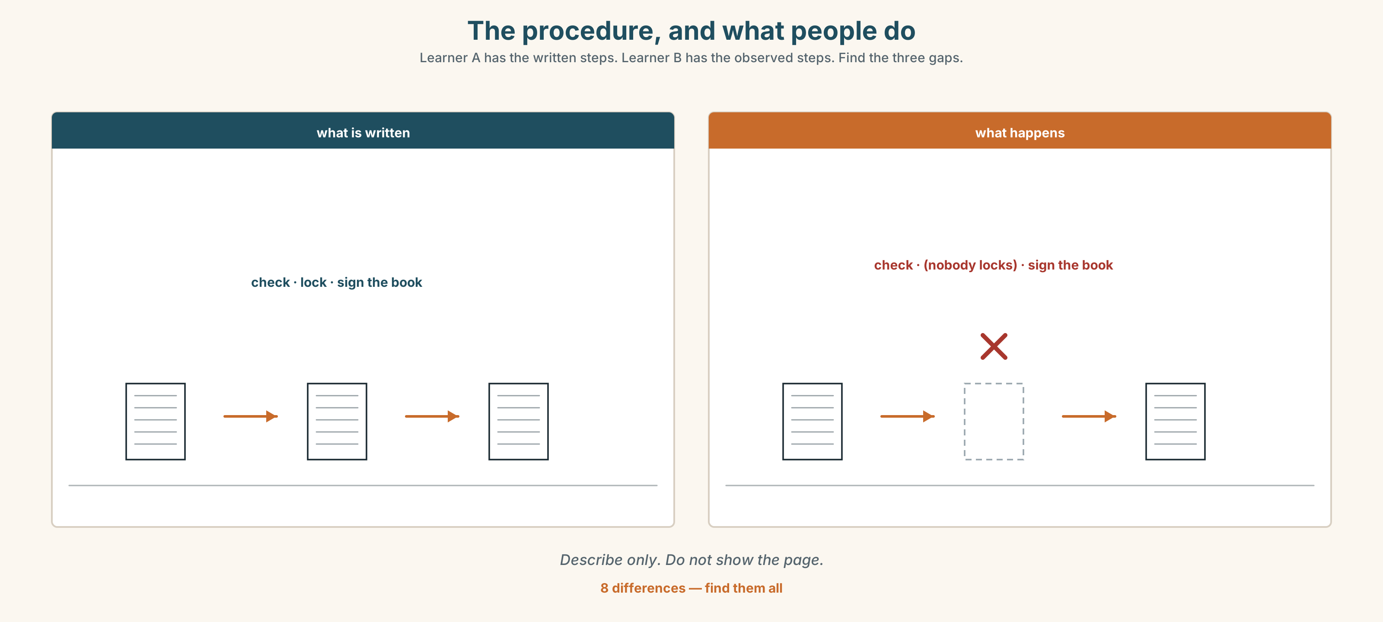{width=6.6in}
The procedure, and what people do — Learner A has the written steps. Learner B has the observed steps. Find the three gaps.
Language Bank
sequencing | first of all · once that's done · at that point · not before
flagging the trap | the bit people get wrong is · if you only do one thing
stating the rule | it has to be signed before it goes · nothing leaves until
admitting the gap | there's no rule about that · that's custom, not policy
Information gap. Learner A has the written procedure. Learner B has what people actually do. Neither sees the other. Find the three places they differ.

4C · The performance — teach the procedure
Four minutes. Explain a procedure to somebody who has never done it, and who will then do it in front of you. You may not touch anything.

4D · Observer
Listen for one thing: which step did the speaker assume and not say?

4E · Two criteria
☐ Could my partner do it without asking me a question? ☐ Did I say which step people usually get wrong?

Part 5 · Reading ◆ A · THE WORLD

5A · Predict
An opinion column called "The rule that was never repealed." The first line is:
Every organisation I have worked in has a rule that no living person has obeyed.
What do you expect? One sentence.

5B · Skim — sixty seconds
Find the turn. The writer changes position once.

The rule that was never repealed
Every organisation I have worked in has a rule that no living person has obeyed. It is written down. It has never been repealed. And if you ask why nobody follows it, you are told, with real confidence, that it does not apply any more — a claim that is never produced in writing, because there is nothing to produce.
Dead rules accumulate for a simple reason: creating one requires a decision, and killing one requires the same decision with none of the credit. A policy that is brought in after an incident is brought in by somebody who can point at it afterwards. A policy that is quietly dropped is dropped by somebody who then has to explain, if anything goes wrong, why they dropped it. The asymmetry does the rest.
For a long time I thought this was simply untidy, and that the answer was a periodic cull. I now think that is wrong, and that the dead rules are doing something.
What they are doing is holding a space. A rule that nobody follows is still a rule that can be produced at a moment of crisis, and the fact that it was ignored for a decade will not help you when it is. It also marks a boundary: everybody knows the door should not be propped open, and the reason they know is the notice, not the enforcement. Remove the notice and you remove the thing the shrug is aimed at.
The real danger is not the dead rule. It is the live rule that has quietly become dead without anybody noticing the moment it happened — because then nobody is shrugging. They simply do not know. The organisation believes the rule is operating. The people believe it was never serious. Neither side is lying, and the gap between them is where the incident comes from.
So: audit, by all means. But the question is not "which rules are nobody following?" It is "which rules do we believe are working?" And the honest version of that question can only be answered by somebody who does not already know the answer.

5C · Close reading
- What claim is "never produced in writing"?
- Explain the asymmetry in paragraph two in your own words.
- Where does the writer change position, and what did they used to think?
- What two things does a dead rule do, according to paragraph four?
- What does the writer say is more dangerous than a dead rule, and why?
- The last sentence sets a condition. What is it, and why does it matter?

5D · Vocabulary in context
repealed · accumulate · asymmetry · cull · produced (produced at a moment of crisis) · operating (the rule is operating)

5E · The counter-text
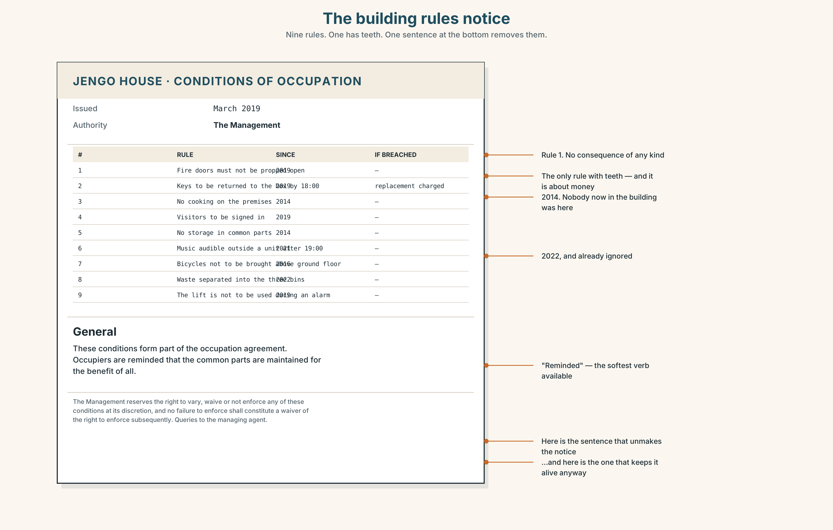{width=6.6in}
The building rules notice — Nine rules. One has teeth. One sentence at the bottom removes them.
Read the building rules notice and answer.
- How many rules are listed?
- What is the stated date and authority?
- Which rule has an enforcement mechanism attached, and which have none?
- Find the rule about the fire doors. What does it say will happen?
- Find the sentence that makes the whole notice unenforceable.

5F · Writer analysis
- The column argues; the notice asserts. Which one tells you who wrote it?
- The notice is signed "The Management". The column is signed by a person. Does that change what you believe?

5G · Text against text
The column says dead rules hold a space. The notice has at least three dead rules on it. Two sentences on whether the notice should be rewritten. The second begins "The risk of rewriting it is…"

Part 6 · Vocabulary Lab 2 ◆ B · THE SYSTEM

Twenty-one ways to say it happened and not say who
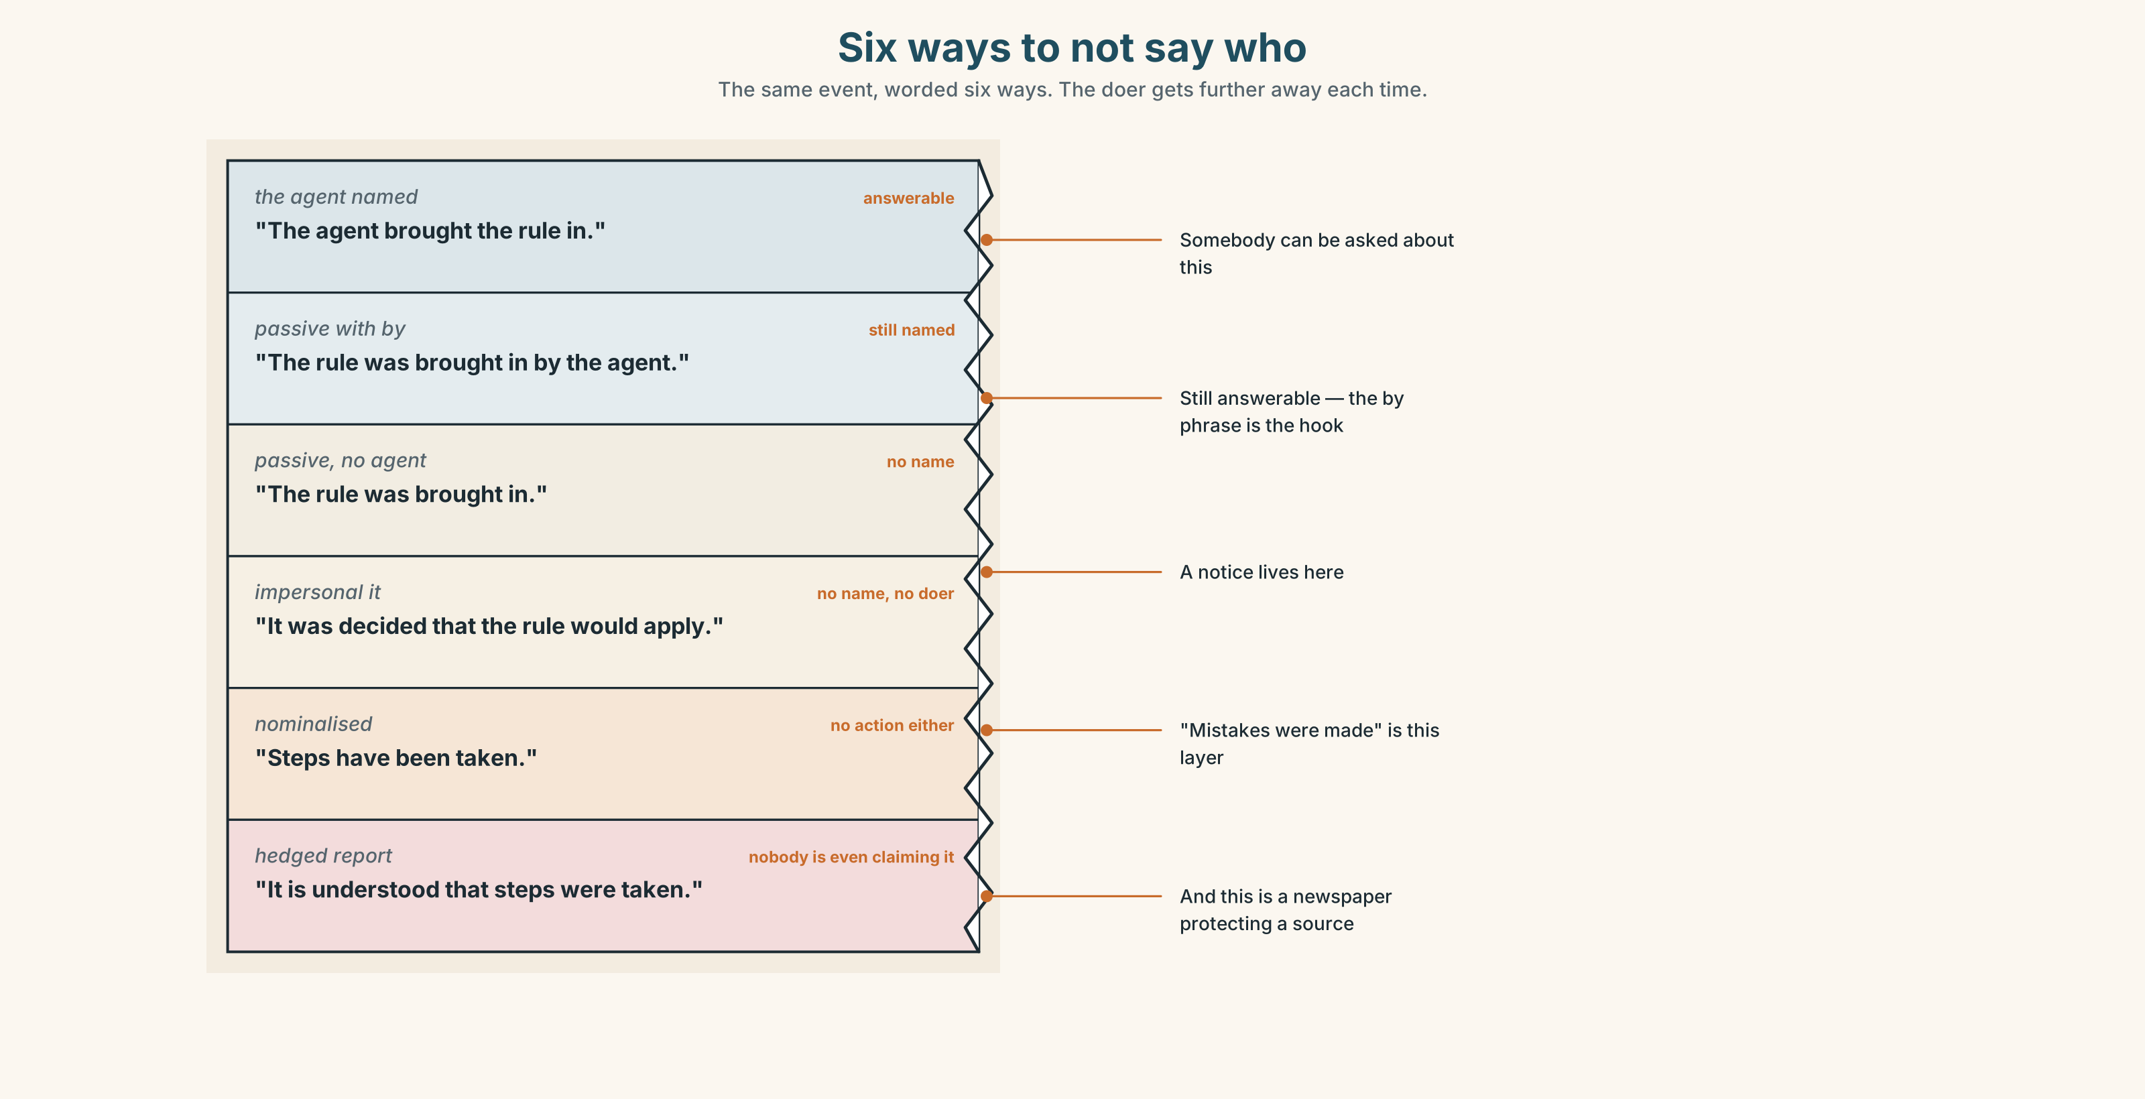{width=6.6in}
Six ways to not say who — The same event, worded six ways. The doer gets further away each time.

6A · Sort — how hidden is the doer?
Put all twenty-one on a line from completely hidden to almost named.
allegedly · reportedly · apparently · supposedly · purportedly · ostensibly · notionally · retrospectively · unilaterally · duly · hereby · it was decided · it is understood · steps have been taken · mistakes were made · is widely regarded as · is thought to be · it emerged that · it turned out that · is said to · be brought about · be done away with · nobody will say who

6B · Chunk completion
- ______ ______ ______ that the works would begin in March.
- The rule ______ ______ ______ away with in 2022, although nothing was written down.
- ______ ______ ______ ______ to prevent a recurrence.
- It ______ that the inspection had never been booked.
- The decision was taken ______ , without consulting anybody.

6C · Register sort
Which appear in an official notice, which in a newspaper, which only in speech? Six appear in two.

6D · Contrast Clinic — by against with, agent against instrument
Six items.
- The door was wedged ______ a fire extinguisher.
- The policy was written ______ the managing agent.
- The lock was forced ______ a screwdriver ______ somebody who knew the building.
- The notice was signed ______ "The Management".
- The report was produced ______ an inspector, ______ a standard template.
- The rule was brought in ______ the landlord after a fire.

Part 7 · Pronunciation & Fluency Lab ◆ B · THE SYSTEM

What happens at the end of -ed
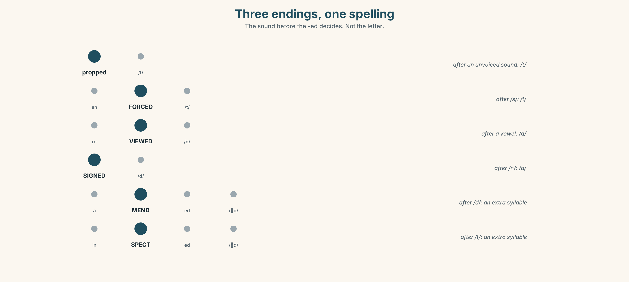{width=6.6in}
Three endings, one spelling — The sound before the -ed decides. Not the letter.

7A · Hear 🔊 Track 6.3
Three endings, one spelling.
/t/ — propped · enforced · wedged? (no — listen again) /d/ — reviewed · signed · amended? (no) /ɪd/ — amended · wedged? (no) · inspected
Sort the twelve words you hear into the three groups. The rule is about the sound before the -ed, not the letter.

7B · Say
"The door was propped, the rule was reviewed, and nothing was amended." Three endings in one sentence.

7C · Make it mean something
In the passive, the -ed often sits between two consonants and is nearly lost: "it was enforced twice" → /ɪtwəzɪnˈfɔːstwaɪs/.
Say it fast. Then say it so a stranger could write it down. Which one would you use in a meeting, and which on a recorded line?

7D · Fluency 20 ⏺
Twenty seconds: what has been done, by whom, and what has not. Three times, faster.

Part 8 · Writing ◆ C · THE PERFORMANCE

A procedure a stranger could follow · 140 words
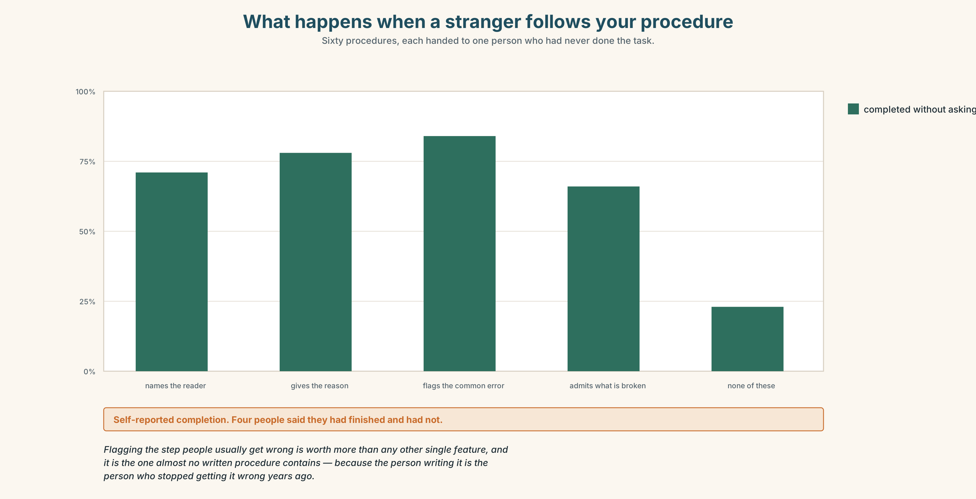{width=6.6in}
What happens when a stranger follows your procedure — Sixty procedures, each handed to one person who had never done the task.

8A · Read the model
Closing the building — for whoever is last out [names the reader in the title. Most procedures do not]
The building is locked at nine. If you are the last person on any floor, you do four things.
Check the two fire doors on your floor are shut. They are propped open during the day and the wedges are kept on the hook beside each one — put the wedge on the hook, not on the floor, because the cleaner moves anything on the floor and then nobody can find it. [the reason is given, and it is the real reason]
Turn off the machines at the wall, not at the screen. Return your key to the box in reception; the box is checked at nine by whoever locks up, and a missing key is phoned through.
If a fire door will not shut, do not force it. Leave it, and message the group — it has been dropping on its hinge since January and it is being looked at. [admits something unresolved, instead of pretending]
Questions about the writer's choices:
- Why is the reason for the hook given at all?
- The last paragraph admits a problem that has lasted a year. What does that buy?
- Count the passives. Why is "the box is checked at nine" passive and "turn off the machines" not?

8B · The anti-model
It is the responsibility of all users to ensure that the premises are secured appropriately at the end of the working day in accordance with building policy. Keys should be returned. Fire safety equipment must not be obstructed at any time.
Correct, complete, and useless. Name three things a new person could not do after reading it.

8C · Generate · 8D · Plan
who this is for → how many steps → each step as an instruction, not a principle → the one people get wrong, and why → what is still broken

8E · Draft 1 — 140 words

8F · Peer review — two criteria
☐ Could I do this tonight without asking anything? ☐ Is there a step where I would have to guess?

8G · Draft 2 · 8H · Test it
Give it to somebody who has never done the task and watch them. Do not help. Note every question they would have asked. Rewrite.

Part 9 · The File ◆ A · THE WORLD + C · THE PERFORMANCE

CULTURE FILE · Unwritten Rules
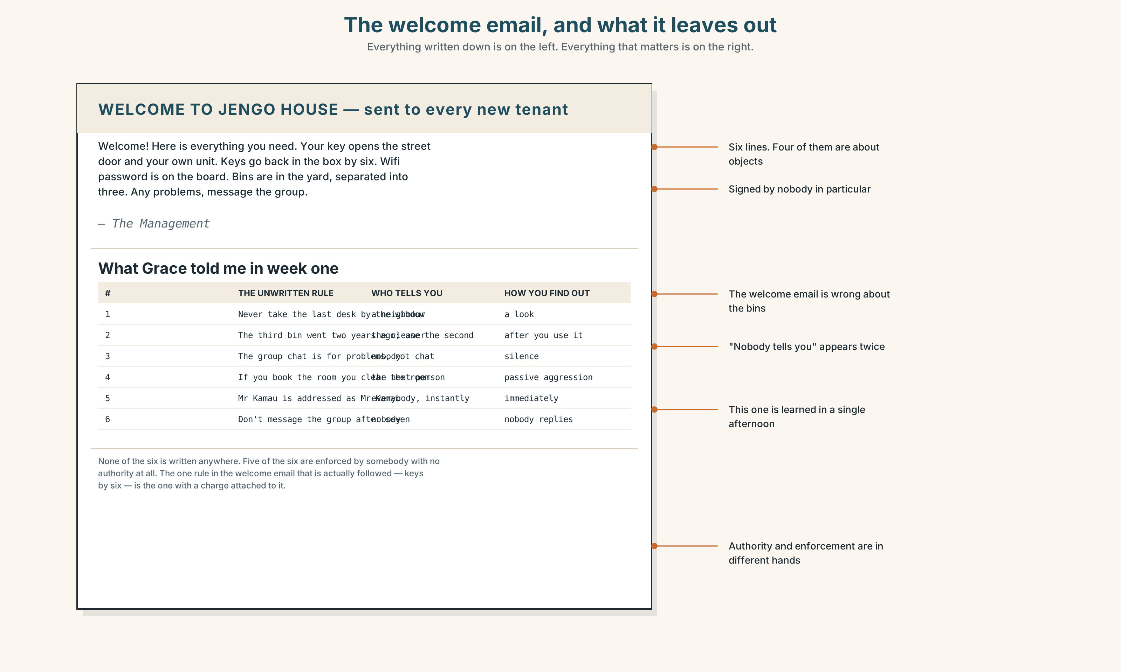{width=6.6in}
The welcome email, and what it leaves out — Everything written down is on the left. Everything that matters is on the right.

9A · Your own first
Write down three unwritten rules of a place you know well — a workplace, a family, a class. Not policies. The things everybody knows and nobody has said.
The test: a rule is unwritten if a newcomer could break it without knowing, and would be told about it afterwards by somebody who was not in charge.

9B · Who enforces them?
For each of your three: who tells the newcomer? It is almost never the manager.

9C · Four incidents
Four short accounts of somebody breaking an unwritten rule. For each: what was the rule, how did they find out, and what did it cost them?

9D · The reciprocal half
Read the four unwritten rules of a workplace in a country not your own. For each, find the nearest equivalent where you are — and the one that has no equivalent at all.

9E · The hard question
Some unwritten rules protect people. Some exclude them. Take one of your three and argue both.

9F · Transfer
Ask somebody who joined your workplace, class or community in the last year: what did nobody tell you? Bring the answer, not your guess at it.

Part 10 · Mediation & Interaction ◆ C · THE PERFORMANCE
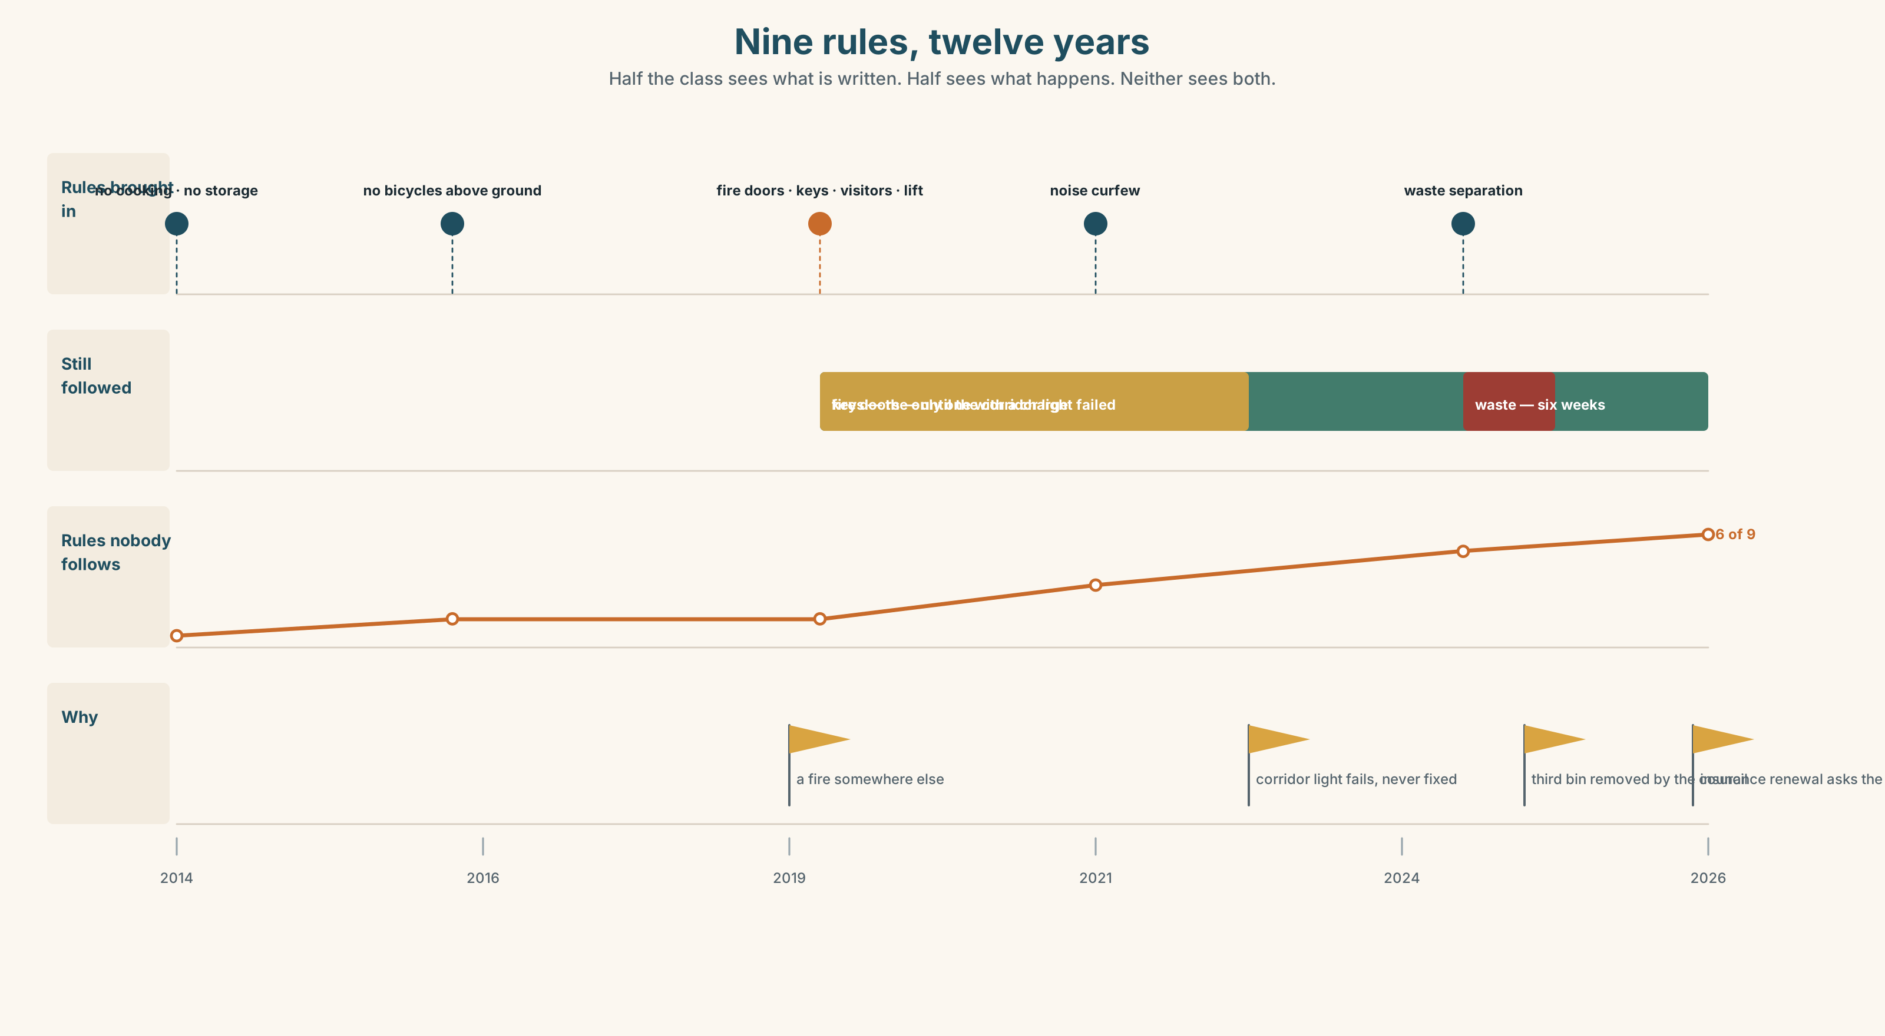{width=6.6in}
Nine rules, twelve years — Half the class sees what is written. Half sees what happens. Neither sees both.

10A · Relay
Half the class sees the written rules; half sees what actually happens. Rebuild by speaking.

10B · Simplify
Explain the building rules notice to somebody moving in tomorrow, in nine minutes. Which rules do you tell them, and in what order?

10C · Compress
The column into 60 words for a management committee. Defend three cuts.

10D · Online interaction
Write the group message proposing that one rule be formally dropped. Somebody will screenshot it to the landlord.

10E · Across languages
How does your language say a thing was done without saying who did it? Does it use a passive, or something else? Show both to a partner.

Part 11 · The Decision ◆ C · THE PERFORMANCE

The fire doors
The notice says fire doors must not be propped. They have been propped every working day for two years, because the corridor is dark and the doors are heavy and nobody has ever said anything.
The insurance renewal is in six weeks. The form asks whether fire doors are kept closed.
- Enforce it. Remove the wedges, tell everyone, and accept that four people will be angry and two will keep doing it.
- Formally drop it and write down what you do instead — hold-open devices on a closer, which cost 94,000 for three doors.
- Say nothing, answer the form honestly about the policy rather than the practice, and continue.

11A · The evidence
- The notice from Part 5, with its unenforceable sentence.
- The chart: what the three options cost, including the one with no money in it.
- The voice. Obi, twenty-five seconds: "I didn't know it was a rule. I knew it was a sign."

11B · Steelman
Argue the option you like least. Two minutes.

11C · Deliberate
I think they should ______, because ______. The strongest argument against me is ______, and my answer to it is ______.

11D · Decide — eighty words, two reasons

11E · Model decision
They should buy the hold-open devices, and I accept that 94,000 is a lot of money for a problem nobody has had.
Enforcing it is the honest-looking option and I think it fails. The reason the doors are propped is that the corridor is dark and the doors are heavy, and removing the wedges does not change either of those things. In six weeks the wedges come back, and now they come back knowing it is forbidden, which is worse than not knowing — that is Obi's line, and it is the only new information in the room.
Saying nothing is the option I would most like to take and it is the one that cannot survive a question. The insurance form does not ask about the policy. It asks whether the doors are kept closed. Answering about the policy is a lie with a defensible sentence wrapped round it.
The devices cost money and solve the actual problem, which is that the rule and the building were never compatible. Somebody should have noticed that in 2019.

11F · The Reveal
What happened. They bought devices for two of the three doors — the third was quoted at 61,000 on its own because of the frame — and propped the third one.
The insurance form was answered "fire doors are fitted with automatic closers", which was true of two doors out of three and was not queried.
The third door is still propped. Nobody has put a wedge under it since March, because somebody moved a filing cabinet in front of it instead, and a cabinet is not a wedge.
They solved two thirds of it, told two thirds of the truth, and the remaining third found a new way to be propped that the notice does not cover.
Was the reasoning sound? And: the notice still says "must not be propped". Is a filing cabinet propping?

Part 12 · Landing ◆ all three lines

12A · Recycle — twelve items
Six from this unit.
- The lift ______ (inspect) every six months.
- The rule ______ (bring) in after a fire in 2019.
- The door was wedged ______ a tenant ______ an extinguisher.
- The works were done in ______ with the drawings.
- It ______ that the inspection had never been booked.
- ______ ______ ______ taken to prevent a recurrence.
Four from Units 1–5.
- If you ______ (press) override, it ______ (log) your name. (Unit 5)
- You ______ prop that door open. (Unit 4)
- I ______ (see) him on Thursday — arranged. (Unit 3)
- At 3,720 she ______ even. (Unit 2)
Two from Making Plans (A2.1).
- The policy, ______ was written in 2019, has never been reviewed. (relative clause)
- The building ______ (inspect) in September. (passive, past simple)

12B · Consolidate
120 words, one paragraph. A rule where you are: when it was brought in, by whom, whether it is enforced, and what happens instead. Six items from Part 6.

12C · Can-do, with evidence
I can… | My evidence | Sure?
choose the passive deliberately, and name or hide the doer on purpose | Part 3G score | ◯ ◑ ●
write a procedure somebody can follow without asking me | Part 8, tested | ◯ ◑ ●
recognise the unwritten rules of a place, including my own | Part 9A | ◯ ◑ ●
decide about a rule that is broken daily and harms nobody | Part 11D | ◯ ◑ ●

12D · Replay ⏺
Part 0C again. Compare.

12E · Glossary — forty-five items, as a map
WHERE RULES COME FROM · statute · regulator · jurisdiction · precedent · policy · protocol · procedure · clause WHAT HAPPENS TO THEM · enforce · waive · amend · appeal · draw up · carry out · phase out · bring in · come into force THE WORDING · in accordance with · subject to approval · at the discretion of · standard practice · a grey area · the small print · by the book · that's the policy HIDING THE DOER · it was decided · it is understood · steps have been taken · mistakes were made · was brought in · be brought about · be done away with · nobody will say who HEDGED REPORTING · allegedly · reportedly · apparently · supposedly · purportedly · ostensibly · notionally · is widely regarded as · is thought to be · is said to · it emerged that · it turned out that OTHER · retrospectively · unilaterally · duly · hereby

12F · Next
Unit 7 · What do you want them to do?

