Table of Contents

A1.1 · Unit 1 · The Yellow Building
English Animated · Starting Out · Escola Monte, Lisbon Student's Book pages 6–27 · 22 pp · ~9 hours This is the first unit of the first book. Nothing is assumed.

Part 0 · The Big Picture ◆ A · THE WORLD
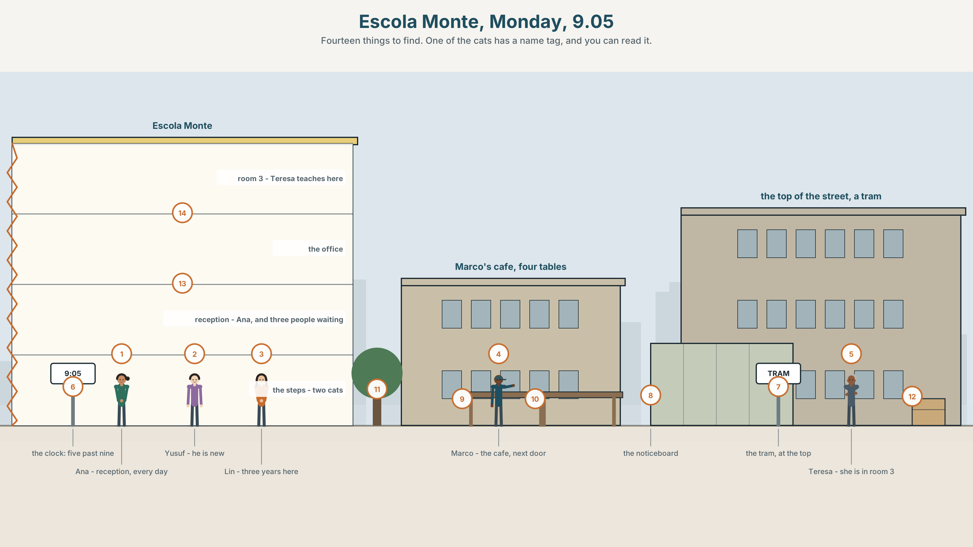{width=6.6in}
Escola Monte, Monday, 9.05 — Fourteen things to find. One of the cats has a name tag, and you can read it.

Who is in this room?
By the end of this unit you can introduce yourself and one other person to a group.
◆ A · THE WORLD | The people in a new place, and how they say who they are
◆ B · THE SYSTEM | am · is · are · I, you, he, she, it, we, they · 22 words for people and places · numbers 0–100 · the sounds /ɪ/ and /iː/
◆ C · THE PERFORMANCE | You stand up and introduce yourself and one other person

0A · Find it — fourteen things
Find these in the picture. Write the number.
☐ a teacher ☐ a student ☐ a desk ☐ a door ☐ a window ☐ a clock ☐ a cat ☐ a café ☐ a table ☐ a chair ☐ a bag ☐ a phone ☐ a tram ☐ a street
Four of these words are not in the picture. Which four?
a car · a dog · a bus · a book · a tree · a bicycle

0B · Guess it
Look at the people in reception. Who is new here today? How do you know? Say one thing. You can use these words:
bag · map · looking · he · she

0C · Say it ⏺
Record. Thirty seconds. Do not prepare.
Who is in this room?
Say the names you know. Say "I don't know" for the others. That is fine — it is Monday. You will listen to this again on the last page of this unit.

Part 1 · Vocabulary Lab 1 ◆ B · THE SYSTEM

1A · Meet — people
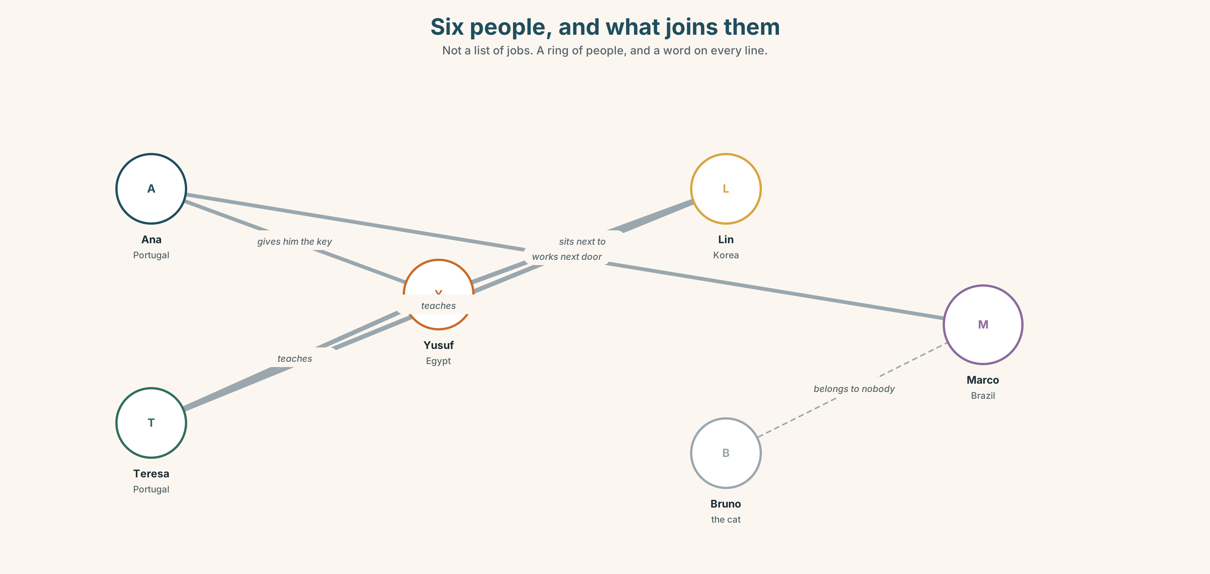{width=6.6in}
Six people, and what joins them — Not a list of jobs. A ring of people, and a word on every line.
Ana · Portugal | reception | She is here every day.
Teresa · Portugal | teacher | She is in room 3.
Yusuf · Egypt | student | He is new.
Lin · Korea | student | She is here for three years.
Marco · Brazil | café | He is next door.
Bruno · ? | cat | He is on the step.

1B · Meet — the words
name · country · city · student · teacher · class · friend · man · woman · people · address · email
Write each word under the right picture.
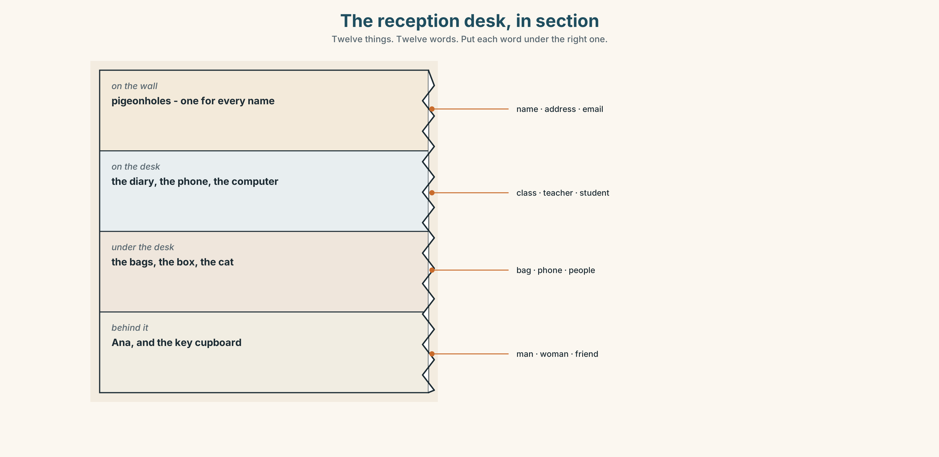{width=6.6in}
The reception desk, in section — Twelve things. Twelve words. Put each word under the right one.

1C · Sort — people or places?
Put each word in the right box. Two words can go in both. Which two, and why?
country · woman · class · city · name · friend · address · teacher · school · student
PEOPLE | PLACES | BOTH

1D · Countries and people
country | person
Portugal | Portuguese
Brazil | ______
Egypt | ______
Korea | ______
Nigeria | ______
Poland | ______
Now say them. Where is the strong part of the word? Mark it.
Por-tu-GUESE · Bra-ZIL-ian · E-GYP-tian · Ko-RE-an · Ni-GER-ian · PO-lish
One of these six is different from the other five. Which one?

1E · Stretch — the phrases you will need today
first name · family name · Where are you from? · This is my friend.
Match each phrase to the moment you need it.
- Somebody asks you to fill in a form. → ______
- You meet somebody for the first time. → ______
- You are with a friend and you meet your teacher. → ______
- Somebody says a long name and you only need the short part. → ______

1F · The hard one
f How do you spell it?
Practise it three times. You will use it in Part 9 and you will use it for the rest of your life.

1G · Own it
Write four things on a card. Do not write your name.
a city · a number · a country · a word you like
Give the card to your teacher. The class guesses whose card it is.

Part 2 · Listening ◆ A · THE WORLD

2A · Monday morning, nine o'clock 🔊 Track 1.1
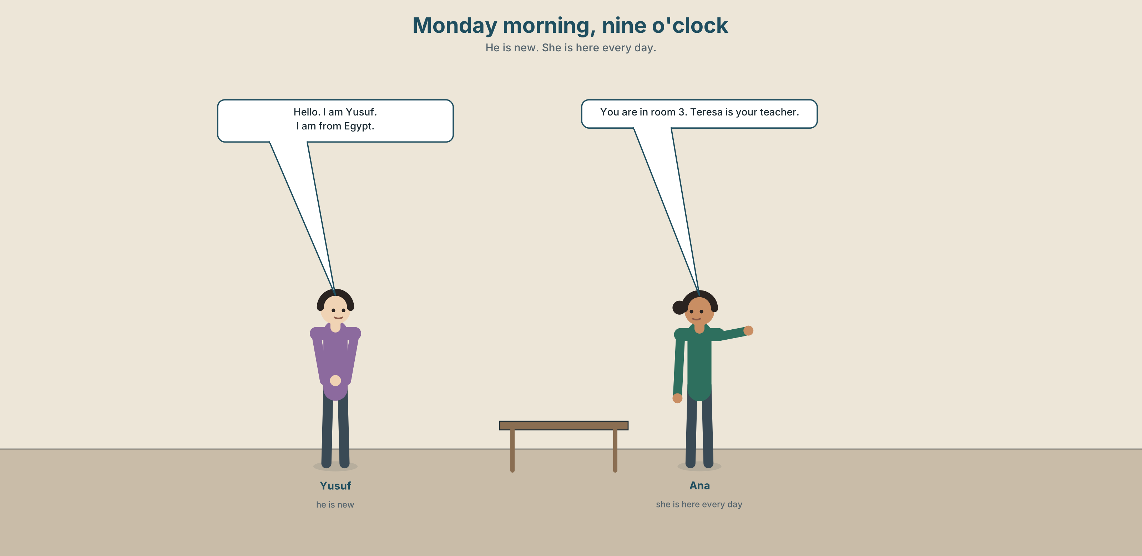{width=6.6in}
Monday morning, nine o'clock — He is new. She is here every day.
Before you listen. Look at the picture. What does Yusuf want? Choose one.
☐ a coffee ☐ a classroom ☐ a taxi ☐ a cat
Listen once. Answer one question.
What is Yusuf's room number?
Listen again. Complete the table.
First name
Family name
Country
Room
Listen again. True or false?
- Ana knows Yusuf's name. ☐ T ☐ F
- Yusuf spells his name for her. ☐ T ☐ F
- Teresa is Yusuf's teacher. ☐ T ☐ F
- The cat has a name. ☐ T ☐ F
Notice. Here are four sentences from the recording.
I am Yusuf. · She is in room 3. · You are in room 3 too. · They are always there.
One word changes four times. Which word? Write the four forms.

2B · Decoding clinic 🔊 Track 1.2
Twenty seconds of the same conversation, at full speed. Four times, four jobs.
- How many words in Ana's first sentence?
- Catch the two numbers.
- I'm — how many words is that really?
- Say the alphabet with Ana. She goes fast. Keep up.
Transcripts are on page 148. Not before you finish.

Part 3 · Grammar Lab 1 ◆ B · THE SYSTEM

am · is · are — and who they belong to

3A · Notice
Look at the four sentences in Part 2 again.
- Which word goes with I?
- Which word goes with she, he and it?
- Which word goes with you, we and they?
- One of these three groups has three words in it. Which?

3B · See
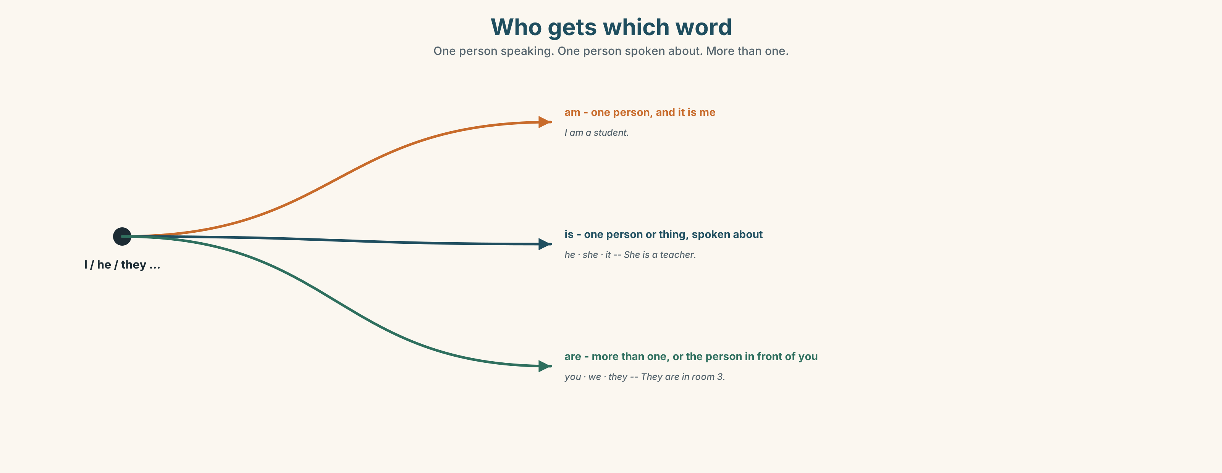{width=6.6in}
Who gets which word — One person speaking. One person spoken about. More than one.

3C · Know
I | am | I am a student.
he · she · it | is | She is a teacher.
you · we · they | are | They are in room 3.
Short forms — what people actually say.
I'm · you're · he's · she's · it's · we're · they're
Watch out. You is one person and more than one person. It is always are. You are my teacher. You are my class.
Why it matters. This is the most common verb in English. You will say it a hundred times today.
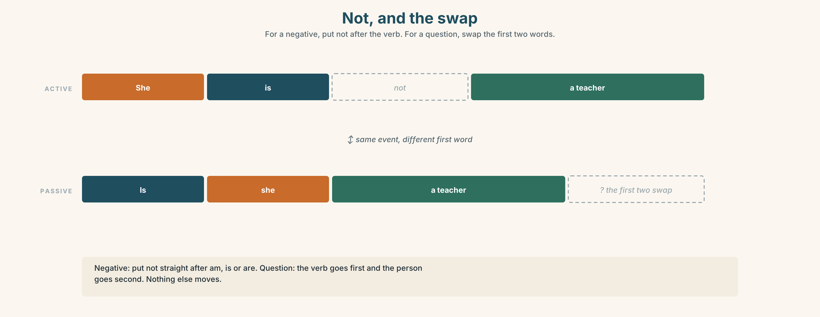{width=6.6in}
Not, and the swap — For a negative, put not after the verb. For a question, swap the first two words.
– | I am not / I'm not · she is not / she isn't · they are not / they aren't
? | Am I…? · Is she…? · Are you…?

3D · Use — controlled
Complete with am, is or are.
Ana (1) ______ at the desk. She (2) ______ Portuguese. Yusuf and Lin (3) ______ students. Yusuf (4) ______ from Egypt and Lin (5) ______ from Korea. I (6) ______ in room 3. You (7) ______ in room 3 too. We (8) ______ in the same class. The cats (9) ______ on the step. They (10) ______ always there.

3E · Use — guided
Make the sentences negative, then make them questions.
- She is a teacher. → ______________ → ______________
- They are in the café. → ______________ → ______________
- I am late. → ______________ → ______________
- You are Brazilian. → ______________ → ______________

3F · Use — open
Find three people in the room. For each one, find out and write down:
their name · their country · one more thing
Then tell the class about one of them. Start: This is ______. She is…

3G · Check — six items, mark your own
- I ______ a student. 2. Marco ______ from Brazil. 3. We ______ in the same class.
- ______ you Teresa? 5. The cats ______ not in the café. 6. She ______ not my teacher.
0–3 → Workbook pp. 4–6. 4–5 → Part 6 will fix it. 6 → the extension on p. 21.
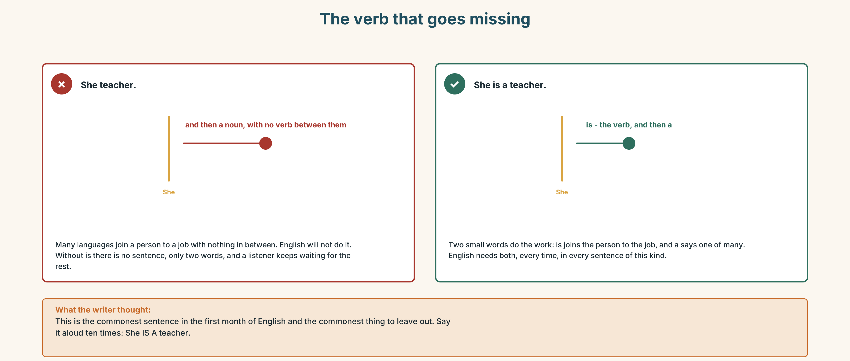{width=6.6in}
The verb that goes missing — The verb that goes missing

Part 4 · Speaking ◆ C · THE PERFORMANCE

4A · Fluency starter — the circle
Stand in a circle. Say three things about yourself. Ten seconds. Move one place to the left. Say the same three things to a new person. Eight seconds. Move again. Six seconds.
Same words. Faster every time. That is the whole exercise.

4B · The functional core — saying who you are, and who somebody else is
Language Bank
you | I'm ______ . · I'm from ______ . · I'm a ______ .
somebody else | This is ______ . · He's from ______ . · She's a ______ .
asking | What's your name? · Where are you from? · Sorry — how do you spell it?
answering a mistake | Not quite — it's ______ . · Almost! · That's it.
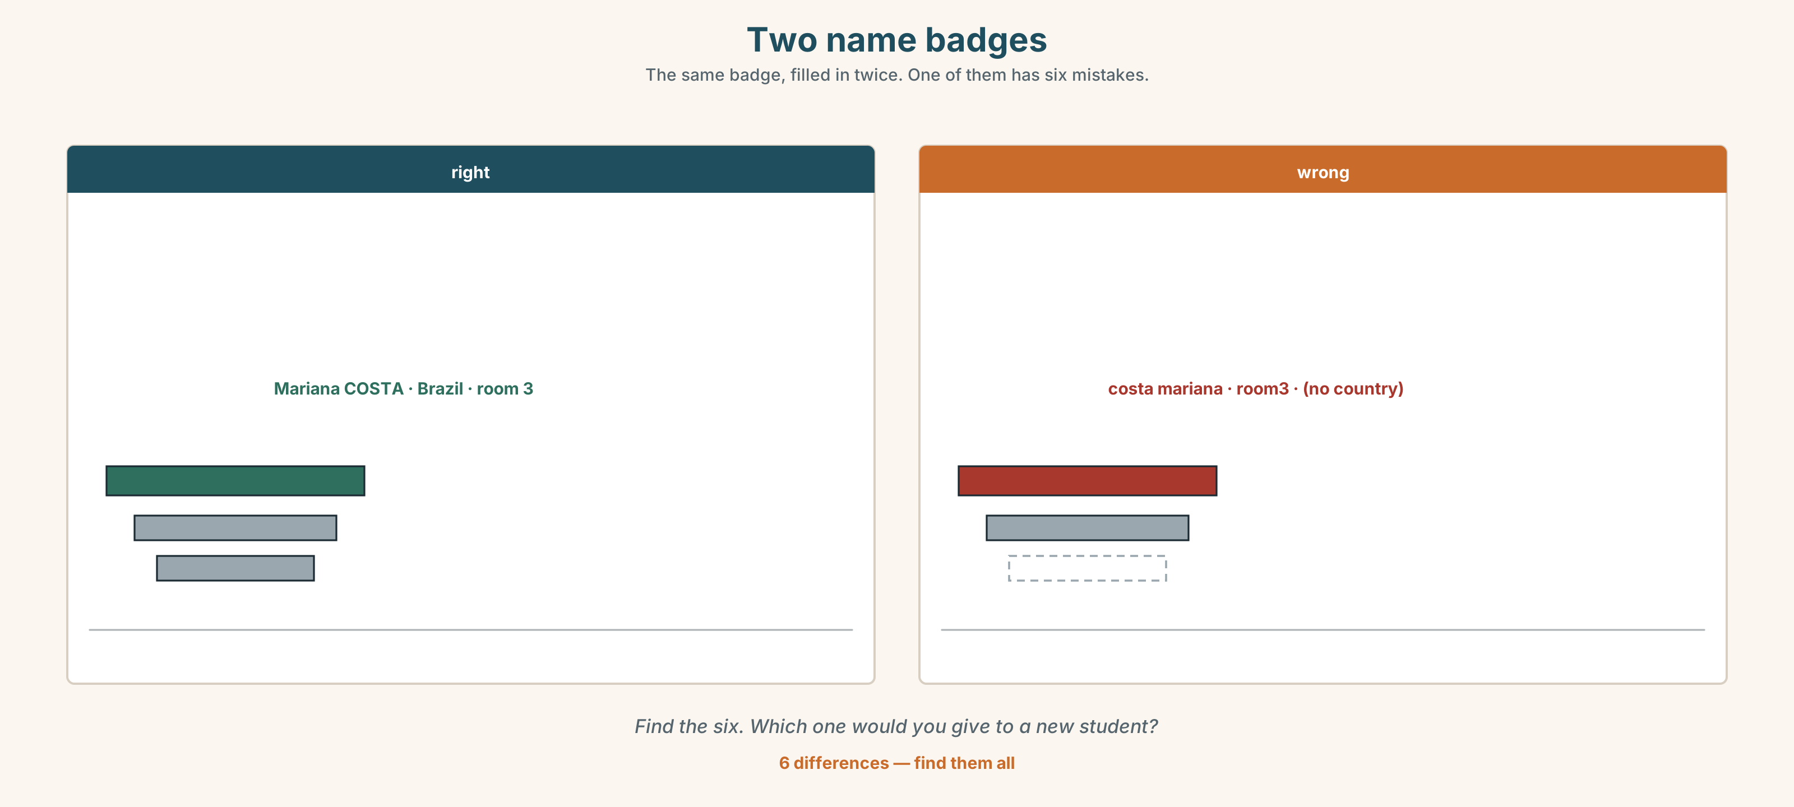{width=6.6in}
Two name badges — The same badge, filled in twice. One of them has six mistakes.
Information gap. Learner A has a sign-in sheet with six names and three gaps. Learner B has the same sheet with the other three gaps. Complete it. You may only speak.

4C · The performance — the introduction ⏺
Stand up. Twenty to thirty seconds. Introduce yourself and one other person to the class.
Hello. I'm ______ . I'm from ______ . And this is ______ . He's / She's from ______ , and he's / she's a ______ .
Record it. You will need it on the last page.

4D · Observer
One person in each group does not speak. You listen for one thing only:
Did everybody get their name said correctly?

4E · Two criteria
☐ Did I say my name clearly enough for a stranger to write it down? ☐ Did I say something about the other person that was not just their name?

Part 5 · Reading ◆ A · THE WORLD

5A · Predict
The title of the text is "The cats on the step." What do you think the text is about? Choose one.
☐ a pet shop ☐ a school ☐ a problem with cats ☐ a café

5B · Read — sixty seconds

The cats on the step
Escola Monte is a yellow building on a very steep street in Lisbon. There are four floors and sixteen classrooms. Ana is at the desk. She knows every student's name, and she knows every student's name before they arrive, because she reads the list on Sunday.
There are two cats on the step. They are not Ana's cats. They are not anybody's cats. One is grey and one is orange, and the orange one has a name tag. The tag says Bruno.
Nobody knows who put the tag on the cat.

5C · Answer
- What colour is the building?
- How many classrooms are there?
- What is Ana's job?
- Why does Ana know the names on Monday?
- How many cats are there?
- What is the question at the end of the text?

5D · Vocabulary in context
Find these in the text. Do not use a dictionary yet. Write what you think each one means, then check with a partner.
steep · floor · tag · nobody

5E · The counter-text
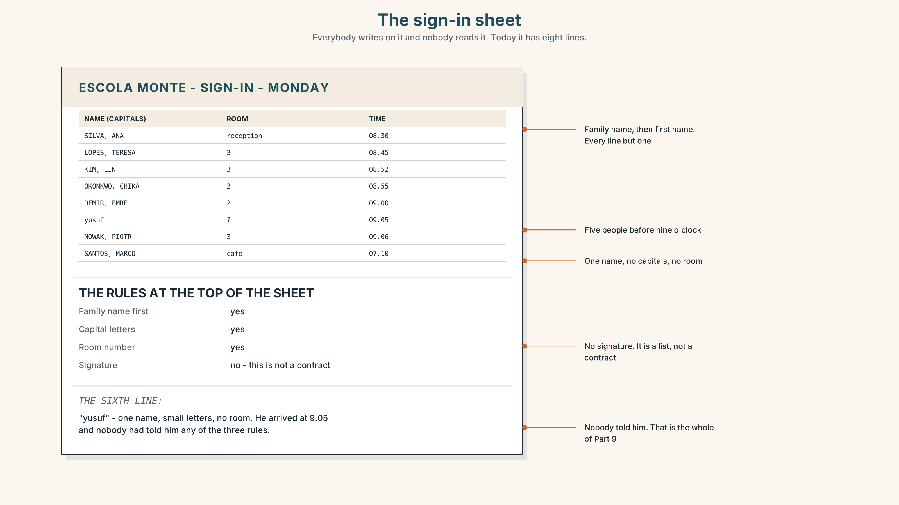{width=6.6in}
The sign-in sheet — Everybody writes on it and nobody reads it. Today it has eight lines.
Read the sheet.
- How many people signed in before nine o'clock?
- Who signed in first, and where do they work?
- The rules at the top ask for three things. Which of the three does the sixth line have?
- One line is different from all the others. What would you do about it?

5F · Two texts
The story says Ana knows every name. The sign-in sheet shows one name she could not read.
Which one is true? Talk about it. There is more than one answer.

Part 6 · Vocabulary Lab 2 ◆ B · THE SYSTEM

Numbers 0–100
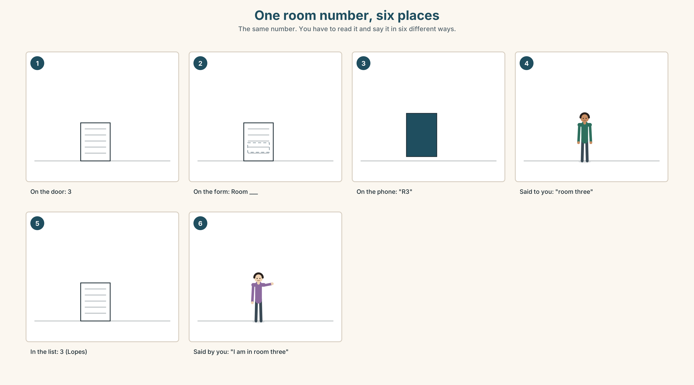{width=6.6in}
One room number, six places — The same number. You have to read it and say it in six different ways.

6A · The ones that catch everybody
13 thir-TEEN | 30 THIR-ty | The stress moves. The meaning moves with it.
14 four-TEEN | 40 FOR-ty
15 fif-TEEN | 50 FIF-ty
Listen 🔊 Track 1.3. Which do you hear? Ten items.

6B · Say the number
a room · a phone number · an age · a price · a floor · a date
Your teacher says one. You say which it is. Then swap.

6C · Chunk
phone number · room number · How old are you? · How do you spell it?
Complete.
- What's your ______ ______ ? — It's 2-1-4-9-0-3-3-7.
- ______ ______ are you? — I'm twenty-two.
- I'm in ______ ______ 3.
- My name is Yusuf. — Sorry, ______ do you ______ it?

6D · Contrast Clinic
Six items. Each one has a number and a form of be. Both must be right.
- I ______ (be) twenty. 2. She ______ (be) in room ______ (13 / 30)?
- They ______ (be) fifteen and seventeen. 4. We ______ (be) on floor ______ (4).
- ______ (be) you forty? 6. The class ______ (be) at ______ (9.15).

Part 7 · Pronunciation & Fluency Lab ◆ B · THE SYSTEM

/ɪ/ and /iː/ — a short sound and a long one
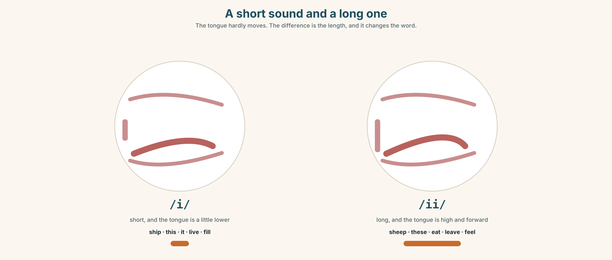{width=6.6in}
A short sound and a long one — The tongue hardly moves. The difference is the length, and it changes the word.

7A · Hear
/ɪ/ | /iː/
it | eat
sit | seat
this | these
live | leave
fill | feel
🔊 Track 1.4. Which do you hear? Ten items.

7B · Say
Say each pair. Then say these sentences.
This is it. These are the seats. Please sit here. I live in Lisbon. I leave at six.

7C · Make it mean something
Two sentences. One letter different. Completely different meaning.
I'd like to live here. · I'd like to leave here.
Say each one to a partner. Your partner says which one you said. If they get it wrong, say it again — do not explain.

7D · Fluency 20 ⏺
Twenty seconds: your name, your country, your city, and one thing you like. Three times. Faster each time. Record the first and the third.

Part 8 · Writing ◆ C · THE PERFORMANCE

Introduce yourself · 40–60 words

8A · Read the model
My name is Mariana Costa. Mariana is my first name and Costa is my family name. I am from Recife, a city in Brazil. [says where, then says where that is — the reader may not know] I am twenty-four and I am a nurse. I am in room 3. My friend Lin is in room 3 too. She is Korean.
Questions about the writer's choices:
- Why does she explain which part is her first name?
- She says from Recife, a city in Brazil. Why does she add the second part?
- The last two sentences are about somebody else. Why are they there?

8B · The anti-model
My name is Mariana. I am from Brazil. I am twenty-four. I am a nurse. I am in room 3. My friend is Lin. She is from Korea.
This is correct English. Why is the first one better? Say one thing.

8C · Plan
my name → which part is which → my country → my city → my age or my job → one other person

8D · Write — 40 to 60 words

8E · Peer review — two things only
Swap with a partner. Read once. Tick, then sign your name.
☐ Can I write your name correctly from this? ☐ Is there one other person in it?

8F · Publish
Your text goes on the wall by the door, with your photo. The wall is how the school learns your name.

Part 9 · The File ◆ A · THE WORLD + C · THE PERFORMANCE

WORK FILE · The front desk
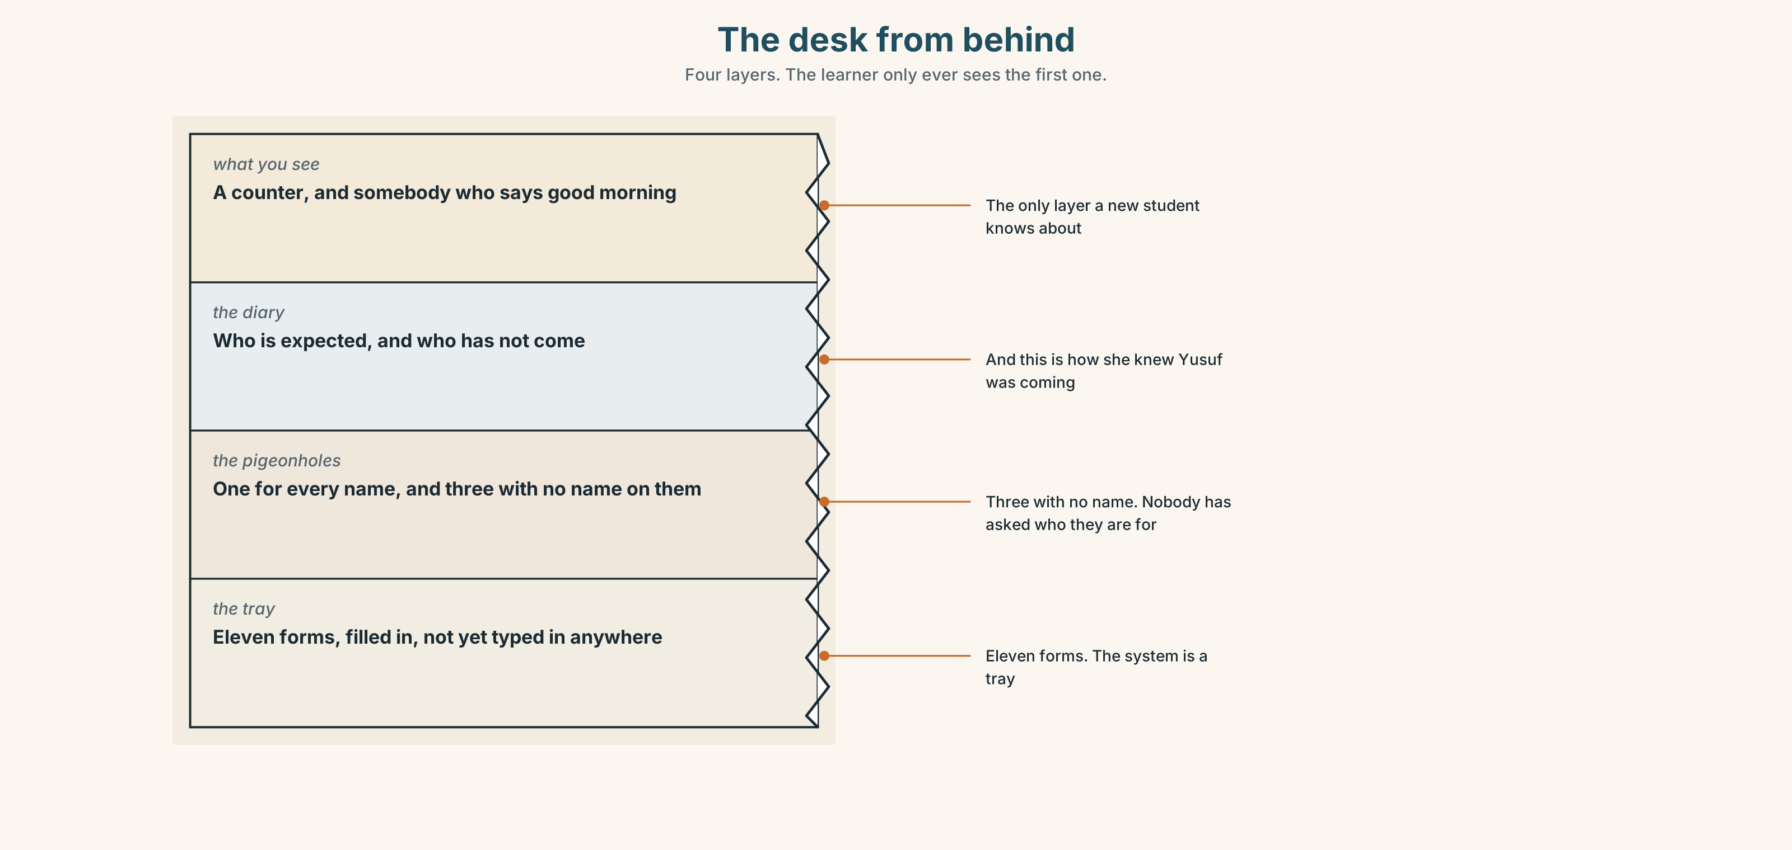{width=6.6in}
The desk from behind — Four layers. The learner only ever sees the first one.

9A · The form
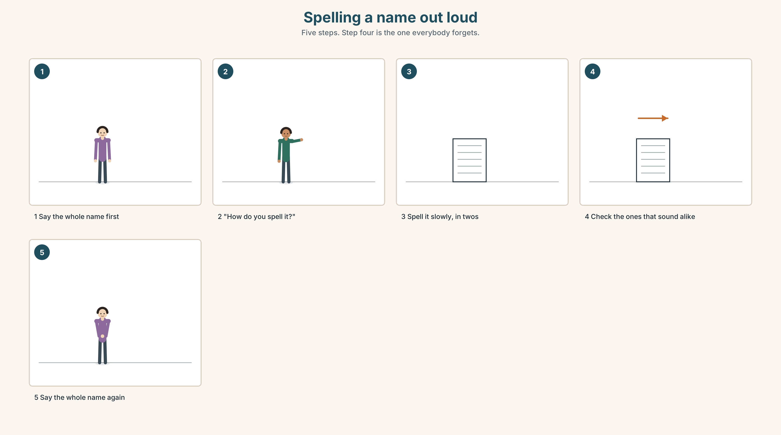{width=6.6in}
Spelling a name out loud — Five steps. Step four is the one everybody forgets.
Complete the form for yourself.
FAMILY NAME (block capitals)
First name
Country
City
Email
Phone

9B · Spelling out loud
🔊 Track 1.5. The alphabet, twice: slowly, then at normal speed.
The eight that cause trouble. Say them. Then say them to a partner with your eyes closed.
A · E · I · G · J · M · N · Y
Now spell these: your family name · your city · your street.

9C · Role play — the front desk
Card A — you arrive. It is your first day. Nobody is expecting you, because your name was written down wrong. You have to fix it without being rude.
Card B — you are at the desk. You have a list. The name on the list is close to the name you are hearing, but not the same. You have four people waiting.
Run it. Then swap cards and run it again.

9D · The thing that always happens
Somebody says your name wrong.
Choose a reply. There are no wrong answers, but they are not the same.
☐ That's fine. ☐ Almost — it's ______ . ☐ Not quite. Can I show you? ☐ Sorry — it's ______ . With the stress on the second part.
When would you use each one?

9E · Transfer — before next week
Find out how to say one person's name correctly — a classmate, a colleague, a neighbour. Not from a list. Ask them. Come back and say it.

Part 10 · Mediation & Interaction ◆ C · THE PERFORMANCE
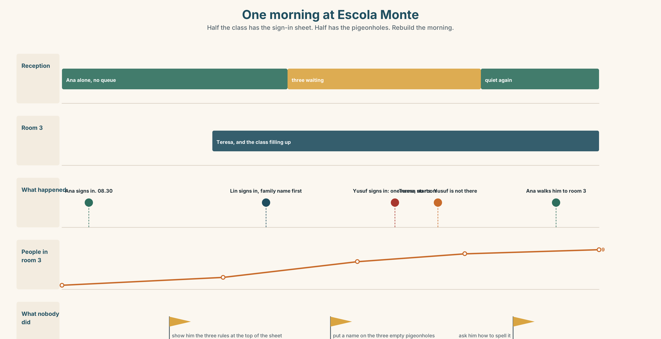{width=6.6in}
One morning at Escola Monte — Half the class has the sign-in sheet. Half has the pigeonholes. Rebuild the morning.

10A · Relay
Half the class sees the left side. Half sees the right. You cannot show each other.
Build the whole picture by speaking. Ten minutes. You may say: Who is in room ______ ? · Where is ______ from? · How do you spell it?

10B · Simplify — for one person
A new student arrives tomorrow. She speaks no Portuguese and very little English.
Write her four sentences. Only four. Which four does she actually need?

10C · Online
Write one message for the class group chat:
Hi everyone — I'm ______ …
It will be read by twenty people you have not met. Keep it to twenty-five words.

10D · Your language
How do you say "What's your name?" in your language? Teach it to one other person. Then write both versions side by side.
English: ______________________ My language: ______________________
Is one of them longer? Is one of them more polite?

Part 11 · The Decision ◆ C · THE PERFORMANCE

Yusuf, or Joseph?
Yusuf is from Cairo. His name is Yusuf.
At the café next door, Marco calls him Joseph. In the first week, Yusuf corrected him twice. Marco said sorry twice. Now it is week three and Marco still says Joseph, and he says it in a friendly way, every morning, in front of other people.
Yusuf has two choices. Neither one is free.

11A · The evidence
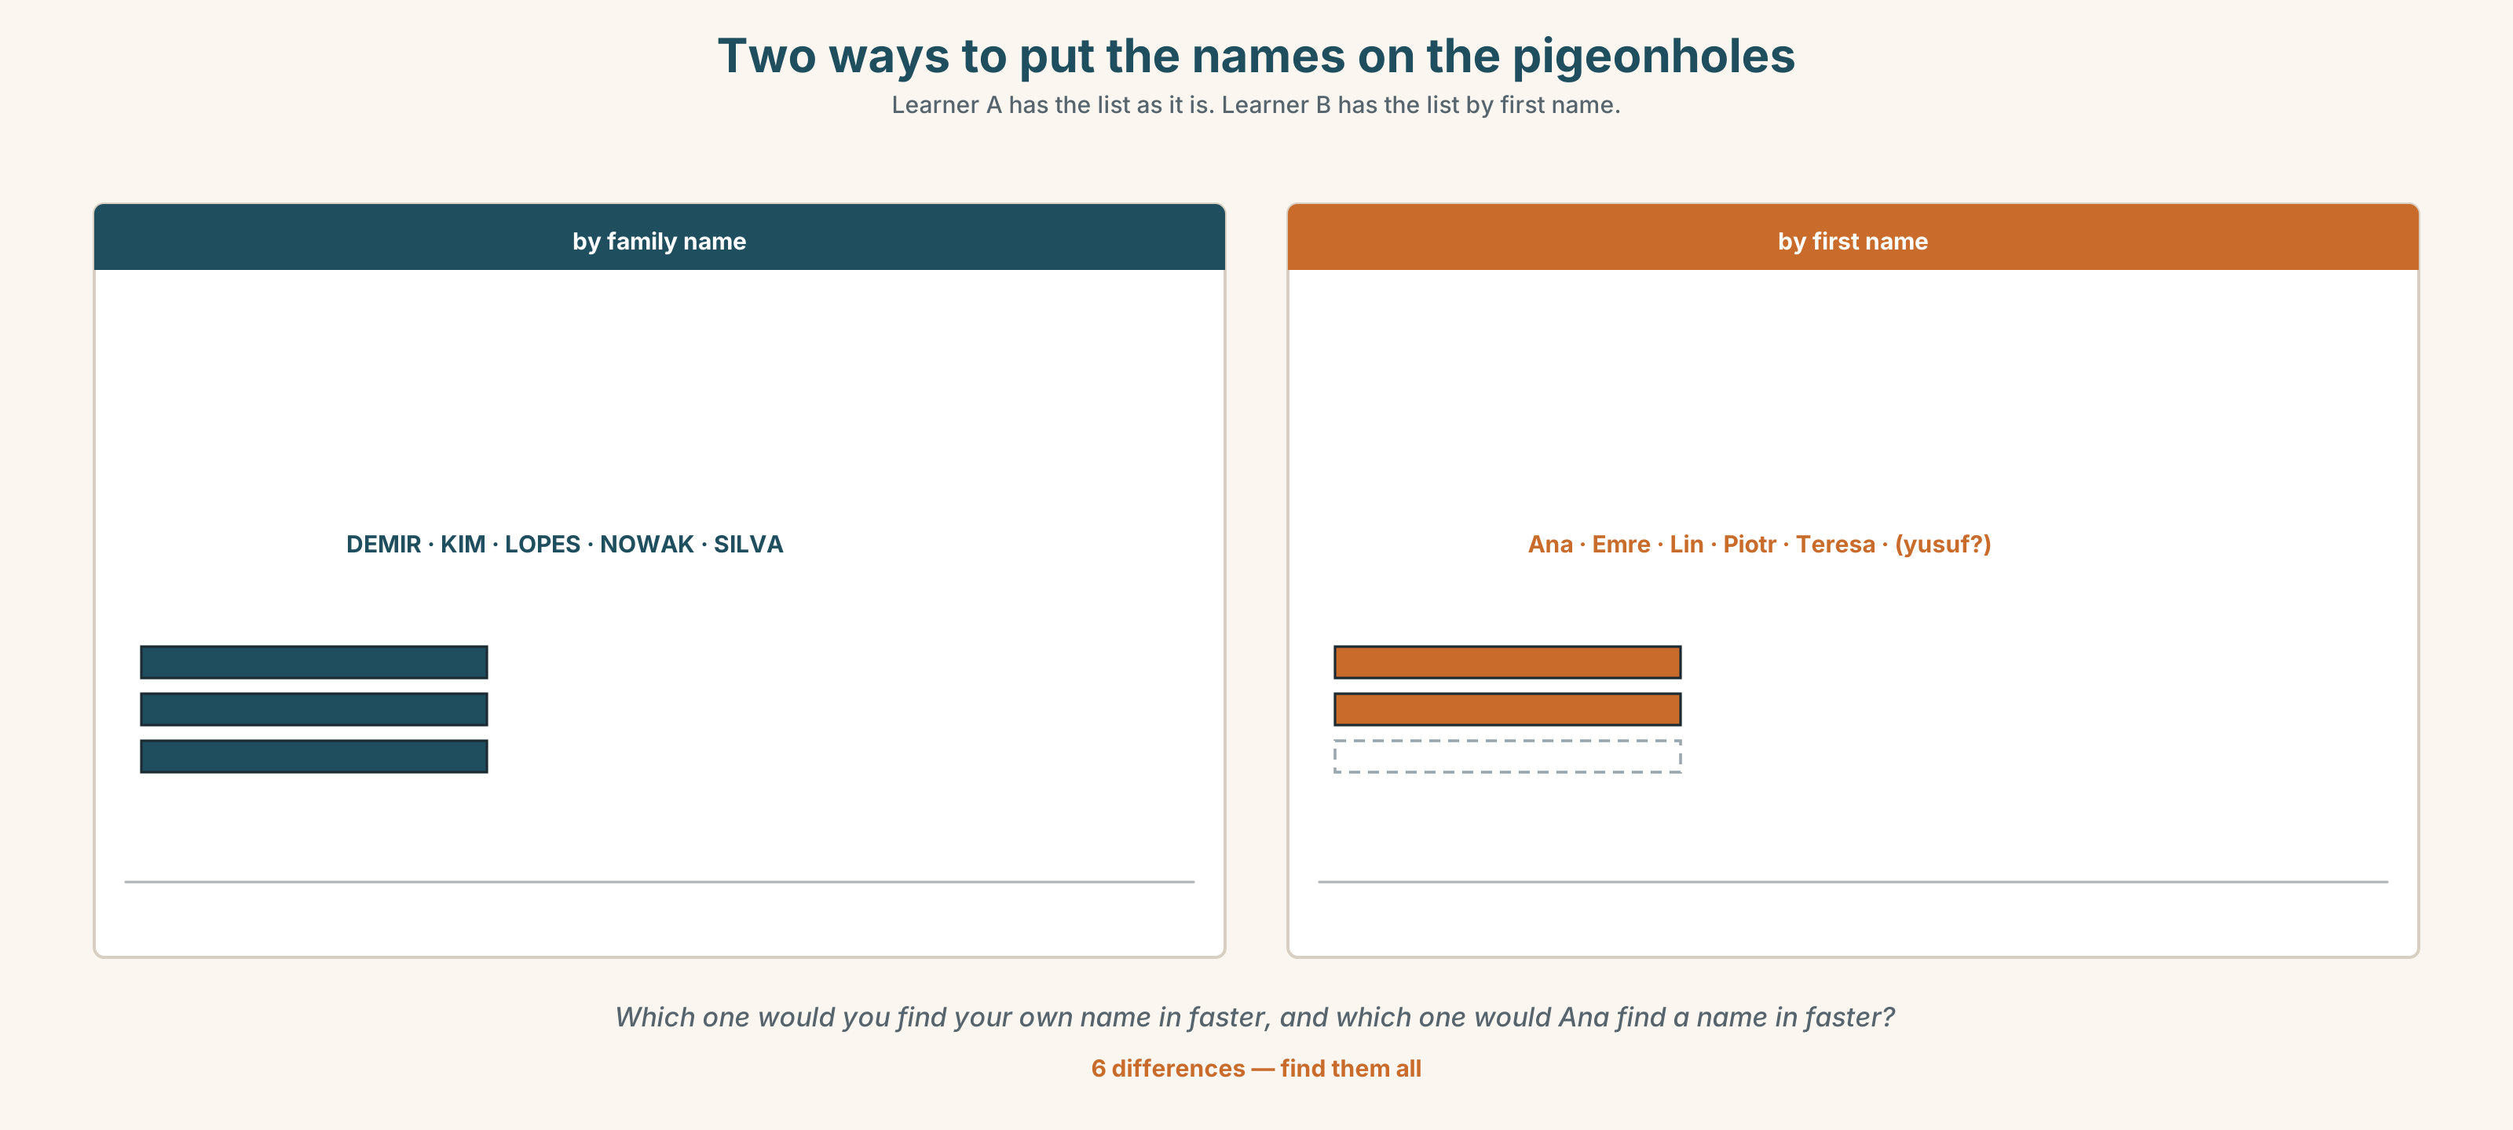{width=6.6in}
Two ways to put the names on the pigeonholes — Learner A has the list as it is. Learner B has the list by first name.
🔊 Track 1.6. Lin, 25 seconds: "I changed mine in my first month here. It was easier. Now nobody at work knows my real name and I don't know how to start."

11B · Talk about it
In threes. Use the frame. Everybody says one.
I think Yusuf should ______ , because ______ .
Words you can use: easy · difficult · polite · his name · every day · in front of people · friendly · tired

11C · Decide
Write two sentences. Choose, and say why.
I think Yusuf should ______________________ , because ______________________ .

11D · Model decision
I think Yusuf should say it one more time, but differently. Two corrections did not work, and Marco is not unkind — he is friendly, and that makes it harder. So: say it when nobody is waiting, and write it down. People remember a name they have seen.

11E · The Reveal
What happened. Yusuf wrote his name on a napkin and gave it to Marco on a quiet afternoon. Marco kept it. He now says Yusuf, and he says it slightly too carefully, which Yusuf finds funny.
Lin never went back to her name. She says she does not mind. She also says she minds.
One question. You do not have to answer it out loud.
Yusuf's reasoning was good and it worked. Would it still have been good reasoning if Marco had not kept the napkin?

Part 12 · Landing ◆ all three lines

12A · Recycle — twelve items
This is Unit 1 of Book 1. There is nothing before it. So everything here is from this unit — and from Unit 2 onwards, four items will come from earlier in this book and two from the book before.
- She ______ a teacher. 2. They ______ from Korea. 3. I ______ not late.
- ______ you in room 3? 5. Marco is from Brazil. He is ______ .
- What's your ______ name — Yusuf or Hassan?
- Sorry, how do you ______ it?
- Thirteen or thirty? (listen) ______
- I am twenty-two. = I ______ twenty-two years old.
- ______ is my friend Lin.
- The cats ______ on the step.
- Ana is at the ______ .

12B · Consolidate — one task, everything in it
Write six sentences about the people in your class. Use am, is and are — all three. Use two numbers. Use two countries. Name three people.

12C · Can-do, with evidence
I can… | My evidence | Sure?
say my name and spell it so a stranger can write it down | your Part 9C role play | ◯ ◑ ●
introduce myself and one other person to a group | your Part 4C recording | ◯ ◑ ●
use am, is and are correctly | your Part 3G score | ◯ ◑ ●
understand and say numbers 0–100 | your Part 6A score | ◯ ◑ ●

12D · Replay ⏺
Find your thirty seconds from Part 0C. Listen. Now record it again: Who is in this room?
Listen to both. Count the names. The first time, how many? Now?

12E · Glossary — thirty-five words, as a map
PEOPLE · student · teacher · friend · man · woman · people · class WHERE FROM · country · city · address · Portuguese · Brazilian · Egyptian · Korean · Nigerian · Polish NAMES · name · first name · family name · How do you spell it? · What's your name? CONTACT · email · phone number NUMBERS · zero · one · two · three · ten · twelve · twenty · thirty · forty · fifty · a hundred MEETING · Where are you from? · This is my friend.

12F · Next
Unit 2 · What does your body do all day? You can say who you are. Next: what you do.

