Table of Contents

A1.1 · Unit 2 · The Six O'Clock Class
English Animated · Starting Out · Escola Monte, Lisbon Student's Book pages 28–49 · 22 pp · ~9 hours

Part 0 · The Big Picture ◆ A · THE WORLD
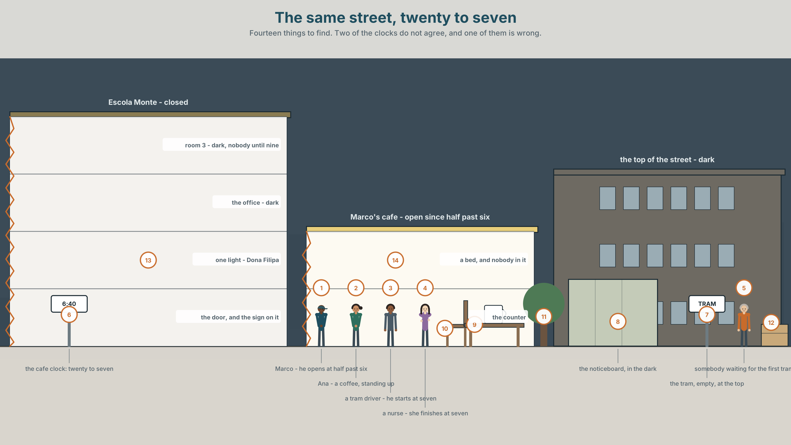{width=6.6in}
The same street, twenty to seven — Fourteen things to find. Two of the clocks do not agree, and one of them is wrong.

What does your body do all day?
By the end of this unit you can say what you do every day, and when you do it.
◆ A · THE WORLD | A street at twenty to seven, and four people who are already working
◆ B · THE SYSTEM | present simple: I, you, we, they · 22 words for the day and the body · days, times, o'clock, half past · the sounds /s/ /z/ /ɪz/
◆ C · THE PERFORMANCE | You tell the class about one day, from waking up to going to bed

0A · Find it — fourteen things
Find these in the picture. Write the number.
☐ a clock ☐ a cup ☐ a bed ☐ a light ☐ a door ☐ a window ☐ a hand ☐ a head ☐ a cat ☐ a tram ☐ a chair ☐ a bag ☐ a street ☐ a café
Three of these words are not in the picture. Which three?
a teacher · a student · a desk · a phone · a book

0B · Guess it
Look at the four people. Who gets up first? How do you know? Say one thing. You can use these words:
work · open · early · tired · six

0C · Say it ⏺
Record. Thirty seconds. Do not prepare.
What do you do every morning?
Say three things. Use I. It does not have to be interesting. You will listen to this again on the last page.

Part 1 · Vocabulary Lab 1 ◆ B · THE SYSTEM

1A · Meet — the day
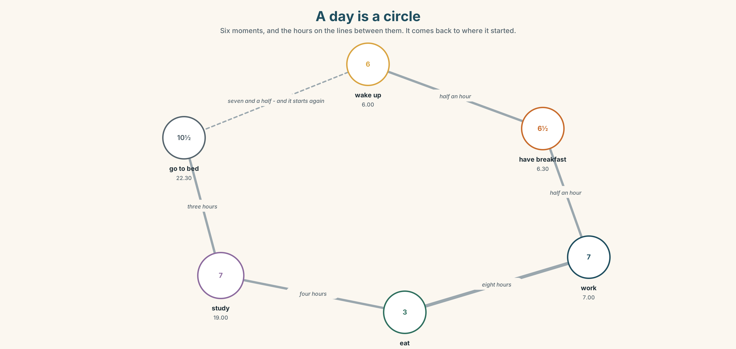{width=6.6in}
A day is a circle — Six moments, and the hours on the lines between them. It comes back to where it started.
wake up | 6.00 | Marco wakes up at six.
get up | 6.05 | Five minutes later.
have breakfast | 6.30 | At the café. He makes it.
work | 7.00–15.00 | Eight hours.
study | 19.00 | Two evenings a week.
go to bed | 22.30 | Early, for a city.

1B · Meet — the words
wash · brush · eat · drink · work · study · sleep · tired · hungry · thirsty · happy
Write each word under the right picture.
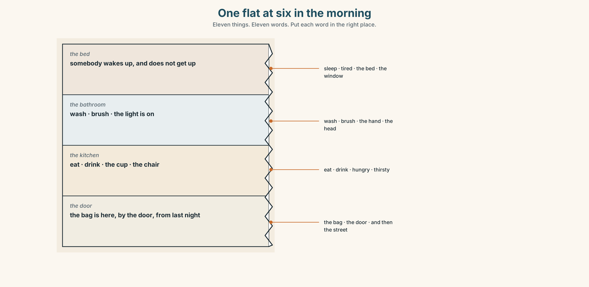{width=6.6in}
One flat at six in the morning — Eleven things. Eleven words. Put each word in the right place.

1C · Sort — a thing you do, or a way you feel?
Put each word in the right box. One word can go in both. Which, and why?
wash · tired · eat · hungry · sleep · happy · drink · thirsty · work · study
YOU DO IT | YOU FEEL IT | BOTH

1D · The body
head | I wash my head.
hand | I wash my hands.
arm | My arms are tired.
leg | My legs are tired.
back | My back is tired.
eye | My eyes are tired.
Now say them. Five of these six are usually said in the plural. Which one is not, and why?

1E · Stretch — the phrases you will need today
have breakfast · go to bed · feel well · wake up · get up
Match each phrase to the moment you need it.
- The alarm makes a noise. → ______
- You put your feet on the floor. → ______
- You eat at seven in the morning. → ______
- The doctor asks you a question. → ______
- It is half past ten at night. → ______

1F · The hard one
f What time is it?
Practise it three times. It is four words and people say it as two.

1G · Own it
Write three times on a card. Do not write your name.
the time you get up · the time you eat · the time you go to bed
Give the card to your teacher. The class guesses whose card it is.

Part 2 · Listening ◆ A · THE WORLD
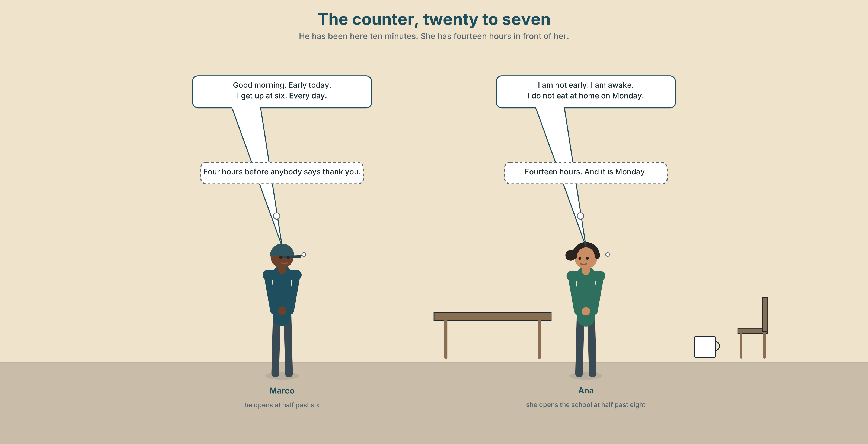{width=6.6in}
The counter, twenty to seven — He has been here ten minutes. She has fourteen hours in front of her.

2A · Twenty to seven 🔊 Track 2.1
Before you listen. Marco opens the café. Ana opens the school. Guess: who starts work first?
Listen once. One question. What time does Marco get up?
Listen again. Complete the table.
 | Gets up | Starts work | Goes to bed
Marco
Ana
the cleaner
Listen again. True or false?
- Marco gets up at six. ☐ T ☐ F
- Ana works on Saturday. ☐ T ☐ F
- The cleaner starts at five. ☐ T ☐ F
- Marco goes to bed late. ☐ T ☐ F
Noticing. Four sentences from the recording.
- I get up at six.
- We open at half past six.
- They start at five.
- You work on Saturday.
All four use the same shape. What is after I, we, they and you?

2B · Decoding clinic 🔊 Track 2.2
Twenty seconds of Marco at speed. Three jobs.
- Count the times he says a number.
- Which word does he say twice — work or open?
- He says half past six very quickly. How many sounds do you hear?
Transcripts, page 148.

Part 3 · Grammar Lab 1 ◆ B · THE SYSTEM

What you do every day

3A · Notice
Look at the four sentences in Part 2 again.
- Is the verb different after I, we, they and you?
- Where is the time — at the start of the sentence, or at the end?
- Can the time go in the other place?
- One of the four sentences is about more than one person. Which?

3B · See
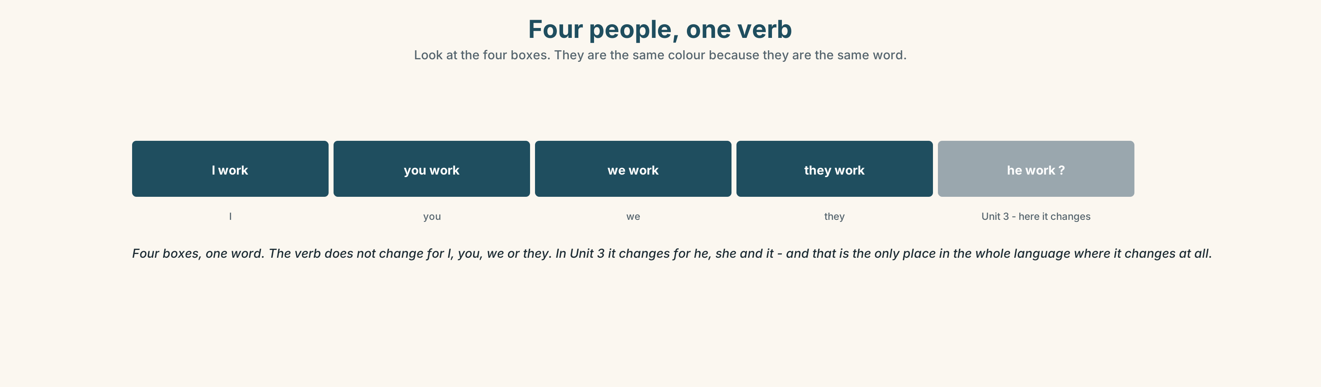{width=6.6in}
Four people, one verb — Look at the four boxes. They are the same colour because they are the same word.

3C · Know
I | work | I work at six.
you | work | You work on Saturday.
we | work | We work together.
they | work | They work at night.
The verb does not change. Not yet. In Unit 3 it changes for he, she and it, and that is the only place it changes in the whole language.
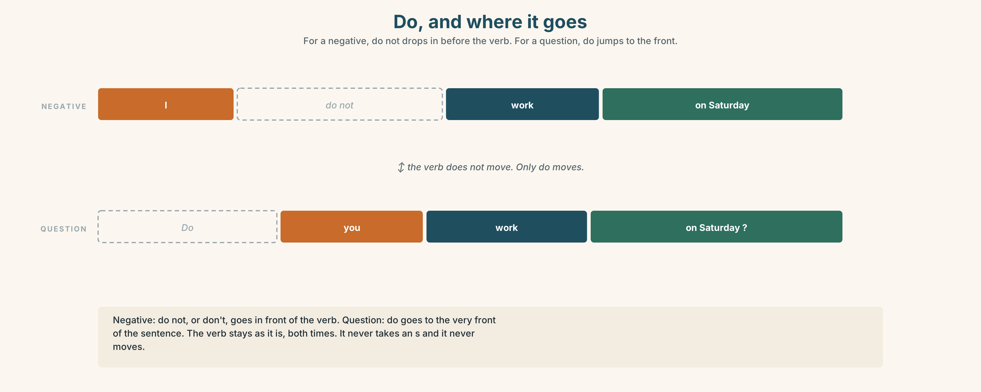{width=6.6in}
Do, and where it goes — For a negative, do not drops in before the verb. For a question, do jumps to the front.
– | I do not work / I don't work · They don't open on Sunday
? | Do you work on Saturday? · Do they open early?
Where the time goes. I get up at six. · At six I get up. Both are English. The first one is normal. The second one puts the time first because the time is the news.
Why it matters. This is how you say anything that is true every day, and most of what you say about your life is true every day.

3D · Use — controlled
Complete with work, don't work, get up, open or don't open.
Marco (1) ______ at six. He (2) ______ the café at half past six. Ana and the cleaner (3) ______ in the same building. They (4) ______ on Sunday. I (5) ______ on Saturday — I study. (6) ______ you work on Saturday?

3E · Use — guided
Make each one negative, then make it a question.
- They open at six.
- I eat breakfast at home.
- We study on Tuesday.
- You work at night.
- They go to bed early.

3F · Use — open
In pairs. Say five true things about your day. Your partner says the same or not the same.

3G · Check — six items, mark your own
- I ______ (get up) at seven.
- They ______ (not open) on Sunday.
- ______ you ______ (work) on Saturday?
- We ______ (study) on Tuesday and Thursday.
- ✗ I am get up at six. → correct it.
- ✗ Do you works on Saturday? → correct it.
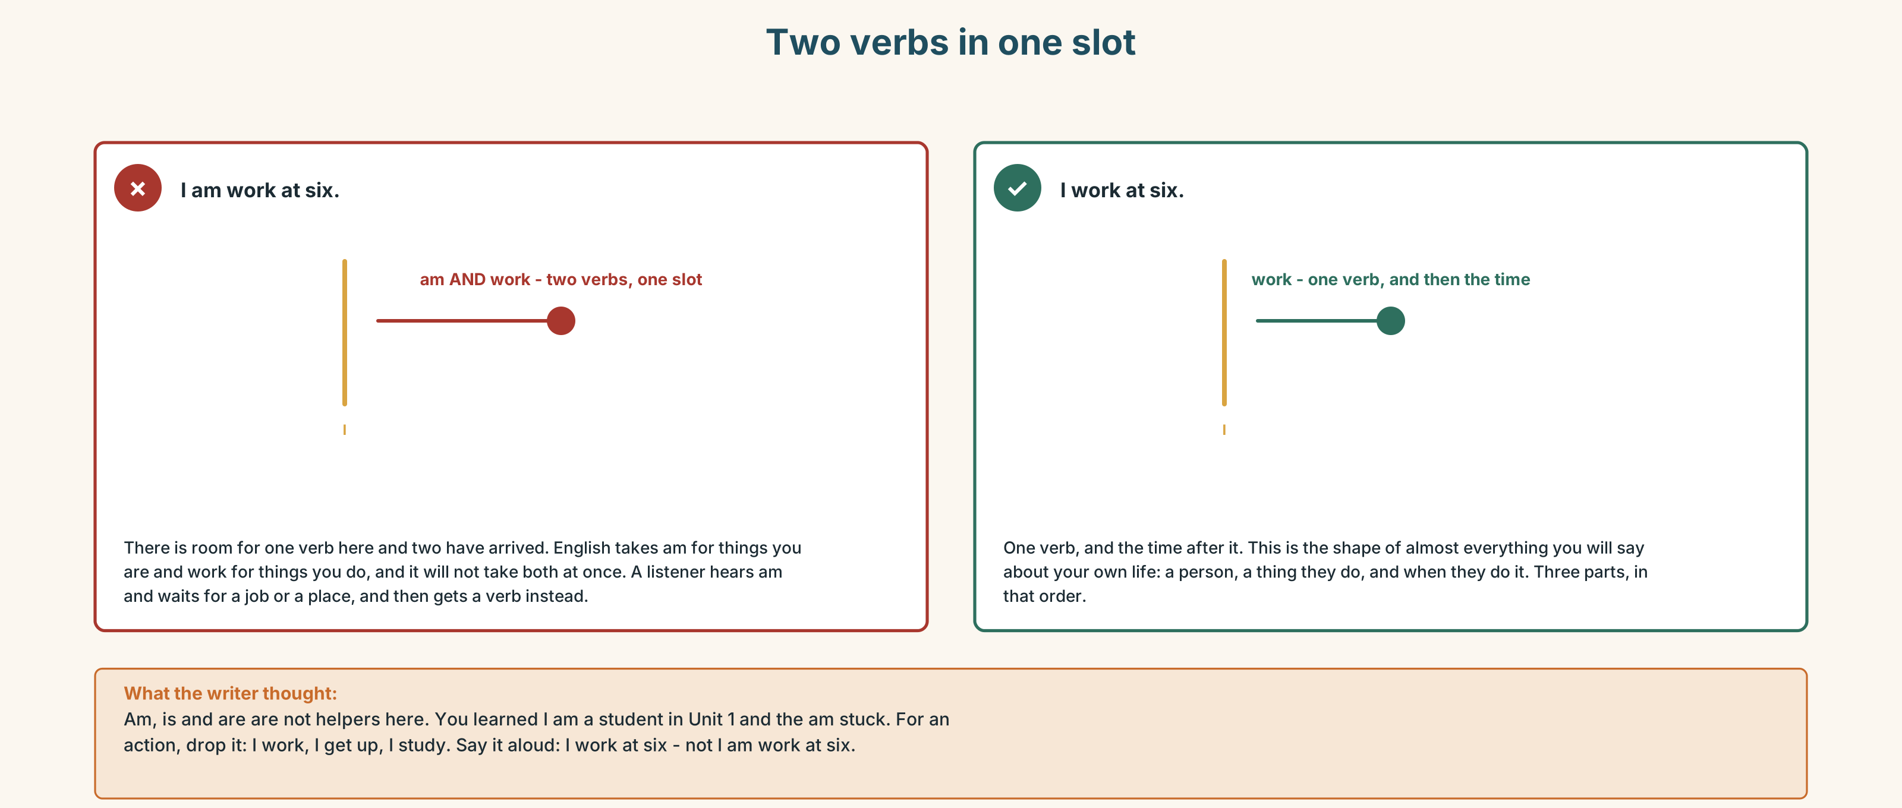{width=6.6in}
Two verbs in one slot — Two verbs in one slot
0–3 → Workbook pp. 8–11. 4–5 → Part 6. 6 → page 47.

Part 4 · Speaking ◆ C · THE PERFORMANCE

4A · Fluency starter — the clock round
Everybody says one thing they do and the time. The next person repeats it and adds theirs. Stop when somebody forgets.

4B · The functional core — saying when
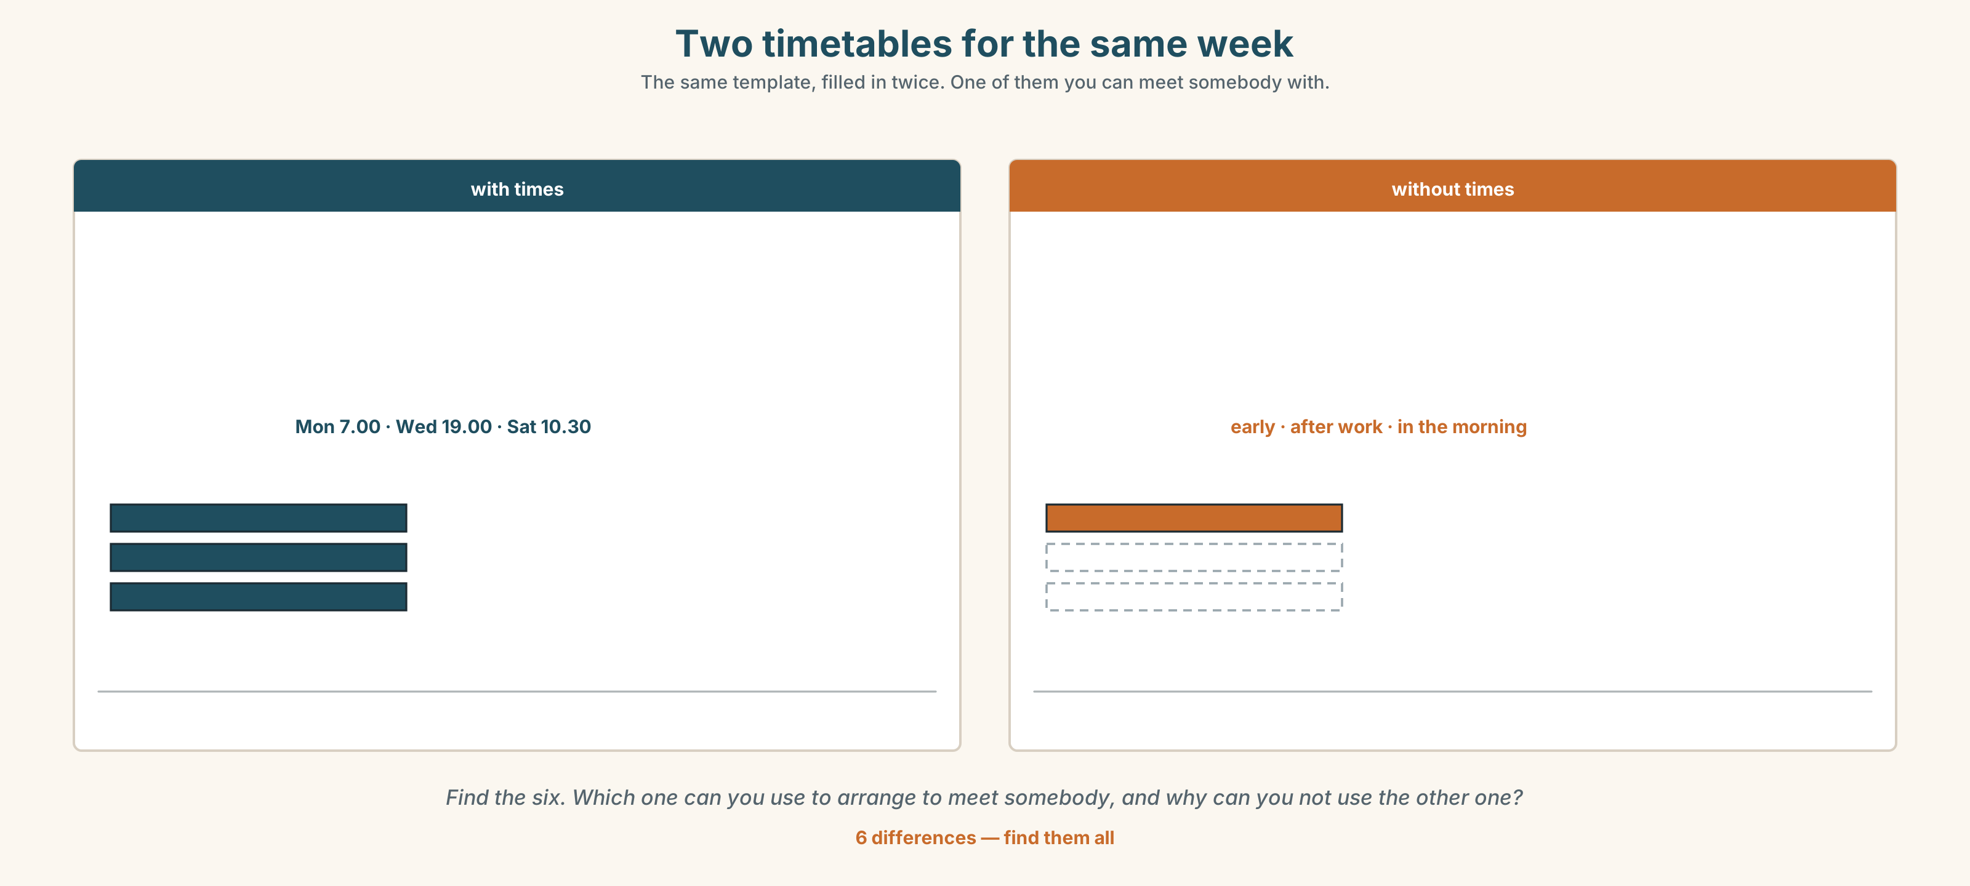{width=6.6in}
Two timetables for the same week — The same template, filled in twice. One of them you can meet somebody with.
Language Bank
the time | at six · at half past six · at seven o'clock
the day | on Monday · on Saturday · every day
the part of the day | in the morning · in the afternoon · in the evening · at night
how often | every day · two days a week
Information gap. Learner A has Marco's week. Learner B has Ana's week. Find one hour when they are both free.

4C · The performance — one day ⏺
Tell the class about one day. One minute. You must say:
what time you get up · two things you do in the morning · one thing you do in the evening · what time you go to bed
Record it.

4D · Observer
One person listens for one thing: did every sentence have a time in it?

4E · Two criteria
☐ Did I use at, on and in correctly? ☐ Did I say six sentences without stopping?

Part 5 · Reading ◆ A · THE WORLD

5A · Predict
The title is "Four people, one street, one morning." What time do you think the first person gets up?

5B · Read — sixty seconds

Four people, one street, one morning
Marco gets up at six. He opens the café at half past six. He does not have breakfast at home — he makes it at work and eats it standing up. He goes to bed at half past ten.
Dona Filipa cleans the school. She starts at five. She finishes at eight, and then she goes to another building and starts again. She sleeps in the afternoon, from one to four.
Ana gets up at seven. She opens the school at half past eight. She has breakfast at home with the radio on, and she says this is the best half hour of her day.
Yusuf gets up at eleven on Saturday and he is not sorry about it. On Monday to Friday he gets up at seven, and on Saturday he sleeps.
Four people. One street. Nobody is in the same place at the same time, and they all think the street is quiet.

5C · Answer
- What time does Marco open the café?
- Where does Marco eat breakfast?
- What time does Dona Filipa start?
- What does she do in the afternoon?
- Why does Ana say the half hour is the best of her day?
- The last sentence says they all think the street is quiet. Why do they all think that?

5D · Vocabulary in context
Guess from the text. Then check.
standing up · finishes · another building · with the radio on · he is not sorry about it

5E · The counter-text
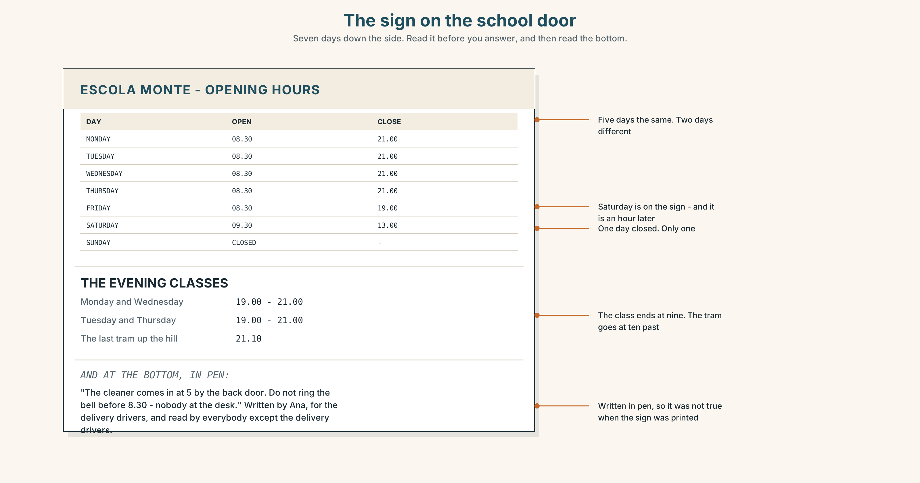{width=6.6in}
The sign on the school door — Seven days down the side. Read it before you answer, and then read the bottom.
Read the sign and answer.
- What time does the school open on Monday?
- What time does it open on Saturday, and is that on the sign?
- Which day is it closed?
- What does the handwritten note say, and who is it for?

5F · Two texts
The sign says the school opens at half past eight. The text says Dona Filipa starts at five.
Is the sign wrong? Say one sentence.

Part 6 · Vocabulary Lab 2 ◆ B · THE SYSTEM

Days, hours and half hours
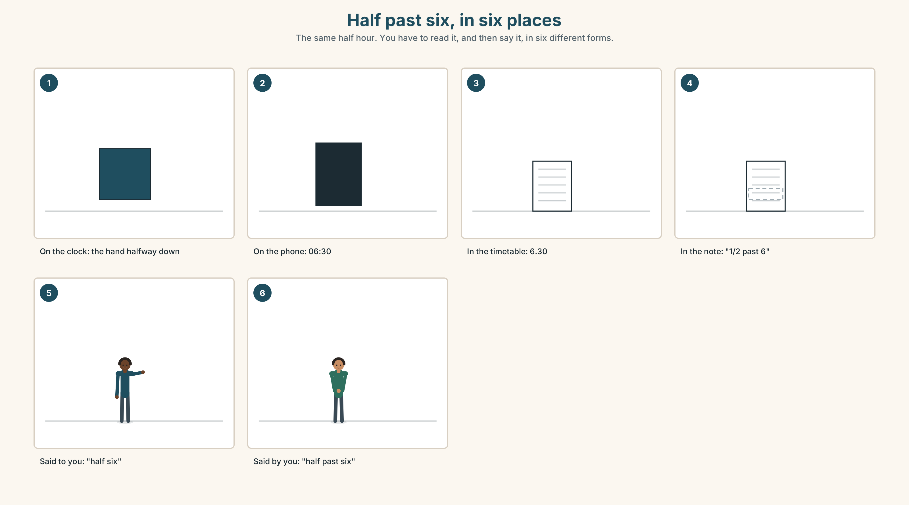{width=6.6in}
Half past six, in six places — The same half hour. You have to read it, and then say it, in six different forms.

6A · The ones that catch everybody
Wednesday | three syllables are written, two are said: WENZ-day
half past six | not half to seven
at night | not in the night
on Monday | not in Monday

6B · Say the time
6.00 · 6.30 · 7.00 · 7.30 · 9.00 · 9.30 · 10.30 · 11.00

6C · Chunk
- ______ past seven
- ______ o'clock
- ______ day — Monday to Sunday, all of them
- in the ______ — before twelve
- at ______ — when it is dark
- ______ Saturday — one day a week

6D · Contrast Clinic
Six items. at, on or in?
- ______ six o'clock
- ______ Monday
- ______ the morning
- ______ night
- ______ Saturday afternoon
- ______ half past eight

Part 7 · Pronunciation & Fluency Lab ◆ B · THE SYSTEM

/s/ /z/ and /ɪz/ — one letter, three sounds
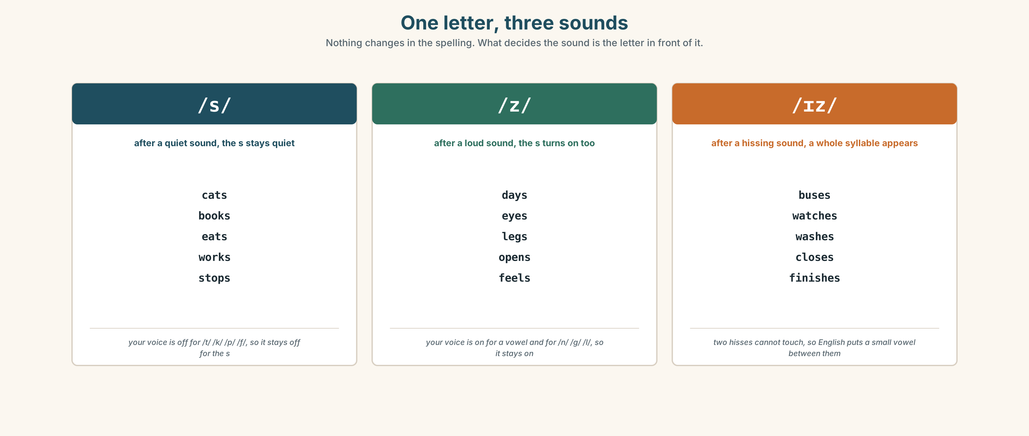{width=6.6in}
One letter, three sounds — Nothing changes in the spelling. What decides the sound is the letter in front of it.

7A · Hear
/s/ after a quiet sound: cats · books · eats · works /z/ after a loud sound: days · eyes · legs · opens /ɪz/ after a hissing sound: buses · watches · washes · closes

7B · Say
Say each group three times. Then say this:
He washes, he works, he opens. — three endings, one sentence.

7C · Make it mean something
Say these two:
My eyes. /z/ My eye's tired. /z/ too — and it is not a plural at all.
One sound, two jobs. Which is which?

7D · Fluency 20 ⏺
Twenty seconds: six things you do every day, with the time. Three times, faster.

Part 8 · Writing ◆ C · THE PERFORMANCE

My day · 40–60 words

8A · Read the model
I get up at half past six. [a time, in the first sentence]
I wash and I have breakfast. I drink coffee, not tea. [two ordinary things, and one small true detail]
I start work at eight. I work until four. [the long part of the day, in one sentence]
In the evening I study English on Tuesday and Thursday. I go to bed at eleven. [the days, and the last time]
Questions about the writer's choices:
- The first sentence is a time. Why not a name?
- I drink coffee, not tea. What does that one small detail do?
- Work is eight hours and it is one sentence. Is that right?

8B · The anti-model
I get up. I wash. I have breakfast. I go to work. I work. I come home. I eat. I go to bed.
Correct English, and it could be anybody. Add four words to it and make it one person.

8C · Plan
the time you get up → two things in the morning → work or school, with the hours → the evening, and the time you go to bed

8D · Write — 40 to 60 words

8E · Peer review — two things only
☐ Is there a time in the first sentence? ☐ Is there one small thing that is only true about this person?

8F · Publish
On the wall, with no names. The class matches the day to the person.

Part 9 · The File ◆ A · THE WORLD + C · THE PERFORMANCE

STUDY FILE · When do you actually study?
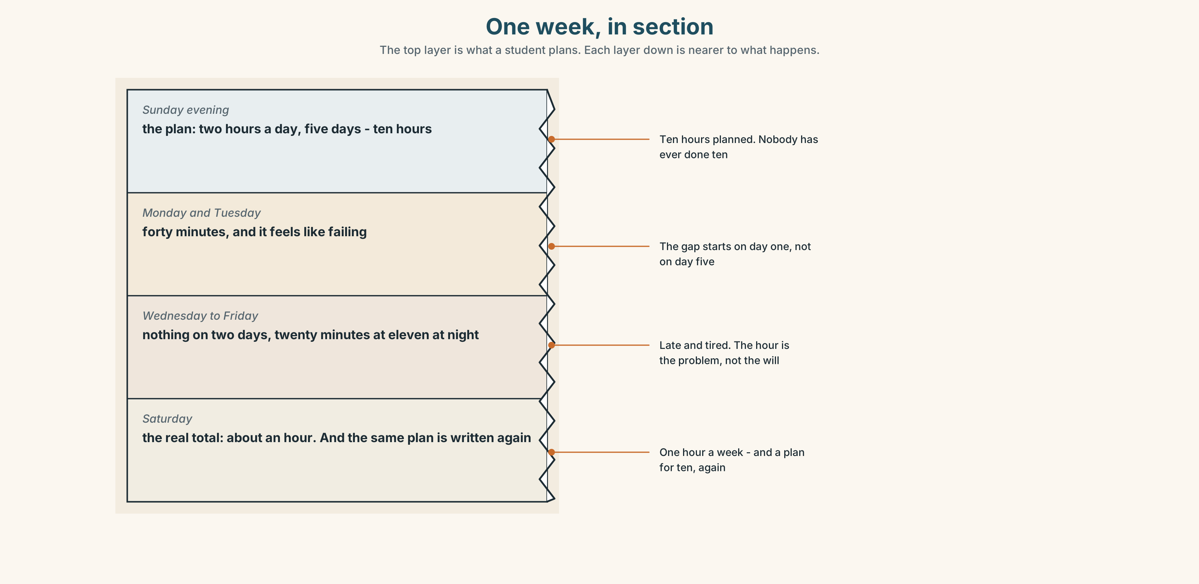{width=6.6in}
One week, in section — The top layer is what a student plans. Each layer down is nearer to what happens.

9A · The week
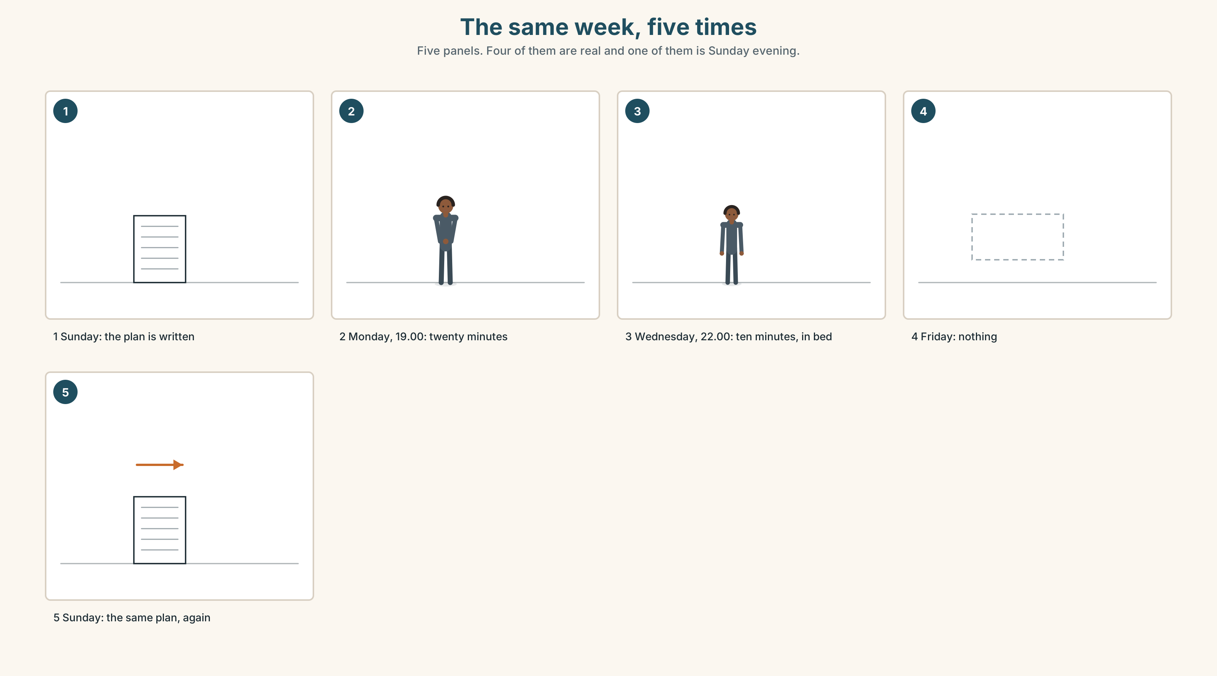{width=6.6in}
The same week, five times — Five panels. Four of them are real and one of them is Sunday evening.
What people plan | two hours, five days a week
What people do | twenty minutes, three days a week
When they do it | late, and tired
What they say | I don't have time.

9B · Twenty minutes
Twenty minutes every day is more than two hours on Sunday. Not because twenty is more — because Sunday does not always happen.
When in your day is there twenty minutes that always happens? Write the time.

9C · Role play — the honest timetable
In pairs. One of you plans a week out loud. The other asks, after every line:
And what do you do now at that time?

9D · The thing that always happens
Everybody has one: a bus, a queue, a kettle, a lift. Find yours. That is where the twenty minutes is.

9E · Transfer — before next week
Write down what time you actually studied, for seven days. Do not change anything. Bring the seven times.

Part 10 · Mediation & Interaction ◆ C · THE PERFORMANCE
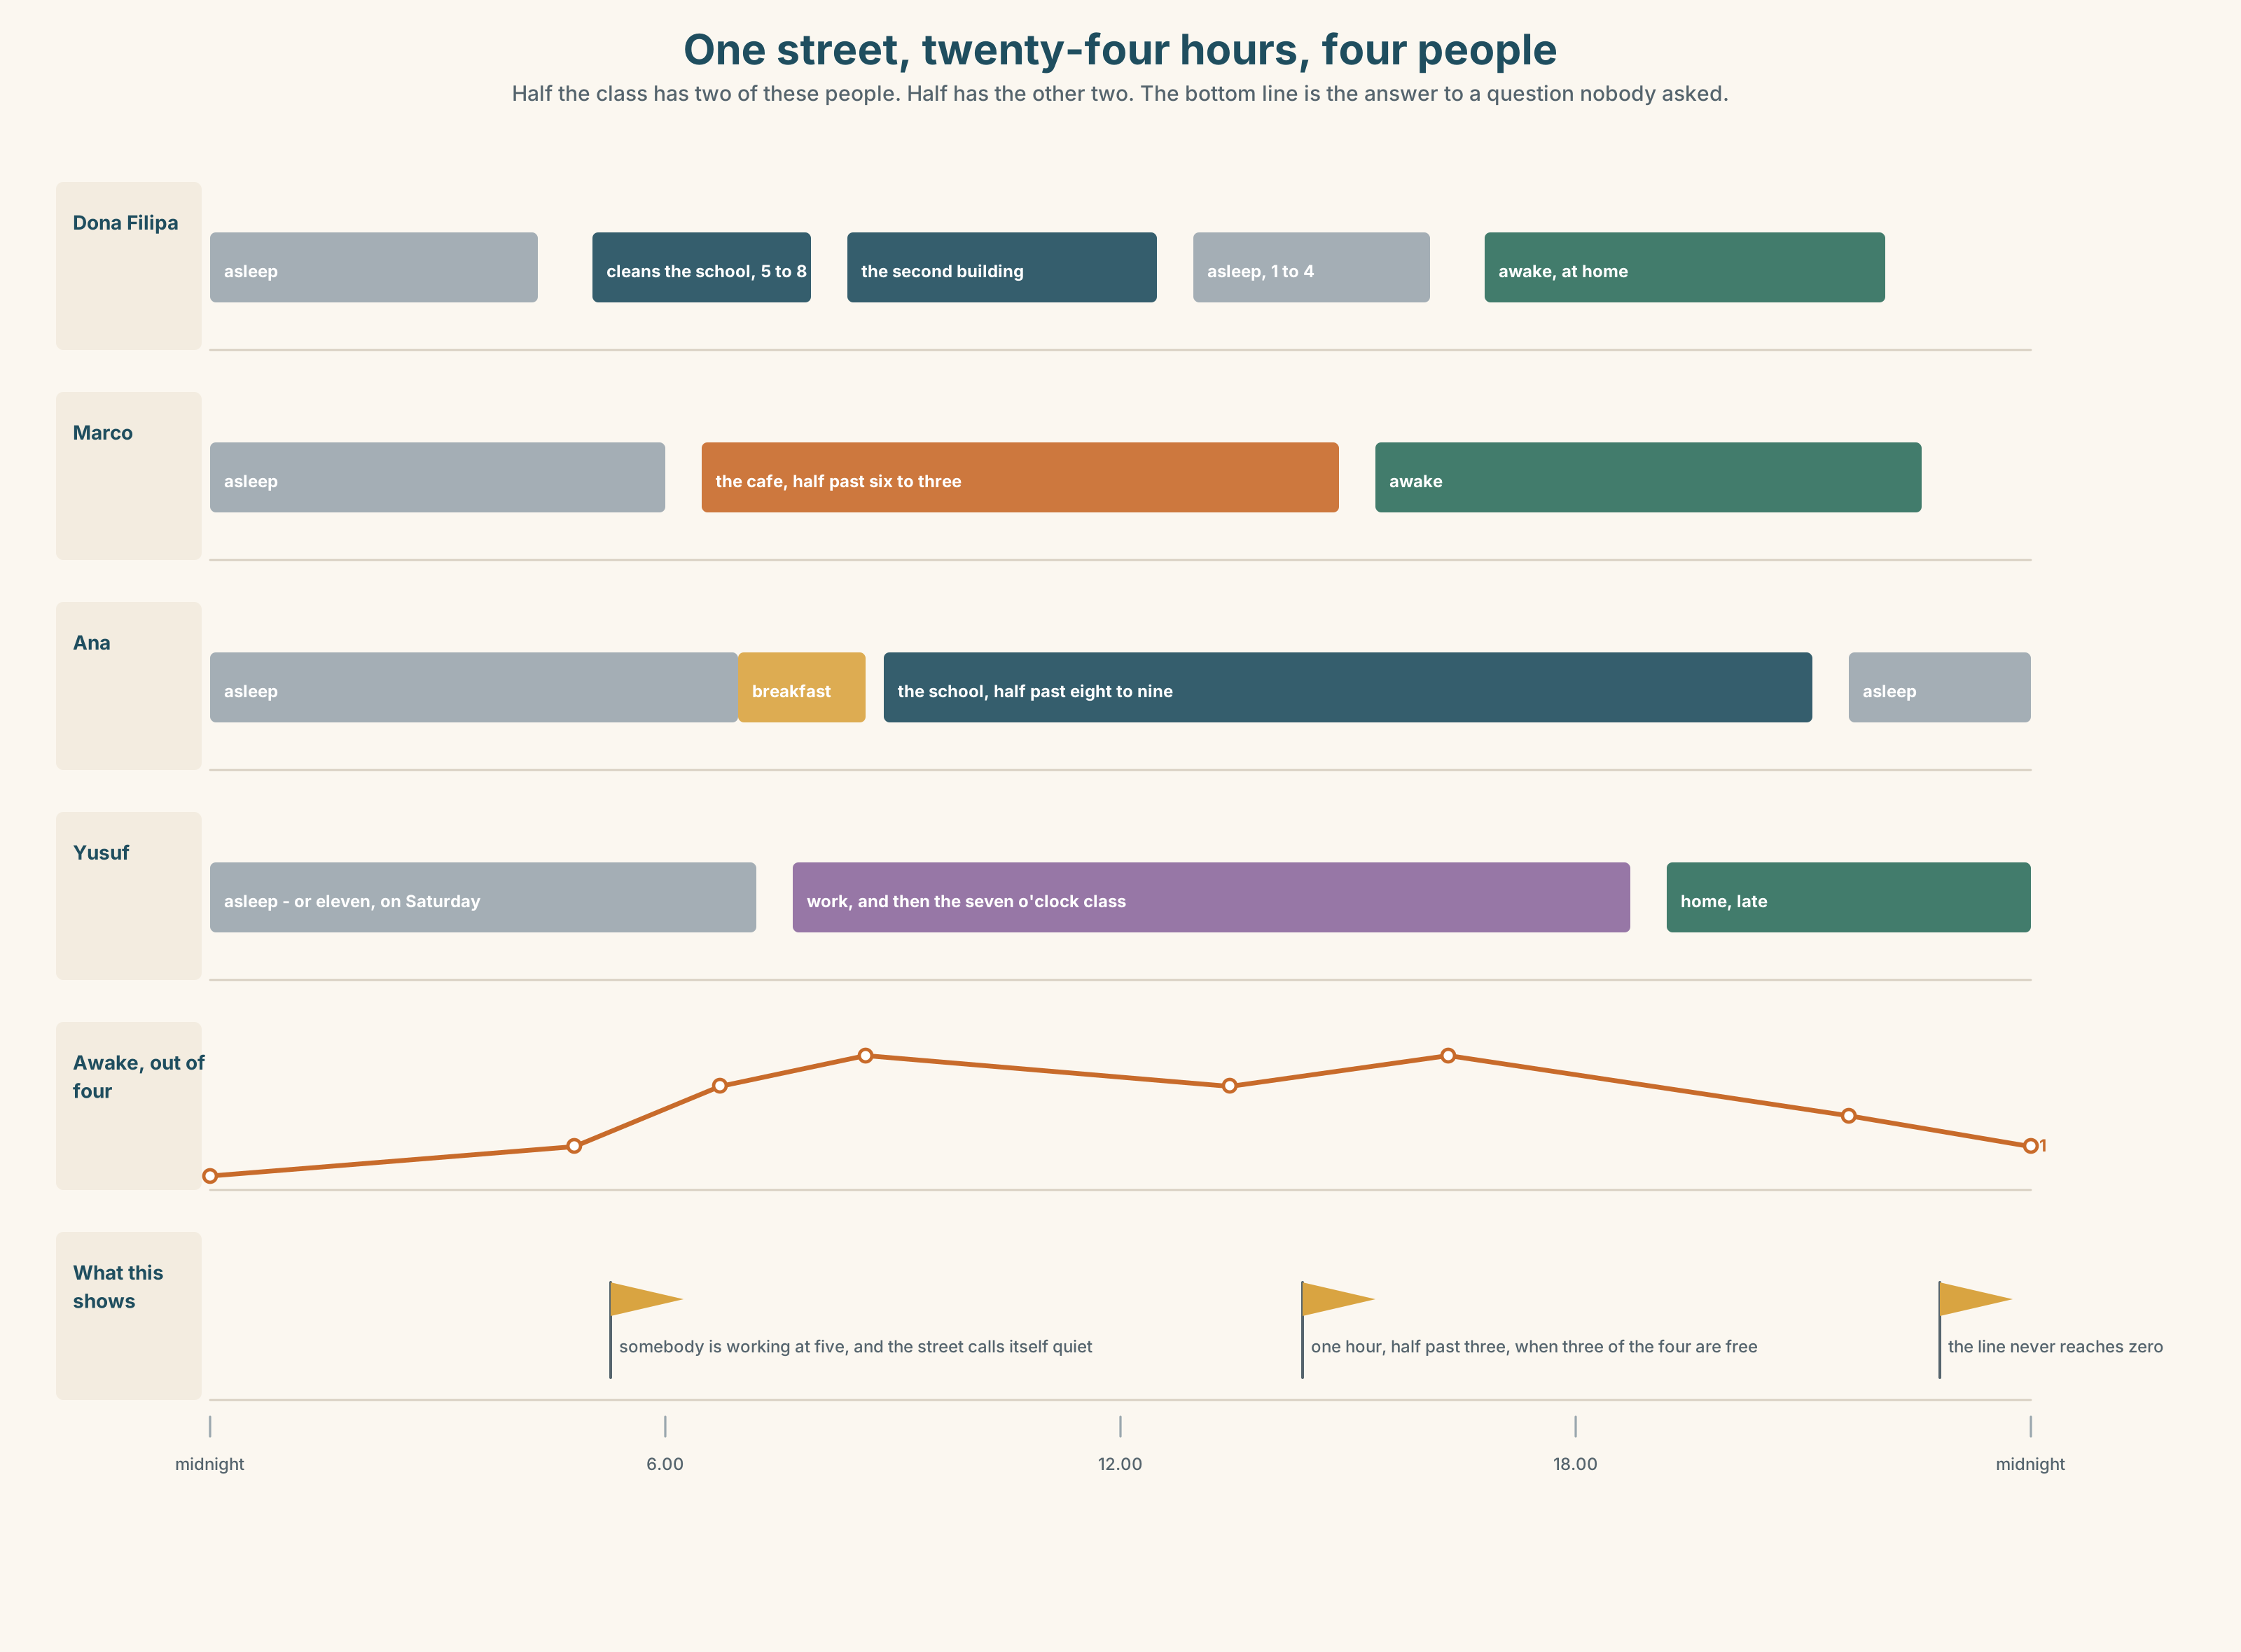{width=6.6in}
One street, twenty-four hours, four people — Half the class has two of these people. Half has the other two. The bottom line is the answer to a question nobody asked.

10A · Relay
Half the class has Marco's day. Half has Dona Filipa's. Rebuild the street's twenty-four hours by speaking. Ten minutes.

10B · Simplify — for one person
A new student asks: What time is the school open? Answer in three sentences. No lists.

10C · Online
Write one message to a classmate: say when you are free this week, and ask when they are. Two sentences.

10D · Your language
Does your language say at six and on Monday with different words? Say both in your language. How many words do you need?

Part 11 · The Decision ◆ C · THE PERFORMANCE

The six o'clock class
Escola Monte has an evening class at seven. Eleven students come.
Four of them work until seven and arrive late, every week. They miss the first fifteen minutes. Teresa starts again for them, every week, and the seven students who came on time wait.
The school can move the class to half past seven. Then nobody is late. But the class finishes at nine, and the last tram is at ten past nine, and three students walk home.

11A · The evidence
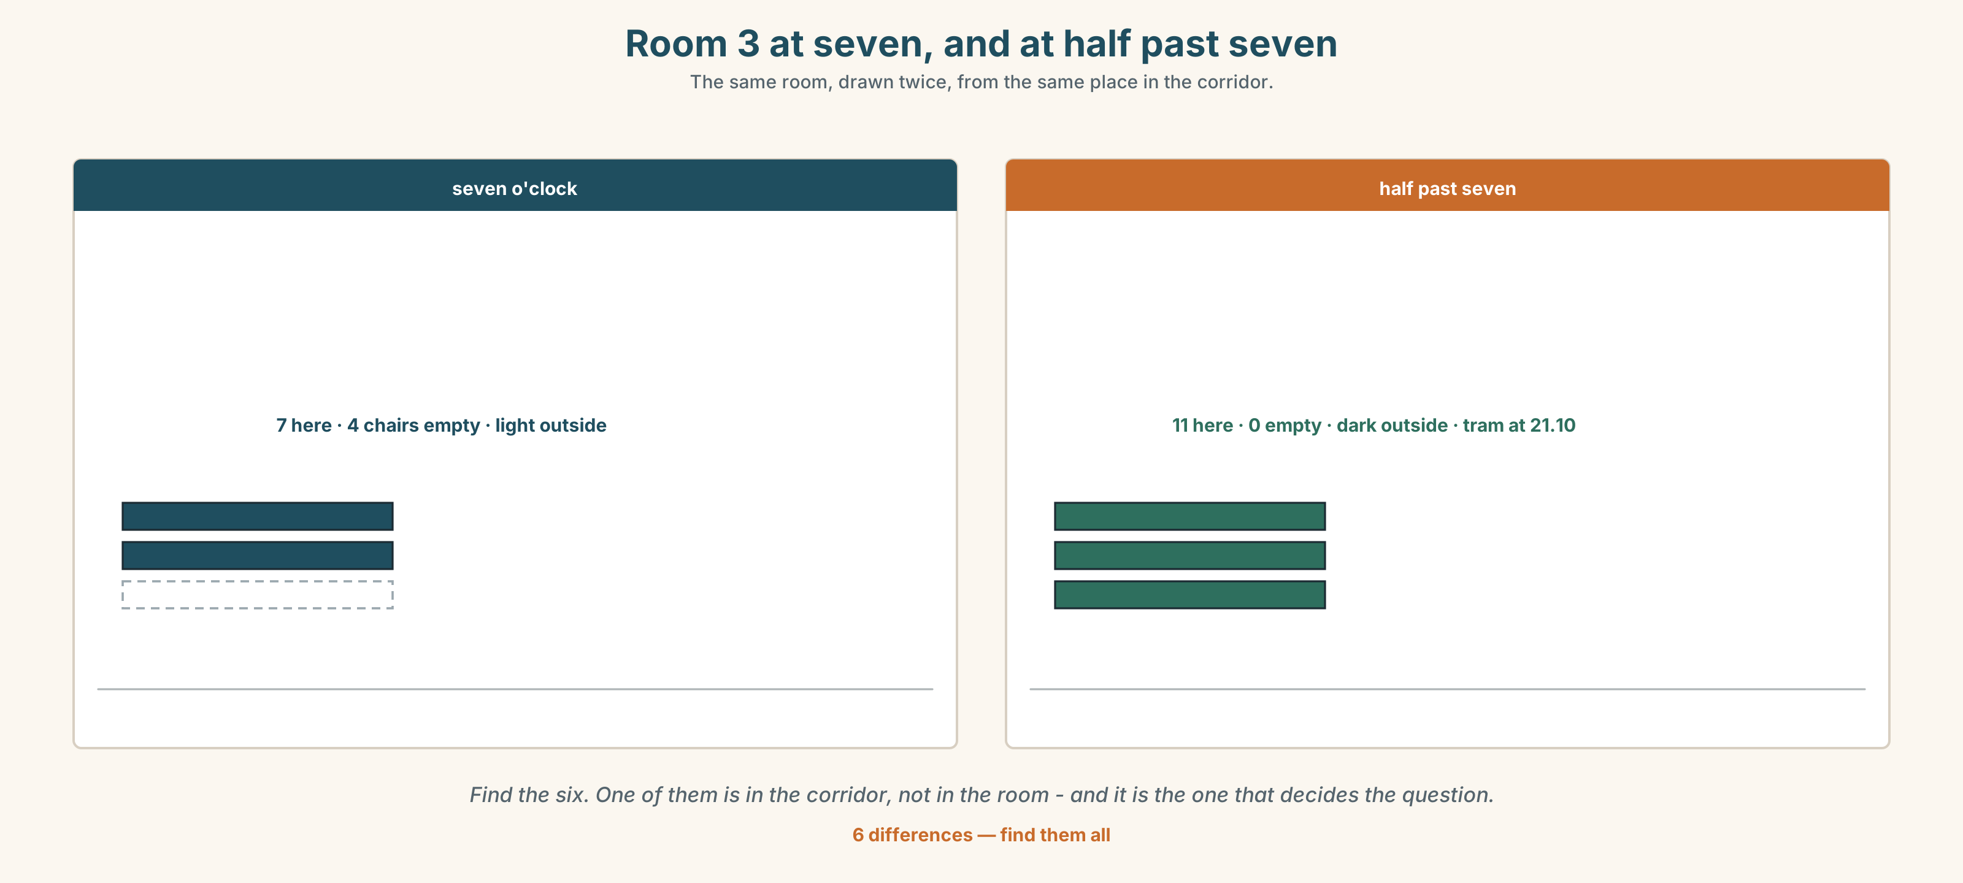{width=6.6in}
Room 3 at seven, and at half past seven — The same room, drawn twice, from the same place in the corridor.
🔊 Track 2.6. Lin, 20 seconds: "I come at seven. I wait. I am not angry. But I get up at six and now I go home at half past nine."

11B · Talk about it
In threes. Use the frame. Everybody says one.
I think the class should start at ______ , because ______ .
Words you can use: work · late · tired · tram · wait · early · every week

11C · Decide
Write two sentences. Choose, and say why.
I think the class should start at ______________________ , because ______________________ .

11D · Model decision
Keep it at seven and do not start again. The first fifteen minutes is speaking practice, and you can walk into speaking practice late. Put the new grammar at half past. Nobody waits and nobody misses anything.

11E · The Reveal
What happened. Teresa moved the grammar to half past seven and left the first fifteen minutes for speaking. The four late students still came late. The seven others stopped waiting.
Then something she did not expect: two of the seven started coming at twenty past instead of seven, because they had worked out what the first fifteen minutes was.
One question. You do not have to answer it out loud.
Teresa solved the problem for the four. Did she make a new one for the seven?

Part 12 · Landing ◆ all three lines

12A · Recycle — twelve items
- I ______ (get up) at six.
- They ______ (not open) on Sunday.
- ______ you ______ (work) on Saturday?
- ______ six o'clock
- ______ Monday
- ______ the morning
- ______ night
- It is half ______ seven.
- I have ______ at seven. (the first meal)
- I go ______ bed at eleven.
- My legs are ______ .
- (Unit 1) She ______ a teacher.

12B · Consolidate — one task, everything in it
Write six sentences about one person in your family. Use they. Put a time in every sentence. Use one negative and one question.

12C · Can-do, with evidence
☐ I can say what I do every day. Evidence: 4C, 8D ☐ I can use at, on and in with times and days. Evidence: 6D ☐ I can make a negative and a question with do. Evidence: 3G ☐ I can hear and say /s/, /z/ and /ɪz/. Evidence: 7D

12D · Replay ⏺
Record 0C again. Listen to both. What is different?

12E · Glossary — thirty-five words, as a map
THE DAY · wake up · get up · have breakfast · work · study · go to bed · sleep THE BODY · head · hand · arm · leg · back · eye DOING · wash · brush · eat · drink FEELING · tired · hungry · thirsty · happy · feel well THE DAYS · Monday · Tuesday · Wednesday · Saturday · Sunday · every day THE TIME · morning · afternoon · evening · night · o'clock · half past · What time is it?

12F · Next
Unit 3 · What is on your screen?

