Table of Contents

A1.1 · Unit 3 · Eleven Screens
English Animated · Starting Out · Escola Monte, Lisbon Student's Book pages 50–71 · 22 pp · ~9 hours

Part 0 · The Big Picture ◆ A · THE WORLD
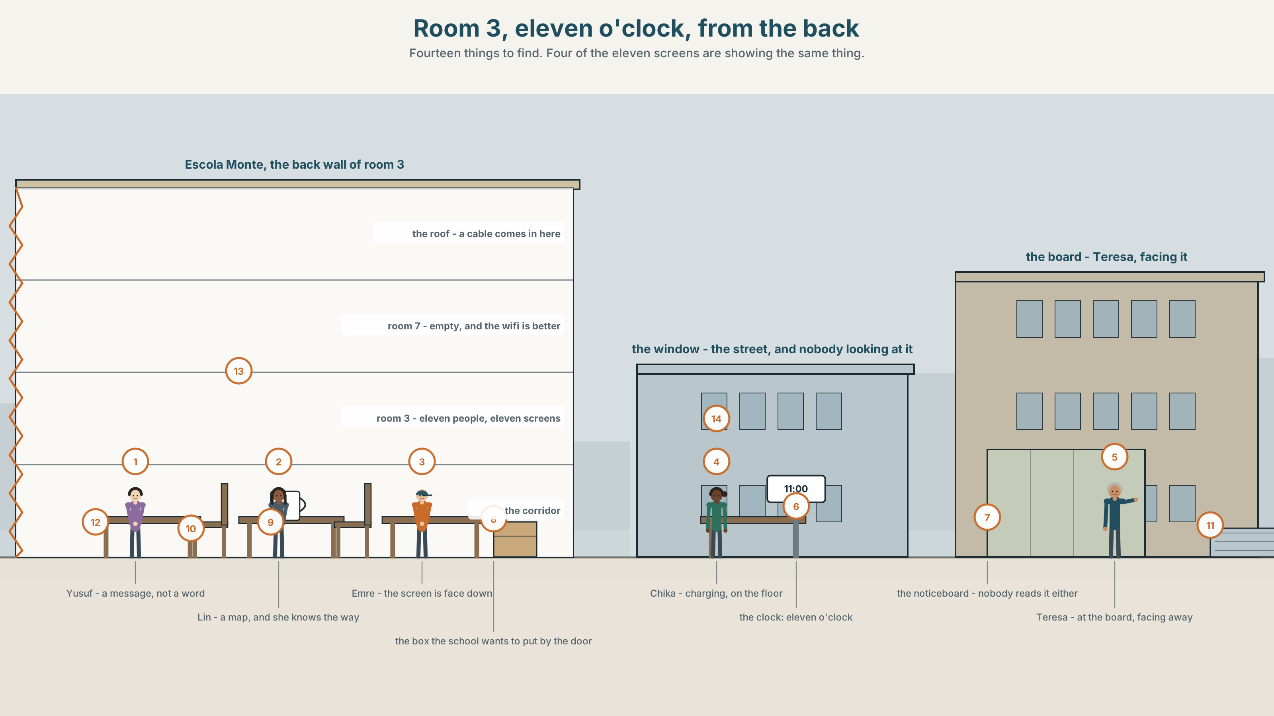{width=6.6in}
Room 3, eleven o'clock, from the back — Fourteen things to find. Four of the eleven screens are showing the same thing.

What is on your screen?
By the end of this unit you can ask somebody what they do, and how often they do it.
◆ A · THE WORLD | A classroom where eleven people are in two places at once
◆ B · THE SYSTEM | present simple he / she / it · do and does questions · 22 words for screens · the seven question words · question tunes, up and down
◆ C · THE PERFORMANCE | You interview a classmate about one habit and report it to the class

0A · Find it — fourteen things
Find these in the picture. Write the number.
☐ a phone ☐ a screen ☐ an app ☐ a message ☐ a photo ☐ a video ☐ a battery ☐ a charger ☐ a map ☐ a camera ☐ a cable ☐ a desk ☐ a clock ☐ a window
Three of these words are not in the picture. Which three?
a password · a notification · the internet

0B · Guess it
Look at the eleven screens. Who is working and who is not? How do you know? Say one thing. You can use these words:
look · message · photo · map · online

0C · Say it ⏺
Record. Thirty seconds. Do not prepare.
What is the first thing you look at in the morning?
Say three things. You will listen to this again on the last page.

Part 1 · Vocabulary Lab 1 ◆ B · THE SYSTEM

1A · Meet — what a phone is made of
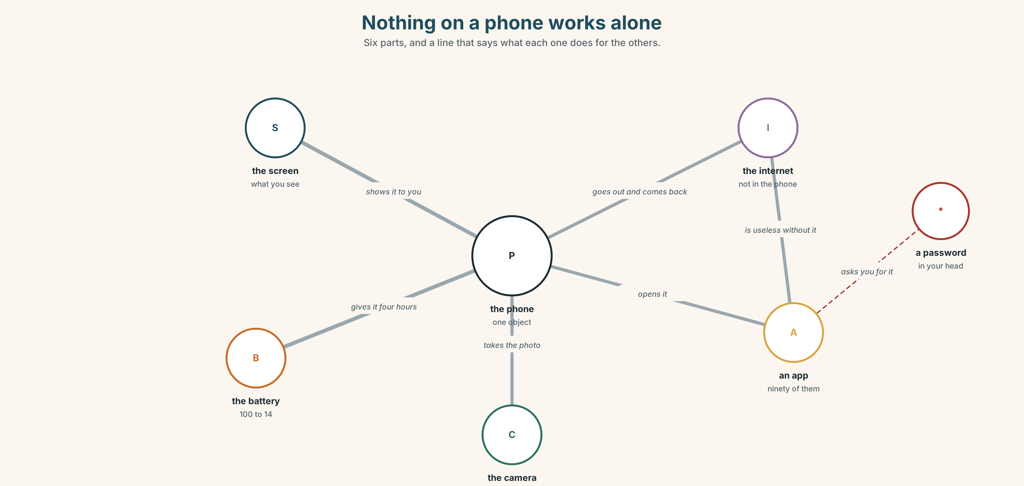{width=6.6in}
Nothing on a phone works alone — Six parts, and a line that says what each one does for the others.
screen | You look at it. It is the part that is broken.
battery | It goes from 100 to 14 in a day.
charger | Everybody has two and nobody has one.
password | The one thing on the phone that is not on the phone.
camera | Two of them, and you only use one.
app | There are ninety. You open four.

1B · Meet — the words
phone · screen · app · message · photo · video · internet · online · notification · map · camera
Write each word under the right picture.
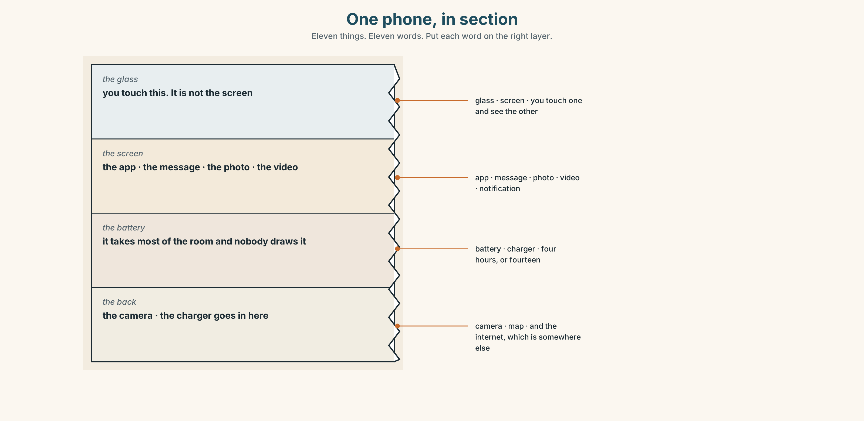{width=6.6in}
One phone, in section — Eleven things. Eleven words. Put each word on the right layer.

1C · Sort — a thing, or a thing you do?
Put each word in the right box. One of them can go in both. Which, and why?
photo · message · video · online · app · screen · camera · notification · map · internet
A THING | A THING YOU DO | BOTH

1D · The verbs that go with it
turn on | I turn on my phone at seven.
turn off | I turn off my phone at eleven. Nobody believes me.
log in | You log in once a year and then you forget the password.
send a message | Four words. It takes two seconds.
take a photo | Not make a photo. English takes it.
check your phone | Eighty times a day, and you remember four.
open an app | Not start. Not put on. Open.
charge the battery | The battery is charged. You charge it.
Now say them. Three of these eight have a word in the middle that can move. Which three? (Try: I turn the phone on.)

1E · Stretch — the phrases you will need today
turn on · log in · take a photo · check your phone · charge the battery
Match each phrase to the moment you need it.
- The screen is black and it is not broken. → ______
- It says 4% and you are going out. → ______
- The website asks you for your name twice. → ______
- Your friend does something funny and you have two seconds. → ______
- You are in a lesson and nothing is happening in your hand. → ______

1F · The hard one
f I don't understand.
Practise it three times. It is the most useful sentence in this book and most people never say it, because they think it is impolite. It is not.

1G · Own it
Write on a card: the app you open first and the app you open most. Do not write your name. The class guesses whose card it is.

Part 2 · Listening ◆ A · THE WORLD
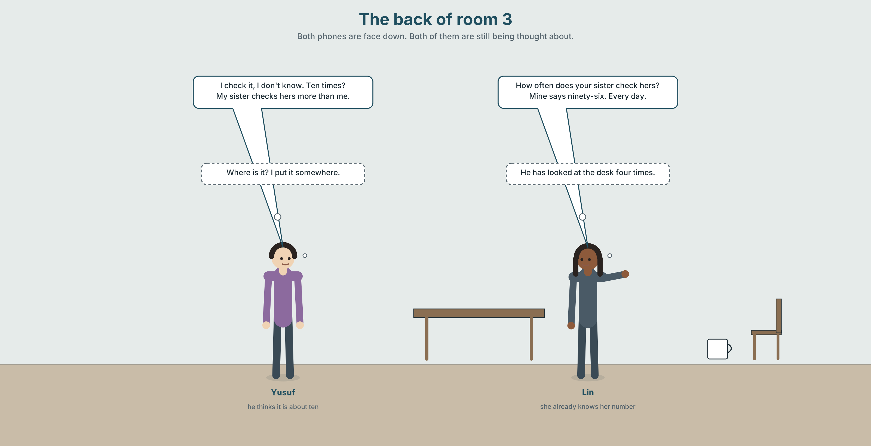{width=6.6in}
The back of room 3 — Both phones are face down. Both of them are still being thought about.

2A · Eleven o'clock, at the back 🔊 Track 3.1
Before you listen. Lin asks Yusuf about his phone. Guess: does he know how often he checks it?
Listen once. One question. How many times a day does Yusuf think he checks his phone?
Listen again. Complete the table.
 | Thinks | The phone says | First app
Yusuf
Lin
Listen again. True or false?
- Yusuf turns off his phone at night. ☐ T ☐ F
- Lin checks her phone before she gets up. ☐ T ☐ F
- Yusuf's battery lasts all day. ☐ T ☐ F
- Lin knows her own password. ☐ T ☐ F
Noticing. Four questions from the recording.
- How often do you check it?
- How often does your sister check hers?
- What does it say?
- Where do you put it at night?
Two of these four have does and two have do. Why?

2B · Decoding clinic 🔊 Track 3.2
Twenty seconds of Lin at speed. Three jobs.
- Count the question words you hear.
- Her voice goes up at the end of two questions and down at the end of two. Which two go up?
- She says how often do you as one word. Write what you hear.
Transcripts, page 149.

Part 3 · Grammar Lab 1 ◆ B · THE SYSTEM

One letter, and the question word in front

3A · Notice
Look at the four questions in Part 2 again.
- Which two have do, and who are they about?
- Which two have does, and who are they about?
- After does, does the verb have an s on it?
- Where is the question word — at the front, or in the middle?

3B · See
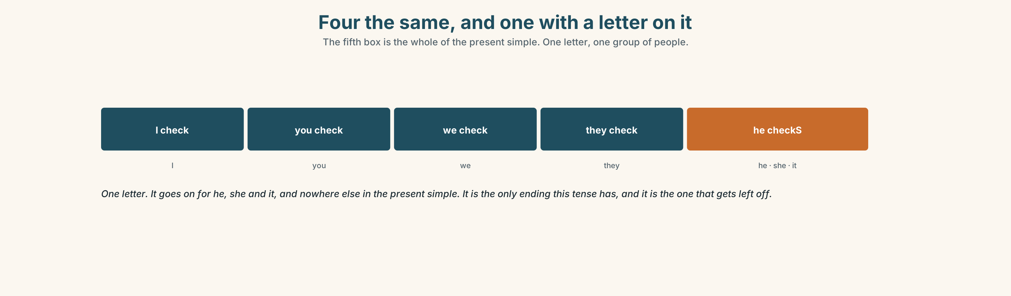{width=6.6in}
Four the same, and one with a letter on it — The fifth box is the whole of the present simple. One letter, one group of people.

3C · Know
I / you / we / they | check | They check their phones at night.
he / she / it | checks | She checks her phone before she gets up.
One letter, one person. The s goes on for he, she and it and nowhere else. It is the only ending the present simple has, and it is the one everybody forgets.
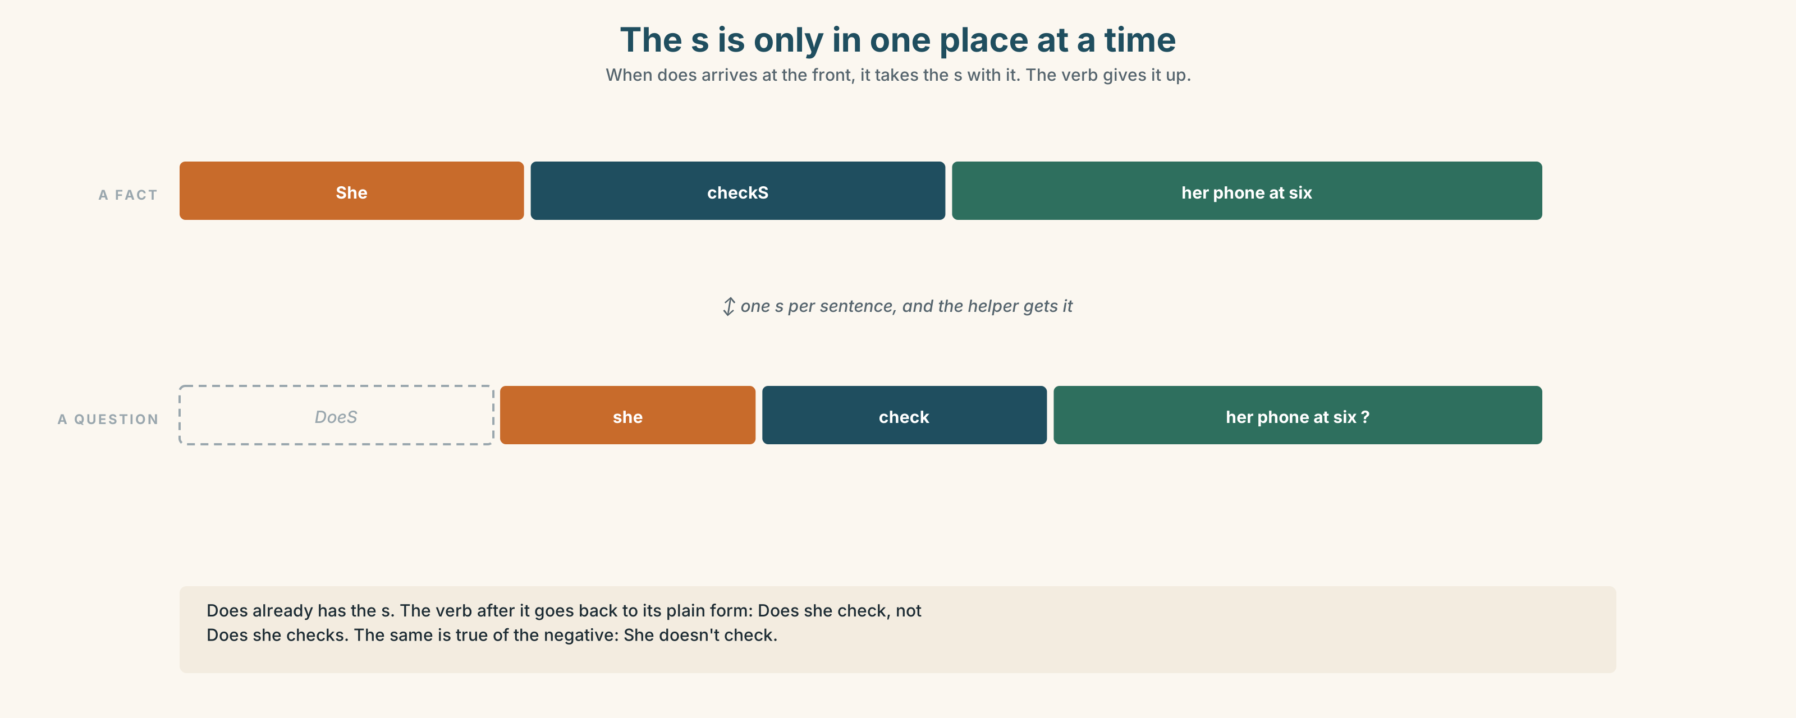{width=6.6in}
The s is only in one place at a time — When does arrives at the front, it takes the s with it. The verb gives it up.
? | Do you check your phone at night? · Does she check her phone at night?
– | I don't check it. · He doesn't check it.
? + word | Where do you put it? · How often does he look at it?
The s is only in one place at a time. Does she checks? is wrong because the s has already gone onto does. One s per question, and the helper gets it.
Why it matters. Every question you will ever ask about somebody else's life has this shape. It is the whole of asking about habits.

3D · Use — controlled
Complete with do, does, don't, doesn't, check or checks.
Lin (1) ______ her phone before she gets up. Yusuf (2) ______ not know how often he looks. (3) ______ you turn off your phone at night? Teresa (4) ______ . She (5) ______ it in a drawer. Her students (6) ______ believe her.

3E · Use — guided
Make a question with the word in brackets.
- She opens the camera first. (which app)
- He checks his phone forty times a day. (how often)
- They charge the battery at night. (when)
- Teresa puts her phone in a drawer. (where)
- Lin uses a map every morning. (why)

3F · Use — open
In pairs. Ask your partner five questions about one other person — a brother, a friend, a neighbour. Every question must have a question word in front.

3G · Check — six items, mark your own
- She ______ (check) her phone at six.
- ______ he ______ (turn off) his phone at night?
- They ______ (not use) the school internet.
- How often ______ your sister ______ (take) a photo?
- ✗ Does she checks her phone? → correct it.
- ✗ How often he checks it? → correct it.
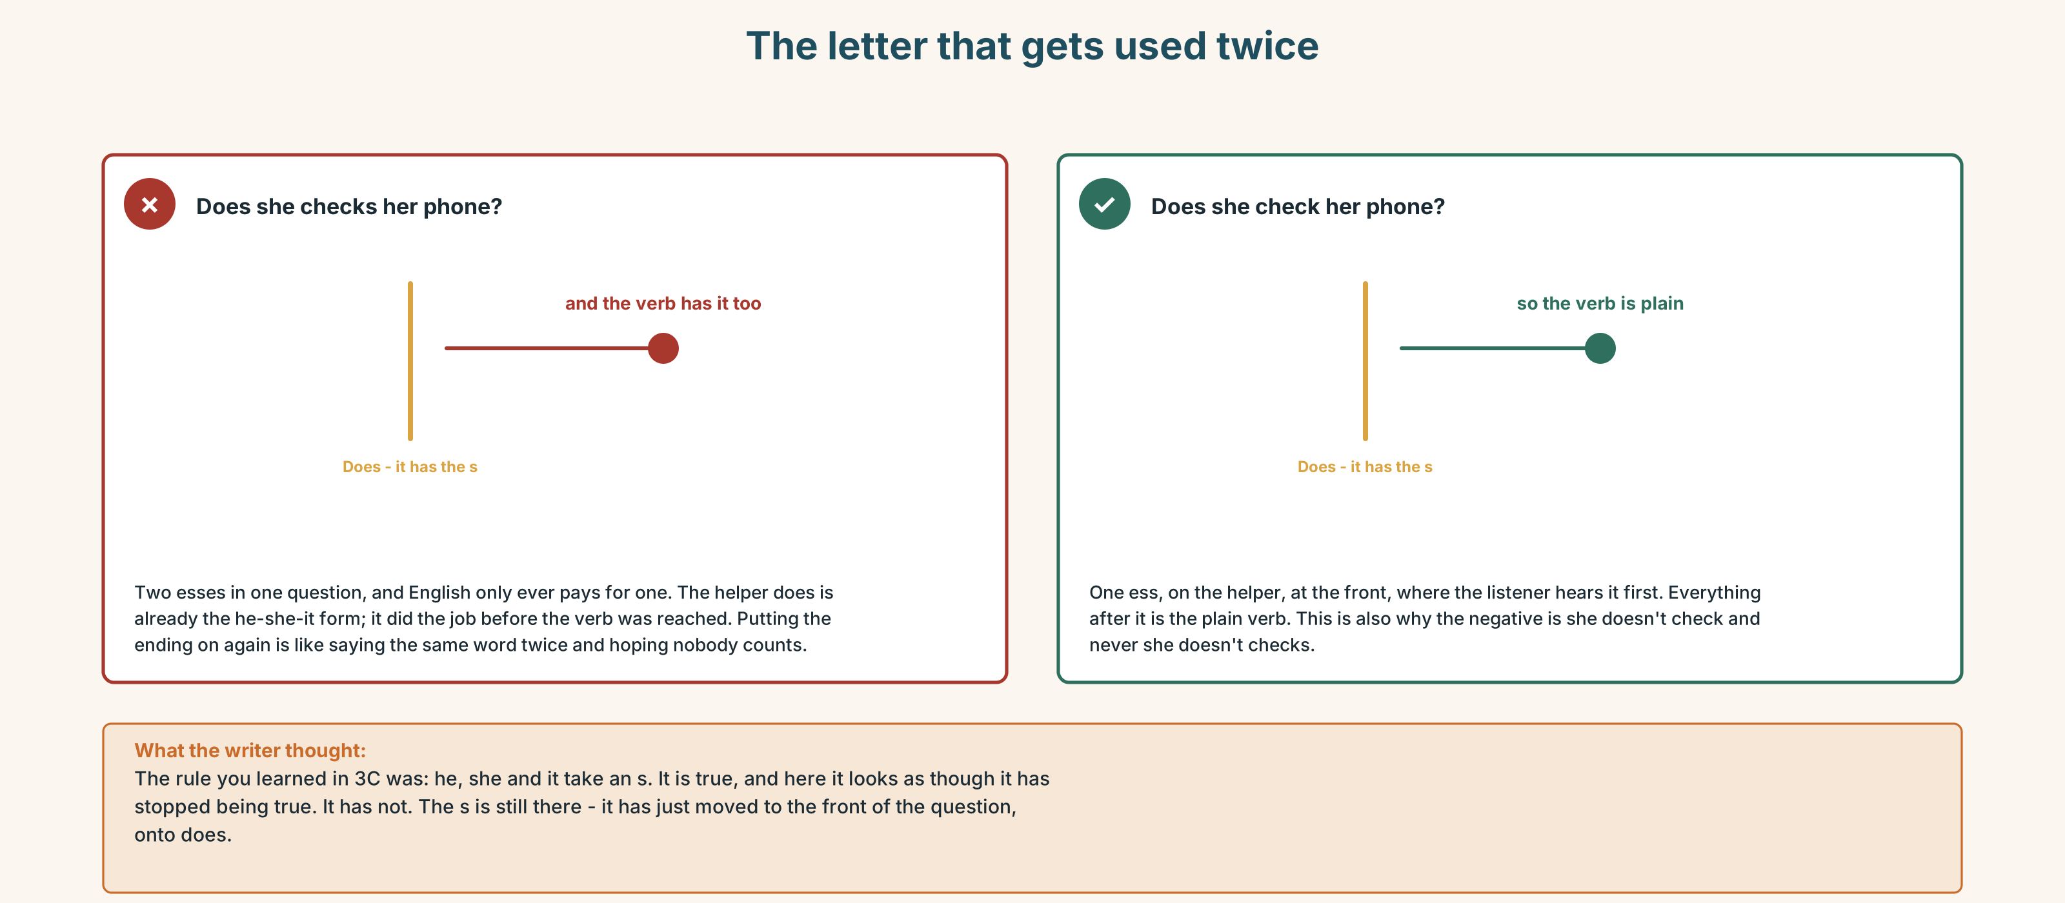{width=6.6in}
The letter that gets used twice — The letter that gets used twice
0–3 → Workbook pp. 12–15. 4–5 → Part 6. 6 → page 68.

Part 4 · Speaking ◆ C · THE PERFORMANCE

4A · Fluency starter — the chain question
One person asks a question with a question word. The next person answers and asks the next one. No question word may be used twice. Seven words, so the chain is seven long.

4B · The functional core — asking about habits
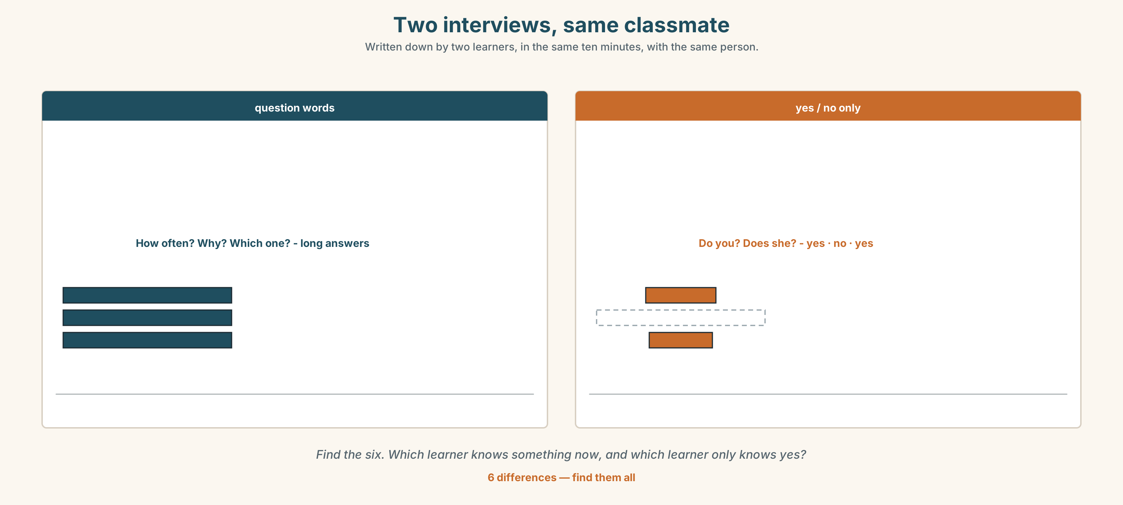{width=6.6in}
Two interviews, same classmate — Written down by two learners, in the same ten minutes, with the same person.
Language Bank
the seven words | what · where · when · who · why · how · which
how + a word | how many · how much · how often
asking again | How do you say…? · What does it mean? · I don't understand.
soft openers | Can I ask you something? · And you?
Information gap. Learner A has Lin's week. Learner B has Yusuf's week. Find out which of the two spends more time online, without saying a number.

4C · The performance — the interview ⏺
Interview one classmate about one habit. Two minutes. You must ask:
one how often question · one what question · one why question · one question you did not plan
Then tell the class in three sentences, using he or she. Record it.

4D · Observer
One person listens for one thing: did every he and she sentence have the s?

4E · Two criteria
☐ Did I ask four questions and not read them? ☐ Did my voice go down at the end of the question-word questions?

Part 5 · Reading ◆ A · THE WORLD

5A · Predict
The title is "The phone in the drawer." Whose drawer do you think it is?

5B · Read — sixty seconds

The phone in the drawer
Teresa teaches in room 3. She puts her phone in a drawer at nine o'clock and she takes it out at one. She says she does not miss it. Her students do not believe her.
Yusuf checks his phone about forty times a day. He thinks it is about ten. The phone knows the real number and it tells him on Sunday, and on Sunday he is surprised, every week.
Lin uses a map every morning. She lives in the city and she knows the way, but she turns it on anyway. She says the map is not for the way. It is for the time.
Dona Filipa has a phone with a long battery and no apps on it. She takes a photo of her grandson every week and she sends it to nobody. The photos stay on the phone.
Four phones. Four different machines, and they all have the same name.

5C · Answer
- Where does Teresa put her phone?
- How often does Yusuf check his phone?
- Why does Lin turn on the map?
- What does Dona Filipa do with her photos?
- Why is Yusuf surprised every week and not only once?
- The last line says four different machines. What makes them different — the phone, or the person?

5D · Vocabulary in context
Guess from the text. Then check.
she does not miss it · the real number · anyway · a long battery · they stay on the phone

5E · The counter-text
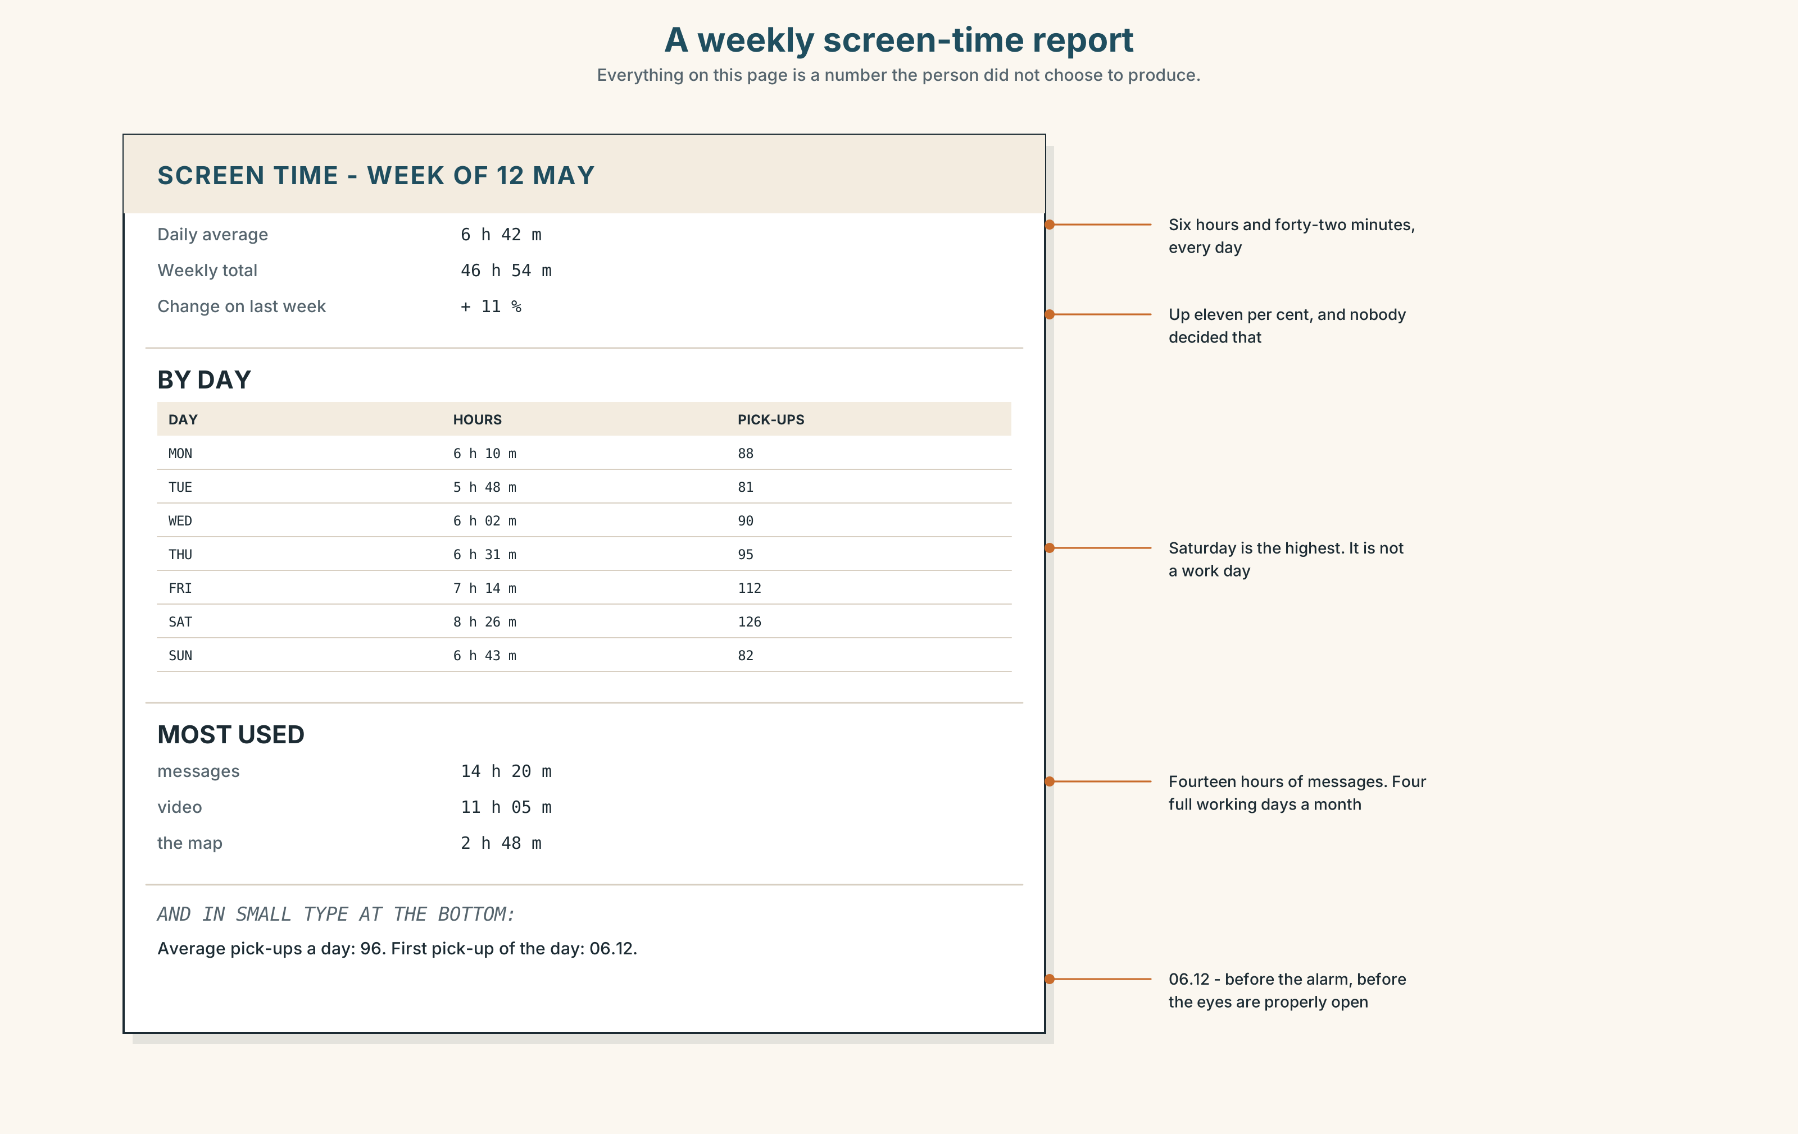{width=6.6in}
A weekly screen-time report — Everything on this page is a number the person did not choose to produce.
Read the report and answer.
- How many hours is the weekly total?
- Which day is the highest, and is it a weekday or the weekend?
- How many times a day is the phone picked up?
- What is at 06.12, and why is that the most interesting number on the page?

5F · Two texts
The text says Yusuf thinks he checks his phone about ten times. The report says the phone is picked up ninety-six times a day.
Is one of them wrong? Say one sentence.

Part 6 · Vocabulary Lab 2 ◆ B · THE SYSTEM

The seven words that open a question
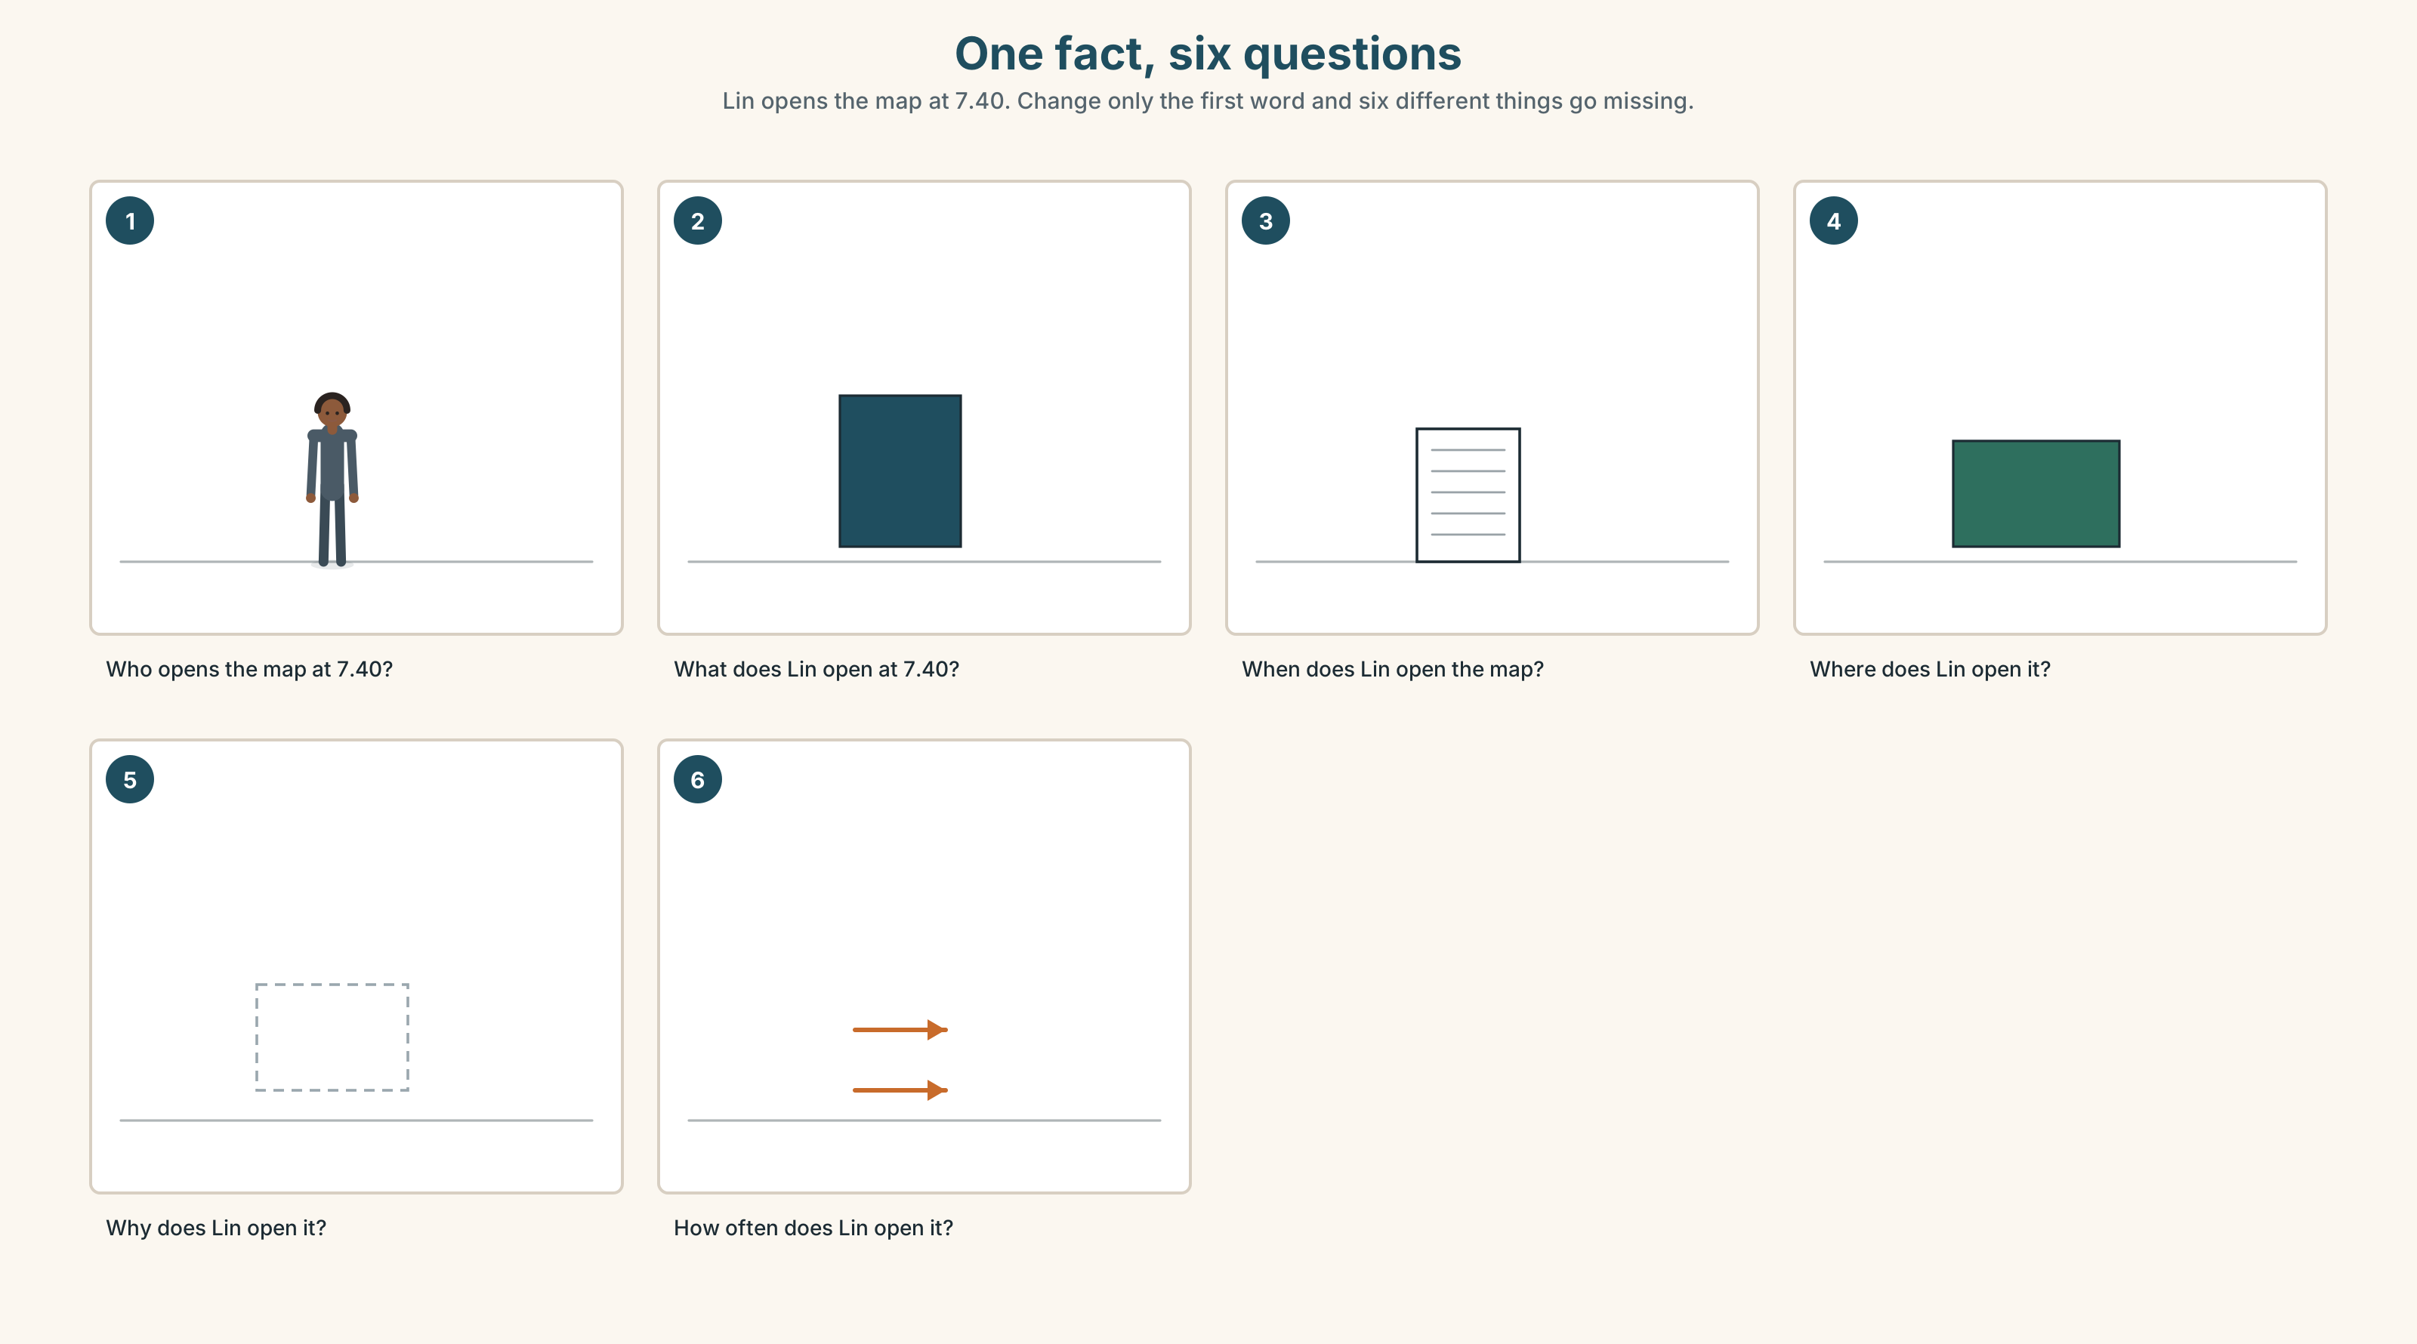{width=6.6in}
One fact, six questions — Lin opens the map at 7.40. Change only the first word and six different things go missing.

6A · The ones that catch everybody
how much | for things you cannot count: how much time
how many | for things you can count: how many photos
which | when there is a short list: which app
how often | the answer is a frequency, not a time

6B · Say the questions
what · where · when · who · why · how · which

6C · Chunk
- ______ many photos?
- ______ much time?
- ______ often do you check it?
- How do you ______ …? — when you do not have the word
- What does it ______ ? — when you have the word and not the meaning
- I don't ______ . — when you have neither

6D · Contrast Clinic
Six items. do or does?
- ______ she take photos?
- ______ they log in every day?
- How often ______ he charge the battery?
- ______ you turn off your phone?
- Which app ______ your brother open first?
- Where ______ Teresa put her phone?

Part 7 · Pronunciation & Fluency Lab ◆ B · THE SYSTEM

Two tunes, and the question decides
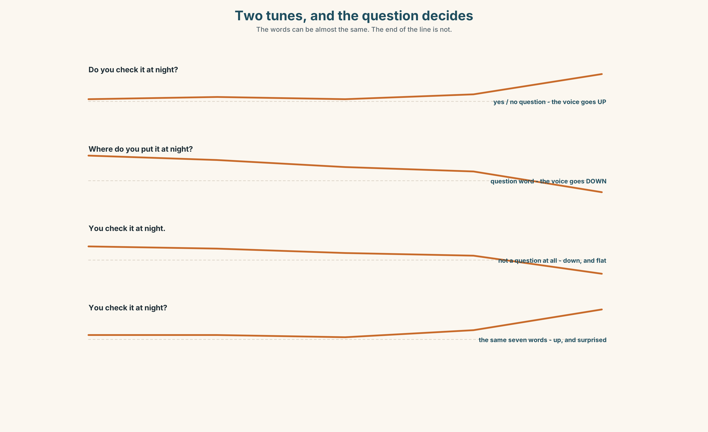{width=6.6in}
Two tunes, and the question decides — The words can be almost the same. The end of the line is not.

7A · Hear
up at the end — a yes/no question: Do you check it? ↗ Does she know? ↗ down at the end — a question with a question word: Where do you put it? ↘ How often does he look? ↘

7B · Say
Say each one three times. Then say this pair:
Do you have a charger? ↗ Where is the charger? ↘
Same room, same person, two tunes.

7C · Make it mean something
Say these two:
You check your phone at night. ↘ — this is a fact, and I know it You check your phone at night? ↗ — this is a question, and I am surprised
Same seven words. The tune is the only difference. Which one is a question?

7D · Fluency 20 ⏺
Twenty seconds: six questions about one person, each with a different question word. Three times, faster.

Part 8 · Writing ◆ C · THE PERFORMANCE

A profile · 40–60 words

8A · Read the model
My brother checks his phone before he opens his eyes. [one strong first sentence, with the s]
He has ninety apps and he opens four. He does not use the camera. [a number, and a negative]
He charges the battery twice a day. He says the phone is old. The phone is one year old. [the gap between what he says and what is true]
He turns it off on Sunday morning, for two hours. [the exception, at the end]
Questions about the writer's choices:
- The first sentence is about something that happens before he is awake. Why start there?
- The phone is one year old. Why is that one short sentence and not part of the one before?
- The last sentence is the only good news. Why is it last?

8B · The anti-model
My brother has a phone. He uses it a lot. He has many apps. He likes his phone. It is a good phone.
Correct English, and it could be anybody. Add two numbers and one negative, and make it one person.

8C · Plan
one habit nobody chooses → a number → something he or she does not do → the exception, at the end

8D · Write — 40 to 60 words

8E · Peer review — two things only
☐ Does every he and she verb have the s? ☐ Is there one number that is true about this person and nobody else?

8F · Publish
On the wall, with no names. The class matches the profile to the writer's partner.

Part 9 · The File ◆ A · THE WORLD + C · THE PERFORMANCE

STUDY FILE · Your phone is a vocabulary book
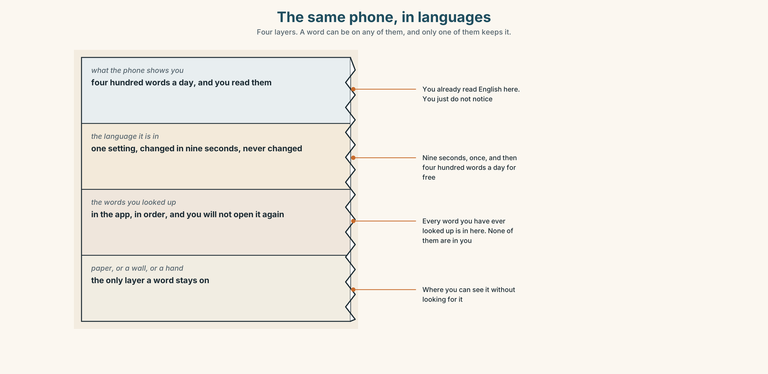{width=6.6in}
The same phone, in languages — Four layers. A word can be on any of them, and only one of them keeps it.

9A · Four minutes a day
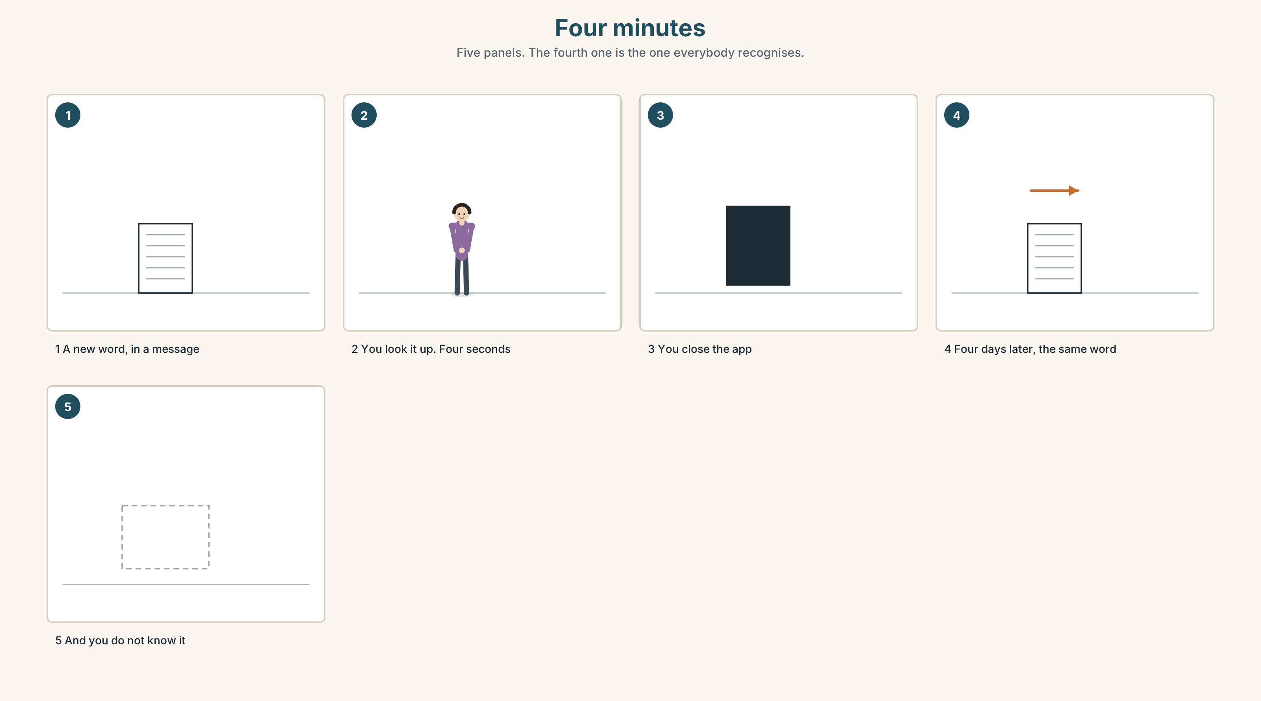{width=6.6in}
Four minutes — Five panels. The fourth one is the one everybody recognises.
What people do | look a word up, read it, close the app
What happens | the word is gone in four minutes
What they say | I have a bad memory.
What is true | the word was never written down anywhere

9B · Change the phone, not yourself
Put your phone in English for one week. You will not learn the words. You will learn where they are, which is more useful and takes no time at all.
Which three words would you see every day? Write them.

9C · Role play — the help desk
In pairs. One of you has a phone in a language you cannot read. The other is a helper. Use only these:
How do you say…? · What does it mean? · I don't understand. · Which one? · Where?

9D · The one place a word stays
A word stays where you can see it without looking for it. Where, in your day, is that place? Not the app. The place.

9E · Transfer — before next week
Write down every English word you look up for seven days, on paper. Do not revise it. Bring the list. The list is the lesson.

Part 10 · Mediation & Interaction ◆ C · THE PERFORMANCE
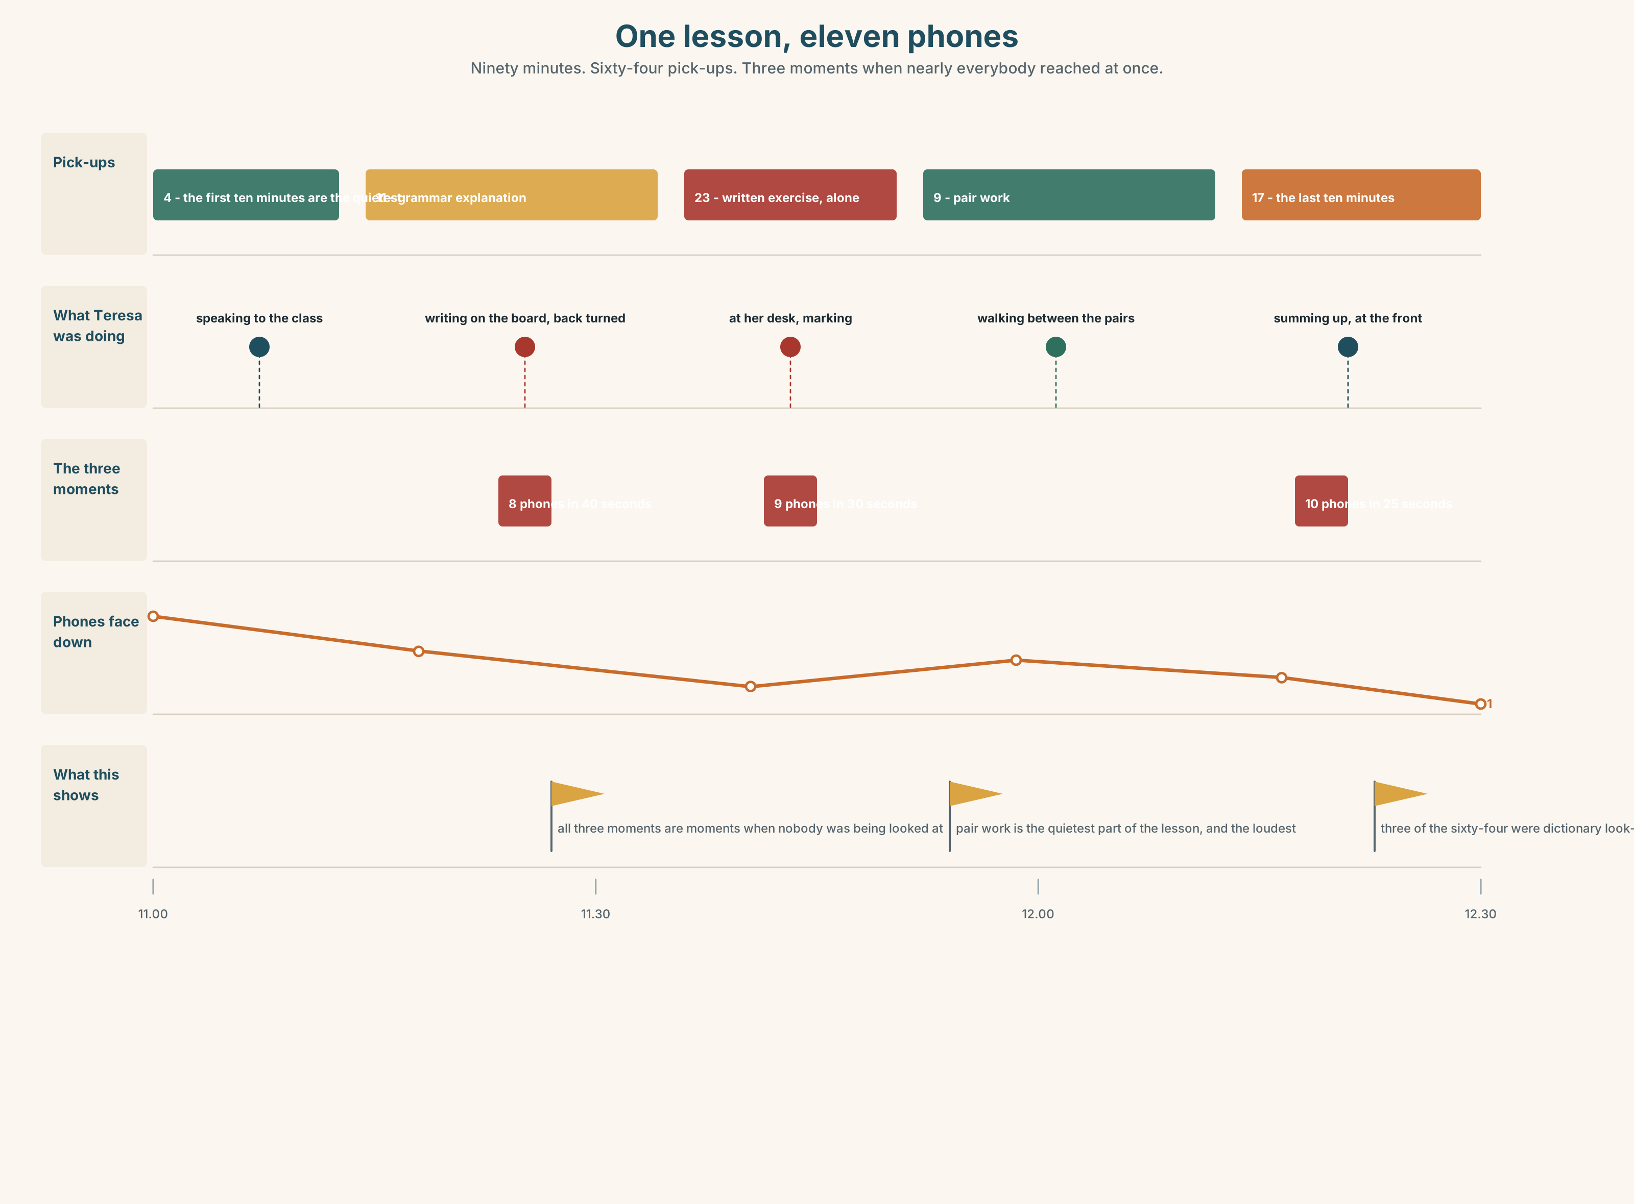{width=6.6in}
One lesson, eleven phones — Ninety minutes. Sixty-four pick-ups. Three moments when nearly everybody reached at once.

10A · Relay
Half the class has the screen-time report. Half has the four people from Part 5. Rebuild the whole picture by speaking. Ten minutes.

10B · Simplify — for one person
A classmate asks: How do I put my phone in English? Answer in four sentences. No lists, no screenshots.

10C · Online
Write one message to a classmate: ask two questions about their phone. Two sentences. One question must start with a question word.

10D · Your language
Does your language have a different word for how much and how many? Say both in your language. Does the difference exist at all?

Part 11 · The Decision ◆ C · THE PERFORMANCE

The box by the door
Escola Monte wants to put a box by the door of room 3. You put your phone in it at the start of the lesson and take it out at the end.
Teresa counted. In one ninety-minute lesson, eleven students picked up a phone sixty-four times. Nobody noticed they were doing it.
But three students use the phone as a dictionary, every lesson. One student has a child at a school that telephones. And the box has no lock.

11A · The evidence
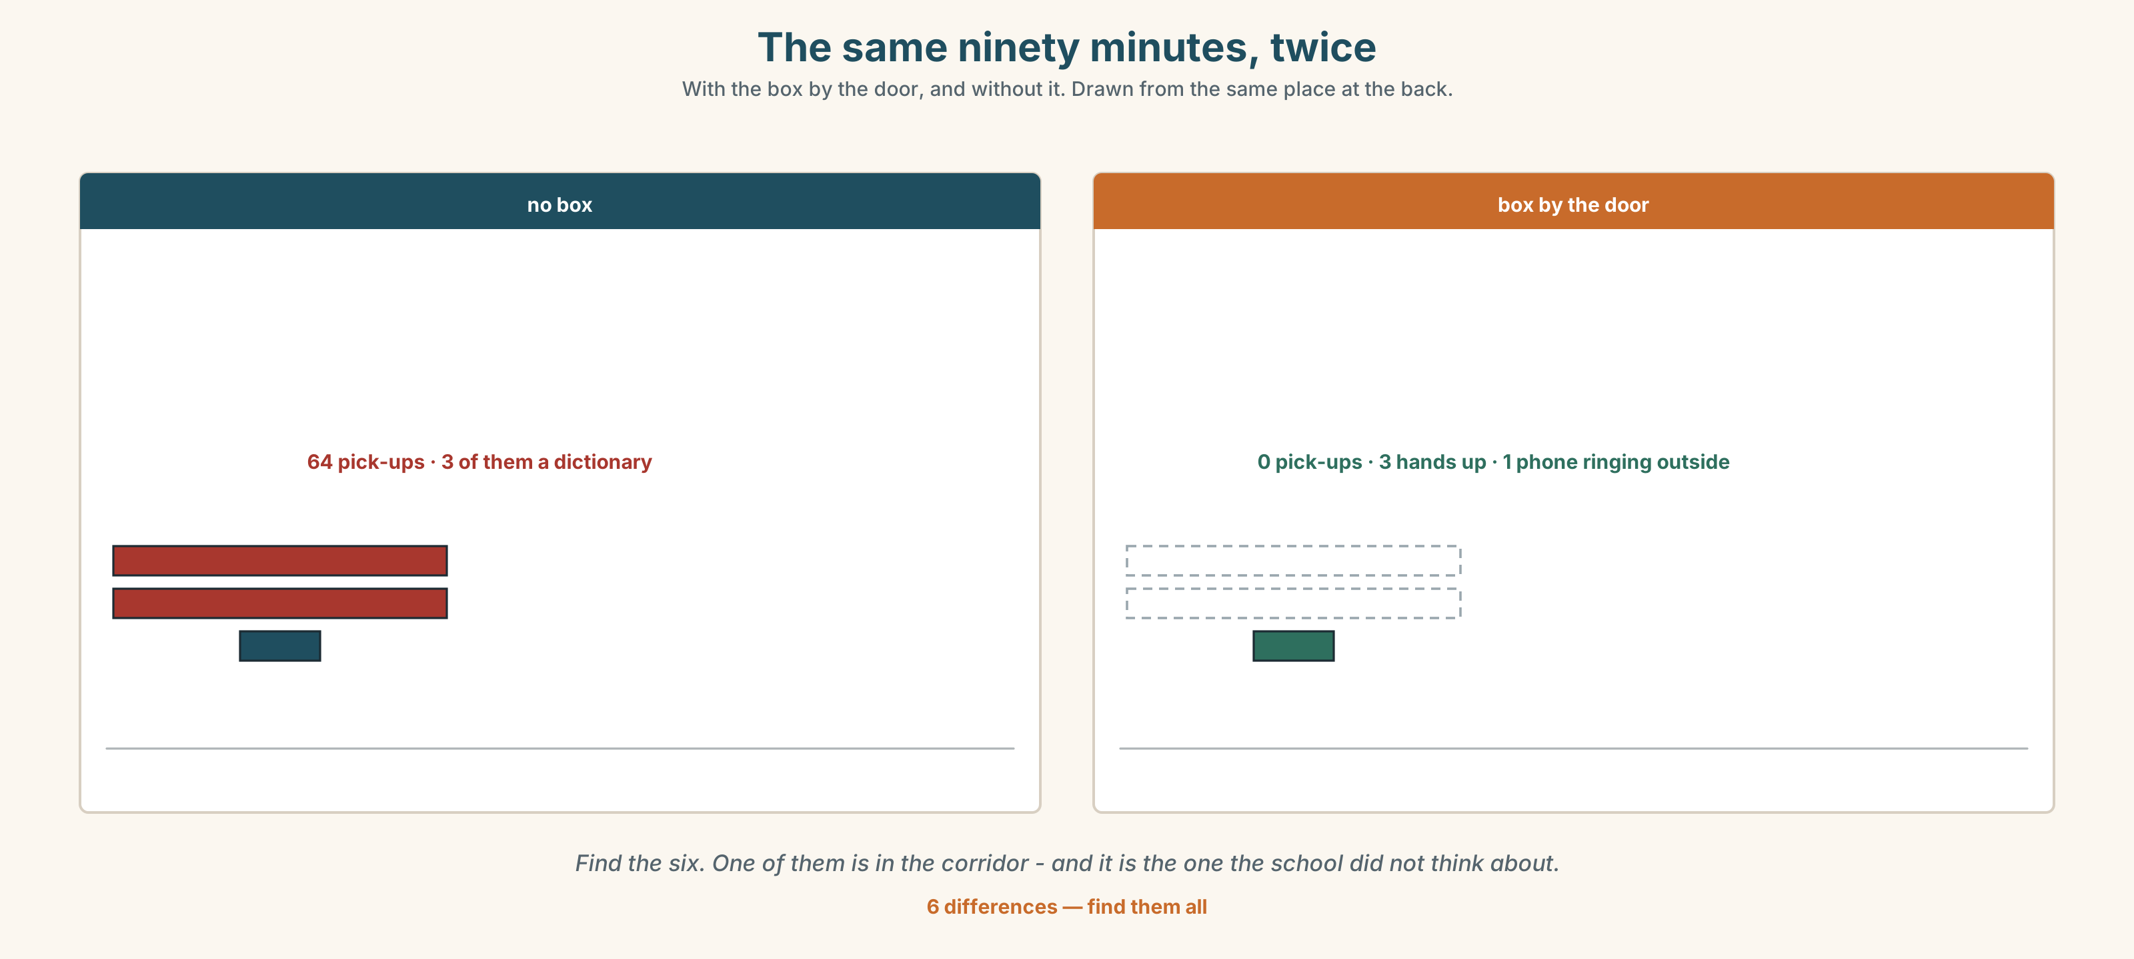{width=6.6in}
The same ninety minutes, twice — With the box by the door, and without it. Drawn from the same place at the back.
🔊 Track 3.6. Yusuf, 20 seconds: "I don't want the box. But I check my phone and I don't know why. I don't even read it. How often? I don't want to know."

11B · Talk about it
In threes. Use the frame. Everybody says one.
I think the phones should ______ , because ______ .
Words you can use: box · dictionary · message · child · lesson · nobody · notification

11C · Decide
Write two sentences. Choose, and say why.
I think the phones should ______________________ , because ______________________ .

11D · Model decision
No box. Put one phone on the desk at the front, on a stand, as the class dictionary, and leave the other ten where they are. The problem is not the phone. The problem is that looking a word up and leaving the room look exactly the same from the front.

11E · The Reveal
What happened. Teresa did not use a box. She put one phone at the front as the dictionary and asked everybody to put their own phone face down. Pick-ups fell from sixty-four to nineteen in a week.
Then something she did not expect: the nineteen were almost all the same two students, and both of them were the ones who answered most questions. They were not leaving the room. They were checking a word and coming straight back.
One question. You do not have to answer it out loud.
Teresa counted pick-ups. Was she counting the right thing?

Part 12 · Landing ◆ all three lines

12A · Recycle — twelve items
- She ______ (check) her phone at six.
- ______ he ______ (turn off) his phone at night?
- How ______ photos do you take? (you can count them)
- How ______ time do you spend online? (you cannot count it)
- ______ app do you open first? (there is a short list)
- ______ do you charge the battery? (the answer is a place)
- ______ does she use a map? (the answer is a reason)
- I need to ______ in, and I do not have the password.
- I want to ______ a photo of this.
- My battery is at four per cent. I have to ______ it.
- (Unit 2) I ______ up at six every day.
- (Unit 1) They ______ from Korea and Egypt.

12B · Consolidate — one task, everything in it
Write six sentences about one person who is not in this room. Use he or she. Put a number in two of them. Use one negative and one question.

12C · Can-do, with evidence
☐ I can ask somebody about a habit. Evidence: 4C, 9C ☐ I can use the s on he, she and it. Evidence: 3G, 8D ☐ I can use do and does in questions. Evidence: 6D ☐ I can hear the difference between a question and a statement. Evidence: 7C

12D · Replay ⏺
Record 0C again. Listen to both. What is different?

12E · Glossary — thirty-five words, as a map
THE OBJECT · phone · screen · battery · charger · camera · map WHAT IS ON IT · app · message · photo · video · notification · password WHERE IT IS · internet · online WHAT YOU DO · turn on · turn off · log in · send a message · take a photo · check your phone · open an app · charge the battery THE SEVEN WORDS · what · where · when · who · why · how · which HOW + ONE WORD · how many · how much · how often WHEN YOU ARE LOST · How do you say…? · What does it mean? · I don't understand.

12F · Next
Unit 4 · Who decides the rules here?

