Table of Contents

A1.1 · Unit 4 · Eleven Signs, One Building
English Animated · Starting Out · Escola Monte, Lisbon Student's Book pages 72–93 · 22 pp · ~9 hours

Part 0 · The Big Picture ◆ A · THE WORLD
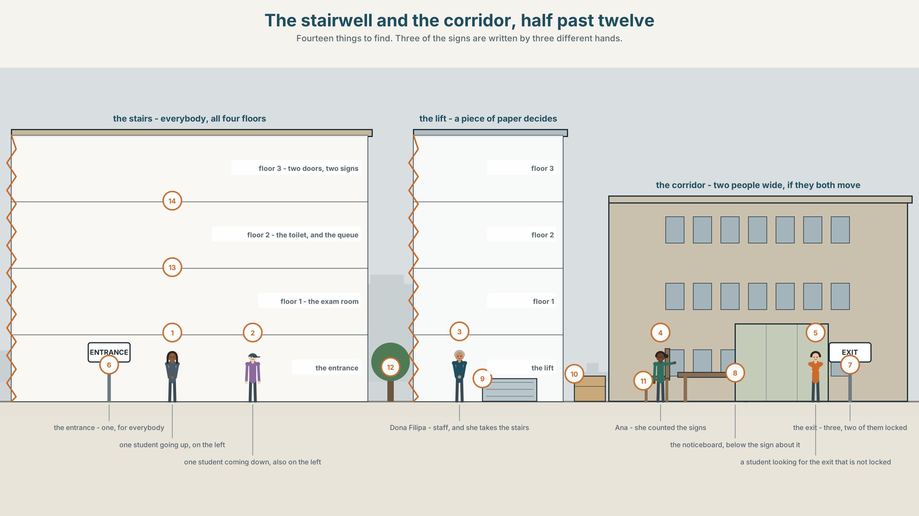{width=6.6in}
The stairwell and the corridor, half past twelve — Fourteen things to find. Three of the signs are written by three different hands.

Who decides the rules here?
By the end of this unit you can ask for permission, give it, and refuse it politely.
◆ A · THE WORLD | A building with eleven signs on it and nobody's name under any of them
◆ B · THE SYSTEM | can and can't for ability, permission and prohibition · 22 words for rules and signs · the words that make a request polite · /æ/ and /ʌ/, and the weak can
◆ C · THE PERFORMANCE | You ask for three things you are not sure you are allowed to have

0A · Find it — fourteen things
Find these in the picture. Write the number.
☐ a sign ☐ a lift ☐ the stairs ☐ a corridor ☐ a toilet ☐ an entrance ☐ an exit ☐ a door ☐ a step ☐ a trolley ☐ a notice ☐ a clock ☐ a window ☐ a bag
Three of these words are not in the picture. Which three?
a rule · a password · a camera

0B · Guess it
Look at the signs. Which one is the newest? How do you know? Say one thing. You can use these words:
sign · door · open · closed · quiet

0C · Say it ⏺
Record. Thirty seconds. Do not prepare.
What is one rule in this building, and who made it?
You will listen to this again on the last page.

Part 1 · Vocabulary Lab 1 ◆ B · THE SYSTEM

1A · Meet — the building, in signs
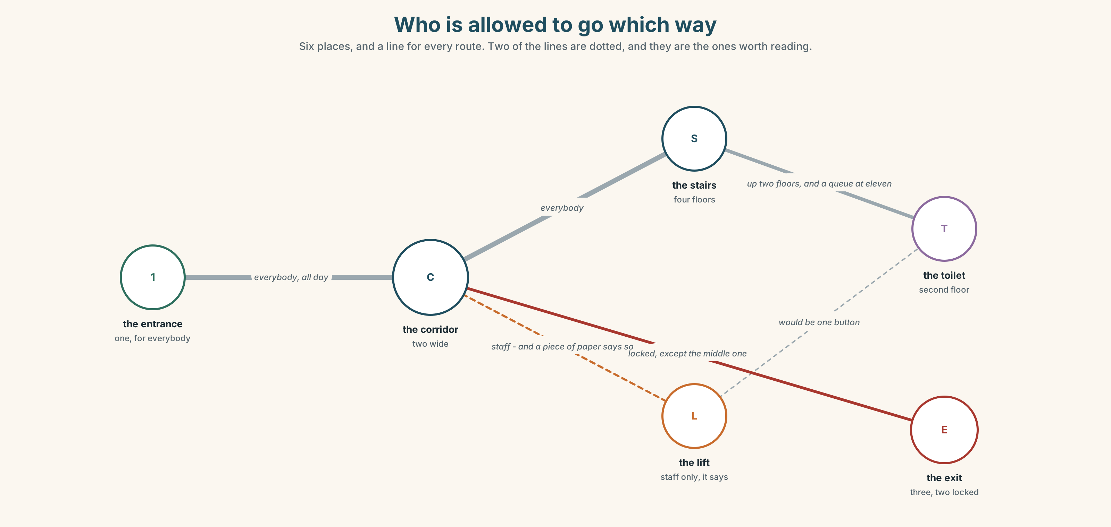{width=6.6in}
Who is allowed to go which way — Six places, and a line for every route. Two of the lines are dotted, and they are the ones worth reading.
entrance | One. Everybody comes through it.
exit | Three. Two of them are locked.
stairs | Four floors. Everybody.
lift | Four floors. Staff only, says a piece of paper.
corridor | Narrow. Two people fit, if they both move.
toilet | Second floor. There is a queue at eleven.

1B · Meet — the words
rule · sign · open · closed · quiet · allowed · forbidden · entrance · exit · lift · stairs · toilet · smoking · corridor
Write each word under the right picture.
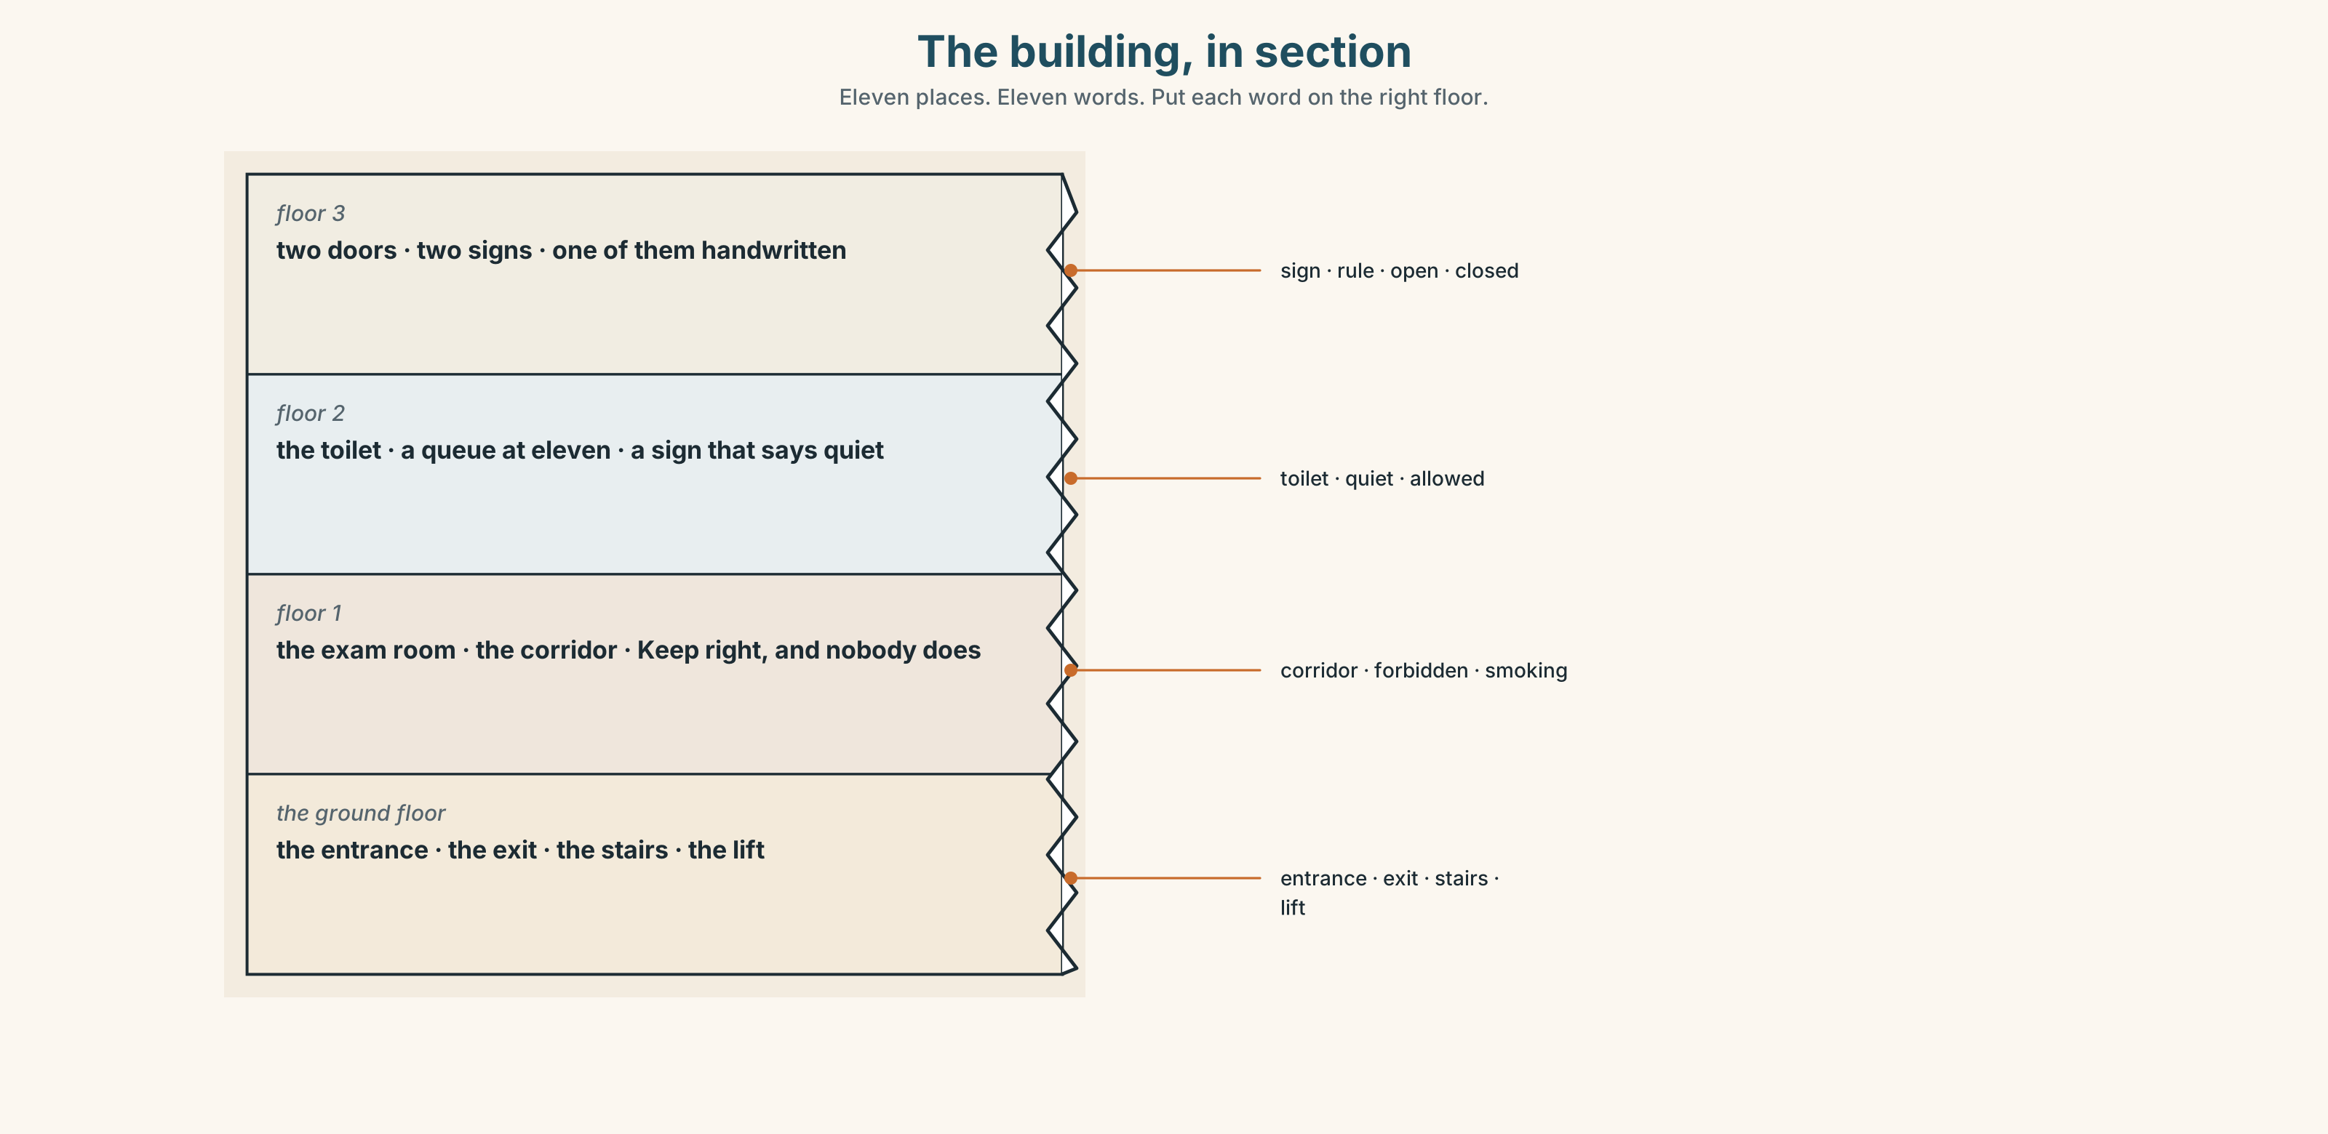{width=6.6in}
The building, in section — Eleven places. Eleven words. Put each word on the right floor.

1C · Sort — a thing, or a rule about a thing?
Put each word in the right box. Two of them can go in both. Which, and why?
lift · quiet · sign · allowed · exit · forbidden · stairs · open · toilet · closed
A PLACE OR A THING | A RULE | BOTH

1D · What signs actually say
No smoking | Two words. It is on nine doors in this building.
Please be quiet | Please does not make it a request. It is still a rule.
Keep right | In the corridor. Nobody does it.
Out of order | On the lift, twice this year.
Push / Pull | The commonest wrong guess in any building anywhere.
Mind the step | There is one step. It is where the old building meets the new one.
Now say them. Five of these six are orders with no person in them. Which one is a warning and not an order?

1E · Stretch — the phrases you will need today
put away · take off · Out of order · Mind the step · Keep right
Match each phrase to the moment you need it.
- You come in from the rain with a wet coat. → ______
- The lesson is finished and your books are everywhere. → ______
- Somebody is walking straight at you in a narrow corridor. → ______
- You press the button and nothing happens. → ______
- There is a small change in the floor and nobody expects it. → ______

1F · The hard one
f No problem.
Practise it three times. Two words, and in most of the world it means yes.

1G · Own it
Write one sign that exists in your home and one that does not exist but should. Do not write your name. The class guesses whose home it is.

Part 2 · Listening ◆ A · THE WORLD
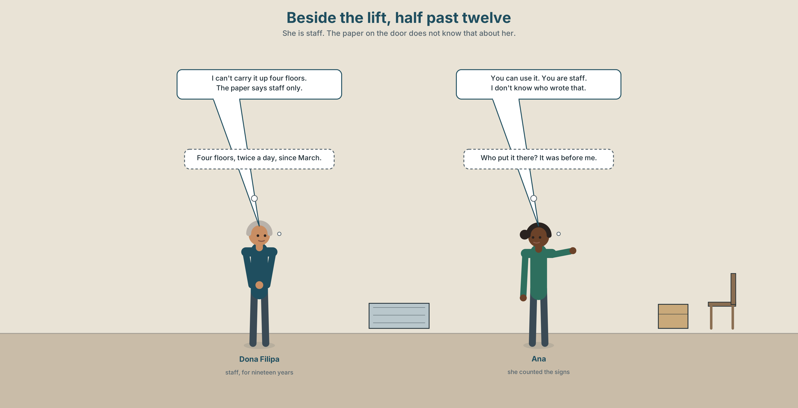{width=6.6in}
Beside the lift, half past twelve — She is staff. The paper on the door does not know that about her.

2A · Beside the lift 🔊 Track 4.1
Before you listen. The lift says Staff only. Dona Filipa is staff. Guess: is this going to be a short conversation?
Listen once. One question. Can Dona Filipa use the lift?
Listen again. Complete the table.
 | Can | Can't | Doesn't know
use the lift
use the back exit
leave the trolley in the corridor
Listen again. True or false?
- Ana wrote the notice on the lift. ☐ T ☐ F
- Dona Filipa carries the trolley up the stairs. ☐ T ☐ F
- Students can use the lift with a teacher. ☐ T ☐ F
- Nobody knows who made the rule. ☐ T ☐ F
Noticing. Four sentences from the recording.
- You can use it.
- Students can't use it.
- Can I leave this here?
- I can't carry it up four floors.
Two of these are about a rule and two are about a body. Which are which?

2B · Decoding clinic 🔊 Track 4.2
Twenty seconds of Ana at speed. Three jobs.
- Count how many times she says can.
- In two of them the word is very short and quiet. In two it is loud. Which two are loud?
- She says can't once. What is the difference you hear — the vowel, or the t?
Transcripts, page 150.

Part 3 · Grammar Lab 1 ◆ B · THE SYSTEM

One word, three jobs

3A · Notice
Look at the four sentences in Part 2 again.
- Does can change after I, you, she or they?
- What is the form of the verb straight after can?
- How do you make a question with can?
- One sentence is about something a body cannot do. Which?

3B · See
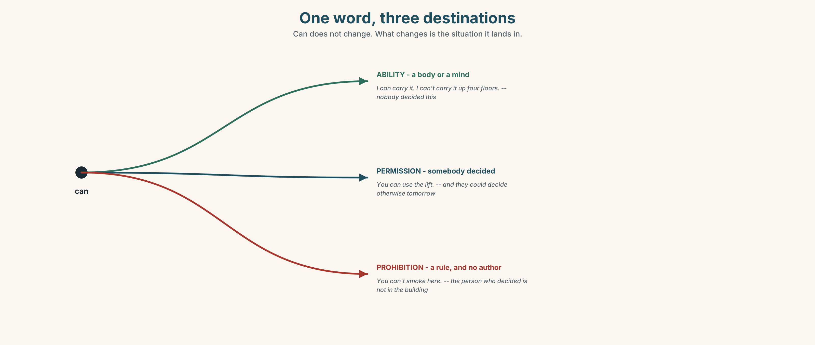{width=6.6in}
One word, three destinations — Can does not change. What changes is the situation it lands in.

3C · Know
ability | what a body or a mind does | I can carry it. I can't carry it up four floors.
permission | somebody decided, and they could decide otherwise | You can use the lift. Students can't.
prohibition | a rule, and the person who made it is gone | You can't smoke here.
Can never changes. No s for he and she. No do in the question. The verb after it is always plain: can go, never can goes and never can to go.
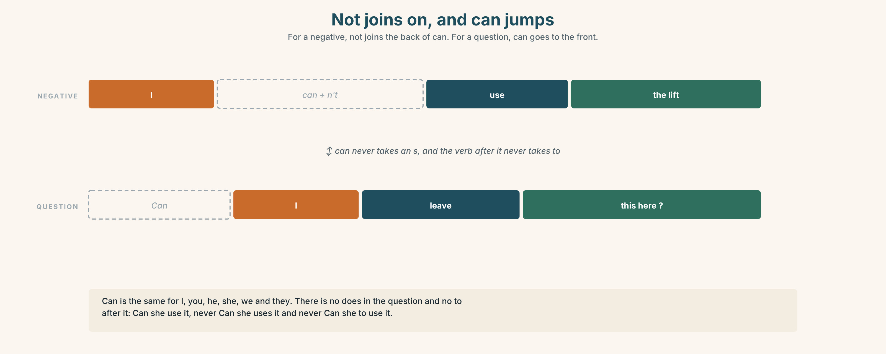{width=6.6in}
Not joins on, and can jumps — For a negative, not joins the back of can. For a question, can goes to the front.
– | I cannot use it · I can't use it · She can't come today
? | Can I leave this here? · Can you help me? · Can she use the lift?
short answers | Yes, you can. · No, I'm sorry, I can't.
The polite layer sits on top. Can I…? is a question. Could you…? is the same question with the sharp edge taken off. Is it OK if…? asks whether the rule allows it rather than whether you allow it.
Why it matters. Half of what you need in a building you do not own is permission, and the other half is finding out who gives it.

3D · Use — controlled
Complete with can, can't, Can I or Could you.
Dona Filipa (1) ______ use the lift. Students (2) ______ use it. (3) ______ leave my bag here? — Yes, of course. (4) ______ open the window? It is very warm. I (5) ______ carry this up four floors. I (6) ______ carry it up one.

3E · Use — guided
Make each one a question with can, then make it more polite.
- You want to open the window.
- You want to leave early.
- You want to use somebody's charger.
- You want somebody to say it again.
- You want to sit at this desk.

3F · Use — open
In pairs. Ask for five things in this room. Your partner says yes, no, or just a moment. Nobody may say no twice in a row.

3G · Check — six items, mark your own
- She ______ (not use) the lift.
- ______ I leave my bag here?
- He ______ (carry) it, but not up four floors.
- ______ you open the window, please? (the polite one)
- ✗ She cans use the lift. → correct it.
- ✗ Can you to help me? → correct it.
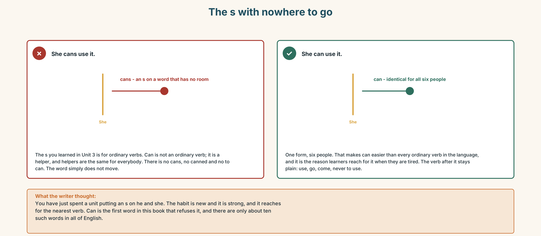{width=6.6in}
The s with nowhere to go — The s with nowhere to go
0–3 → Workbook pp. 16–19. 4–5 → Part 6. 6 → page 90.

Part 4 · Speaking ◆ C · THE PERFORMANCE

4A · Fluency starter — the asking round
Everybody asks the person on their left for one thing. The answer must be yes. Go round twice. The second time the answer must be no, politely.

4B · The functional core — asking, giving and refusing
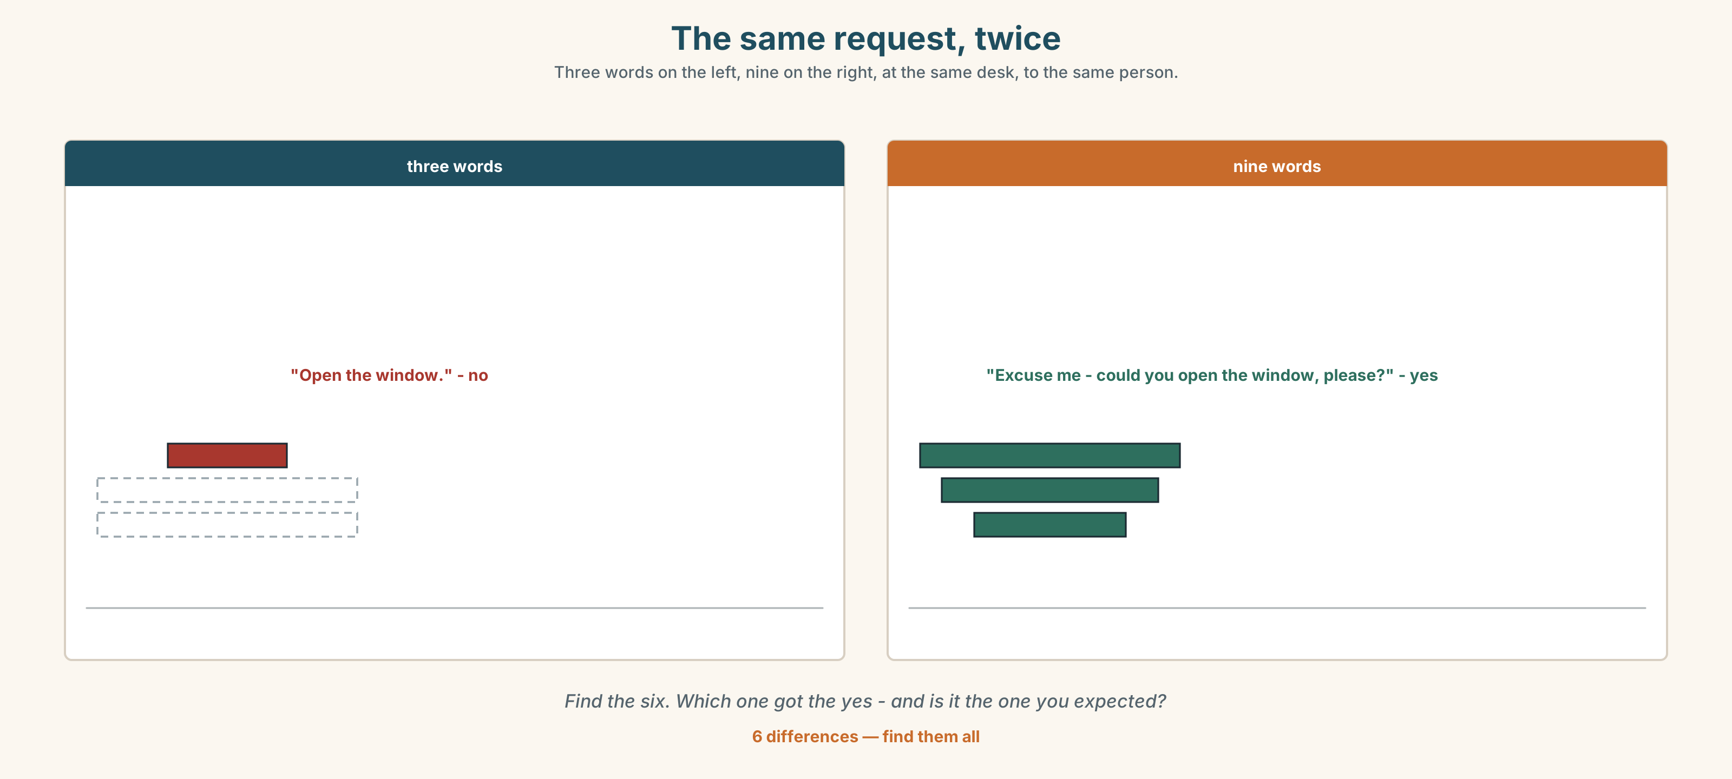{width=6.6in}
The same request, twice — Three words on the left, nine on the right, at the same desk, to the same person.
Language Bank
asking | Can I…? · Could you…? · Is it OK if…?
the small words | please · sorry · excuse me · thank you
saying yes | Of course. · Here you are. · No problem.
saying wait | Just a moment.
saying no | I'm sorry, I can't.
afterwards | Thanks a lot.
Information gap. Learner A has the list of what is allowed. Learner B has the list of what happens anyway. Find the two rules that nobody follows and nobody minds.

4C · The performance — three requests ⏺
Ask three people in this room for three things. Three minutes. One request must be:
something easy · something you expect a no to · something you are genuinely not sure about
Then report: who said yes, who said no, and who said something that was neither. Record it.

4D · Observer
One person listens for one thing: did anybody say no without the word sorry?

4E · Two criteria
☐ Did I use a different form for each of the three requests? ☐ Did I say thank you after the no as well as after the yes?

Part 5 · Reading ◆ A · THE WORLD

5A · Predict
The title is "Who put that there?" How many of the signs in your school do you think have a name on them?

5B · Read — sixty seconds

Who put that there?
Escola Monte has eleven signs. Ana counted them.
Four of them are printed and screwed to the wall. They are about fire and about the law, and the city put them there. Nobody argues with those four.
Four more are printed and taped. They are about the lift, the toilet and the corridor. The school put them there, four years ago, and three of the four people who decided are not here now.
Three are handwritten. One says Out of order, and the lift has worked since March. One says Please be quiet on a door nobody opens. One says Keep right, and the corridor is too narrow for anybody to keep anything.
Eleven signs. Four of them have a reason you can still find. The other seven are rules that are nobody's rules now, and everybody follows them anyway.

5C · Answer
- How many signs are there?
- Who put the first four up?
- What does the handwritten sign on the lift say?
- How many signs have a reason you can still find?
- Why does the writer say "nobody's rules"?
- The last sentence says everybody follows them anyway. Why would people follow a rule that belongs to nobody?

5D · Vocabulary in context
Guess from the text. Then check.
screwed to the wall · taped · argues with · since March · too narrow

5E · The counter-text
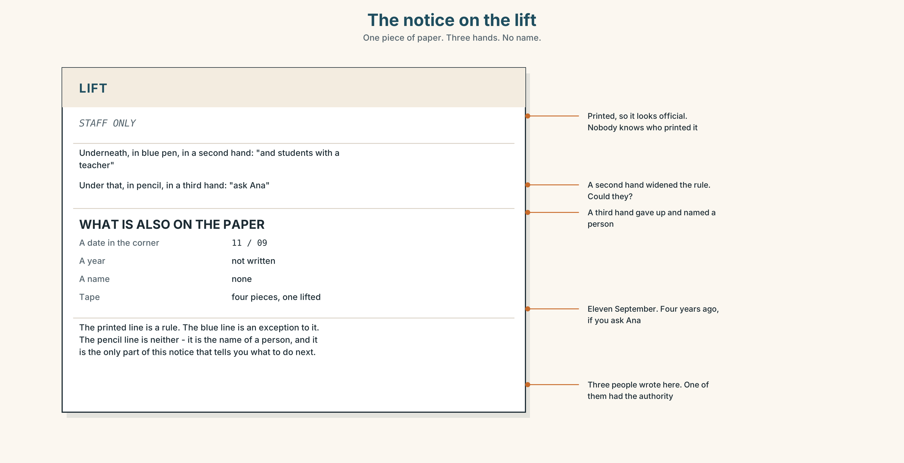{width=6.6in}
The notice on the lift — One piece of paper. Three hands. No name.
Read the notice and answer.
- What does the printed line say?
- What does the handwritten line add, and does it agree with the printed line?
- What is the date in the corner?
- Three people wrote on this notice. Which one of the three had the authority to?

5F · Two texts
The text says the lift has worked since March. The notice says Out of order.
Which one is the rule? Say one sentence.

Part 6 · Vocabulary Lab 2 ◆ B · THE SYSTEM

The small words that do all the work
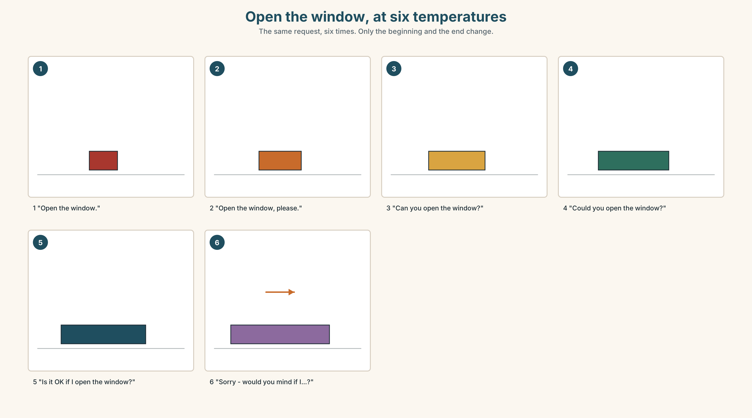{width=6.6in}
Open the window, at six temperatures — The same request, six times. Only the beginning and the end change.

6A · The ones that catch everybody
excuse me | before you speak to somebody
sorry | after you have done something, or when the answer is no
please | inside the request, not at the beginning of the conversation
thank you | after a yes and after a no

6B · Say them
please · sorry · excuse me · thank you · Of course. · Here you are. · Just a moment.

6C · Chunk
- ______ me — you want somebody's attention
- Can ______ …? — you want to do something
- Could ______ …? — you want somebody else to do something
- Is it ______ if…? — you want to know whether the rule allows it
- Here ______ are. — you are handing something over
- Thanks a ______ . — warmer than thank you, and shorter

6D · Contrast Clinic
Six items. excuse me or sorry?
- You want to ask a stranger a question. ______
- You stand on somebody's foot. ______
- You want to get past somebody in the corridor. ______
- You cannot lend somebody your charger. ______
- You arrive ten minutes late. ______
- You need to interrupt two people talking. ______

Part 7 · Pronunciation & Fluency Lab ◆ B · THE SYSTEM

/æ/ and /ʌ/, and the can you can hardly hear
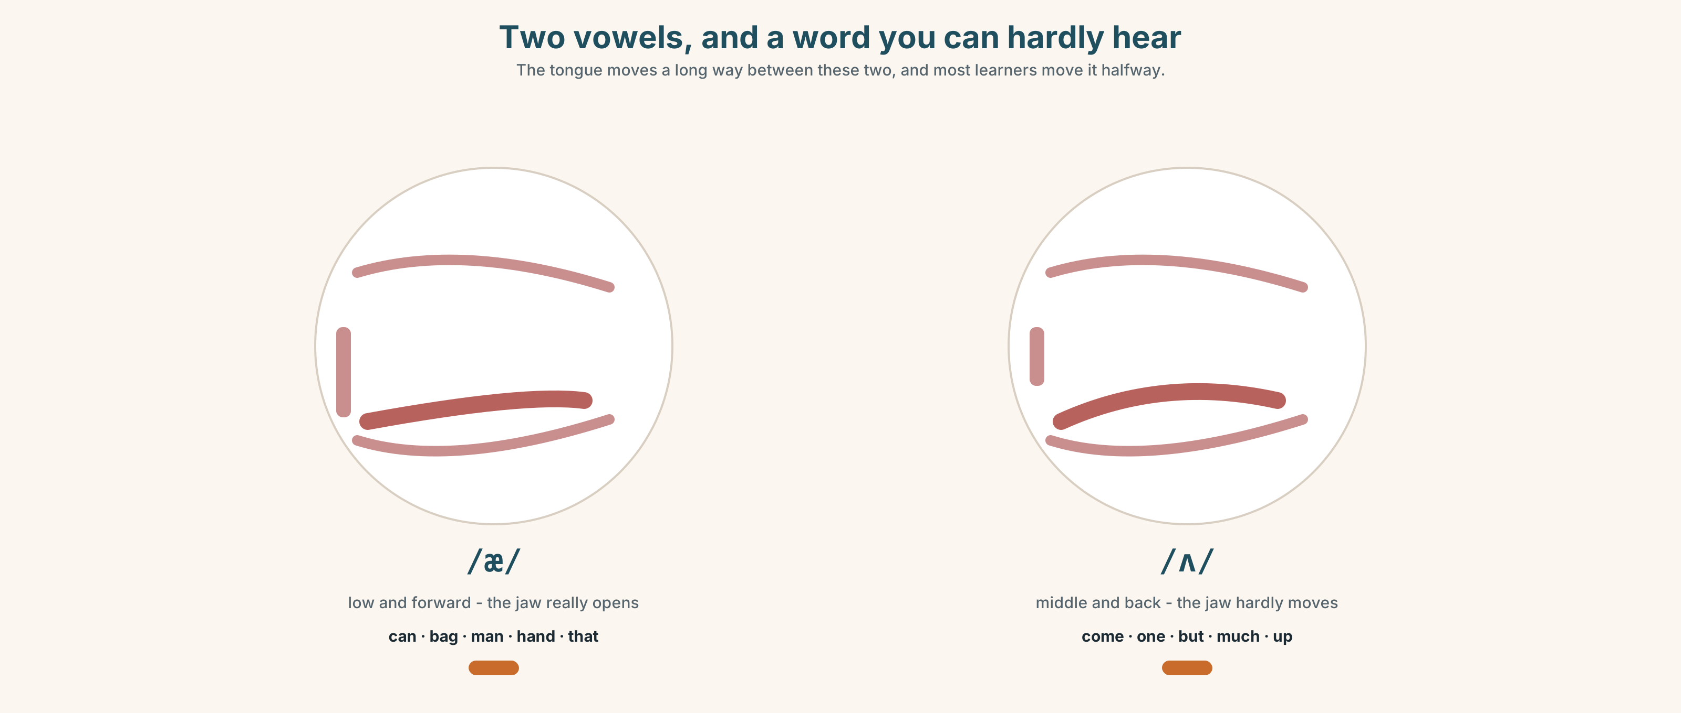{width=6.6in}
Two vowels, and a word you can hardly hear — The tongue moves a long way between these two, and most learners move it halfway.

7A · Hear
/æ/ — can · bag · man · hand · that /ʌ/ — come · one · but · much · up

7B · Say
Say each group three times. Then say this:
I can come, but I can't come up. — both vowels, twice each, in one sentence.

7C · Make it mean something
Say these two:
I can go. — can is short and quiet. You hardly hear it. I can't go. — can't is long and loud, and it is the stressed word in the sentence.
The negative is louder than the positive. If you cannot hear the t, listen to the length instead. Which one is which?

7D · Fluency 20 ⏺
Twenty seconds: three things you can do and three things you can't do in this building. Three times, faster.

Part 8 · Writing ◆ C · THE PERFORMANCE

The rules of a place · 40–60 words

8A · Read the model
You can come in before nine. The door is open from eight. [what you can do, first]
You can't smoke anywhere, including the yard. [the one hard rule, with the gap closed]
Please be quiet in the corridor on the second floor. There is an exam room. [the rule, and then the reason]
If you need the lift, ask at reception. Somebody will say yes. [the rule that is really a door, not a wall]
Questions about the writer's choices:
- The first sentence is about what you can do. Why not start with the hard rule?
- There is an exam room. What does giving the reason do to the rule?
- The last rule tells you who to ask. Why is that more useful than the rule itself?

8B · The anti-model
No smoking. No food. No phones. Be quiet. Keep right. No bags in the corridor. Students can't use the lift.
Correct English, and nobody will read past the third line. Rewrite it so that two of the seven are things you can do, and one of them gives a reason.

8C · Plan
what you can do → the one real prohibition → one rule with a reason → who to ask

8D · Write — 40 to 60 words

8E · Peer review — two things only
☐ Is there at least one sentence with can and not can't? ☐ Is there one reason anywhere in it?

8F · Publish
On the door of the classroom. Keep them up for a week and see which one people actually follow.

Part 9 · The File ◆ A · THE WORLD + C · THE PERFORMANCE

STUDY FILE · The rules you have made for yourself
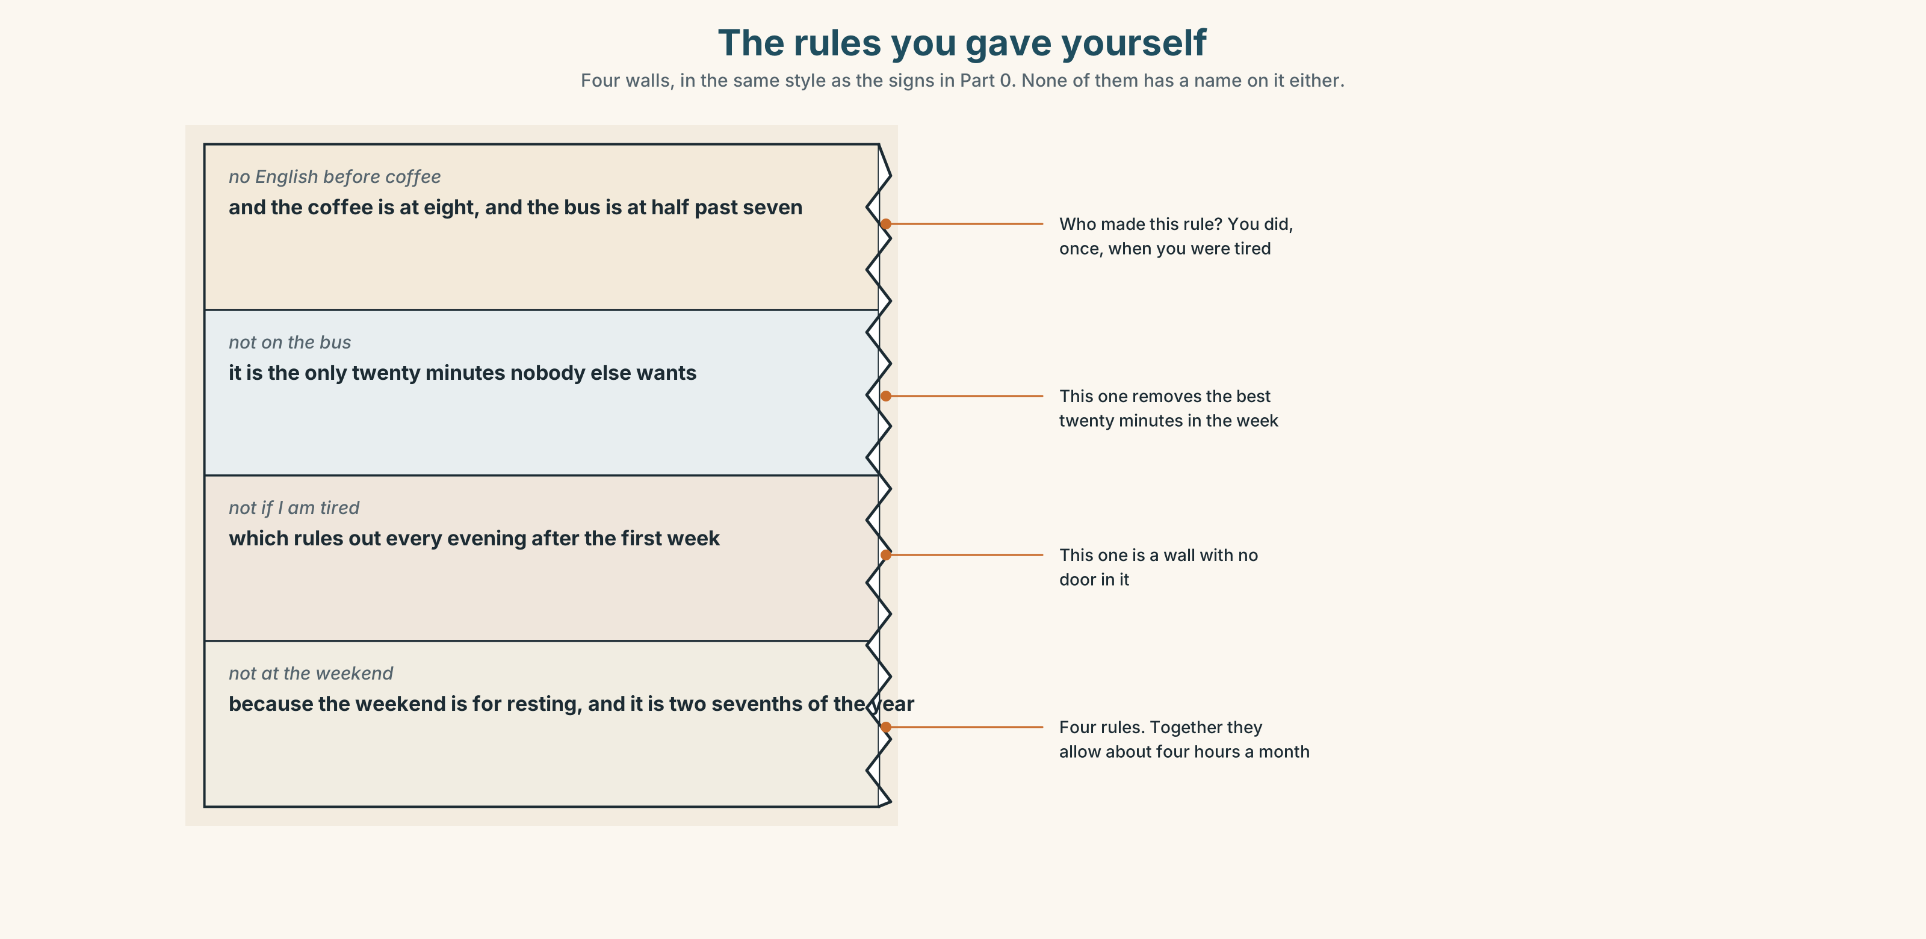{width=6.6in}
The rules you gave yourself — Four walls, in the same style as the signs in Part 0. None of them has a name on it either.

9A · Four walls
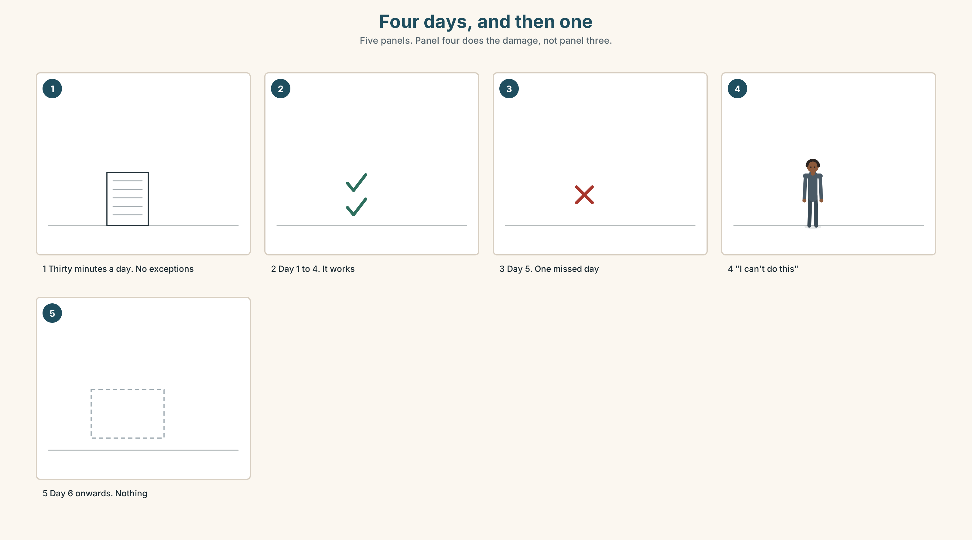{width=6.6in}
Four days, and then one — Five panels. Panel four does the damage, not panel three.
What people decide | thirty minutes, every day, no exceptions
What happens on day five | one missed day
What people conclude | I can't do this.
What is actually true | they did four days, which is four more than before

9B · A rule you can break
A rule you can break and keep is a rule. A rule you cannot break is a wall, and you will walk away from it. Write one rule for your English this week that has a way out in it.
Example: twenty minutes a day, and on a bad day, two minutes.

9C · Role play — asking yourself for permission
In pairs. One of you wants to skip today. The other is the part of you that made the rule. Use Can I…?, Is it OK if…? and I'm sorry, I can't. Swap after two minutes.

9D · Who made that rule?
Find one rule you follow about your own learning that somebody else made — a teacher, a parent, an app. Is it still a good rule? Is the person still here?

9E · Transfer — before next week
Write down every time you nearly studied and did not, for seven days. Write the reason. Do not judge it. Bring the list.

Part 10 · Mediation & Interaction ◆ C · THE PERFORMANCE
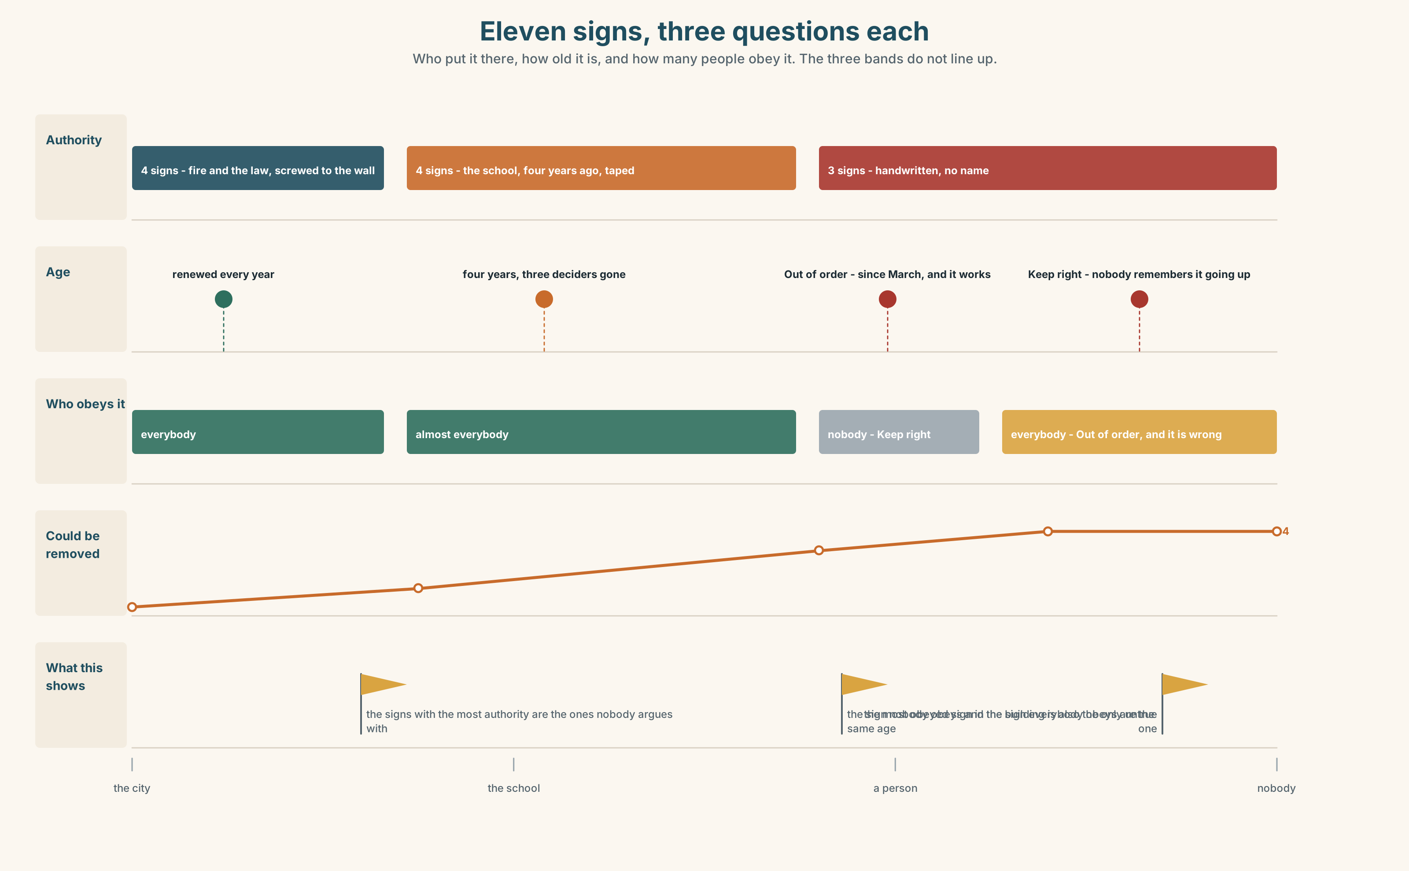{width=6.6in}
Eleven signs, three questions each — Who put it there, how old it is, and how many people obey it. The three bands do not line up.

10A · Relay
Half the class has who wrote each sign. Half has whether people follow it. Rebuild the whole building by speaking. Ten minutes.

10B · Simplify — for one person
A new student asks: Can I use the lift? Answer in three sentences. The true answer is complicated. Say it anyway.

10C · Online
Write one message asking a classmate for something you need. Two sentences. One of them must give a reason.

10D · Your language
Does your language have a polite form for asking? Ask for a pen in your language, twice: once to a friend and once to a stranger. How many words change?

Part 11 · The Decision ◆ C · THE PERFORMANCE

The lift
Escola Monte has one lift. The notice says Staff only. It has said that for four years.
A student broke the door of the lift in the first year, and that is why the notice is there. That student finished the course in the same year and left.
Dona Filipa carries a trolley up four floors twice a day. One student this term cannot use the stairs at all. The school can leave the notice, take it down, or put a key on the lift and give the key to reception.

11A · The evidence
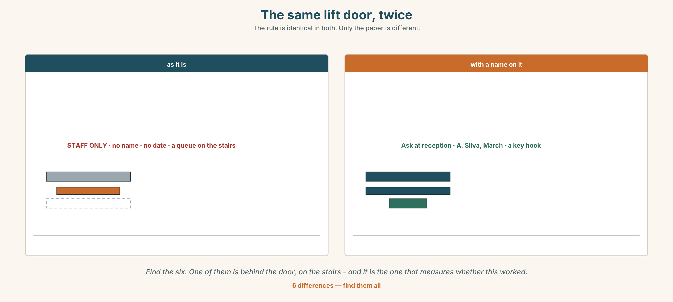{width=6.6in}
The same lift door, twice — The rule is identical in both. Only the paper is different.
🔊 Track 4.6. Dona Filipa, 20 seconds: "I can use the lift. Nobody told me I can. I read the paper on the door every morning for four years and I take the stairs."

11B · Talk about it
In threes. Use the frame. Everybody says one.
I think the lift should be ______ , because ______ .
Words you can use: staff · student · key · stairs · trolley · broken · allowed

11C · Decide
Write two sentences. Choose, and say why.
I think the lift should be ______________________ , because ______________________ .

11D · Model decision
Take the old notice down and put up a new one with a name and a date on it. The rule can stay exactly the same. What changes is that there is now somebody to ask, and a rule you can ask about is a different kind of rule.

11E · The Reveal
What happened. Ana printed a new notice: Lift: ask at reception. A. Silva, March. The rule did not change. In the first week eleven people asked, and she said yes to all eleven.
Then something she did not expect: the asking stopped after two weeks, and people simply used the lift. Nobody broke it. Ana left the notice up anyway, because the name on it was doing something the rule was not.
One question. You do not have to answer it out loud.
The rule did not change and the behaviour did. So what was the rule actually doing before?

Part 12 · Landing ◆ all three lines

12A · Recycle — twelve items
- She ______ (not use) the lift.
- ______ I leave my bag here?
- ______ you say that again, please? (the polite one)
- Is it ______ if I open the window?
- ______ me — where is the toilet?
- I'm ______ , I can't.
- Here you ______ .
- Just a ______ .
- The lift is out of ______ .
- Please ______ your books away.
- (Unit 3) How ______ does he check his phone?
- (Unit 2) They ______ at half past six.

12B · Consolidate — one task, everything in it
Write the rules of a place you know well, in six sentences. Two must use can, one must use can't, and one must say who to ask.

12C · Can-do, with evidence
☐ I can ask for permission in three different ways. Evidence: 4C ☐ I can refuse politely. Evidence: 3F, 6D ☐ I can use can and can't for ability and for rules. Evidence: 3G ☐ I can hear the difference between can and can't. Evidence: 7C

12D · Replay ⏺
Record 0C again. Listen to both. What is different?

12E · Glossary — thirty-five words, as a map
THE PLACES · entrance · exit · stairs · lift · corridor · toilet THE RULE WORDS · rule · sign · open · closed · quiet · allowed · forbidden · smoking WHAT SIGNS SAY · No smoking · Please be quiet · Keep right · Out of order · Push / Pull · Mind the step WHAT YOU DO · put away · take off ASKING · Can I…? · Could you…? · Is it OK if…? THE SMALL WORDS · please · sorry · excuse me · thank you ANSWERING · Here you are. · Of course. · Just a moment. · No problem. · I'm sorry, I can't. · Thanks a lot.

12F · Next
Unit 5 · How do you learn a word?

