Table of Contents

B2.1 · Unit 6 · What the City Did Was Borrow
English Animated · Reading Between Lines · a newsroom, Toronto Student's Book pages 116–137 · 22 pp · ~11 hours

Part 0 · The Big Picture ◆ A · THE WORLD
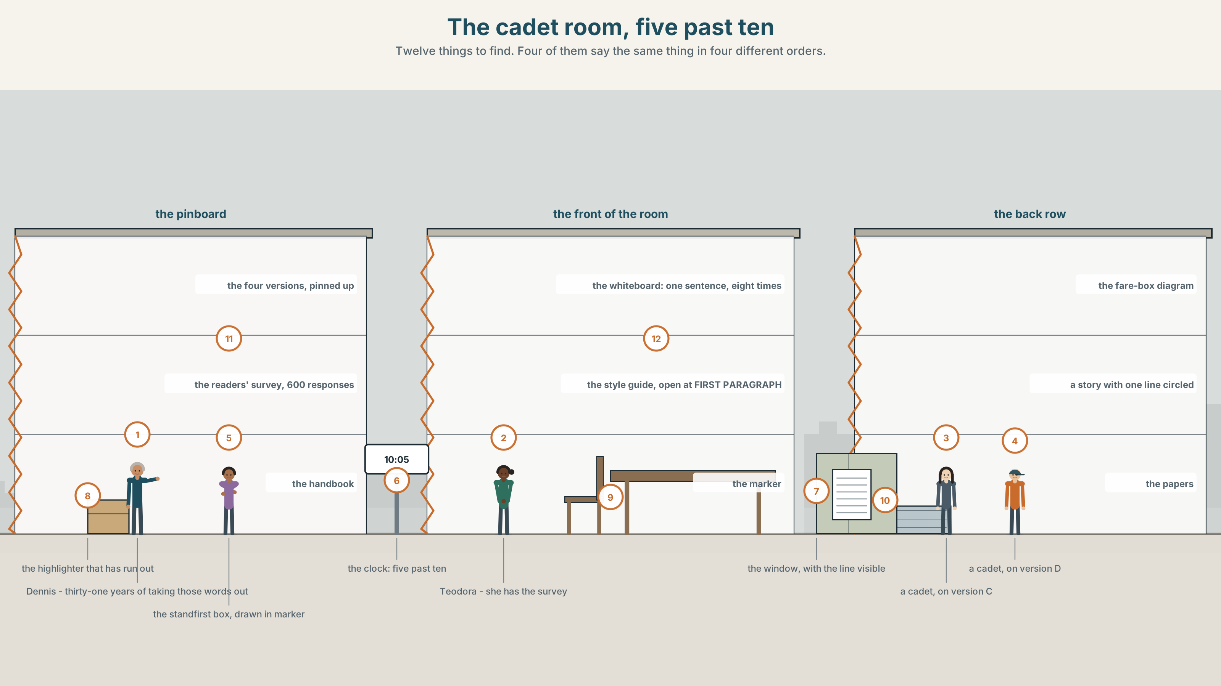{width=6.6in}
The cadet room, five past ten — Twelve things to find. Four of them say the same thing in four different orders.

Why put it there?
By the end of this unit you can decide where in a sentence the point goes, and put it there on purpose. Two hundred words.
◆ A · THE WORLD | A cadet course, one financing story, and six hundred readers who took away the opposite point
◆ B · THE SYSTEM | cleft and pseudo-cleft for information structure · 28 words for explaining and teaching · 22 focusing adverbs and frames · nuclear stress and theme
◆ C · THE PERFORMANCE | Two hundred words in which the point is where you put it

0A · Find it
Find twelve things in this picture. Four of them say the same thing in four different orders.
the four versions of paragraph one, pinned up · the readers' survey, six hundred responses · the whiteboard with one sentence on it eight times · the cadet handbook, open at page 3 · a highlighter that has run out · the style guide, open at FIRST PARAGRAPH · the fare-box diagram · a printed story with one line circled · the standfirst box, drawn in marker · a stack of yesterday's papers · a clock showing 10:05 · a window with the transit line visible

0B · Guess it
One thing on the whiteboard is the version the paper actually printed. Which, and how can you tell from the room rather than from the sentence?

0C · Say it ⏺
Record sixty seconds. Explain something you understand well to somebody who does not. Notice where you put the main point. You will record it again at the end of this unit.

Part 1 · Vocabulary Lab 1 ◆ B · THE SYSTEM
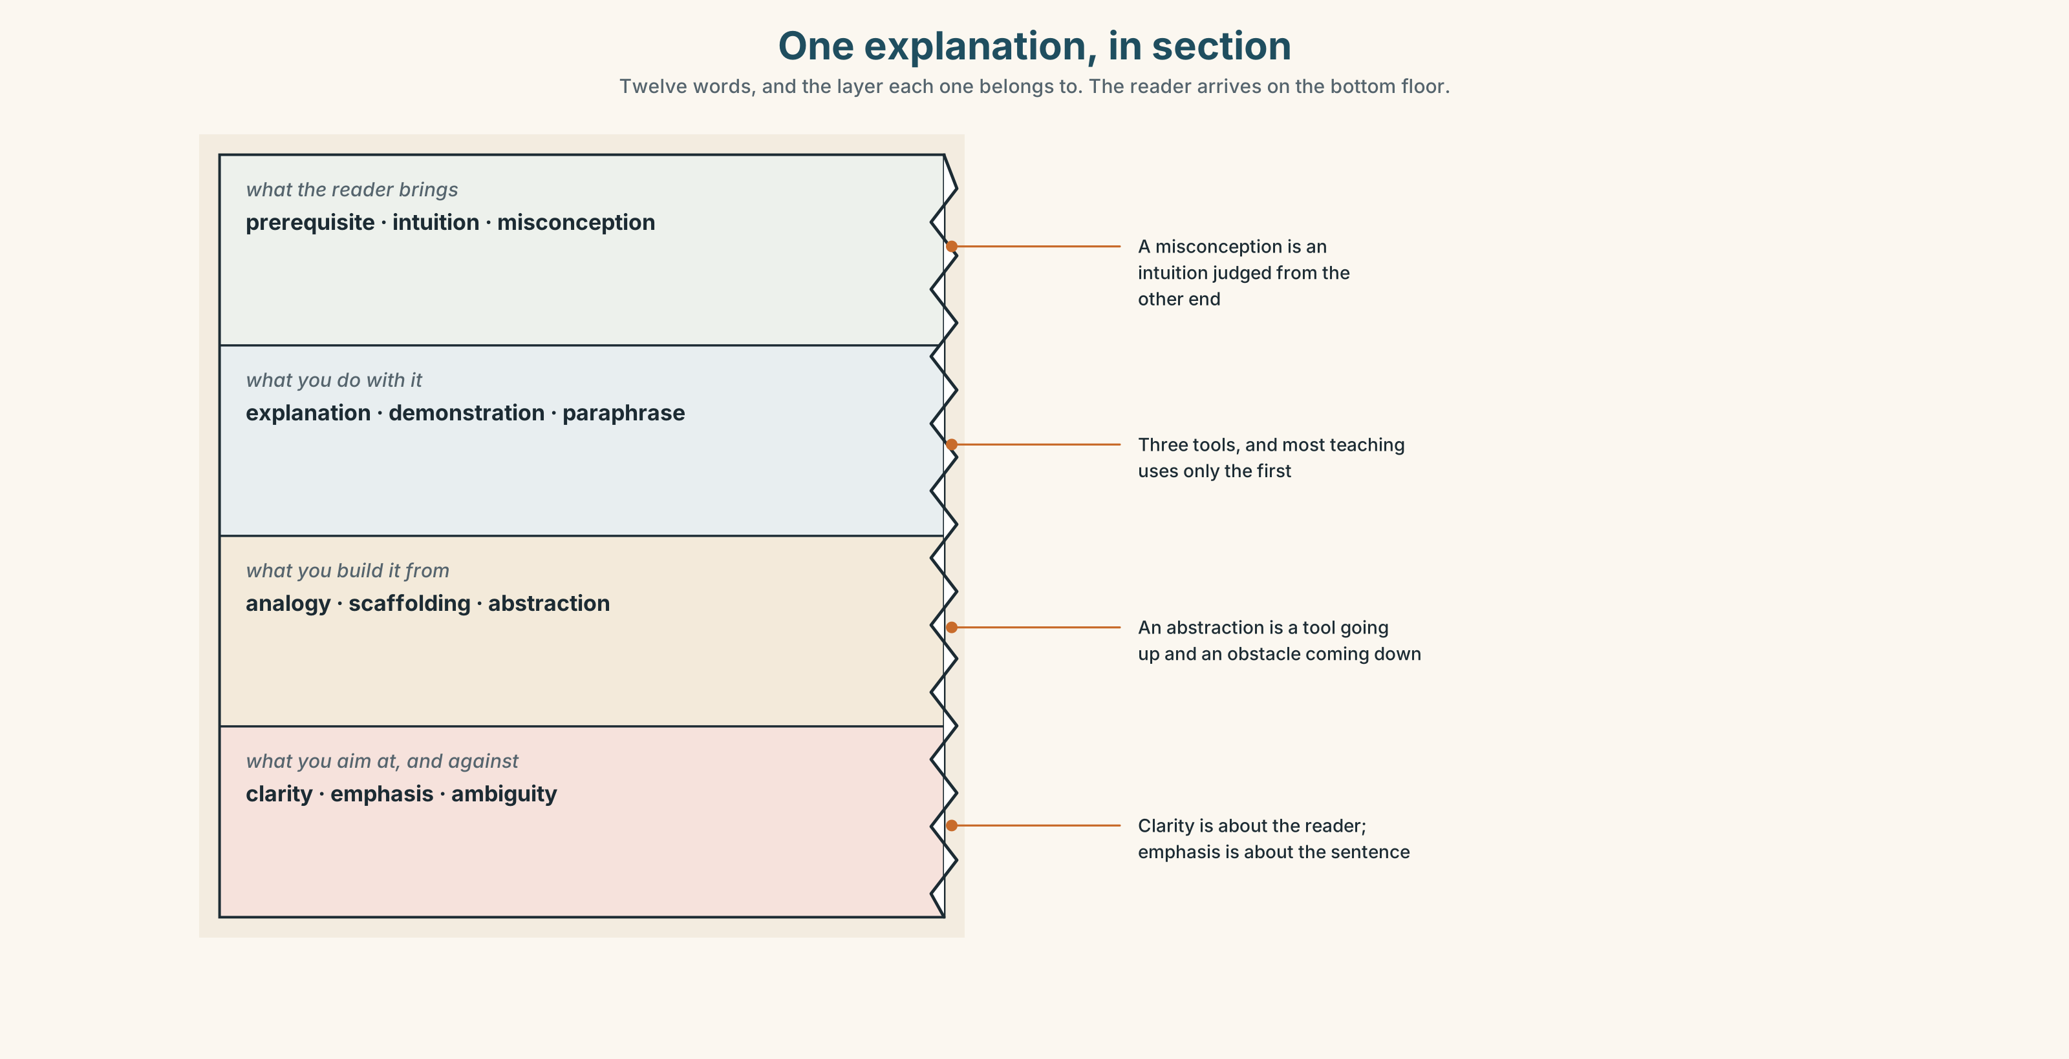{width=6.6in}
One explanation, in section — Twelve words, and the layer each one belongs to. The reader arrives on the bottom floor.

1A · Meet — the words of an explanation
Match each word to one layer of the cutaway.
explanation · emphasis · clarity · ambiguity · paraphrase · analogy · scaffolding · misconception · demonstration · prerequisite · intuition · abstraction

1B · Sort — what the reader brings, what the teacher does, or what you are aiming at?
Three columns. Two of the twelve are the same thing, judged from the two ends of the room.
prerequisite · explanation · ambiguity · demonstration · clarity · intuition · paraphrase · misconception · analogy · emphasis · scaffolding · abstraction

1C · Meet — the five phrases that put a point in focus
the key point is | A promise. Everything after it has to be worth the build-up.
what matters here | The pseudo-cleft in ordinary clothes. It puts the point at the end.
a worked example | The thing learners remember when the explanation has gone.
in other words | A second attempt, and an admission that the first one failed.
the thing to notice | Directs attention before the reader has decided where to look.

1D · Collocation Lab
Complete each one, and say which of the five is the only one that makes a claim about the reader.
to put it another way · a common misconception · step by step · from first principles · the short answer
- ______ ______ ______ is that the city borrowed against future fares.
- ______ ______ ______ is that a fare rise pays for the line. It does not.
- The cadets build the whole model ______ ______ ______ on the first morning.
- Dennis takes them through it ______ ______ ______ , and it takes ninety minutes.
- ______ ______ ______ ______ : the city sold the next thirty years of ticket income.

1E · The phrasal verbs, and the three fixed expressions
go over · break down · spell out
f let me put it another way · f the point I am making is · f that is the whole idea
One of these fixed expressions is usually a sign the speaker has lost the room. Which, and what should they do instead?

1F · Own it
Write one sentence explaining your work or study to somebody who knows nothing about it, and then underline the four words that carry the point.

Part 2 · Listening ◆ A · THE WORLD
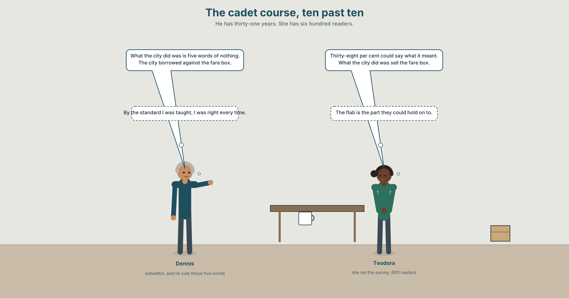{width=6.6in}
The cadet course, ten past ten — He has thirty-one years. She has six hundred readers.

2A · The cadet course, ten past ten 🔊 Track 6.1
Before you listen. Four cadets have written the first paragraph of the same financing story. The subeditor has thirty-one years. The trainer has the readers' survey.
Listen once. What did the city actually do, and which version of the paragraph says so?
Listen again. Complete the table.
 | Where the point sits | What the reader meets first | What they remembered
version A
version B
version C
Listen again. True or false?
- Six hundred readers were surveyed. ☐ T ☐ F
- The clearest version was the shortest. ☐ T ☐ F
- Version A put the point in the first seven words. ☐ T ☐ F
- The trainer wrote the standfirst herself. ☐ T ☐ F
Noticing. Five sentences from the recording.
- The city borrowed against the fare box.
- What the city did was borrow against the fare box.
- It was the fare box that the city borrowed against.
- What happened was that the city borrowed against the fare box.
- The thing that nobody mentioned was the fare box.
Five sentences, the same facts, five different points. Which one makes the fare box the news, and which one makes borrowing the news?

2B · Decoding clinic 🔊 Track 6.2
Thirty seconds at speed. Three jobs.
- The trainer reads one sentence twice with the stress in different places. Mark both.
- What changes about the meaning each time?
- Somebody says that is the whole idea. What have they just conceded?

Part 3 · Grammar Lab 1 ◆ B · THE SYSTEM

Moving the point to where the reader is looking

3A · Notice
Look at the five sentences in Part 2 again.
- In sentence 1, which word carries the point, and how do you know?
- Sentence 2 begins with four words that contain no information at all. What are they for?
- Sentence 3 puts the fare box early. What happens to everything after that?
- Sentences 4 and 5 both delay the point. Which one delays it longer, and why might you want to?

3B · See
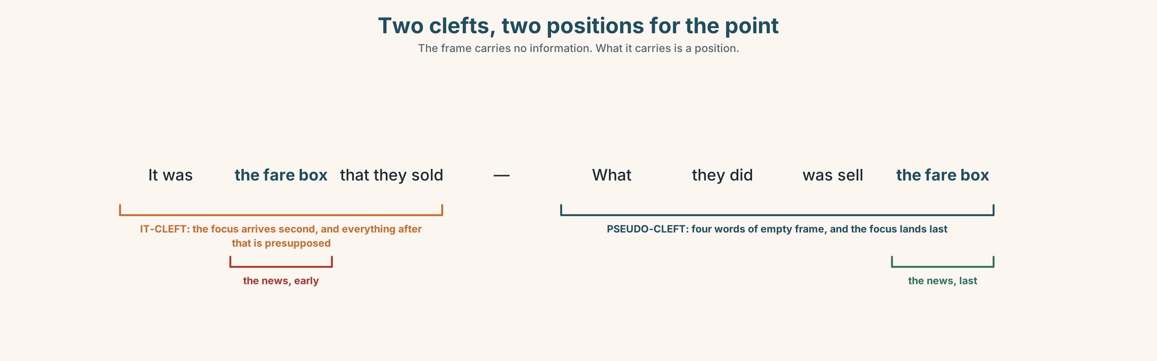{width=6.6in}
Two clefts, two positions for the point — The frame carries no information. What it carries is a position.

3C · Know
the it-cleft | It was X that… — focus early, the rest presupposed | It was the fare box that they borrowed against.
the pseudo-cleft | What… was X — focus at the end, where English wants it | What they did was borrow against the fare box.
the reversed pseudo-cleft | X is what… — the focus first, emphatically | The fare box is what they borrowed against.
the what happened was frame | an empty opening that buys the reader a second | What happened was that the city borrowed.
the thing that frame | the most natural spoken version of all of them | The thing that nobody mentioned was the fare box.
English puts new information at the end of a sentence. Every cleft is a device for getting something to the end — or, in the it-cleft, for declaring that everything after it is already agreed.
The frame carries no information, and that is the point. What the city did was contains nothing a reader did not already know. It costs five words and buys one position, and the position is worth more than the words.
narrowing to the item | namely · specifically · precisely
ranking it | chiefly · notably · crucially
going to the root | essentially · fundamentally
spoken focus frames | all I did was · where it goes wrong is · that is why · it was then that
Why it matters. Readers do not read sentences; they read positions. A true sentence with the point in the wrong position is read as a different sentence, and the correction column cannot fix it, because nothing in it was wrong.

3D · Use — controlled
Rewrite each one using the frame in brackets.
The city borrowed against the fare box. (1) (what … was) The city borrowed against the fare box. (2) (it was … that) The fare box was never mentioned. (3) (the thing that … was) The city sold thirty years of ticket income. (4) (what happened was) They only moved the debt. (5) (all … was)

3E · Use — guided
Rewrite each one so that the word in brackets ends up in focus.
- The city borrowed against the fare box in 2016. (2016)
- The council approved it without a vote. (without a vote)
- Nobody told the transit board. (the transit board)
- The fare rise pays the interest, not the line. (the interest)
- Two of the nine members abstained. (abstained)

3F · Use — open
In pairs. One of you states a fact. The other restates it three times, moving the focus to a different element each time. The first speaker says which version they would print.

3G · Error autopsy
✗ What the city did was borrowed against the fare box. ✗ It was the city who borrowed it was in 2016. ✗ The thing what nobody mentioned was the fare box.
For each, name the rule and say what the writer was reaching for.

3H · Check — eight items
- ______ the city did ______ borrow against the fare box. (two gaps — the pseudo-cleft)
- ______ ______ the fare box ______ they borrowed against. (three gaps — the it-cleft)
- ______ ______ ______ nobody mentioned was the fare box. (three words)
- ______ ______ ______ that the city sold thirty years of income. (three words)
- ______ they did ______ move the debt. (two gaps — all … was)
- ✗ What the city did was borrowed. → correct it.
- Rewrite They approved it without a vote so that without a vote is the news.
- Rewrite It was the fare box that they borrowed against so that the focus falls at the end.

Part 4 · Speaking ◆ C · THE PERFORMANCE

4A · Fluency starter — move the point
One person says a plain sentence. Everybody else restates it with the focus on a different word. Nobody may repeat a position already used.

4B · The functional core — managing information flow
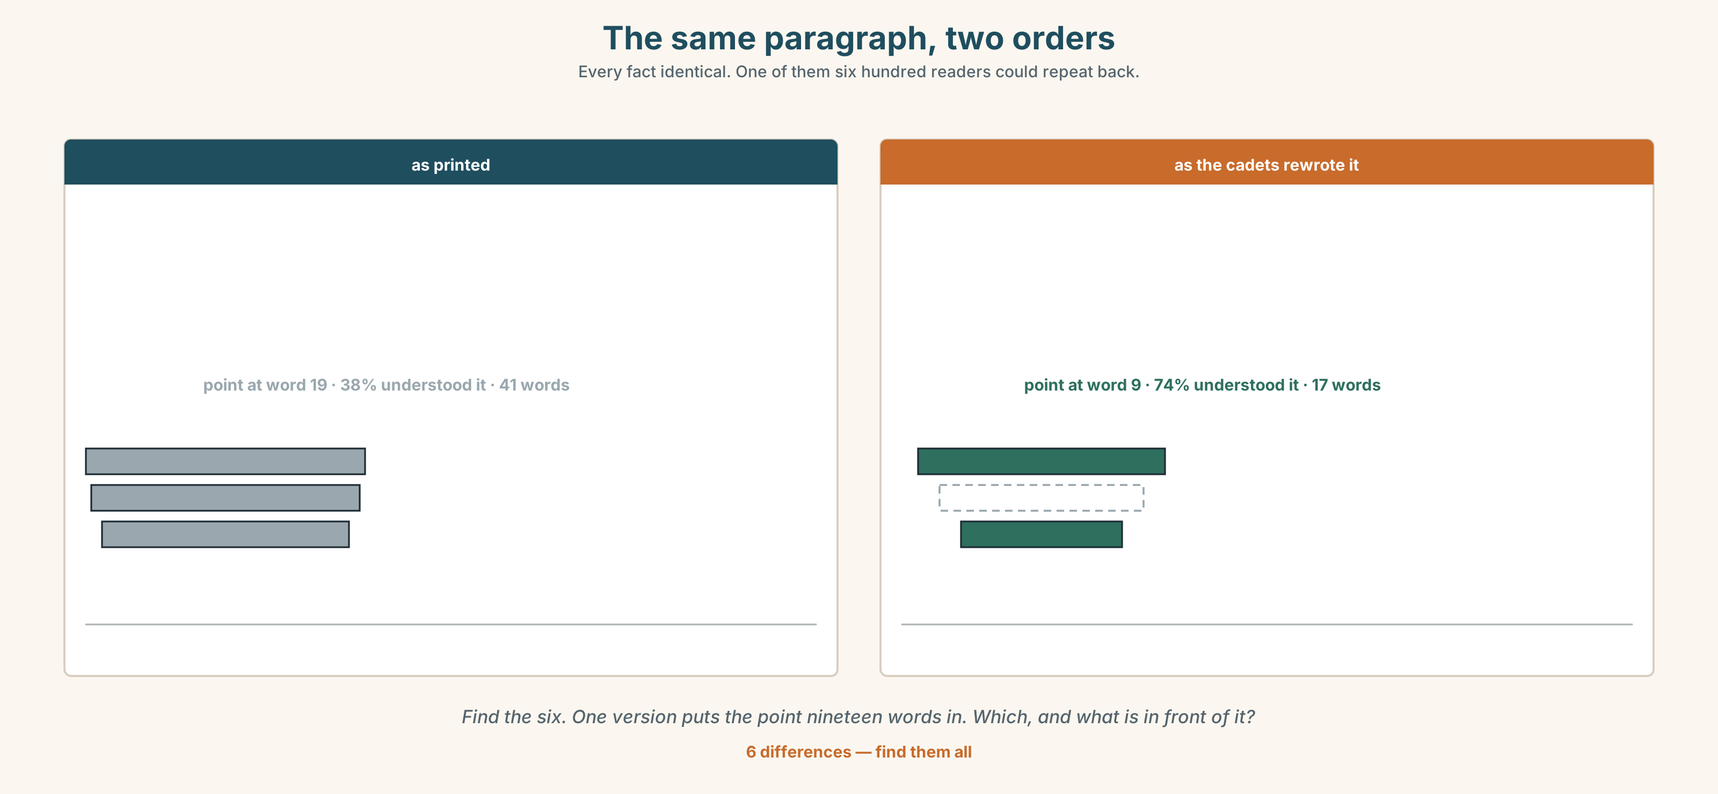{width=6.6in}
The same paragraph, two orders — Every fact identical. One of them six hundred readers could repeat back.
Language Bank
delaying the point | what happened was · the thing that · what matters is · the reason is that
asserting it early | it was X that · the key point is · what matters here
narrowing | namely · specifically · precisely · in other words
repairing | to put it another way · what I mean is · it is not that
Information gap. Learner A has the city's statement. Learner B has the transit board's minutes. Explain the financing to each other in four sentences each, and compare where you put the point.

4C · The performance — three minutes ⏺
Explain something technical from your own field in three minutes to somebody who will be tested on it afterwards. Use at least three focusing frames. Your partner takes the test.
Record it.

4D · Observer
One person writes down every sentence in which the point arrives at the end, and every one in which it arrives first.

4E · Three criteria
☐ Did the point of each sentence land where I meant it to? ☐ Did I use a frame when the point needed to be delayed, and not otherwise? ☐ Could my partner answer the test without me repeating anything?

Part 5 · Reading ◆ A · THE WORLD

5A · Predict
The title is "Six hundred readers, four paragraphs, one story." If readers take the wrong point from a true sentence, whose mistake is it?

5B · Read — two minutes

Six hundred readers, four paragraphs, one story
In 2016 the city raised money for the east-end line by selling the right to thirty years of ticket income. The fare box was not the security for a loan. It was the thing that was sold.
The Herald reported this accurately, in a story of nine hundred words, whose first paragraph read: The city has finalised a financing package for the east-end line, involving a range of instruments including a securitisation of future farebox revenue.
Four years later the readers' editor surveyed six hundred readers who had read the story. Thirty- eight per cent could state what the city had done. Of the rest, the largest group believed the line had been paid for by a fare rise.
The cadet course now begins with that paragraph. The cadets rewrite it four ways. The version that works, every year, is the one that begins What the city did was, which the subeditors hate, because it uses five words to say nothing and is, by any measure they were trained on, worse writing.
It is also the only version that six hundred readers could repeat back.

5C · Comprehension — eight questions
- What did the city sell, and for how long?
- How long was the original story?
- How many readers could state what the city had done?
- What did the largest remaining group believe?
- How does the cadet course begin?
- Why does the writer quote the original first paragraph in full?
- "Worse writing" by whose measure, and what is the writer implying about that measure?
- The last sentence is one line long and stands alone. What is it doing structurally?

5D · Vocabulary in context
Infer from the text, then check.
the security for a loan · a range of instruments · by any measure they were trained on · repeat back · the version that works

5E · The counter-text
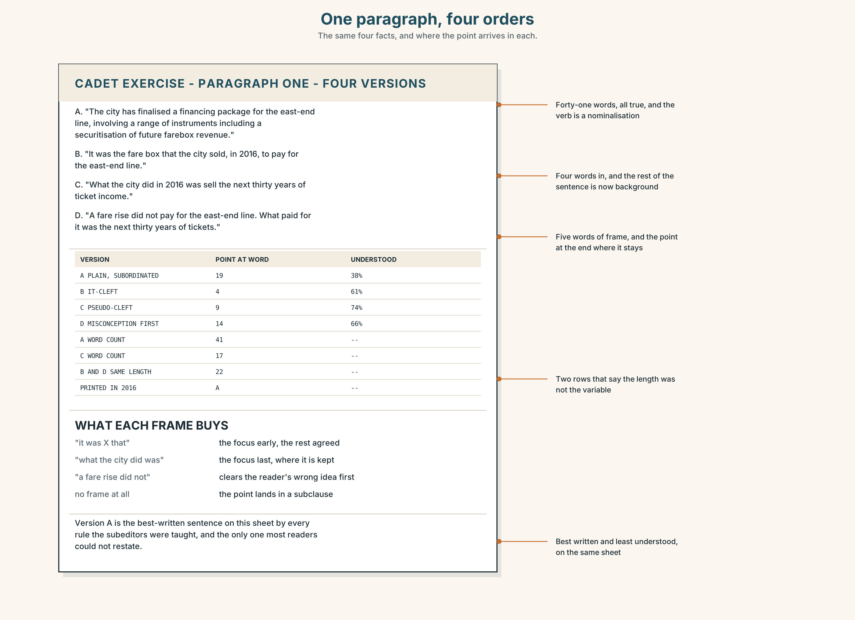{width=6.6in}
One paragraph, four orders — The same four facts, and where the point arrives in each.
Read the four versions of paragraph one and answer.
- Where is the point in each one, counted in words from the start?
- Which version puts the reader's own likely misconception first, and why might that help?
- Two versions are the same length. What is different about them?
- Which version would you print, and what would you lose?

5F · Two texts
The original says a securitisation of future farebox revenue. Version D says what the city did was sell the next thirty years of ticket income.
Is version D less accurate? Write two sentences, and use the word emphasis in one of them.

Part 6 · Vocabulary Lab 2 ◆ B · THE SYSTEM

Words that point at one part of a sentence

6A · Sort — narrowing to the item, ranking it, or going to the root?
Three columns.
namely · chiefly · essentially · specifically · notably · fundamentally · precisely · crucially

6B · Chunk completion
- ______ ______ ______ the position, not the words. (three words — the pseudo-cleft frame)
- ______ ______ ______ ______ the sentence is true and still misread. (four words)
- ______ ______ ______ ______ move the point. (four words — all … was)
- ______ ______ is the first paragraph. (two words — the thing that …)
- ______ ______ ______ ______ ______ is the second clause. (five words — where it goes wrong …)
- ______ ______ ______ the city sold the income. (three words — what happened …)
- ______ ______ ______ the cadets start with that paragraph. (three words)
- ______ ______ ______ ______ the subeditors stopped arguing. (four words — it was then …)

6C · Three that are not interchangeable
namely · notably · essentially
Say which one lists exactly, which one singles out one case, and which one strips a thing to its core.

6D · The phrasal verbs and the fixed expressions
boil down to · come down to · point out
f it is not that · f what I mean is · f this is the bit that
Two of these three phrasal verbs are nearly interchangeable. Which two, and what does the third one do that the others cannot?

6E · Contrast Clinic
Eight items. Rewrite each sentence so that the element in brackets is the news.
- The city borrowed against the fare box in 2016. (the fare box)
- The city borrowed against the fare box in 2016. (2016)
- The council approved it without a vote. (without a vote)
- Nobody told the transit board. (nobody)
- The fare rise pays the interest. (the interest)
- The cadets rewrite it four ways. (four ways)
- The subeditors hate the version that works. (the version that works)
- Six hundred readers could repeat it back. (repeat it back)

Part 7 · Pronunciation & Fluency Lab ◆ B · THE SYSTEM
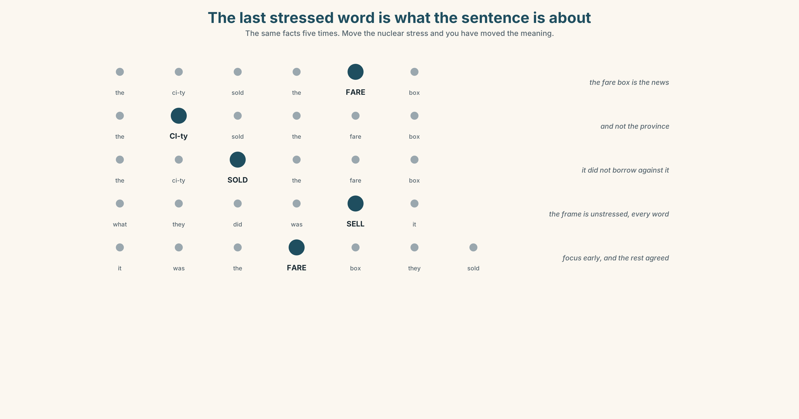{width=6.6in}
The last stressed word is what the sentence is about — The same facts five times. Move the nuclear stress and you have moved the meaning.

The last stressed word is the point

7A · Hear 🔊 Track 6.3
The city borrowed against the FARE BOX. — the fare box is the news The CITY borrowed against the fare box. — and not the province The city BORROWED against the fare box. — it did not sell it, it borrowed

7B · Say
Say each one three times. Then say this:
What the city did was SELL it. — the frame is unstressed, every word of it, and the point lands on the last content word, where English wants it.

7C · Make it mean something
Say these two:
It was the FARE BOX that they sold. — the focus is early, and everything after is agreed What they sold was the FARE BOX. — the focus is last, and the reader has been prepared
A cleft moves the nuclear stress, and the nuclear stress is the sentence's actual meaning. Write the stress where you want it and the syntax will follow.

7D · Fluency 30 ⏺
Thirty seconds: one fact, said five ways, with the nuclear stress in a different place each time. Three times, faster.

Part 8 · Writing ◆ C · THE PERFORMANCE

An explanation that lands · 200 words

8A · Read the model
What the city did in 2016 was sell the next thirty years of ticket income. [the pseudo-cleft: five words of frame, and the point at the end where it is remembered]
It was not a loan secured against the fare box; it was the fare box itself. [an it-cleft correcting the misconception the reader almost certainly arrived with]
The thing that nobody mentioned at the time was what happens in year thirty-one. [the spoken frame, which delays the point for a full clause and is the most readable of all of them]
Essentially, the line was paid for by passengers who have not travelled yet; specifically, by everybody who will buy a ticket between now and 2046. [root first, then the exact set — the two adverbs do different jobs and must come in that order]
Questions about the writer's choices:
- The first sentence spends five words saying nothing. What did those five words buy?
- The second sentence corrects something the reader was never told. Why is that allowed here?
- Essentially then specifically. What happens if you swap them?

8B · The anti-model
The financing package, which involved a securitisation of future revenue streams in conjunction with conventional instruments, was finalised in 2016 following a procurement process that had commenced the previous year and was subject to the usual approvals.
One sentence, forty-two words, every fact true, and the point buried in the middle of a subordinate clause. Rewrite it as four sentences, each with its point at the end.

8C · Plan
the pseudo-cleft with the main point → the it-cleft correcting the misconception → the spoken frame delaying the hardest idea → the root, then the exact set

8D · Write — 200 words

8E · Peer review — three criteria
☐ Does each sentence end on the word you want remembered? ☐ Is every frame earning its words, or is one of them just a throat-clearing? ☐ Could a reader state the point back to you after one reading?

8F · Write it again · 8G · Publish
Rewrite after review. Publish both, and mark the last stressed word of every sentence.

Part 9 · The File ◆ A · THE WORLD + C · THE PERFORMANCE
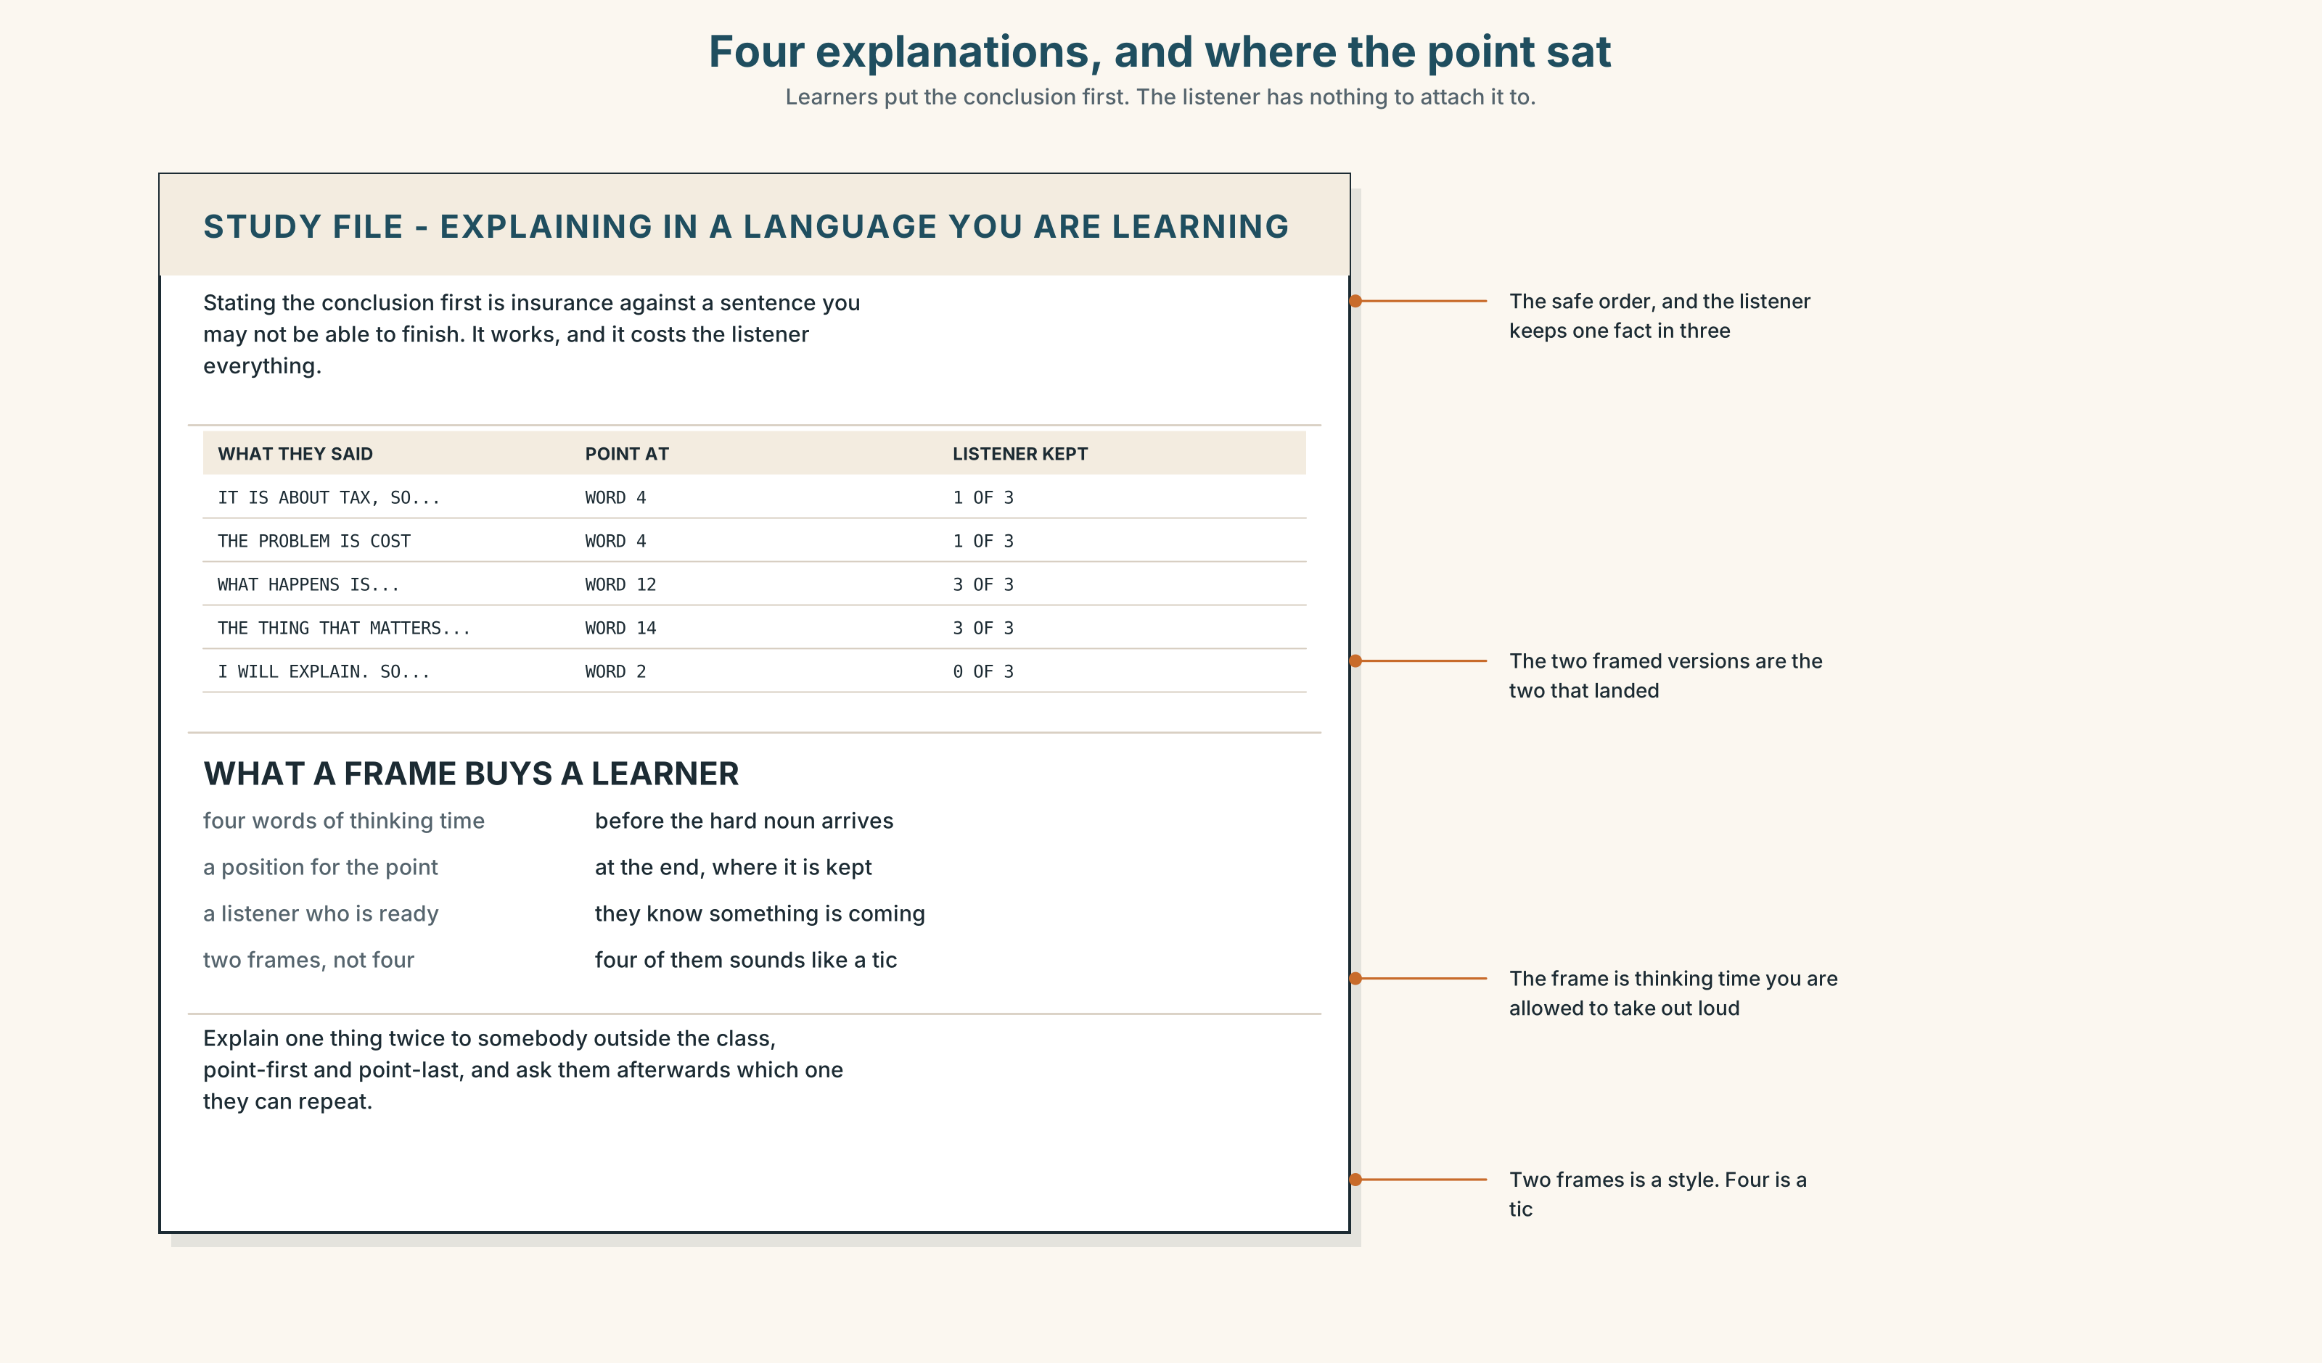{width=6.6in}
Four explanations, and where the point sat — Learners put the conclusion first. The listener has nothing to attach it to.

STUDY FILE · Explaining something in a language you are still learning

9A · The point at the wrong end 🔊 Track 6.4
Learners explaining something in English tend to put the point first, because they are not sure they will be able to finish the sentence. The result is accurate, complete and unmemorable: the listener meets the hardest idea before they are ready for it.
what you do | state the conclusion, then the background
why | insurance, in case the sentence collapses
what it costs | the listener has nothing to attach the conclusion to
the fix | one frame — what happens is… — which buys you four words of thinking time

9B · Buy yourself the time
Take three things you can already explain in English. Rewrite each with a frame at the front, and say the new version out loud.

9C · Role play — the test afterwards
In pairs. One of you explains something for ninety seconds. The other then answers three questions on it. Swap, and compare how much each listener kept.

9D · The frame you already have
Every learner has one frame they use constantly, usually the problem is. Name yours, and learn two more this week. Two is enough; four sounds like a tic.

9E · Transfer — before next week
Explain one thing to somebody outside the class, twice: once point-first and once point-last. Bring back which one they could repeat.

Part 10 · Mediation & Interaction ◆ C · THE PERFORMANCE
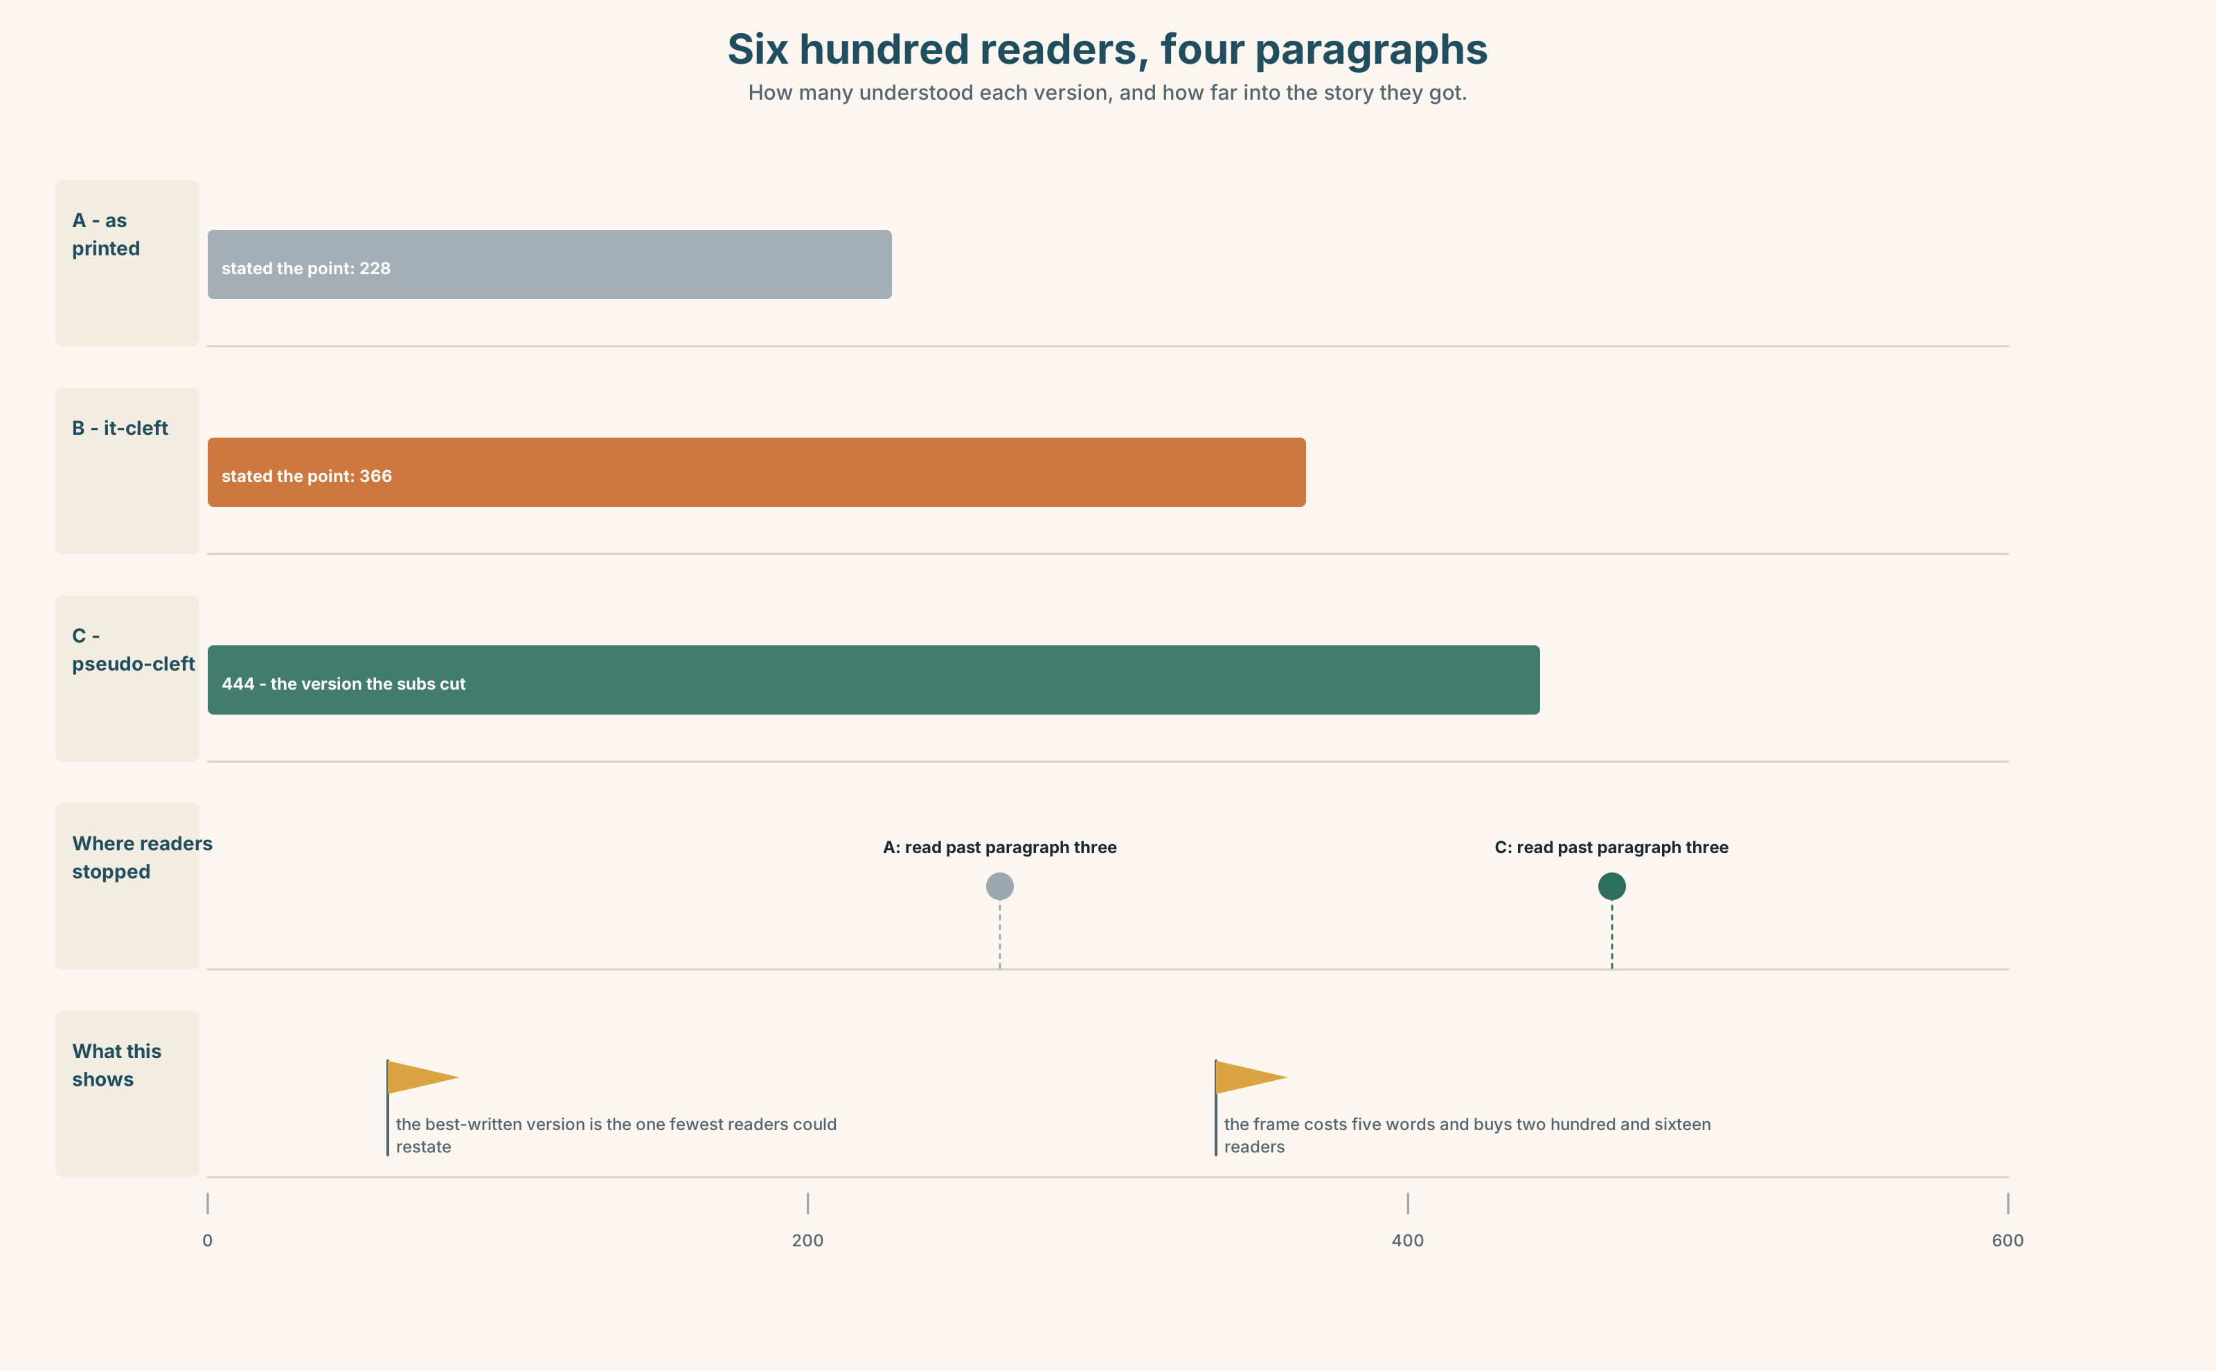{width=6.6in}
Six hundred readers, four paragraphs — How many understood each version, and how far into the story they got.

10A · Relay
Half the class has the city's statement. Half has the readers' survey. Produce one first paragraph, by speaking only. Ten minutes.

10B · Simplify — for one reader
A reader writes: So did my fare rise pay for the line or not? Reply in four sentences. Put the answer at the end of the first one.

10C · Online
Write one message to a colleague whose opening paragraph is accurate and unreadable. Three sentences. Do not rewrite it for them; show them where the point currently is.

10D · Your language
Does your language use clefts, or does it move words instead? Translate all five sentences from Part 2. Which of the five come out identical?

Part 11 · The Decision ◆ C · THE PERFORMANCE

The first paragraph
Thirty-eight per cent of readers could state what a correct story said.
Option one: change nothing. The story was accurate, the words were right, and a newspaper cannot write down to its readers without insulting them.
Option two: a house rule that the point of any complex story appears in the first seven words.
Option three: a one-sentence standfirst above every complex story, written in a focus frame — What the city did was… — and written before the story, not after it.

11A · The evidence
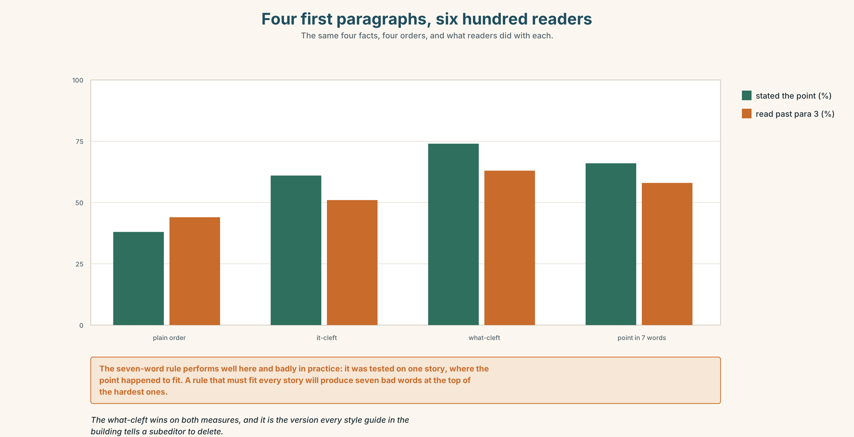{width=6.6in}
Four first paragraphs, six hundred readers — The same four facts, four orders, and what readers did with each.
🔊 Track 6.6. Dennis Hoy, subeditor, 30 seconds: "I have spent thirty-one years taking those five words out of other people's copy. 'What the city did was.' It is flab, it is a throat-clear, and I was right every time by the standard I was taught. The survey says I was also removing the only part of the sentence the reader could hold on to. Both of those things are true and I have not worked out what to do with that yet."

11B · Talk about it
In threes. Use the frame, and put the point of each turn at the end of your sentence.
What I would do is ______ , because ______ , and the cost of it is ______ .

11C · Decide
Write three sentences: the decision, the evidence, and what you would be giving up.

11D · Model decision
Option three. The seven-word rule is a blunt instrument that will produce seven bad words at the top of every difficult story. The standfirst keeps the story itself intact and gives the point one position where it cannot be missed. Writing it first is the part that matters: a writer who cannot put the point in one framed sentence does not yet know what the story is, and finding that out before writing nine hundred words is worth more than the standfirst.

11E · The Reveal
What happened. The Herald adopted the standfirst. Readers' comprehension on complex stories rose from thirty-eight per cent to seventy-one within a year.
Then something nobody predicted: the standfirsts began to change the stories. Writers drafting the framed sentence first found, often, that they could not finish it — and the thing they could not finish was usually the thing they had not yet reported. The desk's query rate to reporters rose by a third, before the first word of copy was written.
One question. You do not have to answer it out loud.
The rule was about where a sentence puts its point. Why did it change what got reported?

Part 12 · Landing ◆ all three lines

12A · Recycle — fifteen items
- ______ the city did ______ sell the income. (two gaps — the pseudo-cleft)
- ______ ______ the fare box ______ they sold. (three gaps — the it-cleft)
- ______ ______ ______ nobody mentioned was year thirty-one. (three words)
- ______ ______ ______ the city sold thirty years of income. (three words)
- ______ they did ______ move the debt. (two gaps)
- ______ , the passengers paid for it. (one word — to the root)
- ______ , everybody buying a ticket before 2046. (one word — the exact set)
- ______ , the first paragraph. (one word — ranking it top)
- ______ ______ ______ : the city sold the next thirty years. (three words)
- ______ ______ ______ ______ is that a fare rise paid for it. (four words)
- ______ ______ ______ ______ ______ ______ . (six words — the speaker starting again)
- ______ ______ ______ ______ . (four words — the concession when the point lands)
- Dennis will ______ ______ it with them line by line. (two words)
- Somebody has to ______ ______ what the city actually sold. (two words)
- The whole thing ______ ______ ______ one position in one sentence. (three words)

12B · Consolidate — one task, everything in it
Write 150 words explaining one thing you know well. Use three different focus frames and mark the last stressed word of every sentence.

12C · Can-do, with evidence
☐ I can use it-clefts and pseudo-clefts to move the point of a sentence. Evidence: 3H, 8D ☐ I can choose where new information lands. Evidence: 6E, 4C ☐ I can explain something so that a listener can repeat it. Evidence: 9C, 10B ☐ I can place the nuclear stress deliberately. Evidence: 7C

12D · Replay ⏺
Record 0C again. Compare. Where did the point sit the first time?

12E · Glossary — fifty items, as a map
WHAT THE READER BRINGS · prerequisite · intuition WHAT THE TEACHER DOES · explanation · demonstration · paraphrase · analogy · scaffolding WHAT YOU AIM AT OR AGAINST · clarity · emphasis · ambiguity · misconception · abstraction THE FIVE FOCUS PHRASES · the key point is · what matters here · a worked example · in other words · the thing to notice HOW YOU TAKE IT APART · to put it another way · a common misconception · step by step · from first principles · the short answer WHAT TEACHERS DO WITH IT · go over · break down · spell out · boil down to · come down to · point out IN THE ROOM · let me put it another way · the point I am making is · that is the whole idea THE ADVERBS · namely · specifically · precisely · chiefly · notably · essentially · fundamentally · crucially THE FRAMES · what matters is · the reason is that · all I did was · the thing that · where it goes wrong is · what happened was · that is why · it was then that STARTING AGAIN · it is not that · what I mean is · this is the bit that

12F · Next
Unit 7 · What does the chart not say?

