Table of Contents

B2.1 · Unit 8 · Seventy-Three Words
English Animated · Reading Between Lines · a newsroom, Toronto Student's Book pages 160–181 · 22 pp · ~11 hours

Part 0 · The Big Picture ◆ A · THE WORLD
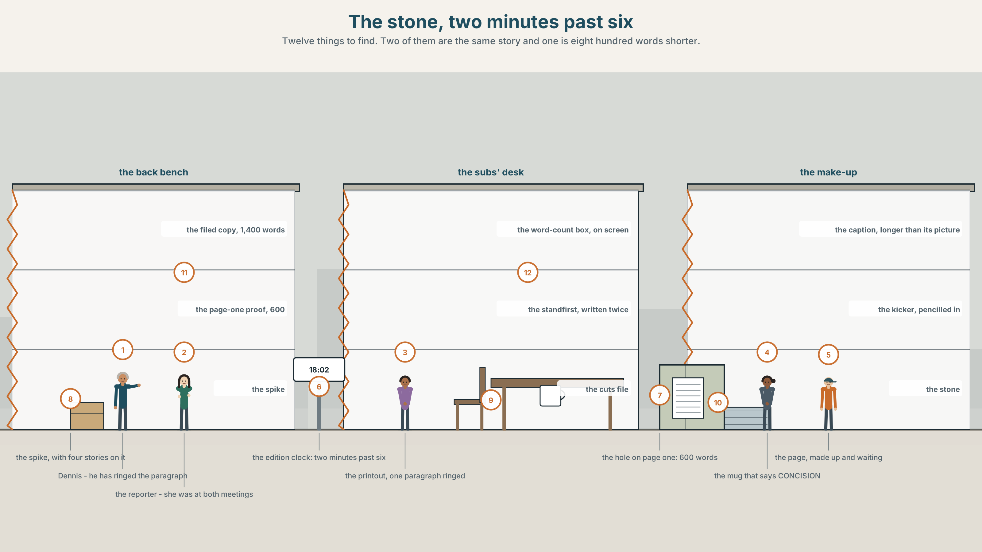{width=6.6in}
The stone, two minutes past six — Twelve things to find. Two of them are the same story and one is eight hundred words shorter.

What was left out?
By the end of this unit you can leave things out on purpose, and say what a cut has cost. Two hundred words.
◆ A · THE WORLD | A story filed at fourteen hundred words, a hole of six hundred, and one paragraph of seventy-three
◆ B · THE SYSTEM | ellipsis and substitution · 28 words for editing and brevity · 22 substitute words and frames · reduced forms and where you pause
◆ C · THE PERFORMANCE | Two hundred words that imply as much as they say

0A · Find it
Find twelve things in this picture. Two of them are the same story and one of them is eight hundred words shorter.
the filed copy, fourteen hundred words · the page-one proof, six hundred · the word-count box on the screen · the standfirst, written twice · the spike, with four stories on it · the caption that is longer than its picture · the kicker, pencilled in · a printout with one paragraph ringed · the stone, with the page made up · the edition clock showing 18:02 · the cuts file, open · a mug that says CONCISION

0B · Guess it
One paragraph on this desk is ringed and nobody has cut it yet. Which two people in the room disagree about it, and how can you tell from where they are standing?

0C · Say it ⏺
Record sixty seconds. Tell a story you know well in sixty seconds, then tell the same story in twenty. Say what you lost. You will record it again at the end of this unit.

Part 1 · Vocabulary Lab 1 ◆ B · THE SYSTEM
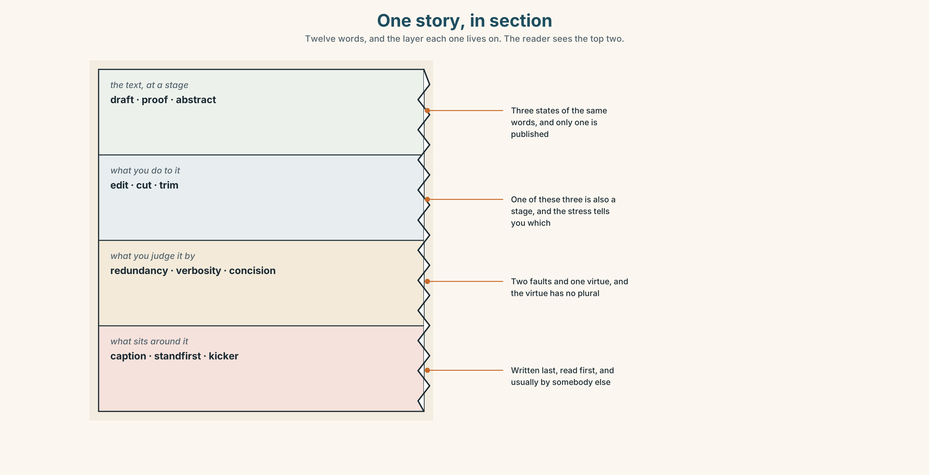{width=6.6in}
One story, in section — Twelve words, and the layer each one lives on. The reader sees the top two.

1A · Meet — the words of an edit
Match each word to one layer of the cutaway.
draft · proof · abstract · edit · cut · trim · redundancy · verbosity · concision · caption · standfirst · kicker

1B · Sort — a stage, an action, a judgement, or a thing round the edge?
Four columns. One of the twelve is both a stage and an action, and the stress tells you which.
draft · edit · redundancy · caption · proof · cut · verbosity · standfirst · abstract · trim · concision · kicker

1C · Meet — the five things that happen at six o'clock
a first pass | Twenty minutes, and it finds about half of what has to go.
kill a paragraph | Faster and kinder than shaving words off six of them.
tighten it up | The instruction every writer has heard and nobody can act on.
the word count | The only number on the desk that is not negotiable.
down to length | Not shorter. A specific number, by a specific time.

1D · Collocation Lab
Complete each one, and say which of the five is the only one the reader ever sees.
an edited version · a working draft · the final cut · a hard cut · what survives
- ______ ______ ______ went up at four and was six hundred words over.
- ______ ______ is a paragraph removed whole, and it is usually the honest kind.
- ______ ______ ______ is what the reader gets, and nobody tells them it is one.
- ______ ______ ______ went to the stone at two minutes past six.
- ______ ______ is not what was best. It is what fitted.

1E · The phrasal verbs, and the three fixed expressions
cut down · chop out · pare back
f it can go · f we are over by forty · f nobody will miss it
One of these fixed expressions is a prediction and two are decisions. Which is the prediction, and who is in a position to check it afterwards?

1F · Own it
Write one sentence of twenty words about your week, then write the same thing in eight, and name the one thing the short version makes the reader guess.

Part 2 · Listening ◆ A · THE WORLD
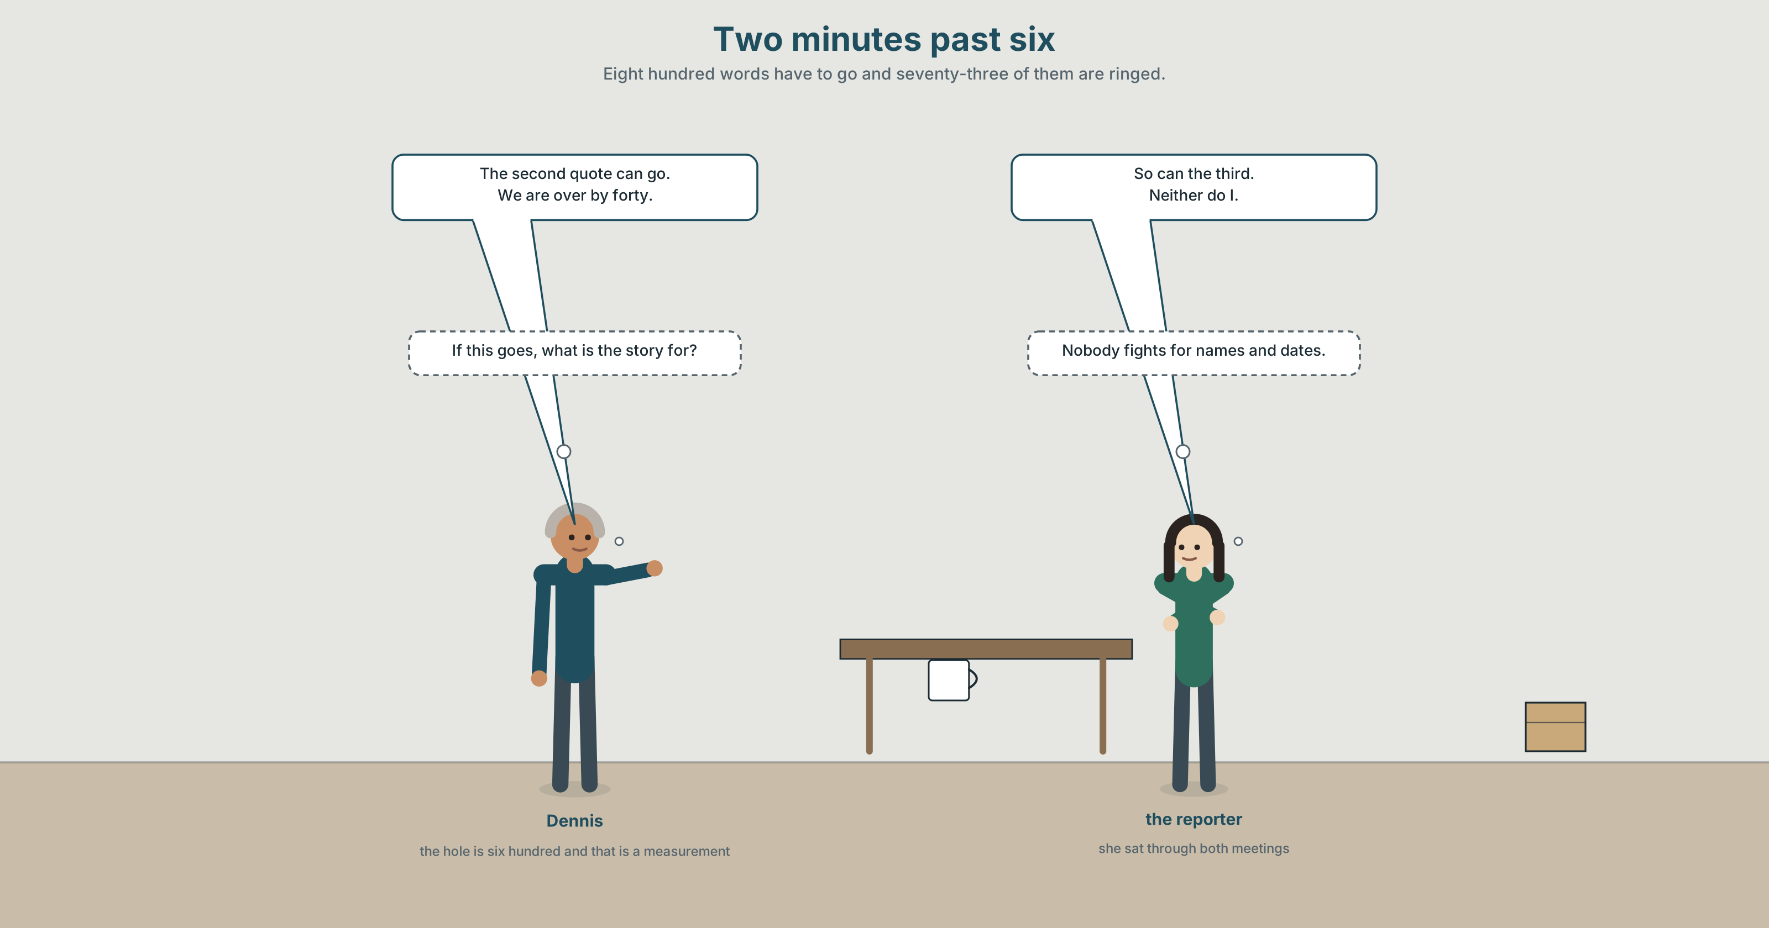{width=6.6in}
Two minutes past six — Eight hundred words have to go and seventy-three of them are ringed.

2A · Two minutes past six 🔊 Track 8.1
Before you listen. The Ward 7 story is filed at fourteen hundred words. The hole on page one is six hundred. One paragraph of seventy-three words names the two councillors who voted for the contract.
Listen once. What does each of them want cut, and what reason does each give?
Listen again. Complete the table.
 | What they would cut | How many words | What they say it costs
the subeditor
the reporter
the agreed version
Listen again. True or false?
- The story is eight hundred words over. ☐ T ☐ F
- The ringed paragraph is seventy-three words. ☐ T ☐ F
- The subeditor wants to cut the quotes. ☐ T ☐ F
- The page goes to the stone at six. ☐ T ☐ F
Noticing. Six exchanges from the recording.
- — Who's filed? — Dev has.
- — Have you cut the quotes? — I have, both.
- — Can we lose the colour? — We can, but I'd rather not.
- — The second quote can go. — So can the third.
- — I don't want to cut that one. — Neither do I.
- — Someone has to decide. — I will if you will.
Every one of these second turns leaves words out. Write each one in full, and count what the speaker saved.

2B · Decoding clinic 🔊 Track 8.2
Thirty seconds at speed. Three jobs.
- One speaker says we are over by forty in five syllables. Write what you hear.
- Where does each speaker pause? Mark the two longest pauses and say what follows each.
- Somebody says nobody will miss it. What is the full sentence, and what has been left out of it?

Part 3 · Grammar Lab 1 ◆ B · THE SYSTEM

Saying less and meaning the same

3A · Notice
Look at the six exchanges in Part 2 again.
- In exchange 1, how many words has the second speaker not said?
- In exchange 2, I have, both — what is both doing, and what has gone?
- In exchange 4, so can the third — what does so stand for?
- Exchange 6 contains two ellipses in six words. Find both.

3B · See
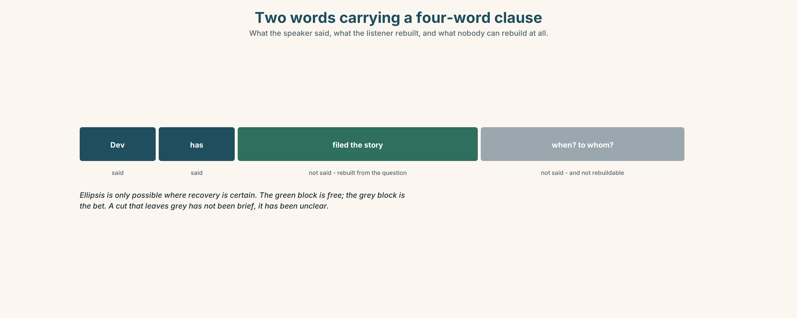{width=6.6in}
Two words carrying a four-word clause — What the speaker said, what the listener rebuilt, and what nobody can rebuild at all.

3C · Know
ellipsis | leaving words out where the reader can recover them | Dev has. → Dev has filed.
substitution with one / ones | standing in for a countable noun | the long version and the short one
substitution with do so / do it | standing in for a whole verb phrase | She cut it, and I would have done so too.
substitution with so | standing in for a clause | — The quote can go. — So can the colour.
substitution with such | standing in for a kind of thing | no such paragraph survived
neither / either | carrying a negative across to a second speaker | — I wouldn't. — Neither would I.
Ellipsis is only possible where recovery is certain. Dev has works because the question supplied filed. Leave out something the listener cannot rebuild and you have not been brief; you have been unclear, and the two are confused daily.
Do so is formal and written; do it is neutral; bare do is British and spoken. She asked me to file and I did is spoken; and I did so is a report; and I did it is in between. Choosing wrongly is one of the clearest register mistakes an advanced learner makes.
pointing back | the former · the latter · the same · as such
carrying a condition | if so · if not
adding a second speaker | likewise · so does mine · neither did I
pointing somewhere else | elsewhere
Why it matters. Half of spoken English is what was not said, and every edit is a bet about what the reader can rebuild. A good cut leaves a hole the reader fills correctly without noticing.

3D · Use — controlled
Complete each second turn with the shortest form that works.
— Who has filed? — Dev (1) ______ . — Have you cut both quotes? — I (2) ______ , ______ . — The second quote can go. — (3) ______ can the third. — I would not cut that paragraph. — (4) ______ would I. — Is it down to length? — If (5) ______ , it goes to the stone now.

3E · Use — guided
Rewrite each one, leaving out everything the listener can recover.
- The second quote can go, and the third quote can go too.
- I have cut both of the quotes.
- I would not cut that paragraph, and she would not cut that paragraph either.
- He asked me to file it and I filed it.
- The long version is better than the short version.

3F · Use — open
In pairs. One of you makes a statement. The other agrees or disagrees in four words or fewer, using substitution. Eight rounds, and nobody may repeat a form.

3G · Error autopsy
✗ — Who has filed? — Dev has filed it the story. ✗ — I would not cut it. — Either would I. ✗ She asked me to file and I did so it.
For each, name the rule and say what the writer was reaching for.

3H · Check — eight items
- — Who has filed? — Dev ______ .
- — Have you cut both? — I ______ .
- — The second can go. — ______ can the third.
- — I would not cut it. — ______ would I.
- — Is it down to length? — If ______ , it goes now.
- ✗ — I would not. — Either would I. → correct it.
- Rewrite The long version is better than the short version using one.
- Rewrite She cut it and I cut it too three ways: spoken, neutral and formal.

Part 4 · Speaking ◆ C · THE PERFORMANCE

4A · Fluency starter — half as long
One person says a sentence. The next says the same thing in half the words. Four rounds, and the fourth version must still be a sentence somebody could act on.

4B · The functional core — compressing and implying
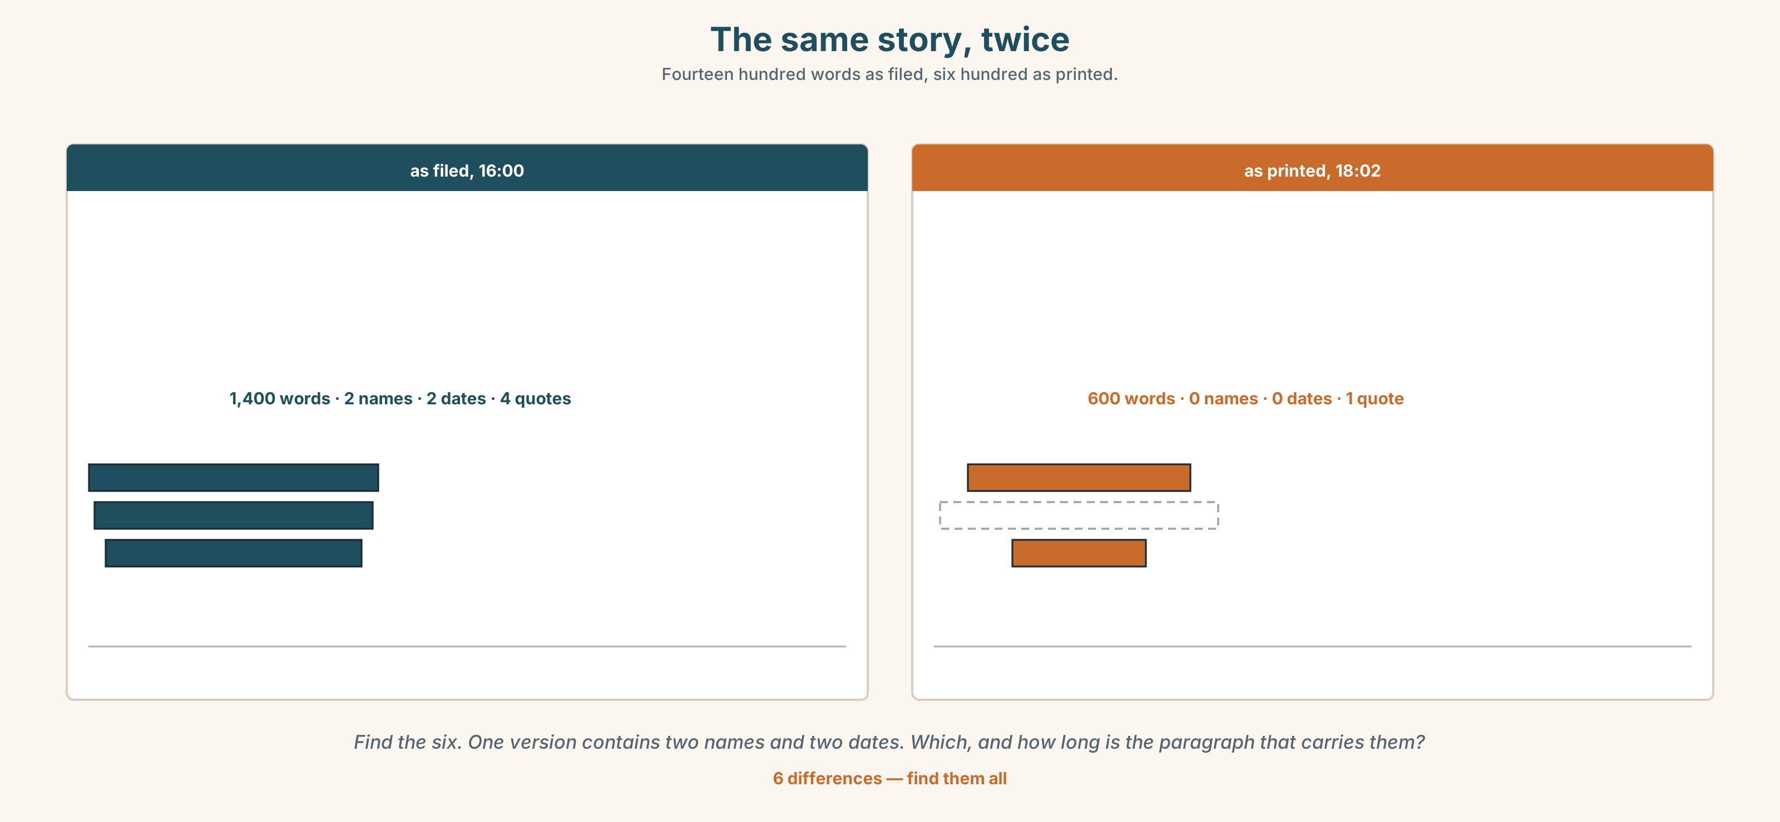{width=6.6in}
The same story, twice — Fourteen hundred words as filed, six hundred as printed.
Language Bank
agreeing short | so does mine · neither did I · likewise · the same
standing in | do so · do it · one · ones · such
pointing back | the former · the latter · as such · elsewhere
conditional short forms | if so · if not
Information gap. Learner A has the filed copy. Learner B has the page-one proof. Find the eight hundred missing words by asking questions only. Ten minutes.

4C · The performance — three minutes ⏺
Tell a story for ninety seconds. Then tell the same story in thirty. Your partner lists, from the short version alone, three things they inferred that you did not say — and you say whether each is right.
Record it.

4D · Observer
One person writes down every substitution used and what each one stood for.

4E · Three criteria
☐ Could my listener rebuild everything I left out? ☐ Did I choose do so, do it or bare do to match the register? ☐ Did the short version imply the same thing, or a different one?

Part 5 · Reading ◆ A · THE WORLD

5A · Predict
The title is "Seventy-three words." If a story has to lose eight hundred words, which paragraph is most likely to go, and why?

5B · Read — two minutes

Seventy-three words
The story was filed at four o'clock at fourteen hundred words. The hole on page one is six hundred. That is not a negotiation; it is a measurement.
The first pass takes twenty minutes and finds three hundred words of repetition, two sentences that say the same thing in different registers, and a quotation that adds nothing the paragraph above it has not said. Nobody will miss any of it.
That leaves five hundred to go, and five hundred words is four paragraphs.
Three of the four are easy. The description of the junction, which took the reporter an afternoon, goes first. The second and third quotations go next; the first one carries the argument and the others agree with it.
The fourth is seventy-three words long and names the two councillors who voted for the contract, and the dates of the two meetings at which they did so. It is the least readable paragraph in the story. It is also the only one that could not be written by somebody who had not been there.
At two minutes past six the subeditor rings it, and does not cut it, and says: If this goes, what is the story for?

5C · Comprehension — eight questions
- How long was the story as filed, and how big is the hole?
- What does the first pass find?
- How many words are left to cut after the first pass?
- Which three paragraphs go, and in what order?
- How long is the fourth paragraph?
- "That is not a negotiation; it is a measurement." What is the writer establishing early?
- Why does the writer mention that the junction description took an afternoon?
- The piece ends on a question, not a decision. What does that leave the reader to do?

5D · Vocabulary in context
Infer from the text, then check.
says the same thing in different registers · carries the argument · the least readable paragraph · could not be written by somebody who had not been there · rings it

5E · The counter-text
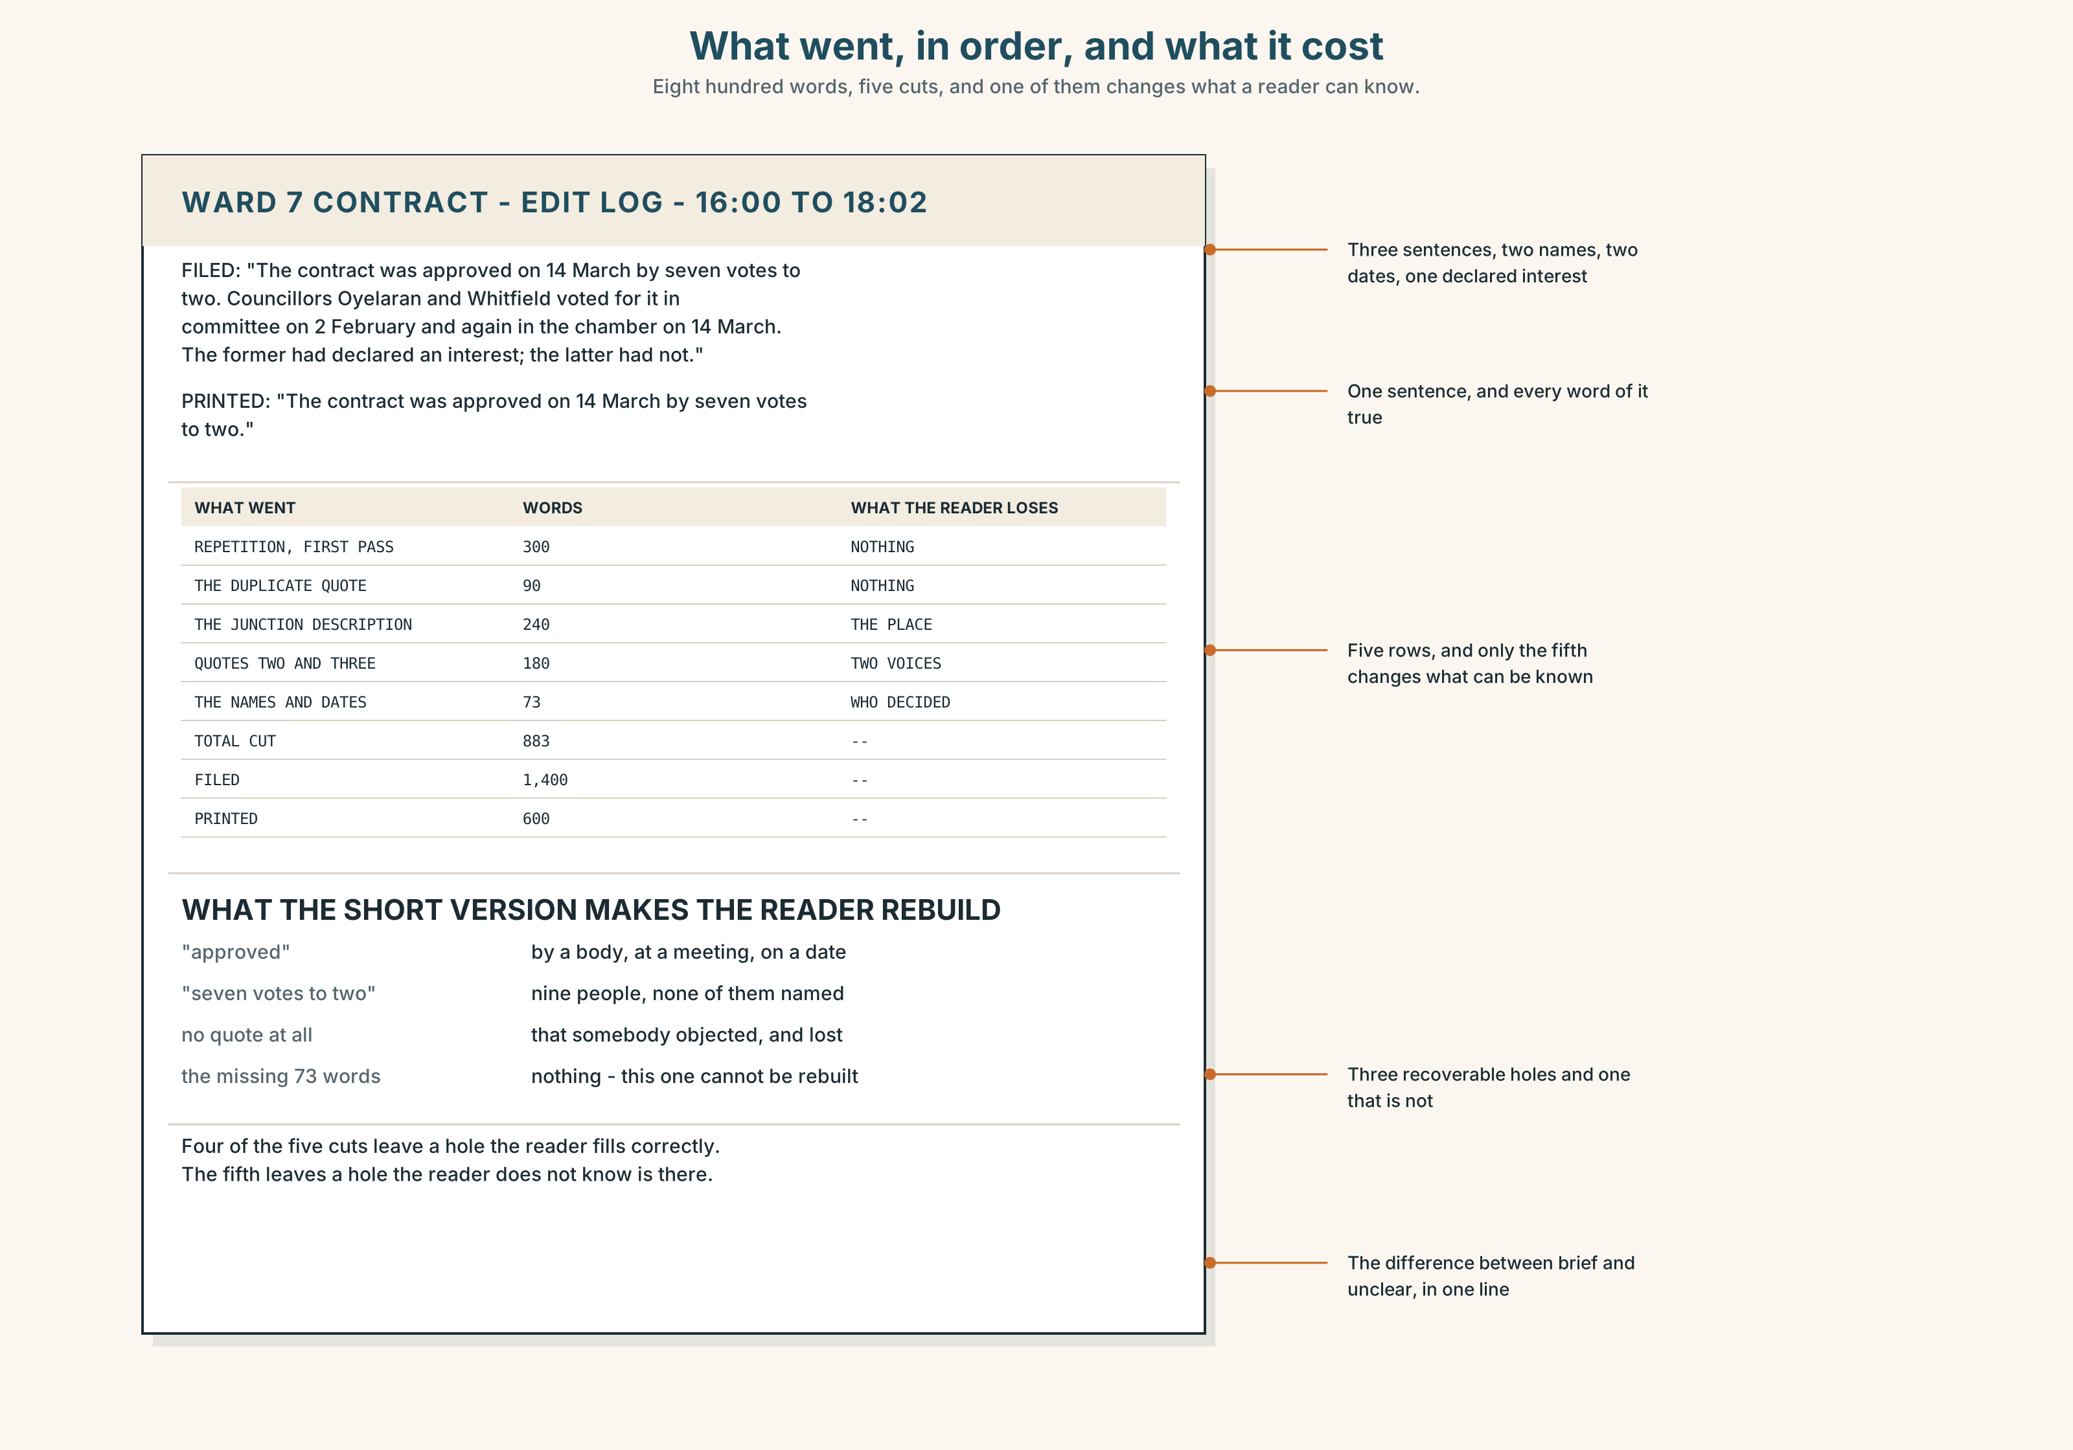{width=6.6in}
What went, in order, and what it cost — Eight hundred words, five cuts, and one of them changes what a reader can know.
Read the two versions and answer.
- How many words went, and from where?
- Find three places in the short version where something has been left out and the reader rebuilds it. What do they rebuild it from?
- One cut changes what a reader can know. Which, and how would you prove that?
- Which version would you publish, and what would you put beside it?

5F · Two texts
The filed version names two councillors and two dates. The printed version says the contract was approved.
Is the printed version untrue? Write two sentences, and use the word concision in one of them.

Part 6 · Vocabulary Lab 2 ◆ B · THE SYSTEM

Words that stand in for other words

6A · Sort — a noun, a clause, a second speaker, or a place?
Four columns.
one · so · neither · elsewhere · ones · likewise · such · either

6B · Chunk completion
- She cut it, and I would have ______ ______ in her place. (two words, formal)
- He asked me to file and I ______ ______ . (two words, neutral)
- The two versions are not ______ ______ . (two words)
- Is it down to length? ______ ______ , send it. (two words)
- ______ ______ , we hold it for the second edition. (two words)
- The paragraph is unreadable and, ______ ______ , the first to go. (two words)
- Of the two quotes, ______ ______ carries the argument. (two words — the first)
- ______ ______ merely agrees with it. (two words — the second)

6C · Three that are not interchangeable
do so · do it · did
Say which one belongs in a report, which one in conversation, and which one in between.

6D · The phrasal verbs and the fixed expressions
leave out · stand in for · do without
f so does mine · f neither did I · f I will if you will
One of these fixed expressions is an offer disguised as a condition. Which, and what is the speaker actually asking for?

6E · Contrast Clinic
Eight items. Rewrite each one as short as it can be and still be rebuilt.
- The second quote can go and the third quote can go as well.
- I have cut both of the two quotations.
- She would not cut it, and I would not cut it either.
- He asked me to file the story and I filed the story.
- The long version is better than the short version.
- If it is down to length, send it to the stone.
- The paragraph is unreadable and because it is unreadable it goes first.
- The first quotation carries the argument; the second quotation agrees with the first quotation.

Part 7 · Pronunciation & Fluency Lab ◆ B · THE SYSTEM
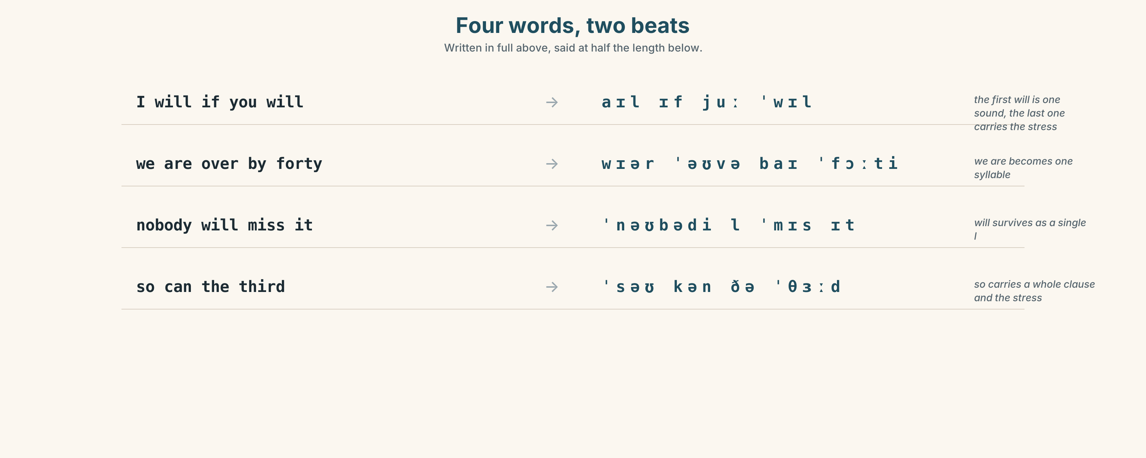{width=6.6in}
Four words, two beats — Written in full above, said at half the length below.

What you leave out, and where you stop

7A · Hear 🔊 Track 8.3
I will if you will. → /aɪl ɪf juː ˈwɪl/ We are over by forty. → /wɪər ˈəʊvə baɪ ˈfɔːti/ Nobody will miss it. → /ˈnəʊbədi l ˈmɪs ɪt/

7B · Say
Say each one three times, fast. Then say this, pausing only where the slash is:
The second can go, / the third can go, / and the fourth stays. — three clauses, two pauses, and the last one is where the meaning is.

7C · Make it mean something
Say these two:
If this goes — what is the story for? — the pause before the question does the work If this goes what is the story for? — no pause, and it is a complaint, not a question
A pause is a punctuation mark you can hear, and in an elliptical sentence it is often the only thing telling the listener that something has been left out.

7D · Fluency 30 ⏺
Thirty seconds: four exchanges, each second turn in four words or fewer, each with one pause. Three times, faster.

Part 8 · Writing ◆ C · THE PERFORMANCE

Two versions and one note · 200 words

8A · Read the model
The contract was approved on 14 March by seven votes to two. [the plain sentence, and nothing has been left out that a reader would want]
Two councillors voted for it twice: once in committee and once in the chamber. The former had declared an interest; the latter had not. [the former and the latter carry two whole noun phrases, and the sentence is half the length it would otherwise be]
The reporter asked both to comment. One did; one did not. [two clauses of three words each, and the reader rebuilds comment from the sentence before]
The printed version of this story says only that the contract was approved. It is not untrue, and nobody will miss the seventy-three words unless they go looking — which, as such, is the whole argument. [as such points back to the entire preceding clause, which is what it is for]
Questions about the writer's choices:
- The second sentence uses the former and the latter. What would repeating the names cost?
- One did; one did not. What is the reader rebuilding, and from where?
- The last sentence calls its own brevity the argument. Is that fair? Say why in one sentence.

8B · The anti-model
The report was published and the report was criticised. The councillors who voted for the contract were the councillors who had attended the committee meeting. The committee meeting took place in March and the chamber vote also took place in March.
Three sentences, every noun phrase repeated in full, and not one substitution anywhere. Rewrite it using one, the former, the latter, do so and likewise, and count the words you saved.

8C · Plan
the plain sentence → the two-part sentence held together by the former and the latter → two short clauses the reader completes → the point, pointed back at with as such

8D · Write — 200 words

8E · Peer review — three criteria
☐ Can every ellipsis be rebuilt, and from something earlier in your own text? ☐ Is each substitution pointing at exactly one thing? ☐ Did you cut anything a reader needed, and how would you know?

8F · Write it again · 8G · Publish
Rewrite after review. Publish both, and mark every place where something has been left out.

Part 9 · The File ◆ A · THE WORLD + C · THE PERFORMANCE
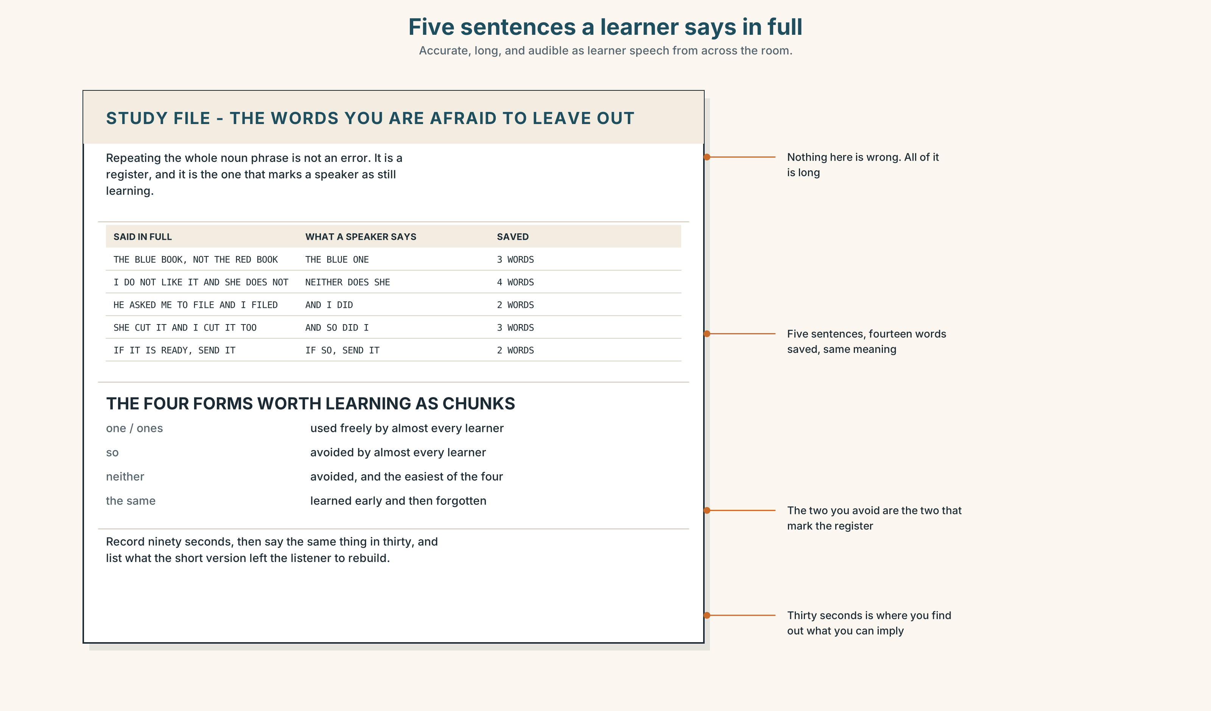{width=6.6in}
Five sentences a learner says in full — Accurate, long, and audible as learner speech from across the room.

STUDY FILE · The words you are afraid to leave out

9A · Saying all of it 🔊 Track 8.4
Learners repeat whole noun phrases where a native speaker would substitute, because the full form feels safer and the short one feels like a gap in their English. The result is accurate, long, and immediately audible as learner speech.
what you say | I like the blue book more than the red book
what a speaker says | I like the blue one better
what it signals | not an error — a register
the fix | four forms, learned as chunks: one · so · neither · the same

9B · Halve it
Take three sentences you have said this week with a repeated noun phrase. Rewrite each with a substitution, and say both out loud.

9C · Role play — four words or fewer
In pairs. One of you makes a statement. The other agrees or disagrees in four words or fewer. Twelve rounds, and no form twice.

9D · The one you avoid
Most learners use one freely and avoid so and neither entirely. Name the one you avoid, and use it four times today.

9E · Transfer — before next week
Record ninety seconds of yourself, then say the same thing in thirty. Bring both, and the list of what the short one left for the listener to rebuild.

Part 10 · Mediation & Interaction ◆ C · THE PERFORMANCE
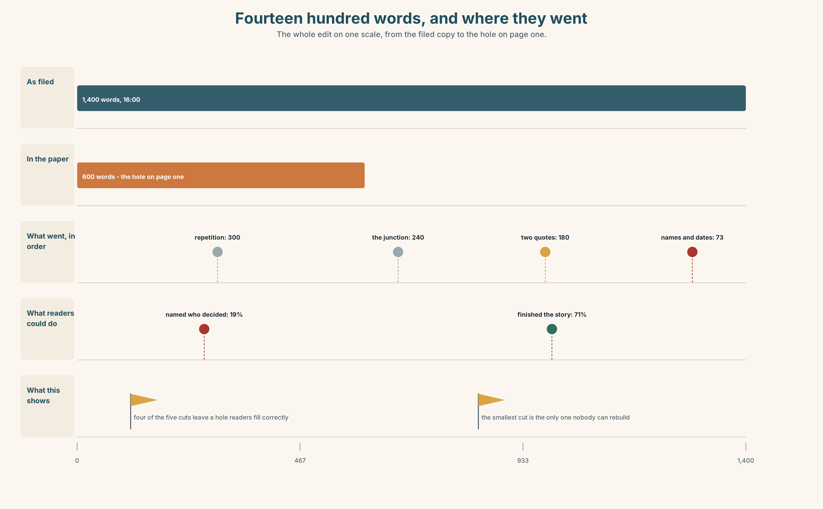{width=6.6in}
Fourteen hundred words, and where they went — The whole edit on one scale, from the filed copy to the hole on page one.

10A · Relay
Half the class has the filed copy. Half has the printed version. Produce a list of what was cut, by speaking only. Ten minutes.

10B · Simplify — for one reader
A reader writes: Who actually voted for this? Reply in four sentences, using at least three substitutions.

10C · Online
Write one message to a reporter whose story is six hundred words over. Three sentences. Name what you would cut and what it would cost.

10D · Your language
Does your language leave out the verb in a short answer, as English does in Dev has? Translate all six exchanges from Part 2. Which second turns get longer?

Part 11 · The Decision ◆ C · THE PERFORMANCE

What happens to the eight hundred words
Option one: nothing. The printed story is the story, every edition since 1911 has been an edited version, and telling readers what they are not getting is a strange way to sell a newspaper.
Option two: publish the full filed version online and link to it from the print story.
Option three: publish the full version online with every cut marked, and say in the print story that it is there.

11A · The evidence
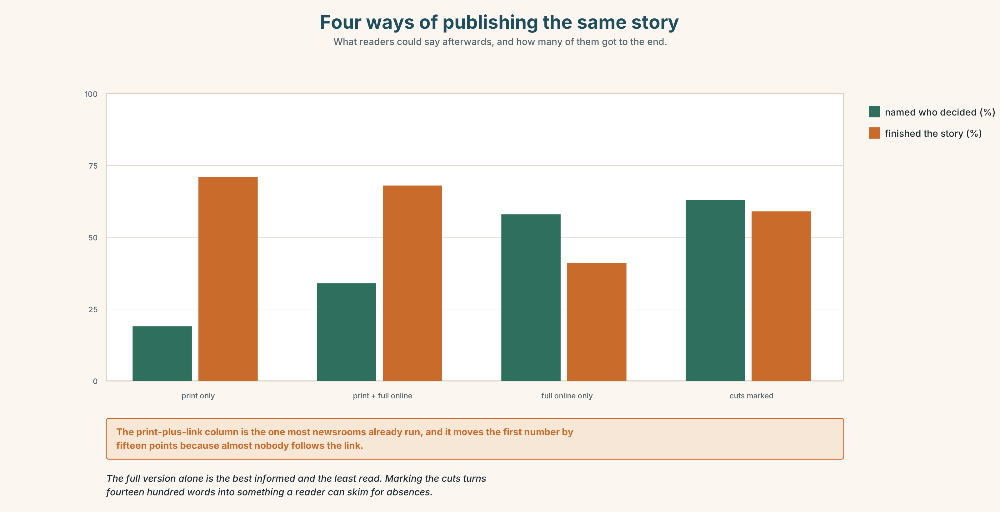{width=6.6in}
Four ways of publishing the same story — What readers could say afterwards, and how many of them got to the end.
🔊 Track 8.6. Dennis Hoy, subeditor, 30 seconds: "I have cut about four hundred thousand words out of other people's stories. Most of them deserved it. The ones that did not were never the beautiful sentences; writers fight for those. They were always seventy-three words of names and dates that nobody fights for, because fighting for them sounds like vanity, and because they are genuinely the dullest thing on the page."

11B · Talk about it
In threes. Use the frame, and keep every turn under fifteen words.
I would ______ , because the reader cannot ______ . — So would I. / Neither would I.

11C · Decide
Write three sentences: the decision, the evidence, and the cut you would defend hardest.

11D · Model decision
Option three. The full version alone is unread — six hundred words is what people have time for, and a link to fourteen hundred is a link nobody follows. Marking the cuts turns the long version into something you can skim for what is missing, which is a different and much shorter act of reading. The cost is that the desk's judgement becomes public, and the desk is right most of the time and will be visibly wrong occasionally.

11E · The Reveal
What happened. The Herald published the marked version. Readers of it rose over a year from almost nobody to about a fifth of the print readership — far more than the plain full version had ever drawn.
Then something nobody predicted: reporters began filing shorter. Seeing, week after week, which of their paragraphs survived, they stopped writing the ones that did not. Average filed length fell by nineteen per cent in a year, and the number of paragraphs the desk cut for repetition fell by half.
One question. You do not have to answer it out loud.
Nobody told the reporters to write less. What did marking the cuts actually show them?

Part 12 · Landing ◆ all three lines

12A · Recycle — fifteen items
- — Who has filed? — Dev ______ .
- — Have you cut both? — I ______ .
- — The second can go. — ______ can the third.
- — I would not cut it. — ______ would I.
- — Is it down to length? — If ______ , send it.
- She cut it and I would have ______ ______ . (two words, formal)
- Of the two, ______ ______ carries the argument. (two words)
- ______ ______ merely agrees with it. (two words)
- The paragraph is unreadable and, ______ ______ , goes first. (two words)
- ______ ______ ______ took twenty minutes. (three words)
- ______ ______ ______ ______ . (four words — the subeditor, at 17:40)
- ______ ______ ______ ______ ______ . (five words — the subeditor, at 18:00)
- It is four hundred words over; we must ______ ______ ______ . (three words)
- Two whole paragraphs will have to be ______ ______ . (two words)
- The colour can be ______ ______ to a single line. (two words)

12B · Consolidate — one task, everything in it
Write 150 words, then cut it to 75 without losing any fact. Mark every substitution and ellipsis in the short version.

12C · Can-do, with evidence
☐ I can leave out what a reader can rebuild. Evidence: 3H, 8D ☐ I can substitute with one, so, such, do so and neither. Evidence: 6E, 9C ☐ I can say what a cut has cost. Evidence: 5E, 10C ☐ I can pause where the ellipsis is. Evidence: 7C

12D · Replay ⏺
Record 0C again. Compare. What did your twenty-second version leave the listener to rebuild?

12E · Glossary — fifty items, as a map
THE TEXT, AT A STAGE · draft · proof · abstract WHAT YOU DO TO IT · edit · cut · trim WHAT YOU JUDGE IT BY · redundancy · verbosity · concision WHAT SITS AROUND IT · caption · standfirst · kicker SIX O'CLOCK · a first pass · kill a paragraph · tighten it up · the word count · down to length WHAT YOU END UP WITH · an edited version · a working draft · the final cut · a hard cut · what survives WHAT SUBEDITORS DO · cut down · chop out · pare back · leave out · stand in for · do without IN THE ROOM · it can go · we are over by forty · nobody will miss it THE SUBSTITUTES · one · ones · so · such · neither · either · likewise · elsewhere THE FRAMES · do so · do it · the same · if so · if not · as such · the former · the latter AGREEING SHORT · so does mine · neither did I · I will if you will

12F · Next
Unit 9 · Who is this written for?

