Table of Contents

B2.1 · Unit 9 · Three Readers, One Style Guide
English Animated · Reading Between Lines · a newsroom, Toronto Student's Book pages 182–203 · 22 pp · ~11 hours

Part 0 · The Big Picture ◆ A · THE WORLD
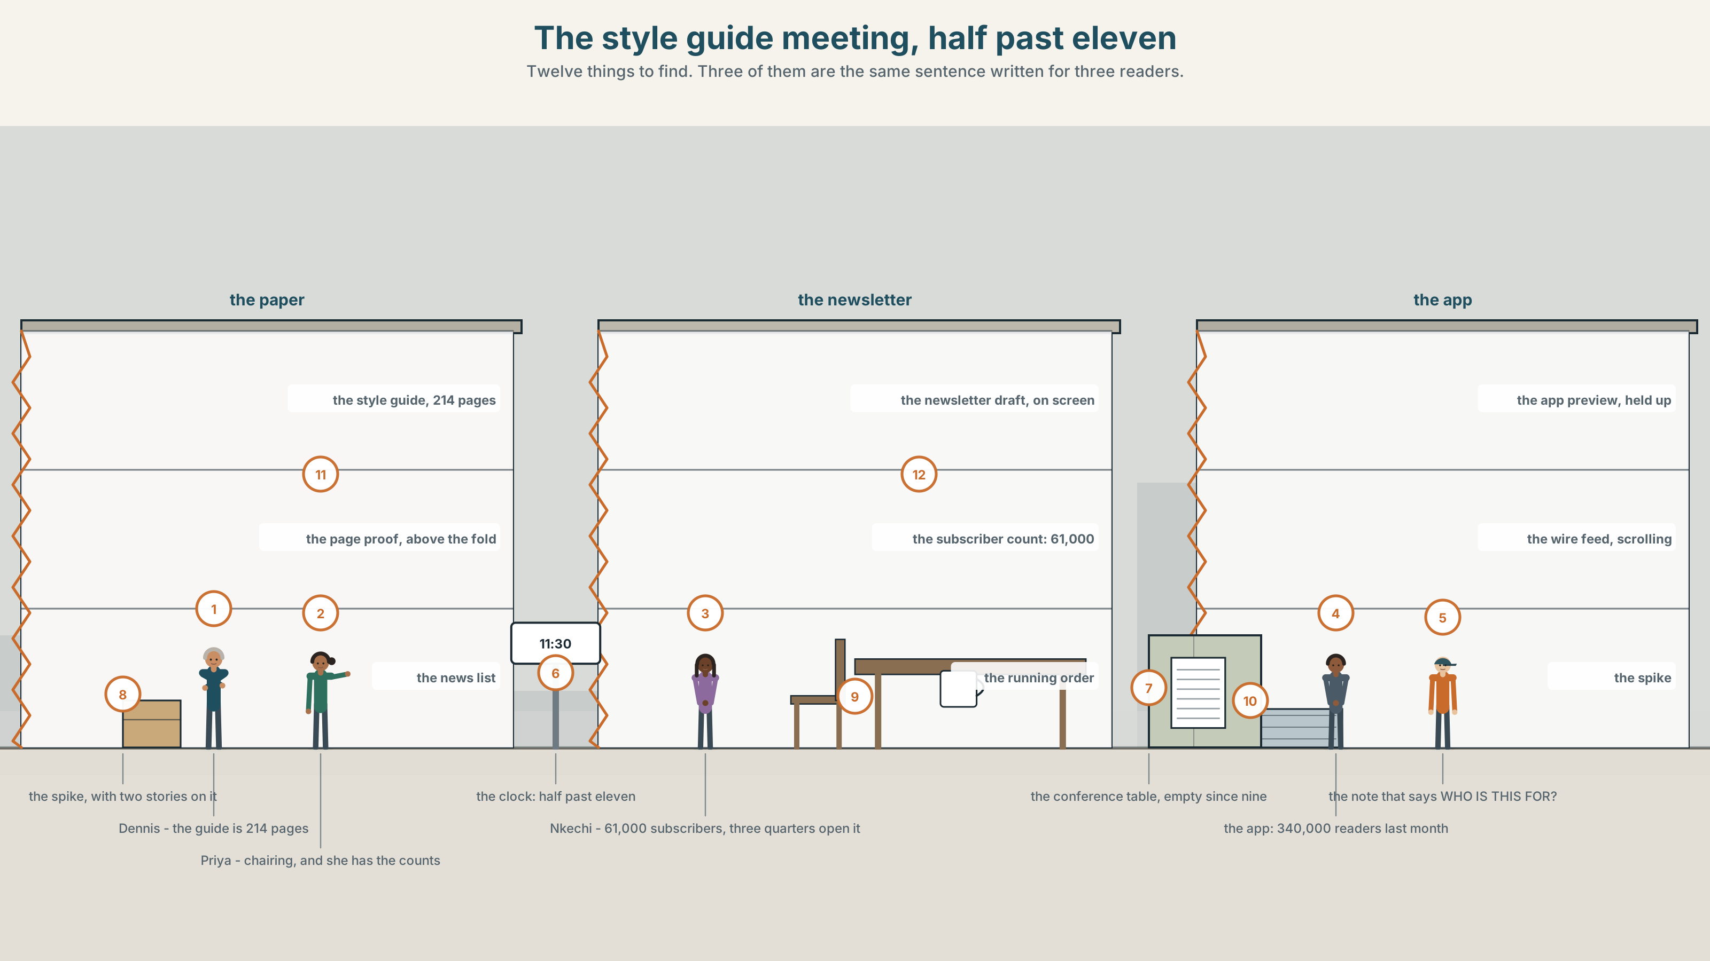{width=6.6in}
The style guide meeting, half past eleven — Twelve things to find. Three of them are the same sentence written for three readers.

Who is this written for?
By the end of this unit you can guide a reader through a text, and choose the signposts that match where they are reading it. Two hundred words.
◆ A · THE WORLD | One style guide written in 1911, three channels, and an argument about the word so
◆ B · THE SYSTEM | discourse markers, the whole system · 28 words for desks and deadlines · 22 connectors and frames · what a marker does to the tune
◆ C · THE PERFORMANCE | Two hundred words a reader never gets lost in

0A · Find it
Find twelve things in this picture. Three of them are the same sentence written for three different readers.
the style guide, 214 pages · the newsletter draft on a screen · the app preview, held up · the page proof, above the fold · the news list for the day · the running order, pinned · the spike, with two stories on it · the wire feed, scrolling · a note that says WHO IS THIS FOR? · the conference table, empty · a clock showing 11:30 · a subscriber count: 61,000

0B · Guess it
One screen in this room has more readers than the newspaper. Which, and which document on the table does not mention it anywhere?

0C · Say it ⏺
Record sixty seconds. Explain how you got to work or college today, and signpost it so the listener always knows where in the story you are. You will record it again at the end of this unit.

Part 1 · Vocabulary Lab 1 ◆ B · THE SYSTEM
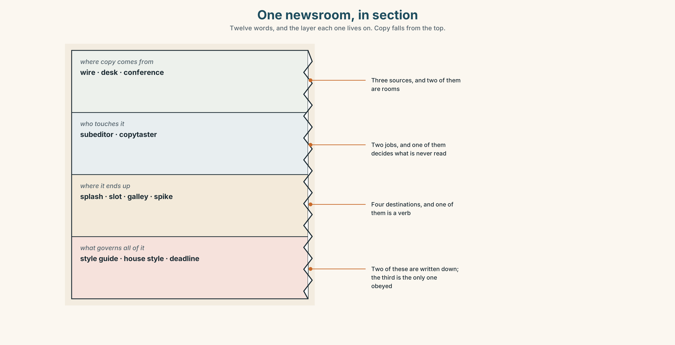{width=6.6in}
One newsroom, in section — Twelve words, and the layer each one lives on. Copy falls from the top.

1A · Meet — the words of a newsroom
Match each word to one layer of the cutaway.
desk · deadline · spike · slot · splash · subeditor · copytaster · galley · conference · style guide · house style · wire

1B · Sort — a person or a group, a place or a time, or a document?
Three columns. One of the twelve is also a verb, and it is the verb nobody wants done to their story.
subeditor · slot · style guide · desk · spike · wire · copytaster · splash · house style · conference · galley · deadline

1C · Meet — the five places a story can be
above the fold | The top half of page one. The only part visible on a newsstand.
the back of the book | The pages nobody turns to, where good writing goes to be unread.
on the stone | Made up, laid out, and almost impossible to change.
the second edition | Another chance, four hours later, for a fifth of the readers.
a slow news day | When a story runs that would not have run on Tuesday.

1D · Collocation Lab
Complete each one, and say which of the five is a measure of a person rather than a story.
a late change · hold the front page · the news list · a running order · filed on time
- ______ ______ ______ goes round at nine and is argued about until eleven thirty.
- The newsletter has ______ ______ ______ ; the paper has a page.
- Nobody has said ______ ______ ______ ______ in this building since 1994.
- ______ ______ ______ after six costs money and is sometimes worth it.
- She has ______ ______ ______ every day for nine years, which is rarer than it sounds.

1E · The phrasal verbs, and the three fixed expressions
send through · turn around · sit on
f we are going with it · f that is a splash · f it will not make the paper
Two of these fixed expressions are decisions and one is a judgement. Which is the judgement, and who in the room is allowed to make it?

1F · Own it
Write three sentences about your week, and put one signpost at the front of each so a listener knows what kind of sentence is coming.

Part 2 · Listening ◆ A · THE WORLD
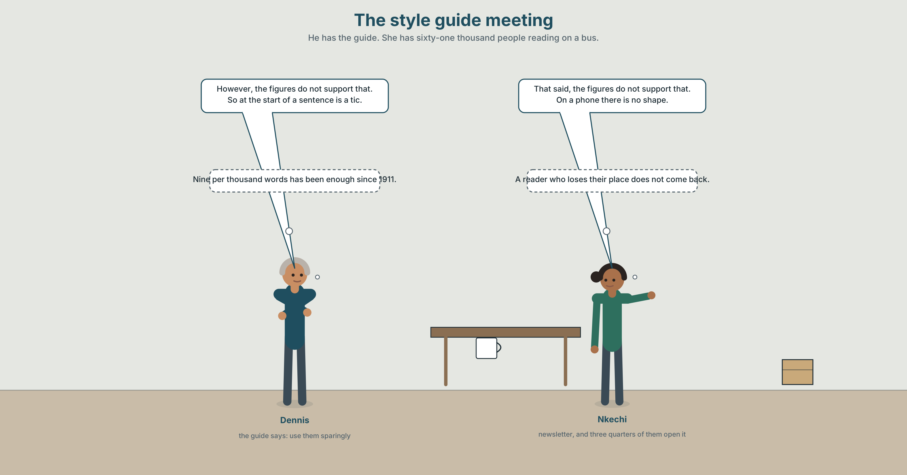{width=6.6in}
The style guide meeting — He has the guide. She has sixty-one thousand people reading on a bus.

2A · The style guide meeting 🔊 Track 9.1
Before you listen. The style guide was written in 1911 and last fully revised in 1998. The newsletter has sixty-one thousand subscribers. The app has more readers than the paper.
Listen once. What does each of them want the guide to say about discourse markers?
Listen again. Complete the table.
 | Markers per thousand words | Who the reader is | What they say it costs
the paper
the newsletter
the app
Listen again. True or false?
- The guide was last fully revised in 1998. ☐ T ☐ F
- The newsletter has more subscribers than the paper has readers. ☐ T ☐ F
- The print desk wants markers banned entirely. ☐ T ☐ F
- The app version is the shortest of the three. ☐ T ☐ F
Noticing. Six sentences from the recording.
- However, the figures do not support that.
- That said, the figures do not support that.
- The figures, as it happens, do not support that.
- Having said that, the figures do not support that.
- By contrast, the figures do not support that.
- In any case, the figures do not support that.
Six markers, one sentence. Which two concede something, which one announces a comparison, and which one says the argument no longer matters?

2B · Decoding clinic 🔊 Track 9.2
Thirty seconds at speed. Three jobs.
- One speaker puts however in three different positions in three sentences. Write all three.
- What happens to the pauses around it each time?
- Somebody says the point being. What has just been left unsaid, and why does it work?

Part 3 · Grammar Lab 1 ◆ B · THE SYSTEM

Signposts, and what each one promises

3A · Notice
Look at the six sentences in Part 2 again.
- Which two could swap with no change of meaning?
- Which one implies the speaker has just agreed to something?
- Sentence 3 puts the marker in the middle. What does that do to the emphasis?
- Sentence 6 dismisses the previous point rather than answering it. How do you know?

3B · See
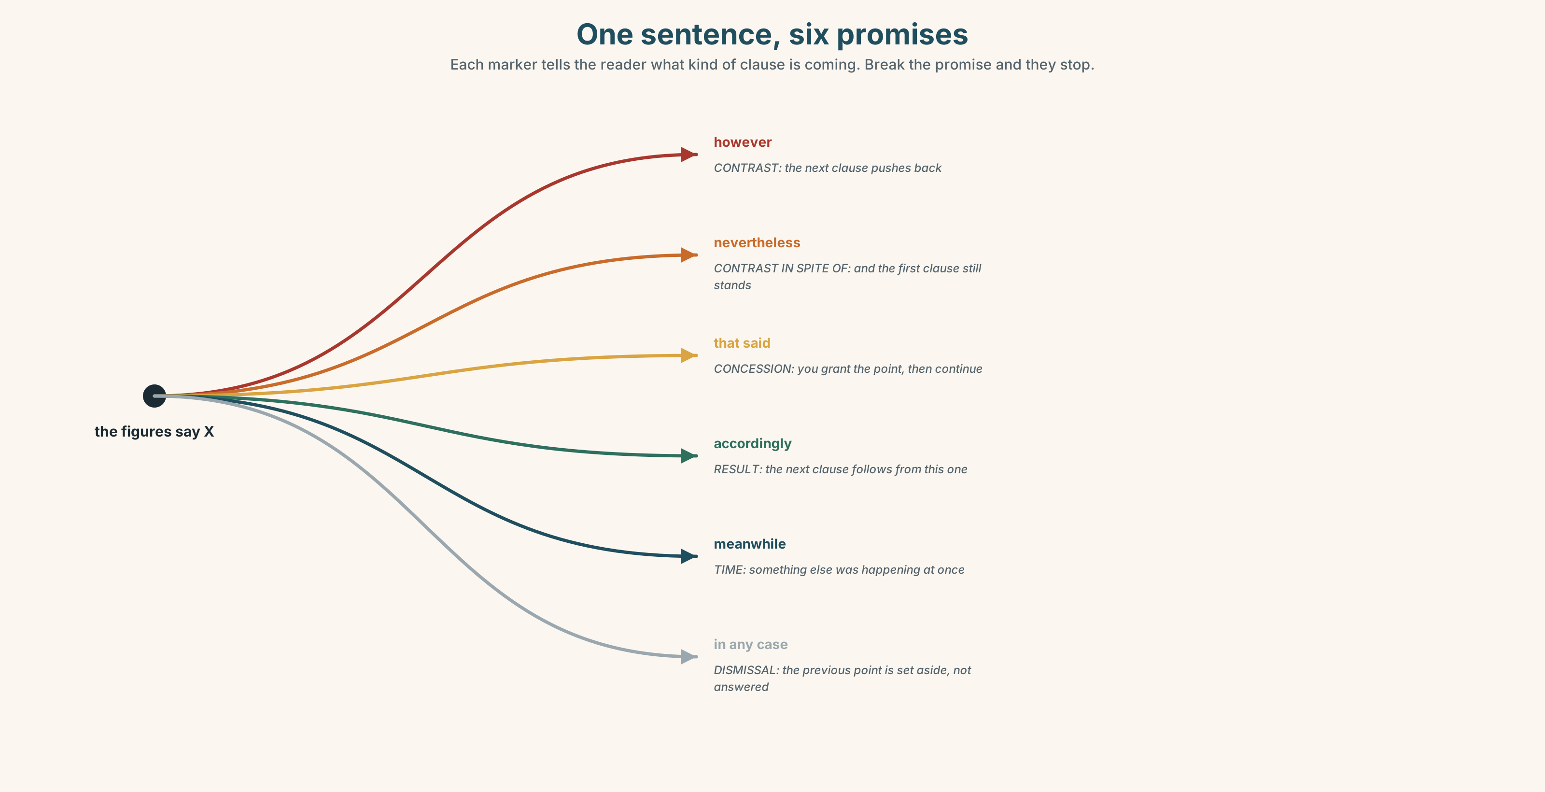{width=6.6in}
One sentence, six promises — Each marker tells the reader what kind of clause is coming. Break the promise and they stop.

3C · Know
contrast | however · nevertheless · by contrast · on the other hand | the next clause pushes back
concession | that said · having said that · in the first place | you grant something, then continue
result | accordingly · hence · thereby · therefore | the next clause follows from the last
sequence | to begin with · thereafter · meanwhile · which brings me to | position in a list or a timeline
dismissal | in any case · for one thing · as it happens | the previous point is set aside
legal and formal | whereby · thereby · thereafter | written only, and mostly in contracts
A marker is a promise about the next clause. If you write however and the next clause does not contrast with anything, the reader has been misdirected, and they will not trust the next one either.
Position changes force, not meaning. However, the figures do not support that is a formal announcement. The figures, however, do not support that is quieter and more confident. The figures do not support that, however sounds like an afterthought, which is sometimes exactly what you want.
managing a conversation | move on · come back to · go on to
holding the floor | the point being · which brings me to · for one thing
conceding and continuing | having said that · that said · in any case
Why it matters. A reader who always knows what kind of sentence is coming next will follow you a long way. One who has been promised a contrast and given an example will stop reading, and will not be able to tell you why.

3D · Use — controlled
Complete with the marker the relationship requires.
The app has more readers than the paper. (1) ______ , it has no style guide of its own. (contrast) The guide was revised in 1998. (2) ______ , it says nothing about newsletters. (result) (3) ______ , the markers were counted. Then the readers were surveyed. (first in a sequence) The newsletter is informal. (4) ______ , it is the most read thing the paper produces. (concession) You may disagree with the count. (5) ______ , the survey is independent of it. (dismissal)

3E · Use — guided
Rewrite each one, moving the marker to the middle and then to the end, and say how the force changes.
- However, the figures do not support that.
- Nevertheless, the newsletter is read to the end.
- Accordingly, the guide will be rewritten.
- Meanwhile, the app version went out unchanged.
- By contrast, the print version carries nine markers.

3F · Use — open
In pairs. One of you makes a claim. The other must respond beginning with a marker that promises a specific relationship, and then keep that promise. Eight rounds, no marker twice.

3G · Error autopsy
✗ However, the figures do not support that, and also they do not support it. ✗ The newsletter is informal, hence it is popular, hence people read it, hence it works. ✗ Whereby the guide was revised in 1998.
For each, name the rule and say what the writer was reaching for.

3H · Check — eight items
- ______ , it has no style guide of its own. (one word, contrast)
- ______ , the guide says nothing about newsletters. (one word, result)
- ______ ______ ______ , the markers were counted. (three words, first in a sequence)
- ______ ______ , it is the most read thing the paper produces. (two words, concession)
- ______ ______ ______ , the survey is independent of it. (three words, dismissal)
- ✗ Whereby the guide was revised in 1998. → correct it.
- Move however to all three positions in one sentence and rank them by force.
- Write one sentence in which nevertheless would be wrong, and say why.

Part 4 · Speaking ◆ C · THE PERFORMANCE

4A · Fluency starter — keep the promise
One person says a marker. The next must produce a sentence that the marker correctly introduces. Anybody may challenge; the challenge is settled by the rest of the group.

4B · The functional core — guiding a reader
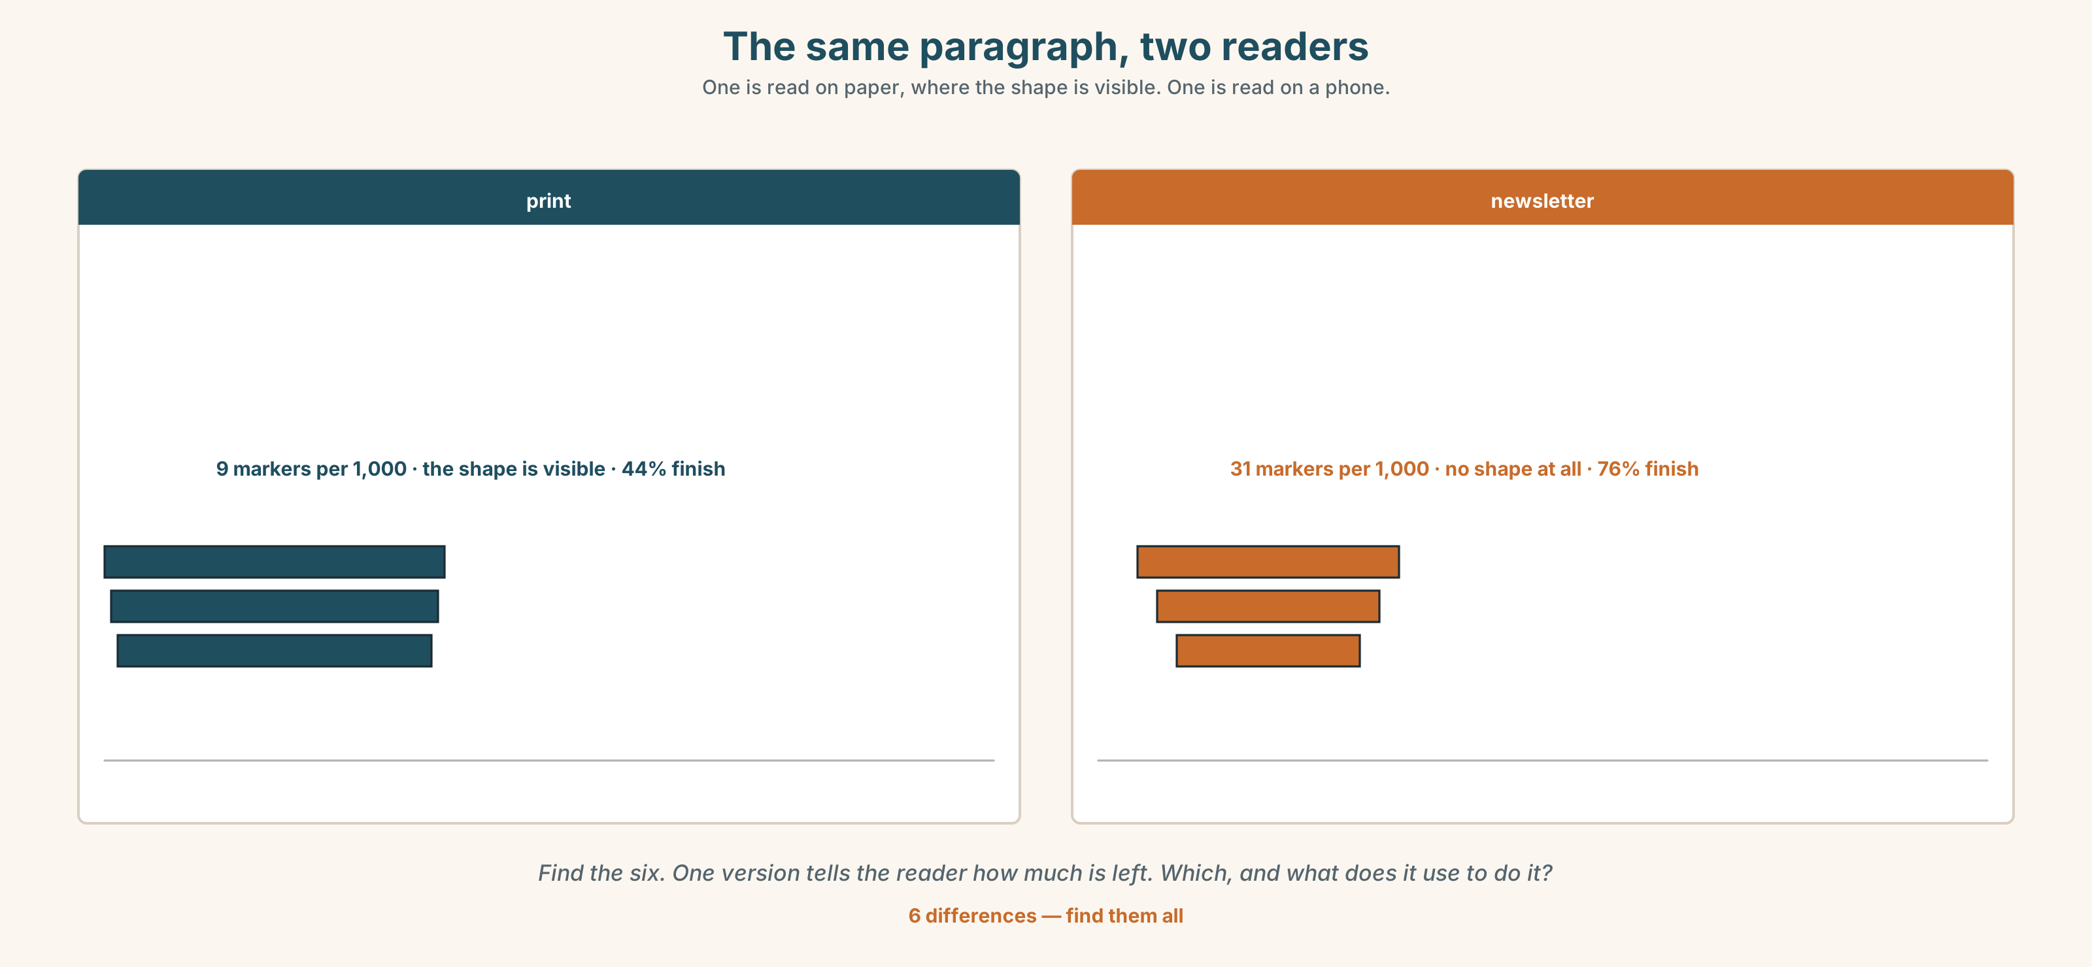{width=6.6in}
The same paragraph, two readers — One is read on paper, where the shape is visible. One is read on a phone.
Language Bank
opening | to begin with · in the first place · for one thing
turning | however · by contrast · on the other hand · that said
continuing | meanwhile · thereafter · which brings me to · go on to
closing it off | in any case · accordingly · the point being
Information gap. Learner A has the print version. Learner B has the newsletter version. Agree on one version for the app, and say which markers you kept and why. Ten minutes.

4C · The performance — three minutes ⏺
Explain an argument with three stages in three minutes. Every stage must open with a marker, and every marker must be kept. Your partner raises a hand the moment a promise is broken.
Record it.

4D · Observer
One person writes down every marker and ticks it if the next clause did what it promised.

4E · Three criteria
☐ Did every marker promise something the next clause delivered? ☐ Did I vary the position, or put them all at the front? ☐ Could my partner say, at any moment, which stage we were in?

Part 5 · Reading ◆ A · THE WORLD

5A · Predict
The title is "The word so, and who is allowed to use it." Why might a rule written in 1911 have trouble with a newsletter?

5B · Read — two minutes

The word so, and who is allowed to use it
The Herald's style guide runs to two hundred and fourteen pages. It was written in 1911 and last fully revised in 1998. It contains no entry for newsletter, app, or push alert.
Its entry for discourse markers is four lines long and says that they should be used sparingly. Counted across a week, the paper averages nine per thousand words. The newsletter averages thirty-one. The app sits between them at fourteen, not by policy but because the app version is produced by cutting the print version.
The newsletter has sixty-one thousand subscribers, three quarters of whom open it. The paper prints a hundred and twelve thousand copies. The app had three hundred and forty thousand readers last month.
In the meeting the print desk's argument was that so at the start of a sentence is a verbal tic. The newsletter writer's argument was that it is a signpost, that her readers are reading on a phone between two other things, and that a reader who loses their place in a newsletter does not come back.
Both are right, and the guide cannot say so, because it has one voice and the paper now has three readers.

5C · Comprehension — eight questions
- How long is the style guide, and when was it last fully revised?
- What does it say about discourse markers?
- What are the three marker densities?
- Why does the app sit between the other two?
- How many people open the newsletter?
- Why does the writer point out that the app density is not a policy?
- "Both are right, and the guide cannot say so." What is the structural problem being described?
- The last sentence has three readers and one voice in it. What is the writer proposing without proposing it?

5D · Vocabulary in context
Infer from the text, then check.
used sparingly · not by policy but because · reading on a phone between two other things · does not come back · has one voice

5E · The counter-text
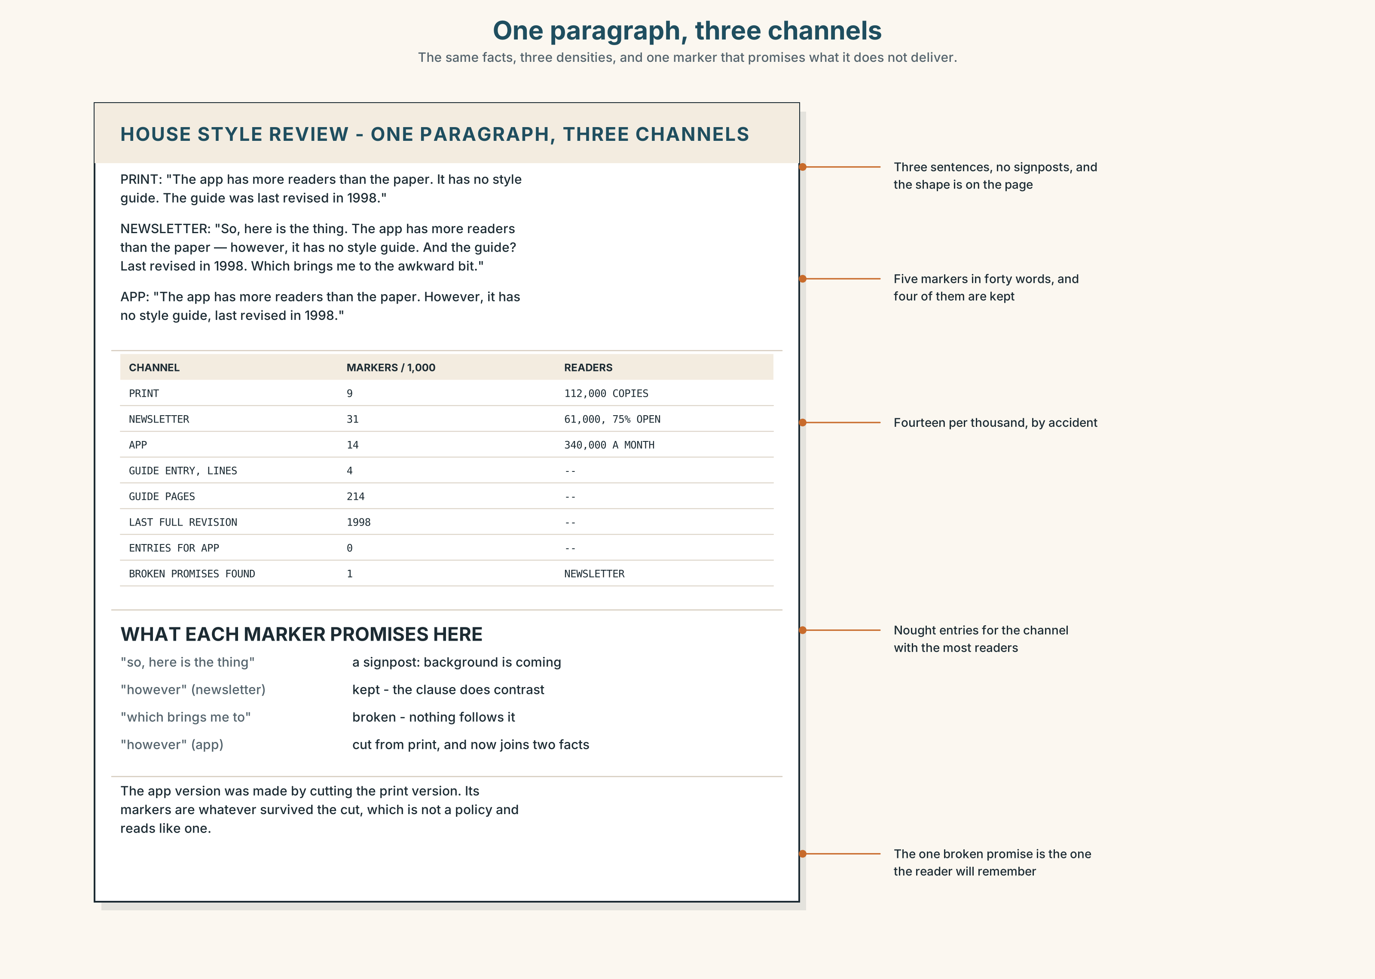{width=6.6in}
One paragraph, three channels — The same facts, three densities, and one marker that promises what it does not deliver.
Read the three versions of the same paragraph and answer.
- How many markers are in each, and of which kinds?
- Find one marker in the newsletter version that promises something the next clause does not deliver.
- The app version was made by cutting the print version. What happened to its signposting?
- Which version would you read on a phone, and which on paper, and are they the same one?

5F · Two texts
The guide says markers should be used sparingly. The newsletter writer says a reader who loses their place does not come back.
Can both be house style? Write two sentences, and use house style in one of them.

Part 6 · Vocabulary Lab 2 ◆ B · THE SYSTEM

The connectors, and what each one promises

6A · Sort — contrast, result, time, or formal only?
Four columns.
however · accordingly · meanwhile · whereby · nevertheless · hence · thereafter · thereby

6B · Chunk completion
- ______ ______ ______ ______ , the guide was written for one reader. (four words — first)
- ______ ______ , it has lasted a hundred and fourteen years. (two words — concession)
- ______ ______ ______ , the newsletter outsells the paper. (three words — an aside)
- ______ ______ ______ ______ , nobody has read all of it. (four words — one reason among several)
- ______ ______ ______ , the app has no guide at all. (three words — the other side)
- ______ ______ , the count was done independently. (two words — comparison)
- ______ ______ ______ , the meeting is on Thursday. (three words — it does not matter now)
- ______ ______ ______ ______ , we have no policy for phones. (four words — restating the start)

6C · Three that are not interchangeable
however · nevertheless · that said
Say which one simply contrasts, which one contrasts in spite of something, and which one grants the other person a point first.

6D · The phrasal verbs and the fixed expressions
move on · come back to · go on to
f having said that · f the point being · f which brings me to
One of these fixed expressions is incomplete on purpose. Which, and what does leaving it unfinished let the speaker do?

6E · Contrast Clinic
Eight items. Rewrite each pair as one sentence with the marker the relationship requires.
- The app has more readers. It has no style guide. (contrast)
- The guide was revised in 1998. It says nothing about newsletters. (result)
- The markers were counted. The readers were surveyed. (sequence)
- The newsletter is informal. It is the most read thing the paper makes. (concession)
- You may dispute the count. The survey is separate. (dismissal)
- The print desk objected. The newsletter went out unchanged. (simultaneous)
- The guide has one voice. The paper has three readers. (formal contrast, written)
- The rule was agreed. Every channel now states its own density. (formal result, written)

Part 7 · Pronunciation & Fluency Lab ◆ B · THE SYSTEM
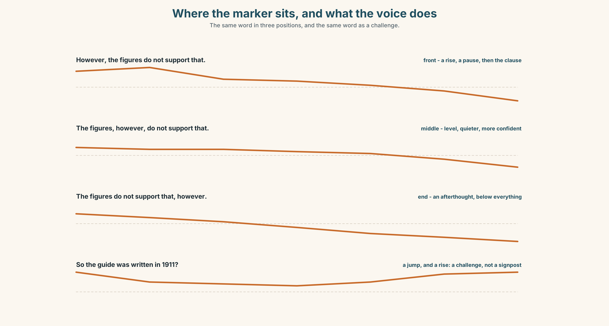{width=6.6in}
Where the marker sits, and what the voice does — The same word in three positions, and the same word as a challenge.

A marker has its own tune

7A · Hear 🔊 Track 9.3
However, ↗ the figures do not support that. ↘ — the marker rises, then a pause The figures, however, → do not support that. ↘ — level, and almost swallowed The figures do not support that, however. ↘↘ — tacked on, and lower than everything

7B · Say
Say all three. Then say this:
That said — and I do take the point — the figures do not support it. — two markers, three pauses, and the voice does not fall until it.

7C · Make it mean something
Say these two:
So, the guide was written in 1911. — a signpost: here comes the background SO the guide was written in 1911? — a challenge: you are summarising to object
An initial marker said on a level tone is a signpost; said with a jump, it is an argument. The word is identical; the tune decides which one the listener hears.

7D · Fluency 30 ⏺
Thirty seconds: one argument in three stages, each opened by a marker, each marker in a different position. Three times, faster.

Part 8 · Writing ◆ C · THE PERFORMANCE

A guided argument · 200 words

8A · Read the model
To begin with, the guide was written for one reader, who bought a paper on the way to work in 1911. [the opening marker sets up a list, and the reader now expects at least a second item]
It has been revised eleven times since; nevertheless, it still has one voice. [nevertheless, not however: the contrast holds in spite of the eleven revisions, which is a different claim]
The newsletter, as it happens, is read by more people than buy the paper — which brings me to the question the guide cannot answer. [an aside in mid-position, then a marker that hands the reader forward instead of back]
Accordingly, the proposal is not a second guide but one rule: each channel states its own marker density, and no marker may promise a relationship the text does not have. [accordingly earns its place because what follows really does follow]
Questions about the writer's choices:
- Nevertheless rather than however. What does the extra meaning buy?
- As it happens sits in the middle of its sentence. Why not at the front?
- The last sentence uses accordingly. Would the paragraph survive without it?

8B · The anti-model
So, the guide is old. However, it is still used. Moreover, it has been revised. Nevertheless, people ignore it. Furthermore, the newsletter is popular. Therefore, something should be done.
Six sentences, six markers, and not one of them describes the relationship it sits between. Rewrite it with three markers, each one true.

8C · Plan
an opening marker that starts a list → a concession that holds in spite of something → an aside in mid-position, then a marker that hands the reader forward → a result that really follows

8D · Write — 200 words

8E · Peer review — three criteria
☐ Does every marker describe the relationship it actually sits between? ☐ Is at least one marker somewhere other than the front of its sentence? ☐ Could a reader say, at any point, what kind of sentence is coming next?

8F · Write it again · 8G · Publish
Rewrite after review. Publish both, and mark every broken promise in the first version.

Part 9 · The File ◆ A · THE WORLD + C · THE PERFORMANCE
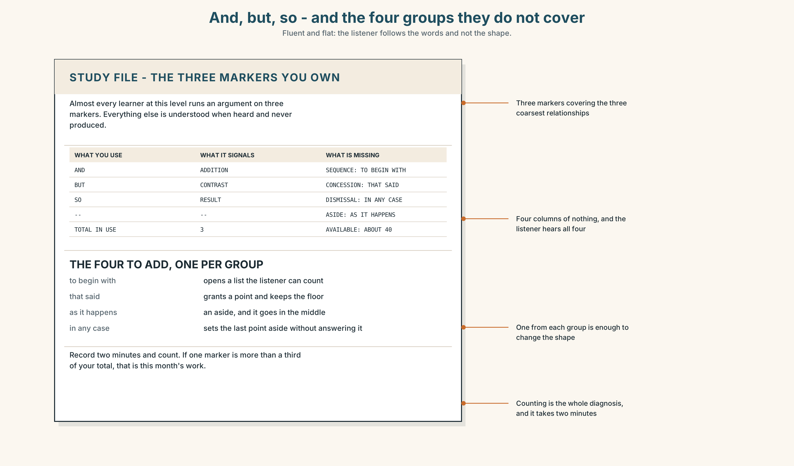{width=6.6in}
And, but, so - and the four groups they do not cover — Fluent and flat: the listener follows the words and not the shape.

STUDY FILE · The three markers you own

9A · And, but, so 🔊 Track 9.4
Most learners at this level run a whole argument on three markers, and the three are nearly always and, but and so. Everything else is understood when heard and never produced. The result is fluent and flat: the listener can follow the words and not the shape.
what you have | and · but · so
what it signals | addition, contrast, result — the three coarsest relationships
what is missing | concession, sequence, aside, dismissal
the smallest useful fix | one marker from each missing group, used this week

9B · Add four
Choose one marker from each of the four missing groups. Write one true sentence with each, about your own week, and say them aloud.

9C · Role play — the promise
In pairs. One of you speaks for a minute. The other raises a hand every time a marker promises something the next clause does not deliver. Swap.

9D · The one you overuse
Everybody has one. Record yourself for two minutes and count. If any single marker is more than a third of your total, that is this month's work.

9E · Transfer — before next week
Take a paragraph you have written and re-signpost it with four different markers. Bring both versions and ask somebody which one they could summarise.

Part 10 · Mediation & Interaction ◆ C · THE PERFORMANCE
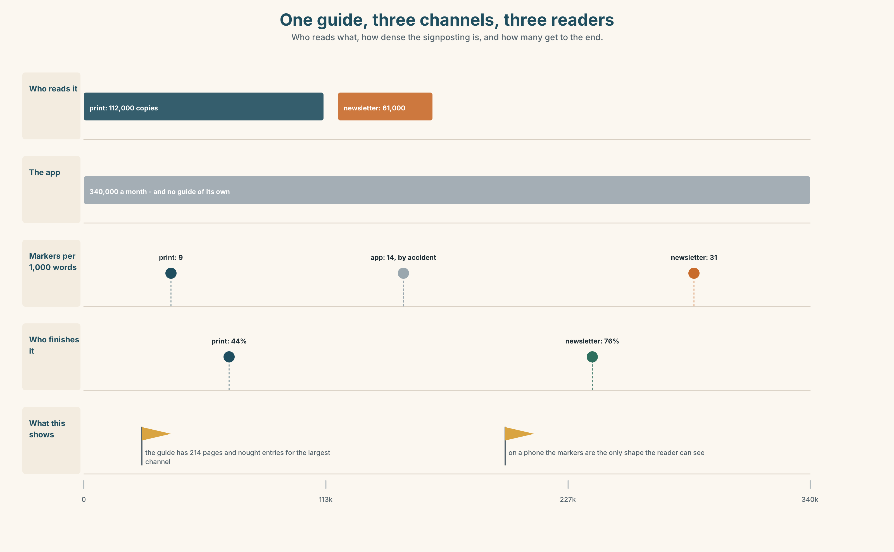{width=6.6in}
One guide, three channels, three readers — Who reads what, how dense the signposting is, and how many get to the end.

10A · Relay
Half the class has the print version. Half has the newsletter. Produce one app version both sides accept, by speaking only. Ten minutes.

10B · Simplify — for one reader
A subscriber writes: Why does the newsletter sound like a different newspaper? Reply in four sentences, using one marker from each of the four groups.

10C · Online
Write one message to a colleague whose draft has eleven markers in three hundred words. Three sentences. Keep two of theirs and say which.

10D · Your language
Where do markers sit in your language — front, middle, or end? Translate all six sentences from Part 2. Which positions does your language not allow?

Part 11 · The Decision ◆ C · THE PERFORMANCE

One voice or three
Option one: one house style, as now. The paper's voice is the paper's voice, and a reader who meets it in three places should recognise it in all three.
Option two: three style guides, one for each channel, each written by the people who write that channel.
Option three: one guide, with a single new rule: each channel states its own marker density, and no marker anywhere may promise a relationship the text does not have.

11A · The evidence
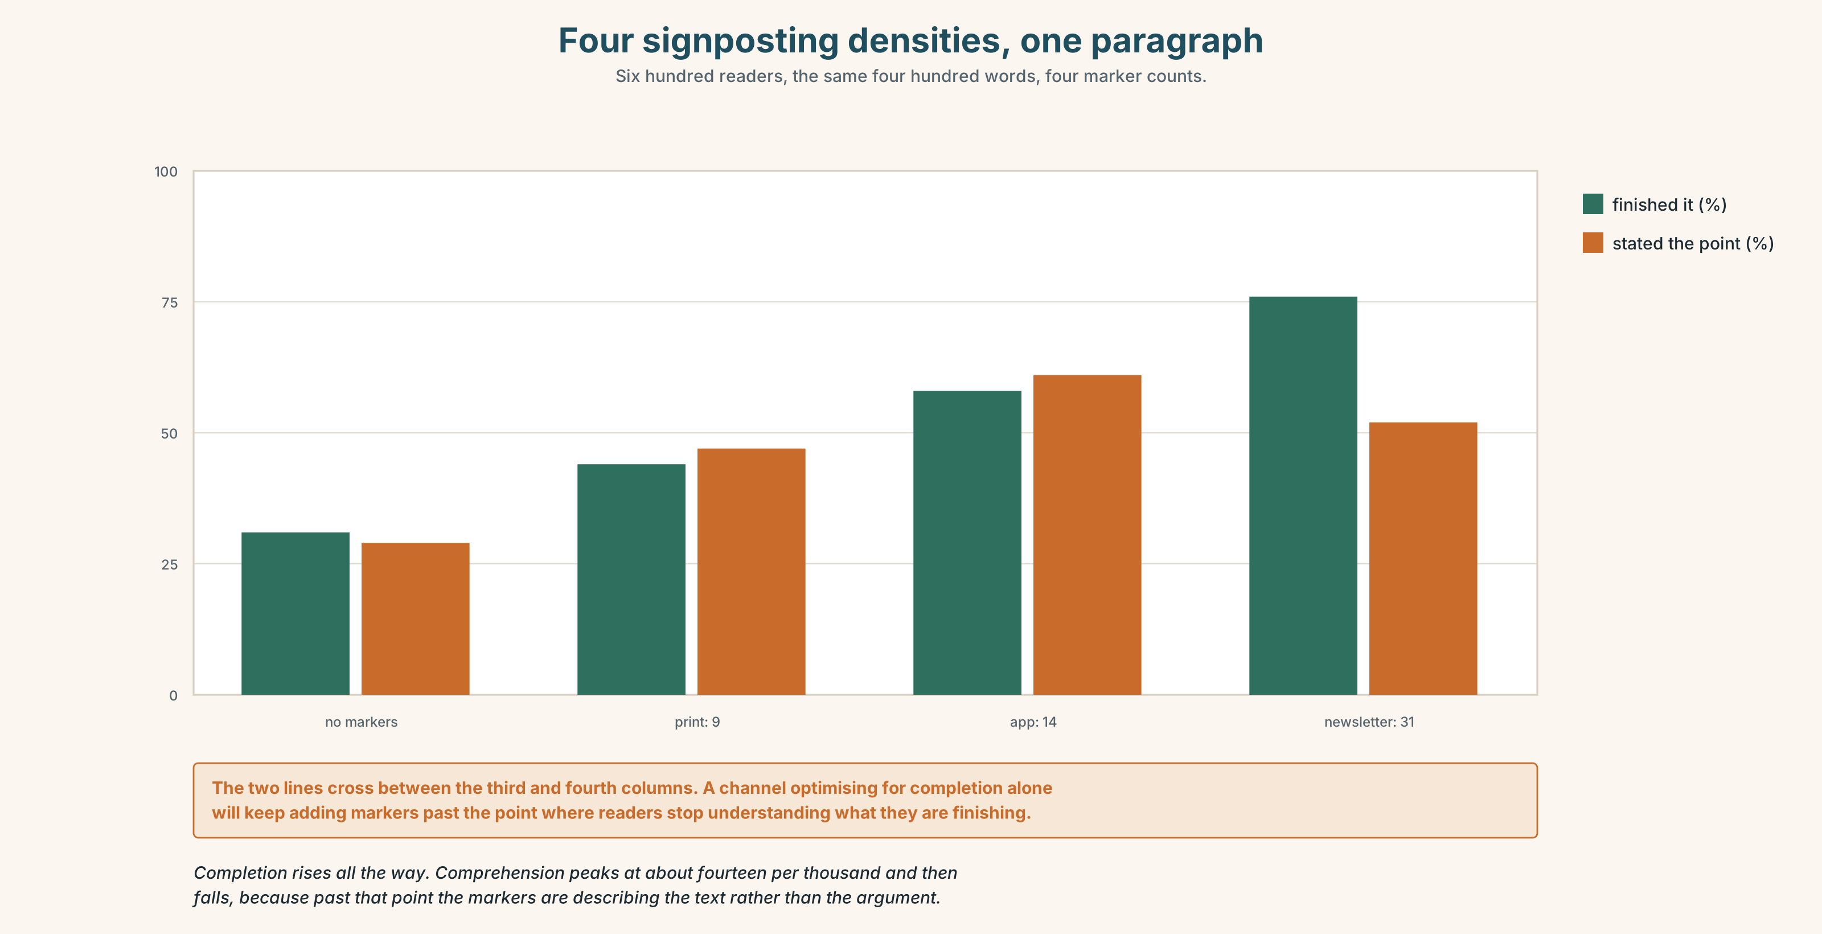{width=6.6in}
Four signposting densities, one paragraph — Six hundred readers, the same four hundred words, four marker counts.
🔊 Track 9.6. Nkechi Adeyemi, newsletter, 30 seconds: "I am not asking to write badly. I am asking for permission to tell sixty-one thousand people, on a phone, on a bus, which bit is coming next. On paper you can see the shape of the thing — you know there are four more paragraphs because you can see them. On a phone there is no shape. The markers are the shape."

11B · Talk about it
In threes. Use the frame, and open every turn with a marker you then keep.
To begin with, ______ . That said, ______ . Which brings me to ______ .

11C · Decide
Write three sentences: the decision, the evidence, and the thing it will not fix.

11D · Model decision
Option three. Three guides is three voices and, within two years, three papers. One guide with one voice is already failing, because the voice was designed for a reader who could see how long the article was. The density clause is administrative and will be argued about; the second clause is the one that matters, and it applies identically on paper and on a phone, because a broken promise costs a reader everywhere.

11E · The Reveal
What happened. The Herald adopted the single rule. The density bands were set at nine, fourteen and thirty-one, and were quietly ignored within six months.
Then something nobody predicted: print marker density rose, from nine to seventeen. Writers who had assumed markers were forbidden discovered that what was forbidden was the false ones, and print comprehension scores rose with the count — on paper, where everybody had agreed the problem did not exist.
One question. You do not have to answer it out loud.
The rule was written to give the newsletter permission. Why did the newspaper change more?

Part 12 · Landing ◆ all three lines

12A · Recycle — fifteen items
- ______ , it has no style guide of its own. (one word, contrast)
- ______ , the guide says nothing about phones. (one word, result)
- ______ , the newsletter went out unchanged. (one word, at the same time)
- ______ , the count was done independently. (one word, in spite of that)
- ______ , the revision took four years. (one word, after that)
- ______ ______ ______ ______ , it was written for one reader. (four words, first)
- ______ ______ , it has lasted a hundred and fourteen years. (two words, concession)
- ______ ______ ______ , the newsletter outsells the paper. (three words, an aside)
- ______ ______ ______ , the meeting is on Thursday. (three words, it no longer matters)
- ______ ______ ______ ______ ______ . (five words — handing the reader forward)
- ______ ______ ______ ______ . (four words — conceding and continuing)
- ______ ______ ______ . (three words — holding the floor, unfinished)
- Can you ______ ______ the file before six? (two words)
- We can ______ ______ two thousand words by Thursday. (two words)
- They will ______ ______ it until the second edition. (two words)

12B · Consolidate — one task, everything in it
Write 150 words of argument with four markers, one from each group, one of them in mid-position. Mark each promise and tick it if you kept it.

12C · Can-do, with evidence
☐ I can use the full range of discourse markers. Evidence: 3H, 8D ☐ I can place a marker at the front, in the middle or at the end for effect. Evidence: 3E, 7B ☐ I can match signposting to where the reader is reading. Evidence: 10B, 5E ☐ I can hear the difference between a signpost and a challenge. Evidence: 7C

12D · Replay ⏺
Record 0C again. Compare. How many different markers did you use the first time?

12E · Glossary — fifty items, as a map
PEOPLE AND GROUPS · subeditor · copytaster · desk · conference PLACES AND TIMES · slot · splash · spike · galley · deadline DOCUMENTS AND SOURCES · style guide · house style · wire WHERE A STORY CAN BE · above the fold · the back of the book · on the stone · the second edition · a slow news day THE DAY'S PAPERWORK · a late change · hold the front page · the news list · a running order · filed on time WHAT DESKS DO · send through · turn around · sit on · move on · come back to · go on to IN THE ROOM · we are going with it · that is a splash · it will not make the paper THE CONNECTORS · however · nevertheless · meanwhile · accordingly · hence · thereby · whereby · thereafter THE FRAMES · in the first place · that said · for one thing · as it happens · to begin with · by contrast · in any case · on the other hand HOLDING THE FLOOR · having said that · the point being · which brings me to

12F · Next
Unit 10 · Whose city is in the headline?

