Table of Contents

B2.1 · Unit 10 · Never Once in the Culture Pages
English Animated · Reading Between Lines · a newsroom, Toronto Student's Book pages 204–225 · 22 pp · ~11 hours

Part 0 · The Big Picture ◆ A · THE WORLD
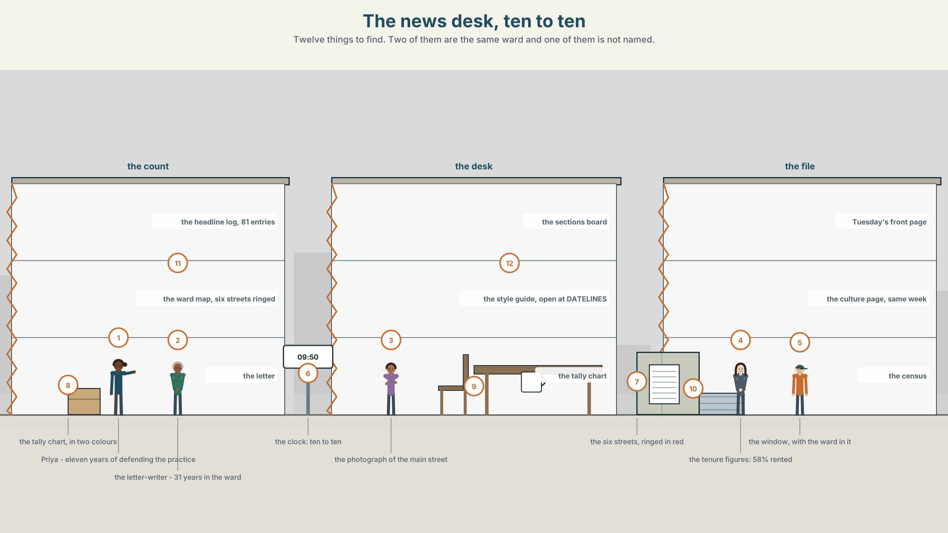{width=6.6in}
The news desk, ten to ten — Twelve things to find. Two of them are the same ward and one of them is not named.

Whose city is in the headline?
By the end of this unit you can put a sentence in marked order for effect, and say what naming a place in a headline does to it. Two hundred words.
◆ A · THE WORLD | Eighty-one headlines, one ward, and a naming rule nobody ever wrote down
◆ B · THE SYSTEM | inversion for emphasis, the full range · 28 words for place, tenure and framing · 22 negative and restrictive adverbs and frames · emphatic contours
◆ C · THE PERFORMANCE | Two hundred words in marked order, on purpose

0A · Find it
Find twelve things in this picture. Two of them are the same ward and one of them is not named.
the headline log, eighty-one entries · the ward map, six streets ringed · the letter from a resident · the sections board: crime, planning, culture, business · the style guide, open at DATELINES · the front page from Tuesday · the culture page from the same week · a photograph of the main street · a tally chart in two colours · the tenure figures from the census · a clock showing 09:50 · a window with the ward in it

0B · Guess it
Two pages in this room describe the same six streets in the same week. Which two, and which one names them?

0C · Say it ⏺
Record sixty seconds. Describe the area you grew up in as a stranger would, and then as you would. Say what changed. You will record it again at the end of this unit.

Part 1 · Vocabulary Lab 1 ◆ B · THE SYSTEM
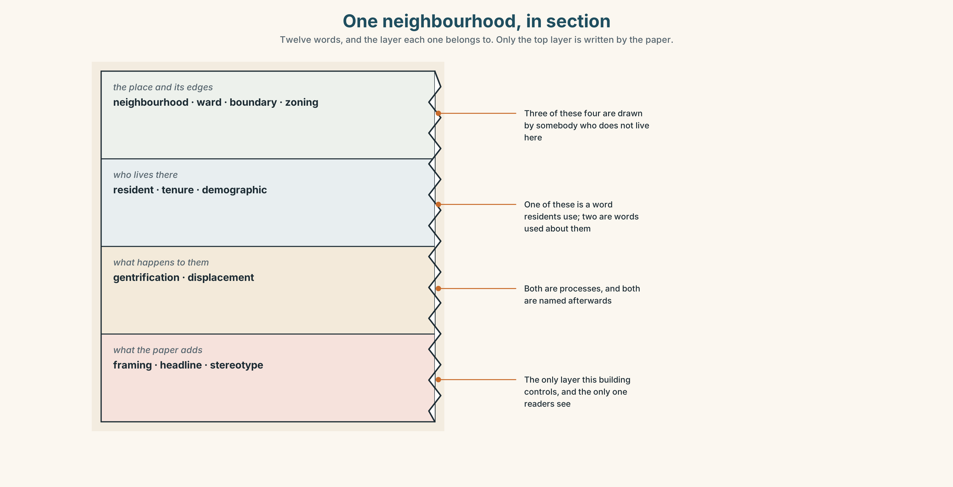{width=6.6in}
One neighbourhood, in section — Twelve words, and the layer each one belongs to. Only the top layer is written by the paper.

1A · Meet — the words of a place in print
Match each word to one layer of the cutaway.
framing · headline · neighbourhood · gentrification · displacement · zoning · tenure · boundary · ward · demographic · stereotype · resident

1B · Sort — the place and its edges, who lives there, or what the paper adds?
Three columns. Two of the twelve are words residents almost never use about the place they live, and both of them are used about it constantly.
neighbourhood · resident · framing · ward · tenure · headline · boundary · demographic · stereotype · zoning · gentrification · displacement

1C · Meet — the five phrases a place acquires
the north end | A name used by everybody except the people who live there.
a problem neighbourhood | A phrase that describes coverage, not a place.
long-term residents | Used in planning stories; never in crime stories.
the same six streets | What eighty-one pieces about a ward of forty thousand actually cover.
an outsider's view | The only kind most readers have, and the only kind most pieces are.

1D · Collocation Lab
Complete each one, and say which of the five decides what a reader remembers.
named in the headline · a postcode in a headline · who is quoted · the first paragraph · the local paper
- The ward is ______ ______ ______ ______ in seven of ten crime stories and one of ten others.
- ______ ______ ______ ______ is a decision about a place, made in four words.
- ______ ______ ______ matters less than ______ ______ ______ ______ , and both matter less than the headline.
- ______ ______ ______ ______ repeats the headline, which is why it rarely corrects it.
- ______ ______ ______ is the only paper that will ever write about these six streets.

1E · The phrasal verbs, and the three fixed expressions
move in · price out · build over
f nobody from there was asked · f that is not what it is called · f whose city is this?
One of these fixed expressions is a correction and two are accusations. Which is the correction, and why is it the hardest one to answer?

1F · Own it
Write the name of the area you live in as the authorities write it, and then as you say it to a friend. If they are the same, say who decided that.

Part 2 · Listening ◆ A · THE WORLD
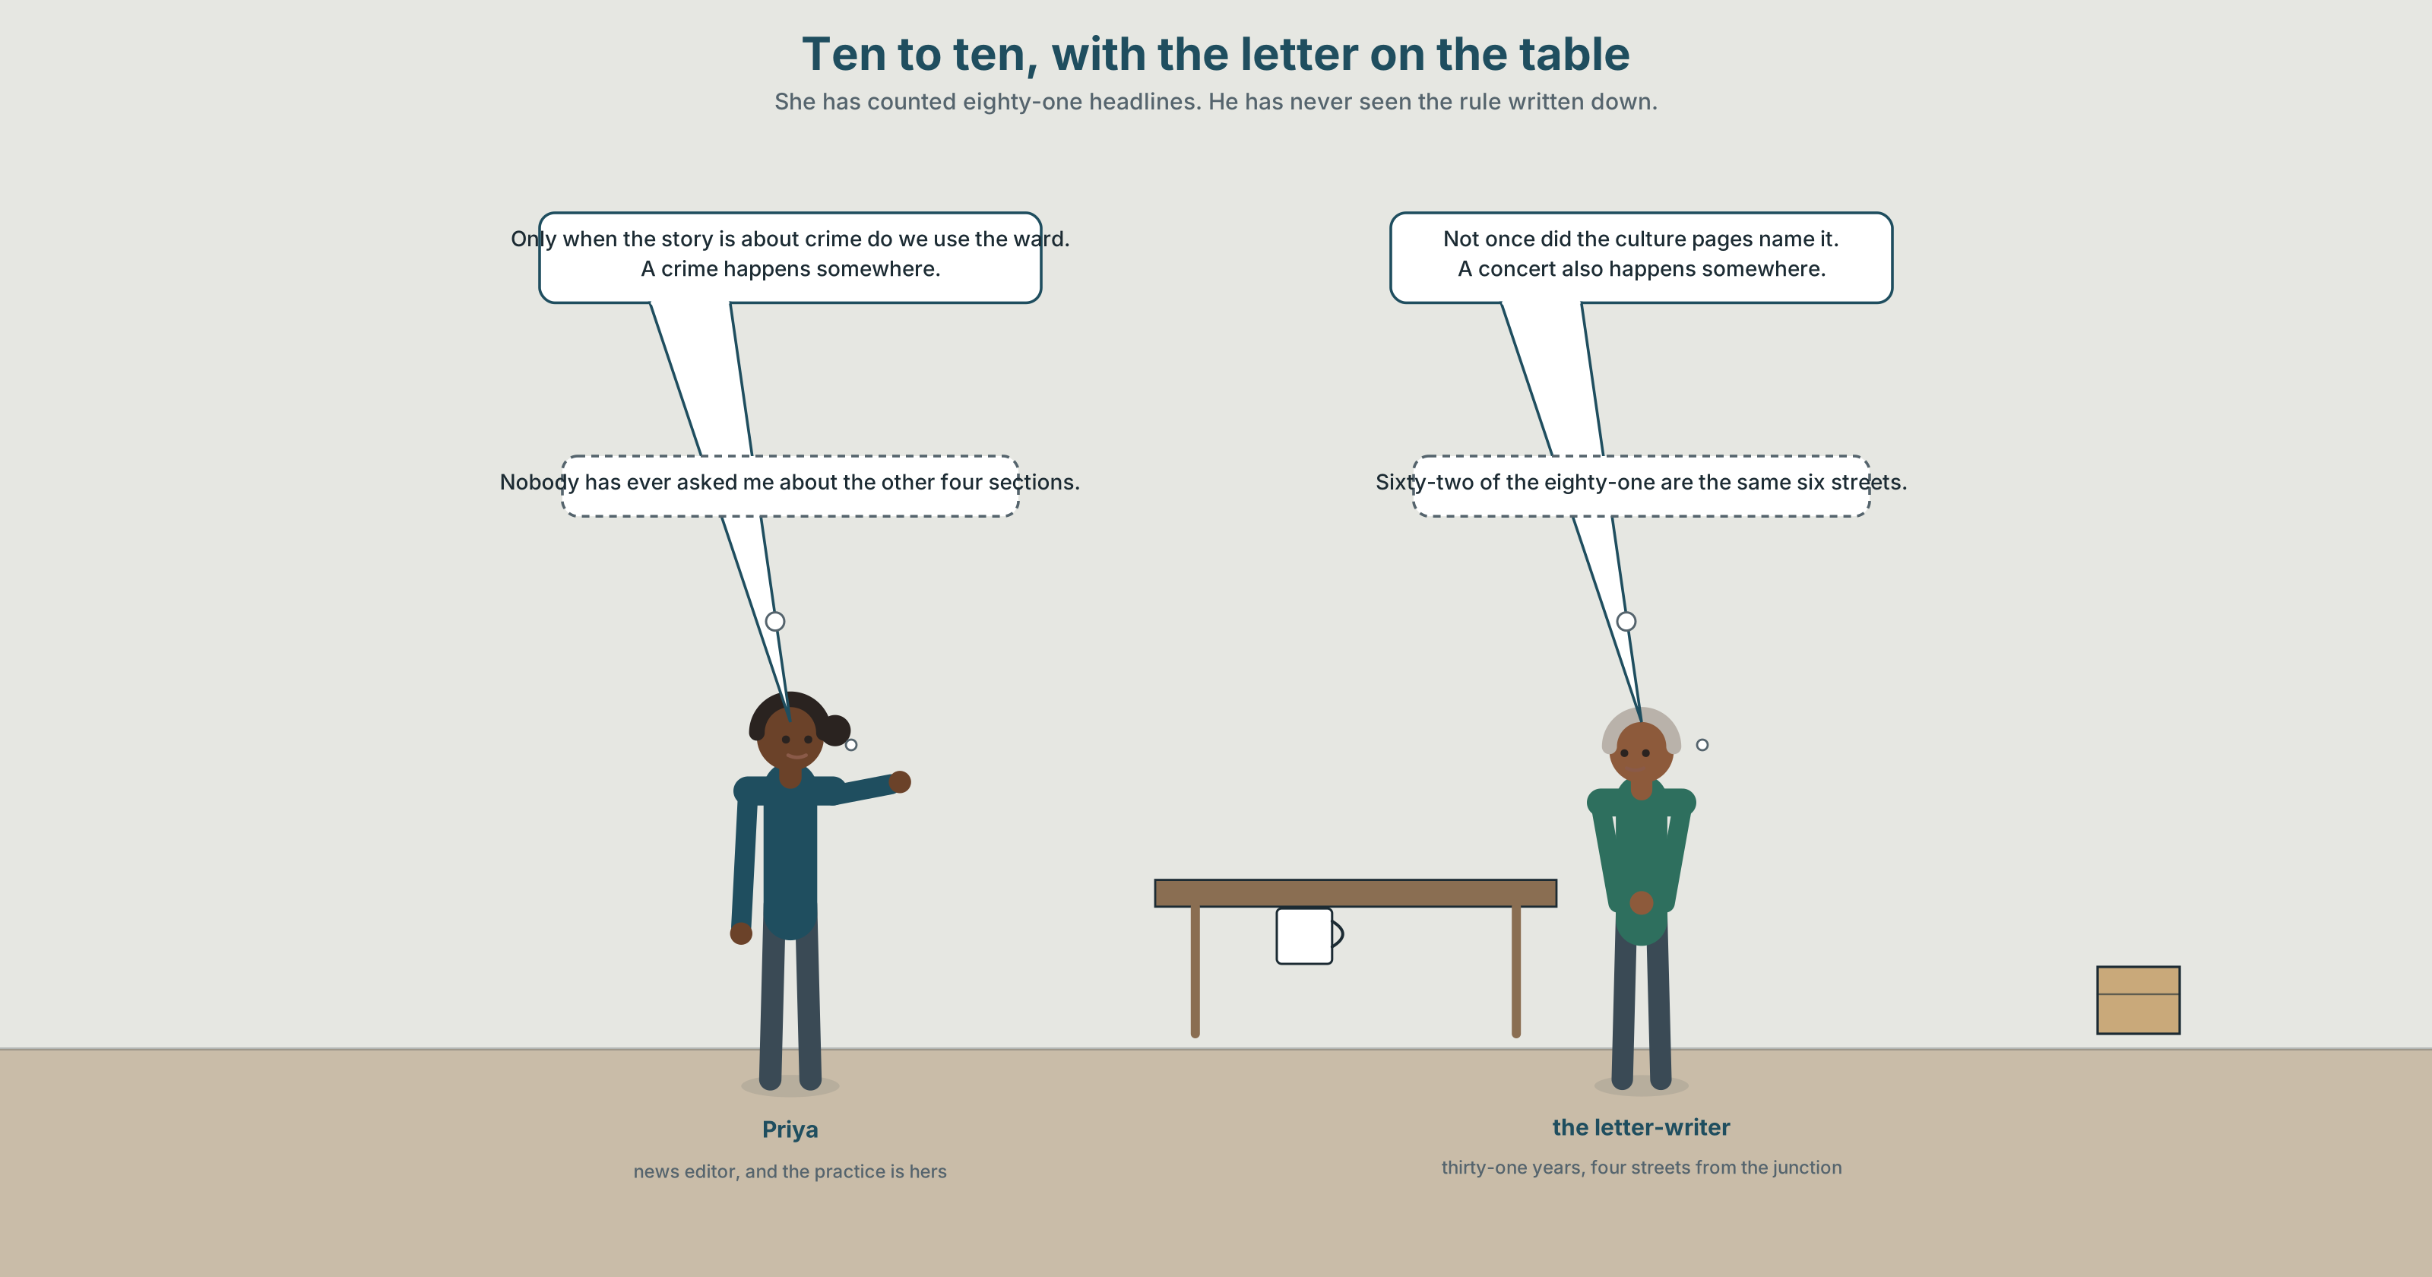{width=6.6in}
Ten to ten, with the letter on the table — She has counted eighty-one headlines. He has never seen the rule written down.

2A · The naming rule 🔊 Track 10.1
Before you listen. A resident has written to the paper. She has counted eighty-one headlines over two years. The news editor has never seen the rule written down, because it never was.
Listen once. What has she counted, and what does the paper say its rule is?
Listen again. Complete the table.
 | Ward named in the headline | Resident quoted | What the section is
crime
planning
culture
Listen again. True or false?
- She counted eighty-one headlines. ☐ T ☐ F
- The rule is written in the style guide. ☐ T ☐ F
- The ward is named in most crime headlines. ☐ T ☐ F
- The culture pages have never named it. ☐ T ☐ F
Noticing. Six sentences from the recording.
- Never before had anybody counted them.
- Not once did the culture pages name it.
- Only when the story is about crime do we use the ward.
- No sooner had the letter arrived than the editor asked for the figures.
- So rarely does the ward appear in good news that readers assume there is none.
- Little did we know that the rule had never been written down.
Every one of these puts the verb before the subject. Write each one in ordinary order, and say what is lost.

2B · Decoding clinic 🔊 Track 10.2
Thirty seconds at speed. Three jobs.
- Two sentences begin with a negative adverb. Mark where the voice jumps in each.
- What happens to the stress on the fronted word?
- Somebody says that is not what it is called. What was it called, and by whom?

Part 3 · Grammar Lab 1 ◆ B · THE SYSTEM

Putting the verb first, and why you would

3A · Notice
Look at the six sentences in Part 2 again.
- In sentence 1, what comes before the subject, and what has happened to the auxiliary?
- Sentence 3 inverts the second clause, not the first. Why that one?
- Sentence 4 has two clauses and only one inversion. Which, and what joins them?
- Sentence 6 is a fixed expression. Could you say little did they know about yourself?

3B · See
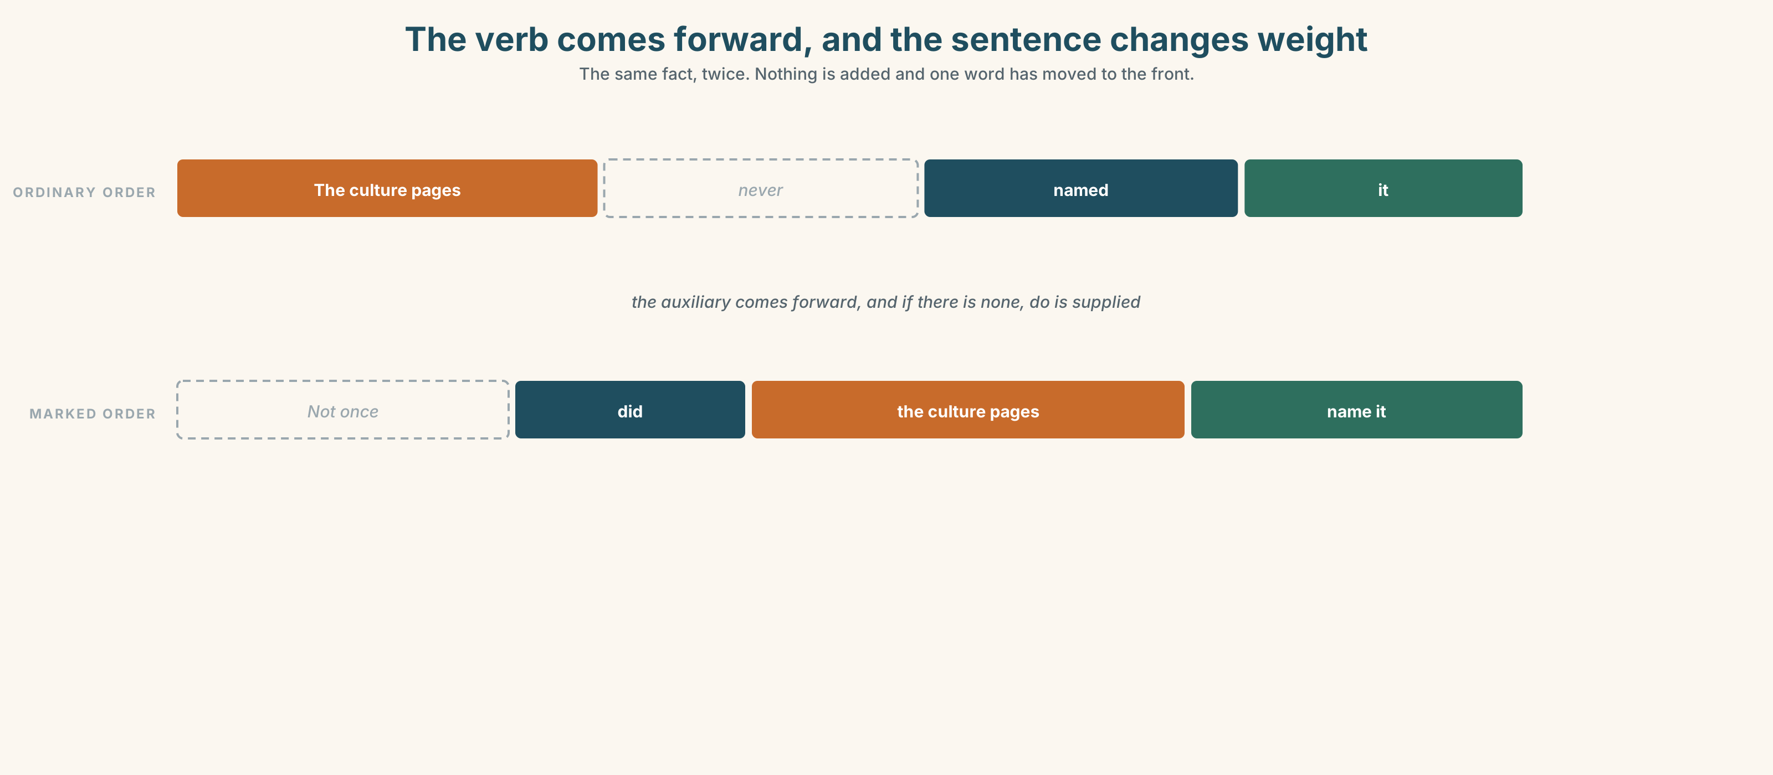{width=6.6in}
The verb comes forward, and the sentence changes weight — The same fact, twice. Nothing is added and one word has moved to the front.

3C · Know
negative adverb first | never · rarely · seldom · nowhere · little | Never had she seen it.
near-negative first | hardly · scarcely · no sooner | Hardly had it arrived when…
restrictive first | only when · only then · only if · not until | Only then did we count them.
absolute negatives | at no point · under no circumstances · not once | Not once did they name it.
so + adjective or adverb | so rarely does · so great was | So rarely does it appear that…
such | such was the | Such was the reaction that…
Inversion is the written language's way of shouting. It costs nothing in words and it cannot be used twice in a paragraph without sounding theatrical, which is the whole constraint.
The auxiliary does the inverting, and if there isn't one, do is supplied. They never counted them becomes Never did they count them, not Never counted they them. This is the same machinery as a question, which is why the pattern feels familiar and the register does not.
the fixed frames | never before had · not once did · only when
what writers do with a place | set out · single out · point up
the degree words | rarely · seldom · scarcely · hardly · little · only
Why it matters. Marked order tells a reader that this sentence is the one to remember. Use it where the emphasis is real and it is the strongest device in the language; use it where it is not and the reader hears a performance.

3D · Use — controlled
Rewrite each one with the bracketed word at the front and the verb inverted.
Anybody had counted them before. (1) (never before) The culture pages did not name it. (2) (not once) We use the ward when the story is about crime. (3) (only when) The letter arrived and the editor asked for figures. (4) (no sooner) The ward appears in good news so rarely that readers assume there is none. (5) (so rarely)

3E · Use — guided
Put each one back into ordinary order and say what is lost.
- Never before had anybody counted them.
- Not once did the culture pages name it.
- Only then did the editor ask for the figures.
- At no point was a resident consulted.
- Such was the reaction that the rule was rewritten.

3F · Use — open
In pairs. One of you states a fact about your own town. The other restates it inverted, and then says whether the emphasis is deserved. Six rounds each.

3G · Error autopsy
✗ Never before anybody had counted them. ✗ Not once the culture pages named it. ✗ Only when the story is about crime we use the ward.
For each, name the rule and say what the writer was reaching for.

3H · Check — eight items
- ______ ______ ______ anybody counted them. (three words + inversion)
- ______ ______ ______ the culture pages name it. (three words + inversion)
- ______ ______ the story is about crime ______ we use the ward. (restrictive)
- ______ ______ ______ the letter arrived than the editor asked. (three words)
- ______ ______ ______ it appear in good news that readers assume there is none. (three words)
- ✗ Never before anybody had counted them. → correct it.
- Rewrite They never asked a resident with at no point.
- Write one inverted sentence about your own town that you could defend in print.

Part 4 · Speaking ◆ C · THE PERFORMANCE

4A · Fluency starter — one inversion each
Everybody states one fact. Everybody else may invert it once. The group votes on whether the emphasis was earned.

4B · The functional core — writing for rhetorical effect
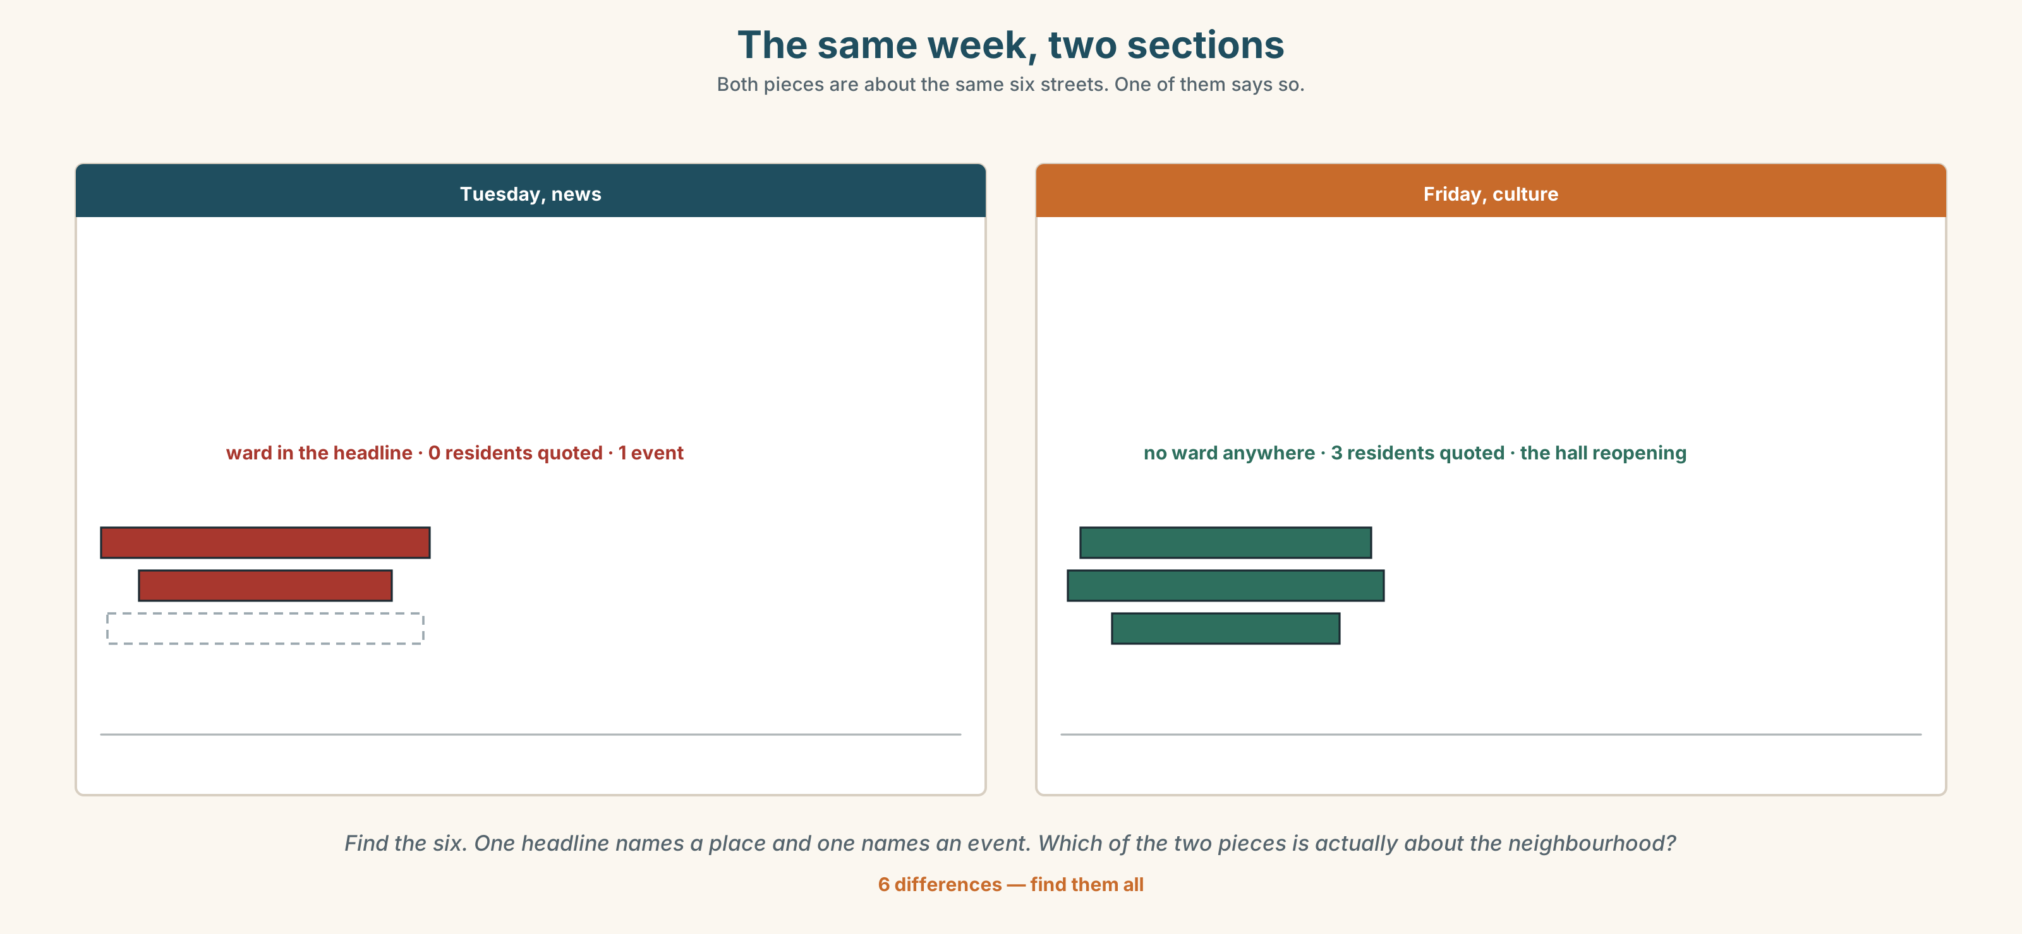{width=6.6in}
The same week, two sections — Both pieces are about the same six streets. One of them says so.
Language Bank
opening with a negative | never before had · not once did · at no point
restricting | only when · only then · under no circumstances
intensifying | so rarely does · such was the · little did
naming a place | the local paper · an outsider's view · that is not what it is called
Information gap. Learner A has the crime headlines. Learner B has the culture headlines. Agree on one sentence describing both, and use exactly one inversion in it.

4C · The performance — three minutes ⏺
Argue a case about your own town in three minutes. You may use inversion exactly twice. Your partner notes where you used it and whether a third would have helped or hurt.
Record it.

4D · Observer
One person marks each inverted sentence and writes beside it what was being emphasised.

4E · Three criteria
☐ Did each inversion mark the sentence that mattered most? ☐ Did I supply do where there was no auxiliary? ☐ Did two inversions sound deliberate, or did they sound like a speech?

Part 5 · Reading ◆ A · THE WORLD

5A · Predict
The title is "Eighty-one headlines." If a newspaper names a neighbourhood in its crime headlines and not elsewhere, what does a reader learn about the neighbourhood?

5B · Read — two minutes

Eighty-one headlines
The letter ran to a page and a half and contained a table. Over two years the Herald published eighty-one pieces mentioning Ward 7. The writer, a resident of thirty-one years, had sorted them by section and counted how often the ward appeared in the headline.
In crime stories it appeared in seventy-one per cent of headlines. In planning stories, eighteen. In business, six. Not once did it appear in a culture headline, although eleven culture pieces over the two years were about events in the ward, including the reopening of a hall the paper itself had campaigned to save.
There is no rule in the style guide about naming a ward. Nobody in the building could produce one. Asked, three editors gave three answers, and all three were about specificity: a crime happens somewhere, and readers want to know where.
The letter's last paragraph points out that a concert also happens somewhere.
The ward is forty thousand people and eleven thousand households, of which fifty-eight per cent are rented. The six streets around the Lake and Seventh junction account for sixty-two of the eighty-one pieces. The writer lives four streets away and has never been quoted in any of them.

5C · Comprehension — eight questions
- How many pieces mentioned the ward, and over how long?
- What were the four percentages?
- How many culture pieces were about events in the ward?
- What did three editors give as the reason?
- How many people live in the ward?
- Why does the writer mention the hall the paper campaigned to save?
- "A concert also happens somewhere." What argument is being made in six words?
- The last sentence is about the letter-writer herself. What does ending there do?

5D · Vocabulary in context
Infer from the text, then check.
sorted them by section · all three were about specificity · account for sixty-two of the eighty-one · four streets away · has never been quoted in any of them

5E · The counter-text
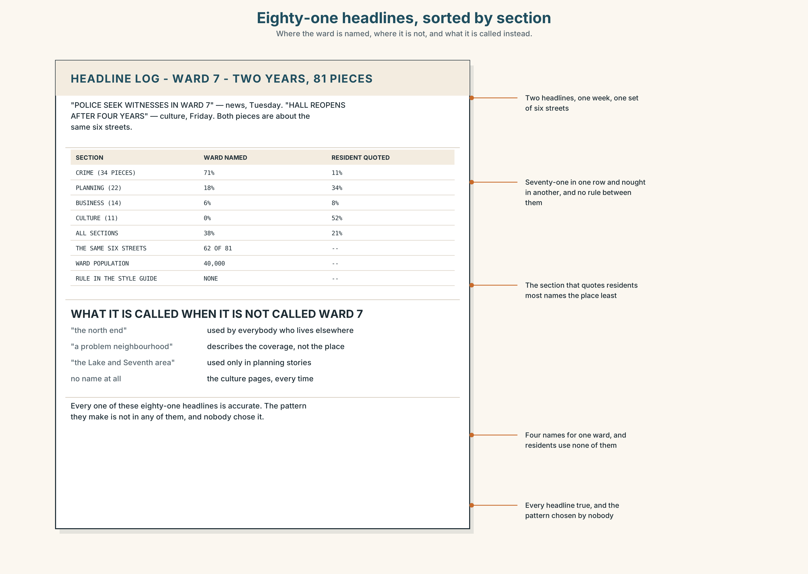{width=6.6in}
Eighty-one headlines, sorted by section — Where the ward is named, where it is not, and what it is called instead.
Read the headline log and answer.
- How many headlines name the ward, and in which sections?
- Find the two headlines about the same week and say which one names the place.
- One headline uses a postcode. What does that do that a ward name does not?
- Rewrite three headlines so that the naming is consistent across sections.

5F · Two texts
The style guide has no rule about naming a ward. The log shows seventy-one per cent in crime and nought in culture.
Is there a rule? Write two sentences, and use the word framing in one of them.

Part 6 · Vocabulary Lab 2 ◆ B · THE SYSTEM

The words that trigger marked order

6A · Sort — how often, how nearly not, where, or how restricted?
Four columns.
rarely · hardly · nowhere · only · seldom · scarcely · never · little

6B · Chunk completion
- ______ ______ had anybody counted them. (two words + had)
- ______ ______ did the culture pages name it. (two words + did)
- ______ ______ the story is about crime do we use the ward. (two words)
- ______ ______ had the letter arrived than the editor called. (two words)
- ______ ______ ______ was a resident consulted. (three words)
- ______ ______ ______ ______ will a postcode be used alone. (four words)
- ______ ______ ______ it appear in good news that readers assume there is none. (three words)
- ______ ______ ______ reaction that the rule was rewritten in a week. (three words)

6C · Three that are not interchangeable
hardly · rarely · only
Say which one is about frequency, which one is about degree, and which one restricts the whole clause.

6D · The phrasal verbs and the fixed expressions
set out · single out · point up
f never before had · f not once did · f only when
One of these three phrasal verbs is what the letter-writer accuses the paper of doing to her ward. Which, and what would the paper say it was doing instead?

6E · Contrast Clinic
Eight items. Rewrite each one in marked order, beginning with the word in brackets.
- Nobody had counted them before. (never before)
- The culture pages did not name it once. (not once)
- We use the ward only when the story is about crime. (only when)
- The letter arrived and the editor called immediately. (no sooner)
- A resident was not consulted at any point. (at no point)
- The reaction was so great that the rule changed. (such)
- It appears in good news so rarely that readers assume there is none. (so rarely)
- We did not know the rule had never been written. (little)

Part 7 · Pronunciation & Fluency Lab ◆ B · THE SYSTEM
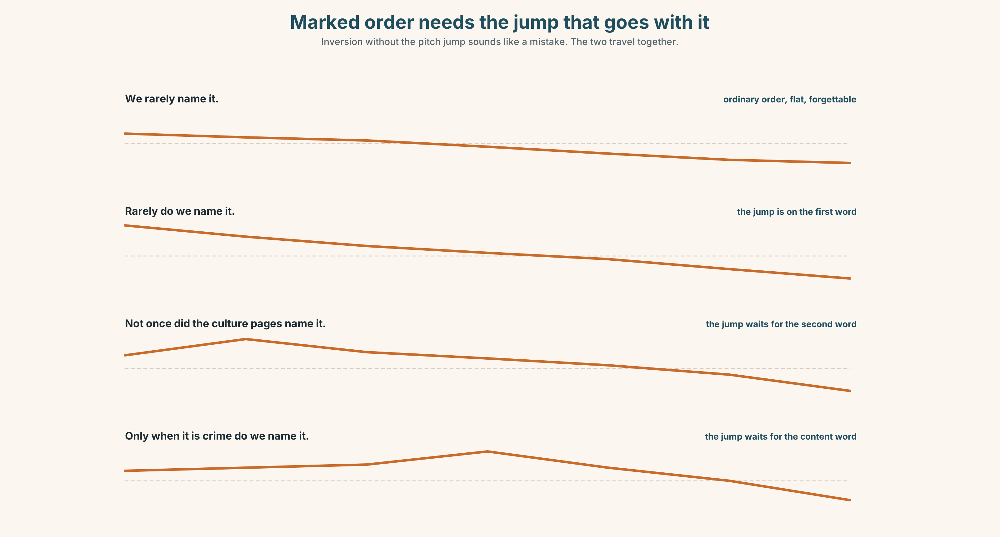{width=6.6in}
Marked order needs the jump that goes with it — Inversion without the pitch jump sounds like a mistake. The two travel together.

Marked order has a marked tune

7A · Hear 🔊 Track 10.3
NEVer before had anybody counted them. — the jump is on the first word Not ONCE did the culture pages name it. — and here on the second Only when it is CRIME do we name it. — the jump waits for the content word

7B · Say
Say each one three times. Then say this:
Never before had anybody counted them — and not once did anybody ask why. — two inversions in one breath, two jumps, and the second must be lower than the first or it sounds like a speech.

7C · Make it mean something
Say these two:
We rarely name it. — flat, ordinary, and forgettable RARELY do we name it. — the jump on rarely, the verb inverted, and it is now the sentence the reader repeats
Inversion without the pitch jump sounds like a mistake, and the jump without inversion sounds like emphasis in the wrong place. The two travel together or not at all.

7D · Fluency 30 ⏺
Thirty seconds: three inverted sentences, each with one jump, each jump lower than the last. Three times, faster.

Part 8 · Writing ◆ C · THE PERFORMANCE

A case about a place · 200 words

8A · Read the model
Over two years the Herald published eighty-one pieces mentioning Ward 7, of which sixty-two concerned the same six streets. [ordinary order, and the figures do the work; nothing is marked yet]
Not once did the ward appear in a culture headline. [the first inversion, on the sentence that is the point of the piece]
Eleven culture pieces over the same period were about events there, including the reopening of a hall this paper campaigned to save. [back to ordinary order immediately; the marked sentence only works if it is surrounded by unmarked ones]
So rarely does a neighbourhood appear in good news that its readers come to believe there is none — and such was the response to this letter that the rule, which had never been written down, was written down in a week. [two marked structures in the last sentence, where the piece is allowed to raise its voice because it has not done so before]
Questions about the writer's choices:
- The first sentence is unmarked. What does that buy the second one?
- The third sentence returns to ordinary order. Why not keep going?
- The last sentence uses two marked structures. Would three have worked?

8B · The anti-model
Never before has a community been so ignored. Not only is the coverage unfair, but so biased is the framing that no resident can recognise themselves in it. Rarely has a newspaper so comprehensively failed. At no point has anybody listened.
Four sentences, five inversions, and not one number anywhere. Rewrite it with one inversion and four facts.

8C · Plan
the figures, unmarked → one inversion, on the point → back to ordinary order, with the concrete example → the close, where you may raise your voice once

8D · Write — 200 words

8E · Peer review — three criteria
☐ Is every inversion on a sentence that deserves the emphasis? ☐ Are the marked sentences surrounded by unmarked ones? ☐ Does the auxiliary invert correctly, with do supplied where needed?

8F · Write it again · 8G · Publish
Rewrite after review. Publish both, and mark every inversion in each.

Part 9 · The File ◆ A · THE WORLD + C · THE PERFORMANCE
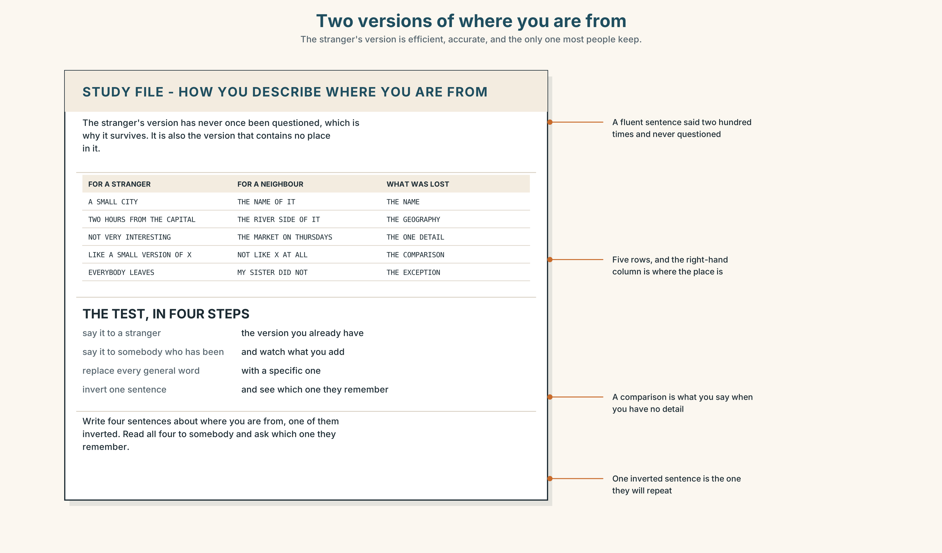{width=6.6in}
Two versions of where you are from — The stranger's version is efficient, accurate, and the only one most people keep.

STUDY FILE · How you describe where you are from

9A · The outsider's version 🔊 Track 10.4
Asked where they are from, most learners give the version a stranger needs: the country, the nearest big city, and a comparison. It is efficient, it is accurate, and after four years abroad it is often the only version they still have.
the outsider's version | a small city, about two hours from the capital
what it leaves out | the name, the street, the thing only you would say
why it survives | it has never once been questioned
the test | describe it to somebody who has been there

9B · Say it twice
Describe your place twice: once for a stranger and once for a neighbour. Write down three things that appear only in the second.

9C · Role play — the follow-up question
In pairs. One describes a place. The other may only ask what is it actually called? and who lives there? Four rounds each.

9D · The sentence you have said two hundred times
Everybody has one fluent, worn sentence about home. Say yours, then replace every general word in it with a specific one and say it again.

9E · Transfer — before next week
Write four sentences about where you are from, one of them inverted. Read all four to somebody and ask which one they remember.

Part 10 · Mediation & Interaction ◆ C · THE PERFORMANCE
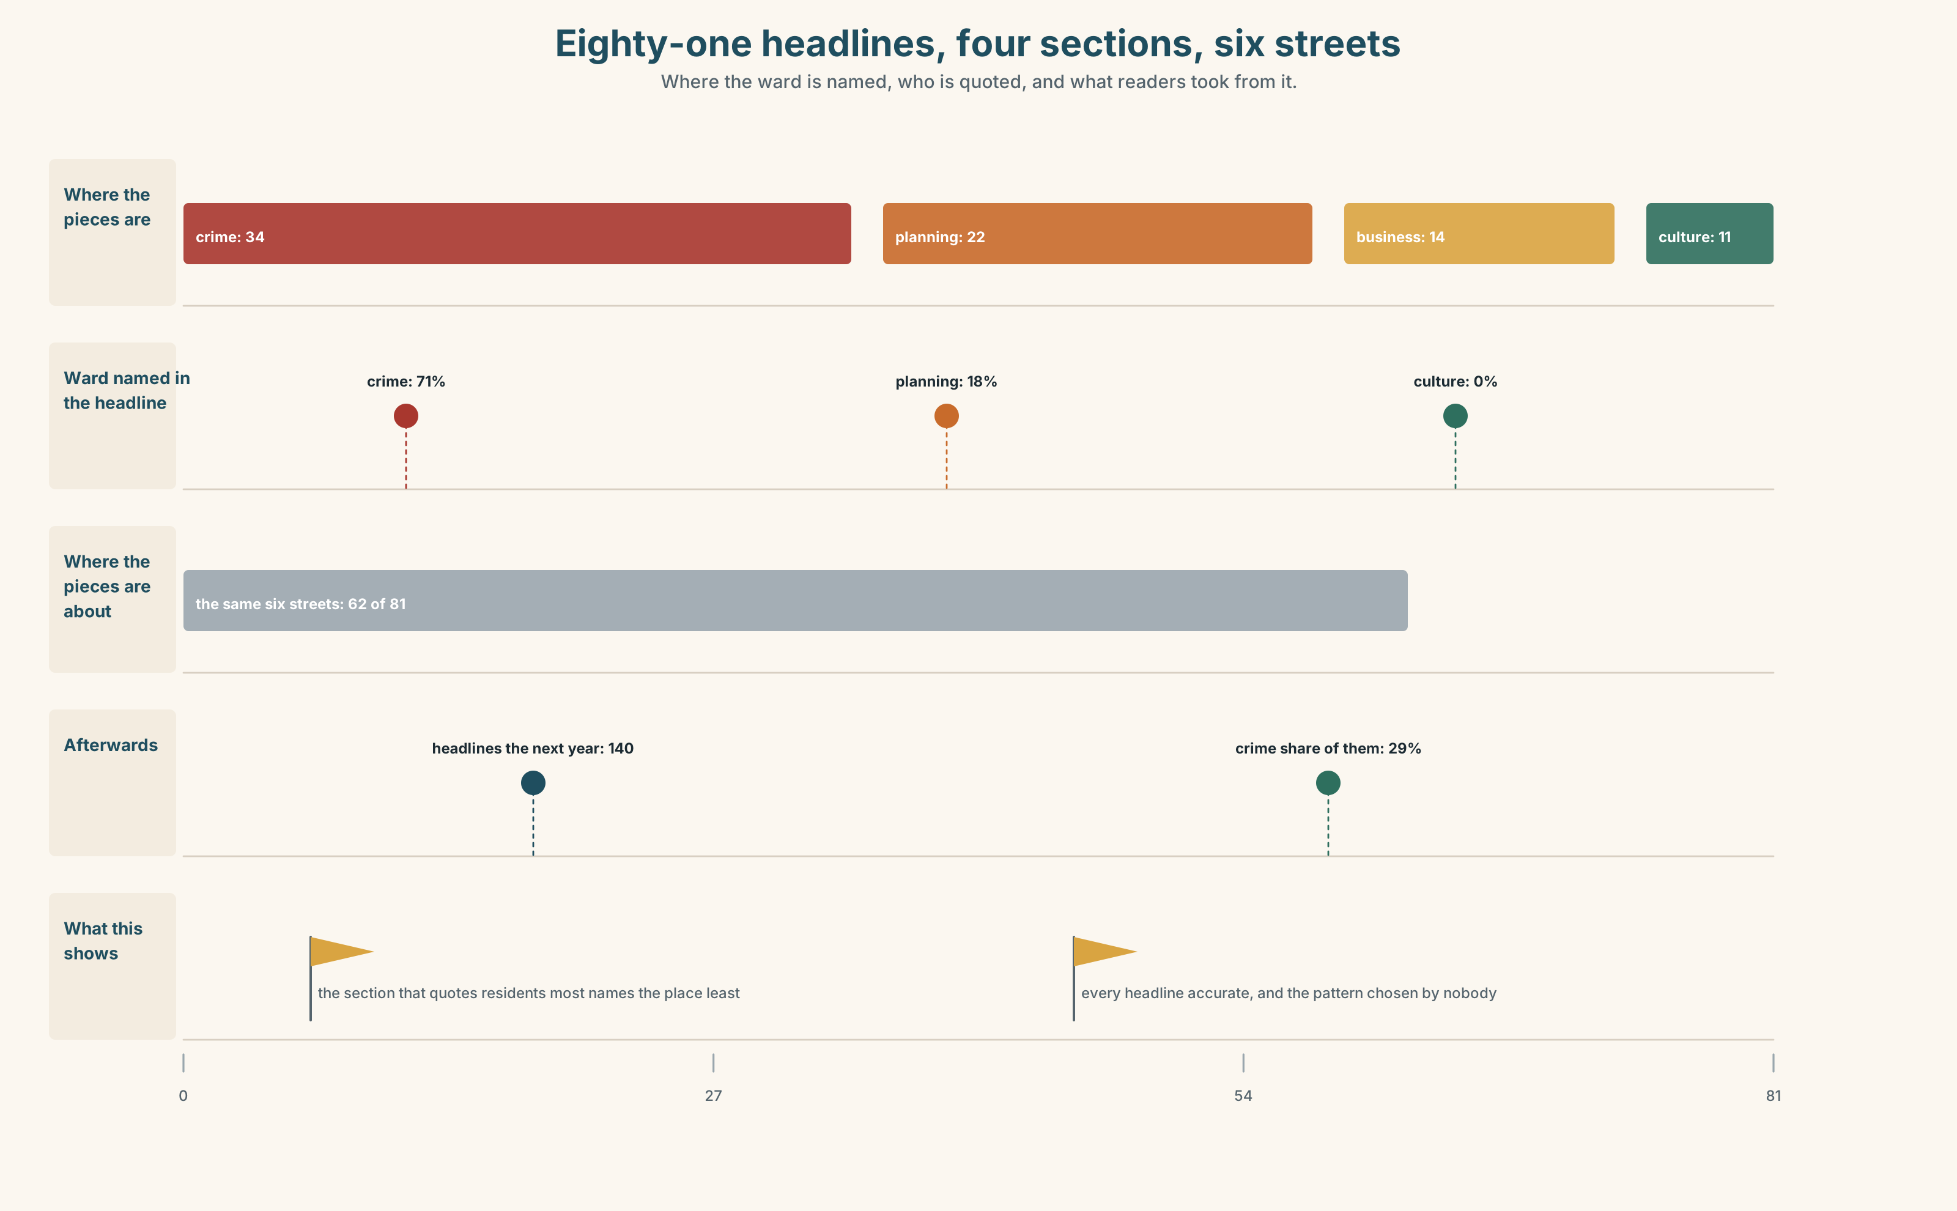{width=6.6in}
Eighty-one headlines, four sections, six streets — Where the ward is named, who is quoted, and what readers took from it.

10A · Relay
Half the class has the crime headlines. Half has the culture headlines. Produce one naming rule both halves accept, by speaking only. Ten minutes.

10B · Simplify — for one reader
The letter-writer asks: So is there a rule or isn't there? Reply in four sentences, with one inversion and three numbers.

10C · Online
Write one message to a colleague whose headline names a ward in a crime story. Three sentences. Ask about the other sections, not about their headline.

10D · Your language
Does your language mark emphasis by moving the verb, or by something else? Translate all six sentences from Part 2. What does your language move instead?

Part 11 · The Decision ◆ C · THE PERFORMANCE

The naming rule
There is no rule. There has been a practice since at least 1994.
Option one: keep it. A crime happens in a place and readers are entitled to know which place. Specificity is the job.
Option two: name a neighbourhood only when the story is about the neighbourhood, and not when it is about one event that happened inside it.
Option three: name it everywhere — in culture, in business, in planning, in sport — at the same rate as in crime, and write the rule down.

11A · The evidence
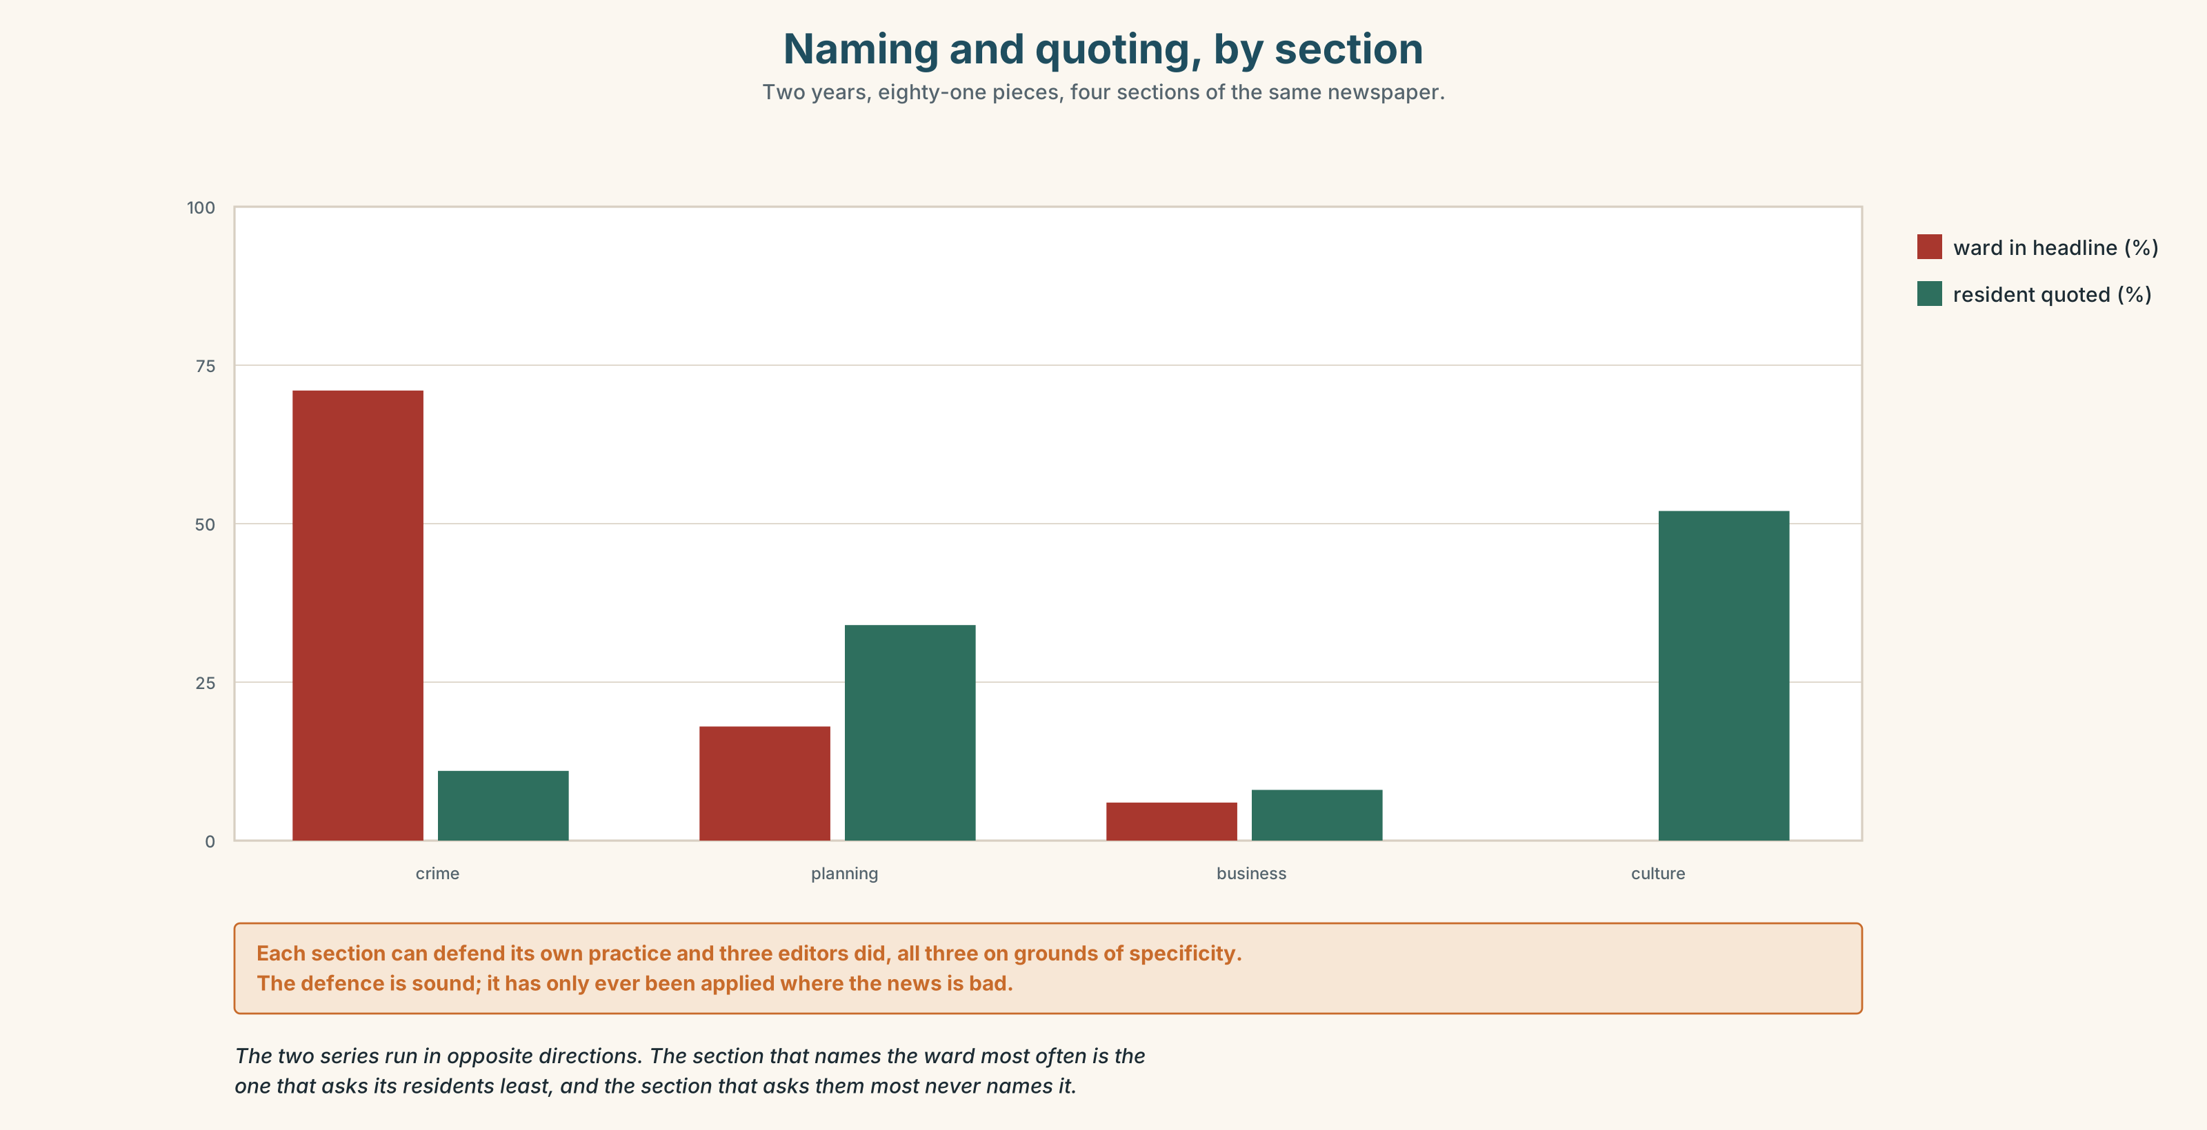{width=6.6in}
Naming and quoting, by section — Two years, eighty-one pieces, four sections of the same newspaper.
🔊 Track 10.6. Priya Raghavan, news editor, 30 seconds: "I have defended the crime practice for eleven years and I would defend it again, because it is right. A crime happens somewhere. What I cannot defend is the other four sections, and nobody has ever asked me to, because nobody ever noticed that the defence only works if you apply it everywhere. We applied it in one place. That is not a rule. That is a habit with a reason attached afterwards."

11B · Talk about it
In threes. Use the frame, and invert exactly once per person.
I would ______ , because ______ . Only when ______ would I ______ .

11C · Decide
Write three sentences: the decision, the evidence, and one inverted sentence you would stand behind in print.

11D · Model decision
Option three. Option two is the comfortable answer and it makes the ward disappear, which is what the letter is complaining about in the first place. The defence of naming is sound and it has only ever been applied where the news was bad. Applying it everywhere costs nothing, writes the rule down, and is the only version that can be checked a year from now by counting, which is how this started.

11E · The Reveal
What happened. The Herald wrote the rule down and applied it to every section. In the following year Ward 7 appeared in a hundred and forty headlines instead of eighty-one, and the crime share of those headlines fell from seventy-one per cent to twenty-nine.
Then something nobody predicted: readers outside the ward, asked to free-associate on its name, produced a list in which crime words fell from first to fourth. Nothing had changed in the ward. Six hundred more headlines had changed, and all of them were true.
One question. You do not have to answer it out loud.
Every one of the eighty-one original headlines was accurate. What exactly was wrong?

Part 12 · Landing ◆ all three lines

12A · Recycle — fifteen items
- ______ ______ had anybody counted them. (two words + had)
- ______ ______ did the culture pages name it. (two words + did)
- ______ ______ the story is about crime do we name it. (two words)
- ______ ______ had the letter arrived than the editor called. (two words)
- ______ ______ ______ was a resident consulted. (three words)
- ______ ______ ______ ______ will a postcode stand alone. (four words)
- ______ ______ ______ it appear in good news. (three words)
- ______ ______ ______ reaction that the rule changed in a week. (three words)
- ______ ______ ______ we know it had never been written. (three words)
- ______ ______ ______ ______ ______ ______ . (six words — the resident's letter, line one)
- ______ ______ ______ ______ ______ ______ . (six words — the correction nobody can answer)
- ______ ______ ______ ? (three words — the question in the headline)
- The piece will ______ ______ three streets as the worst. (two words)
- The figures ______ ______ what the headline hides. (two words)
- Families have been ______ ______ of the six streets since 2016. (two words)

12B · Consolidate — one task, everything in it
Write 150 words about how your own area is written about. Use exactly two inversions and mark them. Say, underneath, why those two sentences and not two others.

12C · Can-do, with evidence
☐ I can use the full range of inversion after negative and restrictive adverbs. Evidence: 3H, 8D ☐ I can judge when marked order is earned. Evidence: 4C, 6E ☐ I can say what naming a place does to a reader's picture of it. Evidence: 5E, 10B ☐ I can produce the pitch jump that marked order requires. Evidence: 7C

12D · Replay ⏺
Record 0C again. Compare. Which version did you give first — the stranger's or your own?

12E · Glossary — fifty items, as a map
THE PLACE AND ITS EDGES · neighbourhood · ward · boundary · zoning WHO LIVES THERE · resident · tenure · demographic WHAT HAPPENS TO THEM · gentrification · displacement WHAT THE PAPER ADDS · framing · headline · stereotype WHAT A PLACE GETS CALLED · the north end · a problem neighbourhood · long-term residents · the same six streets · an outsider's view THE DECISIONS · named in the headline · a postcode in a headline · who is quoted · the first paragraph · the local paper WHAT HAPPENS TO STREETS · move in · price out · build over · set out · single out · point up IN THE ROOM · nobody from there was asked · that is not what it is called · whose city is this? THE TRIGGER WORDS · rarely · seldom · scarcely · hardly · nowhere · never · little · only THE FRAMES · not only · no sooner · only then · at no point · under no circumstances · so rarely does · such was the · little did THE FIXED OPENINGS · never before had · not once did · only when

12F · Next
B2.2 · Holding the Floor — a port and its logistics chain, Rotterdam

