Table of Contents

A2.2 · Unit 4 · Forty Minutes Apart
English Animated · Telling the Story · Ballinmore, west coast of Ireland Student's Book pages 72–93 · 22 pp · ~10 hours

Part 0 · The Big Picture ◆ A · THE WORLD
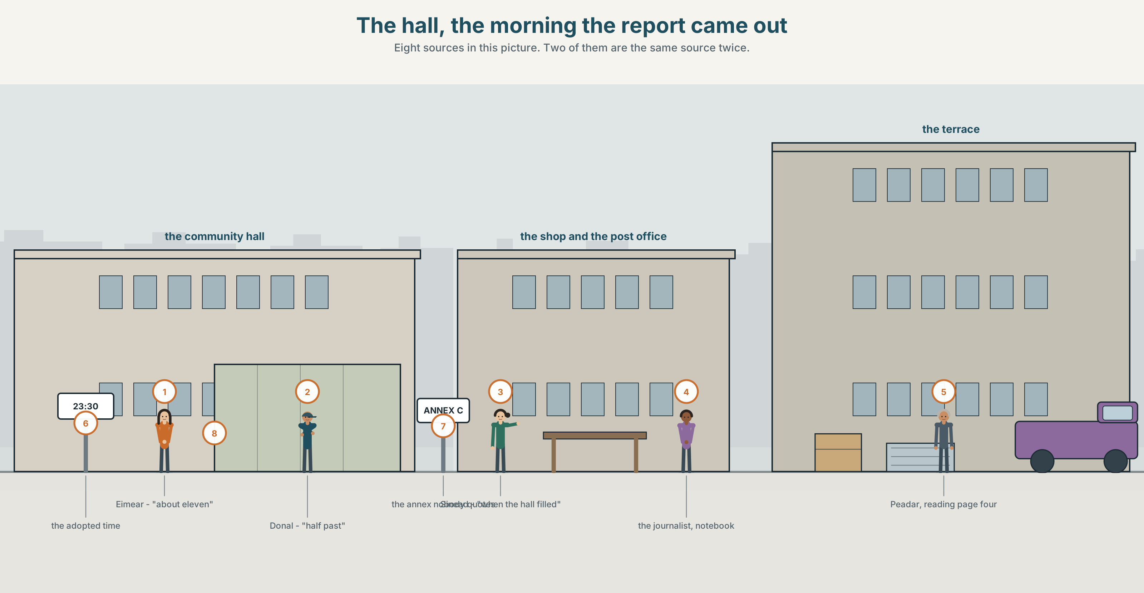{width=6.6in}
The hall, the morning the report came out — Eight sources in this picture. Two of them are the same source twice.

What did they actually say?
By the end of this unit you can report three people's accounts of the same event, accurately and without judging any of them.
◆ A · THE WORLD | Three honest people, one event, and forty minutes between them
◆ B · THE SYSTEM | reported statements · reporting verbs · 23 words for claims and sources · 17 verbs for saying things · where the stress falls when you report
◆ C · THE PERFORMANCE | Three accounts, relayed fairly, in writing

0A · Find it
Find eight sources in this picture. Two of them are the same source twice.
a notebook · a phone recording · a photograph · a printed statement · a letter · a noticeboard · a person talking · a screen showing a broadcast

0B · Guess it
Two of these sources will agree with each other and still both be wrong. Which two, and why?

0C · Say it ⏺
Record thirty seconds. Think of something you were told recently. Who told you, and how do you know they knew? You will record it again at the end of this unit.

Part 1 · Vocabulary Lab 1 ◆ B · THE SYSTEM
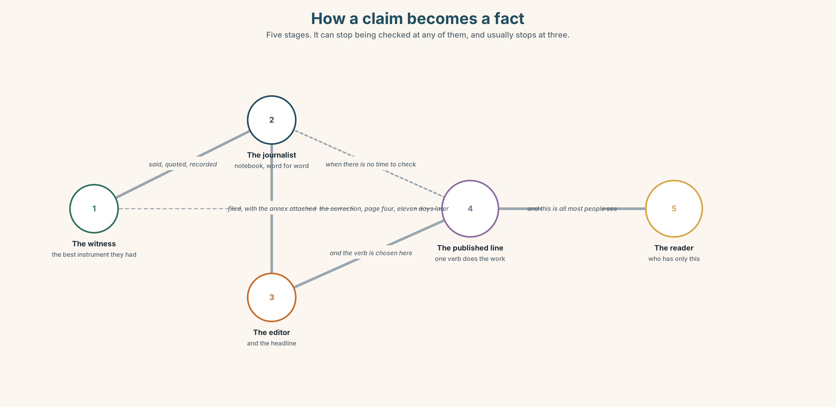{width=6.6in}
How a claim becomes a fact — Five stages. It can stop being checked at any of them, and usually stops at three.

1A · Meet — the words of a claim
Match each word to one place on the map.
claim · source · quote · statement · account · version · evidence · footage · journalist · editor

1B · Sort — the thing said, the person, or the test?
Three columns.
claim · source · journalist · accurate · account · editor · exact · version · trust · doubt
One of them is in two columns at once. Which?

1C · Meet — three things you do to a claim
deny · confirm · doubt
Denying is not the same as disproving. Which of the three can be done without any information at all?
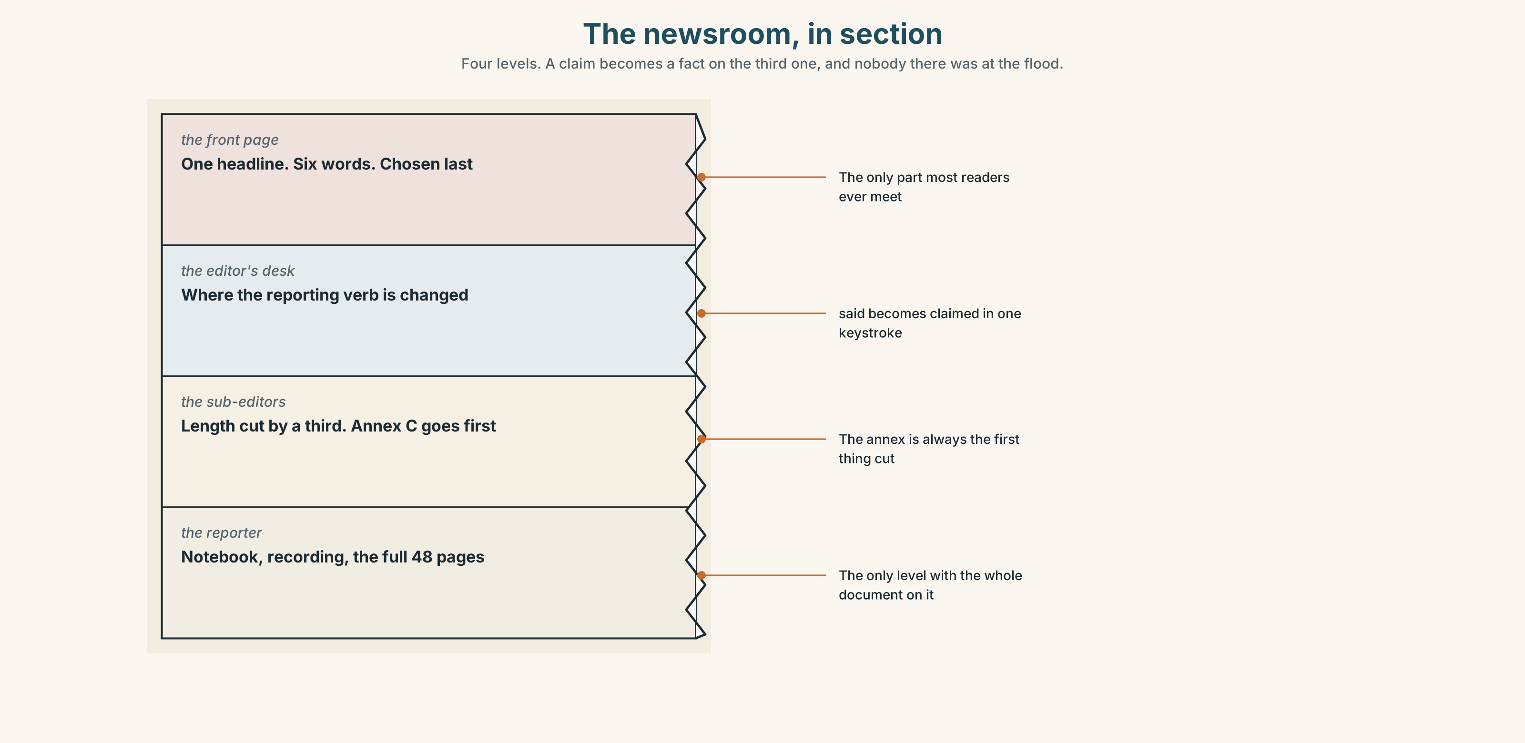{width=6.6in}
The newsroom, in section — Four levels. A claim becomes a fact on the third one, and nobody there was at the flood.
Look at the newsroom, in section. Four levels, four decisions. At which level does a claim become a fact, and who is standing there?

1D · Stretch — the phrases
Complete each one with one word.
- According ______ the inquiry, the surge peaked at 1.6 metres.
- He said it off the ______ , which means you cannot print it.
- She wrote it down word for ______ , and that is why it is useful.
- Nobody has the full ______ , and nobody ever will.
- The paper has printed a ______ and the editor has apologised.

1E · The saying
f That's what she said.
Five words that pass responsibility along. Say them twice: once as an honest report, once as a way of not being blamed. What changes?

1F · Own it
Think of something you believe that you have never checked. Tell a partner three sentences: what it is, who told you, and how you would find out.

Part 2 · Listening ◆ A · THE WORLD
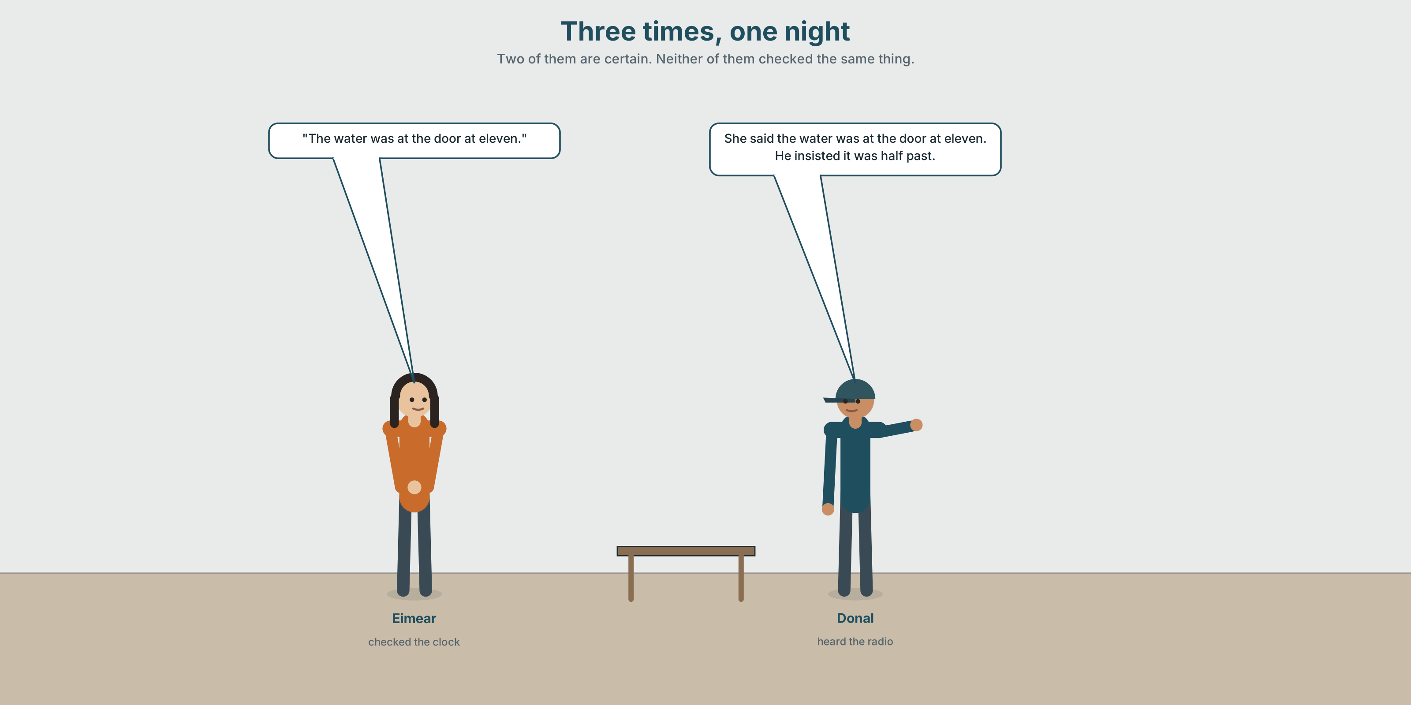{width=6.6in}
Three times, one night — Two of them are certain. Neither of them checked the same thing.

2A · Three times, one night 🔊 Track 4.1
Before you listen. Three people say when the water reached the doors. They are forty minutes apart. Guess: does any of them sound uncertain?
Listen once. One question. What three times are given?
Listen again. Complete the table.
 | Time they give | What they were doing | How sure they sound
Eimear
Donal
Sinéad
Listen again. True or false?
- All three were in different places. ☐ T ☐ F
- One of them checked a clock. ☐ T ☐ F
- One of them is reporting what somebody else said. ☐ T ☐ F
- All three are equally confident. ☐ T ☐ F
Noticing. Four sentences from the recording.
- "The water was at the door at eleven."
- She said the water was at the door at eleven.
- She said that she had checked the clock.
- He insisted it was half past.
Two are the words themselves. Two are somebody reporting them. And one of the reporting verbs is not neutral. Which?

2B · Decoding clinic 🔊 Track 4.2
Twenty-five seconds. Four jobs.
- How many reporting verbs can you hear?
- In she SAID that, which word is stressed?
- Catch the three times.
- One speaker changes a reporting verb halfway through. Which, and to what?
Transcripts, page 153.

Part 3 · Grammar Lab 1 ◆ B · THE SYSTEM

Moving somebody's words

3A · Notice
Look at the four sentences in Part 2.
- In sentence 1, what tense is was? In sentence 2?
- Sentence 3 has had checked. What did she actually say?
- said and insisted both report. What does insisted add that said does not?
- When does the tense not need to move back? Try: She said the drain is still blocked.
- Try "She said me that she had checked." What is wrong?

3B · See
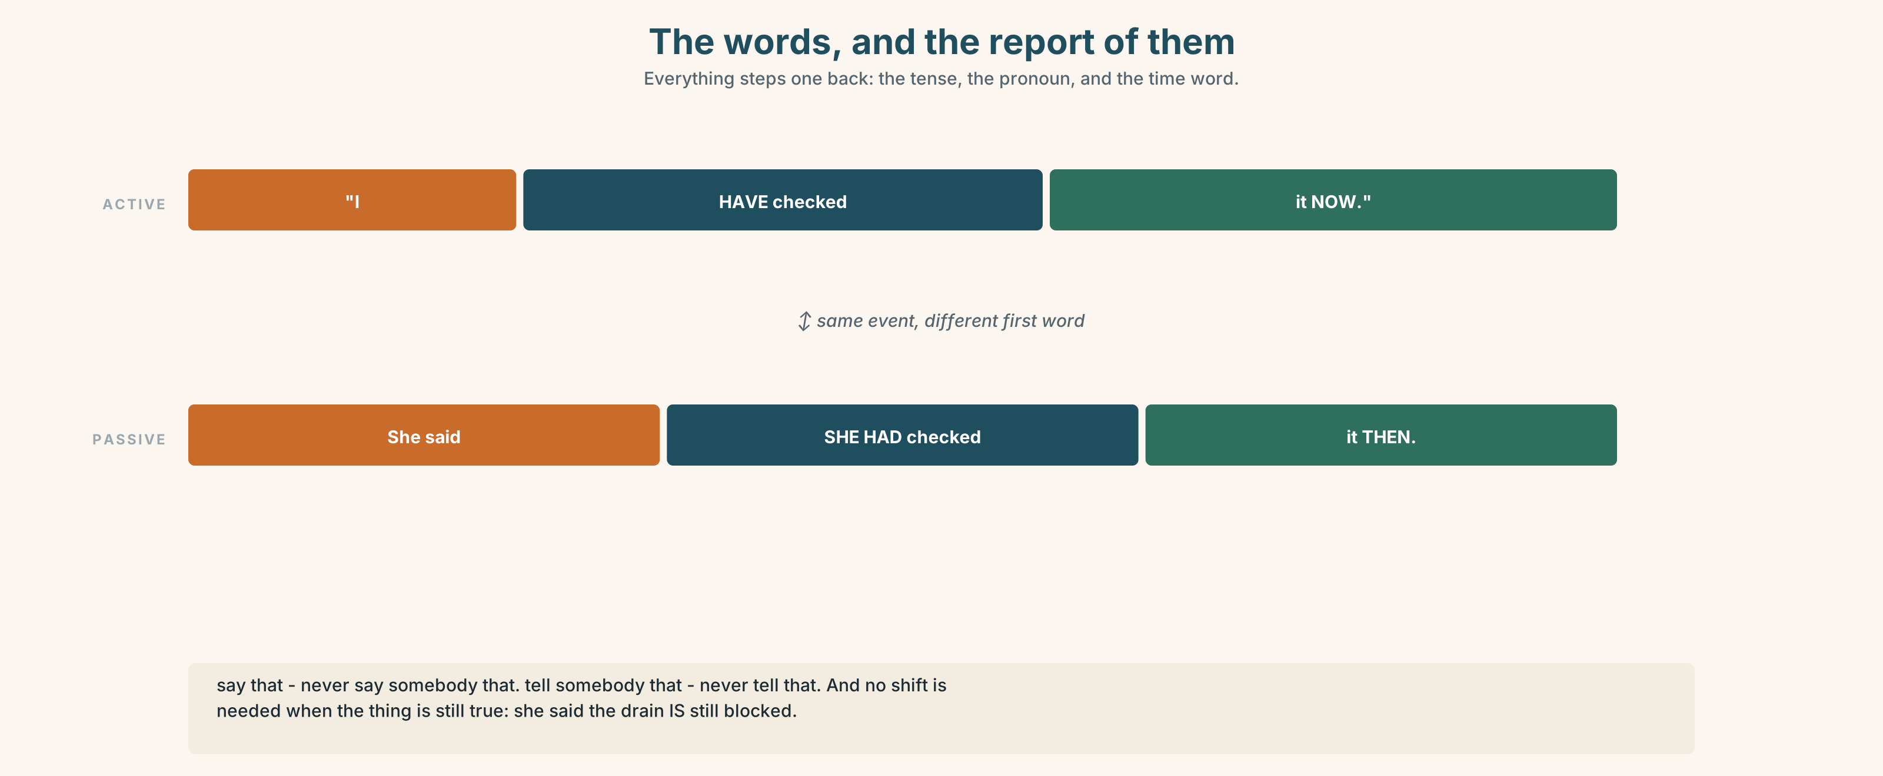{width=6.6in}
The words, and the report of them — Everything steps one back: the tense, the pronoun, and the time word.
Now look at the second picture. The ladder runs from neutral to loaded. Where would you put claimed?
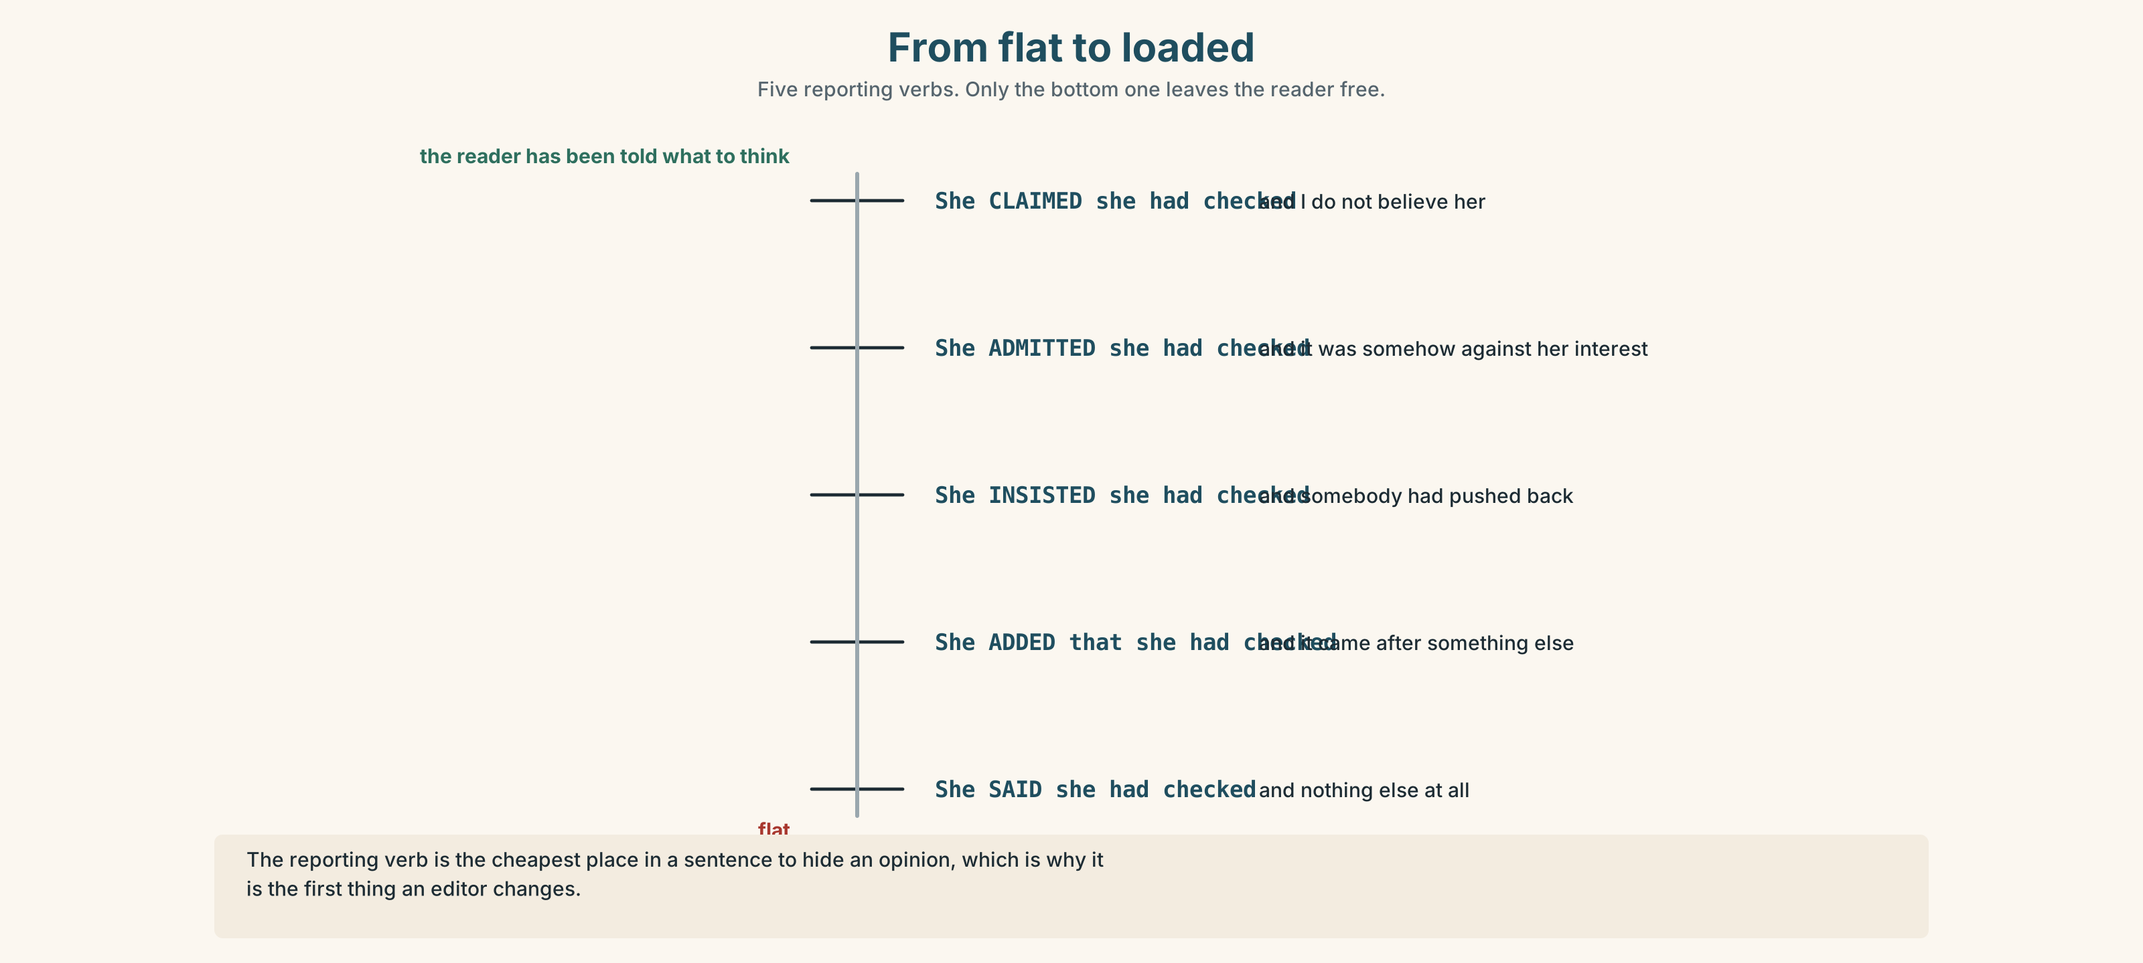{width=6.6in}
From flat to loaded — Five reporting verbs. Only the bottom one leaves the reader free.

3C · Know
Direct | Reported
"The water is at the door." | She said the water was at the door.
"I checked the clock." | She said she had checked the clock.
"I will phone you." | She said she would phone me.
"I can see it." | She said she could see it.
Everything shifts one step back, and so do I/you, here/there, now/then, today/that day.
say and tell are not the same shape. ✓ She said that she had checked. ✓ She told me that she had checked. ✗ She said me… ✗ She told that…
You do not have to shift if the thing is still true. ✓ She said the drain is still blocked. — because it is.
The reporting verb is never neutral for long. said is the flat one. insisted, claimed, admitted and revealed all add a judgement, and a reader hears it.

3D · Use — controlled
Eimear said the water (1) __________ (be) at the door at eleven and that she (2) __________ (check) the clock. Donal insisted it (3) __________ (be) half past. Sinéad told the inquiry that she (4) __________ (not look) at a clock at all and that she (5) __________ (go) by when the hall filled. The report added that the photographs (6) __________ (show) 23.30, and went on to say that it (7) __________ (adopt) that time.

3E · Use — guided
Report each one. Use a different reporting verb each time.
- "I checked the clock." — Eimear
- "It was half past, not eleven." — Donal
- "I didn't look at a clock." — Sinéad
- "We have adopted the photographic time." — the inquiry
- "I'm not going to comment on that." — the council

3F · Use — open
Interview a partner for two minutes about something they did last week. Then report three things they said to a third person, who checks your report with them.

3G · Check — six items
- "I am tired." → She said she ______ tired.
- "I checked it." → He said he ______ it.
- "I will phone." → She said she ______ phone.
- She ______ me that she had seen it. (said / told)
- "The drain is still blocked." → He said the drain ______ still blocked.
- "I didn't say that." → She ______ saying it. (use deny)
0–3 → Workbook pp. 22–24. 4–5 → Part 6. 6 → page 85.

Part 4 · Speaking ◆ C · THE PERFORMANCE

4A · Fluency starter — the relay
Three learners. A tells B something. B reports it to C. C reports it back to A. Thirty seconds each. A says what changed.
Four rounds, and after each one the group names the verb that did the damage.

4B · The functional core — relaying fairly
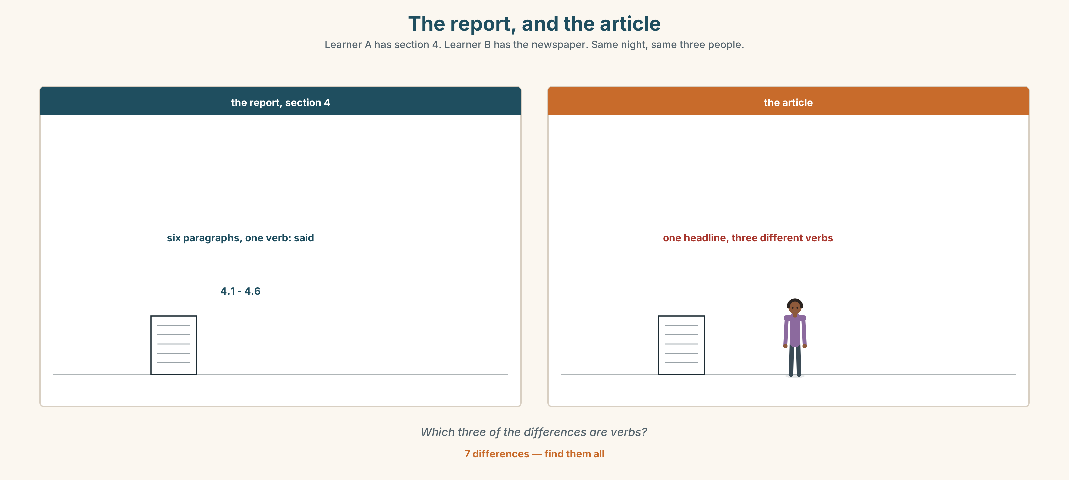{width=6.6in}
The report, and the article — Learner A has section 4. Learner B has the newspaper. Same night, same three people.
Language Bank
flat reporting | She said that… · He told me that… · According to…
marking certainty | She was sure that… · He thought, but wasn't certain, that…
marking the source | She had checked a clock. · He was going by the hall filling up.
refusing to judge | Both of them are honest about this. · I can't reconcile the two.
Role play. Learner A interviews. Learner B is a witness who is confident and wrong. Six minutes. Learner A must not say are you sure?

4C · The performance — one hundred seconds ⏺
Report three accounts of one event. One hundred seconds. You must give:
what each person said · how each one knew · where they disagree · which you would put in a report, and why
Record it.

4D · Observer
One person listens for one thing: did any reporting verb take a side?

4E · Two criteria
☐ Did I shift the tenses where I needed to? ☐ Did I report how each person knew, not just what they said?

Part 5 · Reading ◆ A · THE WORLD

5A · Predict
An extract from the inquiry's report. The title is "Section 4: reconciling the accounts." What do you expect an official report to do with three different times? One sentence.

5B · Read — one hundred and ten seconds

SECTION 4: RECONCILING THE ACCOUNTS
4.1 Three residents gave times for the first water at door level. The times differ by forty minutes. All three accounts are accepted as honest.
4.2 Resident A stated that the water was at her door at eleven. She told the inquiry that she had checked the kitchen clock. The inquiry notes that this clock was later found to be eleven minutes fast.
4.3 Resident B insisted that it was half past eleven. He said that he had not looked at a clock but that he had been listening to a radio programme which he knew ended at half past. The programme in fact ended at 23.15.
4.4 Resident C said that she had not checked the time at all and went by the point at which the hall was full. Hall records show the hall reached capacity at 23.25.
4.5 Photographic metadata gives 23.30. The inquiry has adopted this time.
4.6 The inquiry wishes to record that it does not regard any of the three accounts as unreliable. Each witness used the best instrument available to them, and in each case the instrument was wrong by between five and twenty minutes. This is normal. An account that matched the metadata exactly would be more unusual than these three, and would deserve more scrutiny, not less.

5C · Answer
- How far apart are the three times?
- What was wrong with Resident A's clock, and by how much?
- How did Resident B know the time, and what was the error there?
- What did Resident C use instead of a clock?
- What time has the inquiry adopted, and from what source?
- What is the point of paragraph 4.6? Put it in your own words.

5D · Vocabulary in context
Guess from the text. Then check.
reconciling · capacity · metadata · the best instrument available · deserve more scrutiny

5E · The counter-text
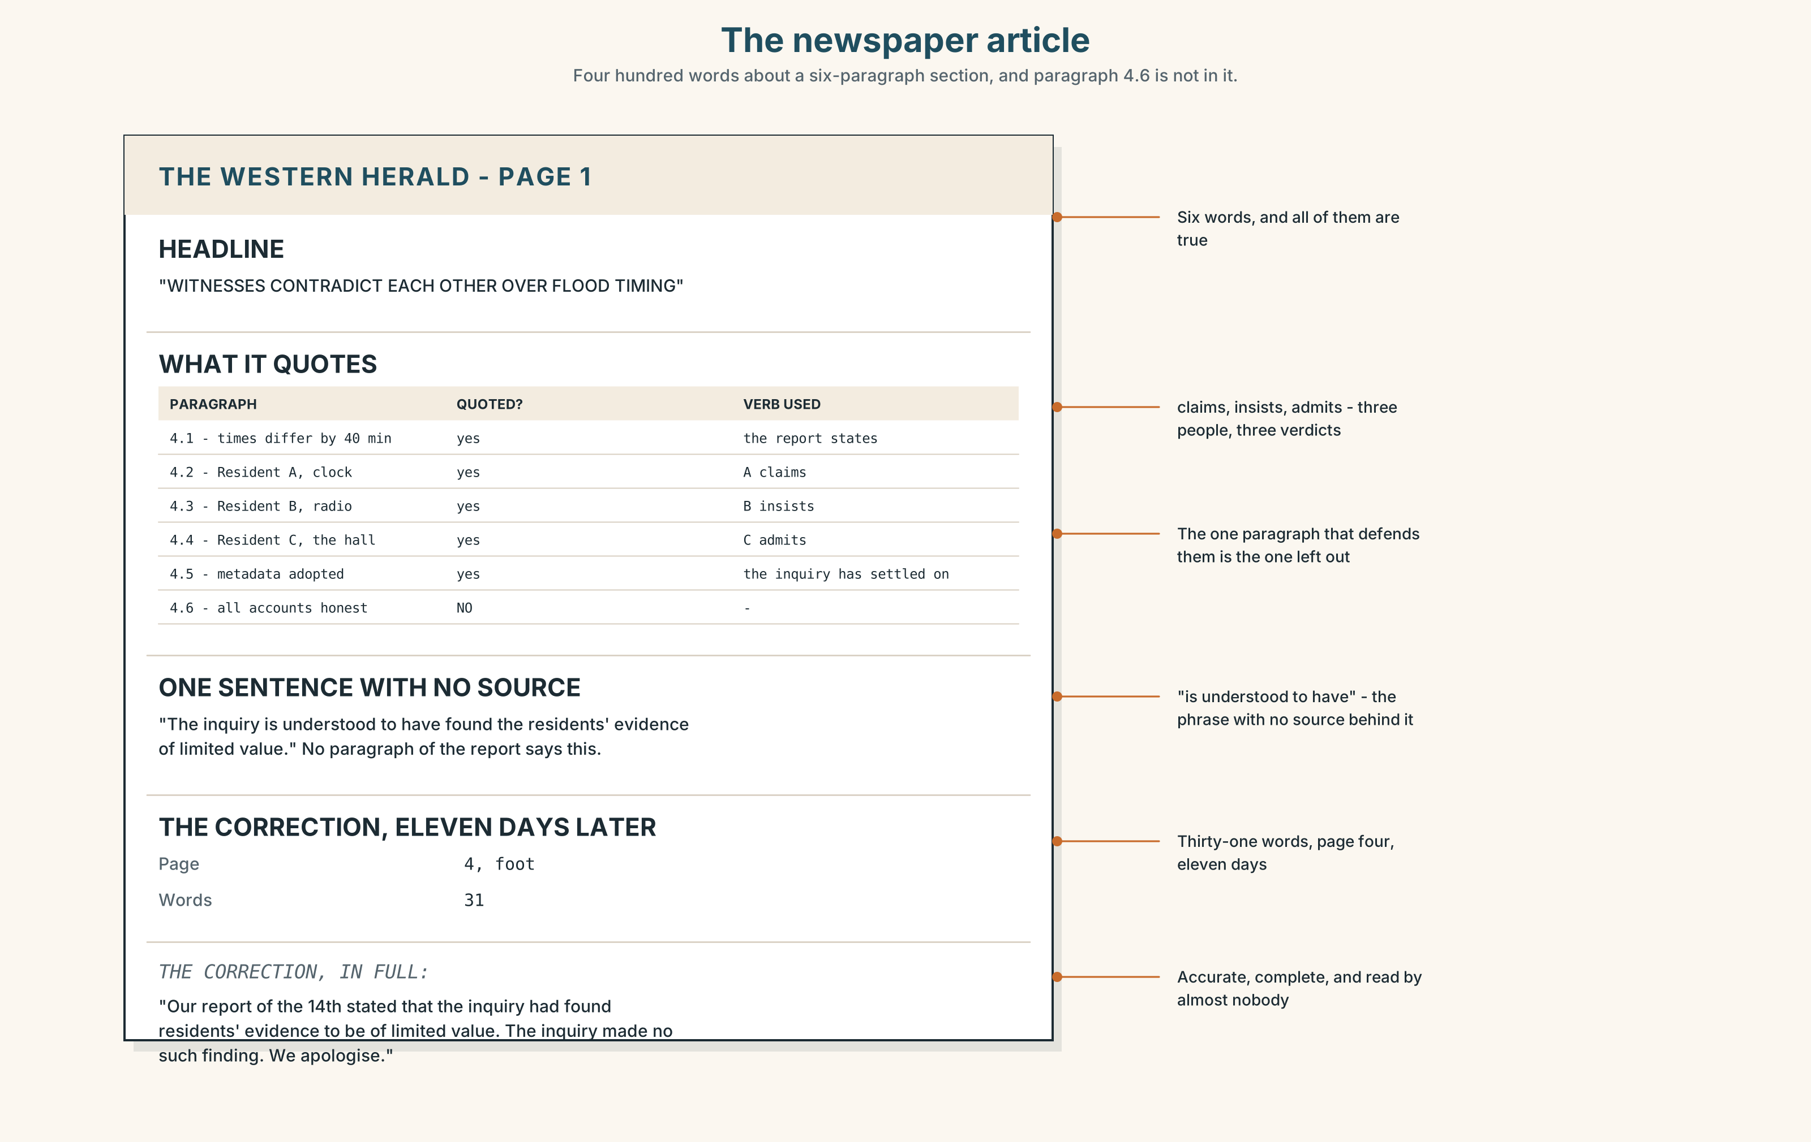{width=6.6in}
The newspaper article — Four hundred words about a six-paragraph section, and paragraph 4.6 is not in it.
Read the newspaper article about the same section and answer.
- What is the headline, and what does it imply?
- Which paragraph of the report is quoted, and which is left out?
- Which reporting verb does the article use for each resident?
- One sentence attributes a view to "the inquiry" that the report does not contain. Find it.

5F · Two texts
The report says all three accounts are accepted as honest. The article's headline says "Witnesses contradict each other."
Put those two facts together. Is the headline false? Two sentences.

Part 6 · Vocabulary Lab 2 ◆ B · THE SYSTEM

Verbs that report, and what they smuggle in
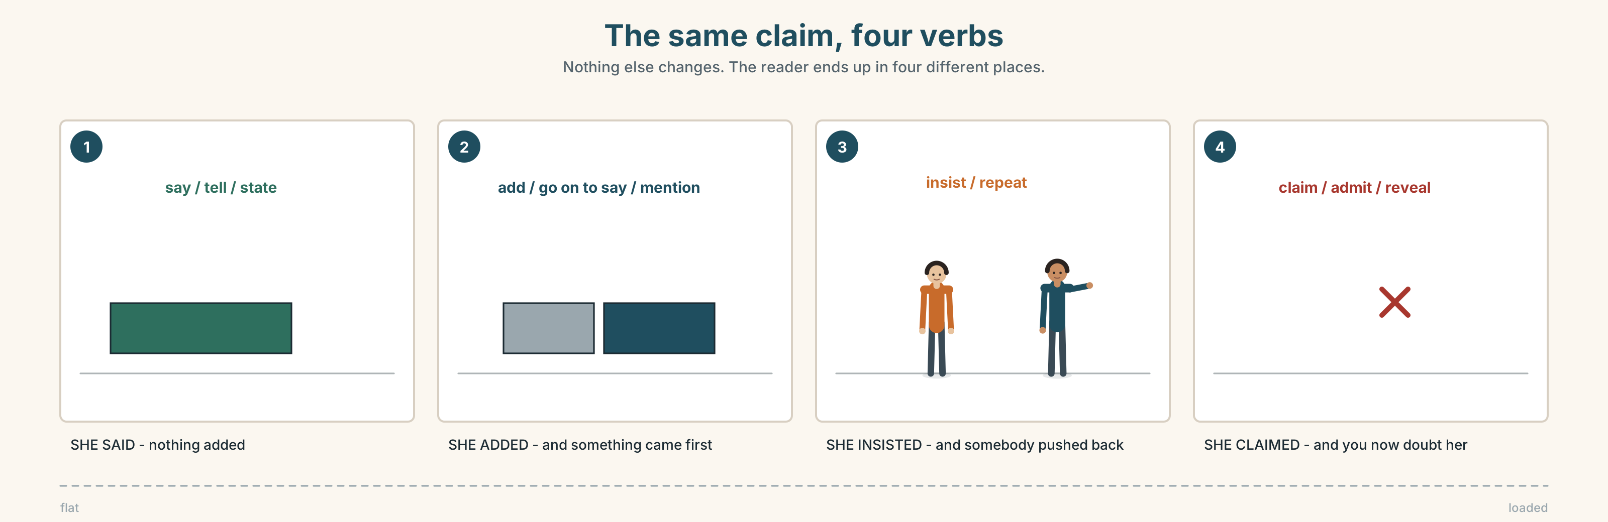{width=6.6in}
The same claim, four verbs — Nothing else changes. The reader ends up in four different places.

6A · Sort — neutral, or loaded?
Two columns.
say · tell · state · add · mention · repeat · insist · admit · reveal · reply · announce
One of them is neutral in a report and loaded in a newspaper. Which?

6B · Chunk completion
- She told me ______ she had checked it.
- He said ______ he had not looked at a clock.
- The inquiry went on ______ say that it had adopted the metadata.
- The council refused to ______ .
- He pointed ______ that the programme ended at 23.15.
- She said it was about eleven, or words to that ______ .

6C · Three that change the reader's mind
admitted · revealed · claimed
Each one tells the reader what to think before they have read the content.
Rewrite each of these three with a neutral verb, and say what is lost — and what is gained.
- She admitted that she had checked a clock.
- He revealed that the programme ended at 23.15.
- She claimed that the hall was full by then.
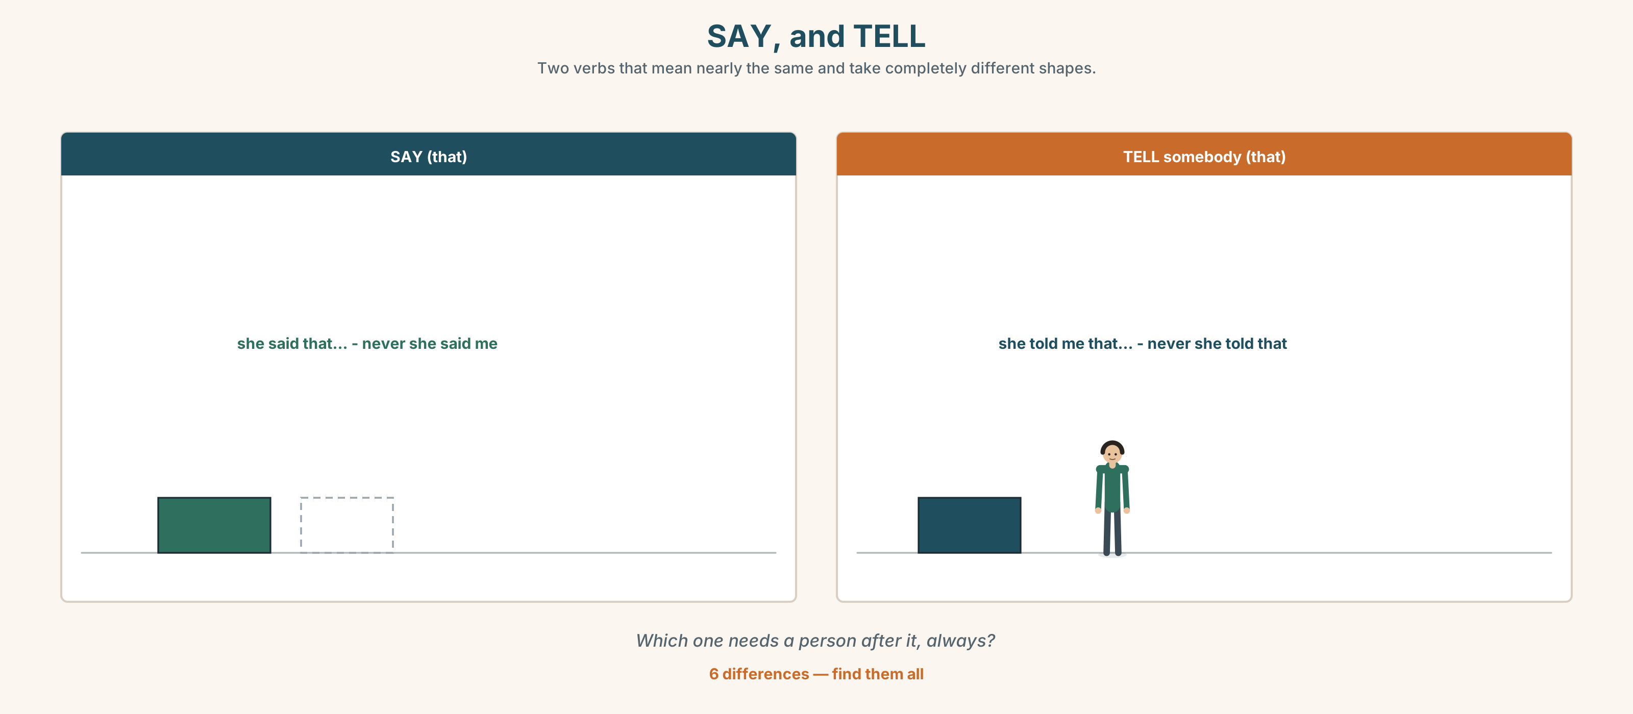{width=6.6in}
SAY, and TELL — Two verbs that mean nearly the same and take completely different shapes.
Six differences. Find them, then answer the question under the picture.

6D · Contrast Clinic — report it
Six items. Report each one, shifting what needs to shift.
- "I am at the door."
- "I checked it twice."
- "I will send it tomorrow."
- "I can't remember."
- "The drain is still blocked." (and it is)
- "I didn't say that."

Part 7 · Pronunciation & Fluency Lab ◆ B · THE SYSTEM

Where the stress goes when you report
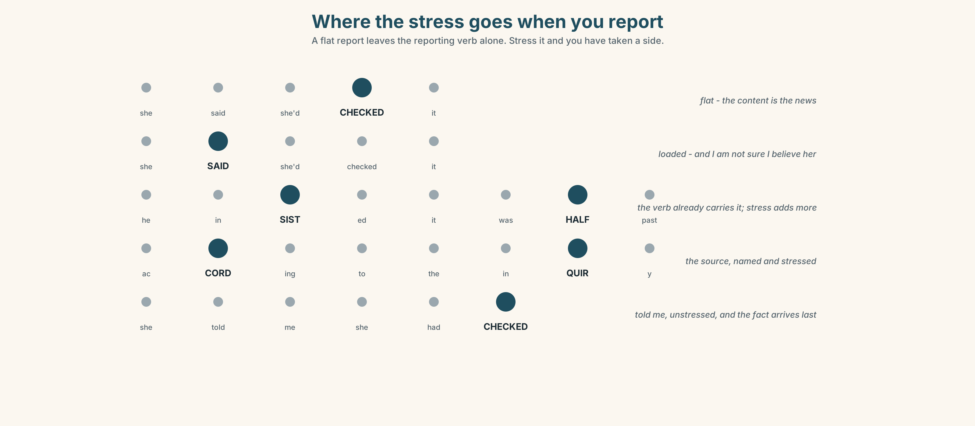{width=6.6in}
Where the stress goes when you report — A flat report leaves the reporting verb alone. Stress it and you have taken a side.

7A · Hear 🔊 Track 4.3
She said she'd checked it. — flat: this is just a report She SAID she'd checked it. — loaded: and I am not sure I believe her She said she'd CHECKED it. — the content is the news

7B · Say
Say all three. Then say this one with the stress in three different places:
He insisted it was half past.

7C · Make it mean something
Say these two:
He SAID it was half past. (and we now know it was not) He said it was HALF PAST. (and that is the fact I am passing on)
Which one would you use in a report, and which in a conversation afterwards?

7D · Fluency 20 ⏺
Twenty seconds: three things somebody told you this week, reported flatly. Three times, faster, with no stress on the reporting verb.

Part 8 · Writing ◆ C · THE PERFORMANCE

Three accounts · 100 words
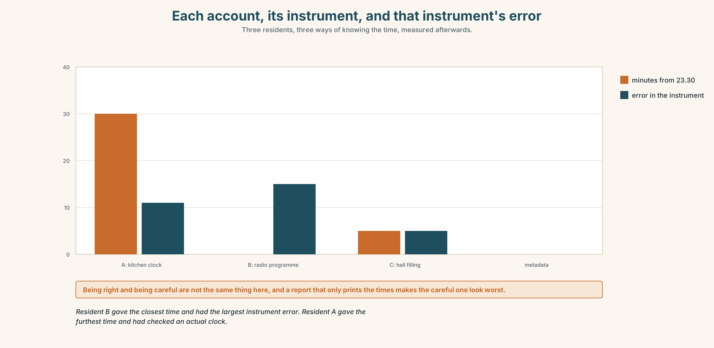{width=6.6in}
Each account, its instrument, and that instrument's error — Three residents, three ways of knowing the time, measured afterwards.

8A · Read the model
Three residents gave times for the first water. They differ by forty minutes. [the disagreement is stated first, flatly, before any of the accounts]
Resident A said she had checked her kitchen clock. Resident B said he had been listening to a programme he knew ended at half past. Resident C said she had gone by the hall filling up. [three identical reporting verbs, and the difference is in how each one knew]
The clock was eleven minutes fast, the programme ended at 23.15, and the hall filled at 23.25. All three were using the best instrument they had. [the corrections, and then a sentence that refuses to make any of them the liar]
Questions about the writer's choices:
- The same verb, said, three times. Is that poor writing?
- The last sentence is a judgement. Is it the right kind?

8B · The anti-model
There is a lot of confusion about what time the water arrived. One resident claims it was eleven, while another insists it was half past. A third admits she did not check. The truth is hard to establish.
Correct English, and three people have been quietly convicted. Find the three verbs that do it, and say what each one implies.

8C · Plan
the disagreement, in one line → each account, with the same verb → how each one knew → the corrections → one sentence that does not pick a liar

8D · Write — 100 words

8E · Peer review — two criteria
☐ Is every reporting verb carrying the same weight? ☐ Does the reader learn how each person knew?

8F · Write it again · 8G · Publish
On the wall, with the newspaper article from Part 5E beside it.

Part 9 · The File ◆ A · THE WORLD + C · THE PERFORMANCE

WORK FILE · The Safety Brief
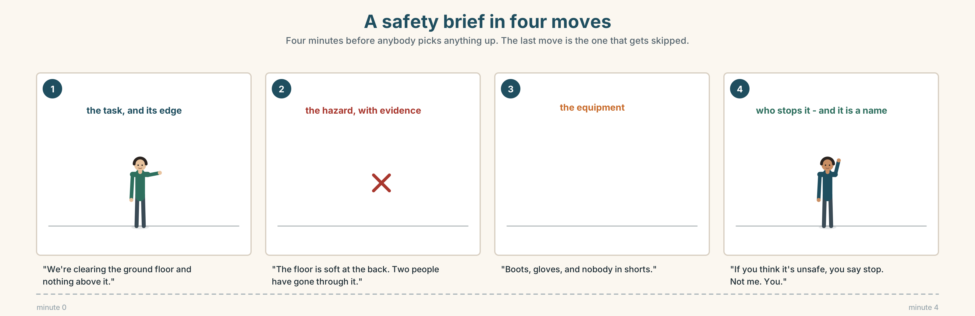{width=6.6in}
A safety brief in four moves — Four minutes before anybody picks anything up. The last move is the one that gets skipped.

9A · Four minutes before anybody moves 🔊 Track 4.4
Volunteers are about to clear a flooded building. Listen to the brief.
- What are the three hazards named?
- What is the one instruction that is not about equipment?
- Who is named as the person to stop the work, and why is a name given?

9B · The shape of a brief
what we are doing · what will hurt you · what to wear · who stops the work
Match each to one phrase.
"We're clearing the ground floor and nothing above it." · "The floor is soft at the back. Two people have gone through it." · "Boots, gloves, and nobody in shorts." · "If you think it's unsafe, you say stop. Not me. You."

9C · Reporting it to somebody who missed it
A volunteer arrives twenty minutes late. Report the brief to them in four sentences, using reported speech. You must not leave out the hazard.

9D · Your turn
In pairs. One of you gives a four-point brief for any task. The other arrives late and is briefed second-hand by a third person. Then check: what was lost?

9E · Transfer
Find one set of safety instructions this week — a label, a sign, a leaflet. Report it to somebody in three sentences. Bring both.

Part 10 · Mediation & Interaction ◆ C · THE PERFORMANCE
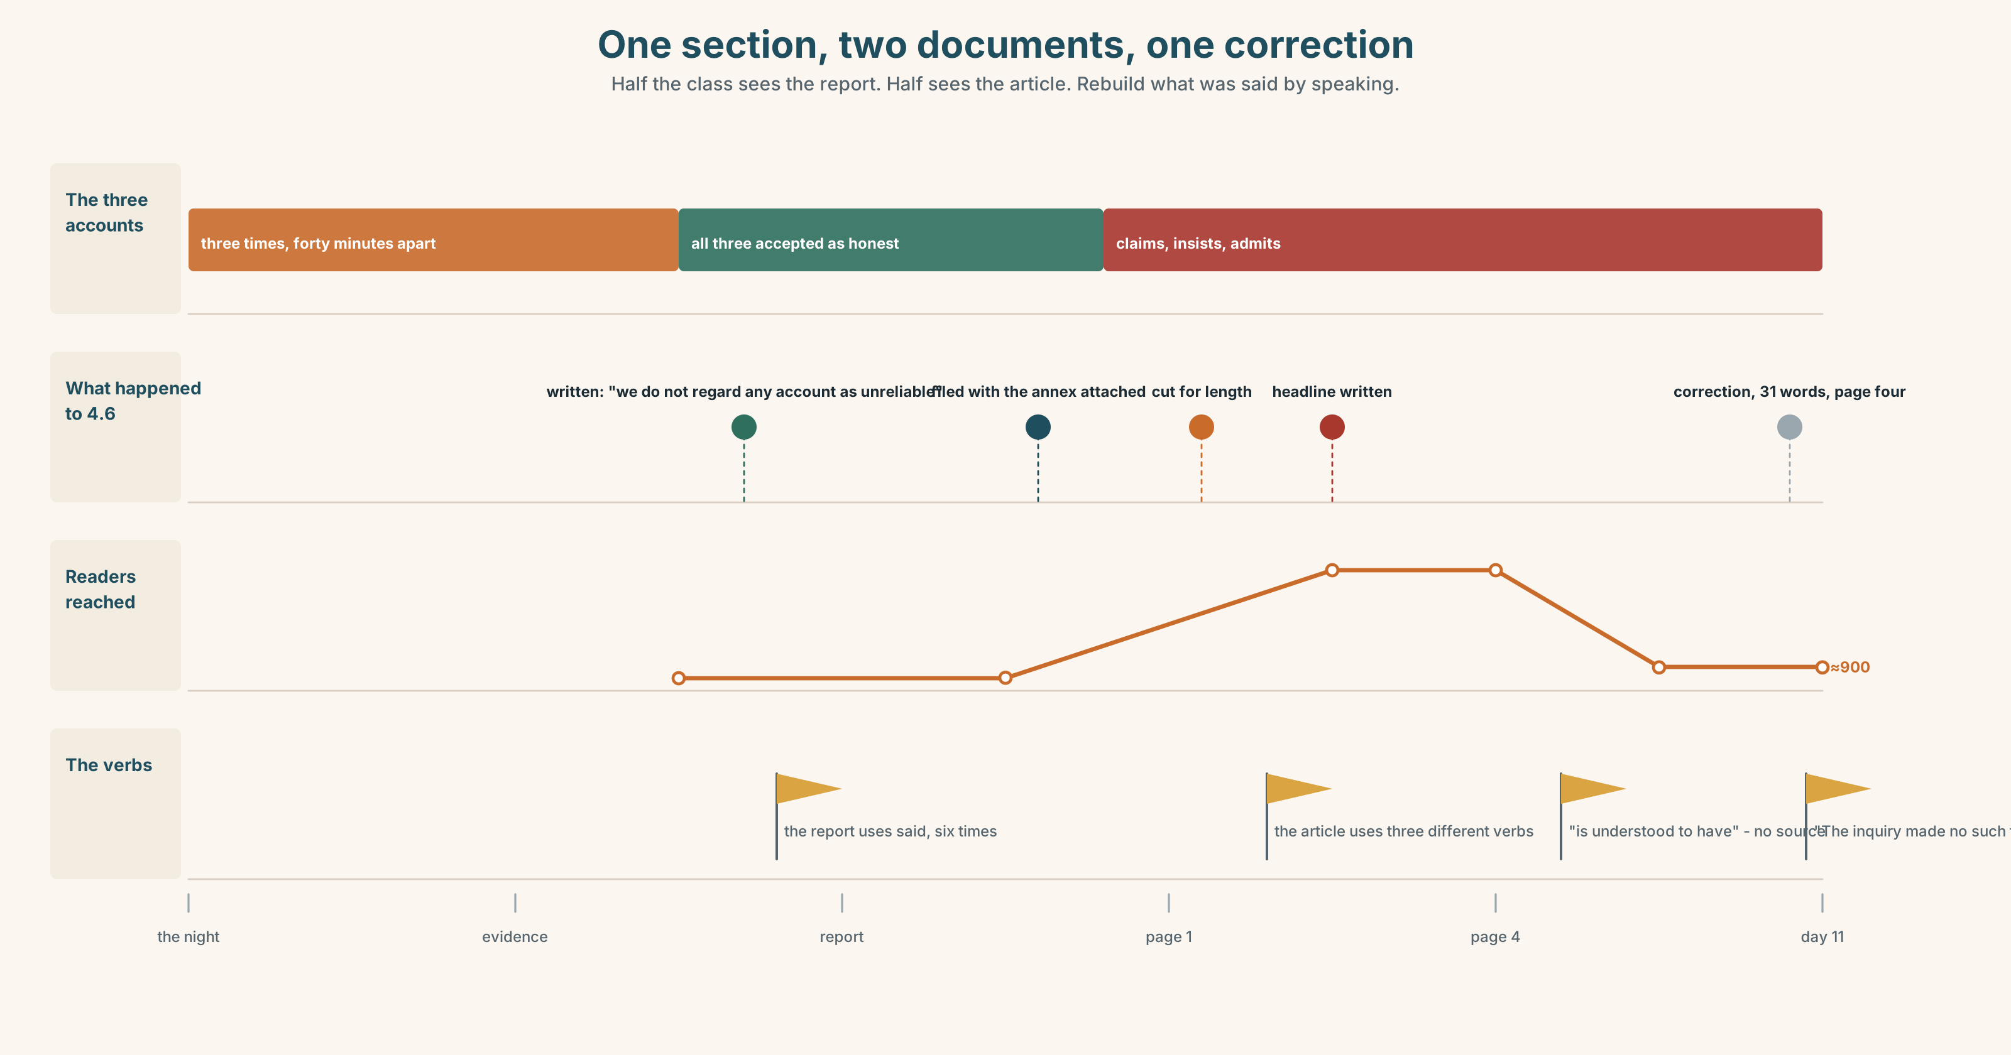{width=6.6in}
One section, two documents, one correction — Half the class sees the report. Half sees the article. Rebuild what was said by speaking.

10A · Relay
Half the class sees the report section. Half sees the newspaper article. Rebuild what was actually said by speaking. Ten minutes.

10B · Simplify
Explain the newspaper article from Part 5E to the three residents it is about. Four sentences only.
Plan: what it says → what the report says → what it left out → what you would ask for

10C · Compress
Section 4 of the report into thirty-five words, without taking a side.

10D · Online
Write one message to the newspaper: you are one of the three, the headline is misleading, and you are asking for one specific thing.

10E · Your language
How does your language report speech? Do the tenses shift back, or do you keep the original words? Report "I checked the clock" in both languages and compare.

Part 11 · The Decision ◆ C · THE PERFORMANCE

One time goes in the report
Three accounts, forty minutes apart, all honest. The report can carry one time in its summary.
- 23.30, the metadata. The most accurate instrument. It is also the only one with no person behind it.
- A range: 23.00 to 23.40. Honest about the uncertainty. Harder to use, and a range in a summary tends to be read as its lowest number.
- All three, named, with their instruments. Six lines instead of one. Nobody is wrong, and nobody can quote it.

11A · The evidence
- The newspaper article from Part 5E — and what it quoted.
- The chart — each account, its instrument, and that instrument's error.
- The voice. The inquiry chair, twenty seconds: "A summary that cannot be quoted is not a summary. But a time that nobody in that town recognises is not a finding either, and I have written both and I do not like either of them."

11B · Talk about it
In threes. Everybody says one. Use the frame.
I think the report should give ______ , because ______ .
Words you can use: accurate · exact · account · version · source · evidence · trust · doubt

11C · Decide
Write two sentences. Choose, and say why.
I think the report should ______________________ , because ______________________ .

11D · Model decision
It should give 23.30 in the summary and all three accounts in an annex, with the instruments and their errors. The summary has to be quotable or it will be replaced by whatever the newspaper writes instead, and the annex is where the town can find itself and see that it was not called unreliable. One number, and one page that explains why that number is not an accusation.

11E · The Reveal
What happened. The report gave 23.30 in the summary and the three accounts in Annex C.
Every newspaper used 23.30. Two of them also used Annex C, and one of those ran a long piece about the eleven-minute clock that Resident A says was the kindest thing written about her all year.
The third newspaper ran the headline about witnesses contradicting each other. It printed a correction eleven days later, at the foot of page four, which Resident B says he did not see and still has not read.
One number, quoted everywhere. One annex, read by two. And one correction nobody saw.
Was it the right decision? Say why — and say what a correction is for.

Part 12 · Landing ◆ all three lines

12A · Recycle — ten items
- "I am tired." → She said she ______ tired.
- She ______ me that she had checked it. (said / told)
- According ______ the inquiry, the surge was 1.6 m.
- He said it off the ______ .
- The editor has printed a ______ .
- (Unit 3) By the time we arrived, it ______ (already / start).
- (Unit 3) He moved it because the forecast ______ (change).
- (Unit 2) We ______ (wait) since June.
- (Unit 1) If I ______ you, I wouldn't wait.
- (A2.1 U7) The hall ______ (build) in 1961.

12B · Consolidate
One hundred words. Three people's accounts of one event. The same reporting verb for all three, how each one knew, and one sentence that does not pick a liar.

12C · Can-do, with evidence
I can… | My evidence | Sure?
move somebody's words into a report | Part 3G score | ◯ ◑ ●
relay three accounts fairly in a hundred seconds | Part 4C recording | ◯ ◑ ●
write a hundred words that judge nobody | Part 8 draft 2 | ◯ ◑ ●
pass on a safety brief without losing the hazard | Part 9D pair work | ◯ ◑ ●

12D · Replay ⏺
Find your thirty seconds from Part 0C. Listen. Record it again. One sentence: what is different?

12E · Glossary — forty items, as a map
THE CLAIM · claim · statement · account · version · quote · word for word · the full story THE SOURCE · source · footage · journalist · editor · press · according to · off the record THE TEST · accurate · exact · trust · doubt · confirm · deny · correction · stand by THE FLAT VERBS · say · say that · tell · tell somebody that · state · add · mention · repeat · reply THE LOADED ONES · insist · admit · reveal · announce · claim MOVING ON · go on to say · point out · refuse to comment · or words to that effect · that's what she said

12F · Next
Unit 5 · Who asked the right question?

