Table of Contents

B2.1 · Unit 2 · We Have Always Said
English Animated · Reading Between Lines · a newsroom, Toronto Student's Book pages 28–49 · 22 pp · ~11 hours

Part 0 · The Big Picture ◆ A · THE WORLD
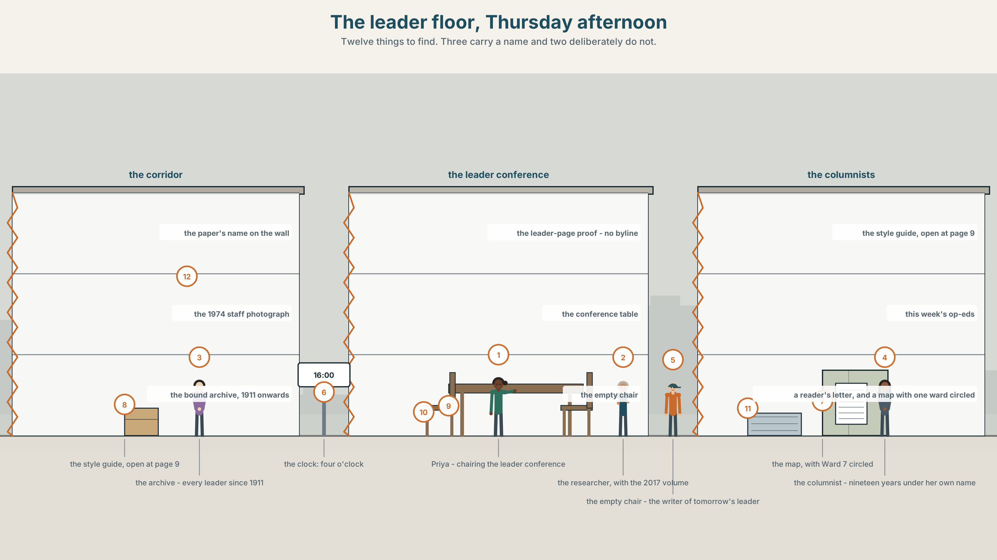{width=6.6in}
The leader floor, Thursday afternoon — Twelve things to find. Three carry a name and two deliberately do not.

Who is "we"?
By the end of this unit you can place yourself in a text deliberately, and say who you are claiming to speak for. Two hundred words.
◆ A · THE WORLD | An unsigned editorial that says we have always said, and an archive that disagrees
◆ B · THE SYSTEM | the perfect across every tense, as a discourse move · 28 words for voice and readership · 22 words for inclusive and exclusive reference · stress on a pronoun
◆ C · THE PERFORMANCE | Two hundred words in which the reader always knows who is speaking

0A · Find it
Find twelve things in this picture. Three of them carry somebody's name and two deliberately do not.
the paper's name on the wall · a leader-page proof with no byline · a photograph of the 1974 staff · a bound archive volume · a columnist's framed first piece · a screen showing a reader comment · an empty chair at the leader conference · a style guide open at page 9 · a list of this week's op-eds · a letter from a reader · a map of the city with one ward circled · a clock

0B · Guess it
One thing in this picture is the reason another one is unsigned. Which two, and in which direction does the causation run?

0C · Say it ⏺
Record sixty seconds. Describe an opinion you hold that a group you belong to also holds. Say which parts are yours and which parts you inherited. You will record it again at the end of this unit.

Part 1 · Vocabulary Lab 1 ◆ B · THE SYSTEM
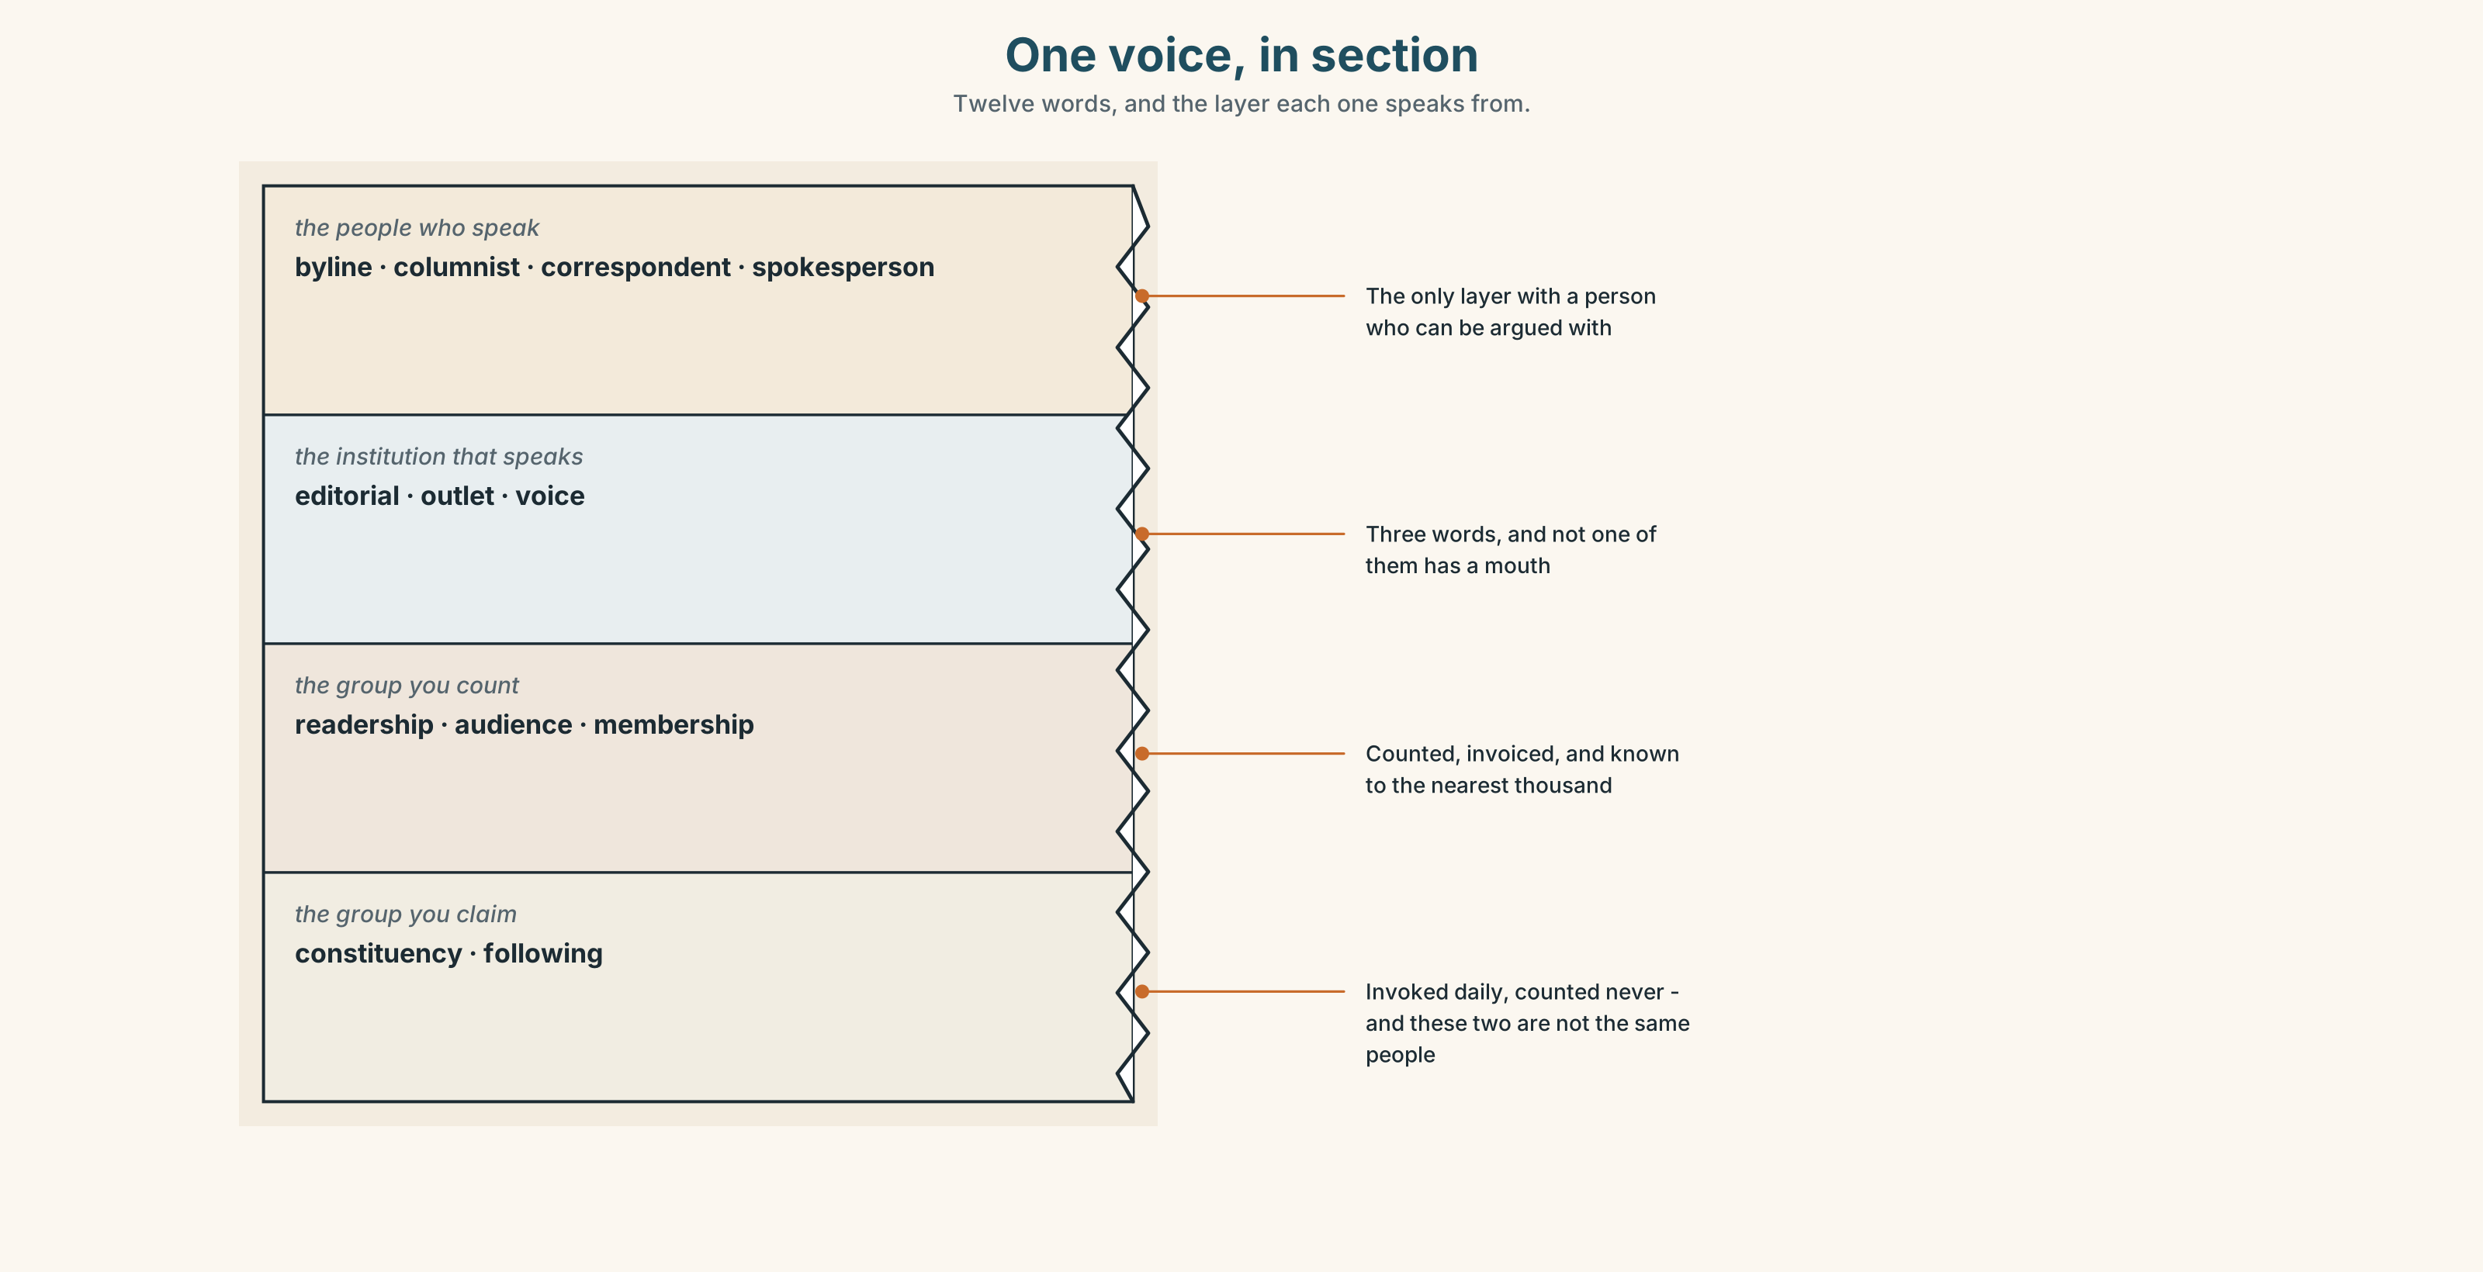{width=6.6in}
One voice, in section — Twelve words, and the layer each one speaks from.

1A · Meet — the words of a voice
Match each word to one layer of the cutaway.
byline · spokesperson · readership · constituency · columnist · editorial · outlet · audience · membership · following · correspondent · voice

1B · Sort — a person, an institution, or a group you are claiming?
Three columns. Two of the ten belong in two columns and that is the point of the unit.
editorial · outlet · membership · voice · columnist · constituency · audience · spokesperson · readership · correspondent

1C · Meet — the phrases that claim a mandate
speak for | A claim about authority that is almost never examined.
on behalf of | The same claim, in the passive voice of institutions.
our readers | A set nobody has counted, invoked to settle arguments.
the paper's view | A view with no person in it.
the community affected | The group most often written about and least often quoted.

1D · Collocation Lab
Complete each one, and say which of the five is the only one that could be checked.
a named writer · an unsigned piece · local to the story · an outsider's account · whose paper is it
- The leader page carries ______ ______ ______ every day and has done since 1911.
- A reporter flown in for three days files ______ ______ ______ , whatever the quality.
- The stringer is ______ ______ ______ ______ and was not asked to write it.
- Readers can argue with ______ ______ ______ ; nobody can argue with an institution.
- The question under all of this is ______ ______ ______ ______ .

1E · The phrasal verbs, and the three fixed expressions
speak up · stand in · write up
f we have always said · f this paper believes · f who is the we here?
Two of these fixed expressions assert and one interrogates. Which, and what does the third one do to the other two?

1F · Own it
Write one sentence beginning We have always… about a group you belong to, and then write down the earliest date on which you can prove it.

Part 2 · Listening ◆ A · THE WORLD
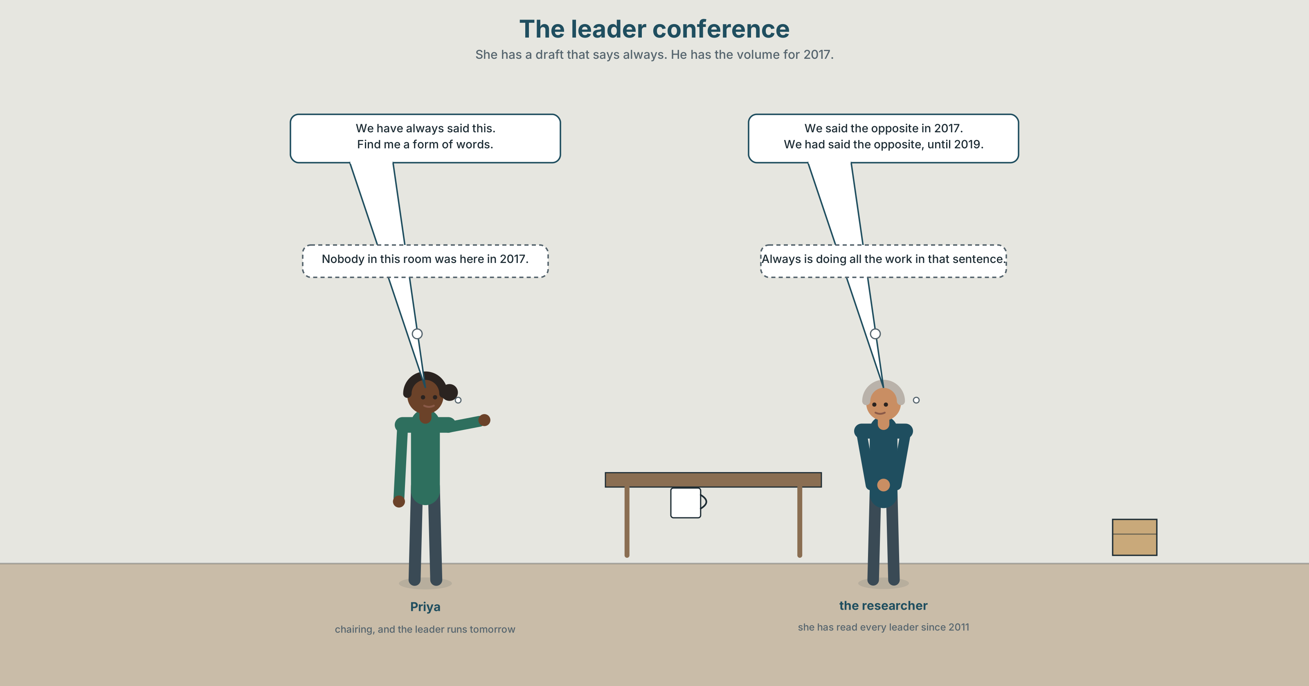{width=6.6in}
The leader conference — She has a draft that says always. He has the volume for 2017.

2A · The leader conference 🔊 Track 2.1
Before you listen. Tomorrow's editorial begins We have always said. A researcher has been through the archive.
Listen once. What did the paper actually say in 2017, and what is being claimed now?
Listen again. Complete the table.
 | The claim | The archive | Who the we includes
2017
2021
today
Listen again. True or false?
- The paper took the same position in 2017 as it takes now. ☐ T ☐ F
- The editorial will carry a byline. ☐ T ☐ F
- Nobody in the room was at the paper in 2017. ☐ T ☐ F
- The researcher is asked to find a form of words. ☐ T ☐ F
Noticing. Four sentences from the recording.
- We have always said this.
- We said this in 2017.
- We had said the opposite, until 2019.
- By next year we will have said it for a decade.
All four are perfects or simples about the same institution. Which one makes a claim about continuity, and which one makes a claim about a point?

2B · Decoding clinic 🔊 Track 2.2
Thirty seconds at speed. Three jobs.
- The editor says we eleven times and stresses it twice. Write the two stressed instances.
- What changes when we is stressed?
- One speaker uses one where another would use we. What does that do to the claim?

Part 3 · Grammar Lab 1 ◆ B · THE SYSTEM

The perfect is a move, not a tense

3A · Notice
Look at the four sentences in Part 2 again.
- Which sentence closes the event at a point in the past?
- Which one connects a past event to the present moment, and why is that useful here?
- What does the past perfect in sentence 3 do to the reader's timeline?
- What does the future perfect in sentence 4 allow the writer to assert?

3B · See
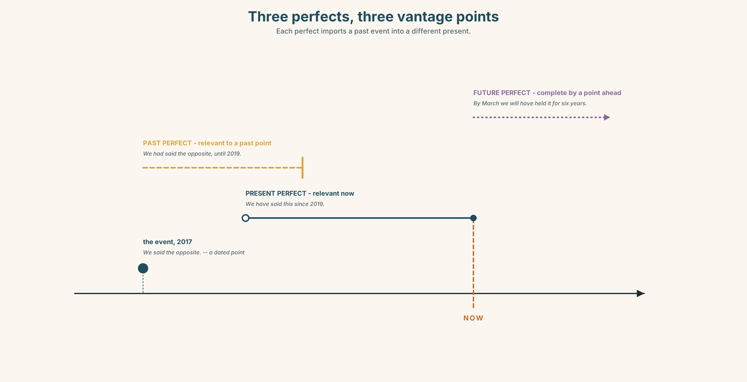{width=6.6in}
Three perfects, three vantage points — Each perfect imports a past event into a different present.

3C · Know
present perfect | the event is relevant now | We have always said this.
past perfect | the event is relevant to a past point | We had said the opposite, until 2019.
future perfect | the event is complete by a future point | By next year we will have said it for a decade.
the discourse function | the perfect imports a past event into the present argument | and that is why institutions like it
The perfect hides the date. We have always said contains no year. The simple past requires one, which is why an archive is dangerous to a paper that prefers the perfect.
Inclusive and exclusive we. English does not mark the difference and most languages that do mark it find English maddening here: we have always said can mean the institution, the editorial board, the staff, or the staff and the readers together, and the sentence does not say which.
institutional | this paper believes · the paper's view
impersonal | one might say · it is widely held · the general view
personal | speaking personally · the present writer · as a reader
generic | we all know — the most expansive and least checkable
Why it matters. Every piece of persuasive writing places the writer somewhere relative to the reader, and the placement is done almost entirely by pronouns and perfects.

3D · Use — controlled
Complete with the most defensible form.
The paper (1) ______ (say) this since 2019, and we (2) ______ (say) the opposite before that. By March we (3) ______ (hold) the position for six years. At the time of the 2017 piece the board (4) ______ (not yet discuss) it. One (5) ______ (might say) that nothing has changed, but the archive disagrees.

3E · Use — guided
Rewrite each one so that the claim is about continuity rather than a point, or the reverse.
- We took this position in 2019.
- We have always opposed the plan.
- The paper had supported it until the inquiry.
- We will hold this view for a decade by next spring.
- The board decided in March.

3F · Use — open
In pairs. One of you writes an editorial sentence using we. The other asks, four times, who is the we here? Each answer must narrow the set.

3G · Error autopsy
✗ We have said this in 2017. ✗ The paper has been believing this since 1911. ✗ By the time we published, we have already corrected it.
For each, name the rule and say what the writer was reaching for.

3H · Check — eight items
- We ______ (say) this since 2019. (continuity to now)
- We ______ (say) the opposite in 2017. (a point, dated)
- The board ______ (not discuss) it before the piece ran. (earlier than a past point)
- By March we ______ (hold) it for six years. (complete by a future point)
- ✗ We have said this in 2017. → correct it.
- ✗ The paper has been believing this since 1911. → correct it.
- Rewrite We have always said this so that it can be checked.
- Rewrite This paper believes so that a named person is responsible.

Part 4 · Speaking ◆ C · THE PERFORMANCE

4A · Fluency starter — narrow the we
One person makes a claim with we. Everybody else asks who is the we here? until the speaker names a number of people. Nobody may answer with another pronoun.

4B · The functional core — positioning yourself in a text
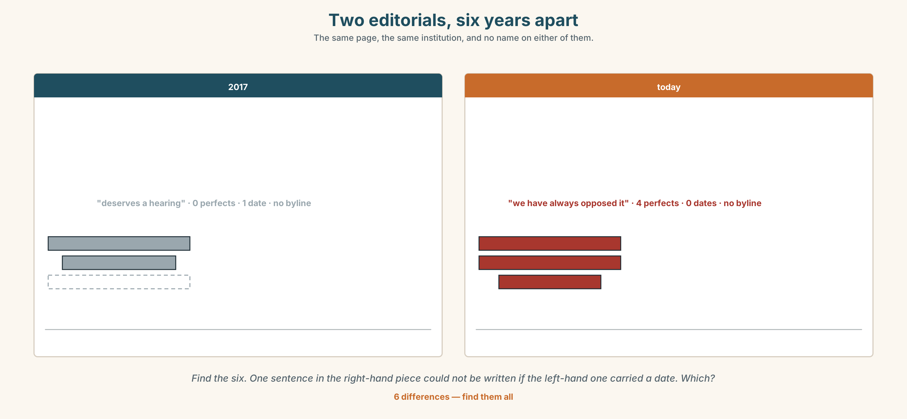{width=6.6in}
Two editorials, six years apart — The same page, the same institution, and no name on either of them.
Language Bank
the institution | this paper believes · the paper's view · on behalf of
the hedge | it is widely held · the general view · one might say
the person | speaking personally · the present writer · as a reader
the challenge | who is the we here? · speak for
Information gap. Learner A has the 2017 editorial. Learner B has today's draft. Agree on a sentence that both archives can live with.

4C · The performance — three minutes ⏺
Argue a position you hold, in three minutes, changing your position in the text three times: once as an institution, once impersonally, and once as yourself. Your partner names each shift as it happens.
Record it.

4D · Observer
One person marks every we and writes, beside each, the number of people it includes.

4E · Three criteria
☐ Did I make all three positions, and were they audible? ☐ Did every perfect carry a claim about relevance now, not just about the past? ☐ Could my partner name the set behind each we?

Part 5 · Reading ◆ A · THE WORLD

5A · Predict
The title is "The ward that is always in the paper." Who do you expect to be quoted in a story about a neighbourhood, and who usually is?

5B · Read — two minutes

The ward that is always in the paper
Ward 7 has appeared in the Herald eighty-one times in two years. The paper has a bureau four kilometres away and has never had a correspondent who lives there.
Of the eighty-one pieces, sixty-two quote a police source, forty-one quote a city councillor, and nine quote somebody who lives in the ward and is not an official. Two of those nine are the same person, who runs a shop on the main street and has now been quoted in four pieces, in each of which he is described as a local resident.
The paper's editorials have said, four times in those two years, that the ward has been neglected. They have not said by whom.
Last month a reporter spent six days in Ward 7 and filed nine hundred words. The readership figures for that piece were the lowest of the month. The eighty other pieces, filed from the bureau in an afternoon, did better.
Nobody at the paper thinks that is an argument. Everybody at the paper knows what it will be used as.

5C · Comprehension — eight questions
- How many times has Ward 7 appeared?
- How far away is the bureau?
- How many pieces quote a resident who is not an official?
- How many of those nine quote the same person?
- What have the editorials said four times?
- Why does the writer point out that the editorials "have not said by whom"?
- What is the function of the perfect in "has now been quoted in four pieces"?
- The last two sentences separate what people think from what will happen. Why end there?

5D · Vocabulary in context
Infer from the text, then check.
a bureau four kilometres away · described as a local resident · neglected · filed from the bureau · what it will be used as

5E · The counter-text
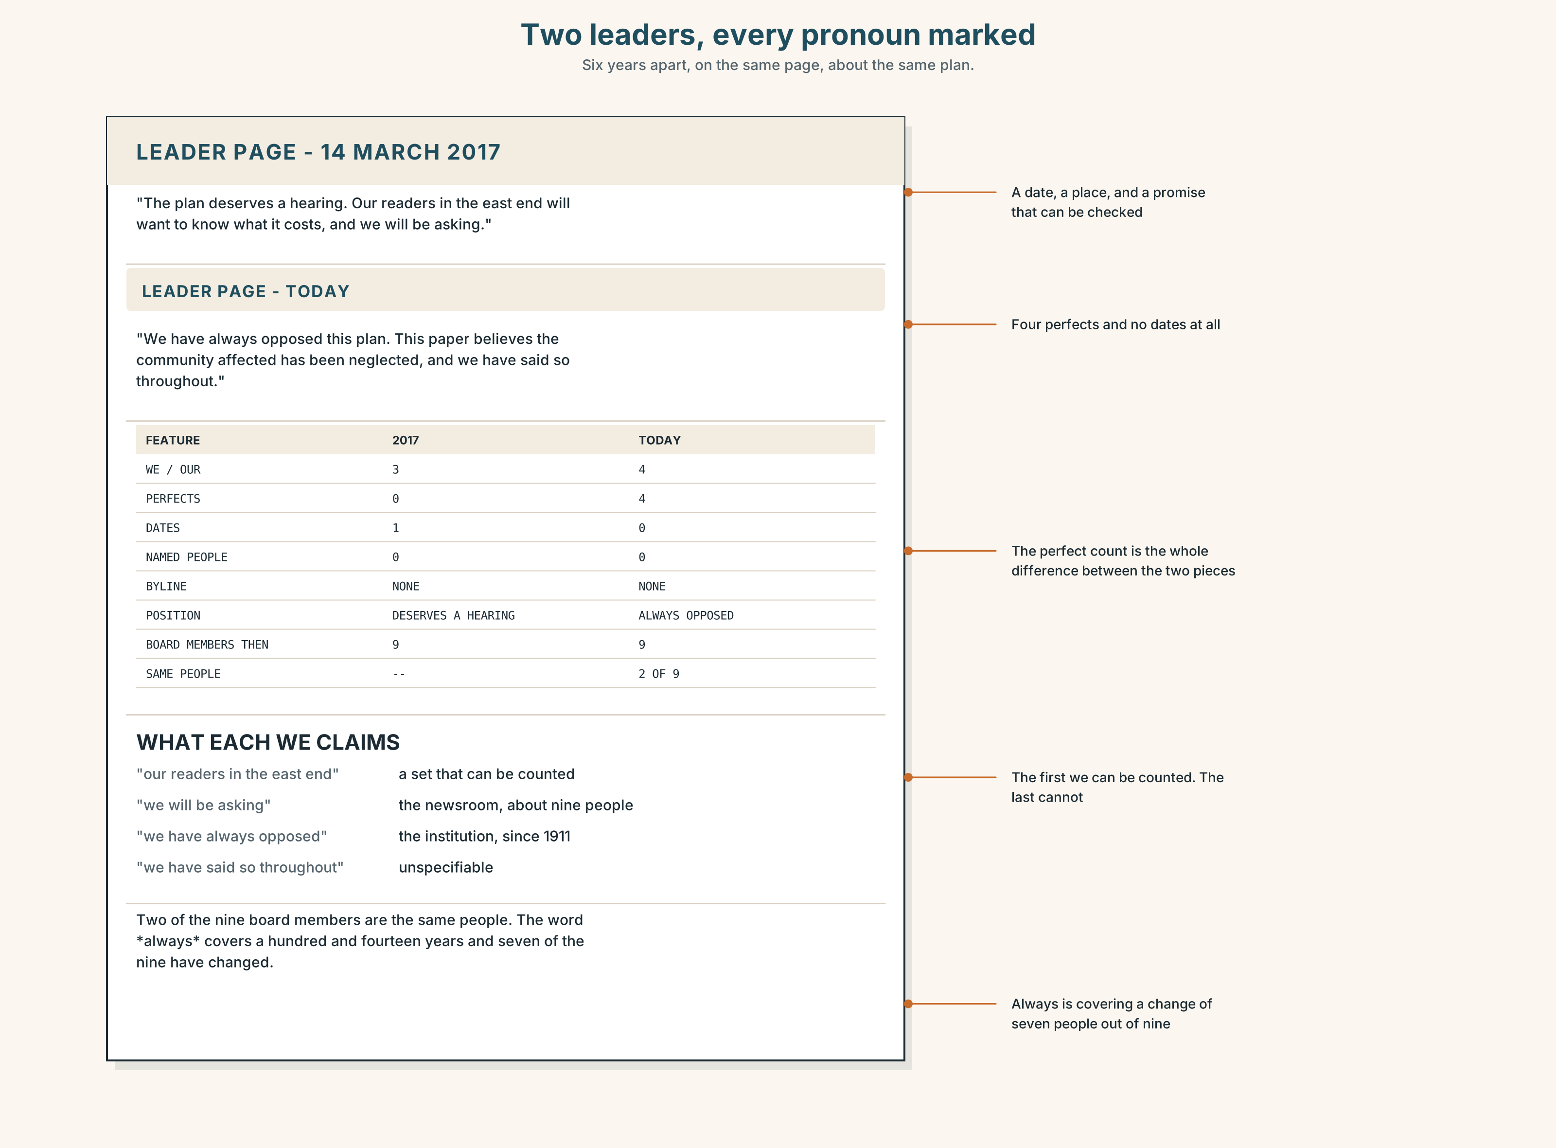{width=6.6in}
Two leaders, every pronoun marked — Six years apart, on the same page, about the same plan.
Read the two editorials — 2017 and today — and answer.
- What position does each take?
- Find every we in both and say what set each one includes.
- How many perfects are in each, and what does each perfect import?
- Neither editorial has a byline. What would change if one did?

5F · Two texts
The 2017 editorial says the plan deserves a hearing. Today's says we have always opposed it.
Is the second sentence false? Write two sentences, and use the word continuity in one of them.

Part 6 · Vocabulary Lab 2 ◆ B · THE SYSTEM

Who is included, and who is being spoken about

6A · Sort — includes the reader, excludes the reader, or avoids the question?
Three columns.
institutional · exclusive · collective · inclusive · generic · anonymous · impersonal · corporate

6B · Chunk completion
- the ______ we — the plural used by a single person with authority
- one ______ say — the most distancing construction in formal English
- it is widely ______ — a claim with the holders removed
- the present ______ — the writer, referring to the writer, in the third person
- speaking ______ — the writer stepping out from behind the institution
- the general ______ — a consensus nobody has measured

6C · Three that are not interchangeable
in this paper · as a reader · the general view
Say which one claims institutional authority, which claims none, and which claims a consensus.

6D · The phrasal verbs and the fixed expressions
own up · take over · sign off
f speaking for myself · f we take the view that · f that is not our position
One of these fixed expressions can only be said by somebody with authority. Which, and how do you know?

6E · Contrast Clinic
Eight items. Rewrite each sentence so that responsibility moves to the place in brackets.
- The paper regrets the error. (to the desk that made it)
- One might say the figures are unreliable. (to a named analyst)
- The community affected was consulted. (to the three people who were asked)
- It is widely held that the plan will fail. (to the writer)
- Mistakes were made. (to a named person)
- We have always opposed it. (to a dated decision)
- This paper believes in transparency. (to an editorial board, with a date)
- Our readers expect better. (to a survey, with a number)

Part 7 · Pronunciation & Fluency Lab ◆ B · THE SYSTEM
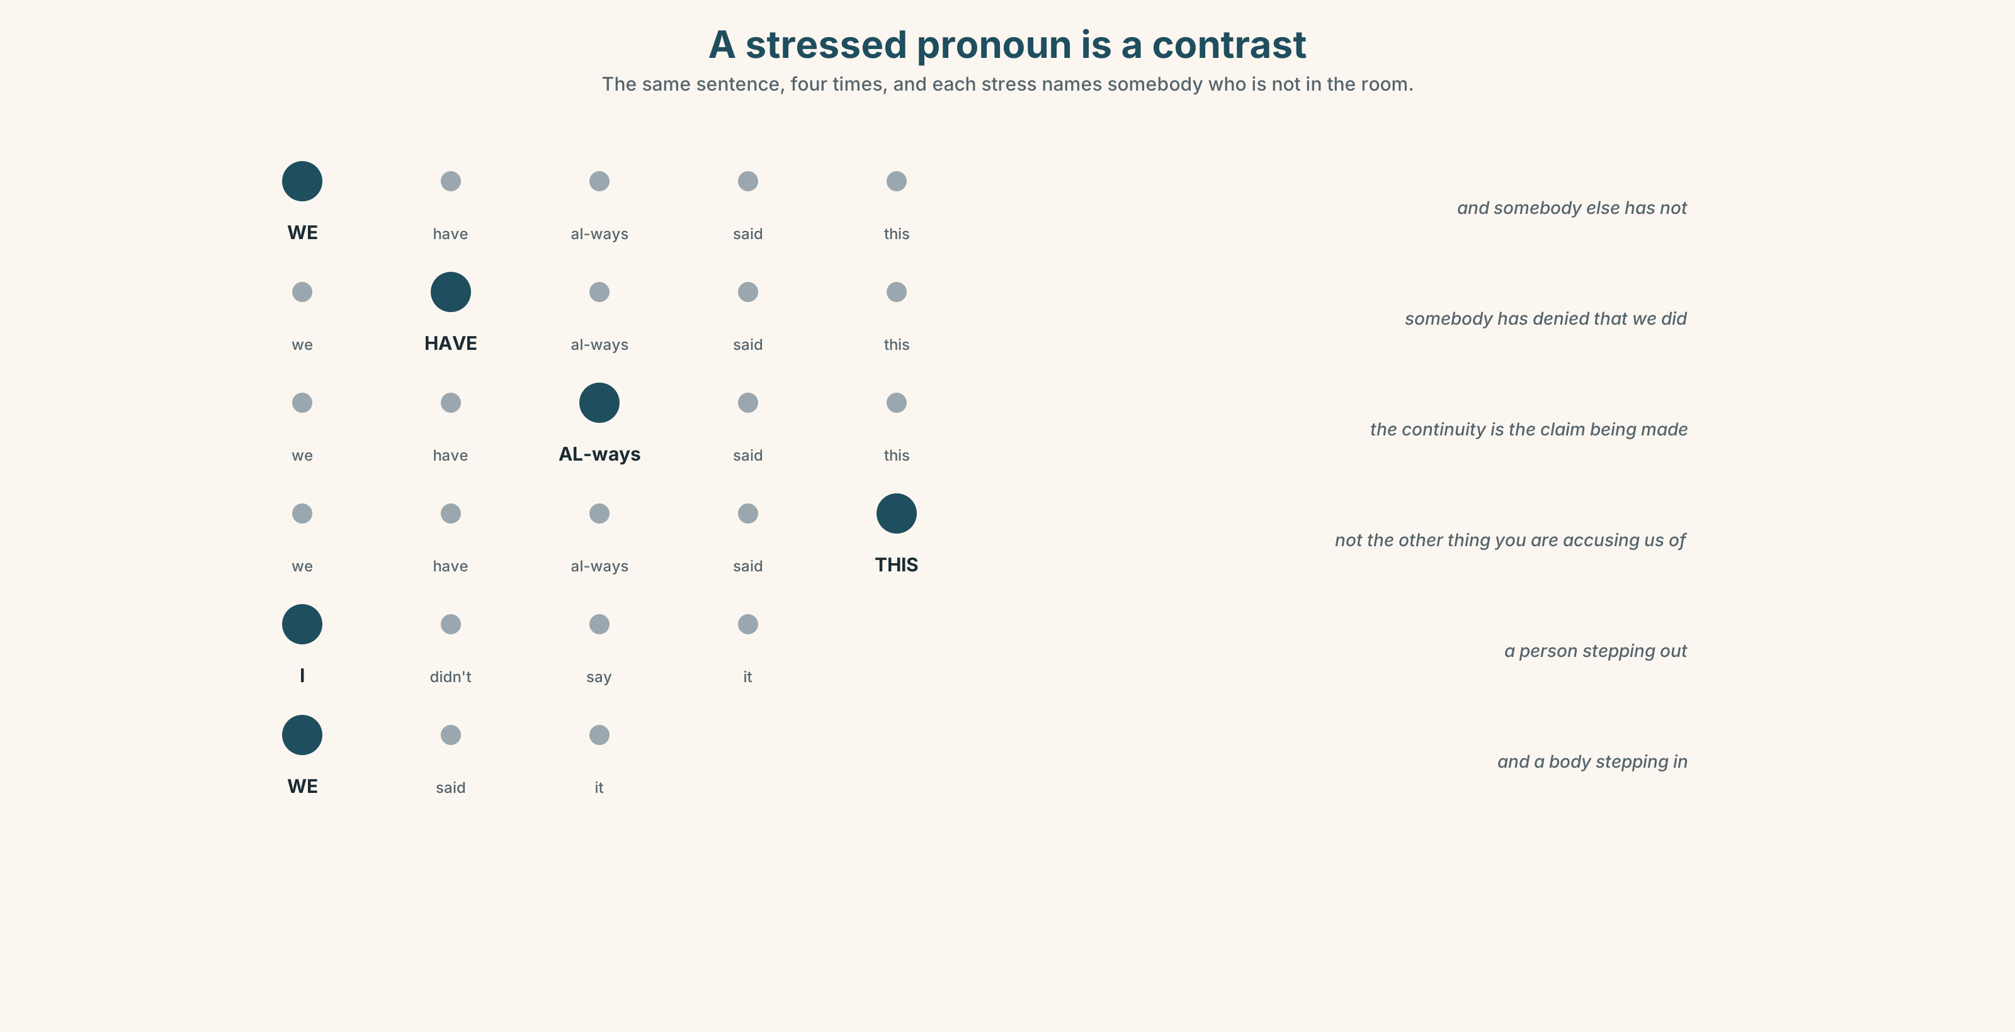{width=6.6in}
A stressed pronoun is a contrast — The same sentence, four times, and each stress names somebody who is not in the room.

A stressed pronoun is a contrast

7A · Hear 🔊 Track 2.3
WE have always said this. — somebody else has not We have ALWAYS said this. — the continuity is the claim We have always said THIS. — not the other thing

7B · Say
Say each one three times. Then say this:
I didn't say it. WE said it. — the stress moves responsibility from a person to a body, and that is the whole function of the editorial we.

7C · Make it mean something
Say these two:
We take the view that… — unstressed we: the institution, routinely WE take the view that… — stressed: and somebody else takes a different one
An unstressed pronoun is a reference. A stressed one is a contrast, and the contrast always implies a party who is not in the room.

7D · Fluency 30 ⏺
Thirty seconds: one position, stated four times — as the institution, impersonally, as yourself, and as a reader. Three times, faster.

Part 8 · Writing ◆ C · THE PERFORMANCE

A position, with its holders named · 200 words

8A · Read the model
This paper opposed the Ward 7 plan in a leader on 14 March 2019. [the institution, with a date — the perfect would have hidden it]
We had supported an earlier version of it in 2017, and we were wrong about the costs. [the past perfect places the earlier position, and the admission is in the same sentence]
The present writer was not on the board in 2017 and has read the file. [the person, distinguished from the institution, and a perfect doing proper work]
It is widely held in this building that the ward has been neglected. By whom is a question we have not answered, and by March we will have been asking it for six years. [the impersonal, the challenge to it, and a future perfect that dates the failure]
Questions about the writer's choices:
- The first sentence uses a simple past with a date. What would we have always opposed have cost?
- The present writer appears once. Why not I?
- The last sentence turns the paper's own phrase against it. Which word does the work?

8B · The anti-model
We have always believed that Ward 7 deserves better. Our readers expect this paper to speak for the communities it serves. Mistakes were made in the past but we have learnt from them. This paper believes in accountability.
Four sentences, four unexaminable claims, and not one date or person in any of them. Rewrite it so that every claim has either a date or a name attached.

8C · Plan
the institution, with a date → the earlier position, placed → the person, separated → the impersonal claim, and the challenge to it

8D · Write — 200 words

8E · Peer review — three criteria
☐ Does every we have a number behind it that the writer could state? ☐ Does every perfect import something into the present argument, or is it hiding a date? ☐ Is there at least one sentence where the writer appears as a person?

8F · Write it again · 8G · Publish
Rewrite after review. Publish both, and mark every pronoun in both.

Part 9 · The File ◆ A · THE WORLD + C · THE PERFORMANCE
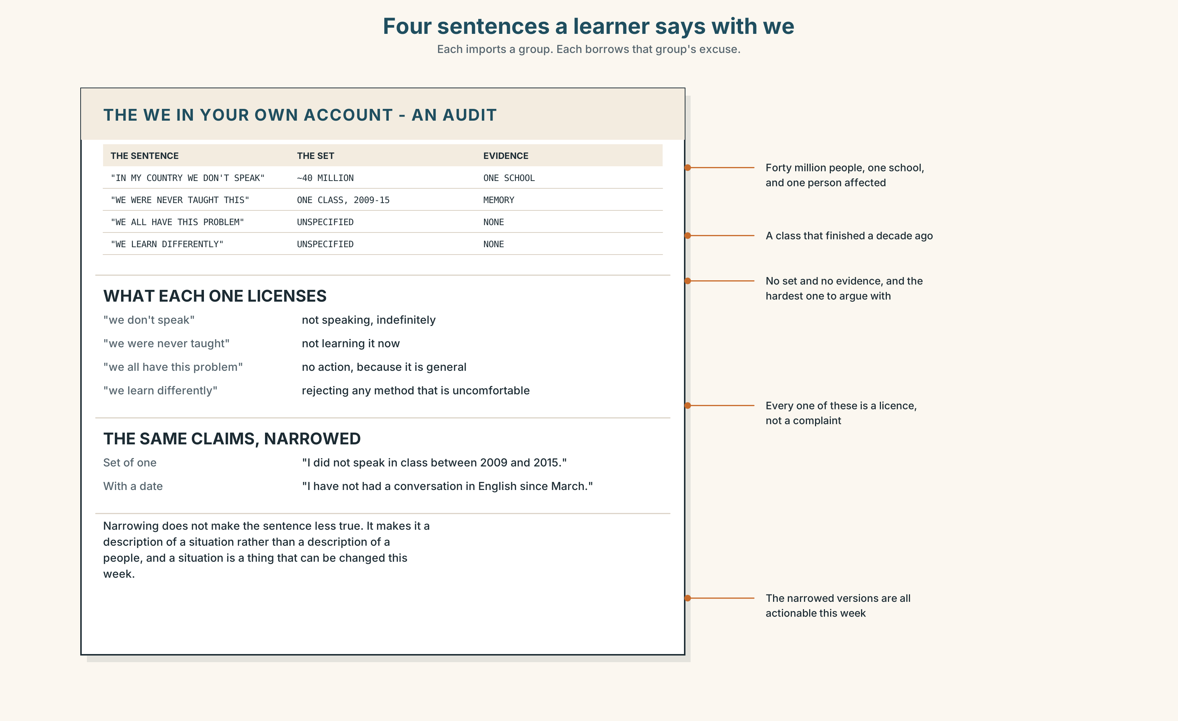{width=6.6in}
Four sentences a learner says with we — Each imports a group. Each borrows that group's excuse.

STUDY FILE · Whose standard are you measuring against?

9A · The we in your own account 🔊 Track 2.4
Learners describe their English in the first person plural more often than they notice: in my country we don't study speaking, we were never taught this, we all have this problem. Each one imports a group and borrows its excuse.
the claim | we were never taught to speak
the set | about forty million people
the evidence | one school, 2009 to 2015
what it licenses | not speaking, indefinitely

9B · Narrow it
Take three sentences you have said about your English that begin with we or in my country. Rewrite each with the smallest honest set and a date.

9C · Role play — who is the we here?
In pairs. One of you describes a difficulty using we. The other may only ask who is the we here? and since when? Four rounds each.

9D · The inherited position
Everybody has at least one belief about language learning they did not arrive at themselves. Name yours and name who gave it to you. Then decide whether you still hold it.

9E · Transfer — before next week
Write the sentence I have always… about your English, and then find the earliest evidence. Bring both. Most people find the always is about four years old.

Part 10 · Mediation & Interaction ◆ C · THE PERFORMANCE
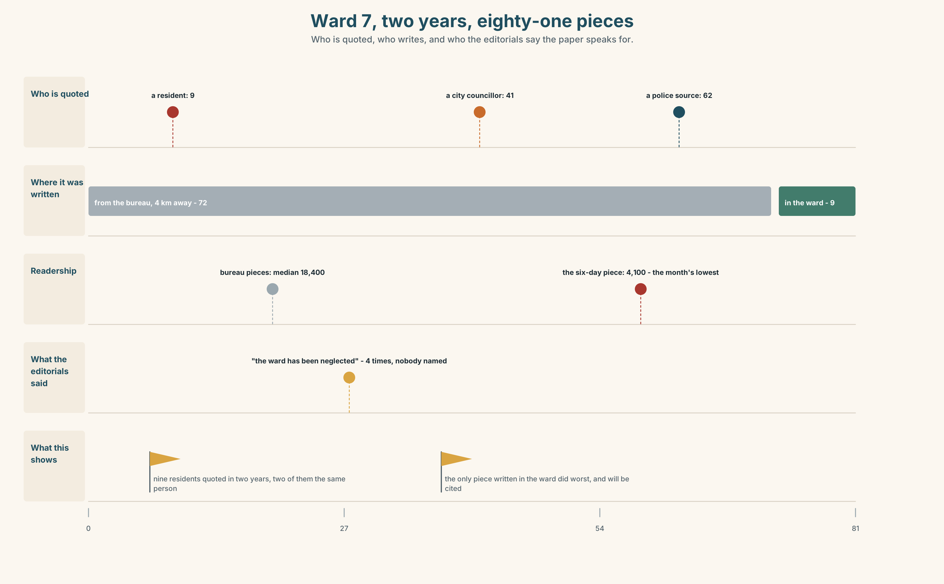{width=6.6in}
Ward 7, two years, eighty-one pieces — Who is quoted, who writes, and who the editorials say the paper speaks for.

10A · Relay
Half the class has the archive. Half has the draft. Produce one sentence both can sign, by speaking only. Ten minutes.

10B · Simplify — for one reader
A reader writes: You say you have always opposed this. I have the 2017 paper in front of me. Reply in four sentences. Do not use the perfect.

10C · Online
Write one message to a colleague about a we in their draft that is doing too much work. Three sentences. Name the set it is claiming.

10D · Your language
Does your language distinguish an inclusive we from an exclusive one? Translate we have always said this both ways. Which does the English sentence mean?

Part 11 · The Decision ◆ C · THE PERFORMANCE

The byline on the leader page
The Herald's editorials have been unsigned since 1911.
Option one: keep it. An unsigned leader is the paper speaking, which is the point of a leader page, and a byline makes it a column.
Option two: sign them. The person who wrote it is named, as everywhere else in the paper, and we have always said becomes harder to write.
Option three: keep them unsigned and publish, once a year, the names of everybody who sat on the board and the dates of every position change.

11A · The evidence
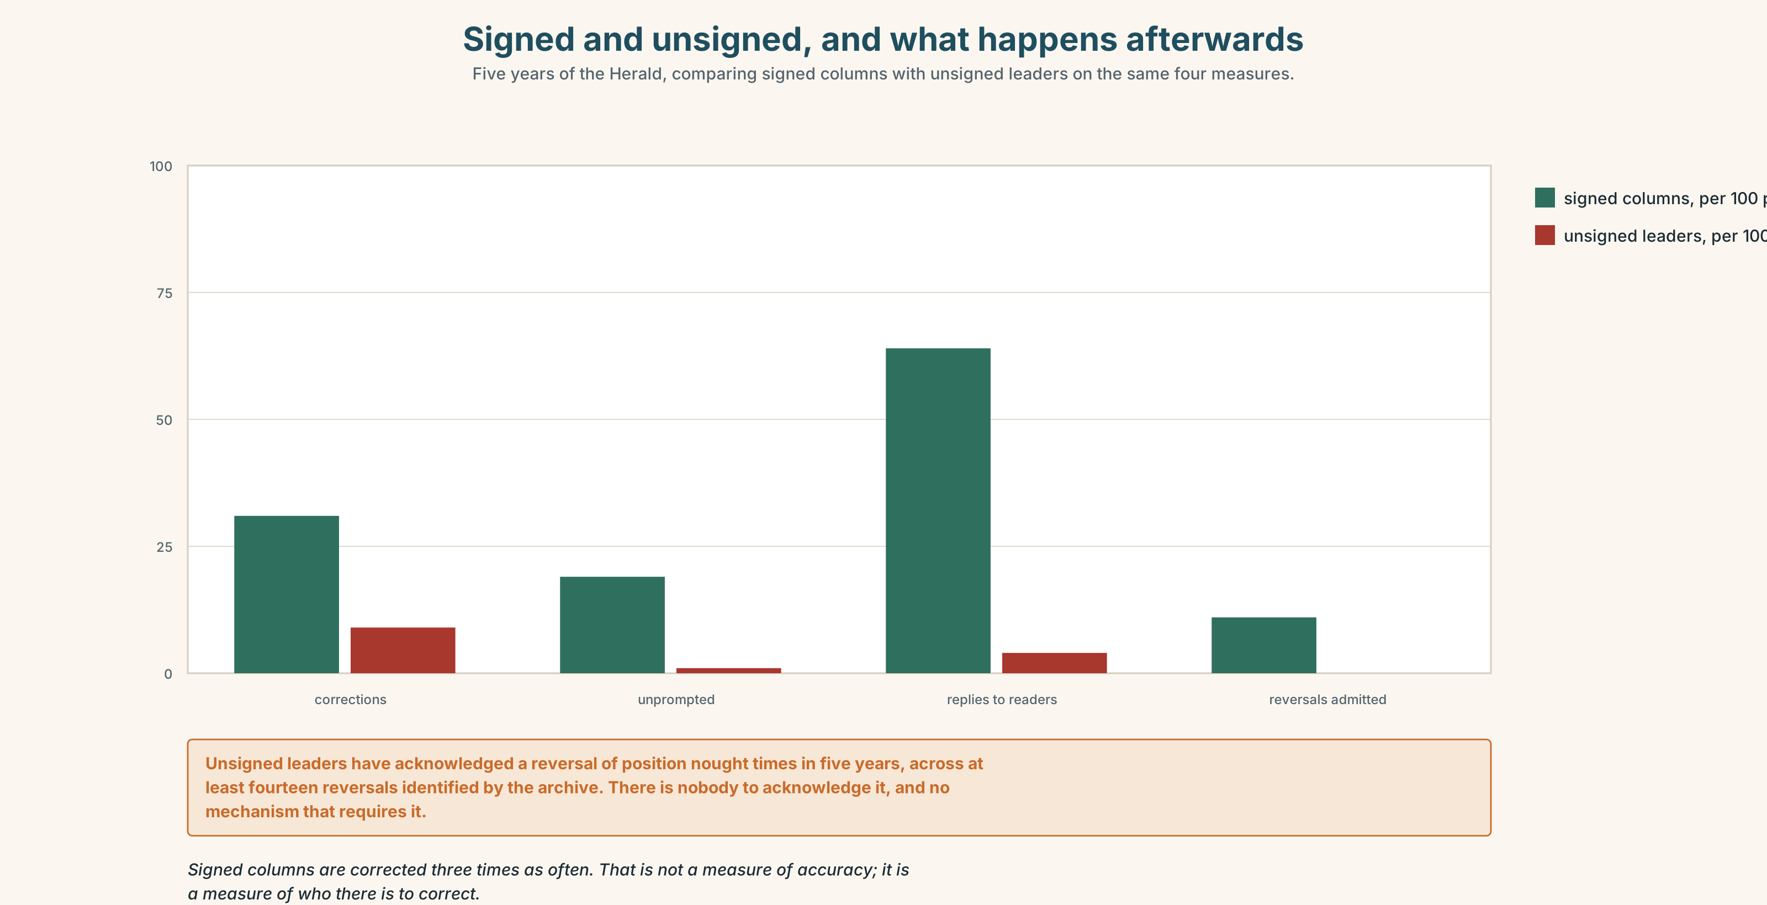{width=6.6in}
Signed and unsigned, and what happens afterwards — Five years of the Herald, comparing signed columns with unsigned leaders on the same four measures.
🔊 Track 2.6. The columnist, 30 seconds: "I have written under my own name for nineteen years and I have been wrong in public about four things. The leader page has been wrong about rather more and has never apologised, because there is nobody there to apologise. That is not a bug in the system. It is the system."

11B · Talk about it
In threes. Use the frame, and state the set behind every we you use.
I would ______ , because ______ , and the people affected are ______ .

11C · Decide
Write three sentences: the decision, the evidence, and who would be accountable under it.

11D · Model decision
Option three. Signing the leader turns it into a column and loses the one thing a leader page can do, which is commit an institution. Publishing the board and the dates keeps the institutional voice and makes we have always said checkable — which is the only part of the current arrangement that is doing damage.

11E · The Reveal
What happened. The Herald published the board list and the position changes. The leader page stayed unsigned.
Then something nobody predicted: the phrase we have always said disappeared from the leader page within four months, without any instruction. Writers who knew a reader could check the date simply stopped reaching for the construction.
One question. You do not have to answer it out loud.
Nobody banned the phrase. What did the list of dates actually change?

Part 12 · Landing ◆ all three lines

12A · Recycle — fifteen items
- We ______ (say) this since 2019. (continuity to now)
- We ______ (say) the opposite in 2017. (a dated point)
- The board ______ (not discuss) it before the piece ran.
- By March we ______ (hold) it for six years.
- The ______ we — a single person using a plural with authority
- ______ might say that nothing has changed.
- It is widely ______ that the ward has been neglected.
- The present ______ was not on the board in 2017.
- ______ personally, I disagree.
- This paper ______ in accountability.
- ______ ______ ______ ? (four words — the challenge)
- That is not ______ ______ . (two words — the institutional refusal)
- She was asked to ______ ______ for the editor on Friday. (two words)
- Somebody has to ______ ______ to the error. (two words)
- The piece was ______ ______ overnight by a stringer. (two words)

12B · Consolidate — one task, everything in it
Write 150 words taking a position, in which you appear once as an institution, once impersonally and once as yourself. Mark the three in the margin.

12C · Can-do, with evidence
☐ I can use the perfect to import a past event into a present argument. Evidence: 3H, 8D ☐ I can place myself in a text at three distances. Evidence: 4C ☐ I can say what set a we includes. Evidence: 6E, 9C ☐ I can hear and use contrastive pronoun stress. Evidence: 7C

12D · Replay ⏺
Record 0C again. Compare. How many of your inherited opinions did you name the first time?

12E · Glossary — fifty items, as a map
THE PEOPLE WHO SPEAK · byline · columnist · correspondent · spokesperson THE INSTITUTION THAT SPEAKS · editorial · outlet · voice THE GROUP YOU COUNT · readership · audience · membership THE GROUP YOU CLAIM · constituency · following THE CLAIMS · speak for · on behalf of · our readers · the paper's view · the community affected THE DESCRIPTIONS · a named writer · an unsigned piece · local to the story · an outsider's account · whose paper is it WHAT PEOPLE DO · speak up · stand in · write up · own up · take over · sign off IN THE ROOM · we have always said · this paper believes · who is the we here? THE REFERENCE · inclusive · exclusive · collective · impersonal · generic · institutional · corporate · anonymous THE FORMULAE · the royal we · one might say · it is widely held · the present writer · in this paper · speaking personally · as a reader · the general view POSITIONING YOURSELF · speaking for myself · we take the view that · that is not our position

12F · Next
Unit 3 · How sure are you?

