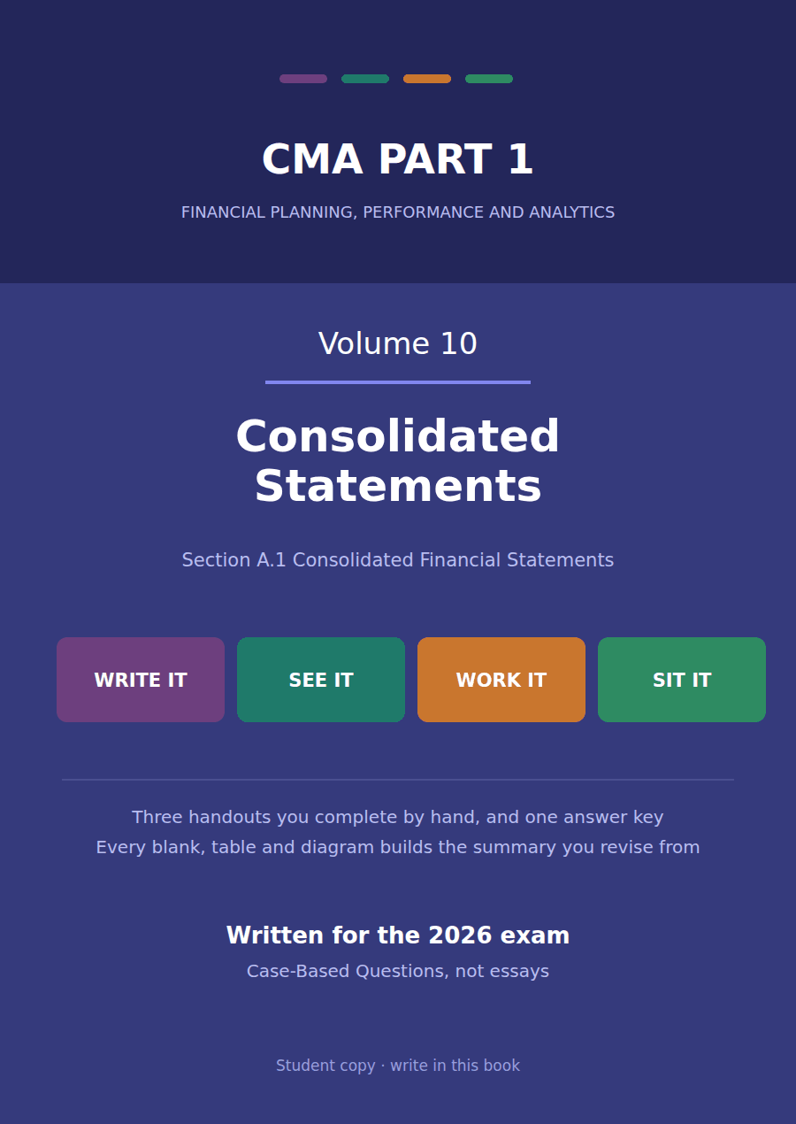

CMA Part 1 · Volume 10
Consolidated Statements
Three handouts, one answer key. When one company reports another as part of itself, and what has to disappear when it does.
These handouts are not notes to read. You write them. The words you supply are the summary, so a finished handout is a page you can revise from, in your own handwriting.
Work in pen. Do not look at the key until the whole handout is done — the key is written to explain the mistake, and you only get that benefit if you have made it first.
The three handouts
# | Handout | What it gives you
1 | What Consolidation Is, and the Two Models | Northwind pays $960,000 for 80% of Lakeside Controls. From that day the two companies report as one, and this handout says why and when.
2 | Full, Proportionate and Equity Consolidation | Three ways to bring Lakeside Controls into Northwind’s statements. All three report the same profit, and only one of them shows the $600,000 of debt.
3 | What Gets Eliminated | Lakeside Controls sells $150,000 of goods to Northwind. Until those goods reach a real customer the group has sold nothing, and $24,000 of profit has to come back out.

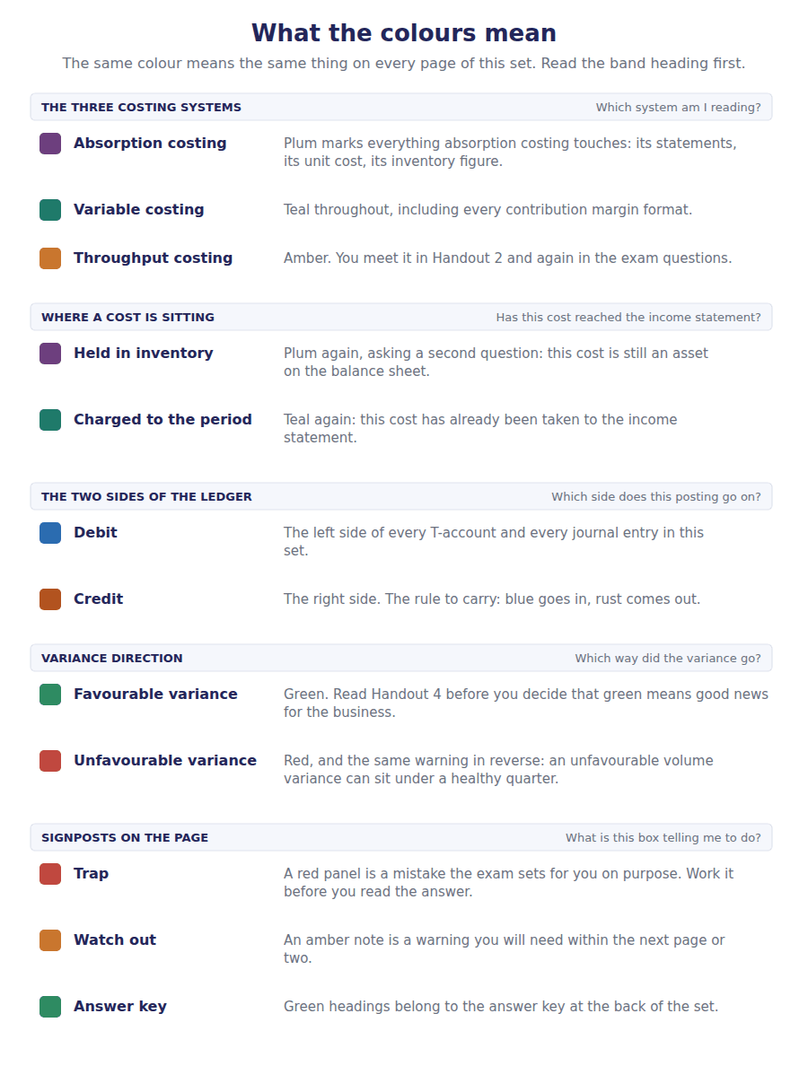
How to read the markers
Marker | Meaning
R1 | Teaching English. Short sentences. This is where a new idea arrives.
R2 | Textbook English. Longer sentences and passive verbs, as a textbook writes them.
R3 | Exam English. Exactly how the CMA exam phrases it, traps included.
Numbered rule | A space you fill in. The number matches the answer key.
Red table | A trap. Read it twice.

Handout 1 · What Consolidation Is, and the Two Models
Northwind pays $960,000 for 80% of Lakeside Controls. From that day the two companies report as one, and this handout says why and when.
Volume 10 · Consolidated Statements · R1 moving to R2
LANGUAGE FOCUS
Register you are working in | R1 while control is being defined, R2 once the two models are being applied.
Say it exactly like this | obtain control of an entity · consolidate a subsidiary · present a single set of statements · recognise a non-controlling interest · absorb the losses of an entity · direct the activities of an entity
Words that are not the same | parent / subsidiary · control / influence · voting interest / variable interest · consolidated / separate
Remember | Consolidation is not addition of two legal entities into one. The companies remain separate in law and keep their own books. Control is not always a majority of the shares. One of the two models exists precisely for the cases where it is not.

What you will be able to do when this handout is finished
- Say what a consolidated set of statements shows and why.
- Define control and distinguish it from influence.
- Apply the voting interest model.
- Say when the variable interest model applies instead.
- Compute the non-controlling interest and the goodwill on an acquisition.

Northwind buys a controller business
On 1 January 20X4 Northwind pays $960,000 for 80% of the shares of Lakeside Controls, a company that makes the control units its components are built into.
The two companies remain separate in law. Lakeside Controls keeps its own books, files its own return and has its own shareholders for the other 20%.
Yet Northwind now decides what Lakeside Controls does. It appoints the board, sets the budget and directs the business.
Reporting the $960,000 as an investment on one line would tell a reader almost nothing about the resources Northwind now directs. So the statements are consolidated.

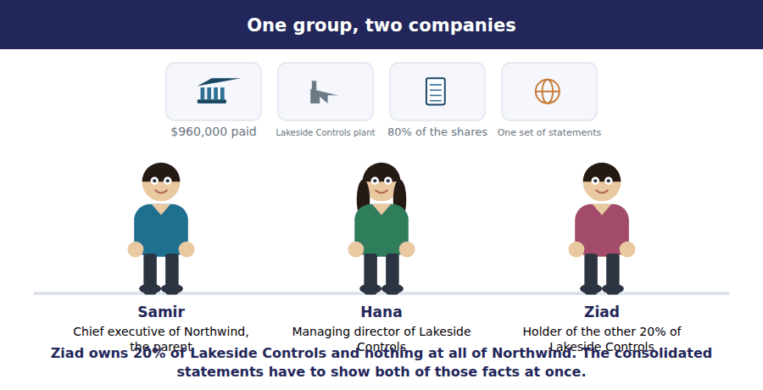
Part 1 · What consolidated statements show resources directed, not shares owned
Exercise 1A Read and complete. Write one word in each space.
OBJECTIVE | Say what consolidated statements show and why a single line will not do.
YOU WILL NEED | Volume 6 Handout 1, where an investment was reported on one line.
HOW TO START | • Think about what a lender to Northwind wants to know about Lakeside Controls debt.  • The group is not a legal person. Ask whose statements these actually are.  • The last blank is what Northwind has over Lakeside Controls that a 10% shareholding would not give it.

WORD BANK
company · control · directs · entity · influence · line · owns
Not every word is used.

R1 Consolidated statements present a parent and its subsidiaries as a single ¹ . The two companies stay separate in law, and the combination exists only in the parent’s reporting.
The reason is what a reader needs. A lender deciding whether to lend to Northwind wants to know what the group owes, and Lakeside Controls debt is invisible if the investment is reported on one ² .
So every asset and liability Lakeside Controls has is brought in, and so is every dollar of its revenue and expense. What the reader then sees is the resources Northwind ³ , rather than the shares it happens to hold.
The reason Northwind may do this is that it has ⁴ . A minority shareholder has no such power and reports an investment instead.
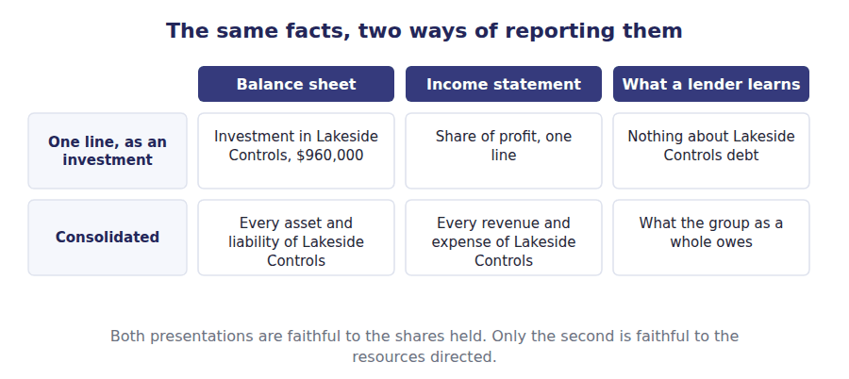
Part 2 · Control, and what it is not the line between the two methods
R2 Control is the power to direct another entity’s activities so as to obtain benefits from it. Significant influence, which is the power to participate without directing, is a different thing and gives the equity method of Volume 6. The usual evidence of control is more than half the votes.
Exercise 1B Sort each holding into the column it belongs in.
OBJECTIVE | Decide which method each shareholding calls for.
YOU WILL NEED | The paragraph above, and Volume 6 Handout 1 on classification.
HOW TO START | • More than half the votes is the ordinary evidence of control, and twenty to fifty per cent the ordinary evidence of influence.  • A majority that cannot actually direct the business is the exception the exam likes: ask whether the power is real.  • One of the holdings is a passive stake too small for either, and it is measured at fair value.

Holding | CONSOLIDATE | EQUITY METHOD | FAIR VALUE
1. 80% of the voting shares, with board control
2. 30% of the voting shares, with one seat on the board
3. 5% of the voting shares, held for its dividends
4. 60% of the voting shares of a company in bankruptcy proceedings
5. 45% of the voting shares, with the other 55% held by one investor
6. 0%, with the power to direct a variable interest entity

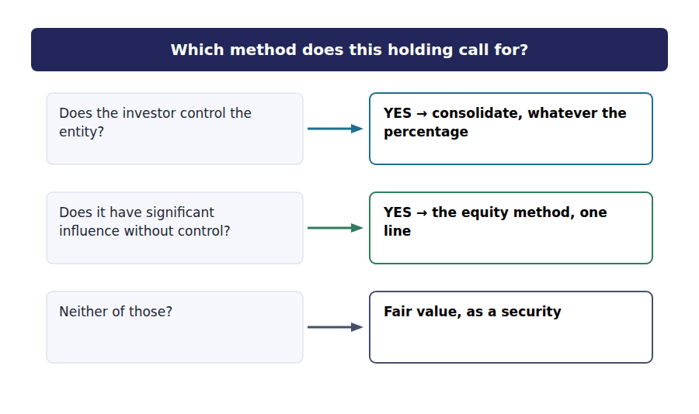
Part 3 · The two models votes, and exposure
Exercise 1C Read and complete. Write one word in each space.
OBJECTIVE | Name the two consolidation models and say when each applies.
YOU WILL NEED | Exercise 1B.
HOW TO START | • The first model counts votes, and Northwind’s 80% is decided by it.  • The second exists because an entity could be arranged so that the party bearing its risks holds no votes at all.  • The last blank is the party that consolidates a variable interest entity, and the standard gives it a name.

WORD BANK
always · beneficiary · interest · majority · not · shareholder · variable
Not every word is used.

R2 The first model is the voting ⁵ model. An investor that holds more than half the votes is presumed to control, so Northwind consolidates Lakeside Controls on its 80% holding.
The presumption can be rebutted. A majority holder that cannot in fact direct the business, because a court or a regulator has taken over, does ⁶ consolidate.
The second model exists for entities whose votes decide nothing. A structure can be arranged so that one party bears the losses and takes the returns while holding few shares or none, and such an entity is a ⁷ interest entity.
There the question is not who votes but who has the power to direct the activities that matter and the exposure to the results. That party is the primary ⁸ , and it consolidates.
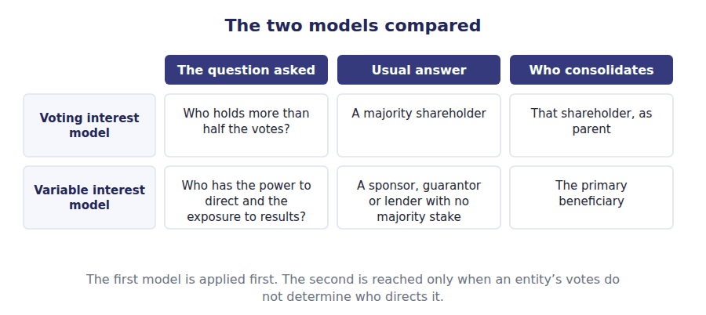
Part 4 · The acquisition, measured goodwill and the other shareholders
Exercise 1D Complete the schedule. Two figures are given.
OBJECTIVE | Compute the non-controlling interest and the goodwill on the acquisition.
YOU WILL NEED | Volume 5 Handout 5, where goodwill was first met. · Exercise 1A.
HOW TO START | • Northwind paid $960,000 for 80%. Work out what that implies the whole of Lakeside Controls is worth.  • The non-controlling interest is the 20% of that implied value that Northwind did not buy.  • Goodwill is the implied total less the $1,000,000 fair value of the identifiable net assets.

The acquisition of Lakeside Controls | Amount
Consideration paid for 80% of the shares | $960,000
Implied value of Lakeside Controls as a whole
Non-controlling interest, 20% of that value
Fair value of the identifiable net assets acquired | $1,000,000
Goodwill recognised

1 | 2 | 3

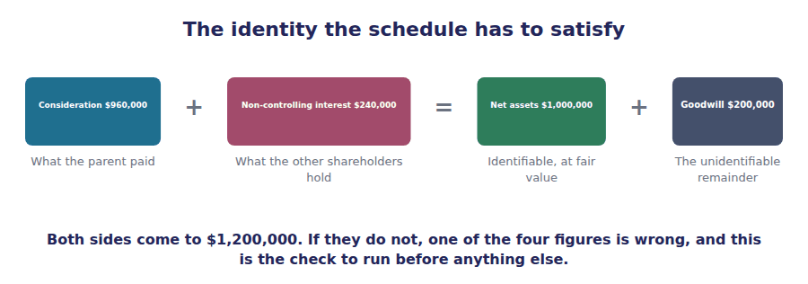
Part 5 · Where the other shareholders go inside equity, not beside it
Exercise 1E Read and complete. Write one word in each space.
OBJECTIVE | Say where the non-controlling interest is reported and why.
YOU WILL NEED | Exercise 1D, and Volume 8 Handout 1 on the equity section.
HOW TO START | • Ziad owns 20% of Lakeside Controls. Ask whether Northwind owes him anything.  • A liability is an obligation to transfer resources. Decide whether that describes a shareholding.  • The last blank is the proportion of Lakeside Controls assets that the consolidated balance sheet carries.

WORD BANK
all · asset · creditors · interest · liability · shareholders · some
Not every word is used.

R2 The other shareholders of Lakeside Controls own part of the group’s net assets. Northwind owes them nothing, so their interest is not a ⁹ however much it looks like one.
It is reported inside consolidated equity, on its own line of $240,000, separately from the equity attributable to Northwind’s own ¹⁰ .
Consolidated profit is presented the same way: one total, then a split showing the part attributable to the parent and the part attributable to the non-controlling ¹¹ .
Note what is not proportionate. Because Northwind controls Lakeside Controls, ¹² of its assets and liabilities are brought in, not 80% of them.
 | If Northwind reports the investment only | If Northwind consolidates
On the balance sheet | One line: investment $960,000
Debt of Lakeside Controls | Invisible
Revenue of Lakeside Controls | Invisible
What the reader sees | An investment of $960,000

1 | 2 | 3 | 4 | 5 | 6

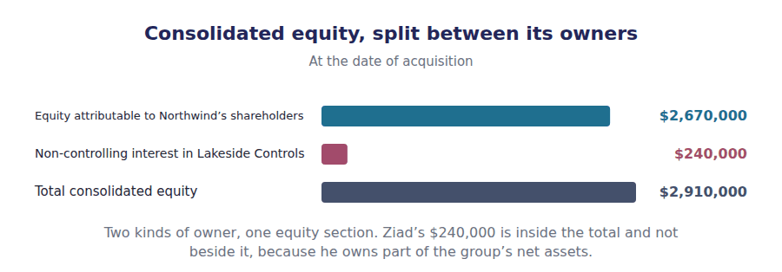
Watch out! Consolidation brings in 100% of a subsidiary’s assets and liabilities however small the parent’s stake above half. The non-controlling interest is how the other owners are shown; it is not a reason to bring in less.
Part 6 · Exam pitch the questions as the CMA sets them
1. [Level A] Consolidated financial statements are prepared because:
(A) The parent and the subsidiary are one legal entity
(B) A reader needs to see the resources the parent controls
(C) The subsidiary is required to stop reporting
(D) Tax is assessed on the group
2. [Level A] An investor holds 80% of the voting shares of another company and appoints its board. The investment is reported by:
(A) The fair value method
(B) Consolidation
(C) The equity method
(D) The cost method
3. [Level B] A company holds 60%% of another whose assets are under the control of a bankruptcy court. It should:
(A) Consolidate, because it holds a majority
(B) Not consolidate, because it cannot direct the activities
(C) Consolidate, but exclude the subsidiary’s liabilities
(D) Report the holding at cost
4. [Level B] A variable interest entity is consolidated by:
(A) Its largest shareholder
(B) Its primary beneficiary
(C) Each investor, in proportion to its interest
(D) Nobody, because it has no voting shares
5. [Level C] Northwind pays $960,000 for 80% of Lakeside Controls, whose identifiable net assets have a fair value of $1,000,000. Goodwill is:
(A) $160,000
(B) $200,000
(C) ($40,000)
(D) Nil
6. [Level B] The non-controlling interest in a consolidated balance sheet is reported:
(A) As a long-term liability
(B) As a separate component of consolidated equity
(C) As a deduction from goodwill
(D) In the notes only
7. [Level C] A parent owns 80% of a subsidiary. The proportion of the subsidiary’s assets included in the consolidated balance sheet is:
(A) 80%
(B) 100%
(C) 20%
(D) Whichever the parent elects
ADAPTIVE TIP Run the identity before you answer any acquisition question: consideration plus non-controlling interest equals identifiable net assets plus goodwill. Three of the four figures are always in the stem, and the one that is missing is what is being asked for.

Handout 2 · Full, Proportionate and Equity Consolidation
Three ways to bring Lakeside Controls into Northwind’s statements. All three report the same profit, and only one of them shows the $600,000 of debt.
Volume 10 · Consolidated Statements · R2
LANGUAGE FOCUS
Register you are working in | R2 throughout, with one R3 comparison because the exam asks this as an effect-on-the-statements question.
Say it exactly like this | bring in a subsidiary in full · include a share of the assets · carry an investment on one line · apply uniform accounting policies · account for a joint venture · distort a leverage ratio
Words that are not the same | full / proportionate · consolidation / one-line consolidation · joint operation / joint venture · assets brought in / investment carried
Remember | Proportionate consolidation is not a compromise US GAAP allows for subsidiaries. It is prohibited for them. The equity method is not a way of avoiding consolidation. It reports the same profit, on one line instead of many.

What you will be able to do when this handout is finished
- Describe each of the three methods.
- Say which method applies to a controlled subsidiary, an associate and a joint arrangement.
- Compute what each method brings into the statements.
- Say why all three report the same profit.
- Say what the choice does to a leverage ratio.

The same Lakeside Controls, three ways
Lakeside Controls has assets of $1,600,000, liabilities of $600,000 and profit of $120,000 for the year. Northwind owns 80% of it.
There are three ways a textbook describes bringing an interest like this into a set of statements, and the exam expects all three.
Only one of them is permitted here. The other two are the answers that apply when control is absent, and knowing which is which is the whole of A.1(j).
Strikingly, all three report the same profit attributable to Northwind. What differs is everything else.

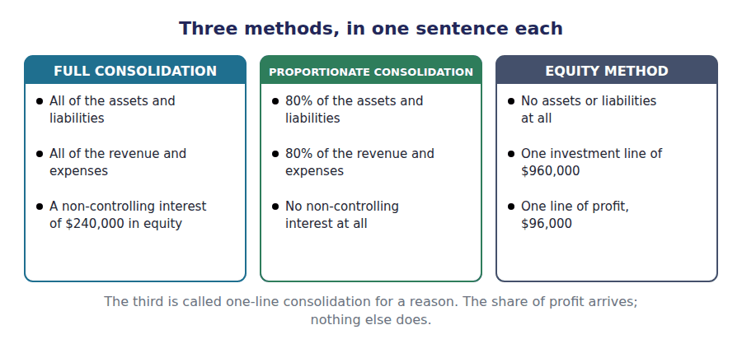
Part 1 · Which method, and when control, joint control, influence
Exercise 2A Read and complete. Write one word in each space.
OBJECTIVE | Say which method applies to each kind of interest and why.
YOU WILL NEED | Handout 1 Exercise 1B, on control and influence.
HOW TO START | • Northwind controls Lakeside Controls, so only one of the three methods is open to it.  • Proportionate consolidation is attractive and prohibited. Ask what would be misleading about reporting 80% of a liability the company is wholly responsible for.  • The last blank is the method a joint venture uses, and it is the same one an associate uses.

WORD BANK
equity · fully · operation · partly · permitted · prohibited · venture
Not every word is used.

R2 Northwind controls Lakeside Controls, so the subsidiary is brought in ¹ . Every asset, every liability, every dollar of revenue, and a non-controlling interest of $240,000 for the owners of the other 20%.
Proportionate consolidation would bring in 80% of each figure. It is ² for a controlled subsidiary, because a parent that controls an entity is answerable for the whole of its debt rather than 80% of it.
Where there is influence but not control, the investor cannot bring in assets it does not direct. It reports its share of the net assets and of the profit on single lines, which is the ³ method of Volume 6.
A joint arrangement is a third case. Where the parties have rights to the net assets of the arrangement it is a joint ⁴ , and it too uses the equity method.
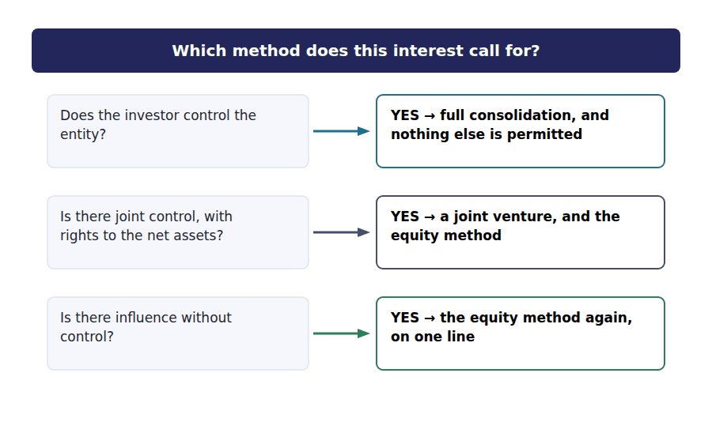
Part 2 · What each method brings in the three columns, computed
Exercise 2B Complete the grid. 80% is four fifths of each figure.
OBJECTIVE | Compute what each of the three methods brings into the statements.
YOU WILL NEED | Exercise 2A, and the opening scene for Lakeside Controls own figures.
HOW TO START | • The first column takes the whole of each figure. The second takes 80% of it.  • The third column brings in no assets and no liabilities at all, so two of its cells are nil and one carries the $960,000 investment.  • Row 5 is the surprise: the profit added is $96,000 in two of the three columns.

 | Full | Proportionate | Equity method
Assets of Lakeside Controls brought in
Liabilities brought in
Investment line carried
Revenue added
Profit added
Non-controlling interest shown

1 | 2 | 3 | 4 | 5 | 6
7 | 8 | 9 | 10 | 11 | 12
13 | 14 | 15 | 16

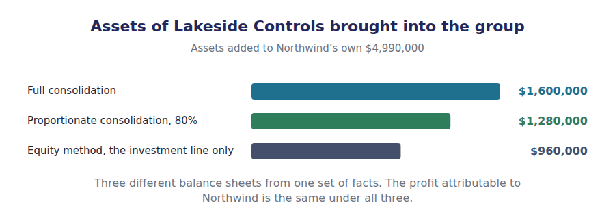
Part 3 · Why the profit is the same the one figure that does not move
R2 Full consolidation adds the whole of a subsidiary’s profit and then gives part of it away to the non-controlling interest. The equity method adds only the investor’s share in the first place. Both arrive at the same figure attributable to the parent.
Exercise 2C Read and complete. Write one word or figure in each space.
OBJECTIVE | Show that the profit attributable to Northwind is the same under full consolidation and the equity method.
YOU WILL NEED | Exercise 2B, and the paragraph above.
HOW TO START | • Lakeside Controls earned $120,000. Under full consolidation all of it is added, and then the other owners’ share is deducted.  • The other owners hold 20%, so their share is $24,000.  • Under the equity method $96,000 is added and nothing is deducted. Compare the two results.

WORD BANK
$120,000 · $24,000 · added · deducted · doubled · unchanged
Not every word is used.

R2 Under full consolidation the whole $120,000 of Lakeside Controls profit is added to Northwind’s $510,000. The consolidated profit is therefore $630,000 before any split.
That total is then divided. The non-controlling interest is credited with its 20% share, which is ⁵ , and the remainder is attributable to Northwind’s own shareholders.
Under the equity method no such split is needed, because only Northwind’s 80% share of $96,000 is ever brought in. Nothing is ⁶ afterwards.
Both routes end at $606,000. The choice of method changes the balance sheet and the revenue line completely and leaves the profit attributable to the parent ⁷ .
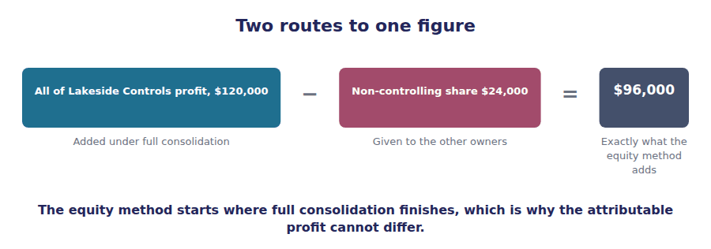
Part 4 · What the choice does to a ratio where it matters most
Exercise 2D Complete the grid. The profit row is given, and it is the point.
OBJECTIVE | Compare Northwind’s totals and leverage under two of the methods.
YOU WILL NEED | Exercise 2C, and Volume 1 Handout 4 for Northwind’s own totals.
HOW TO START | • Northwind’s own assets are $4,990,000 and its own liabilities are $2,320,000.  • Full consolidation adds $1,600,000 of assets and $600,000 of liabilities. The equity method adds the $960,000 investment and no liabilities at all.  • Work the last row from the two above it, and notice which direction it moves.

Measure | Full consolidation | Equity method
Total assets
Total liabilities
Profit attributable to Northwind | $606,000 | $606,000
Debt to assets

1 | 2 | 3 | 4 | 5 | 6

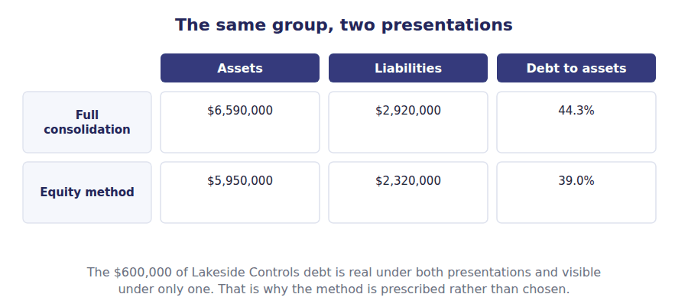
Part 5 · One more requirement the same policies throughout
Exercise 2E Read and complete. Write one word in each space.
OBJECTIVE | Say what must be done before a subsidiary’s figures can be consolidated.
YOU WILL NEED | Exercise 2B, and Volume 4 Handout 4 on inventory cost flows.
HOW TO START | • Suppose Lakeside Controls values its inventory on a different basis from Northwind. A group has to apply uniform accounting policies to like transactions throughout.  • Adding the two figures together would produce a total measured on two bases at once. Ask what has to happen first.  • The last blank is what has to be done when the subsidiary’s year end is not the same as the parent’s.

WORD BANK
audited · consolidation · ledger · parent · restated · separate · uniform
Not every word is used.

R2 A group reports as one entity, so like transactions must be measured the same way throughout it. The requirement is for ⁸ accounting policies across the consolidation.
If Lakeside Controls values inventory on a basis Northwind does not use, its figures are ⁹ onto Northwind’s basis before they are added. The subsidiary’s own statements are unaffected.
The same applies to dates. A subsidiary whose year end differs from the parent’s is consolidated from figures drawn up to the ¹⁰ reporting date, and a gap of more than three months is not acceptable.
None of this changes what Lakeside Controls reports to its own shareholders. The adjustments are made in the ¹¹ and nowhere else.
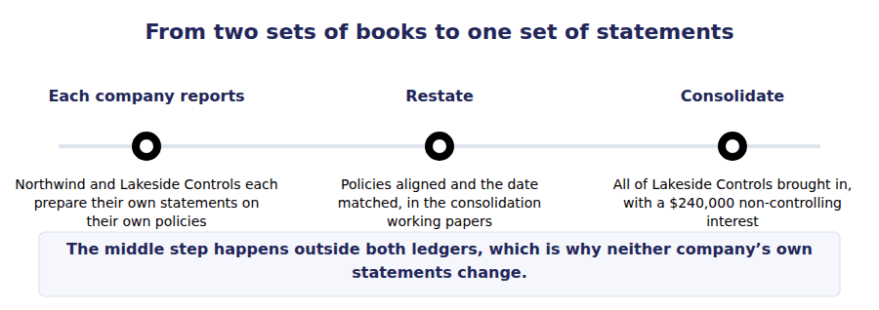
Watch out! Proportionate consolidation is the answer the share percentage invites and it is prohibited for a controlled subsidiary. If a stem gives you 80% and asks for consolidated assets, the answer uses all of the subsidiary’s assets.
Part 6 · Exam pitch the questions as the CMA sets them
1. [Level A] A controlled subsidiary is brought into the group’s statements by:
(A) Proportionate consolidation
(B) Full consolidation, with a non-controlling interest
(C) The equity method
(D) Whichever method the parent elects
2. [Level A] An investment in a joint venture is accounted for using:
(A) Full consolidation
(B) The equity method
(C) Proportionate consolidation
(D) Fair value through profit
3. [Level B] Northwind owns 80% of Lakeside Controls, which has assets of $1,600,000. The assets included in the consolidated balance sheet are:
(A) $1,280,000
(B) $1,600,000
(C) $960,000
(D) $1,000,000
4. [Level B] A subsidiary earns $120,000 and is 80% owned. The profit attributable to the parent under full consolidation compared with the equity method is:
(A) Higher by $24,000
(B) The same
(C) Higher by $120,000
(D) Lower by $24,000
5. [Level B] Compared with the equity method, full consolidation of a subsidiary with debt:
(A) Reduces the group’s reported leverage
(B) Increases the group’s reported assets and liabilities
(C) Increases the profit attributable to the parent
(D) Has no effect on the balance sheet
6. [Level C] A subsidiary values inventory on a basis its parent does not use. For consolidation purposes the subsidiary’s figures should be:
(A) Consolidated as reported, with disclosure of the difference
(B) Restated onto the parent’s basis before consolidation
(C) Excluded from the consolidation
(D) Consolidated at the parent’s election
7. [Level C] An investor has joint control of an arrangement and rights to the individual assets and obligations rather than to its net assets. The arrangement is:
(A) A joint venture, accounted for by the equity method
(B) A joint operation, with the investor recognising its share of the assets and liabilities directly
(C) A subsidiary, consolidated in full
(D) A variable interest entity
ADAPTIVE TIP Decide the relationship before you touch a figure. Control means all of the assets; influence or joint control over net assets means one line. Every number in the question follows from that decision, and no percentage in the stem changes it.

Handout 3 · What Gets Eliminated
Lakeside Controls sells $150,000 of goods to Northwind. Until those goods reach a real customer the group has sold nothing, and $24,000 of profit has to come back out.
Volume 10 · Consolidated Statements · R2 moving to R3
LANGUAGE FOCUS
Register you are working in | R2 for the four eliminations, R3 for the allocation between the parent and the non-controlling interest.
Say it exactly like this | eliminate an intercompany balance · remove unrealised profit from inventory · offset the investment against equity · sell goods on to a third party · allocate an elimination to the non-controlling interest · consolidate the working papers
Words that are not the same | intercompany / external · realised / unrealised · upstream / downstream · gross sales / consolidated revenue
Remember | Eliminating an intercompany sale does not reduce group profit by the sale. Both the revenue and the cost come out, and only the unrealised margin changes profit. An elimination is not a correction. Each company recorded its transaction properly; the group simply cannot report it.

What you will be able to do when this handout is finished
- Say why intercompany items must be eliminated.
- Eliminate intercompany revenue and the matching cost.
- Compute the unrealised profit in closing inventory.
- Distinguish an upstream from a downstream sale.
- Allocate an upstream elimination between the parent and the non-controlling interest.

Goods that have not been sold
During 20X4 Lakeside Controls sold $150,000 of control units to Northwind. They cost $90,000 to make, so $60,000 was recorded as profit.
Northwind has sold $90,000 of them on to its own customers. The remaining $60,000 sit in its warehouse at the year end.
Northwind also still owes $45,000 for them.
The group has sold nothing to anybody outside it on $60,000 of that, and a group cannot owe itself money. Four things have to come out before these statements can be published.

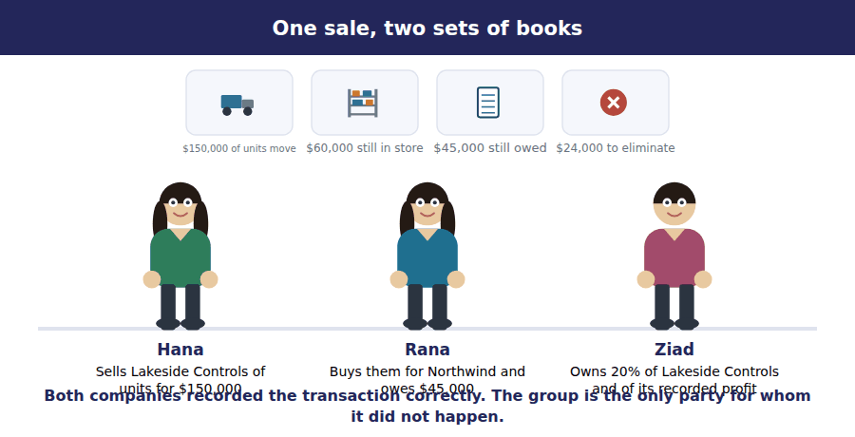
Part 1 · Why anything is eliminated at all the group as one entity
Exercise 3A Read and complete. Write one word in each space.
OBJECTIVE | Say why intercompany items have to be removed from a consolidation.
YOU WILL NEED | Handout 1 Exercise 1A, on what consolidated statements show.
HOW TO START | • A single company cannot report a sale to its own warehouse. Ask what follows for a group reporting as one entity.  • Every item here is an intercompany transaction: real for each of the two companies and non-existent for the group.  • Think about what the $45,000 receivable and the $45,000 payable do when the two balance sheets are added together.  • The last blank is where the eliminations are recorded, and it is not in anybody’s ledger.

WORD BANK
company · entity · holds · law · ledger · papers · substance
Not every word is used.

R2 Consolidated statements present the group as one ¹ . A single entity cannot sell to itself, cannot owe itself money and cannot make a profit by moving goods from one of its own buildings to another.
So every item that exists only between members of the group is removed. Adding the two balance sheets together would otherwise show a $45,000 receivable and a $45,000 payable that cancel in ² and inflate both totals.
The same applies to the income statement. The $150,000 of sales and the $90,000 of cost both come out, and because both sides go, group profit falls only by the margin on goods the group still ³ .
None of this is a correction. Each company recorded its transaction properly and keeps its figures. The eliminations are made in the consolidation working ⁴ alone.
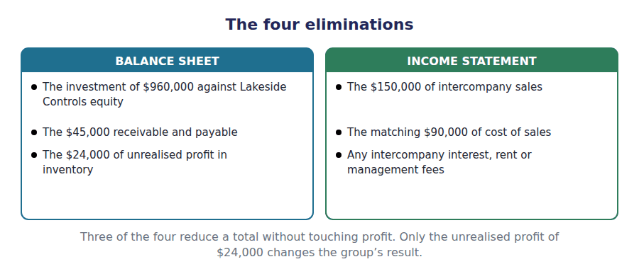
Part 2 · The unrealised profit the only elimination that moves profit
R2 Profit on an intercompany sale is realised when the goods leave the group. Until then the margin on whatever is still held has been recorded by one company and earned by nobody, so it is removed from both inventory and profit.
Exercise 3B Complete the schedule. Three figures are given.
OBJECTIVE | Compute the unrealised profit in closing inventory.
YOU WILL NEED | Exercise 3A, and the paragraph above.
HOW TO START | • Lakeside Controls sold $150,000 of goods that cost it $90,000. Work out the profit and then the rate.  • The rate is the profit as a share of the selling price, because that is what the $60,000 of unsold goods is stated at.  • The last row is the rate applied to the goods still held, and it is the only elimination in this handout that changes profit.

The intercompany sale of $150,000 | Amount
Sales recorded by the selling company | $150,000
Cost of those goods to the selling company | $90,000
Profit recorded on the sale
Gross margin rate
Goods still held by the buying company at the year end | $60,000
Unrealised profit to be eliminated

1 | 2 | 3

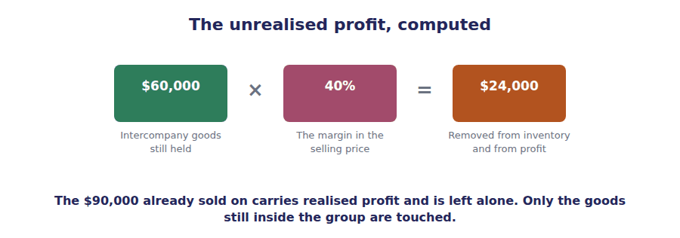
E1 The intercompany sale and the matching cost removed from the consolidated income statement. Both sides, so group profit does not move on this entry.
Account | Debit | Credit
Sales
Cost of Goods Sold
E2 The unrealised profit removed from the goods still held at the year end. The one elimination that does reduce group profit.
Account | Debit | Credit
Cost of Goods Sold
Inventory
E3 The intercompany receivable and payable offset. Both totals fall and profit is untouched.
Account | Debit | Credit
Accounts Payable
Accounts Receivable

Part 3 · Which way the goods went upstream and downstream
Exercise 3C Read and complete. Write one word or figure in each space.
OBJECTIVE | Say who bears the elimination of an upstream unrealised profit.
YOU WILL NEED | Exercise 3B, and Handout 1 Exercise 1E on the non-controlling interest.
HOW TO START | • Lakeside Controls sold to Northwind, so the profit was recorded in the subsidiary’s books.  • Those books belong 80% to Northwind and 20% to the other shareholders. Ask whose profit is being removed.  • The last blank is who bears the whole elimination when the parent is the seller instead.

WORD BANK
$4,800 · downstream · full · parent · shared · subsidiary · upstream
Not every word is used.

R2 The sale ran from Lakeside Controls to Northwind, which makes it an ⁵ sale. The $60,000 of profit was recorded in the subsidiary’s own income statement.
Subsidiary profit belongs 80% to Northwind and 20% to the other shareholders, so the $24,000 eliminated was earned partly for them. The elimination is therefore ⁶ in the same proportions.
Northwind bears $19,200 of it and the non-controlling interest bears ⁷ , which is 20% of the $24,000 removed.
A downstream sale works differently. There the profit was recorded by the parent, so none of it belonged to the other shareholders and the whole elimination falls on the ⁸ .
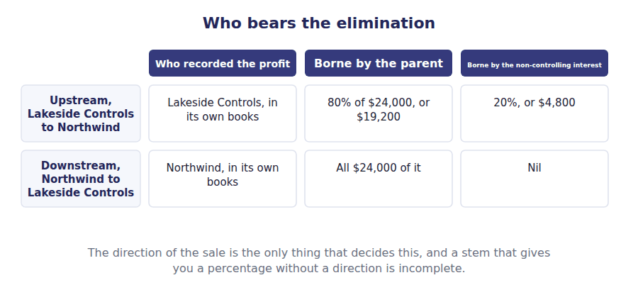
Part 4 · What the statements look like after four totals, two versions
Exercise 3D Complete the right-hand column. Each cell is one subtraction.
OBJECTIVE | Show the effect of the eliminations on four consolidated totals.
YOU WILL NEED | Exercises 3B and 3C.
HOW TO START | • Revenue loses the whole $150,000 of intercompany sales.  • Inventory loses the $24,000 of unrealised profit, not the $60,000 of goods.  • Receivables and payables each lose the same $45,000, so the balance sheet still balances.

Consolidated figure | Before eliminating | After eliminating
Revenue | $5,700,000
Inventory | $1,145,000
Receivables | $914,000
Payables | $710,000

1 | 2 | 3 | 4

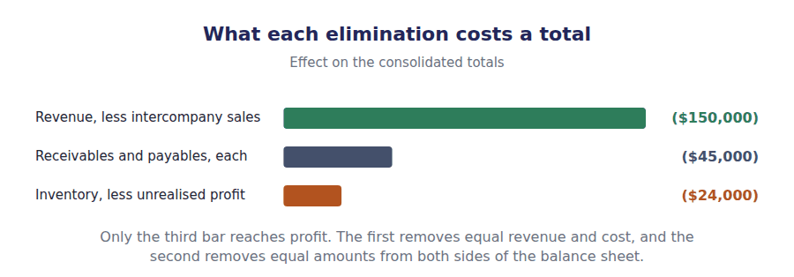
Watch out! Eliminate the profit in the inventory, never the inventory. A stem that says $60,000 of intercompany goods remain unsold at a 40% margin is asking for $24,000, and the figure in the stem is there to be multiplied rather than subtracted.
Part 5 · Exam pitch the questions as the CMA sets them
1. [Level A] Intercompany receivables and payables are eliminated in consolidation because:
(A) They are immaterial
(B) A single entity cannot owe money to itself
(C) They are not legally enforceable
(D) They have already been settled
2. [Level A] A subsidiary sells $150,000 of goods to its parent at a 40% gross margin. All of the goods are sold on to outside customers before the year end. The unrealised profit to eliminate is:
(A) $60,000
(B) Nil
(C) $24,000
(D) $150,000
3. [Level B] A subsidiary sells goods to its parent. At the year end $60,000 of them remain in the parent’s inventory. The margin was 40%. The elimination from consolidated inventory is:
(A) $60,000
(B) $24,000
(C) $36,000
(D) $150,000
4. [Level B] Eliminating $150,000 of intercompany sales reduces consolidated profit by:
(A) $150,000
(B) Nothing, because the matching cost of sales is eliminated too
(C) $60,000
(D) $24,000
5. [Level B] The whole of an unrealised profit elimination is borne by the parent when the sale was:
(A) Upstream, from the subsidiary to the parent
(B) Downstream, from the parent to the subsidiary
(C) Between two subsidiaries
(D) At cost
6. [Level C] Lakeside Controls, which is 80% owned, sells goods upstream leaving $24,000 of unrealised profit at the year end. The amount charged against the non-controlling interest is:
(A) $24,000
(B) $4,800
(C) $19,200
(D) Nil
7. [Level C] The parent’s investment in the subsidiary is eliminated against:
(A) The subsidiary’s retained earnings only
(B) The subsidiary’s equity at the acquisition date, with goodwill and the non-controlling interest recognised
(C) Consolidated revenue
(D) The parent’s own share capital
ADAPTIVE TIP Work the eliminations in a fixed order: investment against equity, then revenue against cost, then receivable against payable, then the unrealised profit. Only the last one touches profit, so if a question asks what happened to consolidated profit, it is asking about one figure out of four.

Answer Key
Volume 10 · Handouts 1 to 3
Every answer carries the reason for it and the mistake it defeats.

Handout 1 · What Consolidation Is, and the Two Models answers
Completed text and exercises
# | Answer | Why | The trap it defeats
1 | entity | One reporting entity, two legal ones.
2 | line | A single investment figure hides everything behind it.
3 | directs | Direction, not ownership, is the test. | Students expect consolidation to show what the parent owns. It shows what the parent controls, which is why 100% of the assets come in and not 80%.
4 | control | The single condition for consolidating.
Grid 1 | 1 CONSOLIDATE 2 EQUITY METHOD 3 FAIR VALUE 4 EQUITY METHOD 5 EQUITY METHOD 6 CONSOLIDATE | Two of the six go against the share count: a majority that cannot direct does not consolidate, and no shares at all sometimes does.
5 | interest | Votes, and more than half of them.
6 | not | The power has to be real.
7 | variable | The standard’s own name for the structure.
8 | beneficiary | Power and exposure, not shares. | Students look for a percentage. Under this model there may be no relevant percentage at all.
9 | liability | No obligation to transfer anything.
10 | shareholders | Two lines inside one equity section.
11 | interest | Profit is split after being totalled.
12 | all | Control is not divisible. | Students bring in 80% of the assets to match the shareholding. Control is the test, and it is all or nothing.

Exam-pitch questions
# | Answer | Why | The trap it defeats
1 | (B) A reader needs to see the resources the parent controls | Consolidation reflects control over resources. (A) is false in law: both companies keep their identity, their books and usually their own tax return. | Level A
2 | (B) Consolidation | A majority with real power means control, which means consolidation. (C) is the method for influence without control, which this holding has gone well past. | Level A
3 | (B) Not consolidate, because it cannot direct the activities | The majority presumption is rebutted when the power is not real. (A) applies the share count mechanically, and (C) proposes a consolidation that would hide exactly what consolidation is for. | Level B
4 | (B) Its primary beneficiary | The party with the power to direct the activities that matter and the exposure to the results consolidates, whatever its shareholding. (A) is the voting model applied to the case the second model exists for. | Level B
5 | (B) $200,000 | $960,000 for 80% implies a total of $1,200,000, which is $200,000 above the $1,000,000 of net assets. (C) compares the $960,000 consideration with 100% of the net assets and so understates goodwill by the non-controlling share of it. | Level C
6 | (B) As a separate component of consolidated equity | Those shareholders own part of the group’s net assets, and the parent owes them nothing. (A) is the classification the name invites and the definition of a liability rules out. | Level B
7 | (B) 100% | Control is not divisible, so everything comes in and the other owners are shown as a non-controlling interest in equity. (A) is proportionate consolidation, which US GAAP does not permit for a controlled subsidiary. | Level C

Exercise 1D · the completed acquisition schedule
The acquisition of Lakeside Controls | Amount
Consideration paid for 80% of the shares | $960,000
Implied value of Lakeside Controls as a whole | $1,200,000
Non-controlling interest, 20% of that value | $240,000
Fair value of the identifiable net assets acquired | $1,000,000
Goodwill recognised | $200,000

Exercise 1E · one line against consolidation
 | If Northwind reports the investment only | If Northwind consolidates
On the balance sheet | One line: investment $960,000 | Every asset and liability Lakeside Controls controls
Debt of Lakeside Controls | Invisible | Added to the group’s own
Revenue of Lakeside Controls | Invisible | Added to the group’s own
What the reader sees | An investment of $960,000 | The resources Northwind directs

R2 The $960,000 paid for 80% implies that the whole of Lakeside Controls is worth $1,200,000, so the non-controlling interest is $240,000 and the goodwill is the $200,000 by which the implied total exceeds the $1,000,000 fair value of the identifiable net assets.
R2 Check it the other way: $960,000 of consideration plus $240,000 of non-controlling interest is $1,200,000, and $1,000,000 of net assets plus $200,000 of goodwill is the same figure. Handout 2 uses that identity again under each of the three methods.

Handout 2 · Full, Proportionate and Equity Consolidation answers
Completed text and exercises
# | Answer | Why | The trap it defeats
1 | fully | All of it, because control is not divisible.
2 | prohibited | Not an option for a subsidiary under US GAAP. | Students pick it because it matches the shareholding. The shareholding is not what consolidation measures.
3 | equity | One line for the net assets, one for the profit.
4 | venture | Rights to the net assets, not to the assets.
5 | $24,000 | 20% of $120,000.
6 | deducted | Only the share was ever added.
7 | unchanged | Same destination, two routes. | Students expect consolidation to raise the parent’s profit. It raises revenue, assets and liabilities; the attributable profit is the one figure it cannot move.
8 | uniform | One policy per kind of transaction, group-wide.
9 | restated | Restated for the group, not for itself. | Students adjust the subsidiary’s own books. The adjustment belongs in the consolidation working papers.
10 | parent | The group reports as at one date.
11 | consolidation | Working papers, not ledgers.

Exam-pitch questions
# | Answer | Why | The trap it defeats
1 | (B) Full consolidation, with a non-controlling interest | Full consolidation is the only method permitted once control exists. (A) matches the shareholding and is prohibited precisely because control is not proportionate. | Level A
2 | (B) The equity method | Rights to the net assets of a jointly controlled arrangement give the equity method. (C) was permitted for joint ventures under older standards, which is why the exam keeps offering it. | Level A
3 | (B) $1,600,000 | All of them, with a non-controlling interest in equity for the share not owned. (A) is the proportionate answer, which is the single most common error on this topic. | Level B
4 | (B) The same | Full consolidation adds $120,000 and then allocates $24,000 to the non-controlling interest, leaving $96,000, which is what the equity method adds directly. (A) forgets the allocation. | Level B
5 | (B) Increases the group’s reported assets and liabilities | Both sides of the balance sheet grow, which is the whole purpose: the subsidiary’s debt becomes visible. (C) is the answer the bigger revenue figure suggests and the non-controlling allocation rules out. | Level B
6 | (B) Restated onto the parent’s basis before consolidation | A group applies uniform policies to like transactions, so the restatement is made in the consolidation. (A) would add two figures measured on different bases and call the total one number. | Level C
7 | (B) A joint operation, with the investor recognising its share of the assets and liabilities directly | Rights to the assets themselves make it a joint operation, and the investor records its own share directly. (A) is the other half of the same distinction, and it is the half the exam states first to see whether you read on. | Level C

Exercise 2B · the three methods, computed
 | Full | Proportionate | Equity method
Assets of Lakeside Controls brought in | $1,600,000 | $1,280,000 | Nil
Liabilities brought in | $600,000 | $480,000 | Nil
Investment line carried | Nil | Nil | $960,000
Revenue added | $900,000 | $720,000 | Nil
Profit added | $120,000 | $96,000 | $96,000
Non-controlling interest shown | $240,000 | Nil | Nil

Exercise 2D · the effect on the totals
Measure | Full consolidation | Equity method
Total assets | $6,590,000 | $5,950,000
Total liabilities | $2,920,000 | $2,320,000
Profit attributable to Northwind | $606,000 | $606,000
Debt to assets | 44.3% | 39.0%

R2 Row 5 of the first grid is the one to remember. Full consolidation adds $120,000 of profit and allocates $24,000 away; the equity method adds $96,000 and allocates nothing. Both leave $606,000 attributable to Northwind.
R2 The second grid is why the method is prescribed. The same group owes the same $600,000 either way, and only full consolidation puts it on the face of the balance sheet, where it moves debt to assets from 39.0% to 44.3%.

Handout 3 · What Gets Eliminated answers
Completed text and exercises
# | Answer | Why | The trap it defeats
1 | entity | One reporting entity, whatever the legal structure.
2 | substance | Real for each company, nothing for the group.
3 | holds | Only the unsold part is unrealised. | Students reduce profit by the whole intercompany sale. The cost comes out with the revenue, so only the unrealised margin moves profit.
4 | papers | Neither ledger is touched.
5 | upstream | From the subsidiary to the parent.
6 | shared | The profit was shared, so the removal is too.
7 | $4,800 | 20% of $24,000.
8 | parent | All the parent’s profit, all the parent’s elimination. | Students split every elimination. Only an upstream one is shared, because only then did the subsidiary record the profit.

Exam-pitch questions
# | Answer | Why | The trap it defeats
1 | (B) A single entity cannot owe money to itself | The group reports as one entity, and the two balances cancel in substance. (C) is false: the debt between two companies is perfectly enforceable, which is why each one reports it. | Level A
2 | (B) Nil | Once the goods leave the group the profit on them is realised, so nothing is eliminated from inventory. (A) eliminates profit on goods that have genuinely been sold. | Level A
3 | (B) $24,000 | $60,000 at 40% is $24,000 of unrealised profit. (A) removes the inventory instead of the profit in it, which would leave the group holding goods it does not report. | Level B
4 | (B) Nothing, because the matching cost of sales is eliminated too | Both the revenue and the cost come out, so that entry alone leaves profit where it was. (A) is the error the size of the sales figure invites, and (D) belongs to the separate unrealised profit entry. | Level B
5 | (B) Downstream, from the parent to the subsidiary | The parent recorded the profit, so none of it belonged to the non-controlling interest. (A) is the direction in which the elimination is shared, which is exactly the pair the question tests. | Level B
6 | (B) $4,800 | The subsidiary recorded the profit, and 20% of its profit belongs to the other shareholders: 20% of $24,000 is $4,800. (D) is the downstream answer applied to an upstream sale. | Level C
7 | (B) The subsidiary’s equity at the acquisition date, with goodwill and the non-controlling interest recognised | The investment offsets the equity it bought, and what the consideration and the non-controlling interest exceed the net assets by is goodwill. (D) is impossible: the parent’s own capital is the group’s capital and stays. | Level C

Exercise 3B · the unrealised profit, computed
The intercompany sale of $150,000 | Amount
Sales recorded by the selling company | $150,000
Cost of those goods to the selling company | $90,000
Profit recorded on the sale | $60,000
Gross margin rate | 40%
Goods still held by the buying company at the year end | $60,000
Unrealised profit to be eliminated | $24,000

Exercise 3D · the effect on the totals
Consolidated figure | Before eliminating | After eliminating
Revenue | $5,700,000 | $5,550,000
Inventory | $1,145,000 | $1,121,000
Receivables | $914,000 | $869,000
Payables | $710,000 | $665,000

The four eliminations, summarised
What is eliminated | Amount | Why
The investment in Lakeside Controls against its equity | $960,000 | The group cannot hold shares in itself
Intercompany sales and the matching cost of sales | $150,000 | No sale was made outside the group
The receivable and the payable between them | $45,000 | The group cannot owe itself money
Unrealised profit in inventory still held | $24,000 | $60,000 of the goods have not been sold on

The elimination entries, completed
E1 Intercompany sales and the matching cost removed.
Account | Debit | Credit
Sales | $150,000
Cost of Goods Sold |  | $150,000
E2 Unrealised profit removed from closing inventory.
Account | Debit | Credit
Cost of Goods Sold | $24,000
Inventory |  | $24,000
E3 The intercompany receivable and payable offset.
Account | Debit | Credit
Accounts Payable | $45,000
Accounts Receivable |  | $45,000

R2 E1 and E3 move no profit at all: each takes equal amounts out of two places. Only E2 reduces the group’s result, by the $24,000 of margin on goods the group still holds, and that $24,000 is split $19,200 to Northwind and $4,800 to the non-controlling interest because the sale was upstream.

Glossary
Every term in Volume 10, with the Arabic equivalent and the places it misleads
The third column is for recognition only. In the exam room you work in English.

Term | What it means in CMA English | بالعربية | Careful
control | The power to direct the activities of another entity so as to obtain benefits from it. | السيطرة | The trigger for consolidation. Influence without control gives the equity method of Volume 6 instead.
downstream | Describing a sale from a parent to its subsidiary. | من الأم إلى التابعة | The whole elimination falls on the parent, because all of the profit removed was the parent’s.
elimination | The removal of an item from a consolidation because it is internal to the group. | الاستبعاد | Made only in the consolidation working papers. Neither company’s own books are touched.
equity method | Reporting an investment at cost plus the investor’s share of the investee’s profits, less dividends received, on one line. | طريقة حقوق الملكية | Volume 6 worked the mechanics. Here it is the alternative consolidation is being chosen over.
full consolidation | Bringing in all of a subsidiary’s assets, liabilities, revenues and expenses, with a non-controlling interest for the part not owned. | التوحيد الكامل | The only method permitted for a controlled subsidiary. All of the assets, whatever the stake.
intercompany transaction | A transaction between two members of the same group. | معاملة بين شركات المجموعة | Real for each company and non-existent for the group, which is why both sides of it have to come out.
joint arrangement | An arrangement over which two or more parties have joint control. | الترتيب المشترك | Joint control means neither party can act alone. It is a third thing, not a weak form of control.
joint venture | A joint arrangement in which the parties have rights to the net assets of the arrangement. | المشروع المشترك | Accounted for by the equity method. A joint operation, where the parties have rights to the assets themselves, is accounted for directly.
non-controlling interest | The portion of a subsidiary’s equity that the parent does not own. | حقوق الملكية غير المسيطرة | Reported inside consolidated equity, not as a liability, because those shareholders are owners of the group’s net assets.
one-line consolidation | A name for the equity method, because it reports the investor’s share of an investee’s net assets and profit on single lines. | التوحيد في سطر واحد | The name is the point: the same share of profit arrives, with none of the detail and none of the debt.
parent | A company that controls one or more other entities. | الشركة الأم | Northwind is the parent from the day control passes, not from the day the shares are paid for if the two differ.
proportionate consolidation | Bringing in a share of an investee’s assets and liabilities equal to the investor’s interest. | التوحيد النسبي | Not permitted for a controlled subsidiary under US GAAP. It is the answer the share percentage invites and the exam rewards avoiding.
significant influence | The power to participate in another entity’s decisions without directing them. | التأثير الجوهري | Ordinarily presumed from a holding of twenty to fifty per cent. It gives the equity method and never consolidation.
subsidiary | An entity controlled by another. | الشركة التابعة | A subsidiary keeps its own legal identity and its own books. Consolidation happens only in the parent’s reporting.
uniform accounting policies | The requirement that a group apply the same policies to like transactions throughout the consolidation. | سياسات محاسبية موحدة | A subsidiary using a different inventory method must be restated before consolidation, not consolidated as it stands.
unrealised profit | Profit recorded on an intercompany sale of goods that the group still holds. | الربح غير المحقق | Realised when the goods are sold outside the group. Only the part still held is eliminated.
upstream | Describing a sale from a subsidiary to its parent. | من التابعة إلى الأم | The direction decides who bears the elimination. Upstream profit was earned partly for the non-controlling interest.
variable interest entity | An entity that is consolidated because of exposure to its risks and rewards rather than because of voting rights. | كيان ذو حصص متغيرة | The second model. It exists because voting rights alone could be arranged to keep an entity off a balance sheet.

