1.1 Two kinds of cost
Chapter 1 · section 1.1

Fill every gap. Each word list holds one word more than there are gaps.
Chapter 1, section by section
Each stage leads to the next.
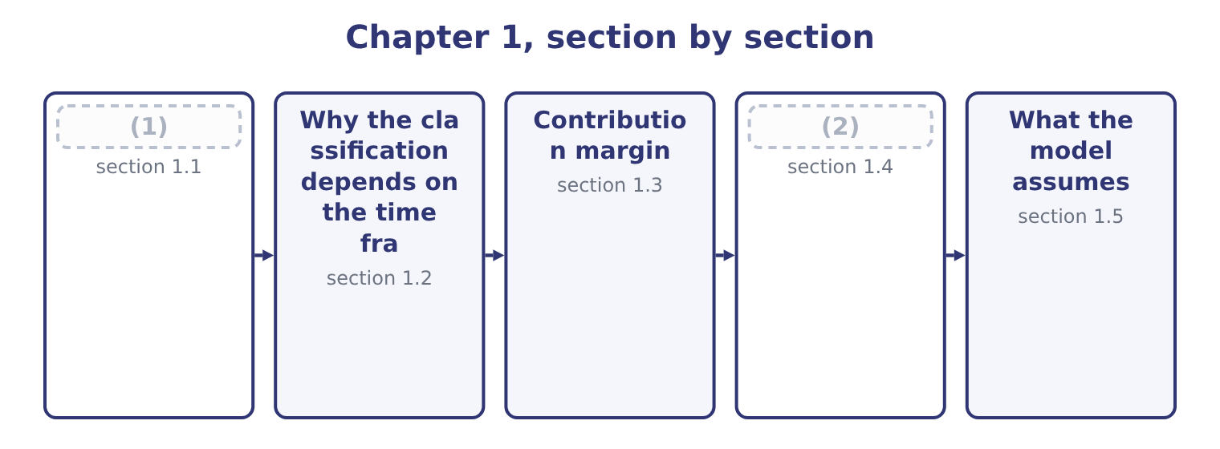
word list
target operating income · The breakeven point · Two kinds of cost

Summary 1 gaps 3–14
A variable cost (3) in total in (4) to the level of activity and stays constant per unit. Sesame, packaging, the (5) that runs the (6) , the piece rate paid to a packer: make twice as many jars and the total (7) , while each jar still carries the same amount. A fixed cost stays constant in total over a range of activity and (8) falls per unit as (9) rises. The factory lease, the (10) on the roasting line, the plant (11) salary, the audit fee. (12) twice as many jars does not make the lease larger, and it halves the lease (13) by each jar. Those two (14) contain the trap that costs most marks in Section C. In total, a variable cost moves and a fixed cost does not. Per unit, a variable cost does not move and a fixed cost does.
word list
volume · roaster · electricity · proportion · sentences · Making · depreciation · therefore · doubles · manager's · classifications · changes · carried

Summary 2 gaps 15–25
Everything else in the chapter (15) from keeping the two columns (16) . A mixed or (17) cost has both elements: a telephone contract with a standing charge and a per-call rate, a (18) agreement with a retainer and an hourly rate, a factory's power bill with a (19) charge and a consumption charge. For (20) purposes a mixed cost is split into its two parts, and Part 1 taught the methods — the (21) method and (22) . A step cost is fixed over a range and then jumps: one supervisor for every (23) packers, one (24) van for every so many (25) . Over a wide enough range every fixed cost is a step cost, which is why the next section matters.
word list
maintenance · delivery · high-low · decision · twenty · capacity · follows · semi-variable · regression · straight · routes · supervisor's

How each kind of cost behaves
Every item belongs to exactly one group.
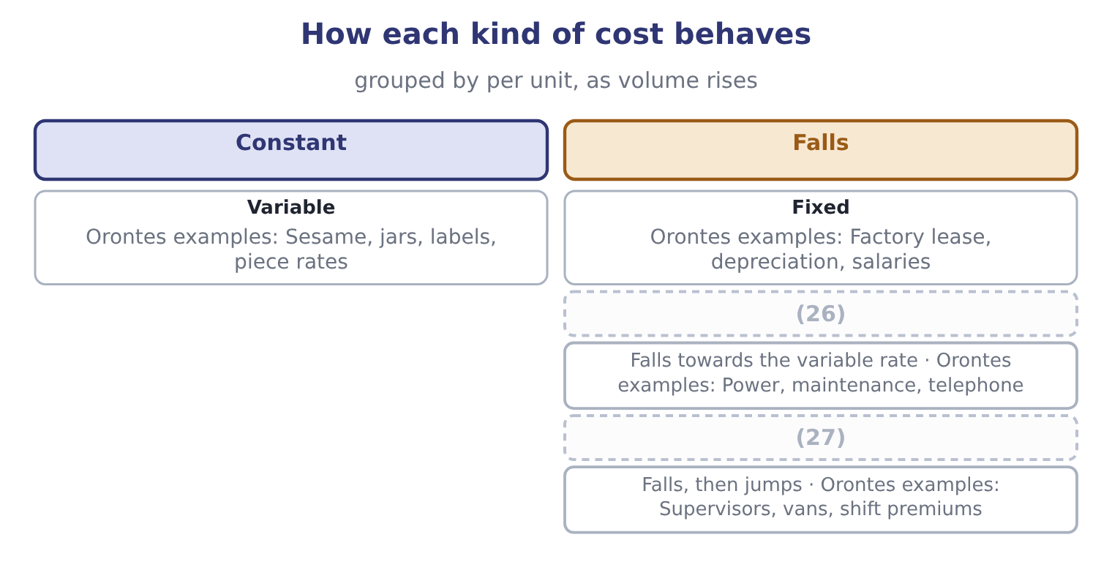
word list
Mixed · Constant · Step

In total or per unit

Summary 3 gaps 28–34
Read which column a (28) is asking about. A cost is not fixed because it is (29) , and not variable because it is large. The test is (30) it moves with (31) . Direct and indirect is a different (32) entirely. A factory (33) salary is indirect and fixed; sesame is direct and variable; a (34) of fifty cents a jar is direct and variable; factory rent is indirect and fixed. The two classifications cut across each other.
word list
unavoidable · keeping · question · royalty · supervisor's · classification · output · whether

The English this section uses, and its Arabic
Each term sits against what it means.
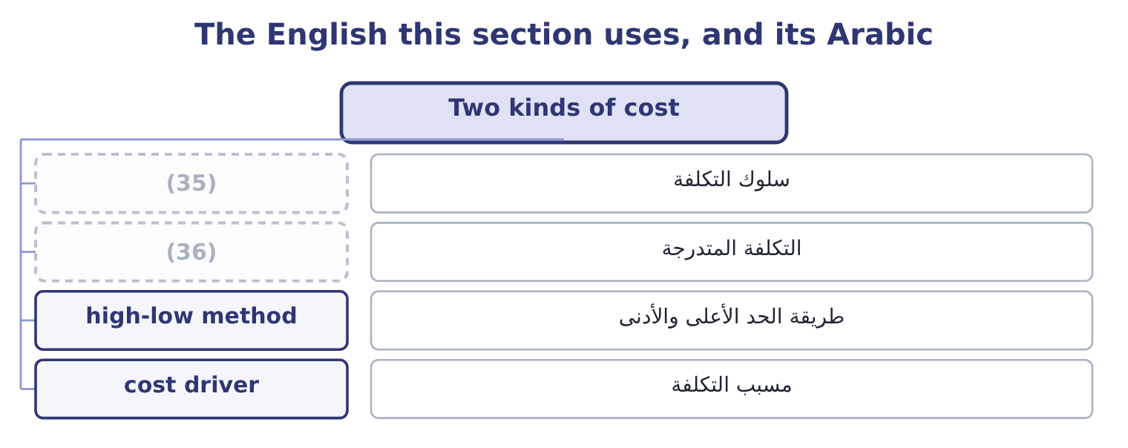
word list
step cost · cost behaviour · relevant range

The English this sheet uses, and its Arabic
English (exam term) | Arabic
cost behaviour | سلوك التكلفة
step cost | التكلفة المتدرجة
high-low method | طريقة الحد الأعلى والأدنى
cost driver | مسبب التكلفة

Answer key · 1.1 Two kinds of cost

1 Two kinds of cost | 19 capacity
2 The breakeven point | 20 decision
3 changes | 21 high-low
4 proportion | 22 regression
5 electricity | 23 twenty
6 roaster | 24 delivery
7 doubles | 25 routes
8 therefore | 26 Mixed
9 volume | 27 Step
10 depreciation | 28 question
11 manager's | 29 unavoidable
12 Making | 30 whether
13 carried | 31 output
14 sentences | 32 classification
15 follows | 33 supervisor's
16 straight | 34 royalty
17 semi-variable | 35 cost behaviour
18 maintenance | 36 step cost

the summaries in full
Summary 1 A variable cost changes in total in proportion to the level of activity and stays constant per unit. Sesame, packaging, the electricity that runs the roaster, the piece rate paid to a packer: make twice as many jars and the total doubles, while each jar still carries the same amount. A fixed cost stays constant in total over a range of activity and therefore falls per unit as volume rises. The factory lease, the depreciation on the roasting line, the plant manager's salary, the audit fee. Making twice as many jars does not make the lease larger, and it halves the lease carried by each jar. Those two sentences contain the trap that costs most marks in Section C. In total, a variable cost moves and a fixed cost does not. Per unit, a variable cost does not move and a fixed cost does.
Summary 2 Everything else in the chapter follows from keeping the two columns straight. A mixed or semi-variable cost has both elements: a telephone contract with a standing charge and a per-call rate, a maintenance agreement with a retainer and an hourly rate, a factory's power bill with a capacity charge and a consumption charge. For decision purposes a mixed cost is split into its two parts, and Part 1 taught the methods — the high-low method and regression. A step cost is fixed over a range and then jumps: one supervisor for every twenty packers, one delivery van for every so many routes. Over a wide enough range every fixed cost is a step cost, which is why the next section matters.
Summary 3 Read which column a question is asking about. A cost is not fixed because it is unavoidable, and not variable because it is large. The test is whether it moves with output. Direct and indirect is a different classification entirely. A factory supervisor's salary is indirect and fixed; sesame is direct and variable; a royalty of fifty cents a jar is direct and variable; factory rent is indirect and fixed. The two classifications cut across each other.

1.2 Why the classification depends on the time frame
Chapter 1 · section 1.2

Fill every gap. Each word list holds one word more than there are gaps.
Summary 1 gaps 1–12
No cost is fixed for ever and almost none is fixed (1) . The classification (2) a period and a range, and the exam tests whether a (3) knows it. Over a very short period almost everything is fixed. (4) output cannot change the lease, the salaries, the (5) , or the sesame already bought and in the silo. The only (6) variable costs of tomorrow are the ones not yet (7) . Over a long enough period almost everything is variable. Given three years, Orontes can leave the factory, sell the (8) line, change the size of its workforce and (9) every contract. There are no fixed costs in a long enough run, which is why the (10) is never absolute. In (11) lies the period the (12) concerns, and that is the period the classification must describe.
word list
Tomorrow's · insurance · candidate · decision · opening · committed · between · instantly · distinction · describes · genuinely · roasting · renegotiate

Summary 2 gaps 13–21
A question about (13) an order next month treats the plant as fixed; a question about (14) a second plant does not. The relevant range (15) the same idea for (16) rather than time. Fixed costs are fixed and variable costs are (17) only within the range of activity the company is actually (18) . Below it, a company closes (19) ; above it, it hires (20) , adds a shift, leases a second warehouse, and pays overtime rates that are not the normal variable rate. A cost-volume-profit (21) is valid inside the relevant range and nowhere else, and saying so is worth a mark.
word list
accepting · departments · actually · carries · volume · operating · analysis · supervisors · proportionate · opening

One cost, three time frames
Every item belongs to exactly one group.
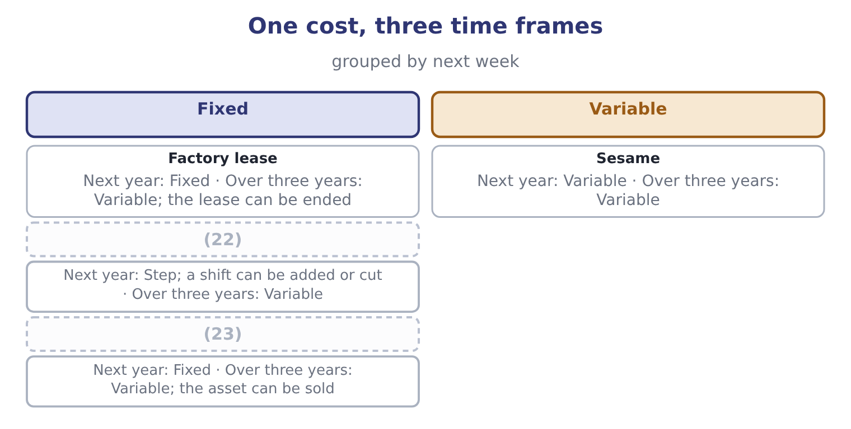
word list
step cost · Supervisors' salaries · Depreciation on the roaster

The English this section uses, and its Arabic
Each term sits against what it means.
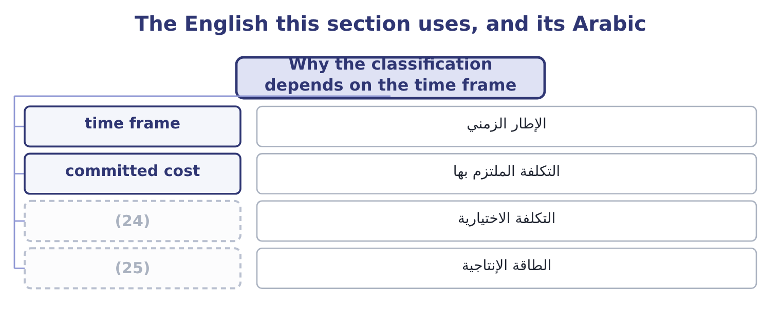
word list
capacity · time frame · discretionary cost

The English this sheet uses, and its Arabic
English (exam term) | Arabic
time frame | الإطار الزمني
committed cost | التكلفة الملتزم بها
discretionary cost | التكلفة الاختيارية
capacity | الطاقة الإنتاجية

Answer key · 1.2 Why the classification depends on the time frame

1 instantly | 14 opening
2 describes | 15 carries
3 candidate | 16 volume
4 Tomorrow's | 17 proportionate
5 insurance | 18 operating
6 genuinely | 19 departments
7 committed | 20 supervisors
8 roasting | 21 analysis
9 renegotiate | 22 Supervisors' salaries
10 distinction | 23 Depreciation on the roaster
11 between | 24 discretionary cost
12 decision | 25 capacity
13 accepting

the summaries in full
Summary 1 No cost is fixed for ever and almost none is fixed instantly. The classification describes a period and a range, and the exam tests whether a candidate knows it. Over a very short period almost everything is fixed. Tomorrow's output cannot change the lease, the salaries, the insurance, or the sesame already bought and in the silo. The only genuinely variable costs of tomorrow are the ones not yet committed. Over a long enough period almost everything is variable. Given three years, Orontes can leave the factory, sell the roasting line, change the size of its workforce and renegotiate every contract. There are no fixed costs in a long enough run, which is why the distinction is never absolute. In between lies the period the decision concerns, and that is the period the classification must describe.
Summary 2 A question about accepting an order next month treats the plant as fixed; a question about opening a second plant does not. The relevant range carries the same idea for volume rather than time. Fixed costs are fixed and variable costs are proportionate only within the range of activity the company is actually operating. Below it, a company closes departments; above it, it hires supervisors, adds a shift, leases a second warehouse, and pays overtime rates that are not the normal variable rate. A cost-volume-profit analysis is valid inside the relevant range and nowhere else, and saying so is worth a mark.

1.3 Contribution margin
Chapter 1 · section 1.3

Fill every gap. Each word list holds one word more than there are gaps.
Summary 1 gaps 1–10
Contribution margin is what is left of a selling price after the variable costs of (1) and selling that unit. It is (2) contribution (3) it is what each unit (4) , first to covering the fixed costs and then, once those are (5) , to operating income. (6) main line is a (7) jar of tahini selling at $12.00, with variable costs of $7.20 a jar. The contribution margin is 12.00 − 7.20 = 4.80 a jar, and the contribution margin ratio is 4.80 ÷ 12.00 = 40.0 per cent. Those figures (8) to the company as a whole. Orontes sold 42,000,000 ÷ 12.00 = 3,500,000 jars, which at $4.80 each gives 3,500,000 × 4.80 = 16,800,000 of total contribution margin — the figure Book 1 used to (9) a degree of operating (10) of 4.02.
word list
Orontes's · leverage · covered · one-kilogram · compute · reconcile · making · called · contributes · because · pausing

Summary 2 gaps 11–20
Deducting fixed costs of $12,624,000 (11) 16,800,000 − 12,624,000 = 4,176,000, which is the operating income on the face of the income statement. That (12) is worth pausing on. The contribution income statement and the (13) one report the same operating income and sort the costs (14) , and only one of them can (15) a question about (16) . Cost of goods sold of $27,300,000 is not the variable cost: it (17) the fixed factory costs absorbed into the product, and it excludes the variable part of selling and (18) . Gross profit and contribution margin are different measures and a (19) who uses one for the other will get every (20) question wrong.
word list
differently · volume · leaves · answer · candidate · contains · ordinary · reconciliation · covering · breakeven · distribution

The English this section uses, and its Arabic
Each term sits against what it means.
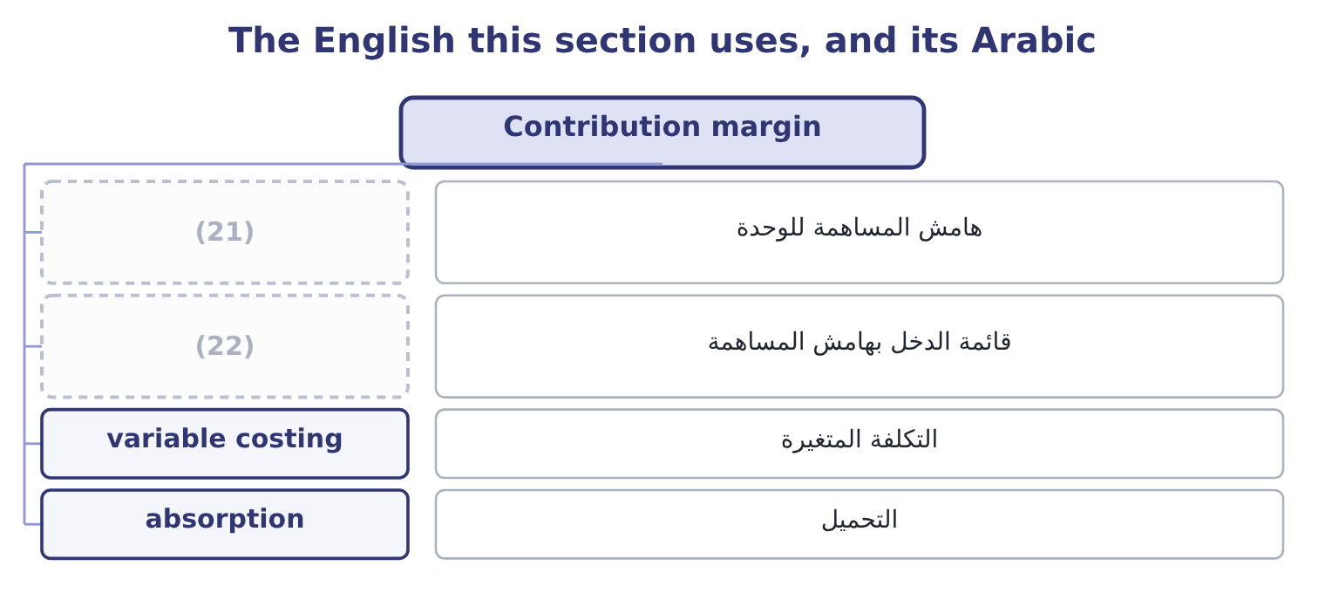
word list
contribution income statement · هامش المساهمة للوحدة · unit contribution margin

The English this sheet uses, and its Arabic
English (exam term) | Arabic
unit contribution margin | هامش المساهمة للوحدة
contribution income statement | قائمة الدخل بهامش المساهمة
variable costing | التكلفة المتغيرة
absorption | التحميل

Answer key · 1.3 Contribution margin

1 making | 12 reconciliation
2 called | 13 ordinary
3 because | 14 differently
4 contributes | 15 answer
5 covered | 16 volume
6 Orontes's | 17 contains
7 one-kilogram | 18 distribution
8 reconcile | 19 candidate
9 compute | 20 breakeven
10 leverage | 21 unit contribution margin
11 leaves | 22 contribution income statement

the summaries in full
Summary 1 Contribution margin is what is left of a selling price after the variable costs of making and selling that unit. It is called contribution because it is what each unit contributes, first to covering the fixed costs and then, once those are covered, to operating income. Orontes's main line is a one-kilogram jar of tahini selling at $12.00, with variable costs of $7.20 a jar. The contribution margin is 12.00 − 7.20 = 4.80 a jar, and the contribution margin ratio is 4.80 ÷ 12.00 = 40.0 per cent. Those figures reconcile to the company as a whole. Orontes sold 42,000,000 ÷ 12.00 = 3,500,000 jars, which at $4.80 each gives 3,500,000 × 4.80 = 16,800,000 of total contribution margin — the figure Book 1 used to compute a degree of operating leverage of 4.02.
Summary 2 Deducting fixed costs of $12,624,000 leaves 16,800,000 − 12,624,000 = 4,176,000, which is the operating income on the face of the income statement. That reconciliation is worth pausing on. The contribution income statement and the ordinary one report the same operating income and sort the costs differently, and only one of them can answer a question about volume. Cost of goods sold of $27,300,000 is not the variable cost: it contains the fixed factory costs absorbed into the product, and it excludes the variable part of selling and distribution. Gross profit and contribution margin are different measures and a candidate who uses one for the other will get every breakeven question wrong.

1.4 The breakeven point
Chapter 1 · section 1.4

Fill every gap. Each word list holds one word more than there are gaps.
Summary 1 gaps 1–5
The breakeven point is the level of (1) at which total (2) equals total cost, so operating income is nil. It is where the fixed costs have been exactly (3) by contribution and not a cent more. In units it is fixed costs divided by the contribution margin per unit. For Orontes: 12,624,000 ÷ 4.80 = 2,630,000 jars. In dollars it is fixed costs divided by the contribution margin ratio: 12,624,000 ÷ 0.40 = 31,560,000 of sales. The same answer (4) as 2,630,000 × 12.00 = 31,560,000, and the exam (5) either route.
word list
arrived · revenue · accepts · appears · activity · covered

Worked example: reading Orontes's breakeven

Summary 2 gaps 6–16
Orontes covers its fixed costs at 2,630,000 jars, or $31,560,000 of sales. (6) sales were 3,500,000 jars, which is 3,500,000 − 2,630,000 = 870,000 jars above the breakeven. What those jars earn. Every jar above the breakeven (7) its whole margin to operating income: 870,000 × 4.80 = 4,176,000, which is the operating income exactly. A ten per cent fall in volume removes 350,000 jars, which removes 350,000 × 4.80 = 1,680,000 of operating income — forty per cent of it, on a ten per cent fall in sales. That is the (8) of operating (9) of 4.02 that Book 1 (10) , arrived at from the cost (11) rather than from the ratio. (12) in Book 1's income (13) showed that a ten per cent sales fall costs forty per cent of the profit; the contribution format shows it (14) , and it is the first thing a board (15) be told about a company whose gross margin is (16) a point a year.
word list
arrived · statement · measured · degree · contributes · should · Nothing · immediately · structure · leverage · Actual · falling

Summary 3 gaps 17–18
A target income (17) one line of the formula. To earn a target operating income, add it to the fixed costs: the volume (18) is fixed costs plus target income, divided by the contribution margin per unit. For a target of $6,000,000: 12,624,000 + 6,000,000 = 18,624,000, and 18,624,000 ÷ 4.80 = 3,880,000 jars.
word list
needed · changes · exactly

The four questions and their answers
Question | Formula | Orontes
Breakeven in units | (19) | 2,630,000 jars
Breakeven in dollars | Fixed costs over the contribution ratio | 31,560,000
Units for a target operating income | (20) | 3,880,000 jars at a 6,000,000 target
Operating income at a volume | Units times unit contribution, less fixed | (21)

word list
Fixed costs over unit contribution · Fixed plus target, over unit contribution · 4,176,000 at 3,500,000 jars · Fixed costs over the contribution ratio

Three ways to get a breakeven wrong

Summary 4 gaps 22–25
Dividing by the (22) price instead of the contribution margin. The price covers the (23) cost of its own unit first. Using gross profit instead of contribution margin, which includes fixed factory cost in the (24) . Forgetting that the target in a (25) question may be stated after tax.
word list
selling · changes · target-income · denominator · variable

The English this section uses, and its Arabic
Each term sits against what it means.
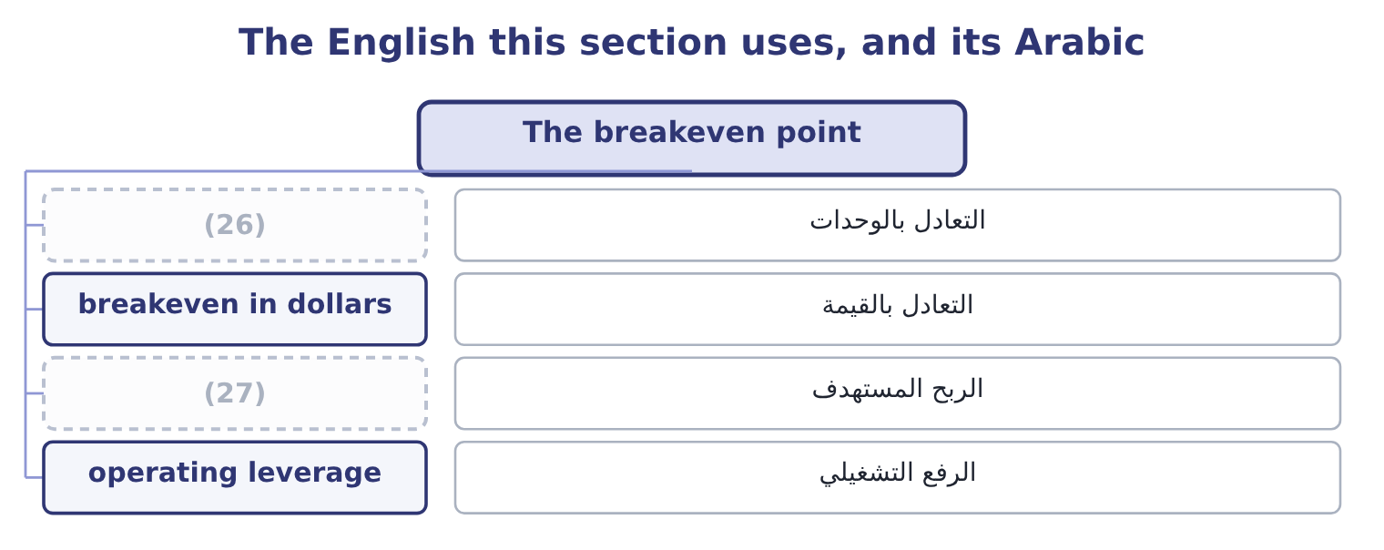
word list
unit contribution margin · breakeven in units · target income

The English this sheet uses, and its Arabic
English (exam term) | Arabic
breakeven in units | التعادل بالوحدات
breakeven in dollars | التعادل بالقيمة
target income | الربح المستهدف
operating leverage | الرفع التشغيلي

Answer key · 1.4 The breakeven point

1 activity | 15 should
2 revenue | 16 falling
3 covered | 17 changes
4 appears | 18 needed
5 accepts | 19 Fixed costs over unit contribution
6 Actual | 20 Fixed plus target, over unit contribution
7 contributes | 21 4,176,000 at 3,500,000 jars
8 degree | 22 selling
9 leverage | 23 variable
10 measured | 24 denominator
11 structure | 25 target-income
12 Nothing | 26 breakeven in units
13 statement | 27 target income
14 immediately

the summaries in full
Summary 1 The breakeven point is the level of activity at which total revenue equals total cost, so operating income is nil. It is where the fixed costs have been exactly covered by contribution and not a cent more. In units it is fixed costs divided by the contribution margin per unit. For Orontes: 12,624,000 ÷ 4.80 = 2,630,000 jars. In dollars it is fixed costs divided by the contribution margin ratio: 12,624,000 ÷ 0.40 = 31,560,000 of sales. The same answer appears as 2,630,000 × 12.00 = 31,560,000, and the exam accepts either route.
Summary 2 Orontes covers its fixed costs at 2,630,000 jars, or $31,560,000 of sales. Actual sales were 3,500,000 jars, which is 3,500,000 − 2,630,000 = 870,000 jars above the breakeven. What those jars earn. Every jar above the breakeven contributes its whole margin to operating income: 870,000 × 4.80 = 4,176,000, which is the operating income exactly. A ten per cent fall in volume removes 350,000 jars, which removes 350,000 × 4.80 = 1,680,000 of operating income — forty per cent of it, on a ten per cent fall in sales. That is the degree of operating leverage of 4.02 that Book 1 measured, arrived at from the cost structure rather than from the ratio. Nothing in Book 1's income statement showed that a ten per cent sales fall costs forty per cent of the profit; the contribution format shows it immediately, and it is the first thing a board should be told about a company whose gross margin is falling a point a year.
Summary 3 A target income changes one line of the formula. To earn a target operating income, add it to the fixed costs: the volume needed is fixed costs plus target income, divided by the contribution margin per unit. For a target of $6,000,000: 12,624,000 + 6,000,000 = 18,624,000, and 18,624,000 ÷ 4.80 = 3,880,000 jars.
Summary 4 Dividing by the selling price instead of the contribution margin. The price covers the variable cost of its own unit first. Using gross profit instead of contribution margin, which includes fixed factory cost in the denominator. Forgetting that the target in a target-income question may be stated after tax.

1.5 What the model assumes
Chapter 1 · section 1.5

Fill every gap. Each word list holds one word more than there are gaps.
Summary 1 gaps 1–12
Cost-volume-profit (1) is a model, and a (2) who can state its assumptions can also state when it (3) not be relied on. Six assumptions, each of which fails (4) . Costs can be split (5) into fixed and variable. Mixed costs must be separated, and the (6) is an estimate. Behaviour is linear within the (7) range. Revenue rises in a straight line, which (8) the selling price does not change with volume —. The sales mix is constant. With several (9) , a change in which ones sell changes the average contribution, which is the whole. Volume is the only cost (10) . Batch sizes, order sizes, product complexity and customer behaviour all drive costs too, which is the argument for (11) costing. Inventory does not change. (12) equals sales, so no fixed cost is carried forward in stock.
word list
analysis · driver · assumes · Production · cleanly · activity-based · candidate · products · should · somewhere · useless · relevant · separation

Summary 2 gaps 13–20
Where inventory moves, (13) costing and variable costing report (14) incomes, as Part 1 showed. (15) else is held constant: prices, costs, (16) , technology. None of this makes the model (17) . It makes it a first (18) that is right about direction and approximate about magnitude, and the (19) habit is to state the assumption that matters most to the decision in hand. For Orontes, that assumption is the constant selling price, because the (20) gross margin has fallen three years running — which means its revenue line is not as straight as the model draws it.
word list
Everything · absorption · approximation · different · company's · costing · professional · useless · efficiency

Build the picture for Barada

Your turn: Barada's cost structure (complete the blanks)
Item | Data | Answer
Contribution margin | (21) | ________
Contribution margin ratio |  | ________
Fixed costs | Operating income 558,000 | ________
Breakeven in dollars |  | ________
Sales needed for a 1,000,000 operating income |  | ________
What it tells you |  | ________

word list
Sales 21,978,000, variable costs 19,340,640 · 17,328,000: 2,079,360 ÷ 0.12 = 17,328,000.

"Margin"

Summary 3 gaps 22–27
English margin (22) in Book 1 as a (23) of sales. Here it appears as an (24) per unit, and the two senses sit a (25) apart: a contribution margin of $4.80 is money, a contribution margin ratio of 40 per cent is a rate. The exam uses both and (26) them only by the word ratio. The (27) rule for an answer is to write the unit and let no figure stand without one.
word list
Behaviour · practical · percentage · amount · appeared · distinguishes · paragraph

"Margin"
Item | Answer
Contribution margin | (28)
Contribution margin ratio | 12.0 per cent: 2,637,360 ÷ 21,978,000 = 12.0 per cent.
Fixed costs | 2,079,360: 2,637,360 − 558,000 = 2,079,360.
Breakeven in dollars | (29)
Sales for a 1,000,000 operating income | 25,661,333: 2,079,360 + 1,000,000 = 3,079,360, and 3,079,360 ÷ 0.12 = 25,661,333.
What it tells you | Barada breaks even at about 79 per cent of its current sales, against Orontes's 75 per cent, and its 12 per cent contribution ratio means ev

word list
17,328,000: 2,079,360 ÷ 0.12 = 17,328,000. · 2,637,360: 21,978,000 − 19,340,640 = 2,637,360. · 2,079,360: 2,637,360 − 558,000 = 2,079,360.

The English this section uses, and its Arabic
Each term sits against what it means.
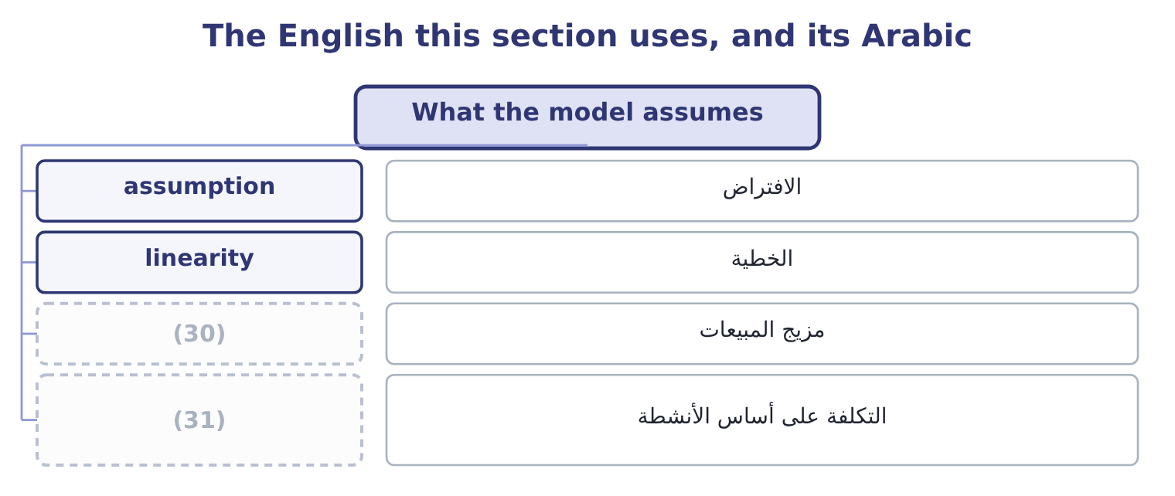
word list
sales mix · activity-based costing · time frame

The English this sheet uses, and its Arabic
English (exam term) | Arabic
assumption | الافتراض
linearity | الخطية
sales mix | مزيج المبيعات
activity-based costing | التكلفة على أساس الأنشطة

Answer key · 1.5 What the model assumes

1 analysis | 17 useless
2 candidate | 18 approximation
3 should | 19 professional
4 somewhere | 20 company's
5 cleanly | 21 Sales 21,978,000, variable costs 19,340,640
6 separation | 22 appeared
7 relevant | 23 percentage
8 assumes | 24 amount
9 products | 25 paragraph
10 driver | 26 distinguishes
11 activity-based | 27 practical
12 Production | 28 2,637,360: 21,978,000 − 19,340,640 = 2,637,360.
13 absorption | 29 17,328,000: 2,079,360 ÷ 0.12 = 17,328,000.
14 different | 30 sales mix
15 Everything | 31 activity-based costing
16 efficiency

the summaries in full
Summary 1 Cost-volume-profit analysis is a model, and a candidate who can state its assumptions can also state when it should not be relied on. Six assumptions, each of which fails somewhere. Costs can be split cleanly into fixed and variable. Mixed costs must be separated, and the separation is an estimate. Behaviour is linear within the relevant range. Revenue rises in a straight line, which assumes the selling price does not change with volume —. The sales mix is constant. With several products, a change in which ones sell changes the average contribution, which is the whole. Volume is the only cost driver. Batch sizes, order sizes, product complexity and customer behaviour all drive costs too, which is the argument for activity-based costing. Inventory does not change. Production equals sales, so no fixed cost is carried forward in stock.
Summary 2 Where inventory moves, absorption costing and variable costing report different incomes, as Part 1 showed. Everything else is held constant: prices, costs, efficiency, technology. None of this makes the model useless. It makes it a first approximation that is right about direction and approximate about magnitude, and the professional habit is to state the assumption that matters most to the decision in hand. For Orontes, that assumption is the constant selling price, because the company's gross margin has fallen three years running — which means its revenue line is not as straight as the model draws it.
Summary 3 English margin appeared in Book 1 as a percentage of sales. Here it appears as an amount per unit, and the two senses sit a paragraph apart: a contribution margin of $4.80 is money, a contribution margin ratio of 40 per cent is a rate. The exam uses both and distinguishes them only by the word ratio. The practical rule for an answer is to write the unit and let no figure stand without one.

