2.1 Income at any volume
Chapter 2 · section 2.1

Fill every gap. Each word list holds one word more than there are gaps.
Chapter 2, section by section
Each stage leads to the next.
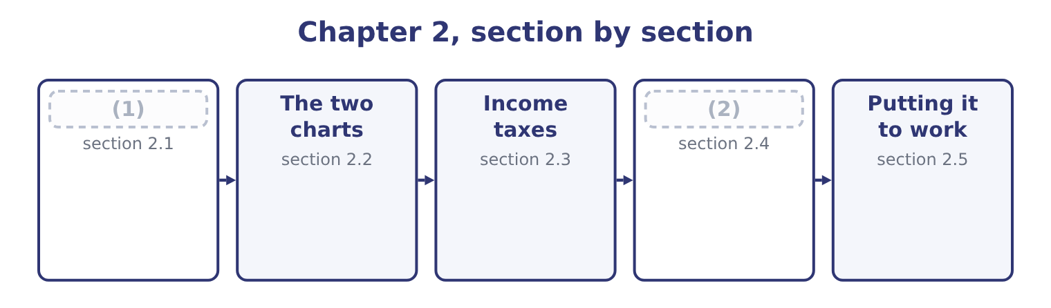
word list
Income at any volume · effective tax rate · The four levers

Summary 1 gaps 3–14
Three (3) reach the same (4) , and the exam uses all three. The contribution route is the (5) . (6) the volume by the contribution margin per unit and (7) the fixed costs. At 3,000,000 jars: 3,000,000 × 4.80 = 14,400,000 of contribution, and 14,400,000 − 12,624,000 = 1,776,000 of operating income. At 4,000,000 jars: 4,000,000 × 4.80 = 19,200,000, and 19,200,000 − 12,624,000 = 6,576,000. The (8) route writes the income (9) as a sentence: operating income is price times units, less variable cost times units, less fixed costs. It is slower and it is the one to use when a (10) changes two things at once, because every (11) is visible. The (12) route is the (13) of all and the one a manager wants. Since fixed costs do not move, the change in operating income is (14) the change in units times the contribution margin. Moving from 3,500,000 to 4,000,000 jars adds 500,000 jars, which adds 500,000 × 4.80 = 2,400,000 — and indeed 6,576,000 − 4,176,000 = 2,400,000. That third route is the whole of decision analysis in one sentence, and: what matters is what changes.
word list
statement · quickest · routes · equation · Multiply · answer · sentence · element · simply · incremental · deduct · question · fastest

Orontes at six volumes
Each stage leads to the next.
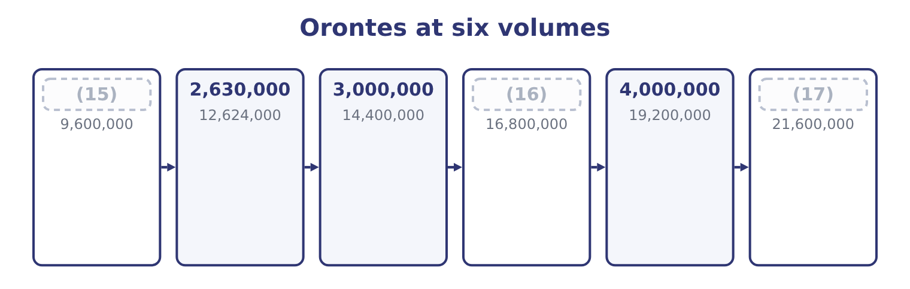
word list
4,500,000 · 2,000,000 · 3,500,000 · sensitivity

Summary 2 gaps 18–22
Read down the last column and the (18) is visible (19) any ratio: a 14 per cent rise in volume from 3,500,000 to 4,000,000 jars (20) operating income by 57 per cent, and a 14 per cent fall to 3,000,000 takes it down by the same (21) . Below 2,630,000 the company loses money, and at 2,000,000 jars it loses $3,024,000 — because the fixed costs are still $12,624,000 (22) the factory does.
word list
proportion · whatever · raises · leverage · without · operating

The English this section uses, and its Arabic
Each term sits against what it means.
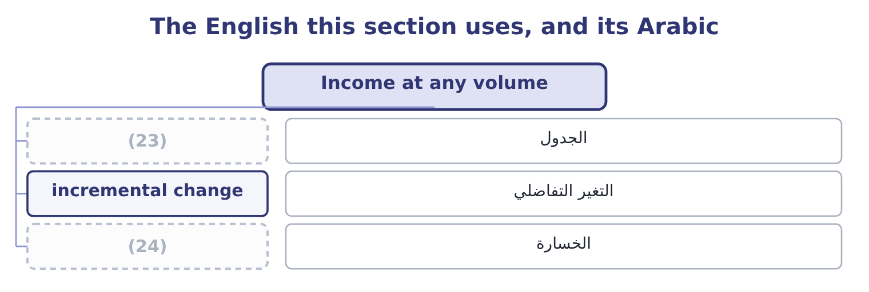
word list
الجدول · loss · schedule

The English this sheet uses, and its Arabic
English (exam term) | Arabic
schedule | الجدول
incremental change | التغير التفاضلي
loss | الخسارة

Answer key · 2.1 Income at any volume

1 Income at any volume | 13 fastest
2 The four levers | 14 simply
3 routes | 15 2,000,000
4 answer | 16 3,500,000
5 quickest | 17 4,500,000
6 Multiply | 18 leverage
7 deduct | 19 without
8 equation | 20 raises
9 statement | 21 proportion
10 question | 22 whatever
11 element | 23 schedule
12 incremental | 24 loss

the summaries in full
Summary 1 Three routes reach the same answer, and the exam uses all three. The contribution route is the quickest. Multiply the volume by the contribution margin per unit and deduct the fixed costs. At 3,000,000 jars: 3,000,000 × 4.80 = 14,400,000 of contribution, and 14,400,000 − 12,624,000 = 1,776,000 of operating income. At 4,000,000 jars: 4,000,000 × 4.80 = 19,200,000, and 19,200,000 − 12,624,000 = 6,576,000. The equation route writes the income statement as a sentence: operating income is price times units, less variable cost times units, less fixed costs. It is slower and it is the one to use when a question changes two things at once, because every element is visible. The incremental route is the fastest of all and the one a manager wants. Since fixed costs do not move, the change in operating income is simply the change in units times the contribution margin. Moving from 3,500,000 to 4,000,000 jars adds 500,000 jars, which adds 500,000 × 4.80 = 2,400,000 — and indeed 6,576,000 − 4,176,000 = 2,400,000. That third route is the whole of decision analysis in one sentence, and: what matters is what changes.
Summary 2 Read down the last column and the leverage is visible without any ratio: a 14 per cent rise in volume from 3,500,000 to 4,000,000 jars raises operating income by 57 per cent, and a 14 per cent fall to 3,000,000 takes it down by the same proportion. Below 2,630,000 the company loses money, and at 2,000,000 jars it loses $3,024,000 — because the fixed costs are still $12,624,000 whatever the factory does.

2.2 The two charts
Chapter 2 · section 2.2

Fill every gap. Each word list holds one word more than there are gaps.
Summary 1 gaps 1–12
The (1) can be drawn, and the exam asks what each line means (2) than for a (3) . The (4) chart puts volume on the horizontal axis and (5) on the vertical. The total (6) line starts at the origin and rises at the (7) price. The total cost line starts at the level of the fixed costs and rises at the variable cost per unit. The two cross at the breakeven point. The vertical (8) between them to the right of that crossing is operating income; to the left it is (9) . The profit-volume chart is (10) and more useful. It plots only operating income (11) volume: a single line starting at minus the fixed costs when volume is nil, crossing zero at the breakeven, and rising at the contribution margin per unit (12) .
word list
rather · simpler · against · distance · cost-volume-profit · drawing · dollars · manufacturer · relationships · loss · thereafter · revenue · selling

Summary 2 gaps 13–19
For Orontes that line starts at minus $12,624,000, (13) zero at 2,630,000 jars and rises $4.80 for every jar after. Three (14) come straight off the profit-volume line, and all three are (15) . The slope is the contribution margin per unit. A steeper line means each unit does more work, which comes from a (16) price or lower variable costs. The intercept is the fixed costs, with the sign (17) . A line starting lower means a heavier fixed base and a company that needs more volume before it earns anything. The horizontal intercept is the breakeven. Anything that (18) the slope or lifts the intercept moves it to the left, which is the (19) a company wants.
word list
reversed · readings · direction · crosses · dollars · higher · examinable · raises

What each change does to the profit-volume line
Every item belongs to exactly one group.
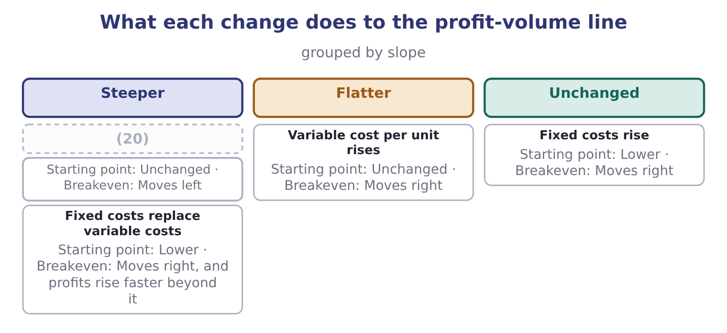
word list
Selling price rises · effective tax rate

Summary 3 gaps 21–28
That last row is the one worth (21) on, because it is the (22) choice every manufacturer faces. Automating a process (23) variable labour into fixed (24) : the contribution margin per unit rises, so the line is steeper, and the fixed base is heavier, so the line starts lower. The company earns more at high (25) and loses more at low ones — which is (26) the degree of operating (27) that Book 1 (28) for Orontes at 4.02, and the reason a food manufacturer with a falling margin should think twice before automating further.
word list
structural · volumes · depreciation · converts · measured · exactly · dwelling · leverage · thereafter

The English this section uses, and its Arabic
Each term sits against what it means.
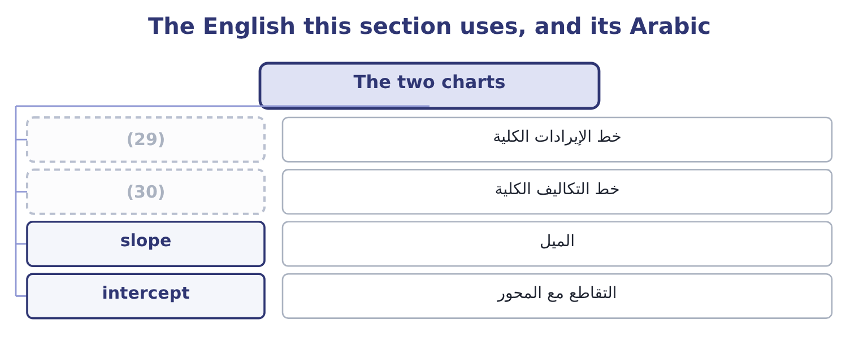
word list
خط الإيرادات الكلية · total cost line · total revenue line

The English this sheet uses, and its Arabic
English (exam term) | Arabic
total revenue line | خط الإيرادات الكلية
total cost line | خط التكاليف الكلية
slope | الميل
intercept | التقاطع مع المحور

Answer key · 2.2 The two charts

1 relationships | 16 higher
2 rather | 17 reversed
3 drawing | 18 raises
4 cost-volume-profit | 19 direction
5 dollars | 20 Selling price rises
6 revenue | 21 dwelling
7 selling | 22 structural
8 distance | 23 converts
9 loss | 24 depreciation
10 simpler | 25 volumes
11 against | 26 exactly
12 thereafter | 27 leverage
13 crosses | 28 measured
14 readings | 29 total revenue line
15 examinable | 30 total cost line

the summaries in full
Summary 1 The relationships can be drawn, and the exam asks what each line means rather than for a drawing. The cost-volume-profit chart puts volume on the horizontal axis and dollars on the vertical. The total revenue line starts at the origin and rises at the selling price. The total cost line starts at the level of the fixed costs and rises at the variable cost per unit. The two cross at the breakeven point. The vertical distance between them to the right of that crossing is operating income; to the left it is loss. The profit-volume chart is simpler and more useful. It plots only operating income against volume: a single line starting at minus the fixed costs when volume is nil, crossing zero at the breakeven, and rising at the contribution margin per unit thereafter.
Summary 2 For Orontes that line starts at minus $12,624,000, crosses zero at 2,630,000 jars and rises $4.80 for every jar after. Three readings come straight off the profit-volume line, and all three are examinable. The slope is the contribution margin per unit. A steeper line means each unit does more work, which comes from a higher price or lower variable costs. The intercept is the fixed costs, with the sign reversed. A line starting lower means a heavier fixed base and a company that needs more volume before it earns anything. The horizontal intercept is the breakeven. Anything that raises the slope or lifts the intercept moves it to the left, which is the direction a company wants.
Summary 3 That last row is the one worth dwelling on, because it is the structural choice every manufacturer faces. Automating a process converts variable labour into fixed depreciation: the contribution margin per unit rises, so the line is steeper, and the fixed base is heavier, so the line starts lower. The company earns more at high volumes and loses more at low ones — which is exactly the degree of operating leverage that Book 1 measured for Orontes at 4.02, and the reason a food manufacturer with a falling margin should think twice before automating further.

2.3 Income taxes
Chapter 2 · section 2.3

Fill every gap. Each word list holds one word more than there are gaps.
Summary 1 gaps 1–7
Everything so far has been (1) before tax, and for most (2) that is correct: tax (3) the profit rather than driving it. But a target stated by a board is (4) stated after tax, and the exam exploits the (5) . The rule is one line. Tax is (6) on operating income less interest, so a target net income must be (7) to a target pre-tax income before it can be added to the fixed costs. Divide the after-tax target by one less the tax rate.
word list
decisions · usually · converted · charged · computed · follows · difference · slope

Worked example: a target stated after tax

Summary 2 gaps 8–18
Orontes's board wants net income of $4,500,000. Its (8) tax rate is 25 per cent. The pre-tax income (9) is 4,500,000 ÷ 0.75 = 6,000,000. Add the fixed costs. The conversion is the whole question. A (10) who adds $4,500,000 to the fixed costs (11) 17,124,000 ÷ 4.80 = 3,567,500 jars and (12) the requirement by more than three hundred (13) jars — because at that (14) the company earns $4,500,000 before tax and only $3,375,000 after it. Divide by one less the tax rate, every time. Two further points (15) the outcome. Tax does not move the breakeven point. At breakeven, operating income is nil, so the tax on it is nil, and a company that loses money pays no tax on the loss. The whole of the tax (16) lives above the breakeven, which is why. Tax (17) every answer above the breakeven by the same (18) .
word list
understates · needed · computes · candidate · scales · effective · factor · adjustment · thousand · intercept · complete · volume

Before tax and after, at a 25 per cent rate
Jars sold | Operating income | Tax at 25% | Net income
2,630,000 | Nil | Nil | Nil
3,000,000 | 1,776,000 | 444,000 | 1,332,000
3,500,000 | 4,176,000 | 1,044,000 | 3,132,000
3,880,000 | 6,000,000 | 1,500,000 | 4,500,000
4,000,000 | 6,576,000 | 1,644,000 | 4,932,000

The tax conversion runs one way

Summary 3 gaps 19–27
To go from an after-tax target to a pre-tax requirement, divide by one less the rate. To go from a pre-tax figure to an after-tax one, (19) by one less the rate. (20) the two is the (21) error on this outcome. Interest is deducted before tax and after operating income, so a question that gives interest expense wants it added to the fixed costs — or, more (22) , treated as a further fixed (23) — before the tax conversion. A loss (24) no tax at the simple rate (25) here. Where a question allows a loss to be (26) back or forward, say so and (27) it.
word list
assumed · generates · deducted · carried · Reversing · precisely · commonest · multiply · compute · deduction

The English this section uses, and its Arabic
Each term sits against what it means.
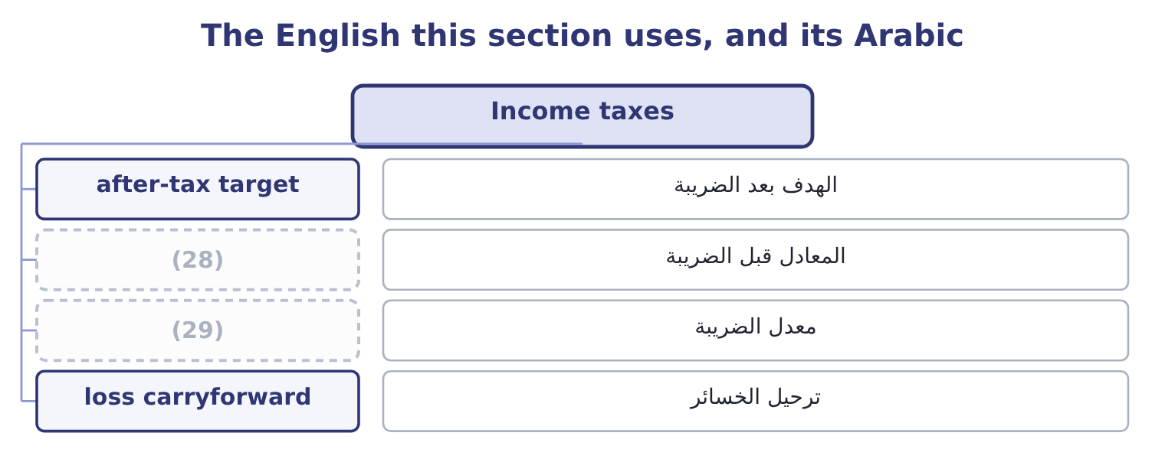
word list
cost-volume-profit chart · pre-tax equivalent · tax rate

The English this sheet uses, and its Arabic
English (exam term) | Arabic
after-tax target | الهدف بعد الضريبة
pre-tax equivalent | المعادل قبل الضريبة
tax rate | معدل الضريبة
loss carryforward | ترحيل الخسائر

Answer key · 2.3 Income taxes

1 computed | 16 adjustment
2 decisions | 17 scales
3 follows | 18 factor
4 usually | 19 multiply
5 difference | 20 Reversing
6 charged | 21 commonest
7 converted | 22 precisely
8 effective | 23 deduction
9 needed | 24 generates
10 candidate | 25 assumed
11 computes | 26 carried
12 understates | 27 compute
13 thousand | 28 pre-tax equivalent
14 volume | 29 tax rate
15 complete

the summaries in full
Summary 1 Everything so far has been computed before tax, and for most decisions that is correct: tax follows the profit rather than driving it. But a target stated by a board is usually stated after tax, and the exam exploits the difference. The rule is one line. Tax is charged on operating income less interest, so a target net income must be converted to a target pre-tax income before it can be added to the fixed costs. Divide the after-tax target by one less the tax rate.
Summary 2 Orontes's board wants net income of $4,500,000. Its effective tax rate is 25 per cent. The pre-tax income needed is 4,500,000 ÷ 0.75 = 6,000,000. Add the fixed costs. The conversion is the whole question. A candidate who adds $4,500,000 to the fixed costs computes 17,124,000 ÷ 4.80 = 3,567,500 jars and understates the requirement by more than three hundred thousand jars — because at that volume the company earns $4,500,000 before tax and only $3,375,000 after it. Divide by one less the tax rate, every time. Two further points complete the outcome. Tax does not move the breakeven point. At breakeven, operating income is nil, so the tax on it is nil, and a company that loses money pays no tax on the loss. The whole of the tax adjustment lives above the breakeven, which is why. Tax scales every answer above the breakeven by the same factor.
Summary 3 To go from an after-tax target to a pre-tax requirement, divide by one less the rate. To go from a pre-tax figure to an after-tax one, multiply by one less the rate. Reversing the two is the commonest error on this outcome. Interest is deducted before tax and after operating income, so a question that gives interest expense wants it added to the fixed costs — or, more precisely, treated as a further fixed deduction — before the tax conversion. A loss generates no tax at the simple rate assumed here. Where a question allows a loss to be carried back or forward, say so and compute it.

2.4 The four levers
Chapter 2 · section 2.4

Fill every gap. Each word list holds one word more than there are gaps.
Summary 1 gaps 1–5
Four (1) can be changed, and a (2) that asks a company to improve its (3) is asking which of them to pull. A five per cent rise takes the jar to $12.60 and the contribution margin to 12.60 − 7.20 = 5.40. At the same volume, operating income (4) 3,500,000 × 5.40 = 18,900,000 of contribution less fixed costs, which is 18,900,000 − 12,624,000 = 6,276,000 — a rise of half as much again, from a five per cent price move. The breakeven falls to 12,624,000 ÷ 5.40 = 2,337,778 jars. The risk is the volume (5) . Cut the variable cost. A five per cent saving takes the variable cost to $6.84 and the margin to 12.00 − 6.84 = 5.16, which at the same volume gives 3,500,000 × 5.16 = 18,060,000 of contribution and 18,060,000 − 12,624,000 = 5,436,000 of operating income.
word list
position · response · things · becomes · question · variable

Summary 2 gaps 6–10
Less powerful than the price rise, (6) the variable cost is a (7) base than the price. Cut the fixed costs. A saving of $1,000,000 adds (8) $1,000,000 to operating income at any volume and moves the breakeven to 11,624,000 ÷ 4.80 = 2,421,667 jars. It is the only lever whose (9) does not depend on volume. Each extra jar adds $4.80, so an extra 500,000 jars adds 500,000 × 4.80 = 2,400,000 — as section 2.1 (10) .
word list
effect · exactly · direction · because · showed · smaller

Four five per cent moves, compared
The bars are drawn to scale.
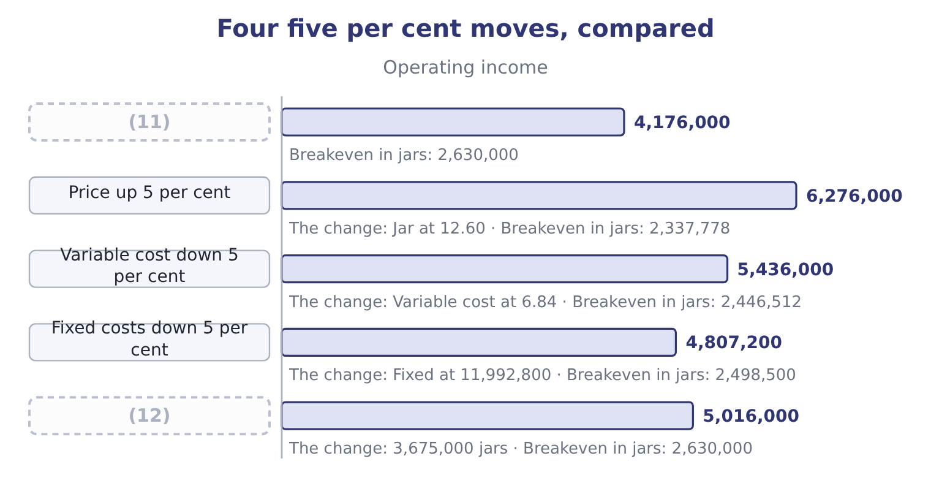
word list
As reported · Volume up 5 per cent · cost-volume-profit chart

Summary 3 gaps 13–18
The (13) is the lesson, and it is the same in almost every (14) : the price is the most powerful lever, the variable cost the (15) , volume the third and the fixed cost the fourth. That is the (16) behind Book 1's finding that two points of gross margin were worth $840,000 a year, and behind the warning that a company buying volume with price is pulling the (17) lever in the wrong (18) .
word list
second · strongest · business · arithmetic · ranking · direction · sensitivity

The English this section uses, and its Arabic
Each term sits against what it means.
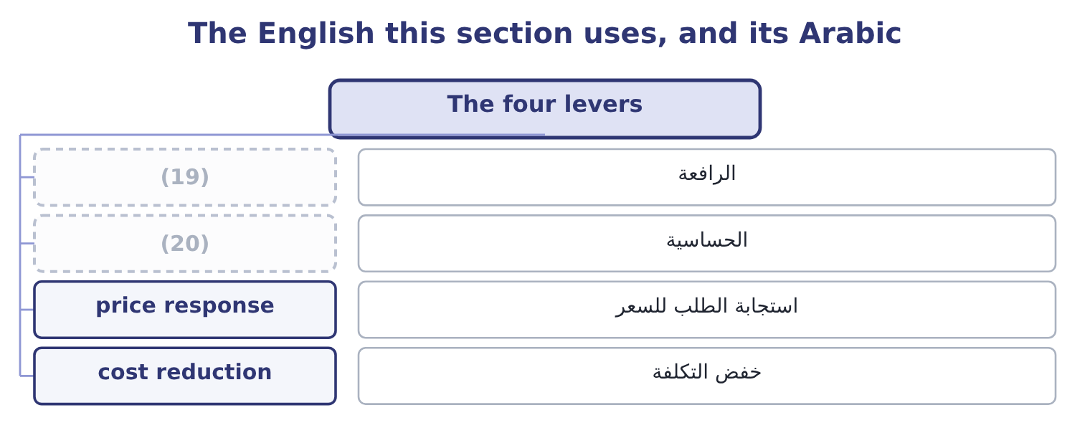
word list
intercept · sensitivity · lever

The English this sheet uses, and its Arabic
English (exam term) | Arabic
lever | الرافعة
sensitivity | الحساسية
price response | استجابة الطلب للسعر
cost reduction | خفض التكلفة

Answer key · 2.4 The four levers

1 things | 11 As reported
2 question | 12 Volume up 5 per cent
3 position | 13 ranking
4 becomes | 14 business
5 response | 15 second
6 because | 16 arithmetic
7 smaller | 17 strongest
8 exactly | 18 direction
9 effect | 19 lever
10 showed | 20 sensitivity

the summaries in full
Summary 1 Four things can be changed, and a question that asks a company to improve its position is asking which of them to pull. A five per cent rise takes the jar to $12.60 and the contribution margin to 12.60 − 7.20 = 5.40. At the same volume, operating income becomes 3,500,000 × 5.40 = 18,900,000 of contribution less fixed costs, which is 18,900,000 − 12,624,000 = 6,276,000 — a rise of half as much again, from a five per cent price move. The breakeven falls to 12,624,000 ÷ 5.40 = 2,337,778 jars. The risk is the volume response. Cut the variable cost. A five per cent saving takes the variable cost to $6.84 and the margin to 12.00 − 6.84 = 5.16, which at the same volume gives 3,500,000 × 5.16 = 18,060,000 of contribution and 18,060,000 − 12,624,000 = 5,436,000 of operating income.
Summary 2 Less powerful than the price rise, because the variable cost is a smaller base than the price. Cut the fixed costs. A saving of $1,000,000 adds exactly $1,000,000 to operating income at any volume and moves the breakeven to 11,624,000 ÷ 4.80 = 2,421,667 jars. It is the only lever whose effect does not depend on volume. Each extra jar adds $4.80, so an extra 500,000 jars adds 500,000 × 4.80 = 2,400,000 — as section 2.1 showed.
Summary 3 The ranking is the lesson, and it is the same in almost every business: the price is the most powerful lever, the variable cost the second, volume the third and the fixed cost the fourth. That is the arithmetic behind Book 1's finding that two points of gross margin were worth $840,000 a year, and behind the warning that a company buying volume with price is pulling the strongest lever in the wrong direction.

2.5 Putting it to work
Chapter 2 · section 2.5

Fill every gap. Each word list holds one word more than there are gaps.
Summary 1 gaps 1–12
The (1) apparatus answers a board's (2) directly, and three forms of question recur. What if volume falls? (3) the fall in units by the contribution margin. (4) else is needed, and the answer is always larger than a board (5) because the fixed costs do not move. What do we need to sell? Add the target to the fixed costs and divide by the contribution margin, (6) the target from after tax if (7) . What can we (8) to spend? This is the question a marketing (9) raises, and it is the mirror of the second. A campaign (10) $500,000 is a rise in fixed costs, so it pays for itself at 500,000 ÷ 4.80 = 104,167 extra jars — about 3 per cent of (11) volume. Whether the campaign will do that is a marketing judgment, and the (12) contribution is the number it has to beat.
word list
accountant's · questions · necessary · current · Multiply · costing · expects · proposal · converting · afford · intercept · Nothing · chapter's

Summary 2 gaps 13–24
The same (13) prices a sales (14) , a quality (15) , a delivery promise and a discount. Two (16) close the chapter. The (17) is only as good as the cost split. If a cost treated as fixed is in fact a step cost that jumps at 4,000,000 jars, the schedule is wrong at its top end, and the error is in the (18) that flatters the (19) . And the (20) range limits every row of that schedule. At 4,500,000 jars Orontes would need a second shift, more (21) and probably more (22) ; at 2,000,000 it would close a line and shed some of the fixed costs it is shown here as carrying. The middle of the table is (23) and the ends are (24) , which is a sentence worth writing in an answer.
word list
illustrative · warehousing · decision · direction · directly · analysis · relevant · supervision · arithmetic · reliable · cautions · improvement · commission

Work the levers

Your turn: income at different levels (complete the blanks)
Item | Data | Answer
Contribution margin per unit | Price 40.00, variable cost 26.00 | ________
Operating income at 300,000 units | (25) | ________
Operating income at 350,000 units |  | ________
Breakeven in units |  | ________
Units for a net income target of 1,500,000 | (26) | ________
Operating income if the price rises 5 per cent at 300,000 units |  | ________

word list
Fixed costs 3,000,000 · target net income · Tax rate 25 per cent

"Income"

Summary 3 gaps 27–31
Operating income is profit before (27) and tax; net income is profit after both; target net income is a goal; and income taxes are the (28) on it. Outside (29) , income means what a person (30) , which is closer to revenue than to profit — and that everyday sense is the one (31) import when they read target income as a sales target.
word list
accounting · interest · candidates · lever · charge · receives

"Income"
Item | Answer
Contribution margin per unit | 14.00: 40.00 − 26.00 = 14.00.
Operating income at 300,000 units | 1,200,000: 300,000 × 14.00 = 4,200,000, and 4,200,000 − 3,000,000 = 1,200,000.
Operating income at 350,000 units | 1,900,000: 350,000 × 14.00 = 4,900,000, and 4,900,000 − 3,000,000 = 1,900,000.
Breakeven in units | (32)
Units for a 1,500,000 net income target | (33) : the pre-tax target is 1,500,000 ÷ 0.75 = 2,000,000, so 3,000,000 + 2,000,000 = 5,000,000 of contribution is needed, and 5,000,000 ÷
Operating income with a 5 per cent price rise | 1,800,000: the price becomes 42.00 and the margin 42.00 − 26.00 = 16.00, so 300,000 × 16.00 = 4,800,000 less 3,000,000.
What it tells you | A five per cent price rise adds 600,000 of operating income at unchanged volume, which is half as much again as the company earns, and the s

word list
357,143 · 1,200,000 · 214,286: 3,000,000 ÷ 14.00 = 214,286.

The English this section uses, and its Arabic
Each term sits against what it means.
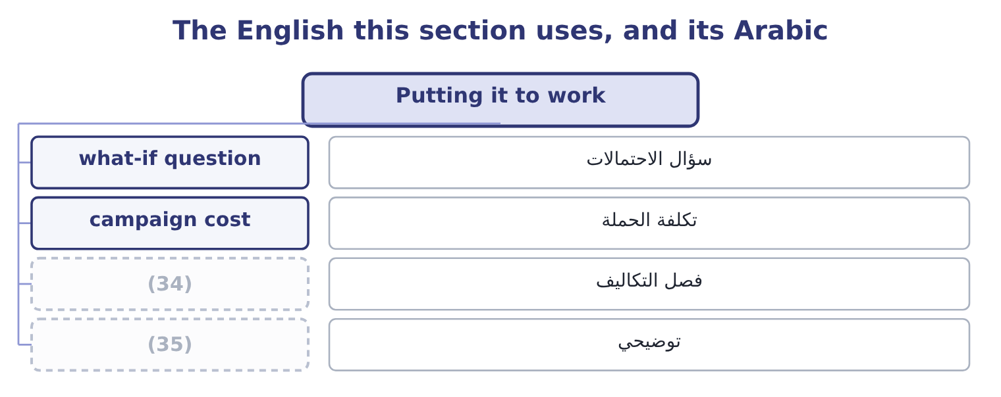
word list
cost split · schedule · illustrative

The English this sheet uses, and its Arabic
English (exam term) | Arabic
what-if question | سؤال الاحتمالات
campaign cost | تكلفة الحملة
cost split | فصل التكاليف
illustrative | توضيحي

Answer key · 2.5 Putting it to work

1 chapter's | 19 decision
2 questions | 20 relevant
3 Multiply | 21 supervision
4 Nothing | 22 warehousing
5 expects | 23 reliable
6 converting | 24 illustrative
7 necessary | 25 Fixed costs 3,000,000
8 afford | 26 Tax rate 25 per cent
9 proposal | 27 interest
10 costing | 28 charge
11 current | 29 accounting
12 accountant's | 30 receives
13 arithmetic | 31 candidates
14 commission | 32 214,286: 3,000,000 ÷ 14.00 = 214,286.
15 improvement | 33 357,143
16 cautions | 34 cost split
17 analysis | 35 illustrative
18 direction

the summaries in full
Summary 1 The chapter's apparatus answers a board's questions directly, and three forms of question recur. What if volume falls? Multiply the fall in units by the contribution margin. Nothing else is needed, and the answer is always larger than a board expects because the fixed costs do not move. What do we need to sell? Add the target to the fixed costs and divide by the contribution margin, converting the target from after tax if necessary. What can we afford to spend? This is the question a marketing proposal raises, and it is the mirror of the second. A campaign costing $500,000 is a rise in fixed costs, so it pays for itself at 500,000 ÷ 4.80 = 104,167 extra jars — about 3 per cent of current volume. Whether the campaign will do that is a marketing judgment, and the accountant's contribution is the number it has to beat.
Summary 2 The same arithmetic prices a sales commission, a quality improvement, a delivery promise and a discount. Two cautions close the chapter. The analysis is only as good as the cost split. If a cost treated as fixed is in fact a step cost that jumps at 4,000,000 jars, the schedule is wrong at its top end, and the error is in the direction that flatters the decision. And the relevant range limits every row of that schedule. At 4,500,000 jars Orontes would need a second shift, more supervision and probably more warehousing; at 2,000,000 it would close a line and shed some of the fixed costs it is shown here as carrying. The middle of the table is reliable and the ends are illustrative, which is a sentence worth writing in an answer.
Summary 3 Operating income is profit before interest and tax; net income is profit after both; target net income is a goal; and income taxes are the charge on it. Outside accounting, income means what a person receives, which is closer to revenue than to profit — and that everyday sense is the one candidates import when they read target income as a sales target.

