3.1 Three products, three margins
Chapter 3 · section 3.1

Fill every gap. Each word list holds one word more than there are gaps.
Chapter 3, section by section
Each stage leads to the next.
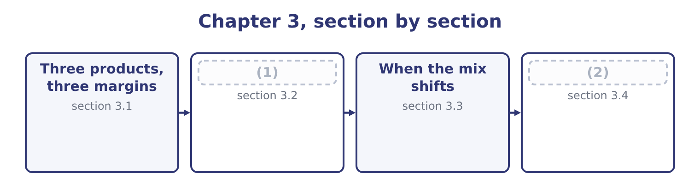
word list
Three products, three margins · The weighted-average contribution margin · Why there is no unique breakeven

Orontes Foods, Inc. — the three lines
The bars are drawn to scale.
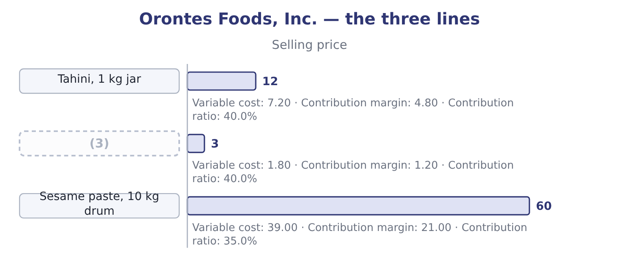
word list
Halva bar · product line

Summary 1 gaps 4–15
Two of the three earn the same ratio and very (4) amounts. A jar contributes four times what a bar does, and a drum contributes four times a jar. So a company that sells more drums earns more contribution for each unit sold, and a company that sells more bars earns less — (5) any question of ratio (6) . The drum, (7) , has the lowest ratio of the three: 21.00 ÷ 60.00 = 35.0 per cent (8) 40.0 for the other two. So a company that sells more drums earns less contribution for each dollar of sales. Those two (9) point in opposite (10) . Which one (11) depends on what is scarce. If (12) is measured in units — jars filled an hour, drums (13) a day — then contribution per unit is the ranking that counts, and the drum is the best product. If the (14) is the market rather than the (15) , so that the question is how much revenue the company can win, then contribution per sales dollar is the ranking that counts, and the jar and the bar are better. If some other resource is scarce — kilograms of sesame, hours on the roaster, square metres of warehouse — then neither ranking is right, and the correct one is contribution per unit of that resource.
word list
factory · handled · sentences · revenue · matters · capacity · constraint · arises · meanwhile · different · directions · against · before

The English this section uses, and its Arabic
Each term sits against what it means.
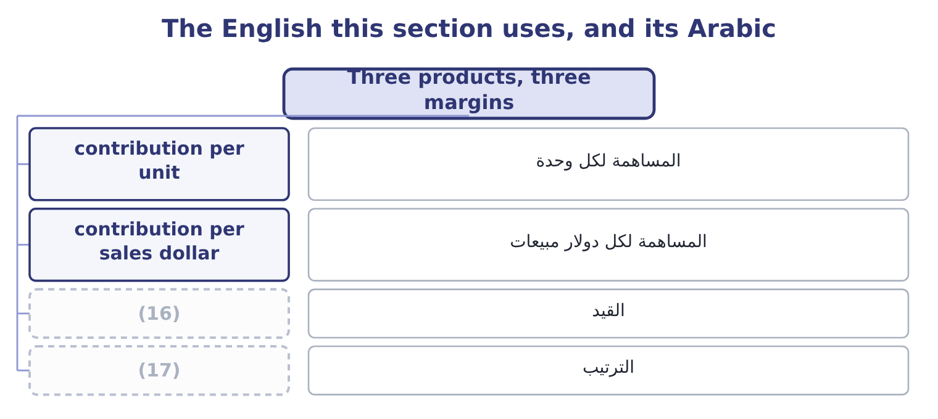
word list
weighting · ranking · constraint

The English this sheet uses, and its Arabic
English (exam term) | Arabic
contribution per unit | المساهمة لكل وحدة
contribution per sales dollar | المساهمة لكل دولار مبيعات
constraint | القيد
ranking | الترتيب

Answer key · 3.1 Three products, three margins

1 The weighted-average contribution margin | 10 directions
2 Why there is no unique breakeven | 11 matters
3 Halva bar | 12 capacity
4 different | 13 handled
5 before | 14 constraint
6 arises | 15 factory
7 meanwhile | 16 constraint
8 against | 17 ranking
9 sentences

the summaries in full
Summary 1 Two of the three earn the same ratio and very different amounts. A jar contributes four times what a bar does, and a drum contributes four times a jar. So a company that sells more drums earns more contribution for each unit sold, and a company that sells more bars earns less — before any question of ratio arises. The drum, meanwhile, has the lowest ratio of the three: 21.00 ÷ 60.00 = 35.0 per cent against 40.0 for the other two. So a company that sells more drums earns less contribution for each dollar of sales. Those two sentences point in opposite directions. Which one matters depends on what is scarce. If capacity is measured in units — jars filled an hour, drums handled a day — then contribution per unit is the ranking that counts, and the drum is the best product. If the constraint is the market rather than the factory, so that the question is how much revenue the company can win, then contribution per sales dollar is the ranking that counts, and the jar and the bar are better. If some other resource is scarce — kilograms of sesame, hours on the roaster, square metres of warehouse — then neither ranking is right, and the correct one is contribution per unit of that resource.

3.2 The weighted-average contribution margin
Chapter 3 · section 3.2

Fill every gap. Each word list holds one word more than there are gaps.
Summary 1 gaps 1–7
With a mix (1) , the three products can be (2) as one composite product — a bundle (3) the products in their usual proportions — and the (4) arithmetic. Orontes sells, in units, five jars and ten bars for every drum. So one bundle is 5 jars, 10 bars and 1 drum. Its contribution is 5 × 4.80 = 24.00 from the jars, 10 × 1.20 = 12.00 from the bars and 1 × 21.00 = 21.00 from the drum, which is 24.00 + 12.00 + 21.00 = 57.00 a bundle. Its revenue is 5 × 12.00 = 60.00, 10 × 3.00 = 30.00 and 1 × 60.00 = 60.00, which is 60.00 + 30.00 + 60.00 = 150.00 a bundle. The (5) contribution ratio is (6) 57.00 ÷ 150.00 = 38.0 per cent — between the 40 per cent of two products and the 35 per cent of the third, and nearer the 40 (7) the drum is only part of the bundle.
word list
because · ranking · therefore · assumed · single-product · treated · weighted-average · containing

Worked example: the breakeven of the bundle

Summary 2 gaps 8–17
The breakeven in bundles. Fixed costs over the bundle's contribution: 12,624,000 ÷ 57.00 = 221,474 bundles. The breakeven in units. Each bundle (8) five jars, ten bars and a drum, so the company (9) even at 5 × 221,474 = 1,107,370 jars, 10 × 221,474 = 2,214,740 bars and 221,474 drums. The breakeven in dollars. Either (10) the bundles by the bundle's revenue, 221,474 × 150.00 = 33,221,100, or (11) the fixed costs by the weighted ratio: 12,624,000 ÷ 0.38 = 33,221,053. The small (12) is rounding in the number of bundles. The company needs about $1,660,000 more sales to break even once the (13) drum is in the mix — which is the whole (14) of a mix in one number, and the (15) a breakeven (16) on the flagship product alone (17) the business.
word list
flatters · difference · bundle's · effect · reason · lower-margin · breaks · multiply · contains · divide · computed

Summary 3 gaps 18–21
A second route (18) the same place from sales (19) rather than unit ratios, and the exam uses it at least as often. In the bundle, the jars are 60.00 ÷ 150.00 = 40.0 per cent of revenue, the bars 30.00 ÷ 150.00 = 20.0 per cent and the drums 40.0 per cent. Weighting each (20) own contribution ratio by its share of sales: 0.40 × 40 = 16.0, 0.20 × 40 = 8.0 and 0.40 × 35 = 14.0, which is 16.0 + 8.0 + 14.0 = 38.0 per cent — the same weighted ratio, reached without ever (21) a bundle.
word list
constructing · reaches · percentages · bundle · product's

Two routes to the same weighted margin
Route | What is weighted | By what | Orontes
Composite unit | Contribution per unit | The unit mix, 5 : 10 : 1 | (22)
Sales percentage | Contribution ratio | (23) | 38.0 per cent

word list
contribution per sales dollar · The share of sales dollars · 57.00 a bundle, 38.0% of 150.00

Which mix is given

Summary 4 gaps 24–31
A mix in units is not a mix in dollars. Five jars to one drum is a unit mix of 5: 1 and a sales mix of 60: 60, which is 50: 50. Read which the question gives before weighting (24) . The weighted contribution (25) per bundle (26) a question in bundles. (27) back into units at the end, or the answer is in a unit (28) buys. The weighted ratio (29) lies between the (30) and lowest product ratios. An answer (31) that range is an arithmetic error.
word list
nobody · anything · Convert · answers · always · highest · products · outside · margin

The English this section uses, and its Arabic
Each term sits against what it means.
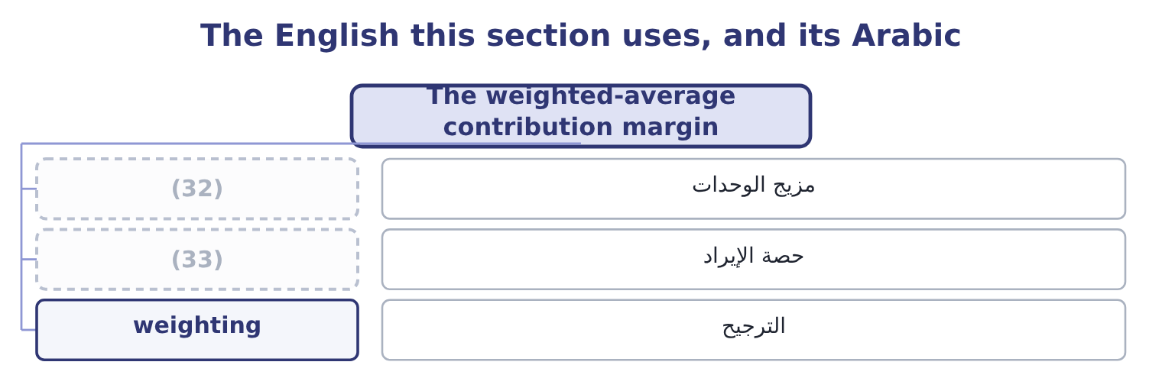
word list
pure case · unit mix · revenue share

The English this sheet uses, and its Arabic
English (exam term) | Arabic
unit mix | مزيج الوحدات
revenue share | حصة الإيراد
weighting | الترجيح

Answer key · 3.2 The weighted-average contribution margin

1 assumed | 18 reaches
2 treated | 19 percentages
3 containing | 20 product's
4 single-product | 21 constructing
5 weighted-average | 22 57.00 a bundle, 38.0% of 150.00
6 therefore | 23 The share of sales dollars
7 because | 24 anything
8 contains | 25 margin
9 breaks | 26 answers
10 multiply | 27 Convert
11 divide | 28 nobody
12 difference | 29 always
13 lower-margin | 30 highest
14 effect | 31 outside
15 reason | 32 unit mix
16 computed | 33 revenue share
17 flatters

the summaries in full
Summary 1 With a mix assumed, the three products can be treated as one composite product — a bundle containing the products in their usual proportions — and the single-product arithmetic. Orontes sells, in units, five jars and ten bars for every drum. So one bundle is 5 jars, 10 bars and 1 drum. Its contribution is 5 × 4.80 = 24.00 from the jars, 10 × 1.20 = 12.00 from the bars and 1 × 21.00 = 21.00 from the drum, which is 24.00 + 12.00 + 21.00 = 57.00 a bundle. Its revenue is 5 × 12.00 = 60.00, 10 × 3.00 = 30.00 and 1 × 60.00 = 60.00, which is 60.00 + 30.00 + 60.00 = 150.00 a bundle. The weighted-average contribution ratio is therefore 57.00 ÷ 150.00 = 38.0 per cent — between the 40 per cent of two products and the 35 per cent of the third, and nearer the 40 because the drum is only part of the bundle.
Summary 2 The breakeven in bundles. Fixed costs over the bundle's contribution: 12,624,000 ÷ 57.00 = 221,474 bundles. The breakeven in units. Each bundle contains five jars, ten bars and a drum, so the company breaks even at 5 × 221,474 = 1,107,370 jars, 10 × 221,474 = 2,214,740 bars and 221,474 drums. The breakeven in dollars. Either multiply the bundles by the bundle's revenue, 221,474 × 150.00 = 33,221,100, or divide the fixed costs by the weighted ratio: 12,624,000 ÷ 0.38 = 33,221,053. The small difference is rounding in the number of bundles. The company needs about $1,660,000 more sales to break even once the lower-margin drum is in the mix — which is the whole effect of a mix in one number, and the reason a breakeven computed on the flagship product alone flatters the business.
Summary 3 A second route reaches the same place from sales percentages rather than unit ratios, and the exam uses it at least as often. In the bundle, the jars are 60.00 ÷ 150.00 = 40.0 per cent of revenue, the bars 30.00 ÷ 150.00 = 20.0 per cent and the drums 40.0 per cent. Weighting each product's own contribution ratio by its share of sales: 0.40 × 40 = 16.0, 0.20 × 40 = 8.0 and 0.40 × 35 = 14.0, which is 16.0 + 8.0 + 14.0 = 38.0 per cent — the same weighted ratio, reached without ever constructing a bundle.
Summary 4 A mix in units is not a mix in dollars. Five jars to one drum is a unit mix of 5: 1 and a sales mix of 60: 60, which is 50: 50. Read which the question gives before weighting anything. The weighted contribution margin per bundle answers a question in bundles. Convert back into units at the end, or the answer is in a unit nobody buys. The weighted ratio always lies between the highest and lowest product ratios. An answer outside that range is an arithmetic error.

3.3 When the mix shifts
Chapter 3 · section 3.3

Fill every gap. Each word list holds one word more than there are gaps.
Summary 1 gaps 1–12
The reason the exam (1) there is no unique breakeven is that the whole (2) above rests on an assumption nobody (3) : that customers will go on buying in the same (4) . Suppose they do not. Suppose the bars sell (5) and the jars worse, so the mix becomes four jars and (6) bars to each drum. The (7) contribution becomes 4 × 4.80 = 19.20 from the jars, 12 × 1.20 = 14.40 from the bars and 21.00 from the drum, which is 19.20 + 14.40 + 21.00 = 54.60. Its revenue becomes 4 × 12.00 = 48.00, 12 × 3.00 = 36.00 and 60.00, which is 48.00 + 36.00 + 60.00 = 144.00. The weighted ratio becomes 54.60 ÷ 144.00 = 37.92 per cent, barely moved, and the breakeven in bundles becomes 12,624,000 ÷ 54.60 = 231,209 — nearly ten (8) bundles more than (9) . (10) about prices, costs or fixed costs (11) . Customers (12) one more bar and one less jar per bundle, and the company must now sell more to stand still.
word list
controls · bought · changed · calculation · missing · proportions · better · insists · twelve · Nothing · before · bundle's · thousand

The same products, four mixes
The bars are drawn to scale.
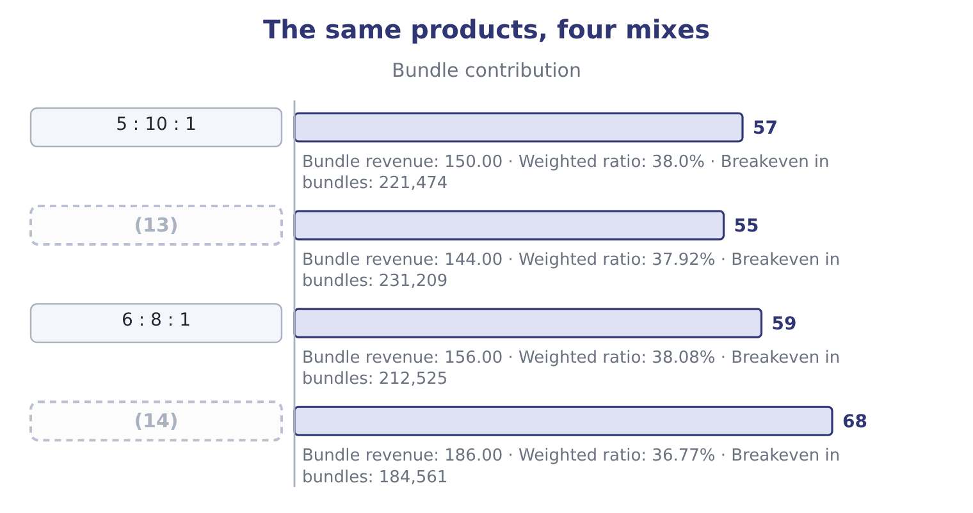
word list
5 : 10 : 1 · 3 : 10 : 2 · 4 : 12 : 1

Summary 2 gaps 15–26
Read the last two columns (15) and the lesson (16) . The weighted ratio barely moves (17) all four mixes — from 36.77 to 38.08 per cent — while the breakeven in bundles moves by more than (18) per cent. That is (19) a bundle is a (20) thing in each row: the fourth mix (21) two drums, so each bundle is larger and fewer are needed. Which is why the answer to "what is the breakeven" is (22) "in what mix", and why a (23) that gives a sales mix is giving an assumption rather than a fact. Three practical (24) , all examinable. A company can miss its profit target while (25) its sales target, if the mix moves towards the thinner (26) . The sales force is told to sell dollars and is paid on dollars, and the dollars arrive while the contribution does not.
word list
products · because · consequences · twenty · across · together · arrives · recommendation · always · question · contains · different · beating

Summary 3 gaps 27–32
A company can beat its profit target while (27) its sales target, by the same (28) in reverse. Book 1's (29) about judging a year by its top line applies here with a number (30) . And a (31) scheme paid on revenue (32) exactly the first outcome. A scheme paid on contribution margin aligns the sales force with the company, and is the standard recommendation in an exam answer on this topic.
word list
attached · weighting · warning · mechanism · commission · produces · missing

The English this section uses, and its Arabic
Each term sits against what it means.
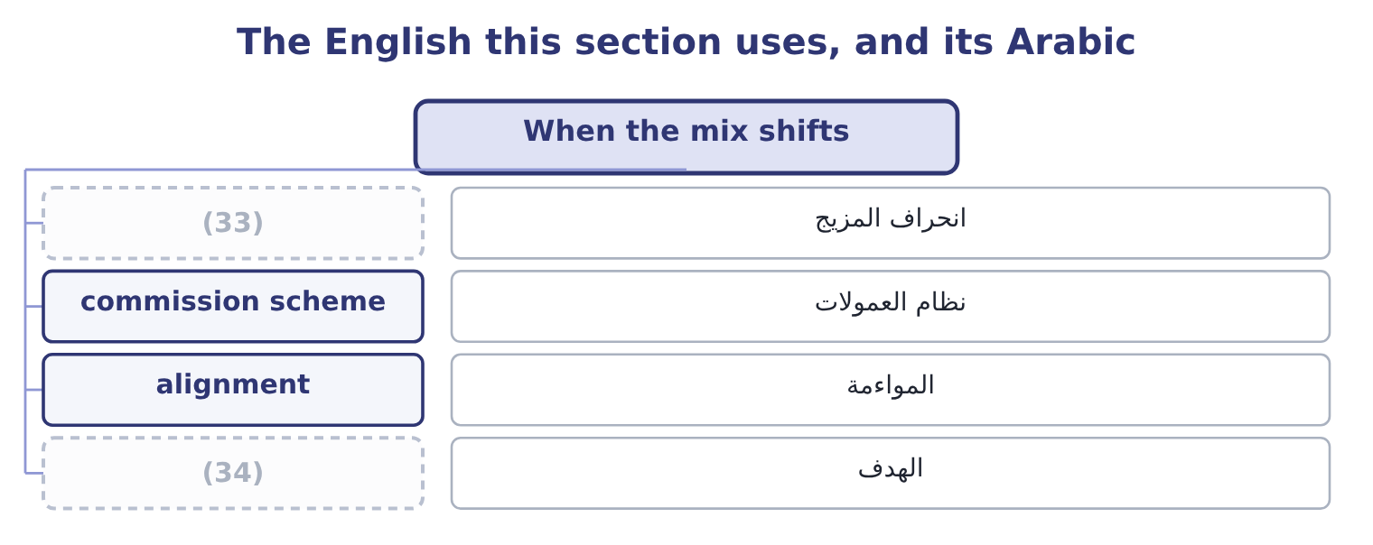
word list
mix variance · assumed constant · target

The English this sheet uses, and its Arabic
English (exam term) | Arabic
mix variance | انحراف المزيج
commission scheme | نظام العمولات
alignment | المواءمة
target | الهدف

Answer key · 3.3 When the mix shifts

1 insists | 18 twenty
2 calculation | 19 because
3 controls | 20 different
4 proportions | 21 contains
5 better | 22 always
6 twelve | 23 question
7 bundle's | 24 consequences
8 thousand | 25 beating
9 before | 26 products
10 Nothing | 27 missing
11 changed | 28 mechanism
12 bought | 29 warning
13 4 : 12 : 1 | 30 attached
14 3 : 10 : 2 | 31 commission
15 together | 32 produces
16 arrives | 33 mix variance
17 across | 34 target

the summaries in full
Summary 1 The reason the exam insists there is no unique breakeven is that the whole calculation above rests on an assumption nobody controls: that customers will go on buying in the same proportions. Suppose they do not. Suppose the bars sell better and the jars worse, so the mix becomes four jars and twelve bars to each drum. The bundle's contribution becomes 4 × 4.80 = 19.20 from the jars, 12 × 1.20 = 14.40 from the bars and 21.00 from the drum, which is 19.20 + 14.40 + 21.00 = 54.60. Its revenue becomes 4 × 12.00 = 48.00, 12 × 3.00 = 36.00 and 60.00, which is 48.00 + 36.00 + 60.00 = 144.00. The weighted ratio becomes 54.60 ÷ 144.00 = 37.92 per cent, barely moved, and the breakeven in bundles becomes 12,624,000 ÷ 54.60 = 231,209 — nearly ten thousand bundles more than before. Nothing about prices, costs or fixed costs changed. Customers bought one more bar and one less jar per bundle, and the company must now sell more to stand still.
Summary 2 Read the last two columns together and the lesson arrives. The weighted ratio barely moves across all four mixes — from 36.77 to 38.08 per cent — while the breakeven in bundles moves by more than twenty per cent. That is because a bundle is a different thing in each row: the fourth mix contains two drums, so each bundle is larger and fewer are needed. Which is why the answer to "what is the breakeven" is always "in what mix", and why a question that gives a sales mix is giving an assumption rather than a fact. Three practical consequences, all examinable. A company can miss its profit target while beating its sales target, if the mix moves towards the thinner products. The sales force is told to sell dollars and is paid on dollars, and the dollars arrive while the contribution does not.
Summary 3 A company can beat its profit target while missing its sales target, by the same mechanism in reverse. Book 1's warning about judging a year by its top line applies here with a number attached. And a commission scheme paid on revenue produces exactly the first outcome. A scheme paid on contribution margin aligns the sales force with the company, and is the standard recommendation in an exam answer on this topic.

3.4 Why there is no unique breakeven
Chapter 3 · section 3.4

Fill every gap. Each word list holds one word more than there are gaps.
Summary 1 gaps 1–12
The outcome asks for the explanation and not only the (1) , so here it is in its (2) form. (3) even means (4) $12,624,000 of fixed costs with contribution. Any combination of jars, bars and drums whose (5) add to that figure will do it, and there are infinitely many such (6) . Selling nothing but jars, the company needs 12,624,000 ÷ 4.80 = 2,630,000 jars, which is $31,560,000 of sales. Selling nothing but bars, it needs 12,624,000 ÷ 1.20 = 10,520,000 bars, which is also $31,560,000 of sales — the same, (7) the two products share a 40 per cent ratio. Selling nothing but drums, it needs 12,624,000 ÷ 21.00 = 601,143 drums, which is 601,143 × 60.00 = 36,068,580 of sales. So the breakeven in dollars is (8) between about $31,560,000 and 36,068,580, (9) entirely on what the company sells. There is no (10) number, and the one (11) in section 3.2 is the number for one assumed mix. That is the answer the exam wants, and the way to write it is in three (12) : the breakeven depends on the weighted contribution margin; the weighted margin depends on the mix; therefore each mix has its own breakeven, and a unique figure exists only when the mix is assumed constant.
word list
compound · because · calculation · sentences · combinations · depending · single · covering · anywhere · contributions · strongest · computed · Breaking

Orontes's breakeven, under four pure and mixed cases
The bars are drawn to scale.
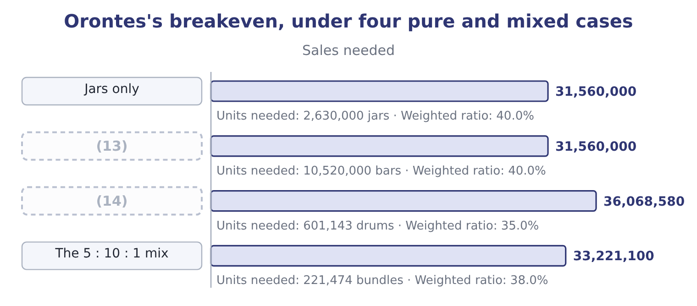
word list
Drums only · Bars only · composite unit

Summary 2 gaps 15–23
One more point (15) the outcome. A company with (16) products has a gross margin that moves when the mix moves, with no change in any (17) own margin — which is the third of the four (18) Book 1 listed for a margin change, and the one it said (19) forget. (20) gross margin fell from 37.0 to 35.0 per cent over three years. Part of that could be price and part could be input costs, and part could be nothing more than drums (21) faster than jars. The (22) own management accounts would show which; the published (23) never will.
word list
company's · causes · Orontes's · growing · statements · candidates · because · completes · several · product's

Weight a mix

Your turn: a two-product breakeven (complete the blanks)
Item | Data | Answer
Contribution per unit, product A | Price 25.00, variable cost 15.00 | 10.00: 25.00 − 15.00 = 10.00.
Contribution per unit, product B | (24) | 3.00: 10.00 − 7.00 = 3.00.
Bundle contribution | Mix of 2 A to 3 B | (25) : 2 × 10.00 = 20.00 from A and 3 × 3.00 = 9.00 from B.
Bundle revenue |  | (26) : 2 × 25.00 = 50.00 and 3 × 10.00 = 30.00.
Weighted contribution ratio |  | 36.25 per cent: 29.00 ÷ 80.00 = 36.25 per cent.
Breakeven in bundles | (27) | 40,000: fixed costs of 1,160,000 divided by the bundle contribution give 40,000 bundles.
Units of each at breakeven |  | (28) : 2 × 40,000 = 80,000 and 3 × 40,000 = 120,000.

word list
80.00 · Fixed costs 1,160,000 · 80,000 of A and 120,000 of B · 29.00 · 221,474 bundles · Price 10.00, variable cost 7.00

"Mix"

Summary 3 gaps 29–34
English mix in management (29) means the proportions in which things are sold or used, and it appears in three (30) the exam uses (31) explanation: sales mix, the proportions of products sold; product mix, often the same thing and (32) the range offered; and mix (33) , the part of a profit (34) caused by proportions rather than by volume or price. Read the compound, not the word.
word list
without · sometimes · variance · combinations · difference · compounds · accounting

The English this section uses, and its Arabic
Each term sits against what it means.
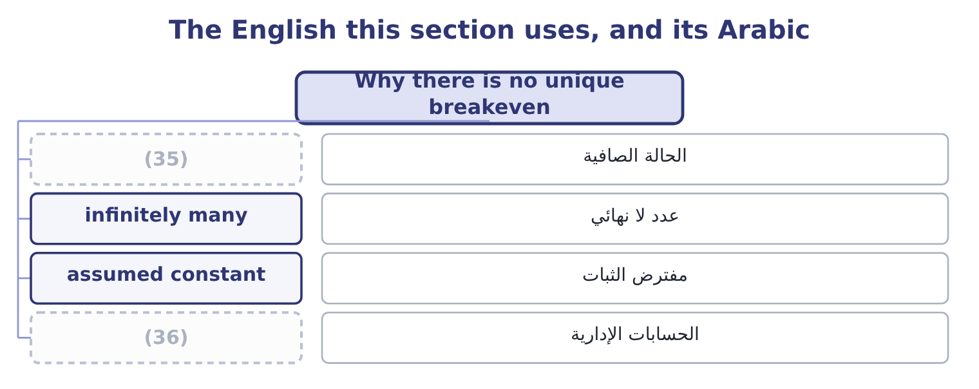
word list
product line · pure case · management accounts

The English this sheet uses, and its Arabic
English (exam term) | Arabic
pure case | الحالة الصافية
infinitely many | عدد لا نهائي
assumed constant | مفترض الثبات
management accounts | الحسابات الإدارية

Answer key · 3.4 Why there is no unique breakeven

1 calculation | 19 candidates
2 strongest | 20 Orontes's
3 Breaking | 21 growing
4 covering | 22 company's
5 contributions | 23 statements
6 combinations | 24 Price 10.00, variable cost 7.00
7 because | 25 29.00
8 anywhere | 26 80.00
9 depending | 27 Fixed costs 1,160,000
10 single | 28 80,000 of A and 120,000 of B
11 computed | 29 accounting
12 sentences | 30 compounds
13 Bars only | 31 without
14 Drums only | 32 sometimes
15 completes | 33 variance
16 several | 34 difference
17 product's | 35 pure case
18 causes | 36 management accounts

the summaries in full
Summary 1 The outcome asks for the explanation and not only the calculation, so here it is in its strongest form. Breaking even means covering $12,624,000 of fixed costs with contribution. Any combination of jars, bars and drums whose contributions add to that figure will do it, and there are infinitely many such combinations. Selling nothing but jars, the company needs 12,624,000 ÷ 4.80 = 2,630,000 jars, which is $31,560,000 of sales. Selling nothing but bars, it needs 12,624,000 ÷ 1.20 = 10,520,000 bars, which is also $31,560,000 of sales — the same, because the two products share a 40 per cent ratio. Selling nothing but drums, it needs 12,624,000 ÷ 21.00 = 601,143 drums, which is 601,143 × 60.00 = 36,068,580 of sales. So the breakeven in dollars is anywhere between about $31,560,000 and 36,068,580, depending entirely on what the company sells. There is no single number, and the one computed in section 3.2 is the number for one assumed mix. That is the answer the exam wants, and the way to write it is in three sentences: the breakeven depends on the weighted contribution margin; the weighted margin depends on the mix; therefore each mix has its own breakeven, and a unique figure exists only when the mix is assumed constant.
Summary 2 One more point completes the outcome. A company with several products has a gross margin that moves when the mix moves, with no change in any product's own margin — which is the third of the four causes Book 1 listed for a margin change, and the one it said candidates forget. Orontes's gross margin fell from 37.0 to 35.0 per cent over three years. Part of that could be price and part could be input costs, and part could be nothing more than drums growing faster than jars. The company's own management accounts would show which; the published statements never will.
Summary 3 English mix in management accounting means the proportions in which things are sold or used, and it appears in three compounds the exam uses without explanation: sales mix, the proportions of products sold; product mix, often the same thing and sometimes the range offered; and mix variance, the part of a profit difference caused by proportions rather than by volume or price. Read the compound, not the word.

