4.1 The margin of safety
Chapter 4 · section 4.1

Fill every gap. Each word list holds one word more than there are gaps.
Chapter 4, section by section
Each stage leads to the next.
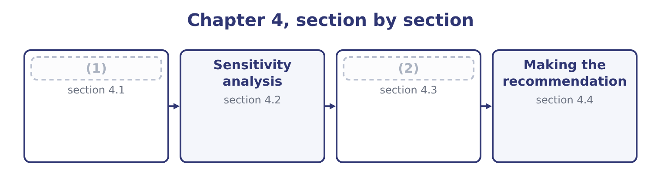
word list
margin of safety ratio · Choosing between cost structures · The margin of safety

Summary 1 gaps 3–13
The margin of safety is the amount by which sales (3) the breakeven. Below that amount the company still makes money; past it, it does not. For Orontes on the (4) figures: 42,000,000 − 31,560,000 = 10,440,000 of sales, which as a (5) is 10,440,000 ÷ 42,000,000 = 24.86 per cent. In units it is 3,500,000 − 2,630,000 = 870,000 jars. So Orontes can lose a quarter of its sales (6) it loses money. That is a usable (7) for a board, and it is the single most (8) figure in Section C, (9) it converts a cost (10) into a statement about risk. On the three-product mix: the breakeven is 33,221,100 of sales, so the margin of safety is 42,000,000 − 33,221,100 = 8,778,900, which is 8,778,900 ÷ 42,000,000 = 20.90 per cent. Four (11) of safety disappear once the (12) drum is in the mix, which is the mix (13) .
word list
exceed · proportion · sentence · before · points · structure · because · effect · useful · single-product · lower-margin · simulation

Summary 2 gaps 14–25
Three (14) of the ratio, all (15) . A high margin of safety means a company can (16) a bad year. A low one means a small fall in (17) turns a profit into a loss. The margin of safety and the degree of operating leverage are the same fact from two (18) . Orontes's leverage of 4.02 says a 10 per cent sales fall costs 40 per cent of the profit; its margin of safety of 24.86 per cent says the profit (19) entirely at a fall of about a quarter. Both come from the same two (20) , the contribution margin and the fixed costs, and the exam may ask for (21) . A margin of safety is (22) only against the mix and the (23) range assumed. A company that would shed fixed costs if (24) fell by a quarter has a larger true margin than the (25) shows.
word list
demand · readings · either · disappears · arithmetic · leverage · examinable · numbers · relevant · absorb · meaningful · volume · directions

Margin of safety, two companies
Measure | Orontes, single product | Orontes, three-product mix | Barada
Sales | 42,000,000 | 42,000,000 | 21,978,000
Breakeven sales | 31,560,000 | 33,221,100 | 17,328,000
Margin of safety | 10,440,000 | 8,778,900 | 4,650,000
(26) | 24.86% | 20.90% | 21.16%
(27) | 4.02 | 4.02 | 4.73

word list
silence of the model · Degree of operating leverage · Margin of safety ratio

Summary 3 gaps 28–33
Barada's (28) repays a second look. Its margin of safety ratio of 21.16 per cent looks much like Orontes's, and its operating leverage of 4.73 is worse — and the figure that (29) most is in (30) column: its contribution margin ratio is 12 per cent against Orontes's 40. Barada has to replace eight (31) of lost sales to (32) one dollar of lost contribution, where Orontes (33) two and a half. A margin of safety says how far away the cliff is; it does not say how hard the climb back up would be.
word list
matters · dollars · position · scenario · neither · recover · replaces

The English this section uses, and its Arabic
Each term sits against what it means.
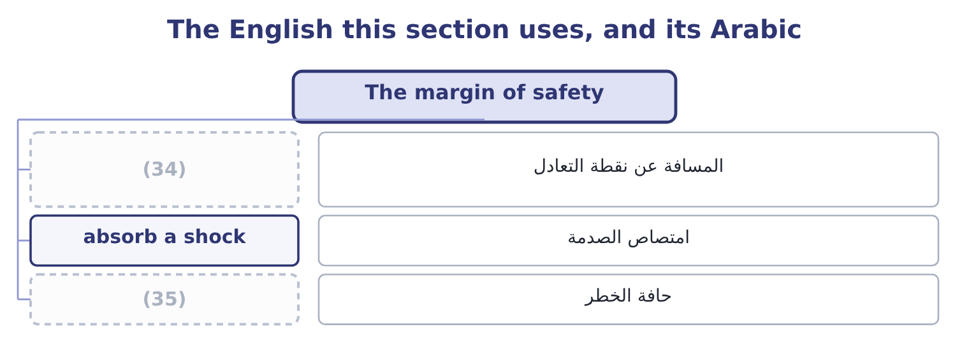
word list
distance from breakeven · cliff edge · pessimistic case

The English this sheet uses, and its Arabic
English (exam term) | Arabic
distance from breakeven | المسافة عن نقطة التعادل
absorb a shock | امتصاص الصدمة
cliff edge | حافة الخطر

Answer key · 4.1 The margin of safety

1 The margin of safety | 19 disappears
2 Choosing between cost structures | 20 numbers
3 exceed | 21 either
4 single-product | 22 meaningful
5 proportion | 23 relevant
6 before | 24 volume
7 sentence | 25 arithmetic
8 useful | 26 Margin of safety ratio
9 because | 27 Degree of operating leverage
10 structure | 28 position
11 points | 29 matters
12 lower-margin | 30 neither
13 effect | 31 dollars
14 readings | 32 recover
15 examinable | 33 replaces
16 absorb | 34 distance from breakeven
17 demand | 35 cliff edge
18 directions

the summaries in full
Summary 1 The margin of safety is the amount by which sales exceed the breakeven. Below that amount the company still makes money; past it, it does not. For Orontes on the single-product figures: 42,000,000 − 31,560,000 = 10,440,000 of sales, which as a proportion is 10,440,000 ÷ 42,000,000 = 24.86 per cent. In units it is 3,500,000 − 2,630,000 = 870,000 jars. So Orontes can lose a quarter of its sales before it loses money. That is a usable sentence for a board, and it is the single most useful figure in Section C, because it converts a cost structure into a statement about risk. On the three-product mix: the breakeven is 33,221,100 of sales, so the margin of safety is 42,000,000 − 33,221,100 = 8,778,900, which is 8,778,900 ÷ 42,000,000 = 20.90 per cent. Four points of safety disappear once the lower-margin drum is in the mix, which is the mix effect.
Summary 2 Three readings of the ratio, all examinable. A high margin of safety means a company can absorb a bad year. A low one means a small fall in demand turns a profit into a loss. The margin of safety and the degree of operating leverage are the same fact from two directions. Orontes's leverage of 4.02 says a 10 per cent sales fall costs 40 per cent of the profit; its margin of safety of 24.86 per cent says the profit disappears entirely at a fall of about a quarter. Both come from the same two numbers, the contribution margin and the fixed costs, and the exam may ask for either. A margin of safety is meaningful only against the mix and the relevant range assumed. A company that would shed fixed costs if volume fell by a quarter has a larger true margin than the arithmetic shows.
Summary 3 Barada's position repays a second look. Its margin of safety ratio of 21.16 per cent looks much like Orontes's, and its operating leverage of 4.73 is worse — and the figure that matters most is in neither column: its contribution margin ratio is 12 per cent against Orontes's 40. Barada has to replace eight dollars of lost sales to recover one dollar of lost contribution, where Orontes replaces two and a half. A margin of safety says how far away the cliff is; it does not say how hard the climb back up would be.

4.2 Sensitivity analysis
Chapter 4 · section 4.2

Fill every gap. Each word list holds one word more than there are gaps.
Summary 1 gaps 1–12
The price is a (1) , the variable cost depends on the sesame market, the fixed costs depend on (2) not yet taken, and the volume is the least certain of the four. (3) analysis asks how much the (4) depends on each. Three (5) , in rising order of (6) , and the exam names all three. Change a (7) input by a stated amount and see what (8) . The output is a (9) of what matters. Change several inputs together in a way that makes a (10) story — a bad year has lower volume and lower prices and (11) higher input costs, because they tend to arrive together. (12) analysis cannot capture that, and a scenario can. Assign a distribution to each input and let a computer draw thousands of combinations, producing a distribution of outcomes rather than three.
word list
ranking · variable · conclusion · Sensitivity · coherent · probably · decisions · happens · techniques · forecast · One-at-a-time · single · effort

Worked example: three scenarios for Orontes

Summary 2 gaps 13–19
Volume falls 10 per cent to 3,150,000 jars and the price is cut 2 per cent to $11.76, so the margin (13) 11.76 − 7.20 = 4.56. Contribution is 3,150,000 × 4.56 = 14,364,000 and operating income is 14,364,000 − 12,624,000 = 1,740,000. Volume rises 8 per cent to 3,780,000 jars at a price 2 per cent higher, $12.24, so the margin is 12.24 − 7.20 = 5.04. Contribution is 3,780,000 × 5.04 = 19,051,200 and operating income is 19,051,200 − 12,624,000 = 6,427,200. At probabilities of 0.25, 0.50 and 0.25: 0.25 × 1,740,000 = 435,000, 0.50 × 4,176,000 = 2,088,000 and 0.25 × 6,427,200 = 1,606,800, which add to 435,000 + 2,088,000 + 1,606,800 = 4,129,800. The expected value is close to the base case and the spread around it is (14) : from $1,740,000 to $6,427,200, a range (15) as large as the expected value itself. That spread is the finding, not the (16) , and an answer that (17) only the $4,129,800 has (18) the thing the board (19) to know — which is.
word list
needed · nearly · expectation · producing · quotes · becomes · hidden · enormous

Three scenarios, one cost structure
The bars are drawn to scale.
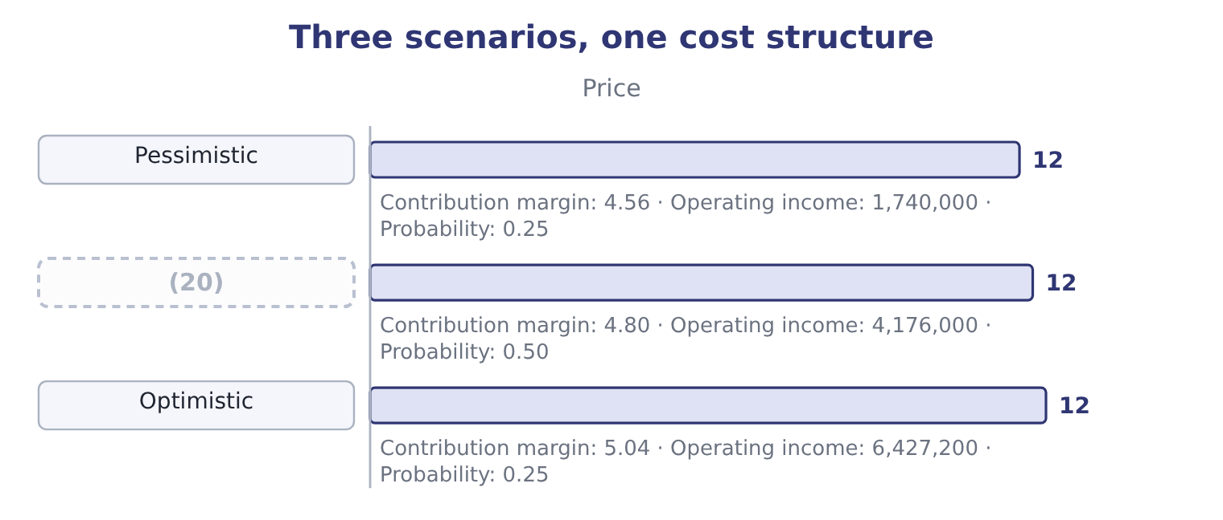
word list
Base · checklist

Scenarios and single variables

Summary 3 gaps 21–26
A scenario (21) several inputs together. Changing one at a time and adding the results (22) and usually (23) the range. An expected value is not an (24) . It is a (25) average of outcomes, and it may itself be (26) . Where a question gives probabilities, use them; where it does not, present the range and say which end you regard as more likely and why.
word list
double-counts · operating · outcome · impossible · weighted · changes · overstates

The English this section uses, and its Arabic
Each term sits against what it means.
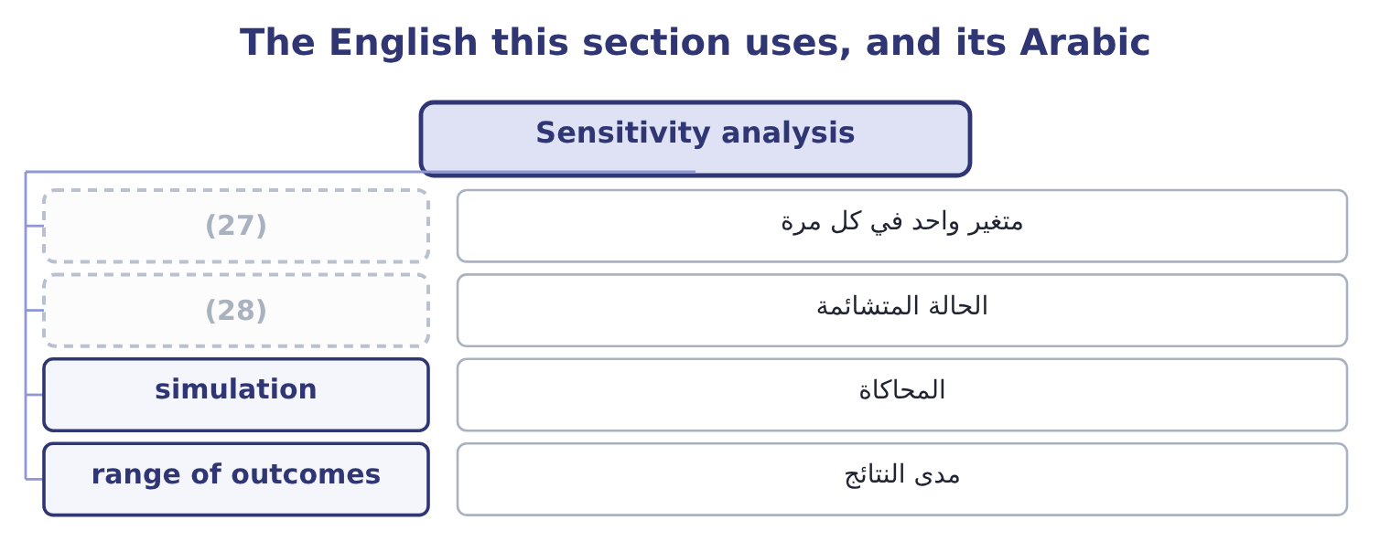
word list
cliff edge · pessimistic case · one-at-a-time

The English this sheet uses, and its Arabic
English (exam term) | Arabic
one-at-a-time | متغير واحد في كل مرة
pessimistic case | الحالة المتشائمة
simulation | المحاكاة
range of outcomes | مدى النتائج

Answer key · 4.2 Sensitivity analysis

1 forecast | 15 nearly
2 decisions | 16 expectation
3 Sensitivity | 17 quotes
4 conclusion | 18 hidden
5 techniques | 19 needed
6 effort | 20 Base
7 single | 21 changes
8 happens | 22 double-counts
9 ranking | 23 overstates
10 coherent | 24 outcome
11 probably | 25 weighted
12 One-at-a-time | 26 impossible
13 becomes | 27 one-at-a-time
14 enormous | 28 pessimistic case

the summaries in full
Summary 1 The price is a forecast, the variable cost depends on the sesame market, the fixed costs depend on decisions not yet taken, and the volume is the least certain of the four. Sensitivity analysis asks how much the conclusion depends on each. Three techniques, in rising order of effort, and the exam names all three. Change a single input by a stated amount and see what happens. The output is a ranking of what matters. Change several inputs together in a way that makes a coherent story — a bad year has lower volume and lower prices and probably higher input costs, because they tend to arrive together. One-at-a-time analysis cannot capture that, and a scenario can. Assign a distribution to each input and let a computer draw thousands of combinations, producing a distribution of outcomes rather than three.
Summary 2 Volume falls 10 per cent to 3,150,000 jars and the price is cut 2 per cent to $11.76, so the margin becomes 11.76 − 7.20 = 4.56. Contribution is 3,150,000 × 4.56 = 14,364,000 and operating income is 14,364,000 − 12,624,000 = 1,740,000. Volume rises 8 per cent to 3,780,000 jars at a price 2 per cent higher, $12.24, so the margin is 12.24 − 7.20 = 5.04. Contribution is 3,780,000 × 5.04 = 19,051,200 and operating income is 19,051,200 − 12,624,000 = 6,427,200. At probabilities of 0.25, 0.50 and 0.25: 0.25 × 1,740,000 = 435,000, 0.50 × 4,176,000 = 2,088,000 and 0.25 × 6,427,200 = 1,606,800, which add to 435,000 + 2,088,000 + 1,606,800 = 4,129,800. The expected value is close to the base case and the spread around it is enormous: from $1,740,000 to $6,427,200, a range nearly as large as the expected value itself. That spread is the finding, not the expectation, and an answer that quotes only the $4,129,800 has hidden the thing the board needed to know — which is.
Summary 3 A scenario changes several inputs together. Changing one at a time and adding the results double-counts and usually overstates the range. An expected value is not an outcome. It is a weighted average of outcomes, and it may itself be impossible. Where a question gives probabilities, use them; where it does not, present the range and say which end you regard as more likely and why.

4.3 Choosing between cost structures
Chapter 4 · section 4.3

Fill every gap. Each word list holds one word more than there are gaps.
Summary 1 gaps 1–8
A (1) kind of recommendation recurs in this topic: two ways of doing the same thing, with (2) mixes of fixed and variable cost. (3) or not; employing a salaried sales force or paying (4) ; owning a fleet or using a carrier; renting a warehouse or paying per pallet. In every case one (5) has higher fixed costs and a higher contribution margin, and the other the (6) . The (7) is which is better, and the answer always (8) on volume. The volume at which the two are equally good is the indifference point.
word list
particular · reverse · option · recommendation · commission · Automating · depends · question · different

Worked example: the indifference volume

Summary 2 gaps 9–19
Orontes can (9) as it is, with a contribution margin of $4.80 and fixed costs of $12,624,000, or (10) .30 and fixed costs of $14,124,000. Automation adds 14,124,000 − 12,624,000 = 1,500,000 of fixed cost and 5.30 − 4.80 = 0.50 of contribution a jar. The extra margin must cover the extra fixed cost: 1,500,000 ÷ 0.50 = 3,000,000 jars. Above 3,000,000 jars automation earns more; below it, the (11) structure does. Orontes sells 3,500,000, so automation is the better choice at (12) volume — by 500,000 × 0.50 = 250,000 a year, which is the figure. The (13) is not the $250,000; it is the 3,000,000. The company is 500,000 jars above the indifference point, which is 14 per cent of its volume, and its margin of safety under the automated structure would fall from 24.86 per cent to 14,124,000 ÷ 5.30 = 2,664,906 jars of breakeven, which on 3,500,000 jars is a margin of safety of about 24 per cent. The gain is real and (14) and it is bought with a (15) higher breakeven in a company whose gross margin is (16) . Stating that (17) is the recommendation; (18) the $250,000 is only the (19) .
word list
falling · recommendation · computing · automate · continue · trade-off · decision · modest · arithmetic · present · permanently · current

High fixed against high variable
 | Higher fixed, higher margin | Higher variable, lower margin
Breakeven | Higher | Lower
Profit at high volume | Higher | Lower
Loss at low volume | (20) | Smaller
Margin of safety | (21) | Higher
Suits | Stable, predictable demand | (22)

word list
Smaller · Volatile or uncertain demand · Lower, for the same sales · Larger

The English this section uses, and its Arabic
Each term sits against what it means.
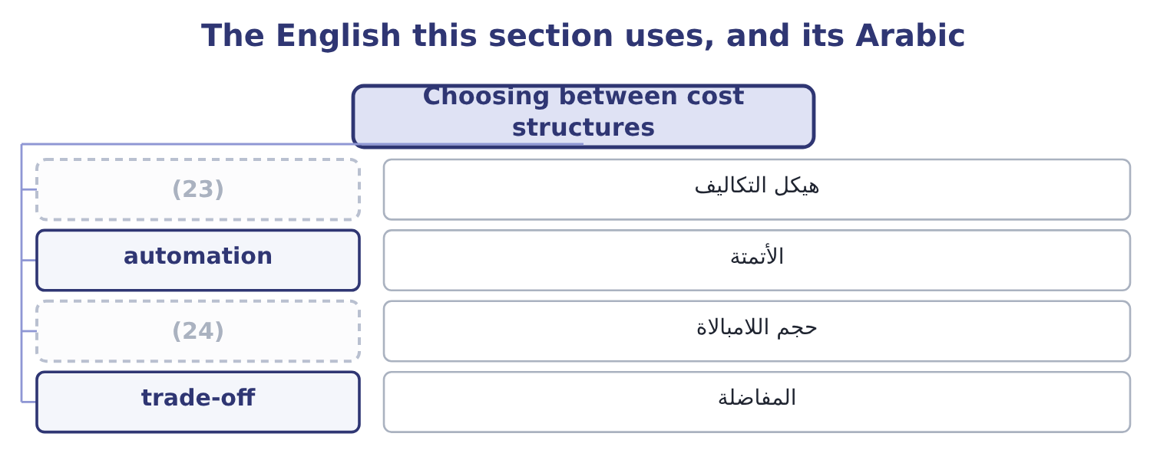
word list
expected value · indifference volume · cost structure

The English this sheet uses, and its Arabic
English (exam term) | Arabic
cost structure | هيكل التكاليف
automation | الأتمتة
indifference volume | حجم اللامبالاة
trade-off | المفاضلة

Answer key · 4.3 Choosing between cost structures

1 particular | 13 decision
2 different | 14 modest
3 Automating | 15 permanently
4 commission | 16 falling
5 option | 17 trade-off
6 reverse | 18 computing
7 question | 19 arithmetic
8 depends | 20 Larger
9 continue | 21 Lower, for the same sales
10 automate | 22 Volatile or uncertain demand
11 present | 23 cost structure
12 current | 24 indifference volume

the summaries in full
Summary 1 A particular kind of recommendation recurs in this topic: two ways of doing the same thing, with different mixes of fixed and variable cost. Automating or not; employing a salaried sales force or paying commission; owning a fleet or using a carrier; renting a warehouse or paying per pallet. In every case one option has higher fixed costs and a higher contribution margin, and the other the reverse. The question is which is better, and the answer always depends on volume. The volume at which the two are equally good is the indifference point.
Summary 2 Orontes can continue as it is, with a contribution margin of $4.80 and fixed costs of $12,624,000, or automate.30 and fixed costs of $14,124,000. Automation adds 14,124,000 − 12,624,000 = 1,500,000 of fixed cost and 5.30 − 4.80 = 0.50 of contribution a jar. The extra margin must cover the extra fixed cost: 1,500,000 ÷ 0.50 = 3,000,000 jars. Above 3,000,000 jars automation earns more; below it, the present structure does. Orontes sells 3,500,000, so automation is the better choice at current volume — by 500,000 × 0.50 = 250,000 a year, which is the figure. The decision is not the $250,000; it is the 3,000,000. The company is 500,000 jars above the indifference point, which is 14 per cent of its volume, and its margin of safety under the automated structure would fall from 24.86 per cent to 14,124,000 ÷ 5.30 = 2,664,906 jars of breakeven, which on 3,500,000 jars is a margin of safety of about 24 per cent. The gain is real and modest and it is bought with a permanently higher breakeven in a company whose gross margin is falling. Stating that trade-off is the recommendation; computing the $250,000 is only the arithmetic.

4.4 Making the recommendation
Chapter 4 · section 4.4

Fill every gap. Each word list holds one word more than there are gaps.
Summary 1 gaps 1–12
The (1) asks for a (2) of action, and an answer that stops at a number does not give one. Five (3) turn an analysis into a recommendation, and they are worth learning as a (4) because the exam rewards each of them. A marker (5) not have to (6) for the answer. (7) it with the number that (8) it. Not every number (9) — the one that (10) . For the automation (11) that is the indifference volume of 3,000,000 jars against actual volume of 3,500,000, not the $250,000 of (12) gain. Name what the decision depends on. Say which one would reverse the answer if it failed, and at what value. Give the qualitative factors their place. The numbers do not capture the effect of automation on a workforce, on flexibility, on the ability to make small batches, or on a supplier relationship.
word list
outcome · annual · should · course · search · computed · decides · drives · checklist · trade-off · elements · question · Support

Summary 2 gaps 13–15
Say what you would do next. Test the volume (13) with the sales force, obtain a second (14) for the equipment, run the decision again at the pessimistic scenario. A recommendation with a next step is a recommendation (15) can act on.
word list
trade-off · quotation · somebody · assumption

A recommendation, in five parts
Element | For the automation decision
The decision | Automate, subject to the volume test below
The deciding number | (16) of 3,000,000 jars against 3,500,000 actual
What it depends on | Volume staying above 3,000,000; the (17) costing what was quoted
What would reverse it | A fall of more than 14 per cent in volume, or fixed costs above 15,300,000
The qualitative factors | Loss of flexibility in small batches; effect on the packing workforce
The next step | Re-run at the pessimistic (18) of 3,150,000 jars before committing

word list
scenario · equipment · automation · Indifference volume

Summary 3 gaps 19–24
One last habit (19) the chapter, and it is the one that most (20) a professional answer. Say what the analysis does not show. (21) analysis is silent about the (22) response, about what the customers will think of a price change, about whether the sales force can deliver the volume, and about everything beyond the relevant range. A (23) who names the silence is telling a marker that the model is (24) , not merely applied.
word list
candidate · distinguishes · understood · competitor's · elements · closes · Cost-volume-profit

Measure the safety and choose

Your turn: safety and structure (complete the blanks)
Item | Data | Answer
Breakeven in sales | (25) | ________
Margin of safety | Sales 12,000,000 | ________
Margin of safety ratio |  | ________
Operating income |  | ________
Indifference volume against a structure with 900,000 more fixed cost and 1.50 more contribution a unit |  | ________
Which structure at 700,000 units |  | ________

word list
Fixed costs 2,400,000, contribution ratio 30 per cent · Indifference volume of 3,000,000 jars against 3,500,000 actual

"Sensitivity"

Summary 4 gaps 26–29
English (26) analysis means testing how much an answer changes when an input changes, and the word carries no (27) of delicacy or of feeling. The (28) phrase sensitive to is used of the answer, not of the (29) : an answer is sensitive to volume if volume moves it a great deal.
word list
related · suggestion · analyst · checklist · sensitivity

"Sensitivity"
Item | Answer
Breakeven in sales | 8,000,000: 2,400,000 ÷ 0.30 = 8,000,000.
Margin of safety | (30)
Margin of safety ratio | (31)
Operating income | 1,200,000: contribution is 12,000,000 × 0.30 = 3,600,000, less fixed costs of 2,400,000.
Indifference volume | (32) : 900,000 ÷ 1.50 = 600,000.
Which structure at 700,000 units | The higher-fixed structure, because 700,000 is above the indifference volume of 600,000 — it earns 100,000 × 1.50 = 150,000 more a year.
What it tells you | The company has a third of its sales as safety and sits 100,000 units above the point at which the heavier structure pays. Both margins are

word list
Breakeven in sales · 33.3 per cent: 4,000,000 ÷ 12,000,000 = 33.3 per cent. · 4,000,000: 12,000,000 − 8,000,000 = 4,000,000. · 600,000 units

The English this section uses, and its Arabic
Each term sits against what it means.
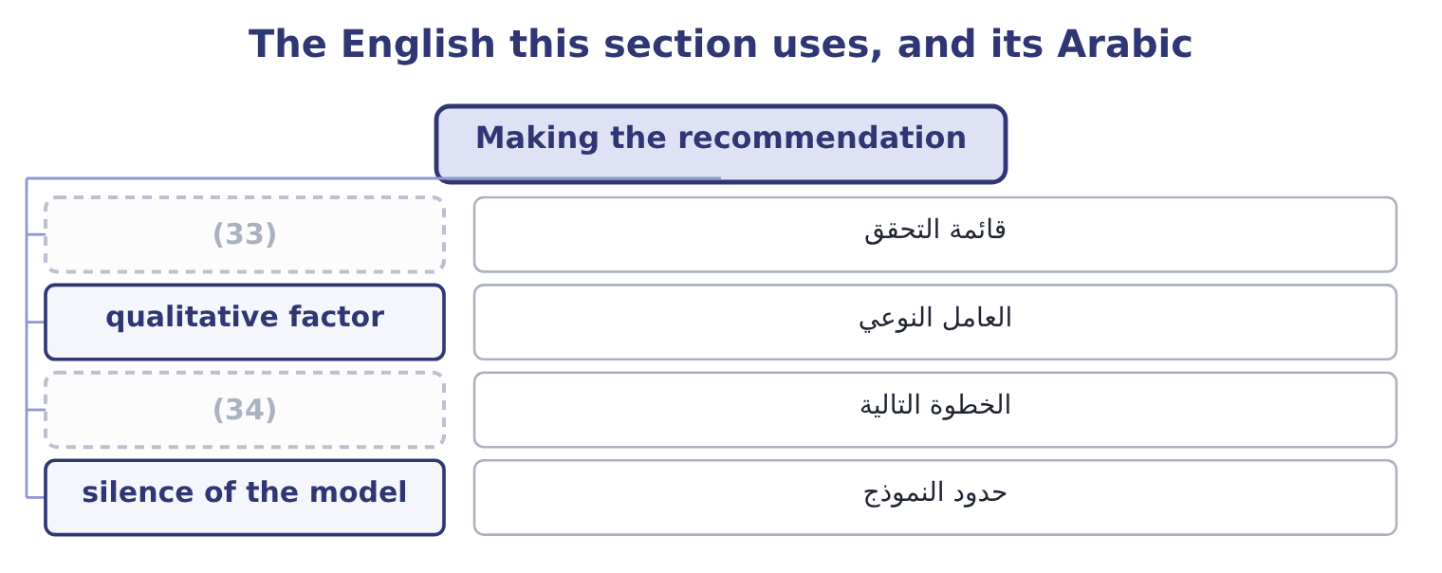
word list
expected value · next step · checklist

The English this sheet uses, and its Arabic
English (exam term) | Arabic
checklist | قائمة التحقق
qualitative factor | العامل النوعي
next step | الخطوة التالية
silence of the model | حدود النموذج

Answer key · 4.4 Making the recommendation

1 outcome | 18 scenario
2 course | 19 closes
3 elements | 20 distinguishes
4 checklist | 21 Cost-volume-profit
5 should | 22 competitor's
6 search | 23 candidate
7 Support | 24 understood
8 drives | 25 Fixed costs 2,400,000, contribution ratio 30 per cent
9 computed | 26 sensitivity
10 decides | 27 suggestion
11 question | 28 related
12 annual | 29 analyst
13 assumption | 30 4,000,000: 12,000,000 − 8,000,000 = 4,000,000.
14 quotation | 31 33.3 per cent: 4,000,000 ÷ 12,000,000 = 33.3 per cent.
15 somebody | 32 600,000 units
16 Indifference volume | 33 checklist
17 equipment | 34 next step

the summaries in full
Summary 1 The outcome asks for a course of action, and an answer that stops at a number does not give one. Five elements turn an analysis into a recommendation, and they are worth learning as a checklist because the exam rewards each of them. A marker should not have to search for the answer. Support it with the number that drives it. Not every number computed — the one that decides. For the automation question that is the indifference volume of 3,000,000 jars against actual volume of 3,500,000, not the $250,000 of annual gain. Name what the decision depends on. Say which one would reverse the answer if it failed, and at what value. Give the qualitative factors their place. The numbers do not capture the effect of automation on a workforce, on flexibility, on the ability to make small batches, or on a supplier relationship.
Summary 2 Say what you would do next. Test the volume assumption with the sales force, obtain a second quotation for the equipment, run the decision again at the pessimistic scenario. A recommendation with a next step is a recommendation somebody can act on.
Summary 3 One last habit closes the chapter, and it is the one that most distinguishes a professional answer. Say what the analysis does not show. Cost-volume-profit analysis is silent about the competitor's response, about what the customers will think of a price change, about whether the sales force can deliver the volume, and about everything beyond the relevant range. A candidate who names the silence is telling a marker that the model is understood, not merely applied.
Summary 4 English sensitivity analysis means testing how much an answer changes when an input changes, and the word carries no suggestion of delicacy or of feeling. The related phrase sensitive to is used of the answer, not of the analyst: an answer is sensitive to volume if volume moves it a great deal.

