5.1 The two tests
Chapter 5 · section 5.1

Fill every gap. Each word list holds one word more than there are gaps.
Chapter 5, section by section
Each stage leads to the next.
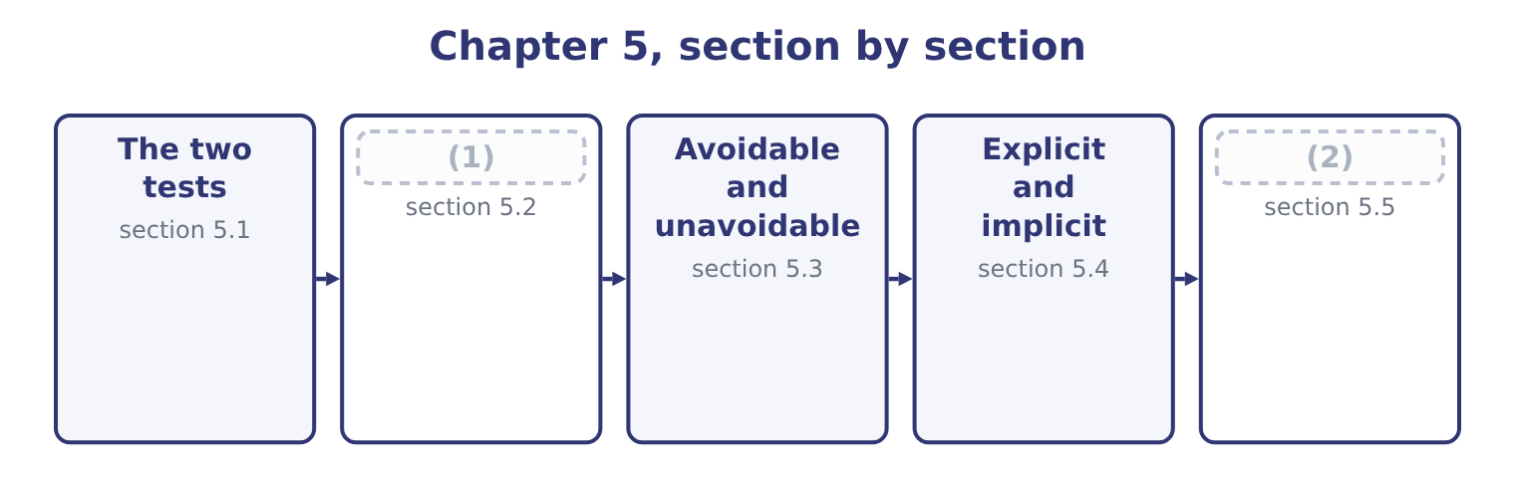
word list
The two tests · Sunk costs · Putting it to work

Summary 1 gaps 3–14
A cost or a (3) is relevant to a decision if it passes both of these tests. It lies in the future. A decision taken today can change what happens from today (4) and nothing that (5) before. Money already spent is spent (6) is chosen. It (7) between the alternatives. If a cost is the same under every (8) , including it changes every total by the same amount and changes no (9) . Including it is not wrong, (10) — it wastes effort and (11) error. Both tests must be (12) . A future cost that does not differ is irrelevant; a differing cost that is already (13) is irrelevant. The exam's (14) trap is a cost that passes one test loudly and fails the other quietly. Two further names describe the same idea from different angles, and the outcome asks for them.
word list
differs · ranking · onwards · apportionment · favourite · revenue · exactly · happened · invites · passed · option · incurred · whatever

Summary 2 gaps 15–19
An (15) cost, also called a (16) cost, is the difference in total cost between two alternatives. It is the relevant amount (17) as a number (18) than as a test. A (19) cost is the cost of one more unit. In most exam settings it equals the variable cost per unit, and the two words are used interchangeably at this level.
word list
rather · differential · incremental · stated · marginal · onwards

Relevant or not, for a decision to discontinue the halva bar
Every item belongs to exactly one group.
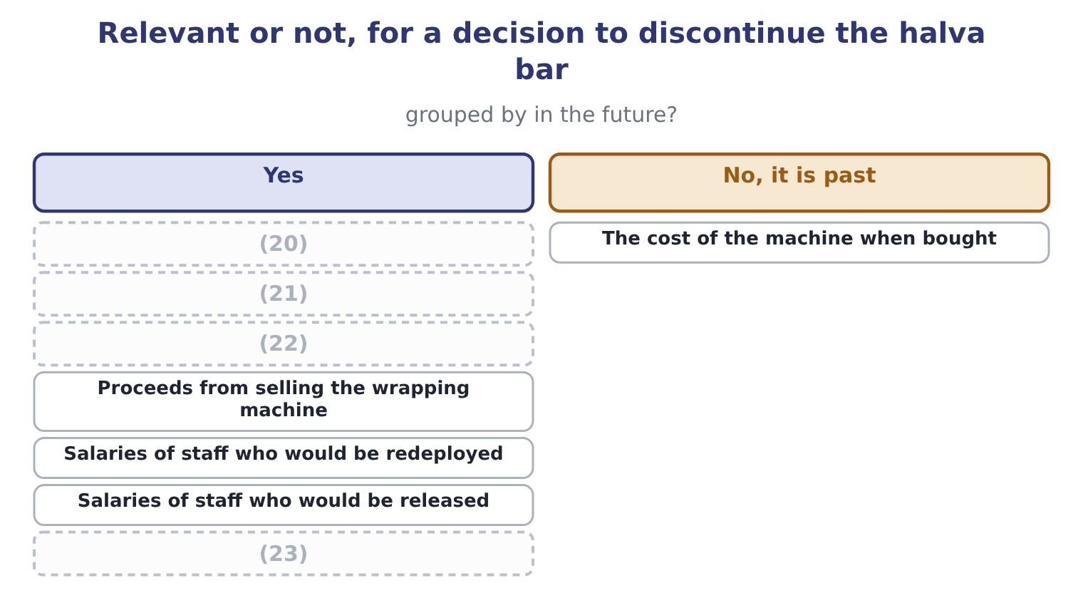
word list
The bar's share of factory rent · Sesame used in bars · Contribution from bar sales · Depreciation on the bar wrapping machine · Proceeds from selling the wrapping machine

Both tests, every time

Summary 3 gaps 24–32
Depreciation is never relevant in itself. It is the (24) of a past payment, so it fails the first test. What is relevant about an owned asset is what else could be done with it — sold, or used (25) — which is section 5.4's (26) . An (27) share of a (28) cost is almost never relevant. The (29) is not how the cost is shared but (30) the total changes. A cost can be relevant for one decision and irrelevant for (31) , with no change in the cost itself. (32) is a property of the decision, not of the cost.
word list
another · whether · including · allocated · spreading · Relevance · question · elsewhere · common · subject

The English this section uses, and its Arabic
Each term sits against what it means.
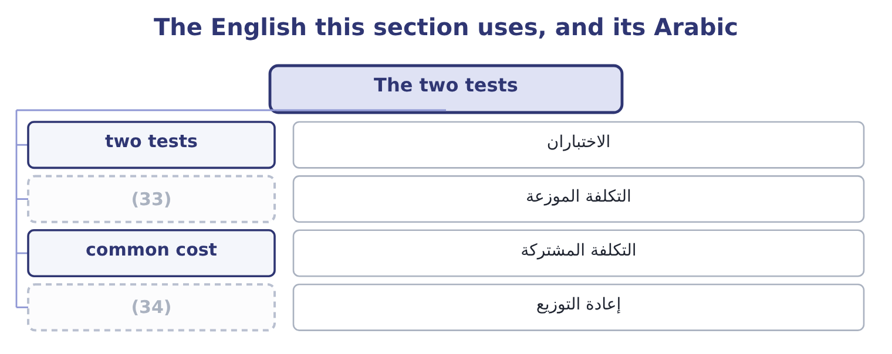
word list
redeployment · الاختباران · allocated cost

The English this sheet uses, and its Arabic
English (exam term) | Arabic
two tests | الاختباران
allocated cost | التكلفة الموزعة
common cost | التكلفة المشتركة
redeployment | إعادة التوزيع

Answer key · 5.1 The two tests

1 Sunk costs | 18 rather
2 Putting it to work | 19 marginal
3 revenue | 20 Sesame used in bars
4 onwards | 21 The bar's share of factory rent
5 happened | 22 Depreciation on the bar wrapping machine
6 whatever | 23 Contribution from bar sales
7 differs | 24 spreading
8 option | 25 elsewhere
9 ranking | 26 subject
10 exactly | 27 allocated
11 invites | 28 common
12 passed | 29 question
13 incurred | 30 whether
14 favourite | 31 another
15 incremental | 32 Relevance
16 differential | 33 allocated cost
17 stated | 34 redeployment

the summaries in full
Summary 1 A cost or a revenue is relevant to a decision if it passes both of these tests. It lies in the future. A decision taken today can change what happens from today onwards and nothing that happened before. Money already spent is spent whatever is chosen. It differs between the alternatives. If a cost is the same under every option, including it changes every total by the same amount and changes no ranking. Including it is not wrong, exactly — it wastes effort and invites error. Both tests must be passed. A future cost that does not differ is irrelevant; a differing cost that is already incurred is irrelevant. The exam's favourite trap is a cost that passes one test loudly and fails the other quietly. Two further names describe the same idea from different angles, and the outcome asks for them.
Summary 2 An incremental cost, also called a differential cost, is the difference in total cost between two alternatives. It is the relevant amount stated as a number rather than as a test. A marginal cost is the cost of one more unit. In most exam settings it equals the variable cost per unit, and the two words are used interchangeably at this level.
Summary 3 Depreciation is never relevant in itself. It is the spreading of a past payment, so it fails the first test. What is relevant about an owned asset is what else could be done with it — sold, or used elsewhere — which is section 5.4's subject. An allocated share of a common cost is almost never relevant. The question is not how the cost is shared but whether the total changes. A cost can be relevant for one decision and irrelevant for another, with no change in the cost itself. Relevance is a property of the decision, not of the cost.

5.2 Sunk costs
Chapter 5 · section 5.2

Fill every gap. Each word list holds one word more than there are gaps.
Summary 1 gaps 1–12
A sunk cost is a cost already incurred that cannot be (1) by any choice now (2) . It fails the first test (3) , and the outcome asks (4) why. The reason is that a decision (5) the future and the past is (6) under every option. Suppose Orontes spent $300,000 on a (7) packaging film for a product line it is now (8) . (9) the line continues or stops, the $300,000 has gone. It appears in (10) column of the (11) , so it cannot favour either. What is relevant about the film is what can still be done with it. If it can be sold for $40,000, that $40,000 is relevant because it is (12) under one option and not the other. If it can be used on another line, saving $180,000 of purchases that would otherwise be made, that saving is relevant. And the choice between those two uses is itself a decision: using the film saves $180,000 and forgoes the $40,000 scrap, so the net benefit of using it is 180,000 − 40,000 = 140,000.
word list
packaging · available · reconsidering · specialised · Whether · receivable · recovered · specifically · comparison · absolutely · neither · changes · identical

Summary 2 gaps 13–21
The original $300,000 appears (13) in any of that (14) . Why (15) and managers include it anyway is worth naming, because the exam sometimes asks for the (16) point. It is called the sunk cost fallacy, or (17) good money after bad: having spent $300,000, a manager feels that (18) the line wastes it, and continues in order to justify the original decision. The (19) is wasted either way; (20) merely adds to it. The (21) is to ask what the choice is from here, which is also the only question a reader of the accounts can answer next year.
word list
discipline · abandoning · nowhere · identical · candidates · spending · continuing · throwing · arithmetic · behavioural

Worked example: replacing a machine

Summary 3 gaps 22–33
Orontes owns a (22) machine bought four years ago for $1,200,000, now (23) in the books at $700,000. A new machine costs $900,000 and would save $350,000 a year of (24) costs for four years. The old machine could be sold today for $250,000 and has no value at the end of the four years. The $1,200,000 original cost, the $700,000 book value, and the $450,000 loss that (25) at $250,000 would (26) in the accounts. All three are the past, recorded in (27) ways. The $900,000 to be paid, the $250,000 to be (28) , and the $350,000 a year to be saved. The net outlay is 900,000 − 250,000 = 650,000, and the savings are 350,000 × 4 = 1,400,000, so (29) is better by 1,400,000 − 650,000 = 750,000 before any (30) . The (31) loss of $450,000 is the figure that stops this decision being taken in practice, because it appears in next year's income (32) and nobody wants to explain it. It is not a cash flow and it does not change the merits, and an answer that says so — and then says the loss should be (33) to the board in advance — is the one worth full marks.
word list
filling · because · received · selling · statement · replacing · standing · explained · different · discounting · produce · operating · accounting

The English this section uses, and its Arabic
Each term sits against what it means.
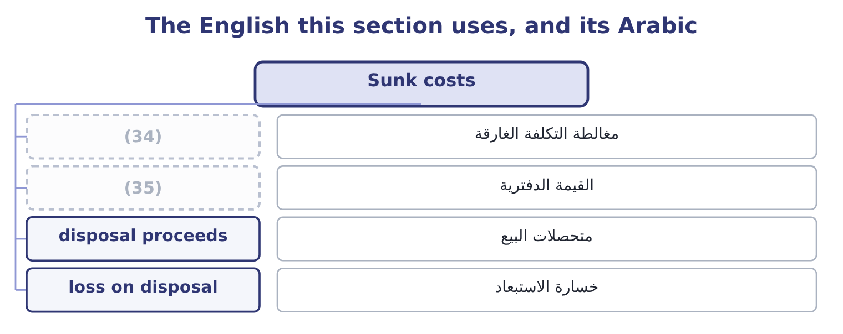
word list
imputed cost · book value · sunk cost fallacy

The English this sheet uses, and its Arabic
English (exam term) | Arabic
sunk cost fallacy | مغالطة التكلفة الغارقة
book value | القيمة الدفترية
disposal proceeds | متحصلات البيع
loss on disposal | خسارة الاستبعاد

Answer key · 5.2 Sunk costs

1 recovered | 19 spending
2 available | 20 continuing
3 absolutely | 21 discipline
4 specifically | 22 filling
5 changes | 23 standing
6 identical | 24 operating
7 specialised | 25 selling
8 reconsidering | 26 produce
9 Whether | 27 different
10 neither | 28 received
11 comparison | 29 replacing
12 receivable | 30 discounting
13 nowhere | 31 accounting
14 arithmetic | 32 statement
15 candidates | 33 explained
16 behavioural | 34 sunk cost fallacy
17 throwing | 35 book value
18 abandoning

the summaries in full
Summary 1 A sunk cost is a cost already incurred that cannot be recovered by any choice now available. It fails the first test absolutely, and the outcome asks specifically why. The reason is that a decision changes the future and the past is identical under every option. Suppose Orontes spent $300,000 on a specialised packaging film for a product line it is now reconsidering. Whether the line continues or stops, the $300,000 has gone. It appears in neither column of the comparison, so it cannot favour either. What is relevant about the film is what can still be done with it. If it can be sold for $40,000, that $40,000 is relevant because it is receivable under one option and not the other. If it can be used on another line, saving $180,000 of purchases that would otherwise be made, that saving is relevant. And the choice between those two uses is itself a decision: using the film saves $180,000 and forgoes the $40,000 scrap, so the net benefit of using it is 180,000 − 40,000 = 140,000.
Summary 2 The original $300,000 appears nowhere in any of that arithmetic. Why candidates and managers include it anyway is worth naming, because the exam sometimes asks for the behavioural point. It is called the sunk cost fallacy, or throwing good money after bad: having spent $300,000, a manager feels that abandoning the line wastes it, and continues in order to justify the original decision. The spending is wasted either way; continuing merely adds to it. The discipline is to ask what the choice is from here, which is also the only question a reader of the accounts can answer next year.
Summary 3 Orontes owns a filling machine bought four years ago for $1,200,000, now standing in the books at $700,000. A new machine costs $900,000 and would save $350,000 a year of operating costs for four years. The old machine could be sold today for $250,000 and has no value at the end of the four years. The $1,200,000 original cost, the $700,000 book value, and the $450,000 loss that selling at $250,000 would produce in the accounts. All three are the past, recorded in different ways. The $900,000 to be paid, the $250,000 to be received, and the $350,000 a year to be saved. The net outlay is 900,000 − 250,000 = 650,000, and the savings are 350,000 × 4 = 1,400,000, so replacing is better by 1,400,000 − 650,000 = 750,000 before any discounting. The accounting loss of $450,000 is the figure that stops this decision being taken in practice, because it appears in next year's income statement and nobody wants to explain it. It is not a cash flow and it does not change the merits, and an answer that says so — and then says the loss should be explained to the board in advance — is the one worth full marks.

5.3 Avoidable and unavoidable
Chapter 5 · section 5.3

Fill every gap. Each word list holds one word more than there are gaps.
Summary 1 gaps 1–12
An avoidable cost is one that will not be incurred if an activity is (1) . An unavoidable cost will be incurred (2) . The pair applies (3) a question asks whether to drop a product, close a (4) , shut a branch or stop serving a customer. The (5) is not the same as variable and fixed, and (6) the two is the commonest error in this topic. Most variable costs are avoidable, (7) they stop when the activity stops. But some fixed costs are avoidable too: a (8) whose post would be eliminated, an insurance policy that would be cancelled, a lease that would be (9) . And some variable costs are unavoidable, as where a supply (10) commits the company to a minimum (11) whatever it produces. A (12) fixed cost belongs entirely to one activity and usually goes with it. A common fixed cost is shared, and usually does not: closing the halva line does not reduce the factory rent, the chief executive's salary or the audit fee, and allocating a share of those to the line never made them avoidable.
word list
separable · contract · anyway · quantity · confusing · surrendered · department · supervisor · whenever · distinction · discontinued · because · avoided

Dropping the halva bar: what stops and what does not
Every item belongs to exactly one group.
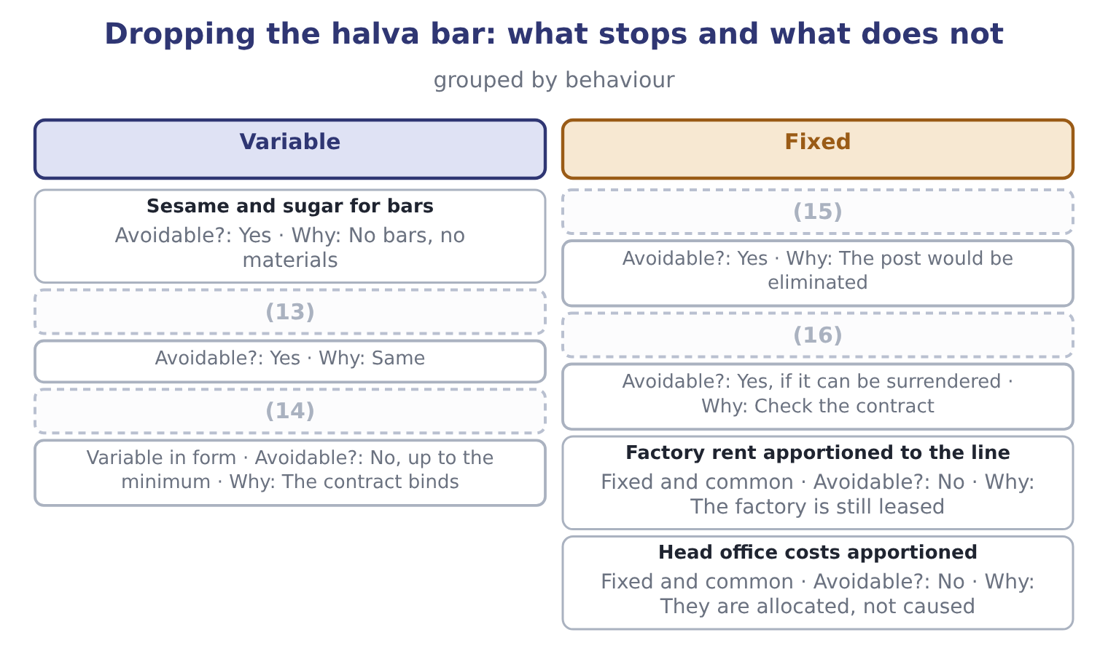
word list
Lease of the bar wrapping machine · Line supervisor's salary · Minimum purchase under a sesame contract · common cost · Bar packaging

Summary 2 gaps 17–20
The rule a question is testing is this: a product should be dropped only if the (17) it earns is less than the fixed costs that would (18) be avoided by dropping it. Here the point is that the avoidable (19) , not the full cost of the line, is the figure to (20) .
word list
actually · eliminated · column · contribution · compare

The English this section uses, and its Arabic
Each term sits against what it means.
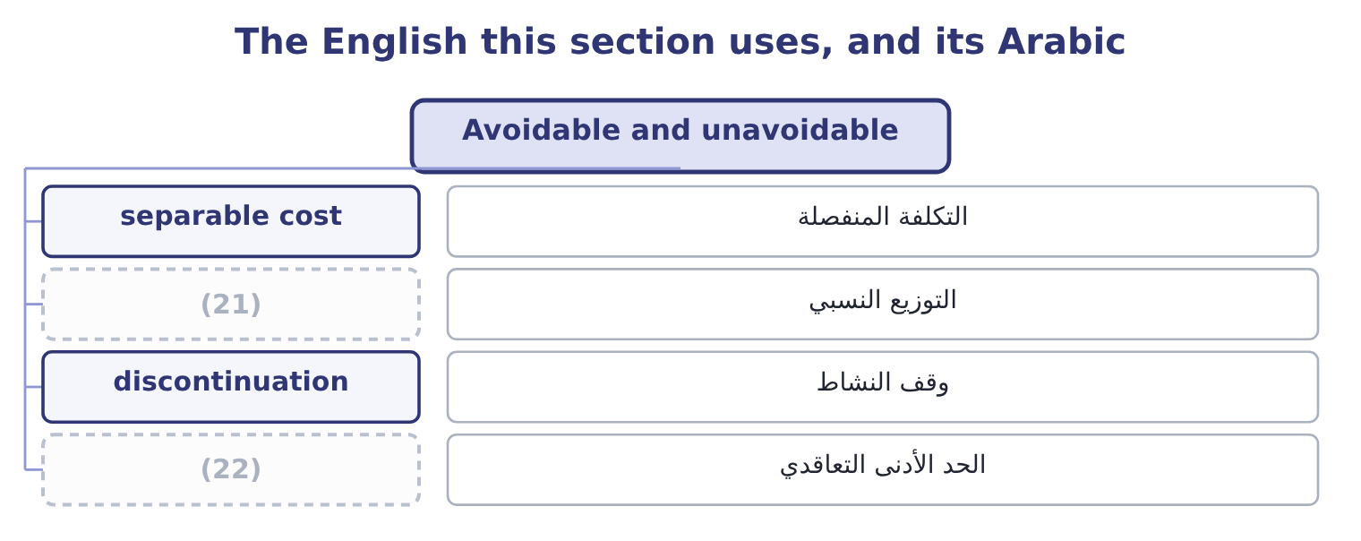
word list
cash flow · contractual minimum · apportionment

The English this sheet uses, and its Arabic
English (exam term) | Arabic
separable cost | التكلفة المنفصلة
apportionment | التوزيع النسبي
discontinuation | وقف النشاط
contractual minimum | الحد الأدنى التعاقدي

Answer key · 5.3 Avoidable and unavoidable

1 discontinued | 12 separable
2 anyway | 13 Bar packaging
3 whenever | 14 Minimum purchase under a sesame contract
4 department | 15 Line supervisor's salary
5 distinction | 16 Lease of the bar wrapping machine
6 confusing | 17 contribution
7 because | 18 actually
8 supervisor | 19 column
9 surrendered | 20 compare
10 contract | 21 apportionment
11 quantity | 22 contractual minimum

the summaries in full
Summary 1 An avoidable cost is one that will not be incurred if an activity is discontinued. An unavoidable cost will be incurred anyway. The pair applies whenever a question asks whether to drop a product, close a department, shut a branch or stop serving a customer. The distinction is not the same as variable and fixed, and confusing the two is the commonest error in this topic. Most variable costs are avoidable, because they stop when the activity stops. But some fixed costs are avoidable too: a supervisor whose post would be eliminated, an insurance policy that would be cancelled, a lease that would be surrendered. And some variable costs are unavoidable, as where a supply contract commits the company to a minimum quantity whatever it produces. A separable fixed cost belongs entirely to one activity and usually goes with it. A common fixed cost is shared, and usually does not: closing the halva line does not reduce the factory rent, the chief executive's salary or the audit fee, and allocating a share of those to the line never made them avoidable.
Summary 2 The rule a question is testing is this: a product should be dropped only if the contribution it earns is less than the fixed costs that would actually be avoided by dropping it. Here the point is that the avoidable column, not the full cost of the line, is the figure to compare.

5.4 Explicit and implicit
Chapter 5 · section 5.4

Fill every gap. Each word list holds one word more than there are gaps.
Summary 1 gaps 1–12
An explicit cost involves a payment: wages, materials, rent, (1) . It appears in the accounting records because (2) was paid. An implicit cost involves no payment and is a (3) cost all the same: the value of (4) the company already owns that is used up or given up by a choice. It appears in no (5) , which is why it has to be (6) about rather than looked up. The most (7) implicit cost has its own name and its own chapter. An (8) cost is the benefit forgone by using a (9) for one purpose instead of its best alternative use. But the (10) is wider. The owner of a small business who works in it (11) a salary bears an implicit cost: the wage that could have been (12) elsewhere. The company that uses a building it owns bears the rent it could have received. And the shareholders of any company bear the implicit cost of their capital, which is precisely the point Book 1 made about economic profit — accounting profit charges for the explicit cost of debt and not for the implicit cost of equity. That gives the pair of definitions the exam wants.
word list
earned · category · appears · opportunity · resource · somebody · without · something · ledger · genuine · reasoned · interest · important

Summary 2 gaps 13–17
Accounting profit is revenue less explicit costs. Economic profit is revenue less explicit and implicit costs (13) . A business can show an accounting profit and an economic loss, which means it is (14) less than the (15) it consumes could earn elsewhere — and a business in that (16) is being kept alive by a cost nobody is (17) it for.
word list
building · together · resources · charging · earning · position

Four kinds of cost, two dimensions
 | Explicit, a payment is made | Implicit, no payment is made
Relevant to a decision | (18) | The contribution forgone on displaced work; rent forgone on an owned building
Not relevant | Last year's advertising already paid; allocated head office charge | (19)

word list
Materials for the extra order; wages of staff hired · Last year's advertising already paid; allocated head office charge · Depreciation of an asset with no alternative use

The English this section uses, and its Arabic
Each term sits against what it means.
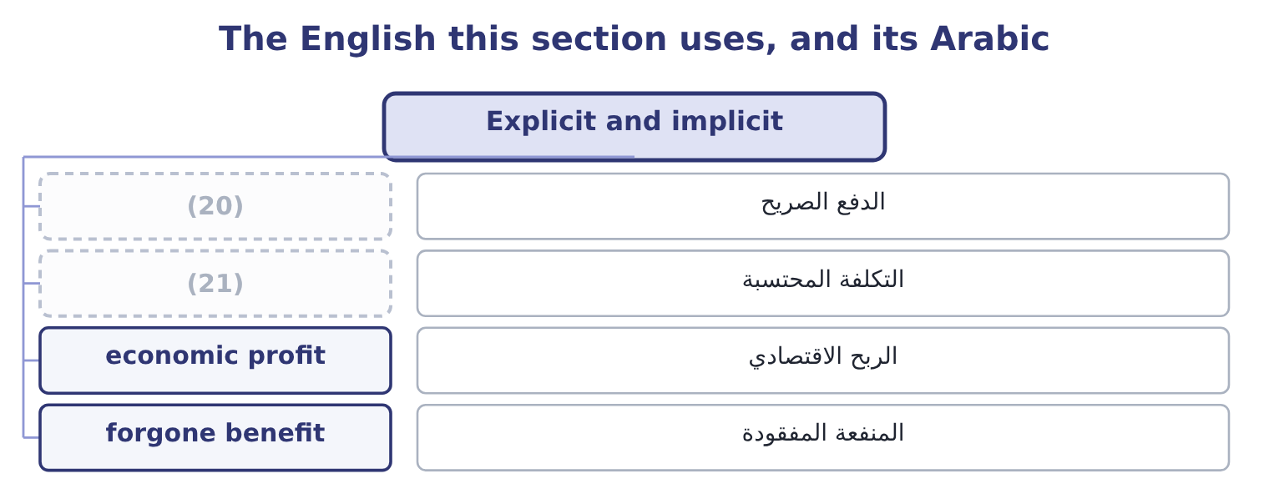
word list
incremental cost · explicit payment · imputed cost

The English this sheet uses, and its Arabic
English (exam term) | Arabic
explicit payment | الدفع الصريح
imputed cost | التكلفة المحتسبة
economic profit | الربح الاقتصادي
forgone benefit | المنفعة المفقودة

Answer key · 5.4 Explicit and implicit

1 interest | 12 earned
2 somebody | 13 together
3 genuine | 14 earning
4 something | 15 resources
5 ledger | 16 position
6 reasoned | 17 charging
7 important | 18 Materials for the extra order; wages of staff hired
8 opportunity | 19 Depreciation of an asset with no alternative use
9 resource | 20 explicit payment
10 category | 21 imputed cost
11 without

the summaries in full
Summary 1 An explicit cost involves a payment: wages, materials, rent, interest. It appears in the accounting records because somebody was paid. An implicit cost involves no payment and is a genuine cost all the same: the value of something the company already owns that is used up or given up by a choice. It appears in no ledger, which is why it has to be reasoned about rather than looked up. The most important implicit cost has its own name and its own chapter. An opportunity cost is the benefit forgone by using a resource for one purpose instead of its best alternative use. But the category is wider. The owner of a small business who works in it without a salary bears an implicit cost: the wage that could have been earned elsewhere. The company that uses a building it owns bears the rent it could have received. And the shareholders of any company bear the implicit cost of their capital, which is precisely the point Book 1 made about economic profit — accounting profit charges for the explicit cost of debt and not for the implicit cost of equity. That gives the pair of definitions the exam wants.
Summary 2 Accounting profit is revenue less explicit costs. Economic profit is revenue less explicit and implicit costs together. A business can show an accounting profit and an economic loss, which means it is earning less than the resources it consumes could earn elsewhere — and a business in that position is being kept alive by a cost nobody is charging it for.

5.5 Putting it to work
Chapter 5 · section 5.5

Fill every gap. Each word list holds one word more than there are gaps.
Summary 1 gaps 1–12
A (1) analysis has a shape, and (2) it is most of the skill. Identify the alternatives, (3) the option of doing nothing, which is always available and often omitted. List the future cash flows under each. Cash flows, not accounting charges: the exam's items are receipts and payments, and depreciation, allocations and book values are excluded by (4) . Remove (5) that is the same under both. What (6) is the difference, and the difference is the decision. Add the (7) costs that the ledger does not contain, which in practice means the opportunity costs. State the answer as a difference, not as two (8) . Two habits are worth building now, (9) every chapter from here to. Build the analysis as a single column of (10) wherever possible. It is faster, it cannot contain an irrelevant item without the error being obvious, and it (11) the answer directly. Say what was excluded and why. One line — "the $700,000 book value is sunk and is not included" — tells a marker that the (12) was a decision rather than an oversight, and it is worth more than the arithmetic that follows it.
word list
implicit · relevant-cost · produces · anything · including · totals · following · exclusion · differences · available · construction · remains · because

Sort the items

Mark each relevant or not, and say why.
Your turn: relevant or not (complete the blanks)
Item | Relevant? | Why
Wages of depot staff who would be made redundant | ________ | ________
The depot building, owned, which could be let for 90,000 a year | ________ | ________
Depreciation on the depot's racking | ________ | ________
Head office costs apportioned to the depot | ________ | ________
Redundancy payments of 140,000 | ________ | ________
The 2,000,000 the depot cost to build in 2016 | ________ | ________
Delivery costs that would rise by 60,000 if customers were served from elsewhere | ________ | ________
Contribution of 400,000 from customers who would be lost | ________ | ________

"Relevant"

Summary 2 gaps 13–19
English relevant in (13) accounting is a (14) term with a two-part definition, and it is not a synonym for important, useful or (15) . A cost can be enormous, (16) recorded and central to the business, and still be irrelevant to the decision in hand — which sounds like a (17) until the definition is (18) . The one (19) in all three languages is to say the definition aloud when using the word: future, and different between the alternatives.
word list
interesting · remembered · management · carefully · technical · safeguard · central · contradiction

"Relevant"
Item | Answer
Wages of staff made redundant | Relevant: the payments stop, so they differ between the alternatives.
The building, lettable at 90,000 | Relevant: it is an opportunity cost, receivable only if the depot closes.
Depreciation on the racking | Not relevant: it spreads a past payment. What the racking would fetch is relevant.
Apportioned head office costs | Not relevant: they continue and are merely re-apportioned.
Redundancy payments of 140,000 | (20)
The 2,000,000 spent in 2016 | Not relevant: sunk.
Delivery costs rising by 60,000 | Relevant: a future cost that arises only on closure.
Contribution of 400,000 lost | Relevant: a benefit forgone under one alternative.
What it tells you | Closing saves the wages, the (21) nothing, and gains 90,000 of rent, against 140,000 of redundancy, 60,000 of delivery and 400,000

word list
apportionment · economic profit · Relevant: a future payment arising only on closure.

The English this section uses, and its Arabic
Each term sits against what it means.
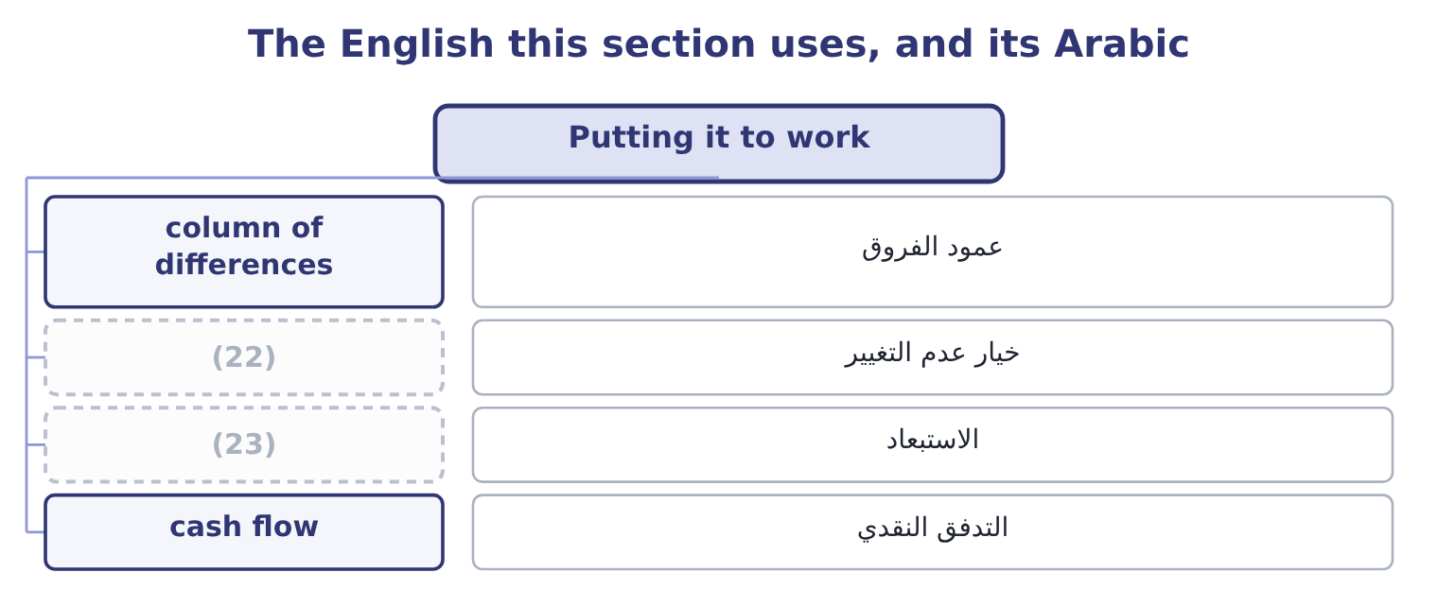
word list
implicit cost · do nothing option · exclusion

The English this sheet uses, and its Arabic
English (exam term) | Arabic
column of differences | عمود الفروق
do nothing option | خيار عدم التغيير
exclusion | الاستبعاد
cash flow | التدفق النقدي

Answer key · 5.5 Putting it to work

1 relevant-cost | 13 management
2 following | 14 technical
3 including | 15 interesting
4 construction | 16 carefully
5 anything | 17 contradiction
6 remains | 18 remembered
7 implicit | 19 safeguard
8 totals | 20 Relevant: a future payment arising only on closure.
9 because | 21 apportionment
10 differences | 22 do nothing option
11 produces | 23 exclusion
12 exclusion

the summaries in full
Summary 1 A relevant-cost analysis has a shape, and following it is most of the skill. Identify the alternatives, including the option of doing nothing, which is always available and often omitted. List the future cash flows under each. Cash flows, not accounting charges: the exam's items are receipts and payments, and depreciation, allocations and book values are excluded by construction. Remove anything that is the same under both. What remains is the difference, and the difference is the decision. Add the implicit costs that the ledger does not contain, which in practice means the opportunity costs. State the answer as a difference, not as two totals. Two habits are worth building now, because every chapter from here to. Build the analysis as a single column of differences wherever possible. It is faster, it cannot contain an irrelevant item without the error being obvious, and it produces the answer directly. Say what was excluded and why. One line — "the $700,000 book value is sunk and is not included" — tells a marker that the exclusion was a decision rather than an oversight, and it is worth more than the arithmetic that follows it.
Summary 2 English relevant in management accounting is a technical term with a two-part definition, and it is not a synonym for important, useful or interesting. A cost can be enormous, carefully recorded and central to the business, and still be irrelevant to the decision in hand — which sounds like a contradiction until the definition is remembered. The one safeguard in all three languages is to say the definition aloud when using the word: future, and different between the alternatives.

