6.1 What an opportunity cost is
Chapter 6 · section 6.1

Fill every gap. Each word list holds one word more than there are gaps.
Chapter 6, section by section
Each stage leads to the next.
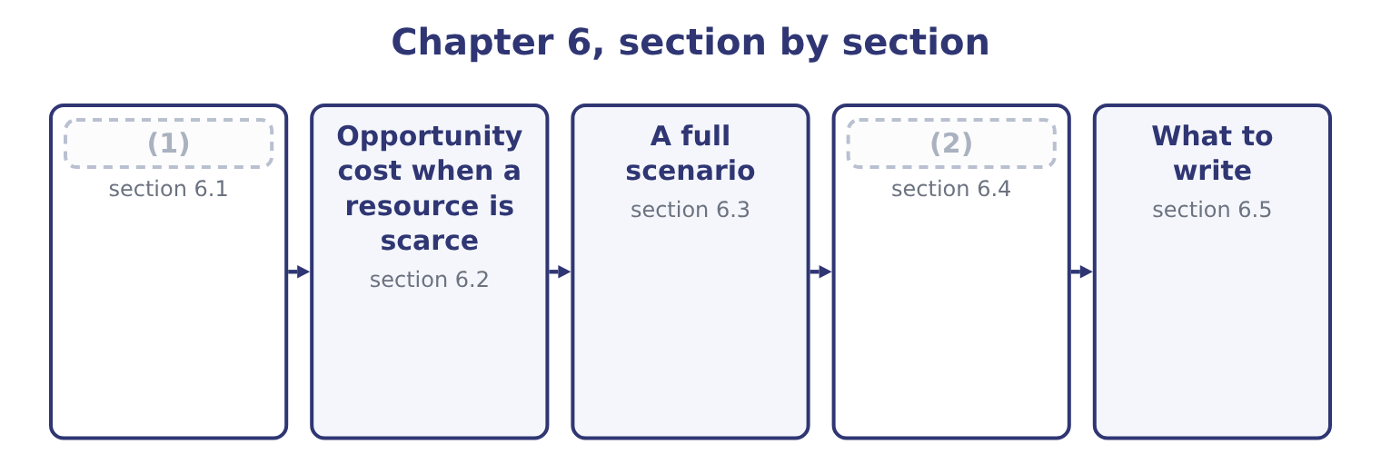
word list
relevant cost of materials · What an opportunity cost is · Where the traps are

Summary 1 gaps 3–14
An opportunity cost is the (3) given up by using a resource in one way rather than in its best (4) alternative. Three (5) define it and the exam tests each. It (6) only where there is an alternative. A resource with nothing else to do has no opportunity cost: an idle (7) used for an extra order costs nothing in forgone contribution, because nothing was forgone. That is why the (8) idle capacity appears in almost every (9) question. It is (10) as the best alternative forgone, not as the sum of all (11) . A (12) of sesame that could be used for a jar (13) $4.80 of contribution or sold for $2.00 has an opportunity cost of $4.80, not $6.80. It is a cost even though no (14) is made. It never appears in the accounts, it never appears in a cost ledger, and omitting it from an analysis will approve work that destroys value.
word list
arises · available · special-order · measured · features · machine · alternatives · payment · phrase · earning · benefit · accounts · kilogram

Summary 2 gaps 15–19
Two (15) forms recur. The forgone contribution of displaced work. (16) an order that fills capacity used by (17) sales costs the contribution of the sales displaced. The forgone (18) from an asset. Using a building the company owns costs the rent it could have earned; using material already in stock costs whatever the material could (19) have realised.
word list
receipt · otherwise · features · common · existing · Accepting

The relevant cost of material already held
The material is ... | Relevant cost | Why
Not in stock | (20) | It must be bought
In stock, and used regularly | (21) | Using it means buying more
In stock, no other use, scrap value only | (22) | The alternative is to sell it
In stock, with an alternative use | The contribution forgone in that use | (23)

word list
The purchase price · The replacement cost · The scrap value forgone · The best alternative is given up · The contribution forgone in that use

Summary 3 gaps 24–25
That table is worth (24) as it stands. The original cost of (25) in stock is never in it, because the original cost is sunk — a point.
word list
nothing · material · learning

The English this section uses, and its Arabic
Each term sits against what it means.
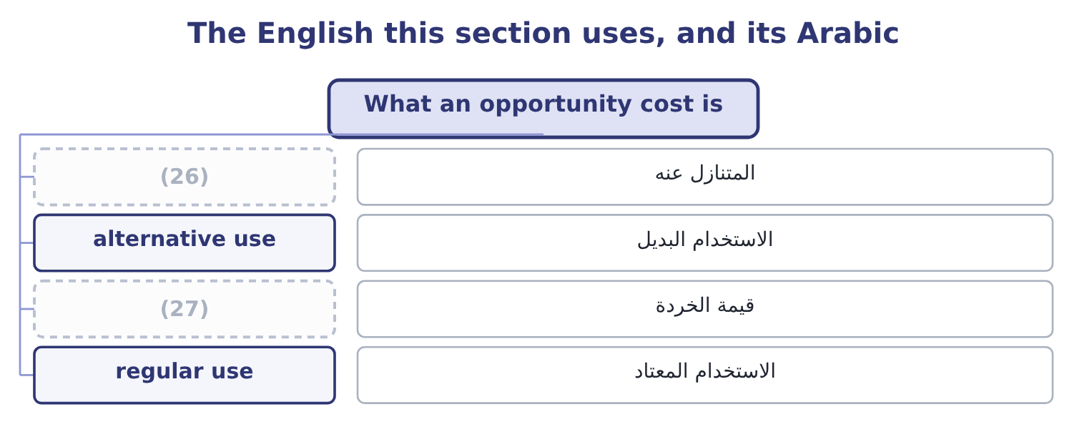
word list
scrap value · alternative use · forgone

The English this sheet uses, and its Arabic
English (exam term) | Arabic
forgone | المتنازل عنه
alternative use | الاستخدام البديل
scrap value | قيمة الخردة
regular use | الاستخدام المعتاد

Answer key · 6.1 What an opportunity cost is

1 What an opportunity cost is | 15 common
2 Where the traps are | 16 Accepting
3 benefit | 17 existing
4 available | 18 receipt
5 features | 19 otherwise
6 arises | 20 The purchase price
7 machine | 21 The replacement cost
8 phrase | 22 The scrap value forgone
9 special-order | 23 The best alternative is given up
10 measured | 24 learning
11 alternatives | 25 material
12 kilogram | 26 forgone
13 earning | 27 scrap value
14 payment

the summaries in full
Summary 1 An opportunity cost is the benefit given up by using a resource in one way rather than in its best available alternative. Three features define it and the exam tests each. It arises only where there is an alternative. A resource with nothing else to do has no opportunity cost: an idle machine used for an extra order costs nothing in forgone contribution, because nothing was forgone. That is why the phrase idle capacity appears in almost every special-order question. It is measured as the best alternative forgone, not as the sum of all alternatives. A kilogram of sesame that could be used for a jar earning $4.80 of contribution or sold for $2.00 has an opportunity cost of $4.80, not $6.80. It is a cost even though no payment is made. It never appears in the accounts, it never appears in a cost ledger, and omitting it from an analysis will approve work that destroys value.
Summary 2 Two common forms recur. The forgone contribution of displaced work. Accepting an order that fills capacity used by existing sales costs the contribution of the sales displaced. The forgone receipt from an asset. Using a building the company owns costs the rent it could have earned; using material already in stock costs whatever the material could otherwise have realised.
Summary 3 That table is worth learning as it stands. The original cost of material in stock is never in it, because the original cost is sunk — a point.

6.2 Opportunity cost when a resource is scarce
Chapter 6 · section 6.2

Fill every gap. Each word list holds one word more than there are gaps.
Summary 1 gaps 1–7
The (1) case of an opportunity cost is a bottleneck: a machine, a skilled grade of labour, a material in short supply, a (2) , a licence. Where one resource limits output, every unit of it used for one product is a unit not (3) for another, and the opportunity cost is whatever that other product would have (4) . The rule that (5) is the one. Rank products by contribution per unit of the (6) resource, not per unit of product and not per sales (7) .
word list
dollar · available · constrained · clearest · contributed · follows · certification · Relieving

Worked example: the roaster is the bottleneck

Summary 2 gaps 8–15
Orontes's roaster is fully used. A jar takes 0.004 roaster hours, a bar 0.001 and a drum 0.020. Contribution per roaster hour. For the jar: 4.80 ÷ 0.004 = 1,200 an hour. For the bar: 1.20 ÷ 0.001 = 1,200 an hour. For the drum: 21.00 ÷ 0.020 = 1,050 an hour. The jar and the bar are (8) good at $1,200 an hour, and the drum is the worst of the three — (9) it has by far the (10) contribution per unit, at $21.00 (11) $4.80 and $1.20. An hour given to drums earns $1,050 and (12) $1,200, so each drum hour costs the company 1,200 − 1,050 = 150 of contribution. On 2,000 drum hours that is 2,000 × 150 = 300,000 a year. Here it is third again, for a third (13) , and the three (14) would produce three different product (15) .
word list
equally · rankings · although · forgoes · reason · highest · products · against · strategies

Summary 3 gaps 16–27
Which one is right depends entirely on what limits the business, and (16) that is the first question to ask of any (17) problem — before computing anything. Two (18) complete the (19) . The ranking holds while the constraint holds. If the roaster could be run an extra shift, the constraint moves (20) and the ranking (21) with it. A constraint is a fact about the present (22) , not about the products. (23) the constraint has a value, and the opportunity cost (24) it. If an hour of roaster time is worth $1,200 of contribution, then an extra hour bought in — overtime, a (25) , a second machine — is worth up to $1,200, and anything (26) than that is worth doing. That figure is (27) called the shadow price of the constraint, and it is the most useful number a bottleneck analysis produces.
word list
changes · configuration · measures · cheaper · outcome · hinge · subcontractor · Relieving · sometimes · product-mix · establishing · elsewhere · refinements

Three rankings, three answers
Every item belongs to exactly one group.
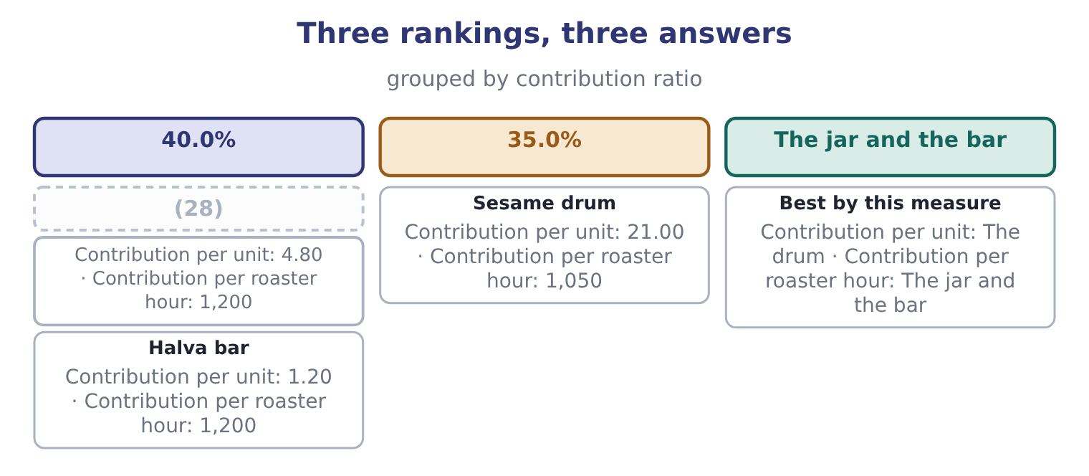
word list
scrap value · Tahini jar

The English this section uses, and its Arabic
Each term sits against what it means.
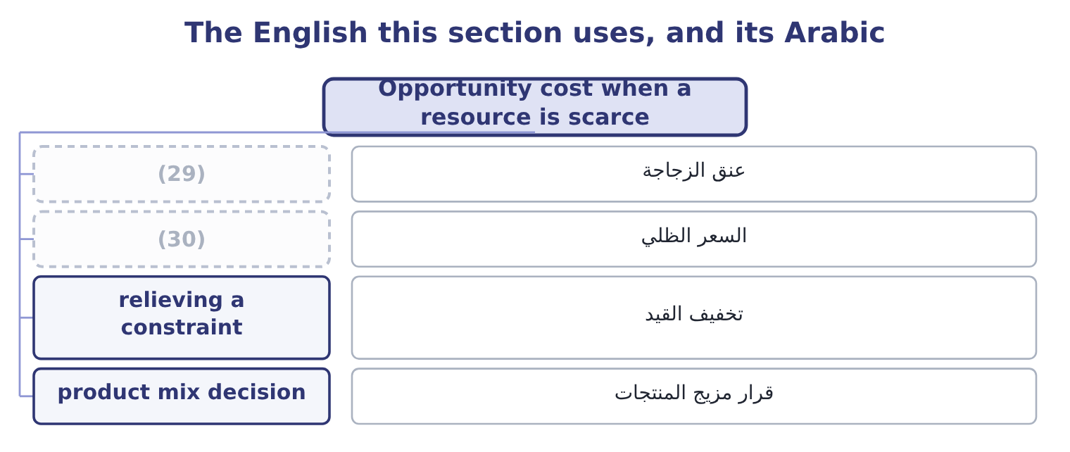
word list
bottleneck · shadow price · alternative use

The English this sheet uses, and its Arabic
English (exam term) | Arabic
bottleneck | عنق الزجاجة
shadow price | السعر الظلي
relieving a constraint | تخفيف القيد
product mix decision | قرار مزيج المنتجات

Answer key · 6.2 Opportunity cost when a resource is scarce

1 clearest | 16 establishing
2 certification | 17 product-mix
3 available | 18 refinements
4 contributed | 19 outcome
5 follows | 20 elsewhere
6 constrained | 21 changes
7 dollar | 22 configuration
8 equally | 23 Relieving
9 although | 24 measures
10 highest | 25 subcontractor
11 against | 26 cheaper
12 forgoes | 27 sometimes
13 reason | 28 Tahini jar
14 rankings | 29 bottleneck
15 strategies | 30 shadow price

the summaries in full
Summary 1 The clearest case of an opportunity cost is a bottleneck: a machine, a skilled grade of labour, a material in short supply, a certification, a licence. Where one resource limits output, every unit of it used for one product is a unit not available for another, and the opportunity cost is whatever that other product would have contributed. The rule that follows is the one. Rank products by contribution per unit of the constrained resource, not per unit of product and not per sales dollar.
Summary 2 Orontes's roaster is fully used. A jar takes 0.004 roaster hours, a bar 0.001 and a drum 0.020. Contribution per roaster hour. For the jar: 4.80 ÷ 0.004 = 1,200 an hour. For the bar: 1.20 ÷ 0.001 = 1,200 an hour. For the drum: 21.00 ÷ 0.020 = 1,050 an hour. The jar and the bar are equally good at $1,200 an hour, and the drum is the worst of the three — although it has by far the highest contribution per unit, at $21.00 against $4.80 and $1.20. An hour given to drums earns $1,050 and forgoes $1,200, so each drum hour costs the company 1,200 − 1,050 = 150 of contribution. On 2,000 drum hours that is 2,000 × 150 = 300,000 a year. Here it is third again, for a third reason, and the three rankings would produce three different product strategies.
Summary 3 Which one is right depends entirely on what limits the business, and establishing that is the first question to ask of any product-mix problem — before computing anything. Two refinements complete the outcome. The ranking holds while the constraint holds. If the roaster could be run an extra shift, the constraint moves elsewhere and the ranking changes with it. A constraint is a fact about the present configuration, not about the products. Relieving the constraint has a value, and the opportunity cost measures it. If an hour of roaster time is worth $1,200 of contribution, then an extra hour bought in — overtime, a subcontractor, a second machine — is worth up to $1,200, and anything cheaper than that is worth doing. That figure is sometimes called the shadow price of the constraint, and it is the most useful number a bottleneck analysis produces.

6.3 A full scenario
Chapter 6 · section 6.3

Fill every gap. Each word list holds one word more than there are gaps.
Summary 1 gaps 1–12
The exam's (1) of this outcome is a table with traps. Here is one, (2) in full. Orontes is asked to quote for a one-off contract to (3) a hotel group with 40,000 jars of a special blend. The (4) facts are supplied. Sesame: the contract needs 20,000 kg. Orontes holds 12,000 kg bought last year at $3.00 a kilogram; sesame now costs $3.40 and is used (5) . Labour: 2,000 hours of (6) labour, paid $18 an hour. The line is fully employed on standard jars; the staff cannot be (7) in the time available. (8) : special jars and labels costing $1.10 a unit, bought. (9) time: 160 roaster hours. The roaster is fully used, and the contribution forgone is $1,200 an hour. Supervision: the (10) supervisor would oversee the contract within the present salary of $6,000 a month. Development: $25,000 was spent last month (11) the blend at the hotel group's request. Overhead: the company (12) factory overhead at $4.00 a jar; none of it would change.
word list
increased · Packaging · supply · absorbs · designing · existing · version · continuously · forgone · filling-line · worked · following · Machine

Worked example: the minimum price

Summary 2 gaps 13–22
All 20,000 kg must be valued at the (13) cost of $3.40, because the material is in (14) use: using the 12,000 kg in stock means (15) 12,000 kg more. The relevant cost is 20,000 × 3.40 = 68,000. The $3.00 (16) price is sunk. The (17) are already employed and already paid, so their wages are not incremental — but their time is. Using 2,000 hours on this contract displaces standard (18) , so the relevant cost is the contribution forgone on the jars not made. Where a question gives that contribution (19) , use it; here the roaster hours in step 4 are the binding (20) and the labour (21) them, so the labour cost is the wages only if extra hours must be paid for. On these facts no extra wages arise, so the relevant labour cost is nil and the (22) is captured in step 4.
word list
constraint · production · directly · buying · follows · commercial · workers · displacement · replacement · continuous · original

Summary 3 gaps 23–34
Bought in (23) , so wholly incremental: 40,000 × 1.10 = 44,000. This is the (24) cost of section 6.2, and it is the largest number in the (25) . Supervision, development and overhead. All three are (26) . The (27) salary does not change; the $25,000 is sunk; the $4.00 a jar is an (28) rate, not a cost that moves. Note the three (29) a careless answer would include: the $25,000 of development, the $36,000 of wages at $18 an hour, and the $160,000 of (30) overhead at $4.00 a jar. Adding all three would give a minimum price of $12.63 a jar, and the contract — which is worth taking at (31) above $7.60 — would be (32) . Note also the one figure a careless answer would omit: the $192,000 of forgone contribution, (33) which the minimum price falls to $2.80 and the company would (34) work that makes it poorer.
word list
analysis · refused · figures · supervisor's · anything · Orontes · without · absorption · opportunity · excluded · accept · absorbed · specially

The contract, item by item
Every item belongs to exactly one group.
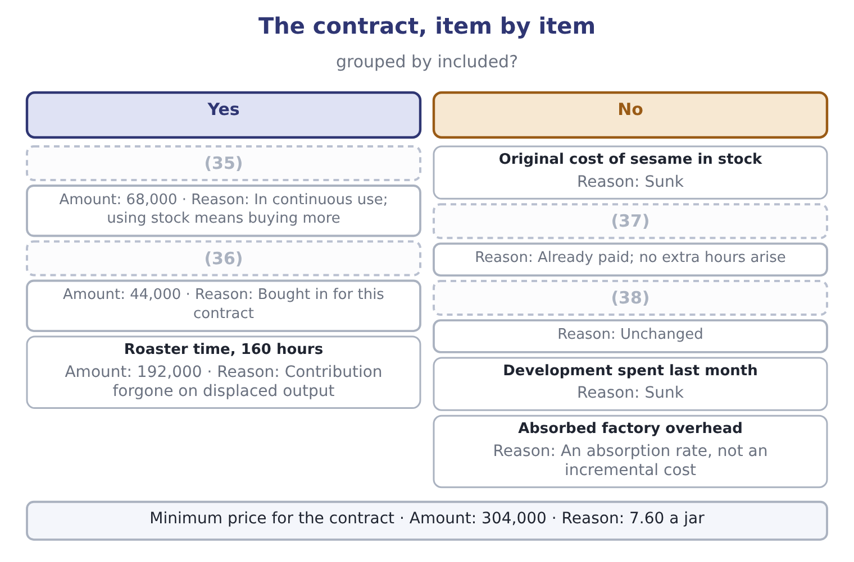
word list
Special packaging · Supervisor's salary · Filling-line wages · relevant cost of materials · Sesame, 20,000 kg at replacement cost

The minimum price is a floor, not a quote

Summary 4 gaps 39–45
The relevant cost is the price below which the contract makes the company worse off. What to (39) charge is a (40) question. A minimum price (41) on relevant costs is valid for a one-off contract with idle or (42) capacity. It is not a basis for (43) pricing, because fixed costs have to be covered by (44) . Where labour is paid whether or not the contract is taken, its wages are not relevant; where the contract (45) overtime or new hires, they are.
word list
requires · computed · somebody · forgone · actually · commercial · displaceable · regular

The English this section uses, and its Arabic
Each term sits against what it means.
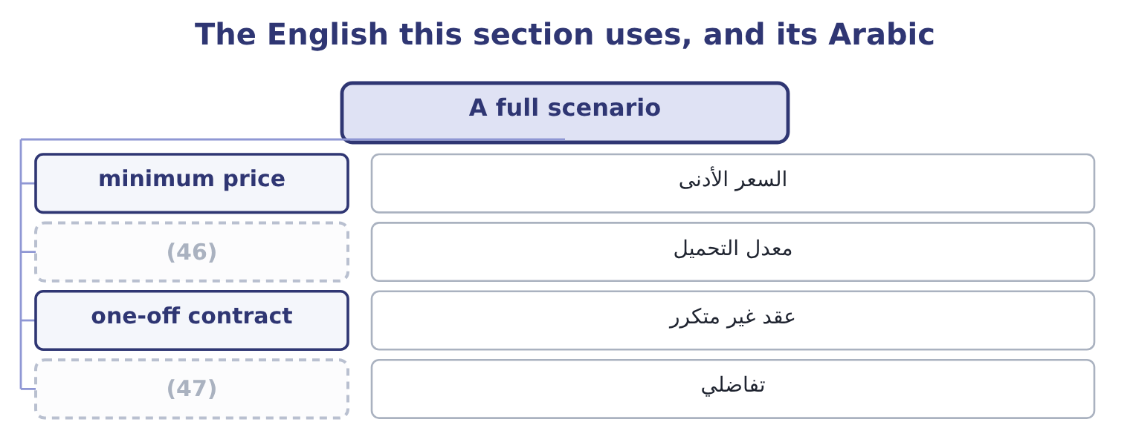
word list
absorption rate · incremental · displaced sales

The English this sheet uses, and its Arabic
English (exam term) | Arabic
minimum price | السعر الأدنى
absorption rate | معدل التحميل
one-off contract | عقد غير متكرر
incremental | تفاضلي

Answer key · 6.3 A full scenario

1 version | 25 analysis
2 worked | 26 excluded
3 supply | 27 supervisor's
4 following | 28 absorption
5 continuously | 29 figures
6 filling-line | 30 absorbed
7 increased | 31 anything
8 Packaging | 32 refused
9 Machine | 33 without
10 existing | 34 accept
11 designing | 35 Sesame, 20,000 kg at replacement cost
12 absorbs | 36 Special packaging
13 replacement | 37 Filling-line wages
14 continuous | 38 Supervisor's salary
15 buying | 39 actually
16 original | 40 commercial
17 workers | 41 computed
18 production | 42 displaceable
19 directly | 43 regular
20 constraint | 44 somebody
21 follows | 45 requires
22 displacement | 46 absorption rate
23 specially | 47 incremental
24 opportunity

the summaries in full
Summary 1 The exam's version of this outcome is a table with traps. Here is one, worked in full. Orontes is asked to quote for a one-off contract to supply a hotel group with 40,000 jars of a special blend. The following facts are supplied. Sesame: the contract needs 20,000 kg. Orontes holds 12,000 kg bought last year at $3.00 a kilogram; sesame now costs $3.40 and is used continuously. Labour: 2,000 hours of filling-line labour, paid $18 an hour. The line is fully employed on standard jars; the staff cannot be increased in the time available. Packaging: special jars and labels costing $1.10 a unit, bought. Machine time: 160 roaster hours. The roaster is fully used, and the contribution forgone is $1,200 an hour. Supervision: the existing supervisor would oversee the contract within the present salary of $6,000 a month. Development: $25,000 was spent last month designing the blend at the hotel group's request. Overhead: the company absorbs factory overhead at $4.00 a jar; none of it would change.
Summary 2 All 20,000 kg must be valued at the replacement cost of $3.40, because the material is in continuous use: using the 12,000 kg in stock means buying 12,000 kg more. The relevant cost is 20,000 × 3.40 = 68,000. The $3.00 original price is sunk. The workers are already employed and already paid, so their wages are not incremental — but their time is. Using 2,000 hours on this contract displaces standard production, so the relevant cost is the contribution forgone on the jars not made. Where a question gives that contribution directly, use it; here the roaster hours in step 4 are the binding constraint and the labour follows them, so the labour cost is the wages only if extra hours must be paid for. On these facts no extra wages arise, so the relevant labour cost is nil and the displacement is captured in step 4.
Summary 3 Bought in specially, so wholly incremental: 40,000 × 1.10 = 44,000. This is the opportunity cost of section 6.2, and it is the largest number in the analysis. Supervision, development and overhead. All three are excluded. The supervisor's salary does not change; the $25,000 is sunk; the $4.00 a jar is an absorption rate, not a cost that moves. Note the three figures a careless answer would include: the $25,000 of development, the $36,000 of wages at $18 an hour, and the $160,000 of absorbed overhead at $4.00 a jar. Adding all three would give a minimum price of $12.63 a jar, and the contract — which is worth taking at anything above $7.60 — would be refused. Note also the one figure a careless answer would omit: the $192,000 of forgone contribution, without which the minimum price falls to $2.80 and the company would accept work that makes it poorer.
Summary 4 The relevant cost is the price below which the contract makes the company worse off. What to actually charge is a commercial question. A minimum price computed on relevant costs is valid for a one-off contract with idle or displaceable capacity. It is not a basis for regular pricing, because fixed costs have to be covered by somebody. Where labour is paid whether or not the contract is taken, its wages are not relevant; where the contract requires overtime or new hires, they are.

6.4 Where the traps are
Chapter 6 · section 6.4

Fill every gap. Each word list holds one word more than there are gaps.
Summary 1 gaps 1–12
Four traps (1) for most of the marks lost on this outcome, and all four (2) in section 6.3. The (3) cost of something already owned. Material at the price paid, a machine at book value, a (4) at cost. Each is sunk; what (5) is what the thing could (6) do. Labour that is paid anyway. A salaried (7) costs the same whether a contract is taken or not, so its wages are not (8) — but its time may be, if the work displaces something else. The (9) cost of labour is nil where there is spare capacity, the wages where extra hours must be bought, and the forgone contribution where (10) work is displaced. Absorbed or (11) overhead. An (12) rate exists to put a full cost on a product for inventory valuation and reporting. It is not a statement that the overhead moves with the product, and in a relevant-cost analysis it is excluded unless the question says the overhead itself changes.
word list
recorded · existing · appeared · absorption · matters · apportioned · relevant · displaces · building · incremental · otherwise · workforce · account

Summary 2 gaps 13–16
The (13) opportunity cost. The three traps above cause costs to be included that should not be; this one causes a cost to be omitted that should be included, and it is the more (14) , because the error (15) work rather than (16) it.
word list
approves · dangerous · refusing · missing · contract

The relevant cost of each resource, in one table
Resource | Spare capacity exists | Fully employed
Labour | (17) | The contribution forgone, or the overtime premium
Machine time | Nil | (18)
Material not in stock | The purchase price | The purchase price
Material in stock, in regular use | The replacement cost | The replacement cost
Material in stock, no other use | The scrap value forgone | The scrap value forgone

word list
The contribution forgone on displaced output · Nil, if already paid · The scrap value forgone

Summary 3 gaps 19–24
A fifth trap is (19) and worth a (20) of its own. An opportunity cost exists only where the alternative is (21) available. If the displaced jars could not have been sold anyway — because demand is short, or the (22) is full — then (23) is forgone and the opportunity cost is nil. A question that says "the company can sell all it (24) " is telling you the alternative exists; a question that says demand is 3,500,000 jars and capacity is 4,000,000 is telling you it does not.
word list
produces · warehouse · sentence · displaced · nothing · subtler · genuinely

The English this section uses, and its Arabic
Each term sits against what it means.
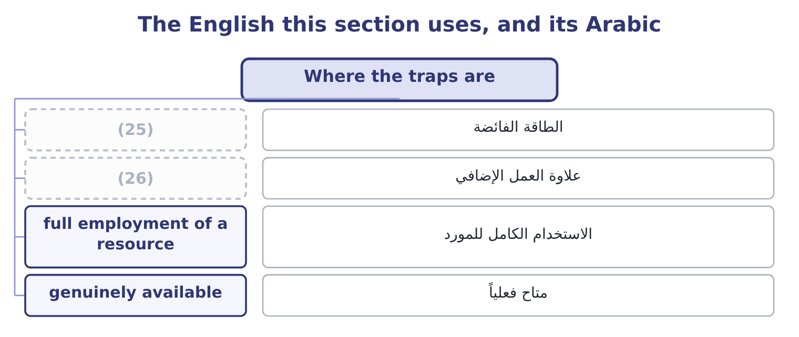
word list
alternative use · spare capacity · overtime premium

The English this sheet uses, and its Arabic
English (exam term) | Arabic
spare capacity | الطاقة الفائضة
overtime premium | علاوة العمل الإضافي
full employment of a resource | الاستخدام الكامل للمورد
genuinely available | متاح فعلياً

Answer key · 6.4 Where the traps are

1 account | 14 dangerous
2 appeared | 15 approves
3 recorded | 16 refusing
4 building | 17 Nil, if already paid
5 matters | 18 The contribution forgone on displaced output
6 otherwise | 19 subtler
7 workforce | 20 sentence
8 incremental | 21 genuinely
9 relevant | 22 warehouse
10 existing | 23 nothing
11 apportioned | 24 produces
12 absorption | 25 spare capacity
13 missing | 26 overtime premium

the summaries in full
Summary 1 Four traps account for most of the marks lost on this outcome, and all four appeared in section 6.3. The recorded cost of something already owned. Material at the price paid, a machine at book value, a building at cost. Each is sunk; what matters is what the thing could otherwise do. Labour that is paid anyway. A salaried workforce costs the same whether a contract is taken or not, so its wages are not incremental — but its time may be, if the work displaces something else. The relevant cost of labour is nil where there is spare capacity, the wages where extra hours must be bought, and the forgone contribution where existing work is displaced. Absorbed or apportioned overhead. An absorption rate exists to put a full cost on a product for inventory valuation and reporting. It is not a statement that the overhead moves with the product, and in a relevant-cost analysis it is excluded unless the question says the overhead itself changes.
Summary 2 The missing opportunity cost. The three traps above cause costs to be included that should not be; this one causes a cost to be omitted that should be included, and it is the more dangerous, because the error approves work rather than refusing it.
Summary 3 A fifth trap is subtler and worth a sentence of its own. An opportunity cost exists only where the alternative is genuinely available. If the displaced jars could not have been sold anyway — because demand is short, or the warehouse is full — then nothing is forgone and the opportunity cost is nil. A question that says "the company can sell all it produces" is telling you the alternative exists; a question that says demand is 3,500,000 jars and capacity is 4,000,000 is telling you it does not.

6.5 What to write
Chapter 6 · section 6.5

Fill every gap. Each word list holds one word more than there are gaps.
Summary 1 gaps 1–12
An analysis of this kind is marked on its (1) as much as its (2) , so three habits are worth building. Give every item a line, (3) the ones excluded. A table with a reason against each excluded item shows that the (4) was decided rather than forgotten, and it is the (5) between a sound answer and one that looks lucky. Name the (6) cost explicitly. Write "contribution forgone on 160 (7) roaster hours at $1,200" rather than " (8) cost $192,000". The marker is (9) for the concept, and the words carry it. State what the answer is a floor for. A minimum price is not a (10) to charge it; it is the point below which the company is worse off. The sentence "the contract is worth taking at any price above $7.60 a jar, and what to charge depends on what the hotel group would pay" is the (11) ending, and it is the (12) into the pricing chapters that follow.
word list
machine · reasoning · displaced · hinge · exclusion · including · opportunity · difference · arithmetic · professional · recommendation · decision · looking

Price a one-off order

Compute the minimum price.
Your turn: the relevant cost of a contract (complete the blanks)
Item | Data | Relevant amount
Material A | 3,000 kg needed; 1,000 kg in stock at a cost of 4.00; in (13) ; current price 4.60 | ________
Material B | 500 kg needed, all in stock, cost 9.00, no other use, scrap value 2.00 | ________
Skilled labour | 400 hours at 22.00; the grade is fully employed and each hour earns 15.00 of (14) elsewhere | ________
Unskilled labour | 600 hours at 14.00; there is (15) and the staff are salaried | ________
Absorbed overhead | 30.00 an hour on 1,000 hours; no overhead changes | ________
Design work done last month | 18,000 | ________
Minimum price for the contract |  | ________

word list
one-off contract · regular use · contribution · spare capacity

"Cost"

Summary 2 gaps 16–19
Only the second and third are relevant to a (16) , and only the first and fourth appear in the (17) — which is the whole (18) of the topic in one sentence. The (19) in every language is to never write the word alone.
word list
decision · records · safeguard · excluded · difficulty

"Cost"
Item | Relevant amount
Material A | (20) : all 3,000 kg at the replacement cost of 4.60, because the material is in regular use.
Material B | 1,000: the scrap value forgone, 500 × 2.00, because there is no other use.
Skilled labour | 14,800: the wages of 400 × 22.00 = 8,800 plus the contribution forgone of 400 × 15.00 = 6,000, because the grade is fully employed.
Unskilled labour | Nil: the staff are salaried and have spare capacity, so nothing changes.
Absorbed overhead | Nil: no overhead changes, so the rate is not a cost of this contract.
Design work | Nil: sunk.
Minimum price | (21) : 13,800 + 1,000 = 14,800 of materials, plus 14,800 of skilled labour.
What it tells you | Two of the six items are excluded entirely and one is included at more than its wage rate. A (22) quotation on these figures would have

word list
29,600 · 14,800 · full-cost · 13,800

The English this section uses, and its Arabic
Each term sits against what it means.
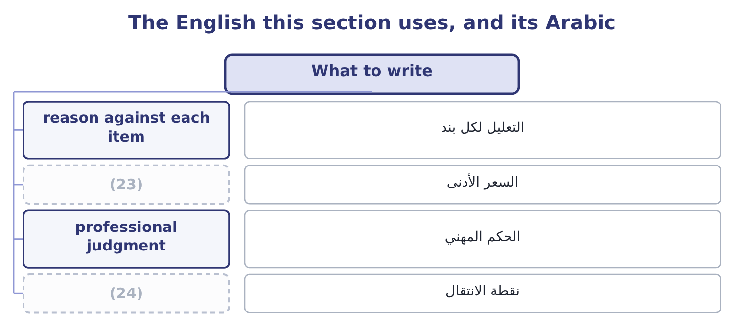
word list
hinge · floor price · professional judgment

The English this sheet uses, and its Arabic
English (exam term) | Arabic
reason against each item | التعليل لكل بند
floor price | السعر الأدنى
professional judgment | الحكم المهني
hinge | نقطة الانتقال

Answer key · 6.5 What to write

1 reasoning | 13 regular use
2 arithmetic | 14 contribution
3 including | 15 spare capacity
4 exclusion | 16 decision
5 difference | 17 records
6 opportunity | 18 difficulty
7 displaced | 19 safeguard
8 machine | 20 13,800
9 looking | 21 29,600
10 recommendation | 22 full-cost
11 professional | 23 floor price
12 hinge | 24 hinge

the summaries in full
Summary 1 An analysis of this kind is marked on its reasoning as much as its arithmetic, so three habits are worth building. Give every item a line, including the ones excluded. A table with a reason against each excluded item shows that the exclusion was decided rather than forgotten, and it is the difference between a sound answer and one that looks lucky. Name the opportunity cost explicitly. Write "contribution forgone on 160 displaced roaster hours at $1,200" rather than "machine cost $192,000". The marker is looking for the concept, and the words carry it. State what the answer is a floor for. A minimum price is not a recommendation to charge it; it is the point below which the company is worse off. The sentence "the contract is worth taking at any price above $7.60 a jar, and what to charge depends on what the hotel group would pay" is the professional ending, and it is the hinge into the pricing chapters that follow.
Summary 2 Only the second and third are relevant to a decision, and only the first and fourth appear in the records — which is the whole difficulty of the topic in one sentence. The safeguard in every language is to never write the word alone.

