7.1 Marginal cost and marginal revenue
Chapter 7 · section 7.1

Fill every gap. Each word list holds one word more than there are gaps.
Chapter 7, section by section
Each stage leads to the next.
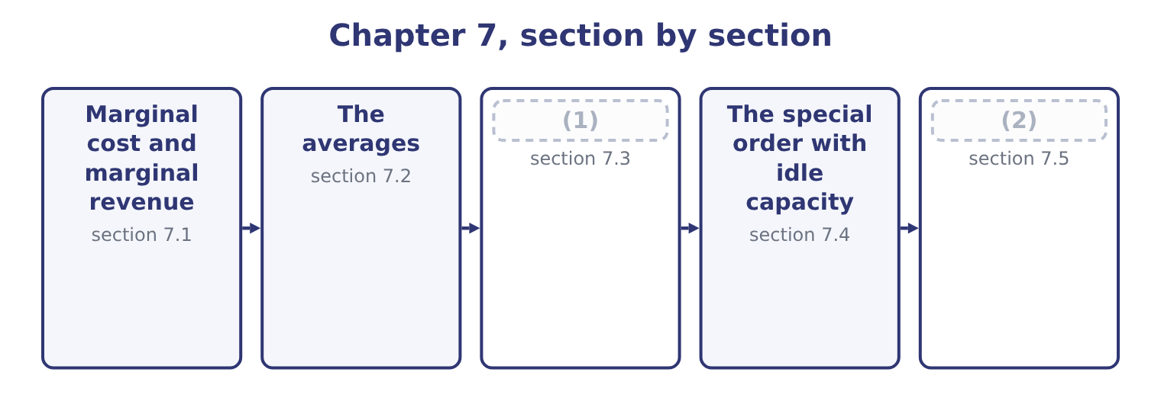
word list
Marginal analysis as a decision rule · The special order without idle capacity · The special order with idle capacity

Summary 1 gaps 3–14
Marginal cost is the increase in total cost from (3) one more unit. Marginal revenue is the increase in total revenue from selling one more unit. Both are (4) , not averages. (5) the relevant range, marginal cost equals the (6) cost per unit. For Orontes, making one more jar costs another $7.20 of sesame, (7) and the rest, and nothing else moves: the lease, the salaries and the (8) are the same at 3,500,001 jars as at 3,500,000. So marginal cost is $7.20 — and (9) that the full cost of a jar, which section 7.2 (10) as $10.81, is not the cost of making another one. (11) the relevant range, marginal cost jumps. The 4,000,001st jar might need a second shift, which adds a (12) and a premium rate; at that point marginal cost rises in a step, which is why the classic (13) diagram draws marginal cost as a curve rather than a line. Marginal revenue equals the selling price only where the company can sell any quantity at that price — the condition economists call pure (14) . Where selling more requires a lower price, and the lower price applies to all units and not only the extra ones, marginal revenue is below the price and can be negative.
word list
notice · packaging · depreciation · supervisor · differences · Within · producing · computes · economics · competition · variable · premium · Outside

Worked example: what the extra jars really earn

Summary 2 gaps 15–20
Orontes sells 3,500,000 jars at $12.00, so total revenue is 3,500,000 × 12.00 = 42,000,000. To sell 3,800,000 jars, the price must fall to $11.50 — for every jar, not only the extra ones. Total revenue (15) 11.50 × 3,800,000 = 43,700,000. Revenue rises by 43,700,000 − 42,000,000 = 1,700,000 for 300,000 extra jars, so marginal revenue is 1,700,000 ÷ 300,000 = 5.67 a jar. Marginal cost is $7.20. Each extra jar earns $5.67 and costs $7.20, so the company would lose 7.20 − 5.67 = 1.53 on each of them. The price is $11.50 and the marginal revenue is $5.67, and the gap (16) them is the revenue given up on the 3,500,000 jars that would have sold at $12.00: 3,500,000 × 0.50 = 1,750,000 of lost revenue against 300,000 × 11.50 = 3,450,000 (17) . That is the (18) behind Book 1's (19) that Orontes had been (20) growth with price, and it is why marginal revenue, not price, is the figure to set against marginal cost.
word list
finding · buying · between · arithmetic · gained · recurring · becomes

Marginal revenue when the price has to fall for every jar
Item | Now | Proposal | Difference
Jars sold | 3,500,000 | 3,800,000 | 300,000
(21) | 12.00 | 11.50 | (0.50)
Total revenue | 42,000,000 | 43,700,000 | 1,700,000
(22) | — | 5.67 | —
Marginal cost a jar | 7.20 | 7.20 | —
(23) | — | Reject | Cost above marginal revenue

word list
Price a jar · one more unit · Verdict · Marginal revenue a jar

Summary 3 gaps 24–26
The (24) rule that follows is the (25) of the next three chapters. Do more of (26) while marginal revenue exceeds marginal cost; stop where they are equal; do less where marginal cost is higher.
word list
Marginal · something · foundation · decision

The English this section uses, and its Arabic
Each term sits against what it means.
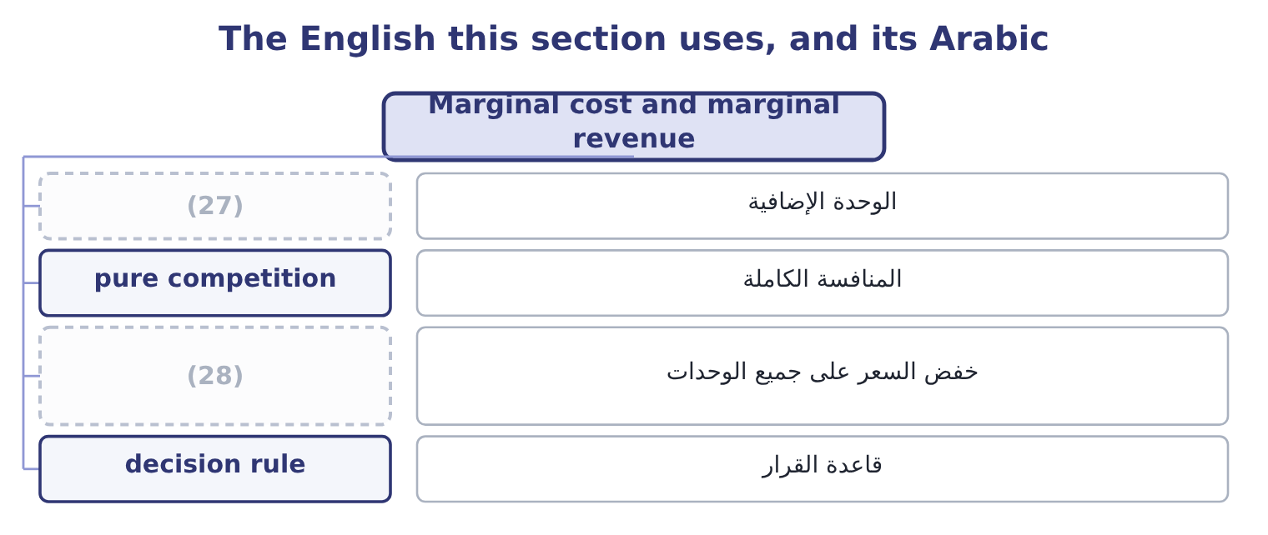
word list
average variable cost · price cut across all units · one more unit

The English this sheet uses, and its Arabic
English (exam term) | Arabic
one more unit | الوحدة الإضافية
pure competition | المنافسة الكاملة
price cut across all units | خفض السعر على جميع الوحدات
decision rule | قاعدة القرار

Answer key · 7.1 Marginal cost and marginal revenue

1 Marginal analysis as a decision rule | 15 becomes
2 The special order without idle capacity | 16 between
3 producing | 17 gained
4 differences | 18 arithmetic
5 Within | 19 finding
6 variable | 20 buying
7 packaging | 21 Price a jar
8 depreciation | 22 Marginal revenue a jar
9 notice | 23 Verdict
10 computes | 24 decision
11 Outside | 25 foundation
12 supervisor | 26 something
13 economics | 27 one more unit
14 competition | 28 price cut across all units

the summaries in full
Summary 1 Marginal cost is the increase in total cost from producing one more unit. Marginal revenue is the increase in total revenue from selling one more unit. Both are differences, not averages. Within the relevant range, marginal cost equals the variable cost per unit. For Orontes, making one more jar costs another $7.20 of sesame, packaging and the rest, and nothing else moves: the lease, the salaries and the depreciation are the same at 3,500,001 jars as at 3,500,000. So marginal cost is $7.20 — and notice that the full cost of a jar, which section 7.2 computes as $10.81, is not the cost of making another one. Outside the relevant range, marginal cost jumps. The 4,000,001st jar might need a second shift, which adds a supervisor and a premium rate; at that point marginal cost rises in a step, which is why the classic economics diagram draws marginal cost as a curve rather than a line. Marginal revenue equals the selling price only where the company can sell any quantity at that price — the condition economists call pure competition. Where selling more requires a lower price, and the lower price applies to all units and not only the extra ones, marginal revenue is below the price and can be negative.
Summary 2 Orontes sells 3,500,000 jars at $12.00, so total revenue is 3,500,000 × 12.00 = 42,000,000. To sell 3,800,000 jars, the price must fall to $11.50 — for every jar, not only the extra ones. Total revenue becomes 11.50 × 3,800,000 = 43,700,000. Revenue rises by 43,700,000 − 42,000,000 = 1,700,000 for 300,000 extra jars, so marginal revenue is 1,700,000 ÷ 300,000 = 5.67 a jar. Marginal cost is $7.20. Each extra jar earns $5.67 and costs $7.20, so the company would lose 7.20 − 5.67 = 1.53 on each of them. The price is $11.50 and the marginal revenue is $5.67, and the gap between them is the revenue given up on the 3,500,000 jars that would have sold at $12.00: 3,500,000 × 0.50 = 1,750,000 of lost revenue against 300,000 × 11.50 = 3,450,000 gained. That is the arithmetic behind Book 1's finding that Orontes had been buying growth with price, and it is why marginal revenue, not price, is the figure to set against marginal cost.
Summary 3 The decision rule that follows is the foundation of the next three chapters. Do more of something while marginal revenue exceeds marginal cost; stop where they are equal; do less where marginal cost is higher.

7.2 The averages
Chapter 7 · section 7.2

Fill every gap. Each word list holds one word more than there are gaps.
Summary 1 gaps 1–8
Four (1) appear in exam questions, and the (2) is simple once the four are kept apart. Total cost is the fixed costs plus the variable costs at that volume. For (3) at 3,500,000 jars: variable costs are 3,500,000 × 7.20 = 25,200,000, and with fixed costs of $12,624,000 the total is 25,200,000 + 12,624,000 = 37,824,000. Average variable cost is the variable cost divided by the units, which is $7.20 and does not (4) within the range. It equals marginal cost here, which is a property of the (5) model and not a (6) truth. Average fixed cost is the fixed costs divided by the units: 12,624,000 ÷ 3,500,000 = 3.61 a jar. It falls as volume rises, which is the whole of what people mean by (7) the overhead. Average total cost is the total divided by the units: 37,824,000 ÷ 3,500,000 = 10.81 a jar. It equals the average variable cost plus the average fixed cost, 7.20 + 3.61 = 10.81, and it falls as volume rises because its fixed (8) does.
word list
arithmetic · straight-line · change · general · confusion · spreading · component · Orontes · averages

The averages at three volumes
Measure | 3,000,000 jars | 3,500,000 jars | 4,000,000 jars
Variable cost in total | 21,600,000 | 25,200,000 | 28,800,000
Fixed cost in total | 12,624,000 | 12,624,000 | 12,624,000
Total cost | 34,224,000 | 37,824,000 | 41,424,000
Average variable cost | 7.20 | 7.20 | 7.20
(9) | 4.21 | 3.61 | 3.16
(10) | 11.41 | 10.81 | 10.36
(11) | 7.20 | 7.20 | 7.20

word list
Average variable cost · Average total cost · Average fixed cost · Marginal cost

Summary 2 gaps 12–22
Three readings, all (12) . Average total cost falls with volume and marginal cost does not. The two are different numbers (13) different questions, and the gap (14) them at 3,500,000 jars is 10.81 − 7.20 = 3.61, which is (15) the average fixed cost. A (16) system reports the average and a decision needs the (17) . That is the single most expensive confusion in (18) accounting, and the special order of section 7.4 is its standard (19) . Average total cost is the right figure for some questions. It is what a (20) must earn over the long run if the company is to cover its fixed costs, and it is the base of the (21) pricing. It is (22) not the figure for a decision about one more unit.
word list
cost-plus · answering · simply · product · recurring · exactly · examinable · between · costing · margin · illustration · management

The English this section uses, and its Arabic
Each term sits against what it means.
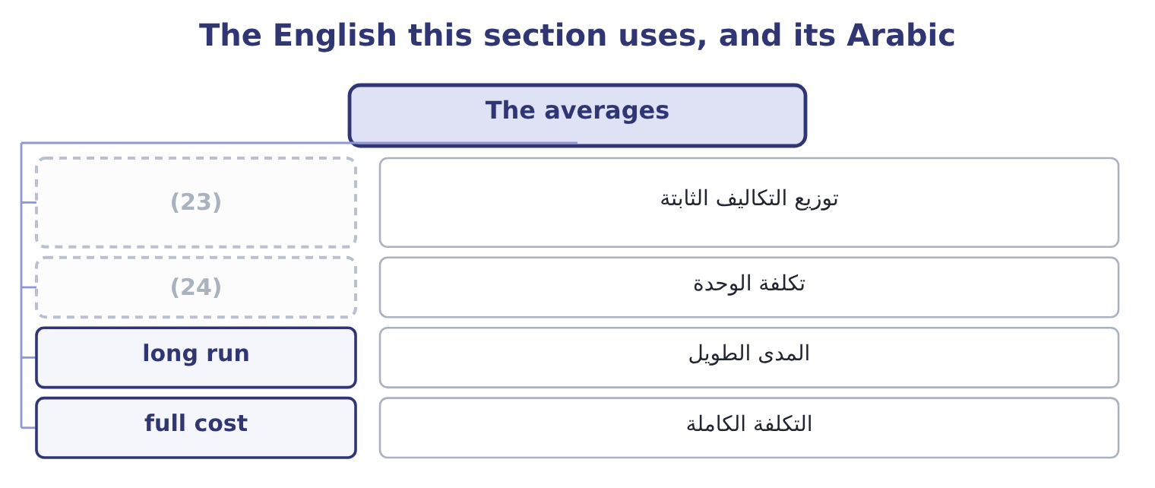
word list
minimum acceptable price · spreading the overhead · unit cost

The English this sheet uses, and its Arabic
English (exam term) | Arabic
spreading the overhead | توزيع التكاليف الثابتة
unit cost | تكلفة الوحدة
long run | المدى الطويل
full cost | التكلفة الكاملة

Answer key · 7.2 The averages

1 averages | 13 answering
2 arithmetic | 14 between
3 Orontes | 15 exactly
4 change | 16 costing
5 straight-line | 17 margin
6 general | 18 management
7 spreading | 19 illustration
8 component | 20 product
9 Average fixed cost | 21 cost-plus
10 Average total cost | 22 simply
11 Marginal cost | 23 spreading the overhead
12 examinable | 24 unit cost

the summaries in full
Summary 1 Four averages appear in exam questions, and the arithmetic is simple once the four are kept apart. Total cost is the fixed costs plus the variable costs at that volume. For Orontes at 3,500,000 jars: variable costs are 3,500,000 × 7.20 = 25,200,000, and with fixed costs of $12,624,000 the total is 25,200,000 + 12,624,000 = 37,824,000. Average variable cost is the variable cost divided by the units, which is $7.20 and does not change within the range. It equals marginal cost here, which is a property of the straight-line model and not a general truth. Average fixed cost is the fixed costs divided by the units: 12,624,000 ÷ 3,500,000 = 3.61 a jar. It falls as volume rises, which is the whole of what people mean by spreading the overhead. Average total cost is the total divided by the units: 37,824,000 ÷ 3,500,000 = 10.81 a jar. It equals the average variable cost plus the average fixed cost, 7.20 + 3.61 = 10.81, and it falls as volume rises because its fixed component does.
Summary 2 Three readings, all examinable. Average total cost falls with volume and marginal cost does not. The two are different numbers answering different questions, and the gap between them at 3,500,000 jars is 10.81 − 7.20 = 3.61, which is exactly the average fixed cost. A costing system reports the average and a decision needs the margin. That is the single most expensive confusion in management accounting, and the special order of section 7.4 is its standard illustration. Average total cost is the right figure for some questions. It is what a product must earn over the long run if the company is to cover its fixed costs, and it is the base of the cost-plus pricing. It is simply not the figure for a decision about one more unit.

7.3 Marginal analysis as a decision rule
Chapter 7 · section 7.3

Fill every gap. Each word list holds one word more than there are gaps.
Summary 1 gaps 1–2
Marginal analysis (1) the change in revenue with the change in cost, and accepts whatever change leaves the company better off. Four everyday decisions are the same (2) in different clothes.
word list
analysis · calculation · compares

A special order: does the extra revenue exceed the extra cost?

Make or buy: does the cost avoided by buying exceed the price paid?

Drop or keep: does the contribution lost exceed the fixed cost avoided?

Summary 2 gaps 3–13
In every case the analysis contains only what changes, which is, and includes the (3) cost of anything (4) , which is. Two (5) apply to all four. The analysis is short-run by (6) . It holds the fixed costs and the capacity (7) , which is correct for a decision inside the (8) range and wrong for a decision that changes the shape of the business. (9) changes the (10) . A (11) order accepted once uses spare capacity; the same order accepted every month (12) part of the regular business, and regular business must cover fixed costs. The exam signals this with the words "one-off" or "will not recur", and an answer that notices their absence is (13) better than one that does not.
word list
cautions · special · displaced · question · relevant · opportunity · answering · becomes · compares · construction · constant · Repetition

The English this section uses, and its Arabic
Each term sits against what it means.
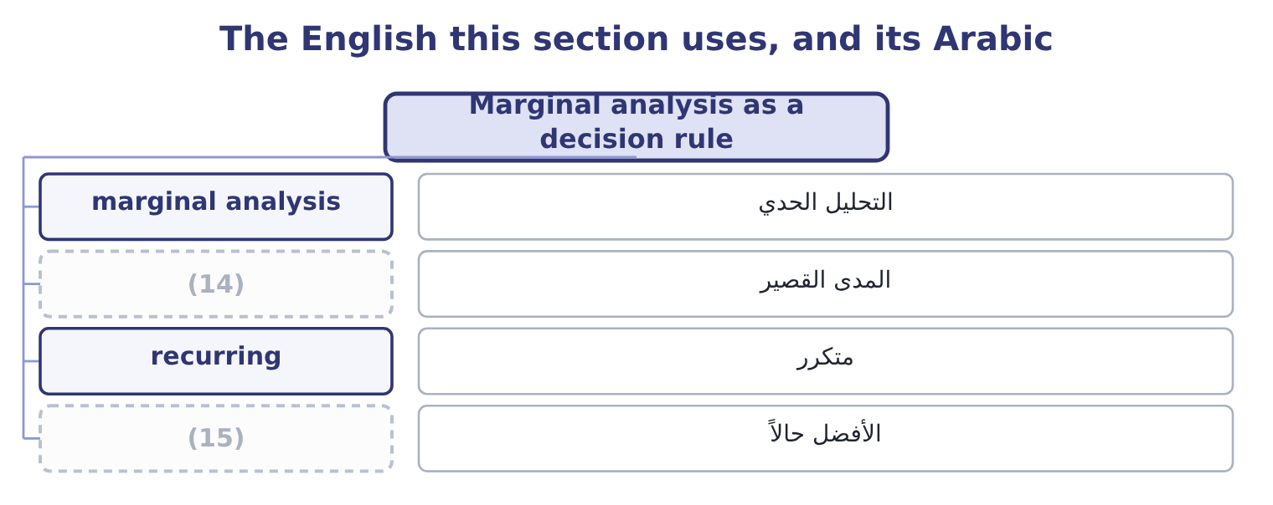
word list
المدى القصير · better off · short run

The English this sheet uses, and its Arabic
English (exam term) | Arabic
marginal analysis | التحليل الحدي
short run | المدى القصير
recurring | متكرر
better off | الأفضل حالاً

Answer key · 7.3 Marginal analysis as a decision rule

1 compares | 9 Repetition
2 calculation | 10 question
3 opportunity | 11 special
4 displaced | 12 becomes
5 cautions | 13 answering
6 construction | 14 short run
7 constant | 15 better off
8 relevant

the summaries in full
Summary 1 Marginal analysis compares the change in revenue with the change in cost, and accepts whatever change leaves the company better off. Four everyday decisions are the same calculation in different clothes.
Summary 2 In every case the analysis contains only what changes, which is, and includes the opportunity cost of anything displaced, which is. Two cautions apply to all four. The analysis is short-run by construction. It holds the fixed costs and the capacity constant, which is correct for a decision inside the relevant range and wrong for a decision that changes the shape of the business. Repetition changes the question. A special order accepted once uses spare capacity; the same order accepted every month becomes part of the regular business, and regular business must cover fixed costs. The exam signals this with the words "one-off" or "will not recur", and an answer that notices their absence is answering better than one that does not.

7.4 The special order with idle capacity
Chapter 7 · section 7.4

Fill every gap. Each word list holds one word more than there are gaps.
Summary 1 gaps 1–4
Now the (1) the chapter opened with. A hotel group (2) $8.50 a jar for 300,000 jars, in plain labelling of its own design. Orontes has capacity to spare: it can make 3,800,000 jars and sells 3,500,000. The special labels cost 30 cents a jar more than the (3) ones. No other cost (4) .
word list
standard · changes · offers · therefore · question

Worked example: the order, with capacity to spare

Summary 2 gaps 5–14
Variable cost of $7.20 plus special labelling of $0.30 is 7.20 + 0.30 = 7.50 a jar. The effect on operating income. What is (5) , and why. The fixed costs of $12,624,000 do not change, so no part of them belongs in the (6) ; the average total cost of $10.81 is therefore (7) , and the order's (8) loss of 10.81 − 8.50 = 2.31 a jar is an (9) of a costing system doing a job it was not (10) for. (11) raises operating income from $4,176,000 to 4,176,000 + 300,000 = 4,476,000. The price of $8.50 is below full cost and above (12) cost, and that is (13) the range in which a special order is worth (14) . Below $7.50 it would not be.
word list
Accepting · precisely · irrelevant · analysis · apparent · artefact · taking · average · designed · incremental · excluded

The same order, two ways of looking at it
Per jar | Full-cost view | Relevant-cost view
Price offered | 8.50 | 8.50
Variable cost | (7.20) | (7.20)
Special labelling | (0.30) | (0.30)
Absorbed fixed cost | (3.61) | (15)
Result a jar | (2.61) loss | (16)
Effect on operating income | (17) | Gains 300,000

word list
Not relevant; it does not change · Appears to lose 783,000 · 1.00 contribution · minimum acceptable price

Summary 3 gaps 18–26
The (18) column is the answer and the (19) column is what a costing system would print. Which is why this (20) exists. Four (21) make the relevant-cost answer the right one, and an exam answer (22) state them. There is (23) spare capacity, so nothing is (24) . The order is (25) , so it does not become the (26) . It does not disturb the regular market — the hotel group will not resell into Orontes's own customers, and the existing customers will not learn of the price and demand it. Any costs specific to the order, such as the special labelling, are included.
word list
conditions · one-off · should · apparent · left-hand · displaced · right-hand · business · outcome · genuinely

The English this section uses, and its Arabic
Each term sits against what it means.
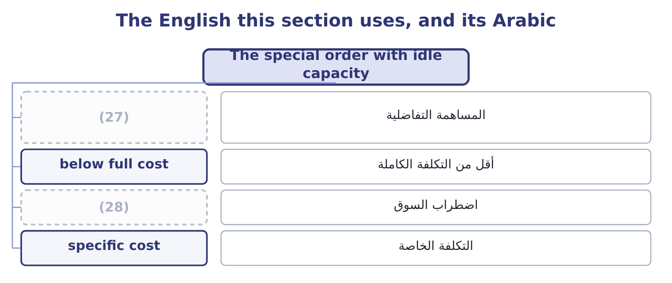
word list
التكلفة الخاصة · market disturbance · incremental contribution

The English this sheet uses, and its Arabic
English (exam term) | Arabic
incremental contribution | المساهمة التفاضلية
below full cost | أقل من التكلفة الكاملة
market disturbance | اضطراب السوق
specific cost | التكلفة الخاصة

Answer key · 7.4 The special order with idle capacity

1 question | 15 Not relevant; it does not change
2 offers | 16 1.00 contribution
3 standard | 17 Appears to lose 783,000
4 changes | 18 right-hand
5 excluded | 19 left-hand
6 analysis | 20 outcome
7 irrelevant | 21 conditions
8 apparent | 22 should
9 artefact | 23 genuinely
10 designed | 24 displaced
11 Accepting | 25 one-off
12 incremental | 26 business
13 precisely | 27 incremental contribution
14 taking | 28 market disturbance

the summaries in full
Summary 1 Now the question the chapter opened with. A hotel group offers $8.50 a jar for 300,000 jars, in plain labelling of its own design. Orontes has capacity to spare: it can make 3,800,000 jars and sells 3,500,000. The special labels cost 30 cents a jar more than the standard ones. No other cost changes.
Summary 2 Variable cost of $7.20 plus special labelling of $0.30 is 7.20 + 0.30 = 7.50 a jar. The effect on operating income. What is excluded, and why. The fixed costs of $12,624,000 do not change, so no part of them belongs in the analysis; the average total cost of $10.81 is therefore irrelevant, and the order's apparent loss of 10.81 − 8.50 = 2.31 a jar is an artefact of a costing system doing a job it was not designed for. Accepting raises operating income from $4,176,000 to 4,176,000 + 300,000 = 4,476,000. The price of $8.50 is below full cost and above incremental cost, and that is precisely the range in which a special order is worth taking. Below $7.50 it would not be.
Summary 3 The right-hand column is the answer and the left-hand column is what a costing system would print. Which is why this outcome exists. Four conditions make the relevant-cost answer the right one, and an exam answer should state them. There is genuinely spare capacity, so nothing is displaced. The order is one-off, so it does not become the business. It does not disturb the regular market — the hotel group will not resell into Orontes's own customers, and the existing customers will not learn of the price and demand it. Any costs specific to the order, such as the special labelling, are included.

7.5 The special order without idle capacity
Chapter 7 · section 7.5

Fill every gap. Each word list holds one word more than there are gaps.
Summary 1 gaps 1–12
Suppose Orontes is making 3,800,000 jars and (1) every one of them. (2) the hotel order now means making 300,000 fewer standard jars. The incremental cost is still $7.50. But the 300,000 standard jars (3) would each have (4) $4.80, so the opportunity cost is 300,000 × 4.80 = 1,440,000. Against an incremental contribution of 300,000 × 1.00 = 300,000, the order would leave the company 1,440,000 − 300,000 = 1,140,000 worse off. The minimum (5) price at full capacity is the incremental cost plus the contribution displaced: 7.50 + 4.80 = 12.30 a jar — thirty cents above the regular price, which is the special (6) , and far above the $8.50 (7) . (8) capacity is the case the exam likes best, because it needs both (9) . Suppose Orontes can make 3,650,000 jars and sells 3,500,000, so 150,000 jars of capacity are spare and the other 150,000 of the order would (10) standard sales. Then half the order carries no opportunity cost and half carries $4.80: the (11) cost is 150,000 × 7.50 = 1,125,000 for the first part and 150,000 × 12.30 = 1,845,000 for the second, so the whole order should not be (12) below 1,125,000 + 1,845,000 = 2,970,000, which is 2,970,000 ÷ 300,000 = 9.90 a jar.
word list
selling · acceptable · contributed · Partial · labelling · displace · relevant · offered · Taking · accepted · halves · becomes · forgone

Summary 2 gaps 13–19
The (13) factors close the chapter and carry real marks. What the regular (14) will think. A price of $8.50 that becomes known is a price every customer will ask for, and Book 1 (15) what two points of margin are worth. Whether the buyer will (16) . A hotel group with 300,000 jars at $8.50 is a potential (17) in Orontes's own market. What the order displaces in the (18) , not only in the figures. A regular customer (19) away for a one-off order may not return.
word list
relationship · showed · resell · customers · qualitative · competitor · displaced · turned

Summary 3 gaps 20–24
Whether the capacity is (20) spare. Capacity used for a special order is capacity not (21) for a sudden opportunity, and a company close to full should price that risk. And what (22) next year. A one-off order that is (23) becomes the regular (24) , priced at a level that does not cover fixed costs.
word list
repeated · really · available · relevant · business · happens

Price three orders

Your turn: special orders (complete the blanks)
Item | Data | Answer
Average total cost | (25) | ________
Minimum price with spare capacity | Special packing adds 1.20 a unit | ________
Minimum price at full capacity | (26) | ________
Effect of a 20,000-unit order at 16.00, with spare capacity |  | ________
Effect of the same order at full capacity |  | ________
The order that should be refused |  | ________

word list
15.20: 14.00 + 1.20 = 15.20. · Fixed 900,000, variable 14.00 a unit, volume 150,000 · Regular contribution is 6.00 a unit

"Marginal"

Summary 4 gaps 27–31
English marginal in economics and (27) accounting means at the margin — the effect of one more unit — and carries no suggestion of smallness or (28) . In everyday English a marginal (29) is a trivial one, and that reading destroys the technical sense (30) : a marginal cost can be the largest number in a decision. The exam uses the technical sense without (31) .
word list
exception · completely · management · difference · unimportance · regular

The same order, with and without spare capacity
Every item belongs to exactly one group.
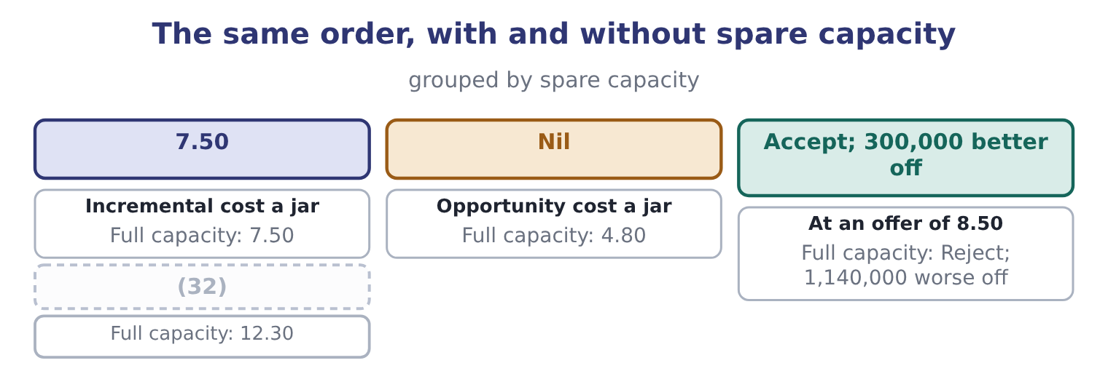
word list
Minimum price a jar · Accept; 300,000 better off

Item — Answer
Item | Answer
Average total cost | 20.00: variable 14.00 plus fixed of 900,000 ÷ 150,000 = 6.00.
Minimum price with spare capacity | (33)
Minimum price at full capacity | 21.20: 15.20 + 6.00 = 21.20.
A 20,000-unit order at 16.00, spare capacity | (34) : the contribution is 16.00 − 15.20 = 0.80 a unit, and 20,000 × 0.80 = 16,000.
The same order at full capacity | (35) : the displaced contribution is 20,000 × 6.00 = 120,000 against 16,000 of incremental contribution.
The order that should be refused | The one taken at full capacity, because it displaces contribution five times its own.
What it tells you | The same order at the same price is worth 16,000 or costs 104,000, and nothing about the order changed. Capacity is the fact that decides, a

word list
15.20: 14.00 + 1.20 = 15.20. · Loses 104,000 · 21.20: 15.20 + 6.00 = 21.20. · Adds 16,000

The English this section uses, and its Arabic
Each term sits against what it means.
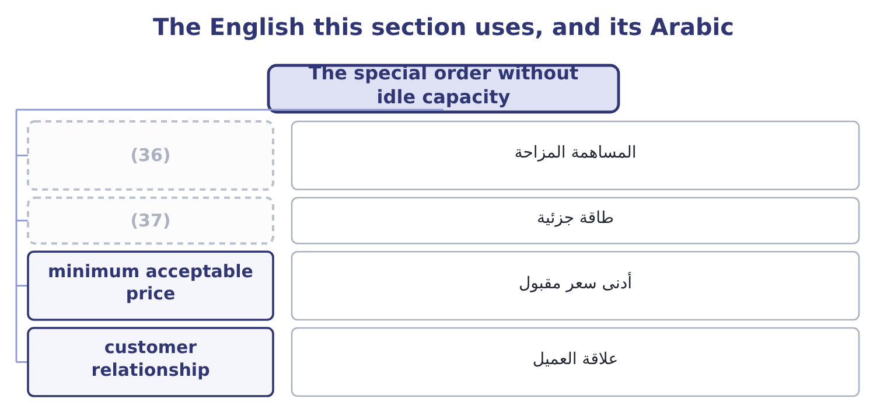
word list
marginal revenue · partial capacity · displaced contribution

The English this sheet uses, and its Arabic
English (exam term) | Arabic
displaced contribution | المساهمة المزاحة
partial capacity | طاقة جزئية
minimum acceptable price | أدنى سعر مقبول
customer relationship | علاقة العميل

Answer key · 7.5 The special order without idle capacity

1 selling | 20 really
2 Taking | 21 available
3 forgone | 22 happens
4 contributed | 23 repeated
5 acceptable | 24 business
6 labelling | 25 Fixed 900,000, variable 14.00 a unit, volume 150,000
7 offered | 26 Regular contribution is 6.00 a unit
8 Partial | 27 management
9 halves | 28 unimportance
10 displace | 29 difference
11 relevant | 30 completely
12 accepted | 31 exception
13 qualitative | 32 Minimum price a jar
14 customers | 33 15.20: 14.00 + 1.20 = 15.20.
15 showed | 34 Adds 16,000
16 resell | 35 Loses 104,000
17 competitor | 36 displaced contribution
18 relationship | 37 partial capacity
19 turned

the summaries in full
Summary 1 Suppose Orontes is making 3,800,000 jars and selling every one of them. Taking the hotel order now means making 300,000 fewer standard jars. The incremental cost is still $7.50. But the 300,000 standard jars forgone would each have contributed $4.80, so the opportunity cost is 300,000 × 4.80 = 1,440,000. Against an incremental contribution of 300,000 × 1.00 = 300,000, the order would leave the company 1,440,000 − 300,000 = 1,140,000 worse off. The minimum acceptable price at full capacity is the incremental cost plus the contribution displaced: 7.50 + 4.80 = 12.30 a jar — thirty cents above the regular price, which is the special labelling, and far above the $8.50 offered. Partial capacity is the case the exam likes best, because it needs both halves. Suppose Orontes can make 3,650,000 jars and sells 3,500,000, so 150,000 jars of capacity are spare and the other 150,000 of the order would displace standard sales. Then half the order carries no opportunity cost and half carries $4.80: the relevant cost is 150,000 × 7.50 = 1,125,000 for the first part and 150,000 × 12.30 = 1,845,000 for the second, so the whole order should not be accepted below 1,125,000 + 1,845,000 = 2,970,000, which is 2,970,000 ÷ 300,000 = 9.90 a jar.
Summary 2 The qualitative factors close the chapter and carry real marks. What the regular customers will think. A price of $8.50 that becomes known is a price every customer will ask for, and Book 1 showed what two points of margin are worth. Whether the buyer will resell. A hotel group with 300,000 jars at $8.50 is a potential competitor in Orontes's own market. What the order displaces in the relationship, not only in the figures. A regular customer turned away for a one-off order may not return.
Summary 3 Whether the capacity is really spare. Capacity used for a special order is capacity not available for a sudden opportunity, and a company close to full should price that risk. And what happens next year. A one-off order that is repeated becomes the regular business, priced at a level that does not cover fixed costs.
Summary 4 English marginal in economics and management accounting means at the margin — the effect of one more unit — and carries no suggestion of smallness or unimportance. In everyday English a marginal difference is a trivial one, and that reading destroys the technical sense completely: a marginal cost can be the largest number in a decision. The exam uses the technical sense without exception.

