8.1 What the costing system says, and what it means
Chapter 8 · section 8.1

Fill every gap. Each word list holds one word more than there are gaps.
Chapter 8, section by section
Each stage leads to the next.
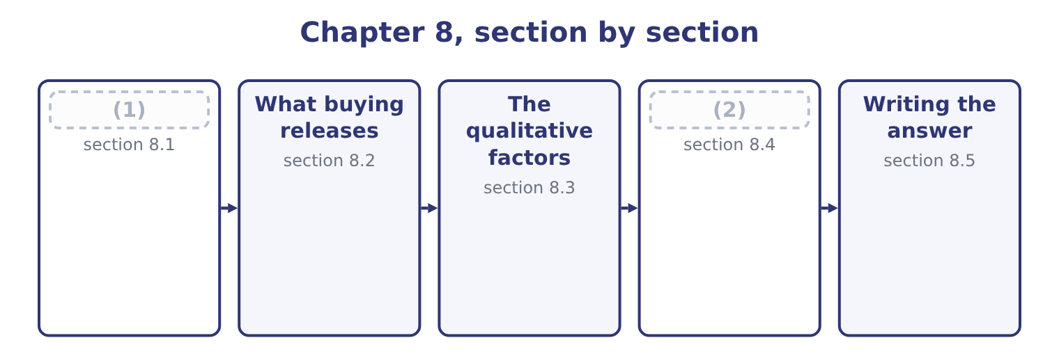
word list
Variants of the same question · What the costing system says, and what it mean · leverage in negotiation

The cost of a lid, as reported
The parts add up to the total; the bars are to scale.
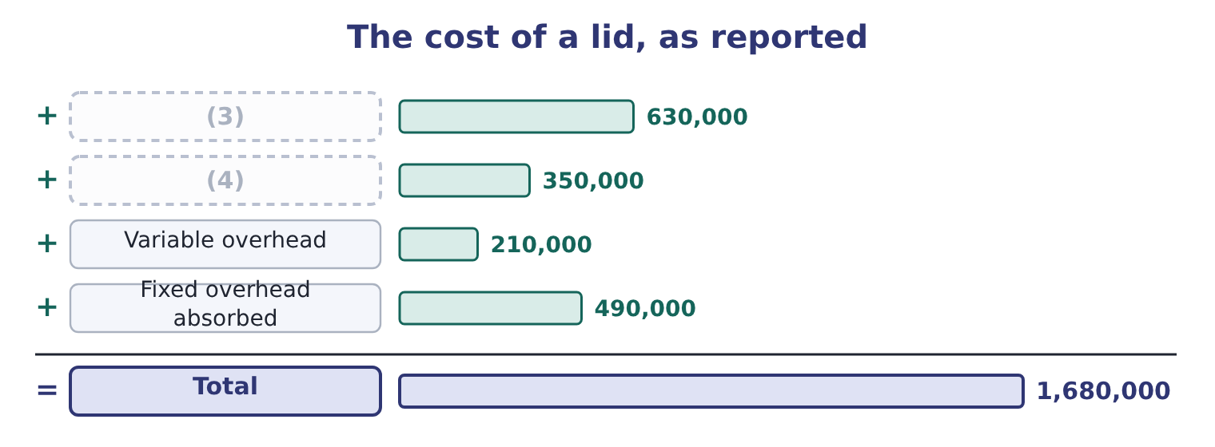
word list
second source · Direct materials · Direct labour

Summary 1 gaps 5–16
The first three lines stop if the lids are bought. The (5) is the question. (6) fixed overhead of $490,000 is a share of the (7) fixed costs (8) to the pressing shop by (9) basis the system uses, and the (10) that would (11) stop is a matter of fact rather than of (12) . Suppose the facts are these: the pressing shop has its own supervisor, whose $175,000 post would be (13) , and the remaining $315,000 is the shop's share of factory rent, (14) , heating and head office costs, all of which (15) whether the shop presses lids or stands empty. Then the relevant cost of making is the three variable lines plus the supervisor: 0.18 + 0.10 + 0.06 = 0.34 a lid, which is 3,500,000 × 0.34 = 1,190,000, plus the (16) $175,000, giving 1,190,000 + 175,000 = 1,365,000.
word list
relevant · amount · continue · fourth · allocation · eliminated · actually · whatever · allocated · insurance · factory's · avoidable · Absorbed

Summary 2 gaps 17–18
Per lid that is 1,365,000 ÷ 3,500,000 = 0.39. The supplier wants 0.42. Buying costs 3,500,000 × 0.42 = 1,470,000 (17) a relevant cost of making of $1,365,000, so buying would make the company 1,470,000 − 1,365,000 = 105,000 worse off a year. (18) should go on making its lids.
word list
Orontes · against · understates

The three ways this goes wrong

Summary 3 gaps 19–26
Comparing the (19) price with the full cost of 0.48. That (20) $315,000 of unavoidable overhead as a (21) , and it is the error the question is built to catch. Comparing with the variable cost alone, at 0.34. That ignores the (22) post, which genuinely does disappear, and (23) the cost of making. (24) that the unavoidable $315,000 does not vanish: if the lids are bought, that overhead is (25) by the other products, whose reported costs rise. (26) has been saved and several products now look worse.
word list
supplier's · whatever · Forgetting · Nothing · saving · understates · supervisor's · treats · re-absorbed

The English this section uses, and its Arabic
Each term sits against what it means.
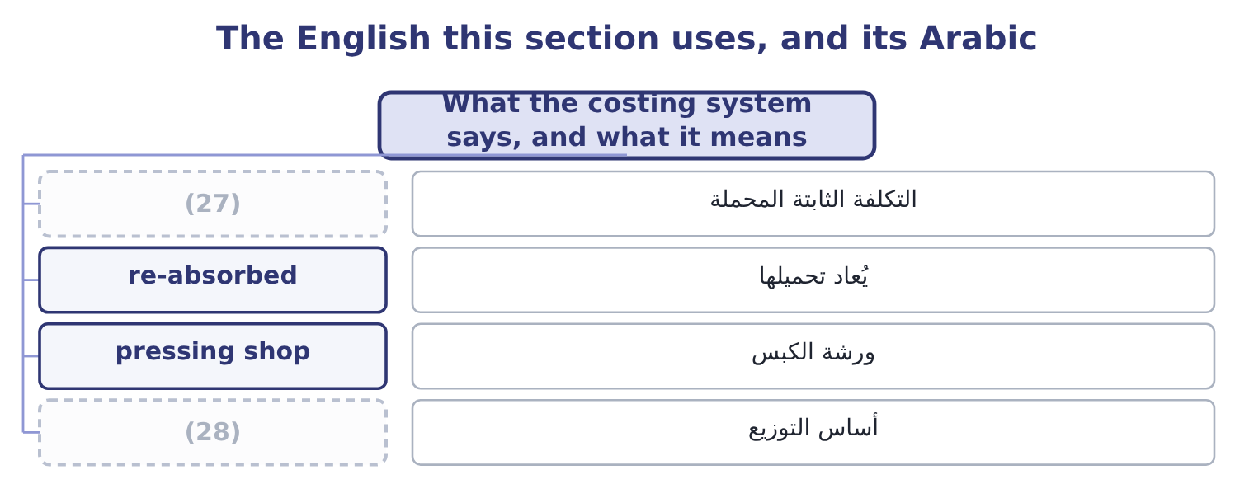
word list
basis of allocation · indifference price · absorbed overhead

The English this sheet uses, and its Arabic
English (exam term) | Arabic
absorbed overhead | التكلفة الثابتة المحملة
re-absorbed | يُعاد تحميلها
pressing shop | ورشة الكبس
basis of allocation | أساس التوزيع

Answer key · 8.1 What the costing system says, and what it means

1 What the costing system says, and what it mean | 15 continue
2 Variants of the same question | 16 avoidable
3 Direct materials | 17 against
4 Direct labour | 18 Orontes
5 fourth | 19 supplier's
6 Absorbed | 20 treats
7 factory's | 21 saving
8 allocated | 22 supervisor's
9 whatever | 23 understates
10 amount | 24 Forgetting
11 actually | 25 re-absorbed
12 allocation | 26 Nothing
13 eliminated | 27 absorbed overhead
14 insurance | 28 basis of allocation

the summaries in full
Summary 1 The first three lines stop if the lids are bought. The fourth is the question. Absorbed fixed overhead of $490,000 is a share of the factory's fixed costs allocated to the pressing shop by whatever basis the system uses, and the amount that would actually stop is a matter of fact rather than of allocation. Suppose the facts are these: the pressing shop has its own supervisor, whose $175,000 post would be eliminated, and the remaining $315,000 is the shop's share of factory rent, insurance, heating and head office costs, all of which continue whether the shop presses lids or stands empty. Then the relevant cost of making is the three variable lines plus the supervisor: 0.18 + 0.10 + 0.06 = 0.34 a lid, which is 3,500,000 × 0.34 = 1,190,000, plus the avoidable $175,000, giving 1,190,000 + 175,000 = 1,365,000.
Summary 2 Per lid that is 1,365,000 ÷ 3,500,000 = 0.39. The supplier wants 0.42. Buying costs 3,500,000 × 0.42 = 1,470,000 against a relevant cost of making of $1,365,000, so buying would make the company 1,470,000 − 1,365,000 = 105,000 worse off a year. Orontes should go on making its lids.
Summary 3 Comparing the supplier's price with the full cost of 0.48. That treats $315,000 of unavoidable overhead as a saving, and it is the error the question is built to catch. Comparing with the variable cost alone, at 0.34. That ignores the supervisor's post, which genuinely does disappear, and understates the cost of making. Forgetting that the unavoidable $315,000 does not vanish: if the lids are bought, that overhead is re-absorbed by the other products, whose reported costs rise. Nothing has been saved and several products now look worse.

8.2 What buying releases
Chapter 8 · section 8.2

Fill every gap. Each word list holds one word more than there are gaps.
Summary 1 gaps 1–10
The (1) above assumes the (2) shop would simply stand empty. If it would not, the comparison changes, and the change is an (3) cost of the kind. (4) the floor space and the two presses, once free, could be used to make a new line of sesame bars earning a (5) of $200,000 a year. That $200,000 is (6) only if the lids are (7) , so it belongs on the buying side. Buying now costs 1,470,000 − 200,000 = 1,270,000 in net terms, (8) $1,365,000 for making, so buying is better by 1,365,000 − 1,270,000 = 95,000 a year. The (9) reverses on a figure that (10) nowhere in the costing system.
word list
receivable · depends · against · appears · contribution · Suppose · bought · arithmetic · recommendation · opportunity · pressing

Worked example: the indifference price

Summary 2 gaps 11–22
Making costs $1,365,000 a year, so the company is (11) at a price of 1,365,000 ÷ 3,500,000 = 0.39 a lid. With the alternative use. If the (12) space earns $200,000, the company can (13) to pay 1,365,000 + 200,000 = 1,565,000, which is 1,565,000 ÷ 3,500,000 = 0.447 a lid. The (14) 0.42 sits between the two. Whether to buy depends (15) on whether the alternative use is real, and the (16) with the supplier should be (17) knowing that 0.447 is the ceiling and 0.39 is the (18) point. The (19) price is the most useful single output of a make-or-buy analysis, because it converts a (20) answer into a (21) position. A buyer who knows the ceiling can ask for a better price; one who knows only that 0.42 beats 0.48 will accept (22) is offered below 0.48.
word list
indifference · released · whatever · entirely · supplier's · walk-away · afford · indifferent · negotiating · yes-or-no · negotiation · conducted · contribution

Make or buy, three cases
Case | Cost of making | Cost of buying | Better by
Space stands empty | 1,365,000 | 1,470,000 | (23)
Space earns 200,000 | 1,365,000 | 1,270,000 | Buying, by 95,000
Space earns 200,000 and the supplier charges 0.39 | 1,365,000 | 1,165,000 | (24)

word list
Buying, by 95,000 · Making, by 105,000 · Buying, by 200,000

Summary 3 gaps 25–32
Two further (25) belong in the figures (26) a question supplies them. One-off costs of (27) . (28) payments, the loss on selling the presses, the cost of qualifying the supplier, the write-off of specialised (29) . These fall on the buying side in the first year and nowhere (30) , which is why a make-or-buy decision should be evaluated over several years and (31) . Changes in other costs. Buying may raise inward freight, (32) and inventory; it may lower scrap, rework and insurance. Each belongs in the comparison if it changes.
word list
discounted · whenever · Redundancy · inspection · tooling · switching · thereafter · make-or-buy · elements

The English this section uses, and its Arabic
Each term sits against what it means.
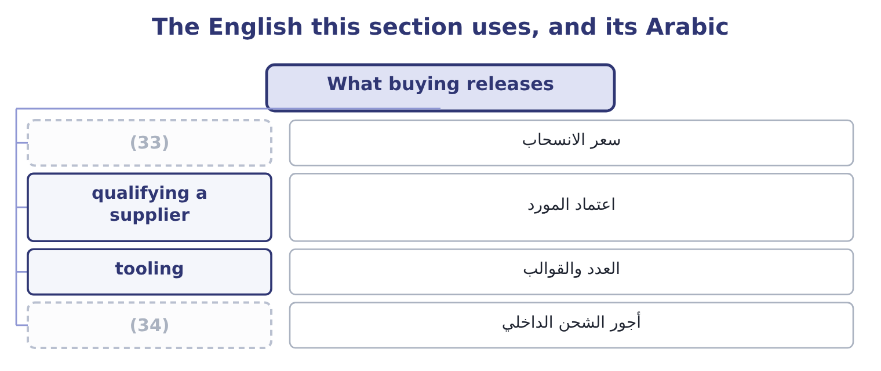
word list
supplier dependability · walk-away price · inward freight

The English this sheet uses, and its Arabic
English (exam term) | Arabic
walk-away price | سعر الانسحاب
qualifying a supplier | اعتماد المورد
tooling | العدد والقوالب
inward freight | أجور الشحن الداخلي

Answer key · 8.2 What buying releases

1 arithmetic | 18 walk-away
2 pressing | 19 indifference
3 opportunity | 20 yes-or-no
4 Suppose | 21 negotiating
5 contribution | 22 whatever
6 receivable | 23 Making, by 105,000
7 bought | 24 Buying, by 200,000
8 against | 25 elements
9 recommendation | 26 whenever
10 appears | 27 switching
11 indifferent | 28 Redundancy
12 released | 29 tooling
13 afford | 30 thereafter
14 supplier's | 31 discounted
15 entirely | 32 inspection
16 negotiation | 33 walk-away price
17 conducted | 34 inward freight

the summaries in full
Summary 1 The arithmetic above assumes the pressing shop would simply stand empty. If it would not, the comparison changes, and the change is an opportunity cost of the kind. Suppose the floor space and the two presses, once free, could be used to make a new line of sesame bars earning a contribution of $200,000 a year. That $200,000 is receivable only if the lids are bought, so it belongs on the buying side. Buying now costs 1,470,000 − 200,000 = 1,270,000 in net terms, against $1,365,000 for making, so buying is better by 1,365,000 − 1,270,000 = 95,000 a year. The recommendation reverses on a figure that appears nowhere in the costing system.
Summary 2 Making costs $1,365,000 a year, so the company is indifferent at a price of 1,365,000 ÷ 3,500,000 = 0.39 a lid. With the alternative use. If the released space earns $200,000, the company can afford to pay 1,365,000 + 200,000 = 1,565,000, which is 1,565,000 ÷ 3,500,000 = 0.447 a lid. The supplier's 0.42 sits between the two. Whether to buy depends entirely on whether the alternative use is real, and the negotiation with the supplier should be conducted knowing that 0.447 is the ceiling and 0.39 is the walk-away point. The indifference price is the most useful single output of a make-or-buy analysis, because it converts a yes-or-no answer into a negotiating position. A buyer who knows the ceiling can ask for a better price; one who knows only that 0.42 beats 0.48 will accept whatever is offered below 0.48.
Summary 3 Two further elements belong in the figures whenever a question supplies them. One-off costs of switching. Redundancy payments, the loss on selling the presses, the cost of qualifying the supplier, the write-off of specialised tooling. These fall on the buying side in the first year and nowhere thereafter, which is why a make-or-buy decision should be evaluated over several years and discounted. Changes in other costs. Buying may raise inward freight, inspection and inventory; it may lower scrap, rework and insurance. Each belongs in the comparison if it changes.

8.3 The qualitative factors
Chapter 8 · section 8.3

Fill every gap. Each word list holds one word more than there are gaps.
Summary 1 gaps 1–12
The outcome names these (1) , and in practice they decide more (2) questions than the arithmetic does. A supplier's lid is not (3) the company's lid. Where the component affects the (4) experience — a seal that leaks, a cap that (5) — the cost of a quality failure is far larger than six cents a unit and falls on the brand rather than on the component. A lid that (6) late stops a (7) line. The questions are whether the supplier can be relied on, whether there is a second source, how far away it is, and what (8) in a strike, a storm or a border (9) . Book 2's chapter on (10) made the same point from the inventory side: removing a buffer transfers risk to the supplier's (11) . Control over the (12) and the schedule.
word list
process · explicitly · happens · customer's · cross-threads · necessarily · closure · arrives · filling · make-or-buy · reliability · just-in-time · consultation

Summary 2 gaps 13–24
Making keeps the (13) to change a specification quickly, to run a short batch for a trial, and to (14) one product over another. Buying gives that up to somebody else's (15) plan. Confidentiality and (16) property. A supplier making a component to a specification (17) the specification. Where the component embodies something the company regards as its own, (18) is a transfer of (19) as well as of work. The supplier's future (20) . A supplier that wins the work gains leverage: the company has sold its presses, (21) its operators, and (22) easily go back. The price offered in the first year is not always the price in the fifth, and the standard (23) is a contract of several years with a price mechanism rather than a (24) quotation. A company should be slow to outsource what it is distinctively good at and quicker to outsource what anybody can do.
word list
conduct · learns · knowledge · cannot · prioritise · production · dismissed · protection · intellectual · outsourcing · single-year · ability · leverage

Summary 3 gaps 25–27
Pressing lids is not what Orontes is for; (25) and grinding sesame is. The (26) and the community. Closing a shop means redundancies, which cost money, morale and reputation, and in some jurisdictions require (27) that takes months.
word list
workforce · specification · consultation · roasting

The qualitative case, both ways
Factor | Argues for making | Argues for buying
Quality | (28) | A specialist may do it better
Dependability | No third party to fail | (29)
Control of schedule | (30) | The supplier's plan governs
Confidentiality | Nothing leaves the company | (31)
Capacity | (32) | Releases space for better uses
Expertise | Keeps skills in house | (33)
Cost behaviour | Fixed costs are already incurred | (34)

word list
A supplier with several plants may be more robust · Converts fixed costs into variable ones · Full control · Buys skills the company lacks · Uses space the company owns · The company controls it · Specifications must be shared · Releases space for better uses

Summary 4 gaps 35–39
The last row (35) its own sentence. Buying converts a fixed cost into a variable one: the company pays only for the lids it needs, so its (36) falls and its (37) leverage falls with it. For a company whose demand is (38) that is worth something real, and it is an (39) for buying that has nothing to do with the price per lid.
word list
deserves · argument · distinctively · breakeven · uncertain · operating

The English this section uses, and its Arabic
Each term sits against what it means.
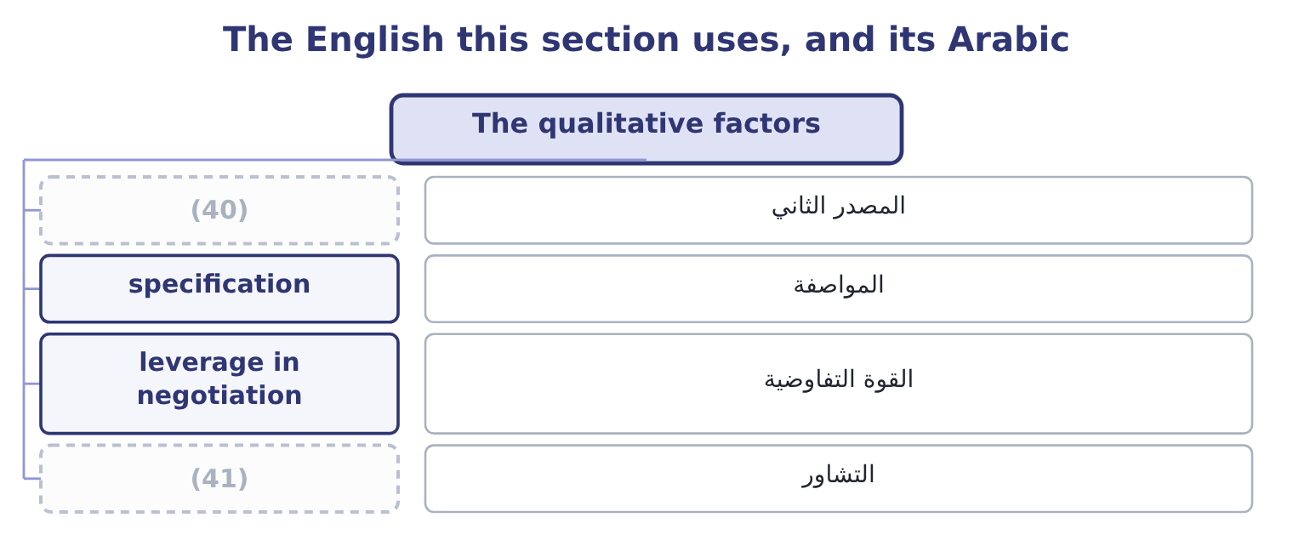
word list
second source · make-or-buy decision · consultation

The English this sheet uses, and its Arabic
English (exam term) | Arabic
second source | المصدر الثاني
specification | المواصفة
leverage in negotiation | القوة التفاوضية
consultation | التشاور

Answer key · 8.3 The qualitative factors

1 explicitly | 22 cannot
2 make-or-buy | 23 protection
3 necessarily | 24 single-year
4 customer's | 25 roasting
5 cross-threads | 26 workforce
6 arrives | 27 consultation
7 filling | 28 The company controls it
8 happens | 29 A supplier with several plants may be more robust
9 closure | 30 Full control
10 just-in-time | 31 Specifications must be shared
11 reliability | 32 Uses space the company owns
12 process | 33 Buys skills the company lacks
13 ability | 34 Converts fixed costs into variable ones
14 prioritise | 35 deserves
15 production | 36 breakeven
16 intellectual | 37 operating
17 learns | 38 uncertain
18 outsourcing | 39 argument
19 knowledge | 40 second source
20 conduct | 41 consultation
21 dismissed

the summaries in full
Summary 1 The outcome names these explicitly, and in practice they decide more make-or-buy questions than the arithmetic does. A supplier's lid is not necessarily the company's lid. Where the component affects the customer's experience — a seal that leaks, a cap that cross-threads — the cost of a quality failure is far larger than six cents a unit and falls on the brand rather than on the component. A lid that arrives late stops a filling line. The questions are whether the supplier can be relied on, whether there is a second source, how far away it is, and what happens in a strike, a storm or a border closure. Book 2's chapter on just-in-time made the same point from the inventory side: removing a buffer transfers risk to the supplier's reliability. Control over the process and the schedule.
Summary 2 Making keeps the ability to change a specification quickly, to run a short batch for a trial, and to prioritise one product over another. Buying gives that up to somebody else's production plan. Confidentiality and intellectual property. A supplier making a component to a specification learns the specification. Where the component embodies something the company regards as its own, outsourcing is a transfer of knowledge as well as of work. The supplier's future conduct. A supplier that wins the work gains leverage: the company has sold its presses, dismissed its operators, and cannot easily go back. The price offered in the first year is not always the price in the fifth, and the standard protection is a contract of several years with a price mechanism rather than a single-year quotation. A company should be slow to outsource what it is distinctively good at and quicker to outsource what anybody can do.
Summary 3 Pressing lids is not what Orontes is for; roasting and grinding sesame is. The workforce and the community. Closing a shop means redundancies, which cost money, morale and reputation, and in some jurisdictions require consultation that takes months.
Summary 4 The last row deserves its own sentence. Buying converts a fixed cost into a variable one: the company pays only for the lids it needs, so its breakeven falls and its operating leverage falls with it. For a company whose demand is uncertain that is worth something real, and it is an argument for buying that has nothing to do with the price per lid.

8.4 Variants of the same question
Chapter 8 · section 8.4

Fill every gap. Each word list holds one word more than there are gaps.
Summary 1 gaps 1–12
The (1) phrase "make or buy" covers a family of (2) with identical arithmetic, and a question may use any of them. Payroll, (3) , cleaning, (4) technology, internal audit. The (5) is the same: what stops being spent, what is (6) , what is given up. The (7) decision, where a company (8) buying decides to make. Here the fixed costs are the ones being added rather than avoided, and the (9) is between the supplier's price and the (10) cost of making, including the new fixed costs and the capital required — which turns it into the capital investment decision. Buying a part of the (11) . Often the best answer is neither all nor nothing: make the base load in house, where the fixed costs are already committed, and buy the peak from a supplier, where the (12) is overtime or a second shift.
word list
outcome's · decisions · comparison · presently · including · information · volume · analysis · incremental · alternative · catering · reverse · released

Summary 2 gaps 13–15
The arithmetic ranks the two (13) at the margin, exactly. (14) one plant of several. The same table, with the (15) costs of one site on one side and the extra transport and overtime at the others on the opposite side.
word list
Closing · avoidable · tooling · sources

Make the base, buy the peak
Cost of making a unit | Cost of buying a unit | Source
0.34 variable, fixed already committed | 0.42 | Make
0.34 | 0.42 | Make
0.34 plus an overtime premium of 0.11 | 0.42 | (16)

word list
avoidable fixed cost · Buy, if the premium exceeds 0.08

The English this section uses, and its Arabic
Each term sits against what it means.
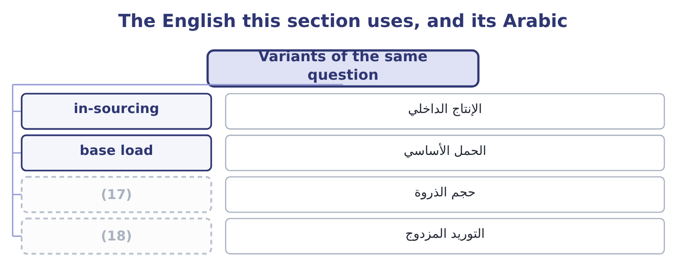
word list
dual sourcing · peak volume · base load

The English this sheet uses, and its Arabic
English (exam term) | Arabic
in-sourcing | الإنتاج الداخلي
base load | الحمل الأساسي
peak volume | حجم الذروة
dual sourcing | التوريد المزدوج

Answer key · 8.4 Variants of the same question

1 outcome's | 10 incremental
2 decisions | 11 volume
3 catering | 12 alternative
4 information | 13 sources
5 analysis | 14 Closing
6 released | 15 avoidable
7 reverse | 16 Buy, if the premium exceeds 0.08
8 presently | 17 peak volume
9 comparison | 18 dual sourcing

the summaries in full
Summary 1 The outcome's phrase "make or buy" covers a family of decisions with identical arithmetic, and a question may use any of them. Payroll, catering, cleaning, information technology, internal audit. The analysis is the same: what stops being spent, what is released, what is given up. The reverse decision, where a company presently buying decides to make. Here the fixed costs are the ones being added rather than avoided, and the comparison is between the supplier's price and the incremental cost of making, including the new fixed costs and the capital required — which turns it into the capital investment decision. Buying a part of the volume. Often the best answer is neither all nor nothing: make the base load in house, where the fixed costs are already committed, and buy the peak from a supplier, where the alternative is overtime or a second shift.
Summary 2 The arithmetic ranks the two sources at the margin, exactly. Closing one plant of several. The same table, with the avoidable costs of one site on one side and the extra transport and overtime at the others on the opposite side.

8.5 Writing the answer
Chapter 8 · section 8.5

Fill every gap. Each word list holds one word more than there are gaps.
Summary 1 gaps 1–12
A (1) answer has five parts and the exam (2) each. The (3) , as a column of (4) , with the avoidable costs identified. Not two full (5) . The treatment of the (6) overhead, stated (7) . One sentence — "the $315,000 of factory and head office overhead (8) whichever is chosen and is excluded" — earns a mark and prevents the (9) error. The (10) cost of released (11) , if any, with its source named. If the question gives no (12) use, say that none has been identified and that the recommendation would change at a value of $105,000 a year or more. The indifference price, as a negotiating position. The qualitative factors that bear on this particular component, chosen rather than recited. For a lid that seals a food product, quality and dependability lead; for a cleaning contract they do not. And the recommendation, which on the facts of section 8.1 is to go on making the lids, to ask the supplier for a price below 0.39, and to re-open the question if a use for the pressing shop is found.
word list
continues · explicitly · alternative · outsourced · differences · comparison · commonest · costings · opportunity · rewards · capacity · make-or-buy · unavoidable

Decide on a bracket

Your turn: make or buy (complete the blanks)
Item | Data | Answer
Variable cost of making a unit | (13) | ________
Annual variable cost | 400,000 units a year | ________
Avoidable fixed costs | A supervisor at 60,000 and machine insurance of 9,000 | ________
Total relevant cost of making |  | ________
Cost of buying | (14) | ________
Better by |  | ________
Indifference price |  | ________

word list
Materials 1.40, labour 0.90, variable overhead 0.50 · 1,280,000: 400,000 × 3.20 = 1,280,000. · Supplier price 3.20 a unit

"Outsourcing"

Summary 2 gaps 15–20
English outsourcing means buying from outside what was (15) made inside, and it carries (16) in ordinary use — of job losses, of distance, of (17) done cheaply — that the technical term does not. (18) is a different idea again: moving work to another country, which may be (19) to a supplier or kept inside the company. In an exam answer, use make or buy for the (20) and outsourcing only where the question does.
word list
country · previously · overtones · decision · outsourced · Offshoring · something

"Outsourcing"
Item | Answer
Variable cost a unit | (21)
Annual variable cost | (22)
Avoidable fixed costs | (23)
Total relevant cost of making | 1,189,000: 1,120,000 + 69,000 = 1,189,000.
Cost of buying | 1,280,000: 400,000 × 3.20 = 1,280,000.
Better by | Making, by 91,000: 1,280,000 − 1,189,000 = 91,000.
Indifference price | (24)
What it tells you | The supplier is 23 cents a unit too expensive, and the company's negotiating ceiling is about 2.97 — unless a use is found for the released

word list
1,120,000: 400,000 × 2.80 = 1,120,000. · 69,000: 60,000 + 9,000 = 69,000. · 2.9725: 1,189,000 ÷ 400,000 = 2.9725. · 2.80: 1.40 + 0.90 + 0.50 = 2.80. · 1,280,000: 400,000 × 3.20 = 1,280,000.

The English this section uses, and its Arabic
Each term sits against what it means.
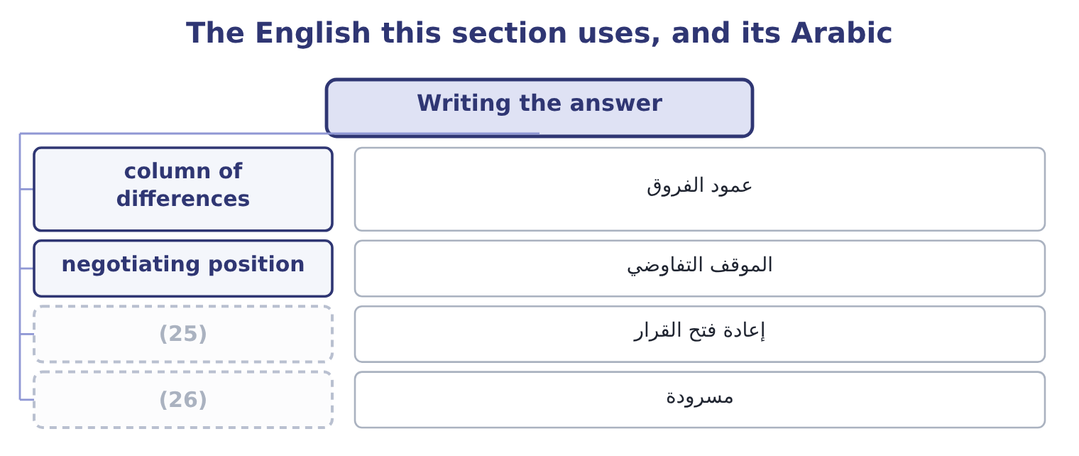
word list
make-or-buy decision · recited · re-open the question

The English this sheet uses, and its Arabic
English (exam term) | Arabic
column of differences | عمود الفروق
negotiating position | الموقف التفاوضي
re-open the question | إعادة فتح القرار
recited | مسرودة

Answer key · 8.5 Writing the answer

1 make-or-buy | 14 Supplier price 3.20 a unit
2 rewards | 15 previously
3 comparison | 16 overtones
4 differences | 17 something
5 costings | 18 Offshoring
6 unavoidable | 19 outsourced
7 explicitly | 20 decision
8 continues | 21 2.80: 1.40 + 0.90 + 0.50 = 2.80.
9 commonest | 22 1,120,000: 400,000 × 2.80 = 1,120,000.
10 opportunity | 23 69,000: 60,000 + 9,000 = 69,000.
11 capacity | 24 2.9725: 1,189,000 ÷ 400,000 = 2.9725.
12 alternative | 25 re-open the question
13 Materials 1.40, labour 0.90, variable overhead 0.50 | 26 recited

the summaries in full
Summary 1 A make-or-buy answer has five parts and the exam rewards each. The comparison, as a column of differences, with the avoidable costs identified. Not two full costings. The treatment of the unavoidable overhead, stated explicitly. One sentence — "the $315,000 of factory and head office overhead continues whichever is chosen and is excluded" — earns a mark and prevents the commonest error. The opportunity cost of released capacity, if any, with its source named. If the question gives no alternative use, say that none has been identified and that the recommendation would change at a value of $105,000 a year or more. The indifference price, as a negotiating position. The qualitative factors that bear on this particular component, chosen rather than recited. For a lid that seals a food product, quality and dependability lead; for a cleaning contract they do not. And the recommendation, which on the facts of section 8.1 is to go on making the lids, to ask the supplier for a price below 0.39, and to re-open the question if a use for the pressing shop is found.
Summary 2 English outsourcing means buying from outside what was previously made inside, and it carries overtones in ordinary use — of job losses, of distance, of something done cheaply — that the technical term does not. Offshoring is a different idea again: moving work to another country, which may be outsourced to a supplier or kept inside the company. In an exam answer, use make or buy for the decision and outsourcing only where the question does.

