9.1 Sell now or process further
Chapter 9 · section 9.1

Fill every gap. Each word list holds one word more than there are gaps.
Chapter 9, section by section
Each stage leads to the next.
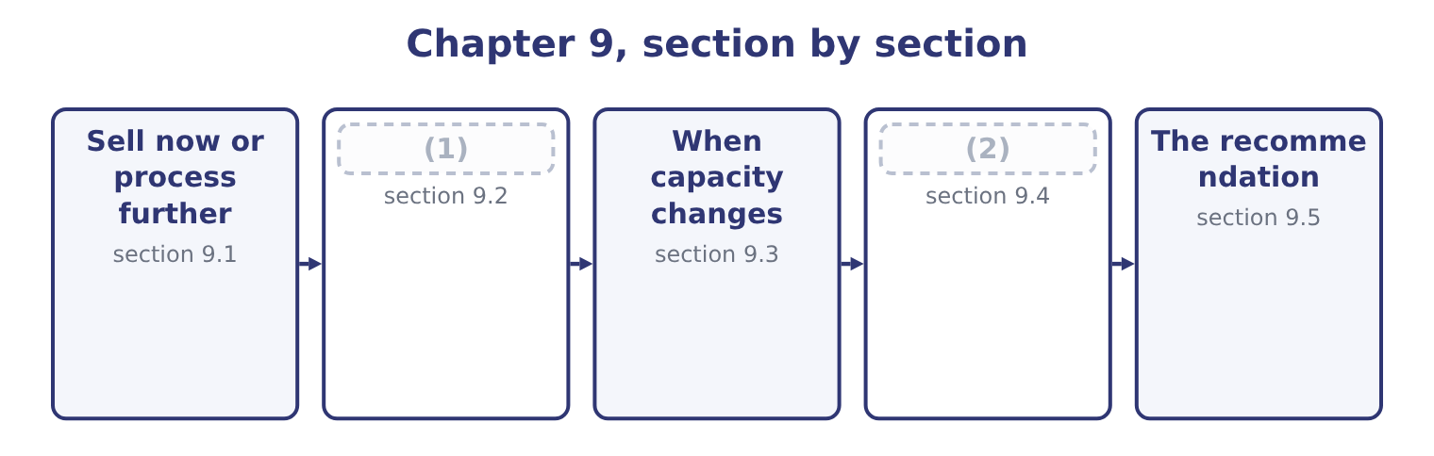
word list
Income taxes in marginal analysis · Sell now or process further · Drop or add a segment

Summary 1 gaps 3–11
A joint process (3) something that can be sold as it is, or taken further and sold for more. The point at which the choice arises is the split-off point, and (4) spent before it is irrelevant to the choice. That last (5) is the whole topic. The cost of producing the paste has been incurred by the time the question arises, and it is the same whether the paste is sold or (6) into jars. It is (7) a joint cost, common to both (8) , and it belongs in neither column — (9) basis the costing (10) has used to (11) it between them.
word list
produces · everything · whatever · apportion · paste's · therefore · system · filled · options · sentence

Worked example: paste or jars

Summary 2 gaps 12–23
A 10 kg drum of (12) paste sells for $60.00. The same paste fills ten tahini jars (13) at $12.00 each, which is 10 × 12.00 = 120.00. Filling, jars, labels and the extra (14) cost $33.00 a drum. The same answer appears: ten jars (15) 10 × 4.80 = 48.00 against a drum's $21.00, and 48.00 − 21.00 = 27.00. The two routes agree because the paste's own (16) cost of $39.00 a drum is in both and cancels — which is the joint cost doing exactly what the rule says it does. Three (17) belong in any answer on this outcome. The further processing must have its own (18) . If filling the jars uses roaster or line time that something else needs, the (19) cost. The two (20) must both exist. Processing further is worth $27.00 a drum only if the jars can be sold; if the jar market is already (21) and the paste market is not, the extra jars are inventory rather than revenue. A joint product may be (22) . Where a process yields two outputs in fixed (23) , the question is never whether to make one of them but only what to do with each at split-off.
word list
supplied · opportunity · handling · proportions · contribute · capacity · unavoidable · variable · sesame · qualifications · selling · therefore · markets

Sell at split-off, or process further
Line | Per drum | In the decision?
Revenue as paste | 60.00 | Yes, forgone if processed
Revenue as ten jars | 120.00 | Yes
Incremental revenue | 60.00 | The benefit
Cost of further processing | 33.00 | The cost
Cost of producing the paste | 39.00 | (24)
Apportioned share of joint cost | (25) | No; apportionment changes nothing real
Net benefit of processing | 27.00 | (26)

word list
demand evidence · Any figure · No; it is a joint cost, incurred either way · The answer

Apportioned joint costs

Summary 3 gaps 27–33
A question will often give you a joint cost apportioned between the (27) by weight, by value or by (28) . The apportionment is for inventory (29) and it is irrelevant to the decision. Processing further can be worth doing for one joint product and not for (30) from the same process. Each is (31) on its own incremental (32) . If the further processing cost exceeds the incremental revenue, sell at split-off — even where the final product sells for far more than the (33) one.
word list
another · valuation · intermediate · decided · products · roaster · volume · figures

The English this section uses, and its Arabic
Each term sits against what it means.
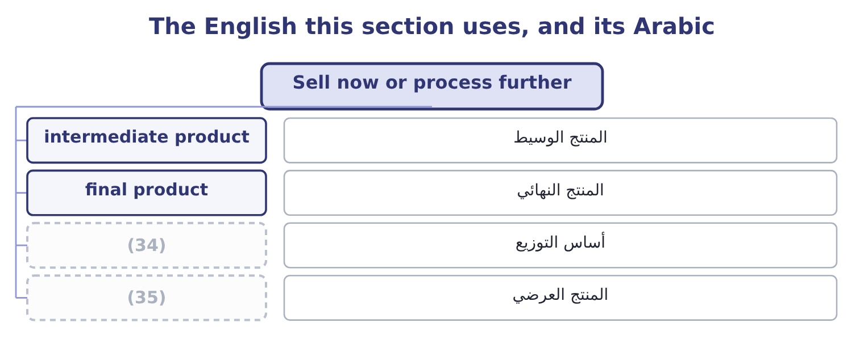
word list
by-product · after-tax effect · apportionment basis

The English this sheet uses, and its Arabic
English (exam term) | Arabic
intermediate product | المنتج الوسيط
final product | المنتج النهائي
apportionment basis | أساس التوزيع
by-product | المنتج العرضي

Answer key · 9.1 Sell now or process further

1 Drop or add a segment | 19 opportunity
2 Income taxes in marginal analysis | 20 markets
3 produces | 21 supplied
4 everything | 22 unavoidable
5 sentence | 23 proportions
6 filled | 24 No; it is a joint cost, incurred either way
7 therefore | 25 Any figure
8 options | 26 The answer
9 whatever | 27 products
10 system | 28 volume
11 apportion | 29 valuation
12 sesame | 30 another
13 selling | 31 decided
14 handling | 32 figures
15 contribute | 33 intermediate
16 variable | 34 apportionment basis
17 qualifications | 35 by-product
18 capacity

the summaries in full
Summary 1 A joint process produces something that can be sold as it is, or taken further and sold for more. The point at which the choice arises is the split-off point, and everything spent before it is irrelevant to the choice. That last sentence is the whole topic. The cost of producing the paste has been incurred by the time the question arises, and it is the same whether the paste is sold or filled into jars. It is therefore a joint cost, common to both options, and it belongs in neither column — whatever basis the costing system has used to apportion it between them.
Summary 2 A 10 kg drum of sesame paste sells for $60.00. The same paste fills ten tahini jars selling at $12.00 each, which is 10 × 12.00 = 120.00. Filling, jars, labels and the extra handling cost $33.00 a drum. The same answer appears: ten jars contribute 10 × 4.80 = 48.00 against a drum's $21.00, and 48.00 − 21.00 = 27.00. The two routes agree because the paste's own variable cost of $39.00 a drum is in both and cancels — which is the joint cost doing exactly what the rule says it does. Three qualifications belong in any answer on this outcome. The further processing must have its own capacity. If filling the jars uses roaster or line time that something else needs, the opportunity cost. The two markets must both exist. Processing further is worth $27.00 a drum only if the jars can be sold; if the jar market is already supplied and the paste market is not, the extra jars are inventory rather than revenue. A joint product may be unavoidable. Where a process yields two outputs in fixed proportions, the question is never whether to make one of them but only what to do with each at split-off.
Summary 3 A question will often give you a joint cost apportioned between the products by weight, by value or by volume. The apportionment is for inventory valuation and it is irrelevant to the decision. Processing further can be worth doing for one joint product and not for another from the same process. Each is decided on its own incremental figures. If the further processing cost exceeds the incremental revenue, sell at split-off — even where the final product sells for far more than the intermediate one.

9.2 Drop or add a segment
Chapter 9 · section 9.2

Fill every gap. Each word list holds one word more than there are gaps.
Summary 1 gaps 1–12
A segment is any part of a business whose results can be (1) : a product line, a (2) , a branch, a customer group, a region. The question is (3) the company is better off with it or without it, and the (4) is. Keep a segment if its contribution (5) the fixed costs that would (6) be avoided by dropping it. For (7) halva line, with a contribution of $900,000 and (8) fixed costs of $500,000, the line is worth 900,000 − 500,000 = 400,000 a year and should be kept. The $300,000 of (9) factory and head office cost that makes it look unprofitable in the (10) accounts does not disappear on closure; it moves to the other products. Adding a segment is the same test run (11) . A (12) new line of sesame bars would contribute $820,000 and need $600,000 of new fixed costs, so it is worth 820,000 − 600,000 = 220,000 and should be added.
word list
actually · separated · management · proposed · whether · Orontes's · avoidable · proposal · arithmetic · exceeds · department · apportioned · forwards

Worked example: the new line that was not worth adding

Summary 2 gaps 13–24
The proposal as (13) . Contribution of $820,000 against $600,000 of new fixed costs, a gain of $220,000. The question (14) asked. Where will the customers come from? The (15) plan expects a tenth of the new line's (16) to be bought by customers who would (17) have bought (18) jars — 100,000 jars a year. Those jars contribute $4.80 each, so 100,000 × 4.80 = 480,000 of (19) contribution is lost. The new line would make the company $260,000 a year worse off. (20) in the new line's own (21) changed. The decision reversed because the analysis was widened to include an effect on a (22) product — and that is the characteristic error in (23) decisions, exactly as a missing (24) cost is the characteristic error in special orders. The rule is to draw the boundary of the analysis around the company, not around the segment.
word list
figures · tahini · otherwise · apportioned · different · add-a-segment · marketing · presented · existing · volume · opportunity · Nothing · nobody

Summary 3 gaps 25–29
Four effects belong inside that boundary (25) a question (26) them. (27) , the opposite: a segment that is unprofitable alone but (28) customers who buy other things. Shared costs that genuinely (29) . Dropping a segment may allow a warehouse to be given up or a delivery round to be dropped; adding one may push a shared resource past a step.
word list
supplies · whenever · change · brings · department · Complementarity

Keep, drop, add
Question | Compare | Decide
Keep a segment? | (30) | Against fixed costs genuinely avoided by dropping
Drop a segment? | Fixed costs avoided | Against contribution lost, plus any effect on other segments
Add a segment? | (31) | Against new fixed costs and any capacity displaced

word list
Contribution earned · Contribution gained, less any cannibalised · segment margin

The English this section uses, and its Arabic
Each term sits against what it means.
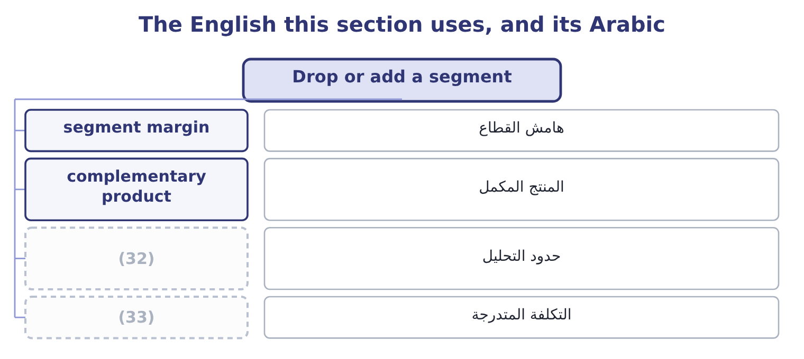
word list
boundary of the analysis · step cost · widen the boundary

The English this sheet uses, and its Arabic
English (exam term) | Arabic
segment margin | هامش القطاع
complementary product | المنتج المكمل
boundary of the analysis | حدود التحليل
step cost | التكلفة المتدرجة

Answer key · 9.2 Drop or add a segment

1 separated | 18 tahini
2 department | 19 existing
3 whether | 20 Nothing
4 arithmetic | 21 figures
5 exceeds | 22 different
6 actually | 23 add-a-segment
7 Orontes's | 24 opportunity
8 avoidable | 25 whenever
9 apportioned | 26 supplies
10 management | 27 Complementarity
11 forwards | 28 brings
12 proposed | 29 change
13 presented | 30 Contribution earned
14 nobody | 31 Contribution gained, less any cannibalised
15 marketing | 32 boundary of the analysis
16 volume | 33 step cost
17 otherwise

the summaries in full
Summary 1 A segment is any part of a business whose results can be separated: a product line, a department, a branch, a customer group, a region. The question is whether the company is better off with it or without it, and the arithmetic is. Keep a segment if its contribution exceeds the fixed costs that would actually be avoided by dropping it. For Orontes's halva line, with a contribution of $900,000 and avoidable fixed costs of $500,000, the line is worth 900,000 − 500,000 = 400,000 a year and should be kept. The $300,000 of apportioned factory and head office cost that makes it look unprofitable in the management accounts does not disappear on closure; it moves to the other products. Adding a segment is the same test run forwards. A proposed new line of sesame bars would contribute $820,000 and need $600,000 of new fixed costs, so it is worth 820,000 − 600,000 = 220,000 and should be added.
Summary 2 The proposal as presented. Contribution of $820,000 against $600,000 of new fixed costs, a gain of $220,000. The question nobody asked. Where will the customers come from? The marketing plan expects a tenth of the new line's volume to be bought by customers who would otherwise have bought tahini jars — 100,000 jars a year. Those jars contribute $4.80 each, so 100,000 × 4.80 = 480,000 of existing contribution is lost. The new line would make the company $260,000 a year worse off. Nothing in the new line's own figures changed. The decision reversed because the analysis was widened to include an effect on a different product — and that is the characteristic error in add-a-segment decisions, exactly as a missing opportunity cost is the characteristic error in special orders. The rule is to draw the boundary of the analysis around the company, not around the segment.
Summary 3 Four effects belong inside that boundary whenever a question supplies them. Complementarity, the opposite: a segment that is unprofitable alone but brings customers who buy other things. Shared costs that genuinely change. Dropping a segment may allow a warehouse to be given up or a delivery round to be dropped; adding one may push a shared resource past a step.

9.3 When capacity changes
Chapter 9 · section 9.3

Fill every gap. Each word list holds one word more than there are gaps.
Summary 1 gaps 1–12
Capacity can be added in three ways and each behaves (1) . (2) adds hours at a premium, with no change in fixed costs. It is the most (3) and the most (4) per unit, and it is the right answer for a short peak. A second shift adds a block of capacity and a block of fixed cost: (5) , lighting, (6) , shift premium. It is a step, and the step has to be (7) by the volume that will use it. New plant adds capacity and (8) the question into the capital (9) decision. The (10) of a step is (11) the same. A second shift at (12) would add $1,200,000 of fixed costs and 800,000 jars of capacity. At a contribution of $4.80 a jar it pays for itself at 1,200,000 ÷ 4.80 = 250,000 jars — less than a third of the capacity it creates. So the shift is worth adding if the company can sell 250,000 more jars, and the whole question becomes a demand question rather than a cost one.
word list
converts · always · canteen · differently · investment · uncertain · arithmetic · justified · flexible · expensive · supervision · Orontes · Overtime

Summary 2 gaps 13–20
Three (13) of a capacity change (14) in an answer. The (15) costs of every other decision change with it. A special order refused at full capacity becomes (16) once capacity is added, because the displaced contribution (17) . A step of $1,200,000 of fixed cost raises the (18) by 1,200,000 ÷ 4.80 = 250,000 jars, which is. A step once taken is hard to (19) . Shift premiums can be withdrawn and (20) released, with difficulty; a new building cannot. The more irreversible the step, the stronger the demand evidence should be.
word list
breakeven · consequences · belong · displaced · acceptable · untake · relevant · disappears · supervisors

Three ways to add capacity
Every item belongs to exactly one group.
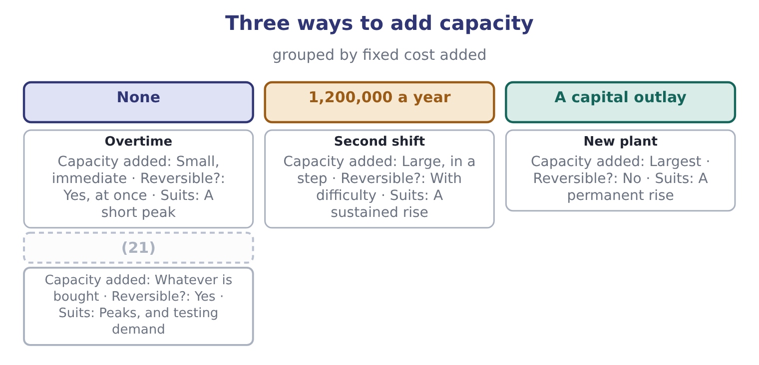
word list
Buying in · joint cost

Summary 3 gaps 22–23
That last row is: buying the peak is a way of adding capacity (22) adding fixed cost, and for a company (23) about demand it is often the best of the four.
word list
premiums · uncertain · without

The English this section uses, and its Arabic
Each term sits against what it means.
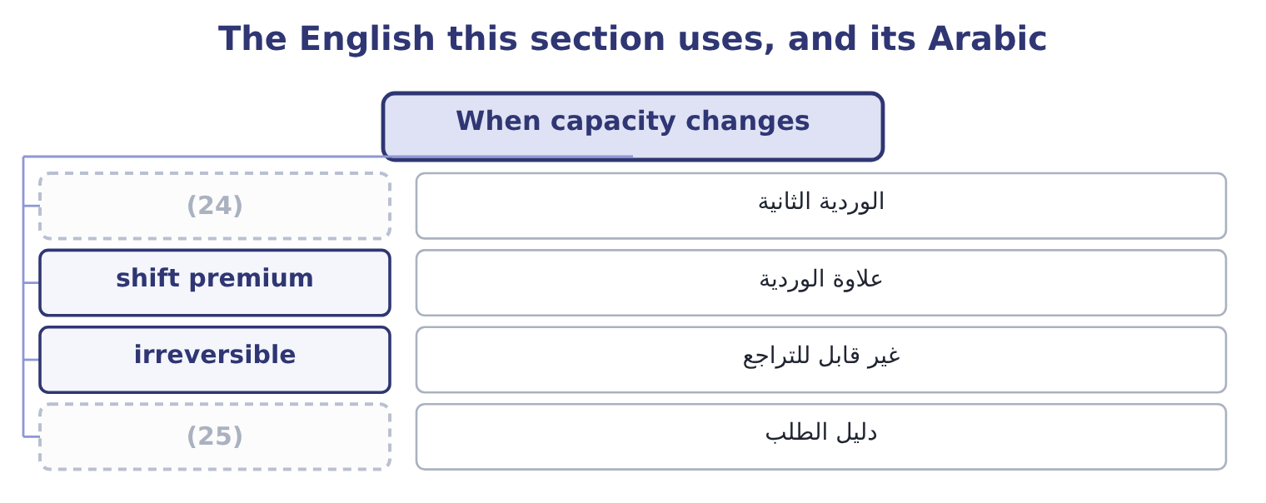
word list
second shift · capital allowance · demand evidence

The English this sheet uses, and its Arabic
English (exam term) | Arabic
second shift | الوردية الثانية
shift premium | علاوة الوردية
irreversible | غير قابل للتراجع
demand evidence | دليل الطلب

Answer key · 9.3 When capacity changes

1 differently | 14 belong
2 Overtime | 15 relevant
3 flexible | 16 acceptable
4 expensive | 17 disappears
5 supervision | 18 breakeven
6 canteen | 19 untake
7 justified | 20 supervisors
8 converts | 21 Buying in
9 investment | 22 without
10 arithmetic | 23 uncertain
11 always | 24 second shift
12 Orontes | 25 demand evidence
13 consequences

the summaries in full
Summary 1 Capacity can be added in three ways and each behaves differently. Overtime adds hours at a premium, with no change in fixed costs. It is the most flexible and the most expensive per unit, and it is the right answer for a short peak. A second shift adds a block of capacity and a block of fixed cost: supervision, lighting, canteen, shift premium. It is a step, and the step has to be justified by the volume that will use it. New plant adds capacity and converts the question into the capital investment decision. The arithmetic of a step is always the same. A second shift at Orontes would add $1,200,000 of fixed costs and 800,000 jars of capacity. At a contribution of $4.80 a jar it pays for itself at 1,200,000 ÷ 4.80 = 250,000 jars — less than a third of the capacity it creates. So the shift is worth adding if the company can sell 250,000 more jars, and the whole question becomes a demand question rather than a cost one.
Summary 2 Three consequences of a capacity change belong in an answer. The relevant costs of every other decision change with it. A special order refused at full capacity becomes acceptable once capacity is added, because the displaced contribution disappears. A step of $1,200,000 of fixed cost raises the breakeven by 1,200,000 ÷ 4.80 = 250,000 jars, which is. A step once taken is hard to untake. Shift premiums can be withdrawn and supervisors released, with difficulty; a new building cannot. The more irreversible the step, the stronger the demand evidence should be.
Summary 3 That last row is: buying the peak is a way of adding capacity without adding fixed cost, and for a company uncertain about demand it is often the best of the four.

9.4 Income taxes in marginal analysis
Chapter 9 · section 9.4

Fill every gap. Each word list holds one word more than there are gaps.
Summary 1 gaps 1–12
Everything so far has been computed before tax. The (1) asks what tax does, and the answer has three parts. Tax (2) the answer. An incremental contribution of $300,000 at a 25 per cent rate is worth 300,000 × 0.75 = 225,000 after tax. Every option in a (3) is scaled by the same factor, so no (4) changes and the decision is the same before and after tax. Except where the (5) are taxed differently, and then tax (6) . A capital (7) available on a (8) machine and not on a leased one, which Book 2 priced as the net (9) to leasing. Operations in two (10) with different rates, so that the same contribution is worth more in one place. And a company with losses available to (11) income, for which the (12) tax rate is nil until the losses are used.
word list
purchased · decides · shelter · comparison · advantage · options · allowance · scales · marginal · because · ranking · outcome · jurisdictions

Summary 2 gaps 13–19
Tax follows cash, not (13) profit. A (14) tax effect is computed on the (15) amounts it changes, which is why. The (16) rule for Section C is short: (17) before tax unless the (18) gives a tax rate or the (19) are taxed differently, and when a rate is given, state the answer both ways — "an incremental gain of $300,000, which is $225,000 after tax at 25 per cent" — because a marker can see both and the board only wants one.
word list
accounting · shelter · question · decision's · alternatives · practical · compute · taxable

Does tax change the decision?
Every item belongs to exactly one group.
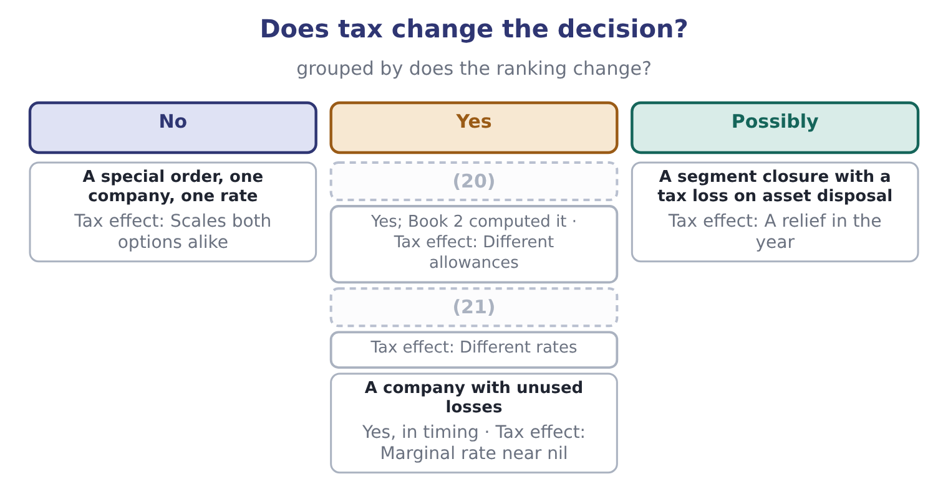
word list
Lease against buy · Two jurisdictions · complementary product

The English this section uses, and its Arabic
Each term sits against what it means.
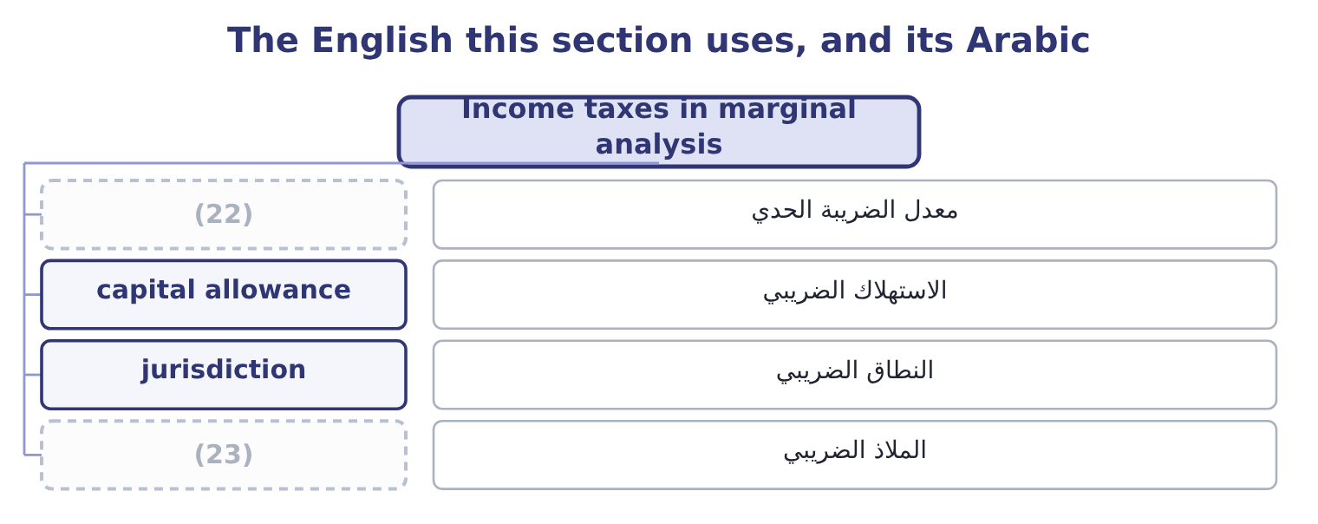
word list
marginal tax rate · shelter · intermediate product

The English this sheet uses, and its Arabic
English (exam term) | Arabic
marginal tax rate | معدل الضريبة الحدي
capital allowance | الاستهلاك الضريبي
jurisdiction | النطاق الضريبي
shelter | الملاذ الضريبي

Answer key · 9.4 Income taxes in marginal analysis

1 outcome | 13 accounting
2 scales | 14 decision's
3 comparison | 15 taxable
4 ranking | 16 practical
5 options | 17 compute
6 decides | 18 question
7 allowance | 19 alternatives
8 purchased | 20 Lease against buy
9 advantage | 21 Two jurisdictions
10 jurisdictions | 22 marginal tax rate
11 shelter | 23 shelter
12 marginal

the summaries in full
Summary 1 Everything so far has been computed before tax. The outcome asks what tax does, and the answer has three parts. Tax scales the answer. An incremental contribution of $300,000 at a 25 per cent rate is worth 300,000 × 0.75 = 225,000 after tax. Every option in a comparison is scaled by the same factor, so no ranking changes and the decision is the same before and after tax. Except where the options are taxed differently, and then tax decides. A capital allowance available on a purchased machine and not on a leased one, which Book 2 priced as the net advantage to leasing. Operations in two jurisdictions with different rates, so that the same contribution is worth more in one place. And a company with losses available to shelter income, for which the marginal tax rate is nil until the losses are used.
Summary 2 Tax follows cash, not accounting profit. A decision's tax effect is computed on the taxable amounts it changes, which is why. The practical rule for Section C is short: compute before tax unless the question gives a tax rate or the alternatives are taxed differently, and when a rate is given, state the answer both ways — "an incremental gain of $300,000, which is $225,000 after tax at 25 per cent" — because a marker can see both and the board only wants one.

9.5 The recommendation
Chapter 9 · section 9.5

Fill every gap. Each word list holds one word more than there are gaps.
Summary 1 gaps 1–12
The last (1) of this topic asks for a course of action, and the (2) structure. State the decision, with the incremental figure that (3) it: "process further: it is worth $27.00 a drum". Name what was excluded and why: the joint cost, the (4) overhead, the sunk (5) , the book value. Name the (6) cost or the displaced contribution, if there is one, and the capacity (7) behind it: "this assumes the filling line has spare capacity; if it does not, the answer reverses". Widen the (8) once, deliberately. Ask what the decision does to the (9) other products, its (10) , its suppliers and its next year. The cannibalisation of section 9.2 and the market (11) . Give the (12) factors their place, chosen rather than recited. Say what would change the answer, with a number: "the new line is worth adding if cannibalisation is below 45,833 jars a year". That last figure is worth deriving, because it shows the habit.
word list
boundary · disturbance · supports · reverses · assumption · customers · five-part · company's · development · outcome · opportunity · apportioned · qualitative

Summary 2 gaps 13–16
The new line gains $220,000 before cannibalisation, and each (13) jar costs $4.80, so the break-even cannibalisation is 220,000 ÷ 4.80 = 45,833 jars. Below that the line is worth adding and above it is not — and the whole decision now rests on a single (14) estimate that (15) can be asked to (16) .
word list
defend · cannibalised · somebody · marketing · business

Four decisions

Your turn: four marginal decisions (complete the blanks)
Decision | Data | Answer
Process further? | Sell at 40.00 or process at a cost of 18.00 and sell at 62.00 | ________
Drop a segment? | (17) | ________
Add a segment? | Contribution 500,000; new fixed costs 380,000; cannibalises 90,000 | ________
Second shift? | (18) | ________
After-tax value of a 120,000 gain | Tax rate 25 per cent | ________
Break-even cannibalisation on the added segment |  | ________

word list
Adds 700,000 of fixed cost; contribution 3.50 a unit · After-tax value of a 120,000 gain · Contribution 300,000; avoidable fixed costs 340,000

"Segment"

Summary 3 gaps 19–24
English segment in management (19) means any part of a business whose results can be reported (20) — a product line, a region, a customer group — and it is deliberately broader than division or department, which name parts of an (21) chart. The exam also uses it in the (22) sense of Part 1, where a segment is (23) by how management (24) the business.
word list
organisation · excluded · accounting · defined · separately · reviews · reporting

"Segment"
Decision | Answer
Process further? | Yes: the incremental revenue is 62.00 − 40.00 = 22.00 against a cost of 18.00, a gain of 4.00 a unit.
Drop a segment? | (25) : avoidable fixed costs of 340,000 exceed the contribution of 300,000 by 40,000.
Add a segment? | Add it: 500,000 − 380,000 = 120,000 of gain, less 90,000 of cannibalisation, leaves 30,000.
Second shift? | It needs 200,000 extra units: 700,000 ÷ 3.50 = 200,000.
After-tax value of a 120,000 gain | (26)
Break-even cannibalisation | 120,000 of contribution: the gain before cannibalisation is 120,000, so anything above that reverses the decision.
What it tells you | (27) : 4.00 a unit, 40,000 a year and 30,000 a year are all small enough that an error in one estimate would

word list
Second shift? · 90,000: 120,000 × 0.75 = 90,000. · Three of the four decisions are close · Drop it

The English this section uses, and its Arabic
Each term sits against what it means.
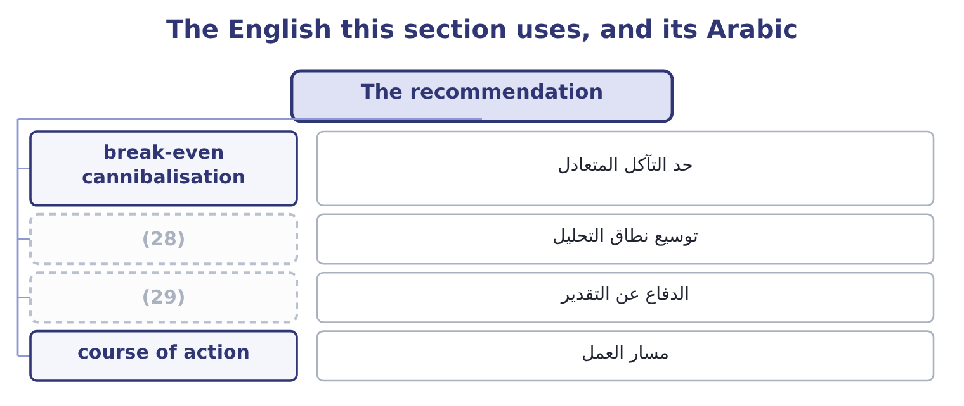
word list
widen the boundary · defend an estimate · course of action

The English this sheet uses, and its Arabic
English (exam term) | Arabic
break-even cannibalisation | حد التآكل المتعادل
widen the boundary | توسيع نطاق التحليل
defend an estimate | الدفاع عن التقدير
course of action | مسار العمل

Answer key · 9.5 The recommendation

1 outcome | 16 defend
2 five-part | 17 Contribution 300,000; avoidable fixed costs 340,000
3 supports | 18 Adds 700,000 of fixed cost; contribution 3.50 a unit
4 apportioned | 19 accounting
5 development | 20 separately
6 opportunity | 21 organisation
7 assumption | 22 reporting
8 boundary | 23 defined
9 company's | 24 reviews
10 customers | 25 Drop it
11 disturbance | 26 90,000: 120,000 × 0.75 = 90,000.
12 qualitative | 27 Three of the four decisions are close
13 cannibalised | 28 widen the boundary
14 marketing | 29 defend an estimate
15 somebody

the summaries in full
Summary 1 The last outcome of this topic asks for a course of action, and the five-part structure. State the decision, with the incremental figure that supports it: "process further: it is worth $27.00 a drum". Name what was excluded and why: the joint cost, the apportioned overhead, the sunk development, the book value. Name the opportunity cost or the displaced contribution, if there is one, and the capacity assumption behind it: "this assumes the filling line has spare capacity; if it does not, the answer reverses". Widen the boundary once, deliberately. Ask what the decision does to the company's other products, its customers, its suppliers and its next year. The cannibalisation of section 9.2 and the market disturbance. Give the qualitative factors their place, chosen rather than recited. Say what would change the answer, with a number: "the new line is worth adding if cannibalisation is below 45,833 jars a year". That last figure is worth deriving, because it shows the habit.
Summary 2 The new line gains $220,000 before cannibalisation, and each cannibalised jar costs $4.80, so the break-even cannibalisation is 220,000 ÷ 4.80 = 45,833 jars. Below that the line is worth adding and above it is not — and the whole decision now rests on a single marketing estimate that somebody can be asked to defend.
Summary 3 English segment in management accounting means any part of a business whose results can be reported separately — a product line, a region, a customer group — and it is deliberately broader than division or department, which name parts of an organisation chart. The exam also uses it in the reporting sense of Part 1, where a segment is defined by how management reviews the business.

