10.1 Three approaches
Chapter 10 · section 10.1

Fill every gap. Each word list holds one word more than there are gaps.
Chapter 10, section by section
Each stage leads to the next.
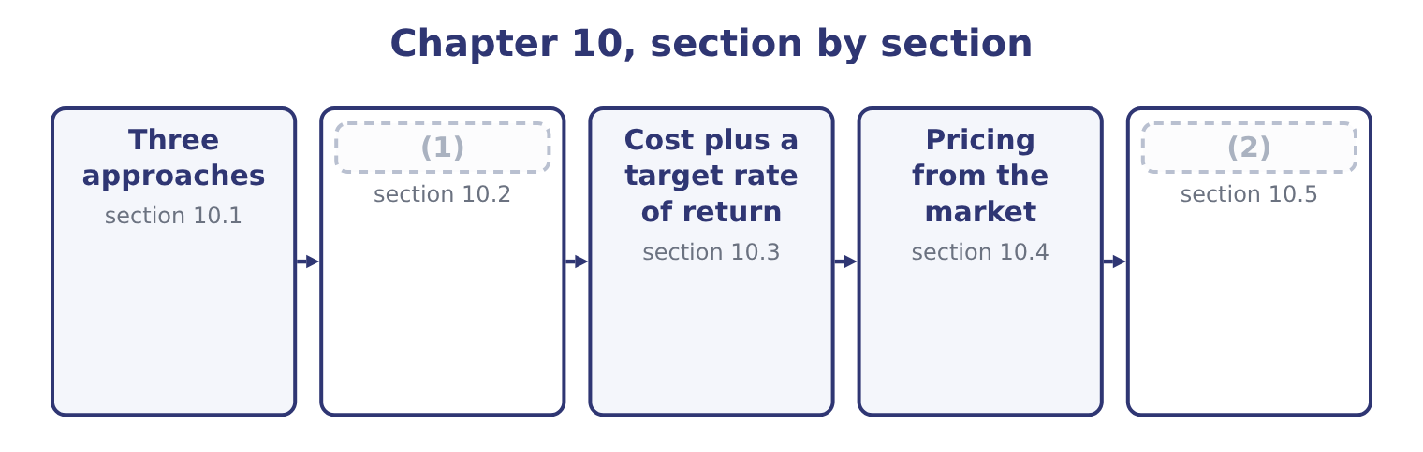
word list
Choosing and defending a price · Pricing from the market · Pricing from a cost

Summary 1 gaps 3–14
The (3) names three (4) and the exam expects them (5) . Cost-based pricing starts from a cost and adds a (6) . Its merits are that it is simple, it can be applied to thousands of products without market research, it covers costs by (7) , and it is (8) to a customer who asks how the price was reached — which is why it is standard for government contracts and for (9) fees. Its defect is that it ignores the customer: it answers the (10) "what do we need" (11) than "what will they pay". (12) pricing starts from the market. Market comparables set the price at or around what similar products fetch, which is the method for commodities, for retail lines facing a shelf of rivals, and for (13) whose price is (14) quoted. The company then has to make the product for less than that price, which is the target costing.
word list
methodologies · defensible · effectively · professional · anything · construction · distinguished · Market-based · research · question · rather · margin · outcome

Summary 2 gaps 15–21
Value-based pricing starts from the customer's (15) of what the product is worth to them. It is the (16) to do and the most (17) where it works: a product that saves a customer $100,000 a year can be priced at far more than it costs to make, and at far more than a (18) product with a weaker claim. It (19) knowing the customer's (20) , which is why it is common in industrial sales and rare in (21) .
word list
economics · grocery · requires · perception · hardest · comparable · profitable · applied

Three ways to arrive at a price
Approach | Starts from | Asks | Best suited to | Main defect
Cost-based | The company's cost | What do we need to earn? | (22) | (23)
Market comparables | (24) | What do others charge? | (25) | Ignores the company's own cost position
Value-based | (26) | What is it worth to them? | Industrial products with measurable benefit | (27)

word list
Ignores what the customer will pay · Competitors' prices · assumed volume · Commodities, crowded shelves · The customer's benefit · Many products, contracts, regulated work · Hard to measure; needs customer knowledge

Summary 3 gaps 28–30
In (28) the three are used together, and the standard sequence in a well-run company is: (29) what the market will pay, subtract the profit required, and manage the cost down to what is left. That (30) is target costing.
word list
sentence · establish · commodities · practice

The English this section uses, and its Arabic
Each term sits against what it means.
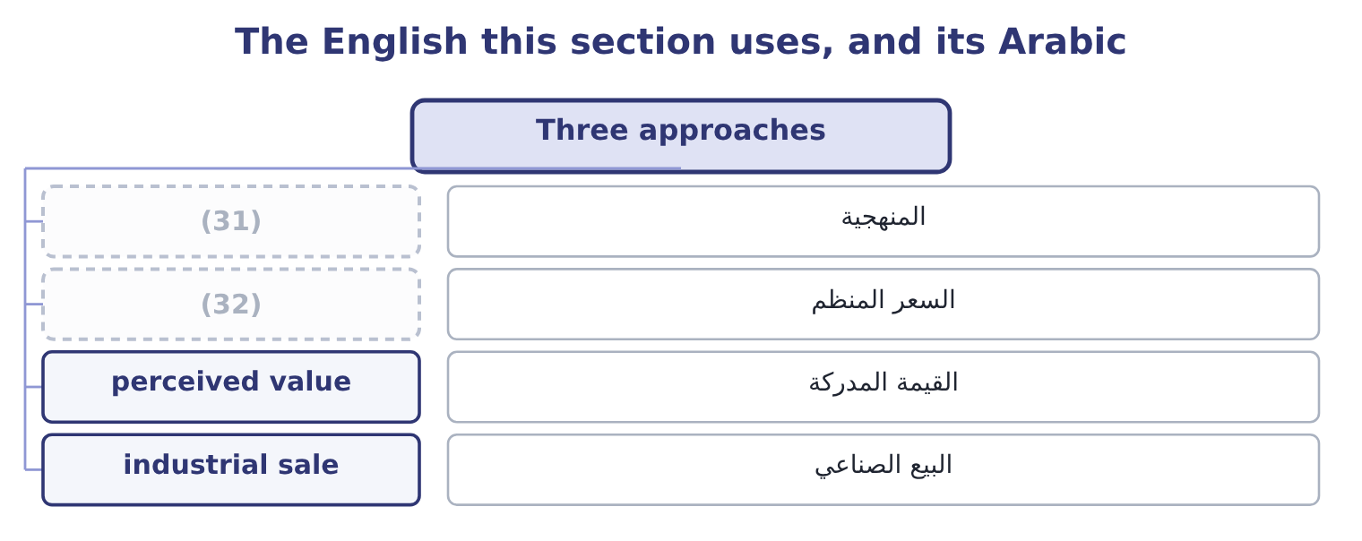
word list
market comparables · regulated price · methodology

The English this sheet uses, and its Arabic
English (exam term) | Arabic
methodology | المنهجية
regulated price | السعر المنظم
perceived value | القيمة المدركة
industrial sale | البيع الصناعي

Answer key · 10.1 Three approaches

1 Pricing from a cost | 17 profitable
2 Choosing and defending a price | 18 comparable
3 outcome | 19 requires
4 methodologies | 20 economics
5 distinguished | 21 grocery
6 margin | 22 Many products, contracts, regulated work
7 construction | 23 Ignores what the customer will pay
8 defensible | 24 Competitors' prices
9 professional | 25 Commodities, crowded shelves
10 question | 26 The customer's benefit
11 rather | 27 Hard to measure; needs customer knowledge
12 Market-based | 28 practice
13 anything | 29 establish
14 effectively | 30 sentence
15 perception | 31 methodology
16 hardest | 32 regulated price

the summaries in full
Summary 1 The outcome names three methodologies and the exam expects them distinguished. Cost-based pricing starts from a cost and adds a margin. Its merits are that it is simple, it can be applied to thousands of products without market research, it covers costs by construction, and it is defensible to a customer who asks how the price was reached — which is why it is standard for government contracts and for professional fees. Its defect is that it ignores the customer: it answers the question "what do we need" rather than "what will they pay". Market-based pricing starts from the market. Market comparables set the price at or around what similar products fetch, which is the method for commodities, for retail lines facing a shelf of rivals, and for anything whose price is effectively quoted. The company then has to make the product for less than that price, which is the target costing.
Summary 2 Value-based pricing starts from the customer's perception of what the product is worth to them. It is the hardest to do and the most profitable where it works: a product that saves a customer $100,000 a year can be priced at far more than it costs to make, and at far more than a comparable product with a weaker claim. It requires knowing the customer's economics, which is why it is common in industrial sales and rare in grocery.
Summary 3 In practice the three are used together, and the standard sequence in a well-run company is: establish what the market will pay, subtract the profit required, and manage the cost down to what is left. That sentence is target costing.

10.2 Pricing from a cost
Chapter 10 · section 10.2

Fill every gap. Each word list holds one word more than there are gaps.
Summary 1 gaps 1–12
A (1) price has two (2) : a cost base, and a markup (3) to it. The (4) questions turn on which cost base is being used, because the same price can be (5) as very different (6) . Four cost bases are used, each with its own markup. The markup must cover fixed manufacturing costs, all selling and administrative costs, and the profit. It is the (7) markup and the most (8) base, because it makes the contribution (9) . Total variable cost, including variable selling costs. The markup covers all fixed costs and the profit. Full manufacturing cost, often called (10) cost. The markup covers selling and administrative costs and the profit. This is the commonest base in practice because the figure is already in the (11) records. Full cost including selling and (12) . The markup covers profit alone.
word list
administration · visible · applied · absorption · components · inventory · expressed · flexible · largest · markups · exam's · together · cost-based

Worked example: four routes to the same $12.00

Summary 2 gaps 13–19
Orontes's variable cost is $7.20 a jar, its fixed costs are $12,624,000 over 3,500,000 jars, which is 12,624,000 ÷ 3,500,000 = 3.61 a jar, and its full cost is 7.20 + 3.61 = 10.81. On the variable cost. To reach $12.00 the markup must be 12.00 − 7.20 = 4.80 over a base of 7.20, which is 4.80 ÷ 7.20 = 66.67 per cent. The markup is 12.00 − 10.81 = 1.19 over 10.81, which is 1.19 ÷ 10.81 = 11.01 per cent. Read the two (13) . The same price is a 67 per cent markup on one base and an 11 per cent markup on (14) . A markup percentage means (15) until the base is stated, and a (16) that gives a markup (17) a base cannot be (18) . Note which base is (19) .
word list
riskier · question · together · answered · nothing · without · another · manufacturing

Summary 3 gaps 20–23
The full-cost markup of 11 per cent is (20) on a fixed cost per unit of $3.61 that depends on selling 3,500,000 jars. If volume falls to 3,000,000, the fixed cost per unit becomes 12,624,000 ÷ 3,000,000 = 4.21, the full cost becomes 7.20 + 4.21 = 11.41, and the same 11 per cent markup gives a price of $12.67. The company would be (21) its price because (22) fell, which is the (23) trap built into full-cost pricing and the first thing to say about it in an exam.
word list
computed · demand · circular · raising · starting

Four cost bases for the same $12.00 price
Every item belongs to exactly one group.
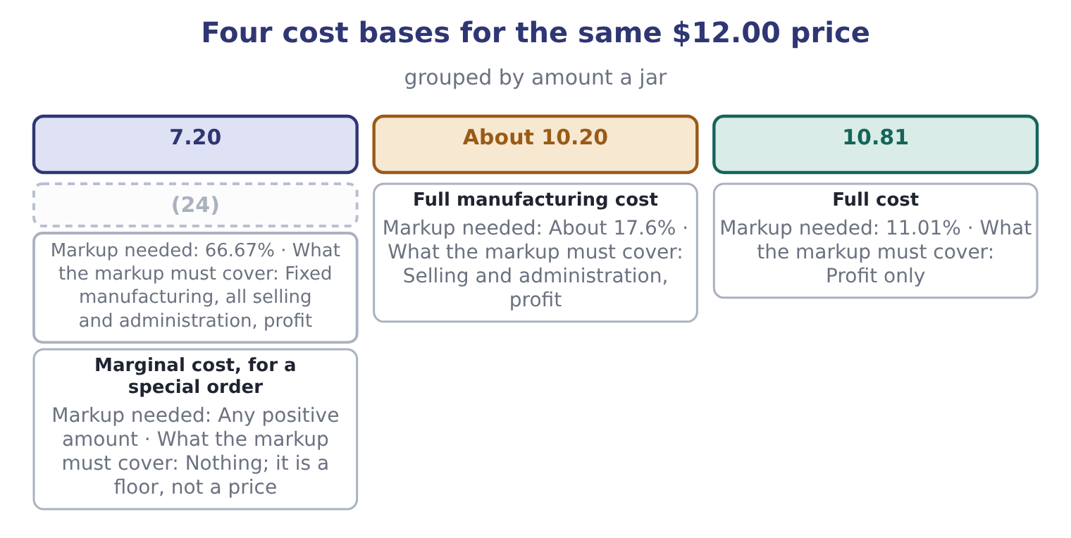
word list
Variable manufacturing cost · Full manufacturing cost

Summary 4 gaps 25–28
One more (25) appears constantly and is worth (26) . A markup is a percentage of cost; a margin is a percentage of price. Orontes's gross margin of 35 per cent corresponds to a markup of 0.35 ÷ 0.65 = 53.85 per cent on cost, and a markup of 66.67 per cent on variable cost corresponds to a contribution margin of 40 per cent on price. (27) the two is the single commonest (28) error in pricing questions.
word list
automating · arithmetic · Confusing · question · conversion

Markup against margin

Summary 5 gaps 29–34
A markup is on cost and a margin is on price. A 50 per cent markup is a 33.3 per cent margin; a 50 per cent margin is a 100 per cent markup. A full-cost price depends on an (29) volume. Say which volume, and note that the price rises as volume falls — which is the (30) of what a market would do. A (31) price is a starting point for (32) and a check that costs are (33) . It is not evidence that (34) will pay it.
word list
opposite · covered · negotiation · channel · customers · assumed · cost-plus

The English this section uses, and its Arabic
Each term sits against what it means.
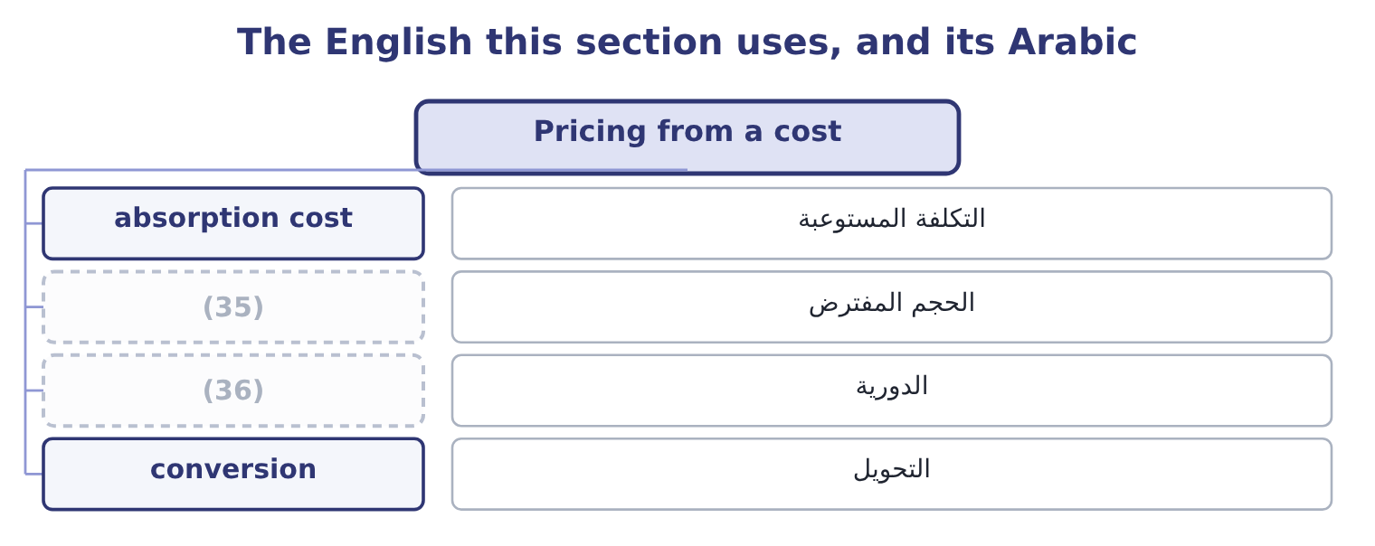
word list
circularity · assumed volume · price taker

The English this sheet uses, and its Arabic
English (exam term) | Arabic
absorption cost | التكلفة المستوعبة
assumed volume | الحجم المفترض
circularity | الدورية
conversion | التحويل

Answer key · 10.2 Pricing from a cost

1 cost-based | 19 riskier
2 components | 20 computed
3 applied | 21 raising
4 exam's | 22 demand
5 expressed | 23 circular
6 markups | 24 Variable manufacturing cost
7 largest | 25 conversion
8 flexible | 26 automating
9 visible | 27 Confusing
10 absorption | 28 arithmetic
11 inventory | 29 assumed
12 administration | 30 opposite
13 together | 31 cost-plus
14 another | 32 negotiation
15 nothing | 33 covered
16 question | 34 customers
17 without | 35 assumed volume
18 answered | 36 circularity

the summaries in full
Summary 1 A cost-based price has two components: a cost base, and a markup applied to it. The exam's questions turn on which cost base is being used, because the same price can be expressed as very different markups. Four cost bases are used, each with its own markup. The markup must cover fixed manufacturing costs, all selling and administrative costs, and the profit. It is the largest markup and the most flexible base, because it makes the contribution visible. Total variable cost, including variable selling costs. The markup covers all fixed costs and the profit. Full manufacturing cost, often called absorption cost. The markup covers selling and administrative costs and the profit. This is the commonest base in practice because the figure is already in the inventory records. Full cost including selling and administration. The markup covers profit alone.
Summary 2 Orontes's variable cost is $7.20 a jar, its fixed costs are $12,624,000 over 3,500,000 jars, which is 12,624,000 ÷ 3,500,000 = 3.61 a jar, and its full cost is 7.20 + 3.61 = 10.81. On the variable cost. To reach $12.00 the markup must be 12.00 − 7.20 = 4.80 over a base of 7.20, which is 4.80 ÷ 7.20 = 66.67 per cent. The markup is 12.00 − 10.81 = 1.19 over 10.81, which is 1.19 ÷ 10.81 = 11.01 per cent. Read the two together. The same price is a 67 per cent markup on one base and an 11 per cent markup on another. A markup percentage means nothing until the base is stated, and a question that gives a markup without a base cannot be answered. Note which base is riskier.
Summary 3 The full-cost markup of 11 per cent is computed on a fixed cost per unit of $3.61 that depends on selling 3,500,000 jars. If volume falls to 3,000,000, the fixed cost per unit becomes 12,624,000 ÷ 3,000,000 = 4.21, the full cost becomes 7.20 + 4.21 = 11.41, and the same 11 per cent markup gives a price of $12.67. The company would be raising its price because demand fell, which is the circular trap built into full-cost pricing and the first thing to say about it in an exam.
Summary 4 One more conversion appears constantly and is worth automating. A markup is a percentage of cost; a margin is a percentage of price. Orontes's gross margin of 35 per cent corresponds to a markup of 0.35 ÷ 0.65 = 53.85 per cent on cost, and a markup of 66.67 per cent on variable cost corresponds to a contribution margin of 40 per cent on price. Confusing the two is the single commonest arithmetic error in pricing questions.
Summary 5 A markup is on cost and a margin is on price. A 50 per cent markup is a 33.3 per cent margin; a 50 per cent margin is a 100 per cent markup. A full-cost price depends on an assumed volume. Say which volume, and note that the price rises as volume falls — which is the opposite of what a market would do. A cost-plus price is a starting point for negotiation and a check that costs are covered. It is not evidence that customers will pay it.

10.3 Cost plus a target rate of return
Chapter 10 · section 10.3

Fill every gap. Each word list holds one word more than there are gaps.
Summary 1 gaps 1–4
Cost plus target rate of return sets the markup so that the company earns a stated return on the capital the (1) employs. (2) of asking what margin feels right, it asks what profit the (3) require and (4) that profit over the units.
word list
spreads · product · Instead · pricing · investors

Worked example: pricing for a 15 per cent return

Summary 2 gaps 5–15
Orontes's (5) total assets are $29,058,800. At a target return of 15 per cent: 29,058,800 × 0.15 = 4,358,820. Over 3,500,000 jars: 4,358,820 ÷ 3,500,000 = 1.25 a jar. Full cost plus that profit: 10.81 + 1.25 = 12.06. The method has one (6) merit and two serious (7) , and the exam wants all three. The merit is that it ties the price to the return the (8) of capital require, which Book 2's.04 per cent — so a target of 15 per cent is a (9) premium over the cost of capital, and the (10) is the value the company (11) to create. The first weakness is the same (12) as before, and worse: the price depends on the volume, and now also on the capital employed, which (13) depends on the volume (14) inventory and (15) .
word list
deliberate · through · receivables · weaknesses · powerful · intends · itself · circularity · difference · average · providers · Orontes's

Summary 3 gaps 16–23
The (16) is that it says (17) about whether anyone will pay $12.06. A target return is an input to the pricing (18) and never a (19) of it. Where the method is (20) used is in regulated industries — a utility allowed to earn a stated return on its asset base — and in long-term contracts where a customer accepts a cost-plus basis and (21) the rate of return rather than the price. In both cases the customer agrees to the (22) in advance, which is (23) what makes it work.
word list
genuinely · nothing · mechanism · justification · employs · negotiates · decision · precisely · second

Markup pricing and target-return pricing
 | Markup on cost | Cost plus target rate of return
The markup is set by | Convention, or what the trade bears | (24)
Needs an estimate of | Volume | (25)
Price on Orontes's figures | (26) | 12.06 at a 15% return on assets
Used in | General practice | (27)
Weakness | (28) | Circular, and still ignores demand

word list
Regulated industries, cost-plus contracts · 12.00 at an 11.01% markup on full cost · The markup has no economic basis · The return required on capital employed · 12.06 at a 15% return on assets · Volume and capital employed

The English this section uses, and its Arabic
Each term sits against what it means.
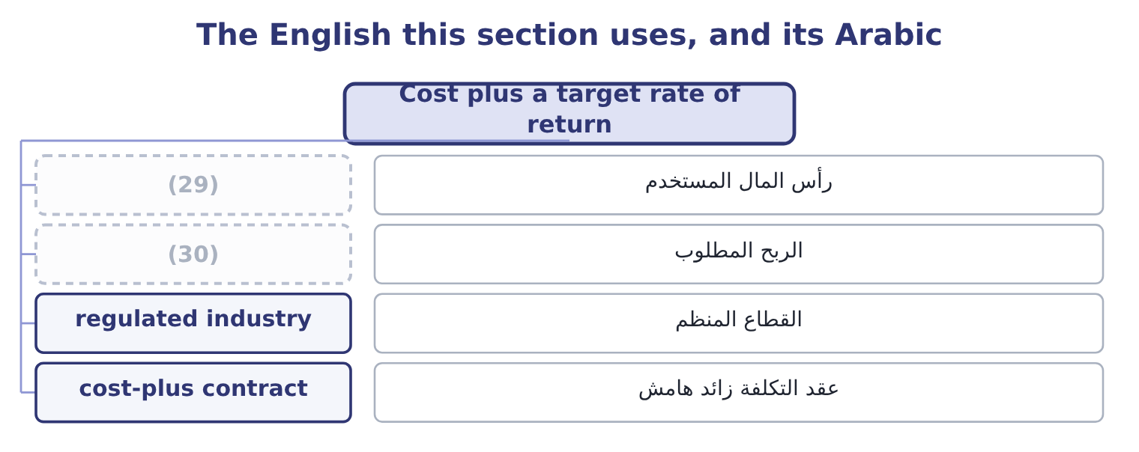
word list
industrial sale · capital employed · required profit

The English this sheet uses, and its Arabic
English (exam term) | Arabic
capital employed | رأس المال المستخدم
required profit | الربح المطلوب
regulated industry | القطاع المنظم
cost-plus contract | عقد التكلفة زائد هامش

Answer key · 10.3 Cost plus a target rate of return

1 product | 16 second
2 Instead | 17 nothing
3 investors | 18 decision
4 spreads | 19 justification
5 average | 20 genuinely
6 powerful | 21 negotiates
7 weaknesses | 22 mechanism
8 providers | 23 precisely
9 deliberate | 24 The return required on capital employed
10 difference | 25 Volume and capital employed
11 intends | 26 12.00 at an 11.01% markup on full cost
12 circularity | 27 Regulated industries, cost-plus contracts
13 itself | 28 The markup has no economic basis
14 through | 29 capital employed
15 receivables | 30 required profit

the summaries in full
Summary 1 Cost plus target rate of return sets the markup so that the company earns a stated return on the capital the product employs. Instead of asking what margin feels right, it asks what profit the investors require and spreads that profit over the units.
Summary 2 Orontes's average total assets are $29,058,800. At a target return of 15 per cent: 29,058,800 × 0.15 = 4,358,820. Over 3,500,000 jars: 4,358,820 ÷ 3,500,000 = 1.25 a jar. Full cost plus that profit: 10.81 + 1.25 = 12.06. The method has one powerful merit and two serious weaknesses, and the exam wants all three. The merit is that it ties the price to the return the providers of capital require, which Book 2's.04 per cent — so a target of 15 per cent is a deliberate premium over the cost of capital, and the difference is the value the company intends to create. The first weakness is the same circularity as before, and worse: the price depends on the volume, and now also on the capital employed, which itself depends on the volume through inventory and receivables.
Summary 3 The second is that it says nothing about whether anyone will pay $12.06. A target return is an input to the pricing decision and never a justification of it. Where the method is genuinely used is in regulated industries — a utility allowed to earn a stated return on its asset base — and in long-term contracts where a customer accepts a cost-plus basis and negotiates the rate of return rather than the price. In both cases the customer agrees to the mechanism in advance, which is precisely what makes it work.

10.4 Pricing from the market
Chapter 10 · section 10.4

Fill every gap. Each word list holds one word more than there are gaps.
Summary 1 gaps 1–12
Market-based (1) reverses the (2) . The price is given by what (3) products fetch, and the (4) task is to be able to make the product for less. Three (5) of a market price appear in (6) . What (7) goods sell for, adjusted for (8) in size, quality, brand and service. This is the (9) case and the (10) case. The competitor's price (11) . In a market with few (12) , each watches the others, and a price change by one is answered by the rest. In an industrial sale, the price ceiling is what the customer would pay for the next best way of solving the same problem — which may be a competitor's product, doing it themselves, or doing nothing. For Orontes, the market price is close to given. Tahini sits on a shelf beside other tahini; the customer compares jars; and Book 1's finding that the gross margin fell from 37.0 to 35.0 per cent while sales grew is exactly what a market-priced product looks like when a company buys share.
word list
sellers · company's · directly · comparable · sources · differences · questions · arithmetic · retail · pricing · similar · circularity · commodity

Who sets the price?
Every item belongs to exactly one group.
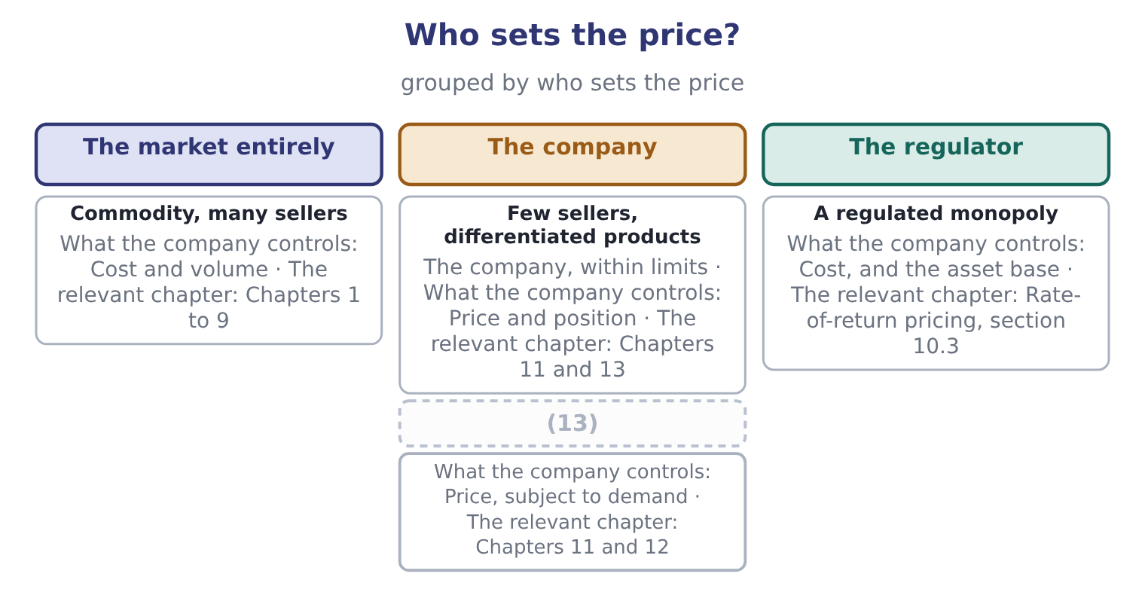
word list
A unique or protected product · Few sellers, differentiated products

Summary 2 gaps 14–22
The (14) question in a market-priced business is (15) not what to (16) but whether to be in the market at the price it offers, and that question is answered with the tools. Take the test at $11.50 a jar. The (17) would be 11.50 − 7.20 = 4.30, the (18) would rise to 12,624,000 ÷ 4.30 = 2,935,814 jars, and the margin of (19) would fall from 24.86 per cent to about 16 per cent. Whether to accept the market’s price is a (20) question, and whether to try to change it is the (21) of the next three (22) .
word list
analytical · chapters · safety · pricing · cost-structure · therefore · breakeven · charge · subject · contribution

A price floor is not a price

Summary 3 gaps 23–28
Neither is a price, and the gap (23) the floor and what the customer will pay is where the (24) is. In a market-priced business, (25) produces a price (26) will pay, and the right use of the cost figure is to decide whether to be in the market at all. A price change by one seller in a (27) market will be answered. Any (28) that assumes competitors do nothing should say so.
word list
exactly · concentrated · profit · nobody · between · cost-plus · calculation

The English this section uses, and its Arabic
Each term sits against what it means.
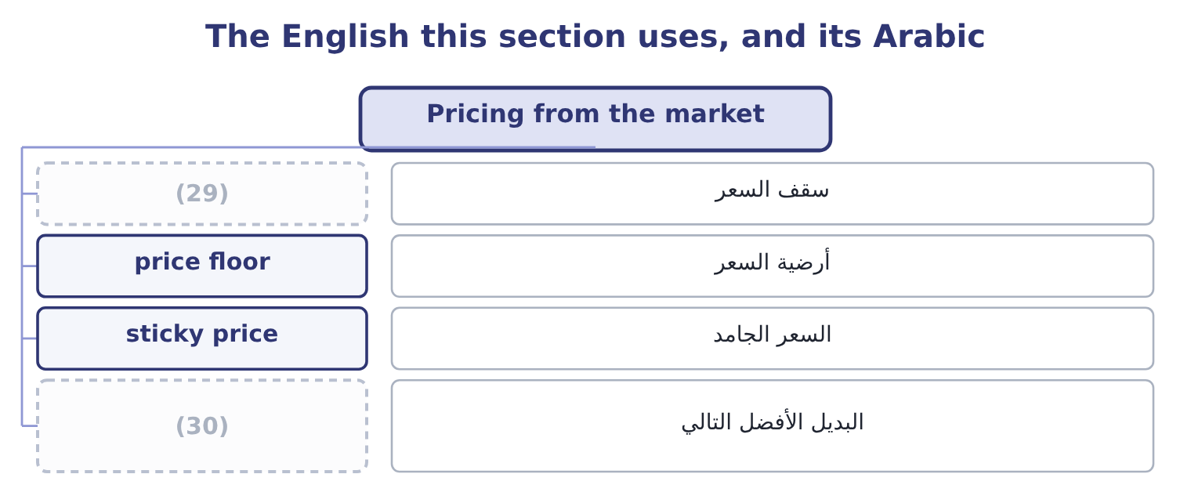
word list
price ceiling · next best alternative · price taker

The English this sheet uses, and its Arabic
English (exam term) | Arabic
price ceiling | سقف السعر
price floor | أرضية السعر
sticky price | السعر الجامد
next best alternative | البديل الأفضل التالي

Answer key · 10.4 Pricing from the market

1 pricing | 16 charge
2 arithmetic | 17 contribution
3 comparable | 18 breakeven
4 company's | 19 safety
5 sources | 20 cost-structure
6 questions | 21 subject
7 similar | 22 chapters
8 differences | 23 between
9 retail | 24 profit
10 commodity | 25 cost-plus
11 directly | 26 nobody
12 sellers | 27 concentrated
13 A unique or protected product | 28 calculation
14 analytical | 29 price ceiling
15 therefore | 30 next best alternative

the summaries in full
Summary 1 Market-based pricing reverses the arithmetic. The price is given by what comparable products fetch, and the company's task is to be able to make the product for less. Three sources of a market price appear in questions. What similar goods sell for, adjusted for differences in size, quality, brand and service. This is the retail case and the commodity case. The competitor's price directly. In a market with few sellers, each watches the others, and a price change by one is answered by the rest. In an industrial sale, the price ceiling is what the customer would pay for the next best way of solving the same problem — which may be a competitor's product, doing it themselves, or doing nothing. For Orontes, the market price is close to given. Tahini sits on a shelf beside other tahini; the customer compares jars; and Book 1's finding that the gross margin fell from 37.0 to 35.0 per cent while sales grew is exactly what a market-priced product looks like when a company buys share.
Summary 2 The analytical question in a market-priced business is therefore not what to charge but whether to be in the market at the price it offers, and that question is answered with the tools. Take the test at $11.50 a jar. The contribution would be 11.50 − 7.20 = 4.30, the breakeven would rise to 12,624,000 ÷ 4.30 = 2,935,814 jars, and the margin of safety would fall from 24.86 per cent to about 16 per cent. Whether to accept the market’s price is a cost-structure question, and whether to try to change it is the subject of the next three chapters.
Summary 3 Neither is a price, and the gap between the floor and what the customer will pay is where the profit is. In a market-priced business, cost-plus produces a price nobody will pay, and the right use of the cost figure is to decide whether to be in the market at all. A price change by one seller in a concentrated market will be answered. Any calculation that assumes competitors do nothing should say so.

10.5 Choosing and defending a price
Chapter 10 · section 10.5

Fill every gap. Each word list holds one word more than there are gaps.
Summary 1 gaps 1–12
Four (1) settle a pricing (2) , and an exam answer that works through them in order will be a good one. What does the product cost, on two bases? The (3) cost, as a floor for a one-off, and the full cost, as the (4) floor. (5) are $7.20 and $10.81. What will the market bear? From comparables, from the (6) price, or from the customer's (7) . For Orontes this is (8) $12.00, and Book 1 shows what (9) when the company tested below it. What return does the company require? The (10) method of section 10.3 (11) the cost of capital into a price, which for Orontes is $12.06 at a 15 per cent target. What will the competitors and the customers do? A price is a move in a game with other (12) , which is.
word list
decision · long-run · around · happened · require · questions · players · target-return · alternative · Orontes's · converts · competitor's · relevant

Summary 2 gaps 13–22
Three further (13) belong in any (14) pricing answer. Price (15) across customers and (16) . A special order at $8.50, a (17) at $9.40 and a shelf price of $12.00 can coexist only while the three markets stay (18) . Pricing below cost to drive out a competitor, agreeing prices with rivals and (19) between customers without (20) are all restricted in most jurisdictions. The (21) a price sends. A low price says cheap as well as (22) , and a price cut in a branded market is read as a statement about quality as well as about cost — which is a further reason Book 1's two points of margin were expensive.
word list
justification · supermarket · serious · separate · consistency · channels · discriminating · competitor · signal · considerations · inexpensive

Price a product four ways

Your turn: cost-based prices (complete the blanks)
Item | Data | Answer
Full cost a unit | (23) | ________
Price at a 25 per cent markup on full cost | Markup 25 per cent on full cost | ________
Markup on variable cost needed to reach that price | Variable cost 18.00 | ________
Margin on price at that price | (24) | ________
Required profit at a 12 per cent return on 9,000,000 of capital |  | ________
Price under cost plus target rate of return | (25) | ________

word list
Full cost and price from the lines above · Required profit spread over 200,000 units · 1,080,000: 9,000,000 × 0.12 = 1,080,000. · Variable 18.00, fixed costs 2,400,000 over 200,000 units

"Markup"

Summary 3 gaps 26–30
English markup is a percentage added to a cost, and margin is a percentage of a price. In (26) speech markup is often used (27) for both, and a (28) who says "I work on fifty per cent" may mean either. An exam answer (29) do the same, in any (30) : write the base beside the percentage.
word list
loosely · one-off · should · retail · shopkeeper · language

"Markup"
Item | Answer
Full cost a unit | 30.00: fixed costs are 2,400,000 ÷ 200,000 = 12.00 a unit, plus variable of 18.00.
Price at a 25 per cent markup on full cost | 37.50: 30.00 × 1.25 = 37.50.
Markup on variable cost needed | 108.33 per cent: the markup is 37.50 − 18.00 = 19.50, and 19.50 ÷ 18.00 = 108.33 per cent.
Margin on price at that price | 52.0 per cent: the contribution is 19.50, and 19.50 ÷ 37.50 = 52.0 per cent.
Required profit at 12 per cent on 9,000,000 | (31)
Price under cost plus target return | (32) : the profit a unit is 1,080,000 ÷ 200,000 = 5.40, plus the full cost of 30.00.
What it tells you | The same product is priced at 37.50 by (33) and 35.40 by the return the capital requires, and the second figure is the one that can be

word list
35.40 · Full cost a unit · 1,080,000: 9,000,000 × 0.12 = 1,080,000. · convention

The English this section uses, and its Arabic
Each term sits against what it means.
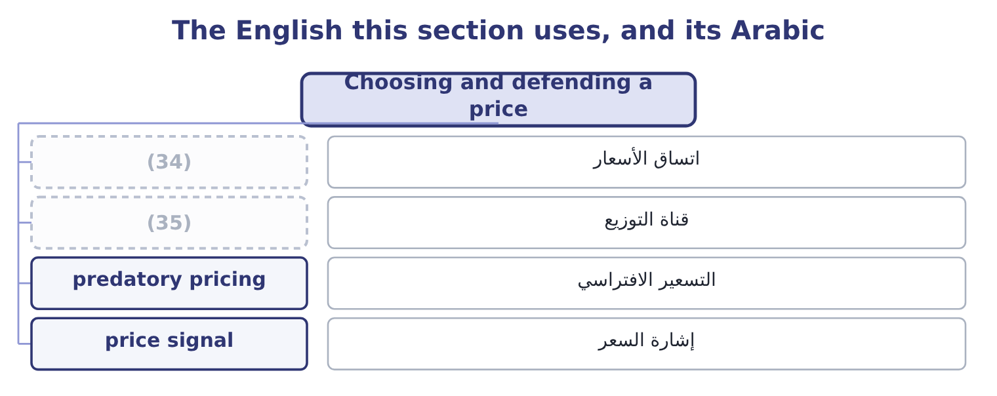
word list
channel · price consistency · circularity

The English this sheet uses, and its Arabic
English (exam term) | Arabic
price consistency | اتساق الأسعار
channel | قناة التوزيع
predatory pricing | التسعير الافتراسي
price signal | إشارة السعر

Answer key · 10.5 Choosing and defending a price

1 questions | 19 discriminating
2 decision | 20 justification
3 relevant | 21 signal
4 long-run | 22 inexpensive
5 Orontes's | 23 Variable 18.00, fixed costs 2,400,000 over 200,000 units
6 competitor's | 24 Full cost and price from the lines above
7 alternative | 25 Required profit spread over 200,000 units
8 around | 26 retail
9 happened | 27 loosely
10 target-return | 28 shopkeeper
11 converts | 29 should
12 players | 30 language
13 considerations | 31 1,080,000: 9,000,000 × 0.12 = 1,080,000.
14 serious | 32 35.40
15 consistency | 33 convention
16 channels | 34 price consistency
17 supermarket | 35 channel
18 separate

the summaries in full
Summary 1 Four questions settle a pricing decision, and an exam answer that works through them in order will be a good one. What does the product cost, on two bases? The relevant cost, as a floor for a one-off, and the full cost, as the long-run floor. Orontes's are $7.20 and $10.81. What will the market bear? From comparables, from the competitor's price, or from the customer's alternative. For Orontes this is around $12.00, and Book 1 shows what happened when the company tested below it. What return does the company require? The target-return method of section 10.3 converts the cost of capital into a price, which for Orontes is $12.06 at a 15 per cent target. What will the competitors and the customers do? A price is a move in a game with other players, which is.
Summary 2 Three further considerations belong in any serious pricing answer. Price consistency across customers and channels. A special order at $8.50, a supermarket at $9.40 and a shelf price of $12.00 can coexist only while the three markets stay separate. Pricing below cost to drive out a competitor, agreeing prices with rivals and discriminating between customers without justification are all restricted in most jurisdictions. The signal a price sends. A low price says cheap as well as inexpensive, and a price cut in a branded market is read as a statement about quality as well as about cost — which is a further reason Book 1's two points of margin were expensive.
Summary 3 English markup is a percentage added to a cost, and margin is a percentage of a price. In retail speech markup is often used loosely for both, and a shopkeeper who says "I work on fifty per cent" may mean either. An exam answer should do the same, in any language: write the base beside the percentage.

