11.1 Demand, supply and the price between them
Chapter 11 · section 11.1

Fill every gap. Each word list holds one word more than there are gaps.
Chapter 11, section by section
Each stage leads to the next.
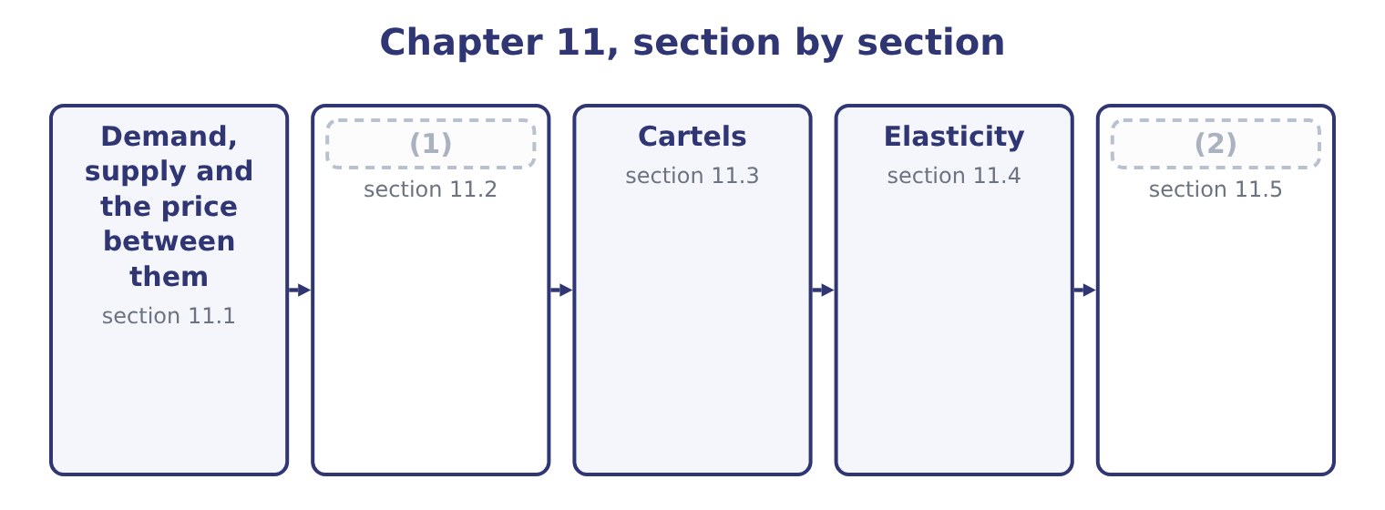
word list
short run and long run · Four market structures · Estimating revenue from a price change

Summary 1 gaps 3–14
A demand curve shows the quantity buyers will take at each price, and it slopes (3) : lower prices bring more buyers and more (4) from each. A supply curve shows the quantity sellers will offer at each price, and it slopes (5) : higher prices make (6) worthwhile for more sellers and for more output from each. The price at which the two (7) are equal is the equilibrium price, and it is where a competitive market (8) . Above it there are (9) goods and the price falls; below it there are (10) buyers and the price rises. The outcome asks what moves each curve, and the exam (11) two things (12) . A (13) along a curve is a response to a change in the price of the good (14) . Nothing has shifted; the market is reading off a different point.
word list
unsold · distinguishes · inelastic · production · upward · carefully · itself · settles · downward · movement · quantities · purchases · unsatisfied

Summary 2 gaps 15–25
A shift of the whole curve is a response to a change in (15) else. Demand shifts with incomes, with the prices of substitutes and complements, with tastes, with the number of buyers and with expectations. Supply shifts with input costs, technology, the number of sellers, taxes and (16) , and expectations. For Orontes, the (17) readings are (18) . A rise in the price of a (19) spread shifts the demand for (20) to the right, because the two are substitutes. A rise in the price of bread, which is eaten with it, shifts demand to the left, because the two are complements. A fall in the (21) price shifts supply to the right, (22) the equilibrium price for (23) — which is why a cost (24) in a competitive market is often competed away (25) than kept.
word list
sesame · lowering · something · technology · practical · rather · tahini · everybody · competing · saving · immediate · subsidies

What moves demand and supply
Curve | Moves right when | Moves left when
Demand | Incomes rise; a (26) 's price rises; tastes favour the product; more buyers | Incomes fall; a complement's price rises; tastes move away
Supply | Input costs fall; technology improves; more sellers; a subsidy | (27)

word list
interdependence · substitute · Input costs rise; sellers leave; a tax is imposed

The English this section uses, and its Arabic
Each term sits against what it means.
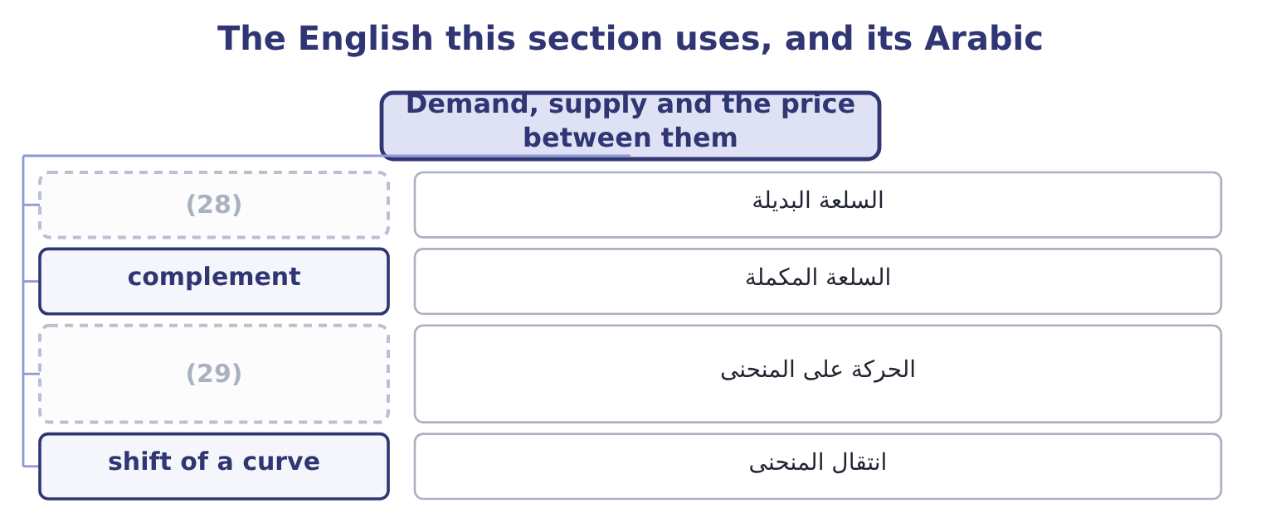
word list
substitute · movement along a curve · supply curve

The English this sheet uses, and its Arabic
English (exam term) | Arabic
substitute | السلعة البديلة
complement | السلعة المكملة
movement along a curve | الحركة على المنحنى
shift of a curve | انتقال المنحنى

Answer key · 11.1 Demand, supply and the price between them

1 Four market structures | 16 subsidies
2 Estimating revenue from a price change | 17 practical
3 downward | 18 immediate
4 purchases | 19 competing
5 upward | 20 tahini
6 production | 21 sesame
7 quantities | 22 lowering
8 settles | 23 everybody
9 unsold | 24 saving
10 unsatisfied | 25 rather
11 distinguishes | 26 substitute
12 carefully | 27 Input costs rise; sellers leave; a tax is imposed
13 movement | 28 substitute
14 itself | 29 movement along a curve
15 something

the summaries in full
Summary 1 A demand curve shows the quantity buyers will take at each price, and it slopes downward: lower prices bring more buyers and more purchases from each. A supply curve shows the quantity sellers will offer at each price, and it slopes upward: higher prices make production worthwhile for more sellers and for more output from each. The price at which the two quantities are equal is the equilibrium price, and it is where a competitive market settles. Above it there are unsold goods and the price falls; below it there are unsatisfied buyers and the price rises. The outcome asks what moves each curve, and the exam distinguishes two things carefully. A movement along a curve is a response to a change in the price of the good itself. Nothing has shifted; the market is reading off a different point.
Summary 2 A shift of the whole curve is a response to a change in something else. Demand shifts with incomes, with the prices of substitutes and complements, with tastes, with the number of buyers and with expectations. Supply shifts with input costs, technology, the number of sellers, taxes and subsidies, and expectations. For Orontes, the practical readings are immediate. A rise in the price of a competing spread shifts the demand for tahini to the right, because the two are substitutes. A rise in the price of bread, which is eaten with it, shifts demand to the left, because the two are complements. A fall in the sesame price shifts supply to the right, lowering the equilibrium price for everybody — which is why a cost saving in a competitive market is often competed away rather than kept.

11.2 Four market structures
Chapter 11 · section 11.2

Fill every gap. Each word list holds one word more than there are gaps.
Summary 1 gaps 1–11
How much (1) a company has to set its own price (2) on the structure of its market, and the (3) names four. Many small sellers, an identical product, free entry and exit, and buyers who know the prices. No seller can charge more than the market price, because buyers would simply go (4) , and none needs to charge less, because each can sell all it wants at the market price. The company is a price taker: its demand curve is (5) at the market price, so price equals marginal revenue, and in the short run it (6) where marginal cost equals that price. Profits above the normal level attract (7) , which pushes the price down until only a normal return (8) . (9) commodities are the usual example. Many sellers, but a differentiated product — by brand, recipe, (10) , service or (11) .
word list
freedom · extrapolation · location · horizontal · entrants · Agricultural · outcome · remains · elsewhere · depends · produces · packaging

Summary 2 gaps 12–23
Each seller has a (12) pricing power, because its product is not quite the same as the others, and its demand curve slopes gently (13) . It can raise the price without losing every (14) , and it loses some. Entry is free, so (15) profits are competed away in the long run, usually by rivals imitating the (16) . (17) food is the (18) example, and it is where Orontes sits. Few sellers, each large enough that its (19) affect the others. The (20) feature is (21) : a price change by one will be answered, so each seller must consider the response before moving. Prices are often sticky, because a cut will be (22) — losing margin without gaining share — while a rise may not be (23) , losing share without gaining margin. Competition shifts into advertising, quality and product variety, where responses are slower.
word list
Branded · interdependence · actions · little · followed · advertising · matched · downward · standard · differentiation · defining · economic · customer

Summary 3 gaps 24–32
Supermarkets, (24) and mobile (25) are examples. One seller of a product with no close substitutes, (26) by a barrier — a patent, a (27) , control of a (28) , or an economy of scale so large that a second entrant could not survive. The (29) faces the whole market demand curve and chooses the point on it that (30) profit, producing where marginal revenue equals marginal cost and (31) what the curve will bear at that quantity. Because marginal revenue is below price, the monopoly price is above the (32) one and the quantity is lower, which is why monopolies are regulated.
word list
resource · competitive · protected · maximises · charging · downward · monopolist · operators · licence · airlines

Four structures, four degrees of pricing power
Structure | Sellers | Product | Pricing power | Short-run price set where
Pure competition | Very many | Identical | (33) | Marginal cost equals the market price
Monopolistic competition | Many | Differentiated | (34) | Marginal revenue equals marginal cost
Oligopoly | Few | (35) | Considerable, limited by rivals' responses | (36)
Monopoly | One | No close substitute | (37) | Marginal revenue equals marginal cost

word list
Some, limited by close substitutes · Interdependently; prices often sticky · Greatest, limited by demand and regulation · None; a price taker · Either · interdependence

Summary 4 gaps 38–41
The rule that (38) the last three is: (39) while marginal revenue (40) marginal cost, and stop where they are equal. Only in pure competition does that (41) into producing where marginal cost equals the price, because only there is marginal revenue equal to price.
word list
collapse · exceeds · unites · produce · monopolies

The English this section uses, and its Arabic
Each term sits against what it means.
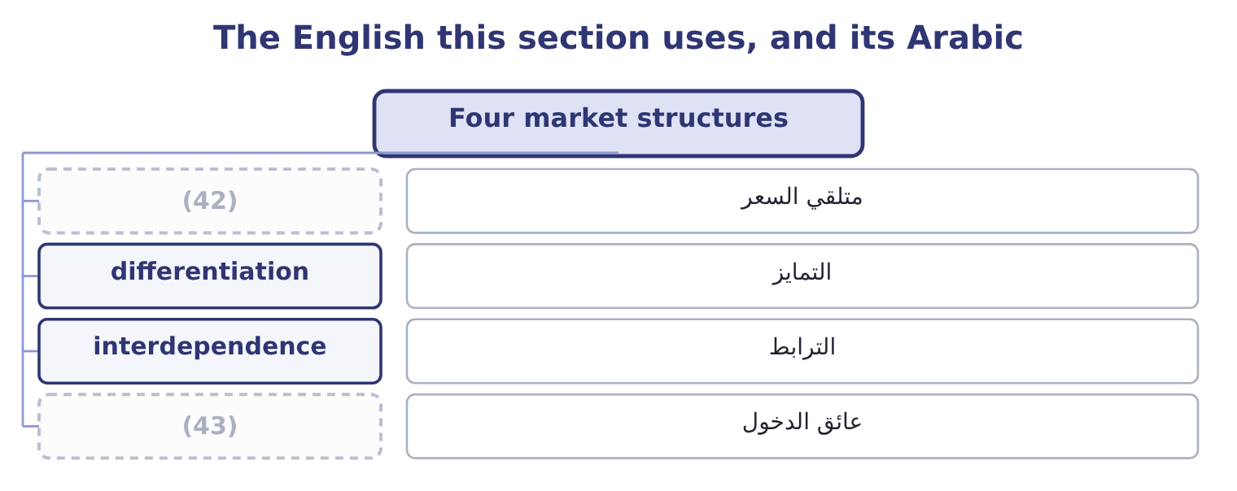
word list
midpoint formula · price taker · barrier to entry

The English this sheet uses, and its Arabic
English (exam term) | Arabic
price taker | متلقي السعر
differentiation | التمايز
interdependence | الترابط
barrier to entry | عائق الدخول

Answer key · 11.2 Four market structures

1 freedom | 23 followed
2 depends | 24 airlines
3 outcome | 25 operators
4 elsewhere | 26 protected
5 horizontal | 27 licence
6 produces | 28 resource
7 entrants | 29 monopolist
8 remains | 30 maximises
9 Agricultural | 31 charging
10 packaging | 32 competitive
11 location | 33 None; a price taker
12 little | 34 Some, limited by close substitutes
13 downward | 35 Either
14 customer | 36 Interdependently; prices often sticky
15 economic | 37 Greatest, limited by demand and regulation
16 differentiation | 38 unites
17 Branded | 39 produce
18 standard | 40 exceeds
19 actions | 41 collapse
20 defining | 42 price taker
21 interdependence | 43 barrier to entry
22 matched

the summaries in full
Summary 1 How much freedom a company has to set its own price depends on the structure of its market, and the outcome names four. Many small sellers, an identical product, free entry and exit, and buyers who know the prices. No seller can charge more than the market price, because buyers would simply go elsewhere, and none needs to charge less, because each can sell all it wants at the market price. The company is a price taker: its demand curve is horizontal at the market price, so price equals marginal revenue, and in the short run it produces where marginal cost equals that price. Profits above the normal level attract entrants, which pushes the price down until only a normal return remains. Agricultural commodities are the usual example. Many sellers, but a differentiated product — by brand, recipe, packaging, service or location.
Summary 2 Each seller has a little pricing power, because its product is not quite the same as the others, and its demand curve slopes gently downward. It can raise the price without losing every customer, and it loses some. Entry is free, so economic profits are competed away in the long run, usually by rivals imitating the differentiation. Branded food is the standard example, and it is where Orontes sits. Few sellers, each large enough that its actions affect the others. The defining feature is interdependence: a price change by one will be answered, so each seller must consider the response before moving. Prices are often sticky, because a cut will be matched — losing margin without gaining share — while a rise may not be followed, losing share without gaining margin. Competition shifts into advertising, quality and product variety, where responses are slower.
Summary 3 Supermarkets, airlines and mobile operators are examples. One seller of a product with no close substitutes, protected by a barrier — a patent, a licence, control of a resource, or an economy of scale so large that a second entrant could not survive. The monopolist faces the whole market demand curve and chooses the point on it that maximises profit, producing where marginal revenue equals marginal cost and charging what the curve will bear at that quantity. Because marginal revenue is below price, the monopoly price is above the competitive one and the quantity is lower, which is why monopolies are regulated.
Summary 4 The rule that unites the last three is: produce while marginal revenue exceeds marginal cost, and stop where they are equal. Only in pure competition does that collapse into producing where marginal cost equals the price, because only there is marginal revenue equal to price.

11.3 Cartels
Chapter 11 · section 11.3

Fill every gap. Each word list holds one word more than there are gaps.
Summary 1 gaps 1–12
A (1) is an agreement among (2) to act as if they were one. Members agree a price, or divide the market by quantity or (3) , or both, and the effect is to convert (4) into a shared monopoly: the price rises towards the monopoly price, the quantity falls, and the profits are divided among the members. Three (5) of cartels are (6) . They raise prices above the (7) level. That is their purpose, and it is why the (8) is a criminal offence in most (9) when practised by private companies. The exam's (10) example, the oil producers' (11) , is an agreement between states rather than companies and sits outside those laws. Each member gains by cheating: with the price held up by the others, an individual seller who quietly shades its price or exceeds its (12) sells more at a high price.
word list
consider · sellers · jurisdictions · examinable · cartel · quota · arrangement · territory · features · organisation · competition · textbook · competitive

Summary 2 gaps 13–24
Since every member faces that (13) , cartels require (14) and punishment to survive, and most collapse — through cheating, through entry by outsiders attracted by the high price, or through a fall in demand that makes the agreed quotas (15) . They are (16) by their effects. Prices that move together without a common cost cause, bids that rotate among suppliers, identical (17) , and prices that are sticky upwards and never downwards are the classic signals, and a (18) accountant who sees them in a supplier market has a reporting (19) to consider. Tacit (20) is the version without an agreement: firms in a concentrated market may arrive at similar prices simply by (21) each other, with no (22) at all. It is harder to (23) and produces similar effects, which is one reason (24) scrutinise concentrated markets even where no agreement can be shown.
word list
extrapolation · collusion · unbearable · obligation · management · regulators · detectable · communication · prosecute · monitoring · incentive · quotations · watching

What a cartel does
Every item belongs to exactly one group.
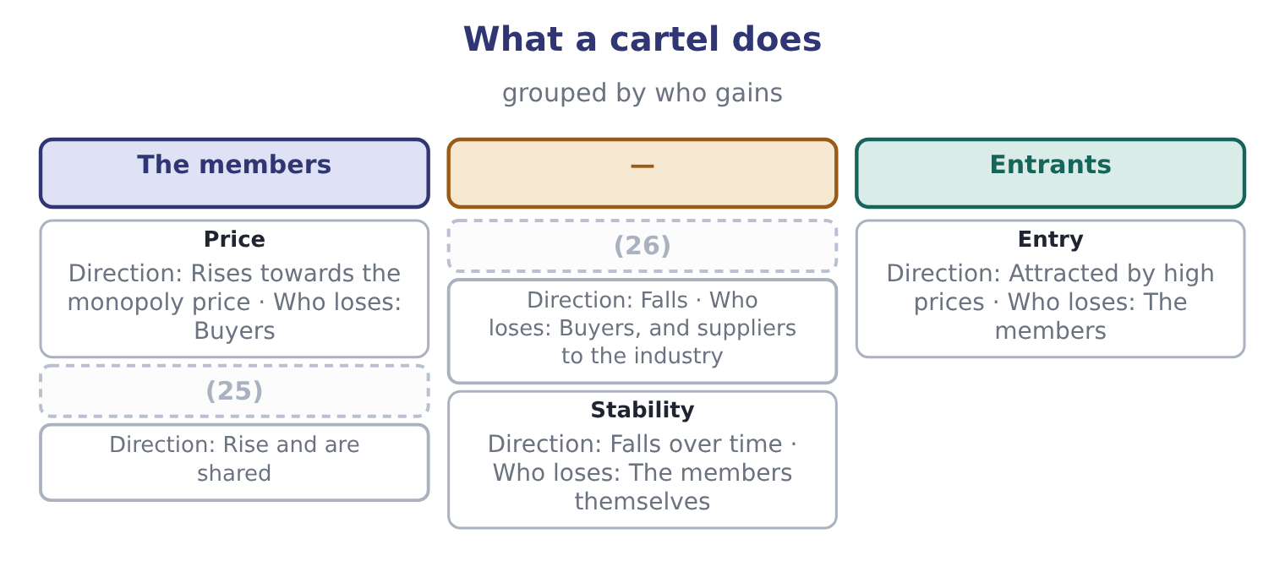
word list
collusion · Quantity · Profits

The English this section uses, and its Arabic
Each term sits against what it means.
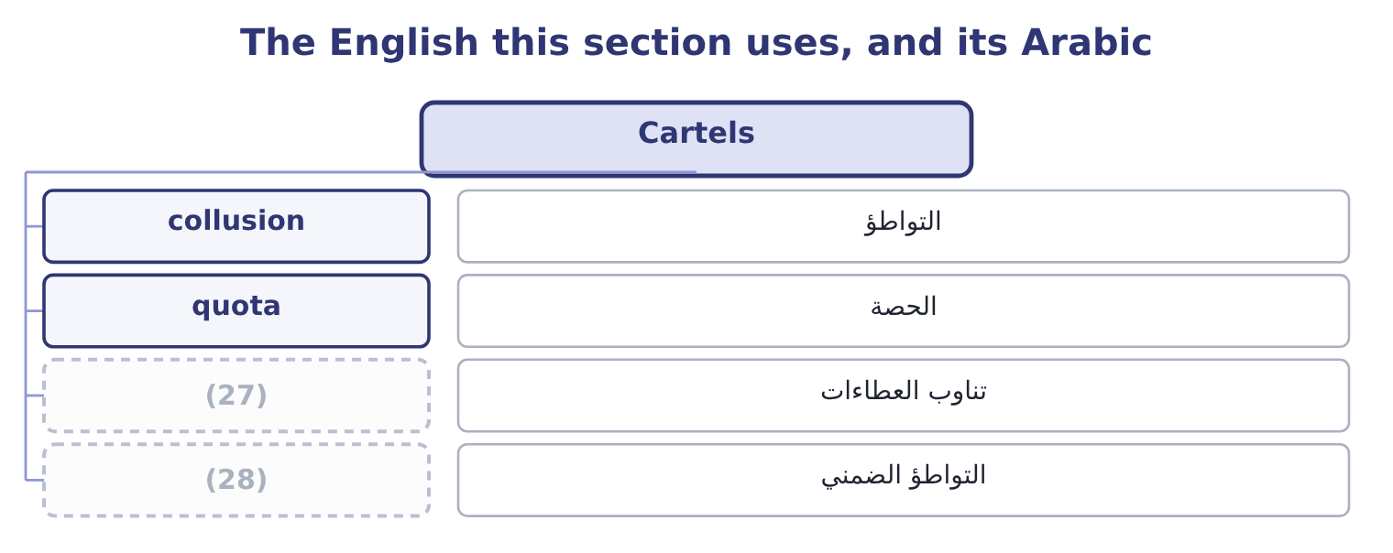
word list
bid rotation · tacit collusion · تناوب العطاءات

The English this sheet uses, and its Arabic
English (exam term) | Arabic
collusion | التواطؤ
quota | الحصة
bid rotation | تناوب العطاءات
tacit collusion | التواطؤ الضمني

Answer key · 11.3 Cartels

1 cartel | 15 unbearable
2 sellers | 16 detectable
3 territory | 17 quotations
4 competition | 18 management
5 features | 19 obligation
6 examinable | 20 collusion
7 competitive | 21 watching
8 arrangement | 22 communication
9 jurisdictions | 23 prosecute
10 textbook | 24 regulators
11 organisation | 25 Profits
12 quota | 26 Quantity
13 incentive | 27 bid rotation
14 monitoring | 28 tacit collusion

the summaries in full
Summary 1 A cartel is an agreement among sellers to act as if they were one. Members agree a price, or divide the market by quantity or territory, or both, and the effect is to convert competition into a shared monopoly: the price rises towards the monopoly price, the quantity falls, and the profits are divided among the members. Three features of cartels are examinable. They raise prices above the competitive level. That is their purpose, and it is why the arrangement is a criminal offence in most jurisdictions when practised by private companies. The exam's textbook example, the oil producers' organisation, is an agreement between states rather than companies and sits outside those laws. Each member gains by cheating: with the price held up by the others, an individual seller who quietly shades its price or exceeds its quota sells more at a high price.
Summary 2 Since every member faces that incentive, cartels require monitoring and punishment to survive, and most collapse — through cheating, through entry by outsiders attracted by the high price, or through a fall in demand that makes the agreed quotas unbearable. They are detectable by their effects. Prices that move together without a common cost cause, bids that rotate among suppliers, identical quotations, and prices that are sticky upwards and never downwards are the classic signals, and a management accountant who sees them in a supplier market has a reporting obligation to consider. Tacit collusion is the version without an agreement: firms in a concentrated market may arrive at similar prices simply by watching each other, with no communication at all. It is harder to prosecute and produces similar effects, which is one reason regulators scrutinise concentrated markets even where no agreement can be shown.

11.4 Elasticity
Chapter 11 · section 11.4

Fill every gap. Each word list holds one word more than there are gaps.
Summary 1 gaps 1–8
Price elasticity of demand (1) how much the quantity (2) responds to a change in price. It is the percentage change in quantity divided by the percentage change in price, and because the two move in opposite directions the result is (3) — so it is (4) quoted as a positive number and the exam does the same. The midpoint formula avoids an awkward feature of the simple (5) : the answer differs (6) on which end you start. It solves this by (7) each change by the average of the two values rather than by the (8) value.
word list
negative · oligopoly · starting · depending · dividing · calculation · demanded · conventionally · measures

Worked example: the elasticity of Orontes's demand

Summary 2 gaps 9–10
At $12.00 the company sells 3,500,000 jars; at $11.50 it would sell 3,800,000. The percentage change in quantity. The change is 300,000 and the average quantity is 3,650,000, so the percentage change is 300,000 ÷ 3,650,000 = 8.22 per cent. The percentage change in price. The change is 0.50 and the average price is 11.75, so the percentage change is 0.50 ÷ 11.75 = 4.26 per cent. An elasticity above 1 means demand is elastic: quantity responds more than (9) , so the price cut raises total revenue. And it does: 11.50 × 3,800,000 = 43,700,000 (10) $42,000,000. But, because contribution falls to 3,800,000 × 4.30 = 16,340,000 from $16,800,000 — a loss of 460,000. Elasticity tells you what happens to revenue. Only the contribution margin tells you what happens to profit, and the two can point in opposite directions, as they do here.
word list
starting · proportionately · against

Summary 3 gaps 11–17
The (11) is fixed and the exam uses it (12) . Elastic demand has an elasticity above 1. Quantity responds more than price, so a price cut raises total revenue and a price rise lowers it. Products with many substitutes, products that take a large share of a (13) budget, and luxuries tend to be elastic, and demand is more elastic over a long (14) than a short one, because buyers have time to find (15) . Inelastic demand has an elasticity below 1. Quantity responds less than price, so a price rise raises total revenue. Necessities, products with no close substitutes, products that are a small part of a budget, and (16) goods tend to be inelastic. Unitary elasticity is (17) 1, where total revenue does not change at all.
word list
alternatives · buyer's · period · precisely · differentiation · vocabulary · addictive · exactly

Elasticity and total revenue
Elasticity | Demand is | A price rise | A price cut | Typical products
Above 1 | Elastic | Lowers total revenue | Raises total revenue | (18)
Equal to 1 | Unitary | Leaves revenue unchanged | Leaves revenue unchanged | (19)
Below 1 | Inelastic | Raises total revenue | (20) | Necessities, few substitutes

word list
barrier to entry · The boundary case · Lowers total revenue · Luxuries, many substitutes

Revenue is not profit

Summary 4 gaps 21–28
An elastic demand means a price cut raises revenue. (21) it raises profit depends on the contribution margin, and Orontes is the (22) example of a cut that does one and not the other. Use the midpoint formula (23) the question says so, and say which formula you used when it does not. The simple formula gives a (24) answer in each (25) . Elasticity is not a (26) of a product for ever. It differs between the short run and the long run, between one price range and (27) on the same curve, and between (28) .
word list
standing · property · Whether · different · markets · complement · whenever · another · direction

The English this section uses, and its Arabic
Each term sits against what it means.
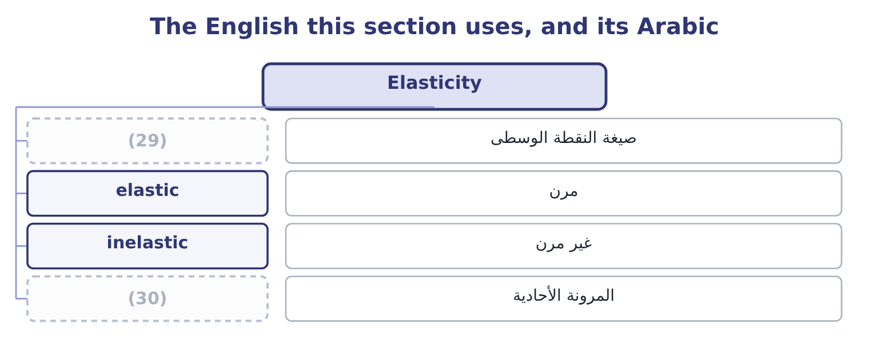
word list
pure competition · unitary elasticity · midpoint formula

The English this sheet uses, and its Arabic
English (exam term) | Arabic
midpoint formula | صيغة النقطة الوسطى
elastic | مرن
inelastic | غير مرن
unitary elasticity | المرونة الأحادية

Answer key · 11.4 Elasticity

1 measures | 16 addictive
2 demanded | 17 exactly
3 negative | 18 Luxuries, many substitutes
4 conventionally | 19 The boundary case
5 calculation | 20 Lowers total revenue
6 depending | 21 Whether
7 dividing | 22 standing
8 starting | 23 whenever
9 proportionately | 24 different
10 against | 25 direction
11 vocabulary | 26 property
12 precisely | 27 another
13 buyer's | 28 markets
14 period | 29 midpoint formula
15 alternatives | 30 unitary elasticity

the summaries in full
Summary 1 Price elasticity of demand measures how much the quantity demanded responds to a change in price. It is the percentage change in quantity divided by the percentage change in price, and because the two move in opposite directions the result is negative — so it is conventionally quoted as a positive number and the exam does the same. The midpoint formula avoids an awkward feature of the simple calculation: the answer differs depending on which end you start. It solves this by dividing each change by the average of the two values rather than by the starting value.
Summary 2 At $12.00 the company sells 3,500,000 jars; at $11.50 it would sell 3,800,000. The percentage change in quantity. The change is 300,000 and the average quantity is 3,650,000, so the percentage change is 300,000 ÷ 3,650,000 = 8.22 per cent. The percentage change in price. The change is 0.50 and the average price is 11.75, so the percentage change is 0.50 ÷ 11.75 = 4.26 per cent. An elasticity above 1 means demand is elastic: quantity responds more than proportionately, so the price cut raises total revenue. And it does: 11.50 × 3,800,000 = 43,700,000 against $42,000,000. But, because contribution falls to 3,800,000 × 4.30 = 16,340,000 from $16,800,000 — a loss of 460,000. Elasticity tells you what happens to revenue. Only the contribution margin tells you what happens to profit, and the two can point in opposite directions, as they do here.
Summary 3 The vocabulary is fixed and the exam uses it precisely. Elastic demand has an elasticity above 1. Quantity responds more than price, so a price cut raises total revenue and a price rise lowers it. Products with many substitutes, products that take a large share of a buyer's budget, and luxuries tend to be elastic, and demand is more elastic over a long period than a short one, because buyers have time to find alternatives. Inelastic demand has an elasticity below 1. Quantity responds less than price, so a price rise raises total revenue. Necessities, products with no close substitutes, products that are a small part of a budget, and addictive goods tend to be inelastic. Unitary elasticity is exactly 1, where total revenue does not change at all.
Summary 4 An elastic demand means a price cut raises revenue. Whether it raises profit depends on the contribution margin, and Orontes is the standing example of a cut that does one and not the other. Use the midpoint formula whenever the question says so, and say which formula you used when it does not. The simple formula gives a different answer in each direction. Elasticity is not a property of a product for ever. It differs between the short run and the long run, between one price range and another on the same curve, and between markets.

11.5 Estimating revenue from a price change
Chapter 11 · section 11.5

Fill every gap. Each word list holds one word more than there are gaps.
Summary 1 gaps 1–5
The last (1) asks for a revenue estimate given a price change and an elasticity, which is the (2) run in reverse. The (3) is three steps. Multiply the percentage change in price by the elasticity to get the percentage change in quantity, in the opposite (4) . Apply that to the (5) quantity. Multiply the new quantity by the new price.
word list
method · calculation · current · consider · outcome · direction

Worked example: a price rise in an inelastic market

Summary 2 gaps 6–14
Orontes (6) the jar by 5 per cent, from $12.00 to $12.60. Market (7) puts the elasticity of its (8) demand at about 0.41 — inelastic, because loyal buyers have no exact (9) . Volume falls about 2 per cent, from 3,500,000 to 3,430,000 jars. The profit effect, which is the point. The contribution margin (10) 12.60 − 7.20 = 5.40, so contribution is 3,430,000 × 5.40 = 18,522,000 against $16,800,000 — a gain of 1,722,000, or 41 per cent of the (11) operating income. (12) this with the price cut of section 11.4, which raised revenue by $1,700,000 and cut profit by $460,000. The two moves are (13) mirror images in revenue and opposite in profit, and the (14) is the contribution margin: at 40 per cent, Orontes loses $4.80 on every jar it does not sell and gains only the price change on every jar it does.
word list
company's · becomes · substitute · branded · raises · reason · warning · research · almost · Compare

Summary 3 gaps 15–26
A company with a high contribution margin should be slow to cut price and quick to (15) raising it, which is the (16) behind the warning Book 1 issued. Three (17) close the chapter, and an exam answer should carry at least one. An elasticity is an estimate, (18) from a narrow range of prices and a (19) period. (20) it to a large price change (21) beyond the evidence. It holds other things equal, and (22) are not other things. In the (23) of section 11.2, a price rise that rivals do not follow has a far higher (24) elasticity than one they match. And the long run (25) from the short. A price rise that loses 2 per cent of volume this year may lose far more over three years as buyers find (26) and rivals position against it — which is the mirror of Book 1's point that a price concession is permanent in a way a volume gain is not.
word list
cautions · consider · Applying · against · alternatives · extrapolates · differs · competitors · particular · usually · oligopoly · effective · arithmetic

Measure and forecast

Your turn: elasticity and revenue (complete the blanks)
Item | Data | Answer
Percentage change in quantity | 40,000 units rising to 44,000 | ________
Percentage change in price | (27) | ________
Elasticity, midpoint |  | ________
Elastic or inelastic? |  | ________
Effect on total revenue |  | ________
New revenue if a 4 per cent price rise meets an elasticity of 0.60, from a base of 50,000 units at 20.00 |  | ________

word list
price elasticity of demand · 20.00 falling to 19.00

"Elastic"

Summary 4 gaps 28–34
English elastic in economics means (28) , and the metaphor is of (29) that stretches a long way when (30) . The everyday sense of flexible or (31) is close enough to be (32) : an elastic demand is not a (33) one, it is a demand that punishes a price rise severely. Note the companion trap in all three languages: inelastic does not mean rigid in the sense of unchanging — an inelastic demand still falls when the price rises, just less than (34) .
word list
consider · something · accommodating · pulled · responsive · forgiving · misleading · proportionately

The same company, two price moves
 | Price cut to 11.50 | Price rise to 12.60
(35) | 1.93 | 0.41
Volume | 3,800,000 | 3,430,000
Total revenue | 43,700,000 | 43,218,000
(36) | 4.30 | 5.40
Total contribution | 16,340,000 | 18,522,000
Change in operating income | (460,000) | 1,722,000

word list
Elasticity assumed · other things equal · Contribution margin a jar

Item — Answer
Item | Answer
Percentage change in quantity | 9.52 per cent: the change is 4,000 and the average quantity is 42,000, so 4,000 ÷ 42,000 = 9.52 per cent.
Percentage change in price | 5.13 per cent: the change is 1.00 and the average price is 19.50, so 1.00 ÷ 19.50 = 5.13 per cent.
Elasticity, midpoint | (37)
Elastic or inelastic? | Elastic, because the figure exceeds 1.
Effect on total revenue | (38) : 19.00 × 44,000 = 836,000 against 20.00 × 40,000 = 800,000.
New revenue after a 4 per cent price rise at an elasticity of 0.60 | 1,015,040: quantity falls 2.4 per cent to 48,800 and the price rises to 20.80, so 20.80 × 48,800 = 1,015,040 against 1,000,000 before.
What it tells you | The same product is elastic in one range and assumed inelastic in another, which is the ordinary state of affairs: elasticity is a local mea

word list
Revenue rises · equilibrium price · 1.86: 9.52 ÷ 5.13 = 1.86.

The English this section uses, and its Arabic
Each term sits against what it means.
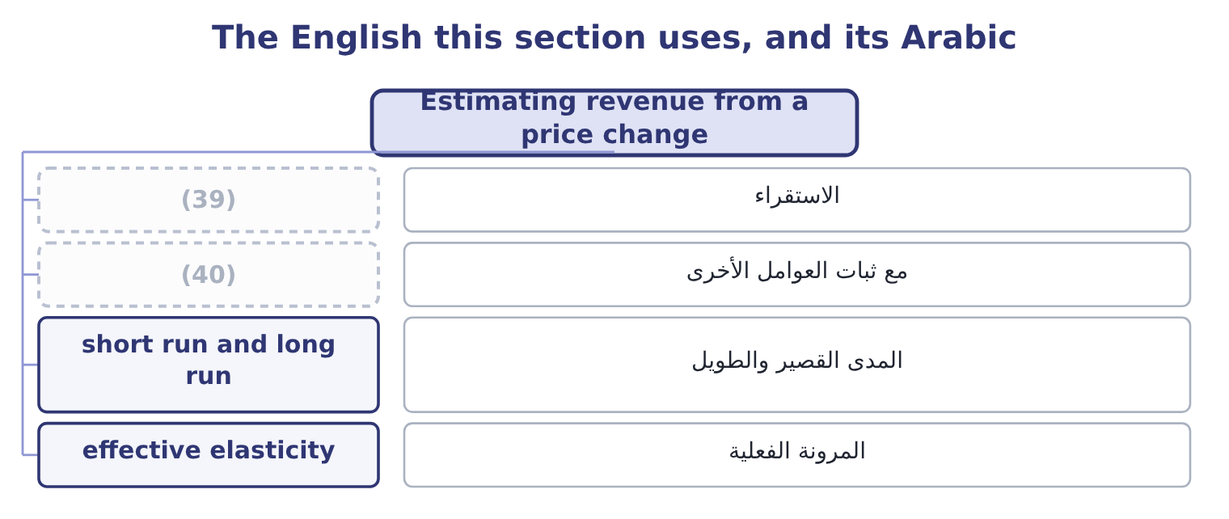
word list
monopolistic competition · other things equal · extrapolation

The English this sheet uses, and its Arabic
English (exam term) | Arabic
extrapolation | الاستقراء
other things equal | مع ثبات العوامل الأخرى
short run and long run | المدى القصير والطويل
effective elasticity | المرونة الفعلية

Answer key · 11.5 Estimating revenue from a price change

1 outcome | 21 extrapolates
2 calculation | 22 competitors
3 method | 23 oligopoly
4 direction | 24 effective
5 current | 25 differs
6 raises | 26 alternatives
7 research | 27 20.00 falling to 19.00
8 branded | 28 responsive
9 substitute | 29 something
10 becomes | 30 pulled
11 company's | 31 accommodating
12 Compare | 32 misleading
13 almost | 33 forgiving
14 reason | 34 proportionately
15 consider | 35 Elasticity assumed
16 arithmetic | 36 Contribution margin a jar
17 cautions | 37 1.86: 9.52 ÷ 5.13 = 1.86.
18 usually | 38 Revenue rises
19 particular | 39 extrapolation
20 Applying | 40 other things equal

the summaries in full
Summary 1 The last outcome asks for a revenue estimate given a price change and an elasticity, which is the calculation run in reverse. The method is three steps. Multiply the percentage change in price by the elasticity to get the percentage change in quantity, in the opposite direction. Apply that to the current quantity. Multiply the new quantity by the new price.
Summary 2 Orontes raises the jar by 5 per cent, from $12.00 to $12.60. Market research puts the elasticity of its branded demand at about 0.41 — inelastic, because loyal buyers have no exact substitute. Volume falls about 2 per cent, from 3,500,000 to 3,430,000 jars. The profit effect, which is the point. The contribution margin becomes 12.60 − 7.20 = 5.40, so contribution is 3,430,000 × 5.40 = 18,522,000 against $16,800,000 — a gain of 1,722,000, or 41 per cent of the company's operating income. Compare this with the price cut of section 11.4, which raised revenue by $1,700,000 and cut profit by $460,000. The two moves are almost mirror images in revenue and opposite in profit, and the reason is the contribution margin: at 40 per cent, Orontes loses $4.80 on every jar it does not sell and gains only the price change on every jar it does.
Summary 3 A company with a high contribution margin should be slow to cut price and quick to consider raising it, which is the arithmetic behind the warning Book 1 issued. Three cautions close the chapter, and an exam answer should carry at least one. An elasticity is an estimate, usually from a narrow range of prices and a particular period. Applying it to a large price change extrapolates beyond the evidence. It holds other things equal, and competitors are not other things. In the oligopoly of section 11.2, a price rise that rivals do not follow has a far higher effective elasticity than one they match. And the long run differs from the short. A price rise that loses 2 per cent of volume this year may lose far more over three years as buyers find alternatives and rivals position against it — which is the mirror of Book 1's point that a price concession is permanent in a way a volume gain is not.
Summary 4 English elastic in economics means responsive, and the metaphor is of something that stretches a long way when pulled. The everyday sense of flexible or accommodating is close enough to be misleading: an elastic demand is not a forgiving one, it is a demand that punishes a price rise severely. Note the companion trap in all three languages: inelastic does not mean rigid in the sense of unchanging — an inelastic demand still falls when the price rises, just less than proportionately.

