12.1 Finding out what the customer values
Chapter 12 · section 12.1

Fill every gap. Each word list holds one word more than there are gaps.
Chapter 12, section by section
Each stage leads to the next.
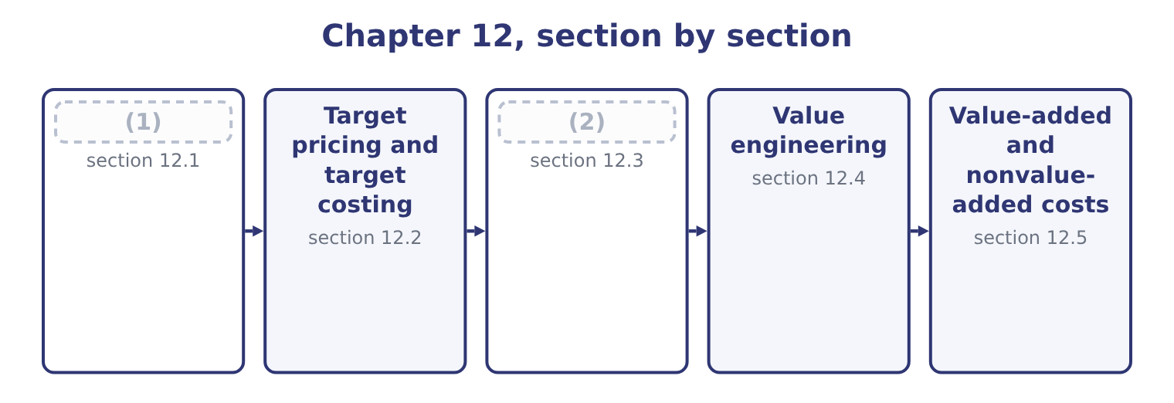
word list
The two target calculations · Target pricing and target costing · Finding out what the customer values

Summary 1 gaps 3–14
Before a target price can be set, (3) has to know what the customer is (4) . The outcome names the (5) , and they divide into three (6) . Surveys, (7) and focus groups establish what features matter and what the product is (8) with. (9) analysis is the formal version: customers choose between bundles of features at (10) prices, and the analysis infers what each feature is worth to them. It is the most (11) method and the most (12) . (13) what customers do. Test markets, trial pricing in one region, and analysis of how sales respond to past price changes — which is the (14) of, estimated from the company's own history rather than assumed. Studying competitors and the alternatives. What rivals charge, what features they include, what a customer would do if neither product existed.
word list
interviews · somebody · families · buying · Conjoint · analysis · expensive · reliable · compared · elasticity · Watching · different · techniques

Summary 2 gaps 15–24
Reverse engineering a (15) product to establish what it must cost to make is standard practice in (16) and tells a company both what its rival's margin is and what is (17) possible. For the (18) bottle, the (19) came from the third family and part of the second. (20) buyers compare a bottle of tahini sauce with the cost of making the sauce (21) from bulk paste, and with two competing branded bottles at $6.50 and $6.60. A new entrant with no (22) must price below both, and the buyers (23) were clear that $6.40 is the figure at which they would switch. That is the target price, and it is now a (24) rather than an outcome.
word list
squeeze · interviewed · themselves · answer · Food-service · respond · technically · manufacturing · competitor's · reputation · constraint

The English this section uses, and its Arabic
Each term sits against what it means.
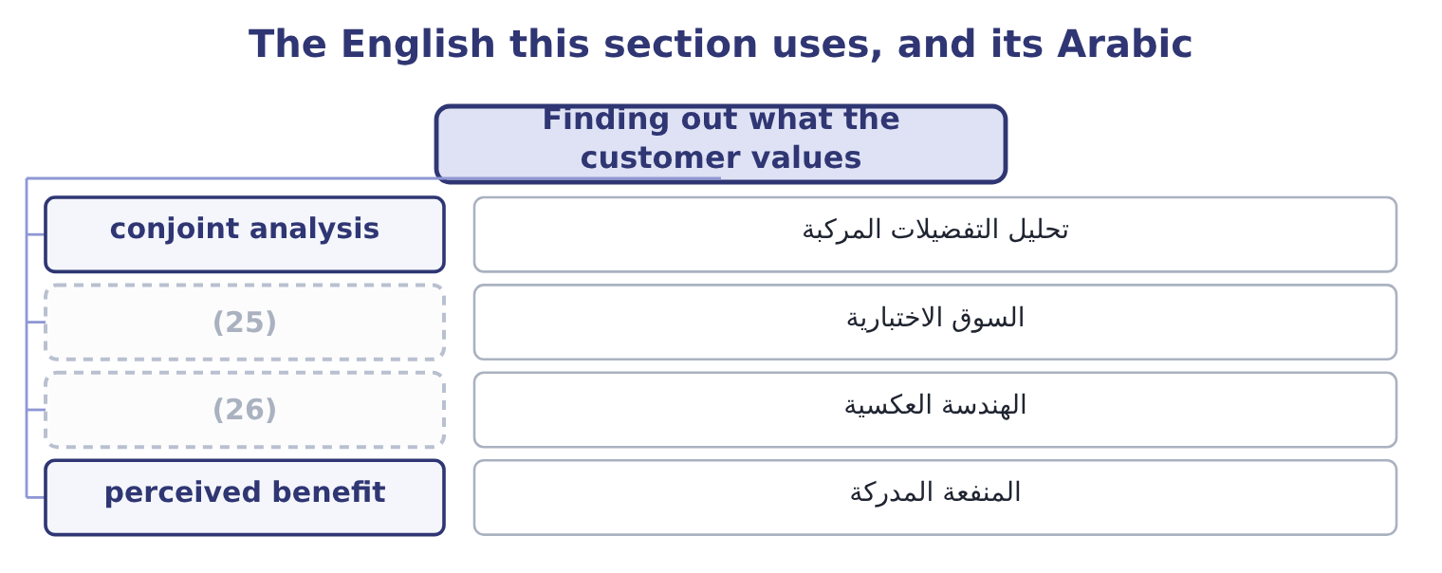
word list
reverse engineering · test market · value engineering

The English this sheet uses, and its Arabic
English (exam term) | Arabic
conjoint analysis | تحليل التفضيلات المركبة
test market | السوق الاختبارية
reverse engineering | الهندسة العكسية
perceived benefit | المنفعة المدركة

Answer key · 12.1 Finding out what the customer values

1 Finding out what the customer values | 14 elasticity
2 The two target calculations | 15 competitor's
3 somebody | 16 manufacturing
4 buying | 17 technically
5 techniques | 18 squeeze
6 families | 19 answer
7 interviews | 20 Food-service
8 compared | 21 themselves
9 Conjoint | 22 reputation
10 different | 23 interviewed
11 reliable | 24 constraint
12 expensive | 25 test market
13 Watching | 26 reverse engineering

the summaries in full
Summary 1 Before a target price can be set, somebody has to know what the customer is buying. The outcome names the techniques, and they divide into three families. Surveys, interviews and focus groups establish what features matter and what the product is compared with. Conjoint analysis is the formal version: customers choose between bundles of features at different prices, and the analysis infers what each feature is worth to them. It is the most reliable method and the most expensive. Watching what customers do. Test markets, trial pricing in one region, and analysis of how sales respond to past price changes — which is the elasticity of, estimated from the company's own history rather than assumed. Studying competitors and the alternatives. What rivals charge, what features they include, what a customer would do if neither product existed.
Summary 2 Reverse engineering a competitor's product to establish what it must cost to make is standard practice in manufacturing and tells a company both what its rival's margin is and what is technically possible. For the squeeze bottle, the answer came from the third family and part of the second. Food-service buyers compare a bottle of tahini sauce with the cost of making the sauce themselves from bulk paste, and with two competing branded bottles at $6.50 and $6.60. A new entrant with no reputation must price below both, and the buyers interviewed were clear that $6.40 is the figure at which they would switch. That is the target price, and it is now a constraint rather than an outcome.

12.2 Target pricing and target costing
Chapter 12 · section 12.2

Fill every gap. Each word list holds one word more than there are gaps.
Summary 1 gaps 1–12
Target costing (1) the cost-plus sequence, and the (2) asks for the steps. Determine the target price. What the market will pay, from the (3) of section 12.1, for a product with the features customers want. Determine the target operating income a unit. What the company requires, (4) derived from a return on the capital the product will employ, which section 12.3 (5) . (6) to find the target cost. Target price less target operating income is the cost the product must not (7) . (8) with the estimated cost of the product as (9) . The (10) is the cost gap. Close the gap before the product is launched, by value (11) , and by redesigning the product, the process and the (12) chain until the estimated cost falls to the target. Two features of that sequence distinguish it from everything.
word list
outcome · Subtract · hardest · supply · computes · techniques · exceed · reverses · engineering · difference · Compare · designed · usually

Summary 2 gaps 13–24
The cost is an (13) , not an input. In cost-plus the cost determines the price; here the price determines the cost that is permitted. It happens before production starts. By the time a product is in production, most of its cost has been (14) by its design — the (15) chosen, the number of parts, the (16) , the process required. (17) vary, and the usual figure quoted is that design locks in about eighty per cent of a (18) lifetime cost while accounting for a small fraction of the spending. Target costing is (19) a design activity, and it is run by a cross-functional team of engineers, buyers, production staff, marketers and (20) , because no one of those functions can close a cost gap alone. Where the gap cannot be closed, the (21) requires the project to be (22) . That is the hardest part of the method and the part that makes it work: a company that (23) anyway has merely used an (24) process to arrive at a price it could not afford.
word list
Estimates · launches · therefore · elaborate · tolerances · techniques · materials · product's · committed · abandoned · output · accountants · discipline

Cost-plus and target costing
Step | Cost-plus pricing | Target costing
Starts from | The estimated cost | (25)
Then | (26) | Subtracts the required profit
Arrives at | A price | (27)
If the number is unacceptable | The company hopes customers accept the price | The company redesigns, or abandons the product
When it happens | After the product exists | (28)
Who does it | Accounting | A cross-functional team

word list
The market price · Before the design is fixed · Subtracts the required profit · A permitted cost · Adds a markup

The English this section uses, and its Arabic
Each term sits against what it means.
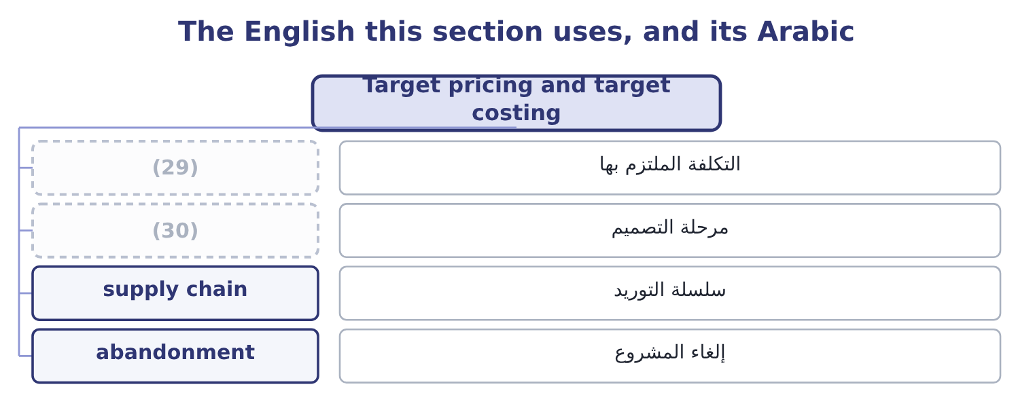
word list
design stage · target cost · committed cost

The English this sheet uses, and its Arabic
English (exam term) | Arabic
committed cost | التكلفة الملتزم بها
design stage | مرحلة التصميم
supply chain | سلسلة التوريد
abandonment | إلغاء المشروع

Answer key · 12.2 Target pricing and target costing

1 reverses | 16 tolerances
2 outcome | 17 Estimates
3 techniques | 18 product's
4 usually | 19 therefore
5 computes | 20 accountants
6 Subtract | 21 discipline
7 exceed | 22 abandoned
8 Compare | 23 launches
9 designed | 24 elaborate
10 difference | 25 The market price
11 engineering | 26 Adds a markup
12 supply | 27 A permitted cost
13 output | 28 Before the design is fixed
14 committed | 29 committed cost
15 materials | 30 design stage

the summaries in full
Summary 1 Target costing reverses the cost-plus sequence, and the outcome asks for the steps. Determine the target price. What the market will pay, from the techniques of section 12.1, for a product with the features customers want. Determine the target operating income a unit. What the company requires, usually derived from a return on the capital the product will employ, which section 12.3 computes. Subtract to find the target cost. Target price less target operating income is the cost the product must not exceed. Compare with the estimated cost of the product as designed. The difference is the cost gap. Close the gap before the product is launched, by value engineering, and by redesigning the product, the process and the supply chain until the estimated cost falls to the target. Two features of that sequence distinguish it from everything.
Summary 2 The cost is an output, not an input. In cost-plus the cost determines the price; here the price determines the cost that is permitted. It happens before production starts. By the time a product is in production, most of its cost has been committed by its design — the materials chosen, the number of parts, the tolerances, the process required. Estimates vary, and the usual figure quoted is that design locks in about eighty per cent of a product's lifetime cost while accounting for a small fraction of the spending. Target costing is therefore a design activity, and it is run by a cross-functional team of engineers, buyers, production staff, marketers and accountants, because no one of those functions can close a cost gap alone. Where the gap cannot be closed, the discipline requires the project to be abandoned. That is the hardest part of the method and the part that makes it work: a company that launches anyway has merely used an elaborate process to arrive at a price it could not afford.

12.3 The two target calculations
Chapter 12 · section 12.3

Fill every gap. Each word list holds one word more than there are gaps.
The outcome asks for two figures, and the arithmetic is short.
Worked example: the target cost of a squeeze bottle

Summary 1 gaps 1–11
The capital and the required return. The line would (1) $3,000,000 of capital — the (2) equipment, the inventory and the receivables — and the board requires 18 per cent on new product capital, a premium over the (3) 9.04 per cent cost of capital that (4) the risk of a new line. The target operating income. In total: 3,000,000 × 0.18 = 540,000 a year. A unit, on a forecast of 1,200,000 bottles: 540,000 ÷ 1,200,000 = 0.45 a bottle. The engineers' first estimate is $6.70, so the gap is 6.70 − 5.95 = 0.75 a bottle, which on 1,200,000 bottles is 1,200,000 × 0.75 = 900,000 a year. The $900,000 is the (5) that makes the (6) work. A gap stated as 75 cents a bottle (7) like a detail for the (8) department; stated as $900,000 a year (9) a target profit of $540,000, it is plainly a (10) of whether the product (11) exist.
word list
employ · filling · sounds · relative · purchasing · number · against · should · method · reflects · question · company's

Summary 2 gaps 12–20
Scaling a unit gap to the (12) total is the first thing to do with it. Two (13) appear in harder (14) . The target operating income may be given (15) as a margin — "the company requires an operating margin of 8 per cent" — in which case the target income a unit is (16) the price times that margin: 6.40 × 0.08 = 0.512. The target cost may be (17) over the product's life rather than a year, (18) the costs of design, launch, support and disposal. That is life-cycle costing, and it matters most where those costs are large relative to (19) — software, (20) , aircraft.
word list
questions · expediting · simply · refinements · annual · pharmaceuticals · expressed · directly · including · manufacturing

The target-cost template
Line | Computation | The squeeze bottle
Target price | What the market will pay | 6.40
Capital employed | Equipment, inventory, receivables | 3,000,000
Required return | (21) | 18%
Target operating income in total | (22) | 540,000
Forecast volume | A year | 1,200,000 bottles
Target operating income a unit | (23) | 0.45
Target cost a unit | Price less target income | 5.95
Estimated cost as designed | (24) | 6.70
Cost gap a unit | Estimate less target | 0.75
Cost gap a year | (25) | 900,000

word list
target operating income · Total over volume · Board's rate for new products · Gap times volume · Capital times the rate · From the engineers

The English this section uses, and its Arabic
Each term sits against what it means.
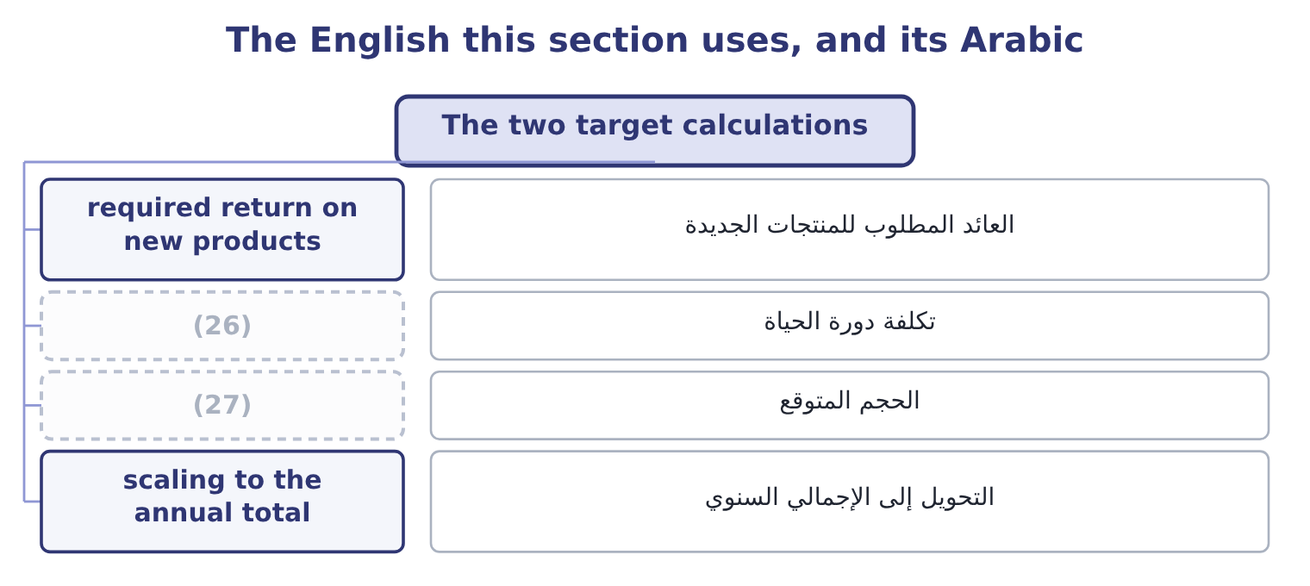
word list
forecast volume · test market · life-cycle costing

The English this sheet uses, and its Arabic
English (exam term) | Arabic
required return on new products | العائد المطلوب للمنتجات الجديدة
life-cycle costing | تكلفة دورة الحياة
forecast volume | الحجم المتوقع
scaling to the annual total | التحويل إلى الإجمالي السنوي

Answer key · 12.3 The two target calculations

1 employ | 15 directly
2 filling | 16 simply
3 company's | 17 expressed
4 reflects | 18 including
5 number | 19 manufacturing
6 method | 20 pharmaceuticals
7 sounds | 21 Board's rate for new products
8 purchasing | 22 Capital times the rate
9 against | 23 Total over volume
10 question | 24 From the engineers
11 should | 25 Gap times volume
12 annual | 26 life-cycle costing
13 refinements | 27 forecast volume
14 questions

the summaries in full
Summary 1 The capital and the required return. The line would employ $3,000,000 of capital — the filling equipment, the inventory and the receivables — and the board requires 18 per cent on new product capital, a premium over the company's 9.04 per cent cost of capital that reflects the risk of a new line. The target operating income. In total: 3,000,000 × 0.18 = 540,000 a year. A unit, on a forecast of 1,200,000 bottles: 540,000 ÷ 1,200,000 = 0.45 a bottle. The engineers' first estimate is $6.70, so the gap is 6.70 − 5.95 = 0.75 a bottle, which on 1,200,000 bottles is 1,200,000 × 0.75 = 900,000 a year. The $900,000 is the number that makes the method work. A gap stated as 75 cents a bottle sounds like a detail for the purchasing department; stated as $900,000 a year against a target profit of $540,000, it is plainly a question of whether the product should exist.
Summary 2 Scaling a unit gap to the annual total is the first thing to do with it. Two refinements appear in harder questions. The target operating income may be given directly as a margin — "the company requires an operating margin of 8 per cent" — in which case the target income a unit is simply the price times that margin: 6.40 × 0.08 = 0.512. The target cost may be expressed over the product's life rather than a year, including the costs of design, launch, support and disposal. That is life-cycle costing, and it matters most where those costs are large relative to manufacturing — software, pharmaceuticals, aircraft.

12.4 Value engineering
Chapter 12 · section 12.4

Fill every gap. Each word list holds one word more than there are gaps.
Summary 1 gaps 1–12
Value engineering is the systematic (1) of a product and its (2) process to find ways of delivering the functions the customer values at a lower cost. The (3) on function is what (4) it from cost cutting: the question is not "what can we remove" but "what does this part do, and is there a cheaper way of doing it". The (5) has four moves, and a question will (6) need at least two of them. Fewer parts, fewer fasteners, fewer (7) , common components shared with other products, a (8) relaxed where precision does nothing for the customer. (9) materials or (10) . A (11) polymer, a moulded part instead of an (12) one, a supplier's standard component instead of a bespoke one. Fewer handling steps, a shorter route through the factory, a change in batch size, a machine moved. Open-book costing, joint design, longer contracts in exchange for lower prices, and moving a component's design to the supplier who makes it.
word list
operations · examination · different · production · emphasis · usually · distinguishes · assembled · method · allocation · processes · Substitute · tolerance

Worked example: closing the 75-cent gap

Summary 2 gaps 13–24
The first design uses a bespoke (13) nozzle. The supplier's standard (14) nozzle does the same job: 0.80 − 0.55 = 0.25 saved. The bottle and the label. A standard bottle in place of a (15) shape saves 1.10 − 0.95 = 0.15, and (16) the label directly on the bottle saves 0.20 − 0.12 = 0.08. (17) the standard bottle runs faster and needs no change of (18) between batches: 0.60 − 0.45 = 0.15 saved. Fewer parts and one less handling step reduce the (19) that drive the overhead, taking the (20) from 1.00 to 0.88, a saving of 0.12. The product can be made for $5.95 and (21) go ahead. Note what was not done. The sauce itself, at $3.00, was left alone, (22) it is the thing the customer is buying: (23) the sesame content would close the gap faster and destroy the product. Value engineering protects the functions the customer values and attacks (24) else, and an answer that proposes diluting the product has missed the whole idea.
word list
production · reducing · everything · printing · custom · two-part · Filling · tooling · allocation · activities · should · because · three-part

Closing the cost gap, component by component
The bars are drawn to scale.
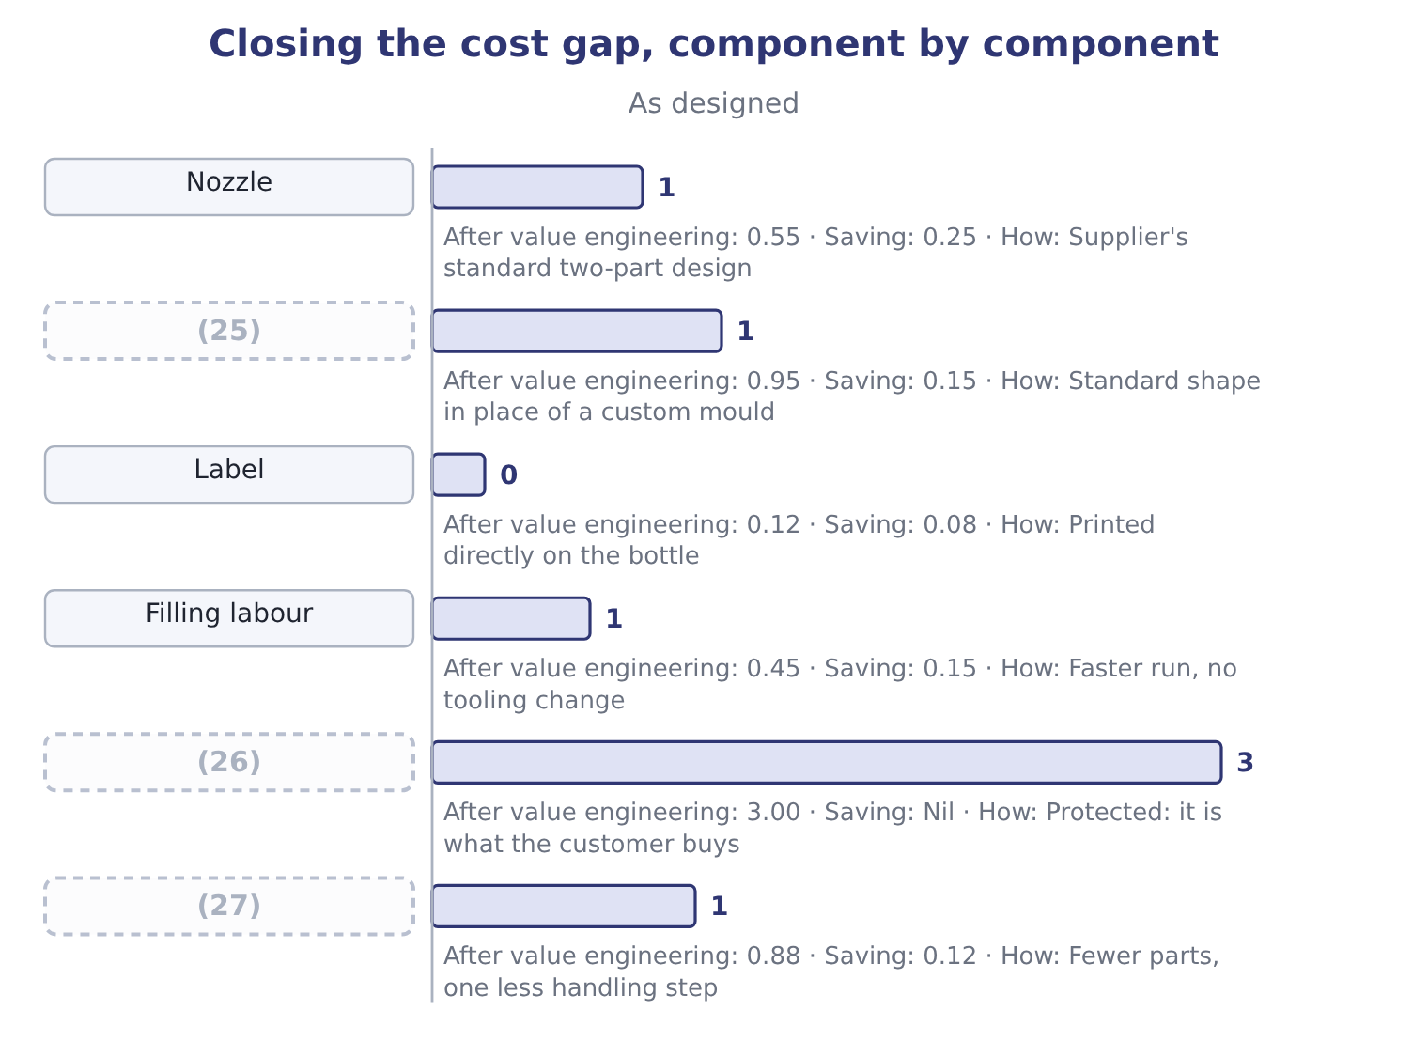
word list
Sauce · Bottle · tolerance · Allocated overhead

The English this section uses, and its Arabic
Each term sits against what it means.
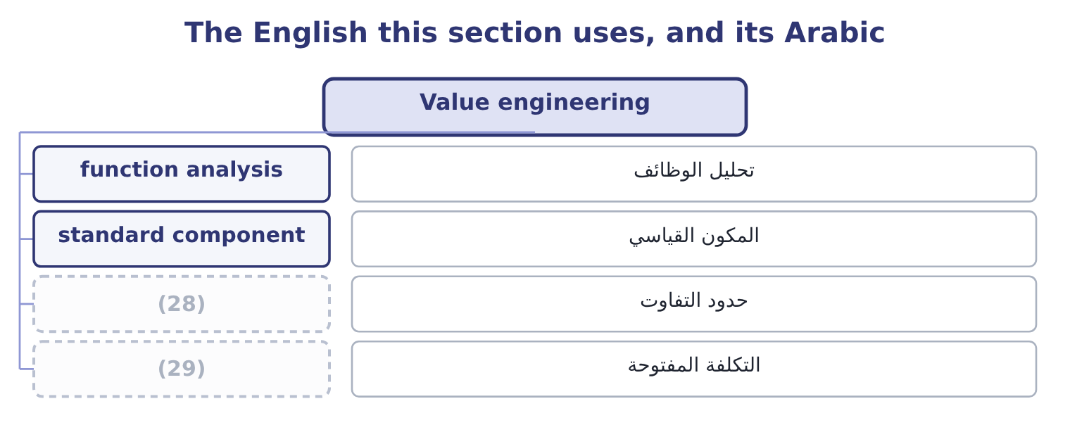
word list
function analysis · tolerance · open-book costing

The English this sheet uses, and its Arabic
English (exam term) | Arabic
function analysis | تحليل الوظائف
standard component | المكون القياسي
tolerance | حدود التفاوت
open-book costing | التكلفة المفتوحة

Answer key · 12.4 Value engineering

1 examination | 16 printing
2 production | 17 Filling
3 emphasis | 18 tooling
4 distinguishes | 19 activities
5 method | 20 allocation
6 usually | 21 should
7 operations | 22 because
8 tolerance | 23 reducing
9 Substitute | 24 everything
10 processes | 25 Bottle
11 different | 26 Sauce
12 assembled | 27 Allocated overhead
13 three-part | 28 tolerance
14 two-part | 29 open-book costing
15 custom

the summaries in full
Summary 1 Value engineering is the systematic examination of a product and its production process to find ways of delivering the functions the customer values at a lower cost. The emphasis on function is what distinguishes it from cost cutting: the question is not "what can we remove" but "what does this part do, and is there a cheaper way of doing it". The method has four moves, and a question will usually need at least two of them. Fewer parts, fewer fasteners, fewer operations, common components shared with other products, a tolerance relaxed where precision does nothing for the customer. Substitute materials or processes. A different polymer, a moulded part instead of an assembled one, a supplier's standard component instead of a bespoke one. Fewer handling steps, a shorter route through the factory, a change in batch size, a machine moved. Open-book costing, joint design, longer contracts in exchange for lower prices, and moving a component's design to the supplier who makes it.
Summary 2 The first design uses a bespoke three-part nozzle. The supplier's standard two-part nozzle does the same job: 0.80 − 0.55 = 0.25 saved. The bottle and the label. A standard bottle in place of a custom shape saves 1.10 − 0.95 = 0.15, and printing the label directly on the bottle saves 0.20 − 0.12 = 0.08. Filling the standard bottle runs faster and needs no change of tooling between batches: 0.60 − 0.45 = 0.15 saved. Fewer parts and one less handling step reduce the activities that drive the overhead, taking the allocation from 1.00 to 0.88, a saving of 0.12. The product can be made for $5.95 and should go ahead. Note what was not done. The sauce itself, at $3.00, was left alone, because it is the thing the customer is buying: reducing the sesame content would close the gap faster and destroy the product. Value engineering protects the functions the customer values and attacks everything else, and an answer that proposes diluting the product has missed the whole idea.

12.5 Value-added and nonvalue-added costs
Chapter 12 · section 12.5

Fill every gap. Each word list holds one word more than there are gaps.
Summary 1 gaps 1–12
A value-added cost is one the customer would be (1) to pay for if they (2) what it was: the (3) in the sauce, the filling of the bottle, the moulding of the nozzle, the design that makes the bottle easy to pour. (4) it and the product is worth less. A nonvalue-added cost is one that adds nothing the customer values: moving material between stores, waiting between (5) , inspecting work that should have been right, reworking what was wrong, counting inventory, (6) a late order, storing finished goods nobody has ordered. The test is the (7) willingness, not the (8) necessity. Some nonvalue-added activities are (9) — a company must count its inventory and inspect its output — and calling them nonvalue-added is not a (10) of the people who do them. It is a (11) about where the cost ought to be (12) first, because reducing a nonvalue-added cost takes nothing away from the product.
word list
customer's · sesame · progress · operations · company's · willing · attacked · criticism · unavoidable · understood · expediting · Remove · statement

Summary 2 gaps 13–17
The classic (13) applies five (14) to manufacturing time, and the exam uses it. Processing time adds value. (15) , moving, waiting and storing do not. The ratio of processing time to total time is the manufacturing cycle (16) , and in most factories it is (17) low — a part that takes four hours to process may spend three weeks in the building.
word list
efficiency · categories · storage · startlingly · Inspection · framework

Where the cost of a bottle goes
Activity | Value-added? | Why
Mixing and cooking the sauce | Yes | It is the product
Moulding the nozzle | (18) | A function the customer uses
Filling and capping | Yes | Necessary to deliver the product
Moving pallets between the filling hall and the warehouse | No | The customer pays nothing for distance
Waiting for a tooling change | No | (19)
Inspecting for leaks | (20) | The customer pays for bottles that do not leak, not for the checking
Reworking leaking bottles | No | (21)
Storing finished goods for eleven weeks | No | (22)

word list
Yes · The cost of doing it wrong once · Chapter 17 of Book 2 priced this · No, though necessary · design stage · Pure delay

Summary 3 gaps 23–31
Three uses of the (23) close the chapter. It (24) the cost gap work. (25) the nonvalue-added costs first, because they can be removed without (26) the product. It supports the (27) argument of Book 2's: a buffer of work in (28) is storage, moving and waiting, all nonvalue-added. And it is a (29) idea as well as a design one. A cost report that splits each (30) spending into value-added and nonvalue-added activity tells a manager something no (31) variance report does, which is why it belongs in the same examination as the performance measures of Part 1.
word list
department's · progress · finished · distinction · touching · directs · Attack · conventional · reporting · just-in-time

Set a target and close a gap

Your turn: target costing (complete the blanks)
Item | Data | Answer
Target operating income in total | Capital 5,000,000, required return 16 per cent | ________
Target operating income a unit | (32) | ________
Target cost a unit | (33) | ________
Cost gap a unit | Estimated cost 14.60 | ________
Cost gap a year |  | ________
Gap after savings of 0.35, 0.18 and 0.12 a unit |  | ________
Which of these is value-added: mixing, inspecting, moving to the warehouse? |  | ________

word list
Volume 800,000 units · Target price 14.00 · Inspecting for leaks

"Target"

Summary 4 gaps 34–38
A sales target is something to aim at and (34) miss; a target cost is a (35) the product must come in under or not be made at all. The same word does both jobs in the same syllabus, and the (36) is the whole (37) of the method. In an answer, say which it is: "a target cost of $5.95, which the design must not (38) ".
word list
discipline · ceiling · value-added · difference · perhaps · exceed

"Target"
Item | Answer
Target operating income in total | (39)
Target operating income a unit | (40)
Target cost a unit | 13.00: 14.00 − 1.00 = 13.00.
Cost gap a unit | 1.60: 14.60 − 13.00 = 1.60.
Cost gap a year | 1,280,000: 800,000 × 1.60 = 1,280,000.
Gap after savings of 0.35, 0.18 and 0.12 | (41) : the savings are 0.35 + 0.18 + 0.12 = 0.65, against a gap of 1.60.
Which is value-added | Mixing only. Inspecting and moving to the warehouse are nonvalue-added, though both may be necessary.
What it tells you | Two-thirds of the gap is still open after three good ideas, and a gap of 0.95 a unit on a target cost of 13.00 is more than seven per cent o

word list
1.00: 800,000 ÷ 800,000 = 1.00. · 0.95 remaining · 800,000: 5,000,000 × 0.16 = 800,000. · unavoidable but nonvalue-added

The English this section uses, and its Arabic
Each term sits against what it means.
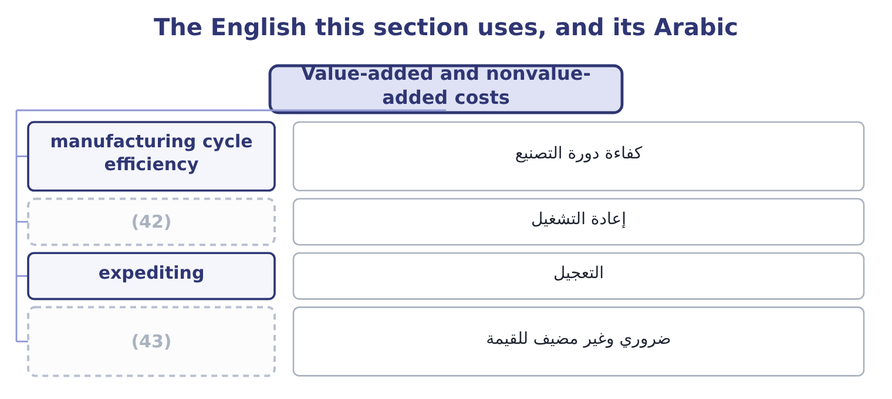
word list
unavoidable but nonvalue-added · rework · إعادة التشغيل

The English this sheet uses, and its Arabic
English (exam term) | Arabic
manufacturing cycle efficiency | كفاءة دورة التصنيع
rework | إعادة التشغيل
expediting | التعجيل
unavoidable but nonvalue-added | ضروري وغير مضيف للقيمة

Answer key · 12.5 Value-added and nonvalue-added costs

1 willing | 23 distinction
2 understood | 24 directs
3 sesame | 25 Attack
4 Remove | 26 touching
5 operations | 27 just-in-time
6 expediting | 28 progress
7 customer's | 29 reporting
8 company's | 30 department's
9 unavoidable | 31 conventional
10 criticism | 32 Volume 800,000 units
11 statement | 33 Target price 14.00
12 attacked | 34 perhaps
13 framework | 35 ceiling
14 categories | 36 difference
15 Inspection | 37 discipline
16 efficiency | 38 exceed
17 startlingly | 39 800,000: 5,000,000 × 0.16 = 800,000.
18 Yes | 40 1.00: 800,000 ÷ 800,000 = 1.00.
19 Pure delay | 41 0.95 remaining
20 No, though necessary | 42 rework
21 The cost of doing it wrong once | 43 unavoidable but nonvalue-added
22 Chapter 17 of Book 2 priced this

the summaries in full
Summary 1 A value-added cost is one the customer would be willing to pay for if they understood what it was: the sesame in the sauce, the filling of the bottle, the moulding of the nozzle, the design that makes the bottle easy to pour. Remove it and the product is worth less. A nonvalue-added cost is one that adds nothing the customer values: moving material between stores, waiting between operations, inspecting work that should have been right, reworking what was wrong, counting inventory, expediting a late order, storing finished goods nobody has ordered. The test is the customer's willingness, not the company's necessity. Some nonvalue-added activities are unavoidable — a company must count its inventory and inspect its output — and calling them nonvalue-added is not a criticism of the people who do them. It is a statement about where the cost ought to be attacked first, because reducing a nonvalue-added cost takes nothing away from the product.
Summary 2 The classic framework applies five categories to manufacturing time, and the exam uses it. Processing time adds value. Inspection, moving, waiting and storing do not. The ratio of processing time to total time is the manufacturing cycle efficiency, and in most factories it is startlingly low — a part that takes four hours to process may spend three weeks in the building.
Summary 3 Three uses of the distinction close the chapter. It directs the cost gap work. Attack the nonvalue-added costs first, because they can be removed without touching the product. It supports the just-in-time argument of Book 2's: a buffer of work in progress is storage, moving and waiting, all nonvalue-added. And it is a reporting idea as well as a design one. A cost report that splits each department's spending into value-added and nonvalue-added activity tells a manager something no conventional variance report does, which is why it belongs in the same examination as the performance measures of Part 1.
Summary 4 A sales target is something to aim at and perhaps miss; a target cost is a ceiling the product must come in under or not be made at all. The same word does both jobs in the same syllabus, and the difference is the whole discipline of the method. In an answer, say which it is: "a target cost of $5.95, which the design must not exceed".

