13.1 Two horizons, two floors
Chapter 13 · section 13.1

Fill every gap. Each word list holds one word more than there are gaps.
Chapter 13, section by section
Each stage leads to the next.
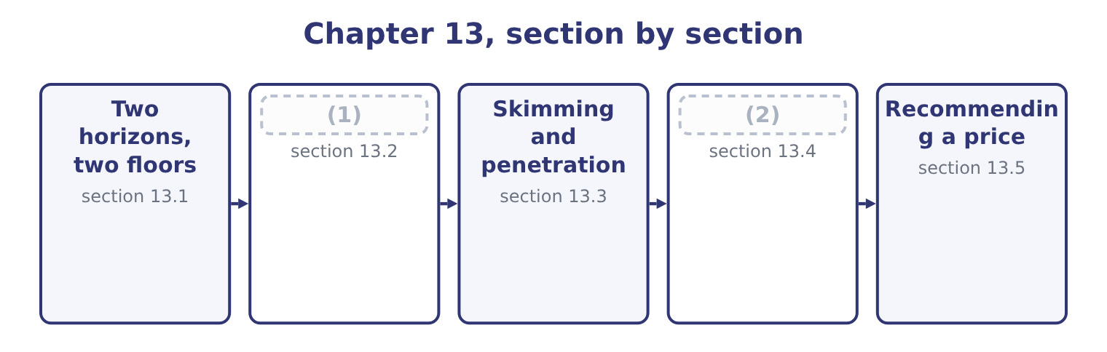
word list
The four stages · Recommending a price · The other strategies

Summary 1 gaps 3–14
A short-term pricing decision takes the capacity, the fixed costs and the product as given, and asks only whether a (3) piece of business is worth (4) . Its floor is the (5) cost: the incremental cost plus any contribution displaced. Below that floor the company is worse off; above it, (6) off, by the contribution the business (7) . A long-term pricing decision asks what a product must earn to justify its (8) . Over a long enough period every cost is (9) : the plant can be sold, the lease ended, the staff (10) . So the (11) floor is the full cost, including the fixed costs, and including a return on the capital employed — which is the (12) price. Four (13) follow, and each is (14) . Short-run prices below full cost are legitimate and sometimes necessary: a special order with idle capacity, a launch price intended to win position, a clearance price for goods that will otherwise be written off.
word list
intended · relevant · examinable · redeployed · avoidable · particular · existence · target-return · taking · consequences · long-run · better · brings

Summary 2 gaps 15–21
The test is whether the business (15) its own incremental cost and whether it (16) the regular market. A company (17) price below full cost (18) . Every product priced on a short-run basis is being (19) by the rest of the range, and a company whose whole range is priced that way is (20) a loss. The (21) the question specifies determines the cost to use. And the two converge over time, because in the long run the fixed costs of the short run become decisions again.
word list
horizon · covers · cannot · subsidised · making · damages · indefinitely · target-return

Two horizons, two floors
 | Short-term decision | Long-term decision
Capacity and fixed costs are | Given | Decisions
The floor is | (22) | Full cost plus a return on capital
For Orontes's jar | (23) | 12.06 at a 15 per cent target return
Suits | (24) | The price list, contract renewals, new products
Danger | Repeating it until it is the business | (25)

word list
Special orders, clearance, launch pricing · 7.20, or 12.00 at full capacity · The price list, contract renewals, new products · Pricing above what the market will pay · Incremental cost plus displaced contribution

The English this section uses, and its Arabic
Each term sits against what it means.
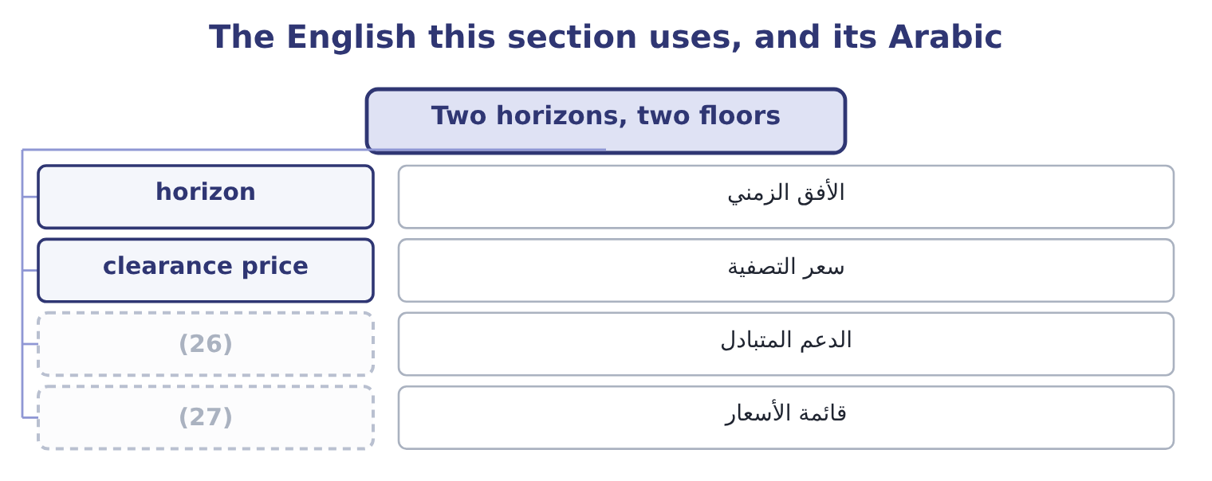
word list
expectation · price list · cross-subsidy

The English this sheet uses, and its Arabic
English (exam term) | Arabic
horizon | الأفق الزمني
clearance price | سعر التصفية
cross-subsidy | الدعم المتبادل
price list | قائمة الأسعار

Answer key · 13.1 Two horizons, two floors

1 The four stages | 15 covers
2 The other strategies | 16 damages
3 particular | 17 cannot
4 taking | 18 indefinitely
5 relevant | 19 subsidised
6 better | 20 making
7 brings | 21 horizon
8 existence | 22 Incremental cost plus displaced contribution
9 avoidable | 23 7.20, or 12.00 at full capacity
10 redeployed | 24 Special orders, clearance, launch pricing
11 long-run | 25 Pricing above what the market will pay
12 target-return | 26 cross-subsidy
13 consequences | 27 price list
14 examinable

the summaries in full
Summary 1 A short-term pricing decision takes the capacity, the fixed costs and the product as given, and asks only whether a particular piece of business is worth taking. Its floor is the relevant cost: the incremental cost plus any contribution displaced. Below that floor the company is worse off; above it, better off, by the contribution the business brings. A long-term pricing decision asks what a product must earn to justify its existence. Over a long enough period every cost is avoidable: the plant can be sold, the lease ended, the staff redeployed. So the long-run floor is the full cost, including the fixed costs, and including a return on the capital employed — which is the target-return price. Four consequences follow, and each is examinable. Short-run prices below full cost are legitimate and sometimes necessary: a special order with idle capacity, a launch price intended to win position, a clearance price for goods that will otherwise be written off.
Summary 2 The test is whether the business covers its own incremental cost and whether it damages the regular market. A company cannot price below full cost indefinitely. Every product priced on a short-run basis is being subsidised by the rest of the range, and a company whose whole range is priced that way is making a loss. The horizon the question specifies determines the cost to use. And the two converge over time, because in the long run the fixed costs of the short run become decisions again.

13.2 The four stages
Chapter 13 · section 13.2

Fill every gap. Each word list holds one word more than there are gaps.
Summary 1 gaps 1–12
A product life cycle (1) the sales of a product from launch to (2) , and the exam names four stages. Sales are low and growing slowly, because (3) do not know the product and distribution is (4) . Costs per unit are high, since volume is small and the (5) has not happened. Competition is light or (6) . Cash flow is negative: (7) has been paid for and the launch costs money. Sales (8) as the product becomes known and distribution (9) . Unit costs fall with volume and (10) . (11) arrive, attracted by the growth, usually with (12) versions. Profits are at their highest, and so is the need for working capital to fund the growth — which is the sustainable growth problem of Book 1, arriving at product level. Sales growth slows and then stops as the market saturates.
word list
Competitors · widens · development · incomplete · withdrawal · improvements · improved · customers · absent · experience · learning · accelerate · describes

Summary 2 gaps 13–21
Competition is at its fiercest, because growth can now only be taken from somebody else, so prices fall and (13) shifts to brand, service and small (14) . Costs per unit are at their (15) . Cash flow is (16) , because the growth no longer (17) working capital. Most (18) spend most of their lives here. Sales fall, as (19) change or a better (20) arrives. Prices may fall further, or in some cases rise, as the (21) buyers become a captive niche. The decision becomes whether to harvest the product — minimum investment, maximum cash — or to withdraw it, which is the drop-a-segment analysis.
word list
remaining · mistaking · technology · lowest · tastes · products · differentiation · consumes · strongest · improvements

Four stages, and what changes in each
Every item belongs to exactly one group.
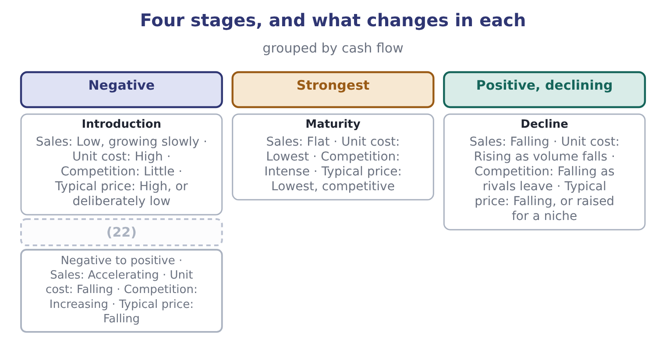
word list
Growth · Introduction

Summary 3 gaps 23–29
Two (23) belong with the model. The stages are a (24) , not a prediction. A (25) sales may fall and recover, a mature product can be (26) into a new growth phase, and the length of each stage varies from months to decades. The stage is not always (27) at the time. Flat sales may be maturity or a bad year, and the cost of (28) the second for the first is a product (29) that should have been invested.
word list
mistaking · product's · relaunched · obvious · harvested · description · accelerate · warnings

The English this section uses, and its Arabic
Each term sits against what it means.
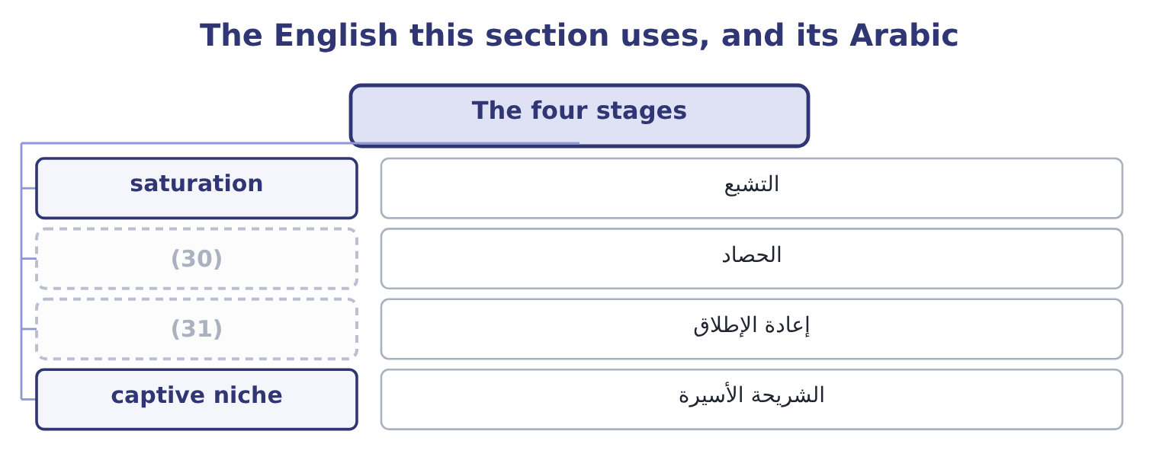
word list
التشبع · relaunch · harvest

The English this sheet uses, and its Arabic
English (exam term) | Arabic
saturation | التشبع
harvest | الحصاد
relaunch | إعادة الإطلاق
captive niche | الشريحة الأسيرة

Answer key · 13.2 The four stages

1 describes | 17 consumes
2 withdrawal | 18 products
3 customers | 19 tastes
4 incomplete | 20 technology
5 learning | 21 remaining
6 absent | 22 Growth
7 development | 23 warnings
8 accelerate | 24 description
9 widens | 25 product's
10 experience | 26 relaunched
11 Competitors | 27 obvious
12 improved | 28 mistaking
13 differentiation | 29 harvested
14 improvements | 30 harvest
15 lowest | 31 relaunch
16 strongest

the summaries in full
Summary 1 A product life cycle describes the sales of a product from launch to withdrawal, and the exam names four stages. Sales are low and growing slowly, because customers do not know the product and distribution is incomplete. Costs per unit are high, since volume is small and the learning has not happened. Competition is light or absent. Cash flow is negative: development has been paid for and the launch costs money. Sales accelerate as the product becomes known and distribution widens. Unit costs fall with volume and experience. Competitors arrive, attracted by the growth, usually with improved versions. Profits are at their highest, and so is the need for working capital to fund the growth — which is the sustainable growth problem of Book 1, arriving at product level. Sales growth slows and then stops as the market saturates.
Summary 2 Competition is at its fiercest, because growth can now only be taken from somebody else, so prices fall and differentiation shifts to brand, service and small improvements. Costs per unit are at their lowest. Cash flow is strongest, because the growth no longer consumes working capital. Most products spend most of their lives here. Sales fall, as tastes change or a better technology arrives. Prices may fall further, or in some cases rise, as the remaining buyers become a captive niche. The decision becomes whether to harvest the product — minimum investment, maximum cash — or to withdraw it, which is the drop-a-segment analysis.
Summary 3 Two warnings belong with the model. The stages are a description, not a prediction. A product's sales may fall and recover, a mature product can be relaunched into a new growth phase, and the length of each stage varies from months to decades. The stage is not always obvious at the time. Flat sales may be maturity or a bad year, and the cost of mistaking the second for the first is a product harvested that should have been invested.

13.3 Skimming and penetration
Chapter 13 · section 13.3

Fill every gap. Each word list holds one word more than there are gaps.
Summary 1 gaps 1–12
Two launch (1) dominate the (2) stage, and the exam asks when each is right. Price skimming launches high and (3) the price over time. It extracts the most from the (4) who value the product most and are least sensitive to price, then reaches (5) more price-sensitive groups as the price falls. It suits a product with a genuine (6) , a patent or a lead over rivals, inelastic early demand, high development costs to recover, and a brand that a high price (7) . Its risk is that the high price and (8) margins attract entrants quickly. Penetration (9) launches low to win volume and share fast. It suits a market where demand is elastic, where costs fall sharply with volume, where there are strong (10) of scale or (11) effects, and where getting to scale first deters entry. Its risk is that the low price is hard to raise later and sets an (12) the product may never escape.
word list
advantage · strategies · pricing · customers · supports · experience · economies · visible · successively · introduction · bundling · expectation · lowers

Worked example: two launches for the premium jar

Summary 2 gaps 13–14
The premium 500 gram jar: a (13) cost of $5.60 and $900,000 a year of fixed costs. Launch at $11.00, selling 250,000 jars in the first year to the least price-sensitive buyers, then cut to $9.50 in the second year, selling 600,000. Year one contributes 250,000 × 5.40 = 1,350,000, giving 1,350,000 − 900,000 = 450,000 of (14) income. Year two contributes 600,000 × 3.90 = 2,340,000, giving 2,340,000 − 900,000 = 1,440,000. The two years total 450,000 + 1,440,000 = 1,890,000. Launch at $8.75, selling 780,000 jars in the first year and 900,000 in the second at the same price. Year one contributes 780,000 × 3.15 = 2,457,000, giving 2,457,000 − 900,000 = 1,557,000. Year two contributes 900,000 × 3.15 = 2,835,000, giving 2,835,000 − 900,000 = 1,935,000. The two years total 1,557,000 + 1,935,000 = 3,492,000.
word list
operating · variable · recover

Summary 3 gaps 15–22
Penetration earns 3,492,000 − 1,890,000 = 1,602,000 more over two years on these estimates. The answer depends (15) on the volume estimates, which is the (16) thing to say about every (17) calculation. Penetration wins here because the (18) computed.41 — buyers in this market respond (19) to price — and it would lose if the premium buyers were as loyal as a skimming strategy (20) . The calculation does not decide the (21) ; it states what each (22) volume assumption has to deliver, and that is what a board should be asked to judge.
word list
strongly · elasticity · honest · strategy's · assumes · dominate · launch-pricing · question · entirely

Skimming against penetration
 | Skimming | Penetration
Launch price | High, falling over time | (23)
Suits demand that is | Inelastic early, with distinct customer groups | Elastic
Suits costs that | (24) | Fall sharply with volume
Recovers development cost | (25) | Slowly, through volume
Main risk | (26) | The low price is hard to raise
Signals | (27) | Value, availability

word list
High margins attract entrants · Are high early and fall slowly · Quality, exclusivity · product life cycle · Low, held · Quickly, from early buyers

The English this section uses, and its Arabic
Each term sits against what it means.
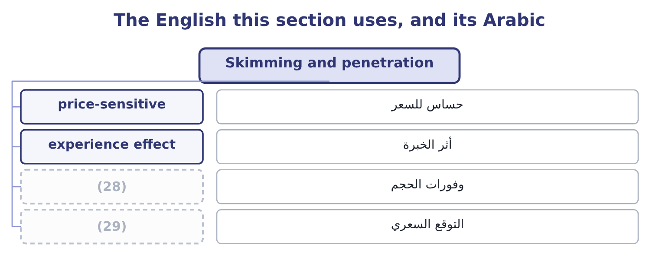
word list
expectation · precedent · economies of scale

The English this sheet uses, and its Arabic
English (exam term) | Arabic
price-sensitive | حساس للسعر
experience effect | أثر الخبرة
economies of scale | وفورات الحجم
expectation | التوقع السعري

Answer key · 13.3 Skimming and penetration

1 strategies | 16 honest
2 introduction | 17 launch-pricing
3 lowers | 18 elasticity
4 customers | 19 strongly
5 successively | 20 assumes
6 advantage | 21 question
7 supports | 22 strategy's
8 visible | 23 Low, held
9 pricing | 24 Are high early and fall slowly
10 economies | 25 Quickly, from early buyers
11 experience | 26 High margins attract entrants
12 expectation | 27 Quality, exclusivity
13 variable | 28 economies of scale
14 operating | 29 expectation
15 entirely

the summaries in full
Summary 1 Two launch strategies dominate the introduction stage, and the exam asks when each is right. Price skimming launches high and lowers the price over time. It extracts the most from the customers who value the product most and are least sensitive to price, then reaches successively more price-sensitive groups as the price falls. It suits a product with a genuine advantage, a patent or a lead over rivals, inelastic early demand, high development costs to recover, and a brand that a high price supports. Its risk is that the high price and visible margins attract entrants quickly. Penetration pricing launches low to win volume and share fast. It suits a market where demand is elastic, where costs fall sharply with volume, where there are strong economies of scale or experience effects, and where getting to scale first deters entry. Its risk is that the low price is hard to raise later and sets an expectation the product may never escape.
Summary 2 The premium 500 gram jar: a variable cost of $5.60 and $900,000 a year of fixed costs. Launch at $11.00, selling 250,000 jars in the first year to the least price-sensitive buyers, then cut to $9.50 in the second year, selling 600,000. Year one contributes 250,000 × 5.40 = 1,350,000, giving 1,350,000 − 900,000 = 450,000 of operating income. Year two contributes 600,000 × 3.90 = 2,340,000, giving 2,340,000 − 900,000 = 1,440,000. The two years total 450,000 + 1,440,000 = 1,890,000. Launch at $8.75, selling 780,000 jars in the first year and 900,000 in the second at the same price. Year one contributes 780,000 × 3.15 = 2,457,000, giving 2,457,000 − 900,000 = 1,557,000. Year two contributes 900,000 × 3.15 = 2,835,000, giving 2,835,000 − 900,000 = 1,935,000. The two years total 1,557,000 + 1,935,000 = 3,492,000.
Summary 3 Penetration earns 3,492,000 − 1,890,000 = 1,602,000 more over two years on these estimates. The answer depends entirely on the volume estimates, which is the honest thing to say about every launch-pricing calculation. Penetration wins here because the elasticity computed.41 — buyers in this market respond strongly to price — and it would lose if the premium buyers were as loyal as a skimming strategy assumes. The calculation does not decide the question; it states what each strategy's volume assumption has to deliver, and that is what a board should be asked to judge.

13.4 The other strategies
Chapter 13 · section 13.4

Fill every gap. Each word list holds one word more than there are gaps.
Summary 1 gaps 1–12
Beyond the two launch (1) , a short list of pricing tactics appears in (2) and each has a condition attached. Bundling sells several (3) for one price below the sum of the separate prices. It works where customers value the components differently — one buyer wants the sauce, (4) the bottle opener — so a bundle (5) more from each than separate prices would. It also hides the price of the (6) items, which makes (7) harder. Price discrimination charges different customers different prices for the same product: by (8) , by time, by (9) or by quantity. It is (10) wherever the groups have different elasticities and can be kept apart, and it is restricted by law in many jurisdictions where it harms (11) . A student (12) , an off-peak fare and a quantity rebate are all examples.
word list
profitable · captures · quantity · questions · individual · discount · competition · strategies · segment · products · comparison · another · channel

Summary 2 gaps 13–24
Peak-load pricing charges more when capacity is scarce — (13) in the evening, hotels in the season, (14) at the weekend. It is the clearest practical (15) of the opportunity cost: the price should carry the (16) displaced, and when nothing is displaced the price can fall to the incremental cost. Promotional pricing cuts the price (17) to attract trial, clear stock, or (18) a rival. Its danger is that temporary becomes (19) , and Book 1's finding about (20) gross margin is what a long series of temporary cuts looks like in the accounts. A loss leader is (21) below cost to draw customers who buy other (22) . It works only where the other purchases are real and attributable, which makes it a (23) about the whole (24) rather than the product. Predatory pricing is pricing below cost to drive a competitor out and raise prices afterwards. It is unlawful in most jurisdictions, and the practical test regulators use is whether the price is below the seller's own avoidable cost — which makes the relevant-cost analysis.
word list
electricity · expected · delivery · Orontes's · priced · attract · things · temporarily · question · application · basket · contribution · answer

Six tactics and the condition each needs
Tactic | Works when | Watch for
Bundling | Customers value the components differently | Hiding a weak product inside a bundle
Price discrimination | Groups have different elasticities and stay separate | (25)
Peak-load pricing | (26) | Customer resentment; measuring the peak correctly
Promotional pricing | (27) | Temporary becoming permanent
Loss leader | The other purchases are real and attributable | (28)
Predatory pricing | Never; it is unlawful | (29)

word list
Customers who buy only the leader · Capacity is scarce at some times and not others · Prices below avoidable cost, whatever the intention · Trial or clearance is genuinely needed · Customer resentment; measuring the peak correctly · Legal restrictions; arbitrage between the groups

The English this section uses, and its Arabic
Each term sits against what it means.
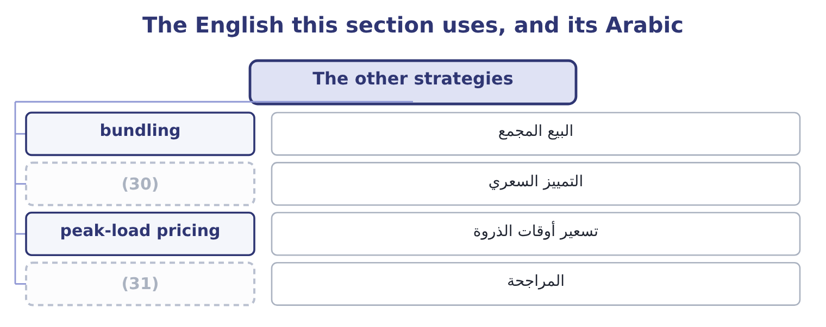
word list
bundling · arbitrage · price discrimination

The English this sheet uses, and its Arabic
English (exam term) | Arabic
bundling | البيع المجمع
price discrimination | التمييز السعري
peak-load pricing | تسعير أوقات الذروة
arbitrage | المراجحة

Answer key · 13.4 The other strategies

1 strategies | 17 temporarily
2 questions | 18 answer
3 products | 19 expected
4 another | 20 Orontes's
5 captures | 21 priced
6 individual | 22 things
7 comparison | 23 question
8 segment | 24 basket
9 channel | 25 Legal restrictions; arbitrage between the groups
10 profitable | 26 Capacity is scarce at some times and not others
11 competition | 27 Trial or clearance is genuinely needed
12 discount | 28 Customers who buy only the leader
13 electricity | 29 Prices below avoidable cost, whatever the intention
14 delivery | 30 price discrimination
15 application | 31 arbitrage
16 contribution

the summaries in full
Summary 1 Beyond the two launch strategies, a short list of pricing tactics appears in questions and each has a condition attached. Bundling sells several products for one price below the sum of the separate prices. It works where customers value the components differently — one buyer wants the sauce, another the bottle opener — so a bundle captures more from each than separate prices would. It also hides the price of the individual items, which makes comparison harder. Price discrimination charges different customers different prices for the same product: by segment, by time, by channel or by quantity. It is profitable wherever the groups have different elasticities and can be kept apart, and it is restricted by law in many jurisdictions where it harms competition. A student discount, an off-peak fare and a quantity rebate are all examples.
Summary 2 Peak-load pricing charges more when capacity is scarce — electricity in the evening, hotels in the season, delivery at the weekend. It is the clearest practical application of the opportunity cost: the price should carry the contribution displaced, and when nothing is displaced the price can fall to the incremental cost. Promotional pricing cuts the price temporarily to attract trial, clear stock, or answer a rival. Its danger is that temporary becomes expected, and Book 1's finding about Orontes's gross margin is what a long series of temporary cuts looks like in the accounts. A loss leader is priced below cost to draw customers who buy other things. It works only where the other purchases are real and attributable, which makes it a question about the whole basket rather than the product. Predatory pricing is pricing below cost to drive a competitor out and raise prices afterwards. It is unlawful in most jurisdictions, and the practical test regulators use is whether the price is below the seller's own avoidable cost — which makes the relevant-cost analysis.

13.5 Recommending a price
Chapter 13 · section 13.5

Fill every gap. Each word list holds one word more than there are gaps.
Summary 1 gaps 1–12
The last outcome of the pricing topic asks for an (1) and a recommendation under stated market (2) , and the five questions below produce one. They are the pricing (3) in order. What is the floor, on the right (4) ? Relevant cost for a (5) decision, full cost plus a return for a long-term one. Both should be stated, (6) the gap between them is where the (7) lives. What will the market bear? From (8) , the customer's (9) , or research —. How (10) is demand? The elasticity of, with the warning that it is local, short-run and (11) . What stage is the product in, and what are the competitors doing? A launch takes skimming or penetration; a mature product defends; a (12) product harvests. And in the oligopoly. What does the price do to everything else? Cannibalisation of the company's own products, the expectations of existing customers, the signal about quality, and the precedent for the next negotiation. Then state the recommendation in one sentence, with the number that drives it and the figure at which it would reverse.
word list
comparables · other-things-equal · relaunch · judgment · declining · conditions · because · short-term · chapters · evaluation · horizon · alternative · responsive

Summary 2 gaps 13–24
For (13) premium jar, that sentence is: launch at $8.75, which earns $1,557,000 in the first year against $450,000 for a skimming launch, and reverse the recommendation if the volume at $8.75 is (14) below 571,429 jars — which is the volume at which penetration's first-year contribution falls to the skimming (15) , computed as 450,000 + 900,000 = 1,350,000 of (16) contribution over a margin of $3.15. Three (17) points complete a good answer. A price is a (18) decision. It sets expectations with customers, with the trade and with competitors, and (19) it later is harder than (20) it. A price is a signal about quality as well as a (21) for money, and a discount (22) more than it earns. And the cheapest (23) position to hold is the one with the lowest cost, which is why: the pricing options a company has are largely (24) before the product is designed.
word list
Orontes's · required · question · communicates · lowering · long-lived · raising · qualitative · expected · request · determined · strategy's · competitive

Choose a launch strategy

Your turn: skimming or penetration (complete the blanks)
Item | Data | Answer
Contribution a unit under skimming | (25) | ________
First-year operating income under skimming | Volume 90,000; fixed costs 700,000 | ________
Contribution a unit under penetration | Price 24.00 | ________
First-year operating income under penetration | (26) | ________
Which is better in year one, and by how much |  | ________
Volume at which penetration matches skimming in year one |  | ________

word list
First-year operating income under skimming · Volume 180,000 · Price 30.00, variable cost 16.00

"Skimming"

Summary 3 gaps 27–35
English price skimming takes its (27) from skimming cream off the top of milk: the seller takes the (28) part of the market first and then works down. It has nothing to do with the other (29) sense of skimming, which is the theft of small (30) from takings, and nothing to do with skimming a (31) . The (32) term is the clearer of the two in every (33) : penetration pricing means pushing into a market, and the image of (34) rather than taking from the top is worth keeping in mind when deciding which strategy a question (35) .
word list
metaphor · financial · document · companion · amounts · describes · language · sentence · entering · richest

"Skimming"
Item | Answer
Contribution a unit under skimming | 14.00: 30.00 − 16.00 = 14.00.
First-year operating income under skimming | (36) : 90,000 × 14.00 = 1,260,000, less fixed costs of 700,000.
Contribution a unit under penetration | 8.00: 24.00 − 16.00 = 8.00.
First-year operating income under penetration | (37) : 180,000 × 8.00 = 1,440,000, less 700,000.
Which is better in year one | (38) : 740,000 − 560,000 = 180,000.
Volume at which penetration matches skimming | 157,500 units: skimming's contribution of 1,260,000 divided by penetration's margin of 8.00.
What it tells you | Penetration wins if it can deliver more than 157,500 units, which is 75 per cent more than skimming's 90,000. The whole decision is a judgme

word list
740,000 · price list · 560,000 · Penetration, by 180,000

The English this section uses, and its Arabic
Each term sits against what it means.
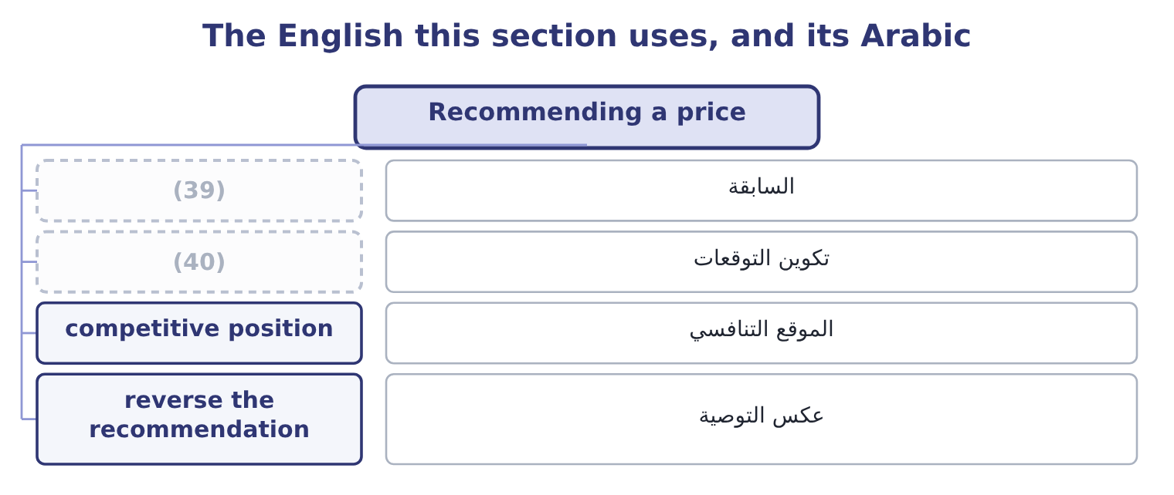
word list
saturation · expectation setting · precedent

The English this sheet uses, and its Arabic
English (exam term) | Arabic
precedent | السابقة
expectation setting | تكوين التوقعات
competitive position | الموقع التنافسي
reverse the recommendation | عكس التوصية

Answer key · 13.5 Recommending a price

1 evaluation | 21 request
2 conditions | 22 communicates
3 chapters | 23 competitive
4 horizon | 24 determined
5 short-term | 25 Price 30.00, variable cost 16.00
6 because | 26 Volume 180,000
7 judgment | 27 metaphor
8 comparables | 28 richest
9 alternative | 29 financial
10 responsive | 30 amounts
11 other-things-equal | 31 document
12 declining | 32 companion
13 Orontes's | 33 language
14 expected | 34 entering
15 strategy's | 35 describes
16 required | 36 560,000
17 qualitative | 37 740,000
18 long-lived | 38 Penetration, by 180,000
19 raising | 39 precedent
20 lowering | 40 expectation setting

the summaries in full
Summary 1 The last outcome of the pricing topic asks for an evaluation and a recommendation under stated market conditions, and the five questions below produce one. They are the pricing chapters in order. What is the floor, on the right horizon? Relevant cost for a short-term decision, full cost plus a return for a long-term one. Both should be stated, because the gap between them is where the judgment lives. What will the market bear? From comparables, the customer's alternative, or research —. How responsive is demand? The elasticity of, with the warning that it is local, short-run and other-things-equal. What stage is the product in, and what are the competitors doing? A launch takes skimming or penetration; a mature product defends; a declining product harvests. And in the oligopoly. What does the price do to everything else? Cannibalisation of the company's own products, the expectations of existing customers, the signal about quality, and the precedent for the next negotiation. Then state the recommendation in one sentence, with the number that drives it and the figure at which it would reverse.
Summary 2 For Orontes's premium jar, that sentence is: launch at $8.75, which earns $1,557,000 in the first year against $450,000 for a skimming launch, and reverse the recommendation if the volume at $8.75 is expected below 571,429 jars — which is the volume at which penetration's first-year contribution falls to the skimming strategy's, computed as 450,000 + 900,000 = 1,350,000 of required contribution over a margin of $3.15. Three qualitative points complete a good answer. A price is a long-lived decision. It sets expectations with customers, with the trade and with competitors, and raising it later is harder than lowering it. A price is a signal about quality as well as a request for money, and a discount communicates more than it earns. And the cheapest competitive position to hold is the one with the lowest cost, which is why: the pricing options a company has are largely determined before the product is designed.
Summary 3 English price skimming takes its metaphor from skimming cream off the top of milk: the seller takes the richest part of the market first and then works down. It has nothing to do with the other financial sense of skimming, which is the theft of small amounts from takings, and nothing to do with skimming a document. The companion term is the clearer of the two in every language: penetration pricing means pushing into a market, and the image of entering rather than taking from the top is worth keeping in mind when deciding which strategy a question describes.

