14.1 What capital budgeting is
Chapter 14 · section 14.1

Fill every gap. Each word list holds one word more than there are gaps.
Chapter 14, section by section
Each stage leads to the next.
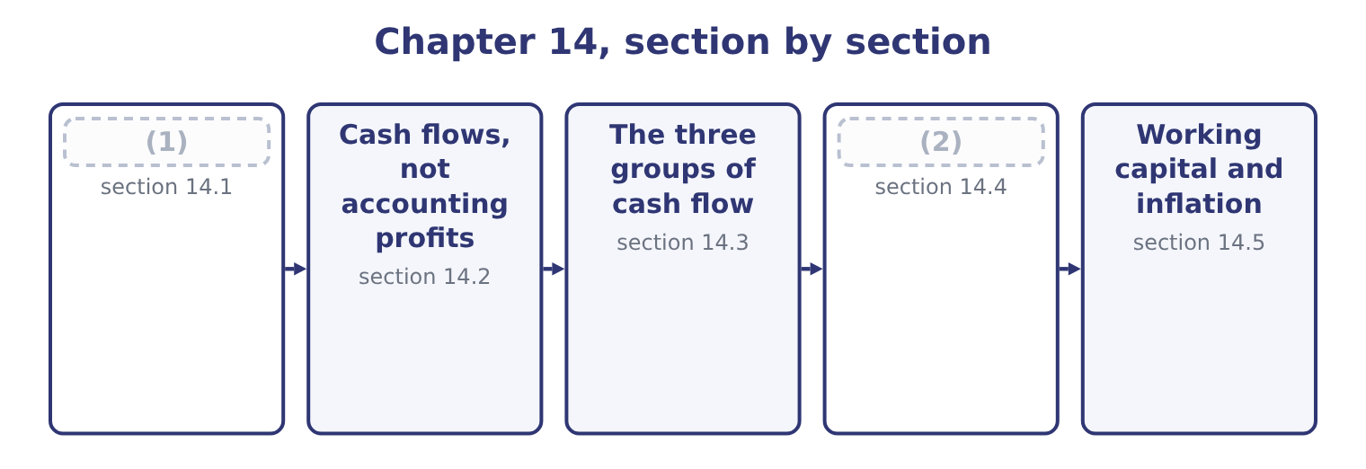
word list
What capital budgeting is · net working capital investment · How tax reaches the cash flows

Summary 1 gaps 3–14
Capital budgeting is the process by which a company (3) , evaluates, selects and controls (4) whose benefits extend beyond one year. The (5) asks for the (6) , and there are six. Proposals arise from the strategy, from (7) , from a regulatory (8) , or from a problem — a machine that is failing, a market that is growing, a rule that must be met. A company with no flow of proposals has a (9) problem rather than an investment problem. A quick test against the strategy, the available funds and an (10) hurdle, to avoid (11) in detail what will never be approved. Ranking the (12) proposals and (13) them to the funds available, which Book 2's. (14) , spending, and controlling the spend against the authority — because a project approved at $3,000,000 and delivered at $4,200,000 was a different project.
word list
investments · operations · fitting · outcome · requirement · Comparing · stages · identifies · evaluating · obvious · surviving · Authorising · management

Summary 2 gaps 15–21
Review, or the (15) . (16) what happened with what was (17) . Two features (18) the whole process from the (19) . A machine (20) is hard to unbuy, and a plant built in the wrong place stays there. That is why the (21) is done before rather than after, and why. The money goes out now and comes back over years, so the arithmetic must account for the fact that money has a time value — which is why the measures.
word list
decisions · authority · distinguish · bought · promised · postaudit · Comparing · analysis

The English this section uses, and its Arabic
Each term sits against what it means.
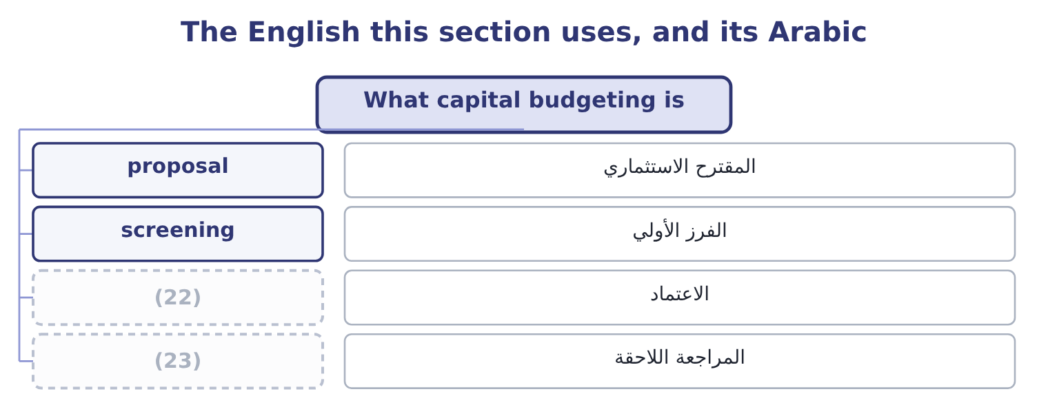
word list
authorisation · consistency · postaudit

The English this sheet uses, and its Arabic
English (exam term) | Arabic
proposal | المقترح الاستثماري
screening | الفرز الأولي
authorisation | الاعتماد
postaudit | المراجعة اللاحقة

Answer key · 14.1 What capital budgeting is

1 What capital budgeting is | 13 fitting
2 How tax reaches the cash flows | 14 Authorising
3 identifies | 15 postaudit
4 investments | 16 Comparing
5 outcome | 17 promised
6 stages | 18 distinguish
7 operations | 19 decisions
8 requirement | 20 bought
9 management | 21 analysis
10 obvious | 22 authorisation
11 evaluating | 23 postaudit
12 surviving

the summaries in full
Summary 1 Capital budgeting is the process by which a company identifies, evaluates, selects and controls investments whose benefits extend beyond one year. The outcome asks for the stages, and there are six. Proposals arise from the strategy, from operations, from a regulatory requirement, or from a problem — a machine that is failing, a market that is growing, a rule that must be met. A company with no flow of proposals has a management problem rather than an investment problem. A quick test against the strategy, the available funds and an obvious hurdle, to avoid evaluating in detail what will never be approved. Ranking the surviving proposals and fitting them to the funds available, which Book 2's. Authorising, spending, and controlling the spend against the authority — because a project approved at $3,000,000 and delivered at $4,200,000 was a different project.
Summary 2 Review, or the postaudit. Comparing what happened with what was promised. Two features distinguish the whole process from the decisions. A machine bought is hard to unbuy, and a plant built in the wrong place stays there. That is why the analysis is done before rather than after, and why. The money goes out now and comes back over years, so the arithmetic must account for the fact that money has a time value — which is why the measures.

14.2 Cash flows, not accounting profits
Chapter 14 · section 14.2

Fill every gap. Each word list holds one word more than there are gaps.
Summary 1 gaps 1–12
Capital budgeting uses cash flows and not accounting (1) , and the outcome asks why. Cash is what can be reinvested, (2) or used to repay debt. Profit is an (3) about timing; cash is a fact about a bank (4) . (5) accounting (6) spreads things. Revenue is (7) when earned rather than when (8) , and the cost of an asset is spread as depreciation over its life. Both are right for (9) a period and wrong for (10) a project, because the whole point is when the money moves. Depreciation is not a cash flow at all. The cash moved when the asset was bought, which is the initial (11) , and depreciation enters a capital budgeting analysis only (12) the tax it saves — the depreciation tax shield of section 14.4. And the relevance rules.
word list
depreciation · account · distributed · reporting · through · deliberately · investment · valuing · profits · Accrual · opinion · recognised · received

Summary 2 gaps 13–24
Only (13) cash flows count: those that would not exist without the project. Five items recur and each is (14) . Sunk costs are excluded. Market research already paid for, a site survey, a (15) study. The $25,000 of (16) . (17) costs are included. If the project uses land the company already owns, the land's market value is a cost of the project, because selling it is the (18) . If it uses capacity that would otherwise make something else, the (19) forgone is a cost. (20) overhead is excluded unless it changes. A project charged a share of head (21) costs that do not move is being charged for something it does not cause. (22) costs are excluded from the cash flows. Interest and the (23) of principal are not project cash flows; the cost of money is accounted for in the discount rate, and including it in both places charges for it twice. This is the (24) most common error in this topic.
word list
single · alternative · examined · repayment · Opportunity · feasibility · contribution · incremental · distributed · development · Allocated · Financing · office

Summary 3 gaps 25–26
Side (25) are included. (26) of the company's existing products, as in, and any benefit to other products, both belong in the project's cash flows.
word list
effects · relevance · Cannibalisation

In or out of a project's cash flows
Every item belongs to exactly one group.
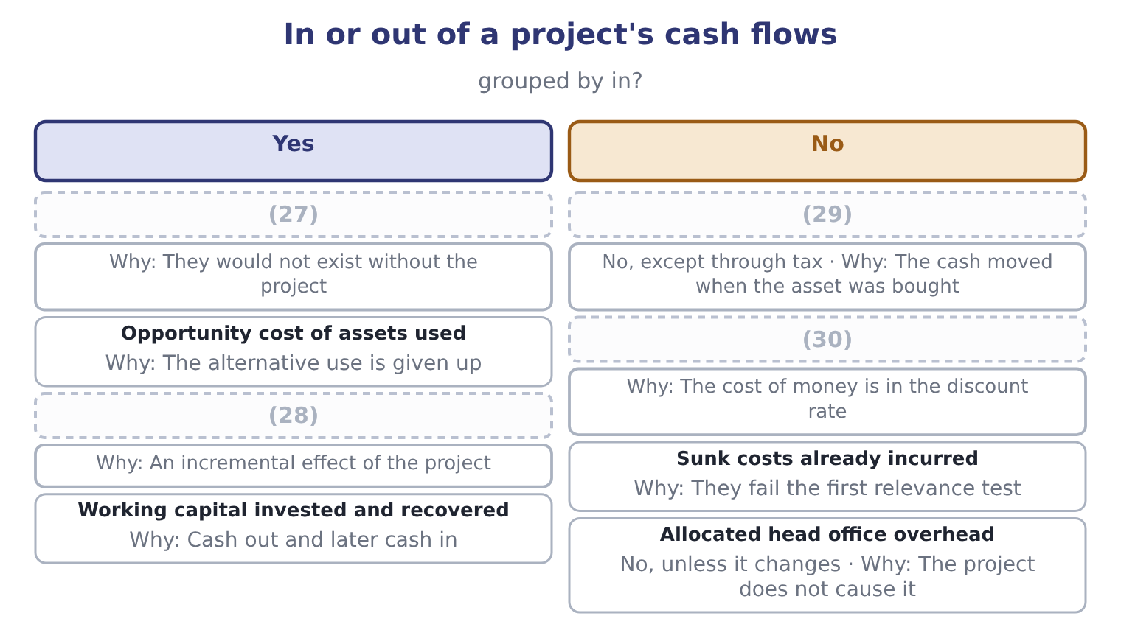
word list
Interest and loan repayments · taxable gain · Lost contribution on cannibalised sales · Incremental revenue and cash costs · Depreciation

Interest belongs in the rate, not the flows

Summary 4 gaps 31–37
Deducting interest from a project's cash flows and then (31) at the cost of capital charges for the money twice and will reject good (32) . Depreciation (33) in the analysis only as a tax shield. It is added back if a question (34) from accounting profit, and never (35) as a cost. A question that gives you an accounting profit is asking you to convert it: add back depreciation, adjust for working capital (36) , and remove any (37) item.
word list
discounting · deducted · non-cash · appears · movements · starts · projects · Cannibalisation

The English this section uses, and its Arabic
Each term sits against what it means.
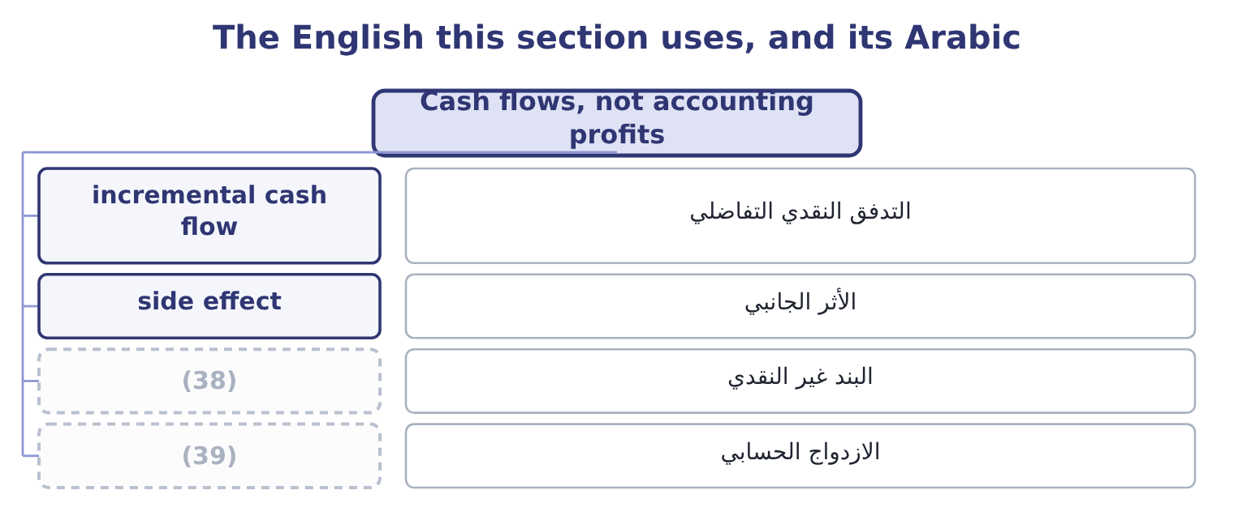
word list
initial investment · double counting · non-cash item

The English this sheet uses, and its Arabic
English (exam term) | Arabic
incremental cash flow | التدفق النقدي التفاضلي
side effect | الأثر الجانبي
non-cash item | البند غير النقدي
double counting | الازدواج الحسابي

Answer key · 14.2 Cash flows, not accounting profits

1 profits | 21 office
2 distributed | 22 Financing
3 opinion | 23 repayment
4 account | 24 single
5 Accrual | 25 effects
6 deliberately | 26 Cannibalisation
7 recognised | 27 Incremental revenue and cash costs
8 received | 28 Lost contribution on cannibalised sales
9 reporting | 29 Depreciation
10 valuing | 30 Interest and loan repayments
11 investment | 31 discounting
12 through | 32 projects
13 incremental | 33 appears
14 examined | 34 starts
15 feasibility | 35 deducted
16 development | 36 movements
17 Opportunity | 37 non-cash
18 alternative | 38 non-cash item
19 contribution | 39 double counting
20 Allocated

the summaries in full
Summary 1 Capital budgeting uses cash flows and not accounting profits, and the outcome asks why. Cash is what can be reinvested, distributed or used to repay debt. Profit is an opinion about timing; cash is a fact about a bank account. Accrual accounting deliberately spreads things. Revenue is recognised when earned rather than when received, and the cost of an asset is spread as depreciation over its life. Both are right for reporting a period and wrong for valuing a project, because the whole point is when the money moves. Depreciation is not a cash flow at all. The cash moved when the asset was bought, which is the initial investment, and depreciation enters a capital budgeting analysis only through the tax it saves — the depreciation tax shield of section 14.4. And the relevance rules.
Summary 2 Only incremental cash flows count: those that would not exist without the project. Five items recur and each is examined. Sunk costs are excluded. Market research already paid for, a site survey, a feasibility study. The $25,000 of development. Opportunity costs are included. If the project uses land the company already owns, the land's market value is a cost of the project, because selling it is the alternative. If it uses capacity that would otherwise make something else, the contribution forgone is a cost. Allocated overhead is excluded unless it changes. A project charged a share of head office costs that do not move is being charged for something it does not cause. Financing costs are excluded from the cash flows. Interest and the repayment of principal are not project cash flows; the cost of money is accounted for in the discount rate, and including it in both places charges for it twice. This is the single most common error in this topic.
Summary 3 Side effects are included. Cannibalisation of the company's existing products, as in, and any benefit to other products, both belong in the project's cash flows.
Summary 4 Deducting interest from a project's cash flows and then discounting at the cost of capital charges for the money twice and will reject good projects. Depreciation appears in the analysis only as a tax shield. It is added back if a question starts from accounting profit, and never deducted as a cost. A question that gives you an accounting profit is asking you to convert it: add back depreciation, adjust for working capital movements, and remove any non-cash item.

14.3 The three groups of cash flow
Chapter 14 · section 14.3

Fill every gap. Each word list holds one word more than there are gaps.
Summary 1 gaps 1–10
Every project's cash flows fall into three groups, and (1) them in that order is the (2) that prevents (3) . The initial investment, at time zero. The (4) price of the asset, plus delivery, installation and (5) ; plus the initial investment in working capital; plus any (6) cost of assets (7) ; less the after-tax proceeds of anything sold or (8) . The operating cash flows, each year of the project's life. The incremental revenue less the incremental cash operating costs, taxed, plus the depreciation tax shield. The terminal cash flow, in the final year. The after-tax proceeds of (9) the asset, plus the (10) of the working capital, plus or less any closing costs.
word list
commissioning · purchase · omissions · opportunity · proposal · displaced · recovery · building · selling · discipline · committed

Worked example: Orontes's roasting line

Summary 2 gaps 11–14
The line costs $3,000,000 installed, and the extra stock and (11) it brings require $400,000 of working capital. The initial (12) is 3,000,000 + 400,000 = 3,400,000. The annual operating flows, before tax. The line adds $2,400,000 of revenue and $1,200,000 of cash operating costs, so the pre-tax operating cash flow is 2,400,000 − 1,200,000 = 1,200,000 a year. At 25 per cent the after-tax operating cash flow is 1,200,000 × 0.75 = 900,000. The depreciation tax shield. The line is depreciated (13) over five years to nil: 3,000,000 ÷ 5 = 600,000 a year, which at 25 per cent saves 600,000 × 0.25 = 150,000 of tax a year. The line would fetch $200,000 at the end, and since its book value is nil the whole proceeds are (14) : 200,000 × 0.75 = 150,000 after tax.
word list
taxable · receivables · consistency · straight-line · outlay

Summary 3 gaps 15–20
The working capital of $400,000 is released. The terminal flow is 400,000 + 150,000 = 550,000, (15) in year five in (16) to that year's operating flow. The project is $3,400,000 out and $1,050,000 a year in for five years, with $550,000 more at the end. (17) that is 1,050,000 × 5 = 5,250,000 plus 550,000, or 5,800,000 — (18) more than $3,400,000, but the comparison is (19) until the timing is (20) for.
word list
received · proposal · accounted · addition · meaningless · Undiscounted · comfortably

The roasting line's cash flows
Item | Amount
(21) | (3,000,000)
Working capital invested at time zero | (400,000)
Total initial investment | (3,400,000)
(22) | 1,200,000
After-tax operating cash flow, each year | 900,000
(23) | 150,000
Annual cash flow, each of years 1 to 5 | 1,050,000
Sale proceeds in year five, before tax | 200,000
(24) | (50,000)
(25) | 400,000
Terminal flow in year five, additional | 550,000

word list
Depreciation tax shield, each year · Pre-tax operating cash flow, each year · Tax on those proceeds · Working capital released in year five · net working capital investment · Equipment, installed, at time zero

The English this section uses, and its Arabic
Each term sits against what it means.
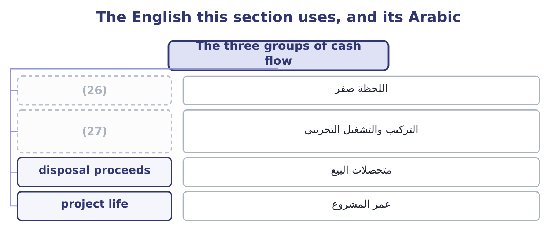
word list
depreciation tax shield · installation and commissioning · time zero

The English this sheet uses, and its Arabic
English (exam term) | Arabic
time zero | اللحظة صفر
installation and commissioning | التركيب والتشغيل التجريبي
disposal proceeds | متحصلات البيع
project life | عمر المشروع

Answer key · 14.3 The three groups of cash flow

1 building | 15 received
2 discipline | 16 addition
3 omissions | 17 Undiscounted
4 purchase | 18 comfortably
5 commissioning | 19 meaningless
6 opportunity | 20 accounted
7 committed | 21 Equipment, installed, at time zero
8 displaced | 22 Pre-tax operating cash flow, each year
9 selling | 23 Depreciation tax shield, each year
10 recovery | 24 Tax on those proceeds
11 receivables | 25 Working capital released in year five
12 outlay | 26 time zero
13 straight-line | 27 installation and commissioning
14 taxable

the summaries in full
Summary 1 Every project's cash flows fall into three groups, and building them in that order is the discipline that prevents omissions. The initial investment, at time zero. The purchase price of the asset, plus delivery, installation and commissioning; plus the initial investment in working capital; plus any opportunity cost of assets committed; less the after-tax proceeds of anything sold or displaced. The operating cash flows, each year of the project's life. The incremental revenue less the incremental cash operating costs, taxed, plus the depreciation tax shield. The terminal cash flow, in the final year. The after-tax proceeds of selling the asset, plus the recovery of the working capital, plus or less any closing costs.
Summary 2 The line costs $3,000,000 installed, and the extra stock and receivables it brings require $400,000 of working capital. The initial outlay is 3,000,000 + 400,000 = 3,400,000. The annual operating flows, before tax. The line adds $2,400,000 of revenue and $1,200,000 of cash operating costs, so the pre-tax operating cash flow is 2,400,000 − 1,200,000 = 1,200,000 a year. At 25 per cent the after-tax operating cash flow is 1,200,000 × 0.75 = 900,000. The depreciation tax shield. The line is depreciated straight-line over five years to nil: 3,000,000 ÷ 5 = 600,000 a year, which at 25 per cent saves 600,000 × 0.25 = 150,000 of tax a year. The line would fetch $200,000 at the end, and since its book value is nil the whole proceeds are taxable: 200,000 × 0.75 = 150,000 after tax.
Summary 3 The working capital of $400,000 is released. The terminal flow is 400,000 + 150,000 = 550,000, received in year five in addition to that year's operating flow. The project is $3,400,000 out and $1,050,000 a year in for five years, with $550,000 more at the end. Undiscounted that is 1,050,000 × 5 = 5,250,000 plus 550,000, or 5,800,000 — comfortably more than $3,400,000, but the comparison is meaningless until the timing is accounted for.

14.4 How tax reaches the cash flows
Chapter 14 · section 14.4

Fill every gap. Each word list holds one word more than there are gaps.
Summary 1 gaps 1–12
Tax enters a capital (1) analysis in three places, and the (2) asks for all three. On the operating flows. (3) the depreciation tax shield. Depreciation is not a cash cost, but it is deductible, so it (4) the tax paid. The shield is the depreciation times the tax rate, and it is a (5) cash inflow of the project. Where the tax rules allow (6) depreciation, the shield (7) earlier and is worth more, which is why the tax code's depreciation method (8) to a project's value even though the total deduction is the same. (9) an asset for more than its tax book value (10) a taxable gain; for less, a deductible loss. In the example the (11) book value is nil, so the whole $200,000 is taxed: 200,000 × 0.25 = 50,000 of tax, (12) $150,000.
word list
produces · outcome · matters · Through · Selling · genuine · leaving · arrives · accelerated · postaudit · budgeting · line's · reduces

Summary 2 gaps 13–21
Had the book value been $200,000 there would have been no tax at all, and had it been $500,000 the $300,000 loss would have saved 300,000 × 0.25 = 75,000. Two (13) points appear in harder (14) . A company with losses has a (15) tax rate of nil until they are used, so its (16) are worth nothing now and (17) later — which, as Book 2's, is the standard reason a (18) company leases rather than buys. And an investment tax credit, where one exists, is a direct (19) of tax in the year of (20) and belongs in the (21) investment rather than in the operating flows.
word list
purchase · marginal · loss-making · something · budgeting · initial · reduction · questions · further · shields

The same project, taxed and untaxed
Every item belongs to exactly one group.
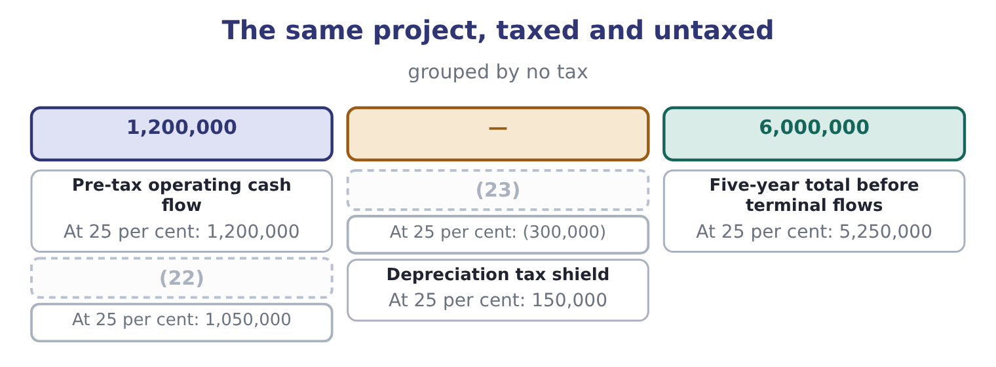
word list
Annual cash flow · operating cash flow · Tax on it

Summary 3 gaps 24–27
Tax takes 12.5 per cent of this project's (24) cash flow rather than 25, (25) half the deduction comes back as the shield. That is the (26) point of the whole section: a 25 per cent tax rate does not reduce a project's value by a (27) .
word list
annual · practical · postaudit · because · quarter

The English this section uses, and its Arabic
Each term sits against what it means.
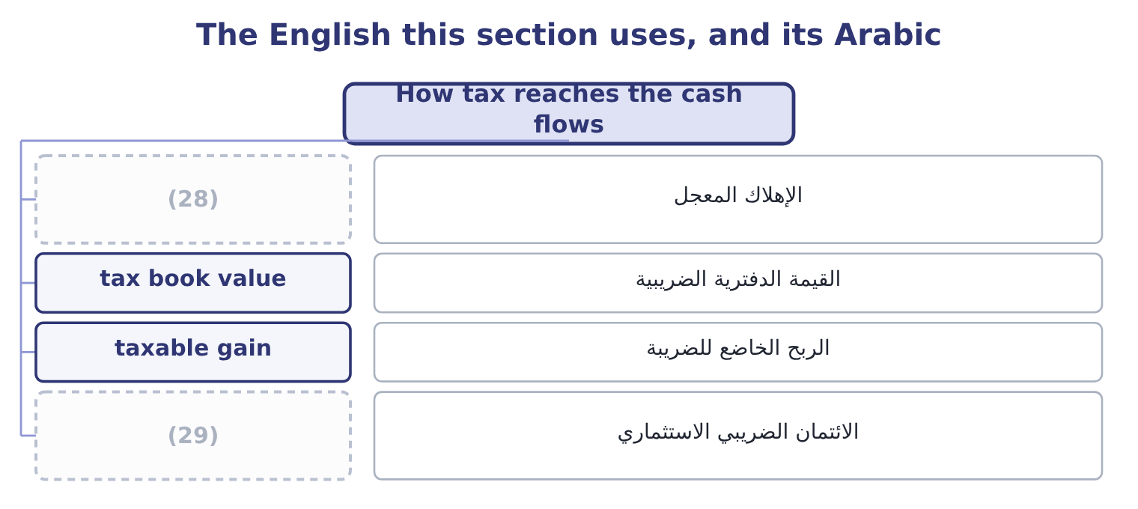
word list
non-cash item · investment tax credit · accelerated depreciation

The English this sheet uses, and its Arabic
English (exam term) | Arabic
accelerated depreciation | الإهلاك المعجل
tax book value | القيمة الدفترية الضريبية
taxable gain | الربح الخاضع للضريبة
investment tax credit | الائتمان الضريبي الاستثماري

Answer key · 14.4 How tax reaches the cash flows

1 budgeting | 16 shields
2 outcome | 17 something
3 Through | 18 loss-making
4 reduces | 19 reduction
5 genuine | 20 purchase
6 accelerated | 21 initial
7 arrives | 22 Annual cash flow
8 matters | 23 Tax on it
9 Selling | 24 annual
10 produces | 25 because
11 line's | 26 practical
12 leaving | 27 quarter
13 further | 28 accelerated depreciation
14 questions | 29 investment tax credit
15 marginal

the summaries in full
Summary 1 Tax enters a capital budgeting analysis in three places, and the outcome asks for all three. On the operating flows. Through the depreciation tax shield. Depreciation is not a cash cost, but it is deductible, so it reduces the tax paid. The shield is the depreciation times the tax rate, and it is a genuine cash inflow of the project. Where the tax rules allow accelerated depreciation, the shield arrives earlier and is worth more, which is why the tax code's depreciation method matters to a project's value even though the total deduction is the same. Selling an asset for more than its tax book value produces a taxable gain; for less, a deductible loss. In the example the line's book value is nil, so the whole $200,000 is taxed: 200,000 × 0.25 = 50,000 of tax, leaving $150,000.
Summary 2 Had the book value been $200,000 there would have been no tax at all, and had it been $500,000 the $300,000 loss would have saved 300,000 × 0.25 = 75,000. Two further points appear in harder questions. A company with losses has a marginal tax rate of nil until they are used, so its shields are worth nothing now and something later — which, as Book 2's, is the standard reason a loss-making company leases rather than buys. And an investment tax credit, where one exists, is a direct reduction of tax in the year of purchase and belongs in the initial investment rather than in the operating flows.
Summary 3 Tax takes 12.5 per cent of this project's annual cash flow rather than 25, because half the deduction comes back as the shield. That is the practical point of the whole section: a 25 per cent tax rate does not reduce a project's value by a quarter.

14.5 Working capital and inflation
Chapter 14 · section 14.5

Fill every gap. Each word list holds one word more than there are gaps.
Summary 1 gaps 1–12
Two (1) complete the cash flows, and both are (2) in their own right. A project that adds sales adds receivables and inventory, and usually adds some payables. The net (3) is an investment: cash goes out at the start, more may go out as the project grows, and the whole of it comes back at the end when the stock is sold and the receivables (4) . The investment is a cash outflow when it is made and an inflow when it is recovered, and the (5) is usually (6) to happen in the final year. Only the net change (7) : an increase in payables funds part of the increase in receivables and inventory, (8) as Book 2's. It is not (9) and it generates no tax shield, because it is not (10) . The $400,000 in (11) roasting line goes out at time zero and comes back in year five (12) .
word list
assumed · depreciated · consumed · collected · exactly · Orontes's · examined · projects · matters · amount · recovery · refinements · undiminished

Summary 2 gaps 13–21
Omitting working capital is a (13) error and it always (14) the project, because it (15) an early outflow and a late inflow of equal size — and the early one is (16) less. Where prices and costs will rise, the (17) must be consistent, and there are two consistent ways to do it. The nominal approach inflates the cash flows at the expected rate and discounts them at the nominal rate — the rate the market (18) quotes, which already (19) expected inflation, as Book 2's. The real approach (20) the cash flows in today's prices and discounts at a real rate, found by removing inflation from the nominal rate: at a nominal 9 per cent and 3 per cent inflation, 1.09 ÷ 1.03 = 1.0583, a real rate of 5.83 per cent. Both give the same answer when applied (21) .
word list
removes · leaves · discounted · flatters · actually · correctly · analysis · adjustment · includes · common

Summary 3 gaps 22–31
The error the exam tests is mixing them: (22) cash flows stated in today's prices at a nominal rate (23) every future inflow and rejects good projects, and it is the (24) inflation mistake in practice. Two (25) are worth naming. Not (26) inflates at the same rate — sesame may rise faster than wages, and a (27) price may not rise at all — so a general inflation adjustment is a (28) . And the depreciation tax shield never inflates, because it is (29) on the historical cost of the asset: in a period of inflation the shield loses real value every year, which is one of Book 1's points about historical cost, (30) in a project (31) .
word list
complications · simplification · expenditure · computed · contracted · appraisal · understates · discounting · everything · commonest · arriving

Build the cash flows

Your turn: a project's cash flows (complete the blanks)
Item | Data | Answer
Initial investment | Equipment 1,800,000; working capital 250,000 | (32)
Annual depreciation | Four-year life, straight line to nil | (33)
After-tax operating cash flow | (34) | 555,000: the pre-tax flow is 1,500,000 − 760,000 = 740,000, and 740,000 × 0.75 = 555,000.
Annual depreciation tax shield |  | 112,500: 450,000 × 0.25 = 112,500.
Total annual cash flow |  | (35)
Terminal cash flow | Asset sold for 120,000, book value nil; working capital recovered | 340,000: the sale yields 120,000 × 0.75 = 90,000 after tax, plus 250,000 of working capital recovered.
Real discount rate | Nominal 10 per cent, inflation 4 per cent | (36) : 1.10 ÷ 1.04 = 1.0577.

word list
450,000: 1,800,000 ÷ 4 = 450,000. · 667,500: 555,000 + 112,500 = 667,500. · Revenue 1,500,000, cash costs 760,000, tax 25 per cent · 5.77 per cent · 112,500: 450,000 × 0.25 = 112,500. · 2,050,000: 1,800,000 + 250,000 = 2,050,000.

"Capital"

Summary 4 gaps 37–43
English capital budgeting is about spending on (37) assets, and the word capital here means the assets (38) than the money, which is the (39) of its sense in Book 2's cost of capital. A capital expenditure buys a machine; capital (40) is the money that (41) it; and capital budgeting is the process of (42) between machines. The rule for an answer is to let the noun beside the word decide: budgeting and expenditure point to assets, cost and (43) point to money.
word list
choosing · opposite · employed · long-lived · discounted · funded · structure · rather

The English this section uses, and its Arabic
Each term sits against what it means.
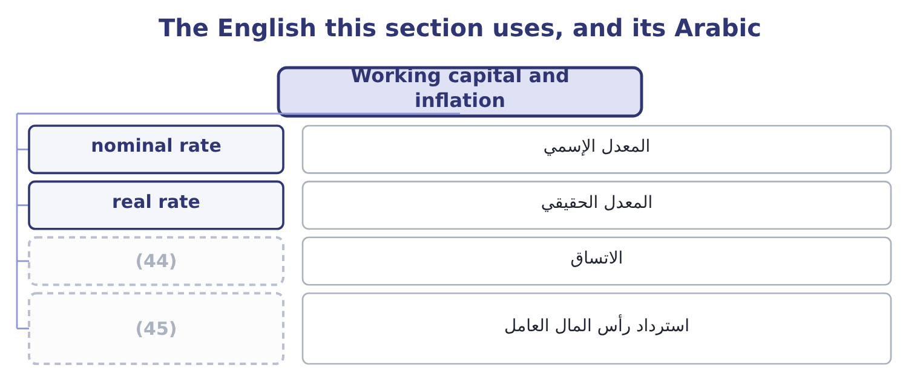
word list
double counting · consistency · recovery of working capital

The English this sheet uses, and its Arabic
English (exam term) | Arabic
nominal rate | المعدل الإسمي
real rate | المعدل الحقيقي
consistency | الاتساق
recovery of working capital | استرداد رأس المال العامل

Answer key · 14.5 Working capital and inflation

1 refinements | 24 commonest
2 examined | 25 complications
3 amount | 26 everything
4 collected | 27 contracted
5 recovery | 28 simplification
6 assumed | 29 computed
7 matters | 30 arriving
8 exactly | 31 appraisal
9 depreciated | 32 2,050,000: 1,800,000 + 250,000 = 2,050,000.
10 consumed | 33 450,000: 1,800,000 ÷ 4 = 450,000.
11 Orontes's | 34 Revenue 1,500,000, cash costs 760,000, tax 25 per cent
12 undiminished | 35 667,500: 555,000 + 112,500 = 667,500.
13 common | 36 5.77 per cent
14 flatters | 37 long-lived
15 removes | 38 rather
16 discounted | 39 opposite
17 analysis | 40 employed
18 actually | 41 funded
19 includes | 42 choosing
20 leaves | 43 structure
21 correctly | 44 consistency
22 discounting | 45 recovery of working capital
23 understates

the summaries in full
Summary 1 Two refinements complete the cash flows, and both are examined in their own right. A project that adds sales adds receivables and inventory, and usually adds some payables. The net amount is an investment: cash goes out at the start, more may go out as the project grows, and the whole of it comes back at the end when the stock is sold and the receivables collected. The investment is a cash outflow when it is made and an inflow when it is recovered, and the recovery is usually assumed to happen in the final year. Only the net change matters: an increase in payables funds part of the increase in receivables and inventory, exactly as Book 2's. It is not depreciated and it generates no tax shield, because it is not consumed. The $400,000 in Orontes's roasting line goes out at time zero and comes back in year five undiminished.
Summary 2 Omitting working capital is a common error and it always flatters the project, because it removes an early outflow and a late inflow of equal size — and the early one is discounted less. Where prices and costs will rise, the analysis must be consistent, and there are two consistent ways to do it. The nominal approach inflates the cash flows at the expected rate and discounts them at the nominal rate — the rate the market actually quotes, which already includes expected inflation, as Book 2's. The real approach leaves the cash flows in today's prices and discounts at a real rate, found by removing inflation from the nominal rate: at a nominal 9 per cent and 3 per cent inflation, 1.09 ÷ 1.03 = 1.0583, a real rate of 5.83 per cent. Both give the same answer when applied correctly.
Summary 3 The error the exam tests is mixing them: discounting cash flows stated in today's prices at a nominal rate understates every future inflow and rejects good projects, and it is the commonest inflation mistake in practice. Two complications are worth naming. Not everything inflates at the same rate — sesame may rise faster than wages, and a contracted price may not rise at all — so a general inflation adjustment is a simplification. And the depreciation tax shield never inflates, because it is computed on the historical cost of the asset: in a period of inflation the shield loses real value every year, which is one of Book 1's points about historical cost, arriving in a project appraisal.
Summary 4 English capital budgeting is about spending on long-lived assets, and the word capital here means the assets rather than the money, which is the opposite of its sense in Book 2's cost of capital. A capital expenditure buys a machine; capital employed is the money that funded it; and capital budgeting is the process of choosing between machines. The rule for an answer is to let the noun beside the word decide: budgeting and expenditure point to assets, cost and structure point to money.

