15.1 The hurdle rate
Chapter 15 · section 15.1

Fill every gap. Each word list holds one word more than there are gaps.
Chapter 15, section by section
Each stage leads to the next.
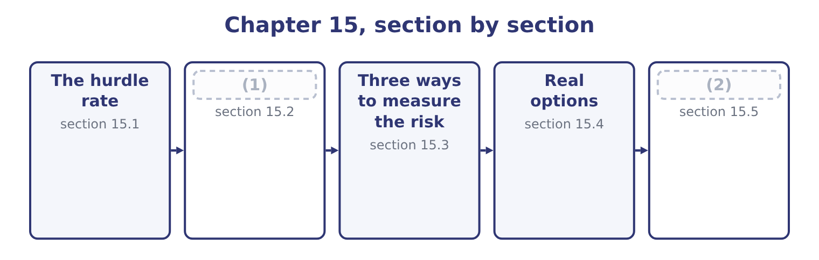
word list
risk-adjusted discount rate · Qualitative factors and the postaudit · Approaches to risk

Summary 1 gaps 3–14
A hurdle rate is the (3) return a project must earn to be (4) . It is the rate used to (5) the cash flows, and a project whose net present value is (6) at that rate has cleared it. For a project of (7) risk, the hurdle is the company's (8) average cost of capital, which Book 2 built from the required returns of every provider of money. (9) is 9.04 per cent. Earning less than that leaves the (10) worse off, which is the (11) profit of Book 1 stated as a rate. Three (12) are made in (13) , and the exam asks about each. A risk adjustment, where the (14) risk differs from the company's. A premium for rationing. Where a company has more good projects than money, raising the hurdle above the cost of capital is a crude way of selecting among them. It is crude because it confuses the cost of money with its scarcity, and the better method is to rank by value created for each dollar invested.
word list
project's · ordinary · adjustments · practice · hopeful · discount · minimum · weighted · positive · providers · accepted · Orontes's · economic

Summary 2 gaps 15–26
A margin for (15) . Many companies set a hurdle above their cost of capital because project (16) ' forecasts are (17) hopeful. It is a (18) response to a real (19) and it has a cost: a hurdle set far above the cost of capital (20) projects that would (21) value, and the honest remedy is to (22) the forecasts rather than the rate. The risk-adjusted rate works as a premium added to the cost of capital, or as a rate (23) directly from the risk of the (24) using the capital asset pricing model of Book 2's. At the company's rate. At 9 per cent the five-year (25) factor is 3.8897 and the five-year (26) factor 0.6499, so the value is 1,050,000 × 3.8897 = 4,084,185 plus 550,000 × 0.6499 = 357,445, which is 4,084,185 + 357,445 = 4,441,630, giving a net present value of 4,441,630 − 3,400,000 = 1,041,630.
word list
present-value · rejects · annuity · create · problem · sponsors · activity · optimism · provider · correct · reasonable · systematically · estimated

Summary 3 gaps 27–38
At a risk-adjusted rate. (27) the line serves a new (28) market and the board adds three points, so the hurdle (29) 9.04 + 3.00 = 12.04 per cent, which at 12 per cent (30) of 3.6048 and 0.5674 gives 1,050,000 × 3.6048 = 3,785,040 plus 550,000 × 0.5674 = 312,070, which is 3,785,040 + 312,070 = 4,097,110 and a net present value of 4,097,110 − 3,400,000 = 697,110. Three points of hurdle rate (31) 1,041,630 − 697,110 = 344,520 of value, a third of it, from a project whose cash flows did not change at all. The project still clears the higher hurdle, so the adjustment did not change the (32) here — but it would have, had the margin been (33) , and a company that adds a premium (34) a reason is (35) value for a feeling. The reason must be stated: this project is (36) than the company's (37) business because it sells into a market Orontes does not know, and the premium is the price of that (38) .
word list
unfamiliarity · riskier · without · removed · rejecting · Orontes's · factors · decision · existing · becomes · export · Suppose · thinner

The English this section uses, and its Arabic
Each term sits against what it means.
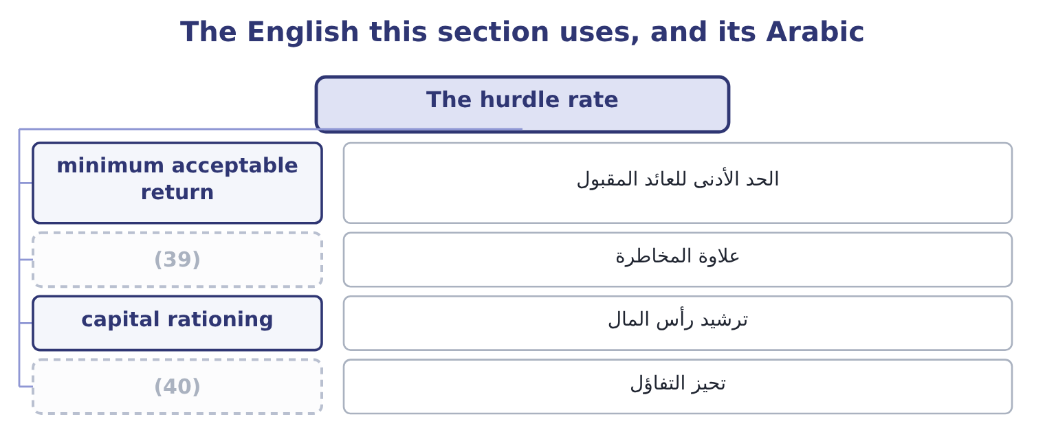
word list
optimism bias · risk premium · scenario analysis

The English this sheet uses, and its Arabic
English (exam term) | Arabic
minimum acceptable return | الحد الأدنى للعائد المقبول
risk premium | علاوة المخاطرة
capital rationing | ترشيد رأس المال
optimism bias | تحيز التفاؤل

Answer key · 15.1 The hurdle rate

1 Approaches to risk | 21 create
2 Qualitative factors and the postaudit | 22 correct
3 minimum | 23 estimated
4 accepted | 24 activity
5 discount | 25 annuity
6 positive | 26 present-value
7 ordinary | 27 Suppose
8 weighted | 28 export
9 Orontes's | 29 becomes
10 providers | 30 factors
11 economic | 31 removed
12 adjustments | 32 decision
13 practice | 33 thinner
14 project's | 34 without
15 optimism | 35 rejecting
16 sponsors | 36 riskier
17 systematically | 37 existing
18 reasonable | 38 unfamiliarity
19 problem | 39 risk premium
20 rejects | 40 optimism bias

the summaries in full
Summary 1 A hurdle rate is the minimum return a project must earn to be accepted. It is the rate used to discount the cash flows, and a project whose net present value is positive at that rate has cleared it. For a project of ordinary risk, the hurdle is the company's weighted average cost of capital, which Book 2 built from the required returns of every provider of money. Orontes's is 9.04 per cent. Earning less than that leaves the providers worse off, which is the economic profit of Book 1 stated as a rate. Three adjustments are made in practice, and the exam asks about each. A risk adjustment, where the project's risk differs from the company's. A premium for rationing. Where a company has more good projects than money, raising the hurdle above the cost of capital is a crude way of selecting among them. It is crude because it confuses the cost of money with its scarcity, and the better method is to rank by value created for each dollar invested.
Summary 2 A margin for optimism. Many companies set a hurdle above their cost of capital because project sponsors' forecasts are systematically hopeful. It is a reasonable response to a real problem and it has a cost: a hurdle set far above the cost of capital rejects projects that would create value, and the honest remedy is to correct the forecasts rather than the rate. The risk-adjusted rate works as a premium added to the cost of capital, or as a rate estimated directly from the risk of the activity using the capital asset pricing model of Book 2's. At the company's rate. At 9 per cent the five-year annuity factor is 3.8897 and the five-year present-value factor 0.6499, so the value is 1,050,000 × 3.8897 = 4,084,185 plus 550,000 × 0.6499 = 357,445, which is 4,084,185 + 357,445 = 4,441,630, giving a net present value of 4,441,630 − 3,400,000 = 1,041,630.
Summary 3 At a risk-adjusted rate. Suppose the line serves a new export market and the board adds three points, so the hurdle becomes 9.04 + 3.00 = 12.04 per cent, which at 12 per cent factors of 3.6048 and 0.5674 gives 1,050,000 × 3.6048 = 3,785,040 plus 550,000 × 0.5674 = 312,070, which is 3,785,040 + 312,070 = 4,097,110 and a net present value of 4,097,110 − 3,400,000 = 697,110. Three points of hurdle rate removed 1,041,630 − 697,110 = 344,520 of value, a third of it, from a project whose cash flows did not change at all. The project still clears the higher hurdle, so the adjustment did not change the decision here — but it would have, had the margin been thinner, and a company that adds a premium without a reason is rejecting value for a feeling. The reason must be stated: this project is riskier than the company's existing business because it sells into a market Orontes does not know, and the premium is the price of that unfamiliarity.

15.2 Approaches to risk
Chapter 15 · section 15.2

Fill every gap. Each word list holds one word more than there are gaps.
Summary 1 gaps 1–12
The outcome asks for (1) approaches, and there are five in (2) use. Raise the discount rate. The risk-adjusted rate of section 15.1. Simple, widely used, and blunt: it assumes risk grows (3) with time, because a higher rate (4) distant flows most, which is true of some risks and not of others. (5) each uncertain cash flow with the certain amount the company would accept instead, then discount at the (6) rate. A flow of $1,050,000 might be (7) as worth 1,050,000 × 0.85 = 892,500 for certain. The method is (8) cleaner than a risk-adjusted rate, because it separates the risk adjustment from the time adjustment, and it is harder to use because somebody must state the (9) . Shorten the (10) payback. Requiring a project to repay (11) three years rather than five is a crude way of (12) that the uncertain distant years do not carry the case.
word list
conceptually · equivalents · separates · steadily · alternative · Replace · required · penalises · common · insisting · risk-free · within · treated

Summary 2 gaps 13–21
Analyse the risk (13) , with the techniques of section 15.3, and (14) the range rather than a single figure. (15) the risk itself. Stage the (16) so that it can be stopped, (17) it in one region, contract a price in advance as Book 2's, insure what can be insured, or share it with a partner. That last approach is the one most often (18) in an exam answer and the most (19) in practice. The purpose of (20) risk is to manage it, and a project that can be stopped after a year is a (21) project from one that cannot.
word list
omitted · separates · valuable · analysing · different · Reduce · pilot · investment · present · explicitly

Five ways to deal with risk
Approach | What it does | Strength | Weakness
Risk-adjusted rate | (22) | Simple; widely understood | Assumes risk rises with time
Certainty equivalent | (23) | Separates risk from time | Requires explicit judgments
Shorter payback | (24) | Easy to apply | Rejects good long projects
Explicit analysis | Shows the range of outcomes | Informative | (25)
Risk reduction | Changes the project | Acts on the cause | (26)

word list
Acts on the cause · Ignores distant, uncertain years · Costs money or forgoes return · Does not decide anything by itself · Replaces flows with certain amounts · Discounts risky flows more heavily

The English this section uses, and its Arabic
Each term sits against what it means.
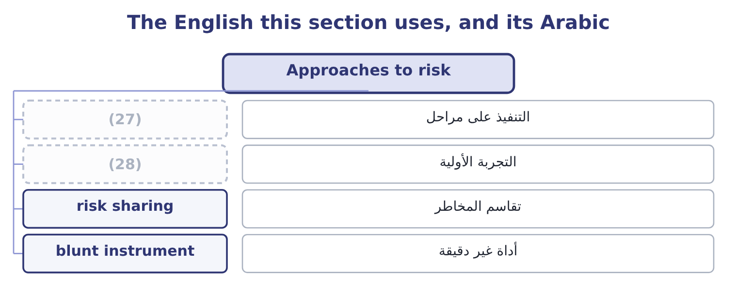
word list
pilot · staging · drift

The English this sheet uses, and its Arabic
English (exam term) | Arabic
staging | التنفيذ على مراحل
pilot | التجربة الأولية
risk sharing | تقاسم المخاطر
blunt instrument | أداة غير دقيقة

Answer key · 15.2 Approaches to risk

1 alternative | 15 Reduce
2 common | 16 investment
3 steadily | 17 pilot
4 penalises | 18 omitted
5 Replace | 19 valuable
6 risk-free | 20 analysing
7 treated | 21 different
8 conceptually | 22 Discounts risky flows more heavily
9 equivalents | 23 Replaces flows with certain amounts
10 required | 24 Ignores distant, uncertain years
11 within | 25 Does not decide anything by itself
12 insisting | 26 Costs money or forgoes return
13 explicitly | 27 staging
14 present | 28 pilot

the summaries in full
Summary 1 The outcome asks for alternative approaches, and there are five in common use. Raise the discount rate. The risk-adjusted rate of section 15.1. Simple, widely used, and blunt: it assumes risk grows steadily with time, because a higher rate penalises distant flows most, which is true of some risks and not of others. Replace each uncertain cash flow with the certain amount the company would accept instead, then discount at the risk-free rate. A flow of $1,050,000 might be treated as worth 1,050,000 × 0.85 = 892,500 for certain. The method is conceptually cleaner than a risk-adjusted rate, because it separates the risk adjustment from the time adjustment, and it is harder to use because somebody must state the equivalents. Shorten the required payback. Requiring a project to repay within three years rather than five is a crude way of insisting that the uncertain distant years do not carry the case.
Summary 2 Analyse the risk explicitly, with the techniques of section 15.3, and present the range rather than a single figure. Reduce the risk itself. Stage the investment so that it can be stopped, pilot it in one region, contract a price in advance as Book 2's, insure what can be insured, or share it with a partner. That last approach is the one most often omitted in an exam answer and the most valuable in practice. The purpose of analysing risk is to manage it, and a project that can be stopped after a year is a different project from one that cannot.

15.3 Three ways to measure the risk
Chapter 15 · section 15.3

Fill every gap. Each word list holds one word more than there are gaps.
Summary 1 gaps 1–12
The (1) names three (2) and asks for them to be (3) . Sensitivity analysis changes one input at a time and (4) the effect on the net present value. Its (5) is a ranking of the inputs by (6) , and the most useful form states, for each input, the value at which the net present value falls to zero. For the (7) line, the present value of the (8) flow at 9 per cent is 550,000 × 0.6499 = 357,445, so the annual flows must cover 3,400,000 − 357,445 = 3,042,555, which over an annuity factor of 3.8897 is 3,042,555 ÷ 3.8897 = 782,208 a year. The project (9) survives a fall in its annual cash flow from $1,050,000 to $782,208 — a (10) of 267,792 ÷ 1,050,000 = 25.50 per cent. That single (11) is worth more to a board than any number of (12) tables.
word list
discounted · margin · techniques · sentence · terminal · roasting · specified · records · outcome · output · therefore · influence · distinguished

Summary 2 gaps 13–23
Scenario analysis changes several inputs together in a coherent story — a bad case in which (13) , price and input costs all move the wrong way at once. It (14) the correlations that (15) analysis cannot, and it produces a (16) of outcomes rather than a ranking. Monte Carlo simulation (17) a probability distribution to each (18) input, draws thousands of (19) at random, and produces a distribution of net present values. Its (20) are the mean, the spread, and the probability that the project (21) value — which is the (22) a board actually asks. Its (23) are that it needs distributions nobody can observe, that correlations between inputs must be specified and are usually guessed, and that the apparent precision of a computed probability flatters the underlying estimates.
word list
captures · volume · destroys · handful · somebody · question · weaknesses · one-at-a-time · outputs · combinations · assigns · uncertain

Three risk techniques
Technique | Changes | Produces | Best for
Sensitivity | One input at a time | A ranking, and break-even values | (24)
Scenario | Several inputs together | A few coherent outcomes | (25)
Simulation | All inputs, many times | (26) | Estimating the probability of loss

word list
risk-adjusted discount rate · Capturing correlated risks · A distribution of outcomes · Finding what the answer depends on

What each technique cannot do

Summary 3 gaps 27–31
Sensitivity analysis cannot (27) the fact that bad things arrive together. That is what (28) are for. A (29) distribution is only as good as the input distributions, and these are usually assumed rather than measured. None of the three makes the (30) . They describe the (31) ; somebody still has to judge whether the company can bear it.
word list
capture · simulation's · scenarios · therefore · uncertainty · decision

The English this section uses, and its Arabic
Each term sits against what it means.
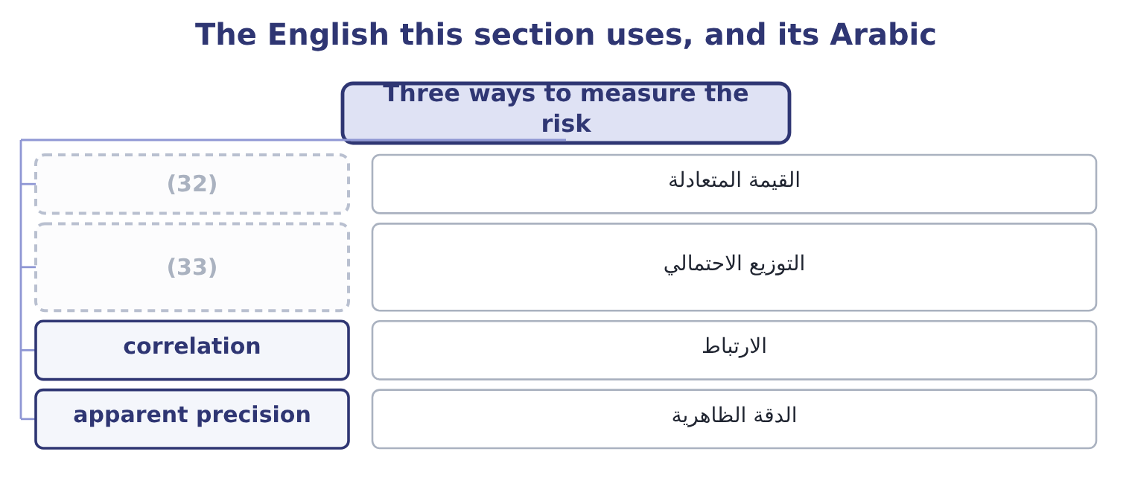
word list
probability distribution · real option · break-even value

The English this sheet uses, and its Arabic
English (exam term) | Arabic
break-even value | القيمة المتعادلة
probability distribution | التوزيع الاحتمالي
correlation | الارتباط
apparent precision | الدقة الظاهرية

Answer key · 15.3 Three ways to measure the risk

1 outcome | 18 uncertain
2 techniques | 19 combinations
3 distinguished | 20 outputs
4 records | 21 destroys
5 output | 22 question
6 influence | 23 weaknesses
7 roasting | 24 Finding what the answer depends on
8 terminal | 25 Capturing correlated risks
9 therefore | 26 A distribution of outcomes
10 margin | 27 capture
11 sentence | 28 scenarios
12 discounted | 29 simulation's
13 volume | 30 decision
14 captures | 31 uncertainty
15 one-at-a-time | 32 break-even value
16 handful | 33 probability distribution
17 assigns

the summaries in full
Summary 1 The outcome names three techniques and asks for them to be distinguished. Sensitivity analysis changes one input at a time and records the effect on the net present value. Its output is a ranking of the inputs by influence, and the most useful form states, for each input, the value at which the net present value falls to zero. For the roasting line, the present value of the terminal flow at 9 per cent is 550,000 × 0.6499 = 357,445, so the annual flows must cover 3,400,000 − 357,445 = 3,042,555, which over an annuity factor of 3.8897 is 3,042,555 ÷ 3.8897 = 782,208 a year. The project therefore survives a fall in its annual cash flow from $1,050,000 to $782,208 — a margin of 267,792 ÷ 1,050,000 = 25.50 per cent. That single sentence is worth more to a board than any number of discounted tables.
Summary 2 Scenario analysis changes several inputs together in a coherent story — a bad case in which volume, price and input costs all move the wrong way at once. It captures the correlations that one-at-a-time analysis cannot, and it produces a handful of outcomes rather than a ranking. Monte Carlo simulation assigns a probability distribution to each uncertain input, draws thousands of combinations at random, and produces a distribution of net present values. Its outputs are the mean, the spread, and the probability that the project destroys value — which is the question a board actually asks. Its weaknesses are that it needs distributions nobody can observe, that correlations between inputs must be specified and are usually guessed, and that the apparent precision of a computed probability flatters the underlying estimates.
Summary 3 Sensitivity analysis cannot capture the fact that bad things arrive together. That is what scenarios are for. A simulation's distribution is only as good as the input distributions, and these are usually assumed rather than measured. None of the three makes the decision. They describe the uncertainty; somebody still has to judge whether the company can bear it.

15.4 Real options
Chapter 15 · section 15.4

Fill every gap. Each word list holds one word more than there are gaps.
Summary 1 gaps 1–12
A discounted cash flow (1) values a project as though it were a (2) made once and then endured. Real (3) are not like that: managers can wait, expand, contract or stop, and each of those (4) is worth something. They are (5) real options because they have the (6) of the financial options of Book 2's. The (7) names four. The option to delay. Waiting for information — a (8) decision, a (9) move, a harvest, a price. A project that can be (10) next year as easily as this one (11) the value of what will be learned in between. The cost of delay is the cash flow (12) and the risk that a competitor moves first. The option to expand. A project that creates the ability to do more if things go well — a plant built with foundations for a second line, a product launched in one city that could be rolled out to twenty.
word list
competitor's · called · planning · structure · forgone · abilities · projects · consequences · started · commitment · analysis · carries · outcome

Summary 2 gaps 13–24
Much of the value of a small first project is the large second one it makes (13) , and a discounted cash flow of the first alone will (14) it. The option to abandon. The ability to stop and recover something — selling the equipment, (15) the building, (16) the contract. It puts a floor under the (17) , and it is worth most where the assets are general-purpose and can be sold, and least where they are (18) and cannot. The option to scale back. (19) at reduced volume rather than closing, mothballing a line, (20) a plant to another product. It is the (21) version of (22) . Two (23) the exam asks for. (24) these options raises a project's value, because each is a right and not an obligation: it will be exercised only when it pays. So a valuation that ignores them understates the project, and the understatement is largest where uncertainty is greatest — the opposite of the intuition that uncertainty always reduces value. And they should be designed.
word list
reject · downside · Considering · consequences · abandonment · cancelling · analysis · specialised · partial · subletting · Running · switching · possible

Summary 3 gaps 25–29
A plant that can be (25) , a lease that can be broken, a contract staged in phases, a supplier (26) with an option to increase volume: each costs something at the outset and is worth more than it costs where the future is (27) uncertain. That is the (28) use of the idea, and no (29) is required to act on it.
word list
genuinely · practical · arrangement · calculation · project's · converted

Four real options
Option | The right to | Worth most when | Example
Delay | Start later, with more information | Information arrives soon and the position can be held | (30)
Expand | Do more if it goes well | The upside is large and the first step is small | (31)
Abandon | Stop and recover value | (32) | Equipment with a resale market
Scale back | (33) | Demand is volatile and costs are partly variable | Mothballing one shift

word list
Run smaller rather than stop · Equipment with a resale market · Waiting for a harvest or a ruling · Foundations laid for a second line · Assets are general-purpose and resaleable

The English this section uses, and its Arabic
Each term sits against what it means.
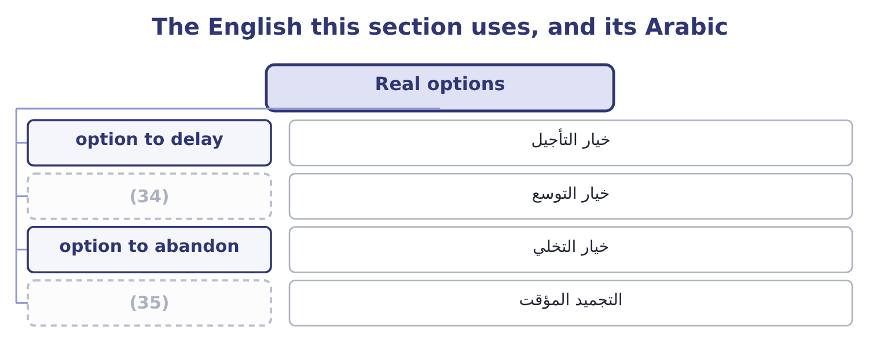
word list
apparent precision · mothballing · option to expand

The English this sheet uses, and its Arabic
English (exam term) | Arabic
option to delay | خيار التأجيل
option to expand | خيار التوسع
option to abandon | خيار التخلي
mothballing | التجميد المؤقت

Answer key · 15.4 Real options

1 analysis | 19 Running
2 commitment | 20 switching
3 projects | 21 partial
4 abilities | 22 abandonment
5 called | 23 consequences
6 structure | 24 Considering
7 outcome | 25 converted
8 planning | 26 arrangement
9 competitor's | 27 genuinely
10 started | 28 practical
11 carries | 29 calculation
12 forgone | 30 Waiting for a harvest or a ruling
13 possible | 31 Foundations laid for a second line
14 reject | 32 Assets are general-purpose and resaleable
15 subletting | 33 Run smaller rather than stop
16 cancelling | 34 option to expand
17 downside | 35 mothballing
18 specialised

the summaries in full
Summary 1 A discounted cash flow analysis values a project as though it were a commitment made once and then endured. Real projects are not like that: managers can wait, expand, contract or stop, and each of those abilities is worth something. They are called real options because they have the structure of the financial options of Book 2's. The outcome names four. The option to delay. Waiting for information — a planning decision, a competitor's move, a harvest, a price. A project that can be started next year as easily as this one carries the value of what will be learned in between. The cost of delay is the cash flow forgone and the risk that a competitor moves first. The option to expand. A project that creates the ability to do more if things go well — a plant built with foundations for a second line, a product launched in one city that could be rolled out to twenty.
Summary 2 Much of the value of a small first project is the large second one it makes possible, and a discounted cash flow of the first alone will reject it. The option to abandon. The ability to stop and recover something — selling the equipment, subletting the building, cancelling the contract. It puts a floor under the downside, and it is worth most where the assets are general-purpose and can be sold, and least where they are specialised and cannot. The option to scale back. Running at reduced volume rather than closing, mothballing a line, switching a plant to another product. It is the partial version of abandonment. Two consequences the exam asks for. Considering these options raises a project's value, because each is a right and not an obligation: it will be exercised only when it pays. So a valuation that ignores them understates the project, and the understatement is largest where uncertainty is greatest — the opposite of the intuition that uncertainty always reduces value. And they should be designed.
Summary 3 A plant that can be converted, a lease that can be broken, a contract staged in phases, a supplier arrangement with an option to increase volume: each costs something at the outset and is worth more than it costs where the future is genuinely uncertain. That is the practical use of the idea, and no calculation is required to act on it.

15.5 Qualitative factors and the postaudit
Chapter 15 · section 15.5

Fill every gap. Each word list holds one word more than there are gaps.
Summary 1 gaps 1–12
Two (1) close the chapter, and both (2) what the numbers do not contain. The qualitative (3) are the ones a net present value cannot carry, and the exam (4) them named. Does the project take the company where it intends to go, or is it a profitable (5) ? A positive net present value in a business the company does not (6) is. (7) , retraining, (8) , the loss of skills that will be needed again. A project that changes service levels, lead times or (9) affects relationships that no cash flow line (10) . Regulatory, (11) and safety (12) , some of which are not optional at any return. Reversibility, which section 15.4 priced as the option to abandon. Reputation, which is slow to build and quick to lose. And the quality of the estimates themselves: a project proposed by a sponsor whose last three forecasts were wrong is a different proposition from the same figures proposed by somebody whose were right.
word list
morale · concern · distraction · outcomes · expects · captures · specifications · Redundancies · environmental · promised · understand · considerations · consequences

Summary 2 gaps 13–24
The postaudit is the stage that makes all of this (13) next time. It is a review, usually a year or two after (14) , comparing the (15) actual cash flows, costs and timing with those (16) in the proposal. Its (17) are four, and the exam asks for them. To improve future estimates. Systematic optimism is only visible in a series of (18) , and once visible it can be (19) at the source rather than by raising the hurdle rate. To hold sponsors (20) . A proposal (21) by somebody who knows it will be audited is a more careful proposal, and that effect (22) before any audit is done. To decide what to do now. A project running badly may be expanded, scaled back or abandoned — the real options of section 15.4, exercised — and the postaudit is when that choice is made (23) rather than by (24) .
word list
project's · purposes · completion · operates · written · postaudits · promised · better · audited · deliberately · accountable · drift · corrected

Summary 3 gaps 25–31
To improve the (25) . (26) errors in a particular kind of project, or a particular (27) , point to something fixable. Three (28) belong with it. The audit should compare like with like, (29) for things outside the (30) control. It should not become a search for blame, or proposals will become defensive and (31) . And the sunk cost rule: what the project cost is history, and the only question it can answer about the future is what to do from here.
word list
conservative · adjusting · sponsor's · process · department · abandon · cautions · Recurring

Rate, risk and options

Your turn: rate and risk (complete the blanks)
Item | Data | Answer
Hurdle rate for a project of ordinary risk | Cost of capital 9.04 per cent | ________
Hurdle rate with a 3-point risk premium |  | ________
Certainty equivalent of a 900,000 flow | (32) | ________
Which technique gives the probability of a negative net present value |  | ________
Which real option a general-purpose, resaleable asset creates |  | ________
The main purpose of a postaudit |  | ________

word list
hurdle rate · Factor 0.80

"Hurdle"

Summary 4 gaps 33–40
English hurdle rate takes its image from an (33) race: a barrier the project must clear. The (34) is apt in one way and misleading in (35) . It is apt because (36) it is pass or fail. It is misleading because a hurdle in a race is the same (37) for every runner, and a hurdle rate should not be: a (38) project should face a (39) one. Any of the three is clear; what (40) in an answer is to say which rate was used and why.
word list
clearing · riskier · athletics · height · metaphor · matters · concern · higher · another

"Hurdle"
Item | Answer
Hurdle rate for ordinary risk | (41)
Hurdle rate with a 3-point premium | 12.04 per cent: 9.04 + 3.00 = 12.04.
Certainty equivalent of a 900,000 flow | 720,000: 900,000 × 0.80 = 720,000, discounted at the risk-free rate.
Technique giving the probability of a negative net present value | Monte Carlo simulation.
Real option created by a general-purpose, resaleable asset | The option to abandon, and in part the option to scale back.
Main purpose of a postaudit | To improve future estimates by making systematic errors visible, and to decide what to do from here.
What it tells you | Three of the six answers are (42) and three are judgments, which is the balance of this topic: the arithmetic is small and the reason

word list
9.04 per cent, the weighted average cost of capital. · definitions · accountability

The English this section uses, and its Arabic
Each term sits against what it means.
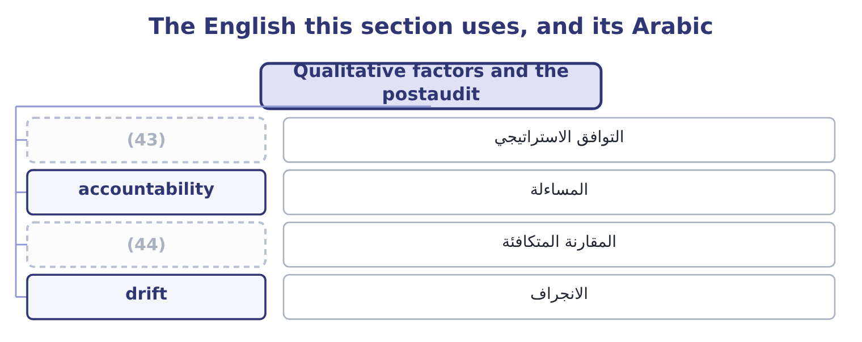
word list
optimism bias · like with like · strategic fit

The English this sheet uses, and its Arabic
English (exam term) | Arabic
strategic fit | التوافق الاستراتيجي
accountability | المساءلة
like with like | المقارنة المتكافئة
drift | الانجراف

Answer key · 15.5 Qualitative factors and the postaudit

1 outcomes | 23 deliberately
2 concern | 24 drift
3 considerations | 25 process
4 expects | 26 Recurring
5 distraction | 27 department
6 understand | 28 cautions
7 Redundancies | 29 adjusting
8 morale | 30 sponsor's
9 specifications | 31 conservative
10 captures | 32 Factor 0.80
11 environmental | 33 athletics
12 consequences | 34 metaphor
13 better | 35 another
14 completion | 36 clearing
15 project's | 37 height
16 promised | 38 riskier
17 purposes | 39 higher
18 postaudits | 40 matters
19 corrected | 41 9.04 per cent, the weighted average cost of capital.
20 accountable | 42 definitions
21 written | 43 strategic fit
22 operates | 44 like with like

the summaries in full
Summary 1 Two outcomes close the chapter, and both concern what the numbers do not contain. The qualitative considerations are the ones a net present value cannot carry, and the exam expects them named. Does the project take the company where it intends to go, or is it a profitable distraction? A positive net present value in a business the company does not understand is. Redundancies, retraining, morale, the loss of skills that will be needed again. A project that changes service levels, lead times or specifications affects relationships that no cash flow line captures. Regulatory, environmental and safety consequences, some of which are not optional at any return. Reversibility, which section 15.4 priced as the option to abandon. Reputation, which is slow to build and quick to lose. And the quality of the estimates themselves: a project proposed by a sponsor whose last three forecasts were wrong is a different proposition from the same figures proposed by somebody whose were right.
Summary 2 The postaudit is the stage that makes all of this better next time. It is a review, usually a year or two after completion, comparing the project's actual cash flows, costs and timing with those promised in the proposal. Its purposes are four, and the exam asks for them. To improve future estimates. Systematic optimism is only visible in a series of postaudits, and once visible it can be corrected at the source rather than by raising the hurdle rate. To hold sponsors accountable. A proposal written by somebody who knows it will be audited is a more careful proposal, and that effect operates before any audit is done. To decide what to do now. A project running badly may be expanded, scaled back or abandoned — the real options of section 15.4, exercised — and the postaudit is when that choice is made deliberately rather than by drift.
Summary 3 To improve the process. Recurring errors in a particular kind of project, or a particular department, point to something fixable. Three cautions belong with it. The audit should compare like with like, adjusting for things outside the sponsor's control. It should not become a search for blame, or proposals will become defensive and conservative. And the sunk cost rule: what the project cost is history, and the only question it can answer about the future is what to do from here.
Summary 4 English hurdle rate takes its image from an athletics race: a barrier the project must clear. The metaphor is apt in one way and misleading in another. It is apt because clearing it is pass or fail. It is misleading because a hurdle in a race is the same height for every runner, and a hurdle rate should not be: a riskier project should face a higher one. Any of the three is clear; what matters in an answer is to say which rate was used and why.

