16.1 Net present value
Chapter 16 · section 16.1

Fill every gap. Each word list holds one word more than there are gaps.
Chapter 16, section by section
Each stage leads to the next.
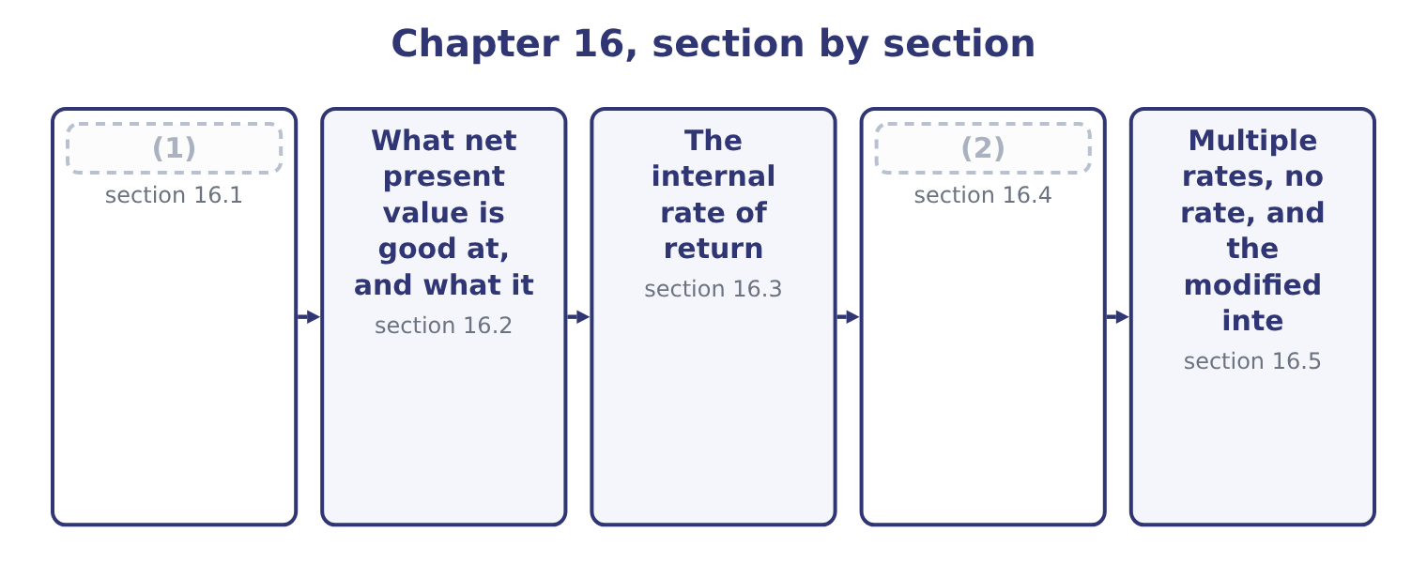
word list
Net present value · Where the two measures disagree · multiple internal rates of return

Summary 1 gaps 3–14
Net present value is the present value of a (3) cash inflows less the present value of its outflows, all discounted at the (4) rate. A positive figure means the project returns more than the money costs, so it creates value; a (5) figure means it (6) value; zero means it exactly earns its cost of capital, which is a pass rather than a failure. The (7) has four steps, and the exam tests each of them. Lay out the cash flows by year, using cash and not (8) profit. Find the (9) factor for each year. For a (10) amount in year n at rate r the factor is 1 ÷ (1 + r) to the power n. For a level amount in every year from 1 to n, the annuity factor is the sum of those (11) , and using it saves four (12) . (13) the initial (14) , which needs no discounting because it happens now.
word list
project's · multiplications · accounting · discount · investment · computation · Subtract · destroys · between · negative · hurdle · single · factors

Worked example: the roasting line at 9 per cent

Summary 2 gaps 15–26
Years 1 to 5: +1,050,000. Year 5 also: +550,000, being 400,000 of (15) working capital and 150,000 of (16) salvage. At 9 per cent the (17) annuity factor is 3.8897 and the year-5 (18) factor is 0.6499. The level flows are worth 1,050,000 × 3.8897 = 4,084,185. The (19) amount is worth 550,000 × 0.6499 = 357,445. (20) 4,084,185 + 357,445 = 4,441,630. Read the result as a sentence: building this line makes Orontes about 1,041,630 better off today than not building it, after paying the providers of the money (21) they require. That is the (22) profit of Book 1 and the market value added of Book 2, computed in advance instead of after the fact. Three (23) of the figure are worth having. The net present value of two projects is the sum of their (24) figures, which no rate-based measure can claim. That is why net present values can be (25) into a capital budget and compared with the company's market value. It is stated in money, so it (26) size.
word list
released · economic · five-year · reflects · individual · after-tax · terminal · aggregated · Together · single-amount · outflows · everything · readings

Summary 3 gaps 27–31
A project earning 40 per cent on 100,000 creates less value than one earning 12 per cent on 10,000,000, and only a money measure says so. It is the (27) ' gain. In the (28) of Book 2, (29) a project with a positive net present value (30) raise the company's market value by about that amount, which is the link between capital (31) and the share price.
word list
should · announcing · interpolation · shareholders · theory · budgeting

The roasting line discounted at 9 per cent
The bars are drawn to scale.
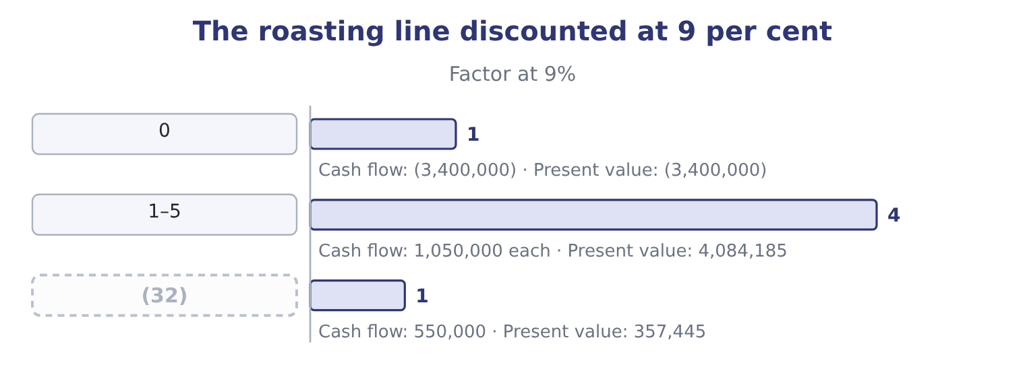
word list
discount factor · 5 (terminal)

The English this section uses, and its Arabic
Each term sits against what it means.
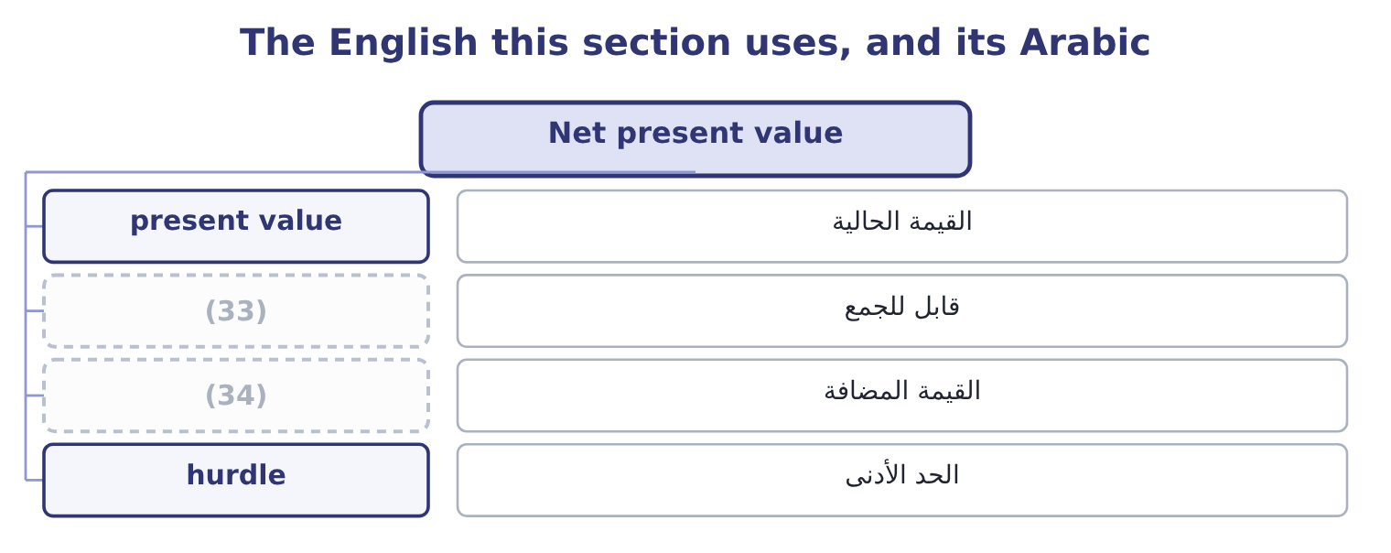
word list
interpolation · additive · value created

The English this sheet uses, and its Arabic
English (exam term) | Arabic
present value | القيمة الحالية
additive | قابل للجمع
value created | القيمة المضافة
hurdle | الحد الأدنى

Answer key · 16.1 Net present value

1 Net present value | 18 single-amount
2 Where the two measures disagree | 19 terminal
3 project's | 20 Together
4 hurdle | 21 everything
5 negative | 22 economic
6 destroys | 23 readings
7 computation | 24 individual
8 accounting | 25 aggregated
9 discount | 26 reflects
10 single | 27 shareholders
11 factors | 28 theory
12 multiplications | 29 announcing
13 Subtract | 30 should
14 investment | 31 budgeting
15 released | 32 5 (terminal)
16 after-tax | 33 additive
17 five-year | 34 value created

the summaries in full
Summary 1 Net present value is the present value of a project's cash inflows less the present value of its outflows, all discounted at the hurdle rate. A positive figure means the project returns more than the money costs, so it creates value; a negative figure means it destroys value; zero means it exactly earns its cost of capital, which is a pass rather than a failure. The computation has four steps, and the exam tests each of them. Lay out the cash flows by year, using cash and not accounting profit. Find the discount factor for each year. For a single amount in year n at rate r the factor is 1 ÷ (1 + r) to the power n. For a level amount in every year from 1 to n, the annuity factor is the sum of those factors, and using it saves four multiplications. Subtract the initial investment, which needs no discounting because it happens now.
Summary 2 Years 1 to 5: +1,050,000. Year 5 also: +550,000, being 400,000 of released working capital and 150,000 of after-tax salvage. At 9 per cent the five-year annuity factor is 3.8897 and the year-5 single-amount factor is 0.6499. The level flows are worth 1,050,000 × 3.8897 = 4,084,185. The terminal amount is worth 550,000 × 0.6499 = 357,445. Together 4,084,185 + 357,445 = 4,441,630. Read the result as a sentence: building this line makes Orontes about 1,041,630 better off today than not building it, after paying the providers of the money everything they require. That is the economic profit of Book 1 and the market value added of Book 2, computed in advance instead of after the fact. Three readings of the figure are worth having. The net present value of two projects is the sum of their individual figures, which no rate-based measure can claim. That is why net present values can be aggregated into a capital budget and compared with the company's market value. It is stated in money, so it reflects size.
Summary 3 A project earning 40 per cent on 100,000 creates less value than one earning 12 per cent on 10,000,000, and only a money measure says so. It is the shareholders' gain. In the theory of Book 2, announcing a project with a positive net present value should raise the company's market value by about that amount, which is the link between capital budgeting and the share price.

16.2 What net present value is good at, and what it is not
Chapter 16 · section 16.2

Fill every gap. Each word list holds one word more than there are gaps.
Summary 1 gaps 1–12
The outcome asks for (1) and limitations, and both lists are short (2) to learn. It uses all the cash flows, (3) those beyond any payback period. It (4) them, so timing is handled (5) . It uses the cost of capital, so the (6) return is explicit and can be (7) for risk. It (8) in money, so size matters. And it (9) directly to value created for the providers of capital, which makes it the measure most (10) with the objective Book 2 set out. Its limitations, and these are the ones (11) forget. It depends (12) on the forecasts. A net present value computed to the nearest dollar from volumes guessed to the nearest hundred thousand jars has a precision it has not earned, which is why. It depends on the rate, and the rate is an estimate.
word list
including · required · discounts · candidates · adjusted · corresponds · enough · measures · entirely · matters · consistent · properly · advantages

Summary 2 gaps 13–23
Three points of (13) rate removed a third of the (14) line's value. It is hard to (15) to people who do not work with (16) . A rate or a payback period (17) immediately; a net present value usually needs a (18) . It gives no sense of (19) relative to the (20) . A net present value of 1,041,630 is (21) on 3,400,000 and (22) on 340,000,000. It assumes the money is (23) . Where capital is rationed, the highest net present value is not necessarily the right choice, which again is. And it says nothing about the pattern of the flows, so it cannot distinguish a project that recovers its money quickly from one that does not — a difference that matters when a company's survival depends on liquidity, as Book 1's.
word list
investment · available · roasting · explain · consistent · hurdle · trivial · communicates · scale · discounting · excellent · paragraph

The precision illusion

Summary 3 gaps 24–30
A question that gives a net present value to the dollar and asks (24) to accept is testing (25) . A question that gives one and asks what else you would want to know is testing (26) , and the answer is always some (27) : the reliability of the volume and price forecasts, the basis of the (28) rate, what (29) if the key (30) is wrong, and what the project commits the company to that cannot be undone.
word list
discount · assumption · judgment · nothing · happens · combination · arithmetic · whether

The English this section uses, and its Arabic
Each term sits against what it means.
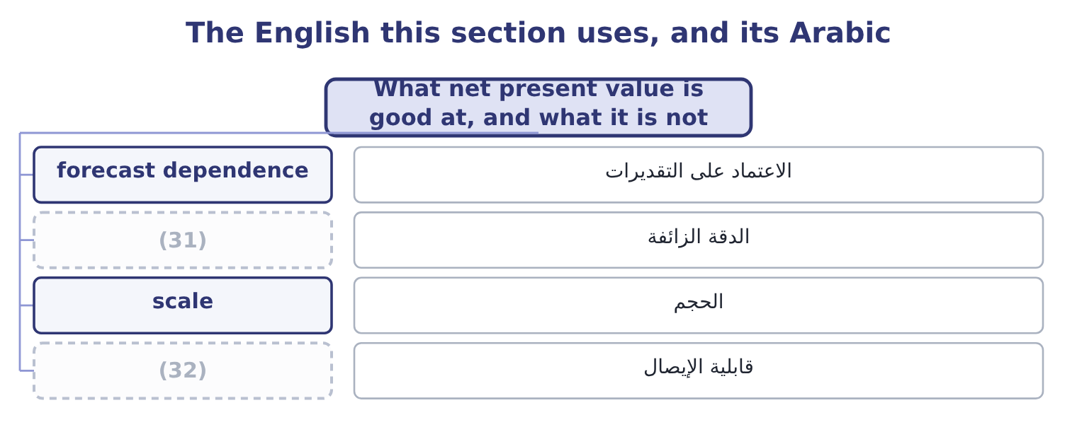
word list
decommissioning · false precision · communicability

The English this sheet uses, and its Arabic
English (exam term) | Arabic
forecast dependence | الاعتماد على التقديرات
false precision | الدقة الزائفة
scale | الحجم
communicability | قابلية الإيصال

Answer key · 16.2 What net present value is good at, and what it is not

1 advantages | 17 communicates
2 enough | 18 paragraph
3 including | 19 scale
4 discounts | 20 investment
5 properly | 21 excellent
6 required | 22 trivial
7 adjusted | 23 available
8 measures | 24 whether
9 corresponds | 25 arithmetic
10 consistent | 26 judgment
11 candidates | 27 combination
12 entirely | 28 discount
13 hurdle | 29 happens
14 roasting | 30 assumption
15 explain | 31 false precision
16 discounting | 32 communicability

the summaries in full
Summary 1 The outcome asks for advantages and limitations, and both lists are short enough to learn. It uses all the cash flows, including those beyond any payback period. It discounts them, so timing is handled properly. It uses the cost of capital, so the required return is explicit and can be adjusted for risk. It measures in money, so size matters. And it corresponds directly to value created for the providers of capital, which makes it the measure most consistent with the objective Book 2 set out. Its limitations, and these are the ones candidates forget. It depends entirely on the forecasts. A net present value computed to the nearest dollar from volumes guessed to the nearest hundred thousand jars has a precision it has not earned, which is why. It depends on the rate, and the rate is an estimate.
Summary 2 Three points of hurdle rate removed a third of the roasting line's value. It is hard to explain to people who do not work with discounting. A rate or a payback period communicates immediately; a net present value usually needs a paragraph. It gives no sense of scale relative to the investment. A net present value of 1,041,630 is excellent on 3,400,000 and trivial on 340,000,000. It assumes the money is available. Where capital is rationed, the highest net present value is not necessarily the right choice, which again is. And it says nothing about the pattern of the flows, so it cannot distinguish a project that recovers its money quickly from one that does not — a difference that matters when a company's survival depends on liquidity, as Book 1's.
Summary 3 A question that gives a net present value to the dollar and asks whether to accept is testing arithmetic. A question that gives one and asks what else you would want to know is testing judgment, and the answer is always some combination: the reliability of the volume and price forecasts, the basis of the discount rate, what happens if the key assumption is wrong, and what the project commits the company to that cannot be undone.

16.3 The internal rate of return
Chapter 16 · section 16.3

Fill every gap. Each word list holds one word more than there are gaps.
Summary 1 gaps 1–12
The internal rate of return is the discount rate at which a project's net present value is (1) zero. It is the project's own return, (2) from its cash flows and nothing else, which is where the word internal comes: no (3) rate enters the (4) . The (5) rule is to accept where the internal rate of return (6) the hurdle rate. For a conventional project — one outflow (7) by inflows — that rule gives the same answer as net present value, because a positive net present value at the hurdle rate and an internal rate above it are two (8) of one fact. There is no (9) for it. It is found by trial, by interpolation between two trials, or by a (10) doing the same thing (11) . The exam (12) the interpolation.
word list
amounts · expects · computed · followed · spreadsheet · statements · quickly · external · exceeds · formula · decision · exactly · calculation

Summary 2 gaps 13–17
The (13) annuity factor is 3.0576 and the year-5 factor 0.4190, so the inflows are worth 1,050,000 × 3.0576 = 3,210,480 plus 550,000 × 0.4190 = 230,450, which is 3,210,480 + 230,450 = 3,440,930, (14) a net present value of 3,440,930 − 3,400,000 = 40,930. Still positive, so the true rate is (15) . The (16) are 2.9906 and 0.4019, so the inflows are worth 1,050,000 × 2.9906 = 3,140,130 plus 550,000 × 0.4019 = 221,045, which is 3,140,130 + 221,045 = 3,361,175, and the net present value is 3,400,000 − 3,361,175 = 38,825 (17) . The rate lies between the two. The total swing between the two trials is 40,930 + 38,825 = 79,755, and the positive part is 40,930 ÷ 79,755 = 0.513 of it, so the rate is 19 + 0.51 = 19.51 per cent.
word list
five-year · factors · higher · giving · negative · project's

Summary 3 gaps 18–29
Call it about 19.5 per cent (18) a hurdle of 9 per cent, which is (19) , and note that it is the same (20) the net present value reached. For a conventional project it always is. It is a rate, so it can be compared with the cost of capital, with other projects and with returns outside the business without any further work; it (21) to people who will not sit through a (22) explanation; it needs no discount rate as an input, which is useful where the cost of capital is disputed; and the gap between it and the hurdle rate is a visible margin of safety. Its (23) , and these are heavily (24) . The (25) implicitly assumes that every interim cash flow is (26) at the internal rate of return itself. For a project returning 19.5 per cent that assumes Orontes can keep finding 19.5 per cent uses for the money, which is a strong claim; net present value assumes (27) at the cost of capital, which is far more (28) because the company can always repay debt or return cash at that rate. It ignores (29) , being a rate.
word list
arithmetic · conclusion · returning · reinvestment · against · discounting · comfortable · defensible · limitations · examined · reinvested · communicates · scale

Summary 4 gaps 30–33
Section 16.4 shows what that does. It can have more than one value, or none at all, where the flows (30) sign more than once. Section 16.5 deals with. It cannot be (31) or added across projects, because rates on (32) amounts do not (33) .
word list
change · different · combine · against · averaged

The English this section uses, and its Arabic
Each term sits against what it means.
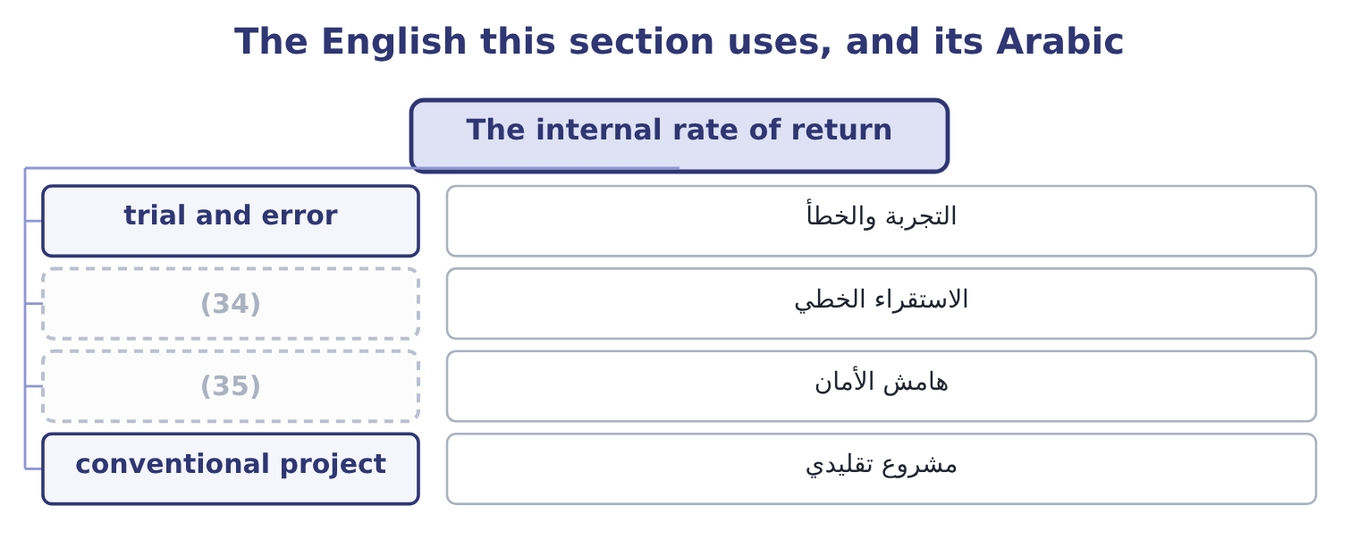
word list
interpolation · mutually exclusive projects · margin of safety

The English this sheet uses, and its Arabic
English (exam term) | Arabic
trial and error | التجربة والخطأ
interpolation | الاستقراء الخطي
margin of safety | هامش الأمان
conventional project | مشروع تقليدي

Answer key · 16.3 The internal rate of return

1 exactly | 19 comfortable
2 computed | 20 conclusion
3 external | 21 communicates
4 calculation | 22 discounting
5 decision | 23 limitations
6 exceeds | 24 examined
7 followed | 25 arithmetic
8 statements | 26 reinvested
9 formula | 27 reinvestment
10 spreadsheet | 28 defensible
11 quickly | 29 scale
12 expects | 30 change
13 five-year | 31 averaged
14 giving | 32 different
15 higher | 33 combine
16 factors | 34 interpolation
17 negative | 35 margin of safety
18 against

the summaries in full
Summary 1 The internal rate of return is the discount rate at which a project's net present value is exactly zero. It is the project's own return, computed from its cash flows and nothing else, which is where the word internal comes: no external rate enters the calculation. The decision rule is to accept where the internal rate of return exceeds the hurdle rate. For a conventional project — one outflow followed by inflows — that rule gives the same answer as net present value, because a positive net present value at the hurdle rate and an internal rate above it are two statements of one fact. There is no formula for it. It is found by trial, by interpolation between two trials, or by a spreadsheet doing the same thing quickly. The exam expects the interpolation.
Summary 2 The five-year annuity factor is 3.0576 and the year-5 factor 0.4190, so the inflows are worth 1,050,000 × 3.0576 = 3,210,480 plus 550,000 × 0.4190 = 230,450, which is 3,210,480 + 230,450 = 3,440,930, giving a net present value of 3,440,930 − 3,400,000 = 40,930. Still positive, so the true rate is higher. The factors are 2.9906 and 0.4019, so the inflows are worth 1,050,000 × 2.9906 = 3,140,130 plus 550,000 × 0.4019 = 221,045, which is 3,140,130 + 221,045 = 3,361,175, and the net present value is 3,400,000 − 3,361,175 = 38,825 negative. The rate lies between the two. The total swing between the two trials is 40,930 + 38,825 = 79,755, and the positive part is 40,930 ÷ 79,755 = 0.513 of it, so the rate is 19 + 0.51 = 19.51 per cent.
Summary 3 Call it about 19.5 per cent against a hurdle of 9 per cent, which is comfortable, and note that it is the same conclusion the net present value reached. For a conventional project it always is. It is a rate, so it can be compared with the cost of capital, with other projects and with returns outside the business without any further work; it communicates to people who will not sit through a discounting explanation; it needs no discount rate as an input, which is useful where the cost of capital is disputed; and the gap between it and the hurdle rate is a visible margin of safety. Its limitations, and these are heavily examined. The arithmetic implicitly assumes that every interim cash flow is reinvested at the internal rate of return itself. For a project returning 19.5 per cent that assumes Orontes can keep finding 19.5 per cent uses for the money, which is a strong claim; net present value assumes reinvestment at the cost of capital, which is far more defensible because the company can always repay debt or return cash at that rate. It ignores scale, being a rate.
Summary 4 Section 16.4 shows what that does. It can have more than one value, or none at all, where the flows change sign more than once. Section 16.5 deals with. It cannot be averaged or added across projects, because rates on different amounts do not combine.

16.4 Where the two measures disagree
Chapter 16 · section 16.4

Fill every gap. Each word list holds one word more than there are gaps.
Summary 1 gaps 1–11
For a single project (1) on its own, the two (2) never disagree about (3) . They disagree about ranking, and only where projects are mutually (4) — where taking one means not taking the other, because they use the same site, the same (5) , the same machine or the same scarce (6) . Three (7) , and the exam asks for them by name. A small project can have a very high rate and (8) little value. A project whose flows arrive early has a (9) internal rate of return than one of the same size whose flows arrive late, even where the late one creates more value in total. A short project and a long one of the same size rank (10) by rate and by value, for the same (11) .
word list
reason · licence · create · causes · acceptance · differently · exclusive · higher · measures · considered · company's · manager

Worked example: a high rate on a small project

Summary 2 gaps 12–17
Two projects, one site. Project S is a repacking (12) : 1,000,000 out now and 1,400,000 back in a year. Project L is the roasting line of section 16.1. Only one can (13) the free floor space. The money grows 1,400,000 ÷ 1,000,000 = 1.40 times in one year, so its internal rate of return is 40 per cent — more than twice the (14) 19.5 per cent. (15) at 9 per cent, 1,400,000 ÷ 1.09 = 1,284,404, so the net present value is 1,284,404 − 1,000,000 = 284,404. Project S: 40 per cent, 284,404 of value. Project L: 19.5 per cent, 1,041,630 of value. The rate prefers S and the value prefers L. Take L. Orontes is not trying to earn the (16) rate on the (17) sum; it is trying to be worth more.
word list
Discounting · line's · smallest · contract · occupy · highest · maximise

Summary 3 gaps 18–29
The (18) 1,041,630 − 284,404 = 757,226 is the cost of letting a (19) make the decision — and the honest way to see it is to ask what Orontes would do with the 2,400,000 it did not invest in Project S, which is to put it to work at the cost of capital, where by (20) it creates nothing. That last (21) is the whole (22) . A rate tells you how hard a (23) works; a value tells you how much money the project makes. When the two (24) , net present value is correct, because the (25) objective is to be worth more and not to maximise a ratio. Two (26) points the exam uses. (27) both projects' net present values against the (28) rate gives two curves that cross. Below the crossover rate one project is (29) ; above it the other is.
word list
supplementary · percentage · company's · dollar · argument · conflict · between · Plotting · discount · definition · missing · better · sentence

Summary 4 gaps 30–36
Where the hurdle rate sits on the wrong side of the crossover, the rate ranking (30) , which is exactly the (31) above. Where a rate answer is wanted anyway, (32) the internal rate of return on the (33) between the two projects — the extra 2,400,000 (34) and the extra flows it brings — and accept the larger project if that (35) rate beats the hurdle. It reaches the same (36) as net present value, with more work.
word list
compute · situation · invested · difference · conclusion · incremental · Discounting · misleads

Rate against value: the repacking contract and the roasting line
Measure | Project S (repacking) | Project L (roasting line) | Prefers
Investment | 1,000,000 | 3,400,000 | —
Internal rate of return | 40 per cent | (37) | S
Net present value at 9% | 284,404 | 1,041,630 | L
Correct choice |  | Take L | (38)

word list
19.5 per cent · Value, not rate · margin of safety

The English this section uses, and its Arabic
Each term sits against what it means.

word list
incremental analysis · value created · crossover rate

The English this sheet uses, and its Arabic
English (exam term) | Arabic
mutually exclusive | متنافية
crossover rate | معدل التقاطع
incremental analysis | التحليل التفاضلي
ranking | الترتيب

Answer key · 16.4 Where the two measures disagree

1 considered | 21 sentence
2 measures | 22 argument
3 acceptance | 23 dollar
4 exclusive | 24 conflict
5 licence | 25 company's
6 manager | 26 supplementary
7 causes | 27 Plotting
8 create | 28 discount
9 higher | 29 better
10 differently | 30 misleads
11 reason | 31 situation
12 contract | 32 compute
13 occupy | 33 difference
14 line's | 34 invested
15 Discounting | 35 incremental
16 highest | 36 conclusion
17 smallest | 37 19.5 per cent
18 missing | 38 Value, not rate
19 percentage | 39 crossover rate
20 definition | 40 incremental analysis

the summaries in full
Summary 1 For a single project considered on its own, the two measures never disagree about acceptance. They disagree about ranking, and only where projects are mutually exclusive — where taking one means not taking the other, because they use the same site, the same licence, the same machine or the same scarce manager. Three causes, and the exam asks for them by name. A small project can have a very high rate and create little value. A project whose flows arrive early has a higher internal rate of return than one of the same size whose flows arrive late, even where the late one creates more value in total. A short project and a long one of the same size rank differently by rate and by value, for the same reason.
Summary 2 Two projects, one site. Project S is a repacking contract: 1,000,000 out now and 1,400,000 back in a year. Project L is the roasting line of section 16.1. Only one can occupy the free floor space. The money grows 1,400,000 ÷ 1,000,000 = 1.40 times in one year, so its internal rate of return is 40 per cent — more than twice the line's 19.5 per cent. Discounting at 9 per cent, 1,400,000 ÷ 1.09 = 1,284,404, so the net present value is 1,284,404 − 1,000,000 = 284,404. Project S: 40 per cent, 284,404 of value. Project L: 19.5 per cent, 1,041,630 of value. The rate prefers S and the value prefers L. Take L. Orontes is not trying to earn the highest rate on the smallest sum; it is trying to be worth more.
Summary 3 The missing 1,041,630 − 284,404 = 757,226 is the cost of letting a percentage make the decision — and the honest way to see it is to ask what Orontes would do with the 2,400,000 it did not invest in Project S, which is to put it to work at the cost of capital, where by definition it creates nothing. That last sentence is the whole argument. A rate tells you how hard a dollar works; a value tells you how much money the project makes. When the two conflict, net present value is correct, because the company's objective is to be worth more and not to maximise a ratio. Two supplementary points the exam uses. Plotting both projects' net present values against the discount rate gives two curves that cross. Below the crossover rate one project is better; above it the other is.
Summary 4 Where the hurdle rate sits on the wrong side of the crossover, the rate ranking misleads, which is exactly the situation above. Where a rate answer is wanted anyway, compute the internal rate of return on the difference between the two projects — the extra 2,400,000 invested and the extra flows it brings — and accept the larger project if that incremental rate beats the hurdle. It reaches the same conclusion as net present value, with more work.

16.5 Multiple rates, no rate, and the modified internal rate of return
Chapter 16 · section 16.5

Fill every gap. Each word list holds one word more than there are gaps.
Summary 1 gaps 1–12
A (1) project has one sign change — out, then in — and exactly one internal rate of return. Where the flows change sign more than once the (2) can have several roots, or none. Projects with more than one sign change are (3) : a mine or (4) that must be (5) at the end, a plant with a large (6) cost, a project needing a second (7) of capital in the middle, a (8) with a penalty on (9) . A (10) site costs 1,000,000 now, returns 2,600,000 at the end of year 1, and (11) 1,650,000 of restoration at the end of year 2. The inflow is worth 2,600,000 ÷ 1.1 = 2,363,636 and the restoration 1,650,000 ÷ 1.21 = 1,363,636, so the net of the two is 2,363,636 − 1,363,636 = 1,000,000, which exactly (12) the initial outlay.
word list
restored · sesame-hulling · decommissioning · offsets · injection · conventional · requires · quarry · common · equation · contract · completion · negative

Summary 2 gaps 13–19
The net present value is zero, so 10 per cent is an internal rate of return. Now the inflow is worth 2,600,000 ÷ 1.5 = 1,733,333 and the restoration 1,650,000 ÷ 2.25 = 733,333, so the net is 1,733,333 − 733,333 = 1,000,000 and the net present value is zero again. Fifty per cent is also an internal rate of return. Both are (13) correct and (14) is a return in any (15) sense. The (16) "is the internal rate of return above the 9 per cent hurdle?" has two (17) answers, so the measure has failed. Net present value has not failed. At 9 per cent the value is 2,600,000 ÷ 1.09 = 2,385,321 for the inflow and 1,650,000 ÷ 1.1881 = 1,388,772 for the restoration, so the project's value is 2,385,321 − 1,388,772 = 996,549 against an outlay of 1,000,000 — very (18) negative, and the decision is to reject, by the (19) of margins.
word list
narrowest · slightly · decision · contradictory · neither · useful · mathematically · question

Summary 3 gaps 20–27
One rate, one answer. The (20) case is rarer and also real: some flow (21) give no real (22) at all, so there is simply no internal rate of return to compute. The modified internal rate of return (23) the reinvestment problem and, incidentally, the (24) one. It works in three steps: compound every inflow forward to the end of the project at the cost of capital, (25) every outflow back to time zero at the same rate, and find the (26) rate that links the two. Because only one sign change (27) , there is exactly one answer.
word list
discount · no-rate · single · solution · multiple-rate · survives · Orontes · patterns · repairs

Worked example: the roasting line's modified rate

Summary 4 gaps 28–39
Compound the (28) at 9 per cent. The five annual flows of 1,050,000, (29) forward to the end of year 5, carry (30) of 1.41158, 1.29503, 1.18810, 1.09000 and 1.00000, which sum to 5.98471, so they are worth 1,050,000 × 5.98471 = 6,283,946 at the end. Add the (31) flow. It (32) falls at the end of year 5, so 6,283,946 + 550,000 = 6,833,946. The investment of 3,400,000 grows to 6,833,946 over five years, a (33) of 6,833,946 ÷ 3,400,000 = 2.010. Take the fifth root. The fifth root of 2.010 is 1.1499, so the modified internal rate of return is 15.0 per cent. (34) per cent against the (35) 19.5 per cent. The (36) is the whole of the reinvestment assumption: the plain internal rate of return credited the project with (37) its interim flows at 19.5 per cent, and the modified measure credits it only with 9 per cent, which is what Orontes can actually get. The project still (38) the hurdle, by a (39) and more honest margin.
word list
terminal · unmodified · Fifteen · clears · inflows · smaller · factors · problem · multiple · already · reinvesting · compounded · difference

The measures compared
Every item belongs to exactly one group.
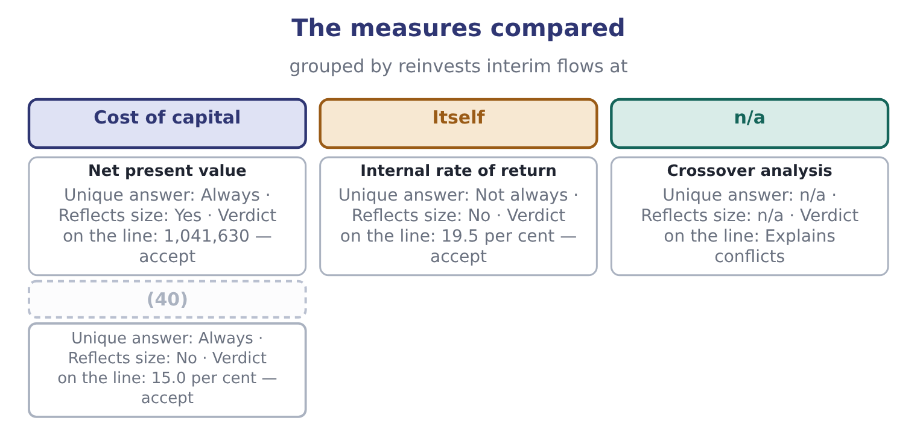
word list
Modified internal rate · net present value

Two measures, one project

Your turn: value and rate (complete the blanks)
Item | Data | Answer
Present value of five flows of 1,050,000 | (41) | ________
Present value of 550,000 in year 5 | (42) | ________
Net present value | Outlay 3,400,000 | ________
Decision on that basis |  | ________
Rate at which net present value is zero | Between 19 and 20 per cent | ________
Which measure wins a conflict between mutually exclusive projects |  | ________

word list
Factor 3.8897 · conventional project · Factor 0.6499

"Internal" and "net"

Summary 5 gaps 43–49
Internal in internal rate of return means computed from the project's own flows, with no (43) rate used — which is both its (44) and the source of every one of its (45) , because a measure that needs no cost of capital also (46) one. Net in net present value means after (47) the investment: the present value of what comes in, less the present value of what goes out. (48) who compute 4,441,630 and stop have found a present value and not a net present value, and the (49) word costs the mark.
word list
deducting · additive · ignores · external · faults · appeal · Candidates · missing

"Internal" and "net"
Item | Answer
Present value of five flows of 1,050,000 | 4,084,185: 1,050,000 × 3.8897 = 4,084,185.
Present value of 550,000 in year 5 | (50)
Net present value | 1,041,630: 4,441,630 − 3,400,000 = 1,041,630.
Decision on that basis | Accept: the value is positive, so the project returns more than the money costs.
Rate at which net present value is zero | About 19.5 per cent, by (51) between the two trials.
Which measure wins a conflict | Net present value, because the objective is value and not a ratio.
What it tells you | The two measures were computed from one set of flows and one rate. Everything else about them concerns what each one leaves out: (52) , timi

word list
scale · 357,445: 550,000 × 0.6499 = 357,445. · Reflects size · interpolation

The English this section uses, and its Arabic
Each term sits against what it means.
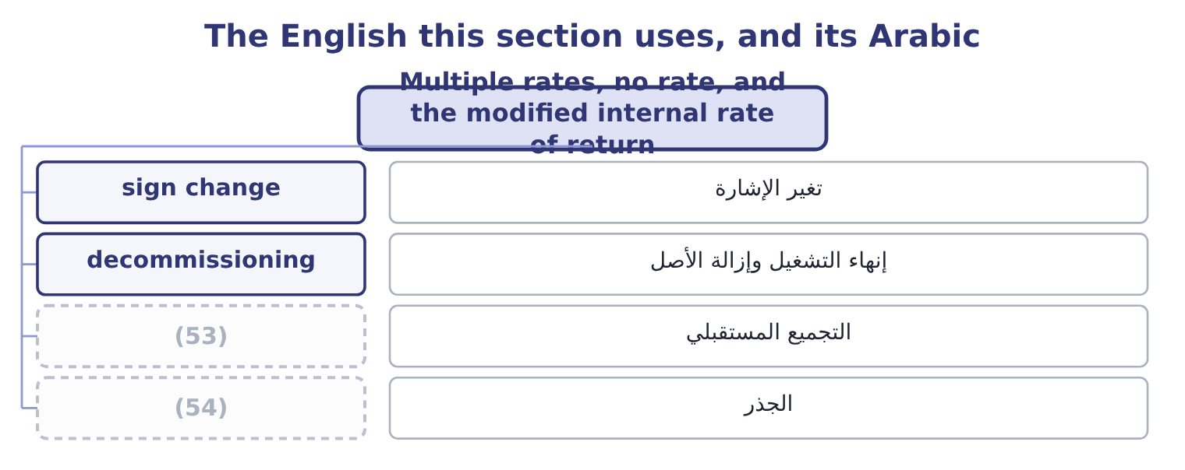
word list
compounding forward · hurdle · root

The English this sheet uses, and its Arabic
English (exam term) | Arabic
sign change | تغير الإشارة
decommissioning | إنهاء التشغيل وإزالة الأصل
compounding forward | التجميع المستقبلي
root | الجذر

Answer key · 16.5 Multiple rates, no rate, and the modified internal rate of return

1 conventional | 28 inflows
2 equation | 29 compounded
3 common | 30 factors
4 quarry | 31 terminal
5 restored | 32 already
6 decommissioning | 33 multiple
7 injection | 34 Fifteen
8 contract | 35 unmodified
9 completion | 36 difference
10 sesame-hulling | 37 reinvesting
11 requires | 38 clears
12 offsets | 39 smaller
13 mathematically | 40 Modified internal rate
14 neither | 41 Factor 3.8897
15 useful | 42 Factor 0.6499
16 question | 43 external
17 contradictory | 44 appeal
18 slightly | 45 faults
19 narrowest | 46 ignores
20 no-rate | 47 deducting
21 patterns | 48 Candidates
22 solution | 49 missing
23 repairs | 50 357,445: 550,000 × 0.6499 = 357,445.
24 multiple-rate | 51 interpolation
25 discount | 52 scale
26 single | 53 compounding forward
27 survives | 54 root

the summaries in full
Summary 1 A conventional project has one sign change — out, then in — and exactly one internal rate of return. Where the flows change sign more than once the equation can have several roots, or none. Projects with more than one sign change are common: a mine or quarry that must be restored at the end, a plant with a large decommissioning cost, a project needing a second injection of capital in the middle, a contract with a penalty on completion. A sesame-hulling site costs 1,000,000 now, returns 2,600,000 at the end of year 1, and requires 1,650,000 of restoration at the end of year 2. The inflow is worth 2,600,000 ÷ 1.1 = 2,363,636 and the restoration 1,650,000 ÷ 1.21 = 1,363,636, so the net of the two is 2,363,636 − 1,363,636 = 1,000,000, which exactly offsets the initial outlay.
Summary 2 The net present value is zero, so 10 per cent is an internal rate of return. Now the inflow is worth 2,600,000 ÷ 1.5 = 1,733,333 and the restoration 1,650,000 ÷ 2.25 = 733,333, so the net is 1,733,333 − 733,333 = 1,000,000 and the net present value is zero again. Fifty per cent is also an internal rate of return. Both are mathematically correct and neither is a return in any useful sense. The question "is the internal rate of return above the 9 per cent hurdle?" has two contradictory answers, so the measure has failed. Net present value has not failed. At 9 per cent the value is 2,600,000 ÷ 1.09 = 2,385,321 for the inflow and 1,650,000 ÷ 1.1881 = 1,388,772 for the restoration, so the project's value is 2,385,321 − 1,388,772 = 996,549 against an outlay of 1,000,000 — very slightly negative, and the decision is to reject, by the narrowest of margins.
Summary 3 One rate, one answer. The no-rate case is rarer and also real: some flow patterns give no real solution at all, so there is simply no internal rate of return to compute. The modified internal rate of return repairs the reinvestment problem and, incidentally, the multiple-rate one. It works in three steps: compound every inflow forward to the end of the project at the cost of capital, discount every outflow back to time zero at the same rate, and find the single rate that links the two. Because only one sign change survives, there is exactly one answer.
Summary 4 Compound the inflows at 9 per cent. The five annual flows of 1,050,000, compounded forward to the end of year 5, carry factors of 1.41158, 1.29503, 1.18810, 1.09000 and 1.00000, which sum to 5.98471, so they are worth 1,050,000 × 5.98471 = 6,283,946 at the end. Add the terminal flow. It already falls at the end of year 5, so 6,283,946 + 550,000 = 6,833,946. The investment of 3,400,000 grows to 6,833,946 over five years, a multiple of 6,833,946 ÷ 3,400,000 = 2.010. Take the fifth root. The fifth root of 2.010 is 1.1499, so the modified internal rate of return is 15.0 per cent. Fifteen per cent against the unmodified 19.5 per cent. The difference is the whole of the reinvestment assumption: the plain internal rate of return credited the project with reinvesting its interim flows at 19.5 per cent, and the modified measure credits it only with 9 per cent, which is what Orontes can actually get. The project still clears the hurdle, by a smaller and more honest margin.
Summary 5 Internal in internal rate of return means computed from the project's own flows, with no external rate used — which is both its appeal and the source of every one of its faults, because a measure that needs no cost of capital also ignores one. Net in net present value means after deducting the investment: the present value of what comes in, less the present value of what goes out. Candidates who compute 4,441,630 and stop have found a present value and not a net present value, and the missing word costs the mark.

