17.1 The payback period
Chapter 17 · section 17.1

Fill every gap. Each word list holds one word more than there are gaps.
Chapter 17, section by section
Each stage leads to the next.
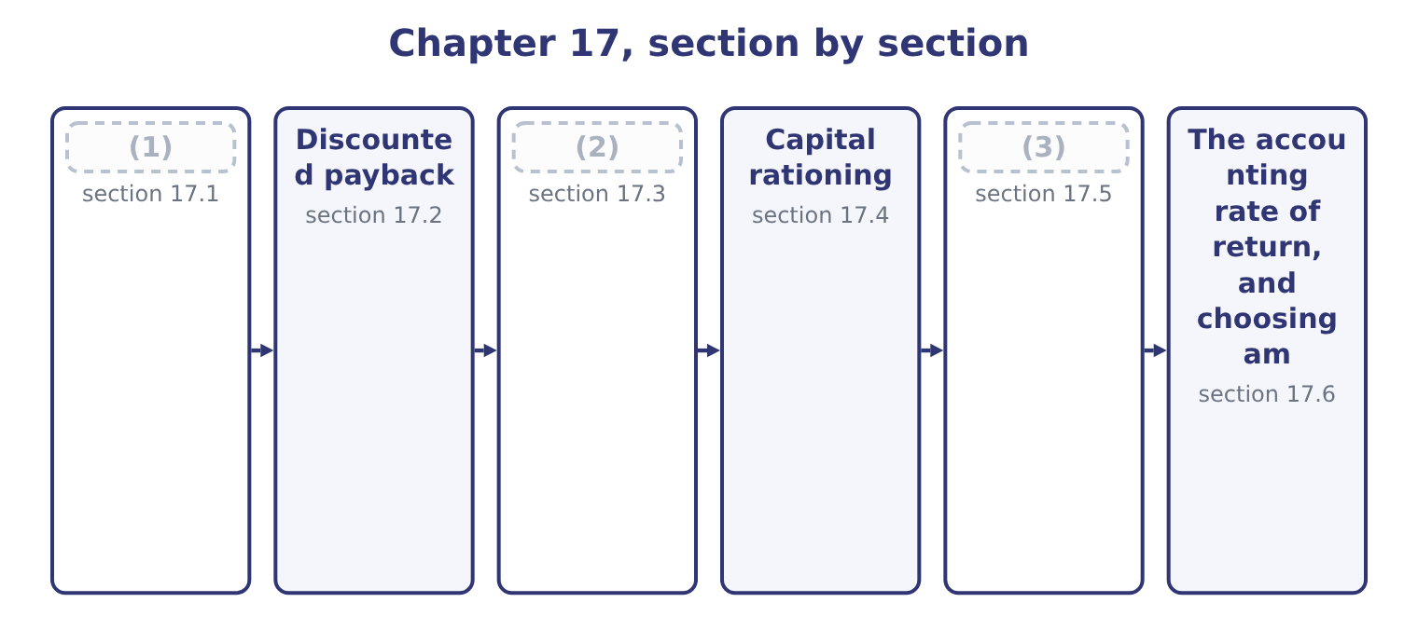
word list
The profitability index · The payback period · recovery of investment · Sensitivity analysis in the investment decisio

Summary 1 gaps 4–9
The payback period is the time taken for a (4) cash inflows to recover its (5) investment. It is not a measure of profitability and it was never meant to be: it is a measure of exposure, (6) how long the (7) money is at risk. Where the inflows are level, divide. Where they are uneven, (8) them year by year until the investment is covered, then take the (9) of the final year needed.
word list
accumulate · project's · advantages · initial · fraction · answering · company's

Worked example: the roasting line's payback

Summary 2 gaps 10–21
Level flows, so divide. The investment is 3,400,000 and the annual inflow 1,050,000, so the payback is 3,400,000 ÷ 1,050,000 = 3.24 years. The long way, which also (10) uneven flows. Three years bring in 1,050,000 × 3 = 3,150,000, (11) 3,400,000 − 3,150,000 = 250,000 to recover. That (12) is 250,000 ÷ 1,050,000 = 0.238 of the fourth year's inflow, so the payback is 3 + 0.24 = 3.24 years, (13) with step 1. Note what step 3 (14) : that cash arrives evenly through the fourth year. It does not, for a (15) with a harvest in it, and a payback stated to two decimals from annual data is as falsely precise as anything. Its (16) , and they are real. It is simple and (17) understood. A plant manager who will never discount anything (18) three and a quarter years. It measures (19) exposure, which matters to a company that cannot afford to have its cash tied up — Book 1's. It is a crude proxy for risk, because distant cash flows are the least certain, so a short payback means the case rests on the years that can be (20) . It is useful as a (21) .
word list
forecast · universally · agreeing · assumes · remainder · leaving · screen · handles · acceptable · business · understands · advantages · liquidity

Summary 3 gaps 22–29
Where a company sees two hundred (22) a year, rejecting those that cannot repay within five is a cheap first filter before the (23) work begins. Its (24) , which are the (25) half. It ignores (26) after the payback point. A project repaying in three years and then (27) ranks equally with one repaying in three years and (28) for twenty. It ignores the time value of money within the payback period, (29) a dollar in year three as equal to one today — which section 17.2 repairs. It has no decision rule of its own.
word list
treating · everything · examined · shortfall · discounting · proposals · limitations · stopping · running

Summary 4 gaps 30–34
The required period is chosen, not derived: nothing in the (30) says whether four years is (31) . It is biased against exactly the (32) that create most value — long-lived (33) , research, brand building — because their returns arrive late. And it is not a profitability measure at all, so a project can have an (34) payback and a negative net present value.
word list
attractive · infrastructure · arithmetic · projects · repaying · acceptable

Payback: what it does and does not do
Every item belongs to exactly one group.
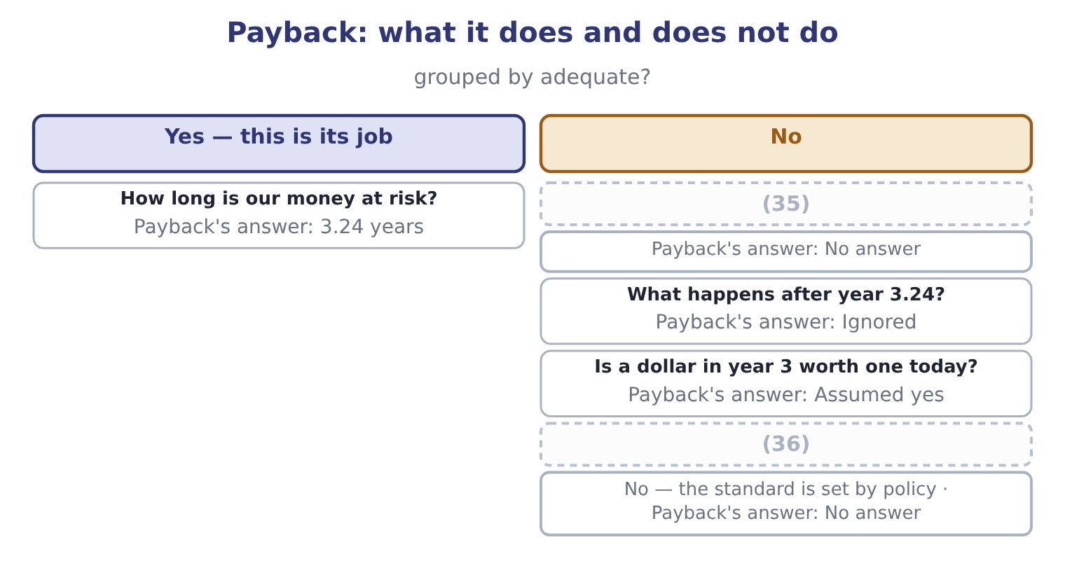
word list
value per dollar invested · Is 3.24 years acceptable? · Does the project create value?

The English this section uses, and its Arabic
Each term sits against what it means.
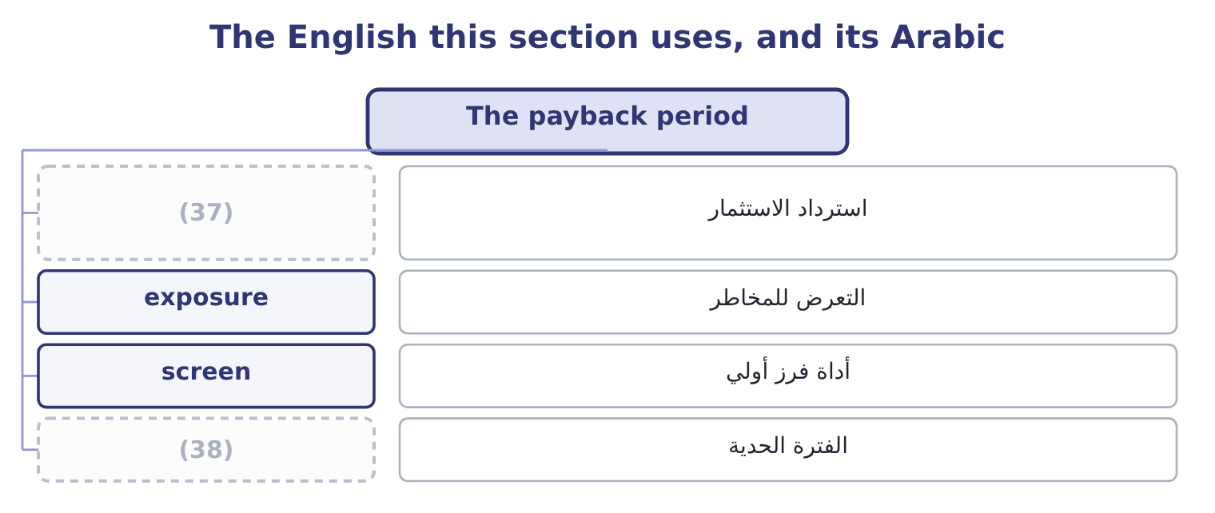
word list
recovery of investment · profitability index · cut-off period

The English this sheet uses, and its Arabic
English (exam term) | Arabic
recovery of investment | استرداد الاستثمار
exposure | التعرض للمخاطر
screen | أداة فرز أولي
cut-off period | الفترة الحدية

Answer key · 17.1 The payback period

1 The payback period | 20 forecast
2 The profitability index | 21 screen
3 Sensitivity analysis in the investment decisio | 22 proposals
4 project's | 23 discounting
5 initial | 24 limitations
6 answering | 25 examined
7 company's | 26 everything
8 accumulate | 27 stopping
9 fraction | 28 running
10 handles | 29 treating
11 leaving | 30 arithmetic
12 remainder | 31 acceptable
13 agreeing | 32 projects
14 assumes | 33 infrastructure
15 business | 34 attractive
16 advantages | 35 Does the project create value?
17 universally | 36 Is 3.24 years acceptable?
18 understands | 37 recovery of investment
19 liquidity | 38 cut-off period

the summaries in full
Summary 1 The payback period is the time taken for a project's cash inflows to recover its initial investment. It is not a measure of profitability and it was never meant to be: it is a measure of exposure, answering how long the company's money is at risk. Where the inflows are level, divide. Where they are uneven, accumulate them year by year until the investment is covered, then take the fraction of the final year needed.
Summary 2 Level flows, so divide. The investment is 3,400,000 and the annual inflow 1,050,000, so the payback is 3,400,000 ÷ 1,050,000 = 3.24 years. The long way, which also handles uneven flows. Three years bring in 1,050,000 × 3 = 3,150,000, leaving 3,400,000 − 3,150,000 = 250,000 to recover. That remainder is 250,000 ÷ 1,050,000 = 0.238 of the fourth year's inflow, so the payback is 3 + 0.24 = 3.24 years, agreeing with step 1. Note what step 3 assumes: that cash arrives evenly through the fourth year. It does not, for a business with a harvest in it, and a payback stated to two decimals from annual data is as falsely precise as anything. Its advantages, and they are real. It is simple and universally understood. A plant manager who will never discount anything understands three and a quarter years. It measures liquidity exposure, which matters to a company that cannot afford to have its cash tied up — Book 1's. It is a crude proxy for risk, because distant cash flows are the least certain, so a short payback means the case rests on the years that can be forecast. It is useful as a screen.
Summary 3 Where a company sees two hundred proposals a year, rejecting those that cannot repay within five is a cheap first filter before the discounting work begins. Its limitations, which are the examined half. It ignores everything after the payback point. A project repaying in three years and then stopping ranks equally with one repaying in three years and running for twenty. It ignores the time value of money within the payback period, treating a dollar in year three as equal to one today — which section 17.2 repairs. It has no decision rule of its own.
Summary 4 The required period is chosen, not derived: nothing in the arithmetic says whether four years is acceptable. It is biased against exactly the projects that create most value — long-lived infrastructure, research, brand building — because their returns arrive late. And it is not a profitability measure at all, so a project can have an attractive payback and a negative net present value.

17.2 Discounted payback
Chapter 17 · section 17.2

Fill every gap. Each word list holds one word more than there are gaps.
Summary 1 gaps 1–4
Discounted payback asks the same (1) of discounted flows: how long until the present value of the inflows covers the investment? It repairs one of (2) two great faults — the (3) of time value within the period — and leaves the other (4) , because flows after the recovery point are still ignored.
word list
untouched · quarters · payback's · ignoring · question

Worked example: the roasting line's discounted payback

Summary 2 gaps 5–16
Discount each year at 9 per cent. The (5) are 0.9174, 0.8417, 0.7722, 0.7084 and 0.6499, so the five inflows of 1,050,000 are worth 963,270, 883,785, 810,810, 743,820 and 682,395 (6) . After one year 963,270; after two, 963,270 + 883,785 = 1,847,055; after three, 1,847,055 + 810,810 = 2,657,865. The investment is still short by 3,400,000 − 2,657,865 = 742,135 at the end of year three. Take the (7) of year four. That (8) is 742,135 ÷ 743,820 = 0.998 of the (9) year's discounted (10) , so the discounted payback is 3 + 1.00 = 4.00 years. (11) 3.24 years; discounted 4.00 years. The (12) of three quarters of a year is the cost of the money during the recovery period, and it is always a (13) : discounting can only make the inflows (14) . A company with a (15) cut-off would (16) this project on payback and reject it on discounted payback, which is why the policy must say which one it means.
word list
factors · ignoring · Undiscounted · respectively · fraction · inflow · fourth · smaller · four-year · lengthening · difference · shortfall · accept

Summary 3 gaps 17–24
A project whose discounted payback is (17) than its life has a (18) net present value, (19) , because by the time the discounted inflows cover the investment the net present value has passed zero, and every later flow adds to it. So discounted payback at least cannot (20) net present value about (21) , which plain payback can. And it is harder to (22) than payback while being easier to (23) : "we get our money back in four years" is not what it says. It says the inflows cover the investment and its (24) cost in four years.
word list
financing · shorter · positive · contradict · acceptance · ignoring · necessarily · explain · misread

The English this section uses, and its Arabic
Each term sits against what it means.
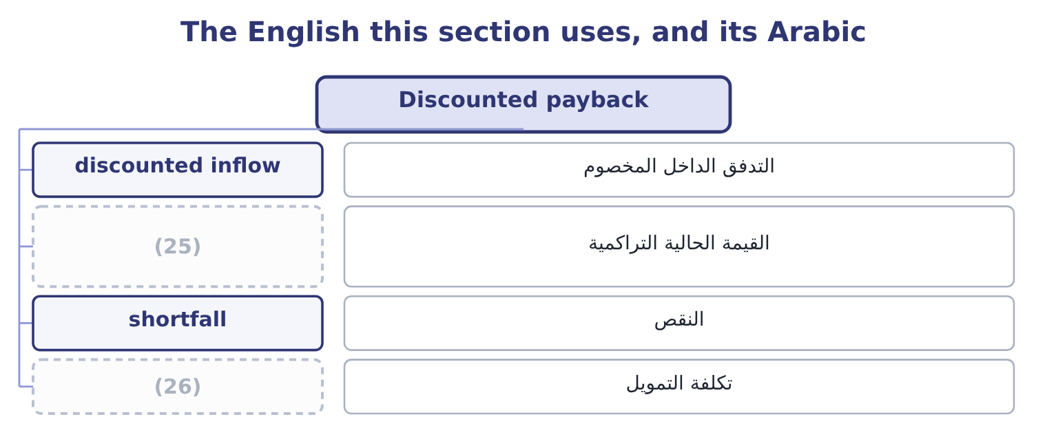
word list
capital rationing · cumulative present value · financing cost

The English this sheet uses, and its Arabic
English (exam term) | Arabic
discounted inflow | التدفق الداخل المخصوم
cumulative present value | القيمة الحالية التراكمية
shortfall | النقص
financing cost | تكلفة التمويل

Answer key · 17.2 Discounted payback

1 question | 14 smaller
2 payback's | 15 four-year
3 ignoring | 16 accept
4 untouched | 17 shorter
5 factors | 18 positive
6 respectively | 19 necessarily
7 fraction | 20 contradict
8 shortfall | 21 acceptance
9 fourth | 22 explain
10 inflow | 23 misread
11 Undiscounted | 24 financing
12 difference | 25 cumulative present value
13 lengthening | 26 financing cost

the summaries in full
Summary 1 Discounted payback asks the same question of discounted flows: how long until the present value of the inflows covers the investment? It repairs one of payback's two great faults — the ignoring of time value within the period — and leaves the other untouched, because flows after the recovery point are still ignored.
Summary 2 Discount each year at 9 per cent. The factors are 0.9174, 0.8417, 0.7722, 0.7084 and 0.6499, so the five inflows of 1,050,000 are worth 963,270, 883,785, 810,810, 743,820 and 682,395 respectively. After one year 963,270; after two, 963,270 + 883,785 = 1,847,055; after three, 1,847,055 + 810,810 = 2,657,865. The investment is still short by 3,400,000 − 2,657,865 = 742,135 at the end of year three. Take the fraction of year four. That shortfall is 742,135 ÷ 743,820 = 0.998 of the fourth year's discounted inflow, so the discounted payback is 3 + 1.00 = 4.00 years. Undiscounted 3.24 years; discounted 4.00 years. The difference of three quarters of a year is the cost of the money during the recovery period, and it is always a lengthening: discounting can only make the inflows smaller. A company with a four-year cut-off would accept this project on payback and reject it on discounted payback, which is why the policy must say which one it means.
Summary 3 A project whose discounted payback is shorter than its life has a positive net present value, necessarily, because by the time the discounted inflows cover the investment the net present value has passed zero, and every later flow adds to it. So discounted payback at least cannot contradict net present value about acceptance, which plain payback can. And it is harder to explain than payback while being easier to misread: "we get our money back in four years" is not what it says. It says the inflows cover the investment and its financing cost in four years.

17.3 The profitability index
Chapter 17 · section 17.3

Fill every gap. Each word list holds one word more than there are gaps.
Summary 1 gaps 1–12
The (1) index is the present value of a (2) inflows divided by the investment. It (3) a net present value into a measure of value for each dollar (4) , which is precisely the blind spot. The index for the roasting line is 4,441,630 ÷ 3,400,000 = 1.306, or 1.31 to two (5) : every dollar (6) comes back as about $1.31 of present value. Two (7) exist and both (8) in exams. The (9) one divides the present value of the inflows by the investment, so the accept rule is an index above 1.00. The other divides the net present value by the investment, so the accept rule is an index above zero; the roasting (10) index on that basis is 1,041,630 ÷ 3,400,000 = 0.306. The two carry the same (11) and differ by (12) 1.00.
word list
information · committed · conventions · common · decimals · ignores · appear · profitability · converts · invested · project's · line's · exactly

Summary 2 gaps 13–24
Read the (13) : if it offers (14) near 1.3, it wants the first; near 0.3, the second. Three (15) make the index worth (16) . It is (17) with net present value about (18) . An index above 1.00 and a (19) net present value are the same (20) , because the index exceeds one precisely when the inflows' present value exceeds the outlay. It ranks (21) under capital (22) , which is section 17.4. And it states value per dollar, which makes (23) of very different sizes (24) in a way net present value cannot. Its limitation is the mirror image of net present value's. Being a ratio, it ignores absolute size: an index of 1.50 on 200,000 creates 100,000 of value and an index of 1.10 on 10,000,000 creates 1,000,000. Where money is not short, take the bigger value; the index matters only when the money is.
word list
having · answers · consistent · positive · rationing · acceptance · comparable · things · correctly · convention · question · projects · statement

Four readings of one project
Every item belongs to exactly one group.
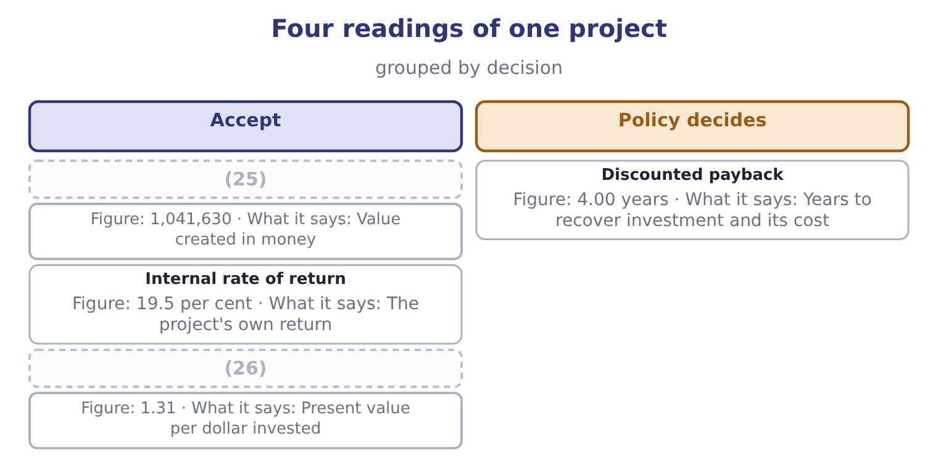
word list
Net present value · Profitability index · cumulative present value

The English this section uses, and its Arabic
Each term sits against what it means.
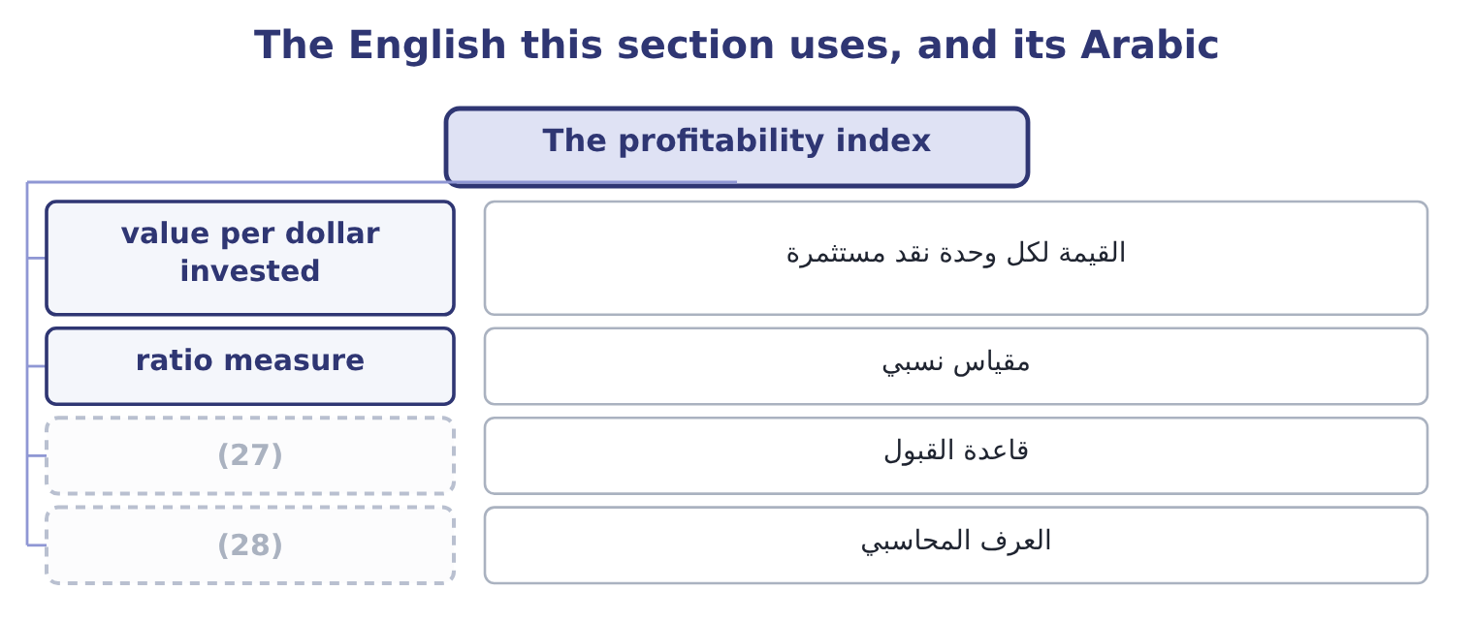
word list
reported results · convention · accept rule

The English this sheet uses, and its Arabic
English (exam term) | Arabic
value per dollar invested | القيمة لكل وحدة نقد مستثمرة
ratio measure | مقياس نسبي
accept rule | قاعدة القبول
convention | العرف المحاسبي

Answer key · 17.3 The profitability index

1 profitability | 15 things
2 project's | 16 having
3 converts | 17 consistent
4 committed | 18 acceptance
5 decimals | 19 positive
6 invested | 20 statement
7 conventions | 21 correctly
8 appear | 22 rationing
9 common | 23 projects
10 line's | 24 comparable
11 information | 25 Net present value
12 exactly | 26 Profitability index
13 question | 27 accept rule
14 answers | 28 convention

the summaries in full
Summary 1 The profitability index is the present value of a project's inflows divided by the investment. It converts a net present value into a measure of value for each dollar committed, which is precisely the blind spot. The index for the roasting line is 4,441,630 ÷ 3,400,000 = 1.306, or 1.31 to two decimals: every dollar invested comes back as about $1.31 of present value. Two conventions exist and both appear in exams. The common one divides the present value of the inflows by the investment, so the accept rule is an index above 1.00. The other divides the net present value by the investment, so the accept rule is an index above zero; the roasting line's index on that basis is 1,041,630 ÷ 3,400,000 = 0.306. The two carry the same information and differ by exactly 1.00.
Summary 2 Read the question: if it offers answers near 1.3, it wants the first; near 0.3, the second. Three things make the index worth having. It is consistent with net present value about acceptance. An index above 1.00 and a positive net present value are the same statement, because the index exceeds one precisely when the inflows' present value exceeds the outlay. It ranks correctly under capital rationing, which is section 17.4. And it states value per dollar, which makes projects of very different sizes comparable in a way net present value cannot. Its limitation is the mirror image of net present value's. Being a ratio, it ignores absolute size: an index of 1.50 on 200,000 creates 100,000 of value and an index of 1.10 on 10,000,000 creates 1,000,000. Where money is not short, take the bigger value; the index matters only when the money is.

17.4 Capital rationing
Chapter 17 · section 17.4

Fill every gap. Each word list holds one word more than there are gaps.
Summary 1 gaps 1–12
Capital rationing is the (1) in which a company has more (2) projects than money to fund them. It comes in two forms, and the exam (3) them. Hard rationing is external: the company cannot raise more money on (4) terms, because lenders will not lend, because covenants of the kind Book 2's, or because an equity issue would be (5) dilutive. Soft rationing is (6) : the board sets a capital budget. Reasons include wanting to avoid the scrutiny of new (7) , limiting how fast the (8) must absorb change, forcing divisions to compete so that weak proposals are filtered out, and distrust of the forecasts, which is. Soft rationing is far more common, and worth (9) : a company turning down projects with positive net present values because of a (10) limit is choosing to be worth less than it could be, and it may have good reasons, but they should be stated. The method under rationing is to rank by (11) index rather than by net present value, and the reason is the (12) of a constraint: with a fixed budget, what should be maximised is value for each dollar of the scarce resource, exactly. The principle is the same and so is the mistake it prevents.
word list
internal · organisation · acceptable · arithmetic · condition · value-creating · noticing · self-imposed · distinguishes · financing · choosing · prohibitively · profitability

Worked example: a budget of 5,000,000 and three proposals

Summary 2 gaps 13–22
Project A needs 5,000,000 and has a net present value of 900,000. Project B needs 2,500,000 and has 600,000. Project C needs 2,500,000 and has 550,000. All three (13) value, and the budget is 5,000,000. Rank by net present value. Project A's 900,000 is the (14) , and it uses the (15) budget, so the (16) answer is A alone, for a total of 900,000. B first, then C, and (17) they need exactly 2,500,000 + 2,500,000 = 5,000,000 — the whole budget — for a total value of 600,000 + 550,000 = 1,150,000. The index ranking creates 1,150,000 − 900,000 = 250,000 more value from the same money, and the reason is (18) in step 1: Project A is the (19) project, not the most (20) one. Ranking by net present value under a constraint rewards size; ranking by index rewards (21) , which is what a constraint (22) .
word list
together · productivity · entire · largest · biggest · demands · greedy · productive · projects · create · visible

Summary 3 gaps 23–34
Three (23) belong with the method. The index ranking is exactly right only where projects are (24) — where half a project can be taken for half the money and half the value. Most capital projects are not: a (25) line cannot be (26) in halves. So where projects are indivisible, the index gives the ranking from which to start, and the answer is then found by (27) the feasible (28) and choosing the one with the (29) total net present value. With a handful of projects that is quick; with many it is a formal problem of a kind solved by linear (30) , which the exam (31) but does not require you to solve. And the method assumes a single (32) constraint. A project needing money in two (33) years, in a company (34) in both, is a harder problem again.
word list
dilutive · period's · programming · cautions · successive · divisible · combinations · roasting · mentions · greatest · bought · rationed · testing

Two rankings of the same three projects, budget 5,000,000
Every item belongs to exactly one group.
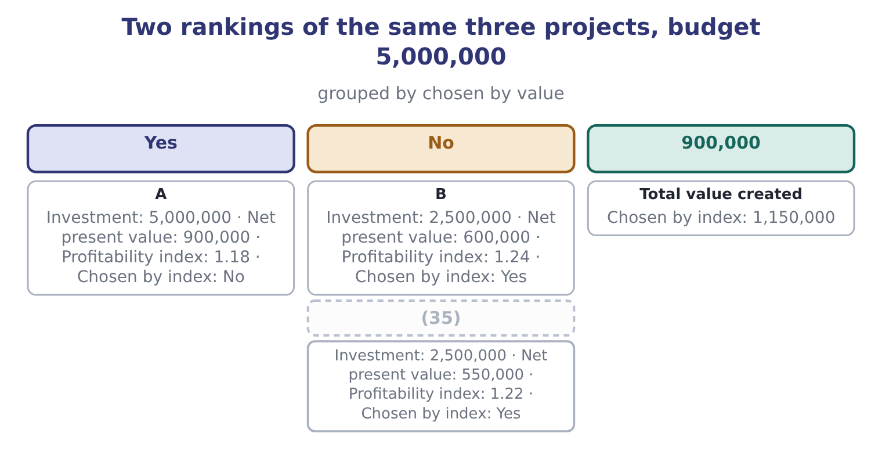
word list
C · shortfall

Answer key · 17.4 Capital rationing

1 condition | 19 biggest
2 value-creating | 20 productive
3 distinguishes | 21 productivity
4 acceptable | 22 demands
5 prohibitively | 23 cautions
6 internal | 24 divisible
7 financing | 25 roasting
8 organisation | 26 bought
9 noticing | 27 testing
10 self-imposed | 28 combinations
11 profitability | 29 greatest
12 arithmetic | 30 programming
13 create | 31 mentions
14 largest | 32 period's
15 entire | 33 successive
16 greedy | 34 rationed
17 together | 35 C
18 visible

the summaries in full
Summary 1 Capital rationing is the condition in which a company has more value-creating projects than money to fund them. It comes in two forms, and the exam distinguishes them. Hard rationing is external: the company cannot raise more money on acceptable terms, because lenders will not lend, because covenants of the kind Book 2's, or because an equity issue would be prohibitively dilutive. Soft rationing is internal: the board sets a capital budget. Reasons include wanting to avoid the scrutiny of new financing, limiting how fast the organisation must absorb change, forcing divisions to compete so that weak proposals are filtered out, and distrust of the forecasts, which is. Soft rationing is far more common, and worth noticing: a company turning down projects with positive net present values because of a self-imposed limit is choosing to be worth less than it could be, and it may have good reasons, but they should be stated. The method under rationing is to rank by profitability index rather than by net present value, and the reason is the arithmetic of a constraint: with a fixed budget, what should be maximised is value for each dollar of the scarce resource, exactly. The principle is the same and so is the mistake it prevents.
Summary 2 Project A needs 5,000,000 and has a net present value of 900,000. Project B needs 2,500,000 and has 600,000. Project C needs 2,500,000 and has 550,000. All three create value, and the budget is 5,000,000. Rank by net present value. Project A's 900,000 is the largest, and it uses the entire budget, so the greedy answer is A alone, for a total of 900,000. B first, then C, and together they need exactly 2,500,000 + 2,500,000 = 5,000,000 — the whole budget — for a total value of 600,000 + 550,000 = 1,150,000. The index ranking creates 1,150,000 − 900,000 = 250,000 more value from the same money, and the reason is visible in step 1: Project A is the biggest project, not the most productive one. Ranking by net present value under a constraint rewards size; ranking by index rewards productivity, which is what a constraint demands.
Summary 3 Three cautions belong with the method. The index ranking is exactly right only where projects are divisible — where half a project can be taken for half the money and half the value. Most capital projects are not: a roasting line cannot be bought in halves. So where projects are indivisible, the index gives the ranking from which to start, and the answer is then found by testing the feasible combinations and choosing the one with the greatest total net present value. With a handful of projects that is quick; with many it is a formal problem of a kind solved by linear programming, which the exam mentions but does not require you to solve. And the method assumes a single period's constraint. A project needing money in two successive years, in a company rationed in both, is a harder problem again.

17.5 Sensitivity analysis in the investment decision
Chapter 17 · section 17.5

Fill every gap. Each word list holds one word more than there are gaps.
Summary 1 gaps 1–5
The method is (1) . Take the net present value, hold (2) constant except one input, and solve for the value of that input at which the net present value (3) zero. Express the answer as a margin — the (4) between the forecast and the reversal point — and then ask whether that margin is (5) given what is known about the input.
word list
everything · distance · comfortable · becomes · mechanical · exposure

Worked example: four margins on the roasting line

Summary 2 gaps 6–15
The annual cash flow. The terminal flow is worth 550,000 × 0.6499 = 357,445 today, so the annual flows must cover 3,400,000 − 357,445 = 3,042,555, which over the (6) factor is 3,042,555 ÷ 3.8897 = 782,208 a year. The forecast is 1,050,000, so the margin is 1,050,000 − 782,208 = 267,792, which is 267,792 ÷ 1,050,000 = 25.50 per cent. Every dollar of overrun (7) the net present value by a dollar, so the project survives an overrun of the whole net present value: 3,400,000 + 1,041,630 = 4,441,630 before it (8) even, a margin of 1,041,630 ÷ 3,400,000 = 30.64 per cent. The net present value (9) zero at the (10) rate of return.5 per cent, so the rate has 19.5 − 9.0 = 10.5 points of (11) . Four years of flows are worth 1,050,000 × 3.2397 = 3,401,685, and the terminal amount (12) a year earlier is worth 550,000 × 0.7084 = 389,620, so a (13) project is worth 3,401,685 + 389,620 = 3,791,305, (14) 3,791,305 − 3,400,000 = 391,305 and still (15) .
word list
reaches · arriving · internal · annuity · headroom · giving · clearing · sensitivity · reduces · four-year · breaks

Summary 3 gaps 16–27
The project survives (16) a fifth of its life. Every margin is in double figures, so the (17) is robust — and the (18) is the annual cash flow at a quarter. That is the number to (19) before approving, and the next step is to push it back to its drivers: the (20) operating flow would have to fall to 782,208 − 150,000 = 632,208, which before tax is 632,208 ÷ 0.75 = 842,944, a fall of 1,200,000 − 842,944 = 357,056, or 357,056 ÷ 1,200,000 = 29.75 per cent of the operating cash flow. Thirty per cent of the operating margin is a large miss; if the volume forecast could (21) be thirty per cent wrong, the forecast is the (22) and not the project. Three uses (23) from an analysis like that, and the exam asks for them. It (24) the variable that (25) . Here it is the annual operating cash flow, and within it the volume, which is where the (26) effort and the (27) . It converts a forecast into a question somebody can answer.
word list
after-tax · appraisal · losing · identifies · tightest · problem · follow · decides · sensitivity · investigate · plausibly · decision · operating

Summary 4 gaps 28–36
Nobody can say whether 1,050,000 a year is right. A sales (28) can say whether volume could fall by thirty per cent. It tells you where to build in (29) . Where the tight variable is one that can be (30) — an input price, a volume (31) , a lease term — the margin can be (32) rather than hoped for. And two (33) , both. (34) analysis misses the fact that bad things arrive (35) , which is what scenario analysis is for; and it says nothing about how likely any of the reversal points is, which is what (36) attempts.
word list
manager · limits · forecast · simulation · bought · commitment · together · One-at-a-time · protection · contracted

How far each input can move before the roasting line breaks even
Input | Forecast | Break-even value | Margin
Annual cash flow | 1,050,000 | 782,208 | 25.50 per cent
Initial investment | 3,400,000 | 4,441,630 | 30.64 per cent overrun
Discount rate | 9.0 per cent | (37) | 10.5 points
Project life | 5 years | Between 4 and 5 years | (38)

word list
19.5 per cent · Over a year · recovery of investment

Answer key · 17.5 Sensitivity analysis in the investment decision

1 mechanical | 20 after-tax
2 everything | 21 plausibly
3 becomes | 22 problem
4 distance | 23 follow
5 comfortable | 24 identifies
6 annuity | 25 decides
7 reduces | 26 appraisal
8 breaks | 27 sensitivity
9 reaches | 28 manager
10 internal | 29 protection
11 headroom | 30 contracted
12 arriving | 31 commitment
13 four-year | 32 bought
14 giving | 33 limits
15 clearing | 34 One-at-a-time
16 losing | 35 together
17 decision | 36 simulation
18 tightest | 37 19.5 per cent
19 investigate | 38 Over a year

the summaries in full
Summary 1 The method is mechanical. Take the net present value, hold everything constant except one input, and solve for the value of that input at which the net present value becomes zero. Express the answer as a margin — the distance between the forecast and the reversal point — and then ask whether that margin is comfortable given what is known about the input.
Summary 2 The annual cash flow. The terminal flow is worth 550,000 × 0.6499 = 357,445 today, so the annual flows must cover 3,400,000 − 357,445 = 3,042,555, which over the annuity factor is 3,042,555 ÷ 3.8897 = 782,208 a year. The forecast is 1,050,000, so the margin is 1,050,000 − 782,208 = 267,792, which is 267,792 ÷ 1,050,000 = 25.50 per cent. Every dollar of overrun reduces the net present value by a dollar, so the project survives an overrun of the whole net present value: 3,400,000 + 1,041,630 = 4,441,630 before it breaks even, a margin of 1,041,630 ÷ 3,400,000 = 30.64 per cent. The net present value reaches zero at the internal rate of return.5 per cent, so the rate has 19.5 − 9.0 = 10.5 points of headroom. Four years of flows are worth 1,050,000 × 3.2397 = 3,401,685, and the terminal amount arriving a year earlier is worth 550,000 × 0.7084 = 389,620, so a four-year project is worth 3,401,685 + 389,620 = 3,791,305, giving 3,791,305 − 3,400,000 = 391,305 and still clearing.
Summary 3 The project survives losing a fifth of its life. Every margin is in double figures, so the decision is robust — and the tightest is the annual cash flow at a quarter. That is the number to investigate before approving, and the next step is to push it back to its drivers: the after-tax operating flow would have to fall to 782,208 − 150,000 = 632,208, which before tax is 632,208 ÷ 0.75 = 842,944, a fall of 1,200,000 − 842,944 = 357,056, or 357,056 ÷ 1,200,000 = 29.75 per cent of the operating cash flow. Thirty per cent of the operating margin is a large miss; if the volume forecast could plausibly be thirty per cent wrong, the forecast is the problem and not the project. Three uses follow from an analysis like that, and the exam asks for them. It identifies the variable that decides. Here it is the annual operating cash flow, and within it the volume, which is where the appraisal effort and the sensitivity. It converts a forecast into a question somebody can answer.
Summary 4 Nobody can say whether 1,050,000 a year is right. A sales manager can say whether volume could fall by thirty per cent. It tells you where to build in protection. Where the tight variable is one that can be contracted — an input price, a volume commitment, a lease term — the margin can be bought rather than hoped for. And two limits, both. One-at-a-time analysis misses the fact that bad things arrive together, which is what scenario analysis is for; and it says nothing about how likely any of the reversal points is, which is what simulation attempts.

17.6 The accounting rate of return, and choosing among the measures
Chapter 17 · section 17.6

Fill every gap. Each word list holds one word more than there are gaps.
Summary 1 gaps 1–11
The accounting rate of return — also met as the return on investment of Book 1 and as the simple or (1) rate of return — (2) average annual accounting profit by the investment. It (3) nothing and uses profit rather than cash, which makes it the (4) of the measures and the one most often seen first, because it is the only one that speaks the (5) of the financial statements the project will (6) appear. From cash flow to profit. The line's pre-tax (7) cash flow is 1,200,000 a year, and depreciation of 1,200,000 − 600,000 = 600,000 must be (8) to reach accounting profit, (9) 600,000 before tax. At 25 per cent, 600,000 × 0.75 = 450,000 of average annual profit. On the initial investment. On the average investment. Where the convention is to use the average of the (10) and closing book (11) , (3,400,000 + 550,000) ÷ 2 = 1,975,000, so the rate is 450,000 ÷ 1,975,000 = 22.78 per cent.
word list
discounts · opening · deducted · eventually · language · operating · divides · amounts · giving · unadjusted · weakest · carrying

Summary 2 gaps 12–23
The same project is 13.24 per cent or 22.78 per cent (12) on a convention nobody outside the finance (13) knows about, and neither figure can be (14) with the 9 per cent cost of capital, because one is an accounting ratio and the other a required return on cash. That is the (15) central weakness and the reason a question that offers both (16) is testing (17) you read the word average. Its (18) , stated plainly for the exam: it ignores the time value of money entirely; it uses accrual profit rather than cash, so it is affected by the depreciation method and by every accrual Book 1's; it depends on an (19) choice between initial and average investment; and it has no (20) accept rule. Its one genuine (21) is that it is the measure in which the (22) effect on reported results and on the divisional (23) measures of Book 4 will actually show up — which matters for the behaviour of the manager being asked to propose it.
word list
advantage · compared · department · figures · depreciation · whether · performance · weaknesses · arbitrary · depending · principled · project's · measure's

Summary 3 gaps 24–30
The (24) answer used by most (25) companies is to compute several and let each answer its own question. Net present value (26) . The internal rate of return (27) and gives the margin over the hurdle. The profitability index ranks under (28) . Payback or discounted payback states the liquidity (29) against a policy limit. The accounting rate of return shows what the financial statements will say. A proposal carrying all five, with the (30) analysis of, is a proposal a board can actually decide on.
word list
communicates · well-run · sensitivity · decides · practical · exposure · shortfall · rationing

Five measures, one project

Your turn: the measures (complete the blanks)
Item | Data | Answer
Payback period | Outlay 3,400,000; inflow 1,050,000 a year | ________
Discounted payback | (31) | ________
Profitability index | (32) | ________
Net present value |  | ________
Which measure ranks projects under a fixed capital budget |  | ________
Which measure the financial statements will show |  | ________

word list
Cumulative present value 2,657,865 after 3 years · Inflows worth 4,441,630 · Measure the financial statements will show

"Payback" and "index"

Summary 4 gaps 33–38
English payback is a (33) of ordinary words and sounds like plain speech, which is why it survives in (34) that have never discounted anything. The danger is that it sounds like a (35) — "the project pays back" — when it is only a (36) . Index in profitability index means a ratio to a base, as in the index numbers of (37) , and the base here is the money (38) .
word list
invested · depreciation · verdict · statistics · boardrooms · compound · duration

"Payback" and "index"
The bars are drawn to scale.
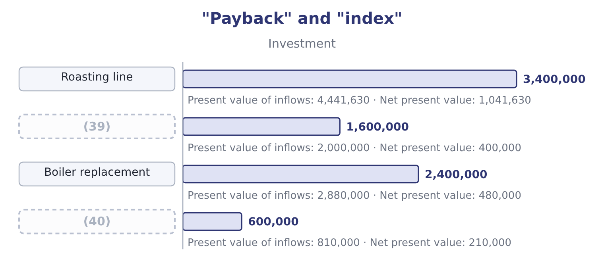
word list
discounted inflow · Fleet renewal · Warehouse racking

Item — Answer
Item | Answer
Payback period | (41) : 3,400,000 ÷ 1,050,000 = 3.24.
Discounted payback | 4.00 years: the shortfall of 742,135 is almost exactly the fourth year's discounted inflow.
Profitability index | (42) : 4,441,630 ÷ 3,400,000 = 1.306.
Net present value | 1,041,630: 4,441,630 − 3,400,000 = 1,041,630.
Measure that ranks under a fixed budget | The profitability index, which maximises value per dollar of the constraint.
Measure the financial statements will show | The accounting rate of return, which uses accrual profit.
What it tells you | Five measures, one project, one decision — accept. The measures differ in what they say when money is short or when liquidity is the worry,

word list
accept rule · 1.31 · 3.24 years

The English this section uses, and its Arabic
Each term sits against what it means.
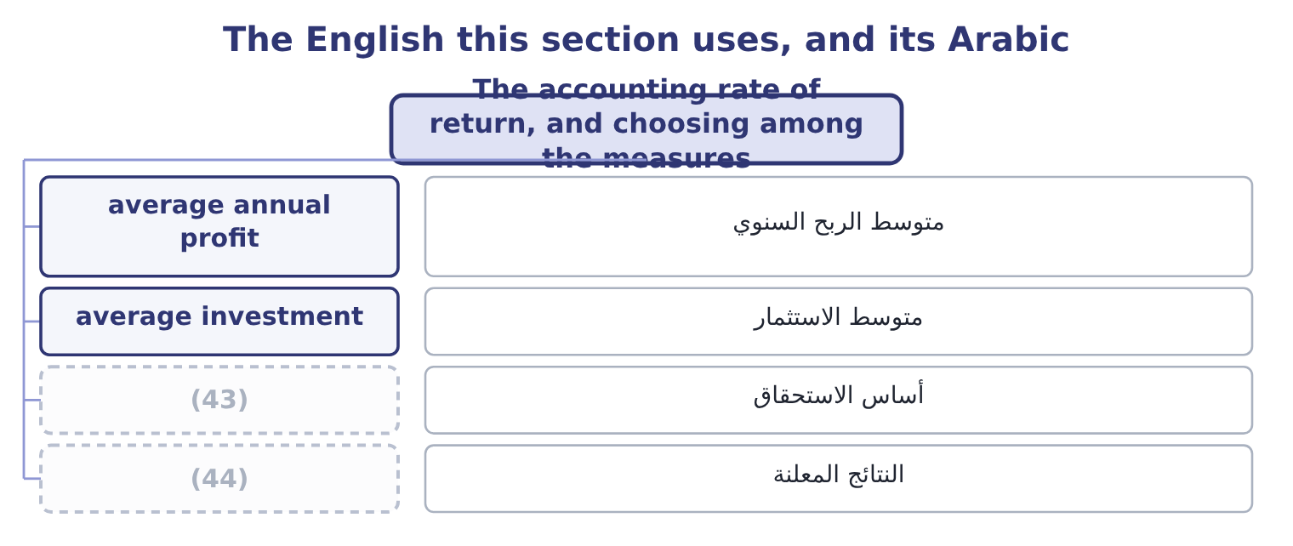
word list
reported results · financing cost · accrual basis

The English this sheet uses, and its Arabic
English (exam term) | Arabic
average annual profit | متوسط الربح السنوي
average investment | متوسط الاستثمار
accrual basis | أساس الاستحقاق
reported results | النتائج المعلنة

Answer key · 17.6 The accounting rate of return, and choosing among the measures

1 unadjusted | 23 performance
2 divides | 24 practical
3 discounts | 25 well-run
4 weakest | 26 decides
5 language | 27 communicates
6 eventually | 28 rationing
7 operating | 29 exposure
8 deducted | 30 sensitivity
9 giving | 31 Cumulative present value 2,657,865 after 3 years
10 opening | 32 Inflows worth 4,441,630
11 amounts | 33 compound
12 depending | 34 boardrooms
13 department | 35 verdict
14 compared | 36 duration
15 measure's | 37 statistics
16 figures | 38 invested
17 whether | 39 Warehouse racking
18 weaknesses | 40 Fleet renewal
19 arbitrary | 41 3.24 years
20 principled | 42 1.31
21 advantage | 43 accrual basis
22 project's | 44 reported results

the summaries in full
Summary 1 The accounting rate of return — also met as the return on investment of Book 1 and as the simple or unadjusted rate of return — divides average annual accounting profit by the investment. It discounts nothing and uses profit rather than cash, which makes it the weakest of the measures and the one most often seen first, because it is the only one that speaks the language of the financial statements the project will eventually appear. From cash flow to profit. The line's pre-tax operating cash flow is 1,200,000 a year, and depreciation of 1,200,000 − 600,000 = 600,000 must be deducted to reach accounting profit, giving 600,000 before tax. At 25 per cent, 600,000 × 0.75 = 450,000 of average annual profit. On the initial investment. On the average investment. Where the convention is to use the average of the opening and closing book amounts, (3,400,000 + 550,000) ÷ 2 = 1,975,000, so the rate is 450,000 ÷ 1,975,000 = 22.78 per cent.
Summary 2 The same project is 13.24 per cent or 22.78 per cent depending on a convention nobody outside the finance department knows about, and neither figure can be compared with the 9 per cent cost of capital, because one is an accounting ratio and the other a required return on cash. That is the measure's central weakness and the reason a question that offers both figures is testing whether you read the word average. Its weaknesses, stated plainly for the exam: it ignores the time value of money entirely; it uses accrual profit rather than cash, so it is affected by the depreciation method and by every accrual Book 1's; it depends on an arbitrary choice between initial and average investment; and it has no principled accept rule. Its one genuine advantage is that it is the measure in which the project's effect on reported results and on the divisional performance measures of Book 4 will actually show up — which matters for the behaviour of the manager being asked to propose it.
Summary 3 The practical answer used by most well-run companies is to compute several and let each answer its own question. Net present value decides. The internal rate of return communicates and gives the margin over the hurdle. The profitability index ranks under rationing. Payback or discounted payback states the liquidity exposure against a policy limit. The accounting rate of return shows what the financial statements will say. A proposal carrying all five, with the sensitivity analysis of, is a proposal a board can actually decide on.
Summary 4 English payback is a compound of ordinary words and sounds like plain speech, which is why it survives in boardrooms that have never discounted anything. The danger is that it sounds like a verdict — "the project pays back" — when it is only a duration. Index in profitability index means a ratio to a base, as in the index numbers of statistics, and the base here is the money invested.

