18.1 Mergers, acquisitions and leveraged buyouts
Chapter 18 · section 18.1

Fill every gap. Each word list holds one word more than there are gaps.
Chapter 18, section by section
Each stage leads to the next.
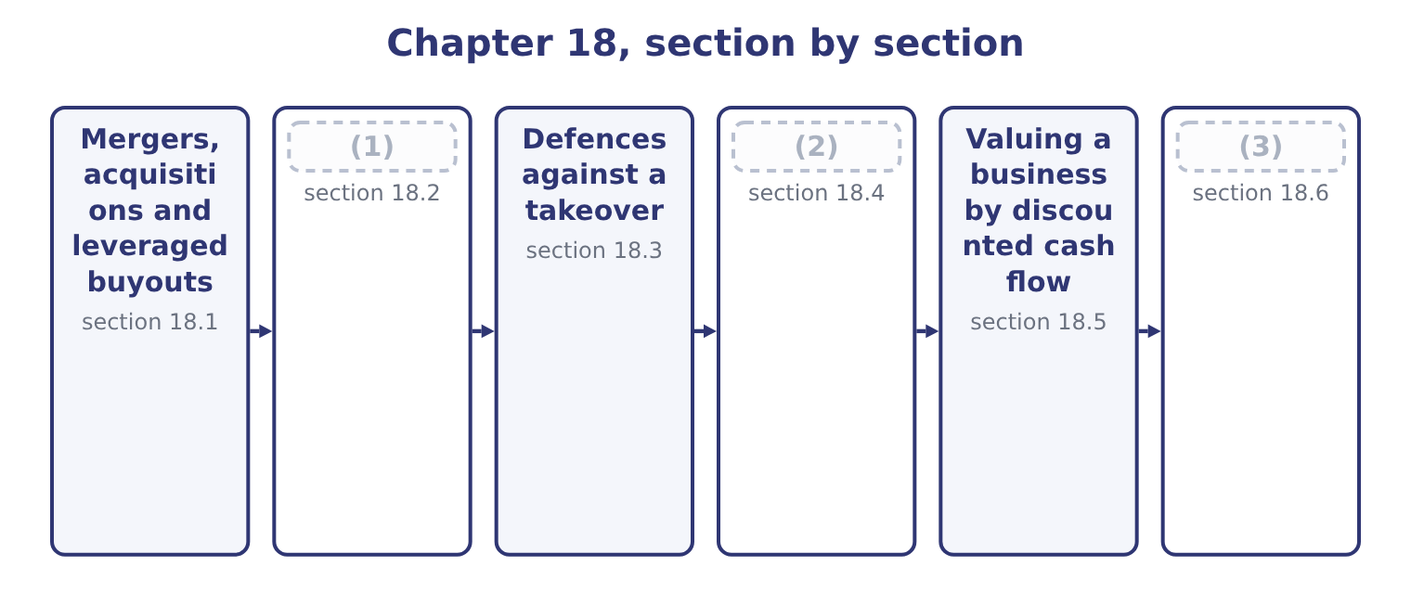
word list
Evaluating the deal and recommending · exclusive to the deal · Divestitures and restructuring · Synergies, and what they are worth

Summary 1 gaps 4–15
A merger combines two companies into one; an (4) is one company buying control of another, whether or not the target (5) as a legal entity. The exam uses the terms loosely and (6) deals by the economic (7) between the parties. A horizontal combination joins competitors in the same industry and the same stage of (8) — two tahini (9) . The usual case is (10) of scale, the (11) of duplicated overhead and increased market power, and the usual obstacle is competition law. A vertical combination joins a company and its supplier or its customer, at different (12) of the same chain. Orontes buying Ghab Mills is vertical and (13) , moving towards the raw (14) ; buying a chain of grocers would be vertical and forward. The usual case is security of supply, the removal of the supplier's margin and better coordination; the usual objection is that the (15) takes on a business it does not know how to run, and loses the discipline of being able to switch suppliers.
word list
stages · economies · elimination · acquirer · relationship · producers · management · backward · survives · production · classifies · acquisition · material

Summary 2 gaps 16–27
A conglomerate combination joins unrelated businesses. The case made for it is diversification of (16) and the use of surplus cash, and both (17) are weak: as Book 2's, shareholders can diversify far more cheaply by (18) both shares than a company can by buying one business with another, and surplus cash can be (19) to them. Conglomerate deals are the ones most often found, on (20) , to have destroyed value. A leveraged buyout is a different animal: the purchase of a company, (21) by a private equity firm or by its own (22) , financed largely by debt secured on the (23) own assets and repaid out of its own cash flow. Where the buyers are the (24) management it is a management buyout. Four (25) define it and the exam asks for them. The capital structure is (26) extreme — debt of seventy per cent or more of the purchase price — which, as Book 2's, magnifies the return on the small slice of equity and magnifies the risk in the same (27) .
word list
managers · survive · deliberately · proportion · returned · arguments · usually · postaudit · target's · holding · existing · earnings · features

Summary 3 gaps 28–39
The target must have steady, (28) cash flow, because the interest has to be paid every quarter whatever the trading (29) . (30) businesses and (31) businesses make poor targets. (32) assets help, both as security for the lenders and as a source of (33) : the sale of a division often funds part of the debt. And the discipline of debt is part of the (34) . A management team that must generate cash to survive behaves (35) from one sitting on a (36) balance sheet, which is the free cash flow problem of Book 2's. The risks are the (37) image. A leveraged company has no capacity to absorb a bad year; interest crowds out (38) , so the business can be starved of the capital (39) it needs; and the pressure to show cash quickly can cut exactly the long-lived spending.
word list
mirror · expenditure · deliberately · comfortable · repayment · argument · conditions · predictable · research-heavy · differently · Cyclical · Saleable · investment

Four kinds of deal
Kind | Who combines | Principal case made | Principal objection
Horizontal | Competitors at the same stage | (40) | Competition law; integration risk
Vertical | Supplier and customer | Security of supply, margin, coordination | (41)
Conglomerate | Unrelated businesses | (42) | Shareholders diversify more cheaply
Leveraged buyout | A financial or management buyer | (43) | No capacity to absorb a bad year

word list
Scale, overhead, market power · Diversification; use of surplus cash · Debt discipline; return on thin equity · Unfamiliar business; loss of flexibility · Competition law; integration risk

The English this section uses, and its Arabic
Each term sits against what it means.
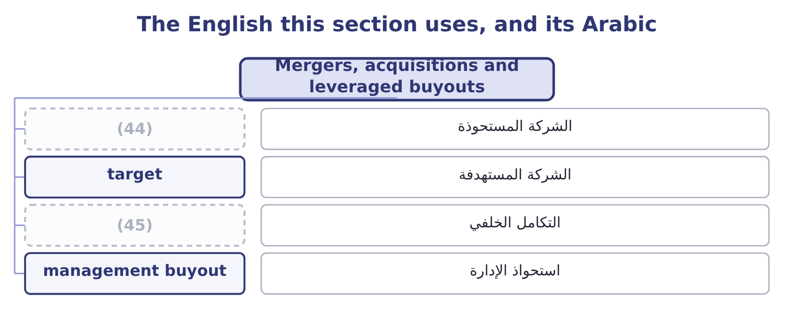
word list
backward integration · acquirer · goodwill

The English this sheet uses, and its Arabic
English (exam term) | Arabic
acquirer | الشركة المستحوذة
target | الشركة المستهدفة
backward integration | التكامل الخلفي
management buyout | استحواذ الإدارة

Answer key · 18.1 Mergers, acquisitions and leveraged buyouts

1 Synergies, and what they are worth | 24 existing
2 Divestitures and restructuring | 25 features
3 Evaluating the deal and recommending | 26 deliberately
4 acquisition | 27 proportion
5 survives | 28 predictable
6 classifies | 29 conditions
7 relationship | 30 Cyclical
8 production | 31 research-heavy
9 producers | 32 Saleable
10 economies | 33 repayment
11 elimination | 34 argument
12 stages | 35 differently
13 backward | 36 comfortable
14 material | 37 mirror
15 acquirer | 38 investment
16 earnings | 39 expenditure
17 arguments | 40 Scale, overhead, market power
18 holding | 41 Unfamiliar business; loss of flexibility
19 returned | 42 Diversification; use of surplus cash
20 postaudit | 43 Debt discipline; return on thin equity
21 usually | 44 acquirer
22 managers | 45 backward integration
23 target's

the summaries in full
Summary 1 A merger combines two companies into one; an acquisition is one company buying control of another, whether or not the target survives as a legal entity. The exam uses the terms loosely and classifies deals by the economic relationship between the parties. A horizontal combination joins competitors in the same industry and the same stage of production — two tahini producers. The usual case is economies of scale, the elimination of duplicated overhead and increased market power, and the usual obstacle is competition law. A vertical combination joins a company and its supplier or its customer, at different stages of the same chain. Orontes buying Ghab Mills is vertical and backward, moving towards the raw material; buying a chain of grocers would be vertical and forward. The usual case is security of supply, the removal of the supplier's margin and better coordination; the usual objection is that the acquirer takes on a business it does not know how to run, and loses the discipline of being able to switch suppliers.
Summary 2 A conglomerate combination joins unrelated businesses. The case made for it is diversification of earnings and the use of surplus cash, and both arguments are weak: as Book 2's, shareholders can diversify far more cheaply by holding both shares than a company can by buying one business with another, and surplus cash can be returned to them. Conglomerate deals are the ones most often found, on postaudit, to have destroyed value. A leveraged buyout is a different animal: the purchase of a company, usually by a private equity firm or by its own managers, financed largely by debt secured on the target's own assets and repaid out of its own cash flow. Where the buyers are the existing management it is a management buyout. Four features define it and the exam asks for them. The capital structure is deliberately extreme — debt of seventy per cent or more of the purchase price — which, as Book 2's, magnifies the return on the small slice of equity and magnifies the risk in the same proportion.
Summary 3 The target must have steady, predictable cash flow, because the interest has to be paid every quarter whatever the trading conditions. Cyclical businesses and research-heavy businesses make poor targets. Saleable assets help, both as security for the lenders and as a source of repayment: the sale of a division often funds part of the debt. And the discipline of debt is part of the argument. A management team that must generate cash to survive behaves differently from one sitting on a comfortable balance sheet, which is the free cash flow problem of Book 2's. The risks are the mirror image. A leveraged company has no capacity to absorb a bad year; interest crowds out investment, so the business can be starved of the capital expenditure it needs; and the pressure to show cash quickly can cut exactly the long-lived spending.

18.2 Synergies, and what they are worth
Chapter 18 · section 18.2

Fill every gap. Each word list holds one word more than there are gaps.
Summary 1 gaps 1–12
Synergy is the value the (1) creates that neither company could create alone — the reason the combined business can be worth more than the sum of its parts, and therefore the only honest (2) for paying more than a target's (3) value. The exam (4) the possible synergies (5) by type. Cross-selling to each other's (6) ; access to the other's (7) or export licences; a (8) brand; pricing power from a larger share; filling gaps in a product range. Removing duplicated head office, finance, IT and sales functions; closing one of two plants and running the other fuller, which is the operating leverage; (9) scale on inputs; (10) the supplier's margin in a vertical deal; moving (11) to the lower-cost site. Selling surplus property or duplicated equipment; releasing working capital where the two (12) can share inventory, which is Book 1's.
word list
standalone · purchasing · eliminating · combination · expects · stronger · vertical · justification · distribution · customers · businesses · identified · production

Summary 2 gaps 13–24
A larger, more (13) company may borrow more cheaply or more deeply; a (14) acquirer can use a target's tax losses where the law allows; and a company with cash can fund a target's investment programme that the target could not finance alone. (15) a weak management team with a better one, which is real and is also the hardest to claim credibly, since it requires the acquirer to be (16) better at running the business. Three (17) separate a real synergy from a hopeful one, and the (18) test them. Cost synergies are far more (19) than revenue synergies. A closed office is a (20) saving with a date on it; a cross-selling forecast is a hope with a (21) attached. Every synergy has a cost. (22) payments, system (23) , rebranding, retraining and the management time consumed are real and usually immediate, while the benefits arrive slowly. They belong in the (24) as a cash outflow at the start. And a synergy must be exclusive to the deal.
word list
reliable · spreadsheet · disciplines · measurable · Redundancy · examiners · diversified · integration · Replacing · profitable · stronger · valuation · demonstrably

Summary 3 gaps 25–26
A saving the (25) could have made (26) is not a reason to pay for the target.
word list
anyway · reliable · acquirer

The synergy that justifies any price

Summary 4 gaps 27–32
Because synergy is a forecast and the (27) is a certainty, the (28) of a deal can always be made to work by raising the synergy (29) . The (30) to ask of every (31) figure is: who will be (32) for delivering it, by when, and how will we know? A synergy with no owner and no date is a number written to justify a price that was decided first.
word list
premium · therefore · claimed · estimate · accountable · arithmetic · question

The English this section uses, and its Arabic
Each term sits against what it means.
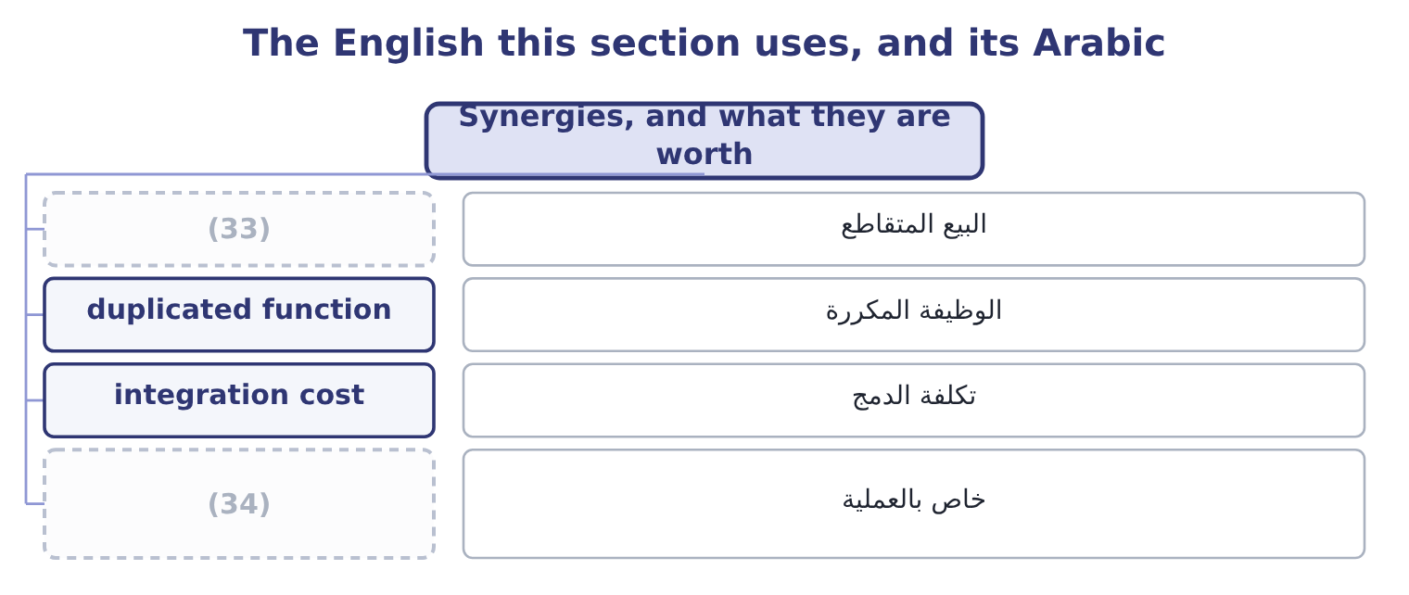
word list
exclusive to the deal · cross-selling · staggered board

The English this sheet uses, and its Arabic
English (exam term) | Arabic
cross-selling | البيع المتقاطع
duplicated function | الوظيفة المكررة
integration cost | تكلفة الدمج
exclusive to the deal | خاص بالعملية

Answer key · 18.2 Synergies, and what they are worth

1 combination | 18 examiners
2 justification | 19 reliable
3 standalone | 20 measurable
4 expects | 21 spreadsheet
5 identified | 22 Redundancy
6 customers | 23 integration
7 distribution | 24 valuation
8 stronger | 25 acquirer
9 purchasing | 26 anyway
10 eliminating | 27 premium
11 production | 28 arithmetic
12 businesses | 29 estimate
13 diversified | 30 question
14 profitable | 31 claimed
15 Replacing | 32 accountable
16 demonstrably | 33 cross-selling
17 disciplines | 34 exclusive to the deal

the summaries in full
Summary 1 Synergy is the value the combination creates that neither company could create alone — the reason the combined business can be worth more than the sum of its parts, and therefore the only honest justification for paying more than a target's standalone value. The exam expects the possible synergies identified by type. Cross-selling to each other's customers; access to the other's distribution or export licences; a stronger brand; pricing power from a larger share; filling gaps in a product range. Removing duplicated head office, finance, IT and sales functions; closing one of two plants and running the other fuller, which is the operating leverage; purchasing scale on inputs; eliminating the supplier's margin in a vertical deal; moving production to the lower-cost site. Selling surplus property or duplicated equipment; releasing working capital where the two businesses can share inventory, which is Book 1's.
Summary 2 A larger, more diversified company may borrow more cheaply or more deeply; a profitable acquirer can use a target's tax losses where the law allows; and a company with cash can fund a target's investment programme that the target could not finance alone. Replacing a weak management team with a better one, which is real and is also the hardest to claim credibly, since it requires the acquirer to be demonstrably better at running the business. Three disciplines separate a real synergy from a hopeful one, and the examiners test them. Cost synergies are far more reliable than revenue synergies. A closed office is a measurable saving with a date on it; a cross-selling forecast is a hope with a spreadsheet attached. Every synergy has a cost. Redundancy payments, system integration, rebranding, retraining and the management time consumed are real and usually immediate, while the benefits arrive slowly. They belong in the valuation as a cash outflow at the start. And a synergy must be exclusive to the deal.
Summary 3 A saving the acquirer could have made anyway is not a reason to pay for the target.
Summary 4 Because synergy is a forecast and the premium is a certainty, the arithmetic of a deal can always be made to work by raising the synergy estimate. The question to ask of every claimed figure is: who will be accountable for delivering it, by when, and how will we know? A synergy with no owner and no date is a number written to justify a price that was decided first.

18.3 Defences against a takeover
Chapter 18 · section 18.3

Fill every gap. Each word list holds one word more than there are gaps.
Summary 1 gaps 1–12
Where an offer is (1) , a target's board has a set of devices available, some built into its (2) in advance and some deployed in response. The exam names them and expects each (3) in a sentence. A poison pill, (4) a shareholders' rights plan, gives existing shareholders other than the bidder the right to buy new shares cheaply once a bidder's holding passes a trigger — (5) ten or twenty per cent. (6) it floods the register with new shares and dilutes the bidder's stake, making the acquisition (7) expensive. It is the most (8) of the defences and, because the board can usually (9) it, it works mainly as a lever to force the bidder to negotiate. A staggered board, also called a (10) board, divides the directors into classes with only one class elected each year, so a bidder who buys control of the shares cannot replace the board for two or three annual (11) . It is a delay (12) than a block, and delay is often enough.
word list
powerful · redeem · meetings · classified · rather · requires · formally · described · constitution · typically · unwelcome · prohibitively · Exercising

Summary 2 gaps 13–24
A golden parachute is a contract (13) senior executives to a large payment if they lose their jobs after a (14) of control. As a defence it is weak, because the cost is small (15) to a bid; its real (16) is that managers who know they are (17) can evaluate an offer on its merits instead of fighting to keep their jobs. Its (18) is the obvious one: shareholders pay executives for losing a (19) the executives may have (20) . A leveraged recapitalisation has the target borrow (21) and pay a large special (22) or buy back shares, so that it (23) a highly leveraged company and much less attractive to a bidder whose plan was to use that unused debt capacity. It delivers value to shareholders (24) and leaves the company carrying the risks Book 2's.
word list
caused · heavily · becomes · dividend · immediately · requires · justification · relative · change · protected · entitling · contest · objection

Summary 3 gaps 25–36
A fair price amendment (25) any bidder to pay all shareholders the same price, or a price approved by a (26) , which prevents the two-tier offer in which early (27) get a good price and the rest are (28) . A voting rights plan (29) the votes attaching to a large block — for example by (30) voting rights from shares above a threshold unless other shareholders approve — so that buying shares does not deliver control. A white knight is a friendly third party (31) to make a competing offer on terms the board (32) . The company is still sold; the board (33) the buyer. Three more appear in (34) . Greenmail is the (35) of a hostile bidder's stake at a premium, usually with a (36) agreement not to bid again, and it benefits the bidder at the expense of the remaining shareholders.
word list
removing · invited · chooses · standstill · squeezed · supermajority · requires · delivers · sellers · repurchase · prefers · restricts · questions

Summary 4 gaps 37–43
A crown jewel defence sells the asset the bidder most wants. A (37) defence has the target bid for the bidder. The test to apply to all of them is whose (38) they serve. A defence that (39) a higher price serves shareholders; a defence that (40) the board's (41) at the cost of an attractive offer does not, which is why poison pills and staggered (42) are the ones (43) investors most often vote to remove.
word list
preserves · requires · interest · institutional · forces · boards · Pac-Man · position

Takeover defences
Defence | Mechanism | Effect | Serves shareholders?
Poison pill | (44) | Dilutes the bidder | Yes if used to negotiate
Staggered board | Directors elected in classes | Delays board control | (45)
Golden parachute | Payment on loss of office | Frees managers to judge the offer | (46)
Leveraged recapitalisation | (47) | Uses up debt capacity | Yes, with added risk
Fair price amendment | Equal price for all holders | (48) | Yes
Voting rights plan | Votes limited above a threshold | (49) | Mainly the board
White knight | (50) | Company sold on better terms | Yes
Greenmail | Buying out the bidder at a premium | (51) | No

word list
Mainly delay · A friendly competing bidder · Blocks two-tier offers · Bid withdrawn · Heavy borrowing and a payout · Cheap new shares to others on a trigger · Mixed · threshold · Shares do not deliver control

The English this section uses, and its Arabic
Each term sits against what it means.
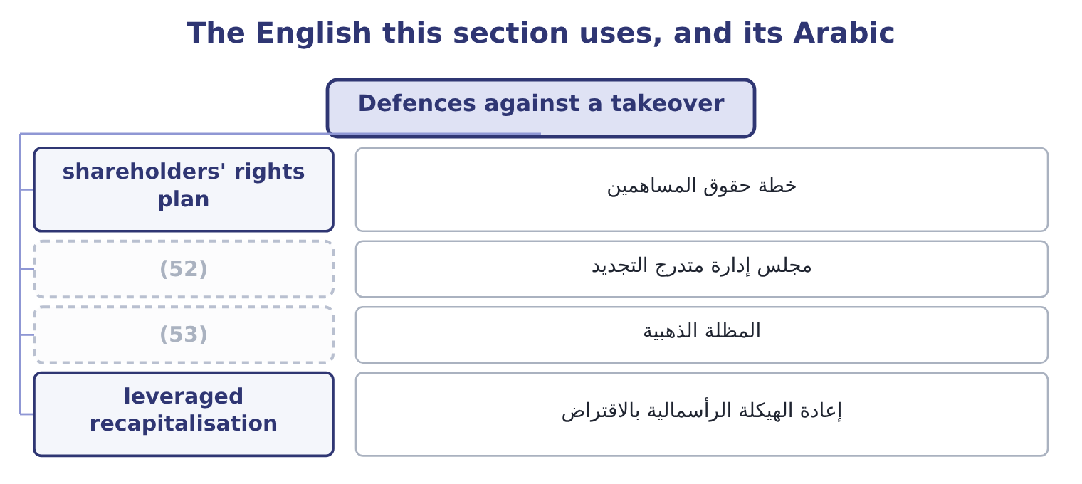
word list
staggered board · leveraged recapitalisation · golden parachute

The English this sheet uses, and its Arabic
English (exam term) | Arabic
shareholders' rights plan | خطة حقوق المساهمين
staggered board | مجلس إدارة متدرج التجديد
golden parachute | المظلة الذهبية
leveraged recapitalisation | إعادة الهيكلة الرأسمالية بالاقتراض

Answer key · 18.3 Defences against a takeover

1 unwelcome | 28 squeezed
2 constitution | 29 restricts
3 described | 30 removing
4 formally | 31 invited
5 typically | 32 prefers
6 Exercising | 33 chooses
7 prohibitively | 34 questions
8 powerful | 35 repurchase
9 redeem | 36 standstill
10 classified | 37 Pac-Man
11 meetings | 38 interest
12 rather | 39 forces
13 entitling | 40 preserves
14 change | 41 position
15 relative | 42 boards
16 justification | 43 institutional
17 protected | 44 Cheap new shares to others on a trigger
18 objection | 45 Mainly delay
19 contest | 46 Mixed
20 caused | 47 Heavy borrowing and a payout
21 heavily | 48 Blocks two-tier offers
22 dividend | 49 Shares do not deliver control
23 becomes | 50 A friendly competing bidder
24 immediately | 51 Bid withdrawn
25 requires | 52 staggered board
26 supermajority | 53 golden parachute
27 sellers

the summaries in full
Summary 1 Where an offer is unwelcome, a target's board has a set of devices available, some built into its constitution in advance and some deployed in response. The exam names them and expects each described in a sentence. A poison pill, formally a shareholders' rights plan, gives existing shareholders other than the bidder the right to buy new shares cheaply once a bidder's holding passes a trigger — typically ten or twenty per cent. Exercising it floods the register with new shares and dilutes the bidder's stake, making the acquisition prohibitively expensive. It is the most powerful of the defences and, because the board can usually redeem it, it works mainly as a lever to force the bidder to negotiate. A staggered board, also called a classified board, divides the directors into classes with only one class elected each year, so a bidder who buys control of the shares cannot replace the board for two or three annual meetings. It is a delay rather than a block, and delay is often enough.
Summary 2 A golden parachute is a contract entitling senior executives to a large payment if they lose their jobs after a change of control. As a defence it is weak, because the cost is small relative to a bid; its real justification is that managers who know they are protected can evaluate an offer on its merits instead of fighting to keep their jobs. Its objection is the obvious one: shareholders pay executives for losing a contest the executives may have caused. A leveraged recapitalisation has the target borrow heavily and pay a large special dividend or buy back shares, so that it becomes a highly leveraged company and much less attractive to a bidder whose plan was to use that unused debt capacity. It delivers value to shareholders immediately and leaves the company carrying the risks Book 2's.
Summary 3 A fair price amendment requires any bidder to pay all shareholders the same price, or a price approved by a supermajority, which prevents the two-tier offer in which early sellers get a good price and the rest are squeezed. A voting rights plan restricts the votes attaching to a large block — for example by removing voting rights from shares above a threshold unless other shareholders approve — so that buying shares does not deliver control. A white knight is a friendly third party invited to make a competing offer on terms the board prefers. The company is still sold; the board chooses the buyer. Three more appear in questions. Greenmail is the repurchase of a hostile bidder's stake at a premium, usually with a standstill agreement not to bid again, and it benefits the bidder at the expense of the remaining shareholders.
Summary 4 A crown jewel defence sells the asset the bidder most wants. A Pac-Man defence has the target bid for the bidder. The test to apply to all of them is whose interest they serve. A defence that forces a higher price serves shareholders; a defence that preserves the board's position at the cost of an attractive offer does not, which is why poison pills and staggered boards are the ones institutional investors most often vote to remove.

18.4 Divestitures and restructuring
Chapter 18 · section 18.4

Fill every gap. Each word list holds one word more than there are gaps.
Summary 1 gaps 1–12
Companies are taken apart as often as they are put together, and for the same reason: (1) the parts are worth more separately than together. The exam names four forms and expects them (2) . A spin-off (3) the shares of a subsidiary to the parent's own shareholders, pro rata. No cash (4) hands and no new (5) is involved; the shareholders simply end up (6) two shares instead of one. It is used where the subsidiary would be valued better on its own, where its management needs its own (7) for incentives and (8) , or where a conglomerate discount is being removed. A (9) divides the whole company into two or more (10) companies and the parent ceases to exist. It is the extreme case of a spin-off and arises from a (11) decision that the (12) have nothing to offer each other, or from a regulator requiring separation.
word list
businesses · interests · investor · strategic · holding · split-up · distributes · currency · distinguished · changes · because · independent · acquisitions

Summary 2 gaps 13–24
An equity (13) sells a minority stake in a subsidiary to (14) investors, usually by a public (15) . Unlike a spin-off it (16) cash, and unlike a sale it keeps (17) . It also (18) a market price for the unit, which is useful as a step (19) a later full separation and as a (20) of what the unit is worth. A tracking stock is a class of the parent's own shares whose (21) and value are tied to the (22) of one division, while the division (23) legally inside the parent. It gives investors exposure to the unit's (24) without a separation, which is its appeal and its weakness: the assets are not ring-fenced, the governance is ambiguous — the board owes duties to two sets of holders whose interests conflict over shared costs — and tracking stocks have largely fallen out of use for exactly that reason.
word list
dividend · performance · outside · carve-out · towards · results · remains · measure · offering · creates · advantages · control · raises

Summary 3 gaps 25–36
Alongside these sit the plain (25) , a sale of a unit for cash to a trade buyer or a financial one, and (26) , where the assets are worth more sold separately than the business is worth running. The (27) also asks you to judge whether a restructuring would (28) shareholders, which is a question with a method. Value each unit separately on its own cash flows and its own cost of capital — a (29) unit and a (30) one do not share a discount rate. (31) the total with the (32) market value. A sum of parts well above the market value is the conglomerate discount, and it is (33) that separation would be (34) . Identify what the group (35) provides to the unit: shared customers, shared (36) , a cheaper cost of capital, scarce management. Those are the synergies of section 18.2 in reverse, and they are what separation would destroy.
word list
outcome · technology · cyclical · Compare · divestiture · liquidation · benefit · rewarded · through · company's · evidence · stable · genuinely

Summary 4 gaps 37–46
Price the costs of separation: duplicated (37) functions, lost purchasing scale, (38) and listing costs, tax on any gain, and the covenants of Book 2's, which may have to be (39) . And (40) only where the gain (41) all four steps. Value the segment on its own flows. The segment (42) free cash flow of 450,000 a year growing at 2 per cent, and as a retail business carries more risk than the group, so it is (43) at 9.5 per cent. The (44) is 0.095 − 0.02 = 0.075, (45) a value of 450,000 ÷ 0.075 = 6,000,000. What is on the table. A regional (46) has offered $7,200,000 in cash for the segment. What separation would destroy.
word list
transaction · survives · discounted · renegotiated · head-office · distributor · denominator · spin-off · generates · recommend · giving

Summary 5 gaps 47–53
The segment buys its jars through the group's purchasing (47) and shares the Latakia (48) . If those (49) are worth, say, 200,000 of present value, the gain falls to about 1,000,000 and the (50) still holds. The right question is not whether the segment is (51) — it is — but whether it is worth more to (52) else, and here it is, by about a fifth. That is what a restructuring decision (53) comes down to, and it is.
word list
contract · somebody · profitable · Alongside · warehouse · recommendation · advantages · always

The English this section uses, and its Arabic
Each term sits against what it means.
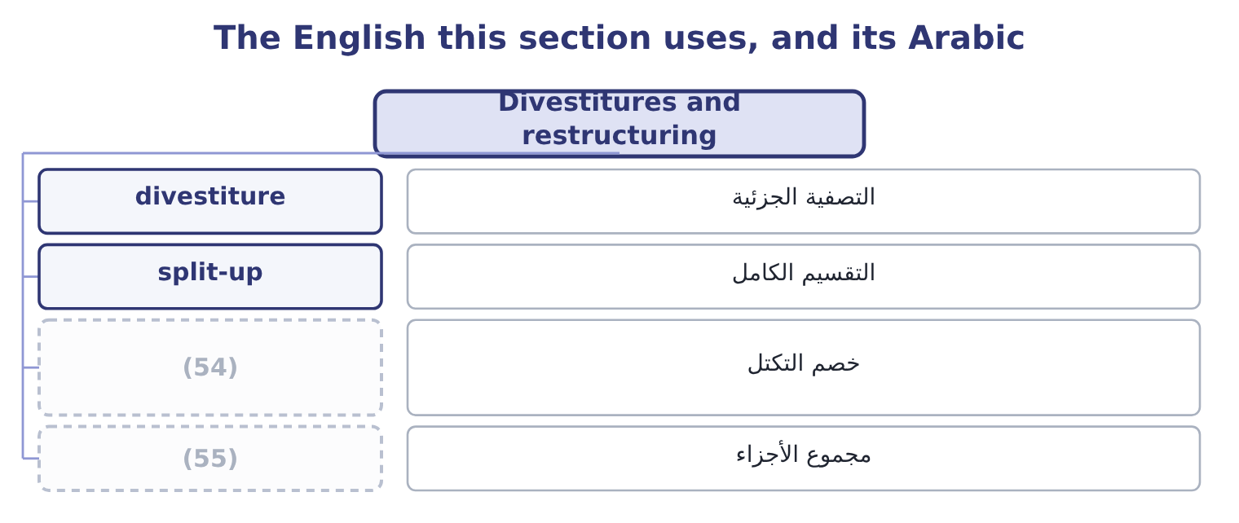
word list
growing perpetuity · sum of the parts · conglomerate discount

The English this sheet uses, and its Arabic
English (exam term) | Arabic
divestiture | التصفية الجزئية
split-up | التقسيم الكامل
conglomerate discount | خصم التكتل
sum of the parts | مجموع الأجزاء

Answer key · 18.4 Divestitures and restructuring

1 because | 29 cyclical
2 distinguished | 30 stable
3 distributes | 31 Compare
4 changes | 32 company's
5 investor | 33 evidence
6 holding | 34 rewarded
7 currency | 35 genuinely
8 acquisitions | 36 technology
9 split-up | 37 head-office
10 independent | 38 transaction
11 strategic | 39 renegotiated
12 businesses | 40 recommend
13 carve-out | 41 survives
14 outside | 42 generates
15 offering | 43 discounted
16 raises | 44 denominator
17 control | 45 giving
18 creates | 46 distributor
19 towards | 47 contract
20 measure | 48 warehouse
21 dividend | 49 advantages
22 results | 50 recommendation
23 remains | 51 profitable
24 performance | 52 somebody
25 divestiture | 53 always
26 liquidation | 54 conglomerate discount
27 outcome | 55 sum of the parts
28 benefit

the summaries in full
Summary 1 Companies are taken apart as often as they are put together, and for the same reason: because the parts are worth more separately than together. The exam names four forms and expects them distinguished. A spin-off distributes the shares of a subsidiary to the parent's own shareholders, pro rata. No cash changes hands and no new investor is involved; the shareholders simply end up holding two shares instead of one. It is used where the subsidiary would be valued better on its own, where its management needs its own currency for incentives and acquisitions, or where a conglomerate discount is being removed. A split-up divides the whole company into two or more independent companies and the parent ceases to exist. It is the extreme case of a spin-off and arises from a strategic decision that the businesses have nothing to offer each other, or from a regulator requiring separation.
Summary 2 An equity carve-out sells a minority stake in a subsidiary to outside investors, usually by a public offering. Unlike a spin-off it raises cash, and unlike a sale it keeps control. It also creates a market price for the unit, which is useful as a step towards a later full separation and as a measure of what the unit is worth. A tracking stock is a class of the parent's own shares whose dividend and value are tied to the results of one division, while the division remains legally inside the parent. It gives investors exposure to the unit's performance without a separation, which is its appeal and its weakness: the assets are not ring-fenced, the governance is ambiguous — the board owes duties to two sets of holders whose interests conflict over shared costs — and tracking stocks have largely fallen out of use for exactly that reason.
Summary 3 Alongside these sit the plain divestiture, a sale of a unit for cash to a trade buyer or a financial one, and liquidation, where the assets are worth more sold separately than the business is worth running. The outcome also asks you to judge whether a restructuring would benefit shareholders, which is a question with a method. Value each unit separately on its own cash flows and its own cost of capital — a cyclical unit and a stable one do not share a discount rate. Compare the total with the company's market value. A sum of parts well above the market value is the conglomerate discount, and it is evidence that separation would be rewarded. Identify what the group genuinely provides to the unit: shared customers, shared technology, a cheaper cost of capital, scarce management. Those are the synergies of section 18.2 in reverse, and they are what separation would destroy.
Summary 4 Price the costs of separation: duplicated head-office functions, lost purchasing scale, transaction and listing costs, tax on any gain, and the covenants of Book 2's, which may have to be renegotiated. And recommend only where the gain survives all four steps. Value the segment on its own flows. The segment generates free cash flow of 450,000 a year growing at 2 per cent, and as a retail business carries more risk than the group, so it is discounted at 9.5 per cent. The denominator is 0.095 − 0.02 = 0.075, giving a value of 450,000 ÷ 0.075 = 6,000,000. What is on the table. A regional distributor has offered $7,200,000 in cash for the segment. What separation would destroy.
Summary 5 The segment buys its jars through the group's purchasing contract and shares the Latakia warehouse. If those advantages are worth, say, 200,000 of present value, the gain falls to about 1,000,000 and the recommendation still holds. The right question is not whether the segment is profitable — it is — but whether it is worth more to somebody else, and here it is, by about a fifth. That is what a restructuring decision always comes down to, and it is.

18.5 Valuing a business by discounted cash flow
Chapter 18 · section 18.5

Fill every gap. Each word list holds one word more than there are gaps.
Summary 1 gaps 1–12
The method is, with four (1) that the exam (2) on. The cash flow is free cash flow to the firm, not a project's (3) flow: operating profit after tax, plus depreciation and other (4) charges, less capital expenditure, less the increase in net working capital. It is the cash the business (5) for all providers of capital, before any (6) to them. The horizon is (7) , so the forecast is split in two: an (8) forecast for five or ten years, where each year is modelled, and a terminal value for (9) after it. The terminal value is usually the larger half of the answer, which is why its two (10) — the long-run growth rate and the rate — deserve more (11) than the detail of year four. The rate is the target's weighted average cost of capital, not the acquirer's, (12) what is being discounted is the target's risk.
word list
standalone · attention · because · differences · incremental · generates · assumptions · non-cash · payment · infinite · explicit · concentrates · everything

Summary 2 gaps 13–21
Using (13) 9.04 per cent to value a mill with different operating risk and different (14) would be the error. And the result is an (15) value — the value of the whole business. (16) the target's debt gives the value of its equity, which is what is (17) being bought. The (18) formula does the terminal value: a cash flow of C in the next year, growing at g for ever, discounted at r, is worth C divided by the (19) r minus g. It (20) g to be below r, and a long-run growth rate above the growth of the economy is not (21) for any company.
word list
gearing · quantity · everything · Subtracting · growing-perpetuity · Orontes's · credible · actually · requires · enterprise

Worked example: what is Ghab Mills worth?

Summary 3 gaps 22–30
Build next (22) free cash flow. The mill's sales are $9,000,000 and its operating profit $1,200,000, so after tax at 25 per cent that is 1,200,000 × 0.75 = 900,000. (23) back depreciation of $300,000 gives 900,000 + 300,000 = 1,200,000 of operating cash. Capital expenditure of 464,000 leaves 1,200,000 − 464,000 = 736,000, and an increase in working capital of 50,000 leaves 736,000 − 50,000 = 686,000 of free cash flow. (24) the rate and the growth. The mill is a stable, (25) business, and its own weighted average cost of capital is 10 per cent; long-run growth of 3 per cent is (26) for a business whose volumes track the (27) crop. The (28) is 0.10 − 0.03 = 0.07. The mill (29) $2,000,000 of debt, so its equity is worth 9,800,000 − 2,000,000 = 7,800,000, which (30) 1,200,000 shares is 7,800,000 ÷ 1,200,000 = 6.50 a share.
word list
Adding · regional · defensible · asset-heavy · denominator · divided · Choose · carries · year's · across

Summary 4 gaps 31–42
The mill's shares trade at $6.50. The valuation has (31) the market price (32) , which is what a standalone valuation should do for a fairly priced business, and it is the right (33) point: the premium Orontes can (34) is not based on the mill being (35) but on what Orontes can do with it that nobody else can. Two (36) the exam uses. The same method applied to part of a company, as section 18.4 did with the (37) segment: its own flows, its own rate, and a share of corporate costs that would genuinely disappear — not an (38) , which is. The combined business is worth the acquirer's standalone value, plus the target's standalone value, plus the present value of the (39) net of the costs of (40) them. The acquirer's (41) gain that net (42) less whatever premium is paid away, which is the arithmetic of section 18.6.
word list
reproduced · allocation · exactly · retail-pack · synergy · achieving · mispriced · refinements · denominator · starting · justify · shareholders · synergies

The English this section uses, and its Arabic
Each term sits against what it means.
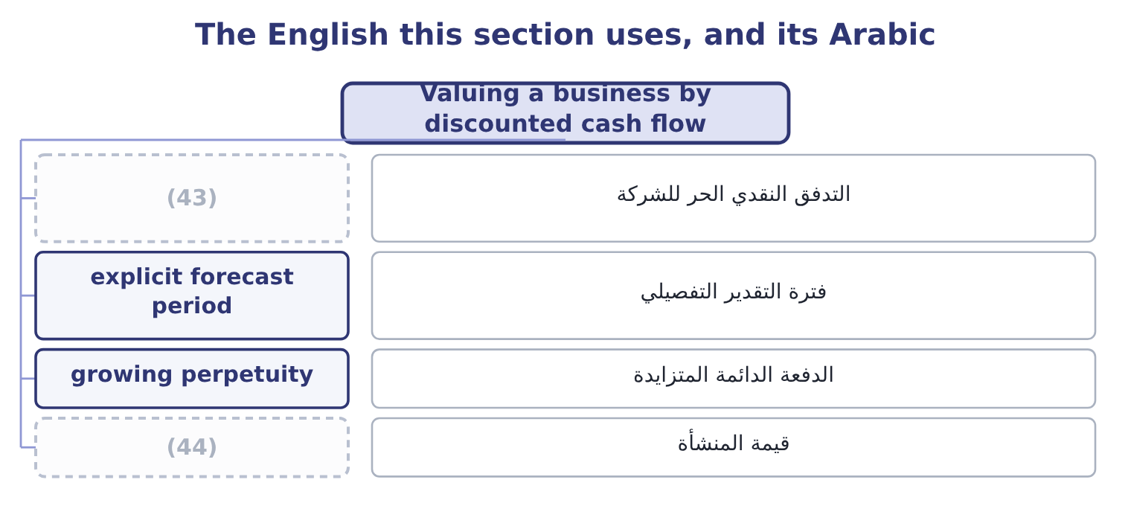
word list
horizontal merger · enterprise value · free cash flow to the firm

The English this sheet uses, and its Arabic
English (exam term) | Arabic
free cash flow to the firm | التدفق النقدي الحر للشركة
explicit forecast period | فترة التقدير التفصيلي
growing perpetuity | الدفعة الدائمة المتزايدة
enterprise value | قيمة المنشأة

Answer key · 18.5 Valuing a business by discounted cash flow

1 differences | 23 Adding
2 concentrates | 24 Choose
3 incremental | 25 asset-heavy
4 non-cash | 26 defensible
5 generates | 27 regional
6 payment | 28 denominator
7 infinite | 29 carries
8 explicit | 30 across
9 everything | 31 reproduced
10 assumptions | 32 exactly
11 attention | 33 starting
12 because | 34 justify
13 Orontes's | 35 mispriced
14 gearing | 36 refinements
15 enterprise | 37 retail-pack
16 Subtracting | 38 allocation
17 actually | 39 synergies
18 growing-perpetuity | 40 achieving
19 quantity | 41 shareholders
20 requires | 42 synergy
21 credible | 43 free cash flow to the firm
22 year's | 44 enterprise value

the summaries in full
Summary 1 The method is, with four differences that the exam concentrates on. The cash flow is free cash flow to the firm, not a project's incremental flow: operating profit after tax, plus depreciation and other non-cash charges, less capital expenditure, less the increase in net working capital. It is the cash the business generates for all providers of capital, before any payment to them. The horizon is infinite, so the forecast is split in two: an explicit forecast for five or ten years, where each year is modelled, and a terminal value for everything after it. The terminal value is usually the larger half of the answer, which is why its two assumptions — the long-run growth rate and the rate — deserve more attention than the detail of year four. The rate is the target's weighted average cost of capital, not the acquirer's, because what is being discounted is the target's risk.
Summary 2 Using Orontes's 9.04 per cent to value a mill with different operating risk and different gearing would be the error. And the result is an enterprise value — the value of the whole business. Subtracting the target's debt gives the value of its equity, which is what is actually being bought. The growing-perpetuity formula does the terminal value: a cash flow of C in the next year, growing at g for ever, discounted at r, is worth C divided by the quantity r minus g. It requires g to be below r, and a long-run growth rate above the growth of the economy is not credible for any company.
Summary 3 Build next year's free cash flow. The mill's sales are $9,000,000 and its operating profit $1,200,000, so after tax at 25 per cent that is 1,200,000 × 0.75 = 900,000. Adding back depreciation of $300,000 gives 900,000 + 300,000 = 1,200,000 of operating cash. Capital expenditure of 464,000 leaves 1,200,000 − 464,000 = 736,000, and an increase in working capital of 50,000 leaves 736,000 − 50,000 = 686,000 of free cash flow. Choose the rate and the growth. The mill is a stable, asset-heavy business, and its own weighted average cost of capital is 10 per cent; long-run growth of 3 per cent is defensible for a business whose volumes track the regional crop. The denominator is 0.10 − 0.03 = 0.07. The mill carries $2,000,000 of debt, so its equity is worth 9,800,000 − 2,000,000 = 7,800,000, which across 1,200,000 shares is 7,800,000 ÷ 1,200,000 = 6.50 a share.
Summary 4 The mill's shares trade at $6.50. The valuation has reproduced the market price exactly, which is what a standalone valuation should do for a fairly priced business, and it is the right starting point: the premium Orontes can justify is not based on the mill being mispriced but on what Orontes can do with it that nobody else can. Two refinements the exam uses. The same method applied to part of a company, as section 18.4 did with the retail-pack segment: its own flows, its own rate, and a share of corporate costs that would genuinely disappear — not an allocation, which is. The combined business is worth the acquirer's standalone value, plus the target's standalone value, plus the present value of the synergies net of the costs of achieving them. The acquirer's shareholders gain that net synergy less whatever premium is paid away, which is the arithmetic of section 18.6.

18.6 Evaluating the deal and recommending
Chapter 18 · section 18.6

Fill every gap. Each word list holds one word more than there are gaps.
Summary 1 gaps 1–12
The arithmetic of a recommendation is short. The maximum Orontes can pay for the mill's equity is its standalone value plus the net synergy; (1) above that (2) value from Orontes's shareholders to the mill's. The (3) the mill's (4) will take is its market value. The (5) happens between those two (6) , and the premium decides how the created value is split. Buying the mill (7) the trading margin and the duplicated (8) on the sixty per cent of its output Orontes already takes, worth 180,000 a year before tax, which after tax is 180,000 × 0.75 = 135,000. (9) as a growing (10) on the same terms as the mill's own flows, that is worth 135,000 ÷ 0.07 = 1,928,571. The cost of (11) them. Integration — systems, (12) , relabelling — will cost 400,000 before tax at the outset, which after tax is 400,000 × 0.75 = 300,000. So the net synergy is 1,928,571 − 300,000 = 1,628,571.
word list
getting · removes · numbers · minimum · administration · negotiation · shareholders · owners · anything · Treated · redundancies · perpetuity · transfers

Summary 2 gaps 13–17
The most Orontes can pay for the equity is 7,800,000 + 1,628,571 = 9,428,571, which is 9,428,571 ÷ 1,200,000 = 7.86 a share. At that price every penny of the created value has gone to the (13) . An offer of $7.25 a share. That is 1,200,000 × 7.25 = 8,700,000 in total, a premium of 8,700,000 − 7,800,000 = 900,000 over market value, or 900,000 ÷ 7,800,000 = 11.54 per cent. Orontes keeps 9,428,571 − 8,700,000 = 728,571 of value and gives away 900,000 ÷ 1,628,571 = 55.26 per cent of the synergy. (14) it from the other (15) . The (16) equity is worth Orontes's 74,925,000 plus the mill's 7,800,000, which is 74,925,000 + 7,800,000 = 82,725,000, plus the net synergy, (17) 82,725,000 + 1,628,571 = 84,353,571.
word list
language · seller · direction · giving · Confirm · combined

Summary 3 gaps 18–29
Paying 8,700,000 in cash (18) Orontes's shareholders with 84,353,571 − 8,700,000 = 75,653,571, a gain of 75,653,571 − 74,925,000 = 728,571 — the same figure. The two (19) must agree, and (20) that they do is the (21) way to find an arithmetic error in an exam. Note what step 4 shows: more than half the value created by the deal goes to the (22) shareholders at a premium of only (23) and a half per cent. That is the normal result in real (24) and the reason the research finds (25) ' shareholders gaining little on average while targets' shareholders gain a great deal. The premium is paid in (26) cash now; the synergy is a forecast (27) over years by people who have just been acquired. The qualitative (28) decide as often as the arithmetic does, and the (29) asks for them.
word list
acquirers · certain · quickest · eleven · considerations · leaves · outcome · acquisitions · routes · checking · standalone · delivered · target's

Summary 4 gaps 30–41
Can we run it? A tahini producer buying a mill is taking on a business with its own (30) , its own labour (31) and its own seasonal crop risk. A mill of forty people acquired by a company of four hundred will either be (32) or resented, and the (33) is managed rather than assumed. In a small supplier the value may walk out of the door: the mill's chief (34) and its buyer of sesame may be the business. Owning the supplier (35) risk that was previously (36) across several. If the mill's crop fails, Orontes now (37) the loss twice. Orontes can (38) switch suppliers if the mill's prices rise. (39) it cannot, and the (40) that kept the mill's prices honest disappears. (41) and its effects. How the deal is paid for changes the gearing of Book 2's. Regulatory and tax consequences, and the accounting: goodwill will arise, and Book 1's. A long-term supply contract, a minority stake, or a joint venture may deliver much of the synergy for a fraction of the price and the risk — and no recommendation is complete without saying why the full acquisition is better than those.
word list
practices · Afterwards · difference · discipline · currently · absorbed · concentrates · carries · engineer · Financing · technology · qualitative · diversified

The price range for Ghab Mills
Item | Amount | Per share
Standalone equity value (the floor) | 7,800,000 | 6.50
Net synergy | 1,628,571 | 1.36
(42) | 9,428,571 | 7.86
Offer at 7.25 | 8,700,000 | 7.25
(43) | 728,571 | 0.61

word list
Maximum justifiable price (the ceiling) · Value retained by Orontes · exclusive to the deal

The deal in six lines

Your turn: the acquisition (complete the blanks)
Item | Data | Answer
Kind of combination | (44) | Vertical, and backward: Orontes moves towards its raw material.
Enterprise value of the mill | (45) | 9,800,000: 686,000 ÷ 0.07 = 9,800,000.
Equity value | Debt 2,000,000 | 7,800,000: 9,800,000 − 2,000,000 = 7,800,000, or 6.50 a share.
Maximum justifiable offer | Net synergy 1,628,571 | 9,428,571: 7,800,000 + 1,628,571 = 9,428,571, or 7.86 a share.
Premium at 7.25 a share | (46) | 11.54 per cent: 900,000 ÷ 7,800,000 = 11.54 per cent.
Defence that dilutes a bidder's stake |  | (47)

word list
Market 6.50 · Free cash flow 686,000; rate 10%; growth 3% · Orontes buys its sesame supplier · The poison pill, or shareholders' rights plan. · enterprise value

"Synergy", "goodwill" and the vocabulary of deals

Summary 5 gaps 48–54
Deal (48) is unusually (49) in English and the (50) do not all travel. Poison pill, white knight, golden (51) and greenmail are (52) that have become technical terms, chevalier blanc — which means they are (53) but should still be explained the first time they appear in a report. Goodwill is the trap: in ordinary English it means benevolence, and in accounting it means the excess of the price paid over the fair value of the (54) net assets acquired.
word list
figures · parachute · benevolence · language · metaphors · identifiable · understood · figurative

The English this section uses, and its Arabic
Each term sits against what it means.
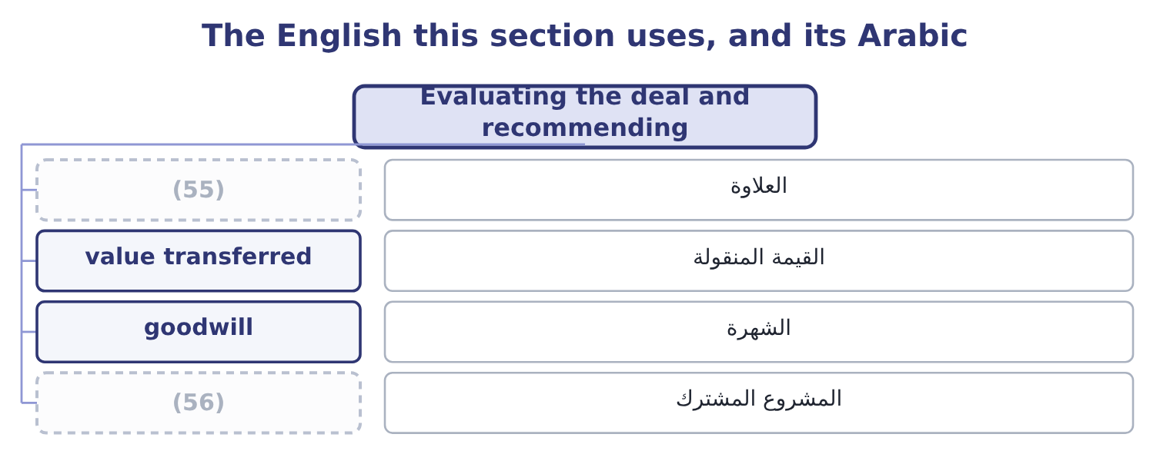
word list
joint venture · horizontal merger · premium

The English this sheet uses, and its Arabic
English (exam term) | Arabic
premium | العلاوة
value transferred | القيمة المنقولة
goodwill | الشهرة
joint venture | المشروع المشترك

Answer key · 18.6 Evaluating the deal and recommending

1 anything | 29 outcome
2 transfers | 30 technology
3 minimum | 31 practices
4 owners | 32 absorbed
5 negotiation | 33 difference
6 numbers | 34 engineer
7 removes | 35 concentrates
8 administration | 36 diversified
9 Treated | 37 carries
10 perpetuity | 38 currently
11 getting | 39 Afterwards
12 redundancies | 40 discipline
13 seller | 41 Financing
14 Confirm | 42 Maximum justifiable price (the ceiling)
15 direction | 43 Value retained by Orontes
16 combined | 44 Orontes buys its sesame supplier
17 giving | 45 Free cash flow 686,000; rate 10%; growth 3%
18 leaves | 46 Market 6.50
19 routes | 47 The poison pill, or shareholders' rights plan.
20 checking | 48 language
21 quickest | 49 figurative
22 target's | 50 figures
23 eleven | 51 parachute
24 acquisitions | 52 metaphors
25 acquirers | 53 understood
26 certain | 54 identifiable
27 delivered | 55 premium
28 considerations | 56 joint venture

the summaries in full
Summary 1 The arithmetic of a recommendation is short. The maximum Orontes can pay for the mill's equity is its standalone value plus the net synergy; anything above that transfers value from Orontes's shareholders to the mill's. The minimum the mill's owners will take is its market value. The negotiation happens between those two numbers, and the premium decides how the created value is split. Buying the mill removes the trading margin and the duplicated administration on the sixty per cent of its output Orontes already takes, worth 180,000 a year before tax, which after tax is 180,000 × 0.75 = 135,000. Treated as a growing perpetuity on the same terms as the mill's own flows, that is worth 135,000 ÷ 0.07 = 1,928,571. The cost of getting them. Integration — systems, redundancies, relabelling — will cost 400,000 before tax at the outset, which after tax is 400,000 × 0.75 = 300,000. So the net synergy is 1,928,571 − 300,000 = 1,628,571.
Summary 2 The most Orontes can pay for the equity is 7,800,000 + 1,628,571 = 9,428,571, which is 9,428,571 ÷ 1,200,000 = 7.86 a share. At that price every penny of the created value has gone to the seller. An offer of $7.25 a share. That is 1,200,000 × 7.25 = 8,700,000 in total, a premium of 8,700,000 − 7,800,000 = 900,000 over market value, or 900,000 ÷ 7,800,000 = 11.54 per cent. Orontes keeps 9,428,571 − 8,700,000 = 728,571 of value and gives away 900,000 ÷ 1,628,571 = 55.26 per cent of the synergy. Confirm it from the other direction. The combined equity is worth Orontes's 74,925,000 plus the mill's 7,800,000, which is 74,925,000 + 7,800,000 = 82,725,000, plus the net synergy, giving 82,725,000 + 1,628,571 = 84,353,571.
Summary 3 Paying 8,700,000 in cash leaves Orontes's shareholders with 84,353,571 − 8,700,000 = 75,653,571, a gain of 75,653,571 − 74,925,000 = 728,571 — the same figure. The two routes must agree, and checking that they do is the quickest way to find an arithmetic error in an exam. Note what step 4 shows: more than half the value created by the deal goes to the target's shareholders at a premium of only eleven and a half per cent. That is the normal result in real acquisitions and the reason the research finds acquirers' shareholders gaining little on average while targets' shareholders gain a great deal. The premium is paid in certain cash now; the synergy is a forecast delivered over years by people who have just been acquired. The qualitative considerations decide as often as the arithmetic does, and the outcome asks for them.
Summary 4 Can we run it? A tahini producer buying a mill is taking on a business with its own technology, its own labour practices and its own seasonal crop risk. A mill of forty people acquired by a company of four hundred will either be absorbed or resented, and the difference is managed rather than assumed. In a small supplier the value may walk out of the door: the mill's chief engineer and its buyer of sesame may be the business. Owning the supplier concentrates risk that was previously diversified across several. If the mill's crop fails, Orontes now carries the loss twice. Orontes can currently switch suppliers if the mill's prices rise. Afterwards it cannot, and the discipline that kept the mill's prices honest disappears. Financing and its effects. How the deal is paid for changes the gearing of Book 2's. Regulatory and tax consequences, and the accounting: goodwill will arise, and Book 1's. A long-term supply contract, a minority stake, or a joint venture may deliver much of the synergy for a fraction of the price and the risk — and no recommendation is complete without saying why the full acquisition is better than those.
Summary 5 Deal language is unusually figurative in English and the figures do not all travel. Poison pill, white knight, golden parachute and greenmail are metaphors that have become technical terms, chevalier blanc — which means they are understood but should still be explained the first time they appear in a report. Goodwill is the trap: in ordinary English it means benevolence, and in accounting it means the excess of the price paid over the fair value of the identifiable net assets acquired.

