1.1 Two kinds of cost
Chapter 1 · section 1.1

Fill every gap. Each word list holds one word more than there are gaps.
Chapter 1, section by section
Each stage leads to the next.
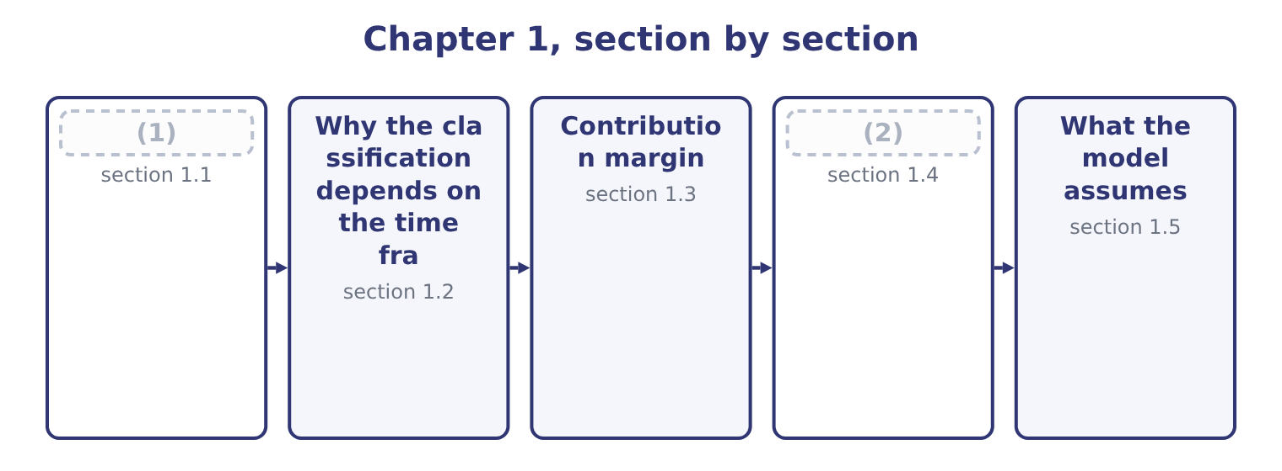
word list
target operating income · The breakeven point · Two kinds of cost

Summary 1 gaps 3–14
A variable cost (3) in total in (4) to the level of activity and stays constant per unit. Sesame, packaging, the (5) that runs the (6) , the piece rate paid to a packer: make twice as many jars and the total (7) , while each jar still carries the same amount. A fixed cost stays constant in total over a range of activity and (8) falls per unit as (9) rises. The factory lease, the (10) on the roasting line, the plant (11) salary, the audit fee. (12) twice as many jars does not make the lease larger, and it halves the lease (13) by each jar. Those two (14) contain the trap that costs most marks in Section C. In total, a variable cost moves and a fixed cost does not. Per unit, a variable cost does not move and a fixed cost does.
word list
volume · roaster · electricity · proportion · sentences · Making · depreciation · therefore · doubles · manager's · classifications · changes · carried

Summary 2 gaps 15–25
Everything else in the chapter (15) from keeping the two columns (16) . A mixed or (17) cost has both elements: a telephone contract with a standing charge and a per-call rate, a (18) agreement with a retainer and an hourly rate, a factory's power bill with a (19) charge and a consumption charge. For (20) purposes a mixed cost is split into its two parts, and Part 1 taught the methods — the (21) method and (22) . A step cost is fixed over a range and then jumps: one supervisor for every (23) packers, one (24) van for every so many (25) . Over a wide enough range every fixed cost is a step cost, which is why the next section matters.
word list
maintenance · delivery · high-low · decision · twenty · capacity · follows · semi-variable · regression · straight · routes · supervisor's

How each kind of cost behaves
Every item belongs to exactly one group.
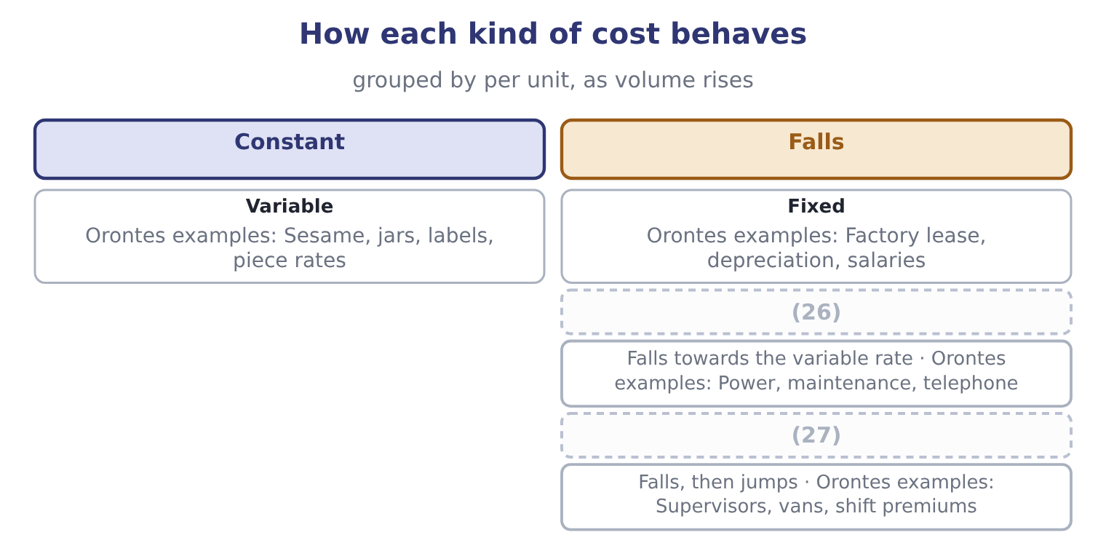
word list
Mixed · Constant · Step

In total or per unit

Summary 3 gaps 28–34
Read which column a (28) is asking about. A cost is not fixed because it is (29) , and not variable because it is large. The test is (30) it moves with (31) . Direct and indirect is a different (32) entirely. A factory (33) salary is indirect and fixed; sesame is direct and variable; a (34) of fifty cents a jar is direct and variable; factory rent is indirect and fixed. The two classifications cut across each other.
word list
unavoidable · keeping · question · royalty · supervisor's · classification · output · whether

The English this section uses, and its Arabic
Each term sits against what it means.
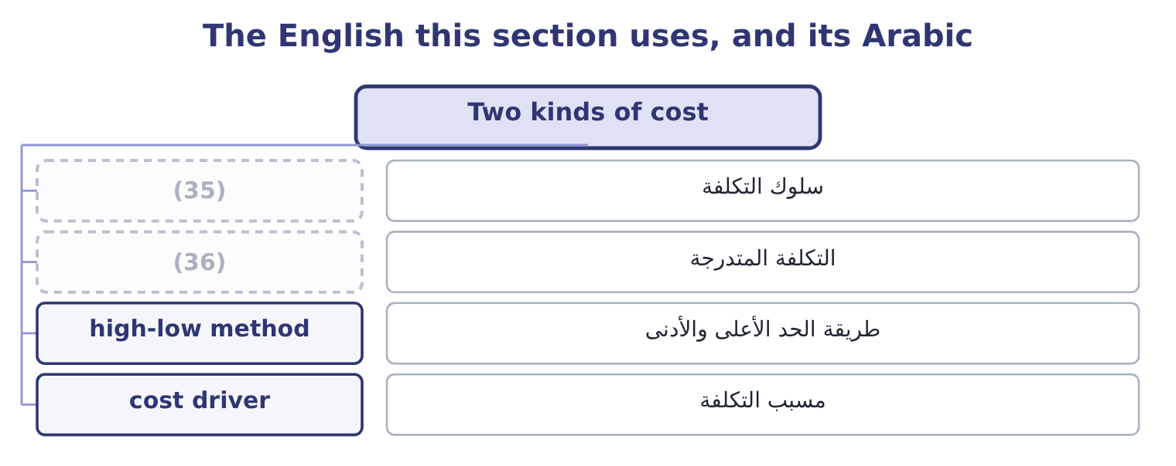
word list
step cost · cost behaviour · relevant range

The English this sheet uses, and its Arabic
English (exam term) | Arabic
cost behaviour | سلوك التكلفة
step cost | التكلفة المتدرجة
high-low method | طريقة الحد الأعلى والأدنى
cost driver | مسبب التكلفة

Answer key · 1.1 Two kinds of cost

1 Two kinds of cost | 19 capacity
2 The breakeven point | 20 decision
3 changes | 21 high-low
4 proportion | 22 regression
5 electricity | 23 twenty
6 roaster | 24 delivery
7 doubles | 25 routes
8 therefore | 26 Mixed
9 volume | 27 Step
10 depreciation | 28 question
11 manager's | 29 unavoidable
12 Making | 30 whether
13 carried | 31 output
14 sentences | 32 classification
15 follows | 33 supervisor's
16 straight | 34 royalty
17 semi-variable | 35 cost behaviour
18 maintenance | 36 step cost

the summaries in full
Summary 1 A variable cost changes in total in proportion to the level of activity and stays constant per unit. Sesame, packaging, the electricity that runs the roaster, the piece rate paid to a packer: make twice as many jars and the total doubles, while each jar still carries the same amount. A fixed cost stays constant in total over a range of activity and therefore falls per unit as volume rises. The factory lease, the depreciation on the roasting line, the plant manager's salary, the audit fee. Making twice as many jars does not make the lease larger, and it halves the lease carried by each jar. Those two sentences contain the trap that costs most marks in Section C. In total, a variable cost moves and a fixed cost does not. Per unit, a variable cost does not move and a fixed cost does.
Summary 2 Everything else in the chapter follows from keeping the two columns straight. A mixed or semi-variable cost has both elements: a telephone contract with a standing charge and a per-call rate, a maintenance agreement with a retainer and an hourly rate, a factory's power bill with a capacity charge and a consumption charge. For decision purposes a mixed cost is split into its two parts, and Part 1 taught the methods — the high-low method and regression. A step cost is fixed over a range and then jumps: one supervisor for every twenty packers, one delivery van for every so many routes. Over a wide enough range every fixed cost is a step cost, which is why the next section matters.
Summary 3 Read which column a question is asking about. A cost is not fixed because it is unavoidable, and not variable because it is large. The test is whether it moves with output. Direct and indirect is a different classification entirely. A factory supervisor's salary is indirect and fixed; sesame is direct and variable; a royalty of fifty cents a jar is direct and variable; factory rent is indirect and fixed. The two classifications cut across each other.

1.2 Why the classification depends on the time frame
Chapter 1 · section 1.2

Fill every gap. Each word list holds one word more than there are gaps.
Summary 1 gaps 1–12
No cost is fixed for ever and almost none is fixed (1) . The classification (2) a period and a range, and the exam tests whether a (3) knows it. Over a very short period almost everything is fixed. (4) output cannot change the lease, the salaries, the (5) , or the sesame already bought and in the silo. The only (6) variable costs of tomorrow are the ones not yet (7) . Over a long enough period almost everything is variable. Given three years, Orontes can leave the factory, sell the (8) line, change the size of its workforce and (9) every contract. There are no fixed costs in a long enough run, which is why the (10) is never absolute. In (11) lies the period the (12) concerns, and that is the period the classification must describe.
word list
Tomorrow's · insurance · candidate · decision · opening · committed · between · instantly · distinction · describes · genuinely · roasting · renegotiate

Summary 2 gaps 13–21
A question about (13) an order next month treats the plant as fixed; a question about (14) a second plant does not. The relevant range (15) the same idea for (16) rather than time. Fixed costs are fixed and variable costs are (17) only within the range of activity the company is actually (18) . Below it, a company closes (19) ; above it, it hires (20) , adds a shift, leases a second warehouse, and pays overtime rates that are not the normal variable rate. A cost-volume-profit (21) is valid inside the relevant range and nowhere else, and saying so is worth a mark.
word list
accepting · departments · actually · carries · volume · operating · analysis · supervisors · proportionate · opening

One cost, three time frames
Every item belongs to exactly one group.
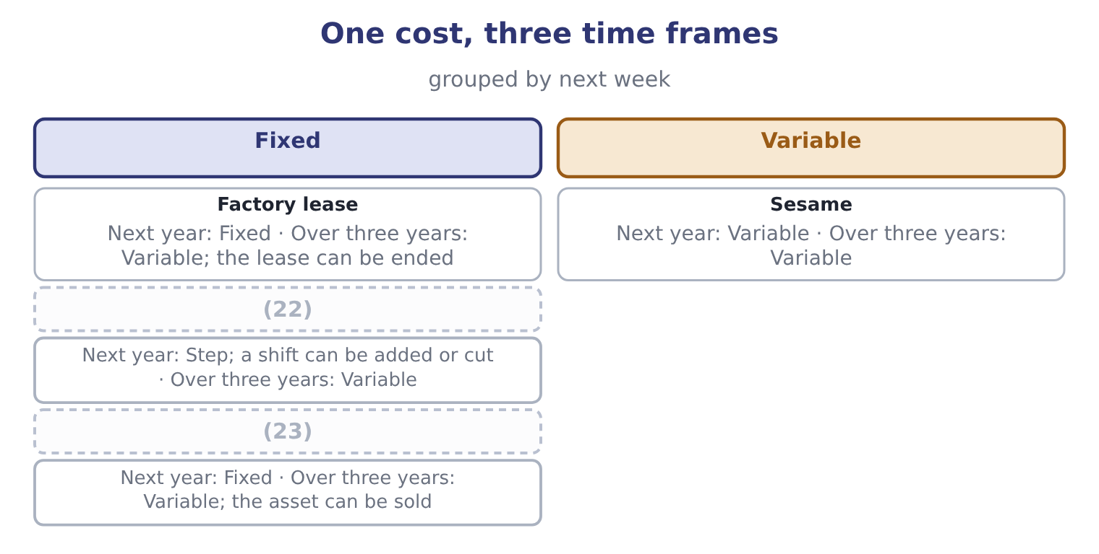
word list
step cost · Supervisors' salaries · Depreciation on the roaster

The English this section uses, and its Arabic
Each term sits against what it means.
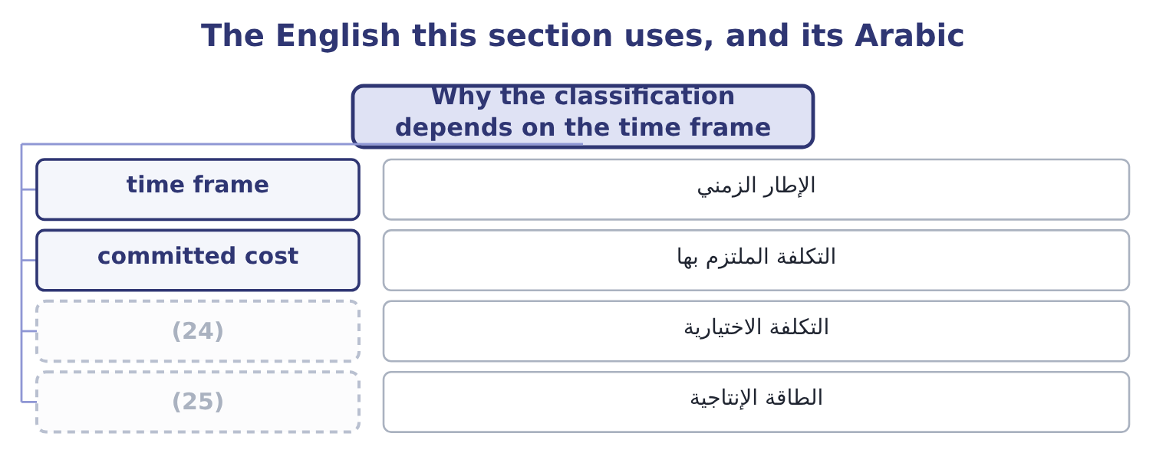
word list
capacity · time frame · discretionary cost

The English this sheet uses, and its Arabic
English (exam term) | Arabic
time frame | الإطار الزمني
committed cost | التكلفة الملتزم بها
discretionary cost | التكلفة الاختيارية
capacity | الطاقة الإنتاجية

Answer key · 1.2 Why the classification depends on the time frame

1 instantly | 14 opening
2 describes | 15 carries
3 candidate | 16 volume
4 Tomorrow's | 17 proportionate
5 insurance | 18 operating
6 genuinely | 19 departments
7 committed | 20 supervisors
8 roasting | 21 analysis
9 renegotiate | 22 Supervisors' salaries
10 distinction | 23 Depreciation on the roaster
11 between | 24 discretionary cost
12 decision | 25 capacity
13 accepting

the summaries in full
Summary 1 No cost is fixed for ever and almost none is fixed instantly. The classification describes a period and a range, and the exam tests whether a candidate knows it. Over a very short period almost everything is fixed. Tomorrow's output cannot change the lease, the salaries, the insurance, or the sesame already bought and in the silo. The only genuinely variable costs of tomorrow are the ones not yet committed. Over a long enough period almost everything is variable. Given three years, Orontes can leave the factory, sell the roasting line, change the size of its workforce and renegotiate every contract. There are no fixed costs in a long enough run, which is why the distinction is never absolute. In between lies the period the decision concerns, and that is the period the classification must describe.
Summary 2 A question about accepting an order next month treats the plant as fixed; a question about opening a second plant does not. The relevant range carries the same idea for volume rather than time. Fixed costs are fixed and variable costs are proportionate only within the range of activity the company is actually operating. Below it, a company closes departments; above it, it hires supervisors, adds a shift, leases a second warehouse, and pays overtime rates that are not the normal variable rate. A cost-volume-profit analysis is valid inside the relevant range and nowhere else, and saying so is worth a mark.

1.3 Contribution margin
Chapter 1 · section 1.3

Fill every gap. Each word list holds one word more than there are gaps.
Summary 1 gaps 1–10
Contribution margin is what is left of a selling price after the variable costs of (1) and selling that unit. It is (2) contribution (3) it is what each unit (4) , first to covering the fixed costs and then, once those are (5) , to operating income. (6) main line is a (7) jar of tahini selling at $12.00, with variable costs of $7.20 a jar. The contribution margin is 12.00 − 7.20 = 4.80 a jar, and the contribution margin ratio is 4.80 ÷ 12.00 = 40.0 per cent. Those figures (8) to the company as a whole. Orontes sold 42,000,000 ÷ 12.00 = 3,500,000 jars, which at $4.80 each gives 3,500,000 × 4.80 = 16,800,000 of total contribution margin — the figure Book 1 used to (9) a degree of operating (10) of 4.02.
word list
Orontes's · leverage · covered · one-kilogram · compute · reconcile · making · called · contributes · because · pausing

Summary 2 gaps 11–20
Deducting fixed costs of $12,624,000 (11) 16,800,000 − 12,624,000 = 4,176,000, which is the operating income on the face of the income statement. That (12) is worth pausing on. The contribution income statement and the (13) one report the same operating income and sort the costs (14) , and only one of them can (15) a question about (16) . Cost of goods sold of $27,300,000 is not the variable cost: it (17) the fixed factory costs absorbed into the product, and it excludes the variable part of selling and (18) . Gross profit and contribution margin are different measures and a (19) who uses one for the other will get every (20) question wrong.
word list
differently · volume · leaves · answer · candidate · contains · ordinary · reconciliation · covering · breakeven · distribution

The English this section uses, and its Arabic
Each term sits against what it means.
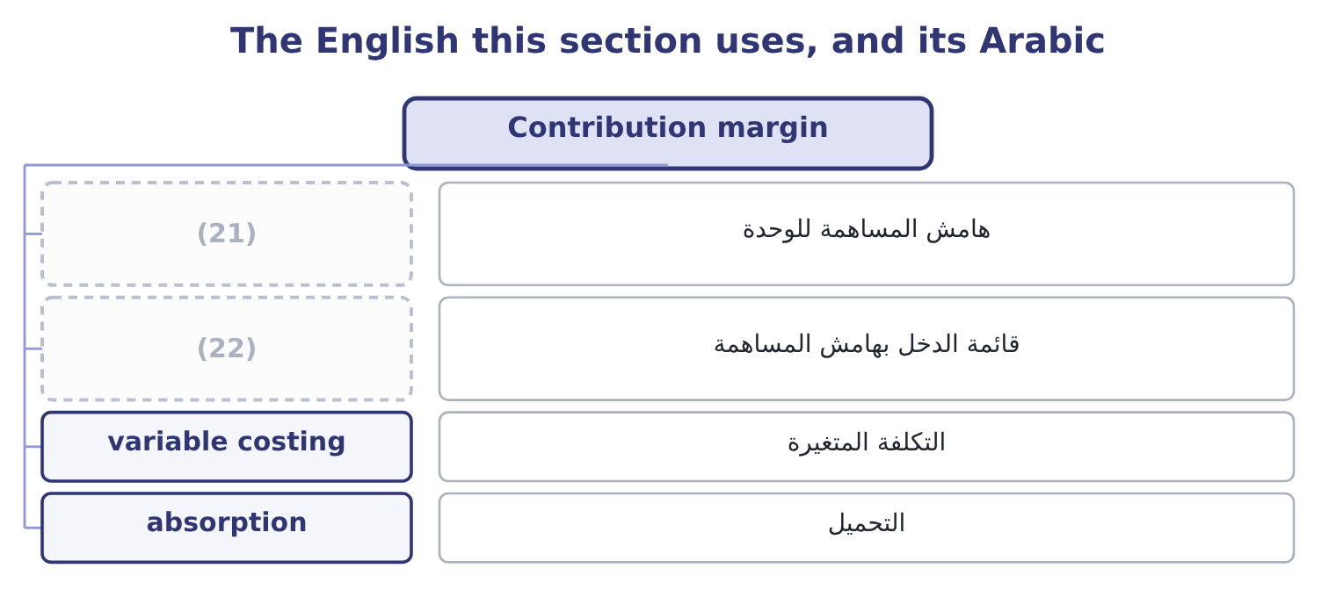
word list
contribution income statement · هامش المساهمة للوحدة · unit contribution margin

The English this sheet uses, and its Arabic
English (exam term) | Arabic
unit contribution margin | هامش المساهمة للوحدة
contribution income statement | قائمة الدخل بهامش المساهمة
variable costing | التكلفة المتغيرة
absorption | التحميل

Answer key · 1.3 Contribution margin

1 making | 12 reconciliation
2 called | 13 ordinary
3 because | 14 differently
4 contributes | 15 answer
5 covered | 16 volume
6 Orontes's | 17 contains
7 one-kilogram | 18 distribution
8 reconcile | 19 candidate
9 compute | 20 breakeven
10 leverage | 21 unit contribution margin
11 leaves | 22 contribution income statement

the summaries in full
Summary 1 Contribution margin is what is left of a selling price after the variable costs of making and selling that unit. It is called contribution because it is what each unit contributes, first to covering the fixed costs and then, once those are covered, to operating income. Orontes's main line is a one-kilogram jar of tahini selling at $12.00, with variable costs of $7.20 a jar. The contribution margin is 12.00 − 7.20 = 4.80 a jar, and the contribution margin ratio is 4.80 ÷ 12.00 = 40.0 per cent. Those figures reconcile to the company as a whole. Orontes sold 42,000,000 ÷ 12.00 = 3,500,000 jars, which at $4.80 each gives 3,500,000 × 4.80 = 16,800,000 of total contribution margin — the figure Book 1 used to compute a degree of operating leverage of 4.02.
Summary 2 Deducting fixed costs of $12,624,000 leaves 16,800,000 − 12,624,000 = 4,176,000, which is the operating income on the face of the income statement. That reconciliation is worth pausing on. The contribution income statement and the ordinary one report the same operating income and sort the costs differently, and only one of them can answer a question about volume. Cost of goods sold of $27,300,000 is not the variable cost: it contains the fixed factory costs absorbed into the product, and it excludes the variable part of selling and distribution. Gross profit and contribution margin are different measures and a candidate who uses one for the other will get every breakeven question wrong.

1.4 The breakeven point
Chapter 1 · section 1.4

Fill every gap. Each word list holds one word more than there are gaps.
Summary 1 gaps 1–5
The breakeven point is the level of (1) at which total (2) equals total cost, so operating income is nil. It is where the fixed costs have been exactly (3) by contribution and not a cent more. In units it is fixed costs divided by the contribution margin per unit. For Orontes: 12,624,000 ÷ 4.80 = 2,630,000 jars. In dollars it is fixed costs divided by the contribution margin ratio: 12,624,000 ÷ 0.40 = 31,560,000 of sales. The same answer (4) as 2,630,000 × 12.00 = 31,560,000, and the exam (5) either route.
word list
arrived · revenue · accepts · appears · activity · covered

Worked example: reading Orontes's breakeven

Summary 2 gaps 6–16
Orontes covers its fixed costs at 2,630,000 jars, or $31,560,000 of sales. (6) sales were 3,500,000 jars, which is 3,500,000 − 2,630,000 = 870,000 jars above the breakeven. What those jars earn. Every jar above the breakeven (7) its whole margin to operating income: 870,000 × 4.80 = 4,176,000, which is the operating income exactly. A ten per cent fall in volume removes 350,000 jars, which removes 350,000 × 4.80 = 1,680,000 of operating income — forty per cent of it, on a ten per cent fall in sales. That is the (8) of operating (9) of 4.02 that Book 1 (10) , arrived at from the cost (11) rather than from the ratio. (12) in Book 1's income (13) showed that a ten per cent sales fall costs forty per cent of the profit; the contribution format shows it (14) , and it is the first thing a board (15) be told about a company whose gross margin is (16) a point a year.
word list
arrived · statement · measured · degree · contributes · should · Nothing · immediately · structure · leverage · Actual · falling

Summary 3 gaps 17–18
A target income (17) one line of the formula. To earn a target operating income, add it to the fixed costs: the volume (18) is fixed costs plus target income, divided by the contribution margin per unit. For a target of $6,000,000: 12,624,000 + 6,000,000 = 18,624,000, and 18,624,000 ÷ 4.80 = 3,880,000 jars.
word list
needed · changes · exactly

The four questions and their answers
Question | Formula | Orontes
Breakeven in units | (19) | 2,630,000 jars
Breakeven in dollars | Fixed costs over the contribution ratio | 31,560,000
Units for a target operating income | (20) | 3,880,000 jars at a 6,000,000 target
Operating income at a volume | Units times unit contribution, less fixed | (21)

word list
Fixed costs over unit contribution · Fixed plus target, over unit contribution · 4,176,000 at 3,500,000 jars · Fixed costs over the contribution ratio

Three ways to get a breakeven wrong

Summary 4 gaps 22–25
Dividing by the (22) price instead of the contribution margin. The price covers the (23) cost of its own unit first. Using gross profit instead of contribution margin, which includes fixed factory cost in the (24) . Forgetting that the target in a (25) question may be stated after tax.
word list
selling · changes · target-income · denominator · variable

The English this section uses, and its Arabic
Each term sits against what it means.
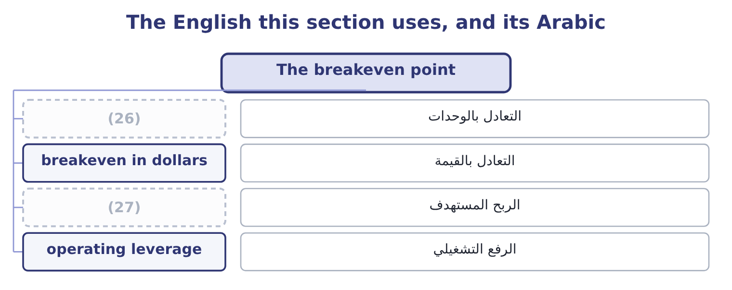
word list
unit contribution margin · breakeven in units · target income

The English this sheet uses, and its Arabic
English (exam term) | Arabic
breakeven in units | التعادل بالوحدات
breakeven in dollars | التعادل بالقيمة
target income | الربح المستهدف
operating leverage | الرفع التشغيلي

Answer key · 1.4 The breakeven point

1 activity | 15 should
2 revenue | 16 falling
3 covered | 17 changes
4 appears | 18 needed
5 accepts | 19 Fixed costs over unit contribution
6 Actual | 20 Fixed plus target, over unit contribution
7 contributes | 21 4,176,000 at 3,500,000 jars
8 degree | 22 selling
9 leverage | 23 variable
10 measured | 24 denominator
11 structure | 25 target-income
12 Nothing | 26 breakeven in units
13 statement | 27 target income
14 immediately

the summaries in full
Summary 1 The breakeven point is the level of activity at which total revenue equals total cost, so operating income is nil. It is where the fixed costs have been exactly covered by contribution and not a cent more. In units it is fixed costs divided by the contribution margin per unit. For Orontes: 12,624,000 ÷ 4.80 = 2,630,000 jars. In dollars it is fixed costs divided by the contribution margin ratio: 12,624,000 ÷ 0.40 = 31,560,000 of sales. The same answer appears as 2,630,000 × 12.00 = 31,560,000, and the exam accepts either route.
Summary 2 Orontes covers its fixed costs at 2,630,000 jars, or $31,560,000 of sales. Actual sales were 3,500,000 jars, which is 3,500,000 − 2,630,000 = 870,000 jars above the breakeven. What those jars earn. Every jar above the breakeven contributes its whole margin to operating income: 870,000 × 4.80 = 4,176,000, which is the operating income exactly. A ten per cent fall in volume removes 350,000 jars, which removes 350,000 × 4.80 = 1,680,000 of operating income — forty per cent of it, on a ten per cent fall in sales. That is the degree of operating leverage of 4.02 that Book 1 measured, arrived at from the cost structure rather than from the ratio. Nothing in Book 1's income statement showed that a ten per cent sales fall costs forty per cent of the profit; the contribution format shows it immediately, and it is the first thing a board should be told about a company whose gross margin is falling a point a year.
Summary 3 A target income changes one line of the formula. To earn a target operating income, add it to the fixed costs: the volume needed is fixed costs plus target income, divided by the contribution margin per unit. For a target of $6,000,000: 12,624,000 + 6,000,000 = 18,624,000, and 18,624,000 ÷ 4.80 = 3,880,000 jars.
Summary 4 Dividing by the selling price instead of the contribution margin. The price covers the variable cost of its own unit first. Using gross profit instead of contribution margin, which includes fixed factory cost in the denominator. Forgetting that the target in a target-income question may be stated after tax.

1.5 What the model assumes
Chapter 1 · section 1.5

Fill every gap. Each word list holds one word more than there are gaps.
Summary 1 gaps 1–12
Cost-volume-profit (1) is a model, and a (2) who can state its assumptions can also state when it (3) not be relied on. Six assumptions, each of which fails (4) . Costs can be split (5) into fixed and variable. Mixed costs must be separated, and the (6) is an estimate. Behaviour is linear within the (7) range. Revenue rises in a straight line, which (8) the selling price does not change with volume —. The sales mix is constant. With several (9) , a change in which ones sell changes the average contribution, which is the whole. Volume is the only cost (10) . Batch sizes, order sizes, product complexity and customer behaviour all drive costs too, which is the argument for (11) costing. Inventory does not change. (12) equals sales, so no fixed cost is carried forward in stock.
word list
analysis · driver · assumes · Production · cleanly · activity-based · candidate · products · should · somewhere · useless · relevant · separation

Summary 2 gaps 13–20
Where inventory moves, (13) costing and variable costing report (14) incomes, as Part 1 showed. (15) else is held constant: prices, costs, (16) , technology. None of this makes the model (17) . It makes it a first (18) that is right about direction and approximate about magnitude, and the (19) habit is to state the assumption that matters most to the decision in hand. For Orontes, that assumption is the constant selling price, because the (20) gross margin has fallen three years running — which means its revenue line is not as straight as the model draws it.
word list
Everything · absorption · approximation · different · company's · costing · professional · useless · efficiency

Build the picture for Barada

Your turn: Barada's cost structure (complete the blanks)
Item | Data | Answer
Contribution margin | (21) | ________
Contribution margin ratio |  | ________
Fixed costs | Operating income 558,000 | ________
Breakeven in dollars |  | ________
Sales needed for a 1,000,000 operating income |  | ________
What it tells you |  | ________

word list
Sales 21,978,000, variable costs 19,340,640 · 17,328,000: 2,079,360 ÷ 0.12 = 17,328,000.

"Margin"

Summary 3 gaps 22–27
English margin (22) in Book 1 as a (23) of sales. Here it appears as an (24) per unit, and the two senses sit a (25) apart: a contribution margin of $4.80 is money, a contribution margin ratio of 40 per cent is a rate. The exam uses both and (26) them only by the word ratio. The (27) rule for an answer is to write the unit and let no figure stand without one.
word list
Behaviour · practical · percentage · amount · appeared · distinguishes · paragraph

"Margin"
Item | Answer
Contribution margin | (28)
Contribution margin ratio | 12.0 per cent: 2,637,360 ÷ 21,978,000 = 12.0 per cent.
Fixed costs | 2,079,360: 2,637,360 − 558,000 = 2,079,360.
Breakeven in dollars | (29)
Sales for a 1,000,000 operating income | 25,661,333: 2,079,360 + 1,000,000 = 3,079,360, and 3,079,360 ÷ 0.12 = 25,661,333.
What it tells you | Barada breaks even at about 79 per cent of its current sales, against Orontes's 75 per cent, and its 12 per cent contribution ratio means ev

word list
17,328,000: 2,079,360 ÷ 0.12 = 17,328,000. · 2,637,360: 21,978,000 − 19,340,640 = 2,637,360. · 2,079,360: 2,637,360 − 558,000 = 2,079,360.

The English this section uses, and its Arabic
Each term sits against what it means.
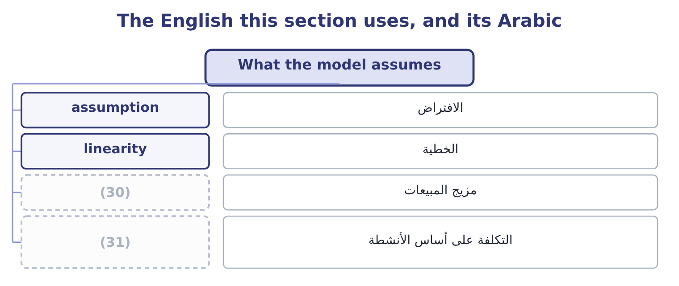
word list
sales mix · activity-based costing · time frame

The English this sheet uses, and its Arabic
English (exam term) | Arabic
assumption | الافتراض
linearity | الخطية
sales mix | مزيج المبيعات
activity-based costing | التكلفة على أساس الأنشطة

Answer key · 1.5 What the model assumes

1 analysis | 17 useless
2 candidate | 18 approximation
3 should | 19 professional
4 somewhere | 20 company's
5 cleanly | 21 Sales 21,978,000, variable costs 19,340,640
6 separation | 22 appeared
7 relevant | 23 percentage
8 assumes | 24 amount
9 products | 25 paragraph
10 driver | 26 distinguishes
11 activity-based | 27 practical
12 Production | 28 2,637,360: 21,978,000 − 19,340,640 = 2,637,360.
13 absorption | 29 17,328,000: 2,079,360 ÷ 0.12 = 17,328,000.
14 different | 30 sales mix
15 Everything | 31 activity-based costing
16 efficiency

the summaries in full
Summary 1 Cost-volume-profit analysis is a model, and a candidate who can state its assumptions can also state when it should not be relied on. Six assumptions, each of which fails somewhere. Costs can be split cleanly into fixed and variable. Mixed costs must be separated, and the separation is an estimate. Behaviour is linear within the relevant range. Revenue rises in a straight line, which assumes the selling price does not change with volume —. The sales mix is constant. With several products, a change in which ones sell changes the average contribution, which is the whole. Volume is the only cost driver. Batch sizes, order sizes, product complexity and customer behaviour all drive costs too, which is the argument for activity-based costing. Inventory does not change. Production equals sales, so no fixed cost is carried forward in stock.
Summary 2 Where inventory moves, absorption costing and variable costing report different incomes, as Part 1 showed. Everything else is held constant: prices, costs, efficiency, technology. None of this makes the model useless. It makes it a first approximation that is right about direction and approximate about magnitude, and the professional habit is to state the assumption that matters most to the decision in hand. For Orontes, that assumption is the constant selling price, because the company's gross margin has fallen three years running — which means its revenue line is not as straight as the model draws it.
Summary 3 English margin appeared in Book 1 as a percentage of sales. Here it appears as an amount per unit, and the two senses sit a paragraph apart: a contribution margin of $4.80 is money, a contribution margin ratio of 40 per cent is a rate. The exam uses both and distinguishes them only by the word ratio. The practical rule for an answer is to write the unit and let no figure stand without one.

2.1 Income at any volume
Chapter 2 · section 2.1

Fill every gap. Each word list holds one word more than there are gaps.
Chapter 2, section by section
Each stage leads to the next.
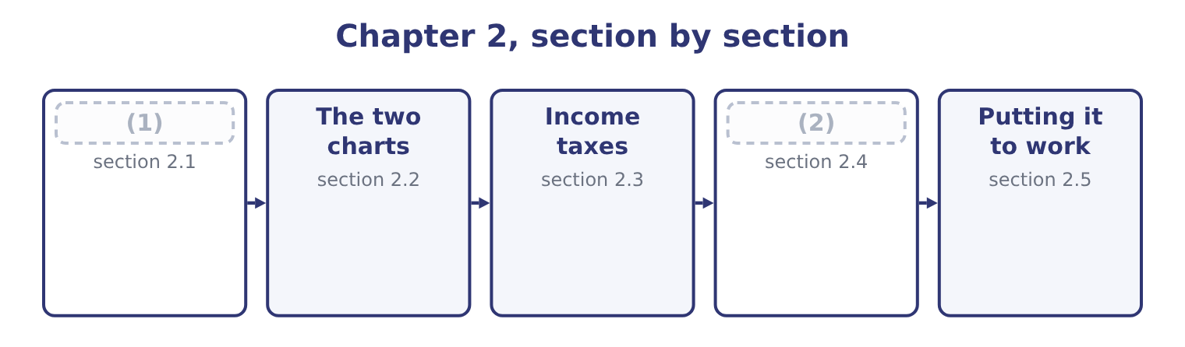
word list
Income at any volume · effective tax rate · The four levers

Summary 1 gaps 3–14
Three (3) reach the same (4) , and the exam uses all three. The contribution route is the (5) . (6) the volume by the contribution margin per unit and (7) the fixed costs. At 3,000,000 jars: 3,000,000 × 4.80 = 14,400,000 of contribution, and 14,400,000 − 12,624,000 = 1,776,000 of operating income. At 4,000,000 jars: 4,000,000 × 4.80 = 19,200,000, and 19,200,000 − 12,624,000 = 6,576,000. The (8) route writes the income (9) as a sentence: operating income is price times units, less variable cost times units, less fixed costs. It is slower and it is the one to use when a (10) changes two things at once, because every (11) is visible. The (12) route is the (13) of all and the one a manager wants. Since fixed costs do not move, the change in operating income is (14) the change in units times the contribution margin. Moving from 3,500,000 to 4,000,000 jars adds 500,000 jars, which adds 500,000 × 4.80 = 2,400,000 — and indeed 6,576,000 − 4,176,000 = 2,400,000. That third route is the whole of decision analysis in one sentence, and: what matters is what changes.
word list
statement · quickest · routes · equation · Multiply · answer · sentence · element · simply · incremental · deduct · question · fastest

Orontes at six volumes
Each stage leads to the next.
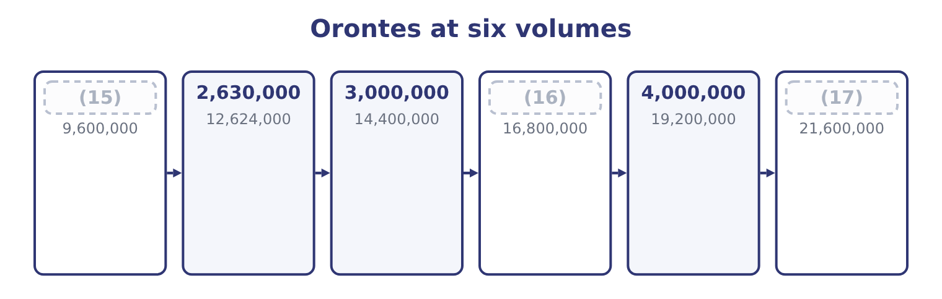
word list
4,500,000 · 2,000,000 · 3,500,000 · sensitivity

Summary 2 gaps 18–22
Read down the last column and the (18) is visible (19) any ratio: a 14 per cent rise in volume from 3,500,000 to 4,000,000 jars (20) operating income by 57 per cent, and a 14 per cent fall to 3,000,000 takes it down by the same (21) . Below 2,630,000 the company loses money, and at 2,000,000 jars it loses $3,024,000 — because the fixed costs are still $12,624,000 (22) the factory does.
word list
proportion · whatever · raises · leverage · without · operating

The English this section uses, and its Arabic
Each term sits against what it means.
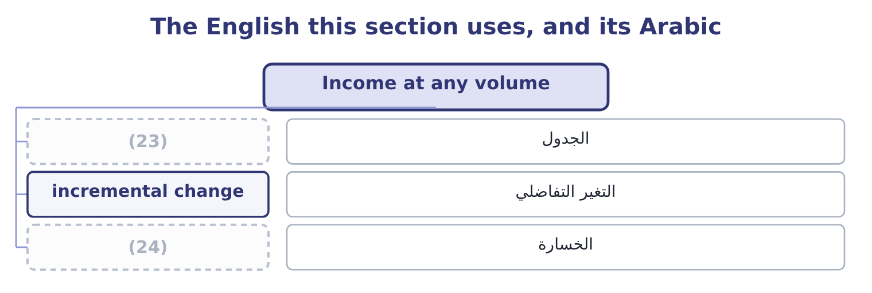
word list
الجدول · loss · schedule

The English this sheet uses, and its Arabic
English (exam term) | Arabic
schedule | الجدول
incremental change | التغير التفاضلي
loss | الخسارة

Answer key · 2.1 Income at any volume

1 Income at any volume | 13 fastest
2 The four levers | 14 simply
3 routes | 15 2,000,000
4 answer | 16 3,500,000
5 quickest | 17 4,500,000
6 Multiply | 18 leverage
7 deduct | 19 without
8 equation | 20 raises
9 statement | 21 proportion
10 question | 22 whatever
11 element | 23 schedule
12 incremental | 24 loss

the summaries in full
Summary 1 Three routes reach the same answer, and the exam uses all three. The contribution route is the quickest. Multiply the volume by the contribution margin per unit and deduct the fixed costs. At 3,000,000 jars: 3,000,000 × 4.80 = 14,400,000 of contribution, and 14,400,000 − 12,624,000 = 1,776,000 of operating income. At 4,000,000 jars: 4,000,000 × 4.80 = 19,200,000, and 19,200,000 − 12,624,000 = 6,576,000. The equation route writes the income statement as a sentence: operating income is price times units, less variable cost times units, less fixed costs. It is slower and it is the one to use when a question changes two things at once, because every element is visible. The incremental route is the fastest of all and the one a manager wants. Since fixed costs do not move, the change in operating income is simply the change in units times the contribution margin. Moving from 3,500,000 to 4,000,000 jars adds 500,000 jars, which adds 500,000 × 4.80 = 2,400,000 — and indeed 6,576,000 − 4,176,000 = 2,400,000. That third route is the whole of decision analysis in one sentence, and: what matters is what changes.
Summary 2 Read down the last column and the leverage is visible without any ratio: a 14 per cent rise in volume from 3,500,000 to 4,000,000 jars raises operating income by 57 per cent, and a 14 per cent fall to 3,000,000 takes it down by the same proportion. Below 2,630,000 the company loses money, and at 2,000,000 jars it loses $3,024,000 — because the fixed costs are still $12,624,000 whatever the factory does.

2.2 The two charts
Chapter 2 · section 2.2

Fill every gap. Each word list holds one word more than there are gaps.
Summary 1 gaps 1–12
The (1) can be drawn, and the exam asks what each line means (2) than for a (3) . The (4) chart puts volume on the horizontal axis and (5) on the vertical. The total (6) line starts at the origin and rises at the (7) price. The total cost line starts at the level of the fixed costs and rises at the variable cost per unit. The two cross at the breakeven point. The vertical (8) between them to the right of that crossing is operating income; to the left it is (9) . The profit-volume chart is (10) and more useful. It plots only operating income (11) volume: a single line starting at minus the fixed costs when volume is nil, crossing zero at the breakeven, and rising at the contribution margin per unit (12) .
word list
rather · simpler · against · distance · cost-volume-profit · drawing · dollars · manufacturer · relationships · loss · thereafter · revenue · selling

Summary 2 gaps 13–19
For Orontes that line starts at minus $12,624,000, (13) zero at 2,630,000 jars and rises $4.80 for every jar after. Three (14) come straight off the profit-volume line, and all three are (15) . The slope is the contribution margin per unit. A steeper line means each unit does more work, which comes from a (16) price or lower variable costs. The intercept is the fixed costs, with the sign (17) . A line starting lower means a heavier fixed base and a company that needs more volume before it earns anything. The horizontal intercept is the breakeven. Anything that (18) the slope or lifts the intercept moves it to the left, which is the (19) a company wants.
word list
reversed · readings · direction · crosses · dollars · higher · examinable · raises

What each change does to the profit-volume line
Every item belongs to exactly one group.
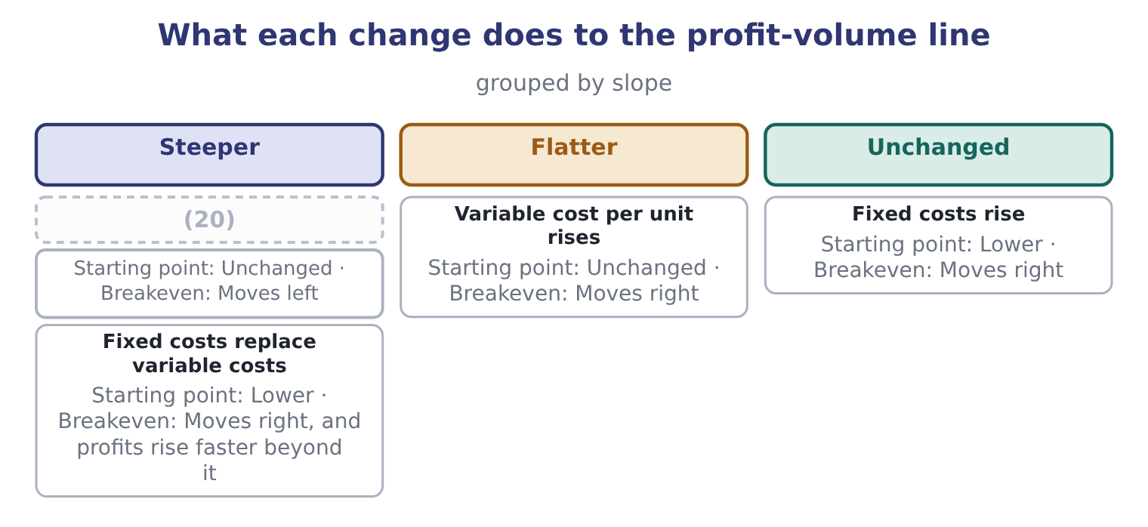
word list
Selling price rises · effective tax rate

Summary 3 gaps 21–28
That last row is the one worth (21) on, because it is the (22) choice every manufacturer faces. Automating a process (23) variable labour into fixed (24) : the contribution margin per unit rises, so the line is steeper, and the fixed base is heavier, so the line starts lower. The company earns more at high (25) and loses more at low ones — which is (26) the degree of operating (27) that Book 1 (28) for Orontes at 4.02, and the reason a food manufacturer with a falling margin should think twice before automating further.
word list
structural · volumes · depreciation · converts · measured · exactly · dwelling · leverage · thereafter

The English this section uses, and its Arabic
Each term sits against what it means.
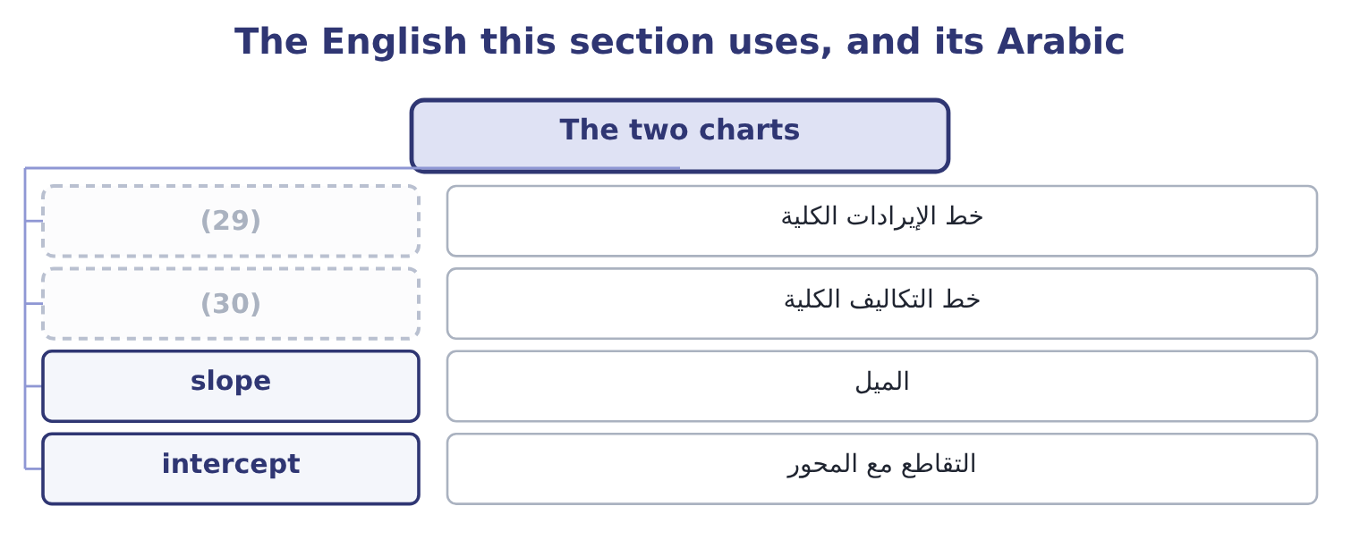
word list
خط الإيرادات الكلية · total cost line · total revenue line

The English this sheet uses, and its Arabic
English (exam term) | Arabic
total revenue line | خط الإيرادات الكلية
total cost line | خط التكاليف الكلية
slope | الميل
intercept | التقاطع مع المحور

Answer key · 2.2 The two charts

1 relationships | 16 higher
2 rather | 17 reversed
3 drawing | 18 raises
4 cost-volume-profit | 19 direction
5 dollars | 20 Selling price rises
6 revenue | 21 dwelling
7 selling | 22 structural
8 distance | 23 converts
9 loss | 24 depreciation
10 simpler | 25 volumes
11 against | 26 exactly
12 thereafter | 27 leverage
13 crosses | 28 measured
14 readings | 29 total revenue line
15 examinable | 30 total cost line

the summaries in full
Summary 1 The relationships can be drawn, and the exam asks what each line means rather than for a drawing. The cost-volume-profit chart puts volume on the horizontal axis and dollars on the vertical. The total revenue line starts at the origin and rises at the selling price. The total cost line starts at the level of the fixed costs and rises at the variable cost per unit. The two cross at the breakeven point. The vertical distance between them to the right of that crossing is operating income; to the left it is loss. The profit-volume chart is simpler and more useful. It plots only operating income against volume: a single line starting at minus the fixed costs when volume is nil, crossing zero at the breakeven, and rising at the contribution margin per unit thereafter.
Summary 2 For Orontes that line starts at minus $12,624,000, crosses zero at 2,630,000 jars and rises $4.80 for every jar after. Three readings come straight off the profit-volume line, and all three are examinable. The slope is the contribution margin per unit. A steeper line means each unit does more work, which comes from a higher price or lower variable costs. The intercept is the fixed costs, with the sign reversed. A line starting lower means a heavier fixed base and a company that needs more volume before it earns anything. The horizontal intercept is the breakeven. Anything that raises the slope or lifts the intercept moves it to the left, which is the direction a company wants.
Summary 3 That last row is the one worth dwelling on, because it is the structural choice every manufacturer faces. Automating a process converts variable labour into fixed depreciation: the contribution margin per unit rises, so the line is steeper, and the fixed base is heavier, so the line starts lower. The company earns more at high volumes and loses more at low ones — which is exactly the degree of operating leverage that Book 1 measured for Orontes at 4.02, and the reason a food manufacturer with a falling margin should think twice before automating further.

2.3 Income taxes
Chapter 2 · section 2.3

Fill every gap. Each word list holds one word more than there are gaps.
Summary 1 gaps 1–7
Everything so far has been (1) before tax, and for most (2) that is correct: tax (3) the profit rather than driving it. But a target stated by a board is (4) stated after tax, and the exam exploits the (5) . The rule is one line. Tax is (6) on operating income less interest, so a target net income must be (7) to a target pre-tax income before it can be added to the fixed costs. Divide the after-tax target by one less the tax rate.
word list
decisions · usually · converted · charged · computed · follows · difference · slope

Worked example: a target stated after tax

Summary 2 gaps 8–18
Orontes's board wants net income of $4,500,000. Its (8) tax rate is 25 per cent. The pre-tax income (9) is 4,500,000 ÷ 0.75 = 6,000,000. Add the fixed costs. The conversion is the whole question. A (10) who adds $4,500,000 to the fixed costs (11) 17,124,000 ÷ 4.80 = 3,567,500 jars and (12) the requirement by more than three hundred (13) jars — because at that (14) the company earns $4,500,000 before tax and only $3,375,000 after it. Divide by one less the tax rate, every time. Two further points (15) the outcome. Tax does not move the breakeven point. At breakeven, operating income is nil, so the tax on it is nil, and a company that loses money pays no tax on the loss. The whole of the tax (16) lives above the breakeven, which is why. Tax (17) every answer above the breakeven by the same (18) .
word list
understates · needed · computes · candidate · scales · effective · factor · adjustment · thousand · intercept · complete · volume

Before tax and after, at a 25 per cent rate
Jars sold | Operating income | Tax at 25% | Net income
2,630,000 | Nil | Nil | Nil
3,000,000 | 1,776,000 | 444,000 | 1,332,000
3,500,000 | 4,176,000 | 1,044,000 | 3,132,000
3,880,000 | 6,000,000 | 1,500,000 | 4,500,000
4,000,000 | 6,576,000 | 1,644,000 | 4,932,000

The tax conversion runs one way

Summary 3 gaps 19–27
To go from an after-tax target to a pre-tax requirement, divide by one less the rate. To go from a pre-tax figure to an after-tax one, (19) by one less the rate. (20) the two is the (21) error on this outcome. Interest is deducted before tax and after operating income, so a question that gives interest expense wants it added to the fixed costs — or, more (22) , treated as a further fixed (23) — before the tax conversion. A loss (24) no tax at the simple rate (25) here. Where a question allows a loss to be (26) back or forward, say so and (27) it.
word list
assumed · generates · deducted · carried · Reversing · precisely · commonest · multiply · compute · deduction

The English this section uses, and its Arabic
Each term sits against what it means.
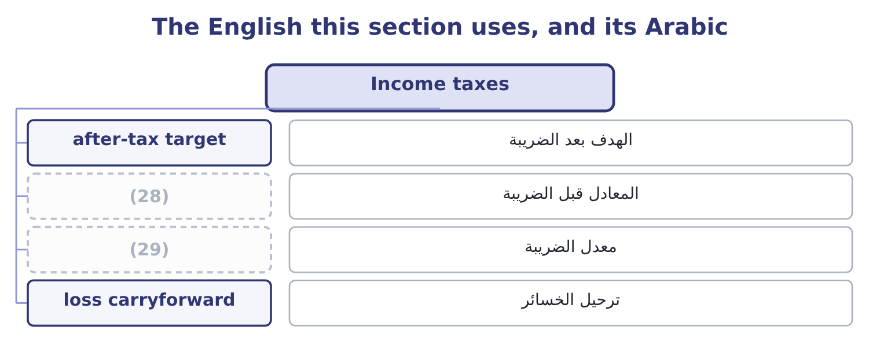
word list
cost-volume-profit chart · pre-tax equivalent · tax rate

The English this sheet uses, and its Arabic
English (exam term) | Arabic
after-tax target | الهدف بعد الضريبة
pre-tax equivalent | المعادل قبل الضريبة
tax rate | معدل الضريبة
loss carryforward | ترحيل الخسائر

Answer key · 2.3 Income taxes

1 computed | 16 adjustment
2 decisions | 17 scales
3 follows | 18 factor
4 usually | 19 multiply
5 difference | 20 Reversing
6 charged | 21 commonest
7 converted | 22 precisely
8 effective | 23 deduction
9 needed | 24 generates
10 candidate | 25 assumed
11 computes | 26 carried
12 understates | 27 compute
13 thousand | 28 pre-tax equivalent
14 volume | 29 tax rate
15 complete

the summaries in full
Summary 1 Everything so far has been computed before tax, and for most decisions that is correct: tax follows the profit rather than driving it. But a target stated by a board is usually stated after tax, and the exam exploits the difference. The rule is one line. Tax is charged on operating income less interest, so a target net income must be converted to a target pre-tax income before it can be added to the fixed costs. Divide the after-tax target by one less the tax rate.
Summary 2 Orontes's board wants net income of $4,500,000. Its effective tax rate is 25 per cent. The pre-tax income needed is 4,500,000 ÷ 0.75 = 6,000,000. Add the fixed costs. The conversion is the whole question. A candidate who adds $4,500,000 to the fixed costs computes 17,124,000 ÷ 4.80 = 3,567,500 jars and understates the requirement by more than three hundred thousand jars — because at that volume the company earns $4,500,000 before tax and only $3,375,000 after it. Divide by one less the tax rate, every time. Two further points complete the outcome. Tax does not move the breakeven point. At breakeven, operating income is nil, so the tax on it is nil, and a company that loses money pays no tax on the loss. The whole of the tax adjustment lives above the breakeven, which is why. Tax scales every answer above the breakeven by the same factor.
Summary 3 To go from an after-tax target to a pre-tax requirement, divide by one less the rate. To go from a pre-tax figure to an after-tax one, multiply by one less the rate. Reversing the two is the commonest error on this outcome. Interest is deducted before tax and after operating income, so a question that gives interest expense wants it added to the fixed costs — or, more precisely, treated as a further fixed deduction — before the tax conversion. A loss generates no tax at the simple rate assumed here. Where a question allows a loss to be carried back or forward, say so and compute it.

2.4 The four levers
Chapter 2 · section 2.4

Fill every gap. Each word list holds one word more than there are gaps.
Summary 1 gaps 1–5
Four (1) can be changed, and a (2) that asks a company to improve its (3) is asking which of them to pull. A five per cent rise takes the jar to $12.60 and the contribution margin to 12.60 − 7.20 = 5.40. At the same volume, operating income (4) 3,500,000 × 5.40 = 18,900,000 of contribution less fixed costs, which is 18,900,000 − 12,624,000 = 6,276,000 — a rise of half as much again, from a five per cent price move. The breakeven falls to 12,624,000 ÷ 5.40 = 2,337,778 jars. The risk is the volume (5) . Cut the variable cost. A five per cent saving takes the variable cost to $6.84 and the margin to 12.00 − 6.84 = 5.16, which at the same volume gives 3,500,000 × 5.16 = 18,060,000 of contribution and 18,060,000 − 12,624,000 = 5,436,000 of operating income.
word list
position · response · things · becomes · question · variable

Summary 2 gaps 6–10
Less powerful than the price rise, (6) the variable cost is a (7) base than the price. Cut the fixed costs. A saving of $1,000,000 adds (8) $1,000,000 to operating income at any volume and moves the breakeven to 11,624,000 ÷ 4.80 = 2,421,667 jars. It is the only lever whose (9) does not depend on volume. Each extra jar adds $4.80, so an extra 500,000 jars adds 500,000 × 4.80 = 2,400,000 — as section 2.1 (10) .
word list
effect · exactly · direction · because · showed · smaller

Four five per cent moves, compared
The bars are drawn to scale.
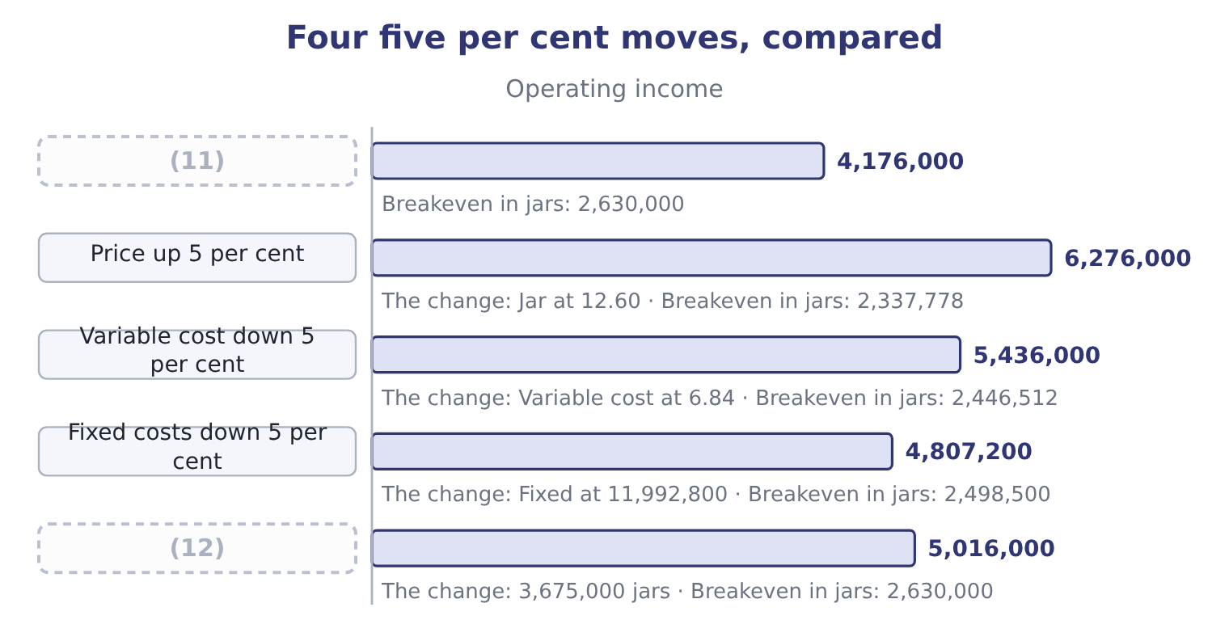
word list
As reported · Volume up 5 per cent · cost-volume-profit chart

Summary 3 gaps 13–18
The (13) is the lesson, and it is the same in almost every (14) : the price is the most powerful lever, the variable cost the (15) , volume the third and the fixed cost the fourth. That is the (16) behind Book 1's finding that two points of gross margin were worth $840,000 a year, and behind the warning that a company buying volume with price is pulling the (17) lever in the wrong (18) .
word list
second · strongest · business · arithmetic · ranking · direction · sensitivity

The English this section uses, and its Arabic
Each term sits against what it means.
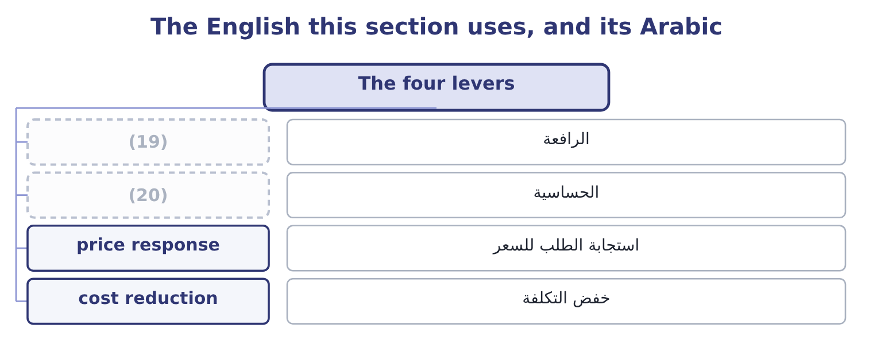
word list
intercept · sensitivity · lever

The English this sheet uses, and its Arabic
English (exam term) | Arabic
lever | الرافعة
sensitivity | الحساسية
price response | استجابة الطلب للسعر
cost reduction | خفض التكلفة

Answer key · 2.4 The four levers

1 things | 11 As reported
2 question | 12 Volume up 5 per cent
3 position | 13 ranking
4 becomes | 14 business
5 response | 15 second
6 because | 16 arithmetic
7 smaller | 17 strongest
8 exactly | 18 direction
9 effect | 19 lever
10 showed | 20 sensitivity

the summaries in full
Summary 1 Four things can be changed, and a question that asks a company to improve its position is asking which of them to pull. A five per cent rise takes the jar to $12.60 and the contribution margin to 12.60 − 7.20 = 5.40. At the same volume, operating income becomes 3,500,000 × 5.40 = 18,900,000 of contribution less fixed costs, which is 18,900,000 − 12,624,000 = 6,276,000 — a rise of half as much again, from a five per cent price move. The breakeven falls to 12,624,000 ÷ 5.40 = 2,337,778 jars. The risk is the volume response. Cut the variable cost. A five per cent saving takes the variable cost to $6.84 and the margin to 12.00 − 6.84 = 5.16, which at the same volume gives 3,500,000 × 5.16 = 18,060,000 of contribution and 18,060,000 − 12,624,000 = 5,436,000 of operating income.
Summary 2 Less powerful than the price rise, because the variable cost is a smaller base than the price. Cut the fixed costs. A saving of $1,000,000 adds exactly $1,000,000 to operating income at any volume and moves the breakeven to 11,624,000 ÷ 4.80 = 2,421,667 jars. It is the only lever whose effect does not depend on volume. Each extra jar adds $4.80, so an extra 500,000 jars adds 500,000 × 4.80 = 2,400,000 — as section 2.1 showed.
Summary 3 The ranking is the lesson, and it is the same in almost every business: the price is the most powerful lever, the variable cost the second, volume the third and the fixed cost the fourth. That is the arithmetic behind Book 1's finding that two points of gross margin were worth $840,000 a year, and behind the warning that a company buying volume with price is pulling the strongest lever in the wrong direction.

2.5 Putting it to work
Chapter 2 · section 2.5

Fill every gap. Each word list holds one word more than there are gaps.
Summary 1 gaps 1–12
The (1) apparatus answers a board's (2) directly, and three forms of question recur. What if volume falls? (3) the fall in units by the contribution margin. (4) else is needed, and the answer is always larger than a board (5) because the fixed costs do not move. What do we need to sell? Add the target to the fixed costs and divide by the contribution margin, (6) the target from after tax if (7) . What can we (8) to spend? This is the question a marketing (9) raises, and it is the mirror of the second. A campaign (10) $500,000 is a rise in fixed costs, so it pays for itself at 500,000 ÷ 4.80 = 104,167 extra jars — about 3 per cent of (11) volume. Whether the campaign will do that is a marketing judgment, and the (12) contribution is the number it has to beat.
word list
accountant's · questions · necessary · current · Multiply · costing · expects · proposal · converting · afford · intercept · Nothing · chapter's

Summary 2 gaps 13–24
The same (13) prices a sales (14) , a quality (15) , a delivery promise and a discount. Two (16) close the chapter. The (17) is only as good as the cost split. If a cost treated as fixed is in fact a step cost that jumps at 4,000,000 jars, the schedule is wrong at its top end, and the error is in the (18) that flatters the (19) . And the (20) range limits every row of that schedule. At 4,500,000 jars Orontes would need a second shift, more (21) and probably more (22) ; at 2,000,000 it would close a line and shed some of the fixed costs it is shown here as carrying. The middle of the table is (23) and the ends are (24) , which is a sentence worth writing in an answer.
word list
illustrative · warehousing · decision · direction · directly · analysis · relevant · supervision · arithmetic · reliable · cautions · improvement · commission

Work the levers

Your turn: income at different levels (complete the blanks)
Item | Data | Answer
Contribution margin per unit | Price 40.00, variable cost 26.00 | ________
Operating income at 300,000 units | (25) | ________
Operating income at 350,000 units |  | ________
Breakeven in units |  | ________
Units for a net income target of 1,500,000 | (26) | ________
Operating income if the price rises 5 per cent at 300,000 units |  | ________

word list
Fixed costs 3,000,000 · target net income · Tax rate 25 per cent

"Income"

Summary 3 gaps 27–31
Operating income is profit before (27) and tax; net income is profit after both; target net income is a goal; and income taxes are the (28) on it. Outside (29) , income means what a person (30) , which is closer to revenue than to profit — and that everyday sense is the one (31) import when they read target income as a sales target.
word list
accounting · interest · candidates · lever · charge · receives

"Income"
Item | Answer
Contribution margin per unit | 14.00: 40.00 − 26.00 = 14.00.
Operating income at 300,000 units | 1,200,000: 300,000 × 14.00 = 4,200,000, and 4,200,000 − 3,000,000 = 1,200,000.
Operating income at 350,000 units | 1,900,000: 350,000 × 14.00 = 4,900,000, and 4,900,000 − 3,000,000 = 1,900,000.
Breakeven in units | (32)
Units for a 1,500,000 net income target | (33) : the pre-tax target is 1,500,000 ÷ 0.75 = 2,000,000, so 3,000,000 + 2,000,000 = 5,000,000 of contribution is needed, and 5,000,000 ÷
Operating income with a 5 per cent price rise | 1,800,000: the price becomes 42.00 and the margin 42.00 − 26.00 = 16.00, so 300,000 × 16.00 = 4,800,000 less 3,000,000.
What it tells you | A five per cent price rise adds 600,000 of operating income at unchanged volume, which is half as much again as the company earns, and the s

word list
357,143 · 1,200,000 · 214,286: 3,000,000 ÷ 14.00 = 214,286.

The English this section uses, and its Arabic
Each term sits against what it means.
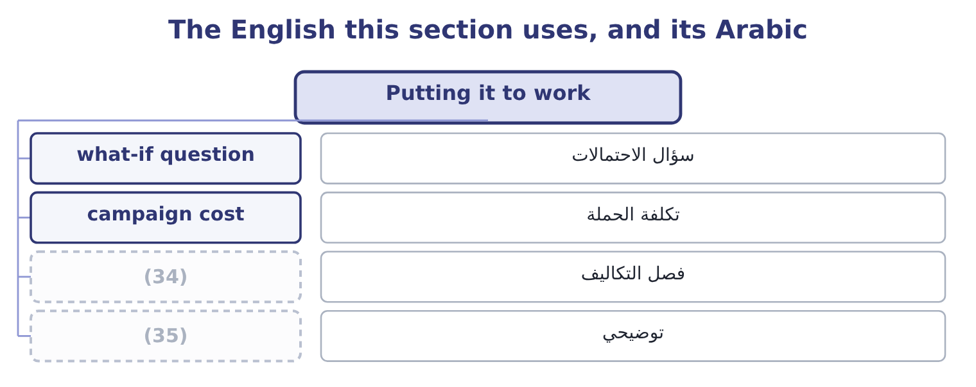
word list
cost split · schedule · illustrative

The English this sheet uses, and its Arabic
English (exam term) | Arabic
what-if question | سؤال الاحتمالات
campaign cost | تكلفة الحملة
cost split | فصل التكاليف
illustrative | توضيحي

Answer key · 2.5 Putting it to work

1 chapter's | 19 decision
2 questions | 20 relevant
3 Multiply | 21 supervision
4 Nothing | 22 warehousing
5 expects | 23 reliable
6 converting | 24 illustrative
7 necessary | 25 Fixed costs 3,000,000
8 afford | 26 Tax rate 25 per cent
9 proposal | 27 interest
10 costing | 28 charge
11 current | 29 accounting
12 accountant's | 30 receives
13 arithmetic | 31 candidates
14 commission | 32 214,286: 3,000,000 ÷ 14.00 = 214,286.
15 improvement | 33 357,143
16 cautions | 34 cost split
17 analysis | 35 illustrative
18 direction

the summaries in full
Summary 1 The chapter's apparatus answers a board's questions directly, and three forms of question recur. What if volume falls? Multiply the fall in units by the contribution margin. Nothing else is needed, and the answer is always larger than a board expects because the fixed costs do not move. What do we need to sell? Add the target to the fixed costs and divide by the contribution margin, converting the target from after tax if necessary. What can we afford to spend? This is the question a marketing proposal raises, and it is the mirror of the second. A campaign costing $500,000 is a rise in fixed costs, so it pays for itself at 500,000 ÷ 4.80 = 104,167 extra jars — about 3 per cent of current volume. Whether the campaign will do that is a marketing judgment, and the accountant's contribution is the number it has to beat.
Summary 2 The same arithmetic prices a sales commission, a quality improvement, a delivery promise and a discount. Two cautions close the chapter. The analysis is only as good as the cost split. If a cost treated as fixed is in fact a step cost that jumps at 4,000,000 jars, the schedule is wrong at its top end, and the error is in the direction that flatters the decision. And the relevant range limits every row of that schedule. At 4,500,000 jars Orontes would need a second shift, more supervision and probably more warehousing; at 2,000,000 it would close a line and shed some of the fixed costs it is shown here as carrying. The middle of the table is reliable and the ends are illustrative, which is a sentence worth writing in an answer.
Summary 3 Operating income is profit before interest and tax; net income is profit after both; target net income is a goal; and income taxes are the charge on it. Outside accounting, income means what a person receives, which is closer to revenue than to profit — and that everyday sense is the one candidates import when they read target income as a sales target.

3.1 Three products, three margins
Chapter 3 · section 3.1

Fill every gap. Each word list holds one word more than there are gaps.
Chapter 3, section by section
Each stage leads to the next.
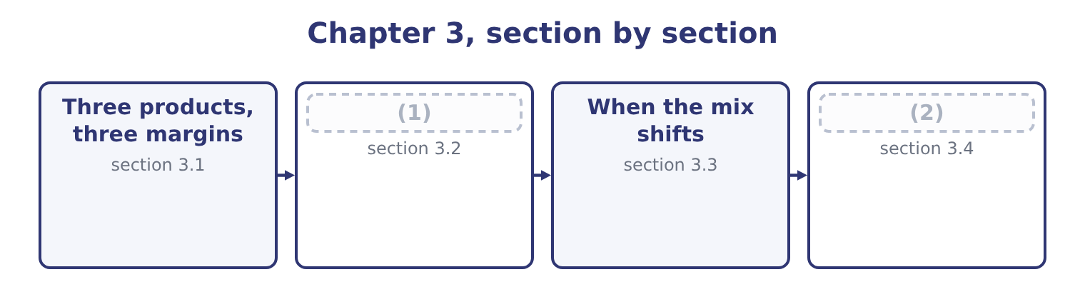
word list
Three products, three margins · The weighted-average contribution margin · Why there is no unique breakeven

Orontes Foods, Inc. — the three lines
The bars are drawn to scale.
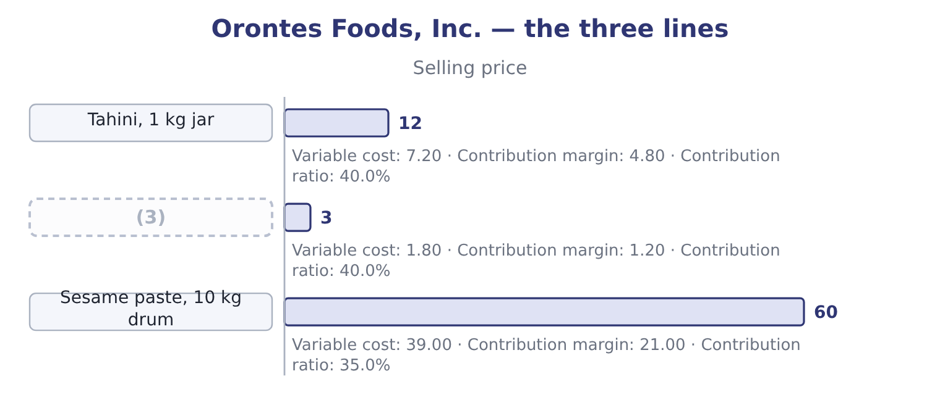
word list
Halva bar · product line

Summary 1 gaps 4–15
Two of the three earn the same ratio and very (4) amounts. A jar contributes four times what a bar does, and a drum contributes four times a jar. So a company that sells more drums earns more contribution for each unit sold, and a company that sells more bars earns less — (5) any question of ratio (6) . The drum, (7) , has the lowest ratio of the three: 21.00 ÷ 60.00 = 35.0 per cent (8) 40.0 for the other two. So a company that sells more drums earns less contribution for each dollar of sales. Those two (9) point in opposite (10) . Which one (11) depends on what is scarce. If (12) is measured in units — jars filled an hour, drums (13) a day — then contribution per unit is the ranking that counts, and the drum is the best product. If the (14) is the market rather than the (15) , so that the question is how much revenue the company can win, then contribution per sales dollar is the ranking that counts, and the jar and the bar are better. If some other resource is scarce — kilograms of sesame, hours on the roaster, square metres of warehouse — then neither ranking is right, and the correct one is contribution per unit of that resource.
word list
factory · handled · sentences · revenue · matters · capacity · constraint · arises · meanwhile · different · directions · against · before

The English this section uses, and its Arabic
Each term sits against what it means.
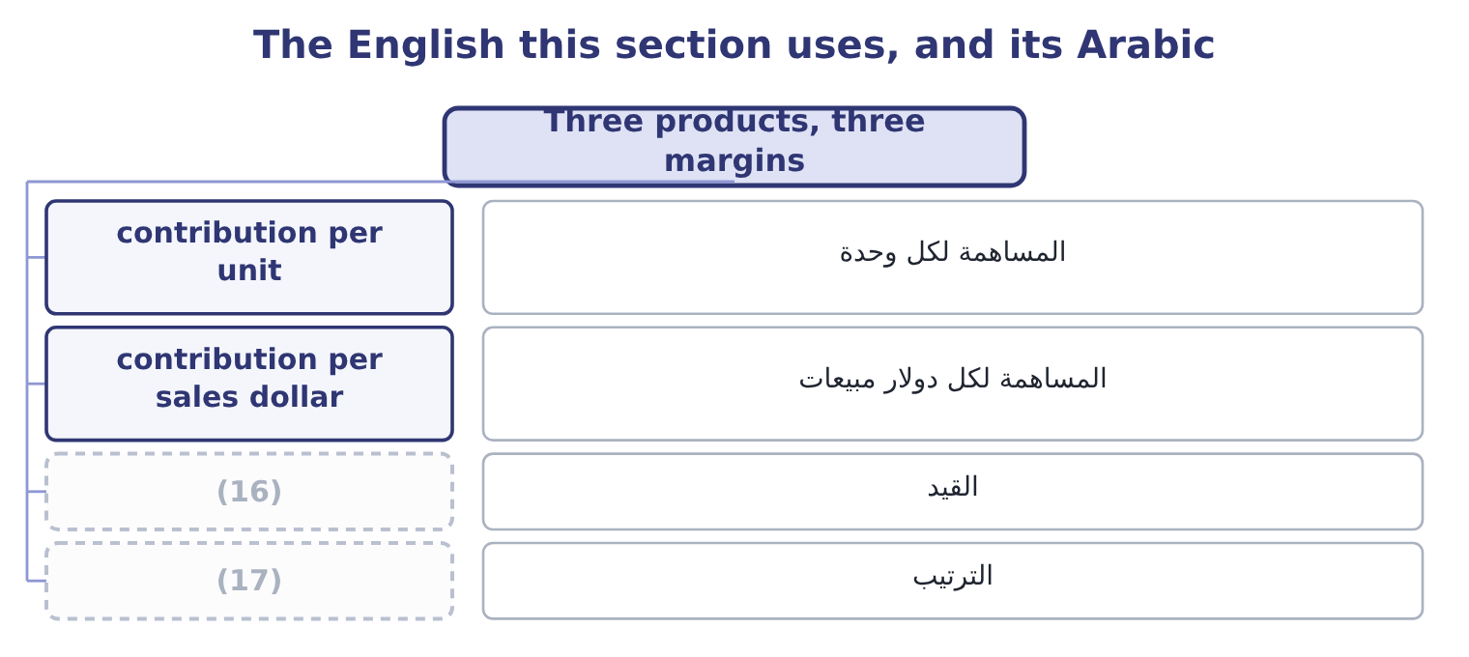
word list
weighting · ranking · constraint

The English this sheet uses, and its Arabic
English (exam term) | Arabic
contribution per unit | المساهمة لكل وحدة
contribution per sales dollar | المساهمة لكل دولار مبيعات
constraint | القيد
ranking | الترتيب

Answer key · 3.1 Three products, three margins

1 The weighted-average contribution margin | 10 directions
2 Why there is no unique breakeven | 11 matters
3 Halva bar | 12 capacity
4 different | 13 handled
5 before | 14 constraint
6 arises | 15 factory
7 meanwhile | 16 constraint
8 against | 17 ranking
9 sentences

the summaries in full
Summary 1 Two of the three earn the same ratio and very different amounts. A jar contributes four times what a bar does, and a drum contributes four times a jar. So a company that sells more drums earns more contribution for each unit sold, and a company that sells more bars earns less — before any question of ratio arises. The drum, meanwhile, has the lowest ratio of the three: 21.00 ÷ 60.00 = 35.0 per cent against 40.0 for the other two. So a company that sells more drums earns less contribution for each dollar of sales. Those two sentences point in opposite directions. Which one matters depends on what is scarce. If capacity is measured in units — jars filled an hour, drums handled a day — then contribution per unit is the ranking that counts, and the drum is the best product. If the constraint is the market rather than the factory, so that the question is how much revenue the company can win, then contribution per sales dollar is the ranking that counts, and the jar and the bar are better. If some other resource is scarce — kilograms of sesame, hours on the roaster, square metres of warehouse — then neither ranking is right, and the correct one is contribution per unit of that resource.

3.2 The weighted-average contribution margin
Chapter 3 · section 3.2

Fill every gap. Each word list holds one word more than there are gaps.
Summary 1 gaps 1–7
With a mix (1) , the three products can be (2) as one composite product — a bundle (3) the products in their usual proportions — and the (4) arithmetic. Orontes sells, in units, five jars and ten bars for every drum. So one bundle is 5 jars, 10 bars and 1 drum. Its contribution is 5 × 4.80 = 24.00 from the jars, 10 × 1.20 = 12.00 from the bars and 1 × 21.00 = 21.00 from the drum, which is 24.00 + 12.00 + 21.00 = 57.00 a bundle. Its revenue is 5 × 12.00 = 60.00, 10 × 3.00 = 30.00 and 1 × 60.00 = 60.00, which is 60.00 + 30.00 + 60.00 = 150.00 a bundle. The (5) contribution ratio is (6) 57.00 ÷ 150.00 = 38.0 per cent — between the 40 per cent of two products and the 35 per cent of the third, and nearer the 40 (7) the drum is only part of the bundle.
word list
because · ranking · therefore · assumed · single-product · treated · weighted-average · containing

Worked example: the breakeven of the bundle

Summary 2 gaps 8–17
The breakeven in bundles. Fixed costs over the bundle's contribution: 12,624,000 ÷ 57.00 = 221,474 bundles. The breakeven in units. Each bundle (8) five jars, ten bars and a drum, so the company (9) even at 5 × 221,474 = 1,107,370 jars, 10 × 221,474 = 2,214,740 bars and 221,474 drums. The breakeven in dollars. Either (10) the bundles by the bundle's revenue, 221,474 × 150.00 = 33,221,100, or (11) the fixed costs by the weighted ratio: 12,624,000 ÷ 0.38 = 33,221,053. The small (12) is rounding in the number of bundles. The company needs about $1,660,000 more sales to break even once the (13) drum is in the mix — which is the whole (14) of a mix in one number, and the (15) a breakeven (16) on the flagship product alone (17) the business.
word list
flatters · difference · bundle's · effect · reason · lower-margin · breaks · multiply · contains · divide · computed

Summary 3 gaps 18–21
A second route (18) the same place from sales (19) rather than unit ratios, and the exam uses it at least as often. In the bundle, the jars are 60.00 ÷ 150.00 = 40.0 per cent of revenue, the bars 30.00 ÷ 150.00 = 20.0 per cent and the drums 40.0 per cent. Weighting each (20) own contribution ratio by its share of sales: 0.40 × 40 = 16.0, 0.20 × 40 = 8.0 and 0.40 × 35 = 14.0, which is 16.0 + 8.0 + 14.0 = 38.0 per cent — the same weighted ratio, reached without ever (21) a bundle.
word list
constructing · reaches · percentages · bundle · product's

Two routes to the same weighted margin
Route | What is weighted | By what | Orontes
Composite unit | Contribution per unit | The unit mix, 5 : 10 : 1 | (22)
Sales percentage | Contribution ratio | (23) | 38.0 per cent

word list
contribution per sales dollar · The share of sales dollars · 57.00 a bundle, 38.0% of 150.00

Which mix is given

Summary 4 gaps 24–31
A mix in units is not a mix in dollars. Five jars to one drum is a unit mix of 5: 1 and a sales mix of 60: 60, which is 50: 50. Read which the question gives before weighting (24) . The weighted contribution (25) per bundle (26) a question in bundles. (27) back into units at the end, or the answer is in a unit (28) buys. The weighted ratio (29) lies between the (30) and lowest product ratios. An answer (31) that range is an arithmetic error.
word list
nobody · anything · Convert · answers · always · highest · products · outside · margin

The English this section uses, and its Arabic
Each term sits against what it means.
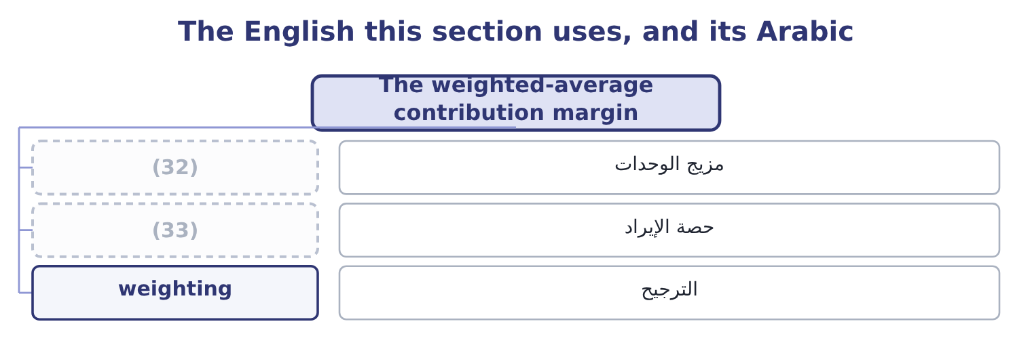
word list
pure case · unit mix · revenue share

The English this sheet uses, and its Arabic
English (exam term) | Arabic
unit mix | مزيج الوحدات
revenue share | حصة الإيراد
weighting | الترجيح

Answer key · 3.2 The weighted-average contribution margin

1 assumed | 18 reaches
2 treated | 19 percentages
3 containing | 20 product's
4 single-product | 21 constructing
5 weighted-average | 22 57.00 a bundle, 38.0% of 150.00
6 therefore | 23 The share of sales dollars
7 because | 24 anything
8 contains | 25 margin
9 breaks | 26 answers
10 multiply | 27 Convert
11 divide | 28 nobody
12 difference | 29 always
13 lower-margin | 30 highest
14 effect | 31 outside
15 reason | 32 unit mix
16 computed | 33 revenue share
17 flatters

the summaries in full
Summary 1 With a mix assumed, the three products can be treated as one composite product — a bundle containing the products in their usual proportions — and the single-product arithmetic. Orontes sells, in units, five jars and ten bars for every drum. So one bundle is 5 jars, 10 bars and 1 drum. Its contribution is 5 × 4.80 = 24.00 from the jars, 10 × 1.20 = 12.00 from the bars and 1 × 21.00 = 21.00 from the drum, which is 24.00 + 12.00 + 21.00 = 57.00 a bundle. Its revenue is 5 × 12.00 = 60.00, 10 × 3.00 = 30.00 and 1 × 60.00 = 60.00, which is 60.00 + 30.00 + 60.00 = 150.00 a bundle. The weighted-average contribution ratio is therefore 57.00 ÷ 150.00 = 38.0 per cent — between the 40 per cent of two products and the 35 per cent of the third, and nearer the 40 because the drum is only part of the bundle.
Summary 2 The breakeven in bundles. Fixed costs over the bundle's contribution: 12,624,000 ÷ 57.00 = 221,474 bundles. The breakeven in units. Each bundle contains five jars, ten bars and a drum, so the company breaks even at 5 × 221,474 = 1,107,370 jars, 10 × 221,474 = 2,214,740 bars and 221,474 drums. The breakeven in dollars. Either multiply the bundles by the bundle's revenue, 221,474 × 150.00 = 33,221,100, or divide the fixed costs by the weighted ratio: 12,624,000 ÷ 0.38 = 33,221,053. The small difference is rounding in the number of bundles. The company needs about $1,660,000 more sales to break even once the lower-margin drum is in the mix — which is the whole effect of a mix in one number, and the reason a breakeven computed on the flagship product alone flatters the business.
Summary 3 A second route reaches the same place from sales percentages rather than unit ratios, and the exam uses it at least as often. In the bundle, the jars are 60.00 ÷ 150.00 = 40.0 per cent of revenue, the bars 30.00 ÷ 150.00 = 20.0 per cent and the drums 40.0 per cent. Weighting each product's own contribution ratio by its share of sales: 0.40 × 40 = 16.0, 0.20 × 40 = 8.0 and 0.40 × 35 = 14.0, which is 16.0 + 8.0 + 14.0 = 38.0 per cent — the same weighted ratio, reached without ever constructing a bundle.
Summary 4 A mix in units is not a mix in dollars. Five jars to one drum is a unit mix of 5: 1 and a sales mix of 60: 60, which is 50: 50. Read which the question gives before weighting anything. The weighted contribution margin per bundle answers a question in bundles. Convert back into units at the end, or the answer is in a unit nobody buys. The weighted ratio always lies between the highest and lowest product ratios. An answer outside that range is an arithmetic error.

3.3 When the mix shifts
Chapter 3 · section 3.3

Fill every gap. Each word list holds one word more than there are gaps.
Summary 1 gaps 1–12
The reason the exam (1) there is no unique breakeven is that the whole (2) above rests on an assumption nobody (3) : that customers will go on buying in the same (4) . Suppose they do not. Suppose the bars sell (5) and the jars worse, so the mix becomes four jars and (6) bars to each drum. The (7) contribution becomes 4 × 4.80 = 19.20 from the jars, 12 × 1.20 = 14.40 from the bars and 21.00 from the drum, which is 19.20 + 14.40 + 21.00 = 54.60. Its revenue becomes 4 × 12.00 = 48.00, 12 × 3.00 = 36.00 and 60.00, which is 48.00 + 36.00 + 60.00 = 144.00. The weighted ratio becomes 54.60 ÷ 144.00 = 37.92 per cent, barely moved, and the breakeven in bundles becomes 12,624,000 ÷ 54.60 = 231,209 — nearly ten (8) bundles more than (9) . (10) about prices, costs or fixed costs (11) . Customers (12) one more bar and one less jar per bundle, and the company must now sell more to stand still.
word list
controls · bought · changed · calculation · missing · proportions · better · insists · twelve · Nothing · before · bundle's · thousand

The same products, four mixes
The bars are drawn to scale.
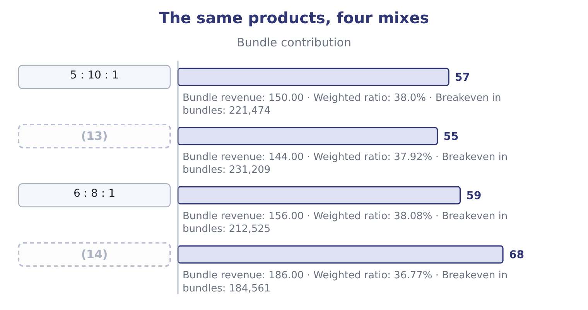
word list
5 : 10 : 1 · 3 : 10 : 2 · 4 : 12 : 1

Summary 2 gaps 15–26
Read the last two columns (15) and the lesson (16) . The weighted ratio barely moves (17) all four mixes — from 36.77 to 38.08 per cent — while the breakeven in bundles moves by more than (18) per cent. That is (19) a bundle is a (20) thing in each row: the fourth mix (21) two drums, so each bundle is larger and fewer are needed. Which is why the answer to "what is the breakeven" is (22) "in what mix", and why a (23) that gives a sales mix is giving an assumption rather than a fact. Three practical (24) , all examinable. A company can miss its profit target while (25) its sales target, if the mix moves towards the thinner (26) . The sales force is told to sell dollars and is paid on dollars, and the dollars arrive while the contribution does not.
word list
products · because · consequences · twenty · across · together · arrives · recommendation · always · question · contains · different · beating

Summary 3 gaps 27–32
A company can beat its profit target while (27) its sales target, by the same (28) in reverse. Book 1's (29) about judging a year by its top line applies here with a number (30) . And a (31) scheme paid on revenue (32) exactly the first outcome. A scheme paid on contribution margin aligns the sales force with the company, and is the standard recommendation in an exam answer on this topic.
word list
attached · weighting · warning · mechanism · commission · produces · missing

The English this section uses, and its Arabic
Each term sits against what it means.
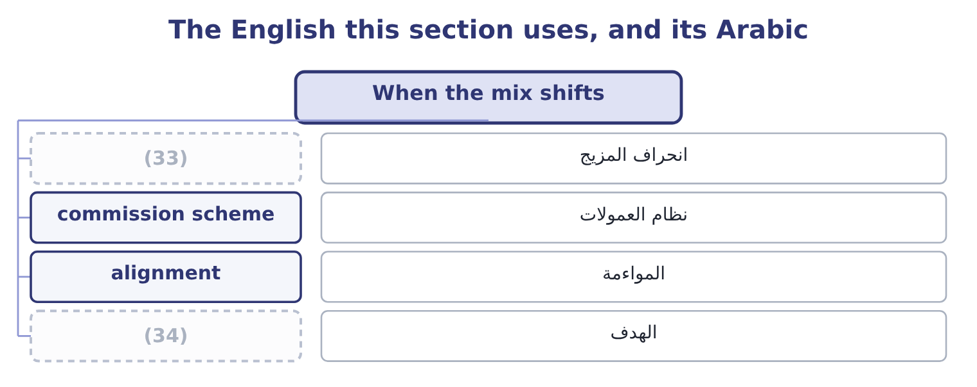
word list
mix variance · assumed constant · target

The English this sheet uses, and its Arabic
English (exam term) | Arabic
mix variance | انحراف المزيج
commission scheme | نظام العمولات
alignment | المواءمة
target | الهدف

Answer key · 3.3 When the mix shifts

1 insists | 18 twenty
2 calculation | 19 because
3 controls | 20 different
4 proportions | 21 contains
5 better | 22 always
6 twelve | 23 question
7 bundle's | 24 consequences
8 thousand | 25 beating
9 before | 26 products
10 Nothing | 27 missing
11 changed | 28 mechanism
12 bought | 29 warning
13 4 : 12 : 1 | 30 attached
14 3 : 10 : 2 | 31 commission
15 together | 32 produces
16 arrives | 33 mix variance
17 across | 34 target

the summaries in full
Summary 1 The reason the exam insists there is no unique breakeven is that the whole calculation above rests on an assumption nobody controls: that customers will go on buying in the same proportions. Suppose they do not. Suppose the bars sell better and the jars worse, so the mix becomes four jars and twelve bars to each drum. The bundle's contribution becomes 4 × 4.80 = 19.20 from the jars, 12 × 1.20 = 14.40 from the bars and 21.00 from the drum, which is 19.20 + 14.40 + 21.00 = 54.60. Its revenue becomes 4 × 12.00 = 48.00, 12 × 3.00 = 36.00 and 60.00, which is 48.00 + 36.00 + 60.00 = 144.00. The weighted ratio becomes 54.60 ÷ 144.00 = 37.92 per cent, barely moved, and the breakeven in bundles becomes 12,624,000 ÷ 54.60 = 231,209 — nearly ten thousand bundles more than before. Nothing about prices, costs or fixed costs changed. Customers bought one more bar and one less jar per bundle, and the company must now sell more to stand still.
Summary 2 Read the last two columns together and the lesson arrives. The weighted ratio barely moves across all four mixes — from 36.77 to 38.08 per cent — while the breakeven in bundles moves by more than twenty per cent. That is because a bundle is a different thing in each row: the fourth mix contains two drums, so each bundle is larger and fewer are needed. Which is why the answer to "what is the breakeven" is always "in what mix", and why a question that gives a sales mix is giving an assumption rather than a fact. Three practical consequences, all examinable. A company can miss its profit target while beating its sales target, if the mix moves towards the thinner products. The sales force is told to sell dollars and is paid on dollars, and the dollars arrive while the contribution does not.
Summary 3 A company can beat its profit target while missing its sales target, by the same mechanism in reverse. Book 1's warning about judging a year by its top line applies here with a number attached. And a commission scheme paid on revenue produces exactly the first outcome. A scheme paid on contribution margin aligns the sales force with the company, and is the standard recommendation in an exam answer on this topic.

3.4 Why there is no unique breakeven
Chapter 3 · section 3.4

Fill every gap. Each word list holds one word more than there are gaps.
Summary 1 gaps 1–12
The outcome asks for the explanation and not only the (1) , so here it is in its (2) form. (3) even means (4) $12,624,000 of fixed costs with contribution. Any combination of jars, bars and drums whose (5) add to that figure will do it, and there are infinitely many such (6) . Selling nothing but jars, the company needs 12,624,000 ÷ 4.80 = 2,630,000 jars, which is $31,560,000 of sales. Selling nothing but bars, it needs 12,624,000 ÷ 1.20 = 10,520,000 bars, which is also $31,560,000 of sales — the same, (7) the two products share a 40 per cent ratio. Selling nothing but drums, it needs 12,624,000 ÷ 21.00 = 601,143 drums, which is 601,143 × 60.00 = 36,068,580 of sales. So the breakeven in dollars is (8) between about $31,560,000 and 36,068,580, (9) entirely on what the company sells. There is no (10) number, and the one (11) in section 3.2 is the number for one assumed mix. That is the answer the exam wants, and the way to write it is in three (12) : the breakeven depends on the weighted contribution margin; the weighted margin depends on the mix; therefore each mix has its own breakeven, and a unique figure exists only when the mix is assumed constant.
word list
compound · because · calculation · sentences · combinations · depending · single · covering · anywhere · contributions · strongest · computed · Breaking

Orontes's breakeven, under four pure and mixed cases
The bars are drawn to scale.
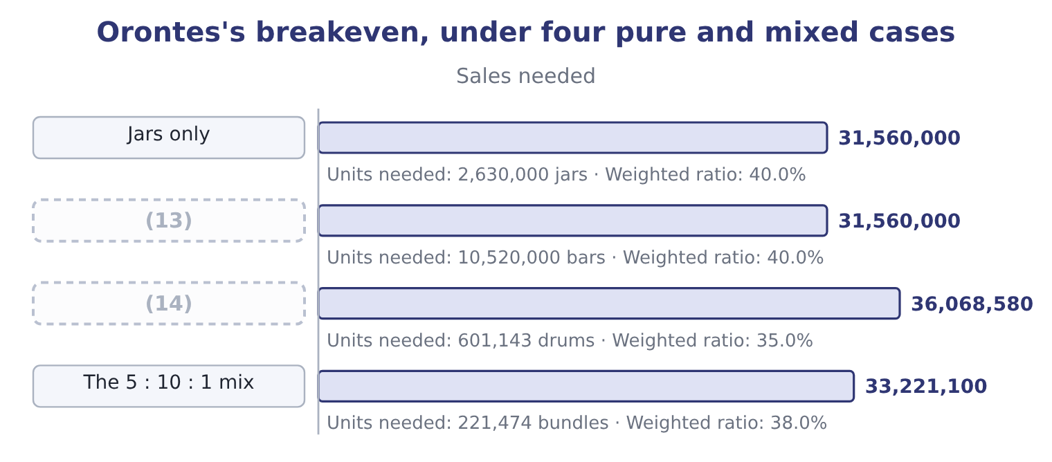
word list
Drums only · Bars only · composite unit

Summary 2 gaps 15–23
One more point (15) the outcome. A company with (16) products has a gross margin that moves when the mix moves, with no change in any (17) own margin — which is the third of the four (18) Book 1 listed for a margin change, and the one it said (19) forget. (20) gross margin fell from 37.0 to 35.0 per cent over three years. Part of that could be price and part could be input costs, and part could be nothing more than drums (21) faster than jars. The (22) own management accounts would show which; the published (23) never will.
word list
company's · causes · Orontes's · growing · statements · candidates · because · completes · several · product's

Weight a mix

Your turn: a two-product breakeven (complete the blanks)
Item | Data | Answer
Contribution per unit, product A | Price 25.00, variable cost 15.00 | 10.00: 25.00 − 15.00 = 10.00.
Contribution per unit, product B | (24) | 3.00: 10.00 − 7.00 = 3.00.
Bundle contribution | Mix of 2 A to 3 B | (25) : 2 × 10.00 = 20.00 from A and 3 × 3.00 = 9.00 from B.
Bundle revenue |  | (26) : 2 × 25.00 = 50.00 and 3 × 10.00 = 30.00.
Weighted contribution ratio |  | 36.25 per cent: 29.00 ÷ 80.00 = 36.25 per cent.
Breakeven in bundles | (27) | 40,000: fixed costs of 1,160,000 divided by the bundle contribution give 40,000 bundles.
Units of each at breakeven |  | (28) : 2 × 40,000 = 80,000 and 3 × 40,000 = 120,000.

word list
80.00 · Fixed costs 1,160,000 · 80,000 of A and 120,000 of B · 29.00 · 221,474 bundles · Price 10.00, variable cost 7.00

"Mix"

Summary 3 gaps 29–34
English mix in management (29) means the proportions in which things are sold or used, and it appears in three (30) the exam uses (31) explanation: sales mix, the proportions of products sold; product mix, often the same thing and (32) the range offered; and mix (33) , the part of a profit (34) caused by proportions rather than by volume or price. Read the compound, not the word.
word list
without · sometimes · variance · combinations · difference · compounds · accounting

The English this section uses, and its Arabic
Each term sits against what it means.
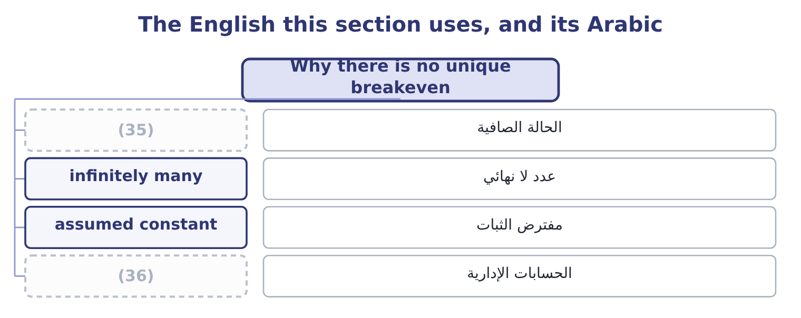
word list
product line · pure case · management accounts

The English this sheet uses, and its Arabic
English (exam term) | Arabic
pure case | الحالة الصافية
infinitely many | عدد لا نهائي
assumed constant | مفترض الثبات
management accounts | الحسابات الإدارية

Answer key · 3.4 Why there is no unique breakeven

1 calculation | 19 candidates
2 strongest | 20 Orontes's
3 Breaking | 21 growing
4 covering | 22 company's
5 contributions | 23 statements
6 combinations | 24 Price 10.00, variable cost 7.00
7 because | 25 29.00
8 anywhere | 26 80.00
9 depending | 27 Fixed costs 1,160,000
10 single | 28 80,000 of A and 120,000 of B
11 computed | 29 accounting
12 sentences | 30 compounds
13 Bars only | 31 without
14 Drums only | 32 sometimes
15 completes | 33 variance
16 several | 34 difference
17 product's | 35 pure case
18 causes | 36 management accounts

the summaries in full
Summary 1 The outcome asks for the explanation and not only the calculation, so here it is in its strongest form. Breaking even means covering $12,624,000 of fixed costs with contribution. Any combination of jars, bars and drums whose contributions add to that figure will do it, and there are infinitely many such combinations. Selling nothing but jars, the company needs 12,624,000 ÷ 4.80 = 2,630,000 jars, which is $31,560,000 of sales. Selling nothing but bars, it needs 12,624,000 ÷ 1.20 = 10,520,000 bars, which is also $31,560,000 of sales — the same, because the two products share a 40 per cent ratio. Selling nothing but drums, it needs 12,624,000 ÷ 21.00 = 601,143 drums, which is 601,143 × 60.00 = 36,068,580 of sales. So the breakeven in dollars is anywhere between about $31,560,000 and 36,068,580, depending entirely on what the company sells. There is no single number, and the one computed in section 3.2 is the number for one assumed mix. That is the answer the exam wants, and the way to write it is in three sentences: the breakeven depends on the weighted contribution margin; the weighted margin depends on the mix; therefore each mix has its own breakeven, and a unique figure exists only when the mix is assumed constant.
Summary 2 One more point completes the outcome. A company with several products has a gross margin that moves when the mix moves, with no change in any product's own margin — which is the third of the four causes Book 1 listed for a margin change, and the one it said candidates forget. Orontes's gross margin fell from 37.0 to 35.0 per cent over three years. Part of that could be price and part could be input costs, and part could be nothing more than drums growing faster than jars. The company's own management accounts would show which; the published statements never will.
Summary 3 English mix in management accounting means the proportions in which things are sold or used, and it appears in three compounds the exam uses without explanation: sales mix, the proportions of products sold; product mix, often the same thing and sometimes the range offered; and mix variance, the part of a profit difference caused by proportions rather than by volume or price. Read the compound, not the word.

4.1 The margin of safety
Chapter 4 · section 4.1

Fill every gap. Each word list holds one word more than there are gaps.
Chapter 4, section by section
Each stage leads to the next.
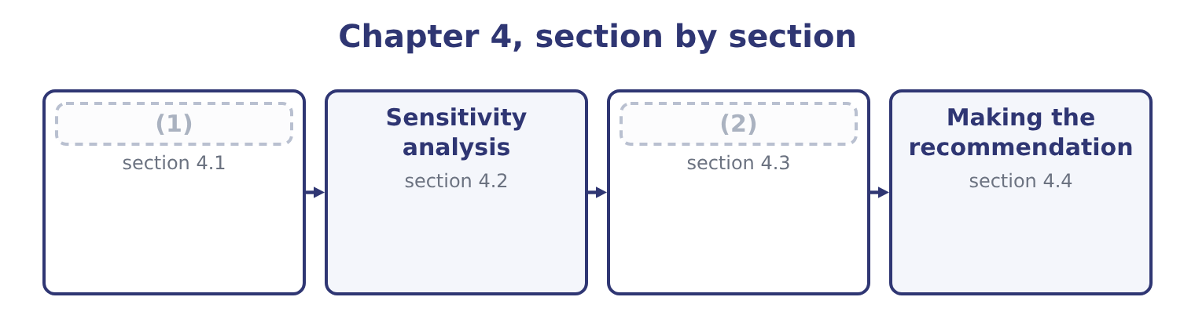
word list
margin of safety ratio · Choosing between cost structures · The margin of safety

Summary 1 gaps 3–13
The margin of safety is the amount by which sales (3) the breakeven. Below that amount the company still makes money; past it, it does not. For Orontes on the (4) figures: 42,000,000 − 31,560,000 = 10,440,000 of sales, which as a (5) is 10,440,000 ÷ 42,000,000 = 24.86 per cent. In units it is 3,500,000 − 2,630,000 = 870,000 jars. So Orontes can lose a quarter of its sales (6) it loses money. That is a usable (7) for a board, and it is the single most (8) figure in Section C, (9) it converts a cost (10) into a statement about risk. On the three-product mix: the breakeven is 33,221,100 of sales, so the margin of safety is 42,000,000 − 33,221,100 = 8,778,900, which is 8,778,900 ÷ 42,000,000 = 20.90 per cent. Four (11) of safety disappear once the (12) drum is in the mix, which is the mix (13) .
word list
exceed · proportion · sentence · before · points · structure · because · effect · useful · single-product · lower-margin · simulation

Summary 2 gaps 14–25
Three (14) of the ratio, all (15) . A high margin of safety means a company can (16) a bad year. A low one means a small fall in (17) turns a profit into a loss. The margin of safety and the degree of operating leverage are the same fact from two (18) . Orontes's leverage of 4.02 says a 10 per cent sales fall costs 40 per cent of the profit; its margin of safety of 24.86 per cent says the profit (19) entirely at a fall of about a quarter. Both come from the same two (20) , the contribution margin and the fixed costs, and the exam may ask for (21) . A margin of safety is (22) only against the mix and the (23) range assumed. A company that would shed fixed costs if (24) fell by a quarter has a larger true margin than the (25) shows.
word list
demand · readings · either · disappears · arithmetic · leverage · examinable · numbers · relevant · absorb · meaningful · volume · directions

Margin of safety, two companies
Measure | Orontes, single product | Orontes, three-product mix | Barada
Sales | 42,000,000 | 42,000,000 | 21,978,000
Breakeven sales | 31,560,000 | 33,221,100 | 17,328,000
Margin of safety | 10,440,000 | 8,778,900 | 4,650,000
(26) | 24.86% | 20.90% | 21.16%
(27) | 4.02 | 4.02 | 4.73

word list
silence of the model · Degree of operating leverage · Margin of safety ratio

Summary 3 gaps 28–33
Barada's (28) repays a second look. Its margin of safety ratio of 21.16 per cent looks much like Orontes's, and its operating leverage of 4.73 is worse — and the figure that (29) most is in (30) column: its contribution margin ratio is 12 per cent against Orontes's 40. Barada has to replace eight (31) of lost sales to (32) one dollar of lost contribution, where Orontes (33) two and a half. A margin of safety says how far away the cliff is; it does not say how hard the climb back up would be.
word list
matters · dollars · position · scenario · neither · recover · replaces

The English this section uses, and its Arabic
Each term sits against what it means.
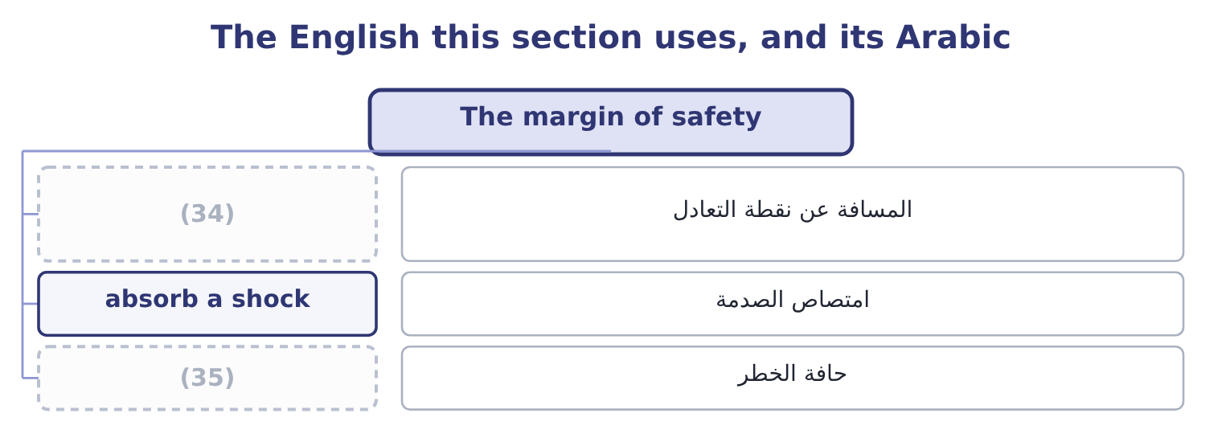
word list
distance from breakeven · cliff edge · pessimistic case

The English this sheet uses, and its Arabic
English (exam term) | Arabic
distance from breakeven | المسافة عن نقطة التعادل
absorb a shock | امتصاص الصدمة
cliff edge | حافة الخطر

Answer key · 4.1 The margin of safety

1 The margin of safety | 19 disappears
2 Choosing between cost structures | 20 numbers
3 exceed | 21 either
4 single-product | 22 meaningful
5 proportion | 23 relevant
6 before | 24 volume
7 sentence | 25 arithmetic
8 useful | 26 Margin of safety ratio
9 because | 27 Degree of operating leverage
10 structure | 28 position
11 points | 29 matters
12 lower-margin | 30 neither
13 effect | 31 dollars
14 readings | 32 recover
15 examinable | 33 replaces
16 absorb | 34 distance from breakeven
17 demand | 35 cliff edge
18 directions

the summaries in full
Summary 1 The margin of safety is the amount by which sales exceed the breakeven. Below that amount the company still makes money; past it, it does not. For Orontes on the single-product figures: 42,000,000 − 31,560,000 = 10,440,000 of sales, which as a proportion is 10,440,000 ÷ 42,000,000 = 24.86 per cent. In units it is 3,500,000 − 2,630,000 = 870,000 jars. So Orontes can lose a quarter of its sales before it loses money. That is a usable sentence for a board, and it is the single most useful figure in Section C, because it converts a cost structure into a statement about risk. On the three-product mix: the breakeven is 33,221,100 of sales, so the margin of safety is 42,000,000 − 33,221,100 = 8,778,900, which is 8,778,900 ÷ 42,000,000 = 20.90 per cent. Four points of safety disappear once the lower-margin drum is in the mix, which is the mix effect.
Summary 2 Three readings of the ratio, all examinable. A high margin of safety means a company can absorb a bad year. A low one means a small fall in demand turns a profit into a loss. The margin of safety and the degree of operating leverage are the same fact from two directions. Orontes's leverage of 4.02 says a 10 per cent sales fall costs 40 per cent of the profit; its margin of safety of 24.86 per cent says the profit disappears entirely at a fall of about a quarter. Both come from the same two numbers, the contribution margin and the fixed costs, and the exam may ask for either. A margin of safety is meaningful only against the mix and the relevant range assumed. A company that would shed fixed costs if volume fell by a quarter has a larger true margin than the arithmetic shows.
Summary 3 Barada's position repays a second look. Its margin of safety ratio of 21.16 per cent looks much like Orontes's, and its operating leverage of 4.73 is worse — and the figure that matters most is in neither column: its contribution margin ratio is 12 per cent against Orontes's 40. Barada has to replace eight dollars of lost sales to recover one dollar of lost contribution, where Orontes replaces two and a half. A margin of safety says how far away the cliff is; it does not say how hard the climb back up would be.

4.2 Sensitivity analysis
Chapter 4 · section 4.2

Fill every gap. Each word list holds one word more than there are gaps.
Summary 1 gaps 1–12
The price is a (1) , the variable cost depends on the sesame market, the fixed costs depend on (2) not yet taken, and the volume is the least certain of the four. (3) analysis asks how much the (4) depends on each. Three (5) , in rising order of (6) , and the exam names all three. Change a (7) input by a stated amount and see what (8) . The output is a (9) of what matters. Change several inputs together in a way that makes a (10) story — a bad year has lower volume and lower prices and (11) higher input costs, because they tend to arrive together. (12) analysis cannot capture that, and a scenario can. Assign a distribution to each input and let a computer draw thousands of combinations, producing a distribution of outcomes rather than three.
word list
ranking · variable · conclusion · Sensitivity · coherent · probably · decisions · happens · techniques · forecast · One-at-a-time · single · effort

Worked example: three scenarios for Orontes

Summary 2 gaps 13–19
Volume falls 10 per cent to 3,150,000 jars and the price is cut 2 per cent to $11.76, so the margin (13) 11.76 − 7.20 = 4.56. Contribution is 3,150,000 × 4.56 = 14,364,000 and operating income is 14,364,000 − 12,624,000 = 1,740,000. Volume rises 8 per cent to 3,780,000 jars at a price 2 per cent higher, $12.24, so the margin is 12.24 − 7.20 = 5.04. Contribution is 3,780,000 × 5.04 = 19,051,200 and operating income is 19,051,200 − 12,624,000 = 6,427,200. At probabilities of 0.25, 0.50 and 0.25: 0.25 × 1,740,000 = 435,000, 0.50 × 4,176,000 = 2,088,000 and 0.25 × 6,427,200 = 1,606,800, which add to 435,000 + 2,088,000 + 1,606,800 = 4,129,800. The expected value is close to the base case and the spread around it is (14) : from $1,740,000 to $6,427,200, a range (15) as large as the expected value itself. That spread is the finding, not the (16) , and an answer that (17) only the $4,129,800 has (18) the thing the board (19) to know — which is.
word list
needed · nearly · expectation · producing · quotes · becomes · hidden · enormous

Three scenarios, one cost structure
The bars are drawn to scale.
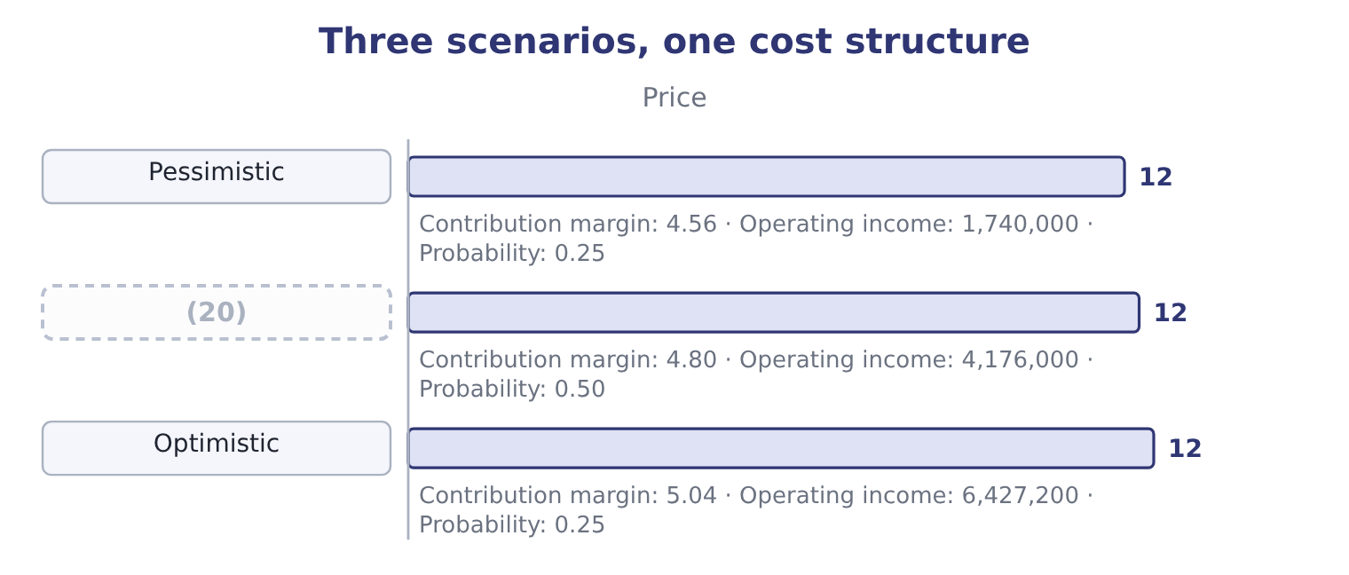
word list
Base · checklist

Scenarios and single variables

Summary 3 gaps 21–26
A scenario (21) several inputs together. Changing one at a time and adding the results (22) and usually (23) the range. An expected value is not an (24) . It is a (25) average of outcomes, and it may itself be (26) . Where a question gives probabilities, use them; where it does not, present the range and say which end you regard as more likely and why.
word list
double-counts · operating · outcome · impossible · weighted · changes · overstates

The English this section uses, and its Arabic
Each term sits against what it means.
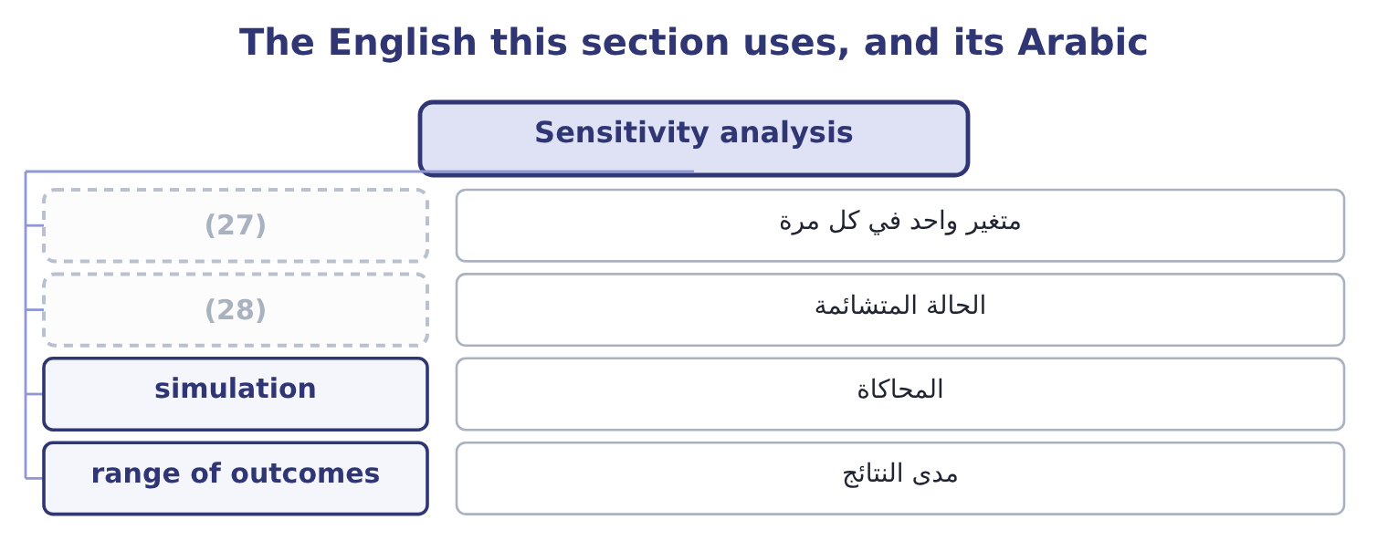
word list
cliff edge · pessimistic case · one-at-a-time

The English this sheet uses, and its Arabic
English (exam term) | Arabic
one-at-a-time | متغير واحد في كل مرة
pessimistic case | الحالة المتشائمة
simulation | المحاكاة
range of outcomes | مدى النتائج

Answer key · 4.2 Sensitivity analysis

1 forecast | 15 nearly
2 decisions | 16 expectation
3 Sensitivity | 17 quotes
4 conclusion | 18 hidden
5 techniques | 19 needed
6 effort | 20 Base
7 single | 21 changes
8 happens | 22 double-counts
9 ranking | 23 overstates
10 coherent | 24 outcome
11 probably | 25 weighted
12 One-at-a-time | 26 impossible
13 becomes | 27 one-at-a-time
14 enormous | 28 pessimistic case

the summaries in full
Summary 1 The price is a forecast, the variable cost depends on the sesame market, the fixed costs depend on decisions not yet taken, and the volume is the least certain of the four. Sensitivity analysis asks how much the conclusion depends on each. Three techniques, in rising order of effort, and the exam names all three. Change a single input by a stated amount and see what happens. The output is a ranking of what matters. Change several inputs together in a way that makes a coherent story — a bad year has lower volume and lower prices and probably higher input costs, because they tend to arrive together. One-at-a-time analysis cannot capture that, and a scenario can. Assign a distribution to each input and let a computer draw thousands of combinations, producing a distribution of outcomes rather than three.
Summary 2 Volume falls 10 per cent to 3,150,000 jars and the price is cut 2 per cent to $11.76, so the margin becomes 11.76 − 7.20 = 4.56. Contribution is 3,150,000 × 4.56 = 14,364,000 and operating income is 14,364,000 − 12,624,000 = 1,740,000. Volume rises 8 per cent to 3,780,000 jars at a price 2 per cent higher, $12.24, so the margin is 12.24 − 7.20 = 5.04. Contribution is 3,780,000 × 5.04 = 19,051,200 and operating income is 19,051,200 − 12,624,000 = 6,427,200. At probabilities of 0.25, 0.50 and 0.25: 0.25 × 1,740,000 = 435,000, 0.50 × 4,176,000 = 2,088,000 and 0.25 × 6,427,200 = 1,606,800, which add to 435,000 + 2,088,000 + 1,606,800 = 4,129,800. The expected value is close to the base case and the spread around it is enormous: from $1,740,000 to $6,427,200, a range nearly as large as the expected value itself. That spread is the finding, not the expectation, and an answer that quotes only the $4,129,800 has hidden the thing the board needed to know — which is.
Summary 3 A scenario changes several inputs together. Changing one at a time and adding the results double-counts and usually overstates the range. An expected value is not an outcome. It is a weighted average of outcomes, and it may itself be impossible. Where a question gives probabilities, use them; where it does not, present the range and say which end you regard as more likely and why.

4.3 Choosing between cost structures
Chapter 4 · section 4.3

Fill every gap. Each word list holds one word more than there are gaps.
Summary 1 gaps 1–8
A (1) kind of recommendation recurs in this topic: two ways of doing the same thing, with (2) mixes of fixed and variable cost. (3) or not; employing a salaried sales force or paying (4) ; owning a fleet or using a carrier; renting a warehouse or paying per pallet. In every case one (5) has higher fixed costs and a higher contribution margin, and the other the (6) . The (7) is which is better, and the answer always (8) on volume. The volume at which the two are equally good is the indifference point.
word list
particular · reverse · option · recommendation · commission · Automating · depends · question · different

Worked example: the indifference volume

Summary 2 gaps 9–19
Orontes can (9) as it is, with a contribution margin of $4.80 and fixed costs of $12,624,000, or (10) .30 and fixed costs of $14,124,000. Automation adds 14,124,000 − 12,624,000 = 1,500,000 of fixed cost and 5.30 − 4.80 = 0.50 of contribution a jar. The extra margin must cover the extra fixed cost: 1,500,000 ÷ 0.50 = 3,000,000 jars. Above 3,000,000 jars automation earns more; below it, the (11) structure does. Orontes sells 3,500,000, so automation is the better choice at (12) volume — by 500,000 × 0.50 = 250,000 a year, which is the figure. The (13) is not the $250,000; it is the 3,000,000. The company is 500,000 jars above the indifference point, which is 14 per cent of its volume, and its margin of safety under the automated structure would fall from 24.86 per cent to 14,124,000 ÷ 5.30 = 2,664,906 jars of breakeven, which on 3,500,000 jars is a margin of safety of about 24 per cent. The gain is real and (14) and it is bought with a (15) higher breakeven in a company whose gross margin is (16) . Stating that (17) is the recommendation; (18) the $250,000 is only the (19) .
word list
falling · recommendation · computing · automate · continue · trade-off · decision · modest · arithmetic · present · permanently · current

High fixed against high variable
 | Higher fixed, higher margin | Higher variable, lower margin
Breakeven | Higher | Lower
Profit at high volume | Higher | Lower
Loss at low volume | (20) | Smaller
Margin of safety | (21) | Higher
Suits | Stable, predictable demand | (22)

word list
Smaller · Volatile or uncertain demand · Lower, for the same sales · Larger

The English this section uses, and its Arabic
Each term sits against what it means.
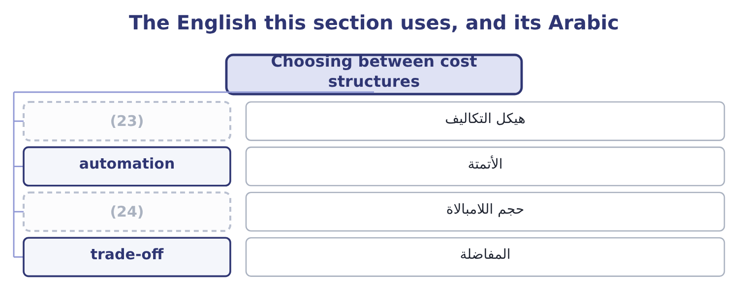
word list
expected value · indifference volume · cost structure

The English this sheet uses, and its Arabic
English (exam term) | Arabic
cost structure | هيكل التكاليف
automation | الأتمتة
indifference volume | حجم اللامبالاة
trade-off | المفاضلة

Answer key · 4.3 Choosing between cost structures

1 particular | 13 decision
2 different | 14 modest
3 Automating | 15 permanently
4 commission | 16 falling
5 option | 17 trade-off
6 reverse | 18 computing
7 question | 19 arithmetic
8 depends | 20 Larger
9 continue | 21 Lower, for the same sales
10 automate | 22 Volatile or uncertain demand
11 present | 23 cost structure
12 current | 24 indifference volume

the summaries in full
Summary 1 A particular kind of recommendation recurs in this topic: two ways of doing the same thing, with different mixes of fixed and variable cost. Automating or not; employing a salaried sales force or paying commission; owning a fleet or using a carrier; renting a warehouse or paying per pallet. In every case one option has higher fixed costs and a higher contribution margin, and the other the reverse. The question is which is better, and the answer always depends on volume. The volume at which the two are equally good is the indifference point.
Summary 2 Orontes can continue as it is, with a contribution margin of $4.80 and fixed costs of $12,624,000, or automate.30 and fixed costs of $14,124,000. Automation adds 14,124,000 − 12,624,000 = 1,500,000 of fixed cost and 5.30 − 4.80 = 0.50 of contribution a jar. The extra margin must cover the extra fixed cost: 1,500,000 ÷ 0.50 = 3,000,000 jars. Above 3,000,000 jars automation earns more; below it, the present structure does. Orontes sells 3,500,000, so automation is the better choice at current volume — by 500,000 × 0.50 = 250,000 a year, which is the figure. The decision is not the $250,000; it is the 3,000,000. The company is 500,000 jars above the indifference point, which is 14 per cent of its volume, and its margin of safety under the automated structure would fall from 24.86 per cent to 14,124,000 ÷ 5.30 = 2,664,906 jars of breakeven, which on 3,500,000 jars is a margin of safety of about 24 per cent. The gain is real and modest and it is bought with a permanently higher breakeven in a company whose gross margin is falling. Stating that trade-off is the recommendation; computing the $250,000 is only the arithmetic.

4.4 Making the recommendation
Chapter 4 · section 4.4

Fill every gap. Each word list holds one word more than there are gaps.
Summary 1 gaps 1–12
The (1) asks for a (2) of action, and an answer that stops at a number does not give one. Five (3) turn an analysis into a recommendation, and they are worth learning as a (4) because the exam rewards each of them. A marker (5) not have to (6) for the answer. (7) it with the number that (8) it. Not every number (9) — the one that (10) . For the automation (11) that is the indifference volume of 3,000,000 jars against actual volume of 3,500,000, not the $250,000 of (12) gain. Name what the decision depends on. Say which one would reverse the answer if it failed, and at what value. Give the qualitative factors their place. The numbers do not capture the effect of automation on a workforce, on flexibility, on the ability to make small batches, or on a supplier relationship.
word list
outcome · annual · should · course · search · computed · decides · drives · checklist · trade-off · elements · question · Support

Summary 2 gaps 13–15
Say what you would do next. Test the volume (13) with the sales force, obtain a second (14) for the equipment, run the decision again at the pessimistic scenario. A recommendation with a next step is a recommendation (15) can act on.
word list
trade-off · quotation · somebody · assumption

A recommendation, in five parts
Element | For the automation decision
The decision | Automate, subject to the volume test below
The deciding number | (16) of 3,000,000 jars against 3,500,000 actual
What it depends on | Volume staying above 3,000,000; the (17) costing what was quoted
What would reverse it | A fall of more than 14 per cent in volume, or fixed costs above 15,300,000
The qualitative factors | Loss of flexibility in small batches; effect on the packing workforce
The next step | Re-run at the pessimistic (18) of 3,150,000 jars before committing

word list
scenario · equipment · automation · Indifference volume

Summary 3 gaps 19–24
One last habit (19) the chapter, and it is the one that most (20) a professional answer. Say what the analysis does not show. (21) analysis is silent about the (22) response, about what the customers will think of a price change, about whether the sales force can deliver the volume, and about everything beyond the relevant range. A (23) who names the silence is telling a marker that the model is (24) , not merely applied.
word list
candidate · distinguishes · understood · competitor's · elements · closes · Cost-volume-profit

Measure the safety and choose

Your turn: safety and structure (complete the blanks)
Item | Data | Answer
Breakeven in sales | (25) | ________
Margin of safety | Sales 12,000,000 | ________
Margin of safety ratio |  | ________
Operating income |  | ________
Indifference volume against a structure with 900,000 more fixed cost and 1.50 more contribution a unit |  | ________
Which structure at 700,000 units |  | ________

word list
Fixed costs 2,400,000, contribution ratio 30 per cent · Indifference volume of 3,000,000 jars against 3,500,000 actual

"Sensitivity"

Summary 4 gaps 26–29
English (26) analysis means testing how much an answer changes when an input changes, and the word carries no (27) of delicacy or of feeling. The (28) phrase sensitive to is used of the answer, not of the (29) : an answer is sensitive to volume if volume moves it a great deal.
word list
related · suggestion · analyst · checklist · sensitivity

"Sensitivity"
Item | Answer
Breakeven in sales | 8,000,000: 2,400,000 ÷ 0.30 = 8,000,000.
Margin of safety | (30)
Margin of safety ratio | (31)
Operating income | 1,200,000: contribution is 12,000,000 × 0.30 = 3,600,000, less fixed costs of 2,400,000.
Indifference volume | (32) : 900,000 ÷ 1.50 = 600,000.
Which structure at 700,000 units | The higher-fixed structure, because 700,000 is above the indifference volume of 600,000 — it earns 100,000 × 1.50 = 150,000 more a year.
What it tells you | The company has a third of its sales as safety and sits 100,000 units above the point at which the heavier structure pays. Both margins are

word list
Breakeven in sales · 33.3 per cent: 4,000,000 ÷ 12,000,000 = 33.3 per cent. · 4,000,000: 12,000,000 − 8,000,000 = 4,000,000. · 600,000 units

The English this section uses, and its Arabic
Each term sits against what it means.
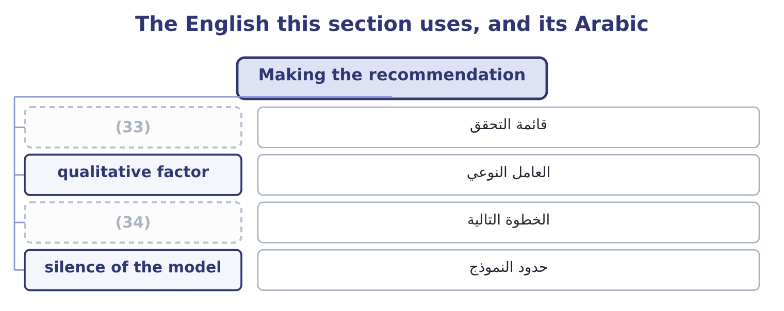
word list
expected value · next step · checklist

The English this sheet uses, and its Arabic
English (exam term) | Arabic
checklist | قائمة التحقق
qualitative factor | العامل النوعي
next step | الخطوة التالية
silence of the model | حدود النموذج

Answer key · 4.4 Making the recommendation

1 outcome | 18 scenario
2 course | 19 closes
3 elements | 20 distinguishes
4 checklist | 21 Cost-volume-profit
5 should | 22 competitor's
6 search | 23 candidate
7 Support | 24 understood
8 drives | 25 Fixed costs 2,400,000, contribution ratio 30 per cent
9 computed | 26 sensitivity
10 decides | 27 suggestion
11 question | 28 related
12 annual | 29 analyst
13 assumption | 30 4,000,000: 12,000,000 − 8,000,000 = 4,000,000.
14 quotation | 31 33.3 per cent: 4,000,000 ÷ 12,000,000 = 33.3 per cent.
15 somebody | 32 600,000 units
16 Indifference volume | 33 checklist
17 equipment | 34 next step

the summaries in full
Summary 1 The outcome asks for a course of action, and an answer that stops at a number does not give one. Five elements turn an analysis into a recommendation, and they are worth learning as a checklist because the exam rewards each of them. A marker should not have to search for the answer. Support it with the number that drives it. Not every number computed — the one that decides. For the automation question that is the indifference volume of 3,000,000 jars against actual volume of 3,500,000, not the $250,000 of annual gain. Name what the decision depends on. Say which one would reverse the answer if it failed, and at what value. Give the qualitative factors their place. The numbers do not capture the effect of automation on a workforce, on flexibility, on the ability to make small batches, or on a supplier relationship.
Summary 2 Say what you would do next. Test the volume assumption with the sales force, obtain a second quotation for the equipment, run the decision again at the pessimistic scenario. A recommendation with a next step is a recommendation somebody can act on.
Summary 3 One last habit closes the chapter, and it is the one that most distinguishes a professional answer. Say what the analysis does not show. Cost-volume-profit analysis is silent about the competitor's response, about what the customers will think of a price change, about whether the sales force can deliver the volume, and about everything beyond the relevant range. A candidate who names the silence is telling a marker that the model is understood, not merely applied.
Summary 4 English sensitivity analysis means testing how much an answer changes when an input changes, and the word carries no suggestion of delicacy or of feeling. The related phrase sensitive to is used of the answer, not of the analyst: an answer is sensitive to volume if volume moves it a great deal.

5.1 The two tests
Chapter 5 · section 5.1

Fill every gap. Each word list holds one word more than there are gaps.
Chapter 5, section by section
Each stage leads to the next.
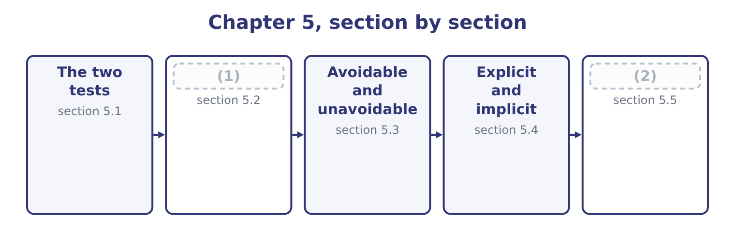
word list
The two tests · Sunk costs · Putting it to work

Summary 1 gaps 3–14
A cost or a (3) is relevant to a decision if it passes both of these tests. It lies in the future. A decision taken today can change what happens from today (4) and nothing that (5) before. Money already spent is spent (6) is chosen. It (7) between the alternatives. If a cost is the same under every (8) , including it changes every total by the same amount and changes no (9) . Including it is not wrong, (10) — it wastes effort and (11) error. Both tests must be (12) . A future cost that does not differ is irrelevant; a differing cost that is already (13) is irrelevant. The exam's (14) trap is a cost that passes one test loudly and fails the other quietly. Two further names describe the same idea from different angles, and the outcome asks for them.
word list
differs · ranking · onwards · apportionment · favourite · revenue · exactly · happened · invites · passed · option · incurred · whatever

Summary 2 gaps 15–19
An (15) cost, also called a (16) cost, is the difference in total cost between two alternatives. It is the relevant amount (17) as a number (18) than as a test. A (19) cost is the cost of one more unit. In most exam settings it equals the variable cost per unit, and the two words are used interchangeably at this level.
word list
rather · differential · incremental · stated · marginal · onwards

Relevant or not, for a decision to discontinue the halva bar
Every item belongs to exactly one group.
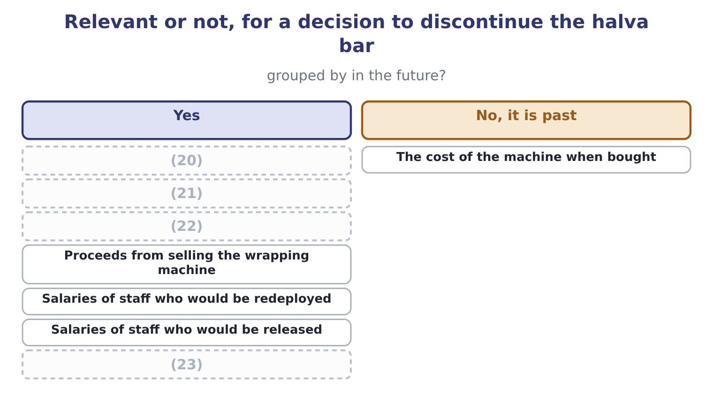
word list
The bar's share of factory rent · Sesame used in bars · Contribution from bar sales · Depreciation on the bar wrapping machine · Proceeds from selling the wrapping machine

Both tests, every time

Summary 3 gaps 24–32
Depreciation is never relevant in itself. It is the (24) of a past payment, so it fails the first test. What is relevant about an owned asset is what else could be done with it — sold, or used (25) — which is section 5.4's (26) . An (27) share of a (28) cost is almost never relevant. The (29) is not how the cost is shared but (30) the total changes. A cost can be relevant for one decision and irrelevant for (31) , with no change in the cost itself. (32) is a property of the decision, not of the cost.
word list
another · whether · including · allocated · spreading · Relevance · question · elsewhere · common · subject

The English this section uses, and its Arabic
Each term sits against what it means.
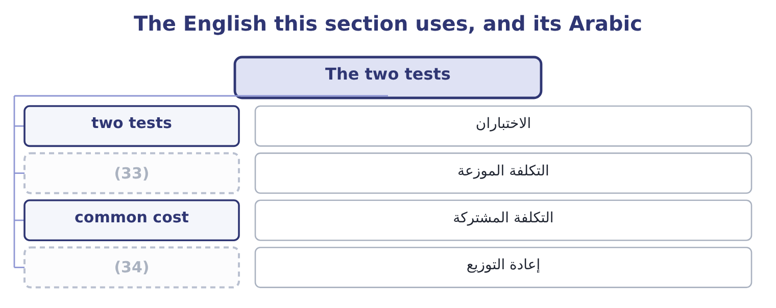
word list
redeployment · الاختباران · allocated cost

The English this sheet uses, and its Arabic
English (exam term) | Arabic
two tests | الاختباران
allocated cost | التكلفة الموزعة
common cost | التكلفة المشتركة
redeployment | إعادة التوزيع

Answer key · 5.1 The two tests

1 Sunk costs | 18 rather
2 Putting it to work | 19 marginal
3 revenue | 20 Sesame used in bars
4 onwards | 21 The bar's share of factory rent
5 happened | 22 Depreciation on the bar wrapping machine
6 whatever | 23 Contribution from bar sales
7 differs | 24 spreading
8 option | 25 elsewhere
9 ranking | 26 subject
10 exactly | 27 allocated
11 invites | 28 common
12 passed | 29 question
13 incurred | 30 whether
14 favourite | 31 another
15 incremental | 32 Relevance
16 differential | 33 allocated cost
17 stated | 34 redeployment

the summaries in full
Summary 1 A cost or a revenue is relevant to a decision if it passes both of these tests. It lies in the future. A decision taken today can change what happens from today onwards and nothing that happened before. Money already spent is spent whatever is chosen. It differs between the alternatives. If a cost is the same under every option, including it changes every total by the same amount and changes no ranking. Including it is not wrong, exactly — it wastes effort and invites error. Both tests must be passed. A future cost that does not differ is irrelevant; a differing cost that is already incurred is irrelevant. The exam's favourite trap is a cost that passes one test loudly and fails the other quietly. Two further names describe the same idea from different angles, and the outcome asks for them.
Summary 2 An incremental cost, also called a differential cost, is the difference in total cost between two alternatives. It is the relevant amount stated as a number rather than as a test. A marginal cost is the cost of one more unit. In most exam settings it equals the variable cost per unit, and the two words are used interchangeably at this level.
Summary 3 Depreciation is never relevant in itself. It is the spreading of a past payment, so it fails the first test. What is relevant about an owned asset is what else could be done with it — sold, or used elsewhere — which is section 5.4's subject. An allocated share of a common cost is almost never relevant. The question is not how the cost is shared but whether the total changes. A cost can be relevant for one decision and irrelevant for another, with no change in the cost itself. Relevance is a property of the decision, not of the cost.

5.2 Sunk costs
Chapter 5 · section 5.2

Fill every gap. Each word list holds one word more than there are gaps.
Summary 1 gaps 1–12
A sunk cost is a cost already incurred that cannot be (1) by any choice now (2) . It fails the first test (3) , and the outcome asks (4) why. The reason is that a decision (5) the future and the past is (6) under every option. Suppose Orontes spent $300,000 on a (7) packaging film for a product line it is now (8) . (9) the line continues or stops, the $300,000 has gone. It appears in (10) column of the (11) , so it cannot favour either. What is relevant about the film is what can still be done with it. If it can be sold for $40,000, that $40,000 is relevant because it is (12) under one option and not the other. If it can be used on another line, saving $180,000 of purchases that would otherwise be made, that saving is relevant. And the choice between those two uses is itself a decision: using the film saves $180,000 and forgoes the $40,000 scrap, so the net benefit of using it is 180,000 − 40,000 = 140,000.
word list
packaging · available · reconsidering · specialised · Whether · receivable · recovered · specifically · comparison · absolutely · neither · changes · identical

Summary 2 gaps 13–21
The original $300,000 appears (13) in any of that (14) . Why (15) and managers include it anyway is worth naming, because the exam sometimes asks for the (16) point. It is called the sunk cost fallacy, or (17) good money after bad: having spent $300,000, a manager feels that (18) the line wastes it, and continues in order to justify the original decision. The (19) is wasted either way; (20) merely adds to it. The (21) is to ask what the choice is from here, which is also the only question a reader of the accounts can answer next year.
word list
discipline · abandoning · nowhere · identical · candidates · spending · continuing · throwing · arithmetic · behavioural

Worked example: replacing a machine

Summary 3 gaps 22–33
Orontes owns a (22) machine bought four years ago for $1,200,000, now (23) in the books at $700,000. A new machine costs $900,000 and would save $350,000 a year of (24) costs for four years. The old machine could be sold today for $250,000 and has no value at the end of the four years. The $1,200,000 original cost, the $700,000 book value, and the $450,000 loss that (25) at $250,000 would (26) in the accounts. All three are the past, recorded in (27) ways. The $900,000 to be paid, the $250,000 to be (28) , and the $350,000 a year to be saved. The net outlay is 900,000 − 250,000 = 650,000, and the savings are 350,000 × 4 = 1,400,000, so (29) is better by 1,400,000 − 650,000 = 750,000 before any (30) . The (31) loss of $450,000 is the figure that stops this decision being taken in practice, because it appears in next year's income (32) and nobody wants to explain it. It is not a cash flow and it does not change the merits, and an answer that says so — and then says the loss should be (33) to the board in advance — is the one worth full marks.
word list
filling · because · received · selling · statement · replacing · standing · explained · different · discounting · produce · operating · accounting

The English this section uses, and its Arabic
Each term sits against what it means.
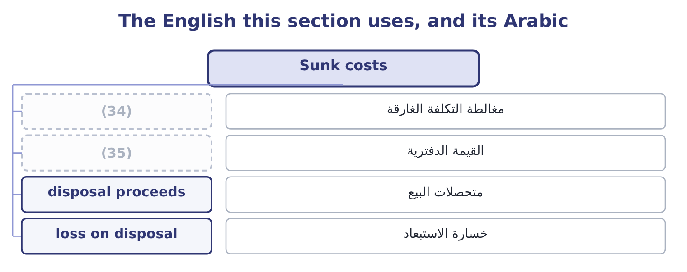
word list
imputed cost · book value · sunk cost fallacy

The English this sheet uses, and its Arabic
English (exam term) | Arabic
sunk cost fallacy | مغالطة التكلفة الغارقة
book value | القيمة الدفترية
disposal proceeds | متحصلات البيع
loss on disposal | خسارة الاستبعاد

Answer key · 5.2 Sunk costs

1 recovered | 19 spending
2 available | 20 continuing
3 absolutely | 21 discipline
4 specifically | 22 filling
5 changes | 23 standing
6 identical | 24 operating
7 specialised | 25 selling
8 reconsidering | 26 produce
9 Whether | 27 different
10 neither | 28 received
11 comparison | 29 replacing
12 receivable | 30 discounting
13 nowhere | 31 accounting
14 arithmetic | 32 statement
15 candidates | 33 explained
16 behavioural | 34 sunk cost fallacy
17 throwing | 35 book value
18 abandoning

the summaries in full
Summary 1 A sunk cost is a cost already incurred that cannot be recovered by any choice now available. It fails the first test absolutely, and the outcome asks specifically why. The reason is that a decision changes the future and the past is identical under every option. Suppose Orontes spent $300,000 on a specialised packaging film for a product line it is now reconsidering. Whether the line continues or stops, the $300,000 has gone. It appears in neither column of the comparison, so it cannot favour either. What is relevant about the film is what can still be done with it. If it can be sold for $40,000, that $40,000 is relevant because it is receivable under one option and not the other. If it can be used on another line, saving $180,000 of purchases that would otherwise be made, that saving is relevant. And the choice between those two uses is itself a decision: using the film saves $180,000 and forgoes the $40,000 scrap, so the net benefit of using it is 180,000 − 40,000 = 140,000.
Summary 2 The original $300,000 appears nowhere in any of that arithmetic. Why candidates and managers include it anyway is worth naming, because the exam sometimes asks for the behavioural point. It is called the sunk cost fallacy, or throwing good money after bad: having spent $300,000, a manager feels that abandoning the line wastes it, and continues in order to justify the original decision. The spending is wasted either way; continuing merely adds to it. The discipline is to ask what the choice is from here, which is also the only question a reader of the accounts can answer next year.
Summary 3 Orontes owns a filling machine bought four years ago for $1,200,000, now standing in the books at $700,000. A new machine costs $900,000 and would save $350,000 a year of operating costs for four years. The old machine could be sold today for $250,000 and has no value at the end of the four years. The $1,200,000 original cost, the $700,000 book value, and the $450,000 loss that selling at $250,000 would produce in the accounts. All three are the past, recorded in different ways. The $900,000 to be paid, the $250,000 to be received, and the $350,000 a year to be saved. The net outlay is 900,000 − 250,000 = 650,000, and the savings are 350,000 × 4 = 1,400,000, so replacing is better by 1,400,000 − 650,000 = 750,000 before any discounting. The accounting loss of $450,000 is the figure that stops this decision being taken in practice, because it appears in next year's income statement and nobody wants to explain it. It is not a cash flow and it does not change the merits, and an answer that says so — and then says the loss should be explained to the board in advance — is the one worth full marks.

5.3 Avoidable and unavoidable
Chapter 5 · section 5.3

Fill every gap. Each word list holds one word more than there are gaps.
Summary 1 gaps 1–12
An avoidable cost is one that will not be incurred if an activity is (1) . An unavoidable cost will be incurred (2) . The pair applies (3) a question asks whether to drop a product, close a (4) , shut a branch or stop serving a customer. The (5) is not the same as variable and fixed, and (6) the two is the commonest error in this topic. Most variable costs are avoidable, (7) they stop when the activity stops. But some fixed costs are avoidable too: a (8) whose post would be eliminated, an insurance policy that would be cancelled, a lease that would be (9) . And some variable costs are unavoidable, as where a supply (10) commits the company to a minimum (11) whatever it produces. A (12) fixed cost belongs entirely to one activity and usually goes with it. A common fixed cost is shared, and usually does not: closing the halva line does not reduce the factory rent, the chief executive's salary or the audit fee, and allocating a share of those to the line never made them avoidable.
word list
separable · contract · anyway · quantity · confusing · surrendered · department · supervisor · whenever · distinction · discontinued · because · avoided

Dropping the halva bar: what stops and what does not
Every item belongs to exactly one group.
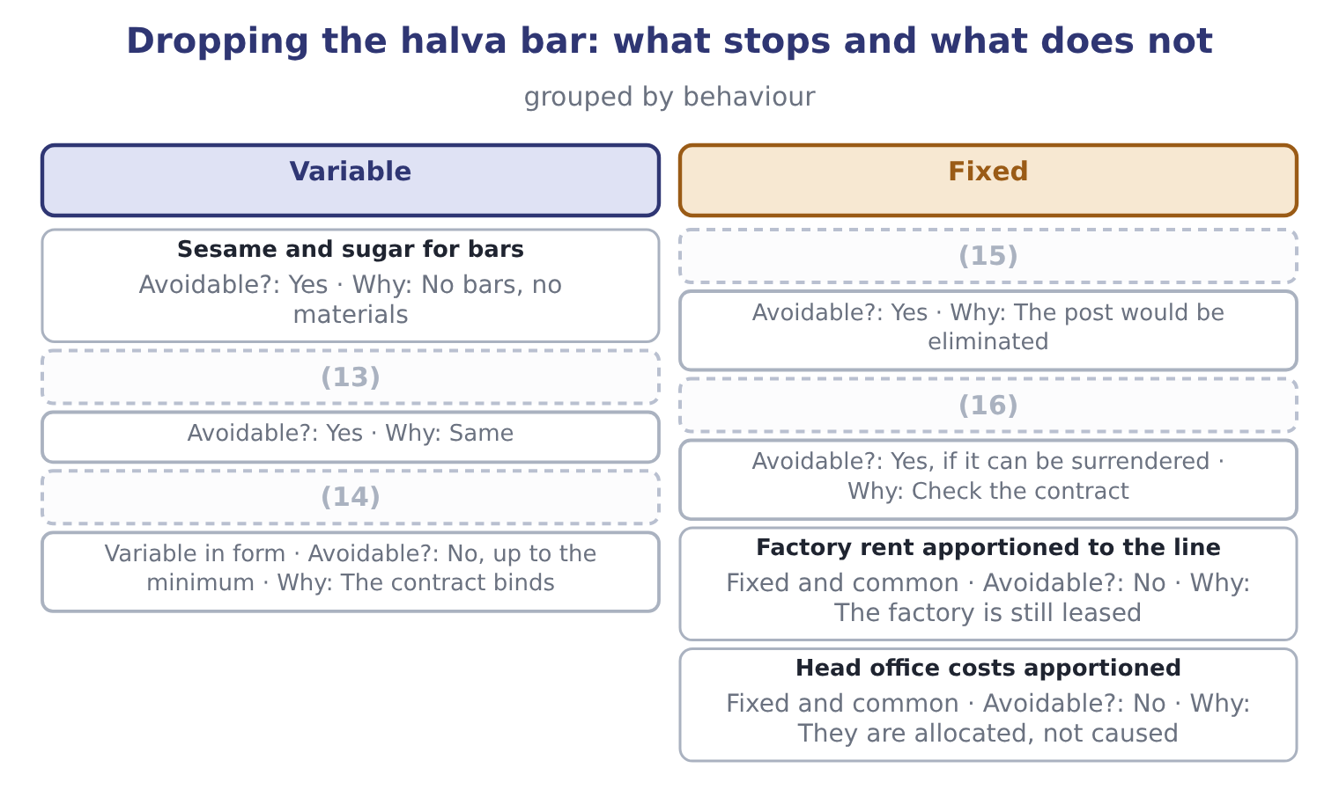
word list
Lease of the bar wrapping machine · Line supervisor's salary · Minimum purchase under a sesame contract · common cost · Bar packaging

Summary 2 gaps 17–20
The rule a question is testing is this: a product should be dropped only if the (17) it earns is less than the fixed costs that would (18) be avoided by dropping it. Here the point is that the avoidable (19) , not the full cost of the line, is the figure to (20) .
word list
actually · eliminated · column · contribution · compare

The English this section uses, and its Arabic
Each term sits against what it means.
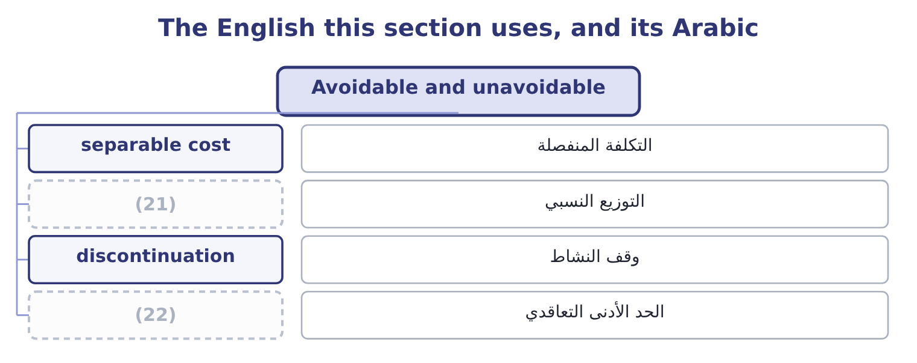
word list
cash flow · contractual minimum · apportionment

The English this sheet uses, and its Arabic
English (exam term) | Arabic
separable cost | التكلفة المنفصلة
apportionment | التوزيع النسبي
discontinuation | وقف النشاط
contractual minimum | الحد الأدنى التعاقدي

Answer key · 5.3 Avoidable and unavoidable

1 discontinued | 12 separable
2 anyway | 13 Bar packaging
3 whenever | 14 Minimum purchase under a sesame contract
4 department | 15 Line supervisor's salary
5 distinction | 16 Lease of the bar wrapping machine
6 confusing | 17 contribution
7 because | 18 actually
8 supervisor | 19 column
9 surrendered | 20 compare
10 contract | 21 apportionment
11 quantity | 22 contractual minimum

the summaries in full
Summary 1 An avoidable cost is one that will not be incurred if an activity is discontinued. An unavoidable cost will be incurred anyway. The pair applies whenever a question asks whether to drop a product, close a department, shut a branch or stop serving a customer. The distinction is not the same as variable and fixed, and confusing the two is the commonest error in this topic. Most variable costs are avoidable, because they stop when the activity stops. But some fixed costs are avoidable too: a supervisor whose post would be eliminated, an insurance policy that would be cancelled, a lease that would be surrendered. And some variable costs are unavoidable, as where a supply contract commits the company to a minimum quantity whatever it produces. A separable fixed cost belongs entirely to one activity and usually goes with it. A common fixed cost is shared, and usually does not: closing the halva line does not reduce the factory rent, the chief executive's salary or the audit fee, and allocating a share of those to the line never made them avoidable.
Summary 2 The rule a question is testing is this: a product should be dropped only if the contribution it earns is less than the fixed costs that would actually be avoided by dropping it. Here the point is that the avoidable column, not the full cost of the line, is the figure to compare.

5.4 Explicit and implicit
Chapter 5 · section 5.4

Fill every gap. Each word list holds one word more than there are gaps.
Summary 1 gaps 1–12
An explicit cost involves a payment: wages, materials, rent, (1) . It appears in the accounting records because (2) was paid. An implicit cost involves no payment and is a (3) cost all the same: the value of (4) the company already owns that is used up or given up by a choice. It appears in no (5) , which is why it has to be (6) about rather than looked up. The most (7) implicit cost has its own name and its own chapter. An (8) cost is the benefit forgone by using a (9) for one purpose instead of its best alternative use. But the (10) is wider. The owner of a small business who works in it (11) a salary bears an implicit cost: the wage that could have been (12) elsewhere. The company that uses a building it owns bears the rent it could have received. And the shareholders of any company bear the implicit cost of their capital, which is precisely the point Book 1 made about economic profit — accounting profit charges for the explicit cost of debt and not for the implicit cost of equity. That gives the pair of definitions the exam wants.
word list
earned · category · appears · opportunity · resource · somebody · without · something · ledger · genuine · reasoned · interest · important

Summary 2 gaps 13–17
Accounting profit is revenue less explicit costs. Economic profit is revenue less explicit and implicit costs (13) . A business can show an accounting profit and an economic loss, which means it is (14) less than the (15) it consumes could earn elsewhere — and a business in that (16) is being kept alive by a cost nobody is (17) it for.
word list
building · together · resources · charging · earning · position

Four kinds of cost, two dimensions
 | Explicit, a payment is made | Implicit, no payment is made
Relevant to a decision | (18) | The contribution forgone on displaced work; rent forgone on an owned building
Not relevant | Last year's advertising already paid; allocated head office charge | (19)

word list
Materials for the extra order; wages of staff hired · Last year's advertising already paid; allocated head office charge · Depreciation of an asset with no alternative use

The English this section uses, and its Arabic
Each term sits against what it means.
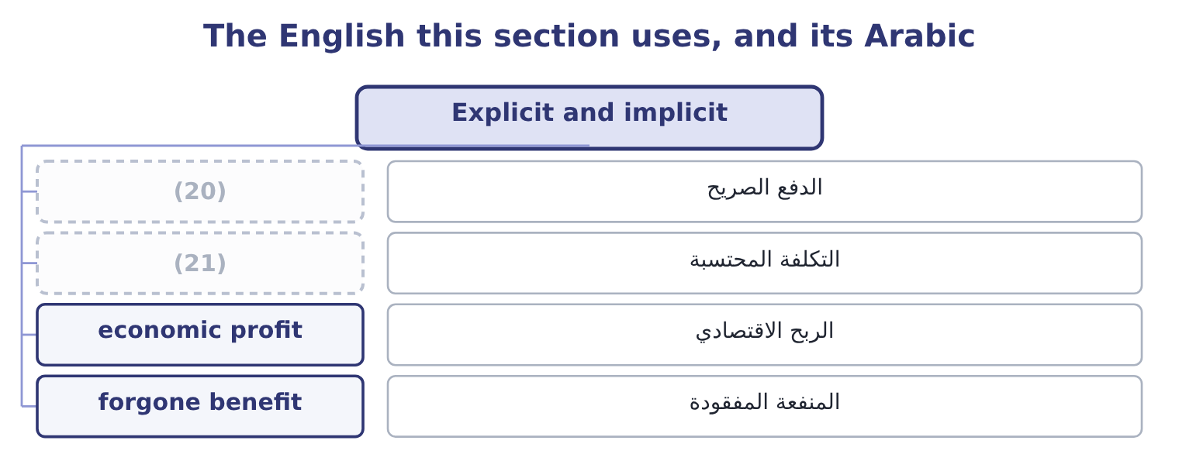
word list
incremental cost · explicit payment · imputed cost

The English this sheet uses, and its Arabic
English (exam term) | Arabic
explicit payment | الدفع الصريح
imputed cost | التكلفة المحتسبة
economic profit | الربح الاقتصادي
forgone benefit | المنفعة المفقودة

Answer key · 5.4 Explicit and implicit

1 interest | 12 earned
2 somebody | 13 together
3 genuine | 14 earning
4 something | 15 resources
5 ledger | 16 position
6 reasoned | 17 charging
7 important | 18 Materials for the extra order; wages of staff hired
8 opportunity | 19 Depreciation of an asset with no alternative use
9 resource | 20 explicit payment
10 category | 21 imputed cost
11 without

the summaries in full
Summary 1 An explicit cost involves a payment: wages, materials, rent, interest. It appears in the accounting records because somebody was paid. An implicit cost involves no payment and is a genuine cost all the same: the value of something the company already owns that is used up or given up by a choice. It appears in no ledger, which is why it has to be reasoned about rather than looked up. The most important implicit cost has its own name and its own chapter. An opportunity cost is the benefit forgone by using a resource for one purpose instead of its best alternative use. But the category is wider. The owner of a small business who works in it without a salary bears an implicit cost: the wage that could have been earned elsewhere. The company that uses a building it owns bears the rent it could have received. And the shareholders of any company bear the implicit cost of their capital, which is precisely the point Book 1 made about economic profit — accounting profit charges for the explicit cost of debt and not for the implicit cost of equity. That gives the pair of definitions the exam wants.
Summary 2 Accounting profit is revenue less explicit costs. Economic profit is revenue less explicit and implicit costs together. A business can show an accounting profit and an economic loss, which means it is earning less than the resources it consumes could earn elsewhere — and a business in that position is being kept alive by a cost nobody is charging it for.

5.5 Putting it to work
Chapter 5 · section 5.5

Fill every gap. Each word list holds one word more than there are gaps.
Summary 1 gaps 1–12
A (1) analysis has a shape, and (2) it is most of the skill. Identify the alternatives, (3) the option of doing nothing, which is always available and often omitted. List the future cash flows under each. Cash flows, not accounting charges: the exam's items are receipts and payments, and depreciation, allocations and book values are excluded by (4) . Remove (5) that is the same under both. What (6) is the difference, and the difference is the decision. Add the (7) costs that the ledger does not contain, which in practice means the opportunity costs. State the answer as a difference, not as two (8) . Two habits are worth building now, (9) every chapter from here to. Build the analysis as a single column of (10) wherever possible. It is faster, it cannot contain an irrelevant item without the error being obvious, and it (11) the answer directly. Say what was excluded and why. One line — "the $700,000 book value is sunk and is not included" — tells a marker that the (12) was a decision rather than an oversight, and it is worth more than the arithmetic that follows it.
word list
implicit · relevant-cost · produces · anything · including · totals · following · exclusion · differences · available · construction · remains · because

Sort the items

Mark each relevant or not, and say why.
Your turn: relevant or not (complete the blanks)
Item | Relevant? | Why
Wages of depot staff who would be made redundant | ________ | ________
The depot building, owned, which could be let for 90,000 a year | ________ | ________
Depreciation on the depot's racking | ________ | ________
Head office costs apportioned to the depot | ________ | ________
Redundancy payments of 140,000 | ________ | ________
The 2,000,000 the depot cost to build in 2016 | ________ | ________
Delivery costs that would rise by 60,000 if customers were served from elsewhere | ________ | ________
Contribution of 400,000 from customers who would be lost | ________ | ________

"Relevant"

Summary 2 gaps 13–19
English relevant in (13) accounting is a (14) term with a two-part definition, and it is not a synonym for important, useful or (15) . A cost can be enormous, (16) recorded and central to the business, and still be irrelevant to the decision in hand — which sounds like a (17) until the definition is (18) . The one (19) in all three languages is to say the definition aloud when using the word: future, and different between the alternatives.
word list
interesting · remembered · management · carefully · technical · safeguard · central · contradiction

"Relevant"
Item | Answer
Wages of staff made redundant | Relevant: the payments stop, so they differ between the alternatives.
The building, lettable at 90,000 | Relevant: it is an opportunity cost, receivable only if the depot closes.
Depreciation on the racking | Not relevant: it spreads a past payment. What the racking would fetch is relevant.
Apportioned head office costs | Not relevant: they continue and are merely re-apportioned.
Redundancy payments of 140,000 | (20)
The 2,000,000 spent in 2016 | Not relevant: sunk.
Delivery costs rising by 60,000 | Relevant: a future cost that arises only on closure.
Contribution of 400,000 lost | Relevant: a benefit forgone under one alternative.
What it tells you | Closing saves the wages, the (21) nothing, and gains 90,000 of rent, against 140,000 of redundancy, 60,000 of delivery and 400,000

word list
apportionment · economic profit · Relevant: a future payment arising only on closure.

The English this section uses, and its Arabic
Each term sits against what it means.
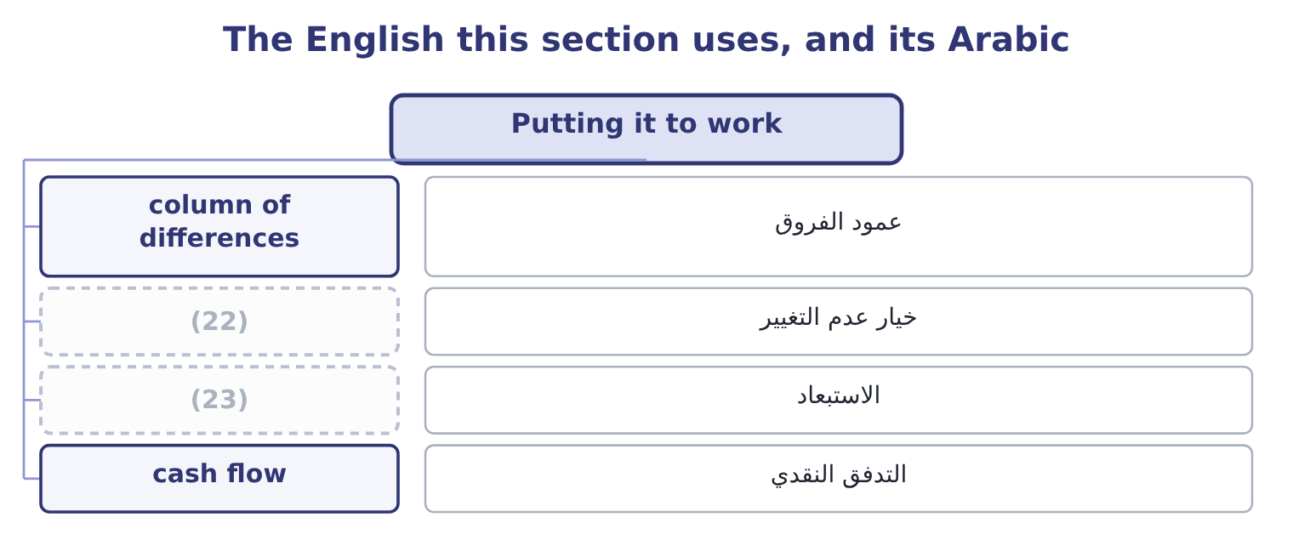
word list
implicit cost · do nothing option · exclusion

The English this sheet uses, and its Arabic
English (exam term) | Arabic
column of differences | عمود الفروق
do nothing option | خيار عدم التغيير
exclusion | الاستبعاد
cash flow | التدفق النقدي

Answer key · 5.5 Putting it to work

1 relevant-cost | 13 management
2 following | 14 technical
3 including | 15 interesting
4 construction | 16 carefully
5 anything | 17 contradiction
6 remains | 18 remembered
7 implicit | 19 safeguard
8 totals | 20 Relevant: a future payment arising only on closure.
9 because | 21 apportionment
10 differences | 22 do nothing option
11 produces | 23 exclusion
12 exclusion

the summaries in full
Summary 1 A relevant-cost analysis has a shape, and following it is most of the skill. Identify the alternatives, including the option of doing nothing, which is always available and often omitted. List the future cash flows under each. Cash flows, not accounting charges: the exam's items are receipts and payments, and depreciation, allocations and book values are excluded by construction. Remove anything that is the same under both. What remains is the difference, and the difference is the decision. Add the implicit costs that the ledger does not contain, which in practice means the opportunity costs. State the answer as a difference, not as two totals. Two habits are worth building now, because every chapter from here to. Build the analysis as a single column of differences wherever possible. It is faster, it cannot contain an irrelevant item without the error being obvious, and it produces the answer directly. Say what was excluded and why. One line — "the $700,000 book value is sunk and is not included" — tells a marker that the exclusion was a decision rather than an oversight, and it is worth more than the arithmetic that follows it.
Summary 2 English relevant in management accounting is a technical term with a two-part definition, and it is not a synonym for important, useful or interesting. A cost can be enormous, carefully recorded and central to the business, and still be irrelevant to the decision in hand — which sounds like a contradiction until the definition is remembered. The one safeguard in all three languages is to say the definition aloud when using the word: future, and different between the alternatives.

6.1 What an opportunity cost is
Chapter 6 · section 6.1

Fill every gap. Each word list holds one word more than there are gaps.
Chapter 6, section by section
Each stage leads to the next.
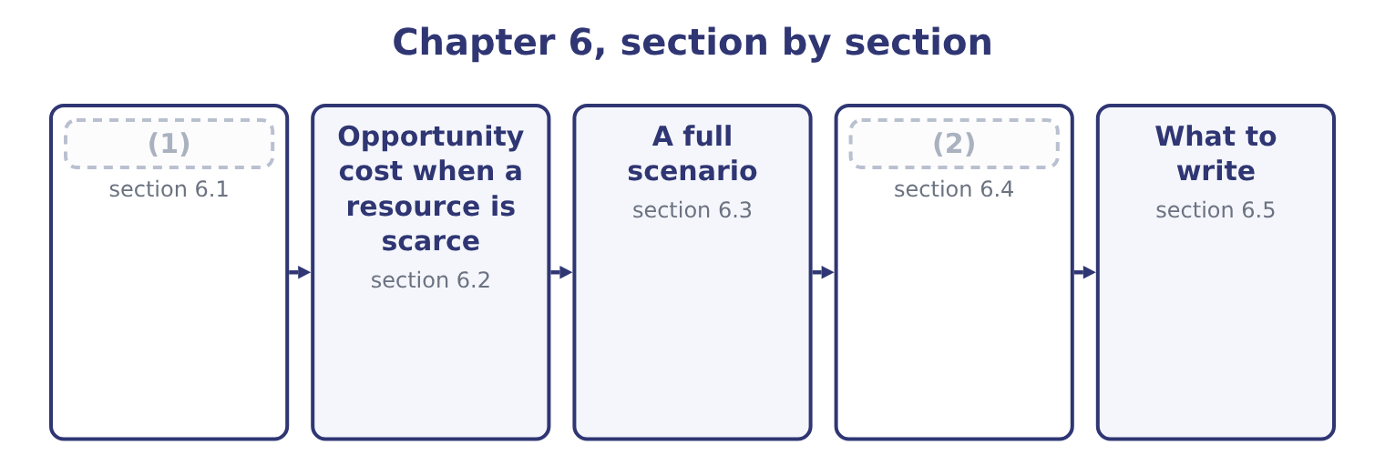
word list
relevant cost of materials · What an opportunity cost is · Where the traps are

Summary 1 gaps 3–14
An opportunity cost is the (3) given up by using a resource in one way rather than in its best (4) alternative. Three (5) define it and the exam tests each. It (6) only where there is an alternative. A resource with nothing else to do has no opportunity cost: an idle (7) used for an extra order costs nothing in forgone contribution, because nothing was forgone. That is why the (8) idle capacity appears in almost every (9) question. It is (10) as the best alternative forgone, not as the sum of all (11) . A (12) of sesame that could be used for a jar (13) $4.80 of contribution or sold for $2.00 has an opportunity cost of $4.80, not $6.80. It is a cost even though no (14) is made. It never appears in the accounts, it never appears in a cost ledger, and omitting it from an analysis will approve work that destroys value.
word list
arises · available · special-order · measured · features · machine · alternatives · payment · phrase · earning · benefit · accounts · kilogram

Summary 2 gaps 15–19
Two (15) forms recur. The forgone contribution of displaced work. (16) an order that fills capacity used by (17) sales costs the contribution of the sales displaced. The forgone (18) from an asset. Using a building the company owns costs the rent it could have earned; using material already in stock costs whatever the material could (19) have realised.
word list
receipt · otherwise · features · common · existing · Accepting

The relevant cost of material already held
The material is ... | Relevant cost | Why
Not in stock | (20) | It must be bought
In stock, and used regularly | (21) | Using it means buying more
In stock, no other use, scrap value only | (22) | The alternative is to sell it
In stock, with an alternative use | The contribution forgone in that use | (23)

word list
The purchase price · The replacement cost · The scrap value forgone · The best alternative is given up · The contribution forgone in that use

Summary 3 gaps 24–25
That table is worth (24) as it stands. The original cost of (25) in stock is never in it, because the original cost is sunk — a point.
word list
nothing · material · learning

The English this section uses, and its Arabic
Each term sits against what it means.
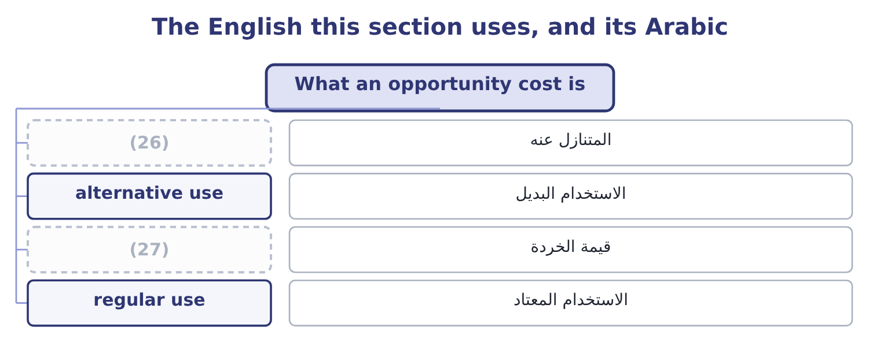
word list
scrap value · alternative use · forgone

The English this sheet uses, and its Arabic
English (exam term) | Arabic
forgone | المتنازل عنه
alternative use | الاستخدام البديل
scrap value | قيمة الخردة
regular use | الاستخدام المعتاد

Answer key · 6.1 What an opportunity cost is

1 What an opportunity cost is | 15 common
2 Where the traps are | 16 Accepting
3 benefit | 17 existing
4 available | 18 receipt
5 features | 19 otherwise
6 arises | 20 The purchase price
7 machine | 21 The replacement cost
8 phrase | 22 The scrap value forgone
9 special-order | 23 The best alternative is given up
10 measured | 24 learning
11 alternatives | 25 material
12 kilogram | 26 forgone
13 earning | 27 scrap value
14 payment

the summaries in full
Summary 1 An opportunity cost is the benefit given up by using a resource in one way rather than in its best available alternative. Three features define it and the exam tests each. It arises only where there is an alternative. A resource with nothing else to do has no opportunity cost: an idle machine used for an extra order costs nothing in forgone contribution, because nothing was forgone. That is why the phrase idle capacity appears in almost every special-order question. It is measured as the best alternative forgone, not as the sum of all alternatives. A kilogram of sesame that could be used for a jar earning $4.80 of contribution or sold for $2.00 has an opportunity cost of $4.80, not $6.80. It is a cost even though no payment is made. It never appears in the accounts, it never appears in a cost ledger, and omitting it from an analysis will approve work that destroys value.
Summary 2 Two common forms recur. The forgone contribution of displaced work. Accepting an order that fills capacity used by existing sales costs the contribution of the sales displaced. The forgone receipt from an asset. Using a building the company owns costs the rent it could have earned; using material already in stock costs whatever the material could otherwise have realised.
Summary 3 That table is worth learning as it stands. The original cost of material in stock is never in it, because the original cost is sunk — a point.

6.2 Opportunity cost when a resource is scarce
Chapter 6 · section 6.2

Fill every gap. Each word list holds one word more than there are gaps.
Summary 1 gaps 1–7
The (1) case of an opportunity cost is a bottleneck: a machine, a skilled grade of labour, a material in short supply, a (2) , a licence. Where one resource limits output, every unit of it used for one product is a unit not (3) for another, and the opportunity cost is whatever that other product would have (4) . The rule that (5) is the one. Rank products by contribution per unit of the (6) resource, not per unit of product and not per sales (7) .
word list
dollar · available · constrained · clearest · contributed · follows · certification · Relieving

Worked example: the roaster is the bottleneck

Summary 2 gaps 8–15
Orontes's roaster is fully used. A jar takes 0.004 roaster hours, a bar 0.001 and a drum 0.020. Contribution per roaster hour. For the jar: 4.80 ÷ 0.004 = 1,200 an hour. For the bar: 1.20 ÷ 0.001 = 1,200 an hour. For the drum: 21.00 ÷ 0.020 = 1,050 an hour. The jar and the bar are (8) good at $1,200 an hour, and the drum is the worst of the three — (9) it has by far the (10) contribution per unit, at $21.00 (11) $4.80 and $1.20. An hour given to drums earns $1,050 and (12) $1,200, so each drum hour costs the company 1,200 − 1,050 = 150 of contribution. On 2,000 drum hours that is 2,000 × 150 = 300,000 a year. Here it is third again, for a third (13) , and the three (14) would produce three different product (15) .
word list
equally · rankings · although · forgoes · reason · highest · products · against · strategies

Summary 3 gaps 16–27
Which one is right depends entirely on what limits the business, and (16) that is the first question to ask of any (17) problem — before computing anything. Two (18) complete the (19) . The ranking holds while the constraint holds. If the roaster could be run an extra shift, the constraint moves (20) and the ranking (21) with it. A constraint is a fact about the present (22) , not about the products. (23) the constraint has a value, and the opportunity cost (24) it. If an hour of roaster time is worth $1,200 of contribution, then an extra hour bought in — overtime, a (25) , a second machine — is worth up to $1,200, and anything (26) than that is worth doing. That figure is (27) called the shadow price of the constraint, and it is the most useful number a bottleneck analysis produces.
word list
changes · configuration · measures · cheaper · outcome · hinge · subcontractor · Relieving · sometimes · product-mix · establishing · elsewhere · refinements

Three rankings, three answers
Every item belongs to exactly one group.
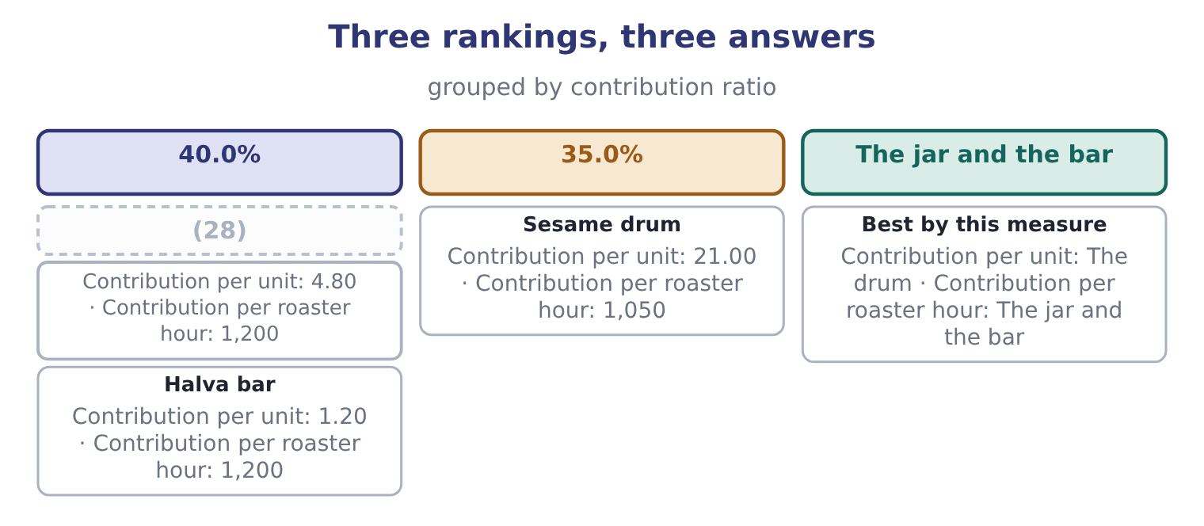
word list
scrap value · Tahini jar

The English this section uses, and its Arabic
Each term sits against what it means.
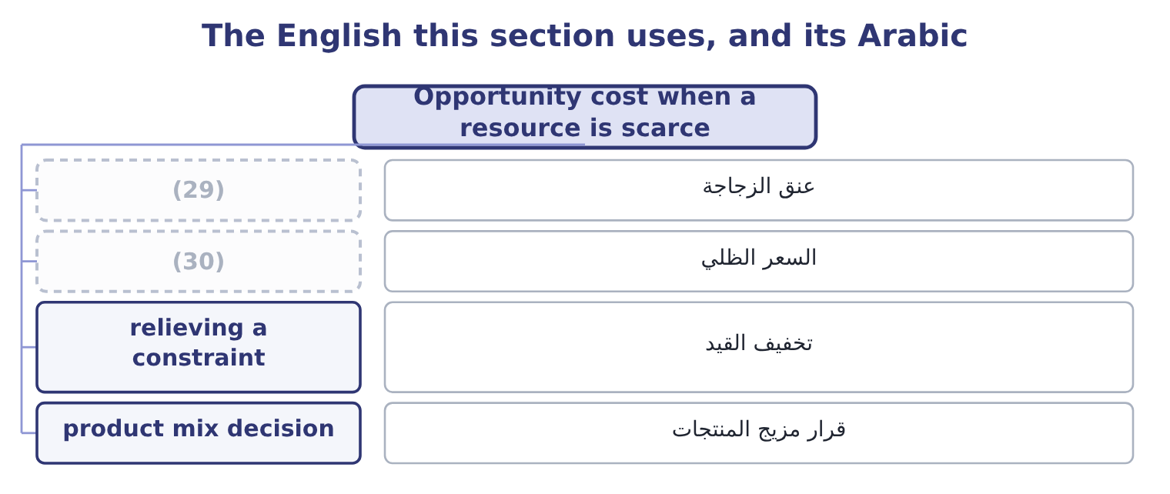
word list
bottleneck · shadow price · alternative use

The English this sheet uses, and its Arabic
English (exam term) | Arabic
bottleneck | عنق الزجاجة
shadow price | السعر الظلي
relieving a constraint | تخفيف القيد
product mix decision | قرار مزيج المنتجات

Answer key · 6.2 Opportunity cost when a resource is scarce

1 clearest | 16 establishing
2 certification | 17 product-mix
3 available | 18 refinements
4 contributed | 19 outcome
5 follows | 20 elsewhere
6 constrained | 21 changes
7 dollar | 22 configuration
8 equally | 23 Relieving
9 although | 24 measures
10 highest | 25 subcontractor
11 against | 26 cheaper
12 forgoes | 27 sometimes
13 reason | 28 Tahini jar
14 rankings | 29 bottleneck
15 strategies | 30 shadow price

the summaries in full
Summary 1 The clearest case of an opportunity cost is a bottleneck: a machine, a skilled grade of labour, a material in short supply, a certification, a licence. Where one resource limits output, every unit of it used for one product is a unit not available for another, and the opportunity cost is whatever that other product would have contributed. The rule that follows is the one. Rank products by contribution per unit of the constrained resource, not per unit of product and not per sales dollar.
Summary 2 Orontes's roaster is fully used. A jar takes 0.004 roaster hours, a bar 0.001 and a drum 0.020. Contribution per roaster hour. For the jar: 4.80 ÷ 0.004 = 1,200 an hour. For the bar: 1.20 ÷ 0.001 = 1,200 an hour. For the drum: 21.00 ÷ 0.020 = 1,050 an hour. The jar and the bar are equally good at $1,200 an hour, and the drum is the worst of the three — although it has by far the highest contribution per unit, at $21.00 against $4.80 and $1.20. An hour given to drums earns $1,050 and forgoes $1,200, so each drum hour costs the company 1,200 − 1,050 = 150 of contribution. On 2,000 drum hours that is 2,000 × 150 = 300,000 a year. Here it is third again, for a third reason, and the three rankings would produce three different product strategies.
Summary 3 Which one is right depends entirely on what limits the business, and establishing that is the first question to ask of any product-mix problem — before computing anything. Two refinements complete the outcome. The ranking holds while the constraint holds. If the roaster could be run an extra shift, the constraint moves elsewhere and the ranking changes with it. A constraint is a fact about the present configuration, not about the products. Relieving the constraint has a value, and the opportunity cost measures it. If an hour of roaster time is worth $1,200 of contribution, then an extra hour bought in — overtime, a subcontractor, a second machine — is worth up to $1,200, and anything cheaper than that is worth doing. That figure is sometimes called the shadow price of the constraint, and it is the most useful number a bottleneck analysis produces.

6.3 A full scenario
Chapter 6 · section 6.3

Fill every gap. Each word list holds one word more than there are gaps.
Summary 1 gaps 1–12
The exam's (1) of this outcome is a table with traps. Here is one, (2) in full. Orontes is asked to quote for a one-off contract to (3) a hotel group with 40,000 jars of a special blend. The (4) facts are supplied. Sesame: the contract needs 20,000 kg. Orontes holds 12,000 kg bought last year at $3.00 a kilogram; sesame now costs $3.40 and is used (5) . Labour: 2,000 hours of (6) labour, paid $18 an hour. The line is fully employed on standard jars; the staff cannot be (7) in the time available. (8) : special jars and labels costing $1.10 a unit, bought. (9) time: 160 roaster hours. The roaster is fully used, and the contribution forgone is $1,200 an hour. Supervision: the (10) supervisor would oversee the contract within the present salary of $6,000 a month. Development: $25,000 was spent last month (11) the blend at the hotel group's request. Overhead: the company (12) factory overhead at $4.00 a jar; none of it would change.
word list
increased · Packaging · supply · absorbs · designing · existing · version · continuously · forgone · filling-line · worked · following · Machine

Worked example: the minimum price

Summary 2 gaps 13–22
All 20,000 kg must be valued at the (13) cost of $3.40, because the material is in (14) use: using the 12,000 kg in stock means (15) 12,000 kg more. The relevant cost is 20,000 × 3.40 = 68,000. The $3.00 (16) price is sunk. The (17) are already employed and already paid, so their wages are not incremental — but their time is. Using 2,000 hours on this contract displaces standard (18) , so the relevant cost is the contribution forgone on the jars not made. Where a question gives that contribution (19) , use it; here the roaster hours in step 4 are the binding (20) and the labour (21) them, so the labour cost is the wages only if extra hours must be paid for. On these facts no extra wages arise, so the relevant labour cost is nil and the (22) is captured in step 4.
word list
constraint · production · directly · buying · follows · commercial · workers · displacement · replacement · continuous · original

Summary 3 gaps 23–34
Bought in (23) , so wholly incremental: 40,000 × 1.10 = 44,000. This is the (24) cost of section 6.2, and it is the largest number in the (25) . Supervision, development and overhead. All three are (26) . The (27) salary does not change; the $25,000 is sunk; the $4.00 a jar is an (28) rate, not a cost that moves. Note the three (29) a careless answer would include: the $25,000 of development, the $36,000 of wages at $18 an hour, and the $160,000 of (30) overhead at $4.00 a jar. Adding all three would give a minimum price of $12.63 a jar, and the contract — which is worth taking at (31) above $7.60 — would be (32) . Note also the one figure a careless answer would omit: the $192,000 of forgone contribution, (33) which the minimum price falls to $2.80 and the company would (34) work that makes it poorer.
word list
analysis · refused · figures · supervisor's · anything · Orontes · without · absorption · opportunity · excluded · accept · absorbed · specially

The contract, item by item
Every item belongs to exactly one group.
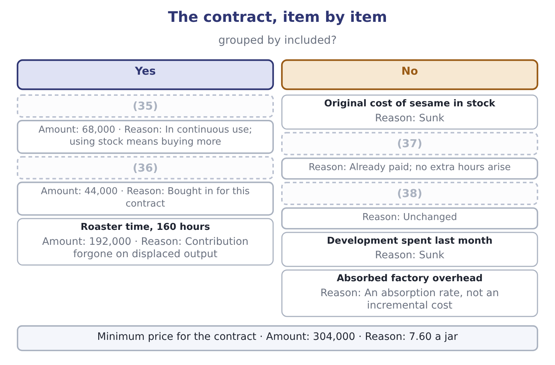
word list
Special packaging · Supervisor's salary · Filling-line wages · relevant cost of materials · Sesame, 20,000 kg at replacement cost

The minimum price is a floor, not a quote

Summary 4 gaps 39–45
The relevant cost is the price below which the contract makes the company worse off. What to (39) charge is a (40) question. A minimum price (41) on relevant costs is valid for a one-off contract with idle or (42) capacity. It is not a basis for (43) pricing, because fixed costs have to be covered by (44) . Where labour is paid whether or not the contract is taken, its wages are not relevant; where the contract (45) overtime or new hires, they are.
word list
requires · computed · somebody · forgone · actually · commercial · displaceable · regular

The English this section uses, and its Arabic
Each term sits against what it means.
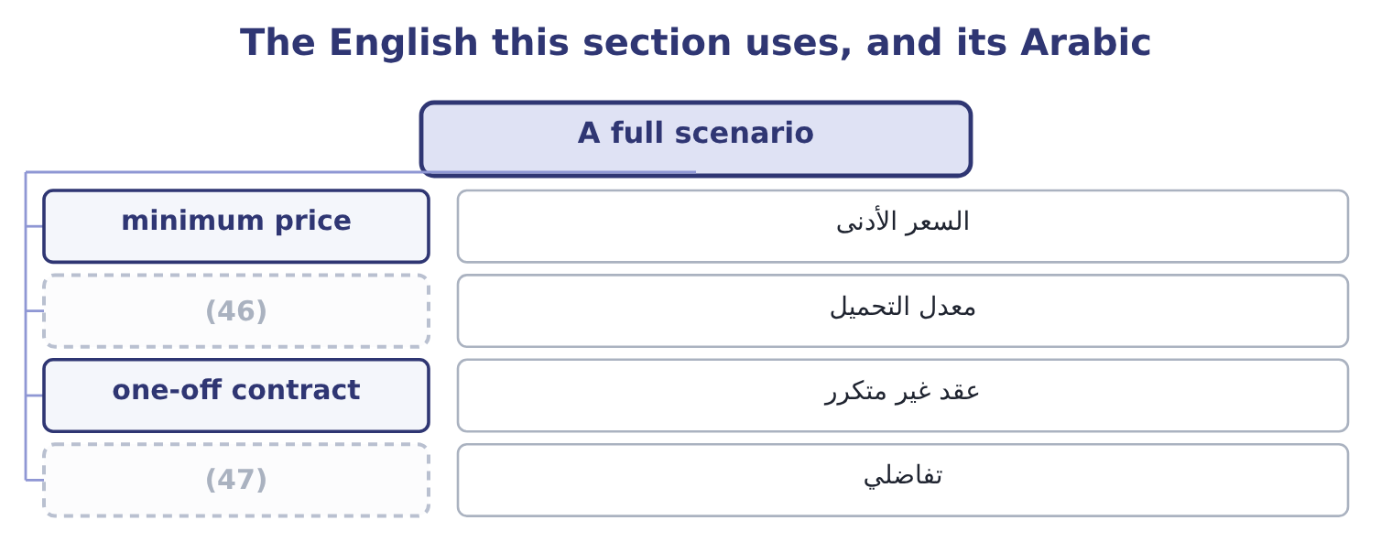
word list
absorption rate · incremental · displaced sales

The English this sheet uses, and its Arabic
English (exam term) | Arabic
minimum price | السعر الأدنى
absorption rate | معدل التحميل
one-off contract | عقد غير متكرر
incremental | تفاضلي

Answer key · 6.3 A full scenario

1 version | 25 analysis
2 worked | 26 excluded
3 supply | 27 supervisor's
4 following | 28 absorption
5 continuously | 29 figures
6 filling-line | 30 absorbed
7 increased | 31 anything
8 Packaging | 32 refused
9 Machine | 33 without
10 existing | 34 accept
11 designing | 35 Sesame, 20,000 kg at replacement cost
12 absorbs | 36 Special packaging
13 replacement | 37 Filling-line wages
14 continuous | 38 Supervisor's salary
15 buying | 39 actually
16 original | 40 commercial
17 workers | 41 computed
18 production | 42 displaceable
19 directly | 43 regular
20 constraint | 44 somebody
21 follows | 45 requires
22 displacement | 46 absorption rate
23 specially | 47 incremental
24 opportunity

the summaries in full
Summary 1 The exam's version of this outcome is a table with traps. Here is one, worked in full. Orontes is asked to quote for a one-off contract to supply a hotel group with 40,000 jars of a special blend. The following facts are supplied. Sesame: the contract needs 20,000 kg. Orontes holds 12,000 kg bought last year at $3.00 a kilogram; sesame now costs $3.40 and is used continuously. Labour: 2,000 hours of filling-line labour, paid $18 an hour. The line is fully employed on standard jars; the staff cannot be increased in the time available. Packaging: special jars and labels costing $1.10 a unit, bought. Machine time: 160 roaster hours. The roaster is fully used, and the contribution forgone is $1,200 an hour. Supervision: the existing supervisor would oversee the contract within the present salary of $6,000 a month. Development: $25,000 was spent last month designing the blend at the hotel group's request. Overhead: the company absorbs factory overhead at $4.00 a jar; none of it would change.
Summary 2 All 20,000 kg must be valued at the replacement cost of $3.40, because the material is in continuous use: using the 12,000 kg in stock means buying 12,000 kg more. The relevant cost is 20,000 × 3.40 = 68,000. The $3.00 original price is sunk. The workers are already employed and already paid, so their wages are not incremental — but their time is. Using 2,000 hours on this contract displaces standard production, so the relevant cost is the contribution forgone on the jars not made. Where a question gives that contribution directly, use it; here the roaster hours in step 4 are the binding constraint and the labour follows them, so the labour cost is the wages only if extra hours must be paid for. On these facts no extra wages arise, so the relevant labour cost is nil and the displacement is captured in step 4.
Summary 3 Bought in specially, so wholly incremental: 40,000 × 1.10 = 44,000. This is the opportunity cost of section 6.2, and it is the largest number in the analysis. Supervision, development and overhead. All three are excluded. The supervisor's salary does not change; the $25,000 is sunk; the $4.00 a jar is an absorption rate, not a cost that moves. Note the three figures a careless answer would include: the $25,000 of development, the $36,000 of wages at $18 an hour, and the $160,000 of absorbed overhead at $4.00 a jar. Adding all three would give a minimum price of $12.63 a jar, and the contract — which is worth taking at anything above $7.60 — would be refused. Note also the one figure a careless answer would omit: the $192,000 of forgone contribution, without which the minimum price falls to $2.80 and the company would accept work that makes it poorer.
Summary 4 The relevant cost is the price below which the contract makes the company worse off. What to actually charge is a commercial question. A minimum price computed on relevant costs is valid for a one-off contract with idle or displaceable capacity. It is not a basis for regular pricing, because fixed costs have to be covered by somebody. Where labour is paid whether or not the contract is taken, its wages are not relevant; where the contract requires overtime or new hires, they are.

6.4 Where the traps are
Chapter 6 · section 6.4

Fill every gap. Each word list holds one word more than there are gaps.
Summary 1 gaps 1–12
Four traps (1) for most of the marks lost on this outcome, and all four (2) in section 6.3. The (3) cost of something already owned. Material at the price paid, a machine at book value, a (4) at cost. Each is sunk; what (5) is what the thing could (6) do. Labour that is paid anyway. A salaried (7) costs the same whether a contract is taken or not, so its wages are not (8) — but its time may be, if the work displaces something else. The (9) cost of labour is nil where there is spare capacity, the wages where extra hours must be bought, and the forgone contribution where (10) work is displaced. Absorbed or (11) overhead. An (12) rate exists to put a full cost on a product for inventory valuation and reporting. It is not a statement that the overhead moves with the product, and in a relevant-cost analysis it is excluded unless the question says the overhead itself changes.
word list
recorded · existing · appeared · absorption · matters · apportioned · relevant · displaces · building · incremental · otherwise · workforce · account

Summary 2 gaps 13–16
The (13) opportunity cost. The three traps above cause costs to be included that should not be; this one causes a cost to be omitted that should be included, and it is the more (14) , because the error (15) work rather than (16) it.
word list
approves · dangerous · refusing · missing · contract

The relevant cost of each resource, in one table
Resource | Spare capacity exists | Fully employed
Labour | (17) | The contribution forgone, or the overtime premium
Machine time | Nil | (18)
Material not in stock | The purchase price | The purchase price
Material in stock, in regular use | The replacement cost | The replacement cost
Material in stock, no other use | The scrap value forgone | The scrap value forgone

word list
The contribution forgone on displaced output · Nil, if already paid · The scrap value forgone

Summary 3 gaps 19–24
A fifth trap is (19) and worth a (20) of its own. An opportunity cost exists only where the alternative is (21) available. If the displaced jars could not have been sold anyway — because demand is short, or the (22) is full — then (23) is forgone and the opportunity cost is nil. A question that says "the company can sell all it (24) " is telling you the alternative exists; a question that says demand is 3,500,000 jars and capacity is 4,000,000 is telling you it does not.
word list
produces · warehouse · sentence · displaced · nothing · subtler · genuinely

The English this section uses, and its Arabic
Each term sits against what it means.
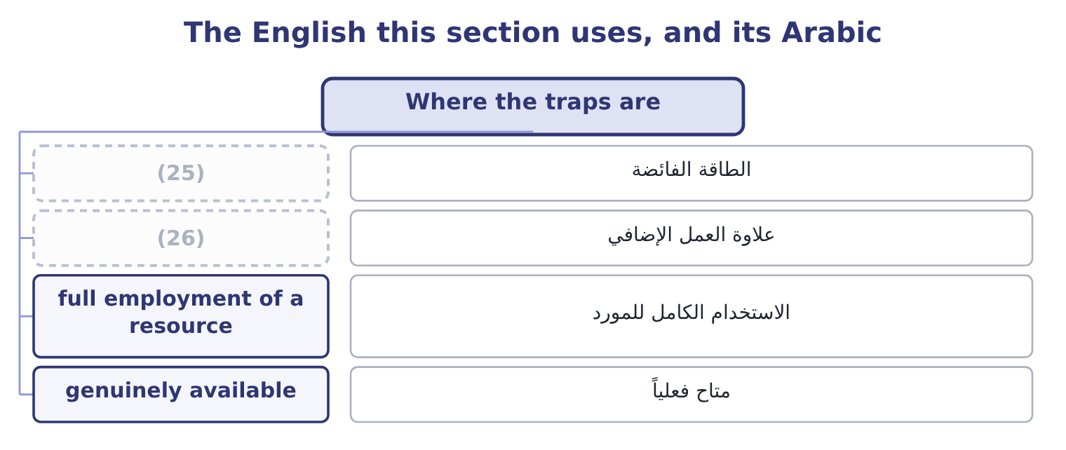
word list
alternative use · spare capacity · overtime premium

The English this sheet uses, and its Arabic
English (exam term) | Arabic
spare capacity | الطاقة الفائضة
overtime premium | علاوة العمل الإضافي
full employment of a resource | الاستخدام الكامل للمورد
genuinely available | متاح فعلياً

Answer key · 6.4 Where the traps are

1 account | 14 dangerous
2 appeared | 15 approves
3 recorded | 16 refusing
4 building | 17 Nil, if already paid
5 matters | 18 The contribution forgone on displaced output
6 otherwise | 19 subtler
7 workforce | 20 sentence
8 incremental | 21 genuinely
9 relevant | 22 warehouse
10 existing | 23 nothing
11 apportioned | 24 produces
12 absorption | 25 spare capacity
13 missing | 26 overtime premium

the summaries in full
Summary 1 Four traps account for most of the marks lost on this outcome, and all four appeared in section 6.3. The recorded cost of something already owned. Material at the price paid, a machine at book value, a building at cost. Each is sunk; what matters is what the thing could otherwise do. Labour that is paid anyway. A salaried workforce costs the same whether a contract is taken or not, so its wages are not incremental — but its time may be, if the work displaces something else. The relevant cost of labour is nil where there is spare capacity, the wages where extra hours must be bought, and the forgone contribution where existing work is displaced. Absorbed or apportioned overhead. An absorption rate exists to put a full cost on a product for inventory valuation and reporting. It is not a statement that the overhead moves with the product, and in a relevant-cost analysis it is excluded unless the question says the overhead itself changes.
Summary 2 The missing opportunity cost. The three traps above cause costs to be included that should not be; this one causes a cost to be omitted that should be included, and it is the more dangerous, because the error approves work rather than refusing it.
Summary 3 A fifth trap is subtler and worth a sentence of its own. An opportunity cost exists only where the alternative is genuinely available. If the displaced jars could not have been sold anyway — because demand is short, or the warehouse is full — then nothing is forgone and the opportunity cost is nil. A question that says "the company can sell all it produces" is telling you the alternative exists; a question that says demand is 3,500,000 jars and capacity is 4,000,000 is telling you it does not.

6.5 What to write
Chapter 6 · section 6.5

Fill every gap. Each word list holds one word more than there are gaps.
Summary 1 gaps 1–12
An analysis of this kind is marked on its (1) as much as its (2) , so three habits are worth building. Give every item a line, (3) the ones excluded. A table with a reason against each excluded item shows that the (4) was decided rather than forgotten, and it is the (5) between a sound answer and one that looks lucky. Name the (6) cost explicitly. Write "contribution forgone on 160 (7) roaster hours at $1,200" rather than " (8) cost $192,000". The marker is (9) for the concept, and the words carry it. State what the answer is a floor for. A minimum price is not a (10) to charge it; it is the point below which the company is worse off. The sentence "the contract is worth taking at any price above $7.60 a jar, and what to charge depends on what the hotel group would pay" is the (11) ending, and it is the (12) into the pricing chapters that follow.
word list
machine · reasoning · displaced · hinge · exclusion · including · opportunity · difference · arithmetic · professional · recommendation · decision · looking

Price a one-off order

Compute the minimum price.
Your turn: the relevant cost of a contract (complete the blanks)
Item | Data | Relevant amount
Material A | 3,000 kg needed; 1,000 kg in stock at a cost of 4.00; in (13) ; current price 4.60 | ________
Material B | 500 kg needed, all in stock, cost 9.00, no other use, scrap value 2.00 | ________
Skilled labour | 400 hours at 22.00; the grade is fully employed and each hour earns 15.00 of (14) elsewhere | ________
Unskilled labour | 600 hours at 14.00; there is (15) and the staff are salaried | ________
Absorbed overhead | 30.00 an hour on 1,000 hours; no overhead changes | ________
Design work done last month | 18,000 | ________
Minimum price for the contract |  | ________

word list
one-off contract · regular use · contribution · spare capacity

"Cost"

Summary 2 gaps 16–19
Only the second and third are relevant to a (16) , and only the first and fourth appear in the (17) — which is the whole (18) of the topic in one sentence. The (19) in every language is to never write the word alone.
word list
decision · records · safeguard · excluded · difficulty

"Cost"
Item | Relevant amount
Material A | (20) : all 3,000 kg at the replacement cost of 4.60, because the material is in regular use.
Material B | 1,000: the scrap value forgone, 500 × 2.00, because there is no other use.
Skilled labour | 14,800: the wages of 400 × 22.00 = 8,800 plus the contribution forgone of 400 × 15.00 = 6,000, because the grade is fully employed.
Unskilled labour | Nil: the staff are salaried and have spare capacity, so nothing changes.
Absorbed overhead | Nil: no overhead changes, so the rate is not a cost of this contract.
Design work | Nil: sunk.
Minimum price | (21) : 13,800 + 1,000 = 14,800 of materials, plus 14,800 of skilled labour.
What it tells you | Two of the six items are excluded entirely and one is included at more than its wage rate. A (22) quotation on these figures would have

word list
29,600 · 14,800 · full-cost · 13,800

The English this section uses, and its Arabic
Each term sits against what it means.
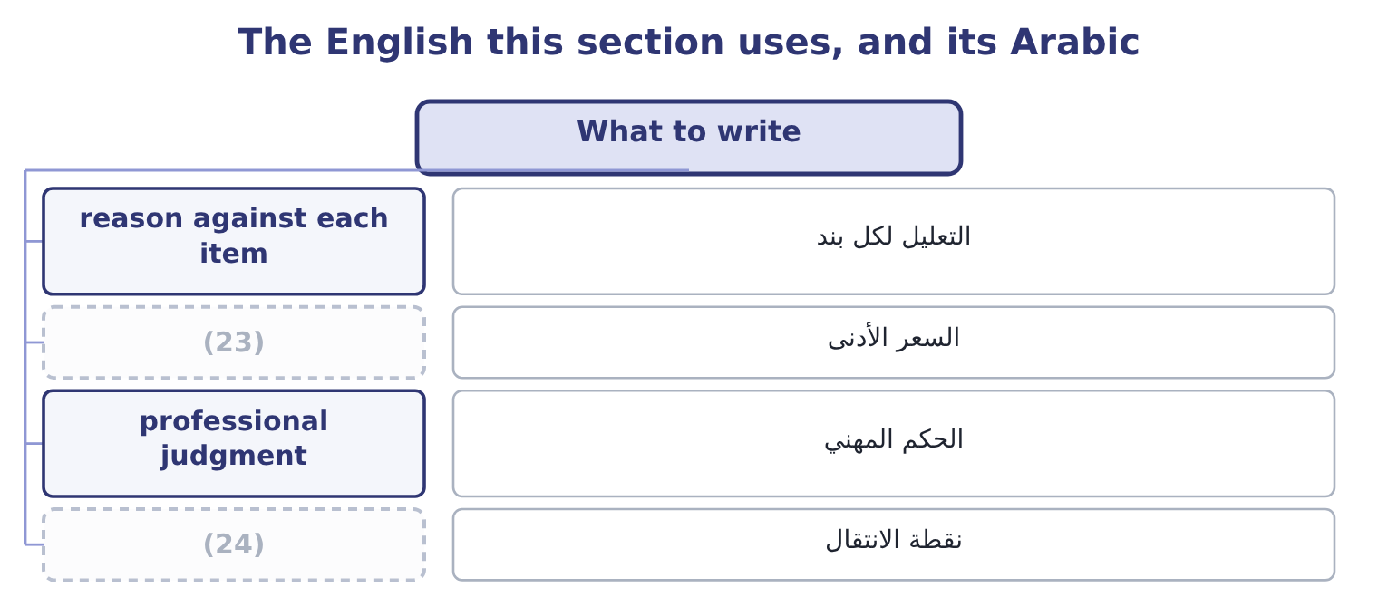
word list
hinge · floor price · professional judgment

The English this sheet uses, and its Arabic
English (exam term) | Arabic
reason against each item | التعليل لكل بند
floor price | السعر الأدنى
professional judgment | الحكم المهني
hinge | نقطة الانتقال

Answer key · 6.5 What to write

1 reasoning | 13 regular use
2 arithmetic | 14 contribution
3 including | 15 spare capacity
4 exclusion | 16 decision
5 difference | 17 records
6 opportunity | 18 difficulty
7 displaced | 19 safeguard
8 machine | 20 13,800
9 looking | 21 29,600
10 recommendation | 22 full-cost
11 professional | 23 floor price
12 hinge | 24 hinge

the summaries in full
Summary 1 An analysis of this kind is marked on its reasoning as much as its arithmetic, so three habits are worth building. Give every item a line, including the ones excluded. A table with a reason against each excluded item shows that the exclusion was decided rather than forgotten, and it is the difference between a sound answer and one that looks lucky. Name the opportunity cost explicitly. Write "contribution forgone on 160 displaced roaster hours at $1,200" rather than "machine cost $192,000". The marker is looking for the concept, and the words carry it. State what the answer is a floor for. A minimum price is not a recommendation to charge it; it is the point below which the company is worse off. The sentence "the contract is worth taking at any price above $7.60 a jar, and what to charge depends on what the hotel group would pay" is the professional ending, and it is the hinge into the pricing chapters that follow.
Summary 2 Only the second and third are relevant to a decision, and only the first and fourth appear in the records — which is the whole difficulty of the topic in one sentence. The safeguard in every language is to never write the word alone.

7.1 Marginal cost and marginal revenue
Chapter 7 · section 7.1

Fill every gap. Each word list holds one word more than there are gaps.
Chapter 7, section by section
Each stage leads to the next.
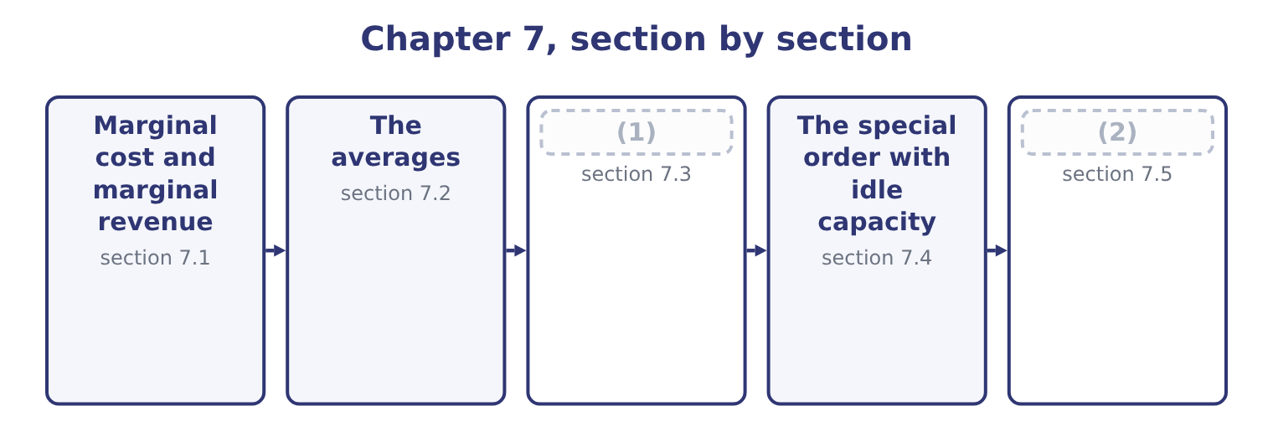
word list
Marginal analysis as a decision rule · The special order without idle capacity · The special order with idle capacity

Summary 1 gaps 3–14
Marginal cost is the increase in total cost from (3) one more unit. Marginal revenue is the increase in total revenue from selling one more unit. Both are (4) , not averages. (5) the relevant range, marginal cost equals the (6) cost per unit. For Orontes, making one more jar costs another $7.20 of sesame, (7) and the rest, and nothing else moves: the lease, the salaries and the (8) are the same at 3,500,001 jars as at 3,500,000. So marginal cost is $7.20 — and (9) that the full cost of a jar, which section 7.2 (10) as $10.81, is not the cost of making another one. (11) the relevant range, marginal cost jumps. The 4,000,001st jar might need a second shift, which adds a (12) and a premium rate; at that point marginal cost rises in a step, which is why the classic (13) diagram draws marginal cost as a curve rather than a line. Marginal revenue equals the selling price only where the company can sell any quantity at that price — the condition economists call pure (14) . Where selling more requires a lower price, and the lower price applies to all units and not only the extra ones, marginal revenue is below the price and can be negative.
word list
notice · packaging · depreciation · supervisor · differences · Within · producing · computes · economics · competition · variable · premium · Outside

Worked example: what the extra jars really earn

Summary 2 gaps 15–20
Orontes sells 3,500,000 jars at $12.00, so total revenue is 3,500,000 × 12.00 = 42,000,000. To sell 3,800,000 jars, the price must fall to $11.50 — for every jar, not only the extra ones. Total revenue (15) 11.50 × 3,800,000 = 43,700,000. Revenue rises by 43,700,000 − 42,000,000 = 1,700,000 for 300,000 extra jars, so marginal revenue is 1,700,000 ÷ 300,000 = 5.67 a jar. Marginal cost is $7.20. Each extra jar earns $5.67 and costs $7.20, so the company would lose 7.20 − 5.67 = 1.53 on each of them. The price is $11.50 and the marginal revenue is $5.67, and the gap (16) them is the revenue given up on the 3,500,000 jars that would have sold at $12.00: 3,500,000 × 0.50 = 1,750,000 of lost revenue against 300,000 × 11.50 = 3,450,000 (17) . That is the (18) behind Book 1's (19) that Orontes had been (20) growth with price, and it is why marginal revenue, not price, is the figure to set against marginal cost.
word list
finding · buying · between · arithmetic · gained · recurring · becomes

Marginal revenue when the price has to fall for every jar
Item | Now | Proposal | Difference
Jars sold | 3,500,000 | 3,800,000 | 300,000
(21) | 12.00 | 11.50 | (0.50)
Total revenue | 42,000,000 | 43,700,000 | 1,700,000
(22) | — | 5.67 | —
Marginal cost a jar | 7.20 | 7.20 | —
(23) | — | Reject | Cost above marginal revenue

word list
Price a jar · one more unit · Verdict · Marginal revenue a jar

Summary 3 gaps 24–26
The (24) rule that follows is the (25) of the next three chapters. Do more of (26) while marginal revenue exceeds marginal cost; stop where they are equal; do less where marginal cost is higher.
word list
Marginal · something · foundation · decision

The English this section uses, and its Arabic
Each term sits against what it means.
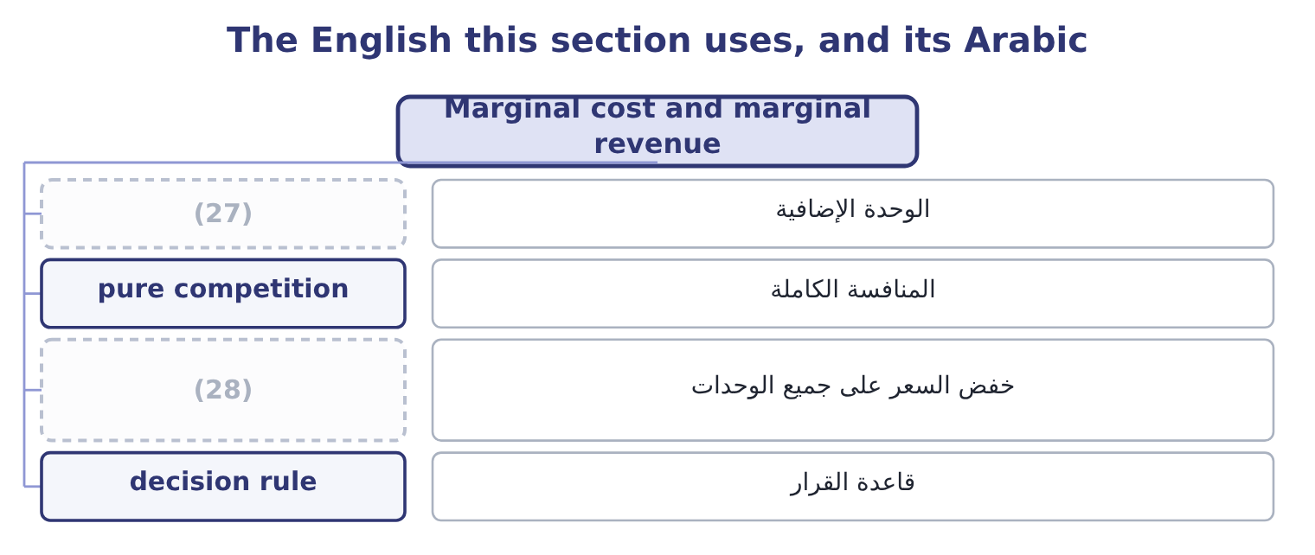
word list
average variable cost · price cut across all units · one more unit

The English this sheet uses, and its Arabic
English (exam term) | Arabic
one more unit | الوحدة الإضافية
pure competition | المنافسة الكاملة
price cut across all units | خفض السعر على جميع الوحدات
decision rule | قاعدة القرار

Answer key · 7.1 Marginal cost and marginal revenue

1 Marginal analysis as a decision rule | 15 becomes
2 The special order without idle capacity | 16 between
3 producing | 17 gained
4 differences | 18 arithmetic
5 Within | 19 finding
6 variable | 20 buying
7 packaging | 21 Price a jar
8 depreciation | 22 Marginal revenue a jar
9 notice | 23 Verdict
10 computes | 24 decision
11 Outside | 25 foundation
12 supervisor | 26 something
13 economics | 27 one more unit
14 competition | 28 price cut across all units

the summaries in full
Summary 1 Marginal cost is the increase in total cost from producing one more unit. Marginal revenue is the increase in total revenue from selling one more unit. Both are differences, not averages. Within the relevant range, marginal cost equals the variable cost per unit. For Orontes, making one more jar costs another $7.20 of sesame, packaging and the rest, and nothing else moves: the lease, the salaries and the depreciation are the same at 3,500,001 jars as at 3,500,000. So marginal cost is $7.20 — and notice that the full cost of a jar, which section 7.2 computes as $10.81, is not the cost of making another one. Outside the relevant range, marginal cost jumps. The 4,000,001st jar might need a second shift, which adds a supervisor and a premium rate; at that point marginal cost rises in a step, which is why the classic economics diagram draws marginal cost as a curve rather than a line. Marginal revenue equals the selling price only where the company can sell any quantity at that price — the condition economists call pure competition. Where selling more requires a lower price, and the lower price applies to all units and not only the extra ones, marginal revenue is below the price and can be negative.
Summary 2 Orontes sells 3,500,000 jars at $12.00, so total revenue is 3,500,000 × 12.00 = 42,000,000. To sell 3,800,000 jars, the price must fall to $11.50 — for every jar, not only the extra ones. Total revenue becomes 11.50 × 3,800,000 = 43,700,000. Revenue rises by 43,700,000 − 42,000,000 = 1,700,000 for 300,000 extra jars, so marginal revenue is 1,700,000 ÷ 300,000 = 5.67 a jar. Marginal cost is $7.20. Each extra jar earns $5.67 and costs $7.20, so the company would lose 7.20 − 5.67 = 1.53 on each of them. The price is $11.50 and the marginal revenue is $5.67, and the gap between them is the revenue given up on the 3,500,000 jars that would have sold at $12.00: 3,500,000 × 0.50 = 1,750,000 of lost revenue against 300,000 × 11.50 = 3,450,000 gained. That is the arithmetic behind Book 1's finding that Orontes had been buying growth with price, and it is why marginal revenue, not price, is the figure to set against marginal cost.
Summary 3 The decision rule that follows is the foundation of the next three chapters. Do more of something while marginal revenue exceeds marginal cost; stop where they are equal; do less where marginal cost is higher.

7.2 The averages
Chapter 7 · section 7.2

Fill every gap. Each word list holds one word more than there are gaps.
Summary 1 gaps 1–8
Four (1) appear in exam questions, and the (2) is simple once the four are kept apart. Total cost is the fixed costs plus the variable costs at that volume. For (3) at 3,500,000 jars: variable costs are 3,500,000 × 7.20 = 25,200,000, and with fixed costs of $12,624,000 the total is 25,200,000 + 12,624,000 = 37,824,000. Average variable cost is the variable cost divided by the units, which is $7.20 and does not (4) within the range. It equals marginal cost here, which is a property of the (5) model and not a (6) truth. Average fixed cost is the fixed costs divided by the units: 12,624,000 ÷ 3,500,000 = 3.61 a jar. It falls as volume rises, which is the whole of what people mean by (7) the overhead. Average total cost is the total divided by the units: 37,824,000 ÷ 3,500,000 = 10.81 a jar. It equals the average variable cost plus the average fixed cost, 7.20 + 3.61 = 10.81, and it falls as volume rises because its fixed (8) does.
word list
arithmetic · straight-line · change · general · confusion · spreading · component · Orontes · averages

The averages at three volumes
Measure | 3,000,000 jars | 3,500,000 jars | 4,000,000 jars
Variable cost in total | 21,600,000 | 25,200,000 | 28,800,000
Fixed cost in total | 12,624,000 | 12,624,000 | 12,624,000
Total cost | 34,224,000 | 37,824,000 | 41,424,000
Average variable cost | 7.20 | 7.20 | 7.20
(9) | 4.21 | 3.61 | 3.16
(10) | 11.41 | 10.81 | 10.36
(11) | 7.20 | 7.20 | 7.20

word list
Average variable cost · Average total cost · Average fixed cost · Marginal cost

Summary 2 gaps 12–22
Three readings, all (12) . Average total cost falls with volume and marginal cost does not. The two are different numbers (13) different questions, and the gap (14) them at 3,500,000 jars is 10.81 − 7.20 = 3.61, which is (15) the average fixed cost. A (16) system reports the average and a decision needs the (17) . That is the single most expensive confusion in (18) accounting, and the special order of section 7.4 is its standard (19) . Average total cost is the right figure for some questions. It is what a (20) must earn over the long run if the company is to cover its fixed costs, and it is the base of the (21) pricing. It is (22) not the figure for a decision about one more unit.
word list
cost-plus · answering · simply · product · recurring · exactly · examinable · between · costing · margin · illustration · management

The English this section uses, and its Arabic
Each term sits against what it means.
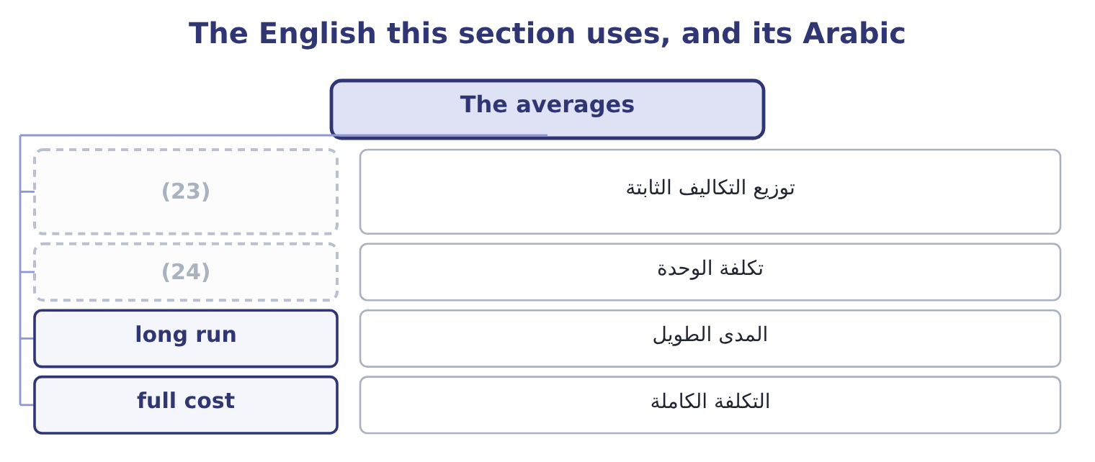
word list
minimum acceptable price · spreading the overhead · unit cost

The English this sheet uses, and its Arabic
English (exam term) | Arabic
spreading the overhead | توزيع التكاليف الثابتة
unit cost | تكلفة الوحدة
long run | المدى الطويل
full cost | التكلفة الكاملة

Answer key · 7.2 The averages

1 averages | 13 answering
2 arithmetic | 14 between
3 Orontes | 15 exactly
4 change | 16 costing
5 straight-line | 17 margin
6 general | 18 management
7 spreading | 19 illustration
8 component | 20 product
9 Average fixed cost | 21 cost-plus
10 Average total cost | 22 simply
11 Marginal cost | 23 spreading the overhead
12 examinable | 24 unit cost

the summaries in full
Summary 1 Four averages appear in exam questions, and the arithmetic is simple once the four are kept apart. Total cost is the fixed costs plus the variable costs at that volume. For Orontes at 3,500,000 jars: variable costs are 3,500,000 × 7.20 = 25,200,000, and with fixed costs of $12,624,000 the total is 25,200,000 + 12,624,000 = 37,824,000. Average variable cost is the variable cost divided by the units, which is $7.20 and does not change within the range. It equals marginal cost here, which is a property of the straight-line model and not a general truth. Average fixed cost is the fixed costs divided by the units: 12,624,000 ÷ 3,500,000 = 3.61 a jar. It falls as volume rises, which is the whole of what people mean by spreading the overhead. Average total cost is the total divided by the units: 37,824,000 ÷ 3,500,000 = 10.81 a jar. It equals the average variable cost plus the average fixed cost, 7.20 + 3.61 = 10.81, and it falls as volume rises because its fixed component does.
Summary 2 Three readings, all examinable. Average total cost falls with volume and marginal cost does not. The two are different numbers answering different questions, and the gap between them at 3,500,000 jars is 10.81 − 7.20 = 3.61, which is exactly the average fixed cost. A costing system reports the average and a decision needs the margin. That is the single most expensive confusion in management accounting, and the special order of section 7.4 is its standard illustration. Average total cost is the right figure for some questions. It is what a product must earn over the long run if the company is to cover its fixed costs, and it is the base of the cost-plus pricing. It is simply not the figure for a decision about one more unit.

7.3 Marginal analysis as a decision rule
Chapter 7 · section 7.3

Fill every gap. Each word list holds one word more than there are gaps.
Summary 1 gaps 1–2
Marginal analysis (1) the change in revenue with the change in cost, and accepts whatever change leaves the company better off. Four everyday decisions are the same (2) in different clothes.
word list
analysis · calculation · compares

A special order: does the extra revenue exceed the extra cost?

Make or buy: does the cost avoided by buying exceed the price paid?

Drop or keep: does the contribution lost exceed the fixed cost avoided?

Summary 2 gaps 3–13
In every case the analysis contains only what changes, which is, and includes the (3) cost of anything (4) , which is. Two (5) apply to all four. The analysis is short-run by (6) . It holds the fixed costs and the capacity (7) , which is correct for a decision inside the (8) range and wrong for a decision that changes the shape of the business. (9) changes the (10) . A (11) order accepted once uses spare capacity; the same order accepted every month (12) part of the regular business, and regular business must cover fixed costs. The exam signals this with the words "one-off" or "will not recur", and an answer that notices their absence is (13) better than one that does not.
word list
cautions · special · displaced · question · relevant · opportunity · answering · becomes · compares · construction · constant · Repetition

The English this section uses, and its Arabic
Each term sits against what it means.
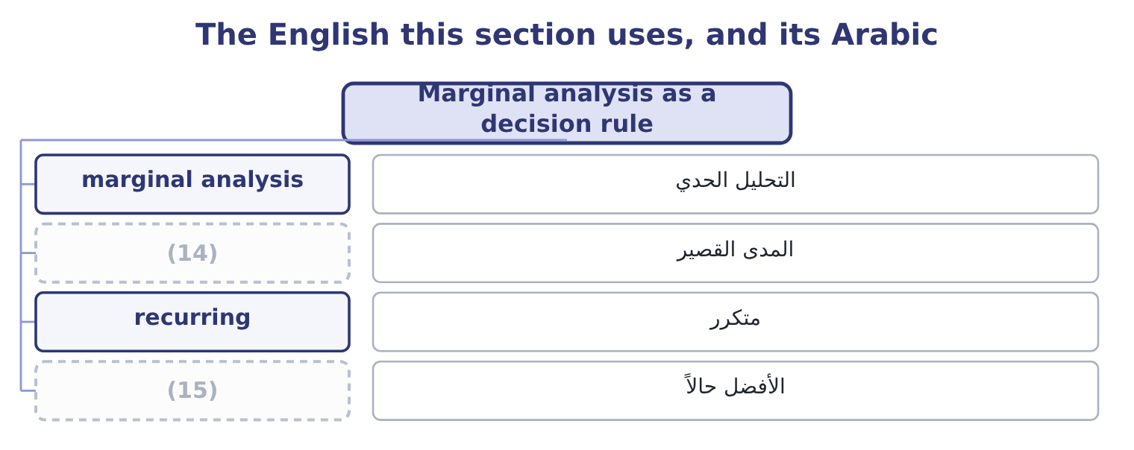
word list
المدى القصير · better off · short run

The English this sheet uses, and its Arabic
English (exam term) | Arabic
marginal analysis | التحليل الحدي
short run | المدى القصير
recurring | متكرر
better off | الأفضل حالاً

Answer key · 7.3 Marginal analysis as a decision rule

1 compares | 9 Repetition
2 calculation | 10 question
3 opportunity | 11 special
4 displaced | 12 becomes
5 cautions | 13 answering
6 construction | 14 short run
7 constant | 15 better off
8 relevant

the summaries in full
Summary 1 Marginal analysis compares the change in revenue with the change in cost, and accepts whatever change leaves the company better off. Four everyday decisions are the same calculation in different clothes.
Summary 2 In every case the analysis contains only what changes, which is, and includes the opportunity cost of anything displaced, which is. Two cautions apply to all four. The analysis is short-run by construction. It holds the fixed costs and the capacity constant, which is correct for a decision inside the relevant range and wrong for a decision that changes the shape of the business. Repetition changes the question. A special order accepted once uses spare capacity; the same order accepted every month becomes part of the regular business, and regular business must cover fixed costs. The exam signals this with the words "one-off" or "will not recur", and an answer that notices their absence is answering better than one that does not.

7.4 The special order with idle capacity
Chapter 7 · section 7.4

Fill every gap. Each word list holds one word more than there are gaps.
Summary 1 gaps 1–4
Now the (1) the chapter opened with. A hotel group (2) $8.50 a jar for 300,000 jars, in plain labelling of its own design. Orontes has capacity to spare: it can make 3,800,000 jars and sells 3,500,000. The special labels cost 30 cents a jar more than the (3) ones. No other cost (4) .
word list
standard · changes · offers · therefore · question

Worked example: the order, with capacity to spare

Summary 2 gaps 5–14
Variable cost of $7.20 plus special labelling of $0.30 is 7.20 + 0.30 = 7.50 a jar. The effect on operating income. What is (5) , and why. The fixed costs of $12,624,000 do not change, so no part of them belongs in the (6) ; the average total cost of $10.81 is therefore (7) , and the order's (8) loss of 10.81 − 8.50 = 2.31 a jar is an (9) of a costing system doing a job it was not (10) for. (11) raises operating income from $4,176,000 to 4,176,000 + 300,000 = 4,476,000. The price of $8.50 is below full cost and above (12) cost, and that is (13) the range in which a special order is worth (14) . Below $7.50 it would not be.
word list
Accepting · precisely · irrelevant · analysis · apparent · artefact · taking · average · designed · incremental · excluded

The same order, two ways of looking at it
Per jar | Full-cost view | Relevant-cost view
Price offered | 8.50 | 8.50
Variable cost | (7.20) | (7.20)
Special labelling | (0.30) | (0.30)
Absorbed fixed cost | (3.61) | (15)
Result a jar | (2.61) loss | (16)
Effect on operating income | (17) | Gains 300,000

word list
Not relevant; it does not change · Appears to lose 783,000 · 1.00 contribution · minimum acceptable price

Summary 3 gaps 18–26
The (18) column is the answer and the (19) column is what a costing system would print. Which is why this (20) exists. Four (21) make the relevant-cost answer the right one, and an exam answer (22) state them. There is (23) spare capacity, so nothing is (24) . The order is (25) , so it does not become the (26) . It does not disturb the regular market — the hotel group will not resell into Orontes's own customers, and the existing customers will not learn of the price and demand it. Any costs specific to the order, such as the special labelling, are included.
word list
conditions · one-off · should · apparent · left-hand · displaced · right-hand · business · outcome · genuinely

The English this section uses, and its Arabic
Each term sits against what it means.
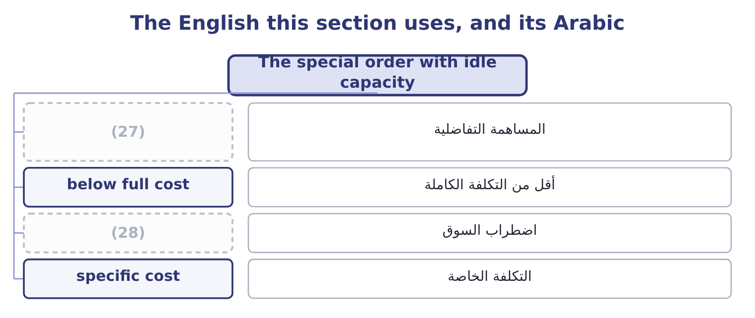
word list
التكلفة الخاصة · market disturbance · incremental contribution

The English this sheet uses, and its Arabic
English (exam term) | Arabic
incremental contribution | المساهمة التفاضلية
below full cost | أقل من التكلفة الكاملة
market disturbance | اضطراب السوق
specific cost | التكلفة الخاصة

Answer key · 7.4 The special order with idle capacity

1 question | 15 Not relevant; it does not change
2 offers | 16 1.00 contribution
3 standard | 17 Appears to lose 783,000
4 changes | 18 right-hand
5 excluded | 19 left-hand
6 analysis | 20 outcome
7 irrelevant | 21 conditions
8 apparent | 22 should
9 artefact | 23 genuinely
10 designed | 24 displaced
11 Accepting | 25 one-off
12 incremental | 26 business
13 precisely | 27 incremental contribution
14 taking | 28 market disturbance

the summaries in full
Summary 1 Now the question the chapter opened with. A hotel group offers $8.50 a jar for 300,000 jars, in plain labelling of its own design. Orontes has capacity to spare: it can make 3,800,000 jars and sells 3,500,000. The special labels cost 30 cents a jar more than the standard ones. No other cost changes.
Summary 2 Variable cost of $7.20 plus special labelling of $0.30 is 7.20 + 0.30 = 7.50 a jar. The effect on operating income. What is excluded, and why. The fixed costs of $12,624,000 do not change, so no part of them belongs in the analysis; the average total cost of $10.81 is therefore irrelevant, and the order's apparent loss of 10.81 − 8.50 = 2.31 a jar is an artefact of a costing system doing a job it was not designed for. Accepting raises operating income from $4,176,000 to 4,176,000 + 300,000 = 4,476,000. The price of $8.50 is below full cost and above incremental cost, and that is precisely the range in which a special order is worth taking. Below $7.50 it would not be.
Summary 3 The right-hand column is the answer and the left-hand column is what a costing system would print. Which is why this outcome exists. Four conditions make the relevant-cost answer the right one, and an exam answer should state them. There is genuinely spare capacity, so nothing is displaced. The order is one-off, so it does not become the business. It does not disturb the regular market — the hotel group will not resell into Orontes's own customers, and the existing customers will not learn of the price and demand it. Any costs specific to the order, such as the special labelling, are included.

7.5 The special order without idle capacity
Chapter 7 · section 7.5

Fill every gap. Each word list holds one word more than there are gaps.
Summary 1 gaps 1–12
Suppose Orontes is making 3,800,000 jars and (1) every one of them. (2) the hotel order now means making 300,000 fewer standard jars. The incremental cost is still $7.50. But the 300,000 standard jars (3) would each have (4) $4.80, so the opportunity cost is 300,000 × 4.80 = 1,440,000. Against an incremental contribution of 300,000 × 1.00 = 300,000, the order would leave the company 1,440,000 − 300,000 = 1,140,000 worse off. The minimum (5) price at full capacity is the incremental cost plus the contribution displaced: 7.50 + 4.80 = 12.30 a jar — thirty cents above the regular price, which is the special (6) , and far above the $8.50 (7) . (8) capacity is the case the exam likes best, because it needs both (9) . Suppose Orontes can make 3,650,000 jars and sells 3,500,000, so 150,000 jars of capacity are spare and the other 150,000 of the order would (10) standard sales. Then half the order carries no opportunity cost and half carries $4.80: the (11) cost is 150,000 × 7.50 = 1,125,000 for the first part and 150,000 × 12.30 = 1,845,000 for the second, so the whole order should not be (12) below 1,125,000 + 1,845,000 = 2,970,000, which is 2,970,000 ÷ 300,000 = 9.90 a jar.
word list
selling · acceptable · contributed · Partial · labelling · displace · relevant · offered · Taking · accepted · halves · becomes · forgone

Summary 2 gaps 13–19
The (13) factors close the chapter and carry real marks. What the regular (14) will think. A price of $8.50 that becomes known is a price every customer will ask for, and Book 1 (15) what two points of margin are worth. Whether the buyer will (16) . A hotel group with 300,000 jars at $8.50 is a potential (17) in Orontes's own market. What the order displaces in the (18) , not only in the figures. A regular customer (19) away for a one-off order may not return.
word list
relationship · showed · resell · customers · qualitative · competitor · displaced · turned

Summary 3 gaps 20–24
Whether the capacity is (20) spare. Capacity used for a special order is capacity not (21) for a sudden opportunity, and a company close to full should price that risk. And what (22) next year. A one-off order that is (23) becomes the regular (24) , priced at a level that does not cover fixed costs.
word list
repeated · really · available · relevant · business · happens

Price three orders

Your turn: special orders (complete the blanks)
Item | Data | Answer
Average total cost | (25) | ________
Minimum price with spare capacity | Special packing adds 1.20 a unit | ________
Minimum price at full capacity | (26) | ________
Effect of a 20,000-unit order at 16.00, with spare capacity |  | ________
Effect of the same order at full capacity |  | ________
The order that should be refused |  | ________

word list
15.20: 14.00 + 1.20 = 15.20. · Fixed 900,000, variable 14.00 a unit, volume 150,000 · Regular contribution is 6.00 a unit

"Marginal"

Summary 4 gaps 27–31
English marginal in economics and (27) accounting means at the margin — the effect of one more unit — and carries no suggestion of smallness or (28) . In everyday English a marginal (29) is a trivial one, and that reading destroys the technical sense (30) : a marginal cost can be the largest number in a decision. The exam uses the technical sense without (31) .
word list
exception · completely · management · difference · unimportance · regular

The same order, with and without spare capacity
Every item belongs to exactly one group.
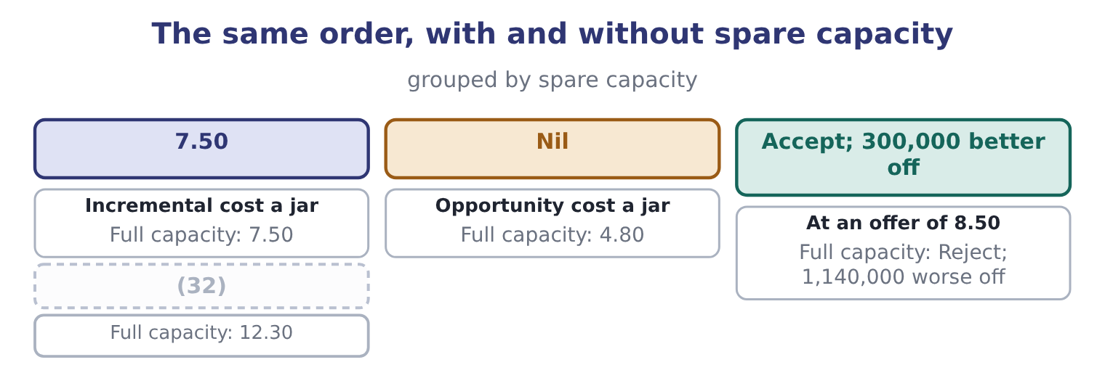
word list
Minimum price a jar · Accept; 300,000 better off

Item — Answer
Item | Answer
Average total cost | 20.00: variable 14.00 plus fixed of 900,000 ÷ 150,000 = 6.00.
Minimum price with spare capacity | (33)
Minimum price at full capacity | 21.20: 15.20 + 6.00 = 21.20.
A 20,000-unit order at 16.00, spare capacity | (34) : the contribution is 16.00 − 15.20 = 0.80 a unit, and 20,000 × 0.80 = 16,000.
The same order at full capacity | (35) : the displaced contribution is 20,000 × 6.00 = 120,000 against 16,000 of incremental contribution.
The order that should be refused | The one taken at full capacity, because it displaces contribution five times its own.
What it tells you | The same order at the same price is worth 16,000 or costs 104,000, and nothing about the order changed. Capacity is the fact that decides, a

word list
15.20: 14.00 + 1.20 = 15.20. · Loses 104,000 · 21.20: 15.20 + 6.00 = 21.20. · Adds 16,000

The English this section uses, and its Arabic
Each term sits against what it means.
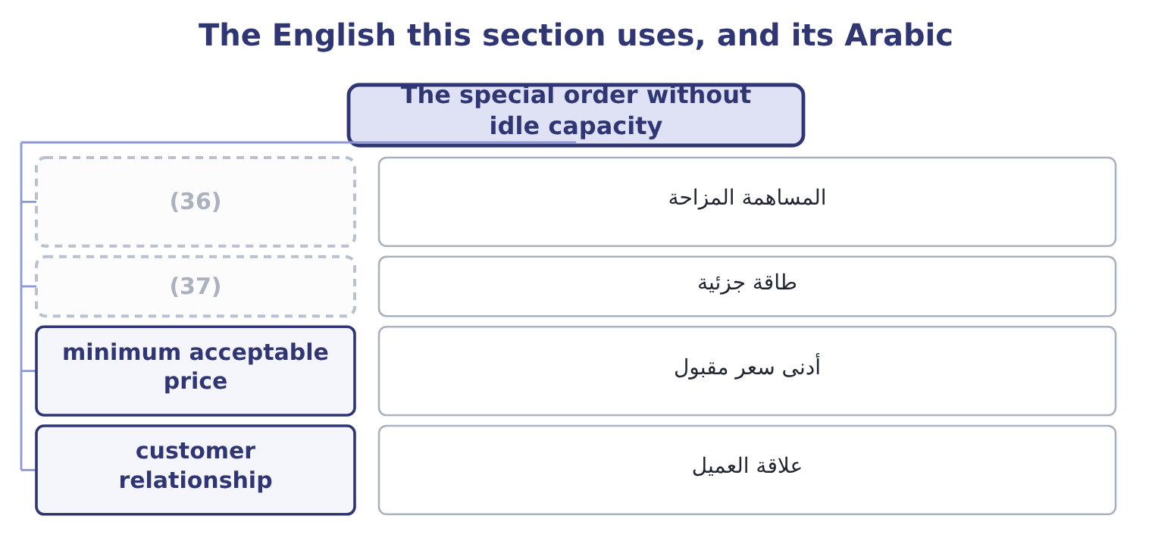
word list
marginal revenue · partial capacity · displaced contribution

The English this sheet uses, and its Arabic
English (exam term) | Arabic
displaced contribution | المساهمة المزاحة
partial capacity | طاقة جزئية
minimum acceptable price | أدنى سعر مقبول
customer relationship | علاقة العميل

Answer key · 7.5 The special order without idle capacity

1 selling | 20 really
2 Taking | 21 available
3 forgone | 22 happens
4 contributed | 23 repeated
5 acceptable | 24 business
6 labelling | 25 Fixed 900,000, variable 14.00 a unit, volume 150,000
7 offered | 26 Regular contribution is 6.00 a unit
8 Partial | 27 management
9 halves | 28 unimportance
10 displace | 29 difference
11 relevant | 30 completely
12 accepted | 31 exception
13 qualitative | 32 Minimum price a jar
14 customers | 33 15.20: 14.00 + 1.20 = 15.20.
15 showed | 34 Adds 16,000
16 resell | 35 Loses 104,000
17 competitor | 36 displaced contribution
18 relationship | 37 partial capacity
19 turned

the summaries in full
Summary 1 Suppose Orontes is making 3,800,000 jars and selling every one of them. Taking the hotel order now means making 300,000 fewer standard jars. The incremental cost is still $7.50. But the 300,000 standard jars forgone would each have contributed $4.80, so the opportunity cost is 300,000 × 4.80 = 1,440,000. Against an incremental contribution of 300,000 × 1.00 = 300,000, the order would leave the company 1,440,000 − 300,000 = 1,140,000 worse off. The minimum acceptable price at full capacity is the incremental cost plus the contribution displaced: 7.50 + 4.80 = 12.30 a jar — thirty cents above the regular price, which is the special labelling, and far above the $8.50 offered. Partial capacity is the case the exam likes best, because it needs both halves. Suppose Orontes can make 3,650,000 jars and sells 3,500,000, so 150,000 jars of capacity are spare and the other 150,000 of the order would displace standard sales. Then half the order carries no opportunity cost and half carries $4.80: the relevant cost is 150,000 × 7.50 = 1,125,000 for the first part and 150,000 × 12.30 = 1,845,000 for the second, so the whole order should not be accepted below 1,125,000 + 1,845,000 = 2,970,000, which is 2,970,000 ÷ 300,000 = 9.90 a jar.
Summary 2 The qualitative factors close the chapter and carry real marks. What the regular customers will think. A price of $8.50 that becomes known is a price every customer will ask for, and Book 1 showed what two points of margin are worth. Whether the buyer will resell. A hotel group with 300,000 jars at $8.50 is a potential competitor in Orontes's own market. What the order displaces in the relationship, not only in the figures. A regular customer turned away for a one-off order may not return.
Summary 3 Whether the capacity is really spare. Capacity used for a special order is capacity not available for a sudden opportunity, and a company close to full should price that risk. And what happens next year. A one-off order that is repeated becomes the regular business, priced at a level that does not cover fixed costs.
Summary 4 English marginal in economics and management accounting means at the margin — the effect of one more unit — and carries no suggestion of smallness or unimportance. In everyday English a marginal difference is a trivial one, and that reading destroys the technical sense completely: a marginal cost can be the largest number in a decision. The exam uses the technical sense without exception.

8.1 What the costing system says, and what it means
Chapter 8 · section 8.1

Fill every gap. Each word list holds one word more than there are gaps.
Chapter 8, section by section
Each stage leads to the next.
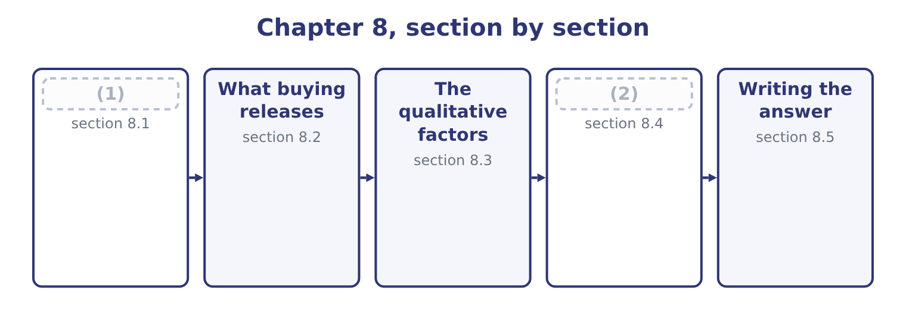
word list
Variants of the same question · What the costing system says, and what it mean · leverage in negotiation

The cost of a lid, as reported
The parts add up to the total; the bars are to scale.
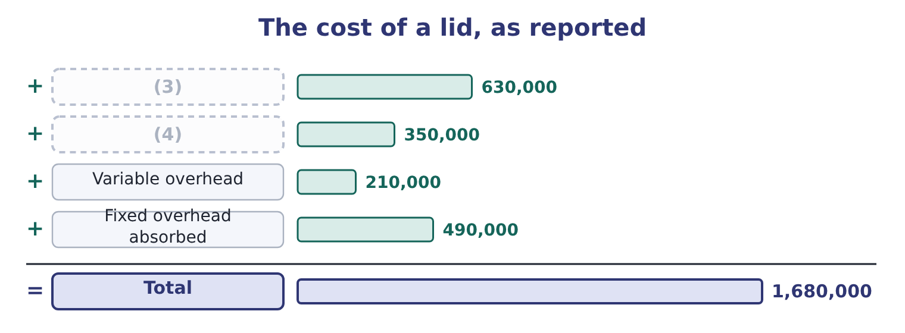
word list
second source · Direct materials · Direct labour

Summary 1 gaps 5–16
The first three lines stop if the lids are bought. The (5) is the question. (6) fixed overhead of $490,000 is a share of the (7) fixed costs (8) to the pressing shop by (9) basis the system uses, and the (10) that would (11) stop is a matter of fact rather than of (12) . Suppose the facts are these: the pressing shop has its own supervisor, whose $175,000 post would be (13) , and the remaining $315,000 is the shop's share of factory rent, (14) , heating and head office costs, all of which (15) whether the shop presses lids or stands empty. Then the relevant cost of making is the three variable lines plus the supervisor: 0.18 + 0.10 + 0.06 = 0.34 a lid, which is 3,500,000 × 0.34 = 1,190,000, plus the (16) $175,000, giving 1,190,000 + 175,000 = 1,365,000.
word list
relevant · amount · continue · fourth · allocation · eliminated · actually · whatever · allocated · insurance · factory's · avoidable · Absorbed

Summary 2 gaps 17–18
Per lid that is 1,365,000 ÷ 3,500,000 = 0.39. The supplier wants 0.42. Buying costs 3,500,000 × 0.42 = 1,470,000 (17) a relevant cost of making of $1,365,000, so buying would make the company 1,470,000 − 1,365,000 = 105,000 worse off a year. (18) should go on making its lids.
word list
Orontes · against · understates

The three ways this goes wrong

Summary 3 gaps 19–26
Comparing the (19) price with the full cost of 0.48. That (20) $315,000 of unavoidable overhead as a (21) , and it is the error the question is built to catch. Comparing with the variable cost alone, at 0.34. That ignores the (22) post, which genuinely does disappear, and (23) the cost of making. (24) that the unavoidable $315,000 does not vanish: if the lids are bought, that overhead is (25) by the other products, whose reported costs rise. (26) has been saved and several products now look worse.
word list
supplier's · whatever · Forgetting · Nothing · saving · understates · supervisor's · treats · re-absorbed

The English this section uses, and its Arabic
Each term sits against what it means.
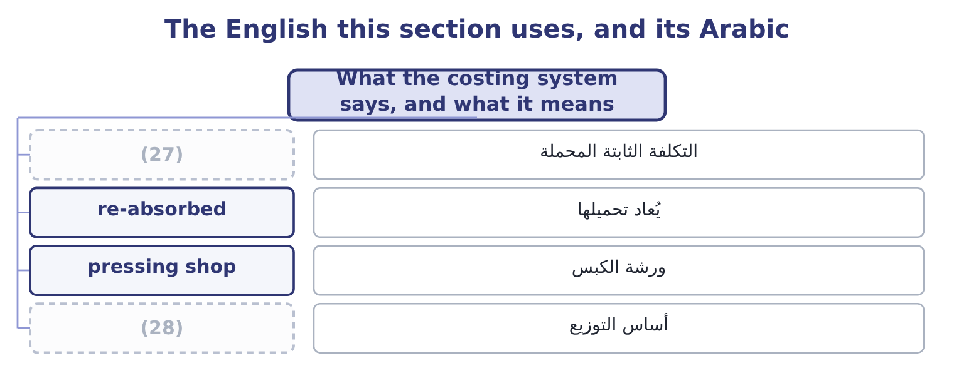
word list
basis of allocation · indifference price · absorbed overhead

The English this sheet uses, and its Arabic
English (exam term) | Arabic
absorbed overhead | التكلفة الثابتة المحملة
re-absorbed | يُعاد تحميلها
pressing shop | ورشة الكبس
basis of allocation | أساس التوزيع

Answer key · 8.1 What the costing system says, and what it means

1 What the costing system says, and what it mean | 15 continue
2 Variants of the same question | 16 avoidable
3 Direct materials | 17 against
4 Direct labour | 18 Orontes
5 fourth | 19 supplier's
6 Absorbed | 20 treats
7 factory's | 21 saving
8 allocated | 22 supervisor's
9 whatever | 23 understates
10 amount | 24 Forgetting
11 actually | 25 re-absorbed
12 allocation | 26 Nothing
13 eliminated | 27 absorbed overhead
14 insurance | 28 basis of allocation

the summaries in full
Summary 1 The first three lines stop if the lids are bought. The fourth is the question. Absorbed fixed overhead of $490,000 is a share of the factory's fixed costs allocated to the pressing shop by whatever basis the system uses, and the amount that would actually stop is a matter of fact rather than of allocation. Suppose the facts are these: the pressing shop has its own supervisor, whose $175,000 post would be eliminated, and the remaining $315,000 is the shop's share of factory rent, insurance, heating and head office costs, all of which continue whether the shop presses lids or stands empty. Then the relevant cost of making is the three variable lines plus the supervisor: 0.18 + 0.10 + 0.06 = 0.34 a lid, which is 3,500,000 × 0.34 = 1,190,000, plus the avoidable $175,000, giving 1,190,000 + 175,000 = 1,365,000.
Summary 2 Per lid that is 1,365,000 ÷ 3,500,000 = 0.39. The supplier wants 0.42. Buying costs 3,500,000 × 0.42 = 1,470,000 against a relevant cost of making of $1,365,000, so buying would make the company 1,470,000 − 1,365,000 = 105,000 worse off a year. Orontes should go on making its lids.
Summary 3 Comparing the supplier's price with the full cost of 0.48. That treats $315,000 of unavoidable overhead as a saving, and it is the error the question is built to catch. Comparing with the variable cost alone, at 0.34. That ignores the supervisor's post, which genuinely does disappear, and understates the cost of making. Forgetting that the unavoidable $315,000 does not vanish: if the lids are bought, that overhead is re-absorbed by the other products, whose reported costs rise. Nothing has been saved and several products now look worse.

8.2 What buying releases
Chapter 8 · section 8.2

Fill every gap. Each word list holds one word more than there are gaps.
Summary 1 gaps 1–10
The (1) above assumes the (2) shop would simply stand empty. If it would not, the comparison changes, and the change is an (3) cost of the kind. (4) the floor space and the two presses, once free, could be used to make a new line of sesame bars earning a (5) of $200,000 a year. That $200,000 is (6) only if the lids are (7) , so it belongs on the buying side. Buying now costs 1,470,000 − 200,000 = 1,270,000 in net terms, (8) $1,365,000 for making, so buying is better by 1,365,000 − 1,270,000 = 95,000 a year. The (9) reverses on a figure that (10) nowhere in the costing system.
word list
receivable · depends · against · appears · contribution · Suppose · bought · arithmetic · recommendation · opportunity · pressing

Worked example: the indifference price

Summary 2 gaps 11–22
Making costs $1,365,000 a year, so the company is (11) at a price of 1,365,000 ÷ 3,500,000 = 0.39 a lid. With the alternative use. If the (12) space earns $200,000, the company can (13) to pay 1,365,000 + 200,000 = 1,565,000, which is 1,565,000 ÷ 3,500,000 = 0.447 a lid. The (14) 0.42 sits between the two. Whether to buy depends (15) on whether the alternative use is real, and the (16) with the supplier should be (17) knowing that 0.447 is the ceiling and 0.39 is the (18) point. The (19) price is the most useful single output of a make-or-buy analysis, because it converts a (20) answer into a (21) position. A buyer who knows the ceiling can ask for a better price; one who knows only that 0.42 beats 0.48 will accept (22) is offered below 0.48.
word list
indifference · released · whatever · entirely · supplier's · walk-away · afford · indifferent · negotiating · yes-or-no · negotiation · conducted · contribution

Make or buy, three cases
Case | Cost of making | Cost of buying | Better by
Space stands empty | 1,365,000 | 1,470,000 | (23)
Space earns 200,000 | 1,365,000 | 1,270,000 | Buying, by 95,000
Space earns 200,000 and the supplier charges 0.39 | 1,365,000 | 1,165,000 | (24)

word list
Buying, by 95,000 · Making, by 105,000 · Buying, by 200,000

Summary 3 gaps 25–32
Two further (25) belong in the figures (26) a question supplies them. One-off costs of (27) . (28) payments, the loss on selling the presses, the cost of qualifying the supplier, the write-off of specialised (29) . These fall on the buying side in the first year and nowhere (30) , which is why a make-or-buy decision should be evaluated over several years and (31) . Changes in other costs. Buying may raise inward freight, (32) and inventory; it may lower scrap, rework and insurance. Each belongs in the comparison if it changes.
word list
discounted · whenever · Redundancy · inspection · tooling · switching · thereafter · make-or-buy · elements

The English this section uses, and its Arabic
Each term sits against what it means.
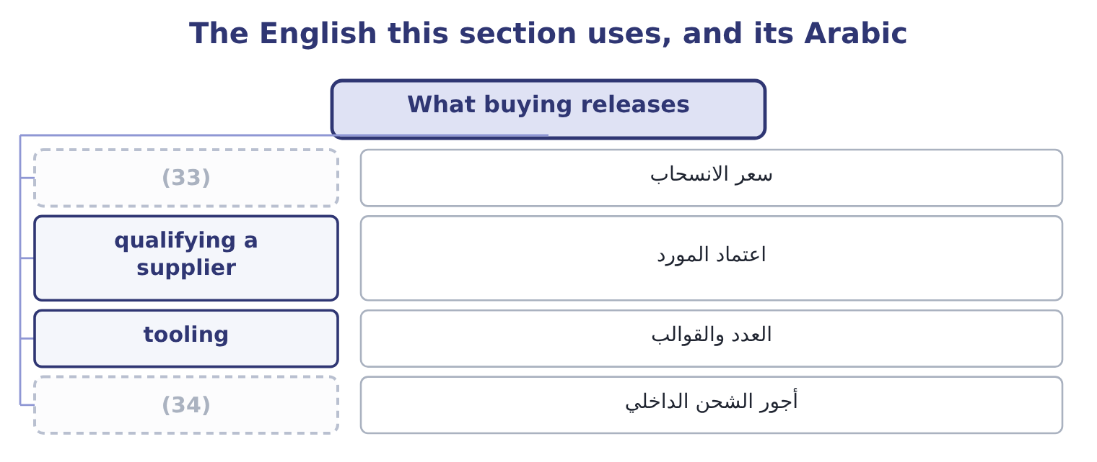
word list
supplier dependability · walk-away price · inward freight

The English this sheet uses, and its Arabic
English (exam term) | Arabic
walk-away price | سعر الانسحاب
qualifying a supplier | اعتماد المورد
tooling | العدد والقوالب
inward freight | أجور الشحن الداخلي

Answer key · 8.2 What buying releases

1 arithmetic | 18 walk-away
2 pressing | 19 indifference
3 opportunity | 20 yes-or-no
4 Suppose | 21 negotiating
5 contribution | 22 whatever
6 receivable | 23 Making, by 105,000
7 bought | 24 Buying, by 200,000
8 against | 25 elements
9 recommendation | 26 whenever
10 appears | 27 switching
11 indifferent | 28 Redundancy
12 released | 29 tooling
13 afford | 30 thereafter
14 supplier's | 31 discounted
15 entirely | 32 inspection
16 negotiation | 33 walk-away price
17 conducted | 34 inward freight

the summaries in full
Summary 1 The arithmetic above assumes the pressing shop would simply stand empty. If it would not, the comparison changes, and the change is an opportunity cost of the kind. Suppose the floor space and the two presses, once free, could be used to make a new line of sesame bars earning a contribution of $200,000 a year. That $200,000 is receivable only if the lids are bought, so it belongs on the buying side. Buying now costs 1,470,000 − 200,000 = 1,270,000 in net terms, against $1,365,000 for making, so buying is better by 1,365,000 − 1,270,000 = 95,000 a year. The recommendation reverses on a figure that appears nowhere in the costing system.
Summary 2 Making costs $1,365,000 a year, so the company is indifferent at a price of 1,365,000 ÷ 3,500,000 = 0.39 a lid. With the alternative use. If the released space earns $200,000, the company can afford to pay 1,365,000 + 200,000 = 1,565,000, which is 1,565,000 ÷ 3,500,000 = 0.447 a lid. The supplier's 0.42 sits between the two. Whether to buy depends entirely on whether the alternative use is real, and the negotiation with the supplier should be conducted knowing that 0.447 is the ceiling and 0.39 is the walk-away point. The indifference price is the most useful single output of a make-or-buy analysis, because it converts a yes-or-no answer into a negotiating position. A buyer who knows the ceiling can ask for a better price; one who knows only that 0.42 beats 0.48 will accept whatever is offered below 0.48.
Summary 3 Two further elements belong in the figures whenever a question supplies them. One-off costs of switching. Redundancy payments, the loss on selling the presses, the cost of qualifying the supplier, the write-off of specialised tooling. These fall on the buying side in the first year and nowhere thereafter, which is why a make-or-buy decision should be evaluated over several years and discounted. Changes in other costs. Buying may raise inward freight, inspection and inventory; it may lower scrap, rework and insurance. Each belongs in the comparison if it changes.

8.3 The qualitative factors
Chapter 8 · section 8.3

Fill every gap. Each word list holds one word more than there are gaps.
Summary 1 gaps 1–12
The outcome names these (1) , and in practice they decide more (2) questions than the arithmetic does. A supplier's lid is not (3) the company's lid. Where the component affects the (4) experience — a seal that leaks, a cap that (5) — the cost of a quality failure is far larger than six cents a unit and falls on the brand rather than on the component. A lid that (6) late stops a (7) line. The questions are whether the supplier can be relied on, whether there is a second source, how far away it is, and what (8) in a strike, a storm or a border (9) . Book 2's chapter on (10) made the same point from the inventory side: removing a buffer transfers risk to the supplier's (11) . Control over the (12) and the schedule.
word list
process · explicitly · happens · customer's · cross-threads · necessarily · closure · arrives · filling · make-or-buy · reliability · just-in-time · consultation

Summary 2 gaps 13–24
Making keeps the (13) to change a specification quickly, to run a short batch for a trial, and to (14) one product over another. Buying gives that up to somebody else's (15) plan. Confidentiality and (16) property. A supplier making a component to a specification (17) the specification. Where the component embodies something the company regards as its own, (18) is a transfer of (19) as well as of work. The supplier's future (20) . A supplier that wins the work gains leverage: the company has sold its presses, (21) its operators, and (22) easily go back. The price offered in the first year is not always the price in the fifth, and the standard (23) is a contract of several years with a price mechanism rather than a (24) quotation. A company should be slow to outsource what it is distinctively good at and quicker to outsource what anybody can do.
word list
conduct · learns · knowledge · cannot · prioritise · production · dismissed · protection · intellectual · outsourcing · single-year · ability · leverage

Summary 3 gaps 25–27
Pressing lids is not what Orontes is for; (25) and grinding sesame is. The (26) and the community. Closing a shop means redundancies, which cost money, morale and reputation, and in some jurisdictions require (27) that takes months.
word list
workforce · specification · consultation · roasting

The qualitative case, both ways
Factor | Argues for making | Argues for buying
Quality | (28) | A specialist may do it better
Dependability | No third party to fail | (29)
Control of schedule | (30) | The supplier's plan governs
Confidentiality | Nothing leaves the company | (31)
Capacity | (32) | Releases space for better uses
Expertise | Keeps skills in house | (33)
Cost behaviour | Fixed costs are already incurred | (34)

word list
A supplier with several plants may be more robust · Converts fixed costs into variable ones · Full control · Buys skills the company lacks · Uses space the company owns · The company controls it · Specifications must be shared · Releases space for better uses

Summary 4 gaps 35–39
The last row (35) its own sentence. Buying converts a fixed cost into a variable one: the company pays only for the lids it needs, so its (36) falls and its (37) leverage falls with it. For a company whose demand is (38) that is worth something real, and it is an (39) for buying that has nothing to do with the price per lid.
word list
deserves · argument · distinctively · breakeven · uncertain · operating

The English this section uses, and its Arabic
Each term sits against what it means.
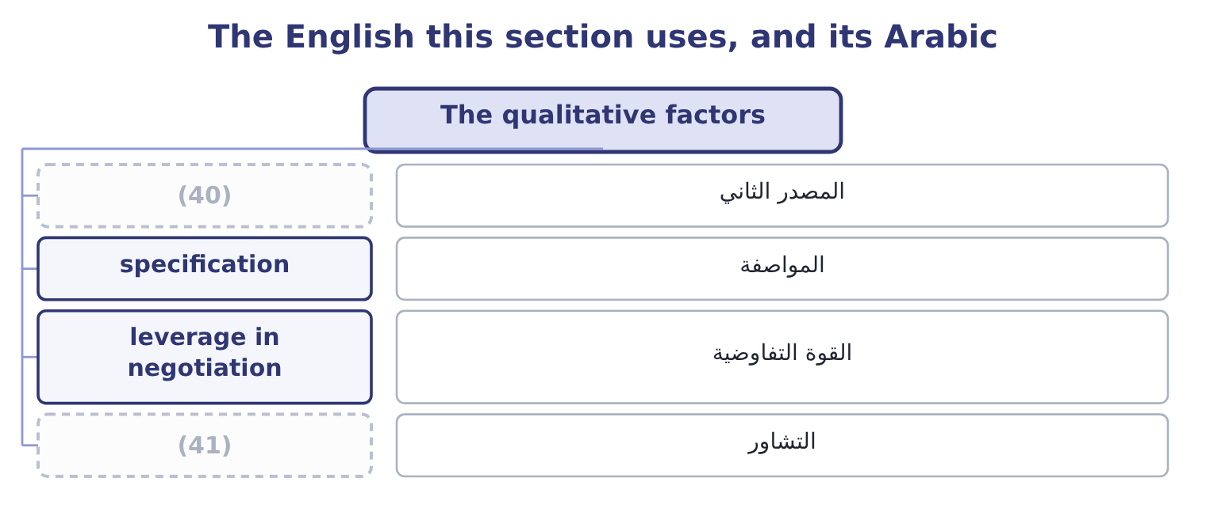
word list
second source · make-or-buy decision · consultation

The English this sheet uses, and its Arabic
English (exam term) | Arabic
second source | المصدر الثاني
specification | المواصفة
leverage in negotiation | القوة التفاوضية
consultation | التشاور

Answer key · 8.3 The qualitative factors

1 explicitly | 22 cannot
2 make-or-buy | 23 protection
3 necessarily | 24 single-year
4 customer's | 25 roasting
5 cross-threads | 26 workforce
6 arrives | 27 consultation
7 filling | 28 The company controls it
8 happens | 29 A supplier with several plants may be more robust
9 closure | 30 Full control
10 just-in-time | 31 Specifications must be shared
11 reliability | 32 Uses space the company owns
12 process | 33 Buys skills the company lacks
13 ability | 34 Converts fixed costs into variable ones
14 prioritise | 35 deserves
15 production | 36 breakeven
16 intellectual | 37 operating
17 learns | 38 uncertain
18 outsourcing | 39 argument
19 knowledge | 40 second source
20 conduct | 41 consultation
21 dismissed

the summaries in full
Summary 1 The outcome names these explicitly, and in practice they decide more make-or-buy questions than the arithmetic does. A supplier's lid is not necessarily the company's lid. Where the component affects the customer's experience — a seal that leaks, a cap that cross-threads — the cost of a quality failure is far larger than six cents a unit and falls on the brand rather than on the component. A lid that arrives late stops a filling line. The questions are whether the supplier can be relied on, whether there is a second source, how far away it is, and what happens in a strike, a storm or a border closure. Book 2's chapter on just-in-time made the same point from the inventory side: removing a buffer transfers risk to the supplier's reliability. Control over the process and the schedule.
Summary 2 Making keeps the ability to change a specification quickly, to run a short batch for a trial, and to prioritise one product over another. Buying gives that up to somebody else's production plan. Confidentiality and intellectual property. A supplier making a component to a specification learns the specification. Where the component embodies something the company regards as its own, outsourcing is a transfer of knowledge as well as of work. The supplier's future conduct. A supplier that wins the work gains leverage: the company has sold its presses, dismissed its operators, and cannot easily go back. The price offered in the first year is not always the price in the fifth, and the standard protection is a contract of several years with a price mechanism rather than a single-year quotation. A company should be slow to outsource what it is distinctively good at and quicker to outsource what anybody can do.
Summary 3 Pressing lids is not what Orontes is for; roasting and grinding sesame is. The workforce and the community. Closing a shop means redundancies, which cost money, morale and reputation, and in some jurisdictions require consultation that takes months.
Summary 4 The last row deserves its own sentence. Buying converts a fixed cost into a variable one: the company pays only for the lids it needs, so its breakeven falls and its operating leverage falls with it. For a company whose demand is uncertain that is worth something real, and it is an argument for buying that has nothing to do with the price per lid.

8.4 Variants of the same question
Chapter 8 · section 8.4

Fill every gap. Each word list holds one word more than there are gaps.
Summary 1 gaps 1–12
The (1) phrase "make or buy" covers a family of (2) with identical arithmetic, and a question may use any of them. Payroll, (3) , cleaning, (4) technology, internal audit. The (5) is the same: what stops being spent, what is (6) , what is given up. The (7) decision, where a company (8) buying decides to make. Here the fixed costs are the ones being added rather than avoided, and the (9) is between the supplier's price and the (10) cost of making, including the new fixed costs and the capital required — which turns it into the capital investment decision. Buying a part of the (11) . Often the best answer is neither all nor nothing: make the base load in house, where the fixed costs are already committed, and buy the peak from a supplier, where the (12) is overtime or a second shift.
word list
outcome's · decisions · comparison · presently · including · information · volume · analysis · incremental · alternative · catering · reverse · released

Summary 2 gaps 13–15
The arithmetic ranks the two (13) at the margin, exactly. (14) one plant of several. The same table, with the (15) costs of one site on one side and the extra transport and overtime at the others on the opposite side.
word list
Closing · avoidable · tooling · sources

Make the base, buy the peak
Cost of making a unit | Cost of buying a unit | Source
0.34 variable, fixed already committed | 0.42 | Make
0.34 | 0.42 | Make
0.34 plus an overtime premium of 0.11 | 0.42 | (16)

word list
avoidable fixed cost · Buy, if the premium exceeds 0.08

The English this section uses, and its Arabic
Each term sits against what it means.
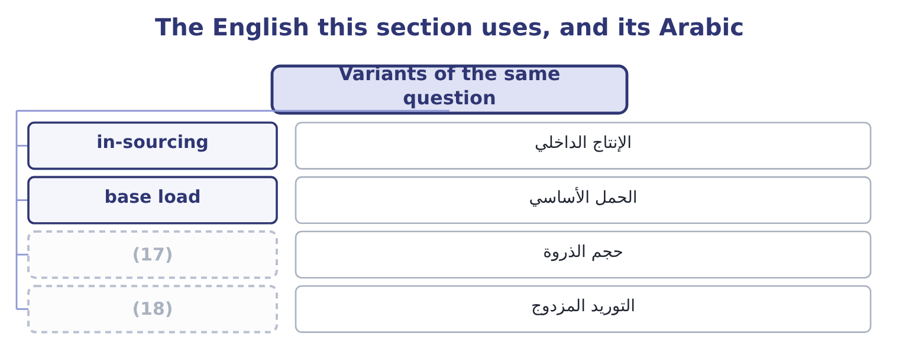
word list
dual sourcing · peak volume · base load

The English this sheet uses, and its Arabic
English (exam term) | Arabic
in-sourcing | الإنتاج الداخلي
base load | الحمل الأساسي
peak volume | حجم الذروة
dual sourcing | التوريد المزدوج

Answer key · 8.4 Variants of the same question

1 outcome's | 10 incremental
2 decisions | 11 volume
3 catering | 12 alternative
4 information | 13 sources
5 analysis | 14 Closing
6 released | 15 avoidable
7 reverse | 16 Buy, if the premium exceeds 0.08
8 presently | 17 peak volume
9 comparison | 18 dual sourcing

the summaries in full
Summary 1 The outcome's phrase "make or buy" covers a family of decisions with identical arithmetic, and a question may use any of them. Payroll, catering, cleaning, information technology, internal audit. The analysis is the same: what stops being spent, what is released, what is given up. The reverse decision, where a company presently buying decides to make. Here the fixed costs are the ones being added rather than avoided, and the comparison is between the supplier's price and the incremental cost of making, including the new fixed costs and the capital required — which turns it into the capital investment decision. Buying a part of the volume. Often the best answer is neither all nor nothing: make the base load in house, where the fixed costs are already committed, and buy the peak from a supplier, where the alternative is overtime or a second shift.
Summary 2 The arithmetic ranks the two sources at the margin, exactly. Closing one plant of several. The same table, with the avoidable costs of one site on one side and the extra transport and overtime at the others on the opposite side.

8.5 Writing the answer
Chapter 8 · section 8.5

Fill every gap. Each word list holds one word more than there are gaps.
Summary 1 gaps 1–12
A (1) answer has five parts and the exam (2) each. The (3) , as a column of (4) , with the avoidable costs identified. Not two full (5) . The treatment of the (6) overhead, stated (7) . One sentence — "the $315,000 of factory and head office overhead (8) whichever is chosen and is excluded" — earns a mark and prevents the (9) error. The (10) cost of released (11) , if any, with its source named. If the question gives no (12) use, say that none has been identified and that the recommendation would change at a value of $105,000 a year or more. The indifference price, as a negotiating position. The qualitative factors that bear on this particular component, chosen rather than recited. For a lid that seals a food product, quality and dependability lead; for a cleaning contract they do not. And the recommendation, which on the facts of section 8.1 is to go on making the lids, to ask the supplier for a price below 0.39, and to re-open the question if a use for the pressing shop is found.
word list
continues · explicitly · alternative · outsourced · differences · comparison · commonest · costings · opportunity · rewards · capacity · make-or-buy · unavoidable

Decide on a bracket

Your turn: make or buy (complete the blanks)
Item | Data | Answer
Variable cost of making a unit | (13) | ________
Annual variable cost | 400,000 units a year | ________
Avoidable fixed costs | A supervisor at 60,000 and machine insurance of 9,000 | ________
Total relevant cost of making |  | ________
Cost of buying | (14) | ________
Better by |  | ________
Indifference price |  | ________

word list
Materials 1.40, labour 0.90, variable overhead 0.50 · 1,280,000: 400,000 × 3.20 = 1,280,000. · Supplier price 3.20 a unit

"Outsourcing"

Summary 2 gaps 15–20
English outsourcing means buying from outside what was (15) made inside, and it carries (16) in ordinary use — of job losses, of distance, of (17) done cheaply — that the technical term does not. (18) is a different idea again: moving work to another country, which may be (19) to a supplier or kept inside the company. In an exam answer, use make or buy for the (20) and outsourcing only where the question does.
word list
country · previously · overtones · decision · outsourced · Offshoring · something

"Outsourcing"
Item | Answer
Variable cost a unit | (21)
Annual variable cost | (22)
Avoidable fixed costs | (23)
Total relevant cost of making | 1,189,000: 1,120,000 + 69,000 = 1,189,000.
Cost of buying | 1,280,000: 400,000 × 3.20 = 1,280,000.
Better by | Making, by 91,000: 1,280,000 − 1,189,000 = 91,000.
Indifference price | (24)
What it tells you | The supplier is 23 cents a unit too expensive, and the company's negotiating ceiling is about 2.97 — unless a use is found for the released

word list
1,120,000: 400,000 × 2.80 = 1,120,000. · 69,000: 60,000 + 9,000 = 69,000. · 2.9725: 1,189,000 ÷ 400,000 = 2.9725. · 2.80: 1.40 + 0.90 + 0.50 = 2.80. · 1,280,000: 400,000 × 3.20 = 1,280,000.

The English this section uses, and its Arabic
Each term sits against what it means.
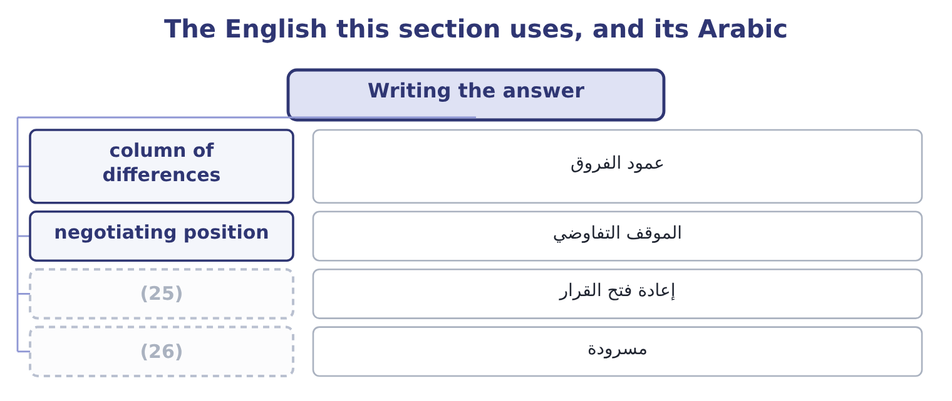
word list
make-or-buy decision · recited · re-open the question

The English this sheet uses, and its Arabic
English (exam term) | Arabic
column of differences | عمود الفروق
negotiating position | الموقف التفاوضي
re-open the question | إعادة فتح القرار
recited | مسرودة

Answer key · 8.5 Writing the answer

1 make-or-buy | 14 Supplier price 3.20 a unit
2 rewards | 15 previously
3 comparison | 16 overtones
4 differences | 17 something
5 costings | 18 Offshoring
6 unavoidable | 19 outsourced
7 explicitly | 20 decision
8 continues | 21 2.80: 1.40 + 0.90 + 0.50 = 2.80.
9 commonest | 22 1,120,000: 400,000 × 2.80 = 1,120,000.
10 opportunity | 23 69,000: 60,000 + 9,000 = 69,000.
11 capacity | 24 2.9725: 1,189,000 ÷ 400,000 = 2.9725.
12 alternative | 25 re-open the question
13 Materials 1.40, labour 0.90, variable overhead 0.50 | 26 recited

the summaries in full
Summary 1 A make-or-buy answer has five parts and the exam rewards each. The comparison, as a column of differences, with the avoidable costs identified. Not two full costings. The treatment of the unavoidable overhead, stated explicitly. One sentence — "the $315,000 of factory and head office overhead continues whichever is chosen and is excluded" — earns a mark and prevents the commonest error. The opportunity cost of released capacity, if any, with its source named. If the question gives no alternative use, say that none has been identified and that the recommendation would change at a value of $105,000 a year or more. The indifference price, as a negotiating position. The qualitative factors that bear on this particular component, chosen rather than recited. For a lid that seals a food product, quality and dependability lead; for a cleaning contract they do not. And the recommendation, which on the facts of section 8.1 is to go on making the lids, to ask the supplier for a price below 0.39, and to re-open the question if a use for the pressing shop is found.
Summary 2 English outsourcing means buying from outside what was previously made inside, and it carries overtones in ordinary use — of job losses, of distance, of something done cheaply — that the technical term does not. Offshoring is a different idea again: moving work to another country, which may be outsourced to a supplier or kept inside the company. In an exam answer, use make or buy for the decision and outsourcing only where the question does.

9.1 Sell now or process further
Chapter 9 · section 9.1

Fill every gap. Each word list holds one word more than there are gaps.
Chapter 9, section by section
Each stage leads to the next.
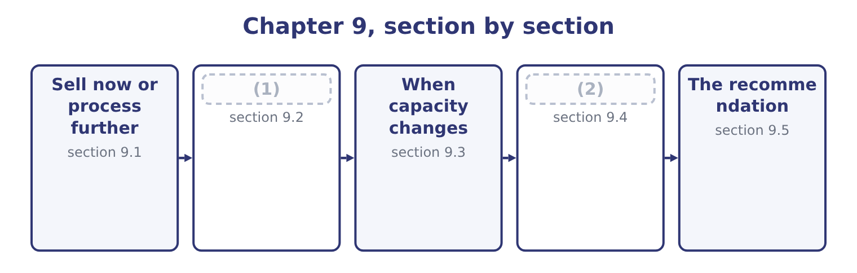
word list
Income taxes in marginal analysis · Sell now or process further · Drop or add a segment

Summary 1 gaps 3–11
A joint process (3) something that can be sold as it is, or taken further and sold for more. The point at which the choice arises is the split-off point, and (4) spent before it is irrelevant to the choice. That last (5) is the whole topic. The cost of producing the paste has been incurred by the time the question arises, and it is the same whether the paste is sold or (6) into jars. It is (7) a joint cost, common to both (8) , and it belongs in neither column — (9) basis the costing (10) has used to (11) it between them.
word list
produces · everything · whatever · apportion · paste's · therefore · system · filled · options · sentence

Worked example: paste or jars

Summary 2 gaps 12–23
A 10 kg drum of (12) paste sells for $60.00. The same paste fills ten tahini jars (13) at $12.00 each, which is 10 × 12.00 = 120.00. Filling, jars, labels and the extra (14) cost $33.00 a drum. The same answer appears: ten jars (15) 10 × 4.80 = 48.00 against a drum's $21.00, and 48.00 − 21.00 = 27.00. The two routes agree because the paste's own (16) cost of $39.00 a drum is in both and cancels — which is the joint cost doing exactly what the rule says it does. Three (17) belong in any answer on this outcome. The further processing must have its own (18) . If filling the jars uses roaster or line time that something else needs, the (19) cost. The two (20) must both exist. Processing further is worth $27.00 a drum only if the jars can be sold; if the jar market is already (21) and the paste market is not, the extra jars are inventory rather than revenue. A joint product may be (22) . Where a process yields two outputs in fixed (23) , the question is never whether to make one of them but only what to do with each at split-off.
word list
supplied · opportunity · handling · proportions · contribute · capacity · unavoidable · variable · sesame · qualifications · selling · therefore · markets

Sell at split-off, or process further
Line | Per drum | In the decision?
Revenue as paste | 60.00 | Yes, forgone if processed
Revenue as ten jars | 120.00 | Yes
Incremental revenue | 60.00 | The benefit
Cost of further processing | 33.00 | The cost
Cost of producing the paste | 39.00 | (24)
Apportioned share of joint cost | (25) | No; apportionment changes nothing real
Net benefit of processing | 27.00 | (26)

word list
demand evidence · Any figure · No; it is a joint cost, incurred either way · The answer

Apportioned joint costs

Summary 3 gaps 27–33
A question will often give you a joint cost apportioned between the (27) by weight, by value or by (28) . The apportionment is for inventory (29) and it is irrelevant to the decision. Processing further can be worth doing for one joint product and not for (30) from the same process. Each is (31) on its own incremental (32) . If the further processing cost exceeds the incremental revenue, sell at split-off — even where the final product sells for far more than the (33) one.
word list
another · valuation · intermediate · decided · products · roaster · volume · figures

The English this section uses, and its Arabic
Each term sits against what it means.
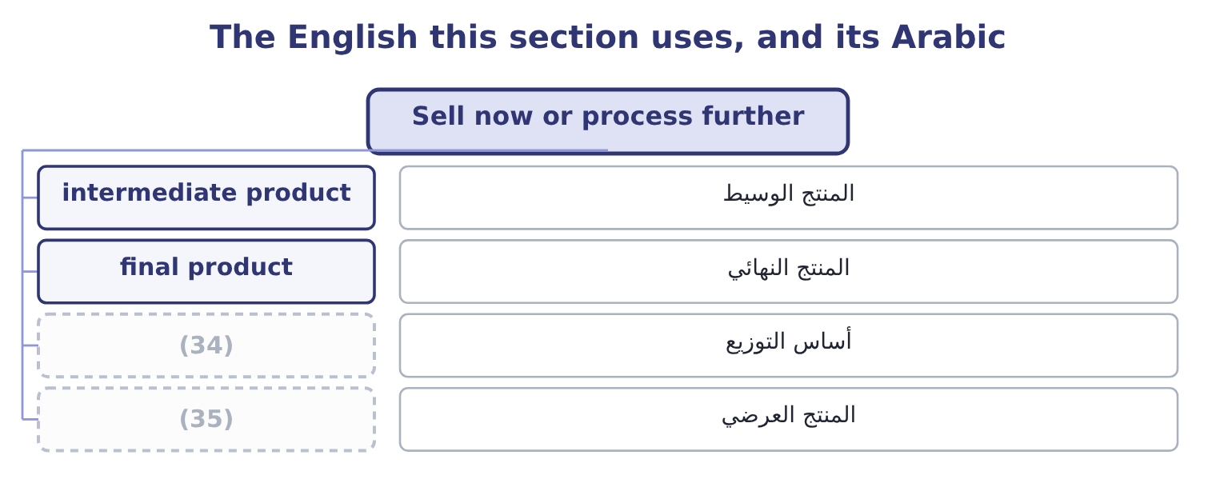
word list
by-product · after-tax effect · apportionment basis

The English this sheet uses, and its Arabic
English (exam term) | Arabic
intermediate product | المنتج الوسيط
final product | المنتج النهائي
apportionment basis | أساس التوزيع
by-product | المنتج العرضي

Answer key · 9.1 Sell now or process further

1 Drop or add a segment | 19 opportunity
2 Income taxes in marginal analysis | 20 markets
3 produces | 21 supplied
4 everything | 22 unavoidable
5 sentence | 23 proportions
6 filled | 24 No; it is a joint cost, incurred either way
7 therefore | 25 Any figure
8 options | 26 The answer
9 whatever | 27 products
10 system | 28 volume
11 apportion | 29 valuation
12 sesame | 30 another
13 selling | 31 decided
14 handling | 32 figures
15 contribute | 33 intermediate
16 variable | 34 apportionment basis
17 qualifications | 35 by-product
18 capacity

the summaries in full
Summary 1 A joint process produces something that can be sold as it is, or taken further and sold for more. The point at which the choice arises is the split-off point, and everything spent before it is irrelevant to the choice. That last sentence is the whole topic. The cost of producing the paste has been incurred by the time the question arises, and it is the same whether the paste is sold or filled into jars. It is therefore a joint cost, common to both options, and it belongs in neither column — whatever basis the costing system has used to apportion it between them.
Summary 2 A 10 kg drum of sesame paste sells for $60.00. The same paste fills ten tahini jars selling at $12.00 each, which is 10 × 12.00 = 120.00. Filling, jars, labels and the extra handling cost $33.00 a drum. The same answer appears: ten jars contribute 10 × 4.80 = 48.00 against a drum's $21.00, and 48.00 − 21.00 = 27.00. The two routes agree because the paste's own variable cost of $39.00 a drum is in both and cancels — which is the joint cost doing exactly what the rule says it does. Three qualifications belong in any answer on this outcome. The further processing must have its own capacity. If filling the jars uses roaster or line time that something else needs, the opportunity cost. The two markets must both exist. Processing further is worth $27.00 a drum only if the jars can be sold; if the jar market is already supplied and the paste market is not, the extra jars are inventory rather than revenue. A joint product may be unavoidable. Where a process yields two outputs in fixed proportions, the question is never whether to make one of them but only what to do with each at split-off.
Summary 3 A question will often give you a joint cost apportioned between the products by weight, by value or by volume. The apportionment is for inventory valuation and it is irrelevant to the decision. Processing further can be worth doing for one joint product and not for another from the same process. Each is decided on its own incremental figures. If the further processing cost exceeds the incremental revenue, sell at split-off — even where the final product sells for far more than the intermediate one.

9.2 Drop or add a segment
Chapter 9 · section 9.2

Fill every gap. Each word list holds one word more than there are gaps.
Summary 1 gaps 1–12
A segment is any part of a business whose results can be (1) : a product line, a (2) , a branch, a customer group, a region. The question is (3) the company is better off with it or without it, and the (4) is. Keep a segment if its contribution (5) the fixed costs that would (6) be avoided by dropping it. For (7) halva line, with a contribution of $900,000 and (8) fixed costs of $500,000, the line is worth 900,000 − 500,000 = 400,000 a year and should be kept. The $300,000 of (9) factory and head office cost that makes it look unprofitable in the (10) accounts does not disappear on closure; it moves to the other products. Adding a segment is the same test run (11) . A (12) new line of sesame bars would contribute $820,000 and need $600,000 of new fixed costs, so it is worth 820,000 − 600,000 = 220,000 and should be added.
word list
actually · separated · management · proposed · whether · Orontes's · avoidable · proposal · arithmetic · exceeds · department · apportioned · forwards

Worked example: the new line that was not worth adding

Summary 2 gaps 13–24
The proposal as (13) . Contribution of $820,000 against $600,000 of new fixed costs, a gain of $220,000. The question (14) asked. Where will the customers come from? The (15) plan expects a tenth of the new line's (16) to be bought by customers who would (17) have bought (18) jars — 100,000 jars a year. Those jars contribute $4.80 each, so 100,000 × 4.80 = 480,000 of (19) contribution is lost. The new line would make the company $260,000 a year worse off. (20) in the new line's own (21) changed. The decision reversed because the analysis was widened to include an effect on a (22) product — and that is the characteristic error in (23) decisions, exactly as a missing (24) cost is the characteristic error in special orders. The rule is to draw the boundary of the analysis around the company, not around the segment.
word list
figures · tahini · otherwise · apportioned · different · add-a-segment · marketing · presented · existing · volume · opportunity · Nothing · nobody

Summary 3 gaps 25–29
Four effects belong inside that boundary (25) a question (26) them. (27) , the opposite: a segment that is unprofitable alone but (28) customers who buy other things. Shared costs that genuinely (29) . Dropping a segment may allow a warehouse to be given up or a delivery round to be dropped; adding one may push a shared resource past a step.
word list
supplies · whenever · change · brings · department · Complementarity

Keep, drop, add
Question | Compare | Decide
Keep a segment? | (30) | Against fixed costs genuinely avoided by dropping
Drop a segment? | Fixed costs avoided | Against contribution lost, plus any effect on other segments
Add a segment? | (31) | Against new fixed costs and any capacity displaced

word list
Contribution earned · Contribution gained, less any cannibalised · segment margin

The English this section uses, and its Arabic
Each term sits against what it means.
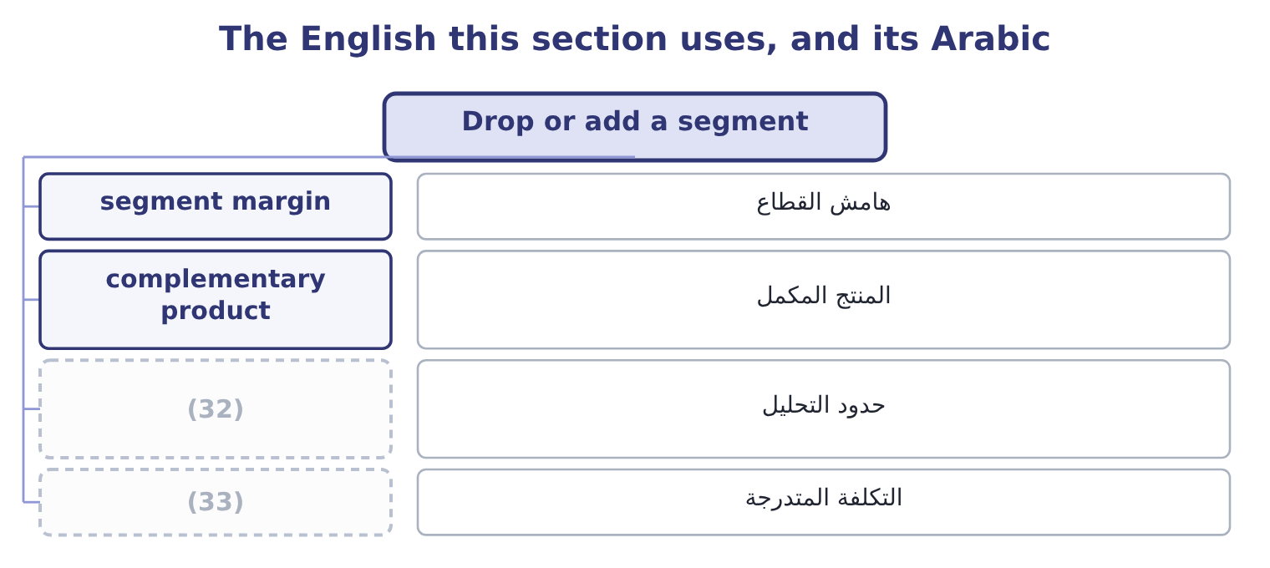
word list
boundary of the analysis · step cost · widen the boundary

The English this sheet uses, and its Arabic
English (exam term) | Arabic
segment margin | هامش القطاع
complementary product | المنتج المكمل
boundary of the analysis | حدود التحليل
step cost | التكلفة المتدرجة

Answer key · 9.2 Drop or add a segment

1 separated | 18 tahini
2 department | 19 existing
3 whether | 20 Nothing
4 arithmetic | 21 figures
5 exceeds | 22 different
6 actually | 23 add-a-segment
7 Orontes's | 24 opportunity
8 avoidable | 25 whenever
9 apportioned | 26 supplies
10 management | 27 Complementarity
11 forwards | 28 brings
12 proposed | 29 change
13 presented | 30 Contribution earned
14 nobody | 31 Contribution gained, less any cannibalised
15 marketing | 32 boundary of the analysis
16 volume | 33 step cost
17 otherwise

the summaries in full
Summary 1 A segment is any part of a business whose results can be separated: a product line, a department, a branch, a customer group, a region. The question is whether the company is better off with it or without it, and the arithmetic is. Keep a segment if its contribution exceeds the fixed costs that would actually be avoided by dropping it. For Orontes's halva line, with a contribution of $900,000 and avoidable fixed costs of $500,000, the line is worth 900,000 − 500,000 = 400,000 a year and should be kept. The $300,000 of apportioned factory and head office cost that makes it look unprofitable in the management accounts does not disappear on closure; it moves to the other products. Adding a segment is the same test run forwards. A proposed new line of sesame bars would contribute $820,000 and need $600,000 of new fixed costs, so it is worth 820,000 − 600,000 = 220,000 and should be added.
Summary 2 The proposal as presented. Contribution of $820,000 against $600,000 of new fixed costs, a gain of $220,000. The question nobody asked. Where will the customers come from? The marketing plan expects a tenth of the new line's volume to be bought by customers who would otherwise have bought tahini jars — 100,000 jars a year. Those jars contribute $4.80 each, so 100,000 × 4.80 = 480,000 of existing contribution is lost. The new line would make the company $260,000 a year worse off. Nothing in the new line's own figures changed. The decision reversed because the analysis was widened to include an effect on a different product — and that is the characteristic error in add-a-segment decisions, exactly as a missing opportunity cost is the characteristic error in special orders. The rule is to draw the boundary of the analysis around the company, not around the segment.
Summary 3 Four effects belong inside that boundary whenever a question supplies them. Complementarity, the opposite: a segment that is unprofitable alone but brings customers who buy other things. Shared costs that genuinely change. Dropping a segment may allow a warehouse to be given up or a delivery round to be dropped; adding one may push a shared resource past a step.

9.3 When capacity changes
Chapter 9 · section 9.3

Fill every gap. Each word list holds one word more than there are gaps.
Summary 1 gaps 1–12
Capacity can be added in three ways and each behaves (1) . (2) adds hours at a premium, with no change in fixed costs. It is the most (3) and the most (4) per unit, and it is the right answer for a short peak. A second shift adds a block of capacity and a block of fixed cost: (5) , lighting, (6) , shift premium. It is a step, and the step has to be (7) by the volume that will use it. New plant adds capacity and (8) the question into the capital (9) decision. The (10) of a step is (11) the same. A second shift at (12) would add $1,200,000 of fixed costs and 800,000 jars of capacity. At a contribution of $4.80 a jar it pays for itself at 1,200,000 ÷ 4.80 = 250,000 jars — less than a third of the capacity it creates. So the shift is worth adding if the company can sell 250,000 more jars, and the whole question becomes a demand question rather than a cost one.
word list
converts · always · canteen · differently · investment · uncertain · arithmetic · justified · flexible · expensive · supervision · Orontes · Overtime

Summary 2 gaps 13–20
Three (13) of a capacity change (14) in an answer. The (15) costs of every other decision change with it. A special order refused at full capacity becomes (16) once capacity is added, because the displaced contribution (17) . A step of $1,200,000 of fixed cost raises the (18) by 1,200,000 ÷ 4.80 = 250,000 jars, which is. A step once taken is hard to (19) . Shift premiums can be withdrawn and (20) released, with difficulty; a new building cannot. The more irreversible the step, the stronger the demand evidence should be.
word list
breakeven · consequences · belong · displaced · acceptable · untake · relevant · disappears · supervisors

Three ways to add capacity
Every item belongs to exactly one group.
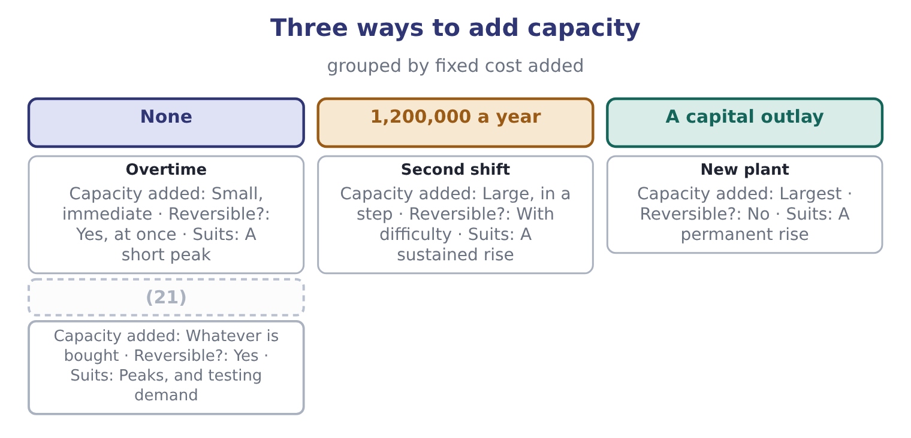
word list
Buying in · joint cost

Summary 3 gaps 22–23
That last row is: buying the peak is a way of adding capacity (22) adding fixed cost, and for a company (23) about demand it is often the best of the four.
word list
premiums · uncertain · without

The English this section uses, and its Arabic
Each term sits against what it means.
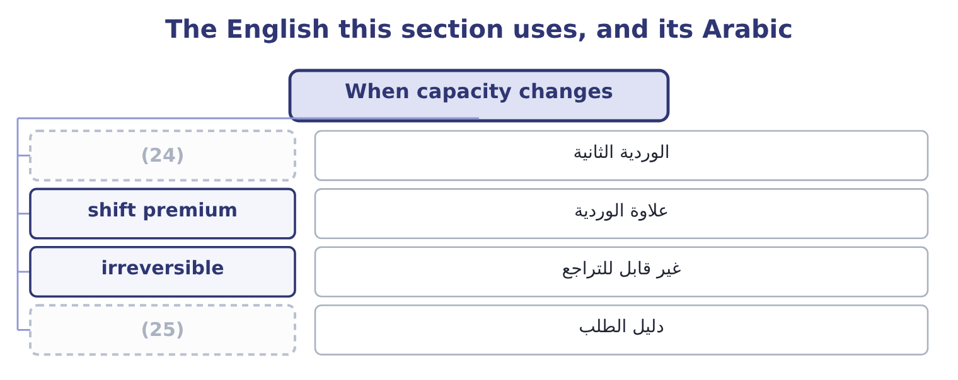
word list
second shift · capital allowance · demand evidence

The English this sheet uses, and its Arabic
English (exam term) | Arabic
second shift | الوردية الثانية
shift premium | علاوة الوردية
irreversible | غير قابل للتراجع
demand evidence | دليل الطلب

Answer key · 9.3 When capacity changes

1 differently | 14 belong
2 Overtime | 15 relevant
3 flexible | 16 acceptable
4 expensive | 17 disappears
5 supervision | 18 breakeven
6 canteen | 19 untake
7 justified | 20 supervisors
8 converts | 21 Buying in
9 investment | 22 without
10 arithmetic | 23 uncertain
11 always | 24 second shift
12 Orontes | 25 demand evidence
13 consequences

the summaries in full
Summary 1 Capacity can be added in three ways and each behaves differently. Overtime adds hours at a premium, with no change in fixed costs. It is the most flexible and the most expensive per unit, and it is the right answer for a short peak. A second shift adds a block of capacity and a block of fixed cost: supervision, lighting, canteen, shift premium. It is a step, and the step has to be justified by the volume that will use it. New plant adds capacity and converts the question into the capital investment decision. The arithmetic of a step is always the same. A second shift at Orontes would add $1,200,000 of fixed costs and 800,000 jars of capacity. At a contribution of $4.80 a jar it pays for itself at 1,200,000 ÷ 4.80 = 250,000 jars — less than a third of the capacity it creates. So the shift is worth adding if the company can sell 250,000 more jars, and the whole question becomes a demand question rather than a cost one.
Summary 2 Three consequences of a capacity change belong in an answer. The relevant costs of every other decision change with it. A special order refused at full capacity becomes acceptable once capacity is added, because the displaced contribution disappears. A step of $1,200,000 of fixed cost raises the breakeven by 1,200,000 ÷ 4.80 = 250,000 jars, which is. A step once taken is hard to untake. Shift premiums can be withdrawn and supervisors released, with difficulty; a new building cannot. The more irreversible the step, the stronger the demand evidence should be.
Summary 3 That last row is: buying the peak is a way of adding capacity without adding fixed cost, and for a company uncertain about demand it is often the best of the four.

9.4 Income taxes in marginal analysis
Chapter 9 · section 9.4

Fill every gap. Each word list holds one word more than there are gaps.
Summary 1 gaps 1–12
Everything so far has been computed before tax. The (1) asks what tax does, and the answer has three parts. Tax (2) the answer. An incremental contribution of $300,000 at a 25 per cent rate is worth 300,000 × 0.75 = 225,000 after tax. Every option in a (3) is scaled by the same factor, so no (4) changes and the decision is the same before and after tax. Except where the (5) are taxed differently, and then tax (6) . A capital (7) available on a (8) machine and not on a leased one, which Book 2 priced as the net (9) to leasing. Operations in two (10) with different rates, so that the same contribution is worth more in one place. And a company with losses available to (11) income, for which the (12) tax rate is nil until the losses are used.
word list
purchased · decides · shelter · comparison · advantage · options · allowance · scales · marginal · because · ranking · outcome · jurisdictions

Summary 2 gaps 13–19
Tax follows cash, not (13) profit. A (14) tax effect is computed on the (15) amounts it changes, which is why. The (16) rule for Section C is short: (17) before tax unless the (18) gives a tax rate or the (19) are taxed differently, and when a rate is given, state the answer both ways — "an incremental gain of $300,000, which is $225,000 after tax at 25 per cent" — because a marker can see both and the board only wants one.
word list
accounting · shelter · question · decision's · alternatives · practical · compute · taxable

Does tax change the decision?
Every item belongs to exactly one group.
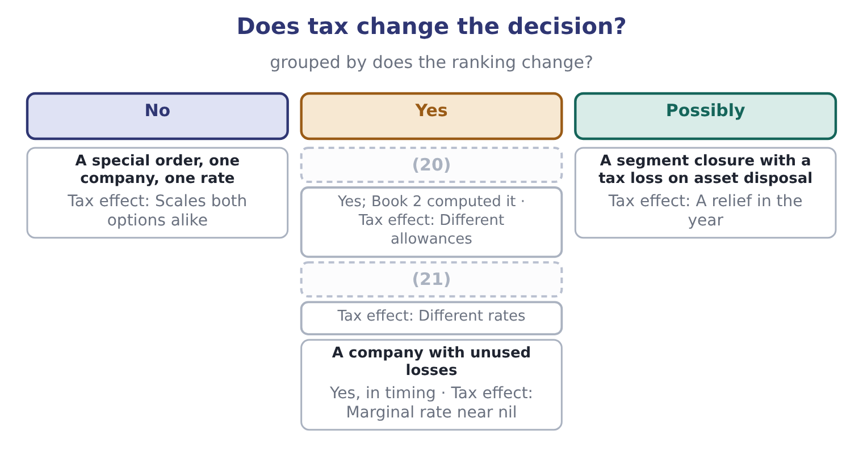
word list
Lease against buy · Two jurisdictions · complementary product

The English this section uses, and its Arabic
Each term sits against what it means.
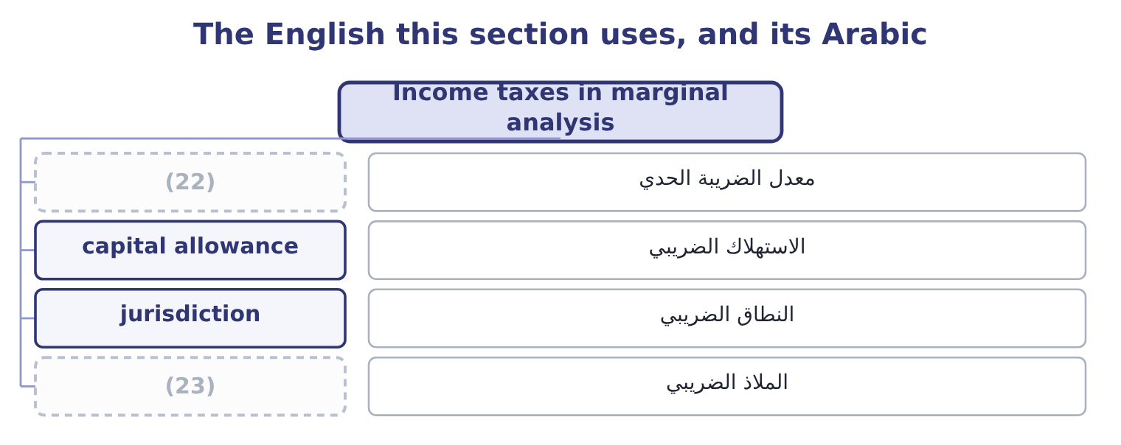
word list
marginal tax rate · shelter · intermediate product

The English this sheet uses, and its Arabic
English (exam term) | Arabic
marginal tax rate | معدل الضريبة الحدي
capital allowance | الاستهلاك الضريبي
jurisdiction | النطاق الضريبي
shelter | الملاذ الضريبي

Answer key · 9.4 Income taxes in marginal analysis

1 outcome | 13 accounting
2 scales | 14 decision's
3 comparison | 15 taxable
4 ranking | 16 practical
5 options | 17 compute
6 decides | 18 question
7 allowance | 19 alternatives
8 purchased | 20 Lease against buy
9 advantage | 21 Two jurisdictions
10 jurisdictions | 22 marginal tax rate
11 shelter | 23 shelter
12 marginal

the summaries in full
Summary 1 Everything so far has been computed before tax. The outcome asks what tax does, and the answer has three parts. Tax scales the answer. An incremental contribution of $300,000 at a 25 per cent rate is worth 300,000 × 0.75 = 225,000 after tax. Every option in a comparison is scaled by the same factor, so no ranking changes and the decision is the same before and after tax. Except where the options are taxed differently, and then tax decides. A capital allowance available on a purchased machine and not on a leased one, which Book 2 priced as the net advantage to leasing. Operations in two jurisdictions with different rates, so that the same contribution is worth more in one place. And a company with losses available to shelter income, for which the marginal tax rate is nil until the losses are used.
Summary 2 Tax follows cash, not accounting profit. A decision's tax effect is computed on the taxable amounts it changes, which is why. The practical rule for Section C is short: compute before tax unless the question gives a tax rate or the alternatives are taxed differently, and when a rate is given, state the answer both ways — "an incremental gain of $300,000, which is $225,000 after tax at 25 per cent" — because a marker can see both and the board only wants one.

9.5 The recommendation
Chapter 9 · section 9.5

Fill every gap. Each word list holds one word more than there are gaps.
Summary 1 gaps 1–12
The last (1) of this topic asks for a course of action, and the (2) structure. State the decision, with the incremental figure that (3) it: "process further: it is worth $27.00 a drum". Name what was excluded and why: the joint cost, the (4) overhead, the sunk (5) , the book value. Name the (6) cost or the displaced contribution, if there is one, and the capacity (7) behind it: "this assumes the filling line has spare capacity; if it does not, the answer reverses". Widen the (8) once, deliberately. Ask what the decision does to the (9) other products, its (10) , its suppliers and its next year. The cannibalisation of section 9.2 and the market (11) . Give the (12) factors their place, chosen rather than recited. Say what would change the answer, with a number: "the new line is worth adding if cannibalisation is below 45,833 jars a year". That last figure is worth deriving, because it shows the habit.
word list
boundary · disturbance · supports · reverses · assumption · customers · five-part · company's · development · outcome · opportunity · apportioned · qualitative

Summary 2 gaps 13–16
The new line gains $220,000 before cannibalisation, and each (13) jar costs $4.80, so the break-even cannibalisation is 220,000 ÷ 4.80 = 45,833 jars. Below that the line is worth adding and above it is not — and the whole decision now rests on a single (14) estimate that (15) can be asked to (16) .
word list
defend · cannibalised · somebody · marketing · business

Four decisions

Your turn: four marginal decisions (complete the blanks)
Decision | Data | Answer
Process further? | Sell at 40.00 or process at a cost of 18.00 and sell at 62.00 | ________
Drop a segment? | (17) | ________
Add a segment? | Contribution 500,000; new fixed costs 380,000; cannibalises 90,000 | ________
Second shift? | (18) | ________
After-tax value of a 120,000 gain | Tax rate 25 per cent | ________
Break-even cannibalisation on the added segment |  | ________

word list
Adds 700,000 of fixed cost; contribution 3.50 a unit · After-tax value of a 120,000 gain · Contribution 300,000; avoidable fixed costs 340,000

"Segment"

Summary 3 gaps 19–24
English segment in management (19) means any part of a business whose results can be reported (20) — a product line, a region, a customer group — and it is deliberately broader than division or department, which name parts of an (21) chart. The exam also uses it in the (22) sense of Part 1, where a segment is (23) by how management (24) the business.
word list
organisation · excluded · accounting · defined · separately · reviews · reporting

"Segment"
Decision | Answer
Process further? | Yes: the incremental revenue is 62.00 − 40.00 = 22.00 against a cost of 18.00, a gain of 4.00 a unit.
Drop a segment? | (25) : avoidable fixed costs of 340,000 exceed the contribution of 300,000 by 40,000.
Add a segment? | Add it: 500,000 − 380,000 = 120,000 of gain, less 90,000 of cannibalisation, leaves 30,000.
Second shift? | It needs 200,000 extra units: 700,000 ÷ 3.50 = 200,000.
After-tax value of a 120,000 gain | (26)
Break-even cannibalisation | 120,000 of contribution: the gain before cannibalisation is 120,000, so anything above that reverses the decision.
What it tells you | (27) : 4.00 a unit, 40,000 a year and 30,000 a year are all small enough that an error in one estimate would

word list
Second shift? · 90,000: 120,000 × 0.75 = 90,000. · Three of the four decisions are close · Drop it

The English this section uses, and its Arabic
Each term sits against what it means.
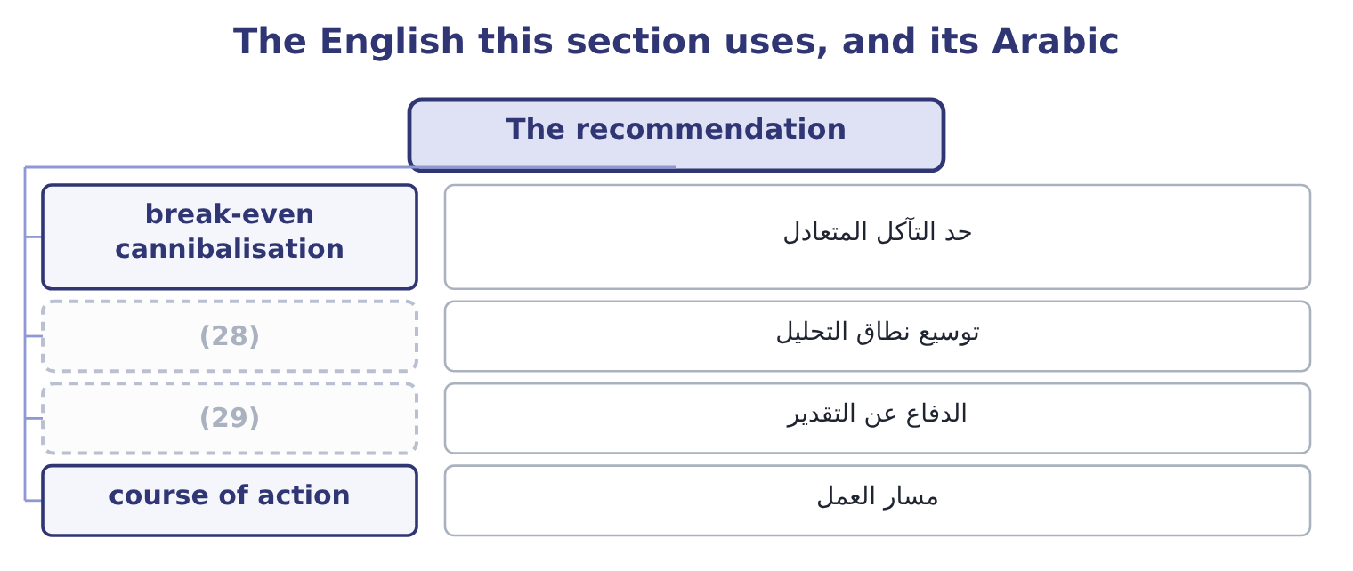
word list
widen the boundary · defend an estimate · course of action

The English this sheet uses, and its Arabic
English (exam term) | Arabic
break-even cannibalisation | حد التآكل المتعادل
widen the boundary | توسيع نطاق التحليل
defend an estimate | الدفاع عن التقدير
course of action | مسار العمل

Answer key · 9.5 The recommendation

1 outcome | 16 defend
2 five-part | 17 Contribution 300,000; avoidable fixed costs 340,000
3 supports | 18 Adds 700,000 of fixed cost; contribution 3.50 a unit
4 apportioned | 19 accounting
5 development | 20 separately
6 opportunity | 21 organisation
7 assumption | 22 reporting
8 boundary | 23 defined
9 company's | 24 reviews
10 customers | 25 Drop it
11 disturbance | 26 90,000: 120,000 × 0.75 = 90,000.
12 qualitative | 27 Three of the four decisions are close
13 cannibalised | 28 widen the boundary
14 marketing | 29 defend an estimate
15 somebody

the summaries in full
Summary 1 The last outcome of this topic asks for a course of action, and the five-part structure. State the decision, with the incremental figure that supports it: "process further: it is worth $27.00 a drum". Name what was excluded and why: the joint cost, the apportioned overhead, the sunk development, the book value. Name the opportunity cost or the displaced contribution, if there is one, and the capacity assumption behind it: "this assumes the filling line has spare capacity; if it does not, the answer reverses". Widen the boundary once, deliberately. Ask what the decision does to the company's other products, its customers, its suppliers and its next year. The cannibalisation of section 9.2 and the market disturbance. Give the qualitative factors their place, chosen rather than recited. Say what would change the answer, with a number: "the new line is worth adding if cannibalisation is below 45,833 jars a year". That last figure is worth deriving, because it shows the habit.
Summary 2 The new line gains $220,000 before cannibalisation, and each cannibalised jar costs $4.80, so the break-even cannibalisation is 220,000 ÷ 4.80 = 45,833 jars. Below that the line is worth adding and above it is not — and the whole decision now rests on a single marketing estimate that somebody can be asked to defend.
Summary 3 English segment in management accounting means any part of a business whose results can be reported separately — a product line, a region, a customer group — and it is deliberately broader than division or department, which name parts of an organisation chart. The exam also uses it in the reporting sense of Part 1, where a segment is defined by how management reviews the business.

10.1 Three approaches
Chapter 10 · section 10.1

Fill every gap. Each word list holds one word more than there are gaps.
Chapter 10, section by section
Each stage leads to the next.
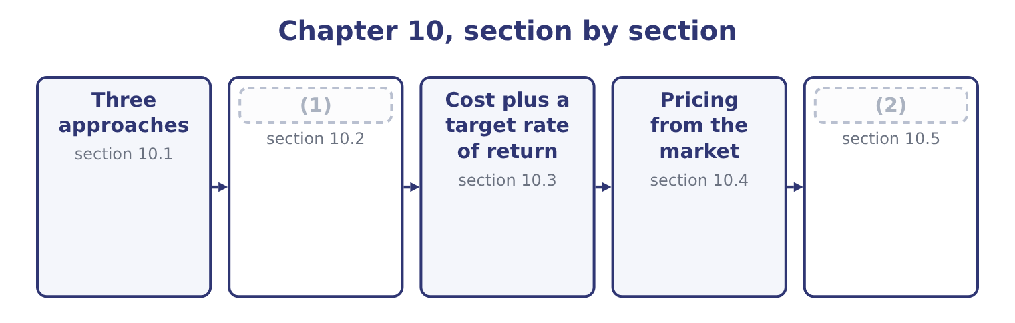
word list
Choosing and defending a price · Pricing from the market · Pricing from a cost

Summary 1 gaps 3–14
The (3) names three (4) and the exam expects them (5) . Cost-based pricing starts from a cost and adds a (6) . Its merits are that it is simple, it can be applied to thousands of products without market research, it covers costs by (7) , and it is (8) to a customer who asks how the price was reached — which is why it is standard for government contracts and for (9) fees. Its defect is that it ignores the customer: it answers the (10) "what do we need" (11) than "what will they pay". (12) pricing starts from the market. Market comparables set the price at or around what similar products fetch, which is the method for commodities, for retail lines facing a shelf of rivals, and for (13) whose price is (14) quoted. The company then has to make the product for less than that price, which is the target costing.
word list
methodologies · defensible · effectively · professional · anything · construction · distinguished · Market-based · research · question · rather · margin · outcome

Summary 2 gaps 15–21
Value-based pricing starts from the customer's (15) of what the product is worth to them. It is the (16) to do and the most (17) where it works: a product that saves a customer $100,000 a year can be priced at far more than it costs to make, and at far more than a (18) product with a weaker claim. It (19) knowing the customer's (20) , which is why it is common in industrial sales and rare in (21) .
word list
economics · grocery · requires · perception · hardest · comparable · profitable · applied

Three ways to arrive at a price
Approach | Starts from | Asks | Best suited to | Main defect
Cost-based | The company's cost | What do we need to earn? | (22) | (23)
Market comparables | (24) | What do others charge? | (25) | Ignores the company's own cost position
Value-based | (26) | What is it worth to them? | Industrial products with measurable benefit | (27)

word list
Ignores what the customer will pay · Competitors' prices · assumed volume · Commodities, crowded shelves · The customer's benefit · Many products, contracts, regulated work · Hard to measure; needs customer knowledge

Summary 3 gaps 28–30
In (28) the three are used together, and the standard sequence in a well-run company is: (29) what the market will pay, subtract the profit required, and manage the cost down to what is left. That (30) is target costing.
word list
sentence · establish · commodities · practice

The English this section uses, and its Arabic
Each term sits against what it means.
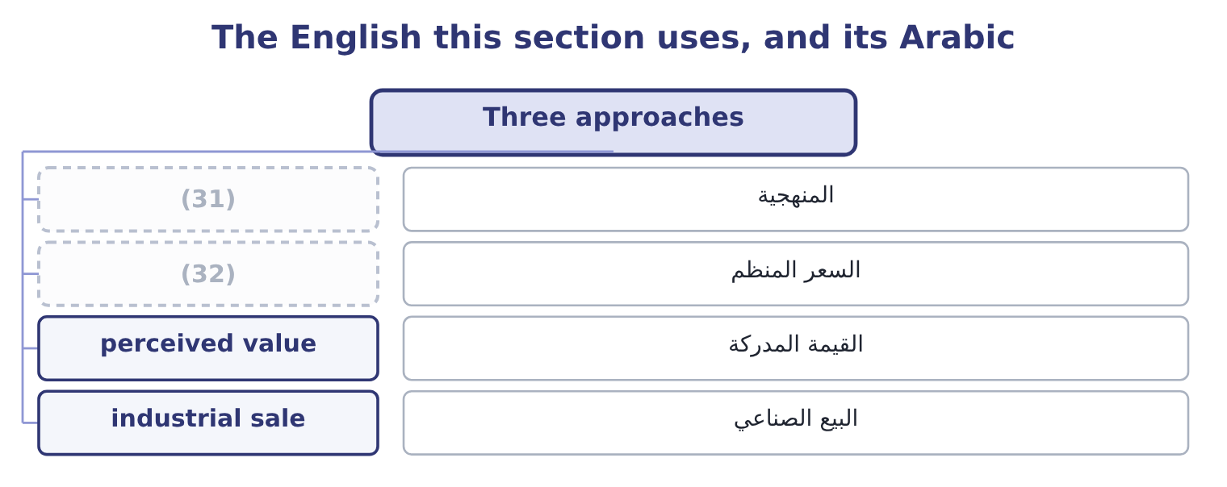
word list
market comparables · regulated price · methodology

The English this sheet uses, and its Arabic
English (exam term) | Arabic
methodology | المنهجية
regulated price | السعر المنظم
perceived value | القيمة المدركة
industrial sale | البيع الصناعي

Answer key · 10.1 Three approaches

1 Pricing from a cost | 17 profitable
2 Choosing and defending a price | 18 comparable
3 outcome | 19 requires
4 methodologies | 20 economics
5 distinguished | 21 grocery
6 margin | 22 Many products, contracts, regulated work
7 construction | 23 Ignores what the customer will pay
8 defensible | 24 Competitors' prices
9 professional | 25 Commodities, crowded shelves
10 question | 26 The customer's benefit
11 rather | 27 Hard to measure; needs customer knowledge
12 Market-based | 28 practice
13 anything | 29 establish
14 effectively | 30 sentence
15 perception | 31 methodology
16 hardest | 32 regulated price

the summaries in full
Summary 1 The outcome names three methodologies and the exam expects them distinguished. Cost-based pricing starts from a cost and adds a margin. Its merits are that it is simple, it can be applied to thousands of products without market research, it covers costs by construction, and it is defensible to a customer who asks how the price was reached — which is why it is standard for government contracts and for professional fees. Its defect is that it ignores the customer: it answers the question "what do we need" rather than "what will they pay". Market-based pricing starts from the market. Market comparables set the price at or around what similar products fetch, which is the method for commodities, for retail lines facing a shelf of rivals, and for anything whose price is effectively quoted. The company then has to make the product for less than that price, which is the target costing.
Summary 2 Value-based pricing starts from the customer's perception of what the product is worth to them. It is the hardest to do and the most profitable where it works: a product that saves a customer $100,000 a year can be priced at far more than it costs to make, and at far more than a comparable product with a weaker claim. It requires knowing the customer's economics, which is why it is common in industrial sales and rare in grocery.
Summary 3 In practice the three are used together, and the standard sequence in a well-run company is: establish what the market will pay, subtract the profit required, and manage the cost down to what is left. That sentence is target costing.

10.2 Pricing from a cost
Chapter 10 · section 10.2

Fill every gap. Each word list holds one word more than there are gaps.
Summary 1 gaps 1–12
A (1) price has two (2) : a cost base, and a markup (3) to it. The (4) questions turn on which cost base is being used, because the same price can be (5) as very different (6) . Four cost bases are used, each with its own markup. The markup must cover fixed manufacturing costs, all selling and administrative costs, and the profit. It is the (7) markup and the most (8) base, because it makes the contribution (9) . Total variable cost, including variable selling costs. The markup covers all fixed costs and the profit. Full manufacturing cost, often called (10) cost. The markup covers selling and administrative costs and the profit. This is the commonest base in practice because the figure is already in the (11) records. Full cost including selling and (12) . The markup covers profit alone.
word list
administration · visible · applied · absorption · components · inventory · expressed · flexible · largest · markups · exam's · together · cost-based

Worked example: four routes to the same $12.00

Summary 2 gaps 13–19
Orontes's variable cost is $7.20 a jar, its fixed costs are $12,624,000 over 3,500,000 jars, which is 12,624,000 ÷ 3,500,000 = 3.61 a jar, and its full cost is 7.20 + 3.61 = 10.81. On the variable cost. To reach $12.00 the markup must be 12.00 − 7.20 = 4.80 over a base of 7.20, which is 4.80 ÷ 7.20 = 66.67 per cent. The markup is 12.00 − 10.81 = 1.19 over 10.81, which is 1.19 ÷ 10.81 = 11.01 per cent. Read the two (13) . The same price is a 67 per cent markup on one base and an 11 per cent markup on (14) . A markup percentage means (15) until the base is stated, and a (16) that gives a markup (17) a base cannot be (18) . Note which base is (19) .
word list
riskier · question · together · answered · nothing · without · another · manufacturing

Summary 3 gaps 20–23
The full-cost markup of 11 per cent is (20) on a fixed cost per unit of $3.61 that depends on selling 3,500,000 jars. If volume falls to 3,000,000, the fixed cost per unit becomes 12,624,000 ÷ 3,000,000 = 4.21, the full cost becomes 7.20 + 4.21 = 11.41, and the same 11 per cent markup gives a price of $12.67. The company would be (21) its price because (22) fell, which is the (23) trap built into full-cost pricing and the first thing to say about it in an exam.
word list
computed · demand · circular · raising · starting

Four cost bases for the same $12.00 price
Every item belongs to exactly one group.
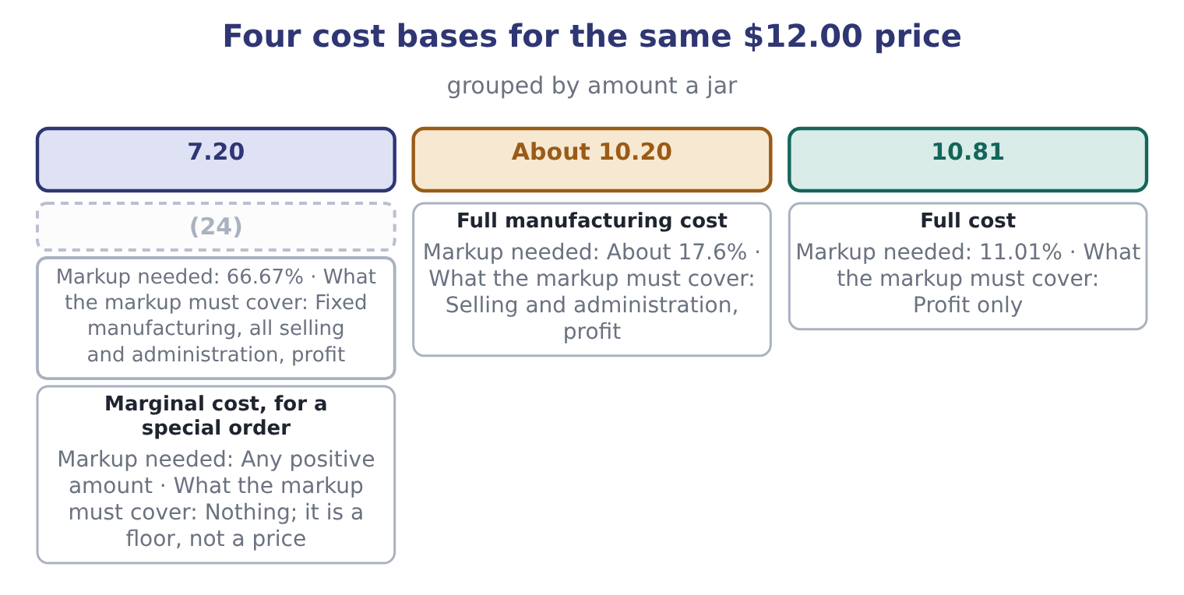
word list
Variable manufacturing cost · Full manufacturing cost

Summary 4 gaps 25–28
One more (25) appears constantly and is worth (26) . A markup is a percentage of cost; a margin is a percentage of price. Orontes's gross margin of 35 per cent corresponds to a markup of 0.35 ÷ 0.65 = 53.85 per cent on cost, and a markup of 66.67 per cent on variable cost corresponds to a contribution margin of 40 per cent on price. (27) the two is the single commonest (28) error in pricing questions.
word list
automating · arithmetic · Confusing · question · conversion

Markup against margin

Summary 5 gaps 29–34
A markup is on cost and a margin is on price. A 50 per cent markup is a 33.3 per cent margin; a 50 per cent margin is a 100 per cent markup. A full-cost price depends on an (29) volume. Say which volume, and note that the price rises as volume falls — which is the (30) of what a market would do. A (31) price is a starting point for (32) and a check that costs are (33) . It is not evidence that (34) will pay it.
word list
opposite · covered · negotiation · channel · customers · assumed · cost-plus

The English this section uses, and its Arabic
Each term sits against what it means.
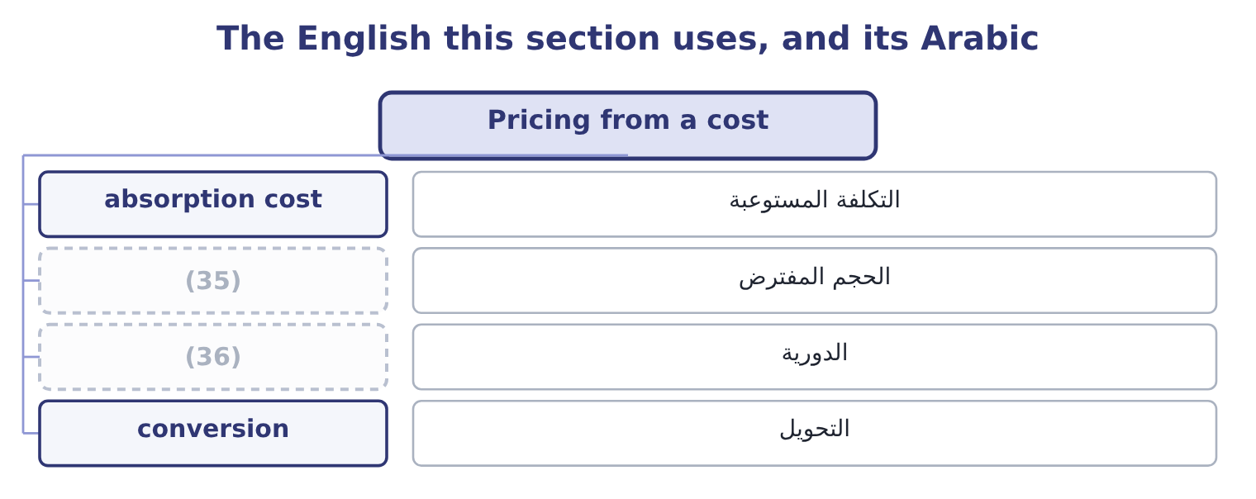
word list
circularity · assumed volume · price taker

The English this sheet uses, and its Arabic
English (exam term) | Arabic
absorption cost | التكلفة المستوعبة
assumed volume | الحجم المفترض
circularity | الدورية
conversion | التحويل

Answer key · 10.2 Pricing from a cost

1 cost-based | 19 riskier
2 components | 20 computed
3 applied | 21 raising
4 exam's | 22 demand
5 expressed | 23 circular
6 markups | 24 Variable manufacturing cost
7 largest | 25 conversion
8 flexible | 26 automating
9 visible | 27 Confusing
10 absorption | 28 arithmetic
11 inventory | 29 assumed
12 administration | 30 opposite
13 together | 31 cost-plus
14 another | 32 negotiation
15 nothing | 33 covered
16 question | 34 customers
17 without | 35 assumed volume
18 answered | 36 circularity

the summaries in full
Summary 1 A cost-based price has two components: a cost base, and a markup applied to it. The exam's questions turn on which cost base is being used, because the same price can be expressed as very different markups. Four cost bases are used, each with its own markup. The markup must cover fixed manufacturing costs, all selling and administrative costs, and the profit. It is the largest markup and the most flexible base, because it makes the contribution visible. Total variable cost, including variable selling costs. The markup covers all fixed costs and the profit. Full manufacturing cost, often called absorption cost. The markup covers selling and administrative costs and the profit. This is the commonest base in practice because the figure is already in the inventory records. Full cost including selling and administration. The markup covers profit alone.
Summary 2 Orontes's variable cost is $7.20 a jar, its fixed costs are $12,624,000 over 3,500,000 jars, which is 12,624,000 ÷ 3,500,000 = 3.61 a jar, and its full cost is 7.20 + 3.61 = 10.81. On the variable cost. To reach $12.00 the markup must be 12.00 − 7.20 = 4.80 over a base of 7.20, which is 4.80 ÷ 7.20 = 66.67 per cent. The markup is 12.00 − 10.81 = 1.19 over 10.81, which is 1.19 ÷ 10.81 = 11.01 per cent. Read the two together. The same price is a 67 per cent markup on one base and an 11 per cent markup on another. A markup percentage means nothing until the base is stated, and a question that gives a markup without a base cannot be answered. Note which base is riskier.
Summary 3 The full-cost markup of 11 per cent is computed on a fixed cost per unit of $3.61 that depends on selling 3,500,000 jars. If volume falls to 3,000,000, the fixed cost per unit becomes 12,624,000 ÷ 3,000,000 = 4.21, the full cost becomes 7.20 + 4.21 = 11.41, and the same 11 per cent markup gives a price of $12.67. The company would be raising its price because demand fell, which is the circular trap built into full-cost pricing and the first thing to say about it in an exam.
Summary 4 One more conversion appears constantly and is worth automating. A markup is a percentage of cost; a margin is a percentage of price. Orontes's gross margin of 35 per cent corresponds to a markup of 0.35 ÷ 0.65 = 53.85 per cent on cost, and a markup of 66.67 per cent on variable cost corresponds to a contribution margin of 40 per cent on price. Confusing the two is the single commonest arithmetic error in pricing questions.
Summary 5 A markup is on cost and a margin is on price. A 50 per cent markup is a 33.3 per cent margin; a 50 per cent margin is a 100 per cent markup. A full-cost price depends on an assumed volume. Say which volume, and note that the price rises as volume falls — which is the opposite of what a market would do. A cost-plus price is a starting point for negotiation and a check that costs are covered. It is not evidence that customers will pay it.

10.3 Cost plus a target rate of return
Chapter 10 · section 10.3

Fill every gap. Each word list holds one word more than there are gaps.
Summary 1 gaps 1–4
Cost plus target rate of return sets the markup so that the company earns a stated return on the capital the (1) employs. (2) of asking what margin feels right, it asks what profit the (3) require and (4) that profit over the units.
word list
spreads · product · Instead · pricing · investors

Worked example: pricing for a 15 per cent return

Summary 2 gaps 5–15
Orontes's (5) total assets are $29,058,800. At a target return of 15 per cent: 29,058,800 × 0.15 = 4,358,820. Over 3,500,000 jars: 4,358,820 ÷ 3,500,000 = 1.25 a jar. Full cost plus that profit: 10.81 + 1.25 = 12.06. The method has one (6) merit and two serious (7) , and the exam wants all three. The merit is that it ties the price to the return the (8) of capital require, which Book 2's.04 per cent — so a target of 15 per cent is a (9) premium over the cost of capital, and the (10) is the value the company (11) to create. The first weakness is the same (12) as before, and worse: the price depends on the volume, and now also on the capital employed, which (13) depends on the volume (14) inventory and (15) .
word list
deliberate · through · receivables · weaknesses · powerful · intends · itself · circularity · difference · average · providers · Orontes's

Summary 3 gaps 16–23
The (16) is that it says (17) about whether anyone will pay $12.06. A target return is an input to the pricing (18) and never a (19) of it. Where the method is (20) used is in regulated industries — a utility allowed to earn a stated return on its asset base — and in long-term contracts where a customer accepts a cost-plus basis and (21) the rate of return rather than the price. In both cases the customer agrees to the (22) in advance, which is (23) what makes it work.
word list
genuinely · nothing · mechanism · justification · employs · negotiates · decision · precisely · second

Markup pricing and target-return pricing
 | Markup on cost | Cost plus target rate of return
The markup is set by | Convention, or what the trade bears | (24)
Needs an estimate of | Volume | (25)
Price on Orontes's figures | (26) | 12.06 at a 15% return on assets
Used in | General practice | (27)
Weakness | (28) | Circular, and still ignores demand

word list
Regulated industries, cost-plus contracts · 12.00 at an 11.01% markup on full cost · The markup has no economic basis · The return required on capital employed · 12.06 at a 15% return on assets · Volume and capital employed

The English this section uses, and its Arabic
Each term sits against what it means.
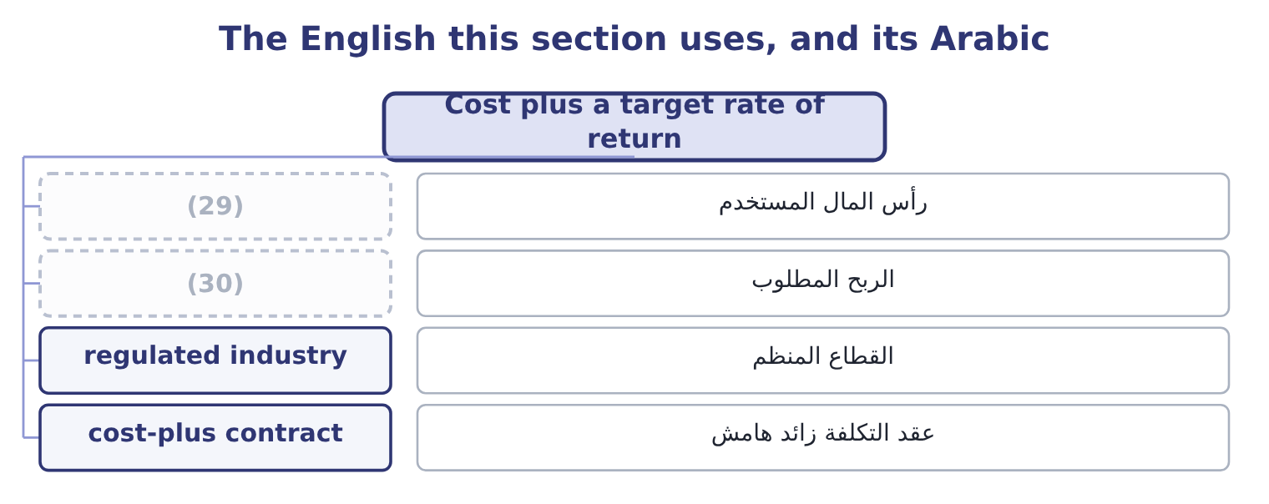
word list
industrial sale · capital employed · required profit

The English this sheet uses, and its Arabic
English (exam term) | Arabic
capital employed | رأس المال المستخدم
required profit | الربح المطلوب
regulated industry | القطاع المنظم
cost-plus contract | عقد التكلفة زائد هامش

Answer key · 10.3 Cost plus a target rate of return

1 product | 16 second
2 Instead | 17 nothing
3 investors | 18 decision
4 spreads | 19 justification
5 average | 20 genuinely
6 powerful | 21 negotiates
7 weaknesses | 22 mechanism
8 providers | 23 precisely
9 deliberate | 24 The return required on capital employed
10 difference | 25 Volume and capital employed
11 intends | 26 12.00 at an 11.01% markup on full cost
12 circularity | 27 Regulated industries, cost-plus contracts
13 itself | 28 The markup has no economic basis
14 through | 29 capital employed
15 receivables | 30 required profit

the summaries in full
Summary 1 Cost plus target rate of return sets the markup so that the company earns a stated return on the capital the product employs. Instead of asking what margin feels right, it asks what profit the investors require and spreads that profit over the units.
Summary 2 Orontes's average total assets are $29,058,800. At a target return of 15 per cent: 29,058,800 × 0.15 = 4,358,820. Over 3,500,000 jars: 4,358,820 ÷ 3,500,000 = 1.25 a jar. Full cost plus that profit: 10.81 + 1.25 = 12.06. The method has one powerful merit and two serious weaknesses, and the exam wants all three. The merit is that it ties the price to the return the providers of capital require, which Book 2's.04 per cent — so a target of 15 per cent is a deliberate premium over the cost of capital, and the difference is the value the company intends to create. The first weakness is the same circularity as before, and worse: the price depends on the volume, and now also on the capital employed, which itself depends on the volume through inventory and receivables.
Summary 3 The second is that it says nothing about whether anyone will pay $12.06. A target return is an input to the pricing decision and never a justification of it. Where the method is genuinely used is in regulated industries — a utility allowed to earn a stated return on its asset base — and in long-term contracts where a customer accepts a cost-plus basis and negotiates the rate of return rather than the price. In both cases the customer agrees to the mechanism in advance, which is precisely what makes it work.

10.4 Pricing from the market
Chapter 10 · section 10.4

Fill every gap. Each word list holds one word more than there are gaps.
Summary 1 gaps 1–12
Market-based (1) reverses the (2) . The price is given by what (3) products fetch, and the (4) task is to be able to make the product for less. Three (5) of a market price appear in (6) . What (7) goods sell for, adjusted for (8) in size, quality, brand and service. This is the (9) case and the (10) case. The competitor's price (11) . In a market with few (12) , each watches the others, and a price change by one is answered by the rest. In an industrial sale, the price ceiling is what the customer would pay for the next best way of solving the same problem — which may be a competitor's product, doing it themselves, or doing nothing. For Orontes, the market price is close to given. Tahini sits on a shelf beside other tahini; the customer compares jars; and Book 1's finding that the gross margin fell from 37.0 to 35.0 per cent while sales grew is exactly what a market-priced product looks like when a company buys share.
word list
sellers · company's · directly · comparable · sources · differences · questions · arithmetic · retail · pricing · similar · circularity · commodity

Who sets the price?
Every item belongs to exactly one group.
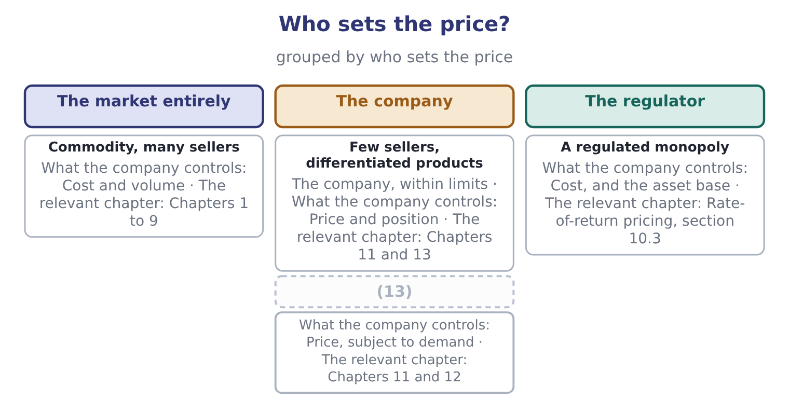
word list
A unique or protected product · Few sellers, differentiated products

Summary 2 gaps 14–22
The (14) question in a market-priced business is (15) not what to (16) but whether to be in the market at the price it offers, and that question is answered with the tools. Take the test at $11.50 a jar. The (17) would be 11.50 − 7.20 = 4.30, the (18) would rise to 12,624,000 ÷ 4.30 = 2,935,814 jars, and the margin of (19) would fall from 24.86 per cent to about 16 per cent. Whether to accept the market’s price is a (20) question, and whether to try to change it is the (21) of the next three (22) .
word list
analytical · chapters · safety · pricing · cost-structure · therefore · breakeven · charge · subject · contribution

A price floor is not a price

Summary 3 gaps 23–28
Neither is a price, and the gap (23) the floor and what the customer will pay is where the (24) is. In a market-priced business, (25) produces a price (26) will pay, and the right use of the cost figure is to decide whether to be in the market at all. A price change by one seller in a (27) market will be answered. Any (28) that assumes competitors do nothing should say so.
word list
exactly · concentrated · profit · nobody · between · cost-plus · calculation

The English this section uses, and its Arabic
Each term sits against what it means.
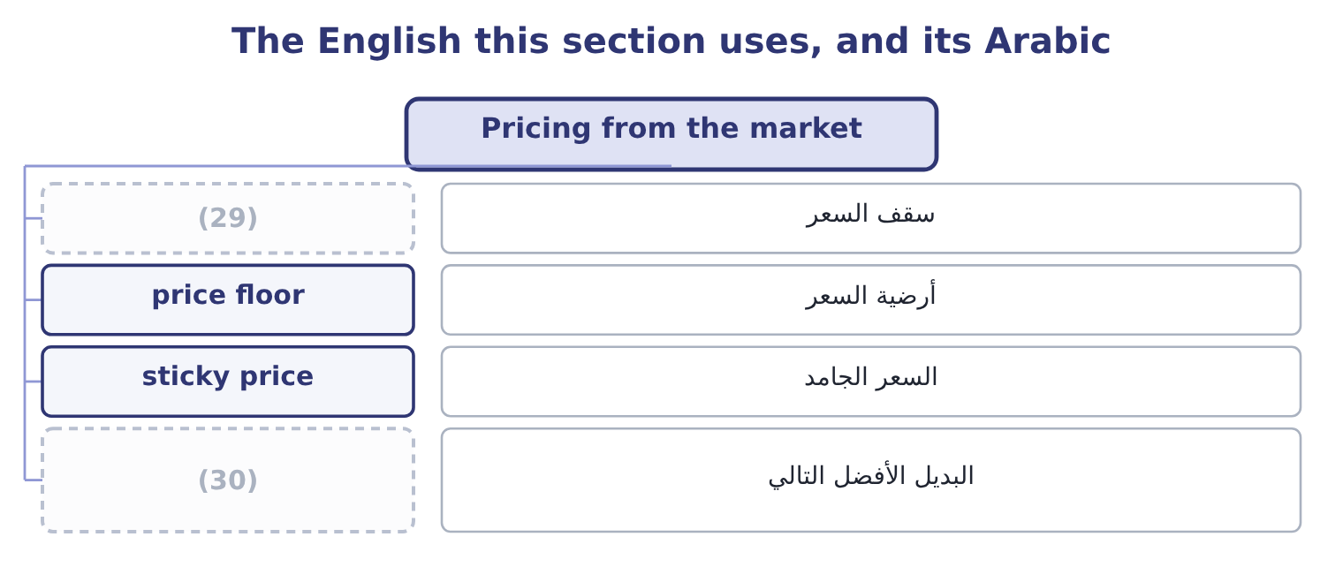
word list
price ceiling · next best alternative · price taker

The English this sheet uses, and its Arabic
English (exam term) | Arabic
price ceiling | سقف السعر
price floor | أرضية السعر
sticky price | السعر الجامد
next best alternative | البديل الأفضل التالي

Answer key · 10.4 Pricing from the market

1 pricing | 16 charge
2 arithmetic | 17 contribution
3 comparable | 18 breakeven
4 company's | 19 safety
5 sources | 20 cost-structure
6 questions | 21 subject
7 similar | 22 chapters
8 differences | 23 between
9 retail | 24 profit
10 commodity | 25 cost-plus
11 directly | 26 nobody
12 sellers | 27 concentrated
13 A unique or protected product | 28 calculation
14 analytical | 29 price ceiling
15 therefore | 30 next best alternative

the summaries in full
Summary 1 Market-based pricing reverses the arithmetic. The price is given by what comparable products fetch, and the company's task is to be able to make the product for less. Three sources of a market price appear in questions. What similar goods sell for, adjusted for differences in size, quality, brand and service. This is the retail case and the commodity case. The competitor's price directly. In a market with few sellers, each watches the others, and a price change by one is answered by the rest. In an industrial sale, the price ceiling is what the customer would pay for the next best way of solving the same problem — which may be a competitor's product, doing it themselves, or doing nothing. For Orontes, the market price is close to given. Tahini sits on a shelf beside other tahini; the customer compares jars; and Book 1's finding that the gross margin fell from 37.0 to 35.0 per cent while sales grew is exactly what a market-priced product looks like when a company buys share.
Summary 2 The analytical question in a market-priced business is therefore not what to charge but whether to be in the market at the price it offers, and that question is answered with the tools. Take the test at $11.50 a jar. The contribution would be 11.50 − 7.20 = 4.30, the breakeven would rise to 12,624,000 ÷ 4.30 = 2,935,814 jars, and the margin of safety would fall from 24.86 per cent to about 16 per cent. Whether to accept the market’s price is a cost-structure question, and whether to try to change it is the subject of the next three chapters.
Summary 3 Neither is a price, and the gap between the floor and what the customer will pay is where the profit is. In a market-priced business, cost-plus produces a price nobody will pay, and the right use of the cost figure is to decide whether to be in the market at all. A price change by one seller in a concentrated market will be answered. Any calculation that assumes competitors do nothing should say so.

10.5 Choosing and defending a price
Chapter 10 · section 10.5

Fill every gap. Each word list holds one word more than there are gaps.
Summary 1 gaps 1–12
Four (1) settle a pricing (2) , and an exam answer that works through them in order will be a good one. What does the product cost, on two bases? The (3) cost, as a floor for a one-off, and the full cost, as the (4) floor. (5) are $7.20 and $10.81. What will the market bear? From comparables, from the (6) price, or from the customer's (7) . For Orontes this is (8) $12.00, and Book 1 shows what (9) when the company tested below it. What return does the company require? The (10) method of section 10.3 (11) the cost of capital into a price, which for Orontes is $12.06 at a 15 per cent target. What will the competitors and the customers do? A price is a move in a game with other (12) , which is.
word list
decision · long-run · around · happened · require · questions · players · target-return · alternative · Orontes's · converts · competitor's · relevant

Summary 2 gaps 13–22
Three further (13) belong in any (14) pricing answer. Price (15) across customers and (16) . A special order at $8.50, a (17) at $9.40 and a shelf price of $12.00 can coexist only while the three markets stay (18) . Pricing below cost to drive out a competitor, agreeing prices with rivals and (19) between customers without (20) are all restricted in most jurisdictions. The (21) a price sends. A low price says cheap as well as (22) , and a price cut in a branded market is read as a statement about quality as well as about cost — which is a further reason Book 1's two points of margin were expensive.
word list
justification · supermarket · serious · separate · consistency · channels · discriminating · competitor · signal · considerations · inexpensive

Price a product four ways

Your turn: cost-based prices (complete the blanks)
Item | Data | Answer
Full cost a unit | (23) | ________
Price at a 25 per cent markup on full cost | Markup 25 per cent on full cost | ________
Markup on variable cost needed to reach that price | Variable cost 18.00 | ________
Margin on price at that price | (24) | ________
Required profit at a 12 per cent return on 9,000,000 of capital |  | ________
Price under cost plus target rate of return | (25) | ________

word list
Full cost and price from the lines above · Required profit spread over 200,000 units · 1,080,000: 9,000,000 × 0.12 = 1,080,000. · Variable 18.00, fixed costs 2,400,000 over 200,000 units

"Markup"

Summary 3 gaps 26–30
English markup is a percentage added to a cost, and margin is a percentage of a price. In (26) speech markup is often used (27) for both, and a (28) who says "I work on fifty per cent" may mean either. An exam answer (29) do the same, in any (30) : write the base beside the percentage.
word list
loosely · one-off · should · retail · shopkeeper · language

"Markup"
Item | Answer
Full cost a unit | 30.00: fixed costs are 2,400,000 ÷ 200,000 = 12.00 a unit, plus variable of 18.00.
Price at a 25 per cent markup on full cost | 37.50: 30.00 × 1.25 = 37.50.
Markup on variable cost needed | 108.33 per cent: the markup is 37.50 − 18.00 = 19.50, and 19.50 ÷ 18.00 = 108.33 per cent.
Margin on price at that price | 52.0 per cent: the contribution is 19.50, and 19.50 ÷ 37.50 = 52.0 per cent.
Required profit at 12 per cent on 9,000,000 | (31)
Price under cost plus target return | (32) : the profit a unit is 1,080,000 ÷ 200,000 = 5.40, plus the full cost of 30.00.
What it tells you | The same product is priced at 37.50 by (33) and 35.40 by the return the capital requires, and the second figure is the one that can be

word list
35.40 · Full cost a unit · 1,080,000: 9,000,000 × 0.12 = 1,080,000. · convention

The English this section uses, and its Arabic
Each term sits against what it means.
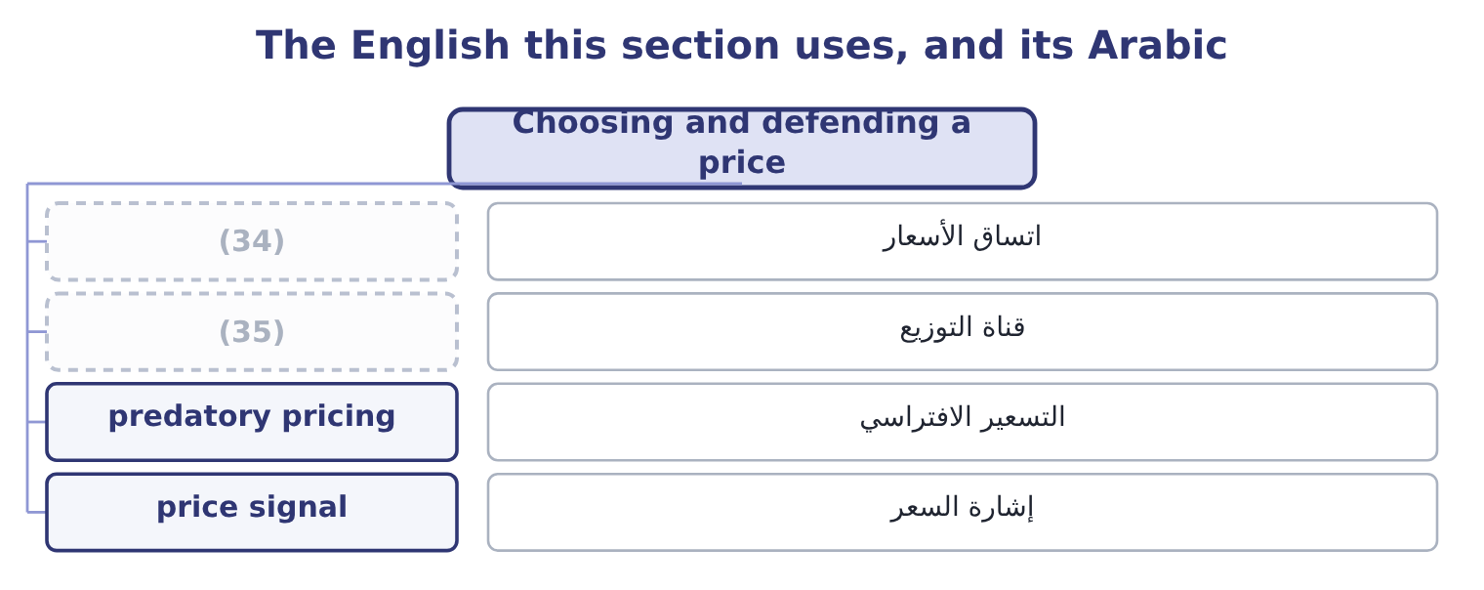
word list
channel · price consistency · circularity

The English this sheet uses, and its Arabic
English (exam term) | Arabic
price consistency | اتساق الأسعار
channel | قناة التوزيع
predatory pricing | التسعير الافتراسي
price signal | إشارة السعر

Answer key · 10.5 Choosing and defending a price

1 questions | 19 discriminating
2 decision | 20 justification
3 relevant | 21 signal
4 long-run | 22 inexpensive
5 Orontes's | 23 Variable 18.00, fixed costs 2,400,000 over 200,000 units
6 competitor's | 24 Full cost and price from the lines above
7 alternative | 25 Required profit spread over 200,000 units
8 around | 26 retail
9 happened | 27 loosely
10 target-return | 28 shopkeeper
11 converts | 29 should
12 players | 30 language
13 considerations | 31 1,080,000: 9,000,000 × 0.12 = 1,080,000.
14 serious | 32 35.40
15 consistency | 33 convention
16 channels | 34 price consistency
17 supermarket | 35 channel
18 separate

the summaries in full
Summary 1 Four questions settle a pricing decision, and an exam answer that works through them in order will be a good one. What does the product cost, on two bases? The relevant cost, as a floor for a one-off, and the full cost, as the long-run floor. Orontes's are $7.20 and $10.81. What will the market bear? From comparables, from the competitor's price, or from the customer's alternative. For Orontes this is around $12.00, and Book 1 shows what happened when the company tested below it. What return does the company require? The target-return method of section 10.3 converts the cost of capital into a price, which for Orontes is $12.06 at a 15 per cent target. What will the competitors and the customers do? A price is a move in a game with other players, which is.
Summary 2 Three further considerations belong in any serious pricing answer. Price consistency across customers and channels. A special order at $8.50, a supermarket at $9.40 and a shelf price of $12.00 can coexist only while the three markets stay separate. Pricing below cost to drive out a competitor, agreeing prices with rivals and discriminating between customers without justification are all restricted in most jurisdictions. The signal a price sends. A low price says cheap as well as inexpensive, and a price cut in a branded market is read as a statement about quality as well as about cost — which is a further reason Book 1's two points of margin were expensive.
Summary 3 English markup is a percentage added to a cost, and margin is a percentage of a price. In retail speech markup is often used loosely for both, and a shopkeeper who says "I work on fifty per cent" may mean either. An exam answer should do the same, in any language: write the base beside the percentage.

11.1 Demand, supply and the price between them
Chapter 11 · section 11.1

Fill every gap. Each word list holds one word more than there are gaps.
Chapter 11, section by section
Each stage leads to the next.
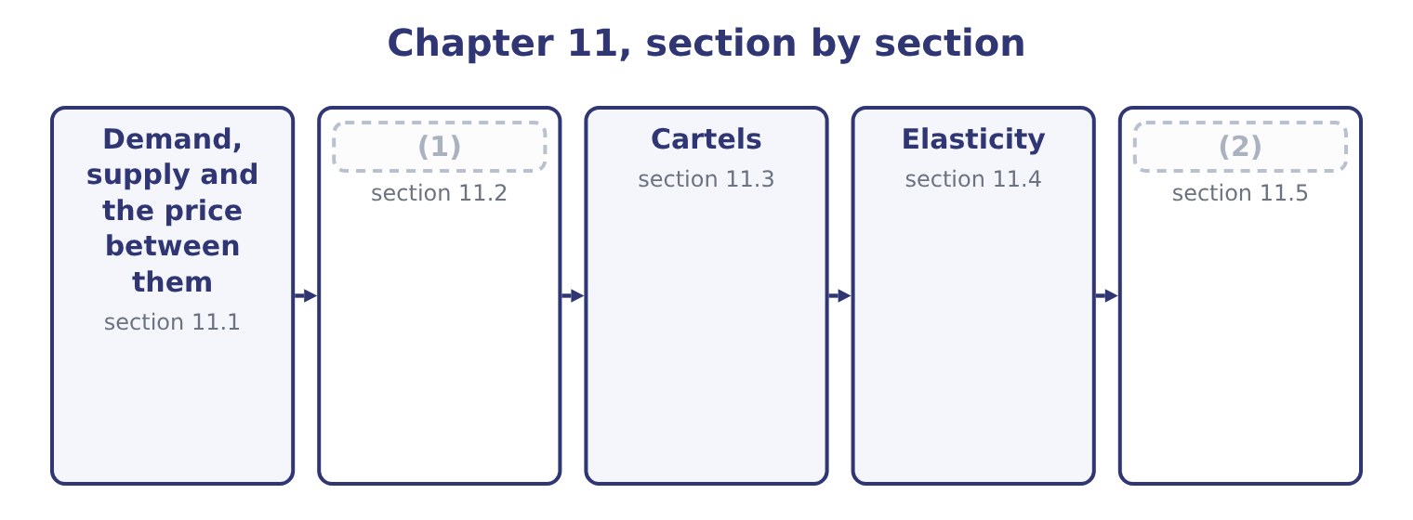
word list
short run and long run · Four market structures · Estimating revenue from a price change

Summary 1 gaps 3–14
A demand curve shows the quantity buyers will take at each price, and it slopes (3) : lower prices bring more buyers and more (4) from each. A supply curve shows the quantity sellers will offer at each price, and it slopes (5) : higher prices make (6) worthwhile for more sellers and for more output from each. The price at which the two (7) are equal is the equilibrium price, and it is where a competitive market (8) . Above it there are (9) goods and the price falls; below it there are (10) buyers and the price rises. The outcome asks what moves each curve, and the exam (11) two things (12) . A (13) along a curve is a response to a change in the price of the good (14) . Nothing has shifted; the market is reading off a different point.
word list
unsold · distinguishes · inelastic · production · upward · carefully · itself · settles · downward · movement · quantities · purchases · unsatisfied

Summary 2 gaps 15–25
A shift of the whole curve is a response to a change in (15) else. Demand shifts with incomes, with the prices of substitutes and complements, with tastes, with the number of buyers and with expectations. Supply shifts with input costs, technology, the number of sellers, taxes and (16) , and expectations. For Orontes, the (17) readings are (18) . A rise in the price of a (19) spread shifts the demand for (20) to the right, because the two are substitutes. A rise in the price of bread, which is eaten with it, shifts demand to the left, because the two are complements. A fall in the (21) price shifts supply to the right, (22) the equilibrium price for (23) — which is why a cost (24) in a competitive market is often competed away (25) than kept.
word list
sesame · lowering · something · technology · practical · rather · tahini · everybody · competing · saving · immediate · subsidies

What moves demand and supply
Curve | Moves right when | Moves left when
Demand | Incomes rise; a (26) 's price rises; tastes favour the product; more buyers | Incomes fall; a complement's price rises; tastes move away
Supply | Input costs fall; technology improves; more sellers; a subsidy | (27)

word list
interdependence · substitute · Input costs rise; sellers leave; a tax is imposed

The English this section uses, and its Arabic
Each term sits against what it means.
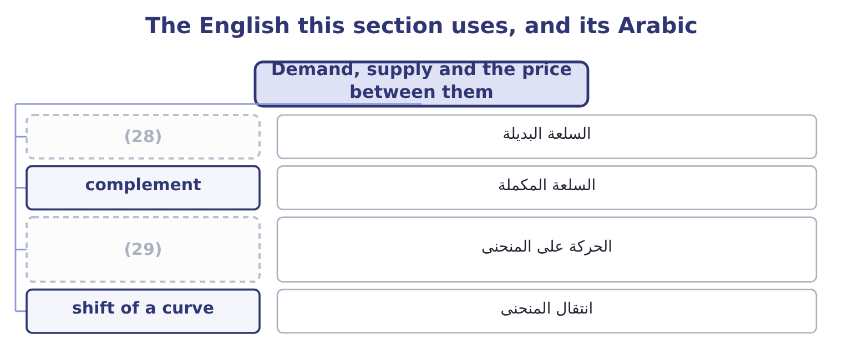
word list
substitute · movement along a curve · supply curve

The English this sheet uses, and its Arabic
English (exam term) | Arabic
substitute | السلعة البديلة
complement | السلعة المكملة
movement along a curve | الحركة على المنحنى
shift of a curve | انتقال المنحنى

Answer key · 11.1 Demand, supply and the price between them

1 Four market structures | 16 subsidies
2 Estimating revenue from a price change | 17 practical
3 downward | 18 immediate
4 purchases | 19 competing
5 upward | 20 tahini
6 production | 21 sesame
7 quantities | 22 lowering
8 settles | 23 everybody
9 unsold | 24 saving
10 unsatisfied | 25 rather
11 distinguishes | 26 substitute
12 carefully | 27 Input costs rise; sellers leave; a tax is imposed
13 movement | 28 substitute
14 itself | 29 movement along a curve
15 something

the summaries in full
Summary 1 A demand curve shows the quantity buyers will take at each price, and it slopes downward: lower prices bring more buyers and more purchases from each. A supply curve shows the quantity sellers will offer at each price, and it slopes upward: higher prices make production worthwhile for more sellers and for more output from each. The price at which the two quantities are equal is the equilibrium price, and it is where a competitive market settles. Above it there are unsold goods and the price falls; below it there are unsatisfied buyers and the price rises. The outcome asks what moves each curve, and the exam distinguishes two things carefully. A movement along a curve is a response to a change in the price of the good itself. Nothing has shifted; the market is reading off a different point.
Summary 2 A shift of the whole curve is a response to a change in something else. Demand shifts with incomes, with the prices of substitutes and complements, with tastes, with the number of buyers and with expectations. Supply shifts with input costs, technology, the number of sellers, taxes and subsidies, and expectations. For Orontes, the practical readings are immediate. A rise in the price of a competing spread shifts the demand for tahini to the right, because the two are substitutes. A rise in the price of bread, which is eaten with it, shifts demand to the left, because the two are complements. A fall in the sesame price shifts supply to the right, lowering the equilibrium price for everybody — which is why a cost saving in a competitive market is often competed away rather than kept.

11.2 Four market structures
Chapter 11 · section 11.2

Fill every gap. Each word list holds one word more than there are gaps.
Summary 1 gaps 1–11
How much (1) a company has to set its own price (2) on the structure of its market, and the (3) names four. Many small sellers, an identical product, free entry and exit, and buyers who know the prices. No seller can charge more than the market price, because buyers would simply go (4) , and none needs to charge less, because each can sell all it wants at the market price. The company is a price taker: its demand curve is (5) at the market price, so price equals marginal revenue, and in the short run it (6) where marginal cost equals that price. Profits above the normal level attract (7) , which pushes the price down until only a normal return (8) . (9) commodities are the usual example. Many sellers, but a differentiated product — by brand, recipe, (10) , service or (11) .
word list
freedom · extrapolation · location · horizontal · entrants · Agricultural · outcome · remains · elsewhere · depends · produces · packaging

Summary 2 gaps 12–23
Each seller has a (12) pricing power, because its product is not quite the same as the others, and its demand curve slopes gently (13) . It can raise the price without losing every (14) , and it loses some. Entry is free, so (15) profits are competed away in the long run, usually by rivals imitating the (16) . (17) food is the (18) example, and it is where Orontes sits. Few sellers, each large enough that its (19) affect the others. The (20) feature is (21) : a price change by one will be answered, so each seller must consider the response before moving. Prices are often sticky, because a cut will be (22) — losing margin without gaining share — while a rise may not be (23) , losing share without gaining margin. Competition shifts into advertising, quality and product variety, where responses are slower.
word list
Branded · interdependence · actions · little · followed · advertising · matched · downward · standard · differentiation · defining · economic · customer

Summary 3 gaps 24–32
Supermarkets, (24) and mobile (25) are examples. One seller of a product with no close substitutes, (26) by a barrier — a patent, a (27) , control of a (28) , or an economy of scale so large that a second entrant could not survive. The (29) faces the whole market demand curve and chooses the point on it that (30) profit, producing where marginal revenue equals marginal cost and (31) what the curve will bear at that quantity. Because marginal revenue is below price, the monopoly price is above the (32) one and the quantity is lower, which is why monopolies are regulated.
word list
resource · competitive · protected · maximises · charging · downward · monopolist · operators · licence · airlines

Four structures, four degrees of pricing power
Structure | Sellers | Product | Pricing power | Short-run price set where
Pure competition | Very many | Identical | (33) | Marginal cost equals the market price
Monopolistic competition | Many | Differentiated | (34) | Marginal revenue equals marginal cost
Oligopoly | Few | (35) | Considerable, limited by rivals' responses | (36)
Monopoly | One | No close substitute | (37) | Marginal revenue equals marginal cost

word list
Some, limited by close substitutes · Interdependently; prices often sticky · Greatest, limited by demand and regulation · None; a price taker · Either · interdependence

Summary 4 gaps 38–41
The rule that (38) the last three is: (39) while marginal revenue (40) marginal cost, and stop where they are equal. Only in pure competition does that (41) into producing where marginal cost equals the price, because only there is marginal revenue equal to price.
word list
collapse · exceeds · unites · produce · monopolies

The English this section uses, and its Arabic
Each term sits against what it means.
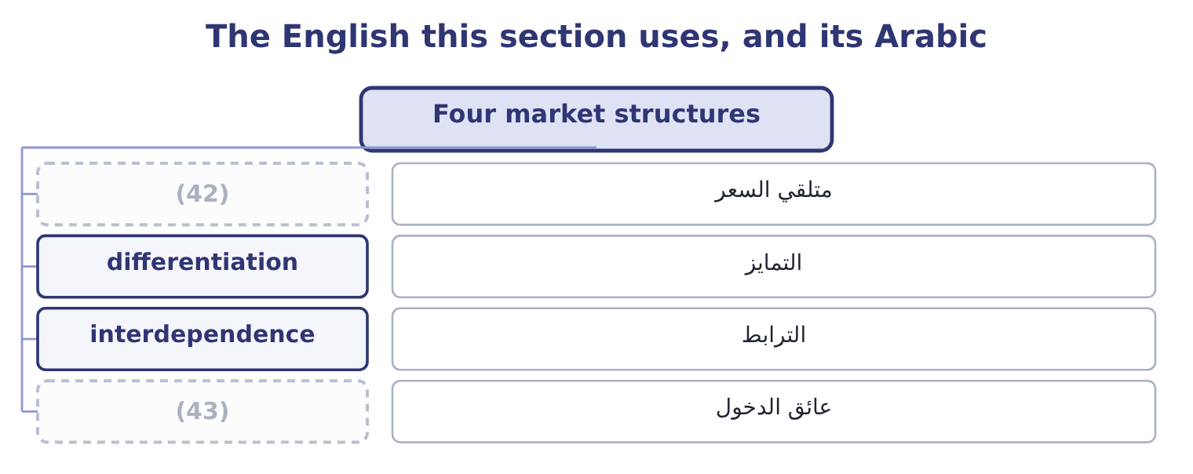
word list
midpoint formula · price taker · barrier to entry

The English this sheet uses, and its Arabic
English (exam term) | Arabic
price taker | متلقي السعر
differentiation | التمايز
interdependence | الترابط
barrier to entry | عائق الدخول

Answer key · 11.2 Four market structures

1 freedom | 23 followed
2 depends | 24 airlines
3 outcome | 25 operators
4 elsewhere | 26 protected
5 horizontal | 27 licence
6 produces | 28 resource
7 entrants | 29 monopolist
8 remains | 30 maximises
9 Agricultural | 31 charging
10 packaging | 32 competitive
11 location | 33 None; a price taker
12 little | 34 Some, limited by close substitutes
13 downward | 35 Either
14 customer | 36 Interdependently; prices often sticky
15 economic | 37 Greatest, limited by demand and regulation
16 differentiation | 38 unites
17 Branded | 39 produce
18 standard | 40 exceeds
19 actions | 41 collapse
20 defining | 42 price taker
21 interdependence | 43 barrier to entry
22 matched

the summaries in full
Summary 1 How much freedom a company has to set its own price depends on the structure of its market, and the outcome names four. Many small sellers, an identical product, free entry and exit, and buyers who know the prices. No seller can charge more than the market price, because buyers would simply go elsewhere, and none needs to charge less, because each can sell all it wants at the market price. The company is a price taker: its demand curve is horizontal at the market price, so price equals marginal revenue, and in the short run it produces where marginal cost equals that price. Profits above the normal level attract entrants, which pushes the price down until only a normal return remains. Agricultural commodities are the usual example. Many sellers, but a differentiated product — by brand, recipe, packaging, service or location.
Summary 2 Each seller has a little pricing power, because its product is not quite the same as the others, and its demand curve slopes gently downward. It can raise the price without losing every customer, and it loses some. Entry is free, so economic profits are competed away in the long run, usually by rivals imitating the differentiation. Branded food is the standard example, and it is where Orontes sits. Few sellers, each large enough that its actions affect the others. The defining feature is interdependence: a price change by one will be answered, so each seller must consider the response before moving. Prices are often sticky, because a cut will be matched — losing margin without gaining share — while a rise may not be followed, losing share without gaining margin. Competition shifts into advertising, quality and product variety, where responses are slower.
Summary 3 Supermarkets, airlines and mobile operators are examples. One seller of a product with no close substitutes, protected by a barrier — a patent, a licence, control of a resource, or an economy of scale so large that a second entrant could not survive. The monopolist faces the whole market demand curve and chooses the point on it that maximises profit, producing where marginal revenue equals marginal cost and charging what the curve will bear at that quantity. Because marginal revenue is below price, the monopoly price is above the competitive one and the quantity is lower, which is why monopolies are regulated.
Summary 4 The rule that unites the last three is: produce while marginal revenue exceeds marginal cost, and stop where they are equal. Only in pure competition does that collapse into producing where marginal cost equals the price, because only there is marginal revenue equal to price.

11.3 Cartels
Chapter 11 · section 11.3

Fill every gap. Each word list holds one word more than there are gaps.
Summary 1 gaps 1–12
A (1) is an agreement among (2) to act as if they were one. Members agree a price, or divide the market by quantity or (3) , or both, and the effect is to convert (4) into a shared monopoly: the price rises towards the monopoly price, the quantity falls, and the profits are divided among the members. Three (5) of cartels are (6) . They raise prices above the (7) level. That is their purpose, and it is why the (8) is a criminal offence in most (9) when practised by private companies. The exam's (10) example, the oil producers' (11) , is an agreement between states rather than companies and sits outside those laws. Each member gains by cheating: with the price held up by the others, an individual seller who quietly shades its price or exceeds its (12) sells more at a high price.
word list
consider · sellers · jurisdictions · examinable · cartel · quota · arrangement · territory · features · organisation · competition · textbook · competitive

Summary 2 gaps 13–24
Since every member faces that (13) , cartels require (14) and punishment to survive, and most collapse — through cheating, through entry by outsiders attracted by the high price, or through a fall in demand that makes the agreed quotas (15) . They are (16) by their effects. Prices that move together without a common cost cause, bids that rotate among suppliers, identical (17) , and prices that are sticky upwards and never downwards are the classic signals, and a (18) accountant who sees them in a supplier market has a reporting (19) to consider. Tacit (20) is the version without an agreement: firms in a concentrated market may arrive at similar prices simply by (21) each other, with no (22) at all. It is harder to (23) and produces similar effects, which is one reason (24) scrutinise concentrated markets even where no agreement can be shown.
word list
extrapolation · collusion · unbearable · obligation · management · regulators · detectable · communication · prosecute · monitoring · incentive · quotations · watching

What a cartel does
Every item belongs to exactly one group.
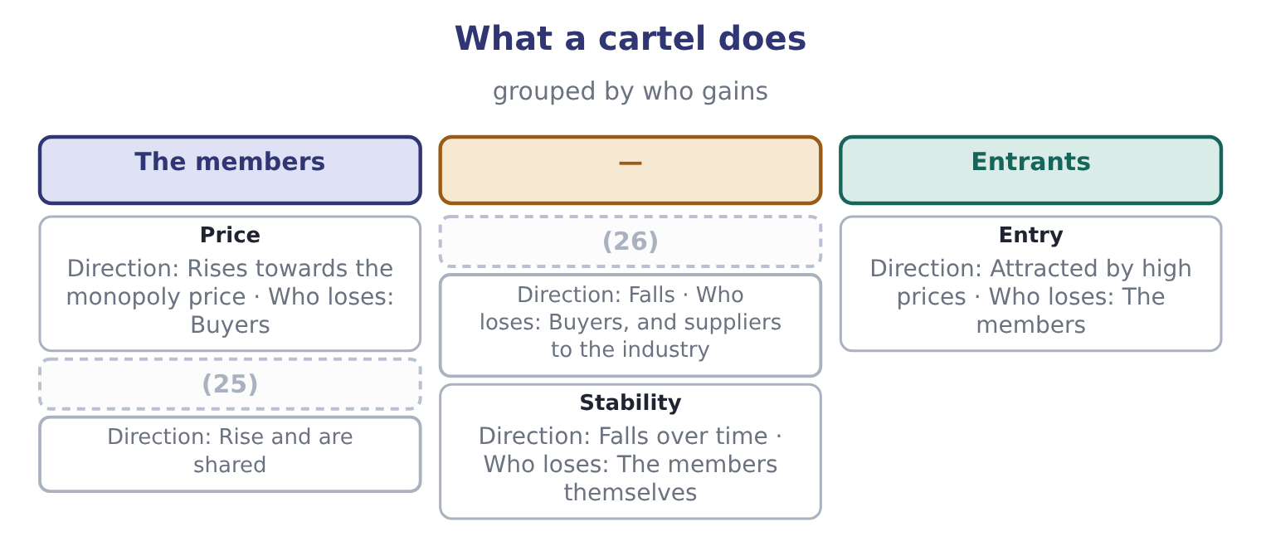
word list
collusion · Quantity · Profits

The English this section uses, and its Arabic
Each term sits against what it means.
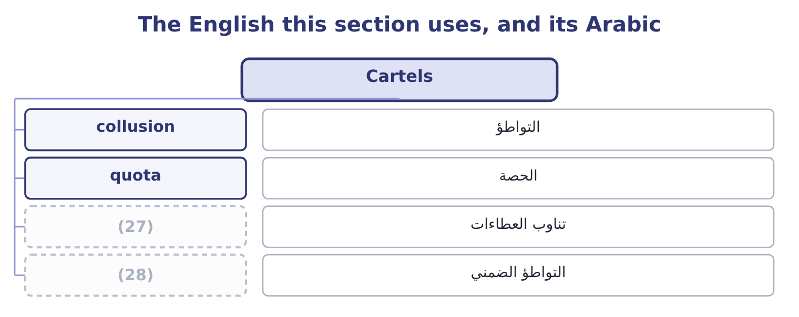
word list
bid rotation · tacit collusion · تناوب العطاءات

The English this sheet uses, and its Arabic
English (exam term) | Arabic
collusion | التواطؤ
quota | الحصة
bid rotation | تناوب العطاءات
tacit collusion | التواطؤ الضمني

Answer key · 11.3 Cartels

1 cartel | 15 unbearable
2 sellers | 16 detectable
3 territory | 17 quotations
4 competition | 18 management
5 features | 19 obligation
6 examinable | 20 collusion
7 competitive | 21 watching
8 arrangement | 22 communication
9 jurisdictions | 23 prosecute
10 textbook | 24 regulators
11 organisation | 25 Profits
12 quota | 26 Quantity
13 incentive | 27 bid rotation
14 monitoring | 28 tacit collusion

the summaries in full
Summary 1 A cartel is an agreement among sellers to act as if they were one. Members agree a price, or divide the market by quantity or territory, or both, and the effect is to convert competition into a shared monopoly: the price rises towards the monopoly price, the quantity falls, and the profits are divided among the members. Three features of cartels are examinable. They raise prices above the competitive level. That is their purpose, and it is why the arrangement is a criminal offence in most jurisdictions when practised by private companies. The exam's textbook example, the oil producers' organisation, is an agreement between states rather than companies and sits outside those laws. Each member gains by cheating: with the price held up by the others, an individual seller who quietly shades its price or exceeds its quota sells more at a high price.
Summary 2 Since every member faces that incentive, cartels require monitoring and punishment to survive, and most collapse — through cheating, through entry by outsiders attracted by the high price, or through a fall in demand that makes the agreed quotas unbearable. They are detectable by their effects. Prices that move together without a common cost cause, bids that rotate among suppliers, identical quotations, and prices that are sticky upwards and never downwards are the classic signals, and a management accountant who sees them in a supplier market has a reporting obligation to consider. Tacit collusion is the version without an agreement: firms in a concentrated market may arrive at similar prices simply by watching each other, with no communication at all. It is harder to prosecute and produces similar effects, which is one reason regulators scrutinise concentrated markets even where no agreement can be shown.

11.4 Elasticity
Chapter 11 · section 11.4

Fill every gap. Each word list holds one word more than there are gaps.
Summary 1 gaps 1–8
Price elasticity of demand (1) how much the quantity (2) responds to a change in price. It is the percentage change in quantity divided by the percentage change in price, and because the two move in opposite directions the result is (3) — so it is (4) quoted as a positive number and the exam does the same. The midpoint formula avoids an awkward feature of the simple (5) : the answer differs (6) on which end you start. It solves this by (7) each change by the average of the two values rather than by the (8) value.
word list
negative · oligopoly · starting · depending · dividing · calculation · demanded · conventionally · measures

Worked example: the elasticity of Orontes's demand

Summary 2 gaps 9–10
At $12.00 the company sells 3,500,000 jars; at $11.50 it would sell 3,800,000. The percentage change in quantity. The change is 300,000 and the average quantity is 3,650,000, so the percentage change is 300,000 ÷ 3,650,000 = 8.22 per cent. The percentage change in price. The change is 0.50 and the average price is 11.75, so the percentage change is 0.50 ÷ 11.75 = 4.26 per cent. An elasticity above 1 means demand is elastic: quantity responds more than (9) , so the price cut raises total revenue. And it does: 11.50 × 3,800,000 = 43,700,000 (10) $42,000,000. But, because contribution falls to 3,800,000 × 4.30 = 16,340,000 from $16,800,000 — a loss of 460,000. Elasticity tells you what happens to revenue. Only the contribution margin tells you what happens to profit, and the two can point in opposite directions, as they do here.
word list
starting · proportionately · against

Summary 3 gaps 11–17
The (11) is fixed and the exam uses it (12) . Elastic demand has an elasticity above 1. Quantity responds more than price, so a price cut raises total revenue and a price rise lowers it. Products with many substitutes, products that take a large share of a (13) budget, and luxuries tend to be elastic, and demand is more elastic over a long (14) than a short one, because buyers have time to find (15) . Inelastic demand has an elasticity below 1. Quantity responds less than price, so a price rise raises total revenue. Necessities, products with no close substitutes, products that are a small part of a budget, and (16) goods tend to be inelastic. Unitary elasticity is (17) 1, where total revenue does not change at all.
word list
alternatives · buyer's · period · precisely · differentiation · vocabulary · addictive · exactly

Elasticity and total revenue
Elasticity | Demand is | A price rise | A price cut | Typical products
Above 1 | Elastic | Lowers total revenue | Raises total revenue | (18)
Equal to 1 | Unitary | Leaves revenue unchanged | Leaves revenue unchanged | (19)
Below 1 | Inelastic | Raises total revenue | (20) | Necessities, few substitutes

word list
barrier to entry · The boundary case · Lowers total revenue · Luxuries, many substitutes

Revenue is not profit

Summary 4 gaps 21–28
An elastic demand means a price cut raises revenue. (21) it raises profit depends on the contribution margin, and Orontes is the (22) example of a cut that does one and not the other. Use the midpoint formula (23) the question says so, and say which formula you used when it does not. The simple formula gives a (24) answer in each (25) . Elasticity is not a (26) of a product for ever. It differs between the short run and the long run, between one price range and (27) on the same curve, and between (28) .
word list
standing · property · Whether · different · markets · complement · whenever · another · direction

The English this section uses, and its Arabic
Each term sits against what it means.
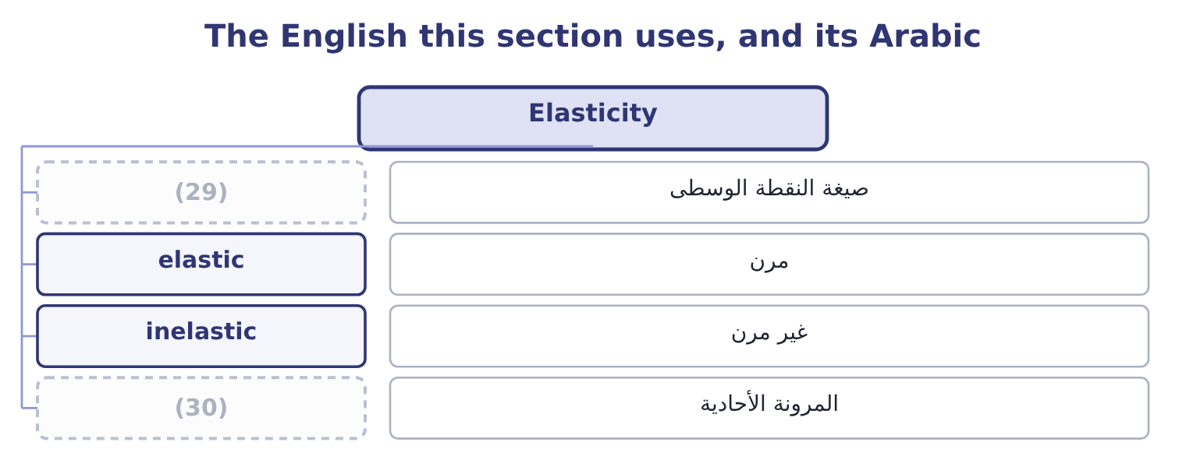
word list
pure competition · unitary elasticity · midpoint formula

The English this sheet uses, and its Arabic
English (exam term) | Arabic
midpoint formula | صيغة النقطة الوسطى
elastic | مرن
inelastic | غير مرن
unitary elasticity | المرونة الأحادية

Answer key · 11.4 Elasticity

1 measures | 16 addictive
2 demanded | 17 exactly
3 negative | 18 Luxuries, many substitutes
4 conventionally | 19 The boundary case
5 calculation | 20 Lowers total revenue
6 depending | 21 Whether
7 dividing | 22 standing
8 starting | 23 whenever
9 proportionately | 24 different
10 against | 25 direction
11 vocabulary | 26 property
12 precisely | 27 another
13 buyer's | 28 markets
14 period | 29 midpoint formula
15 alternatives | 30 unitary elasticity

the summaries in full
Summary 1 Price elasticity of demand measures how much the quantity demanded responds to a change in price. It is the percentage change in quantity divided by the percentage change in price, and because the two move in opposite directions the result is negative — so it is conventionally quoted as a positive number and the exam does the same. The midpoint formula avoids an awkward feature of the simple calculation: the answer differs depending on which end you start. It solves this by dividing each change by the average of the two values rather than by the starting value.
Summary 2 At $12.00 the company sells 3,500,000 jars; at $11.50 it would sell 3,800,000. The percentage change in quantity. The change is 300,000 and the average quantity is 3,650,000, so the percentage change is 300,000 ÷ 3,650,000 = 8.22 per cent. The percentage change in price. The change is 0.50 and the average price is 11.75, so the percentage change is 0.50 ÷ 11.75 = 4.26 per cent. An elasticity above 1 means demand is elastic: quantity responds more than proportionately, so the price cut raises total revenue. And it does: 11.50 × 3,800,000 = 43,700,000 against $42,000,000. But, because contribution falls to 3,800,000 × 4.30 = 16,340,000 from $16,800,000 — a loss of 460,000. Elasticity tells you what happens to revenue. Only the contribution margin tells you what happens to profit, and the two can point in opposite directions, as they do here.
Summary 3 The vocabulary is fixed and the exam uses it precisely. Elastic demand has an elasticity above 1. Quantity responds more than price, so a price cut raises total revenue and a price rise lowers it. Products with many substitutes, products that take a large share of a buyer's budget, and luxuries tend to be elastic, and demand is more elastic over a long period than a short one, because buyers have time to find alternatives. Inelastic demand has an elasticity below 1. Quantity responds less than price, so a price rise raises total revenue. Necessities, products with no close substitutes, products that are a small part of a budget, and addictive goods tend to be inelastic. Unitary elasticity is exactly 1, where total revenue does not change at all.
Summary 4 An elastic demand means a price cut raises revenue. Whether it raises profit depends on the contribution margin, and Orontes is the standing example of a cut that does one and not the other. Use the midpoint formula whenever the question says so, and say which formula you used when it does not. The simple formula gives a different answer in each direction. Elasticity is not a property of a product for ever. It differs between the short run and the long run, between one price range and another on the same curve, and between markets.

11.5 Estimating revenue from a price change
Chapter 11 · section 11.5

Fill every gap. Each word list holds one word more than there are gaps.
Summary 1 gaps 1–5
The last (1) asks for a revenue estimate given a price change and an elasticity, which is the (2) run in reverse. The (3) is three steps. Multiply the percentage change in price by the elasticity to get the percentage change in quantity, in the opposite (4) . Apply that to the (5) quantity. Multiply the new quantity by the new price.
word list
method · calculation · current · consider · outcome · direction

Worked example: a price rise in an inelastic market

Summary 2 gaps 6–14
Orontes (6) the jar by 5 per cent, from $12.00 to $12.60. Market (7) puts the elasticity of its (8) demand at about 0.41 — inelastic, because loyal buyers have no exact (9) . Volume falls about 2 per cent, from 3,500,000 to 3,430,000 jars. The profit effect, which is the point. The contribution margin (10) 12.60 − 7.20 = 5.40, so contribution is 3,430,000 × 5.40 = 18,522,000 against $16,800,000 — a gain of 1,722,000, or 41 per cent of the (11) operating income. (12) this with the price cut of section 11.4, which raised revenue by $1,700,000 and cut profit by $460,000. The two moves are (13) mirror images in revenue and opposite in profit, and the (14) is the contribution margin: at 40 per cent, Orontes loses $4.80 on every jar it does not sell and gains only the price change on every jar it does.
word list
company's · becomes · substitute · branded · raises · reason · warning · research · almost · Compare

Summary 3 gaps 15–26
A company with a high contribution margin should be slow to cut price and quick to (15) raising it, which is the (16) behind the warning Book 1 issued. Three (17) close the chapter, and an exam answer should carry at least one. An elasticity is an estimate, (18) from a narrow range of prices and a (19) period. (20) it to a large price change (21) beyond the evidence. It holds other things equal, and (22) are not other things. In the (23) of section 11.2, a price rise that rivals do not follow has a far higher (24) elasticity than one they match. And the long run (25) from the short. A price rise that loses 2 per cent of volume this year may lose far more over three years as buyers find (26) and rivals position against it — which is the mirror of Book 1's point that a price concession is permanent in a way a volume gain is not.
word list
cautions · consider · Applying · against · alternatives · extrapolates · differs · competitors · particular · usually · oligopoly · effective · arithmetic

Measure and forecast

Your turn: elasticity and revenue (complete the blanks)
Item | Data | Answer
Percentage change in quantity | 40,000 units rising to 44,000 | ________
Percentage change in price | (27) | ________
Elasticity, midpoint |  | ________
Elastic or inelastic? |  | ________
Effect on total revenue |  | ________
New revenue if a 4 per cent price rise meets an elasticity of 0.60, from a base of 50,000 units at 20.00 |  | ________

word list
price elasticity of demand · 20.00 falling to 19.00

"Elastic"

Summary 4 gaps 28–34
English elastic in economics means (28) , and the metaphor is of (29) that stretches a long way when (30) . The everyday sense of flexible or (31) is close enough to be (32) : an elastic demand is not a (33) one, it is a demand that punishes a price rise severely. Note the companion trap in all three languages: inelastic does not mean rigid in the sense of unchanging — an inelastic demand still falls when the price rises, just less than (34) .
word list
consider · something · accommodating · pulled · responsive · forgiving · misleading · proportionately

The same company, two price moves
 | Price cut to 11.50 | Price rise to 12.60
(35) | 1.93 | 0.41
Volume | 3,800,000 | 3,430,000
Total revenue | 43,700,000 | 43,218,000
(36) | 4.30 | 5.40
Total contribution | 16,340,000 | 18,522,000
Change in operating income | (460,000) | 1,722,000

word list
Elasticity assumed · other things equal · Contribution margin a jar

Item — Answer
Item | Answer
Percentage change in quantity | 9.52 per cent: the change is 4,000 and the average quantity is 42,000, so 4,000 ÷ 42,000 = 9.52 per cent.
Percentage change in price | 5.13 per cent: the change is 1.00 and the average price is 19.50, so 1.00 ÷ 19.50 = 5.13 per cent.
Elasticity, midpoint | (37)
Elastic or inelastic? | Elastic, because the figure exceeds 1.
Effect on total revenue | (38) : 19.00 × 44,000 = 836,000 against 20.00 × 40,000 = 800,000.
New revenue after a 4 per cent price rise at an elasticity of 0.60 | 1,015,040: quantity falls 2.4 per cent to 48,800 and the price rises to 20.80, so 20.80 × 48,800 = 1,015,040 against 1,000,000 before.
What it tells you | The same product is elastic in one range and assumed inelastic in another, which is the ordinary state of affairs: elasticity is a local mea

word list
Revenue rises · equilibrium price · 1.86: 9.52 ÷ 5.13 = 1.86.

The English this section uses, and its Arabic
Each term sits against what it means.
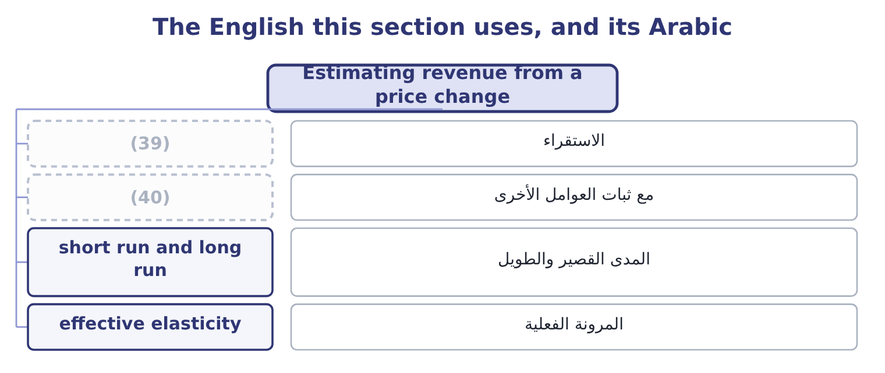
word list
monopolistic competition · other things equal · extrapolation

The English this sheet uses, and its Arabic
English (exam term) | Arabic
extrapolation | الاستقراء
other things equal | مع ثبات العوامل الأخرى
short run and long run | المدى القصير والطويل
effective elasticity | المرونة الفعلية

Answer key · 11.5 Estimating revenue from a price change

1 outcome | 21 extrapolates
2 calculation | 22 competitors
3 method | 23 oligopoly
4 direction | 24 effective
5 current | 25 differs
6 raises | 26 alternatives
7 research | 27 20.00 falling to 19.00
8 branded | 28 responsive
9 substitute | 29 something
10 becomes | 30 pulled
11 company's | 31 accommodating
12 Compare | 32 misleading
13 almost | 33 forgiving
14 reason | 34 proportionately
15 consider | 35 Elasticity assumed
16 arithmetic | 36 Contribution margin a jar
17 cautions | 37 1.86: 9.52 ÷ 5.13 = 1.86.
18 usually | 38 Revenue rises
19 particular | 39 extrapolation
20 Applying | 40 other things equal

the summaries in full
Summary 1 The last outcome asks for a revenue estimate given a price change and an elasticity, which is the calculation run in reverse. The method is three steps. Multiply the percentage change in price by the elasticity to get the percentage change in quantity, in the opposite direction. Apply that to the current quantity. Multiply the new quantity by the new price.
Summary 2 Orontes raises the jar by 5 per cent, from $12.00 to $12.60. Market research puts the elasticity of its branded demand at about 0.41 — inelastic, because loyal buyers have no exact substitute. Volume falls about 2 per cent, from 3,500,000 to 3,430,000 jars. The profit effect, which is the point. The contribution margin becomes 12.60 − 7.20 = 5.40, so contribution is 3,430,000 × 5.40 = 18,522,000 against $16,800,000 — a gain of 1,722,000, or 41 per cent of the company's operating income. Compare this with the price cut of section 11.4, which raised revenue by $1,700,000 and cut profit by $460,000. The two moves are almost mirror images in revenue and opposite in profit, and the reason is the contribution margin: at 40 per cent, Orontes loses $4.80 on every jar it does not sell and gains only the price change on every jar it does.
Summary 3 A company with a high contribution margin should be slow to cut price and quick to consider raising it, which is the arithmetic behind the warning Book 1 issued. Three cautions close the chapter, and an exam answer should carry at least one. An elasticity is an estimate, usually from a narrow range of prices and a particular period. Applying it to a large price change extrapolates beyond the evidence. It holds other things equal, and competitors are not other things. In the oligopoly of section 11.2, a price rise that rivals do not follow has a far higher effective elasticity than one they match. And the long run differs from the short. A price rise that loses 2 per cent of volume this year may lose far more over three years as buyers find alternatives and rivals position against it — which is the mirror of Book 1's point that a price concession is permanent in a way a volume gain is not.
Summary 4 English elastic in economics means responsive, and the metaphor is of something that stretches a long way when pulled. The everyday sense of flexible or accommodating is close enough to be misleading: an elastic demand is not a forgiving one, it is a demand that punishes a price rise severely. Note the companion trap in all three languages: inelastic does not mean rigid in the sense of unchanging — an inelastic demand still falls when the price rises, just less than proportionately.

12.1 Finding out what the customer values
Chapter 12 · section 12.1

Fill every gap. Each word list holds one word more than there are gaps.
Chapter 12, section by section
Each stage leads to the next.
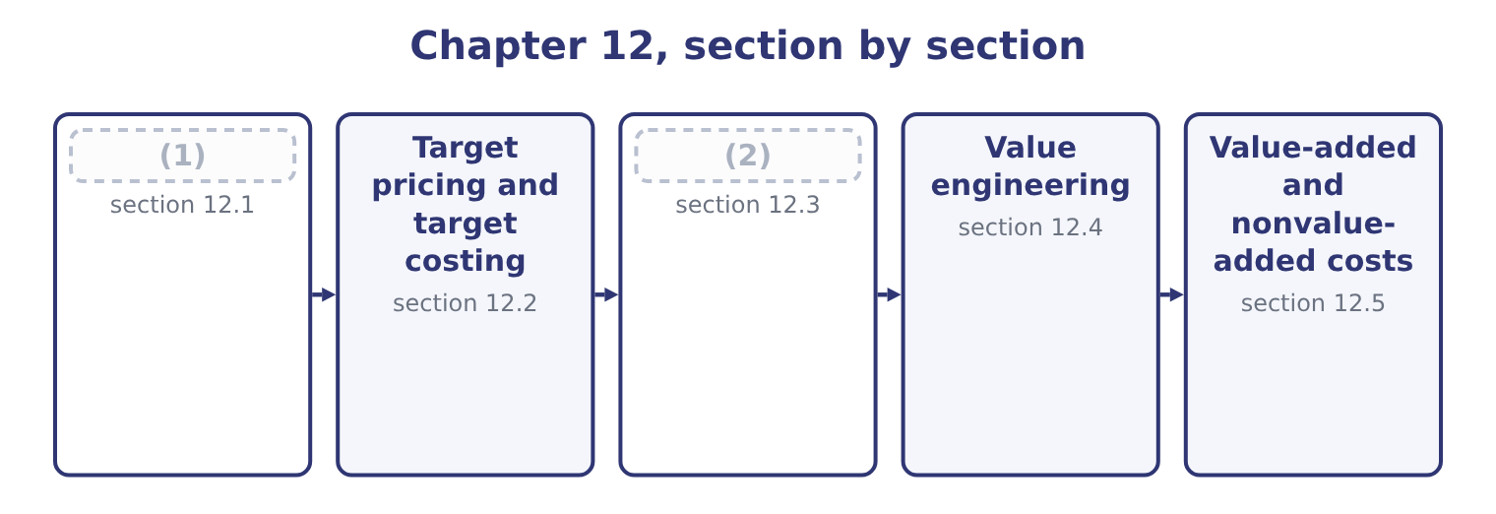
word list
The two target calculations · Target pricing and target costing · Finding out what the customer values

Summary 1 gaps 3–14
Before a target price can be set, (3) has to know what the customer is (4) . The outcome names the (5) , and they divide into three (6) . Surveys, (7) and focus groups establish what features matter and what the product is (8) with. (9) analysis is the formal version: customers choose between bundles of features at (10) prices, and the analysis infers what each feature is worth to them. It is the most (11) method and the most (12) . (13) what customers do. Test markets, trial pricing in one region, and analysis of how sales respond to past price changes — which is the (14) of, estimated from the company's own history rather than assumed. Studying competitors and the alternatives. What rivals charge, what features they include, what a customer would do if neither product existed.
word list
interviews · somebody · families · buying · Conjoint · analysis · expensive · reliable · compared · elasticity · Watching · different · techniques

Summary 2 gaps 15–24
Reverse engineering a (15) product to establish what it must cost to make is standard practice in (16) and tells a company both what its rival's margin is and what is (17) possible. For the (18) bottle, the (19) came from the third family and part of the second. (20) buyers compare a bottle of tahini sauce with the cost of making the sauce (21) from bulk paste, and with two competing branded bottles at $6.50 and $6.60. A new entrant with no (22) must price below both, and the buyers (23) were clear that $6.40 is the figure at which they would switch. That is the target price, and it is now a (24) rather than an outcome.
word list
squeeze · interviewed · themselves · answer · Food-service · respond · technically · manufacturing · competitor's · reputation · constraint

The English this section uses, and its Arabic
Each term sits against what it means.
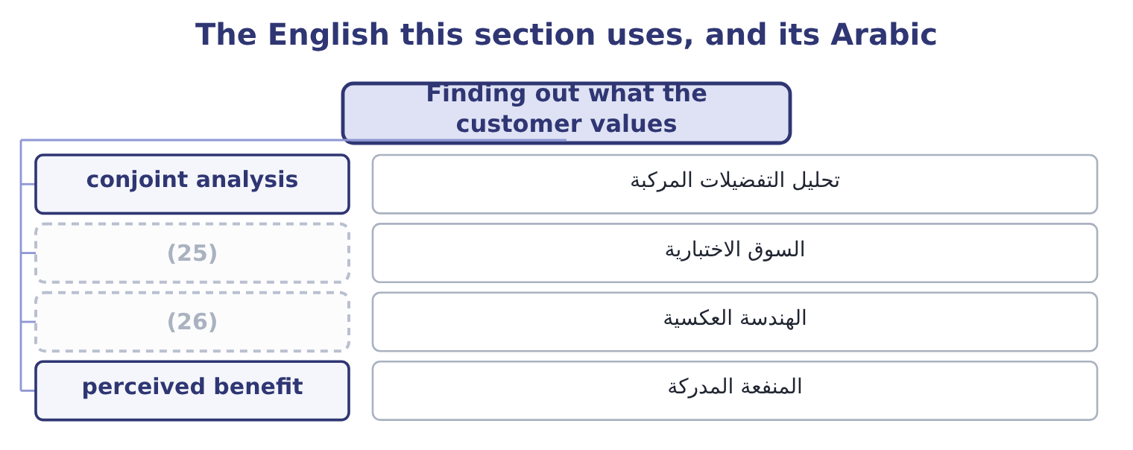
word list
reverse engineering · test market · value engineering

The English this sheet uses, and its Arabic
English (exam term) | Arabic
conjoint analysis | تحليل التفضيلات المركبة
test market | السوق الاختبارية
reverse engineering | الهندسة العكسية
perceived benefit | المنفعة المدركة

Answer key · 12.1 Finding out what the customer values

1 Finding out what the customer values | 14 elasticity
2 The two target calculations | 15 competitor's
3 somebody | 16 manufacturing
4 buying | 17 technically
5 techniques | 18 squeeze
6 families | 19 answer
7 interviews | 20 Food-service
8 compared | 21 themselves
9 Conjoint | 22 reputation
10 different | 23 interviewed
11 reliable | 24 constraint
12 expensive | 25 test market
13 Watching | 26 reverse engineering

the summaries in full
Summary 1 Before a target price can be set, somebody has to know what the customer is buying. The outcome names the techniques, and they divide into three families. Surveys, interviews and focus groups establish what features matter and what the product is compared with. Conjoint analysis is the formal version: customers choose between bundles of features at different prices, and the analysis infers what each feature is worth to them. It is the most reliable method and the most expensive. Watching what customers do. Test markets, trial pricing in one region, and analysis of how sales respond to past price changes — which is the elasticity of, estimated from the company's own history rather than assumed. Studying competitors and the alternatives. What rivals charge, what features they include, what a customer would do if neither product existed.
Summary 2 Reverse engineering a competitor's product to establish what it must cost to make is standard practice in manufacturing and tells a company both what its rival's margin is and what is technically possible. For the squeeze bottle, the answer came from the third family and part of the second. Food-service buyers compare a bottle of tahini sauce with the cost of making the sauce themselves from bulk paste, and with two competing branded bottles at $6.50 and $6.60. A new entrant with no reputation must price below both, and the buyers interviewed were clear that $6.40 is the figure at which they would switch. That is the target price, and it is now a constraint rather than an outcome.

12.2 Target pricing and target costing
Chapter 12 · section 12.2

Fill every gap. Each word list holds one word more than there are gaps.
Summary 1 gaps 1–12
Target costing (1) the cost-plus sequence, and the (2) asks for the steps. Determine the target price. What the market will pay, from the (3) of section 12.1, for a product with the features customers want. Determine the target operating income a unit. What the company requires, (4) derived from a return on the capital the product will employ, which section 12.3 (5) . (6) to find the target cost. Target price less target operating income is the cost the product must not (7) . (8) with the estimated cost of the product as (9) . The (10) is the cost gap. Close the gap before the product is launched, by value (11) , and by redesigning the product, the process and the (12) chain until the estimated cost falls to the target. Two features of that sequence distinguish it from everything.
word list
outcome · Subtract · hardest · supply · computes · techniques · exceed · reverses · engineering · difference · Compare · designed · usually

Summary 2 gaps 13–24
The cost is an (13) , not an input. In cost-plus the cost determines the price; here the price determines the cost that is permitted. It happens before production starts. By the time a product is in production, most of its cost has been (14) by its design — the (15) chosen, the number of parts, the (16) , the process required. (17) vary, and the usual figure quoted is that design locks in about eighty per cent of a (18) lifetime cost while accounting for a small fraction of the spending. Target costing is (19) a design activity, and it is run by a cross-functional team of engineers, buyers, production staff, marketers and (20) , because no one of those functions can close a cost gap alone. Where the gap cannot be closed, the (21) requires the project to be (22) . That is the hardest part of the method and the part that makes it work: a company that (23) anyway has merely used an (24) process to arrive at a price it could not afford.
word list
Estimates · launches · therefore · elaborate · tolerances · techniques · materials · product's · committed · abandoned · output · accountants · discipline

Cost-plus and target costing
Step | Cost-plus pricing | Target costing
Starts from | The estimated cost | (25)
Then | (26) | Subtracts the required profit
Arrives at | A price | (27)
If the number is unacceptable | The company hopes customers accept the price | The company redesigns, or abandons the product
When it happens | After the product exists | (28)
Who does it | Accounting | A cross-functional team

word list
The market price · Before the design is fixed · Subtracts the required profit · A permitted cost · Adds a markup

The English this section uses, and its Arabic
Each term sits against what it means.
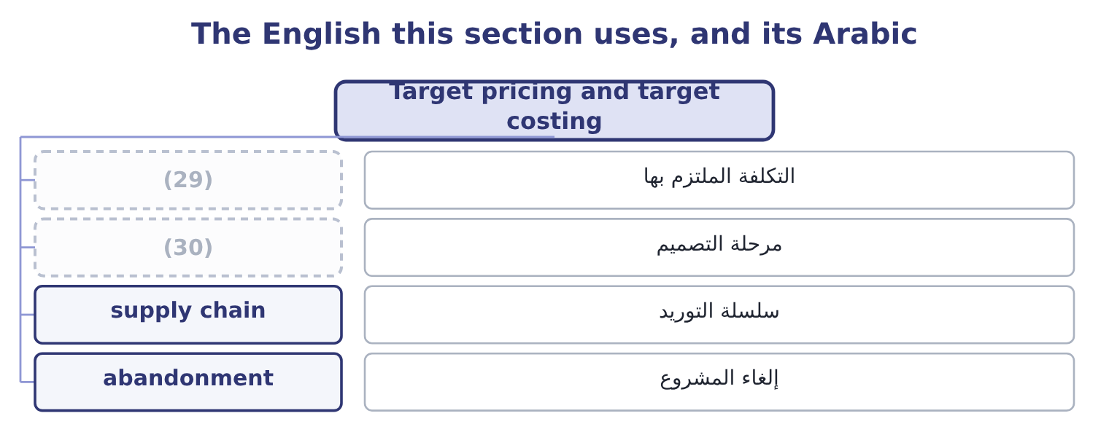
word list
design stage · target cost · committed cost

The English this sheet uses, and its Arabic
English (exam term) | Arabic
committed cost | التكلفة الملتزم بها
design stage | مرحلة التصميم
supply chain | سلسلة التوريد
abandonment | إلغاء المشروع

Answer key · 12.2 Target pricing and target costing

1 reverses | 16 tolerances
2 outcome | 17 Estimates
3 techniques | 18 product's
4 usually | 19 therefore
5 computes | 20 accountants
6 Subtract | 21 discipline
7 exceed | 22 abandoned
8 Compare | 23 launches
9 designed | 24 elaborate
10 difference | 25 The market price
11 engineering | 26 Adds a markup
12 supply | 27 A permitted cost
13 output | 28 Before the design is fixed
14 committed | 29 committed cost
15 materials | 30 design stage

the summaries in full
Summary 1 Target costing reverses the cost-plus sequence, and the outcome asks for the steps. Determine the target price. What the market will pay, from the techniques of section 12.1, for a product with the features customers want. Determine the target operating income a unit. What the company requires, usually derived from a return on the capital the product will employ, which section 12.3 computes. Subtract to find the target cost. Target price less target operating income is the cost the product must not exceed. Compare with the estimated cost of the product as designed. The difference is the cost gap. Close the gap before the product is launched, by value engineering, and by redesigning the product, the process and the supply chain until the estimated cost falls to the target. Two features of that sequence distinguish it from everything.
Summary 2 The cost is an output, not an input. In cost-plus the cost determines the price; here the price determines the cost that is permitted. It happens before production starts. By the time a product is in production, most of its cost has been committed by its design — the materials chosen, the number of parts, the tolerances, the process required. Estimates vary, and the usual figure quoted is that design locks in about eighty per cent of a product's lifetime cost while accounting for a small fraction of the spending. Target costing is therefore a design activity, and it is run by a cross-functional team of engineers, buyers, production staff, marketers and accountants, because no one of those functions can close a cost gap alone. Where the gap cannot be closed, the discipline requires the project to be abandoned. That is the hardest part of the method and the part that makes it work: a company that launches anyway has merely used an elaborate process to arrive at a price it could not afford.

12.3 The two target calculations
Chapter 12 · section 12.3

Fill every gap. Each word list holds one word more than there are gaps.
The outcome asks for two figures, and the arithmetic is short.
Worked example: the target cost of a squeeze bottle

Summary 1 gaps 1–11
The capital and the required return. The line would (1) $3,000,000 of capital — the (2) equipment, the inventory and the receivables — and the board requires 18 per cent on new product capital, a premium over the (3) 9.04 per cent cost of capital that (4) the risk of a new line. The target operating income. In total: 3,000,000 × 0.18 = 540,000 a year. A unit, on a forecast of 1,200,000 bottles: 540,000 ÷ 1,200,000 = 0.45 a bottle. The engineers' first estimate is $6.70, so the gap is 6.70 − 5.95 = 0.75 a bottle, which on 1,200,000 bottles is 1,200,000 × 0.75 = 900,000 a year. The $900,000 is the (5) that makes the (6) work. A gap stated as 75 cents a bottle (7) like a detail for the (8) department; stated as $900,000 a year (9) a target profit of $540,000, it is plainly a (10) of whether the product (11) exist.
word list
employ · filling · sounds · relative · purchasing · number · against · should · method · reflects · question · company's

Summary 2 gaps 12–20
Scaling a unit gap to the (12) total is the first thing to do with it. Two (13) appear in harder (14) . The target operating income may be given (15) as a margin — "the company requires an operating margin of 8 per cent" — in which case the target income a unit is (16) the price times that margin: 6.40 × 0.08 = 0.512. The target cost may be (17) over the product's life rather than a year, (18) the costs of design, launch, support and disposal. That is life-cycle costing, and it matters most where those costs are large relative to (19) — software, (20) , aircraft.
word list
questions · expediting · simply · refinements · annual · pharmaceuticals · expressed · directly · including · manufacturing

The target-cost template
Line | Computation | The squeeze bottle
Target price | What the market will pay | 6.40
Capital employed | Equipment, inventory, receivables | 3,000,000
Required return | (21) | 18%
Target operating income in total | (22) | 540,000
Forecast volume | A year | 1,200,000 bottles
Target operating income a unit | (23) | 0.45
Target cost a unit | Price less target income | 5.95
Estimated cost as designed | (24) | 6.70
Cost gap a unit | Estimate less target | 0.75
Cost gap a year | (25) | 900,000

word list
target operating income · Total over volume · Board's rate for new products · Gap times volume · Capital times the rate · From the engineers

The English this section uses, and its Arabic
Each term sits against what it means.
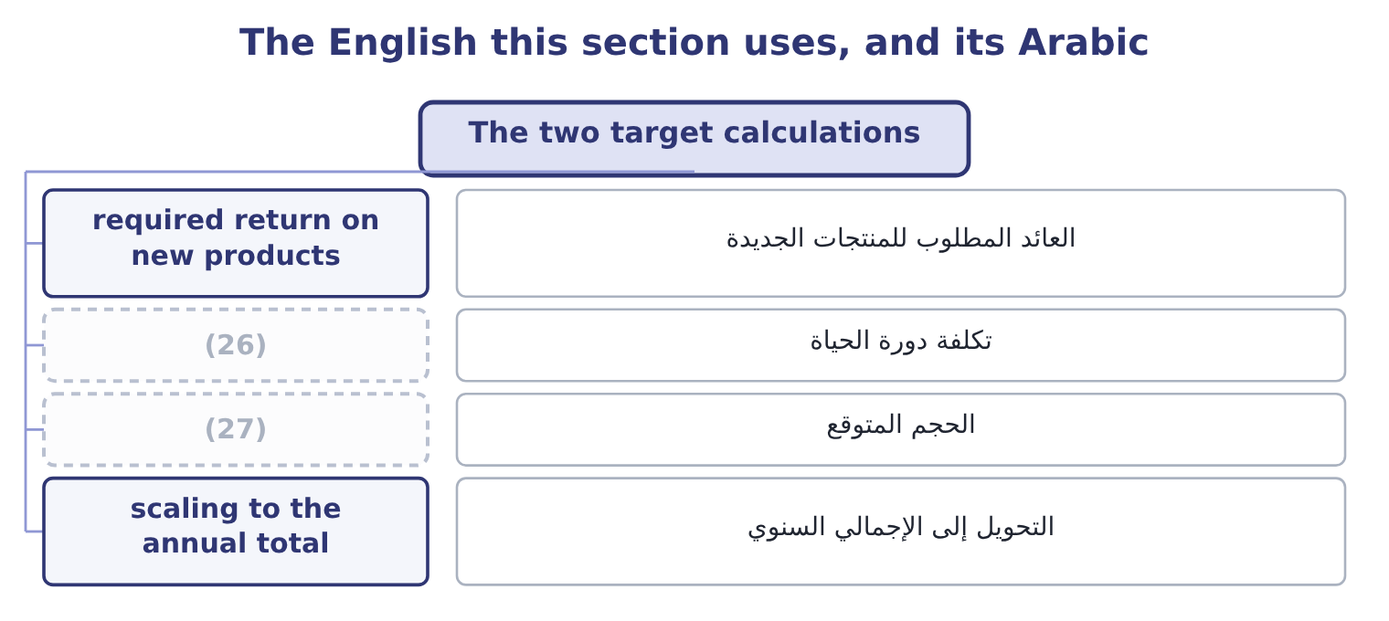
word list
forecast volume · test market · life-cycle costing

The English this sheet uses, and its Arabic
English (exam term) | Arabic
required return on new products | العائد المطلوب للمنتجات الجديدة
life-cycle costing | تكلفة دورة الحياة
forecast volume | الحجم المتوقع
scaling to the annual total | التحويل إلى الإجمالي السنوي

Answer key · 12.3 The two target calculations

1 employ | 15 directly
2 filling | 16 simply
3 company's | 17 expressed
4 reflects | 18 including
5 number | 19 manufacturing
6 method | 20 pharmaceuticals
7 sounds | 21 Board's rate for new products
8 purchasing | 22 Capital times the rate
9 against | 23 Total over volume
10 question | 24 From the engineers
11 should | 25 Gap times volume
12 annual | 26 life-cycle costing
13 refinements | 27 forecast volume
14 questions

the summaries in full
Summary 1 The capital and the required return. The line would employ $3,000,000 of capital — the filling equipment, the inventory and the receivables — and the board requires 18 per cent on new product capital, a premium over the company's 9.04 per cent cost of capital that reflects the risk of a new line. The target operating income. In total: 3,000,000 × 0.18 = 540,000 a year. A unit, on a forecast of 1,200,000 bottles: 540,000 ÷ 1,200,000 = 0.45 a bottle. The engineers' first estimate is $6.70, so the gap is 6.70 − 5.95 = 0.75 a bottle, which on 1,200,000 bottles is 1,200,000 × 0.75 = 900,000 a year. The $900,000 is the number that makes the method work. A gap stated as 75 cents a bottle sounds like a detail for the purchasing department; stated as $900,000 a year against a target profit of $540,000, it is plainly a question of whether the product should exist.
Summary 2 Scaling a unit gap to the annual total is the first thing to do with it. Two refinements appear in harder questions. The target operating income may be given directly as a margin — "the company requires an operating margin of 8 per cent" — in which case the target income a unit is simply the price times that margin: 6.40 × 0.08 = 0.512. The target cost may be expressed over the product's life rather than a year, including the costs of design, launch, support and disposal. That is life-cycle costing, and it matters most where those costs are large relative to manufacturing — software, pharmaceuticals, aircraft.

12.4 Value engineering
Chapter 12 · section 12.4

Fill every gap. Each word list holds one word more than there are gaps.
Summary 1 gaps 1–12
Value engineering is the systematic (1) of a product and its (2) process to find ways of delivering the functions the customer values at a lower cost. The (3) on function is what (4) it from cost cutting: the question is not "what can we remove" but "what does this part do, and is there a cheaper way of doing it". The (5) has four moves, and a question will (6) need at least two of them. Fewer parts, fewer fasteners, fewer (7) , common components shared with other products, a (8) relaxed where precision does nothing for the customer. (9) materials or (10) . A (11) polymer, a moulded part instead of an (12) one, a supplier's standard component instead of a bespoke one. Fewer handling steps, a shorter route through the factory, a change in batch size, a machine moved. Open-book costing, joint design, longer contracts in exchange for lower prices, and moving a component's design to the supplier who makes it.
word list
operations · examination · different · production · emphasis · usually · distinguishes · assembled · method · allocation · processes · Substitute · tolerance

Worked example: closing the 75-cent gap

Summary 2 gaps 13–24
The first design uses a bespoke (13) nozzle. The supplier's standard (14) nozzle does the same job: 0.80 − 0.55 = 0.25 saved. The bottle and the label. A standard bottle in place of a (15) shape saves 1.10 − 0.95 = 0.15, and (16) the label directly on the bottle saves 0.20 − 0.12 = 0.08. (17) the standard bottle runs faster and needs no change of (18) between batches: 0.60 − 0.45 = 0.15 saved. Fewer parts and one less handling step reduce the (19) that drive the overhead, taking the (20) from 1.00 to 0.88, a saving of 0.12. The product can be made for $5.95 and (21) go ahead. Note what was not done. The sauce itself, at $3.00, was left alone, (22) it is the thing the customer is buying: (23) the sesame content would close the gap faster and destroy the product. Value engineering protects the functions the customer values and attacks (24) else, and an answer that proposes diluting the product has missed the whole idea.
word list
production · reducing · everything · printing · custom · two-part · Filling · tooling · allocation · activities · should · because · three-part

Closing the cost gap, component by component
The bars are drawn to scale.
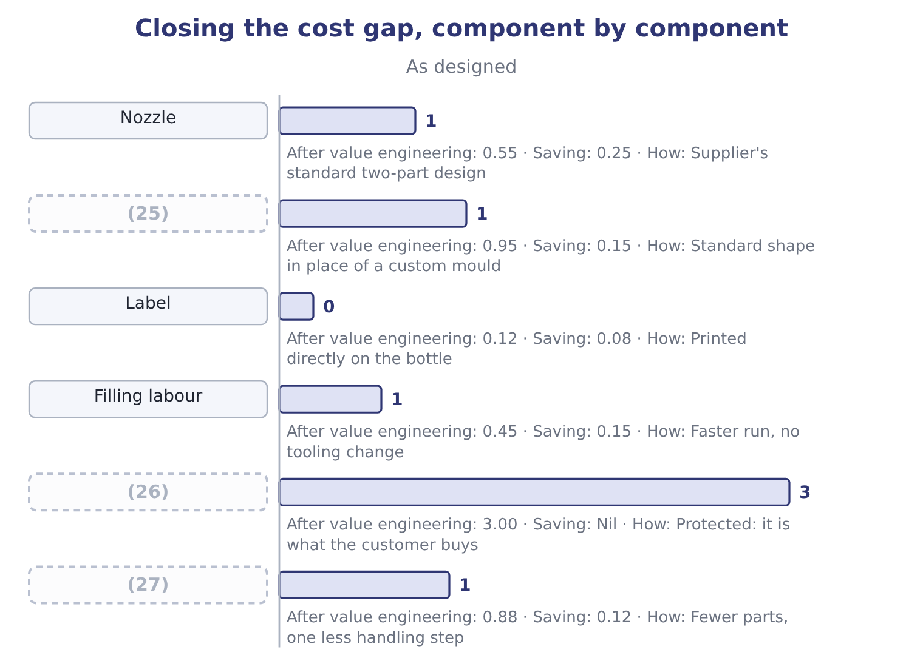
word list
Sauce · Bottle · tolerance · Allocated overhead

The English this section uses, and its Arabic
Each term sits against what it means.
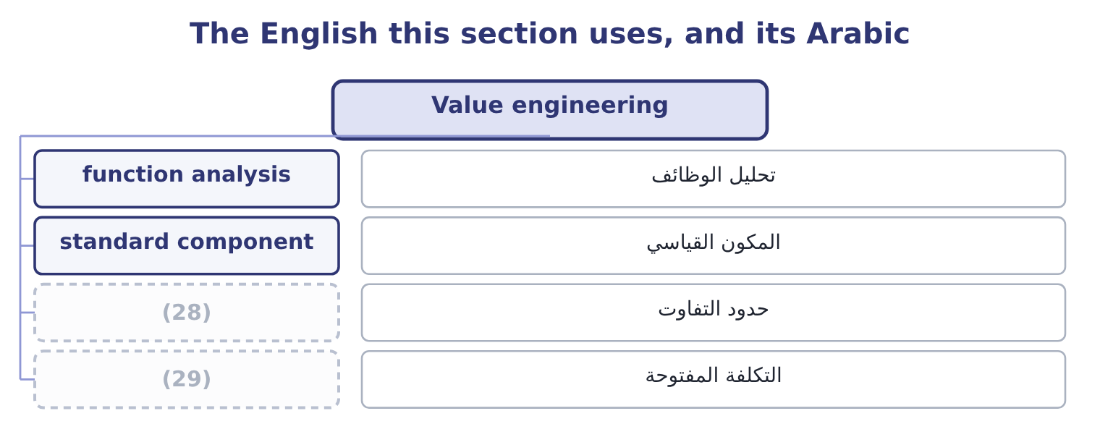
word list
function analysis · tolerance · open-book costing

The English this sheet uses, and its Arabic
English (exam term) | Arabic
function analysis | تحليل الوظائف
standard component | المكون القياسي
tolerance | حدود التفاوت
open-book costing | التكلفة المفتوحة

Answer key · 12.4 Value engineering

1 examination | 16 printing
2 production | 17 Filling
3 emphasis | 18 tooling
4 distinguishes | 19 activities
5 method | 20 allocation
6 usually | 21 should
7 operations | 22 because
8 tolerance | 23 reducing
9 Substitute | 24 everything
10 processes | 25 Bottle
11 different | 26 Sauce
12 assembled | 27 Allocated overhead
13 three-part | 28 tolerance
14 two-part | 29 open-book costing
15 custom

the summaries in full
Summary 1 Value engineering is the systematic examination of a product and its production process to find ways of delivering the functions the customer values at a lower cost. The emphasis on function is what distinguishes it from cost cutting: the question is not "what can we remove" but "what does this part do, and is there a cheaper way of doing it". The method has four moves, and a question will usually need at least two of them. Fewer parts, fewer fasteners, fewer operations, common components shared with other products, a tolerance relaxed where precision does nothing for the customer. Substitute materials or processes. A different polymer, a moulded part instead of an assembled one, a supplier's standard component instead of a bespoke one. Fewer handling steps, a shorter route through the factory, a change in batch size, a machine moved. Open-book costing, joint design, longer contracts in exchange for lower prices, and moving a component's design to the supplier who makes it.
Summary 2 The first design uses a bespoke three-part nozzle. The supplier's standard two-part nozzle does the same job: 0.80 − 0.55 = 0.25 saved. The bottle and the label. A standard bottle in place of a custom shape saves 1.10 − 0.95 = 0.15, and printing the label directly on the bottle saves 0.20 − 0.12 = 0.08. Filling the standard bottle runs faster and needs no change of tooling between batches: 0.60 − 0.45 = 0.15 saved. Fewer parts and one less handling step reduce the activities that drive the overhead, taking the allocation from 1.00 to 0.88, a saving of 0.12. The product can be made for $5.95 and should go ahead. Note what was not done. The sauce itself, at $3.00, was left alone, because it is the thing the customer is buying: reducing the sesame content would close the gap faster and destroy the product. Value engineering protects the functions the customer values and attacks everything else, and an answer that proposes diluting the product has missed the whole idea.

12.5 Value-added and nonvalue-added costs
Chapter 12 · section 12.5

Fill every gap. Each word list holds one word more than there are gaps.
Summary 1 gaps 1–12
A value-added cost is one the customer would be (1) to pay for if they (2) what it was: the (3) in the sauce, the filling of the bottle, the moulding of the nozzle, the design that makes the bottle easy to pour. (4) it and the product is worth less. A nonvalue-added cost is one that adds nothing the customer values: moving material between stores, waiting between (5) , inspecting work that should have been right, reworking what was wrong, counting inventory, (6) a late order, storing finished goods nobody has ordered. The test is the (7) willingness, not the (8) necessity. Some nonvalue-added activities are (9) — a company must count its inventory and inspect its output — and calling them nonvalue-added is not a (10) of the people who do them. It is a (11) about where the cost ought to be (12) first, because reducing a nonvalue-added cost takes nothing away from the product.
word list
customer's · sesame · progress · operations · company's · willing · attacked · criticism · unavoidable · understood · expediting · Remove · statement

Summary 2 gaps 13–17
The classic (13) applies five (14) to manufacturing time, and the exam uses it. Processing time adds value. (15) , moving, waiting and storing do not. The ratio of processing time to total time is the manufacturing cycle (16) , and in most factories it is (17) low — a part that takes four hours to process may spend three weeks in the building.
word list
efficiency · categories · storage · startlingly · Inspection · framework

Where the cost of a bottle goes
Activity | Value-added? | Why
Mixing and cooking the sauce | Yes | It is the product
Moulding the nozzle | (18) | A function the customer uses
Filling and capping | Yes | Necessary to deliver the product
Moving pallets between the filling hall and the warehouse | No | The customer pays nothing for distance
Waiting for a tooling change | No | (19)
Inspecting for leaks | (20) | The customer pays for bottles that do not leak, not for the checking
Reworking leaking bottles | No | (21)
Storing finished goods for eleven weeks | No | (22)

word list
Yes · The cost of doing it wrong once · Chapter 17 of Book 2 priced this · No, though necessary · design stage · Pure delay

Summary 3 gaps 23–31
Three uses of the (23) close the chapter. It (24) the cost gap work. (25) the nonvalue-added costs first, because they can be removed without (26) the product. It supports the (27) argument of Book 2's: a buffer of work in (28) is storage, moving and waiting, all nonvalue-added. And it is a (29) idea as well as a design one. A cost report that splits each (30) spending into value-added and nonvalue-added activity tells a manager something no (31) variance report does, which is why it belongs in the same examination as the performance measures of Part 1.
word list
department's · progress · finished · distinction · touching · directs · Attack · conventional · reporting · just-in-time

Set a target and close a gap

Your turn: target costing (complete the blanks)
Item | Data | Answer
Target operating income in total | Capital 5,000,000, required return 16 per cent | ________
Target operating income a unit | (32) | ________
Target cost a unit | (33) | ________
Cost gap a unit | Estimated cost 14.60 | ________
Cost gap a year |  | ________
Gap after savings of 0.35, 0.18 and 0.12 a unit |  | ________
Which of these is value-added: mixing, inspecting, moving to the warehouse? |  | ________

word list
Volume 800,000 units · Target price 14.00 · Inspecting for leaks

"Target"

Summary 4 gaps 34–38
A sales target is something to aim at and (34) miss; a target cost is a (35) the product must come in under or not be made at all. The same word does both jobs in the same syllabus, and the (36) is the whole (37) of the method. In an answer, say which it is: "a target cost of $5.95, which the design must not (38) ".
word list
discipline · ceiling · value-added · difference · perhaps · exceed

"Target"
Item | Answer
Target operating income in total | (39)
Target operating income a unit | (40)
Target cost a unit | 13.00: 14.00 − 1.00 = 13.00.
Cost gap a unit | 1.60: 14.60 − 13.00 = 1.60.
Cost gap a year | 1,280,000: 800,000 × 1.60 = 1,280,000.
Gap after savings of 0.35, 0.18 and 0.12 | (41) : the savings are 0.35 + 0.18 + 0.12 = 0.65, against a gap of 1.60.
Which is value-added | Mixing only. Inspecting and moving to the warehouse are nonvalue-added, though both may be necessary.
What it tells you | Two-thirds of the gap is still open after three good ideas, and a gap of 0.95 a unit on a target cost of 13.00 is more than seven per cent o

word list
1.00: 800,000 ÷ 800,000 = 1.00. · 0.95 remaining · 800,000: 5,000,000 × 0.16 = 800,000. · unavoidable but nonvalue-added

The English this section uses, and its Arabic
Each term sits against what it means.
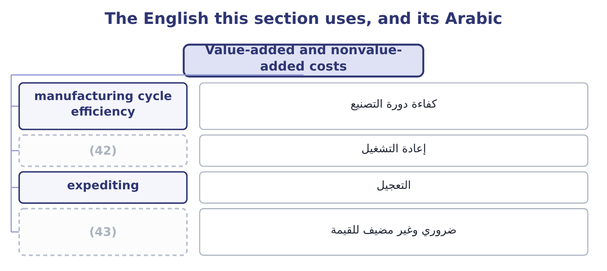
word list
unavoidable but nonvalue-added · rework · إعادة التشغيل

The English this sheet uses, and its Arabic
English (exam term) | Arabic
manufacturing cycle efficiency | كفاءة دورة التصنيع
rework | إعادة التشغيل
expediting | التعجيل
unavoidable but nonvalue-added | ضروري وغير مضيف للقيمة

Answer key · 12.5 Value-added and nonvalue-added costs

1 willing | 23 distinction
2 understood | 24 directs
3 sesame | 25 Attack
4 Remove | 26 touching
5 operations | 27 just-in-time
6 expediting | 28 progress
7 customer's | 29 reporting
8 company's | 30 department's
9 unavoidable | 31 conventional
10 criticism | 32 Volume 800,000 units
11 statement | 33 Target price 14.00
12 attacked | 34 perhaps
13 framework | 35 ceiling
14 categories | 36 difference
15 Inspection | 37 discipline
16 efficiency | 38 exceed
17 startlingly | 39 800,000: 5,000,000 × 0.16 = 800,000.
18 Yes | 40 1.00: 800,000 ÷ 800,000 = 1.00.
19 Pure delay | 41 0.95 remaining
20 No, though necessary | 42 rework
21 The cost of doing it wrong once | 43 unavoidable but nonvalue-added
22 Chapter 17 of Book 2 priced this

the summaries in full
Summary 1 A value-added cost is one the customer would be willing to pay for if they understood what it was: the sesame in the sauce, the filling of the bottle, the moulding of the nozzle, the design that makes the bottle easy to pour. Remove it and the product is worth less. A nonvalue-added cost is one that adds nothing the customer values: moving material between stores, waiting between operations, inspecting work that should have been right, reworking what was wrong, counting inventory, expediting a late order, storing finished goods nobody has ordered. The test is the customer's willingness, not the company's necessity. Some nonvalue-added activities are unavoidable — a company must count its inventory and inspect its output — and calling them nonvalue-added is not a criticism of the people who do them. It is a statement about where the cost ought to be attacked first, because reducing a nonvalue-added cost takes nothing away from the product.
Summary 2 The classic framework applies five categories to manufacturing time, and the exam uses it. Processing time adds value. Inspection, moving, waiting and storing do not. The ratio of processing time to total time is the manufacturing cycle efficiency, and in most factories it is startlingly low — a part that takes four hours to process may spend three weeks in the building.
Summary 3 Three uses of the distinction close the chapter. It directs the cost gap work. Attack the nonvalue-added costs first, because they can be removed without touching the product. It supports the just-in-time argument of Book 2's: a buffer of work in progress is storage, moving and waiting, all nonvalue-added. And it is a reporting idea as well as a design one. A cost report that splits each department's spending into value-added and nonvalue-added activity tells a manager something no conventional variance report does, which is why it belongs in the same examination as the performance measures of Part 1.
Summary 4 A sales target is something to aim at and perhaps miss; a target cost is a ceiling the product must come in under or not be made at all. The same word does both jobs in the same syllabus, and the difference is the whole discipline of the method. In an answer, say which it is: "a target cost of $5.95, which the design must not exceed".

13.1 Two horizons, two floors
Chapter 13 · section 13.1

Fill every gap. Each word list holds one word more than there are gaps.
Chapter 13, section by section
Each stage leads to the next.
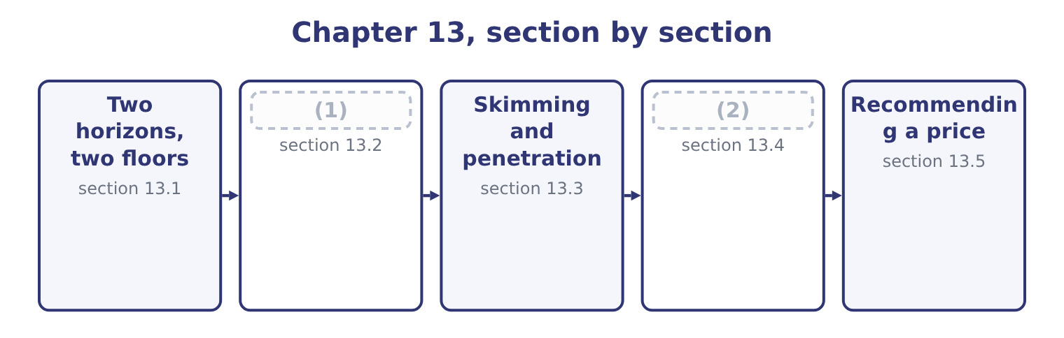
word list
The four stages · Recommending a price · The other strategies

Summary 1 gaps 3–14
A short-term pricing decision takes the capacity, the fixed costs and the product as given, and asks only whether a (3) piece of business is worth (4) . Its floor is the (5) cost: the incremental cost plus any contribution displaced. Below that floor the company is worse off; above it, (6) off, by the contribution the business (7) . A long-term pricing decision asks what a product must earn to justify its (8) . Over a long enough period every cost is (9) : the plant can be sold, the lease ended, the staff (10) . So the (11) floor is the full cost, including the fixed costs, and including a return on the capital employed — which is the (12) price. Four (13) follow, and each is (14) . Short-run prices below full cost are legitimate and sometimes necessary: a special order with idle capacity, a launch price intended to win position, a clearance price for goods that will otherwise be written off.
word list
intended · relevant · examinable · redeployed · avoidable · particular · existence · target-return · taking · consequences · long-run · better · brings

Summary 2 gaps 15–21
The test is whether the business (15) its own incremental cost and whether it (16) the regular market. A company (17) price below full cost (18) . Every product priced on a short-run basis is being (19) by the rest of the range, and a company whose whole range is priced that way is (20) a loss. The (21) the question specifies determines the cost to use. And the two converge over time, because in the long run the fixed costs of the short run become decisions again.
word list
horizon · covers · cannot · subsidised · making · damages · indefinitely · target-return

Two horizons, two floors
 | Short-term decision | Long-term decision
Capacity and fixed costs are | Given | Decisions
The floor is | (22) | Full cost plus a return on capital
For Orontes's jar | (23) | 12.06 at a 15 per cent target return
Suits | (24) | The price list, contract renewals, new products
Danger | Repeating it until it is the business | (25)

word list
Special orders, clearance, launch pricing · 7.20, or 12.00 at full capacity · The price list, contract renewals, new products · Pricing above what the market will pay · Incremental cost plus displaced contribution

The English this section uses, and its Arabic
Each term sits against what it means.
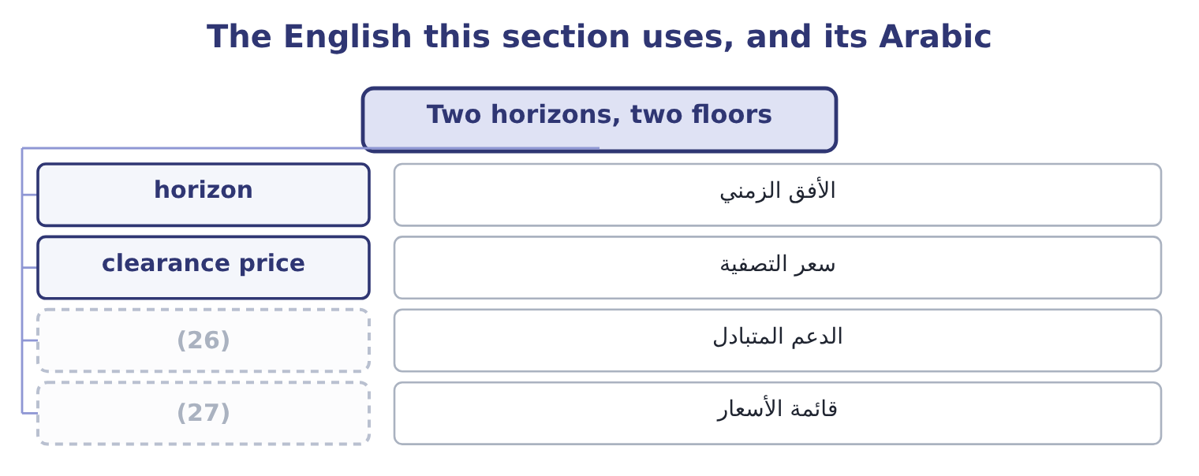
word list
expectation · price list · cross-subsidy

The English this sheet uses, and its Arabic
English (exam term) | Arabic
horizon | الأفق الزمني
clearance price | سعر التصفية
cross-subsidy | الدعم المتبادل
price list | قائمة الأسعار

Answer key · 13.1 Two horizons, two floors

1 The four stages | 15 covers
2 The other strategies | 16 damages
3 particular | 17 cannot
4 taking | 18 indefinitely
5 relevant | 19 subsidised
6 better | 20 making
7 brings | 21 horizon
8 existence | 22 Incremental cost plus displaced contribution
9 avoidable | 23 7.20, or 12.00 at full capacity
10 redeployed | 24 Special orders, clearance, launch pricing
11 long-run | 25 Pricing above what the market will pay
12 target-return | 26 cross-subsidy
13 consequences | 27 price list
14 examinable

the summaries in full
Summary 1 A short-term pricing decision takes the capacity, the fixed costs and the product as given, and asks only whether a particular piece of business is worth taking. Its floor is the relevant cost: the incremental cost plus any contribution displaced. Below that floor the company is worse off; above it, better off, by the contribution the business brings. A long-term pricing decision asks what a product must earn to justify its existence. Over a long enough period every cost is avoidable: the plant can be sold, the lease ended, the staff redeployed. So the long-run floor is the full cost, including the fixed costs, and including a return on the capital employed — which is the target-return price. Four consequences follow, and each is examinable. Short-run prices below full cost are legitimate and sometimes necessary: a special order with idle capacity, a launch price intended to win position, a clearance price for goods that will otherwise be written off.
Summary 2 The test is whether the business covers its own incremental cost and whether it damages the regular market. A company cannot price below full cost indefinitely. Every product priced on a short-run basis is being subsidised by the rest of the range, and a company whose whole range is priced that way is making a loss. The horizon the question specifies determines the cost to use. And the two converge over time, because in the long run the fixed costs of the short run become decisions again.

13.2 The four stages
Chapter 13 · section 13.2

Fill every gap. Each word list holds one word more than there are gaps.
Summary 1 gaps 1–12
A product life cycle (1) the sales of a product from launch to (2) , and the exam names four stages. Sales are low and growing slowly, because (3) do not know the product and distribution is (4) . Costs per unit are high, since volume is small and the (5) has not happened. Competition is light or (6) . Cash flow is negative: (7) has been paid for and the launch costs money. Sales (8) as the product becomes known and distribution (9) . Unit costs fall with volume and (10) . (11) arrive, attracted by the growth, usually with (12) versions. Profits are at their highest, and so is the need for working capital to fund the growth — which is the sustainable growth problem of Book 1, arriving at product level. Sales growth slows and then stops as the market saturates.
word list
Competitors · widens · development · incomplete · withdrawal · improvements · improved · customers · absent · experience · learning · accelerate · describes

Summary 2 gaps 13–21
Competition is at its fiercest, because growth can now only be taken from somebody else, so prices fall and (13) shifts to brand, service and small (14) . Costs per unit are at their (15) . Cash flow is (16) , because the growth no longer (17) working capital. Most (18) spend most of their lives here. Sales fall, as (19) change or a better (20) arrives. Prices may fall further, or in some cases rise, as the (21) buyers become a captive niche. The decision becomes whether to harvest the product — minimum investment, maximum cash — or to withdraw it, which is the drop-a-segment analysis.
word list
remaining · mistaking · technology · lowest · tastes · products · differentiation · consumes · strongest · improvements

Four stages, and what changes in each
Every item belongs to exactly one group.
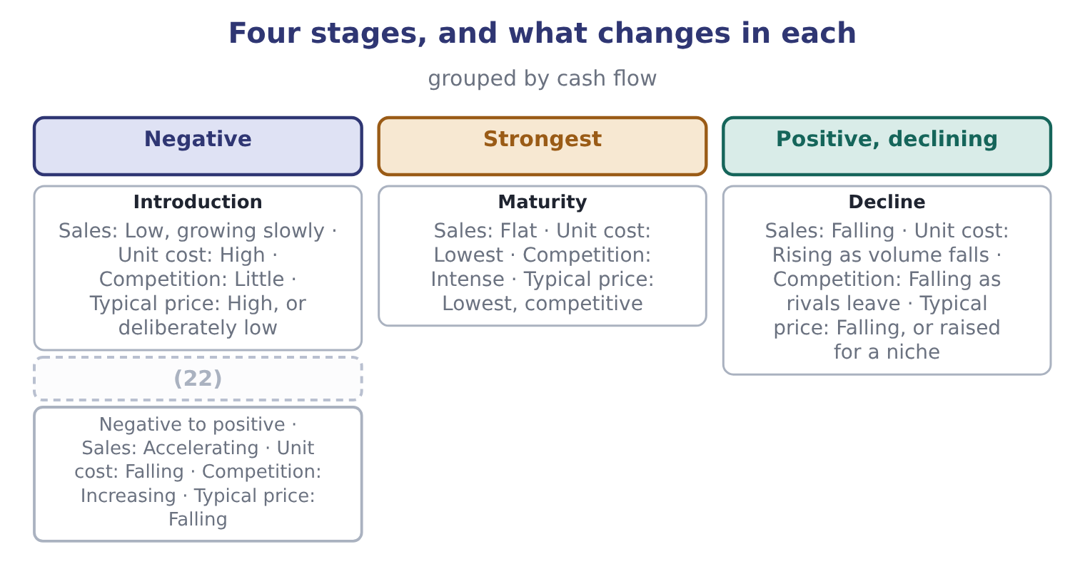
word list
Growth · Introduction

Summary 3 gaps 23–29
Two (23) belong with the model. The stages are a (24) , not a prediction. A (25) sales may fall and recover, a mature product can be (26) into a new growth phase, and the length of each stage varies from months to decades. The stage is not always (27) at the time. Flat sales may be maturity or a bad year, and the cost of (28) the second for the first is a product (29) that should have been invested.
word list
mistaking · product's · relaunched · obvious · harvested · description · accelerate · warnings

The English this section uses, and its Arabic
Each term sits against what it means.
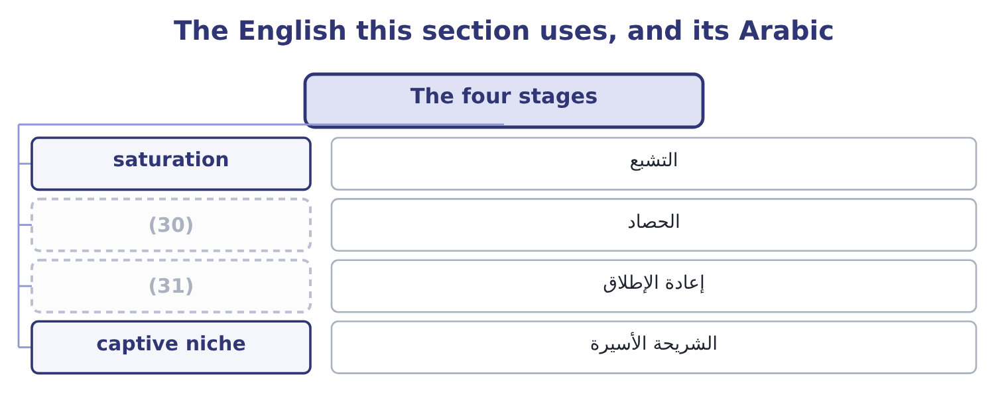
word list
التشبع · relaunch · harvest

The English this sheet uses, and its Arabic
English (exam term) | Arabic
saturation | التشبع
harvest | الحصاد
relaunch | إعادة الإطلاق
captive niche | الشريحة الأسيرة

Answer key · 13.2 The four stages

1 describes | 17 consumes
2 withdrawal | 18 products
3 customers | 19 tastes
4 incomplete | 20 technology
5 learning | 21 remaining
6 absent | 22 Growth
7 development | 23 warnings
8 accelerate | 24 description
9 widens | 25 product's
10 experience | 26 relaunched
11 Competitors | 27 obvious
12 improved | 28 mistaking
13 differentiation | 29 harvested
14 improvements | 30 harvest
15 lowest | 31 relaunch
16 strongest

the summaries in full
Summary 1 A product life cycle describes the sales of a product from launch to withdrawal, and the exam names four stages. Sales are low and growing slowly, because customers do not know the product and distribution is incomplete. Costs per unit are high, since volume is small and the learning has not happened. Competition is light or absent. Cash flow is negative: development has been paid for and the launch costs money. Sales accelerate as the product becomes known and distribution widens. Unit costs fall with volume and experience. Competitors arrive, attracted by the growth, usually with improved versions. Profits are at their highest, and so is the need for working capital to fund the growth — which is the sustainable growth problem of Book 1, arriving at product level. Sales growth slows and then stops as the market saturates.
Summary 2 Competition is at its fiercest, because growth can now only be taken from somebody else, so prices fall and differentiation shifts to brand, service and small improvements. Costs per unit are at their lowest. Cash flow is strongest, because the growth no longer consumes working capital. Most products spend most of their lives here. Sales fall, as tastes change or a better technology arrives. Prices may fall further, or in some cases rise, as the remaining buyers become a captive niche. The decision becomes whether to harvest the product — minimum investment, maximum cash — or to withdraw it, which is the drop-a-segment analysis.
Summary 3 Two warnings belong with the model. The stages are a description, not a prediction. A product's sales may fall and recover, a mature product can be relaunched into a new growth phase, and the length of each stage varies from months to decades. The stage is not always obvious at the time. Flat sales may be maturity or a bad year, and the cost of mistaking the second for the first is a product harvested that should have been invested.

13.3 Skimming and penetration
Chapter 13 · section 13.3

Fill every gap. Each word list holds one word more than there are gaps.
Summary 1 gaps 1–12
Two launch (1) dominate the (2) stage, and the exam asks when each is right. Price skimming launches high and (3) the price over time. It extracts the most from the (4) who value the product most and are least sensitive to price, then reaches (5) more price-sensitive groups as the price falls. It suits a product with a genuine (6) , a patent or a lead over rivals, inelastic early demand, high development costs to recover, and a brand that a high price (7) . Its risk is that the high price and (8) margins attract entrants quickly. Penetration (9) launches low to win volume and share fast. It suits a market where demand is elastic, where costs fall sharply with volume, where there are strong (10) of scale or (11) effects, and where getting to scale first deters entry. Its risk is that the low price is hard to raise later and sets an (12) the product may never escape.
word list
advantage · strategies · pricing · customers · supports · experience · economies · visible · successively · introduction · bundling · expectation · lowers

Worked example: two launches for the premium jar

Summary 2 gaps 13–14
The premium 500 gram jar: a (13) cost of $5.60 and $900,000 a year of fixed costs. Launch at $11.00, selling 250,000 jars in the first year to the least price-sensitive buyers, then cut to $9.50 in the second year, selling 600,000. Year one contributes 250,000 × 5.40 = 1,350,000, giving 1,350,000 − 900,000 = 450,000 of (14) income. Year two contributes 600,000 × 3.90 = 2,340,000, giving 2,340,000 − 900,000 = 1,440,000. The two years total 450,000 + 1,440,000 = 1,890,000. Launch at $8.75, selling 780,000 jars in the first year and 900,000 in the second at the same price. Year one contributes 780,000 × 3.15 = 2,457,000, giving 2,457,000 − 900,000 = 1,557,000. Year two contributes 900,000 × 3.15 = 2,835,000, giving 2,835,000 − 900,000 = 1,935,000. The two years total 1,557,000 + 1,935,000 = 3,492,000.
word list
operating · variable · recover

Summary 3 gaps 15–22
Penetration earns 3,492,000 − 1,890,000 = 1,602,000 more over two years on these estimates. The answer depends (15) on the volume estimates, which is the (16) thing to say about every (17) calculation. Penetration wins here because the (18) computed.41 — buyers in this market respond (19) to price — and it would lose if the premium buyers were as loyal as a skimming strategy (20) . The calculation does not decide the (21) ; it states what each (22) volume assumption has to deliver, and that is what a board should be asked to judge.
word list
strongly · elasticity · honest · strategy's · assumes · dominate · launch-pricing · question · entirely

Skimming against penetration
 | Skimming | Penetration
Launch price | High, falling over time | (23)
Suits demand that is | Inelastic early, with distinct customer groups | Elastic
Suits costs that | (24) | Fall sharply with volume
Recovers development cost | (25) | Slowly, through volume
Main risk | (26) | The low price is hard to raise
Signals | (27) | Value, availability

word list
High margins attract entrants · Are high early and fall slowly · Quality, exclusivity · product life cycle · Low, held · Quickly, from early buyers

The English this section uses, and its Arabic
Each term sits against what it means.
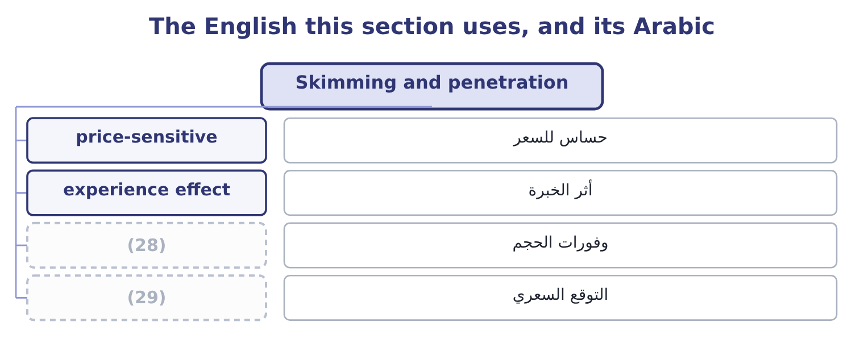
word list
expectation · precedent · economies of scale

The English this sheet uses, and its Arabic
English (exam term) | Arabic
price-sensitive | حساس للسعر
experience effect | أثر الخبرة
economies of scale | وفورات الحجم
expectation | التوقع السعري

Answer key · 13.3 Skimming and penetration

1 strategies | 16 honest
2 introduction | 17 launch-pricing
3 lowers | 18 elasticity
4 customers | 19 strongly
5 successively | 20 assumes
6 advantage | 21 question
7 supports | 22 strategy's
8 visible | 23 Low, held
9 pricing | 24 Are high early and fall slowly
10 economies | 25 Quickly, from early buyers
11 experience | 26 High margins attract entrants
12 expectation | 27 Quality, exclusivity
13 variable | 28 economies of scale
14 operating | 29 expectation
15 entirely

the summaries in full
Summary 1 Two launch strategies dominate the introduction stage, and the exam asks when each is right. Price skimming launches high and lowers the price over time. It extracts the most from the customers who value the product most and are least sensitive to price, then reaches successively more price-sensitive groups as the price falls. It suits a product with a genuine advantage, a patent or a lead over rivals, inelastic early demand, high development costs to recover, and a brand that a high price supports. Its risk is that the high price and visible margins attract entrants quickly. Penetration pricing launches low to win volume and share fast. It suits a market where demand is elastic, where costs fall sharply with volume, where there are strong economies of scale or experience effects, and where getting to scale first deters entry. Its risk is that the low price is hard to raise later and sets an expectation the product may never escape.
Summary 2 The premium 500 gram jar: a variable cost of $5.60 and $900,000 a year of fixed costs. Launch at $11.00, selling 250,000 jars in the first year to the least price-sensitive buyers, then cut to $9.50 in the second year, selling 600,000. Year one contributes 250,000 × 5.40 = 1,350,000, giving 1,350,000 − 900,000 = 450,000 of operating income. Year two contributes 600,000 × 3.90 = 2,340,000, giving 2,340,000 − 900,000 = 1,440,000. The two years total 450,000 + 1,440,000 = 1,890,000. Launch at $8.75, selling 780,000 jars in the first year and 900,000 in the second at the same price. Year one contributes 780,000 × 3.15 = 2,457,000, giving 2,457,000 − 900,000 = 1,557,000. Year two contributes 900,000 × 3.15 = 2,835,000, giving 2,835,000 − 900,000 = 1,935,000. The two years total 1,557,000 + 1,935,000 = 3,492,000.
Summary 3 Penetration earns 3,492,000 − 1,890,000 = 1,602,000 more over two years on these estimates. The answer depends entirely on the volume estimates, which is the honest thing to say about every launch-pricing calculation. Penetration wins here because the elasticity computed.41 — buyers in this market respond strongly to price — and it would lose if the premium buyers were as loyal as a skimming strategy assumes. The calculation does not decide the question; it states what each strategy's volume assumption has to deliver, and that is what a board should be asked to judge.

13.4 The other strategies
Chapter 13 · section 13.4

Fill every gap. Each word list holds one word more than there are gaps.
Summary 1 gaps 1–12
Beyond the two launch (1) , a short list of pricing tactics appears in (2) and each has a condition attached. Bundling sells several (3) for one price below the sum of the separate prices. It works where customers value the components differently — one buyer wants the sauce, (4) the bottle opener — so a bundle (5) more from each than separate prices would. It also hides the price of the (6) items, which makes (7) harder. Price discrimination charges different customers different prices for the same product: by (8) , by time, by (9) or by quantity. It is (10) wherever the groups have different elasticities and can be kept apart, and it is restricted by law in many jurisdictions where it harms (11) . A student (12) , an off-peak fare and a quantity rebate are all examples.
word list
profitable · captures · quantity · questions · individual · discount · competition · strategies · segment · products · comparison · another · channel

Summary 2 gaps 13–24
Peak-load pricing charges more when capacity is scarce — (13) in the evening, hotels in the season, (14) at the weekend. It is the clearest practical (15) of the opportunity cost: the price should carry the (16) displaced, and when nothing is displaced the price can fall to the incremental cost. Promotional pricing cuts the price (17) to attract trial, clear stock, or (18) a rival. Its danger is that temporary becomes (19) , and Book 1's finding about (20) gross margin is what a long series of temporary cuts looks like in the accounts. A loss leader is (21) below cost to draw customers who buy other (22) . It works only where the other purchases are real and attributable, which makes it a (23) about the whole (24) rather than the product. Predatory pricing is pricing below cost to drive a competitor out and raise prices afterwards. It is unlawful in most jurisdictions, and the practical test regulators use is whether the price is below the seller's own avoidable cost — which makes the relevant-cost analysis.
word list
electricity · expected · delivery · Orontes's · priced · attract · things · temporarily · question · application · basket · contribution · answer

Six tactics and the condition each needs
Tactic | Works when | Watch for
Bundling | Customers value the components differently | Hiding a weak product inside a bundle
Price discrimination | Groups have different elasticities and stay separate | (25)
Peak-load pricing | (26) | Customer resentment; measuring the peak correctly
Promotional pricing | (27) | Temporary becoming permanent
Loss leader | The other purchases are real and attributable | (28)
Predatory pricing | Never; it is unlawful | (29)

word list
Customers who buy only the leader · Capacity is scarce at some times and not others · Prices below avoidable cost, whatever the intention · Trial or clearance is genuinely needed · Customer resentment; measuring the peak correctly · Legal restrictions; arbitrage between the groups

The English this section uses, and its Arabic
Each term sits against what it means.
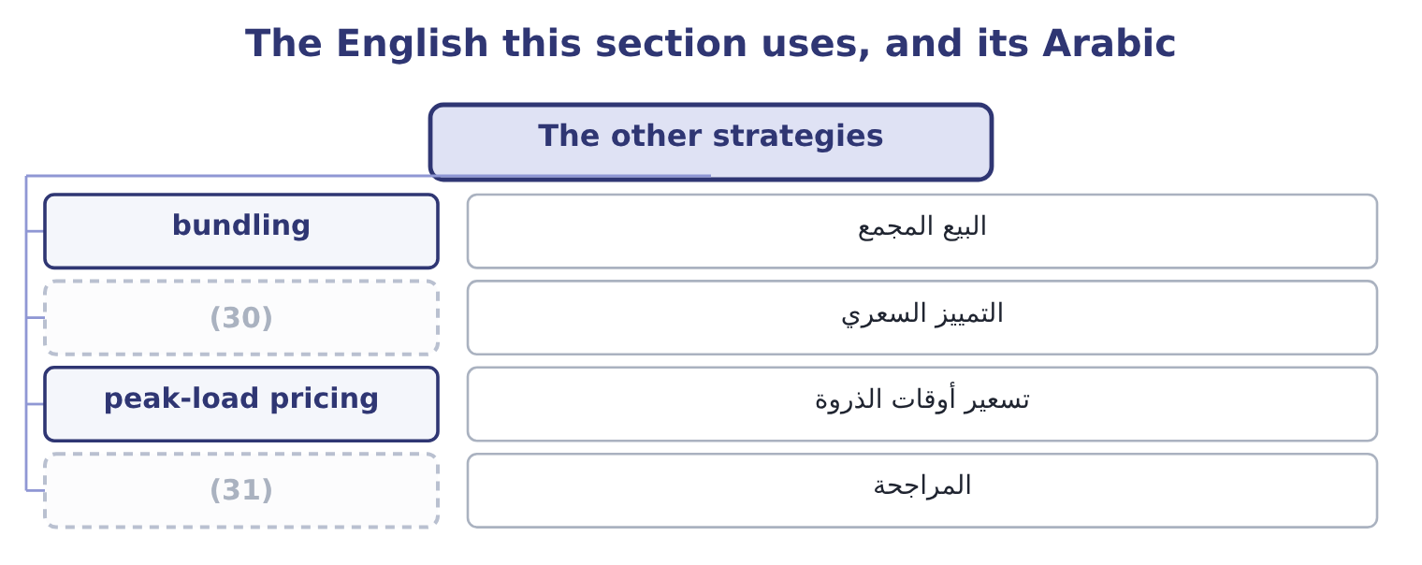
word list
bundling · arbitrage · price discrimination

The English this sheet uses, and its Arabic
English (exam term) | Arabic
bundling | البيع المجمع
price discrimination | التمييز السعري
peak-load pricing | تسعير أوقات الذروة
arbitrage | المراجحة

Answer key · 13.4 The other strategies

1 strategies | 17 temporarily
2 questions | 18 answer
3 products | 19 expected
4 another | 20 Orontes's
5 captures | 21 priced
6 individual | 22 things
7 comparison | 23 question
8 segment | 24 basket
9 channel | 25 Legal restrictions; arbitrage between the groups
10 profitable | 26 Capacity is scarce at some times and not others
11 competition | 27 Trial or clearance is genuinely needed
12 discount | 28 Customers who buy only the leader
13 electricity | 29 Prices below avoidable cost, whatever the intention
14 delivery | 30 price discrimination
15 application | 31 arbitrage
16 contribution

the summaries in full
Summary 1 Beyond the two launch strategies, a short list of pricing tactics appears in questions and each has a condition attached. Bundling sells several products for one price below the sum of the separate prices. It works where customers value the components differently — one buyer wants the sauce, another the bottle opener — so a bundle captures more from each than separate prices would. It also hides the price of the individual items, which makes comparison harder. Price discrimination charges different customers different prices for the same product: by segment, by time, by channel or by quantity. It is profitable wherever the groups have different elasticities and can be kept apart, and it is restricted by law in many jurisdictions where it harms competition. A student discount, an off-peak fare and a quantity rebate are all examples.
Summary 2 Peak-load pricing charges more when capacity is scarce — electricity in the evening, hotels in the season, delivery at the weekend. It is the clearest practical application of the opportunity cost: the price should carry the contribution displaced, and when nothing is displaced the price can fall to the incremental cost. Promotional pricing cuts the price temporarily to attract trial, clear stock, or answer a rival. Its danger is that temporary becomes expected, and Book 1's finding about Orontes's gross margin is what a long series of temporary cuts looks like in the accounts. A loss leader is priced below cost to draw customers who buy other things. It works only where the other purchases are real and attributable, which makes it a question about the whole basket rather than the product. Predatory pricing is pricing below cost to drive a competitor out and raise prices afterwards. It is unlawful in most jurisdictions, and the practical test regulators use is whether the price is below the seller's own avoidable cost — which makes the relevant-cost analysis.

13.5 Recommending a price
Chapter 13 · section 13.5

Fill every gap. Each word list holds one word more than there are gaps.
Summary 1 gaps 1–12
The last outcome of the pricing topic asks for an (1) and a recommendation under stated market (2) , and the five questions below produce one. They are the pricing (3) in order. What is the floor, on the right (4) ? Relevant cost for a (5) decision, full cost plus a return for a long-term one. Both should be stated, (6) the gap between them is where the (7) lives. What will the market bear? From (8) , the customer's (9) , or research —. How (10) is demand? The elasticity of, with the warning that it is local, short-run and (11) . What stage is the product in, and what are the competitors doing? A launch takes skimming or penetration; a mature product defends; a (12) product harvests. And in the oligopoly. What does the price do to everything else? Cannibalisation of the company's own products, the expectations of existing customers, the signal about quality, and the precedent for the next negotiation. Then state the recommendation in one sentence, with the number that drives it and the figure at which it would reverse.
word list
comparables · other-things-equal · relaunch · judgment · declining · conditions · because · short-term · chapters · evaluation · horizon · alternative · responsive

Summary 2 gaps 13–24
For (13) premium jar, that sentence is: launch at $8.75, which earns $1,557,000 in the first year against $450,000 for a skimming launch, and reverse the recommendation if the volume at $8.75 is (14) below 571,429 jars — which is the volume at which penetration's first-year contribution falls to the skimming (15) , computed as 450,000 + 900,000 = 1,350,000 of (16) contribution over a margin of $3.15. Three (17) points complete a good answer. A price is a (18) decision. It sets expectations with customers, with the trade and with competitors, and (19) it later is harder than (20) it. A price is a signal about quality as well as a (21) for money, and a discount (22) more than it earns. And the cheapest (23) position to hold is the one with the lowest cost, which is why: the pricing options a company has are largely (24) before the product is designed.
word list
Orontes's · required · question · communicates · lowering · long-lived · raising · qualitative · expected · request · determined · strategy's · competitive

Choose a launch strategy

Your turn: skimming or penetration (complete the blanks)
Item | Data | Answer
Contribution a unit under skimming | (25) | ________
First-year operating income under skimming | Volume 90,000; fixed costs 700,000 | ________
Contribution a unit under penetration | Price 24.00 | ________
First-year operating income under penetration | (26) | ________
Which is better in year one, and by how much |  | ________
Volume at which penetration matches skimming in year one |  | ________

word list
First-year operating income under skimming · Volume 180,000 · Price 30.00, variable cost 16.00

"Skimming"

Summary 3 gaps 27–35
English price skimming takes its (27) from skimming cream off the top of milk: the seller takes the (28) part of the market first and then works down. It has nothing to do with the other (29) sense of skimming, which is the theft of small (30) from takings, and nothing to do with skimming a (31) . The (32) term is the clearer of the two in every (33) : penetration pricing means pushing into a market, and the image of (34) rather than taking from the top is worth keeping in mind when deciding which strategy a question (35) .
word list
metaphor · financial · document · companion · amounts · describes · language · sentence · entering · richest

"Skimming"
Item | Answer
Contribution a unit under skimming | 14.00: 30.00 − 16.00 = 14.00.
First-year operating income under skimming | (36) : 90,000 × 14.00 = 1,260,000, less fixed costs of 700,000.
Contribution a unit under penetration | 8.00: 24.00 − 16.00 = 8.00.
First-year operating income under penetration | (37) : 180,000 × 8.00 = 1,440,000, less 700,000.
Which is better in year one | (38) : 740,000 − 560,000 = 180,000.
Volume at which penetration matches skimming | 157,500 units: skimming's contribution of 1,260,000 divided by penetration's margin of 8.00.
What it tells you | Penetration wins if it can deliver more than 157,500 units, which is 75 per cent more than skimming's 90,000. The whole decision is a judgme

word list
740,000 · price list · 560,000 · Penetration, by 180,000

The English this section uses, and its Arabic
Each term sits against what it means.
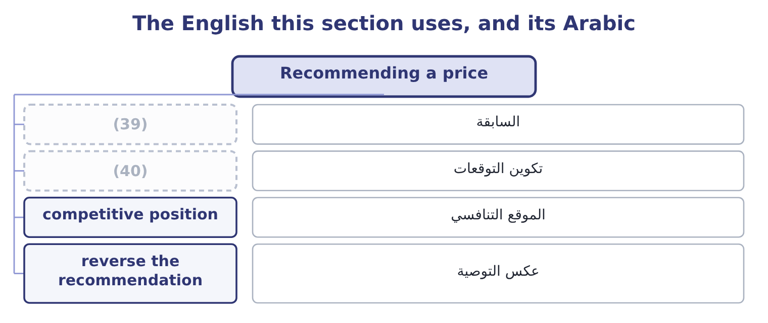
word list
saturation · expectation setting · precedent

The English this sheet uses, and its Arabic
English (exam term) | Arabic
precedent | السابقة
expectation setting | تكوين التوقعات
competitive position | الموقع التنافسي
reverse the recommendation | عكس التوصية

Answer key · 13.5 Recommending a price

1 evaluation | 21 request
2 conditions | 22 communicates
3 chapters | 23 competitive
4 horizon | 24 determined
5 short-term | 25 Price 30.00, variable cost 16.00
6 because | 26 Volume 180,000
7 judgment | 27 metaphor
8 comparables | 28 richest
9 alternative | 29 financial
10 responsive | 30 amounts
11 other-things-equal | 31 document
12 declining | 32 companion
13 Orontes's | 33 language
14 expected | 34 entering
15 strategy's | 35 describes
16 required | 36 560,000
17 qualitative | 37 740,000
18 long-lived | 38 Penetration, by 180,000
19 raising | 39 precedent
20 lowering | 40 expectation setting

the summaries in full
Summary 1 The last outcome of the pricing topic asks for an evaluation and a recommendation under stated market conditions, and the five questions below produce one. They are the pricing chapters in order. What is the floor, on the right horizon? Relevant cost for a short-term decision, full cost plus a return for a long-term one. Both should be stated, because the gap between them is where the judgment lives. What will the market bear? From comparables, the customer's alternative, or research —. How responsive is demand? The elasticity of, with the warning that it is local, short-run and other-things-equal. What stage is the product in, and what are the competitors doing? A launch takes skimming or penetration; a mature product defends; a declining product harvests. And in the oligopoly. What does the price do to everything else? Cannibalisation of the company's own products, the expectations of existing customers, the signal about quality, and the precedent for the next negotiation. Then state the recommendation in one sentence, with the number that drives it and the figure at which it would reverse.
Summary 2 For Orontes's premium jar, that sentence is: launch at $8.75, which earns $1,557,000 in the first year against $450,000 for a skimming launch, and reverse the recommendation if the volume at $8.75 is expected below 571,429 jars — which is the volume at which penetration's first-year contribution falls to the skimming strategy's, computed as 450,000 + 900,000 = 1,350,000 of required contribution over a margin of $3.15. Three qualitative points complete a good answer. A price is a long-lived decision. It sets expectations with customers, with the trade and with competitors, and raising it later is harder than lowering it. A price is a signal about quality as well as a request for money, and a discount communicates more than it earns. And the cheapest competitive position to hold is the one with the lowest cost, which is why: the pricing options a company has are largely determined before the product is designed.
Summary 3 English price skimming takes its metaphor from skimming cream off the top of milk: the seller takes the richest part of the market first and then works down. It has nothing to do with the other financial sense of skimming, which is the theft of small amounts from takings, and nothing to do with skimming a document. The companion term is the clearer of the two in every language: penetration pricing means pushing into a market, and the image of entering rather than taking from the top is worth keeping in mind when deciding which strategy a question describes.

14.1 What capital budgeting is
Chapter 14 · section 14.1

Fill every gap. Each word list holds one word more than there are gaps.
Chapter 14, section by section
Each stage leads to the next.
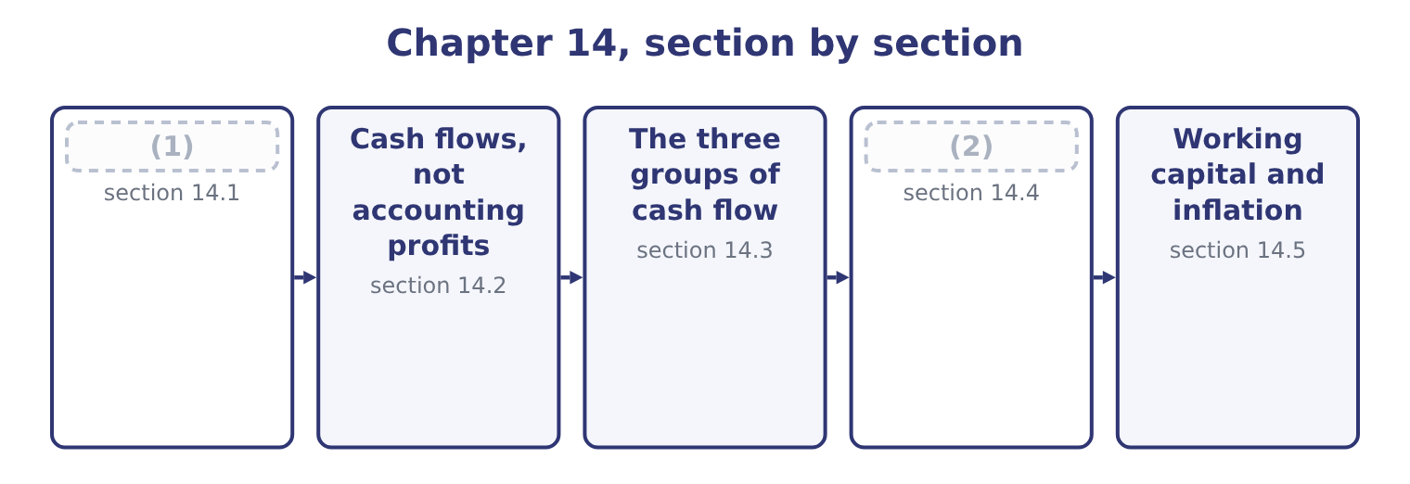
word list
What capital budgeting is · net working capital investment · How tax reaches the cash flows

Summary 1 gaps 3–14
Capital budgeting is the process by which a company (3) , evaluates, selects and controls (4) whose benefits extend beyond one year. The (5) asks for the (6) , and there are six. Proposals arise from the strategy, from (7) , from a regulatory (8) , or from a problem — a machine that is failing, a market that is growing, a rule that must be met. A company with no flow of proposals has a (9) problem rather than an investment problem. A quick test against the strategy, the available funds and an (10) hurdle, to avoid (11) in detail what will never be approved. Ranking the (12) proposals and (13) them to the funds available, which Book 2's. (14) , spending, and controlling the spend against the authority — because a project approved at $3,000,000 and delivered at $4,200,000 was a different project.
word list
investments · operations · fitting · outcome · requirement · Comparing · stages · identifies · evaluating · obvious · surviving · Authorising · management

Summary 2 gaps 15–21
Review, or the (15) . (16) what happened with what was (17) . Two features (18) the whole process from the (19) . A machine (20) is hard to unbuy, and a plant built in the wrong place stays there. That is why the (21) is done before rather than after, and why. The money goes out now and comes back over years, so the arithmetic must account for the fact that money has a time value — which is why the measures.
word list
decisions · authority · distinguish · bought · promised · postaudit · Comparing · analysis

The English this section uses, and its Arabic
Each term sits against what it means.
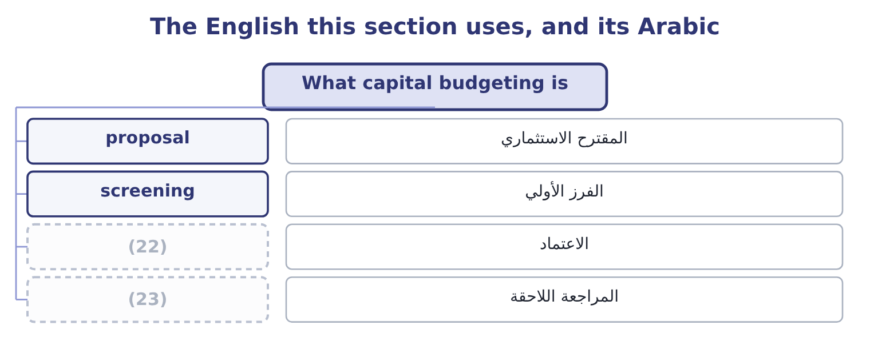
word list
authorisation · consistency · postaudit

The English this sheet uses, and its Arabic
English (exam term) | Arabic
proposal | المقترح الاستثماري
screening | الفرز الأولي
authorisation | الاعتماد
postaudit | المراجعة اللاحقة

Answer key · 14.1 What capital budgeting is

1 What capital budgeting is | 13 fitting
2 How tax reaches the cash flows | 14 Authorising
3 identifies | 15 postaudit
4 investments | 16 Comparing
5 outcome | 17 promised
6 stages | 18 distinguish
7 operations | 19 decisions
8 requirement | 20 bought
9 management | 21 analysis
10 obvious | 22 authorisation
11 evaluating | 23 postaudit
12 surviving

the summaries in full
Summary 1 Capital budgeting is the process by which a company identifies, evaluates, selects and controls investments whose benefits extend beyond one year. The outcome asks for the stages, and there are six. Proposals arise from the strategy, from operations, from a regulatory requirement, or from a problem — a machine that is failing, a market that is growing, a rule that must be met. A company with no flow of proposals has a management problem rather than an investment problem. A quick test against the strategy, the available funds and an obvious hurdle, to avoid evaluating in detail what will never be approved. Ranking the surviving proposals and fitting them to the funds available, which Book 2's. Authorising, spending, and controlling the spend against the authority — because a project approved at $3,000,000 and delivered at $4,200,000 was a different project.
Summary 2 Review, or the postaudit. Comparing what happened with what was promised. Two features distinguish the whole process from the decisions. A machine bought is hard to unbuy, and a plant built in the wrong place stays there. That is why the analysis is done before rather than after, and why. The money goes out now and comes back over years, so the arithmetic must account for the fact that money has a time value — which is why the measures.

14.2 Cash flows, not accounting profits
Chapter 14 · section 14.2

Fill every gap. Each word list holds one word more than there are gaps.
Summary 1 gaps 1–12
Capital budgeting uses cash flows and not accounting (1) , and the outcome asks why. Cash is what can be reinvested, (2) or used to repay debt. Profit is an (3) about timing; cash is a fact about a bank (4) . (5) accounting (6) spreads things. Revenue is (7) when earned rather than when (8) , and the cost of an asset is spread as depreciation over its life. Both are right for (9) a period and wrong for (10) a project, because the whole point is when the money moves. Depreciation is not a cash flow at all. The cash moved when the asset was bought, which is the initial (11) , and depreciation enters a capital budgeting analysis only (12) the tax it saves — the depreciation tax shield of section 14.4. And the relevance rules.
word list
depreciation · account · distributed · reporting · through · deliberately · investment · valuing · profits · Accrual · opinion · recognised · received

Summary 2 gaps 13–24
Only (13) cash flows count: those that would not exist without the project. Five items recur and each is (14) . Sunk costs are excluded. Market research already paid for, a site survey, a (15) study. The $25,000 of (16) . (17) costs are included. If the project uses land the company already owns, the land's market value is a cost of the project, because selling it is the (18) . If it uses capacity that would otherwise make something else, the (19) forgone is a cost. (20) overhead is excluded unless it changes. A project charged a share of head (21) costs that do not move is being charged for something it does not cause. (22) costs are excluded from the cash flows. Interest and the (23) of principal are not project cash flows; the cost of money is accounted for in the discount rate, and including it in both places charges for it twice. This is the (24) most common error in this topic.
word list
single · alternative · examined · repayment · Opportunity · feasibility · contribution · incremental · distributed · development · Allocated · Financing · office

Summary 3 gaps 25–26
Side (25) are included. (26) of the company's existing products, as in, and any benefit to other products, both belong in the project's cash flows.
word list
effects · relevance · Cannibalisation

In or out of a project's cash flows
Every item belongs to exactly one group.
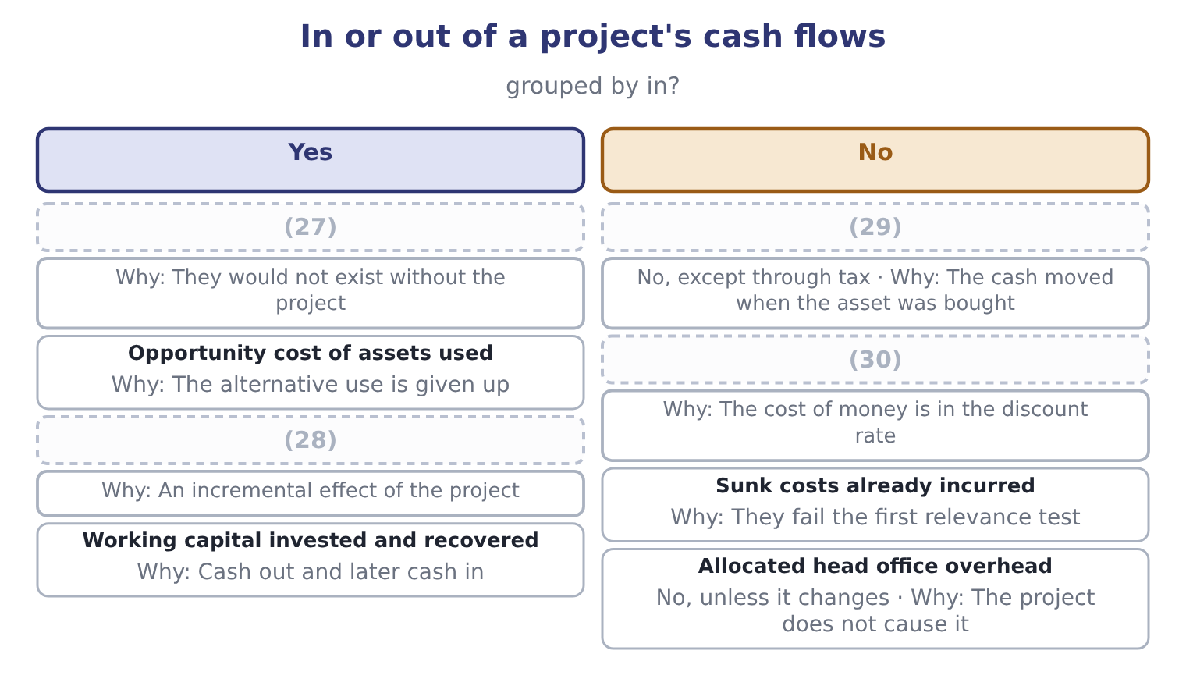
word list
Interest and loan repayments · taxable gain · Lost contribution on cannibalised sales · Incremental revenue and cash costs · Depreciation

Interest belongs in the rate, not the flows

Summary 4 gaps 31–37
Deducting interest from a project's cash flows and then (31) at the cost of capital charges for the money twice and will reject good (32) . Depreciation (33) in the analysis only as a tax shield. It is added back if a question (34) from accounting profit, and never (35) as a cost. A question that gives you an accounting profit is asking you to convert it: add back depreciation, adjust for working capital (36) , and remove any (37) item.
word list
discounting · deducted · non-cash · appears · movements · starts · projects · Cannibalisation

The English this section uses, and its Arabic
Each term sits against what it means.
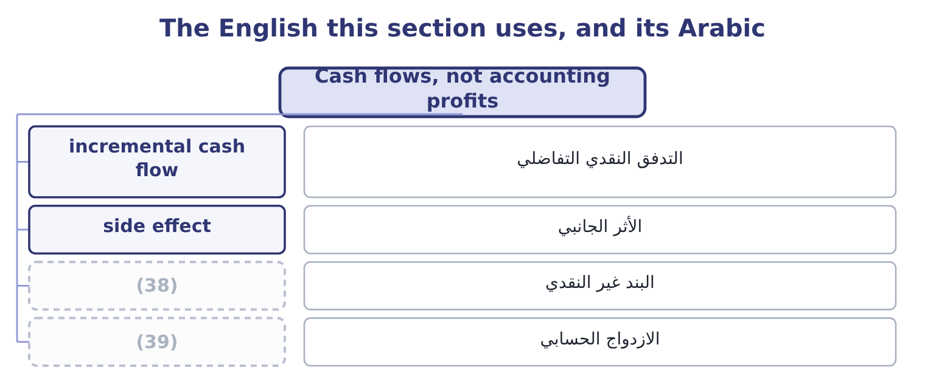
word list
initial investment · double counting · non-cash item

The English this sheet uses, and its Arabic
English (exam term) | Arabic
incremental cash flow | التدفق النقدي التفاضلي
side effect | الأثر الجانبي
non-cash item | البند غير النقدي
double counting | الازدواج الحسابي

Answer key · 14.2 Cash flows, not accounting profits

1 profits | 21 office
2 distributed | 22 Financing
3 opinion | 23 repayment
4 account | 24 single
5 Accrual | 25 effects
6 deliberately | 26 Cannibalisation
7 recognised | 27 Incremental revenue and cash costs
8 received | 28 Lost contribution on cannibalised sales
9 reporting | 29 Depreciation
10 valuing | 30 Interest and loan repayments
11 investment | 31 discounting
12 through | 32 projects
13 incremental | 33 appears
14 examined | 34 starts
15 feasibility | 35 deducted
16 development | 36 movements
17 Opportunity | 37 non-cash
18 alternative | 38 non-cash item
19 contribution | 39 double counting
20 Allocated

the summaries in full
Summary 1 Capital budgeting uses cash flows and not accounting profits, and the outcome asks why. Cash is what can be reinvested, distributed or used to repay debt. Profit is an opinion about timing; cash is a fact about a bank account. Accrual accounting deliberately spreads things. Revenue is recognised when earned rather than when received, and the cost of an asset is spread as depreciation over its life. Both are right for reporting a period and wrong for valuing a project, because the whole point is when the money moves. Depreciation is not a cash flow at all. The cash moved when the asset was bought, which is the initial investment, and depreciation enters a capital budgeting analysis only through the tax it saves — the depreciation tax shield of section 14.4. And the relevance rules.
Summary 2 Only incremental cash flows count: those that would not exist without the project. Five items recur and each is examined. Sunk costs are excluded. Market research already paid for, a site survey, a feasibility study. The $25,000 of development. Opportunity costs are included. If the project uses land the company already owns, the land's market value is a cost of the project, because selling it is the alternative. If it uses capacity that would otherwise make something else, the contribution forgone is a cost. Allocated overhead is excluded unless it changes. A project charged a share of head office costs that do not move is being charged for something it does not cause. Financing costs are excluded from the cash flows. Interest and the repayment of principal are not project cash flows; the cost of money is accounted for in the discount rate, and including it in both places charges for it twice. This is the single most common error in this topic.
Summary 3 Side effects are included. Cannibalisation of the company's existing products, as in, and any benefit to other products, both belong in the project's cash flows.
Summary 4 Deducting interest from a project's cash flows and then discounting at the cost of capital charges for the money twice and will reject good projects. Depreciation appears in the analysis only as a tax shield. It is added back if a question starts from accounting profit, and never deducted as a cost. A question that gives you an accounting profit is asking you to convert it: add back depreciation, adjust for working capital movements, and remove any non-cash item.

14.3 The three groups of cash flow
Chapter 14 · section 14.3

Fill every gap. Each word list holds one word more than there are gaps.
Summary 1 gaps 1–10
Every project's cash flows fall into three groups, and (1) them in that order is the (2) that prevents (3) . The initial investment, at time zero. The (4) price of the asset, plus delivery, installation and (5) ; plus the initial investment in working capital; plus any (6) cost of assets (7) ; less the after-tax proceeds of anything sold or (8) . The operating cash flows, each year of the project's life. The incremental revenue less the incremental cash operating costs, taxed, plus the depreciation tax shield. The terminal cash flow, in the final year. The after-tax proceeds of (9) the asset, plus the (10) of the working capital, plus or less any closing costs.
word list
commissioning · purchase · omissions · opportunity · proposal · displaced · recovery · building · selling · discipline · committed

Worked example: Orontes's roasting line

Summary 2 gaps 11–14
The line costs $3,000,000 installed, and the extra stock and (11) it brings require $400,000 of working capital. The initial (12) is 3,000,000 + 400,000 = 3,400,000. The annual operating flows, before tax. The line adds $2,400,000 of revenue and $1,200,000 of cash operating costs, so the pre-tax operating cash flow is 2,400,000 − 1,200,000 = 1,200,000 a year. At 25 per cent the after-tax operating cash flow is 1,200,000 × 0.75 = 900,000. The depreciation tax shield. The line is depreciated (13) over five years to nil: 3,000,000 ÷ 5 = 600,000 a year, which at 25 per cent saves 600,000 × 0.25 = 150,000 of tax a year. The line would fetch $200,000 at the end, and since its book value is nil the whole proceeds are (14) : 200,000 × 0.75 = 150,000 after tax.
word list
taxable · receivables · consistency · straight-line · outlay

Summary 3 gaps 15–20
The working capital of $400,000 is released. The terminal flow is 400,000 + 150,000 = 550,000, (15) in year five in (16) to that year's operating flow. The project is $3,400,000 out and $1,050,000 a year in for five years, with $550,000 more at the end. (17) that is 1,050,000 × 5 = 5,250,000 plus 550,000, or 5,800,000 — (18) more than $3,400,000, but the comparison is (19) until the timing is (20) for.
word list
received · proposal · accounted · addition · meaningless · Undiscounted · comfortably

The roasting line's cash flows
Item | Amount
(21) | (3,000,000)
Working capital invested at time zero | (400,000)
Total initial investment | (3,400,000)
(22) | 1,200,000
After-tax operating cash flow, each year | 900,000
(23) | 150,000
Annual cash flow, each of years 1 to 5 | 1,050,000
Sale proceeds in year five, before tax | 200,000
(24) | (50,000)
(25) | 400,000
Terminal flow in year five, additional | 550,000

word list
Depreciation tax shield, each year · Pre-tax operating cash flow, each year · Tax on those proceeds · Working capital released in year five · net working capital investment · Equipment, installed, at time zero

The English this section uses, and its Arabic
Each term sits against what it means.
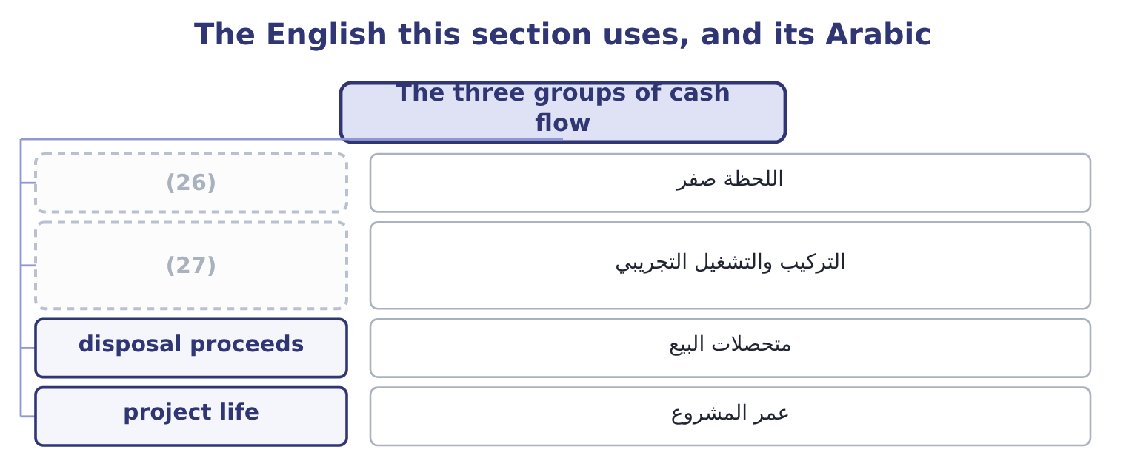
word list
depreciation tax shield · installation and commissioning · time zero

The English this sheet uses, and its Arabic
English (exam term) | Arabic
time zero | اللحظة صفر
installation and commissioning | التركيب والتشغيل التجريبي
disposal proceeds | متحصلات البيع
project life | عمر المشروع

Answer key · 14.3 The three groups of cash flow

1 building | 15 received
2 discipline | 16 addition
3 omissions | 17 Undiscounted
4 purchase | 18 comfortably
5 commissioning | 19 meaningless
6 opportunity | 20 accounted
7 committed | 21 Equipment, installed, at time zero
8 displaced | 22 Pre-tax operating cash flow, each year
9 selling | 23 Depreciation tax shield, each year
10 recovery | 24 Tax on those proceeds
11 receivables | 25 Working capital released in year five
12 outlay | 26 time zero
13 straight-line | 27 installation and commissioning
14 taxable

the summaries in full
Summary 1 Every project's cash flows fall into three groups, and building them in that order is the discipline that prevents omissions. The initial investment, at time zero. The purchase price of the asset, plus delivery, installation and commissioning; plus the initial investment in working capital; plus any opportunity cost of assets committed; less the after-tax proceeds of anything sold or displaced. The operating cash flows, each year of the project's life. The incremental revenue less the incremental cash operating costs, taxed, plus the depreciation tax shield. The terminal cash flow, in the final year. The after-tax proceeds of selling the asset, plus the recovery of the working capital, plus or less any closing costs.
Summary 2 The line costs $3,000,000 installed, and the extra stock and receivables it brings require $400,000 of working capital. The initial outlay is 3,000,000 + 400,000 = 3,400,000. The annual operating flows, before tax. The line adds $2,400,000 of revenue and $1,200,000 of cash operating costs, so the pre-tax operating cash flow is 2,400,000 − 1,200,000 = 1,200,000 a year. At 25 per cent the after-tax operating cash flow is 1,200,000 × 0.75 = 900,000. The depreciation tax shield. The line is depreciated straight-line over five years to nil: 3,000,000 ÷ 5 = 600,000 a year, which at 25 per cent saves 600,000 × 0.25 = 150,000 of tax a year. The line would fetch $200,000 at the end, and since its book value is nil the whole proceeds are taxable: 200,000 × 0.75 = 150,000 after tax.
Summary 3 The working capital of $400,000 is released. The terminal flow is 400,000 + 150,000 = 550,000, received in year five in addition to that year's operating flow. The project is $3,400,000 out and $1,050,000 a year in for five years, with $550,000 more at the end. Undiscounted that is 1,050,000 × 5 = 5,250,000 plus 550,000, or 5,800,000 — comfortably more than $3,400,000, but the comparison is meaningless until the timing is accounted for.

14.4 How tax reaches the cash flows
Chapter 14 · section 14.4

Fill every gap. Each word list holds one word more than there are gaps.
Summary 1 gaps 1–12
Tax enters a capital (1) analysis in three places, and the (2) asks for all three. On the operating flows. (3) the depreciation tax shield. Depreciation is not a cash cost, but it is deductible, so it (4) the tax paid. The shield is the depreciation times the tax rate, and it is a (5) cash inflow of the project. Where the tax rules allow (6) depreciation, the shield (7) earlier and is worth more, which is why the tax code's depreciation method (8) to a project's value even though the total deduction is the same. (9) an asset for more than its tax book value (10) a taxable gain; for less, a deductible loss. In the example the (11) book value is nil, so the whole $200,000 is taxed: 200,000 × 0.25 = 50,000 of tax, (12) $150,000.
word list
produces · outcome · matters · Through · Selling · genuine · leaving · arrives · accelerated · postaudit · budgeting · line's · reduces

Summary 2 gaps 13–21
Had the book value been $200,000 there would have been no tax at all, and had it been $500,000 the $300,000 loss would have saved 300,000 × 0.25 = 75,000. Two (13) points appear in harder (14) . A company with losses has a (15) tax rate of nil until they are used, so its (16) are worth nothing now and (17) later — which, as Book 2's, is the standard reason a (18) company leases rather than buys. And an investment tax credit, where one exists, is a direct (19) of tax in the year of (20) and belongs in the (21) investment rather than in the operating flows.
word list
purchase · marginal · loss-making · something · budgeting · initial · reduction · questions · further · shields

The same project, taxed and untaxed
Every item belongs to exactly one group.
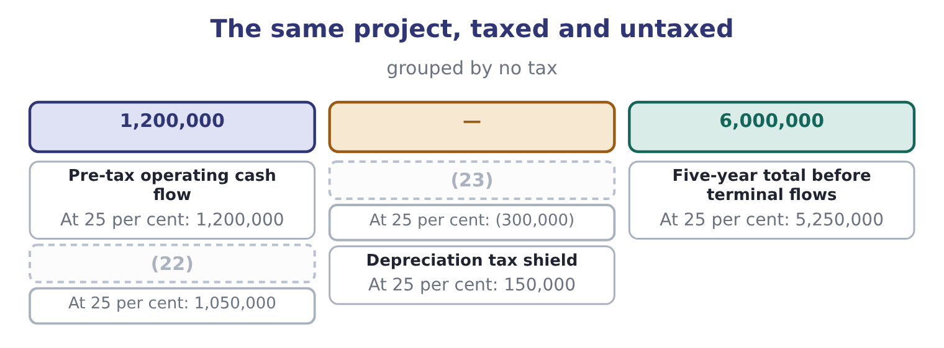
word list
Annual cash flow · operating cash flow · Tax on it

Summary 3 gaps 24–27
Tax takes 12.5 per cent of this project's (24) cash flow rather than 25, (25) half the deduction comes back as the shield. That is the (26) point of the whole section: a 25 per cent tax rate does not reduce a project's value by a (27) .
word list
annual · practical · postaudit · because · quarter

The English this section uses, and its Arabic
Each term sits against what it means.
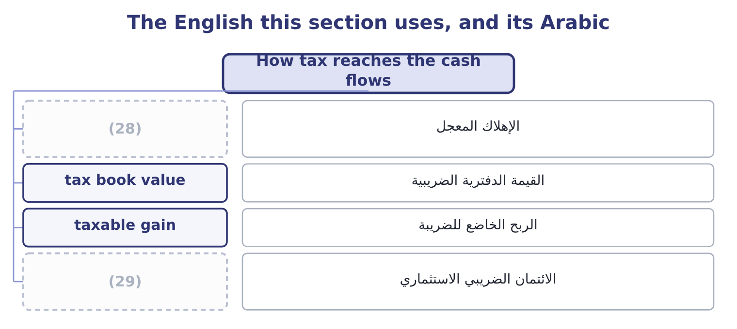
word list
non-cash item · investment tax credit · accelerated depreciation

The English this sheet uses, and its Arabic
English (exam term) | Arabic
accelerated depreciation | الإهلاك المعجل
tax book value | القيمة الدفترية الضريبية
taxable gain | الربح الخاضع للضريبة
investment tax credit | الائتمان الضريبي الاستثماري

Answer key · 14.4 How tax reaches the cash flows

1 budgeting | 16 shields
2 outcome | 17 something
3 Through | 18 loss-making
4 reduces | 19 reduction
5 genuine | 20 purchase
6 accelerated | 21 initial
7 arrives | 22 Annual cash flow
8 matters | 23 Tax on it
9 Selling | 24 annual
10 produces | 25 because
11 line's | 26 practical
12 leaving | 27 quarter
13 further | 28 accelerated depreciation
14 questions | 29 investment tax credit
15 marginal

the summaries in full
Summary 1 Tax enters a capital budgeting analysis in three places, and the outcome asks for all three. On the operating flows. Through the depreciation tax shield. Depreciation is not a cash cost, but it is deductible, so it reduces the tax paid. The shield is the depreciation times the tax rate, and it is a genuine cash inflow of the project. Where the tax rules allow accelerated depreciation, the shield arrives earlier and is worth more, which is why the tax code's depreciation method matters to a project's value even though the total deduction is the same. Selling an asset for more than its tax book value produces a taxable gain; for less, a deductible loss. In the example the line's book value is nil, so the whole $200,000 is taxed: 200,000 × 0.25 = 50,000 of tax, leaving $150,000.
Summary 2 Had the book value been $200,000 there would have been no tax at all, and had it been $500,000 the $300,000 loss would have saved 300,000 × 0.25 = 75,000. Two further points appear in harder questions. A company with losses has a marginal tax rate of nil until they are used, so its shields are worth nothing now and something later — which, as Book 2's, is the standard reason a loss-making company leases rather than buys. And an investment tax credit, where one exists, is a direct reduction of tax in the year of purchase and belongs in the initial investment rather than in the operating flows.
Summary 3 Tax takes 12.5 per cent of this project's annual cash flow rather than 25, because half the deduction comes back as the shield. That is the practical point of the whole section: a 25 per cent tax rate does not reduce a project's value by a quarter.

14.5 Working capital and inflation
Chapter 14 · section 14.5

Fill every gap. Each word list holds one word more than there are gaps.
Summary 1 gaps 1–12
Two (1) complete the cash flows, and both are (2) in their own right. A project that adds sales adds receivables and inventory, and usually adds some payables. The net (3) is an investment: cash goes out at the start, more may go out as the project grows, and the whole of it comes back at the end when the stock is sold and the receivables (4) . The investment is a cash outflow when it is made and an inflow when it is recovered, and the (5) is usually (6) to happen in the final year. Only the net change (7) : an increase in payables funds part of the increase in receivables and inventory, (8) as Book 2's. It is not (9) and it generates no tax shield, because it is not (10) . The $400,000 in (11) roasting line goes out at time zero and comes back in year five (12) .
word list
assumed · depreciated · consumed · collected · exactly · Orontes's · examined · projects · matters · amount · recovery · refinements · undiminished

Summary 2 gaps 13–21
Omitting working capital is a (13) error and it always (14) the project, because it (15) an early outflow and a late inflow of equal size — and the early one is (16) less. Where prices and costs will rise, the (17) must be consistent, and there are two consistent ways to do it. The nominal approach inflates the cash flows at the expected rate and discounts them at the nominal rate — the rate the market (18) quotes, which already (19) expected inflation, as Book 2's. The real approach (20) the cash flows in today's prices and discounts at a real rate, found by removing inflation from the nominal rate: at a nominal 9 per cent and 3 per cent inflation, 1.09 ÷ 1.03 = 1.0583, a real rate of 5.83 per cent. Both give the same answer when applied (21) .
word list
removes · leaves · discounted · flatters · actually · correctly · analysis · adjustment · includes · common

Summary 3 gaps 22–31
The error the exam tests is mixing them: (22) cash flows stated in today's prices at a nominal rate (23) every future inflow and rejects good projects, and it is the (24) inflation mistake in practice. Two (25) are worth naming. Not (26) inflates at the same rate — sesame may rise faster than wages, and a (27) price may not rise at all — so a general inflation adjustment is a (28) . And the depreciation tax shield never inflates, because it is (29) on the historical cost of the asset: in a period of inflation the shield loses real value every year, which is one of Book 1's points about historical cost, (30) in a project (31) .
word list
complications · simplification · expenditure · computed · contracted · appraisal · understates · discounting · everything · commonest · arriving

Build the cash flows

Your turn: a project's cash flows (complete the blanks)
Item | Data | Answer
Initial investment | Equipment 1,800,000; working capital 250,000 | (32)
Annual depreciation | Four-year life, straight line to nil | (33)
After-tax operating cash flow | (34) | 555,000: the pre-tax flow is 1,500,000 − 760,000 = 740,000, and 740,000 × 0.75 = 555,000.
Annual depreciation tax shield |  | 112,500: 450,000 × 0.25 = 112,500.
Total annual cash flow |  | (35)
Terminal cash flow | Asset sold for 120,000, book value nil; working capital recovered | 340,000: the sale yields 120,000 × 0.75 = 90,000 after tax, plus 250,000 of working capital recovered.
Real discount rate | Nominal 10 per cent, inflation 4 per cent | (36) : 1.10 ÷ 1.04 = 1.0577.

word list
450,000: 1,800,000 ÷ 4 = 450,000. · 667,500: 555,000 + 112,500 = 667,500. · Revenue 1,500,000, cash costs 760,000, tax 25 per cent · 5.77 per cent · 112,500: 450,000 × 0.25 = 112,500. · 2,050,000: 1,800,000 + 250,000 = 2,050,000.

"Capital"

Summary 4 gaps 37–43
English capital budgeting is about spending on (37) assets, and the word capital here means the assets (38) than the money, which is the (39) of its sense in Book 2's cost of capital. A capital expenditure buys a machine; capital (40) is the money that (41) it; and capital budgeting is the process of (42) between machines. The rule for an answer is to let the noun beside the word decide: budgeting and expenditure point to assets, cost and (43) point to money.
word list
choosing · opposite · employed · long-lived · discounted · funded · structure · rather

The English this section uses, and its Arabic
Each term sits against what it means.
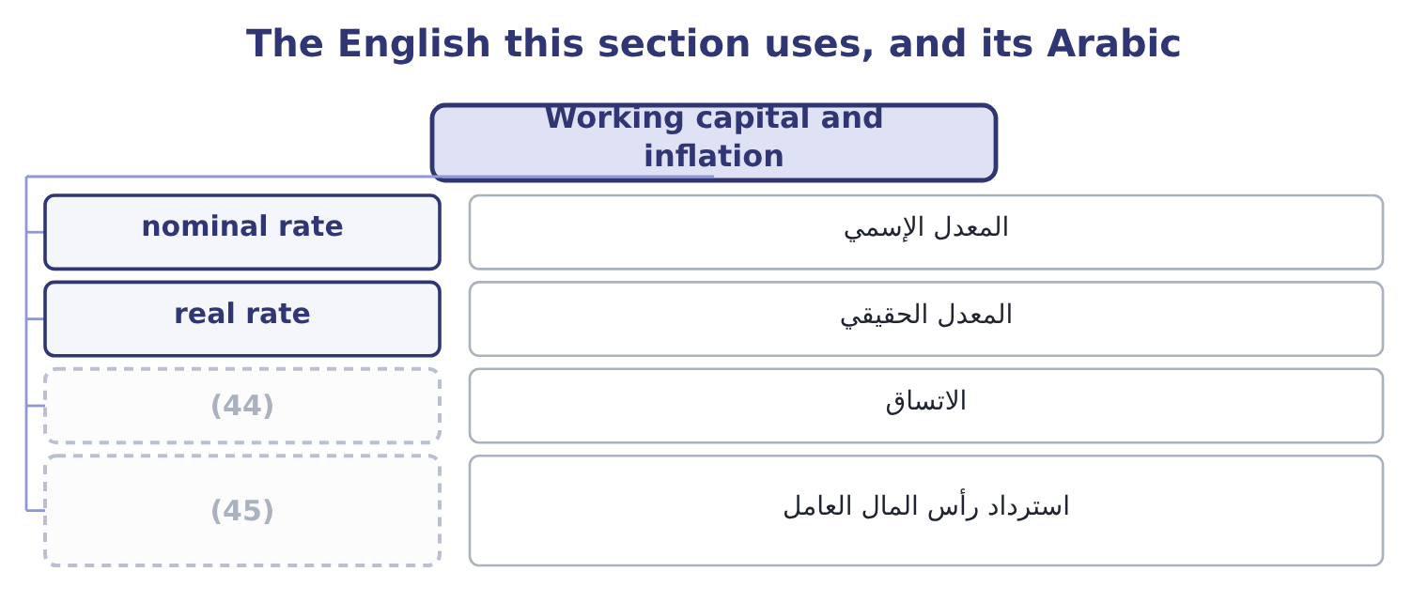
word list
double counting · consistency · recovery of working capital

The English this sheet uses, and its Arabic
English (exam term) | Arabic
nominal rate | المعدل الإسمي
real rate | المعدل الحقيقي
consistency | الاتساق
recovery of working capital | استرداد رأس المال العامل

Answer key · 14.5 Working capital and inflation

1 refinements | 24 commonest
2 examined | 25 complications
3 amount | 26 everything
4 collected | 27 contracted
5 recovery | 28 simplification
6 assumed | 29 computed
7 matters | 30 arriving
8 exactly | 31 appraisal
9 depreciated | 32 2,050,000: 1,800,000 + 250,000 = 2,050,000.
10 consumed | 33 450,000: 1,800,000 ÷ 4 = 450,000.
11 Orontes's | 34 Revenue 1,500,000, cash costs 760,000, tax 25 per cent
12 undiminished | 35 667,500: 555,000 + 112,500 = 667,500.
13 common | 36 5.77 per cent
14 flatters | 37 long-lived
15 removes | 38 rather
16 discounted | 39 opposite
17 analysis | 40 employed
18 actually | 41 funded
19 includes | 42 choosing
20 leaves | 43 structure
21 correctly | 44 consistency
22 discounting | 45 recovery of working capital
23 understates

the summaries in full
Summary 1 Two refinements complete the cash flows, and both are examined in their own right. A project that adds sales adds receivables and inventory, and usually adds some payables. The net amount is an investment: cash goes out at the start, more may go out as the project grows, and the whole of it comes back at the end when the stock is sold and the receivables collected. The investment is a cash outflow when it is made and an inflow when it is recovered, and the recovery is usually assumed to happen in the final year. Only the net change matters: an increase in payables funds part of the increase in receivables and inventory, exactly as Book 2's. It is not depreciated and it generates no tax shield, because it is not consumed. The $400,000 in Orontes's roasting line goes out at time zero and comes back in year five undiminished.
Summary 2 Omitting working capital is a common error and it always flatters the project, because it removes an early outflow and a late inflow of equal size — and the early one is discounted less. Where prices and costs will rise, the analysis must be consistent, and there are two consistent ways to do it. The nominal approach inflates the cash flows at the expected rate and discounts them at the nominal rate — the rate the market actually quotes, which already includes expected inflation, as Book 2's. The real approach leaves the cash flows in today's prices and discounts at a real rate, found by removing inflation from the nominal rate: at a nominal 9 per cent and 3 per cent inflation, 1.09 ÷ 1.03 = 1.0583, a real rate of 5.83 per cent. Both give the same answer when applied correctly.
Summary 3 The error the exam tests is mixing them: discounting cash flows stated in today's prices at a nominal rate understates every future inflow and rejects good projects, and it is the commonest inflation mistake in practice. Two complications are worth naming. Not everything inflates at the same rate — sesame may rise faster than wages, and a contracted price may not rise at all — so a general inflation adjustment is a simplification. And the depreciation tax shield never inflates, because it is computed on the historical cost of the asset: in a period of inflation the shield loses real value every year, which is one of Book 1's points about historical cost, arriving in a project appraisal.
Summary 4 English capital budgeting is about spending on long-lived assets, and the word capital here means the assets rather than the money, which is the opposite of its sense in Book 2's cost of capital. A capital expenditure buys a machine; capital employed is the money that funded it; and capital budgeting is the process of choosing between machines. The rule for an answer is to let the noun beside the word decide: budgeting and expenditure point to assets, cost and structure point to money.

15.1 The hurdle rate
Chapter 15 · section 15.1

Fill every gap. Each word list holds one word more than there are gaps.
Chapter 15, section by section
Each stage leads to the next.
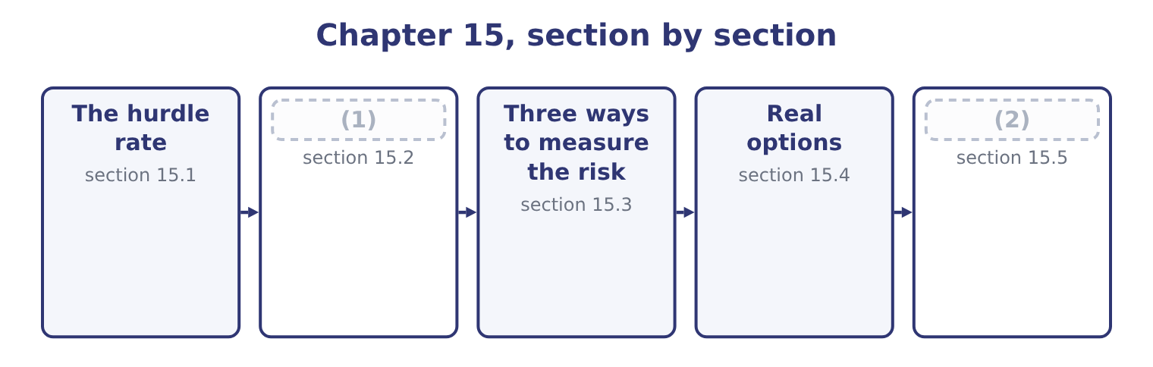
word list
risk-adjusted discount rate · Qualitative factors and the postaudit · Approaches to risk

Summary 1 gaps 3–14
A hurdle rate is the (3) return a project must earn to be (4) . It is the rate used to (5) the cash flows, and a project whose net present value is (6) at that rate has cleared it. For a project of (7) risk, the hurdle is the company's (8) average cost of capital, which Book 2 built from the required returns of every provider of money. (9) is 9.04 per cent. Earning less than that leaves the (10) worse off, which is the (11) profit of Book 1 stated as a rate. Three (12) are made in (13) , and the exam asks about each. A risk adjustment, where the (14) risk differs from the company's. A premium for rationing. Where a company has more good projects than money, raising the hurdle above the cost of capital is a crude way of selecting among them. It is crude because it confuses the cost of money with its scarcity, and the better method is to rank by value created for each dollar invested.
word list
project's · ordinary · adjustments · practice · hopeful · discount · minimum · weighted · positive · providers · accepted · Orontes's · economic

Summary 2 gaps 15–26
A margin for (15) . Many companies set a hurdle above their cost of capital because project (16) ' forecasts are (17) hopeful. It is a (18) response to a real (19) and it has a cost: a hurdle set far above the cost of capital (20) projects that would (21) value, and the honest remedy is to (22) the forecasts rather than the rate. The risk-adjusted rate works as a premium added to the cost of capital, or as a rate (23) directly from the risk of the (24) using the capital asset pricing model of Book 2's. At the company's rate. At 9 per cent the five-year (25) factor is 3.8897 and the five-year (26) factor 0.6499, so the value is 1,050,000 × 3.8897 = 4,084,185 plus 550,000 × 0.6499 = 357,445, which is 4,084,185 + 357,445 = 4,441,630, giving a net present value of 4,441,630 − 3,400,000 = 1,041,630.
word list
present-value · rejects · annuity · create · problem · sponsors · activity · optimism · provider · correct · reasonable · systematically · estimated

Summary 3 gaps 27–38
At a risk-adjusted rate. (27) the line serves a new (28) market and the board adds three points, so the hurdle (29) 9.04 + 3.00 = 12.04 per cent, which at 12 per cent (30) of 3.6048 and 0.5674 gives 1,050,000 × 3.6048 = 3,785,040 plus 550,000 × 0.5674 = 312,070, which is 3,785,040 + 312,070 = 4,097,110 and a net present value of 4,097,110 − 3,400,000 = 697,110. Three points of hurdle rate (31) 1,041,630 − 697,110 = 344,520 of value, a third of it, from a project whose cash flows did not change at all. The project still clears the higher hurdle, so the adjustment did not change the (32) here — but it would have, had the margin been (33) , and a company that adds a premium (34) a reason is (35) value for a feeling. The reason must be stated: this project is (36) than the company's (37) business because it sells into a market Orontes does not know, and the premium is the price of that (38) .
word list
unfamiliarity · riskier · without · removed · rejecting · Orontes's · factors · decision · existing · becomes · export · Suppose · thinner

The English this section uses, and its Arabic
Each term sits against what it means.
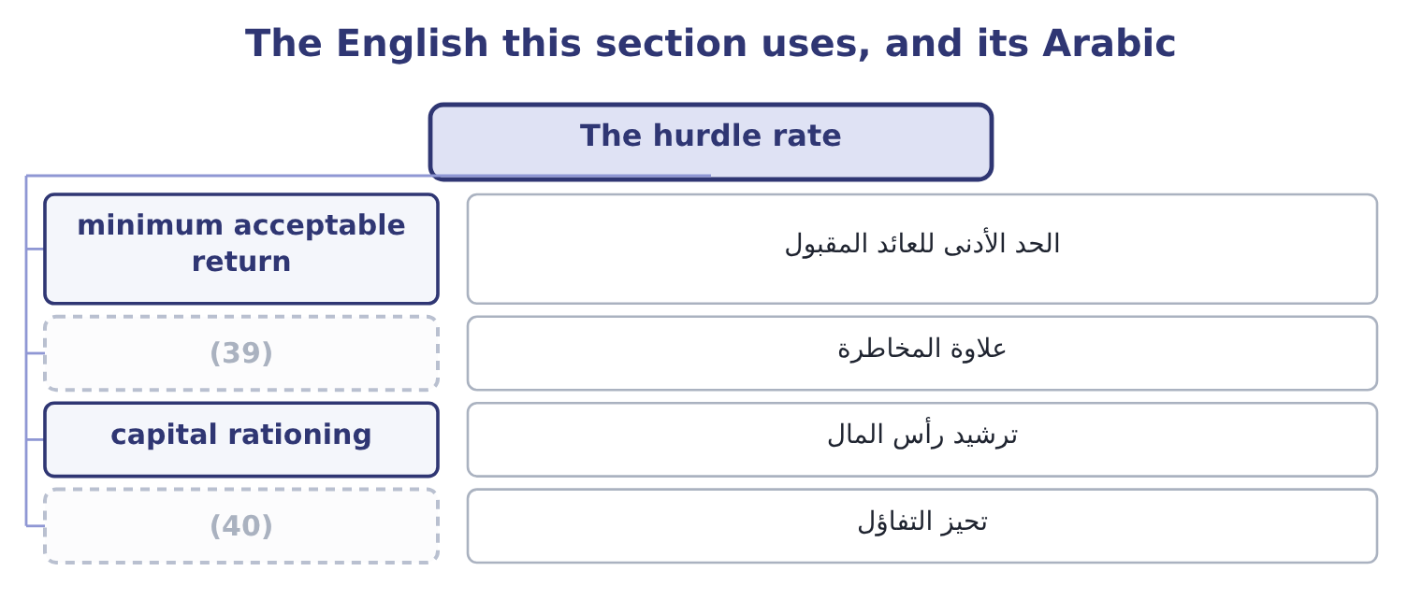
word list
optimism bias · risk premium · scenario analysis

The English this sheet uses, and its Arabic
English (exam term) | Arabic
minimum acceptable return | الحد الأدنى للعائد المقبول
risk premium | علاوة المخاطرة
capital rationing | ترشيد رأس المال
optimism bias | تحيز التفاؤل

Answer key · 15.1 The hurdle rate

1 Approaches to risk | 21 create
2 Qualitative factors and the postaudit | 22 correct
3 minimum | 23 estimated
4 accepted | 24 activity
5 discount | 25 annuity
6 positive | 26 present-value
7 ordinary | 27 Suppose
8 weighted | 28 export
9 Orontes's | 29 becomes
10 providers | 30 factors
11 economic | 31 removed
12 adjustments | 32 decision
13 practice | 33 thinner
14 project's | 34 without
15 optimism | 35 rejecting
16 sponsors | 36 riskier
17 systematically | 37 existing
18 reasonable | 38 unfamiliarity
19 problem | 39 risk premium
20 rejects | 40 optimism bias

the summaries in full
Summary 1 A hurdle rate is the minimum return a project must earn to be accepted. It is the rate used to discount the cash flows, and a project whose net present value is positive at that rate has cleared it. For a project of ordinary risk, the hurdle is the company's weighted average cost of capital, which Book 2 built from the required returns of every provider of money. Orontes's is 9.04 per cent. Earning less than that leaves the providers worse off, which is the economic profit of Book 1 stated as a rate. Three adjustments are made in practice, and the exam asks about each. A risk adjustment, where the project's risk differs from the company's. A premium for rationing. Where a company has more good projects than money, raising the hurdle above the cost of capital is a crude way of selecting among them. It is crude because it confuses the cost of money with its scarcity, and the better method is to rank by value created for each dollar invested.
Summary 2 A margin for optimism. Many companies set a hurdle above their cost of capital because project sponsors' forecasts are systematically hopeful. It is a reasonable response to a real problem and it has a cost: a hurdle set far above the cost of capital rejects projects that would create value, and the honest remedy is to correct the forecasts rather than the rate. The risk-adjusted rate works as a premium added to the cost of capital, or as a rate estimated directly from the risk of the activity using the capital asset pricing model of Book 2's. At the company's rate. At 9 per cent the five-year annuity factor is 3.8897 and the five-year present-value factor 0.6499, so the value is 1,050,000 × 3.8897 = 4,084,185 plus 550,000 × 0.6499 = 357,445, which is 4,084,185 + 357,445 = 4,441,630, giving a net present value of 4,441,630 − 3,400,000 = 1,041,630.
Summary 3 At a risk-adjusted rate. Suppose the line serves a new export market and the board adds three points, so the hurdle becomes 9.04 + 3.00 = 12.04 per cent, which at 12 per cent factors of 3.6048 and 0.5674 gives 1,050,000 × 3.6048 = 3,785,040 plus 550,000 × 0.5674 = 312,070, which is 3,785,040 + 312,070 = 4,097,110 and a net present value of 4,097,110 − 3,400,000 = 697,110. Three points of hurdle rate removed 1,041,630 − 697,110 = 344,520 of value, a third of it, from a project whose cash flows did not change at all. The project still clears the higher hurdle, so the adjustment did not change the decision here — but it would have, had the margin been thinner, and a company that adds a premium without a reason is rejecting value for a feeling. The reason must be stated: this project is riskier than the company's existing business because it sells into a market Orontes does not know, and the premium is the price of that unfamiliarity.

15.2 Approaches to risk
Chapter 15 · section 15.2

Fill every gap. Each word list holds one word more than there are gaps.
Summary 1 gaps 1–12
The outcome asks for (1) approaches, and there are five in (2) use. Raise the discount rate. The risk-adjusted rate of section 15.1. Simple, widely used, and blunt: it assumes risk grows (3) with time, because a higher rate (4) distant flows most, which is true of some risks and not of others. (5) each uncertain cash flow with the certain amount the company would accept instead, then discount at the (6) rate. A flow of $1,050,000 might be (7) as worth 1,050,000 × 0.85 = 892,500 for certain. The method is (8) cleaner than a risk-adjusted rate, because it separates the risk adjustment from the time adjustment, and it is harder to use because somebody must state the (9) . Shorten the (10) payback. Requiring a project to repay (11) three years rather than five is a crude way of (12) that the uncertain distant years do not carry the case.
word list
conceptually · equivalents · separates · steadily · alternative · Replace · required · penalises · common · insisting · risk-free · within · treated

Summary 2 gaps 13–21
Analyse the risk (13) , with the techniques of section 15.3, and (14) the range rather than a single figure. (15) the risk itself. Stage the (16) so that it can be stopped, (17) it in one region, contract a price in advance as Book 2's, insure what can be insured, or share it with a partner. That last approach is the one most often (18) in an exam answer and the most (19) in practice. The purpose of (20) risk is to manage it, and a project that can be stopped after a year is a (21) project from one that cannot.
word list
omitted · separates · valuable · analysing · different · Reduce · pilot · investment · present · explicitly

Five ways to deal with risk
Approach | What it does | Strength | Weakness
Risk-adjusted rate | (22) | Simple; widely understood | Assumes risk rises with time
Certainty equivalent | (23) | Separates risk from time | Requires explicit judgments
Shorter payback | (24) | Easy to apply | Rejects good long projects
Explicit analysis | Shows the range of outcomes | Informative | (25)
Risk reduction | Changes the project | Acts on the cause | (26)

word list
Acts on the cause · Ignores distant, uncertain years · Costs money or forgoes return · Does not decide anything by itself · Replaces flows with certain amounts · Discounts risky flows more heavily

The English this section uses, and its Arabic
Each term sits against what it means.
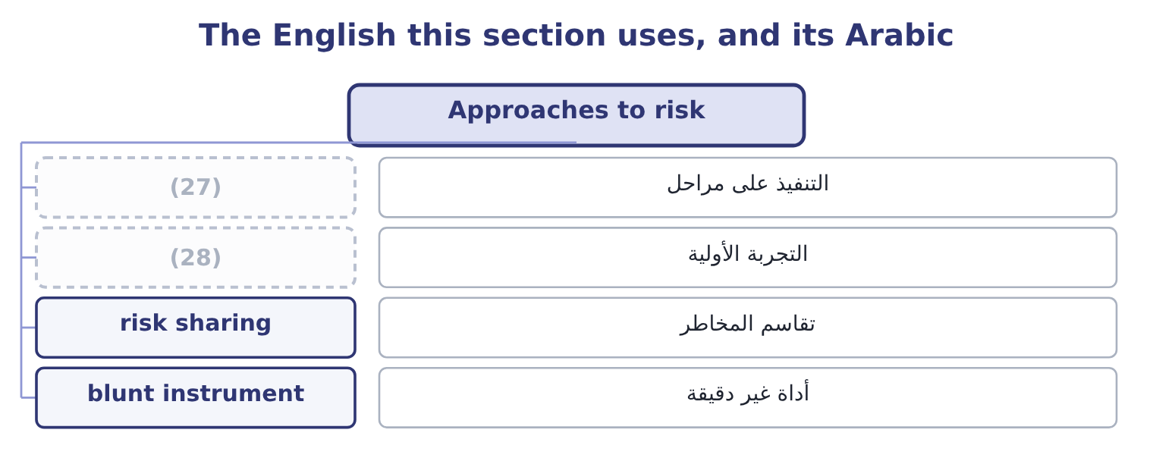
word list
pilot · staging · drift

The English this sheet uses, and its Arabic
English (exam term) | Arabic
staging | التنفيذ على مراحل
pilot | التجربة الأولية
risk sharing | تقاسم المخاطر
blunt instrument | أداة غير دقيقة

Answer key · 15.2 Approaches to risk

1 alternative | 15 Reduce
2 common | 16 investment
3 steadily | 17 pilot
4 penalises | 18 omitted
5 Replace | 19 valuable
6 risk-free | 20 analysing
7 treated | 21 different
8 conceptually | 22 Discounts risky flows more heavily
9 equivalents | 23 Replaces flows with certain amounts
10 required | 24 Ignores distant, uncertain years
11 within | 25 Does not decide anything by itself
12 insisting | 26 Costs money or forgoes return
13 explicitly | 27 staging
14 present | 28 pilot

the summaries in full
Summary 1 The outcome asks for alternative approaches, and there are five in common use. Raise the discount rate. The risk-adjusted rate of section 15.1. Simple, widely used, and blunt: it assumes risk grows steadily with time, because a higher rate penalises distant flows most, which is true of some risks and not of others. Replace each uncertain cash flow with the certain amount the company would accept instead, then discount at the risk-free rate. A flow of $1,050,000 might be treated as worth 1,050,000 × 0.85 = 892,500 for certain. The method is conceptually cleaner than a risk-adjusted rate, because it separates the risk adjustment from the time adjustment, and it is harder to use because somebody must state the equivalents. Shorten the required payback. Requiring a project to repay within three years rather than five is a crude way of insisting that the uncertain distant years do not carry the case.
Summary 2 Analyse the risk explicitly, with the techniques of section 15.3, and present the range rather than a single figure. Reduce the risk itself. Stage the investment so that it can be stopped, pilot it in one region, contract a price in advance as Book 2's, insure what can be insured, or share it with a partner. That last approach is the one most often omitted in an exam answer and the most valuable in practice. The purpose of analysing risk is to manage it, and a project that can be stopped after a year is a different project from one that cannot.

15.3 Three ways to measure the risk
Chapter 15 · section 15.3

Fill every gap. Each word list holds one word more than there are gaps.
Summary 1 gaps 1–12
The (1) names three (2) and asks for them to be (3) . Sensitivity analysis changes one input at a time and (4) the effect on the net present value. Its (5) is a ranking of the inputs by (6) , and the most useful form states, for each input, the value at which the net present value falls to zero. For the (7) line, the present value of the (8) flow at 9 per cent is 550,000 × 0.6499 = 357,445, so the annual flows must cover 3,400,000 − 357,445 = 3,042,555, which over an annuity factor of 3.8897 is 3,042,555 ÷ 3.8897 = 782,208 a year. The project (9) survives a fall in its annual cash flow from $1,050,000 to $782,208 — a (10) of 267,792 ÷ 1,050,000 = 25.50 per cent. That single (11) is worth more to a board than any number of (12) tables.
word list
discounted · margin · techniques · sentence · terminal · roasting · specified · records · outcome · output · therefore · influence · distinguished

Summary 2 gaps 13–23
Scenario analysis changes several inputs together in a coherent story — a bad case in which (13) , price and input costs all move the wrong way at once. It (14) the correlations that (15) analysis cannot, and it produces a (16) of outcomes rather than a ranking. Monte Carlo simulation (17) a probability distribution to each (18) input, draws thousands of (19) at random, and produces a distribution of net present values. Its (20) are the mean, the spread, and the probability that the project (21) value — which is the (22) a board actually asks. Its (23) are that it needs distributions nobody can observe, that correlations between inputs must be specified and are usually guessed, and that the apparent precision of a computed probability flatters the underlying estimates.
word list
captures · volume · destroys · handful · somebody · question · weaknesses · one-at-a-time · outputs · combinations · assigns · uncertain

Three risk techniques
Technique | Changes | Produces | Best for
Sensitivity | One input at a time | A ranking, and break-even values | (24)
Scenario | Several inputs together | A few coherent outcomes | (25)
Simulation | All inputs, many times | (26) | Estimating the probability of loss

word list
risk-adjusted discount rate · Capturing correlated risks · A distribution of outcomes · Finding what the answer depends on

What each technique cannot do

Summary 3 gaps 27–31
Sensitivity analysis cannot (27) the fact that bad things arrive together. That is what (28) are for. A (29) distribution is only as good as the input distributions, and these are usually assumed rather than measured. None of the three makes the (30) . They describe the (31) ; somebody still has to judge whether the company can bear it.
word list
capture · simulation's · scenarios · therefore · uncertainty · decision

The English this section uses, and its Arabic
Each term sits against what it means.
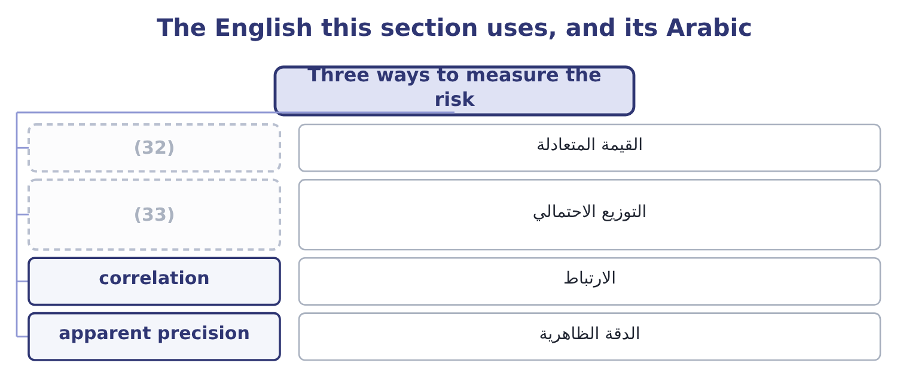
word list
probability distribution · real option · break-even value

The English this sheet uses, and its Arabic
English (exam term) | Arabic
break-even value | القيمة المتعادلة
probability distribution | التوزيع الاحتمالي
correlation | الارتباط
apparent precision | الدقة الظاهرية

Answer key · 15.3 Three ways to measure the risk

1 outcome | 18 uncertain
2 techniques | 19 combinations
3 distinguished | 20 outputs
4 records | 21 destroys
5 output | 22 question
6 influence | 23 weaknesses
7 roasting | 24 Finding what the answer depends on
8 terminal | 25 Capturing correlated risks
9 therefore | 26 A distribution of outcomes
10 margin | 27 capture
11 sentence | 28 scenarios
12 discounted | 29 simulation's
13 volume | 30 decision
14 captures | 31 uncertainty
15 one-at-a-time | 32 break-even value
16 handful | 33 probability distribution
17 assigns

the summaries in full
Summary 1 The outcome names three techniques and asks for them to be distinguished. Sensitivity analysis changes one input at a time and records the effect on the net present value. Its output is a ranking of the inputs by influence, and the most useful form states, for each input, the value at which the net present value falls to zero. For the roasting line, the present value of the terminal flow at 9 per cent is 550,000 × 0.6499 = 357,445, so the annual flows must cover 3,400,000 − 357,445 = 3,042,555, which over an annuity factor of 3.8897 is 3,042,555 ÷ 3.8897 = 782,208 a year. The project therefore survives a fall in its annual cash flow from $1,050,000 to $782,208 — a margin of 267,792 ÷ 1,050,000 = 25.50 per cent. That single sentence is worth more to a board than any number of discounted tables.
Summary 2 Scenario analysis changes several inputs together in a coherent story — a bad case in which volume, price and input costs all move the wrong way at once. It captures the correlations that one-at-a-time analysis cannot, and it produces a handful of outcomes rather than a ranking. Monte Carlo simulation assigns a probability distribution to each uncertain input, draws thousands of combinations at random, and produces a distribution of net present values. Its outputs are the mean, the spread, and the probability that the project destroys value — which is the question a board actually asks. Its weaknesses are that it needs distributions nobody can observe, that correlations between inputs must be specified and are usually guessed, and that the apparent precision of a computed probability flatters the underlying estimates.
Summary 3 Sensitivity analysis cannot capture the fact that bad things arrive together. That is what scenarios are for. A simulation's distribution is only as good as the input distributions, and these are usually assumed rather than measured. None of the three makes the decision. They describe the uncertainty; somebody still has to judge whether the company can bear it.

15.4 Real options
Chapter 15 · section 15.4

Fill every gap. Each word list holds one word more than there are gaps.
Summary 1 gaps 1–12
A discounted cash flow (1) values a project as though it were a (2) made once and then endured. Real (3) are not like that: managers can wait, expand, contract or stop, and each of those (4) is worth something. They are (5) real options because they have the (6) of the financial options of Book 2's. The (7) names four. The option to delay. Waiting for information — a (8) decision, a (9) move, a harvest, a price. A project that can be (10) next year as easily as this one (11) the value of what will be learned in between. The cost of delay is the cash flow (12) and the risk that a competitor moves first. The option to expand. A project that creates the ability to do more if things go well — a plant built with foundations for a second line, a product launched in one city that could be rolled out to twenty.
word list
competitor's · called · planning · structure · forgone · abilities · projects · consequences · started · commitment · analysis · carries · outcome

Summary 2 gaps 13–24
Much of the value of a small first project is the large second one it makes (13) , and a discounted cash flow of the first alone will (14) it. The option to abandon. The ability to stop and recover something — selling the equipment, (15) the building, (16) the contract. It puts a floor under the (17) , and it is worth most where the assets are general-purpose and can be sold, and least where they are (18) and cannot. The option to scale back. (19) at reduced volume rather than closing, mothballing a line, (20) a plant to another product. It is the (21) version of (22) . Two (23) the exam asks for. (24) these options raises a project's value, because each is a right and not an obligation: it will be exercised only when it pays. So a valuation that ignores them understates the project, and the understatement is largest where uncertainty is greatest — the opposite of the intuition that uncertainty always reduces value. And they should be designed.
word list
reject · downside · Considering · consequences · abandonment · cancelling · analysis · specialised · partial · subletting · Running · switching · possible

Summary 3 gaps 25–29
A plant that can be (25) , a lease that can be broken, a contract staged in phases, a supplier (26) with an option to increase volume: each costs something at the outset and is worth more than it costs where the future is (27) uncertain. That is the (28) use of the idea, and no (29) is required to act on it.
word list
genuinely · practical · arrangement · calculation · project's · converted

Four real options
Option | The right to | Worth most when | Example
Delay | Start later, with more information | Information arrives soon and the position can be held | (30)
Expand | Do more if it goes well | The upside is large and the first step is small | (31)
Abandon | Stop and recover value | (32) | Equipment with a resale market
Scale back | (33) | Demand is volatile and costs are partly variable | Mothballing one shift

word list
Run smaller rather than stop · Equipment with a resale market · Waiting for a harvest or a ruling · Foundations laid for a second line · Assets are general-purpose and resaleable

The English this section uses, and its Arabic
Each term sits against what it means.
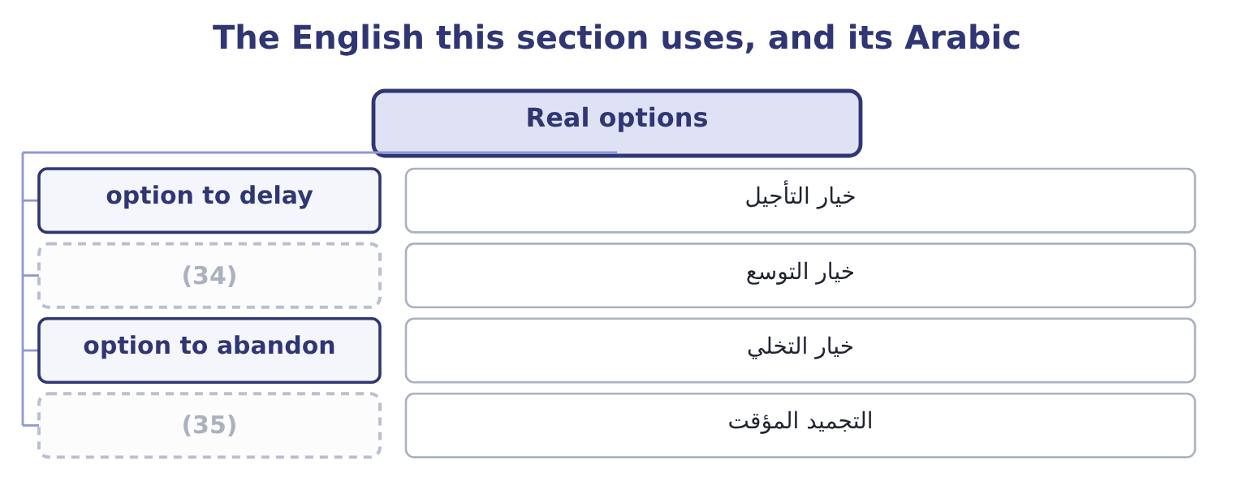
word list
apparent precision · mothballing · option to expand

The English this sheet uses, and its Arabic
English (exam term) | Arabic
option to delay | خيار التأجيل
option to expand | خيار التوسع
option to abandon | خيار التخلي
mothballing | التجميد المؤقت

Answer key · 15.4 Real options

1 analysis | 19 Running
2 commitment | 20 switching
3 projects | 21 partial
4 abilities | 22 abandonment
5 called | 23 consequences
6 structure | 24 Considering
7 outcome | 25 converted
8 planning | 26 arrangement
9 competitor's | 27 genuinely
10 started | 28 practical
11 carries | 29 calculation
12 forgone | 30 Waiting for a harvest or a ruling
13 possible | 31 Foundations laid for a second line
14 reject | 32 Assets are general-purpose and resaleable
15 subletting | 33 Run smaller rather than stop
16 cancelling | 34 option to expand
17 downside | 35 mothballing
18 specialised

the summaries in full
Summary 1 A discounted cash flow analysis values a project as though it were a commitment made once and then endured. Real projects are not like that: managers can wait, expand, contract or stop, and each of those abilities is worth something. They are called real options because they have the structure of the financial options of Book 2's. The outcome names four. The option to delay. Waiting for information — a planning decision, a competitor's move, a harvest, a price. A project that can be started next year as easily as this one carries the value of what will be learned in between. The cost of delay is the cash flow forgone and the risk that a competitor moves first. The option to expand. A project that creates the ability to do more if things go well — a plant built with foundations for a second line, a product launched in one city that could be rolled out to twenty.
Summary 2 Much of the value of a small first project is the large second one it makes possible, and a discounted cash flow of the first alone will reject it. The option to abandon. The ability to stop and recover something — selling the equipment, subletting the building, cancelling the contract. It puts a floor under the downside, and it is worth most where the assets are general-purpose and can be sold, and least where they are specialised and cannot. The option to scale back. Running at reduced volume rather than closing, mothballing a line, switching a plant to another product. It is the partial version of abandonment. Two consequences the exam asks for. Considering these options raises a project's value, because each is a right and not an obligation: it will be exercised only when it pays. So a valuation that ignores them understates the project, and the understatement is largest where uncertainty is greatest — the opposite of the intuition that uncertainty always reduces value. And they should be designed.
Summary 3 A plant that can be converted, a lease that can be broken, a contract staged in phases, a supplier arrangement with an option to increase volume: each costs something at the outset and is worth more than it costs where the future is genuinely uncertain. That is the practical use of the idea, and no calculation is required to act on it.

15.5 Qualitative factors and the postaudit
Chapter 15 · section 15.5

Fill every gap. Each word list holds one word more than there are gaps.
Summary 1 gaps 1–12
Two (1) close the chapter, and both (2) what the numbers do not contain. The qualitative (3) are the ones a net present value cannot carry, and the exam (4) them named. Does the project take the company where it intends to go, or is it a profitable (5) ? A positive net present value in a business the company does not (6) is. (7) , retraining, (8) , the loss of skills that will be needed again. A project that changes service levels, lead times or (9) affects relationships that no cash flow line (10) . Regulatory, (11) and safety (12) , some of which are not optional at any return. Reversibility, which section 15.4 priced as the option to abandon. Reputation, which is slow to build and quick to lose. And the quality of the estimates themselves: a project proposed by a sponsor whose last three forecasts were wrong is a different proposition from the same figures proposed by somebody whose were right.
word list
morale · concern · distraction · outcomes · expects · captures · specifications · Redundancies · environmental · promised · understand · considerations · consequences

Summary 2 gaps 13–24
The postaudit is the stage that makes all of this (13) next time. It is a review, usually a year or two after (14) , comparing the (15) actual cash flows, costs and timing with those (16) in the proposal. Its (17) are four, and the exam asks for them. To improve future estimates. Systematic optimism is only visible in a series of (18) , and once visible it can be (19) at the source rather than by raising the hurdle rate. To hold sponsors (20) . A proposal (21) by somebody who knows it will be audited is a more careful proposal, and that effect (22) before any audit is done. To decide what to do now. A project running badly may be expanded, scaled back or abandoned — the real options of section 15.4, exercised — and the postaudit is when that choice is made (23) rather than by (24) .
word list
project's · purposes · completion · operates · written · postaudits · promised · better · audited · deliberately · accountable · drift · corrected

Summary 3 gaps 25–31
To improve the (25) . (26) errors in a particular kind of project, or a particular (27) , point to something fixable. Three (28) belong with it. The audit should compare like with like, (29) for things outside the (30) control. It should not become a search for blame, or proposals will become defensive and (31) . And the sunk cost rule: what the project cost is history, and the only question it can answer about the future is what to do from here.
word list
conservative · adjusting · sponsor's · process · department · abandon · cautions · Recurring

Rate, risk and options

Your turn: rate and risk (complete the blanks)
Item | Data | Answer
Hurdle rate for a project of ordinary risk | Cost of capital 9.04 per cent | ________
Hurdle rate with a 3-point risk premium |  | ________
Certainty equivalent of a 900,000 flow | (32) | ________
Which technique gives the probability of a negative net present value |  | ________
Which real option a general-purpose, resaleable asset creates |  | ________
The main purpose of a postaudit |  | ________

word list
hurdle rate · Factor 0.80

"Hurdle"

Summary 4 gaps 33–40
English hurdle rate takes its image from an (33) race: a barrier the project must clear. The (34) is apt in one way and misleading in (35) . It is apt because (36) it is pass or fail. It is misleading because a hurdle in a race is the same (37) for every runner, and a hurdle rate should not be: a (38) project should face a (39) one. Any of the three is clear; what (40) in an answer is to say which rate was used and why.
word list
clearing · riskier · athletics · height · metaphor · matters · concern · higher · another

"Hurdle"
Item | Answer
Hurdle rate for ordinary risk | (41)
Hurdle rate with a 3-point premium | 12.04 per cent: 9.04 + 3.00 = 12.04.
Certainty equivalent of a 900,000 flow | 720,000: 900,000 × 0.80 = 720,000, discounted at the risk-free rate.
Technique giving the probability of a negative net present value | Monte Carlo simulation.
Real option created by a general-purpose, resaleable asset | The option to abandon, and in part the option to scale back.
Main purpose of a postaudit | To improve future estimates by making systematic errors visible, and to decide what to do from here.
What it tells you | Three of the six answers are (42) and three are judgments, which is the balance of this topic: the arithmetic is small and the reason

word list
9.04 per cent, the weighted average cost of capital. · definitions · accountability

The English this section uses, and its Arabic
Each term sits against what it means.
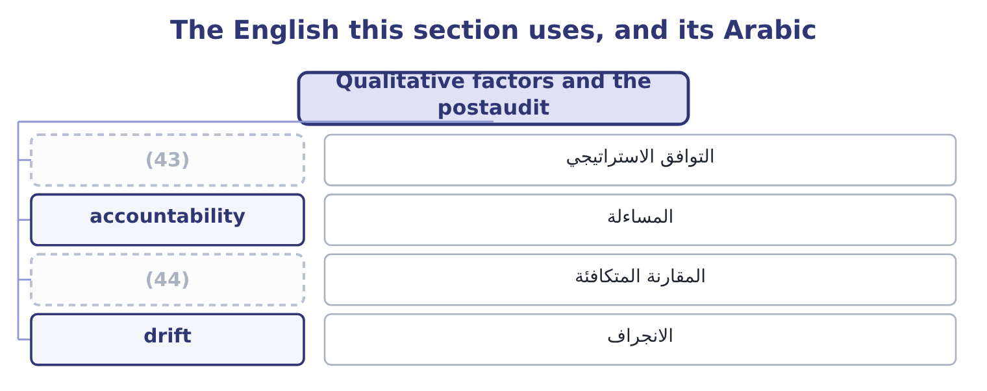
word list
optimism bias · like with like · strategic fit

The English this sheet uses, and its Arabic
English (exam term) | Arabic
strategic fit | التوافق الاستراتيجي
accountability | المساءلة
like with like | المقارنة المتكافئة
drift | الانجراف

Answer key · 15.5 Qualitative factors and the postaudit

1 outcomes | 23 deliberately
2 concern | 24 drift
3 considerations | 25 process
4 expects | 26 Recurring
5 distraction | 27 department
6 understand | 28 cautions
7 Redundancies | 29 adjusting
8 morale | 30 sponsor's
9 specifications | 31 conservative
10 captures | 32 Factor 0.80
11 environmental | 33 athletics
12 consequences | 34 metaphor
13 better | 35 another
14 completion | 36 clearing
15 project's | 37 height
16 promised | 38 riskier
17 purposes | 39 higher
18 postaudits | 40 matters
19 corrected | 41 9.04 per cent, the weighted average cost of capital.
20 accountable | 42 definitions
21 written | 43 strategic fit
22 operates | 44 like with like

the summaries in full
Summary 1 Two outcomes close the chapter, and both concern what the numbers do not contain. The qualitative considerations are the ones a net present value cannot carry, and the exam expects them named. Does the project take the company where it intends to go, or is it a profitable distraction? A positive net present value in a business the company does not understand is. Redundancies, retraining, morale, the loss of skills that will be needed again. A project that changes service levels, lead times or specifications affects relationships that no cash flow line captures. Regulatory, environmental and safety consequences, some of which are not optional at any return. Reversibility, which section 15.4 priced as the option to abandon. Reputation, which is slow to build and quick to lose. And the quality of the estimates themselves: a project proposed by a sponsor whose last three forecasts were wrong is a different proposition from the same figures proposed by somebody whose were right.
Summary 2 The postaudit is the stage that makes all of this better next time. It is a review, usually a year or two after completion, comparing the project's actual cash flows, costs and timing with those promised in the proposal. Its purposes are four, and the exam asks for them. To improve future estimates. Systematic optimism is only visible in a series of postaudits, and once visible it can be corrected at the source rather than by raising the hurdle rate. To hold sponsors accountable. A proposal written by somebody who knows it will be audited is a more careful proposal, and that effect operates before any audit is done. To decide what to do now. A project running badly may be expanded, scaled back or abandoned — the real options of section 15.4, exercised — and the postaudit is when that choice is made deliberately rather than by drift.
Summary 3 To improve the process. Recurring errors in a particular kind of project, or a particular department, point to something fixable. Three cautions belong with it. The audit should compare like with like, adjusting for things outside the sponsor's control. It should not become a search for blame, or proposals will become defensive and conservative. And the sunk cost rule: what the project cost is history, and the only question it can answer about the future is what to do from here.
Summary 4 English hurdle rate takes its image from an athletics race: a barrier the project must clear. The metaphor is apt in one way and misleading in another. It is apt because clearing it is pass or fail. It is misleading because a hurdle in a race is the same height for every runner, and a hurdle rate should not be: a riskier project should face a higher one. Any of the three is clear; what matters in an answer is to say which rate was used and why.

16.1 Net present value
Chapter 16 · section 16.1

Fill every gap. Each word list holds one word more than there are gaps.
Chapter 16, section by section
Each stage leads to the next.
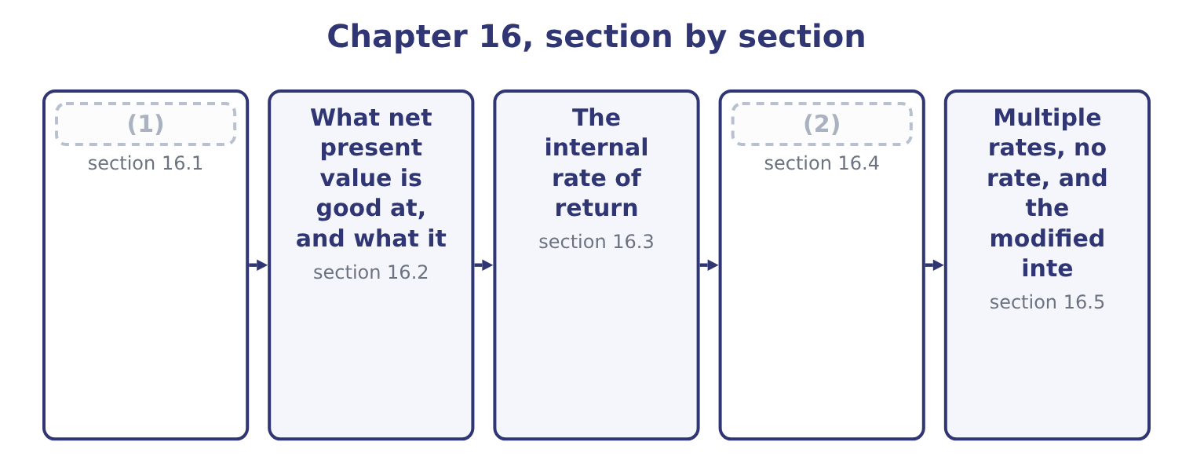
word list
Net present value · Where the two measures disagree · multiple internal rates of return

Summary 1 gaps 3–14
Net present value is the present value of a (3) cash inflows less the present value of its outflows, all discounted at the (4) rate. A positive figure means the project returns more than the money costs, so it creates value; a (5) figure means it (6) value; zero means it exactly earns its cost of capital, which is a pass rather than a failure. The (7) has four steps, and the exam tests each of them. Lay out the cash flows by year, using cash and not (8) profit. Find the (9) factor for each year. For a (10) amount in year n at rate r the factor is 1 ÷ (1 + r) to the power n. For a level amount in every year from 1 to n, the annuity factor is the sum of those (11) , and using it saves four (12) . (13) the initial (14) , which needs no discounting because it happens now.
word list
project's · multiplications · accounting · discount · investment · computation · Subtract · destroys · between · negative · hurdle · single · factors

Worked example: the roasting line at 9 per cent

Summary 2 gaps 15–26
Years 1 to 5: +1,050,000. Year 5 also: +550,000, being 400,000 of (15) working capital and 150,000 of (16) salvage. At 9 per cent the (17) annuity factor is 3.8897 and the year-5 (18) factor is 0.6499. The level flows are worth 1,050,000 × 3.8897 = 4,084,185. The (19) amount is worth 550,000 × 0.6499 = 357,445. (20) 4,084,185 + 357,445 = 4,441,630. Read the result as a sentence: building this line makes Orontes about 1,041,630 better off today than not building it, after paying the providers of the money (21) they require. That is the (22) profit of Book 1 and the market value added of Book 2, computed in advance instead of after the fact. Three (23) of the figure are worth having. The net present value of two projects is the sum of their (24) figures, which no rate-based measure can claim. That is why net present values can be (25) into a capital budget and compared with the company's market value. It is stated in money, so it (26) size.
word list
released · economic · five-year · reflects · individual · after-tax · terminal · aggregated · Together · single-amount · outflows · everything · readings

Summary 3 gaps 27–31
A project earning 40 per cent on 100,000 creates less value than one earning 12 per cent on 10,000,000, and only a money measure says so. It is the (27) ' gain. In the (28) of Book 2, (29) a project with a positive net present value (30) raise the company's market value by about that amount, which is the link between capital (31) and the share price.
word list
should · announcing · interpolation · shareholders · theory · budgeting

The roasting line discounted at 9 per cent
The bars are drawn to scale.
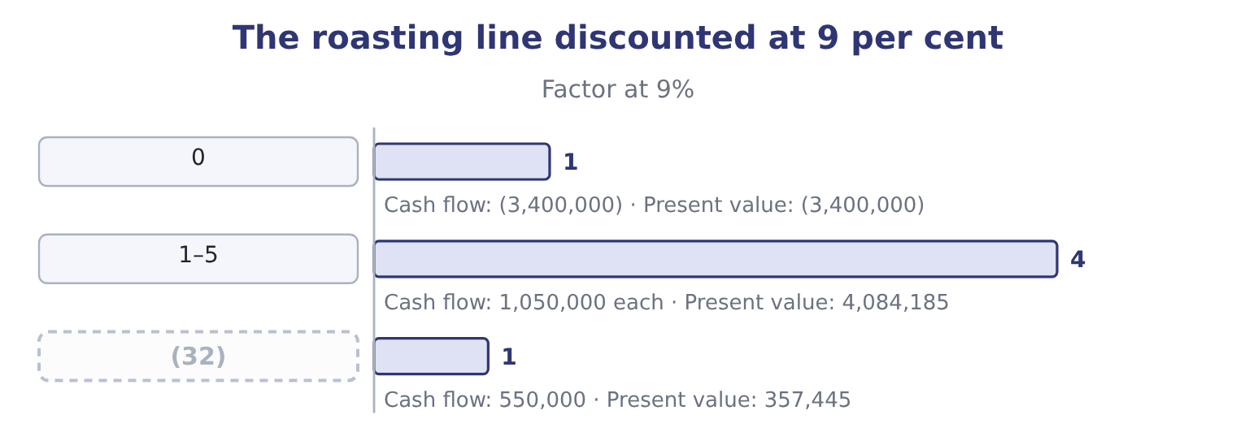
word list
discount factor · 5 (terminal)

The English this section uses, and its Arabic
Each term sits against what it means.
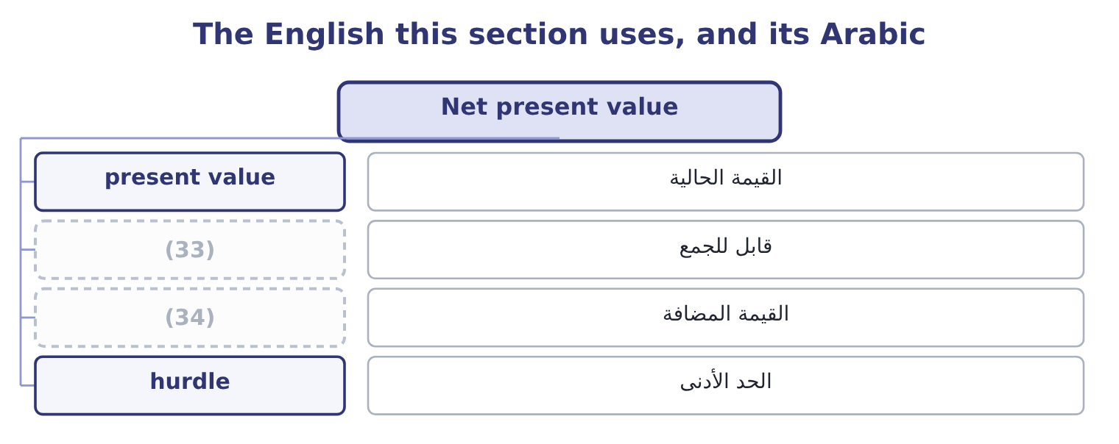
word list
interpolation · additive · value created

The English this sheet uses, and its Arabic
English (exam term) | Arabic
present value | القيمة الحالية
additive | قابل للجمع
value created | القيمة المضافة
hurdle | الحد الأدنى

Answer key · 16.1 Net present value

1 Net present value | 18 single-amount
2 Where the two measures disagree | 19 terminal
3 project's | 20 Together
4 hurdle | 21 everything
5 negative | 22 economic
6 destroys | 23 readings
7 computation | 24 individual
8 accounting | 25 aggregated
9 discount | 26 reflects
10 single | 27 shareholders
11 factors | 28 theory
12 multiplications | 29 announcing
13 Subtract | 30 should
14 investment | 31 budgeting
15 released | 32 5 (terminal)
16 after-tax | 33 additive
17 five-year | 34 value created

the summaries in full
Summary 1 Net present value is the present value of a project's cash inflows less the present value of its outflows, all discounted at the hurdle rate. A positive figure means the project returns more than the money costs, so it creates value; a negative figure means it destroys value; zero means it exactly earns its cost of capital, which is a pass rather than a failure. The computation has four steps, and the exam tests each of them. Lay out the cash flows by year, using cash and not accounting profit. Find the discount factor for each year. For a single amount in year n at rate r the factor is 1 ÷ (1 + r) to the power n. For a level amount in every year from 1 to n, the annuity factor is the sum of those factors, and using it saves four multiplications. Subtract the initial investment, which needs no discounting because it happens now.
Summary 2 Years 1 to 5: +1,050,000. Year 5 also: +550,000, being 400,000 of released working capital and 150,000 of after-tax salvage. At 9 per cent the five-year annuity factor is 3.8897 and the year-5 single-amount factor is 0.6499. The level flows are worth 1,050,000 × 3.8897 = 4,084,185. The terminal amount is worth 550,000 × 0.6499 = 357,445. Together 4,084,185 + 357,445 = 4,441,630. Read the result as a sentence: building this line makes Orontes about 1,041,630 better off today than not building it, after paying the providers of the money everything they require. That is the economic profit of Book 1 and the market value added of Book 2, computed in advance instead of after the fact. Three readings of the figure are worth having. The net present value of two projects is the sum of their individual figures, which no rate-based measure can claim. That is why net present values can be aggregated into a capital budget and compared with the company's market value. It is stated in money, so it reflects size.
Summary 3 A project earning 40 per cent on 100,000 creates less value than one earning 12 per cent on 10,000,000, and only a money measure says so. It is the shareholders' gain. In the theory of Book 2, announcing a project with a positive net present value should raise the company's market value by about that amount, which is the link between capital budgeting and the share price.

16.2 What net present value is good at, and what it is not
Chapter 16 · section 16.2

Fill every gap. Each word list holds one word more than there are gaps.
Summary 1 gaps 1–12
The outcome asks for (1) and limitations, and both lists are short (2) to learn. It uses all the cash flows, (3) those beyond any payback period. It (4) them, so timing is handled (5) . It uses the cost of capital, so the (6) return is explicit and can be (7) for risk. It (8) in money, so size matters. And it (9) directly to value created for the providers of capital, which makes it the measure most (10) with the objective Book 2 set out. Its limitations, and these are the ones (11) forget. It depends (12) on the forecasts. A net present value computed to the nearest dollar from volumes guessed to the nearest hundred thousand jars has a precision it has not earned, which is why. It depends on the rate, and the rate is an estimate.
word list
including · required · discounts · candidates · adjusted · corresponds · enough · measures · entirely · matters · consistent · properly · advantages

Summary 2 gaps 13–23
Three points of (13) rate removed a third of the (14) line's value. It is hard to (15) to people who do not work with (16) . A rate or a payback period (17) immediately; a net present value usually needs a (18) . It gives no sense of (19) relative to the (20) . A net present value of 1,041,630 is (21) on 3,400,000 and (22) on 340,000,000. It assumes the money is (23) . Where capital is rationed, the highest net present value is not necessarily the right choice, which again is. And it says nothing about the pattern of the flows, so it cannot distinguish a project that recovers its money quickly from one that does not — a difference that matters when a company's survival depends on liquidity, as Book 1's.
word list
investment · available · roasting · explain · consistent · hurdle · trivial · communicates · scale · discounting · excellent · paragraph

The precision illusion

Summary 3 gaps 24–30
A question that gives a net present value to the dollar and asks (24) to accept is testing (25) . A question that gives one and asks what else you would want to know is testing (26) , and the answer is always some (27) : the reliability of the volume and price forecasts, the basis of the (28) rate, what (29) if the key (30) is wrong, and what the project commits the company to that cannot be undone.
word list
discount · assumption · judgment · nothing · happens · combination · arithmetic · whether

The English this section uses, and its Arabic
Each term sits against what it means.
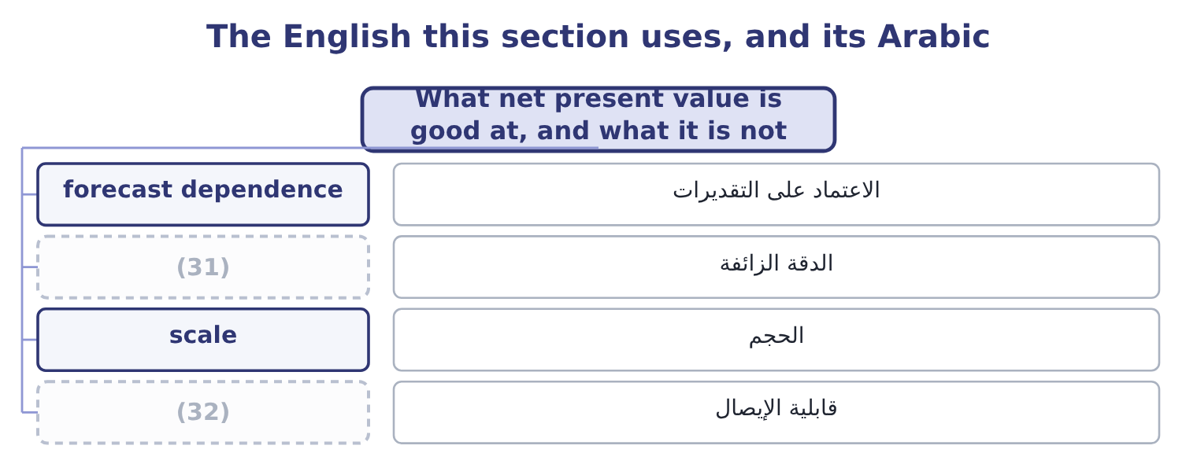
word list
decommissioning · false precision · communicability

The English this sheet uses, and its Arabic
English (exam term) | Arabic
forecast dependence | الاعتماد على التقديرات
false precision | الدقة الزائفة
scale | الحجم
communicability | قابلية الإيصال

Answer key · 16.2 What net present value is good at, and what it is not

1 advantages | 17 communicates
2 enough | 18 paragraph
3 including | 19 scale
4 discounts | 20 investment
5 properly | 21 excellent
6 required | 22 trivial
7 adjusted | 23 available
8 measures | 24 whether
9 corresponds | 25 arithmetic
10 consistent | 26 judgment
11 candidates | 27 combination
12 entirely | 28 discount
13 hurdle | 29 happens
14 roasting | 30 assumption
15 explain | 31 false precision
16 discounting | 32 communicability

the summaries in full
Summary 1 The outcome asks for advantages and limitations, and both lists are short enough to learn. It uses all the cash flows, including those beyond any payback period. It discounts them, so timing is handled properly. It uses the cost of capital, so the required return is explicit and can be adjusted for risk. It measures in money, so size matters. And it corresponds directly to value created for the providers of capital, which makes it the measure most consistent with the objective Book 2 set out. Its limitations, and these are the ones candidates forget. It depends entirely on the forecasts. A net present value computed to the nearest dollar from volumes guessed to the nearest hundred thousand jars has a precision it has not earned, which is why. It depends on the rate, and the rate is an estimate.
Summary 2 Three points of hurdle rate removed a third of the roasting line's value. It is hard to explain to people who do not work with discounting. A rate or a payback period communicates immediately; a net present value usually needs a paragraph. It gives no sense of scale relative to the investment. A net present value of 1,041,630 is excellent on 3,400,000 and trivial on 340,000,000. It assumes the money is available. Where capital is rationed, the highest net present value is not necessarily the right choice, which again is. And it says nothing about the pattern of the flows, so it cannot distinguish a project that recovers its money quickly from one that does not — a difference that matters when a company's survival depends on liquidity, as Book 1's.
Summary 3 A question that gives a net present value to the dollar and asks whether to accept is testing arithmetic. A question that gives one and asks what else you would want to know is testing judgment, and the answer is always some combination: the reliability of the volume and price forecasts, the basis of the discount rate, what happens if the key assumption is wrong, and what the project commits the company to that cannot be undone.

16.3 The internal rate of return
Chapter 16 · section 16.3

Fill every gap. Each word list holds one word more than there are gaps.
Summary 1 gaps 1–12
The internal rate of return is the discount rate at which a project's net present value is (1) zero. It is the project's own return, (2) from its cash flows and nothing else, which is where the word internal comes: no (3) rate enters the (4) . The (5) rule is to accept where the internal rate of return (6) the hurdle rate. For a conventional project — one outflow (7) by inflows — that rule gives the same answer as net present value, because a positive net present value at the hurdle rate and an internal rate above it are two (8) of one fact. There is no (9) for it. It is found by trial, by interpolation between two trials, or by a (10) doing the same thing (11) . The exam (12) the interpolation.
word list
amounts · expects · computed · followed · spreadsheet · statements · quickly · external · exceeds · formula · decision · exactly · calculation

Summary 2 gaps 13–17
The (13) annuity factor is 3.0576 and the year-5 factor 0.4190, so the inflows are worth 1,050,000 × 3.0576 = 3,210,480 plus 550,000 × 0.4190 = 230,450, which is 3,210,480 + 230,450 = 3,440,930, (14) a net present value of 3,440,930 − 3,400,000 = 40,930. Still positive, so the true rate is (15) . The (16) are 2.9906 and 0.4019, so the inflows are worth 1,050,000 × 2.9906 = 3,140,130 plus 550,000 × 0.4019 = 221,045, which is 3,140,130 + 221,045 = 3,361,175, and the net present value is 3,400,000 − 3,361,175 = 38,825 (17) . The rate lies between the two. The total swing between the two trials is 40,930 + 38,825 = 79,755, and the positive part is 40,930 ÷ 79,755 = 0.513 of it, so the rate is 19 + 0.51 = 19.51 per cent.
word list
five-year · factors · higher · giving · negative · project's

Summary 3 gaps 18–29
Call it about 19.5 per cent (18) a hurdle of 9 per cent, which is (19) , and note that it is the same (20) the net present value reached. For a conventional project it always is. It is a rate, so it can be compared with the cost of capital, with other projects and with returns outside the business without any further work; it (21) to people who will not sit through a (22) explanation; it needs no discount rate as an input, which is useful where the cost of capital is disputed; and the gap between it and the hurdle rate is a visible margin of safety. Its (23) , and these are heavily (24) . The (25) implicitly assumes that every interim cash flow is (26) at the internal rate of return itself. For a project returning 19.5 per cent that assumes Orontes can keep finding 19.5 per cent uses for the money, which is a strong claim; net present value assumes (27) at the cost of capital, which is far more (28) because the company can always repay debt or return cash at that rate. It ignores (29) , being a rate.
word list
arithmetic · conclusion · returning · reinvestment · against · discounting · comfortable · defensible · limitations · examined · reinvested · communicates · scale

Summary 4 gaps 30–33
Section 16.4 shows what that does. It can have more than one value, or none at all, where the flows (30) sign more than once. Section 16.5 deals with. It cannot be (31) or added across projects, because rates on (32) amounts do not (33) .
word list
change · different · combine · against · averaged

The English this section uses, and its Arabic
Each term sits against what it means.
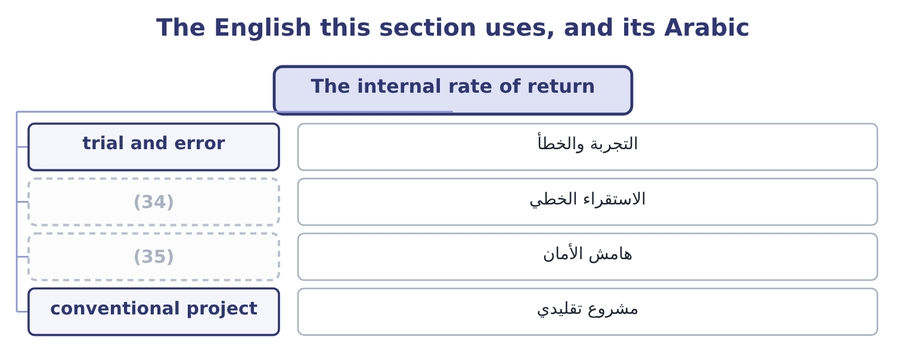
word list
interpolation · mutually exclusive projects · margin of safety

The English this sheet uses, and its Arabic
English (exam term) | Arabic
trial and error | التجربة والخطأ
interpolation | الاستقراء الخطي
margin of safety | هامش الأمان
conventional project | مشروع تقليدي

Answer key · 16.3 The internal rate of return

1 exactly | 19 comfortable
2 computed | 20 conclusion
3 external | 21 communicates
4 calculation | 22 discounting
5 decision | 23 limitations
6 exceeds | 24 examined
7 followed | 25 arithmetic
8 statements | 26 reinvested
9 formula | 27 reinvestment
10 spreadsheet | 28 defensible
11 quickly | 29 scale
12 expects | 30 change
13 five-year | 31 averaged
14 giving | 32 different
15 higher | 33 combine
16 factors | 34 interpolation
17 negative | 35 margin of safety
18 against

the summaries in full
Summary 1 The internal rate of return is the discount rate at which a project's net present value is exactly zero. It is the project's own return, computed from its cash flows and nothing else, which is where the word internal comes: no external rate enters the calculation. The decision rule is to accept where the internal rate of return exceeds the hurdle rate. For a conventional project — one outflow followed by inflows — that rule gives the same answer as net present value, because a positive net present value at the hurdle rate and an internal rate above it are two statements of one fact. There is no formula for it. It is found by trial, by interpolation between two trials, or by a spreadsheet doing the same thing quickly. The exam expects the interpolation.
Summary 2 The five-year annuity factor is 3.0576 and the year-5 factor 0.4190, so the inflows are worth 1,050,000 × 3.0576 = 3,210,480 plus 550,000 × 0.4190 = 230,450, which is 3,210,480 + 230,450 = 3,440,930, giving a net present value of 3,440,930 − 3,400,000 = 40,930. Still positive, so the true rate is higher. The factors are 2.9906 and 0.4019, so the inflows are worth 1,050,000 × 2.9906 = 3,140,130 plus 550,000 × 0.4019 = 221,045, which is 3,140,130 + 221,045 = 3,361,175, and the net present value is 3,400,000 − 3,361,175 = 38,825 negative. The rate lies between the two. The total swing between the two trials is 40,930 + 38,825 = 79,755, and the positive part is 40,930 ÷ 79,755 = 0.513 of it, so the rate is 19 + 0.51 = 19.51 per cent.
Summary 3 Call it about 19.5 per cent against a hurdle of 9 per cent, which is comfortable, and note that it is the same conclusion the net present value reached. For a conventional project it always is. It is a rate, so it can be compared with the cost of capital, with other projects and with returns outside the business without any further work; it communicates to people who will not sit through a discounting explanation; it needs no discount rate as an input, which is useful where the cost of capital is disputed; and the gap between it and the hurdle rate is a visible margin of safety. Its limitations, and these are heavily examined. The arithmetic implicitly assumes that every interim cash flow is reinvested at the internal rate of return itself. For a project returning 19.5 per cent that assumes Orontes can keep finding 19.5 per cent uses for the money, which is a strong claim; net present value assumes reinvestment at the cost of capital, which is far more defensible because the company can always repay debt or return cash at that rate. It ignores scale, being a rate.
Summary 4 Section 16.4 shows what that does. It can have more than one value, or none at all, where the flows change sign more than once. Section 16.5 deals with. It cannot be averaged or added across projects, because rates on different amounts do not combine.

16.4 Where the two measures disagree
Chapter 16 · section 16.4

Fill every gap. Each word list holds one word more than there are gaps.
Summary 1 gaps 1–11
For a single project (1) on its own, the two (2) never disagree about (3) . They disagree about ranking, and only where projects are mutually (4) — where taking one means not taking the other, because they use the same site, the same (5) , the same machine or the same scarce (6) . Three (7) , and the exam asks for them by name. A small project can have a very high rate and (8) little value. A project whose flows arrive early has a (9) internal rate of return than one of the same size whose flows arrive late, even where the late one creates more value in total. A short project and a long one of the same size rank (10) by rate and by value, for the same (11) .
word list
reason · licence · create · causes · acceptance · differently · exclusive · higher · measures · considered · company's · manager

Worked example: a high rate on a small project

Summary 2 gaps 12–17
Two projects, one site. Project S is a repacking (12) : 1,000,000 out now and 1,400,000 back in a year. Project L is the roasting line of section 16.1. Only one can (13) the free floor space. The money grows 1,400,000 ÷ 1,000,000 = 1.40 times in one year, so its internal rate of return is 40 per cent — more than twice the (14) 19.5 per cent. (15) at 9 per cent, 1,400,000 ÷ 1.09 = 1,284,404, so the net present value is 1,284,404 − 1,000,000 = 284,404. Project S: 40 per cent, 284,404 of value. Project L: 19.5 per cent, 1,041,630 of value. The rate prefers S and the value prefers L. Take L. Orontes is not trying to earn the (16) rate on the (17) sum; it is trying to be worth more.
word list
Discounting · line's · smallest · contract · occupy · highest · maximise

Summary 3 gaps 18–29
The (18) 1,041,630 − 284,404 = 757,226 is the cost of letting a (19) make the decision — and the honest way to see it is to ask what Orontes would do with the 2,400,000 it did not invest in Project S, which is to put it to work at the cost of capital, where by (20) it creates nothing. That last (21) is the whole (22) . A rate tells you how hard a (23) works; a value tells you how much money the project makes. When the two (24) , net present value is correct, because the (25) objective is to be worth more and not to maximise a ratio. Two (26) points the exam uses. (27) both projects' net present values against the (28) rate gives two curves that cross. Below the crossover rate one project is (29) ; above it the other is.
word list
supplementary · percentage · company's · dollar · argument · conflict · between · Plotting · discount · definition · missing · better · sentence

Summary 4 gaps 30–36
Where the hurdle rate sits on the wrong side of the crossover, the rate ranking (30) , which is exactly the (31) above. Where a rate answer is wanted anyway, (32) the internal rate of return on the (33) between the two projects — the extra 2,400,000 (34) and the extra flows it brings — and accept the larger project if that (35) rate beats the hurdle. It reaches the same (36) as net present value, with more work.
word list
compute · situation · invested · difference · conclusion · incremental · Discounting · misleads

Rate against value: the repacking contract and the roasting line
Measure | Project S (repacking) | Project L (roasting line) | Prefers
Investment | 1,000,000 | 3,400,000 | —
Internal rate of return | 40 per cent | (37) | S
Net present value at 9% | 284,404 | 1,041,630 | L
Correct choice |  | Take L | (38)

word list
19.5 per cent · Value, not rate · margin of safety

The English this section uses, and its Arabic
Each term sits against what it means.
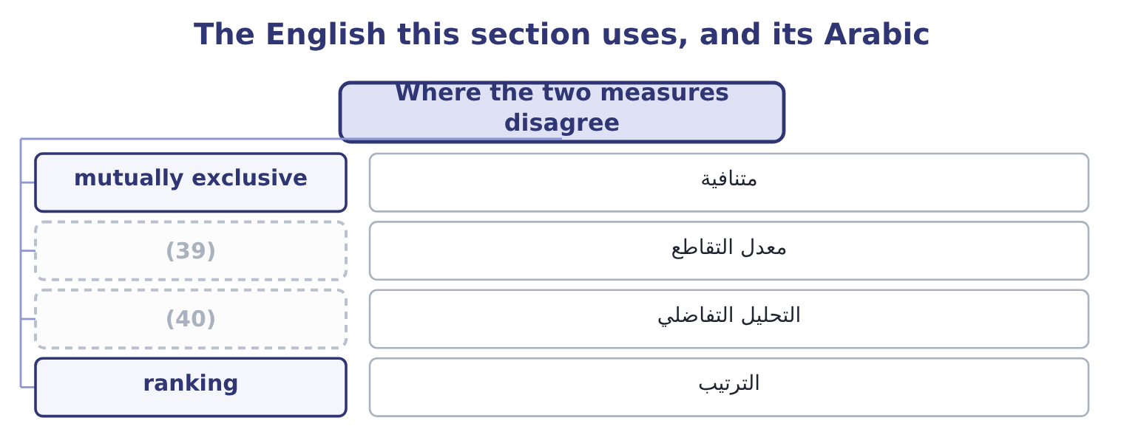
word list
incremental analysis · value created · crossover rate

The English this sheet uses, and its Arabic
English (exam term) | Arabic
mutually exclusive | متنافية
crossover rate | معدل التقاطع
incremental analysis | التحليل التفاضلي
ranking | الترتيب

Answer key · 16.4 Where the two measures disagree

1 considered | 21 sentence
2 measures | 22 argument
3 acceptance | 23 dollar
4 exclusive | 24 conflict
5 licence | 25 company's
6 manager | 26 supplementary
7 causes | 27 Plotting
8 create | 28 discount
9 higher | 29 better
10 differently | 30 misleads
11 reason | 31 situation
12 contract | 32 compute
13 occupy | 33 difference
14 line's | 34 invested
15 Discounting | 35 incremental
16 highest | 36 conclusion
17 smallest | 37 19.5 per cent
18 missing | 38 Value, not rate
19 percentage | 39 crossover rate
20 definition | 40 incremental analysis

the summaries in full
Summary 1 For a single project considered on its own, the two measures never disagree about acceptance. They disagree about ranking, and only where projects are mutually exclusive — where taking one means not taking the other, because they use the same site, the same licence, the same machine or the same scarce manager. Three causes, and the exam asks for them by name. A small project can have a very high rate and create little value. A project whose flows arrive early has a higher internal rate of return than one of the same size whose flows arrive late, even where the late one creates more value in total. A short project and a long one of the same size rank differently by rate and by value, for the same reason.
Summary 2 Two projects, one site. Project S is a repacking contract: 1,000,000 out now and 1,400,000 back in a year. Project L is the roasting line of section 16.1. Only one can occupy the free floor space. The money grows 1,400,000 ÷ 1,000,000 = 1.40 times in one year, so its internal rate of return is 40 per cent — more than twice the line's 19.5 per cent. Discounting at 9 per cent, 1,400,000 ÷ 1.09 = 1,284,404, so the net present value is 1,284,404 − 1,000,000 = 284,404. Project S: 40 per cent, 284,404 of value. Project L: 19.5 per cent, 1,041,630 of value. The rate prefers S and the value prefers L. Take L. Orontes is not trying to earn the highest rate on the smallest sum; it is trying to be worth more.
Summary 3 The missing 1,041,630 − 284,404 = 757,226 is the cost of letting a percentage make the decision — and the honest way to see it is to ask what Orontes would do with the 2,400,000 it did not invest in Project S, which is to put it to work at the cost of capital, where by definition it creates nothing. That last sentence is the whole argument. A rate tells you how hard a dollar works; a value tells you how much money the project makes. When the two conflict, net present value is correct, because the company's objective is to be worth more and not to maximise a ratio. Two supplementary points the exam uses. Plotting both projects' net present values against the discount rate gives two curves that cross. Below the crossover rate one project is better; above it the other is.
Summary 4 Where the hurdle rate sits on the wrong side of the crossover, the rate ranking misleads, which is exactly the situation above. Where a rate answer is wanted anyway, compute the internal rate of return on the difference between the two projects — the extra 2,400,000 invested and the extra flows it brings — and accept the larger project if that incremental rate beats the hurdle. It reaches the same conclusion as net present value, with more work.

16.5 Multiple rates, no rate, and the modified internal rate of return
Chapter 16 · section 16.5

Fill every gap. Each word list holds one word more than there are gaps.
Summary 1 gaps 1–12
A (1) project has one sign change — out, then in — and exactly one internal rate of return. Where the flows change sign more than once the (2) can have several roots, or none. Projects with more than one sign change are (3) : a mine or (4) that must be (5) at the end, a plant with a large (6) cost, a project needing a second (7) of capital in the middle, a (8) with a penalty on (9) . A (10) site costs 1,000,000 now, returns 2,600,000 at the end of year 1, and (11) 1,650,000 of restoration at the end of year 2. The inflow is worth 2,600,000 ÷ 1.1 = 2,363,636 and the restoration 1,650,000 ÷ 1.21 = 1,363,636, so the net of the two is 2,363,636 − 1,363,636 = 1,000,000, which exactly (12) the initial outlay.
word list
restored · sesame-hulling · decommissioning · offsets · injection · conventional · requires · quarry · common · equation · contract · completion · negative

Summary 2 gaps 13–19
The net present value is zero, so 10 per cent is an internal rate of return. Now the inflow is worth 2,600,000 ÷ 1.5 = 1,733,333 and the restoration 1,650,000 ÷ 2.25 = 733,333, so the net is 1,733,333 − 733,333 = 1,000,000 and the net present value is zero again. Fifty per cent is also an internal rate of return. Both are (13) correct and (14) is a return in any (15) sense. The (16) "is the internal rate of return above the 9 per cent hurdle?" has two (17) answers, so the measure has failed. Net present value has not failed. At 9 per cent the value is 2,600,000 ÷ 1.09 = 2,385,321 for the inflow and 1,650,000 ÷ 1.1881 = 1,388,772 for the restoration, so the project's value is 2,385,321 − 1,388,772 = 996,549 against an outlay of 1,000,000 — very (18) negative, and the decision is to reject, by the (19) of margins.
word list
narrowest · slightly · decision · contradictory · neither · useful · mathematically · question

Summary 3 gaps 20–27
One rate, one answer. The (20) case is rarer and also real: some flow (21) give no real (22) at all, so there is simply no internal rate of return to compute. The modified internal rate of return (23) the reinvestment problem and, incidentally, the (24) one. It works in three steps: compound every inflow forward to the end of the project at the cost of capital, (25) every outflow back to time zero at the same rate, and find the (26) rate that links the two. Because only one sign change (27) , there is exactly one answer.
word list
discount · no-rate · single · solution · multiple-rate · survives · Orontes · patterns · repairs

Worked example: the roasting line's modified rate

Summary 4 gaps 28–39
Compound the (28) at 9 per cent. The five annual flows of 1,050,000, (29) forward to the end of year 5, carry (30) of 1.41158, 1.29503, 1.18810, 1.09000 and 1.00000, which sum to 5.98471, so they are worth 1,050,000 × 5.98471 = 6,283,946 at the end. Add the (31) flow. It (32) falls at the end of year 5, so 6,283,946 + 550,000 = 6,833,946. The investment of 3,400,000 grows to 6,833,946 over five years, a (33) of 6,833,946 ÷ 3,400,000 = 2.010. Take the fifth root. The fifth root of 2.010 is 1.1499, so the modified internal rate of return is 15.0 per cent. (34) per cent against the (35) 19.5 per cent. The (36) is the whole of the reinvestment assumption: the plain internal rate of return credited the project with (37) its interim flows at 19.5 per cent, and the modified measure credits it only with 9 per cent, which is what Orontes can actually get. The project still (38) the hurdle, by a (39) and more honest margin.
word list
terminal · unmodified · Fifteen · clears · inflows · smaller · factors · problem · multiple · already · reinvesting · compounded · difference

The measures compared
Every item belongs to exactly one group.
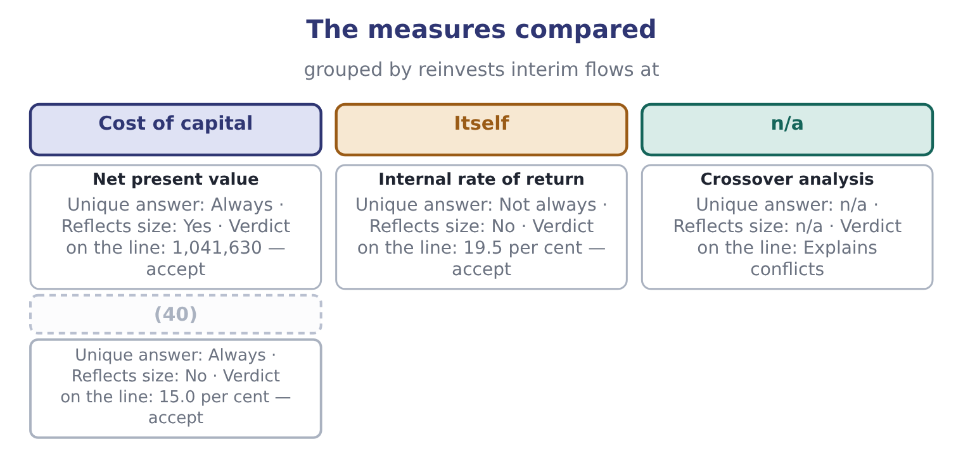
word list
Modified internal rate · net present value

Two measures, one project

Your turn: value and rate (complete the blanks)
Item | Data | Answer
Present value of five flows of 1,050,000 | (41) | ________
Present value of 550,000 in year 5 | (42) | ________
Net present value | Outlay 3,400,000 | ________
Decision on that basis |  | ________
Rate at which net present value is zero | Between 19 and 20 per cent | ________
Which measure wins a conflict between mutually exclusive projects |  | ________

word list
Factor 3.8897 · conventional project · Factor 0.6499

"Internal" and "net"

Summary 5 gaps 43–49
Internal in internal rate of return means computed from the project's own flows, with no (43) rate used — which is both its (44) and the source of every one of its (45) , because a measure that needs no cost of capital also (46) one. Net in net present value means after (47) the investment: the present value of what comes in, less the present value of what goes out. (48) who compute 4,441,630 and stop have found a present value and not a net present value, and the (49) word costs the mark.
word list
deducting · additive · ignores · external · faults · appeal · Candidates · missing

"Internal" and "net"
Item | Answer
Present value of five flows of 1,050,000 | 4,084,185: 1,050,000 × 3.8897 = 4,084,185.
Present value of 550,000 in year 5 | (50)
Net present value | 1,041,630: 4,441,630 − 3,400,000 = 1,041,630.
Decision on that basis | Accept: the value is positive, so the project returns more than the money costs.
Rate at which net present value is zero | About 19.5 per cent, by (51) between the two trials.
Which measure wins a conflict | Net present value, because the objective is value and not a ratio.
What it tells you | The two measures were computed from one set of flows and one rate. Everything else about them concerns what each one leaves out: (52) , timi

word list
scale · 357,445: 550,000 × 0.6499 = 357,445. · Reflects size · interpolation

The English this section uses, and its Arabic
Each term sits against what it means.
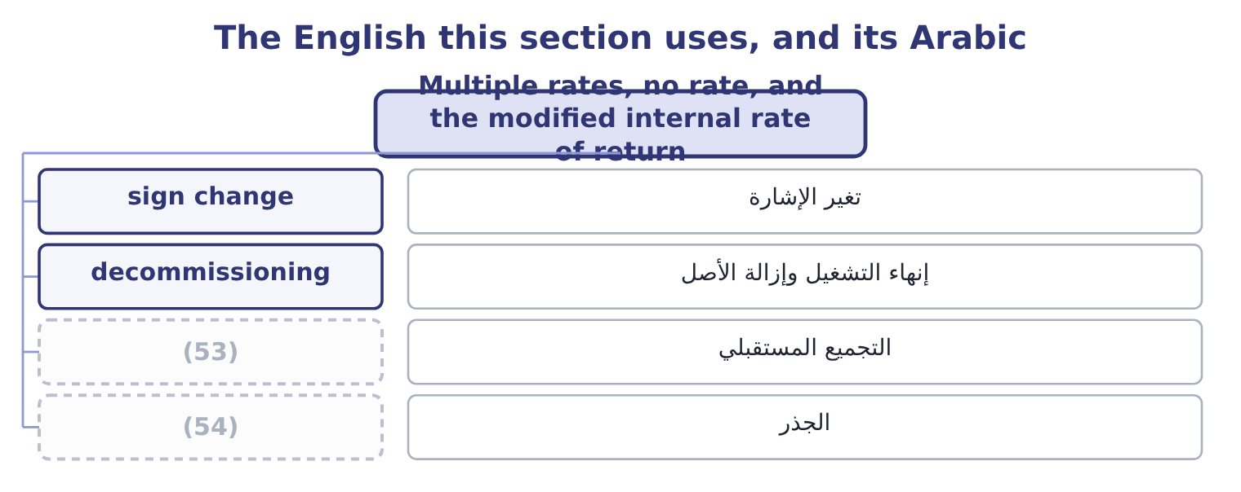
word list
compounding forward · hurdle · root

The English this sheet uses, and its Arabic
English (exam term) | Arabic
sign change | تغير الإشارة
decommissioning | إنهاء التشغيل وإزالة الأصل
compounding forward | التجميع المستقبلي
root | الجذر

Answer key · 16.5 Multiple rates, no rate, and the modified internal rate of return

1 conventional | 28 inflows
2 equation | 29 compounded
3 common | 30 factors
4 quarry | 31 terminal
5 restored | 32 already
6 decommissioning | 33 multiple
7 injection | 34 Fifteen
8 contract | 35 unmodified
9 completion | 36 difference
10 sesame-hulling | 37 reinvesting
11 requires | 38 clears
12 offsets | 39 smaller
13 mathematically | 40 Modified internal rate
14 neither | 41 Factor 3.8897
15 useful | 42 Factor 0.6499
16 question | 43 external
17 contradictory | 44 appeal
18 slightly | 45 faults
19 narrowest | 46 ignores
20 no-rate | 47 deducting
21 patterns | 48 Candidates
22 solution | 49 missing
23 repairs | 50 357,445: 550,000 × 0.6499 = 357,445.
24 multiple-rate | 51 interpolation
25 discount | 52 scale
26 single | 53 compounding forward
27 survives | 54 root

the summaries in full
Summary 1 A conventional project has one sign change — out, then in — and exactly one internal rate of return. Where the flows change sign more than once the equation can have several roots, or none. Projects with more than one sign change are common: a mine or quarry that must be restored at the end, a plant with a large decommissioning cost, a project needing a second injection of capital in the middle, a contract with a penalty on completion. A sesame-hulling site costs 1,000,000 now, returns 2,600,000 at the end of year 1, and requires 1,650,000 of restoration at the end of year 2. The inflow is worth 2,600,000 ÷ 1.1 = 2,363,636 and the restoration 1,650,000 ÷ 1.21 = 1,363,636, so the net of the two is 2,363,636 − 1,363,636 = 1,000,000, which exactly offsets the initial outlay.
Summary 2 The net present value is zero, so 10 per cent is an internal rate of return. Now the inflow is worth 2,600,000 ÷ 1.5 = 1,733,333 and the restoration 1,650,000 ÷ 2.25 = 733,333, so the net is 1,733,333 − 733,333 = 1,000,000 and the net present value is zero again. Fifty per cent is also an internal rate of return. Both are mathematically correct and neither is a return in any useful sense. The question "is the internal rate of return above the 9 per cent hurdle?" has two contradictory answers, so the measure has failed. Net present value has not failed. At 9 per cent the value is 2,600,000 ÷ 1.09 = 2,385,321 for the inflow and 1,650,000 ÷ 1.1881 = 1,388,772 for the restoration, so the project's value is 2,385,321 − 1,388,772 = 996,549 against an outlay of 1,000,000 — very slightly negative, and the decision is to reject, by the narrowest of margins.
Summary 3 One rate, one answer. The no-rate case is rarer and also real: some flow patterns give no real solution at all, so there is simply no internal rate of return to compute. The modified internal rate of return repairs the reinvestment problem and, incidentally, the multiple-rate one. It works in three steps: compound every inflow forward to the end of the project at the cost of capital, discount every outflow back to time zero at the same rate, and find the single rate that links the two. Because only one sign change survives, there is exactly one answer.
Summary 4 Compound the inflows at 9 per cent. The five annual flows of 1,050,000, compounded forward to the end of year 5, carry factors of 1.41158, 1.29503, 1.18810, 1.09000 and 1.00000, which sum to 5.98471, so they are worth 1,050,000 × 5.98471 = 6,283,946 at the end. Add the terminal flow. It already falls at the end of year 5, so 6,283,946 + 550,000 = 6,833,946. The investment of 3,400,000 grows to 6,833,946 over five years, a multiple of 6,833,946 ÷ 3,400,000 = 2.010. Take the fifth root. The fifth root of 2.010 is 1.1499, so the modified internal rate of return is 15.0 per cent. Fifteen per cent against the unmodified 19.5 per cent. The difference is the whole of the reinvestment assumption: the plain internal rate of return credited the project with reinvesting its interim flows at 19.5 per cent, and the modified measure credits it only with 9 per cent, which is what Orontes can actually get. The project still clears the hurdle, by a smaller and more honest margin.
Summary 5 Internal in internal rate of return means computed from the project's own flows, with no external rate used — which is both its appeal and the source of every one of its faults, because a measure that needs no cost of capital also ignores one. Net in net present value means after deducting the investment: the present value of what comes in, less the present value of what goes out. Candidates who compute 4,441,630 and stop have found a present value and not a net present value, and the missing word costs the mark.

17.1 The payback period
Chapter 17 · section 17.1

Fill every gap. Each word list holds one word more than there are gaps.
Chapter 17, section by section
Each stage leads to the next.
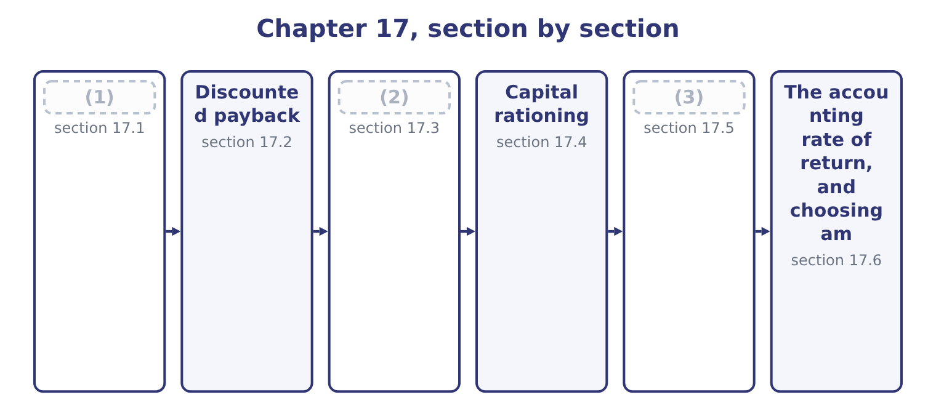
word list
The profitability index · The payback period · recovery of investment · Sensitivity analysis in the investment decisio

Summary 1 gaps 4–9
The payback period is the time taken for a (4) cash inflows to recover its (5) investment. It is not a measure of profitability and it was never meant to be: it is a measure of exposure, (6) how long the (7) money is at risk. Where the inflows are level, divide. Where they are uneven, (8) them year by year until the investment is covered, then take the (9) of the final year needed.
word list
accumulate · project's · advantages · initial · fraction · answering · company's

Worked example: the roasting line's payback

Summary 2 gaps 10–21
Level flows, so divide. The investment is 3,400,000 and the annual inflow 1,050,000, so the payback is 3,400,000 ÷ 1,050,000 = 3.24 years. The long way, which also (10) uneven flows. Three years bring in 1,050,000 × 3 = 3,150,000, (11) 3,400,000 − 3,150,000 = 250,000 to recover. That (12) is 250,000 ÷ 1,050,000 = 0.238 of the fourth year's inflow, so the payback is 3 + 0.24 = 3.24 years, (13) with step 1. Note what step 3 (14) : that cash arrives evenly through the fourth year. It does not, for a (15) with a harvest in it, and a payback stated to two decimals from annual data is as falsely precise as anything. Its (16) , and they are real. It is simple and (17) understood. A plant manager who will never discount anything (18) three and a quarter years. It measures (19) exposure, which matters to a company that cannot afford to have its cash tied up — Book 1's. It is a crude proxy for risk, because distant cash flows are the least certain, so a short payback means the case rests on the years that can be (20) . It is useful as a (21) .
word list
forecast · universally · agreeing · assumes · remainder · leaving · screen · handles · acceptable · business · understands · advantages · liquidity

Summary 3 gaps 22–29
Where a company sees two hundred (22) a year, rejecting those that cannot repay within five is a cheap first filter before the (23) work begins. Its (24) , which are the (25) half. It ignores (26) after the payback point. A project repaying in three years and then (27) ranks equally with one repaying in three years and (28) for twenty. It ignores the time value of money within the payback period, (29) a dollar in year three as equal to one today — which section 17.2 repairs. It has no decision rule of its own.
word list
treating · everything · examined · shortfall · discounting · proposals · limitations · stopping · running

Summary 4 gaps 30–34
The required period is chosen, not derived: nothing in the (30) says whether four years is (31) . It is biased against exactly the (32) that create most value — long-lived (33) , research, brand building — because their returns arrive late. And it is not a profitability measure at all, so a project can have an (34) payback and a negative net present value.
word list
attractive · infrastructure · arithmetic · projects · repaying · acceptable

Payback: what it does and does not do
Every item belongs to exactly one group.
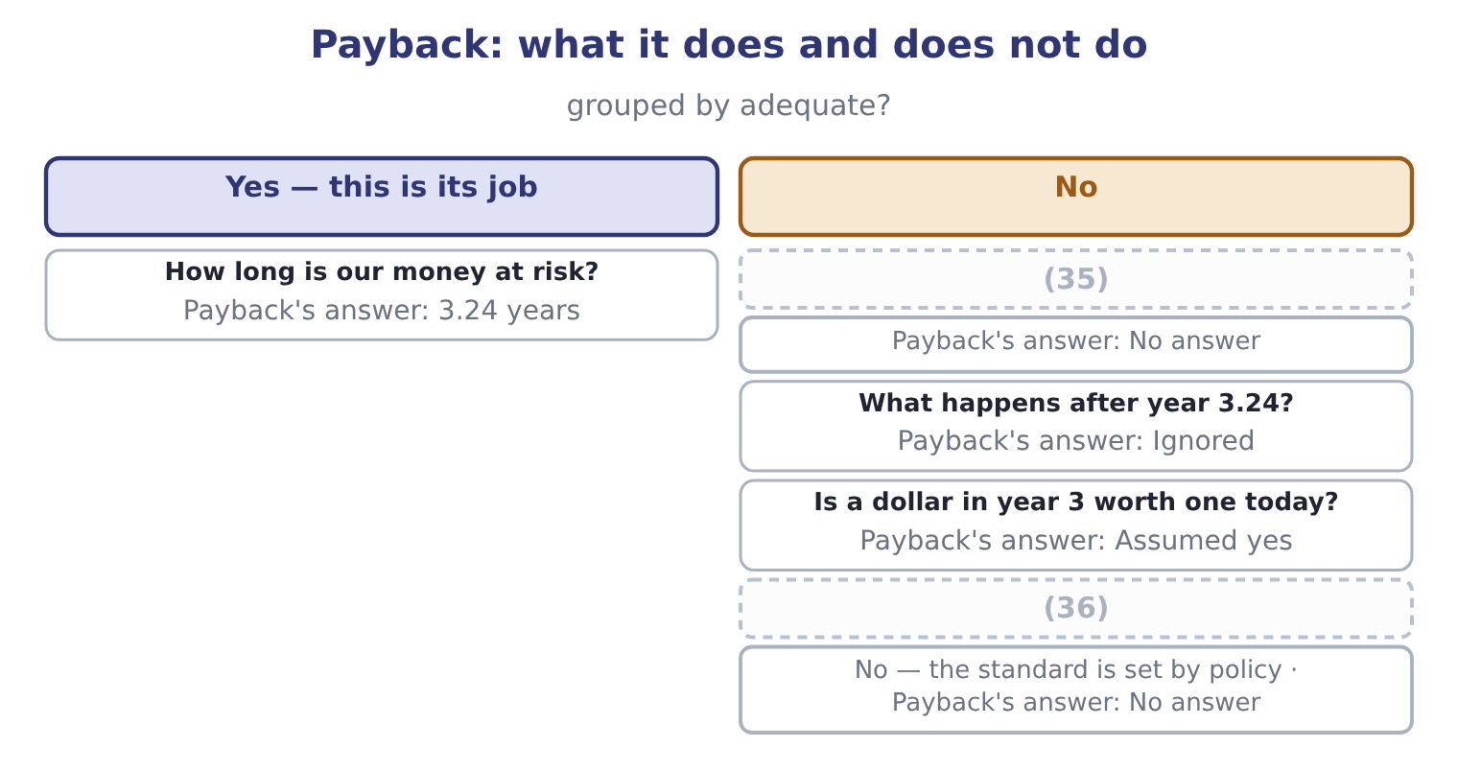
word list
value per dollar invested · Is 3.24 years acceptable? · Does the project create value?

The English this section uses, and its Arabic
Each term sits against what it means.
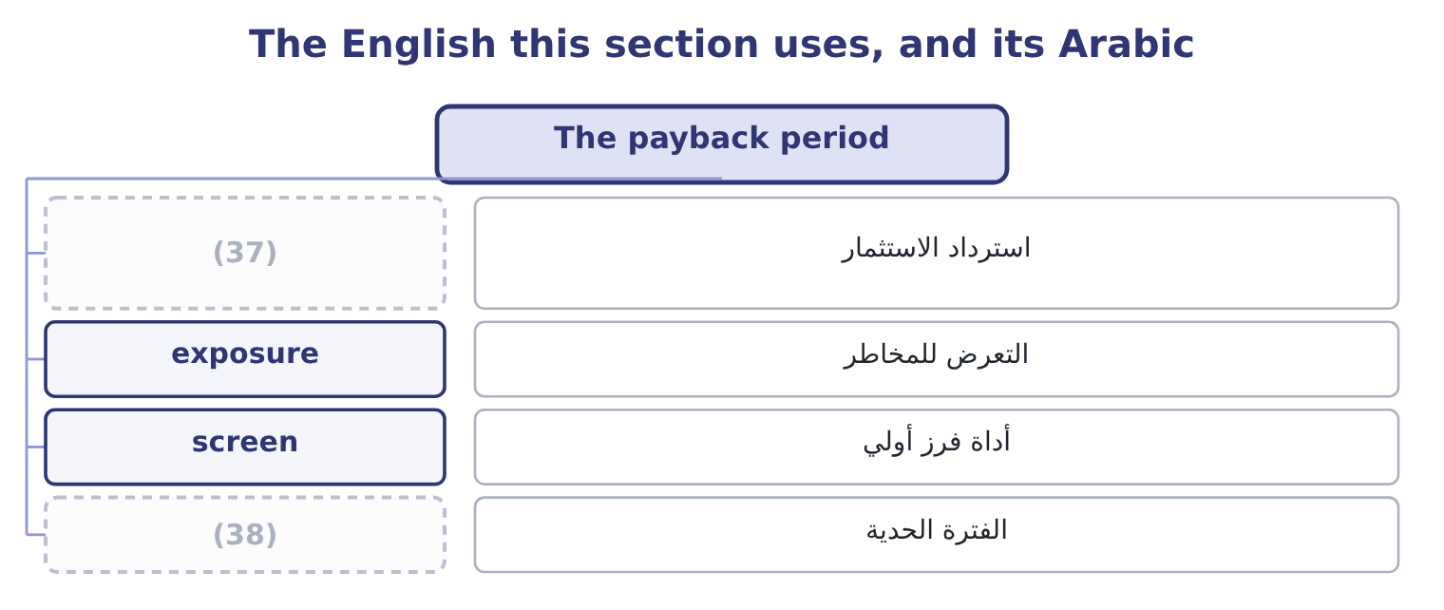
word list
recovery of investment · profitability index · cut-off period

The English this sheet uses, and its Arabic
English (exam term) | Arabic
recovery of investment | استرداد الاستثمار
exposure | التعرض للمخاطر
screen | أداة فرز أولي
cut-off period | الفترة الحدية

Answer key · 17.1 The payback period

1 The payback period | 20 forecast
2 The profitability index | 21 screen
3 Sensitivity analysis in the investment decisio | 22 proposals
4 project's | 23 discounting
5 initial | 24 limitations
6 answering | 25 examined
7 company's | 26 everything
8 accumulate | 27 stopping
9 fraction | 28 running
10 handles | 29 treating
11 leaving | 30 arithmetic
12 remainder | 31 acceptable
13 agreeing | 32 projects
14 assumes | 33 infrastructure
15 business | 34 attractive
16 advantages | 35 Does the project create value?
17 universally | 36 Is 3.24 years acceptable?
18 understands | 37 recovery of investment
19 liquidity | 38 cut-off period

the summaries in full
Summary 1 The payback period is the time taken for a project's cash inflows to recover its initial investment. It is not a measure of profitability and it was never meant to be: it is a measure of exposure, answering how long the company's money is at risk. Where the inflows are level, divide. Where they are uneven, accumulate them year by year until the investment is covered, then take the fraction of the final year needed.
Summary 2 Level flows, so divide. The investment is 3,400,000 and the annual inflow 1,050,000, so the payback is 3,400,000 ÷ 1,050,000 = 3.24 years. The long way, which also handles uneven flows. Three years bring in 1,050,000 × 3 = 3,150,000, leaving 3,400,000 − 3,150,000 = 250,000 to recover. That remainder is 250,000 ÷ 1,050,000 = 0.238 of the fourth year's inflow, so the payback is 3 + 0.24 = 3.24 years, agreeing with step 1. Note what step 3 assumes: that cash arrives evenly through the fourth year. It does not, for a business with a harvest in it, and a payback stated to two decimals from annual data is as falsely precise as anything. Its advantages, and they are real. It is simple and universally understood. A plant manager who will never discount anything understands three and a quarter years. It measures liquidity exposure, which matters to a company that cannot afford to have its cash tied up — Book 1's. It is a crude proxy for risk, because distant cash flows are the least certain, so a short payback means the case rests on the years that can be forecast. It is useful as a screen.
Summary 3 Where a company sees two hundred proposals a year, rejecting those that cannot repay within five is a cheap first filter before the discounting work begins. Its limitations, which are the examined half. It ignores everything after the payback point. A project repaying in three years and then stopping ranks equally with one repaying in three years and running for twenty. It ignores the time value of money within the payback period, treating a dollar in year three as equal to one today — which section 17.2 repairs. It has no decision rule of its own.
Summary 4 The required period is chosen, not derived: nothing in the arithmetic says whether four years is acceptable. It is biased against exactly the projects that create most value — long-lived infrastructure, research, brand building — because their returns arrive late. And it is not a profitability measure at all, so a project can have an attractive payback and a negative net present value.

17.2 Discounted payback
Chapter 17 · section 17.2

Fill every gap. Each word list holds one word more than there are gaps.
Summary 1 gaps 1–4
Discounted payback asks the same (1) of discounted flows: how long until the present value of the inflows covers the investment? It repairs one of (2) two great faults — the (3) of time value within the period — and leaves the other (4) , because flows after the recovery point are still ignored.
word list
untouched · quarters · payback's · ignoring · question

Worked example: the roasting line's discounted payback

Summary 2 gaps 5–16
Discount each year at 9 per cent. The (5) are 0.9174, 0.8417, 0.7722, 0.7084 and 0.6499, so the five inflows of 1,050,000 are worth 963,270, 883,785, 810,810, 743,820 and 682,395 (6) . After one year 963,270; after two, 963,270 + 883,785 = 1,847,055; after three, 1,847,055 + 810,810 = 2,657,865. The investment is still short by 3,400,000 − 2,657,865 = 742,135 at the end of year three. Take the (7) of year four. That (8) is 742,135 ÷ 743,820 = 0.998 of the (9) year's discounted (10) , so the discounted payback is 3 + 1.00 = 4.00 years. (11) 3.24 years; discounted 4.00 years. The (12) of three quarters of a year is the cost of the money during the recovery period, and it is always a (13) : discounting can only make the inflows (14) . A company with a (15) cut-off would (16) this project on payback and reject it on discounted payback, which is why the policy must say which one it means.
word list
factors · ignoring · Undiscounted · respectively · fraction · inflow · fourth · smaller · four-year · lengthening · difference · shortfall · accept

Summary 3 gaps 17–24
A project whose discounted payback is (17) than its life has a (18) net present value, (19) , because by the time the discounted inflows cover the investment the net present value has passed zero, and every later flow adds to it. So discounted payback at least cannot (20) net present value about (21) , which plain payback can. And it is harder to (22) than payback while being easier to (23) : "we get our money back in four years" is not what it says. It says the inflows cover the investment and its (24) cost in four years.
word list
financing · shorter · positive · contradict · acceptance · ignoring · necessarily · explain · misread

The English this section uses, and its Arabic
Each term sits against what it means.
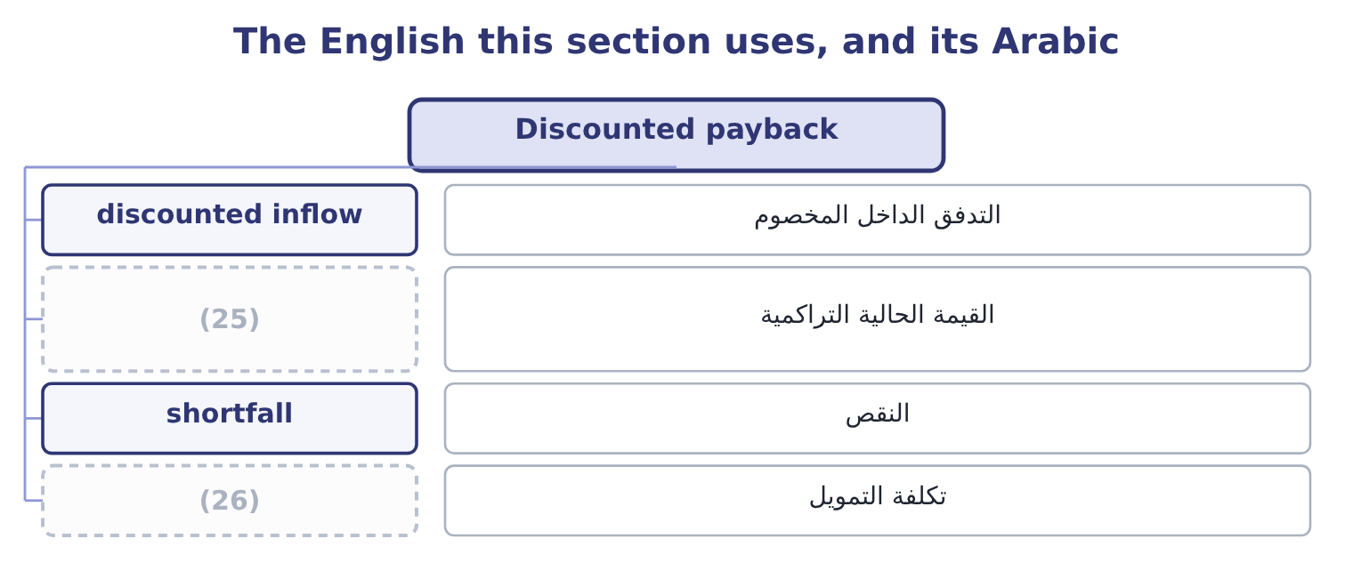
word list
capital rationing · cumulative present value · financing cost

The English this sheet uses, and its Arabic
English (exam term) | Arabic
discounted inflow | التدفق الداخل المخصوم
cumulative present value | القيمة الحالية التراكمية
shortfall | النقص
financing cost | تكلفة التمويل

Answer key · 17.2 Discounted payback

1 question | 14 smaller
2 payback's | 15 four-year
3 ignoring | 16 accept
4 untouched | 17 shorter
5 factors | 18 positive
6 respectively | 19 necessarily
7 fraction | 20 contradict
8 shortfall | 21 acceptance
9 fourth | 22 explain
10 inflow | 23 misread
11 Undiscounted | 24 financing
12 difference | 25 cumulative present value
13 lengthening | 26 financing cost

the summaries in full
Summary 1 Discounted payback asks the same question of discounted flows: how long until the present value of the inflows covers the investment? It repairs one of payback's two great faults — the ignoring of time value within the period — and leaves the other untouched, because flows after the recovery point are still ignored.
Summary 2 Discount each year at 9 per cent. The factors are 0.9174, 0.8417, 0.7722, 0.7084 and 0.6499, so the five inflows of 1,050,000 are worth 963,270, 883,785, 810,810, 743,820 and 682,395 respectively. After one year 963,270; after two, 963,270 + 883,785 = 1,847,055; after three, 1,847,055 + 810,810 = 2,657,865. The investment is still short by 3,400,000 − 2,657,865 = 742,135 at the end of year three. Take the fraction of year four. That shortfall is 742,135 ÷ 743,820 = 0.998 of the fourth year's discounted inflow, so the discounted payback is 3 + 1.00 = 4.00 years. Undiscounted 3.24 years; discounted 4.00 years. The difference of three quarters of a year is the cost of the money during the recovery period, and it is always a lengthening: discounting can only make the inflows smaller. A company with a four-year cut-off would accept this project on payback and reject it on discounted payback, which is why the policy must say which one it means.
Summary 3 A project whose discounted payback is shorter than its life has a positive net present value, necessarily, because by the time the discounted inflows cover the investment the net present value has passed zero, and every later flow adds to it. So discounted payback at least cannot contradict net present value about acceptance, which plain payback can. And it is harder to explain than payback while being easier to misread: "we get our money back in four years" is not what it says. It says the inflows cover the investment and its financing cost in four years.

17.3 The profitability index
Chapter 17 · section 17.3

Fill every gap. Each word list holds one word more than there are gaps.
Summary 1 gaps 1–12
The (1) index is the present value of a (2) inflows divided by the investment. It (3) a net present value into a measure of value for each dollar (4) , which is precisely the blind spot. The index for the roasting line is 4,441,630 ÷ 3,400,000 = 1.306, or 1.31 to two (5) : every dollar (6) comes back as about $1.31 of present value. Two (7) exist and both (8) in exams. The (9) one divides the present value of the inflows by the investment, so the accept rule is an index above 1.00. The other divides the net present value by the investment, so the accept rule is an index above zero; the roasting (10) index on that basis is 1,041,630 ÷ 3,400,000 = 0.306. The two carry the same (11) and differ by (12) 1.00.
word list
information · committed · conventions · common · decimals · ignores · appear · profitability · converts · invested · project's · line's · exactly

Summary 2 gaps 13–24
Read the (13) : if it offers (14) near 1.3, it wants the first; near 0.3, the second. Three (15) make the index worth (16) . It is (17) with net present value about (18) . An index above 1.00 and a (19) net present value are the same (20) , because the index exceeds one precisely when the inflows' present value exceeds the outlay. It ranks (21) under capital (22) , which is section 17.4. And it states value per dollar, which makes (23) of very different sizes (24) in a way net present value cannot. Its limitation is the mirror image of net present value's. Being a ratio, it ignores absolute size: an index of 1.50 on 200,000 creates 100,000 of value and an index of 1.10 on 10,000,000 creates 1,000,000. Where money is not short, take the bigger value; the index matters only when the money is.
word list
having · answers · consistent · positive · rationing · acceptance · comparable · things · correctly · convention · question · projects · statement

Four readings of one project
Every item belongs to exactly one group.
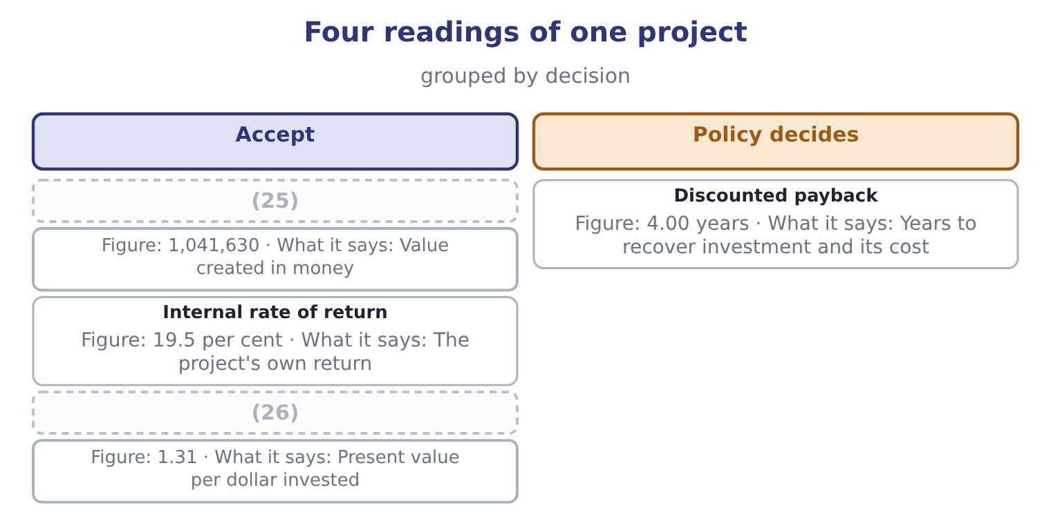
word list
Net present value · Profitability index · cumulative present value

The English this section uses, and its Arabic
Each term sits against what it means.
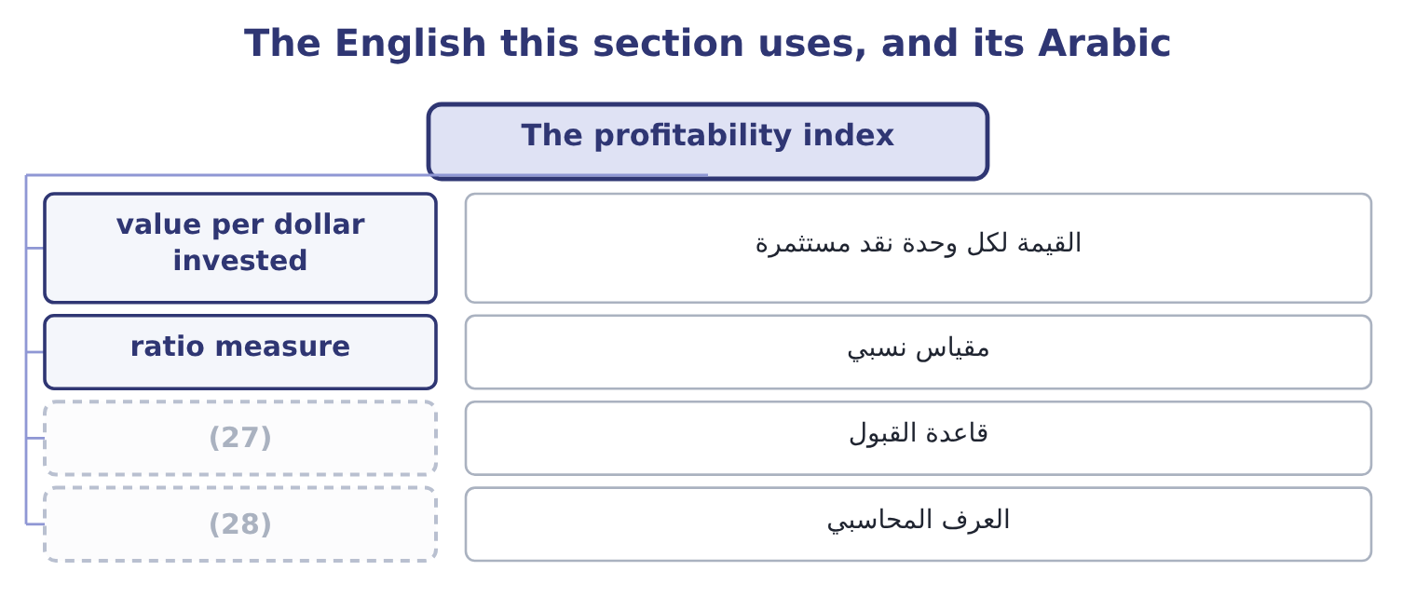
word list
reported results · convention · accept rule

The English this sheet uses, and its Arabic
English (exam term) | Arabic
value per dollar invested | القيمة لكل وحدة نقد مستثمرة
ratio measure | مقياس نسبي
accept rule | قاعدة القبول
convention | العرف المحاسبي

Answer key · 17.3 The profitability index

1 profitability | 15 things
2 project's | 16 having
3 converts | 17 consistent
4 committed | 18 acceptance
5 decimals | 19 positive
6 invested | 20 statement
7 conventions | 21 correctly
8 appear | 22 rationing
9 common | 23 projects
10 line's | 24 comparable
11 information | 25 Net present value
12 exactly | 26 Profitability index
13 question | 27 accept rule
14 answers | 28 convention

the summaries in full
Summary 1 The profitability index is the present value of a project's inflows divided by the investment. It converts a net present value into a measure of value for each dollar committed, which is precisely the blind spot. The index for the roasting line is 4,441,630 ÷ 3,400,000 = 1.306, or 1.31 to two decimals: every dollar invested comes back as about $1.31 of present value. Two conventions exist and both appear in exams. The common one divides the present value of the inflows by the investment, so the accept rule is an index above 1.00. The other divides the net present value by the investment, so the accept rule is an index above zero; the roasting line's index on that basis is 1,041,630 ÷ 3,400,000 = 0.306. The two carry the same information and differ by exactly 1.00.
Summary 2 Read the question: if it offers answers near 1.3, it wants the first; near 0.3, the second. Three things make the index worth having. It is consistent with net present value about acceptance. An index above 1.00 and a positive net present value are the same statement, because the index exceeds one precisely when the inflows' present value exceeds the outlay. It ranks correctly under capital rationing, which is section 17.4. And it states value per dollar, which makes projects of very different sizes comparable in a way net present value cannot. Its limitation is the mirror image of net present value's. Being a ratio, it ignores absolute size: an index of 1.50 on 200,000 creates 100,000 of value and an index of 1.10 on 10,000,000 creates 1,000,000. Where money is not short, take the bigger value; the index matters only when the money is.

17.4 Capital rationing
Chapter 17 · section 17.4

Fill every gap. Each word list holds one word more than there are gaps.
Summary 1 gaps 1–12
Capital rationing is the (1) in which a company has more (2) projects than money to fund them. It comes in two forms, and the exam (3) them. Hard rationing is external: the company cannot raise more money on (4) terms, because lenders will not lend, because covenants of the kind Book 2's, or because an equity issue would be (5) dilutive. Soft rationing is (6) : the board sets a capital budget. Reasons include wanting to avoid the scrutiny of new (7) , limiting how fast the (8) must absorb change, forcing divisions to compete so that weak proposals are filtered out, and distrust of the forecasts, which is. Soft rationing is far more common, and worth (9) : a company turning down projects with positive net present values because of a (10) limit is choosing to be worth less than it could be, and it may have good reasons, but they should be stated. The method under rationing is to rank by (11) index rather than by net present value, and the reason is the (12) of a constraint: with a fixed budget, what should be maximised is value for each dollar of the scarce resource, exactly. The principle is the same and so is the mistake it prevents.
word list
internal · organisation · acceptable · arithmetic · condition · value-creating · noticing · self-imposed · distinguishes · financing · choosing · prohibitively · profitability

Worked example: a budget of 5,000,000 and three proposals

Summary 2 gaps 13–22
Project A needs 5,000,000 and has a net present value of 900,000. Project B needs 2,500,000 and has 600,000. Project C needs 2,500,000 and has 550,000. All three (13) value, and the budget is 5,000,000. Rank by net present value. Project A's 900,000 is the (14) , and it uses the (15) budget, so the (16) answer is A alone, for a total of 900,000. B first, then C, and (17) they need exactly 2,500,000 + 2,500,000 = 5,000,000 — the whole budget — for a total value of 600,000 + 550,000 = 1,150,000. The index ranking creates 1,150,000 − 900,000 = 250,000 more value from the same money, and the reason is (18) in step 1: Project A is the (19) project, not the most (20) one. Ranking by net present value under a constraint rewards size; ranking by index rewards (21) , which is what a constraint (22) .
word list
together · productivity · entire · largest · biggest · demands · greedy · productive · projects · create · visible

Summary 3 gaps 23–34
Three (23) belong with the method. The index ranking is exactly right only where projects are (24) — where half a project can be taken for half the money and half the value. Most capital projects are not: a (25) line cannot be (26) in halves. So where projects are indivisible, the index gives the ranking from which to start, and the answer is then found by (27) the feasible (28) and choosing the one with the (29) total net present value. With a handful of projects that is quick; with many it is a formal problem of a kind solved by linear (30) , which the exam (31) but does not require you to solve. And the method assumes a single (32) constraint. A project needing money in two (33) years, in a company (34) in both, is a harder problem again.
word list
dilutive · period's · programming · cautions · successive · divisible · combinations · roasting · mentions · greatest · bought · rationed · testing

Two rankings of the same three projects, budget 5,000,000
Every item belongs to exactly one group.
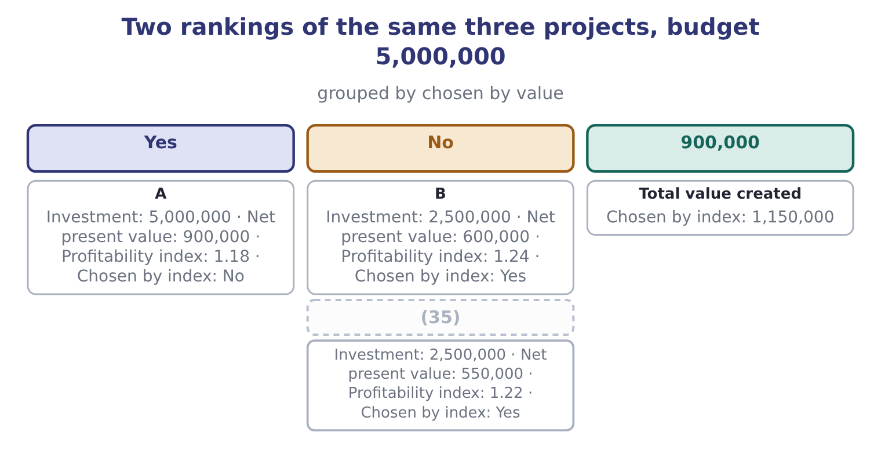
word list
C · shortfall

Answer key · 17.4 Capital rationing

1 condition | 19 biggest
2 value-creating | 20 productive
3 distinguishes | 21 productivity
4 acceptable | 22 demands
5 prohibitively | 23 cautions
6 internal | 24 divisible
7 financing | 25 roasting
8 organisation | 26 bought
9 noticing | 27 testing
10 self-imposed | 28 combinations
11 profitability | 29 greatest
12 arithmetic | 30 programming
13 create | 31 mentions
14 largest | 32 period's
15 entire | 33 successive
16 greedy | 34 rationed
17 together | 35 C
18 visible

the summaries in full
Summary 1 Capital rationing is the condition in which a company has more value-creating projects than money to fund them. It comes in two forms, and the exam distinguishes them. Hard rationing is external: the company cannot raise more money on acceptable terms, because lenders will not lend, because covenants of the kind Book 2's, or because an equity issue would be prohibitively dilutive. Soft rationing is internal: the board sets a capital budget. Reasons include wanting to avoid the scrutiny of new financing, limiting how fast the organisation must absorb change, forcing divisions to compete so that weak proposals are filtered out, and distrust of the forecasts, which is. Soft rationing is far more common, and worth noticing: a company turning down projects with positive net present values because of a self-imposed limit is choosing to be worth less than it could be, and it may have good reasons, but they should be stated. The method under rationing is to rank by profitability index rather than by net present value, and the reason is the arithmetic of a constraint: with a fixed budget, what should be maximised is value for each dollar of the scarce resource, exactly. The principle is the same and so is the mistake it prevents.
Summary 2 Project A needs 5,000,000 and has a net present value of 900,000. Project B needs 2,500,000 and has 600,000. Project C needs 2,500,000 and has 550,000. All three create value, and the budget is 5,000,000. Rank by net present value. Project A's 900,000 is the largest, and it uses the entire budget, so the greedy answer is A alone, for a total of 900,000. B first, then C, and together they need exactly 2,500,000 + 2,500,000 = 5,000,000 — the whole budget — for a total value of 600,000 + 550,000 = 1,150,000. The index ranking creates 1,150,000 − 900,000 = 250,000 more value from the same money, and the reason is visible in step 1: Project A is the biggest project, not the most productive one. Ranking by net present value under a constraint rewards size; ranking by index rewards productivity, which is what a constraint demands.
Summary 3 Three cautions belong with the method. The index ranking is exactly right only where projects are divisible — where half a project can be taken for half the money and half the value. Most capital projects are not: a roasting line cannot be bought in halves. So where projects are indivisible, the index gives the ranking from which to start, and the answer is then found by testing the feasible combinations and choosing the one with the greatest total net present value. With a handful of projects that is quick; with many it is a formal problem of a kind solved by linear programming, which the exam mentions but does not require you to solve. And the method assumes a single period's constraint. A project needing money in two successive years, in a company rationed in both, is a harder problem again.

17.5 Sensitivity analysis in the investment decision
Chapter 17 · section 17.5

Fill every gap. Each word list holds one word more than there are gaps.
Summary 1 gaps 1–5
The method is (1) . Take the net present value, hold (2) constant except one input, and solve for the value of that input at which the net present value (3) zero. Express the answer as a margin — the (4) between the forecast and the reversal point — and then ask whether that margin is (5) given what is known about the input.
word list
everything · distance · comfortable · becomes · mechanical · exposure

Worked example: four margins on the roasting line

Summary 2 gaps 6–15
The annual cash flow. The terminal flow is worth 550,000 × 0.6499 = 357,445 today, so the annual flows must cover 3,400,000 − 357,445 = 3,042,555, which over the (6) factor is 3,042,555 ÷ 3.8897 = 782,208 a year. The forecast is 1,050,000, so the margin is 1,050,000 − 782,208 = 267,792, which is 267,792 ÷ 1,050,000 = 25.50 per cent. Every dollar of overrun (7) the net present value by a dollar, so the project survives an overrun of the whole net present value: 3,400,000 + 1,041,630 = 4,441,630 before it (8) even, a margin of 1,041,630 ÷ 3,400,000 = 30.64 per cent. The net present value (9) zero at the (10) rate of return.5 per cent, so the rate has 19.5 − 9.0 = 10.5 points of (11) . Four years of flows are worth 1,050,000 × 3.2397 = 3,401,685, and the terminal amount (12) a year earlier is worth 550,000 × 0.7084 = 389,620, so a (13) project is worth 3,401,685 + 389,620 = 3,791,305, (14) 3,791,305 − 3,400,000 = 391,305 and still (15) .
word list
reaches · arriving · internal · annuity · headroom · giving · clearing · sensitivity · reduces · four-year · breaks

Summary 3 gaps 16–27
The project survives (16) a fifth of its life. Every margin is in double figures, so the (17) is robust — and the (18) is the annual cash flow at a quarter. That is the number to (19) before approving, and the next step is to push it back to its drivers: the (20) operating flow would have to fall to 782,208 − 150,000 = 632,208, which before tax is 632,208 ÷ 0.75 = 842,944, a fall of 1,200,000 − 842,944 = 357,056, or 357,056 ÷ 1,200,000 = 29.75 per cent of the operating cash flow. Thirty per cent of the operating margin is a large miss; if the volume forecast could (21) be thirty per cent wrong, the forecast is the (22) and not the project. Three uses (23) from an analysis like that, and the exam asks for them. It (24) the variable that (25) . Here it is the annual operating cash flow, and within it the volume, which is where the (26) effort and the (27) . It converts a forecast into a question somebody can answer.
word list
after-tax · appraisal · losing · identifies · tightest · problem · follow · decides · sensitivity · investigate · plausibly · decision · operating

Summary 4 gaps 28–36
Nobody can say whether 1,050,000 a year is right. A sales (28) can say whether volume could fall by thirty per cent. It tells you where to build in (29) . Where the tight variable is one that can be (30) — an input price, a volume (31) , a lease term — the margin can be (32) rather than hoped for. And two (33) , both. (34) analysis misses the fact that bad things arrive (35) , which is what scenario analysis is for; and it says nothing about how likely any of the reversal points is, which is what (36) attempts.
word list
manager · limits · forecast · simulation · bought · commitment · together · One-at-a-time · protection · contracted

How far each input can move before the roasting line breaks even
Input | Forecast | Break-even value | Margin
Annual cash flow | 1,050,000 | 782,208 | 25.50 per cent
Initial investment | 3,400,000 | 4,441,630 | 30.64 per cent overrun
Discount rate | 9.0 per cent | (37) | 10.5 points
Project life | 5 years | Between 4 and 5 years | (38)

word list
19.5 per cent · Over a year · recovery of investment

Answer key · 17.5 Sensitivity analysis in the investment decision

1 mechanical | 20 after-tax
2 everything | 21 plausibly
3 becomes | 22 problem
4 distance | 23 follow
5 comfortable | 24 identifies
6 annuity | 25 decides
7 reduces | 26 appraisal
8 breaks | 27 sensitivity
9 reaches | 28 manager
10 internal | 29 protection
11 headroom | 30 contracted
12 arriving | 31 commitment
13 four-year | 32 bought
14 giving | 33 limits
15 clearing | 34 One-at-a-time
16 losing | 35 together
17 decision | 36 simulation
18 tightest | 37 19.5 per cent
19 investigate | 38 Over a year

the summaries in full
Summary 1 The method is mechanical. Take the net present value, hold everything constant except one input, and solve for the value of that input at which the net present value becomes zero. Express the answer as a margin — the distance between the forecast and the reversal point — and then ask whether that margin is comfortable given what is known about the input.
Summary 2 The annual cash flow. The terminal flow is worth 550,000 × 0.6499 = 357,445 today, so the annual flows must cover 3,400,000 − 357,445 = 3,042,555, which over the annuity factor is 3,042,555 ÷ 3.8897 = 782,208 a year. The forecast is 1,050,000, so the margin is 1,050,000 − 782,208 = 267,792, which is 267,792 ÷ 1,050,000 = 25.50 per cent. Every dollar of overrun reduces the net present value by a dollar, so the project survives an overrun of the whole net present value: 3,400,000 + 1,041,630 = 4,441,630 before it breaks even, a margin of 1,041,630 ÷ 3,400,000 = 30.64 per cent. The net present value reaches zero at the internal rate of return.5 per cent, so the rate has 19.5 − 9.0 = 10.5 points of headroom. Four years of flows are worth 1,050,000 × 3.2397 = 3,401,685, and the terminal amount arriving a year earlier is worth 550,000 × 0.7084 = 389,620, so a four-year project is worth 3,401,685 + 389,620 = 3,791,305, giving 3,791,305 − 3,400,000 = 391,305 and still clearing.
Summary 3 The project survives losing a fifth of its life. Every margin is in double figures, so the decision is robust — and the tightest is the annual cash flow at a quarter. That is the number to investigate before approving, and the next step is to push it back to its drivers: the after-tax operating flow would have to fall to 782,208 − 150,000 = 632,208, which before tax is 632,208 ÷ 0.75 = 842,944, a fall of 1,200,000 − 842,944 = 357,056, or 357,056 ÷ 1,200,000 = 29.75 per cent of the operating cash flow. Thirty per cent of the operating margin is a large miss; if the volume forecast could plausibly be thirty per cent wrong, the forecast is the problem and not the project. Three uses follow from an analysis like that, and the exam asks for them. It identifies the variable that decides. Here it is the annual operating cash flow, and within it the volume, which is where the appraisal effort and the sensitivity. It converts a forecast into a question somebody can answer.
Summary 4 Nobody can say whether 1,050,000 a year is right. A sales manager can say whether volume could fall by thirty per cent. It tells you where to build in protection. Where the tight variable is one that can be contracted — an input price, a volume commitment, a lease term — the margin can be bought rather than hoped for. And two limits, both. One-at-a-time analysis misses the fact that bad things arrive together, which is what scenario analysis is for; and it says nothing about how likely any of the reversal points is, which is what simulation attempts.

17.6 The accounting rate of return, and choosing among the measures
Chapter 17 · section 17.6

Fill every gap. Each word list holds one word more than there are gaps.
Summary 1 gaps 1–11
The accounting rate of return — also met as the return on investment of Book 1 and as the simple or (1) rate of return — (2) average annual accounting profit by the investment. It (3) nothing and uses profit rather than cash, which makes it the (4) of the measures and the one most often seen first, because it is the only one that speaks the (5) of the financial statements the project will (6) appear. From cash flow to profit. The line's pre-tax (7) cash flow is 1,200,000 a year, and depreciation of 1,200,000 − 600,000 = 600,000 must be (8) to reach accounting profit, (9) 600,000 before tax. At 25 per cent, 600,000 × 0.75 = 450,000 of average annual profit. On the initial investment. On the average investment. Where the convention is to use the average of the (10) and closing book (11) , (3,400,000 + 550,000) ÷ 2 = 1,975,000, so the rate is 450,000 ÷ 1,975,000 = 22.78 per cent.
word list
discounts · opening · deducted · eventually · language · operating · divides · amounts · giving · unadjusted · weakest · carrying

Summary 2 gaps 12–23
The same project is 13.24 per cent or 22.78 per cent (12) on a convention nobody outside the finance (13) knows about, and neither figure can be (14) with the 9 per cent cost of capital, because one is an accounting ratio and the other a required return on cash. That is the (15) central weakness and the reason a question that offers both (16) is testing (17) you read the word average. Its (18) , stated plainly for the exam: it ignores the time value of money entirely; it uses accrual profit rather than cash, so it is affected by the depreciation method and by every accrual Book 1's; it depends on an (19) choice between initial and average investment; and it has no (20) accept rule. Its one genuine (21) is that it is the measure in which the (22) effect on reported results and on the divisional (23) measures of Book 4 will actually show up — which matters for the behaviour of the manager being asked to propose it.
word list
advantage · compared · department · figures · depreciation · whether · performance · weaknesses · arbitrary · depending · principled · project's · measure's

Summary 3 gaps 24–30
The (24) answer used by most (25) companies is to compute several and let each answer its own question. Net present value (26) . The internal rate of return (27) and gives the margin over the hurdle. The profitability index ranks under (28) . Payback or discounted payback states the liquidity (29) against a policy limit. The accounting rate of return shows what the financial statements will say. A proposal carrying all five, with the (30) analysis of, is a proposal a board can actually decide on.
word list
communicates · well-run · sensitivity · decides · practical · exposure · shortfall · rationing

Five measures, one project

Your turn: the measures (complete the blanks)
Item | Data | Answer
Payback period | Outlay 3,400,000; inflow 1,050,000 a year | ________
Discounted payback | (31) | ________
Profitability index | (32) | ________
Net present value |  | ________
Which measure ranks projects under a fixed capital budget |  | ________
Which measure the financial statements will show |  | ________

word list
Cumulative present value 2,657,865 after 3 years · Inflows worth 4,441,630 · Measure the financial statements will show

"Payback" and "index"

Summary 4 gaps 33–38
English payback is a (33) of ordinary words and sounds like plain speech, which is why it survives in (34) that have never discounted anything. The danger is that it sounds like a (35) — "the project pays back" — when it is only a (36) . Index in profitability index means a ratio to a base, as in the index numbers of (37) , and the base here is the money (38) .
word list
invested · depreciation · verdict · statistics · boardrooms · compound · duration

"Payback" and "index"
The bars are drawn to scale.
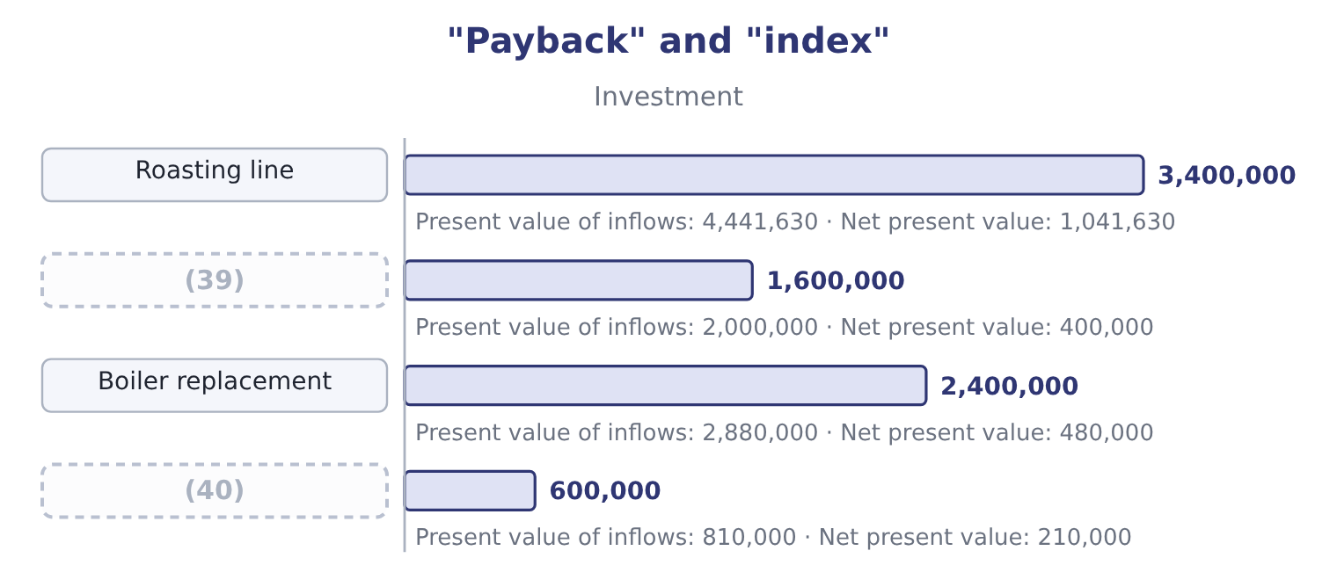
word list
discounted inflow · Fleet renewal · Warehouse racking

Item — Answer
Item | Answer
Payback period | (41) : 3,400,000 ÷ 1,050,000 = 3.24.
Discounted payback | 4.00 years: the shortfall of 742,135 is almost exactly the fourth year's discounted inflow.
Profitability index | (42) : 4,441,630 ÷ 3,400,000 = 1.306.
Net present value | 1,041,630: 4,441,630 − 3,400,000 = 1,041,630.
Measure that ranks under a fixed budget | The profitability index, which maximises value per dollar of the constraint.
Measure the financial statements will show | The accounting rate of return, which uses accrual profit.
What it tells you | Five measures, one project, one decision — accept. The measures differ in what they say when money is short or when liquidity is the worry,

word list
accept rule · 1.31 · 3.24 years

The English this section uses, and its Arabic
Each term sits against what it means.
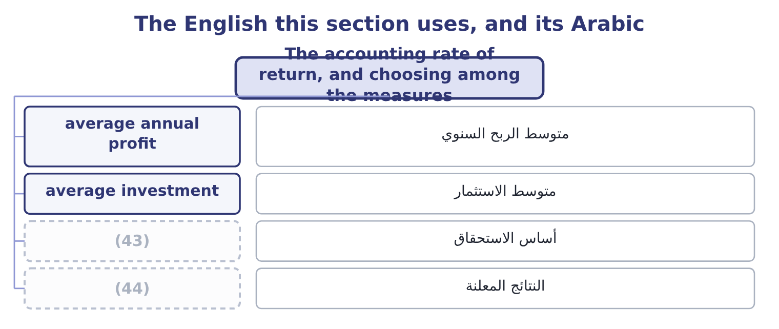
word list
reported results · financing cost · accrual basis

The English this sheet uses, and its Arabic
English (exam term) | Arabic
average annual profit | متوسط الربح السنوي
average investment | متوسط الاستثمار
accrual basis | أساس الاستحقاق
reported results | النتائج المعلنة

Answer key · 17.6 The accounting rate of return, and choosing among the measures

1 unadjusted | 23 performance
2 divides | 24 practical
3 discounts | 25 well-run
4 weakest | 26 decides
5 language | 27 communicates
6 eventually | 28 rationing
7 operating | 29 exposure
8 deducted | 30 sensitivity
9 giving | 31 Cumulative present value 2,657,865 after 3 years
10 opening | 32 Inflows worth 4,441,630
11 amounts | 33 compound
12 depending | 34 boardrooms
13 department | 35 verdict
14 compared | 36 duration
15 measure's | 37 statistics
16 figures | 38 invested
17 whether | 39 Warehouse racking
18 weaknesses | 40 Fleet renewal
19 arbitrary | 41 3.24 years
20 principled | 42 1.31
21 advantage | 43 accrual basis
22 project's | 44 reported results

the summaries in full
Summary 1 The accounting rate of return — also met as the return on investment of Book 1 and as the simple or unadjusted rate of return — divides average annual accounting profit by the investment. It discounts nothing and uses profit rather than cash, which makes it the weakest of the measures and the one most often seen first, because it is the only one that speaks the language of the financial statements the project will eventually appear. From cash flow to profit. The line's pre-tax operating cash flow is 1,200,000 a year, and depreciation of 1,200,000 − 600,000 = 600,000 must be deducted to reach accounting profit, giving 600,000 before tax. At 25 per cent, 600,000 × 0.75 = 450,000 of average annual profit. On the initial investment. On the average investment. Where the convention is to use the average of the opening and closing book amounts, (3,400,000 + 550,000) ÷ 2 = 1,975,000, so the rate is 450,000 ÷ 1,975,000 = 22.78 per cent.
Summary 2 The same project is 13.24 per cent or 22.78 per cent depending on a convention nobody outside the finance department knows about, and neither figure can be compared with the 9 per cent cost of capital, because one is an accounting ratio and the other a required return on cash. That is the measure's central weakness and the reason a question that offers both figures is testing whether you read the word average. Its weaknesses, stated plainly for the exam: it ignores the time value of money entirely; it uses accrual profit rather than cash, so it is affected by the depreciation method and by every accrual Book 1's; it depends on an arbitrary choice between initial and average investment; and it has no principled accept rule. Its one genuine advantage is that it is the measure in which the project's effect on reported results and on the divisional performance measures of Book 4 will actually show up — which matters for the behaviour of the manager being asked to propose it.
Summary 3 The practical answer used by most well-run companies is to compute several and let each answer its own question. Net present value decides. The internal rate of return communicates and gives the margin over the hurdle. The profitability index ranks under rationing. Payback or discounted payback states the liquidity exposure against a policy limit. The accounting rate of return shows what the financial statements will say. A proposal carrying all five, with the sensitivity analysis of, is a proposal a board can actually decide on.
Summary 4 English payback is a compound of ordinary words and sounds like plain speech, which is why it survives in boardrooms that have never discounted anything. The danger is that it sounds like a verdict — "the project pays back" — when it is only a duration. Index in profitability index means a ratio to a base, as in the index numbers of statistics, and the base here is the money invested.

18.1 Mergers, acquisitions and leveraged buyouts
Chapter 18 · section 18.1

Fill every gap. Each word list holds one word more than there are gaps.
Chapter 18, section by section
Each stage leads to the next.
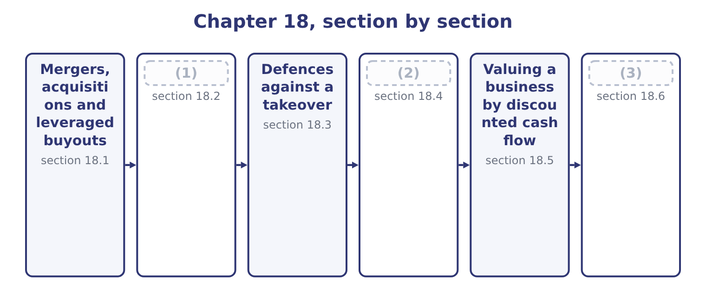
word list
Evaluating the deal and recommending · exclusive to the deal · Divestitures and restructuring · Synergies, and what they are worth

Summary 1 gaps 4–15
A merger combines two companies into one; an (4) is one company buying control of another, whether or not the target (5) as a legal entity. The exam uses the terms loosely and (6) deals by the economic (7) between the parties. A horizontal combination joins competitors in the same industry and the same stage of (8) — two tahini (9) . The usual case is (10) of scale, the (11) of duplicated overhead and increased market power, and the usual obstacle is competition law. A vertical combination joins a company and its supplier or its customer, at different (12) of the same chain. Orontes buying Ghab Mills is vertical and (13) , moving towards the raw (14) ; buying a chain of grocers would be vertical and forward. The usual case is security of supply, the removal of the supplier's margin and better coordination; the usual objection is that the (15) takes on a business it does not know how to run, and loses the discipline of being able to switch suppliers.
word list
stages · economies · elimination · acquirer · relationship · producers · management · backward · survives · production · classifies · acquisition · material

Summary 2 gaps 16–27
A conglomerate combination joins unrelated businesses. The case made for it is diversification of (16) and the use of surplus cash, and both (17) are weak: as Book 2's, shareholders can diversify far more cheaply by (18) both shares than a company can by buying one business with another, and surplus cash can be (19) to them. Conglomerate deals are the ones most often found, on (20) , to have destroyed value. A leveraged buyout is a different animal: the purchase of a company, (21) by a private equity firm or by its own (22) , financed largely by debt secured on the (23) own assets and repaid out of its own cash flow. Where the buyers are the (24) management it is a management buyout. Four (25) define it and the exam asks for them. The capital structure is (26) extreme — debt of seventy per cent or more of the purchase price — which, as Book 2's, magnifies the return on the small slice of equity and magnifies the risk in the same (27) .
word list
managers · survive · deliberately · proportion · returned · arguments · usually · postaudit · target's · holding · existing · earnings · features

Summary 3 gaps 28–39
The target must have steady, (28) cash flow, because the interest has to be paid every quarter whatever the trading (29) . (30) businesses and (31) businesses make poor targets. (32) assets help, both as security for the lenders and as a source of (33) : the sale of a division often funds part of the debt. And the discipline of debt is part of the (34) . A management team that must generate cash to survive behaves (35) from one sitting on a (36) balance sheet, which is the free cash flow problem of Book 2's. The risks are the (37) image. A leveraged company has no capacity to absorb a bad year; interest crowds out (38) , so the business can be starved of the capital (39) it needs; and the pressure to show cash quickly can cut exactly the long-lived spending.
word list
mirror · expenditure · deliberately · comfortable · repayment · argument · conditions · predictable · research-heavy · differently · Cyclical · Saleable · investment

Four kinds of deal
Kind | Who combines | Principal case made | Principal objection
Horizontal | Competitors at the same stage | (40) | Competition law; integration risk
Vertical | Supplier and customer | Security of supply, margin, coordination | (41)
Conglomerate | Unrelated businesses | (42) | Shareholders diversify more cheaply
Leveraged buyout | A financial or management buyer | (43) | No capacity to absorb a bad year

word list
Scale, overhead, market power · Diversification; use of surplus cash · Debt discipline; return on thin equity · Unfamiliar business; loss of flexibility · Competition law; integration risk

The English this section uses, and its Arabic
Each term sits against what it means.
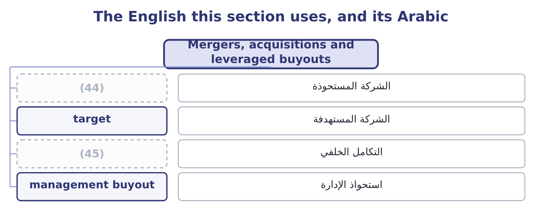
word list
backward integration · acquirer · goodwill

The English this sheet uses, and its Arabic
English (exam term) | Arabic
acquirer | الشركة المستحوذة
target | الشركة المستهدفة
backward integration | التكامل الخلفي
management buyout | استحواذ الإدارة

Answer key · 18.1 Mergers, acquisitions and leveraged buyouts

1 Synergies, and what they are worth | 24 existing
2 Divestitures and restructuring | 25 features
3 Evaluating the deal and recommending | 26 deliberately
4 acquisition | 27 proportion
5 survives | 28 predictable
6 classifies | 29 conditions
7 relationship | 30 Cyclical
8 production | 31 research-heavy
9 producers | 32 Saleable
10 economies | 33 repayment
11 elimination | 34 argument
12 stages | 35 differently
13 backward | 36 comfortable
14 material | 37 mirror
15 acquirer | 38 investment
16 earnings | 39 expenditure
17 arguments | 40 Scale, overhead, market power
18 holding | 41 Unfamiliar business; loss of flexibility
19 returned | 42 Diversification; use of surplus cash
20 postaudit | 43 Debt discipline; return on thin equity
21 usually | 44 acquirer
22 managers | 45 backward integration
23 target's

the summaries in full
Summary 1 A merger combines two companies into one; an acquisition is one company buying control of another, whether or not the target survives as a legal entity. The exam uses the terms loosely and classifies deals by the economic relationship between the parties. A horizontal combination joins competitors in the same industry and the same stage of production — two tahini producers. The usual case is economies of scale, the elimination of duplicated overhead and increased market power, and the usual obstacle is competition law. A vertical combination joins a company and its supplier or its customer, at different stages of the same chain. Orontes buying Ghab Mills is vertical and backward, moving towards the raw material; buying a chain of grocers would be vertical and forward. The usual case is security of supply, the removal of the supplier's margin and better coordination; the usual objection is that the acquirer takes on a business it does not know how to run, and loses the discipline of being able to switch suppliers.
Summary 2 A conglomerate combination joins unrelated businesses. The case made for it is diversification of earnings and the use of surplus cash, and both arguments are weak: as Book 2's, shareholders can diversify far more cheaply by holding both shares than a company can by buying one business with another, and surplus cash can be returned to them. Conglomerate deals are the ones most often found, on postaudit, to have destroyed value. A leveraged buyout is a different animal: the purchase of a company, usually by a private equity firm or by its own managers, financed largely by debt secured on the target's own assets and repaid out of its own cash flow. Where the buyers are the existing management it is a management buyout. Four features define it and the exam asks for them. The capital structure is deliberately extreme — debt of seventy per cent or more of the purchase price — which, as Book 2's, magnifies the return on the small slice of equity and magnifies the risk in the same proportion.
Summary 3 The target must have steady, predictable cash flow, because the interest has to be paid every quarter whatever the trading conditions. Cyclical businesses and research-heavy businesses make poor targets. Saleable assets help, both as security for the lenders and as a source of repayment: the sale of a division often funds part of the debt. And the discipline of debt is part of the argument. A management team that must generate cash to survive behaves differently from one sitting on a comfortable balance sheet, which is the free cash flow problem of Book 2's. The risks are the mirror image. A leveraged company has no capacity to absorb a bad year; interest crowds out investment, so the business can be starved of the capital expenditure it needs; and the pressure to show cash quickly can cut exactly the long-lived spending.

18.2 Synergies, and what they are worth
Chapter 18 · section 18.2

Fill every gap. Each word list holds one word more than there are gaps.
Summary 1 gaps 1–12
Synergy is the value the (1) creates that neither company could create alone — the reason the combined business can be worth more than the sum of its parts, and therefore the only honest (2) for paying more than a target's (3) value. The exam (4) the possible synergies (5) by type. Cross-selling to each other's (6) ; access to the other's (7) or export licences; a (8) brand; pricing power from a larger share; filling gaps in a product range. Removing duplicated head office, finance, IT and sales functions; closing one of two plants and running the other fuller, which is the operating leverage; (9) scale on inputs; (10) the supplier's margin in a vertical deal; moving (11) to the lower-cost site. Selling surplus property or duplicated equipment; releasing working capital where the two (12) can share inventory, which is Book 1's.
word list
standalone · purchasing · eliminating · combination · expects · stronger · vertical · justification · distribution · customers · businesses · identified · production

Summary 2 gaps 13–24
A larger, more (13) company may borrow more cheaply or more deeply; a (14) acquirer can use a target's tax losses where the law allows; and a company with cash can fund a target's investment programme that the target could not finance alone. (15) a weak management team with a better one, which is real and is also the hardest to claim credibly, since it requires the acquirer to be (16) better at running the business. Three (17) separate a real synergy from a hopeful one, and the (18) test them. Cost synergies are far more (19) than revenue synergies. A closed office is a (20) saving with a date on it; a cross-selling forecast is a hope with a (21) attached. Every synergy has a cost. (22) payments, system (23) , rebranding, retraining and the management time consumed are real and usually immediate, while the benefits arrive slowly. They belong in the (24) as a cash outflow at the start. And a synergy must be exclusive to the deal.
word list
reliable · spreadsheet · disciplines · measurable · Redundancy · examiners · diversified · integration · Replacing · profitable · stronger · valuation · demonstrably

Summary 3 gaps 25–26
A saving the (25) could have made (26) is not a reason to pay for the target.
word list
anyway · reliable · acquirer

The synergy that justifies any price

Summary 4 gaps 27–32
Because synergy is a forecast and the (27) is a certainty, the (28) of a deal can always be made to work by raising the synergy (29) . The (30) to ask of every (31) figure is: who will be (32) for delivering it, by when, and how will we know? A synergy with no owner and no date is a number written to justify a price that was decided first.
word list
premium · therefore · claimed · estimate · accountable · arithmetic · question

The English this section uses, and its Arabic
Each term sits against what it means.
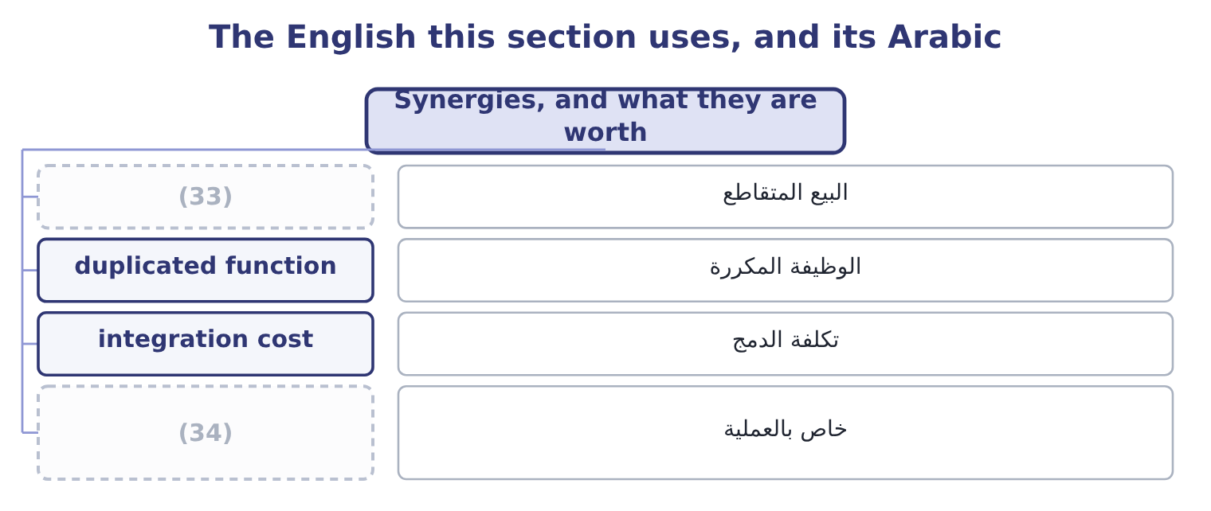
word list
exclusive to the deal · cross-selling · staggered board

The English this sheet uses, and its Arabic
English (exam term) | Arabic
cross-selling | البيع المتقاطع
duplicated function | الوظيفة المكررة
integration cost | تكلفة الدمج
exclusive to the deal | خاص بالعملية

Answer key · 18.2 Synergies, and what they are worth

1 combination | 18 examiners
2 justification | 19 reliable
3 standalone | 20 measurable
4 expects | 21 spreadsheet
5 identified | 22 Redundancy
6 customers | 23 integration
7 distribution | 24 valuation
8 stronger | 25 acquirer
9 purchasing | 26 anyway
10 eliminating | 27 premium
11 production | 28 arithmetic
12 businesses | 29 estimate
13 diversified | 30 question
14 profitable | 31 claimed
15 Replacing | 32 accountable
16 demonstrably | 33 cross-selling
17 disciplines | 34 exclusive to the deal

the summaries in full
Summary 1 Synergy is the value the combination creates that neither company could create alone — the reason the combined business can be worth more than the sum of its parts, and therefore the only honest justification for paying more than a target's standalone value. The exam expects the possible synergies identified by type. Cross-selling to each other's customers; access to the other's distribution or export licences; a stronger brand; pricing power from a larger share; filling gaps in a product range. Removing duplicated head office, finance, IT and sales functions; closing one of two plants and running the other fuller, which is the operating leverage; purchasing scale on inputs; eliminating the supplier's margin in a vertical deal; moving production to the lower-cost site. Selling surplus property or duplicated equipment; releasing working capital where the two businesses can share inventory, which is Book 1's.
Summary 2 A larger, more diversified company may borrow more cheaply or more deeply; a profitable acquirer can use a target's tax losses where the law allows; and a company with cash can fund a target's investment programme that the target could not finance alone. Replacing a weak management team with a better one, which is real and is also the hardest to claim credibly, since it requires the acquirer to be demonstrably better at running the business. Three disciplines separate a real synergy from a hopeful one, and the examiners test them. Cost synergies are far more reliable than revenue synergies. A closed office is a measurable saving with a date on it; a cross-selling forecast is a hope with a spreadsheet attached. Every synergy has a cost. Redundancy payments, system integration, rebranding, retraining and the management time consumed are real and usually immediate, while the benefits arrive slowly. They belong in the valuation as a cash outflow at the start. And a synergy must be exclusive to the deal.
Summary 3 A saving the acquirer could have made anyway is not a reason to pay for the target.
Summary 4 Because synergy is a forecast and the premium is a certainty, the arithmetic of a deal can always be made to work by raising the synergy estimate. The question to ask of every claimed figure is: who will be accountable for delivering it, by when, and how will we know? A synergy with no owner and no date is a number written to justify a price that was decided first.

18.3 Defences against a takeover
Chapter 18 · section 18.3

Fill every gap. Each word list holds one word more than there are gaps.
Summary 1 gaps 1–12
Where an offer is (1) , a target's board has a set of devices available, some built into its (2) in advance and some deployed in response. The exam names them and expects each (3) in a sentence. A poison pill, (4) a shareholders' rights plan, gives existing shareholders other than the bidder the right to buy new shares cheaply once a bidder's holding passes a trigger — (5) ten or twenty per cent. (6) it floods the register with new shares and dilutes the bidder's stake, making the acquisition (7) expensive. It is the most (8) of the defences and, because the board can usually (9) it, it works mainly as a lever to force the bidder to negotiate. A staggered board, also called a (10) board, divides the directors into classes with only one class elected each year, so a bidder who buys control of the shares cannot replace the board for two or three annual (11) . It is a delay (12) than a block, and delay is often enough.
word list
powerful · redeem · meetings · classified · rather · requires · formally · described · constitution · typically · unwelcome · prohibitively · Exercising

Summary 2 gaps 13–24
A golden parachute is a contract (13) senior executives to a large payment if they lose their jobs after a (14) of control. As a defence it is weak, because the cost is small (15) to a bid; its real (16) is that managers who know they are (17) can evaluate an offer on its merits instead of fighting to keep their jobs. Its (18) is the obvious one: shareholders pay executives for losing a (19) the executives may have (20) . A leveraged recapitalisation has the target borrow (21) and pay a large special (22) or buy back shares, so that it (23) a highly leveraged company and much less attractive to a bidder whose plan was to use that unused debt capacity. It delivers value to shareholders (24) and leaves the company carrying the risks Book 2's.
word list
caused · heavily · becomes · dividend · immediately · requires · justification · relative · change · protected · entitling · contest · objection

Summary 3 gaps 25–36
A fair price amendment (25) any bidder to pay all shareholders the same price, or a price approved by a (26) , which prevents the two-tier offer in which early (27) get a good price and the rest are (28) . A voting rights plan (29) the votes attaching to a large block — for example by (30) voting rights from shares above a threshold unless other shareholders approve — so that buying shares does not deliver control. A white knight is a friendly third party (31) to make a competing offer on terms the board (32) . The company is still sold; the board (33) the buyer. Three more appear in (34) . Greenmail is the (35) of a hostile bidder's stake at a premium, usually with a (36) agreement not to bid again, and it benefits the bidder at the expense of the remaining shareholders.
word list
removing · invited · chooses · standstill · squeezed · supermajority · requires · delivers · sellers · repurchase · prefers · restricts · questions

Summary 4 gaps 37–43
A crown jewel defence sells the asset the bidder most wants. A (37) defence has the target bid for the bidder. The test to apply to all of them is whose (38) they serve. A defence that (39) a higher price serves shareholders; a defence that (40) the board's (41) at the cost of an attractive offer does not, which is why poison pills and staggered (42) are the ones (43) investors most often vote to remove.
word list
preserves · requires · interest · institutional · forces · boards · Pac-Man · position

Takeover defences
Defence | Mechanism | Effect | Serves shareholders?
Poison pill | (44) | Dilutes the bidder | Yes if used to negotiate
Staggered board | Directors elected in classes | Delays board control | (45)
Golden parachute | Payment on loss of office | Frees managers to judge the offer | (46)
Leveraged recapitalisation | (47) | Uses up debt capacity | Yes, with added risk
Fair price amendment | Equal price for all holders | (48) | Yes
Voting rights plan | Votes limited above a threshold | (49) | Mainly the board
White knight | (50) | Company sold on better terms | Yes
Greenmail | Buying out the bidder at a premium | (51) | No

word list
Mainly delay · A friendly competing bidder · Blocks two-tier offers · Bid withdrawn · Heavy borrowing and a payout · Cheap new shares to others on a trigger · Mixed · threshold · Shares do not deliver control

The English this section uses, and its Arabic
Each term sits against what it means.
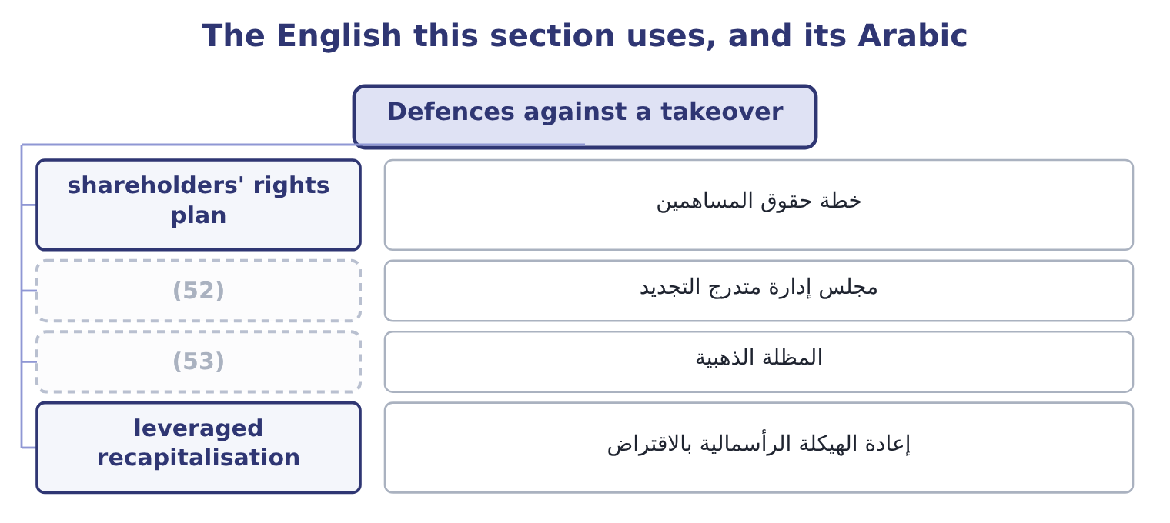
word list
staggered board · leveraged recapitalisation · golden parachute

The English this sheet uses, and its Arabic
English (exam term) | Arabic
shareholders' rights plan | خطة حقوق المساهمين
staggered board | مجلس إدارة متدرج التجديد
golden parachute | المظلة الذهبية
leveraged recapitalisation | إعادة الهيكلة الرأسمالية بالاقتراض

Answer key · 18.3 Defences against a takeover

1 unwelcome | 28 squeezed
2 constitution | 29 restricts
3 described | 30 removing
4 formally | 31 invited
5 typically | 32 prefers
6 Exercising | 33 chooses
7 prohibitively | 34 questions
8 powerful | 35 repurchase
9 redeem | 36 standstill
10 classified | 37 Pac-Man
11 meetings | 38 interest
12 rather | 39 forces
13 entitling | 40 preserves
14 change | 41 position
15 relative | 42 boards
16 justification | 43 institutional
17 protected | 44 Cheap new shares to others on a trigger
18 objection | 45 Mainly delay
19 contest | 46 Mixed
20 caused | 47 Heavy borrowing and a payout
21 heavily | 48 Blocks two-tier offers
22 dividend | 49 Shares do not deliver control
23 becomes | 50 A friendly competing bidder
24 immediately | 51 Bid withdrawn
25 requires | 52 staggered board
26 supermajority | 53 golden parachute
27 sellers

the summaries in full
Summary 1 Where an offer is unwelcome, a target's board has a set of devices available, some built into its constitution in advance and some deployed in response. The exam names them and expects each described in a sentence. A poison pill, formally a shareholders' rights plan, gives existing shareholders other than the bidder the right to buy new shares cheaply once a bidder's holding passes a trigger — typically ten or twenty per cent. Exercising it floods the register with new shares and dilutes the bidder's stake, making the acquisition prohibitively expensive. It is the most powerful of the defences and, because the board can usually redeem it, it works mainly as a lever to force the bidder to negotiate. A staggered board, also called a classified board, divides the directors into classes with only one class elected each year, so a bidder who buys control of the shares cannot replace the board for two or three annual meetings. It is a delay rather than a block, and delay is often enough.
Summary 2 A golden parachute is a contract entitling senior executives to a large payment if they lose their jobs after a change of control. As a defence it is weak, because the cost is small relative to a bid; its real justification is that managers who know they are protected can evaluate an offer on its merits instead of fighting to keep their jobs. Its objection is the obvious one: shareholders pay executives for losing a contest the executives may have caused. A leveraged recapitalisation has the target borrow heavily and pay a large special dividend or buy back shares, so that it becomes a highly leveraged company and much less attractive to a bidder whose plan was to use that unused debt capacity. It delivers value to shareholders immediately and leaves the company carrying the risks Book 2's.
Summary 3 A fair price amendment requires any bidder to pay all shareholders the same price, or a price approved by a supermajority, which prevents the two-tier offer in which early sellers get a good price and the rest are squeezed. A voting rights plan restricts the votes attaching to a large block — for example by removing voting rights from shares above a threshold unless other shareholders approve — so that buying shares does not deliver control. A white knight is a friendly third party invited to make a competing offer on terms the board prefers. The company is still sold; the board chooses the buyer. Three more appear in questions. Greenmail is the repurchase of a hostile bidder's stake at a premium, usually with a standstill agreement not to bid again, and it benefits the bidder at the expense of the remaining shareholders.
Summary 4 A crown jewel defence sells the asset the bidder most wants. A Pac-Man defence has the target bid for the bidder. The test to apply to all of them is whose interest they serve. A defence that forces a higher price serves shareholders; a defence that preserves the board's position at the cost of an attractive offer does not, which is why poison pills and staggered boards are the ones institutional investors most often vote to remove.

18.4 Divestitures and restructuring
Chapter 18 · section 18.4

Fill every gap. Each word list holds one word more than there are gaps.
Summary 1 gaps 1–12
Companies are taken apart as often as they are put together, and for the same reason: (1) the parts are worth more separately than together. The exam names four forms and expects them (2) . A spin-off (3) the shares of a subsidiary to the parent's own shareholders, pro rata. No cash (4) hands and no new (5) is involved; the shareholders simply end up (6) two shares instead of one. It is used where the subsidiary would be valued better on its own, where its management needs its own (7) for incentives and (8) , or where a conglomerate discount is being removed. A (9) divides the whole company into two or more (10) companies and the parent ceases to exist. It is the extreme case of a spin-off and arises from a (11) decision that the (12) have nothing to offer each other, or from a regulator requiring separation.
word list
businesses · interests · investor · strategic · holding · split-up · distributes · currency · distinguished · changes · because · independent · acquisitions

Summary 2 gaps 13–24
An equity (13) sells a minority stake in a subsidiary to (14) investors, usually by a public (15) . Unlike a spin-off it (16) cash, and unlike a sale it keeps (17) . It also (18) a market price for the unit, which is useful as a step (19) a later full separation and as a (20) of what the unit is worth. A tracking stock is a class of the parent's own shares whose (21) and value are tied to the (22) of one division, while the division (23) legally inside the parent. It gives investors exposure to the unit's (24) without a separation, which is its appeal and its weakness: the assets are not ring-fenced, the governance is ambiguous — the board owes duties to two sets of holders whose interests conflict over shared costs — and tracking stocks have largely fallen out of use for exactly that reason.
word list
dividend · performance · outside · carve-out · towards · results · remains · measure · offering · creates · advantages · control · raises

Summary 3 gaps 25–36
Alongside these sit the plain (25) , a sale of a unit for cash to a trade buyer or a financial one, and (26) , where the assets are worth more sold separately than the business is worth running. The (27) also asks you to judge whether a restructuring would (28) shareholders, which is a question with a method. Value each unit separately on its own cash flows and its own cost of capital — a (29) unit and a (30) one do not share a discount rate. (31) the total with the (32) market value. A sum of parts well above the market value is the conglomerate discount, and it is (33) that separation would be (34) . Identify what the group (35) provides to the unit: shared customers, shared (36) , a cheaper cost of capital, scarce management. Those are the synergies of section 18.2 in reverse, and they are what separation would destroy.
word list
outcome · technology · cyclical · Compare · divestiture · liquidation · benefit · rewarded · through · company's · evidence · stable · genuinely

Summary 4 gaps 37–46
Price the costs of separation: duplicated (37) functions, lost purchasing scale, (38) and listing costs, tax on any gain, and the covenants of Book 2's, which may have to be (39) . And (40) only where the gain (41) all four steps. Value the segment on its own flows. The segment (42) free cash flow of 450,000 a year growing at 2 per cent, and as a retail business carries more risk than the group, so it is (43) at 9.5 per cent. The (44) is 0.095 − 0.02 = 0.075, (45) a value of 450,000 ÷ 0.075 = 6,000,000. What is on the table. A regional (46) has offered $7,200,000 in cash for the segment. What separation would destroy.
word list
transaction · survives · discounted · renegotiated · head-office · distributor · denominator · spin-off · generates · recommend · giving

Summary 5 gaps 47–53
The segment buys its jars through the group's purchasing (47) and shares the Latakia (48) . If those (49) are worth, say, 200,000 of present value, the gain falls to about 1,000,000 and the (50) still holds. The right question is not whether the segment is (51) — it is — but whether it is worth more to (52) else, and here it is, by about a fifth. That is what a restructuring decision (53) comes down to, and it is.
word list
contract · somebody · profitable · Alongside · warehouse · recommendation · advantages · always

The English this section uses, and its Arabic
Each term sits against what it means.
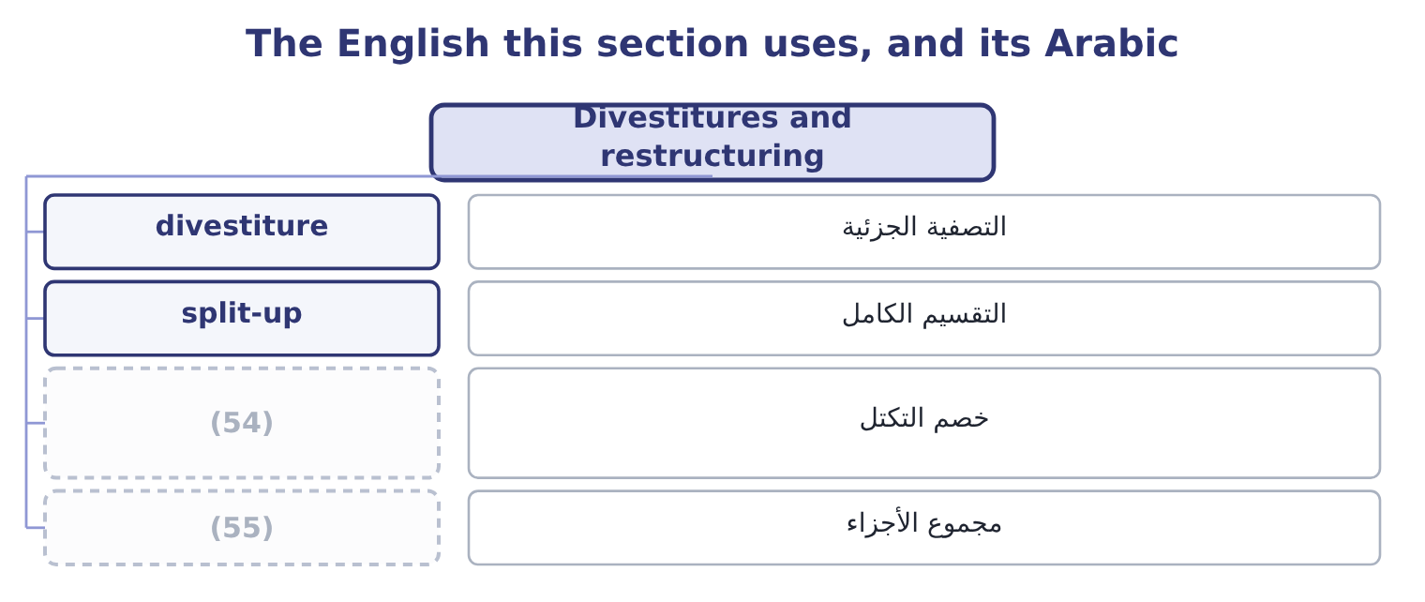
word list
growing perpetuity · sum of the parts · conglomerate discount

The English this sheet uses, and its Arabic
English (exam term) | Arabic
divestiture | التصفية الجزئية
split-up | التقسيم الكامل
conglomerate discount | خصم التكتل
sum of the parts | مجموع الأجزاء

Answer key · 18.4 Divestitures and restructuring

1 because | 29 cyclical
2 distinguished | 30 stable
3 distributes | 31 Compare
4 changes | 32 company's
5 investor | 33 evidence
6 holding | 34 rewarded
7 currency | 35 genuinely
8 acquisitions | 36 technology
9 split-up | 37 head-office
10 independent | 38 transaction
11 strategic | 39 renegotiated
12 businesses | 40 recommend
13 carve-out | 41 survives
14 outside | 42 generates
15 offering | 43 discounted
16 raises | 44 denominator
17 control | 45 giving
18 creates | 46 distributor
19 towards | 47 contract
20 measure | 48 warehouse
21 dividend | 49 advantages
22 results | 50 recommendation
23 remains | 51 profitable
24 performance | 52 somebody
25 divestiture | 53 always
26 liquidation | 54 conglomerate discount
27 outcome | 55 sum of the parts
28 benefit

the summaries in full
Summary 1 Companies are taken apart as often as they are put together, and for the same reason: because the parts are worth more separately than together. The exam names four forms and expects them distinguished. A spin-off distributes the shares of a subsidiary to the parent's own shareholders, pro rata. No cash changes hands and no new investor is involved; the shareholders simply end up holding two shares instead of one. It is used where the subsidiary would be valued better on its own, where its management needs its own currency for incentives and acquisitions, or where a conglomerate discount is being removed. A split-up divides the whole company into two or more independent companies and the parent ceases to exist. It is the extreme case of a spin-off and arises from a strategic decision that the businesses have nothing to offer each other, or from a regulator requiring separation.
Summary 2 An equity carve-out sells a minority stake in a subsidiary to outside investors, usually by a public offering. Unlike a spin-off it raises cash, and unlike a sale it keeps control. It also creates a market price for the unit, which is useful as a step towards a later full separation and as a measure of what the unit is worth. A tracking stock is a class of the parent's own shares whose dividend and value are tied to the results of one division, while the division remains legally inside the parent. It gives investors exposure to the unit's performance without a separation, which is its appeal and its weakness: the assets are not ring-fenced, the governance is ambiguous — the board owes duties to two sets of holders whose interests conflict over shared costs — and tracking stocks have largely fallen out of use for exactly that reason.
Summary 3 Alongside these sit the plain divestiture, a sale of a unit for cash to a trade buyer or a financial one, and liquidation, where the assets are worth more sold separately than the business is worth running. The outcome also asks you to judge whether a restructuring would benefit shareholders, which is a question with a method. Value each unit separately on its own cash flows and its own cost of capital — a cyclical unit and a stable one do not share a discount rate. Compare the total with the company's market value. A sum of parts well above the market value is the conglomerate discount, and it is evidence that separation would be rewarded. Identify what the group genuinely provides to the unit: shared customers, shared technology, a cheaper cost of capital, scarce management. Those are the synergies of section 18.2 in reverse, and they are what separation would destroy.
Summary 4 Price the costs of separation: duplicated head-office functions, lost purchasing scale, transaction and listing costs, tax on any gain, and the covenants of Book 2's, which may have to be renegotiated. And recommend only where the gain survives all four steps. Value the segment on its own flows. The segment generates free cash flow of 450,000 a year growing at 2 per cent, and as a retail business carries more risk than the group, so it is discounted at 9.5 per cent. The denominator is 0.095 − 0.02 = 0.075, giving a value of 450,000 ÷ 0.075 = 6,000,000. What is on the table. A regional distributor has offered $7,200,000 in cash for the segment. What separation would destroy.
Summary 5 The segment buys its jars through the group's purchasing contract and shares the Latakia warehouse. If those advantages are worth, say, 200,000 of present value, the gain falls to about 1,000,000 and the recommendation still holds. The right question is not whether the segment is profitable — it is — but whether it is worth more to somebody else, and here it is, by about a fifth. That is what a restructuring decision always comes down to, and it is.

18.5 Valuing a business by discounted cash flow
Chapter 18 · section 18.5

Fill every gap. Each word list holds one word more than there are gaps.
Summary 1 gaps 1–12
The method is, with four (1) that the exam (2) on. The cash flow is free cash flow to the firm, not a project's (3) flow: operating profit after tax, plus depreciation and other (4) charges, less capital expenditure, less the increase in net working capital. It is the cash the business (5) for all providers of capital, before any (6) to them. The horizon is (7) , so the forecast is split in two: an (8) forecast for five or ten years, where each year is modelled, and a terminal value for (9) after it. The terminal value is usually the larger half of the answer, which is why its two (10) — the long-run growth rate and the rate — deserve more (11) than the detail of year four. The rate is the target's weighted average cost of capital, not the acquirer's, (12) what is being discounted is the target's risk.
word list
standalone · attention · because · differences · incremental · generates · assumptions · non-cash · payment · infinite · explicit · concentrates · everything

Summary 2 gaps 13–21
Using (13) 9.04 per cent to value a mill with different operating risk and different (14) would be the error. And the result is an (15) value — the value of the whole business. (16) the target's debt gives the value of its equity, which is what is (17) being bought. The (18) formula does the terminal value: a cash flow of C in the next year, growing at g for ever, discounted at r, is worth C divided by the (19) r minus g. It (20) g to be below r, and a long-run growth rate above the growth of the economy is not (21) for any company.
word list
gearing · quantity · everything · Subtracting · growing-perpetuity · Orontes's · credible · actually · requires · enterprise

Worked example: what is Ghab Mills worth?

Summary 3 gaps 22–30
Build next (22) free cash flow. The mill's sales are $9,000,000 and its operating profit $1,200,000, so after tax at 25 per cent that is 1,200,000 × 0.75 = 900,000. (23) back depreciation of $300,000 gives 900,000 + 300,000 = 1,200,000 of operating cash. Capital expenditure of 464,000 leaves 1,200,000 − 464,000 = 736,000, and an increase in working capital of 50,000 leaves 736,000 − 50,000 = 686,000 of free cash flow. (24) the rate and the growth. The mill is a stable, (25) business, and its own weighted average cost of capital is 10 per cent; long-run growth of 3 per cent is (26) for a business whose volumes track the (27) crop. The (28) is 0.10 − 0.03 = 0.07. The mill (29) $2,000,000 of debt, so its equity is worth 9,800,000 − 2,000,000 = 7,800,000, which (30) 1,200,000 shares is 7,800,000 ÷ 1,200,000 = 6.50 a share.
word list
Adding · regional · defensible · asset-heavy · denominator · divided · Choose · carries · year's · across

Summary 4 gaps 31–42
The mill's shares trade at $6.50. The valuation has (31) the market price (32) , which is what a standalone valuation should do for a fairly priced business, and it is the right (33) point: the premium Orontes can (34) is not based on the mill being (35) but on what Orontes can do with it that nobody else can. Two (36) the exam uses. The same method applied to part of a company, as section 18.4 did with the (37) segment: its own flows, its own rate, and a share of corporate costs that would genuinely disappear — not an (38) , which is. The combined business is worth the acquirer's standalone value, plus the target's standalone value, plus the present value of the (39) net of the costs of (40) them. The acquirer's (41) gain that net (42) less whatever premium is paid away, which is the arithmetic of section 18.6.
word list
reproduced · allocation · exactly · retail-pack · synergy · achieving · mispriced · refinements · denominator · starting · justify · shareholders · synergies

The English this section uses, and its Arabic
Each term sits against what it means.
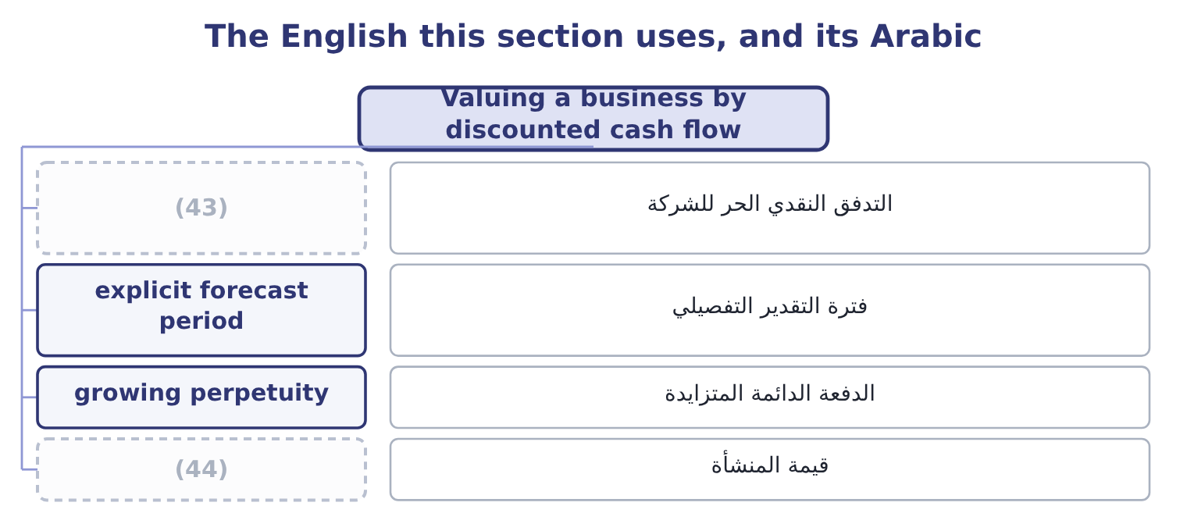
word list
horizontal merger · enterprise value · free cash flow to the firm

The English this sheet uses, and its Arabic
English (exam term) | Arabic
free cash flow to the firm | التدفق النقدي الحر للشركة
explicit forecast period | فترة التقدير التفصيلي
growing perpetuity | الدفعة الدائمة المتزايدة
enterprise value | قيمة المنشأة

Answer key · 18.5 Valuing a business by discounted cash flow

1 differences | 23 Adding
2 concentrates | 24 Choose
3 incremental | 25 asset-heavy
4 non-cash | 26 defensible
5 generates | 27 regional
6 payment | 28 denominator
7 infinite | 29 carries
8 explicit | 30 across
9 everything | 31 reproduced
10 assumptions | 32 exactly
11 attention | 33 starting
12 because | 34 justify
13 Orontes's | 35 mispriced
14 gearing | 36 refinements
15 enterprise | 37 retail-pack
16 Subtracting | 38 allocation
17 actually | 39 synergies
18 growing-perpetuity | 40 achieving
19 quantity | 41 shareholders
20 requires | 42 synergy
21 credible | 43 free cash flow to the firm
22 year's | 44 enterprise value

the summaries in full
Summary 1 The method is, with four differences that the exam concentrates on. The cash flow is free cash flow to the firm, not a project's incremental flow: operating profit after tax, plus depreciation and other non-cash charges, less capital expenditure, less the increase in net working capital. It is the cash the business generates for all providers of capital, before any payment to them. The horizon is infinite, so the forecast is split in two: an explicit forecast for five or ten years, where each year is modelled, and a terminal value for everything after it. The terminal value is usually the larger half of the answer, which is why its two assumptions — the long-run growth rate and the rate — deserve more attention than the detail of year four. The rate is the target's weighted average cost of capital, not the acquirer's, because what is being discounted is the target's risk.
Summary 2 Using Orontes's 9.04 per cent to value a mill with different operating risk and different gearing would be the error. And the result is an enterprise value — the value of the whole business. Subtracting the target's debt gives the value of its equity, which is what is actually being bought. The growing-perpetuity formula does the terminal value: a cash flow of C in the next year, growing at g for ever, discounted at r, is worth C divided by the quantity r minus g. It requires g to be below r, and a long-run growth rate above the growth of the economy is not credible for any company.
Summary 3 Build next year's free cash flow. The mill's sales are $9,000,000 and its operating profit $1,200,000, so after tax at 25 per cent that is 1,200,000 × 0.75 = 900,000. Adding back depreciation of $300,000 gives 900,000 + 300,000 = 1,200,000 of operating cash. Capital expenditure of 464,000 leaves 1,200,000 − 464,000 = 736,000, and an increase in working capital of 50,000 leaves 736,000 − 50,000 = 686,000 of free cash flow. Choose the rate and the growth. The mill is a stable, asset-heavy business, and its own weighted average cost of capital is 10 per cent; long-run growth of 3 per cent is defensible for a business whose volumes track the regional crop. The denominator is 0.10 − 0.03 = 0.07. The mill carries $2,000,000 of debt, so its equity is worth 9,800,000 − 2,000,000 = 7,800,000, which across 1,200,000 shares is 7,800,000 ÷ 1,200,000 = 6.50 a share.
Summary 4 The mill's shares trade at $6.50. The valuation has reproduced the market price exactly, which is what a standalone valuation should do for a fairly priced business, and it is the right starting point: the premium Orontes can justify is not based on the mill being mispriced but on what Orontes can do with it that nobody else can. Two refinements the exam uses. The same method applied to part of a company, as section 18.4 did with the retail-pack segment: its own flows, its own rate, and a share of corporate costs that would genuinely disappear — not an allocation, which is. The combined business is worth the acquirer's standalone value, plus the target's standalone value, plus the present value of the synergies net of the costs of achieving them. The acquirer's shareholders gain that net synergy less whatever premium is paid away, which is the arithmetic of section 18.6.

18.6 Evaluating the deal and recommending
Chapter 18 · section 18.6

Fill every gap. Each word list holds one word more than there are gaps.
Summary 1 gaps 1–12
The arithmetic of a recommendation is short. The maximum Orontes can pay for the mill's equity is its standalone value plus the net synergy; (1) above that (2) value from Orontes's shareholders to the mill's. The (3) the mill's (4) will take is its market value. The (5) happens between those two (6) , and the premium decides how the created value is split. Buying the mill (7) the trading margin and the duplicated (8) on the sixty per cent of its output Orontes already takes, worth 180,000 a year before tax, which after tax is 180,000 × 0.75 = 135,000. (9) as a growing (10) on the same terms as the mill's own flows, that is worth 135,000 ÷ 0.07 = 1,928,571. The cost of (11) them. Integration — systems, (12) , relabelling — will cost 400,000 before tax at the outset, which after tax is 400,000 × 0.75 = 300,000. So the net synergy is 1,928,571 − 300,000 = 1,628,571.
word list
getting · removes · numbers · minimum · administration · negotiation · shareholders · owners · anything · Treated · redundancies · perpetuity · transfers

Summary 2 gaps 13–17
The most Orontes can pay for the equity is 7,800,000 + 1,628,571 = 9,428,571, which is 9,428,571 ÷ 1,200,000 = 7.86 a share. At that price every penny of the created value has gone to the (13) . An offer of $7.25 a share. That is 1,200,000 × 7.25 = 8,700,000 in total, a premium of 8,700,000 − 7,800,000 = 900,000 over market value, or 900,000 ÷ 7,800,000 = 11.54 per cent. Orontes keeps 9,428,571 − 8,700,000 = 728,571 of value and gives away 900,000 ÷ 1,628,571 = 55.26 per cent of the synergy. (14) it from the other (15) . The (16) equity is worth Orontes's 74,925,000 plus the mill's 7,800,000, which is 74,925,000 + 7,800,000 = 82,725,000, plus the net synergy, (17) 82,725,000 + 1,628,571 = 84,353,571.
word list
language · seller · direction · giving · Confirm · combined

Summary 3 gaps 18–29
Paying 8,700,000 in cash (18) Orontes's shareholders with 84,353,571 − 8,700,000 = 75,653,571, a gain of 75,653,571 − 74,925,000 = 728,571 — the same figure. The two (19) must agree, and (20) that they do is the (21) way to find an arithmetic error in an exam. Note what step 4 shows: more than half the value created by the deal goes to the (22) shareholders at a premium of only (23) and a half per cent. That is the normal result in real (24) and the reason the research finds (25) ' shareholders gaining little on average while targets' shareholders gain a great deal. The premium is paid in (26) cash now; the synergy is a forecast (27) over years by people who have just been acquired. The qualitative (28) decide as often as the arithmetic does, and the (29) asks for them.
word list
acquirers · certain · quickest · eleven · considerations · leaves · outcome · acquisitions · routes · checking · standalone · delivered · target's

Summary 4 gaps 30–41
Can we run it? A tahini producer buying a mill is taking on a business with its own (30) , its own labour (31) and its own seasonal crop risk. A mill of forty people acquired by a company of four hundred will either be (32) or resented, and the (33) is managed rather than assumed. In a small supplier the value may walk out of the door: the mill's chief (34) and its buyer of sesame may be the business. Owning the supplier (35) risk that was previously (36) across several. If the mill's crop fails, Orontes now (37) the loss twice. Orontes can (38) switch suppliers if the mill's prices rise. (39) it cannot, and the (40) that kept the mill's prices honest disappears. (41) and its effects. How the deal is paid for changes the gearing of Book 2's. Regulatory and tax consequences, and the accounting: goodwill will arise, and Book 1's. A long-term supply contract, a minority stake, or a joint venture may deliver much of the synergy for a fraction of the price and the risk — and no recommendation is complete without saying why the full acquisition is better than those.
word list
practices · Afterwards · difference · discipline · currently · absorbed · concentrates · carries · engineer · Financing · technology · qualitative · diversified

The price range for Ghab Mills
Item | Amount | Per share
Standalone equity value (the floor) | 7,800,000 | 6.50
Net synergy | 1,628,571 | 1.36
(42) | 9,428,571 | 7.86
Offer at 7.25 | 8,700,000 | 7.25
(43) | 728,571 | 0.61

word list
Maximum justifiable price (the ceiling) · Value retained by Orontes · exclusive to the deal

The deal in six lines

Your turn: the acquisition (complete the blanks)
Item | Data | Answer
Kind of combination | (44) | Vertical, and backward: Orontes moves towards its raw material.
Enterprise value of the mill | (45) | 9,800,000: 686,000 ÷ 0.07 = 9,800,000.
Equity value | Debt 2,000,000 | 7,800,000: 9,800,000 − 2,000,000 = 7,800,000, or 6.50 a share.
Maximum justifiable offer | Net synergy 1,628,571 | 9,428,571: 7,800,000 + 1,628,571 = 9,428,571, or 7.86 a share.
Premium at 7.25 a share | (46) | 11.54 per cent: 900,000 ÷ 7,800,000 = 11.54 per cent.
Defence that dilutes a bidder's stake |  | (47)

word list
Market 6.50 · Free cash flow 686,000; rate 10%; growth 3% · Orontes buys its sesame supplier · The poison pill, or shareholders' rights plan. · enterprise value

"Synergy", "goodwill" and the vocabulary of deals

Summary 5 gaps 48–54
Deal (48) is unusually (49) in English and the (50) do not all travel. Poison pill, white knight, golden (51) and greenmail are (52) that have become technical terms, chevalier blanc — which means they are (53) but should still be explained the first time they appear in a report. Goodwill is the trap: in ordinary English it means benevolence, and in accounting it means the excess of the price paid over the fair value of the (54) net assets acquired.
word list
figures · parachute · benevolence · language · metaphors · identifiable · understood · figurative

The English this section uses, and its Arabic
Each term sits against what it means.
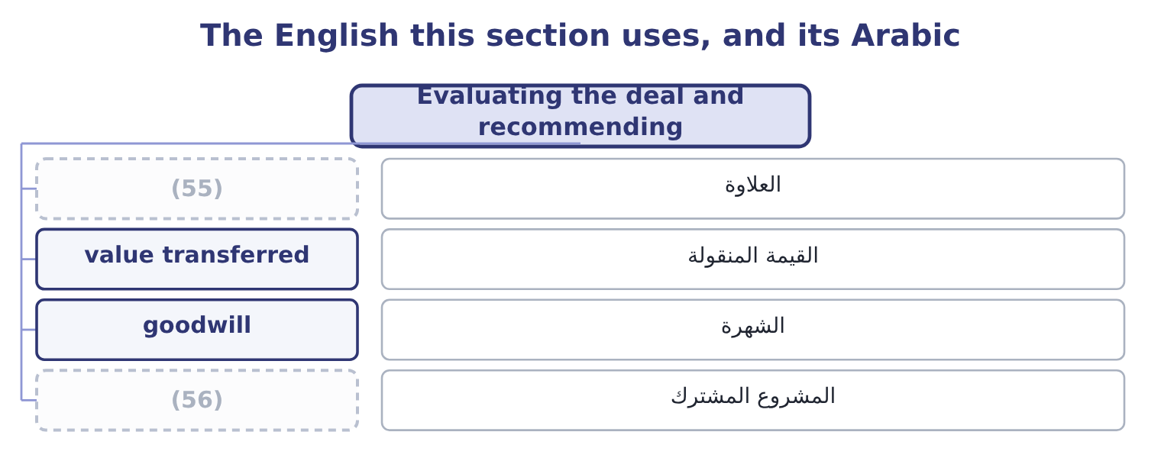
word list
joint venture · horizontal merger · premium

The English this sheet uses, and its Arabic
English (exam term) | Arabic
premium | العلاوة
value transferred | القيمة المنقولة
goodwill | الشهرة
joint venture | المشروع المشترك

Answer key · 18.6 Evaluating the deal and recommending

1 anything | 29 outcome
2 transfers | 30 technology
3 minimum | 31 practices
4 owners | 32 absorbed
5 negotiation | 33 difference
6 numbers | 34 engineer
7 removes | 35 concentrates
8 administration | 36 diversified
9 Treated | 37 carries
10 perpetuity | 38 currently
11 getting | 39 Afterwards
12 redundancies | 40 discipline
13 seller | 41 Financing
14 Confirm | 42 Maximum justifiable price (the ceiling)
15 direction | 43 Value retained by Orontes
16 combined | 44 Orontes buys its sesame supplier
17 giving | 45 Free cash flow 686,000; rate 10%; growth 3%
18 leaves | 46 Market 6.50
19 routes | 47 The poison pill, or shareholders' rights plan.
20 checking | 48 language
21 quickest | 49 figurative
22 target's | 50 figures
23 eleven | 51 parachute
24 acquisitions | 52 metaphors
25 acquirers | 53 understood
26 certain | 54 identifiable
27 delivered | 55 premium
28 considerations | 56 joint venture

the summaries in full
Summary 1 The arithmetic of a recommendation is short. The maximum Orontes can pay for the mill's equity is its standalone value plus the net synergy; anything above that transfers value from Orontes's shareholders to the mill's. The minimum the mill's owners will take is its market value. The negotiation happens between those two numbers, and the premium decides how the created value is split. Buying the mill removes the trading margin and the duplicated administration on the sixty per cent of its output Orontes already takes, worth 180,000 a year before tax, which after tax is 180,000 × 0.75 = 135,000. Treated as a growing perpetuity on the same terms as the mill's own flows, that is worth 135,000 ÷ 0.07 = 1,928,571. The cost of getting them. Integration — systems, redundancies, relabelling — will cost 400,000 before tax at the outset, which after tax is 400,000 × 0.75 = 300,000. So the net synergy is 1,928,571 − 300,000 = 1,628,571.
Summary 2 The most Orontes can pay for the equity is 7,800,000 + 1,628,571 = 9,428,571, which is 9,428,571 ÷ 1,200,000 = 7.86 a share. At that price every penny of the created value has gone to the seller. An offer of $7.25 a share. That is 1,200,000 × 7.25 = 8,700,000 in total, a premium of 8,700,000 − 7,800,000 = 900,000 over market value, or 900,000 ÷ 7,800,000 = 11.54 per cent. Orontes keeps 9,428,571 − 8,700,000 = 728,571 of value and gives away 900,000 ÷ 1,628,571 = 55.26 per cent of the synergy. Confirm it from the other direction. The combined equity is worth Orontes's 74,925,000 plus the mill's 7,800,000, which is 74,925,000 + 7,800,000 = 82,725,000, plus the net synergy, giving 82,725,000 + 1,628,571 = 84,353,571.
Summary 3 Paying 8,700,000 in cash leaves Orontes's shareholders with 84,353,571 − 8,700,000 = 75,653,571, a gain of 75,653,571 − 74,925,000 = 728,571 — the same figure. The two routes must agree, and checking that they do is the quickest way to find an arithmetic error in an exam. Note what step 4 shows: more than half the value created by the deal goes to the target's shareholders at a premium of only eleven and a half per cent. That is the normal result in real acquisitions and the reason the research finds acquirers' shareholders gaining little on average while targets' shareholders gain a great deal. The premium is paid in certain cash now; the synergy is a forecast delivered over years by people who have just been acquired. The qualitative considerations decide as often as the arithmetic does, and the outcome asks for them.
Summary 4 Can we run it? A tahini producer buying a mill is taking on a business with its own technology, its own labour practices and its own seasonal crop risk. A mill of forty people acquired by a company of four hundred will either be absorbed or resented, and the difference is managed rather than assumed. In a small supplier the value may walk out of the door: the mill's chief engineer and its buyer of sesame may be the business. Owning the supplier concentrates risk that was previously diversified across several. If the mill's crop fails, Orontes now carries the loss twice. Orontes can currently switch suppliers if the mill's prices rise. Afterwards it cannot, and the discipline that kept the mill's prices honest disappears. Financing and its effects. How the deal is paid for changes the gearing of Book 2's. Regulatory and tax consequences, and the accounting: goodwill will arise, and Book 1's. A long-term supply contract, a minority stake, or a joint venture may deliver much of the synergy for a fraction of the price and the risk — and no recommendation is complete without saying why the full acquisition is better than those.
Summary 5 Deal language is unusually figurative in English and the figures do not all travel. Poison pill, white knight, golden parachute and greenmail are metaphors that have become technical terms, chevalier blanc — which means they are understood but should still be explained the first time they appear in a report. Goodwill is the trap: in ordinary English it means benevolence, and in accounting it means the excess of the price paid over the fair value of the identifiable net assets acquired.

