Table of Contents

B1.2 · Unit 3 · The Post That Ends on Friday
English Animated · Weighing It Up · Hospital Regional, Valdivia Student's Book pages 50–71 · 22 pp · ~11 hours

Part 0 · The Big Picture ◆ A · THE WORLD
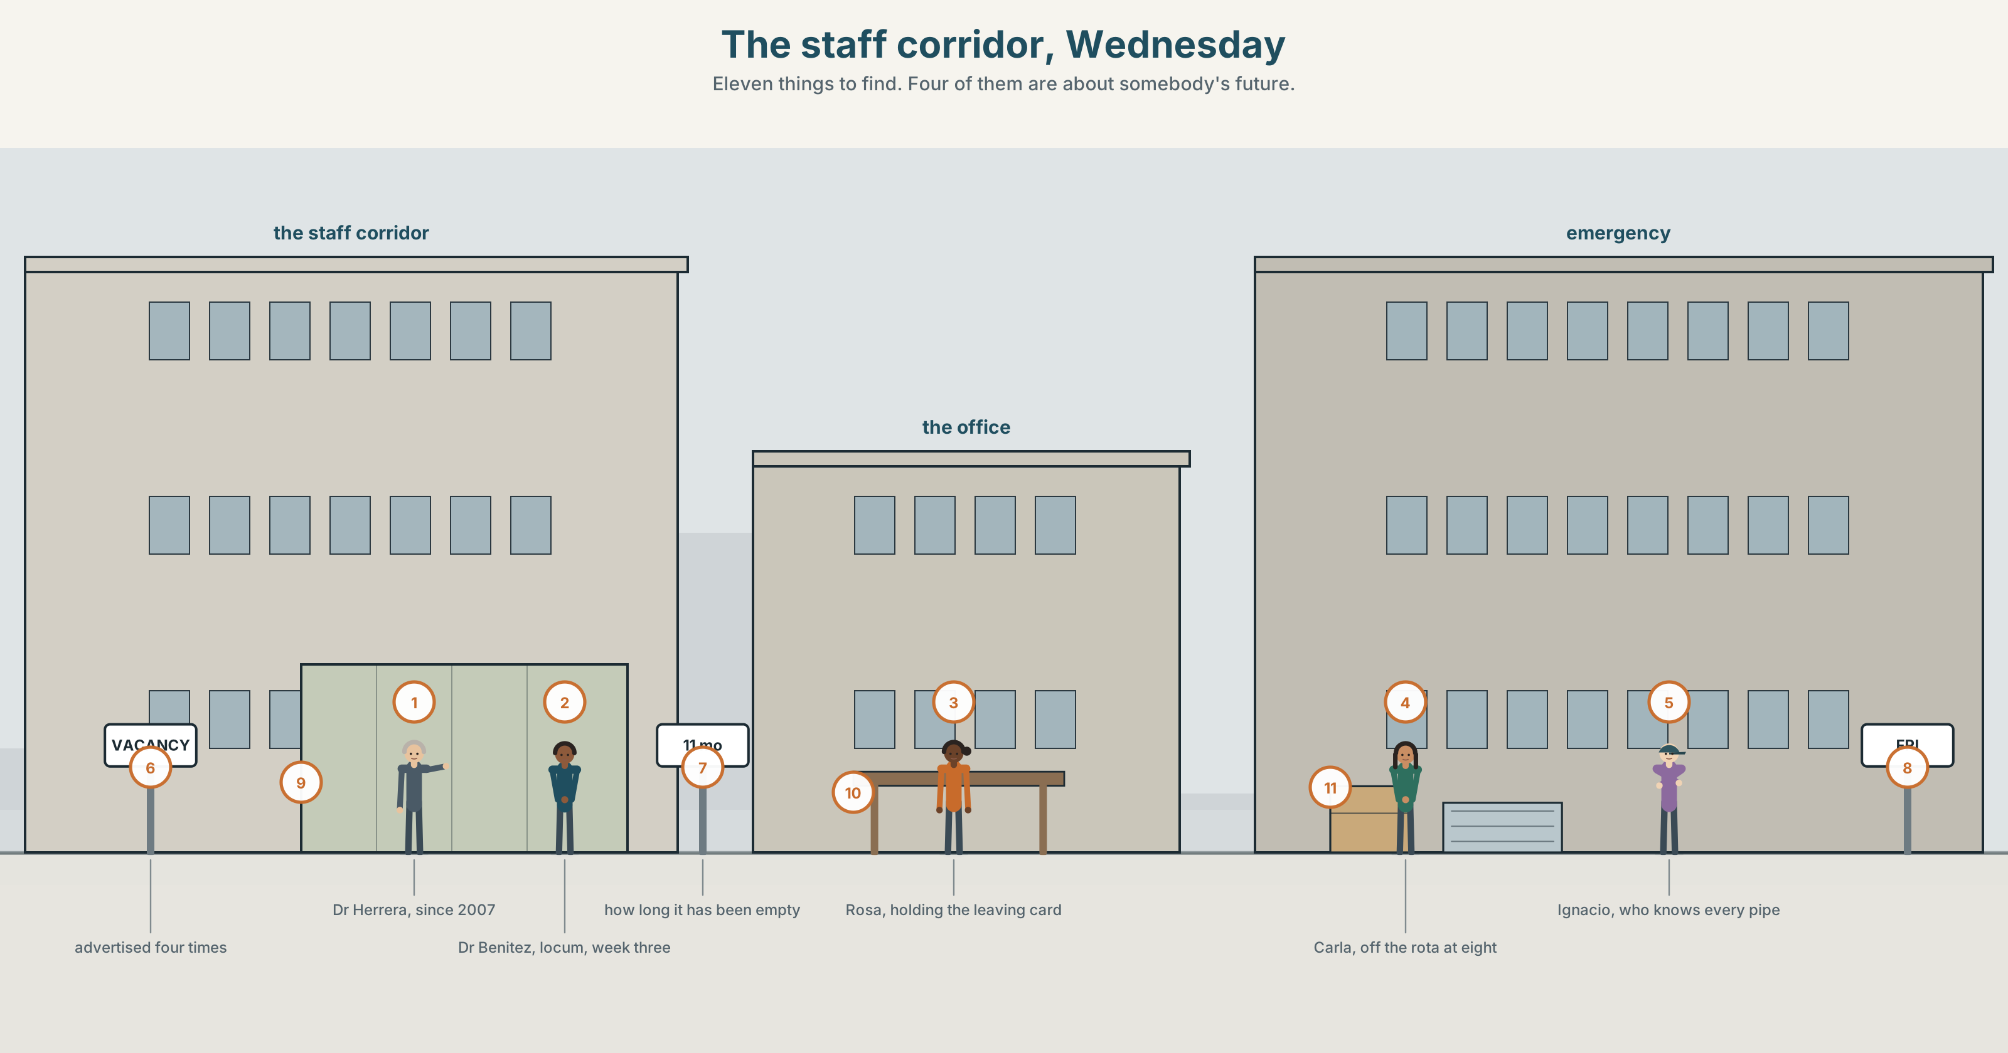{width=6.6in}
The staff corridor, Wednesday — Eleven things to find. Four of them are about somebody's future.

Are you where you expected to be?
By the end of this unit you can give a two-minute talk about the choice that put you where you are.
◆ A · THE WORLD | Six careers in one building, and not one of them went to plan
◆ B · THE SYSTEM | mixed conditionals · consequence chains · 23 words for posts and paths · 22 words for cause and result · how the tune changes when the halves do not match
◆ C · THE PERFORMANCE | Two minutes on one decision and everything downstream of it

0A · Find it
Find eleven things in this picture. Four of them are about somebody's future.
a vacancy notice · a rota on a wall · a shortlist pinned to a board · a name badge · a locum's temporary pass · a study timetable · a reference request in a tray · a photograph of a 1998 intake · a lanyard with three keys · a coffee machine · a leaving card going round

0B · Guess it
Two people in this picture are doing a job they did not train for. Which, and what is the evidence in the drawing?

0C · Say it ⏺
Record forty-five seconds. Name one decision that put you where you are. Now say what you would be doing if you had decided the other way. You will record it again at the end of this unit.

Part 1 · Vocabulary Lab 1 ◆ B · THE SYSTEM
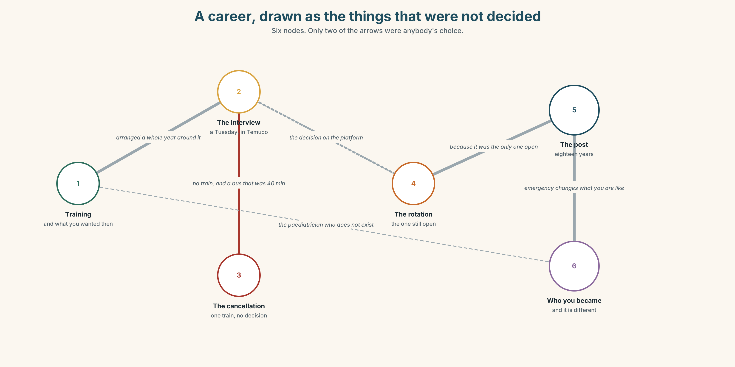{width=6.6in}
A career, drawn as the things that were not decided — Six nodes. Only two of the arrows were anybody's choice.

1A · Meet — the words of a working life
Match each word to one place on the map.
career · speciality · rotation · post · vacancy · training · mentor · supervisor · shortlist · reference

1B · Sort — a thing you apply for, a thing you are given, or a thing you become?
Three columns.
post · reference · speciality · shortlist · mentor · appointment · vacancy · trajectory · supervisor
One of them is in the first column for the person and the second column for the institution. Which?

1C · Meet — three words with a shape in them
rotation · trajectory · career path
All three describe movement. Which one is a circle, which is a curve, and which is a line somebody else drew?

1D · Collocation Lab
Complete each one with one word.
- She applied ______ a post in paediatrics and got one in emergency.
- He took ______ a post in Valdivia because his sister lived here.
- On ______ , the two candidates were identical.
- Nobody could explain what the right ______ meant and everybody used the phrase.
- She turned ______ the Santiago job twice and does not regret it on most days.
- He went ______ medicine because of one teacher and has never told her.

1E · The fixed expressions
f It just happened. f I never planned any of this.
Two sentences that people say about careers. One of them is modest. One of them is a defence.
Write the question that produces each one.

1F · Own it
Think of the job, course or city you are in. Tell a partner four sentences: how you got there, what the alternative was, who decided, and whether you would call it a plan.

Part 2 · Listening ◆ A · THE WORLD
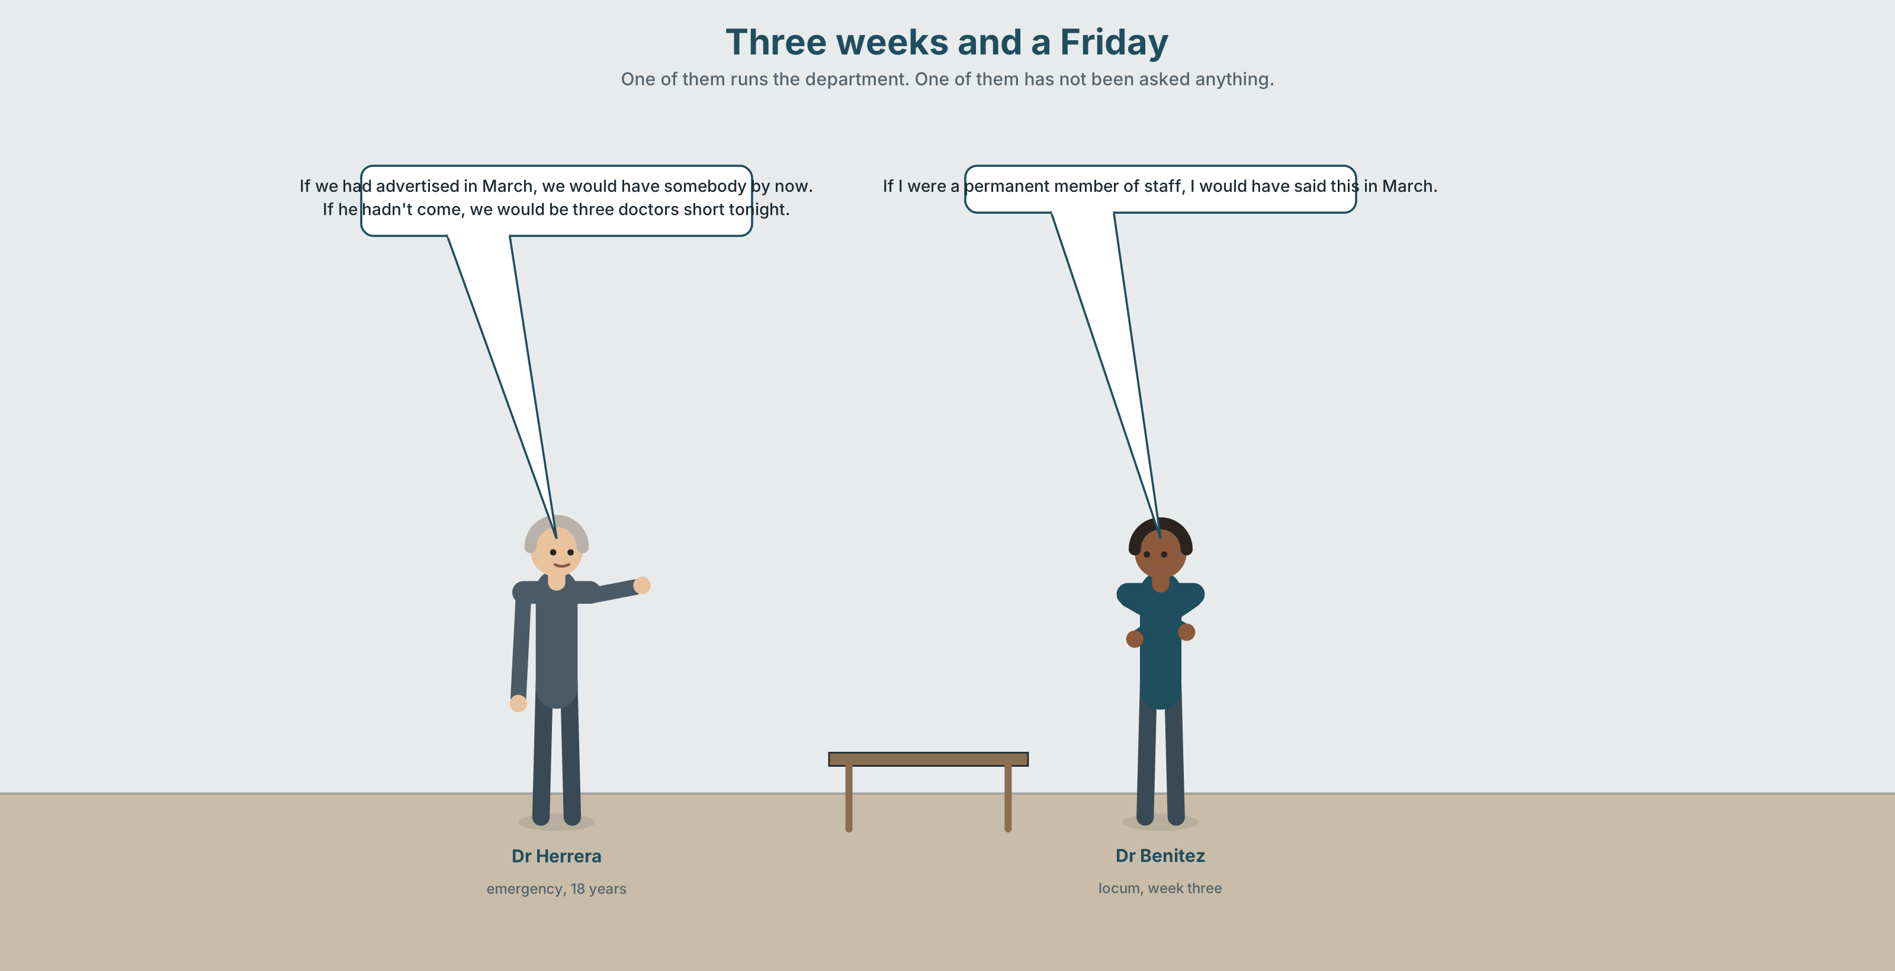{width=6.6in}
Three weeks and a Friday — One of them runs the department. One of them has not been asked anything.

2A · Three weeks and a Friday 🔊 Track 3.1
Before you listen. Dr Benítez is a locum. His contract ends on Friday. Renewing costs twice what a permanent post would. Guess: what is stopping them from recruiting?
Listen once. One question. How long has the permanent post been vacant?
Listen again. Complete the table.
 | What they want | What it costs | What they are not saying
Dr Herrera
the finance office
Dr Benítez
Listen again. Choose the best answer.
- The post has been vacant for four months / eleven months / two years.
- A locum costs about 1.4 / 2.0 / 3.2 times a permanent doctor.
- Recruitment would take about six weeks / three months / a year.
- Dr Benítez would stay permanently if the money improved / the rota changed / he were asked properly.
Noticing. Four sentences from the recording.
- If we had advertised in March, we would have somebody by now.
- If I were a permanent member of staff, I would have said this in March.
- If he hadn't come, we would be three doctors short tonight.
- If we advertise now, we will be short for three months.
Two of these mix a past condition with a present result. Which two, and how can you tell?

2B · Decoding clinic 🔊 Track 3.2
Thirty seconds of Dr Herrera. Four jobs.
- How many conditionals can you count?
- In sentence 1, does her voice rise or fall at March?
- Catch the two costs she gives.
- She says one sentence that is a conditional with no if in it. Find it.
Transcripts, page 152.

Part 3 · Grammar Lab 1 ◆ B · THE SYSTEM

When the two halves are in different times

3A · Notice
Look at the four sentences in Part 2.
- In sentence 1, which half is about the past and which about now?
- In sentence 2, which half is about now and which about the past?
- Sentences 1 and 2 are mirror images. Write out which time each half is in.
- Sentence 3 does the same thing. What is the real situation behind it?
- Try "If we had advertised in March, we would have had somebody by now." Is that wrong? What changes?

3B · See
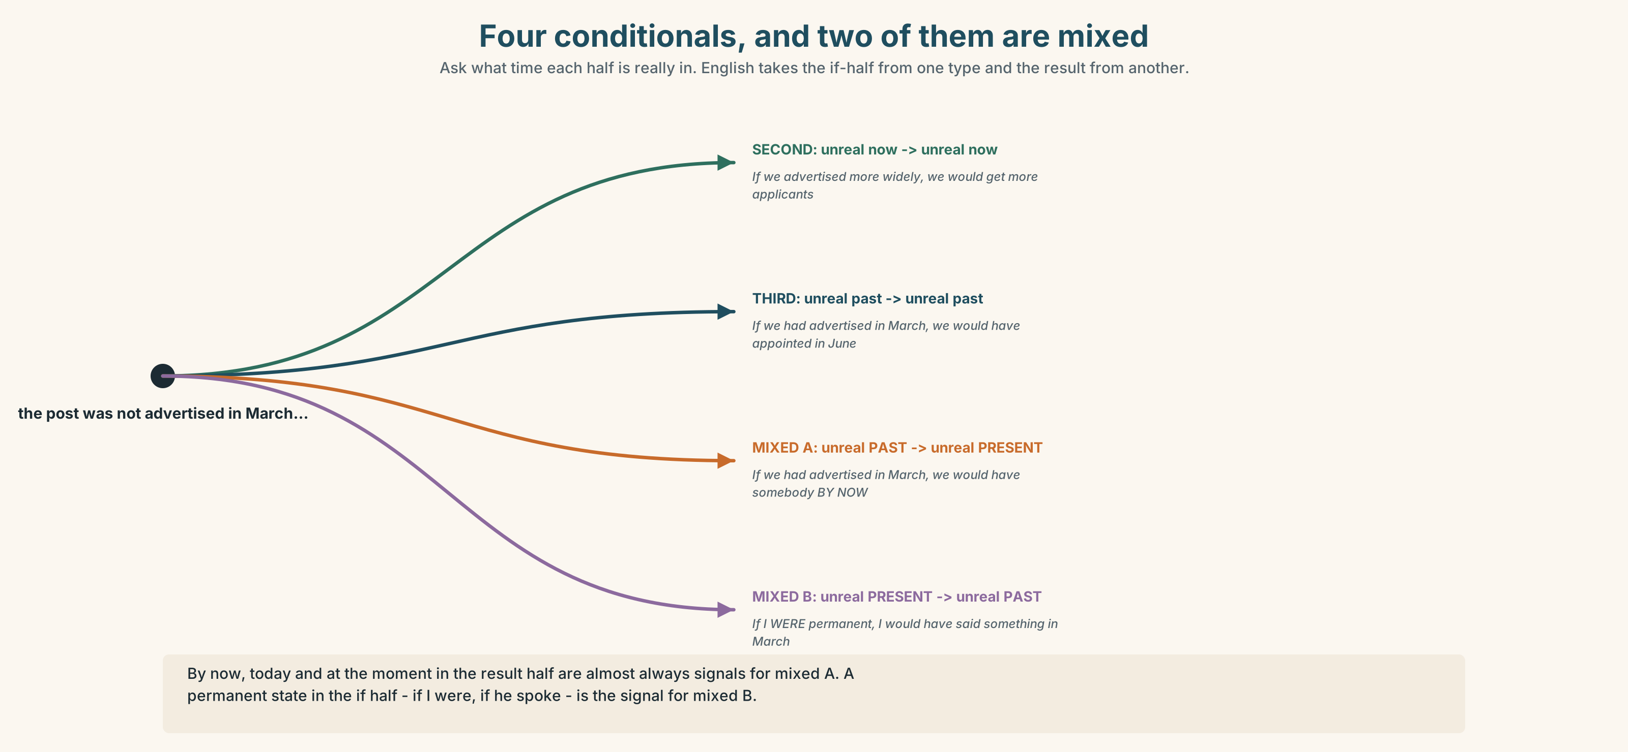{width=6.6in}
Four conditionals, and two of them are mixed — Ask what time each half is really in. English takes the if-half from one type and the result from another.

3C · Know
 | if half | result half | Meaning
second | past simple | would + verb | unreal now → unreal now
third | past perfect | would have + pp | unreal past → unreal past
mixed A | past perfect | would + verb | unreal past → unreal present
mixed B | past simple | would have + pp | unreal present state → unreal past
Mixed A — the past did not happen, and that is why now is like this. If we had advertised in March, we would have somebody by now.
Mixed B — a permanent condition about now, and its effect on the past. If I were permanent, I would have said this in March.
How to choose. Ask what time each half is really in. English has no special form for a mixed conditional; it takes the if half from one type and the result half from the other.
Watch out. by now, today, at the moment in the result half are almost always signals for mixed A. ✗ If we had advertised in March, we would have had somebody by now is possible, but it means the having happened and finished in the past, which is not what anybody means here.

3D · Use — controlled
If the post (1) __________ (be advertised) in March, we (2) __________ (have) somebody by now. If Dr Benítez (3) __________ (not / come) in September, we (4) __________ (be) three doctors short tonight. If he (5) __________ (be) a permanent member of staff, he (6) __________ (say) something about the rota in his first week. And if we (7) __________ (advertise) now, we (8) __________ (be) short until February.

3E · Use — guided
Write each one as a mixed conditional. Say which type.
- We didn't advertise in March. We have nobody now.
- He is not permanent. He said nothing in March.
- She trained in paediatrics. She is not in paediatrics now.
- I am not a confident speaker. I did not apply in 2019.
- They cut the training budget in 2021. There are two supervisors now instead of five.

3F · Use — open
In pairs. Each of you names one decision from your own life. Your partner produces one mixed A and one mixed B about it. Then swap. Four minutes each.

3G · Error autopsy
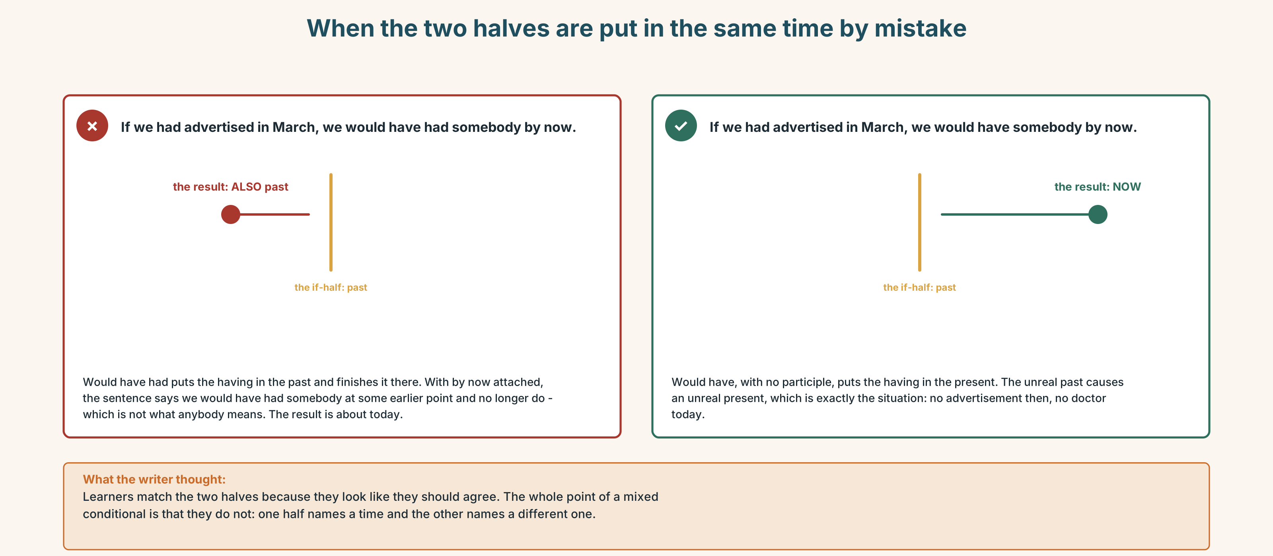{width=6.6in}
When the two halves are put in the same time by mistake — When the two halves are put in the same time by mistake
Read both versions. Then say, in one sentence, when the first one would actually be correct.

3H · Check — eight items
- If we ______ (advertise) in March, we ______ (have) somebody now.
- If I ______ (be) permanent, I ______ (say) something in March.
- If he ______ (not / come), we ______ (be) short tonight.
- If she ______ (not / take) that post, she ______ (work) in Santiago now.
- If I ______ (be) braver, I ______ (apply) two years ago.
- If they ______ (not / cut) the budget, there ______ (be) five supervisors today.
- If we ______ (advertise) now, we ______ (be) short until February. (real)
- If he ______ (speak) Spanish, he ______ (get) the job last year.
0–4 → Workbook pp. 16–19. 5–6 → Part 6. 7–8 → page 63.

Part 4 · Speaking ◆ C · THE PERFORMANCE

4A · Fluency starter — the fork
One learner names a fork in their life. The others ask only questions beginning "What would you be doing now if…". Six questions, then swap.

4B · The functional core — the decision and everything after it
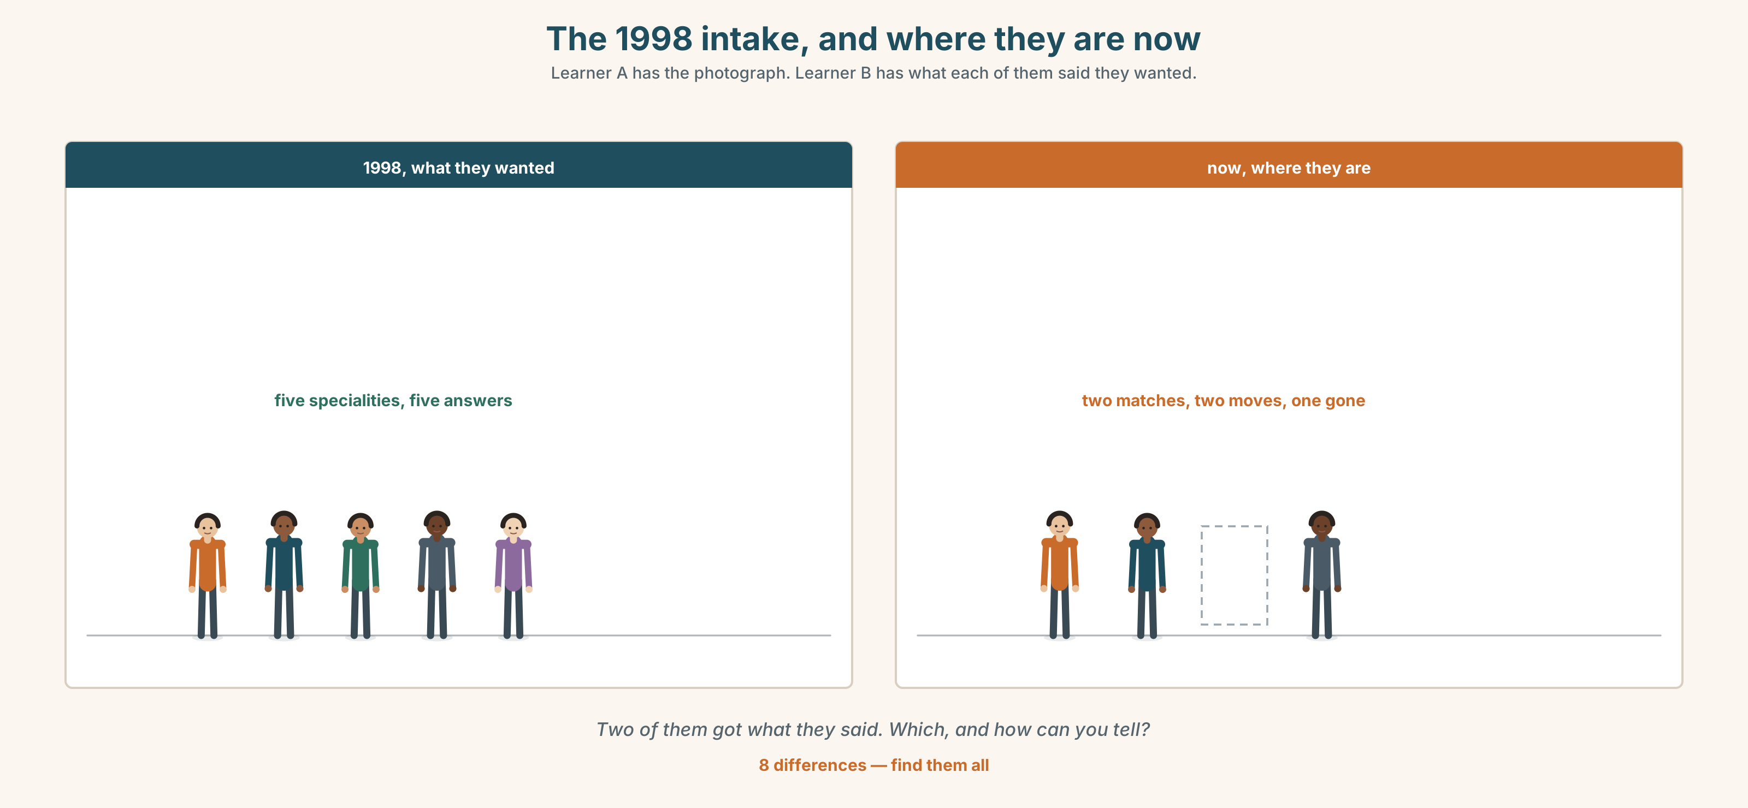{width=6.6in}
The 1998 intake, and where they are now — Learner A has the photograph. Learner B has what each of them said they wanted.
Language Bank
the decision | I took a post in… · I applied for… · I turned down…
the chain | Which meant that… · That led to… · One thing led to another.
the counterfactual now | If I hadn't, I'd be… · I would probably be…
the honest ending | It just happened. · And that is why I am here.
Information gap. Learner A has the 1998 intake photograph and where each person is now. Learner B has what each of them said they wanted in 1998. Find the two who got what they said.

4C · The performance — two minutes ⏺
Give a two-minute talk on the choice that put you where you are. You must include:
the decision, with a date · two things that followed from it · one mixed conditional about now · one thing you did not decide at all
Record it.

4D · Observer
One person listens for one thing: how much of the speaker's path was chosen?

4E · Three criteria
☐ Did I use a mixed conditional correctly? ☐ Is there a date in it? ☐ Did I name one thing that was not a decision?

Part 5 · Reading ◆ A · THE WORLD

5A · Predict
A personal essay by a doctor. The title is "I am in emergency medicine because of a train." What do you expect the train to be? Two sentences.

5B · Read — two minutes

I am in emergency medicine because of a train
In 2007 I was in my final year and I wanted paediatrics. I had wanted paediatrics since I was nineteen and I had arranged my entire fifth year around it, including an elective I paid for myself.
The interviews for the paediatric rotations were in Temuco on a Tuesday. There was one train. It was cancelled, and the replacement bus — which existed, and which I could have taken — would have got me there forty minutes late, and I decided, standing on a platform at six in the morning, that arriving forty minutes late to an interview was worse than not arriving.
I now think that was wrong. I think they would have seen me. I was twenty-four and I had never in my life been late to anything and I did not know that lateness is survivable.
So I took the emergency rotation that was still open, because it was the only one still open, and I have been in emergency medicine for eighteen years and I am good at it and I would not change it.
Here is the part that bothers me. If I had taken the bus, I would be a paediatrician now. I would be a different person: emergency changes what you are like, it genuinely does, and I have watched it happen to eleven other people. The me that exists is a product of a cancelled train.
And here is the part that bothers me more. Every year I interview fifth-years. Last year a candidate arrived thirty-five minutes late, apologised once, and was excellent, and two of the three people on the panel wanted to mark her down for it.
I told them about the train. We appointed her. She starts in March and I have not told her any of this.

5C · Comprehension — eight questions
- What speciality did the writer want, and for how long?
- What exactly happened on the Tuesday, and what decision did she make on the platform?
- Why does she now think the decision was wrong?
- How did she end up in emergency medicine?
- What does she mean by "the me that exists is a product of a cancelled train"?
- What happened at the interview last year?
- What did she do, and what has she not done?
- Why do you think she has not told the new appointee?

5D · Vocabulary in context
Guess from the text. Then check.
an elective · the replacement bus · lateness is survivable · still open · mark her down

5E · The counter-text
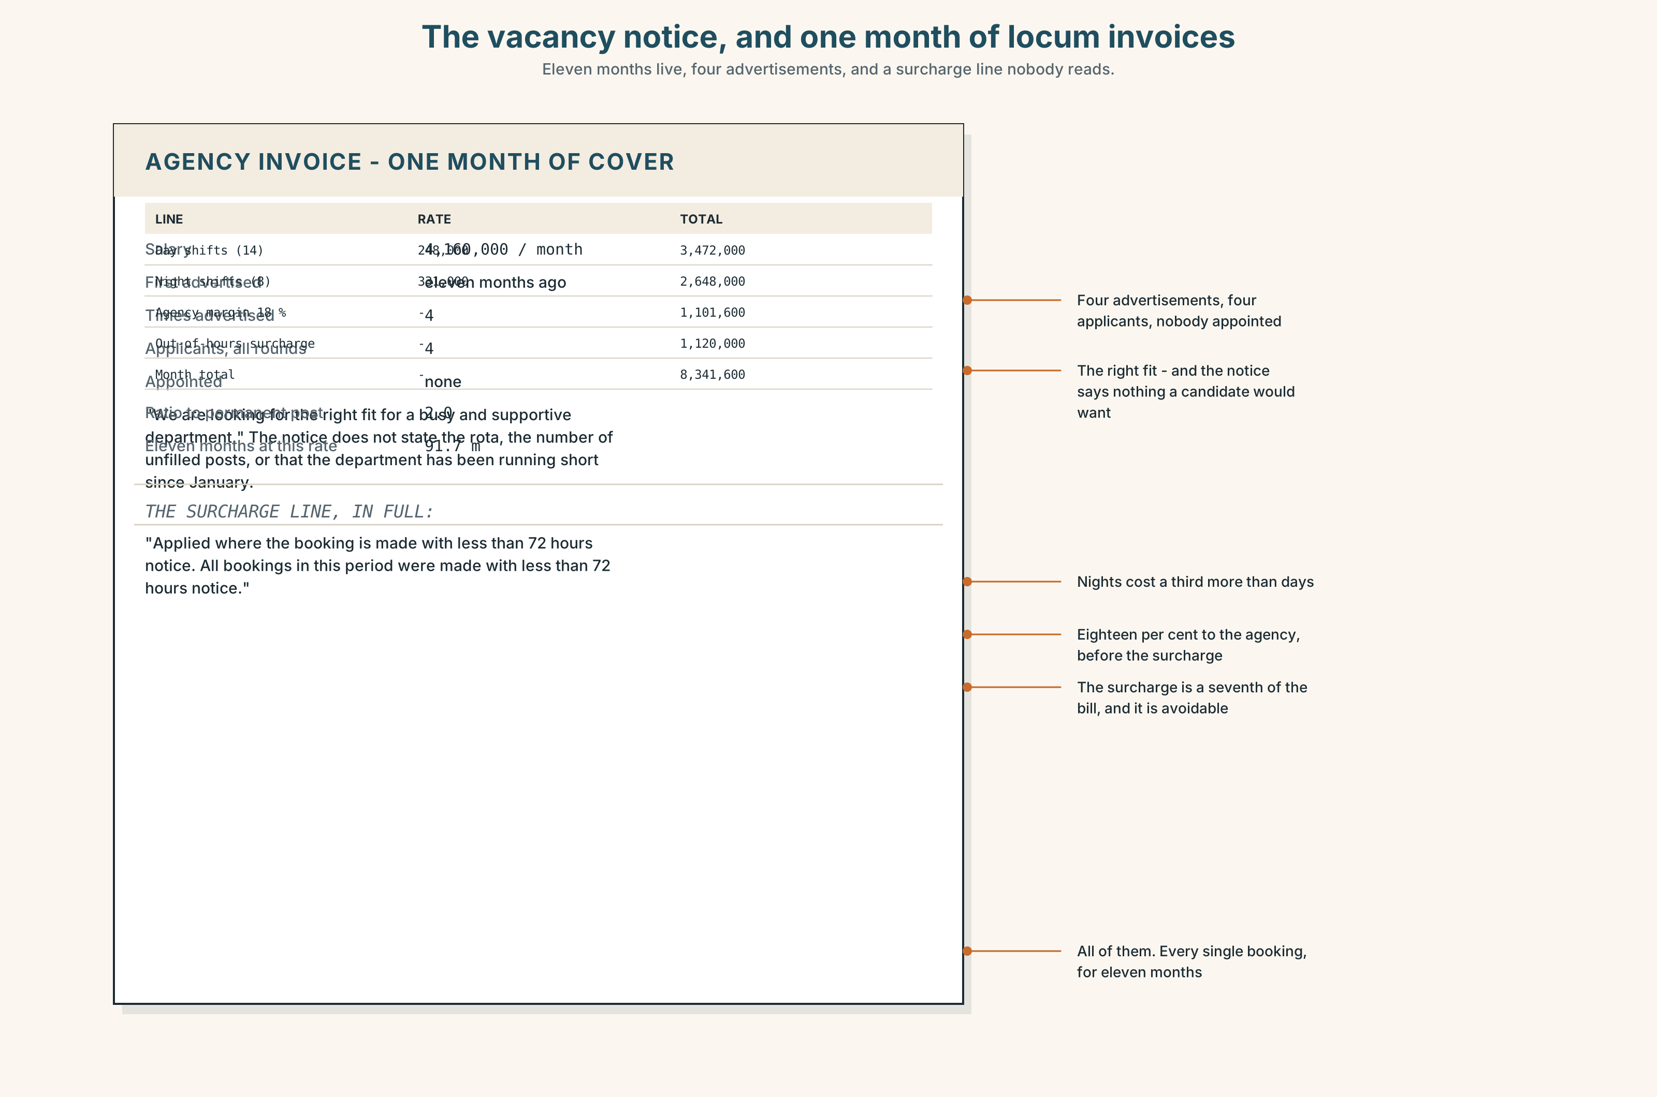{width=6.6in}
The vacancy notice, and one month of locum invoices — Eleven months live, four advertisements, and a surcharge line nobody reads.
Read the vacancy notice and the locum invoice, and answer.
- What is the post, and what is the advertised salary?
- What does one month of locum cover cost, and how does that compare with the post?
- How long has the post been vacant, and how many times has it been advertised?
- What does the notice say about the right fit, and what does it not say?
- One line of the invoice is a surcharge. What for?

5F · Two texts
The essay says the writer would be a paediatrician if she had taken the bus. The vacancy notice has been live for eleven months with four applicants.
Put those two facts together. What does a career actually run on? Three sentences.

Part 6 · Vocabulary Lab 2 ◆ B · THE SYSTEM

Saying that one thing caused another

6A · Sort — how formal, and how certain?
Three columns: spoken · written · very formal.
so · therefore · consequently · hence · accordingly · thereby · which meant that · as a result
One of them is almost never correct in the way learners use it. Which, and why?

6B · Chunk completion
- The post was not advertised, as a ______ there was nobody to appoint.
- The train was cancelled, which ______ that she took the bus or nothing.
- That decision ______ to eighteen years in emergency medicine.
- One cancellation set ______ a chain nobody could have predicted.
- The budget cut brought ______ the loss of three supervisor posts.
- Each of those followed ______ from the one before.

6C · Three that are not interchangeable
consequence · outcome · knock-on
A consequence follows directly. An outcome is where the whole thing ended. A knock-on effect is the one nobody was looking at.
Which fits each sentence?
- The ______ of eleven months of vacancy is a locum bill of forty million.
- One ______ of the budget cut was that nobody was available to supervise students.
- The ______ , after four rounds, was that they appointed internally.

6D · The fixed expression
f And that is why I am here.
Write the three sentences that come before it, for somebody whose path was chosen, and for somebody whose path was not.

6E · Contrast Clinic
Eight items. Second, third, mixed A or mixed B.
- We didn't advertise. We have nobody now.
- We didn't advertise. We had nobody in June.
- I'm not permanent. I didn't say anything in March.
- I'm not permanent. I don't say anything.
- She took the bus. (she didn't) She is a paediatrician. (she isn't)
- He speaks no Spanish. He didn't get the job.
- The train ran. (it didn't) Her life is different. (it isn't)
- They cut the budget. There are two supervisors now.

Part 7 · Pronunciation & Fluency Lab ◆ B · THE SYSTEM

Two halves that do not match
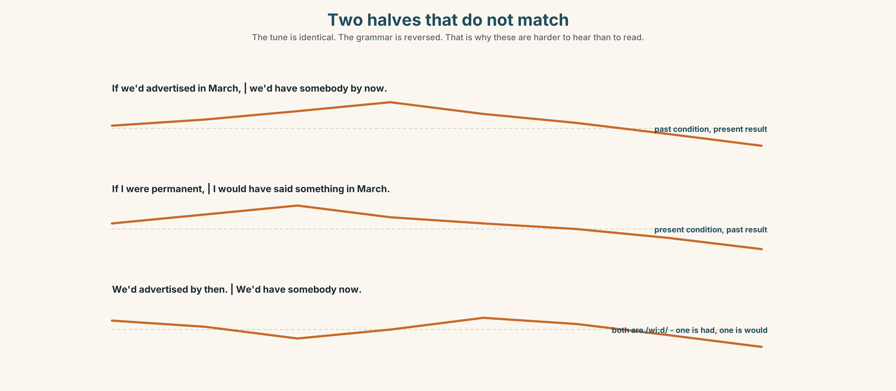{width=6.6in}
Two halves that do not match — The tune is identical. The grammar is reversed. That is why these are harder to hear than to read.

7A · Hear 🔊 Track 3.3
If we'd advertised in March ↗ | we'd have somebody by now ↘ If I were permanent ↗ | I'd have said something in March ↘
The tune is the same in both. The grammar is reversed. That is why mixed conditionals are harder to hear than to read.

7B · Say
Say both. Then say the first one three times, faster, keeping we'd and we'd distinct — one is we had and one is we would.

7C · Make it mean something
Say these two:
We'd have somebody by now. (= we would have) We'd advertised by then. (= we had advertised)
Both are /wiːd/. What tells a listener which is which?

7D · Fluency 30 ⏺
Thirty seconds: three mixed conditionals about your own life. Three times, faster, keeping the rise and the fall.

Part 8 · Writing ◆ C · THE PERFORMANCE

The choice that put you here · 160 words
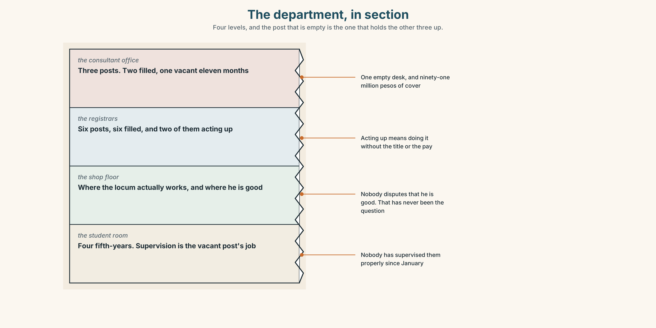{width=6.6in}
The department, in section — Four levels, and the post that is empty is the one that holds the other three up.

8A · Read the model
In 2011 I applied for two posts and was shortlisted for one, which was in a town I had never been to and which I took because the other one did not call me back. [the decision, with a date, and the honest mechanism: somebody else's silence]
That meant a supervisor who happened to be interested in rotas, which meant two years of work I had not chosen, which is now the only part of my CV anybody asks about. [the chain, three links, and each link is an accident with a consequence]
If I had not taken it, I would be better at the clinical work and worse at everything else, and I would almost certainly still be in Santiago. [one mixed conditional, and it does not flatter the writer]
I did not decide any of this. I decided one thing, in April, for a bad reason. [the ending, which refuses the shape of a career story]
Questions about the writer's choices:
- The reason given in the first paragraph is the other one did not call me back. What does naming a bad reason do for the reader's trust?
- The mixed conditional admits the writer would be better at something. Why include that?
- The last paragraph is two sentences. What would be lost if it were four?

8B · The anti-model
I always knew I wanted to work in healthcare. From a young age I was fascinated by medicine and I worked hard to achieve my goal. Every step of my career has been a learning experience and I am grateful for all the opportunities I have had.
Correct English, and no decision anywhere in it. Name three things that are missing, and one word that is doing the work of an argument.

8C · Plan
the decision, with a date and its real reason → two or three links of the chain → one mixed conditional that does not flatter you → what you did not decide

8D · Write — 160 words

8E · Peer review — three criteria
☐ Is there a date and a real reason? ☐ Does the mixed conditional cost the writer something? ☐ Is there one thing in it that was not a decision?

8F · Write it again · 8G · Publish
On the wall, with the vacancy notice from Part 5E beside it.

Part 9 · The File ◆ A · THE WORLD + C · THE PERFORMANCE

CULTURE FILE · Politeness and Directness
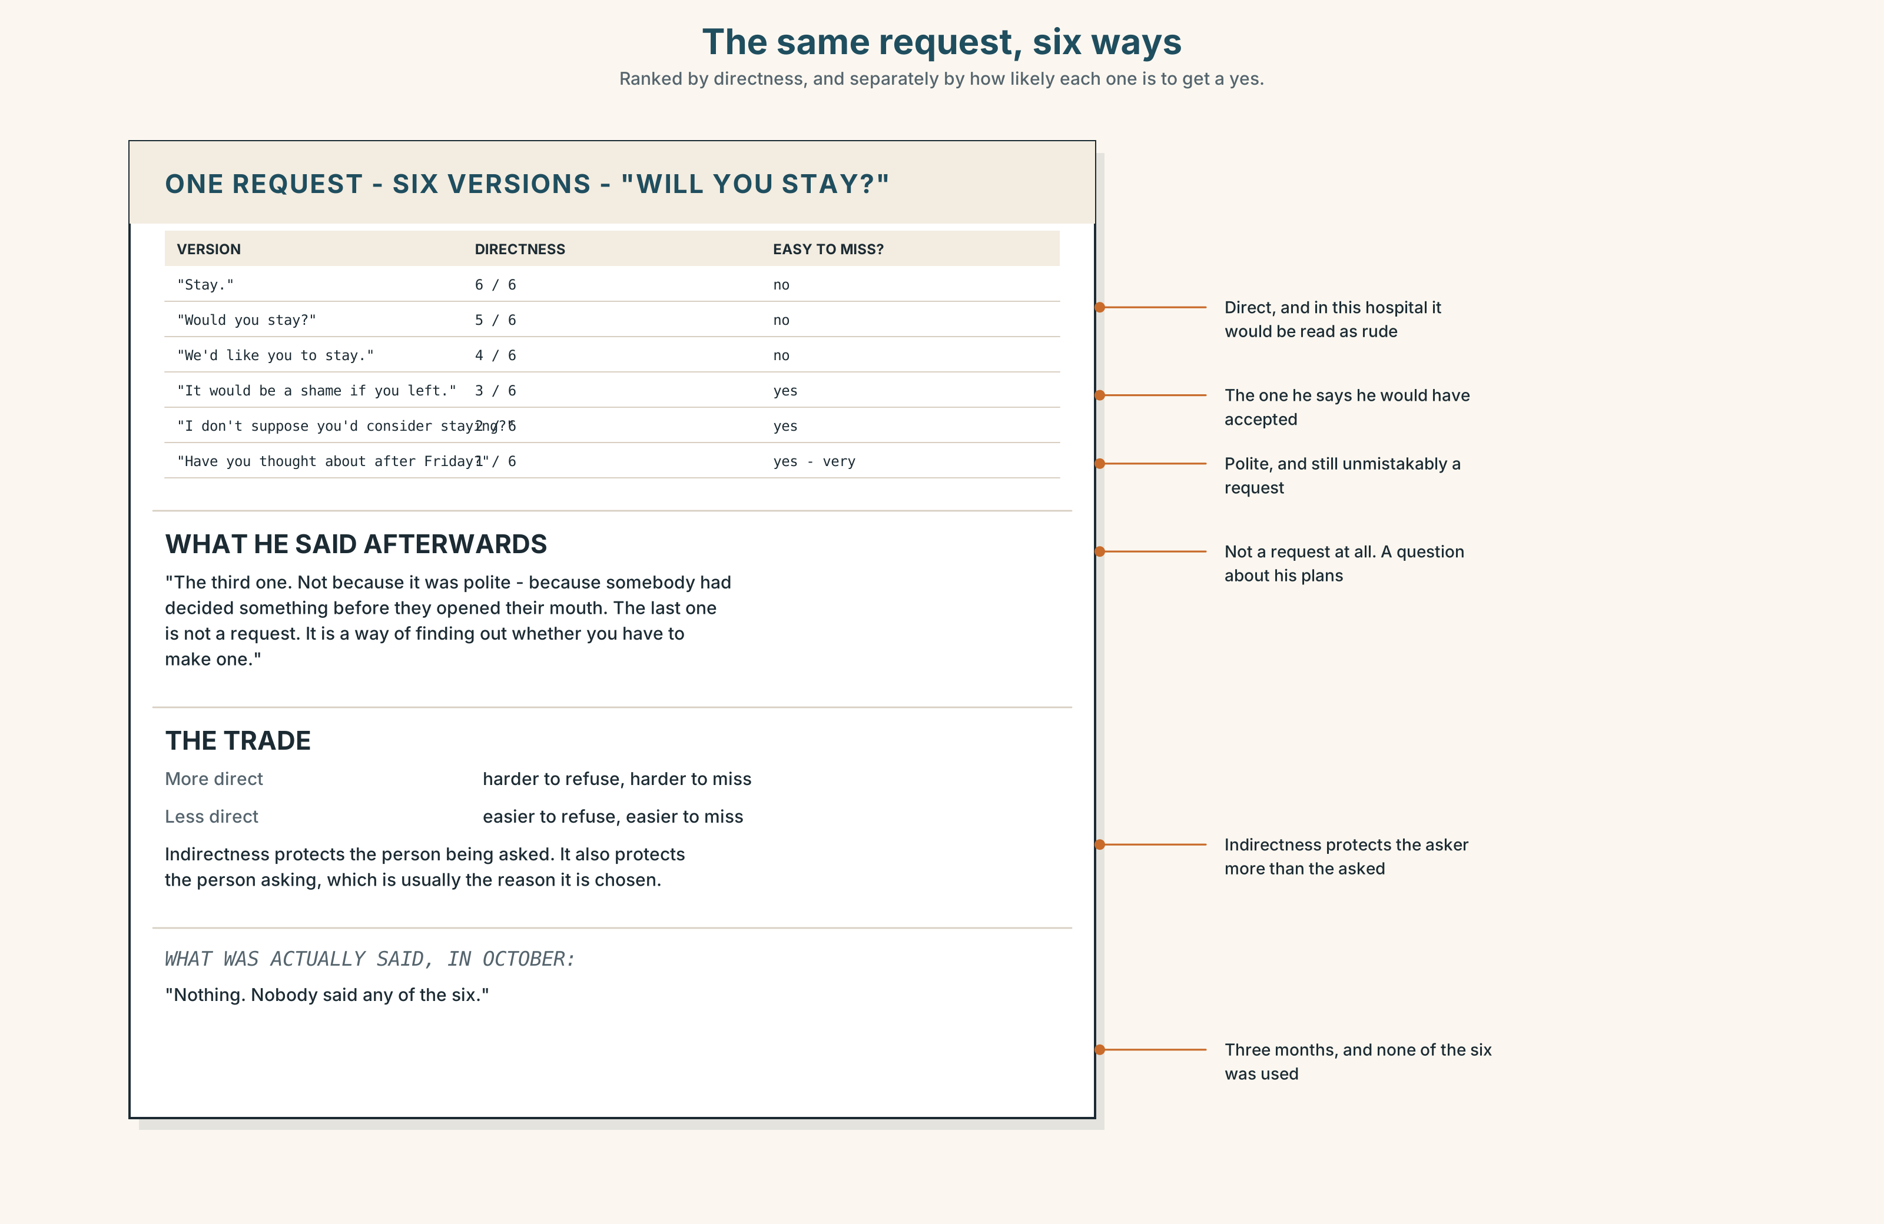{width=6.6in}
The same request, six ways — Ranked by directness, and separately by how likely each one is to get a yes.

9A · The same request, six ways 🔊 Track 3.4
Dr Benítez has been asked to stay. Listen to six versions of the asking, from four countries' worth of hospital.
- Which version is the most direct, and does it sound rude?
- Which version does he say he would have accepted, and why?
- One version is so indirect he did not realise it was a request. Which?

9B · Directness is not rudeness
"Stay." · "Would you stay?" · "We'd like you to stay." · "I don't suppose there's any chance you'd consider staying?" · "It would be a great shame if you were to leave." · "Have you thought about what you're doing after Friday?"
Rank them from most to least direct. Then rank them from most to least likely to get a yes, and explain any difference between your two orders.

9C · What indirectness costs
An indirect request is easier to refuse — which is the point — but it is also easier to miss.
Which two of the six would a tired person at the end of a shift fail to hear as a request?

9D · Your turn
In pairs. Eight minutes. One of you must ask for something significant. Round one: as directly as you can without being rude. Round two: so indirectly that your partner has to ask you what you mean. Then discuss which was more comfortable and which worked.

9E · Transfer
Find one request made to you this week. Write down how direct it was, and whether you would have answered differently if it had been phrased the other way.

Part 10 · Mediation & Interaction ◆ C · THE PERFORMANCE
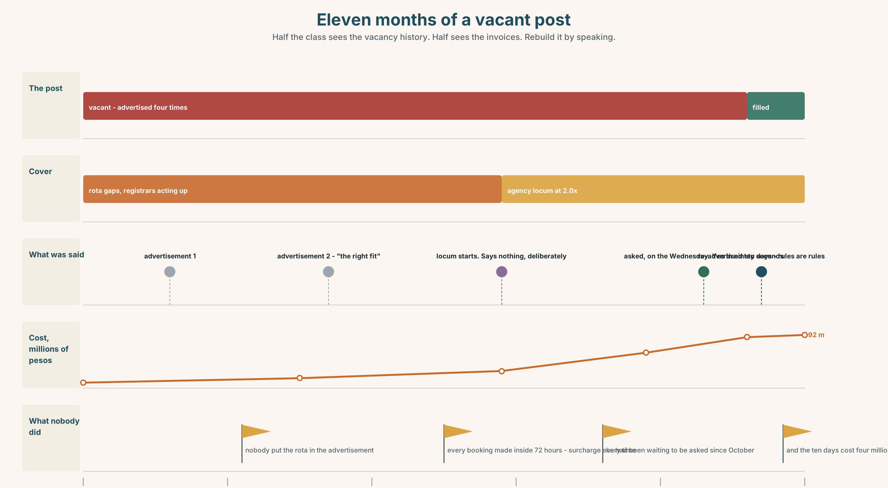{width=6.6in}
Eleven months of a vacant post — Half the class sees the vacancy history. Half sees the invoices. Rebuild it by speaking.

10A · Relay
Half the class sees the vacancy history. Half sees the locum invoices. Rebuild eleven months by speaking. Twelve minutes.

10B · Simplify
Explain the locum invoice from Part 5E to a department head who has never seen one. Five sentences only.
Plan: what a shift costs → what the agency takes → what the surcharge is for → what a year of this costs → what it buys that a permanent post does not

10C · Compress
The essay in Part 5 into forty words, keeping the train.

10D · Online
Write one message to the finance office: you accept the locum is expensive, you have the eleven-month figure, and you are asking for one specific permission by one specific date.

10E · Your language
How does your language make a request more polite? Does it lengthen the sentence, change the verb, or add a particle? Ask would you stay? in both languages, in three degrees of politeness.

Part 11 · The Decision ◆ C · THE PERFORMANCE

Friday
Dr Benítez's locum contract ends on Friday. The permanent post has been vacant for eleven months and has been advertised four times.
- Renew the locum. Costs about 2.0 times the permanent salary. The department is covered on Saturday. It is the fourth renewal.
- Recruit properly. Three months to appoint and start. The department runs three doctors short through the summer, which is the busiest quarter.
- Offer him the permanent post. He has never been asked. He is not on the shortlist because he has not applied, and he has not applied because nobody has suggested it.

11A · The evidence
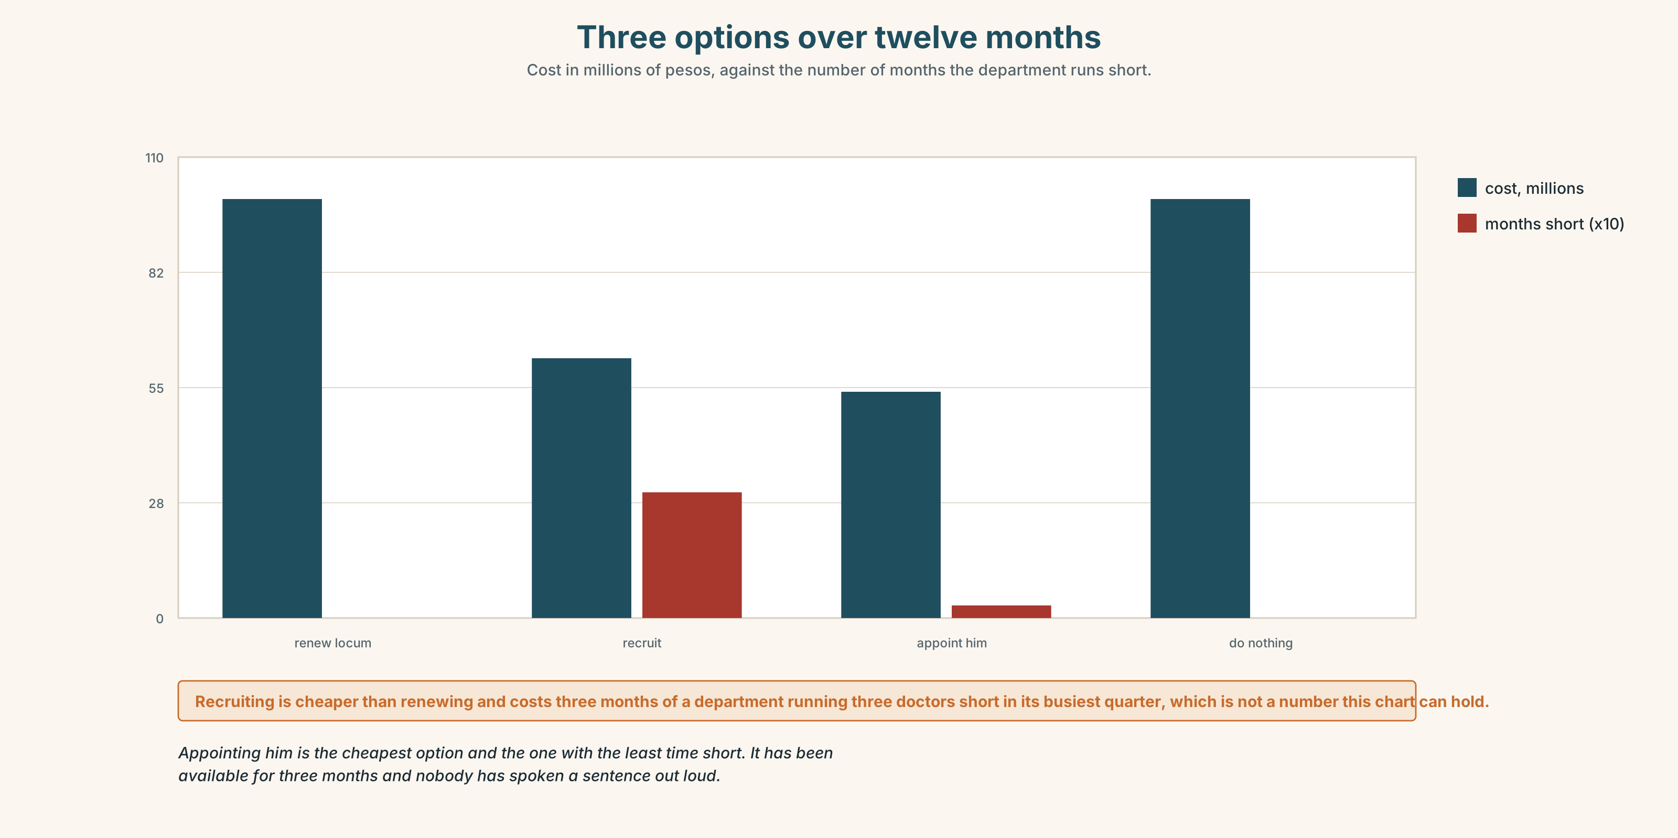{width=6.6in}
Three options over twelve months — Cost in millions of pesos, against the number of months the department runs short.
- The vacancy notice and the invoice from Part 5E — and the surcharge line.
- The chart — cost, cover and risk for each of the three options over twelve months.
- The voice. Dr Benítez, thirty seconds: "Nobody has asked me. I am aware that I could have said something, and I have thought about why I have not, and the honest answer is that if I were permanent I would have said it in week two, and I am not, so I have spent three months being careful instead."

11B · Talk about it
In fours. Everybody speaks twice. Use the frame.
If they ______ , then ______ . Which would mean ______ .
Words you can use: post · vacancy · appointment · shortlist · the right fit · apply for · take up a post · knock-on · as a result

11C · Decide
Write three sentences. Choose, say why, and name what it costs.
I think the hospital should ______________________ , because ______________________ . What this costs is ______________________ .

11D · Model decision
Ask him, today, before Friday. The entire reason he is not a candidate is that nobody has spoken a sentence out loud, and the department is about to spend eleven months and forty million pesos solving a problem that one conversation might close. If he says no, nothing is lost and the recruitment runs anyway. The thing to notice is that the obvious option has been available every day for three months and has not been taken, and that is a fact about the department rather than about him.

11E · The Reveal
What happened. Dr Herrera asked him on the Wednesday. He said yes within about ninety seconds and then said that he had been waiting for somebody to ask since October.
Finance refused the appointment in its first form because the post had been advertised four times and the rules require a competitive process. It was re-advertised for ten working days. He applied. Two other people applied. He was appointed in January.
The ten days cost one more locum month, at 2.0, which is about four million pesos, and everybody involved describes this as the cheapest part of the whole year.
One sentence, three months late, and then ten days of process because the rules exist for a reason.
Was it the right decision? Say why — and say whether the competitive process was worth four million.

Part 12 · Landing ◆ all three lines

12A · Recycle — twelve items
- If we ______ (advertise) in March, we ______ (have) somebody now.
- If I ______ (be) permanent, I ______ (say) something in March.
- She applied ______ a post in paediatrics.
- He took ______ a post in Valdivia.
- On ______ , the two candidates were identical.
- The post was not advertised, as a ______ there was nobody to appoint.
- That decision ______ to eighteen years in emergency medicine.
- One cancellation set ______ a chain nobody predicted.
- (Unit 2) If I ______ (not / look), she ______ (have) it.
- (Unit 1) There ______ (be) a bakery here. (not now)
- (A2.2 U7) This time next year I ______ (live) in Galway.
- (A2.1 U4) The person ______ has the key is the manager.

12B · Consolidate
One hundred and sixty words. The choice that put you where you are. A date, a real reason, a chain of at least two links, and one mixed conditional that costs you something.

12C · Can-do, with evidence
I can… | My evidence | Sure?
put the two halves of a conditional in different times | Part 3H score | ◯ ◑ ●
give a two-minute talk about one decision | Part 4C recording | ◯ ◑ ●
write 160 words with a real reason in them | Part 8 draft 2 | ◯ ◑ ●
judge how direct a request should be | Part 9D pair work | ◯ ◑ ●

12D · Replay ⏺
Find your forty-five seconds from Part 0C. Listen. Record it again. Two sentences: what is different, and what you can now say about the thing you did not decide.

12E · Glossary — forty-five items, as a map
THE POST · career · speciality · rotation · post · vacancy · appointment · a career path · trajectory GETTING IT · apply for · shortlist · reference · take up a post · turn down · on paper · the right fit THE PEOPLE · mentor · supervisor · training WHAT ACTUALLY HAPPENS · go into · end up in · stand down · fall through · it just happened · I never planned any of this CAUSE AND EFFECT · consequence · knock-on · result · chain · outcome · as a result · which meant that · led to · brought about · set off · in turn · one thing led to another · follow on · come about THE FORMAL ONES · therefore · consequently · hence · accordingly · thereby · inevitably · and that is why I am here

12F · Next
Unit 4 · What must have happened here?

