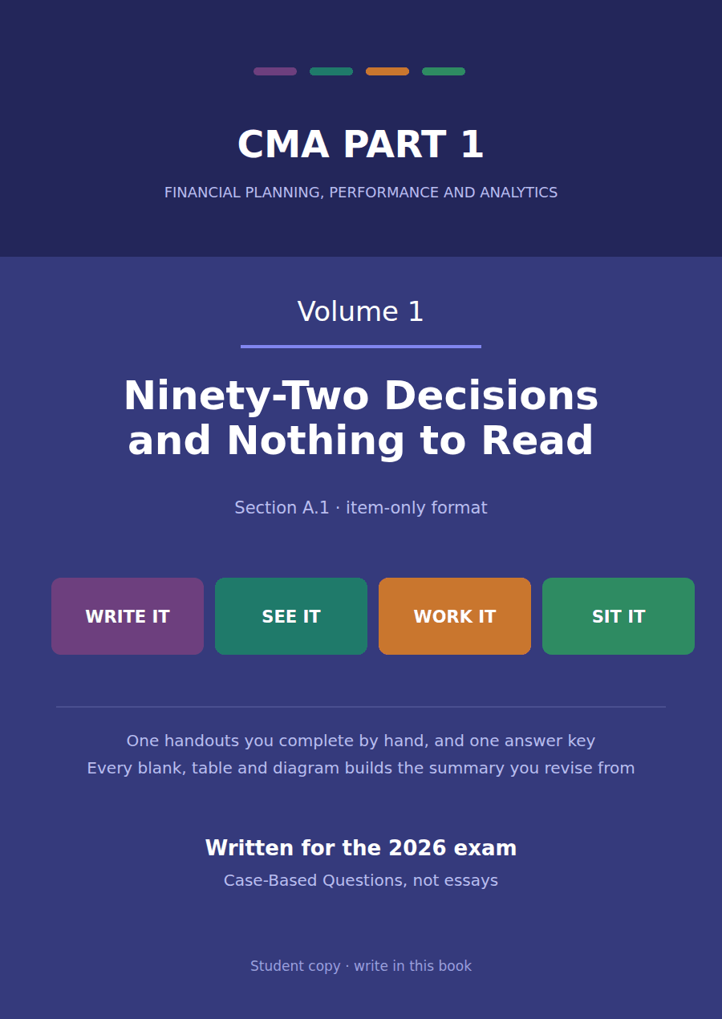

CMA Part 1 · Volume 1
The Framework and the Statements
One handout, built entirely out of questions. Every element is a multiple choice, a blank or a match, including the scaffolding, and the only element that is not a question is the material the questions are asked about.
There is nothing to read on these pages. Every element is a question, including the ones that tell you how to start, and the only thing that is not a question is the material the questions are asked about.
Begin with the cold open on the first page. You have not been taught any of it and you are meant to get some of it wrong: attempting an answer you do not have changes how well the next hour sticks. The same six questions come back on the last page, word for word, so you can see what moved.
Work in pen and mark each part at the CHECK bar before going on. The key does not only give the letter — it names what each wrong option means, so a missed item tells you what you believe rather than only that you were wrong.
The one handouts
# | Handout | What it gives you
1 | Who Reads These Statements, and What They Need | Six readers, four statements, twelve figures. Ninety-two things to decide and nothing to read.

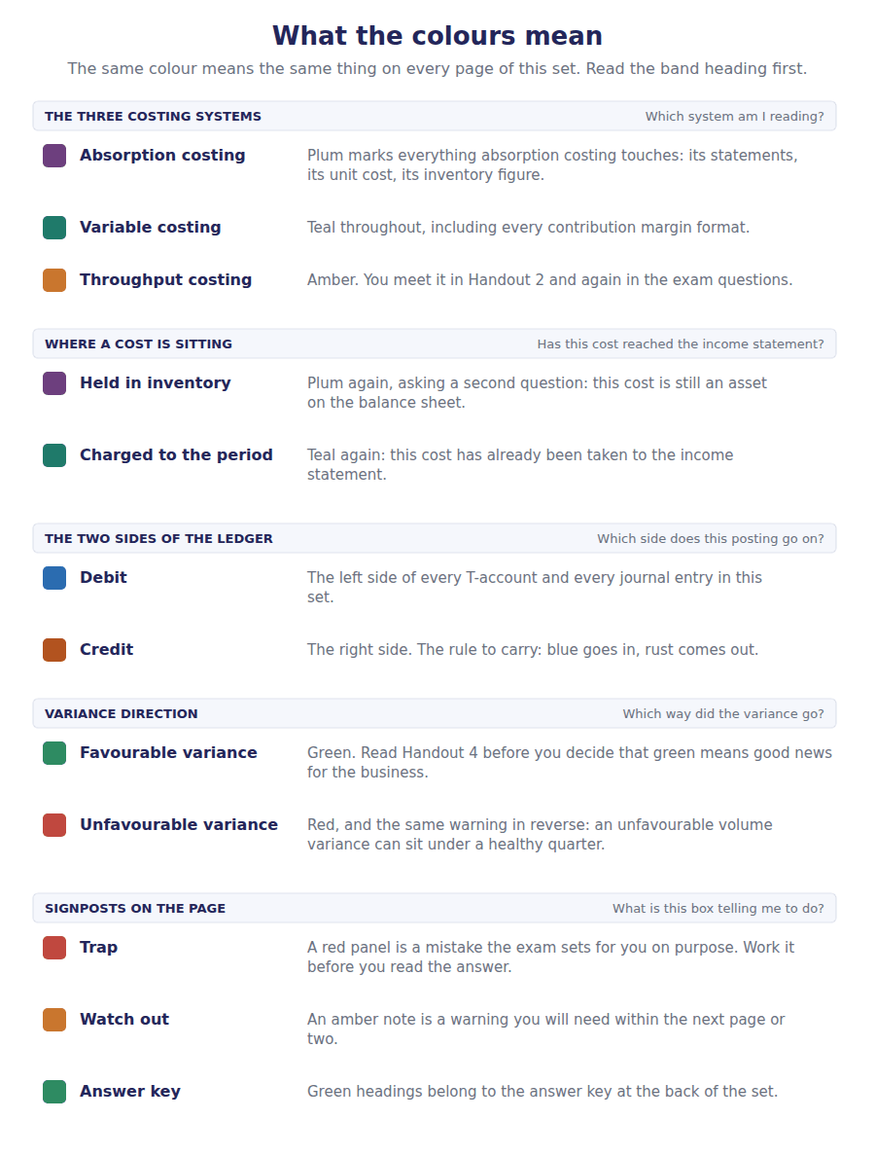
How to read the markers
Marker | Meaning
MATERIAL | The evidence an item set is asked about. It states no rule and reaches no conclusion.
STEP | The decision that has to be made before the item below it. Lower-case letters, and it has wrong options in it.
Two-tier | Answer and reason, both chosen. Both have to be right for the item to count.
Cream box | Somebody else’s work, and it is wrong. You are asked to name the error, not to redo it.
CHECK | Mark what you have done before going on, and the score that says go back.
Numbered rule | A space you fill in. The number matches the answer key.

Handout 1 · Who Reads These Statements, and What They Need
Volume 1 · The Framework and the Statements · R1 moving to R2

Cold open six questions, none of them taught yet
Items 1 to 6 Answer all six, then tick whether you were sure. You have not been taught any of this and some of your answers will be wrong, which is what the page is for. The same six come back on the last page, word for word.
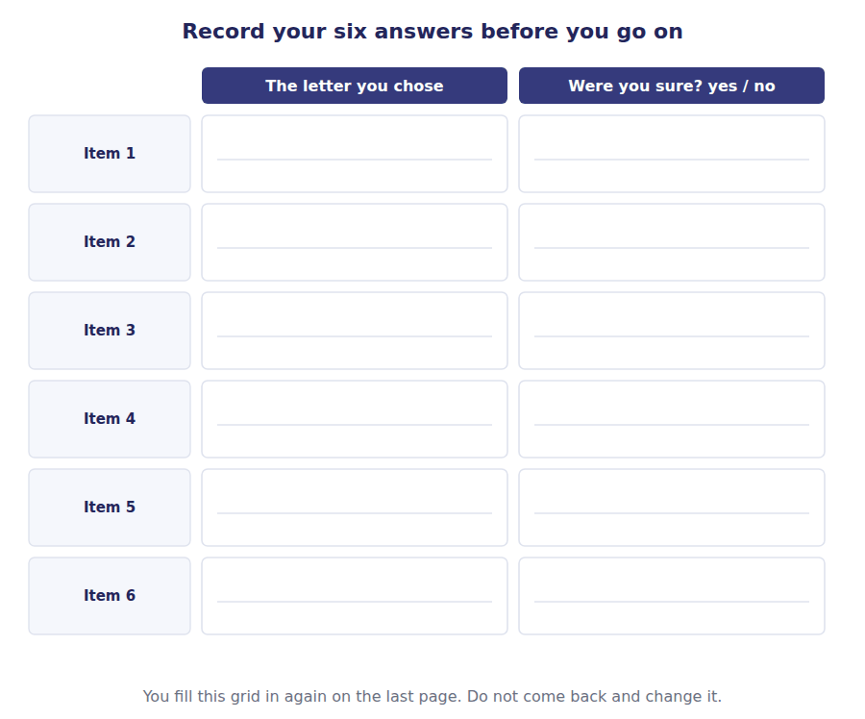
1. [Level B] Which one of these readers can require Northwind to produce a report in a format of its own choosing?
(A) The Gulf Bank, which has lent it money for five years
(B) Hala, who holds 2,000 of its 20,000 shares
(C) The Ministry of Finance, which collects its tax
(D) Delta Plastics, which invoices it on 30 days’ credit
2. [Level B] Financial position is reported:
(A) over a period
(B) at a single date
(C) both, in the same column
(D) neither: it is a ratio
3. [Level B] Northwind’s total assets of $4,990,000 is:
(A) a figure that accumulated through the year
(B) a figure measured at one moment
(C) an average of the twelve month ends
(D) the total of the year’s purchases
4. [Level B] Which statement answers the question “did the trading operations generate cash this year?”
(A) The statement of income
(B) The statement of financial position
(C) The statement of cash flows
(D) The statement of changes in equity
5. [Level B] Northwind presents 20X4 and 20X3 side by side. The quality that requires it is:
(A) relevance
(B) comparability
(C) prudence
(D) materiality
6. [Level B] Rania, the finance director, is not a primary user. The reason is that she:
(A) already has everything the statements contain, and more
(B) has no money invested in the company
(C) is the person who signs the statements
(D) is an employee rather than an owner
CHECK items 1 to 6 · do not mark these yet; they are marked on the last page
Part 1 · Six readers and the one question that sorts them
MATERIAL A
Six people who will read Northwind’s statements for 20X4
Hala holds 2,000 of Northwind’s 20,000 shares. She has never worked there and has no other dealings with the company.
The Gulf Bank lent Northwind $1,350,000, repayable over five years. It reads the statements before each annual review of the facility.
Delta Plastics sells Northwind resin and invoices it on 30 days’ credit. It is owed part of the $530,000 shown as accounts payable.
The Ministry of Finance requires Northwind to file an annual tax return on a form the Ministry designs, and can ask for any schedule it wants.
Samer works on Northwind’s assembly line. His union negotiates pay each year and would like to know what the company can afford.
Rania is Northwind’s finance director. She signs the statements and can open the ledger at any hour of any day.
المادة بالعربية
هالة تملك 2,000 سهم من أصل 20,000 سهم في نورثويند. لم تعمل فيها يوماً وليست لها معها أي تعاملات أخرى.
بنك الخليج أقرض نورثويند مبلغ $1,350,000 يُسدَّد على خمس سنوات، ويقرأ القوائم قبل كل مراجعة سنوية للتسهيل.
دلتا بلاستيك تبيع نورثويند مادة الراتنج وتصدر لها فاتورة بأجل 30 يوماً، ولها جزء من مبلغ $530,000 المدرج كحسابات دائنة.
وزارة المالية تُلزم نورثويند بتقديم إقرار ضريبي سنوي على نموذج تصممه الوزارة، ولها أن تطلب أي جدول تشاء.
سامر يعمل على خط التجميع في نورثويند. ونقابته تفاوض على الأجور كل عام وتود أن تعرف ما تستطيع الشركة تحمّله.
رانيا هي المديرة المالية لنورثويند. توقّع القوائم وتستطيع فتح دفتر الأستاذ في أي ساعة من أي يوم.

Step 1, the grid, and items 7 to 11 Work from Material A and from nothing else. The step comes first and it has wrong options in it.
STEP 1 Before you sort the six readers, decide which question does the sorting.
(a) who has the most money at stake (b) who can require a report on a form they design themselves (c) who reads the statements most often (d) who is closest to the people who run the company
Reader from Material A | A primary user | Reads them, but not a primary user | Has another route to the information
1. Hala
2. The Gulf Bank
3. Delta Plastics
4. The Ministry of Finance
5. Samer
6. Rania

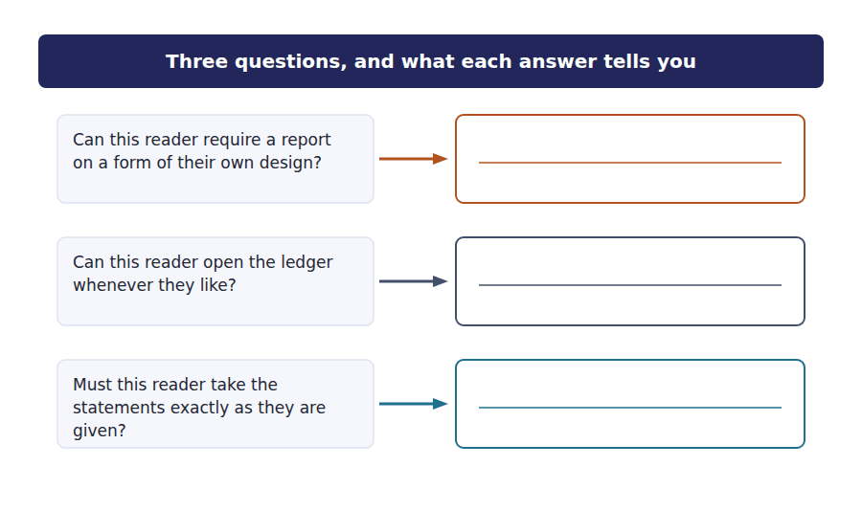
7. [Level B] The Gulf Bank and the Ministry of Finance both have a claim on Northwind’s cash. Only one of them is a primary user. The feature that separates them is:
(A) the size of the claim
(B) whether the claim is secured on the company’s assets
(C) whether they can require a report in a format they design
(D) whether the claim falls due within a year
8. [Level B] Hala holds shares and Samer works on the assembly line. Both are outside the accounts department. Hala is a primary user and Samer is not, because:
(A) Hala has more money at risk than Samer does
(B) the framework’s list names investors, lenders and other creditors, and an employee is none of the three
(C) Samer can ask his union to obtain the information
(D) Samer is paid by the company and so is not independent of it
9. [Level A] Delta Plastics is owed money for thirty days; the Gulf Bank is owed money for five years. On the framework’s list:
(A) only the bank is named, because thirty days is too short to matter
(B) only Delta is named, because trade credit is the commonest claim
(C) both are named: the bank as a lender and Delta as an other creditor
(D) neither is named, because the list covers only owners
10. [Level C] Rania can open the ledger and the Ministry can design its own form. They are both outside the primary group, and the reasons are:
(A) the same reason stated two ways
(B) opposite: one already has more than the statements hold, and one can compel a different report
(C) unrelated to the framework, which excludes only employees
(D) about seniority: both outrank the ordinary reader
11. [Level B] The word general in general purpose financial reporting refers to:
(A) the range of subjects the report covers
(B) the readers the one report has to serve
(C) the level of detail, which is kept general rather than specific
(D) the accounting basis, which is general rather than tax-based
Exercise 1A Read and complete. Write one word in each space. The bank holds words that look right and are not.
WORD BANK
balances · creditors · debtors · flows · general · primary · principal · privileged · secondary · stewardship
Not every word is used.

R1 Material A has six readers in it, and the statements are written for four of them. The framework calls those four the ¹ users.
The other two are outside the group for opposite reasons. One can require a report on a form it designs; one can open the ledger. What the four who remain have in common is that they must take the statements as they are given, which is why one report is prepared for all of them, and why the framework calls that reporting ² purpose.
Delta Plastics is owed money for thirty days and the Gulf Bank for five years. Both are on the list, because the list names investors, lenders and other ³ , and the length of the credit does not move a reader from one category to another.
What those four readers want is one thing in three forms: a basis for judging the amount, the timing and the certainty of the company’s future cash ⁴ . What they want second is a way of judging how well management has used what was entrusted to it, which the framework calls ⁵ .
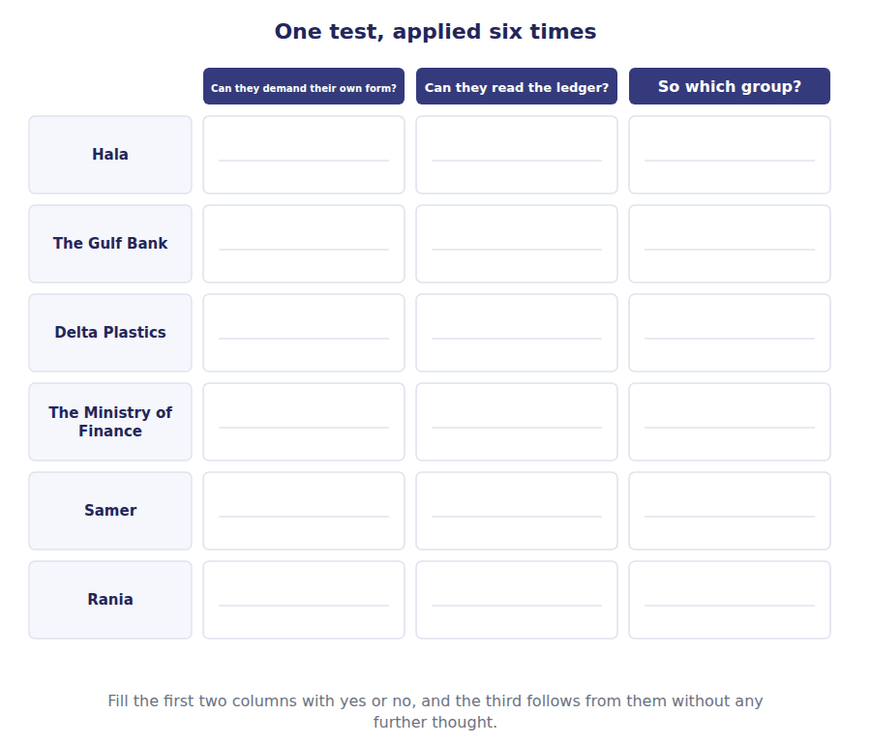
CHECK items 1A and 7 to 11 · fewer than 9 of 12 right: go back to Material A and re-read Step 1 before Part 2
Part 2 · Four statements and the one phrase that tells them apart
MATERIAL B
The four headings exactly as Northwind prints them, with the figures removed
1 Statement of Income — for the year ended 31 December 20X4
2 Statement of Financial Position — as at 31 December 20X4
3 Statement of Cash Flows — for the year ended 31 December 20X4
4 Statement of Changes in Equity — for the year ended 31 December 20X4
المادة بالعربية
1 قائمة الدخل — للسنة المنتهية في 31 ديسمبر 20X4
2 قائمة المركز المالي — كما في 31 ديسمبر 20X4
3 قائمة التدفقات النقدية — للسنة المنتهية في 31 ديسمبر 20X4
4 قائمة التغيرات في حقوق الملكية — للسنة المنتهية في 31 ديسمبر 20X4

Step 2, the matching, and items 12 to 15 Everything in Part 2 is answered from the four headings in Material B. No figures are needed and none are given.
STEP 2 Look at the four headings and at nothing else. Apart from their names, what is the one difference between them?
(a) the order in which the words are written (b) one ends as at a date and the other three end for the year ended (c) the number of columns each one will carry (d) nothing of substance: all four headings mean the same thing
 | Item | Answer |  | Option
1 | How much did Northwind sell over the year? |  | A | Statement of income
2 | What did it own and owe on 31 December 20X4? |  | B | Statement of financial position
3 | By how much did the cash balance move during the year? |  | C | Statement of cash flows
4 | How much of the year’s profit was kept in the business rather than paid out? |  | D | Statement of changes in equity
5 | What was left after every expense had been deducted?
6 | How much was owed to suppliers at the year end?
7 | How much was spent on new plant and equipment during the year?
8 | What did the shareholders put in when new shares were issued?
A statement may be the answer more than once, or not at all. Count nothing: work each question out.

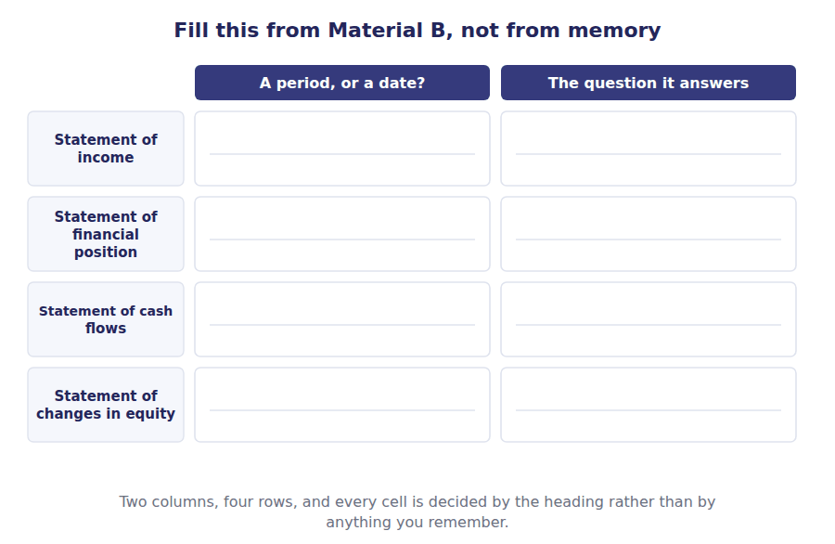
12. Northwind’s sales of $4,800,000 belong to a period or to a date?
the answer
(A) A period
(B) A date
(C) Both, depending on the reader
(D) Neither: sales are a ratio
because
(i) because a large figure is always a total of the year
(ii) because the statement that holds it is headed for the year ended
(iii) because sales are collected in cash during the year
(iv) because sales are compared with the prior year
answer because both tiers must agree
13. Northwind’s total assets of $4,990,000 belong to a period or to a date?
the answer
(A) A period
(B) A date
(C) Both
(D) Neither
because
(i) because assets were bought during the year
(ii) because the statement that holds it is headed as at
(iii) because assets are larger than sales
(iv) because assets are measured once a year
answer because both tiers must agree
14. Northwind presents 20X4 and 20X3 side by side. Which quality requires it, and why?
the answer
(A) Relevance
(B) Comparability
(C) Prudence
(D) Materiality
because
(i) because two years are twice as relevant as one
(ii) because the second year makes the figures more certain
(iii) because one year alone cannot show a reader whether anything moved
(iv) because the exam requires two years of disclosure
answer because both tiers must agree
15. A question asks for Northwind’s financial performance for 20X4. Which figure answers it, and why?
the answer
(A) Total assets of $4,990,000
(B) Net income of $510,000
(C) Cash of $420,000
(D) Accounts payable of $530,000
because
(i) because it is the largest figure the company reports
(ii) because performance is what was earned and spent over a span, and this figure covers the year
(iii) because performance means the ability to pay
(iv) because net income is the figure investors care about most
answer because both tiers must agree
Exercise 1B Read and complete. Every answer comes out of Material B.
WORD BANK
balance · date · instant · liquidity · movement · performance · period · position · reserve · turnover
Not every word is used.

R1 Three of the four headings in Material B end with the same four words and one does not. The three that match each cover a span of time, which an accountant calls a ⁶ . The one that does not match is true at a single ⁷ .
What the odd one out reports is what the company owns and owes, and the exam’s name for that is financial ⁸ . The three that cover a span report, among other things, what was earned and what was spent, and the exam’s name for that is financial ⁹ .
Which means that some questions can be answered before any figure is read. If the heading says as at, the figure underneath it is a ¹⁰ . If the heading says for the year ended, the figure underneath it is a ¹¹ .
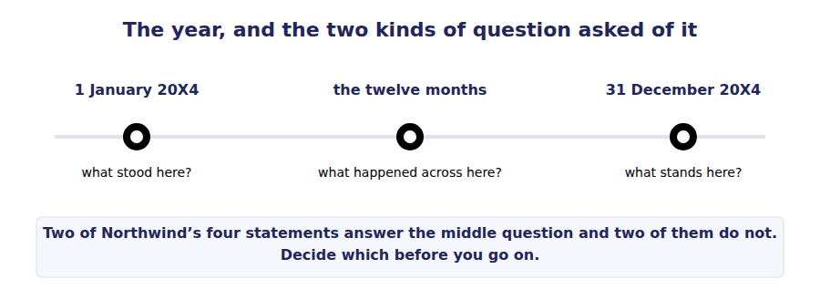
CHECK items 1B and 12 to 15 · fewer than 5 of 6 right: re-read Step 2 and the four headings before Part 3
Part 3 · Twelve figures and three goes at the same task
MATERIAL C
Twelve figures from Northwind’s books for 20X4, in alphabetical order
Accounts payable $530,000
Administrative expenses $345,000
Cash $420,000
Common stock $300,000
Cost of sales $2,880,000
Depreciation and amortisation $275,000
Gain on disposal of equipment $30,000
Income tax expense $170,000
Interest expense $90,000
Inventory $845,000
Sales $4,800,000
Selling expenses $560,000
المادة بالعربية
الأرقام الاثنا عشر أعلاه مأخوذة من دفاتر نورثويند لسنة 20X4، وهي مرتّبة أبجدياً لا حسب القائمة التي تنتمي إليها. ليس كل رقم منها ينتمي إلى القائمة نفسها، وليست كل الأرقام لازمة في كل جزء.

Step 3 and Stage 1 Build the top of the income statement from Material C. Two lines are done; the rest are yours, and the third column is where you show the arithmetic.
STEP 3 Which line must you reach before you can reach operating income?
(a) net income (b) gross margin (c) income before income tax (d) income tax expense
Line | Figure | How you got it
Sales | $4,800,000 | Read from Material C
Cost of sales | $2,880,000 | Read from Material C
Gross margin
Selling expenses
Administrative expenses
Depreciation and amortisation
Operating income
Five rows and ten cells. Three of the five figures are read straight from Material C and two of them are arithmetic.

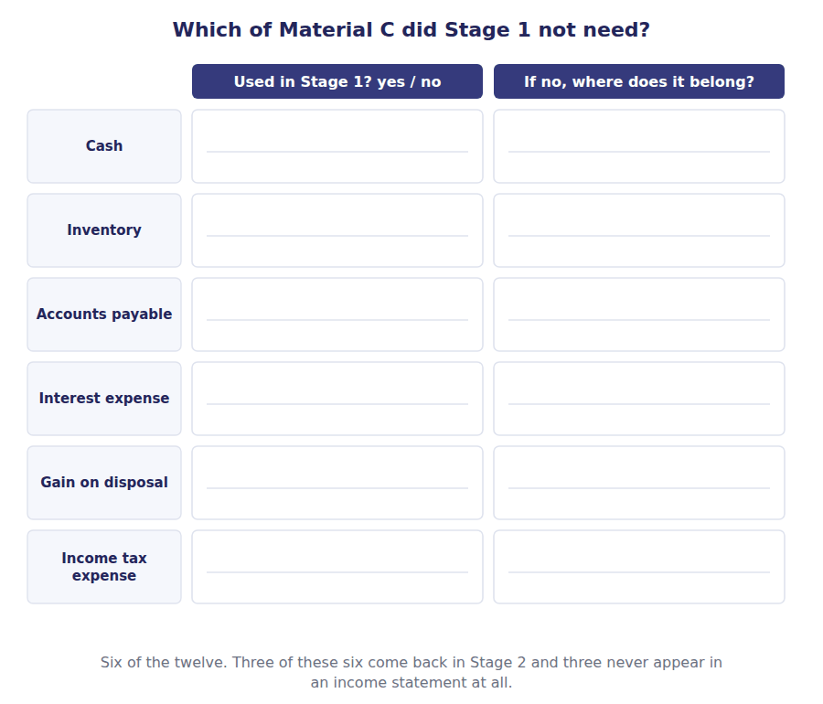
Stage 2 The same task, further down the statement, and this time the third column asks only whether the line is added or subtracted.
Line | Figure | Add or subtract?
Operating income, from Stage 1 | $740,000 | the line you have just reached
Interest expense
Gain on disposal of equipment
Income before income tax
Income tax expense
Net income
One of these five lines is added and the rest are subtracted. Decide which from what the line is, not from where it sits in the column.

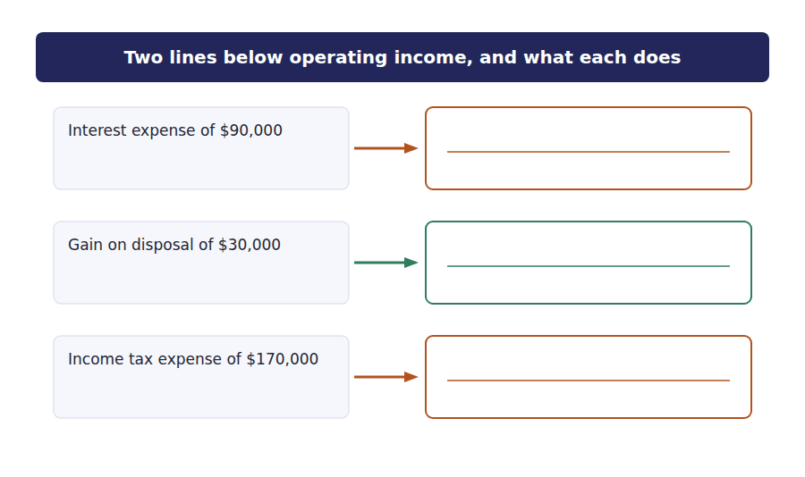
Stage 3 The same question with nothing given: one worked row, and then six figures to place with no skeleton to place them in.
Figure from Material C | Which statement holds it | A period or a date?
Sales of $4,800,000 | Statement of income | A period: the year to 31 December 20X4
Inventory of $845,000
Interest expense of $90,000
Cash of $420,000
Accounts payable of $530,000
Common stock of $300,000
One of the six belongs to two statements at once, and the third column is where that shows.

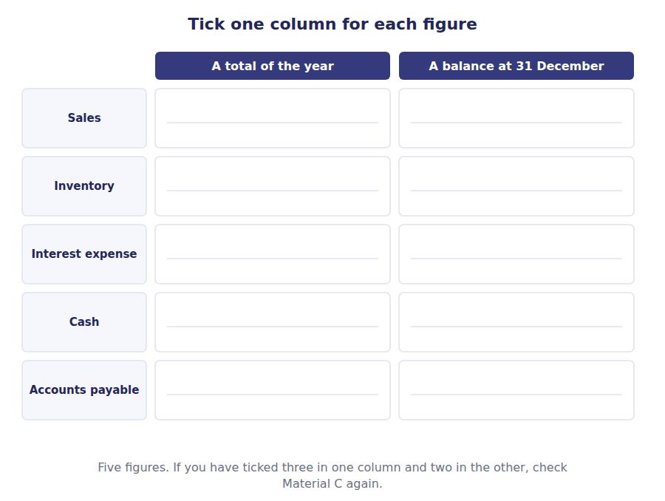
Exercise 1C Read and complete. One of these three answers is in the glossary at the back and two of them are not.
WORD BANK
accrual · cash · comparable · deferred · payable · prudent · receivable
Not every word is used.

R2 Two years appear in every one of Northwind’s statements. A reader given one year alone could not tell whether anything had improved, so the second year is there to make the first ¹² .
A figure is reported in the year in which it happened rather than in the year in which cash moved, and that convention is called the ¹³ basis. Sales of $4,800,000 appear in the income statement for the year whether or not every invoice has been collected, and the part not yet collected stands in the position statement as a ¹⁴ .
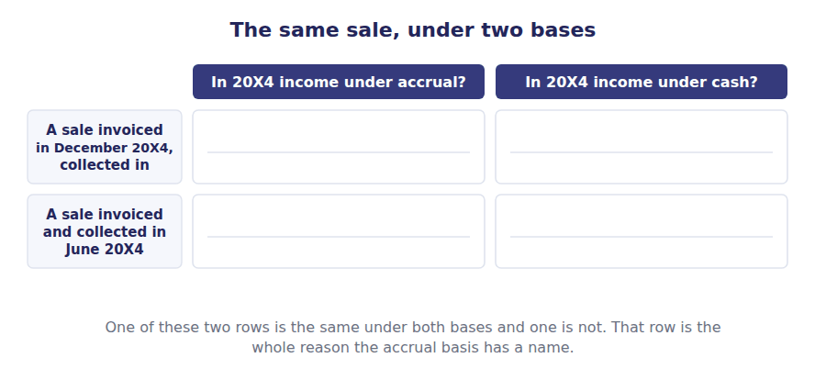
CHECK items 1C and Stages 1 to 3 · fewer than 28 of 34 cells right: redo the stage you lost cells in before Part 4
Part 4 · Four pieces of work each of them wrong in exactly one way
Step 4 and items 16 to 19 Somebody else has done each of these and got it wrong. Name the error. You are not asked to redo the work.
STEP 4 Before you name any error, decide what you will compare the work against.
(a) your memory of what a statement looks like (b) Material B for the headings and Material C for the figures (c) the answer key at the back (d) the totals alone, since an error always shows in a total
16. A student’s sort of Material A
Primary users: Hala, the Gulf Bank, Delta Plastics,
the Ministry of Finance
Not primary users: Samer, Rania
What is wrong with it?
(A) Delta Plastics does not belong: thirty days of credit is too short
(B) The Ministry of Finance does not belong: it designs its own form
(C) Samer does belong: his union has a claim on the company
(D) Rania does belong: she needs the statements to run the business
17. A heading written out in full
Northwind Components, Inc.
Statement of Financial Position
for the year ended 31 December 20X4
What is wrong with it?
(A) The company’s legal form should not appear above the statement
(B) Financial position is reported at a date, so the third line is wrong
(C) The statement should be called a balance sheet, not this
(D) The date should be written before the month, not after it
18. The foot of somebody’s income statement
Operating income 740,000
Interest expense (90,000)
Income before income tax 650,000
What is wrong with it?
(A) Interest expense belongs inside operating income, not below it
(B) The gain on disposal of $30,000 has been left out, so the subtotal should be $680,000
(C) Income tax expense has been left out of the statement
(D) Operating income is wrong: it should be $1,920,000
19. The foot of somebody’s position statement
Total assets 4,990,000

Total liabilities 2,320,000
Common stock 300,000
Additional paid-in capital 1,020,000
Retained earnings 1,274,000
Total liabilities and equity 4,914,000
What is wrong with it?
(A) Retained earnings are overstated by the dividend of $170,000
(B) Accumulated other comprehensive income of $76,000 has been left out of equity
(C) Total liabilities should include the deferred tax liability as well
(D) Total assets are overstated by the allowance for credit losses
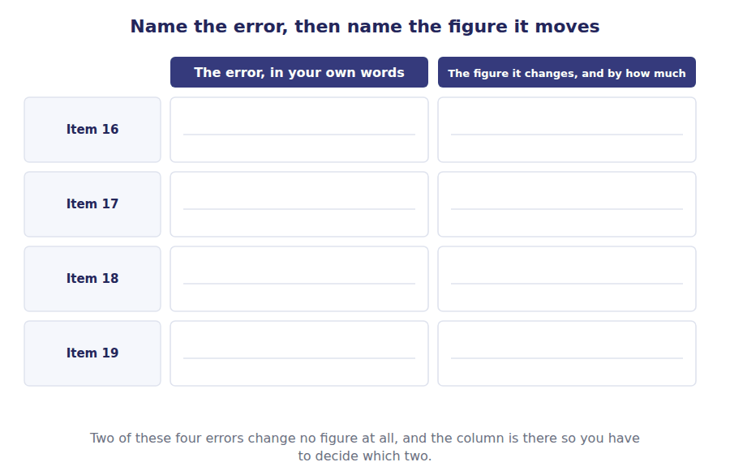
CHECK items 16 to 19 · fewer than 3 of 4 right: read the error you missed against Material B and C before Part 5
Part 5 · Ten items in no order drawn from every part and labelled with none
Items 20 to 29 These ten are deliberately jumbled. Nothing tells you which part an item comes from, which is the only honest way to find out whether you can tell the ideas apart.
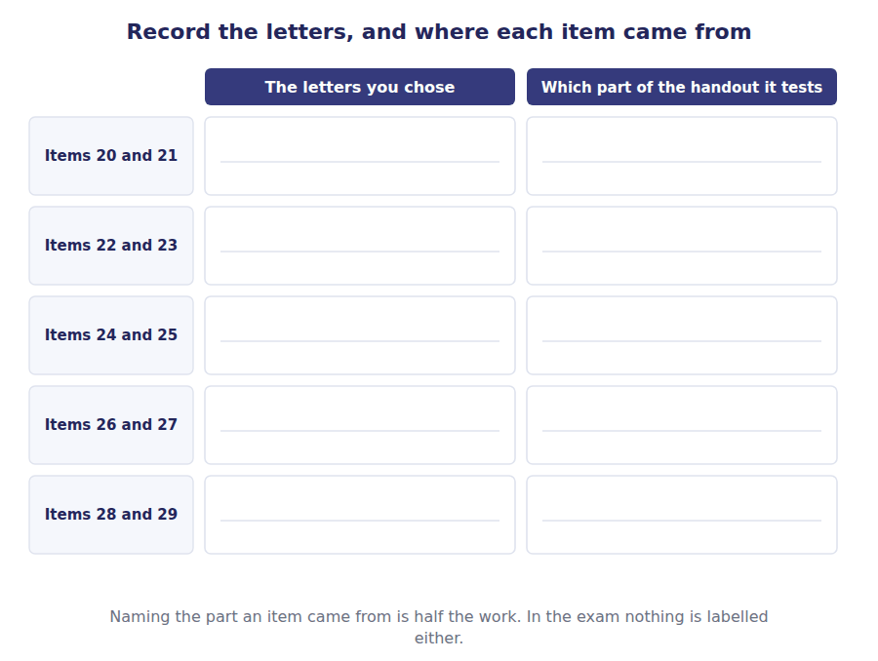
20. [Level B] A customer who buys from Northwind reads its statements before placing a large order. The customer is:
(A) a primary user, because the order exposes it to the company
(B) not a primary user: it is not an investor, a lender or an other creditor
(C) a primary user, because placing an order extends credit
(D) not a primary user, because the order is too small to matter
21. [Level C] Which figure in Material C could appear in both the statement of income and the statement of cash flows?
(A) Sales
(B) Depreciation and amortisation
(C) Common stock
(D) Inventory
22. [Level A] Which pair of figures are both balances at a single date?
(A) Sales and cost of sales
(B) Inventory and accounts payable
(C) Interest expense and income tax expense
(D) Sales and cash
23. [Level B] Holding management to account for the resources entrusted to it is:
(A) a by-product of decision usefulness
(B) a purpose of financial reporting in its own right
(C) a requirement of tax law rather than of the framework
(D) relevant only to companies whose shares are listed
24. [Level C] Northwind’s gain on disposal of $30,000 sits below operating income. A reader who ignored it would understate:
(A) gross margin
(B) income before income tax
(C) total assets
(D) sales
25. [Level B] Comparability is the reason a company that changes its inventory method must:
(A) go back to the method it used before
(B) tell the reader about the change and apply it to the prior year it presents
(C) present one year only, so that no false comparison is possible
(D) wait until the start of a new decade before changing
26. [Level C] A question gives Northwind’s cash of $420,000 and asks whether trading generated enough cash to cover the $170,000 paid to shareholders. The reader needs:
(A) net income from the statement of income, and nothing else
(B) cash from operating activities and the dividend paid, both in the statement of cash flows
(C) total assets from the statement of financial position
(D) the statement of changes in equity, where the dividend appears
27. [Level B] The four headings in Material B differ in one phrase. A student who had only that phrase, and no figures at all, could still answer:
(A) nothing: figures are needed for every question
(B) whether each statement reports a balance or a movement
(C) how large each statement’s total will be
(D) which statement the auditor signs first
28. [Level A] Two readers both have money at risk in Northwind. One is a primary user and one is not. The feature that decides it is:
(A) the size of the amount at risk
(B) whether the reader can require a report in a format they design
(C) how long the money is at risk for
(D) whether the reader is inside the company or outside it
29. [Level B] Northwind’s $510,000 of net income and its $4,990,000 of total assets are both reported for 20X4. Which is true?
(A) Both describe the year
(B) Both describe 31 December
(C) The first describes the year; the second describes 31 December
(D) The first describes 31 December; the second describes the year
CHECK items 20 to 29 · fewer than 8 of 10 right: go back to the part each missed item came from, not to the key
Part 6 · The cold open again the same six questions, word for word
Items 30 to 35 These are items 1 to 6, unchanged. Answer them again without looking back, then put both sets of answers side by side in the grid.
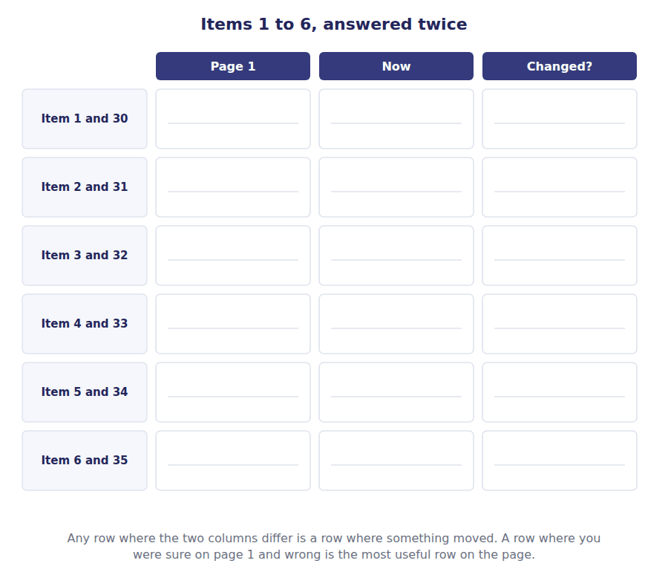
30. [Level B] Which one of these readers can require Northwind to produce a report in a format of its own choosing?
(A) The Gulf Bank, which has lent it money for five years
(B) Hala, who holds 2,000 of its 20,000 shares
(C) The Ministry of Finance, which collects its tax
(D) Delta Plastics, which invoices it on 30 days’ credit
31. [Level B] Financial position is reported:
(A) over a period
(B) at a single date
(C) both, in the same column
(D) neither: it is a ratio
32. [Level B] Northwind’s total assets of $4,990,000 is:
(A) a figure that accumulated through the year
(B) a figure measured at one moment
(C) an average of the twelve month ends
(D) the total of the year’s purchases
33. [Level B] Which statement answers the question “did the trading operations generate cash this year?”
(A) The statement of income
(B) The statement of financial position
(C) The statement of cash flows
(D) The statement of changes in equity
34. [Level B] Northwind presents 20X4 and 20X3 side by side. The quality that requires it is:
(A) relevance
(B) comparability
(C) prudence
(D) materiality
35. [Level B] Rania, the finance director, is not a primary user. The reason is that she:
(A) already has everything the statements contain, and more
(B) has no money invested in the company
(C) is the person who signs the statements
(D) is an employee rather than an owner
Items 36 and 37 Two questions that were not in the cold open. Neither can be answered from one part of this handout alone.
36. [Level C] Samer’s union asks Northwind for a schedule of profit by department. Northwind refuses. Which is true?
(A) Northwind must comply, because employees are primary users
(B) Northwind need not comply, and that refusal is part of what makes Samer not a primary user
(C) Northwind must comply, because the information already exists
(D) The union becomes a primary user at the moment it asks
37. [Level C] Hala wants to know whether Northwind earned more this year than last, and whether it owns more than it owes today. The smallest set of statements that answers her is:
(A) the statement of income for 20X4 only
(B) the statement of income for 20X4 and 20X3, and the statement of financial position at 31 December 20X4
(C) all four statements for both years
(D) the statement of financial position at both year ends
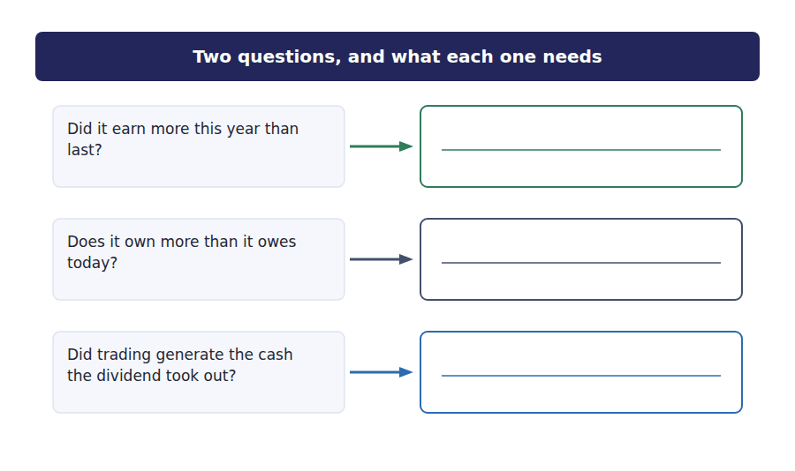
CHECK items 30 to 37 · fewer than 7 of 8 right: compare each changed row against the key’s last table

Answer Key
Volume 1 · Handouts 1 to 1
Every answer carries the reason for it and the mistake it defeats.

Handout 1 · Who Reads These Statements, and What They Need answers
Completed text and exercises
# | Answer | Why | The trap it defeats
Step 1 | (b) who can require a report on a form they design themselves | Three of these sort readers by how exposed or how interested they are, and the framework sorts them by neither. The test is the power to demand a format: a reader who has it does not need general purpose statements, and a reader who lacks it has nothing else.
Grid 1 | 1 A primary user 2 A primary user 3 A primary user 4 Has another route to the information 5 Reads them, but not a primary user 6 Has another route to the information | Two readers end up outside the primary group for opposite reasons. One writes its own form; one can read the ledger.
1 | primary | The framework’s own word for the named readers. | Principal is the near-miss, and it means something else in accounting: the amount of a loan.
2 | general | One report, because the readers cannot ask for their own. | Students read this as general interest. It names the audience, not the subject matter.
3 | creditors | The phrase that carries the trade suppliers onto the list.
4 | flows | Amount, timing and certainty — of what?
5 | stewardship | The second job the statements do, and a purpose in its own right.
Step 2 | (b) one ends as at a date and the other three end for the year ended | Four headings, held identical except for one phrase, so the phrase is what you are being shown. Everything in Part 2 and most of Part 3 comes out of that one difference, and no sentence on these pages has to explain it.
Match 1 | 1-A 2-B 3-C 4-D 5-A 6-B 7-C 8-D | A statement may be the answer more than once, or not at all. Count nothing: work each question out.
6 | period | A span of time, not a moment.
7 | date | One moment, and the statement says which.
8 | position | Owns and owes, at a moment. | The exam says this far more often than it says balance sheet.
9 | performance | Earned and spent, over a span. | Performance is the period word. A question that says position is asking about a date.
10 | balance | What is left standing on one day.
11 | movement | What happened across the span.
Step 3 | (b) gross margin | The other three are all below operating income, so none of them can be a step towards it. Getting the order of the subtotals right is most of what the first stage is testing.
12 | comparable | What a second year makes the first one.
13 | accrual | Reported when it happened, not when cash moved. | The opposite basis is cash, and the CMA tests the difference in every volume.
14 | receivable | The amount a customer still owes.
Step 4 | (b) Material B for the headings and Material C for the figures | Three of the four are how a candidate loses this kind of question. Memory is unreliable, the key is not available in the exam, and two of the four errors below do not show in a total at all.

Exam-pitch questions
# | Answer | Why | The trap it defeats
1 | (C) The Ministry of Finance, which collects its tax | Only the Ministry designs the form. Everyone else reads what they are given, and that is the test the framework uses — not how much is at stake, and not how powerful the reader is. | Level B
2 | (B) at a single date | Position is what is owned and owed, which can only be true at one moment. Performance is the period word; position is the date word, and the exam uses both far more often than it says balance sheet. | Level B
3 | (B) a figure measured at one moment | Assets are counted at the year end. Nothing about the figure accumulated: a balance is a photograph, and sales, expenses and cash flows are the things that accumulate. | Level B
4 | (C) The statement of cash flows | Trading generated cash is a cash question about a span of time, and only one statement is about cash over a span. The income statement answers what was earned, which is not the same thing. | Level B
5 | (B) comparability | One year alone cannot tell a reader whether anything is improving. Comparability is also why a change of method has to be disclosed, and it is the reason two years appear and not one. | Level B
6 | (A) already has everything the statements contain, and more | Primary users are readers who depend on the statements because they have no other route to the information. Management has the ledger, so the statements tell it nothing it did not know. | Level B
7 | (C) whether they can require a report in a format they design | Everything else about the two is held still on purpose. Both are owed money, both read the statements, both have power. One can design the form it is answered on and the other cannot, and that is the only thing the framework asks. | Level B
8 | (B) the framework’s list names investors, lenders and other creditors, and an employee is none of the three | The list is short and closed, and being affected by the company is not enough to get a reader onto it. Samer may lose more than Hala and he is still not a primary user. | Level B
9 | (C) both are named: the bank as a lender and Delta as an other creditor | Other creditors is the phrase that carries the trade suppliers, and the list is investors, lenders and other creditors. The length of the credit changes nothing about which category a reader sits in. | Level A
10 | (B) opposite: one already has more than the statements hold, and one can compel a different report | Two different exits from the same group. Rania does not need general purpose statements because she has the source; the Ministry does not need them because it can order something better suited to it. A student who learns one exit misses the other. | Level C
11 | (B) the readers the one report has to serve | General purpose names the audience, not the content. One report is prepared because many readers cannot ask for their own, and the report itself is as specific as the rules require. | Level B
16 | (B) The Ministry of Finance does not belong: it designs its own form | The Ministry is the one reader in Material A that can compel a report of its own design, which is the single test Step 1 established. The other three options are each a plausible mis-sort and each one is contradicted by the grid. | Level C
17 | (B) Financial position is reported at a date, so the third line is wrong | Material B shows this statement headed as at, and the other three headed for the year ended. A position statement cannot be for a span because what is owned and owed is only true at a moment. | Level C
18 | (B) The gain on disposal of $30,000 has been left out, so the subtotal should be $680,000 | Material C holds a gain on disposal and this statement does not use it. The arithmetic shown is internally consistent, which is why the error does not show in a total: you can only find it by checking the statement against the material. | Level C
19 | (B) Accumulated other comprehensive income of $76,000 has been left out of equity | The two sides differ by $76,000, and that is exactly the accumulated other comprehensive income. This is the one error of the four that does show in a total, and the gap names the missing line for you. | Level C
20 | (B) not a primary user: it is not an investor, a lender or an other creditor | A customer is exposed and is still not on the list. Delta Plastics is on the list because it is owed money, which is the thing that makes a reader an other creditor; a customer that has not yet paid is owed goods, not money. | Level B
21 | (B) Depreciation and amortisation | Depreciation is an expense in the income statement and is added back in arriving at cash from operations, because it moved no cash. It is the one figure in Material C that has a job in two statements for two different reasons. | Level C
22 | (B) Inventory and accounts payable | Two of the four pairs are both period figures, one pair is mixed, and one pair is two balances. Nothing about the size of the figures helps here, which is the point of asking it this way. | Level A
23 | (B) a purpose of financial reporting in its own right | Stewardship is tested as a purpose, not as a consequence of one. The statements are there both to help a reader decide and to let that reader judge what management did with the money. | Level B
24 | (B) income before income tax | The gain is below operating income, so the lines above it are untouched and the lines below it are all short by the same amount. This is item 18 asked the other way round, and a student who got 18 from the key rather than from the material will miss it. | Level C
25 | (B) tell the reader about the change and apply it to the prior year it presents | Comparability does not forbid a change; it governs what has to happen when one is made. Two years are presented so a reader can compare them, so both years have to be on the same basis and the change has to be disclosed. | Level B
26 | (B) cash from operating activities and the dividend paid, both in the statement of cash flows | Both halves of the question are cash questions about a span, so both figures are in the same statement. The last option is the trap worth understanding: the dividend really is in the statement of changes in equity, and the cash generated is not, so that statement answers half the question and no more. | Level C
27 | (B) whether each statement reports a balance or a movement | Step 2 is the whole handout in one item. The phrase decides the kind of figure, and the kind of figure decides which questions the statement can answer, before any number is read. | Level B
28 | (B) whether the reader can require a report in a format they design | The same test as item 7, with the readers no longer named. If this one is harder than item 7 was, what was learned there was the pair of readers rather than the test. | Level A
29 | (C) The first describes the year; the second describes 31 December | Two figures, one period and one date, in a single stem. A student who decides by size will pick the wrong one, because the larger figure is the one that is not a total of the year. | Level B
36 | (B) Northwind need not comply, and that refusal is part of what makes Samer not a primary user | The test runs in both directions. A reader who cannot compel a report is a reader the general purpose statements are written for, and the refusal is the evidence rather than the injustice. Samer is excluded for a different reason again: he is not on the list at all. | Level C
37 | (B) the statement of income for 20X4 and 20X3, and the statement of financial position at 31 December 20X4 | Two questions, one about performance over two periods and one about position at one date. The comparative income statement answers the first and a single position statement answers the second, which is why the comparative requirement and the date requirement are different requirements. | Level C

Two-tier questions: the answer and the reason
# | Answer | Why | The trap it defeats
12 | (A) A period + (ii) | The second tier is the whole item. A student who answers period because the figure is large will be wrong about total assets two items later; a student who answers period because of the heading will not be. | both tiers
13 | (B) A date + (ii) | The same reasoning as the previous item, applied to a figure that tempts the other way. Assets were indeed bought during the year, which is why reason (i) feels right and is not: the figure reported is what stood on one day. | both tiers
14 | (B) Comparability + (iii) | Comparability is the only one of the four qualities that is about setting something beside something else. It is also why a change of method must be disclosed, which is a different consequence of the same quality. | both tiers
15 | (B) Net income of $510,000 + (ii) | Performance and position are the two words the exam uses most and the two that students swap most. Performance is the period word, and the reason has to be the heading rather than the importance of the figure. | both tiers

Items asked twice
Item | Repeats item | Answer
30 | 1 | (C)
31 | 2 | (B)
32 | 3 | (B)
33 | 4 | (C)
34 | 5 | (B)
35 | 6 | (A)

What a wrong answer means
# | If you chose | then you are reading it like this
1 | (A) | you are sorting readers by how much money is at stake
1 | (B) | you are sorting by ownership rather than by power to demand
1 | (D) | you are reading short credit as weak and therefore excluded
2 | (A) | you have swapped position and performance
2 | (C) | you are thinking of the two-year comparative, which is two dates rather than a period
3 | (A) | you are treating every large figure as a total of the year
3 | (C) | you are thinking of an average balance, which is a ratio input and not a reported figure
4 | (A) | you are reading profit as cash
4 | (B) | you are reading the closing cash balance as the cash generated
5 | (A) | you are naming the quality that makes a figure worth having at all, not the one that needs a second year
5 | (C) | prudence is about measuring uncertainty, not about how many years are shown
6 | (B) | you are testing for a financial stake, and a lender has no ownership stake either
6 | (C) | signing it is a consequence of her access, not the reason she is excluded
6 | (D) | an employee is excluded for a different reason: not being on the framework’s list at all
7 | (A) | you are ranking readers by exposure, which the framework never does
7 | (B) | security changes what a lender recovers, not whether it is a primary user
7 | (D) | the length of the claim is the Delta Plastics question, and the answer there is that it makes no difference
8 | (A) | you are ranking by exposure again; an employee with his whole income at risk is still not on the list
8 | (C) | asking through somebody else does not change the category, and the union cannot demand a format either
8 | (D) | independence is an auditing idea, not the framework’s test
9 | (A) | you are using duration as the test, and the framework does not
9 | (D) | you are reading primary user as owner, which leaves out both lenders and suppliers
10 | (A) | they look alike only because both end outside the group; the mechanisms are different and the exam tests both
10 | (C) | employees are a third exit, and the one that has nothing to do with power or access
10 | (D) | seniority is not a category in the framework
11 | (A) | this is the commonest misreading in the whole volume: general purpose does not mean general interest
11 | (C) | a general purpose statement is highly detailed; the word says nothing about detail
11 | (D) | the basis is a separate question and the answer to it is accrual
12 | (A) | right answer, wrong reason: size is not what decides it
12 | (C) | collection is a cash question and sales are recognised whether or not cash arrives
13 | (A) | you are reading the history of the balance rather than the heading of the statement
13 | (D) | how often it is measured is not what the heading says
14 | (A) | relevance makes a figure worth having; it does not call for a second one
14 | (C) | prudence is about how uncertainty is measured, not how many years appear
15 | (A) | you have swapped performance and position
15 | (C) | the ability to pay is a liquidity question and it is answered from the position statement and the cash flow statement
16 | (A) | you are using duration as the test again
16 | (C) | being affected by the company is not being on the list
16 | (D) | needing information is not the same as depending on the statements for it
17 | (A) | the legal form belongs in the heading of every statement
17 | (C) | both names are used and the exam prefers this one
17 | (D) | the order of day and month is a convention, not an error
18 | (A) | interest is a financing cost and sits below operating income by design
18 | (C) | tax comes after this subtotal, so its absence here is correct
18 | (D) | that figure is the gross margin, which is two lines higher up
19 | (A) | the dividend is $170,000, which is not the size of the gap
19 | (C) | the deferred tax liability is already inside total liabilities
19 | (D) | the allowance is already deducted in arriving at total assets
20 | (A) | exposure is not the test, in this handout or in the exam
20 | (C) | a buyer takes credit; it does not give it
21 | (A) | sales are in the income statement; the cash flow statement carries collections, which are a different figure
21 | (C) | common stock is a balance and a movement in equity, and neither is the income statement
21 | (D) | inventory is a balance; the income statement carries cost of sales instead
22 | (A) | both of these accumulated across the year
22 | (C) | both of these are expenses, and an expense is a period figure
22 | (D) | a mixed pair, and the commonest wrong answer: cash is a balance and sales are not
23 | (A) | this is the tempting answer and the exam marks it wrong
23 | (D) | Northwind is not listed and its forty investors are owed the same account
24 | (A) | gross margin is above the gain and so cannot be affected by it
24 | (C) | total assets are a balance and the gain is in the income statement
24 | (D) | the gain is not revenue from selling components
25 | (A) | comparability does not freeze a company’s methods
25 | (C) | showing one year is the problem comparability exists to solve
26 | (A) | profit is not cash, and this is the substitution the whole volume is built to stop
26 | (C) | a closing balance says nothing about what generated it
26 | (D) | half right, which is why it is the option most often chosen
27 | (A) | Part 2 was answered without a single figure
27 | (C) | the heading says nothing about magnitude
28 | (A) | exposure is the misreading this handout returns to four times
28 | (C) | duration is the Delta Plastics misreading
28 | (D) | inside and outside is the Rania misreading, and it is about access rather than location
29 | (A) | you have made total assets a period figure
29 | (B) | you have made net income a balance
29 | (D) | the right distinction, applied the wrong way round
36 | (A) | employees are the clearest case of readers who are not primary users
36 | (C) | existing is not the test; being able to compel it is
36 | (D) | asking changes nothing, which is exactly the point of the test
37 | (A) | one year cannot answer a question about more than last year
37 | (C) | true but not smallest, and the exam asks for the smallest
37 | (D) | position says nothing about what was earned

Part 1 · the classification grid
Reader | Group | The feature that put them there
Hala | A primary user | An investor, and she cannot demand a report of her own design
The Gulf Bank | A primary user | A lender, and it reads what it is given
Delta Plastics | A primary user | An other creditor: owed money, and the thirty days change nothing
The Ministry of Finance | Has another route | It designs the form it is answered on
Samer | Reads them, not a primary user | An employee, and employees are not on the framework’s list
Rania | Has another route | She can open the ledger, so the statements tell her nothing new

Part 2 · the matching exercise
The question asked | The statement that answers it
How much did Northwind sell over the year? | Statement of income
What did it own and owe on 31 December 20X4? | Statement of financial position
By how much did the cash balance move during the year? | Statement of cash flows
How much of the year’s profit was kept in the business rather than paid out? | Statement of changes in equity
What was left after every expense had been deducted? | Statement of income
How much was owed to suppliers at the year end? | Statement of financial position
How much was spent on new plant and equipment during the year? | Statement of cash flows
What did the shareholders put in when new shares were issued? | Statement of changes in equity

Part 3 · Stage 1, worked in full
Line | Figure | How you got it
Sales | $4,800,000 | given
Cost of sales | $2,880,000 | given
Gross margin | $1,920,000 | $4,800,000 less $2,880,000
Selling expenses | $560,000 | given
Administrative expenses | $345,000 | given
Depreciation and amortisation | $275,000 | given
Operating income | $740,000 | $1,920,000 less the three expenses, which total $1,180,000

Part 3 · Stage 2, worked in full
Line | Figure | Add or subtract?
Operating income | $740,000 | from Stage 1
Interest expense | ($90,000) | subtract
Gain on disposal | $30,000 | add
Income before income tax | $680,000 | $740,000 less $90,000 plus $30,000
Income tax expense | ($170,000) | subtract
Net income | $510,000 | $680,000 less $170,000

Part 3 · Stage 3, worked in full
Figure from Material C | Which statement holds it | A period or a date?
Sales of $4,800,000 | Statement of income | A period
Inventory of $845,000 | Statement of financial position | A date
Interest expense of $90,000 | Statement of income | A period
Cash of $420,000 | Statement of financial position | A date
Accounts payable of $530,000 | Statement of financial position | A date
Common stock of $300,000 | Statement of changes in equity, and the position statement at the year end | The movement is a period; the balance is a date

- The three figures in Material C that Stage 1 did not need were interest expense, the gain on disposal and income tax expense. All three arrive in Stage 2.
- The three that never appear in an income statement at all are cash, inventory and accounts payable. All three are balances.
- Common stock is the figure that belongs to two statements: it moves in the statement of changes in equity and it stands as a balance in the statement of financial position.
Part 4 · what each piece of work was wrong about
Item | The error | Does it show in a total?
16 | The Ministry of Finance was put in the primary group, and it is the one reader that can compel its own form | No
17 | A position statement was headed for the year ended; position is reported as at a date | No
18 | The gain on disposal of $30,000 was omitted, so income before income tax was $650,000 instead of $680,000 | No: the arithmetic shown is self-consistent
19 | Accumulated other comprehensive income of $76,000 was left out of equity | Yes: the two sides differ by exactly that amount

Part 6 · the cold open, and what each item was for
Item | Answer | The part of the handout that settles it
1 and 30 | C | Part 1: the one test, and the Ministry is the reader that fails it
2 and 31 | B | Part 2: position is the date word
3 and 32 | B | Part 2 and Part 3: a balance, whatever its size
4 and 33 | C | Part 2: a cash question about a span
5 and 34 | B | Part 2 and item 28: comparability
6 and 35 | A | Part 1: access, not stake

For the teacher
- Part 5 is interleaved on purpose. Students who meet mixed items feel that the blocked parts taught them more, and are measurably wrong about it: the discrimination they complain about is the thing that transfers to the exam. Expect the complaint and do not reorganise the part.
- The cold open is meant to go badly. If a class scores well on items 1 to 6 before any teaching, the six items are too easy for the group and the handout will not move them.
- The gap between the page 1 answers and the Part 6 answers is the only measurement in this handout that is worth recording. A row where a student was sure and wrong is worth more classroom time than three rows they left blank.
- Items 7, 29 and 36 are the same test three times, with the readers named, then unnamed, then reversed. A student who gets 7 and misses 29 learned the pair of readers rather than the test, and that is a diagnosis rather than a mark.

Glossary
Every term in Volume 1, with the Arabic equivalent and the places it misleads
The third column is for recognition only. In the exam room you work in English.

Term | What it means in CMA English | بالعربية | Careful
comparability | The quality that lets a user set one company, or one year, beside another. | القابلية للمقارنة | It is why two years are always presented, and why a change of method has to be disclosed.
financial performance | What a company earned and spent over a span of time: the subject of the income statement. | الأداء المالي | Performance is a period word. If a question says position it is asking about a date.
financial position | What a company owns and owes at one moment: the subject of the balance sheet. | المركز المالي | The exam says financial position far more often than it says balance sheet, and means the same thing.
general purpose financial reporting | One set of statements prepared for users who cannot require a company to produce a report in their own format. | التقرير المالي ذو الغرض العام | General purpose means one report for many readers, not a report about general matters.
primary user | An existing or potential investor, lender or other creditor: the readers the statements are written for. | المستخدم الرئيسي | A short list. Employees, customers and regulators may read the statements; the statements are not written for them.
stewardship | How well management has used the resources entrusted to it by the providers of capital. | الإشراف على الموارد | The second job the statements do, and the exam tests it as a purpose in its own right.

