9.1 Three categories of debt securities
Chapter 9 · section 9.1

Fill every gap. Each word list holds one word more than there are gaps.
Chapter 9, section by section
Each stage leads to the next.
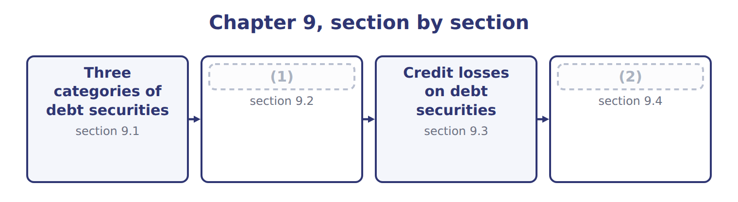
word list
Equity securities and the equity method · other comprehensive income (OCI) · Measuring debt securities

Summary 1 gaps 3–13
A debt security gives its (3) a right to interest and to (4) , like a bond. An equity security gives an (5) interest, like (6) of common stock. Section 9.4 (7) equity securities. When a company buys a debt security, it (8) it into one of three categories, and it reassesses the (9) at each reporting date. The category depends on (10) intent and ability, not on the type of bond. (11) securities are (12) and held mainly to sell in the near term. (13) (HTM) securities are securities the company has the positive intent and the ability to hold until they mature. Available-for-sale (AFS) securities are all other debt securities. HTM is a strict category. If the company would sell the bond when interest rates change or when it needs cash, it does not have the intent to hold it. And if it sells or transfers HTM securities for other reasons, it taints the whole HTM portfolio, which raises doubt about its intent for all its other HTM securities.
word list
covers · ownership · holder · classification · Held-to-maturity · bought · positive · management's · shares · classifies · Trading · repayment

Summary 2 gaps 14–18
The (14) allows a few (15) , such as a sale after the issuer's credit quality falls sharply, or a sale very close to maturity. A company may also elect the fair value option for a (16) when it first (17) it. The election is (18) , and all changes in fair value then go to net income.
word list
security · recognizes · exceptions · standard · maturity · irrevocable

Intent decides

Summary 3 gaps 19–21
The same bond can be trading, AFS or HTM. Read the facts about intent and (19) . A company that might sell when rates (20) cannot use HTM. Equity (21) are never trading, AFS or HTM under current U.S. GAAP.
word list
securities · ability · standard · change

The English this section uses, and its Arabic
Each term sits against what it means.
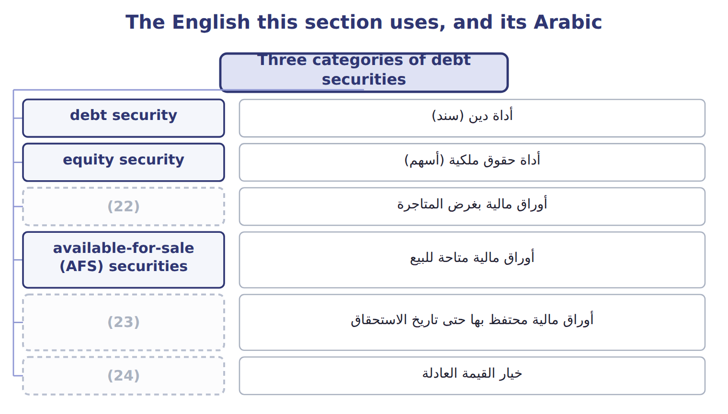
word list
held-to-maturity (HTM) securities · fair value option · أداة دين (سند) · trading securities

The English this sheet uses, and its Arabic
English (exam term) | Arabic
debt security | أداة دين (سند)
equity security | أداة حقوق ملكية (أسهم)
trading securities | أوراق مالية بغرض المتاجرة
available-for-sale (AFS) securities | أوراق مالية متاحة للبيع
held-to-maturity (HTM) securities | أوراق مالية محتفظ بها حتى تاريخ الاستحقاق
fair value option | خيار القيمة العادلة

Answer key · 9.1 Three categories of debt securities

1 Measuring debt securities | 13 Held-to-maturity
2 Equity securities and the equity method | 14 standard
3 holder | 15 exceptions
4 repayment | 16 security
5 ownership | 17 recognizes
6 shares | 18 irrevocable
7 covers | 19 ability
8 classifies | 20 change
9 classification | 21 securities
10 management's | 22 trading securities
11 Trading | 23 held-to-maturity (HTM) securities
12 bought | 24 fair value option

the summaries in full
Summary 1 A debt security gives its holder a right to interest and to repayment, like a bond. An equity security gives an ownership interest, like shares of common stock. Section 9.4 covers equity securities. When a company buys a debt security, it classifies it into one of three categories, and it reassesses the classification at each reporting date. The category depends on management's intent and ability, not on the type of bond. Trading securities are bought and held mainly to sell in the near term. Held-to-maturity (HTM) securities are securities the company has the positive intent and the ability to hold until they mature. Available-for-sale (AFS) securities are all other debt securities. HTM is a strict category. If the company would sell the bond when interest rates change or when it needs cash, it does not have the intent to hold it. And if it sells or transfers HTM securities for other reasons, it taints the whole HTM portfolio, which raises doubt about its intent for all its other HTM securities.
Summary 2 The standard allows a few exceptions, such as a sale after the issuer's credit quality falls sharply, or a sale very close to maturity. A company may also elect the fair value option for a security when it first recognizes it. The election is irrevocable, and all changes in fair value then go to net income.
Summary 3 The same bond can be trading, AFS or HTM. Read the facts about intent and ability. A company that might sell when rates change cannot use HTM. Equity securities are never trading, AFS or HTM under current U.S. GAAP.

9.2 Measuring debt securities
Chapter 9 · section 9.2

Fill every gap. Each word list holds one word more than there are gaps.
How each category of investment is measured
Every item belongs to exactly one group.
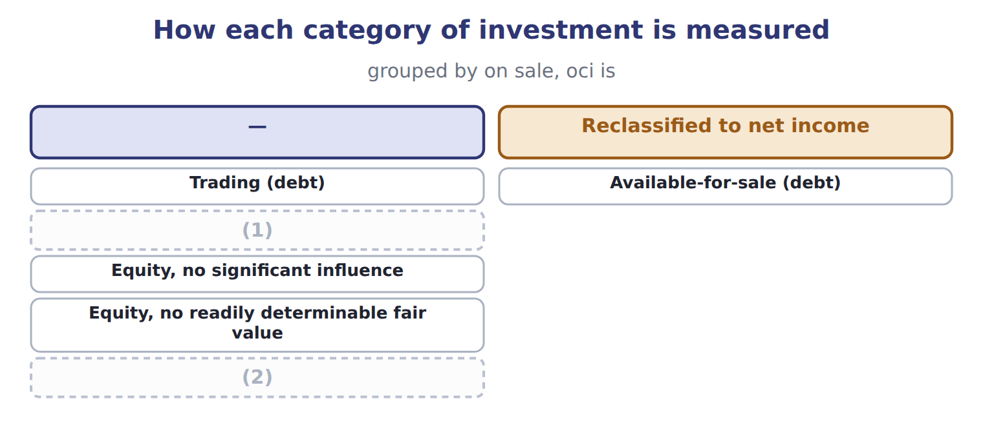
word list
Held-to-maturity (debt) · basis difference · Equity method

Summary 1 gaps 3–9
A bond is (3) at a bond premium when its stated interest rate is (4) than the market rate, and at a bond discount when it is lower. Under the (5) method, interest revenue for each year is the carrying amount at the start of the year multiplied by the market rate at (6) . The cash (7) is the face amount multiplied by the stated rate. The (8) amortizes the premium or discount, so the carrying amount moves (9) face value.
word list
effective-interest · received · bought · difference · recycling · toward · purchase · higher

Orontes buys a corporate bond

Summary 2 gaps 10–12
On (10) 1, 2025, Orontes buys a 3-year bond with a face amount of $100,000 and a stated rate of 6%, paid each (11) 31. The market rate is 5%, so Orontes pays $102,723, a (12) of $2,723.
word list
January · trading · December · premium

Orontes buys a corporate bond
Name each line from how it moves.
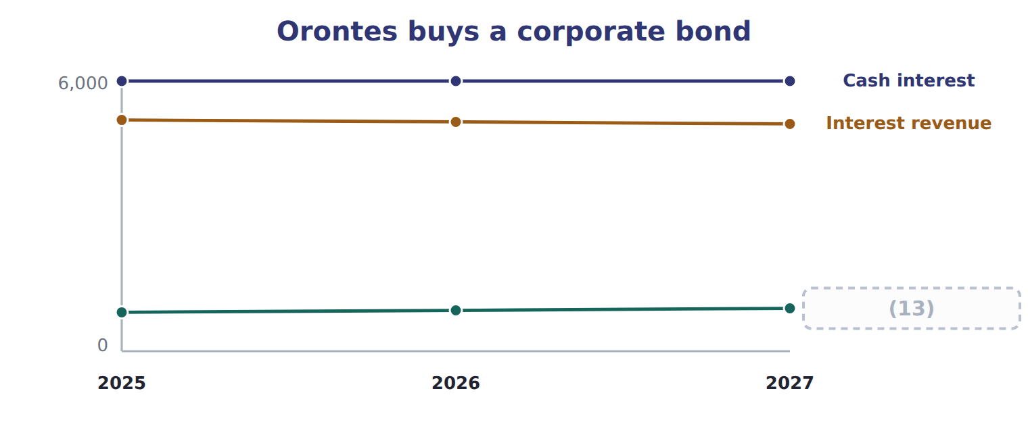
word list
Premium amortized · fair value

Summary 3 gaps 14–15
In 2025, (14) revenue is $102,723 × 5% = $5,136. At (15) the bond's fair value is $101,000.
word list
counted · interest · year-end

The same bond under three categories, 2025 (whole USD)
Every item belongs to exactly one group.
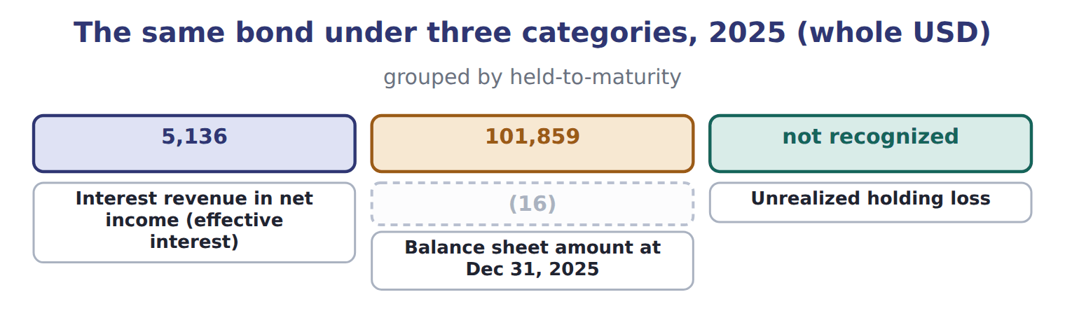
word list
Amortized cost at Dec 31, 2025 · unrealized holding gain or loss

Summary 4 gaps 17–28
Interest (17) is the same in all three categories. Only the (18) sheet amount and the place of the unrealized loss (19) . While Orontes holds an AFS bond, its unrealized gains and (20) build up in accumulated OCI, part of (21) . When Orontes sells the bond, the realized gain or loss moves to net income through a (22) adjustment, (23) called recycling. On the sale, the realized gain is the price minus the amortized cost: $101,500 − $100,952 = $548. Accumulated OCI for the bond (24) to zero, so the gain is never (25) twice. Transfers (26) categories are made at fair value. When a security moves into trading, any unrealized gain or loss not yet in net income goes to net income (27) . When an AFS security moves to HTM, the unrealized amount stays in accumulated OCI and is amortized over the (28) life. Transfers into or out of trading should be rare.
word list
changes · counted · differ · sometimes · returns · between · immediately · reclassification · losses · balance · remaining · equity · revenue

Where does it go?

Summary 5 gaps 29–31
Trading: fair value (29) in net income. Interest revenue = (30) carrying amount × market rate, not face × stated rate. On sale of AFS debt, recycle the (31) OCI; do not count the gain twice.
word list
accumulated · counted · changes · beginning

The English this section uses, and its Arabic
Each term sits against what it means.
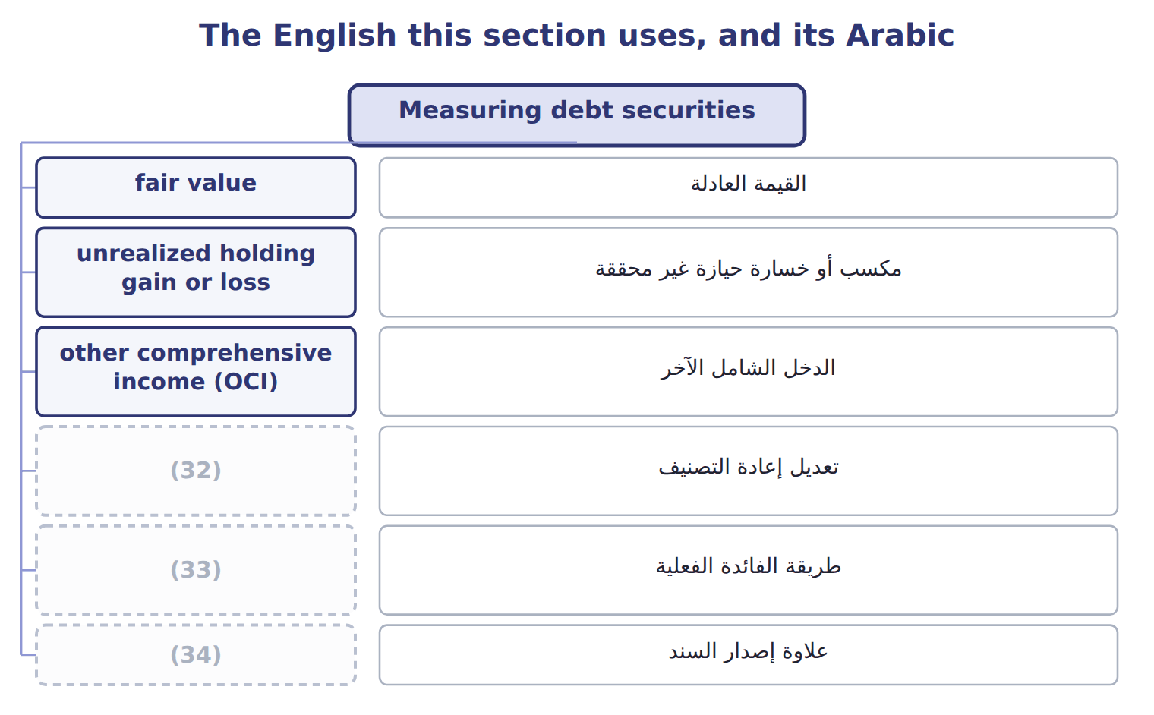
word list
reclassification adjustment · bond discount · effective-interest method · bond premium

The English this sheet uses, and its Arabic
English (exam term) | Arabic
fair value | القيمة العادلة
unrealized holding gain or loss | مكسب أو خسارة حيازة غير محققة
other comprehensive income (OCI) | الدخل الشامل الآخر
reclassification adjustment | تعديل إعادة التصنيف
effective-interest method | طريقة الفائدة الفعلية
bond premium | علاوة إصدار السند
bond discount | خصم إصدار السند

Answer key · 9.2 Measuring debt securities

1 Held-to-maturity (debt) | 18 balance
2 Equity method | 19 differ
3 bought | 20 losses
4 higher | 21 equity
5 effective-interest | 22 reclassification
6 purchase | 23 sometimes
7 received | 24 returns
8 difference | 25 counted
9 toward | 26 between
10 January | 27 immediately
11 December | 28 remaining
12 premium | 29 changes
13 Premium amortized | 30 beginning
14 interest | 31 accumulated
15 year-end | 32 reclassification adjustment
16 Amortized cost at Dec 31, 2025 | 33 effective-interest method
17 revenue | 34 bond premium

the summaries in full
Summary 1 A bond is bought at a bond premium when its stated interest rate is higher than the market rate, and at a bond discount when it is lower. Under the effective-interest method, interest revenue for each year is the carrying amount at the start of the year multiplied by the market rate at purchase. The cash received is the face amount multiplied by the stated rate. The difference amortizes the premium or discount, so the carrying amount moves toward face value.
Summary 2 On January 1, 2025, Orontes buys a 3-year bond with a face amount of $100,000 and a stated rate of 6%, paid each December 31. The market rate is 5%, so Orontes pays $102,723, a premium of $2,723.
Summary 3 In 2025, interest revenue is $102,723 × 5% = $5,136. At year-end the bond's fair value is $101,000.
Summary 4 Interest revenue is the same in all three categories. Only the balance sheet amount and the place of the unrealized loss differ. While Orontes holds an AFS bond, its unrealized gains and losses build up in accumulated OCI, part of equity. When Orontes sells the bond, the realized gain or loss moves to net income through a reclassification adjustment, sometimes called recycling. On the sale, the realized gain is the price minus the amortized cost: $101,500 − $100,952 = $548. Accumulated OCI for the bond returns to zero, so the gain is never counted twice. Transfers between categories are made at fair value. When a security moves into trading, any unrealized gain or loss not yet in net income goes to net income immediately. When an AFS security moves to HTM, the unrealized amount stays in accumulated OCI and is amortized over the remaining life. Transfers into or out of trading should be rare.
Summary 5 Trading: fair value changes in net income. Interest revenue = beginning carrying amount × market rate, not face × stated rate. On sale of AFS debt, recycle the accumulated OCI; do not count the gain twice.

9.3 Credit losses on debt securities
Chapter 9 · section 9.3

Fill every gap. Each word list holds one word more than there are gaps.
Summary 1 gaps 1–7
HTM securities are (1) at amortized cost, so they follow CECL, like the (2) : the company records an allowance for lifetime expected credit losses from day one. For very safe bonds, such as U.S. (3) bonds, the expected loss can be zero. AFS securities follow a (4) model. A (5) is impaired when its fair value is below its amortized cost. The credit part is (6) in an allowance (7) net income. The rest of the decline goes to OCI.
word list
measured · receivables · through · amortized · security · recorded · different · Treasury

The fair-value floor

The test, and what follows either way
One route applies, and only one.
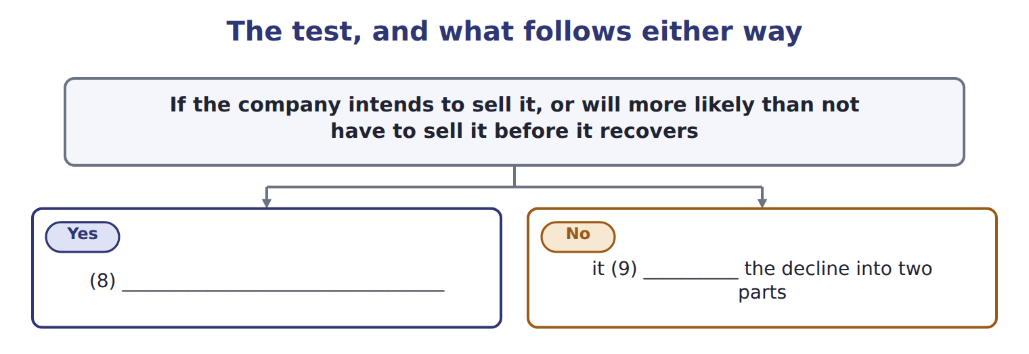
word list
reclassification adjustment · writes the security down to fair value through net income · separates

Summary 2 gaps 10–14
An AFS bond has an amortized cost of $50,000 and a fair value of $44,000. The allowance can never be (10) than amortized cost minus fair value: $6,000. Case A: the present value of expected cash flows is $47,000. The credit loss is $3,000 (allowance, net income), and the other $3,000 of the (11) goes to OCI. Case B: the present value of expected cash flows is $42,000. The credit loss would be $8,000, but the allowance is (12) to $6,000. (13) goes to OCI. If credit quality (14) later, the allowance can be reversed through net income.
word list
larger · Otherwise · decline · improves · limited · Nothing

The AFS floor

Summary 3 gaps 15–16
AFS allowance ≤ (15) cost − fair value. HTM has no such limit. If the company (16) to sell, there is no allowance: write the bond down to fair value.
word list
intends · amortized · impaired

Answer key · 9.3 Credit losses on debt securities

1 measured | 9 separates
2 receivables | 10 larger
3 Treasury | 11 decline
4 different | 12 limited
5 security | 13 Nothing
6 recorded | 14 improves
7 through | 15 amortized
8 writes the security down to fair value through net income | 16 intends

the summaries in full
Summary 1 HTM securities are measured at amortized cost, so they follow CECL, like the receivables: the company records an allowance for lifetime expected credit losses from day one. For very safe bonds, such as U.S. Treasury bonds, the expected loss can be zero. AFS securities follow a different model. A security is impaired when its fair value is below its amortized cost. The credit part is recorded in an allowance through net income. The rest of the decline goes to OCI.
Summary 2 An AFS bond has an amortized cost of $50,000 and a fair value of $44,000. The allowance can never be larger than amortized cost minus fair value: $6,000. Case A: the present value of expected cash flows is $47,000. The credit loss is $3,000 (allowance, net income), and the other $3,000 of the decline goes to OCI. Case B: the present value of expected cash flows is $42,000. The credit loss would be $8,000, but the allowance is limited to $6,000. Nothing goes to OCI. If credit quality improves later, the allowance can be reversed through net income.
Summary 3 AFS allowance ≤ amortized cost − fair value. HTM has no such limit. If the company intends to sell, there is no allowance: write the bond down to fair value.

9.4 Equity securities and the equity method
Chapter 9 · section 9.4

Fill every gap. Each word list holds one word more than there are gaps.
Summary 1 gaps 1–12
For shares, the key (1) is how much influence the investor has over the investee, the company whose shares it holds. Shares with a readily determinable fair value are (2) at fair value, and all (3) go to net income. There is no AFS (4) and no OCI (5) for shares. Dividends received are income. For example, Orontes (6) listed shares for $20,000; at (7) they are worth $23,500, and Orontes received dividends of $400. Net income includes an (8) gain of $3,500 and (9) income of $400. For shares with no readily determinable fair value, such as shares of a private company, the investor may use the (10) alternative: cost minus impairment, adjusted when an orderly (11) in the same or a similar share shows a new price. An investor with (12) influence can take part in the investee's financial and operating decisions.
word list
unrealized · bought · transaction · changes · dividend · option · year-end · measured · significant · impaired · category · question · measurement

Summary 2 gaps 13–19
Influence is presumed when the investor holds 20% to 50% of the voting stock, but the evidence decides: a board seat, (13) in policy decisions or large (14) between the companies can show influence even below 20%. With (15) influence, the investor uses the equity method. Under the equity method, the investment (16) at cost. It increases by the (17) share of the (18) net income and decreases by the dividends the investor receives. The dividends are not income, (19) they only return part of the investment.
word list
participation · difference · investee's · transactions · because · starts · investor's · significant

Orontes and Jordan Glass Co.

Summary 3 gaps 20–26
On (20) 1, 2025, Orontes buys 30% of Jordan Glass Co., its bottle (21) , for $1,200,000. Jordan (22) net assets have a book value of $3,000,000, so Orontes's share of book value is $900,000. The basis (23) of $300,000 has two parts: $30,000 for Orontes's share of equipment worth more than its book value, which is (24) over 10 years ($3,000 a year), and $270,000 of goodwill, which is not amortized. In 2025 Jordan Glass earns $500,000 and pays dividends of $200,000. Orontes reports (25) income of $147,000 and an investment of $1,287,000 at the end of 2025. The dividends of $60,000 are cash in and investment out; they do not (26) net income.
word list
supplier · difference · change · depreciated · Glass's · private · January · equity-method

Jordan Glass in 2026

Summary 4 gaps 27–37
In 2026 Jordan Glass earns $400,000 and pays (27) of $100,000. The extra (28) is the same as in 2025. Three more equity-method rules appear in exam (29) . Losses reduce the investment only to zero, unless the investor has (30) the investee's debts. Profits on sales between the two companies are (31) until the goods are sold to outsiders. And when an investor first gains (32) influence, it starts the equity method from that date; it does not restate prior years. An investor may also elect the fair value option for an equity-method investment. Crypto assets that meet the ASU 2023-08 (33) are measured at fair value through net income. This rule became (34) for fiscal years beginning after December 15, 2024, so it is now testable. IFRS 9 (35) debt by the business model and the cash flows (amortized cost, FVOCI or FVPL), not by intent. For shares, IFRS 9 allows an (36) election to put fair value changes in OCI, with no recycling on sale; U.S. GAAP has no such option. Under IAS 28, an equity-method investment that is impaired can later be written back up; under U.S. GAAP the (37) is not reversed.
word list
effective · definition · amortize · dividends · eliminated · irrevocable · guaranteed · impairment · classifies · questions · significant · depreciation

Dividends and percentages

Summary 5 gaps 38–40
Equity method: dividends reduce the (38) . They are not income. Take only the (39) share of the investee's income. (40) the part of the basis difference assigned to assets; do not amortize the goodwill.
word list
investment · unrealized · Depreciate · investor's

Dividends and percentages
Item | Investment | Facts | Amounts, Dec 31, 2025
A | Corporate bond | Bought to sell in the near term; the (41) team trades it actively. | cost 40,000; fair value 42,000
B | Government bond | (42) intends and is able to hold it until it matures in 2029. | cost 60,000; fair value 57,000
C | (43) | No plan to trade it or to hold it to maturity; no credit loss expected. | cost 30,000; fair value 28,500
D | Listed shares (5% of the company) | No significant influence. Dividend received during 2025: 800. | (44)
E | (45) | Orontes has a seat on the board. Carrying amount on Jan 1, 2025: 500,000. Investee net income: 120,000; dividends paid: 40,000.

word list
cost 25,000; fair value 27,000 · Corporate bond · treasury · Shares of Amman Cold Storage Co. (25%) · Orontes · equity method

Item — Answer
Item | Answer
Share of net income | (46)
Extra depreciation | 3,000
Dividends | 30% × 100,000 = 30,000
Ending balance | 1,287,000 + 120,000 − 3,000 − 30,000 = 1,374,000
Equity-method income | (47)

word list
cost 30,000; fair value 28,500 · 30% × 400,000 = 120,000 · 120,000 − 3,000 = 117,000

Investment — Category
Investment | Category
A | (48)
B | Held-to-maturity
C | (49)
D | Equity: fair value through net income
E | (50)

word list
Available-for-sale · Equity method · Trading · B

The English this section uses, and its Arabic
Each term sits against what it means.
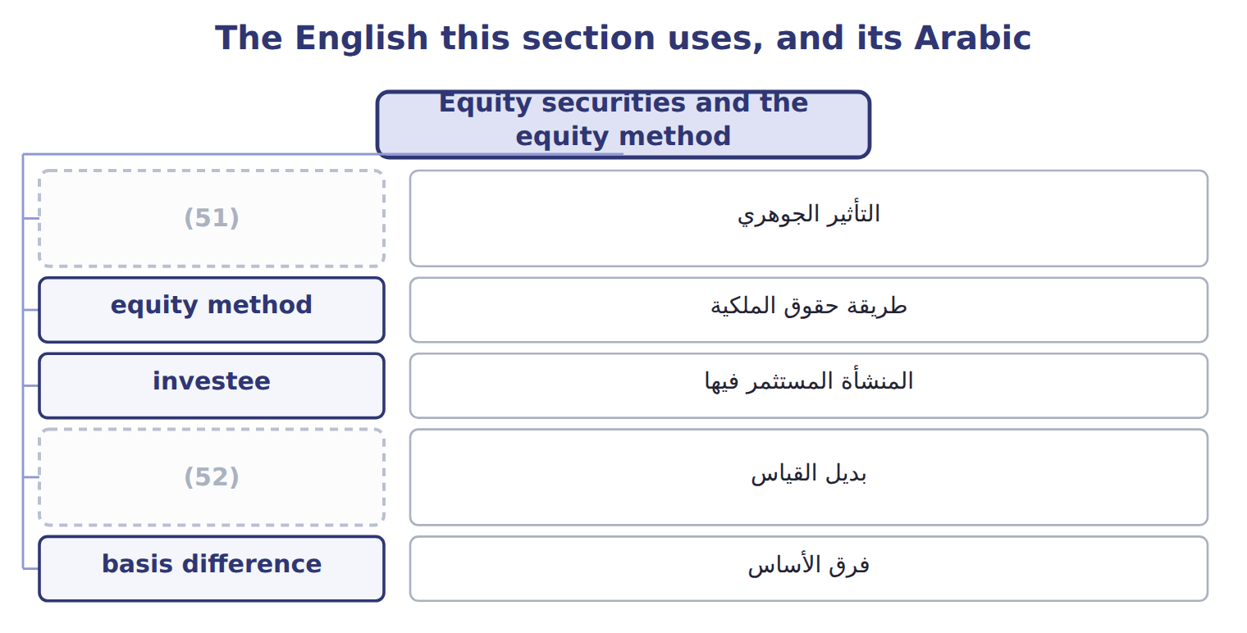
word list
significant influence · measurement alternative · فرق الأساس

The English this sheet uses, and its Arabic
English (exam term) | Arabic
significant influence | التأثير الجوهري
equity method | طريقة حقوق الملكية
investee | المنشأة المستثمر فيها
measurement alternative | بديل القياس
basis difference | فرق الأساس

Answer key · 9.4 Equity securities and the equity method

1 question | 27 dividends
2 measured | 28 depreciation
3 changes | 29 questions
4 category | 30 guaranteed
5 option | 31 eliminated
6 bought | 32 significant
7 year-end | 33 definition
8 unrealized | 34 effective
9 dividend | 35 classifies
10 measurement | 36 irrevocable
11 transaction | 37 impairment
12 significant | 38 investment
13 participation | 39 investor's
14 transactions | 40 Depreciate
15 significant | 41 treasury
16 starts | 42 Orontes
17 investor's | 43 Corporate bond
18 investee's | 44 cost 25,000; fair value 27,000
19 because | 45 Shares of Amman Cold Storage Co. (25%)
20 January | 46 30% × 400,000 = 120,000
21 supplier | 47 120,000 − 3,000 = 117,000
22 Glass's | 48 Trading
23 difference | 49 Available-for-sale
24 depreciated | 50 Equity method
25 equity-method | 51 significant influence
26 change | 52 measurement alternative

the summaries in full
Summary 1 For shares, the key question is how much influence the investor has over the investee, the company whose shares it holds. Shares with a readily determinable fair value are measured at fair value, and all changes go to net income. There is no AFS category and no OCI option for shares. Dividends received are income. For example, Orontes bought listed shares for $20,000; at year-end they are worth $23,500, and Orontes received dividends of $400. Net income includes an unrealized gain of $3,500 and dividend income of $400. For shares with no readily determinable fair value, such as shares of a private company, the investor may use the measurement alternative: cost minus impairment, adjusted when an orderly transaction in the same or a similar share shows a new price. An investor with significant influence can take part in the investee's financial and operating decisions.
Summary 2 Influence is presumed when the investor holds 20% to 50% of the voting stock, but the evidence decides: a board seat, participation in policy decisions or large transactions between the companies can show influence even below 20%. With significant influence, the investor uses the equity method. Under the equity method, the investment starts at cost. It increases by the investor's share of the investee's net income and decreases by the dividends the investor receives. The dividends are not income, because they only return part of the investment.
Summary 3 On January 1, 2025, Orontes buys 30% of Jordan Glass Co., its bottle supplier, for $1,200,000. Jordan Glass's net assets have a book value of $3,000,000, so Orontes's share of book value is $900,000. The basis difference of $300,000 has two parts: $30,000 for Orontes's share of equipment worth more than its book value, which is depreciated over 10 years ($3,000 a year), and $270,000 of goodwill, which is not amortized. In 2025 Jordan Glass earns $500,000 and pays dividends of $200,000. Orontes reports equity-method income of $147,000 and an investment of $1,287,000 at the end of 2025. The dividends of $60,000 are cash in and investment out; they do not change net income.
Summary 4 In 2026 Jordan Glass earns $400,000 and pays dividends of $100,000. The extra depreciation is the same as in 2025. Three more equity-method rules appear in exam questions. Losses reduce the investment only to zero, unless the investor has guaranteed the investee's debts. Profits on sales between the two companies are eliminated until the goods are sold to outsiders. And when an investor first gains significant influence, it starts the equity method from that date; it does not restate prior years. An investor may also elect the fair value option for an equity-method investment. Crypto assets that meet the ASU 2023-08 definition are measured at fair value through net income. This rule became effective for fiscal years beginning after December 15, 2024, so it is now testable. IFRS 9 classifies debt by the business model and the cash flows (amortized cost, FVOCI or FVPL), not by intent. For shares, IFRS 9 allows an irrevocable election to put fair value changes in OCI, with no recycling on sale; U.S. GAAP has no such option. Under IAS 28, an equity-method investment that is impaired can later be written back up; under U.S. GAAP the impairment is not reversed.
Summary 5 Equity method: dividends reduce the investment. They are not income. Take only the investor's share of the investee's income. Depreciate the part of the basis difference assigned to assets; do not amortize the goodwill.

