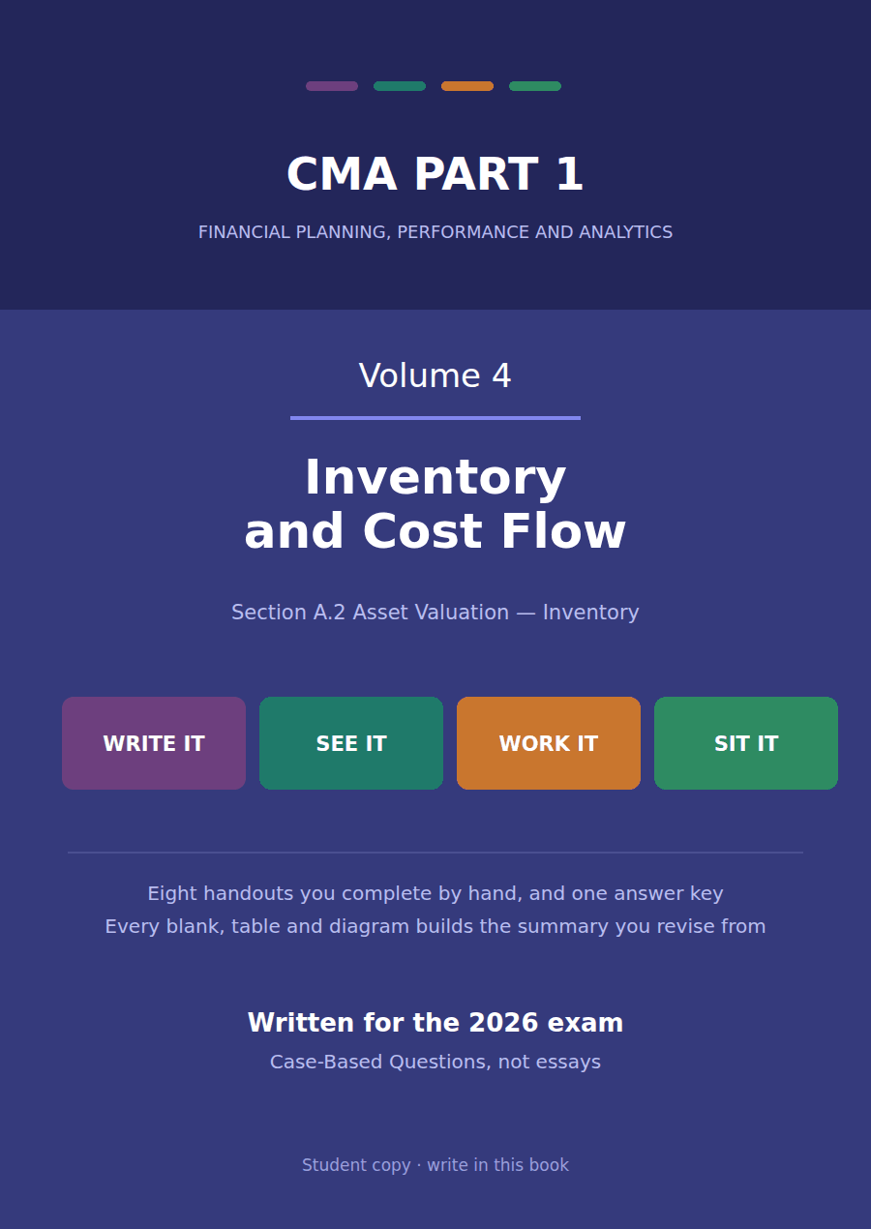

CMA Part 1 · Volume 4
Inventory and Cost Flow
Eight handouts, one answer key. The densest block in Section A: what belongs in inventory, which cost flow assumption, and what each one does to income and to assets.
These handouts are not notes to read. You write them. The words you supply are the summary, so a finished handout is a page you can revise from, in your own handwriting.
Work in pen. Do not look at the key until the whole handout is done — the key is written to explain the mistake, and you only get that benefit if you have made it first.
The eight handouts
# | Handout | What it gives you
1 | What Belongs in Inventory, and at What Cost | Two questions before any pricing method is chosen: which goods are ours, and what did they cost us to get here?
2 | FIFO, LIFO and Weighted Average | The same 12,000 units and the same $552,000 of cost. Three assumptions about which cost went out of the door, and three different answers.
3 | The LIFO Reserve and the LIFO Liquidation | LIFO holds a company’s balance sheet decades out of date, and one bad year can release all of it into income at once.
4 | What Each Method Does to Income and to Assets | Three methods, three profits, one business. The method that reports the best result is the one that leaves the company with least cash.
5 | Lower of Cost or Market: LIFO and Retail | Inventory may never be carried above what it is worth. Under LIFO, deciding what it is worth takes three figures rather than one.
6 | Lower of Cost and Net Realisable Value: Everything Else | The same principle with the arithmetic taken out of it. One comparison instead of three, and most inventory in the world uses this version.
7 | Inventory Errors and How They Unwind | An inventory error is wrong twice: once this year and once, in the opposite direction, next year. After that it is gone.
8 | Choosing a Method, and Defending the Choice | Four methods, each better at something and worse at something else. The exam asks you to choose, and to say what you traded away.

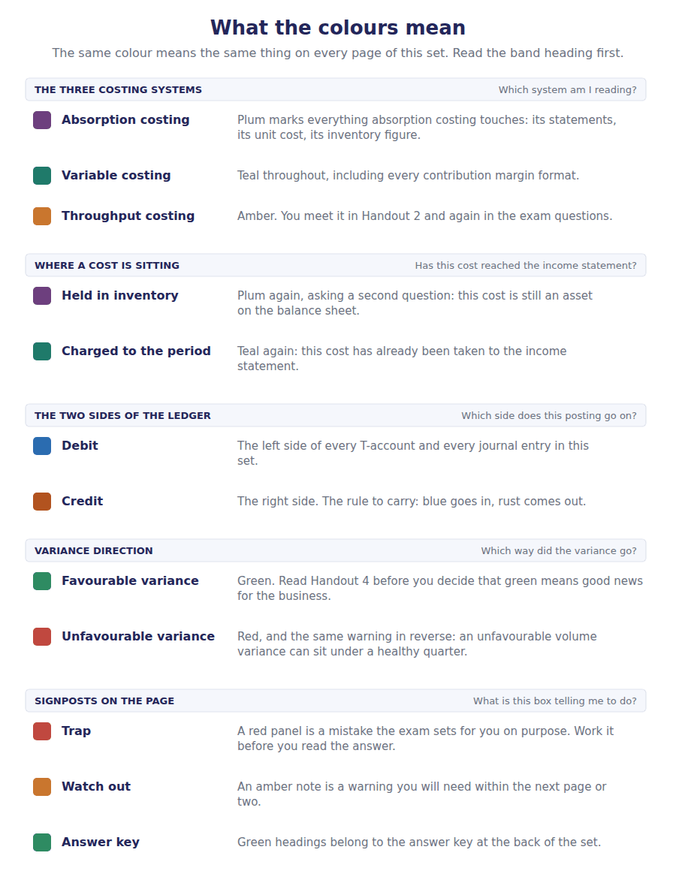
How to read the markers
Marker | Meaning
R1 | Teaching English. Short sentences. This is where a new idea arrives.
R2 | Textbook English. Longer sentences and passive verbs, as a textbook writes them.
R3 | Exam English. Exactly how the CMA exam phrases it, traps included.
Numbered rule | A space you fill in. The number matches the answer key.
Red table | A trap. Read it twice.

Handout 1 · What Belongs in Inventory, and at What Cost
Two questions before any pricing method is chosen: which goods are ours, and what did they cost us to get here?
Volume 4 · Inventory and Cost Flow · R1 moving to R2
LANGUAGE FOCUS
Register you are working in | R1 while the two questions are separated, R2 once shipping terms and capitalisable costs arrive.
Say it exactly like this | include goods in inventory · take title to goods · ship goods FOB shipping point · capitalise a cost · bring inventory to its present location and condition · hold goods on consignment
Words that are not the same | FOB shipping point / FOB destination · consignor / consignee · product cost / period cost · freight-in / freight-out
Remember | Possession does not decide ownership. Goods in your warehouse may belong to somebody else, and goods on a ship may be yours. Freight-in and freight-out look alike and are opposites. One is in inventory, one is a selling expense.

What you will be able to do when this handout is finished
- Decide whether goods in transit belong to the buyer or the seller.
- Say who reports consigned goods as inventory, and why.
- Decide whether a cost is included in inventory or charged to the period.
- Compute the cost of a purchase including all the costs that belong in it.
- Say what the two questions in this handout have to settle before a cost flow assumption can be chosen.

The $845,000 on Northwind’s balance sheet
Inventory is the largest current asset Northwind reports after receivables, and the one with the most judgement inside it.
Before any of the famous questions can be asked — FIFO or LIFO, and what each does to income — two duller questions have to be settled. Which goods are actually ours, and what did each of them cost?
Get either of those wrong and every method in Handout 2 gives a wrong answer accurately. This handout settles both.
Throughout this volume one product line is followed in detail: the NW-40 flow controller, of which Northwind had 12,000 units available for sale during 20X4 at a total cost of $552,000.

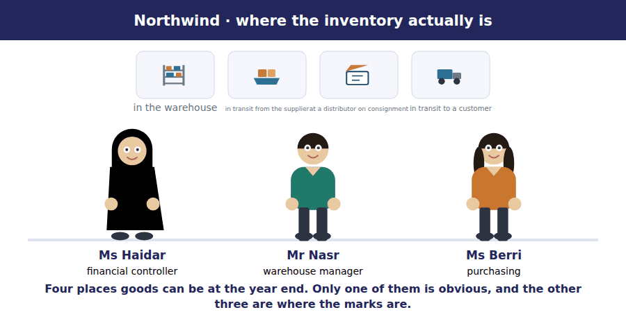
Part 1 · Which goods are ours? possession is not ownership
Exercise 1A Read and complete. Write one word in each space.
OBJECTIVE | Decide who owns goods in transit, and who owns goods held on consignment.
YOU WILL NEED | Nothing — this is the first exercise in the volume.
HOW TO START | • The shipping term tells you where title passes. Read it literally: the name says the point at which the goods become the buyer’s.  • Blank 3 is the party that still owns goods sitting in somebody else’s shop.  • The last blank is the test that settles all of these cases.

WORD BANK
CIF · consignor · customer · delivery · FOB · supplier · title
Not every word is used.

R1 Goods sitting in Northwind’s warehouse on 31 December are obviously its inventory. The harder cases are the goods that are somewhere else.
Goods on a ship belong to whoever holds title, and the shipping term says who that is. ¹ shipping point means title passed when the goods left the supplier, so they are Northwind’s even though they are at sea. FOB destination means title passes on arrival, so they are still the ² ’s.
Goods Northwind has sent to a distributor to sell on its behalf are held on consignment. The distributor has possession, but the ³ — Northwind — still owns them, and still reports them as inventory.
One test runs through all of these cases, and it is not where the goods are standing. It is who holds ⁴ to them at the reporting date.
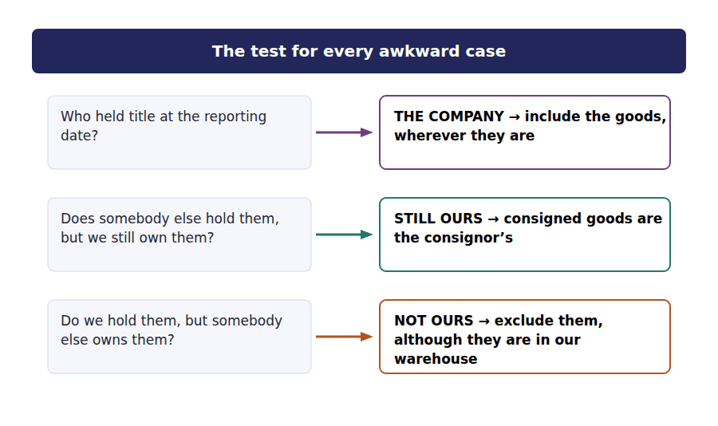
Exercise 1B Sort each item into the column it belongs in.
OBJECTIVE | Decide whether each item belongs in Northwind’s year-end inventory.
YOU WILL NEED | Exercise 1A
HOW TO START | • Read the shipping term before anything else. It settles two of these six on its own.  • Two items are in somebody else’s hands and one of them is still Northwind’s.  • The last item is in Northwind’s warehouse and is not Northwind’s.

Goods at 31 December 20X4 | IN NORTHWIND’S INVENTORY | NOT IN IT
1. Controllers on the warehouse shelves
2. Goods on a ship from the supplier, shipped FOB shipping point
3. Goods on a ship from the supplier, shipped FOB destination
4. Goods sent to a distributor on consignment, unsold
5. Goods in a truck on the way to a customer, FOB destination
6. Goods held in the warehouse for another company on consignment

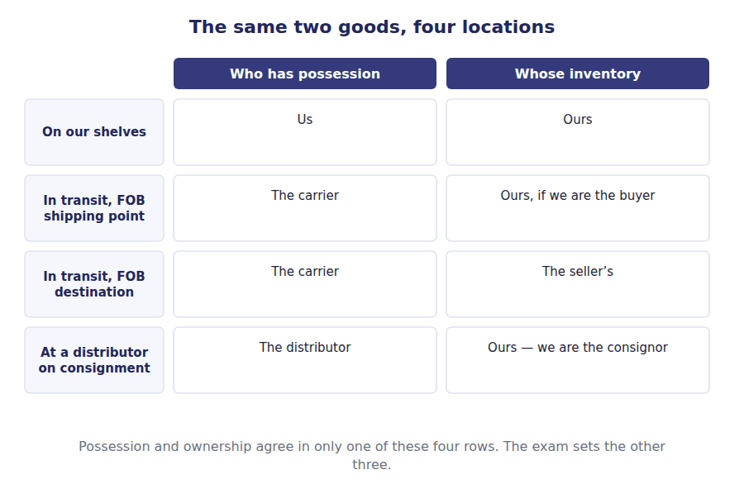
Part 2 · What did they cost? everything needed to get them here
R2 Inventory is measured at cost, and cost means more than the invoice price. The rule is that inventory includes all the costs of bringing the goods to their present location and condition.
R2 That phrase does real work. Freight paid to get the goods to Northwind is part of their cost, because without it they would not be here. Freight paid to send goods to a customer is not, because the goods were already here and the delivery is a cost of selling rather than of acquiring.
Exercise 1C Complete the table. Write yes or no, and the reason.
OBJECTIVE | Decide whether each cost is included in inventory or charged to the period.
YOU WILL NEED | Exercise 1B, and the two paragraphs above.
HOW TO START | • Apply the phrase literally: was this cost necessary to bring the goods to their present location and condition?  • Two of these costs look like freight and only one of them is inventoriable.  • The storage cost is the one most often got wrong. Ask whether the goods were already in a saleable condition while they sat there.

Cost incurred | In inventory? | Why
Invoice price of the goods | ______________ | ______________
Freight paid to bring the goods to the warehouse | ______________ | ______________
Import duty on the shipment | ______________ | ______________
Freight paid to deliver goods to a customer | ______________ | ______________
Storage of finished goods awaiting sale | ______________ | ______________
The purchasing manager’s salary | ______________ | ______________

1 | 2 | 3 | 4 | 5 | 6
7 | 8 | 9 | 10 | 11 | 12

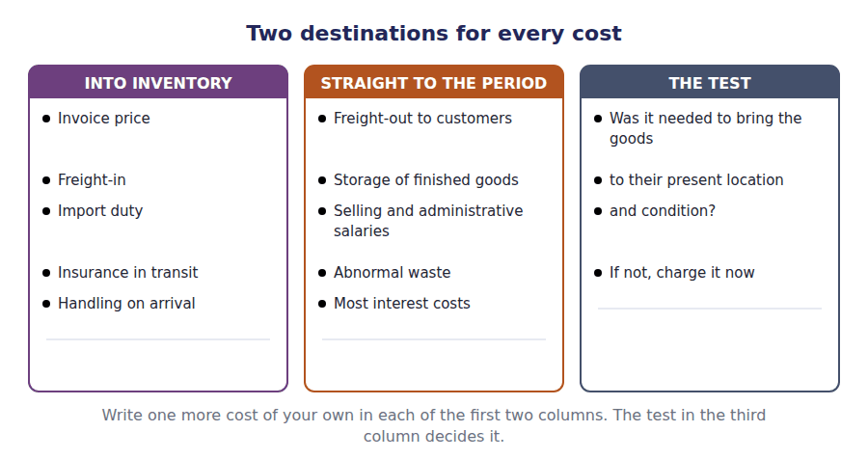
Exercise 1D Read and complete.
OBJECTIVE | Compute the cost of a purchase including every cost that belongs in it.
YOU WILL NEED | Exercise 1C
HOW TO START | • Work through the four amounts in order, deciding each one before you add it.  • Two of the four belong in inventory and one does not.  • The discount reduces the cost, because that is what the goods actually cost the company.

WORD BANK
$211,000 · $214,000 · expense · increases · inventory · reduces · selling
Not every word is used.

R2 Northwind buys a consignment of controllers with an invoice price of $200,000, pays $6,000 of freight to bring them in, pays $9,000 of import duty, and pays $3,000 to deliver part of the consignment to a customer two weeks later.
The first three are costs of bringing the goods to their present location and condition, so all three go into ⁵ . The fourth is freight-out: the goods were already here, and delivering them is a cost of ⁶ .
The supplier offers 2% for payment within ten days and Northwind takes it, saving $4,000. That discount ⁷ the cost of the inventory, because the goods did not in fact cost what the invoice said.
The cost carried into inventory is therefore $200,000 plus $6,000 plus $9,000 less $4,000, which is ⁸ .
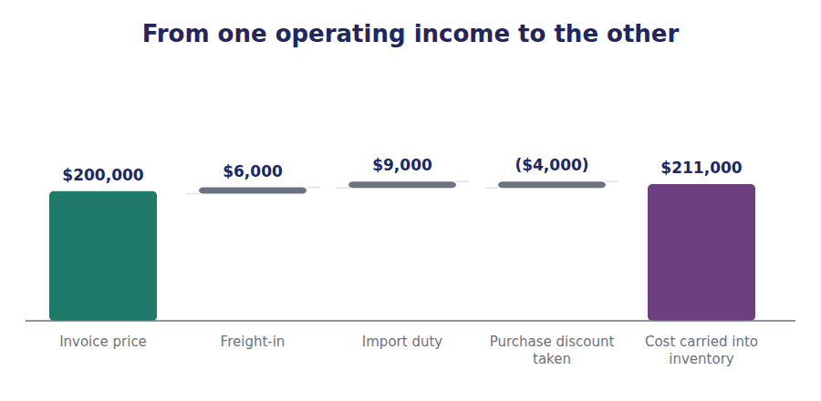
Part 3 · The pool the whole volume works on goods available for sale
Exercise 1E Read and complete.
OBJECTIVE | Build the pool of goods available for sale, and say what still has to be decided.
YOU WILL NEED | Exercises 1A to 1D
HOW TO START | • Add the four layers. The units and the costs are both given.  • Blank 2 is what is left when the units sold are taken out of the units available.  • The last blank is the question this volume has not yet asked, and Handout 2 asks it.

WORD BANK
$552,000 · $845,000 · 12,000 · 3,500 · dates · prices
Not every word is used.

R2 Northwind began 20X4 with 2,000 units of the NW-40 flow controller on hand and bought three further batches during the year. In total 12,000 units were available for sale, at a cost of ⁹ .
Of those, 8,500 units were sold, which leaves ¹⁰ units in the warehouse at 31 December.
Both of those figures are facts. They were counted, and no accounting policy can change either of them.
What is not yet a fact is how the $552,000 of cost is split between the units sold and the units left. The four batches were bought at four different ¹¹ , and which of those prices attaches to the units still on hand is a choice, and Handout 2 is about making it.
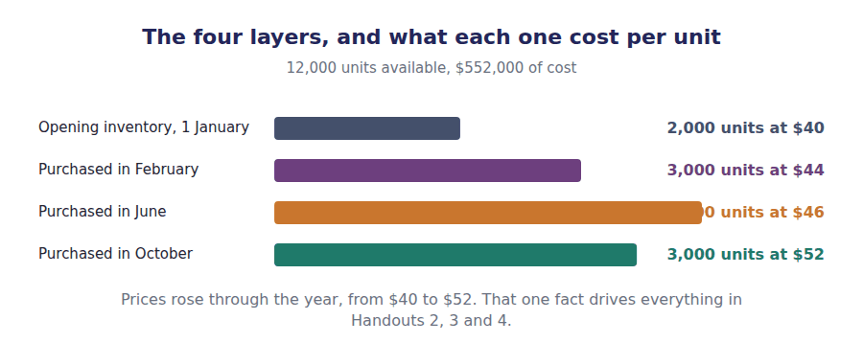
Watch out! Units are counted and costs are recorded. Neither is a choice. The only choice in this volume is which recorded cost attaches to which counted unit, and it changes reported profit without changing a single thing about the business.
Part 4 · Exam pitch the questions as the CMA sets them
1. [Level B] At 31 December, goods costing $40,000 are on a ship from a supplier, shipped FOB shipping point. These goods should be included in the inventory of:
(A) The seller, because they have not arrived
(B) The buyer, because title passed when the goods left the seller
(C) Neither, until the goods are received
(D) Both, in proportion to the voyage completed
2. [Level B] Goods held by a distributor on consignment at the year end are reported as inventory by:
(A) The distributor, because it has possession
(B) The consignor, because it still owns the goods
(C) Neither party, until the goods are sold
(D) Whichever party bears the cost of insurance
3. [Level A] Which of the following costs is NOT included in the cost of inventory?
(A) Freight paid to bring purchased goods to the warehouse
(B) Import duty on purchased goods
(C) Freight paid to deliver goods to a customer
(D) Insurance on goods while in transit from the supplier
4. [Level B] A company purchases goods for $200,000, pays $6,000 freight-in and $9,000 import duty, and takes a $4,000 purchase discount. The cost of the inventory is:
(A) $200,000
(B) $211,000
(C) $215,000
(D) $219,000
5. [Level C] Storage costs of finished goods awaiting sale are normally:
(A) Included in the cost of inventory
(B) Charged to the period as incurred
(C) Added to freight-in
(D) Capitalised and amortised over the holding period
6. [Level A] Northwind had 12,000 units available for sale at a total cost of $552,000 and sold 8,500 units. The units remaining are:
(A) 3,500
(B) 8,500
(C) 12,000
(D) 20,500
7. [Level C] Goods are in a truck on the way to a customer at the year end, shipped FOB destination. They should be reported as inventory of:
(A) The customer, because the sale has been made
(B) The seller, because title has not yet passed
(C) Neither, because the goods are in transit
(D) The carrier
ADAPTIVE TIP For every awkward item, write down two things before you answer: who has it, and who owns it. If those two differ, the question is testing ownership, and ownership always wins.

Handout 2 · FIFO, LIFO and Weighted Average
The same 12,000 units and the same $552,000 of cost. Three assumptions about which cost went out of the door, and three different answers.
Volume 4 · Inventory and Cost Flow · R2 throughout
LANGUAGE FOCUS
Register you are working in | R2 textbook English. The sentences are short because the arithmetic is the hard part, not the prose.
Say it exactly like this | apply a cost flow assumption · assume the oldest costs are sold first · split goods available for sale · compute a weighted average unit cost · leave the newest layers in inventory · match current costs against current revenue
Words that are not the same | cost flow / physical flow · FIFO / LIFO · periodic / perpetual · closing inventory / cost of goods sold
Remember | A cost flow assumption is not a claim about which physical units left the warehouse. The goods can move in any order. LIFO is not forbidden under US GAAP. It is forbidden under IFRS, and Volume 12 covers that difference.

What you will be able to do when this handout is finished
- State the identity that every cost flow assumption has to satisfy.
- Compute closing inventory and cost of goods sold under FIFO.
- Compute both under LIFO.
- Compute both under weighted average.
- Say why a cost flow assumption need not match the physical movement of the goods.

One pool of cost, split two ways
Handout 1 established the pool. 12,000 units of the NW-40 flow controller were available for sale during 20X4, bought in four batches at four prices, at a total cost of $552,000.
8,500 units were sold and 3,500 remain. Those counts are facts.
The whole of this handout is one question: of the $552,000, how much went out with the 8,500 units sold, and how much stayed with the 3,500 units left?

Layer | Units | Cost per unit | Total cost
Opening inventory, 1 January | 2,000 | $40 | $80,000
Purchased in February | 3,000 | $44 | $132,000
Purchased in June | 4,000 | $46 | $184,000
Purchased in October | 3,000 | $52 | $156,000
Goods available for sale | 12,000 |  | $552,000

Part 1 · The identity underneath what every method has to satisfy
Exercise 2A Read and complete. Write one word in each space.
OBJECTIVE | State the identity every cost flow assumption satisfies, and say what it implies.
YOU WILL NEED | Handout 1, for the pool of goods available for sale.
HOW TO START | • Blank 1 is the pool the two outputs are carved from.  • Blank 3 follows directly: if one output rises, what happens to the other?  • The last blank is what the choice of method does NOT change.

WORD BANK
available · cost · higher · inventory · lower · revenue · units
Not every word is used.

R2 Every cost flow assumption starts from the same pool. Opening inventory plus purchases gives goods ¹ for sale, which for the NW-40 flow controller is $552,000 and is the same figure whatever method is chosen.
That pool is then divided in two. Part of it is charged to cost of goods sold, and the rest stays on the balance sheet as closing ² . Nothing is left over and nothing is invented.
One consequence follows immediately and is worth saying out loud. Because the two outputs add to a fixed total, a method that produces a higher closing inventory must produce a ³ cost of goods sold, by exactly the same amount.
And because the pool itself is fixed, the choice of method changes neither the number of units nor the total ⁴ of them. It changes only which part of that cost is reported where.
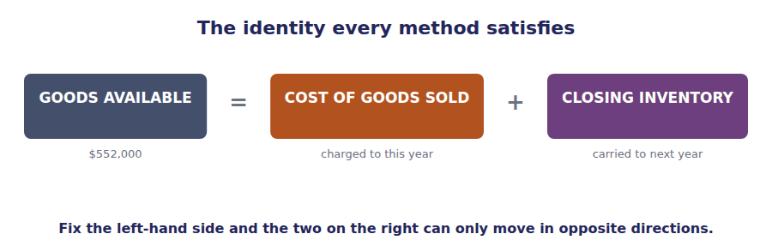
Part 2 · FIFO the oldest costs leave first
R2 The first of the three is first-in, first-out, which everyone calls FIFO. The name states the assumption: the costs that came in first are the costs charged out first, so what is left in inventory is whatever came in most recently.
Exercise 2B Work out which layers the 3,500 remaining units come from, then price them.
OBJECTIVE | Compute closing inventory and cost of goods sold under FIFO.
YOU WILL NEED | Exercise 2A
HOW TO START | • Under FIFO the oldest costs leave first, so the newest costs are the ones still here. Start from the bottom of the layer table.  • The October batch is 3,000 units. You need 3,500, so you will take all of October and part of one more layer.  • Cost of goods sold is then $552,000 less your answer — do not compute it from the units sold.

FIFO · which layers are left | Units | Cost per unit | Total
From the October purchase | 3,000 | $52 | ______________
From the June purchase | 500 | $46 | ______________
FIFO closing inventory | 3,500 |  | ______________
FIFO cost of goods sold | 8,500 |  | ______________

1 | 2 | 3 | 4

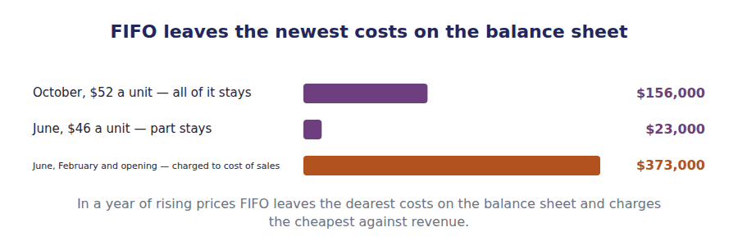
Part 3 · LIFO the newest costs leave first
R2 The second is last-in, first-out, or LIFO, and it is the exact reverse. The costs that came in most recently are charged out first, so what is left in inventory is whatever came in earliest — in a long-established company, costs that may be decades old.
Exercise 2C Work out which layers remain under LIFO, then price them.
OBJECTIVE | Compute closing inventory and cost of goods sold under LIFO.
YOU WILL NEED | Exercise 2B
HOW TO START | • Under LIFO the newest costs leave first, so the oldest costs are the ones still here. Start from the top of the layer table.  • The opening layer is 2,000 units. You need 3,500, so you will take all of it and part of February.  • Compare your answer with Exercise 2B before you go on. The difference is the point of the next handout.

LIFO · which layers are left | Units | Cost per unit | Total
From opening inventory | 2,000 | $40 | ______________
From the February purchase | 1,500 | $44 | ______________
LIFO closing inventory | 3,500 |  | ______________
LIFO cost of goods sold | 8,500 |  | ______________

1 | 2 | 3 | 4

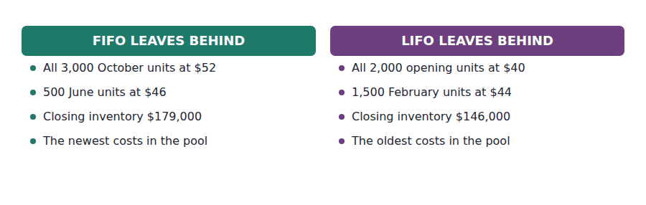
Part 4 · Weighted average one price for everything
Exercise 2D Read and complete.
OBJECTIVE | Compute the weighted average unit cost and apply it to both outputs.
YOU WILL NEED | Exercises 2B and 2C
HOW TO START | • The average is weighted by quantity. Do not average the four prices.  • Blank 1 is a division, and the answer is a round number.  • Apply the same unit cost to both the units sold and the units left.

WORD BANK
$161,000 · $391,000 · $46 · $47 · $552,000 · averages · exceeds
Not every word is used.

R2 The weighted average unit cost is the total cost of the pool divided by the total units in it: $552,000 divided by 12,000 units, which is ⁵ a unit.
Notice that this is not the average of $40, $44, $46 and $52, which would be $45.50. The average is weighted by how many units were bought at each price, and the June batch of 4,000 units pulls it towards $46.
That one rate is then applied to both outputs. Closing inventory is 3,500 units at $46, which is ⁶ , and cost of goods sold is the remaining ⁷ .
The answer sits between the other two, which it always will: an average cannot fall outside the range of the costs it ⁸ .
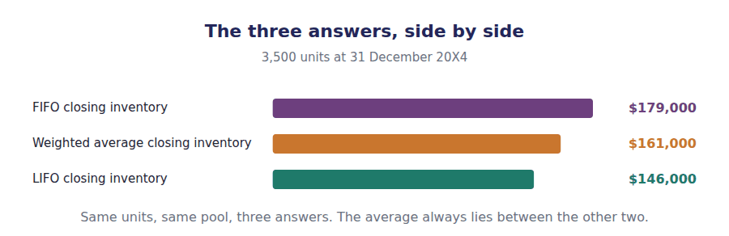
Part 5 · Cost flow is not physical flow the point students most often miss
Exercise 2E Read and complete.
OBJECTIVE | Say why the assumption need not match the way the goods actually moved.
YOU WILL NEED | Exercises 2B, 2C and 2D
HOW TO START | • Blank 1 is what a cost flow assumption is an assumption about.  • Blank 3 is the kind of goods for which a company has no choice but to track each unit.  • The last blank is the one method whose name describes a physical fact rather than an assumption.

WORD BANK
average · costs · forbidden · goods · inconsistent · specific
Not every word is used. A word may be used more than once.

R2 A cost flow assumption is an assumption about ⁹ , not about goods. Northwind’s warehouse staff take whichever controller is nearest the door, and the accounting is unaffected by which one that is.
A company may use LIFO for its accounts while physically selling its oldest stock first, and in a business with perishable goods it almost certainly does. Nothing about that is ¹⁰ , because the two questions are separate.
There is one exception. Where the units are not interchangeable — aircraft, bespoke machines, numbered works of art — the cost of each individual unit must be tracked, and the method is called ¹¹ identification.
That is the only one of the four whose name describes what actually happened to the goods. The other three describe what is assumed about the ¹² .
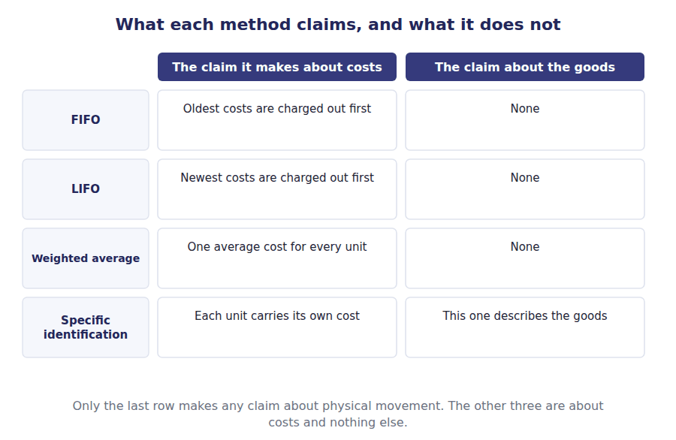
Method | Closing inventory | Cost of goods sold | Together they equal
FIFO
LIFO
Weighted average

1 | 2 | 3 | 4 | 5 | 6
7 | 8 | 9

Watch out! LIFO is permitted under US GAAP and prohibited under IFRS. Any question that mentions IFRS has removed LIFO from the options before you start reading them. Volume 12 covers the difference and its consequences.
Part 6 · Exam pitch the questions as the CMA sets them
1. [Level A] Goods available for sale cost $552,000. Closing inventory under a given method is $179,000. Cost of goods sold under that method is:
(A) $373,000
(B) $179,000
(C) $552,000
(D) $731,000
2. [Level B] In a period of rising prices, FIFO compared with LIFO produces:
(A) Higher closing inventory and higher cost of goods sold
(B) Higher closing inventory and lower cost of goods sold
(C) Lower closing inventory and lower cost of goods sold
(D) The same closing inventory and the same cost of goods sold
3. [Level B] A company buys 2,000 units at $40, 3,000 at $44, 4,000 at $46 and 3,000 at $52. The weighted average unit cost is:
(A) $45.50
(B) $46
(C) $40
(D) $52
4. [Level A] Under LIFO, closing inventory consists of:
(A) The most recently purchased units
(B) The earliest costs in the pool
(C) An average of all costs in the pool
(D) The actual units physically remaining
5. [Level C] Which statement about cost flow assumptions is correct?
(A) The assumption chosen must match the physical movement of the goods
(B) The assumption concerns which costs attach to units sold, not which units moved
(C) Specific identification may be used for any inventory
(D) FIFO is required where goods are perishable
6. [Level C] Northwind’s weighted average closing inventory is $161,000. Its FIFO figure is $179,000 and its LIFO figure is $146,000. This ordering:
(A) Is a coincidence of these particular numbers
(B) Must always hold, because an average cannot fall outside the range of the costs averaged
(C) Would reverse if prices were rising
(D) Depends on whether a periodic or perpetual system is used
7. [Level C] Under which cost flow assumption do a periodic system and a perpetual system always give the same answer?
(A) LIFO
(B) FIFO
(C) Weighted average
(D) All three
ADAPTIVE TIP Compute whichever of the two outputs is easier, then subtract from goods available for sale to get the other. Computing both from scratch doubles the arithmetic and doubles the chance of an error.

Handout 3 · The LIFO Reserve and the LIFO Liquidation
LIFO holds a company’s balance sheet decades out of date, and one bad year can release all of it into income at once.
Volume 4 · Inventory and Cost Flow · R2 throughout
LANGUAGE FOCUS
Register you are working in | R2 textbook English. The ideas here connect two years at a time, so the sentences carry more than one clause.
Say it exactly like this | disclose the LIFO reserve · restate inventory to a FIFO basis · dip into an old layer · liquidate a LIFO layer · defer tax by using LIFO · compare companies on the same basis
Words that are not the same | reserve / allowance · liquidation / sale · reported figure / restated figure · tax deferred / tax saved
Remember | A LIFO reserve is not money. It is the gap between two measurements of the same inventory. LIFO defers tax; it does not avoid it. A liquidation collects the deferral back, often at the worst moment.

What you will be able to do when this handout is finished
- Compute the LIFO reserve and say what it measures.
- Restate a LIFO company’s inventory and income to a FIFO basis.
- Explain why LIFO defers tax, and why the deferral is not permanent.
- Recognise a LIFO liquidation and compute the effect on income.
- State the conformity rule and why it exists.

The $33,000 that is not on the balance sheet
Handout 2 produced two closing inventory figures for the same 3,500 units: $179,000 under FIFO and $146,000 under LIFO.
The gap between them is $33,000. Nothing about the goods differs — the same controllers are on the same shelves — and the gap is entirely the consequence of an accounting choice.
That gap has a name, it is disclosed, and this handout is about what it does. It makes a LIFO company comparable with a FIFO one, it measures a tax deferral, and in a bad year it comes back all at once.

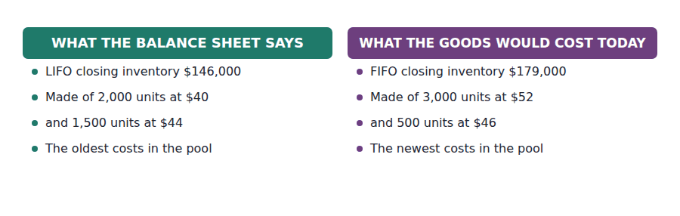
Part 1 · The reserve the gap, and why it is disclosed
Exercise 3A Read and complete. Write one word in each space.
OBJECTIVE | Compute the reserve and say what a reader does with it.
YOU WILL NEED | Handout 2, for both closing inventory figures.
HOW TO START | • Blank 1 is a subtraction you can do from Handout 2’s answers.  • Blank 3 is what a reader adds the reserve to in order to compare the company with a FIFO one.  • The last blank is the word that explains why the disclosure is required rather than optional.

WORD BANK
$33,000 · cash · comparability · FIFO · itself · LIFO · prudence
Not every word is used.

R2 Northwind’s inventory would be $179,000 on a FIFO basis and is $146,000 on a LIFO basis. The difference of ¹ is the LIFO reserve.
It is not a fund and nothing is set aside. It is the amount by which LIFO holds the balance sheet below what the same goods would be carried at under the other assumption, and in a company that has used LIFO for thirty years it can be larger than the reported inventory ² .
A reader comparing Northwind with a FIFO competitor adds the reserve to reported inventory, which restates it to a ³ basis, and adds the after-tax movement in the reserve to reported income.
That is why the disclosure is required. Without it the two companies could not be compared at all, and ⁴ is exactly what the disclosure exists to protect.
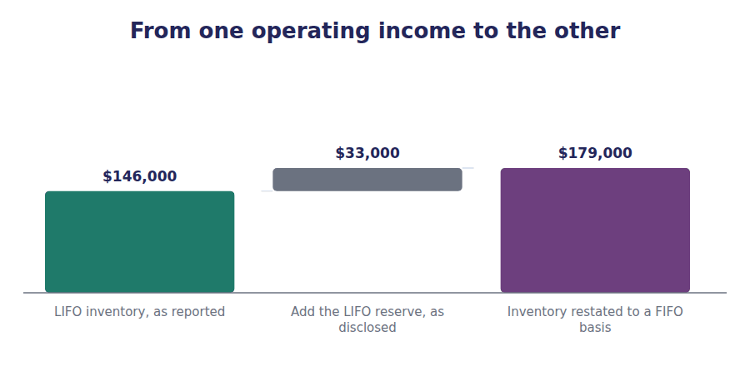
Exercise 3B Complete the table. Both lines are restated with the same reserve.
OBJECTIVE | Restate a LIFO company to a FIFO basis.
YOU WILL NEED | Exercise 3A
HOW TO START | • Inventory is restated by adding the whole reserve.  • Cost of goods sold moves the other way, because the pool is fixed.  • The tax column uses the 25% rate from the data.

As reported, LIFO | Adjustment | Restated to FIFO
Closing inventory $146,000 | Add the reserve of $33,000 | ______________
Cost of goods sold $406,000 | Deduct the reserve of $33,000 | ______________
Gross margin $231,500 | Add the reserve of $33,000 | ______________
Income tax at 25% | Add $8,250 | ______________

1 | 2 | 3 | 4

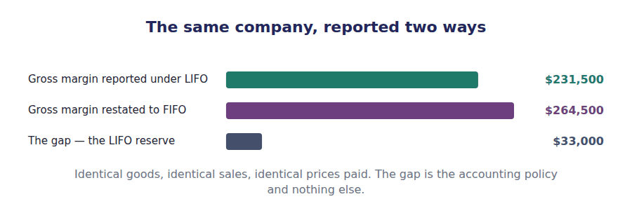
Part 2 · Why a company chooses LIFO and what it is really buying
R2 LIFO charges the newest and dearest costs against revenue, so in a period of rising prices it reports a lower profit. A company that reports a lower profit pays less tax, and that is the whole of the attraction.
R2 The tax is not avoided. The goods will eventually be sold, and when the old cheap layers finally reach cost of goods sold the tax arrives with them. What LIFO buys is time, and time has a value, which is why the choice is worth making.
Exercise 3C Read and complete.
OBJECTIVE | Compute what LIFO saves this year, and say what it has actually bought.
YOU WILL NEED | Exercise 3B, and the two paragraphs above.
HOW TO START | • Blank 1 is the difference between the two tax charges, and you have both from Exercise 3B.  • Blank 3 is the name of the US tax rule that forces a company using LIFO for tax to use it in its accounts as well.  • The last blank is what the company has bought, and it is not a saving.

WORD BANK
$8,250 · conformity · matching · profit · revenue · saving
Not every word is used.

R2 Under LIFO Northwind reports a gross margin of $231,500 and under FIFO it would report $264,500. At 25% the tax charge differs by ⁵ , and that is the cash Northwind keeps this year by having chosen LIFO.
There is a condition attached, and it is the reason LIFO appears in published accounts at all. The US ⁶ rule says that a company using LIFO for tax must use it in its financial statements too, so it cannot report a high profit to shareholders and a low one to the tax authority.
The company therefore buys its tax position with its reported ⁷ . A lower reported margin is the price of the deferral, and a board has to decide whether that trade is worth making.
And it is a deferral rather than a saving. The tax has been postponed to whichever year the old layers are finally sold, which is the subject of Part 3.
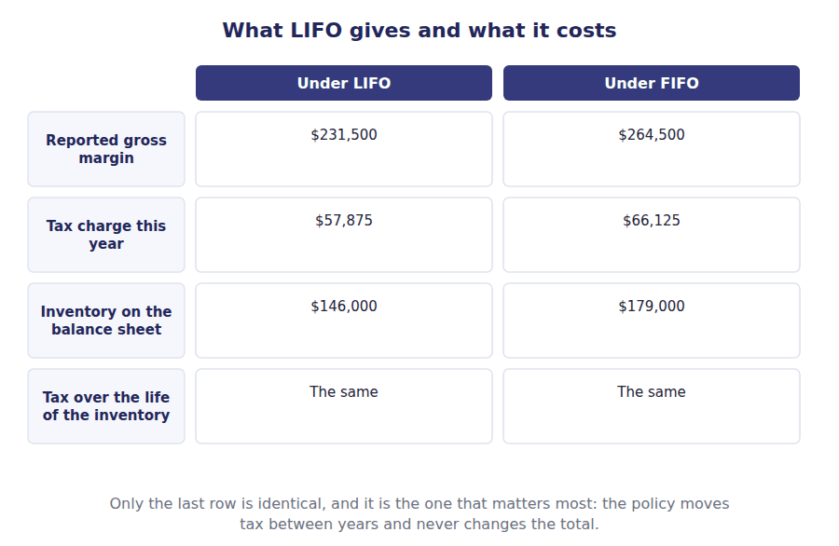
Part 3 · The liquidation when the old layers finally come out
Exercise 3D Complete the schedule. Work from the newest cost down into the old layers.
OBJECTIVE | Compute cost of goods sold in a year when quantities fall.
YOU WILL NEED | Exercise 3C
HOW TO START | • In 20X5 Northwind buys only 2,000 units and sells 4,000, so quantities fall by 2,000 units.  • LIFO charges the newest cost first: this year’s purchase at $56.  • Once that is used up, the next costs are the old layers Handout 2 left behind, and they are very much cheaper.

20X5 · LIFO cost of goods sold | Units | Cost per unit | Total
This year’s purchase, newest cost first | 2,000 | $56
Then into an old layer at $44 | 1,500 | $44
Then into an old layer at $40 | 500 | $40
Cost of goods sold | 4,000

1 | 2 | 3 | 4

WORD BANK
afford · higher · liquidation · lower · reserve · welcome
Not every word is used.

R2 Northwind sold 4,000 units in 20X5 and replaced only 2,000 of them. The remaining 2,000 units had to come out of the layers carried forward from 20X4, and those layers are priced at $44 and $40.
Had Northwind replaced the units it sold, those 2,000 would have cost $56 each. Instead they cost far less, so cost of goods sold is lower and reported profit is ⁸ by $26,000.
That increase is a LIFO ⁹ , and it has nothing to do with trading well. It arises because quantities fell, which is more often a sign of difficulty than of success.
The tax deferred in earlier years arrives with it. A company having a bad enough year to run its inventory down is therefore handed a higher reported profit and a larger tax bill, at precisely the moment it can least ¹⁰ either.
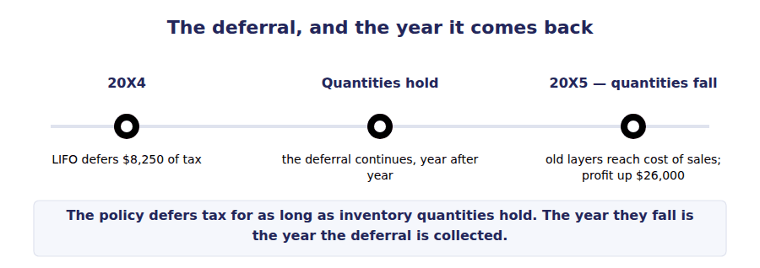
Exercise 3E Sort each statement into the column that says whether it is true.
OBJECTIVE | Say how a company reduces the risk of a liquidation, and what it must disclose when one happens.
YOU WILL NEED | Exercise 3D
HOW TO START | • Putting similar items into one inventory pool means a fall in one can be offset by a rise in another.  • A liquidation changes reported profit materially, so a reader has to be told.  • Two of these statements describe a liquidation as something it is not.

Statement about LIFO liquidations | TRUE | FALSE
1. Grouping similar items into one inventory pool reduces the risk of a liquidation
2. A liquidation means the company traded unusually well
3. The effect on income must be disclosed when it is material
4. A liquidation brings forward tax that LIFO had deferred
5. A liquidation happens whenever prices fall
6. A liquidation arises because inventory quantities fell

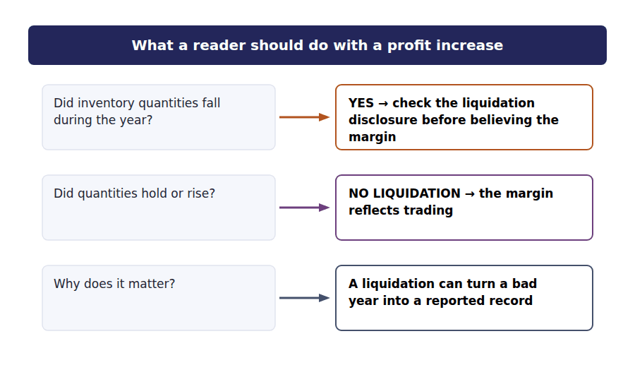
Watch out! A liquidation is measured in units, not dollars. Read the stem for whether quantities fell. If they did not, there is no liquidation however violently prices moved.
Part 4 · Exam pitch the questions as the CMA sets them
1. [Level B] A company reports LIFO inventory of $146,000 and discloses a LIFO reserve of $33,000. Inventory restated to a FIFO basis is:
(A) $113,000
(B) $179,000
(C) $33,000
(D) $146,000
2. [Level A] The LIFO reserve is best described as:
(A) A fund of cash set aside to replace inventory
(B) The difference between inventory measured under LIFO and under FIFO
(C) The tax saved by using LIFO
(D) A liability for future inventory purchases
3. [Level B] In a period of rising prices, a company using LIFO rather than FIFO will report:
(A) Higher net income and pay higher tax
(B) Lower net income and pay lower tax in the current year
(C) Lower net income and the same tax
(D) Higher inventory on the balance sheet
4. [Level B] The LIFO conformity rule requires that:
(A) LIFO be applied consistently from year to year
(B) A company using LIFO for tax purposes also use it in its financial statements
(C) All companies in an industry use the same cost flow assumption
(D) The LIFO reserve be disclosed
5. [Level B] A LIFO liquidation occurs when:
(A) Prices fall during the period
(B) Inventory quantities decline, so older low-cost layers enter cost of goods sold
(C) A company changes from LIFO to FIFO
(D) The LIFO reserve increases
6. [Level C] In 20X5 Northwind sells 4,000 units and purchases only 2,000. The 2,000 units drawn from old layers would have cost $56 each to replace but carried much older costs. The effect on reported pre-tax income is:
(A) A decrease of $26,000
(B) An increase of $26,000
(C) No effect, because the units were already in inventory
(D) An increase equal to the whole LIFO reserve
7. [Level C] Why does grouping similar inventory items into pools reduce the risk of a LIFO liquidation?
(A) Because pools are measured at current cost
(B) Because a decline in the quantity of one item can be offset by an increase in another within the same pool
(C) Because pooling is required by the conformity rule
(D) Because pools eliminate the LIFO reserve
ADAPTIVE TIP Any question that gives you a LIFO reserve is asking you to restate something. Write down which direction before you compute: add it to inventory, deduct it from cost of goods sold, add the after-tax movement to income.

Handout 4 · What Each Method Does to Income and to Assets
Three methods, three profits, one business. The method that reports the best result is the one that leaves the company with least cash.
Volume 4 · Inventory and Cost Flow · R2 throughout, closing at R3
LANGUAGE FOCUS
Register you are working in | R2 textbook English, rising to R3 for the final passage, which is the comparison an exam asks for.
Say it exactly like this | report a higher gross margin · overstate the current ratio · understate inventory · generate a holding gain · compare like with like · restate before comparing
Words that are not the same | reported profit / cash generated · holding gain / operating margin · balance sheet effect / income statement effect · rising prices / falling prices
Remember | A higher reported profit is not a better outcome. Under LIFO the company with the lower profit keeps more cash. The method does not change what the goods cost. It changes which year the cost is reported in.

What you will be able to do when this handout is finished
- Prepare the same income statement under all three methods.
- Say which method reports the highest profit when prices are rising, and which when they are falling.
- Explain what a holding gain is and why FIFO reports one.
- Say what each method does to the balance sheet and to ratios built on it.
- State the one comparison that is identical under all three methods.

Three income statements for one year of trading
Northwind sold 8,500 units of the NW-40 flow controller at $75 each, for sales of $637,500. That is a fact: the invoices exist.
The goods available for sale cost $552,000. That is a fact too: the suppliers were paid.
Everything between those two facts is a consequence of the method chosen, and the three methods produce gross margins of $264,500, $246,500 and $231,500.
This handout sets the three statements side by side and asks which of them tells a reader the most useful thing.

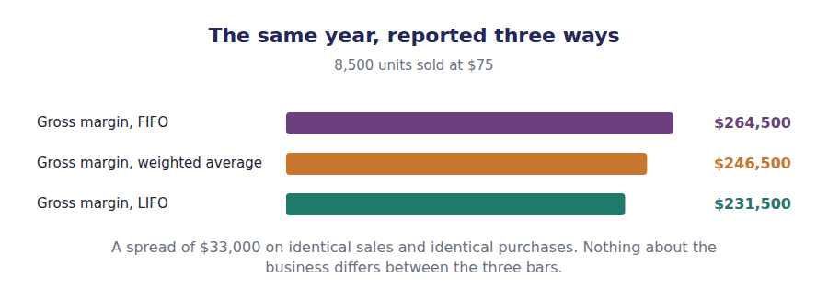
Part 1 · Three statements built from the figures you already have
Exercise 4A Complete the table. Each column uses the closing inventory figure you produced in Handout 2.
OBJECTIVE | Prepare the income statement under all three methods.
YOU WILL NEED | Handout 2, for the three closing inventory figures.
HOW TO START | • The first two rows are identical across all three columns. Fill them first.  • Closing inventory is the only input that differs. Everything below it follows.  • Work down one column at a time, not across the rows.

 | FIFO | Weighted average | LIFO
Sales, 8,500 units at $75 | $637,500 | $637,500 | $637,500
Goods available for sale | $552,000 | $552,000 | $552,000
Less closing inventory
Cost of goods sold
Gross margin
Income tax at 25%
Profit after tax

1 | 2 | 3 | 4 | 5 | 6
7 | 8 | 9 | 10 | 11 | 12
13 | 14 | 15

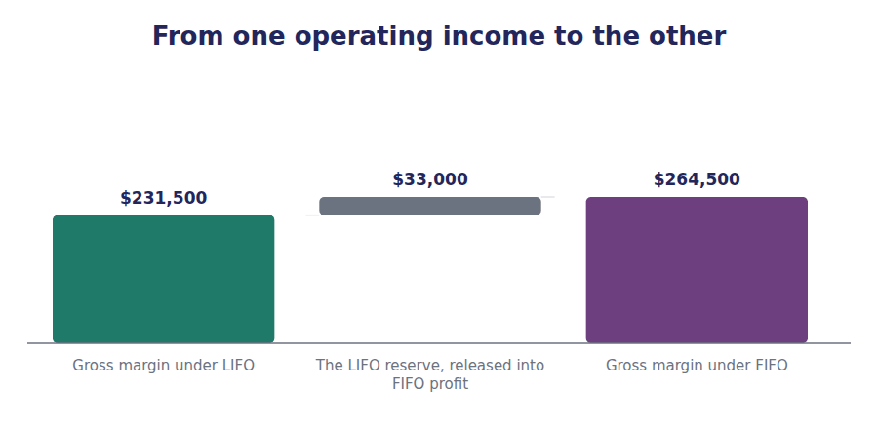
Part 2 · Which direction, and why rising prices, and falling ones
Exercise 4B Read and complete. Write one word in each space.
OBJECTIVE | State which method reports the highest profit, and say what happens when prices fall.
YOU WILL NEED | Exercise 4A
HOW TO START | • The direction depends entirely on which way prices moved. Say which way they moved here before you start.  • Blank 2 follows from which costs each method charges against revenue.  • The last blank is what happens to the whole comparison if prices fall instead.

WORD BANK
cheapest · dearest · highest · lowest · must · repeat · reverse
Not every word is used.

R2 Prices rose through 20X4, from $40 a unit to $52. FIFO charges the oldest and therefore the ¹ costs against revenue, so it reports the highest gross margin, $264,500.
LIFO charges the newest and dearest costs, so it reports the lowest, $231,500. The weighted average sits between them, as an average always ² .
On the balance sheet the ordering reverses. FIFO leaves the newest costs in inventory, so it reports the ³ closing inventory, and LIFO the lowest.
If prices had fallen, every one of those statements would ⁴ . Nothing about the methods would have changed; the direction of prices is what drives the comparison, and a question that does not tell you which way they moved has not given you enough to answer.
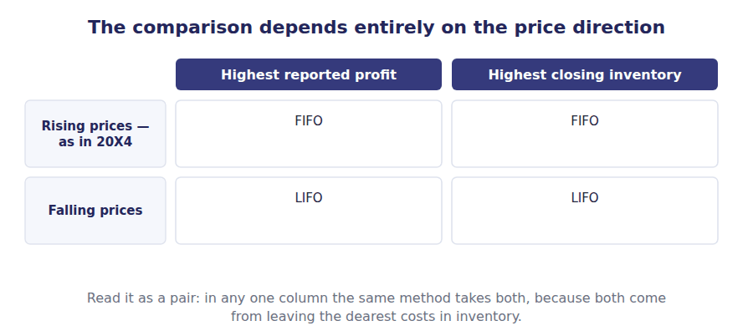
Part 3 · The holding gain what FIFO’s extra profit actually is
R2 FIFO reports $33,000 more gross margin than LIFO on identical trading. That extra amount did not come from selling better. It came from holding goods while the cost of buying them again rose.
R2 The question a reader should ask is whether the margin could be repeated. Northwind must replace the units it sold, and replacing them costs what the October batch cost, not what the opening batch cost. On that basis part of the FIFO margin is not available to be earned again.
R2 Analysts have a blunter name for the same amount. They call it a phantom profit, because a margin that depends on having bought before a price rise cannot be earned again once the cheaper goods are gone.
Exercise 4C Read and complete.
OBJECTIVE | Separate the holding gain from the trading margin.
YOU WILL NEED | Exercise 4B, and the two paragraphs above.
HOW TO START | • Blank 1 names the part of FIFO profit that comes from price movement rather than from trading.  • Blank 3 is the method that keeps that component out of gross margin by construction.  • The last blank is the other name for the same thing, used when the point is that the profit cannot be repeated.

WORD BANK
FIFO · holding · LIFO · operating · phantom · reduce · replace
Not every word is used.

R2 Part of the margin FIFO reports arises from having bought goods before prices rose and sold them afterwards. That component is a ⁵ gain, and it is reported inside gross margin where a reader cannot see it separately.
LIFO charges the most recent costs against revenue, which is as close as a cost flow assumption gets to charging what it would cost to ⁶ the goods sold. The holding component is therefore largely kept out of the margin.
That is the strongest argument made for ⁷ , and it is an argument about the income statement alone. The same construction leaves the balance sheet carrying costs that may be decades old.
When the point being made is that the margin cannot be earned again, the same amount is often called a ⁸ profit. The two names describe one thing from two directions.
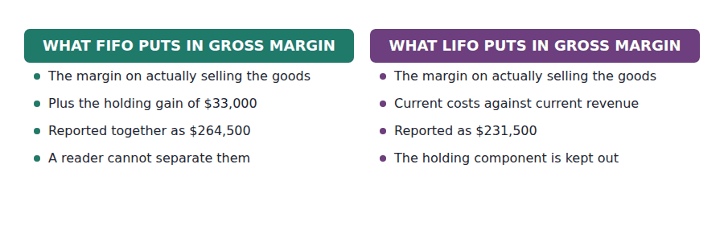
Part 4 · What it does to the balance sheet and to every ratio built on it
Exercise 4D Complete the table. The last column asks which method a reader would think looks better.
OBJECTIVE | Say what each method does to the balance sheet and to the ratios a reader computes from it.
YOU WILL NEED | Exercise 4C
HOW TO START | • Compute each percentage from the figures in Exercise 4A.  • Two rows favour FIFO and two favour LIFO. That split is the point of the exercise.  • The last row is about cash, and cash is the only one of the four that is not an accounting measure at all.

Measure | FIFO | LIFO | Which looks better
Gross margin percentage
Closing inventory
Cash paid in tax
Cash held at the year end

1 | 2 | 3 | 4 | 5 | 6
7 | 8 | 9 | 10 | 11 | 12

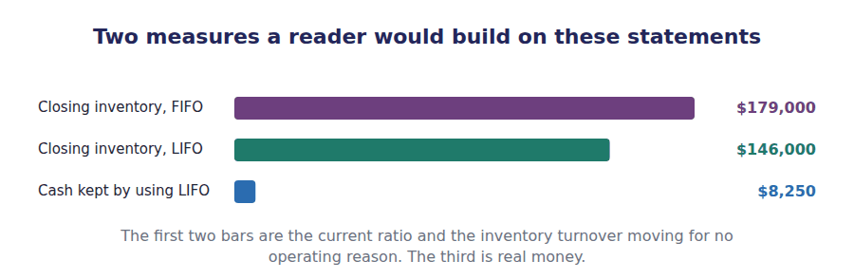
Exercise 4E Read and complete. This passage is written at exam pitch.
OBJECTIVE | State what is identical under all three methods, and what a reader must do before comparing two companies.
YOU WILL NEED | Exercises 4A to 4D
HOW TO START | • Blank 1 is the one figure in the whole comparison that no method changes.  • Blank 3 is what a reader does with a disclosed reserve before comparing.  • The last blank is the thing the method really decides, which is not the amount of anything.

WORD BANK
$33,000 · cash · identical · inventory · profit · reserve · timing
Not every word is used.

R3 Across all three columns of Exercise 4A, sales are $637,500 and goods available for sale cost $552,000. Over the whole life of the inventory the total profit is ⁹ under every method, because the same goods were bought at the same prices and sold for the same amount.
What differs is which year each part of that total is reported in. Nothing is created and nothing is destroyed, which is why the method is a question of ¹⁰ rather than of amount.
It follows that two companies using different methods cannot be compared as reported. A reader restates the LIFO company by adding its disclosed ¹¹ to inventory and the after-tax movement in it to income, and only then are the two on the same basis.
One thing the choice does decide in substance, and it is not an accounting figure at all: how much ¹² the company pays in tax this year. That is the only difference in the comparison that a business can actually spend.
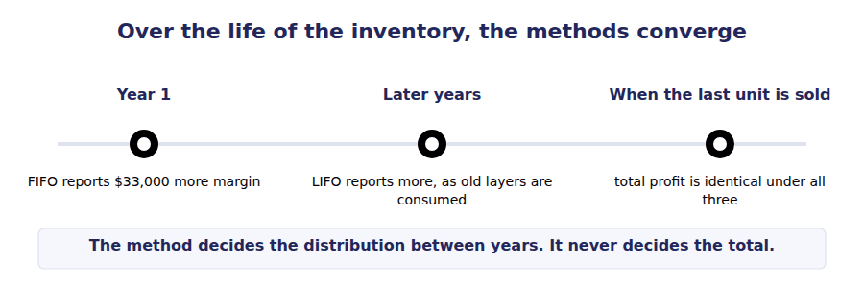
Watch out! If a question asks which method gives the higher profit and does not say which way prices moved, the answer is that it cannot be determined. That option is often present, and it is often right.
Part 5 · Exam pitch the questions as the CMA sets them
1. [Level A] In a period of rising prices, which method reports the highest gross margin?
(A) LIFO
(B) FIFO
(C) Weighted average
(D) All three report the same
2. [Level C] A company using FIFO reports a gross margin of $264,500. The same company using LIFO would report $231,500. The difference of $33,000 is best described as:
(A) An operating efficiency gain
(B) A holding gain, arising from the rise in buying prices rather than from trading
(C) An error in one of the two computations
(D) A tax saving
3. [Level C] Compared with FIFO, a company using LIFO in a period of rising prices will report:
(A) A higher current ratio and a lower inventory turnover
(B) A lower current ratio and a higher inventory turnover
(C) A higher current ratio and a higher inventory turnover
(D) The same current ratio and the same inventory turnover
4. [Level B] Over the entire period during which a given quantity of inventory is bought and sold, total profit under FIFO compared with LIFO is:
(A) Higher under FIFO
(B) Higher under LIFO
(C) The same under both
(D) Dependent on the tax rate
5. [Level C] A question states that a company uses LIFO and that its reported profit is higher than a FIFO competitor’s. The most likely explanation is that:
(A) LIFO always reports higher profit
(B) Prices have been falling, or the company has had a LIFO liquidation
(C) The competitor has made an error
(D) The two companies have different sales volumes
6. [Level B] Northwind pays $66,125 in tax under FIFO and $57,875 under LIFO. The difference of $8,250 represents:
(A) Tax permanently avoided by using LIFO
(B) Tax deferred to a later period, which will be paid when the old layers are sold
(C) An error, since the same transactions occurred
(D) A reduction in the LIFO reserve
7. [Level C] To compare a LIFO company with a FIFO company on the same basis, a reader should:
(A) Deduct the LIFO reserve from the LIFO company’s inventory
(B) Add the LIFO reserve to the LIFO company’s inventory and the after-tax movement in it to income
(C) Deduct the LIFO reserve from the FIFO company’s inventory
(D) Make no adjustment, since both are acceptable methods
ADAPTIVE TIP Before answering any comparison question, write two words at the top of your page: prices rising, or prices falling. Half the wrong answers in this topic are correct statements about the other direction.

Handout 5 · Lower of Cost or Market: LIFO and Retail
Inventory may never be carried above what it is worth. Under LIFO, deciding what it is worth takes three figures rather than one.
Volume 4 · Inventory and Cost Flow · R2 throughout
LANGUAGE FOCUS
Register you are working in | R2 textbook English. This rule is mechanical, so the sentences are short and the order of operations matters.
Say it exactly like this | write inventory down to market · apply the ceiling and the floor · determine designated market value · compare market with cost · recognise a loss on write-down · carry inventory at the lower of two figures
Words that are not the same | cost / market · ceiling / floor · replacement cost / selling price · write-down / write-up
Remember | Market does not mean selling price. It starts as replacement cost and is then bounded at both ends. The rule never writes inventory up. The word lower in its name is doing real work.

What you will be able to do when this handout is finished
- State why inventory may not be carried above its value, and which measurement principle that follows from.
- Compute the ceiling and the floor for an item.
- Determine designated market value and compare it with cost.
- Apply the rule to four items and say which one is unaffected.
- Record the write-down and say where the loss is reported.

The one rule that overrides every method
Handouts 2 to 4 settled how cost is measured. This handout and the next add a condition on top of all of them: inventory may never be carried at more than it is worth.
The principle is simple and the arithmetic is not. Which version of the rule applies depends on how the inventory was measured in the first place.
Inventory measured under LIFO or by the retail inventory method uses the older lower of cost or market rule, which this handout works. Everything else — FIFO, weighted average, specific identification — uses the simpler rule in Handout 6.
Northwind reviews four items at the year end, each costing $100, and they are deliberately chosen so that all four behave differently.

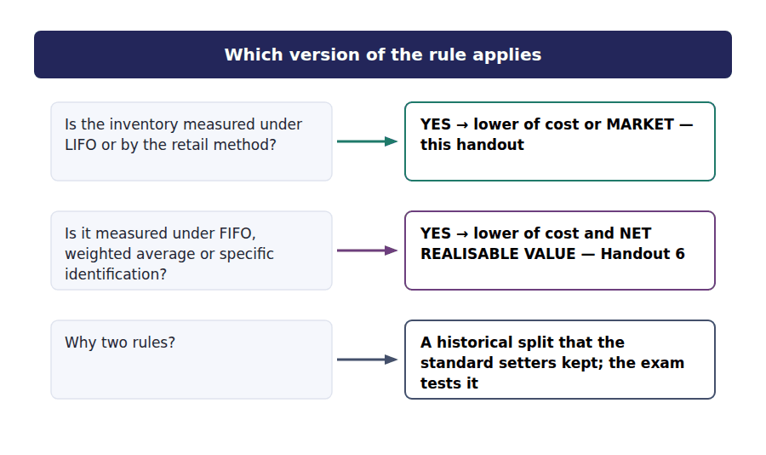
Part 1 · Why the rule exists at all and what it will not do
Exercise 5A Read and complete. Write one word in each space.
OBJECTIVE | State the principle behind the rule and the one thing it never does.
YOU WILL NEED | Handout 4, for how cost is measured under each method.
HOW TO START | • Blank 1 is what an asset must not be carried above.  • Blank 3 is the direction the rule refuses to move in.  • The last blank is where the loss is reported when a write-down is made.

WORD BANK
benefit · cost · down · higher · lower · sold · up
Not every word is used.

R2 An asset may not be carried at more than the ¹ the company expects to get from it. Inventory that has become obsolete, or damaged, or simply cheaper to buy than it was, is worth less than it cost, and continuing to carry it at cost would overstate the balance sheet.
The rule therefore compares cost with a measure of current value and carries the inventory at the ² of the two. The comparison is made at every reporting date, not only when something obvious has gone wrong.
What the rule never does is work in the other direction. Inventory is never written ³ above cost because its value has risen, however clear the evidence, because the gain has not been realised by selling anything.
When a write-down is made the loss is recognised immediately, normally within cost of goods ⁴ , and it reduces this year’s profit even though the goods have not been sold.
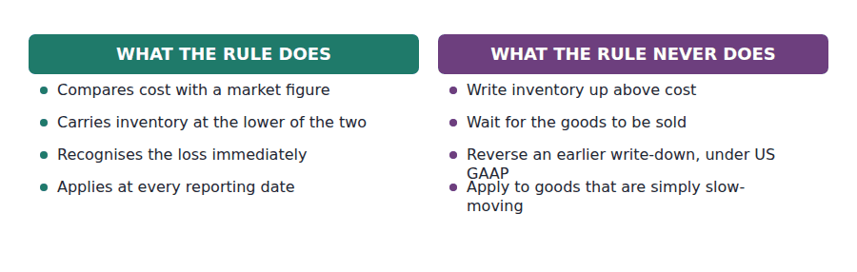
Part 2 · Three figures, and the middle one building designated market value
R2 Under this version of the rule, market is not a single observable number. It begins as replacement cost, and is then bounded above and below so that it cannot produce an absurd result in either direction.
R2 The upper bound is what the company could actually get for the item: the selling price less the costs of completing and selling it. The lower bound is that same figure less a normal profit margin, which stops a company writing an item down so far that selling it next year produces an unnaturally large profit.
Exercise 5B Read and complete.
OBJECTIVE | Compute the ceiling and the floor for one item.
YOU WILL NEED | Exercise 5A, and the two paragraphs above.
HOW TO START | • Work with item A: cost $100, replacement cost $90, selling price $105, cost to sell $10, normal profit margin 10% of selling price.  • The ceiling is a subtraction. Do it first.  • The floor is the ceiling less the normal profit, and the normal profit is computed on the selling price.

WORD BANK
$100 · $105 · $84.50 · $90 · $95 · loss · profit
Not every word is used.

R2 Item A has a selling price of $105 and will cost $10 to sell, so the company could realise ⁵ on it. That figure is the ceiling: market may not be set above it, because the company cannot get more than that.
A normal profit on a $105 sale is 10%, which is $10.50. The floor is therefore $95 less $10.50, which is ⁶ . Market may not be set below that, because carrying the item lower would hand next year an abnormally large ⁷ on a sale that was always going to be made.
Replacement cost is $90, and $90 lies between the floor and the ceiling. It is therefore not adjusted, and designated market value is ⁸ .
The final comparison is then made against cost. Cost is $100 and market is $90, so item A is carried at the lower of them, which is $90.
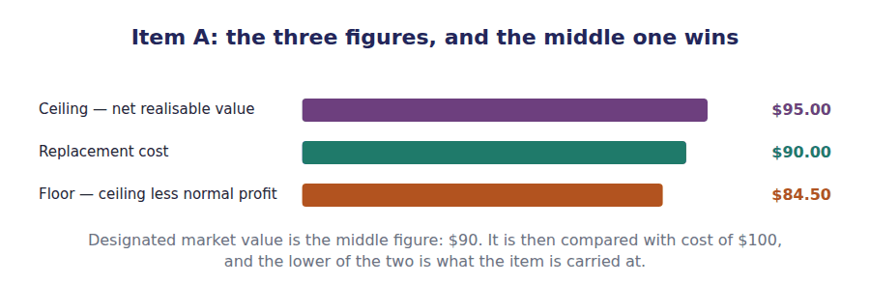
Part 3 · Four items, four outcomes the rule applied
Exercise 5C Complete the table. Compute the ceiling and floor first, then the market, then the carrying amount.
OBJECTIVE | Apply the rule to all four items and say which one is unaffected.
YOU WILL NEED | Exercise 5B
HOW TO START | • Each item costs $100, so the last column tells you immediately which ones were written down.  • Item B’s replacement cost falls below the floor. Item C’s rises above the ceiling. Those two are the point of the exercise.  • Item D needs no write-down at all, and you should be able to say why before you compute it.

Item | Cost | Replacement | Ceiling | Floor | Market | Carry at
A · standard housing | $100 | $90
B · obsolete sensor | $100 | $80
C · damaged batch | $100 | $98
D · scarce controller | $100 | $110

1 | 2 | 3 | 4 | 5 | 6
7 | 8 | 9 | 10 | 11 | 12
13 | 14 | 15 | 16

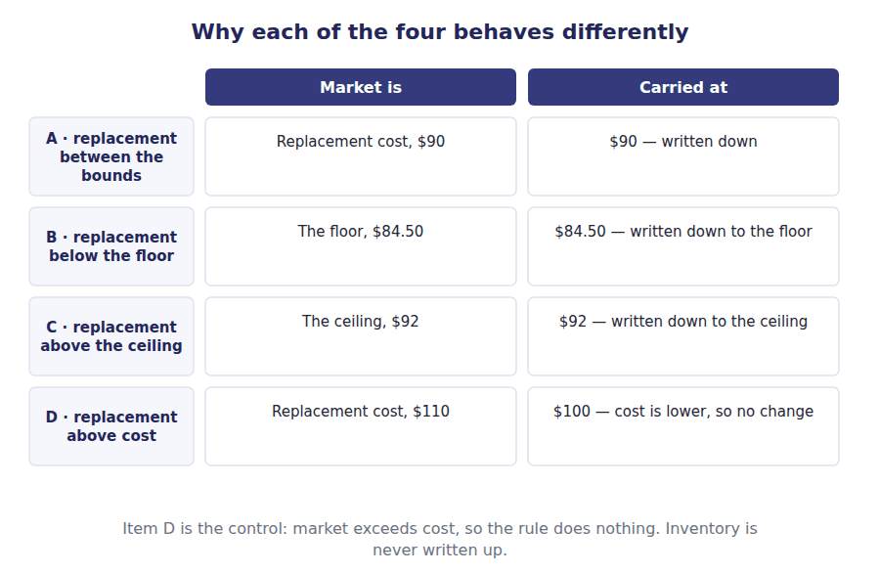
Part 4 · Recording it the entry, and where the loss goes
Exercise 5D Complete the journal entry, assuming 1,000 units of item B.
OBJECTIVE | Record the write-down and say where the loss is reported.
YOU WILL NEED | Exercise 5C
HOW TO START | • Item B is written down from $100 to $84.50, so the loss per unit is $15.50.  • With 1,000 units the total is $15,500.  • Two accounts move and one of them reduces the asset.

J1 1,000 units of item B written down from cost of $100 to a market value of $84.50. The loss is recognised now, although nothing has been sold.
Account | Debit | Credit
Cost of Goods Sold
Inventory

WORD BANK
fell · improves · inventory · obscures · rose · sold
Not every word is used.

R2 The loss may be presented in one of two places and the choice is a presentation decision rather than a measurement one. Where write-downs are a normal part of trading they are absorbed within cost of goods ⁹ , which is what the entry above does.
Where a write-down is unusually large, presenting it separately on the face of the income statement tells a reader more, because burying an exceptional amount inside a routine line ¹⁰ the margin on ordinary trading.
Either way the amount reaches this year’s profit. The timing is not optional: the loss belongs to the year in which the value ¹¹ , not to the year in which the goods are eventually sold.
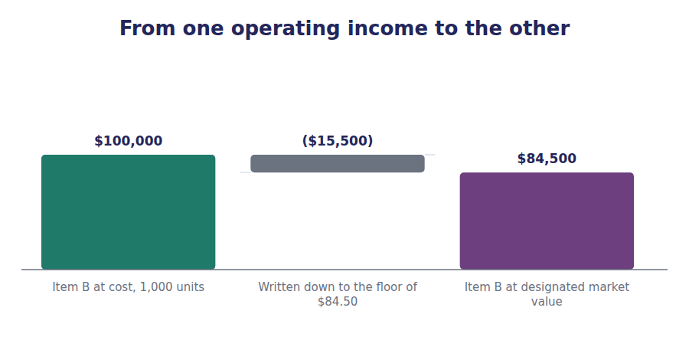
Exercise 5E Sort each statement into the column that says whether it is true under US GAAP.
OBJECTIVE | Say what happens if the value recovers, and how the rule may be applied.
YOU WILL NEED | Exercise 5D
HOW TO START | • Recovery is where US GAAP and IFRS part company, and Volume 12 covers the difference.  • The rule may be applied item by item, to groups, or to inventory as a whole, and the three give different answers.  • Applying it item by item always gives the largest write-down. Think about why before you sort.

Statement, under US GAAP | TRUE | FALSE
1. A write-down is reversed if the market value later recovers
2. The rule may be applied to each item individually
3. The rule may be applied to the total of a group of similar items
4. Applying the rule item by item produces the largest write-down
5. Inventory may be written up above cost once it has been written down
6. The written-down amount becomes the new cost for future comparisons

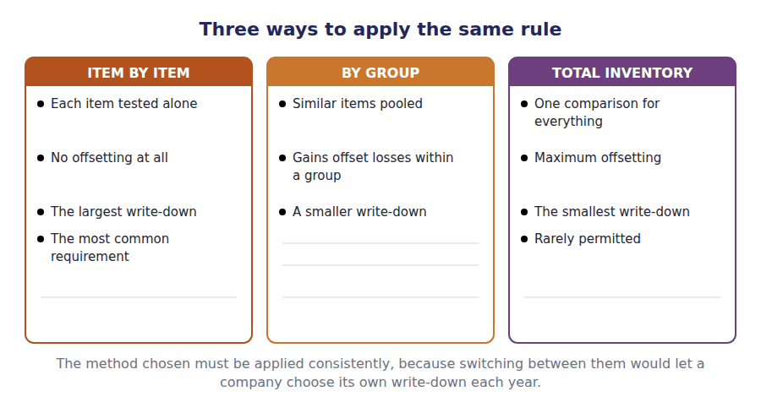
Watch out! Three figures, and you want the middle one. Compute the ceiling and the floor before you look at replacement cost, and the arithmetic stops being confusing.
Part 5 · Exam pitch the questions as the CMA sets them
1. [Level A] Under the lower of cost or market rule, the ceiling is:
(A) Replacement cost
(B) Net realisable value, being selling price less costs to complete and sell
(C) Net realisable value less a normal profit margin
(D) The original cost of the item
2. [Level C] An item costs $100. Replacement cost is $80, net realisable value is $95 and a normal profit margin is $10.50. The item should be carried at:
(A) $80
(B) $84.50
(C) $95
(D) $100
3. [Level B] An item costs $100, replacement cost is $110, net realisable value is $120 and the floor is $106.50. The item should be carried at:
(A) $100
(B) $106.50
(C) $110
(D) $120
4. [Level C] The purpose of the floor in the lower of cost or market rule is to:
(A) Prevent inventory being carried above its selling price
(B) Prevent a write-down so large that a normal profit is reported when the item is eventually sold
(C) Ensure inventory is never written below replacement cost
(D) Allow write-downs to be reversed in a later period
5. [Level A] The lower of cost or market rule applies to inventory measured using:
(A) FIFO or weighted average
(B) LIFO or the retail inventory method
(C) Specific identification only
(D) Any method
6. [Level C] Applying the lower of cost or market rule item by item rather than to groups of similar items will generally produce:
(A) A smaller write-down, because gains offset losses
(B) A larger write-down, because gains on some items cannot offset losses on others
(C) The same write-down either way
(D) No write-down at all
7. [Level B] Under US GAAP, if the market value of previously written-down inventory recovers before it is sold, the company should:
(A) Reverse the write-down up to the original cost
(B) Reverse the write-down in full, including any excess over cost
(C) Make no entry; the written-down amount is the new cost
(D) Disclose the recovery and reverse it when the goods are sold
ADAPTIVE TIP Write the three figures in a column — ceiling, replacement, floor — and circle the middle one. Then compare it with cost. Doing it in that order makes every one of these questions mechanical.

Handout 6 · Lower of Cost and Net Realisable Value: Everything Else
The same principle with the arithmetic taken out of it. One comparison instead of three, and most inventory in the world uses this version.
Volume 4 · Inventory and Cost Flow · R2 throughout, closing at R3
LANGUAGE FOCUS
Register you are working in | R2 textbook English, rising to R3 for the comparison of the two rules, which is how the exam frames the topic.
Say it exactly like this | measure at the lower of cost and net realisable value · estimate the costs of completion · deduct the costs necessary to make the sale · assess at each reporting date · group items for the comparison · record the write-down in cost of goods sold
Words that are not the same | net realisable value / market · costs to complete / costs to sell · LCM / LCNRV · US GAAP / IFRS
Remember | Net realisable value is not selling price. The costs of completing and selling the goods come out of it first. This rule has no ceiling and no floor. Those exist only in the version in Handout 5.

What you will be able to do when this handout is finished
- State which inventory uses this rule rather than the one in Handout 5.
- Compute net realisable value from a selling price and the costs of selling.
- Apply the rule to four items and compare the answers with Handout 5.
- Say why the simpler rule gives a different answer for some items and the same answer for others.
- State the treatment of a later recovery under US GAAP and under IFRS.

The same four items, the simpler rule
Handout 5 applied the lower of cost or market rule to four items, and reached three write-downs through a ceiling, a floor and a middle figure.
This handout applies the other version of the rule to the same four items. It is simpler by a long way: one comparison instead of three, and no bounds at all.
It is also the version that applies to most of the inventory in the world, because it covers everything measured under FIFO, weighted average or specific identification — which is to say, every company that does not use LIFO.
Two of the four items come out at a different figure under this rule. Finding out which two, and why, is the work of this handout.

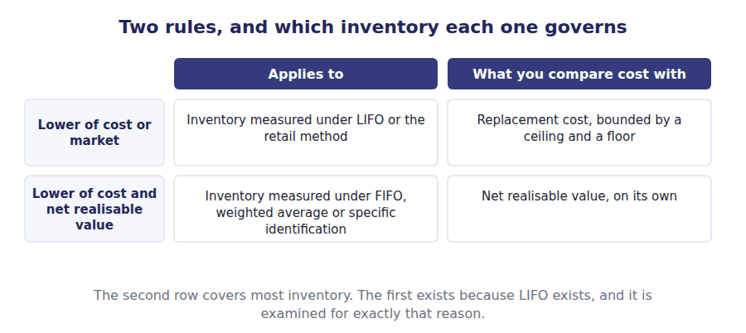
Part 1 · One comparison what net realisable value is
Exercise 6A Read and complete. Write one word in each space.
OBJECTIVE | State what net realisable value is and what is deducted in computing it.
YOU WILL NEED | Handout 5, for the ceiling, which is the same figure.
HOW TO START | • Blank 1 is the starting point, and it is an estimate rather than a quoted figure.  • Two kinds of cost are deducted. One applies to unfinished goods and one to all goods.  • The last blank is what this rule does not have, and Handout 5 did.

WORD BANK
ceiling · completion · floor · overhead · replacement · selling · storage
Not every word is used.

R2 Net realisable value starts from the estimated ¹ price in the ordinary course of business. Not a distress price, and not a price in a market the company does not actually sell in.
Two kinds of cost are then deducted. The costs of ² , where the goods are unfinished and work remains to be done on them, and the costs necessary to make the sale — commission, packing, delivery.
Only costs that would be avoided if the sale were not made are deducted. General administrative ³ is not, because the company would incur it whether or not this particular item sold.
The resulting figure is then compared with cost, and the lower of the two is the carrying amount. There is no ceiling and no ⁴ : the bounds that complicated Handout 5 have no part in this version at all.
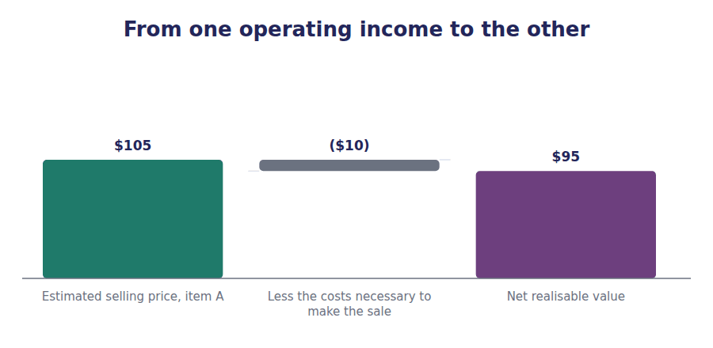
Part 2 · The same four items under the simpler rule
R2 The deduction has a name worth using, because the exam uses it. The amounts taken off the selling price are the costs to sell, and the test for one is whether the company would avoid it by not making the sale.
Exercise 6B Complete the last two columns. One subtraction, then one comparison.
OBJECTIVE | Apply the rule to all four items.
YOU WILL NEED | Exercise 6A
HOW TO START | • Net realisable value is the selling price less the cost to sell. There are no other adjustments.  • Then carry each item at the lower of cost and that figure.  • Every item costs $100, so the last column tells you at a glance which ones were written down.

Item | Cost | Selling price | Cost to sell | Net realisable value | Carry at
A · standard housing | $100 | $105 | $10
B · obsolete sensor | $100 | $105 | $10
C · damaged batch | $100 | $100 | $8
D · scarce controller | $100 | $135 | $15

1 | 2 | 3 | 4 | 5 | 6
7 | 8

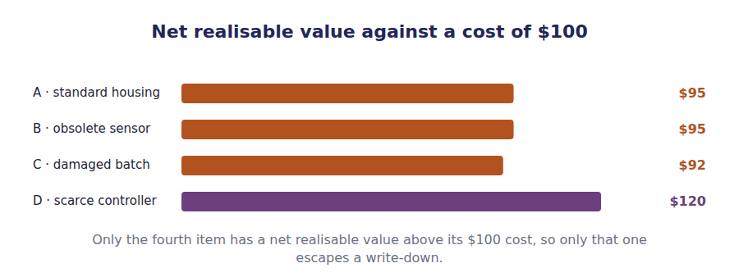
Part 3 · Where the two rules part company and where they agree
R2 Setting the two sets of answers side by side shows something worth noticing. The rules agree on some items and differ on others, and the pattern is not random.
R2 They agree whenever replacement cost happens to lie outside the ceiling, because in that case the market figure is driven to the ceiling, and the ceiling is net realisable value. They differ whenever replacement cost lies inside the bounds, because then the older rule uses a figure the newer one never looks at.
Exercise 6C Complete the table. The first two columns come from Handouts 5 and 6.
OBJECTIVE | Compare the two sets of answers and say where they agree.
YOU WILL NEED | Exercise 6B, and Handout 5 Exercise 5C.
HOW TO START | • Copy your two sets of answers in before you look for the pattern.  • Two items agree and two do not.  • Look at where replacement cost sat relative to the ceiling in each case. That is the whole explanation.

Item | Under LIFO or retail — LCM | Under FIFO or average — LCNRV | Do they agree?
A · standard housing
B · obsolete sensor
C · damaged batch
D · scarce controller

1 | 2 | 3 | 4 | 5 | 6
7 | 8 | 9 | 10 | 11 | 12

WORD BANK
cost · FIFO · LIFO · looks · market · price · value
Not every word is used.

R3 Items C and D give the same answer under both rules. Item C’s replacement cost was above the ceiling, so the market figure was driven down to the ceiling — and the ceiling is net realisable ⁵ , which is what the simpler rule uses directly.
Item D needed no write-down under either rule, because its net realisable value exceeded ⁶ . Where no write-down is required, the two rules cannot disagree.
Items A and B differ. In both, replacement cost sat inside the bounds or below the floor, so the older rule used a figure the simpler rule never ⁷ at, and the two carrying amounts diverge.
The practical consequence is worth stating plainly. Two companies holding identical goods in identical condition can carry them at different amounts purely because one of them uses ⁸ .
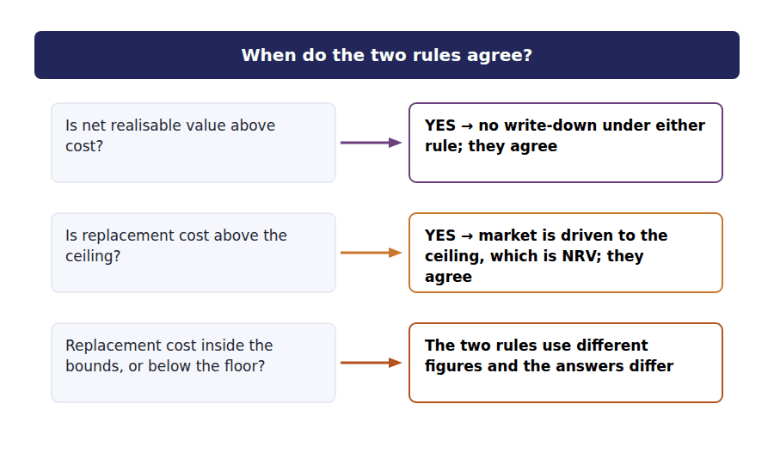
Part 4 · Recovery, and the IFRS difference the one place the two frameworks separate
Exercise 6D Match each statement to the framework it describes.
OBJECTIVE | State the treatment of a later recovery under US GAAP and under IFRS.
YOU WILL NEED | Exercise 6C
HOW TO START | • One framework treats the written-down amount as the new cost and never looks back. The other allows a reversal.  • The reversal is limited, and the limit is the original cost.  • One of these statements is true under both frameworks.

 | Item | Answer |  | Option
1 | A write-down is never reversed; the reduced amount becomes the new cost |  | A | US GAAP
2 | A write-down is reversed if net realisable value later recovers, limited to the original cost |  | B | IFRS
3 | Inventory may be carried above original cost if value rises sharply |  | C | Neither — no framework permits a write-up above cost
4 | The write-down is recognised in profit or loss when it occurs |  | D | Both — the timing of the loss is not in dispute
5 | The reversal is recognised as a reduction of cost of goods sold in the period of recovery |  | E | IFRS

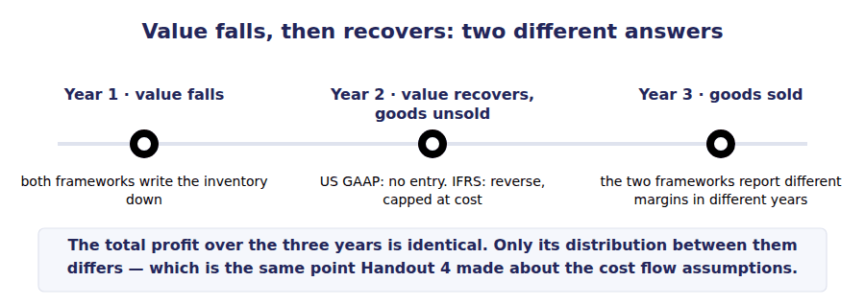
Exercise 6E Sort each situation into the column it belongs in.
OBJECTIVE | Decide whether each situation requires a write-down.
YOU WILL NEED | Exercises 6A to 6D
HOW TO START | • Ask one question: will the company end up with less than the goods cost?  • Slow-moving is not the same as unsaleable. One of these items will sell eventually at full price.  • The last one is about a cost that has risen, which is not what the rule is about at all.

Situation at the year end | WRITE DOWN | NO WRITE-DOWN
1. Controllers made obsolete by a new model; they will sell at half price
2. Goods damaged in the warehouse and saleable only as scrap
3. Slow-moving stock that will sell at full price within eighteen months
4. Goods whose selling price fell below cost after the year end but because of conditions existing at it
5. Goods the company would now pay more to buy than it originally did
6. Work in process whose costs to complete now exceed what it will fetch

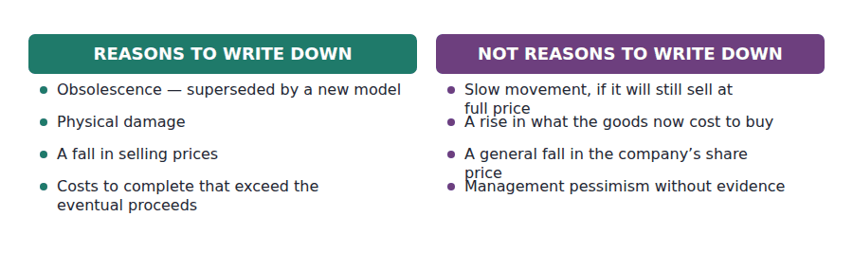
Watch out! Net realisable value is an estimate of what the company will end up with, so it is assessed at every reporting date and not only when something has visibly gone wrong. A question that describes obsolescence has already told you the answer.
Part 5 · Exam pitch the questions as the CMA sets them
1. [Level A] Inventory measured under FIFO is subsequently measured at:
(A) The lower of cost or market, using replacement cost bounded by a ceiling and a floor
(B) The lower of cost and net realisable value
(C) Replacement cost
(D) Net realisable value in all cases
2. [Level B] An item cost $100. It can be sold for $105, and selling it will cost $10 in commission and delivery. Under the lower of cost and net realisable value, the item is carried at:
(A) $100
(B) $95
(C) $105
(D) $90
3. [Level B] Which of the following is deducted in arriving at net realisable value?
(A) A share of general administrative overhead
(B) Sales commission payable on the sale
(C) The original purchase cost
(D) Interest on the funds tied up in inventory
4. [Level B] Under US GAAP, inventory written down to net realisable value subsequently recovers in value before being sold. The company should:
(A) Reverse the write-down, limited to the original cost
(B) Reverse the write-down in full
(C) Make no entry; the reduced amount is the new cost basis
(D) Recognise a gain in other comprehensive income
5. [Level C] A company holds slow-moving inventory that it expects to sell at full price within two years. At the year end it should:
(A) Write the inventory down to a nominal amount
(B) Write it down by half as a matter of prudence
(C) Make no write-down, since net realisable value exceeds cost
(D) Reclassify the inventory as a non-current asset
6. [Level C] For which item will the lower of cost or market rule and the lower of cost and net realisable value rule give the SAME answer?
(A) An item whose replacement cost lies between the floor and the ceiling
(B) An item whose replacement cost is below the floor
(C) An item whose replacement cost is above the ceiling
(D) An item whose replacement cost equals its original cost
7. [Level C] Work in process cost $80 to date, will cost a further $40 to complete, and the finished item will sell for $100 with $5 of selling costs. The inventory should be carried at:
(A) $80
(B) $95
(C) $55
(D) $120
ADAPTIVE TIP For finished goods, net realisable value is one subtraction. For work in process it is two, and the one students forget is the cost of finishing the goods. Read the stem for the word complete before you compute.

Handout 7 · Inventory Errors and How They Unwind
An inventory error is wrong twice: once this year and once, in the opposite direction, next year. After that it is gone.
Volume 4 · Inventory and Cost Flow · R2 throughout, closing at R3
LANGUAGE FOCUS
Register you are working in | R2 textbook English, rising to R3 for the final passage. The vocabulary here is directional: overstate, understate, reverse.
Say it exactly like this | overstate closing inventory · understate cost of goods sold · an error counterbalances in the following period · restate the comparative figures · the error washes out · affect working capital
Words that are not the same | overstated / understated · counterbalancing / non-counterbalancing · closing inventory / opening inventory · this year / next year
Remember | An error that counterbalances is not harmless. Two years of reported results were wrong, and decisions were taken on them. Self-correcting does not mean self-disclosing. The company still has to restate if the amounts are material.

What you will be able to do when this handout is finished
- Trace an inventory error through cost of goods sold to net income.
- Say what the same error does in the following year, and why.
- Explain what counterbalancing means and what it does not excuse.
- Build the full grid of four error directions.
- Identify the error that does not counterbalance at all.

One miscount, two wrong years
At 31 December 20X4 a warehouse team counts a pallet twice. Closing inventory is recorded $30,000 higher than it should be.
Nothing else is wrong. The purchases were recorded correctly, the sales were recorded correctly, and the goods that were actually there are correctly priced. One pallet was counted twice.
That single error moves four figures in 20X4 and four more in 20X5, in the opposite direction. By the end of 20X5 it has vanished entirely, and the company has still published two years of wrong numbers.
This handout traces it, and then builds the grid that handles any inventory error in either direction.

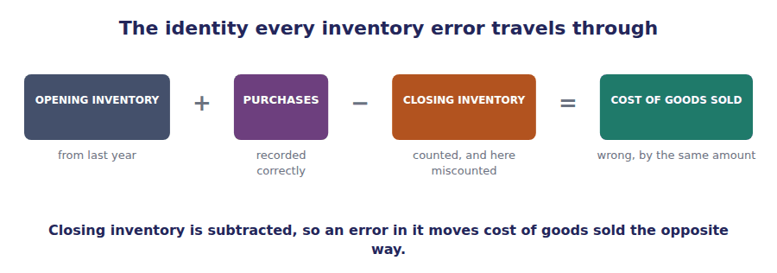
Part 1 · Year one what the error does immediately
Exercise 7A Read and complete. Write one word in each space.
OBJECTIVE | Trace the error through to net income in the year it is made.
YOU WILL NEED | Handout 2, for the relationship between the pool and the two outputs.
HOW TO START | • Start from the identity in the figure above and move one step at a time.  • Closing inventory is subtracted, so blank 2 is the opposite direction to blank 1.  • Then cost of goods sold is subtracted from sales, so blank 3 flips again.

WORD BANK
correct · income · overstated · purchases · unchanged · understated
Not every word is used. A word may be used more than once.

R2 Closing inventory at the end of 20X4 is ¹ by $30,000.
Closing inventory is deducted in arriving at cost of goods sold, so if it is too high then cost of goods sold is too low. Cost of goods sold is ² by the same $30,000.
Cost of goods sold is deducted in arriving at gross margin, so the flip happens again. Gross margin and net income are both ³ by $30,000.
On the balance sheet, inventory is a current asset, so working capital and the current ratio are overstated as well, and closing retained earnings is overstated by the amount of the ⁴ error.
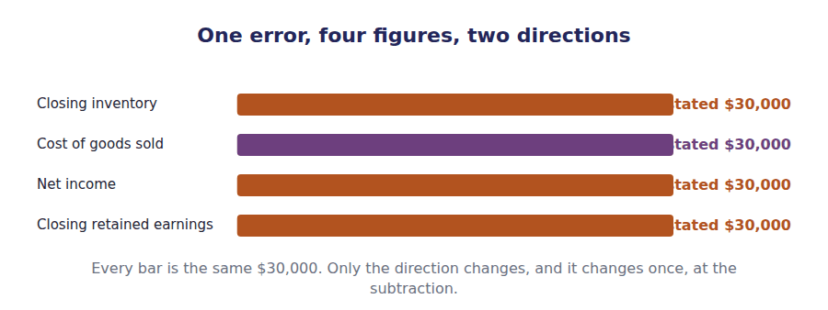
Part 2 · Year two the same error, running backwards
R2 The error is not repeated in 20X5. The warehouse counts correctly at the end of that year, so closing inventory for 20X5 is right.
R2 But the opening inventory of 20X5 is the closing inventory of 20X4, and that figure is still too high. Opening inventory is added in arriving at cost of goods sold, so this time the error pushes cost of goods sold up rather than down.
Exercise 7B Read and complete.
OBJECTIVE | Trace the same error through the following year.
YOU WILL NEED | Exercise 7A, and the two paragraphs above.
HOW TO START | • The figure carried into year two is the opening inventory, and it is added rather than subtracted.  • That one difference in sign is why every effect reverses.  • The last blank is what has happened to retained earnings by the end of year two.

WORD BANK
added · correct · overstated · right · subtracted · understated · wrong
Not every word is used.

R2 Opening inventory for 20X5 is overstated by $30,000, because it is last year’s closing figure carried forward.
Opening inventory is ⁵ in arriving at cost of goods sold, not subtracted, so this time the error raises cost of goods sold. Cost of goods sold is overstated by $30,000 and net income is ⁶ by the same amount.
Over the two years together, cost of goods sold is understated once and overstated once by the same figure, so the cumulative total is ⁷ . The same is true of net income.
And because retained earnings accumulates net income, the $30,000 overstatement at the end of 20X4 is exactly cancelled by the $30,000 understatement in 20X5. By 31 December 20X5 retained earnings is ⁸ .
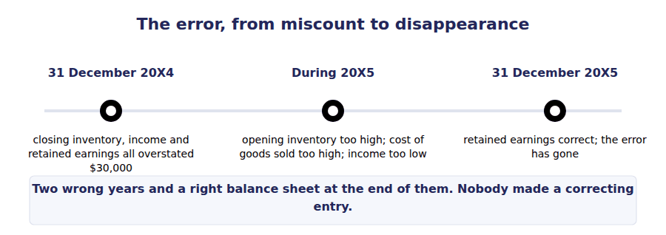
R2 An error that reverses itself like this is called a counterbalancing error, and most inventory errors are of that kind. The name describes the arithmetic and makes no promise about what the company has to do, which is the subject of Part 4.
Exercise 7C Complete the table. Write the direction and the amount in each cell.
OBJECTIVE | Set out the two years side by side and state the cumulative position.
YOU WILL NEED | Exercises 7A and 7B
HOW TO START | • Work down each column rather than across each row.  • Two rows have a dash in one of the year columns. Decide which before you start.  • The last column is the cumulative position, and most of it is one word.

Figure | Year 1 effect | Year 2 effect | Over the two years
Closing inventory, year 1
Opening inventory, year 2
Cost of goods sold
Net income
Closing retained earnings
Working capital

1 | 2 | 3 | 4 | 5 | 6
7 | 8 | 9 | 10 | 11 | 12
13 | 14 | 15 | 16 | 17 | 18

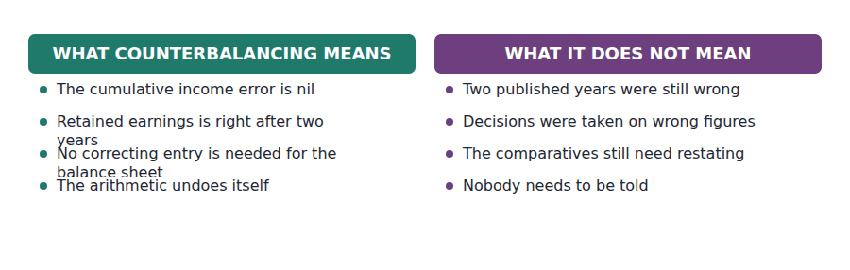
Part 3 · The grid any error, either direction
Exercise 7D Complete the table. Write overstated or understated in each cell.
OBJECTIVE | Build the grid for all four error directions.
YOU WILL NEED | Exercise 7C
HOW TO START | • The first row is the case you have just worked. Fill it from memory and use it to check the pattern.  • Rows two to four are each the reverse of one of the others. You should be able to derive them rather than reason them out again.  • The last row is different in kind. Think about what happens to the identity when purchases are recorded but the goods are not counted.

The error | Cost of goods sold | Net income | Closing retained earnings
Closing inventory overstated
Closing inventory understated
Opening inventory overstated
Opening inventory understated
Purchases recorded but goods excluded from the count

1 | 2 | 3 | 4 | 5 | 6
7 | 8 | 9 | 10 | 11 | 12
13 | 14 | 15

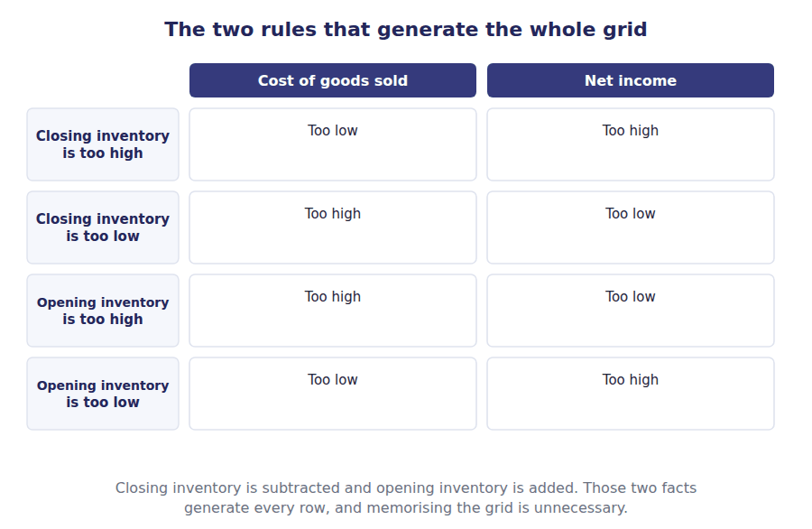
Part 4 · The error that does not unwind and what still has to be done
Exercise 7E Read and complete. This passage is written at exam pitch.
OBJECTIVE | Identify the error that does not counterbalance, and say what the company must still do.
YOU WILL NEED | Exercise 7D
HOW TO START | • Blank 1 is the condition under which an inventory error does not reverse in the following year.  • Blank 3 is what the company must do when the amounts are material, even though the arithmetic has already fixed itself.  • The last blank names the thing a reader has lost that no reversal restores.

WORD BANK
count · decisions · disclosures · ignore · pricing · restate · reverse
Not every word is used.

R3 An inventory error counterbalances because last year’s closing figure becomes this year’s opening figure. The one case in which that does not happen is where the error is in the ⁹ rather than in the count — a permanent misapplication of a cost flow assumption, say, which is repeated in every subsequent year and therefore never reverses.
The last row of the grid is a related case. Goods received and recorded as purchases but left out of the count overstate cost of goods sold, and because the goods are physically present they will be counted next year, so the error does ¹⁰ — but working capital was understated at a reporting date, and a covenant tested at that date was tested against the wrong figure.
Where the amounts are material the company must ¹¹ the comparative figures, even though retained earnings has already corrected itself, because a reader comparing the two years is still being shown wrong numbers.
And that is the point this handout ends on. Counterbalancing fixes the arithmetic. It does not give back the two years of ¹² that were taken on figures that were wrong.
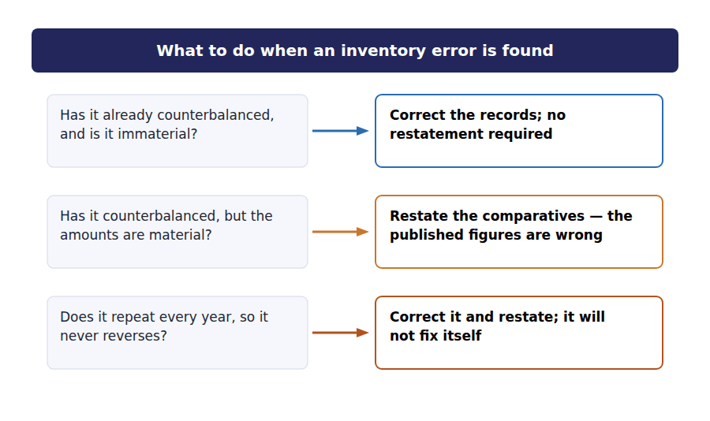
Watch out! Read the stem for which inventory figure is wrong — opening or closing — before anything else. Closing is subtracted and opening is added, and that single fact decides every direction in the question.
Part 5 · Exam pitch the questions as the CMA sets them
1. [Level B] Closing inventory at the end of year 1 is overstated by $30,000. The effect on year 1 net income is:
(A) Understated by $30,000
(B) Overstated by $30,000
(C) No effect
(D) Overstated by $60,000
2. [Level B] The same $30,000 overstatement of year 1 closing inventory affects year 2 net income how?
(A) Overstated by $30,000
(B) Understated by $30,000
(C) No effect
(D) Understated by $60,000
3. [Level B] After two years, the cumulative effect of a counterbalancing inventory error on retained earnings is:
(A) An overstatement equal to the error
(B) An understatement equal to the error
(C) Nil
(D) Twice the amount of the error
4. [Level C] Goods received before the year end are recorded as purchases but are omitted from the physical count. The effect on that year’s figures is:
(A) Cost of goods sold understated and net income overstated
(B) Cost of goods sold overstated and net income understated
(C) No effect on either, since purchases and inventory offset
(D) Inventory overstated and net income overstated
5. [Level C] Which of the following inventory errors does NOT counterbalance?
(A) A pallet counted twice at the year end
(B) Goods in transit omitted from the count
(C) A cost flow assumption applied incorrectly in every year
(D) Closing inventory priced at the wrong unit cost in one year only
6. [Level C] A material inventory error from two years ago has fully counterbalanced. The company should:
(A) Do nothing, since retained earnings is now correct
(B) Restate the comparative figures, because the published results for those years were wrong
(C) Record a correcting entry in the current year
(D) Disclose the error only if it recurs
7. [Level A] Closing inventory is understated by $20,000. Working capital at that date is:
(A) Overstated by $20,000
(B) Understated by $20,000
(C) Unaffected
(D) Understated by $40,000
ADAPTIVE TIP Draw the identity before you answer: opening plus purchases less closing equals cost of goods sold. Mark which figure the question says is wrong, follow the sign, and flip once more at net income. Three steps, and no memorisation.

Handout 8 · Choosing a Method, and Defending the Choice
Four methods, each better at something and worse at something else. The exam asks you to choose, and to say what you traded away.
Volume 4 · Inventory and Cost Flow · R2 throughout, closing at R3
LANGUAGE FOCUS
Register you are working in | R2 textbook English, rising to R3 for the final case, which is written the way a Case-Based Question frames it.
Say it exactly like this | recommend a method for a company · apply a method consistently · disclose the method used · justify a change in accounting principle · weigh the balance sheet against the income statement · satisfy a covenant
Words that are not the same | recommend / require · advantage / trade-off · consistency / comparability · change of method / error
Remember | There is no best method. Each one is better on one statement and worse on the other, and the question is which matters here. Consistency does not forbid a change. It requires that a change be justified and disclosed.

What you will be able to do when this handout is finished
- State the main advantage and the main disadvantage of each method.
- Recommend a method for a company given its circumstances.
- Say what the recommendation trades away.
- State what consistency requires and what it permits.
- Say what must be disclosed about the method chosen.

Seven handouts of mechanics, one of judgement
You can now measure inventory under four methods, apply either write-down rule to the result, and trace an error through two years of it.
What you have not yet been asked is which method a company should use. That question is Level C in the learning outcomes, it is where the Case-Based Questions live, and it has no single right answer.
What it does have is a right structure. Name what each method is good at, name what it costs, identify which of those matters to this company, and say so.
This handout builds that structure and then applies it to five companies.

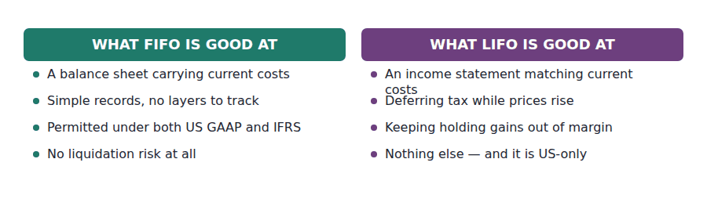
Part 1 · What each method is good at and what it costs
Exercise 8A Read and complete. Write one word in each space.
OBJECTIVE | State the main advantage and disadvantage of each method.
YOU WILL NEED | Handouts 2, 3 and 4, for how each method behaves.
HOW TO START | • Each method is better on one statement and worse on the other. Name the statement in each case.  • Blank 3 is the one thing LIFO cannot do, and it is geographical.  • The last blank is the practical advantage of the weighted average that has nothing to do with either statement.

WORD BANK
accuracy · balance · GAAP · IFRS · income · margin · simplicity
Not every word is used.

R2 FIFO leaves the newest costs in inventory, so its ¹ sheet figure is close to what the goods would cost today. Its weakness is on the other statement: in a rising market its margin includes a holding gain that cannot be repeated.
LIFO is the reverse. It charges the newest costs against revenue, so its ² statement matches current costs against current revenue, and its balance sheet is left carrying costs that may be decades old.
LIFO also carries two burdens FIFO does not. Layers have to be tracked for as long as they survive, and the method is not permitted under ³ at all, so a company reporting under those standards cannot choose it.
The weighted average sits between the two on both statements, which makes it nobody’s first choice on principle and a sensible one in practice. Its real advantage is ⁴ : one rate, no layers, and no liquidation to disclose.
 | FIFO | LIFO | Weighted average
Balance sheet | Current costs — the best of the three | Costs that may be decades old | Between the two
Income statement | Includes a holding gain in a rising market | Current costs against current revenue — the best of the three | Between the two
Tax, when prices rise | Highest tax paid now | Lowest tax paid now | Between the two
Available under IFRS | Yes | No | Yes
Risk of a distorting event | Low | A liquidation can inflate profit | Low
Record-keeping | Straightforward | Layers must be tracked for years | Simplest of the three

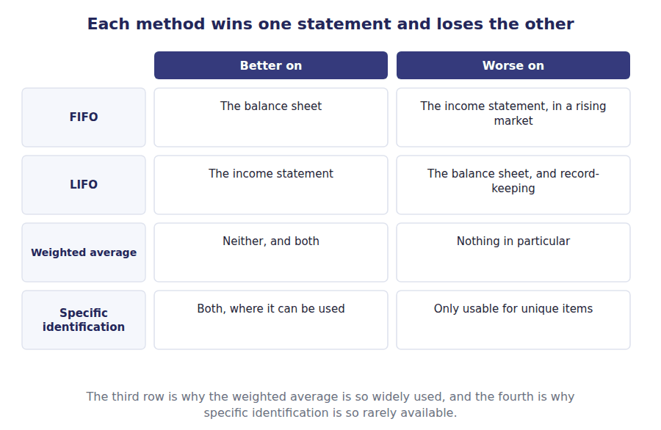
Part 2 · Recommending a method five companies, five answers
R2 A recommendation is only as good as the reason attached to it. An examiner marking a Case-Based Question is looking for the fact in the scenario that decides the answer, not for the name of a method.
R2 Two kinds of fact decide these questions. Some remove options altogether: a company reporting under IFRS cannot use LIFO, and a company whose units are not interchangeable must use specific identification. Others weigh one statement against the other, and those are the ones to argue.
Exercise 8B Complete the table. One method and one reason in each row.
OBJECTIVE | Recommend a method for five companies, and give the deciding reason.
YOU WILL NEED | Exercise 8A, and the two paragraphs above.
HOW TO START | • Look first for a fact that removes an option. Two of these five are decided that way and need no argument at all.  • The fuel depot is about physical indistinguishability, not about prices.  • The last row is about which statement the company actually cares about, and it is not the income statement.

The company | Recommend | The reason that decides it
A US distributor with steadily rising costs and a strong preference for cash
A company that reports under IFRS
A fuel depot holding one grade of oil in a single tank
A dealer in numbered industrial machines
A company with a bank covenant on its current ratio

1 | 2 | 3 | 4 | 5 | 6
7 | 8 | 9 | 10

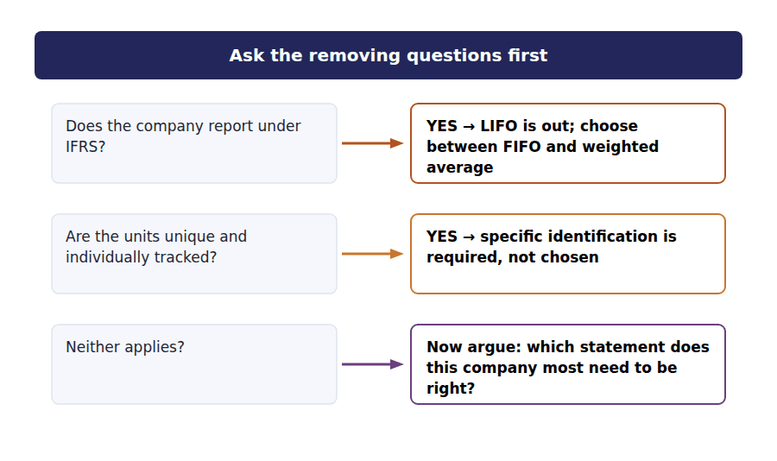
Part 3 · Defending the choice the part that earns the marks
Exercise 8C Read and complete.
OBJECTIVE | Say what a recommendation has to include besides the name of a method.
YOU WILL NEED | Exercise 8B
HOW TO START | • Blank 1 is what a recommendation is worthless without.  • Blank 3 is the thing a good answer names even though the company accepted it.  • The last blank is what a reader needs in order to compare this company with another.

WORD BANK
compared · costs · gains · method · price · reason · statement
Not every word is used.

R2 A method named without a ⁵ earns nothing. The reason has to point at a fact in the scenario — the reporting framework, the direction of prices, the nature of the units, a covenant — and show why that fact decides the answer.
A good answer then names what the choice ⁶ . Recommending LIFO to a US distributor for the tax deferral is right, and it is better if you add that the company accepts a lower reported margin and an inventory figure that will drift further from current costs every year.
Where the company is choosing between methods rather than being forced into one, the answer should also say which ⁷ the company most needs to be right, because that is the trade being made.
Finally, whichever method is chosen, the company must disclose it. Without that disclosure a reader cannot restate the figures, and without restatement two companies cannot be ⁸ .
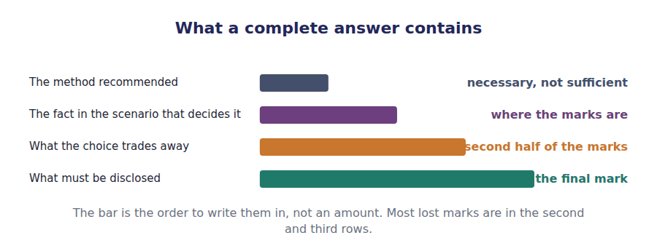
Part 4 · Changing the method consistency, and what it actually requires
R2 Moving from one acceptable method to another is a change in accounting principle, and the standards do not forbid it. What they require is preferability: the company must be able to show that the new method is better, not merely that it produces a number the company prefers.
Exercise 8D Sort each statement into the column that says whether it is true.
OBJECTIVE | State what consistency requires, and what it permits.
YOU WILL NEED | Exercise 8C
HOW TO START | • Consistency is often misread as a prohibition. Two of these statements misread it in exactly that way.  • A change of method is applied to prior years as well, so that the comparison survives.  • The requirement that a new method be better rather than merely different has a name.

Statement about changing an inventory method | TRUE | FALSE
1. A company may never change its inventory method
2. A change must be justified as preferable, not merely different
3. A change is applied retrospectively, with prior periods restated
4. A change may be made whenever the new method gives a better result this year
5. The effect of the change must be disclosed
6. A change of method is treated in the same way as the correction of an error

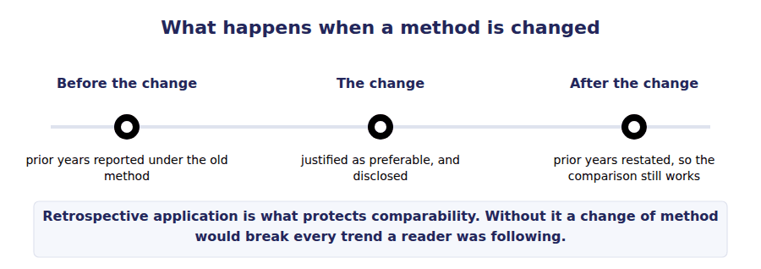
Part 5 · One case, written out the way a Case-Based Question frames it
Exercise 8E Read and complete. This passage is written at exam pitch.
OBJECTIVE | Work a full recommendation for one company, including the trade-off.
YOU WILL NEED | Exercises 8A to 8D
HOW TO START | • Read the scenario for the facts that remove options before you weigh anything.  • Blank 2 is the covenant measure that LIFO would damage.  • The last blank is what the company gives up by choosing as it does.

WORD BANK
covenant · current · free · margin · obvious · quick · tax
Not every word is used.

R3 A US distributor faces steadily rising purchase costs. Its bank requires a current ratio above 1.5, tested at each year end, and the margin above that threshold is thin. Management would prefer to pay less tax.
LIFO would defer tax, which is what management wants. It would also report the lowest closing inventory of the three methods, and inventory sits in the numerator of the ⁹ ratio, so the method that saves the tax is the method most likely to breach the covenant.
The recommendation is therefore FIFO or weighted average, and the fact that decides it is the ¹⁰ rather than the direction of prices. A breach would make the loan repayable on demand, which is a larger problem than a year of higher ¹¹ .
What the company gives up is the deferral: on inventory of this size, real cash, every year that prices continue to rise. A complete answer names that cost rather than pretending the recommendation is ¹² .
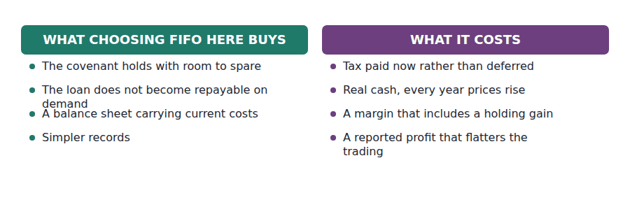
Watch out! A Case-Based Question rarely has one defensible answer. It almost always has one defensible structure: the deciding fact, the recommendation, the trade-off. Write all three even when you are unsure of the second.
Part 6 · Exam pitch the questions as the CMA sets them
1. [Level A] A company reporting under IFRS asks which cost flow assumption it should adopt. Which is NOT available to it?
(A) FIFO
(B) Weighted average
(C) LIFO
(D) Specific identification
2. [Level C] A fuel depot stores a single grade of oil in one tank, so that individual deliveries cannot be distinguished. The most appropriate method is:
(A) FIFO, because the oldest oil is drawn off first
(B) Weighted average, because the units are physically indistinguishable
(C) Specific identification, because the deliveries are documented
(D) LIFO, because the newest oil is at the top of the tank
3. [Level B] The main advantage claimed for LIFO is that it:
(A) Reports inventory on the balance sheet at current cost
(B) Matches current costs against current revenue on the income statement
(C) Is the simplest method to apply
(D) Is permitted in all jurisdictions
4. [Level C] A company subject to a current ratio covenant is choosing an inventory method in a period of rising prices. LIFO would:
(A) Improve the current ratio, by lowering cost of goods sold
(B) Weaken the current ratio, by reporting the lowest inventory figure
(C) Leave the current ratio unaffected
(D) Improve the current ratio, by deferring tax
5. [Level B] A company wishes to change from LIFO to FIFO. Which statement is correct?
(A) A change of method is never permitted
(B) The change must be justified as preferable and applied retrospectively, with prior periods restated
(C) The change is applied to the current year only
(D) The change is treated as the correction of an error
6. [Level C] Which of the following is the strongest argument AGAINST a US company adopting LIFO?
(A) It would reduce the tax paid this year
(B) It leaves the balance sheet carrying costs that may be many years out of date, and exposes reported profit to liquidation effects
(C) It is prohibited under US GAAP
(D) It cannot be applied consistently
7. [Level C] A complete recommendation of an inventory method in a Case-Based Question should include:
(A) The name of the method only
(B) The method, the fact in the scenario that decides it, and what the choice trades away
(C) A calculation of inventory under all four methods
(D) A statement that no method is better than any other
ADAPTIVE TIP In any scenario, scan first for a fact that removes an option — a reporting framework, a covenant, units that are not interchangeable. Only argue about the statements once no fact has already decided it for you.

Answer Key
Volume 4 · Handouts 1 to 8
Every answer carries the reason for it and the mistake it defeats.

Handout 1 · What Belongs in Inventory, and at What Cost answers
Completed text and exercises
# | Answer | Why | The trap it defeats
1 | FOB | The term names the point where title passes.
2 | supplier | Still the seller’s until it arrives.
3 | consignor | Possession moved; ownership did not. | Students exclude consigned goods because they are not in the warehouse, which understates inventory and overstates cost of sales.
4 | title | Title, not location.
Grid 1 | 1 IN NORTHWIND’S INVENTORY 2 IN NORTHWIND’S INVENTORY 3 NOT IN IT 4 IN NORTHWIND’S INVENTORY 5 IN NORTHWIND’S INVENTORY 6 NOT IN IT | The fifth item surprises people: goods already on the truck are still Northwind’s until they arrive, because title has not passed.
5 | inventory | All three were needed to get the goods here.
6 | selling | Freight-out is a selling expense. | Students put freight-out into inventory because it is freight. The direction is what matters, not the word.
7 | reduces | What the goods actually cost.
8 | $211,000 | 200,000 + 6,000 + 9,000 − 4,000.
9 | $552,000 | The four layers added together.
10 | 3,500 | 12,000 available less 8,500 sold.
11 | prices | Four batches, four prices, one choice. | Students think the method changes what the goods cost. It changes only which cost is attached to which unit.

Exam-pitch questions
# | Answer | Why | The trap it defeats
1 | (B) The buyer, because title passed when the goods left the seller | FOB shipping point passes title at despatch, so the buyer owns goods in transit and must include them. (A) and (C) both treat arrival as the trigger, which is what FOB destination would mean. | Level B
2 | (B) The consignor, because it still owns the goods | Consignment separates possession from ownership, and inventory follows ownership. (A) is the most frequently chosen wrong answer because the goods are physically with the distributor. | Level B
3 | (C) Freight paid to deliver goods to a customer | Freight-out is a selling expense: the goods were already in their present location and condition. The other three were all necessary to get them there. The word freight appears in two options and points in opposite directions. | Level A
4 | (B) $211,000 | $200,000 + $6,000 + $9,000 − $4,000 = $211,000. (C) ignores the discount, (D) adds it, and (A) ignores every cost of acquisition — each wrong answer drops or reverses one element. | Level B
5 | (B) Charged to the period as incurred | The goods were already in their present location and condition, so storing them adds nothing to their cost. Storage that is necessary before a further production stage is a different case and would be included — which is why the question says finished goods. | Level C
6 | (A) 3,500 | 12,000 − 8,500 = 3,500 units. This figure is a count, and no accounting choice changes it — only the cost attached to it. | Level A
7 | (B) The seller, because title has not yet passed | FOB destination passes title on arrival, so the seller still owns the goods and still reports them. (A) is the trap: an invoice may have been raised, but the shipping term governs — and the revenue has not been earned either. | Level C

Exercise 1C · the completed table
Cost incurred | In inventory? | Why
Invoice price of the goods | Yes | The basic cost of acquiring them
Freight paid to bring the goods to the warehouse | Yes | Needed to bring them to their present location
Import duty on the shipment | Yes | Unavoidable to get the goods here
Freight paid to deliver goods to a customer | No | The goods were already here; a cost of selling
Storage of finished goods awaiting sale | No | They were already in a saleable condition
The purchasing manager’s salary | No | A general operating cost, not traceable to the goods

- 12,000 units of the NW-40 flow controller were available for sale during 20X4, at a cost of $552,000.
- 8,500 units were sold and 3,500 units remain.
- How the $552,000 splits between those two counts is the subject of Handout 2, and it is a choice rather than a fact.

Handout 2 · FIFO, LIFO and Weighted Average answers
Completed text and exercises
# | Answer | Why | The trap it defeats
1 | available | Opening plus purchases.
2 | inventory | The two outputs exhaust the pool.
3 | lower | They move in opposite directions, dollar for dollar. | Students treat the two figures as independent. They are two halves of one fixed total.
4 | cost | The pool does not move.
5 | $46 | $552,000 ÷ 12,000 units.
6 | $161,000 | 3,500 units at $46.
7 | $391,000 | $552,000 less closing inventory.
8 | averages | Always between FIFO and LIFO. | Students average the four prices without weighting, which ignores how many units were bought at each.
9 | costs | Costs, not goods. | Students object that LIFO is unrealistic because old stock would spoil. The physical flow is not what is being described.
10 | inconsistent | The two questions are independent.
11 | specific | Required where units are not interchangeable.
12 | costs | Costs, not goods. | Students object that LIFO is unrealistic because old stock would spoil. The physical flow is not what is being described.

Exam-pitch questions
# | Answer | Why | The trap it defeats
1 | (A) $373,000 | The pool splits in two: $552,000 − $179,000 = $373,000. Every method satisfies this identity, which is why computing one output always gives the other. | Level A
2 | (B) Higher closing inventory and lower cost of goods sold | FIFO leaves the newest and dearest costs in inventory, so closing inventory is higher; and because the pool is fixed, cost of goods sold must be lower by the same amount. (A) and (C) both move the two figures in the same direction, which the identity forbids. | Level B
3 | (B) $46 | $552,000 ÷ 12,000 units = $46. (A) averages the four prices without weighting them by quantity, which is the single most common error in this calculation. | Level B
4 | (B) The earliest costs in the pool | LIFO charges the newest costs to cost of goods sold, so the oldest costs are what remain. (D) confuses the cost flow assumption with the physical units, which is exactly the distinction Part 5 draws. | Level A
5 | (B) The assumption concerns which costs attach to units sold, not which units moved | The assumption is about costs. (A) and (D) both claim a link to physical flow that does not exist. (C) overstates specific identification, which is required where units are not interchangeable and is impractical otherwise. | Level C
6 | (B) Must always hold, because an average cannot fall outside the range of the costs averaged | The weighted average always lies between FIFO and LIFO, because it is an average of the same costs. (C) has it backwards: prices here are rising, and falling prices would swap FIFO and LIFO while leaving the average in the middle. | Level C
7 | (B) FIFO | Under FIFO the oldest costs leave first whether you compute during the year or at the end of it, so the timing of the computation cannot change the answer. Under LIFO and under a moving average it can, which is why the exam names the system in those questions. | Level C

Exercises 2B, 2C and 2D · the three answers
Method | Closing inventory | Cost of goods sold | Together they equal
FIFO | $179,000 | $373,000 | $552,000
LIFO | $146,000 | $406,000 | $552,000
Weighted average | $161,000 | $391,000 | $552,000

How each figure was built
Method | Closing inventory is made of | Amount
FIFO | 3,000 October units at $52, plus 500 June units at $46 | $179,000
LIFO | 2,000 opening units at $40, plus 1,500 February units at $44 | $146,000
Weighted average | 3,500 units at the average of $46 | $161,000

Handout 3 · The LIFO Reserve and the LIFO Liquidation answers
Completed text and exercises
# | Answer | Why | The trap it defeats
1 | $33,000 | $179,000 − $146,000.
2 | itself | Decades of price rises accumulate in it.
3 | FIFO | Add the reserve to get back to FIFO. | Students subtract the reserve, which moves the comparison in the wrong direction.
4 | comparability | The reason the disclosure is required.
5 | $8,250 | The reserve at the tax rate.
6 | conformity | LIFO for tax means LIFO for reporting. | Students assume a company can have both. The conformity rule is precisely what stops it.
7 | profit | Reported margin is what is being traded away.
8 | higher | Old cheap costs reach cost of sales.
9 | liquidation | Quantities fell and the layers came out.
10 | afford | The worst possible timing, structurally. | Students read a liquidation as good news because profit rose. It is usually the opposite.
Grid 1 | 1 TRUE 2 FALSE 3 TRUE 4 TRUE 5 FALSE 6 TRUE | A liquidation is about quantities, not prices. Prices decide the size of the effect; quantities decide whether there is one at all.

Exam-pitch questions
# | Answer | Why | The trap it defeats
1 | (B) $179,000 | The reserve is added back: $146,000 + $33,000 = $179,000. (A) subtracts it, which moves the comparison the wrong way and is the most common error in this calculation. | Level B
2 | (B) The difference between inventory measured under LIFO and under FIFO | It is the gap between two measurements of the same goods. (A) is the usual misconception — no money is involved. (C) is the reserve multiplied by the tax rate, a different figure. (D) invents an obligation. | Level A
3 | (B) Lower net income and pay lower tax in the current year | LIFO charges the newest and dearest costs against revenue, so profit and the current tax charge both fall. (D) is backwards: LIFO leaves the oldest and cheapest costs in inventory. | Level B
4 | (B) A company using LIFO for tax purposes also use it in its financial statements | Conformity ties the tax election to the reporting treatment, which is why a company cannot take the tax benefit and still report a FIFO profit. (A) describes applying a method the same way each year, and (D) a disclosure requirement — both real rules, neither of them this one. | Level B
5 | (B) Inventory quantities decline, so older low-cost layers enter cost of goods sold | Quantities decide whether a liquidation happens; prices only decide how large its effect is. (A) is the most commonly chosen wrong answer. (C) is a change of method, which Handout 8 deals with. | Level B
6 | (B) An increase of $26,000 | Old cheap costs reach cost of goods sold instead of current ones, so cost of sales falls and profit rises by $26,000. (C) misses the point entirely: it is precisely because the units were old that the effect arises. | Level C
7 | (B) Because a decline in the quantity of one item can be offset by an increase in another within the same pool | A liquidation is triggered by a fall in the quantity of the pool, so offsetting movements inside it prevent one. (D) is wrong in the other direction — pooling preserves the reserve by preventing the layers from being consumed. | Level C

Exercise 3B · restated to a FIFO basis
As reported, LIFO | Adjustment | Restated to FIFO
Closing inventory $146,000 | Add the reserve of $33,000 | $179,000
Cost of goods sold $406,000 | Deduct the reserve of $33,000 | $373,000
Gross margin $231,500 | Add the reserve of $33,000 | $264,500
Income tax at 25% | Add $8,250 | $66,125

Exercise 3D · the completed liquidation schedule
20X5 · LIFO cost of goods sold | Units | Cost per unit | Total
This year’s purchase, newest cost first | 2,000 | $56 | $112,000
Then into an old layer at $44 | 1,500 | $44 | $66,000
Then into an old layer at $40 | 500 | $40 | $20,000
Cost of goods sold | 4,000 |  | $198,000

- The LIFO reserve at 31 December 20X4 is $33,000.
- It represents $8,250 of tax deferred at a 25% rate.
- The 20X5 liquidation of 2,000 units raises reported pre-tax income by $26,000 and collects part of that deferral.

Handout 4 · What Each Method Does to Income and to Assets answers
Completed text and exercises
# | Answer | Why | The trap it defeats
1 | cheapest | Oldest costs charged out under FIFO.
2 | must | An average lies between the extremes.
3 | highest | Income and balance sheet run in opposite directions. | Students memorise "FIFO higher" without the condition. In falling prices FIFO reports the lower profit.
4 | reverse | The direction of prices drives everything.
5 | holding | Profit from holding, not from trading.
6 | replace | Current costs against current revenue.
7 | LIFO | An argument about the income statement only. | Students treat LIFO as better overall. It improves one statement by damaging the other.
8 | phantom | Not repeatable, because buying again costs more.
9 | identical | Same goods, same prices, same sales.
10 | timing | Which year, not how much.
11 | reserve | Restate before comparing.
12 | cash | The only real difference. | Students rank the methods by reported profit. The company reporting least keeps most cash.

Exam-pitch questions
# | Answer | Why | The trap it defeats
1 | (B) FIFO | FIFO charges the oldest and cheapest costs against revenue, so its gross margin is the highest: $264,500 against $231,500 under LIFO. The weighted average lies between them. | Level A
2 | (B) A holding gain, arising from the rise in buying prices rather than from trading | The amount arises from holding goods while their cost rose. (A) ascribes it to trading, which is the misreading the term exists to prevent. (D) confuses the pre-tax difference with the tax on it. | Level C
3 | (B) A lower current ratio and a higher inventory turnover | LIFO reports lower inventory, which lowers current assets and therefore the current ratio, and shrinks the denominator of inventory turnover so that it looks faster. Neither movement reflects anything about operations. | Level C
4 | (C) The same under both | The same goods are bought at the same prices and sold for the same amounts, so the total is identical; only its distribution between years differs. This is the single most useful fact in the topic and the one students least often state. | Level B
5 | (B) Prices have been falling, or the company has had a LIFO liquidation | LIFO reports the higher profit when prices fall, and a liquidation can produce the same result even while prices rise. (A) states a rule that holds only in one price direction. (D) is possible but does not explain a comparison of margins. | Level C
6 | (B) Tax deferred to a later period, which will be paid when the old layers are sold | The timing of the tax moves, not the total. (A) is the error the word deferral exists to prevent. (C) misunderstands the question — the transactions are identical and the taxable profit is not. | Level B
7 | (B) Add the LIFO reserve to the LIFO company’s inventory and the after-tax movement in it to income | The reserve restates the LIFO company onto a FIFO basis. (A) moves it the wrong way. (D) is the dangerous answer: both methods are acceptable and the resulting figures are still not comparable, which is exactly why the reserve is disclosed. | Level C

Exercise 4A · the three completed income statements
 | FIFO | Weighted average | LIFO
Sales, 8,500 units at $75 | $637,500 | $637,500 | $637,500
Goods available for sale | $552,000 | $552,000 | $552,000
Less closing inventory | ($179,000) | ($161,000) | ($146,000)
Cost of goods sold | $373,000 | $391,000 | $406,000
Gross margin | $264,500 | $246,500 | $231,500
Income tax at 25% | ($66,125) | ($61,625) | ($57,875)
Profit after tax | $198,375 | $184,875 | $173,625

Exercise 4D · the completed comparison
Measure | FIFO | LIFO | Which looks better
Gross margin percentage | 41.5% | 36.3% | FIFO
Closing inventory | $179,000 | $146,000 | FIFO
Cash paid in tax | $66,125 | $57,875 | LIFO
Cash held at the year end | lower by $8,250 | higher | LIFO

- FIFO reports $33,000 more gross margin than LIFO, and that amount is the LIFO reserve.
- LIFO pays $8,250 less tax this year, and that amount is the reserve at 25%.
- Over the life of the inventory the total profit is identical under all three methods. Only the distribution between years differs.

Handout 5 · Lower of Cost or Market: LIFO and Retail answers
Completed text and exercises
# | Answer | Why | The trap it defeats
1 | benefit | Never above what the company will get from it.
2 | lower | The lower of the two. The name says so.
3 | up | One direction only. | Students apply the rule symmetrically and write inventory up when prices recover. It is a floor on losses, not a valuation model.
4 | sold | Charged at once, usually within cost of goods sold.
5 | $95 | $105 selling price less $10 to sell.
6 | $84.50 | $95 ceiling less $10.50 normal profit.
7 | profit | The floor exists to stop that.
8 | $90 | Between the bounds, so unchanged. | Students stop at replacement cost without testing the bounds, which is right about half the time and wrong the other half.
9 | sold | Absorbed in the routine line when routine.
10 | obscures | A large write-down inside cost of sales hides the trading margin.
11 | fell | The year the value fell, not the year of sale. | Students defer the loss until the goods are sold, which is the whole thing the rule prevents.
Grid 1 | 1 FALSE 2 TRUE 3 TRUE 4 TRUE 5 FALSE 6 TRUE | Item by item gives the largest write-down because gains on some items cannot offset losses on others. The reversal question is the one that differs under IFRS.

Exam-pitch questions
# | Answer | Why | The trap it defeats
1 | (B) Net realisable value, being selling price less costs to complete and sell | The ceiling is what the company could actually realise. (C) is the floor, (A) is the starting point that the bounds are applied to, and (D) is the figure market is ultimately compared against. | Level A
2 | (B) $84.50 | The floor is $95 − $10.50 = $84.50, and replacement cost of $80 falls below it, so market is the floor. Market of $84.50 is lower than cost, so that is the carrying amount. (A) is the trap: replacement cost is the starting point, not the answer. | Level C
3 | (A) $100 | Market is $110, which lies between the bounds — but market exceeds cost, so the rule does nothing and the item stays at $100. Inventory is never written up, which is what the word lower in the rule’s name guarantees. | Level B
4 | (B) Prevent a write-down so large that a normal profit is reported when the item is eventually sold | The floor stops the loss being overstated this year and the profit overstated next year. (A) describes the ceiling. (C) reverses the floor’s effect — it is a lower bound on market, and market can certainly be below replacement cost. | Level C
5 | (B) LIFO or the retail inventory method | LIFO and the retail method use the market version; everything else uses the lower of cost and net realisable value in Handout 6. This split is examined directly and is pure recall. | Level A
6 | (B) A larger write-down, because gains on some items cannot offset losses on others | Offsetting is what shrinks a write-down, and applying the rule item by item removes it entirely. The method must then be applied consistently, or a company could choose its own result each year. | Level C
7 | (C) Make no entry; the written-down amount is the new cost | The reduced amount becomes the new cost basis and recoveries are not reversed. (A) is the IFRS treatment, which is why this question so often appears in a GAAP-versus-IFRS context — Volume 12 covers it. | Level B

Exercise 5C · the completed table
Item | Cost | Replacement | Ceiling | Floor | Market | Carry at
A · standard housing | $100 | $90 | $95 | $84.5 | $90 | $90
B · obsolete sensor | $100 | $80 | $95 | $84.5 | $84.5 | $84.5
C · damaged batch | $100 | $98 | $92 | $82 | $92 | $92
D · scarce controller | $100 | $110 | $120 | $106.5 | $110 | $100

- Item A: replacement cost lies between the bounds, so market is $90 and the item is written down from $100.
- Item B: replacement cost of $80 is below the floor, so market is the floor of $84.50.
- Item C: replacement cost of $98 is above the ceiling, so market is the ceiling of $92.
- Item D: market of $110 exceeds cost, so the item stays at $100. The rule never writes inventory up.

Handout 6 · Lower of Cost and Net Realisable Value: Everything Else answers
Completed text and exercises
# | Answer | Why | The trap it defeats
1 | selling | An estimate, in the ordinary course of business.
2 | completion | Relevant to work in process; nil for finished goods.
3 | overhead | Only avoidable costs come out. | Students deduct a share of general overhead, which understates net realisable value and produces a write-down that is not justified.
4 | floor | No bounds in this version.
5 | value | The ceiling is net realisable value.
6 | cost | No write-down means no disagreement.
7 | looks | Replacement cost plays no part in the simpler rule.
8 | LIFO | The cost flow assumption decides which rule applies. | Students treat the two rules as alternatives a company may choose between. The cost flow assumption decides it.
Match 1 | 1-A 2-B 3-C 4-D 5-E | The frameworks agree on recognising the loss and disagree on reversing it. Volume 12 returns to this as one of the six named differences.
Grid 1 | 1 WRITE DOWN 2 WRITE DOWN 3 NO WRITE-DOWN 4 WRITE DOWN 5 NO WRITE-DOWN 6 WRITE DOWN | Slow-moving is a cash flow problem, not a measurement one. A rise in buying prices is not a reason to write anything down — or up.

Exam-pitch questions
# | Answer | Why | The trap it defeats
1 | (B) The lower of cost and net realisable value | FIFO, weighted average and specific identification use the net realisable value rule; LIFO and the retail method use the market rule. (D) is wrong because cost is carried where it is the lower of the two. | Level A
2 | (B) $95 | Net realisable value is $105 − $10 = $95, which is below cost, so the item is written down to $95. (A) ignores the write-down, (C) uses selling price without deducting the costs of selling. | Level B
3 | (B) Sales commission payable on the sale | Only costs necessary to make the sale are deducted. (A) and (D) would be incurred whether or not this item sold, so deducting them would create write-downs that are not justified. (C) is the figure NRV is compared against. | Level B
4 | (C) Make no entry; the reduced amount is the new cost basis | US GAAP prohibits reversal; the written-down amount becomes the new cost. (A) is the IFRS treatment, and the pairing of these two options is exactly how the exam tests the difference. | Level B
5 | (C) Make no write-down, since net realisable value exceeds cost | Slow movement is a cash flow problem rather than a measurement one: if the goods will realise more than they cost, the rule does nothing. (B) is prudence used as a substitute for evidence, which the standards do not permit. | Level C
6 | (C) An item whose replacement cost is above the ceiling | When replacement cost exceeds the ceiling, the market figure is driven down to the ceiling — and the ceiling is net realisable value, which is what the other rule uses directly. In (A) and (B) the older rule uses a figure the newer one never looks at. | Level C
7 | (C) $55 | Net realisable value is $100 − $40 to complete − $5 to sell = $55, which is below the $80 cost, so the item is written down to $55. (B) forgets the costs to complete, which is exactly why unfinished goods are examined separately from finished ones. | Level C

Exercise 6B · the completed table
Item | Cost | Selling price | Cost to sell | Net realisable value | Carry at
A · standard housing | $100 | $105 | $10 | $95 | $95
B · obsolete sensor | $100 | $105 | $10 | $95 | $95
C · damaged batch | $100 | $100 | $8 | $92 | $92
D · scarce controller | $100 | $135 | $15 | $120 | $100

Exercise 6C · the two rules compared
Item | Under LIFO or retail — LCM | Under FIFO or average — LCNRV | Do they agree?
A · standard housing | $90 | $95 | No
B · obsolete sensor | $84.5 | $95 | No
C · damaged batch | $92 | $92 | Yes
D · scarce controller | $100 | $100 | Yes

- The rules agree where no write-down is needed, and where replacement cost is above the ceiling.
- They differ where replacement cost lies inside the bounds or below the floor, because the simpler rule never looks at replacement cost.
- Which rule applies is decided by the cost flow assumption, not by the company.

Handout 7 · Inventory Errors and How They Unwind answers
Completed text and exercises
# | Answer | Why | The trap it defeats
1 | overstated | Counted twice, so too high.
2 | understated | It is subtracted, so the direction flips.
3 | overstated | Counted twice, so too high.
4 | income | Retained earnings carries the income error forward. | Students stop at cost of goods sold and forget that the error reaches the balance sheet through retained earnings.
5 | added | Opening is added, closing is subtracted.
6 | understated | The mirror image of year one.
7 | correct | Two equal errors in opposite directions.
8 | right | The balance sheet corrects itself after two years. | Students expect a correcting entry in year two. The arithmetic does it without one.
9 | pricing | A repeated pricing error never reverses.
10 | reverse | The goods are there and will be counted.
11 | restate | Required where material, counterbalanced or not. | Students conclude that a counterbalanced error needs no action. The comparatives are still wrong.
12 | decisions | What no reversal restores.

Exam-pitch questions
# | Answer | Why | The trap it defeats
1 | (B) Overstated by $30,000 | Closing inventory is deducted in computing cost of goods sold, so cost of goods sold is understated and net income is overstated by the same $30,000. (A) misses the second flip in direction. | Level B
2 | (B) Understated by $30,000 | Year 1 closing inventory is year 2 opening inventory, which is added in computing cost of goods sold. Cost of goods sold is overstated and net income understated — the exact reverse of year 1, which is what counterbalancing means. | Level B
3 | (C) Nil | Two equal errors in opposite directions cancel, so retained earnings is correct at the end of year 2. No correcting entry is required for the balance sheet — which is not the same as saying no action is required at all. | Level B
4 | (B) Cost of goods sold overstated and net income understated | The purchase is in the pool but the goods are missing from closing inventory, so cost of goods sold absorbs them and is too high. (C) is the plausible-sounding trap: the two entries do not offset, because only one of them was made. | Level C
5 | (C) A cost flow assumption applied incorrectly in every year | An error repeated every year never becomes a prior opening balance that reverses, so it accumulates. The other three are one-off errors in a closing figure, and every one of those counterbalances in the following year. | Level C
6 | (B) Restate the comparative figures, because the published results for those years were wrong | Counterbalancing fixes the cumulative arithmetic and leaves two published years wrong. (A) is the single most common error of judgement in this topic. (C) would introduce a new error, since the balance sheet is already right. | Level C
7 | (B) Understated by $20,000 | Inventory is a current asset, so understating it understates current assets and therefore working capital by the same amount. The current ratio falls with it, which matters wherever a covenant is tested at a reporting date. | Level A

Exercise 7C · the completed two-year table
Figure | Year 1 effect | Year 2 effect | Over the two years
Closing inventory, year 1 | Overstated $30,000 | — | Corrected by the year 2 count
Opening inventory, year 2 | — | Overstated $30,000 | —
Cost of goods sold | Understated $30,000 | Overstated $30,000 | Correct in total
Net income | Overstated $30,000 | Understated $30,000 | Correct in total
Closing retained earnings | Overstated $30,000 | Correct | Correct
Working capital | Overstated $30,000 | Correct | Correct

Exercise 7D · the completed grid
The error | Cost of goods sold | Net income | Closing retained earnings
Closing inventory overstated | Understated | Overstated | Overstated
Closing inventory understated | Overstated | Understated | Understated
Opening inventory overstated | Overstated | Understated | Understated
Opening inventory understated | Understated | Overstated | Overstated
Purchases recorded but goods excluded from the count | Overstated | Understated | Understated

- Closing inventory is subtracted; opening inventory is added. Those two facts generate every cell above.
- An error in a closing figure counterbalances in the following year and leaves retained earnings correct.
- It leaves two published years wrong, and material amounts must still be restated.

Handout 8 · Choosing a Method, and Defending the Choice answers
Completed text and exercises
# | Answer | Why | The trap it defeats
1 | balance | Current costs on the balance sheet.
2 | income | Current costs against current revenue.
3 | IFRS | Prohibited under IFRS; permitted under US GAAP. | Students recommend LIFO for a company that reports under IFRS, which is not a trade-off but an impossibility.
4 | simplicity | One rate, no layers, no liquidation.
5 | reason | A method name alone earns nothing.
6 | costs | Name what was traded away. | Students name a method and stop. The examiner is marking the reasoning, and the trade-off is half of it.
7 | statement | Which statement does this company need to be right?
8 | compared | Disclosure is what makes comparison possible.
Grid 1 | 1 FALSE 2 TRUE 3 TRUE 4 FALSE 5 TRUE 6 FALSE | A change in principle and the correction of an error are both applied retrospectively and are not the same thing: one is a choice, the other is a mistake.
9 | current | Inventory is in the numerator.
10 | covenant | The covenant removes the option; prices only shape it.
11 | tax | A breach is worse than a tax bill.
12 | free | Every recommendation costs something. | Students present a recommendation as though it had no downside, which is exactly the half of the answer the examiner is looking for.

Exam-pitch questions
# | Answer | Why | The trap it defeats
1 | (C) LIFO | LIFO is prohibited under IFRS. This is not a trade-off to be weighed but an option that has been removed, and a question that mentions IFRS has already eliminated an answer before you start reading the others. | Level A
2 | (B) Weighted average, because the units are physically indistinguishable | Where units are completely interchangeable, no layer has any meaning and one average cost is the honest answer. (A) and (D) both reason from the physical movement of the goods, which Handout 2 established is not what a cost flow assumption describes. | Level C
3 | (B) Matches current costs against current revenue on the income statement | LIFO’s case is entirely about the income statement. (A) describes FIFO and is precisely LIFO’s weakness. (C) is false — layers must be tracked for years. (D) is false under IFRS. | Level B
4 | (B) Weaken the current ratio, by reporting the lowest inventory figure | Inventory is in the numerator of the current ratio, and LIFO reports the lowest inventory of the three methods. (D) confuses a cash benefit with a ratio effect — the deferred tax does help cash, but the ratio still falls. | Level C
5 | (B) The change must be justified as preferable and applied retrospectively, with prior periods restated | Consistency permits change and requires justification, retrospective application and disclosure. (C) would break every trend a reader was following, which is exactly what retrospective application prevents. (D) confuses a choice with a mistake. | Level B
6 | (B) It leaves the balance sheet carrying costs that may be many years out of date, and exposes reported profit to liquidation effects | Those are LIFO’s two real costs. (A) is an argument in favour, stated as though it were against. (C) is false for a US company — that is IFRS. (D) is invented. | Level C
7 | (B) The method, the fact in the scenario that decides it, and what the choice trades away | The reasoning carries the marks, and the trade-off is half of it. (C) may be useful working but does not answer the question asked. (D) is true in the abstract and useless as an answer. | Level C

Exercise 8B · the completed recommendations
The company | Recommend | The reason that decides it
A US distributor with steadily rising costs and a strong preference for cash | LIFO | It defers tax while prices rise, and the company reports to US GAAP
A company that reports under IFRS | FIFO or weighted average | LIFO is prohibited under IFRS, so the choice is between the other two
A fuel depot holding one grade of oil in a single tank | Weighted average | The units are physically indistinguishable, so no layer has meaning
A dealer in numbered industrial machines | Specific identification | The units are not interchangeable and each one’s cost is known
A company with a bank covenant on its current ratio | FIFO or weighted average | LIFO reports the lowest inventory, which is the covenant’s numerator

The methods compared
 | FIFO | LIFO | Weighted average
Balance sheet | Current costs — the best of the three | Costs that may be decades old | Between the two
Income statement | Includes a holding gain in a rising market | Current costs against current revenue — the best of the three | Between the two
Tax, when prices rise | Highest tax paid now | Lowest tax paid now | Between the two
Available under IFRS | Yes | No | Yes
Risk of a distorting event | Low | A liquidation can inflate profit | Low
Record-keeping | Straightforward | Layers must be tracked for years | Simplest of the three

- FIFO is better on the balance sheet; LIFO is better on the income statement; the weighted average is between them on both.
- Facts that remove options come first: IFRS removes LIFO, and non-interchangeable units require specific identification.
- A recommendation without the deciding fact and the trade-off is half an answer.

Glossary
Every term in Volume 4, with the Arabic equivalent and the places it misleads
The third column is for recognition only. In the exam room you work in English.

Term | What it means in CMA English | بالعربية | Careful
ceiling | The upper bound on market: net realisable value, being selling price less the costs of completing and selling. | الحد الأعلى | It stops the company carrying inventory at more than it can get for it.
change in accounting principle | A move from one acceptable method to another. | التغير في السياسة المحاسبية | Applied retrospectively, with prior periods restated, so that a reader can still compare the years.
consignment | An arrangement where one party holds goods for sale on behalf of their owner. | بضاعة الأمانة | The consignor still owns them. Possession has moved and ownership has not.
consistency | Applying the same accounting method from one period to the next. | الثبات | Not a prohibition on change. It requires that a change be justified as preferable and that its effect be disclosed.
cost flow assumption | An assumption about which recorded costs attach to the units sold. | افتراض تدفق التكلفة | An assumption about costs, not about goods. The physical units may move in any order at all.
costs to complete | What still has to be spent to get unfinished goods ready for sale. | تكاليف الإكمال | Relevant to work in process. For finished goods it is nil, which is why most exam items only deduct selling costs.
costs to sell | The costs directly necessary to make the sale: commission, packing, delivery. | تكاليف البيع | Only the costs that would not be incurred if the sale were not made. General overhead is not deducted.
counterbalancing error | An error whose effect on income reverses in the following period, leaving the cumulative total correct. | خطأ ذاتي التصحيح | Most inventory errors are of this kind. That is a fact about the arithmetic, not a reason to leave them uncorrected.
covenant | A condition in a loan agreement, often expressed as a financial ratio. | تعهد في اتفاقية قرض | The reason a balance sheet effect can matter more to a company than an income statement one.
current ratio | Current assets divided by current liabilities. | نسبة التداول | Inventory sits in the numerator, so the choice of method moves it without anything about the business changing.
designated market value | The middle of the three: replacement cost, bounded by the ceiling and the floor. | القيمة السوقية المحددة | Pick the middle figure of the three. That one instruction is the whole computation.
first-in, first-out | The assumption that the oldest costs are charged to cost of goods sold first. | الوارد أولاً صادر أولاً | Closing inventory is therefore made of the newest, and usually the dearest, costs.
floor | The lower bound on market: net realisable value less a normal profit margin. | الحد الأدنى | It stops the company writing the item down so far that selling it later produces an abnormally large profit.
FOB destination | Title passes when the goods arrive at the buyer’s premises. | تسليم مكان الوصول | The seller owns goods in transit, and must include them in inventory at the year end.
FOB shipping point | Title passes when the goods leave the seller’s premises. | تسليم نقطة الشحن | The buyer owns goods in transit, and includes them in inventory although they are on a ship.
freight-in | The cost of getting purchased goods to the company. | مصاريف الشحن للداخل | Part of the cost of inventory. Freight-out, the cost of delivering to a customer, is a selling expense.
holding gain | The part of reported profit that arises from holding goods while their cost rose, rather than from the margin on selling them. | مكسب الاحتفاظ | FIFO reports it inside gross margin, where it is indistinguishable from trading profit. LIFO keeps it out.
inventory | Goods held for sale in the ordinary course of business, and the materials and work in process that will become them. | المخزون | Held for sale is the test. A delivery van is not inventory for Northwind, and it is inventory for a van dealer.
inventory pool | A group of similar items treated as one for LIFO purposes. | مجمع المخزون | Pooling reduces the chance of a liquidation, because a fall in one item can be offset by a rise in another.
inventory turnover | Cost of goods sold divided by inventory: how many times the stock is sold and replaced. | معدل دوران المخزون | A LIFO company looks faster than a FIFO one for no operating reason at all — its denominator is artificially small.
last-in, first-out | The assumption that the newest costs are charged to cost of goods sold first. | الوارد أخيراً صادر أولاً | Closing inventory is left holding the oldest costs, which can be many years out of date.
LIFO conformity rule | A US tax rule: a company using LIFO for tax must also use it in its financial statements. | قاعدة التوافق | The reason LIFO exists at all in published accounts. Without it, companies would use LIFO for tax and FIFO for reporting.
LIFO liquidation | A reduction in inventory quantities that forces old, low-cost layers into cost of goods sold. | تصفية طبقات المخزون | It inflates reported profit and brings forward the tax the policy had been deferring.
LIFO reserve | The difference between inventory measured on a LIFO basis and the same inventory measured on a FIFO basis. | احتياطي الوارد أخيراً صادر أولاً | Disclosed precisely so that a reader can undo the policy and compare the company with a FIFO one.
lower of cost or market | A rule requiring inventory to be carried at the lower of its cost and a bounded market figure. | التكلفة أو السوق أيهما أقل | Applies where inventory is measured under LIFO or by the retail inventory method. Everything else uses the rule in Handout 6.
net realisable value | The estimated selling price in the ordinary course of business, less the costs of completion and the costs necessary to make the sale. | صافي القيمة القابلة للتحقق | What the company will actually end up with. It is the ceiling from Handout 5, used here on its own.
obsolescence | Loss of value because an item is out of date rather than damaged. | التقادم | The commonest trigger for a write-down in a technology or fashion business, and the hardest to spot from outside.
periodic system | Counting inventory at the period end and deriving cost of goods sold from the count. | نظام الجرد الدوري | Under LIFO a periodic system and a perpetual system can give different answers. Under FIFO they never do.
phantom profit | Reported profit that could not be repeated, because replacing the goods costs more than they were carried at. | الربح الوهمي | Another name for the holding gain, used when the point is that the profit is not sustainable.
preferability | The requirement that a new method be demonstrably better, not merely different. | الأفضلية | It exists to stop a company changing method whenever the result would flatter this year.
purchase discount | A reduction for paying a supplier early. | خصم الشراء | It reduces the cost of inventory. The goods did not cost what the invoice said if the company paid less.
replacement cost | What it would cost the company to buy or make the item today. | تكلفة الاستبدال | The starting point for market, and only the starting point. It is then bounded at both ends.
restatement | Correcting prior period figures and presenting them again. | إعادة عرض القوائم | Required where the error is material, even if it has already counterbalanced, because the comparative figures are still wrong.
specific identification | Tracking the actual cost of each individual unit. | التحديد العيني | Required where units are not interchangeable. Practical for aircraft, absurd for screws.
tax deferral | Postponing a tax payment to a later year rather than avoiding it. | تأجيل الضريبة | Worth real money, because cash held now is worth more than cash held later. It is not a saving.
weighted average | One average cost per unit, applied to everything. | المتوسط المرجح | Weighted by quantity, not a simple average of the four prices. Students lose marks on exactly that.
working capital | Current assets less current liabilities. | رأس المال العامل | Inventory sits inside it, so an inventory error moves it and every ratio built on it.
write-down | Reducing the carrying amount of inventory to its market figure. | تخفيض قيمة المخزون | A loss is recognised at once. Under US GAAP a later recovery is not reversed.

