Table of Contents

A2.1 · Unit 5 · If the Van Comes at Six
English Animated · Making Plans · Pasar Chow Kit, Kuala Lumpur Student's Book pages 94–115 · 22 pp · ~10 hours

Part 0 · The Big Picture ◆ A · THE WORLD
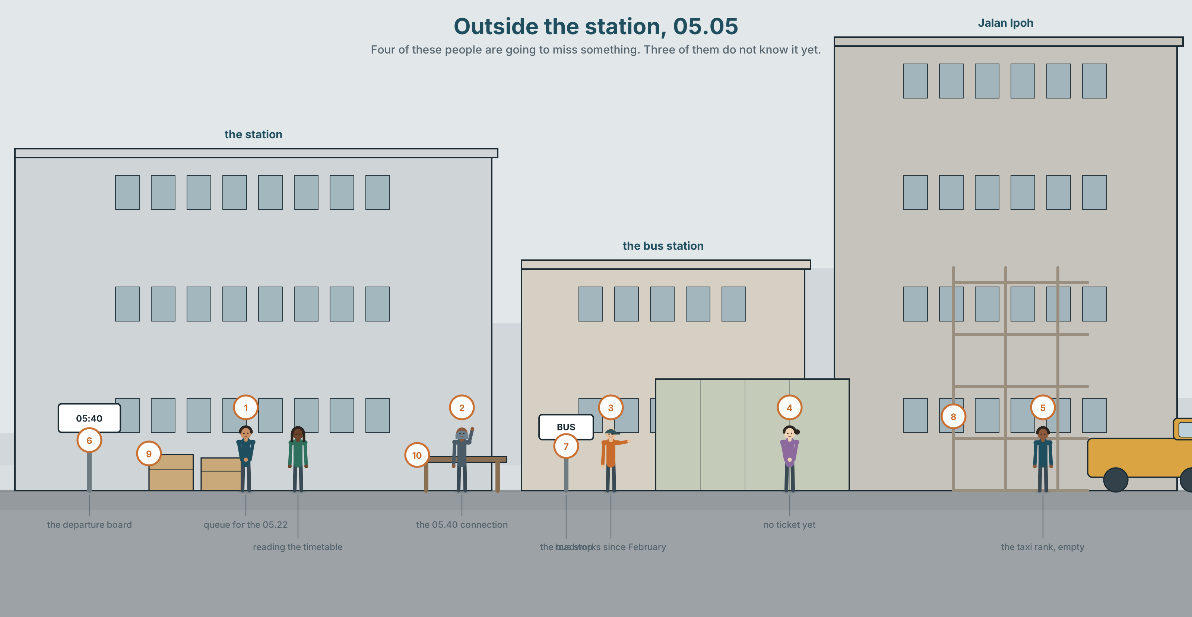{width=6.6in}
Outside the station, 05.05 — Four of these people are going to miss something. Three of them do not know it yet.

What happens if you miss it?
By the end of this unit you can explain a plan and what happens if each part of it fails — out loud, and in seventy words.
◆ A · THE WORLD | Getting somewhere on time, and what people do when they cannot
◆ B · THE SYSTEM | if + present, will · unless · as soon as, until, by the time · 24 words for travel and delay · 16 words for planning around it · the voice that goes up and then down
◆ C · THE PERFORMANCE | A plan with two fallbacks, said and written

0A · Find it
Find ten things in the station and the street outside.
platform · gate · ticket machine · timetable · queue · barrier · roadworks · bus stop · departure board · luggage · taxi rank · clock

0B · Guess it
Four people in this picture are going to miss something. Which four, and what?

0C · Say it ⏺
Record thirty seconds. What is your plan tomorrow morning, and what will you do if it goes wrong? You will record it again at the end of this unit.

Part 1 · Vocabulary Lab 1 ◆ B · THE SYSTEM
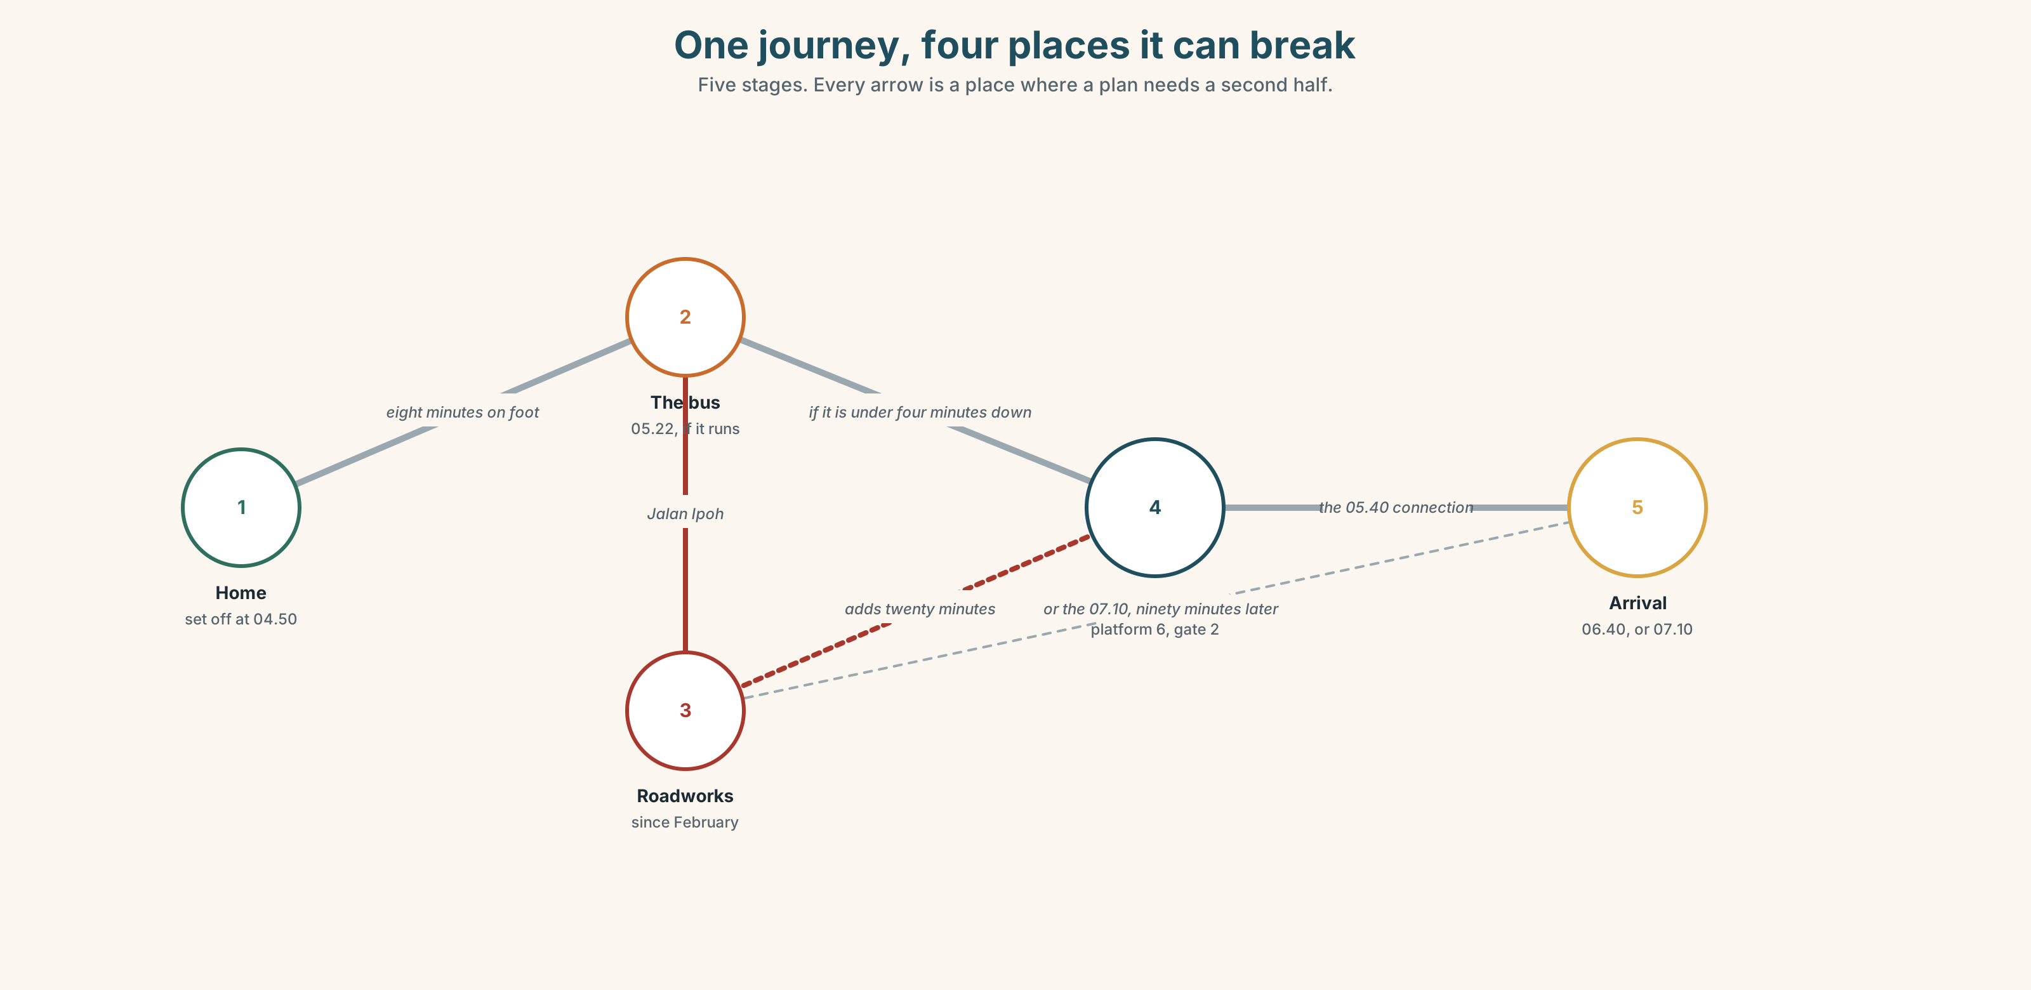{width=6.6in}
One journey, four places it can break — Five stages. Every arrow is a place where a plan needs a second half.

1A · Meet — the words of a journey
Match each word to one place on the map.
ticket · fare · seat · platform · gate · board · connection · timetable · journey · queue

1B · Sort — whose fault is it?
Three columns: the traveller · the operator · nobody.
traffic · roadworks · breakdown · delay · late · a cancelled train · missing the connection · arriving early
Put delay in one column. Then argue for a different one.

1C · Meet — what you get, and what you do not
cancel · refund · early · late
Which of these four do you have a legal right to in your country? Check with a partner.
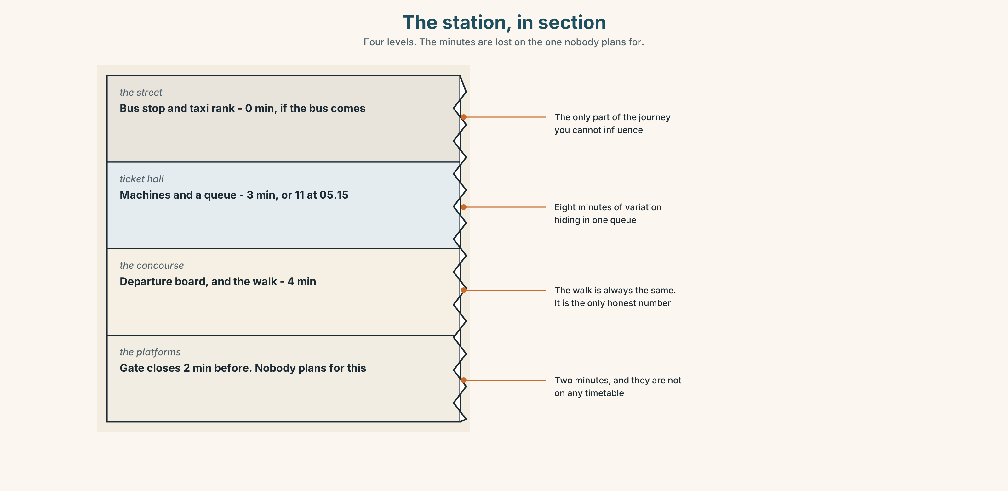{width=6.6in}
The station, in section — Four levels. The minutes are lost on the one nobody plans for.
Look at the station in section. Four levels, four ways of being late. Which level costs the most minutes, and why does nobody plan for it?

1D · Stretch — the phrases
Complete each one with one word.
- We're going to run ______ — there is no way round it now.
- If the bus is twenty minutes down, I'll miss the ______ at Sentral.
- That one has gone. The ______ one is at 06.40.
- He's been stuck in ______ since half past four.
- We'd better set ______ now if we want the four o'clock slot.

1E · The saying
f There's nothing we can do.
Sometimes true. Often not. Write two situations: one where it is honest, and one where it is an excuse. Read both. Can a partner tell which is which?

1F · Own it
Think of the last time you were late for something. Tell a partner three sentences: what went wrong, what you did, and what you would do differently.

Part 2 · Listening ◆ A · THE WORLD
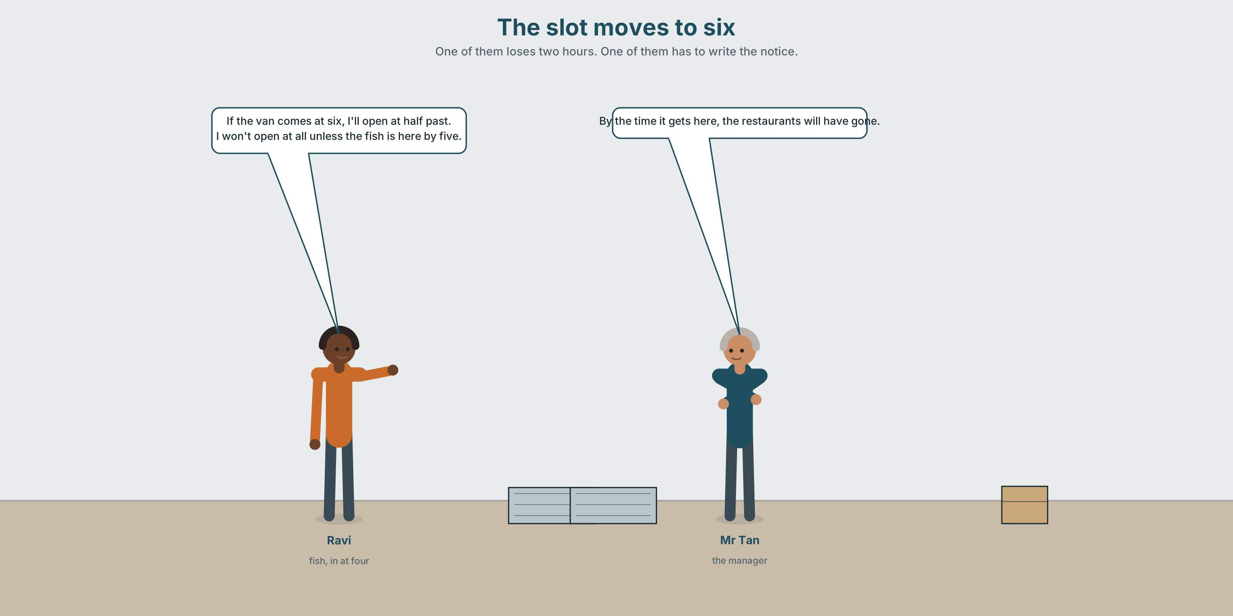{width=6.6in}
The slot moves to six — One of them loses two hours. One of them has to write the notice.

2A · The slot moves to six 🔊 Track 5.1
Before you listen. The market's delivery slot is at four. It is moving to six. Guess: who is most affected — Siti, Ravi or Mei Ling?
Listen once. One question. When does the change start?
Listen again. Complete the table.
 | What they will do | What happens if that fails
Siti
Ravi
Mr Tan
Listen again. True or false?
- The change starts next month. ☐ T ☐ F
- Ravi will lose his best two hours. ☐ T ☐ F
- Siti can open late without losing much. ☐ T ☐ F
- A private van would cost more than the lost trade. ☐ T ☐ F
Noticing. Four sentences from the recording.
- If the van comes at six, I'll open at half past.
- I won't open at all unless the fish is here by five.
- As soon as it arrives, I'll start.
- By the time it gets here, the restaurants will have gone.
Two of these say what will happen. Two say when. Which are which?

2B · Decoding clinic 🔊 Track 5.2
Twenty-five seconds of Ravi. Four jobs.
- How many times does he say if?
- In if the van comes, does his voice go up or down at the end of comes?
- Catch the two times he gives.
- He says one sentence with no if in it at all, and it is still a condition. Which?
Transcripts, page 154.

Part 3 · Grammar Lab 1 ◆ B · THE SYSTEM

If it happens, this happens

3A · Notice
Look at the four sentences in Part 2.
- In sentence 1, which half is the condition and which is the result?
- Sentence 1 has comes, not will come. Why not?
- Sentence 2 uses unless. Rewrite it with if… not. Is anything lost?
- In sentences 3 and 4, nothing is uncertain. What are as soon as and by the time doing?
- Try "If the van will come at six, I'll open at half past." What is wrong?

3B · See
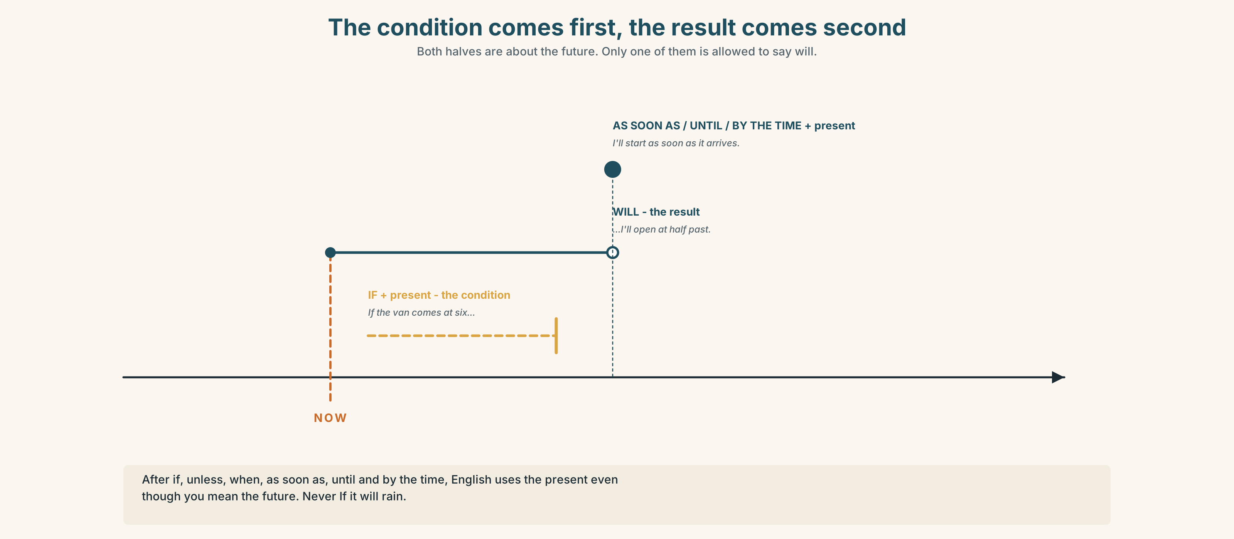{width=6.6in}
The condition comes first, the result comes second — Both halves are about the future. Only one of them is allowed to say will.
Now look at the second picture. The road forks. What is at the end of each branch?
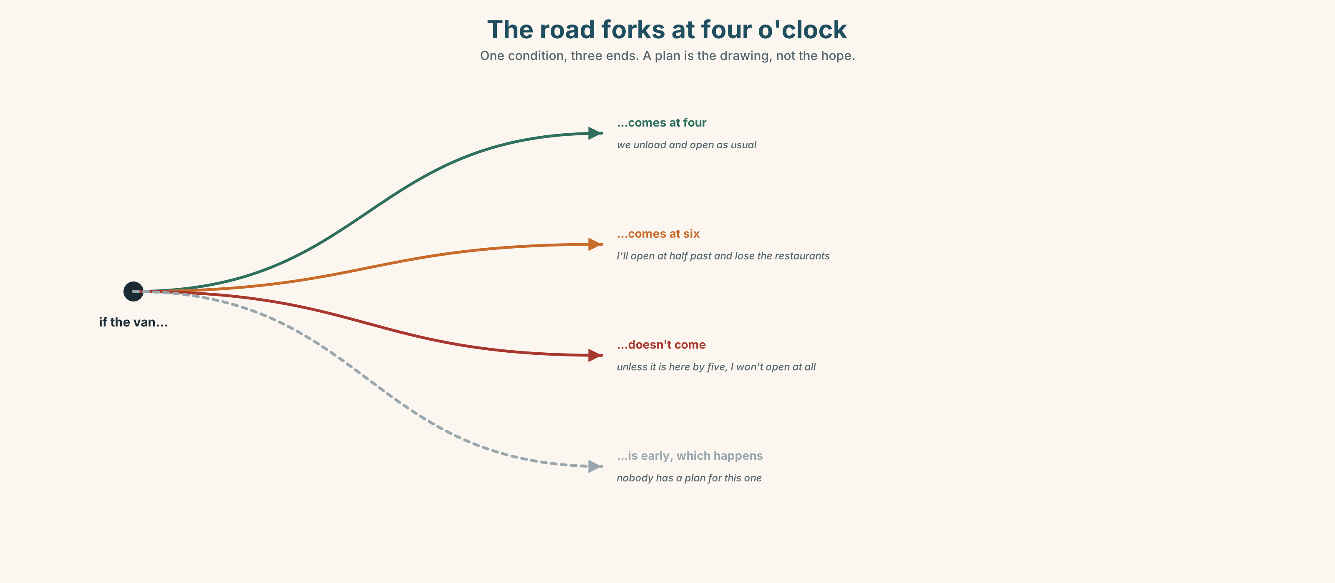{width=6.6in}
The road forks at four o'clock — One condition, three ends. A plan is the drawing, not the hope.

3C · Know
 | Shape | Example
first conditional | if + present , will + verb | If the van comes at six, I 'll open at half past.
unless | = if … not | I won't open unless the fish is here by five.
time clauses | as soon as / until / by the time / whenever + present | I'll start as soon as it arrives.
The rule under all three. After if, unless, when, as soon as, until and by the time, English uses the present, even though you are talking about the future.
Watch out. ✗ If it will rain… ✓ If it rains… unless is already negative. ✗ unless it doesn't rain for if it rains.
Why it matters. A plan with no if in it is not a plan. It is a hope.

3D · Use — controlled
If the van (1) __________ (arrive) at six, Ravi (2) __________ (not open) at all. He (3) __________ (start) as soon as the ice (4) __________ (come), but by the time he (5) __________ (be) ready, the restaurant buyers (6) __________ (go). Unless Mr Tan (7) __________ (find) a second slot, somebody (8) __________ (lose) two hours every day.

3E · Use — guided
Join each pair with if, unless, as soon as, until or by the time.
- The ice arrives. / I'll start.
- It doesn't rain. / We won't cancel.
- You wait here. / I come back.
- The traffic clears. / The market will be closed.
- You don't leave now. / You'll miss the connection.

3F · Use — open
Your morning tomorrow. Tell a partner three things that could go wrong, and what you will do about each. Use if twice and unless once.

3G · Check — six items
- If it ______ (rain), we ______ (not go).
- I'll call you as soon as I ______ (arrive).
- ______ you leave now, you'll miss it.
- We'll wait here until the bus ______ (come).
- By the time we ______ (get) there, it ______ (close).
- I ______ (not buy) it ______ it's on offer.
0–3 → Workbook pp. 28–30. 4–5 → Part 6. 6 → page 107.

Part 4 · Speaking ◆ C · THE PERFORMANCE

4A · Fluency starter — the chain
One learner says a condition. The next turns the result into a new condition.
"If it rains, I'll take the bus." → "If you take the bus, you'll be late." → …
Keep it going. The chain breaks when somebody uses will after if.

4B · The functional core — a plan with fallbacks
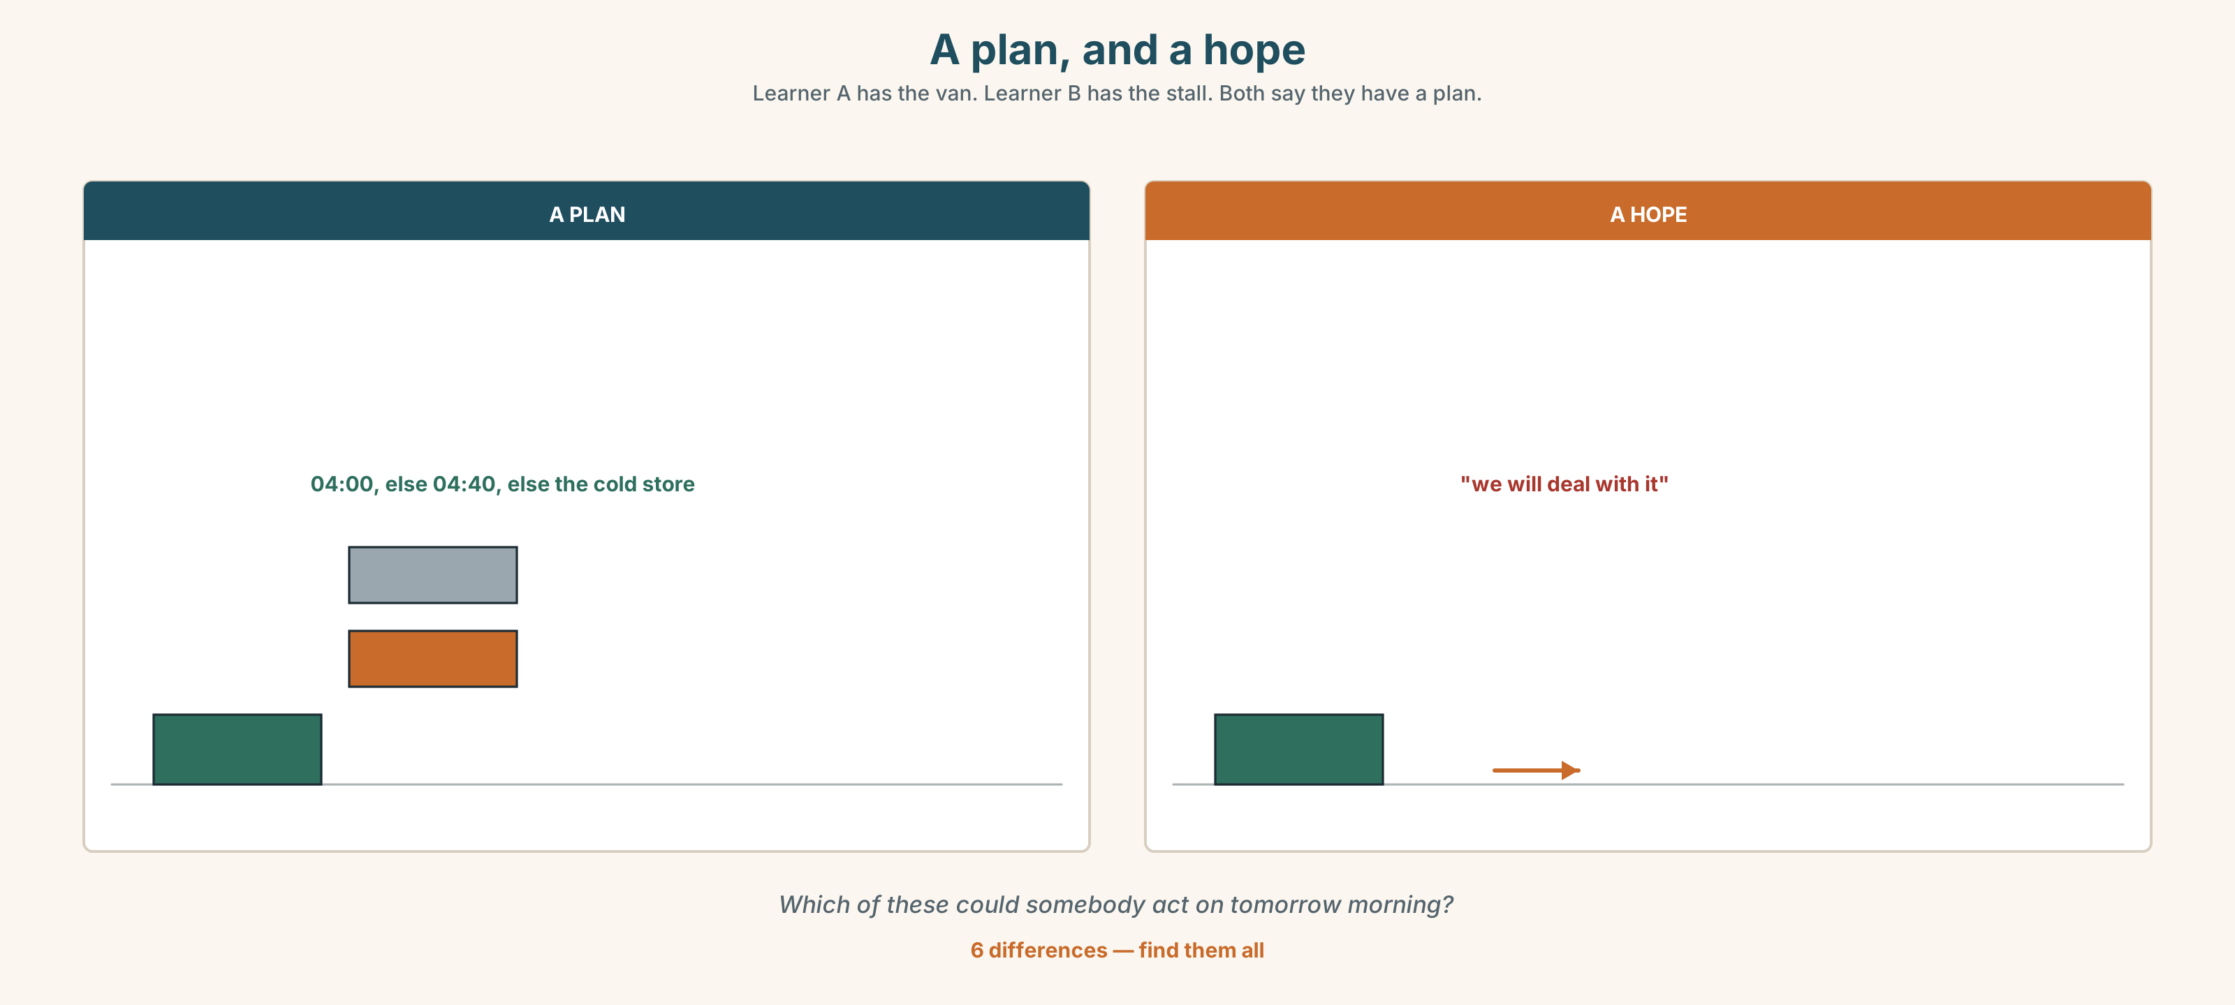{width=6.6in}
A plan, and a hope — Learner A has the van. Learner B has the stall. Both say they have a plan.
Language Bank
the plan | The plan is to… · We'll set off at… · I'll be there by…
the fallback | If that doesn't work, I'll… · In that case… · Otherwise…
the deadline | At the latest. · No later than… · In time for…
the insurance | Just in case. · In case it rains. · Straight away, not later.
Role play. Learner A runs a stall. Learner B drives a van. The slot has moved to six. Agree a plan with two fallbacks. Six minutes.

4C · The performance — seventy seconds ⏺
Explain one plan and two fallbacks to the group. Seventy seconds. You must give:
the plan · what happens if the first part fails · what happens if the second does · the one thing you will not do
Record it.

4D · Observer
One person listens for one thing: was there a real fallback, or just a wish?

4E · Two criteria
☐ Did I use the present after if, unless and as soon as? ☐ Are both fallbacks things I could actually do?

Part 5 · Reading ◆ A · THE WORLD

5A · Predict
A review of a travel app. The title is "It told me I would make it." What do you expect the reviewer to be angry about? One sentence.

5B · Read — one hundred seconds

It told me I would make it ★★☆☆☆
The app does one thing well. If you put in where you are and where you want to be, it gives you a route, a fare and a time, and the time is usually right.
The problem is what it does not do. It will not tell you what happens if any part of that route fails. I used it for a 05.40 connection at Sentral. It said I would arrive at 05.22. It did not say that the 05.22 is the only bus that makes that connection, and that if it runs four minutes late — which it did, because of roadworks on Jalan Ipoh that have been there since February — the next option is 07.10.
Eighteen minutes of margin, and no warning that all eighteen were in one place.
A better app would say: you will make this unless the bus is more than three minutes down. That is one sentence. It is also the only sentence I needed.
Two stars, and one of them is for the fare calculator, which is honest about what a refund is worth and how long it takes.

5C · Answer
- What three things does the app give you?
- What time did it say the writer would arrive, and what connection was she making?
- Why was the bus late?
- What is the next option after the 05.40, and how much later is it?
- What one sentence does the writer say the app should have given her?
- What is the second star for?

5D · Vocabulary in context
Guess from the text. Then check.
a route · margin · down (as in "four minutes down") · the only option · honest about

5E · The counter-text
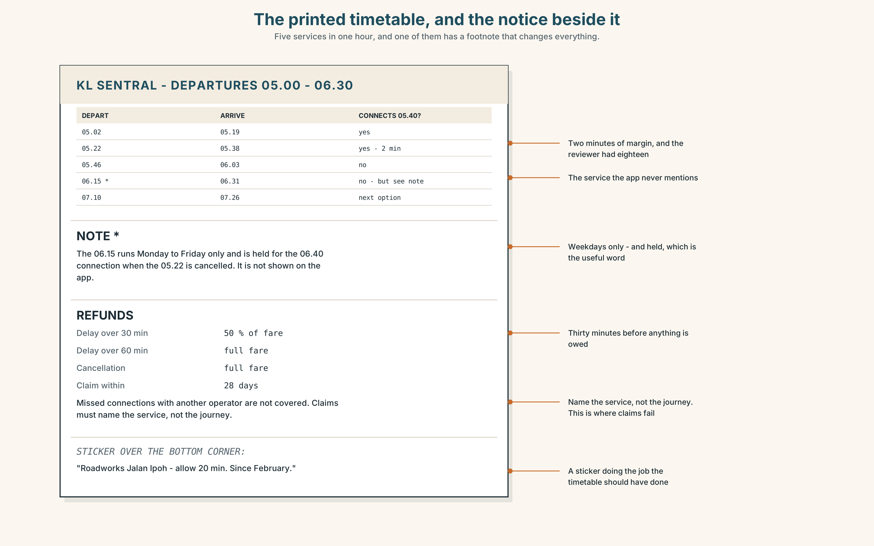{width=6.6in}
The printed timetable, and the notice beside it — Five services in one hour, and one of them has a footnote that changes everything.
Read the printed timetable and the notice beside it, and answer.
- How many services run between 05.00 and 06.00?
- If the 05.22 is cancelled, what is the next service that makes the 05.40 connection?
- What does the notice say about refunds, and in what circumstances?
- One line of the timetable has a footnote mark. What does the footnote say?

5F · Two texts
The review says the next option after a missed 05.40 is 07.10. The timetable shows a 06.15 service — with a footnote.
Put those two facts together. Was the reviewer wrong? Two sentences.

Part 6 · Vocabulary Lab 2 ◆ B · THE SYSTEM

Words that fix a plan in time
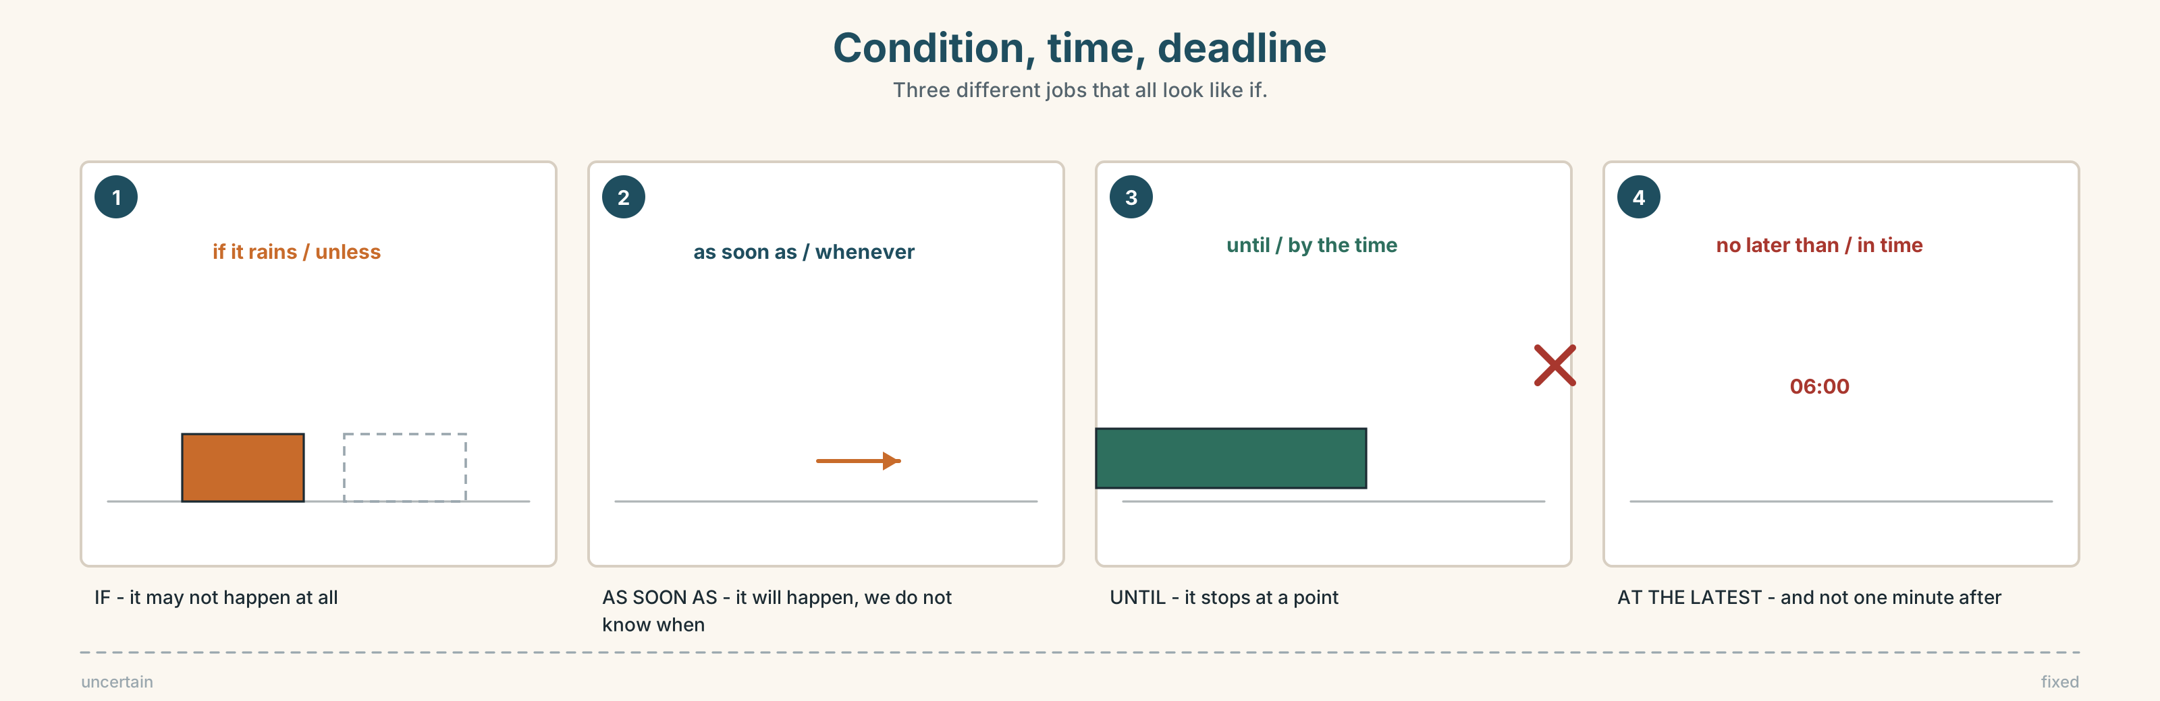{width=6.6in}
Condition, time, deadline — Three different jobs that all look like if.

6A · Sort — a condition, a time, or a deadline?
Three columns.
unless · as soon as · at the latest · if it rains · until · no later than · by the time · in case · whenever · in time
CONDITION | TIME | DEADLINE

6B · Chunk completion
- Take an umbrella **just ______ ** .
- Be there by six at the ______ .
- I need it no ______ than Thursday.
- We left early, so we arrived ______ time.
- The van is late. In that ______ , we open at seven.
- Pay now, ______ they'll cancel it.

6C · Three ways of saying now
straight away · as soon as possible · whenever you can
Put one in each, and say what each one tells the other person about how urgent it is.
- Send it ______ . (the building is on fire)
- Send it ______ . (this week would be good)
- Send it ______ . (I am not in a hurry and I want you to know that)
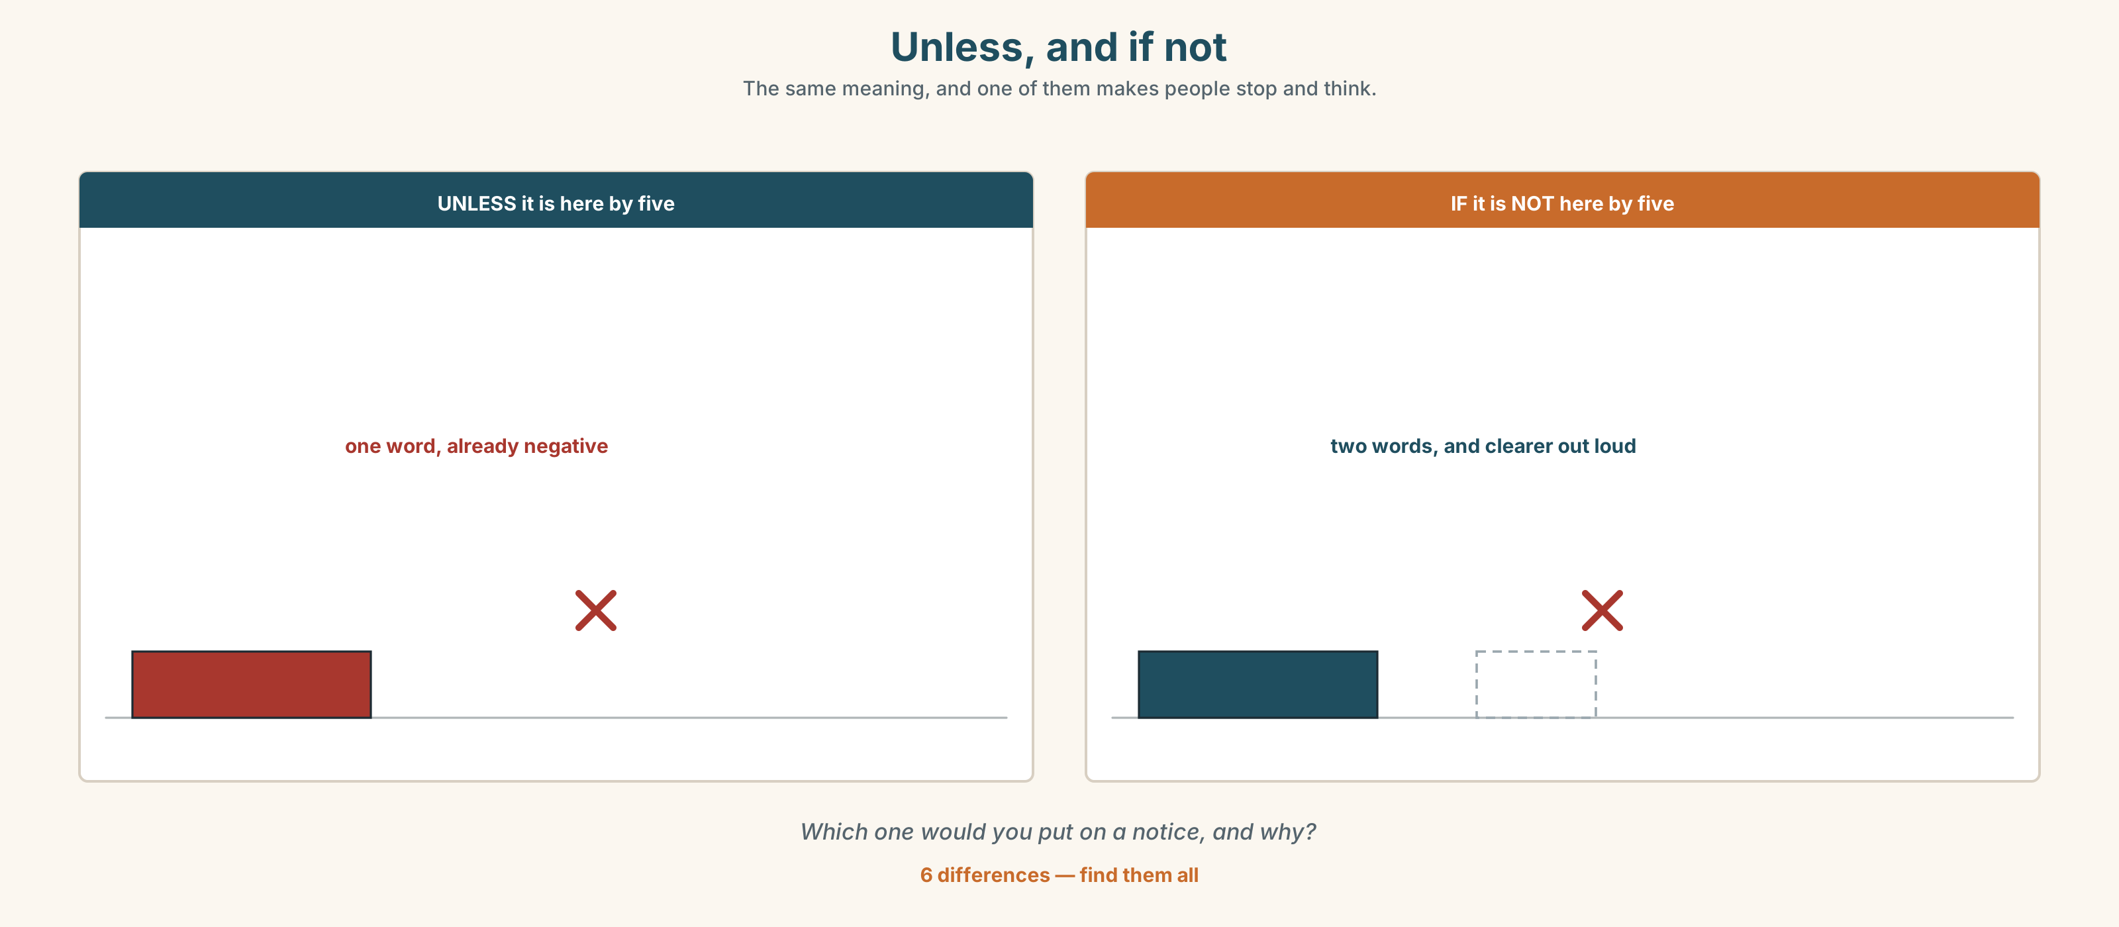{width=6.6in}
Unless, and if not — The same meaning, and one of them makes people stop and think.
Six differences. Find them, then answer the question under the picture.

6D · Contrast Clinic — if, unless, when or until
Six items.
- ______ it rains, we'll stay in.
- ______ it rains, we'll go. (we only go in dry weather)
- Wait here ______ I get back.
- I'll phone ______ I land.
- You'll miss it ______ you leave now.
- ______ the time we arrive, they'll have closed.

Part 7 · Pronunciation & Fluency Lab ◆ B · THE SYSTEM

Up, then down
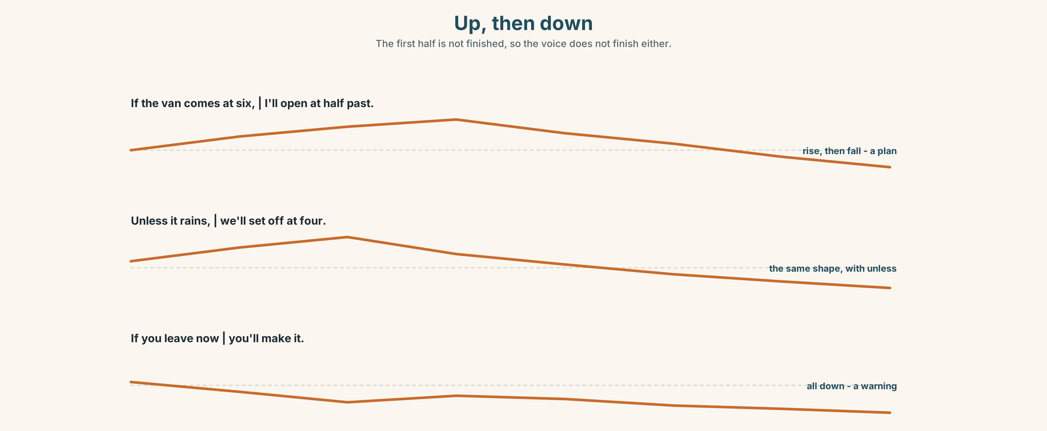{width=6.6in}
Up, then down — The first half is not finished, so the voice does not finish either.

7A · Hear 🔊 Track 5.3
If the van comes at six ↗ | I'll open at half past ↘ Unless it rains ↗ | we'll set off at four ↘
The first half goes up because it is not finished. The second half goes down because it is.

7B · Say
Say both. Then say them with the halves the other way round:
I'll open at half past ↗ | if the van comes at six ↘

7C · Make it mean something
Say this twice:
If you leave now ↗ you'll make it. ↘ (a plan) If you leave now ↘ you'll make it. ↘ (a warning — and almost a threat)
Which one would you rather be told?

7D · Fluency 20 ⏺
Twenty seconds: three conditions and three results. Three times, faster — keeping the rise.

Part 8 · Writing ◆ C · THE PERFORMANCE

The plan and what could go wrong · 70 words
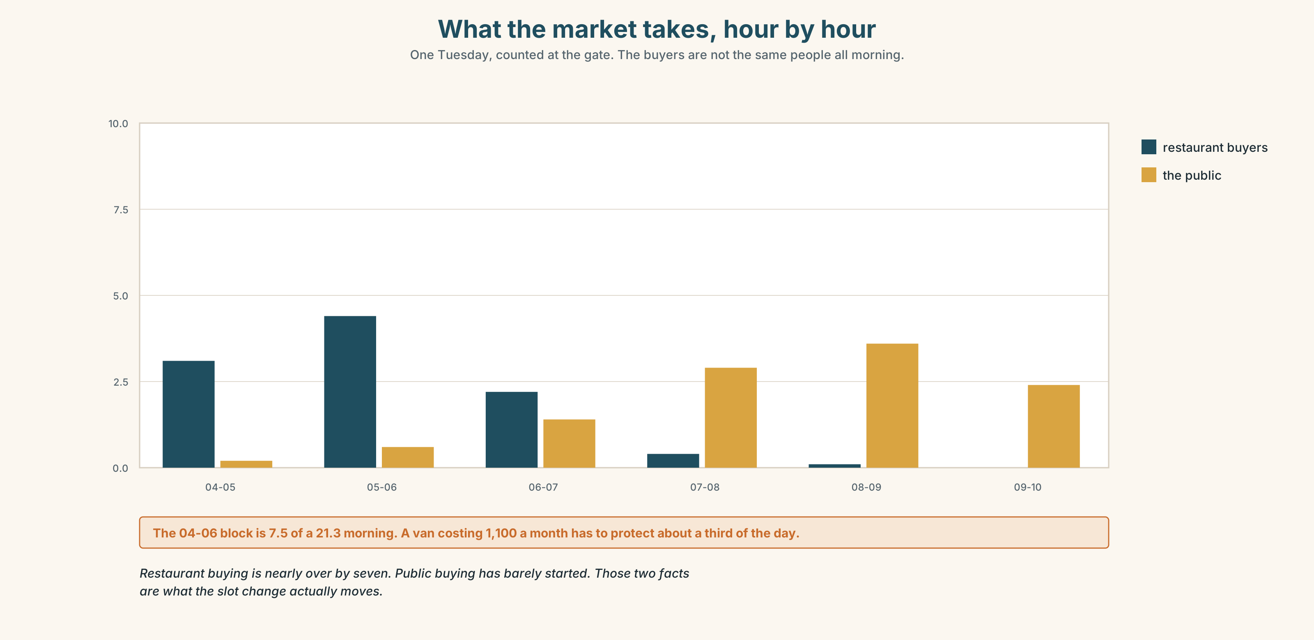{width=6.6in}
What the market takes, hour by hour — One Tuesday, counted at the gate. The buyers are not the same people all morning.

8A · Read the model
We'll set off at four. If the road is closed again we'll go round by Jalan Ipoh, which adds twenty minutes, so I'll leave at twenty to in that case. [the fallback has a cost, and the cost is named]
If we're not at the market by five we won't unload at all — we'll go straight to the cold store and bring it at eight. [the second fallback is a different plan, not the same plan slower]
What I won't do is unload warm fish in a queue. [one line saying what is not on the table]
Questions about the writer's choices:
- The first fallback names twenty minutes. Why does a number help here?
- The last line is a refusal. What does it do for the reader?

8B · The anti-model
We will set off at four and arrive at five. If there is a problem we will deal with it. We will do our best to be on time and we hope everything will be fine.
Correct English, and nobody can act on it. Name two things the reader still does not know.

8C · Plan
the plan, with a time → fallback 1, with its cost → fallback 2, which is different → one thing you will not do

8D · Write — 70 words

8E · Peer review — two criteria
☐ Is each fallback something you could actually do tomorrow? ☐ Does one of them have a number in it?

8F · Write it again · 8G · Publish
On the wall, with the timetable from Part 5E beside it.

Part 9 · The File ◆ A · THE WORLD + C · THE PERFORMANCE

STUDY FILE · Source Check
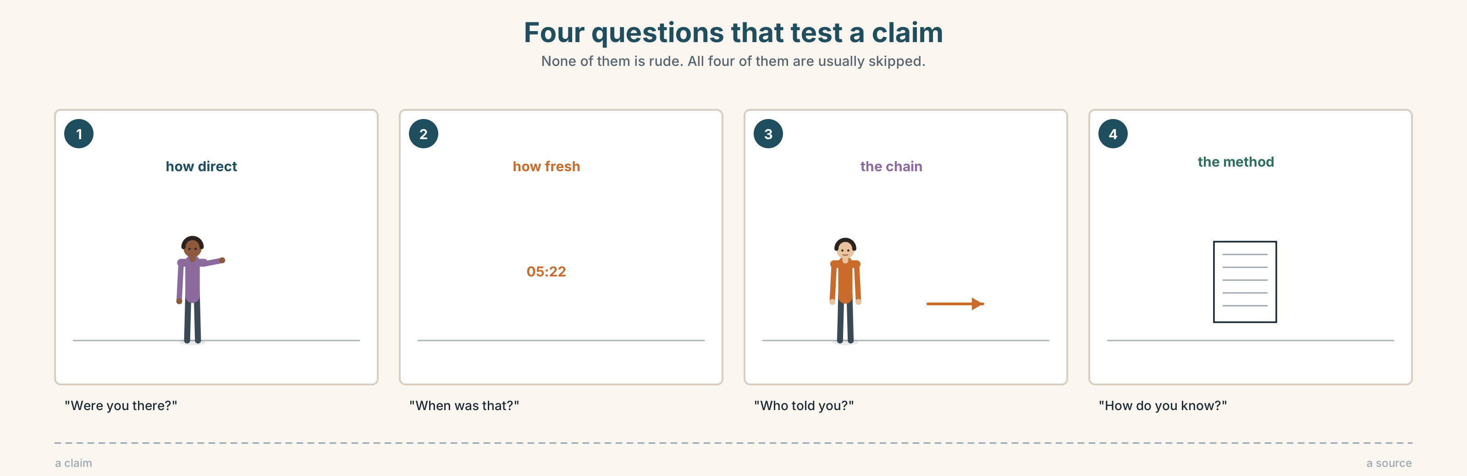{width=6.6in}
Four questions that test a claim — None of them is rude. All four of them are usually skipped.

9A · Four claims about one delay 🔊 Track 5.4
Four people say why the 05.22 was late. Listen.
- Who was actually on the bus?
- Who read it somewhere?
- Which claim has a number in it, and does that make it more reliable?

9B · Rank the sources
Put these four in order, most reliable first. Then argue about your order.
the operator's own notice · a passenger who was there · a news app · somebody's cousin

9C · The questions that test a claim
Match each question to what it tests.
"Were you there?" · "When was that?" · "Who told you?" · "How do you know?"
how fresh · how direct · the chain · the method

9D · Your turn
In pairs. One of you makes a claim about the delay. The other asks three of the four questions above. Then swap. Four minutes.

9E · Transfer
Find one claim this week — on a sign, in a message, on a screen. Ask yourself the four questions. Bring the claim and your answer.

Part 10 · Mediation & Interaction ◆ C · THE PERFORMANCE
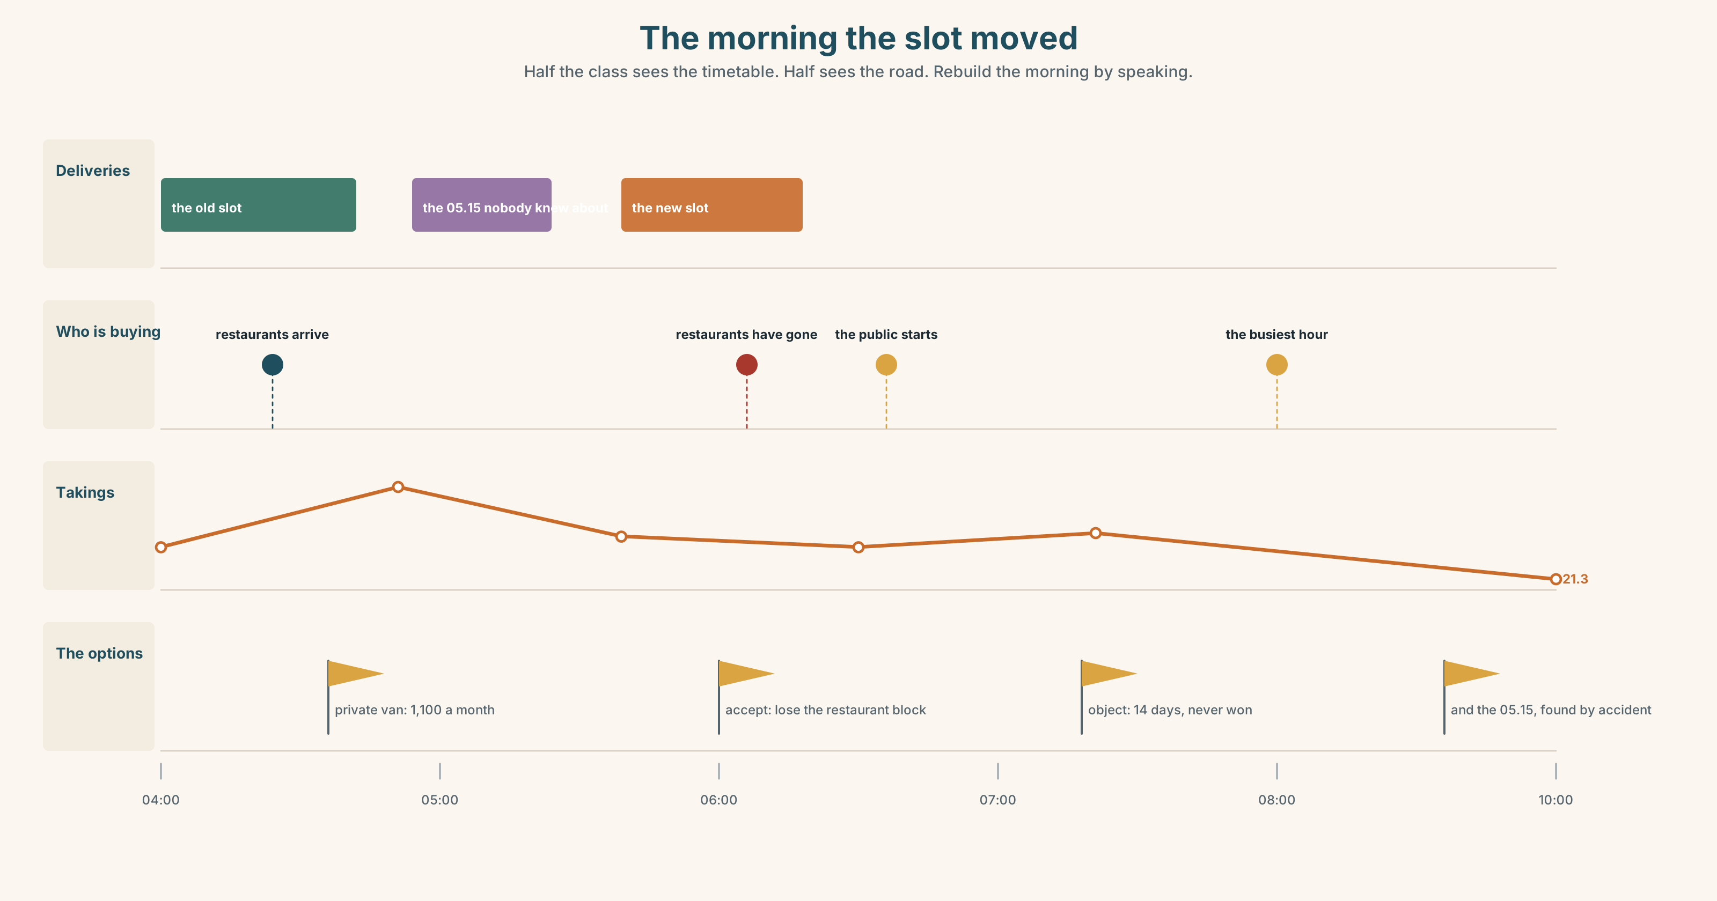{width=6.6in}
The morning the slot moved — Half the class sees the timetable. Half sees the road. Rebuild the morning by speaking.

10A · Relay
Half the class sees the timetable. Half sees the road closures. Rebuild the whole morning by speaking. Ten minutes.

10B · Simplify
Explain the timetable notice from Part 5E to a traveller who has just missed a connection. Four sentences only.
Plan: what you are owed → when → what you have to do first → what will not be refunded

10C · Compress
The review in Part 5 into thirty words, as a one-star-to-five-star summary line.

10D · Online
Write one message to the market group: the slot moves to six on the first, you have a plan, and you need two people to say by Friday whether they can take an early key.

10E · Your language
How does your language mark a condition? Is there a word like unless, or do you have to say if not? Show a partner both.

Part 11 · The Decision ◆ C · THE PERFORMANCE

Two hours, every day
From the first of next month the market's delivery slot moves from four o'clock to six. The restaurant buyers come between five and seven and they will not wait.
- Accept it. Start two hours later. Lose the restaurant trade, keep the costs where they are.
- Pay for a private van. Keep the four o'clock arrival. It costs 1,100 a month, shared between however many traders sign up.
- Fight it. The committee can object within fourteen days. It has never won an objection.

11A · The evidence
- The timetable and the notice from Part 5E — and the footnote.
- The chart — what the market takes hour by hour, and who is buying.
- The voice. Mr Tan, twenty seconds: "If six traders sign, it's a hundred and eighty each and it is obviously worth it. If three sign, it's three hundred and sixty and it obviously isn't. I can't tell you which it is until people decide."

11B · Talk about it
In threes. Everybody says one. Use the frame.
If the market ______ , then ______ . So I think they should ______ .
Words you can use: slot · restaurants · cost · share · refund · delay · in time · otherwise

11C · Decide
Write two sentences. Choose, and say why.
I think the market should ______________________ , because ______________________ .

11D · Model decision
They should take the private van for three months and make the committee object at the same time. The objection will probably fail, but it is free, and it is the only way of finding out whether the slot was ever negotiable. Paying for the van answers the question the objection cannot: whether the four o'clock trade is worth 1,100 a month, and nobody in that market actually knows.

11E · The Reveal
What happened. Nine traders signed, so it was 122 each. The van kept the four o'clock arrival and the restaurant trade held up.
The objection failed in eleven days, as everybody expected, but the reply named a second slot at 05.15 that nobody had known existed, and four traders moved to it in the second month and stopped paying for the van.
By month four, five traders were paying 220 each and two of them were thinking about stopping.
The van worked. The objection, which failed, found the better answer.
Was it the right decision? Say why — and say what the five who stayed should do now.

Part 12 · Landing ◆ all three lines

12A · Recycle — ten items
- If it ______ (rain), we'll stay.
- I'll start as soon as it ______ (arrive).
- You'll miss it ______ you leave now.
- We'll wait ______ the bus comes.
- Take it just in ______ .
- (Unit 4) The person ______ has the key is Mr Tan.
- (Unit 4) Nurul is ______ charge of food safety.
- (Unit 3) I ______ (use) to live here.
- (Unit 2) It was raining ______ he left.
- (Starting Out) The train ______ (leave) at six every day.

12B · Consolidate
Seventy words, one paragraph. A journey you have to make. The plan, two things that could go wrong, and what you will do about each. Use if twice, unless once, as soon as once.

12C · Can-do, with evidence
I can… | My evidence | Sure?
say what will happen if something does or does not happen | Part 3G score | ◯ ◑ ●
explain a plan and two fallbacks in seventy seconds | Part 4C recording | ◯ ◑ ●
write seventy words a colleague could act on | Part 8 draft 2 | ◯ ◑ ●
test where a claim came from | Part 9D pair work | ◯ ◑ ●

12D · Replay ⏺
Find your thirty seconds from Part 0C. Listen. Record it again. One sentence: what is different?

12E · Glossary — forty items, as a map
THE JOURNEY · ticket · fare · seat · board · platform · gate · connection · timetable · journey · queue WHAT GOES WRONG · delay · cancel · late · traffic · roadworks · breakdown · run late · miss the connection · stuck in traffic WHAT YOU DO · early · refund · the next one · set off · turn up · there's nothing we can do THE CONDITION · if it rains · unless · in case · just in case · whenever · otherwise THE TIME · as soon as · until · by the time · straight away · in time THE DEADLINE · at the latest · no later than · in that case · we'll see

12F · Next
Unit 6 · What are you willing to pay for?

