Table of Contents

A2.1 · Unit 7 · Four Hundred Kilometres
English Animated · Making Plans · Pasar Chow Kit, Kuala Lumpur Student's Book pages 138–159 · 22 pp · ~10 hours

Part 0 · The Big Picture ◆ A · THE WORLD
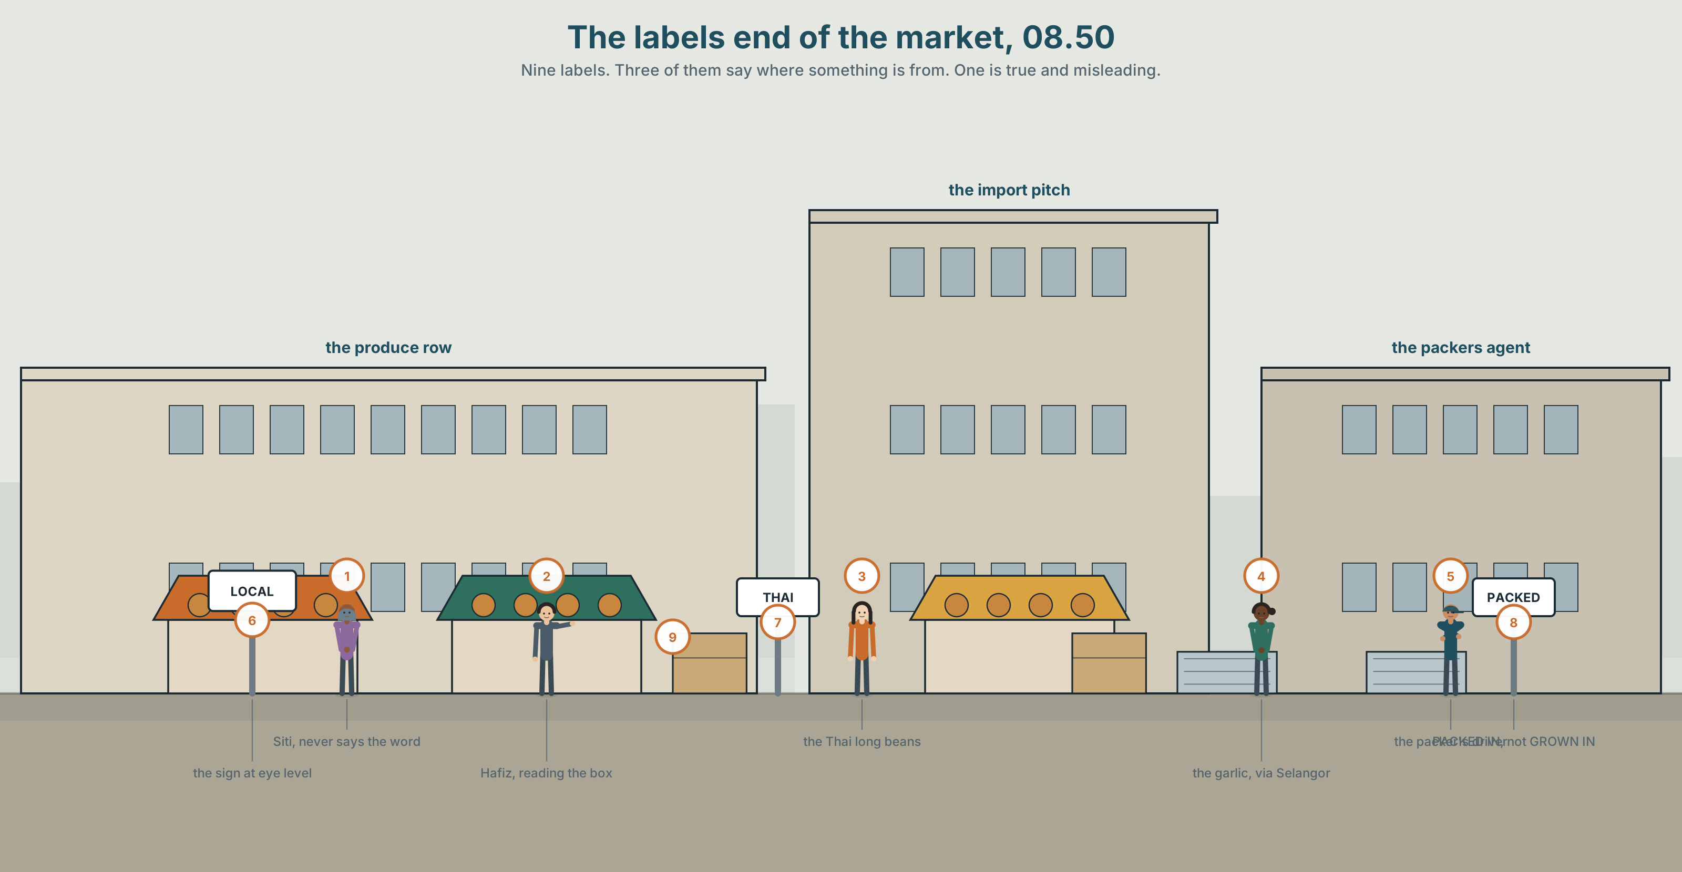{width=6.6in}
The labels end of the market, 08.50 — Nine labels. Three of them say where something is from. One is true and misleading.

Where are you from, really?
By the end of this unit you can describe where something comes from and how it reaches the person who buys it. Ninety words.
◆ A · THE WORLD | Where things and people come from, and who gets asked the question twice
◆ B · THE SYSTEM | the passive, present and past · by and agent phrases · 23 words for origin and belonging · 17 words for how things are made · the -ed you can and cannot hear
◆ C · THE PERFORMANCE | Ninety words tracing one thing back to where it started

0A · Find it
Find nine labels in this picture. Three of them say where something is from.
LOCAL · GROWN IN CAMERON · PRODUCT OF THAILAND · FARM FRESH · IMPORTED · PACKED IN SELANGOR · NO ORIGIN GIVEN

0B · Guess it
One label in this picture is true but misleading. Which, and what does it leave out?

0C · Say it ⏺
Record thirty seconds. Where are you from, and how many sentences does it take to answer that honestly? You will record it again at the end of this unit.

Part 1 · Vocabulary Lab 1 ◆ B · THE SYSTEM
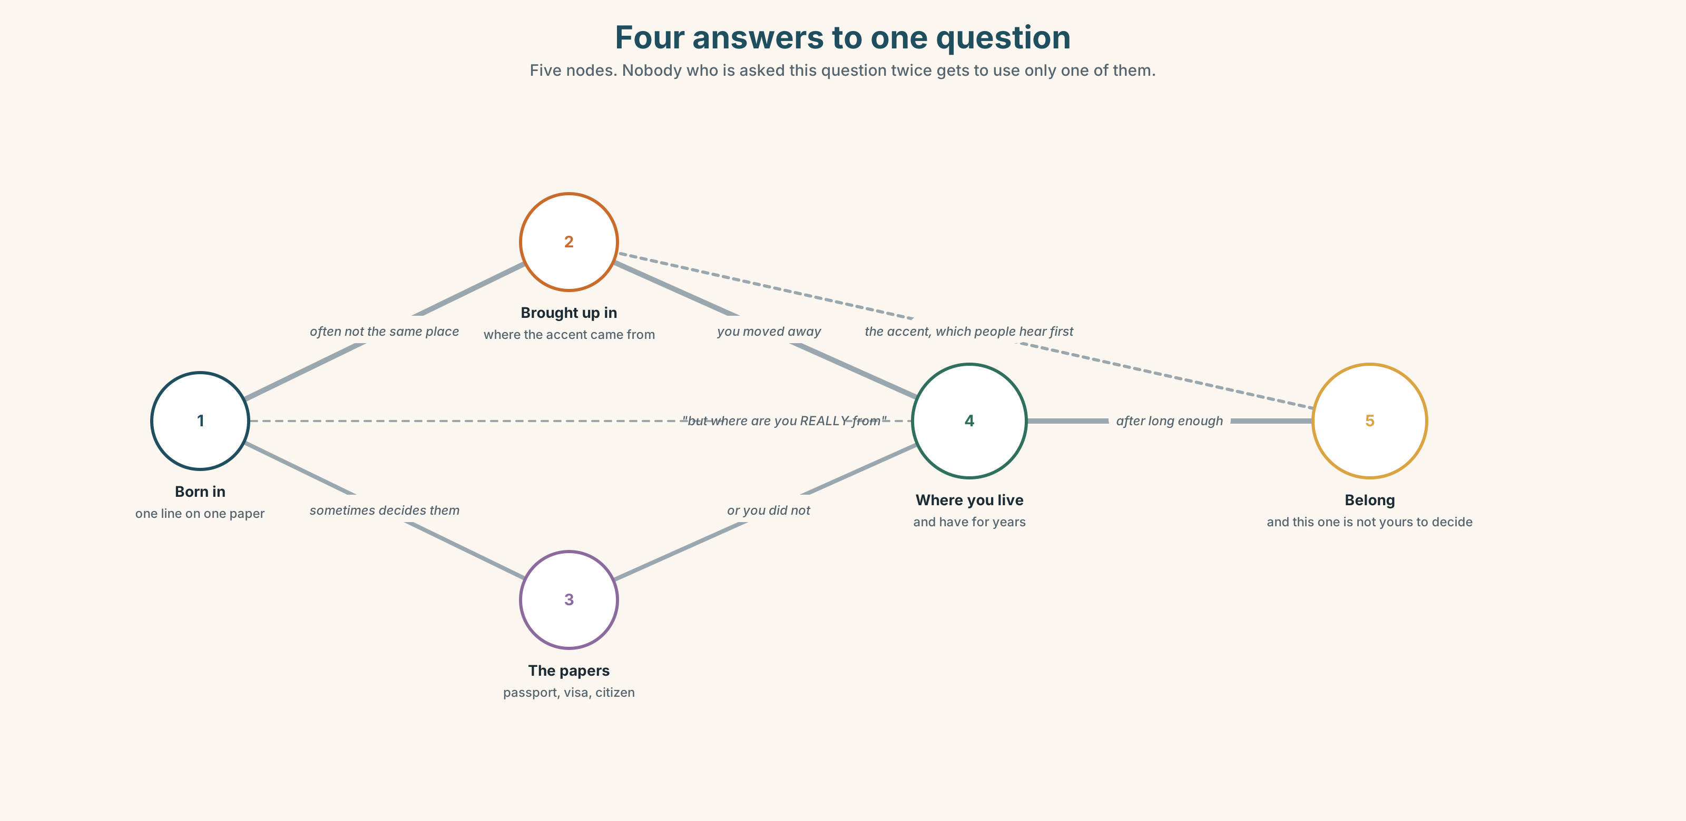{width=6.6in}
Four answers to one question — Five nodes. Nobody who is asked this question twice gets to use only one of them.

1A · Meet — where people come from
Match each word to one place on the map.
born · raise · move · family · home · village · town · country · roots · settle

1B · Sort — a place, a paper, or a feeling?
Three columns.
passport · home · village · visa · belong · roots · country · citizen · accent · town
One of them changes column depending on who is asking. Which?

1C · Meet — the ones people notice first
accent · language · foreign
An accent tells people where you learned to speak. It does not tell them where you are from. Give one example from your own country.
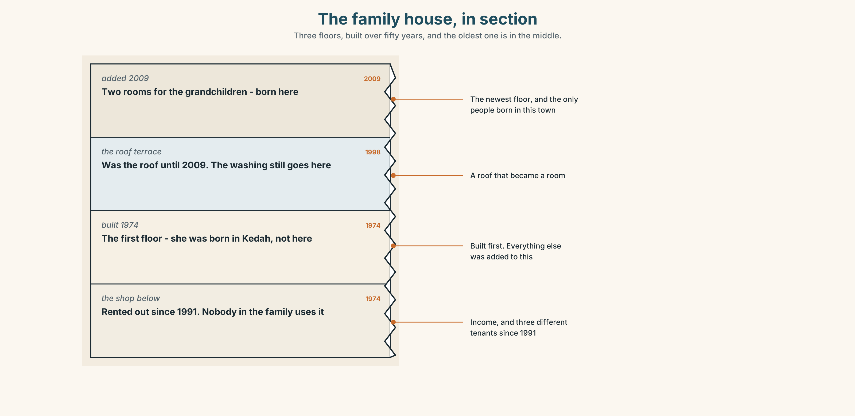{width=6.6in}
The family house, in section — Three floors, built over fifty years, and the oldest one is in the middle.
Look at the family house in section. Three generations, three floors. Which floor was built first, and who was born in a different country?

1D · Stretch — the phrases
Complete each one with one word.
- She was ______ in Penang but has never lived there.
- He was brought ______ by his grandmother in a village of two hundred people.
- They moved ______ in 1998 and have been back twice.
- Every year in April she goes ______ for a week.
- I grew ______ two streets from here.

1E · The saying
f It's complicated.
Two words people use when the real answer takes four sentences.
"Where are you from?" — "It's complicated."
What are the four sentences? Write them for somebody you know, real or invented.

1F · Own it
Tell a partner three sentences about where you are from: one with a place, one with a date, and one that complicates the first two.

Part 2 · Listening ◆ A · THE WORLD
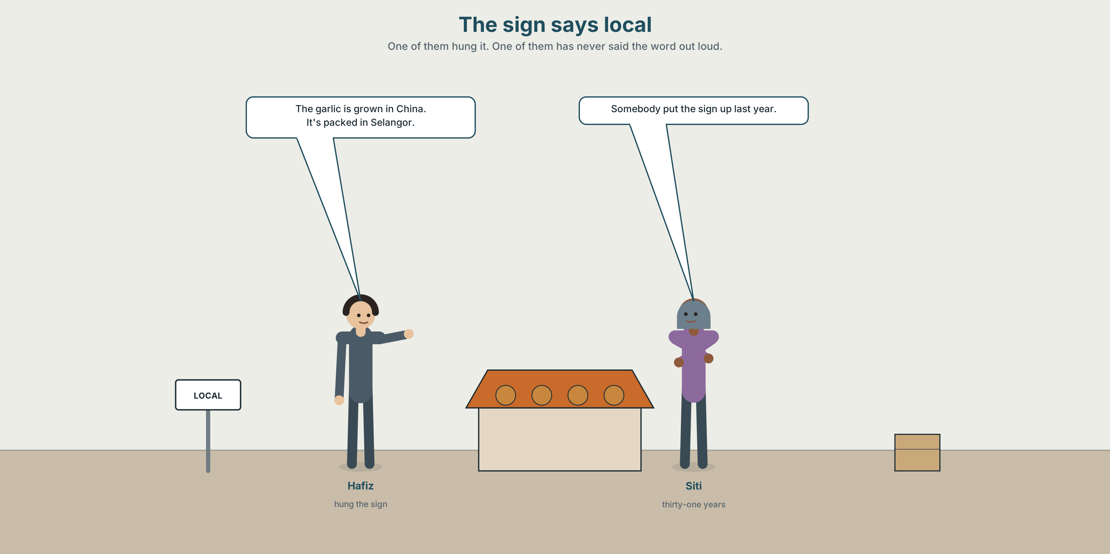{width=6.6in}
The sign says local — One of them hung it. One of them has never said the word out loud.

2A · The sign says local 🔊 Track 7.1
Before you listen. The stall has a sign saying LOCAL. Half the produce comes from 400 km away. Guess: does Siti know?
Listen once. One question. Who put the sign up?
Listen again. Complete the table.
 | Where is it grown? | How far? | What the label says
tomatoes
long beans
garlic
Listen again. True or false?
- The garlic is grown in Malaysia. ☐ T ☐ F
- The sign was put up by Hafiz. ☐ T ☐ F
- Nobody has ever asked about it. ☐ T ☐ F
- The tomatoes travel further than the beans. ☐ T ☐ F
Noticing. Four sentences from the recording.
- Somebody put the sign up last year.
- The sign was put up last year.
- They grow the garlic in China.
- The garlic is grown in China.
Two of these name the person. Two do not. Which, and which pair sounds more like a label?

2B · Decoding clinic 🔊 Track 7.2
Twenty-five seconds of Hafiz. Four jobs.
- How many times does he say is grown or are grown?
- In packed, can you hear a d, a t, or neither?
- Catch the two distances he gives.
- He says one thing twice, in two different ways. What?
Transcripts, page 156.

Part 3 · Grammar Lab 1 ◆ B · THE SYSTEM

When nobody is named

3A · Notice
Look at the four sentences in Part 2.
- Sentences 1 and 2 describe the same event. What is in one and missing from the other?
- In sentence 4, where has they gone?
- Why would a label use sentence 4 rather than sentence 3?
- Is leaving the person out always dishonest? Give one example where it is not.
- Try "The garlic is grow in China." What is missing?

3B · See
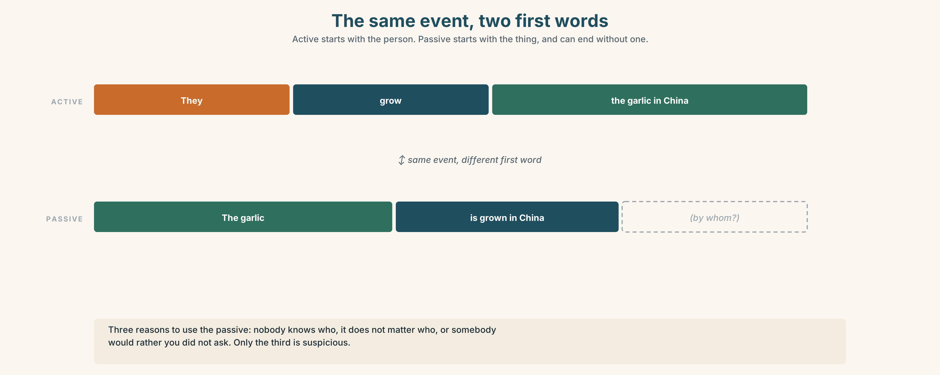{width=6.6in}
The same event, two first words — Active starts with the person. Passive starts with the thing, and can end without one.
Now look at the second picture. The sentence has three slots. Which one can be deleted?
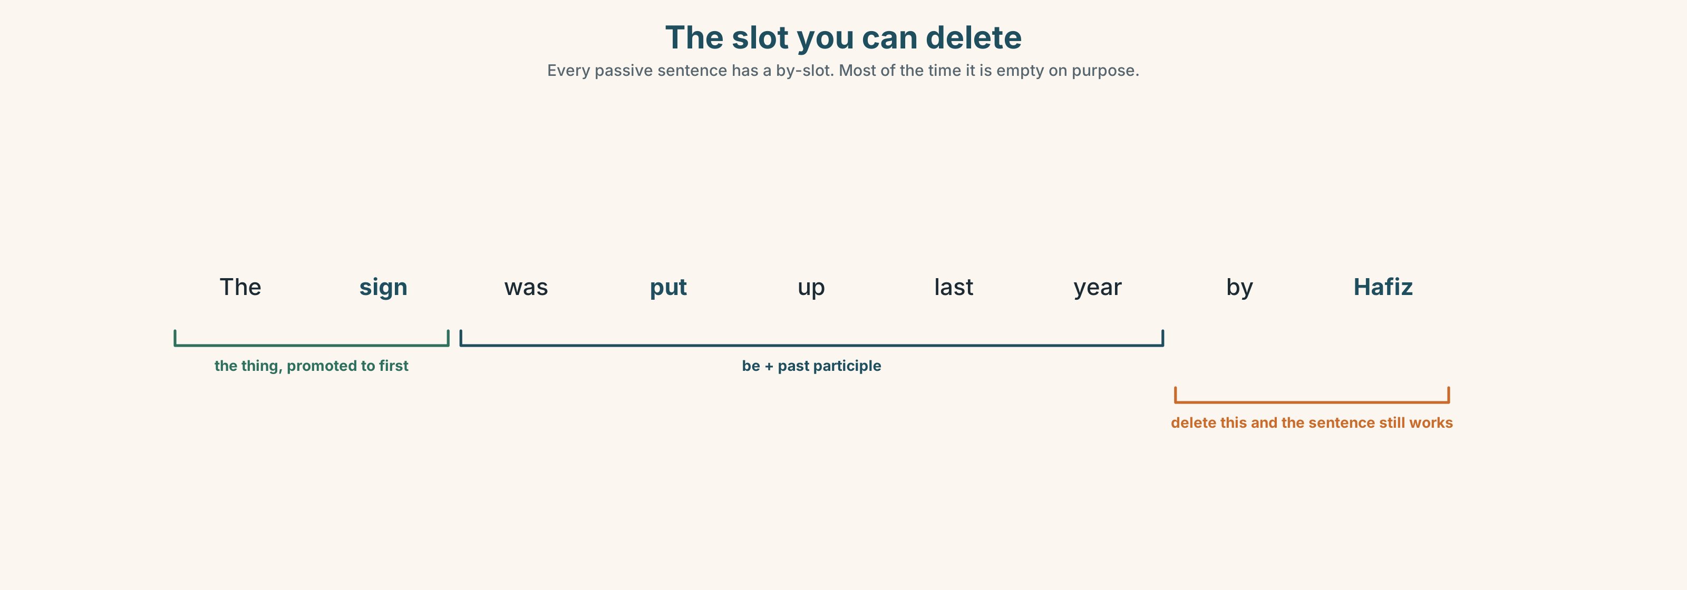{width=6.6in}
The slot you can delete — Every passive sentence has a by-slot. Most of the time it is empty on purpose.

3C · Know
 | Shape | Example
present passive | am / is / are + past participle | The garlic is grown in China.
past passive | was / were + past participle | The sign was put up last year.
naming the agent | by + who or what | It was built by my grandfather.
Three reasons to use the passive, and only one of them is suspicious:
- Nobody knows who → The sign was put up last year.
- It does not matter who → The garlic is grown in China.
- Somebody would rather you did not ask → Mistakes were made.
Watch out. The participle is not the infinitive. ✗ is grow ✓ is grown · ✗ was build ✓ was built
Why it matters. The passive lets you put the important thing first and the person last — or nowhere. On a food label, that is a decision, not a grammar choice.

3D · Use — controlled
The tomatoes (1) __________ (grow) in Cameron Highlands and (2) __________ (bring) down overnight. The garlic (3) __________ (not grow) here at all; it (4) __________ (import) from China and (5) __________ (pack) in Selangor. The sign (6) __________ (put up) last year by a man nobody can now name.

3E · Use — guided
Make each one passive. Leave out the agent if it adds nothing.
- They grow the beans in Johor.
- Somebody stole the scales on Tuesday.
- My grandfather built this house.
- They pack the garlic in Selangor.
- Somebody has moved the noticeboard.

3F · Use — open
Choose one thing in this room. Tell a partner three passive sentences about it: where it was made, what it is made of, and who it was bought by.

3G · Check — six items
- The rice ______ (grow) in Kedah.
- This house ______ (build) in 1961.
- The crates ______ (bring) down every night.
- The sign ______ (put up) by Hafiz last year.
- Garlic ______ (not grow) in Malaysia.
- Where ______ these ______ (make) ?
0–3 → Workbook pp. 40–42. 4–5 → Part 6. 6 → page 151.

Part 4 · Speaking ◆ C · THE PERFORMANCE

4A · Fluency starter — where is it from?
One learner holds up any object. The others must give three passive sentences about it in thirty seconds. No guessing allowed to be challenged.
Five objects. Five rounds.

4B · The functional core — tracing something back
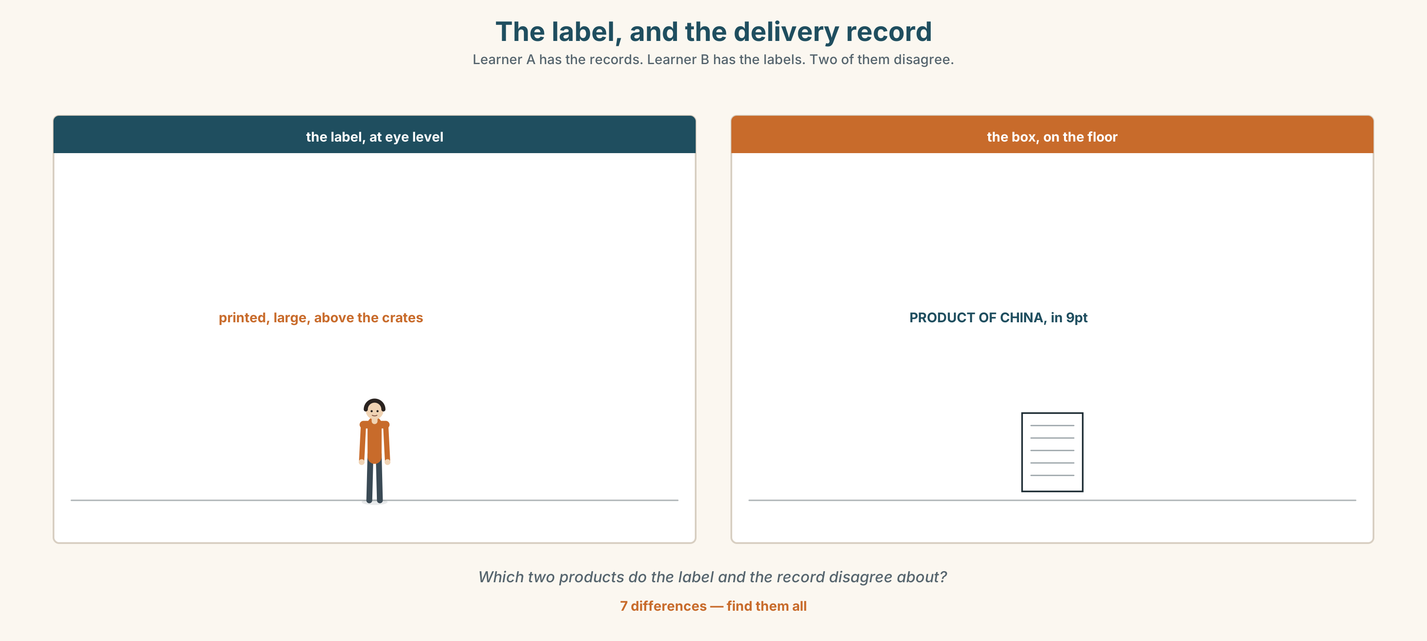{width=6.6in}
The label, and the delivery record — Learner A has the records. Learner B has the labels. Two of them disagree.
Language Bank
the origin | It's grown in… · It was made in… · It comes from…
the journey | It's brought down overnight. · It's sent by road. · Then it's packed in…
the method | by hand · by machine · at the factory
the honest gap | Nobody knows who… · The label doesn't say. · It's complicated.
Information gap. Learner A has the delivery records. Learner B has the labels. Neither sees the other. Find the two products whose labels and records disagree.

4C · The performance — eighty seconds ⏺
Trace one everyday thing back to where it started. Eighty seconds. You must give:
where it is grown or made · how it travels · what is done to it on the way · one thing you cannot find out
Record it.

4D · Observer
One person listens for one thing: did the speaker admit what they could not find out?

4E · Two criteria
☐ Did I use at least four passive forms? ☐ Did I name an agent where it mattered, and leave it out where it did not?

Part 5 · Reading ◆ A · THE WORLD

5A · Predict
A feature article. The title is "The word local is not regulated." What do you expect the article to find? One sentence.

5B · Read — one hundred and ten seconds

The word local is not regulated
There is no law in this country about the word local. It is not defined anywhere. A sign saying LOCAL PRODUCE can be hung above vegetables grown four hundred kilometres away and nothing has been broken.
We looked at forty-one stalls in one market. Twenty-nine had a sign using the word. Of those twenty-nine, eleven were selling at least one item that had been imported from another country, and all eleven were doing it openly: the boxes were stacked behind the stall with the country of origin printed on the side.
Nobody was hiding anything. That is the interesting part.
When we asked traders what local meant, we were given four answers. It meant grown in Malaysia. It meant not from a supermarket. It meant I know the man who brings it. And, from one trader who had been there thirty-one years, it meant you are buying it from me and not from somebody in an office.
That last answer is the one the sign is really making. It is not a claim about geography. It is a claim about who you are handing your money to, and on that measure every one of the twenty-nine signs was telling the truth.
The boxes, however, are still behind the stall. Somebody chose to put the sign at eye level and the boxes on the floor, and that choice was made by a person, even if nobody can now remember which one.

5C · Answer
- Is the word local defined in law?
- How many of the forty-one stalls used the word, and how many of those sold imported items?
- Why does the writer say "nobody was hiding anything" is the interesting part?
- What were the four meanings traders gave?
- Which meaning does the writer think the sign is really making?
- What is the writer's last point about the boxes?

5D · Vocabulary in context
Guess from the text. Then check.
regulated · defined · at eye level · on that measure · openly

5E · The counter-text
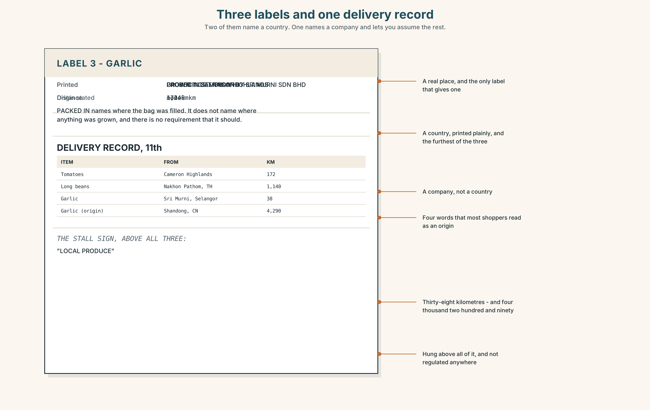{width=6.6in}
Three labels and one delivery record — Two of them name a country. One names a company and lets you assume the rest.
Read the three product labels and the delivery record, and answer.
- Which label gives a country, and which gives only a company?
- Which product travels furthest, and does its label say so?
- What does PACKED IN mean, and what does it not mean?
- One label has no origin at all. Is that legal?

5F · Two texts
The feature says eleven stalls sold imported items. The delivery record shows garlic arriving from a Selangor packer, not from abroad.
Put those two facts together. Where is the garlic from? Two sentences.

Part 6 · Vocabulary Lab 2 ◆ B · THE SYSTEM

How things are made and moved
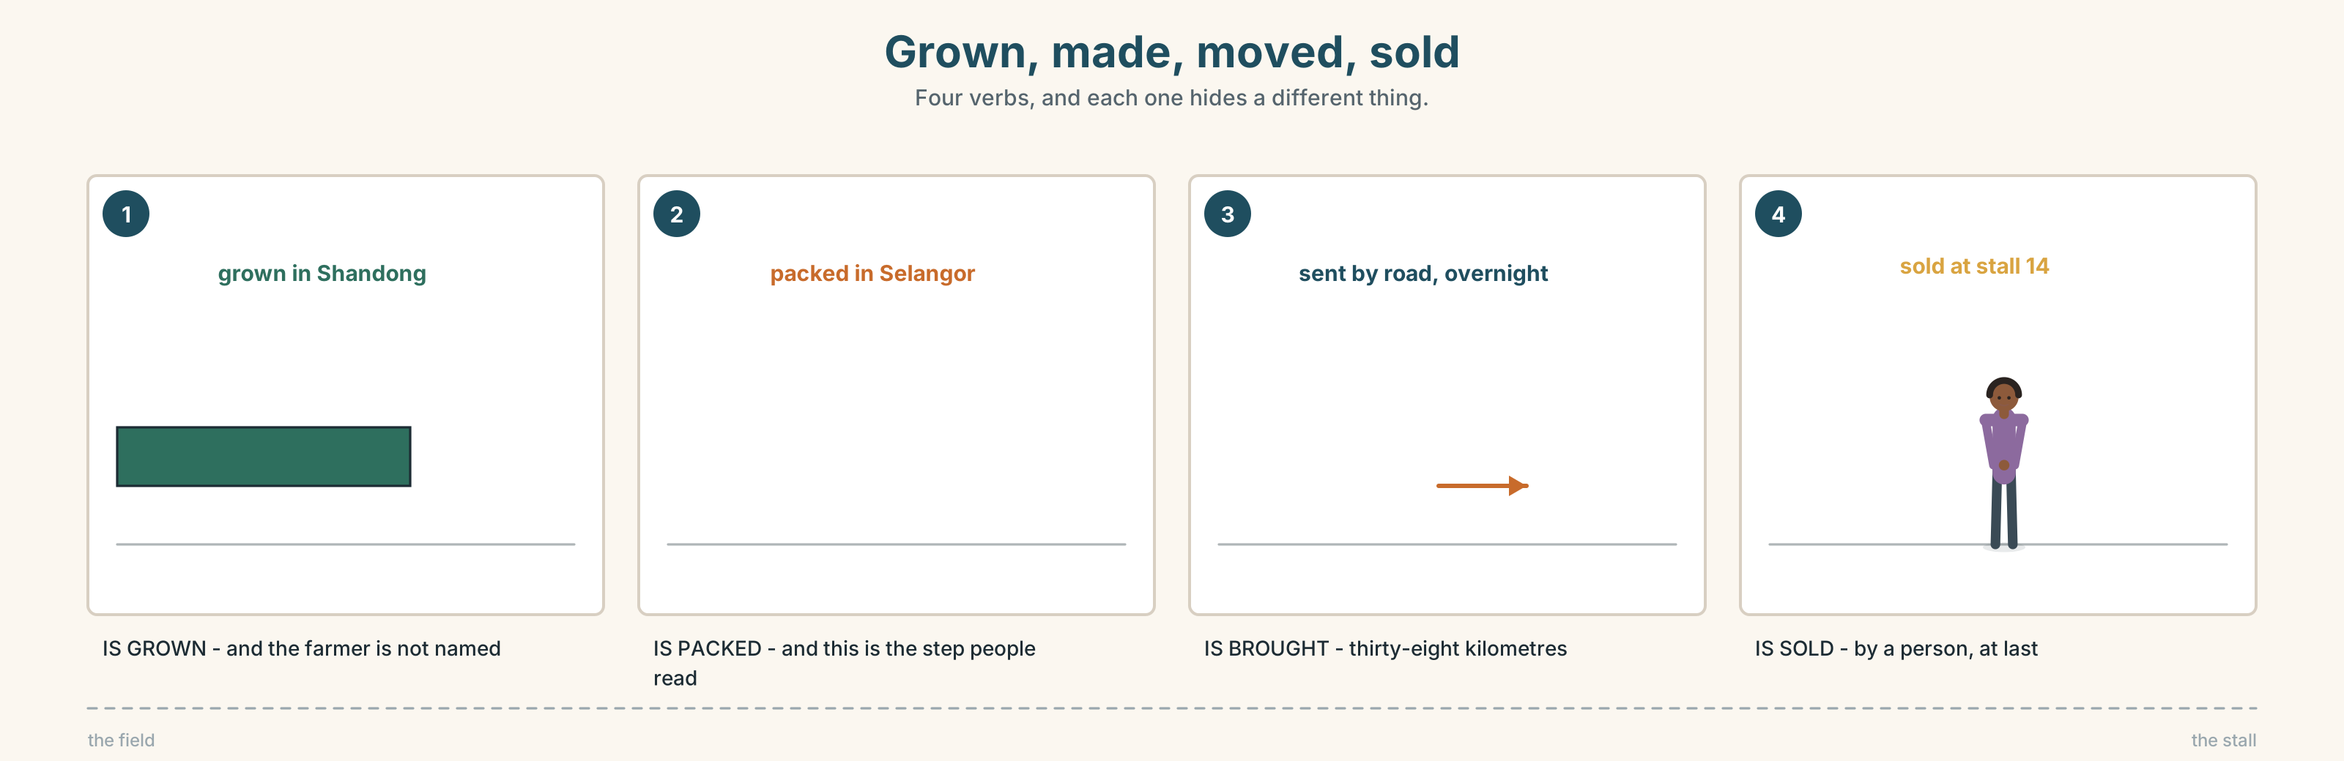{width=6.6in}
Grown, made, moved, sold — Four verbs, and each one hides a different thing.

6A · Sort — grown, made, or moved?
Three columns.
grown · made · built · sold · sent · brought · taken · given
Two of them could be in two columns. Which, and with what?

6B · Chunk completion
- These are made ______ Vietnam.
- The beans are grown ______ Johor.
- The house was built ______ my grandfather.
- It's sold ______ the far end, not here.
- Each one is finished by ______ — you can see the marks.
- The rest are cut by ______ , four hundred an hour.

6C · Three words that hide a step
packed · processed · distributed
Each of these tells you something was done — and hides where the thing started.
Write one sentence with each, and then rewrite it naming the country of origin.
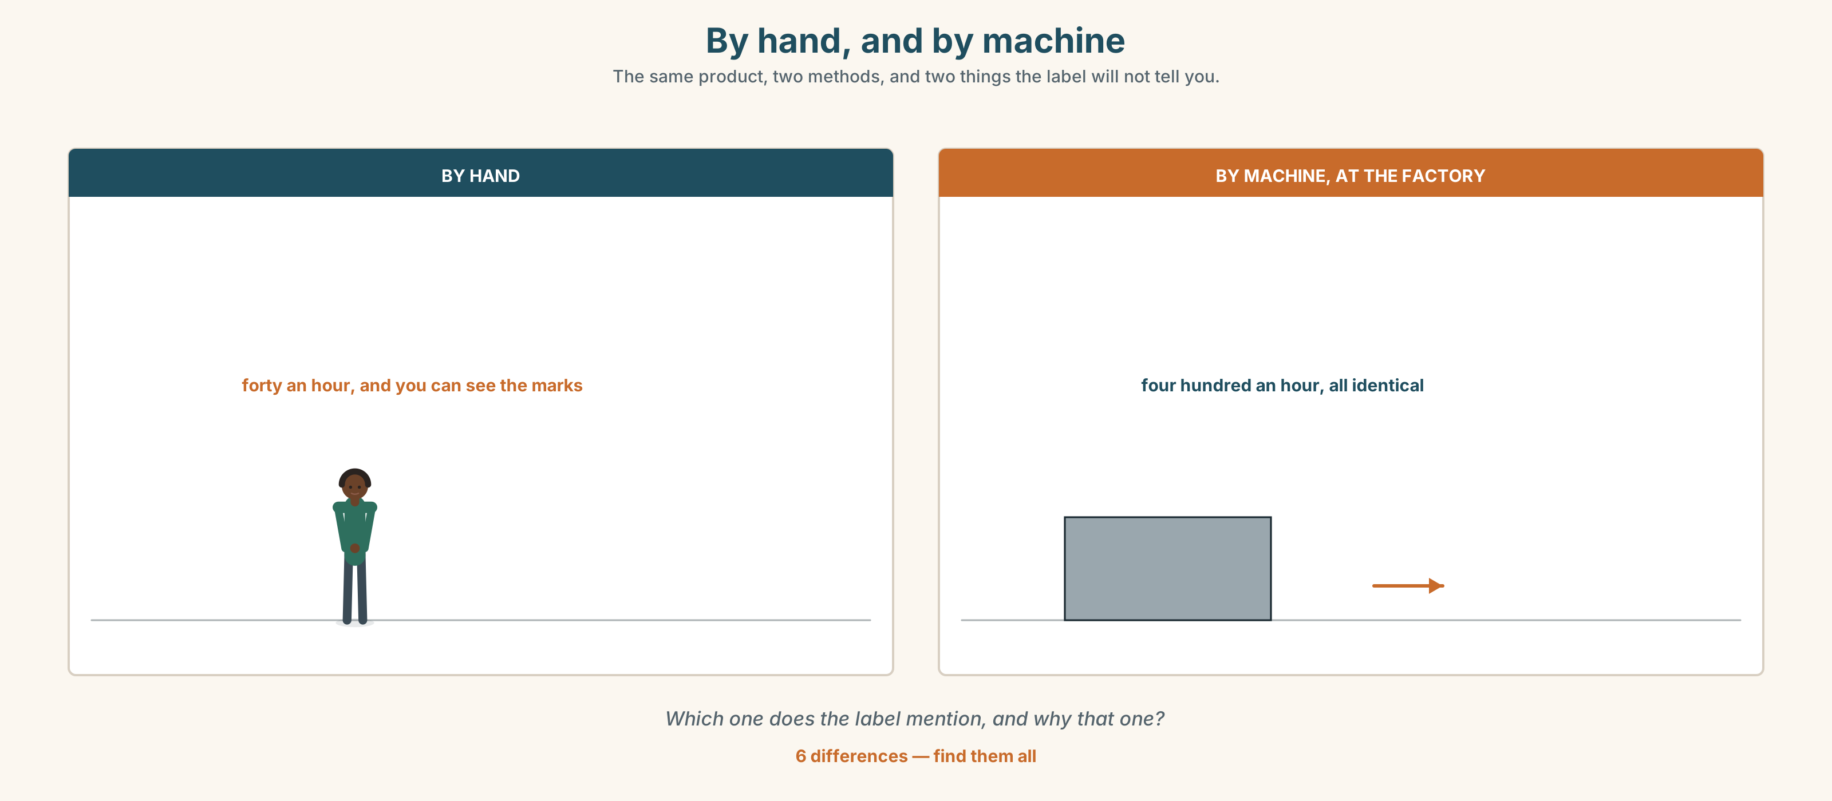{width=6.6in}
By hand, and by machine — The same product, two methods, and two things the label will not tell you.
Six differences. Find them, then answer the question under the picture.

6D · Contrast Clinic — active or passive
Six items. Choose the better one, and say why.
- Somebody stole the scales. / The scales were stolen.
- My grandfather built this house. / This house was built by my grandfather.
- They grow garlic in China. / Garlic is grown in China.
- Mistakes were made. / We made a mistake.
- The sign was put up last year. / Somebody put the sign up last year.
- The crates are brought down overnight. / They bring the crates down overnight.

Part 7 · Pronunciation & Fluency Lab ◆ B · THE SYSTEM

The -ed you cannot hear
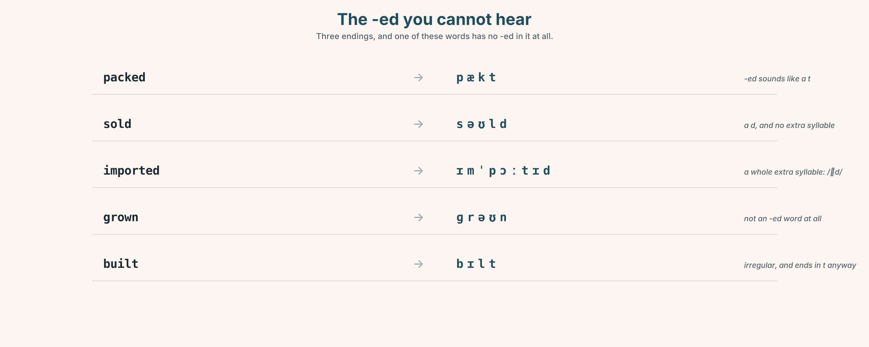{width=6.6in}
The -ed you cannot hear — Three endings, and one of these words has no -ed in it at all.

7A · Hear 🔊 Track 7.3
packed → /pækt/ — a t grown → /ɡrəʊn/ — not an -ed word at all imported → /ɪmˈpɔːtɪd/ — a whole extra syllable sold → /səʊld/ — a d

7B · Say
Say each one. Then say the sentence three times, faster:
It's grown in China, packed in Selangor and sold here.

7C · Make it mean something
Say these two:
It's PACKED in Selangor. (and that is all that happens there) It's packed in SELANGOR. (not here, whatever the sign says)
Which one is an accusation?

7D · Fluency 20 ⏺
Twenty seconds: three things in this room, and where each was made. Three times, faster.

Part 8 · Writing ◆ C · THE PERFORMANCE

Where it comes from · 90 words
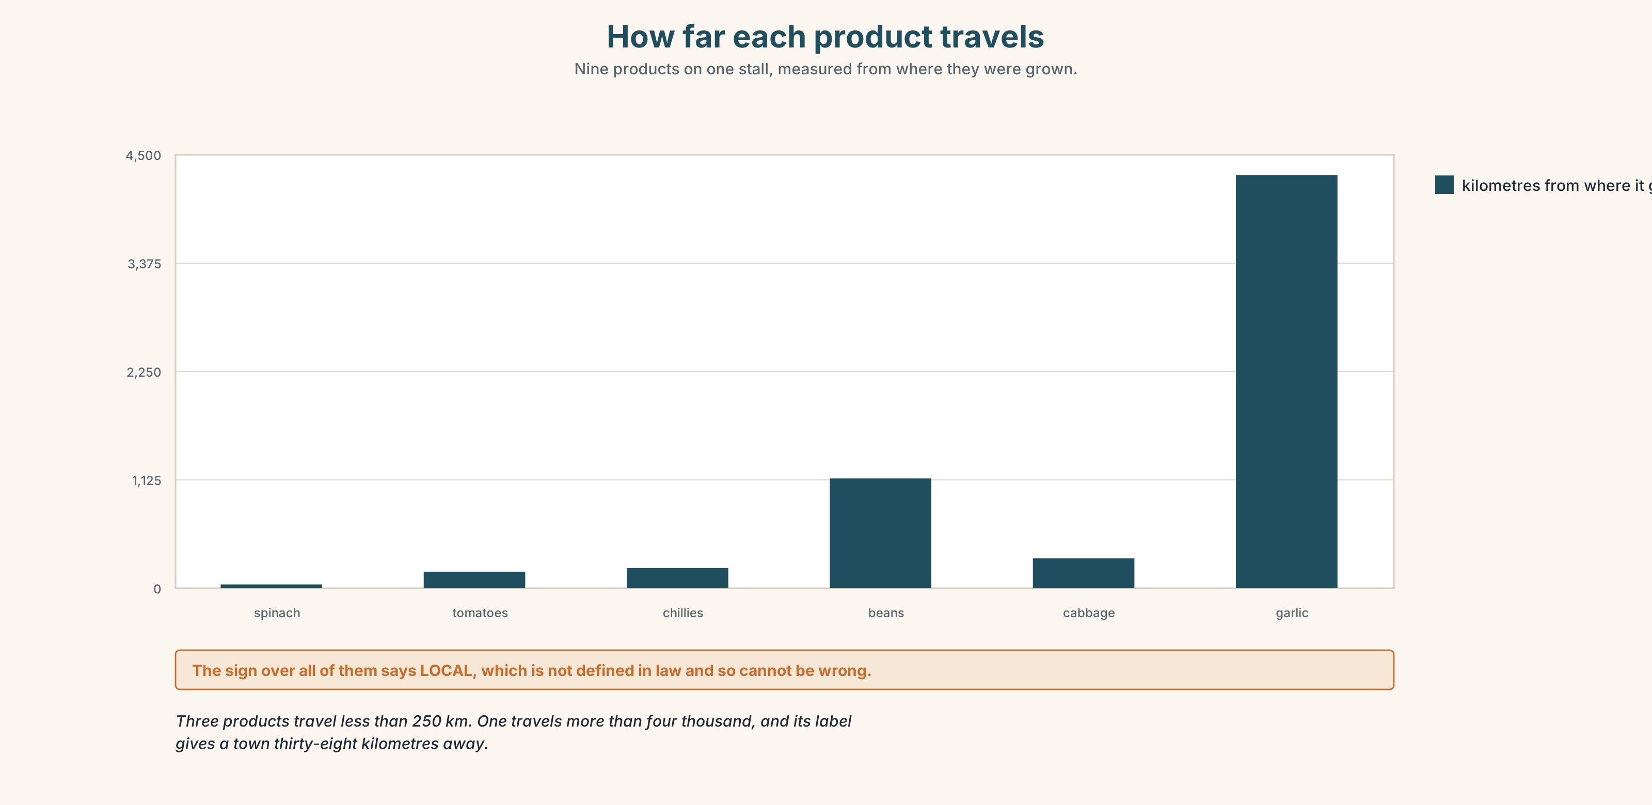{width=6.6in}
How far each product travels — Nine products on one stall, measured from where they were grown.

8A · Read the model
The coffee is grown in Aceh, about 1,400 km from here, on farms of two or three hectares. [a number, and it is the distance — which is the fact the label leaves out]
It is picked by hand, dried on concrete beside the road, and sold to a buyer who comes up the valley twice a month. Then it is sent to Medan and roasted there. [four passives, no agents, because none of them would help]
I do not know who the buyer is. Nobody I asked knew his name, and he has been coming for eleven years. [the honest gap, and it is specific]
Questions about the writer's choices:
- Four passives in one paragraph and no agent in any of them. Is that evasive here?
- The last paragraph admits ignorance. What does that do to the first two?

8B · The anti-model
This product comes from a beautiful region with a long tradition. It is produced using traditional methods by local farmers who care about quality. It is then exported all over the world.
Correct English, and it could be about anything. Name three facts it is missing.

8C · Plan
where it starts, with a distance → what is done to it, in order → where it is sold → one thing you could not find out

8D · Write — 90 words

8E · Peer review — two criteria
☐ Is there a distance or a date? ☐ Is there one honest gap?

8F · Write it again · 8G · Publish
On the wall, with the three labels from Part 5E beside it.

Part 9 · The File ◆ A · THE WORLD + C · THE PERFORMANCE

WORK FILE · The Remote Problem
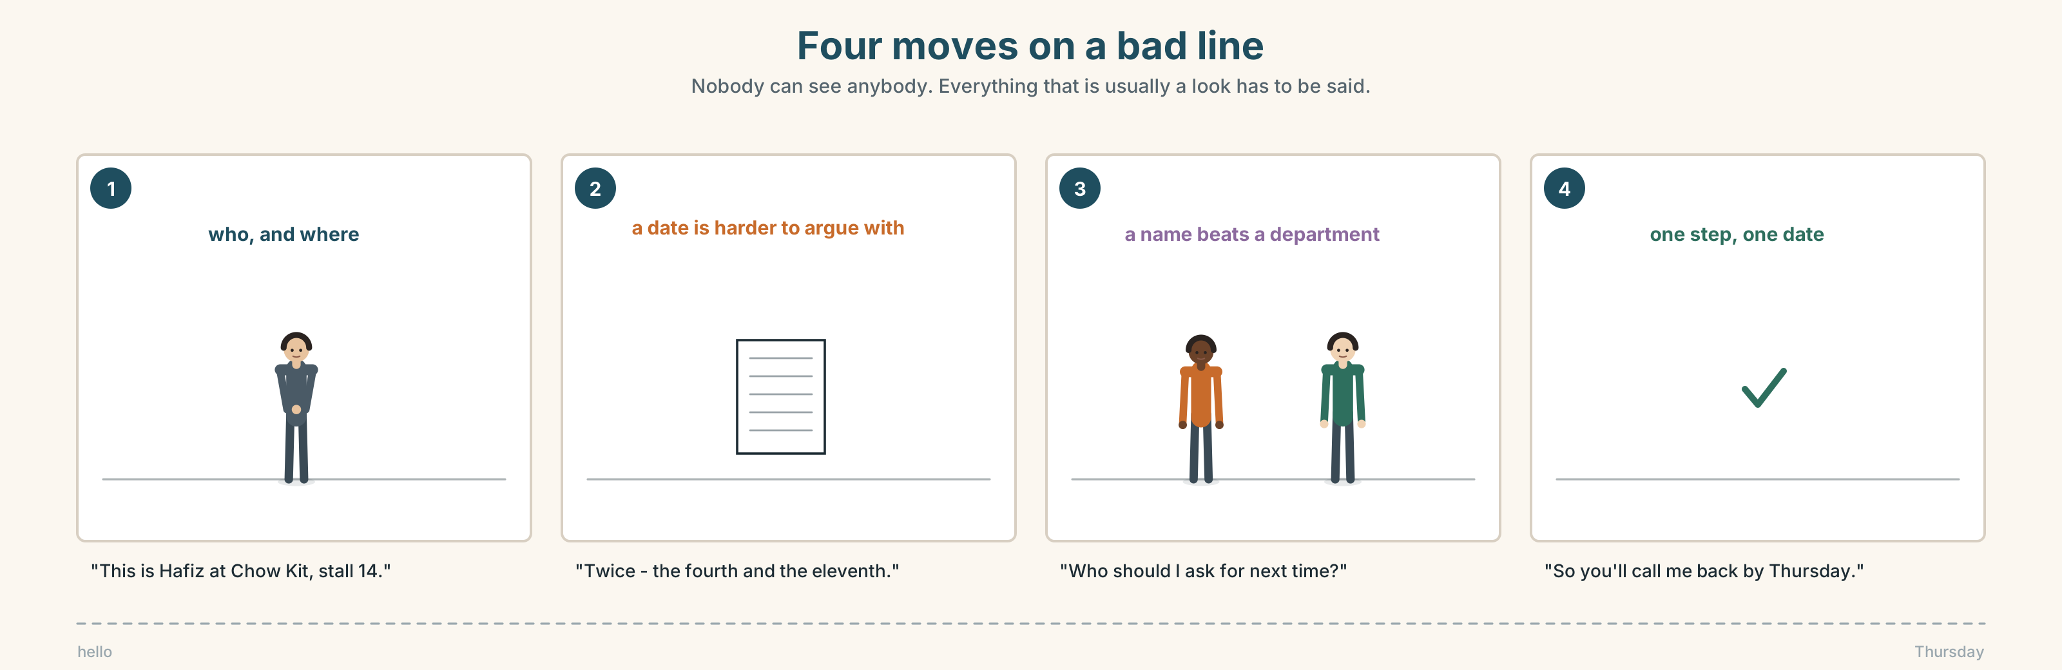{width=6.6in}
Four moves on a bad line — Nobody can see anybody. Everything that is usually a look has to be said.

9A · A problem nobody is in the room for 🔊 Track 7.4
The Selangor packer has sent the wrong garlic twice. Nobody at the market has met anybody there. Listen to the call.
- How many people are on the call, and who has the authority to fix it?
- What has been agreed by the end?
- One person says something that stops the call going round in circles. What?

9B · The four moves on a bad line
saying who you are · stating the problem with a date · asking for one named person · agreeing what happens by when
Match each to one phrase.
"This is Hafiz at Chow Kit, stall 14." · "Twice — the fourth and the eleventh." · "Who should I ask for next time?" · "So you'll call me back by Thursday."

9C · When you cannot see each other
Being unable to see somebody changes what you have to say out loud. Which three of these do you have to say on a call that you would not say face to face?
"I'm still here." · "Sorry, go ahead." · "Can I just check I've understood?" · "Yes." · "I'm writing this down."

9D · Your turn
In pairs, back to back. Six minutes. One of you has a problem with an order. The other works for the supplier and does not have the authority to fix it. You must both leave with one named next step.

9E · Transfer
Make one real call or message this week where you ask for a named person and a date. Bring what you got.

Part 10 · Mediation & Interaction ◆ C · THE PERFORMANCE
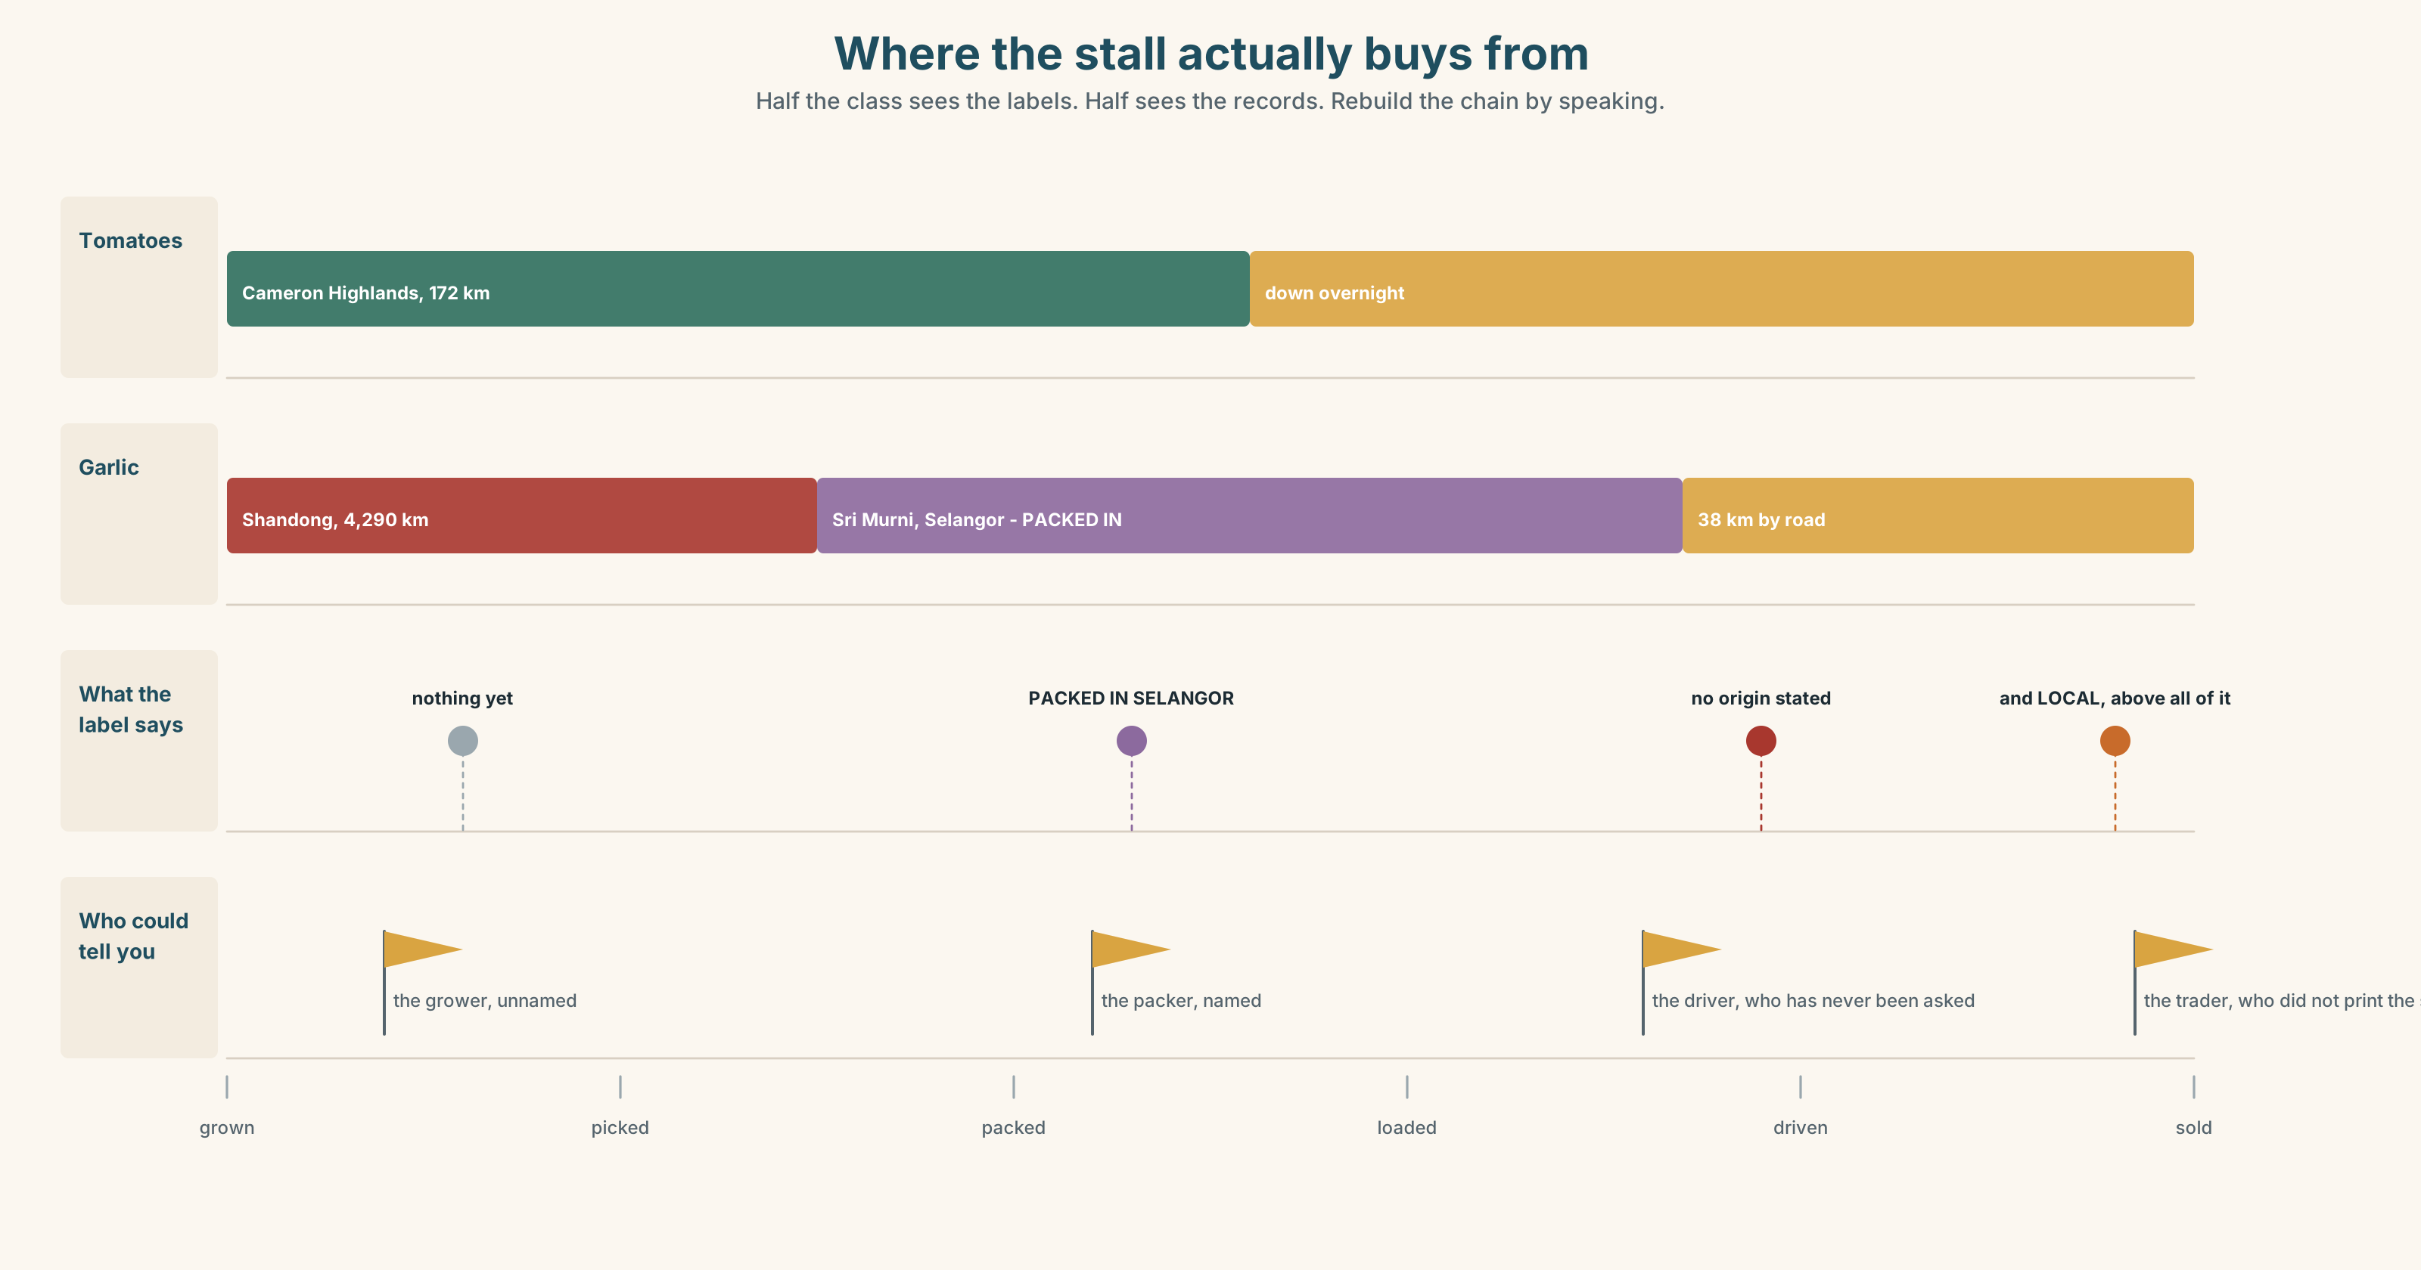{width=6.6in}
Where the stall actually buys from — Half the class sees the labels. Half sees the records. Rebuild the chain by speaking.

10A · Relay
Half the class sees the labels. Half sees the delivery records. Rebuild the whole supply chain by speaking. Ten minutes.

10B · Simplify
Explain the three labels from Part 5E to a shopper who wants to buy only Malaysian produce. Four sentences only.
Plan: which one is → which one is not → which one you cannot tell → what to ask the trader

10C · Compress
The feature in Part 5 into thirty-five words, as a card to pin beside the sign.

10D · Online
Write one message to the packer: two deliveries were wrong, you want a named contact, and you want a reply by Thursday.

10E · Your language
How does your language make a passive? Does it have one at all, or does it use people say or one does? Show a partner the label grown in China in both languages.

Part 11 · The Decision ◆ C · THE PERFORMANCE

The sign, or the sourcing
The sign above the stall says LOCAL. Half the produce under it travels four hundred kilometres, and the garlic comes from China by way of a packer in Selangor. Nothing illegal is happening.
- Change the sign. Take the word down. Lose whatever it was bringing in.
- Change the sourcing. Buy only Malaysian. Prices go up between nine and fourteen per cent and three products disappear for four months of the year.
- Change what the sign says. Keep it, and add the distances underneath, in small print.

11A · The evidence
- The three labels and the delivery record from Part 5E.
- The chart — where each product is grown, and how far it travels.
- The voice. Siti, twenty seconds: "I have never said the word local to a customer in thirty-one years. Somebody printed it and I let them hang it, which I suppose is the same thing."

11B · Talk about it
In threes. Everybody says one. Use the frame.
I think they should ______ , because ______ .
Words you can use: honest · grown · imported · price · belong · roots · foreign · trust

11C · Decide
Write two sentences. Choose, and say why.
I think they should ______________________ , because ______________________ .

11D · Model decision
They should put the distances up. The feature is right that the sign is a claim about who you hand your money to, and that claim is true — but it is being made with a word that sounds like geography, and the fix is not to argue about the word. It is to put the four hundred kilometres next to it and let the customer decide what local meant all along.

11E · The Reveal
What happened. They printed the distances on small cards and put one in front of each crate. It took an afternoon.
For three weeks almost nobody read them. Then a food writer photographed the cards and the photograph was shared about nine thousand times, mostly by people who had never been to the market, and for a month the stall was busier than it had ever been.
Two other traders copied the cards. Four were angry about it, because customers had started asking them for distances they did not know.
It worked, and then it worked too well, and it made four people's lives harder.
Was it the right decision? Say why — and say what you would say to the four.

Part 12 · Landing ◆ all three lines

12A · Recycle — ten items
- The rice ______ (grow) in Kedah.
- This house ______ (build) in 1961.
- It's made ______ Vietnam.
- She was ______ in Penang.
- I grew ______ two streets from here.
- (Unit 6) I can't afford ______ (buy) it.
- (Unit 6) Do you mind ______ (wait) ?
- (Unit 5) If it ______ (rain), we'll stay.
- (Unit 3) I ______ (use) to live here.
- (Starting Out) Where ______ you from?

12B · Consolidate
Ninety words, one paragraph. One thing in your home and where it came from. At least four passives, one by phrase, and one thing you do not know.

12C · Can-do, with evidence
I can… | My evidence | Sure?
say what is done to something without naming who | Part 3G score | ◯ ◑ ●
trace one thing back in eighty seconds | Part 4C recording | ◯ ◑ ●
write ninety words with a distance and a gap | Part 8 draft 2 | ◯ ◑ ●
get a named contact and a date on a call | Part 9D role play | ◯ ◑ ●

12D · Replay ⏺
Find your thirty seconds from Part 0C. Listen. Record it again. One sentence: what is different?

12E · Glossary — forty items, as a map
WHERE YOU STARTED · born · be born in · raise · be brought up · grow up · family · roots THE PLACE · home · village · town · country · move · move away · go back · settle · settle in THE PAPERS · passport · visa · citizen · foreign · language · accent · belong · it's complicated MADE · made · be made in · built · be built by · by hand · by machine · at the factory GROWN · grown · be grown in MOVED · sold · be sold at · sent · brought · taken · given · nobody knows who

12F · Next
Unit 8 · What are you allowed to do?

