Table of Contents

A2.1 · Unit 8 · Two Metres From the Stall
English Animated · Making Plans · Pasar Chow Kit, Kuala Lumpur Student's Book pages 160–181 · 22 pp · ~10 hours

Part 0 · The Big Picture ◆ A · THE WORLD
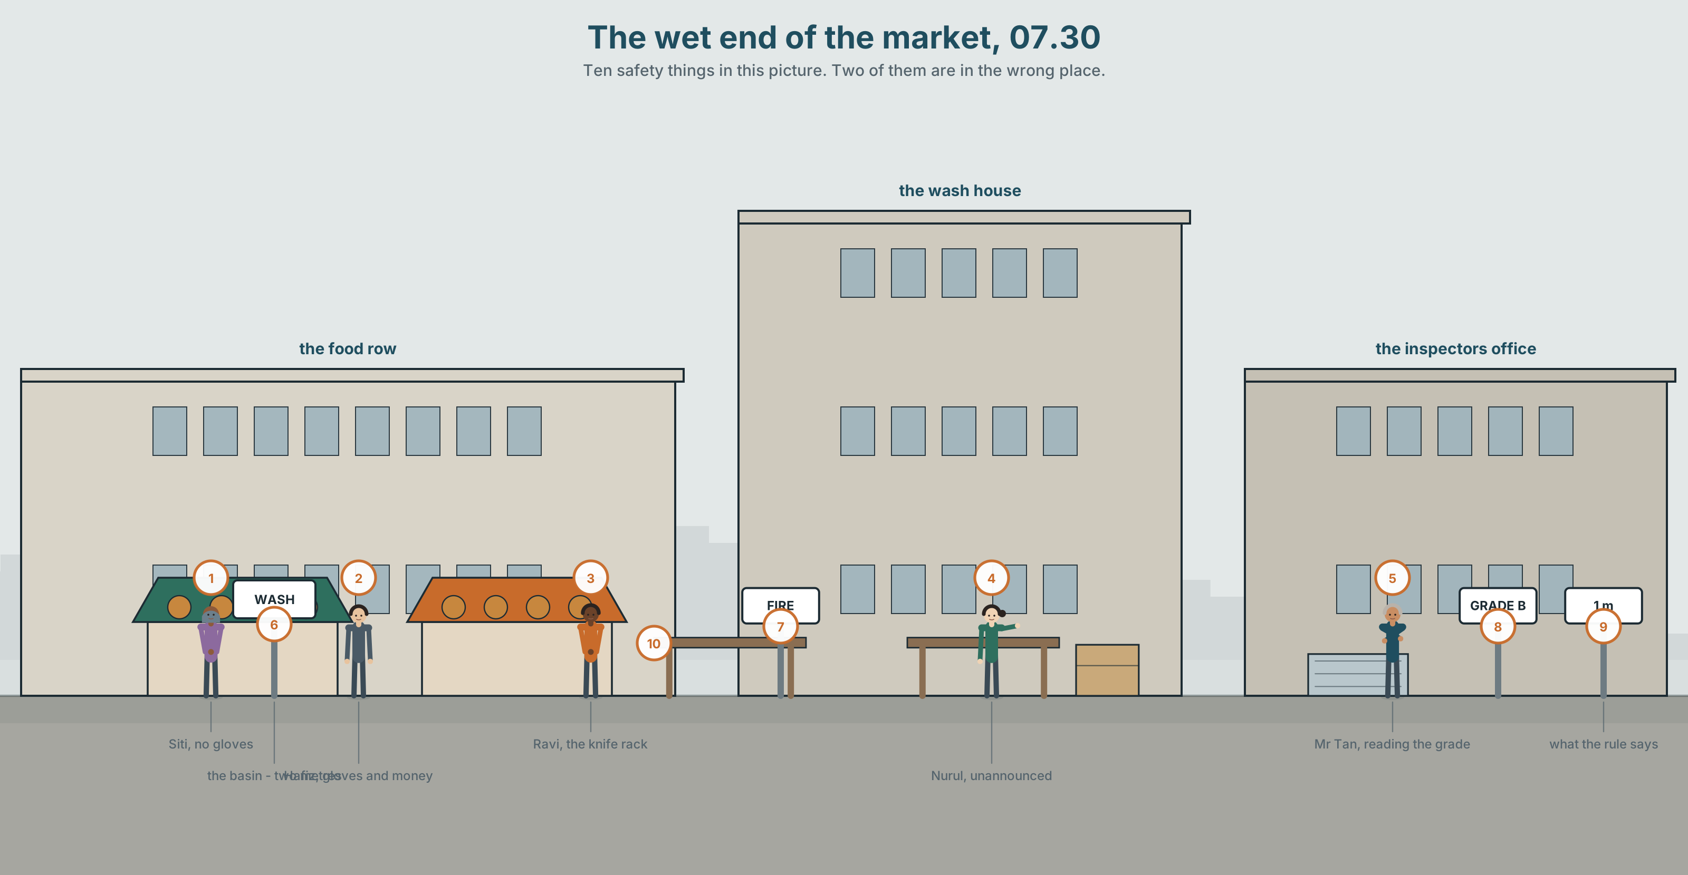{width=6.6in}
The wet end of the market, 07.30 — Ten safety things in this picture. Two of them are in the wrong place.

What are you allowed to do?
By the end of this unit you can explain the rules of a workplace to somebody on their first day — the ones that matter, and the ones everybody ignores.
◆ A · THE WORLD | Rules written for a reason, and what happens to the reason
◆ B · THE SYSTEM | have to · allowed to · supposed to · must · should · don't have to · 25 words for safety and rules · 15 ways of saying the same obligation differently · supposed to said as two syllables
◆ C · THE PERFORMANCE | The rules of a place, explained to a stranger in ninety seconds

0A · Find it
Find ten safety things in this picture. Two of them are in the wrong place.
handwash · soap · gloves · mask · helmet · fire point · first aid box · warning sign · bin · drain cover · licence on the wall · knife rack

0B · Guess it
Three of the rules in this picture are broken right now. Which, and would any of them actually hurt somebody?

0C · Say it ⏺
Record thirty seconds. Name one rule where you work or study that nobody follows. Why doesn't anybody follow it? You will record it again at the end of this unit.

Part 1 · Vocabulary Lab 1 ◆ B · THE SYSTEM
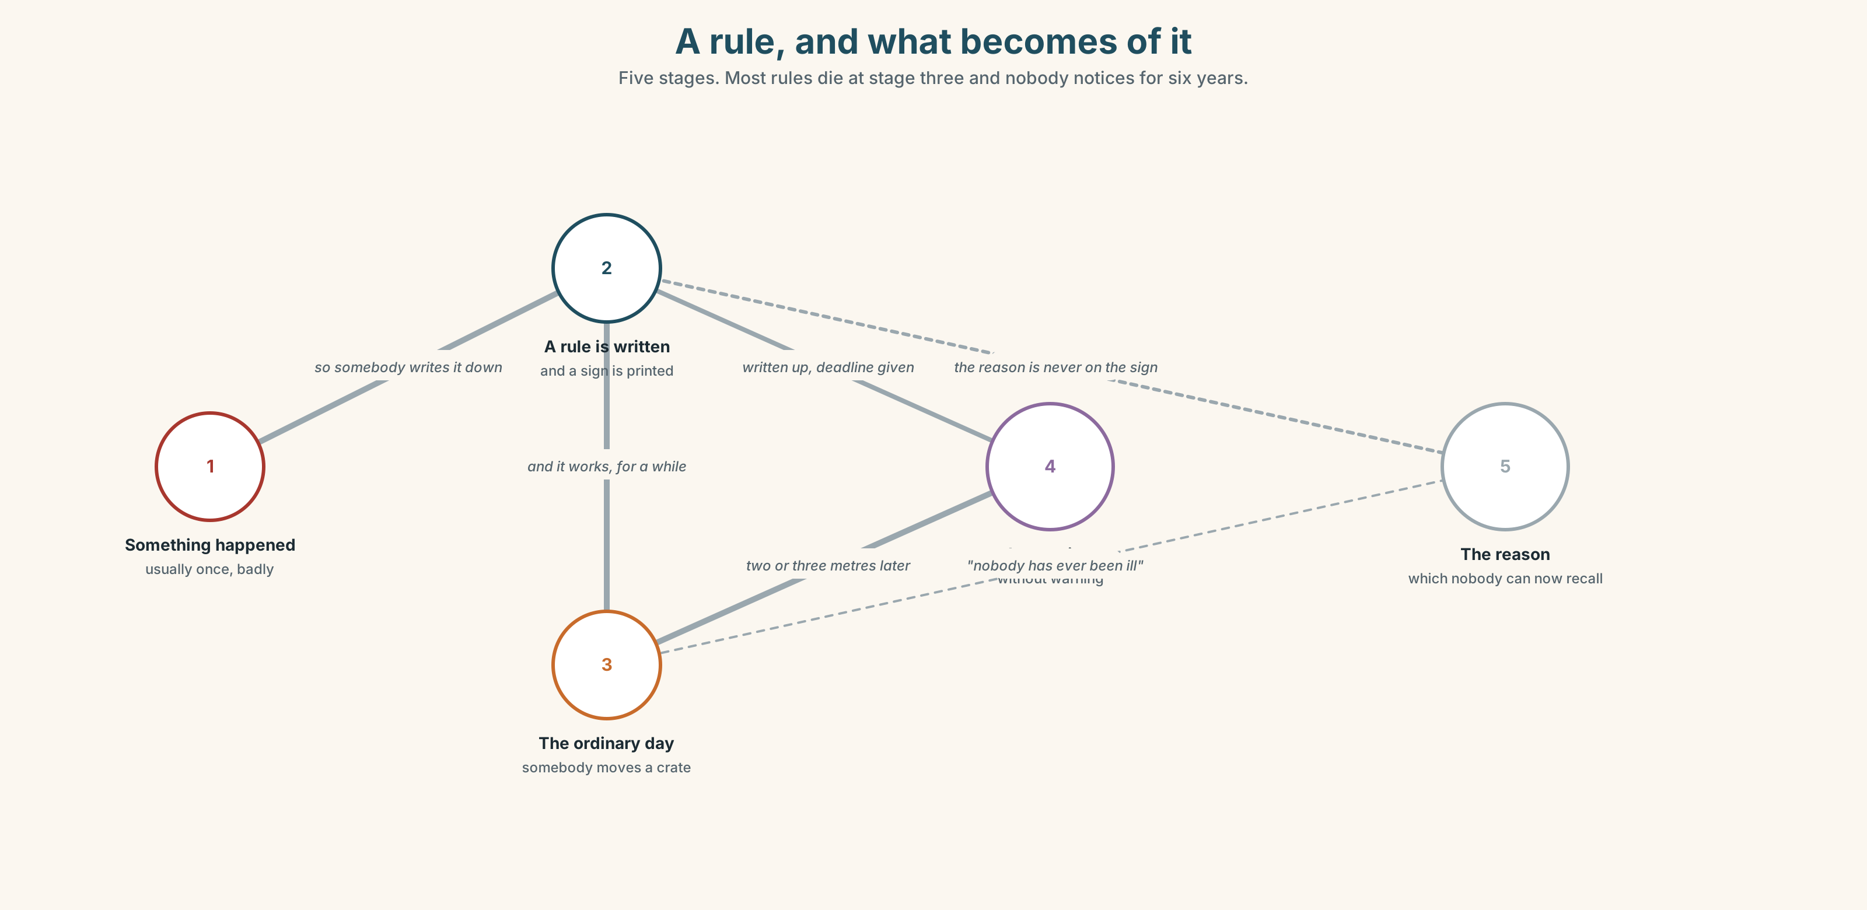{width=6.6in}
A rule, and what becomes of it — Five stages. Most rules die at stage three and nobody notices for six years.

1A · Meet — the words on the wall
Match each word to one place on the map.
rule · safety · hygiene · inspection · licence · warning · sign · fine · permission · forbidden

1B · Sort — a thing, a rule, or a consequence?
Three columns.
gloves · fine · inspection · mask · forbidden · soap · warning · helmet · licence · knife
One of them is in two columns at once. Which, and why?

1C · Meet — the words for how you do it
careful · dangerous · clean
A knife is dangerous. A dirty knife is more dangerous, and it does not look it. Give one more example from your own work or home.
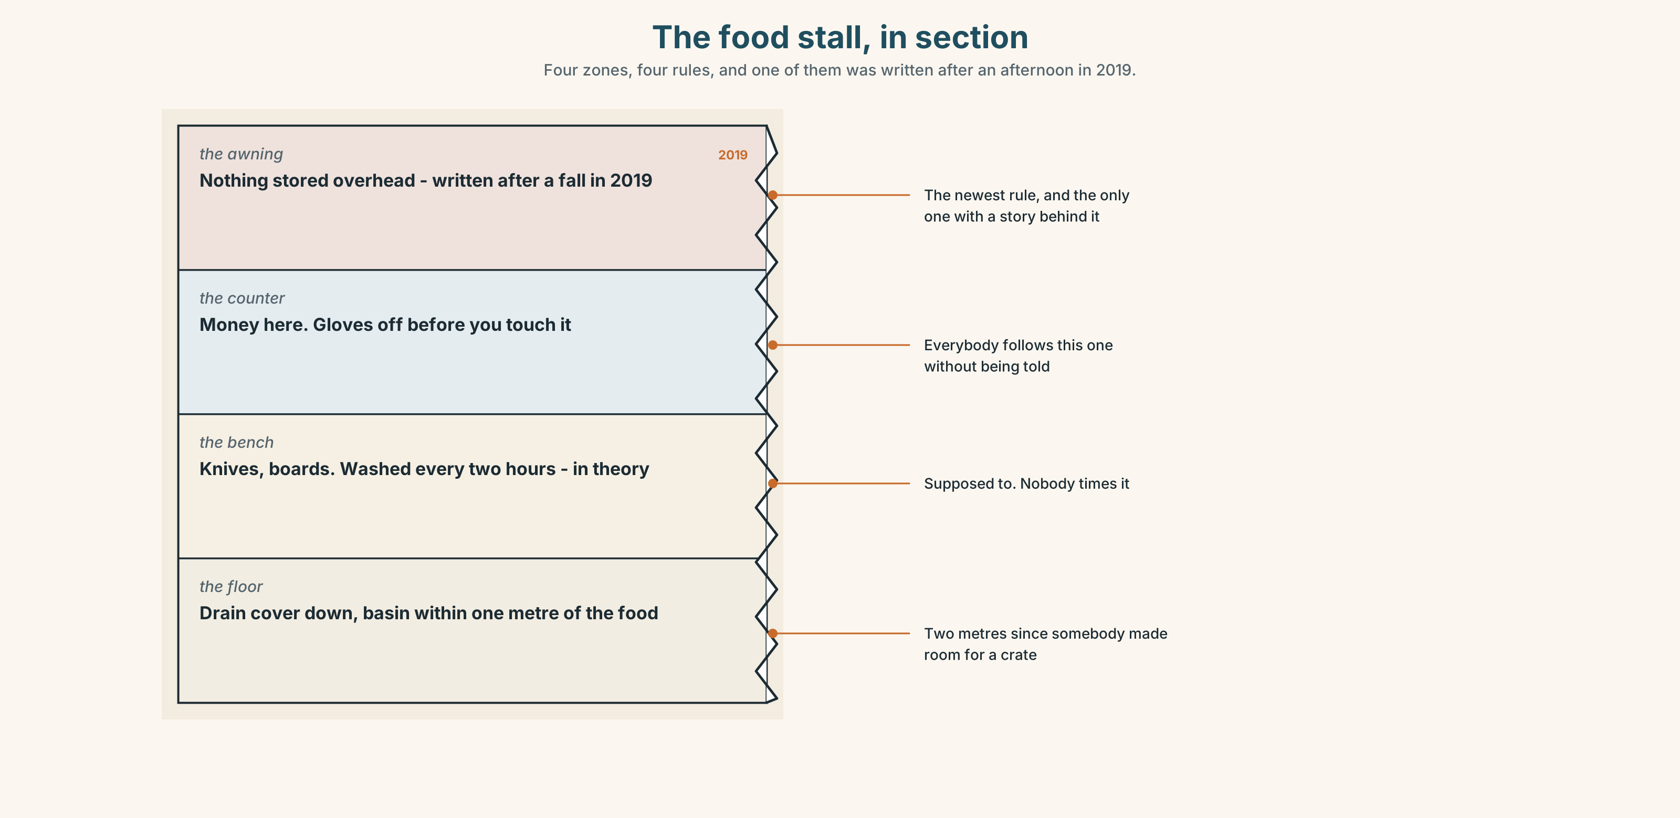{width=6.6in}
The food stall, in section — Four zones, four rules, and one of them was written after an afternoon in 2019.
Look at the food stall in section. Four zones, four rules. Which zone has the rule that was written last, and what happened to make somebody write it?

1D · Stretch — the phrases
Complete each one with one word.
- You're ______ to wash your hands before you touch the fish. (but you often don't)
- Leave your bag there at your own ______ .
- ______ your hands — the sign has been there eleven years.
- Keep ______ of the shutter when it comes down.
- Take ______ your gloves before you handle the money.

1E · The saying
f Rules are rules.
Three words that end an argument without winning it.
"It's two metres, not one. Nobody has ever been ill." — "Rules are rules."
Write the next line of that conversation — once for somebody who agrees, once for somebody who does not.

1F · Own it
Think of a place you know well. Tell a partner three sentences: one rule that matters, one rule that does not, and one rule nobody has ever explained to you.

Part 2 · Listening ◆ A · THE WORLD
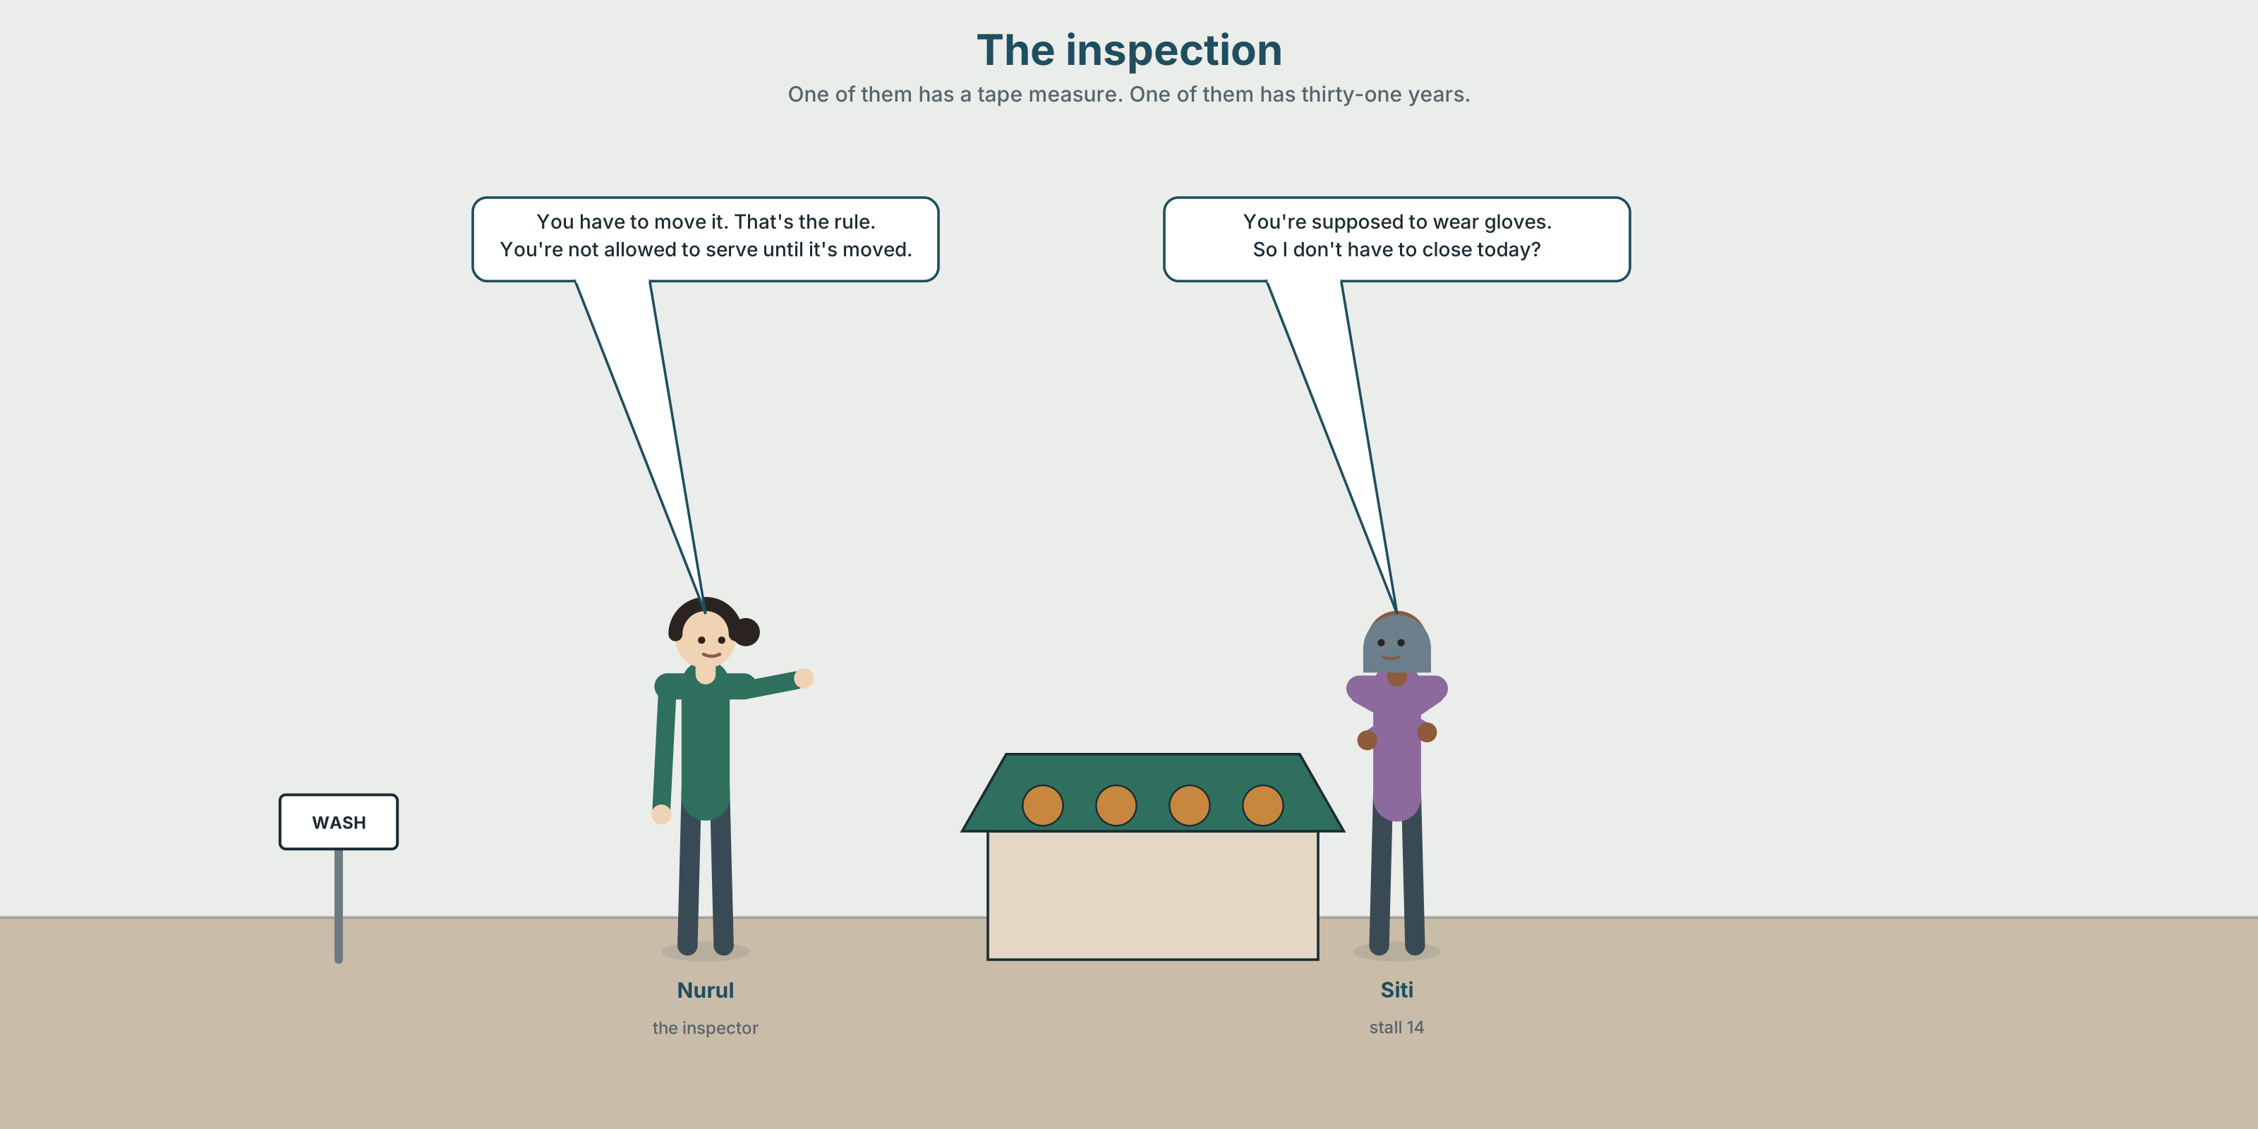{width=6.6in}
The inspection — One of them has a tape measure. One of them has thirty-one years.

2A · The inspection 🔊 Track 8.1
Before you listen. Nurul inspects food stalls. She arrives without warning. Guess: does she tell people what she has found straight away?
Listen once. One question. What is the problem she finds?
Listen again. Complete the table.
 | What the rule says | What is actually there | What happens now
handwash
gloves
the drain
Listen again. Choose.
- The handwash must be within one / two / three metres.
- Siti has to / doesn't have to / is supposed to close while it is fixed.
- The gloves are required / recommended / forbidden.
- The fine is 100 / 400 / nothing, this time.
Noticing. Four sentences from the recording.
- You have to move it. That's the rule.
- You're supposed to wear gloves.
- You don't have to close today.
- You're not allowed to serve until it's moved.
Two of these are absolute. Two leave you room. Which are which?

2B · Decoding clinic 🔊 Track 8.2
Twenty-five seconds of Nurul. Four jobs.
- How many times does she say have to or supposed to?
- In supposed to, how many syllables can you hear?
- Catch the distance and the fine.
- She softens one sentence at the end. How?
Transcripts, page 157.

Part 3 · Grammar Lab 1 ◆ B · THE SYSTEM

Six ways of saying you must

3A · Notice
Look at the four sentences in Part 2.
- Sentence 1 and sentence 2 are both rules. Which one does she expect you to break?
- Sentence 3 has don't have to. Does it mean the same as mustn't?
- Sentence 4 is a ban. Which words make it one?
- have to, supposed to, allowed to. Put them in order, strongest first.
- Try "You don't must close today." What is wrong?

3B · See
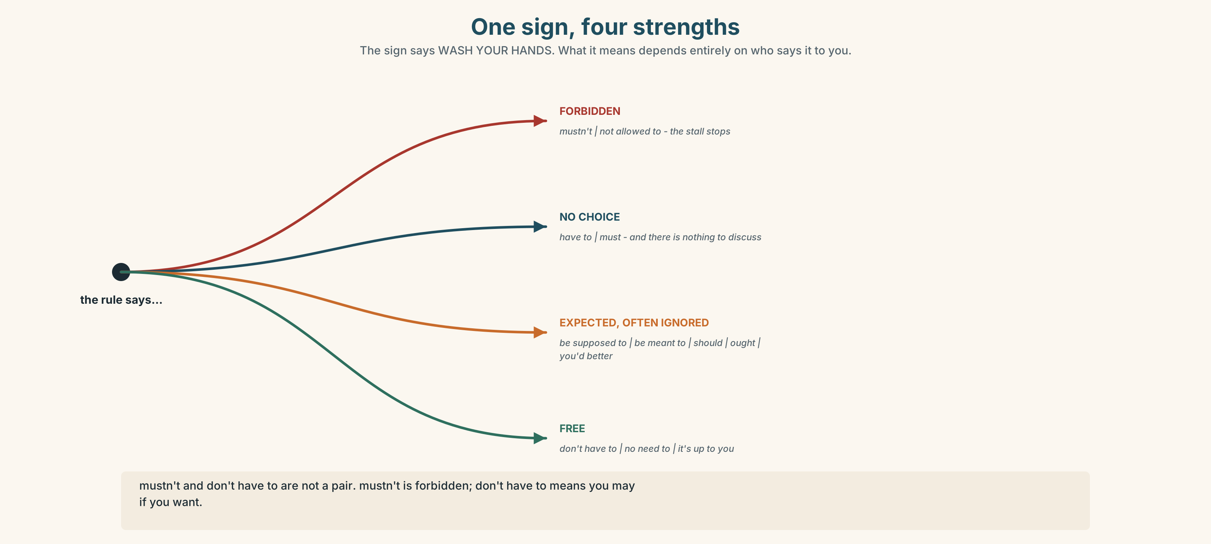{width=6.6in}
One sign, four strengths — The sign says WASH YOUR HANDS. What it means depends entirely on who says it to you.
Now look at the second picture. The ladder runs from forbidden to free. Where does supposed to sit, and why is it the most interesting rung?
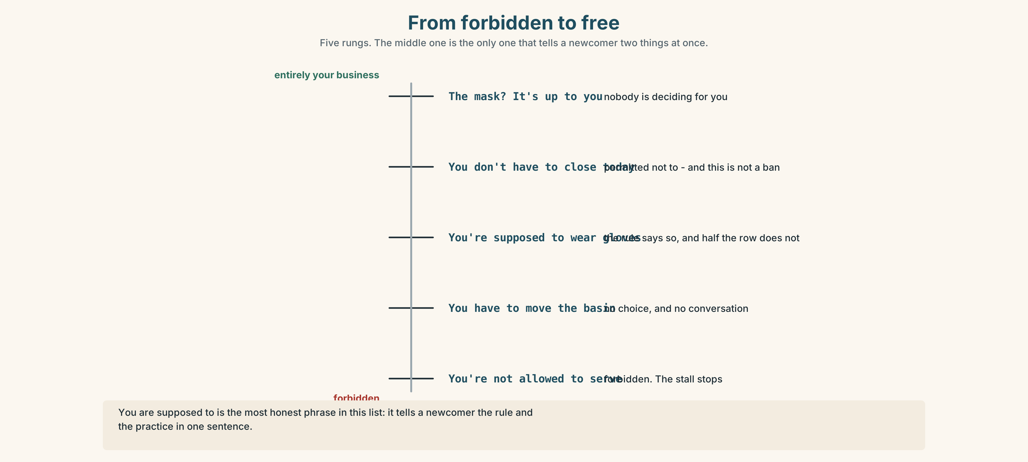{width=6.6in}
From forbidden to free — Five rungs. The middle one is the only one that tells a newcomer two things at once.

3C · Know
 | Meaning | Example
have to / must | no choice | You have to move it.
be not allowed to / mustn't | forbidden | You*'re not allowed to** serve.*
be supposed to / be meant to | the rule says so, and people often don't | You*'re supposed to** wear gloves.*
should / ought to / you'd better | advice, with weight | You should report it.
don't have to / no need to | free to choose | You don't have to close today.
it's up to you | nobody is deciding for you | The mask? It's up to you.
The one everybody gets wrong. mustn't = it is forbidden. don't have to = you may if you want. ✗ You don't have to smoke here. (if you mean it is banned)
Why it matters. You're supposed to is the most honest phrase in this list. It tells a newcomer both what the rule is and that people break it, which is exactly what they need to know on their first morning.

3D · Use — controlled
You (1) __________ (have to) wash your hands before you touch the fish — that one is not negotiable. You (2) __________ (be supposed to) wear gloves, and half the row doesn't. You (3) __________ (not be allowed to) serve while the handwash is more than one metre away. You (4) __________ (not have to) close the stall today, but you (5) __________ (should) move the basin before Thursday. The mask is (6) __________ to you.

3E · Use — guided
Rewrite each one so it is weaker — still true, but leaving room.
- You must wear gloves.
- You are not allowed to park here.
- You have to report it the same day.
- Smoking is forbidden.
- You must not leave the knife out.

3F · Use — open
In pairs. One of you is new. The other explains four rules: one that matters, one that nobody follows, one that is advice, and one that is a genuine ban. Four minutes.

3G · Check — six items
- You ______ (not / allowed) park here.
- You ______ (not / have) come if you're ill — stay at home.
- We're ______ to sign in, but nobody does.
- You ______ wear a helmet on this side. (it is the law)
- You ______ report it today. (my advice)
- The mask is ______ to you.
0–3 → Workbook pp. 46–48. 4–5 → Part 6. 6 → page 173.

Part 4 · Speaking ◆ C · THE PERFORMANCE

4A · Fluency starter — strongest to weakest
Your teacher reads a rule. Each learner must restate it one step weaker than the last person.
"You must wear gloves." → "You're supposed to wear gloves." → "You should…" → …
The round ends when somebody reaches it's up to you.

4B · The functional core — explaining the rules
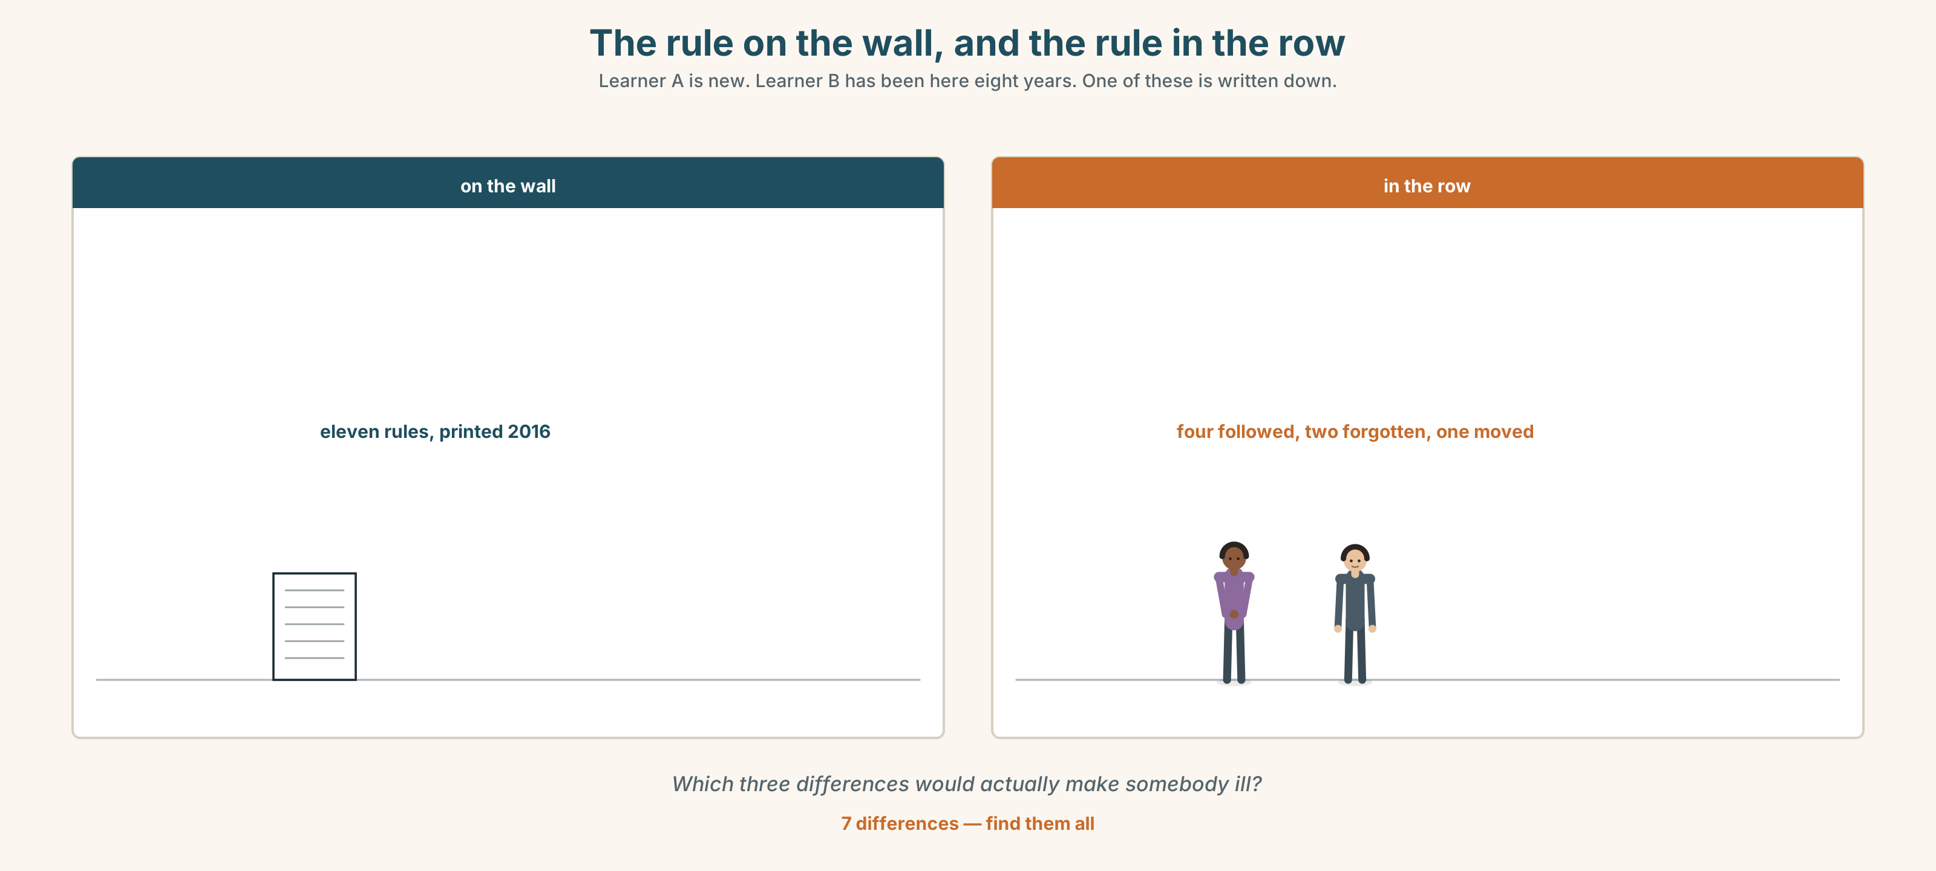{width=6.6in}
The rule on the wall, and the rule in the row — Learner A is new. Learner B has been here eight years. One of these is written down.
Language Bank
the real rule | You have to… · You're not allowed to… · That one is not negotiable.
the paper rule | You're supposed to… · You're meant to… · Officially, yes.
the advice | You'd better… · I'd report it. · There's no need to, but…
the honest ending | It's up to you. · Nobody will say anything. · Until somebody does.
Role play. Learner A is on their first morning. Learner B has worked here eight years. Eight rules in six minutes. Learner A must ask about one rule twice.

4C · The performance — ninety seconds ⏺
Explain the rules of one place to somebody arriving tomorrow. Ninety seconds. You must include:
one rule that matters · one that nobody follows · one piece of advice · one thing that is genuinely up to them
Record it.

4D · Observer
One person listens for one thing: did the speaker make clear which rules are real?

4E · Two criteria
☐ Did I use at least four different strengths of obligation? ☐ Would a newcomer now know which rule to break first?

Part 5 · Reading ◆ A · THE WORLD

5A · Predict
An interview with a food safety inspector. The title is "I am not trying to catch anybody." Do you believe that? One sentence, before you read.

5B · Read — one hundred seconds

"I am not trying to catch anybody" An interview with a market food safety inspector
You arrive without warning. Why? Because a stall that is clean on Tuesday because I told them I was coming on Tuesday tells me nothing. I am not trying to catch anybody. I am trying to see the ordinary day.
What do you find most often? Handwash in the wrong place. The rule is one metre. It is almost always two or three, because somebody moved it to make room for a crate in 2019 and nobody moved it back.
Does that actually matter? Yes, and I will tell you exactly why, because people assume it is paperwork. At one metre you wash your hands between the money and the food, because the basin is in the way. At three metres you have to decide to wash them. Nobody decides forty times an hour.
What do you do when you find it? I write it down and I give them until the end of the month. I close a stall perhaps twice a year, and both times it is something I could smell from the aisle.
Do traders lie to you? Almost never. They tell me the truth and then they tell me why the rule is stupid, and about a third of the time they are right. I write that down too. Nobody reads it.

5C · Answer
- Why does she arrive without warning?
- What does she find most often, and why is it usually there?
- What is her argument for why one metre matters? Put it in your own words.
- How long does she usually give traders?
- How often does she close a stall, and for what?
- What does she do when a trader says a rule is stupid?

5D · Vocabulary in context
Guess from the text. Then check.
the ordinary day · paperwork · in the way · from the aisle · about a third of the time

5E · The counter-text
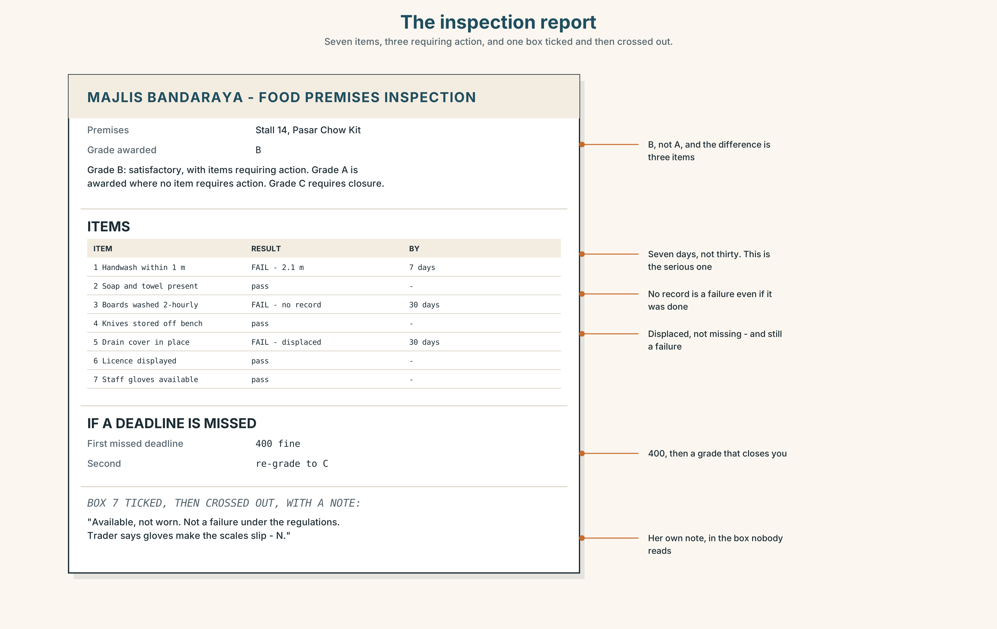{width=6.6in}
The inspection report — Seven items, three requiring action, and one box ticked and then crossed out.
Read the inspection report and answer.
- How many items are listed, and how many are marked as requiring action?
- What is the deadline for each one, and what happens if it is missed?
- What does the grade at the top mean?
- One box has been ticked and then crossed out. Which, and what was written beside it?

5F · Two texts
The interview says she gives traders until the end of the month. The report gives a deadline of seven days for one item.
Put those two facts together. What does that tell you about that item? Two sentences.

Part 6 · Vocabulary Lab 2 ◆ B · THE SYSTEM

The same rule, said six ways
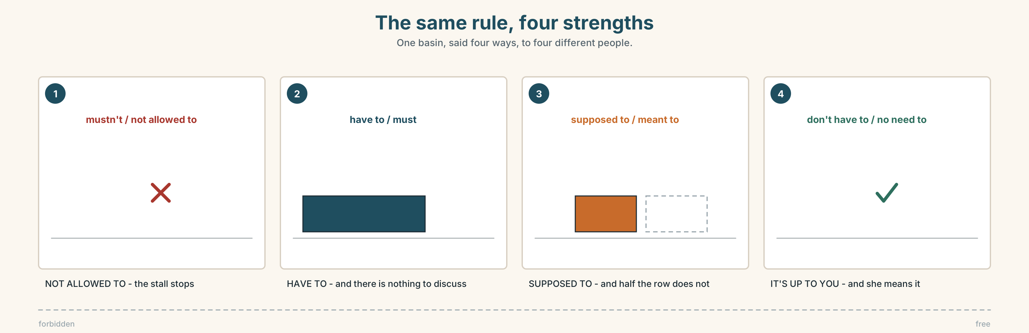{width=6.6in}
The same rule, four strengths — One basin, said four ways, to four different people.

6A · Sort — how strong?
Put these on a line from strongest to weakest.
must · should · be supposed to · be allowed to · ought · need · you'd better · it's up to you

6B · Chunk completion
- You have ______ wash your hands. (no choice)
- You don't have ______ close today. (free to decide)
- We're meant ______ sign in, but nobody does.
- You're not allowed ______ serve until it's moved.
- There's no ______ to phone — just come.
- You'd ______ move it before Thursday.

6C · Two that are not opposites
mustn't and don't have to look like a pair. They are not.
Put the right one in each, and then explain the difference to a partner in one sentence.
- You ______ touch that — it is wired to the alarm.
- You ______ come in on Saturday if you don't want to.
- Visitors ______ go past this line.
- We ______ book in advance, but it is easier if we do.
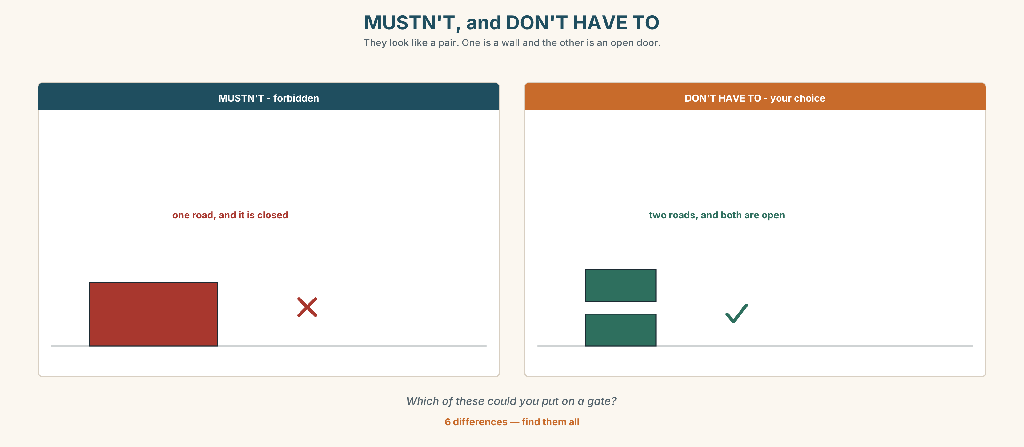{width=6.6in}
MUSTN'T, and DON'T HAVE TO — They look like a pair. One is a wall and the other is an open door.
Six differences. Find them, then answer the question under the picture.

6D · Contrast Clinic — which form
Six items.
- You ______ wear a helmet here. (the law)
- You ______ wear a mask here. (your choice)
- We ______ to wash the boards every two hours. (the rule, often ignored)
- You ______ park there. (forbidden)
- You ______ tell her today. (strong advice)
- You ______ bring anything. (no need)

Part 7 · Pronunciation & Fluency Lab ◆ B · THE SYSTEM

The phrase that lost a syllable
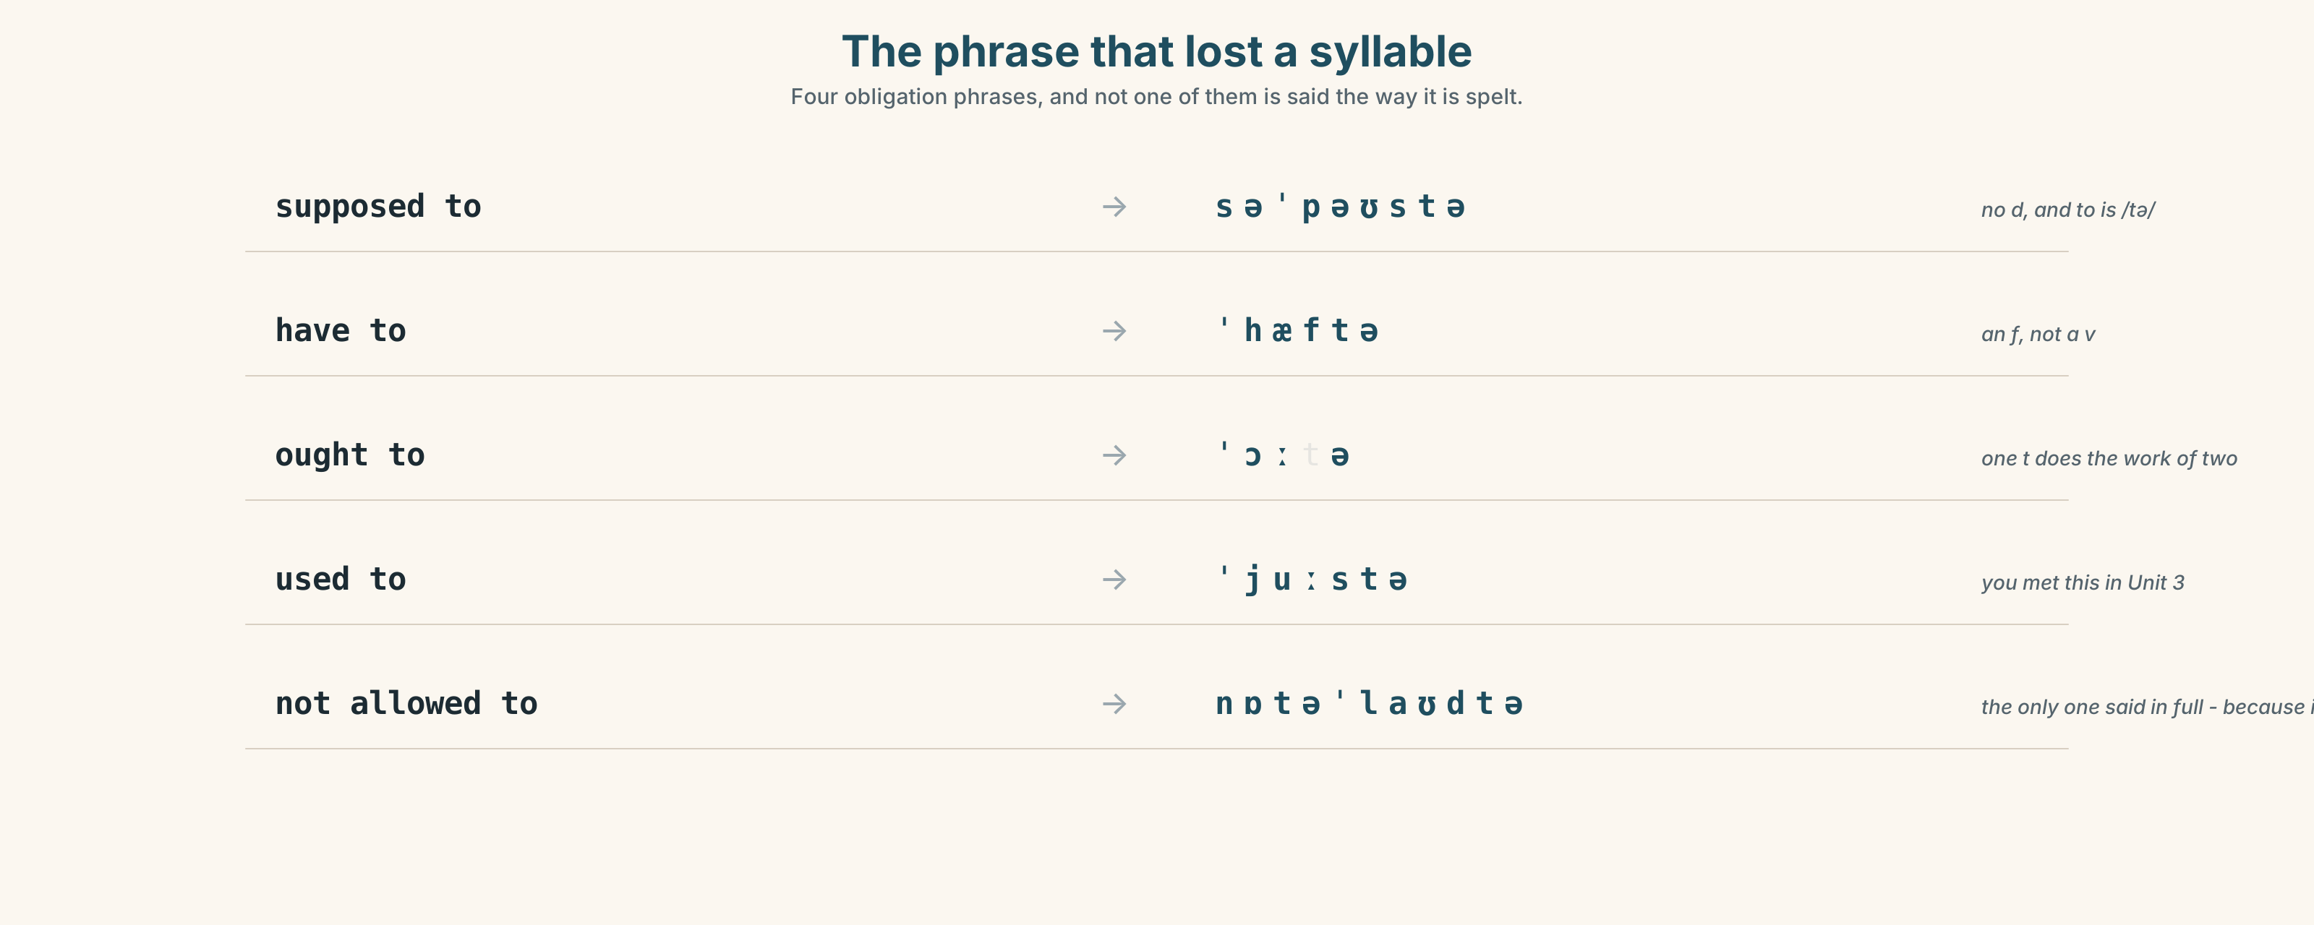{width=6.6in}
The phrase that lost a syllable — Four obligation phrases, and not one of them is said the way it is spelt.

7A · Hear 🔊 Track 8.3
supposed to → /səˈpəʊstə/ — no d, and to is /tə/ have to → /ˈhæftə/ — a f, not a v ought to → /ˈɔːtə/ used to → /ˈjuːstə/ — you met this one in Unit 3

7B · Say
Say each one. Then say the sentence three times, faster:
You're supposed to wash your hands, and you have to wear gloves.

7C · Make it mean something
Say these two:
You're SUPPOSED to. (and we both know you don't) You HAVE to. (and there is nothing to discuss)
Which one is an inspector's sentence and which one is a colleague's?

7D · Fluency 20 ⏺
Twenty seconds: three rules where you work or study, each at a different strength. Three times, faster.

Part 8 · Writing ◆ C · THE PERFORMANCE

The rules, honestly · 90 words
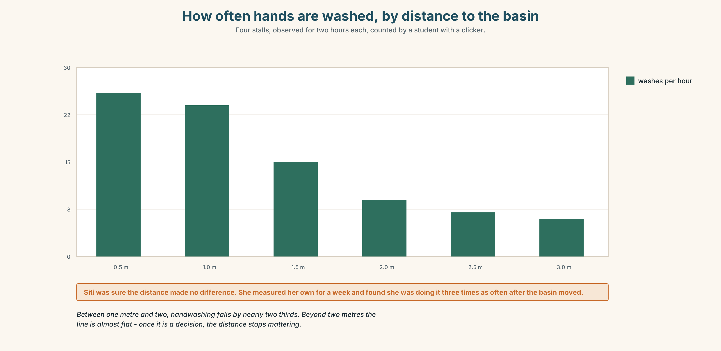{width=6.6in}
How often hands are washed, by distance to the basin — Four stalls, observed for two hours each, counted by a student with a clicker.

8A · Read the model
Wash your hands before you touch the fish. That one is not negotiable and nobody will warn you twice. [the real rule, first, and the consequence named]
You are supposed to wear gloves. About half the row does. If Nurul is in the building, wear them; otherwise do what you like, and take them off before you handle money either way. [the paper rule, the actual practice, and one piece of real advice inside it]
Nobody has ever explained the drain cover rule to me and I have been here nine years. [one honest gap, which makes the rest trustworthy]
Questions about the writer's choices:
- The second paragraph says what people actually do. Is that irresponsible?
- Why end on something the writer does not know?

8B · The anti-model
Please follow all safety rules at all times. Hygiene is very important and all staff must respect the regulations. Failure to comply may result in action being taken.
Correct English, and no newcomer is any wiser. Name two things it does not tell them.

8C · Plan
the rule that matters, with its consequence → the rule on paper, and what people do → one piece of advice → one thing you do not know

8D · Write — 90 words

8E · Peer review — two criteria
☐ Can the reader tell which rule to take seriously? ☐ Is there one honest admission?

8F · Write it again · 8G · Publish
On the wall, with the inspection report from Part 5E beside it.

Part 9 · The File ◆ A · THE WORLD + C · THE PERFORMANCE

STUDY FILE · Reading at Speed
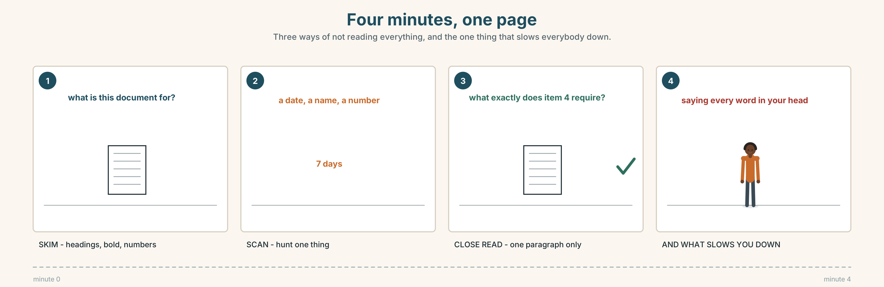{width=6.6in}
Four minutes, one page — Three ways of not reading everything, and the one thing that slows everybody down.

9A · Four minutes, one page
You have four minutes and a two-page inspection report. You need three things from it.
the grade · the deadline · which items need action
Do not read it. Find them. Then compare with a partner: where did you look first?

9B · Three ways of not reading everything
skimming — the shape of the page: headings, bold, numbers scanning — hunting one thing: a date, a name, a word close reading — the one paragraph that decides something
Match each to one of these tasks.
Is there a fine? · What is this document for? · What exactly does item 4 require?

9C · What slows you down
Which of these actually slow a reader? Mark three.
long words · reading every word aloud in your head · an unfamiliar layout · words you half-know · going back · a page with no headings

9D · Your turn
A second report, three minutes. Six questions. Then: which question did you answer last, and why that one?

9E · Transfer
Take one page of anything this week — a bill, a notice, an email. Give yourself ninety seconds and write the three things it wants from you.

Part 10 · Mediation & Interaction ◆ C · THE PERFORMANCE
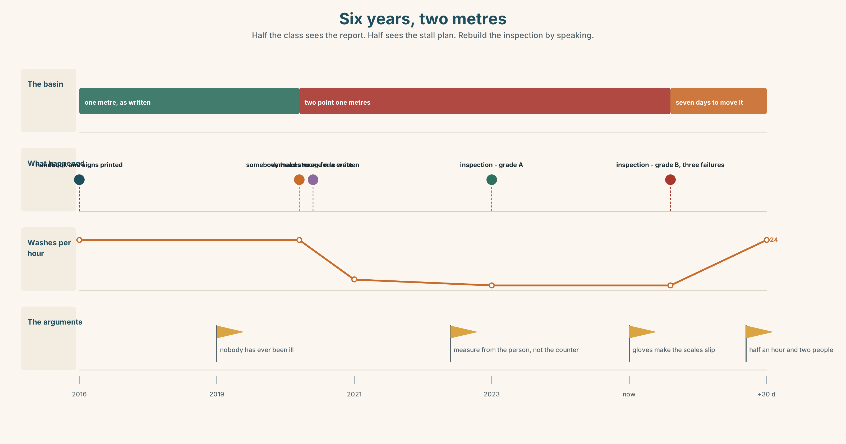{width=6.6in}
Six years, two metres — Half the class sees the report. Half sees the stall plan. Rebuild the inspection by speaking.

10A · Relay
Half the class sees the inspection report. Half sees the stall plan. Rebuild the whole inspection by speaking. Ten minutes.

10B · Simplify
Explain the inspection report from Part 5E to a trader who cannot read it. Four sentences only.
Plan: what the grade means → what must be done → by when → what happens if it is not

10C · Compress
The interview in Part 5 into thirty-five words, for the traders' noticeboard.

10D · Online
Write one message to the traders' group: the inspection found one thing, it affects four stalls, and you want everybody to check their own basin before Thursday.

10E · Your language
How does your language say you're supposed to? Is there a phrase that means "the rule says so, and people don't"? If not, what do speakers use instead?

Part 11 · The Decision ◆ C · THE PERFORMANCE

One metre, or two
The handwash basin is two metres from the stall. The rule says one. It has been two metres since 2019, when somebody moved it to make room for a crate.
- Close and fix it now. One day's trade lost — about 480 — and the plumber can come Thursday.
- Fix it at month end. The deadline. Keep trading. If Nurul comes back before then, it is a 400 fine and a second entry on the record.
- Argue it. The basin is two metres from the counter but one metre from where she actually stands. Measure it from the person, not the furniture.

11A · The evidence
- The inspection report from Part 5E — and the box that was ticked and crossed out.
- The chart — handwashing frequency measured at one, two and three metres.
- The voice. Nurul, twenty seconds: "I measure from the food. Not from the counter and not from where you happen to be standing. If I measured from the person, every basin in this market would pass and half of them would still not be used."

11B · Talk about it
In threes. Everybody says one. Use the frame.
I think Siti should ______ , because ______ .
Words you can use: safety · hygiene · fine · careful · clean · rule · warning · inspection

11C · Decide
Write two sentences. Choose, and say why.
I think Siti should ______________________ , because ______________________ .

11D · Model decision
She should move it now and not close. A basin is not a wall; two of them could carry it in twenty minutes on a Tuesday afternoon when the row is empty, and the only reason this has been open for six years is that everybody has treated it as a plumbing job. The argument about measuring from the person is a good argument and it should be made at the committee, next year, when nothing is at stake.

11E · The Reveal
What happened. Hafiz and Zul moved it on the Tuesday in about half an hour, without a plumber, and the stall did not close.
Siti measured her own handwashing for a week afterwards, out of curiosity, and found she was doing it roughly three times as often. She had been sure the distance made no difference.
The argument about measuring from the person was made at the committee in January. It lost. Nurul had already written it into her own report, four years earlier, under the heading trader comments, where nobody had read it.
Half an hour's work. Three times the handwashing. And a good argument that had already lost once in writing.
Was it the right decision? Say why — and say what you think of the trader comments box.

Part 12 · Landing ◆ all three lines

12A · Recycle — ten items
- You ______ (not / allowed) park here.
- We're ______ to sign in, but nobody does.
- You don't ______ to come if you're ill.
- Wash your ______ — the sign has been there eleven years.
- Better safe ______ sorry.
- (Unit 7) The garlic ______ (grow) in China.
- (Unit 7) This house ______ (build) in 1961.
- (Unit 6) I can't afford ______ (replace) it.
- (Unit 4) The person ______ has the key is Mr Tan.
- (Starting Out) You ______ (must) wear a helmet.

12B · Consolidate
Ninety words, one paragraph. The rules of a place you know. At least four different strengths, and one thing you have never had explained.

12C · Can-do, with evidence
I can… | My evidence | Sure?
say how strong a rule is, six ways | Part 3G score | ◯ ◑ ●
explain a workplace's rules in ninety seconds | Part 4C recording | ◯ ◑ ●
write ninety words a newcomer can trust | Part 8 draft 2 | ◯ ◑ ●
find three things in a document in four minutes | Part 9A times | ◯ ◑ ●

12D · Replay ⏺
Find your thirty seconds from Part 0C. Listen. Record it again. One sentence: what is different?

12E · Glossary — forty items, as a map
ON THE WALL · rule · sign · warning · licence · permission · forbidden · fine · inspection · report ON THE BENCH · soap · knife · gloves · mask · helmet · clean · hygiene · safety HOW YOU DO IT · careful · dangerous · wash your hands · keep clear · take off · at your own risk NO CHOICE · must · have to · not allowed to · be meant to ROOM TO MOVE · be supposed to · be allowed to · should · ought · you'd better · need FREE · mustn't · don't have to · no need to · it's up to you · get out of THE ENDING · better safe than sorry · rules are rules

12F · Next
Unit 9 · Is the machine listening?

