Table of Contents

A2.1 · Unit 9 · Free Wifi, Nine Cameras
English Animated · Making Plans · Pasar Chow Kit, Kuala Lumpur Student's Book pages 182–203 · 22 pp · ~10 hours

Part 0 · The Big Picture ◆ A · THE WORLD
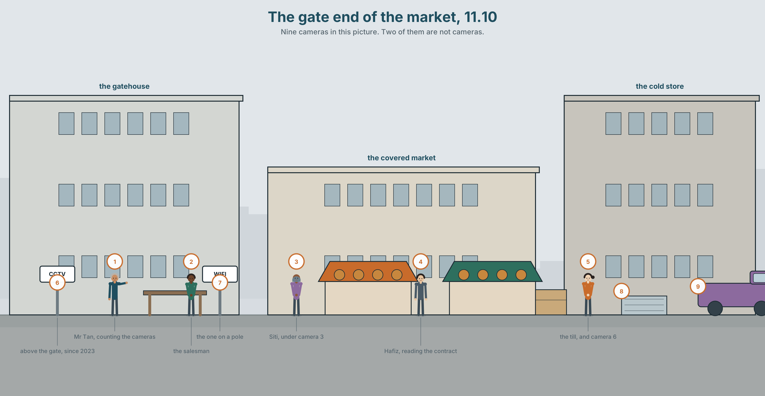{width=6.6in}
The gate end of the market, 11.10 — Nine cameras in this picture. Two of them are not cameras.

Is the machine listening?
By the end of this unit you can describe how a device is set up and say what is too much. Ninety words.
◆ A · THE WORLD | What is being counted while you are not thinking about it
◆ B · THE SYSTEM | too and enough · so and such · adverbs of manner · 22 words for screens and privacy · 18 words for saying how much and how
◆ C · THE PERFORMANCE | Ninety words on one device, and where you would draw the line

0A · Find it
Find nine cameras in this picture. Two of them are not cameras.
above the gate · on the cold store · over the till · the one on a pole · in the office window · the smoke detector · the one pointing at the drain · the doorbell · the fire alarm

0B · Guess it
One of these cameras is pointing at something nobody would expect. Which, and at what?

0C · Say it ⏺
Record thirty seconds. Name one thing on your phone you have never changed the setting of. Why not? You will record it again at the end of this unit.

Part 1 · Vocabulary Lab 1 ◆ B · THE SYSTEM
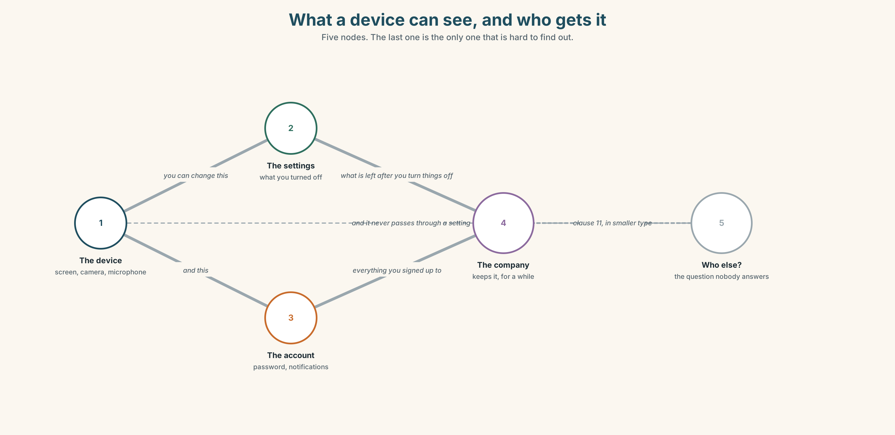{width=6.6in}
What a device can see, and who gets it — Five nodes. The last one is the only one that is hard to find out.

1A · Meet — the words on the screen
Match each word to one place on the map.
screen · camera · microphone · record · track · data · setting · account · password · notification

1B · Sort — something you do, or something done to you?
Two columns.
share · track · delete · follow · record · block · access · sign up · privacy · data
Two of them are in both columns depending on who is holding the phone. Which?

1C · Meet — the three you can actually control
block · delete · access
Blocking stops one person. Deleting stops one thing. Access is the only one that stops a system. Why do apps make the first two easy and the third hard?
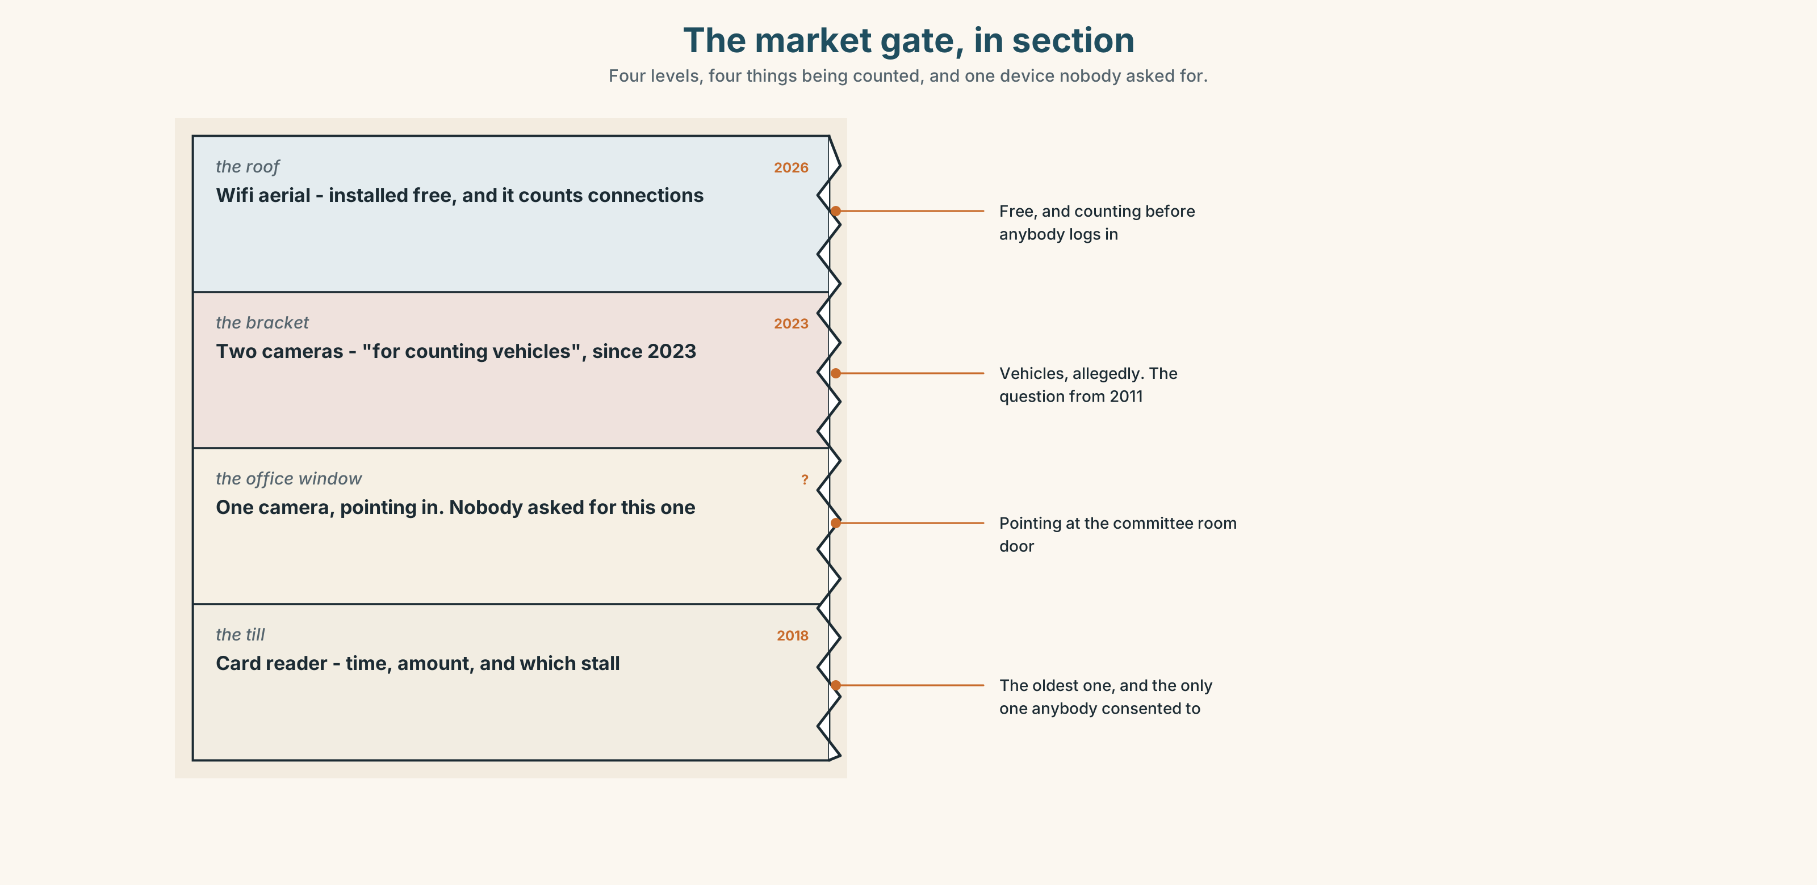{width=6.6in}
The market gate, in section — Four levels, four things being counted, and one device nobody asked for.
Look at the market gate in section. Four levels, four things being counted. Which level has the device nobody at the market asked for?

1D · Stretch — the phrases
Complete each one with one word.
- **Turn ______ ** the microphone when you are not using it.
- **Log ______ ** before you hand the phone to anybody.
- She keeps a ______ account and a public one, and posts different things on each.
- The only question that matters is ______ can see it.
- He **signed ______ ** in 2016 and has never looked at the settings since.

1E · The saying
f I never read them.
The terms and conditions. Everybody says this.
Write the sentence that comes next, once for somebody who is embarrassed about it and once for somebody who is not.

1F · Own it
Think of one app you use every day. Tell a partner three sentences: what it can see, what you have turned off, and one setting you did not know existed.

Part 2 · Listening ◆ A · THE WORLD
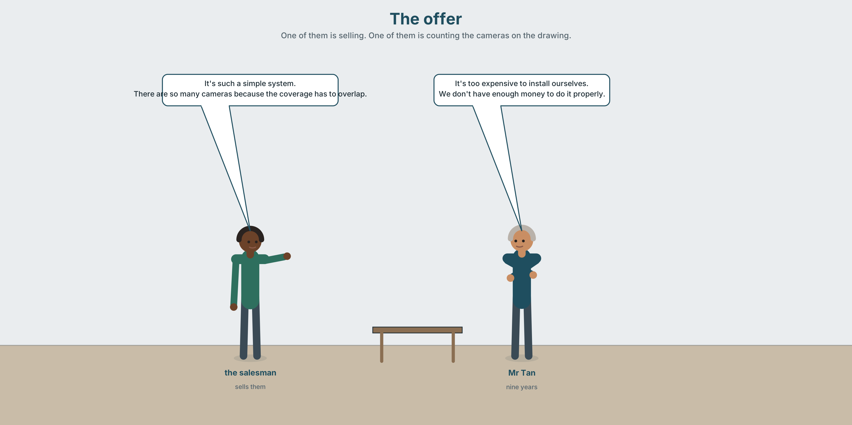{width=6.6in}
The offer — One of them is selling. One of them is counting the cameras on the drawing.

2A · The offer 🔊 Track 9.1
Before you listen. A company offers the market free wifi. There is a condition. Guess what the condition is.
Listen once. One question. What does the market have to accept?
Listen again. Complete the table.
 | What they say it does | What they do not say
the cameras
the wifi
the data
Listen again. True or false?
- The cameras count people. ☐ T ☐ F
- The salesman can explain what else they count. ☐ T ☐ F
- The market would own the data. ☐ T ☐ F
- Mr Tan asks who else can see it. ☐ T ☐ F
Noticing. Four sentences from the recording.
- It's too expensive to install ourselves.
- We don't have enough money to do it properly.
- There are so many cameras.
- It's such a simple system.
Two of these use so or such. Two use too or enough. Which pair is about a limit, and which is about a strong feeling?

2B · Decoding clinic 🔊 Track 9.2
Twenty-five seconds of the salesman. Four jobs.
- How many times does he say so or such?
- Does he say too once, or not at all?
- Catch the number of cameras.
- He answers a question he was not asked. Which?
Transcripts, page 158.

Part 3 · Grammar Lab 1 ◆ B · THE SYSTEM

Too much, enough, and far too many

3A · Notice
Look at the four sentences in Part 2.
- In sentence 1, is too expensive a fact or a judgement?
- Sentence 2 says enough money to do it properly. Enough for what?
- so many cameras and such a simple system. What comes after each one?
- Which of the four is the salesman most likely to have said?
- Try "There are too many cameras to be useful." and "There are so many cameras." What is the difference?

3B · See
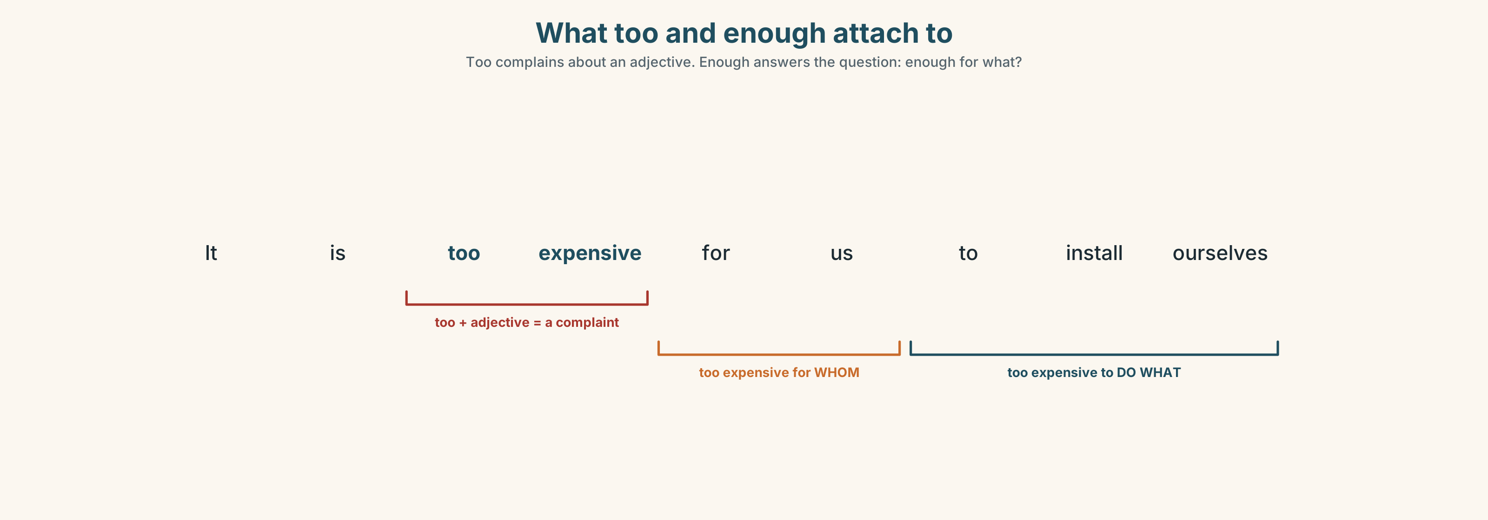{width=6.6in}
What too and enough attach to — Too complains about an adjective. Enough answers the question: enough for what?
Now look at the second picture. It runs from not enough through enough to far too much. Where would you put nine cameras?
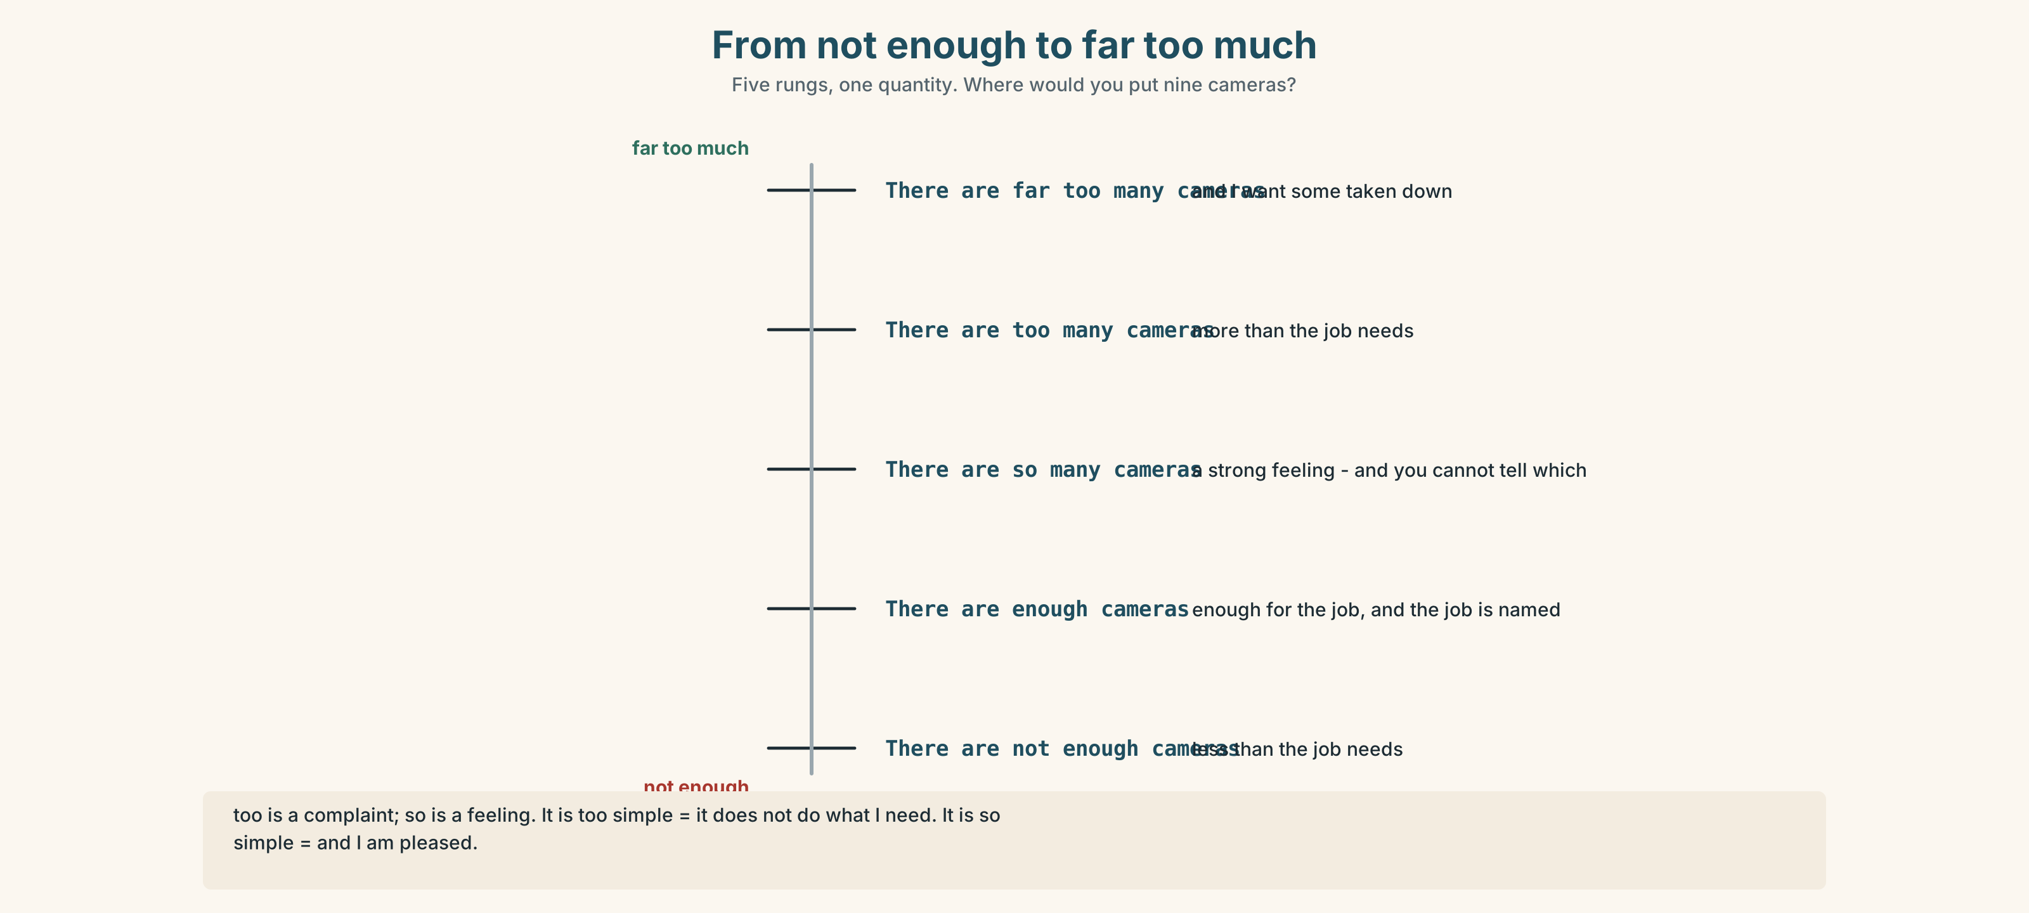{width=6.6in}
From not enough to far too much — Five rungs, one quantity. Where would you put nine cameras?

3C · Know
 | Shape | Example
too | too + adjective (= more than you want) | It's too expensive.
too much / too many | + noun | too much data · too many cameras
enough | adjective + enough , enough + noun | big enough · enough money
not enough | less than you need | We don't have enough money.
so | so + adjective or adverb | It's so simple. · He spoke so quickly.
such | such + (a) + adjective + noun | It's such a simple system.
too is a complaint. so is a feeling. It's too simple = it does not do what I need. It's so simple = and I am pleased about that.
Adverbs of manner. Most add -ly: quick → quickly, careful → carefully. Some do not change: fast → fast, hard → hard. One is irregular: good → well.
Watch out. ✗ so a simple system ✓ such a simple system ✓ so simple ✗ He speaks very good. ✓ He speaks very well.

3D · Use — controlled
The system is (1) __________ expensive for the market to buy, so the company is offering it free. There are nine cameras, which is (2) __________ many for a building this size, and nobody can explain clearly (3) __________ they count. Mr Tan does not have (4) __________ information to decide. He says it is (5) __________ a generous offer that he has stopped believing it, and he reads the contract very (6) __________ .

3E · Use — guided
Put too, too much, too many, enough, so or such in each.
- It's ______ late to change it now.
- There are ______ notifications. I turned them off.
- The screen isn't bright ______ .
- It's ______ a long document that nobody reads it.
- We don't have ______ time.
- He talks ______ quickly on the phone.

3F · Use — open
Think of one app or device. Tell a partner three things: one that is too something, one that is not enough, and one that is so good you would not change it.

3G · Check — six items
- It's ______ expensive. We can't afford it.
- There are ______ many cameras.
- The password isn't long ______ .
- It's ______ a simple system.
- She explained it very ______ . (good)
- He reads the terms ______ . (careful)
0–3 → Workbook pp. 52–54. 4–5 → Part 6. 6 → page 195.

Part 4 · Speaking ◆ C · THE PERFORMANCE

4A · Fluency starter — where is the line?
Your teacher names a thing a device could do: count how many people walk past. Everybody says one sentence: "That's fine / That's too much, because ______ ."
Six rounds. Each one goes a little further. Stop when the room disagrees.

4B · The functional core — saying what is too much
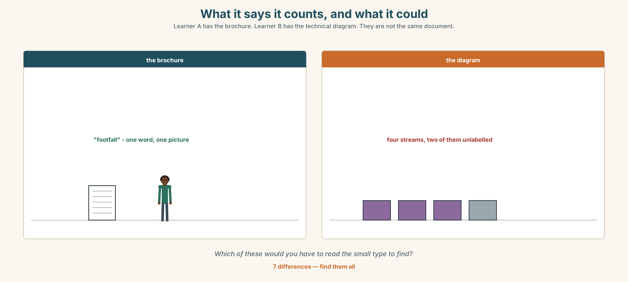{width=6.6in}
What it says it counts, and what it could — Learner A has the brochure. Learner B has the technical diagram. They are not the same document.
Language Bank
accepting | That's fine. · I don't mind that. · That's useful, actually.
the limit | That's too far. · That's where I'd stop. · Not without asking.
the question | Who can see it? · How long is it kept? · Can I turn it off?
the refusal | That's quite enough. · Not at that price. · I'd want that in writing.
Role play. Learner A sells the system. Learner B runs the market. Six minutes. Learner B must ask all three questions above and get at least one real answer.

4C · The performance — ninety seconds ⏺
Describe one device and say where your line is. Ninety seconds. You must give:
what it records · what you have turned off · one thing you accept that others might not · the thing you would refuse
Record it.

4D · Observer
One person listens for one thing: did the speaker name a limit, or only complain?

4E · Two criteria
☐ Did I use too, enough and so or such correctly? ☐ Is my line in a specific place, not just "I don't like it"?

Part 5 · Reading ◆ A · THE WORLD

5A · Predict
An archive document: minutes of a market committee meeting, from 2011. The title is "Item 6: the cameras." What do you expect a 2011 meeting to have worried about? One sentence.

5B · Read — one hundred seconds

MINUTES OF THE TRADERS' COMMITTEE — 14 MARCH 2011 Item 6: the cameras
Mr Rahim reported that two cameras had been installed above the gate on 3 March without the committee being told. He had asked the city office and been told they were for counting vehicles.
Mrs Lau asked whether they were recording. The city office had said no. Mrs Lau asked how a camera counts vehicles without recording. No answer was given at the meeting.
Mr Rahim proposed that the committee write and ask three questions: what is recorded, how long it is kept, and who can see it. The proposal was carried, 7 votes to 1.
Mr Chin voted against, saying the committee had more important things to do and that nobody was interested in a market gate.
ACTION: Secretary to write to the city office. Reply to be brought to the May meeting.

Archivist's note, added 2019: no reply was ever recorded in the minutes. The cameras were removed in 2014 during the roof works and were not reinstalled. The letter is in box 11 and was never sent.

5C · Answer
- When were the cameras installed, and who was told?
- What reason was given for them?
- What was Mrs Lau's question, and why was it a good one?
- What three questions did the committee agree to ask?
- How did the vote go, and what was Mr Chin's argument?
- What does the archivist's note tell you that the minutes do not?

5D · Vocabulary in context
Guess from the text. Then check.
the proposal was carried · voted against · action · reinstalled · the archivist's note

5E · The counter-text
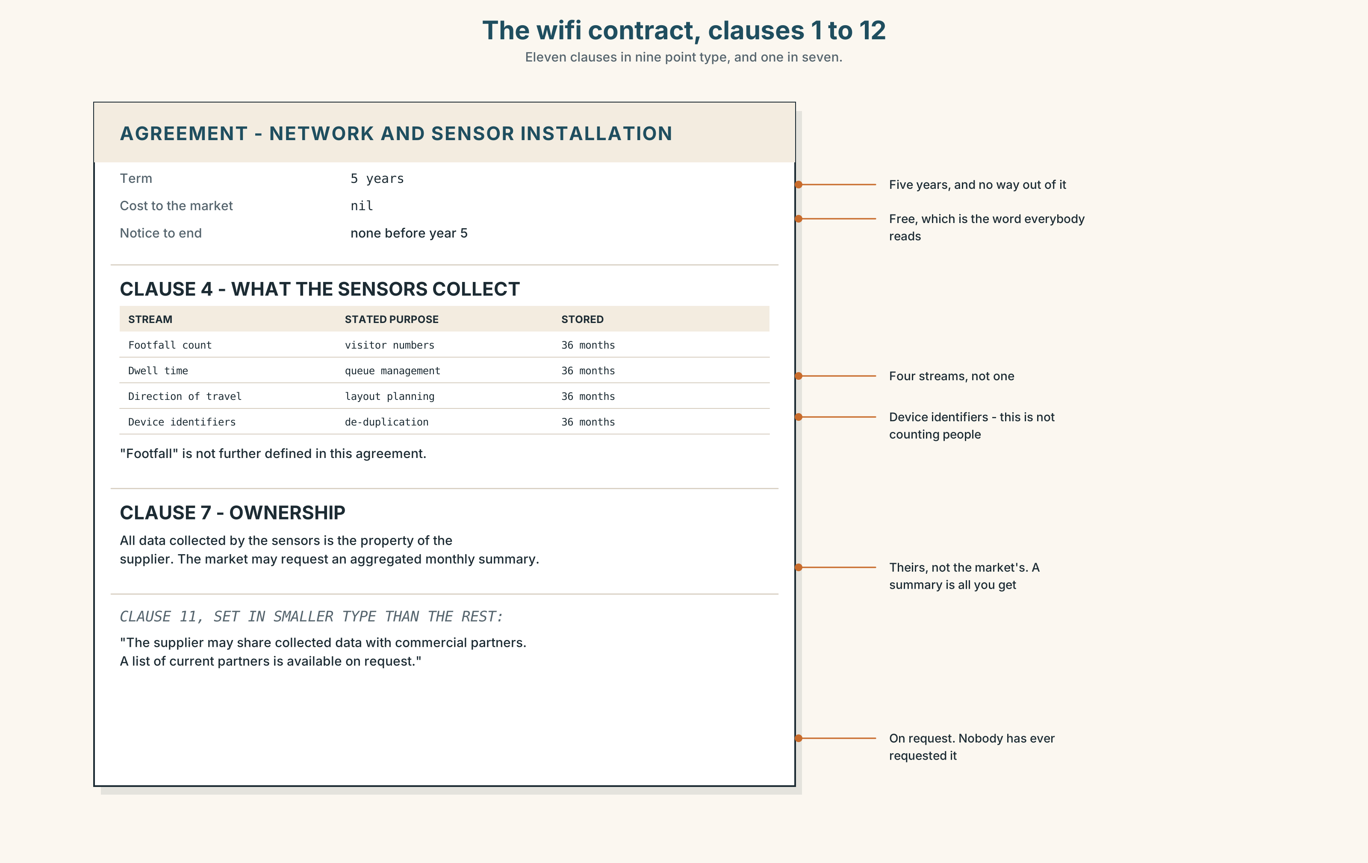{width=6.6in}
The wifi contract, clauses 1 to 12 — Eleven clauses in nine point type, and one in seven.
Read the extract from the wifi contract and answer.
- How long is the data kept, and who owns it?
- What exactly do the cameras count, according to clause 4?
- What does the market get, and what does it give?
- One clause is in much smaller type than the others. Which, and what does it say?

5F · Two texts
The 2011 minutes record three questions: what is recorded, how long it is kept, who can see it. The 2026 contract answers two of them.
Which one is not answered, and where would you look? Two sentences.

Part 6 · Vocabulary Lab 2 ◆ B · THE SYSTEM

How, and how much
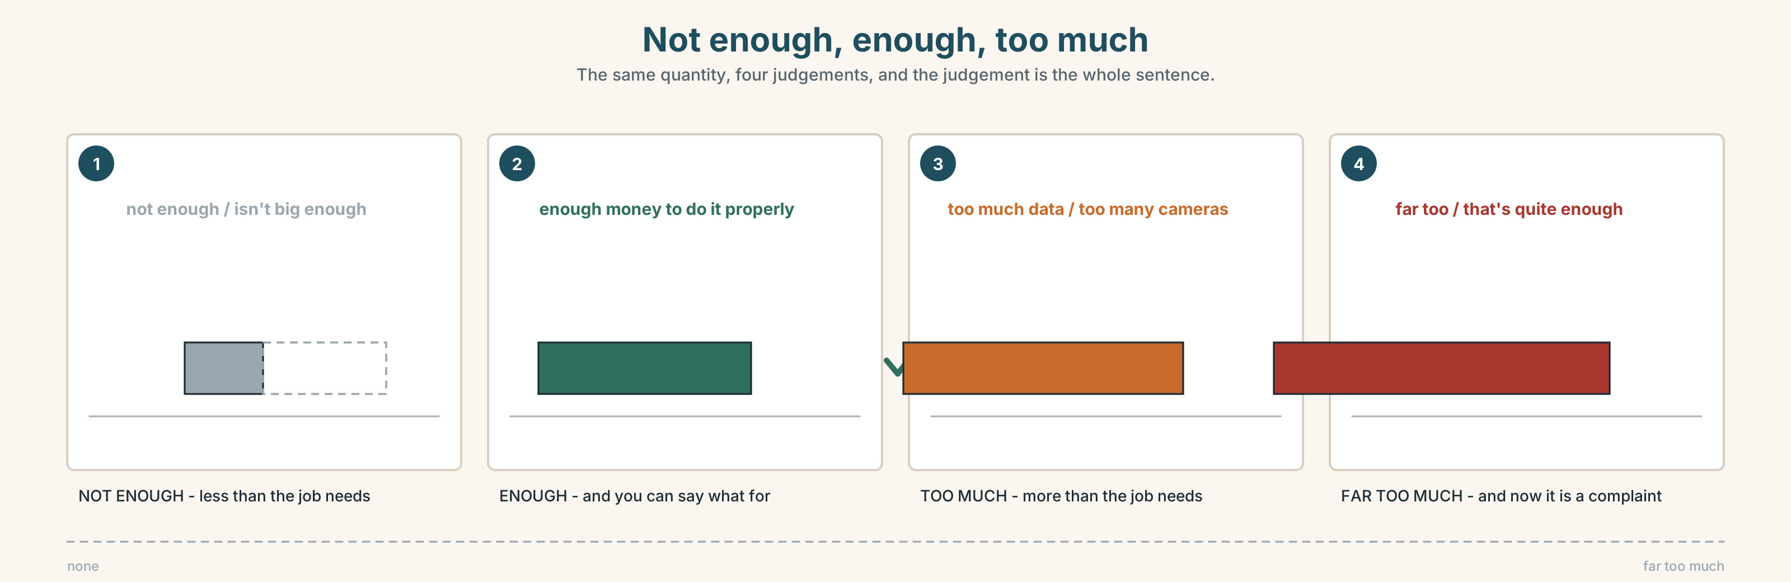{width=6.6in}
Not enough, enough, too much — The same quantity, four judgements, and the judgement is the whole sentence.

6A · Sort — adjective or adverb?
Two columns. Two words go in both.
quick · quickly · slow · slowly · careful · carefully · bad · badly · good · well · loud · loudly · quiet · quietly · clear · clearly · hard · fast

6B · Chunk completion
- There's ______ much data and nobody is reading it.
- We don't have ______ enough staff to check it.
- ______ many notifications and you stop seeing any of them.
- It is far ______ generous to be a favour.
- **That's quite ______ ** — I don't want to hear the rest.
- Could you ______ down ? I'm writing it.

6C · The adverbs that do not take -ly
hard and fast do not change. good becomes well.
Correct each sentence. One of them is already correct.
- She works very hardly.
- He drives too fastly.
- The system works very good.
- They explained it clearly.
- He answered quick.
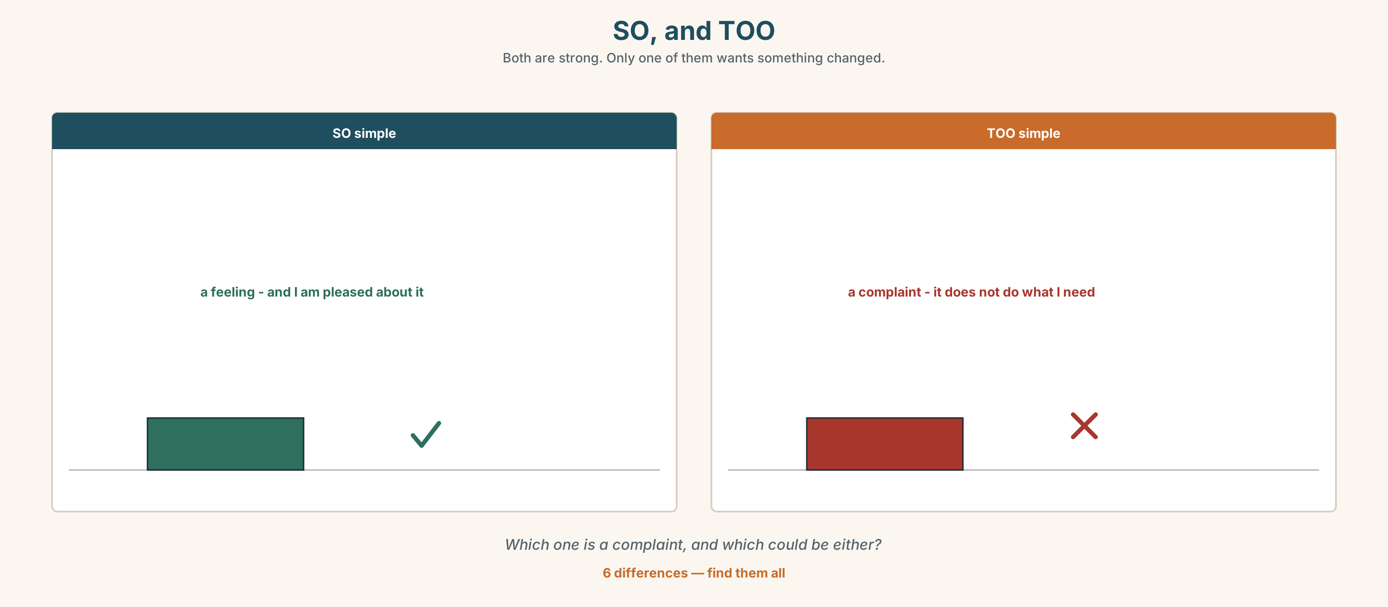{width=6.6in}
SO, and TOO — Both are strong. Only one of them wants something changed.
Six differences. Find them, then answer the question under the picture.

6D · Contrast Clinic — too, so, such or enough
Six items.
- It's ______ expensive for us.
- It's ______ expensive that nobody has bought one.
- It isn't cheap ______ .
- It's ______ a good system.
- There are ______ many settings.
- We haven't got ______ information.

Part 7 · Pronunciation & Fluency Lab ◆ B · THE SYSTEM

The word you lean on
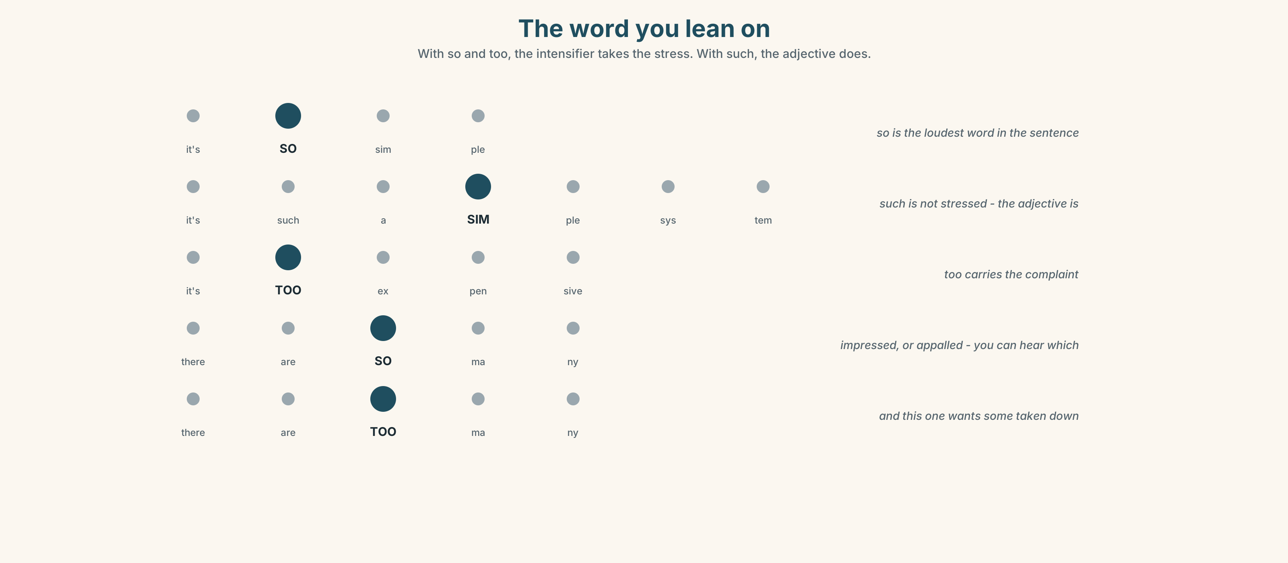{width=6.6in}
The word you lean on — With so and too, the intensifier takes the stress. With such, the adjective does.

7A · Hear 🔊 Track 9.3
It's SO simple. — so is the loudest word in the sentence It's such a SIMple system. — such is not; the adjective is It's TOO expensive. — too carries the complaint

7B · Say
Say each one. Then say all three, faster, keeping the stress where it is.

7C · Make it mean something
Say these two:
There are SO many cameras. (and I am impressed, or appalled — you can hear which) There are TOO many cameras. (and I want some of them taken down)
Say the first one twice: once impressed, once appalled. What changes?

7D · Fluency 20 ⏺
Twenty seconds: three things that are too much, and one that is just enough. Three times, faster.

Part 8 · Writing ◆ C · THE PERFORMANCE

Where I draw the line · 90 words
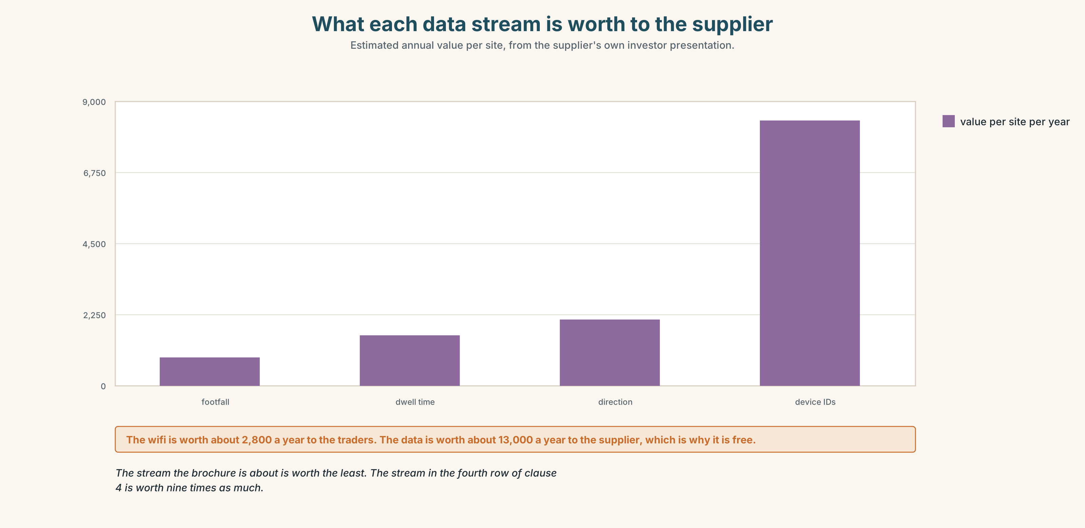{width=6.6in}
What each data stream is worth to the supplier — Estimated annual value per site, from the supplier's own investor presentation.

8A · Read the model
My phone knows where I am, and I have left that on, because I use the map four times a week and I would rather have it. [accepting something, with the reason, which makes the refusal credible]
I turned the microphone off for every app except two. It took eleven minutes and I found three apps I had signed up to in 2019 and never opened since. [a number, and a small specific discovery]
Where I stop is anything that keeps the data after I delete the account. That is not a setting. You have to read for it. [the line, in a specific place, and why it is hard to find]
Questions about the writer's choices:
- The first paragraph accepts something. Why start there?
- The last line says the limit is not a setting. Why does that matter?

8B · The anti-model
Technology is watching us all the time. Companies collect our data and we do not know what they do with it. We should all be more careful about our privacy and protect our personal information.
Correct English, and nobody will do anything after reading it. Name two things it is missing.

8C · Plan
one thing you accept, with the reason → what you turned off, with a number → where you stop → why that line is hard to see

8D · Write — 90 words

8E · Peer review — two criteria
☐ Is there one thing the writer accepts? ☐ Is the line in a specific place?

8F · Write it again · 8G · Publish
On the wall, with the contract extract from Part 5E beside it.

Part 9 · The File ◆ A · THE WORLD + C · THE PERFORMANCE

CULTURE FILE · Register Map
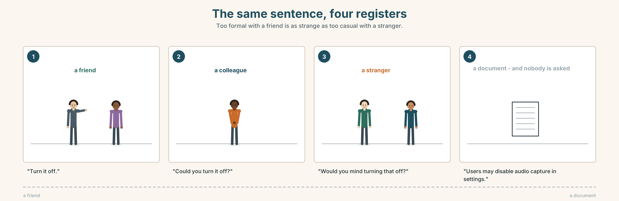{width=6.6in}
The same sentence, four registers — Too formal with a friend is as strange as too casual with a stranger.

9A · The same thing, four ways 🔊 Track 9.4
One message — turn the microphone off — said four times. Listen.
- Which one is to a friend?
- Which one is in a contract?
- Which one is to a stranger you need something from?

9B · Four registers
"Turn it off." · "Could you turn it off?" · "Would you mind turning that off?" · "Users may disable audio capture in settings."
Match each to one: a friend · a colleague · a stranger · a document.

9C · Getting it wrong in both directions
Being too formal with a friend is as strange as being too casual with a stranger.
Which of these is wrong, and in which direction?
- To your closest friend: "I was wondering whether you might consider turning it off."
- To a government officer: "Turn it off, yeah?"
- In a contract: "Just switch it off, it's easy."
- To a colleague you have known a week: "Could you turn it off?"

9D · Your turn
In pairs. One sentence, four registers. Take any request and say it to a friend, a colleague, a stranger and a document. Your partner guesses which is which.

9E · Transfer
Find one sentence this week that is in the wrong register — too formal or too casual. Bring it, and say what it should have been.

Part 10 · Mediation & Interaction ◆ C · THE PERFORMANCE
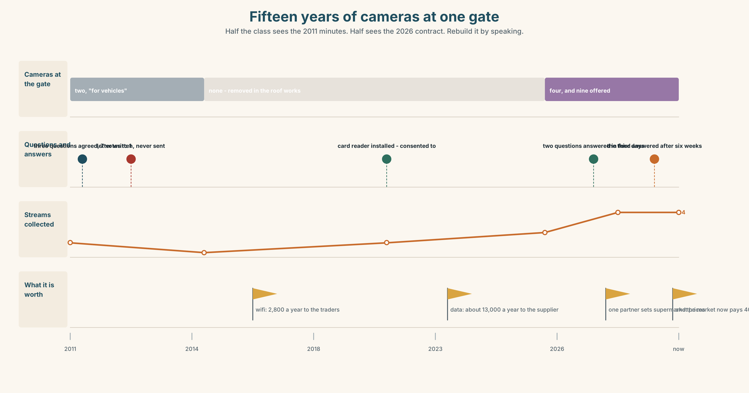{width=6.6in}
Fifteen years of cameras at one gate — Half the class sees the 2011 minutes. Half sees the 2026 contract. Rebuild it by speaking.

10A · Relay
Half the class sees the 2011 minutes. Half sees the 2026 contract. Rebuild fifteen years of cameras by speaking. Ten minutes.

10B · Simplify
Explain the contract extract from Part 5E to a trader who has not read it. Four sentences only.
Plan: what the market gets → what the cameras do → who owns the data → what to ask before signing

10C · Compress
The 2011 minutes into thirty words, as a note to put in front of the current committee.

10D · Online
Write one message to the committee: the offer is on the table, three questions have not been answered, and you want them answered in writing before the vote.

10E · Your language
How does your language say too much? Is it one word or two, and does it also mean very? Show a partner so many and too many in both languages.

Part 11 · The Decision ◆ C · THE PERFORMANCE

Free wifi, nine cameras
A company will install wifi across the whole market, free, for five years. In return it puts up nine cameras and keeps what they record. Nobody at the company has been able to say clearly what the cameras count beyond "footfall".
- Accept. Free wifi is worth about 2,800 a year to the traders. Nine cameras in a public market where there are already four.
- Refuse. Pay for wifi, or do without. The market has done without for thirty years.
- Accept with conditions. Signed answers to the three 2011 questions, a copy of the data, and the right to end it with three months' notice.

11A · The evidence
- The contract extract from Part 5E — and the clause in smaller type.
- The chart — what the cameras can count, and what each thing is worth to the company.
- The voice. The salesman, twenty seconds: "Honestly, I don't know what else it counts. I sell them. There's a technical team and I've asked twice and they send me a diagram I don't understand either."

11B · Talk about it
In threes. Everybody says one. Use the frame.
I think the market should ______ , because ______ .
Words you can use: privacy · data · track · record · too much · enough · who can see · free

11C · Decide
Write two sentences. Choose, and say why.
I think the market should ______________________ , because ______________________ .

11D · Model decision
Accept with conditions, and make the conditions the three questions from 2011. The committee asked them fifteen years ago and never got an answer, and the only thing that has changed is that somebody now wants something badly enough to answer. If the company will not put the answers in writing, that is itself the answer, and it costs nothing to find out.

11E · The Reveal
What happened. The committee asked for the three answers in writing. The company answered two of them in four days and did not answer the third.
The third was who else can see it. The reply, when it came six weeks later, named two partner companies that nobody had heard of, and one of them is a company that sets prices for supermarkets.
The market refused. Three months later the same company offered the deal again, without the cameras, for a fee of 400 a month, which the market is now paying.
The question that was never answered in 2011 was the one that mattered. And the wifi now costs money.
Was it the right decision? Say why — and say what 400 a month is buying.

Part 12 · Landing ◆ all three lines

12A · Recycle — ten items
- It's ______ expensive for us.
- There are ______ many cameras.
- It isn't big ______ .
- It's ______ a simple system.
- She explained it very ______ . (good)
- (Unit 8) We're ______ to sign in, but nobody does.
- (Unit 8) You ______ (not / allowed) park here.
- (Unit 7) The garlic ______ (grow) in China.
- (Unit 6) I can't afford ______ (buy) it.
- (Starting Out) This one is ______ (big) than that one.

12B · Consolidate
Ninety words, one paragraph. One device and where your line is. Use too, enough, so or such, and two adverbs of manner.

12C · Can-do, with evidence
I can… | My evidence | Sure?
say what is too much and what is enough | Part 3G score | ◯ ◑ ●
describe a device and draw a line in ninety seconds | Part 4C recording | ◯ ◑ ●
write ninety words with a specific limit | Part 8 draft 2 | ◯ ◑ ●
say the same thing in four registers | Part 9D pair work | ◯ ◑ ●

12D · Replay ⏺
Find your thirty seconds from Part 0C. Listen. Record it again. One sentence: what is different?

12E · Glossary — forty items, as a map
THE DEVICE · screen · camera · microphone · setting · notification · account · password WHAT IT DOES · record · track · data · access · share · follow · privacy WHAT YOU DO · delete · block · turn off · log out · sign up · a private account · who can see · I never read them HOW MUCH · too · enough · too much · not enough · far too · that's quite enough HOW STRONGLY · so · such · so many HOW · quickly · slowly · carefully · badly · well · loudly · quietly · clearly · slow down

12F · Next
Unit 10 · Who gets to speak?

