Table of Contents

A2.1 · Unit 3 · Forty Minutes of Broth
English Animated · Making Plans · Pasar Chow Kit, Kuala Lumpur Student's Book pages 50–71 · 22 pp · ~10 hours

Part 0 · The Big Picture ◆ A · THE WORLD
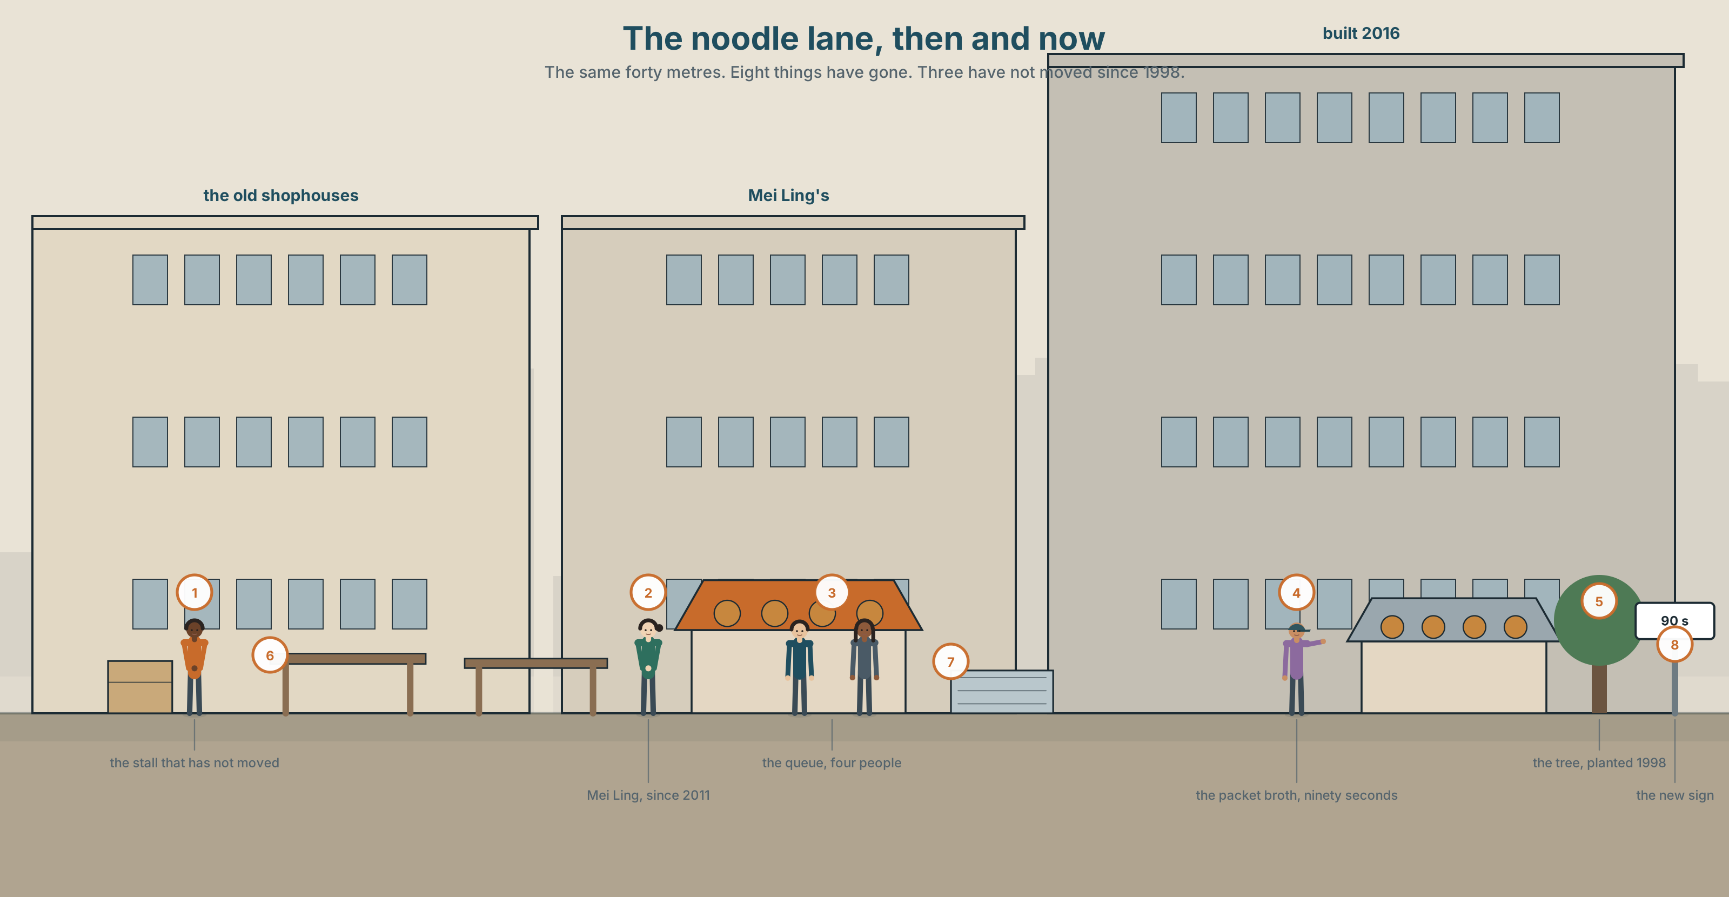{width=6.6in}
The noodle lane, then and now — The same forty metres. Eight things have gone. Three have not moved since 1998.

What did you used to love?
By the end of this unit you can compare something you loved as a child with what it is now. Sixty seconds.
◆ A · THE WORLD | What changes in a place, and what people decide to keep
◆ B · THE SYSTEM | used to · anymore and still · 25 words for childhood and change · 15 words for then and now · used to said as one word
◆ C · THE PERFORMANCE | Sixty seconds on a thing that is not what it was

0A · Find it
The same corner, photographed twice: 1998 on the left, now on the right. Find eight things that are in one picture and not in the other.

0B · Guess it
Three things in the old picture are still there today. Which three? Give one reason for each.

0C · Say it ⏺
Record thirty seconds. What did you love when you were eight? You will record it again at the end of this unit.

Part 1 · Vocabulary Lab 1 ◆ B · THE SYSTEM
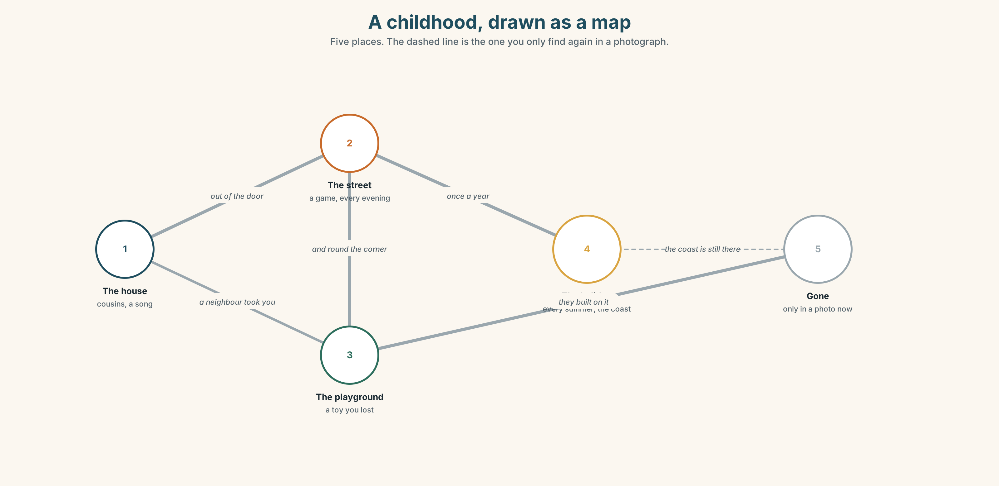{width=6.6in}
A childhood, drawn as a map — Five places. The dashed line is the one you only find again in a photograph.

1A · Meet — the words of a childhood
Match each word to one place on the map.
childhood · memory · photo · toy · game · song · cartoon · playground · street · cousin

1B · Sort — a thing, a person, or a feeling?
Three columns.
toy · cousin · memory · playground · neighbour · song · holiday · game · photo · childhood
One of them belongs in two columns. Which, and why?

1C · Meet — the words for what happened to it
change · different · same · old · young · favourite · remember
Which two are opposites? Which one can describe both a person and a pair of shoes?
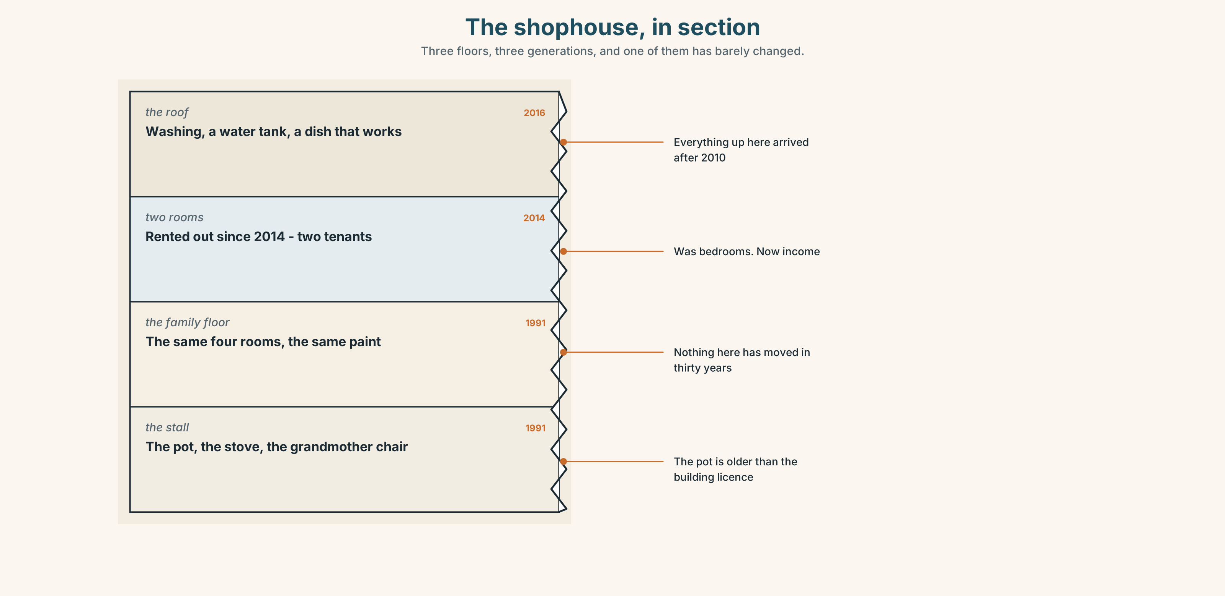{width=6.6in}
The shophouse, in section — Three floors, three generations, and one of them has barely changed.
Look at the shophouse in section. Three floors, three families, three decades. Which floor has changed least, and how can you tell from the drawing?

1D · Stretch — the phrases
Complete each one with one word.
- When I was ______ , the whole street was open on a Sunday.
- In those ______ nobody locked anything.
- The recipe is my ______ 's — I did not write it.
- We went to the coast every ______ until I was fourteen.
- I try not to look ______ on it too often.

1E · The saying
f I don't anymore.
Three words, and a whole story behind them. Finish this exchange:
"Do you still make it the long way?" — "I don't anymore." — "______ ?"

1F · Own it
Think of one thing you used to do and do not do now. Tell a partner three sentences: what it was, when you stopped, and whether you miss it.

Part 2 · Listening ◆ A · THE WORLD
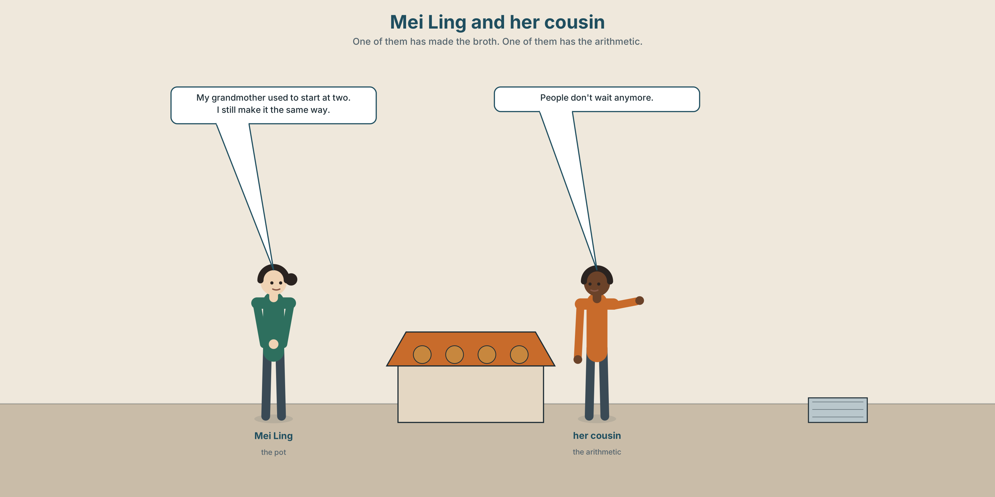{width=6.6in}
Mei Ling and her cousin — One of them has made the broth. One of them has the arithmetic.

2A · The broth takes forty minutes 🔊 Track 3.1
Before you listen. Mei Ling sells noodles. Her grandmother taught her the broth. Guess: is the grandmother alive?
Listen once. One question. How long has the recipe been in the family?
Listen again. Complete the table.
 | Then | Now
How long the broth takes
How many bowls an hour
Who waits
Listen again. True or false?
- Her grandmother used to start the broth at two in the morning. ☐ T ☐ F
- Mei Ling still starts at two. ☐ T ☐ F
- The queue used to be longer. ☐ T ☐ F
- She has already changed the recipe once. ☐ T ☐ F
Noticing. Four sentences from the recording.
- My grandmother used to start at two.
- She started at two every day for thirty years.
- People don't wait anymore.
- I still make it the same way.
Two of these are about a habit that stopped. Two are about now. Which are which?

2B · Decoding clinic 🔊 Track 3.2
Twenty-five seconds of Mei Ling. Four jobs.
- How many times does she say used to?
- In used to, can you hear the d?
- Catch the two numbers she gives.
- She corrects herself once. What does she change?
Transcripts, page 152.

Part 3 · Grammar Lab 1 ◆ B · THE SYSTEM

The habit that stopped

3A · Notice
Look at the four sentences in Part 2.
- Sentence 1 and sentence 2 say nearly the same thing. What does sentence 1 add?
- Does sentence 1 tell you she still does it?
- In sentence 3, which word carries the whole meaning?
- used to and still. One looks back. One reaches now. Which is which?
- Try "I used to make it yesterday." Why is that wrong?

3B · See
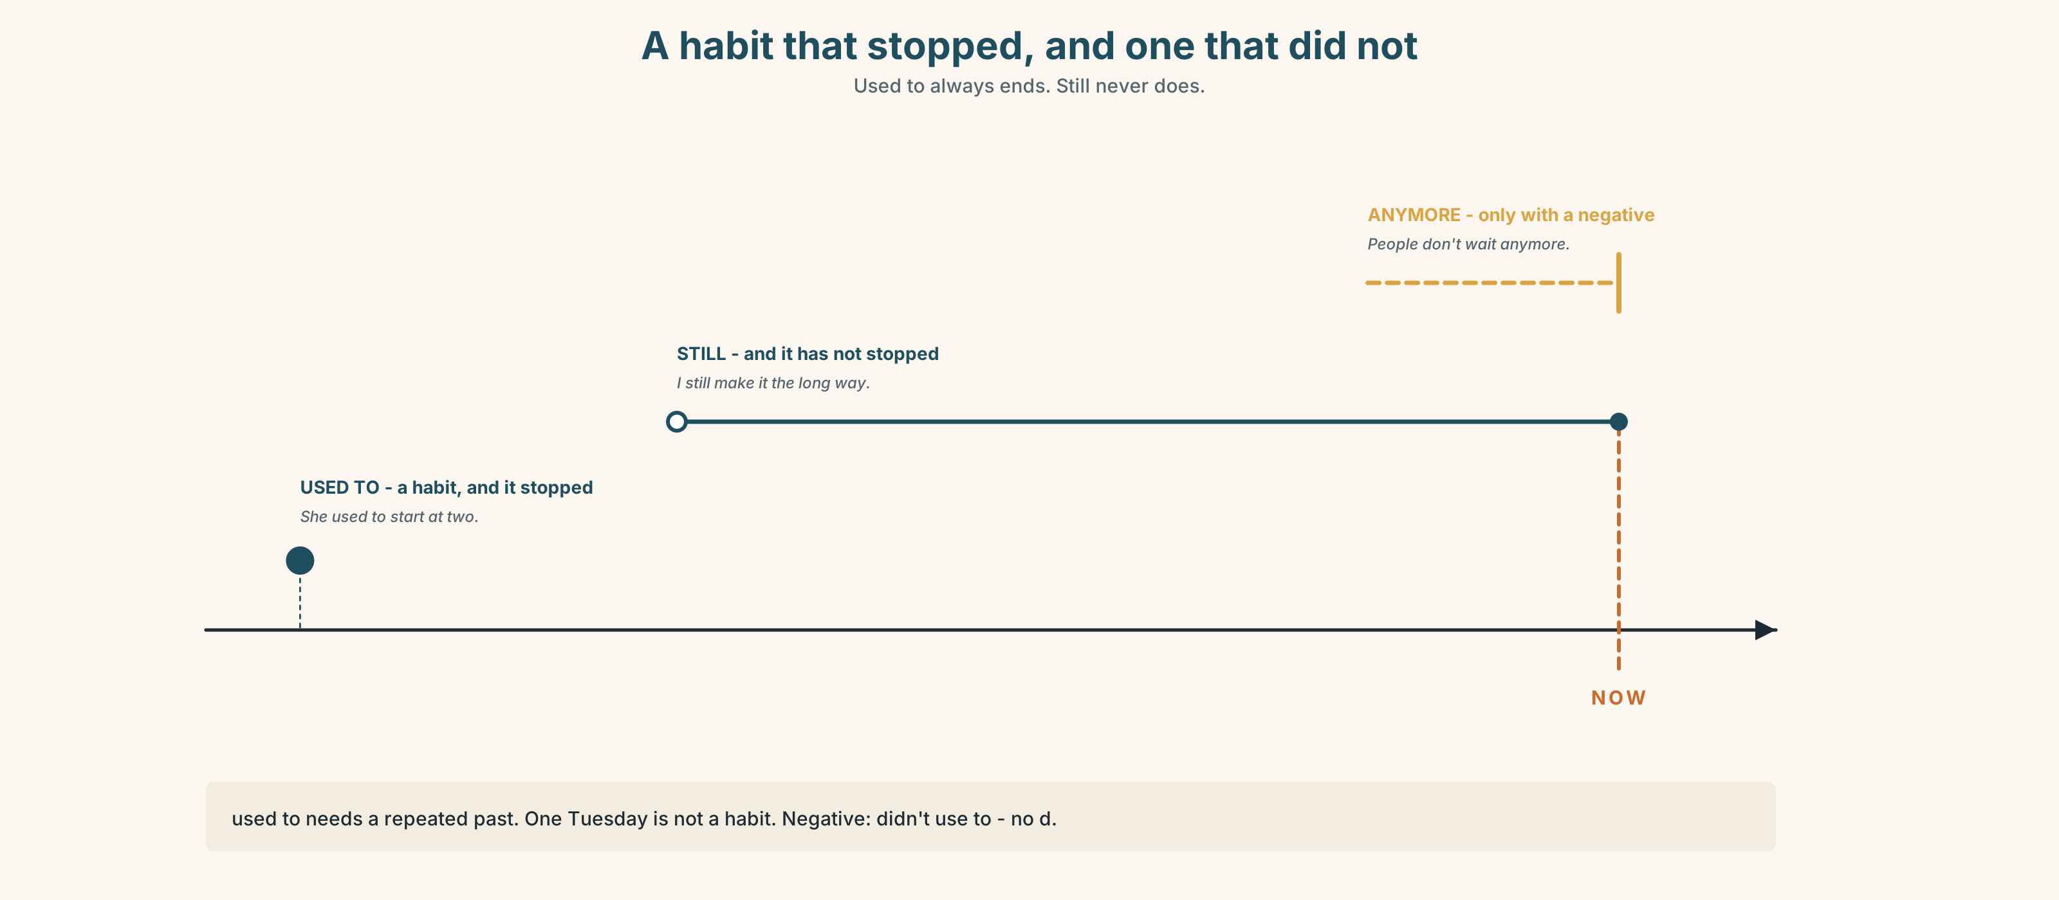{width=6.6in}
A habit that stopped, and one that did not — Used to always ends. Still never does.
Now read the second picture from the bottom up. Which rung says the habit has not stopped?
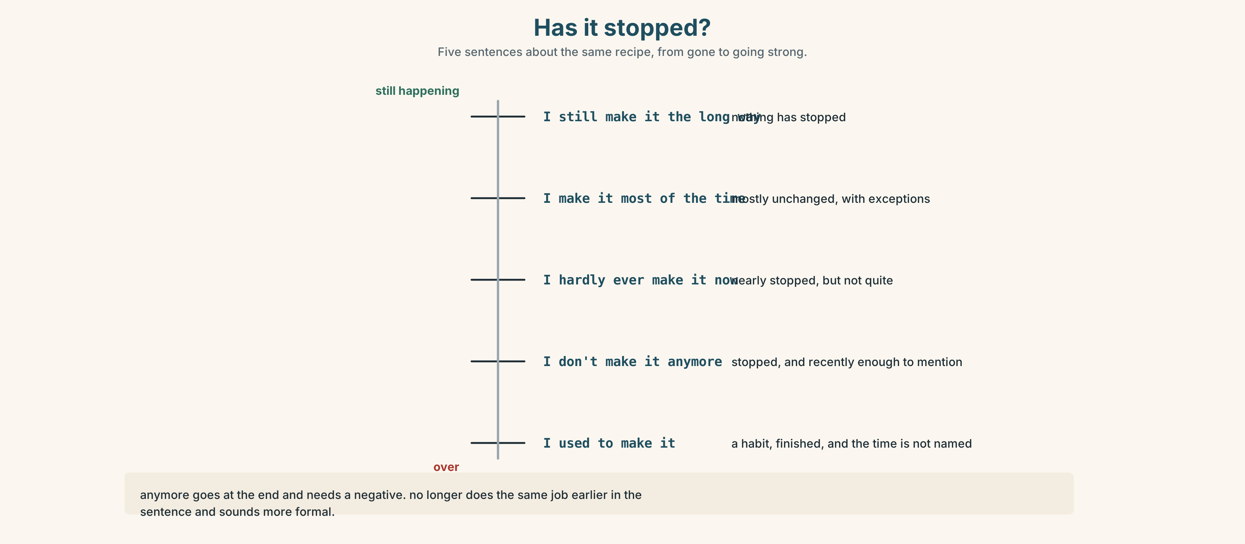{width=6.6in}
Has it stopped? — Five sentences about the same recipe, from gone to going strong.

3C · Know
 | Use it for | Example
used to + verb | a habit or a state that has stopped | She used to start at two.
past simple | one finished action, or a habit with a number | She started at two every day for thirty years.
negative → didn't use to (no d) · question → Did you use to…? anymore goes at the end, and only with a negative → I don't make it that way anymore. no longer does the same job, earlier in the sentence, and sounds more formal. still says the opposite: it has not stopped → I still make it the long way.
Watch out. used to needs a repeated past. One Tuesday is not a habit. ✗ I used to go there last week. ✓ I used to go there every week.
Why it matters. I made it the long way tells me about one pot of soup. I used to make it the long way tells me about a life that changed.

3D · Use — controlled
My grandmother (1) __________ (start) the broth at two in the morning, and she never (2) __________ (use) a clock. People (3) __________ (wait) forty minutes and nobody complained. They don't wait (4) __________ . I (5) __________ (still / make) it the same way, but I (6) __________ (not / sell) as many bowls as she did.

3E · Use — guided
Rewrite each one with used to, didn't use to or still.
- I played in that street every evening. (and I don't now)
- I don't like coriander. (and I never did)
- I go there every Friday. (and I have not stopped)
- We had a television with four channels. (and we don't now)
- She wasn't shy as a child. (she is now)

3F · Use — open
Ask three people: What did you use to do at the weekend when you were ten? Write one answer with used to and one with still.

3G · Check — six items
- I ______ (use) to live on this street.
- We ______ (not use) to lock the door.
- ______ you ______ (use) to walk to school?
- I don't eat it ______ .
- She ______ works here. She has never left.
- In those days we ______ (go) to the coast every summer.
0–3 → Workbook pp. 16–18. 4–5 → Part 6. 6 → page 63.

Part 4 · Speaking ◆ C · THE PERFORMANCE

4A · Fluency starter — then and now
Stand in two lines. Your teacher says a word: school. Each pair has thirty seconds: "It used to be ______ . Now it's ______ ."
Four rounds. Four words. Nobody may repeat an adjective.

4B · The functional core — comparing then and now
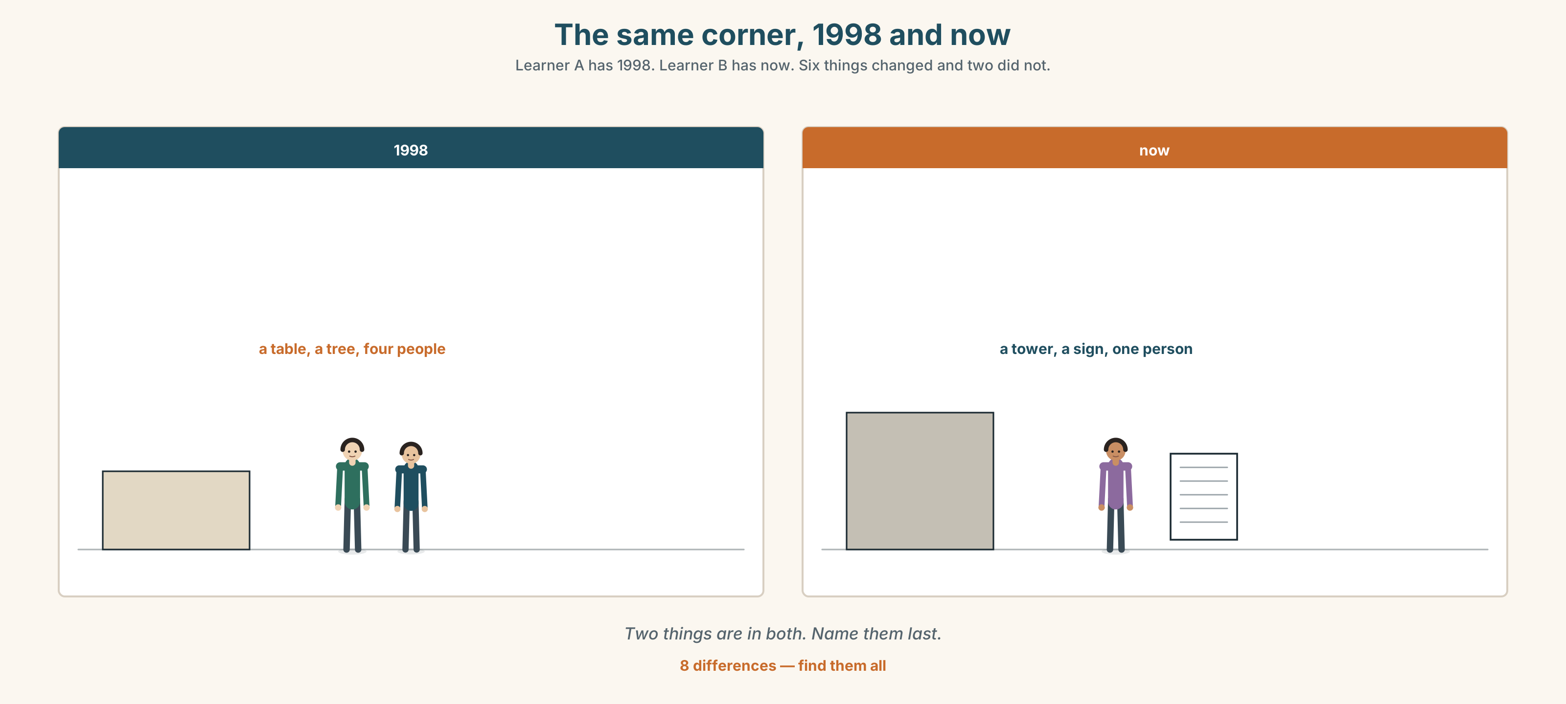{width=6.6in}
The same corner, 1998 and now — Learner A has 1998. Learner B has now. Six things changed and two did not.
Language Bank
then | It used to… · Back then… · In those days… · When I was little…
now | These days… · Nowadays… · Not like before.
what stopped | I don't ______ anymore. · Hardly ever. · Rarely.
what didn't | I still… · Most of the time, yes.
Information gap. Learner A has the street in 1998. Learner B has it now. Neither sees the other. Find six things that changed and two that did not.

4C · The performance — sixty seconds ⏺
Talk about one thing you loved as a child. Sixty seconds. You must say:
what it was · what you used to do with it · what it is like now · whether you miss it
Record it.

4D · Observer
One person listens for one thing: did the speaker say clearly what has stopped?

4E · Two criteria
☐ Did I use used to at least twice? ☐ Did I say one thing that has not changed?

Part 5 · Reading ◆ A · THE WORLD

5A · Predict
A short story. The title is "The pot." Two sentences. What do you expect a story with that title to be about?

5B · Read — one hundred seconds

The pot
When my grandmother was alive the broth took forty minutes and nobody thought that was long. People used to stand in the lane and talk while they waited. The waiting was part of it. I was eight, and my job was to carry the bowls out and bring them back, and I did it every summer until I was fifteen.
She died in 2011. I kept the pot.
Last year a man came and stood in the queue for six minutes and then left. He wasn't rude about it. He just looked at his phone twice and went to the stall at the end, which does a broth in ninety seconds out of a packet, and it is not bad.
I still make it the long way. I start at two in the morning and I do not use a clock, because she never used one and I have never needed one either. But I sell forty bowls on a Tuesday and she used to sell a hundred and ten.
My cousin says I should change it. He says nobody is coming back for the forty minutes, they are coming back for the taste, and the taste is in the bones and not in the time.
He may be right. He has never made it.

5C · Answer
- How old was the writer when she carried the bowls?
- What used to happen in the lane while people waited?
- What did the man in the queue do, and how long did he wait?
- Why does the writer not use a clock?
- How many bowls each, then and now?
- What is the cousin's argument, and what is the writer's answer to it?

5D · Vocabulary in context
Guess from the text. Then check.
the lane · out of a packet · the bones · come back for · he may be right

5E · The counter-text
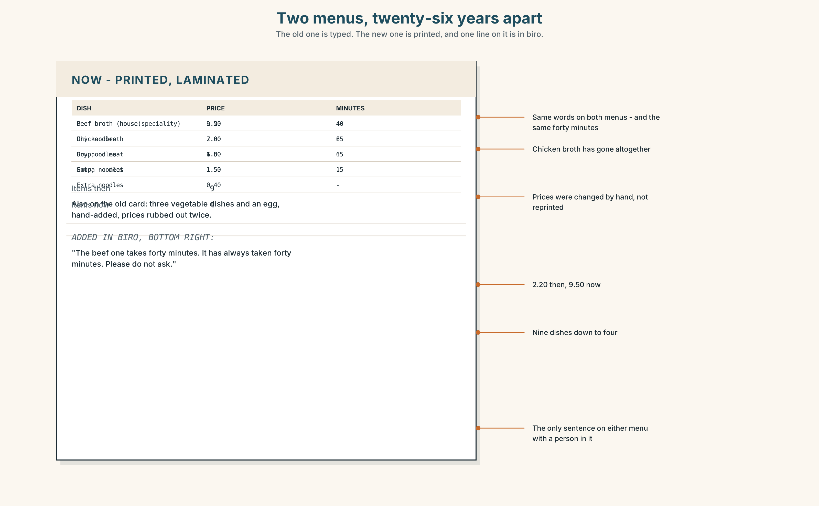{width=6.6in}
Two menus, twenty-six years apart — The old one is typed. The new one is printed, and one line on it is in biro.
Read the two menus — 1998 and now — and answer.
- How many items were on the old menu, and how many are on the new one?
- What was the old price of the broth, and what is it now?
- Which dish is on both menus with the same words, and what has changed about it?
- One line on the new menu was added by hand. What does it say?

5F · Two texts
The story says she sells forty bowls on a Tuesday. The new menu says the broth is the house speciality and is first on the list.
Put those two facts together. What is the menu doing? Two sentences.

Part 6 · Vocabulary Lab 2 ◆ B · THE SYSTEM

Then, now, and how often
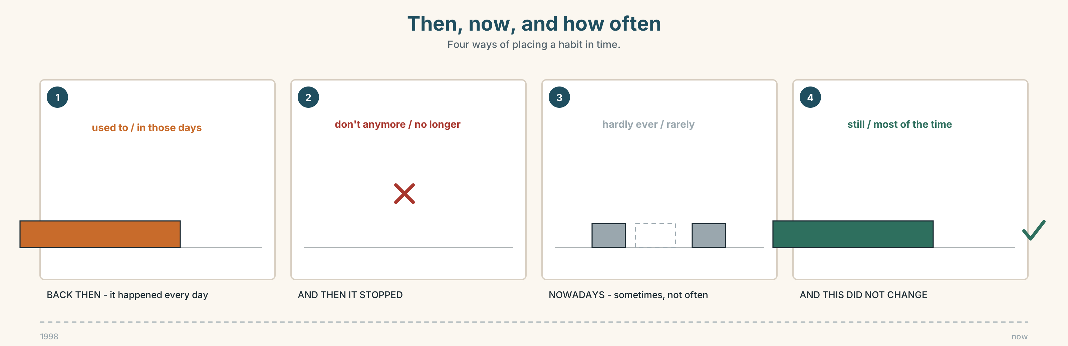{width=6.6in}
Then, now, and how often — Four ways of placing a habit in time.

6A · Sort — then, now, or how often?
Three columns.
back then · nowadays · rarely · in those days · these days · hardly ever · never · most of the time · ever
THEN | NOW | HOW OFTEN

6B · Chunk completion
- I don't go there ______ .
- ______ , everybody cooks it in a packet.
- It isn't ______ before — the lane is quieter.
- He is ______ longer at that stall.
- I remember it ______ it was, not as it is.
- She's right ______ of the time.

6C · The strong words and the quiet ones
never is absolute. hardly ever is nearly. rarely is written more than spoken.
Put one of the three in each sentence, and say why the other two are worse.
- I ______ eat out. (maybe twice a year)
- I ______ eat out. (not once in my life)
- The word ______ appears in a formal report.
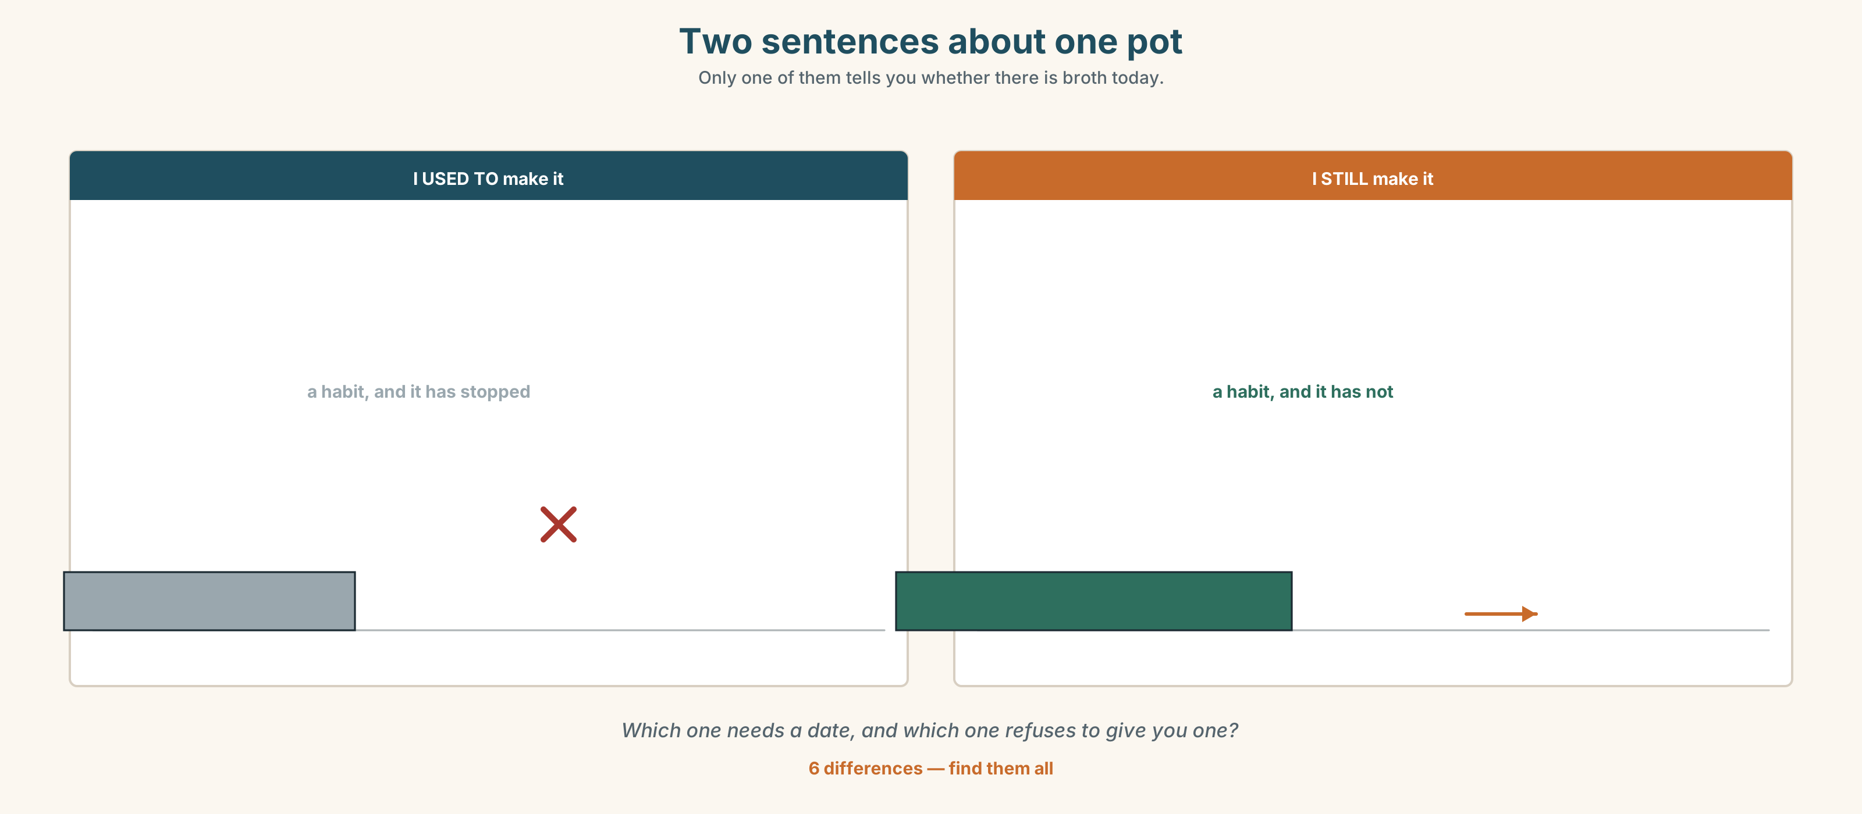{width=6.6in}
Two sentences about one pot — Only one of them tells you whether there is broth today.
Six differences. Find them, then answer the question under the picture.

6D · Contrast Clinic — stopped or not
Six items. used to, still, or anymore?
- I ______ live in that street. (I moved in 2015)
- I ______ live in that street. (I have never moved)
- We don't speak ______ .
- She ______ to be very quiet.
- Do they ______ open on Sundays?
- Nobody waits forty minutes ______ .

Part 7 · Pronunciation & Fluency Lab ◆ B · THE SYSTEM

Two words that became one
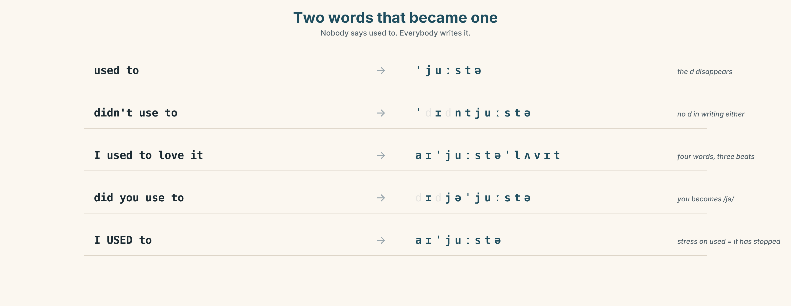{width=6.6in}
Two words that became one — Nobody says used to. Everybody writes it.

7A · Hear 🔊 Track 3.3
used to → /ˈjuːstə/ — no d, and the two words join didn't use to → /ˈdɪdntjuːstə/ I used to love it → /aɪˈjuːstəˈlʌvɪt/

7B · Say
Say each one. Then say the sentence three times, faster:
I used to walk to school every day.

7C · Make it mean something
Say these two:
I USED to. (stress on used — and you are telling somebody it has stopped) I used to WALK. (stress on walk — and you are telling them how, not whether)
Which one answers the question "Do you still?"

7D · Fluency 20 ⏺
Twenty seconds: three things you used to do and one you still do. Three times, faster.

Part 8 · Writing ◆ C · THE PERFORMANCE

Then and now · 80 words
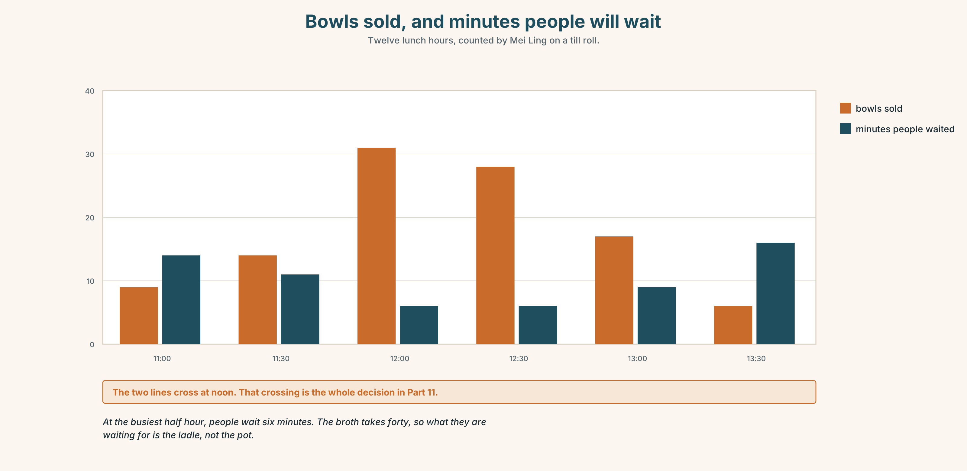{width=6.6in}
Bowls sold, and minutes people will wait — Twelve lunch hours, counted by Mei Ling on a till roll.

8A · Read the model
We used to walk to the river every Sunday, all of us, and my cousin always carried the bag because he was the oldest. [one habit, one detail, and the detail does the work]
Nobody walks it now. There is a road across the path and the water is lower than it was.
I still go twice a year, on my own, and I take the same bag. [what did not change — and it is one small object, not a feeling]
Questions about the writer's choices:
- The first sentence names who carried the bag. Why is that better than "we were happy"?
- The last line is about a bag. What is it really about?

8B · The anti-model
When I was a child everything was better. We used to play outside and we were very happy. Nowadays children only look at screens. Life has changed a lot and not in a good way.
Correct English. Name two things that are missing — and say why a reader does not believe it.

8C · Plan
one habit → one detail that proves it → what stopped → what is still there

8D · Write — 80 words

8E · Peer review — two criteria
☐ Is there one detail only this writer could know? ☐ Is there one thing that did not change?

8F · Write it again · 8G · Publish
On the wall, beside the two menus from Part 5E.

Part 9 · The File ◆ A · THE WORLD + C · THE PERFORMANCE

CULTURE FILE · The Misunderstanding
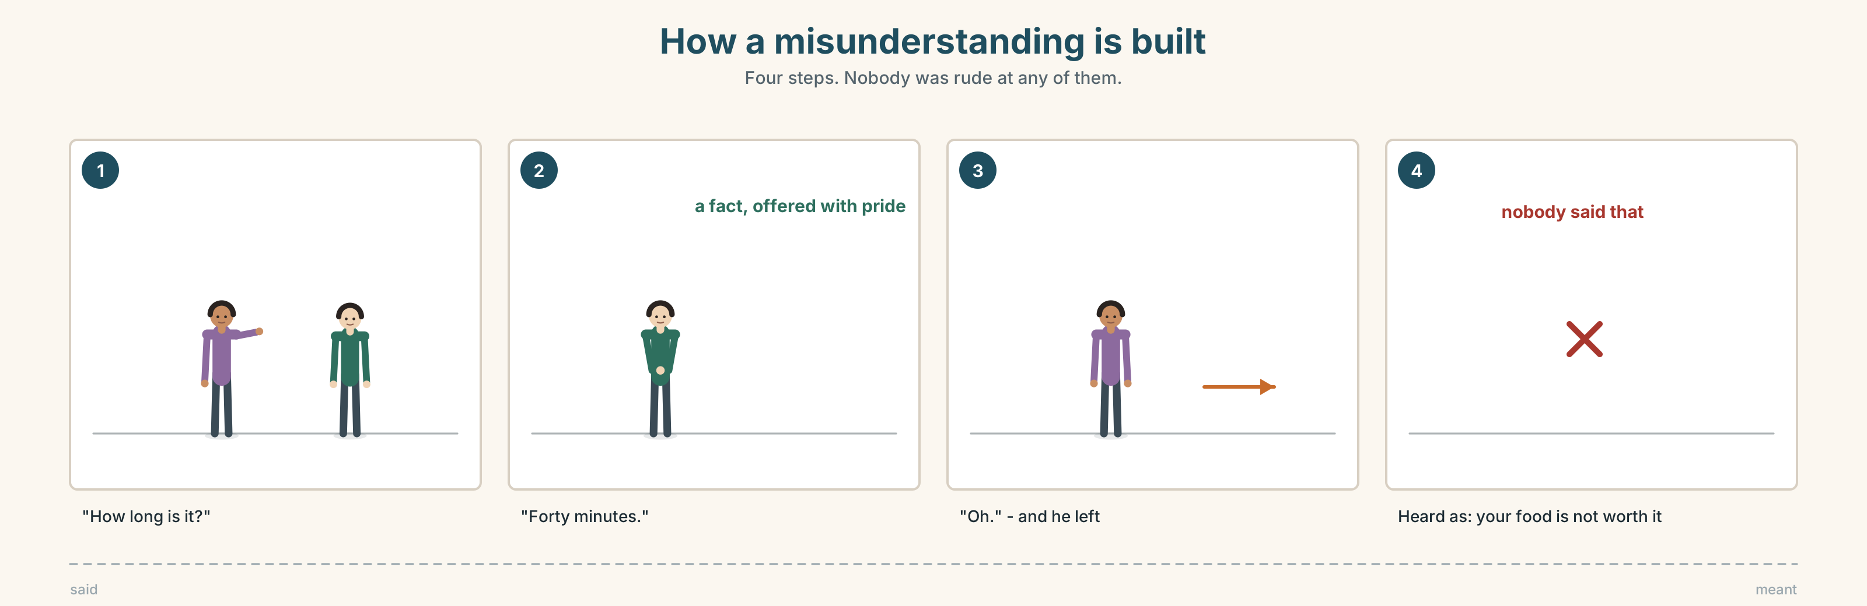{width=6.6in}
How a misunderstanding is built — Four steps. Nobody was rude at any of them.

9A · Nobody was rude 🔊 Track 3.4
A visitor waits six minutes and leaves. Mei Ling says nothing and is offended. The visitor has no idea. Listen to both of them talking about it afterwards.
- What does the visitor think happened?
- What does Mei Ling think happened?
- Which one of them thinks waiting is part of the food?

9B · Where it went wrong
the thing that was said · the thing that was heard · the thing that was meant
Three columns. Put these four lines in the right place.
"How long is it?" · "Forty minutes." · "Oh." · (and he left)

9C · Repair phrases
Match each to its job.
"Sorry — I didn't realise." · "Can I ask why…?" · "Ah, I see." · "That's not what I meant."
apologising · checking · understanding · correcting

9D · Your turn
In pairs. One of you is in a hurry. One of you is proud of taking time. Play it twice: once badly, once with a repair phrase. Two minutes each.

9E · Transfer
Think of one thing in your country that takes a long time on purpose. Explain to the group why the time is part of it.

Part 10 · Mediation & Interaction ◆ C · THE PERFORMANCE
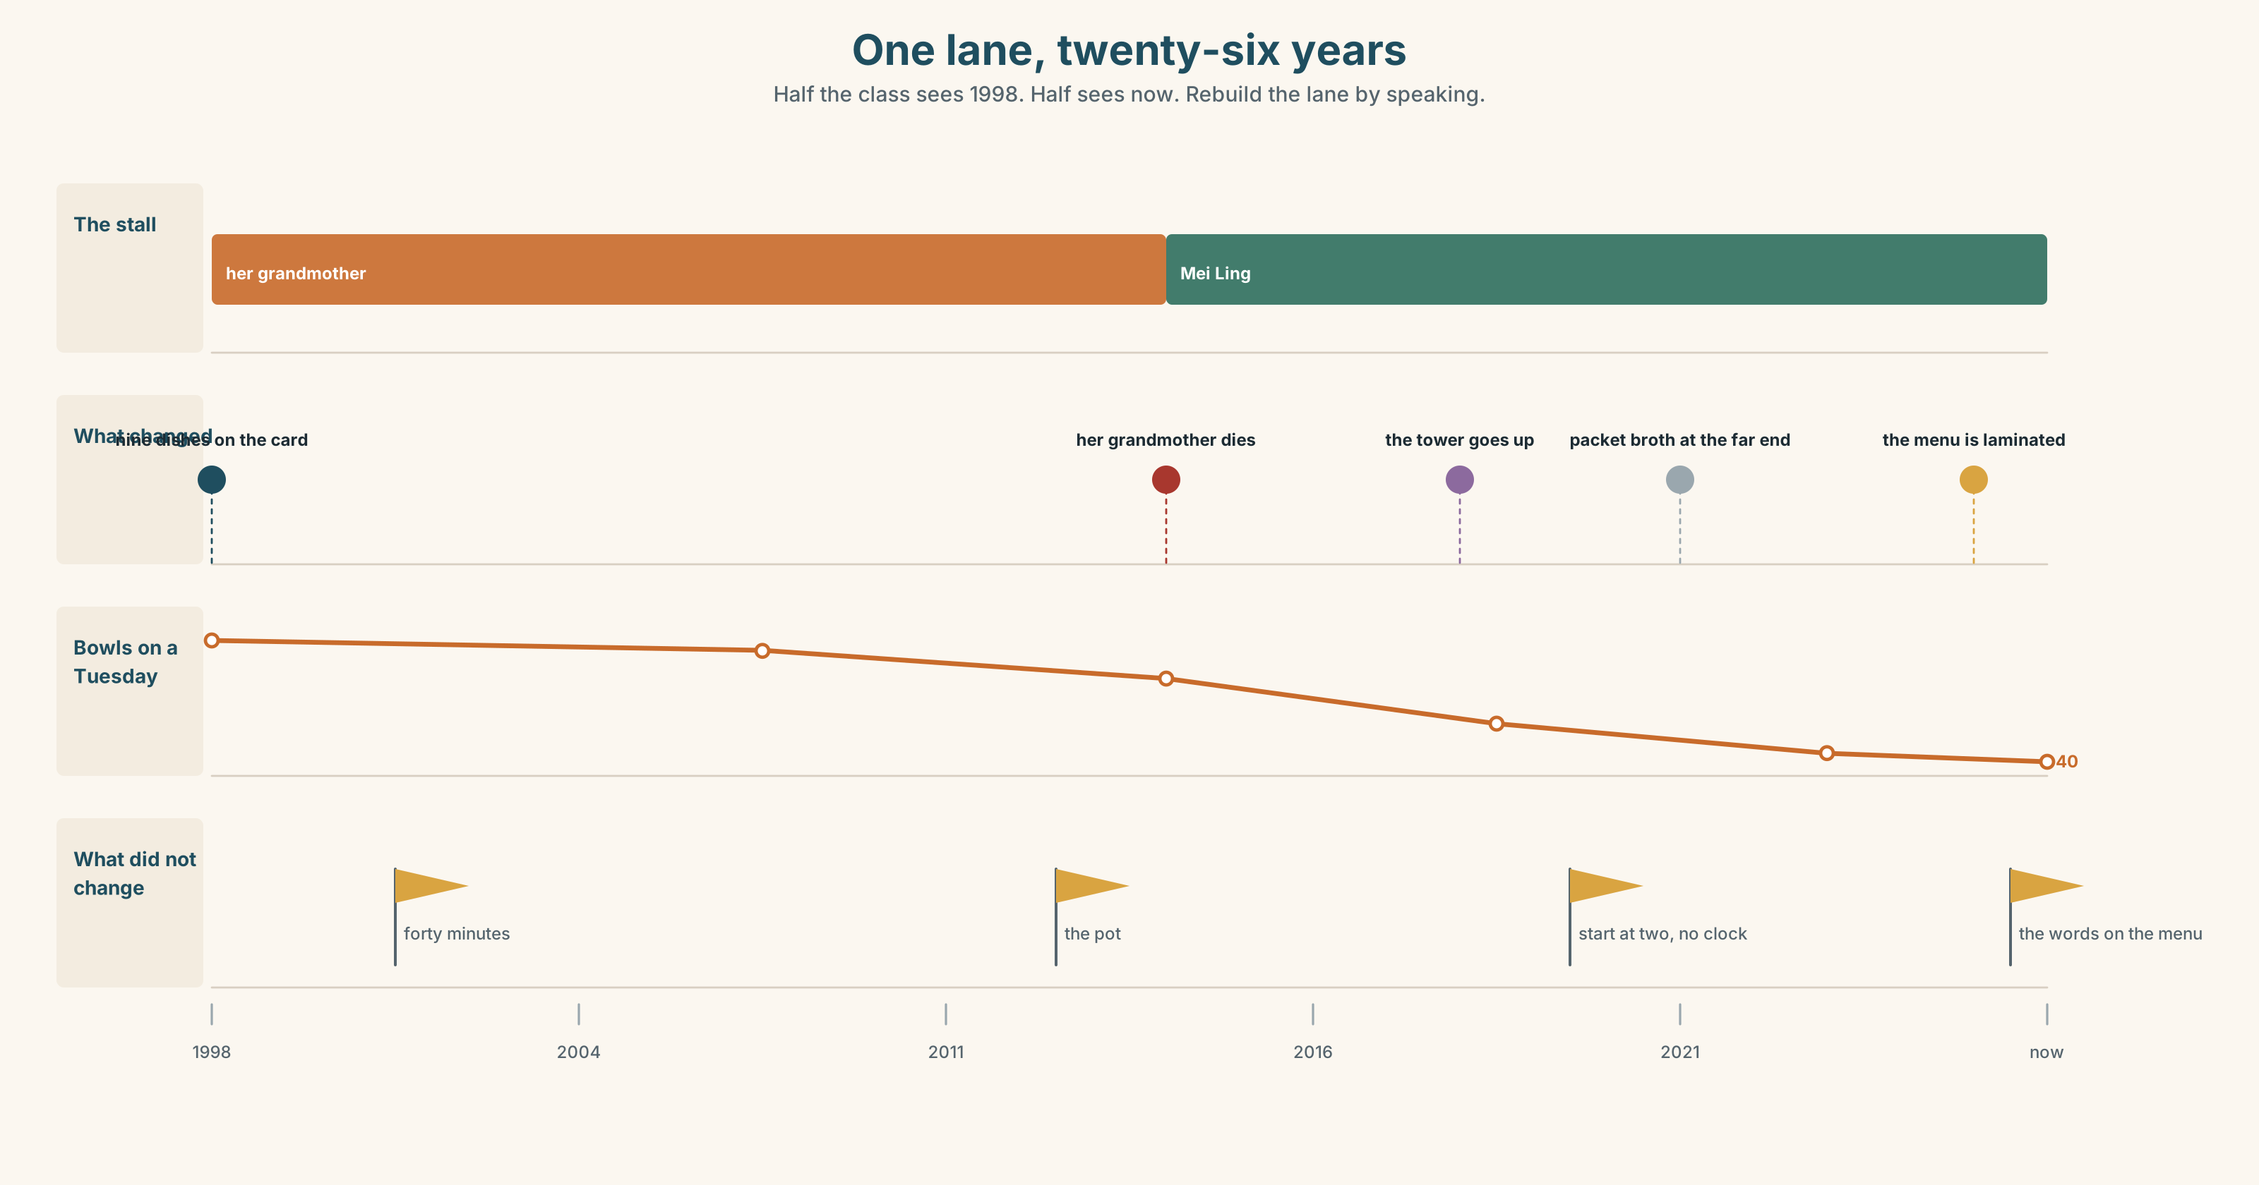{width=6.6in}
One lane, twenty-six years — Half the class sees 1998. Half sees now. Rebuild the lane by speaking.

10A · Relay
Half the class sees 1998. Half sees now. Rebuild the whole street by speaking. Ten minutes.

10B · Simplify
Explain the old menu from Part 5E to somebody who has never eaten here. Four sentences only.
Plan: what it is → how long it takes → why → what to order first

10C · Compress
The story in Part 5 into thirty words, as a label to put next to the pot.

10D · Online
Write one message for the market's page: the broth takes forty minutes, you are not going to change that, and you want people to know before they queue.

10E · Your language
How does your language say used to? Is it one word, two, or a different tense altogether? Show a partner, then say one sentence about your own childhood in both languages.

Part 11 · The Decision ◆ C · THE PERFORMANCE

Forty minutes, or ninety seconds
The broth takes forty minutes. The lunch queue is twenty-five minutes long at its worst and people leave. The stall at the end does a packet broth in ninety seconds and sells three times as much.
- Keep it. Forty minutes. Fewer bowls, and the thing stays what it is.
- Change it. Make the base the night before. Eight minutes a bowl. Nobody will know.
- Both. The long one until it runs out, the quick one after. Two prices.

11A · The evidence
- The two menus from Part 5E — and what the handwritten line says.
- The chart — bowls sold per hour, against how long people are willing to wait.
- The voice. Her cousin, twenty seconds: "They're not coming back for the forty minutes. Nobody has ever come back for the forty minutes."

11B · Talk about it
In threes. Everybody says one. Use the frame.
I think Mei Ling should ______ , because ______ .
Words you can use: memory · queue · taste · her grandmother's · change · the same · money

11C · Decide
Write two sentences. Choose, and say why.
I think Mei Ling should ______________________ , because ______________________ .

11D · Model decision
She should make the base the night before and keep everything else. The forty minutes was never the point — her grandmother started at two in the morning precisely so that nobody would have to wait, and doing the slow thing at the wrong end of the day is not loyalty to her, it is just doing it in the hardest order.

11E · The Reveal
What happened. She made the base the night before. Service came down to nine minutes and sales went up by half in three weeks.
Four regulars said it tasted different. She could not taste any difference and neither could her cousin, and two of the four were back within a month.
She did not tell anybody she had changed it. She has told one person since: the man who waited six minutes and left, who came back and is now there on Tuesdays.
Sales up by half. Four complaints. One secret she is not comfortable with.
Was it the right decision? Say why — and say what you think of the secret.

Part 12 · Landing ◆ all three lines

12A · Recycle — ten items
- I ______ (use) to live here.
- Nobody waits ______ .
- She ______ makes it the long way.
- ______ those days the street was open on Sundays.
- We went to the coast ______ summer.
- (Unit 2) ______ he was loading, the road closed.
- (Unit 2) It ______ (rain) all morning.
- (Unit 1) I've worked here ______ three years.
- (Starting Out) My grandmother ______ (teach) me.
- (Starting Out) There ______ four of us in the house.

12B · Consolidate
Eighty words, one paragraph. A place you knew as a child. Two sentences with used to, one with anymore, one with still.

12C · Can-do, with evidence
I can… | My evidence | Sure?
say what I used to do and no longer do | Part 3G score | ◯ ◑ ●
compare then and now in sixty seconds | Part 4C recording | ◯ ◑ ●
write eighty words about a change | Part 8 draft 2 | ◯ ◑ ●
repair a misunderstanding politely | Part 9D role play | ◯ ◑ ●

12D · Replay ⏺
Find your thirty seconds from Part 0C. Listen. Record it again. One sentence: what is different?

12E · Glossary — forty items, as a map
THE CHILDHOOD · childhood · memory · remember · photo · toy · game · song · cartoon · playground THE PEOPLE · cousin · neighbour · my grandmother's THE PLACE · street · holiday · every summer · when I was little · in those days WHAT HAPPENED TO IT · change · different · same · old · young · favourite · look back on IT STOPPED · used to · anymore · no longer · not like before · I don't anymore · things have changed · miss out on IT DIDN'T · nowadays · these days · back then · the way it was · most of the time HOW OFTEN · rarely · ever · never · hardly ever

12F · Next
Unit 4 · Who is the person who…?

