Table of Contents

A2.1 · Unit 4 · The Corner Pitch
English Animated · Making Plans · Pasar Chow Kit, Kuala Lumpur Student's Book pages 72–93 · 22 pp · ~10 hours

Part 0 · The Big Picture ◆ A · THE WORLD
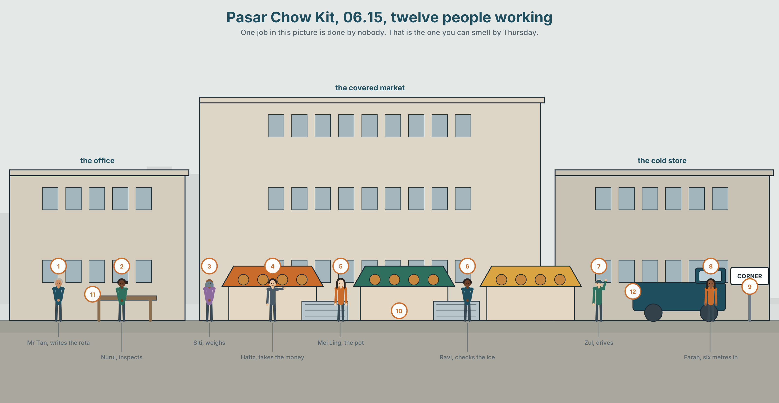{width=6.6in}
Pasar Chow Kit, 06.15, twelve people working — One job in this picture is done by nobody. That is the one you can smell by Thursday.

Who is the person who…?
By the end of this unit you can describe three jobs in one workplace, so that somebody on their first day knows who to ask for what.
◆ A · THE WORLD | How a workplace divides itself up, and who ends up with the gaps
◆ B · THE SYSTEM | who, which, that, where · 24 words for teams and roles · 16 words for describing a job · where to pause in a long sentence
◆ C · THE PERFORMANCE | Three jobs, described so a stranger can use them

0A · Find it
Twelve people are working in this picture. Find the person who:
opens the gate · weighs · takes the money · writes the rota · checks the ice · cleans the drain · drives · inspects · unlocks the cold store · answers the phone · fixes the lights · decides who gets the corner

0B · Guess it
One job in this picture is done by nobody. Which, and what happens as a result?

0C · Say it ⏺
Record thirty seconds. Think of a place you know. Who is the person you ask when something goes wrong? You will record it again at the end of the unit.

Part 1 · Vocabulary Lab 1 ◆ B · THE SYSTEM
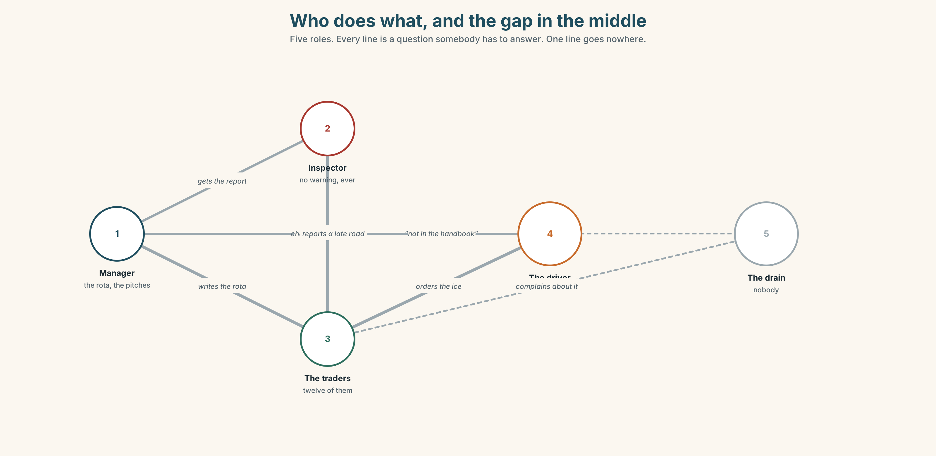{width=6.6in}
Who does what, and the gap in the middle — Five roles. Every line is a question somebody has to answer. One line goes nowhere.

1A · Meet — the people and the work
Match each word to one place on the map.
team · role · job · task · boss · manager · colleague · staff · shift

1B · Sort — a person, a piece of work, or a time?
Three columns.
manager · task · shift · colleague · job · staff · role · boss · team
Two of them can go in two columns. Which, and why?

1C · Meet — what you say about somebody good
responsible · thorough · reliable · honest · hard-working · calm · friendly
Which one would you want in a person who counts money? Which in a person who opens at four?
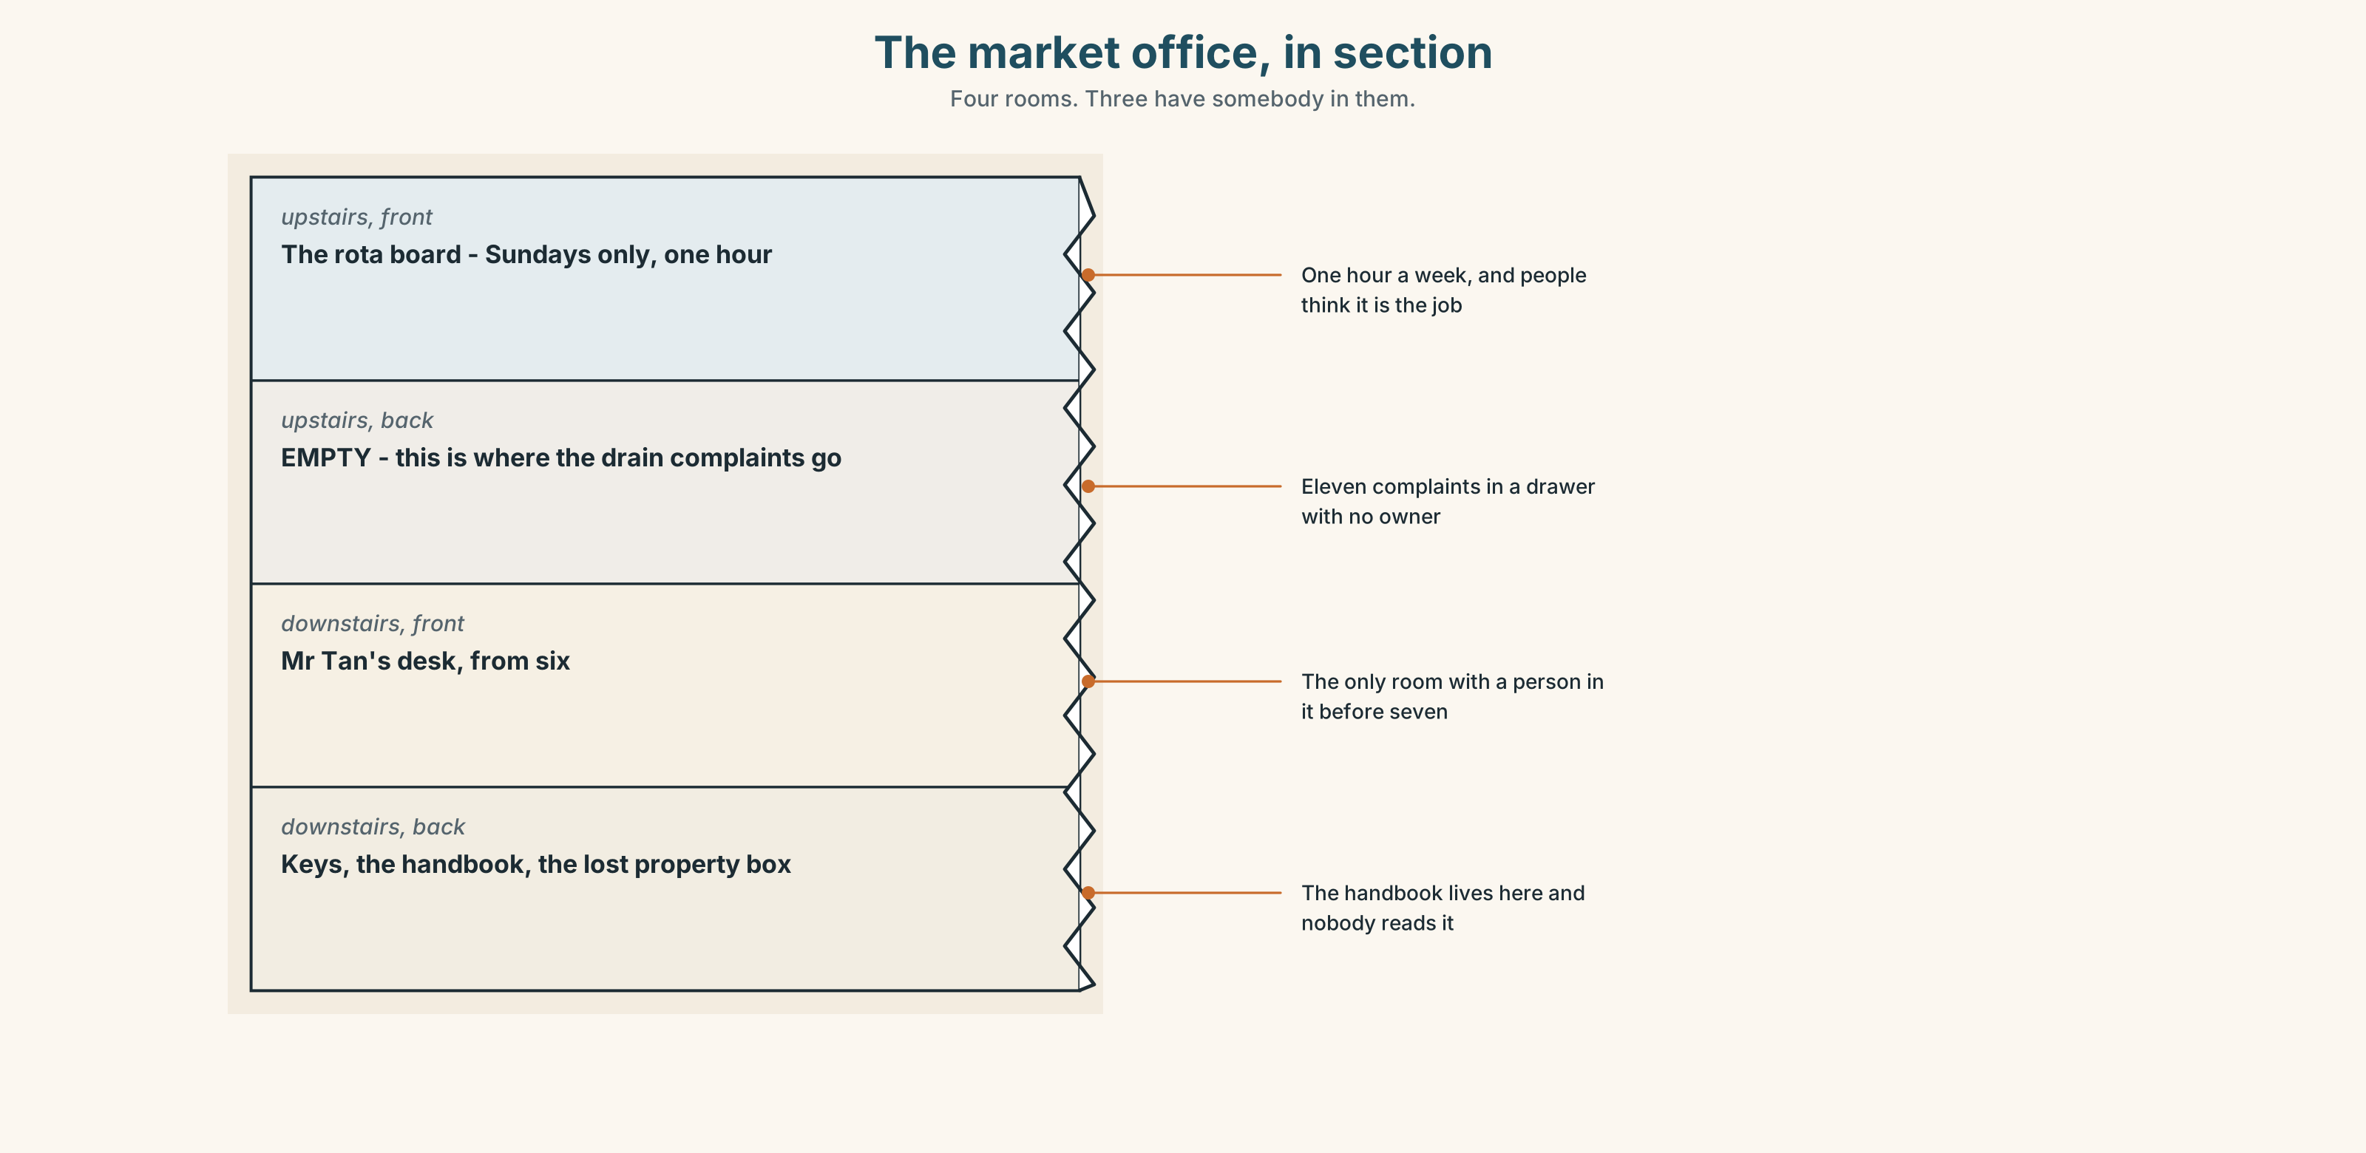{width=6.6in}
The market office, in section — Four rooms. Three have somebody in them.
Look at the market office in section. Four rooms, four jobs. Which room has nobody in it, and whose job has fallen into it?

1D · Stretch — the phrases
Complete each one with one word.
- Nurul is in ______ of food safety for the whole market.
- Could you ______ after the stall for ten minutes?
- He's the ______ who has the key to the cold store.
- Four of us work ______ on a Saturday.
- When she is ill, Hafiz ______ over.

1E · The saying
f That's not my job.
Four words that can be fair or lazy. Write one situation where it is fair, and one where it is not. Read both to a partner. Can they tell which is which?

1F · Own it
Think of a place you have worked, studied or lived in. Tell a partner three sentences about three different people — using who in each one.

Part 2 · Listening ◆ A · THE WORLD
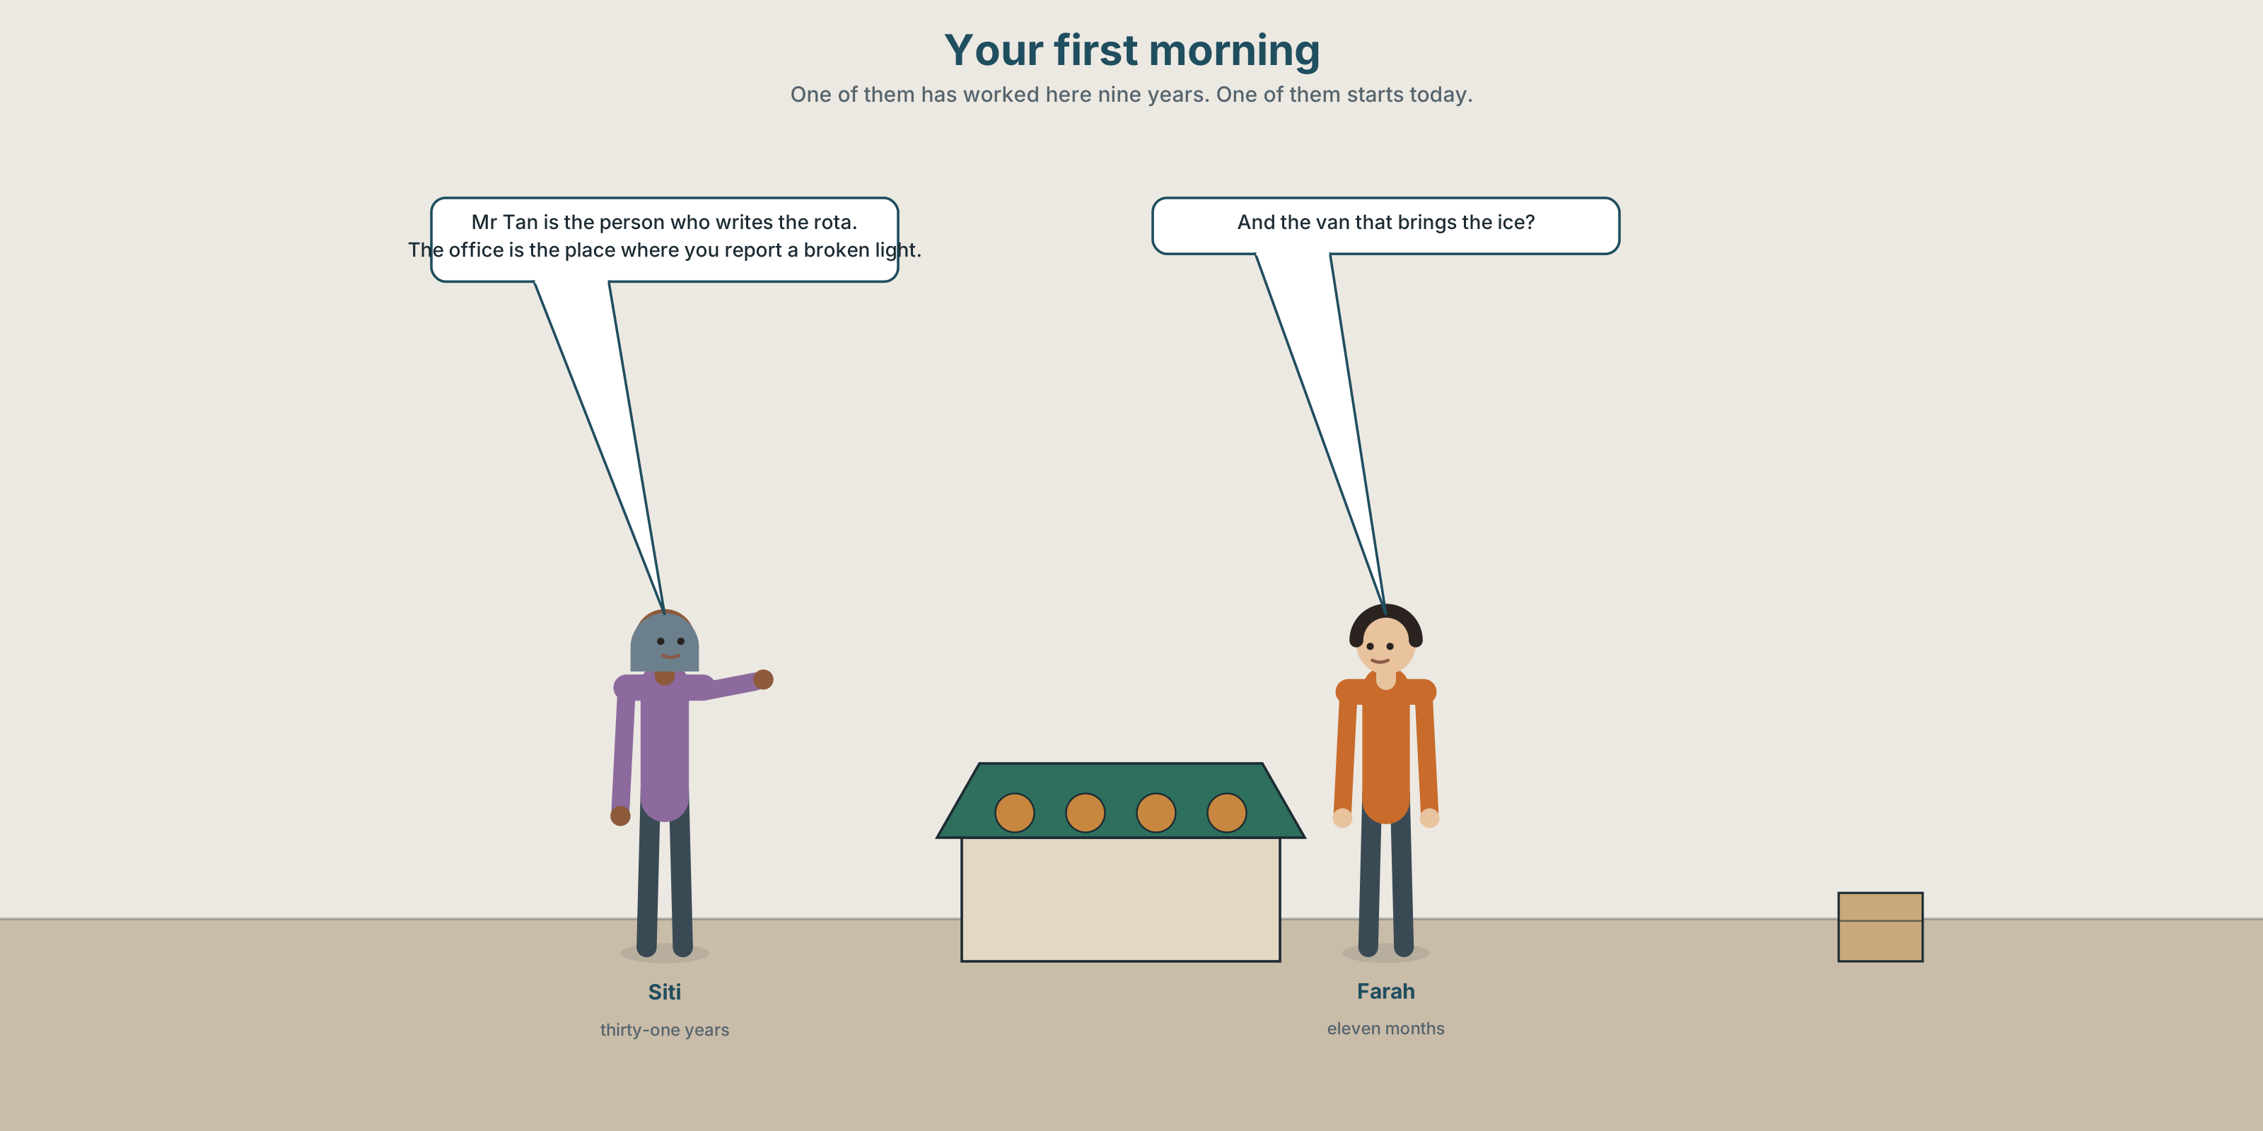{width=6.6in}
Your first morning — One of them has worked here nine years. One of them starts today.

2A · Your first morning 🔊 Track 4.1
Before you listen. Somebody is starting work at the market today. Who would explain the place to them — the manager, or another trader?
Listen once. One question. How many people does the speaker name?
Listen again. Complete the table.
Name | What they do | When to go to them
Mr Tan
Nurul
Zul
Listen again. Choose.
- The person who has the cold store key is Mr Tan / Nurul / a trader.
- Nurul arrives every Monday / on a rota / without warning.
- The place where you report a broken light is the office / the gate / nowhere.
- The thing nobody is responsible for is the drain / the ice / the rota.
Noticing. Four sentences from the recording.
- Mr Tan is the person who writes the rota.
- Nurul is the inspector who comes without warning.
- The office is the place where you report a broken light.
- The van that brings the ice is Zul's.
Three of these describe a person. One describes a place. Find it.

2B · Decoding clinic 🔊 Track 4.2
Twenty-five seconds. Four jobs.
- How many times does the speaker say who?
- Where does she pause in sentence 1 — before who or after it?
- Catch the two names she says twice.
- One sentence has no pause at all. Which, and why is it still clear?
Transcripts, page 153.

Part 3 · Grammar Lab 1 ◆ B · THE SYSTEM

Saying which one you mean

3A · Notice
Look at the four sentences in Part 2.
- In sentence 1, could you take out who writes the rota? What would be left?
- In sentence 3, why where and not who?
- Sentences 1 and 4 both pick one thing out of several. Out of what, in each case?
- who, which, where. Which one is for people, which for things, which for places?
- Try "Mr Tan is the person which writes the rota." What is wrong?

3B · See
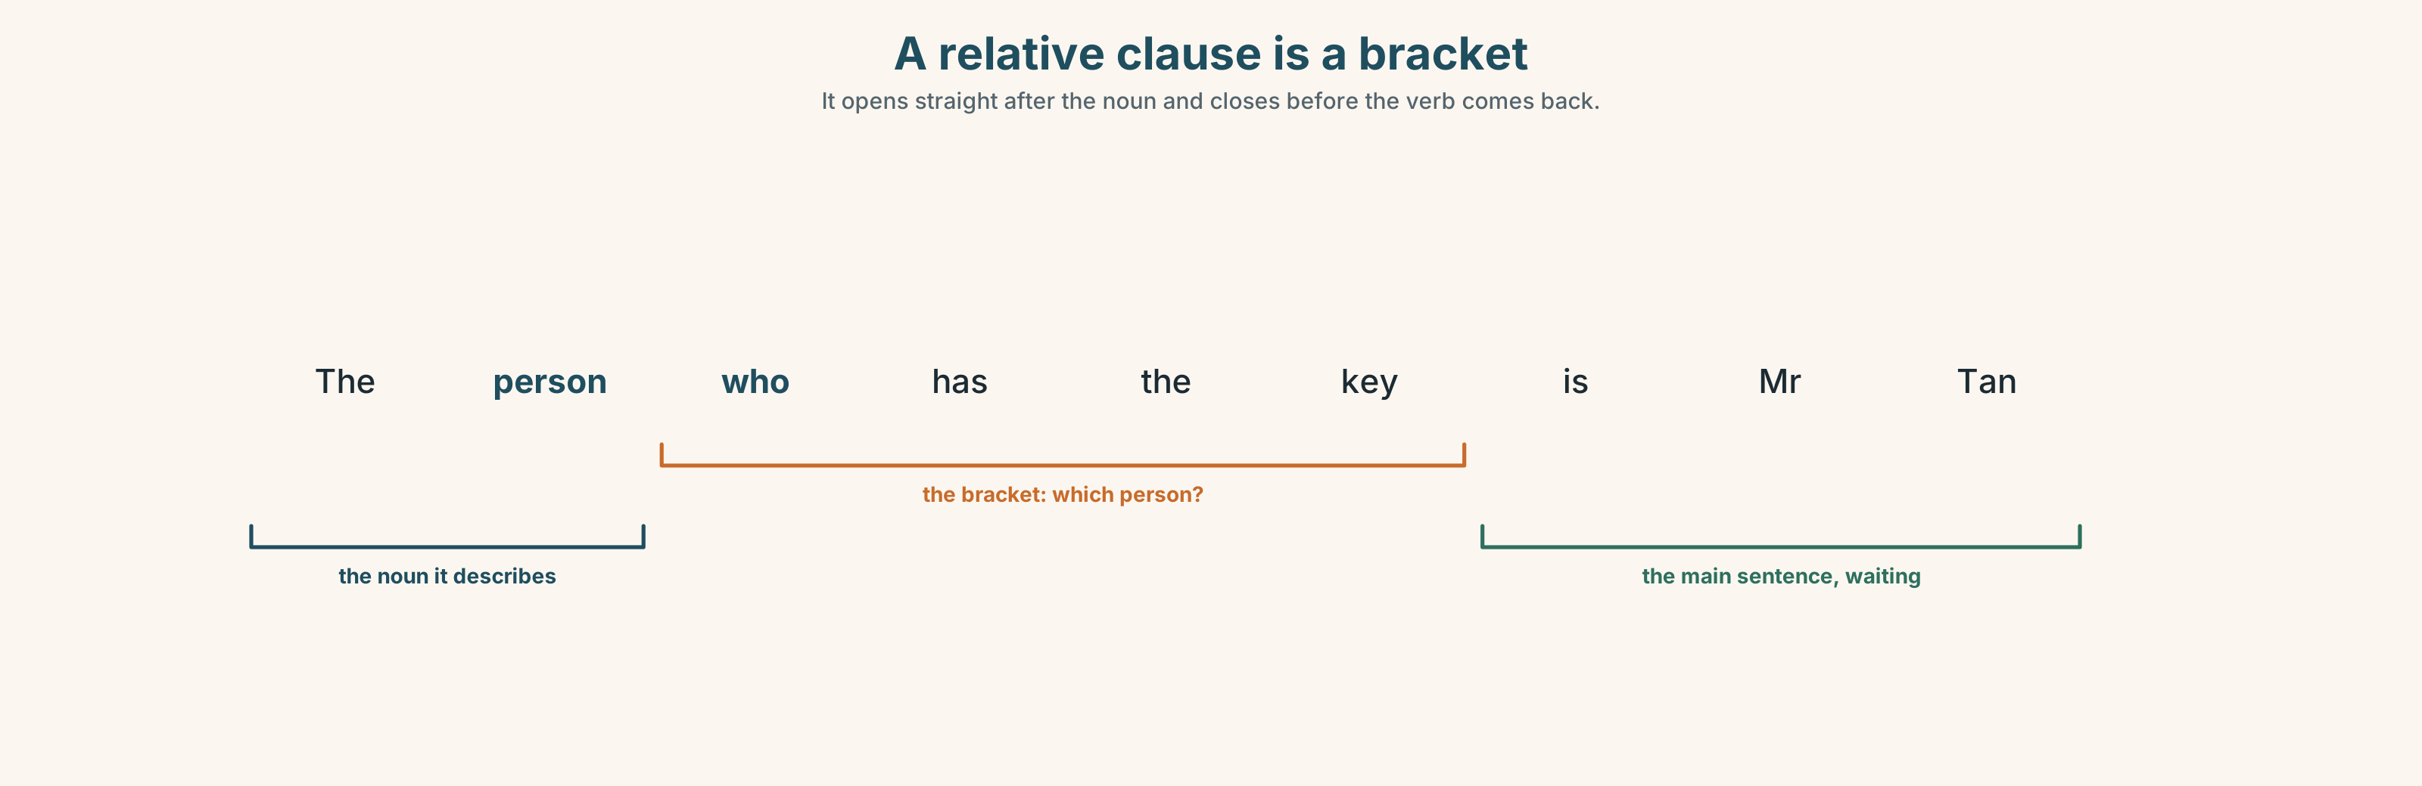{width=6.6in}
A relative clause is a bracket — It opens straight after the noun and closes before the verb comes back.
Now look at the second picture. A relative clause is a bracket. Where does it open and where does it close?
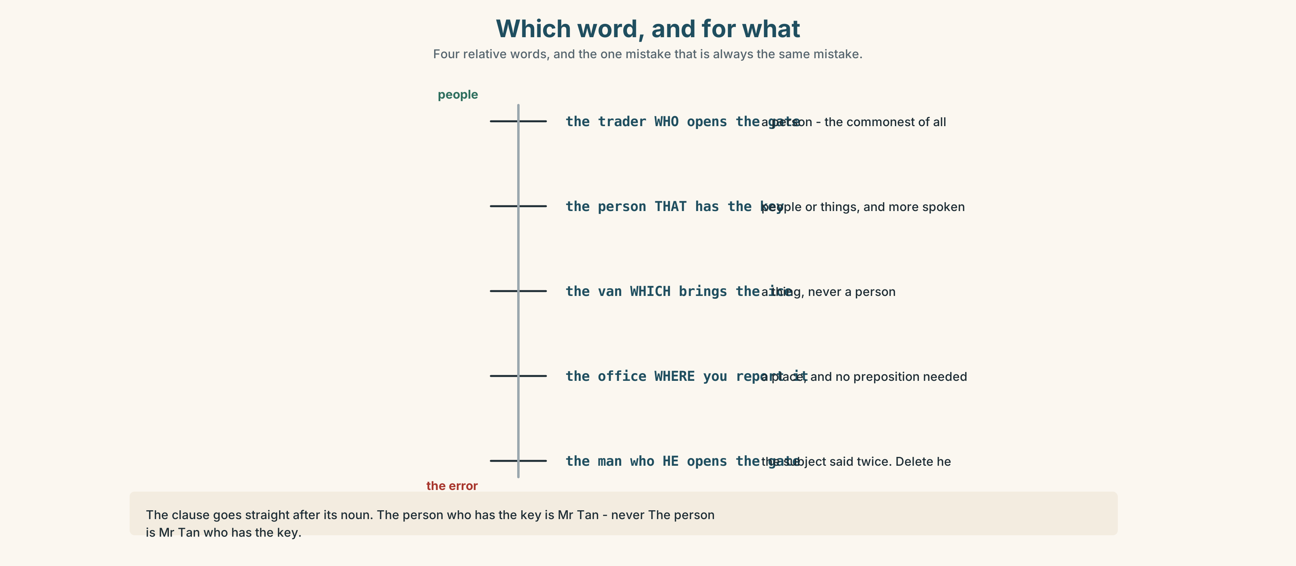{width=6.6in}
Which word, and for what — Four relative words, and the one mistake that is always the same mistake.

3C · Know
 | Use it for | Example
who | people | the trader who opens the gate
which | things | the van which brings the ice
that | people or things, and more common in speech | the person that has the key
where | places | the office where you report it
The clause comes straight after the noun it describes. ✓ The person who has the key is Mr Tan. ✗ The person is Mr Tan who has the key.
Watch out. Do not say the subject twice. ✗ the man who he opens the gate ✓ the man who opens the gate
Why it matters. There are twelve people in this market. The man tells me nothing. The man who has the cold store key tells me exactly one.

3D · Use — controlled
Mr Tan is the manager (1) __________ writes the rota. The office (2) __________ he works is next to the gate. Nurul is the inspector (3) __________ arrives without warning, and the van (4) __________ brings the ice belongs to Zul. The one job (5) __________ nobody does is the drain, (6) __________ is why it smells by Thursday.

3E · Use — guided
Join each pair into one sentence.
- That's the trader. She opens the gate at four.
- This is the room. We keep the scales here.
- He's the colleague. I trust him with the money.
- That's the van. It broke down on Tuesday.
- She's the person. Her name is on the rota every Sunday.

3F · Use — open
Describe three people in this room without using their names. Your partner must guess. Use who in all three.

3G · Check — six items
- The person ______ has the key is Mr Tan.
- This is the place ______ we weigh everything.
- The van ______ brings the ice is late again.
- She's the one ______ I asked on Monday.
- Is that the manager ______ wrote the rota?
- The job ______ nobody wants is the drain.
0–3 → Workbook pp. 22–24. 4–5 → Part 6. 6 → page 85.

Part 4 · Speaking ◆ C · THE PERFORMANCE

4A · Fluency starter — guess the job
One learner thinks of a job in this building. The others ask only questions beginning "Is it the person who…?" Six questions maximum.
Three rounds. Three learners.

4B · The functional core — telling somebody who to ask
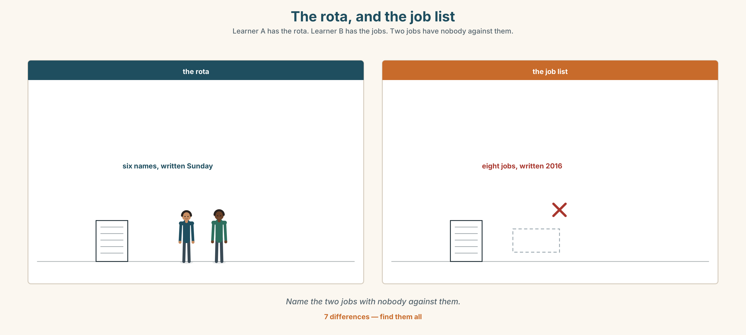{width=6.6in}
The rota, and the job list — Learner A has the rota. Learner B has the jobs. Two jobs have nobody against them.
Language Bank
naming the role | She's the one who… · He's in charge of… · That's the person that…
naming the place | The office where… · Round the back, where…
saying when | Go to her if… · Only ask him when… · Don't ask on a Friday.
the honest warning | Nobody really does that one. · That's not anybody's job.
Information gap. Learner A has the rota. Learner B has the job list. Neither sees the other. Work out which two jobs have nobody's name against them.

4C · The performance — eighty seconds ⏺
Describe three jobs in one workplace to somebody arriving on Monday. Eighty seconds. You must give:
who each person is · what each one decides · one thing you would not ask them
Record it.

4D · Observer
One person listens for one thing: could a stranger now go to the right person?

4E · Two criteria
☐ Did I use who, which or where in each of the three? ☐ Did I say one thing not to ask?

Part 5 · Reading ◆ A · THE WORLD

5A · Predict
A personal essay by a market manager. The title is "Twelve stalls and one corner." What problem do you expect him to describe? One sentence.

5B · Read — one hundred seconds

Twelve stalls and one corner
I have been the manager here for nine years. People think the job is the rota. It is not. The rota takes an hour on a Sunday. The job is the corner.
There is one corner pitch. It is the pitch that everybody who walks in from the car park sees first, and the trader who has it takes about forty per cent more than the trader who is six metres further in. It came free in March.
Three people want it. One is the trader who has been here longest and has never asked me for anything. One is the trader who pays the most and is, if I am honest, the most reliable person in this market. One is a woman who started eleven months ago, who is on her own with two children, and who is six metres further in.
My predecessor had a rule: longest serving. It is a good rule because it cannot be argued with and a bad rule because it rewards nothing except staying.
I have read the handbook. The handbook says the manager decides. That is the sentence that tells you the handbook was written by somebody who has never had to.

5C · Answer
- How long has the writer been the manager?
- What does he say the job really is?
- How much more does the corner pitch take?
- Describe the three people who want it, in one sentence each.
- What was his predecessor's rule, and what does he say is wrong with it?
- What is his complaint about the handbook?

5D · Vocabulary in context
Guess from the text. Then check.
a pitch · six metres further in · my predecessor · rewards nothing except · if I am honest

5E · The counter-text
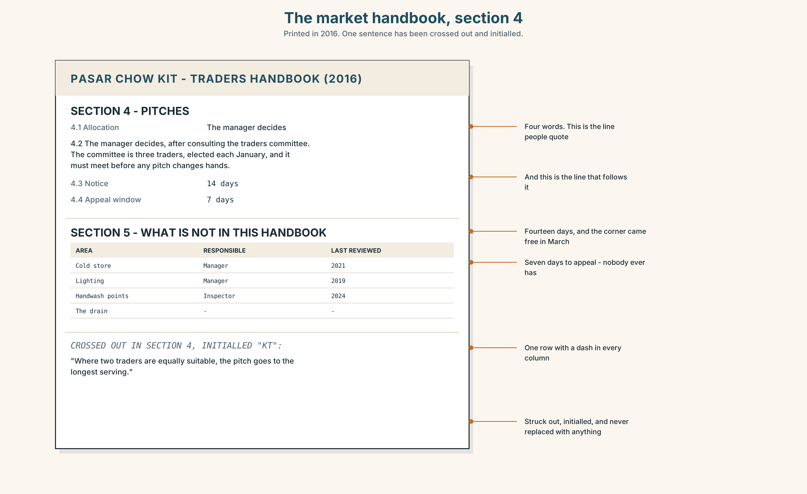{width=6.6in}
The market handbook, section 4 — Printed in 2016. One sentence has been crossed out and initialled.
Read the market handbook extract and answer.
- Which section covers pitch allocation?
- What exactly does the handbook say the manager must do before deciding?
- How many days' notice must traders be given?
- One sentence has been crossed out and initialled. What did it say?

5F · Two texts
The essay says "the handbook says the manager decides." The handbook says the manager decides after consulting the traders' committee.
Put those two facts together. What has the writer left out, and why might he have? Two sentences.

Part 6 · Vocabulary Lab 2 ◆ B · THE SYSTEM

Describing the work itself
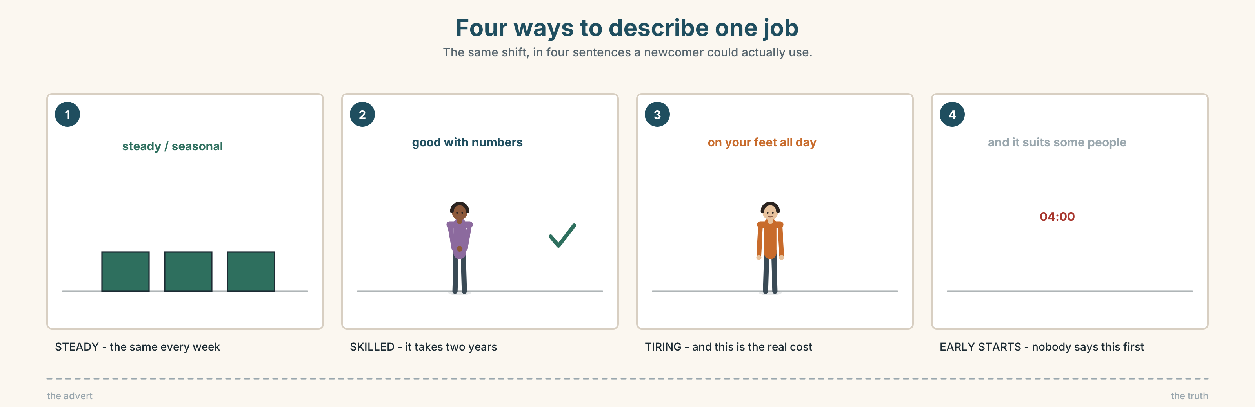{width=6.6in}
Four ways to describe one job — The same shift, in four sentences a newcomer could actually use.

6A · Sort — would you want it?
Two columns, and be honest.
stressful · steady · interesting · tiring · well-paid · badly-paid · boring · skilled · seasonal · useful · helpful · difficult
I'd take it | I wouldn't
Two of these are in both columns for most people. Which?

6B · Chunk completion
- She's a people ______ — she remembers everybody.
- He's good with ______ , so he counts the takings.
- It's on your ______ all day , and that is the real cost of it.
- The early ______ are the part nobody tells you about.
- I get ______ with everybody here except one person.
- The hours are long, but it ______ me.

6C · Two words that look the same
helpful and useful are not the same. A person is helpful. A thing is useful.
Put the right one in each.
- The new scales are very ______ .
- Hafiz was extremely ______ on Tuesday.
- That's a ______ piece of advice.
- Thank you — you've been very ______ .
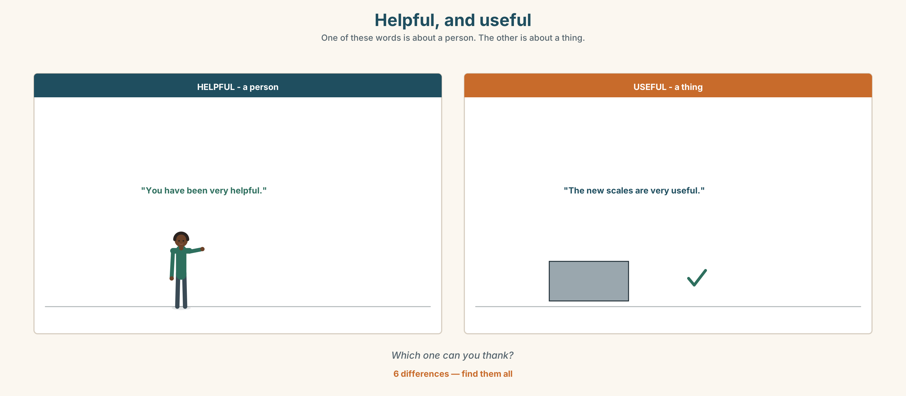{width=6.6in}
Helpful, and useful — One of these words is about a person. The other is about a thing.
Six differences. Find them, then answer the question under the picture.

6D · Contrast Clinic — who, which, where or that
Six items.
- The person ______ opens the gate.
- The room ______ we keep the ice.
- The van ______ broke down.
- The job ______ nobody wants.
- The inspector ______ came on Thursday.
- The market ______ I have worked for nine years.

Part 7 · Pronunciation & Fluency Lab ◆ B · THE SYSTEM

Where to breathe in a long sentence
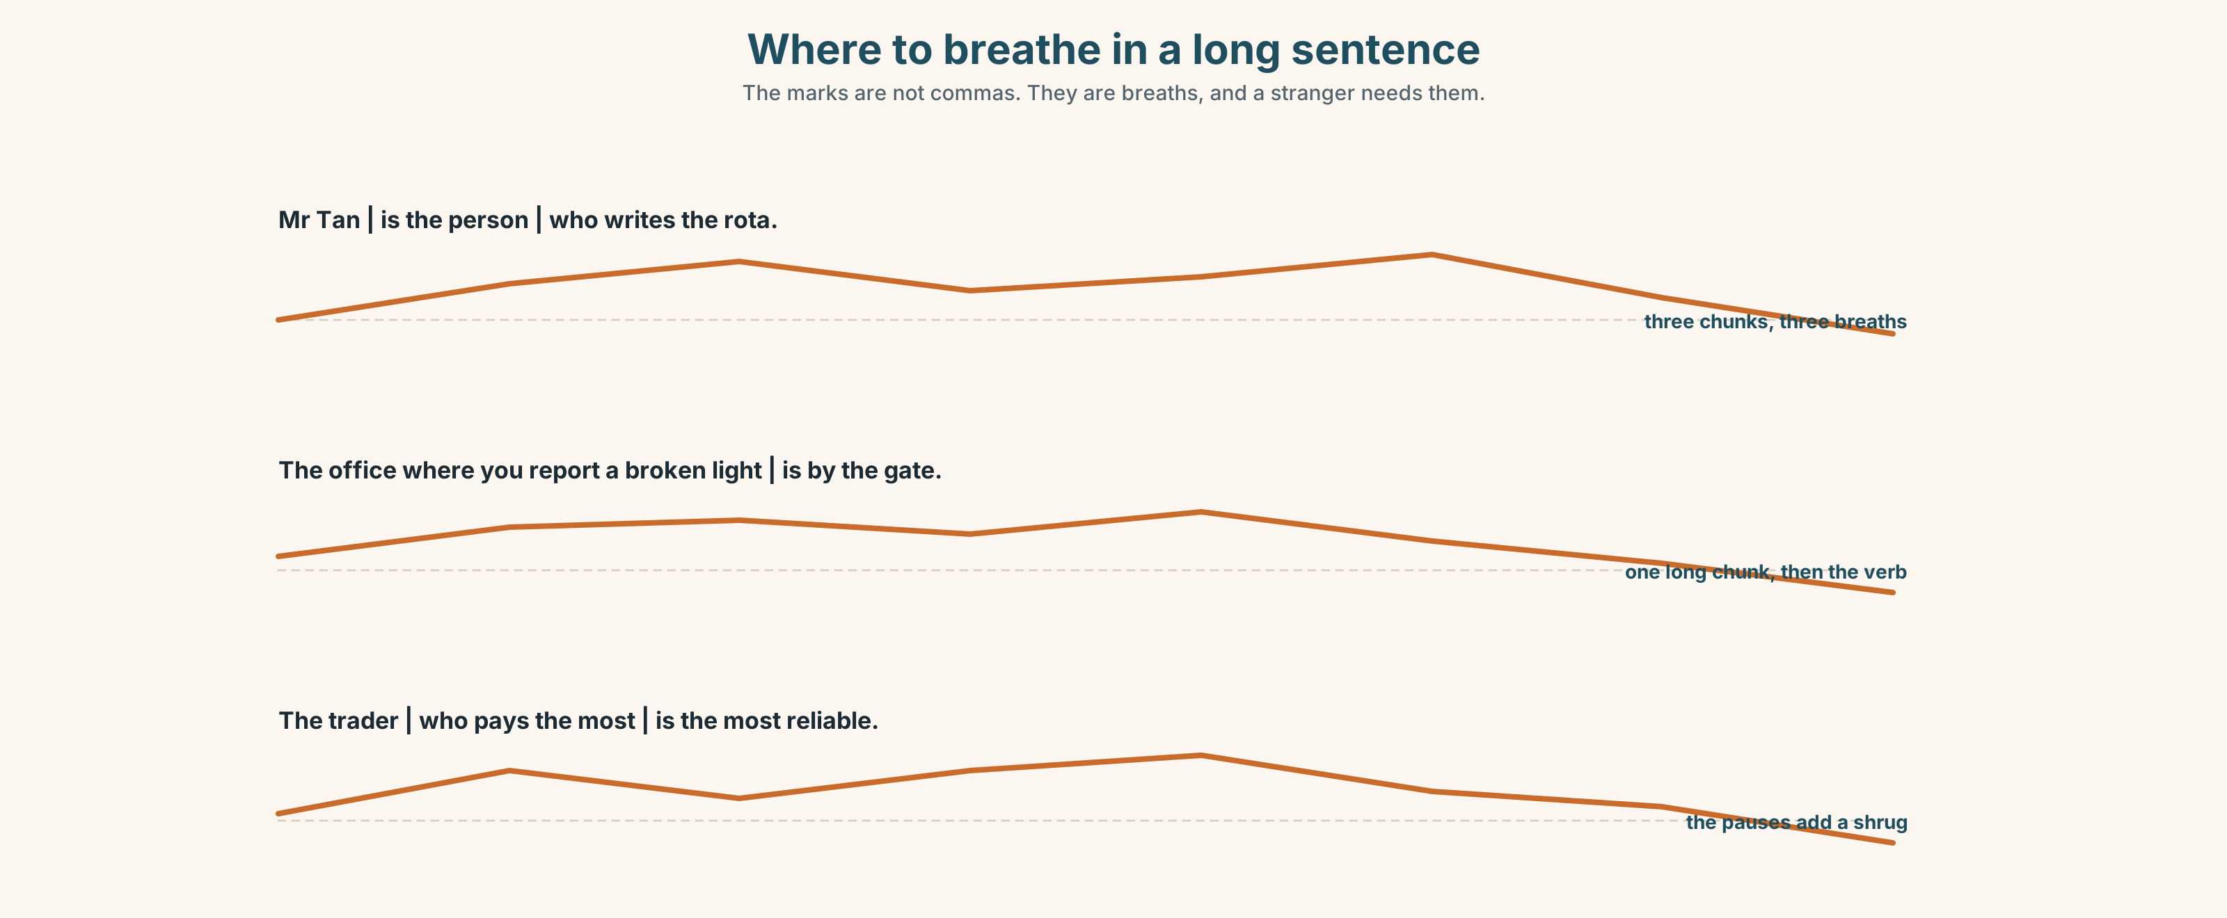{width=6.6in}
Where to breathe in a long sentence — The marks are not commas. They are breaths, and a stranger needs them.

7A · Hear 🔊 Track 4.3
Mr Tan | is the person | who writes the rota. The office | where you report a broken light | is next to the gate.
The marks are not commas. They are breaths.

7B · Say
Say each one with the breaths. Then say it again with no breath at all. Which version can a stranger follow?

7C · Make it mean something
Say this sentence twice:
The trader who pays the most | is the most reliable. The trader | who pays the most | is the most reliable.
The second one adds something the first does not. What?

7D · Fluency 20 ⏺
Twenty seconds: three people in your life, each described with who. Three times, faster — but keep the breath before who.

Part 8 · Writing ◆ C · THE PERFORMANCE

Who to ask · 90 words
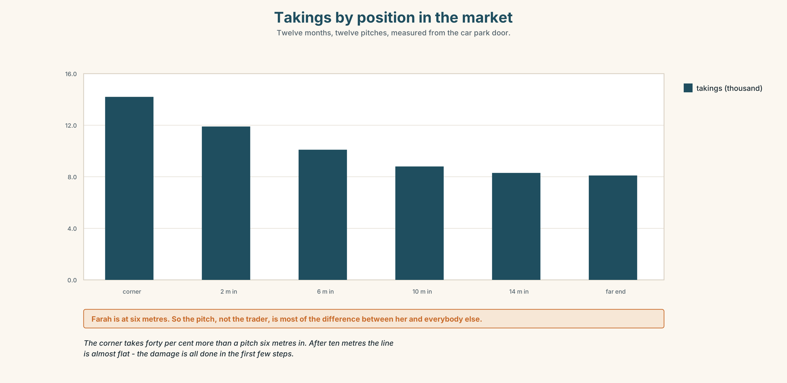{width=6.6in}
Takings by position in the market — Twelve months, twelve pitches, measured from the car park door.

8A · Read the model
Mr Tan is the manager who writes the rota and decides who gets which pitch. He is in the office by the gate from six. [the role, then where and when — a newcomer can act on this]
Nurul is the inspector who arrives without warning. Do not try to be friendly with her; she is not here for that, and she is honest about it. [one thing not to do, and why]
Zul drives the van which brings the ice. If the ice is late, it is almost never Zul. [a warning about blame, not about the person]
Questions about the writer's choices:
- Each paragraph gives one thing you should not do. Why is that more useful than praise?
- The last line defends somebody who was not accused. Why?

8B · The anti-model
There are many people working here. Mr Tan is the manager and he is very nice. Nurul is the inspector. Zul drives the van. Everybody is friendly and works very hard as a team.
Correct English, and useless on a first morning. Name two questions it does not answer.

8C · Plan
name → the role, with who or which → where and when to find them → one thing not to ask

8D · Write — 90 words

8E · Peer review — two criteria
☐ Could a stranger use this on Monday morning? ☐ Is there one honest warning in it?

8F · Write it again · 8G · Publish
On the wall, with the handbook extract from Part 5E beside it.

Part 9 · The File ◆ A · THE WORLD + C · THE PERFORMANCE

WORK FILE · The Review
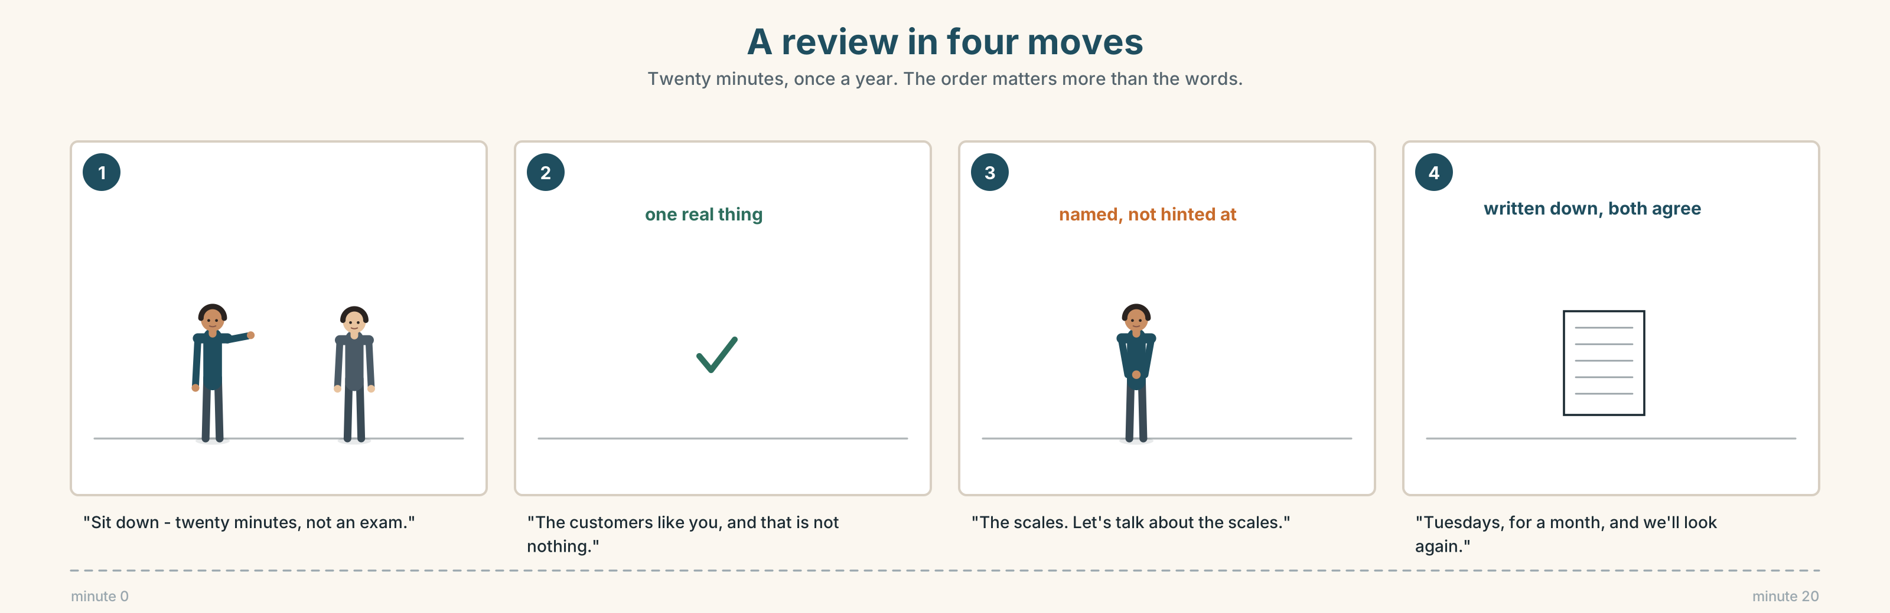{width=6.6in}
A review in four moves — Twenty minutes, once a year. The order matters more than the words.

9A · Twenty minutes, once a year 🔊 Track 4.4
Mr Tan reviews Hafiz's first year. Listen.
- How does Mr Tan open it, and how long does the small talk last?
- What does he praise, and what does he raise?
- He asks one question he does not know the answer to. Which?

9B · The four moves
opening · praising · raising something · agreeing what happens next
Match each to one phrase.
"Sit down — this is twenty minutes, not an exam." · "The customers like you, and that is not nothing." · "The scales. Let's talk about the scales." · "So: Tuesdays, for a month, and we'll look again."

9C · Receiving it
What do you say when somebody raises something true? Put these in order, best first.
"I know. I'm working on it." · "That's not fair." · "Yes. What would help?" · "Sorry."

9D · Your turn
In pairs. Ten minutes. One reviews, one is reviewed. The reviewer must praise one real thing and raise one real thing. Then swap.

9E · Transfer
Write the one sentence you would want said about your work this year. Keep it. You will look at it again at the end of the book.

Part 10 · Mediation & Interaction ◆ C · THE PERFORMANCE
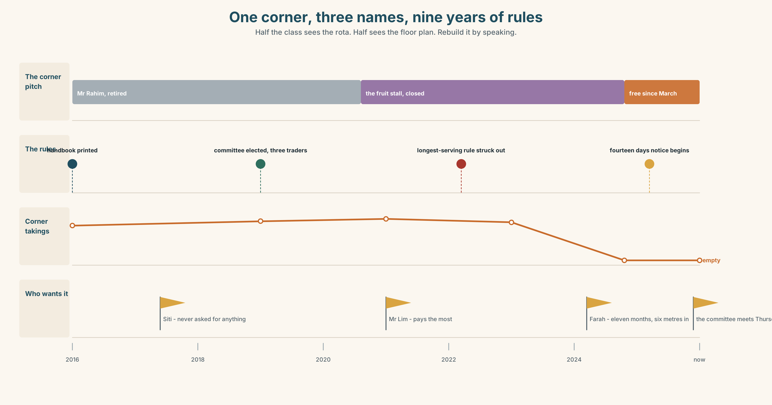{width=6.6in}
One corner, three names, nine years of rules — Half the class sees the rota. Half sees the floor plan. Rebuild it by speaking.

10A · Relay
Half the class sees the rota. Half sees the floor plan. Rebuild who does what, and where, by speaking. Ten minutes.

10B · Simplify
Explain the handbook extract from Part 5E to a trader who has never read it. Four sentences only.
Plan: who decides → who must be asked first → how much notice → what you can do if you disagree

10C · Compress
The essay in Part 5 into thirty-five words, for the traders' noticeboard.

10D · Online
Write one message to the traders' group: the corner pitch is free, three people want it, and you want the committee to meet on Thursday.

10E · Your language
How does your language join the person to who opens the gate? Does the clause come before or after the noun? Show a partner both orders.

Part 11 · The Decision ◆ C · THE PERFORMANCE

One corner, three names
The corner pitch takes forty per cent more than the pitches six metres in. Three traders want it.
- Siti. Thirty-one years. Has never asked for anything. Would not ask now if you did not offer.
- Mr Lim. Pays the most, never late, the most reliable trader in the market. Also already does well.
- Nurul's cousin Farah. Eleven months. On her own with two children. Six metres in, and that six metres is most of what is wrong with her takings.

11A · The evidence
- The handbook extract from Part 5E — and the sentence that was crossed out.
- The chart — takings by position in the market, over twelve months.
- The voice. Siti, fifteen seconds: "Give it to the girl. I've had thirty-one years of people walking past me and I've done all right."

11B · Talk about it
In threes. Everybody says one. Use the frame.
I think the pitch should go to ______ , because ______ .
Words you can use: fair · longest · reliable · needs it · rewards · rule · honest · team

11C · Decide
Write two sentences. Choose, and say why.
I think the pitch should go to ______________________ , because ______________________ .

11D · Model decision
It should go to Farah, and Mr Tan should say out loud, at the committee, that he is not using the longest-serving rule and why. A rule you break quietly is worse than no rule. If he says it in the room, the next manager has something to argue with; if he does not, the next three corners go to whoever shouts.

11E · The Reveal
What happened. It went to Farah. The committee agreed in eleven minutes because Siti spoke first and nobody wanted to speak after her.
Mr Lim did not complain and has not spoken to Mr Tan about anything except deliveries since.
Farah's takings went up thirty-one per cent and she now opens at four, which she could not afford to do before because she was not taking enough to pay somebody to watch the children.
It worked. And it cost him the trader who pays the most.
Was it the right decision? Say why — and say what you would have said to Mr Lim.

Part 12 · Landing ◆ all three lines

12A · Recycle — ten items
- The person ______ has the key is Mr Tan.
- The office ______ he works is by the gate.
- The van ______ brings the ice is late.
- Nurul is in ______ of food safety.
- When Siti is ill, Hafiz ______ over.
- (Unit 3) I ______ (use) to live on this street.
- (Unit 3) Nobody waits ______ .
- (Unit 2) ______ he was loading, the road closed.
- (Starting Out) She ______ (work) here every Saturday.
- (Starting Out) There ______ twelve stalls in this row.

12B · Consolidate
Ninety words, one paragraph. Three people in a place you know. One sentence each with who, which or where, and one honest warning.

12C · Can-do, with evidence
I can… | My evidence | Sure?
say exactly which person or thing I mean | Part 3G score | ◯ ◑ ●
describe three jobs in eighty seconds | Part 4C recording | ◯ ◑ ●
write ninety words a newcomer could use | Part 8 draft 2 | ◯ ◑ ●
take part in a short review, both sides | Part 9D role play | ◯ ◑ ●

12D · Replay ⏺
Find your thirty seconds from Part 0C. Listen. Record it again. One sentence: what is different?

12E · Glossary — forty items, as a map
THE PEOPLE · team · staff · colleague · boss · manager · the one who · work together THE WORK · job · role · task · shift · in charge of · look after · take over · that's not my job WHAT YOU WANT IN SOMEBODY · responsible · thorough · reliable · honest · hard-working · friendly · calm WHAT THE WORK IS LIKE · helpful · useful · difficult · boring · interesting · stressful · tiring · steady · seasonal · skilled THE MONEY · well-paid · badly-paid THE REAL COST · on your feet all day · early starts · a people person · good with numbers · get on with · it suits me

12F · Next
Unit 5 · What happens if you miss it?

