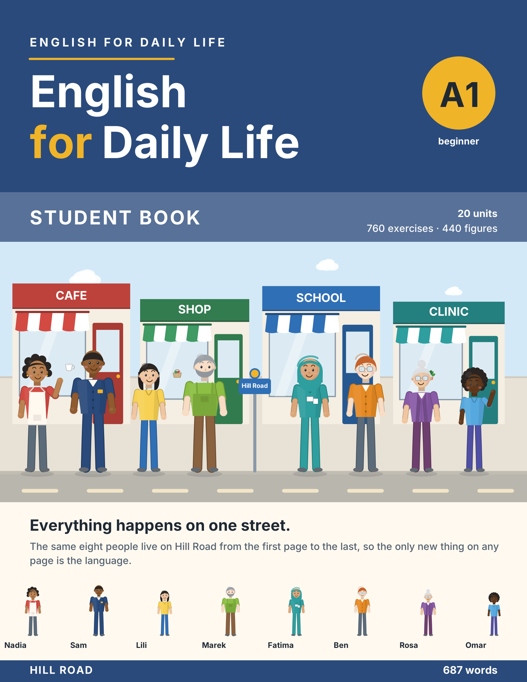

English for Daily Life

A1 — Student Book
20 units · 760 exercises · 440 figures
A beginner’s course. Everything happens on one street, Hill Road, and the same eight people live there, so the only new thing on any page is the language.
Unit | Title | Grammar
1 | Hello | am, is, are · my, your, his, her
2 | In the Class | questions and short answers · isn’t, aren’t · a/an · this, that
3 | Who’s This? | possessive ’s · plural nouns · our, their
4 | Where I Live | there is, there are · how many · in, on, under
5 | Every Day | present simple I, you, we, they · time · days
6 | She Works Here | present simple he, she, it · does
7 | Food and Drink | some, any · countable and uncountable · like
8 | In the Town | prepositions of place · imperatives
9 | I Can Do That | can, can’t
10 | Last Weekend | was, were · past time words
11 | A Day Out | past simple, regular verbs
12 | Last Year | past simple, irregular verbs · questions with did
13 | Right Now | present continuous · beside the present simple
14 | Next Week | going to
15 | Bigger and Better | comparatives · adjectives
16 | Things I Like Doing | like, love, hate + ing
17 | Would You Like? | would like · polite requests
18 | The Best in Town | superlatives
19 | How Are You? | have got · should
20 | See You Soon | past, present and will, together
The people of Hill Road
Nadia cooks at the cafe. Sam drives bus 12. Lili is a student. Marek looks after the flats. Fatima is a nurse at the clinic and teaches the evening class. Ben works in the shop. Rosa is Marek’s mother. Omar is his son.
At the back of this book
Grammar File, one entry per unit · Word File, every word with the unit that teaches it and an Arabic gloss · Phrase File · irregular verbs · sound and symbol table · Audio File, all eighty listening scripts to the word · Picture File, all 440 figures with alt text · Can-Do Record.

Unit 1: Hello
In this unit you say hello. You say your name. You count to ten.
Warm Up
W1 Look at Figure 1.1. Tick the words you know.
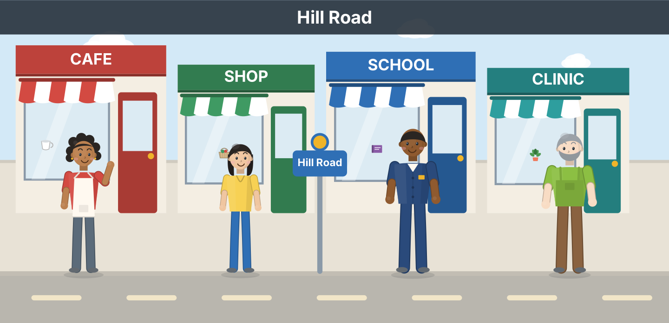
Figure 1.1 · Hill Road.
- a cafe — ✓ (example)
- a shop — ______
- a school — ______
- a clinic — ______
- a bus — ______
W2 Look at Figure 1.2. Write the number: 1, 2 or 3.
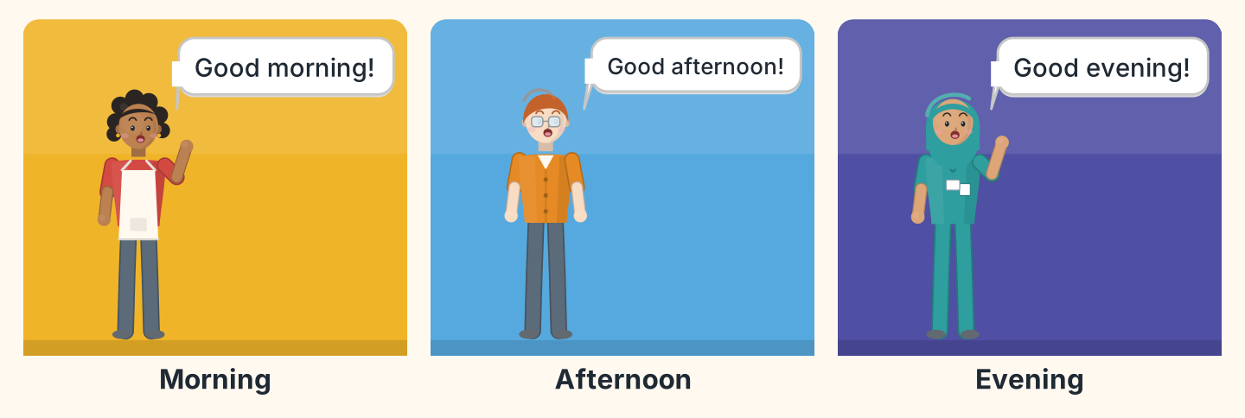
Figure 1.2 · Three times of day.
- Good evening. — 3 (example)
- Good morning. — ______
- Good afternoon. — ______
- Good morning. — ______
W3 Say hello to three people in your class.
- Hello. I’m Lili. (example)
- Say hello.
- Say your name.
- Say goodbye.
Part 1 · Words & Sounds
1A Look at Figure 1.3. Match the person and the job.
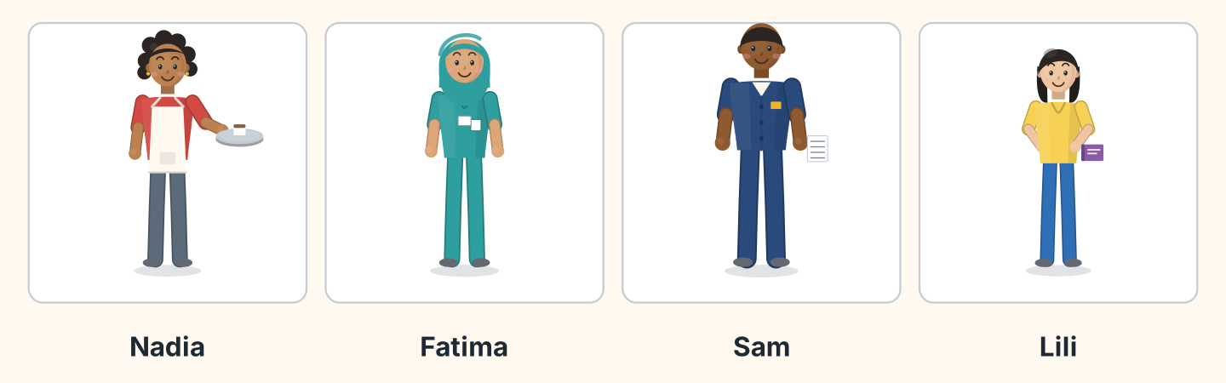
Figure 1.3 · Four people on Hill Road.
Person | Job
1 Nadia | a a student
2 Fatima | b a cook
3 Sam | c a nurse
4 Lili | d a driver
 | e a teacher
One option is not needed.
- 1 — b (example)
- 2 — ______
- 3 — ______
- 4 — ______
1B Look at Figure 1.4. Write the letters in the box.
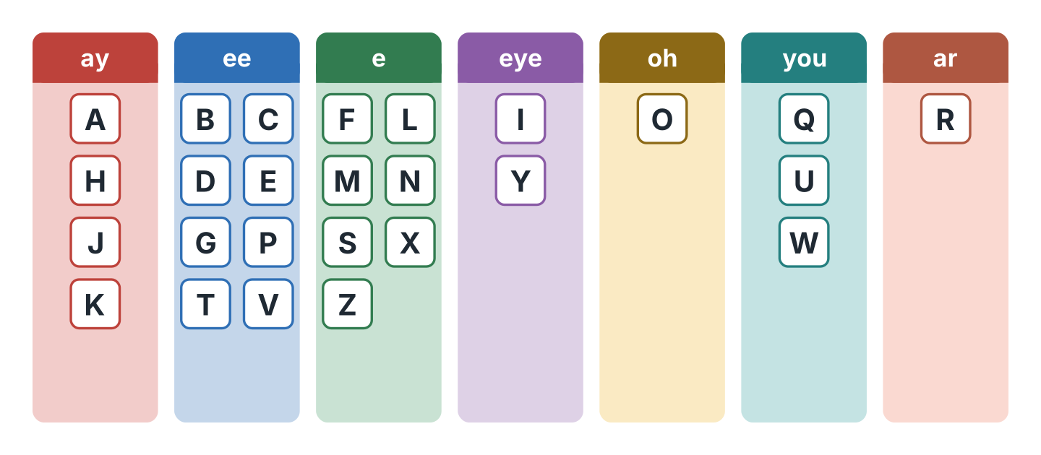
Figure 1.4 · The alphabet in seven sounds.
Words: A · E · I · O · U
- ay — A (example)
- ee — ______
- eye — ______
- oh — ______
- you — ______
1C Listen. Write the letters you hear.
- S-A-M — Sam (example)
- ______________
- ______________
- ______________
- ______________
1D Look at Figure 1.5. Write the word.
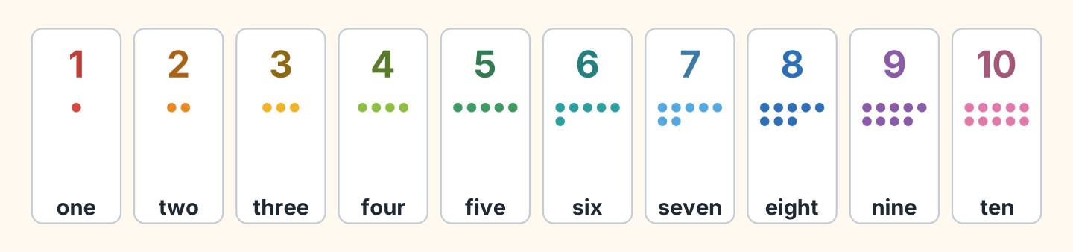
Figure 1.5 · One to ten.
- 2 — two (example)
- 5 — ______________
- 7 — ______________
- 9 — ______________
- 10 — ______________
1E Write the number.
- six — 6 (example)
- three — ______
- eight — ______
- one — ______
- four — ______
1F Say it. Look at Figure 1.6. Say the words.
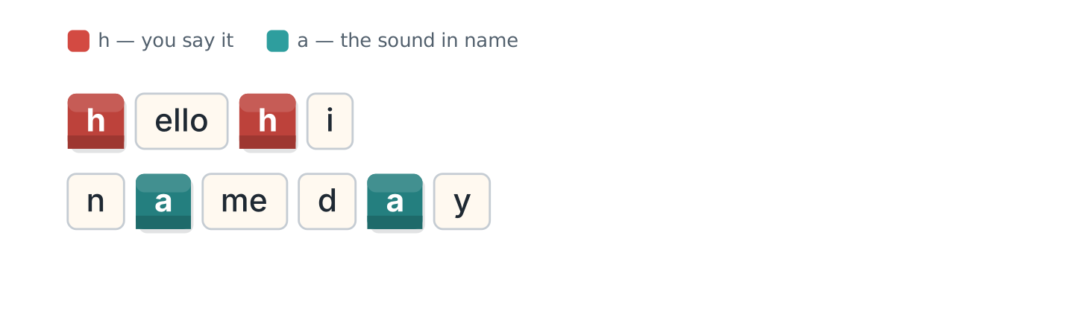
Figure 1.6 · Two sounds in hello and name.
- hello (example)
- hi
- name
- day
- Hello, Hannah.
Part 2 · Grammar
2A Look at Figure 1.7. Complete with am, is or are.
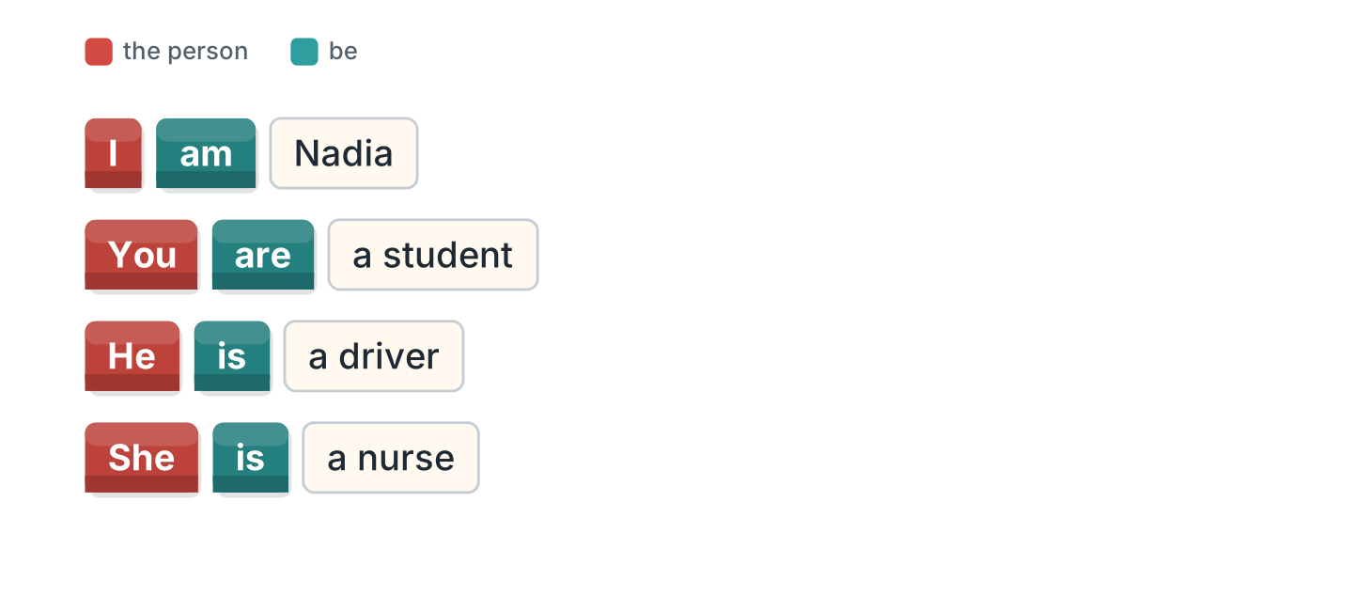
Figure 1.7 · am, is and are.
- I am Nadia. (am) (example)
- She ______ a nurse.
- You ______ a student.
- He ______ a driver.
- I ______ from Egypt.
2B Choose the correct word.
- I (am / is) Lili. — am (example)
- He (am / is) Sam.
- You (is / are) a teacher.
- She (are / is) from Brazil.
- I (am / are) a cook.
2C Look at Figure 1.8. Write the short form.
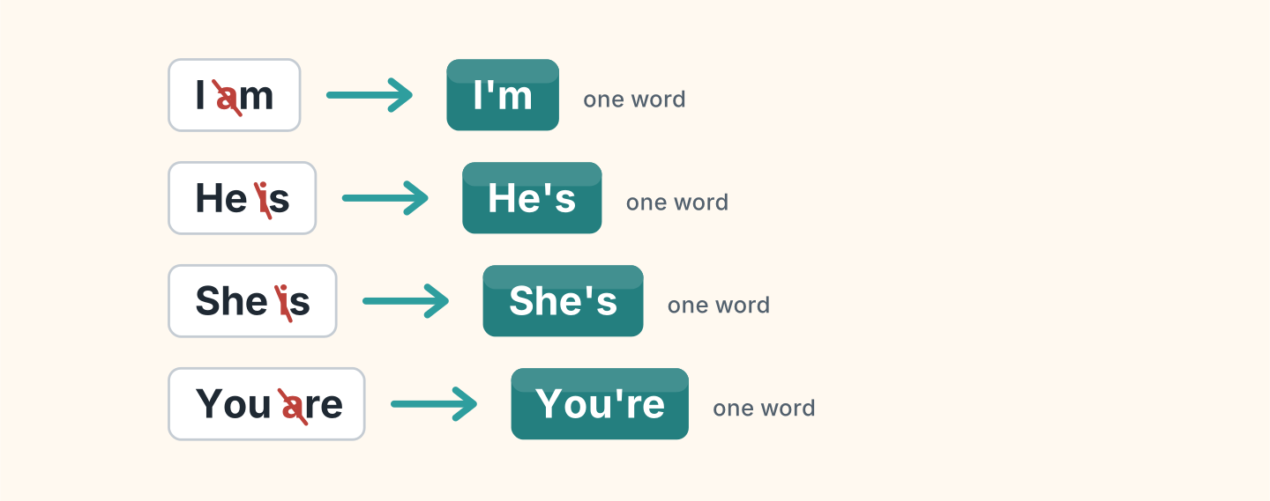
Figure 1.8 · Two words become one.
- I am — I’m (example)
- He is — ______________
- She is — ______________
- You are — ______________
2D Write the long form.
- I’m — I am (example)
- She’s — ______________
- He’s — ______________
- You’re — ______________
2E Look at Figure 1.9. Complete with my, your, his or her.
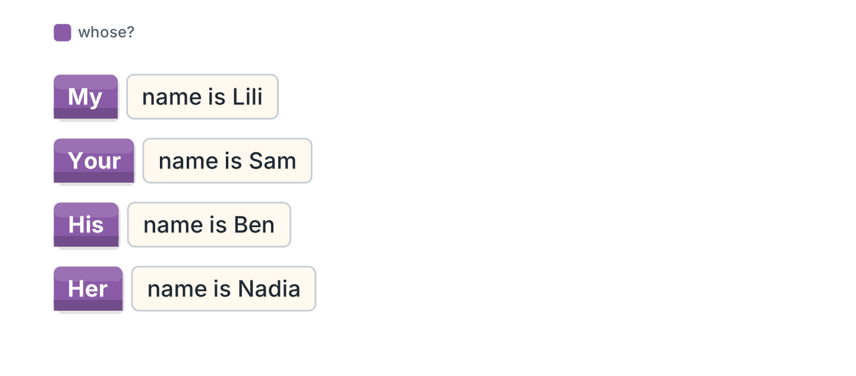
Figure 1.9 · my, your, his and her.
- I’m Lili. My name is Lili. (My) (example)
- He’s Ben. ______ name is Ben.
- She’s Nadia. ______ name is Nadia.
- Hello. What’s ______ name?
- I’m Omar. ______ name is Omar.
2F Find the mistake. Write the correct word.
- I is Sam. — am (example)
- She are a nurse. — ______________
- He am from Poland. — ______________
- You is a student. — ______________
Part 3 · Listening
3A Listen. Look at Figure 1.10. Write the number.
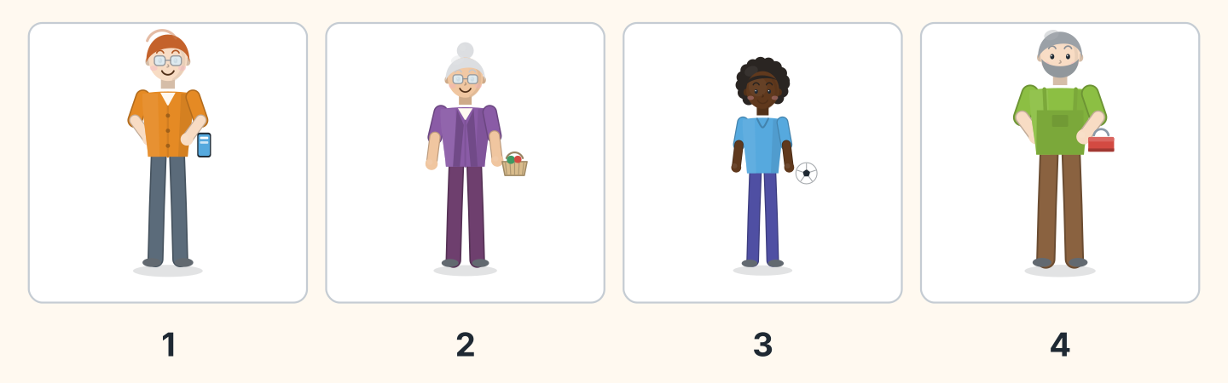
Figure 1.10 · Four voices.
- Ben — 1 (example)
- Rosa — ______
- Omar — ______
- Marek — ______
3B Listen. Look at Figure 1.11. Complete the class list.
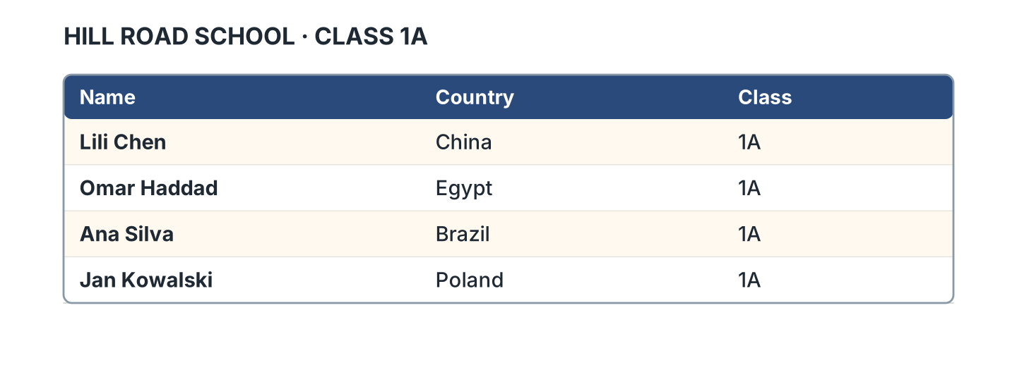
Figure 1.11 · The class list.
- Lili Chen is from China. (China) (example)
- Omar Haddad is from ______________.
- Ana Silva is from ______________.
- Jan Kowalski is from ______________.
3C Listen. Look at Figure 1.12. Tick the country.
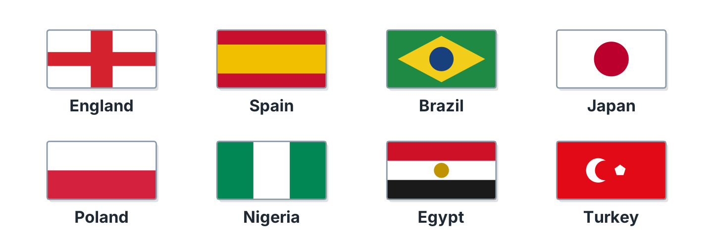
Figure 1.12 · Eight countries.
- Japan ✓ (example)
- Spain — ______
- Turkey — ______
- Nigeria — ______
- England — ______
3D Listen. Write the name.
- B-E-N — Ben (example)
- ______________
- ______________
- ______________
Part 4 · Speaking
4A Look at Figure 1.13. Ask and answer with a friend.
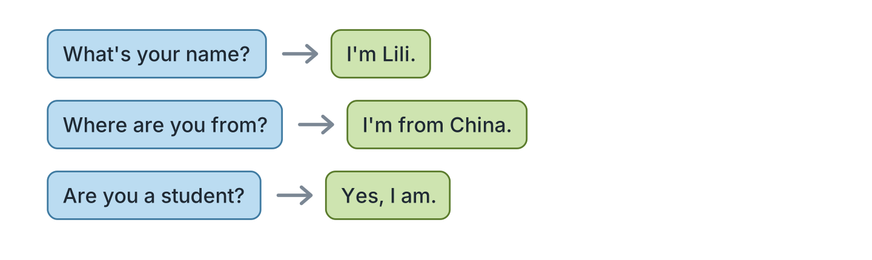
Figure 1.13 · A question and an answer.
- A: What’s your name? B: I’m Lili. (example)
- A: What’s your name? B: ______________
- A: Where are you from? B: ______________
- A: Are you a student? B: ______________
4B Spell your name. Then spell your friend’s name.
- L-I-L-I (example)
- Spell your first name.
- Spell your surname.
- Spell your friend’s first name.
4C Look at Figure 1.14. Introduce a friend.
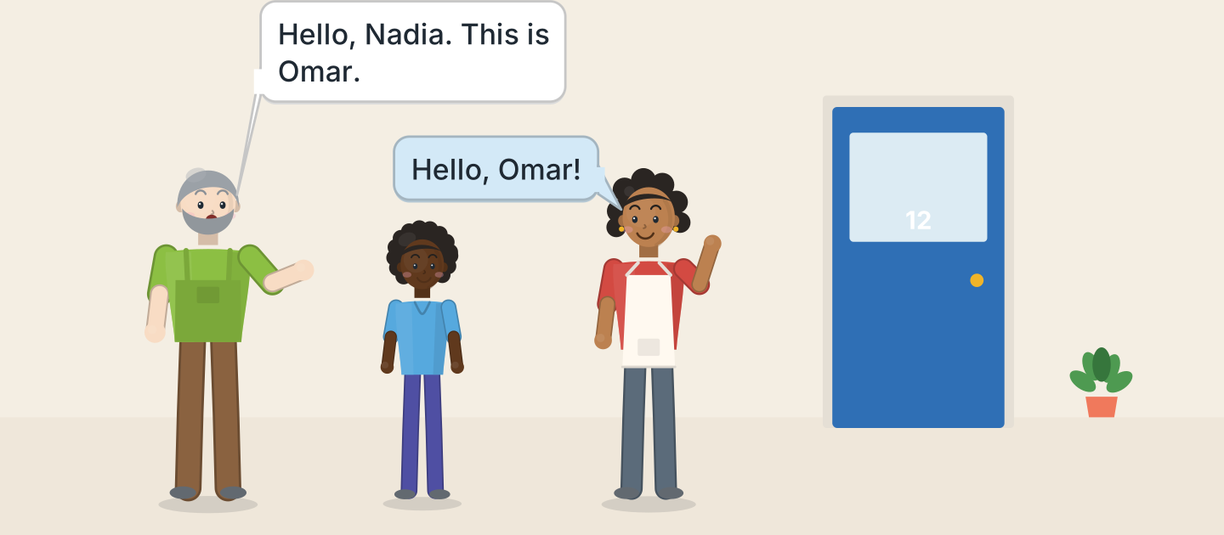
Figure 1.14 · Marek introduces Omar.
- Hello, Nadia. This is Omar. (example)
- Say hello.
- Say your friend’s name.
- Your friend says hello.
4D Say goodbye to three people.
- Goodbye, Sam. (example)
- Goodbye, ______________.
- Bye, ______________.
- Goodbye, ______________.
Part 5 · Reading
5A Look at Figure 1.15. Answer yes or no.
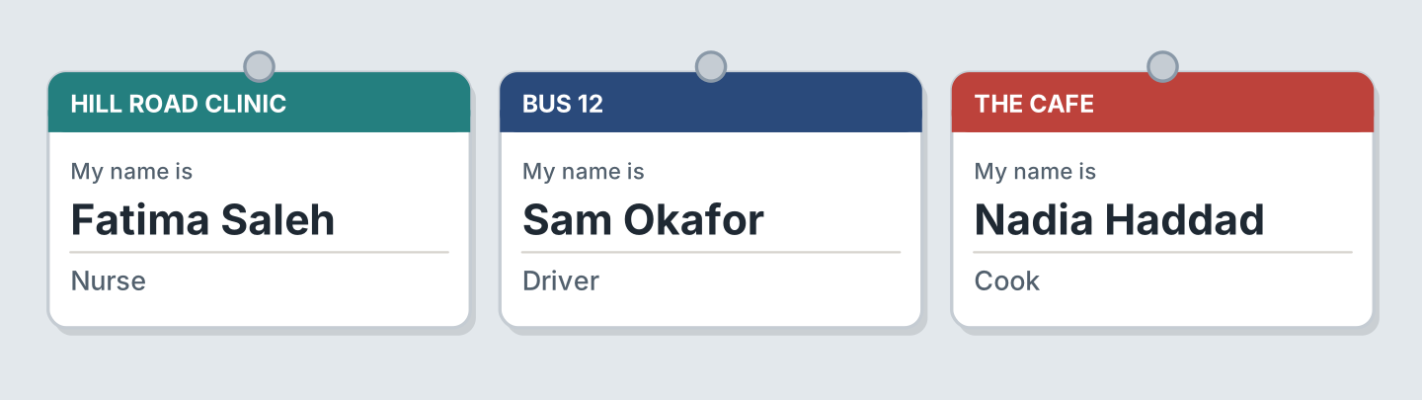
Figure 1.15 · Three name badges.
- Fatima is a nurse. — yes (example)
- Sam is a cook. — ______
- Nadia is at the cafe. — ______
- Fatima is at the clinic. — ______
- Sam is a driver. — ______
5B Look at Figure 1.15. Complete the sentences.
Words: cook · driver · nurse · clinic
- Fatima is a nurse. (nurse) (example)
- Sam is a ______________.
- Nadia is a ______________.
- Fatima is at the ______________.
5C Look at Figure 1.16. Choose the correct answer.
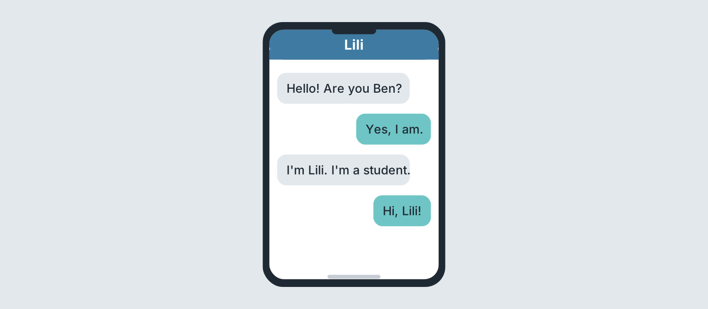
Figure 1.16 · Two messages.
- Who is the student? (a) Ben (b) Lili (c) Sam — b (example)
- Who writes first? (a) Lili (b) Ben (c) Nadia
- Is Ben there? (a) yes (b) no (c) we do not know
- What is Lili? (a) a cook (b) a driver (c) a student
5D Read and correct. Write the correct word.
- Lili is a nurse. — student (example)
- Ben is a student. — ______________
- Fatima is a cook. — ______________
- Sam is a teacher. — ______________
Part 6 · Writing
6A Look at Figure 1.17. Complete the form for you.
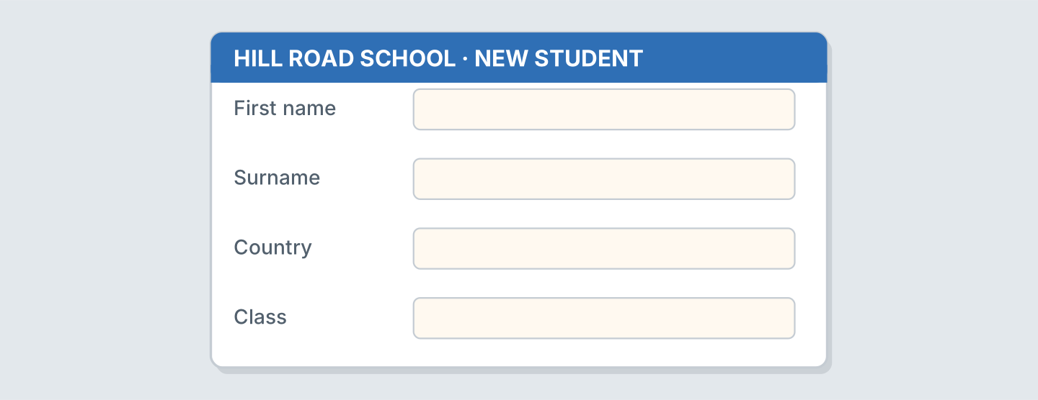
Figure 1.17 · A form for a new student.
- First name: Lili (example)
- First name: ______________
- Surname: ______________
- Country: ______________
6B Look at Figure 1.18. Write three sentences about you.
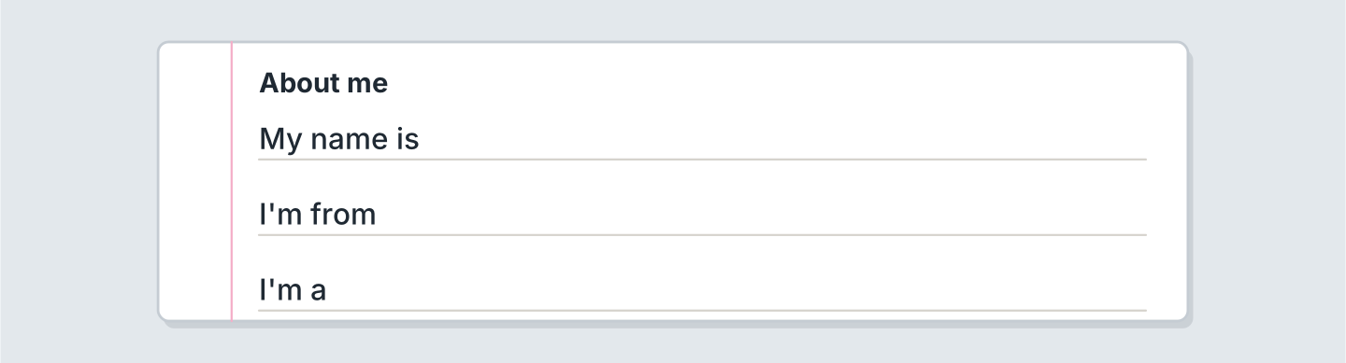
Figure 1.18 · Three lines about you.
- My name is Lili. (example)
- My name is ______________.
- I’m from ______________.
- I’m a ______________.
6C Write a message to a new friend. Write three lines.
- Hello! I’m Lili. (example)
- Say hello.
- Say your name.
- Say your country.
Part 7 · Real-World File
7A Look at Figure 1.19. Answer the questions.
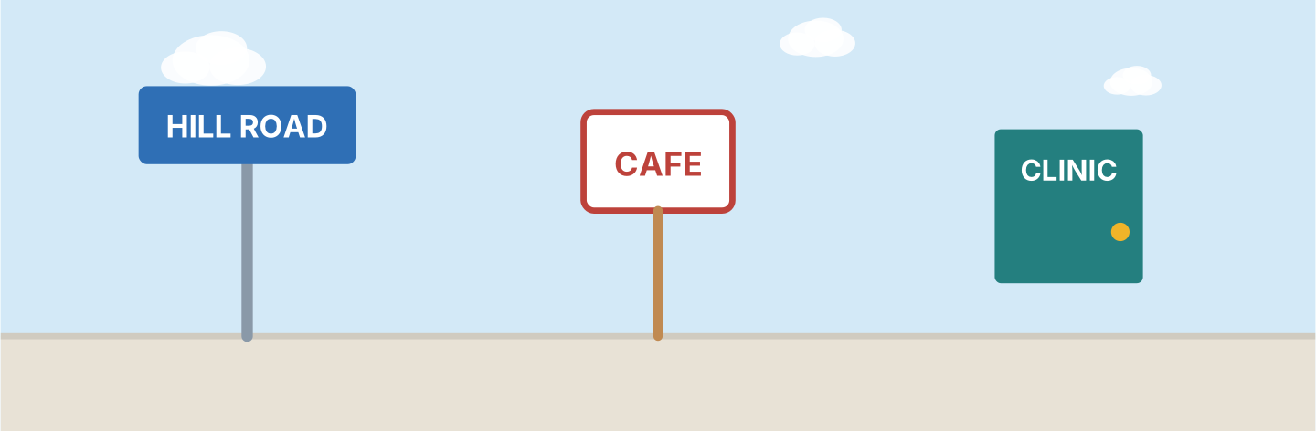
Figure 1.19 · Signs on Hill Road.
- What is the street? — Hill Road (example)
- Where is the cafe? — ______________
- Where is the nurse? — ______________
- What is the number of the bus? — ______________
7B Look at Figure 1.20. Write your name on the badge.

Figure 1.20 · A badge with no name.
- My name is Lili. (example)
- Write your first name.
- Write your surname.
- Write your school.
7C Look at Figure 1.11 again. Complete line 5 for you.
- Name: Lili Chen (example)
- Name: ______________
- Country: ______________
- Class: ______________
Part 8 · Review & Can-Do
8A Look at Figure 1.21. Write the job.
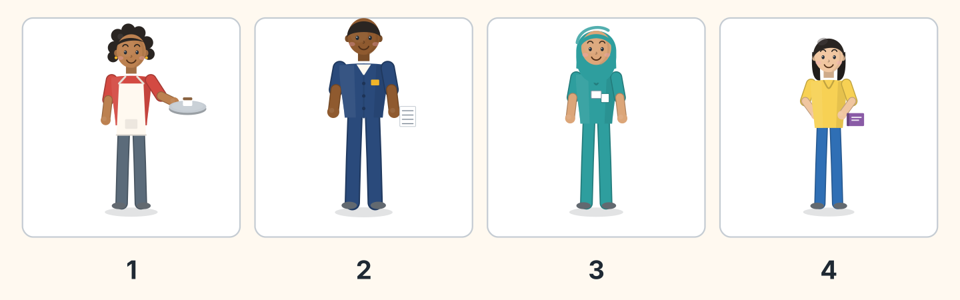
Figure 1.21 · Four people to name.
Words: cook · driver · nurse · student · teacher
- 1 — cook (example)
- 2 — ______________
- 3 — ______________
- 4 — ______________
8B Complete the conversation.
Words: am · Hello · name · you
- A: Hello. I’m Sam. (Hello) (example)
- B: Hi, Sam. My ______ is Lili.
- A: Are ______ a student?
- B: Yes, I ______.
8C Write the numbers.
- 3 — three (example)
- 6 — ______________
- 8 — ______________
- 10 — ______________
8D Match the person and the country.
Person | Country
1 Lili | a Egypt
2 Omar | b Poland
3 Ana | c China
4 Jan | d Brazil
 | e Japan
One option is not needed.
- 1 — c (example)
- 2 — ______
- 3 — ______
- 4 — ______
8E Look at Figure 1.22. Tick what you can do.
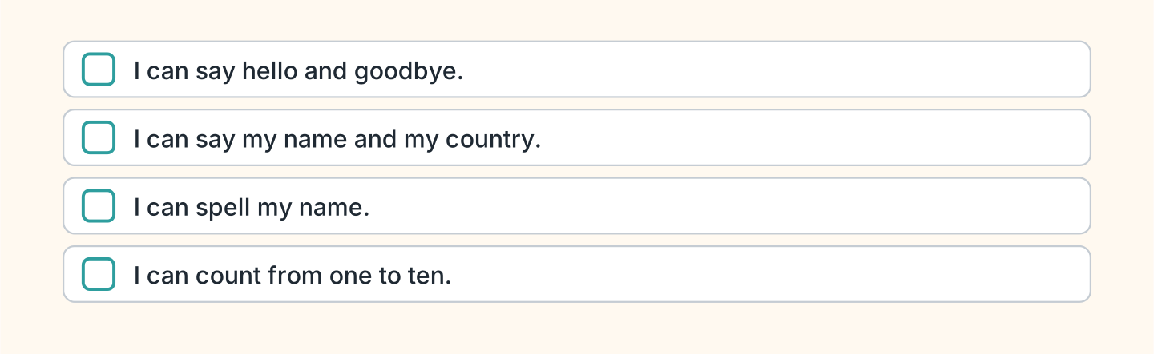
Figure 1.22 · What I can do.
- I can say hello and goodbye. — ✓ (example)
- I can say my name and my country. — ______
- I can spell my name. — ______
- I can count from one to ten. — ______

Unit 2: In the Class
In this unit you name things in the class. You ask questions. You say no.
Warm Up
W1 Look at Figure 2.1. Tick the things you can see.
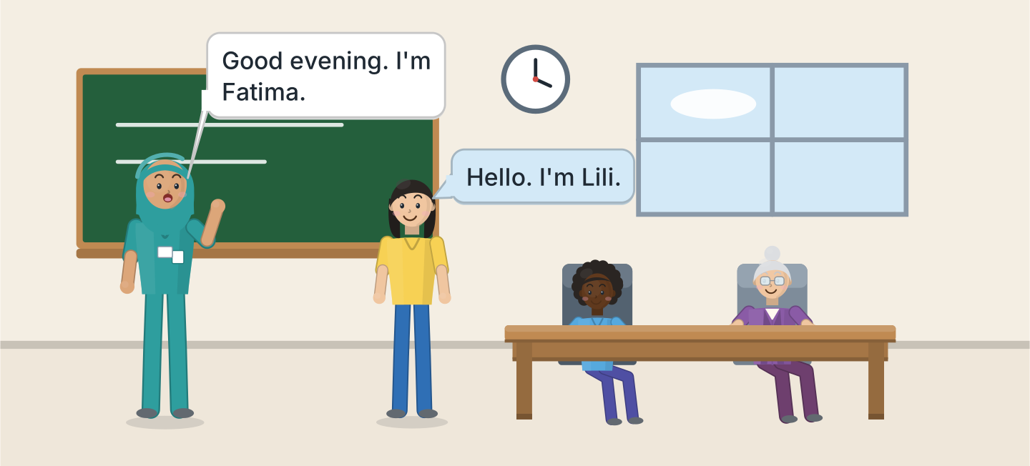
Figure 2.1 · The evening class.
- a board — ✓ (example)
- a window — ______
- a clock — ______
- a desk — ______
- a chair — ______
W2 Look at Figure 2.2. Write the word.
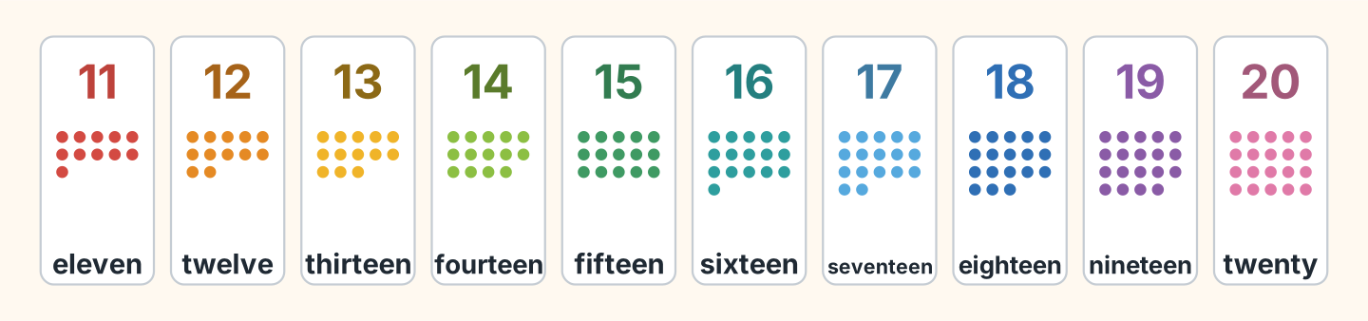
Figure 2.2 · Eleven to twenty.
- 11 — eleven (example)
- 13 — ______________
- 15 — ______________
- 18 — ______________
- 20 — ______________
W3 Count from eleven to twenty with a friend.
- eleven, twelve, thirteen (example)
- Count from 11 to 15.
- Count from 16 to 20.
- Count from 11 to 20.
Part 1 · Words & Sounds
1A Look at Figure 2.3. Write the word.
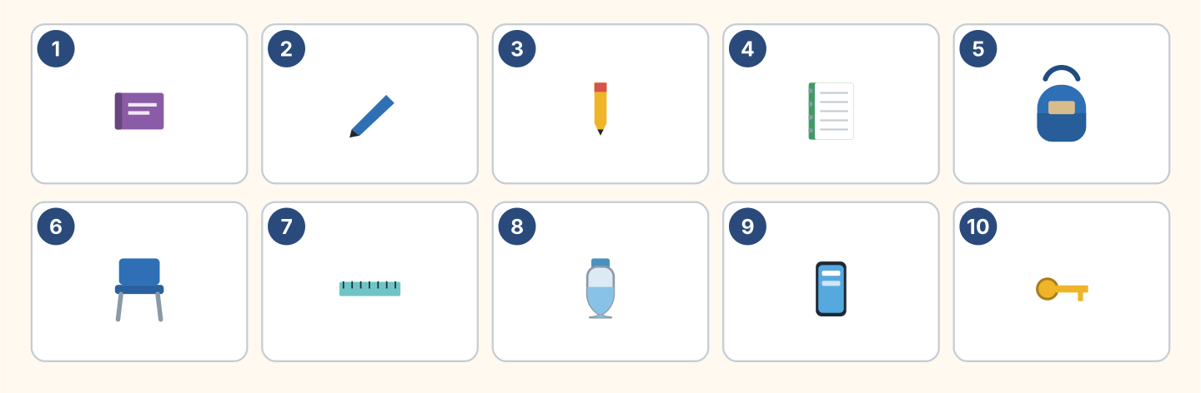
Figure 2.3 · Ten things in the class.
Words: bag · book · bottle · chair · key · notebook · pen · pencil · phone · ruler
- 1 — book (example)
- 2 — ______________
- 3 — ______________
- 6 — ______________
- 10 — ______________
1B Look at Figure 2.4. Write a or an.
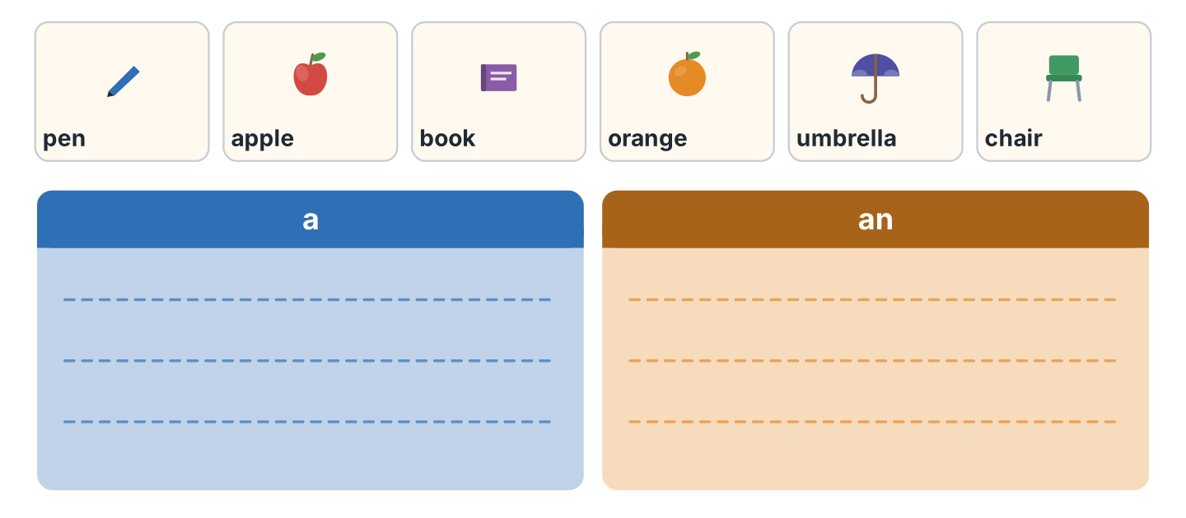
Figure 2.4 · a or an.
- a pen (example)
- ______ apple
- ______ book
- ______ orange
- ______ umbrella
1C Say it. Listen to the first sound. Then say a or an.
- a pen (example)
- an apple
- a chair
- an orange
- an umbrella
1D Look at Figure 2.5. Write this or that.
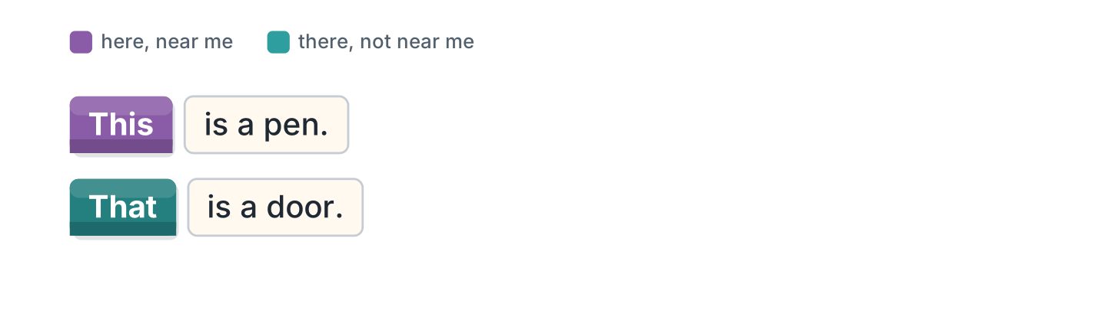
Figure 2.5 · this and that.
- This is a pen. (This) (example)
- ______ is a door.
- ______ is my bag. It is here.
- ______ is the board. It is there.
1E Look at Figure 2.6. Match the job and the place.
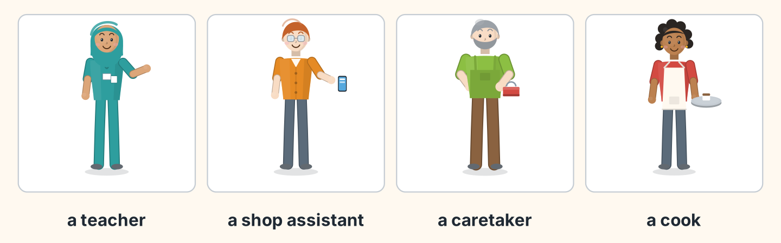
Figure 2.6 · Four jobs.
Job | Place
1 a teacher | a the cafe
2 a shop assistant | b the school
3 a caretaker | c the shop
4 a cook | d the flats
 | e the clinic
One option is not needed.
- 1 — b (example)
- 2 — ______
- 3 — ______
- 4 — ______
1F Write the number.
- fourteen — 14 (example)
- twelve — ______
- seventeen — ______
- nineteen — ______
- twenty — ______
Part 2 · Grammar
2A Look at Figure 2.7. Write the question.
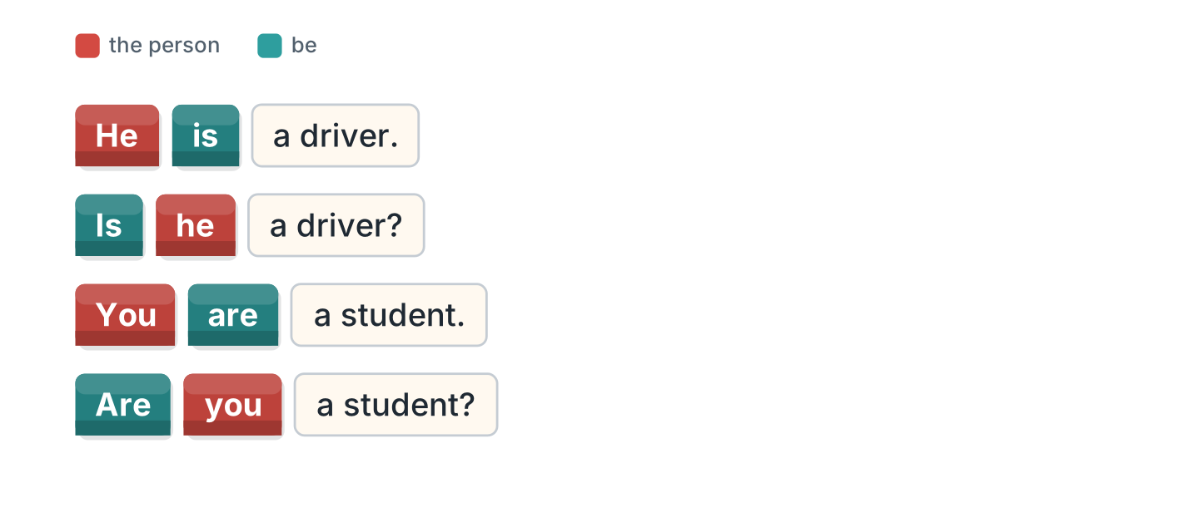
Figure 2.7 · A sentence and a question.
- He is a driver. — Is he a driver? (example)
- She is a nurse. — ______________
- You are a student. — ______________
- It is a pen. — ______________
2B Complete the question with Is or Are.
- Is he a teacher? (Is) (example)
- ______ you from Poland?
- ______ she in Room 11?
- ______ it your bag?
- ______ they students?
2C Look at Figure 2.8. Write the short form.
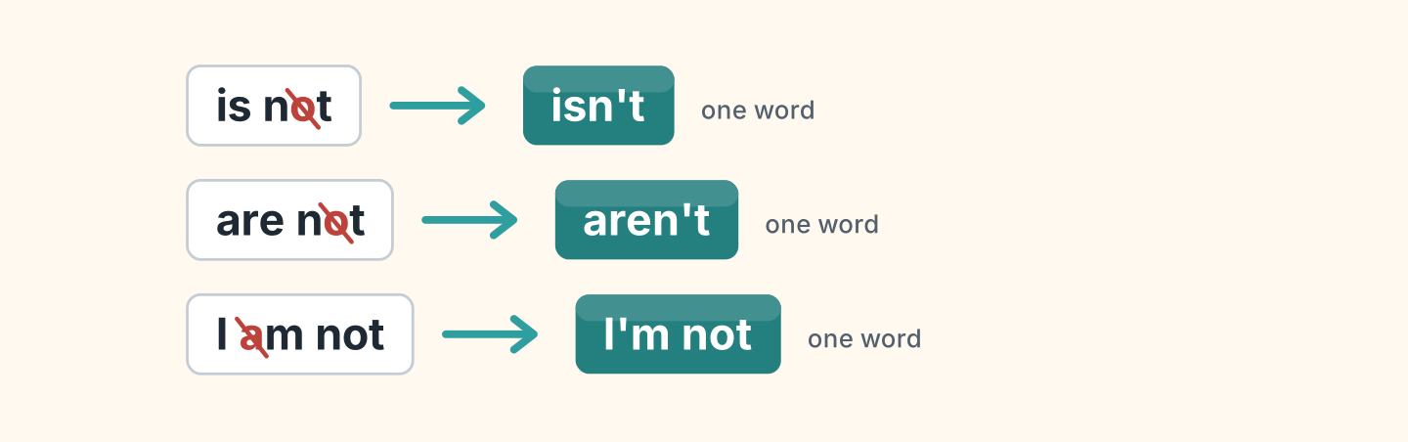
Figure 2.8 · The short negative.
- is not — isn’t (example)
- are not — ______________
- I am not — ______________
2D Complete with isn’t or aren’t.
- He isn’t a cook. (isn’t) (example)
- She ______________ a doctor.
- They ______________ in Room 12.
- It ______________ my pen.
- You ______________ in my class.
2E Look at Figure 2.9. Write the answer.
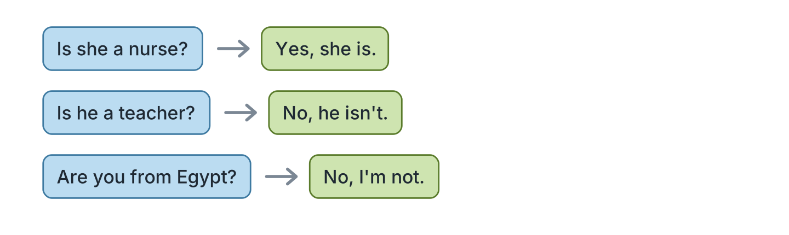
Figure 2.9 · Yes and no answers.
- Is she a nurse? — Yes, she is. (example)
- Is he a teacher? ✗ — ______________
- Are you from Egypt? ✗ — ______________
- Is it your book? ✓ — ______________
2F Find the mistake. Write the correct word.
- Is you a student? — Are (example)
- She not is a teacher. — ______________
- Are he in Room 11? — ______________
- It aren’t my bag. — ______________
Part 3 · Listening
3A Listen. Look at Figure 2.10. Write the number.
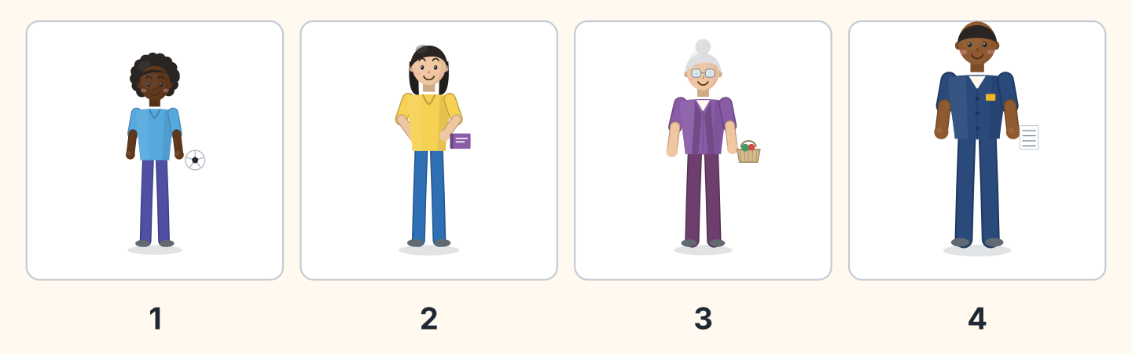
Figure 2.10 · Four people in the class.
- Omar — 1 (example)
- Lili — ______
- Rosa — ______
- Sam — ______
3B Listen. Look at Figure 2.11. Complete the timetable.
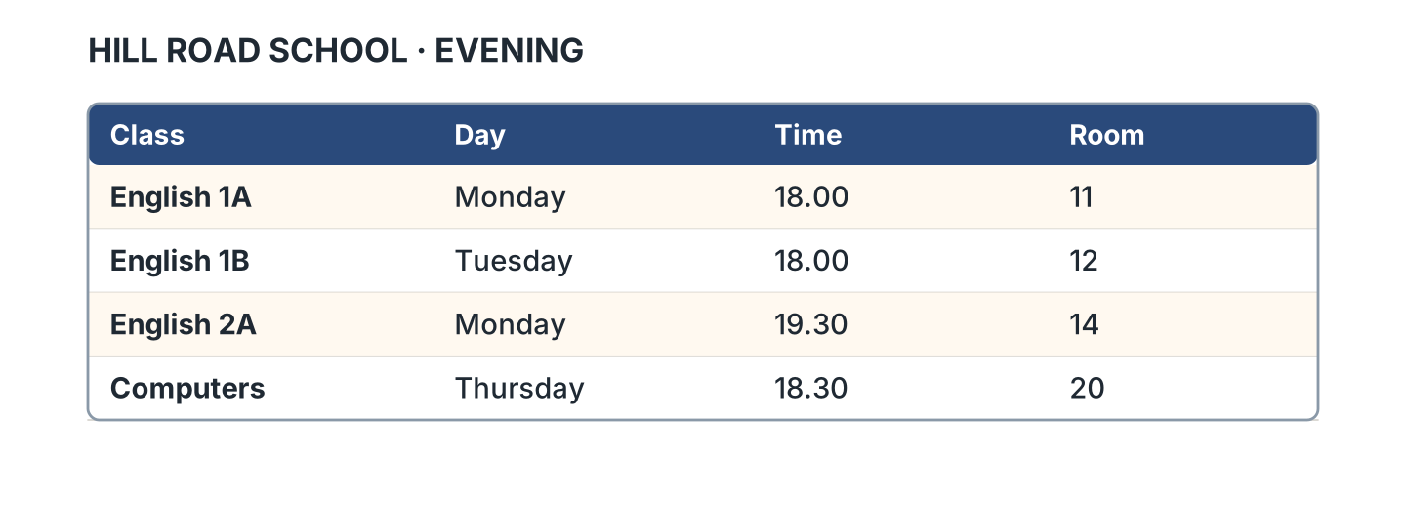
Figure 2.11 · The evening timetable.
- English 1A is on Monday. (Monday) (example)
- English 1B is in Room ______.
- English 2A is at ______________.
- Computers is on ______________.
3C Listen. Look at Figure 2.12. Write the number you hear.
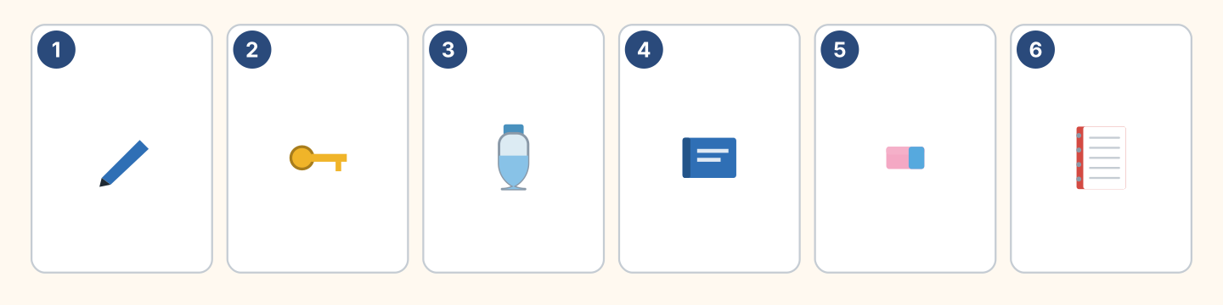
Figure 2.12 · Six things on a desk.
- a pen — 1 (example)
- a bottle — ______
- a book — ______
- a notebook — ______
3D Listen. Write the room number.
- Fatima — Room 11 (example)
- Lili — Room ______
- Omar — Room ______
- Rosa — Room ______
Part 4 · Speaking
4A Look at Figure 2.13. Ask and answer about five things.
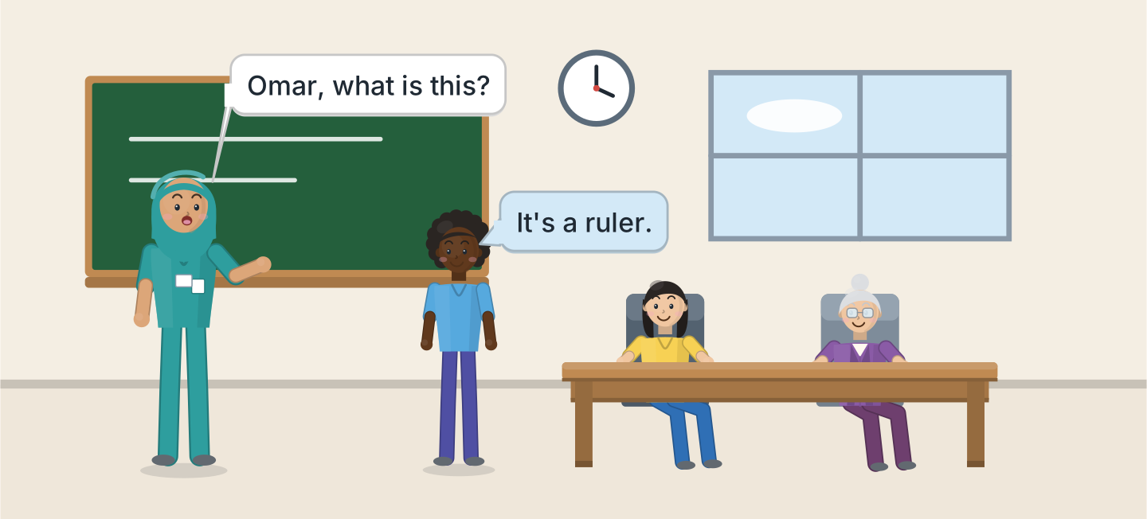
Figure 2.13 · Asking in the class.
- A: What is this? B: It’s a ruler. (example)
- Ask about a pen.
- Ask about a book.
- Ask about a chair.
- Ask about a window.
4B Look at Figure 2.14. Ask and answer with a friend.
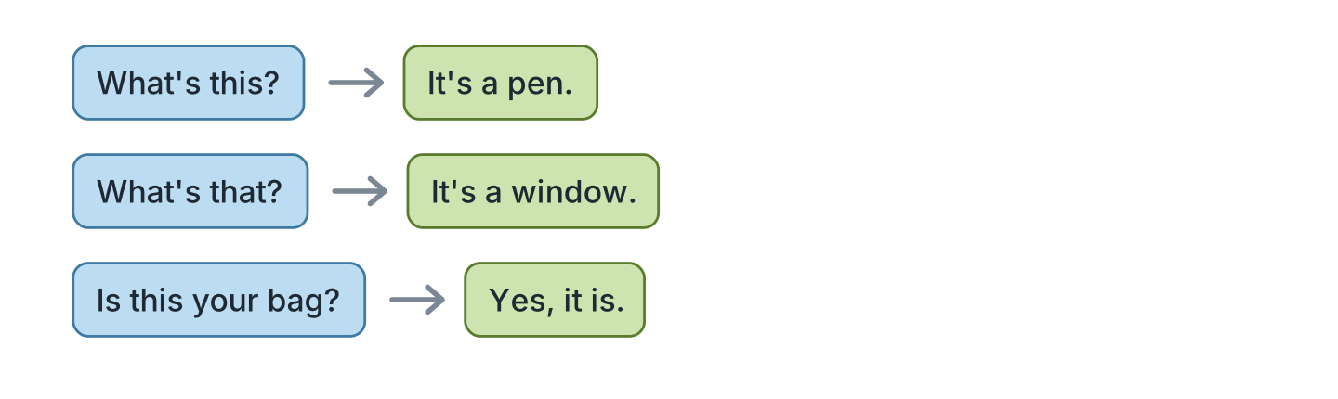
Figure 2.14 · Ask and answer.
- A: What’s this? B: It’s a pen. (example)
- A: What’s that? B: ______________
- A: Is this your bag? B: ______________
- A: Is that your pencil? B: ______________
4C Ask three friends about their class.
- A: Are you in Class 1A? B: Yes, I am. (example)
- Ask about the class.
- Ask about the room.
- Ask about the teacher.
4D Say these things to your teacher.
- Sorry. Again, please. (example)
- Open your book, please.
- What is this in English?
- Thank you.
Part 5 · Reading
5A Look at Figure 2.15. Answer the questions.
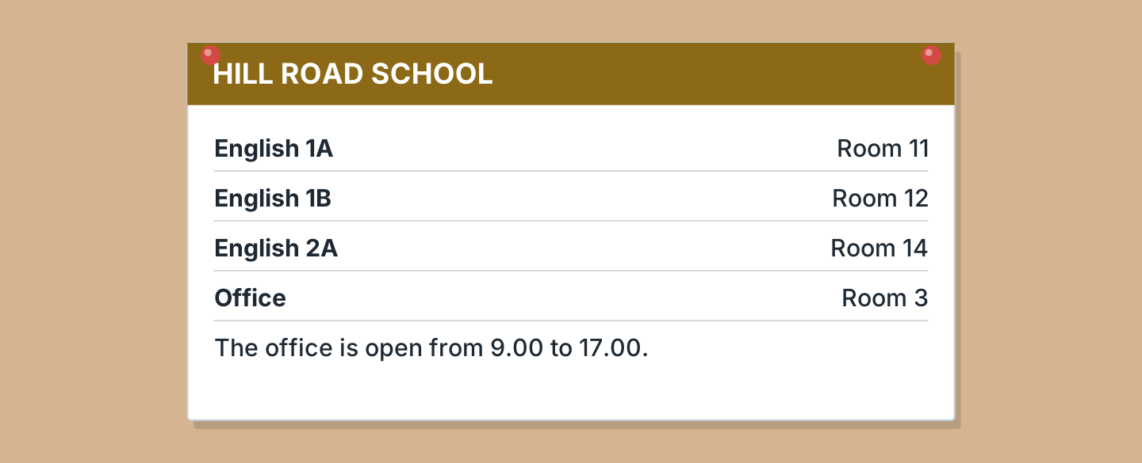
Figure 2.15 · A notice at the school.
- Where is English 1A? — Room 11 (example)
- Where is English 1B? — ______________
- Where is the office? — ______________
- Where is English 2A? — ______________
5B Look at Figure 2.15. Answer yes or no.
- English 1A is in Room 11. — yes (example)
- The office is in Room 14. — ______
- The office is open at 10.00. — ______
- English 2A is in Room 12. — ______
5C Look at Figure 2.16. Choose the correct answer.
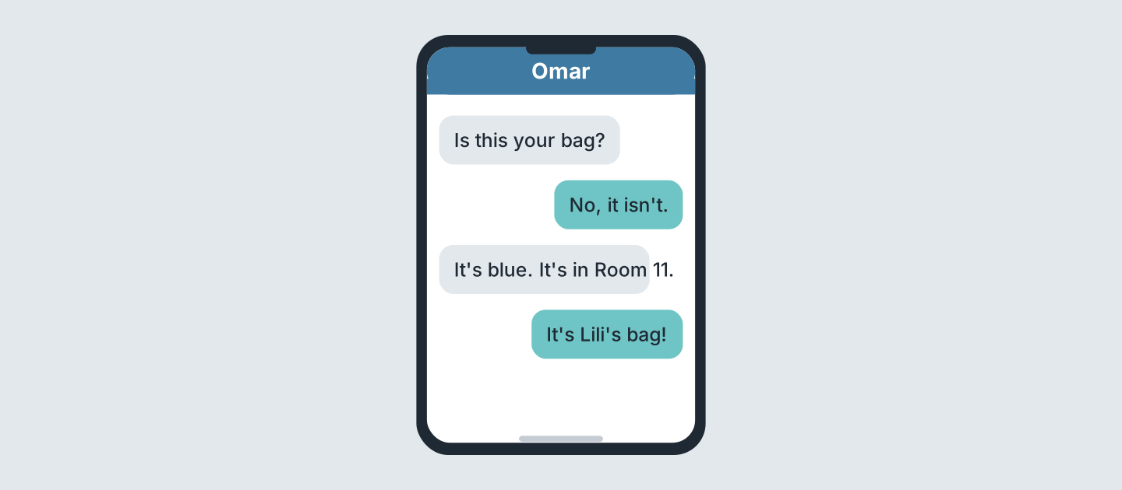
Figure 2.16 · Messages about a bag.
- Who writes first? (a) Omar (b) Lili (c) Rosa — a (example)
- What colour is the bag? (a) red (b) blue (c) black
- Where is the bag? (a) Room 11 (b) Room 12 (c) Room 14
- Whose bag is it? (a) Omar’s (b) Lili’s (c) Rosa’s
5D Read and correct. Write the correct word.
- The bag is red. — blue (example)
- The bag is in Room 14. — ______________
- The office is in Room 11. — ______________
- English 1B is on Monday. — ______________
Part 6 · Writing
6A Look at Figure 2.17. Complete the card for you.
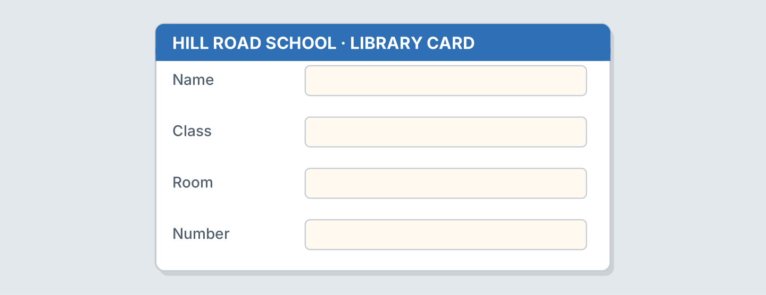
Figure 2.17 · A card for the library.
- Name: Omar Haddad (example)
- Name: ______________
- Class: ______________
- Room: ______________
6B Look at Figure 2.18. Write four lines about your class.
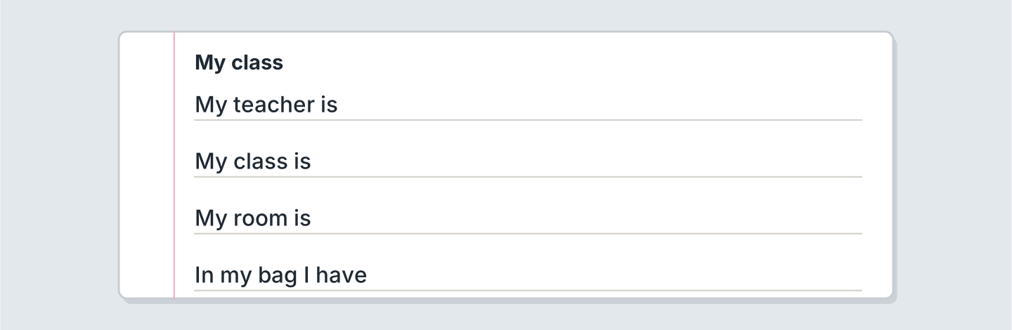
Figure 2.18 · Four lines about your class.
- My teacher is Fatima. (example)
- My teacher is ______________.
- My class is ______________.
- My room is ______________.
6C Write a message about a lost bag. Write three lines.
- Is this your bag? (example)
- Ask about the bag.
- Say the colour.
- Say the room.
Part 7 · Real-World File
7A Look at Figure 2.19. Answer the questions.
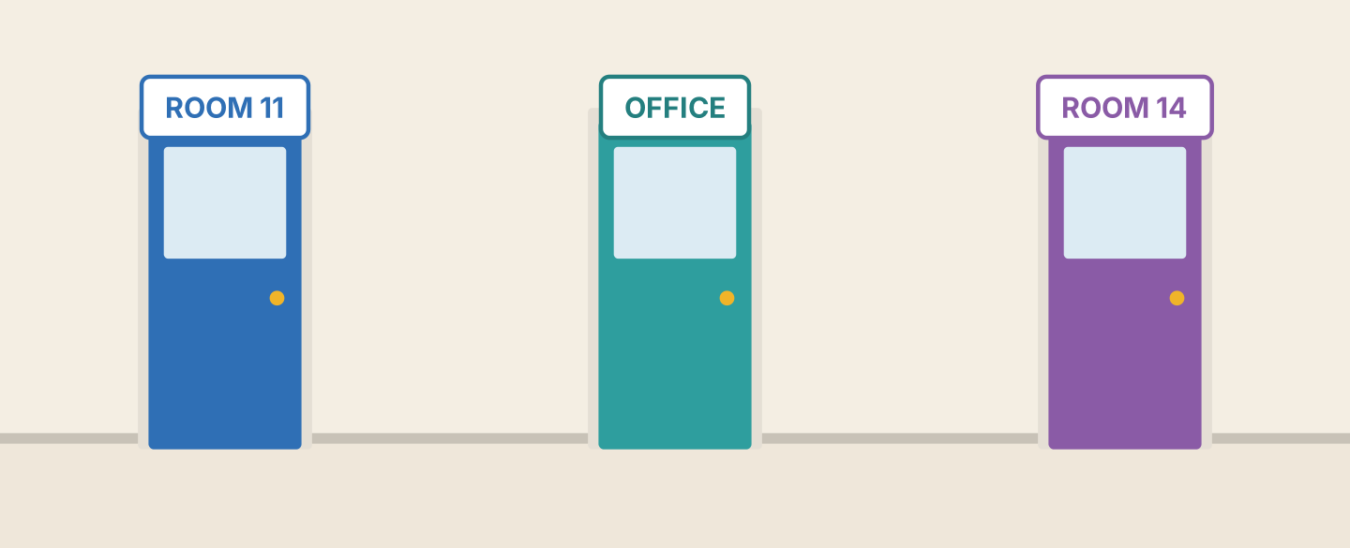
Figure 2.19 · Three doors at the school.
- What is the first room? — Room 11 (example)
- What is the second door? — ______________
- What is the third room? — ______________
- Is Room 12 here? — ______
7B Look at Figure 2.20. Complete the sentences.
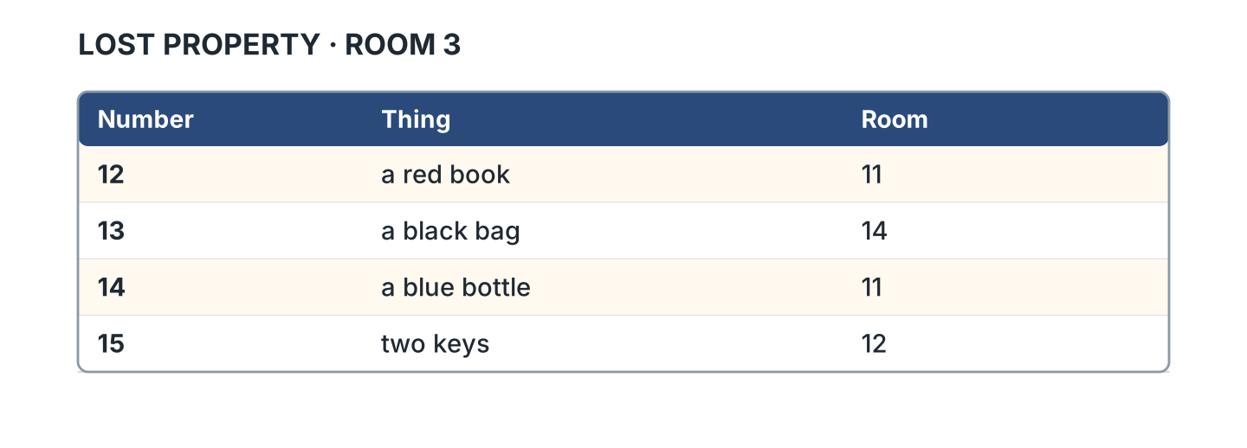
Figure 2.20 · The lost property list.
- Number 12 is a red book. (book) (example)
- Number 13 is a black ______________.
- Number 14 is a blue ______________.
- Number 15 is two ______________.
7C Look at Figure 2.20. Write line 16 for your thing.
- 16 · a green pen · Room 11 (example)
- Number: ______________
- Thing: ______________
- Room: ______________
Part 8 · Review & Can-Do
8A Look at Figure 2.21. Write the word.
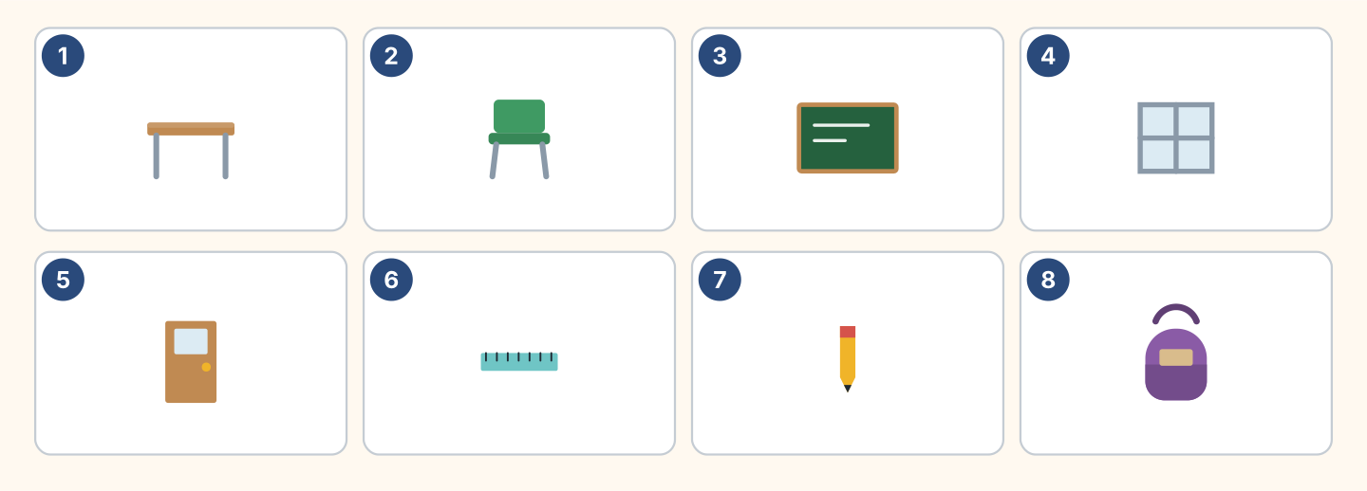
Figure 2.21 · Eight things from this unit.
Words: bag · board · chair · desk · door · pencil · ruler · window
- 1 — desk (example)
- 3 — ______________
- 4 — ______________
- 5 — ______________
- 8 — ______________
8B Complete the conversation.
Words: isn’t · It’s · this · What
- A: What is this? (What) (example)
- B: ______ a ruler.
- A: Is ______ your ruler?
- B: No, it ______. It’s Lili’s.
8C Write the numbers.
- 16 — sixteen (example)
- 11 — ______________
- 14 — ______________
- 19 — ______________
8D Write a or an.
- a desk (example)
- ______ orange
- ______ window
- ______ umbrella
- ______ ruler
8E Look at Figure 2.22. Tick what you can do.
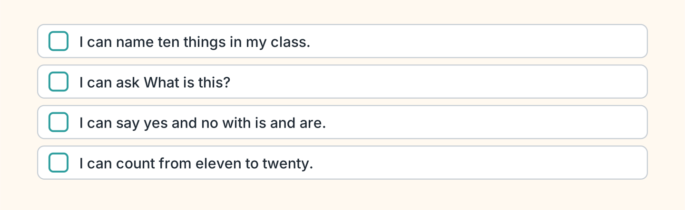
Figure 2.22 · What I can do.
- I can name ten things in my class. — ✓ (example)
- I can ask What is this? — ______
- I can say yes and no with is and are. — ______
- I can count from eleven to twenty. — ______

Unit 3: Who’s This?
In this unit you talk about your family. You count to a hundred.
Warm Up
W1 Look at Figure 3.1. Write the name.
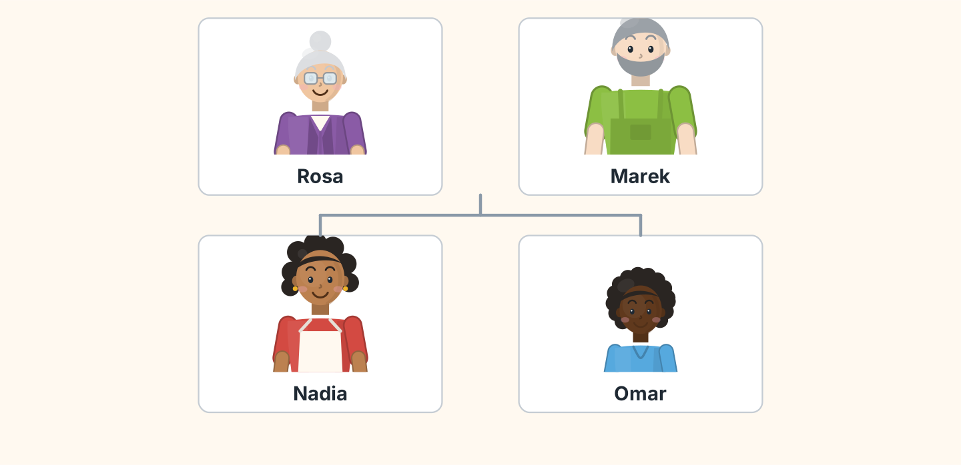
Figure 3.1 · Marek’s family.
- the grandmother — Rosa (example)
- the father — ______________
- the mother — ______________
- the son — ______________
W2 Look at Figure 3.2. Write the word.
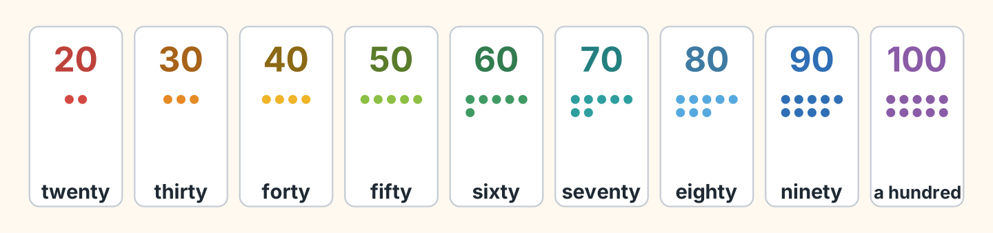
Figure 3.2 · Twenty to a hundred.
- 20 — twenty (example)
- 40 — ______________
- 60 — ______________
- 90 — ______________
- 100 — ______________
W3 Say the numbers to a friend.
- twenty, thirty, forty (example)
- Count 20, 30, 40, 50.
- Count 60, 70, 80.
- Say your age.
Part 1 · Words & Sounds
1A Look at Figure 3.3. Match the person and the word.
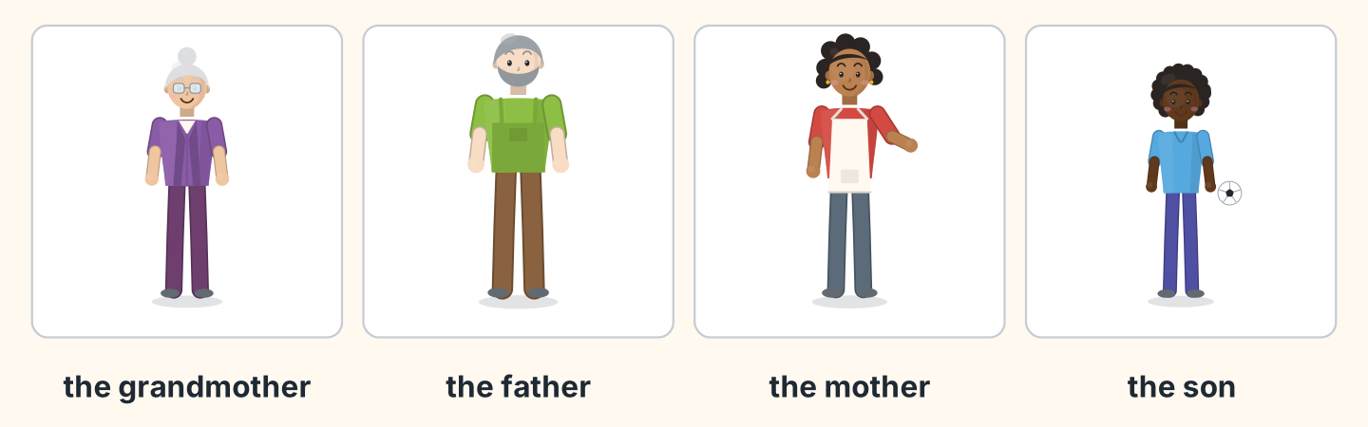
Figure 3.3 · Four people in a family.
Person | Word
1 Rosa | a the son
2 Marek | b the grandmother
3 Nadia | c the daughter
4 Omar | d the father
 | e the mother
One option is not needed.
- 1 — b (example)
- 2 — ______
- 3 — ______
- 4 — ______
1B Look at Figure 3.4. Write one or two.
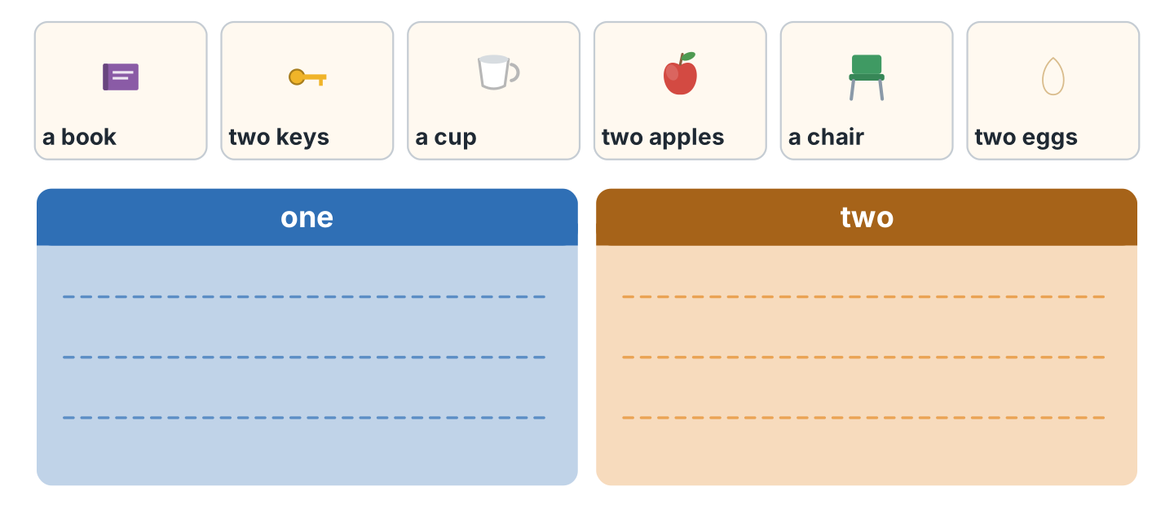
Figure 3.4 · One and two.
- a book — one (example)
- two keys — ______________
- a cup — ______________
- two apples — ______________
- two eggs — ______________
1C Look at Figure 3.5. Write the plural.
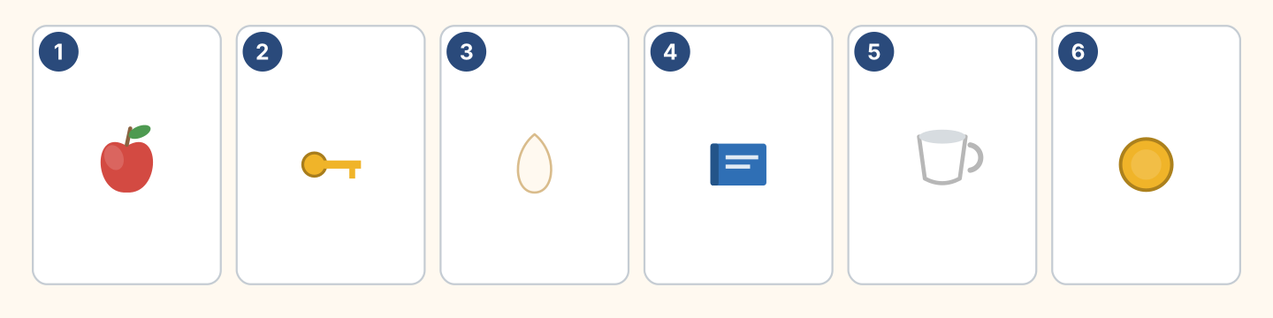
Figure 3.5 · Six things to count.
- one apple — two apples (example)
- one key — two ______________
- one egg — two ______________
- one cup — two ______________
1D Say it. Say the plural of these words.
- book — books (example)
- key
- sister
- watch
- family
1E Look at Figure 3.6. Write the sentence.
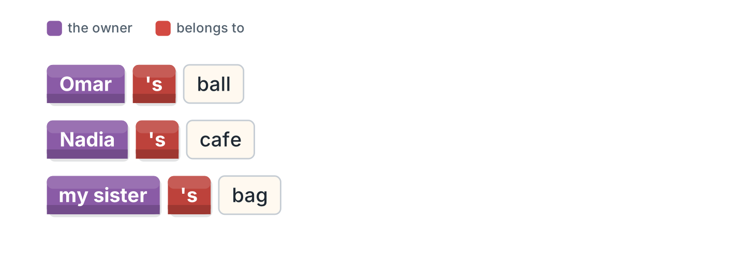
Figure 3.6 · The ’s of the owner.
- the ball of Omar — Omar’s ball (example)
- the cafe of Nadia — ______________
- the bag of my sister — ______________
- the son of Marek — ______________
1F Write the number.
- seventy — 70 (example)
- thirty — ______
- fifty — ______
- eighty — ______
- a hundred — ______
Part 2 · Grammar
2A Look at Figure 3.7. Complete with our or their.
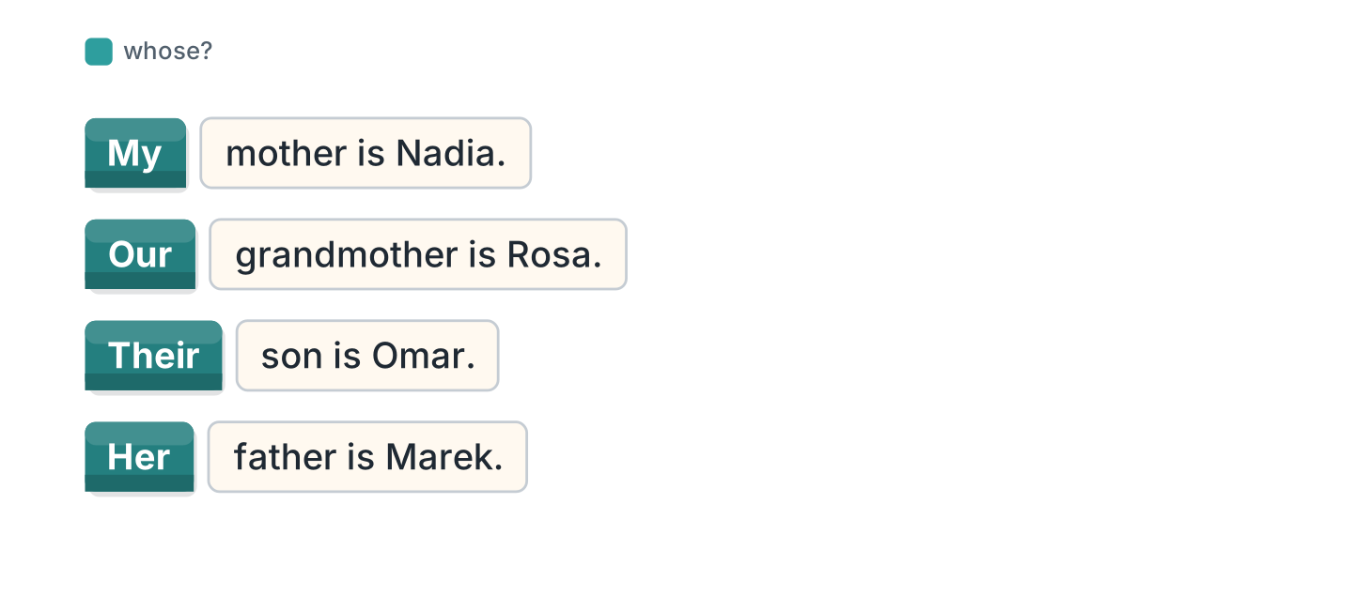
Figure 3.7 · our and their.
- My mother is Nadia. (My) (example)
- ______ grandmother is Rosa.
- ______ son is Omar.
- ______ father is a driver.
2B Choose the correct word.
- This is (my / me) sister. — my (example)
- Rosa is (her / she) grandmother.
- (Our / We) father is Marek.
- (They / Their) son is nine.
- (He / His) name is Omar.
2C Look at Figure 3.8. Write the plural.
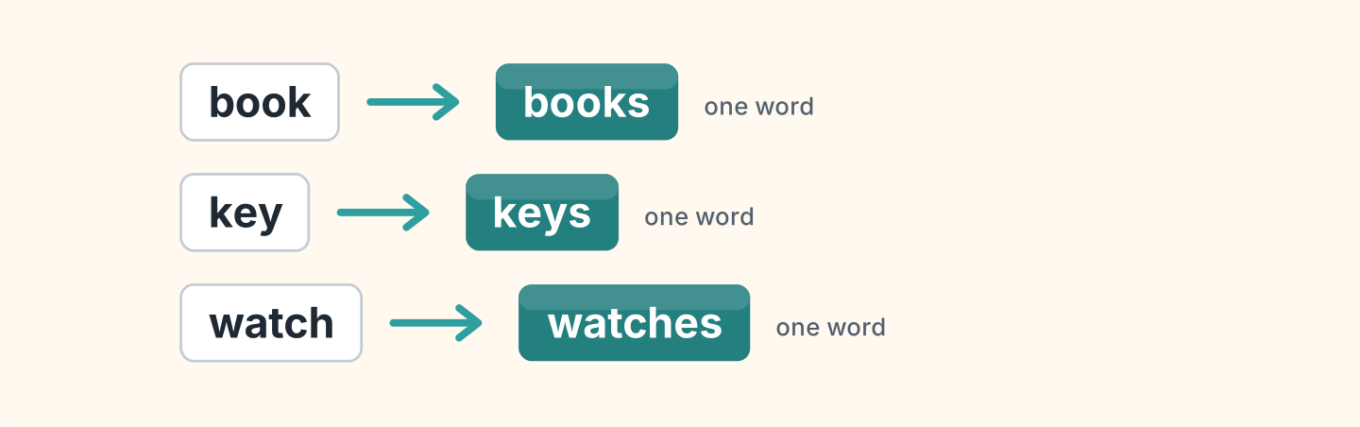
Figure 3.8 · One book, two books.
- one book — two books (example)
- one key — ______________
- one watch — ______________
- one family — ______________
2D Write the answer with ’s.
- Whose bag is it? (Lili) — It’s Lili’s bag. (example)
- Whose ball is it? (Omar) — ______________
- Whose cafe is it? (Nadia) — ______________
- Whose keys are they? (Marek) — ______________
2E Look at Figure 3.9. Write the question.
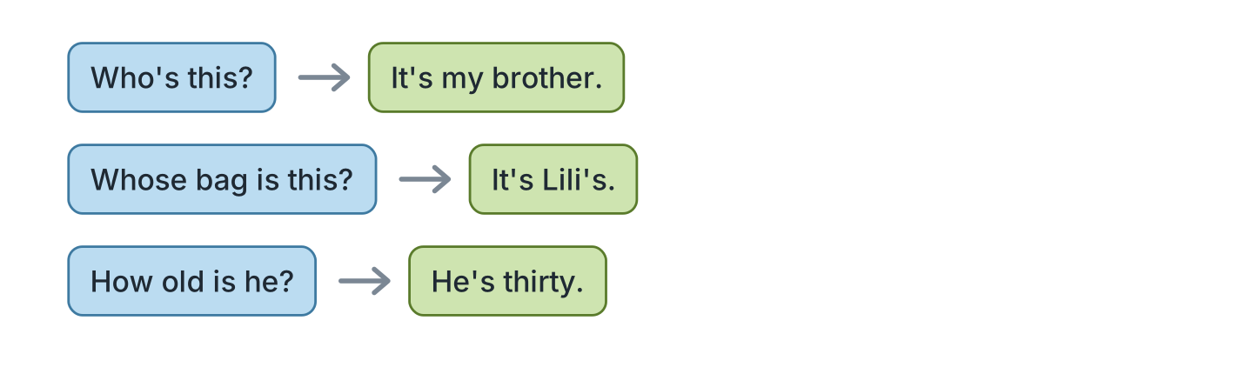
Figure 3.9 · Who and whose.
- It’s my brother. — Who’s this? (example)
- It’s Lili’s. — ______________
- He’s thirty. — ______________
- She’s my mother. — ______________
2F Find the mistake. Write the correct word.
- Whose this? — Who’s (example)
- He have two sister. — ______________
- This is the bag of Omar. — ______________
- Their is my mother. — ______________
Part 3 · Listening
3A Listen. Look at Figure 3.10. Write the number.
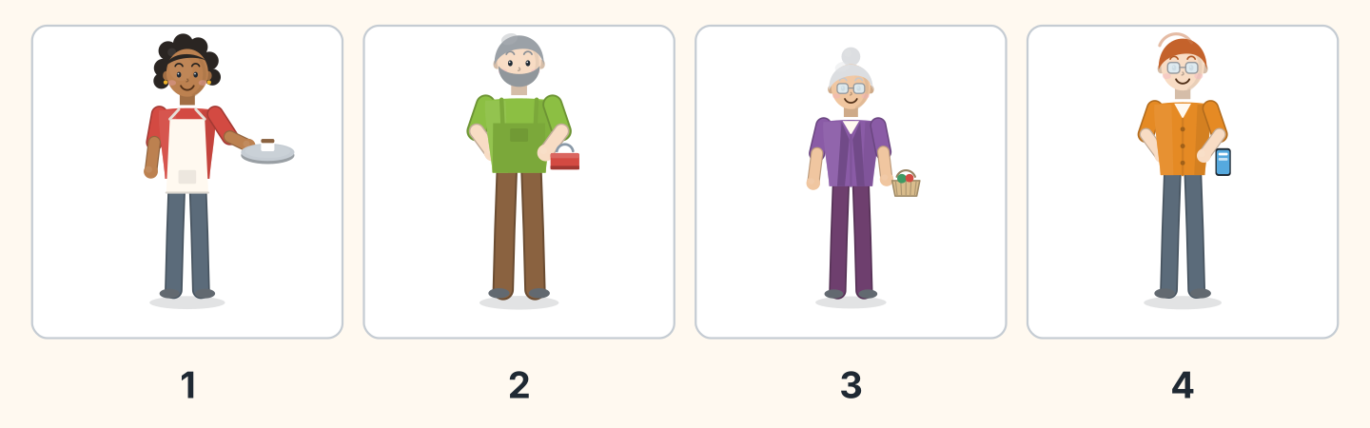
Figure 3.10 · Four people talking.
- Nadia — 1 (example)
- Marek — ______
- Rosa — ______
- Ben — ______
3B Listen. Look at Figure 3.11. Write the age.
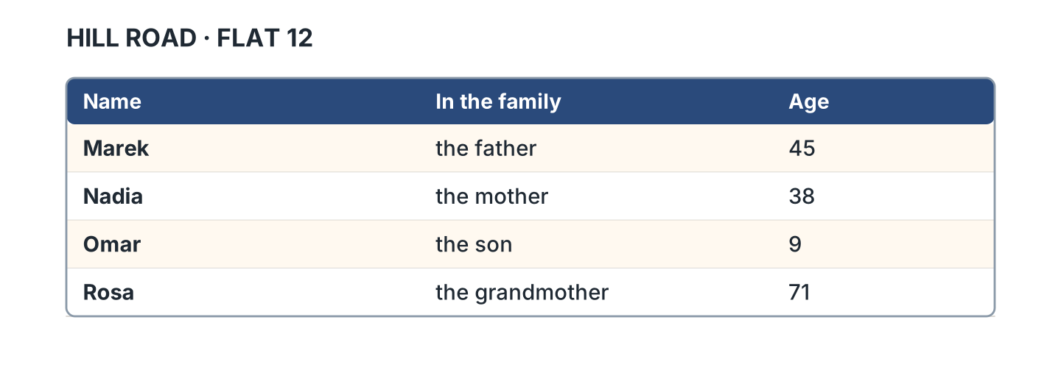
Figure 3.11 · A family list.
- Marek — 45 (example)
- Nadia — ______
- Omar — ______
- Rosa — ______
3C Listen. Look at Figure 3.12. Write yes or no.
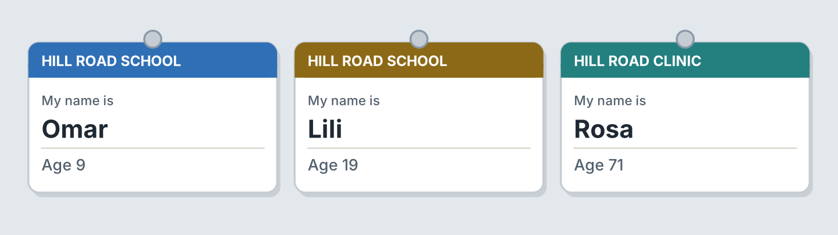
Figure 3.12 · Ages on three cards.
- Omar is nine. — yes (example)
- Lili is twenty. — ______
- Rosa is seventy-one. — ______
- Omar is at the clinic. — ______
3D Listen. Write the number you hear.
- thirty-five — 35 (example)
- ______
- ______
- ______
Part 4 · Speaking
4A Look at Figure 3.13. Introduce a person.
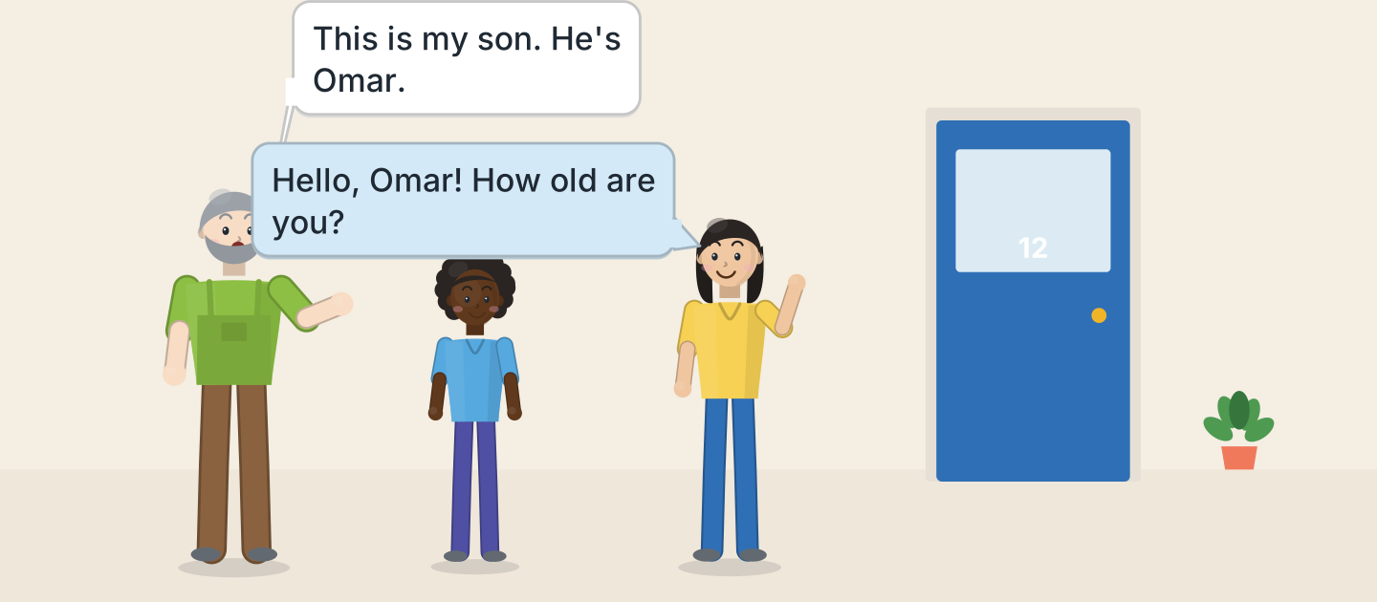
Figure 3.13 · Omar meets Lili.
- This is my son. He’s Omar. (example)
- Introduce a person in your family.
- Say the name.
- Say the age.
4B Look at Figure 3.14. Ask and answer.
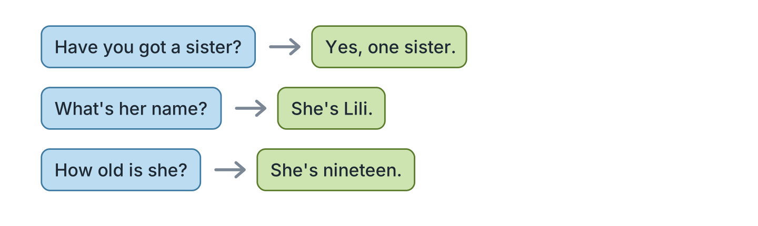
Figure 3.14 · Ask about a family.
- A: Have you got a sister? B: Yes, one sister. (example)
- A: What’s her name? B: ______________
- A: How old is she? B: ______________
- A: Where does she live? B: ______________
4C Ask three friends about a brother or a sister.
- A: Who’s this? B: This is my brother. (example)
- Ask about a brother.
- Ask about a sister.
- Ask the age.
4D Say the ages of four people you know.
- My mother is forty-two. (example)
- ______________
- ______________
- ______________
Part 5 · Reading
5A Look at Figure 3.15. Answer the questions.
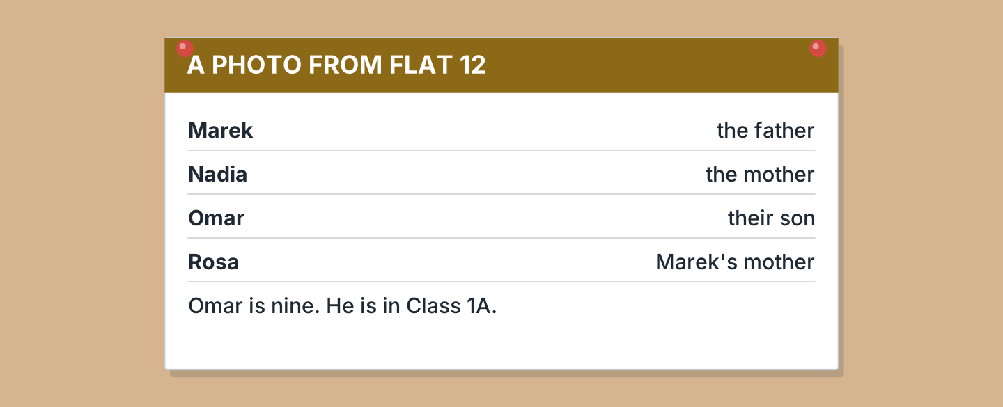
Figure 3.15 · A note about a photo.
- Who is the father? — Marek (example)
- Who is the mother? — ______________
- Who is their son? — ______________
- Whose mother is Rosa? — ______________
5B Look at Figure 3.15. Write yes or no.
- Omar is nine. — yes (example)
- Omar is in Class 1B. — ______
- Rosa is Nadia’s mother. — ______
- Marek is the father. — ______
5C Look at Figure 3.16. Choose the correct answer.
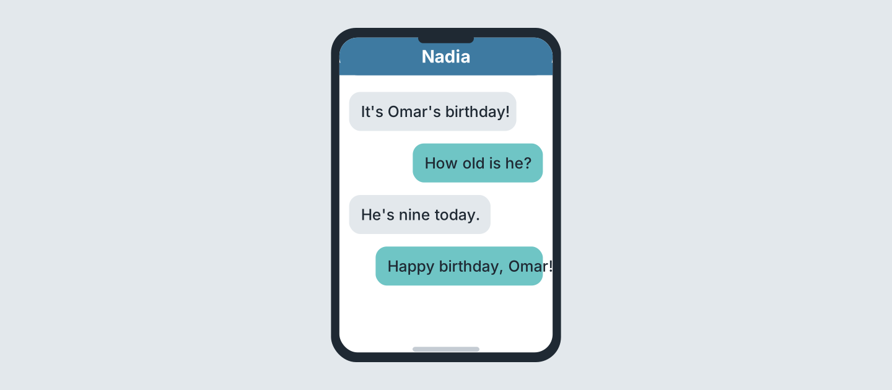
Figure 3.16 · Messages about a birthday.
- Whose birthday is it? (a) Nadia’s (b) Omar’s (c) Rosa’s — b (example)
- How old is he? (a) eight (b) nine (c) ten
- When is the birthday? (a) today (b) Monday (c) Sunday
- Who writes first? (a) Nadia (b) Omar (c) Rosa
5D Read and correct. Write the correct word.
- Omar is ten. — nine (example)
- Rosa is the mother. — ______________
- Nadia is forty-five. — ______________
- Omar is in Class 2A. — ______________
Part 6 · Writing
6A Look at Figure 3.17. Complete the card for you.
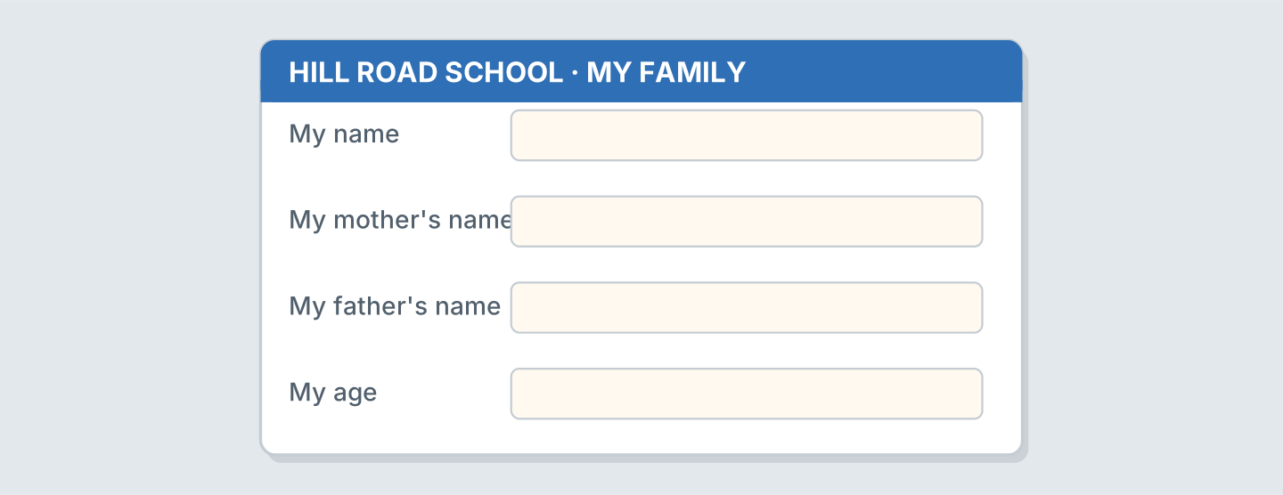
Figure 3.17 · A card for a family.
- My name: Omar Haddad (example)
- My name: ______________
- My mother’s name: ______________
- My age: ______________
6B Look at Figure 3.18. Write four lines.
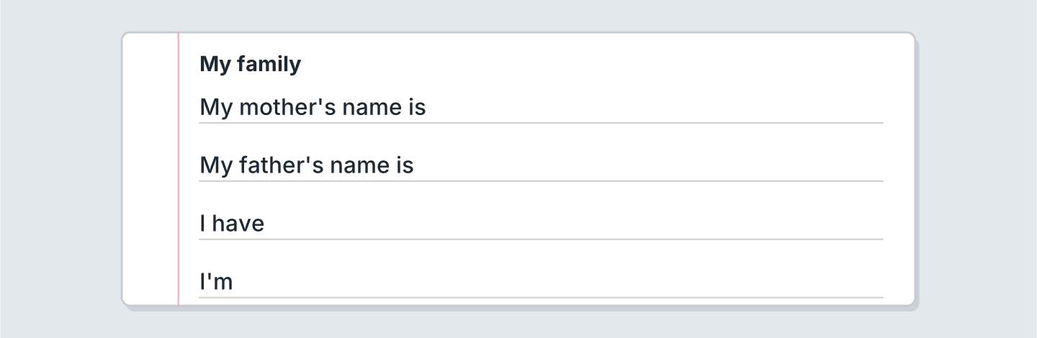
Figure 3.18 · Four lines about your family.
- My mother’s name is Nadia. (example)
- My mother’s name is ______________.
- My father’s name is ______________.
- I have ______________.
6C Write about a person in your family. Write three lines.
- This is my grandmother. (example)
- Say who the person is.
- Say the name.
- Say the age.
Part 7 · Real-World File
7A Look at Figure 3.19. Answer the questions.
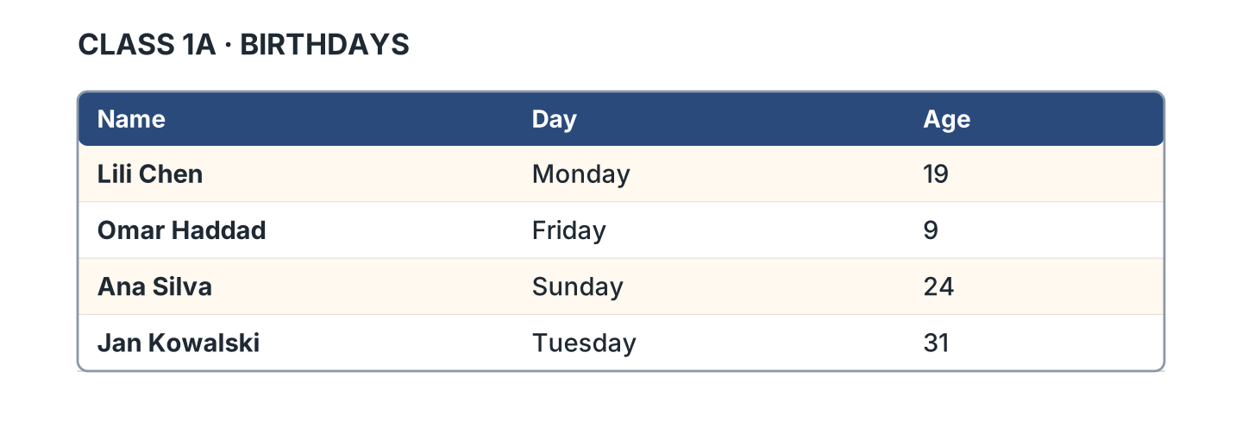
Figure 3.19 · A list of birthdays.
- Whose birthday is on Friday? — Omar’s (example)
- Whose birthday is on Monday? — ______________
- How old is Ana? — ______________
- Whose birthday is on Sunday? — ______________
7B Look at Figure 3.20. Write the age.
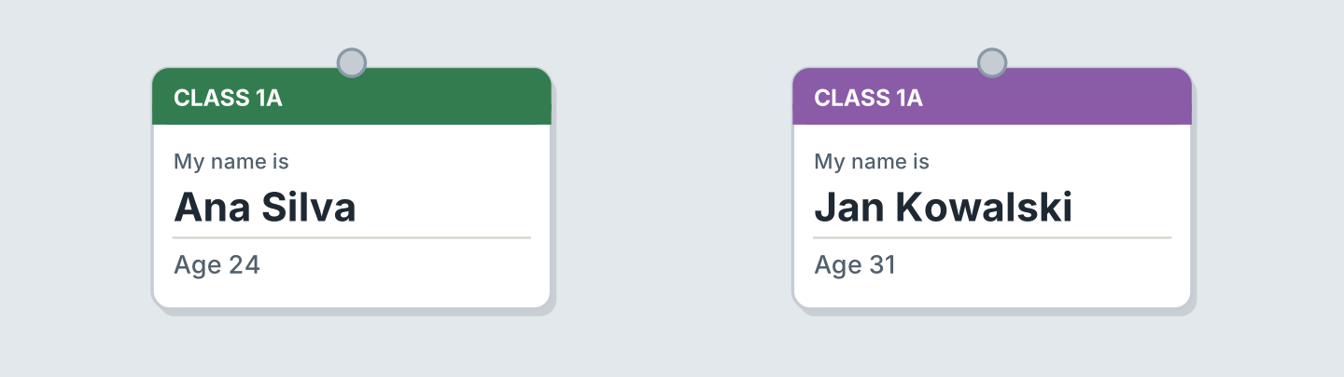
Figure 3.20 · Two cards with ages.
- Ana Silva — 24 (example)
- Jan Kowalski — ______
- Who is older? — ______________
- Who is in Class 1A? — ______________
7C Write your own card. Use Figure 3.20.
- Name: Ana Silva · Age 24 (example)
- Name: ______________
- Age: ______________
- Class: ______________
Part 8 · Review & Can-Do
8A Look at Figure 3.21. Write the word.
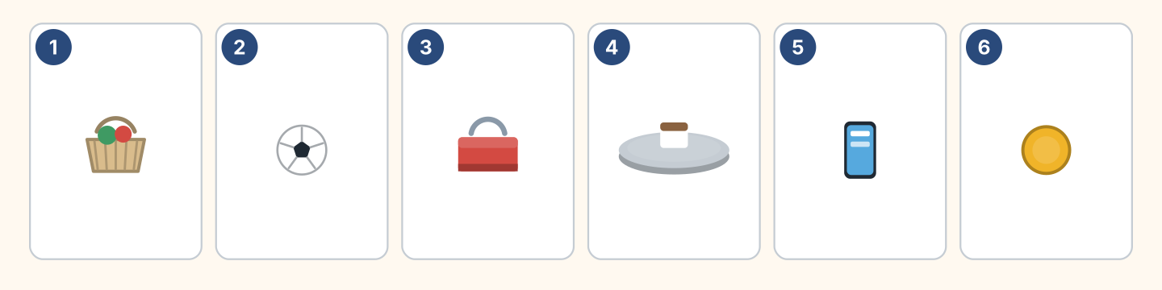
Figure 3.21 · Six people and things.
Words: ball · basket · coin · phone · toolbox · tray
- 1 — basket (example)
- 2 — ______________
- 3 — ______________
- 4 — ______________
- 6 — ______________
8B Complete the conversation.
Words: How · my · old · Who’s
- A: Who’s this? (Who’s) (example)
- B: This is ______ brother.
- A: ______ old is he?
- B: He’s twelve years ______.
8C Write the numbers.
- 45 — forty-five (example)
- 30 — ______________
- 70 — ______________
- 100 — ______________
8D Match the question and the answer.
Question | Answer
1 Who’s this? | a It’s Lili’s.
2 Whose bag is it? | b She’s thirty.
3 How old is she? | c It’s my sister.
4 Where is she from? | d She’s from Spain.
 | e Yes, she is.
One option is not needed.
- 1 — c (example)
- 2 — ______
- 3 — ______
- 4 — ______
8E Look at Figure 3.22. Tick what you can do.
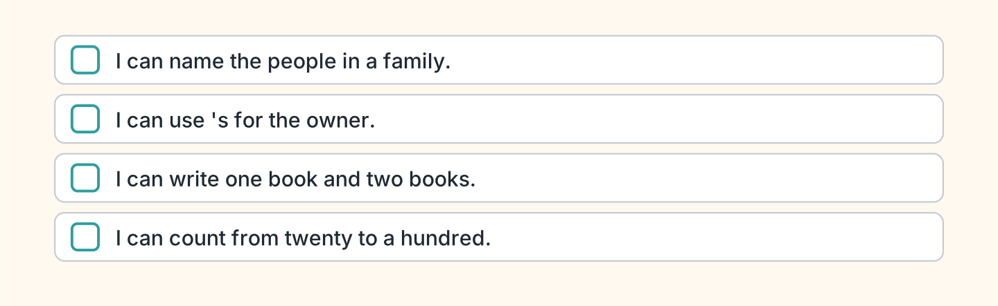
Figure 3.22 · What I can do.
- I can name the people in a family. — ✓ (example)
- I can use ’s for the owner. — ______
- I can write one book and two books. — ______
- I can count from twenty to a hundred. — ______

Unit 4: Where I Live
In this unit you say what is in your home. You ask how many.
Warm Up
W1 Look at Figure 4.1. Tick the rooms you can see.
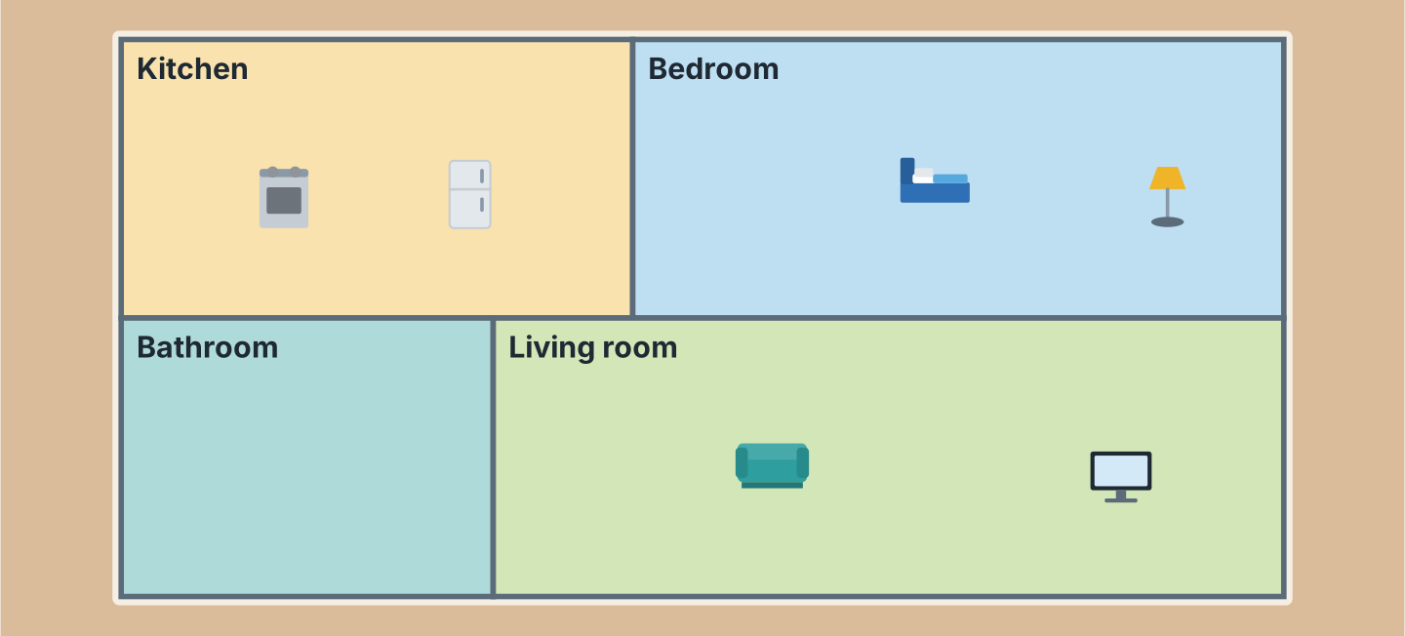
Figure 4.1 · A flat on Hill Road.
- a kitchen — ✓ (example)
- a bedroom — ______
- a bathroom — ______
- a living room — ______
- a garden — ______
W2 Look at Figure 4.2. Write the word.
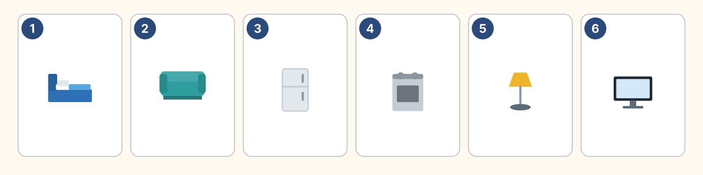
Figure 4.2 · Six things in a home.
Words: bed · cooker · fridge · lamp · sofa · tv
- 1 — bed (example)
- 2 — ______________
- 3 — ______________
- 5 — ______________
- 6 — ______________
W3 Say the rooms in your home.
- In my home there is a kitchen. (example)
- Say two rooms.
- Say your mother’s room.
- Say your brother or sister’s room.
Part 1 · Words & Sounds
1A Look at Figure 4.3. Write the room.
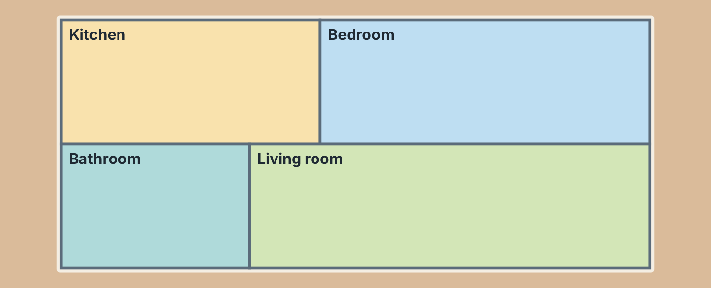
Figure 4.3 · Four rooms.
- You cook here. — the kitchen (example)
- You sleep here. — ______________
- You wash here. — ______________
- You watch TV here. — ______________
1B Look at Figure 4.4. Write the word.
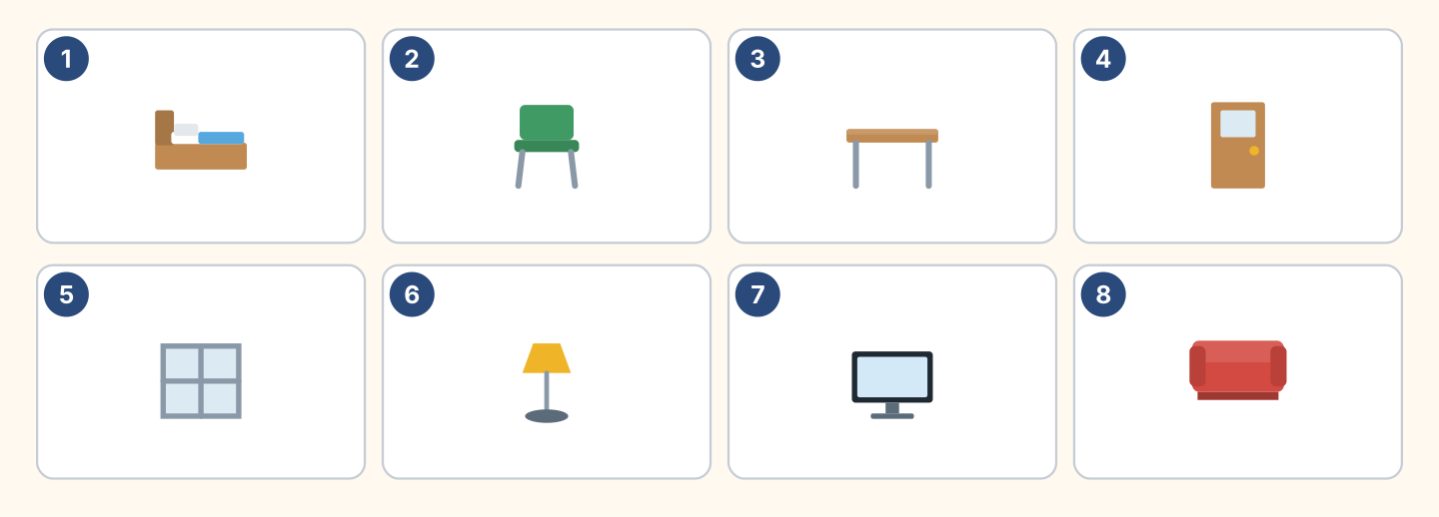
Figure 4.4 · Eight things to name.
Words: bed · chair · desk · door · lamp · sofa · tv · window
- 1 — bed (example)
- 3 — ______________
- 4 — ______________
- 6 — ______________
- 8 — ______________
1C Look at Figure 4.5. Write in, on or under.
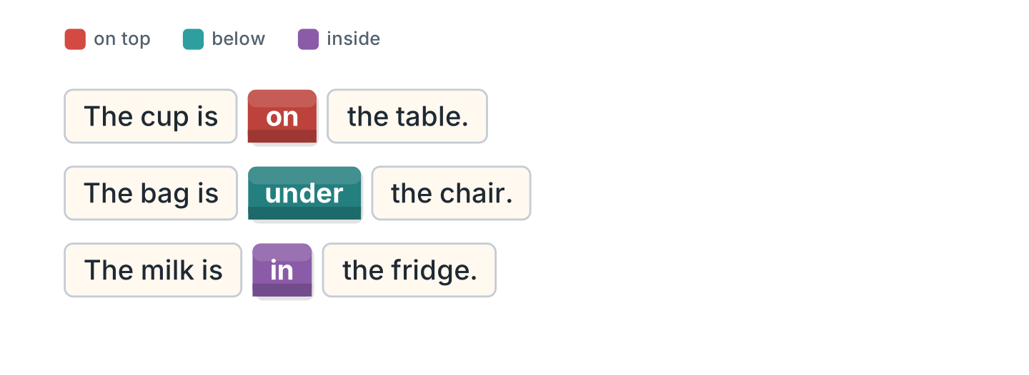
Figure 4.5 · in, on and under.
- The cup is on the table. (on) (example)
- The bag is ______ the chair.
- The milk is ______ the fridge.
- The lamp is ______ the desk.
1D Say it. Say where the things are.
- The book is on the bed. (example)
- Say where your bag is.
- Say where your pen is.
- Say where your phone is.
1E Look at Figure 4.6. Write kitchen or bedroom.
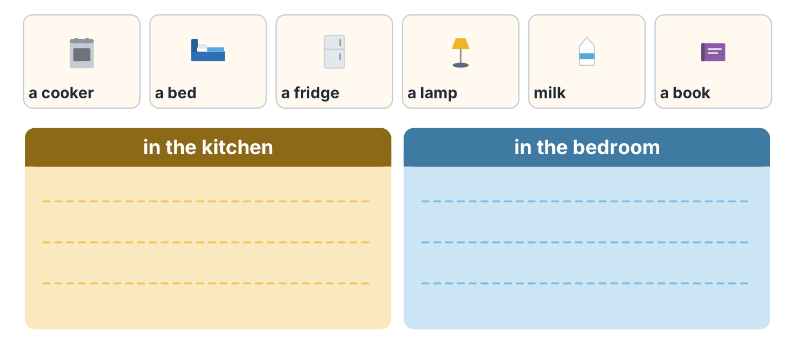
Figure 4.6 · Kitchen or bedroom.
- a cooker — kitchen (example)
- a bed — ______________
- a fridge — ______________
- a lamp — ______________
1F Write the opposite word.
- big — small (example)
- old — ______________
- young — ______________
- up — ______________
Part 2 · Grammar
2A Look at Figure 4.7. Write There is or There are.
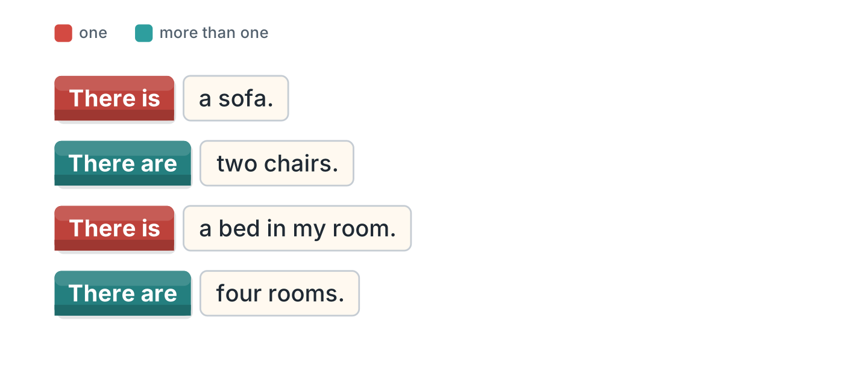
Figure 4.7 · There is and there are.
- There is a sofa. (There is) (example)
- ______________ two chairs.
- ______________ a bed in my room.
- ______________ four rooms.
2B Choose the correct word.
- There (is / are) a lamp. — is (example)
- There (is / are) three windows.
- There (is / are) a big kitchen.
- There (is / are) two beds.
- There (is / are) a garden.
2C Look at Figure 4.8. Write the short form.
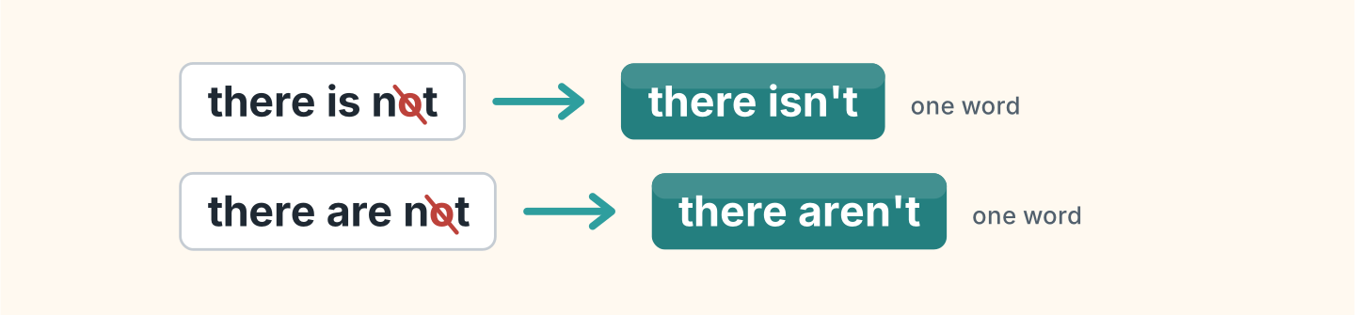
Figure 4.8 · The short negative.
- there is not — there isn’t (example)
- there are not — ______________
- There is not a garden. — ______________
2D Complete with isn’t or aren’t.
- There isn’t a balcony. (isn’t) (example)
- There ______________ any chairs.
- There ______________ a shower.
- There ______________ two bathrooms.
2E Look at Figure 4.9. Write the answer.
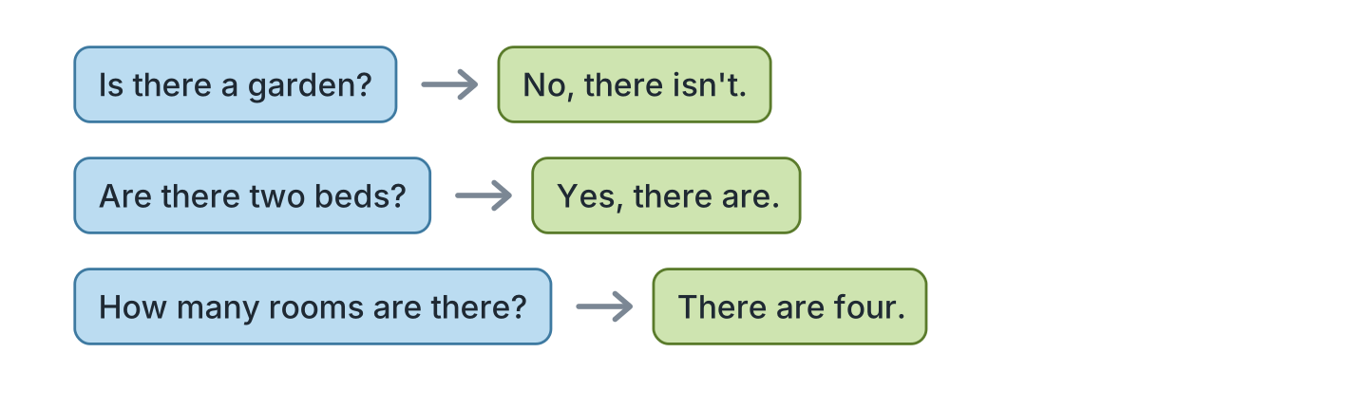
Figure 4.9 · Asking how many.
- Is there a garden? ✗ — No, there isn’t. (example)
- Are there two beds? ✓ — ______________
- Is there a kitchen? ✓ — ______________
- How many rooms are there? (4) — ______________
2F Find the mistake. Write the correct words.
- There are a bed. — There is (example)
- There is two chairs. — ______________
- How many room are there? — ______________
- There aren’t a garden. — ______________
Part 3 · Listening
3A Listen. Look at Figure 4.10. Write the number.
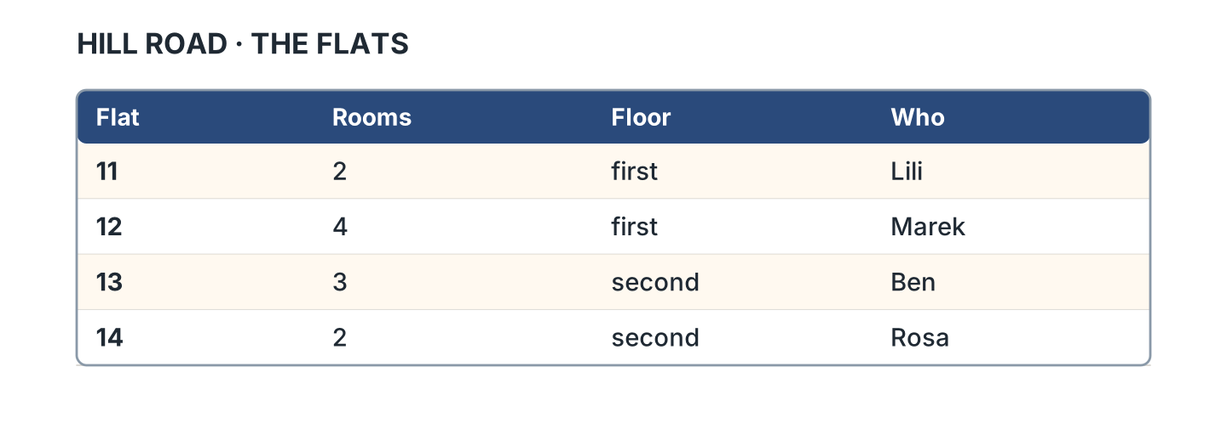
Figure 4.10 · Four flats.
- Lili — 11 (example)
- Marek — ______
- Ben — ______
- Rosa — ______
3B Listen. Look at Figure 4.11. Write the room.
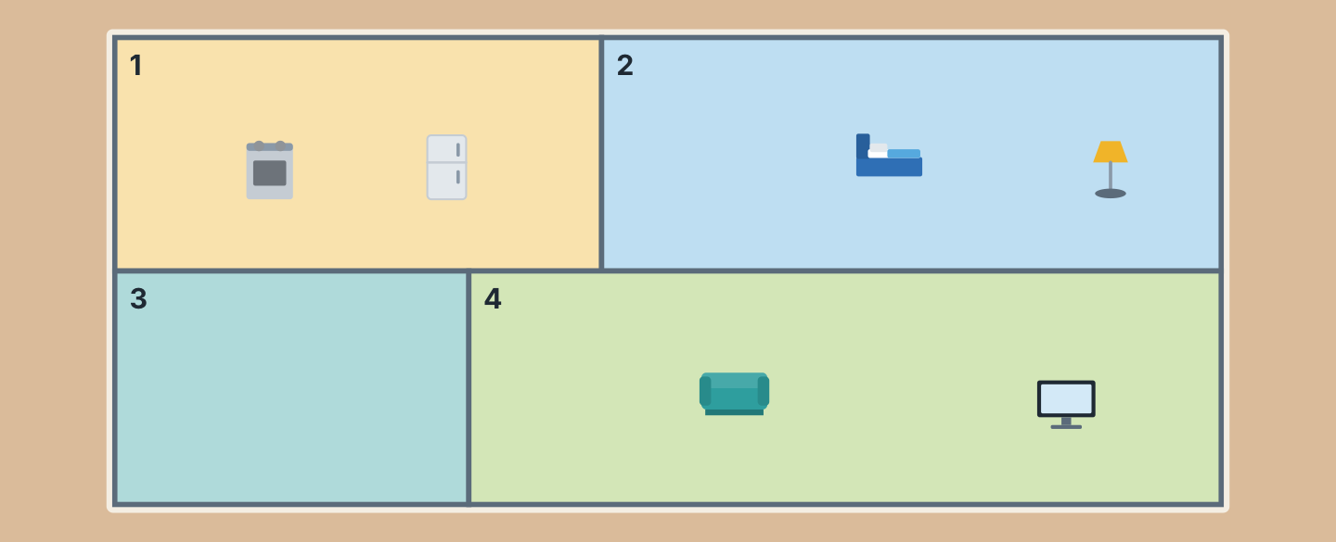
Figure 4.11 · A plan with no words.
- Room 1 — the kitchen (example)
- Room 2 — ______________
- Room 3 — ______________
- Room 4 — ______________
3C Listen. Look at Figure 4.12. Write the number.
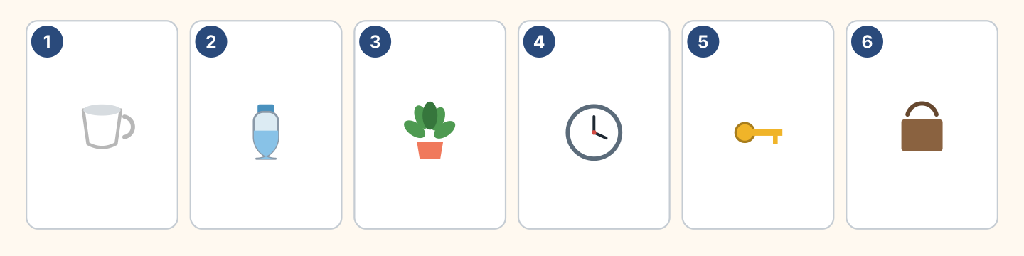
Figure 4.12 · Six more things.
- a cup — 1 (example)
- a clock — ______
- a plant — ______
- a bag — ______
3D Listen. Write how many.
- chairs — 4 (example)
- windows — ______
- beds — ______
- rooms — ______
Part 4 · Speaking
4A Look at Figure 4.13. Talk about your home.
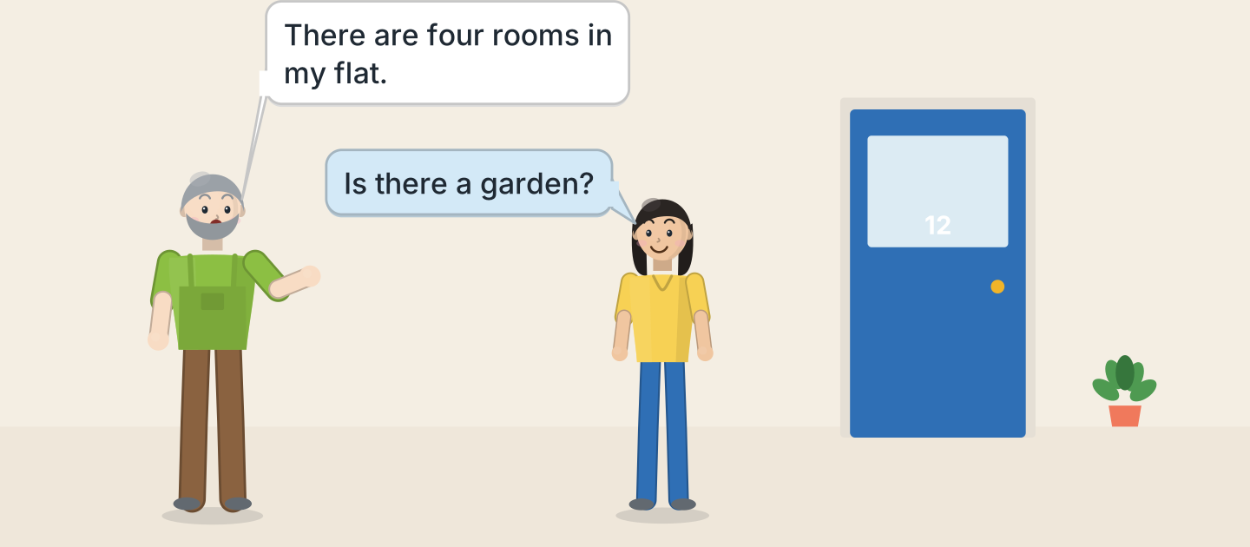
Figure 4.13 · Marek shows the flat.
- There are four rooms in my flat. (example)
- Say how many rooms.
- Say one room.
- Say one thing in it.
4B Look at Figure 4.14. Ask and answer.
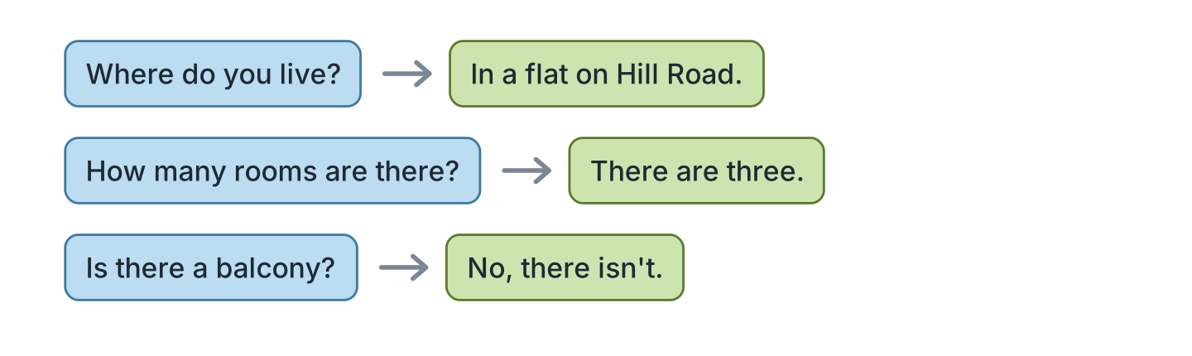
Figure 4.14 · Ask about a home.
- A: Where do you live? B: In a flat on Hill Road. (example)
- A: How many rooms are there? B: ______________
- A: Is there a garden? B: ______________
- A: Is there a balcony? B: ______________
4C Ask a friend about their home.
- A: Is there a kitchen? B: Yes, there is. (example)
- Ask about the kitchen.
- Ask about his sister’s room.
- Ask about her parents.
4D Say where three things are in your bag.
- My pen is in my bag. (example)
- ______________
- ______________
- ______________
Part 5 · Reading
5A Look at Figure 4.15. Answer the questions.
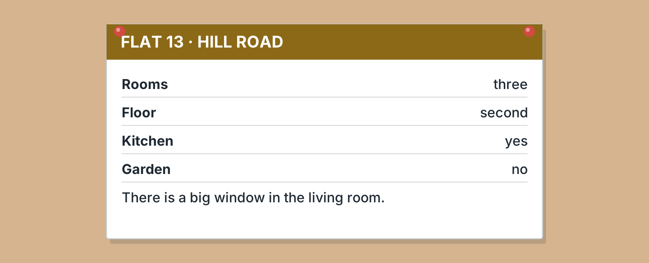
Figure 4.15 · A flat for rent.
- How many rooms are there? — three (example)
- Which floor is it? — ______________
- Is there a garden? — ______________
- Where is the big window? — ______________
5B Look at Figure 4.15. Write yes or no.
- There is a kitchen. — yes (example)
- There are four rooms. — ______
- There is a garden. — ______
- It is on the first floor. — ______
5C Look at Figure 4.16. Choose the correct answer.
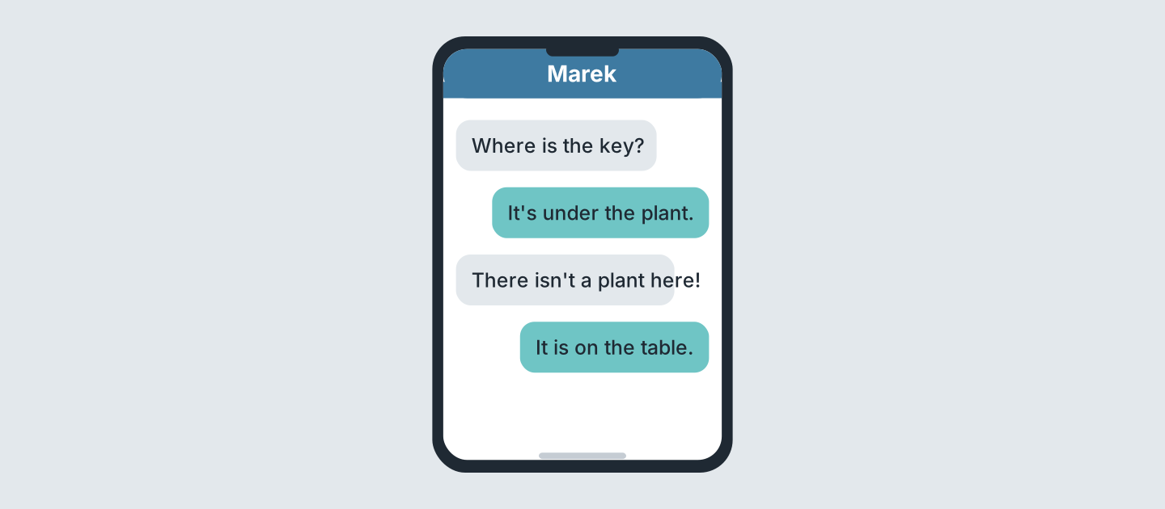
Figure 4.16 · Messages about a key.
- What is lost? (a) bag (b) key (c) phone — b (example)
- Where is it first? (a) table (b) plant (c) bag
- Is there a plant? (a) yes (b) no (c) maybe
- Where is the key? (a) fridge (b) table (c) bed
5D Read and correct. Write the correct word.
- The key is in the fridge. — table (example)
- Flat 13 is on the first floor. — ______________
- There are four rooms in Flat 13. — ______________
- There is a garden. — ______________
Part 6 · Writing
6A Look at Figure 4.17. Complete the form for you.
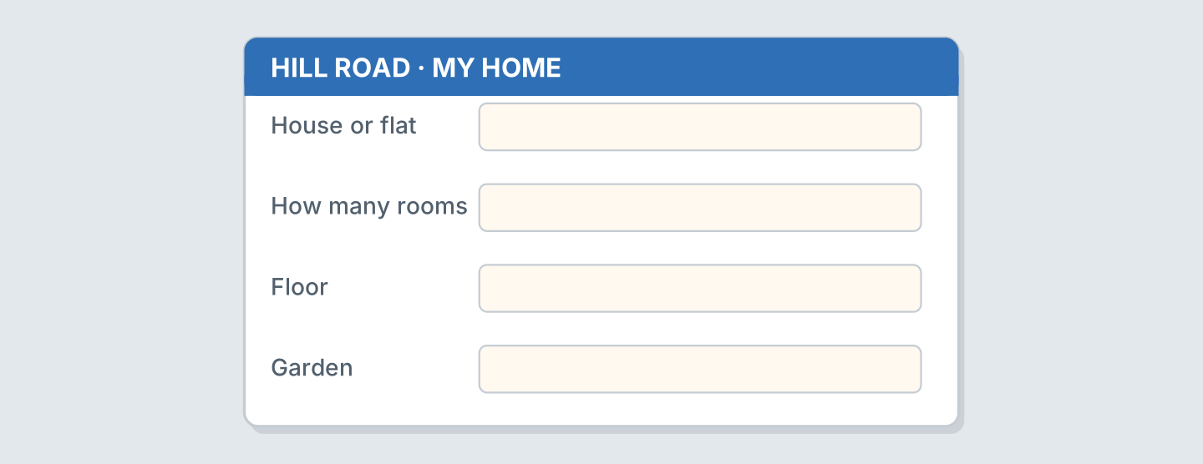
Figure 4.17 · A form about your home.
- House or flat: a flat (example)
- House or flat: ______________
- How many rooms: ______________
- Garden: ______________
6B Look at Figure 4.18. Write four lines.
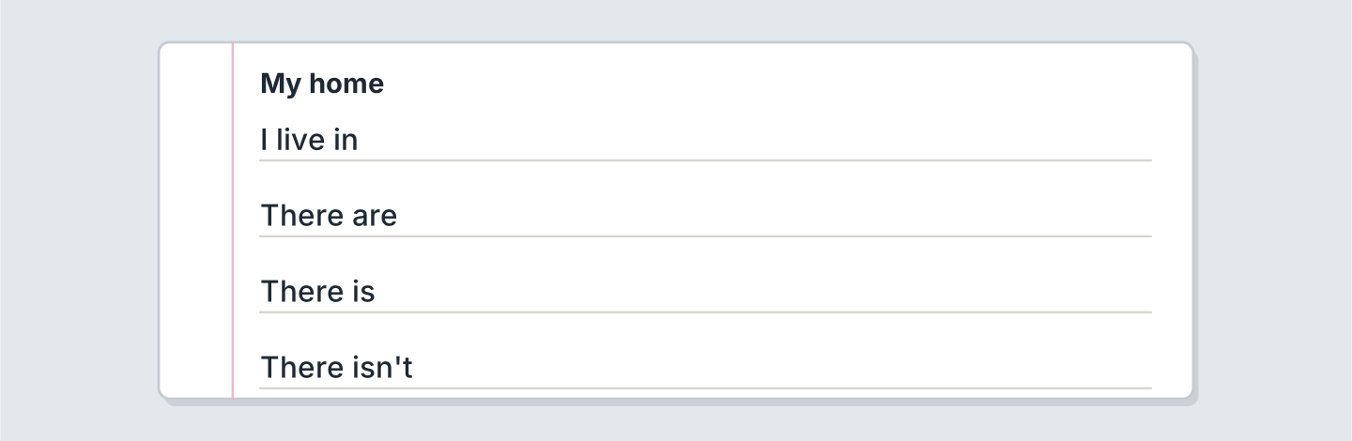
Figure 4.18 · Four lines about your home.
- I live in a flat with my parents. (example)
- I live in ______________.
- There are ______________.
- My sister’s room is ______________.
6C Write about your bedroom. Write three lines.
- There is a bed in my room. (example)
- Say one thing in the room.
- Say whose room it is.
- Say one thing that is not there.
Part 7 · Real-World File
7A Look at Figure 4.19. Answer the questions.
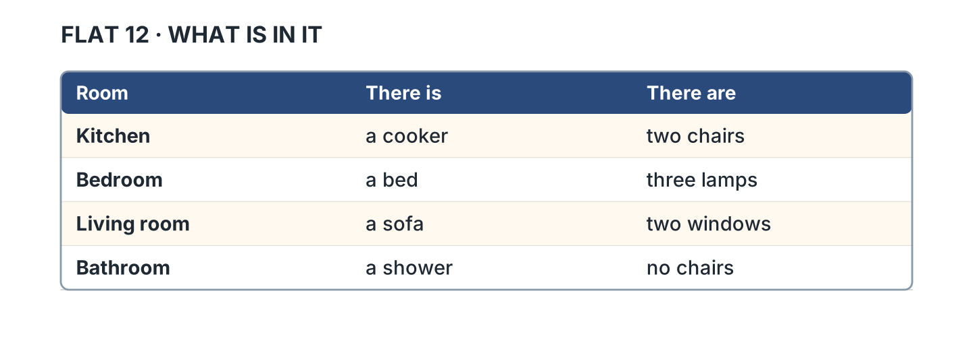
Figure 4.19 · What is in the rooms.
- What is in the kitchen? — a cooker (example)
- How many lamps are in the bedroom? — ______________
- What is in the living room? — ______________
- How many chairs are in the kitchen? — ______________
7B Look at Figure 4.20. Write the number.
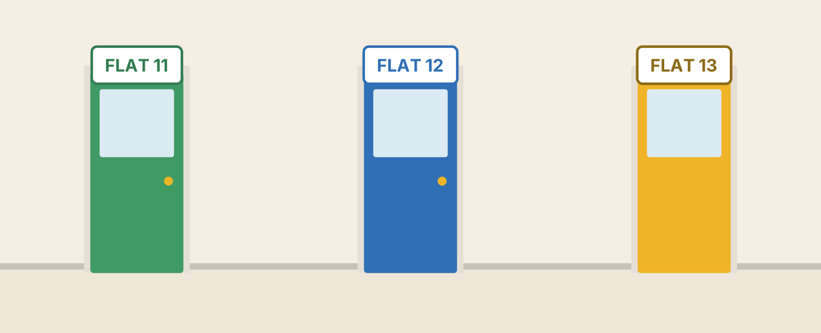
Figure 4.20 · Doors in the flats.
- the green door — Flat 11 (example)
- the blue door — ______________
- the yellow door — ______________
- Is Flat 14 here? — ______
7C Write a note about a flat. Use Figure 4.15.
- Rooms: three (example)
- Rooms: ______________
- Floor: ______________
- Garden: ______________
Part 8 · Review & Can-Do
8A Look at Figure 4.21. Write the word.
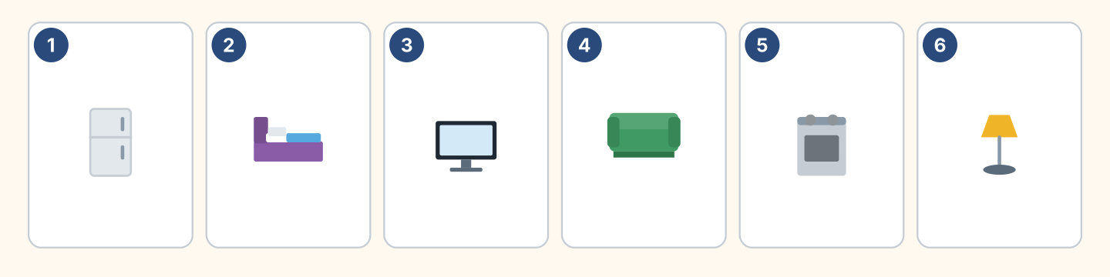
Figure 4.21 · Six things from this unit.
Words: bed · cooker · fridge · lamp · sofa · tv
- 1 — fridge (example)
- 2 — ______________
- 3 — ______________
- 5 — ______________
- 6 — ______________
8B Complete the conversation.
Words: are · How · isn’t · there
- A: How many rooms are there? (How) (example)
- B: There ______ three.
- A: Is ______ a garden?
- B: No, there ______.
8C Write in, on or under.
- The cat is under the bed. (under) (example)
- My father’s keys are ______ the fridge.
- The photo of my children is ______ the desk.
- My grandmother’s bag is ______ the chair.
8D Match the question and the answer.
Question | Answer
1 How many rooms are there? | a On the second floor.
2 Is there a garden? | b There are three.
3 Which floor is it? | c No, there isn’t.
4 Where is the key? | d Under the plant.
 | e Yes, I am.
One option is not needed.
- 1 — b (example)
- 2 — ______
- 3 — ______
- 4 — ______
8E Look at Figure 4.22. Tick what you can do.
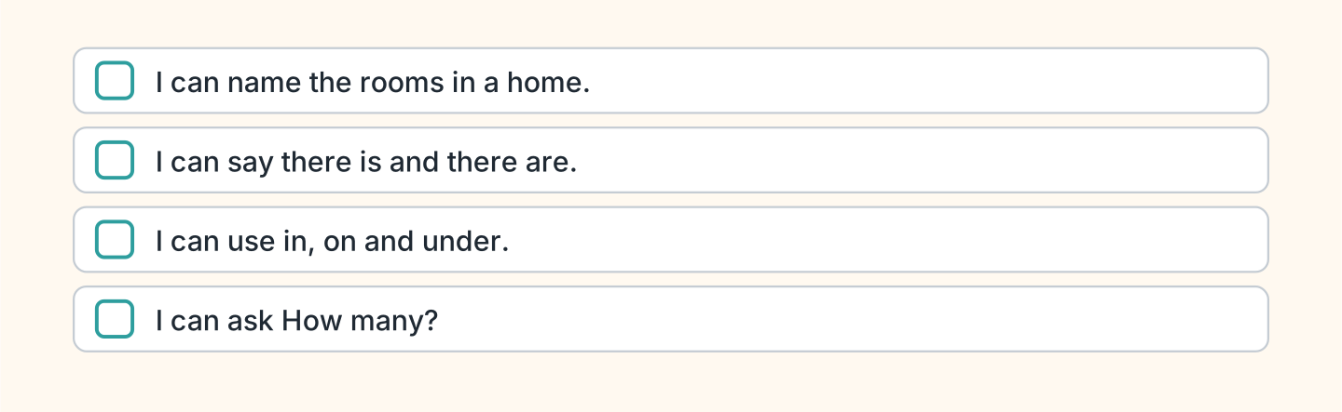
Figure 4.22 · What I can do.
- I can name the rooms in a home. — ✓ (example)
- I can say there is and there are. — ______
- I can use in, on and under. — ______
- I can ask How many? — ______

Unit 5: Every Day
In this unit you say what you do every day. You tell the time.
Warm Up
W1 Look at Figure 5.1. Write the time.
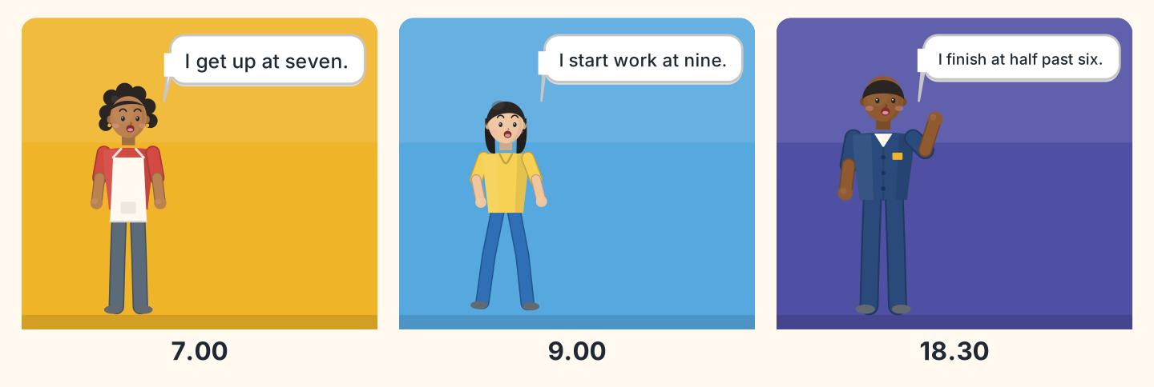
Figure 5.1 · A day on Hill Road.
- Nadia gets up at — seven (example)
- Lili starts work at — ______________
- Sam finishes at — ______________
- Who gets up first? — ______________
W2 Look at Figure 5.2. Write the time.
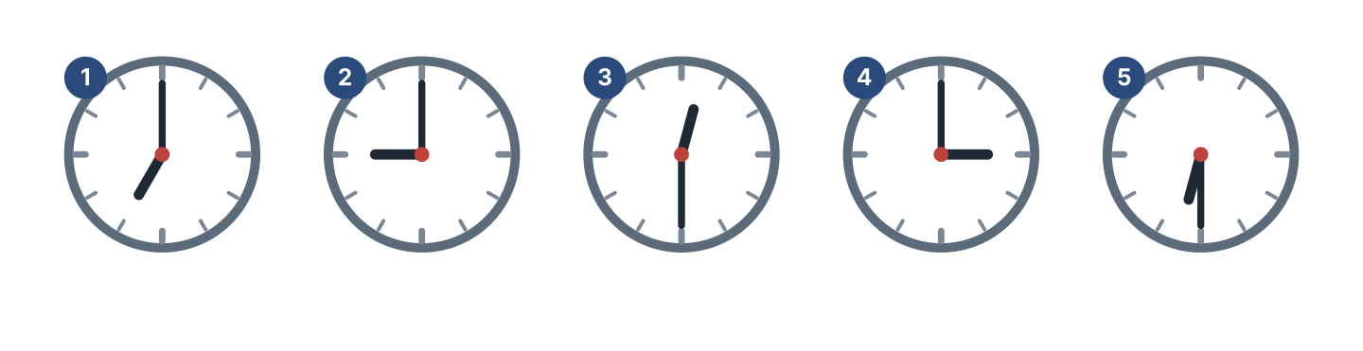
Figure 5.2 · Five times.
- clock 1 — seven o’clock (example)
- clock 2 — ______________
- clock 3 — ______________
- clock 5 — ______________
W3 Say the days of the week.
- Monday, Tuesday, Wednesday (example)
- Say the seven days.
- Say your free day.
- Say today.
Part 1 · Words & Sounds
1A Look at Figure 5.3. Write the word.
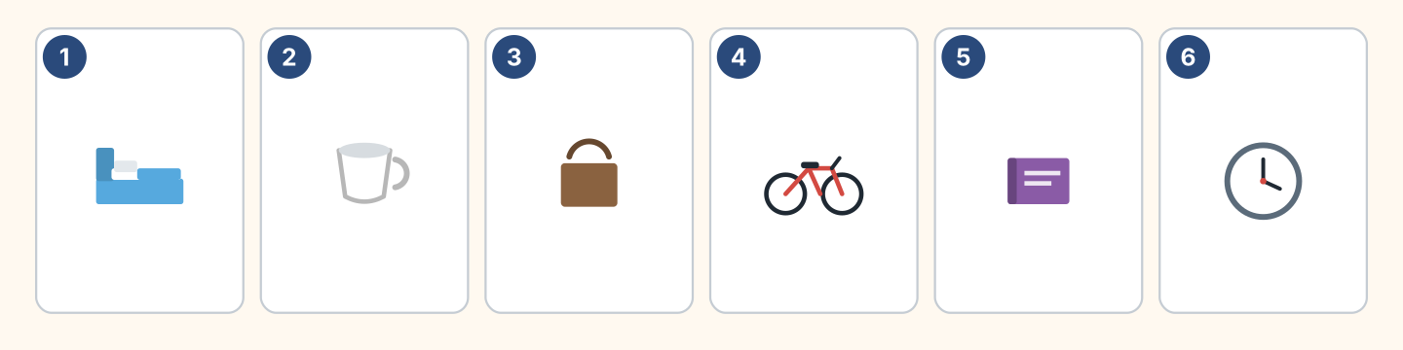
Figure 5.3 · A day in six pictures.
Words: bag · bed · bike · book · clock · cup
- 1 — bed (example)
- 2 — ______________
- 3 — ______________
- 4 — ______________
- 6 — ______________
1B Look at Figure 5.4. Write the time.
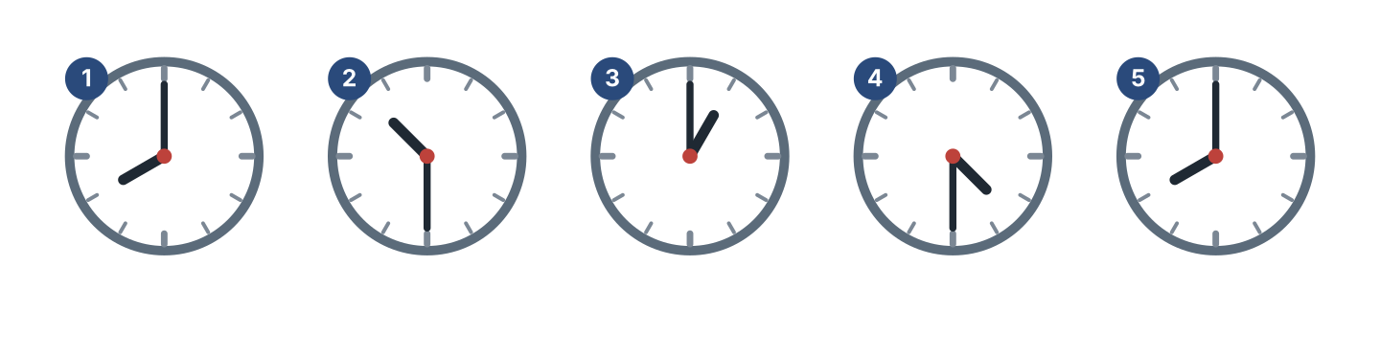
Figure 5.4 · Five more times.
- clock 1 — eight o’clock (example)
- clock 2 — ______________
- clock 3 — ______________
- clock 4 — ______________
1C Look at Figure 5.5. Write at or on.
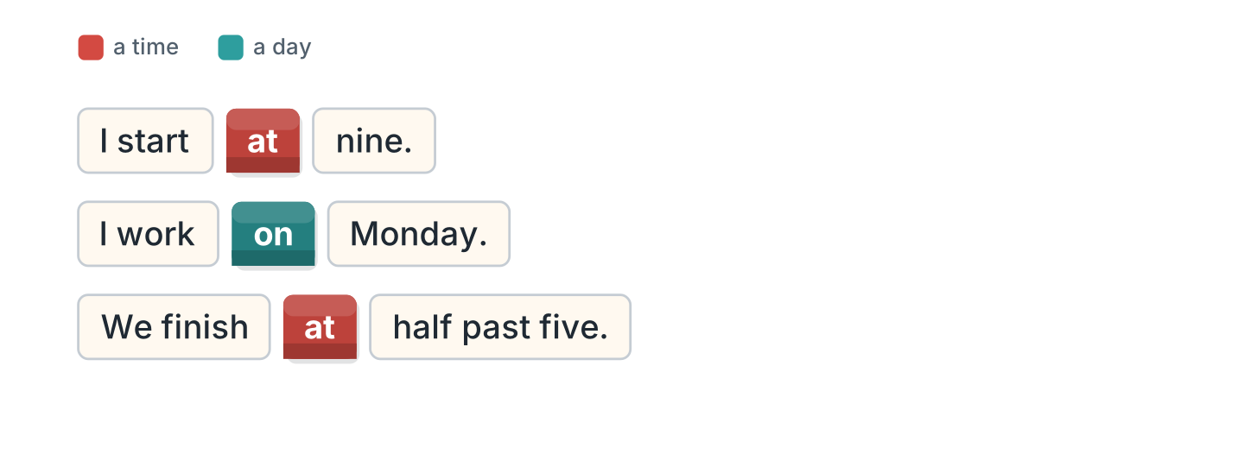
Figure 5.5 · at and on.
- I start at nine. (at) (example)
- My father works ______ Monday.
- We finish ______ half past five.
- My sister studies ______ Saturday.
1D Say it. Say these times.
- 7.00 — seven o’clock (example)
- 9.30
- 12.00
- 4.30
- 6.15
1E Look at Figure 5.6. Answer the questions.
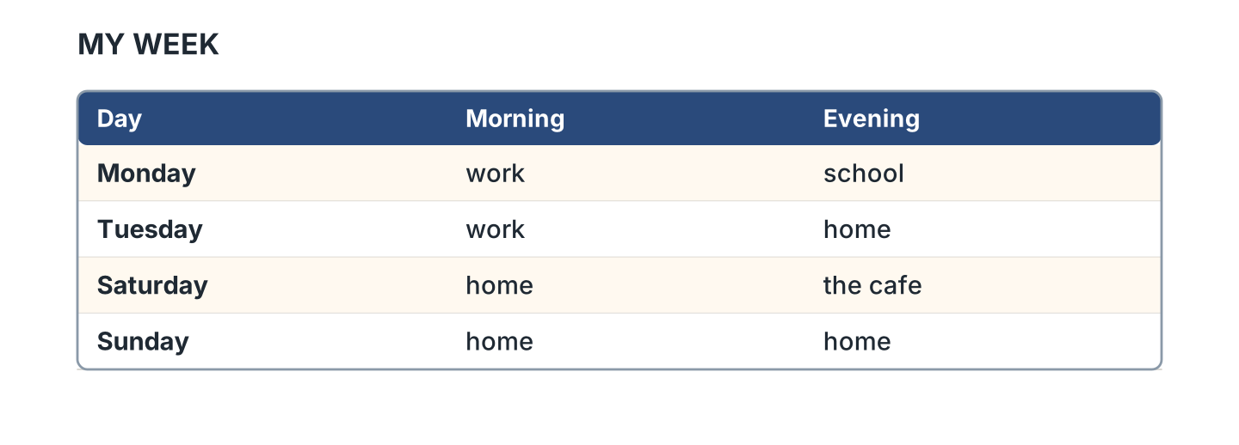
Figure 5.6 · The days of the week.
- What do I do on Monday morning? — work (example)
- What do I do on Monday evening? — ______________
- Where am I on Saturday evening? — ______________
- What do I do on Sunday? — ______________
1F Write the day after.
- Monday — Tuesday (example)
- Friday — ______________
- Saturday — ______________
- Wednesday — ______________
Part 2 · Grammar
2A Look at Figure 5.7. Complete the sentence.
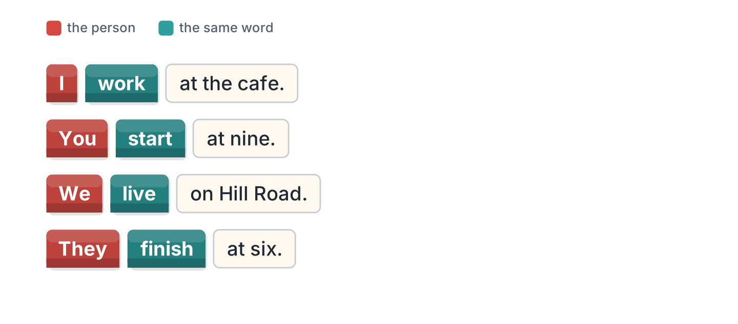
Figure 5.7 · I, you, we and they.
- I work at the cafe. (work) (example)
- We ______________ on Hill Road.
- You ______________ at nine.
- They ______________ at six.
2B Choose the correct word.
- I (work / works) here. — work (example)
- They (live / lives) in a flat.
- We (start / starts) at eight.
- You (study / studies) English.
- I (get / gets) up early.
2C Look at Figure 5.8. Write the short form.

Figure 5.8 · The negative.
- do not — don’t (example)
- I do not work here. — ______________
- We do not study on Sunday. — ______________
2D Write the negative.
- I work on Monday. — I don’t work on Monday. (example)
- We live here. — ______________
- They start at eight. — ______________
- You study English. — ______________
2E Look at Figure 5.9. Write the answer.
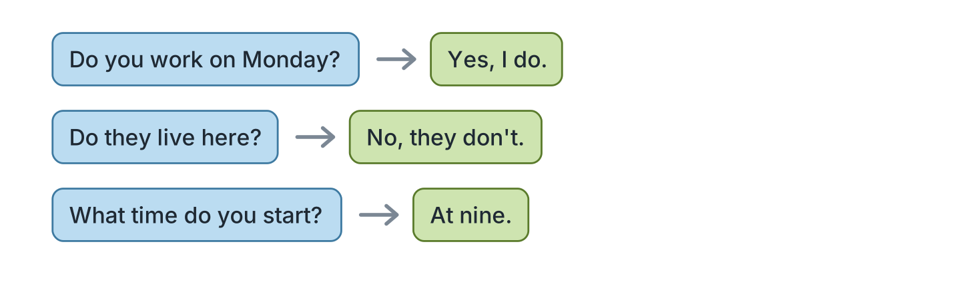
Figure 5.9 · Questions with do.
- Do you work on Monday? ✓ — Yes, I do. (example)
- Do they live here? ✗ — ______________
- Do you study English? ✓ — ______________
- What time do you start? (9.00) — ______________
2F Find the mistake. Write the correct words.
- I no work here. — don’t work (example)
- We starts at nine. — ______________
- Do you lives here? — ______________
- They don’t lives here. — ______________
Part 3 · Listening
3A Listen. Look at Figure 5.10. Write the number.
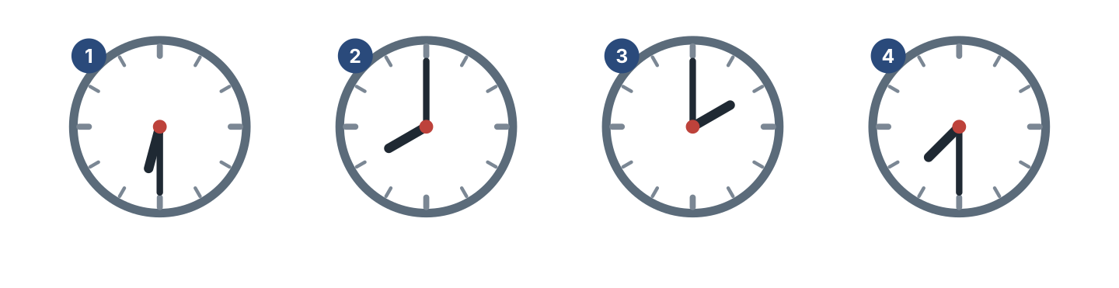
Figure 5.10 · Four people, four times.
- half past six — 1 (example)
- eight o’clock — ______
- two o’clock — ______
- half past seven — ______
3B Listen. Look at Figure 5.11. Complete the week.
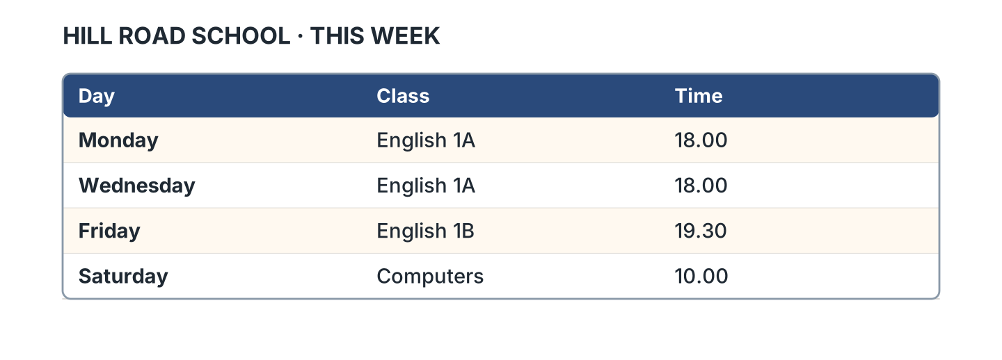
Figure 5.11 · A week at the school.
- English 1A starts at 18.00. (18.00) (example)
- English 1B is on ______________.
- English 1B starts at ______________.
- Computers starts at ______________.
3C Listen. Look at Figure 5.12. Write the number.
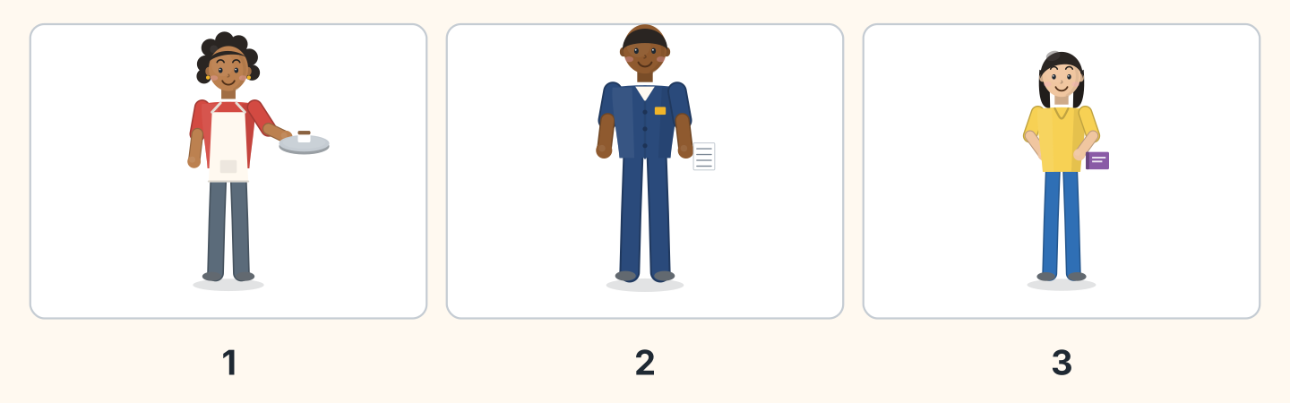
Figure 5.12 · Three people in a day.
- Nadia — 1 (example)
- Sam — ______
- Lili — ______
- Who starts first? — ______________
3D Listen. Write the time you hear.
- half past eight — 8.30 (example)
- ______________
- ______________
- ______________
Part 4 · Speaking
4A Look at Figure 5.13. Ask about times.
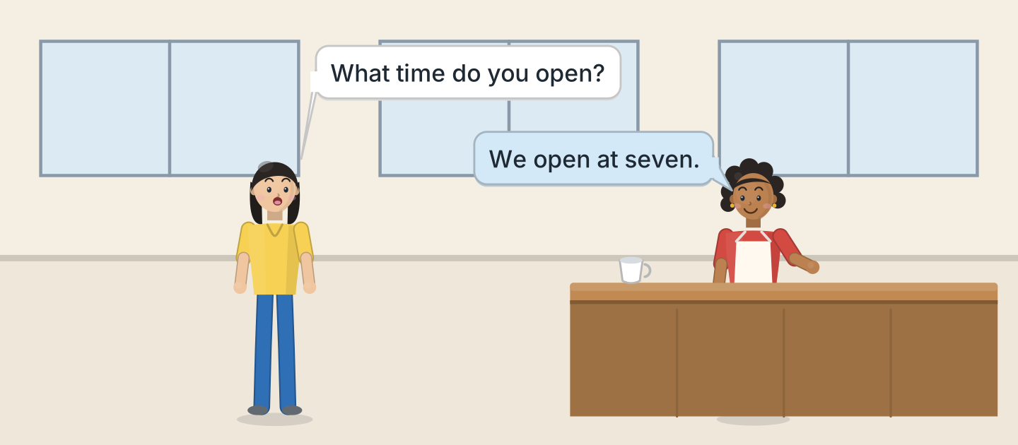
Figure 5.13 · Lili asks about the day.
- A: What time do you open? B: We open at seven. (example)
- Ask when the cafe opens.
- Ask when it closes.
- Ask about Sunday.
4B Look at Figure 5.14. Ask and answer.
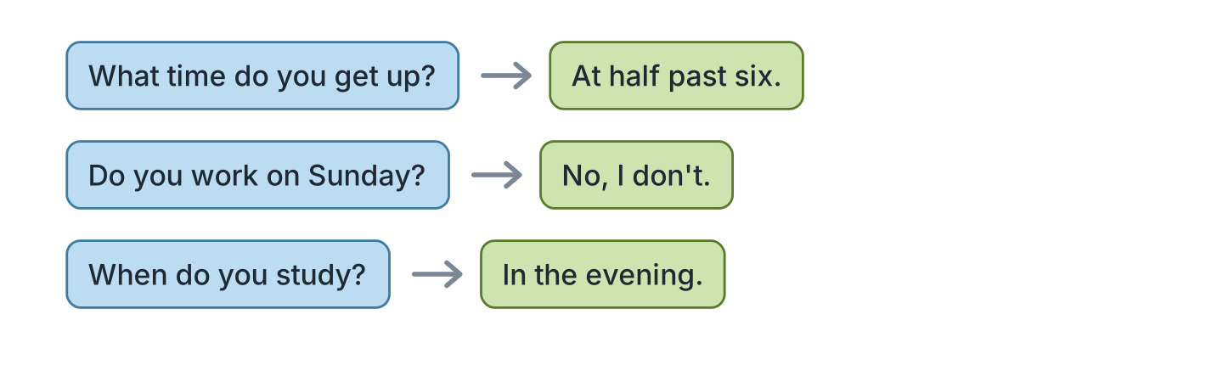
Figure 5.14 · Ask about a day.
- A: What time do you get up? B: At half past six. (example)
- A: Do you work on Sunday? B: ______________
- A: When do you study? B: ______________
- A: What time do you finish? B: ______________
4C Ask three friends about their day.
- A: What time do you start? B: At nine. (example)
- Ask about their brother.
- Ask about their kitchen and their garden.
- Ask about the weekend.
4D Say four things you do every day.
- I get up at seven. I have breakfast in the big kitchen. (example)
- ______________
- ______________
- ______________
Part 5 · Reading
5A Look at Figure 5.15. Answer the questions.
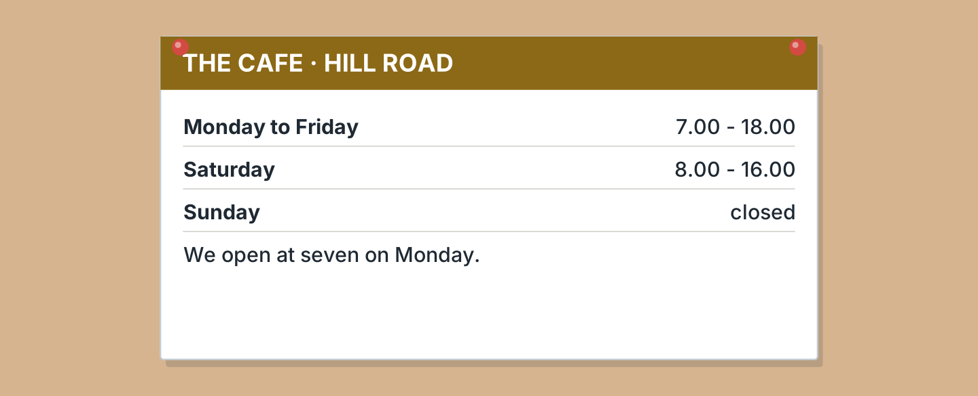
Figure 5.15 · The cafe times.
- What time does it open on Monday? — seven (example)
- What time does it close on Friday? — ______________
- When does it open on Saturday? — ______________
- Is it open on Sunday? — ______________
5B Look at Figure 5.15. Write yes or no.
- It opens at seven on Monday. — yes (example)
- It is open on Sunday. — ______
- It closes at four on Saturday. — ______
- It opens at eight on Tuesday. — ______
5C Look at Figure 5.16. Choose the correct answer.
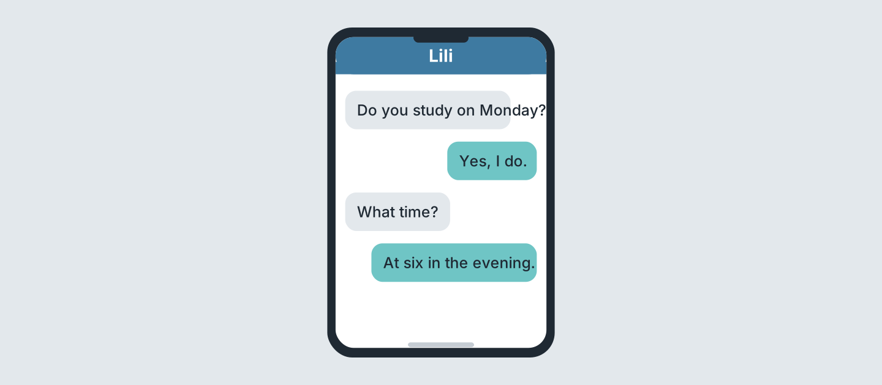
Figure 5.16 · Messages about a class.
- Who studies on Monday? (a) Lili (b) Ben (c) Sam — a (example)
- What time is the class? (a) four (b) six (c) eight
- When is it? (a) morning (b) afternoon (c) evening
- Who writes first? (a) Lili (b) a friend (c) Nadia
5D Read and correct. Write the correct word.
- The cafe opens at eight. — seven (example)
- The cafe is open on Sunday. — ______________
- The class is at four. — ______________
- The cafe closes at nine. — ______________
Part 6 · Writing
6A Look at Figure 5.17. Complete the form for you.
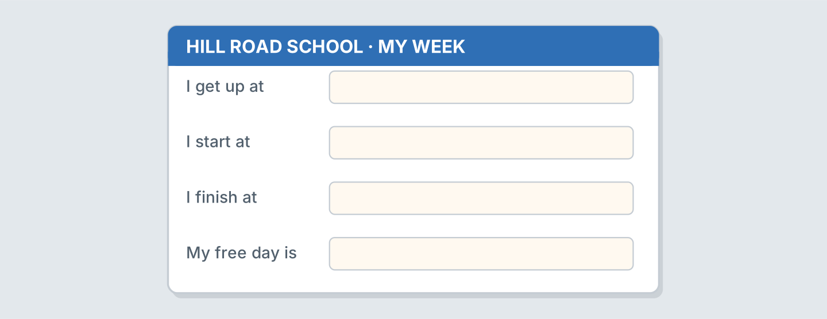
Figure 5.17 · A form about your week.
- I get up at: half past six (example)
- I get up at: ______________
- I start at: ______________
- My free day is: ______________
6B Look at Figure 5.18. Write four lines.
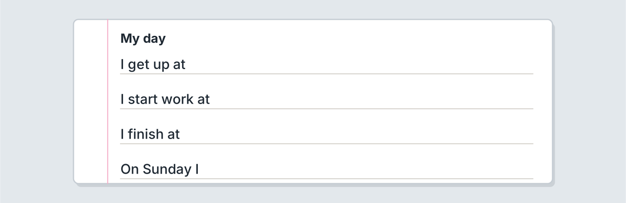
Figure 5.18 · Four lines about your day.
- My mother gets up at seven. (example)
- I get up in my bedroom at ______________.
- I start work at ______________.
- On Sunday my family ______________.
6C Write about your weekend. Write three lines.
- On Saturday I study with my sister. (example)
- Say one thing you do.
- Say who is with you.
- Say one thing you do not do.
Part 7 · Real-World File
7A Look at Figure 5.19. Answer the questions.
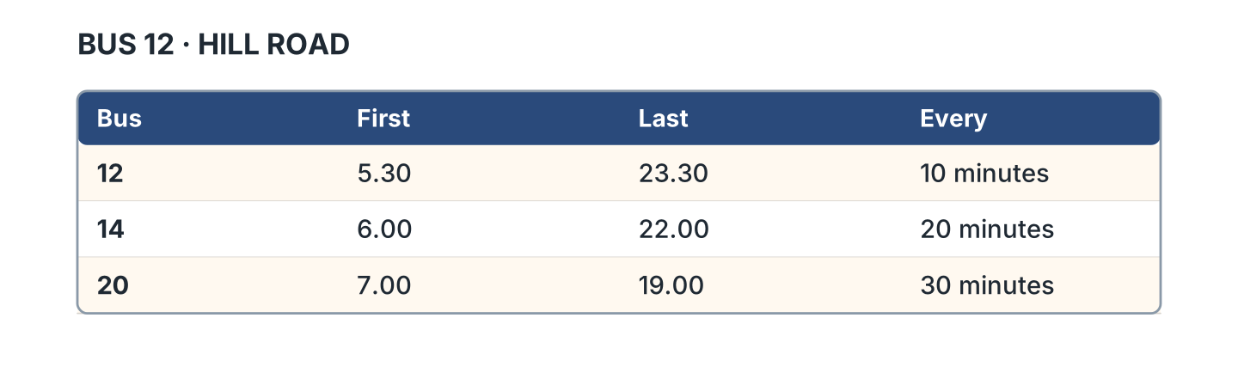
Figure 5.19 · The bus times.
- When is the first bus 12? — 5.30 (example)
- When is the last bus 12? — ______________
- When is the last bus 14? — ______________
- When is the first bus 20? — ______________
7B Look at Figure 5.20. Write the time.
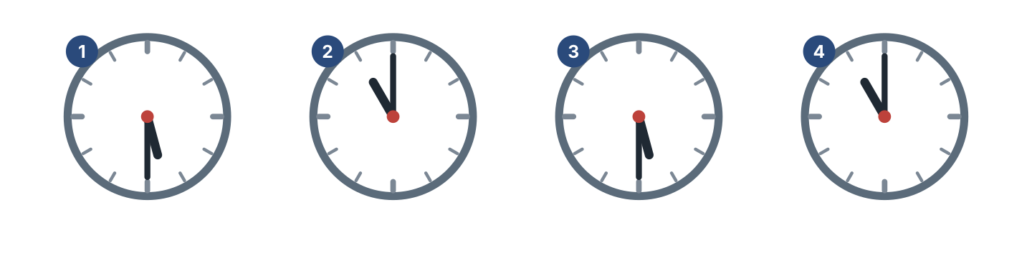
Figure 5.20 · Four clocks to read.
- clock 1 — half past five (example)
- clock 2 — ______________
- clock 3 — ______________
- clock 4 — ______________
7C Write your own times. Use Figure 5.19.
- First bus: 5.30 (example)
- I leave home at: ______________
- My bus is: ______________
- I arrive at: ______________
Part 8 · Review & Can-Do
8A Look at Figure 5.21. Write the word.
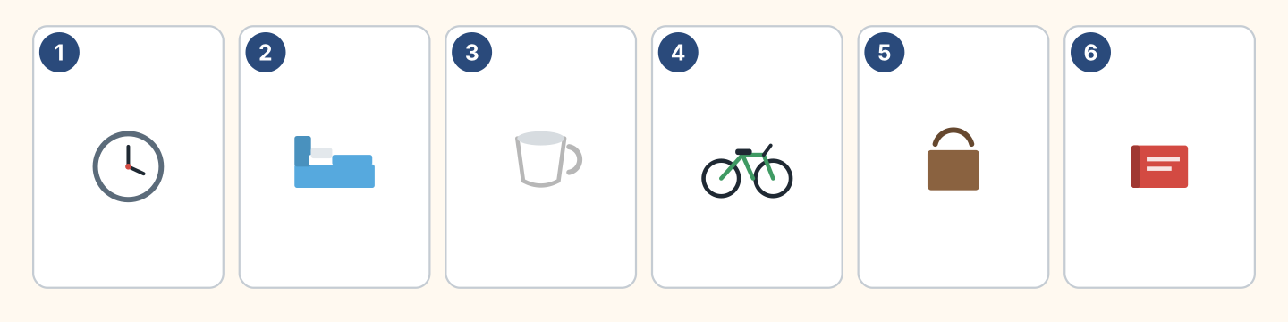
Figure 5.21 · Six things from this unit.
Words: bag · bed · bike · book · clock · cup
- 1 — clock (example)
- 2 — ______________
- 3 — ______________
- 4 — ______________
- 6 — ______________
8B Complete the conversation.
Words: at · do · don’t · What
- A: What time do you start? (What) (example)
- B: I start ______ eight.
- A: ______ you work on Sunday?
- B: No, I ______.
8C Write the time in words.
- 9.30 — half past nine (example)
- 7.00 — ______________
- 11.30 — ______________
- 2.00 — ______________
8D Match the question and the answer.
Question | Answer
1 What time do you get up? | a On Monday.
2 When do you study? | b At seven.
3 Do you work on Sunday? | c No, I don’t.
4 Where do you work? | d At the cafe.
 | e Yes, there is.
One option is not needed.
- 1 — b (example)
- 2 — ______
- 3 — ______
- 4 — ______
8E Look at Figure 5.22. Tick what you can do.
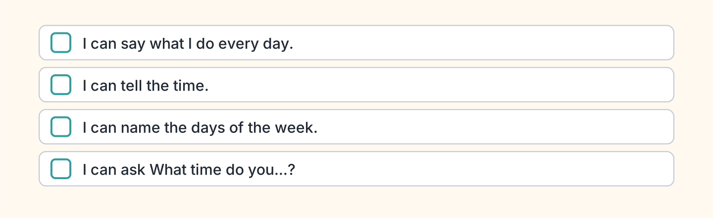
Figure 5.22 · What I can do.
- I can say what I do every day. — ✓ (example)
- I can tell the time. — ______
- I can name the days of the week. — ______
- I can ask What time do you start? — ______

Unit 6: She Works Here
In this unit you say what another person does. You ask about them.
Warm Up
W1 Look at Figure 6.1. Write the job.
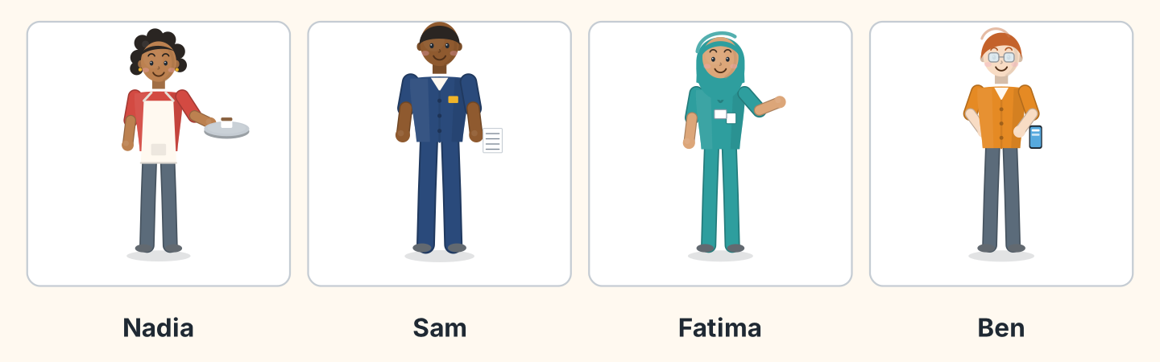
Figure 6.1 · Four people at work.
Words: cook · driver · nurse · shop assistant
- Nadia — a cook (example)
- Sam — ______________
- Fatima — ______________
- Ben — ______________
W2 Look at Figure 6.2. Write the place.
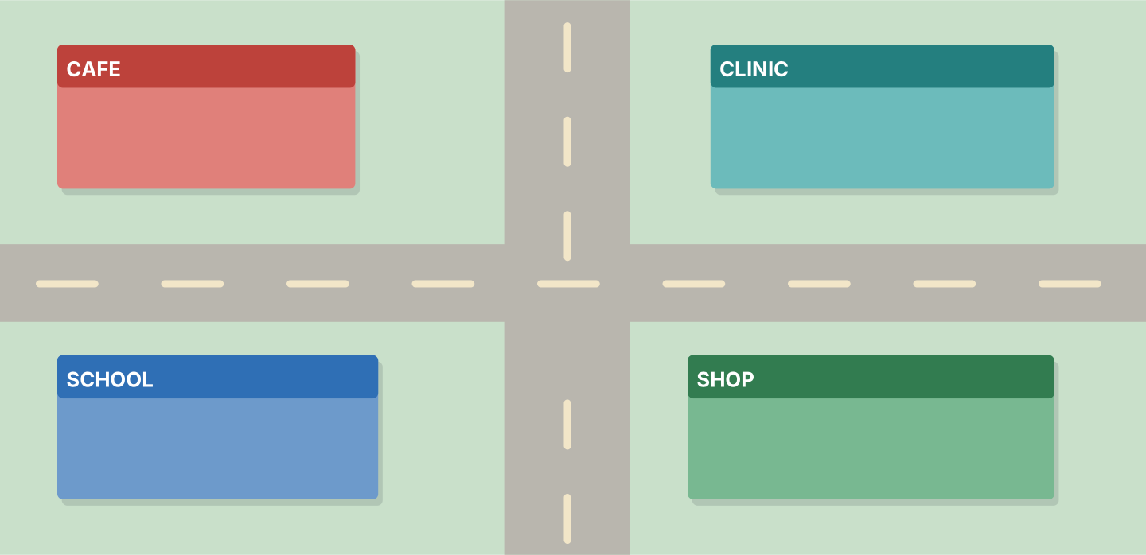
Figure 6.2 · Four places of work.
- Nadia works at — the cafe (example)
- Fatima works at — ______________
- Lili studies at — ______________
- Ben works at — ______________
W3 Say what three people in your family do.
- My mother is a teacher. (example)
- Say a job.
- Say the place.
- Say the time they start.
Part 1 · Words & Sounds
1A Look at Figure 6.3. Match the person and the job.
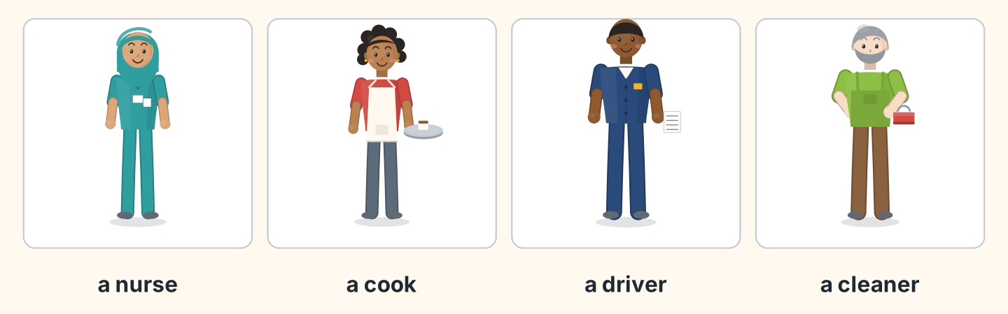
Figure 6.3 · Six jobs.
Person | Job
1 Fatima | a a cleaner
2 Nadia | b a nurse
3 Sam | c a cook
4 Marek | d a driver
 | e a doctor
One option is not needed.
- 1 — b (example)
- 2 — ______
- 3 — ______
- 4 — ______
1B Look at Figure 6.4. Answer the questions.
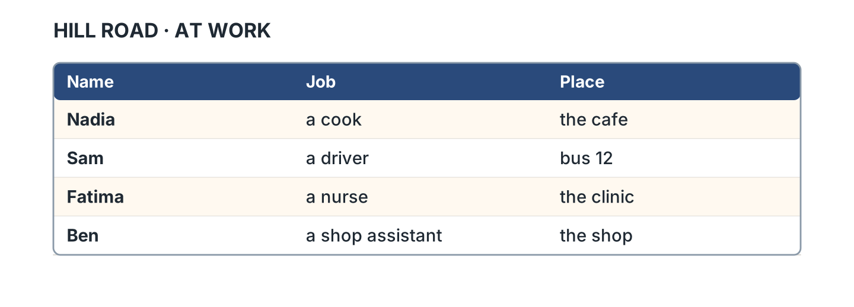
Figure 6.4 · Who works where.
- Where does Nadia work? — the cafe (example)
- Where does Sam work? — ______________
- What does Fatima do? — ______________
- What does Ben do? — ______________
1C Look at Figure 6.5. Write the word in the correct box.
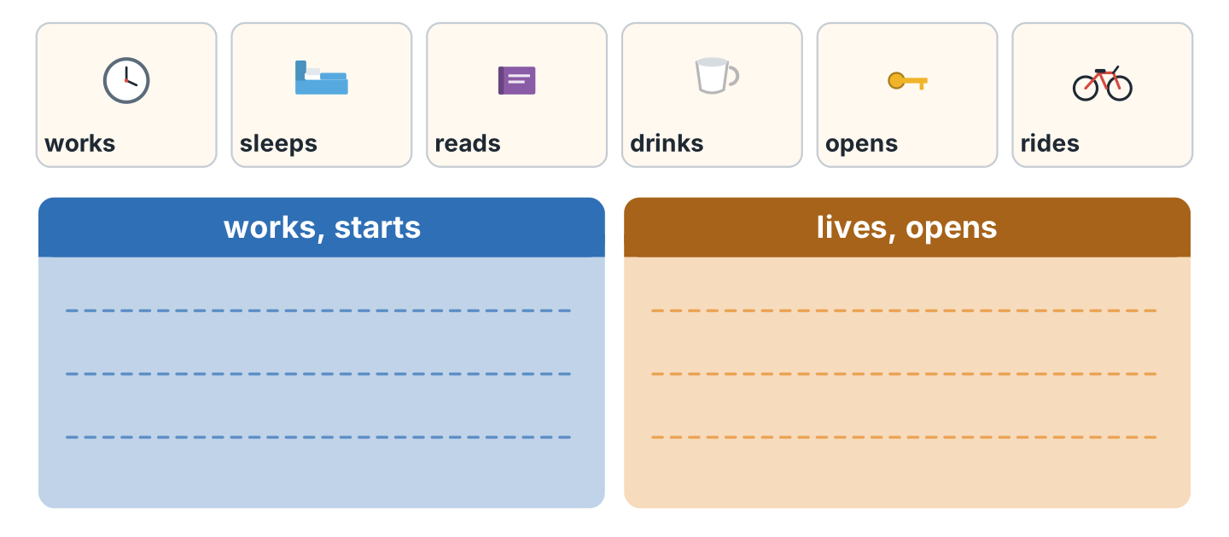
Figure 6.5 · The sound of the s.
- works — the first box (example)
- lives — ______________
- reads — ______________
- opens — ______________
1D Say it. Say these words.
- works (example)
- starts
- lives
- opens
- finishes
1E Look at Figure 6.6. Write the word.
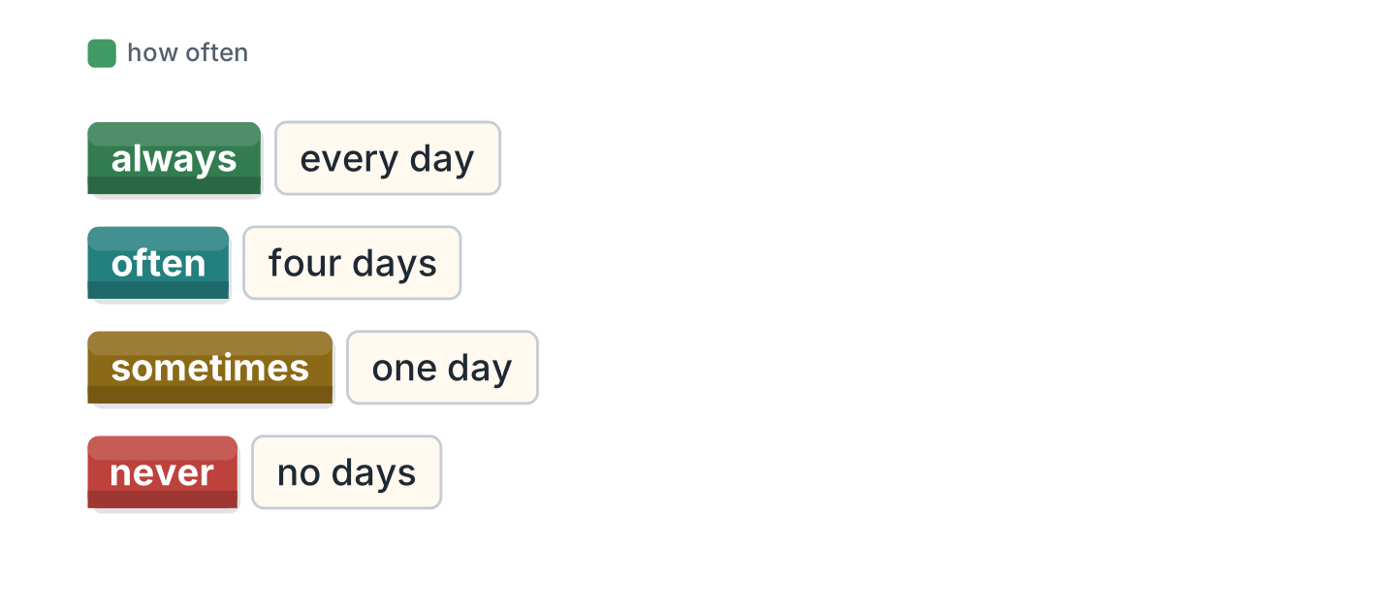
Figure 6.6 · How often it happens.
Words: always · never · often · sometimes
- every day — always (example)
- four days — ______________
- one day — ______________
- no days — ______________
1F Write the place for the job.
- a nurse — a clinic (example)
- a cook — ______________
- a driver — ______________
- a teacher — ______________
Part 2 · Grammar
2A Look at Figure 6.7. Complete with works or work.
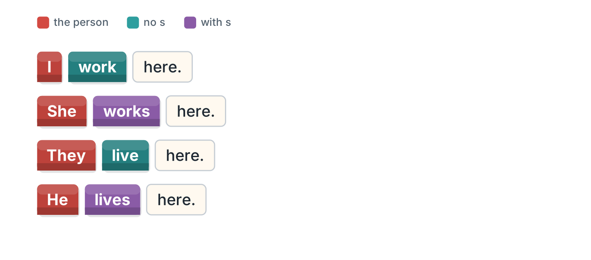
Figure 6.7 · He, she and it.
- She works here. (works) (example)
- They ______________ here.
- He ______________ on Hill Road.
- I ______________ at the school.
2B Write the he form.
- I work — he works (example)
- I live — he ______________
- I start — she ______________
- I finish — she ______________
- I study — he ______________
2C Look at Figure 6.8. Write the short form.

Figure 6.8 · The negative with does.
- does not — doesn’t (example)
- She does not work here. — ______________
- He does not live here. — ______________
2D Complete with don’t or doesn’t.
- She doesn’t work on Friday. (doesn’t) (example)
- They ______________ live here.
- He ______________ start at eight.
- I ______________ work on Sunday.
2E Look at Figure 6.9. Write the answer.
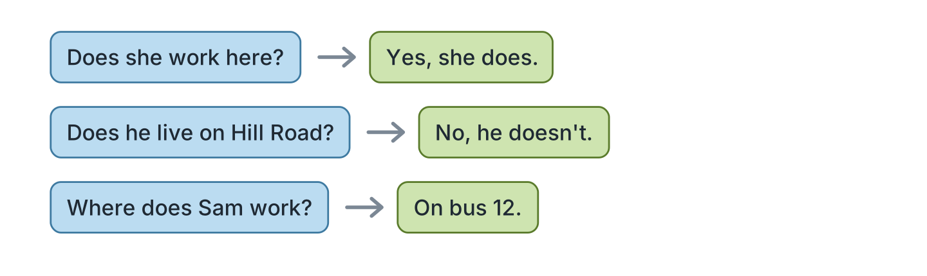
Figure 6.9 · Questions with does.
- Does she work here? ✓ — Yes, she does. (example)
- Does he live on Hill Road? ✗ — ______________
- Does Nadia cook? ✓ — ______________
- Where does Sam work? (bus 12) — ______________
2F Find the mistake. Write the correct words.
- She work here. — works (example)
- Does she works here? — ______________
- He don’t live here. — ______________
- Sam drive a bus. — ______________
Part 3 · Listening
3A Listen. Look at Figure 6.10. Write the number.
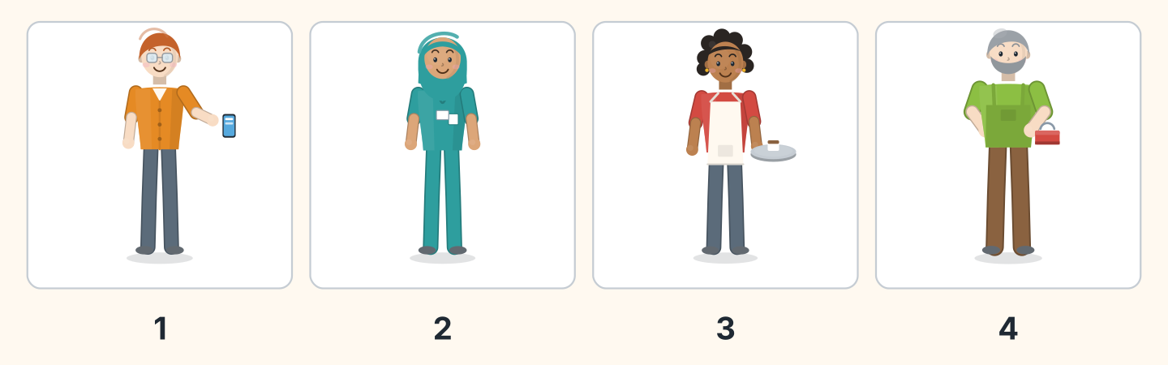
Figure 6.10 · Four workers.
- Ben — 1 (example)
- Fatima — ______
- Nadia — ______
- Marek — ______
3B Listen. Look at Figure 6.11. Complete the week.
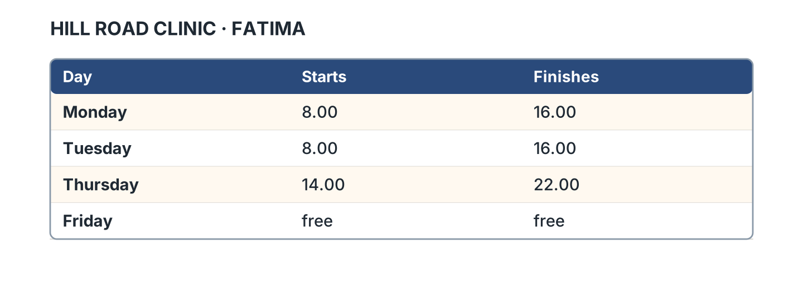
Figure 6.11 · A week at the clinic.
- On Monday she starts at eight. (eight) (example)
- On Tuesday she finishes at ______________.
- On Thursday she starts at ______________.
- On Friday she is ______________.
3C Listen. Look at Figure 6.12. Tick the box.
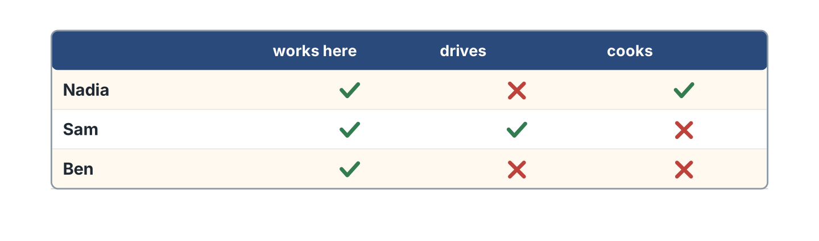
Figure 6.12 · Who does what.
- Nadia cooks. — ✓ (example)
- Sam drives. — ______
- Ben cooks. — ______
- Nadia drives. — ______
3D Listen. Write the job you hear.
- a nurse (example)
- ______________
- ______________
- ______________
Part 4 · Speaking
4A Look at Figure 6.13. Ask about Fatima.
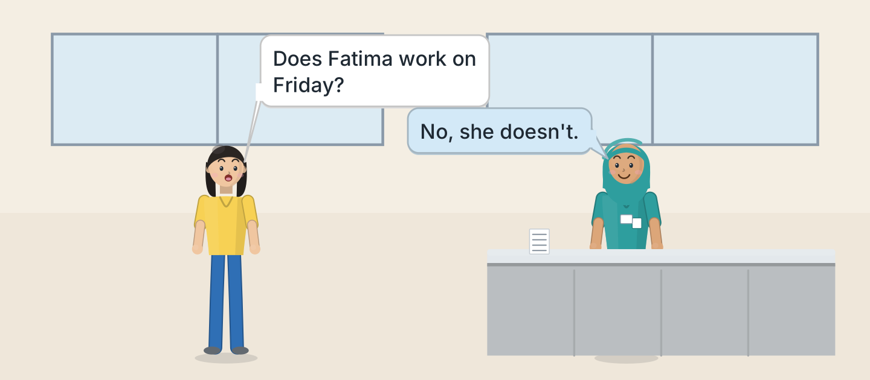
Figure 6.13 · Lili asks about Fatima.
- A: Does Fatima work on Friday? B: No, she doesn’t. (example)
- Ask where she works.
- Ask when she starts.
- Ask about Saturday.
4B Look at Figure 6.14. Ask and answer.
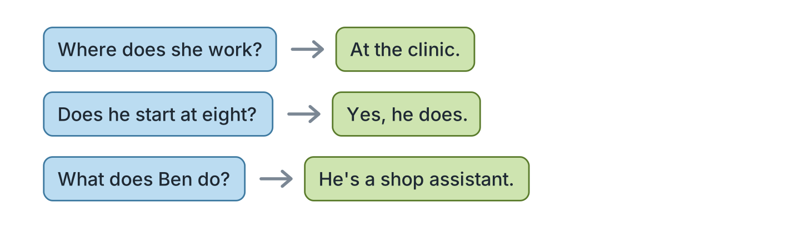
Figure 6.14 · Ask about a person.
- A: Where does she work? B: At the clinic. (example)
- A: Does he start at eight? B: ______________
- A: What does Ben do? B: ______________
- A: Does she work on Sunday? B: ______________
4C Tell a friend about a person you know.
- My brother works in a shop. (example)
- Say the job.
- Say the room or the flat.
- Say when they start.
4D Ask a friend about their family.
- A: What does your father do? B: He’s a driver. (example)
- Ask about a mother or a father.
- Ask about the place.
- Ask about the time.
Part 5 · Reading
5A Look at Figure 6.15. Answer the questions.
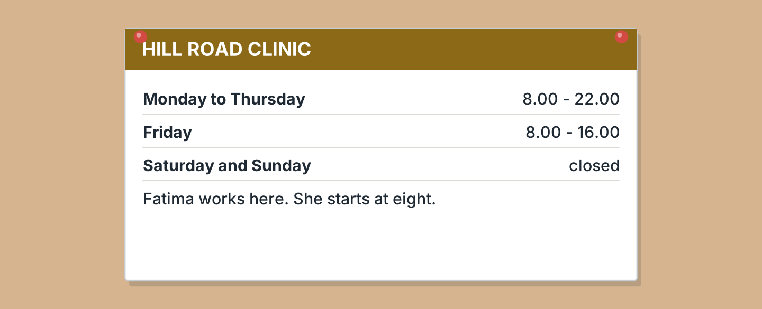
Figure 6.15 · A notice about the clinic.
- When does it open on Monday? — eight (example)
- When does it close on Thursday? — ______________
- Is the clinic shut at the weekend? — ______________
- Who works there? — ______________
5B Look at Figure 6.15. Write yes or no.
- The clinic opens at eight. — yes (example)
- It is open all day Saturday. — ______
- It closes at ten on Monday. — ______
- Fatima works on Friday evening. — ______
5C Look at Figure 6.16. Choose the correct answer.
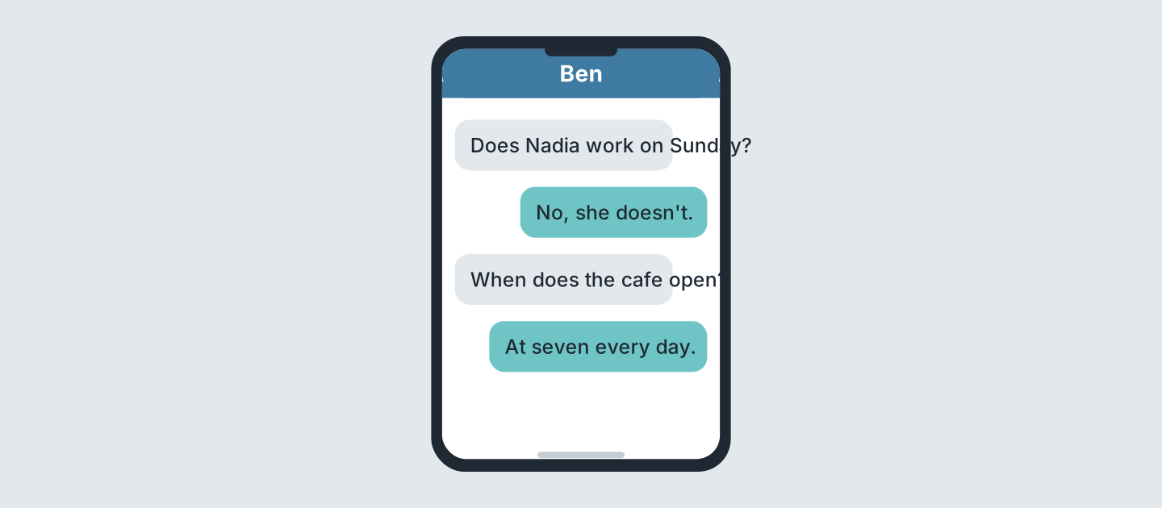
Figure 6.16 · Messages about a job.
- Who asks first? (a) Ben (b) Nadia (c) Sam — a (example)
- Does Nadia work on Sunday? (a) yes (b) no (c) maybe
- When does the cafe open? (a) six (b) seven (c) eight
- How often does it open? (a) every day (b) Monday (c) never
5D Read and correct. Write the correct word.
- Fatima is a cook. — nurse (example)
- Fatima works on Friday evening. — ______________
- The clinic opens at nine. — ______________
- Ben works at the clinic. — ______________
Part 6 · Writing
6A Look at Figure 6.17. Complete the form.
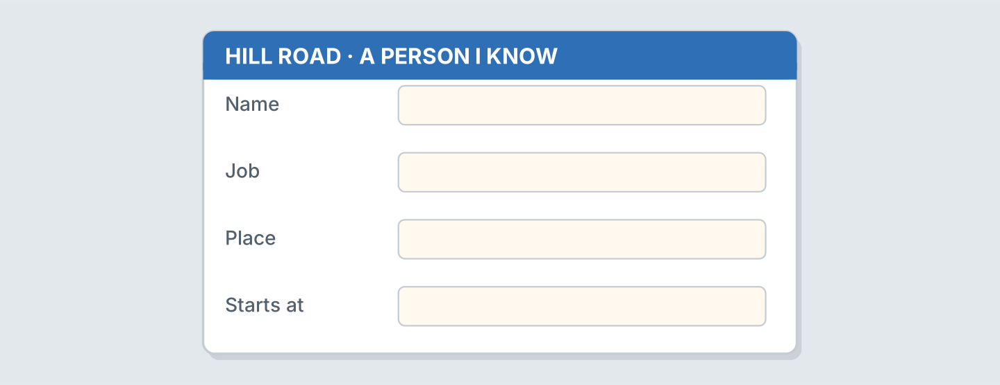
Figure 6.17 · A form about a person.
- Name: Fatima Saleh (example)
- Name: ______________
- Job: ______________
- Place: ______________
6B Look at Figure 6.18. Write four lines.
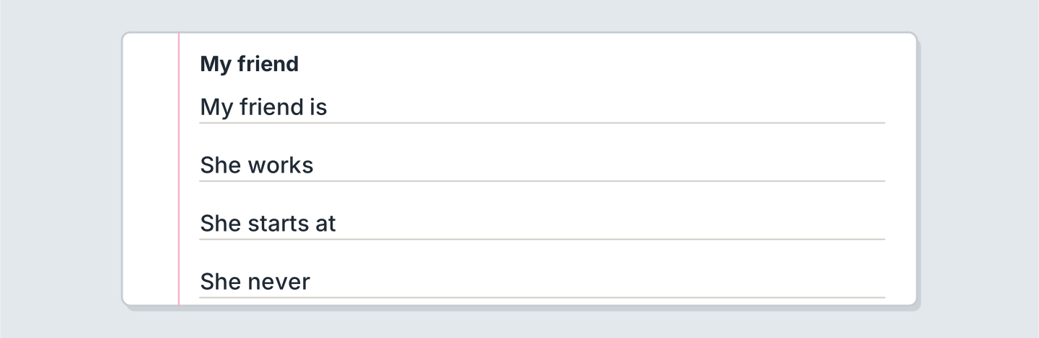
Figure 6.18 · Four lines about a friend.
- My friend is a nurse. She lives in a small house. (example)
- My friend is ______________.
- She works ______________.
- There is a big ______________ in her kitchen.
6C Write about a person at your work or school. Write three lines.
- Marek is a cleaner. He washes the flats. (example)
- Say the name and the job.
- Say the floor or the room.
- Say one thing they do.
Part 7 · Real-World File
7A Look at Figure 6.19. Answer the questions.
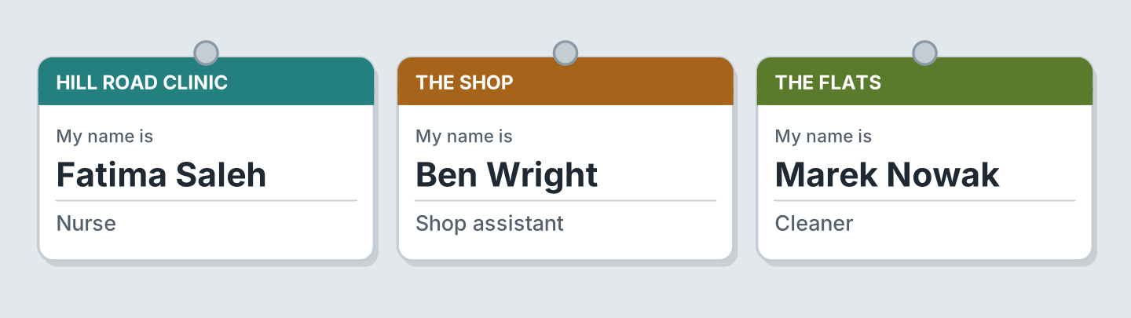
Figure 6.19 · Three places of work.
- Who is a nurse? — Fatima (example)
- Who works at the shop? — ______________
- What does Marek do? — ______________
- Where does Fatima work? — ______________
7B Look at Figure 6.20. Answer the questions.
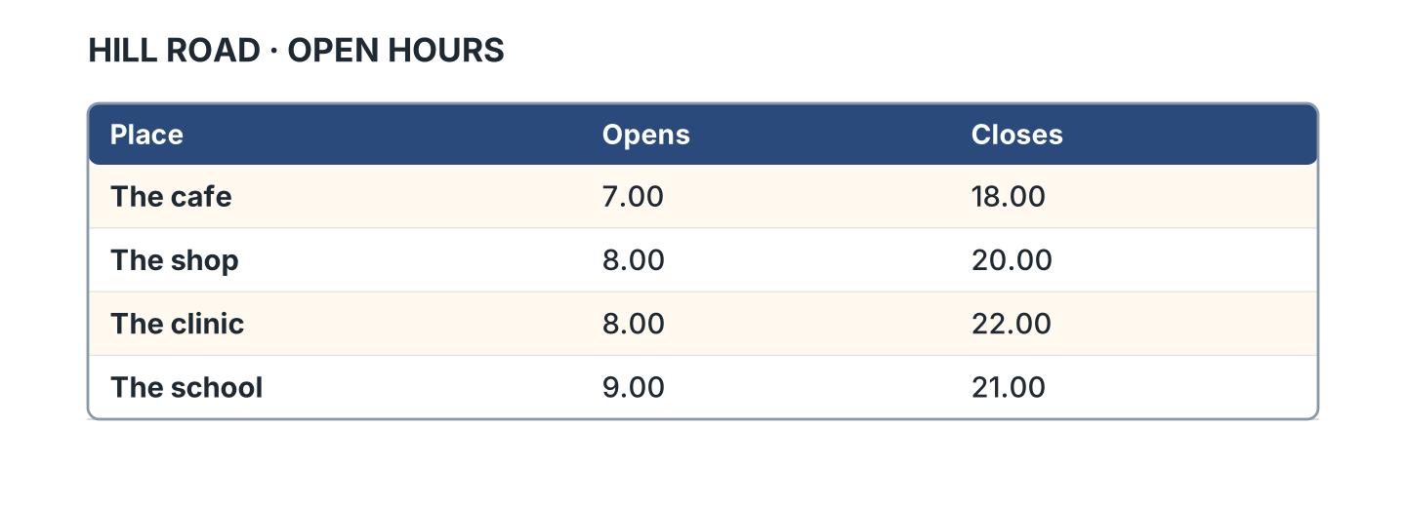
Figure 6.20 · Hours at four places.
- When does the cafe open? — 7.00 (example)
- When does the shop close? — ______________
- Which place closes last? — ______________
- Which place opens last? — ______________
7C Write the hours of a place you know.
- The shop opens at eight. (example)
- Name of the place: ______________
- It opens at: ______________
- It closes at: ______________
Part 8 · Review & Can-Do
8A Look at Figure 6.21. Write the word.
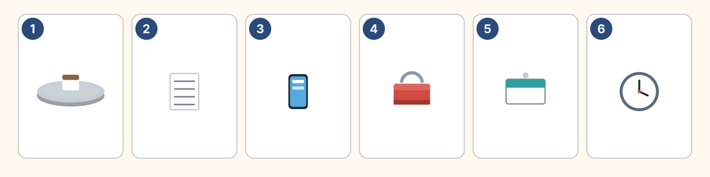
Figure 6.21 · Six things from this unit.
Words: badge · clock · phone · timetable · toolbox · tray
- 1 — tray (example)
- 2 — ______________
- 3 — ______________
- 4 — ______________
- 6 — ______________
8B Complete the conversation.
Words: does · doesn’t · What · works
- A: What does your sister do? (What) (example)
- B: She ______ at the clinic.
- A: ______ she work on Friday?
- B: No, she ______.
8C Write the he or she form.
- I live — she lives (example)
- I start — he ______________
- I watch — she ______________
- I study — he ______________
8D Match the question and the answer.
Question | Answer
1 What does she do? | a At the clinic.
2 Where does he work? | b She’s a nurse.
3 Does he work on Sunday? | c No, he doesn’t.
4 When does she start? | d At eight.
 | e Yes, there are.
One option is not needed.
- 1 — b (example)
- 2 — ______
- 3 — ______
- 4 — ______
8E Look at Figure 6.22. Tick what you can do.
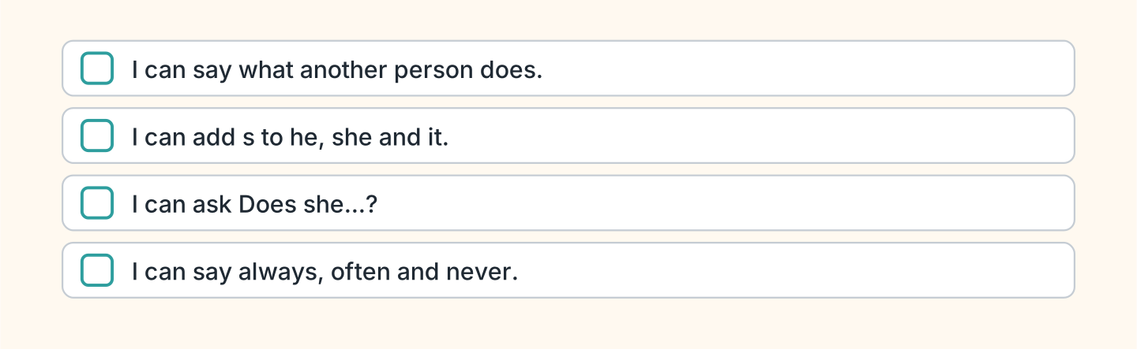
Figure 6.22 · What I can do.
- I can say what another person does. — ✓ (example)
- I can add s to he, she and it. — ______
- I can ask Does she work here? — ______
- I can say always, often and never. — ______

Unit 7: Food and Drink
In this unit you order food. You say what you like.
Warm Up
W1 Look at Figure 7.1. Answer the questions.
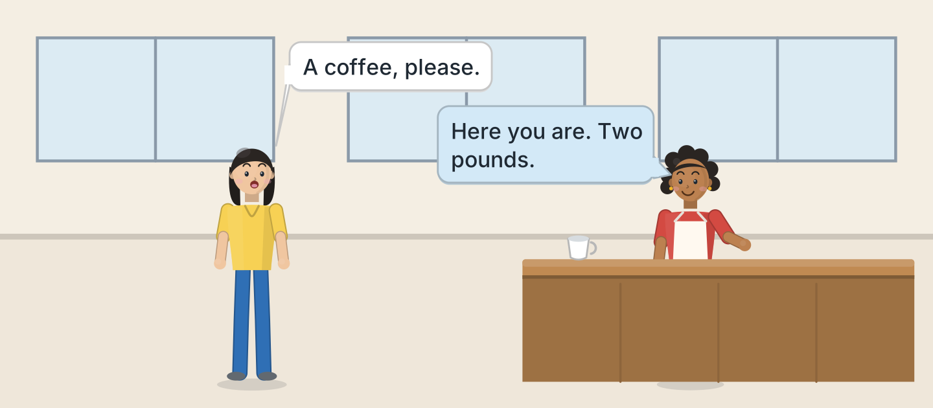
Figure 7.1 · A morning at the cafe.
- What does Lili want? — a coffee (example)
- How much is it? — ______________
- Who works at the cafe? — ______________
- Is Lili at the shop? — ______
W2 Look at Figure 7.2. Write the word.
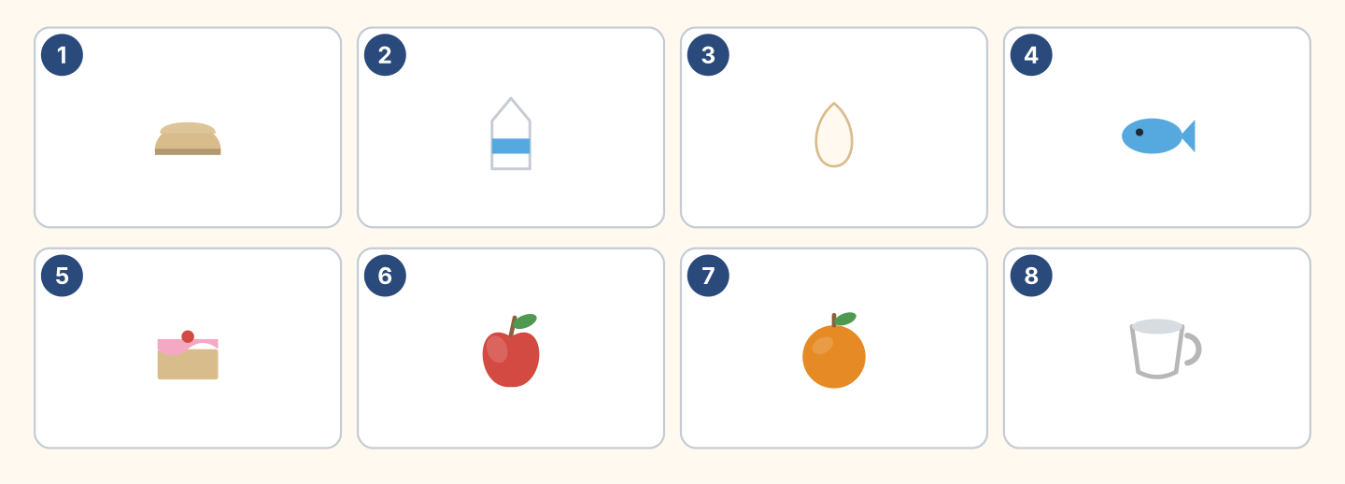
Figure 7.2 · Eight things to eat and drink.
Words: apple · bread · cake · cup · egg · fish · milk · orange
- 1 — bread (example)
- 2 — ______________
- 3 — ______________
- 5 — ______________
- 7 — ______________
W3 Say three things you eat every day.
- I eat bread and cheese every morning. (example)
- Say one food you have for lunch.
- Say what your mother cooks.
- Say one thing you never eat.
Part 1 · Words & Sounds
1A Look at Figure 7.3. Answer the questions.
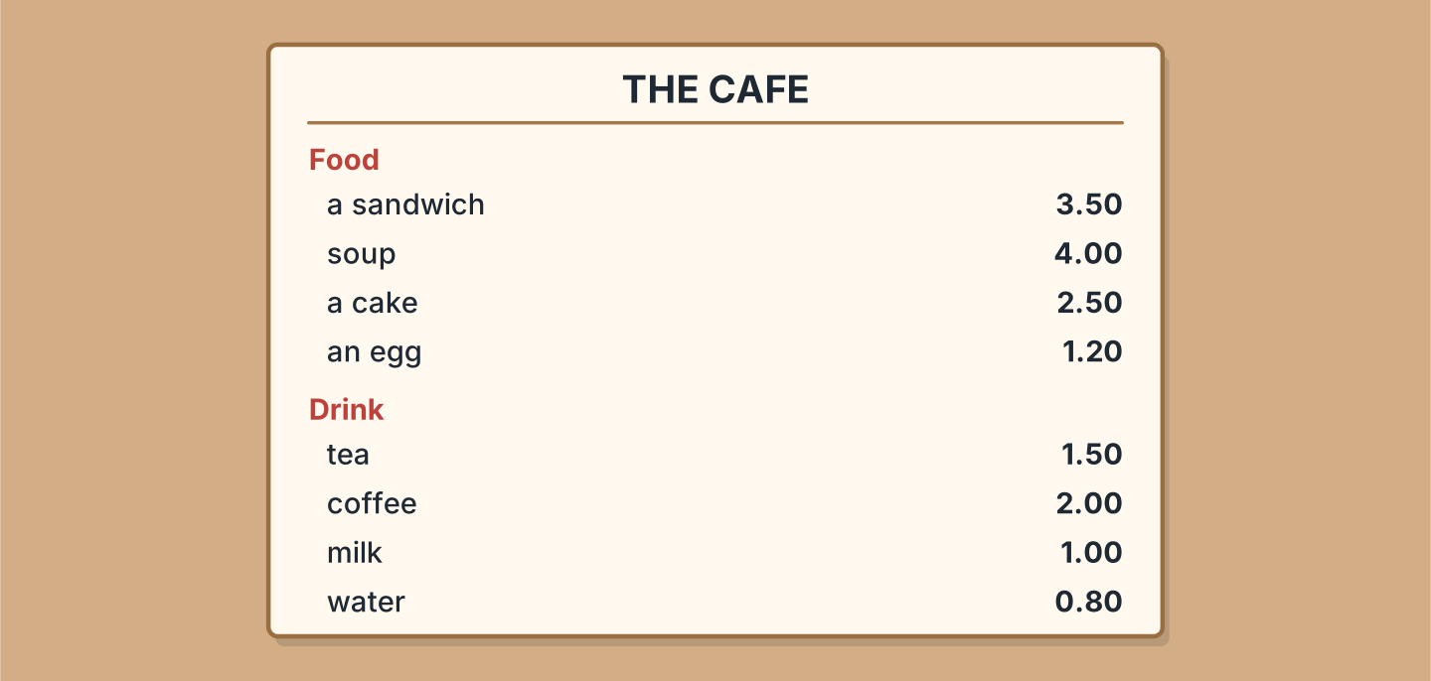
Figure 7.3 · The cafe menu.
- How much is a cake? — 2.50 (example)
- How much is soup? — ______________
- How much is tea? — ______________
- What is the cheapest drink? — ______________
1B Look at Figure 7.4. Write a, an or nothing.
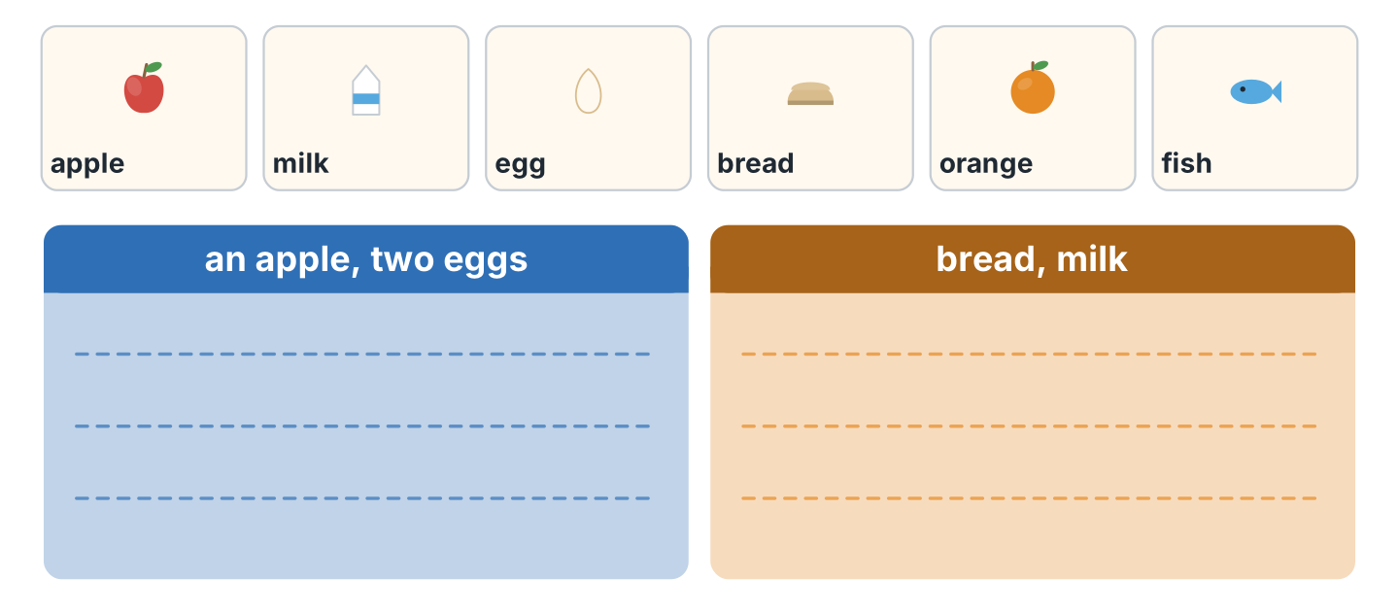
Figure 7.4 · One or not one.
- an apple (example)
- ______ milk
- ______ egg
- ______ bread
- ______ orange
1C Look at Figure 7.5. Write some or any.
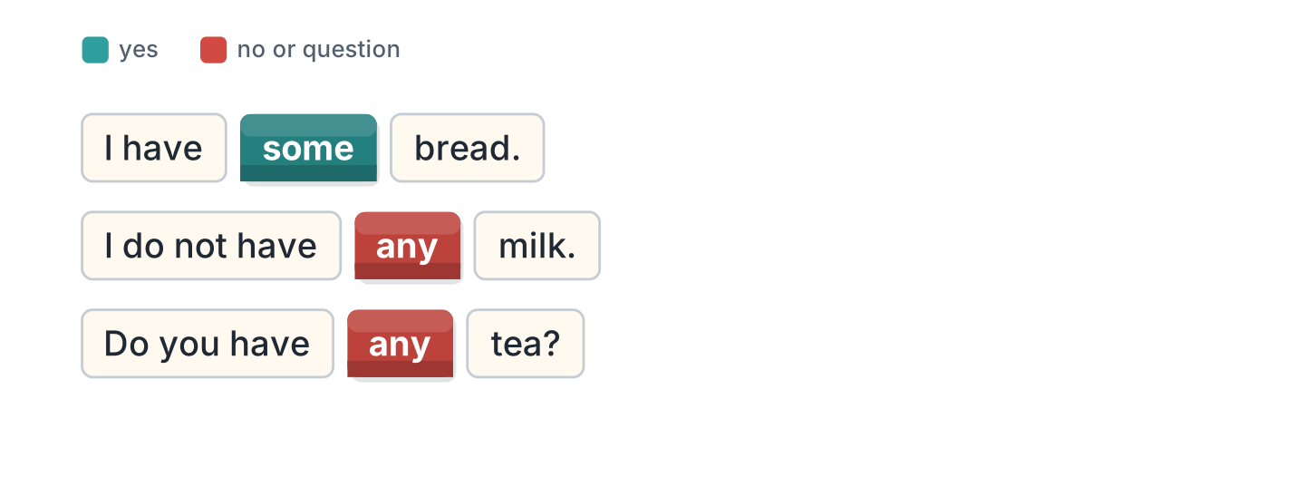
Figure 7.5 · some and any.
- I have some bread. (some) (example)
- I do not have ______ milk.
- Do you have ______ tea?
- We have ______ cake.
1D Say it. Say the prices.
- 2.50 — two pounds fifty (example)
- 1.50
- 4.00
- 0.80
- 3.50
1E Look at Figure 7.6. Write the word.
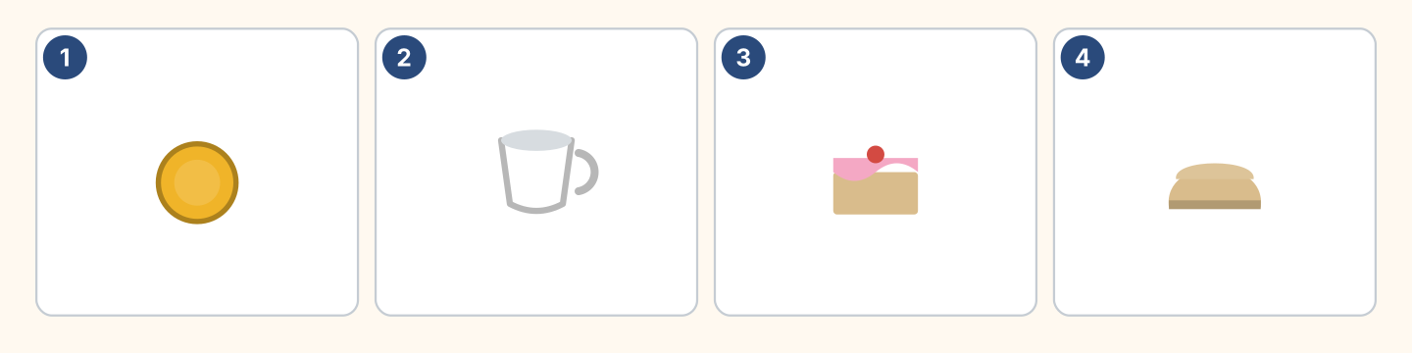
Figure 7.6 · Four prices.
Words: bread · cake · coin · cup
- 1 — coin (example)
- 2 — ______________
- 3 — ______________
- 4 — ______________
1F Write the food or the drink.
- tea — a drink (example)
- bread — ______________
- coffee — ______________
- a busy restaurant sells — ______________
Part 2 · Grammar
2A Look at Figure 7.7. Complete the sentence.
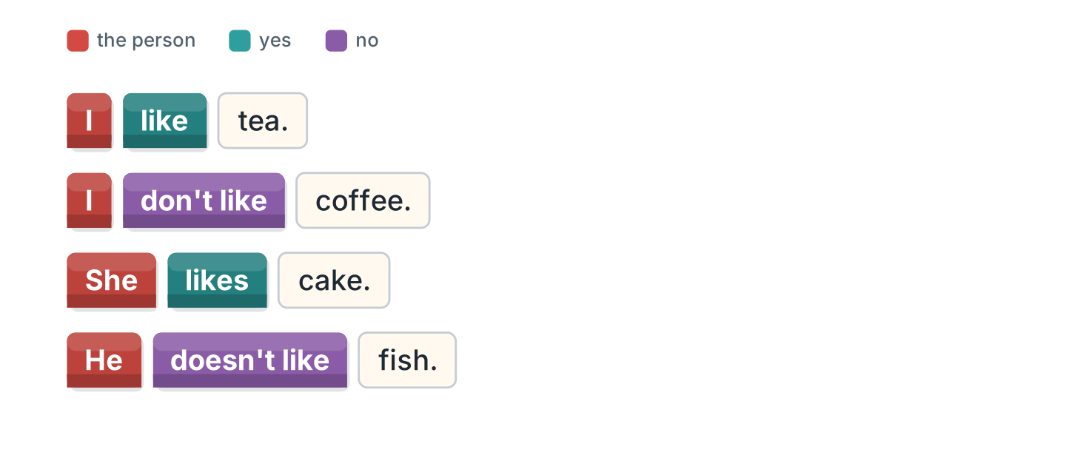
Figure 7.7 · like and do not like.
- I like tea. (like) (example)
- She ______________ cake.
- He ______________ fish.
- I ______________ coffee.
2B Choose the correct word.
- She (like / likes) cake. — likes (example)
- I (like / likes) fish.
- He (don’t / doesn’t) like milk.
- They (like / likes) soup.
- We (don’t / doesn’t) like coffee.
2C Look at Figure 7.8. Write the answer.
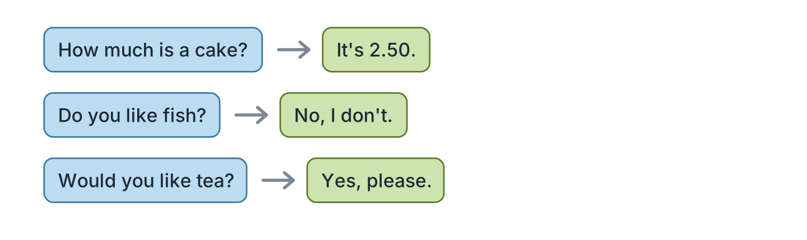
Figure 7.8 · Asking the price.
- How much is a cake? — It’s 2.50. (example)
- Do you like fish? ✗ — ______________
- Would you like tea? ✓ — ______________
- How much is soup? — ______________
2D Write some or any.
- We have some bread. (some) (example)
- There isn’t ______ milk.
- Is there ______ cake?
- I have ______ water.
2E Look at Figure 7.9. Answer the questions.
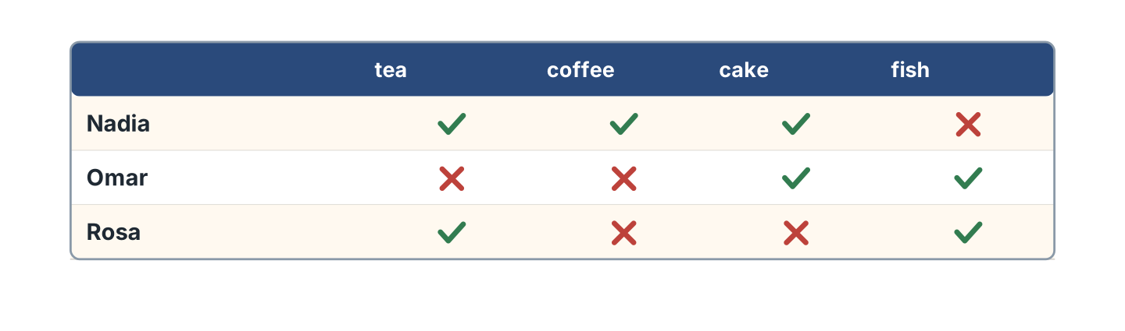
Figure 7.9 · Who likes what.
- Does Nadia like tea? — Yes, she does. (example)
- Does Omar like coffee? — ______________
- Does Rosa like fish? — ______________
- Who likes cake? — ______________
2F Find the mistake. Write the correct words.
- I likes tea. — like (example)
- She don’t like fish. — ______________
- Do you have some milk? — ______________
- He like cake. — ______________
Part 3 · Listening
3A Listen. Look at Figure 7.10. Write the number.
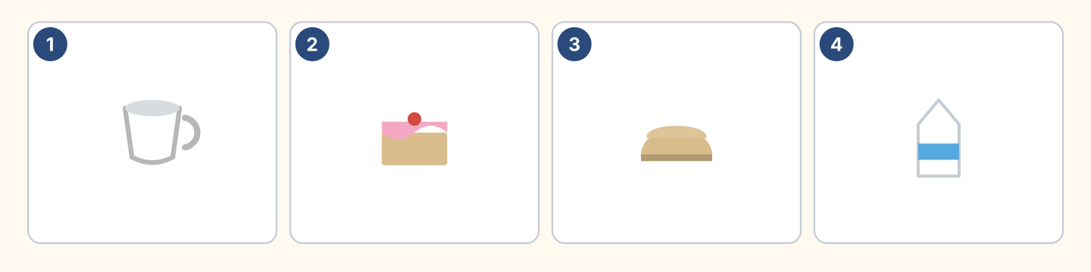
Figure 7.10 · Four orders.
- a cup of tea — 1 (example)
- a cake — ______
- bread — ______
- milk — ______
3B Listen. Look at Figure 7.11. Write the price.
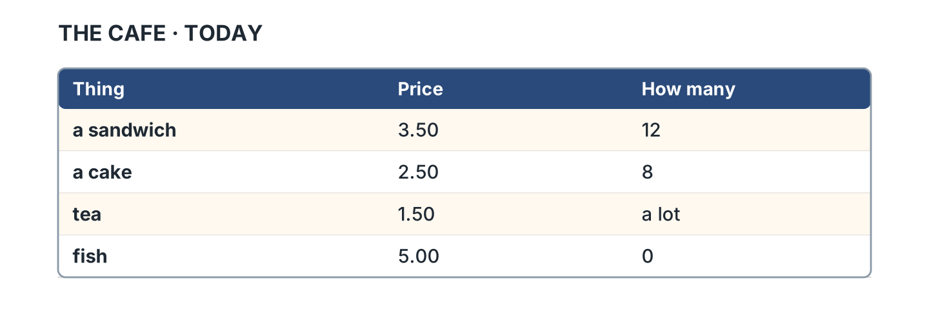
Figure 7.11 · What the cafe sells.
- a sandwich — 3.50 (example)
- a cake — ______________
- tea — ______________
- fish — ______________
3C Listen. Look at Figure 7.12. Write how many.
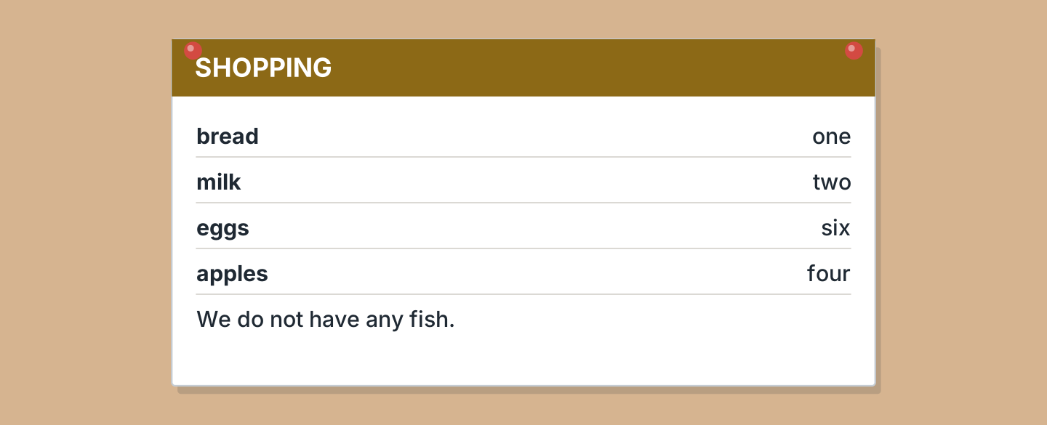
Figure 7.12 · A shopping list.
- bread — one (example)
- milk — ______________
- eggs — ______________
- apples — ______________
3D Listen. Write the price you hear.
- two pounds — 2.00 (example)
- ______________
- ______________
- ______________
Part 4 · Speaking
4A Look at Figure 7.13. Order something.
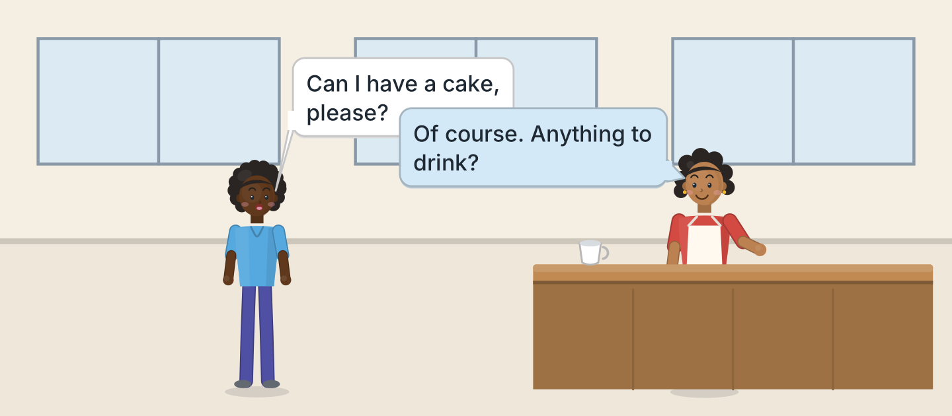
Figure 7.13 · Omar orders.
- A: Can I have a cake, please? B: Of course. (example)
- Order a drink.
- Order some food.
- Ask the price.
4B Look at Figure 7.14. Ask and answer.
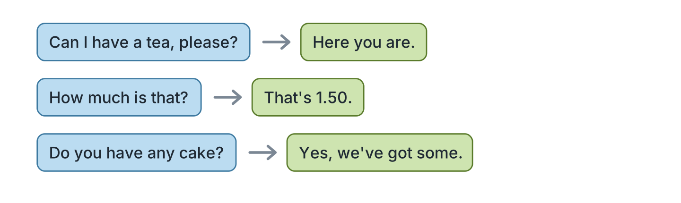
Figure 7.14 · At the counter.
- A: Can I have a tea, please? B: Here you are. (example)
- A: How much is that? B: ______________
- A: Do you have any cake? B: ______________
- A: Would you like milk? B: ______________
4C Ask three friends what they like.
- A: Do you like coffee? B: Yes, I do. (example)
- Ask about a drink.
- Ask what the waiter sells.
- Ask about breakfast.
4D Say four things you like and do not like.
- I like soup. I don’t like fish. (example)
- ______________
- ______________
- ______________
Part 5 · Reading
5A Look at Figure 7.15. Answer the questions.
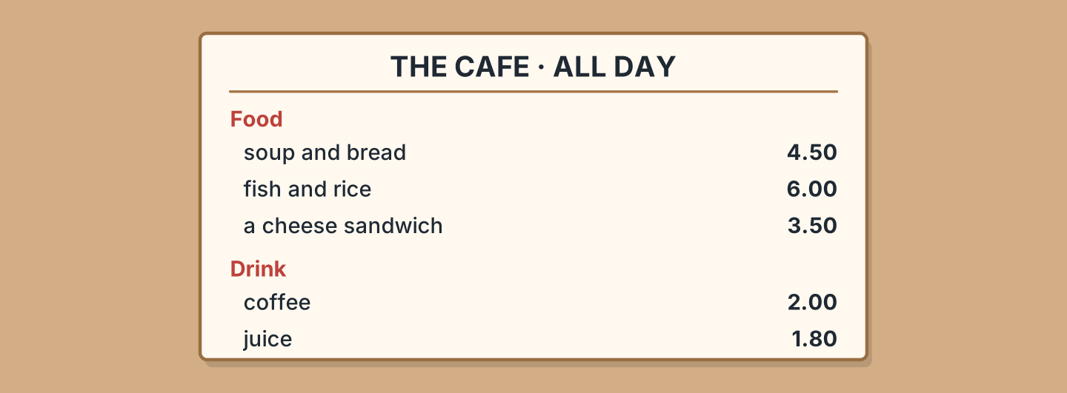
Figure 7.15 · A longer menu.
- How much is the soup? — 4.50 (example)
- How much is the juice? — ______________
- What comes with the fish? — ______________
- Which food is cheapest? — ______________
5B Look at Figure 7.15. Write yes or no.
- There is soup on the menu. — yes (example)
- The coffee is two pounds. — ______
- There is a fish sandwich. — ______
- The juice is one pound eighty. — ______
5C Look at Figure 7.16. Choose the correct answer.
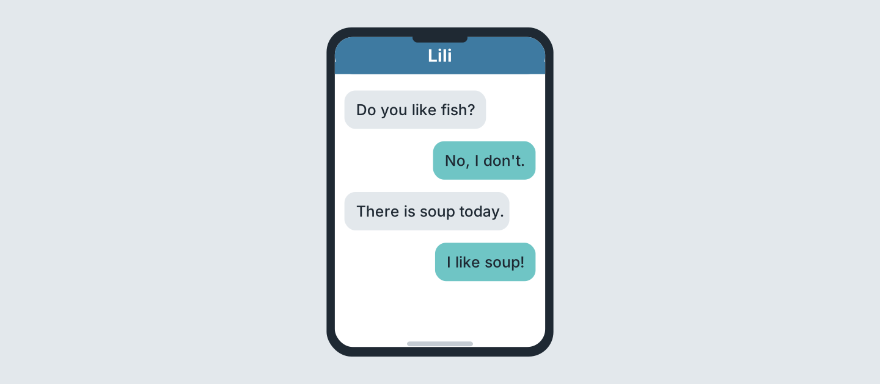
Figure 7.16 · Messages about lunch.
- Who writes first? (a) a friend (b) Lili (c) Nadia — a (example)
- Does Lili like fish? (a) yes (b) no (c) maybe
- What is there today? (a) soup (b) fish (c) cake
- Does Lili like soup? (a) yes (b) no (c) maybe
5D Read and correct. Write the correct word.
- Lili likes fish. — soup (example)
- The coffee is one pound. — ______________
- There is cake today. — ______________
- The juice is three pounds. — ______________
Part 6 · Writing
6A Look at Figure 7.17. Complete the form.
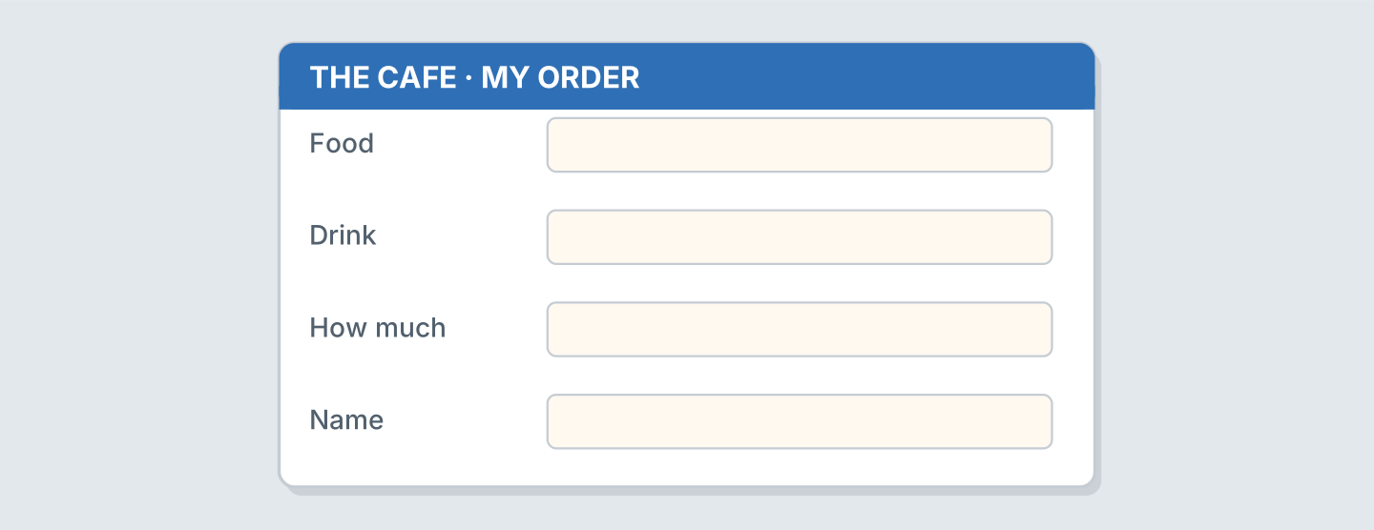
Figure 7.17 · A form for your order.
- Food: a sandwich (example)
- Food: ______________
- Drink: ______________
- How much: ______________
6B Look at Figure 7.18. Write four lines.
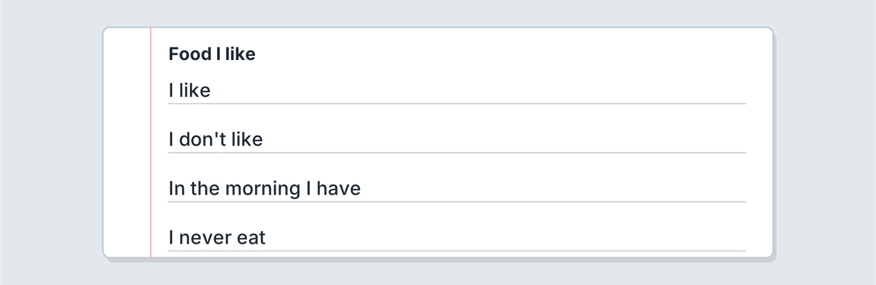
Figure 7.18 · Four lines about food.
- I like bread and cheese in the kitchen at home. (example)
- I like ______________.
- My father often cooks ______________.
- I never eat ______________.
6C Write a shopping list. Write four things.
- bread, milk, eggs, apples for the fridge (example)
- ______________
- ______________
- ______________
Part 7 · Real-World File
7A Look at Figure 7.19. Answer the questions.
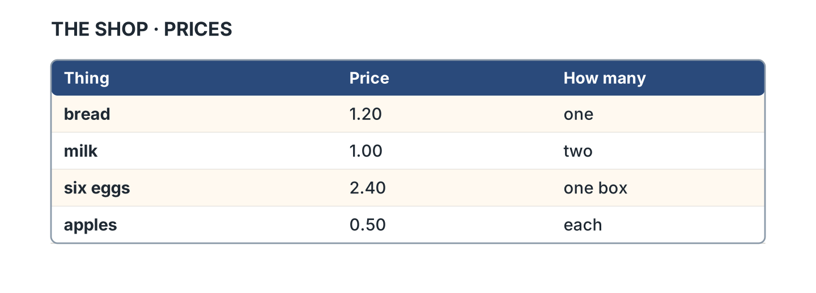
Figure 7.19 · Prices in the shop.
- How much is bread? — 1.20 (example)
- How much is milk? — ______________
- How much are six eggs? — ______________
- How much is one apple? — ______________
7B Look at Figure 7.20. Write the word.
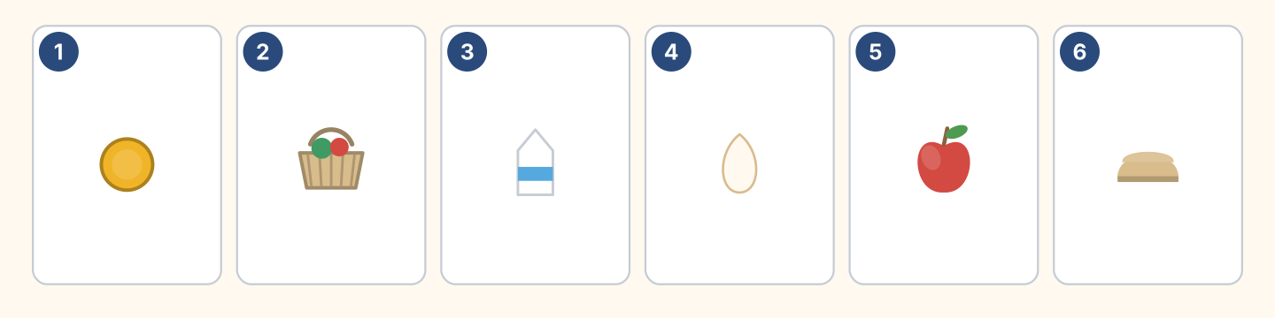
Figure 7.20 · Money and food.
Words: apple · basket · bread · coin · egg · milk
- 1 — coin (example)
- 2 — ______________
- 3 — ______________
- 5 — ______________
7C Write what you buy. Use Figure 7.19.
- I buy bread at the market in the morning. It’s 1.20. (example)
- ______________
- ______________
- ______________
Part 8 · Review & Can-Do
8A Look at Figure 7.21. Write the word.
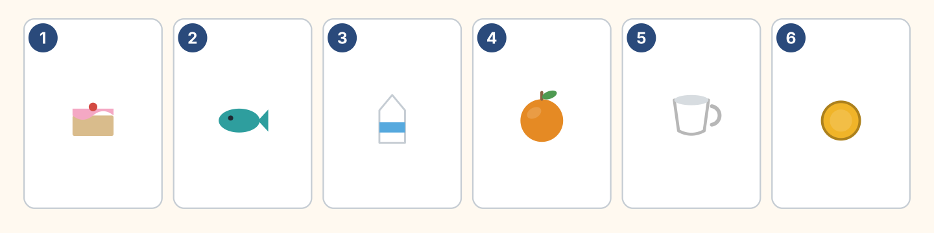
Figure 7.21 · Six things from this unit.
Words: cake · coin · cup · fish · milk · orange
- 1 — cake (example)
- 2 — ______________
- 3 — ______________
- 4 — ______________
- 6 — ______________
8B Complete the conversation.
Words: any · Can · how · like
- A: Can I have a tea, please? (Can) (example)
- B: Of course. Would you ______ milk?
- A: No, thank you. Do you have ______ cake?
- B: Yes. And ______ much is that?
8C Write some or any.
- I have some bread. (some) (example)
- There isn’t ______ fish.
- Do you have ______ milk?
- We have ______ eggs.
8D Match the question and the answer.
Question | Answer
1 How much is a cake? | a Yes, please.
2 Do you like fish? | b It’s 2.50.
3 Would you like tea? | c No, I don’t.
4 Can I have bread? | d Here you are.
 | e She’s a cook.
One option is not needed.
- 1 — b (example)
- 2 — ______
- 3 — ______
- 4 — ______
8E Look at Figure 7.22. Tick what you can do.
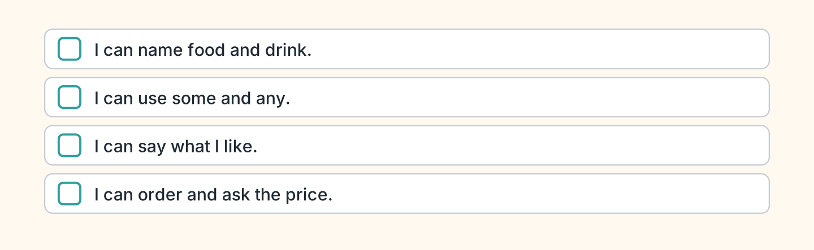
Figure 7.22 · What I can do.
- I can name food and drink. — ✓ (example)
- I can use some and any. — ______
- I can say what I like. — ______
- I can order and ask the price. — ______

Unit 8: In the Town
In this unit you find places in a town. You ask the way.
Warm Up
W1 Look at Figure 8.1. Write the place.
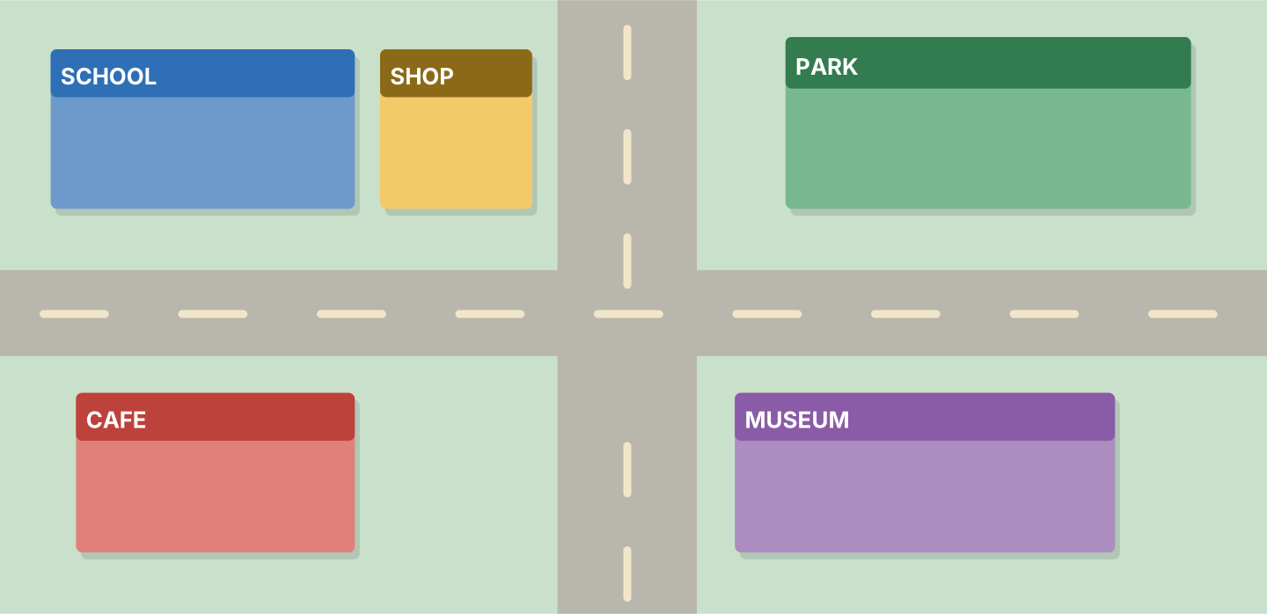
Figure 8.1 · The map of the town.
- You learn here, often in the evening. — the school (example)
- You see old things here. — ______________
- You buy a cheese sandwich here. — ______________
- Children play here. — ______________
W2 Look at Figure 8.2. Write the word.
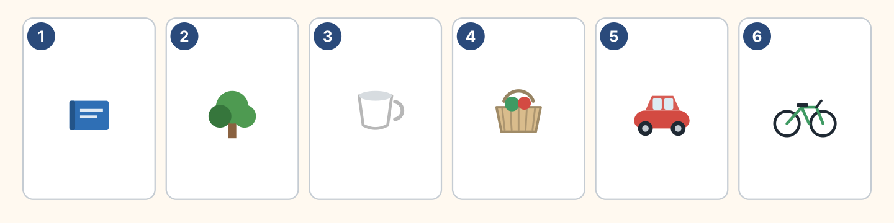
Figure 8.2 · Six places.
Words: basket · bike · book · car · cup · tree
- 1 — book (example)
- 2 — ______________
- 4 — ______________
- 5 — ______________
- 6 — ______________
W3 Say four places in your town.
- There is a market here. I buy fruit for lunch. (example)
- Say one place near the busy station.
- Say where you buy fruit and juice.
- Say one place that is not there.
Part 1 · Words & Sounds
1A Look at Figure 8.3. Write the place.
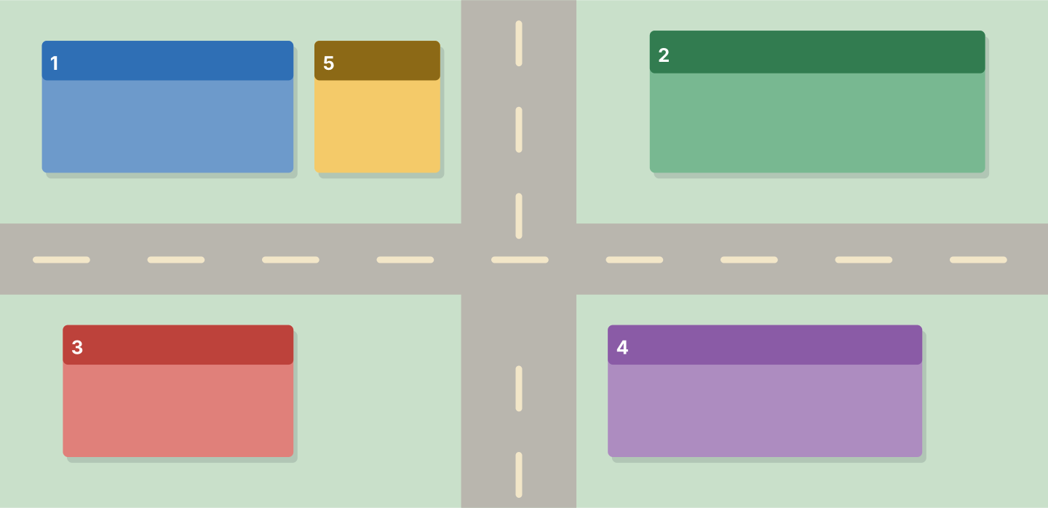
Figure 8.3 · A map with numbers.
Words: cafe · museum · park · school · shop
- 1 — school (example)
- 2 — ______________
- 3 — ______________
- 4 — ______________
- 5 — ______________
1B Look at Figure 8.4. Write the word.
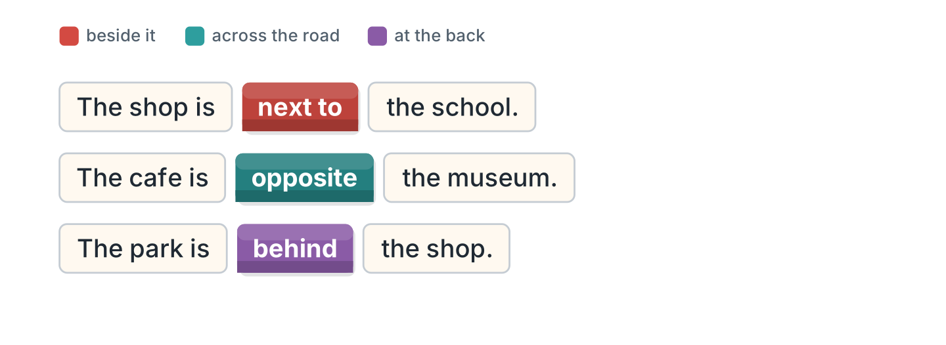
Figure 8.4 · next to and opposite.
- The shop is next to the school. (next to) (example)
- The cafe is ______________ the museum.
- The park is ______________ the shop.
- The bus stop is ______________ the cafe.
1C Look at Figure 8.5. Write the word.
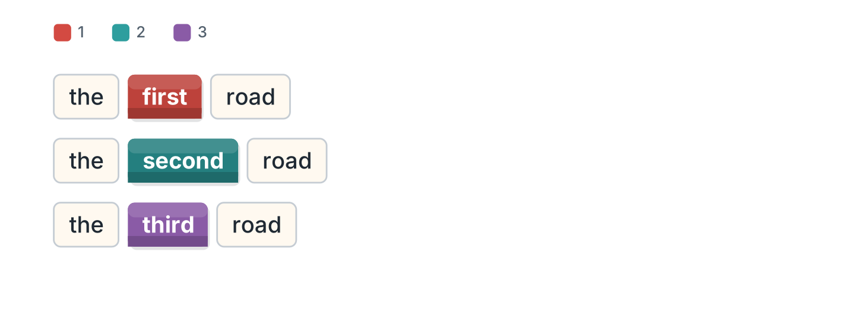
Figure 8.5 · First, second, third.
- road 1 — the first road (example)
- road 2 — ______________
- road 3 — ______________
- Which road is the museum on? — ______________
1D Say it. Say these words.
- first (example)
- second
- third
- straight
- opposite
1E Look at Figure 8.6. Answer the questions.
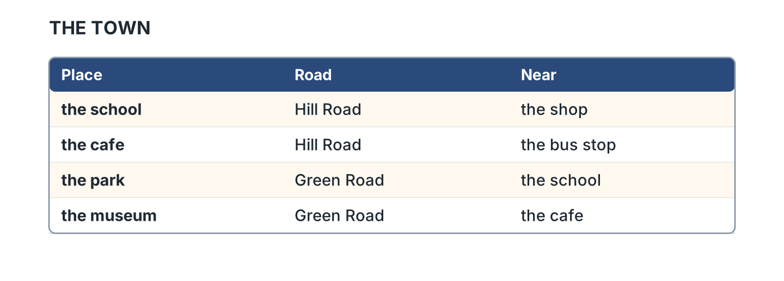
Figure 8.6 · Where the places are.
- Which road is the school on? — Hill Road (example)
- Which road is the park on? — ______________
- What is near the cafe? — ______________
- What is near the school? — ______________
1F Write the opposite word.
- left — right (example)
- near — ______________
- first — ______________
- here — ______________
Part 2 · Grammar
2A Look at Figure 8.7. Complete the sentence.
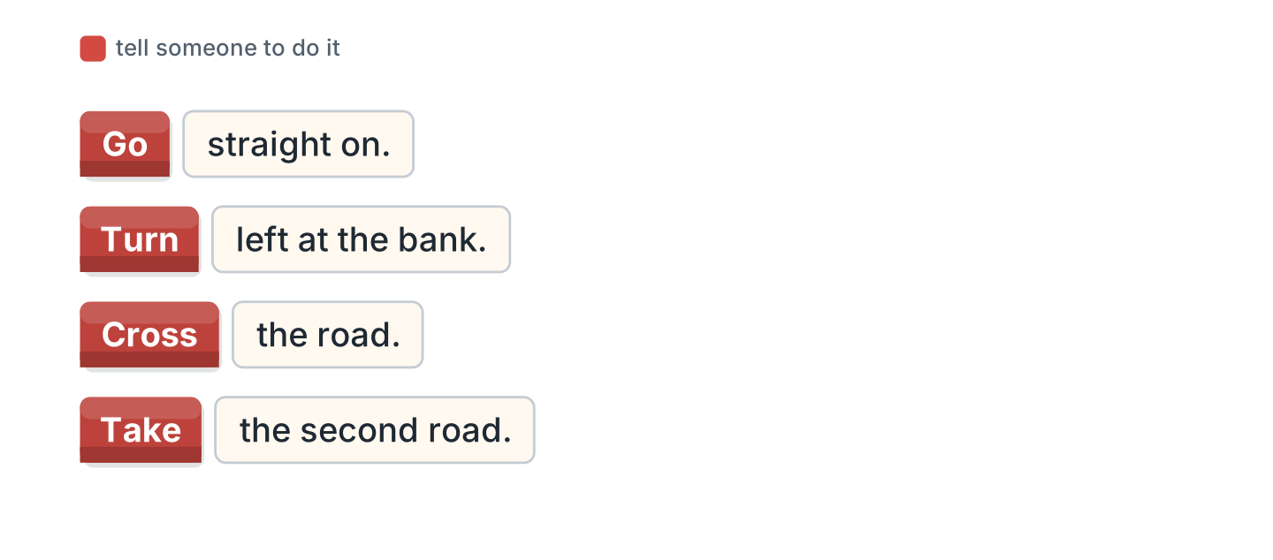
Figure 8.7 · Telling someone the way.
Words: Cross · Go · Take · Turn
- Go straight on. (Go) (example)
- ______ left at the bank.
- ______ the road.
- ______ the second road.
2B Choose the correct word.
- Turn (left / leave) at the shop. — left (example)
- Go (straight / street) on.
- Take the (two / second) road.
- The cafe is (opposite / open) the park.
- Cross the (road / ride).
2C Look at Figure 8.8. Write the answer.
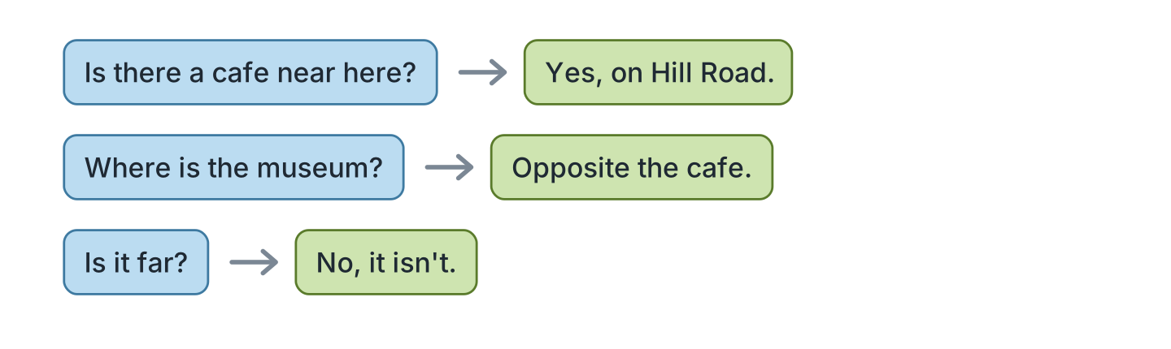
Figure 8.8 · Asking if there is one.
- Is there a cafe near here? ✓ — Yes, on Hill Road. (example)
- Where is the museum? — ______________
- Is it far? ✗ — ______________
- Is there a bank here? ✓ — ______________
2D Write the instruction.
- (go / straight) — Go straight on. (example)
- (turn / left) — ______________
- (cross / road) — ______________
- (take / first road) — ______________
2E Look at Figure 8.9. Answer the questions.
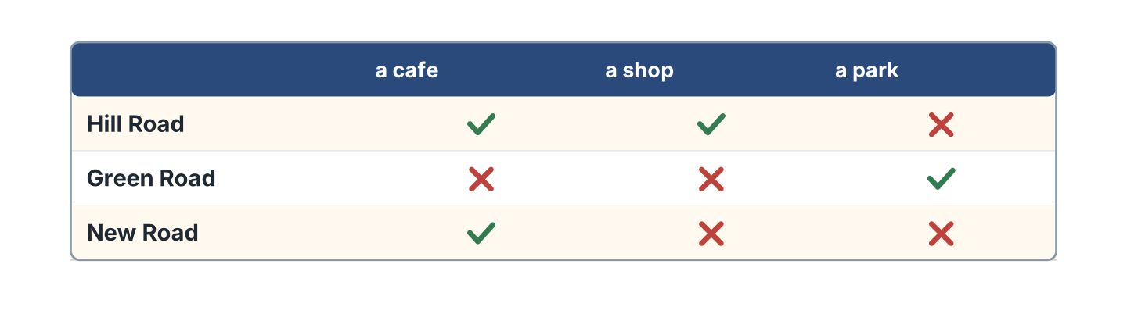
Figure 8.9 · What is on each road.
- Is there a cafe on Hill Road? — Yes, there is. (example)
- Is there a park on Hill Road? — ______________
- Is there a shop on New Road? — ______________
- Which road has a park? — ______________
2F Find the mistake. Write the correct words.
- Go straight at. — on (example)
- Turn to left at the bank. — ______________
- Take the two road. — ______________
- The cafe is next the school. — ______________
Part 3 · Listening
3A Listen. Look at Figure 8.10. Write the place.
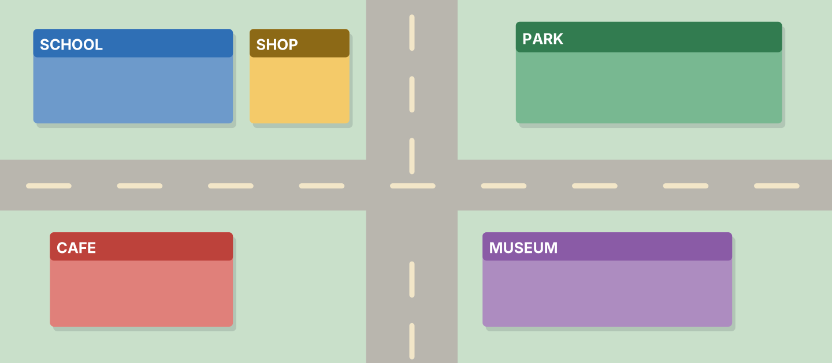
Figure 8.10 · A map to listen to.
- Go straight on. — the park (example)
- ______________
- ______________
- ______________
3B Listen. Look at Figure 8.11. Write the time.
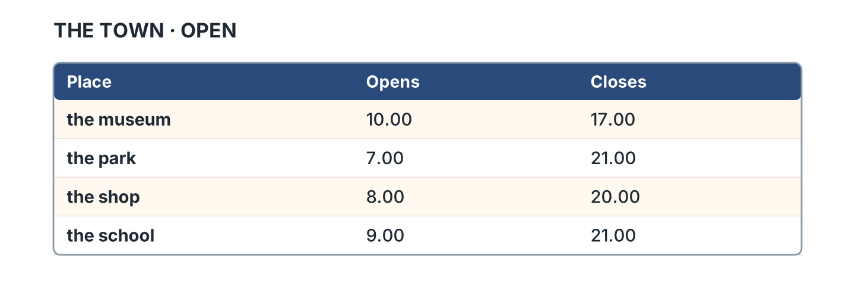
Figure 8.11 · Four places and their times.
- The museum opens at ten. (ten) (example)
- The park closes at ______________.
- The shop opens at ______________.
- The school closes at ______________.
3C Listen. Look at Figure 8.12. Write the number.
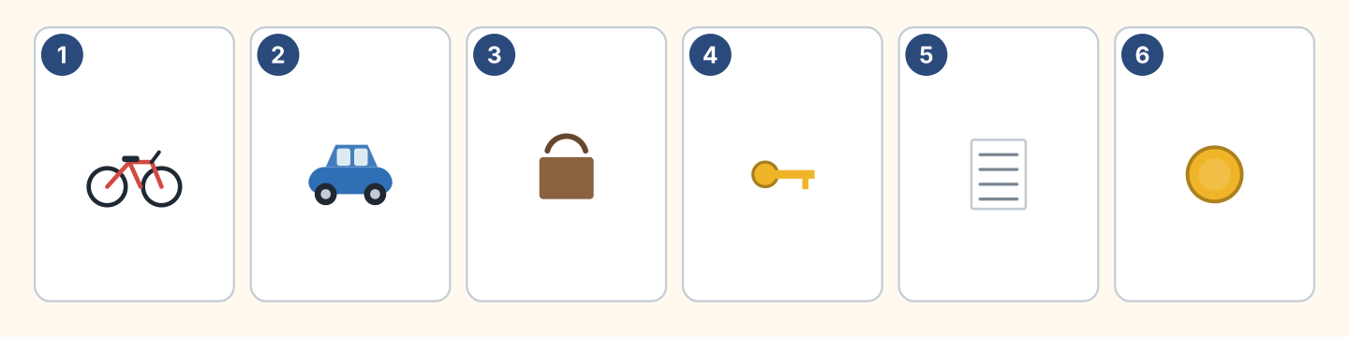
Figure 8.12 · Six ways to travel.
- a bike — 1 (example)
- a car — ______
- a bag — ______
- a coin — ______
3D Listen. Write left or right.
- left (example)
- ______________
- ______________
- ______________
Part 4 · Speaking
4A Look at Figure 8.13. Ask the way.
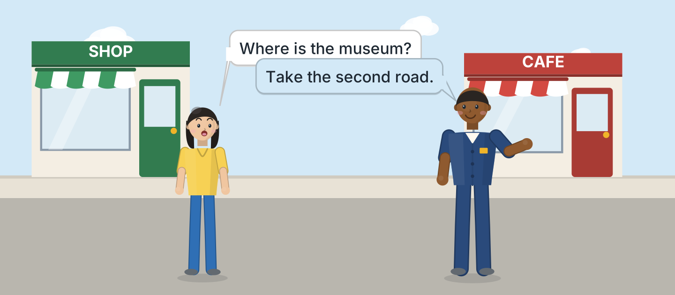
Figure 8.13 · Sam tells Lili the way.
- A: Where is the museum? B: Take the second road. (example)
- Ask about the park.
- Ask about the cafe.
- Ask if it is far.
4B Look at Figure 8.14. Ask and answer.
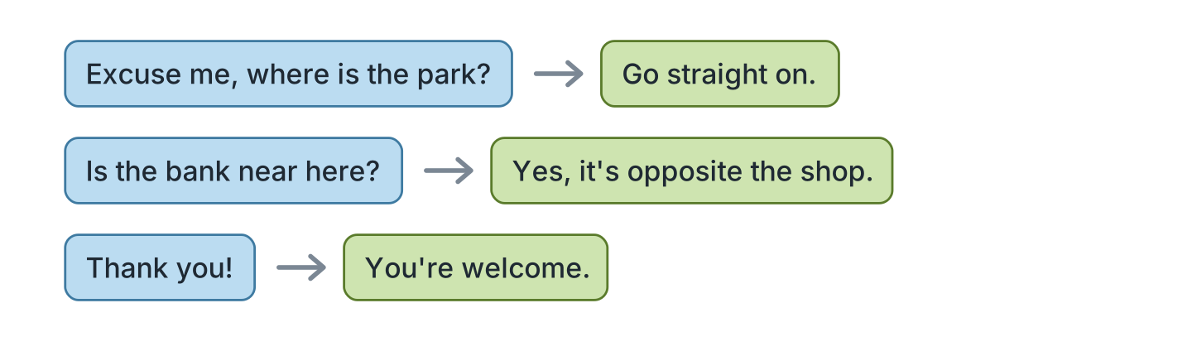
Figure 8.14 · Ask the way.
- A: Excuse me, where is the park? B: Go straight on. (example)
- A: Is the bank near here? B: ______________
- A: Is it far? B: ______________
- A: Thank you! B: ______________
4C Tell a friend the way to your home.
- Take the first road. Turn left. (example)
- Say the first road.
- Say left or right.
- Say what is near.
4D Ask three friends about their town.
- A: Is there a museum in your town? B: Yes, there is. (example)
- Ask about a hotel with cheap food.
- Ask where the market sells fish.
- Ask about a cheap restaurant.
Part 5 · Reading
5A Look at Figure 8.15. Answer the questions.
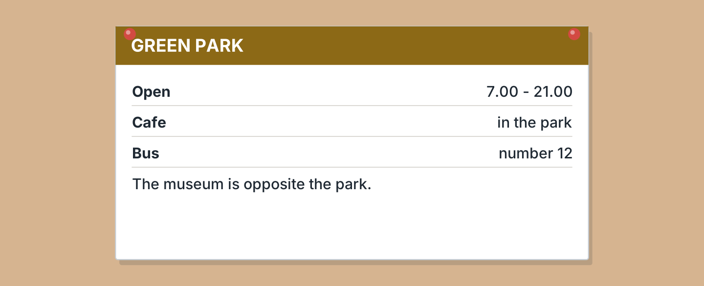
Figure 8.15 · A notice in the park.
- When does the park open? — 7.00 (example)
- When does it close? — ______________
- Which bus goes there? — ______________
- What is opposite the park? — ______________
5B Look at Figure 8.15. Write yes or no.
- There is a cafe in the park. — yes (example)
- The park closes at nine. — ______
- Bus 14 goes there. — ______
- The museum is opposite the park. — ______
5C Look at Figure 8.16. Choose the correct answer.
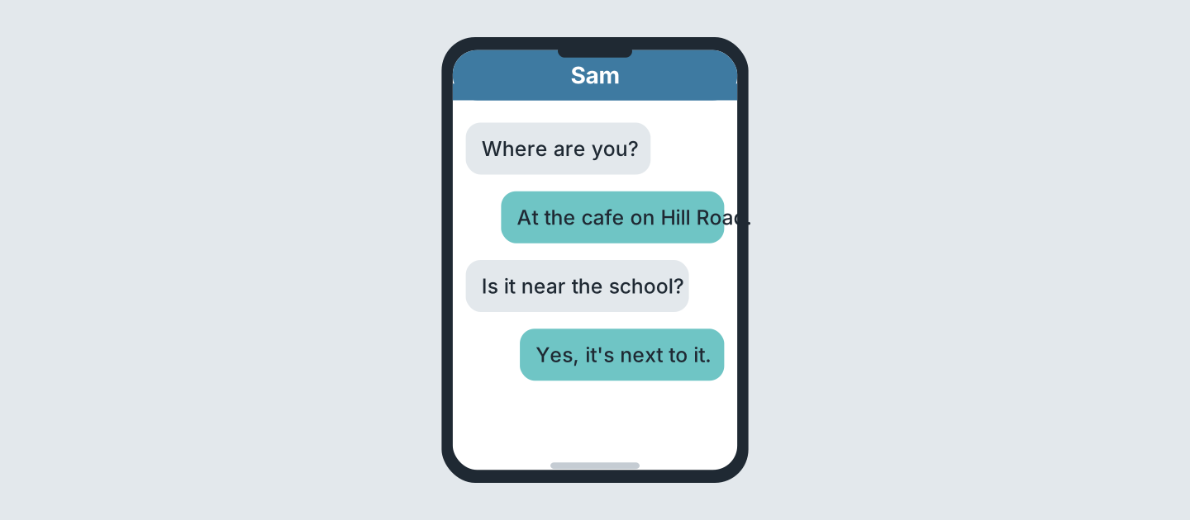
Figure 8.16 · Messages about a place.
- Who asks first? (a) Sam (b) Lili (c) Ben — a (example)
- Where is the writer? (a) park (b) cafe (c) school
- Which road is it on? (a) Hill (b) Green (c) New
- Is it near the school? (a) yes (b) no (c) maybe
5D Read and correct. Write the correct word.
- The park closes at nine. — twenty-one (example)
- Bus 14 goes to the park. — ______________
- The cafe is on Green Road. — ______________
- The park opens at eight. — ______________
Part 6 · Writing
6A Look at Figure 8.17. Complete the form.
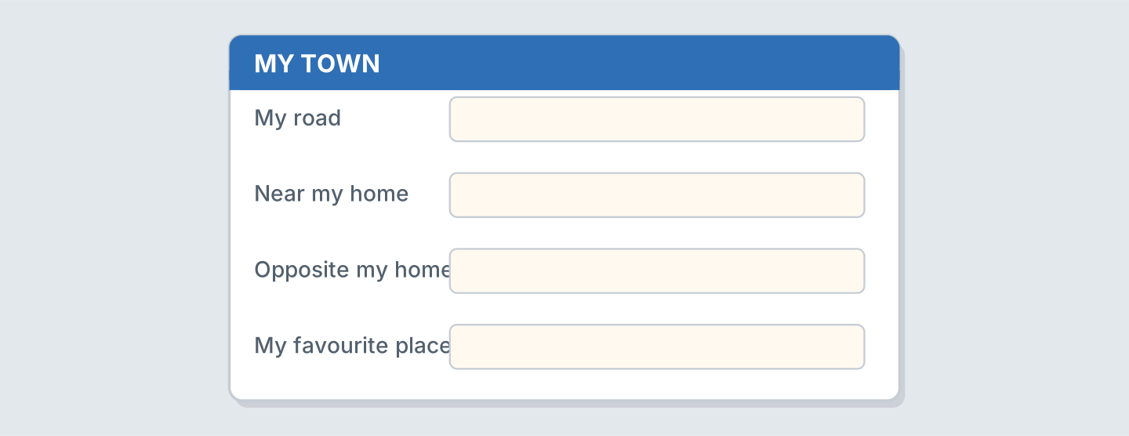
Figure 8.17 · A form about your town.
- My road: Hill Road (example)
- My road: ______________
- Near my home: ______________
- My favourite place: ______________
6B Look at Figure 8.18. Write four lines.
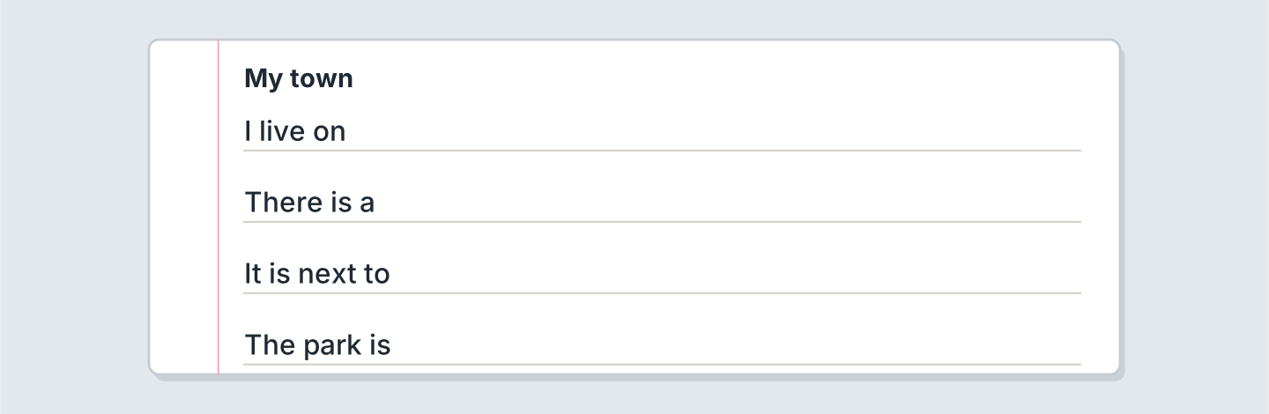
Figure 8.18 · Four lines about your town.
- I live near a cheap market. (example)
- I live on ______________.
- There is a ______________.
- I buy milk at ______________.
6C Write the way from your home to a shop.
- Turn right. Go straight on. (example)
- Say the first thing to do.
- Say left or right.
- Say where the supermarket and the bank are.
Part 7 · Real-World File
7A Look at Figure 8.19. Answer the questions.
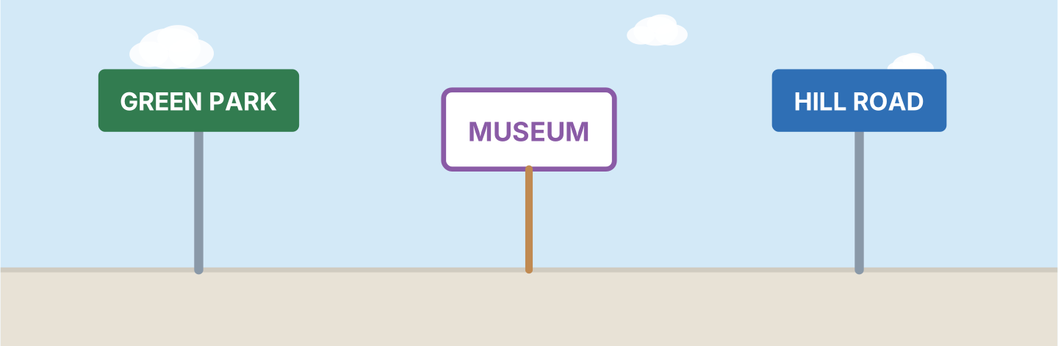
Figure 8.19 · Signs in the town.
- What is the green sign? — Green Park (example)
- What is the purple sign? — ______________
- What is the blue sign? — ______________
- Which sign is a road? — ______________
7B Look at Figure 8.20. Answer the questions.
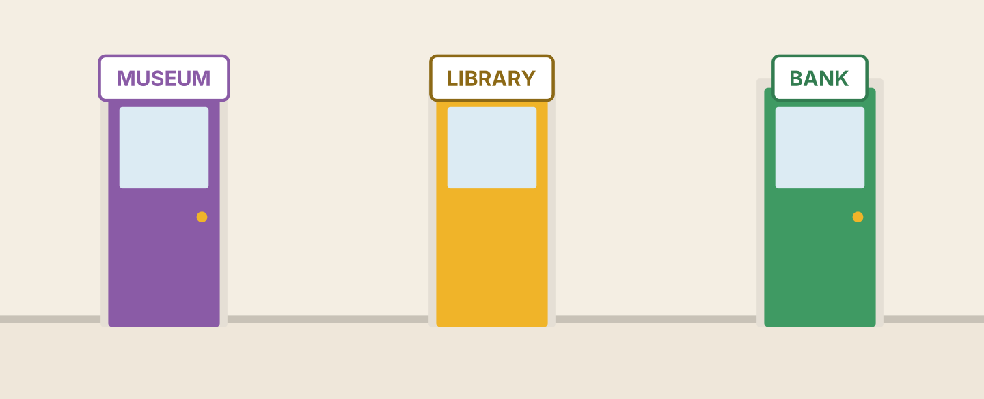
Figure 8.20 · Three doors in the town.
- What is the purple door? — the museum (example)
- What is the yellow door? — ______________
- What is the green door? — ______________
- Is there a bank? — ______
7C Write three signs for your town.
- HILL ROAD · THE BAKERY · THE MARKET (example)
- ______________
- ______________
- ______________
Part 8 · Review & Can-Do
8A Look at Figure 8.21. Write the word.
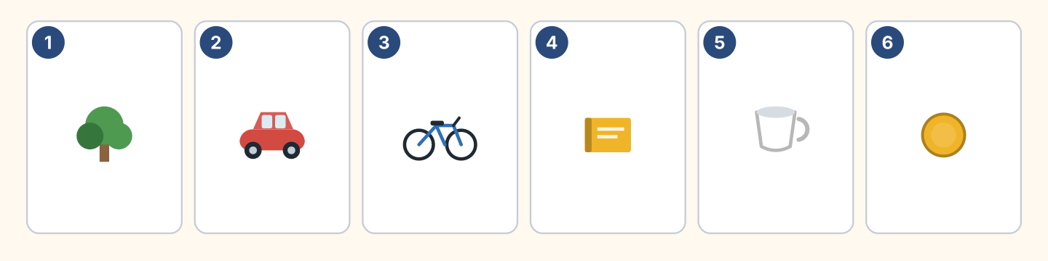
Figure 8.21 · Six things from this unit.
Words: bike · book · car · coin · cup · tree
- 1 — tree (example)
- 2 — ______________
- 3 — ______________
- 4 — ______________
- 6 — ______________
8B Complete the conversation.
Words: far · left · straight · Where
- A: Where is the bank? (Where) (example)
- B: Go ______ on, then turn ______.
- A: Is it ______?
- B: No, it is near.
8C Write next to, opposite or behind.
- The shop is next to the school. (next to) (example)
- The cafe is ______________ the museum.
- The park is ______________ the shop.
- The bank is ______________ the cafe.
8D Match the question and the answer.
Question | Answer
1 Where is the park? | a No, it’s near.
2 Is it far? | b Go straight on.
3 Is there a cafe here? | c Yes, on Hill Road.
4 Which road is it? | d The second one.
 | e She’s a nurse.
One option is not needed.
- 1 — b (example)
- 2 — ______
- 3 — ______
- 4 — ______
8E Look at Figure 8.22. Tick what you can do.
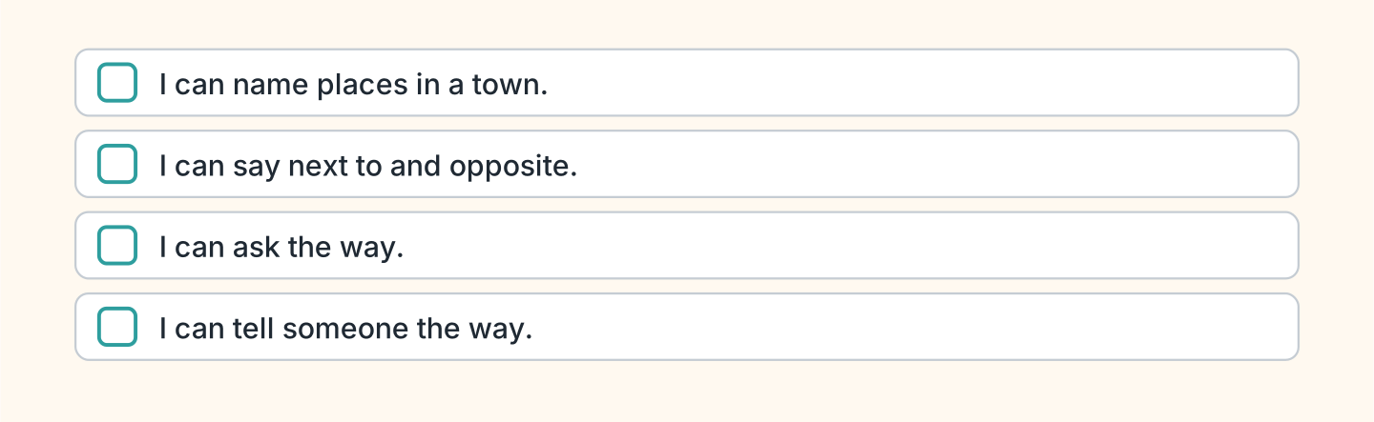
Figure 8.22 · What I can do.
- I can name places in a town. — ✓ (example)
- I can say next to and opposite. — ______
- I can ask the way. — ______
- I can tell someone the way. — ______

Unit 9: I Can Do That
In this unit you say what you can do. You ask a friend.
Warm Up
W1 Look at Figure 9.1. Write yes or no.
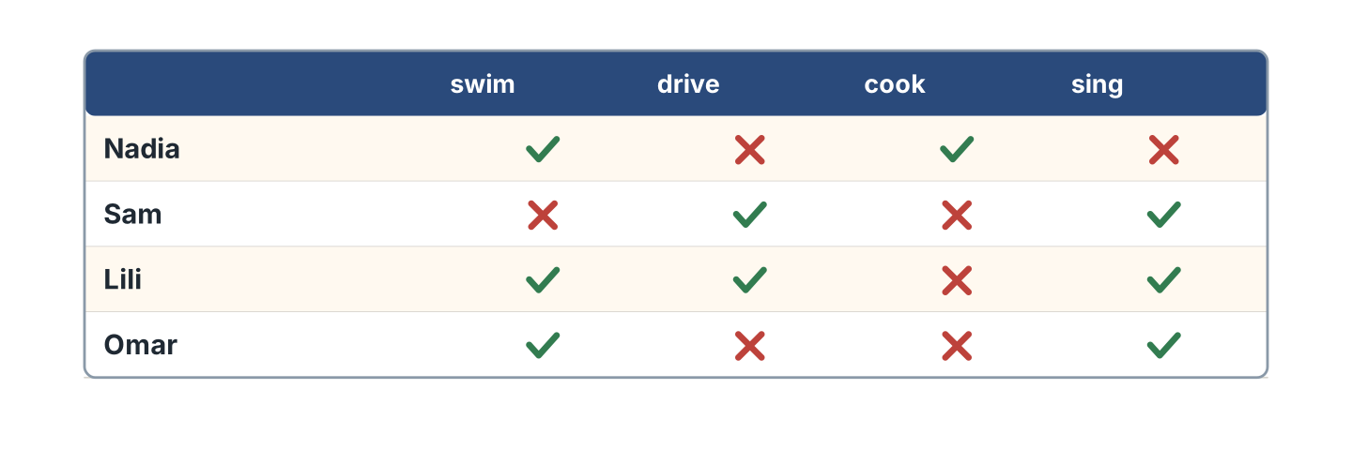
Figure 9.1 · Four people and four things.
- Nadia can swim. — yes (example)
- Sam can cook. — ______
- Lili can drive. — ______
- Omar can sing. — ______
W2 Look at Figure 9.2. Write the word.
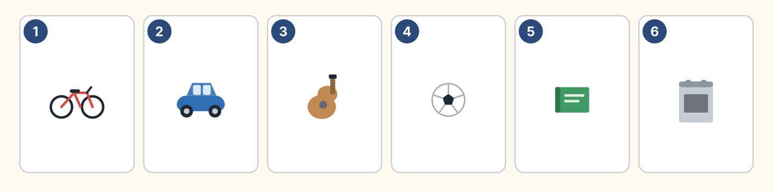
Figure 9.2 · Six things people do.
Words: ball · bike · book · car · cooker · guitar
- 1 — bike (example)
- 2 — ______________
- 3 — ______________
- 5 — ______________
- 6 — ______________
W3 Say three things you can do.
- I can swim at the pool near the square. (example)
- Say one thing you can do.
- Say if it is near the station or the market.
- Ask a friend.
Part 1 · Words & Sounds
1A Look at Figure 9.3. Match the person and the word.
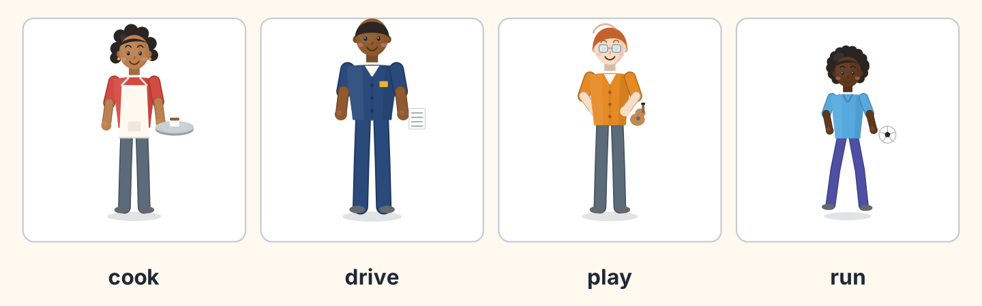
Figure 9.3 · Four people doing things.
Person | Word
1 Nadia | a play
2 Sam | b cook
3 Ben | c drive
4 Omar | d run
 | e swim
One option is not needed.
- 1 — b (example)
- 2 — ______
- 3 — ______
- 4 — ______
1B Look at Figure 9.4. Write the word.
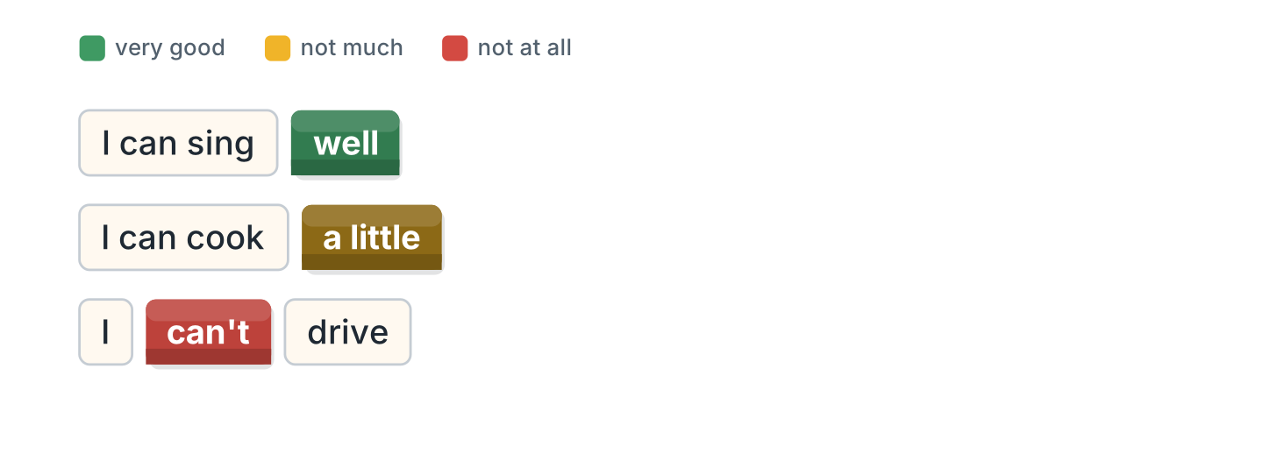
Figure 9.4 · Well or a little.
Words: a little · can’t · well
- I can sing well. (well) (example)
- I can cook ______________.
- I ______________ drive.
- She can swim ______________.
1C Look at Figure 9.5. Write the word.
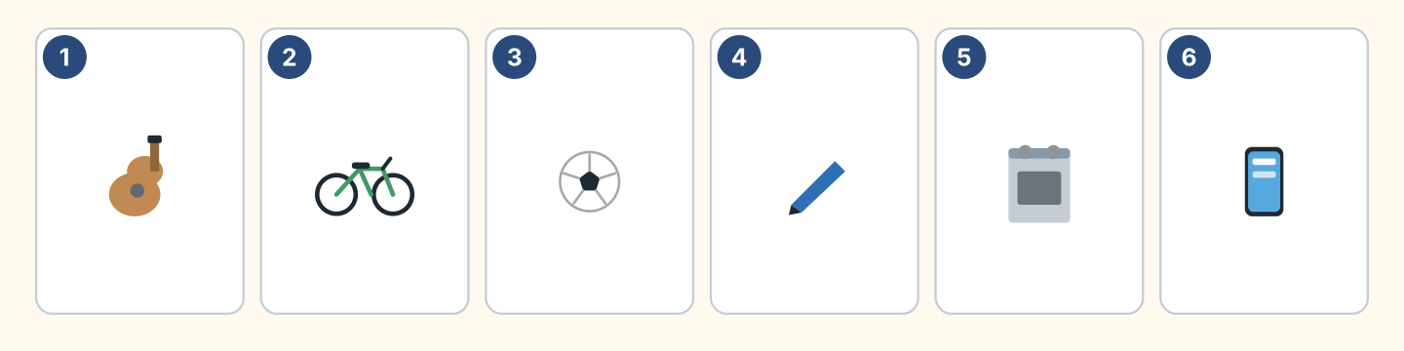
Figure 9.5 · Six things to try.
Words: ball · bike · cooker · guitar · pen · phone
- 1 — guitar (example)
- 2 — ______________
- 3 — ______________
- 5 — ______________
1D Say it. Say these words.
- can (example)
- can’t
- swim
- drive
- guitar
1E Look at Figure 9.6. Answer the questions.
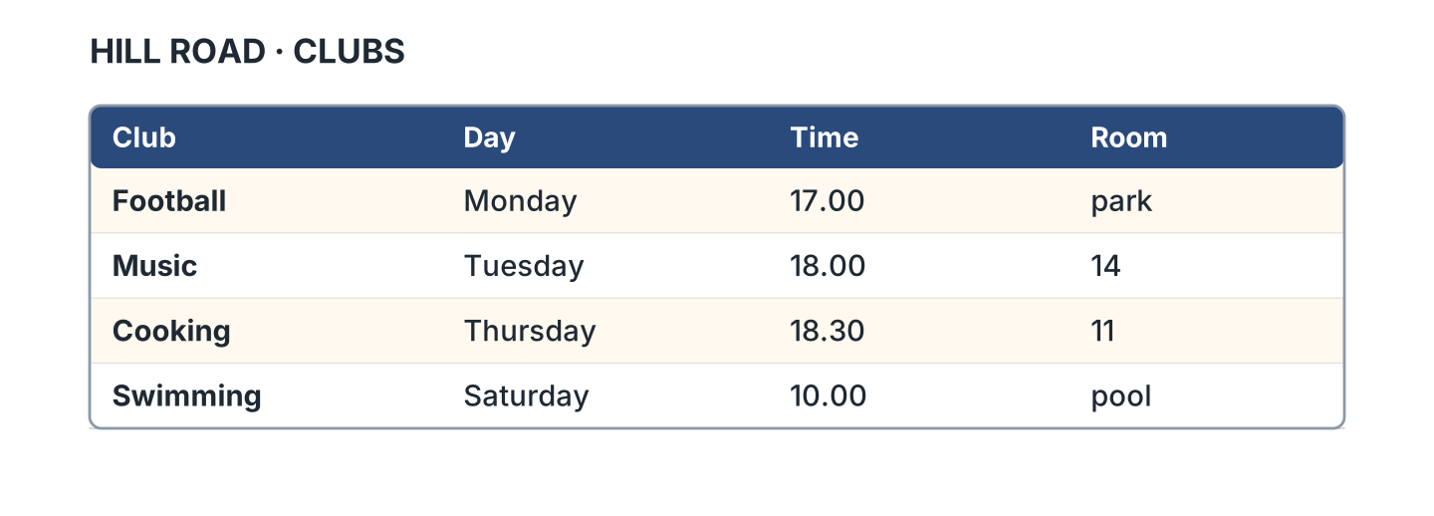
Figure 9.6 · A club list.
- When is the football club? — Monday (example)
- When is the music club? — ______________
- Where is the cooking club? — ______________
- What time is swimming? — ______________
1F Write the thing you need.
- to play music — a guitar (example)
- to ride to the hotel — ______________
- to cook some rice — ______________
- to play football — ______________
Part 2 · Grammar
2A Look at Figure 9.7. Complete with can or can’t.
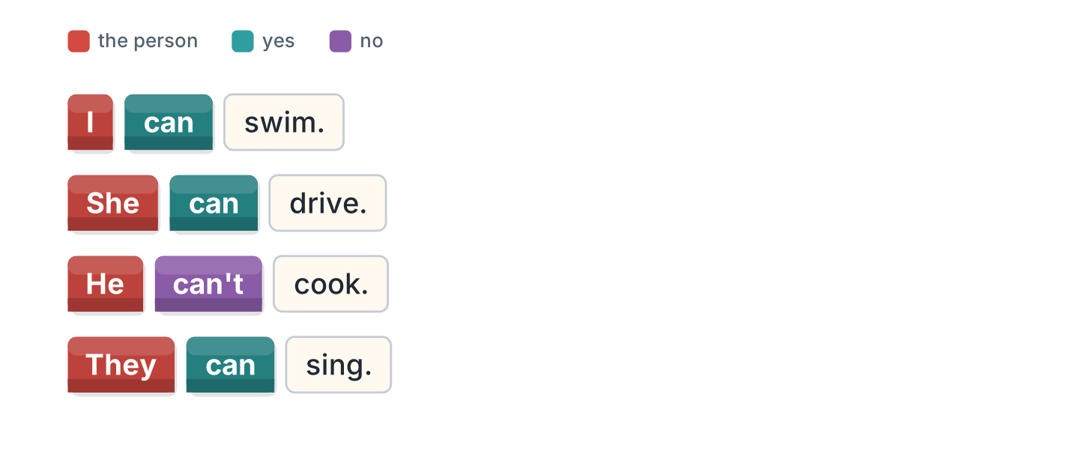
Figure 9.7 · can and cannot.
- I can swim. (can) (example)
- She ______________ drive.
- He ______________ cook.
- They ______________ sing.
2B Choose the correct word.
- She (can / cans) drive. — can (example)
- I can (swim / swims).
- He (can’t / doesn’t can) cook.
- They can (play / plays) football.
- We (can / cans) help.
2C Look at Figure 9.8. Write the short form.

Figure 9.8 · The short form.
- cannot — can’t (example)
- I cannot drive. — ______________
- She cannot come. — ______________
2D Write the negative.
- I can swim. — I can’t swim. (example)
- He can cook. — ______________
- They can sing. — ______________
- She can drive. — ______________
2E Look at Figure 9.9. Write the answer.
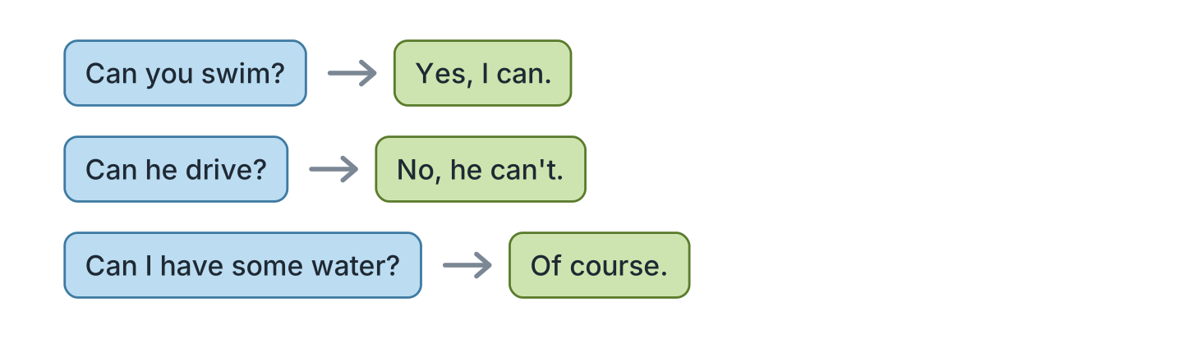
Figure 9.9 · Questions with can.
- Can you swim? ✓ — Yes, I can. (example)
- Can he drive? ✗ — ______________
- Can they sing? ✓ — ______________
- Can I have some water? ✓ — ______________
2F Find the mistake. Write the correct words.
- She cans drive. — can (example)
- I can to swim. — ______________
- He don’t can cook. — ______________
- Can you to help me? — ______________
Part 3 · Listening
3A Listen. Look at Figure 9.10. Write the number.
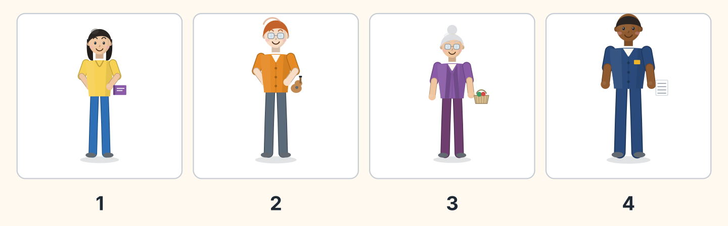
Figure 9.10 · Four voices to match.
- Lili — 1 (example)
- Ben — ______
- Rosa — ______
- Sam — ______
3B Listen. Look at Figure 9.11. Write yes or no.
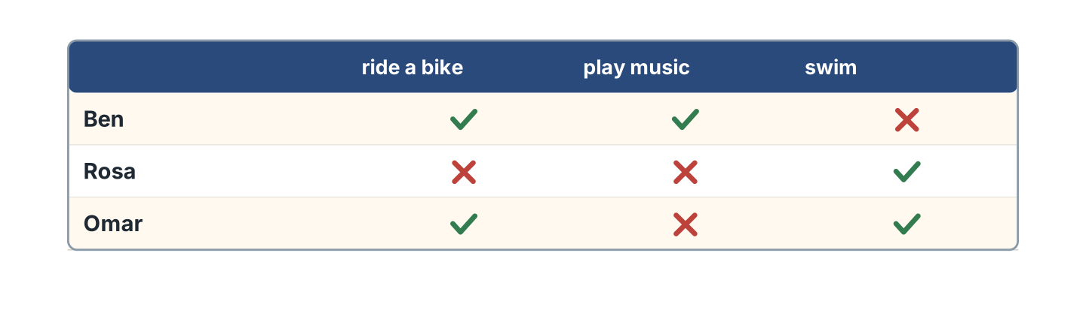
Figure 9.11 · A grid to complete.
- Ben can ride a bike. — yes (example)
- Rosa can swim. — ______
- Omar can play music. — ______
- Ben can swim. — ______
3C Listen. Look at Figure 9.12. Write the club.
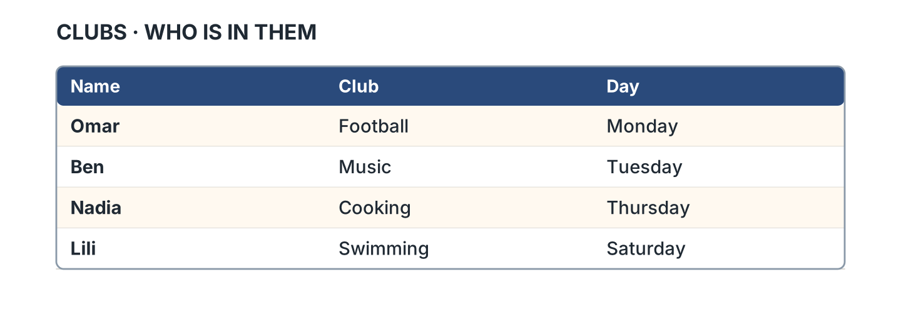
Figure 9.12 · Who is in which club.
- Omar — Football (example)
- Ben — ______________
- Nadia — ______________
- Lili — ______________
3D Listen. Write can or can’t.
- can (example)
- ______________
- ______________
- ______________
Part 4 · Speaking
4A Look at Figure 9.13. Ask a friend.
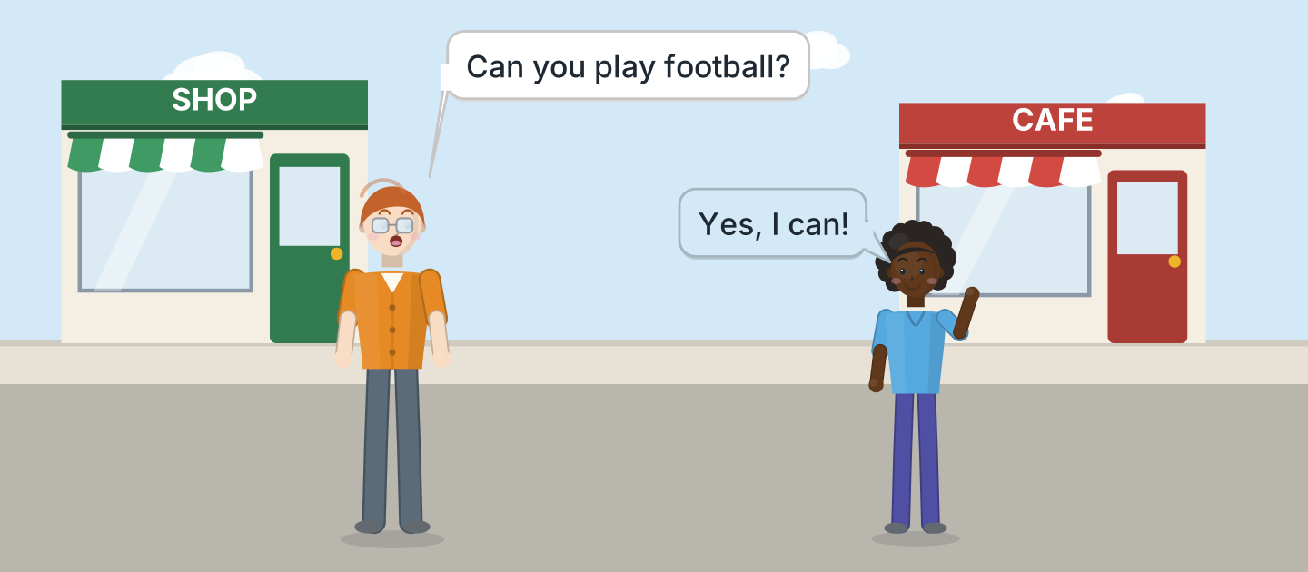
Figure 9.13 · Ben asks Omar.
- A: Can you play football? B: Yes, I can! (example)
- Ask about swimming at the hotel pool.
- Ask about cooking rice and fish.
- Ask about music.
4B Look at Figure 9.14. Ask and answer.
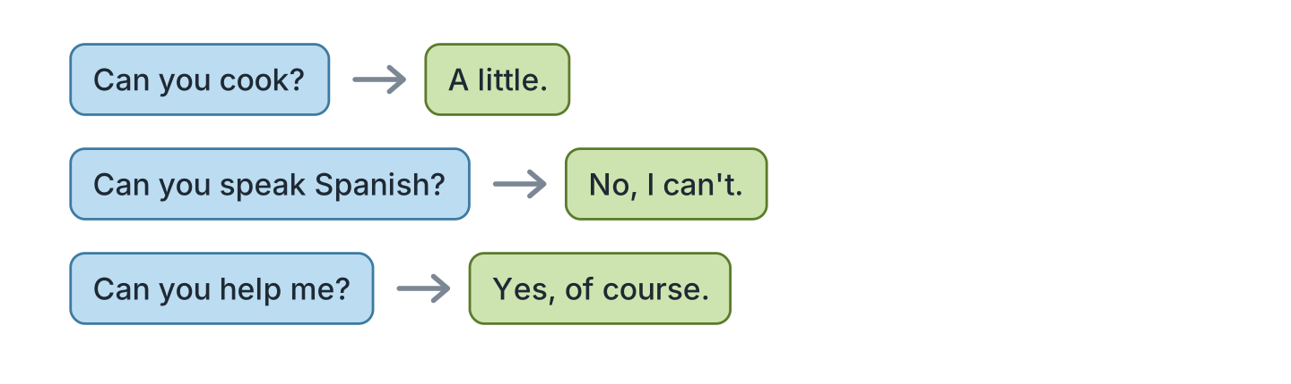
Figure 9.14 · Ask a friend.
- A: Can you cook? B: A little. (example)
- A: Can you speak Spanish? B: ______________
- A: Can you help me? B: ______________
- A: Can you drive? B: ______________
4C Tell a friend about your family.
- My father can drive to the market. (example)
- Say one thing a person can do.
- Say if they often help at the hospital.
- Say how well.
4D Choose a club and tell a friend.
- I want the music club. I can play guitar. (example)
- Say the club and the road.
- Say if it is far or near the park.
- Say what you can do.
Part 5 · Reading
5A Look at Figure 9.15. Answer the questions.
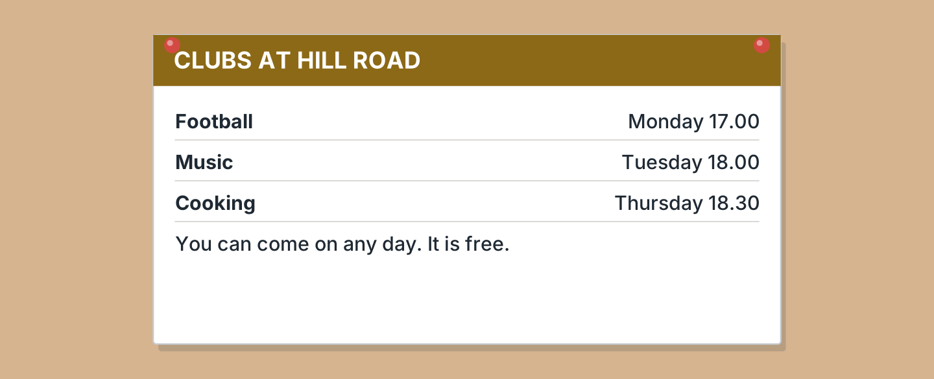
Figure 9.15 · A notice about the clubs.
- When is the football club? — Monday (example)
- What time is the music club? — ______________
- When is the cooking club? — ______________
- What does it cost? — ______________
5B Look at Figure 9.15. Write yes or no.
- The clubs are free. — yes (example)
- The music club is on Monday. — ______
- You can come on any day. — ______
- The cooking club is at six. — ______
5C Look at Figure 9.16. Choose the correct answer.
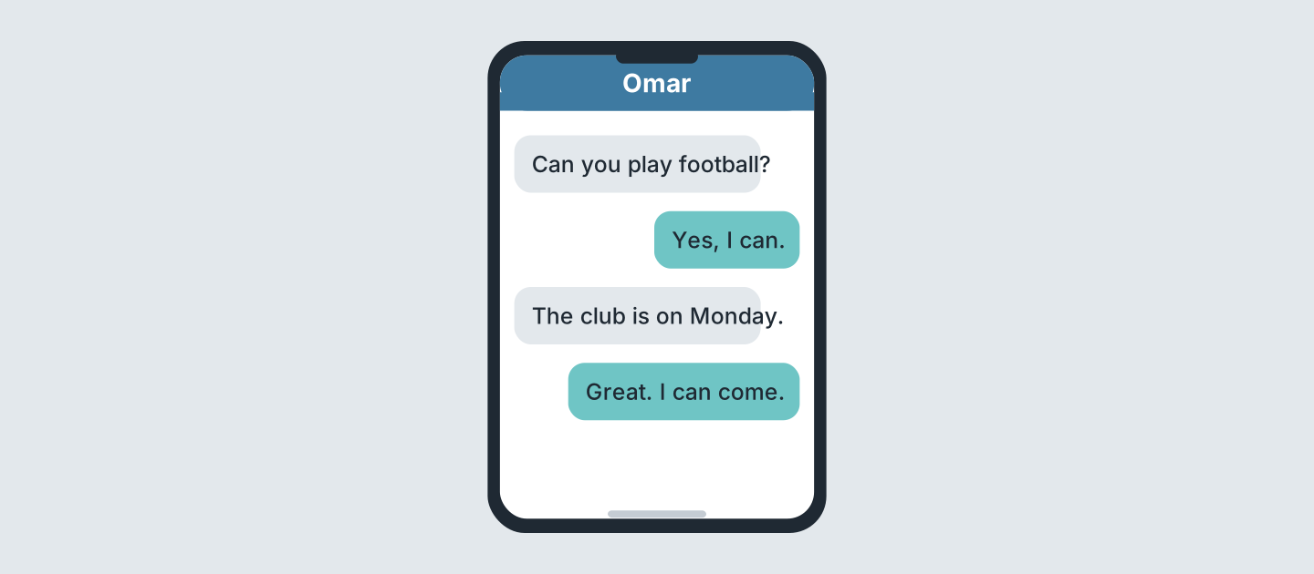
Figure 9.16 · Messages about a club.
- Who texts first? (a) a friend (b) Omar (c) Ben — a (example)
- Can Omar play football? (a) yes (b) no (c) perhaps
- Which day is the club? (a) Monday (b) Tuesday (c) Sunday
- Is Omar coming? (a) yes (b) no (c) perhaps
5D Read and correct. Write the correct word.
- The football club is on Tuesday. — Monday (example)
- The music club is at five. — ______________
- The clubs cost five pounds. — ______________
- The cooking club is on Friday. — ______________
Part 6 · Writing
6A Look at Figure 9.17. Complete the form.
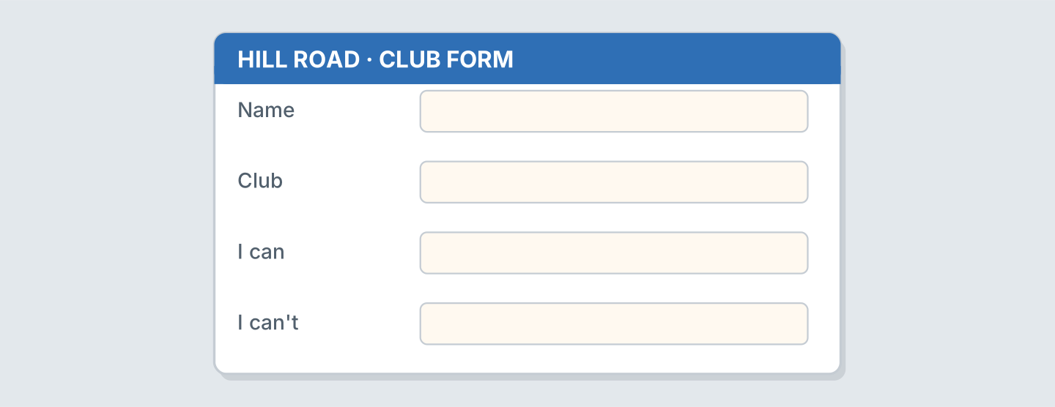
Figure 9.17 · A form for a club.
- Club: Music (example)
- Name: ______________
- Club: ______________
- I can: ______________
6B Look at Figure 9.18. Write four lines.
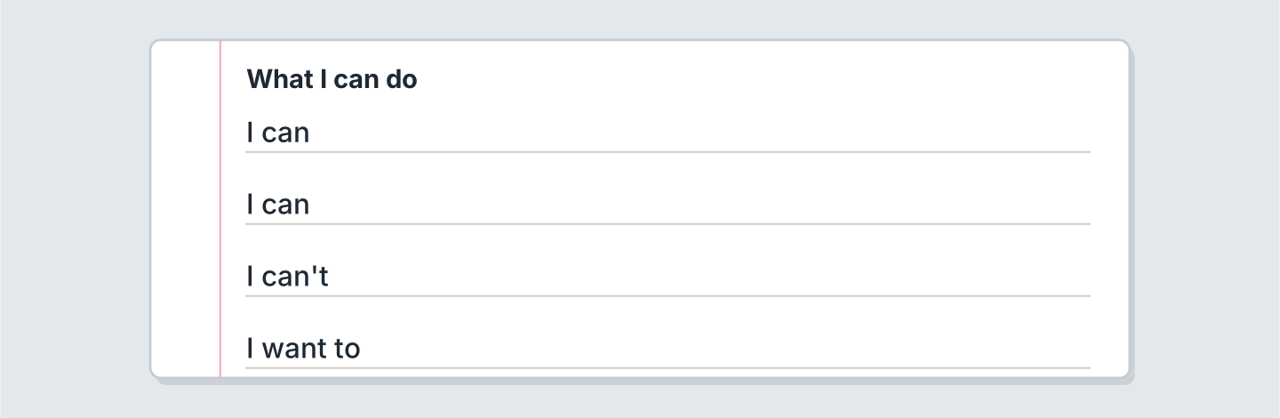
Figure 9.18 · Four lines about you.
- I can swim well. (example)
- I can ______________.
- I can’t ______________.
- I want to ______________.
6C Write about a friend. Write three lines.
- My friend can play the guitar in the park. (example)
- Say one thing they can do.
- Say if they walk to the square or take a ticket.
- Say which club is good for them.
Part 7 · Real-World File
7A Look at Figure 9.19. Answer the questions.
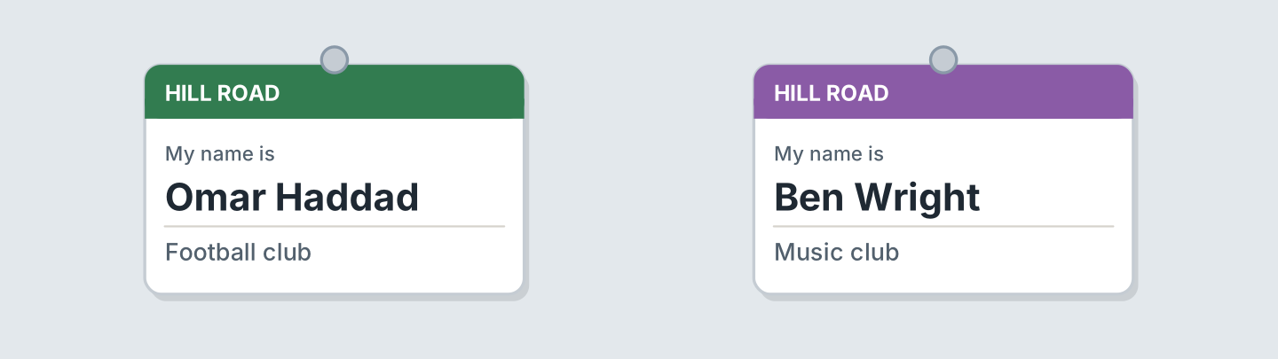
Figure 9.19 · A club card.
- Which club is Omar in? — Football (example)
- Which club is Ben in? — ______________
- Where are the clubs? — ______________
- Who is in the music club? — ______________
7B Look at Figure 9.20. Answer the questions.
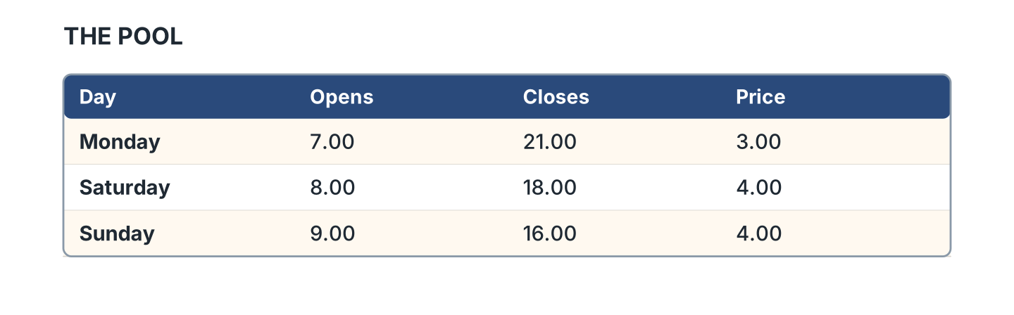
Figure 9.20 · The pool times.
- When does the pool open on Monday? — 7.00 (example)
- When does it close on Sunday? — ______________
- How much is it on Saturday? — ______________
- Which day is cheapest? — ______________
7C Write a club card for you.
- Name: Omar · Club: Football (example)
- Name: ______________
- Club: ______________
- Day: ______________
Part 8 · Review & Can-Do
8A Look at Figure 9.21. Write the word.
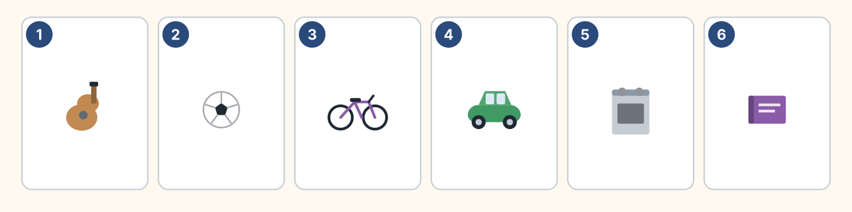
Figure 9.21 · Six things from this unit.
Words: ball · bike · book · car · cooker · guitar
- 1 — guitar (example)
- 2 — ______________
- 3 — ______________
- 4 — ______________
- 6 — ______________
8B Complete the conversation.
Words: can · can’t · little · you
- A: Can you cook? (Can) (example)
- B: Yes, a ______.
- A: ______ you drive?
- B: No, I ______.
8C Write can or can’t.
- She can swim well. (can) (example)
- He ______ drive. He has no car.
- They ______ sing. They are in a band.
- I ______ cook. I eat at the cafe.
8D Match the question and the answer.
Question | Answer
1 Can you swim? | a A little.
2 Can you cook? | b Yes, of course.
3 Can you help me? | c No, I can’t.
4 Can I have water? | d Here you are.
 | e At the clinic.
One option is not needed.
- 1 — c (example)
- 2 — ______
- 3 — ______
- 4 — ______
8E Look at Figure 9.22. Tick what you can do.
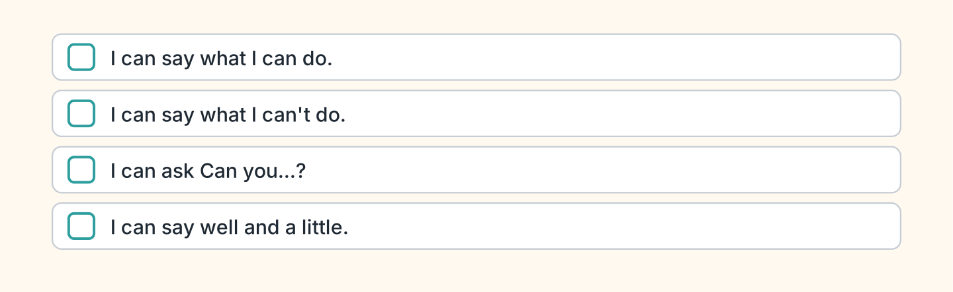
Figure 9.22 · What I can do.
- I can say what I can do. — ✓ (example)
- I can say what I can’t do. — ______
- I can ask Can you swim? — ______
- I can say well and a little. — ______

Unit 10: Last Weekend
In this unit you say where you were. You talk about the weekend.
Warm Up
W1 Look at Figure 10.1. Write the word.
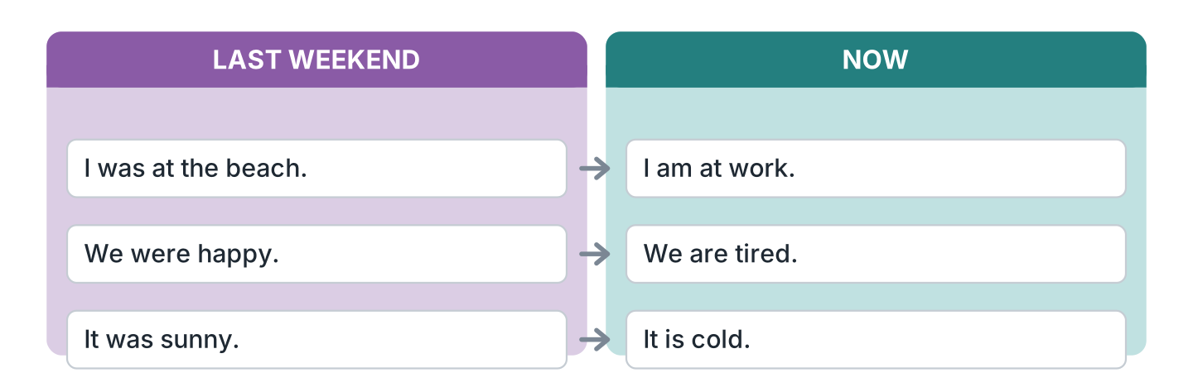
Figure 10.1 · Last weekend and now.
- I was at the beach. (was) (example)
- We ______ happy.
- It ______ sunny.
- We ______ tired now.
W2 Look at Figure 10.2. Write the word.
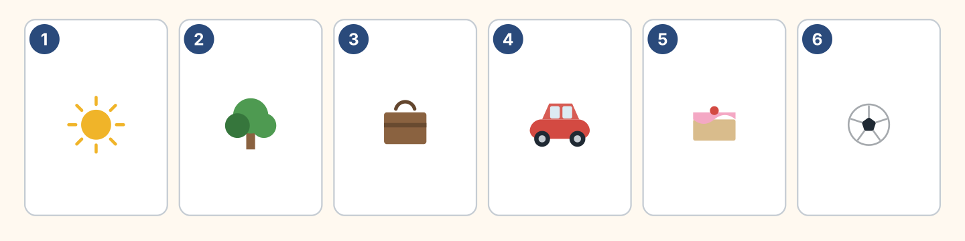
Figure 10.2 · Six places and things.
Words: ball · cake · car · suitcase · sun · tree
- 1 — sun (example)
- 2 — ______________
- 3 — ______________
- 5 — ______________
- 6 — ______________
W3 Say where you were last weekend.
- I was at home on Saturday. (example)
- Say where you were.
- Say if the market and the park were open.
- Say how it was.
Part 1 · Words & Sounds
1A Look at Figure 10.3. Match the person and the word.
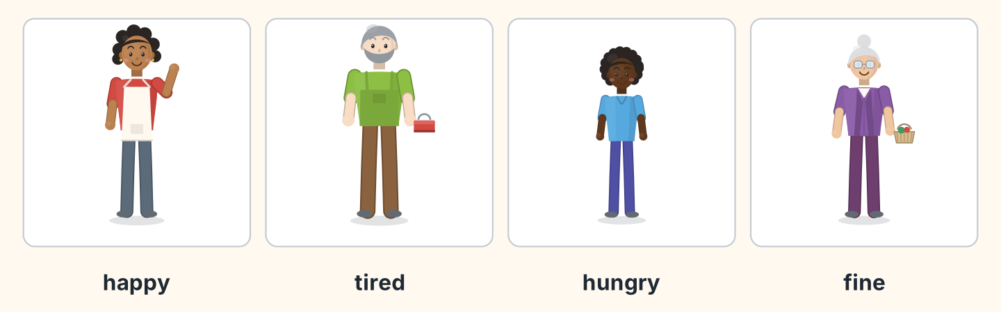
Figure 10.3 · Four feelings.
Person | Word
1 Nadia | a tired
2 Marek | b happy
3 Omar | c fine
4 Rosa | d hungry
 | e angry
One option is not needed.
- 1 — b (example)
- 2 — ______
- 3 — ______
- 4 — ______
1B Look at Figure 10.4. Write the place.
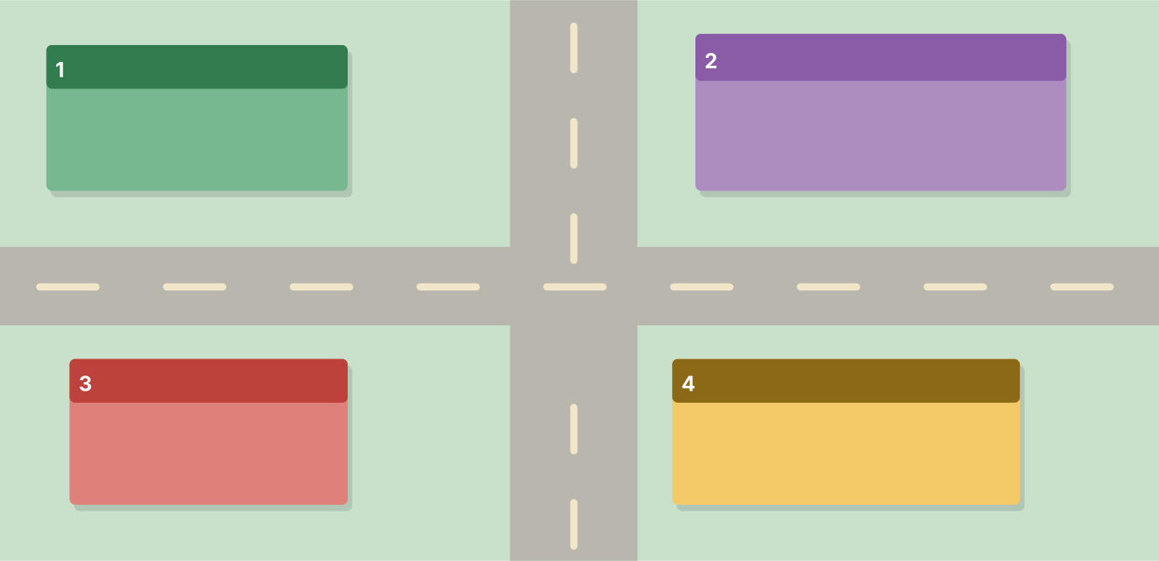
Figure 10.4 · Four places by number.
Words: cafe · home · museum · park
- 1 — park (example)
- 2 — ______________
- 3 — ______________
- 4 — ______________
1C Look at Figure 10.5. Write the time word.
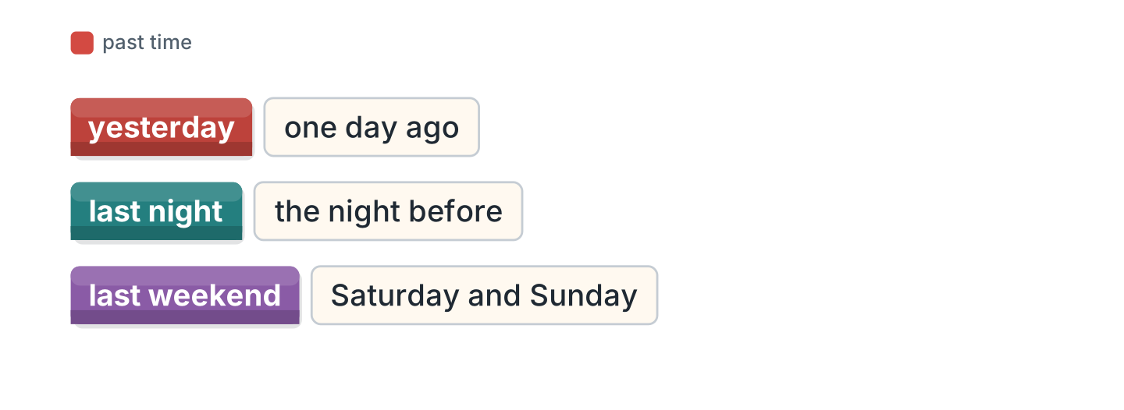
Figure 10.5 · Yesterday and last week.
- one day ago — yesterday (example)
- the night before — ______________
- Saturday and Sunday — ______________
- seven days ago — ______________
1D Say it. Say these words.
- yesterday (example)
- was
- were
- weekend
- holiday
1E Look at Figure 10.6. Answer the questions.
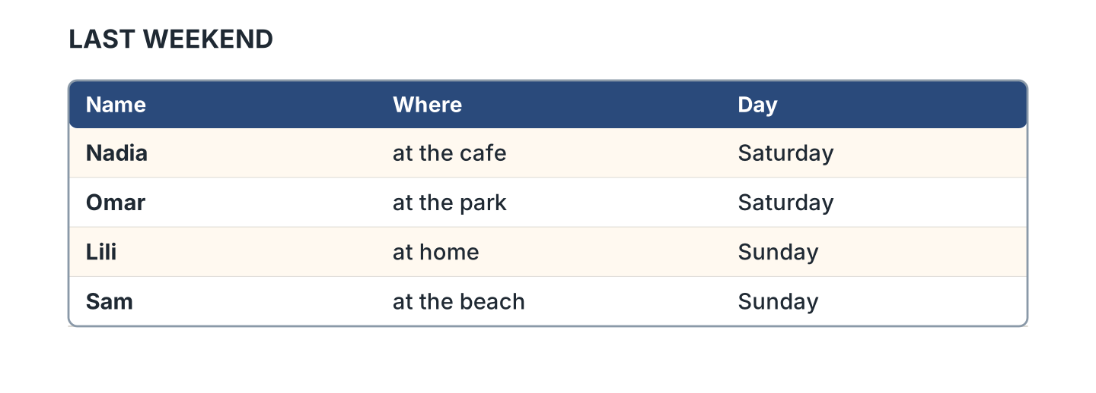
Figure 10.6 · A weekend list.
- Where was Nadia? — at the cafe (example)
- Where was Omar? — ______________
- Who was at home? — ______________
- Who was at the beach? — ______________
1F Write the opposite word.
- happy — sad (example)
- tired — ______________
- hungry — ______________
- great — ______________
Part 2 · Grammar
2A Look at Figure 10.7. Complete with was or were.
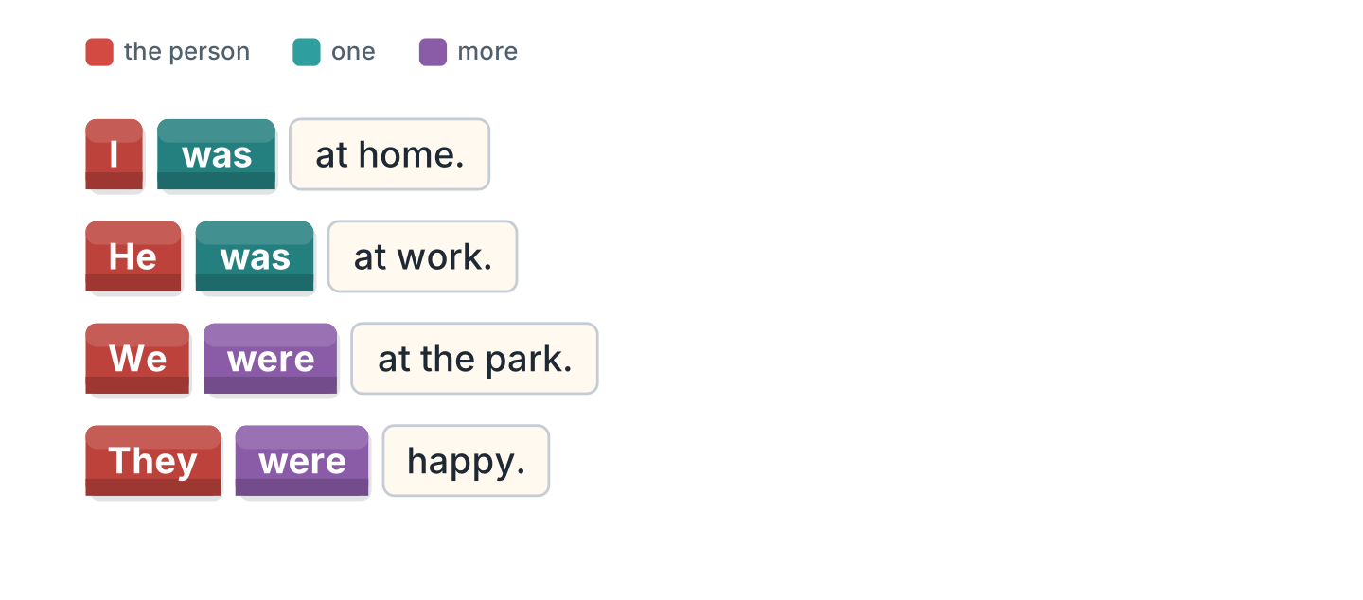
Figure 10.7 · was and were.
- I was at home. (was) (example)
- He ______ at work.
- We ______ at the park.
- They ______ happy.
2B Choose the correct word.
- I (was / were) tired. — was (example)
- They (was / were) at school.
- She (was / were) at the cafe.
- We (was / were) at the beach.
- It (was / were) sunny.
2C Look at Figure 10.8. Write the short form.
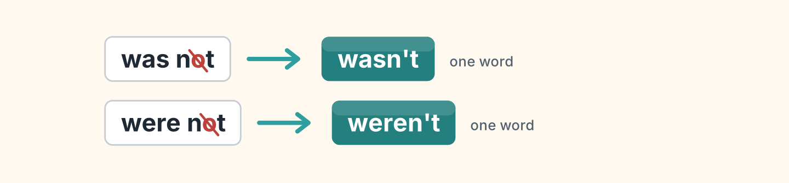
Figure 10.8 · The short negative.
- was not — wasn’t (example)
- were not — ______________
- I was not at home. — ______________
2D Write the negative.
- I was at work. — I wasn’t at work. (example)
- She was tired. — ______________
- They were at the park. — ______________
- It was cold. — ______________
2E Look at Figure 10.9. Write the answer.
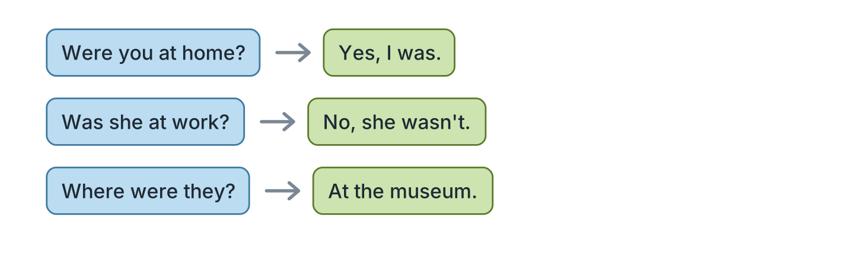
Figure 10.9 · Questions about the past.
- Were you at home? ✓ — Yes, I was. (example)
- Was she at work? ✗ — ______________
- Were they at the park? ✓ — ______________
- Where were they? (museum) — ______________
2F Find the mistake. Write the correct word.
- I were at home. — was (example)
- They was at school. — ______________
- Was you at the beach? — ______________
- She weren’t tired. — ______________
Part 3 · Listening
3A Listen. Look at Figure 10.10. Write the number.
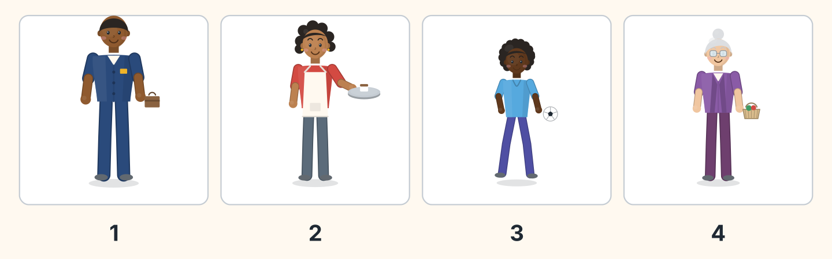
Figure 10.10 · Four people last weekend.
- Sam — 1 (example)
- Nadia — ______
- Omar — ______
- Rosa — ______
3B Listen. Look at Figure 10.11. Write yes or no.
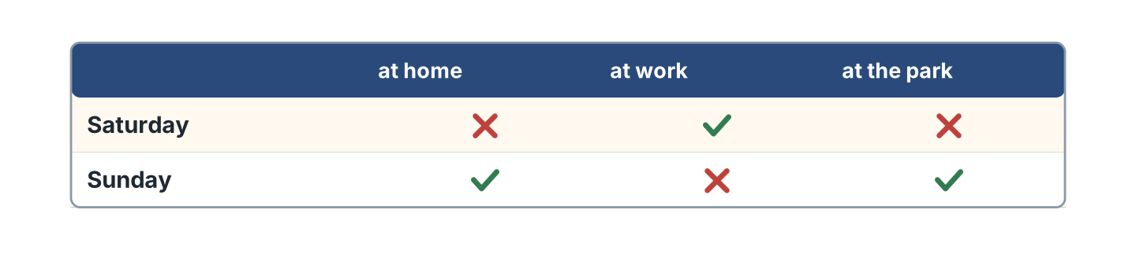
Figure 10.11 · Where everyone was.
- On Saturday they were at work. — yes (example)
- On Saturday they were at home. — ______
- On Sunday they were at the park. — ______
- On Sunday they were at work. — ______
3C Listen. Look at Figure 10.12. Complete the week.
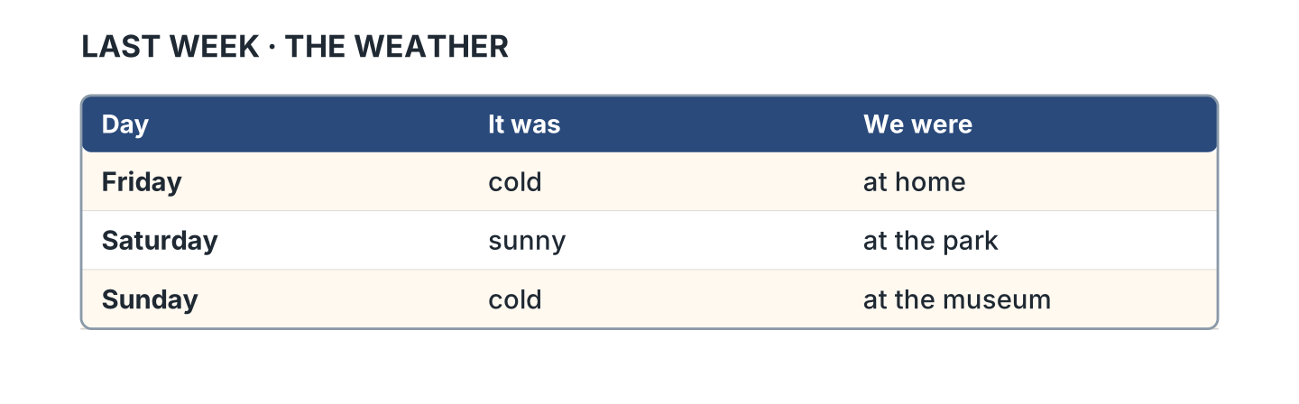
Figure 10.12 · The weather last week.
- On Friday it was cold. (cold) (example)
- On Saturday it was ______________.
- On Saturday they were at ______________.
- On Sunday they were at ______________.
3D Listen. Write was or were.
- was (example)
- ______________
- ______________
- ______________
Part 4 · Speaking
4A Look at Figure 10.13. Ask about the weekend.
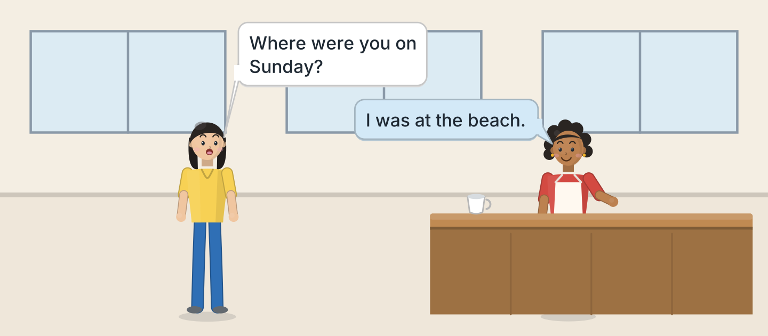
Figure 10.13 · Nadia asks about the weekend.
- A: Where were you on Sunday? B: I was at the beach. (example)
- Ask if the hotel and the cinema were open.
- Ask who they were with.
- Ask how it was.
4B Look at Figure 10.14. Ask and answer.
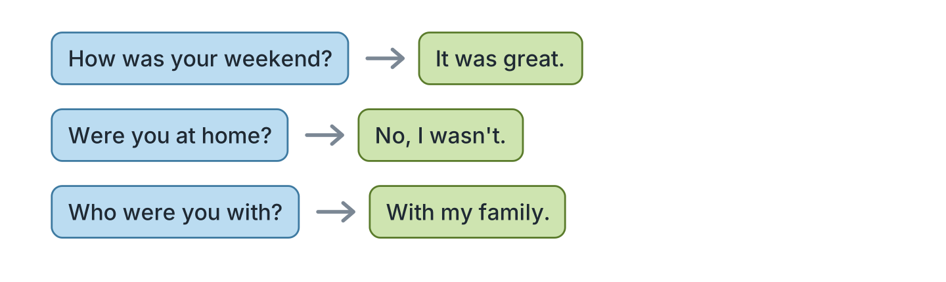
Figure 10.14 · Ask about the weekend.
- A: How was your weekend? B: It was great. (example)
- A: Were you at home? B: ______________
- A: Who were you with? B: ______________
- A: Where were you? B: ______________
4C Tell a friend about last Saturday.
- I was at the park with my family. (example)
- Say where you were.
- Say if you walked or bought a ticket.
- Say how it was.
4D Ask three friends about yesterday.
- A: Where were you yesterday? B: At work. (example)
- Ask if they could swim at the pool.
- Ask if their club was open.
- Ask how it was.
Part 5 · Reading
5A Look at Figure 10.15. Answer the questions.
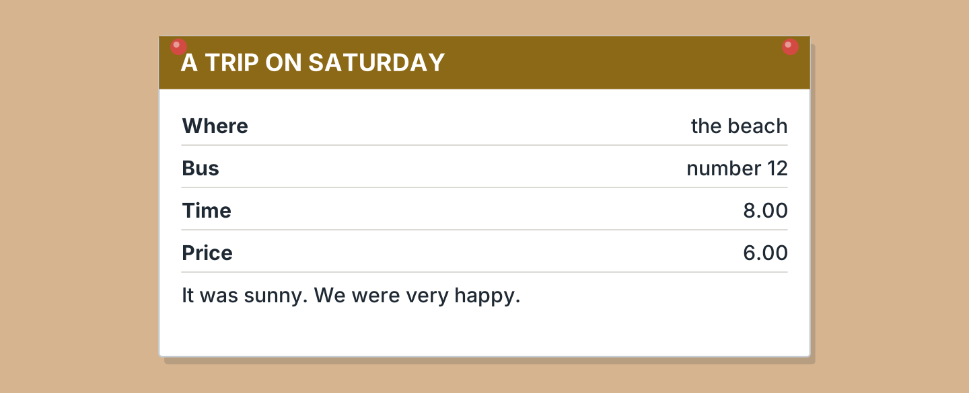
Figure 10.15 · A note about a trip.
- Where was the trip? — the beach (example)
- Which bus was it? — ______________
- What time was it? — ______________
- How much was it? — ______________
5B Look at Figure 10.15. Write yes or no.
- The trip was on Saturday. — yes (example)
- It was cold. — ______
- The bus was number 14. — ______
- They were happy. — ______
5C Look at Figure 10.16. Choose the correct answer.
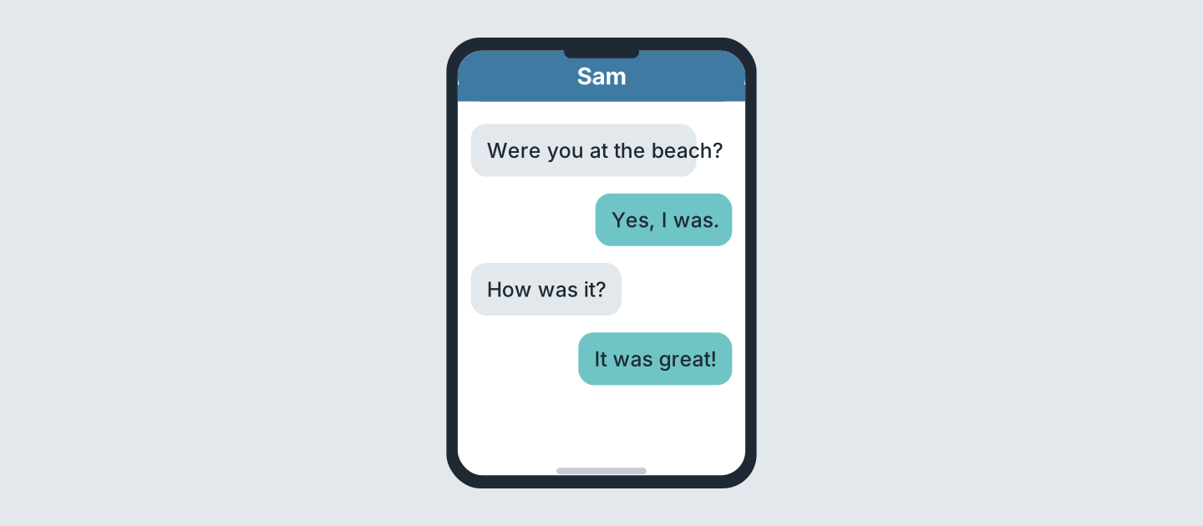
Figure 10.16 · Messages after the weekend.
- Who starts? (a) a friend (b) Sam (c) Lili — a (example)
- Where was Sam? (a) home (b) beach (c) park
- How was it? (a) great (b) cold (c) bad
- Was Sam at the beach? (a) yes (b) no (c) maybe
5D Read and correct. Write the correct word.
- The trip was on Sunday. — Saturday (example)
- The bus was at nine. — ______________
- The trip was ten pounds. — ______________
- It was cold at the beach. — ______________
Part 6 · Writing
6A Look at Figure 10.17. Complete the form.
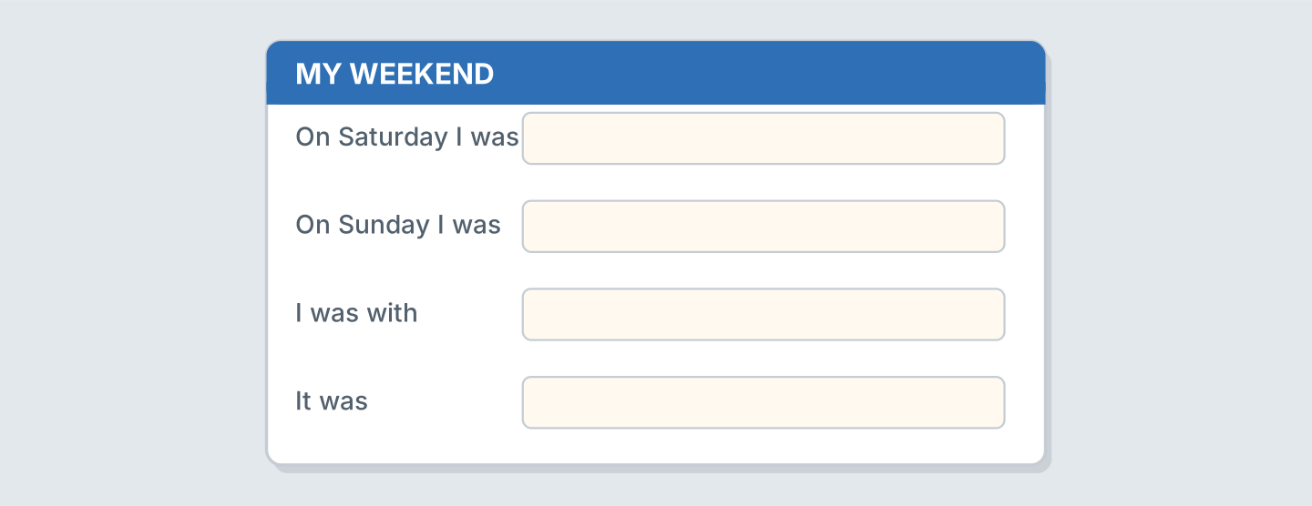
Figure 10.17 · A form about your weekend.
- On Saturday I was: at the park (example)
- On Saturday I was: ______________
- On Sunday I was: ______________
- I was with: ______________
6B Look at Figure 10.18. Write four lines.
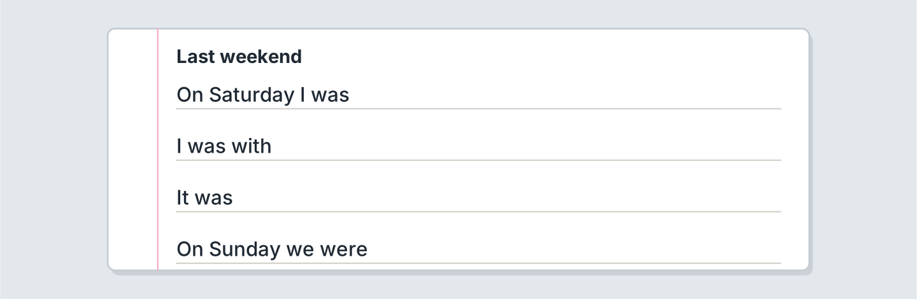
Figure 10.18 · Four lines about last weekend.
- On Saturday I was at the market. (example)
- On Saturday I was ______________.
- I was with ______________.
- The shop was ______________.
6C Write a message about your weekend. Write three lines.
- I was at the beach. It was sunny. (example)
- Say where you were.
- Say if the cafe was open.
- Say how you felt.
Part 7 · Real-World File
7A Look at Figure 10.19. Answer the questions.
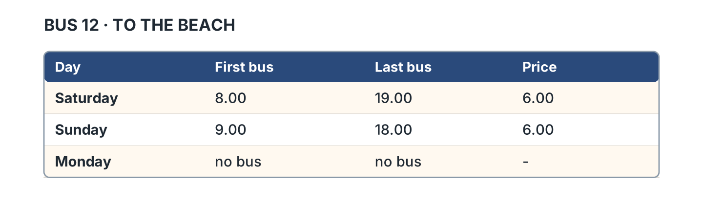
Figure 10.19 · The bus to the beach.
- When is the first bus on Saturday? — 8.00 (example)
- When is the last bus on Sunday? — ______________
- How much is the bus? — ______________
- Is there a bus on Monday? — ______
7B Look at Figure 10.20. Write the sentence.
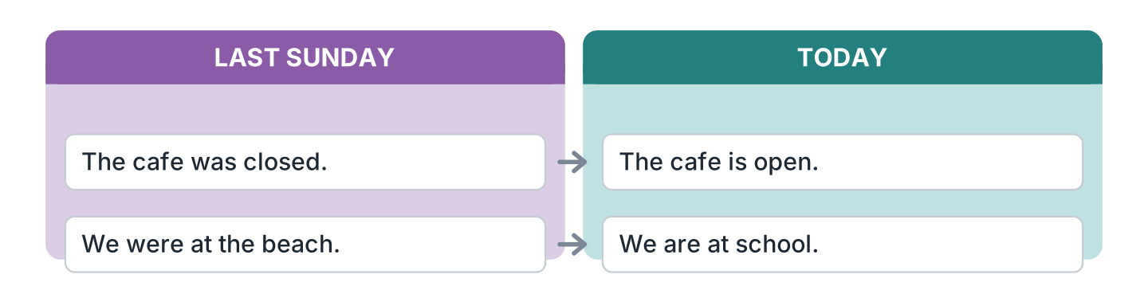
Figure 10.20 · Then and now.
- Last Sunday the cafe was closed. (closed) (example)
- Today the cafe is ______________.
- Last Sunday we were at ______________.
- Today we are at ______________.
7C Write about a trip you made.
- I was at the museum on Sunday. It was cheap. (example)
- Where: ______________
- When: ______________
- How it was: ______________
Part 8 · Review & Can-Do
8A Look at Figure 10.21. Write the word.
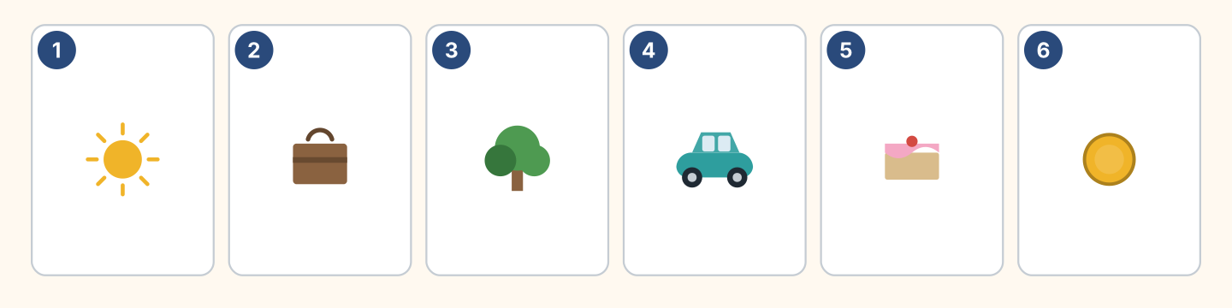
Figure 10.21 · Six things from this unit.
Words: cake · car · coin · suitcase · sun · tree
- 1 — sun (example)
- 2 — ______________
- 3 — ______________
- 4 — ______________
- 6 — ______________
8B Complete the conversation.
Words: was · Were · were · Where
- A: Where were you on Sunday? (Where) (example)
- B: I ______ at the beach.
- A: ______ you with your family?
- B: Yes, we ______ all there.
8C Write was or were.
- I was at home. (was) (example)
- They ______ at the park.
- She ______ tired.
- We ______ very happy.
8D Match the question and the answer.
Question | Answer
1 Where were you? | a It was great.
2 How was it? | b At the beach.
3 Were you alone? | c No, with my family.
4 When was the trip? | d On Saturday.
 | e Yes, I can.
One option is not needed.
- 1 — b (example)
- 2 — ______
- 3 — ______
- 4 — ______
8E Look at Figure 10.22. Tick what you can do.
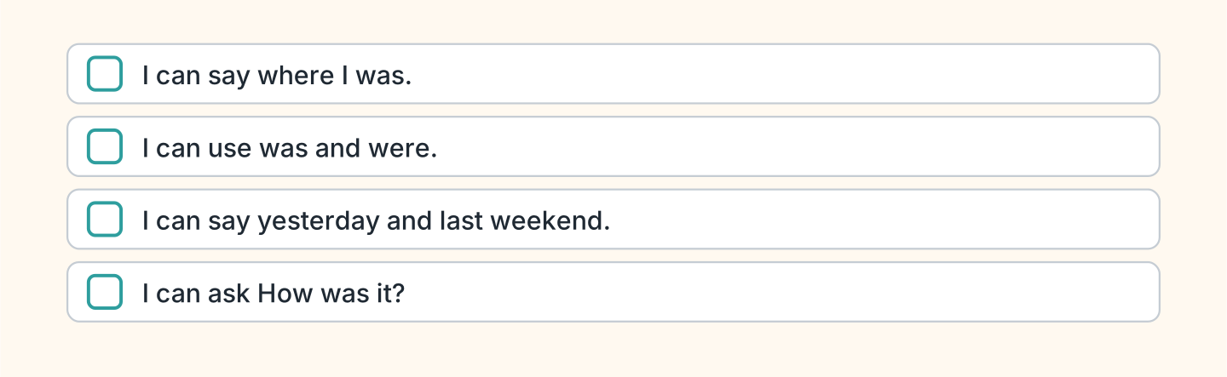
Figure 10.22 · What I can do.
- I can say where I was. — ✓ (example)
- I can use was and were. — ______
- I can say yesterday and last weekend. — ______
- I can ask How was it? — ______

Unit 11: A Day Out
In this unit you say what you did yesterday. You add ed to a verb.
Warm Up
W1 Look at Figure 11.1. Write the word.
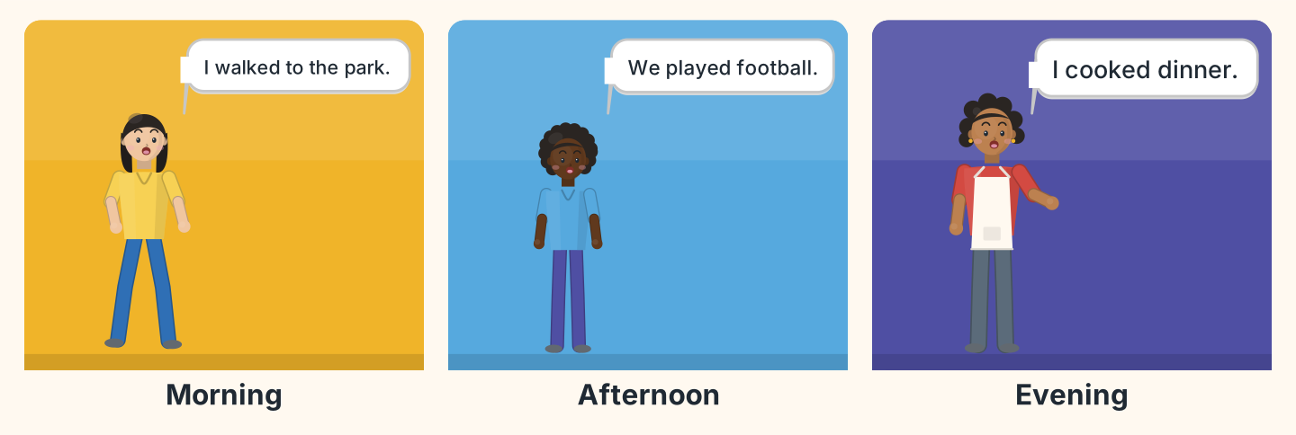
Figure 11.1 · A day out.
- Lili walked to the park. (walked) (example)
- Omar and his friends ______________ football.
- Nadia ______________ dinner.
- Who walked? — ______________
W2 Look at Figure 11.2. Write the word.
Words: ball · bike · cake · cup · sun · tree
- 1 — ball (example)
- 2 — ______________
- 4 — ______________
- 5 — ______________
- 6 — ______________
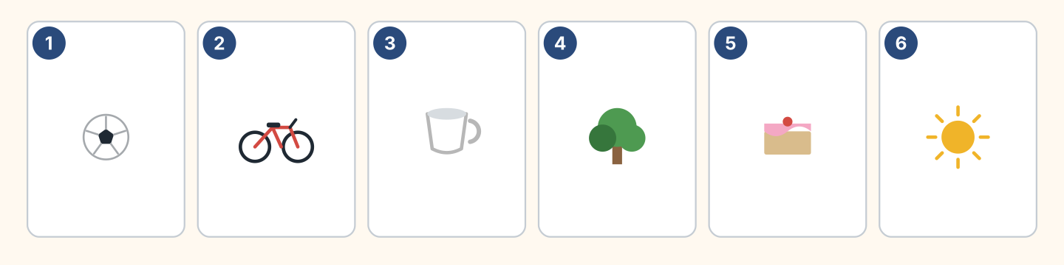
Figure 11.2 · Six things from the day.
W3 Say three things you did yesterday.
- Yesterday I walked to work. (example)
- Say one thing in the morning.
- Say one thing in the evening.
- Say if you were tired.
Part 1 · Words & Sounds
1A Look at Figure 11.3. Write the past form.
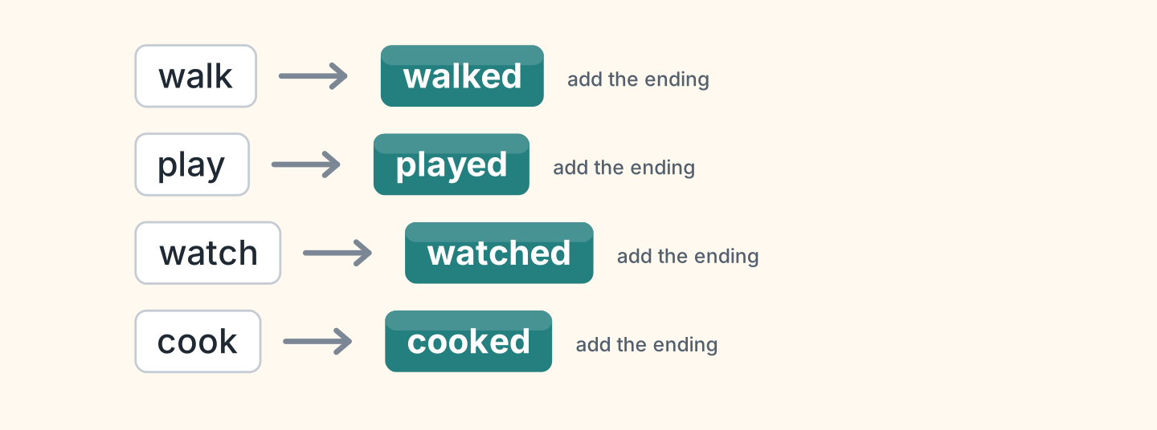
Figure 11.3 · Add the ending.
- walk — walked (example)
- play — ______________
- watch — ______________
- cook — ______________
- open — ______________
1B Look at Figure 11.4. Write the word in the correct box.
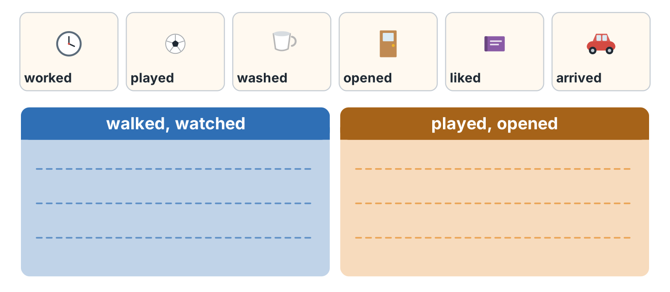
Figure 11.4 · Two endings to hear.
- worked — the first box (example)
- played — ______________
- washed — ______________
- arrived — ______________
1C Say it. Say these past forms.
- walked (example)
- played
- watched
- opened
- visited
1D Look at Figure 11.5. Write the name.
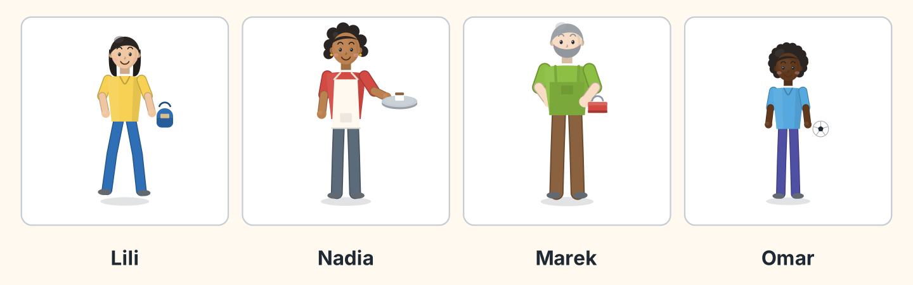
Figure 11.5 · Four people yesterday.
- She walked to the park. — Lili (example)
- She cooked dinner. — ______________
- He played football. — ______________
- He carried a toolbox. — ______________
1E Look at Figure 11.6. Answer the questions.
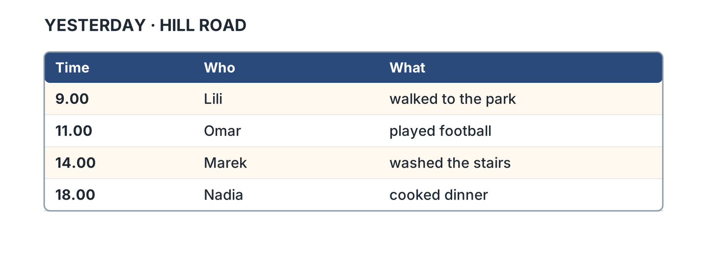
Figure 11.6 · What happened and when.
- What did Lili do? — she walked to the park (example)
- What did Omar do? — ______________
- When did Marek work? — ______________
- Who cooked dinner? — ______________
1F Write the past form.
- help — helped (example)
- ask — ______________
- listen — ______________
- wait — ______________
Part 2 · Grammar
2A Look at Figure 11.7. Complete the sentence.
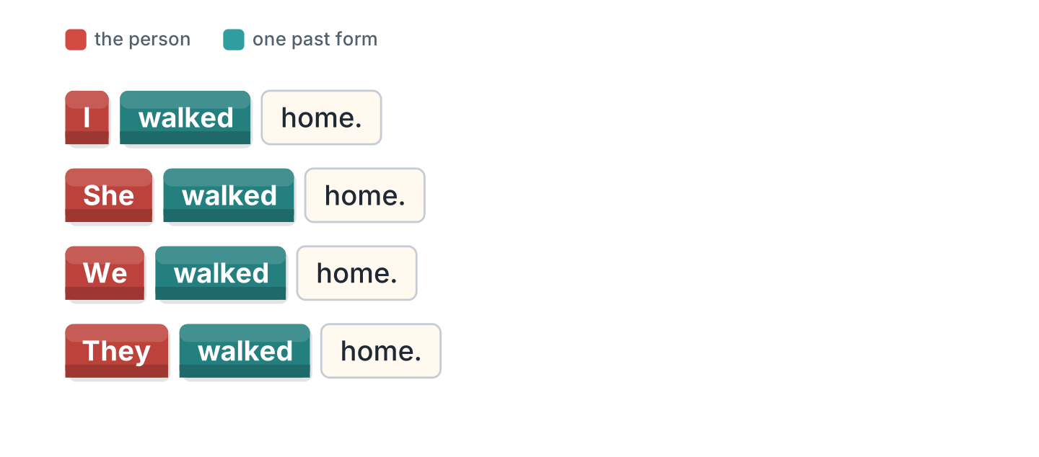
Figure 11.7 · The form does not change.
- I walked home. (walked) (example)
- She ______________ home.
- We ______________ home.
- They ______________ home.
2B Choose the correct word.
- I (walk / walked) home yesterday. — walked (example)
- She (play / played) football last week.
- We (cook / cooked) dinner yesterday.
- They (watch / watched) a film last night.
- He (open / opened) the shop at eight.
2C Look at Figure 11.8. Write the short form.

Figure 11.8 · The short negative.
- did not — didn’t (example)
- I did not walk. — ______________
- She did not play. — ______________
2D Write the negative.
- I walked home. — I didn’t walk home. (example)
- She played football. — ______________
- We watched a film. — ______________
- They cooked dinner. — ______________
2E Look at Figure 11.9. Write the answer.
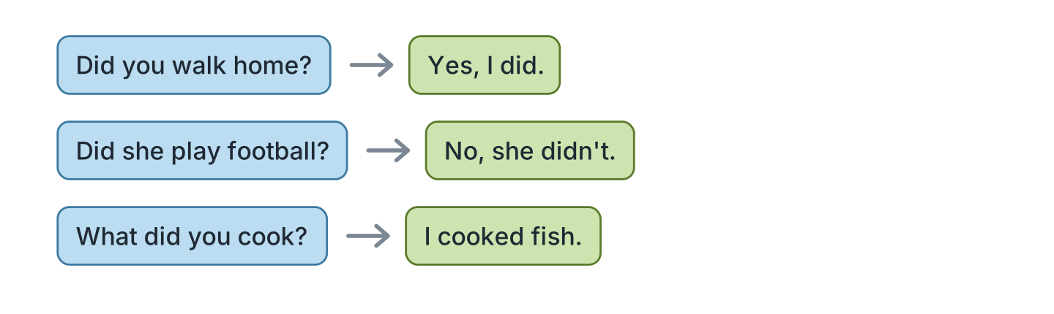
Figure 11.9 · Questions about yesterday.
- Did you walk home? ✓ — Yes, I did. (example)
- Did she play football? ✗ — ______________
- Did they cook dinner? ✓ — ______________
- What did you cook? (fish) — ______________
2F Find the mistake. Write the correct words.
- I walk home yesterday. — walked (example)
- She didn’t walked home. — ______________
- Did you played football? — ______________
- We no watched a film. — ______________
Part 3 · Listening
3A Listen. Look at Figure 11.10. Write the number.
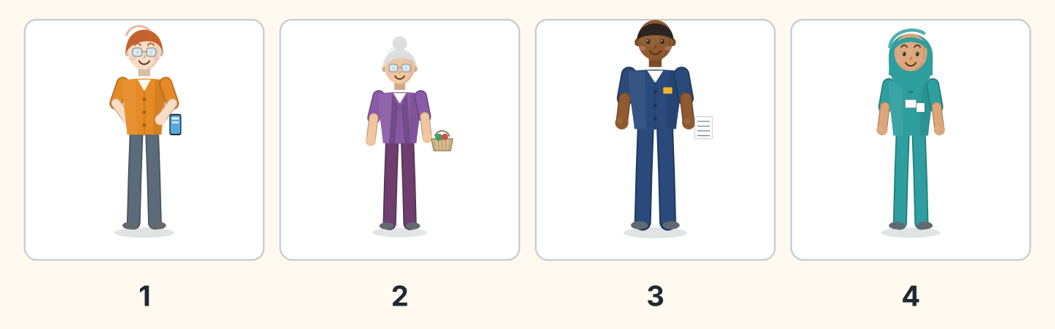
Figure 11.10 · Four voices.
- Ben — 1 (example)
- Rosa — ______
- Sam — ______
- Fatima — ______
3B Listen. Look at Figure 11.11. Complete the day.
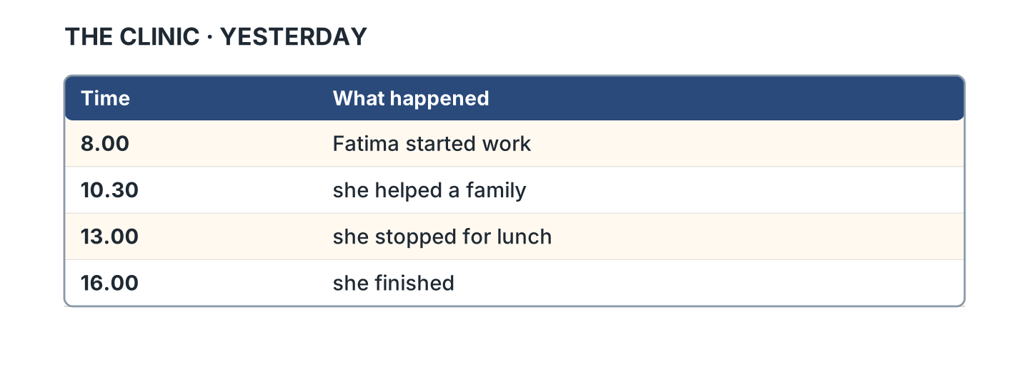
Figure 11.11 · The day at the clinic.
- Fatima started work at eight. (eight) (example)
- She helped a family at ______________.
- She stopped for ______________.
- She finished at ______________.
3C Listen. Look at Figure 11.12. Write the number.
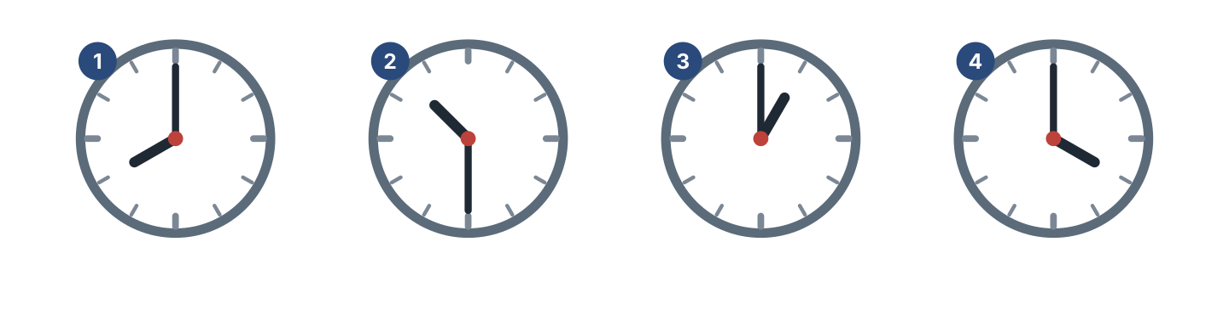
Figure 11.12 · Four times to hear.
- eight o’clock — 1 (example)
- half past ten — ______
- one o’clock — ______
- four o’clock — ______
3D Listen. Write the past form you hear.
- walked (example)
- ______________
- ______________
- ______________
Part 4 · Speaking
4A Look at Figure 11.13. Talk about yesterday.
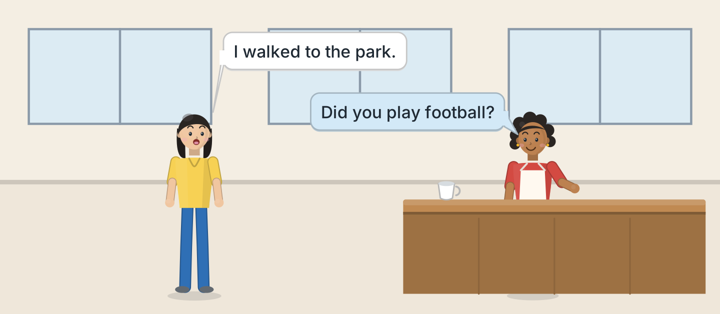
Figure 11.13 · Lili talks about the day.
- A: I walked to the park. B: Did you play football? (example)
- Say which road you walked to.
- Ask your friend about the museum.
- Say what you cooked for dinner.
4B Look at Figure 11.14. Ask and answer.
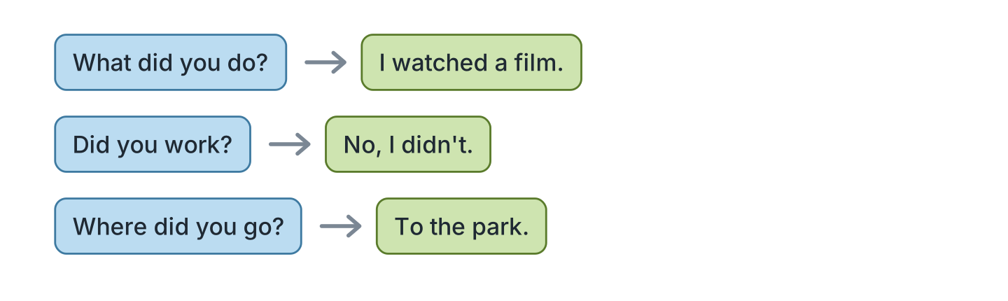
Figure 11.14 · Ask about yesterday.
- A: What did you do? B: I watched a film. (example)
- A: Did you work? B: ______________
- A: Where did you go? B: ______________
- A: Who did you see? B: ______________
4C Ask three friends about the weekend.
- A: Did you stay at home? B: Yes, I did. (example)
- Ask about the shop on Saturday.
- Ask about the market.
- Ask if the market was open.
4D Say four things your family did last week.
- My sister visited our grandmother and cooked rice. (example)
- ______________
- ______________
- ______________
Part 5 · Reading
5A Look at Figure 11.15. Answer the questions.
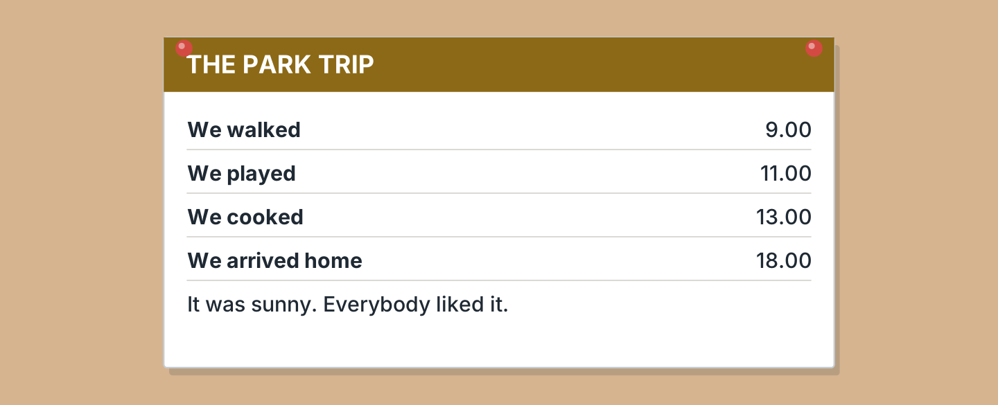
Figure 11.15 · A note about the trip.
- When did they walk? — at nine (example)
- When did they play? — ______________
- When did they arrive home? — ______________
- How was the weather? — ______________
5B Look at Figure 11.15. Write yes or no.
- They walked at nine. — yes (example)
- They cooked at eleven. — ______
- The weather was cold. — ______
- Everybody liked it. — ______
5C Look at Figure 11.16. Choose the correct answer.
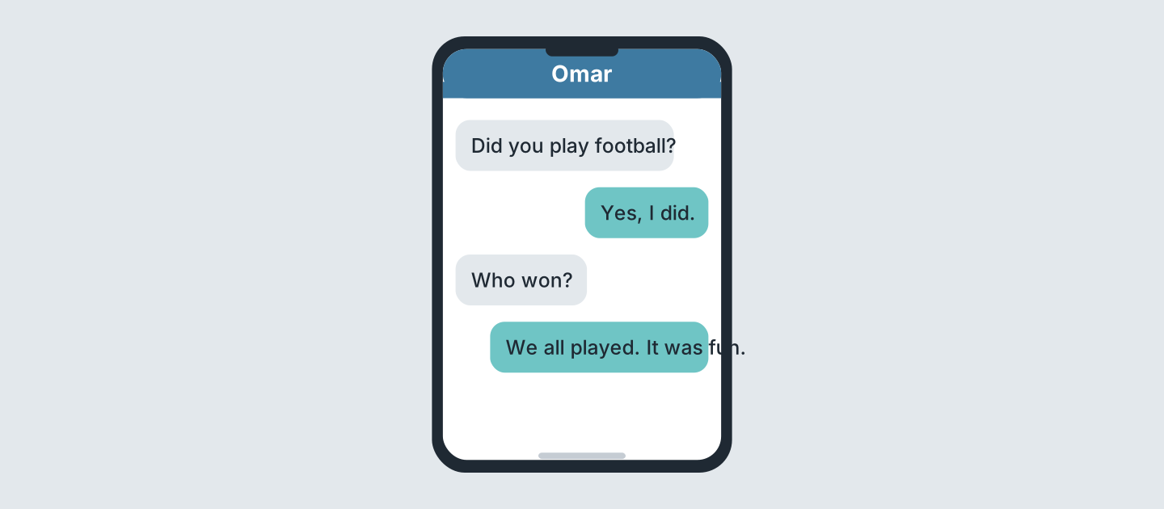
Figure 11.16 · Messages after the day.
- Who begins? (a) a friend (b) Omar (c) Lili — a (example)
- Did Omar play? (a) yes (b) no (c) perhaps
- Who won? (a) Omar (b) nobody (c) everybody
- How was it? (a) fun (b) cold (c) long
5D Read and correct. Write the correct word.
- They walked at ten. — nine (example)
- They arrived home at six in the morning. — ______________
- It was cold at the park. — ______________
- They played at one. — ______________
Part 6 · Writing
6A Look at Figure 11.17. Complete the form.
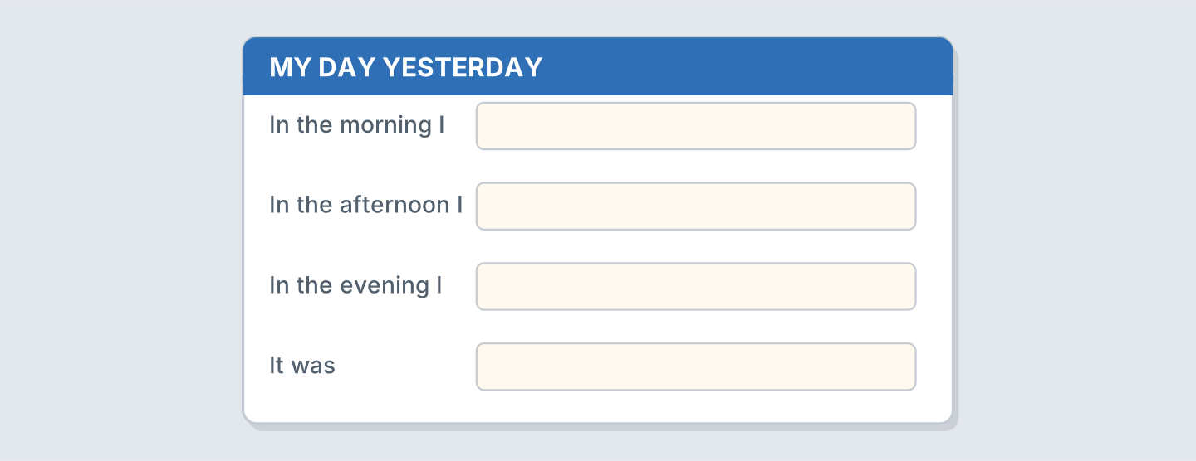
Figure 11.17 · A form about yesterday.
- In the morning I: walked to work (example)
- In the morning I: ______________
- In the evening I: ______________
- It was: ______________
6B Look at Figure 11.18. Write four lines.
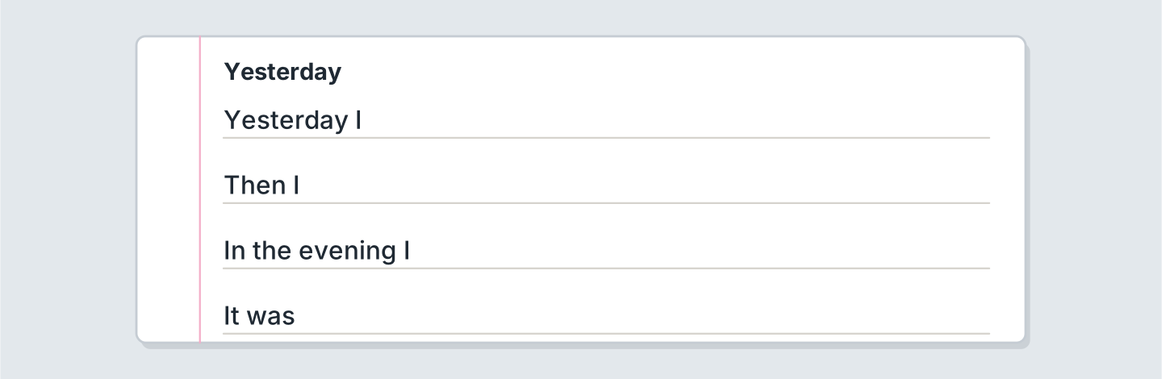
Figure 11.18 · Four lines about yesterday.
- Yesterday I walked to the shop. (example)
- Yesterday I ______________.
- Then I ______________.
- The weather was ______________.
6C Write about a day out. Write three lines.
- We walked to the park near the library. (example)
- Say where you walked.
- Say what you did.
- Say if the shop was busy.
Part 7 · Real-World File
7A Look at Figure 11.19. Answer the questions.
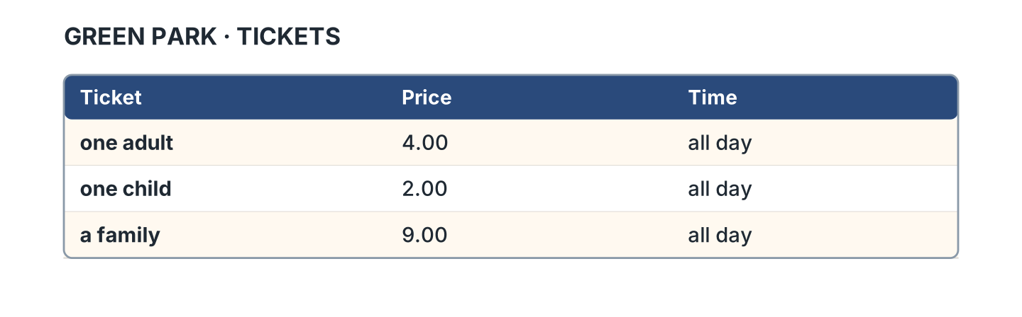
Figure 11.19 · The ticket for the park.
- How much is one adult? — 4.00 (example)
- How much is one child? — ______________
- How much is a family? — ______________
- How long is a ticket for? — ______________
7B Look at Figure 11.20. Write the sentence.
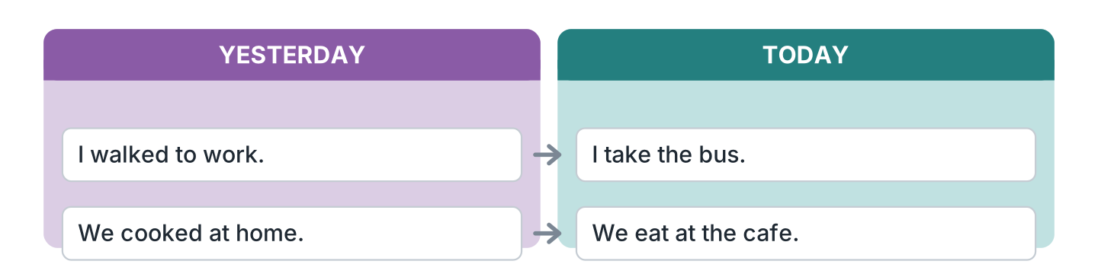
Figure 11.20 · Yesterday and today.
- Yesterday I walked to work. (walked) (example)
- Today I ______________ the bus.
- Yesterday we ______________ at home.
- Today we ______________ at the cafe.
7C Write a ticket for a place you know.
- One adult · 4.00 · all day (example)
- Place: ______________
- Price: ______________
- Time: ______________
Part 8 · Review & Can-Do
8A Look at Figure 11.21. Write the word.
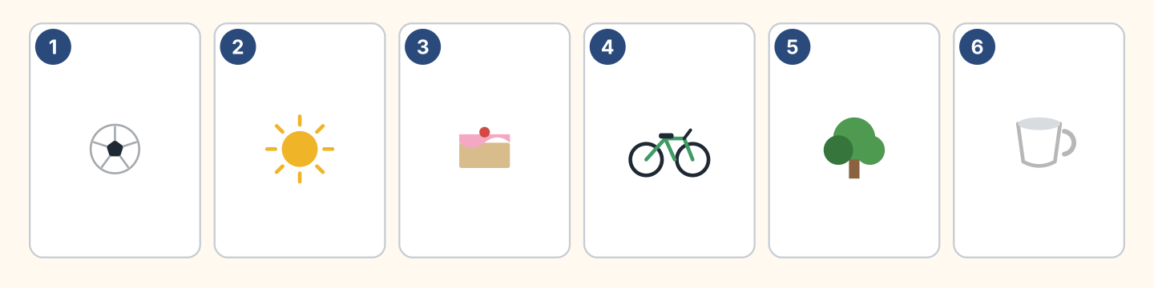
Figure 11.21 · Six things from this unit.
Words: ball · bike · cake · cup · sun · tree
- 1 — ball (example)
- 2 — ______________
- 3 — ______________
- 4 — ______________
- 5 — ______________
8B Complete the conversation.
Words: did · didn’t · Did · walked
- A: Did you go out yesterday? (Did) (example)
- B: Yes, I ______. I ______ to the park.
- A: ______ you play football?
- B: No, I ______.
8C Write the past form.
- visit — visited (example)
- wash — ______________
- close — ______________
- carry — ______________
8D Match the question and the answer.
Question | Answer
1 What did you do? | a Yes, I did.
2 Did you walk? | b I watched a film.
3 Where did you go? | c To the park.
4 How was it? | d It was fun.
 | e She’s a nurse.
One option is not needed.
- 1 — b (example)
- 2 — ______
- 3 — ______
- 4 — ______
8E Look at Figure 11.22. Tick what you can do.
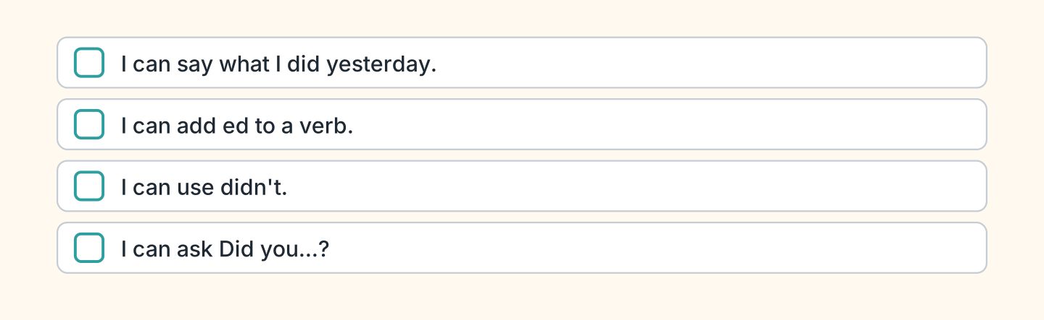
Figure 11.22 · What I can do.
- I can say what I did yesterday. — ✓ (example)
- I can add ed to a verb. — ______
- I can use didn’t. — ______
- I can ask Did you…? — ______

Unit 12: Last Year
In this unit you use went, saw and had. You ask about the past.
Warm Up
W1 Look at Figure 12.1. Write the past form.
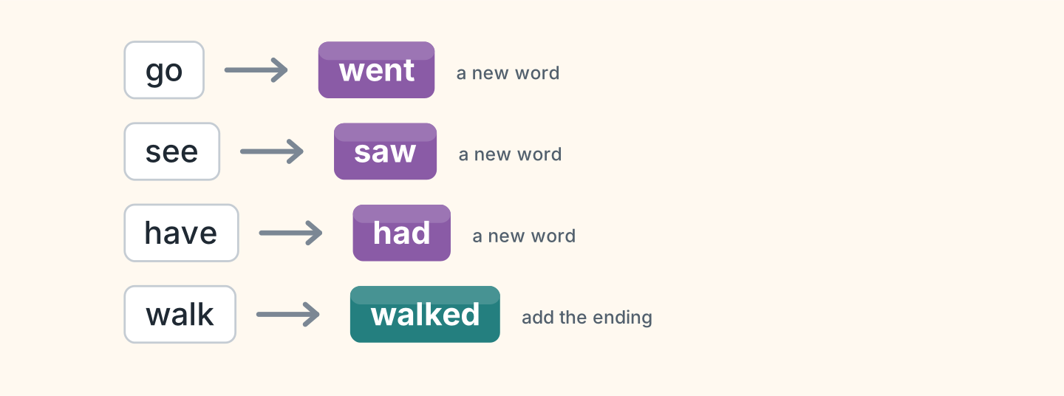
Figure 12.1 · Some verbs change.
- go — went (example)
- see — ______________
- have — ______________
- walk — ______________
W2 Look at Figure 12.2. Write the word.
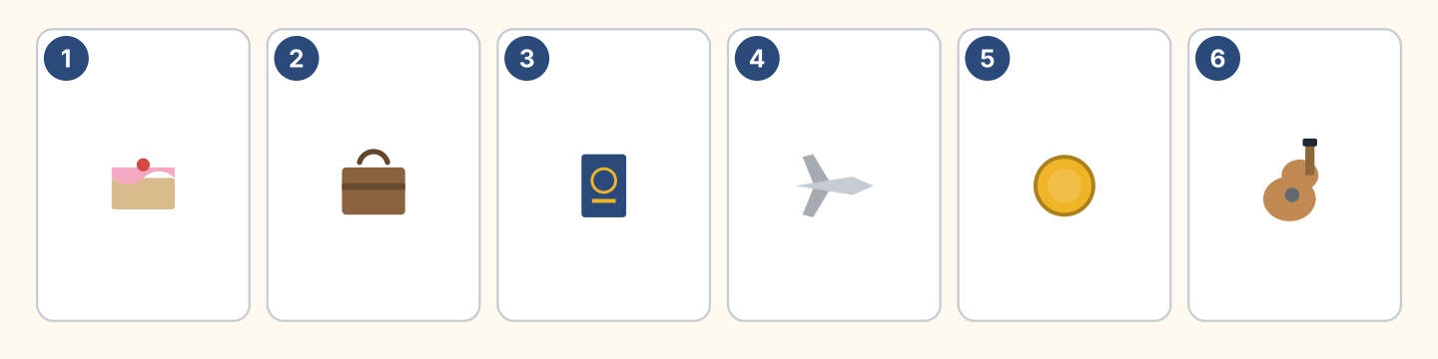
Figure 12.2 · Six things from last year.
Words: cake · coin · guitar · passport · plane · suitcase
- 1 — cake (example)
- 2 — ______________
- 3 — ______________
- 4 — ______________
- 6 — ______________
W3 Say three things you did last year.
- Last year I went to Spain. (example)
- Say where you went.
- Say who you saw.
- Say if the trip was long or short.
Part 1 · Words & Sounds
1A Look at Figure 12.3. Write the past form.
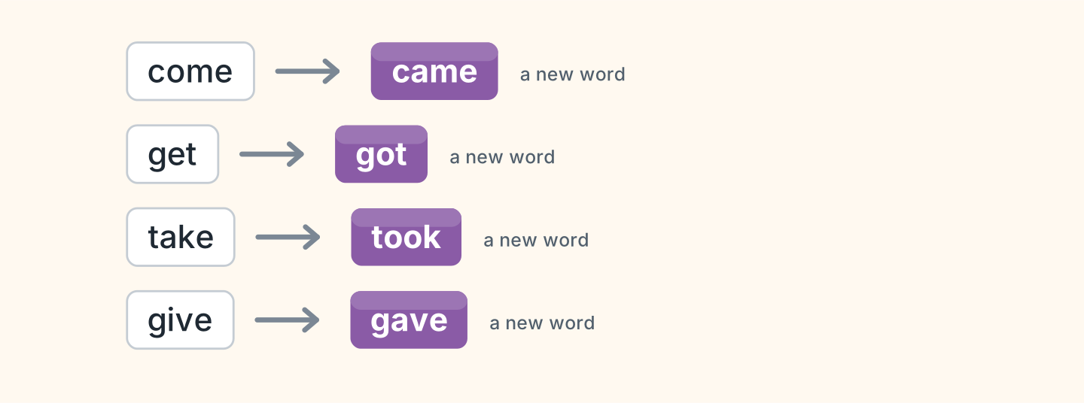
Figure 12.3 · Eight new past forms.
- come — came (example)
- get — ______________
- take — ______________
- give — ______________
1B Look at Figure 12.4. Write the word in the correct box.
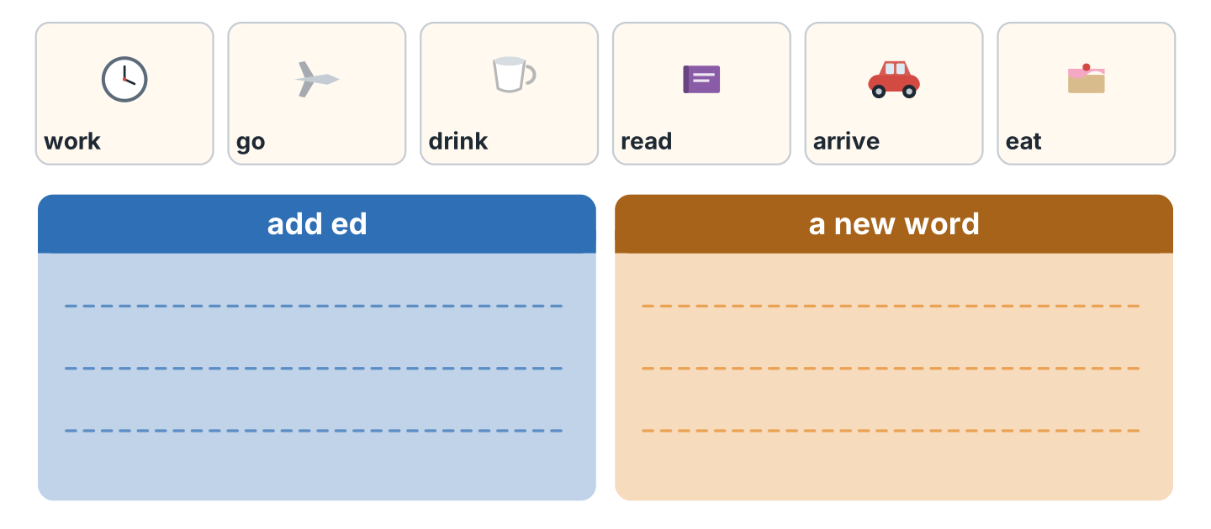
Figure 12.4 · Add it or change it.
- work — add ed (example)
- go — ______________
- drink — ______________
- arrive — ______________
1C Say it. Say these new past words.
- went (example)
- saw
- had
- took
- gave
1D Look at Figure 12.5. Write the name.
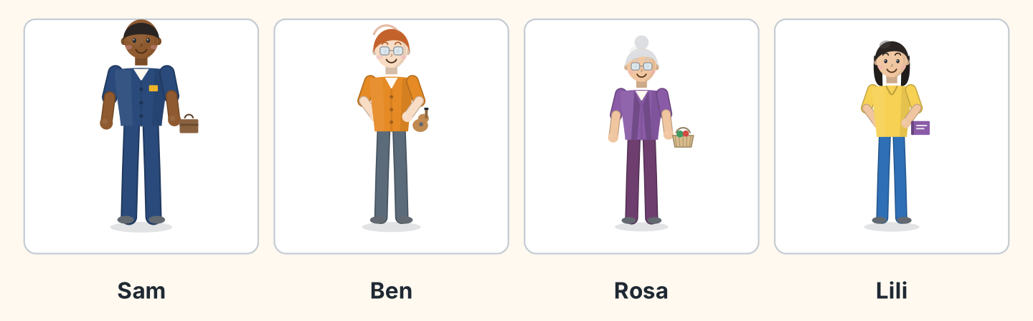
Figure 12.5 · Four people last year.
- He carried a suitcase. — Sam (example)
- He held a guitar. — ______________
- She carried a basket. — ______________
- She held a book. — ______________
1E Look at Figure 12.6. Answer the questions.
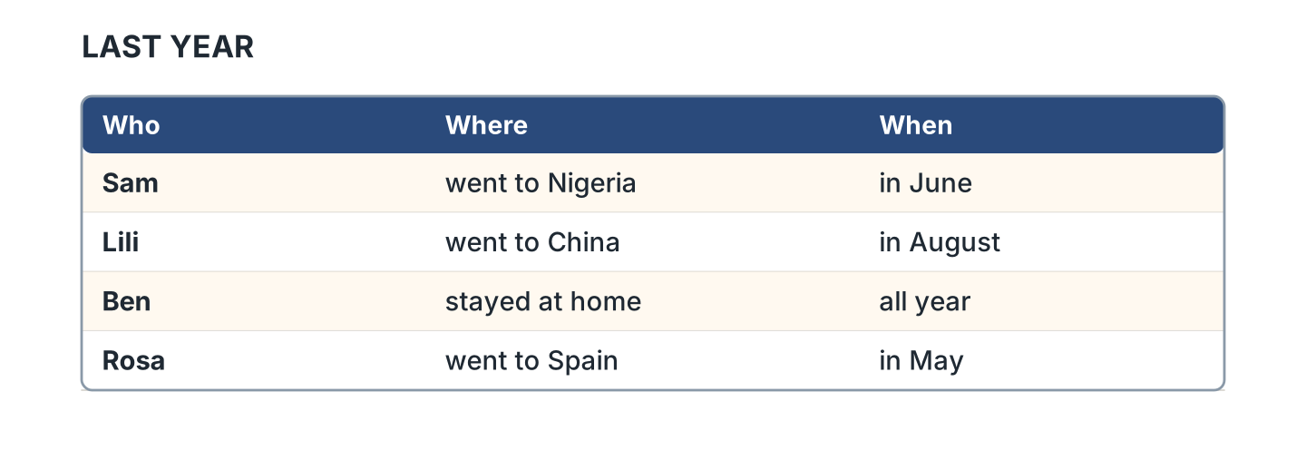
Figure 12.6 · Where people went.
- Where did Sam go? — to Nigeria (example)
- Where did Lili go? — ______________
- When did Rosa go? — ______________
- Who stayed at home? — ______________
1F Write the new past word.
- eat — ate (example)
- say — ______________
- meet — ______________
- find — ______________
Part 2 · Grammar
2A Look at Figure 12.7. Write the question.
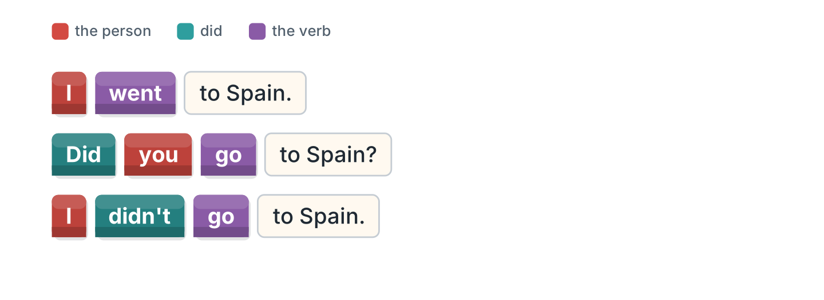
Figure 12.7 · Did and the plain verb.
- I went to Spain. — Did you go to Spain? (example)
- She saw the sea. — ______________
- They took a plane. — ______________
- He had a party. — ______________
2B Choose the correct verb.
- Did you (go / went) to Spain? — go (example)
- I (see / saw) my family.
- She didn’t (take / took) a plane.
- We (have / had) a good time.
- Did they (come / came) home?
2C Look at Figure 12.8. Write the answer.
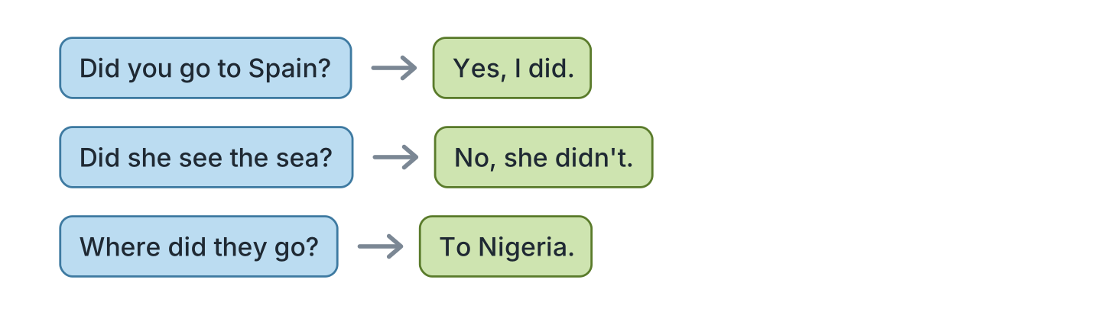
Figure 12.8 · Questions and answers.
- Did you go to Spain? ✓ — Yes, I did. (example)
- Did she see the sea? ✗ — ______________
- Did they take a plane? ✓ — ______________
- Where did they go? (Nigeria) — ______________
2D Write the sentence with didn’t.
- I went to Spain. — I didn’t go to Spain. (example)
- She saw the sea. — ______________
- We had a party. — ______________
- They took a plane. — ______________
2E Look at Figure 12.9. Write yes or no.
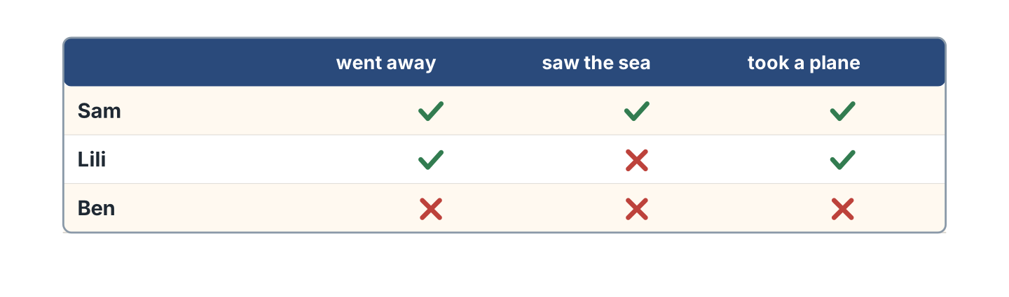
Figure 12.9 · Who did what.
- Sam went away. — yes (example)
- Lili saw the sea. — ______
- Ben took a plane. — ______
- Sam took a plane. — ______
2F Find the wrong verb. Write the correct one.
- Did you went to Spain? — go (example)
- I didn’t saw my family. — ______________
- She go to the beach. — ______________
- We taked a plane. — ______________
Part 3 · Listening
3A Listen. Look at Figure 12.10. Write the number.
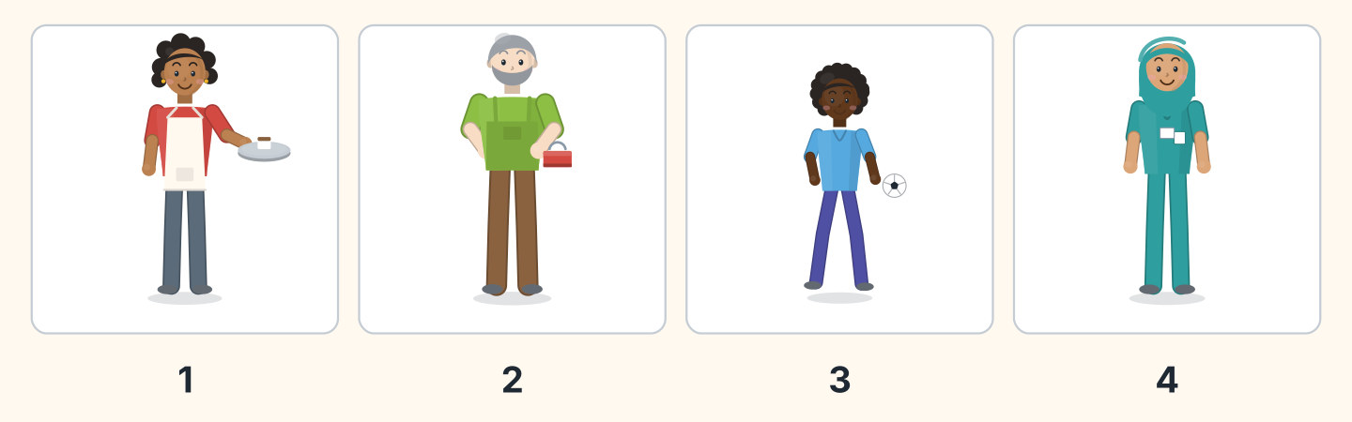
Figure 12.10 · Four voices about last year.
- Nadia — 1 (example)
- Marek — ______
- Omar — ______
- Fatima — ______
3B Listen. Look at Figure 12.11. Complete the lines.
Figure 12.11 · A birthday last year.
- Omar got a bike. (a bike) (example)
- They ate ______________.
- They gave him ______________.
- He was ______________.
3C Listen. Look at Figure 12.12. Write the number.
Figure 12.12 · Four ways to travel.
- a plane — 1 (example)
- a train — ______
- a boat — ______
- a car — ______
3D Listen. Write the new past word you hear.
- went (example)
- ______________
- ______________
- ______________
Part 4 · Speaking
4A Look at Figure 12.13. Ask about last year.
Figure 12.13 · Sam talks about last year.
- A: Where did you go last year? B: I went to Nigeria. (example)
- Ask which country your friend visited.
- Ask what they saw there.
- Ask if the food was good.
4B Look at Figure 12.14. Ask and answer.
Figure 12.14 · Ask about last year.
- A: Where did you go? B: I went to Spain. (example)
- A: Did you take a plane? B: ______________
- A: What did you see? B: ______________
- A: Who did you go with? B: ______________
4C Tell a friend about a birthday.
- I had a party at the restaurant. We ate a cake. (example)
- Say what you had for the party.
- Say what you ate and drank.
- Say who came and helped.
4D Ask three friends about a trip.
- A: Did you go away last year? B: Yes, I did. (example)
- Ask where.
- Ask how they went.
- Ask when they came home.
Part 5 · Reading
5A Look at Figure 12.15. Answer the questions.
Figure 12.15 · A letter about a trip.
- Where did Sam go? — to Nigeria (example)
- How did he go? — ______________
- Who did he see? — ______________
- When did he come home? — ______________
5B Look at Figure 12.15. Write yes or no.
- Sam went to Nigeria. — yes (example)
- He took a train. — ______
- He saw his family. — ______
- He came home in June. — ______
5C Look at Figure 12.16. Choose the correct answer.
Figure 12.16 · Messages about a party.
- What did they eat? (a) cake (b) fish (c) soup — a (example)
- Did Rosa go to it? (a) yes (b) no (c) maybe
- Who asks her? (a) a friend (b) Ben (c) Omar
- Where was Rosa? (a) home (b) work (c) the park
5D Read and correct. Write the correct word.
- Sam took a train. — plane (example)
- Sam came home in June. — ______________
- Sam went to Spain. — ______________
- Rosa came to the party. — ______________
Part 6 · Writing
6A Look at Figure 12.17. Complete the form.
Figure 12.17 · A form about last year.
- I went to: Spain (example)
- I went to: ______________
- I saw: ______________
- It was: ______________
6B Look at Figure 12.18. Write four lines.
Figure 12.18 · Four lines about last year.
- Last year I went to the sea and stayed a week. (example)
- Last year I went ______________.
- I saw ______________.
- The food was ______________.
6C Write a short letter about a trip. Write three lines.
- I went to the mountains and walked all day. (example)
- Say which country you visited.
- Say what you watched or played.
- Say when you arrived home.
Part 7 · Real-World File
7A Look at Figure 12.19. Answer the questions.
Figure 12.19 · A plane ticket.
- Where does HR 12 go? — Lagos (example)
- Where does HR 20 go? — ______________
- What time is HR 31? — ______________
- Which day is HR 12? — ______________
7B Look at Figure 12.20. Write the sentence.
Figure 12.20 · Then and now.
- Last year I went by plane. (went) (example)
- This year I ______________ by bus.
- Last year we ______________ at home.
- This year we ______________ at the cafe.
7C Write a ticket for a trip you want.
- HR 12 · Lagos · Monday · 07.40 (example)
- To: ______________
- Day: ______________
- Time: ______________
Part 8 · Review & Can-Do
8A Look at Figure 12.21. Write the word.
Figure 12.21 · Six things from this unit.
Words: boat · cake · passport · plane · suitcase · train
- 1 — passport (example)
- 2 — ______________
- 3 — ______________
- 4 — ______________
- 5 — ______________
8B Complete the conversation.
Words: did · Did · saw · went
- A: Did you go away last year? (Did) (example)
- B: Yes, I ______. I ______ to Spain.
- A: What ______ you see?
- B: I ______ the sea.
8C Write the past form.
- drink — drank (example)
- write — ______________
- know — ______________
- sleep — ______________
8D Match the question and the answer.
Question | Answer
1 Where did you go? | a Yes, I did.
2 Did you take a plane? | b To Nigeria.
3 What did you see? | c My family.
4 When did you come home? | d In July.
 | e It’s a bike.
One option is not needed.
- 1 — b (example)
- 2 — ______
- 3 — ______
- 4 — ______
8E Look at Figure 12.22. Tick what you can do.
Figure 12.22 · What I can do.
- I can use went, saw, had and got. — ✓ (example)
- I can ask about a country. — ______
- I can say what I did last year. — ______
- I can tell a friend about a trip. — ______

Unit 13: Right Now
In this unit you say what is happening now. You add ing to a verb.
Warm Up
W1 Look at Figure 13.1. Answer the questions.
Figure 13.1 · The class right now.
- What is Lili doing? — she is writing (example)
- Who is asking the question? — ______________
- Where are they? — ______________
- How many people are sitting? — ______________
W2 Look at Figure 13.2. Write the word.
Figure 13.2 · Six things people wear.
Words: coat · dress · hat · shirt · shoes · trousers
- 1 — shirt (example)
- 2 — ______________
- 3 — ______________
- 5 — ______________
- 6 — ______________
W3 Say what three people near you are doing.
- My friend is reading. She watched a film and waited. (example)
- Say what one person near you is doing.
- Say what you are wearing and where you bought it.
- Say if the market and the restaurant are open.
Part 1 · Words & Sounds
1A Look at Figure 13.3. Write the ing form.
Figure 13.3 · Adding ing.
- work — working (example)
- read — ______________
- wait — ______________
- sit — ______________
1B Look at Figure 13.4. Write the name.
Figure 13.4 · Four people doing things.
- She is carrying a tray. — Nadia (example)
- He is holding a phone. — ______________
- She is carrying a basket. — ______________
- He is holding a toolbox. — ______________
1C Look at Figure 13.5. Write the word.
Figure 13.5 · What they are wearing.
Words: coat · dress · hat · shirt
- 1 — hat (example)
- 2 — ______________
- 3 — ______________
- 4 — ______________
1D Say it. Say these ing forms.
- working (example)
- reading
- sitting
- running
- waiting
1E Look at Figure 13.6. Answer the questions.
Figure 13.6 · Who is doing what.
- What is Nadia doing? — she is cooking (example)
- What is Sam doing? — ______________
- Where is Lili? — ______________
- Who is running? — ______________
1F Write the ing form.
- cook — cooking (example)
- eat — ______________
- drink — ______________
- sleep — ______________
Part 2 · Grammar
2A Look at Figure 13.7. Complete with am, is or are.
Figure 13.7 · be plus ing.
- I am reading. (am) (example)
- She ______ reading.
- They ______ reading.
- We ______ waiting.
2B Choose the correct word.
- I (am / is) working. — am (example)
- She (is / are) cooking.
- They (is / are) waiting.
- He (am / is) reading.
- We (is / are) sitting.
2C Look at Figure 13.8. Write the sentence for now.
Figure 13.8 · Every day and right now.
- I work at the cafe. — I’m working now. (example)
- She reads every day. — ______________
- They play on Monday. — ______________
- We cook every evening. — ______________
2D Write the negative.
- I am working. — I’m not working. (example)
- She is cooking. — ______________
- They are waiting. — ______________
- He is reading. — ______________
2E Look at Figure 13.9. Write the answer.
Figure 13.9 · Questions about now.
- What are you doing? (wait) — I’m waiting. (example)
- Is she working? ✓ — ______________
- Are they eating? ✗ — ______________
- What are you reading? (a book) — ______________
2F Find the mistake. Write the correct words.
- I working now. — am working (example)
- She is cook dinner. — ______________
- They is waiting. — ______________
- He no is reading. — ______________
Part 3 · Listening
3A Listen. Look at Figure 13.10. Write the number.
Figure 13.10 · Four people to find.
- Lili — 1 (example)
- Sam — ______
- Omar — ______
- Nadia — ______
3B Listen. Look at Figure 13.11. Write yes or no.
Figure 13.11 · A moment in the class.
- Omar is listening. — yes (example)
- Fatima is sitting. — ______
- Two people are sitting. — ______
- Omar is writing. — ______
3C Listen. Look at Figure 13.12. Write the place.
Figure 13.12 · Where everyone is.
- Ben — in the shop (example)
- Fatima — ______________
- Marek — ______________
- Rosa — ______________
3D Listen. Write the ing form you hear.
- waiting (example)
- ______________
- ______________
- ______________
Part 4 · Speaking
4A Look at Figure 13.13. Ask what is happening.
Figure 13.13 · Ben on the phone.
- A: What are you doing? B: I’m waiting for the bus. (example)
- Ask what your friend is cooking, soup or fish.
- Say what you are doing at this moment.
- Say who visited and helped you yesterday.
4B Look at Figure 13.14. Ask and answer.
Figure 13.14 · Ask what is happening.
- A: What are you doing? B: I’m cooking. (example)
- A: Where is he walking? B: ______________
- A: Are you working today? B: ______________
- A: What are you wearing? B: ______________
4C Say what four people in your class are doing.
- Lili is reading a book. Yesterday she walked here. (example)
- ______________
- ______________
- ______________
4D Describe what a friend is wearing.
- She is wearing a red coat. She took it to the party. (example)
- Say one thing they are wearing.
- Say the colour of it.
- Ask if they are cold.
Part 5 · Reading
5A Look at Figure 13.15. Answer the questions.
Figure 13.15 · A notice on the door.
- What is Nadia doing? — she is cooking (example)
- What is Ben doing? — ______________
- Is the cafe open? — ______________
- Who are they waiting for? — ______________
5B Look at Figure 13.15. Write yes or no.
- Nadia is cooking. — yes (example)
- The cafe is closed. — ______
- Ben is helping. — ______
- They are waiting for you. — ______
5C Look at Figure 13.16. Choose the correct answer.
Figure 13.16 · Messages right now.
- Where is Lili? (a) home (b) school (c) shop — a (example)
- What is Lili doing? (a) reading (b) cooking (c) waiting
- Where is the friend? (a) home (b) the bus stop (c) school
- Is Lili going out? (a) yes (b) no (c) perhaps
5D Read and correct. Write the correct word.
- Lili is cooking at home. — reading (example)
- The friend is waiting at the shop. — ______________
- Nadia is washing in the cafe. — ______________
- The cafe is closed. — ______________
Part 6 · Writing
6A Look at Figure 13.17. Complete the form.
Figure 13.17 · A form about right now.
- I am: sitting in the class (example)
- I am: ______________
- I am wearing: ______________
- Outside it is: ______________
6B Look at Figure 13.18. Write four lines.
Figure 13.18 · Four lines about now.
- I’m sitting in the kitchen. I came home and gave it back. (example)
- I’m sitting in ______________.
- I’m wearing ______________.
- Outside it is ______________.
6C Write a message about this moment. Write three lines.
- I’m waiting. I walked here and found my ticket. (example)
- Say where you are and how you came here.
- Say what you are doing.
- Ask if your friend got a ticket.
Part 7 · Real-World File
7A Look at Figure 13.19. Answer the questions.
Figure 13.19 · The board at the station.
- What is train A12 doing? — waiting (example)
- What is train B40 doing? — ______________
- Which train is late? — ______________
- What time is train B40? — ______________
7B Look at Figure 13.20. Write the word.
Figure 13.20 · Three ways to travel now.
Words: bike · car · train
- 1 — train (example)
- 2 — ______________
- 3 — ______________
- Which one has two wheels? — ______________
7C Write three lines for a station board.
- A12 · the city · 14.05 · waiting (example)
- ______________
- ______________
- ______________
Part 8 · Review & Can-Do
8A Look at Figure 13.21. Write the word.
Figure 13.21 · Six things from this unit.
Words: coat · dress · hat · shirt · shoes · trousers
- 1 — shirt (example)
- 2 — ______________
- 4 — ______________
- 5 — ______________
- 6 — ______________
8B Complete the conversation.
Words: am · are · doing · waiting
- A: What are you doing? (doing) (example)
- B: I ______ ______ for the bus.
- A: ______ you going to work?
- B: Yes, I am.
8C Write the ing form.
- sit — sitting (example)
- run — ______________
- write — ______________
- carry — ______________
8D Match the question and the answer.
Question | Answer
1 What are you doing? | a Yes, I am.
2 Are you working? | b I’m reading.
3 Where are you going? | c To the shop.
4 What is she wearing? | d A red coat.
 | e I went to Spain.
One option is not needed.
- 1 — b (example)
- 2 — ______
- 3 — ______
- 4 — ______
8E Look at Figure 13.22. Tick what you can do.
Figure 13.22 · What I can do.
- I can say what is happening now. — ✓ (example)
- I can add ing to a verb. — ______
- I can ask What are you doing? — ______
- I can name six things people wear. — ______

Unit 14: Next Week
In this unit you say what you are going to do. You talk about next week.
Warm Up
W1 Look at Figure 14.1. Answer the questions.
Figure 14.1 · Lili’s week.
- What is she going to do on Monday? — see Nadia (example)
- What is on Tuesday? — ______________
- Which day has two things? — ______________
- Where is she going on Friday? — ______________
W2 Look at Figure 14.2. Write the word.
Figure 14.2 · Six things for a trip.
Words: bag · coin · passport · plane · suitcase · timetable
- 1 — suitcase (example)
- 2 — ______________
- 3 — ______________
- 5 — ______________
- 6 — ______________
W3 Say three things you are going to do next week.
- I’m going to visit my sister. Last year I stayed a week. (example)
- Say one thing you will visit.
- Say the day and the time.
- Say who is going with you.
Part 1 · Words & Sounds
1A Look at Figure 14.3. Complete the sentence.
Figure 14.3 · going to and a verb.
- I am going to visit Spain. (going to) (example)
- She is ______________ fly on Monday.
- We are ______________ stay a week.
- They are ______________ meet us.
1B Look at Figure 14.4. Write the word.
Figure 14.4 · Four ways to travel.
Words: boat · car · plane · train
- 1 — plane (example)
- 2 — ______________
- 3 — ______________
- 4 — ______________
1C Say it. Say these words.
- going to (example)
- tomorrow
- tonight
- soon
- later
1D Look at Figure 14.5. Write the name.
Figure 14.5 · Four people with plans.
- He is carrying a suitcase. — Sam (example)
- She is holding a book. — ______________
- She is carrying a tray. — ______________
- He is packing a bag. — ______________
1E Look at Figure 14.6. Answer the questions.
Figure 14.6 · When people are going.
- Where is Sam going? — Nigeria (example)
- When is Lili going? — ______________
- How is Rosa going? — ______________
- Who is going by car? — ______________
1F Write the time word.
- the day after today — tomorrow (example)
- this evening — ______________
- in a short time — ______________
- after this — ______________
Part 2 · Grammar
2A Look at Figure 14.7. Write the short form.
Figure 14.7 · The short forms.
- I am going — I’m going (example)
- She is going — ______________
- We are going — ______________
- They are going — ______________
2B Choose the correct form of be.
- I (am / is) going to fly. — am (example)
- She (is / are) going to stay.
- They (is / are) going to meet us.
- We (am / are) going to pack.
- He (is / are) going to book a ticket.
2C Look at Figure 14.8. Write the answer.
Figure 14.8 · Questions about plans.
- Are you going to fly? ✓ — Yes, I am. (example)
- Is she going to stay? ✗ — ______________
- Are they going to meet us? ✓ — ______________
- When are you going? (Monday) — ______________
2D Write the sentence with not.
- I’m going to fly. — I’m not going to fly. (example)
- She’s going to stay. — ______________
- They’re going to meet us. — ______________
- We’re going to pack. — ______________
2E Look at Figure 14.9. Write yes or no.
Figure 14.9 · Who is going where.
- Sam is going by plane. — yes (example)
- Lili is going by plane. — ______
- Rosa is going next week. — ______
- Lili is going next week. — ______
2F Find the missing word. Write it.
- I going to fly. — am going (example)
- She is going fly. — ______________
- They going to stay. — ______________
- Are you going to flying? — ______________
Part 3 · Listening
3A Listen. Look at Figure 14.10. Complete the week.
Figure 14.10 · A week to complete.
- On Monday I am going to work. (work) (example)
- On Wednesday I am going to ______________.
- On Friday I am going to ______________.
- Which day is free? — ______________
3B Listen. Look at Figure 14.11. Write the number.
Figure 14.11 · Four voices with plans.
- Rosa — 1 (example)
- Marek — ______
- Omar — ______
- Fatima — ______
3C Listen. Look at Figure 14.12. Write the time.
Figure 14.12 · The airport board.
- HR 12 — 07.40 (example)
- HR 20 — ______________
- HR 31 — ______________
- Which flight is first? — ______________
3D Listen. Write the day you hear.
- Monday (example)
- ______________
- ______________
- ______________
Part 4 · Speaking
4A Look at Figure 14.13. Talk about a plan.
Figure 14.13 · Sam packs a suitcase.
- A: I’m going to fly. B: Are you going to Lagos? (example)
- Say which country you will visit.
- Say the day you walked there before.
- Ask if your friend watched the film.
4B Look at Figure 14.14. Ask and answer.
Figure 14.14 · Ask about a plan.
- A: What is the plan? B: I’m going to Spain. (example)
- A: When are you going? B: ______________
- A: Are you going to fly? B: ______________
- A: Who are you going with? B: ______________
4C Ask three friends about the weekend.
- A: What are you going to do? B: I’m going to rest. (example)
- Ask about the first day.
- Ask about the last day.
- Ask who with.
4D Make a plan with a friend.
- We’re going to meet at the station and buy some food. (example)
- Say the place and what you will eat.
- Say the time you are waiting.
- Say how you are going.
Part 5 · Reading
5A Look at Figure 14.15. Answer the questions.
Figure 14.15 · A plan on the board.
- Where is the trip? — the beach (example)
- When is it? — ______________
- What does a ticket cost? — ______________
- Where are they going to meet? — ______________
5B Look at Figure 14.15. Write yes or no.
- The trip is to the beach. — yes (example)
- The trip is on Sunday. — ______
- They are going by train. — ______
- The trip is free. — ______
5C Look at Figure 14.16. Choose the correct answer.
Figure 14.16 · Messages about a plan.
- Where is Sam going? (a) beach (b) city (c) park — a (example)
- When is Sam going? (a) Friday (b) Saturday (c) Sunday
- How is he going? (a) bus (b) car (c) train
- What will he book? (a) room (b) ticket (c) car
5D Read and correct. Write the correct word.
- The trip is on Sunday. — Saturday (example)
- The trip is nine pounds. — ______________
- They are going by bus. — ______________
- They are going to meet at the school. — ______________
Part 6 · Writing
6A Look at Figure 14.17. Complete the form.
Figure 14.17 · A form about next week.
- I am going to: visit my family (example)
- I am going to: ______________
- When: ______________
- How: ______________
6B Look at Figure 14.18. Write four lines.
Figure 14.18 · Four lines about your plan.
- Next week I’m going to visit Spain. (example)
- Next week I’m going to ______________.
- I’m going on ______________.
- I’m going with ______________.
6C Write a message about a plan. Write three lines.
- I’m going to the beach on Saturday. (example)
- Say where you are going.
- Say when.
- Ask your friend to come.
Part 7 · Real-World File
7A Look at Figure 14.19. Answer the questions.
Figure 14.19 · The train to the beach.
- When does the Saturday train leave? — 08.10 (example)
- When does it arrive? — ______________
- How much is the ticket? — ______________
- Is there a train on Monday? — ______
7B Look at Figure 14.20. Write your own week.
Figure 14.20 · A week to fill in.
- Monday: I’m going to work. (example)
- Monday: ______________
- Wednesday: ______________
- Friday: ______________
7C Write a plan for a trip.
- The beach · Saturday · by train · 6.00 (example)
- Where: ______________
- When: ______________
- How: ______________
Part 8 · Review & Can-Do
8A Look at Figure 14.21. Write the word.
Figure 14.21 · Six things from this unit.
Words: boat · passport · plane · suitcase · timetable · train
- 1 — plane (example)
- 2 — ______________
- 3 — ______________
- 4 — ______________
- 6 — ______________
8B Complete the conversation.
Words: going · to · What · when
- A: What are you going to do? (What) (example)
- B: I’m ______ to visit my family.
- A: And ______ are you going?
- B: I’m going ______ fly on Monday.
8C Write the short form.
- I am going — I’m going (example)
- He is going — ______________
- They are going — ______________
- We are going — ______________
8D Match the question and the answer.
Question | Answer
1 What are you going to do? | a On Monday.
2 When are you going? | b I’m going to rest.
3 Are you going to fly? | c Yes, I am.
4 Who are you going with? | d With my family.
 | e I went to Spain.
One option is not needed.
- 1 — b (example)
- 2 — ______
- 3 — ______
- 4 — ______
8E Look at Figure 14.22. Tick what you can do.
Figure 14.22 · What I can do.
- I can say what I am going to do. — ✓ (example)
- I can talk about next week. — ______
- I can ask When are you going? — ______
- I can name four ways to travel. — ______

Unit 15: Bigger and Better
In this unit you compare two things. You say which one you want.
Warm Up
W1 Look at Figure 15.1. Answer the questions.
Figure 15.1 · Two bikes to choose.
- Which bike is cheaper? — the green bike (example)
- Which bike is bigger? — ______________
- Which bike is newer? — ______________
- How much is the red bike? — ______________
W2 Look at Figure 15.2. Write the word.
Figure 15.2 · Add er to the word.
- big — bigger (example)
- old — ______________
- cheap — ______________
- good — ______________
W3 Compare two things in your bag.
- My pen is longer than my key. I will pack it tonight. (example)
- Say two things you will pack tomorrow.
- Say which is bigger.
- Say which you need for the flight.
Part 1 · Words & Sounds
1A Look at Figure 15.3. Write the opposite.
Figure 15.3 · Opposites.
- big — small (example)
- old — ______________
- cheap — ______________
- fast — ______________
1B Look at Figure 15.4. Answer the questions.
Figure 15.4 · Two cars to compare.
- Which car is cheaper? — the blue car (example)
- Which car is newer? — ______________
- Which car is bigger? — ______________
- How much is the red car? — ______________
1C Look at Figure 15.5. Write the comparing word.
Figure 15.5 · Long words take more.
- cheap — cheaper (example)
- expensive — ______________
- easy — ______________
- difficult — ______________
1D Say it. Say these words.
- bigger (example)
- cheaper
- easier
- busier
- more expensive
1E Look at Figure 15.6. Answer the questions.
Figure 15.6 · Four things and their prices.
- How much is the bike? — 85 (example)
- How much is the coat? — ______________
- Which thing is cheapest? — ______________
- Which things are small? — ______________
1F Write the comparing word.
- long — longer (example)
- short — ______________
- quiet — ______________
- busy — ______________
Part 2 · Grammar
2A Look at Figure 15.7. Complete the sentence.
Figure 15.7 · than between the two.
- The red bike is bigger than the green one. (than) (example)
- Spain is warmer ______ England.
- The train is faster ______ the bus.
- This coat is cheaper ______ that one.
2B Choose the correct word.
- The red bike is (big / bigger) than the green one. — bigger (example)
- This coat is (cheap / cheaper) than that one.
- Green Town is (busy / busier) than Hill Road.
- The train is (more fast / faster) than the bus.
- This book is (more difficult / difficulter).
2C Look at Figure 15.8. Write the answer.
Figure 15.8 · Questions about two things.
- Which bike is cheaper? — The green one. (example)
- Is Spain warmer than England? ✓ — ______________
- Which is better? (the red one) — ______________
- Which car is bigger? (the red one) — ______________
2D Write the sentence with than.
- (the train / fast / the bus) — The train is faster than the bus. (example)
- (the coat / cheap / the bike) — ______________
- (Rosa / old / Omar) — ______________
- (this book / easy / that book) — ______________
2E Look at Figure 15.9. Write yes or no.
Figure 15.9 · Which one is which.
- The red bike is bigger. — yes (example)
- The red bike is cheaper. — ______
- The green bike is newer. — ______
- The green bike is cheaper. — ______
2F Find the mistake. Write the correct words.
- This bike is more big. — bigger (example)
- Spain is warm than England. — ______________
- This coat is cheaper that one. — ______________
- This book is difficulter. — ______________
Part 3 · Listening
3A Listen. Look at Figure 15.10. Answer the questions.
Figure 15.10 · Two coats.
- Which coat is cheaper? — the brown coat (example)
- Which coat is bigger? — ______________
- How much is the navy coat? — ______________
- Which coat does she want? — ______________
3B Listen. Look at Figure 15.11. Write the number.
Figure 15.11 · Two towns.
- People in Hill Road — 4000 (example)
- Shops in Green Town — ______________
- Schools in Green Town — ______________
- Parks in Hill Road — ______________
3C Listen. Look at Figure 15.12. Write the number.
Figure 15.12 · Four things to compare.
- a bike — 1 (example)
- a car — ______
- a hat — ______
- a coat — ______
3D Listen. Write the comparing word you hear.
- cheaper (example)
- ______________
- ______________
- ______________
Part 4 · Speaking
4A Look at Figure 15.13. Choose in the shop.
Figure 15.13 · Choosing in the shop.
- A: Which bike is cheaper? B: The green one is cheaper. (example)
- Ask what the price was last year.
- Ask which one to take to the airport.
- Say which you plan to book soon.
4B Look at Figure 15.14. Ask and answer.
Figure 15.14 · Ask and choose.
- A: Which one is bigger? B: The red one. (example)
- A: Is this one cheaper? B: ______________
- A: Which do you like? B: ______________
- A: Which is better? B: ______________
4C Compare two towns you know.
- My town is busier than Hill Road. (example)
- Say the two towns you went to.
- Say which is busier and which you saw first.
- Say which one you are going to visit again.
4D Compare two people in your family.
- My brother is younger than me. He went to the party. (example)
- Say who is older.
- Say who is younger.
- Say one more thing.
Part 5 · Reading
5A Look at Figure 15.15. Answer the questions.
Figure 15.15 · A notice in the shop.
- How much is the green bike? — 85 (example)
- How much is the red bike? — ______________
- Which bike is cheaper? — ______________
- How much is a hat? — ______________
5B Look at Figure 15.15. Write yes or no.
- The green bike is cheaper. — yes (example)
- The coat is forty pounds. — ______
- The red bike is cheaper. — ______
- A hat is nine pounds. — ______
5C Look at Figure 15.16. Choose the correct answer.
Figure 15.16 · Messages about a bike.
- Who speaks first? (a) a friend (b) Ben (c) Lili — a (example)
- Which bike is newer? (a) red (b) green (c) both
- Which is more expensive? (a) red (b) green (c) both
- Which is cheaper? (a) red (b) green (c) both
5D Read and correct. Write the correct word.
- The red bike is cheaper. — green (example)
- The green bike is newer. — ______________
- The green bike is more expensive. — ______________
- A hat is forty pounds. — ______________
Part 6 · Writing
6A Look at Figure 15.17. Complete the form.
Figure 15.17 · A form to compare two things.
- Thing one: the red bike (example)
- Thing one: ______________
- Thing two: ______________
- Which is cheaper: ______________
6B Look at Figure 15.18. Write four lines.
Figure 15.18 · Four lines comparing.
- One is a red bike. (example)
- One is ______________.
- The other is ______________.
- I want the ______________.
6C Write about two things in a shop. Write three lines.
- The red coat is more expensive. I plan to buy it later. (example)
- Say the two things you had.
- Compare them.
- Say which one you are going to take.
Part 7 · Real-World File
7A Look at Figure 15.19. Answer the questions.
Figure 15.19 · Two buses to the beach.
- Which is cheaper? — bus 12 (example)
- Which is faster? — ______________
- How much is the train? — ______________
- How often is bus 12? — ______________
7B Look at Figure 15.20. Answer the questions.
Figure 15.20 · Two hats in the window.
- Which hat is cheaper? — the red hat (example)
- Which hat is bigger? — ______________
- How much is the green hat? — ______________
- Which one do you want? — ______________
7C Compare two prices you know.
- The bus is cheaper than the plane. I will fly tomorrow. (example)
- The thing I am going to buy: ______________
- The thing I saw last week: ______________
- Which is cheaper: ______________
Part 8 · Review & Can-Do
8A Look at Figure 15.21. Write the word.
Figure 15.21 · Six things from this unit.
Words: bag · bike · car · coat · coin · hat
- 1 — bike (example)
- 2 — ______________
- 3 — ______________
- 4 — ______________
- 5 — ______________
8B Complete the conversation.
Words: cheaper · one · than · Which
- A: Which bike is cheaper? (Which) (example)
- B: The green ______ is ______.
- A: Is it smaller ______ the red one?
- B: Yes, it is.
8C Write the comparing word.
- small — smaller (example)
- young — ______________
- nice — ______________
- expensive — ______________
8D Match the question and the answer.
Question | Answer
1 Which is cheaper? | a The green one.
2 Is it bigger? | b Yes, it is.
3 Which do you want? | c The red one.
4 How much is it? | d It’s 85.
 | e I’m going to fly.
One option is not needed.
- 1 — a (example)
- 2 — ______
- 3 — ______
- 4 — ______
8E Look at Figure 15.22. Tick what you can do.
Figure 15.22 · What I can do.
- I can compare two things. — ✓ (example)
- I can add er to a short word. — ______
- I can use more with a long word. — ______
- I can say which one I want. — ______

Unit 16: Things I Like Doing
In this unit you say what you like doing in your free time.
Warm Up
W1 Look at Figure 16.1. Answer the questions.
Figure 16.1 · Four people and four hobbies.
- Who likes dancing? — Nadia and Ben (example)
- Who likes swimming? — ______________
- Who likes cooking? — ______________
- How many people like reading? — ______________
W2 Look at Figure 16.2. Write the word.
Figure 16.2 · Six things to do.
Words: ball · bike · book · camera · cooker · guitar
- 1 — guitar (example)
- 2 — ______________
- 3 — ______________
- 4 — ______________
- 5 — ______________
W3 Say what you do in your free time.
- I love cooking at the weekend. (example)
- Say one thing you love doing tonight.
- Say one thing you hate doing later.
- Say if it is easier than your work.
Part 1 · Words & Sounds
1A Look at Figure 16.3. Write the ing word.
Figure 16.3 · The verb takes ing.
- dance — dancing (example)
- sing — ______________
- swim — ______________
- paint — ______________
1B Look at Figure 16.4. Choose the correct word.
Figure 16.4 · How much you like it.
- I (love / hate) dancing. Yes! — love (example)
- I (love / hate) waiting. Never!
- I (like / hate) reading. Yes.
- I (love / hate) running. No.
1C Look at Figure 16.5. Write the thing.
Figure 16.5 · Four people doing things.
- Ben — a guitar (example)
- Lili — ______________
- Omar — ______________
- Rosa — ______________
1D Say it. Say these ing words.
- dancing (example)
- singing
- swimming
- painting
- cooking
1E Look at Figure 16.6. Answer the questions.
Figure 16.6 · The free time club.
- When is dancing? — Monday (example)
- When is painting? — ______________
- Who goes swimming? — ______________
- Which club is on Friday? — ______________
1F Write the ing word.
- read — reading (example)
- cook — ______________
- walk — ______________
- run — ______________
Part 2 · Grammar
2A Look at Figure 16.7. Complete the sentence.
Figure 16.7 · like plus ing.
- I like dancing. (dance) (example)
- She likes ______ . (read)
- They hate ______ . (wait)
- He loves ______ . (swim)
2B Choose the correct word.
- She (like / likes) cooking. — likes (example)
- I (love / loves) painting.
- They (hate / hates) waiting.
- He (like / likes) swimming.
- We (love / loves) music.
2C Look at Figure 16.8. Write the answer.
Figure 16.8 · Questions about free time.
- Do you like dancing? — Yes, I love it. (example)
- Does she like cooking? ✗ — ______________
- What do you like doing? (paint) — ______________
- Do you like films? ✓ — ______________
2D Write the sentence with ing.
- (I / like / swim) — I like swimming. (example)
- (She / love / paint) — ______________
- (They / hate / wait) — ______________
- (He / like / cook) — ______________
2E Look at Figure 16.9. Write yes or no.
Figure 16.9 · Who likes what.
- Ben likes music. — yes (example)
- Omar likes sport. — ______
- Rosa likes films. — ______
- Ben likes sport. — ______
2F Find the mistake. Write the correct words.
- I like to dancing. — dancing (example)
- She like reading. — ______________
- They hates waiting. — ______________
- He loves to swim it. — ______________
Part 3 · Listening
3A Listen. Look at Figure 16.10. Write the number.
Figure 16.10 · Four voices about hobbies.
- cooking — 1 (example)
- chess — ______
- painting — ______
- walking — ______
3B Listen. Look at Figure 16.11. Answer the questions.
Figure 16.11 · A notice about the clubs.
- When is dancing? — Monday 19.00 (example)
- When is swimming? — ______________
- When is chess? — ______________
- Is the club free? — ______________
3C Listen. Look at Figure 16.12. Write the number.
Figure 16.12 · Four more things to do.
- a camera — 1 (example)
- a guitar — ______
- a bike — ______
- a ball — ______
3D Listen. Write the ing word you hear.
- dancing (example)
- ______________
- ______________
- ______________
Part 4 · Speaking
4A Look at Figure 16.13. Ask about free time.
Figure 16.13 · Ben asks about free time.
- A: What do you like doing? B: I love cooking. (example)
- Ask what she did last Monday.
- Ask if the dancing club is quieter.
- Say one thing you will do tomorrow.
4B Look at Figure 16.14. Ask and answer.
Figure 16.14 · Ask about free time.
- A: What do you like doing? B: I like swimming. (example)
- A: Do you like music? B: ______________
- A: Do you hate waiting? B: ______________
- A: What do you hate? B: ______________
4C Talk about a club you know.
- I go to the dancing club on Monday. (example)
- Say the name of the club you visited.
- Say the day you plan to go again.
- Say why it is better than the old club.
4D Talk about your family and free time.
- My sister loves painting. I hate it. (example)
- Say what one person loves doing at the weekend.
- Say what one person hates, and why it is noisy.
- Say what you did together last month.
Part 5 · Reading
5A Look at Figure 16.15. Answer the questions.
Figure 16.15 · A letter about a hobby.
- What does Rosa love? — painting (example)
- What does Rosa hate? — ______________
- What does Rosa like? — ______________
- When is the club? — ______________
5B Look at Figure 16.15. Write yes or no.
- Rosa loves painting. — yes (example)
- Rosa likes shopping. — ______
- Rosa says painting is boring. — ______
- Rosa goes to a club on Tuesday. — ______
5C Look at Figure 16.16. Choose the correct answer.
Figure 16.16 · Messages about a film.
- Who writes first? (a) Omar (b) a friend (c) Rosa — b (example)
- Does Omar like films? (a) yes (b) no (c) a little
- When is the film? (a) Monday (b) Friday (c) Sunday
- What does Omar hate? (a) films (b) waiting (c) walking
5D Read and correct. Write the correct word.
- Rosa hates painting. — loves (example)
- Rosa loves shopping. — ______________
- The club is on Monday. — ______________
- Omar hates films. — ______________
Part 6 · Writing
6A Look at Figure 16.17. Complete the form.
Figure 16.17 · A form about free time.
- I love: cooking (example)
- I love: ______________
- I like: ______________
- I hate: ______________
6B Look at Figure 16.18. Write four lines.
Figure 16.18 · Four lines about you.
- I love cooking. (example)
- I love ______________.
- I like ______________.
- I hate ______________.
6C Write about your free time. Write three lines.
- I love painting. I go to a club on Tuesday. (example)
- Say what you love doing, and when you started.
- Say where you do it, and if it is cheaper or expensive.
- Say who went with you the last time.
Part 7 · Real-World File
7A Look at Figure 16.19. Answer the questions.
Figure 16.19 · The club prices.
- How much is painting? — 2.00 (example)
- How much is swimming? — ______________
- Which clubs are free? — ______________
- When is the chess club? — ______________
7B Look at Figure 16.20. Answer the questions.
Figure 16.20 · How many people go.
- How many people swim? — 24 (example)
- How many people dance? — ______________
- How many play chess? — ______________
- Which club has the most? — ______________
7C Write about a free time place near you.
- The pool is open at seven. I love swimming there. (example)
- The place I will visit soon: ______________
- The day I plan to go: ______________
- The things I pack: ______________
Part 8 · Review & Can-Do
8A Look at Figure 16.21. Write the word.
Figure 16.21 · Six things from this unit.
Words: ball · bike · book · camera · cooker · guitar
- 1 — guitar (example)
- 2 — ______________
- 3 — ______________
- 4 — ______________
- 5 — ______________
8B Complete the conversation.
Words: cooking · doing · hate · love
- A: What do you like doing? (doing) (example)
- B: I ______ painting.
- A: Do you like ______ ?
- B: No, I ______ it.
8C Write the ing word.
- sing — singing (example)
- dance — ______________
- swim — ______________
- wait — ______________
8D Match the question and the answer.
Question | Answer
1 What do you like doing? | a Yes, I love it.
2 Do you like music? | b I like painting.
3 Does she like cooking? | c No, she doesn’t.
4 When is the club? | d On Tuesday.
 | e It is five pounds.
One option is not needed.
- 1 — b (example)
- 2 — ______
- 3 — ______
- 4 — ______
8E Look at Figure 16.22. Tick what you can do.
Figure 16.22 · What I can do.
- I can say what I like doing. — ✓ (example)
- I can use love, like and hate. — ______
- I can add ing after like. — ______
- I can ask what you like doing. — ______

Unit 17: Would You Like?
In this unit you ask for things in a polite way.
Warm Up
W1 Look at Figure 17.1. Answer the questions.
Figure 17.1 · At the counter.
- Where are they? — in the cafe (example)
- What does Nadia offer? — ______________
- Who asks the price? — ______________
- What does Rosa say first? — ______________
W2 Look at Figure 17.2. Write the word.
Figure 17.2 · Six things to buy.
Words: bag · book · coat · cup · hat · coin
- 1 — coin (example)
- 2 — ______________
- 3 — ______________
- 4 — ______________
- 5 — ______________
W3 Ask for three things in a cafe.
- I would like a coffee, please. (example)
- Ask for a drink for later.
- Ask for something to eat tomorrow.
- Ask for the price of a camera.
Part 1 · Words & Sounds
1A Look at Figure 17.3. Choose the correct word.
Figure 17.3 · A polite way to ask.
- (Would / Will) you like a coffee? — Would (example)
- I (would / will) like a sandwich.
- (Can / Am) I have the bill, please?
- (Would / Does) you like a cake?
1B Look at Figure 17.4. Answer the questions.
Figure 17.4 · A receipt.
- How much is a coffee? — 2.00 (example)
- What is the price of a cake? — ______________
- What is the total? — ______________
- What is the change? — ______________
1C Look at Figure 17.5. Write the money word.
Figure 17.5 · Money words.
- paper money — a note (example)
- metal money — ______________
- money back — ______________
- ten pounds of paper — ______________
1D Say it. Say these polite words.
- please (example)
- thank you
- of course
- here you are
- anything else
1E Look at Figure 17.6. Answer the questions.
Figure 17.6 · Sizes in the shop.
- What size is a small coat? — 40 (example)
- What size is a large coat? — ______________
- What size is a medium hat? — ______________
- What size is a small bag? — ______________
1F Write the polite answer.
- Thank you. — You are welcome. (example)
- Here you are. — ______________
- Anything else? — ______________
- Would you like a bag? — ______________
Part 2 · Grammar
2A Look at Figure 17.7. Complete the sentence.
Figure 17.7 · Would like and like.
- I would like a coffee now. (would) (example)
- She ______ like a cake now.
- I ______ coffee every day.
- They ______ like two tickets.
2B Choose the correct word.
- I would (like / likes) a sandwich. — like (example)
- Would you (like / likes) a drink?
- She would like (a / the) cake, please.
- We (would / are) like two coffees.
- He would like (a / an) orange.
2C Look at Figure 17.8. Write the answer.
Figure 17.8 · Asking and answering.
- Would you like a coffee? ✓ — Yes, please. (example)
- Would you like anything else? ✗ — ______________
- How would you like to pay? (card) — ______________
- Would you like a bag? ✓ — ______________
2D Write the short form.
- I would like a cake. — I’d like a cake. (example)
- He would like a coffee. — ______________
- She would like a bag. — ______________
- We would like two cakes. — ______________
2E Look at Figure 17.9. Write yes or no.
Figure 17.9 · The short form.
- I’d means I would. — yes (example)
- He’d means he did. — ______
- We write I’d like, not I’d to like. — ______
- She’d means she would. — ______
2F Find the mistake. Write the correct words.
- I would like to a coffee. — a coffee (example)
- Would you likes a cake? — ______________
- She would to like a bag. — ______________
- I’d liked a sandwich now. — ______________
Part 3 · Listening
3A Listen. Look at Figure 17.10. Write the number.
Figure 17.10 · Four customers.
- Rosa — 1 (example)
- Ben — ______
- Lili — ______
- Marek — ______
3B Listen. Look at Figure 17.11. Answer the questions.
Figure 17.11 · What they paid.
- What did Rosa buy? — a coat (example)
- How much did Ben pay? — ______________
- Who paid by card? — ______________
- What did Marek buy? — ______________
3C Listen. Look at Figure 17.12. Write the number.
Figure 17.12 · Four ways to pay.
- cash — 1 (example)
- a card — ______
- a phone — ______
- a letter — ______
3D Listen. Write the price you hear.
- 2.00 (example)
- ______________
- ______________
- ______________
Part 4 · Speaking
4A Look at Figure 17.13. Buy a thing in the shop.
Figure 17.13 · Buying a coat.
- A: I’d like this coat, please. B: Would you like a bag? (example)
- Ask for a different size.
- Ask the price of the coat.
- Say how you will pay later.
4B Look at Figure 17.14. Ask and answer.
Figure 17.14 · In the shop.
- A: I’d like this, please. B: Of course. (example)
- A: Have you got a bigger one? B: ______________
- A: What is the price? B: ______________
- A: Would you like a bag? B: ______________
4C Order food for two people.
- I’d like a coffee and a cake, please. (example)
- Order a drink you love.
- Order food for a friend, and plan to pay.
- Ask for the bill soon.
4D Say what you would like for your free time.
- I’d like a camera. I love walking in the hills. (example)
- Say one thing you would like for music.
- Say one thing you would like for sport.
- Say if it is cheaper or expensive, and why.
Part 5 · Reading
5A Look at Figure 17.15. Answer the questions.
Figure 17.15 · A shop notice.
- When does the shop open? — 8.00 (example)
- What time does the shop close? — ______________
- Can you pay by card? — ______________
- How many days to return a thing? — ______________
5B Look at Figure 17.15. Write yes or no.
- The shop takes cash. — yes (example)
- The shop opens at nine. — ______
- You can return a thing in ten days. — ______
- You can ask for another size. — ______
5C Look at Figure 17.16. Choose the correct answer.
Figure 17.16 · Messages about a coat.
- Who writes first? (a) Ben (b) a friend (c) Lili — b (example)
- Which coat does Lili want? (a) navy (b) red (c) green
- What size does she want? (a) small (b) large (c) medium
- Who asks about the size? (a) Lili (b) the friend (c) Ben
5D Read and correct. Write the correct word.
- Lili would like the red coat. — navy (example)
- The shop opens at seven. — ______________
- You can return a thing in twenty days. — ______________
- Lili would like a large coat. — ______________
Part 6 · Writing
6A Look at Figure 17.17. Complete the form.
Figure 17.17 · A form for an order.
- I would like: a coat (example)
- I would like: ______________
- Size: ______________
- Colour: ______________
6B Look at Figure 17.18. Write four lines.
Figure 17.18 · Four lines for a shop.
- I’d like a navy coat. (example)
- I’d like ______________.
- The size is ______________.
- I will pay by ______________.
6C Write an order for a club shop. Write three lines.
- I’d like a ball. I love playing sport on Monday. (example)
- Say what you would like for dancing or swimming.
- Say the size and the colour you want.
- Say how you will pay, and when it will come.
Part 7 · Real-World File
7A Look at Figure 17.19. Answer the questions.
Figure 17.19 · A long receipt.
- How much is the coat? — 45.00 (example)
- How much is the hat? — ______________
- What is the total? — ______________
- How much change is there? — ______________
7B Look at Figure 17.20. Answer the questions.
Figure 17.20 · Three prices in the shop.
- How much is the coat? — 45 (example)
- How much is the bag? — ______________
- How much is the hat? — ______________
- Which thing costs the most? — ______________
7C Write about a shop near you.
- The shop takes cards. It opens at eight. (example)
- The shop I will visit tomorrow: ______________
- Open from: ______________
- What I plan to buy: ______________
Part 8 · Review & Can-Do
8A Look at Figure 17.21. Write the word.
Figure 17.21 · Six things from this unit.
Words: bag · book · coat · coin · cup · hat
- 1 — coin (example)
- 2 — ______________
- 3 — ______________
- 4 — ______________
- 5 — ______________
8B Complete the conversation.
Words: How · like · please · Would
- A: Would you like a coffee? (Would) (example)
- B: Yes, ______ .
- A: ______ would you like to pay?
- B: I’d ______ to pay by card.
8C Write the short form.
- I would like — I’d like (example)
- He would like — ______________
- She would like — ______________
- They would like — ______________
8D Match the question and the answer.
Question | Answer
1 Would you like a cake? | a Yes, please.
2 How much is that? | b That’s eight pounds.
3 How would you like to pay? | c By card, please.
4 Anything else? | d No, thanks.
 | e It is on Tuesday.
One option is not needed.
- 1 — a (example)
- 2 — ______
- 3 — ______
- 4 — ______
8E Look at Figure 17.22. Tick what you can do.
Figure 17.22 · What I can do.
- I can ask in a polite way. — ✓ (example)
- I can use I would like. — ______
- I can ask about size and colour. — ______
- I can pay and count my change. — ______

Unit 18: The Best in Town
In this unit you say which thing is the best of all.
Warm Up
W1 Look at Figure 18.1. Answer the questions.
Figure 18.1 · The best cafe in town.
- Where are Omar and Nadia? — in the cafe (example)
- What does Omar say about the cafe? — ______________
- What is the nicest thing there? — ______________
- Who works in the cafe? — ______________
W2 Look at Figure 18.2. Answer the questions.
Figure 18.2 · Three cafes in town.
- How many people go to the Park Cafe? — 60 (example)
- How many go to the Hill Road Cafe? — ______________
- How many go to the Station Cafe? — ______________
- Which cafe is the busiest? — ______________
W3 Look at Figure 18.3. Write the word.
Figure 18.3 · Six things in town.
Words: boat · car · mountain · plane · train · tree
- 1 — tree (example)
- 2 — ______________
- 3 — ______________
- 4 — ______________
- 5 — ______________
Part 1 · Words & Sounds
1A Look at Figure 18.4. Write the missing word.
Figure 18.4 · Big, bigger, biggest.
- one thing: a big shop (example)
- two things: ______ than my shop
- all the things: the ______ in town
- one thing: a ______ cafe
1B Look at Figure 18.5. Write the est word.
Figure 18.5 · Adding the ending.
- old — oldest (example)
- new — ______________
- cheap — ______________
- long — ______________
1C Look at Figure 18.6. Write the word that changes.
Figure 18.6 · Words that change.
- good — best (example)
- bad — ______________
- busy — ______________
- beautiful — ______________
1D Say it. Say these est words.
- oldest (example)
- newest
- busiest
- quietest
- nicest
1E Write the opposite.
- big — small (example)
- old — ______________
- long — ______________
- cheap — ______________
1F Write the est word.
- small — smallest (example)
- quiet — ______________
- nice — ______________
- high — ______________
Part 2 · Grammar
2A Look at Figure 18.7. Complete the sentence.
Figure 18.7 · The word the.
- It is the oldest shop in town. (the) (example)
- She is ______ busiest person here.
- That is ______ smallest island.
- Monday is ______ worst day.
2B Choose the correct word.
- It is the (old / oldest) shop in town. — oldest (example)
- She is the (busy / busiest) person here.
- This is the (good / best) cafe.
- That was the (bad / worst) day.
- It is the (most beautiful / beautifulest) lake.
2C Look at Figure 18.8. Write the answer.
Figure 18.8 · Asking which is best.
- Which shop is the cheapest? — The one on Hill Road. (example)
- Who is the busiest? (Nadia) — ______________
- What is the best day? (Saturday) — ______________
- Which cafe is the quietest? (the Station) — ______________
2D Write the sentence with the est word.
- (this / be / cheap / shop) — This is the cheapest shop. (example)
- (Rosa / be / old / person) — ______________
- (Monday / be / busy / day) — ______________
- (that / be / small / island) — ______________
2E Look at Figure 18.9. Write yes or no.
Figure 18.9 · Two things and all things.
- We use than with two things. — yes (example)
- We use the with the est word. — ______
- Bigger is about all the things. — ______
- The biggest is about all the things. — ______
2F Find the mistake. Write the correct words.
- It is oldest shop in town. — the oldest (example)
- She is the busier person here. — ______________
- This is the goodest cafe. — ______________
- It is beautifulest lake. — ______________
Part 3 · Listening
3A Listen. Look at Figure 18.10. Answer the questions.
Figure 18.10 · Three buildings.
- How old is the school? — 80 years (example)
- How old is the clinic? — ______________
- How tall is the school? — ______________
- Which building is busier? — ______________
3B Listen. Look at Figure 18.11. Answer the questions.
Figure 18.11 · A table of places.
- When did the Cafe open? — 1998 (example)
- When did the School open? — ______________
- How many people go to the Shop? — ______________
- Which place is the cheapest? — ______________
3C Listen. Look at Figure 18.12. Write how far they live.
Figure 18.12 · Four people who live near.
- Nadia — 400 m (example)
- Sam — ______________
- Lili — ______________
- Ben — ______________
3D Listen. Write the est word you hear.
- oldest (example)
- ______________
- ______________
- ______________
Part 4 · Speaking
4A Look at Figure 18.13. Talk about your streets.
Figure 18.13 · Talking about the town.
- A: Which street is the quietest? B: Park Street is. (example)
- Ask which street is the busiest.
- Ask which shop is the oldest.
- Say where you live.
4B Look at Figure 18.14. Ask and answer.
Figure 18.14 · Four questions to ask.
- A: What is the best shop? B: The one by the school. (example)
- A: What is the worst day? B: ______________
- A: Who is the oldest here? B: ______________
- A: Which bus is the fastest? B: ______________
4C Talk about the best places in your town.
- The park is the quietest place in my town. (example)
- Say the best place to eat soon, and what you paid.
- Say the best place for sport or swimming.
- Say why you liked it last year.
4D Talk about your family.
- My father is the oldest in my family. (example)
- Say who is the oldest.
- Say who is the busiest, and who likes dancing.
- Say who cooks the best food.
Part 5 · Reading
5A Look at Figure 18.15. Answer the questions.
Figure 18.15 · A page about one country.
- How long is the longest river? — 320 km (example)
- How high is the highest mountain? — ______________
- How big is the biggest lake? — ______________
- Where is the most famous place? — ______________
5B Look at Figure 18.15. Write yes or no.
- The longest river is 320 km. — yes (example)
- The oldest building is 200 years old. — ______
- The famous place is a bridge. — ______
- The bridge is in the south. — ______
5C Look at Figure 18.16. Choose the correct answer.
Figure 18.16 · Three islands.
- Which island is the biggest? (a) Green (b) Long (c) Sun — b (example)
- Which island has the most people? (a) Green (b) Sun (c) Long
- Which island is the hottest? (a) Sun (b) Green (c) Long
- Which island is the smallest? (a) Long (b) Sun (c) Green
5D Read and correct. Write the correct word.
- Sun Island is the biggest. — Long (example)
- Green Island is the hottest. — ______________
- Long Island is the smallest. — ______________
- Sun Island has the most people. — ______________
Part 6 · Writing
6A Look at Figure 18.17. Complete the form.
Figure 18.17 · A form about your town.
- The best place: the park (example)
- The best place: ______________
- The oldest building: ______________
- The busiest street: ______________
6B Look at Figure 18.18. Write four lines.
Figure 18.18 · Four lines to write.
- The best place is the park. (example)
- The best place is ______________.
- It is the oldest ______________.
- The busiest street is ______________.
6C Write about the best place you know. Write three lines.
- The lake is the quietest place near my town. (example)
- Say the name of the place and what you love there.
- Say why it is the best for music or walking.
- Say when you plan to go there.
Part 7 · Real-World File
7A Look at Figure 18.19. Answer the questions.
Figure 18.19 · A town notice board.
- How many signs are there? — three (example)
- What is the name of the town? — ______________
- Which sign is about cake? — ______________
- Which sign is about a street? — ______________
7B Look at Figure 18.20. Answer the questions.
Figure 18.20 · A map of the town.
- What is in the north west? — the School (example)
- What is in the north east? — ______________
- What is in the south west? — ______________
- What is on the east side? — ______________
7C Write about the best shop in your town.
- The biggest shop takes cash. The nicest one is polite. (example)
- The shop I would visit: ______________
- It takes cash or a card: ______________
- The total I would pay: ______________
- What I would return: ______________
Part 8 · Review & Can-Do
8A Look at Figure 18.21. Write small or big.
Figure 18.21 · Three pairs to sort.
- a coin — small (example)
- a mountain — ______________
- an apple — ______________
- a train — ______________
- a key — ______________
8B Complete the conversation.
Words: best · the · Which · worst
- A: Which shop is the best? (Which) (example)
- B: The one by ______ school.
- A: And the ______ one?
- B: The small one is the ______ .
8C Write the opposite est word.
- biggest — smallest (example)
- best — ______________
- oldest — ______________
- cheapest — ______________
8D Match the question and the answer.
Question | Answer
1 Which cafe is the busiest? | a The Hill Road one.
2 Who is the oldest? | b Rosa is.
3 What is the best day? | c Saturday.
4 Which island is the smallest? | d Sun Island.
 | e It costs nine pounds.
One option is not needed.
- 1 — a (example)
- 2 — ______
- 3 — ______
- 4 — ______
8E Look at Figure 18.22. Tick what you can do.
Figure 18.22 · What I can do.
- I can say which thing is the best. — ✓ (example)
- I can add est to a short word. — ______
- I can put the before the est word. — ______
- I can ask which place is the cheapest. — ______

Unit 19: How Are You?
In this unit you say how you feel and give advice.
Warm Up
W1 Look at Figure 19.1. Answer the questions.
Figure 19.1 · At the clinic.
- Where is Ben? — at the clinic (example)
- What has Ben got? — ______________
- Who talks to Ben? — ______________
- What does Fatima ask? — ______________
W2 Look at Figure 19.2. Write the word.
Figure 19.2 · The parts of the body.
Words: arm · ear · foot · hand · head · leg · stomach
- your two ears are on it — head (example)
- you hear with it — ______________
- you take a cup with it — ______________
- you walk on it — ______________
- food goes into it — ______________
W3 Say how you feel today.
- I am very well today, thank you. (example)
- Say how you feel.
- Say one part of you that hurts the most.
- Say what you will do at home today.
Part 1 · Words & Sounds
1A Look at Figure 19.3. Choose the correct word.
Figure 19.3 · Have got and has got.
- I (have / has) got a cold. — have (example)
- She (have / has) got a headache.
- They (have / has) got the flu.
- He (have / has) got a temperature.
1B Look at Figure 19.4. Write the short form.
Figure 19.4 · The short form.
- I have got — I’ve got (example)
- She has got — ______________
- We have got — ______________
- He has got — ______________
1C Look at Figure 19.5. Write the word for the pain.
Figure 19.5 · Five words for pain.
- my head hurts — a headache (example)
- my tooth hurts — ______________
- my back hurts — ______________
- I am very ill — ______________
1D Say it. Say these body words.
- stomach (example)
- headache
- toothache
- temperature
- medicine
1E Look at Figure 19.6. Write ill or well.
Figure 19.6 · Ill and well.
- medicine — ill (example)
- a bike ride — ______________
- in bed — ______________
- football — ______________
1F Write the part of the body.
- You hear with them. — ears (example)
- You walk on them. — ______________
- You take a cup with it. — ______________
- You eat with them. — ______________
Part 2 · Grammar
2A Look at Figure 19.7. Write the answer.
Figure 19.7 · Asking and saying no.
- Have you got a temperature? ✓ — Yes, I have. (example)
- Has she got the flu? ✗ — ______________
- What’s the matter? (a toothache) — ______________
- Have they got a cold? ✓ — ______________
2B Choose the correct word.
- She (have / has) got a cold. — has (example)
- (Have / Has) you got a headache?
- He (haven’t / hasn’t) got a temperature.
- We (have / has) got the flu.
- (Have / Has) she got a backache?
2C Look at Figure 19.8. Complete the advice.
Figure 19.8 · Giving advice.
- You should go to bed. (should) (example)
- You ______ go to work. Stay at home.
- You ______ drink water.
- ______ this medicine now.
2D Write the sentence with have got.
- (I / a cold) — I have got a cold. (example)
- (she / a headache) — ______________
- (they / the flu) — ______________
- (he / a backache) — ______________
2E Look at Figure 19.9. Write yes or no.
Figure 19.9 · Have got and have not got.
- I’ve got means I have got. — yes (example)
- Haven’t got means I have one. — ______
- She hasn’t got a temperature. — ______
- We use has got with she. — ______
2F Find the mistake. Write the correct words.
- She have got a cold. — has got (example)
- I has got a headache. — ______________
- You should to go to bed. — ______________
- Have she got the flu? — ______________
Part 3 · Listening
3A Listen. Look at Figure 19.10. Write the number.
Figure 19.10 · Four people at the clinic.
- Ben — 1 (example)
- Lili — ______
- Rosa — ______
- Omar — ______
3B Listen. Look at Figure 19.11. Answer the questions.
Figure 19.11 · What the nurse wrote.
- What has Ben got? — a headache (example)
- What has Rosa got? — ______________
- What is Rosa’s temperature? — ______________
- What advice is for Omar? — ______________
3C Listen. Look at Figure 19.12. Answer the questions.
Figure 19.12 · The clinic times.
- What time does the clinic open? — 8.00 (example)
- What time does it close? — ______________
- When does it close on Saturday? — ______________
- Which day is it closed? — ______________
3D Listen. Write the word for the pain you hear.
- a headache (example)
- ______________
- ______________
- ______________
Part 4 · Speaking
4A Look at Figure 19.13. Ask how a friend is.
Figure 19.13 · Asking how a friend is.
- A: How are you today? B: I’ve got a cold. (example)
- Ask what the matter is, and how long.
- Ask if she needs anything.
- Say you hope she is better soon.
4B Look at Figure 19.14. Ask and answer.
Figure 19.14 · Four things to say.
- A: How are you? B: Not very well. (example)
- A: What’s the matter? B: ______________
- A: You should see a doctor. B: ______________
- A: Get well soon! B: ______________
4C Talk about a day you were ill.
- Last year I had the flu. I stayed at home. (example)
- Say what you had, and if your temperature was high.
- Say how many days you were ill at home.
- Say what made you well again.
4D Give advice to a friend with a cold.
- You should drink water and go to bed. (example)
- Say one thing to do, like walking in the biggest park.
- Say one thing not to do, like sport or swimming.
- Say when to see a doctor tomorrow.
Part 5 · Reading
5A Look at Figure 19.15. Answer the questions.
Figure 19.15 · A note from the school.
- Who is the note about? — Lili (example)
- What day is the note? — ______________
- What has Lili got? — ______________
- How many days at home? — ______________
5B Look at Figure 19.15. Write yes or no.
- Lili has got the flu. — yes (example)
- Lili has got a backache. — ______
- Lili should stay at home. — ______
- The note is about Monday. — ______
5C Look at Figure 19.16. Choose the correct answer.
Figure 19.16 · Messages about a cold.
- Who writes first? (a) Rosa (b) a friend (c) Ben — b (example)
- What has Rosa got? (a) flu (b) a backache (c) a cold
- Has Rosa got medicine? (a) yes (b) no (c) one pill
- Where is Rosa? (a) at work (b) in bed (c) at school
5D Read and correct. Write the correct word.
- Lili has got a cold. — flu (example)
- Lili is at home for four days. — ______________
- Rosa has got a toothache. — ______________
- Rosa is at work. — ______________
Part 6 · Writing
6A Look at Figure 19.17. Complete the form.
Figure 19.17 · A form at the clinic.
- The matter: a headache (example)
- Name: ______________
- The matter: ______________
- How many days: ______________
6B Look at Figure 19.18. Write four lines.
Figure 19.18 · Four lines for a note.
- I am not well today. (example)
- I’ve got ______________.
- I will be at home for ______________.
- Thank you, ______________.
6C Write a note to a friend who is ill. Write three lines.
- I hope you are well soon. Drink more water. (example)
- Say you are sorry, and that you hate the flu.
- Say the best advice you know.
- Say thanks, and name the nicest nurse.
Part 7 · Real-World File
7A Look at Figure 19.19. Answer the questions.
Figure 19.19 · On the medicine box.
- How many pills at one time? — 1 pill (example)
- How often can you take it? — ______________
- How many pills in one day? — ______________
- Who should you ask about children? — ______________
7B Look at Figure 19.20. Answer the questions.
Figure 19.20 · Three ways to get well.
- What is the best advice? — drink water (example)
- What is the second advice? — ______________
- What is the worst advice? — ______________
- Which advice is about bed? — ______________
7C Write about a clinic near you.
- The clinic opens at eight and closes at six. (example)
- The nearest clinic to me: ______________
- It is open from: ______________
- What I would pay: ______________
- The quietest day there: ______________
Part 8 · Review & Can-Do
8A Look at Figure 19.21. Write the word.
Figure 19.21 · Six things at the clinic.
Words: bed · bottle · chair · clock · paper · pill
- 1 — pill (example)
- 2 — ______________
- 3 — ______________
- 4 — ______________
- 5 — ______________
8B Complete the conversation.
Words: got · matter · should · the
- A: What’s the matter? (matter) (example)
- B: I’ve ______ a bad headache.
- A: You ______ go to bed.
- B: Yes. I will take ______ medicine.
8C Write the short form.
- I have got — I’ve got (example)
- He has got — ______________
- They have got — ______________
- She has got — ______________
8D Match the question and the answer.
Question | Answer
1 How are you? | a Not very well.
2 What’s the matter? | b I’ve got a toothache.
3 Have you got a temperature? | c No, I haven’t.
4 What should I do? | d Go to bed.
 | e It is five pounds.
One option is not needed.
- 1 — a (example)
- 2 — ______
- 3 — ______
- 4 — ______
8E Look at Figure 19.22. Tick what you can do.
Figure 19.22 · What I can do.
- I can say how I feel. — ✓ (example)
- I can use have got and has got. — ______
- I can name parts of the body. — ______
- I can give advice with should. — ______

Unit 20: See You Soon
In this unit you say goodbye and write to a friend.
Warm Up
W1 Look at Figure 20.1. Answer the questions.
Figure 20.1 · Everyone on Hill Road.
- How many people are there? — seven (example)
- Which shops can you see? — ______________
- Which sign is in the street? — ______________
- Where does Nadia work? — ______________
W2 Look at Figure 20.2. Answer the questions.
Figure 20.2 · Saying goodbye.
- Where are Lili and Nadia? — at the bus stop (example)
- Who will miss everyone? — ______________
- What does Nadia ask for? — ______________
- Why are they there? — ______________
W3 Say goodbye to a friend.
- Good luck! I will miss you. See you soon. (example)
- Say goodbye.
- Say when you will meet again.
- Say you hope your friend will not need medicine.
Part 1 · Words & Sounds
1A Look at Figure 20.3. Match the words and the meaning.
Figure 20.3 · Words for a goodbye.
- I will miss you — you go away (example)
- Good luck! — ______________
- See you soon — ______________
- Keep in touch — ______________
1B Look at Figure 20.4. Answer the questions.
Figure 20.4 · A postcard.
- Who is the postcard from? — Lili (example)
- Who is the postcard to? — ______________
- Where is Lili now? — ______________
- What is the weather like? — ______________
1C Look at Figure 20.5. Write the post word.
Figure 20.5 · Post words.
- you buy it — a stamp (example)
- the letter goes in it — ______________
- a picture and words — ______________
- what is new — ______________
1D Say it. Say these goodbye words.
- goodbye (example)
- good luck
- see you soon
- keep in touch
- all the best
1E Look at Figure 20.6. Write post or phone.
Figure 20.6 · Two ways to send news.
- a letter — post (example)
- a message — ______________
- a stamp — ______________
- a photo — ______________
1F Write the word.
- a small picture you send — a postcard (example)
- you put it on a letter — ______________
- the letter goes in it — ______________
- what is new — ______________
Part 2 · Grammar
2A Look at Figure 20.7. Write the time word.
Figure 20.7 · The three times.
- ______ I was at school. — Last year (example)
- ______ I am at work.
- ______ I will be in Spain.
- ______ I will have new friends.
2B Choose the correct word.
- Last year I (am / was) at school. — was (example)
- Next year I (will be / was) in Spain.
- Yesterday I (work / worked) in the cafe.
- Now I (am / will be) at home.
- Next week she (went / will go) to the lake.
2C Look at Figure 20.8. Write the next year line.
Figure 20.8 · Then and next.
- I lived in a small town. — I will live in a city. (example)
- I had one friend here. — ______________
- I was a student. — ______________
- I worked in a cafe. — ______________
2D Look at Figure 20.9. Write the answer.
Figure 20.9 · Four questions from the book.
- Where are you from? — I am from Hill Road. (example)
- What did you do yesterday? (work) — ______________
- What will you do next week? (Spain) — ______________
- Would you like a coffee? ✓ — ______________
2E Write yes or no.
- We use was for yesterday. — yes (example)
- We use will for next year. — ______
- We use am for last week. — ______
- We use did for a past question. — ______
2F Find the mistake. Write the correct words.
- Next year I was in Spain. — will be (example)
- Last year I will be at school. — ______________
- Yesterday I will work. — ______________
- Next week she went to the lake. — ______________
Part 3 · Listening
3A Listen. Look at Figure 20.10. Write the place.
Figure 20.10 · Four people and their plans.
- Lili — Spain (example)
- Omar — ______________
- Ben — ______________
- Rosa — ______________
3B Listen. Look at Figure 20.11. Answer the questions.
Figure 20.11 · What they will do.
- When will Lili go? — 3 June (example)
- How long will Lili be there? — ______________
- When will Omar start? — ______________
- How long will Rosa be away? — ______________
3C Listen. Look at Figure 20.12. Answer the questions.
Figure 20.12 · A year of plans.
- What happens in June? — Lili goes to Spain (example)
- What happens in July? — ______________
- What happens in September? — ______________
- What happens in December? — ______________
3D Listen. Write the goodbye words you hear.
- Good luck! (example)
- ______________
- ______________
- ______________
Part 4 · Speaking
4A Look at Figure 20.13. Say goodbye at work.
Figure 20.13 · A last word at the cafe.
- A: Good luck in the new job! B: I will miss you. (example)
- Wish your friend good luck.
- Say what you will miss, and what you should do.
- Say when you will meet again.
4B Look at Figure 20.14. Ask and answer.
Figure 20.14 · Things to say at the end.
- A: Good luck! B: Thank you! (example)
- A: I will miss you. B: ______________
- A: Keep in touch. B: ______________
- A: See you soon! B: ______________
4C Talk about your plans for next year.
- Next year I will start a new job in the city. (example)
- Say where you will be, north or south.
- Say what you plan to do.
- Say who you will miss, and what you hope for.
4D Talk about this book.
- I liked the unit about food the best. (example)
- Say the unit you love the most.
- Say one new thing you can do, like giving advice.
- Say what will make your English better.
Part 5 · Reading
5A Look at Figure 20.15. Answer the questions.
Figure 20.15 · A letter to everyone.
- Who is the letter from? — Lili (example)
- What day is the letter? — ______________
- What is the news? — ______________
- When will Lili come back? — ______________
5B Look at Figure 20.15. Write yes or no.
- The letter is to everyone on Hill Road. — yes (example)
- Lili will come back in June. — ______
- Lili has a new job in Spain. — ______
- Lili will write every week. — ______
5C Look at Figure 20.16. Choose the correct answer.
Figure 20.16 · Messages at the end.
- Who writes first? (a) Omar (b) his friend (c) Nadia — b (example)
- What will Omar send? (a) a letter (b) a postcard (c) news
- Where is Omar going? (a) Spain (b) the lake (c) school
- When will they meet? (a) June (b) July (c) May
5D Read and correct. Write the correct word.
- Lili will come back next July. — June (example)
- Lili will write every week. — ______________
- Omar will send a letter. — ______________
- The letter is from Rosa. — ______________
Part 6 · Writing
6A Look at Figure 20.17. Complete the form.
Figure 20.17 · A form for a postcard.
- To: Nadia (example)
- To: ______________
- Where I am: ______________
- The weather: ______________
6B Look at Figure 20.18. Write five lines.
Figure 20.18 · Five lines to write.
- Dear Nadia, (example)
- I am in ______________.
- The weather is ______________.
- Yesterday I ______________.
6C Write a postcard to a friend. Write four lines.
- Dear Sam, I am at the lake. See you soon. (example)
- Say where you are, and if you are ill or well.
- Say what you did yesterday, and how you feel.
- Say when you will come home.
Part 7 · Real-World File
7A Look at Figure 20.19. Answer the questions.
Figure 20.19 · On the envelope.
- Who is the letter to? — Nadia Haddad (example)
- What is the street? — ______________
- What is the town? — ______________
- What is the country? — ______________
7B Look at Figure 20.20. Answer the questions.
Figure 20.20 · At the post office.
- How much is a stamp for a letter? — 1.20 (example)
- How much is a stamp for a postcard? — ______________
- When does the post office open? — ______________
- When is the post office closed? — ______________
7C Write an address you know.
- The town is Greenfield and the country is England. (example)
- Street: ______________
- Town and country: ______________
- The total I would pay to send a letter: ______________
Part 8 · Review & Can-Do
8A Look at Figure 20.21. Write the word.
Figure 20.21 · Six things to send.
Words: book · camera · envelope · paper · phone · suitcase
- 1 — envelope (example)
- 2 — ______________
- 3 — ______________
- 4 — ______________
- 5 — ______________
8B Complete the conversation.
Words: luck · miss · soon · touch
- A: Good luck in Spain! (luck) (example)
- B: Thank you. I will ______ you.
- A: Keep in ______ .
- B: I will. See you ______ .
8C Write the word for the time.
- yesterday — the past (example)
- now — ______________
- next year — ______________
- last week — ______________
8D Match the question and the answer.
Question | Answer
1 Where will you be next year? | a In Spain.
2 What did you do yesterday? | b I worked in the cafe.
3 Would you like a coffee? | c Yes, please.
4 What’s the matter? | d I’ve got a headache.
 | e It is the biggest lake.
One option is not needed.
- 1 — a (example)
- 2 — ______
- 3 — ______
- 4 — ______
8E Look at Figure 20.22. Tick what you can do.
Figure 20.22 · What I can do.
- I can say goodbye to a friend. — ✓ (example)
- I can write a short postcard. — ______
- I can talk about last year and next year. — ______
- I can use everything from this book. — ______

Grammar File
One page for each grammar point, in the order the course teaches it. The wording is A1 wording. Eight terms are used and no others: verb, noun, question, answer, short form, past, now and next.

Unit 1 · am, is, are
Person | Verb | Example
I | am | I am Nadia.
you, we, they | are | You are here.
he, she, it | is | She is a student.
Short forms: I’m · you’re · he’s · she’s · we’re · they’re.
my, your, his, her go in front of a noun: my name, her bag.

Unit 2 · Questions and short answers
Turn the sentence round to ask:
Sentence | Question
You are a teacher. | Are you a teacher?
She is here. | Is she here?
Answer short: Yes, I am. · No, I’m not. · Yes, she is. · No, she isn’t.
a before a sound like b, c, d: a bag. an before a, e, i, o, u: an apple.
this is near. that is far.

Unit 3 · Possessive ’s and plurals
Add ’s to a name to show it belongs to them: Marek’s mother.
Add s to make more than one: one bag, two bags. Some words change: one child, two children · one man, two men · one woman, two women.
our and their go in front of a noun, like my and your.

Unit 4 · there is, there are
One thing | More than one
There is a bed. | There are two beds.
Question: Is there a kitchen? · How many rooms are there?
in, on, under say where: in the kitchen, on the table, under the bed.

Unit 5 · Present simple · I, you, we, they
Use it for every day:
I work. You live here. We start at eight. They finish at five.
Question: Do you work here? Answer: Yes, I do. · No, I don’t.
Times: at seven o’clock · half past eight · a quarter past nine.

Unit 6 · Present simple · he, she, it
Add s to the verb:
He works. She lives here. It starts at eight.
Some add es: he goes, she watches, he finishes.
Question: Does she work here? Answer: Yes, she does. · No, she doesn’t. The s goes on does, not on the verb after it.

Unit 7 · some, any · countable and uncountable
Use some in a sentence: There is some bread. Use any in a question and after not: Is there any milk? · There isn’t any rice.
Some words you can count: one egg, two eggs. Some words you cannot: bread, milk, rice, water, sugar. They take is, not are: The milk is cold.
like: I like tea. She likes coffee.

Unit 8 · Where things are · imperatives
next to, opposite, between, behind, in front of, near, far from.
To tell someone what to do, use the verb alone: Go straight on. Turn left. Cross the road. Don’t turn right.

Unit 9 · can, can’t
Person | Verb
I, you, he, she, we, they | can
I can swim. She can drive. They can’t cook. can never adds an s, and the verb after it never changes.
Question: Can you swim? Answer: Yes, I can. · No, I can’t.

Unit 10 · was, were
The past of am and is is was. The past of are is were.
Person | Past
I, he, she, it | was
you, we, they | were
I was at home. They were at the party. Question: Were you there? · No, I wasn’t.
Past time words: yesterday · last week · two days ago.

Unit 11 · Past simple · regular verbs
Add ed to the verb:
work → worked · play → played · listen → listened
If the verb ends in e, add d: live → lived. If it ends in y after a sound like b or r, the y becomes ied: carry → carried. Some double the last letter: stop → stopped.
The past is the same for every person: I worked, she worked, they worked.

Unit 12 · Past simple · irregular verbs · did
Some verbs do not add ed. They become a new word. The list is in the back of this book.
go → went · have → had · see → saw · eat → ate
Question: Did you go? Answer: Yes, I did. · No, I didn’t. After did and didn’t, the verb goes back to its first form: Did you go? · I didn’t go.

Unit 13 · Present continuous
For what is happening now:
Person | Verb | Verb + ing
I | am | working
you, we, they | are | working
he, she, it | is | working
She is cooking now. · They are waiting.
Every day is the present simple. Now is the present continuous: She cooks every day. She is cooking now.

Unit 14 · going to
For what you plan:
I am going to fly. · She is going to pack. · They are going to travel.
Question: Are you going to travel? Answer: Yes, I am.
Next time words: tomorrow · tonight · next week · soon · later.

Unit 15 · Comparatives
Two things, one measure. Add er to a short word:
old → older · cheap → cheaper · big → bigger · busy → busier
Long words take more in front: more expensive · more difficult.
Some are new words: good → better · bad → worse.
Use than between the two things: My bag is bigger than yours.

Unit 16 · like, love, hate + ing
After like, love and hate, the verb takes ing:
I love dancing. · She likes reading. · They hate waiting.
Spelling: dance → dancing (the e goes) · swim → swimming (the m doubles).
Question: Do you like dancing? · What do you like doing?

Unit 17 · would like
would like is a polite way to say want:
I would like a coffee. · Would you like a cake?
Short form: I’d like · he’d like · we’d like. The verb after would like never changes, and there is no s on would.
like is always true. would like is right now: I like coffee. (every day) · I’d like a coffee. (now)

Unit 18 · Superlatives
Three things or more. Add est and put the in front:
the oldest · the cheapest · the longest · the busiest
Long words take most: the most beautiful.
Some are new words: good → the best · bad → the worst.
Two things take er and than. All the things take the and est.

Unit 19 · have got · should
Person | Verb
I, you, we, they | have got
he, she, it | has got
I have got a cold. · She has got a headache. Short forms: I’ve got · she’s got. No: I haven’t got a temperature. Question: Have you got a cold? · Yes, I have.
For advice use should: You should go to bed. · You shouldn’t go to work. The verb after should never changes.

Unit 20 · The three times, together
Time | Verb | Example
last year | past | I was at school. I worked here.
now | present | I am at work.
next year | will | I will be in Spain. I will live there.
will is the same for every person, and the verb after it never changes.
Question: Will you come back? Answer: Yes, I will.

Word File
Every word the course teaches, the unit that teaches it, and an Arabic gloss. A word appears once: no word is taught as new twice, and check X1a holds that across all 190 unit pairs.
687 words · 20 units
Word | Unit | Arabic
Brazil | 1 | البرازيل
China | 1 | الصين
Egypt | 1 | مصر
England | 1 | إنجلترا
Friday | 5 | الجمعة
Japan | 1 | اليابان
Monday | 2 | الاثنين
Nigeria | 1 | نيجيريا
Poland | 1 | بولندا
Saturday | 5 | السبت
Spain | 1 | إسبانيا
Sunday | 5 | الأحد
Thursday | 2 | الخميس
Tuesday | 2 | الثلاثاء
Turkey | 1 | تركيا
Wednesday | 5 | الأربعاء
address | 4 | عنوان
adult | 11 | بالغ
advice | 19 | نصيحة
after | 5 | بعد
afternoon | 1 | بعد الظهر
again | 2 | مرة أخرى
age | 3 | عمر
ago | 10 | منذ
airport | 14 | مطار
album | 12 | ألبوم
all | 10 | كل
alone | 10 | وحده
always | 5 | دائماً
angry | 10 | غاضب
another | 17 | آخر
answered | 11 | أجاب
any | 7 | أي
anything | 17 | أي شيء
apple | 2 | تفاحة
appointment | 19 | موعد
are | 4 | يكون (جمع)
arm | 19 | ذراع
arrive | 5 | يصل
arrived | 11 | وصل
asked | 11 | سأل
assistant | 2 | مساعد
at | 13 | في
ate | 12 | أكل
away | 12 | بعيداً
ay | 1 | صوت «آي»
baby | 3 | رضيع
backache | 19 | ألم في الظهر
backpack | 2 | حقيبة ظهر
badge | 1 | شارة
badly | 9 | بشكل سيّئ
bag | 2 | حقيبة
bakery | 8 | مخبز
balcony | 4 | شرفة
ball | 3 | كرة
banana | 7 | موزة
band | 9 | فرقة
bank | 6 | بنك
basket | 3 | سلة
bathroom | 4 | حمّام
beach | 10 | شاطئ
beautiful | 18 | جميل
because | 10 | لأن
bed | 4 | سرير
bedroom | 4 | غرفة نوم
before | 5 | قبل
behind | 4 | خلف
best | 18 | الأفضل
better | 15 | أفضل
between | 8 | بين
big | 4 | كبير
bigger | 15 | أكبر
biggest | 18 | الأكبر
bike | 5 | دراجة
bill | 17 | فاتورة
birthday | 3 | عيد ميلاد
bit | 9 | قليل
black | 2 | أسود
blue | 2 | أزرق
board | 2 | لوح
boat | 12 | قارب
body | 19 | جسم
book | 2 | كتاب
boring | 16 | ممل
bottle | 2 | زجاجة
bought | 10 | اشترى
bread | 7 | خبز
breakfast | 5 | فطور
bridge | 8 | جسر
brother | 3 | أخ
brown | 15 | بني
builder | 6 | بنّاء
building | 18 | مبنى
bus | 1 | حافلة
busier | 15 | أكثر انشغالاً
busiest | 18 | الأكثر انشغالاً
busy | 6 | مشغول
buy | 7 | يشتري
bye | 1 | مع السلامة
cafe | 1 | مقهى
cake | 7 | كعكة
came | 12 | جاء
camera | 16 | كاميرا
can | 9 | يستطيع
cant | 9 | لا يستطيع
car | 8 | سيارة
card | 2 | بطاقة
cards | 16 | ورق لعب
caretaker | 2 | حارس العمارة
carpet | 4 | سجادة
carried | 11 | حمل
carry | 9 | يحمل
carrying | 13 | يحمل الآن
cash | 17 | نقد
cat | 4 | قطة
chair | 2 | كرسي
change | 17 | باقي النقود
cheap | 7 | رخيص
cheaper | 15 | أرخص
cheapest | 18 | الأرخص
cheese | 7 | جبن
chemist | 8 | صيدلية
chess | 16 | شطرنج
chicken | 7 | دجاج
child | 3 | طفل
children | 3 | أطفال
choose | 15 | يختار
cinema | 8 | سينما
city | 8 | مدينة
class | 1 | صف
cleaner | 6 | عامل نظافة
clinic | 1 | عيادة
clock | 2 | ساعة حائط
close | 5 | يغلق
closed | 10 | مغلق
closes | 5 | يغلق
club | 9 | نادٍ
clubs | 9 | أندية
coat | 13 | معطف
coffee | 7 | قهوة
coin | 3 | عملة معدنية
cold | 10 | بارد
colour | 2 | لون
come | 5 | يأتي
compare | 15 | يقارن
computer | 9 | حاسوب
cook | 1 | يطبخ
cooked | 11 | طبخ
cooker | 4 | موقد
cooking | 13 | طبخ
corner | 8 | زاوية
cost | 7 | يكلّف
counter | 17 | طاولة الخدمة
country | 1 | بلد
course | 17 | بالطبع
cross | 8 | يعبر
cup | 2 | فنجان
cupboard | 4 | خزانة
customer | 17 | زبون
cycling | 16 | ركوب الدراجة
dance | 9 | يرقص
dancing | 16 | رقص
daughter | 3 | ابنة
day | 1 | يوم
dear | 20 | عزيزي
desk | 2 | مكتب
did | 12 | فعل
didnt | 12 | لم
different | 6 | مختلف
difficult | 15 | صعب
dinner | 5 | عشاء
doctor | 2 | طبيب
does | 6 | يفعل
doesnt | 6 | لا يفعل
door | 2 | باب
downstairs | 4 | في الطابق السفلي
drank | 12 | شرب
draw | 16 | يرسم
drawing | 16 | رسم
dress | 13 | فستان
drink | 5 | يشرب
drinking | 13 | يشرب الآن
drive | 6 | يقود
driver | 1 | سائق
drives | 6 | يقود
ear | 19 | أذن
early | 5 | مبكراً
easier | 15 | أسهل
east | 18 | شرق
easy | 15 | سهل
eat | 5 | يأكل
eating | 13 | يأكل الآن
ee | 1 | صوت «إي»
egg | 3 | بيضة
eggs | 7 | بيض
eight | 1 | ثمانية
eighteen | 2 | ثمانية عشر
eighty | 3 | ثمانون
eleven | 2 | أحد عشر
else | 17 | غير ذلك
end | 20 | نهاية
engineer | 6 | مهندس
envelope | 20 | ظرف
euro | 7 | يورو
evening | 1 | مساء
every | 5 | كل
everyone | 20 | الجميع
everything | 20 | كل شيء
expensive | 15 | غالٍ
eye | 1 | عين
factory | 6 | مصنع
family | 3 | عائلة
famous | 18 | مشهور
far | 8 | بعيد
farmer | 6 | مزارع
fast | 15 | سريع
faster | 15 | أسرع
father | 3 | أب
favourite | 8 | مفضّل
feel | 19 | يشعر
feet | 19 | أقدام
felt | 10 | شعر
fifteen | 2 | خمسة عشر
fifty | 3 | خمسون
film | 11 | فيلم
fine | 10 | بخير
finish | 5 | ينهي
finished | 11 | أنهى
finishes | 6 | ينهي
first | 1 | أول
fish | 7 | سمك
five | 1 | خمسة
flat | 4 | شقة
flats | 2 | شقق
flight | 14 | رحلة جوية
floor | 4 | طابق
flu | 19 | إنفلونزا
fly | 14 | يطير
food | 7 | طعام
foot | 19 | قدم
football | 9 | كرة القدم
for | 13 | لـ
forty | 3 | أربعون
found | 12 | وجد
four | 1 | أربعة
fourteen | 2 | أربعة عشر
free | 5 | مجاني
fridge | 4 | ثلاجة
friend | 1 | صديق
from | 1 | من
front | 8 | أمام
fruit | 7 | فاكهة
fun | 11 | متعة
future | 20 | مستقبل
game | 16 | لعبة
garden | 4 | حديقة
gave | 12 | أعطى
get | 5 | يحصل
give | 12 | يعطي
go | 5 | يذهب
goes | 8 | يذهب
going | 13 | ذاهب
goodbye | 1 | وداعاً
got | 12 | حصل
grandfather | 3 | جد
grandmother | 3 | جدة
great | 10 | رائع
green | 2 | أخضر
grow | 16 | يزرع
guide | 14 | مرشد
guitar | 9 | جيتار
had | 12 | كان لديه
half | 5 | نصف
hand | 19 | يد
happened | 11 | حدث
happy | 10 | سعيد
hard | 6 | صعب
harder | 15 | أصعب
hat | 13 | قبعة
hate | 16 | يكره
head | 19 | رأس
headache | 19 | صداع
held | 12 | أمسك
hello | 1 | مرحباً
help | 9 | يساعد
helped | 11 | ساعد
helps | 6 | يساعد
here | 8 | هنا
hi | 1 | أهلاً
high | 18 | عالٍ
highest | 18 | الأعلى
hobby | 16 | هواية
holding | 13 | يمسك
holiday | 10 | عطلة
home | 4 | بيت
hope | 19 | يأمل
hospital | 6 | مستشفى
hot | 18 | حار
hotel | 8 | فندق
hours | 6 | ساعات
house | 4 | منزل
hundred | 3 | مئة
hungry | 7 | جائع
hurt | 19 | يؤلم
husband | 3 | زوج
ill | 19 | مريض
interesting | 16 | مثير للاهتمام
island | 18 | جزيرة
jacket | 13 | سترة
job | 1 | وظيفة
jobs | 1 | وظائف
juice | 7 | عصير
jump | 9 | يقفز
jumper | 13 | كنزة
keep | 20 | يحتفظ
key | 2 | مفتاح
kitchen | 4 | مطبخ
km | 18 | كيلومتر
knew | 12 | عرف
lake | 18 | بحيرة
lamp | 4 | مصباح
language | 9 | لغة
large | 17 | كبير
last | 10 | الماضي
late | 5 | متأخر
later | 14 | لاحقاً
learn | 8 | يتعلم
leave | 5 | يغادر
left | 8 | يسار
leg | 19 | ساق
letter | 1 | رسالة
library | 2 | مكتبة
lift | 9 | مصعد
like | 7 | يحب
liked | 11 | أحب
likes | 6 | يحب
listen | 9 | يستمع
listened | 11 | استمع
little | 9 | قليل
live | 3 | يسكن
lived | 11 | سكن
lives | 6 | يسكن
living | 4 | المعيشة
longer | 15 | أطول
longest | 18 | الأطول
look | 13 | ينظر
lost | 2 | ضائع
love | 16 | يحب كثيراً
luck | 20 | حظ
lucky | 20 | محظوظ
lunch | 5 | غداء
made | 10 | صنع
man | 3 | رجل
manager | 6 | مدير
many | 4 | كثير
map | 8 | خريطة
market | 6 | سوق
married | 3 | متزوج
matter | 19 | أمر
meat | 7 | لحم
medicine | 19 | دواء
medium | 17 | متوسط
meet | 12 | يقابل
men | 3 | رجال
menu | 7 | قائمة الطعام
met | 12 | قابل
metal | 17 | معدن
metres | 18 | أمتار
milk | 4 | حليب
mirror | 4 | مرآة
miss | 20 | يفتقد
moment | 13 | لحظة
money | 7 | مال
month | 11 | شهر
morning | 1 | صباح
most | 18 | الأكثر
mother | 3 | أم
mountain | 10 | جبل
much | 7 | كثير
museum | 8 | متحف
music | 16 | موسيقى
name | 1 | اسم
navy | 15 | كحلي
near | 4 | قريب
needed | 11 | احتاج
never | 5 | أبداً
new | 4 | جديد
newest | 18 | الأحدث
news | 20 | أخبار
next | 8 | القادم
nice | 4 | لطيف
nicer | 15 | ألطف
nicest | 18 | الألطف
night | 5 | ليل
nine | 1 | تسعة
nineteen | 2 | تسعة عشر
ninety | 3 | تسعون
no | 1 | لا
noisy | 15 | صاخب
north | 18 | شمال
note | 17 | ورقة نقدية
notebook | 2 | دفتر
notice | 2 | إعلان
now | 13 | الآن
number | 1 | رقم
nurse | 1 | ممرضة
oclock | 5 | تماماً (في الساعة)
office | 2 | مكتب
often | 6 | غالباً
oh | 1 | أوه
old | 3 | قديم
older | 15 | أكبر سناً
oldest | 18 | الأكبر سناً
one | 1 | واحد
open | 2 | يفتح
opened | 11 | فتح
opposite | 8 | مقابل
orange | 2 | برتقال
order | 7 | يطلب
our | 3 | لنا
outside | 13 | في الخارج
pack | 14 | يحزم
paid | 17 | دفع
pain | 19 | ألم
paint | 9 | يدهن
painting | 16 | رسم
paper | 17 | ورق
parents | 3 | والدان
park | 8 | حديقة عامة
party | 10 | حفلة
passport | 12 | جواز سفر
past | 5 | الماضي
pay | 17 | يدفع
pen | 2 | قلم
pencil | 2 | قلم رصاص
people | 3 | ناس
phone | 2 | هاتف
photo | 3 | صورة
piano | 9 | بيانو
pill | 19 | حبة دواء
place | 2 | مكان
plan | 14 | يخطط
plane | 12 | طائرة
plant | 4 | نبتة
play | 8 | يلعب
played | 11 | لعب
please | 1 | من فضلك
polite | 17 | مهذب
pool | 9 | حوض سباحة
post | 6 | بريد
postcard | 20 | بطاقة بريدية
potato | 7 | بطاطا
pound | 7 | جنيه
present | 12 | هدية
price | 7 | سعر
promise | 20 | يعد
property | 2 | عقار
purple | 2 | بنفسجي
quarter | 5 | ربع
quiet | 15 | هادئ
quieter | 15 | أهدأ
quietest | 18 | الأهدأ
read | 9 | يقرأ
reading | 13 | قراءة
receipt | 17 | إيصال
red | 2 | أحمر
remember | 20 | يتذكر
rent | 4 | إيجار
rest | 10 | راحة
restaurant | 6 | مطعم
return | 17 | يُرجع
rice | 7 | أرز
ride | 8 | يركب
right | 8 | يمين
river | 18 | نهر
road | 1 | طريق
room | 2 | غرفة
rubber | 2 | ممحاة
ruler | 2 | مسطرة
run | 9 | يجري
running | 13 | جري
sad | 10 | حزين
said | 12 | قال
sail | 14 | يبحر
salt | 7 | ملح
same | 6 | نفس
sandwich | 7 | شطيرة
saw | 12 | رأى
school | 1 | مدرسة
sea | 12 | بحر
second | 8 | ثانٍ
sell | 7 | يبيع
sells | 7 | يبيع
send | 20 | يرسل
seven | 1 | سبعة
seventeen | 2 | سبعة عشر
seventy | 3 | سبعون
shelf | 4 | رف
shirt | 13 | قميص
shoes | 13 | حذاء
shop | 1 | متجر
shopping | 7 | تسوّق
shorter | 15 | أقصر
should | 19 | ينبغي
shower | 4 | دُش
shut | 6 | يغلق
side | 18 | جانب
sign | 1 | لافتة
signs | 1 | لافتات
sing | 9 | يغني
singing | 16 | غناء
single | 3 | مفرد
sister | 3 | أخت
sit | 13 | يجلس
sitting | 13 | يجلس الآن
six | 1 | ستة
sixteen | 2 | ستة عشر
sixty | 3 | ستون
size | 15 | مقاس
sleep | 4 | ينام
sleeping | 13 | نائم
slept | 12 | نام
slow | 15 | بطيء
slower | 15 | أبطأ
small | 4 | صغير
smaller | 15 | أصغر
smallest | 18 | الأصغر
sofa | 4 | أريكة
some | 7 | بعض
sometimes | 5 | أحياناً
son | 3 | ابن
soon | 14 | قريباً
sorry | 1 | آسف
soup | 7 | حساء
south | 18 | جنوب
speak | 9 | يتكلم
spell | 1 | يتهجّى
sport | 16 | رياضة
square | 8 | ساحة
stamp | 20 | طابع
standing | 13 | واقف
start | 5 | يبدأ
started | 11 | بدأ
starts | 6 | يبدأ
station | 6 | محطة
stay | 11 | يبقى
stayed | 11 | بقي
stomach | 19 | معدة
stop | 8 | يتوقف
stopped | 11 | توقف
straight | 8 | مستقيم
street | 1 | شارع
student | 1 | طالب
study | 5 | يدرس
sugar | 7 | سكر
suitcase | 10 | حقيبة سفر
sun | 10 | شمس
sunny | 10 | مشمس
supermarket | 8 | سوبرماركت
surname | 1 | اسم العائلة
swim | 9 | يسبح
swimming | 16 | سباحة
table | 2 | طاولة
take | 8 | يأخذ
talked | 11 | تكلّم
tall | 18 | طويل
tallest | 18 | الأطول
tea | 7 | شاي
teacher | 1 | معلّم
teeth | 19 | أسنان
temperature | 19 | حرارة
ten | 1 | عشرة
tennis | 9 | تنس
terrible | 10 | فظيع
than | 15 | من (للمقارنة)
thank | 1 | يشكر
thanks | 17 | شكراً
that | 2 | ذلك
their | 3 | لهم
then | 5 | ثم
there | 4 | هناك
third | 8 | ثالث
thirsty | 7 | عطشان
thirteen | 2 | ثلاثة عشر
thirty | 3 | ثلاثون
this | 1 | هذا
three | 1 | ثلاثة
ticket | 8 | تذكرة
time | 2 | وقت
timetable | 2 | جدول مواعيد
tired | 10 | متعب
to | 13 | إلى
together | 6 | معاً
tomato | 7 | طماطم
tomorrow | 14 | غداً
tonight | 14 | الليلة
took | 12 | أخذ
toolbox | 3 | صندوق عدّة
tooth | 19 | سن
toothache | 19 | ألم أسنان
total | 17 | المجموع
touch | 20 | يلمس
town | 8 | بلدة
train | 12 | قطار
travel | 8 | يسافر
tray | 3 | صينية
tree | 8 | شجرة
trip | 10 | رحلة
trousers | 13 | بنطال
turn | 8 | ينعطف
tv | 4 | تلفاز
twelve | 2 | اثنا عشر
twenty | 2 | عشرون
two | 1 | اثنان
umbrella | 2 | مظلة
under | 4 | تحت
up | 5 | أعلى
upstairs | 4 | في الطابق العلوي
usually | 5 | عادةً
very | 9 | جداً
visit | 10 | يزور
visited | 11 | زار
wait | 11 | ينتظر
waited | 11 | انتظر
waiter | 6 | نادل
waiting | 13 | انتظار
waitress | 6 | نادلة
wake | 5 | يستيقظ
walk | 8 | يمشي
walked | 11 | مشى
walking | 16 | مشي
wall | 4 | جدار
want | 7 | يريد
wanted | 11 | أراد
warm | 10 | دافئ
was | 10 | كان
wash | 4 | يغسل
washed | 11 | غسل
watch | 3 | يشاهد
watched | 11 | شاهد
watches | 6 | ساعات يد
water | 7 | ماء
way | 8 | طريق
wear | 13 | يرتدي
wearing | 13 | يرتدي الآن
weather | 10 | طقس
week | 5 | أسبوع
weekend | 5 | عطلة نهاية الأسبوع
welcome | 17 | أهلاً وسهلاً
well | 9 | بخير
went | 12 | ذهب
were | 10 | كانوا
west | 18 | غرب
what | 2 | ماذا
wheels | 13 | عجلات
when | 10 | متى
where | 12 | أين
who | 3 | من
whose | 3 | لِمَن
why | 10 | لماذا
wife | 3 | زوجة
window | 2 | نافذة
wish | 20 | يتمنى
with | 10 | مع
woke | 12 | استيقظ
woman | 3 | امرأة
women | 3 | نساء
wonderful | 20 | رائع
work | 5 | يعمل
worked | 11 | عمل
workers | 6 | عمّال
working | 13 | يعمل الآن
works | 6 | يعمل
world | 18 | عالم
worse | 15 | أسوأ
worst | 18 | الأسوأ
would | 17 | سوف (للتهذيب)
write | 9 | يكتب
writing | 13 | كتابة
wrote | 12 | كتب
year | 11 | سنة
years | 3 | سنوات
yellow | 2 | أصفر
yes | 1 | نعم
yesterday | 10 | أمس
young | 3 | صغير السن
younger | 15 | أصغر سناً

Phrase File
The things you say, grouped by what you are doing. Every set comes from the Part 7 Real-World File of its unit, so the phrases here are the phrases the course practises.

1 · Meeting someone
Hello. · Hi. · Good morning. · Good afternoon. · Good evening. What’s your name? — My name is Nadia. How do you spell it? — N-A-D-I-A. Where are you from? — I’m from Egypt. Nice to meet you. · Goodbye. · Bye. · See you tomorrow.

2 · In the class
What’s this in English? — It’s a pen. How do you say this in English? Can you say it again, please? I don’t understand. · Sorry, I don’t know. Open your book. · Close the door, please.

3 · Family and people
Who’s this? — This is my brother. How old is he? — He’s twelve. Are you married? — Yes, I am. · No, I’m not. This is Marek’s mother. · These are their children.

4 · Where you live
Where do you live? — I live at 14 Hill Road. What’s your address? · What’s your phone number? How many rooms are there? — There are three. Is there a lift? — Yes, there is.

5 · Times and days
What time is it? — It’s half past eight. What time do you start? — At nine o’clock. When are you free? — On Friday. See you at seven.

6 · Jobs
What do you do? — I’m a nurse. Where do you work? — At the clinic. What time does she finish? — At six. Does he work on Saturday? — No, he doesn’t.

7 · Food and drink
I’m hungry. · I’m thirsty. What would you like? — Some bread, please. Is there any milk? — No, there isn’t any. I like tea. I don’t like coffee. The bill, please.

8 · In the town
Excuse me, where is the bank? Go straight on. · Turn left. · Turn right. · Cross the road. It’s opposite the school. · It’s next to the cafe. Is it far? — No, it’s near.

9 · What you can do
Can you swim? — Yes, I can. Can you help me, please? — Of course. I can’t drive. · I can speak two languages.

10 · Last weekend
Where were you? — I was at home. How was it? — It was great. It was terrible. · It was a very good day.

11 · Yesterday
What did you do yesterday? — I worked. I walked to the park. · She cooked dinner. I watched a film. · We listened to music.

12 · Last year
Where did you go? — I went to Spain. What did you see? — I saw the sea. Did you have a good time? — Yes, I did. I didn’t go to the beach.

13 · Right now
What are you doing? — I’m cooking. She’s waiting outside. · They’re working now. Are you listening? — Yes, I am.

14 · Next week
What are you going to do? — I’m going to travel. When are you going to fly? — Tomorrow. I’m going to pack tonight. Have a good trip!

15 · Comparing two things
Which one is cheaper? — The green one. This coat is bigger than that one. Which do you want? — The red one, please. This book is more difficult.

16 · Free time
What do you like doing? — I like swimming. Do you like music? — Yes, I love it. Do you hate waiting? — Yes, I do. There’s a club on Monday. Everyone can come.

17 · Buying and paying
I’d like a coffee, please. Would you like anything else? — No, thanks. How much is it? — That’s eight pounds. How would you like to pay? — By card, please. Have you got a bigger one? Here you are. · Your change is two pounds. · Thank you. · You’re welcome.

18 · The best in town
Which is the best cafe? — The one on Hill Road. What’s the oldest building here? Which street is the quietest? It’s the most beautiful place I know.

19 · How you feel
How are you? — Not very well. What’s the matter? — I’ve got a headache. Have you got a temperature? — No, I haven’t. You should go to bed. · You shouldn’t go to work. Get well soon. · I hope you’re better soon.

20 · Saying goodbye
Good luck! — Thank you! I will miss you. — I will miss you too. Keep in touch. — I promise. See you soon! · See you in June! All the best. · Have a wonderful time.

Irregular Verbs
These verbs do not add ed in the past. They become a new word. Learn them in pairs, and say them out loud.
Now | Past | Arabic
be (am, is) | was | كان
be (are) | were | كانوا
buy | bought | اشترى
come | came | جاء
do | did | فعل
drink | drank | شرب
eat | ate | أكل
find | found | وجد
get | got | حصل
give | gave | أعطى
go | went | ذهب
have | had | كان لديه
hold | held | أمسك
know | knew | عرف
leave | left | غادر
lose | lost | فقد
make | made | صنع
meet | met | قابل
say | said | قال
see | saw | رأى
sleep | slept | نام
take | took | أخذ
wake | woke | استيقظ
write | wrote | كتب
Four that look the same: cost · cut · put · shut. The past is the same word.
After did and didn’t the verb goes back: Did you go? · I didn’t see it. Never did went, never didn’t saw.

Sound and Symbol Table
English does not spell one sound one way. This table gives the twenty sounds the course asks you to say, each with a plain spelling you can read on sight, the symbol a dictionary uses, and words from the book.
The plain spelling in the middle column is how the sound is written in Unit 1. Use it until the symbols are easy.

Vowels
Symbol | Say it like | Words in this book | Unit
/eɪ/ | ay | name, day, eight, Spain, stay | 1
/iː/ | ee | three, teacher, see, meet, street | 1
/e/ | e | ten, bed, red, yes, well | 1
/aɪ/ | eye | five, nine, hi, time, write | 1
/əʊ/ | oh | go, no, home, open, oh | 1
/juː/ | you | you, Tuesday, music, student, new | 1
/ɑː/ | ar | car, park, start, far, afternoon | 1
/ɪ/ | short i | sit, big, this, fish, is | 2
/æ/ | short a | bag, flat, man, apple, have | 2
/ɒ/ | short o | shop, stop, hot, clock, coffee | 4
/ʌ/ | short u | bus, much, lunch, up, London | 4
/ʊ/ | short oo | book, look, good, cook, foot | 7
/uː/ | long oo | two, food, room, soup, school | 7
/ɔː/ | aw | four, door, morning, walk, talk | 8
/ɜː/ | er | first, third, work, nurse, Thursday | 8
/ə/ | weak uh | a, the, teacher, sister, banana | 3
The last one, /ə/, is the commonest sound in English. It is what an unstressed vowel turns into: teach-er, ba-na-na. You never say it loudly.

Consonants worth a line of their own
Symbol | Say it like | Words in this book | Unit
/h/ | h, breathed out | hello, hi, house, how, help | 1
/θ/ | th, tongue out, no voice | three, third, thirsty, thanks | 8
/ð/ | th, tongue out, with voice | this, that, the, they, there | 2
/ŋ/ | ng at the back | working, going, singing, young | 13
/tʃ/ | ch | chair, child, watch, kitchen, cheese | 2
/ʃ/ | sh | shop, she, shoes, station, delicious | 6
/k/ | k, even where it is spelled ch | stomach, chemist, school | 19

The three endings the course drills
Plural s and he/she/it s are the same three sounds (Units 3 and 6):
After the sound | You say | Words
p, t, k, f | s | books, starts, works, shops
most other sounds | z | keys, lives, opens, sisters
s, z, sh, ch, x | iz | watches, finishes, buses, oranges
Past ed is three sounds too, never ed as a full syllable except after t or d (Unit 11):
After the sound | You say | Words
p, k, f, s, sh, ch | t | walked, watched, washed, stopped
most other sounds | d | played, opened, lived, carried
t or d | id | visited, wanted, needed, started

Two things that change in fast speech
going to becomes one run of sound, gonna, in speech. Write going to (Unit 14).
can is weak in a sentence and strong on its own. I can swim has a quiet can; Yes, I can has a loud one. can’t is always loud, and that is how you hear the difference (Unit 9).

Audio File
Every listening script in the course, to the word. Eighty scripts, four in each of the twenty units.
How to use this book without the recordings. Read the script aloud at a natural pace. Read it twice. Do not read the answers out, and do not slow down past the point where the sentence stops sounding like English — a beginner who only ever hears speech at half speed learns to understand speech at half speed. Where a script marks two voices, two people should read it.
Speaker letters are N Nadia, S Sam, L Lili, M Marek, F Fatima, B Ben, R Rosa, O Omar, and V for a voice who is not one of the eight.

Unit 1 · Hello
3A · Four voices.
1 — B: Hello. My name is Ben. I work in the shop. 2 — R: Hello. I’m Rosa. I live at number fourteen. 3 — O: Hi! I’m Omar. I’m nine. 4 — M: Good evening. My name is Marek. I look after the flats.
3B · The class list.
F: Good evening, everyone. Lili Chen — you’re from China, yes? L: Yes, from China. F: Omar Haddad. Omar is from Egypt. F: Ana Silva — Brazil. Is that right, Ana? V: Yes, Brazil. F: And Jan Kowalski, from Poland. Thank you.
3C · Eight countries.
F: Where is everyone from? Lili is from China. Hannah is from Japan. F: Ana is from Brazil, and Jan is from Poland. F: Carmen is from Spain. And Chidi — Chidi is from Nigeria. F: That’s six countries in one class.
3D · Spelling names.
1 — L: My name is Lili. L-I-L-I. 2 — M: Marek. That’s M-A-R-E-K. 3 — R: Rosa. R-O-S-A.

Unit 2 · In the Class
3A · Four people in the class.
1 — O: This is my pen. And that’s my book. 2 — L: Is this your notebook? No? Sorry. 3 — R: Excuse me. What’s this in English? 4 — S: That’s a ruler. R-U-L-E-R.
3B · The evening timetable.
F: English 1A is on Monday, in Room 11. F: English 1B is on Wednesday, in Room 12. F: English 2A is on Tuesday, at half past seven. F: And Computers — Computers is on Thursday.
3C · Six things on a desk.
V: On the desk there is a pen. The pen is number one. V: Number three is a bottle. Number four is a book. V: And number six — number six is a notebook.
3D · Room numbers.
F: Fatima is in English 1A, Room 11. F: Lili is in 1A too, so Room 11. F: Omar is in 1A. Room 11. F: Rosa is in English 1B. That’s Room 12.

Unit 3 · Who’s This?
3A · Four people talking.
1 — N: This is my son. His name is Omar. 2 — M: Rosa is my mother. She lives upstairs. 3 — R: These are my grandchildren. This is Omar. 4 — B: My sister’s name is Ana. She lives in Brazil.
3B · A family list.
M: I’m Marek. I’m forty-five. M: My wife Nadia is thirty-eight. M: Our son Omar is nine. M: And my mother Rosa is seventy-one.
3C · Ages on three cards.
V: Omar is nine years old. V: Lili is nineteen. She’s a student. V: Rosa is seventy-one. She’s at home today, not at the clinic.
3D · Numbers.
V: thirty-five · sixty-two · eighty · one hundred

Unit 4 · Where I Live
3A · Four flats.
V: Lili lives in flat eleven. V: Marek is in flat twelve, on the first floor. V: Ben is in flat thirteen. V: And Rosa — Rosa is in flat fourteen.
3B · A plan with no words.
M: Room one is the kitchen. There’s a cooker and a fridge. M: Room two is the bedroom. There’s a bed and a lamp. M: Room three is the bathroom. There’s a shower. M: Room four is the living room. There’s a sofa and a TV.
3C · Six more things.
V: Number one is a cup. Number four is a clock. V: Number three is a plant. And number six is a bag.
3D · How many.
M: In my flat there are four chairs. M: There are five windows. M: There are two beds. M: And there are four rooms.

Unit 5 · Every Day
3A · Four people, four times.
1 — N: I start work at half past six. 2 — S: My first bus is at eight o’clock. 3 — L: My class is at two o’clock. 4 — F: I finish at half past seven.
3B · A week at the school.
F: English 1A is on Monday and on Wednesday. It starts at 18.00. F: English 1B is on Friday. F: 1B starts at 19.30. F: And Computers is on Saturday. Computers starts at 10.00.
3C · Three people in a day.
V: Nadia is number one. She starts at half past six. V: Sam is number two. He starts at eight. V: Lili is number three. She starts at nine. V: So Nadia starts first.
3D · Times.
V: half past eight · seven o’clock · half past twelve · half past five

Unit 6 · She Works Here
3A · Four workers.
1 — B: I work in the shop. I start at eight and I finish at six. 2 — F: I’m a nurse. I work at the clinic on Hill Road. 3 — N: I cook at the cafe. I make the bread every morning. 4 — M: I look after the flats. I start early.
3B · A week at the clinic.
F: On Monday I start at 8.00. F: On Tuesday I start at 8.00 and I finish at 16.00. F: On Thursday I start at 14.00. That’s a late day. F: And on Friday I’m free. I don’t work on Friday.
3C · Who does what.
V: Nadia works here and she cooks. She doesn’t drive. V: Sam works here and he drives. He doesn’t cook. V: Ben works here. He doesn’t drive and he doesn’t cook.
3D · Jobs.
V: She works at the clinic. She’s a nurse. V: He drives bus twelve. He’s a driver. V: She washes the floors at the school. She’s a cleaner. V: He makes the food at the cafe. He’s a cook.

Unit 7 · Food and Drink
3A · Four orders.
1 — R: A cup of tea, please. 2 — O: Can I have a cake? 3 — L: Some bread, please. 4 — B: And some milk. Thank you.
3B · What the cafe sells.
N: A sandwich is 3.50. N: A cake is 2.50. N: Tea is 1.50 — that’s the cheapest thing we have. N: Fish is 5.00, but there isn’t any fish today.
3C · A shopping list.
R: On my list: one bread. R: Two milk. R: Six eggs. R: And four apples. That’s everything.
3D · Prices.
V: two pounds · one pound twenty · four pounds fifty · eighty pence

Unit 8 · In the Town
3A · A map to listen to.
1 — V: Go straight on. It’s at the end of the road. That’s the park. 2 — V: Turn left at the cafe. It’s opposite the school. That’s the museum. 3 — V: Cross the road and turn right. It’s next to the shop. That’s the cafe. 4 — V: Go straight on and turn left. It’s behind the clinic. That’s the school.
3B · Four places and their times.
V: The museum opens at 10.00 and closes at 17.00. V: The park opens at 7.00 and closes at 21.00. V: The shop opens at 8.00 and closes at 20.00. V: The school opens at 9.00 and closes at 21.00.
3C · Six ways to travel.
V: Number one is a bike. Number two is a car. V: Number three is a bag. And number six is a coin.
3D · Left or right.
V: Turn left at the bank. V: Then turn right at the market. V: Take the second road on the left. V: The clinic is on your right.

Unit 9 · I Can Do That
3A · Four voices to match.
1 — L: I can swim, and I can speak three languages. 2 — B: I can ride a bike and I can play the guitar. I can’t swim. 3 — R: I can swim. I can’t ride a bike any more. 4 — S: I can drive a bus. That’s my job.
3B · A grid to complete.
V: Ben can ride a bike and he can play music. He can’t swim. V: Rosa can swim. She can’t ride a bike and she can’t play music. V: Omar can ride a bike and he can swim. He can’t play music.
3C · Who is in which club.
V: Omar is in the Football club, on Monday. V: Ben is in the Music club, on Tuesday. V: Nadia is in the Cooking club, on Thursday. V: Lili is in the Swimming club, on Saturday.
3D · can or can’t.
V: I can cook. · I can’t drive. · She can swim. · He can’t come today.

Unit 10 · Last Weekend
3A · Four people last weekend.
1 — S: I was at work on Saturday. The bus was busy. 2 — N: I was at the cafe. It was a long day. 3 — O: I was at the park with my friends. It was great. 4 — R: I was at home. I was tired.
3B · Where everyone was.
V: On Saturday we were at work. We weren’t at home, and we weren’t at the park. V: On Sunday we were at home, and later we were at the park. Nobody was at work.
3C · The weather last week.
M: On Friday it was cold, and we were at home. M: On Saturday it was sunny, and we were at the park. M: On Sunday it was cold again, and we were at the museum.
3D · was or were.
V: It was a good day. · They were at the beach. · She was tired. · We were at home.

Unit 11 · A Day Out
3A · Four voices.
1 — B: Yesterday I worked in the shop. I finished at six. 2 — R: I carried my basket to the market and I talked to everybody. 3 — S: I started at six and I stopped at two. The bus was full. 4 — F: I helped a family at the clinic and I finished late.
3B · The day at the clinic.
F: Yesterday I started work at eight. F: At 10.30 I helped a family. F: At 13.00 I stopped for lunch. F: And I finished at 16.00. It was a long day.
3C · Four times to hear.
V: eight o’clock · half past ten · one o’clock · four o’clock
3D · Past forms.
V: I walked to the park. · He played football. · She watched a film. · They arrived late.

Unit 12 · Last Year
3A · Four voices about last year.
1 — N: Last year I went to Egypt. I saw my sister. 2 — M: We had a small party here. Everybody came. 3 — O: I got a bike for my birthday. I took it to the park. 4 — F: I wrote to my brother in Nigeria and he gave me a photo.
3B · A birthday last year.
M: It was Omar’s birthday last year. He got a bike. M: We ate a big cake. M: We gave him a card. M: He was eight. Everybody came to the party.
3C · Four ways to travel.
V: Number one is a plane. Number two is a train. V: Number three is a boat. Number four is a car.
3D · New past words.
V: I went to Spain. · I saw the sea. · We had lunch there. · She took a photo.

Unit 13 · Right Now
3A · Four people to find.
1 — L: I’m reading. I’ve got a book about Spain. 2 — S: I’m waiting for the bus. I’m looking at the timetable. 3 — O: I’m playing football in the park. 4 — N: I’m working. I’m carrying the tray.
3B · A moment in the class.
F: Omar, are you listening? O: Yes, I am. V: Fatima is standing at the front. She isn’t sitting. V: Lili and Rosa are sitting at their desks. Omar is standing, and he is listening. He isn’t writing.
3C · Where everyone is.
V: It’s two o’clock. Ben is in the shop. V: Fatima is at the clinic. V: Marek is on the stairs. V: And Rosa is in the park.
3D · ing forms.
V: I’m waiting. · She’s reading. · He’s cooking. · They’re running.

Unit 14 · Next Week
3A · A week to complete.
V: On Monday I’m going to work. V: On Wednesday I’m going to the clinic. V: On Friday I’m going to the park. V: Tuesday is free. There’s nothing on Tuesday.
3B · Four voices with plans.
1 — R: I’m going to the market tomorrow morning. 2 — M: I’m going to paint the stairs next week. 3 — O: I’m going to play football on Saturday. 4 — F: I’m going to fly to Lagos in June.
3C · The airport board.
V: Flight HR 12 to Lagos leaves at 07.40. V: Flight HR 20 to Madrid leaves at 11.15. V: Flight HR 31 to Beijing leaves at 21.00. V: So the first flight tomorrow is HR 12.
3D · Days.
V: Monday · Saturday · Friday · Sunday

Unit 15 · Bigger and Better
3A · Two coats.
L: I like this brown coat. How much is it? B: The brown one is 40. The navy one is 65. L: So the brown coat is cheaper. Is it bigger too? B: Yes, the brown one is big and the navy one is small. L: Then I’ll take the brown one, please.
3B · Two towns.
V: Hill Road has 4000 people. Green Town has 12000. V: Hill Road has 12 shops. Green Town has 40. V: Hill Road has one school. Green Town has 3. V: And Hill Road has 2 parks. Green Town has only one.
3C · Four things to compare.
V: Number one is a bike. Number two is a car. V: Number three is a hat. Number four is a coat.
3D · Comparing words.
V: This one is cheaper. · That bag is bigger. · The green one is better. · It’s more expensive.

Unit 16 · Things I Like Doing
3A · Four voices about hobbies.
1 — N: I love cooking. I cook at work and I cook at home. 2 — M: I play chess on Friday. It’s a quiet game. 3 — F: I like painting. I go to the club on Tuesday. 4 — S: I like walking. I walk to the bus every morning.
3B · A notice about the clubs.
V: Dancing is on Monday at 19.00. V: Painting is on Tuesday at 18.00. V: Swimming is on Thursday at 17.30. V: Chess is on Friday at 19.30. V: Everyone can come, and every club is free.
3C · Four more things to do.
V: Number one is a camera. Number two is a guitar. V: Number three is a bike. Number four is a ball.
3D · ing words.
V: I love dancing. · She likes reading. · He loves cooking. · They hate waiting.

Unit 17 · Would You Like?
3A · Four customers.
1 — R: I’d like this coat, please. The navy one. 2 — B: Have you got this hat in a bigger size? 3 — L: I’d like the brown bag. How much is it? 4 — M: Just this book, please. Here you are.
3B · What they paid.
V: Rosa bought a coat. It was 45, and she paid cash. V: Ben bought a hat. It was 11, and he paid by card. V: Lili bought a bag. It was 18, and she paid by card. V: Marek bought a book. It was 7, and he paid cash.
3C · Four ways to pay.
V: Number one is cash. Number two is a card. V: Number three is a phone. Number four is a letter in the post.
3D · Prices.
V: two pounds · two pounds fifty · three pounds fifty · eight pounds

Unit 18 · The Best in Town
3A · Three buildings.
V: The school is 80 years old. It’s 14 metres tall, and 400 people go there every day. V: The clinic is 12 years old. It’s 8 metres tall, and 90 people go there. V: So the school is the older building, and it’s the busier one too.
3B · A table of places.
V: The Cafe opened in 1998. 90 people go there every day, and it’s cheap. V: The Shop opened in 1975. 220 people go there, and it’s the cheapest place on the road. V: The School opened in 1946. 400 people go there, and it’s free.
3C · Four people who live near.
N: I’m Nadia. I live 400 metres from the cafe. S: I’m Sam. I live 2 kilometres away, so I take the bus. L: I’m Lili. I live 900 metres away. I walk. B: I’m Ben. I live 150 metres away — the nearest of all of us.
3D · est words.
V: It’s the oldest building here. · She’s the busiest person I know. · This is the best cafe. · That’s the cheapest one.

Unit 19 · How Are You?
3A · Four people at the clinic.
1 — B: I’ve got a headache. It started this morning. 2 — L: My tooth hurts. I’ve got a toothache. 3 — R: I’ve got a bad cold, and a temperature. 4 — O: My back hurts. I’ve got a backache.
3B · What the nurse wrote.
F: Ben has got a headache. His temperature is 37. He should drink water. F: Lili has got a toothache. Her temperature is 37. She should see the dentist. F: Rosa has got a cold. Her temperature is 38. She should go to bed. F: Omar has got a backache. His temperature is 36. No football for him.
3C · The clinic times.
V: The clinic opens at 8.00 from Monday to Friday, and it closes at 18.00. V: On Saturday it opens at 9.00 and closes at 13.00. V: On Sunday it is closed. V: Please telephone for an appointment.
3D · Words for pain.
V: I’ve got a headache. · She’s got a toothache. · He’s got a cold. · They’ve got a backache.

Unit 20 · See You Soon
3A · Four people and their plans.
L: I’m Lili. I’m going to Spain on the third of June. O: I’m Omar. I’m starting at a new school in September. B: I’m Ben. I’m staying here, at the shop. Every day, as always. R: I’m Rosa. I’m going to the lake in July.
3B · What they will do.
V: Lili goes to Spain on 3 June, for one year. V: Omar starts his new school on 1 September. He’ll be there four years. V: Ben stays at the same shop, every day. There’s no end to it! V: Rosa goes to the lake in July, for two weeks.
3C · A year of plans.
V: In June, Lili goes to Spain. V: In July, Rosa is at the lake. V: In September, Omar starts school. V: And in December, everyone comes home.
3D · Goodbye words.
V: Good luck! · See you soon! · Keep in touch. · I will miss you.

Picture File
Every figure in the course: its number, the part it belongs to, the job it does, its caption, and alt text for a reader who cannot see it.
The four jobs are data (the figure carries the information the task needs), contrast (it shows one form against another), lexis (it shows what a word means) and document (it reproduces a thing from the world: a form, a receipt, a notice). There is no fifth job, and no figure is decoration.
440 figures · 20 units

Unit 1
Figure | Part | Job | Caption | Alt text
1.1 | Warm Up | lexis | Hill Road | CAFE; SHOP; SCHOOL; CLINIC; Hill Road
1.2 | Warm Up | data | Three times of day | Good morning!; Morning; Good afternoon!; Afternoon; Good evening!; Evening
1.3 | Part 1 | data | Four people on Hill Road | Nadia; Fatima; Sam; Lili
1.4 | Part 1 | data | The alphabet in seven sounds | ay; A; H; J; K; ee; B; C; D; E; G; P; T; V
1.5 | Part 1 | lexis | One to ten | 1; one; 2; two; 3; three; 4; four; 5; five; 6; six; 7; seven
1.6 | Part 1 | contrast | Two sounds in hello and name | h — you say it; a — the sound in name; h; ello; i; n; a; me; d; y
1.7 | Part 2 | contrast | am, is and are | the person; be; I; am; Nadia; You; are; a student; He; is; a driver; She; a nurse
1.8 | Part 2 | contrast | Two words become one | I; a; m; I’m; one word; H; e; s; He’s; She’s; Y; o; u; r
1.9 | Part 2 | contrast | my, your, his and her | whose?; My; name is Lili; Your; name is Sam; His; name is Ben; Her; name is Nadia
1.10 | Part 3 | data | Four voices | 1; 2; 3; 4
1.11 | Part 3 | document | The class list | HILL ROAD SCHOOL · CLASS 1A; Name; Country; Class; Lili Chen; China; 1A; Omar Haddad; Egypt; Ana Silva; Brazil; Jan Kowalski; Poland
1.12 | Part 3 | lexis | Eight countries | England; Spain; Brazil; Japan; Poland; Nigeria; Egypt; Turkey
1.13 | Part 4 | contrast | A question and an answer | What’s your name?; I’m Lili.; Where are you from?; I’m from China.; Are you a student?; Yes, I am.
1.14 | Part 4 | data | Marek introduces Omar | 12; Hello, Nadia. This is; Omar.; Hello, Omar!
1.15 | Part 5 | document | Three name badges | HILL ROAD CLINIC; My name is; Fatima Saleh; Nurse; BUS 12; Sam Okafor; Driver; THE CAFE; Nadia Haddad; Cook
1.16 | Part 5 | document | Two messages | Lili; Hello! Are you Ben?; Yes, I am.; I’m Lili. I’m a student.; Hi, Lili!
1.17 | Part 6 | document | A form for a new student | HILL ROAD SCHOOL · NEW STUDENT; First name; Surname; Country; Class
1.18 | Part 6 | data | Three lines about you | About me; My name is; I’m from; I’m a
1.19 | Part 7 | document | Signs on Hill Road | HILL ROAD; CAFE; CLINIC
1.20 | Part 7 | document | A badge with no name | HILL ROAD SCHOOL; My name is; Student
1.21 | Part 8 | data | Four people to name | 1; 2; 3; 4
1.22 | Part 8 | data | What I can do | I can say hello and goodbye.; I can say my name and my country.; I can spell my name.; I can count from one to ten.

Unit 2
Figure | Part | Job | Caption | Alt text
2.1 | Warm Up | lexis | The evening class | Good evening. I’m; Fatima.; Hello. I’m Lili.
2.2 | Warm Up | lexis | Eleven to twenty | 11; eleven; 12; twelve; 13; thirteen; 14; fourteen; 15; fifteen; 16; sixteen; 17; seventeen
2.3 | Part 1 | data | Ten things in the class | 1; 2; 3; 4; 5; 6; 7; 8; 9; 10
2.4 | Part 1 | contrast | a or an | pen; apple; book; orange; umbrella; chair; a; an
2.5 | Part 1 | contrast | this and that | here, near me; there, not near me; This; is a pen.; That; is a door.
2.6 | Part 1 | lexis | Four jobs | a teacher; a shop assistant; a caretaker; a cook
2.7 | Part 2 | contrast | A sentence and a question | the person; be; He; is; a driver.; a driver?; You; are; a student.; a student?
2.8 | Part 2 | contrast | The short negative | i; s; n; o; t; isn’t; one word; a; r; e; aren’t; m; I’m not
2.9 | Part 2 | contrast | Yes and no answers | Is she a nurse?; Yes, she is.; Is he a teacher?; No, he isn’t.; Are you from Egypt?; No, I’m not.
2.10 | Part 3 | data | Four people in the class | 1; 2; 3; 4
2.11 | Part 3 | document | The evening timetable | HILL ROAD SCHOOL · EVENING; Class; Day; Time; Room; English 1A; Monday; 18.00; 11; English 1B; Tuesday; 12; English 2A; 19.30
2.12 | Part 3 | data | Six things on a desk | 1; 2; 3; 4; 5; 6
2.13 | Part 4 | data | Asking in the class | Omar, what is this?; It’s a ruler.
2.14 | Part 4 | contrast | Ask and answer | What’s this?; It’s a pen.; What’s that?; It’s a window.; Is this your bag?; Yes, it is.
2.15 | Part 5 | document | A notice at the school | HILL ROAD SCHOOL; English 1A; Room 11; English 1B; Room 12; English 2A; Room 14; Office; Room 3; The office is open from 9.00 to 17.00.
2.16 | Part 5 | document | Messages about a bag | Omar; Is this your bag?; No, it isn’t.; It’s blue. It’s in Room 11.; It’s Lili’s bag!
2.17 | Part 6 | document | A card for the library | HILL ROAD SCHOOL · LIBRARY CARD; Name; Class; Room; Number
2.18 | Part 6 | data | Four lines about your class | My class; My teacher is; My class is; My room is; In my bag I have
2.19 | Part 7 | document | Three doors at the school | ROOM 11; OFFICE; ROOM 14
2.20 | Part 7 | document | The lost property list | LOST PROPERTY · ROOM 3; Number; Thing; Room; 12; a red book; 11; 13; a black bag; 14; a blue bottle; 15; two keys
2.21 | Part 8 | lexis | Eight things from this unit | 1; 2; 3; 4; 5; 6; 7; 8
2.22 | Part 8 | data | What I can do | I can name ten things in my class.; I can ask What is this?; I can say yes and no with is and are.; I can count from eleven to twenty.

Unit 3
Figure | Part | Job | Caption | Alt text
3.1 | Warm Up | data | Marek’s family | Rosa; Marek; Nadia; Omar
3.2 | Warm Up | lexis | Twenty to a hundred | 20; twenty; 30; thirty; 40; forty; 50; fifty; 60; sixty; 70; seventy; 80; eighty
3.3 | Part 1 | lexis | Four people in a family | the grandmother; the father; the mother; the son
3.4 | Part 1 | contrast | One and two | a book; two keys; a cup; two apples; a chair; two eggs; one; two
3.5 | Part 1 | data | Six things to count | 1; 2; 3; 4; 5; 6
3.6 | Part 1 | contrast | The ’s of the owner | the owner; belongs to; Omar; ’s; ball; Nadia; cafe; my sister; bag
3.7 | Part 2 | contrast | our and their | whose?; My; mother is Nadia.; Our; grandmother is Rosa.; Their; son is Omar.; Her; father is Marek.
3.8 | Part 2 | contrast | One book, two books | b; o; k; books; one word; e; y; keys; w; a; t; c; h; watches
3.9 | Part 2 | contrast | Who and whose | Who’s this?; It’s my brother.; Whose bag is this?; It’s Lili’s.; How old is he?; He’s thirty.
3.10 | Part 3 | data | Four people talking | 1; 2; 3; 4
3.11 | Part 3 | document | A family list | HILL ROAD · FLAT 12; Name; In the family; Age; Marek; the father; 45; Nadia; the mother; 38; Omar; the son; 9; Rosa
3.12 | Part 3 | lexis | Ages on three cards | HILL ROAD SCHOOL; My name is; Omar; Age 9; Lili; Age 19; HILL ROAD CLINIC; Rosa; Age 71
3.13 | Part 4 | data | Omar meets Lili | 12; This is my son. He’s; Omar.; Hello, Omar! How old are; you?
3.14 | Part 4 | contrast | Ask about a family | Have you got a sister?; Yes, one sister.; What’s her name?; She’s Lili.; How old is she?; She’s nineteen.
3.15 | Part 5 | document | A note about a photo | A PHOTO FROM FLAT 12; Marek; the father; Nadia; the mother; Omar; their son; Rosa; Marek’s mother; Omar is nine. He is in Class 1A.
3.16 | Part 5 | document | Messages about a birthday | Nadia; It’s Omar’s birthday!; How old is he?; He’s nine today.; Happy birthday, Omar!
3.17 | Part 6 | document | A card for a family | HILL ROAD SCHOOL · MY FAMILY; My name; My mother’s name; My father’s name; My age
3.18 | Part 6 | data | Four lines about your family | My family; My mother’s name is; My father’s name is; I have; I’m
3.19 | Part 7 | document | A list of birthdays | CLASS 1A · BIRTHDAYS; Name; Day; Age; Lili Chen; Monday; 19; Omar Haddad; Friday; 9; Ana Silva; Sunday; 24; Jan Kowalski
3.20 | Part 7 | document | Two cards with ages | CLASS 1A; My name is; Ana Silva; Age 24; Jan Kowalski; Age 31
3.21 | Part 8 | lexis | Six people and things | 1; 2; 3; 4; 5; 6
3.22 | Part 8 | data | What I can do | I can name the people in a family.; I can use ’s for the owner.; I can write one book and two books.; I can count from twenty to a hundred.

Unit 4
Figure | Part | Job | Caption | Alt text
4.1 | Warm Up | data | A flat on Hill Road | Kitchen; Bedroom; Bathroom; Living room
4.2 | Warm Up | lexis | Six things in a home | 1; 2; 3; 4; 5; 6
4.3 | Part 1 | lexis | Four rooms | Kitchen; Bedroom; Bathroom; Living room
4.4 | Part 1 | data | Eight things to name | 1; 2; 3; 4; 5; 6; 7; 8
4.5 | Part 1 | contrast | in, on and under | on top; below; inside; The cup is; on; the table.; The bag is; under; the chair.; The milk is; in; the fridge.
4.6 | Part 1 | contrast | Kitchen or bedroom | a cooker; a bed; a fridge; a lamp; milk; a book; in the kitchen; in the bedroom
4.7 | Part 2 | contrast | There is and there are | one; more than one; There is; a sofa.; There are; two chairs.; a bed in my room.; four rooms.
4.8 | Part 2 | contrast | The short negative | t; h; e; r; i; s; n; o; there isn’t; one word; a; there aren’t
4.9 | Part 2 | contrast | Asking how many | Is there a garden?; No, there isn’t.; Are there two beds?; Yes, there are.; How many rooms are there?; There are four.
4.10 | Part 3 | document | Four flats | HILL ROAD · THE FLATS; Flat; Rooms; Floor; Who; 11; 2; first; Lili; 12; 4; Marek; 13; 3
4.11 | Part 3 | data | A plan with no words | 1; 2; 3; 4
4.12 | Part 3 | lexis | Six more things | 1; 2; 3; 4; 5; 6
4.13 | Part 4 | data | Marek shows the flat | 12; There are four rooms in; my flat.; Is there a garden?
4.14 | Part 4 | contrast | Ask about a home | Where do you live?; In a flat on Hill Road.; How many rooms are there?; There are three.; Is there a balcony?; No, there isn’t.
4.15 | Part 5 | document | A flat for rent | FLAT 13 · HILL ROAD; Rooms; three; Floor; second; Kitchen; yes; Garden; no; There is a big window in the living room.
4.16 | Part 5 | document | Messages about a key | Marek; Where is the key?; It’s under the plant.; There isn’t a plant here!; It is on the table.
4.17 | Part 6 | document | A form about your home | HILL ROAD · MY HOME; House or flat; How many rooms; Floor; Garden
4.18 | Part 6 | data | Four lines about your home | My home; I live in; There are; There is; There isn’t
4.19 | Part 7 | document | What is in the rooms | FLAT 12 · WHAT IS IN IT; Room; There is; There are; Kitchen; a cooker; two chairs; Bedroom; a bed; three lamps; Living room; a sofa; two windows; Bathroom
4.20 | Part 7 | document | Doors in the flats | FLAT 11; FLAT 12; FLAT 13
4.21 | Part 8 | lexis | Six things from this unit | 1; 2; 3; 4; 5; 6
4.22 | Part 8 | data | What I can do | I can name the rooms in a home.; I can say there is and there are.; I can use in, on and under.; I can ask How many?

Unit 5
Figure | Part | Job | Caption | Alt text
5.1 | Warm Up | data | A day on Hill Road | I get up at seven.; 7.00; I start work at nine.; 9.00; I finish at half past six.; 18.30
5.2 | Warm Up | data | Five times | 1; 2; 3; 4; 5
5.3 | Part 1 | lexis | A day in six pictures | 1; 2; 3; 4; 5; 6
5.4 | Part 1 | data | Five more times | 1; 2; 3; 4; 5
5.5 | Part 1 | contrast | at and on | a time; a day; I start; at; nine.; I work; on; Monday.; We finish; half past five.
5.6 | Part 1 | document | The days of the week | MY WEEK; Day; Morning; Evening; Monday; work; school; Tuesday; home; Saturday; the cafe; Sunday
5.7 | Part 2 | contrast | I, you, we and they | the person; the same word; I; work; at the cafe.; You; start; at nine.; We; live; on Hill Road.; They; finish; at six.
5.8 | Part 2 | contrast | The negative | d; o; n; t; don’t; one word
5.9 | Part 2 | contrast | Questions with do | Do you work on Monday?; Yes, I do.; Do they live here?; No, they don’t.; What time do you start?; At nine.
5.10 | Part 3 | data | Four people, four times | 1; 2; 3; 4
5.11 | Part 3 | document | A week at the school | HILL ROAD SCHOOL · THIS WEEK; Day; Class; Time; Monday; English 1A; 18.00; Wednesday; Friday; English 1B; 19.30; Saturday; Computers; 10.00
5.12 | Part 3 | data | Three people in a day | 1; 2; 3
5.13 | Part 4 | data | Lili asks about the day | What time do you open?; We open at seven.
5.14 | Part 4 | contrast | Ask about a day | What time do you get up?; At half past six.; Do you work on Sunday?; No, I don’t.; When do you study?; In the evening.
5.15 | Part 5 | document | The cafe times | THE CAFE · HILL ROAD; Monday to Friday; 7.00 - 18.00; Saturday; 8.00 - 16.00; Sunday; closed; We open at seven on Monday.
5.16 | Part 5 | document | Messages about a class | Lili; Do you study on Monday?; Yes, I do.; What time?; At six in the evening.
5.17 | Part 6 | document | A form about your week | HILL ROAD SCHOOL · MY WEEK; I get up at; I start at; I finish at; My free day is
5.18 | Part 6 | data | Four lines about your day | My day; I get up at; I start work at; I finish at; On Sunday I
5.19 | Part 7 | document | The bus times | BUS 12 · HILL ROAD; Bus; First; Last; Every; 12; 5.30; 23.30; 10 minutes; 14; 6.00; 22.00; 20 minutes; 20
5.20 | Part 7 | data | Four clocks to read | 1; 2; 3; 4
5.21 | Part 8 | lexis | Six things from this unit | 1; 2; 3; 4; 5; 6
5.22 | Part 8 | data | What I can do | I can say what I do every day.; I can tell the time.; I can name the days of the week.; I can ask What time do you…?

Unit 6
Figure | Part | Job | Caption | Alt text
6.1 | Warm Up | data | Four people at work | Nadia; Sam; Fatima; Ben
6.2 | Warm Up | lexis | Four places of work | CAFE; CLINIC; SCHOOL; SHOP
6.3 | Part 1 | lexis | Six jobs | a nurse; a cook; a driver; a cleaner
6.4 | Part 1 | document | Who works where | HILL ROAD · AT WORK; Name; Job; Place; Nadia; a cook; the cafe; Sam; a driver; bus 12; Fatima; a nurse; the clinic; Ben
6.5 | Part 1 | contrast | The sound of the s | works; sleeps; reads; drinks; opens; rides; works, starts; lives, opens
6.6 | Part 1 | lexis | How often it happens | how often; always; every day; often; four days; sometimes; one day; never; no days
6.7 | Part 2 | contrast | He, she and it | the person; no s; with s; I; work; here.; She; works; They; live; He; lives
6.8 | Part 2 | contrast | The negative with does | d; o; e; s; n; t; doesn’t; one word
6.9 | Part 2 | contrast | Questions with does | Does she work here?; Yes, she does.; Does he live on Hill Road?; No, he doesn’t.; Where does Sam work?; On bus 12.
6.10 | Part 3 | data | Four workers | 1; 2; 3; 4
6.11 | Part 3 | document | A week at the clinic | HILL ROAD CLINIC · FATIMA; Day; Starts; Finishes; Monday; 8.00; 16.00; Tuesday; Thursday; 14.00; 22.00; Friday; free
6.12 | Part 3 | data | Who does what | works here; drives; cooks; Nadia; Sam; Ben
6.13 | Part 4 | data | Lili asks about Fatima | Does Fatima work on; Friday?; No, she doesn’t.
6.14 | Part 4 | contrast | Ask about a person | Where does she work?; At the clinic.; Does he start at eight?; Yes, he does.; What does Ben do?; He’s a shop assistant.
6.15 | Part 5 | document | A notice about the clinic | HILL ROAD CLINIC; Monday to Thursday; 8.00 - 22.00; Friday; 8.00 - 16.00; Saturday and Sunday; closed; Fatima works here. She starts at eight.
6.16 | Part 5 | document | Messages about a job | Ben; Does Nadia work on Sunday?; No, she doesn’t.; When does the cafe open?; At seven every day.
6.17 | Part 6 | document | A form about a person | HILL ROAD · A PERSON I KNOW; Name; Job; Place; Starts at
6.18 | Part 6 | data | Four lines about a friend | My friend; My friend is; She works; She starts at; She never
6.19 | Part 7 | document | Three places of work | HILL ROAD CLINIC; My name is; Fatima Saleh; Nurse; THE SHOP; Ben Wright; Shop assistant; THE FLATS; Marek Nowak; Cleaner
6.20 | Part 7 | document | Hours at four places | HILL ROAD · OPEN HOURS; Place; Opens; Closes; The cafe; 7.00; 18.00; The shop; 8.00; 20.00; The clinic; 22.00; The school; 9.00
6.21 | Part 8 | lexis | Six things from this unit | 1; 2; 3; 4; 5; 6
6.22 | Part 8 | data | What I can do | I can say what another person does.; I can add s to he, she and it.; I can ask Does she…?; I can say always, often and never.

Unit 7
Figure | Part | Job | Caption | Alt text
7.1 | Warm Up | data | A morning at the cafe | A coffee, please.; Here you are. Two; pounds.
7.2 | Warm Up | lexis | Eight things to eat and drink | 1; 2; 3; 4; 5; 6; 7; 8
7.3 | Part 1 | document | The cafe menu | THE CAFE; Food; a sandwich; 3.50; soup; 4.00; a cake; 2.50; an egg; 1.20; Drink; tea; 1.50; coffee
7.4 | Part 1 | contrast | One or not one | apple; milk; egg; bread; orange; fish; an apple, two eggs; bread, milk
7.5 | Part 1 | contrast | some and any | yes; no or question; I have; some; bread.; I do not have; any; milk.; Do you have; tea?
7.6 | Part 1 | lexis | Four prices | 1; 2; 3; 4
7.7 | Part 2 | contrast | like and do not like | the person; yes; no; I; like; tea.; don’t like; coffee.; She; likes; cake.; He; doesn’t like; fish.
7.8 | Part 2 | contrast | Asking the price | How much is a cake?; It’s 2.50.; Do you like fish?; No, I don’t.; Would you like tea?; Yes, please.
7.9 | Part 2 | data | Who likes what | tea; coffee; cake; fish; Nadia; Omar; Rosa
7.10 | Part 3 | data | Four orders | 1; 2; 3; 4
7.11 | Part 3 | document | What the cafe sells | THE CAFE · TODAY; Thing; Price; How many; a sandwich; 3.50; 12; a cake; 2.50; 8; tea; 1.50; a lot; fish
7.12 | Part 3 | document | A shopping list | SHOPPING; bread; one; milk; two; eggs; six; apples; four; We do not have any fish.
7.13 | Part 4 | data | Omar orders | Can I have a cake,; please?; Of course. Anything to; drink?
7.14 | Part 4 | contrast | At the counter | Can I have a tea, please?; Here you are.; How much is that?; That’s 1.50.; Do you have any cake?; Yes, we’ve got some.
7.15 | Part 5 | document | A longer menu | THE CAFE · ALL DAY; Food; soup and bread; 4.50; fish and rice; 6.00; a cheese sandwich; 3.50; Drink; coffee; 2.00; juice; 1.80
7.16 | Part 5 | document | Messages about lunch | Lili; Do you like fish?; No, I don’t.; There is soup today.; I like soup!
7.17 | Part 6 | document | A form for your order | THE CAFE · MY ORDER; Food; Drink; How much; Name
7.18 | Part 6 | data | Four lines about food | Food I like; I like; I don’t like; In the morning I have; I never eat
7.19 | Part 7 | document | Prices in the shop | THE SHOP · PRICES; Thing; Price; How many; bread; 1.20; one; milk; 1.00; two; six eggs; 2.40; one box; apples
7.20 | Part 7 | lexis | Money and food | 1; 2; 3; 4; 5; 6
7.21 | Part 8 | lexis | Six things from this unit | 1; 2; 3; 4; 5; 6
7.22 | Part 8 | data | What I can do | I can name food and drink.; I can use some and any.; I can say what I like.; I can order and ask the price.

Unit 8
Figure | Part | Job | Caption | Alt text
8.1 | Warm Up | data | The map of the town | SCHOOL; PARK; CAFE; MUSEUM; SHOP
8.2 | Warm Up | lexis | Six places | 1; 2; 3; 4; 5; 6
8.3 | Part 1 | data | A map with numbers | 1; 2; 3; 4; 5
8.4 | Part 1 | contrast | next to and opposite | beside it; across the road; at the back; The shop is; next to; the school.; The cafe is; opposite; the museum.; The park is; behind; the shop.
8.5 | Part 1 | lexis | First, second, third | 1; 2; 3; the; first; road; second; third
8.6 | Part 1 | document | Where the places are | THE TOWN; Place; Road; Near; the school; Hill Road; the shop; the cafe; the bus stop; the park; Green Road; the museum
8.7 | Part 2 | contrast | Telling someone the way | tell someone to do it; Go; straight on.; Turn; left at the bank.; Cross; the road.; Take; the second road.
8.8 | Part 2 | contrast | Asking if there is one | Is there a cafe near here?; Yes, on Hill Road.; Where is the museum?; Opposite the cafe.; Is it far?; No, it isn’t.
8.9 | Part 2 | data | What is on each road | a cafe; a shop; a park; Hill Road; Green Road; New Road
8.10 | Part 3 | data | A map to listen to | SCHOOL; PARK; CAFE; MUSEUM; SHOP
8.11 | Part 3 | document | Four places and their times | THE TOWN · OPEN; Place; Opens; Closes; the museum; 10.00; 17.00; the park; 7.00; 21.00; the shop; 8.00; 20.00; the school
8.12 | Part 3 | lexis | Six ways to travel | 1; 2; 3; 4; 5; 6
8.13 | Part 4 | data | Sam tells Lili the way | SHOP; CAFE; Where is the museum?; Take the second road.
8.14 | Part 4 | contrast | Ask the way | Excuse me, where is the park?; Go straight on.; Is the bank near here?; Yes, it’s opposite the shop.; Thank you!; You’re welcome.
8.15 | Part 5 | document | A notice in the park | GREEN PARK; Open; 7.00 - 21.00; Cafe; in the park; Bus; number 12; The museum is opposite the park.
8.16 | Part 5 | document | Messages about a place | Sam; Where are you?; At the cafe on Hill Road.; Is it near the school?; Yes, it’s next to it.
8.17 | Part 6 | document | A form about your town | MY TOWN; My road; Near my home; Opposite my home; My favourite place
8.18 | Part 6 | data | Four lines about your town | My town; I live on; There is a; It is next to; The park is
8.19 | Part 7 | document | Signs in the town | GREEN PARK; MUSEUM; HILL ROAD
8.20 | Part 7 | data | Three doors in the town | MUSEUM; LIBRARY; BANK
8.21 | Part 8 | lexis | Six things from this unit | 1; 2; 3; 4; 5; 6
8.22 | Part 8 | data | What I can do | I can name places in a town.; I can say next to and opposite.; I can ask the way.; I can tell someone the way.

Unit 9
Figure | Part | Job | Caption | Alt text
9.1 | Warm Up | data | Four people and four things | swim; drive; cook; sing; Nadia; Sam; Lili; Omar
9.2 | Warm Up | lexis | Six things people do | 1; 2; 3; 4; 5; 6
9.3 | Part 1 | lexis | Four people doing things | cook; drive; play; run
9.4 | Part 1 | contrast | Well or a little | very good; not much; not at all; I can sing; well; I can cook; a little; I; can’t; drive
9.5 | Part 1 | data | Six things to try | 1; 2; 3; 4; 5; 6
9.6 | Part 1 | document | A club list | HILL ROAD · CLUBS; Club; Day; Time; Room; Football; Monday; 17.00; park; Music; Tuesday; 18.00; 14; Cooking
9.7 | Part 2 | contrast | can and cannot | the person; yes; no; I; can; swim.; She; drive.; He; can’t; cook.; They; sing.
9.8 | Part 2 | contrast | The short form | c; a; n; o; t; can’t; one word
9.9 | Part 2 | contrast | Questions with can | Can you swim?; Yes, I can.; Can he drive?; No, he can’t.; Can I have some water?; Of course.
9.10 | Part 3 | data | Four voices to match | 1; 2; 3; 4
9.11 | Part 3 | data | A grid to complete | ride a bike; play music; swim; Ben; Rosa; Omar
9.12 | Part 3 | document | Who is in which club | CLUBS · WHO IS IN THEM; Name; Club; Day; Omar; Football; Monday; Ben; Music; Tuesday; Nadia; Cooking; Thursday; Lili
9.13 | Part 4 | data | Ben asks Omar | SHOP; CAFE; Can you play football?; Yes, I can!
9.14 | Part 4 | contrast | Ask a friend | Can you cook?; A little.; Can you speak Spanish?; No, I can’t.; Can you help me?; Yes, of course.
9.15 | Part 5 | document | A notice about the clubs | CLUBS AT HILL ROAD; Football; Monday 17.00; Music; Tuesday 18.00; Cooking; Thursday 18.30; You can come on any day. It is free.
9.16 | Part 5 | document | Messages about a club | Omar; Can you play football?; Yes, I can.; The club is on Monday.; Great. I can come.
9.17 | Part 6 | document | A form for a club | HILL ROAD · CLUB FORM; Name; Club; I can; I can’t
9.18 | Part 6 | data | Four lines about you | What I can do; I can; I can’t; I want to
9.19 | Part 7 | document | A club card | HILL ROAD; My name is; Omar Haddad; Football club; Ben Wright; Music club
9.20 | Part 7 | document | The pool times | THE POOL; Day; Opens; Closes; Price; Monday; 7.00; 21.00; 3.00; Saturday; 8.00; 18.00; 4.00; Sunday
9.21 | Part 8 | lexis | Six things from this unit | 1; 2; 3; 4; 5; 6
9.22 | Part 8 | data | What I can do | I can say what I can do.; I can say what I can’t do.; I can ask Can you…?; I can say well and a little.

Unit 10
Figure | Part | Job | Caption | Alt text
10.1 | Warm Up | contrast | Last weekend and now | LAST WEEKEND; NOW; I was at the beach.; I am at work.; We were happy.; We are tired.; It was sunny.; It is cold.
10.2 | Warm Up | lexis | Six places and things | 1; 2; 3; 4; 5; 6
10.3 | Part 1 | lexis | Four feelings | happy; tired; hungry; fine
10.4 | Part 1 | data | Four places by number | 1; 2; 3; 4
10.5 | Part 1 | contrast | Yesterday and last week | past time; yesterday; one day ago; last night; the night before; last weekend; Saturday and Sunday
10.6 | Part 1 | document | A weekend list | LAST WEEKEND; Name; Where; Day; Nadia; at the cafe; Saturday; Omar; at the park; Lili; at home; Sunday; Sam; at the beach
10.7 | Part 2 | contrast | was and were | the person; one; more; I; was; at home.; He; at work.; We; were; at the park.; They; happy.
10.8 | Part 2 | contrast | The short negative | w; a; s; n; o; t; wasn’t; one word; e; r; weren’t
10.9 | Part 2 | contrast | Questions about the past | Were you at home?; Yes, I was.; Was she at work?; No, she wasn’t.; Where were they?; At the museum.
10.10 | Part 3 | data | Four people last weekend | 1; 2; 3; 4
10.11 | Part 3 | data | Where everyone was | at home; at work; at the park; Saturday; Sunday
10.12 | Part 3 | document | The weather last week | LAST WEEK · THE WEATHER; Day; It was; We were; Friday; cold; at home; Saturday; sunny; at the park; Sunday; at the museum
10.13 | Part 4 | data | Nadia asks about the weekend | Where were you on; Sunday?; I was at the beach.
10.14 | Part 4 | contrast | Ask about the weekend | How was your weekend?; It was great.; Were you at home?; No, I wasn’t.; Who were you with?; With my family.
10.15 | Part 5 | document | A note about a trip | A TRIP ON SATURDAY; Where; the beach; Bus; number 12; Time; 8.00; Price; 6.00; It was sunny. We were very happy.
10.16 | Part 5 | document | Messages after the weekend | Sam; Were you at the beach?; Yes, I was.; How was it?; It was great!
10.17 | Part 6 | document | A form about your weekend | MY WEEKEND; On Saturday I was; On Sunday I was; I was with; It was
10.18 | Part 6 | data | Four lines about last weekend | Last weekend; On Saturday I was; I was with; It was; On Sunday we were
10.19 | Part 7 | document | The bus to the beach | BUS 12 · TO THE BEACH; Day; First bus; Last bus; Price; Saturday; 8.00; 19.00; 6.00; Sunday; 9.00; 18.00; Monday; no bus
10.20 | Part 7 | contrast | Then and now | LAST SUNDAY; TODAY; The cafe was closed.; The cafe is open.; We were at the beach.; We are at school.
10.21 | Part 8 | lexis | Six things from this unit | 1; 2; 3; 4; 5; 6
10.22 | Part 8 | data | What I can do | I can say where I was.; I can use was and were.; I can say yesterday and last weekend.; I can ask How was it?

Unit 11
Figure | Part | Job | Caption | Alt text
11.1 | Warm Up | data | A day out | I walked to the park.; Morning; We played football.; Afternoon; I cooked dinner.; Evening
11.2 | Warm Up | lexis | Six things from the day | 1; 2; 3; 4; 5; 6
11.3 | Part 1 | contrast | Add the ending | walk; ed; add the ending; play; watch; cook
11.4 | Part 1 | contrast | Two endings to hear | worked; played; washed; opened; liked; arrived; walked, watched; played, opened
11.5 | Part 1 | data | Four people yesterday | Lili; Nadia; Marek; Omar
11.6 | Part 1 | document | What happened and when | YESTERDAY · HILL ROAD; Time; Who; What; 9.00; Lili; walked to the park; 11.00; Omar; played football; 14.00; Marek; washed the stairs; 18.00
11.7 | Part 2 | contrast | The form does not change | the person; one past form; I; walked; home.; She; We; They
11.8 | Part 2 | contrast | The short negative | d; i; n; o; t; didn’t; one word
11.9 | Part 2 | contrast | Questions about yesterday | Did you walk home?; Yes, I did.; Did she play football?; No, she didn’t.; What did you cook?; I cooked fish.
11.10 | Part 3 | data | Four voices | 1; 2; 3; 4
11.11 | Part 3 | document | The day at the clinic | THE CLINIC · YESTERDAY; Time; What happened; 8.00; Fatima started work; 10.30; she helped a family; 13.00; she stopped for lunch; 16.00; she finished
11.12 | Part 3 | data | Four times to hear | 1; 2; 3; 4
11.13 | Part 4 | data | Lili talks about the day | I walked to the park.; Did you play football?
11.14 | Part 4 | contrast | Ask about yesterday | What did you do?; I watched a film.; Did you work?; No, I didn’t.; Where did you go?; To the park.
11.15 | Part 5 | document | A note about the trip | THE PARK TRIP; We walked; 9.00; We played; 11.00; We cooked; 13.00; We arrived home; 18.00; It was sunny. Everybody liked it.
11.16 | Part 5 | document | Messages after the day | Omar; Did you play football?; Yes, I did.; Who won?; We all played. It was fun.
11.17 | Part 6 | document | A form about yesterday | MY DAY YESTERDAY; In the morning I; In the afternoon I; In the evening I; It was
11.18 | Part 6 | data | Four lines about yesterday | Yesterday; Yesterday I; Then I; In the evening I; It was
11.19 | Part 7 | document | The ticket for the park | GREEN PARK · TICKETS; Ticket; Price; Time; one adult; 4.00; all day; one child; 2.00; a family; 9.00
11.20 | Part 7 | contrast | Yesterday and today | YESTERDAY; TODAY; I walked to work.; I take the bus.; We cooked at home.; We eat at the cafe.
11.21 | Part 8 | lexis | Six things from this unit | 1; 2; 3; 4; 5; 6
11.22 | Part 8 | data | What I can do | I can say what I did yesterday.; I can add ed to a verb.; I can use didn’t.; I can ask Did you…?

Unit 12
Figure | Part | Job | Caption | Alt text
12.1 | Warm Up | contrast | Some verbs change | go; went; a new word; see; saw; have; had; walk; ed; add the ending
12.2 | Warm Up | lexis | Six things from last year | 1; 2; 3; 4; 5; 6
12.3 | Part 1 | contrast | Eight new past forms | come; came; a new word; get; got; take; took; give; gave
12.4 | Part 1 | contrast | Add it or change it | work; go; drink; read; arrive; eat; add ed; a new word
12.5 | Part 1 | data | Four people last year | Sam; Ben; Rosa; Lili
12.6 | Part 1 | document | Where people went | LAST YEAR; Who; Where; When; Sam; went to Nigeria; in June; Lili; went to China; in August; Ben; stayed at home; all year; Rosa
12.7 | Part 2 | contrast | Did and the plain verb | the person; did; the verb; I; went; to Spain.; you; go; to Spain?; didn’t
12.8 | Part 2 | contrast | Questions and answers | Did you go to Spain?; Yes, I did.; Did she see the sea?; No, she didn’t.; Where did they go?; To Nigeria.
12.9 | Part 2 | data | Who did what | went away; saw the sea; took a plane; Sam; Lili; Ben
12.10 | Part 3 | data | Four voices about last year | 1; 2; 3; 4
12.11 | Part 3 | document | A birthday last year | OMAR’S BIRTHDAY; He got; a bike; We ate; a big cake; We gave him; a card; He was; eight; Everybody came to the party.
12.12 | Part 3 | lexis | Four ways to travel | 1; 2; 3; 4
12.13 | Part 4 | data | Sam talks about last year | SHOP; CAFE; Where did you go last; year?; I went to Nigeria.
12.14 | Part 4 | contrast | Ask about last year | Where did you go?; I went to Spain.; Did you take a plane?; Yes, I did.; What did you see?; I saw the sea.
12.15 | Part 5 | document | A letter about a trip | A LETTER FROM SAM; I went to; Nigeria; I took; a plane; I saw; my family; I came home; in July; I had a very good time.
12.16 | Part 5 | document | Messages about a party | Rosa; Did you come to the party?; No, I didn’t.; We ate cake and sang.; I was at work!
12.17 | Part 6 | document | A form about last year | LAST YEAR; I went to; I saw; I ate; It was
12.18 | Part 6 | data | Four lines about last year | Last year; Last year I went; I saw; I ate; It was
12.19 | Part 7 | document | A plane ticket | FLIGHT · HILL AIRPORT; Flight; To; Day; Time; HR 12; Lagos; Monday; 07.40; HR 20; Madrid; Tuesday; 11.15; HR 31
12.20 | Part 7 | contrast | Then and now | LAST YEAR; THIS YEAR; I went by plane.; I go by bus.; We ate at home.; We eat at the cafe.
12.21 | Part 8 | lexis | Six things from this unit | 1; 2; 3; 4; 5; 6
12.22 | Part 8 | data | What I can do | I can use went, saw, had and got.; I can ask Did you…?; I can say what I did last year.; I can tell a friend about a trip.

Unit 13
Figure | Part | Job | Caption | Alt text
13.1 | Warm Up | data | The class right now | What are you doing?; I’m writing.
13.2 | Warm Up | lexis | Six things people wear | 1; 2; 3; 4; 5; 6
13.3 | Part 1 | contrast | Adding ing | work; ing; add the ending; read; wait; sit; ting
13.4 | Part 1 | data | Four people doing things | Nadia; Ben; Rosa; Marek
13.5 | Part 1 | lexis | What they are wearing | 1; 2; 3; 4
13.6 | Part 1 | document | Who is doing what | HILL ROAD · RIGHT NOW; Who; Where; What; Nadia; the cafe; is cooking; Sam; bus 12; is driving; Lili; the school; is writing; Omar
13.7 | Part 2 | contrast | be plus ing | the person; be; verb + ing; I; am; reading.; She; is; They; are
13.8 | Part 2 | contrast | Every day and right now | EVERY DAY; RIGHT NOW; I work at the cafe.; I’m working now.; She reads every day.; She’s reading now.; They play on Monday.; They’re playing now.
13.9 | Part 2 | contrast | Questions about now | What are you doing?; I’m waiting.; Is she working?; Yes, she is.; Are they eating?; No, they aren’t.
13.10 | Part 3 | data | Four people to find | 1; 2; 3; 4
13.11 | Part 3 | data | A moment in the class | Omar, are you; listening?; Yes, I am.
13.12 | Part 3 | document | Where everyone is | AT TWO O CLOCK; Who; Where; Ben; in the shop; Fatima; at the clinic; Marek; on the stairs; Rosa; in the park
13.13 | Part 4 | data | Ben on the phone | SHOP; CAFE; What are you doing?; I’m waiting for the bus.
13.14 | Part 4 | contrast | Ask what is happening | What are you doing?; I’m cooking.; Where are you going?; To the shop.; Are you working today?; Yes, I am.
13.15 | Part 5 | document | A notice on the door | THE CAFE IS OPEN; Nadia; is cooking; Ben; is helping; The kitchen; is working; We are waiting for you. Come in!
13.16 | Part 5 | document | Messages right now | Lili; What are you doing?; I’m reading at home.; I’m waiting at the bus stop.; I’m coming now.
13.17 | Part 6 | document | A form about right now | RIGHT NOW; I am; I am wearing; Near me there is; Outside it is
13.18 | Part 6 | data | Four lines about now | Right now; I’m sitting in; I’m wearing; Near me, people are; Outside it is
13.19 | Part 7 | document | The board at the station | HILL ROAD STATION; Train; To; Time; Now; A12; the city; 14.05; waiting; B40; the beach; 14.20; coming; C07
13.20 | Part 7 | lexis | Three ways to travel now | 1; 2; 3
13.21 | Part 8 | lexis | Six things from this unit | 1; 2; 3; 4; 5; 6
13.22 | Part 8 | data | What I can do | I can say what is happening now.; I can add ing to a verb.; I can ask What are you doing?; I can name six things people wear.

Unit 14
Figure | Part | Job | Caption | Alt text
14.1 | Warm Up | document | Lili’s week | NEXT WEEK; Monday; Tuesday; Wednesday; Thursday; Friday; see Nadia; English class; the clinic; football; the beach
14.2 | Warm Up | lexis | Six things for a trip | 1; 2; 3; 4; 5; 6
14.3 | Part 1 | contrast | going to and a verb | the person; going to; I; am going to; visit Spain.; She; is going to; fly on Monday.; We; are going to; stay a week.
14.4 | Part 1 | lexis | Four ways to travel | 1; 2; 3; 4
14.5 | Part 1 | data | Four people with plans | Sam; Lili; Nadia; Ben
14.6 | Part 1 | document | When people are going | NEXT MONTH · PLANS; Who; Where; When; How; Sam; Nigeria; Monday; plane; Lili; the beach; Saturday; train; Rosa
14.7 | Part 2 | contrast | The short forms | I; a; m; g; o; n; I’m going; one word; S; h; e; She’s going; W; r
14.8 | Part 2 | contrast | Questions about plans | Are you going to fly?; Yes, I am.; Is she going to stay?; No, she isn’t.; When are you going?; On Monday.
14.9 | Part 2 | data | Who is going where | by plane; by train; next week; Sam; Lili; Rosa
14.10 | Part 3 | document | A week to complete | MY WEEK; Monday; Tuesday; Wednesday; Thursday; Friday; work; the clinic; the park
14.11 | Part 3 | data | Four voices with plans | 1; 2; 3; 4
14.12 | Part 3 | document | The airport board | HILL AIRPORT · TOMORROW; Flight; To; Time; HR 12; Lagos; 07.40; HR 20; Madrid; 11.15; HR 31; Beijing; 21.00
14.13 | Part 4 | data | Sam packs a suitcase | 12; I’m going to fly on; Monday.; Are you going to Lagos?
14.14 | Part 4 | contrast | Ask about a plan | What are you going to do?; I’m going to visit Spain.; When are you going?; Next week.; Are you going to fly?; Yes, I am.
14.15 | Part 5 | document | A plan on the board | THE SCHOOL TRIP; Where; the beach; When; Saturday; How; by train; Price; 6.00; We are going to meet at the station.
14.16 | Part 5 | document | Messages about a plan | Sam; Are you going to the beach?; Yes, I’m going on Saturday.; Are you going to take the train?; Yes. I’m going to book a ticket.
14.17 | Part 6 | document | A form about next week | NEXT WEEK; I am going to; When; How; With
14.18 | Part 6 | data | Four lines about your plan | My plan; Next week I’m going to; I’m going on; I’m going by; I’m going with
14.19 | Part 7 | document | The train to the beach | TRAIN · TO THE BEACH; Day; Leaves; Arrives; Price; Saturday; 08.10; 09.30; 6.00; Sunday; 09.10; 10.30; Monday; no train
14.20 | Part 7 | document | A week to fill in | YOUR WEEK; Monday; Tuesday; Wednesday; Thursday; Friday
14.21 | Part 8 | lexis | Six things from this unit | 1; 2; 3; 4; 5; 6
14.22 | Part 8 | data | What I can do | I can say what I am going to do.; I can talk about next week.; I can ask When are you going?; I can name four ways to travel.

Unit 15
Figure | Part | Job | Caption | Alt text
15.1 | Warm Up | data | Two bikes to choose | The red bike; The green bike; Price; 120; 85; Size; big; small; Age; new; old
15.2 | Warm Up | contrast | Add er to the word | big; ger; add the ending; old; er; cheap; good; better; a new word
15.3 | Part 1 | contrast | Opposites | one way; the other way; big; small; old; young; cheap; expensive; fast; slow
15.4 | Part 1 | data | Two cars to compare | The blue car; The red car; Price; 4000; 7500; Age; 10 years; 2 years; Size; small; big
15.5 | Part 1 | contrast | Long words take more | add er; put more in front; cheap; cheaper; expensive; more expensive; easy; easier; difficult; more difficult
15.6 | Part 1 | document | Four things and their prices | THE SHOP · THIS WEEK; Thing; Price; Size; a bike; 85; small; a coat; 40; big; a bag; 18; a hat; 9
15.7 | Part 2 | contrast | than between the two | the comparing word; than; The red bike is; bigger; the green one.; Spain is; warmer; England.
15.8 | Part 2 | contrast | Questions about two things | Which bike is cheaper?; The green one.; Is Spain warmer than England?; Yes, it is.; Which is better?; I like the red one.
15.9 | Part 2 | data | Which one is which | cheaper; bigger; newer; The red bike; The green bike
15.10 | Part 3 | data | Two coats | The brown coat; The navy coat; Price; 40; 65; Size; big; small
15.11 | Part 3 | document | Two towns | TWO TOWNS; Hill Road; Green Town; People; 4000; 12000; Shops; 12; 40; Schools; 1; 3; Parks; 2
15.12 | Part 3 | lexis | Four things to compare | 1; 2; 3; 4
15.13 | Part 4 | data | Choosing in the shop | SHOP; CAFE; Which bike is cheaper?; The green one is; cheaper.
15.14 | Part 4 | contrast | Ask and choose | Which one is bigger?; The red one.; Is this one cheaper?; Yes, it is.; Which do you like?; I like the green one.
15.15 | Part 5 | document | A notice in the shop | THE SHOP · SALE; The green bike; 85; The red bike; 120; A coat; 40; A hat; 9; The green bike is cheaper than the red one.
15.16 | Part 5 | document | Messages about a bike | Ben; Which bike is better?; The red one is newer.; But it is more expensive.; The green one is cheaper.
15.17 | Part 6 | document | A form to compare two things | TWO THINGS; Thing one; Thing two; Which is cheaper; Which do I want
15.18 | Part 6 | data | Four lines comparing | Two things; One is; The other is; The first one is; I want the
15.19 | Part 7 | document | Two buses to the beach | TO THE BEACH; Bus 12; Train A12; Price; 6.00; 9.00; Time; 90 minutes; 40 minutes; Every; 2 hours; 1 hour
15.20 | Part 7 | data | Two hats in the window | The red hat; The green hat; Price; 9; 14; Size; small; big
15.21 | Part 8 | lexis | Six things from this unit | 1; 2; 3; 4; 5; 6
15.22 | Part 8 | data | What I can do | I can compare two things.; I can add er to a short word.; I can use more with a long word.; I can say which one I want.

Unit 16
Figure | Part | Job | Caption | Alt text
16.1 | Warm Up | data | Four people and four hobbies | dancing; reading; cooking; swimming; Nadia; Ben; Lili; Omar
16.2 | Warm Up | lexis | Six things to do | 1; 2; 3; 4; 5; 6
16.3 | Part 1 | contrast | The verb takes ing | dance; dancing; add the ending; sing; ing; swim; ming; paint
16.4 | Part 1 | contrast | How much you like it | a lot; yes; no; never; I love; dancing.; I like; reading.; I don’t like; running.; I hate; waiting.
16.5 | Part 1 | data | Four people doing things | Ben; Lili; Omar; Rosa
16.6 | Part 1 | document | The free time club | HILL ROAD · FREE TIME; Club; Day; Who goes; Dancing; Monday; Nadia and Ben; Painting; Tuesday; Rosa; Swimming; Thursday; Lili and Omar; Chess
16.7 | Part 2 | contrast | like plus ing | the person; like or hate; verb + ing; I; like; dancing.; She; likes; reading.; They; hate; waiting.
16.8 | Part 2 | contrast | Questions about free time | Do you like dancing?; Yes, I love it.; Does she like cooking?; No, she doesn’t.; What do you like doing?; I like painting.
16.9 | Part 2 | data | Who likes what | music; sport; films; Ben; Omar; Rosa
16.10 | Part 3 | data | Four voices about hobbies | 1; 2; 3; 4
16.11 | Part 3 | document | A notice about the clubs | FREE TIME AT HILL ROAD; Dancing; Monday 19.00; Painting; Tuesday 18.00; Swimming; Thursday 17.30; Chess; Friday 19.30; Everyone can come. It is free.
16.12 | Part 3 | lexis | Four more things to do | 1; 2; 3; 4
16.13 | Part 4 | data | Ben asks about free time | What do you like doing?; I love cooking.
16.14 | Part 4 | contrast | Ask about free time | What do you like doing?; I like swimming.; Do you like music?; Yes, I love it.; Do you hate waiting?; Yes, I do.
16.15 | Part 5 | document | A letter about a hobby | A NOTE FROM ROSA; I love; painting; I like; the garden; I hate; shopping; On Tuesday; the club; Painting is interesting. Shopping is boring.
16.16 | Part 5 | document | Messages about a film | Omar; Do you like films?; Yes, I love them.; There is one on Friday.; I hate waiting. I will come early.
16.17 | Part 6 | document | A form about free time | MY FREE TIME; I love; I like; I hate; My club
16.18 | Part 6 | data | Four lines about you | Free time; I love; I like; I don’t like; I hate
16.19 | Part 7 | document | The club prices | CLUBS · PRICES; Club; Day; Price; Dancing; Monday; free; Painting; Tuesday; 2.00; Swimming; Thursday; 3.00; Chess
16.20 | Part 7 | data | How many people go | THE MOST PEOPLE; 1; Swimming; 24; 2; Dancing; 18; 3; Chess; 6
16.21 | Part 8 | lexis | Six things from this unit | 1; 2; 3; 4; 5; 6
16.22 | Part 8 | data | What I can do | I can say what I like doing.; I can use love, like and hate.; I can add ing after like.; I can ask What do you like doing?

Unit 17
Figure | Part | Job | Caption | Alt text
17.1 | Warm Up | data | At the counter | Would you like a coffee?; Yes, please. How much; is it?
17.2 | Warm Up | lexis | Six things to buy | 1; 2; 3; 4; 5; 6
17.3 | Part 1 | contrast | A polite way to ask | would like; can I have; Would you like; a coffee?; I would like; a sandwich.; the bill, please?
17.4 | Part 1 | document | A receipt | THE CAFE · RECEIPT; a coffee; 2.00; a cake; 2.50; a sandwich; 3.50; Total; 8.00; You gave 10.00. Your change is 2.00.
17.5 | Part 1 | lexis | Money words | paper money; metal money; money back; a note; 10.00; a coin; 1.00; change; 2.00 back
17.6 | Part 1 | document | Sizes in the shop | THE SHOP · SIZES; Thing; Small; Medium; Large; a coat; 40; 45; 50; a hat; 9; 11; 13; a bag
17.7 | Part 2 | contrast | Would like and like | ALWAYS TRUE; RIGHT NOW; I like coffee.; I would like a coffee.; She likes cake.; She would like a cake.
17.8 | Part 2 | contrast | Asking and answering | Would you like a coffee?; Yes, please.; Would you like anything else?; No, thanks.; How would you like to pay?; By card, please.
17.9 | Part 2 | contrast | The short form | I; w; o; u; l; d; k; e; I’d like; one word; H; He’d like
17.10 | Part 3 | data | Four customers | 1; 2; 3; 4
17.11 | Part 3 | document | What they paid | THE SHOP · TODAY; Who; Thing; Price; Paid; Rosa; a coat; 45; cash; Ben; a hat; 11; card; Lili
17.12 | Part 3 | lexis | Four ways to pay | 1; 2; 3; 4
17.13 | Part 4 | data | Buying a coat | SHOP; CAFE; I’d like this coat, please.; Would you like a bag?
17.14 | Part 4 | contrast | In the shop | I’d like this, please.; Of course.; Have you got a bigger one?; Yes, here you are.; How much is that?; That’s 45 pounds.
17.15 | Part 5 | document | A shop notice | THE SHOP; Opens; 8.00; Closes; 20.00; Cards; yes; Return a thing; in 14 days; Please ask if you would like another size.
17.16 | Part 5 | document | Messages about a coat | Lili; Would you like the red coat?; I’d like the navy one.; What size?; Medium, please.
17.17 | Part 6 | document | A form for an order | MY ORDER; I would like; Size; Colour; I will pay by
17.18 | Part 6 | data | Four lines for a shop | In the shop; I’d like; The size is; The colour is; I will pay by
17.19 | Part 7 | document | A long receipt | THE SHOP · RECEIPT; a coat, medium; 45.00; a hat, small; 9.00; Total; 54.00; You gave; 60.00; Your change is 6.00. Thank you!
17.20 | Part 7 | data | Three prices in the shop | THE MOST EXPENSIVE; 1; A coat; 45; 2; A bag; 18; 3; A hat; 9
17.21 | Part 8 | lexis | Six things from this unit | 1; 2; 3; 4; 5; 6
17.22 | Part 8 | data | What I can do | I can ask in a polite way.; I can use I would like.; I can ask about size and colour.; I can pay and count my change.

Unit 18
Figure | Part | Job | Caption | Alt text
18.1 | Warm Up | data | The best cafe in town | This is the best cafe in; town!; Thank you! Our cake is; the nicest.
18.2 | Warm Up | data | Three cafes in town | THE BUSIEST CAFE; 1; The Hill Road Cafe; 90 people; 2; The Park Cafe; 60 people; 3; The Station Cafe; 30 people
18.3 | Warm Up | lexis | Six things in town | 1; 2; 3; 4; 5; 6
18.4 | Part 1 | contrast | Big, bigger, biggest | one thing; two things; all the things; big; a big shop; bigger; bigger than my shop; the biggest; the biggest in town
18.5 | Part 1 | contrast | Adding the ending | old; est; add the ending; new; cheap; long
18.6 | Part 1 | contrast | Words that change | good; best; a new word; bad; worst; busy; busiest; beautiful; most beautiful
18.7 | Part 2 | contrast | The word the | the + -est, always; It is; the oldest; shop in town.; She is; the busiest; person here.
18.8 | Part 2 | contrast | Asking which is best | Which shop is the cheapest?; The one on Hill Road.; Who is the busiest?; Nadia is.; What is the best day?; Saturday is the best.
18.9 | Part 2 | contrast | Two things and all things | TWO THINGS; ALL THE THINGS; My bag is bigger than yours.; My bag is the biggest.; Monday is busier than Sunday.; Monday is the busiest day.
18.10 | Part 3 | data | Three buildings | The school; The clinic; How old; 80 years; 12 years; How tall; 14 metres; 8 metres; How busy; 400 people; 90 people
18.11 | Part 3 | document | A table of places | HILL ROAD · THE PLACES; Place; Opened; People a day; Price; The Cafe; 1998; 90; cheap; The Shop; 1975; 220; cheapest; The School
18.12 | Part 3 | data | Four people who live near | Nadia; Sam; Lili; Ben
18.13 | Part 4 | data | Talking about the town | SHOP; CAFE; Which street is the; quietest?; Park Street is.
18.14 | Part 4 | contrast | Four questions to ask | What is the best shop?; The one by the school.; What is the worst day?; Monday, I think.; Who is the oldest here?; Rosa is.; Which bus is the fastest?; The number 12.
18.15 | Part 5 | document | A page about one country | MY COUNTRY · THE BIGGEST THINGS; The longest river; 320 km; The highest mountain; 2,100 m; The biggest lake; 40 km; The oldest building; 900 years; The most famous place is the old bridge in the north.
18.16 | Part 5 | document | Three islands | THREE ISLANDS; Island; How big; People; Weather; Green Island; 12 km; 400; cold; Long Island; 40 km; 9,000; warm; Sun Island
18.17 | Part 6 | document | A form about your town | THE BEST IN MY TOWN; The best place; The oldest building; The busiest street; The nicest food
18.18 | Part 6 | data | Four lines to write | My town; The best place is; It is the oldest; The busiest street is; I like it because
18.19 | Part 7 | document | A town notice board | OLD TOWN; BEST CAKE IN TOWN; QUIET STREET
18.20 | Part 7 | data | A map of the town | The School; The Cafe; The Shop; The Clinic; The Park
18.21 | Part 8 | lexis | Three pairs to sort | a coin; a mountain; an apple; a plane; a key; a train; SMALL; BIG
18.22 | Part 8 | data | What I can do | I can say which thing is the best.; I can add -est to a short word.; I can use the before the word.; I can ask which place is the cheapest.

Unit 19
Figure | Part | Job | Caption | Alt text
19.1 | Warm Up | data | At the clinic | I’ve got a headache.; Sit down. How long?
19.2 | Warm Up | lexis | The parts of the body | head; ear; hand; arm; stomach; leg; foot
19.3 | Part 1 | contrast | Have got and has got | I, you, we, they; have got; he, she, it; has got; I; a cold.; She; a headache.
19.4 | Part 1 | contrast | The short form | I; h; a; v; e; g; o; t; I’ve got; one word; S; She’s got
19.5 | Part 1 | lexis | Five words for pain | a headache; my head hurts; a toothache; my tooth hurts; a backache; my back hurts; a cold; I am ill; the flu; I am very ill
19.6 | Part 1 | contrast | Ill and well | medicine; in bed; football; fruit; hot water; a bike ride; ILL; WELL
19.7 | Part 2 | contrast | Asking and saying no | Have you got a temperature?; Yes, I have.; Has she got the flu?; No, she hasn’t.; What’s the matter?; I’ve got a toothache.
19.8 | Part 2 | contrast | Giving advice | a good idea; a bad idea; do it now; You should; go to bed.; You shouldn’t; go to work.; Take; this medicine.
19.9 | Part 2 | contrast | Have got and have not got | YES; NO; I’ve got a cold.; I haven’t got the flu.; She’s got a headache.; She hasn’t got a temperature.
19.10 | Part 3 | data | Four people at the clinic | 1; 2; 3; 4
19.11 | Part 3 | document | What the nurse wrote | THE CLINIC · TODAY; Who; The matter; Temperature; Advice; Ben; a headache; 37; drink water; Lili; a toothache; see the dentist; Rosa; a cold
19.12 | Part 3 | document | The clinic times | THE CLINIC · HILL ROAD; Monday to Friday; 8.00 - 18.00; Saturday; 9.00 - 13.00; Sunday; closed; Please telephone for an appointment.
19.13 | Part 4 | data | Asking how a friend is | SHOP; CAFE; How are you today?; I’ve got a cold.
19.14 | Part 4 | contrast | Four things to say | How are you?; Not very well.; What’s the matter?; My ear hurts.; You should see a doctor.; Yes, I will.; Get well soon!; Thank you.
19.15 | Part 5 | document | A note from the school | HILL ROAD SCHOOL · A NOTE; Student; Lili Grant; Day; Tuesday; The matter; a temperature; At home for; 2 days; Lili has got the flu. She should stay at home.
19.16 | Part 5 | document | Messages about a cold | Rosa; How are you today?; I’ve got a bad cold.; Have you got medicine?; Yes. I am in bed.
19.17 | Part 6 | document | A form at the clinic | THE CLINIC · ABOUT YOU; Name; The matter; How many days; Medicine
19.18 | Part 6 | data | Four lines for a note | A note to school; I am not well today.; I’ve got; I will be at home for; Thank you,
19.19 | Part 7 | document | On the medicine box | MEDICINE · FOR A HEADACHE; How many; 1 pill; How often; every 6 hours; In one day; 4 pills; For children; ask the doctor; Take this medicine with water after food.
19.20 | Part 7 | data | Three ways to get well | THE BEST ADVICE FOR A COLD; 1; Drink water; very good; 2; Go to bed; good; 3; Play football; bad
19.21 | Part 8 | lexis | Six things at the clinic | 1; 2; 3; 4; 5; 6
19.22 | Part 8 | data | What I can do | I can say how I feel.; I can use have got and has got.; I can name parts of the body.; I can give advice with should.

Unit 20
Figure | Part | Job | Caption | Alt text
20.1 | Warm Up | data | Everyone on Hill Road | CAFE; SHOP; SCHOOL; CLINIC; Hill Road
20.2 | Warm Up | data | Saying goodbye | 12; Hill Road; I will miss everyone here.; Send us a postcard!
20.3 | Part 1 | lexis | Words for a goodbye | I will miss you; you go away; Good luck!; you start a new thing; See you soon; you will come back; Keep in touch; write to me
20.4 | Part 1 | document | A postcard | A POSTCARD FROM LILI; To; Nadia, Hill Road; From; Lili; Where; the lake in the north; Weather; hot and sunny; I am having a wonderful time. See you in June!
20.5 | Part 1 | lexis | Post words | a stamp; you buy it; an envelope; the letter goes in; a postcard; a picture and words; the news; what is new
20.6 | Part 1 | contrast | Two ways to send news | a letter; a message; a stamp; a photo; a postcard; a book; BY POST; BY PHONE
20.7 | Part 2 | contrast | The three times | before; today; after; Last year; I was at school.; Now; I am at work.; Next year; I will be in Spain.
20.8 | Part 2 | contrast | Then and next | LAST YEAR; NEXT YEAR; I lived in a small town.; I will live in a city.; I had one friend here.; I will have new friends.; I was a student.; I will be a teacher.
20.9 | Part 2 | contrast | Four questions from the book | Where are you from?; I am from Hill Road.; What did you do yesterday?; I worked in the cafe.; What will you do next week?; I will go to Spain.; Would you like a coffee?; Yes, please!
20.10 | Part 3 | data | Four people and their plans | Lili; Omar; Ben; Rosa
20.11 | Part 3 | document | What they will do | NEXT MONTH · HILL ROAD; Who; Where; When; How long; Lili; Spain; 3 June; one year; Omar; a new school; 1 September; four years; Ben
20.12 | Part 3 | data | A year of plans | THE YEAR AHEAD; JUNE; JULY; SEPT; DEC; Lili goes to Spain; Rosa at the lake; Omar starts school; everyone comes home
20.13 | Part 4 | data | A last word at the cafe | Good luck in your new; job!; Thank you. I will miss; you.
20.14 | Part 4 | contrast | Things to say at the end | Good luck!; Thank you!; I will miss you.; I will miss you too.; Keep in touch.; I promise.; See you soon!; See you in June!
20.15 | Part 5 | document | A letter to everyone | A LETTER FROM LILI; To; everyone on Hill Road; Day; 2 June; News; a new job in Spain; Back; next June; Thank you for a wonderful year. I will write every month.
20.16 | Part 5 | document | Messages at the end | Omar; I hope you have a good trip.; Thank you! I will send a postcard.; Good luck in Spain.; See you next June!
20.17 | Part 6 | document | A form for a postcard | MY POSTCARD; To; Where I am; The weather; What I did; From
20.18 | Part 6 | data | Five lines to write | My postcard; Dear; I am in; The weather is; Yesterday I; See you soon,
20.19 | Part 7 | document | On the envelope | THE ENVELOPE; Name; Nadia Haddad; Street; 14 Hill Road; Town; Greenfield; Country; England
20.20 | Part 7 | document | At the post office | THE POST OFFICE; A stamp for a letter; 1.20; A stamp for a postcard; 0.95; Open; 9.00 - 17.30; Sunday; closed; Please write the country on the last line.
20.21 | Part 8 | lexis | Six things to send | 1; 2; 3; 4; 5; 6
20.22 | Part 8 | data | What I can do | I can say goodbye to a friend.; I can write a short postcard.; I can talk about last year and next year.; I can use everything from this book.

Can-Do Record
Tick a line when you can do it without help. Every line is the 8E of its unit, so the record and the book say the same thing by construction.
Unit | I can … | ✓
1 | I can say hello and goodbye.
1 | I can say my name and my country.
1 | I can spell my name.
1 | I can count from one to ten.
2 | I can name ten things in my class.
2 | I can ask What is this?
2 | I can say yes and no with is and are.
2 | I can count from eleven to twenty.
3 | I can name the people in a family.
3 | I can use ’s for the owner.
3 | I can write one book and two books.
3 | I can count from twenty to a hundred.
4 | I can name the rooms in a home.
4 | I can say there is and there are.
4 | I can use in, on and under.
4 | I can ask How many?
5 | I can say what I do every day.
5 | I can tell the time.
5 | I can name the days of the week.
5 | I can ask What time do you start?
6 | I can say what another person does.
6 | I can add s to he, she and it.
6 | I can ask Does she work here?
6 | I can say always, often and never.
7 | I can name food and drink.
7 | I can use some and any.
7 | I can say what I like.
7 | I can order and ask the price.
8 | I can name places in a town.
8 | I can say next to and opposite.
8 | I can ask the way.
8 | I can tell someone the way.
9 | I can say what I can do.
9 | I can say what I can’t do.
9 | I can ask Can you swim?
9 | I can say well and a little.
10 | I can say where I was.
10 | I can use was and were.
10 | I can say yesterday and last weekend.
10 | I can ask How was it?
11 | I can say what I did yesterday.
11 | I can add ed to a verb.
11 | I can use didn’t.
11 | I can ask Did you…?
12 | I can use went, saw, had and got.
12 | I can ask about a country.
12 | I can say what I did last year.
12 | I can tell a friend about a trip.
13 | I can say what is happening now.
13 | I can add ing to a verb.
13 | I can ask What are you doing?
13 | I can name six things people wear.
14 | I can say what I am going to do.
14 | I can talk about next week.
14 | I can ask When are you going?
14 | I can name four ways to travel.
15 | I can compare two things.
15 | I can add er to a short word.
15 | I can use more with a long word.
15 | I can say which one I want.
16 | I can say what I like doing.
16 | I can use love, like and hate.
16 | I can add ing after like.
16 | I can ask what you like doing.
17 | I can ask in a polite way.
17 | I can use I would like.
17 | I can ask about size and colour.
17 | I can pay and count my change.
18 | I can say which thing is the best.
18 | I can add est to a short word.
18 | I can put the before the est word.
18 | I can ask which place is the cheapest.
19 | I can say how I feel.
19 | I can use have got and has got.
19 | I can name parts of the body.
19 | I can give advice with should.
20 | I can say goodbye to a friend.
20 | I can write a short postcard.
20 | I can talk about last year and next year.
20 | I can use everything from this book.

