Table of Contents

B1.1 · Unit 2 · What It Costs To Make
English Animated · Taking a Position · Jengo House, Nairobi Student's Book pages 28–47 · 20 pp · ~11.5 hours

Part 0 · The Big Picture ◆ A · THE WORLD
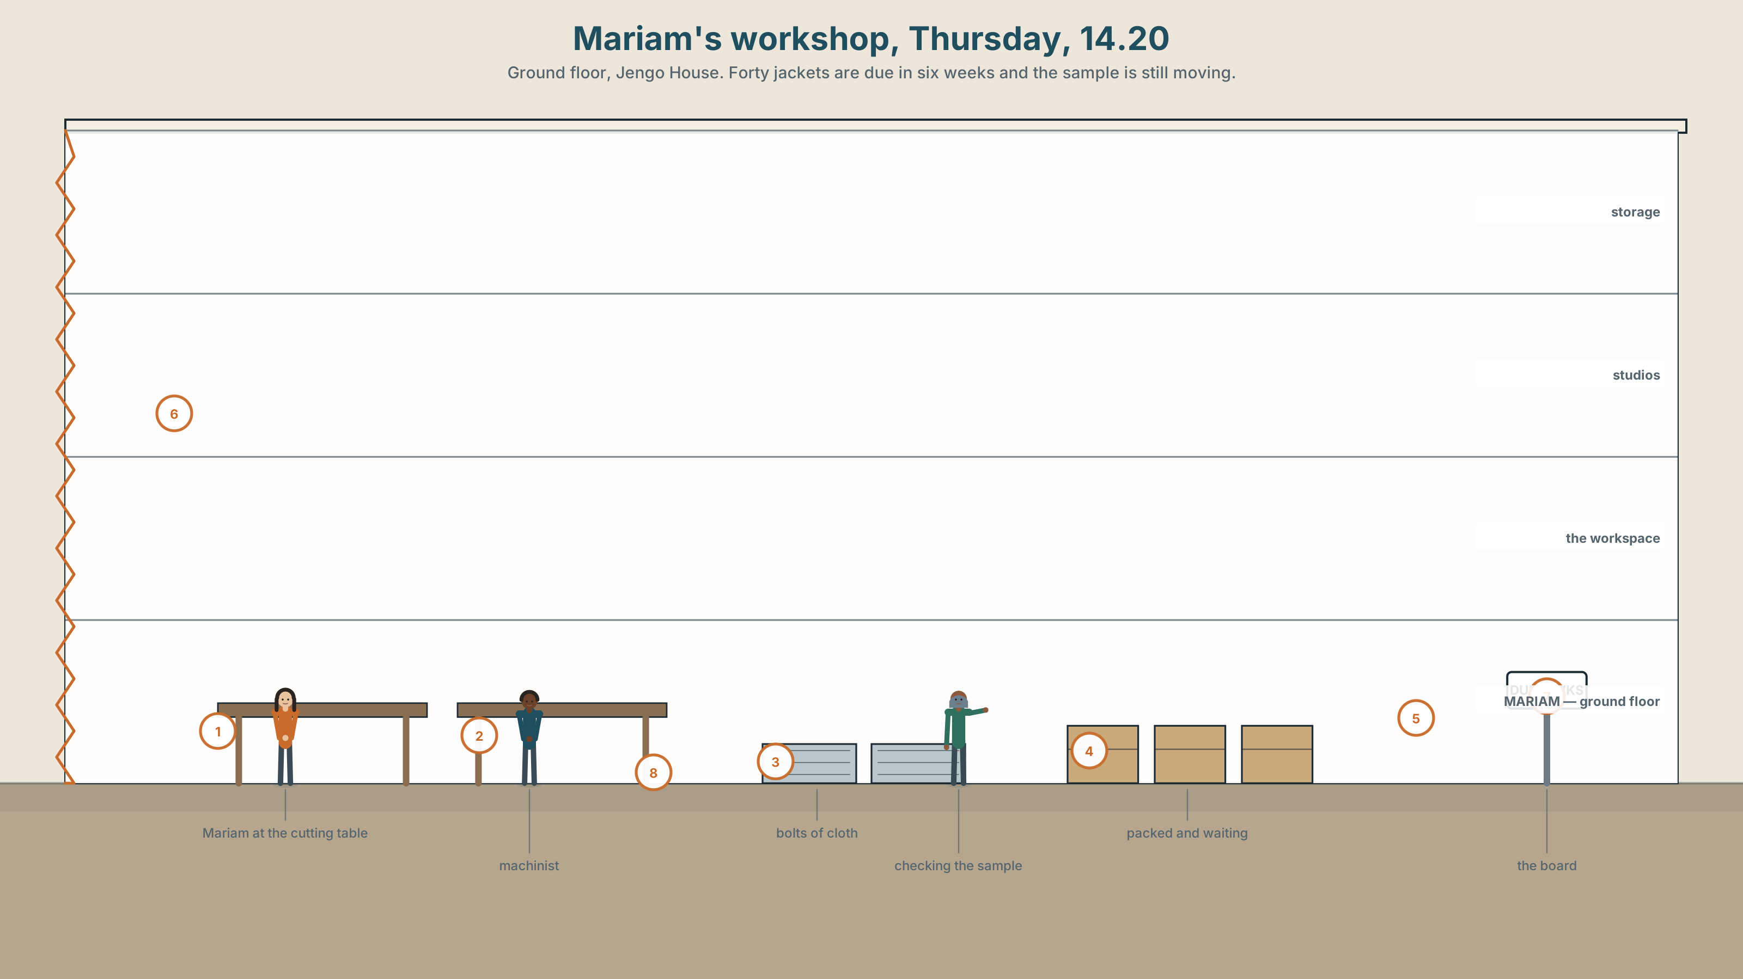{width=6.6in}
Mariam's workshop, Thursday, 14.20 — Ground floor, Jengo House. Forty jackets are due in six weeks and the sample is still moving.

What does a price hide?
By the end of this unit you will present a true cost breakdown for one product — and defend every line of it.
◆ A · THE WORLD | What a thing costs to make, and who absorbs the difference
◆ B · THE SYSTEM | The perfect simple against the perfect continuous · the present perfect, returning · 24 words for cost and margin · 21 ways to say finished or still going · weak forms in perfect chains
◆ C · THE PERFORMANCE | A costed presentation with every line defended, and a 140-word written breakdown

0A · Find it
Find and label twelve things in Mariam's workshop. Four of these sixteen are not there.
bolt of cloth · cutting table · overlocker · industrial iron · pattern · toile · bobbin · thread stand · dye vat · offcuts bin · packing crate · invoice spike · loom · spinning wheel · rail of finished work · tape measure

0B · Guess it
The jacket on the rail sells for 4,800. Write down what you think the cloth cost. Keep the number. You will check it in Part 8.

0C · Say it ⏺
Record thirty seconds. What does a price hide? No preparation. You will record it again at the end of the unit.

Part 1 · Vocabulary Lab 1 ◆ B · THE SYSTEM
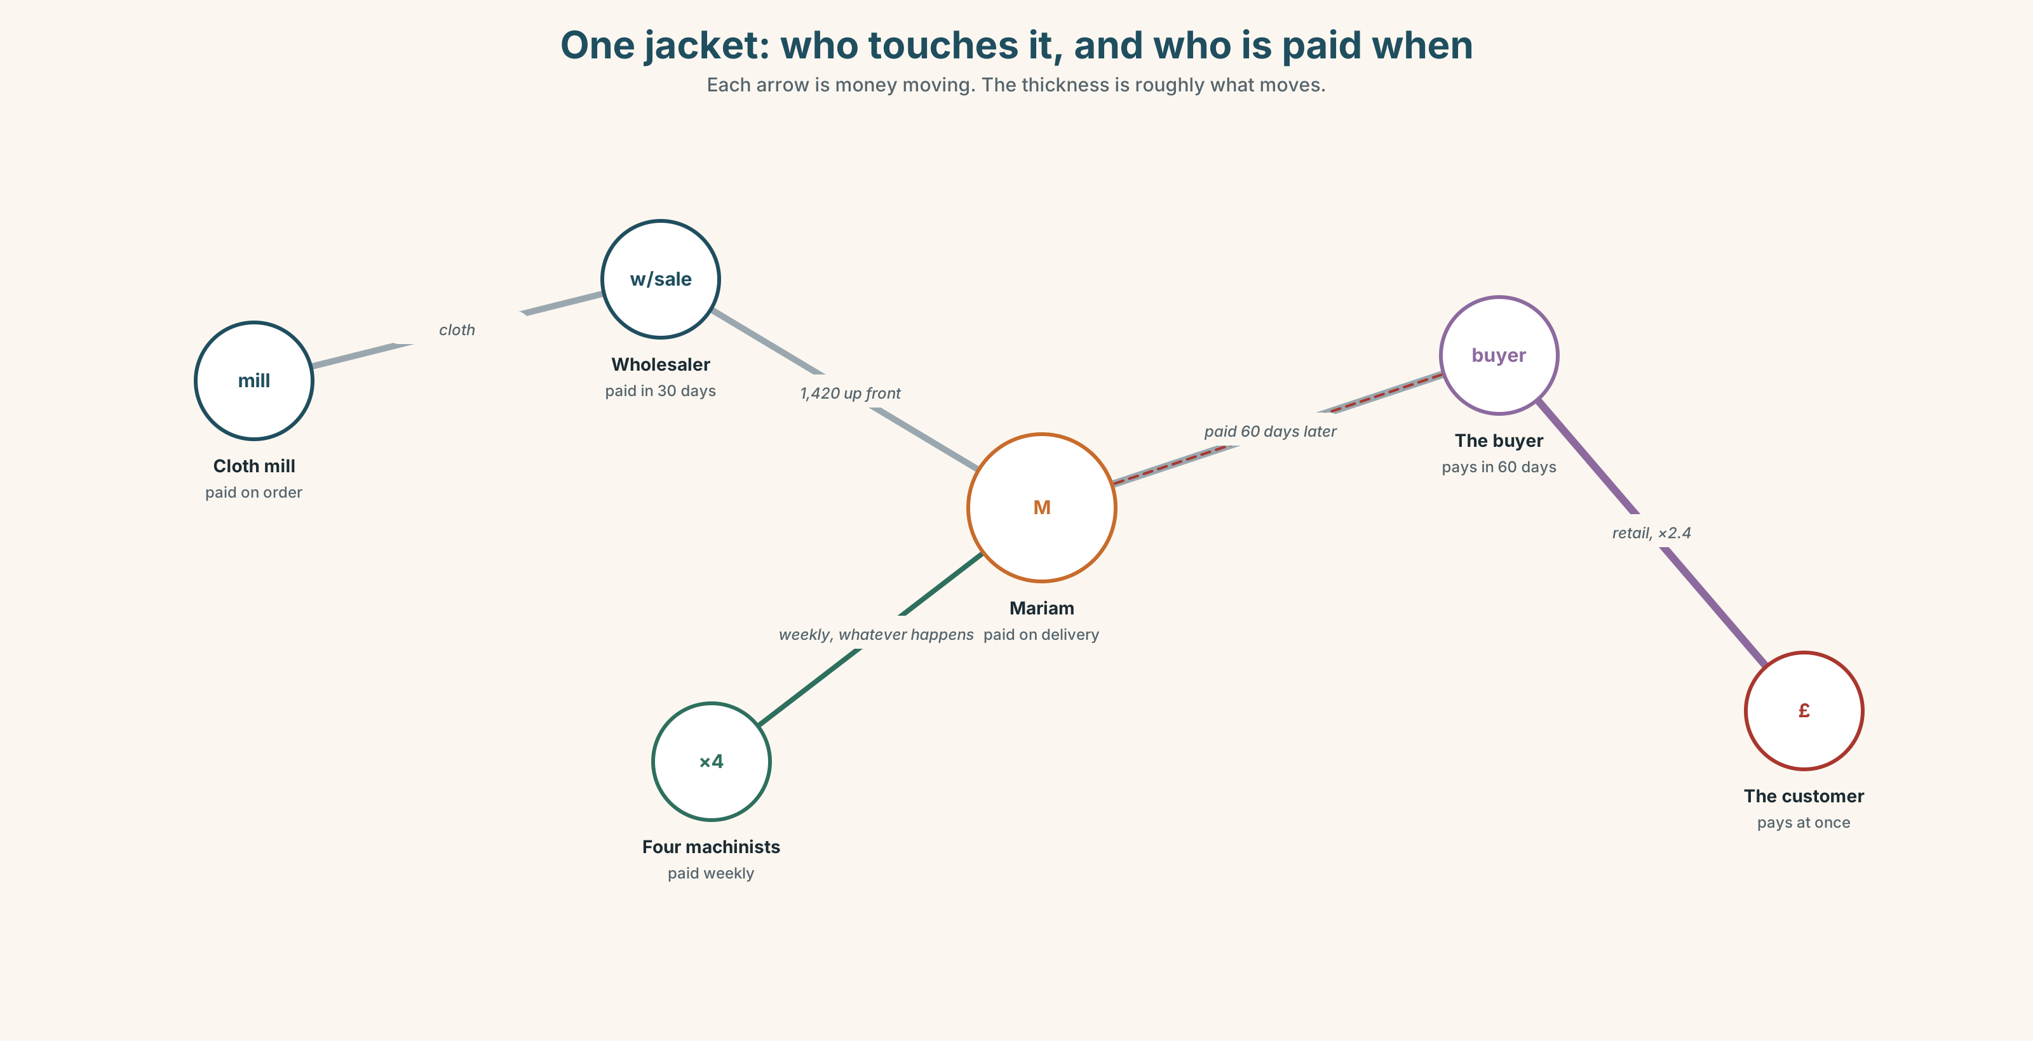{width=6.6in}
One jacket: who touches it, and who is paid when — Each arrow is money moving. The thickness is roughly what moves.

1A · Meet — follow the money
Use the network. Each arrow is money moving. Name the person or stage at each node.
supplier · wholesale · retail · markup · margin · overheads · invoice · deposit · instalment · subsidy · undercut · cost

1B · Sort — who carries the risk?
Put the six people on the network in order, from the one who is paid first to the one who is paid last. Then answer: who carries the risk if nobody buys the jacket?

1C · Sort — odd one out, and why
- margin · markup · profit · overheads
- wholesale · retail · supplier · invoice
- deposit · instalment · subsidy · payment
- undercut · knock off · bump up · mark up

1D · Stretch — the phrases
Complete each with one word.
- Nobody will pay more than the going ______ for a plain jacket.
- At 4,800 she does not make money. She ______ even.
- The cloth is good and the stitching is good. It is value for ______.
- Her own eleven hours do not appear anywhere. That is ______ work.
- If you add it all up honestly, it doesn't ______ ______.

1E · Stretch — four phrasal verbs that all move a price
add up · knock off · mark up · bump up
Two of these make a price smaller. Two make it bigger. Which, and what is the difference between the two that make it bigger?
Corpus Note Overheads is almost never singular. Margin is singular five times in six. A learner who says "our overhead is high" will be understood, and will sound like a translation.

1F · Own it
Price something you have made, cooked, repaired or organised. Use six of these words. Include one cost you would normally forget.

Part 2 · Listening ◆ A · THE WORLD
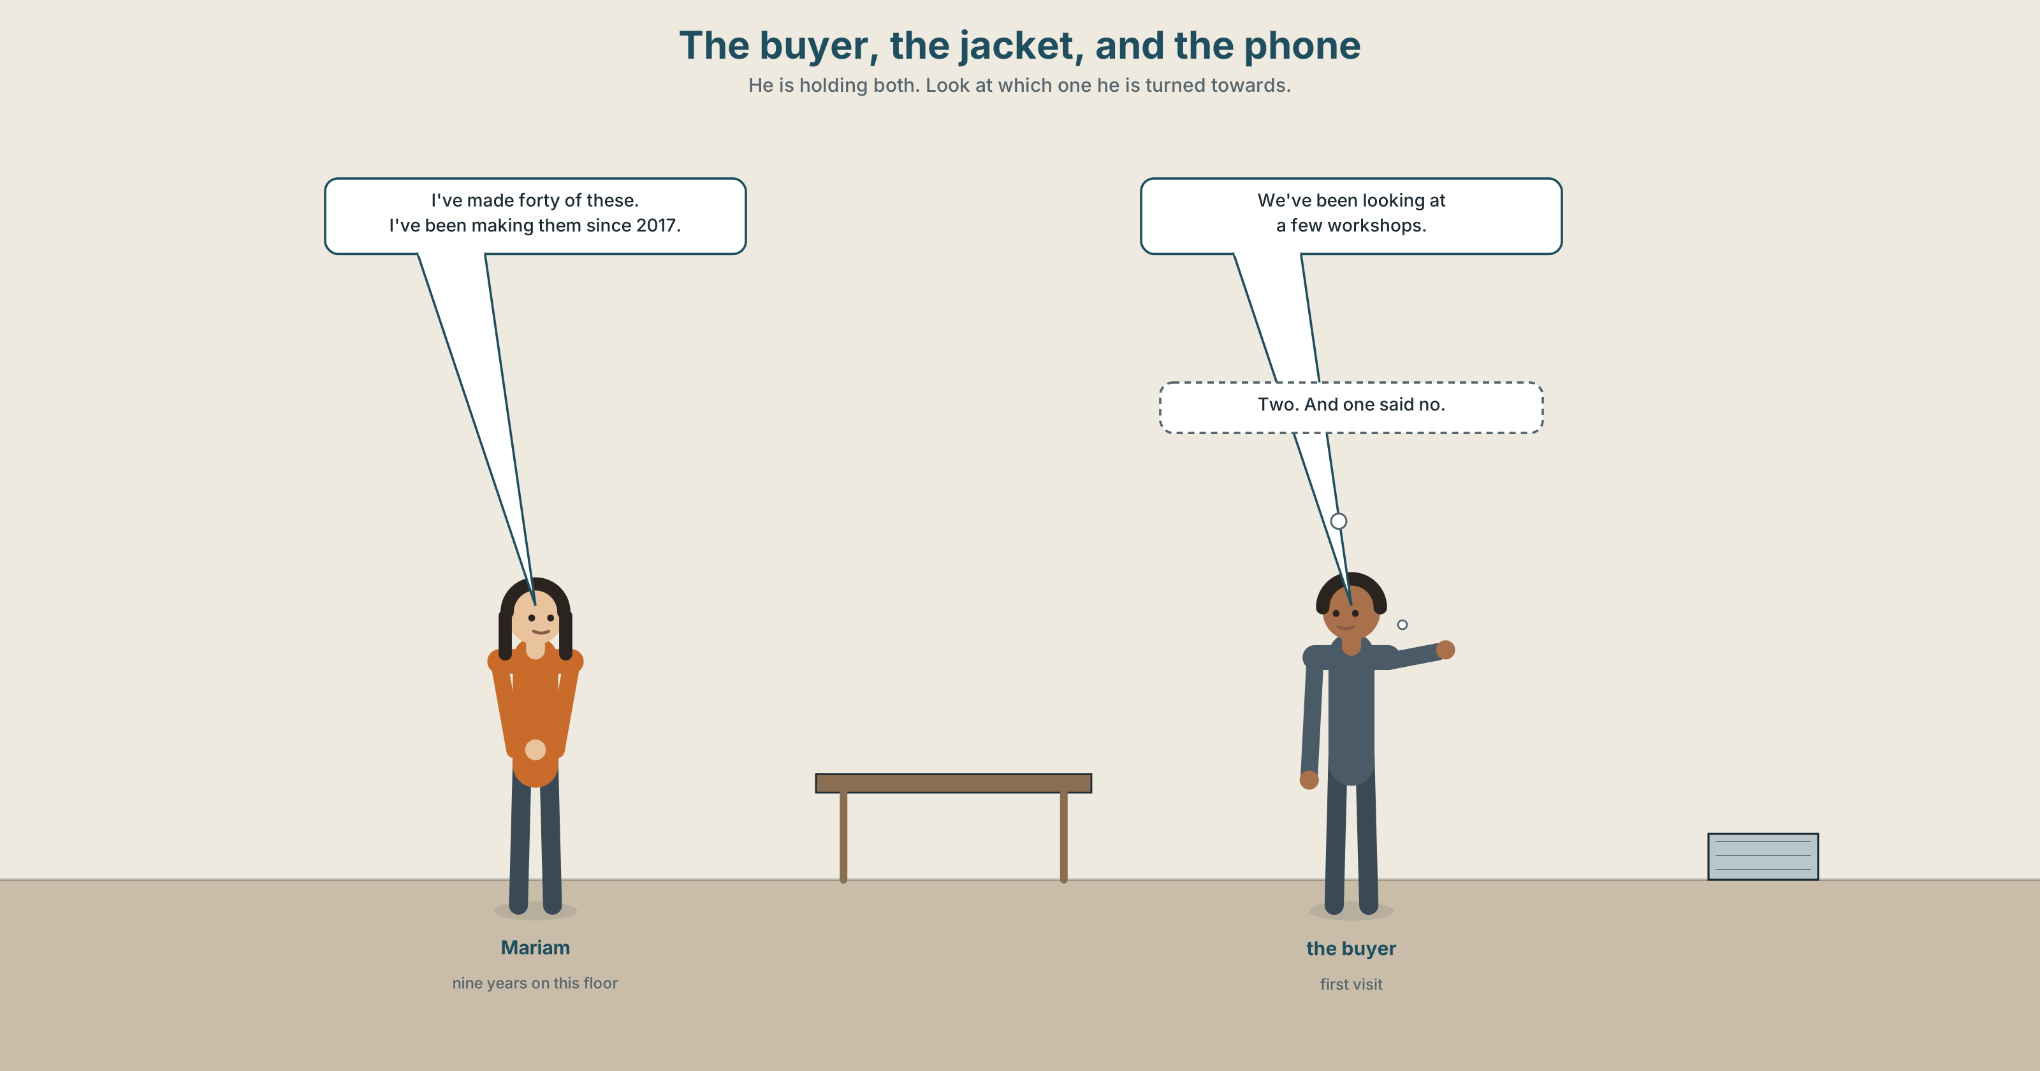{width=6.6in}
The buyer, the jacket, and the phone — He is holding both. Look at which one he is turned towards.

2A · Forty jackets 🔊 Track 2.1
Before you listen. Look at the picture. The buyer is holding a phone and a jacket. Which is he looking at?
Gist — one listen, one question. Does Mariam get the order?
Detail — complete the frame.
 | What he says | What she hears
About the price
About the quantity
About the timing
Inference. He says "we've been looking at a few workshops." He has not been looking at a few workshops. How can you tell?
Attitude. Mariam says "I can do that" twice. The second one means something different. Which sound tells you?
Noticing. Six sentences from the recording. Sort them into two groups.
- I've made forty of these.
- I've been making these for nine years.
- We've spoken to three other workshops.
- We've been speaking to a few people.
- She's finished the sample.
- She's been finishing samples all week.
A. The speaker is interested in the result — it is done, here is how many. B. The speaker is interested in the activity — it has been going on.

2B · Decoding clinic 🔊 Track 2.2
Thirty-eight seconds of the buyer at full speed. Four replays, four jobs.
- How many times does he say we've?
- Catch the three numbers.
- we've been — how many sounds is that really?
- What happens to have in what have you?
Transcripts, page 172.

Part 3 · Grammar Lab 1 ◆ B · THE SYSTEM

The result, or the activity

3A · Notice
Go back to the six sentences in Part 2.
- Which sentences give you a number? What do they all have in common?
- Which sentences give you a length of time?
- I've made forty and I've been making these for nine years — which one tells you she is still doing it?
- Try putting a number into sentence 2: I've been making forty of these for nine years. What goes wrong?
- So: which form takes how many, and which takes how long?

3B · See
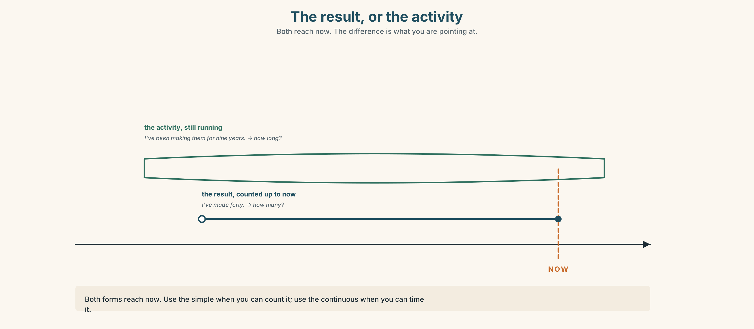{width=6.6in}
The result, or the activity — Both reach now. The difference is what you are pointing at.

3C · Know
 | What it points at | Takes | Example
have/has + past participle | the result, counted up to now | how many, how much | I've made forty.
have/has been + -ing | the activity, running up to now | how long, since, for | I've been making these for nine years.
Watch out. Both forms reach now. The difference is not time — it is what you are pointing at. I've painted the room (it is finished) against I've been painting the room (there is paint on me).
Why it matters. We've been speaking to a few workshops and we've spoken to three workshops are both true. One of them is a negotiating position.

3D · Use — controlled
Complete with the perfect simple or the perfect continuous.
Mariam (1) __________ (work) on the ground floor since 2021. In that time she (2) __________ (make) more than nine hundred pieces, and she (3) __________ (train) four people. This month she (4) __________ (not sleep) much, because the sample (5) __________ (go) back and forth three times. "I (6) __________ (do) this for nine years," she says. "I (7) __________ (never have) an order cancelled after a deposit — but I (8) __________ (hear) stories all week."

3E · Use — guided
Rewrite each sentence so it points at the other thing. Then say what changes.
- I've written three emails to them. → I've been …
- We've been looking for a supplier. → We've …
- She's been cutting cloth all morning. → She's …
- They've paid two instalments. → They've been …

3F · Use — open
Tell a partner about something you have been doing for a long time, and something you have finished. Your partner must be able to say which is which without asking.

3G · Check — six items, mark your own
- How long ______ you ______ (work) here?
- I ______ (finish) all four of them.
- She ______ (cut) cloth since seven this morning — look at her hands.
- We ______ (speak) to three suppliers so far.
- It ______ (rain), I think. The floor is wet.
- He ______ (send) the invoice twice already.
0–3 → Workbook pp. 14–16. 4–5 → the Contrast Clinic in Part 6. 6 → p. 39.
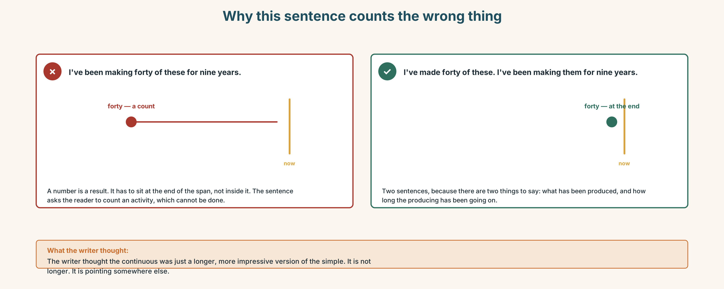{width=6.6in}
Why this sentence counts the wrong thing — Why this sentence counts the wrong thing

Part 4 · Speaking ◆ C · THE PERFORMANCE

4A · Fluency sprint — 4 / 3 / 2
Describe something you own that was expensive. Four minutes, then three, then two, new partner each time.

4B · The functional core — saying what a price is made of
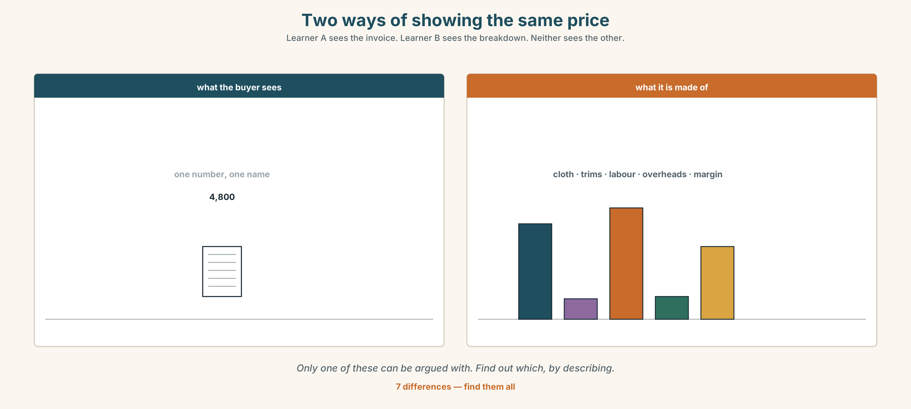{width=6.6in}
Two ways of showing the same price — Learner A sees the invoice. Learner B sees the breakdown. Neither sees the other.
Language Bank
breaking it down | the cloth alone is … · that's before overheads · if you take off the …
defending a figure | I can show you where that comes from · that's eleven hours of work · I've priced this honestly
pushing back | I've had it done for less · that seems high for … · what's your best on forty?
holding | I can do that, but something has to give · not at that price, no
Information gap. Learner A holds Mariam's real costing. Learner B holds the buyer's budget. Neither sees the other. Find out whether a deal exists at all.

4C · The performance — the costed pitch
Three minutes. One product. You must show where every figure comes from, and the group must ask you one question you did not prepare for.

4D · Observer
Listen for one thing: which figure did the speaker not explain?

4E · Two criteria
☐ Did I say where every number came from? ☐ Did I include something people usually leave out?

Part 5 · Reading ◆ A · THE WORLD

5A · Predict
A report extract called "The cost of the cheapest option." The first line is:
Procurement teams are rewarded for the price on the invoice, and for nothing else.
What do you expect it to argue? One sentence.

5B · Skim — sixty seconds
Where does the argument turn? Mark the paragraph.

The cost of the cheapest option
Procurement teams are rewarded for the price on the invoice, and for nothing else. This is not a criticism of the people in them. It is a description of what their targets measure, and people hit the targets they are given.
The effect is well documented in manufacturing and almost undocumented in small-scale production, which is where most of the world's clothing is actually made. A buyer with a unit-price target will move an order to a workshop that quotes eight per cent lower. On the invoice, the saving is real. What the invoice does not carry is the four days of rework when the first batch comes back with the seams wrong, the two weeks of delay while a replacement is cut, or the senior fitter's time spent on a problem that the cheaper workshop was never equipped to avoid.
None of those costs appear in the procurement figure. All of them appear somewhere else.
The pattern repeats at every scale. A workshop that has been underpricing for years is not cheaper; it is subsidising its buyers with unpaid hours, deferred maintenance and, eventually, its own capacity to keep trading. When it closes, the buyer records no loss at all. The cost shows up as a sourcing problem eighteen months later, and nobody connects the two.
What makes this hard to correct is not that it is unknown. It is that the invoice is a single number with a name on it, and the other costs are spread across four departments, three quarters and one person's weekend. A number that can be pointed at will always beat a number that has to be assembled.
The workshops that survive are not the cheapest. They are the ones that learned to put the assembled number on the page before anybody asked for it.

5C · Close reading
- What are procurement teams rewarded for?
- Name three costs that do not appear on the invoice.
- What does the writer say happens when an underpriced workshop closes?
- What does the writer mean by "a number that can be pointed at"?
- The last paragraph is one sentence of advice. What is it?
- The writer says this is "not a criticism of the people". Why say that at all?

5D · Vocabulary in context
Infer first, rate your confidence, then check: ◯ guessing ◑ fairly sure ● certain.
procurement · rework · underpricing · deferred · assembled (the assembled number) · subsidising

5E · The counter-text
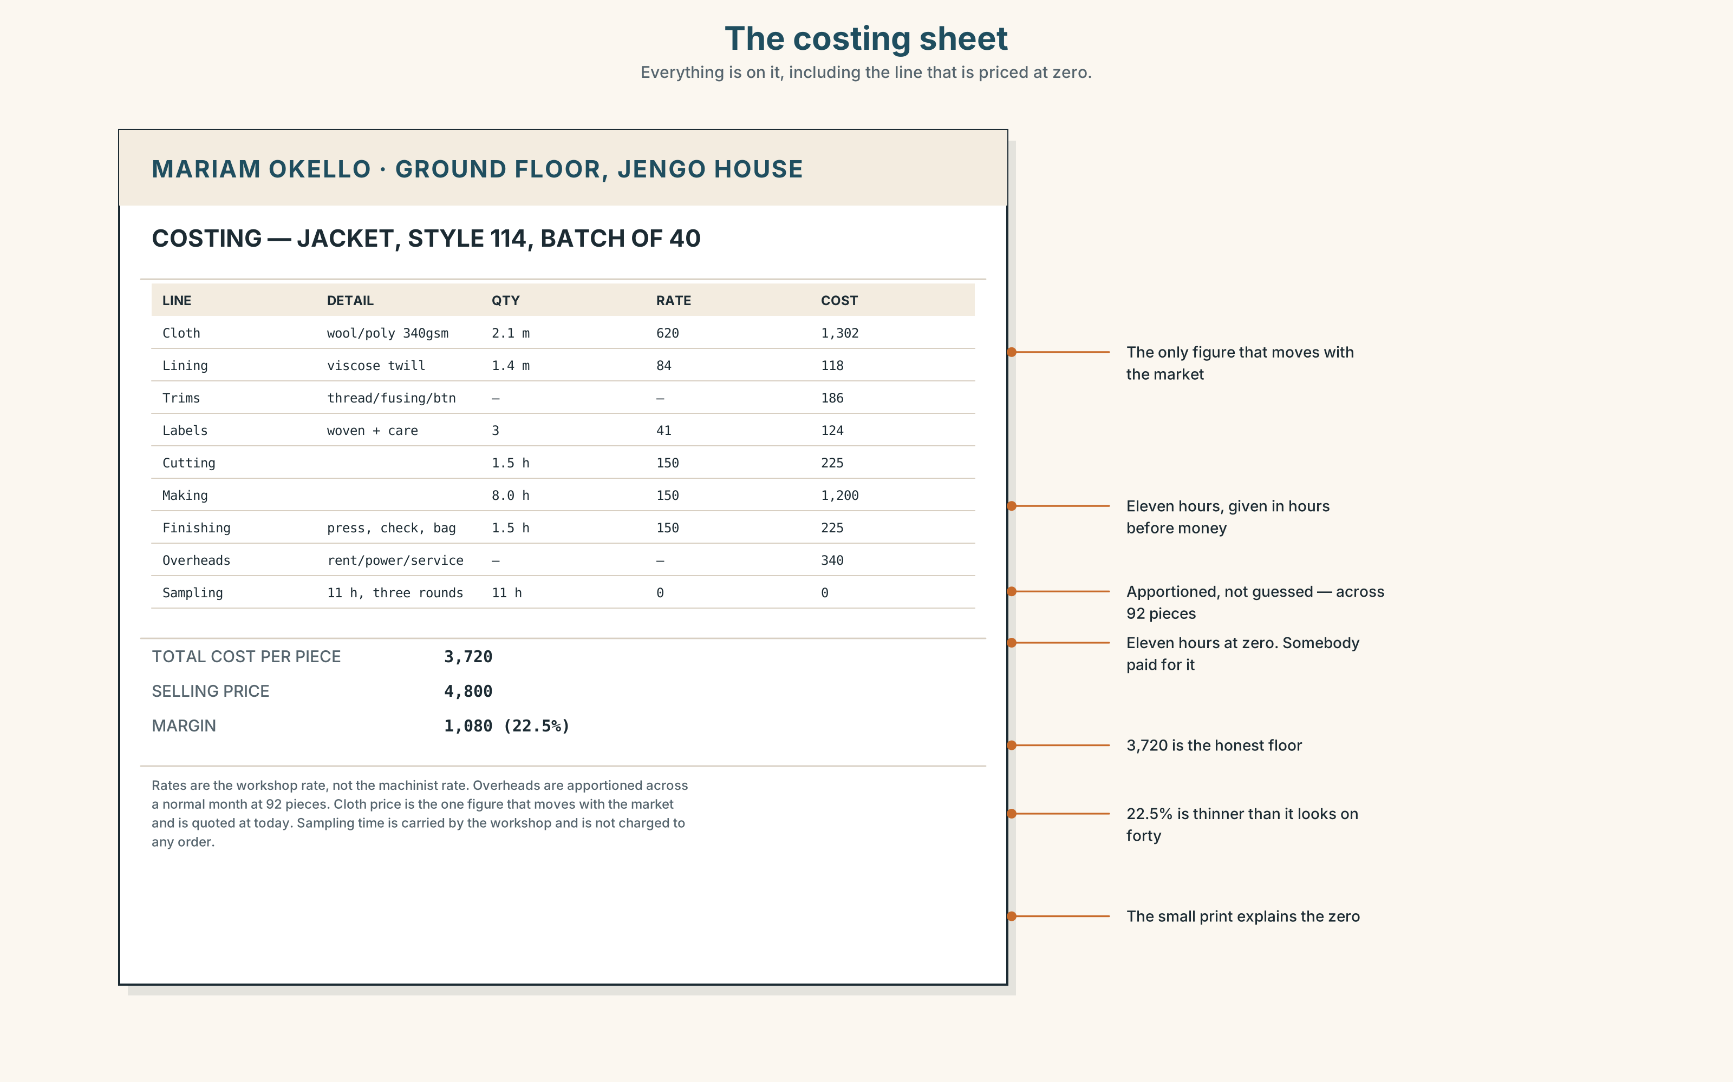{width=6.6in}
The costing sheet — Everything is on it, including the line that is priced at zero.
Read the costing sheet and answer.
- What is the total cost of materials?
- How many hours of labour are costed, and at what rate?
- Find the line that is priced at zero. Why is it there at all?
- What is the margin on one jacket, as a percentage?
- The sheet has a figure the article says nobody puts on the page. Which line is it?

5F · Writer analysis
The article argues; the costing sheet asserts.
- Which of the two could you disagree with, and how would you do it?
- The article names nobody. The sheet names one person. What does that change?

5G · Text against text
The article says the assembled number should go on the page before anybody asks. The sheet does exactly that. Would you send it to the buyer? Two sentences. The second begins "The risk is…"

Part 6 · Vocabulary Lab 2 ◆ B · THE SYSTEM

Finished, or still going
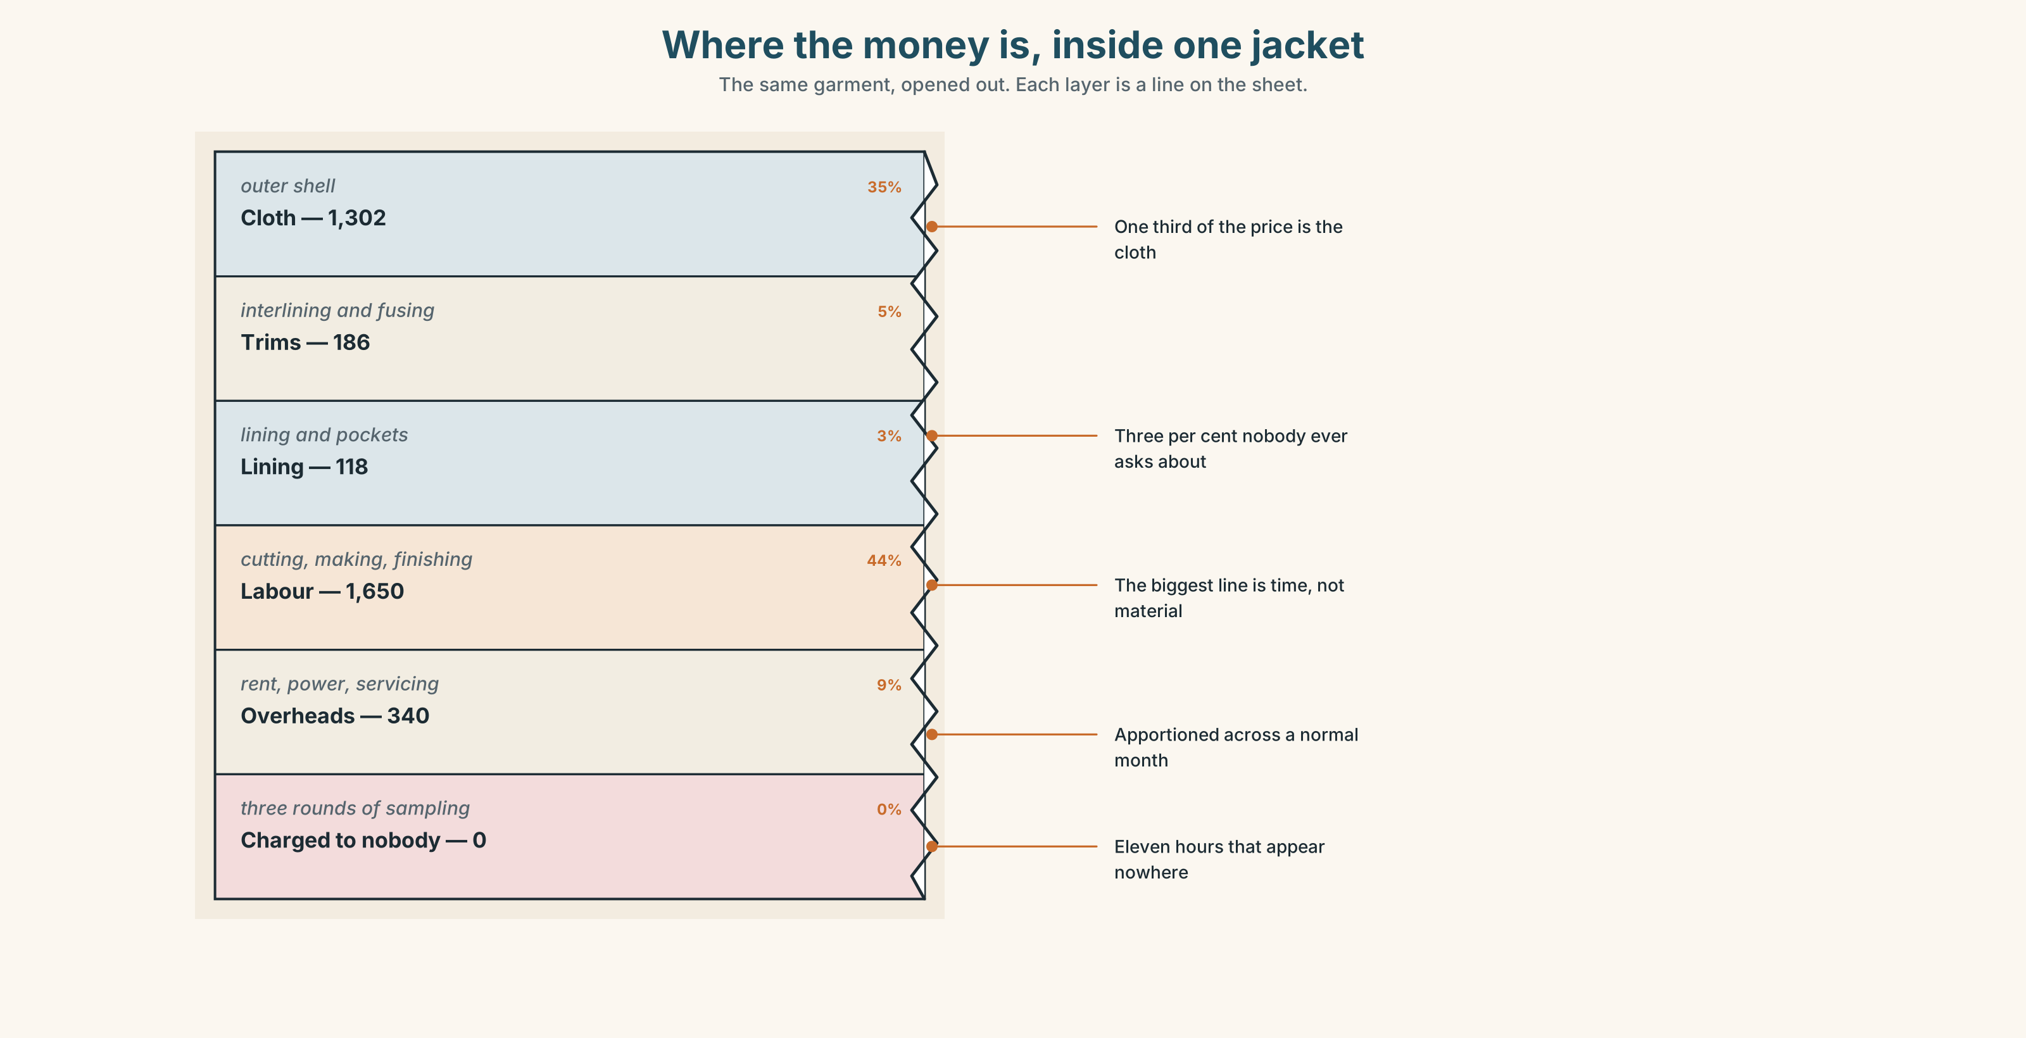{width=6.6in}
Where the money is, inside one jacket — The same garment, opened out. Each layer is a line on the sheet.

6A · Sort — which group?
Put the twenty-one items into two columns: this points at a result · this points at an activity. Three can go in both — say why.
so far · up to now · ongoing · outstanding · finalised · incomplete · cumulative · intermittent · provisional · repeatedly · gradually · steadily · throughout · all morning · twice already · bit by bit · in one go · for the last six months · keep at · get through · I've been meaning to…

6B · Chunk completion
- We've been at it ______ by ______, for six weeks.
- I'd rather do it ______ one ______ than come back three times.
- The invoice is still ______ — she hasn't been paid.
- Nothing is ______ until the buyer signs.
- I've ______ ______ to call him since Tuesday.

6C · Collocation grid
Which adjectives go with which nouns? Find the one combination nobody says.
 | costs | payment | work | progress
ongoing
outstanding
cumulative
provisional

6D · Contrast Clinic — simple against continuous
Six items. Only the time expression decides.
- She ______ (cut) forty of them.
- She ______ (cut) cloth since seven.
- We ______ (speak) to three suppliers.
- We ______ (speak) to suppliers all week.
- He ______ (send) the invoice twice.
- He ______ (chase) that invoice for a month.
Then, in one sentence each, say what the difference actually is.

Part 7 · Pronunciation & Fluency Lab ◆ B · THE SYSTEM

Four words that become one
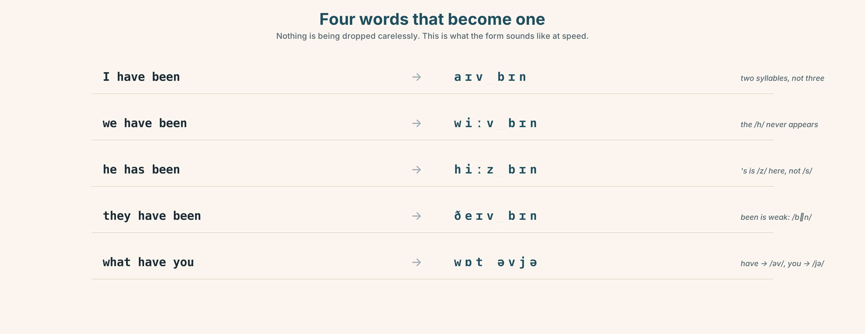{width=6.6in}
Four words that become one — Nothing is being dropped carelessly. This is what the form sounds like at speed.

7A · Hear 🔊 Track 2.3
I have been → I've been → /aɪvbɪn/ we have been → we've been → /wiːvbɪn/ he has been → he's been → /hiːzbɪn/ they have been → they've been → /ðeɪvbɪn/

7B · Say
Choral, then alone, then inside the sentence: "I've been making these for nine years and I've never had one come back."

7C · Make it mean something
Say it twice: once naturally, once with every word fully pronounced. Which one sounds like somebody defending their work? Which sounds like a witness statement?

7D · Fluency 20 ⏺
Twenty seconds on something I have been doing for a long time. Three times, faster each time. Record the first and the third.

Part 8 · Writing ◆ C · THE PERFORMANCE

A cost breakdown somebody will argue with · 140 words
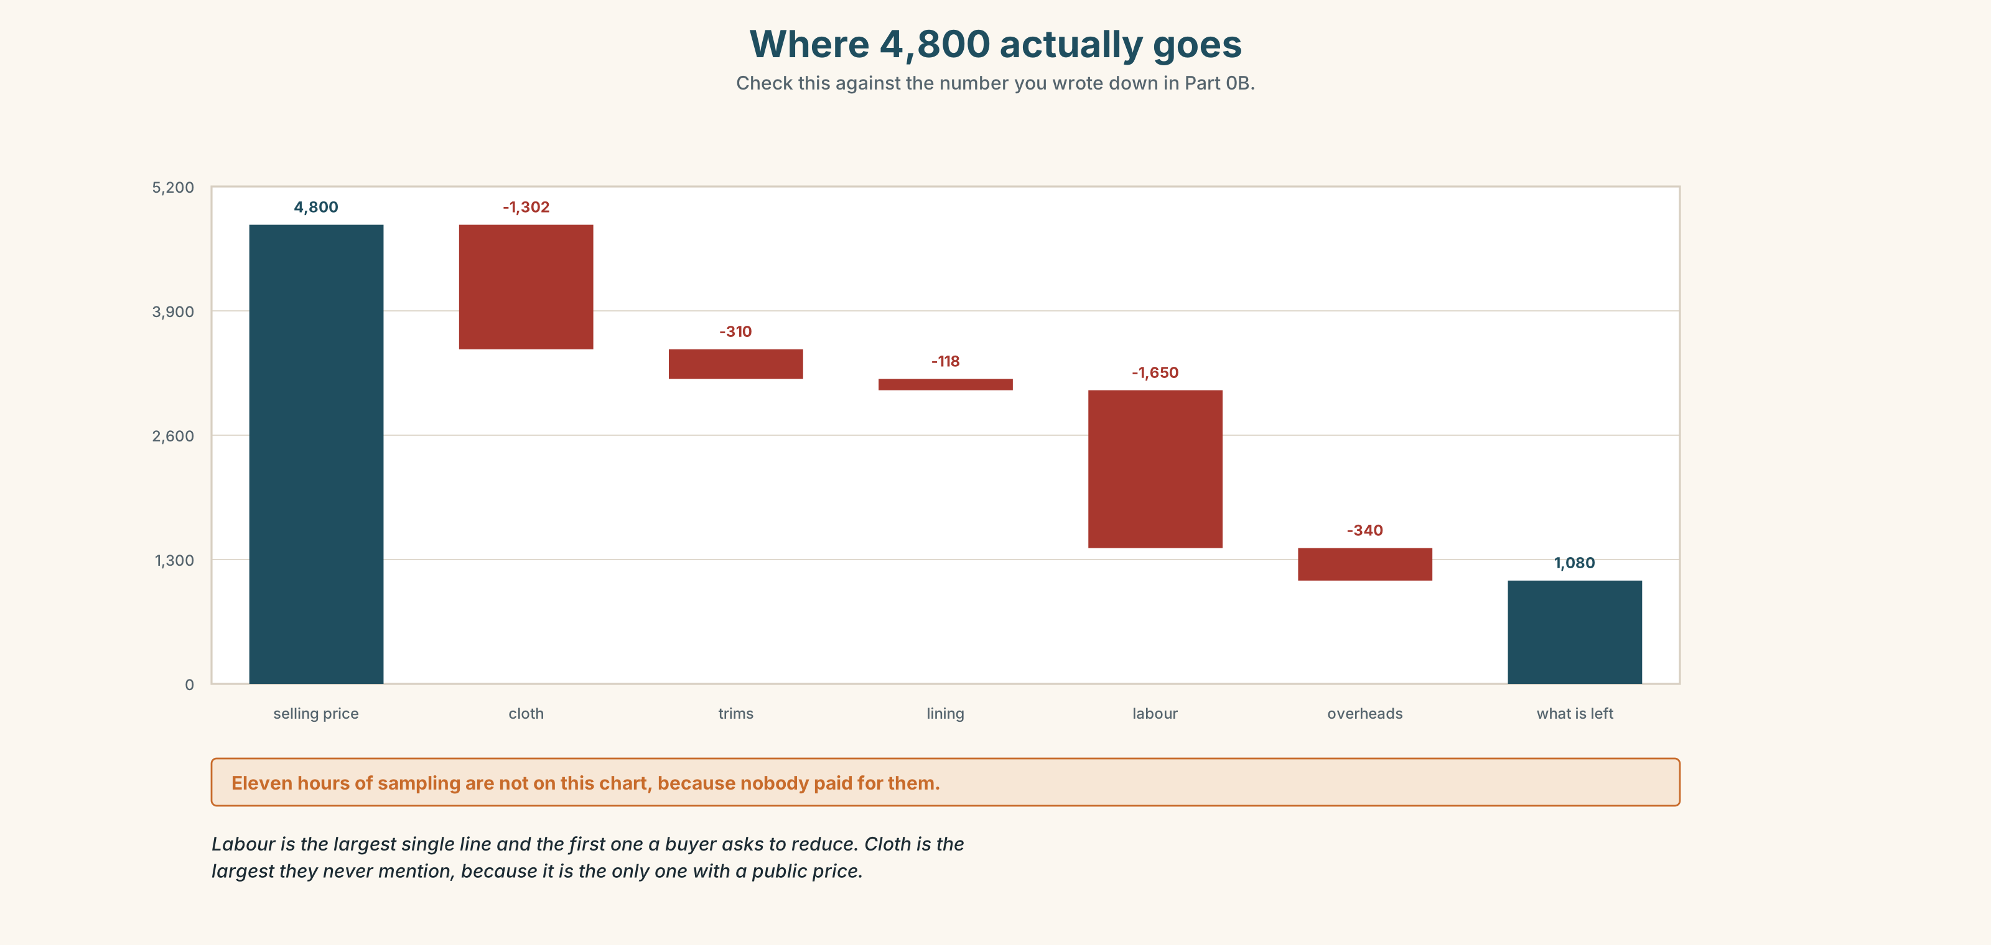{width=6.6in}
Where 4,800 actually goes — Check this against the number you wrote down in Part 0B.
Go back to Part 0B. What did you guess the cloth cost? Look at the chart.

8A · Read the model
This is what the jacket costs us to make, and I would rather send it than be asked for it. [opens by naming what the document is for — and why it arrived unrequested]
Cloth and lining are 1,420, and that is the one figure that moves with the market. Thread, fusing, buttons and the labels come to 310. Cutting and making is eleven hours; at our rate that is 1,650. [the labour line is given in hours first, then money — it is harder to argue with]
Overheads — the rent, the power, the machines being serviced — work out at 340 a piece across a normal month. That brings us to 3,720.
At 4,800 we are making 1,080 a jacket, and out of that comes the time I have been spending on samples, which I have never charged anyone for. I am not asking you to pay for it. I am telling you it is there. [the last line is the whole argument, and it is four words long]
Questions about the writer's choices:
- Why give the labour in hours before giving it in money?
- Why is the overheads line explained and the cloth line not?
- The last sentence gives something away. Why is that stronger than hiding it?

8B · The anti-model
Jacket cost: materials 1,730, labour 1,650, overheads 340, total 3,720. Selling price 4,800. Margin 1,080 (22.5%). Please confirm.
Correct, complete, and worse. Name three things the model does that this does not.

8C · Generate · 8D · Plan
what it is → the figure that moves → the figure in hours → the figure people forget → the total → what is still not in it

8E · Draft 1 — 140 words

8F · Peer review — two criteria
☐ Could I argue with any single line, and know which one? ☐ Is there a cost in here that I would have left out?

8G · Draft 2 · 8H · Publish
To the class wall. One of these is the source for Unit 3's mediation task.

Part 9 · The File ◆ A · THE WORLD + C · THE PERFORMANCE

STUDY FILE · Source Check
Three sources make the same claim: small workshops are 8–12% cheaper than factories.
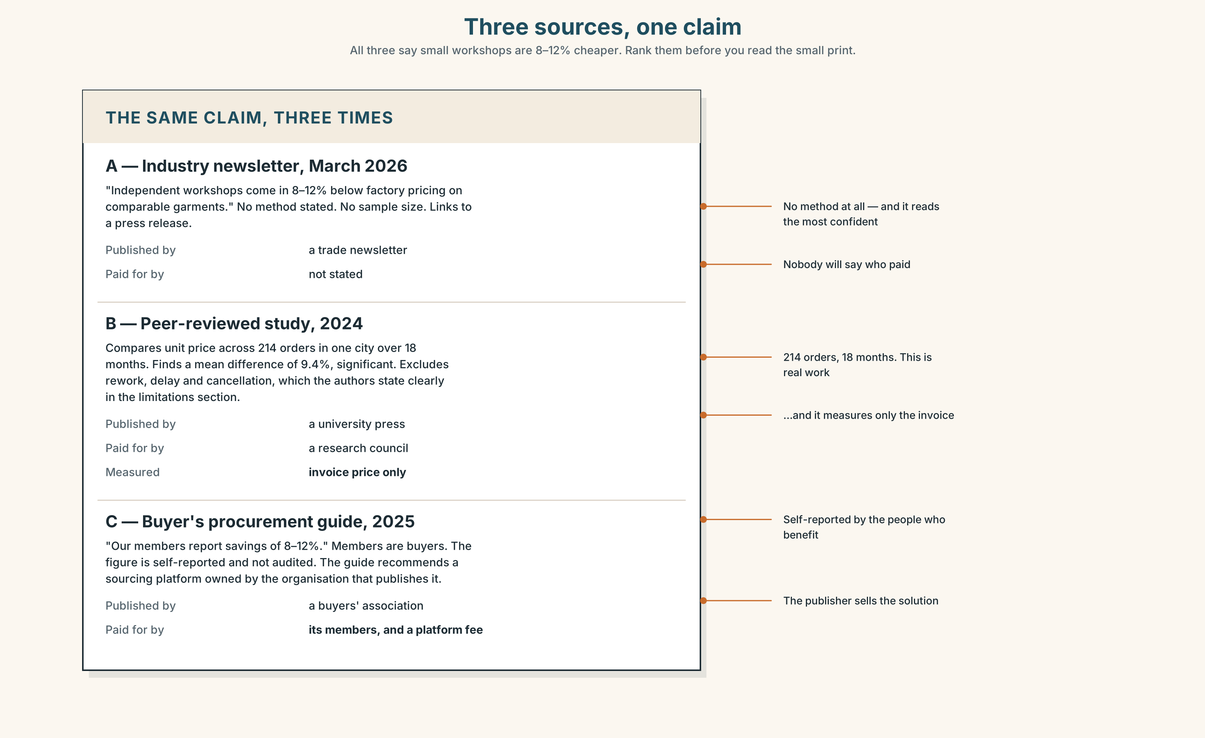{width=6.6in}
Three sources, one claim — All three say small workshops are 8–12% cheaper. Rank them before you read the small print.

9A · Rank them
Read all three. Rank them from most to least reliable before you read 9B.

9B · Ask the four questions
For each source: Who made it? Who paid for it? What did they measure? What would change the answer?

9C · The one that is hardest
Source B is the most carefully done and the least useful. Say why in one sentence.

9D · Write the note
Sixty words to a colleague who has only seen Source A, telling them what they would need to know before quoting it.

9E · Transfer
Find a number you have repeated to somebody this year. Where did it come from? Bring it.

Part 10 · Mediation & Interaction ◆ C · THE PERFORMANCE
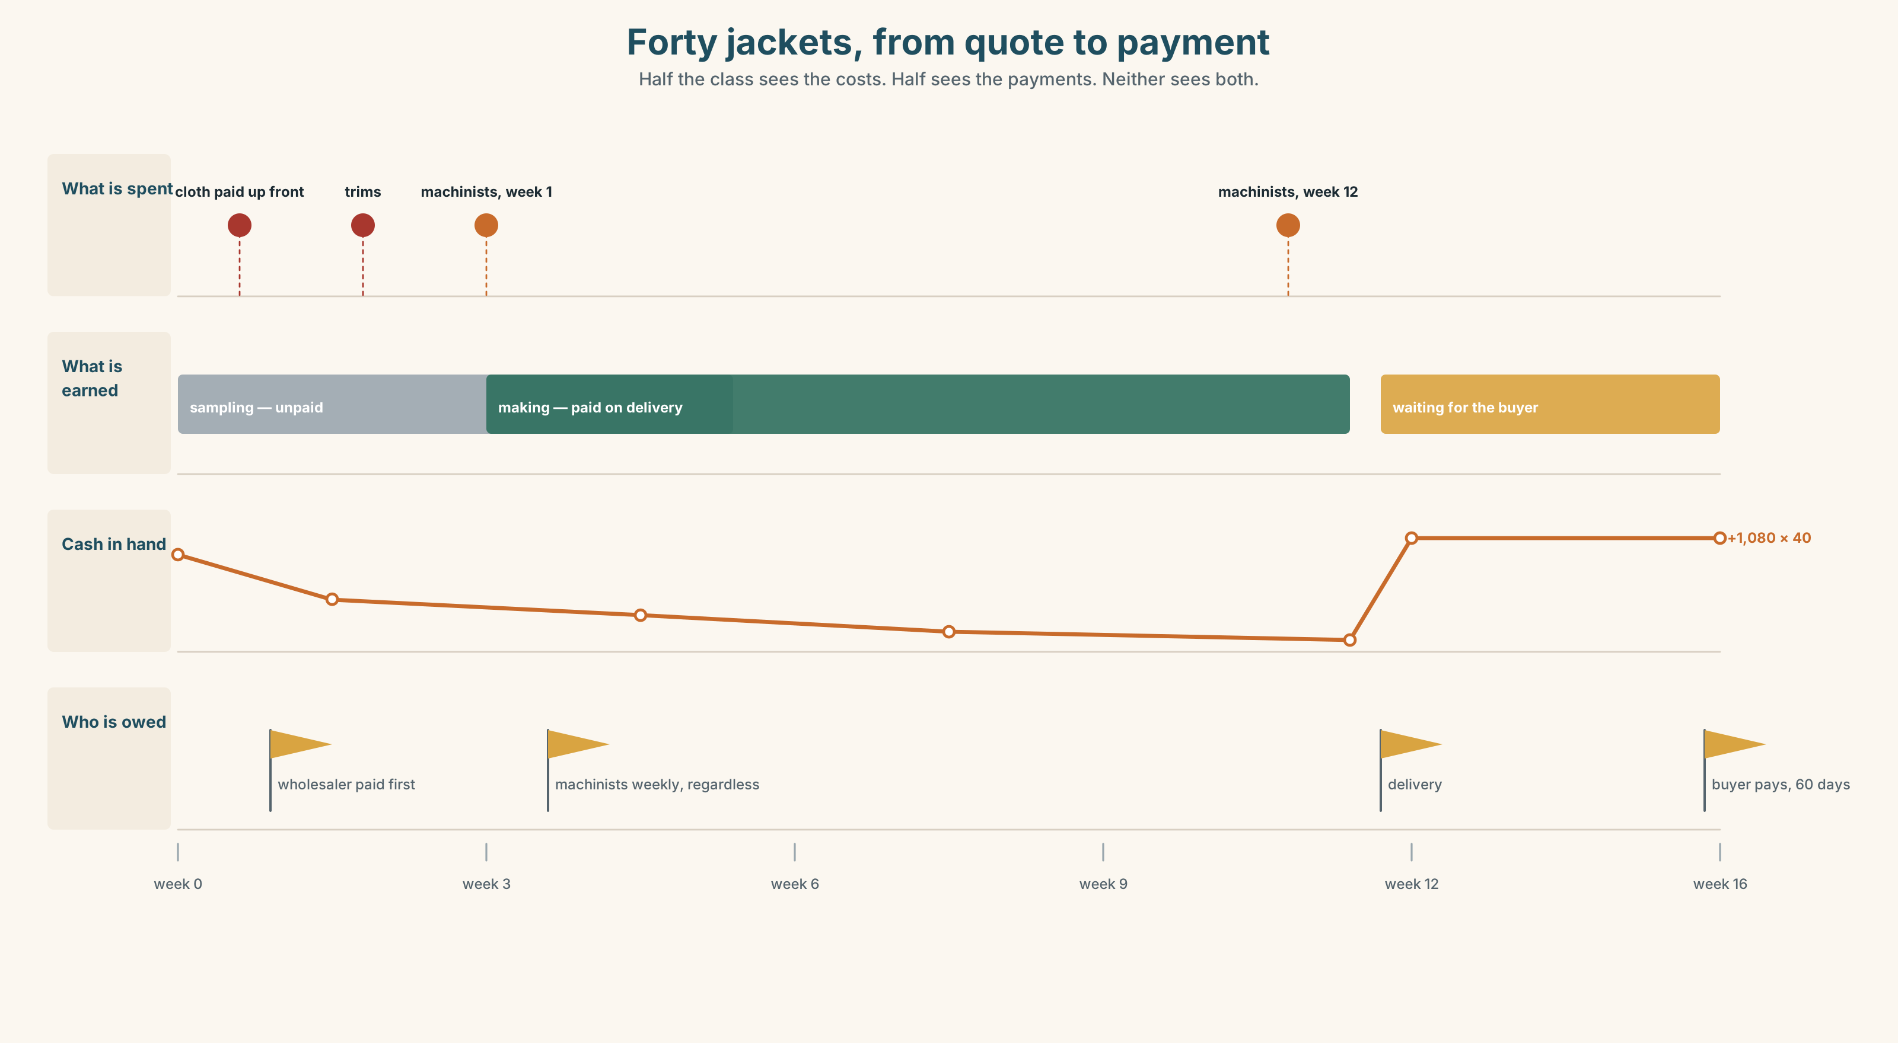{width=6.6in}
Forty jackets, from quote to payment — Half the class sees the costs. Half sees the payments. Neither sees both.

10A · Relay
Half the class sees the costs band, half sees the payments band. Rebuild the whole picture by speaking only. Twelve minutes.

10B · Simplify
Explain the costing sheet from Part 5 to Didier, who makes coffee, has never priced anything, and has eight minutes.
Plan: what the document is → the three big numbers → where the argument is → what you'd ask

10C · Compress
The 300-word article into 60 words for a WhatsApp group of workshop owners. Defend three cuts.

10D · Online interaction
Now write it as the message. It will be forwarded to a buyer. Write it knowing that.

10E · Across languages
Say 10B in your own language, then bring it back. Which word had no equivalent?

Part 11 · The Decision ◆ C · THE PERFORMANCE

The order at 4,100
The buyer will take forty jackets at 4,100. Mariam's honest cost is 3,720.
At 4,100 she makes 380 a jacket. At that margin, one batch of rework wipes out the order. She has been quoting 4,800 for two years and has never been asked to justify it until now.
- Take it. Forty jackets is six weeks of guaranteed work and the first order of this size.
- Hold at 4,800. Defensible, honest, and he has three other workshops on his phone.
- Take it, and cut something. Cheaper lining. Nobody would see it for a year.

11A · The evidence
- The costing sheet from Part 5.
- The chart from Part 8 — where the money actually goes.
- The voice. The buyer, thirty seconds, from Track 2.1: "We've been looking at a few workshops."

11B · Steelman
Argue for the option you like least, as well as its best advocate would. Two minutes.

11C · Deliberate
I think she should ______, because ______. The strongest argument against me is ______, and my answer to it is ______.

11D · Decide — eighty words, two reasons

11E · Model decision
I think she should hold at 4,800 and say exactly why, in writing, on one page.
Taking 4,100 is not the disaster it looks like — 380 a jacket on forty jackets is still money, and six weeks of booked work has a value that does not appear on the sheet. I understand the argument and on a different week I might make it.
But the sheet is the thing that changes this. Two years of quoting 4,800 with nothing behind it is a position. A costed page is an argument, and she has never put one in front of a buyer. If he walks away from a costed page, he was always going to walk, and she will know that for the next buyer. If he does not, she has set the price for every order after this one.
Cutting the lining is the only option I would rule out entirely. It is the one choice that she could not put in writing.

11F · The Reveal
What happened. He went to another workshop and came back eleven weeks later, because the first batch had the seams wrong and the rework ate the saving — which is the article in Part 5, happening. He paid 4,650.
Mariam lost eleven weeks of work she had counted on. Two of her four machinists left during it, and one did not come back when the order arrived.
She was right, and it cost her two machinists.
Was the reasoning sound? And: is "I was right" worth anything, if you could not afford to be?

Part 12 · Landing ◆ all three lines

12A · Recycle — twelve items
Six from this unit.
- She ______ (make) these for nine years.
- She ______ (make) forty of them this month.
- The invoice is still ______ — nobody has paid it.
- At 3,720 she ______ even.
- Eleven hours of her time is ______ work.
- I've ______ ______ to call him since Tuesday.
Four from Unit 1.
- By the time the notice went up, the objection period ______ (close).
- Four businesses were ______ out by rising rents.
- ______ then, nobody had built on the open ground.
- The ground floor has had a change of ______.
Two from Telling the Story (A2.2).
- He said he ______ (not receive) the costing. (reported speech)
- ______ of the four suppliers answered — only one. (quantifiers)

12B · Consolidate
120 words, one paragraph. Describe a month of work using both perfect forms and at least six items from Part 6. One continuous piece. No lists.

12C · Can-do, with evidence
I can… | My evidence | Sure?
distinguish a result from an ongoing activity, and choose the right form | Part 3G score | ◯ ◑ ●
break a price down and defend every line of it | Part 4C recording | ◯ ◑ ●
judge whether a number I have been given is worth repeating | Part 9D note | ◯ ◑ ●
take a position where both options cost something | Part 11D decision | ◯ ◑ ●

12D · Replay ⏺
Listen to Part 0C. Record it again. Compare. One sentence on what changed.

12E · Glossary — forty-five items, as a map
WHAT IT COSTS · cost · overheads · wholesale · retail · supplier · the going rate · a fair price · break even WHAT YOU ADD · margin · markup · mark up · bump up · the bottom line · value for money WHAT YOU TAKE OFF · undercut · knock off · subsidy · a deposit · an instalment WHAT IS HIDDEN · unpaid work · it doesn't add up · you get what you pay for · add up STILL GOING · ongoing · intermittent · gradually · steadily · repeatedly · bit by bit · throughout · keep at · all morning FINISHED · finalised · outstanding · incomplete · cumulative · provisional · in one go · get through · twice already · so far · up to now · for the last six months · I've been meaning to…

12F · Next
Unit 3 · Is a name a choice? Somebody will have to explain your cost breakdown to a person who has never priced anything.

