Table of Contents

B1.1 · Unit 3 · The Name On The Door
English Animated · Taking a Position · Jengo House, Nairobi Student's Book pages 48–67 · 20 pp · ~11.5 hours

Part 0 · The Big Picture ◆ A · THE WORLD
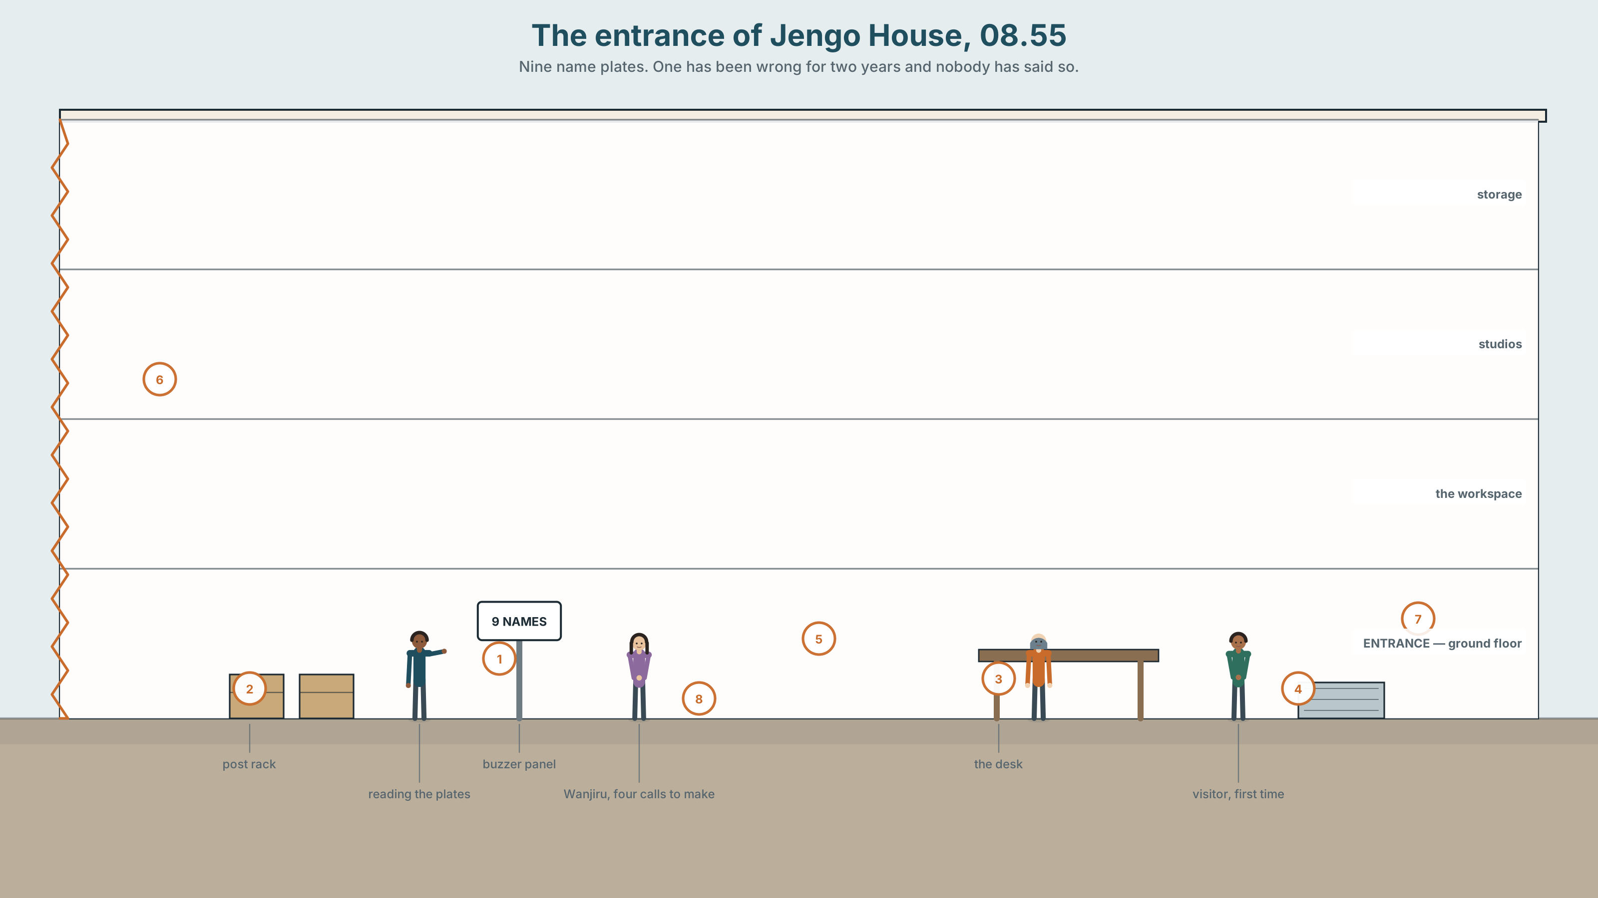{width=6.6in}
The entrance of Jengo House, 08.55 — Nine name plates. One has been wrong for two years and nobody has said so.

Is a name a choice?
By the end of this unit you will write and record a 150-word professional introduction — the one that goes in front of people who have never met you.
◆ A · THE WORLD | What a name does, who gets to change it, and what it costs either way
◆ B · THE SYSTEM | Four futures, chosen not guessed · going to and the present continuous, returning · 24 words for identity and documents · 21 ways to commit, or not · contrastive stress
◆ C · THE PERFORMANCE | A recorded 150-word profile, and the decision about what name is on it

0A · Find it
Twelve things in the entrance of Jengo House. Four of these sixteen are not there.
buzzer panel · name plates · post rack · visitor book · lanyard · security desk · noticeboard · lift call button · fire plan · parcel shelf · bicycle rack · stair nosing · turnstile · barrier arm · metal detector · reception bell

0B · Guess it
Look at the name plates by the door. One of them is wrong, and has been for two years. Which, and how can you tell?

0C · Say it ⏺
Record thirty seconds. Is a name a choice? Unprepared. You will record it again at the end.

Part 1 · Vocabulary Lab 1 ◆ B · THE SYSTEM
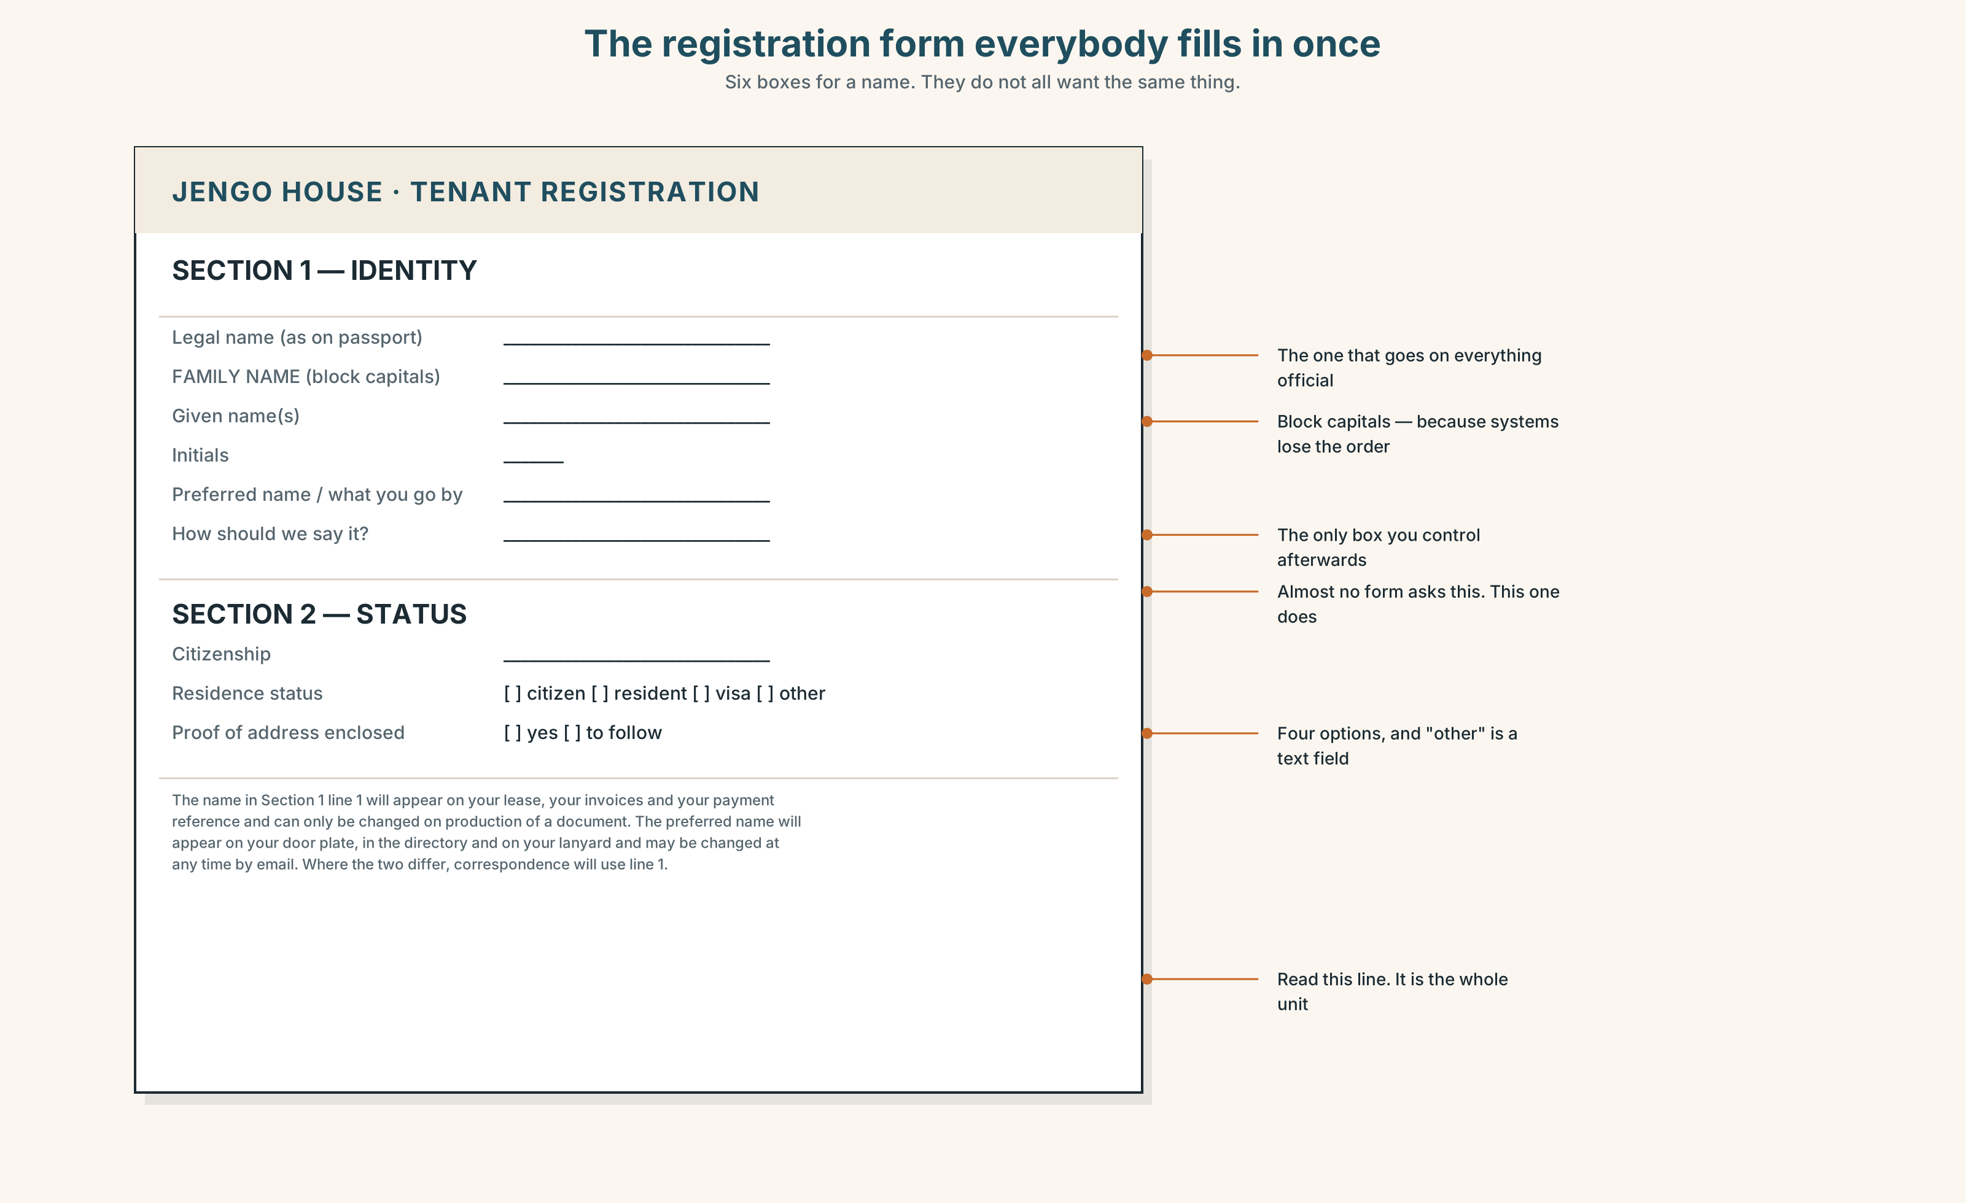{width=6.6in}
The registration form everybody fills in once — Six boxes for a name. They do not all want the same thing.

1A · Meet — on the form
Find each word on the registration form, and say which box it belongs in.
identity · passport · visa · residence · citizenship · surname · initials · nickname · pronounce · spelling · transliterate · misspell

1B · Sort — cline of permanence
Put these in order, from easiest to change to hardest.
nickname · spelling on an email · the name on a lanyard · the name on a payslip · the name on a passport · citizenship
Where exactly does it stop being a choice? Mark the point. People disagree about where it is.

1C · Sort — odd one out, and why
- surname · family name · given name · legal name
- passport · visa · residence · citizenship
- misspell · transliterate · pronounce · translate
- fill out · turn down · go by · sign off

1D · Stretch — the phrases
- On the form it says Oluwafemi. Everyone calls him Femi — he ______ by Femi.
- She is ______ as M. Achieng professionally and nothing else.
- The bank wants a ______ of address before it will change anything.
- For the ______, I have asked three times.
- Mwangi is a ______ name here, and nobody in Lisbon could spell it.

1E · Stretch — four phrasal verbs on one form
fill out · turn down · go by · sign off
Which two are things you do to a form, and which two are things somebody else does to you?
Corpus Note Transliterate appears in English about once in nine million words. Spell appears about once in twenty thousand. If you need the first word, the person you are talking to may not have it.

1F · Own it
Write your own name three ways: as a form wants it, as a colleague would say it, as you would introduce yourself at a conference. Are all three the same? Should they be?

Part 2 · Listening ◆ A · THE WORLD
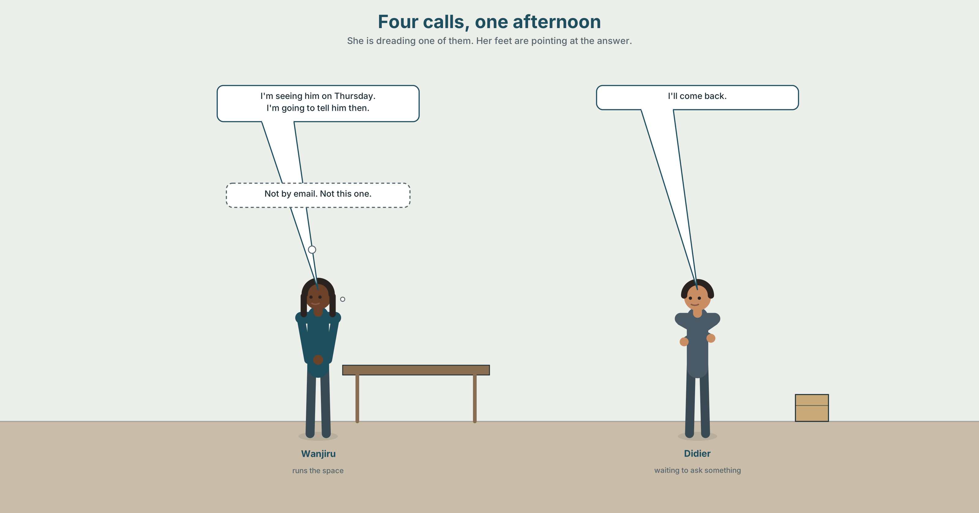{width=6.6in}
Four calls, one afternoon — She is dreading one of them. Her feet are pointing at the answer.

2A · Three ways to say what happens next 🔊 Track 3.1
Before you listen. Wanjiru is making four calls in one afternoon. Look at the picture: which call is she dreading?
Gist — one listen, one question. Which of the four things is already arranged?
Detail — complete the frame.
What she says | Is it decided? | Who decided it?
"I'm seeing him on Thursday."
"I'm going to tell him."
"I'll call you back."
"The lift goes out of service at six."
Inference. She says "I'll call you back" to one person and "I'm calling you back at four" to another. Which one is she more likely to actually do?
Attitude. She says "I'm going to have to" twice. Which sound carries the reluctance?
Noticing. Four sentences. Sort them by what the speaker is really doing.
- I'm seeing Mr Kamau on Thursday.
- I'm going to ask him about the lease.
- I'll ask him, if you want.
- The lease runs out in March.
A. arranged with another person · B. my intention, decided before now · C. decided at this moment, for you · D. a fact on a timetable

2B · Decoding clinic 🔊 Track 3.2
Forty seconds of Wanjiru at speed. Four jobs.
- Count the contractions in the first sentence.
- Catch the three times.
- Where does going to become one sound?
- I'll — what happens to the /w/?
Transcripts, page 173.

Part 3 · Grammar Lab 1 ◆ B · THE SYSTEM

Four futures, and why you would choose each one

3A · Notice
Return to the four sentences in Part 2.
- Which one involves another person who also knows?
- Which one was decided before the conversation started?
- Which one was decided during the conversation?
- Which one would still be true if everybody forgot about it?
- Try swapping 1 and 3. What goes wrong socially — not grammatically?

3B · See
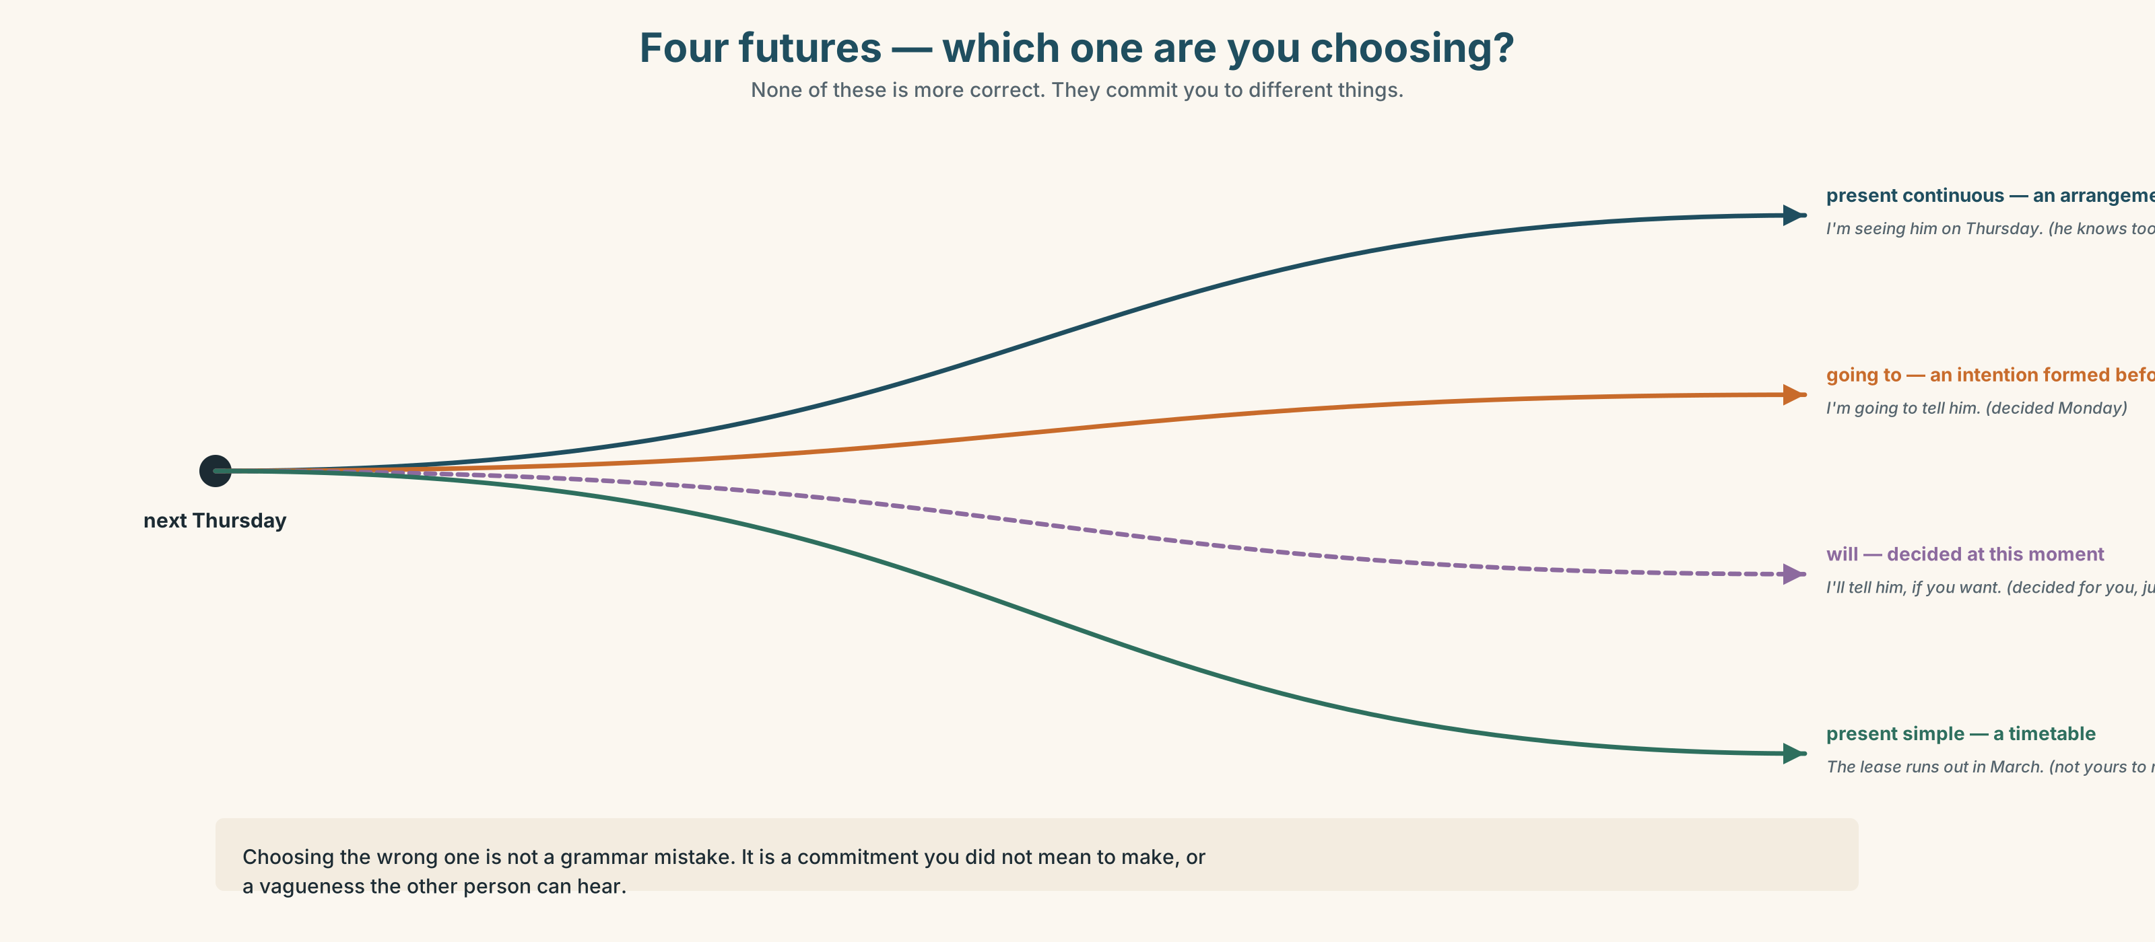{width=6.6in}
Four futures — which one are you choosing? — None of these is more correct. They commit you to different things.

3C · Know
Form | What it signals | Example
present continuous | an arrangement — somebody else knows too | I'm seeing him on Thursday.
going to | an intention formed before now | I'm going to ask about the lease.
will | a decision made at this moment, often for someone | I'll ask him, if you want.
present simple | a timetable — not yours to change | The lease runs out in March.
Watch out. I'll send it and I'm sending it are both correct and they promise different things. The first is a decision. The second is a plan that already exists — and is therefore harder to get out of.
Why it matters. Choosing the wrong future does not produce a grammar mistake. It produces a commitment you did not mean to make, or a vagueness the other person can hear.

3D · Use — controlled
Wanjiru (1) __________ (meet) the landlord on Thursday; it has been in the diary for a week. She (2) __________ (tell) him about the lift, because she decided that on Monday and has been rehearsing it since. If he refuses, she (3) __________ (take) it to the tenants — she has just this second thought of that. The lease (4) __________ (run out) in March whatever anybody does. "I (5) __________ (not do) this by email," she says. "I (6) __________ (sit) in front of him."

3E · Use — guided
Rewrite each one so it commits more, then so it commits less. Say what changes socially.
- I'll look at it.
- We're going to review the contract.
- I'm meeting them next week.

3F · Use — open
Tell a partner four things about your next month — one arrangement, one intention, one thing you are deciding right now, one timetable. Your partner must be able to say which is which.

3G · Check — six items
- — The phone's ringing. — I ______ get it.
- I ______ (see) the dentist at four; it's been booked for weeks.
- The train ______ (leave) at 06:12.
- I've decided — I ______ (tell) her tomorrow.
- — Can somebody help? — I ______.
- We ______ (move) office in March. The lease is signed.
0–3 → Workbook pp. 22–24. 4–5 → Part 6. 6 → p. 59.
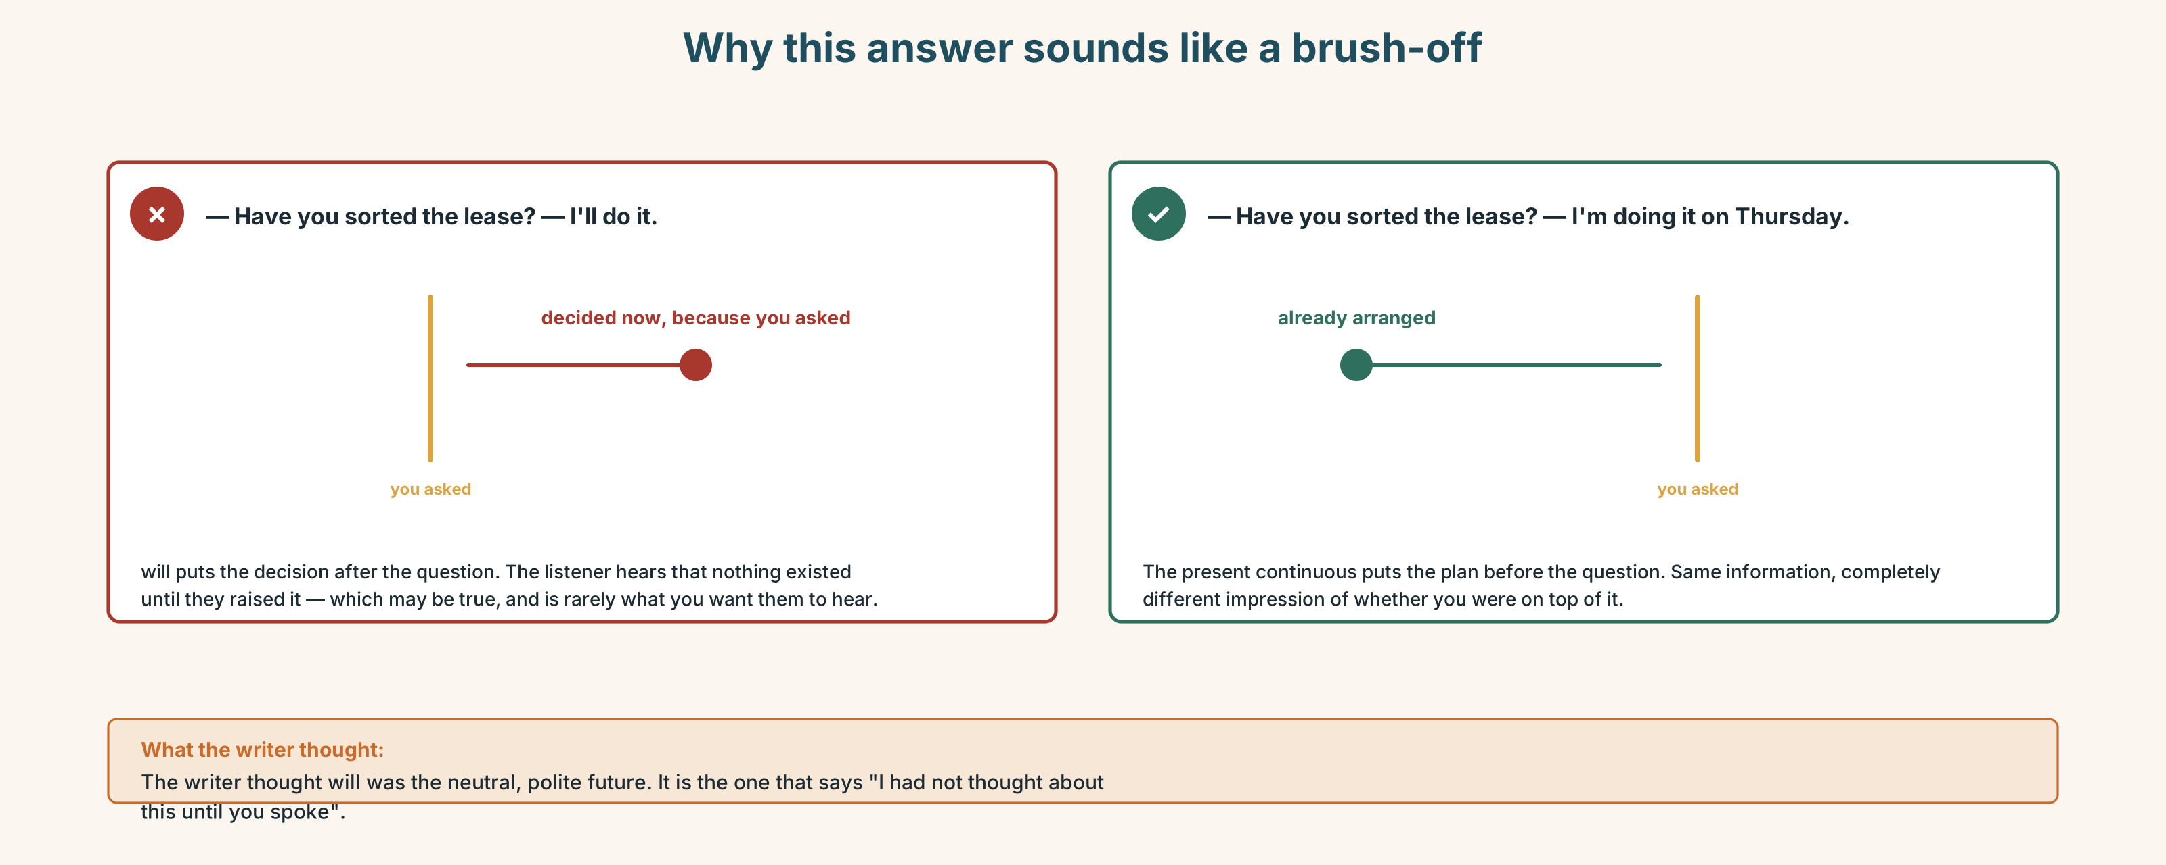{width=6.6in}
Why this answer sounds like a brush-off — Why this answer sounds like a brush-off

Part 4 · Speaking ◆ C · THE PERFORMANCE

4A · Fluency sprint — 4 / 3 / 2
Your next three months. Four minutes, three, two. New partner each time.

4B · The functional core — committing, and not committing
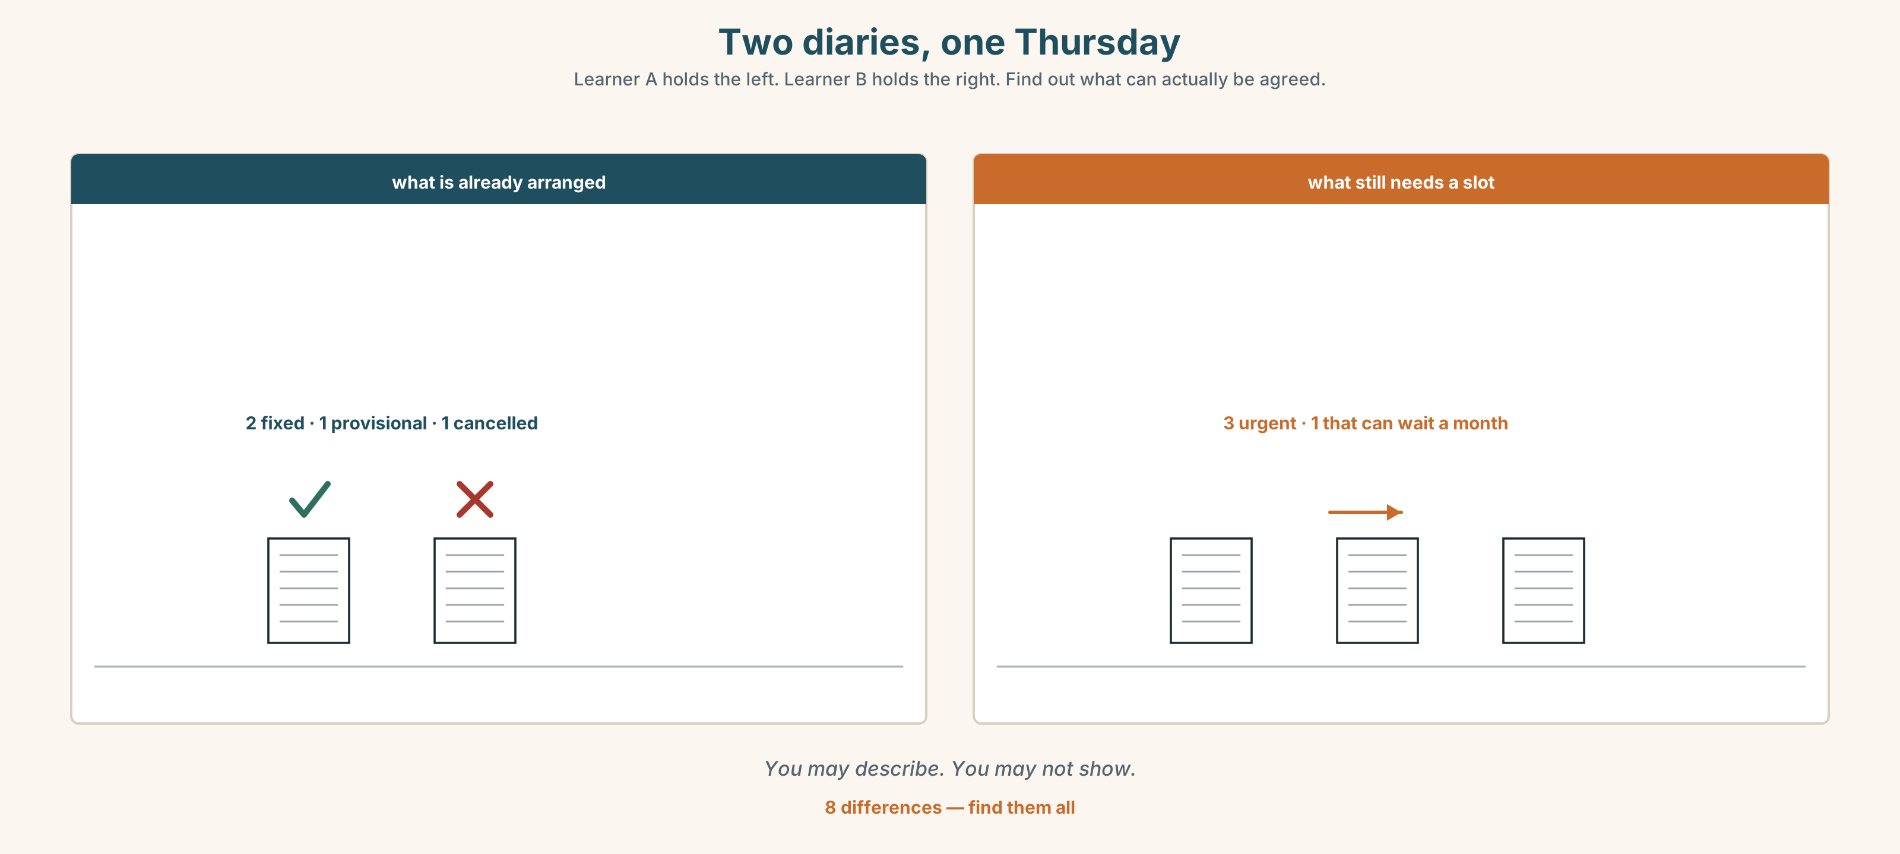{width=6.6in}
Two diaries, one Thursday — Learner A holds the left. Learner B holds the right. Find out what can actually be agreed.
Language Bank
a firm commitment | I'm sending it on Tuesday · that's in the diary · you have my word on it
an intention | I'm going to · I fully intend to · that's the plan
deliberately soft | I'll try to · I should be able to · let me see what I can do
a refusal that sounds like one | I'm not going to be able to · that's not something I can commit to
Information gap. Learner A has a diary with four fixed things. Learner B has four things they need done. Find out what can actually be agreed. Nobody may show the page.

4C · The performance — the name conversation
In pairs, three rounds, swapping roles. Somebody says your name wrong for the third time.
Card A — you are the one whose name it is. You have corrected them twice. Card B — you are friendly, busy, and you genuinely have not noticed.

4D · Observer
Listen for one thing: at what point does the correction stop being about the name?

4E · Two criteria
☐ Did I make exactly the commitment I meant to, and no more? ☐ Did I leave the other person a way to agree?

Part 5 · Reading ◆ A · THE WORLD

5A · Predict
A fiction extract called "The second name." The first line is:
For eleven years my mother called me by a name that is not on any document I own.
What do you expect? One sentence.

5B · Skim — sixty seconds
Where does the narrator change their mind? Mark it.

The second name
For eleven years my mother called me by a name that is not on any document I own. It is four letters long and it means nothing in particular. She says she chose it before I was born and then put something longer on the certificate because the registrar was watching.
At school I used the long one. At home I was the short one. It did not feel like a secret; it felt like weather — something that changed depending on which room you were in.
The trouble started when the two rooms met. A teacher came to the house and used the long name in front of my mother, and I watched my mother decide, in about half a second, not to correct her. That was the first time I understood that one of the names was going to have to win.
I am going to say that I chose the long one, and that is almost true. What actually happened is that the long one was already on things. It was on the register, the library card, the inoculation record, the bank account somebody opened for me when I was nine. Choosing the short one would not have been a choice; it would have been nineteen separate arguments with nineteen institutions, each of which would have asked me for a document carrying the name I was trying to leave.
So I did not choose. I let the paperwork choose, which is what most people mean when they say they chose.
My mother still uses the short one. I am forty-one. When she dies, nobody alive will call me by it, and I have started to mind about that in a way I did not expect, because for eleven years I thought the short name was the one that did not count.

5C · Close reading
- Why did the long name go on the certificate?
- What does "it felt like weather" describe?
- What did the narrator understand when the teacher visited?
- The narrator says "I am going to say that I chose… and that is almost true." What is the gap between those two things?
- List the five institutions named. What do they have in common?
- What changed when the narrator reached forty-one?

5D · Vocabulary in context
registrar · inoculation record · carry (carrying the name) · mind (I have started to mind) · count (the one that did not count)

5E · The counter-text
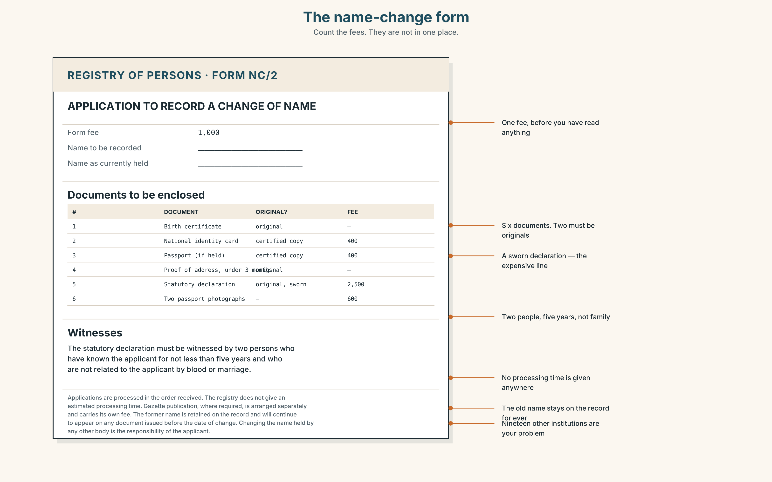{width=6.6in}
The name-change form — Count the fees. They are not in one place.
Read the name-change form and answer.
- How many documents must be enclosed?
- What must the two witnesses be?
- How long does the form say the process takes, and where does it say that?
- What happens to the old name?
- Count the places where a fee is payable.

5F · Writer analysis
The extract is one person's account. The form is nobody's.
- The extract says choosing would have meant "nineteen separate arguments". Does the form support that, or contradict it?
- Which document is more honest about what the process costs?

5G · Text against text
Which one would you give to somebody who had just decided to change their name? Two sentences. The second begins "But they would also need…"

Part 6 · Vocabulary Lab 2 ◆ B · THE SYSTEM

Committing, and getting out of it
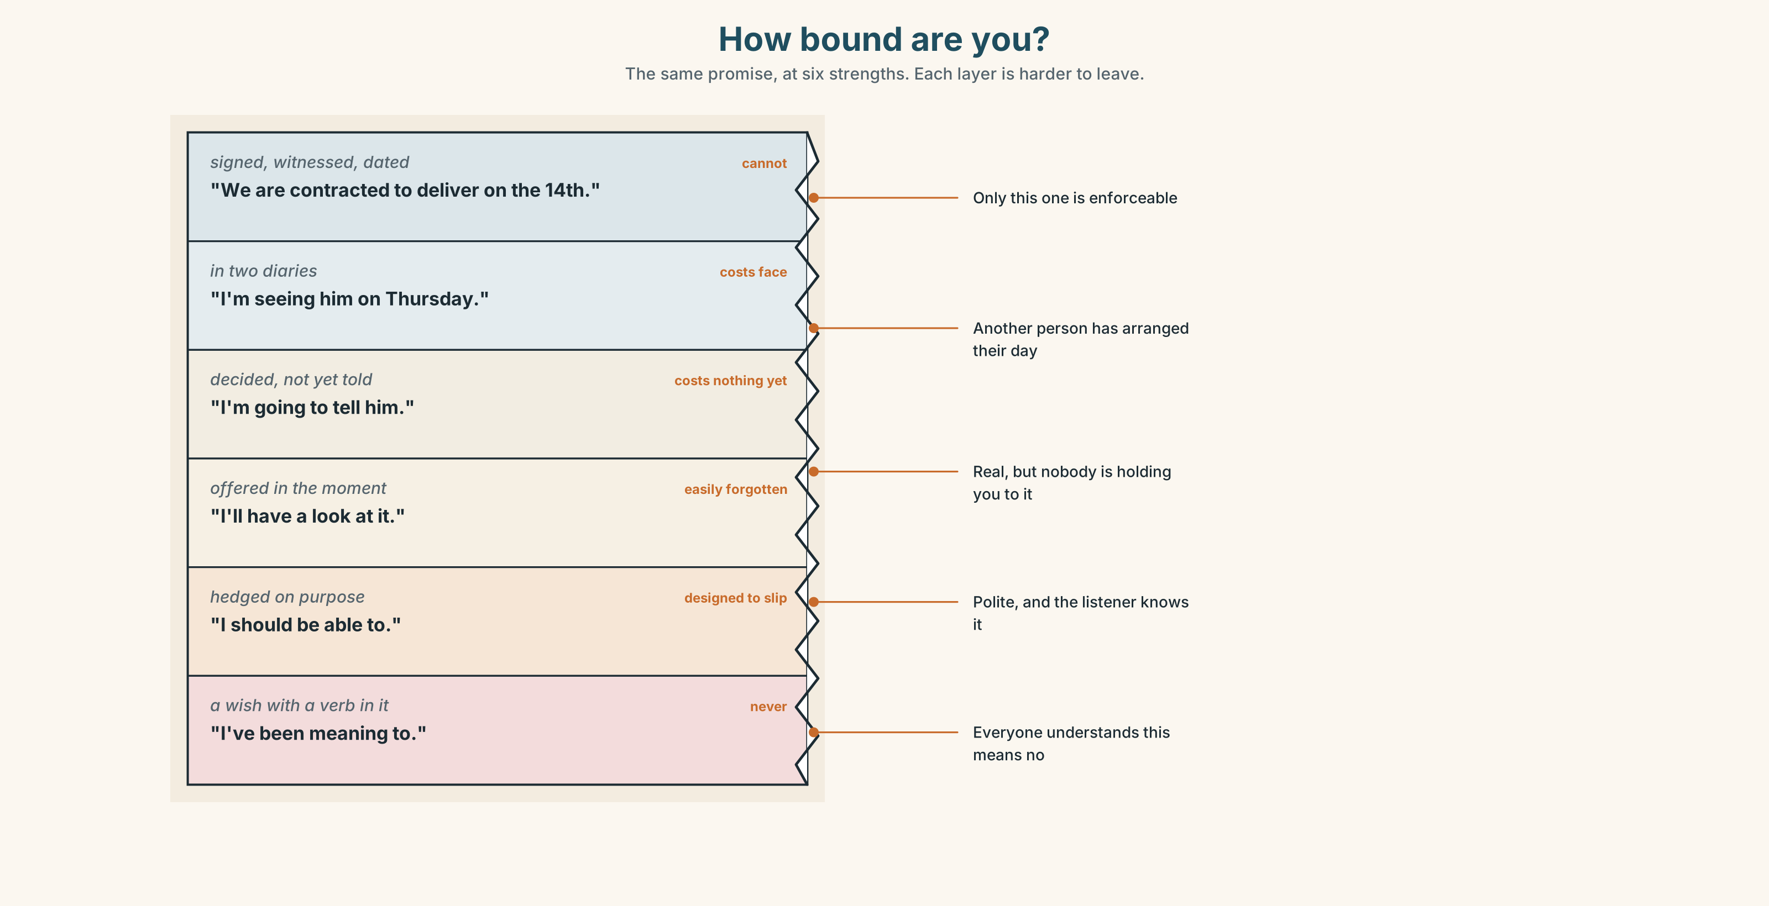{width=6.6in}
How bound are you? — The same promise, at six strengths. Each layer is harder to leave.

6A · Cline — how bound are you?
Put all twenty-one on a line from fully committed to free to walk away.
intend · arrange · promise · commit · expect · aim · anticipate · hesitate · provisionally · imminently · shortly · be due to · be about to · be set to · be thinking of · be likely to · look set to · as things stand · put off · back out of · I was going to…

6B · Chunk completion
- The lease is ______ to expire in March.
- He was ______ to sign, and then he read clause nine.
- I'm ______ of asking for an extension.
- ______ things ______, we have until Friday.
- She ______ out of it the night before.

6C · Register sort
Which of these would you write in a contract, and which only say out loud? Four belong in both.

6D · Contrast Clinic — the four futures
Six items. Context decides.
- — There's someone at the door. — I ______ go.
- We ______ (announce) it on Monday; the press release is written.
- The building ______ (close) at seven, every day.
- I ______ (not sign) that, and I've thought about it for a week.
- Don't worry, I ______ (sort) it out.
- She ______ (start) on the fourteenth — contract's signed.

Part 7 · Pronunciation & Fluency Lab ◆ B · THE SYSTEM

Saying which word matters
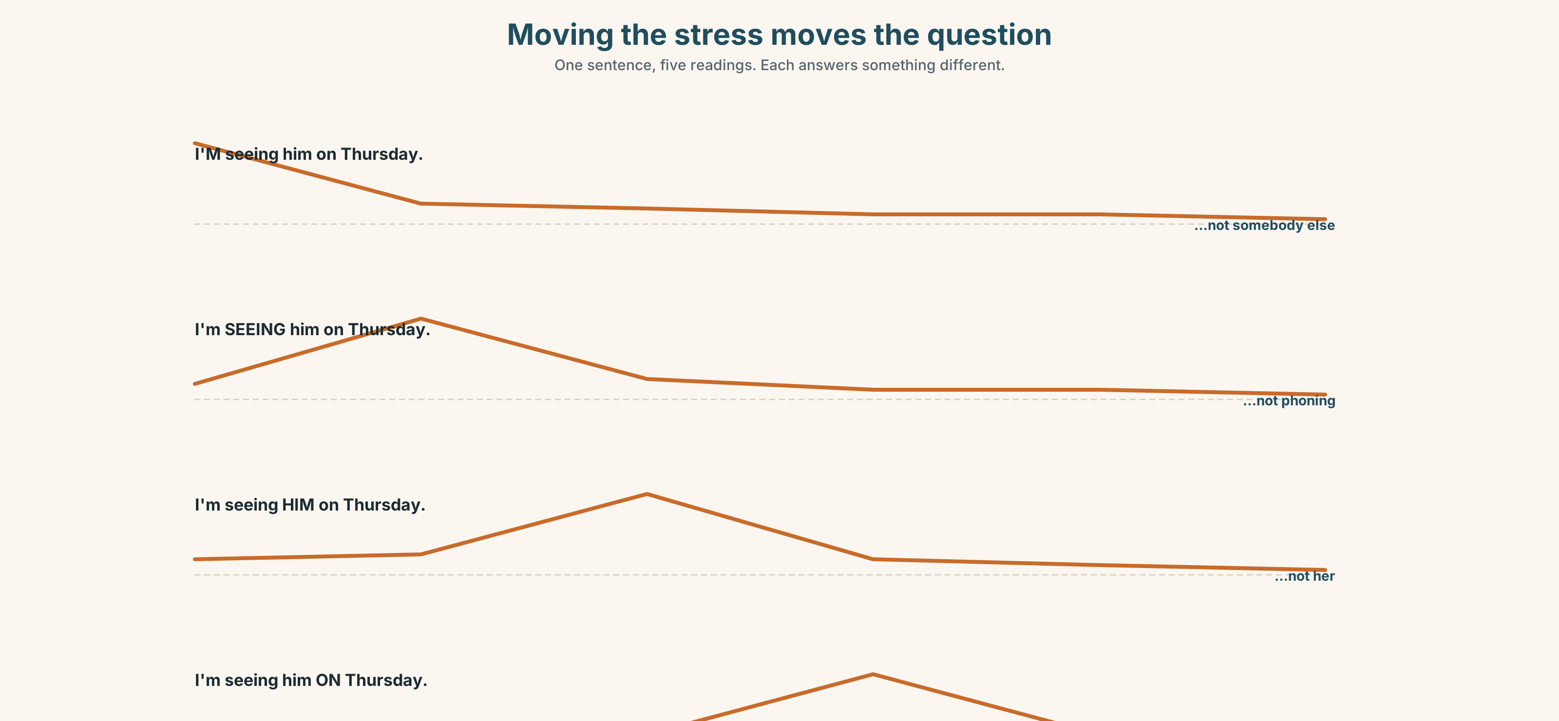{width=6.6in}
Moving the stress moves the question — One sentence, five readings. Each answers something different.

7A · Hear 🔊 Track 3.3
The same sentence, five times. The stress moves. Each one answers a different question.
I'm seeing him on Thursday. · I'm seeing him on Thursday. · I'm seeing him on Thursday. · I'm seeing him on Thursday. · I'm seeing him on Thursday.
Match each one to the question it answers.

7B · Say
Say each version. Your partner says which question you answered. If they get it wrong, say it again — do not explain.

7C · Make it mean something
I didn't say she stole the money.
Seven words, seven meanings. Say it three ways. Your partner writes down what you accused her of.

7D · Fluency 20 ⏺
Twenty seconds: what I am doing next month, and what I am going to do. Three times, faster.

Part 8 · Writing ◆ C · THE PERFORMANCE

A professional introduction · 150 words
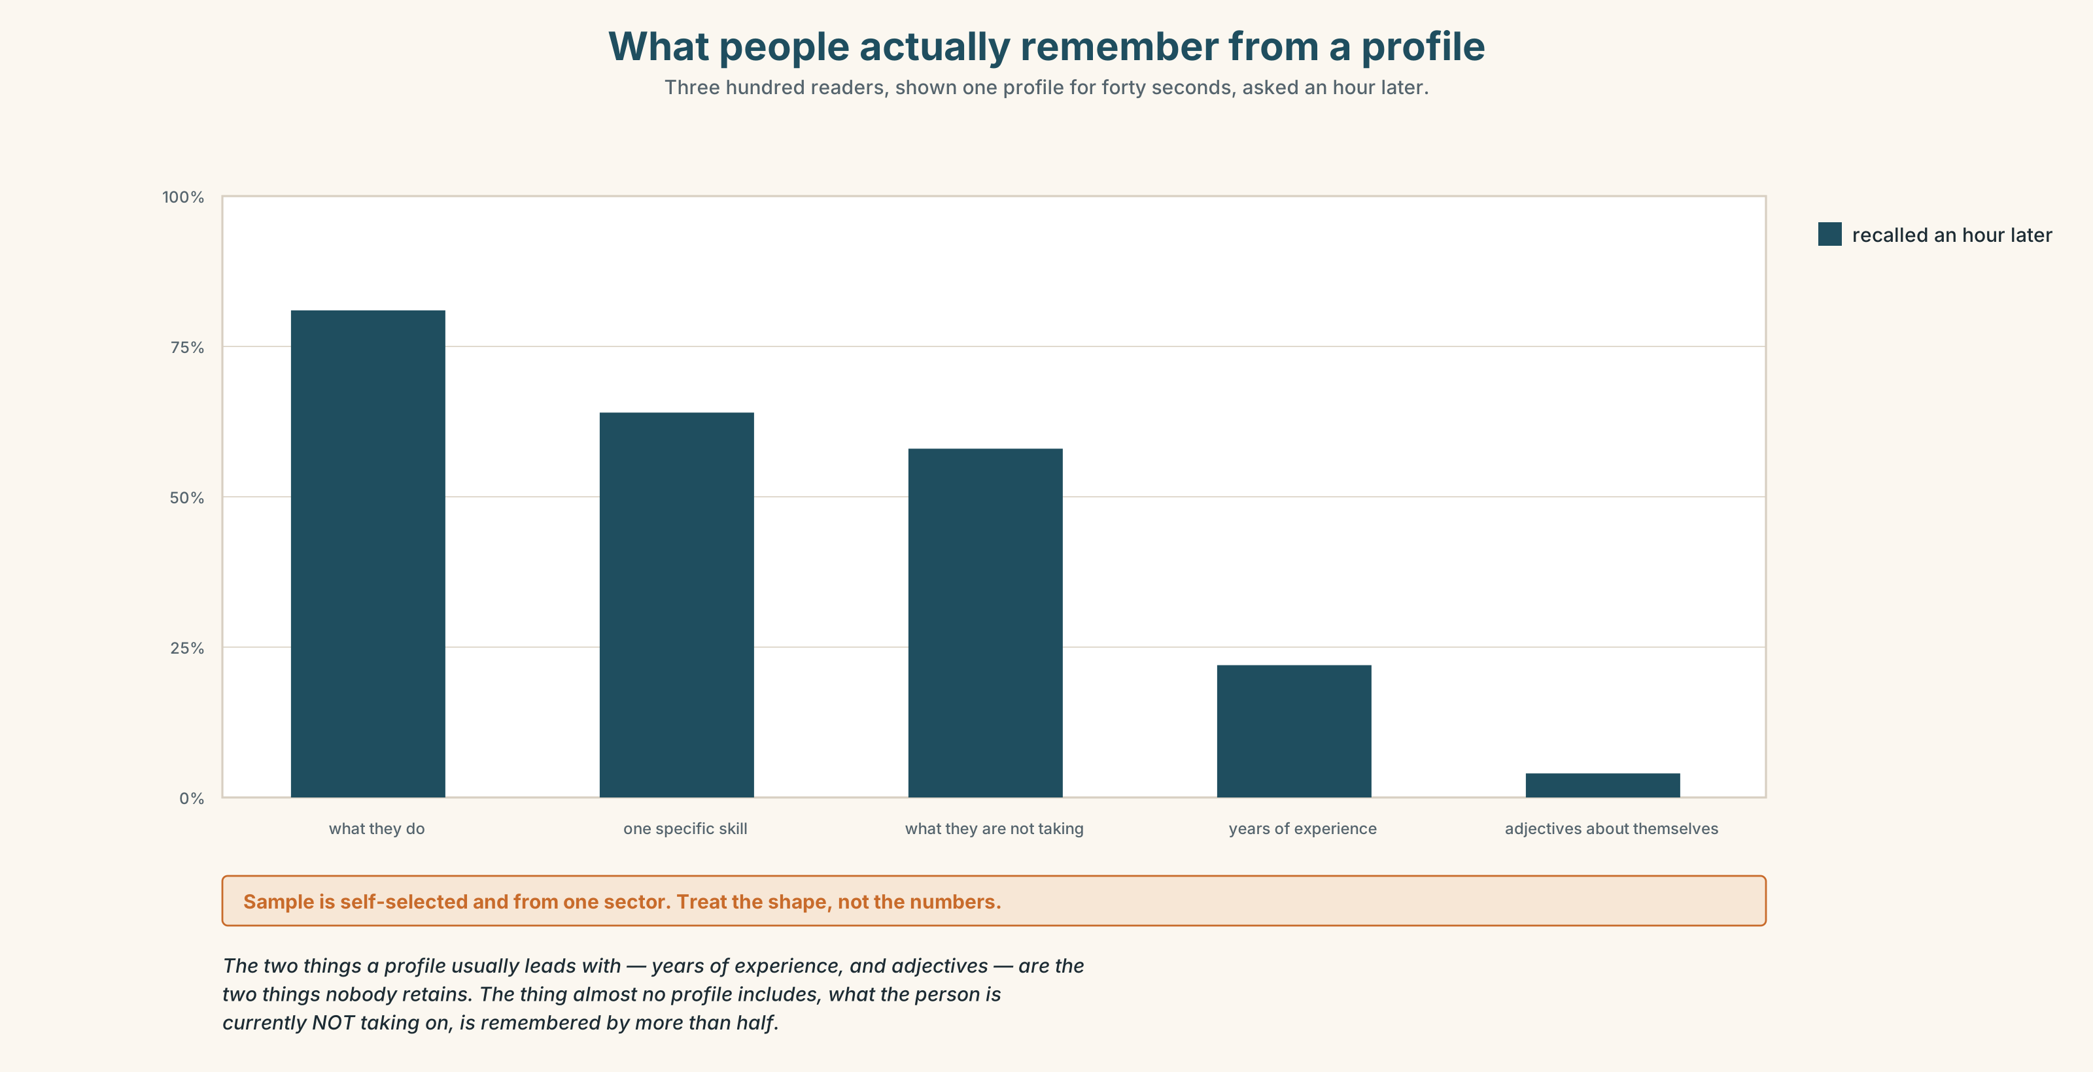{width=6.6in}
What people actually remember from a profile — Three hundred readers, shown one profile for forty seconds, asked an hour later.

8A · Read the model
I'm Mariam Okello. Mariam is what I go by; Okello is the family name and the one on anything official. [deals with the name in sentence two, briskly, so nobody has to wonder]
I make clothes — jackets mostly, in small runs, from a workshop on the ground floor of Jengo House in Nairobi. I have been doing it for nine years and I trained four of the people who now work with me.
What I am good at is the part most workshops find difficult: taking a design that exists as a drawing and turning it into something that can be made forty times without changing. [one specific claim, not three vague ones]
I am not taking new wholesale orders until March. I am taking sampling work, and I am happy to look at anything with a real deadline on it. [says what is closed before what is open]
If you want to see the work, come to the building. I would rather show you than send photographs.
Questions about the writer's choices:
- Why handle the name in sentence two rather than leaving it?
- There are two futures in paragraph four. Why those two and not will?
- The last line refuses something. Why is that a strong ending?

8B · The anti-model
My name is Mariam Okello. I am a passionate and detail-oriented garment professional with 9+ years of experience delivering high-quality results for a diverse portfolio of clients. I am always looking for exciting new opportunities and would love to connect.
Grammatically perfect. Name three things it does not tell you.

8C · Generate · 8D · Plan
who you are and what you go by → what you actually do, concretely → the one thing you are good at that others find hard → what is closed → what is open → how to see it

8E · Draft 1 — 150 words

8F · Peer review — two criteria
☐ Could I pick this person out of ten similar people? ☐ Do I know exactly what to do next if I want to work with them?

8G · Draft 2 · 8H · Record it ⏺
Read your own profile aloud, recorded, in under sixty seconds. It goes next to the text.

Part 9 · The File ◆ A · THE WORLD + C · THE PERFORMANCE

CULTURE FILE · Translating the Untranslatable

9A · Four words with no clean equivalent
Read the four. For each: what does it do that no single English word does?
saudade (Portuguese) · harambee (Swahili) · jugaad (Hindi) · Verschlimmbessern (German)

9B · The other direction
Here are four English items that resist translation. Try them in your own language.
fair play · privacy · accountable · awkward
Which was hardest, and was it hard because of the word or because of the idea?

9C · Bring one
Bring one word from your language that English has to explain in a sentence. Teach it to the group. Then write the sentence English needs.
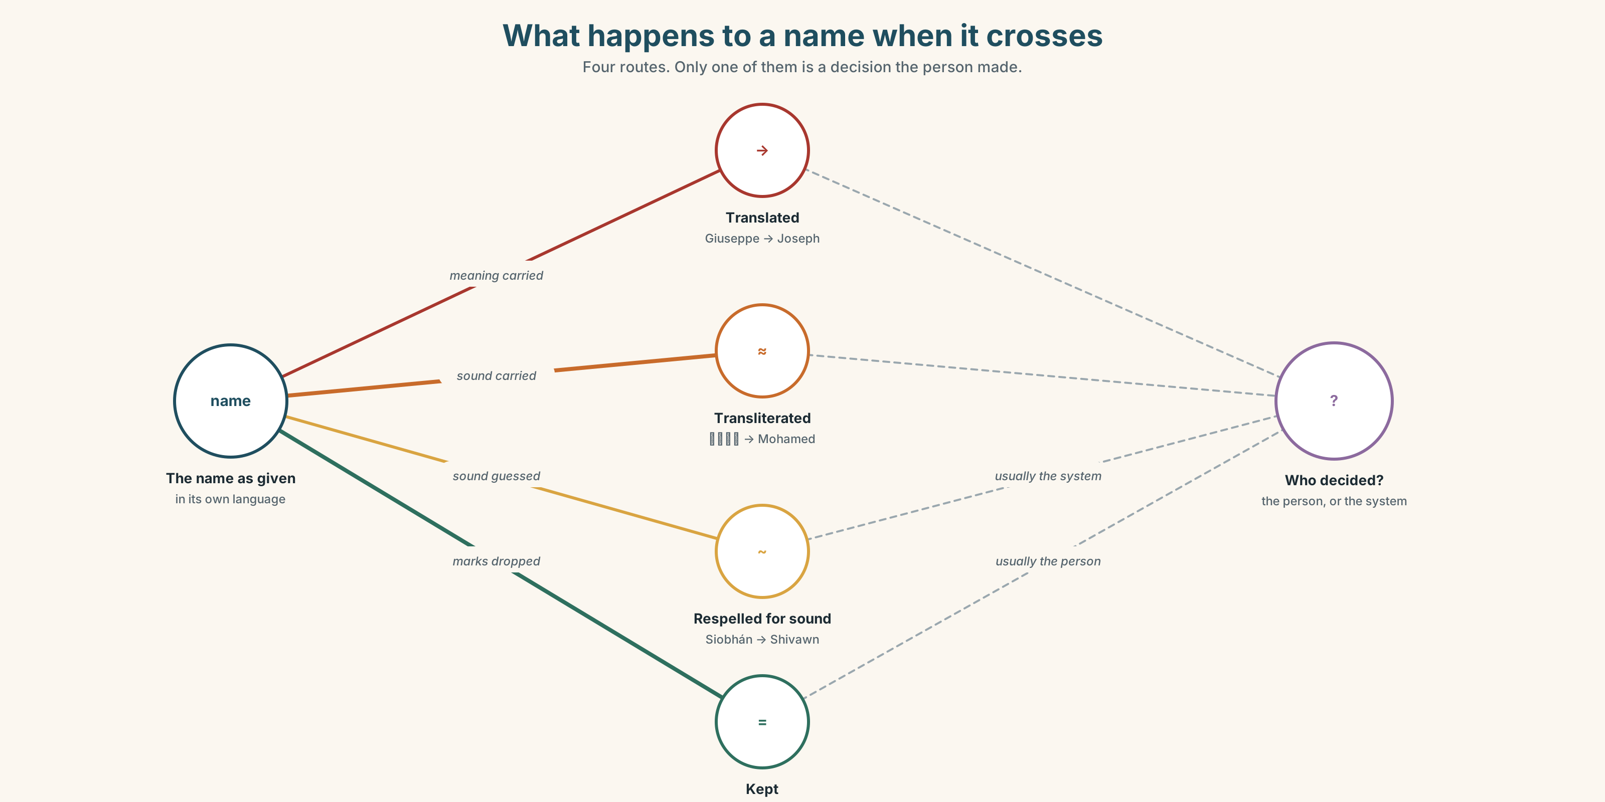{width=6.6in}
What happens to a name when it crosses — Four routes. Only one of them is a decision the person made.

9D · The name question
Some names translate. Some transliterate. Some do neither.
Which of these is happening: Giuseppe → Joseph · محمد → Mohamed · Nguyễn → Nguyen · Siobhán → Shivawn
And which of the four is a decision somebody made about themselves?

9E · Transfer
Ask one person this week how their name should be said, and whether the version people use is the one they chose. Bring what they said, not what you assumed.

Part 10 · Mediation & Interaction ◆ C · THE PERFORMANCE
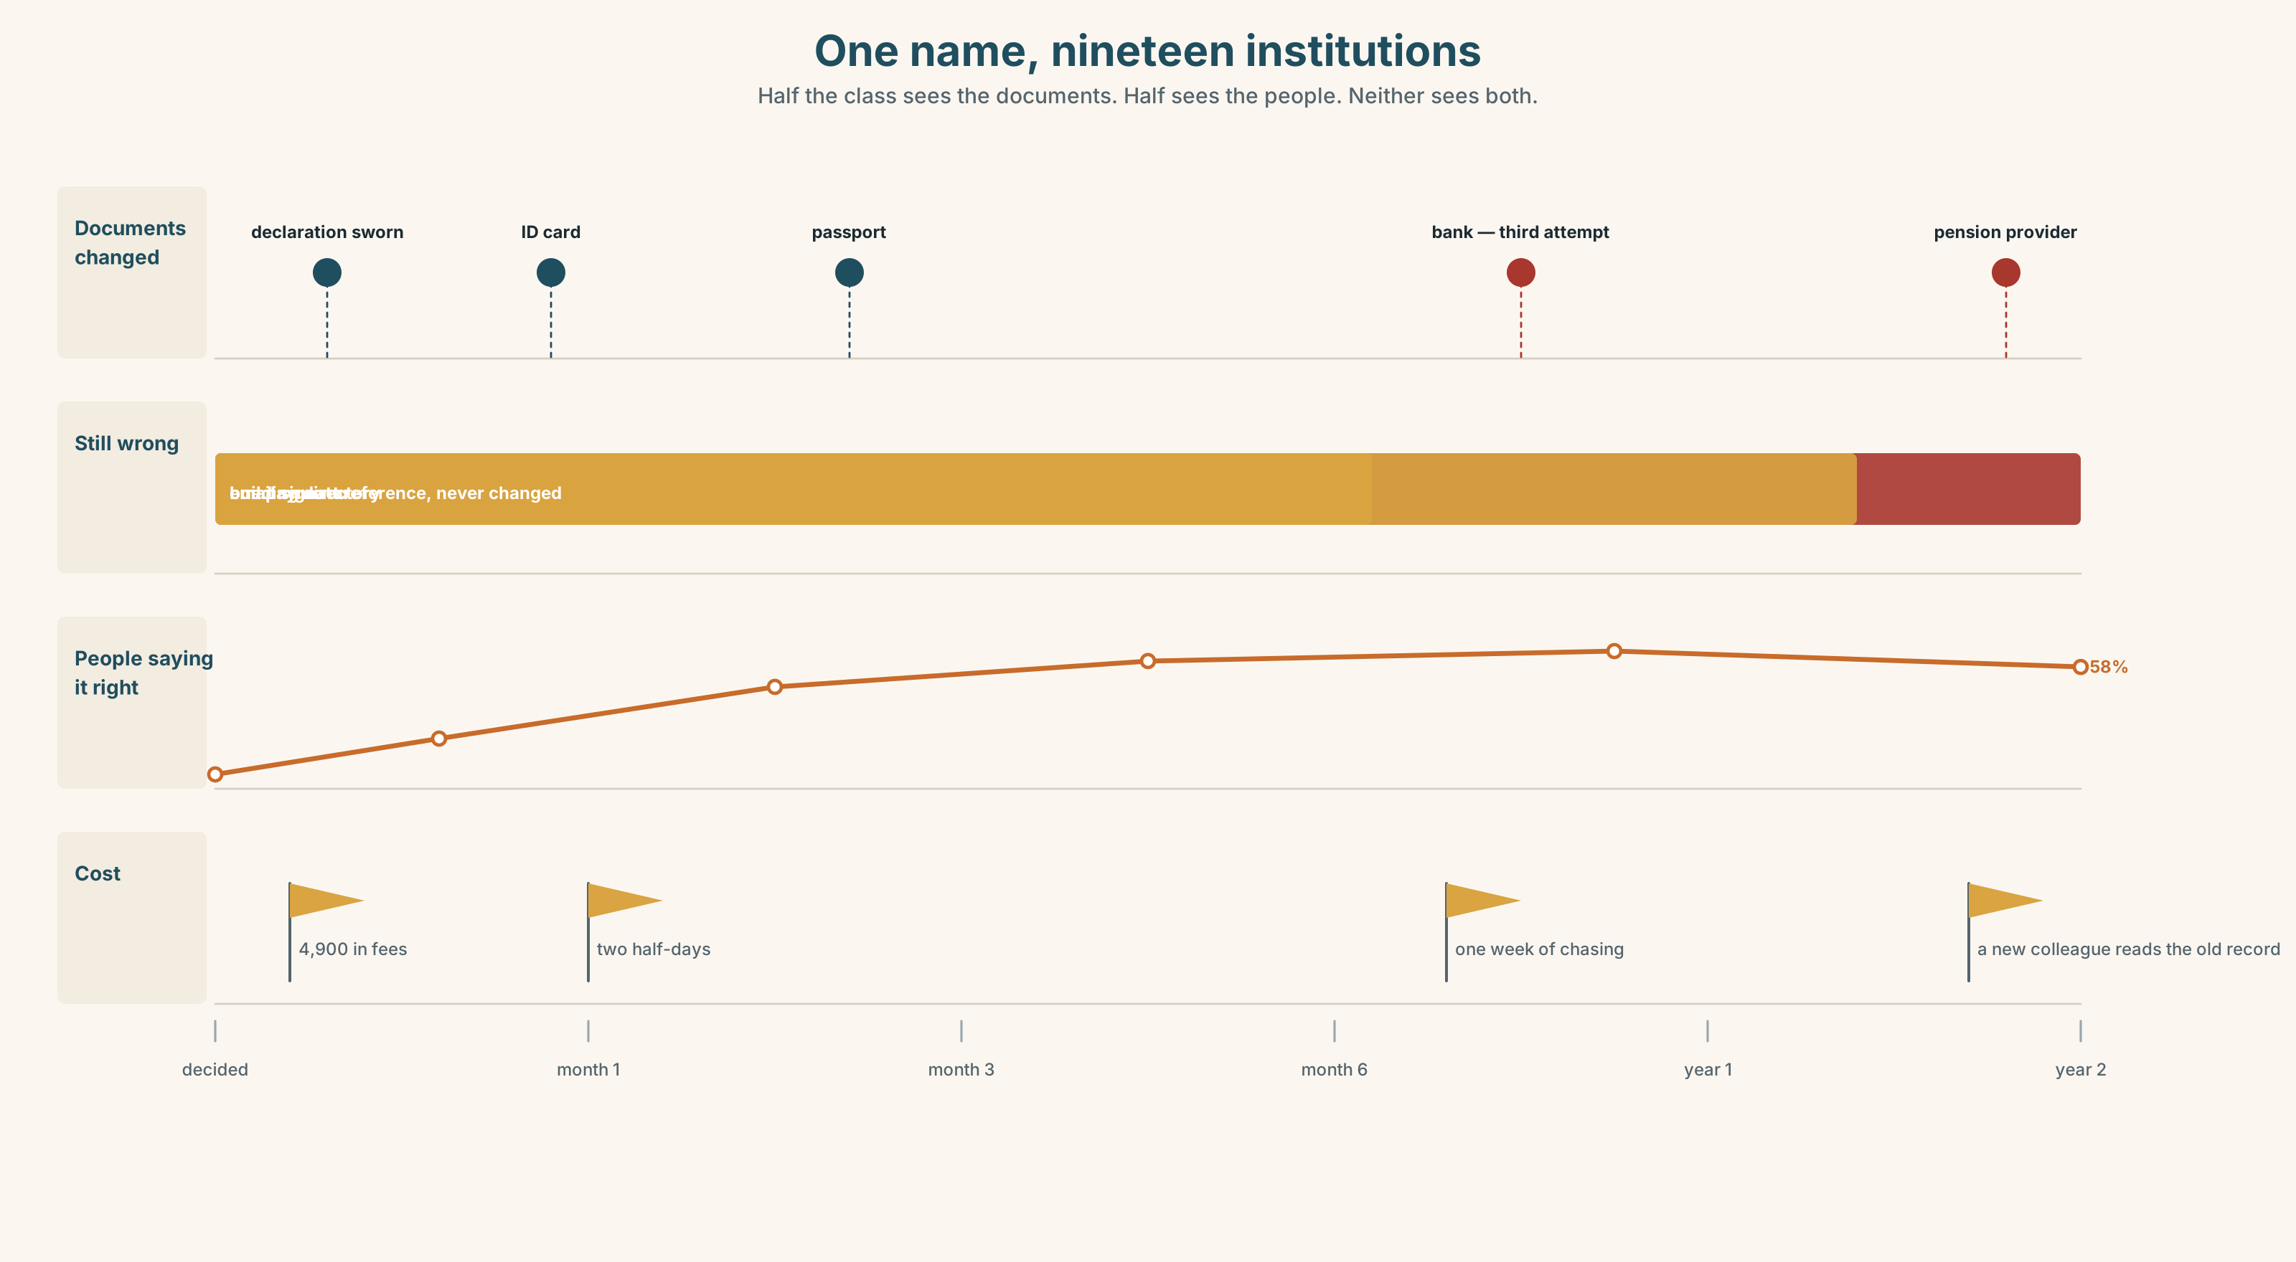{width=6.6in}
One name, nineteen institutions — Half the class sees the documents. Half sees the people. Neither sees both.

10A · Relay
Half the class sees the documents band; half sees the people band. Rebuild it by speaking.

10B · Simplify
Explain the name-change form from Part 5 to somebody who has decided to do it and has an hour before the office closes. What do they need to know first?
Plan: what it is → what they need before they start → what it costs → what takes longest

10C · Compress
The 330-word extract into 60 words, for someone deciding. Three cuts defended.

10D · Online interaction
Write the one message you would send a colleague who has been spelling your name wrong for six months. It will be read once, quickly, probably on a phone.

10E · Across languages
Introduce yourself in your own language, then in English. What did you have to add in English that your language leaves out — and what did you have to drop?

Part 11 · The Decision ◆ C · THE PERFORMANCE

Joseph, or the other thing
Didier runs the café on the ground floor. His full name is Didier Nsengimana. For two years the biggest account — a company that orders ninety coffees a week — has called him Dee.
It began as a shortening. It is now on their internal system, on the standing order, and on the reference that appears on every payment. Changing it means changing the reference, which means their finance team reopening the account.
- Leave it. It is a nickname, they are friendly, and ninety coffees a week is ninety coffees.
- Correct it once, properly, in writing. Make it easy. Accept the risk that it is a nuisance to them.
- Correct it and ask them to change the payment reference too. The whole thing, done once.

11A · The evidence
- The standing order record — the name as their system holds it.
- The chart: how often a correction is actually made, and by whom.
- The voice. Lin, from A1.1, twenty-five seconds: "I changed mine in my first month here. It was easier. Now nobody at work knows my real name and I don't know how to start."

11B · Steelman
Argue the option you like least. Two minutes.

11C · Deliberate
I think he should ______, because ______. The strongest argument against me is ______, and my answer to it is ______.

11D · Decide — eighty words, two reasons

11E · Model decision
I think he should correct it once, in writing, and not ask them to change the payment reference.
The full correction is the one I would want to be right, and I think it is wrong here. The payment reference is their system's problem and it is genuinely expensive to change — reopening an account is a week of somebody's attention. Asking for it turns a thirty-second courtesy into a favour, and favours get remembered as difficulty.
But leaving it entirely is worse, and Lin's recording is why. The cost of saying nothing is not felt in the first year. It is felt when the wrong name has been true for so long that correcting it would need an explanation, and the explanation is the thing nobody has time for.
So: one line, friendly, with the spelling, and no request attached to it. The reference can stay wrong. The person saying it out loud ninety times a week is the one that matters.

11F · The Reveal
What happened. He sent one line. Four people started saying Didier within a week. The finance system still says D NSENG and the payment reference has never changed.
Eight months later a new account manager arrived, read the system, and called him Dee.
He fixed the people and not the paperwork, and the paperwork refilled the people.
Was the reasoning sound? And what, exactly, would the full fix have cost?

Part 12 · Landing ◆ all three lines

12A · Recycle — twelve items
Six from this unit.
- I ______ (see) him on Thursday — it's in the diary.
- The lease ______ (expire) in March whatever we do.
- — There's a call for you. — I ______ take it.
- She ______ out of it the night before.
- On the form it is Oluwafemi, but he ______ by Femi.
- The bank wants ______ of address first.
Four from Units 1–2.
- She ______ (make) these for nine years. (perfect continuous)
- At 3,720 she ______ even. (Unit 2 lexis)
- By the time the notice went up, the period ______ (close). (past perfect)
- Four businesses were ______ out by rising rents. (Unit 1 lexis)
Two from Telling the Story (A2.2).
- The hall, ______ is the only building above the flood line, is still used. (non-defining)
- He ______ (work) on the wall when the water came. (past continuous)

12B · Consolidate
120 words, one paragraph. Your next three months: one arrangement, one intention, one timetable, one thing you are refusing. Use at least six items from Part 6.

12C · Can-do, with evidence
I can… | My evidence | Sure?
choose a future form to make exactly the commitment I mean | Part 3G score | ◯ ◑ ●
write and record a professional introduction people remember | Part 8 recording | ◯ ◑ ●
explain an official form to somebody who has to act on it today | Part 10B | ◯ ◑ ●
take a position on something that is about me | Part 11D decision | ◯ ◑ ●

12D · Replay ⏺
Part 0C, again. Compare. One sentence on what changed.

12E · Glossary — forty-five items, as a map
WHO YOU ARE · identity · citizenship · residence · a common name · be known as · go by ON THE DOCUMENT · passport · visa · surname · initials · legal name · maiden name · given name · birth certificate · proof of address SAYING IT · pronounce · spelling · transliterate · misspell · for the record · it's a long story ON THE FORM · fill out · turn down · sign off COMMITTED · intend · arrange · promise · commit · be due to · be set to · be about to · shortly · imminently NOT QUITE · expect · aim · anticipate · hesitate · provisionally · be thinking of · be likely to · look set to · as things stand GETTING OUT · put off · back out of · I was going to…

12F · Next
Unit 4 · Who is responsible for your health?

