Table of Contents

B1.2 · Unit 7 · Eleven Nights
English Animated · Weighing It Up · Hospital Regional, Valdivia Student's Book pages 138–159 · 22 pp · ~11 hours

Part 0 · The Big Picture ◆ A · THE WORLD
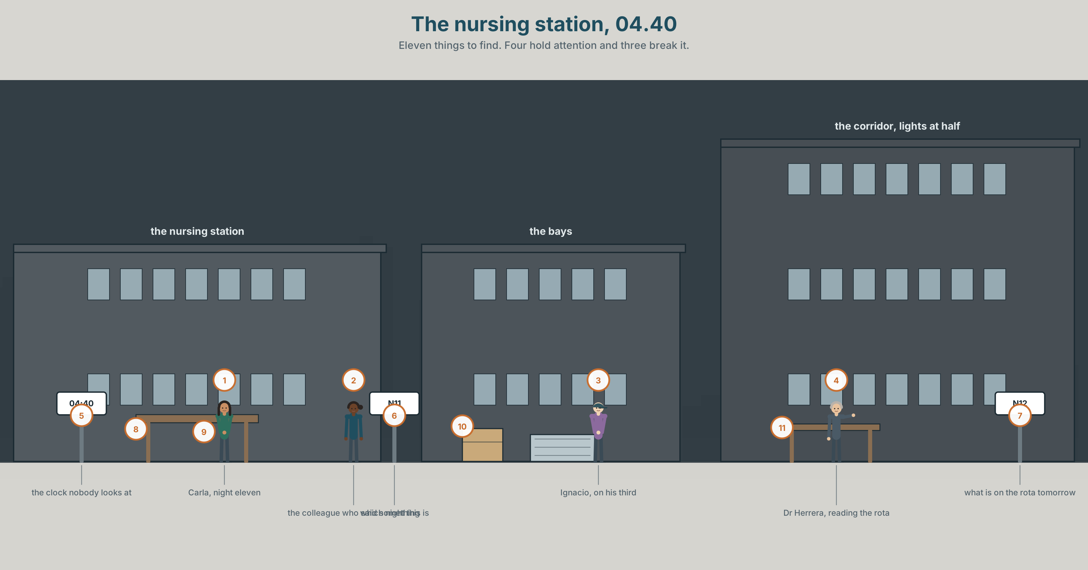{width=6.6in}
The nursing station, 04.40 — Eleven things to find. Four hold attention and three break it.

Did you stop to think, or stop thinking?
By the end of this unit you can describe a habit you tried to change, and what actually happened. One hundred and sixty words.
◆ A · THE WORLD | A rota that permits something nobody would design
◆ B · THE SYSTEM | gerunds and infinitives where the meaning changes · remember · stop · try · go on · 23 words for attention and dependence · 22 verbs that take one form or the other · stress used to disambiguate
◆ C · THE PERFORMANCE | A hundred and sixty words about something you tried to stop

0A · Find it
Find eleven things in this picture. Four of them are there to hold somebody's attention and three are there to break it.
a nursing station screen · a coffee machine · a drug chart · a phone on silent · a rota printed and amended by hand · a window with the blind down · a clock showing 04.40 · a vending machine · a handover sheet · a chair somebody has slept in · a bell

0B · Guess it
Two things in this picture have been there for eleven nights. Which, and how can you tell?

0C · Say it ⏺
Record forty-five seconds. Name a habit you have tried to change. What happened in the first week, and what happened after that? You will record it again at the end of this unit.

Part 1 · Vocabulary Lab 1 ◆ B · THE SYSTEM
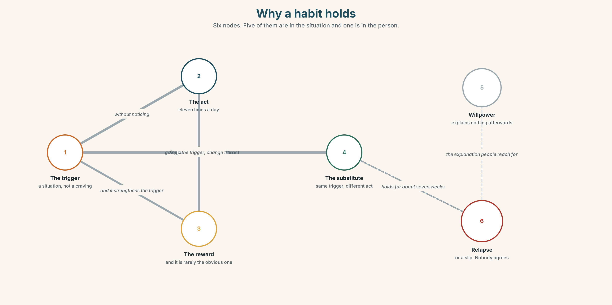{width=6.6in}
Why a habit holds — Six nodes. Five of them are in the situation and one is in the person.

1A · Meet — the words of trying to stop
Match each word to one place on the map.
habit · dependence · craving · trigger · relapse · willpower · abstinence · substitute · reward · focus

1B · Sort — about the body, the mind, or the situation?
Three columns.
craving · trigger · willpower · dependence · distraction · relapse · attention · substitute · abstinence
One of them is almost always described as being in the mind and is almost always in the situation. Which?

1C · Meet — three words people use about themselves
willpower · relapse · trigger
Willpower explains success. Relapse explains failure. A trigger explains neither. Which of the three is the most useful to somebody trying to change something, and why?

1D · Collocation Lab
Complete each one with one word.
- She has been trying to cut ______ for about eight months.
- He stopped cold ______ and lasted eleven days.
- One cigarette is a ______ . Three is a relapse. Nobody agrees where the line is.
- After that weekend she was back to ______ one .
- The first ______ is the one everybody warns you about, and it is not the hard one.
- She did it ______ noticing , which is the part that frightened her.

1E · The fixed expressions
f I stopped for a bit. f I didn't even realise I'd done it.
Two sentences people say about habits. One of them is about will and one is about attention.
Which is which, and which is harder to do anything about?

1F · Own it
Think of something you have tried to stop or start. Tell a partner four sentences: what it was, what triggered it, what you replaced it with, and what actually happened.

Part 2 · Listening ◆ A · THE WORLD
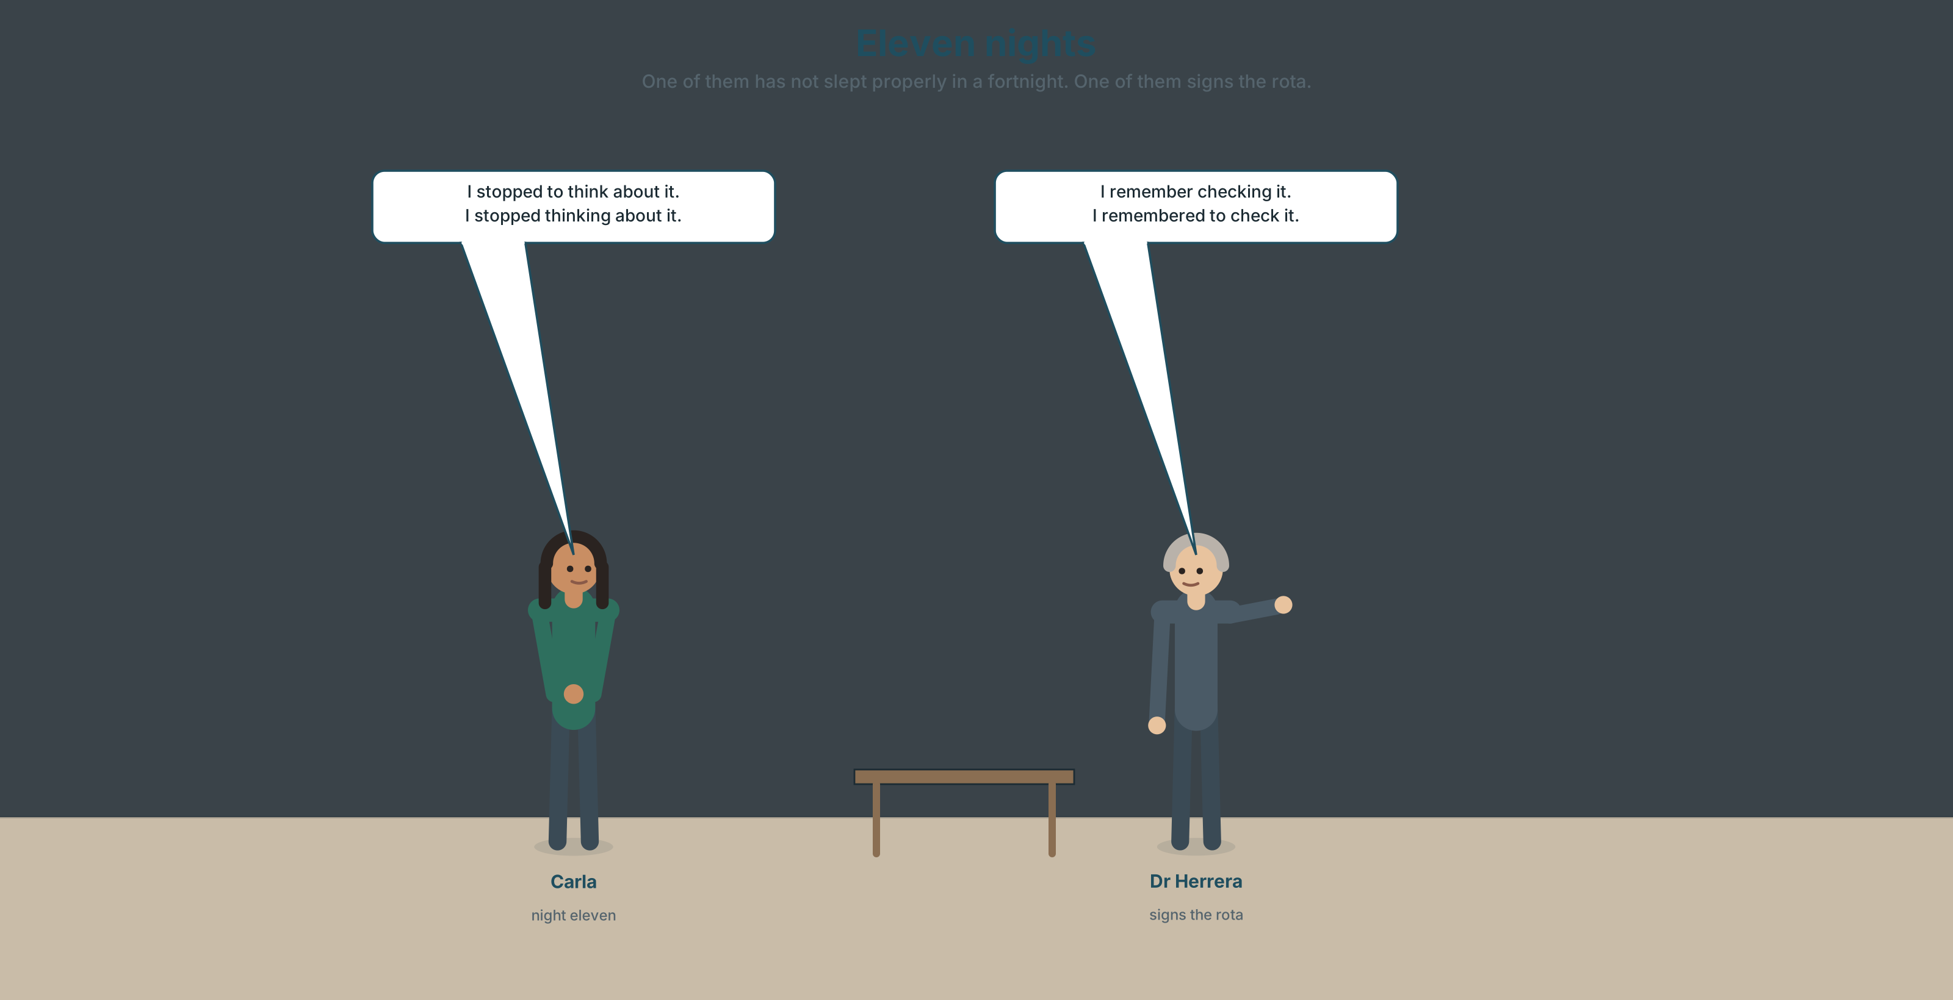{width=6.6in}
Eleven nights — One of them has not slept properly in a fortnight. One of them signs the rota.

2A · Eleven nights 🔊 Track 7.1
Before you listen. Carla has worked eleven nights in a row. She chose to. The rota permits it. Guess: what is the argument against it?
Listen once. One question. Why has she done it?
Listen again. Complete the table.
 | What they say | What they are actually worried about
Carla
Dr Herrera
the rota policy
Listen again. Choose the best answer.
- The rota permits up to seven / ten / twelve consecutive nights.
- She is doing it because of preference / money / childcare.
- The colleague's objection is about her / the patients / both.
- Her own account of the eleventh night is confident / vague / detailed.
Noticing. Four sentences from the recording.
- I stopped to think about it.
- I stopped thinking about it.
- I remember checking it.
- I remembered to check it.
Each pair is the same verb with a different form, and the meanings are not related. Explain each pair in one sentence.

2B · Decoding clinic 🔊 Track 7.2
Thirty seconds of Carla. Four jobs.
- How many -ing forms can you count after a verb?
- In I stopped to think, where is the stress?
- Catch the two numbers she gives.
- She says one thing that she then cannot date. Which?
Transcripts, page 156.

Part 3 · Grammar Lab 1 ◆ B · THE SYSTEM

The same verb, two different sentences

3A · Notice
Look at the four sentences in Part 2.
- In sentence 1, what did she stop? In sentence 2?
- In sentence 3, which happened first — the remembering or the checking? In sentence 4?
- Is there a pattern across the two pairs? Look at which form points backwards.
- Try try doing and try to do. Which one is an experiment and which is an effort?
- Try "I regret to tell you" and "I regret telling you." Which one is bad news for the listener?

3B · See
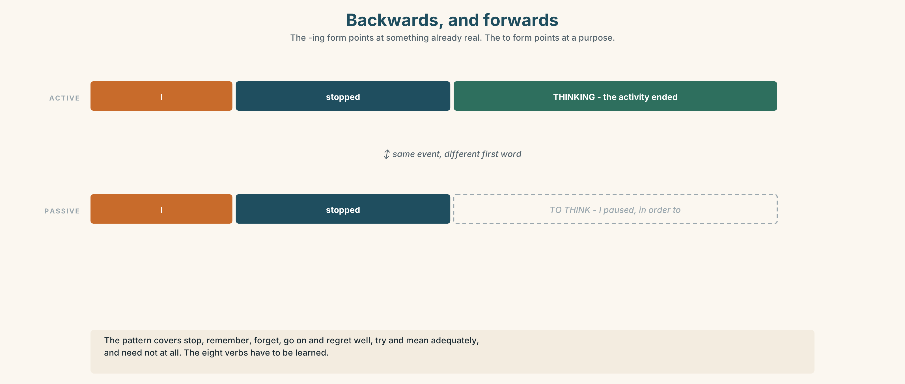{width=6.6in}
Backwards, and forwards — The -ing form points at something already real. The to form points at a purpose.

3C · Know
Verb | + -ing | + to
stop | stop the activity · I stopped thinking. | stop in order to do · I stopped to think.
remember | the memory of doing it · I remember checking. | the duty, then the act · I remembered to check.
forget | I'll never forget seeing it. | I forgot to check.
try | an experiment · Try changing the time. | an effort · Try to change it.
go on | continue the same thing · He went on talking. | move to a new thing · He went on to say that…
regret | about the past · I regret saying it. | about now · I regret to say that…
mean | involve · It means leaving at four. | intend · I meant to leave at four.
need | passive meaning · It needs fixing. | I need to fix it.
The pattern, as far as there is one. The -ing form points backwards or inwards: to something already happening, or already remembered. The to form points forwards: to a purpose, an intention or a duty.
It is not a reliable rule. It covers stop, remember, forget, go on and regret well, try and mean adequately, and need not at all. The eight verbs have to be learned.
Why it matters. I stopped checking and I stopped to check are opposite accounts of the same night, and a hospital record contains both sentences.

3D · Use — controlled
She remembers (1) __________ (check) the chart at about two. She does not remember (2) __________ (check) it again after four, and she thinks she forgot (3) __________ (do) it. At some point she stopped (4) __________ (think) about whether she was tired, which she says is different from (5) __________ (stop / notice). She tried (6) __________ (drink) coffee, which did not work, and then she tried (7) __________ (stay) on her feet, which did. The rota needs (8) __________ (change), and everybody has meant (9) __________ (raise) it for two years.

3E · Use — guided
Write both versions, and say what each means.
- stop + smoke
- remember + lock the door
- try + ask somebody else
- go on + explain
- regret + tell him

3F · Use — open
In pairs. Tell the story of one shift, one day or one journey, using six of the eight verbs in Part 3C. Your partner's job is to catch any form that produces the wrong meaning.

3G · Error autopsy
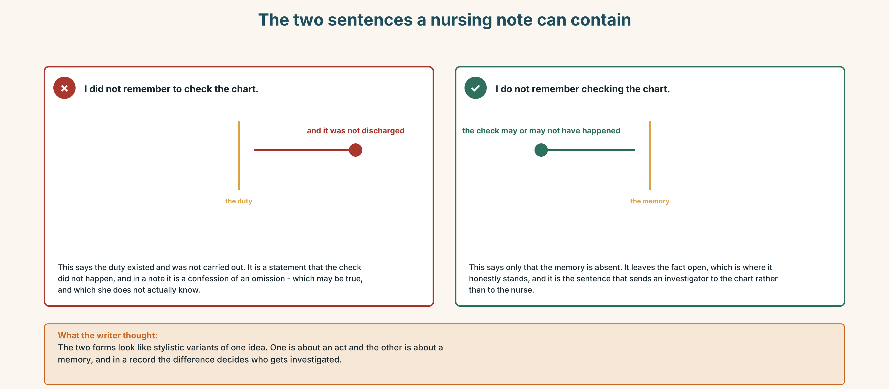{width=6.6in}
The two sentences a nursing note can contain — The two sentences a nursing note can contain
Read both versions. Then say which of the two you would want in a nursing note, and why.

3H · Check — eight items
- I stopped ______ (think) about it. (the thinking ended)
- I stopped ______ (think) about it. (I paused in order to)
- I remember ______ (check) it. (the memory)
- I remembered ______ (check) it. (the duty)
- Try ______ (change) the time. (an experiment)
- He went on ______ (talk) for an hour. (the same thing)
- He went on ______ (say) that it was unsafe. (a new thing)
- The rota needs ______ (change).
0–4 → Workbook pp. 40–43. 5–6 → Part 6. 7–8 → page 151.

Part 4 · Speaking ◆ C · THE PERFORMANCE

4A · Fluency starter — the pair
Your teacher gives a verb from Part 3C. Each learner must produce both forms in two sentences about their own life, in thirty seconds. Nobody may use the example from the table.

4B · The functional core — describing an attempt
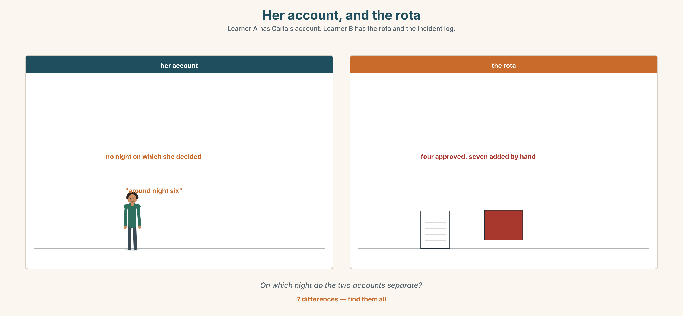{width=6.6in}
Her account, and the rota — Learner A has Carla's account. Learner B has the rota and the incident log.
Language Bank
the attempt | I tried cutting down. · I tried to stop completely.
what it involved | It meant leaving at… · That meant giving up…
what happened | I kept going for… · I went back to it when…
the honest ending | I didn't even realise I'd done it. · I stopped for a bit.
Information gap. Learner A has Carla's account of the eleven nights. Learner B has the rota and the incident log for the same period. Find the night on which the two accounts separate.

4C · The performance — two minutes ⏺
Describe a habit you tried to change. Two minutes. You must include:
what you tried, in both forms — the experiment and the effort · what it meant giving up · what the trigger turned out to be · what actually happened
Record it.

4D · Observer
One person listens for one thing: did the speaker explain the failure with willpower?

4E · Three criteria
☐ Did I use three of the eight verbs in both forms? ☐ Did I name a trigger rather than a weakness? ☐ Is the ending honest rather than tidy?

Part 5 · Reading ◆ A · THE WORLD

5A · Predict
An interview transcript. The title is "I didn't choose the eleventh one. I just didn't stop." What do you expect the difference to be? Two sentences.

5B · Read — two minutes and a quarter

"I didn't choose the eleventh one. I just didn't stop" Interview, night nurse, eleven consecutive nights
Why eleven? It wasn't eleven at the start. It was four, and then somebody was off, and then I picked up two because the money is a third more at night and I have a daughter at university in Santiago.
At what point did it become a decision? That is the question, and I have thought about it a lot since, and the honest answer is that it never did. There is no night on which I decided to do eleven. Around night six I stopped thinking about it. Not stopped caring — stopped thinking. It went from being a thing I was doing to being the shape of the week.
Did anybody say anything? Yes. On night eight somebody asked if I was all right and I said I was fine, and I remember saying it and I remember meaning it.
And on the eleventh? I remember checking a drug chart at about two. I do not remember checking it again, and I believe I did, and I cannot tell you that I did.
Nothing happened. I want to be clear that nothing happened. That is not a defence, it is the thing that worries me, because if something had happened there would be a form and a review and the rota would have been looked at, and because nothing happened there is nothing except this conversation.
What would you say to somebody on night six? I would say: you are not going to notice night seven. Nobody notices night seven. Get somebody else to count for you, because the thing that goes first is not your hands and it is not your judgement, it is your ability to be the person who is counting.

5C · Comprehension — eight questions
- How did eleven nights come about?
- What does she say happened around night six, and what distinction does she draw?
- What happened on night eight?
- What is the difference between what she remembers at two and what she remembers after?
- Why does she say "nothing happened" is not a defence?
- What would have existed if something had happened?
- What is her advice to somebody on night six?
- What does she say goes first?

5D · Vocabulary in context
Guess from the text. Then check.
picked up two · the shape of the week · a defence · looked at · the person who is counting

5E · The counter-text
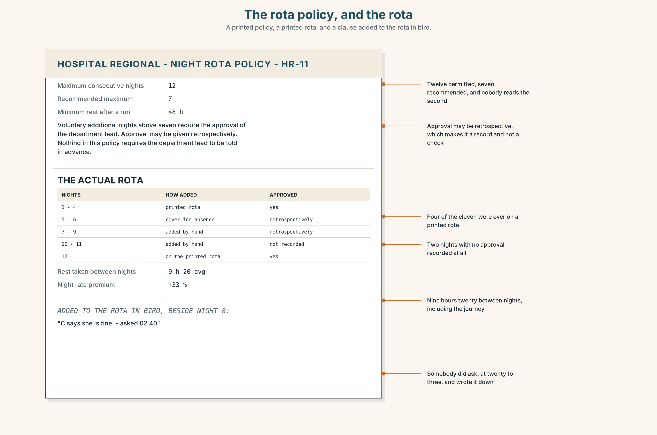{width=6.6in}
The rota policy, and the rota — A printed policy, a printed rota, and a clause added to the rota in biro.
Read the rota policy and the actual rota, and answer.
- What is the maximum number of consecutive nights the policy permits?
- What does the policy say about voluntary additional shifts, and who has to approve them?
- How many of the eleven nights were approved, and by whom?
- What does the policy say about the rest period, and what rest did she actually have?
- One clause has been added by hand to the printed rota. What does it say?

5F · Two texts
The interview says nothing happened. The incident log for those eleven nights shows two near misses, neither involving her.
Put those two facts together. What does the log actually tell you? Three sentences.

Part 6 · Vocabulary Lab 2 ◆ B · THE SYSTEM

Verbs that take one form, and verbs that take both

6A · Sort — -ing, to, or both with a change of meaning?
Three columns.
enjoy · decide · stop · avoid · remember · manage · try · forget · consider · prefer · go on · resent · need
Two of them take both with almost no change of meaning. Which?

6B · Chunk completion
- She carried ______ working because nobody told her to stop.
- He has put ______ raising it for two years.
- I meant ______ say something on night eight.
- He went ______ to say that the rota was the problem.
- She gave ______ on the fourth attempt and started again in March.
- It took three weeks to keep ______ it completely.

6C · The three that are nearly a rule
stop · remember · forget
With all three, the -ing form points at something already real, and the to form points at something intended.
Write one pair for each, from your own life, and then say whether the rule held.

6D · The fixed expression
f I meant to.
Two words that are an apology, an explanation and a refusal of responsibility at once.
Write the sentence before it and the sentence after it, for somebody being honest and for somebody who is not.

6E · Contrast Clinic
Eight items. Choose the form and explain the meaning you have chosen.
- I stopped ______ (smoke) in 2019.
- On the way home I stopped ______ (buy) milk.
- I remember ______ (lock) it.
- I remembered ______ (lock) it.
- Try ______ (move) it to the other side.
- Try ______ (finish) by four.
- He went on ______ (work) all night.
- The window needs ______ (clean).

Part 7 · Pronunciation & Fluency Lab ◆ B · THE SYSTEM

Stress as the disambiguator
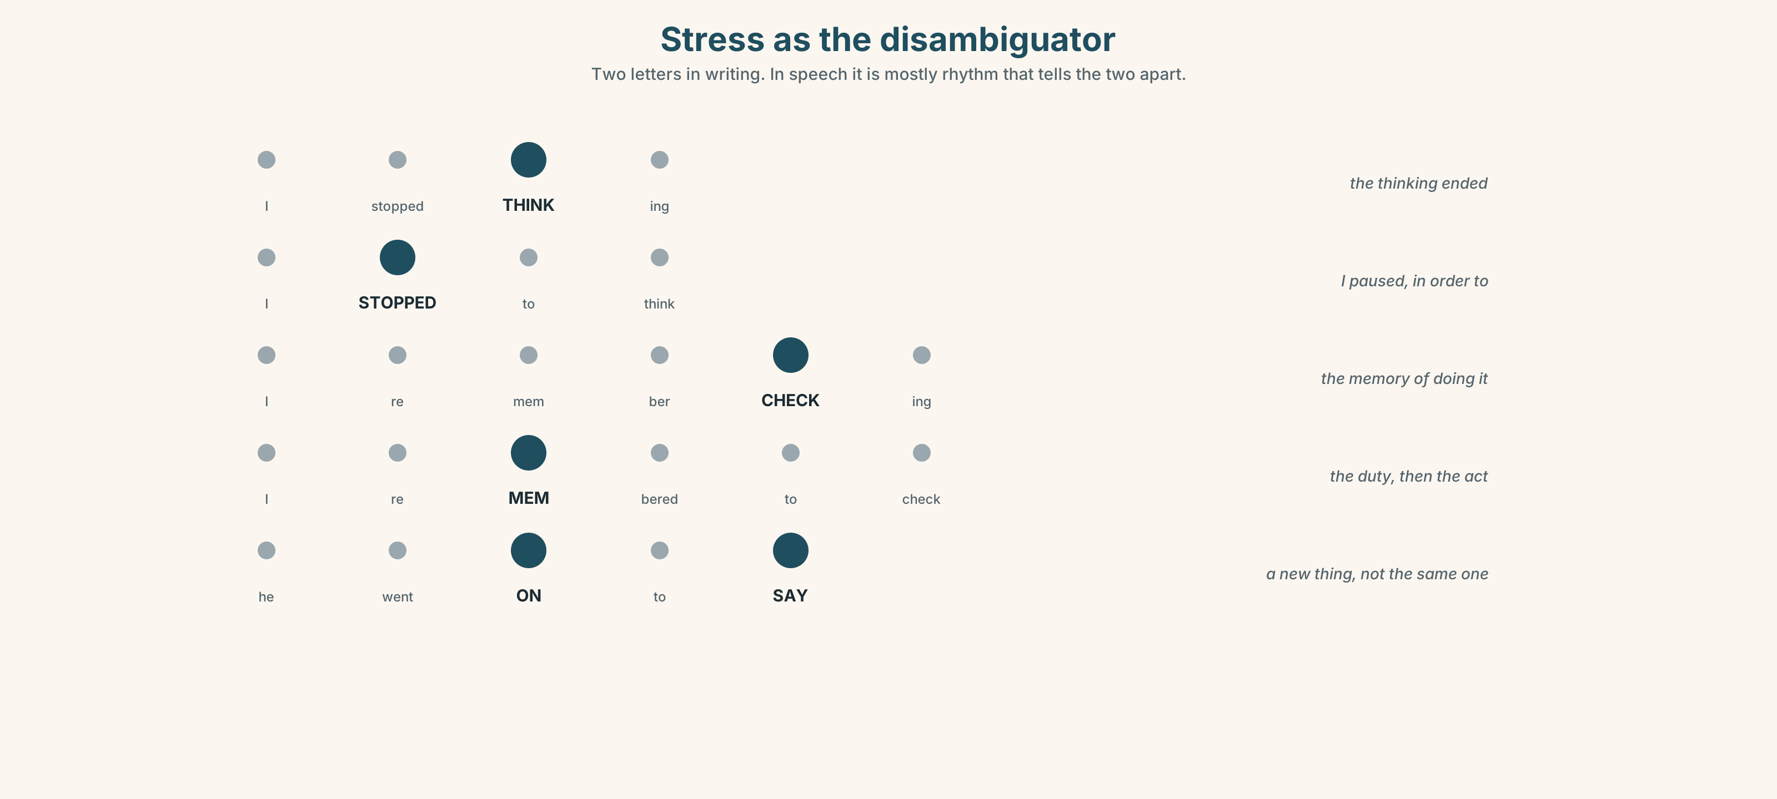{width=6.6in}
Stress as the disambiguator — Two letters in writing. In speech it is mostly rhythm that tells the two apart.

7A · Hear 🔊 Track 7.3
I stopped THINKing. — the thinking ended I STOPPED to think. — I paused, in order to I remember CHECKing. — the memory I reMEMbered to check. — the duty
The two forms are distinguished in writing by two letters and in speech mostly by rhythm.

7B · Say
Say all four. Then say the pair three times, faster, keeping them distinct:
I stopped thinking about it, and then I stopped to think about it.

7C · Make it mean something
Say these two:
I didn't remember to check. (I failed in a duty) I don't remember checking. (I may have done it)
One of these is a confession and one is a gap. Which would you rather write in a note?

7D · Fluency 30 ⏺
Thirty seconds: four of the eight verbs, in both forms, about last week. Three times, faster.

Part 8 · Writing ◆ C · THE PERFORMANCE

Something I tried to change · 160 words
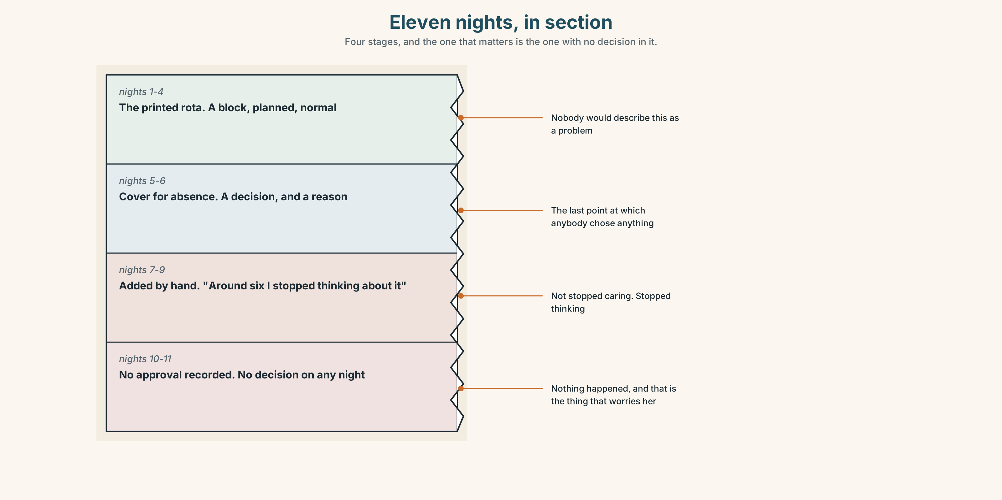{width=6.6in}
Eleven nights, in section — Four stages, and the one that matters is the one with no decision in it.

8A · Read the model
I tried to stop completely in January and I lasted nine days. In March I tried cutting down to three a day, which worked for about seven weeks. [the effort and the experiment, both named, and both with a number attached]
What I eventually noticed is that it was never about the cigarette. It was about going outside. I had been going outside eleven times a day for six years and I had stopped noticing that I did it. [the trigger, and it is a situation and not a weakness]
I now go outside eleven times a day and stand in the same place. That is the whole of the change and it is not a triumph; it is a substitution and it may not hold. [what actually happened, named accurately, and the writer refuses the ending the reader wants]
I did not use willpower. I do not think I have any. [one sentence that disposes of the category]
Questions about the writer's choices:
- Both forms of try appear, with different results. What does that let the writer show?
- The trigger is going outside, not the cigarette. Why is that a better explanation?
- The last two sentences dismiss willpower. Is that an excuse?

8B · The anti-model
I decided to give up and it was very difficult at first. There were times when I wanted to give in but I stayed strong and reminded myself why I was doing it. It just takes determination and the right mindset. Anyone can do it if they really want to.
Correct English, and useless to anybody trying. Name three things it does not contain, and say what the right mindset is standing in for.

8C · Plan
what you tried, in both forms, with numbers → the trigger, as a situation → what actually happened → one sentence that refuses the tidy ending

8D · Write — 160 words

8E · Peer review — three criteria
☐ Are both forms of at least one verb used, with different meanings? ☐ Is the trigger a situation rather than a character flaw? ☐ Does the ending refuse to be a triumph?

8F · Write it again · 8G · Publish
On the wall, with the rota from Part 5E beside it.

Part 9 · The File ◆ A · THE WORLD + C · THE PERFORMANCE

WORK FILE · The Process Note
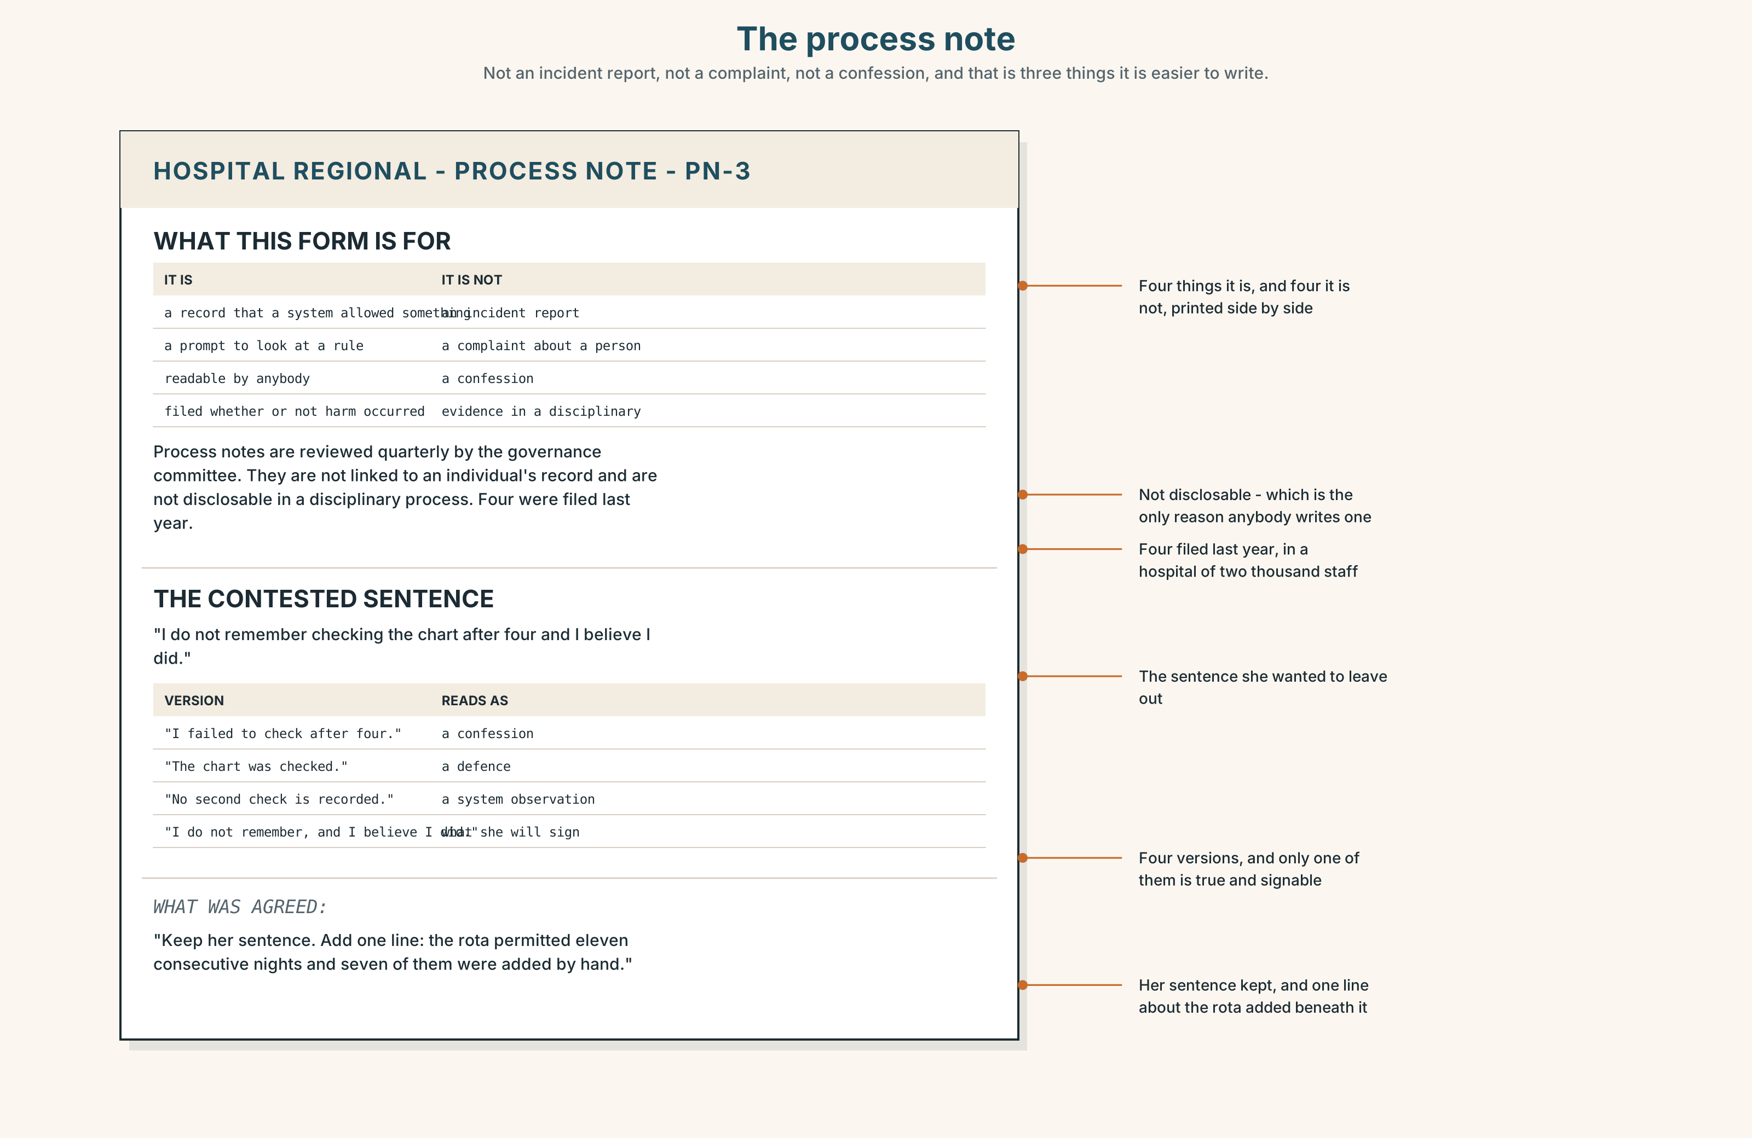{width=6.6in}
The process note — Not an incident report, not a complaint, not a confession, and that is three things it is easier to write.

9A · Writing it down afterwards 🔊 Track 7.4
Carla is asked to write a process note about the eleven nights. Listen to her talking it through with Dr Herrera first.
- What does Dr Herrera say the note is for, and what does she say it is not for?
- Which sentence does Carla want to leave out, and why?
- What is agreed about the sentence in the end?

9B · What a process note is
not an incident report — nothing happened not a complaint — nobody broke a rule not a confession — she did nothing wrong is a record that a system permitted something
Which of the four is hardest to hold on to while writing it?

9C · The sentence that is hard to write
"I do not remember checking the chart after four and I believe I did."
Rewrite it four ways: as a confession, as a defence, as a system observation, and as a sentence you would be willing to sign. Which of your four is longest?

9D · Your turn
Write a 120-word process note about something that went nearly wrong anywhere in your life. Nothing may have actually happened. Then swap, and your partner marks every sentence that is about a person rather than a system.

9E · Transfer
Find one thing this week that a system permits and nobody would design. Write one sentence about it that you would be willing to sign.

Part 10 · Mediation & Interaction ◆ C · THE PERFORMANCE
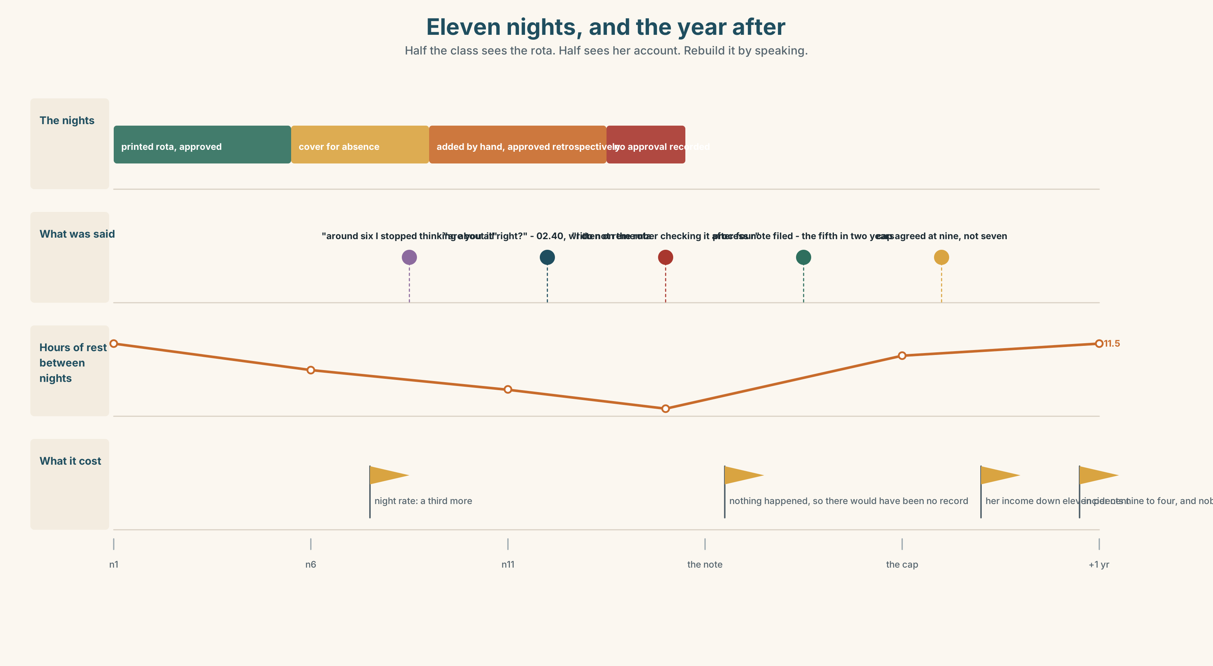{width=6.6in}
Eleven nights, and the year after — Half the class sees the rota. Half sees her account. Rebuild it by speaking.

10A · Relay
Half the class sees the rota and the policy. Half sees Carla's account. Rebuild the eleven nights by speaking. Twelve minutes.

10B · Simplify
Explain the rota policy from Part 5E to somebody who has just been offered three extra nights. Five sentences only.
Plan: what the maximum is → what counts as voluntary → who has to approve it → what the rest period is → the one question to ask yourself on night six

10C · Compress
The interview in Part 5 into forty words, keeping the last answer.

10D · Online
Write one message to the rota lead: nothing happened, you are raising it anyway, and you are proposing one specific change that costs nothing.

10E · Your language
How does your language distinguish I stopped smoking from I stopped to smoke? Say both in your language. Does the difference come from the verb, the word order, or something else?

Part 11 · The Decision ◆ C · THE PERFORMANCE

Night twelve
Carla has worked eleven consecutive nights. She chose to, she needs the money, the rota permits it, and a colleague has said she thinks it is unsafe. Night twelve is on the rota.
- Let it run. She is an adult, the policy permits twelve, nothing has happened, and she needs the money more than anybody else needs her to stop.
- Stop her. Take her off night twelve. She loses a third of a night's pay, somebody has to cover, and she will be the nurse who was taken off.
- Change the policy. Cap consecutive nights at seven for everybody. It costs about four shifts a month in agency cover and it takes the decision away from the person least able to make it at four in the morning.

11A · The evidence
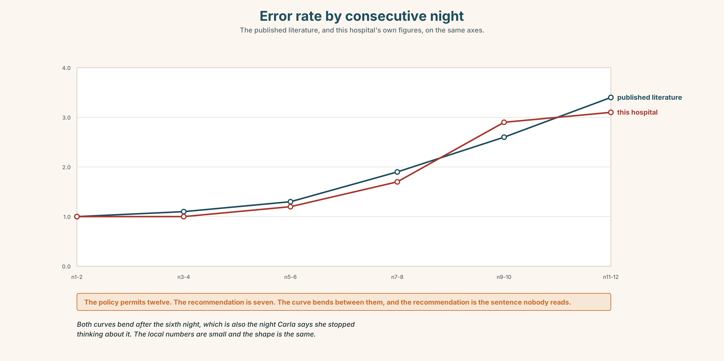{width=6.6in}
Error rate by consecutive night — The published literature, and this hospital's own figures, on the same axes.
- The policy and the rota from Part 5E — and the clause added by hand.
- The chart — error rates by consecutive night, from the literature and from this hospital.
- The voice. Carla, thirty seconds: "If you ask me now, I will tell you I am fine, and the reason I will tell you that is that I am the person being asked. I said it on night eight and I meant it. I would quite like somebody to stop asking me and decide."

11B · Talk about it
In fours. Everybody speaks twice. Use the frame.
She stopped ______ , which is not the same as stopping ______ . So ______ .
Words you can use: habit · dependence · trigger · relapse · willpower · focus · attention · without noticing · the first week

11C · Decide
Write three sentences. Choose, say why, and name what it costs.
I think the hospital should ______________________ , because ______________________ . What this costs is ______________________ .

11D · Model decision
Change the policy to seven and pay for the agency cover. Carla is right that she is the worst possible person to ask, and so is everybody else at four in the morning on their eleventh night; that is not a fact about her character, it is what the research says about everybody's. A cap is the only version of this that does not require one tired person to be heroic about their own tiredness, and it costs four shifts a month, which is a number the hospital can actually decide about.

11E · The Reveal
What happened. The cap was proposed at seven and agreed at nine, because seven would have required more agency cover than the budget had.
Carla's income fell by about eleven per cent. She has said twice, publicly, that she supports the cap, and once, privately, that she has been looking at agency work herself because the agency rate for a single night is higher than the hospital's.
Consecutive-night incidents in the following year fell from nine to four. Nobody can say whether that is the cap, because nine and four are small numbers and the department also got a new consultant in March.
The cap worked, probably, and it cost one person eleven per cent of her income, definitely.
Was it the right decision? Say why — and say what should be done about the agency rate.

Part 12 · Landing ◆ all three lines

12A · Recycle — twelve items
- I stopped ______ (think) about it. (the thinking ended)
- I stopped ______ (think). (I paused in order to)
- I remember ______ (check) it. (the memory)
- I remembered ______ (check) it. (the duty)
- She has been trying to cut ______ .
- He stopped cold ______ .
- She was back to ______ one .
- He has put ______ raising it for two years.
- (Unit 6) She ______ (have) it done on Thursday.
- (Unit 5) By March we ______ (pass) eleven thousand.
- (A2.1 U6) I can't afford ______ (replace) it.
- (A2.1 U6) Do you mind ______ (wait) ?

12B · Consolidate
One hundred and sixty words. A habit you tried to change. Both forms of at least one verb, a trigger that is a situation, and an ending that refuses to be tidy.

12C · Can-do, with evidence
I can… | My evidence | Sure?
choose between -ing and to where the meaning changes | Part 3H score | ◯ ◑ ●
describe an attempt to change something in two minutes | Part 4C recording | ◯ ◑ ●
write 160 words that explain a failure without willpower | Part 8 draft 2 | ◯ ◑ ●
write a process note about a system, not a person | Part 9D note | ◯ ◑ ●

12D · Replay ⏺
Find your forty-five seconds from Part 0C. Listen. Record it again. Two sentences: what is different, and whether you have stopped explaining it with willpower.

12E · Glossary — forty-five items, as a map
THE HABIT · habit · dependence · craving · trigger · relapse · abstinence · substitute · reward THE MIND · attention · focus · distraction · willpower · without noticing TRYING · cut down · cut out · cold turkey · keep off · the first week · a slip · give in · slip back · back to square one WHAT PEOPLE SAY · I stopped for a bit · I didn't even realise I'd done it · I meant to BOTH FORMS, DIFFERENT MEANINGS · remember · forget · stop · try · go on · mean · need · regret ONE FORM ONLY · resent · like · prefer · consider · carry on · put off THE PAIRS · stop to think · stop thinking · try doing · try to do · remember doing · remember to do · go on to

12F · Next
Unit 8 · Which the do you mean?

