Table of Contents

B1.2 · Unit 8 · Which Patients, Exactly
English Animated · Weighing It Up · Hospital Regional, Valdivia Student's Book pages 160–181 · 22 pp · ~11 hours

Part 0 · The Big Picture ◆ A · THE WORLD
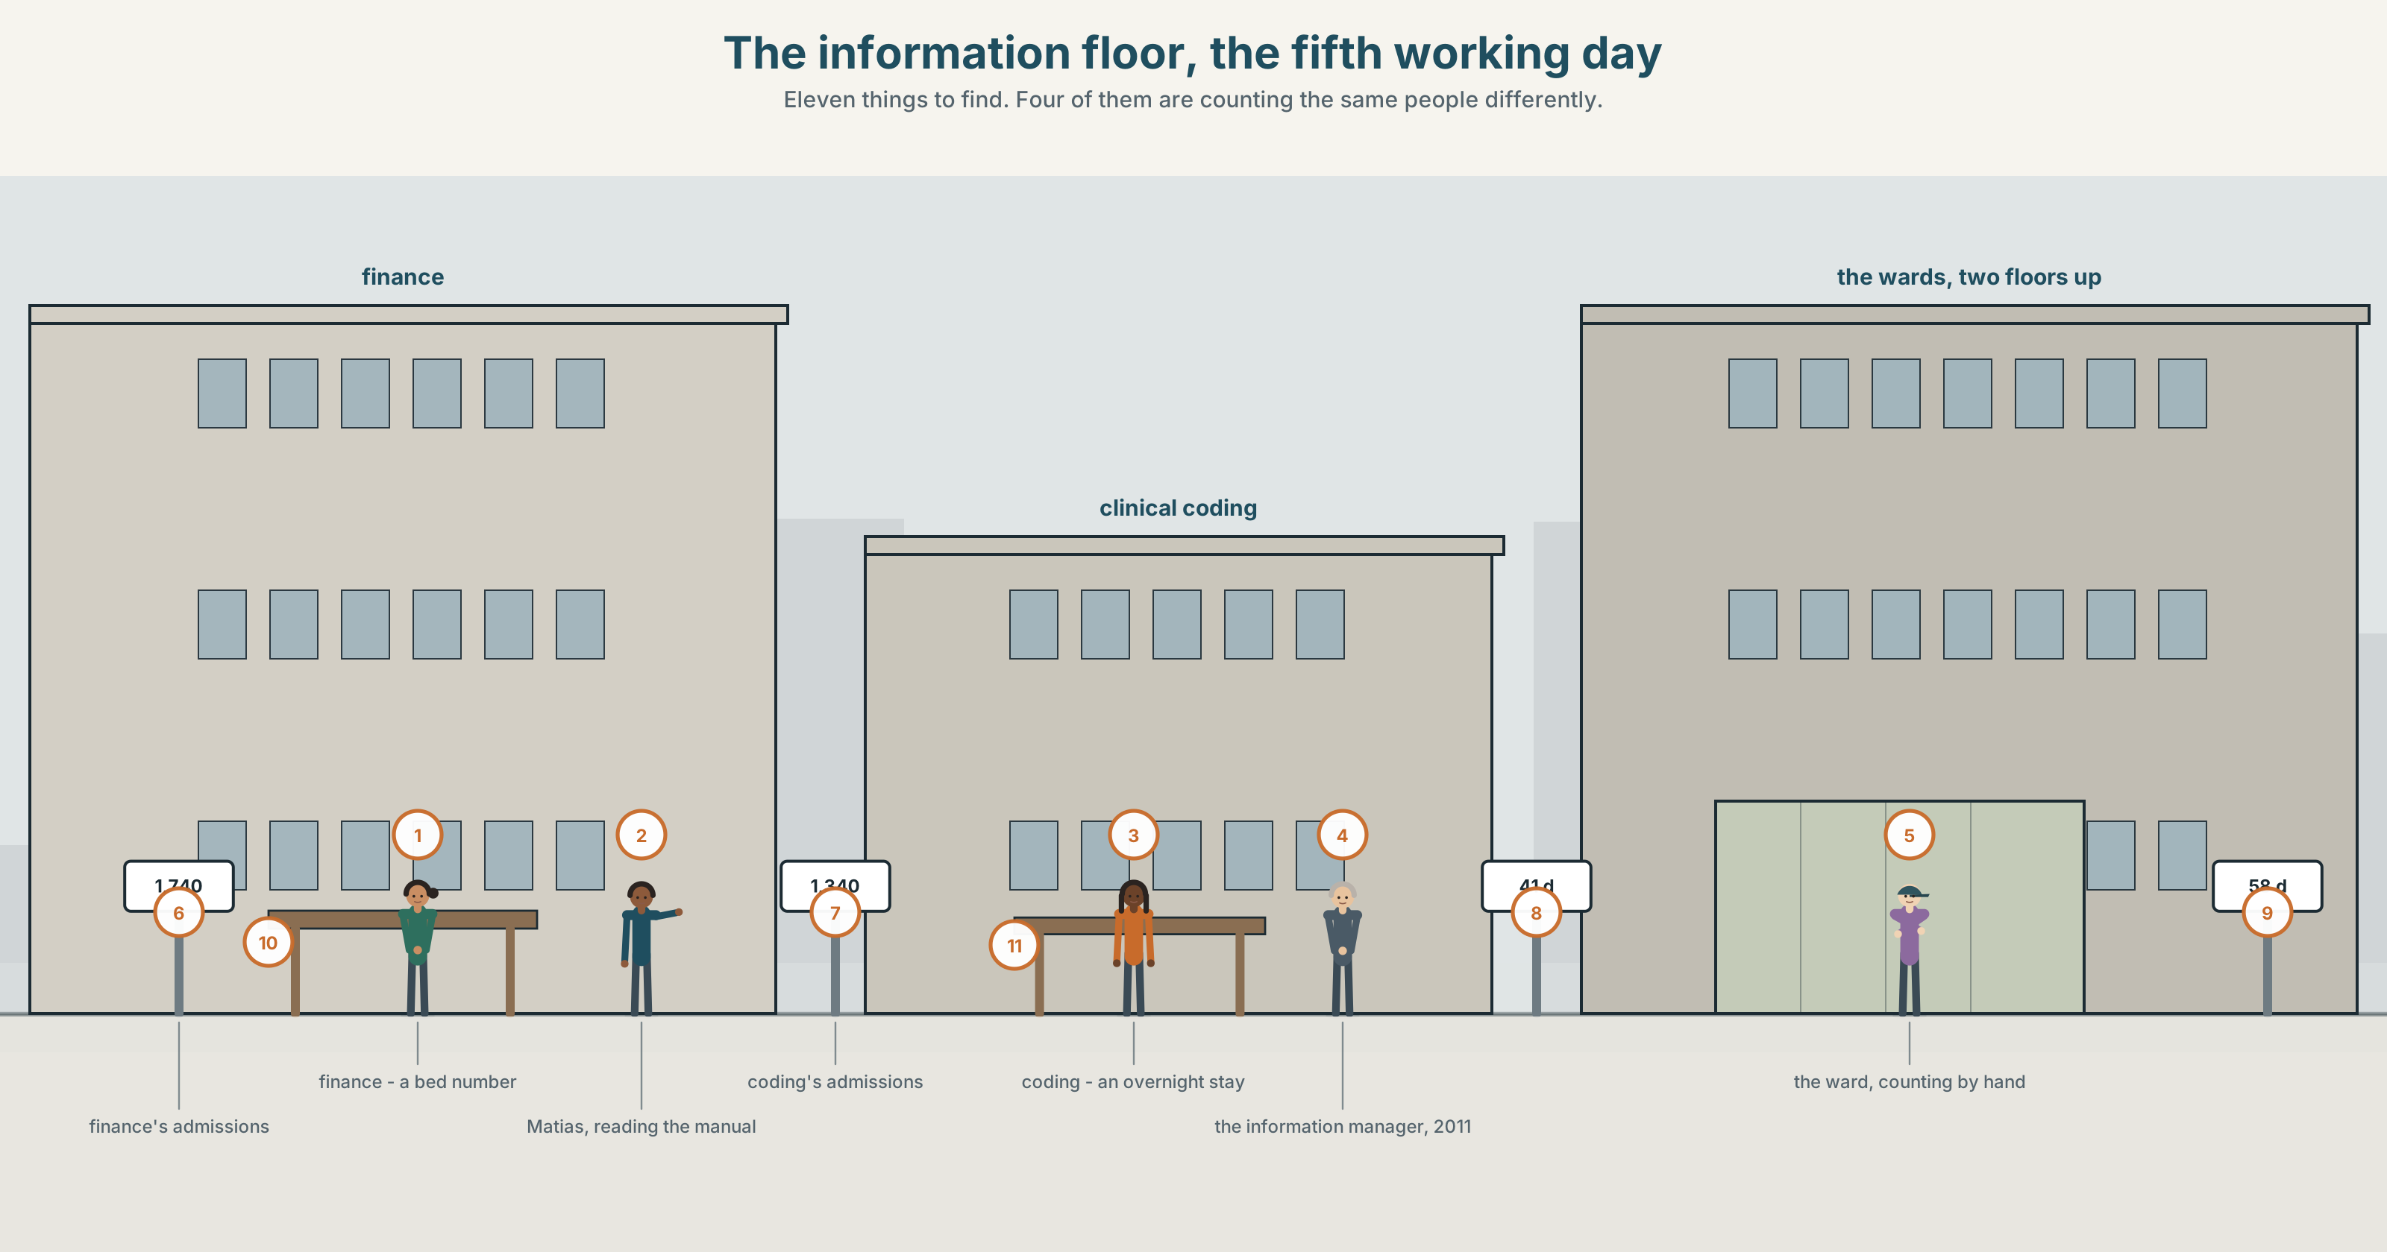{width=6.6in}
The information floor, the fifth working day — Eleven things to find. Four of them are counting the same people differently.

Which the do you mean?
By the end of this unit you can explain a category or a statistic to somebody outside the field.
◆ A · THE WORLD | One phrase in one report, read four ways by four departments
◆ B · THE SYSTEM | articles and determiners, advanced · generic reference · 23 words for categories and data · 22 determiners and pointers · /ðə/ /ðiː/ /ə/ /eɪ/
◆ C · THE PERFORMANCE | A category explained to somebody who does not work here

0A · Find it
Find eleven things in this picture. Four of them are counting the same people differently.
a ward whiteboard · a monthly return · a screen showing a dashboard · a paper list on a clip · a bed state board · a discharge book · a printout taped to a wall · a coding manual · a sticky note correcting a number · a calculator · a report cover

0B · Guess it
Two of these would give different totals for the same Tuesday. Which, and why?

0C · Say it ⏺
Record forty-five seconds. Name a word your job, course or family uses in a way an outsider would misunderstand. Define it, and say what it excludes. You will record it again at the end of this unit.

Part 1 · Vocabulary Lab 1 ◆ B · THE SYSTEM
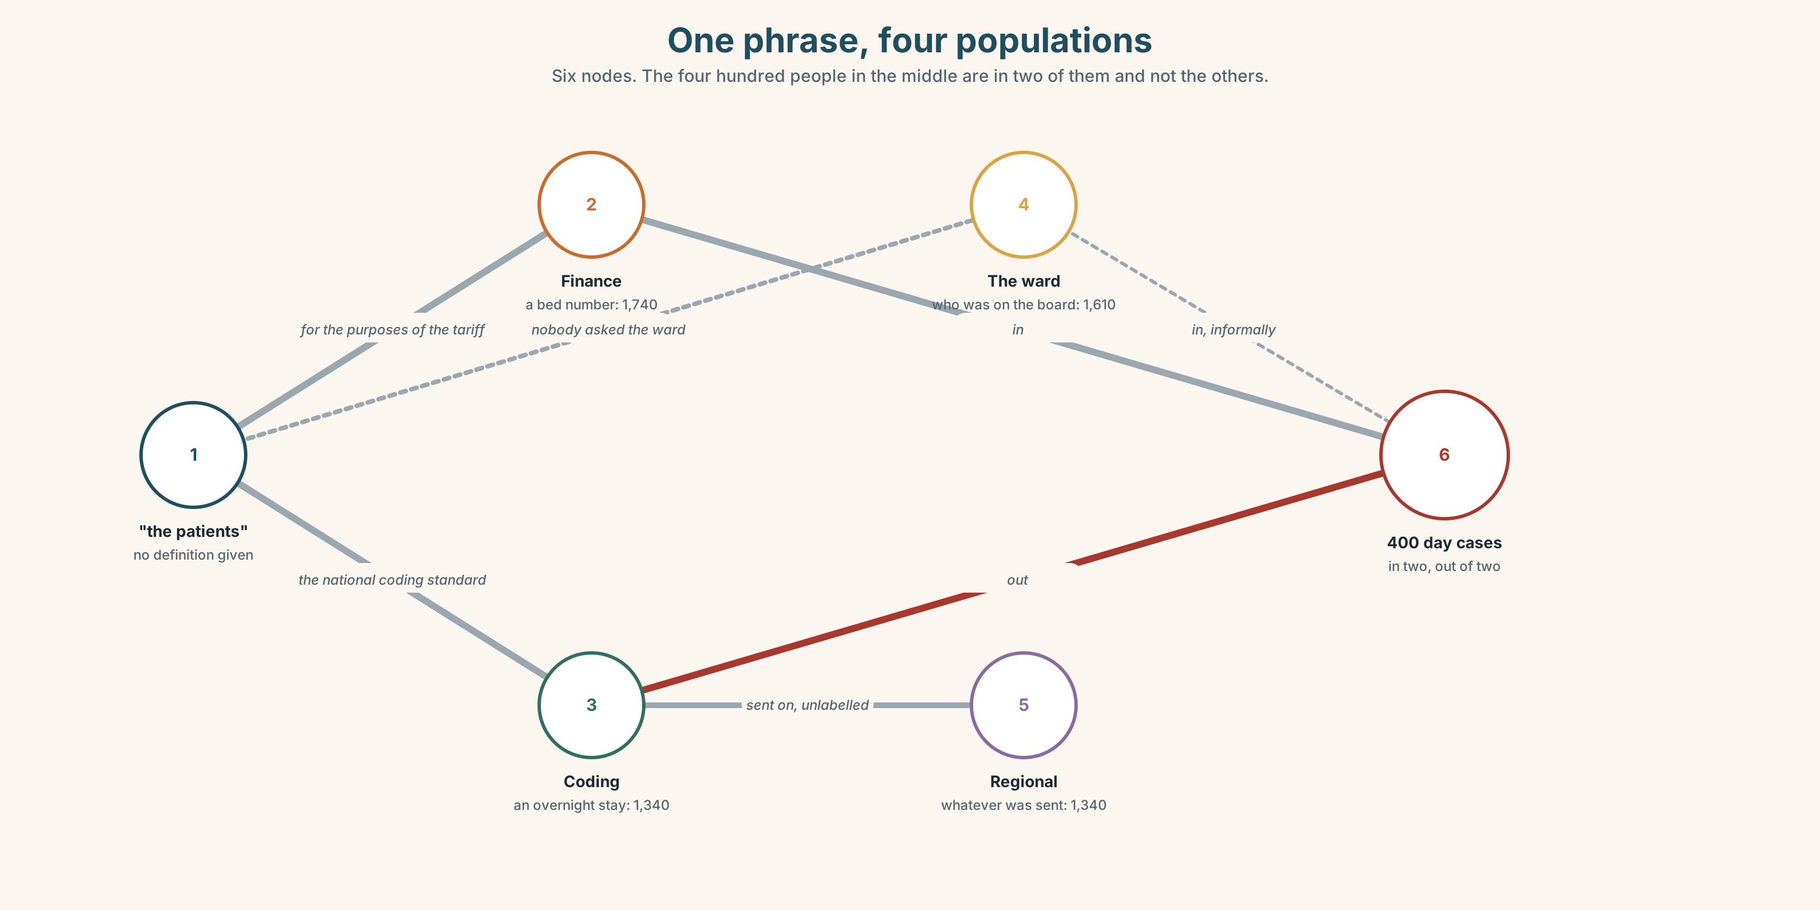{width=6.6in}
One phrase, four populations — Six nodes. The four hundred people in the middle are in two of them and not the others.

1A · Meet — the words of a definition
Match each word to one place on the map.
category · definition · criterion · boundary · overlap · ambiguity · classification · data · dataset · field

1B · Sort — the thing, the rule, or the problem?
Three columns.
category · criterion · overlap · dataset · boundary · ambiguity · classification · record · abstraction
One of them only exists because two of the others were drawn carelessly. Which?

1C · Meet — two words that look like each other
data · dataset
Data is what was recorded. A dataset is a decision about which data to keep. Which of the two can be wrong without anybody having made a mistake?

1D · Collocation Lab
Complete each one with one word.
- By ______ , a patient who has not been admitted is not an admission.
- In ______ the two definitions agree. In ______ they differ by about four hundred.
- That is a working ______ and has never been written down.
- For the ______ of this report, a day case counts as an admission.
- Day cases fall ______ admissions in finance and not in clinical coding.
- If you break ______ the figure by department, three of the four disagree.

1E · The fixed expressions
f It depends what you mean by. f Four departments, four meanings.
The first one is said in a meeting. The second one is written in a report, once, by somebody who has given up.
Write the sentence that provokes the first and the sentence that follows the second.

1F · Own it
Think of a number that your workplace, school or household quotes. Tell a partner four sentences: what it counts, what it excludes, who produced it, and whether anybody has checked the definition.

Part 2 · Listening ◆ A · THE WORLD
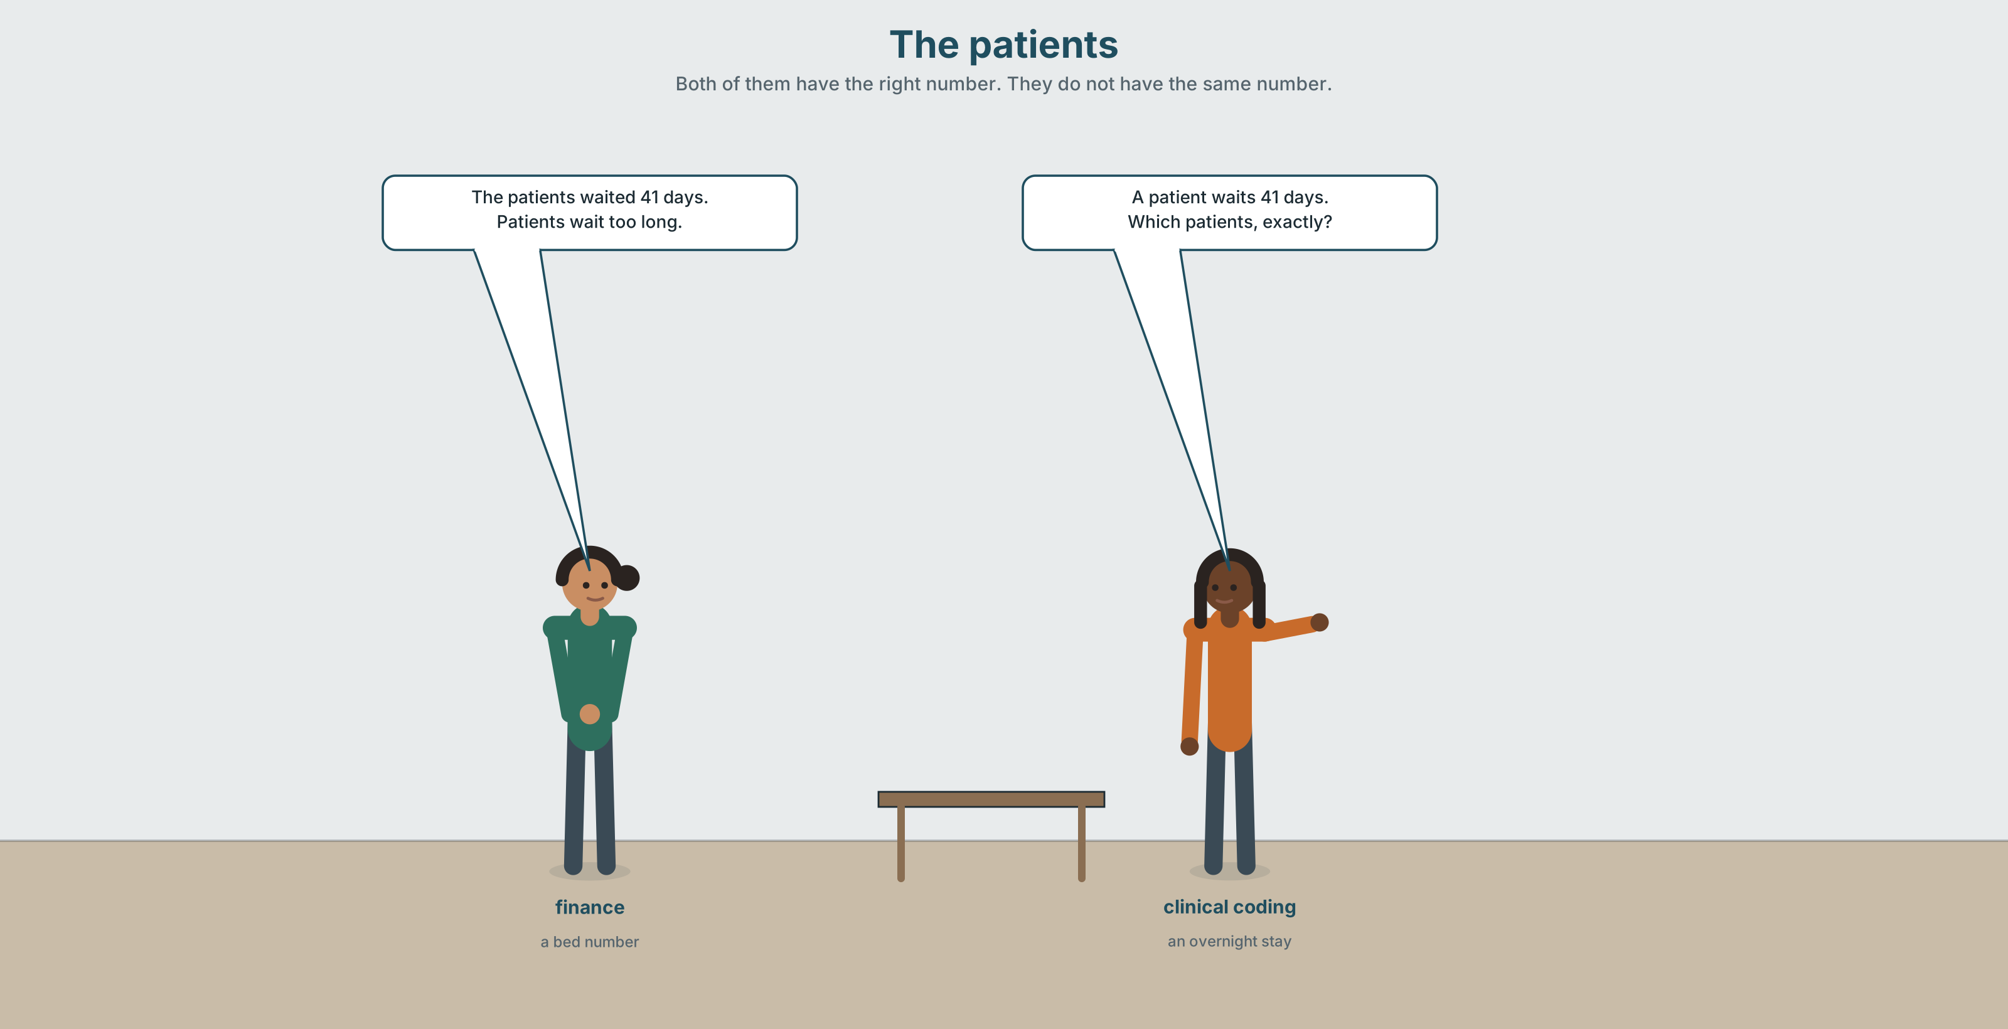{width=6.6in}
The patients — Both of them have the right number. They do not have the same number.

2A · The patients 🔊 Track 8.1
Before you listen. A report says the patients waited an average of 41 days. Four departments read this differently. Guess: what is the biggest disagreement?
Listen once. One question. What do the four readings have in common?
Listen again. Complete the table.
Department | What they read the patients as | Their number
finance
clinical coding
the ward
the regional office
Listen again. Choose the best answer.
- The four numbers range from 38 to 44 / 31 to 58 / 41 to 41.
- The report's own definition is in the text / in a footnote / nowhere.
- The phrase that causes it is the patients / an average / 41 days.
- Nobody has raised it because nobody noticed / everybody noticed / nobody owns the report.
Noticing. Four sentences from the recording.
- Patients wait too long.
- The patients waited 41 days.
- A patient waits 41 days.
- The patient waited 41 days.
One of these is about everybody. One is about a group. One is about a type. One is about one person. Which is which?

2B · Decoding clinic 🔊 Track 8.2
Thirty seconds. Four jobs.
- How many times is the said as /ðiː/ rather than /ðə/?
- Does the speaker say /ə/ or /eɪ/ for a, and when does it change?
- Catch the four numbers.
- One speaker stresses the. What is she doing?
Transcripts, page 157.

Part 3 · Grammar Lab 1 ◆ B · THE SYSTEM

Three ways of saying everybody

3A · Notice
Look at the four sentences in Part 2.
- In sentence 1, how many patients?
- In sentence 3, is there a particular patient?
- Sentences 1 and 3 both make a general claim. What is the difference in feel?
- Sentence 4 uses the with a singular. Can that ever be generic? Try: The patient is the last person consulted.
- Try "The patients wait too long." Who exactly is waiting?

3B · See
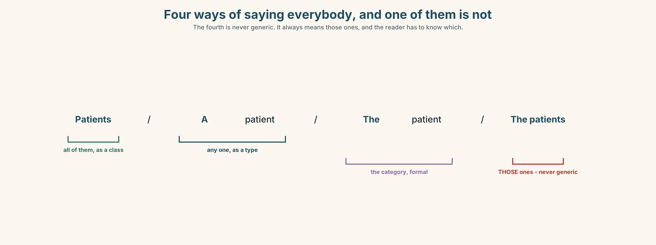{width=6.6in}
Four ways of saying everybody, and one of them is not — The fourth is never generic. It always means those ones, and the reader has to know which.

3C · Know
 | Shape | Means
bare plural | Patients wait too long. | all of them, everywhere, as a class
a / an + singular | A patient waits 41 days. | any one, as a representative type
the + singular | The patient is the last to be consulted. | the category as an institution — formal
the + plural | The patients waited 41 days. | a specific group, already identified
The trap is the fourth row. The patients is never generic in ordinary English. It always means those patients, and if the reader does not already know which ones, the sentence is broken.
Determiners that narrow further: certain patients (some, unspecified) · given patients (specified, in a formula) · such patients (of the kind just described) · the respective departments (each its own) · the former / the latter (of two just named).
The phrases that carry a definition: by definition · for the purposes of · in principle · in practice · as a whole · in the main.
Why it matters. A report that says the patients without having said which ones is a report that four departments will read four ways, and all four will be reading in good faith.

3D · Use — controlled
(1) __________ patients wait too long. That is a general claim and nobody disputes it. (2) __________ patients in this report waited 41 days on average — but (3) __________ report does not say which patients, and (4) __________ four departments reading it each have (5) __________ working definition of their own. For (6) __________ purposes of finance, a day case is an admission. In clinical coding it is not. (7) __________ latter definition produces a figure four hundred lower, and (8) __________ ambiguity has never been raised because nobody owns the report.

3E · Use — guided
Rewrite each one so it says what the writer means.
- The patients are waiting longer. (meaning: all patients, everywhere)
- Patients waited 41 days. (meaning: the 1,340 in this report)
- A patient is entitled to an interpreter. (meaning: every patient, as a rule)
- The patient is not consulted. (meaning: the category, in a formal sentence)
- Such patients are excluded. (meaning: the ones described in the previous sentence)

3F · Use — open
In pairs. Take any number from your own life — a price, a grade, a waiting time. State it four times: about everybody, about a type, about a specific group, and about the category as an institution. Your partner says which is which.

3G · Error autopsy
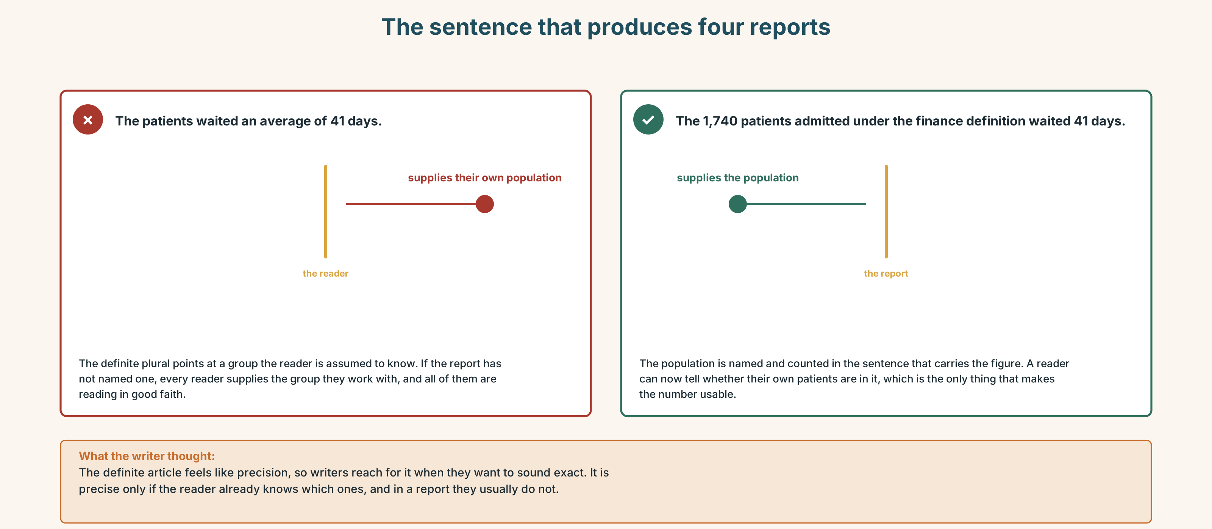{width=6.6in}
The sentence that produces four reports — The sentence that produces four reports
Read both versions. Then say how many different reports the first sentence produces.

3H · Check — eight items
- ______ patients wait too long. (all, everywhere)
- ______ patients in this report waited 41 days. (this group)
- ______ patient waits 41 days. (a representative type)
- ______ patient is the last to be consulted. (the category, formal)
- ______ patients are excluded. (of the kind just described)
- ______ departments each produced their own figure. (each its own)
- Of the two definitions, ______ produces a lower figure. (the second)
- ______ the purposes of this report, a day case is an admission.
0–4 → Workbook pp. 46–49. 5–6 → Part 6. 7–8 → page 173.

Part 4 · Speaking ◆ C · THE PERFORMANCE

4A · Fluency starter — four generalities
Your teacher names a group: nurses · students · landlords. Each learner must produce four sentences about them, one of each kind from Part 3C. Four groups. Four rounds.

4B · The functional core — explaining a category
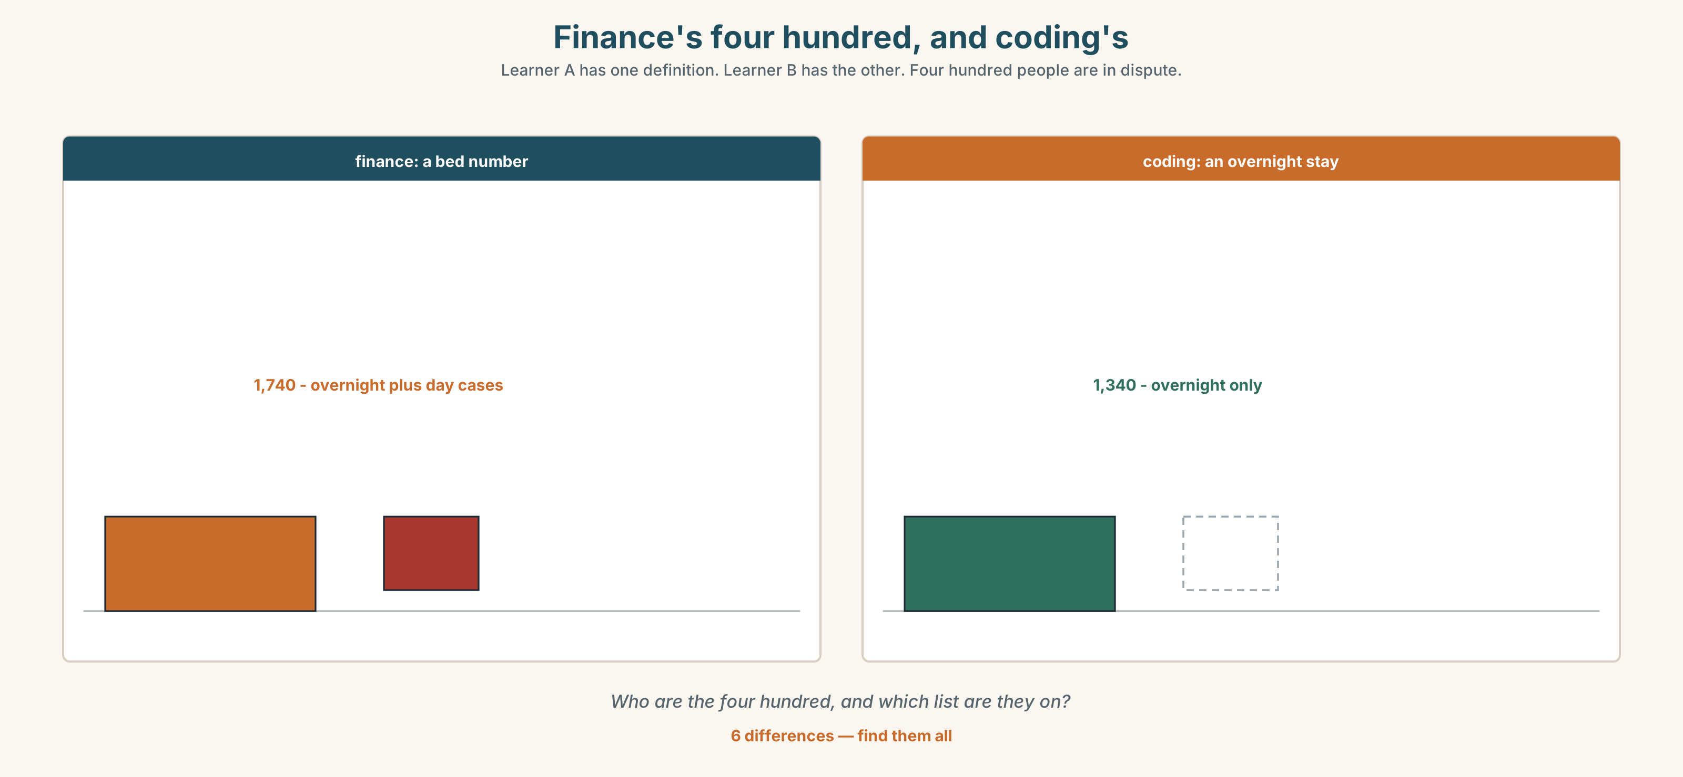{width=6.6in}
Finance's four hundred, and coding's — Learner A has one definition. Learner B has the other. Four hundred people are in dispute.
Language Bank
the definition | By definition… · For the purposes of this…
the boundary | What falls under it is… · What it excludes is…
the honest gap | In principle… in practice… · It depends what you mean by…
the check | Which ones, exactly? · Does that include…?
Information gap. Learner A has finance's definition. Learner B has clinical coding's. Neither sees the other. Find the four hundred people who are in one and not the other.

4C · The performance — two minutes ⏺
Explain a category or a statistic to somebody outside your field. Two minutes. You must include:
the definition · one thing it includes that an outsider would not expect · one thing it excludes · the number, and which definition produced it
Record it.

4D · Observer
One person listens for one thing: could the listener now tell whether a given case is in or out?

4E · Three criteria
☐ Did I use three of the four generic forms correctly? ☐ Did I say what the category excludes? ☐ Is every number attached to a definition?

Part 5 · Reading ◆ A · THE WORLD

5A · Predict
An archive document: the minutes of the meeting at which a definition was set, in 2011. The title is "Item 7: what counts as an admission." What do you expect the meeting to have decided? Two sentences.

5B · Read — two minutes

MINUTES OF THE INFORMATION GROUP — 9 NOVEMBER 2011 Item 7: what counts as an admission
7.1 The group considered whether day cases should be counted as admissions.
7.2 Finance stated that day cases must be counted as admissions, because the tariff is paid on an admission basis and a day case that is not counted is a day case that is not paid for.
7.3 Clinical coding stated that day cases must not be counted as admissions, because the national coding standard defines an admission as requiring an overnight stay, and that a local variation would make the hospital's returns incomparable with every other hospital's.
7.4 Both positions were agreed to be correct.
7.5 It was agreed that each department would continue to use its own definition for its own purposes, and that the matter would be reviewed when a single reporting system was introduced. Mr Vergara noted that this effectively meant the hospital had two admission figures. The chair noted that it had always had two admission figures and that the meeting had simply written that down.
7.6 ACTION: Information manager to prepare a note setting out both definitions, for circulation to all departments.

Archivist's note, added 2024: no note was circulated. The single reporting system was introduced in 2019 and uses the finance definition without stating that it does so. The clinical coding definition remains in use for national returns. Item 7 has not been reviewed.

5C · Comprehension — eight questions
- What was the question in front of the group?
- What was finance's argument, and what was clinical coding's?
- What did the group conclude about the two positions?
- What was agreed, and what did Mr Vergara point out?
- What did the chair say, and what is the force of it?
- What action was agreed?
- What does the archivist's note say happened?
- Which definition is now in use, and does the system say so?

5D · Vocabulary in context
Guess from the text. Then check.
on an admission basis · a local variation · incomparable · effectively meant · without stating that it does so

5E · The counter-text
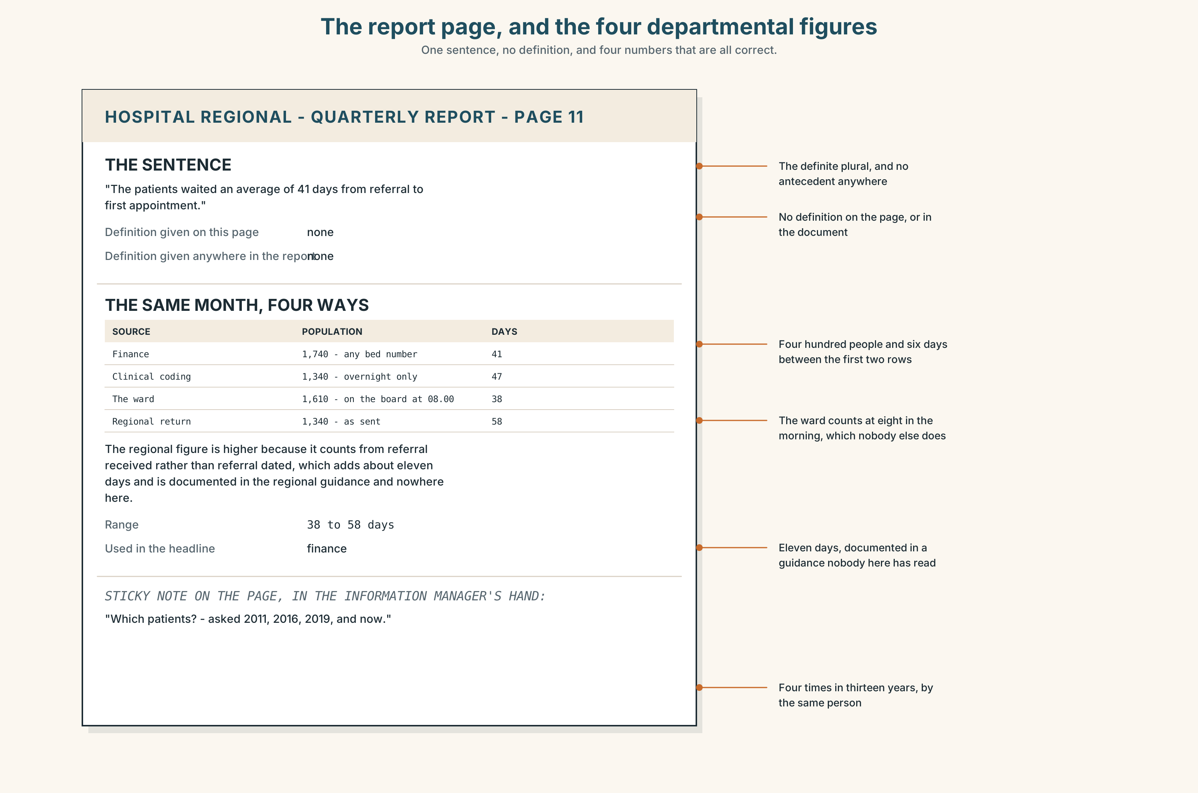{width=6.6in}
The report page, and the four departmental figures — One sentence, no definition, and four numbers that are all correct.
Read the report page and the four departmental figures, and answer.
- What does the headline sentence say, and what does it not say?
- What are the four figures, and what is the range between them?
- Where, if anywhere, is a definition given?
- Which of the four departments' figures is used in the regional return?
- One sticky note has been attached to the page. What does it say?

5F · Two texts
The 2011 minutes record an agreed action to circulate both definitions. The report has no definition anywhere on it.
Put those two facts together. Whose fault is the report? Three sentences.

Part 6 · Vocabulary Lab 2 ◆ B · THE SYSTEM

Pointing precisely

6A · Sort — narrowing, generalising, or pointing back?
Three columns.
certain · given · such · any · particular · generic · specific · the former · the latter · respective · as a whole

6B · Chunk completion
- In the ______ , the two figures agree to within fifty.
- A kind ______ working definition has been in use since 2011.
- The sort ______ patient this excludes is the one who comes in and goes home.
- The one in ______ is the regional return.
- What does admission stand ______ in this system?
- The paragraph refers ______ a definition that is not in the document.

6C · Three that look like precision
certain · given · particular
Certain means some, and I am not telling you which. Given means specified, in a formula. Particular means this one, as opposed to others.
Which fits each sentence, and what changes?
- ______ patients are excluded from this figure.
- For a ______ month, the figure is produced on the fifth working day.
- This ______ figure is the one in the regional return.

6D · The fixed expression
f Which patients, exactly?
Three words that stop a meeting. Write the two sentences before it and the sentence after it, in a meeting where it is welcome and in one where it is not.

6E · Contrast Clinic
Eight items. Choose the article or determiner, and name the meaning.
- ______ patients wait too long. (everybody)
- ______ patients waited 41 days. (this group)
- ______ patient waits 41 days. (a type)
- ______ patient is rarely consulted. (the category, formal)
- ______ patients are excluded. (the kind just described)
- For a ______ month, the return is due on the fifth. (in a formula)
- ______ departments produced their own figures. (each its own)
- Of the two, ______ is lower. (the second)

Part 7 · Pronunciation & Fluency Lab ◆ B · THE SYSTEM

Two words, four sounds
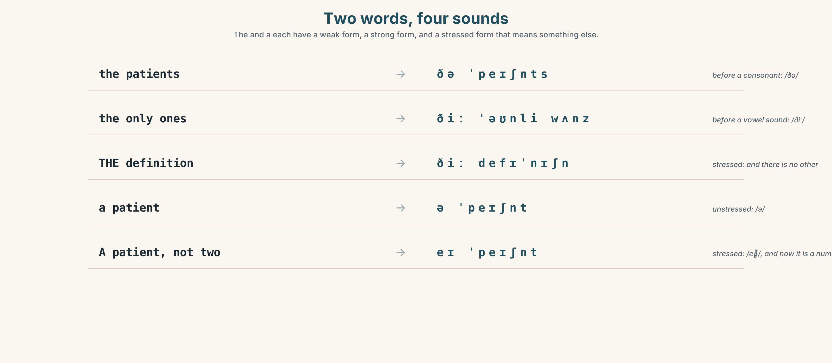{width=6.6in}
Two words, four sounds — The and a each have a weak form, a strong form, and a stressed form that means something else.

7A · Hear 🔊 Track 8.3
the patients → /ðə/ — before a consonant the only ones → /ðiː/ — before a vowel sound THE patients → /ðiː/ — stressed, meaning the real ones a patient → /ə/ · A patient, not two → /eɪ/

7B · Say
Say all four. Then say the sentence three times, faster:
The patients in the appendix are the only ones the definition covers.

7C · Make it mean something
Say these two:
It's a definition. (one of several) It's THE definition. (and there is no other)
In the 2011 minutes, which of the two is true?

7D · Fluency 30 ⏺
Thirty seconds: four generic statements about any group you like, one of each kind. Three times, faster.

Part 8 · Writing ◆ C · THE PERFORMANCE

A category, explained · 160 words
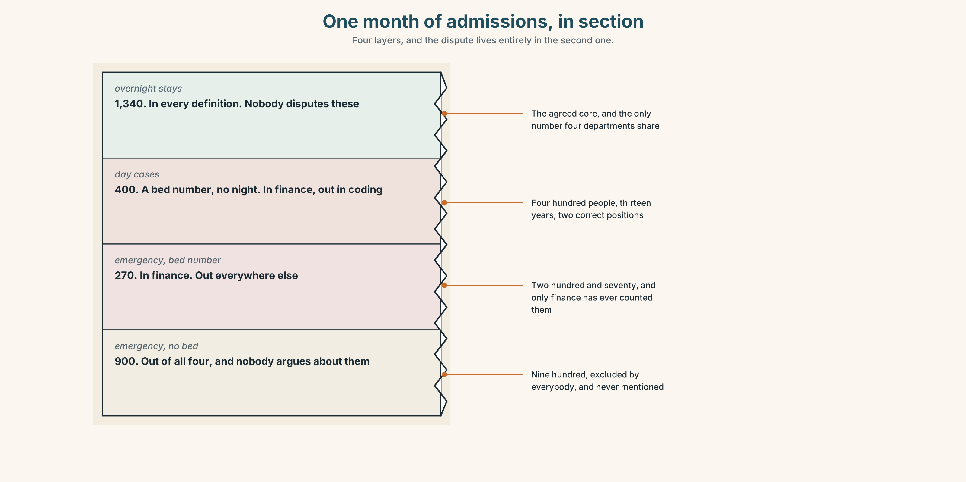{width=6.6in}
One month of admissions, in section — Four layers, and the dispute lives entirely in the second one.

8A · Read the model
An admission, in this report, means any patient given a bed number, whether or not they stayed overnight. [the definition, in the first sentence, and it names the test: a bed number]
That includes day cases, which most people would not call an admission, and about four hundred of them a month fall into this figure. It excludes patients seen and discharged from the emergency department without a bed number, of whom there are about nine hundred. [one surprising inclusion and one surprising exclusion, both with numbers]
Clinical coding uses the national standard, which requires an overnight stay. Their figure for the same month is 1,340 lower. Neither definition is wrong. [the other definition, the size of the gap, and a refusal to adjudicate]
If somebody quotes an admission figure at you, the only useful question is whether a day case is in it. [what the reader should do, in one sentence]
Questions about the writer's choices:
- The definition names a physical test — a bed number. Why is that better than a principle?
- Both the inclusion and the exclusion have numbers. What would be lost without them?
- The last sentence is an instruction. Who is it for?

8B · The anti-model
Admissions data is collected in accordance with agreed definitions and is subject to ongoing review. Figures may vary between departments due to differing methodologies. Users should exercise caution when making comparisons.
Correct English, and it will not help anybody. Name three things it does not say, and say what differing methodologies is standing in for.

8C · Plan
the definition, with a physical test → one surprising inclusion, with a number → one surprising exclusion, with a number → the other definition and the size of the gap → the one question a reader should ask

8D · Write — 160 words

8E · Peer review — three criteria
☐ Can a reader now sort a case into the category or out of it? ☐ Is there an inclusion and an exclusion, both with numbers? ☐ Does the piece avoid saying one definition is right?

8F · Write it again · 8G · Publish
On the wall, with the report page from Part 5E beside it.

Part 9 · The File ◆ A · THE WORLD + C · THE PERFORMANCE

STUDY FILE · Exam Decode
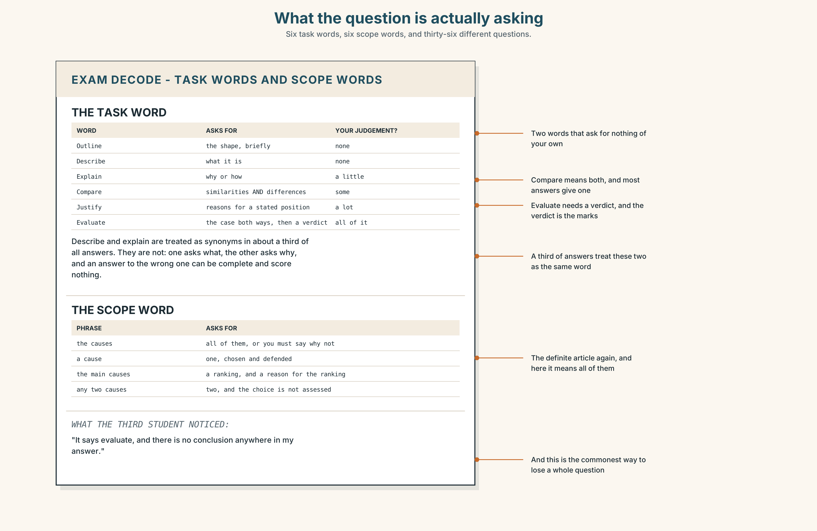{width=6.6in}
What the question is actually asking — Six task words, six scope words, and thirty-six different questions.

9A · What the question is actually asking 🔊 Track 8.4
Matías and two others are reading past exam questions. Listen.
- Which word in the first question do they spend longest on, and why?
- Which question turns out to be asking for something different from what it looks like?
- What does the third student notice that the other two have missed?

9B · The words that set the task
describe · explain · compare · evaluate · justify · outline
Rank them by how much of your own judgement each one requires. Then say which two are most often treated as synonyms and are not.

9C · The words that set the scope
the · a · all · any · the main · one
"Describe the causes" and "describe a cause" and "describe the main causes" are three different questions.
Write what each of the three is asking for, and say which is hardest to fail.

9D · Your turn
Take one question from your own field. Underline the task word and the scope word. Then write, in one sentence, what a complete answer would contain. Swap, and your partner marks whether your sentence answers the question that was asked.

9E · Transfer
Find one question you have been asked this week — in writing, at work, anywhere. Identify its task word and its scope word, and say whether you answered both.

Part 10 · Mediation & Interaction ◆ C · THE PERFORMANCE
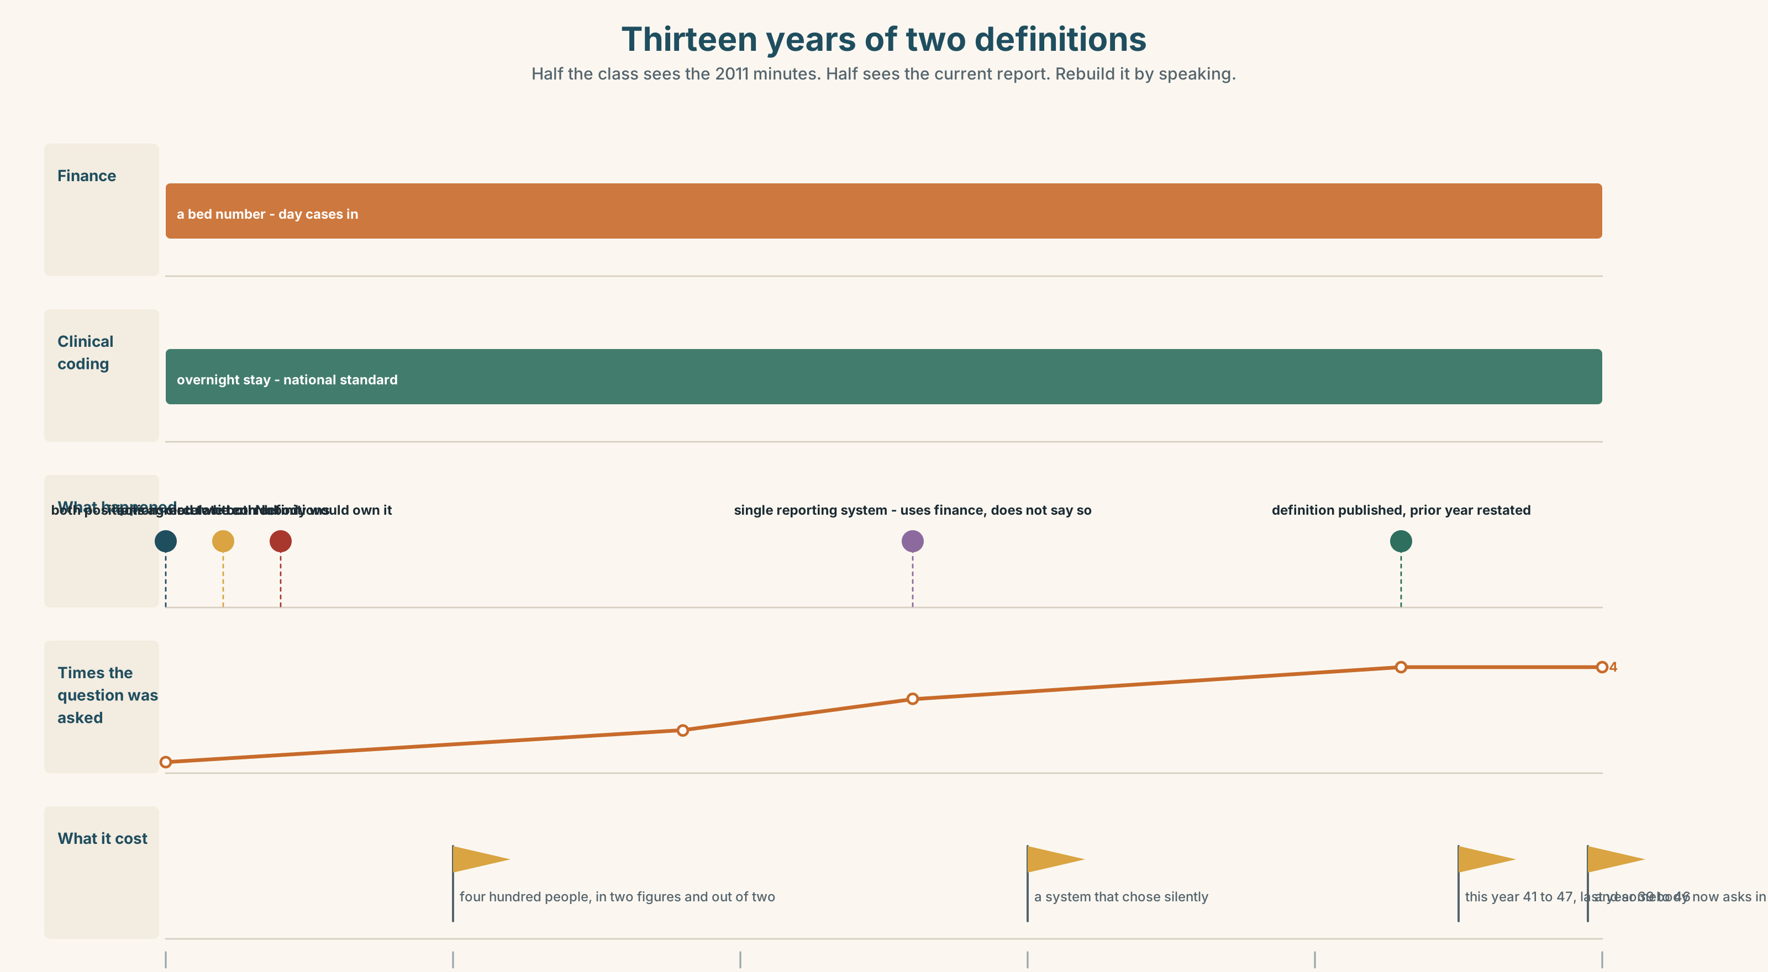{width=6.6in}
Thirteen years of two definitions — Half the class sees the 2011 minutes. Half sees the current report. Rebuild it by speaking.

10A · Relay
Half the class sees the 2011 minutes. Half sees the current report. Rebuild thirteen years by speaking. Twelve minutes.

10B · Simplify
Explain the admission definition from Part 5E to a journalist who has asked for the figure. Five sentences only.
Plan: what the figure counts → what it excludes → what the other figure is → why both are honest → which one you are giving them

10C · Compress
The 2011 minutes into forty words, keeping the chair's remark.

10D · Online
Write one message to the information manager: you have found two figures for one month, you have the 2011 minutes, and you are asking for one specific thing by one specific date.

10E · Your language
Does your language have articles? If not, how does it distinguish patients wait too long from the patients waited 41 days? Say both in your language and explain to a partner what carries the difference.

Part 11 · The Decision ◆ C · THE PERFORMANCE

One figure, four readings
A report says the patients waited an average of 41 days. Four departments each read it as their own population. Their figures range from 31 to 58.
- Publish a definition. One sentence at the top of the report. It would make the figure comparable and it would make this year's figure look worse than last year's, which was produced the other way.
- Publish all four. Honest, unusable, and the regional office will pick one.
- Leave it. Everybody carries on reading their own number, as they have since 2011, and the report continues to be quoted in four meetings a month.

11A · The evidence
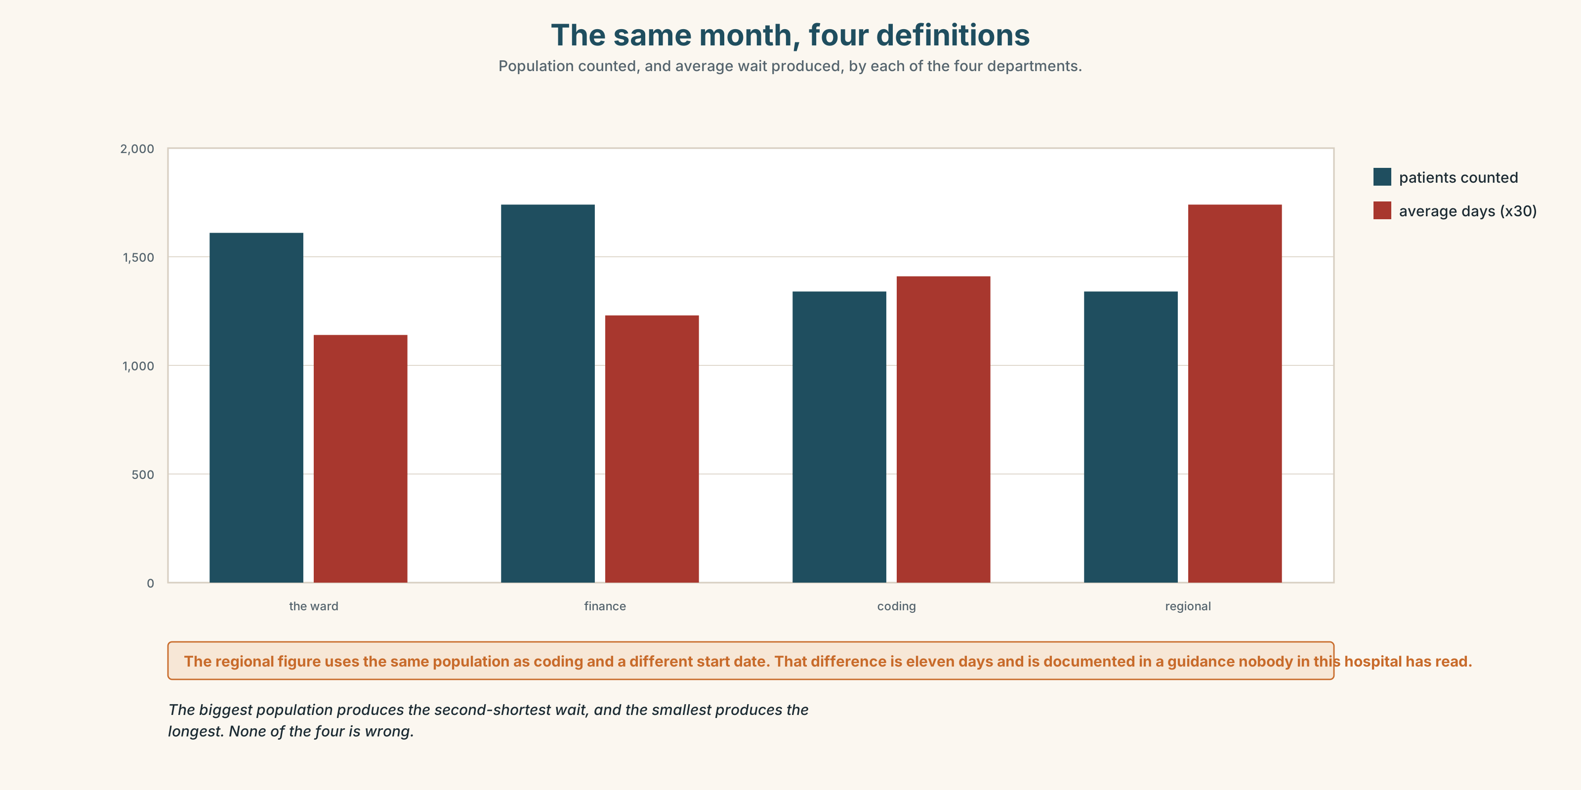{width=6.6in}
The same month, four definitions — Population counted, and average wait produced, by each of the four departments.
- The report page and the four figures from Part 5E — and the sticky note.
- The chart — the four populations, their overlaps, and the four hundred people in dispute.
- The voice. The information manager, thirty seconds: "I was asked to write that note in 2011. I did write it. I could not find anybody who would own it, because owning it would mean choosing, and the two people who would have had to agree had both correctly been told that their definition was the right one."

11B · Talk about it
In fours. Everybody speaks twice. Use the frame.
By definition ______ . In practice ______ . So the figure means ______ .
Words you can use: category · definition · criterion · boundary · overlap · ambiguity · classification · in principle · for the purposes of · fall under

11C · Decide
Write three sentences. Choose, say why, and name what it costs.
I think the hospital should ______________________ , because ______________________ . What this costs is ______________________ .

11D · Model decision
Publish the definition and publish last year's figure recalculated on the same basis, in the same table. The reason this has survived thirteen years is that fixing it makes somebody's number worse, and the only way to remove that cost is to restate the comparison at the same time. One sentence and one recalculated column turn an embarrassment into a correction, and a correction is a thing an organisation can survive.

11E · The Reveal
What happened. The definition went in, with the recalculated prior year beside it. The figure for this year rose from 41 to 47 days and last year's rose from 39 to 46, so the direction of travel was unchanged and the headline was waiting times up by one day.
Three departments adopted the published definition within a quarter. Clinical coding did not, and could not, because the national standard binds them.
The report is still quoted in four meetings a month. In two of them somebody now asks which definition, which the information manager describes as the entire return on thirteen years.
One sentence and one column. Three of four departments. And somebody now asks the question in half the meetings.
Was it the right decision? Say why — and say what should be done about clinical coding.

Part 12 · Landing ◆ all three lines

12A · Recycle — twelve items
- ______ patients wait too long. (everybody)
- ______ patients waited 41 days. (this group)
- ______ patient waits 41 days. (a type)
- By ______ , a day case is not an overnight stay.
- For the ______ of this report, it is an admission.
- Day cases fall ______ admissions in finance.
- If you break ______ the figure, three departments disagree.
- The sort ______ patient this excludes comes in and goes home.
- (Unit 7) I stopped ______ (think) about it. (the thinking ended)
- (Unit 6) She ______ (have) it done on Thursday.
- (A2.2 U10) ______ truth matters. (in general)
- (A2.2 U9) ______ of it can be carried over. (zero, uncountable)

12B · Consolidate
One hundred and sixty words. A category from your own world, explained to an outsider. A definition with a physical test, one inclusion and one exclusion with numbers, and the one question a reader should ask.

12C · Can-do, with evidence
I can… | My evidence | Sure?
choose between four ways of making a general statement | Part 3H score | ◯ ◑ ●
explain a category in two minutes | Part 4C recording | ◯ ◑ ●
write 160 words a reader could sort cases with | Part 8 draft 2 | ◯ ◑ ●
identify the task word and the scope word in a question | Part 9D sentences | ◯ ◑ ●

12D · Replay ⏺
Find your forty-five seconds from Part 0C. Listen. Record it again. Two sentences: what is different, and whether your definition now excludes anything.

12E · Glossary — forty-five items, as a map
THE CATEGORY · category · abstraction · definition · a working definition · criterion · classification THE EDGES · boundary · overlap · ambiguity · fall under · rule in · set apart · group together · break down THE NUMBERS · data · dataset · field · record STATING IT · by definition · in principle · in practice · for the purposes of · as a whole · in the main · in general POINTING · the · a · such · any · certain · given · particular · specific · generic · respective · the former · the latter · the one in question · the sort of · a kind of · refer to · stand for WHAT PEOPLE SAY · it depends what you mean by · four departments, four meanings · which patients, exactly

12F · Next
Unit 9 · How many is most?

